Table of Contents
I. Installation Requirements……………………………………………………………………….....2
II. Obtaining the Installation File………………………………………………………………….….3
III. Begin the Installation Process……………………………………………………………………...7

Appendix A – MDAC Updates…………………………………………………………………………25
Appendix B – Microsoft .NET Framework 3.5……………………………………………………….27
.Net Frameworks 2.0 and 3.5………………………………………………………………………….27
Using the Microsoft Website………………………………………………………………………….35
Checking Windows Version and Updates…………………………………………………………….36
Appendix C – EAOR Network Installation…………………………………………………..……….37
For installations after the first one:……………………………………………………………………38
For installations that upgrade to a newer version of EAOR:………………………………………….39
Appendix D – EAOR Folder Permissions Error………………………………………………….…..40
Case 1 Windows XP……………………………………………………………………………...........40
Case 2 Windows 7…………………………………………………………………………………......42
Appendix E – Crystal Reports Error…………………………………………………………………..46
Crystal Reports Error Fix-1…………………………………………………………………………....46
Crystal Reports Error Fix-2…………………………………………………………………………....47
Appendix F – EAOR ‘has stopped working’ Error……………………………………………….….50

Installation Requirements
Before you begin - To install EAOR Version 2017-1 on your computer, you must have Administrator rights. If you do not have Administrator rights on your machine, or if you are not sure what this means, contact your System Administrator for assistance. You may also need an Internet connection during installation if your computer does not have the software needed by EAOR. This Internet connection is used by the installation process to retrieve software needed by EAOR Version 2017-1. It is recommended that you close all other applications during this installation.
Minimum System Requirements - This section describes the minimum configuration requirements for a computer where EAOR Version 2017-1 is to be installed. If the minimum requirements are not met, EAOR Version 2017-1 setup will block the installation of the redistributable package. Specifically, note that you cannot install the .NET Framework on a computer running the Microsoft Windows 95 operating system.
Required software - EAOR Version 2017-1 uses the Microsoft Data Access Component (MDAC) 2.8 SP1 or later and the .NET Frameworks 2.0 and 3.5. Microsoft provides MDAC and the .NET Framework at no charge.

- MDAC allows programs to use the Access database, and is required for EAOR Version 2017-1 to work correctly. Please see Appendix A for installing MDAC.
- The Microsoft .NET Framework is a component of the Microsoft Windows® operating system used to build and run Windows-based applications. If the version of this software is not on your computer, the setup process will use your connection to the Internet to install it for you. Please see Appendix B for more information about the .NET Framework updates.
Operating System Requirements - To install EAOR Version 2017-1, you must have one of the following operating systems with Microsoft Internet Explorer 5.5 or later installed on your computer:
- Microsoft Windows 2003 Server with the latest Windows service pack and critical updates available from the Microsoft Security Web site (https://www.microsoft.com/en-us/security/default.aspx)
- Microsoft Windows XP (Home or Professional).
- Microsoft Windows 7.
Hardware Requirements - The minimum hardware requirements include:
- Central Processing Unit (CPU) Intel Pentium class, 90 megahertz (MHz) or the minimum CPU required for running the operating system, whichever is higher.
- Random Access Memory (RAM) 32 MB or the minimum RAM required for running the operating system, whichever is higher.
- Hard Drive with 60 MB of free space.
- Disk Drive either a 3.5” or CD standard disk drive (for submitting/importing/exporting data). This is optional if you have an Internet connection.
- Conventional Mouse or other pointing device.
Network Installation – Please see Appendix C for instructions on how to install EAOR for multiple computers on a network.

Obtaining the Installation File
  - You may download the EAOR Version 2017-1 Installation files from the Internet at https://floridadep.gov/air/permitting-compliance/content/annual-operating-report. Click on the EAOR Version 2017-1 Installation link under the Download Software title. 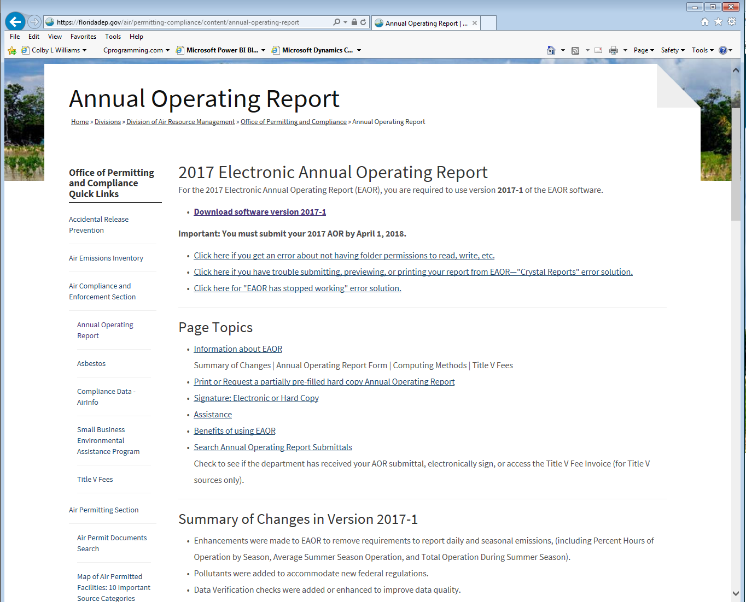

  - This will take you to the Download Website. Click on the link, “Click here to download EAOR Version 2017-1”.
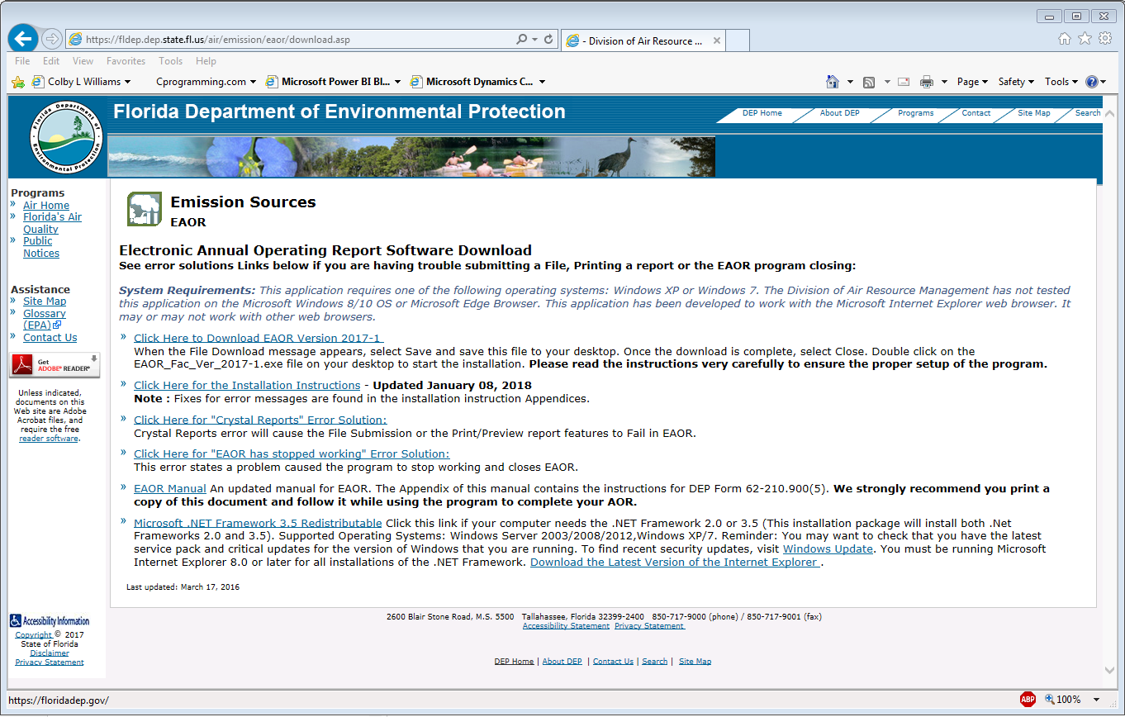

  - The link will display a File Download message box. Click on the down arrow next to the Save button and then select Save As.

  - In the Save As box, select your Desktop or EAOR Default folder (C:\EAOR) or a temporary folder where you want to save the EXE.
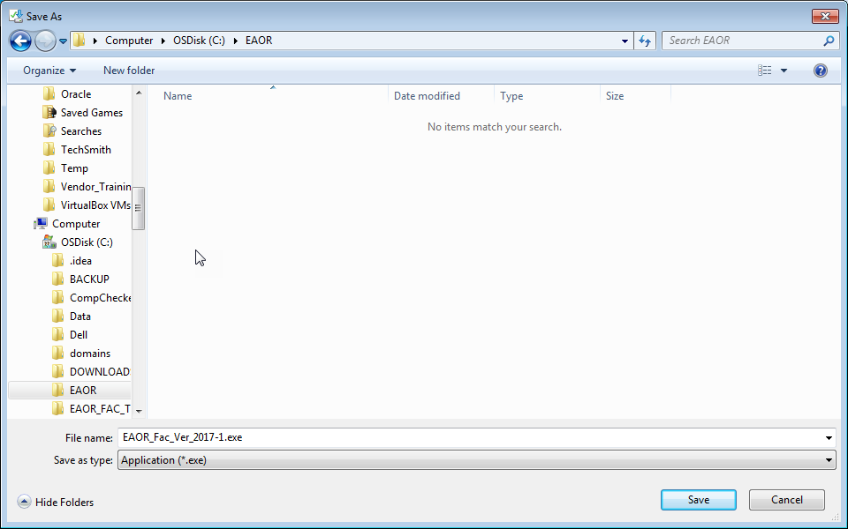

Once the Save is complete then you will see the security scan and then the warning message as shown below, then
click the Actions button.

Once clicking the Actions button, then it will show the SmartScreen Filter, select the Run anyway option as shown
below to run the program .

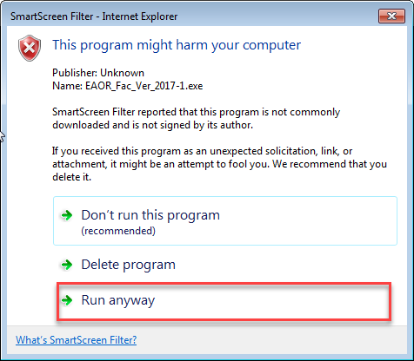

Begin the Installation Process
  - Once the installation file is downloaded to your local computer, right click on the file that says EAOR_Fac_Ver_2017-1.exe and Select Run as Administrator as shown below:
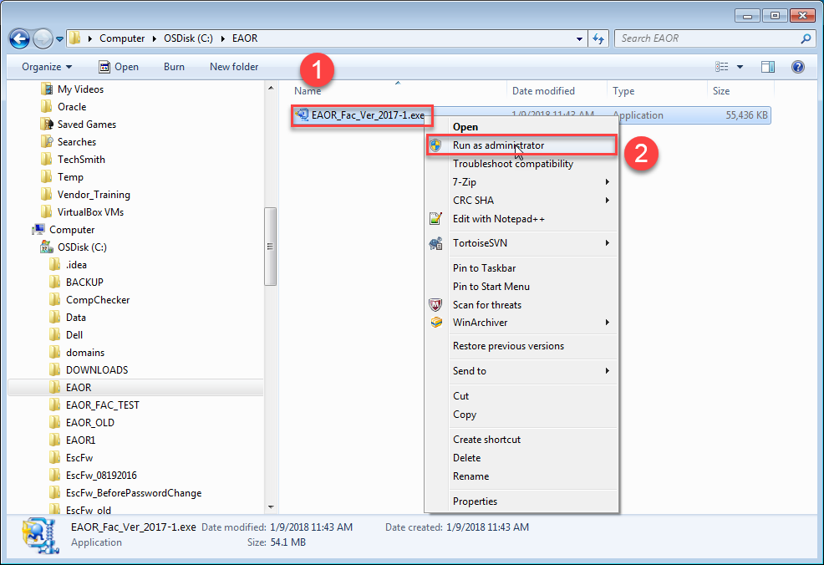

Note: - Select “Yes” if you get User Account Control Message as below (After you click Run as administrator):

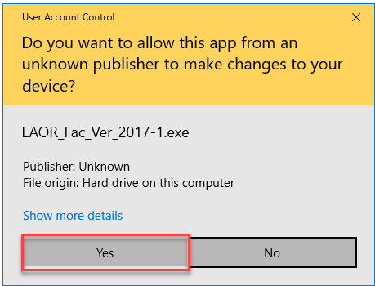

- Right click on the file name or icon and Select Run as administrator as shown above. Desktop Icon is shown below
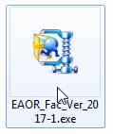

  - Right clicking the file name or icon and selecting run as administrator will open the installation message box that is shown below.

- 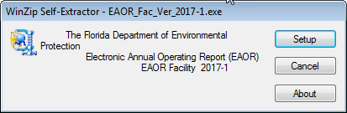

3. Click on the Setup button to start the installation process.

4.

You will see the message below click on the Accept button to continue.

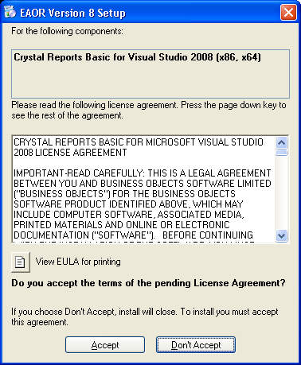

- When you click on the Accept button on the window above you’ll see the following dialog box.
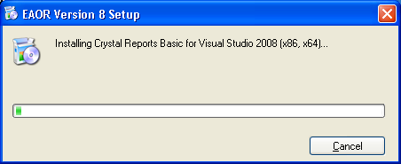

Note (If EAOR Installation Failed) :- For few systems, If crystal reports are already installed then EAOR Installer will show the following popup message. You need to close that popup and Uninstall Crystal Reports Basic Runtime for Visual Studio 2008 and then run the EAOR_Fac_Ver_2017-1.exe. (If you don’t see below popup continue with the installation process)

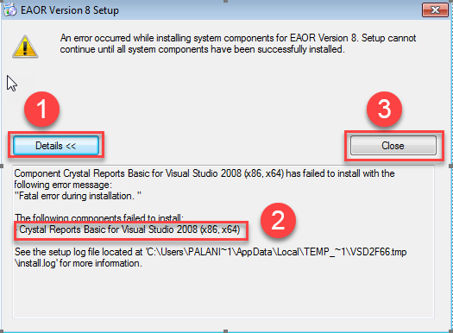

- If you encounter the following error then please continue with next step, otherwise Skip to Step 12 (in Section III).

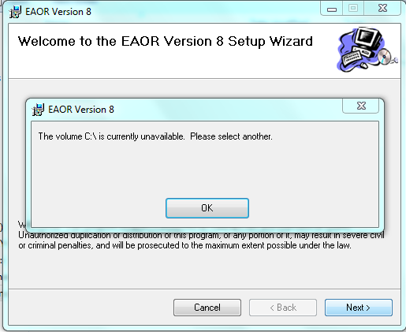

a) Download the EAOR Facility installation file to the desktop (or) EAOR Default folder (C:\EAOR).

b) Rename the file from .exe to .zip.
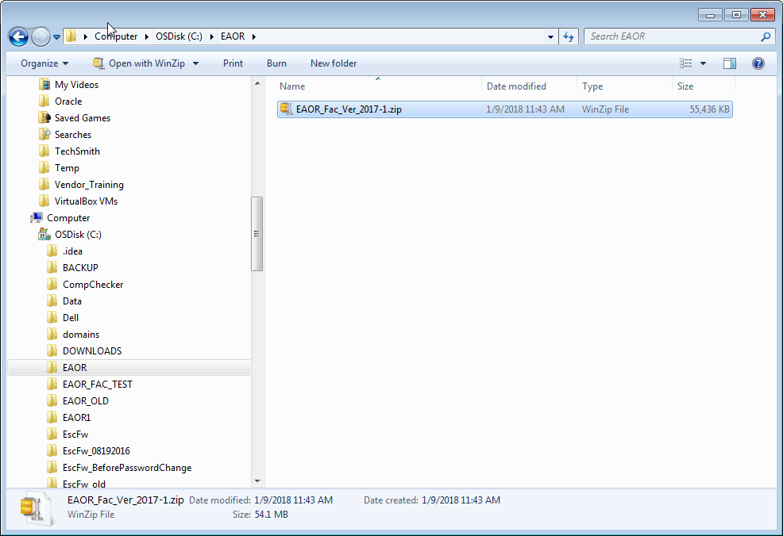

c) Unzip the file saved to the desktop (or) EAOR Default folder (C:\EAOR).

d) After unzipping the files will be displayed as shown below, then double-click the
file setup.exe (i.e. Type says ‘Application’) and follow the prompts.

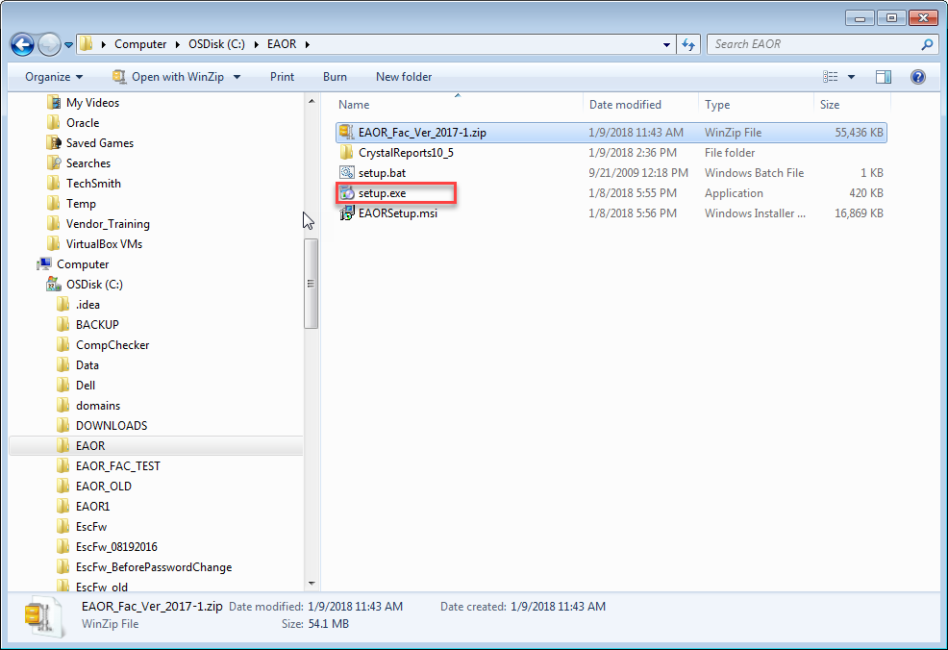

- If Dot Net Framework 2.0 is NOT already installed on your PC then you’ll see the following message and should continue with the next step, otherwise skip to step 12 (in Section III).
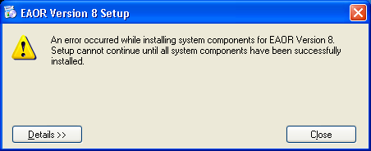
Click on the Details button in the window above to display the error message.

- Click on the Close button to close the error dialog box.

9. If Dot Net Framework 3.5 or .Net Framework 3.0 is installed on your PC and .Net Framework
  - is not already installed, then you must uninstall .Net Frameworks 3.0 and 3.5 to resolve the above error and should continue with the next step, otherwise you’ll see the message in step 12 (Section III).

10. Remove both .Net Frameworks 3.5 and 3.0 before proceeding to the next step. To remove
.Net Framework 3.5 and or 3.0 go to Start → Control Panel → Add or Remove Programs and select .Net Framework 3.5 from the list and then click on the Change/Remove button.
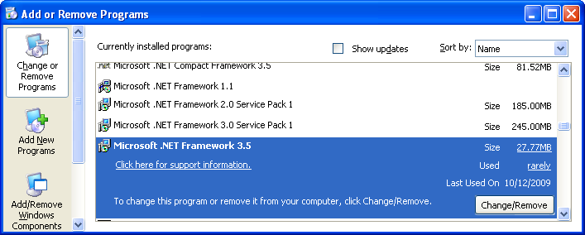

A new Dialog box will appear. Choose the Uninstall option then click on the Next button.
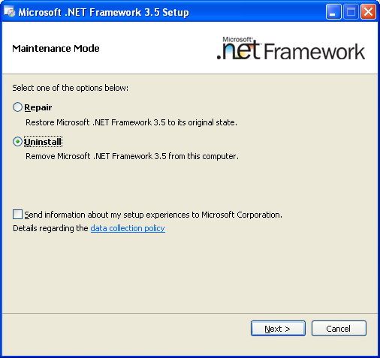
Once .Net Framework 3.5 has been successfully removed repeat this step for .Net Framework 3.0 if it’s also installed on your PC.

11. You’ll need to install .Net Frameworks 2.0 and 3.5 before proceeding with the EAOR Facility installation process. To do this go to the EAOR Software Download page at http://fldep.dep.state.fl.us/air/emission/eaor/download.asp and then go to Appendix B in this manual and follow all the steps starting with step 3. Running the .Net 3.5 Framework setup program will install both .Net Frameworks 2.0 and 3.5 on your PC. Once the .Net Framework 3.5 installation is complete go back to Section III step 1 above to install EAOR.

12. You will see the Welcome message, as shown below.
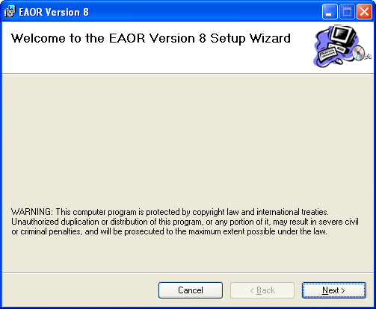

13. Please read the Warning message and then click Next to continue the installation. You will see the Select Installation Folder message as shown below.
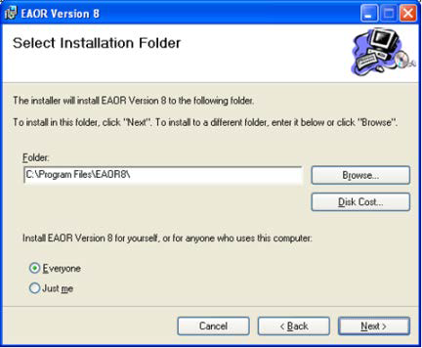

14. In the Select Installation Folder message you have options:
    - to change the folder location of the EAOR application, use the browse button to locate a different folder
    - check to see if your computer has the disk space needed to install EAOR, click on the Disk Cost button
    - Change the installation option so others that use the computer cannot use EAOR, click on the Just me radio button.

15. Once you have made any changes that are needed, or if the default options are acceptable, click the Next button to continue the installation process.
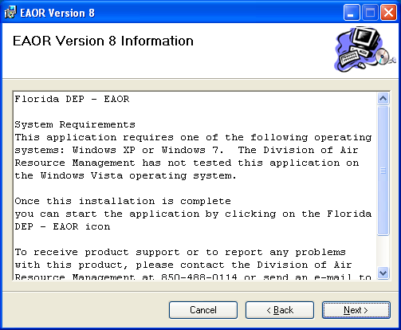

16. You will see the EAOR Information message, shown above. This message includes the Division of Air Resource Management phone number and e-mail address. When you click next from the EAOR Information message, you will see the Confirm Installation message, as shown below. You may click Next to continue, back to return to the EAOR Information message, or Cancel to quit the installation process.
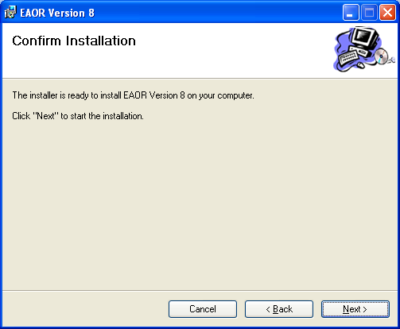

- When you click next from the Confirm Installation message, you will see the Installation EAOR message, as shown below. You may click Cancel if you want to stop the installation process.

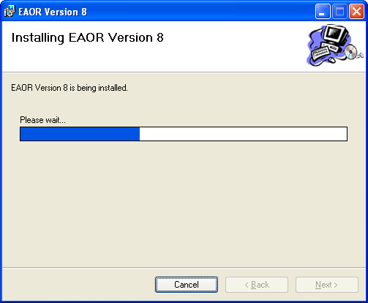

- Next you will see an important Information message for the Administrator who is installing this application for others who do not have Administrator rights. All users must have read, write, and modify permissions to use EAOR. Click on the Next button to continue.
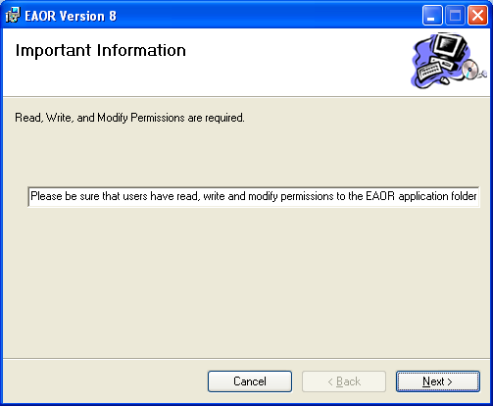

- Then you will see the Installation Complete message. Click the Close button.
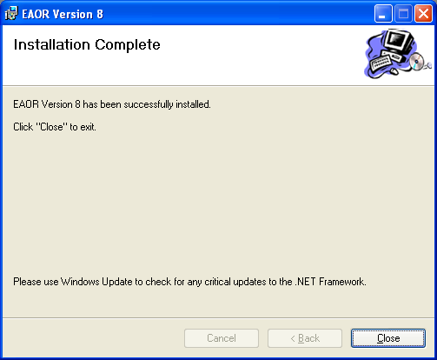
- You will see the Florida DEP-EAOR v8 program group on your Start menu.

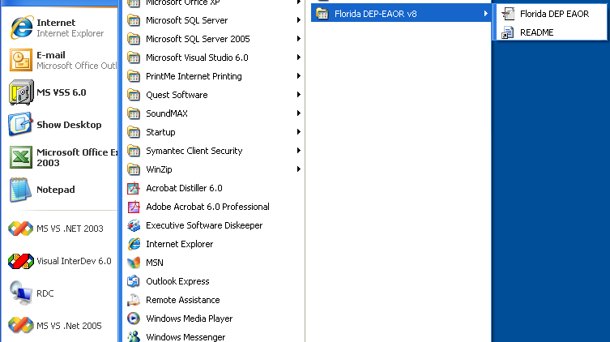

- Before using EAOR make sure that all users have read, write and modify permissions to the folder where EAOR is installed. Go to Appendix D in this document for instructions on how to do this.

- You will see the Florida DEP EAOR icon on your desktop.


- You may start EAOR by clicking on the Florida DEP EAOR icon on your start menu or on your desktop.

- If this is the first time EAOR has been opened on the computer or if the EAOR code tables need to be updated, you will see the following three message boxes. Click the OK button on the first one below entitled Code Tables Update Required to continue.
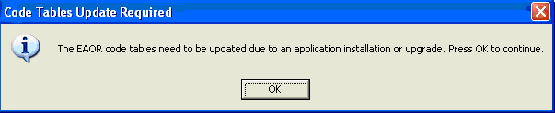

Next you will see the Updating Code Tables message below for a few seconds while the code tables are updated.
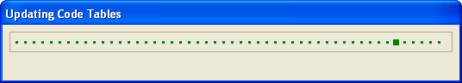
When the code table updates are complete, you will see the EAOR Code Tables Update message below. Click the OK button to continue.
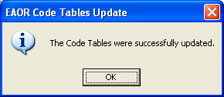

- The EAOR Version 2017-1 application will open and you will see a screen similar to the one below. To confirm you have the correct version of EAOR software installed, click on Help in the bar menu, then go to “About EAOR” as shown below. You may click the Exit EAOR button to close the application.
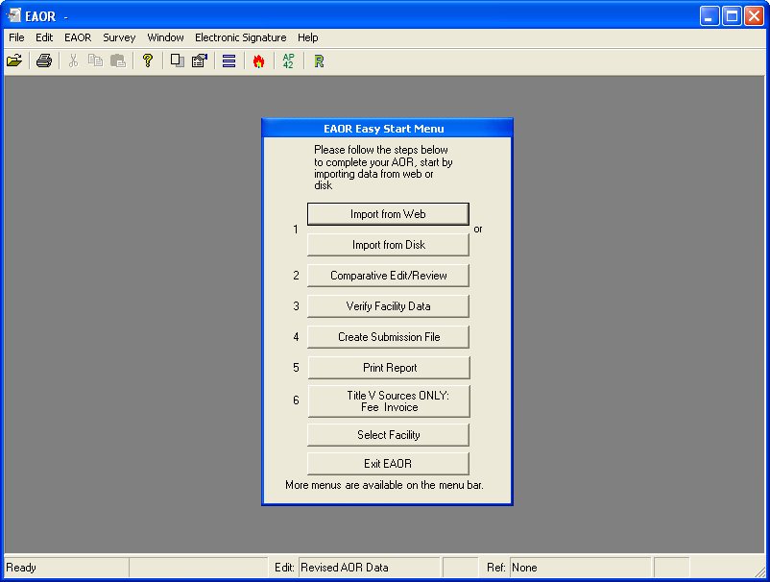

Go to “About EAOR” and confirm the Version is 2017-1 prior to using EAOR.
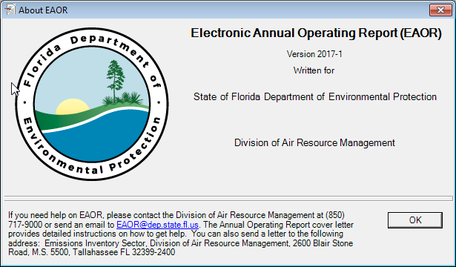

Appendix A – MDAC Updates
      - MDAC may need to be installed on PCs running Windows XP. If you are running the Windows 7 operating system MDAC comes preinstalled as an operating system component (WDAC – Windows Data Access Components).

      - Installing Microsoft Data Access Component (MDAC) – When the User’s computer does not have MDAC installed, EAOR Version 2017-1 will not install until the User downloads and installs a copy from the Microsoft website. The version recommended is: MDAC 2.8 SP1 or later. It is available from the Microsoft Download Center at www.microsoft.com. The MDAC can be downloaded from:

https://www.microsoft.com/en-us/download/details.aspx?id=5793

      - Click on the Download button to begin the process.

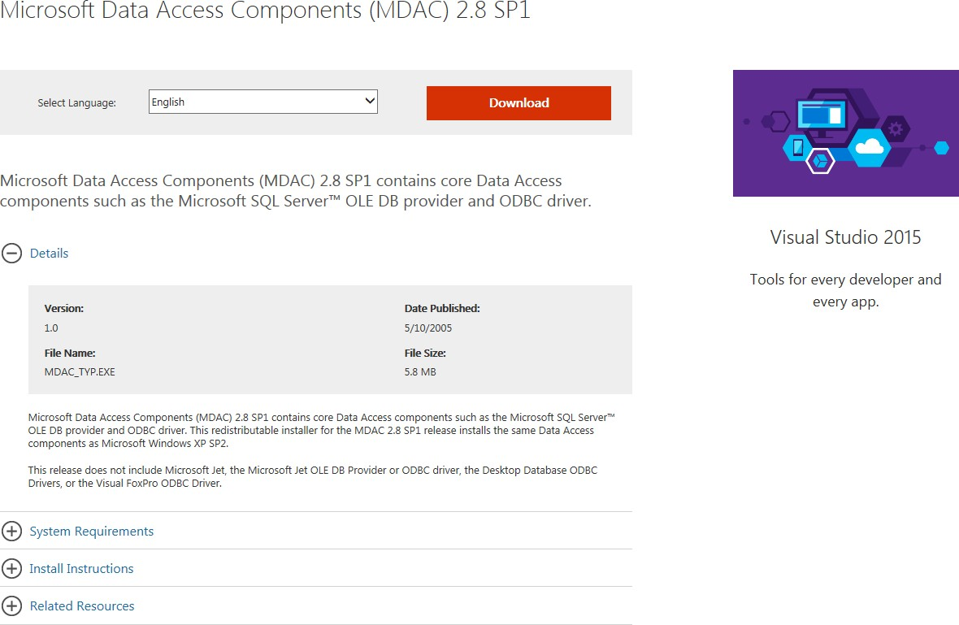

4. Once you click the Download button, the website responds with the following window. Click on the Run button to begin the installation or click on the Save button to save the installation file to your computer to begin the installation at a later time.
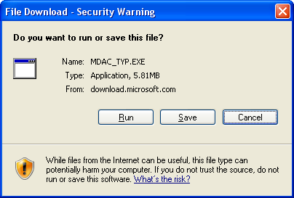
- After you complete the MDAC installation, please continue the EAOR installation.

Appendix B – Microsoft .NET Framework 3.5
1. The .Net Frameworks 2.0 and 3.5 may need to be installed on PCs running Windows XP. If you are running the Windows 7 operating system .Net Framework 3.5 with SP1 comes preinstalled as an operating system component (this includes .NET Framework 2.0 SP2,
3.0 SP2 and 3.5 SP1).

- For computers that do not have Microsoft .NET Framework 3.5, the EAOR Version 2017-1 Installation process will display a Windows Installer message similar to the one shown below.
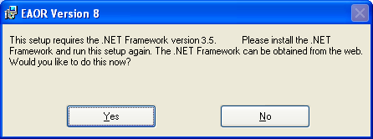

- When you select Yes from the Windows Installer Loader message, you will be taken to the DEP EAOR website as shown in the image below.

- The Supported Operating Systems for the .NET Framework 3.5 include: Windows Server 2003; Windows Server 2008; Windows Vista; Windows XP. Reminder: You may want to check to see if you have the latest service pack and critical updates for the version of Windows that you are running. To find recent security updates, visit Windows Update. You must also be running Microsoft Internet Explorer 5.01 or later for all installations of the .NET Framework.
- Confirm that your version of Windows is included in the supported operating systems list, and that it has the recommended service pack and critical updates.
- This version of EAOR requires both .Net 2.0 and 3.5. If .Net Framework 3.5 or 3.0 is installed on your PC and .Net Framework 2.0 is not installed then go to step 7 otherwise go to step 8.
- Remove both .Net Frameworks 3.5 and 3.0 before proceeding to the next step. To remove
.Net Framework 3.5 and or 3.0 go to Start → Control Panel → Add or Remove Programs and select .Net Framework 3.5 from the list and then click on the Change/Remove button.
A new Dialog box will appear. Choose the Uninstall option then click on the Next button.

Once .Net Framework 3.5 has been successfully removed repeat this step for .Net Framework 3.0 if it’s also installed on your PC.

- If your computer’s Windows operating system is up to date, click on the Microsoft .NET Framework 3.5 Redistributable link and you should see a dialog box similar to the following image.

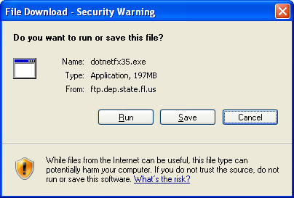

- The File Download – Security Warning will ask if you want to run or save this file. Select Save by clicking on the Save button. When you click on Save, you will see the Save As window as shown below.

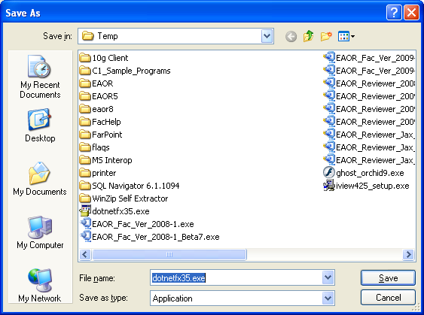

- Select Desktop by clicking on the Desktop icon on the left-hand side of the dialog box. You should see the Percent Completed window as shown in the following image. Click on the check box for Close this dialog box when download completes.

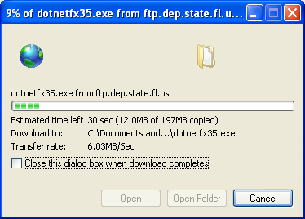

- To begin the .NET Framework 3.5 installation, click on the dotnetfx35.exe icon on your desktop.

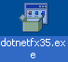

- You may receive the Open File – Security message shown in the following image. Select Run by clicking on the Run button.
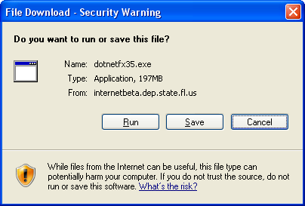

You may also see this message. If so, select Run by clicking on the Run button.
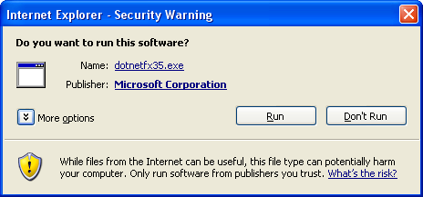

- Now you should see the following messages about Extracting Files and Installing Components.
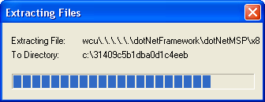
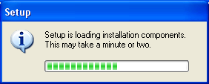

- Next you will see the Microsoft .NET Framework 3.5 Setup license agreement. Read the license agreement and click on the “I have read and ACCEPT …” check box to accept the agreement, and the click the Install button.
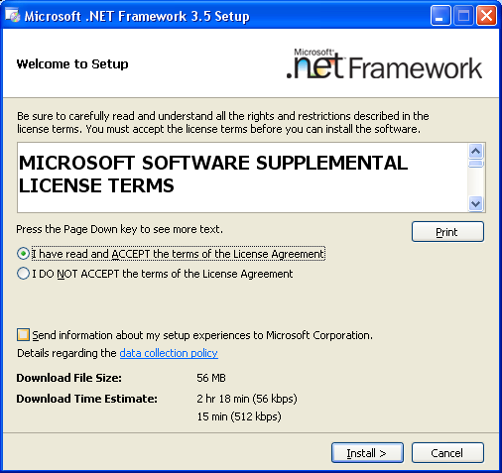

- You will see this download progress message during the installation.
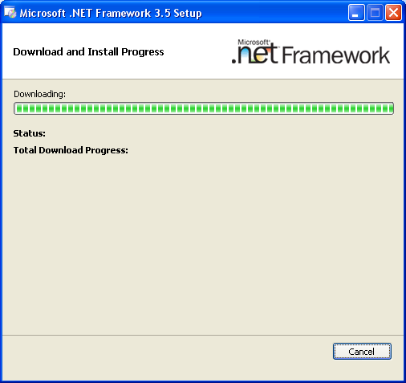
- When the installation is complete, you should see the Setup Complete message. You may close this window by clicking the Exit button and begin installing EAOR Version 2017-1.
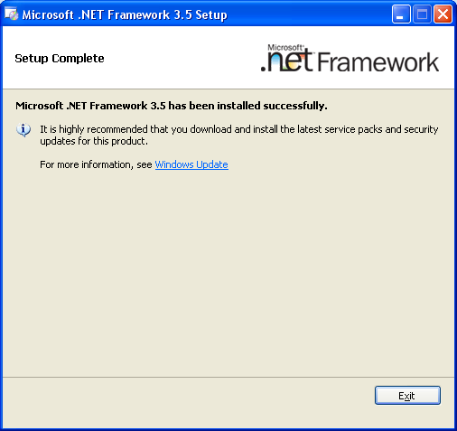

Using the Microsoft Website

- When you select No from the Windows Installer Loader message, you may obtain the
.NET Framework 3.5 by going to the Microsoft website at: https://www.microsoft.com/en-us/download/details.aspx?id=22
. This link should take you to a page similar to the following.
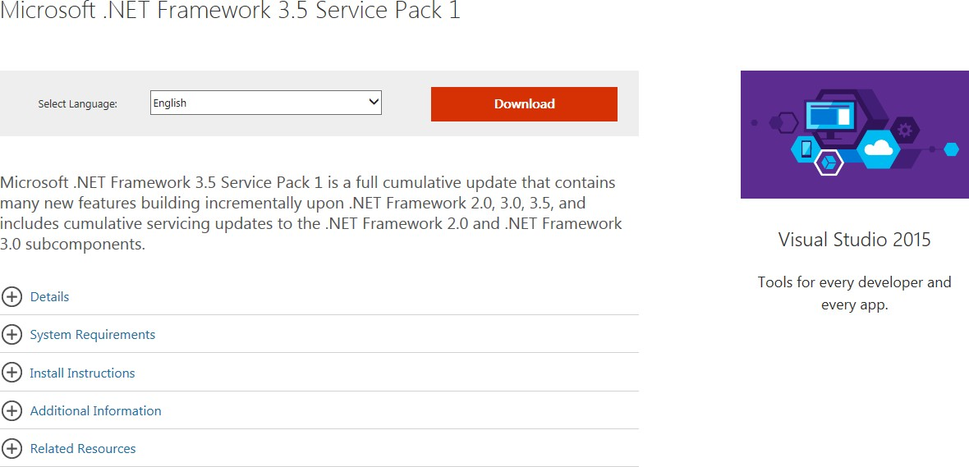

- Click the Download button in the middle left-hand side of the page and you should see the same messages that are presented in this appendix starting with step 8.

Checking Windows Version and Updates

  - To check your computer’s operating system version and service pack, click on My Computer and then click on the View System Information under the System Tasks title.
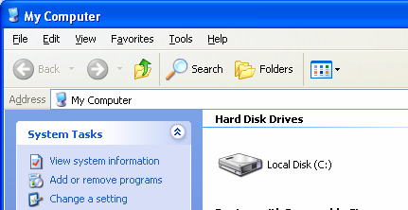

  - The system information lists the Operating System Version and Service Pack in the System Properties General tab.
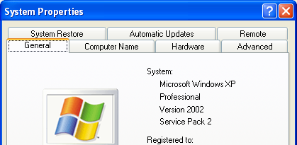

Appendix C – EAOR Network Installation
The following instructions are for installing EAOR for multiple users through the network. For installing EAOR on the first computer follow steps 1 through 7. For the installations on other computers after the first one, follow steps 8 through 14. If you are upgrading to a newer version of EAOR, please follow steps 15 through 17.

- Install EAOR on the first local computer following the steps in Section II and III, found on pages 2 through 11, of these instructions.

- Copy the Data folder from the local installation, usually this is in C:\Program Files\EAOR8 to the Network.
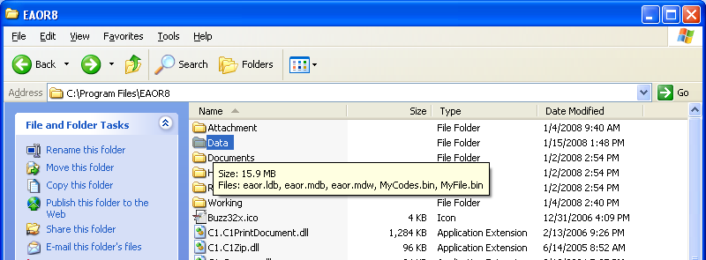

- Go to File, Options and Browse or enter the network path in the DB Path field. In the Example below the network path is \\Arm-air2k\o drive\Brandt\Active Applications\EAOR\Data.
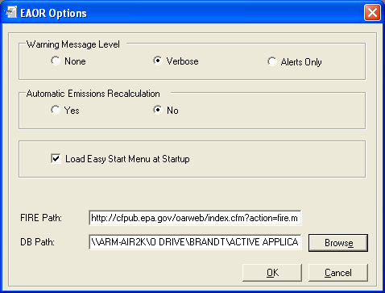
- After you have entered the DB Path, click OK to continue.

- You should see the Changes to the Database location … message as show below. Click OK.
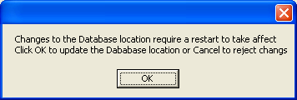
- Exit EAOR.

- Both the Network Database and the local database are updated; you need to have both Data directories.

For installations after the first one:

- Install EAOR on the local computer.

- Copy the Data folder from the Network to the local installation, usually this is in C:\Program Files\EAOR8. You will get a message similar to the one below. Click the Yes to All button.
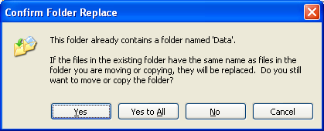
- Go to File, Options and Browse or enter the network path in the DB Path field. In the Example below the network path is \\Arm-air2k\o drive\Brandt\Active Applications\EAOR\Data. Your network path will be different.
- After you have entered the DB Path, click OK to continue.

- You should see the Changes to the Database location ... message as show below. Click OK
- Exit EAOR

- Both the Network Database and the local database are updated; you need to have both Data directories.

For installations that upgrade to a newer version of EAOR:

- Install the newer version on the local computers to update the version.

- Copy the Data folder from one of the local computers to the network. You will get a message similar to the one below. Click the Yes to All button.
- If in addition to updating the version of EAOR, you are also adding a new local computer to use the network version of EAOR, please follow the steps for installations after the first one, numbers 8 through 14.

Appendix D – EAOR Folder Permissions Error

Case 1 Windows XP

  - Locate the following folder C:\Program Files\ and right click on the EAOR8 folder and select the Properties option and select the Security tab.
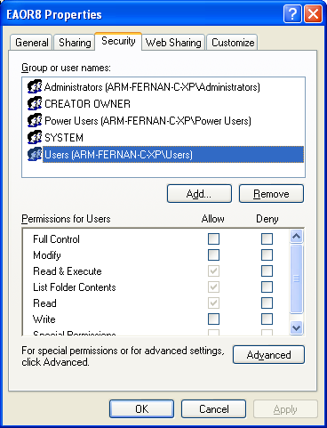

  - Select the Users group and under Permissions for Users select Modify, Read & Execute, List Folder Contents, Read and Write then click on the Apply button.
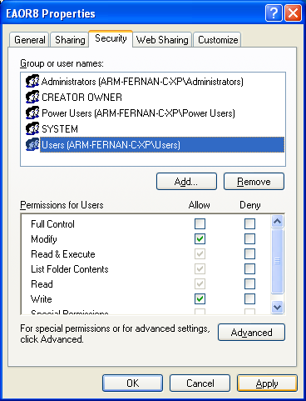

  - Verify that the Users group has the following permissions:
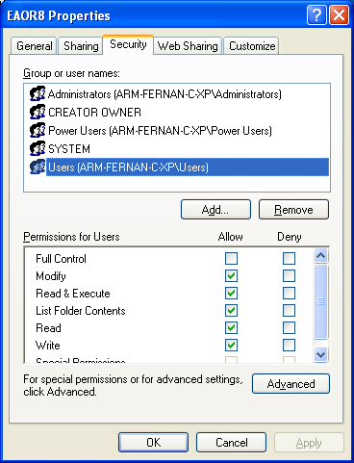

Case 2 Windows 7

- Go to C:\Program Files\ (if you have the 32-bit version of Windows 7) otherwise go to C:\Program Files (x86)\ (if you have the 64-bit version of Windows 7) and right click on the EAOR8 folder and select Properties and go to the Security tab.

- Select the Users account from the list and then click on the Edit button.

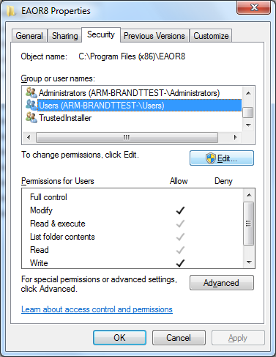

- Select Users again from the list and click on the Modify check box then click on the
Apply button
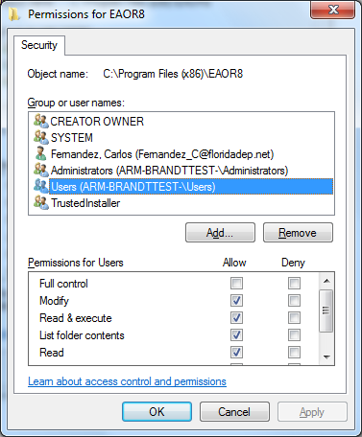

- You’ll be taken back to the dialog box in step 2. The Users permissions should match the permissions in the screenshot below.
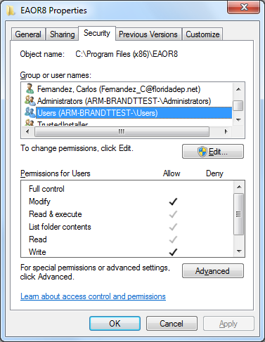

Appendix E – Crystal Reports Error

Crystal Reports Error Fix-1
If you attempt to print/preview reports and/or submit your data file, and you receive the following series of similar error messages, please follow the steps below.

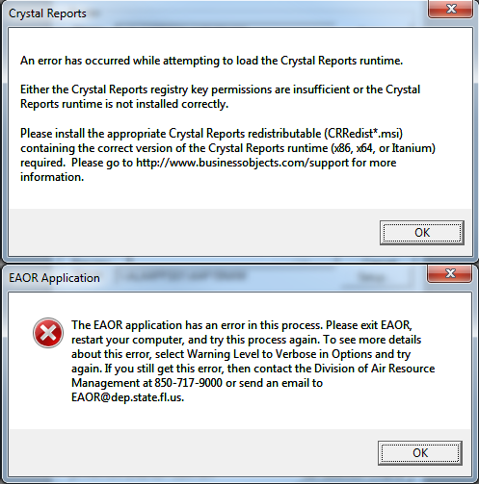
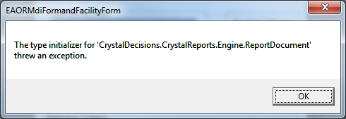

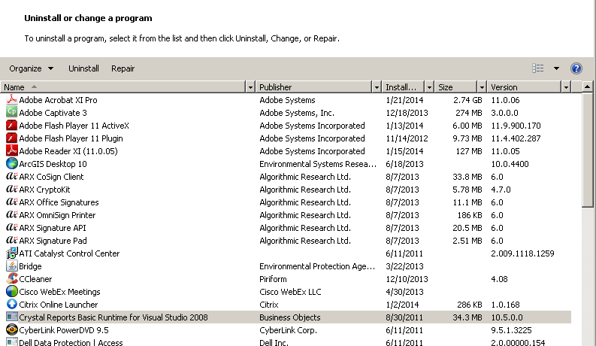
- Uninstall Crystal Reports Basic Runtime for Visual Studio 2008.
- Install the Crystal Reports 10.5 (x86) for 32-bit software running on a 64-bit OS (see link below):
https://smpdl.sap- ag.de/~sapidp/012002523100009351342008E/CRBasicVS2008_redist_x86.zip
- Go back to your list of Programs from the Control Panel and confirm that item #2 has been installed.
- Open EAOR and try to print/preview reports.

Crystal Reports Error Fix-2
If you are not able to resolve the Crystal Reports Error through Appendix E – Crystal Reports Error Fix-1, then please try the following steps:

- Uninstall Crystal Reports Basic Runtime for Visual Studio 2008: Go to Control Panel
→Programs and Features →select Crystal Reports Basic Runtime for Visual Studio 2008 and uninstall. If the PC has Crystal Reports (CR) runtime version 10.5.0.0, then uninstall it and install CR runtime version 10.5.2.0. Also, note that EAOR requires a 32-bit CR runtime, not 64-bit.

- Please confirm the program was completely uninstalled and is no longer in the Programs list.

- Then install the Crystal Reports 10.5 (x86) for 32-bit software running on a 64-bit OS (see link below):
https://smpdl.sap- ag.de/~sapidp/012002523100009351342008E/CRBasicVS2008_redist_x86.zip

- Go back to your list of Programs from the Control Panel and confirm that item #3 has been installed. *If you don’t see it in your list of Programs, then please save the .zip file to your desktop (as shown below), unzip the file, and then double-click the file CRRedist2008_x86.msi

Select ‘Save as’
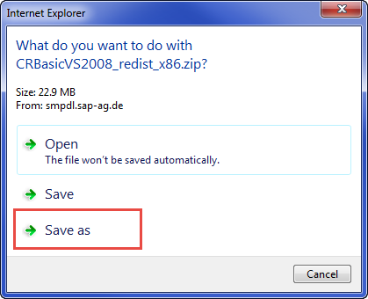

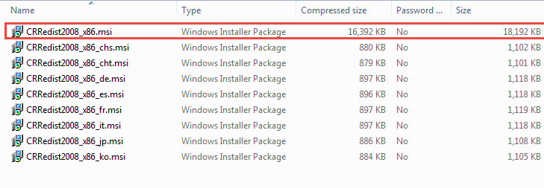
Note: If you do not have .msi on the end of it, then double click on the one that’s around 18,000 kb):

In my Programs list, this is what I have on my PC (which is a 64-bit operating system):

- Then open EAOR Facility and try to Print/Preview Reports or Submit your data file.

Appendix F – EAOR ‘has stopped working’ Error
If you seem to have a successful install of the EAOR software, but when you go to open the program, the following message appears “Electronic Annual Operating Report has stopped working” or EAOR suddenly closes, then please see below:
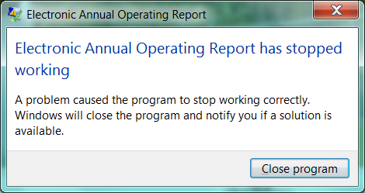

Please do the following:
  - Right click on the EAOR Facility icon on your desktop.
  - Select Properties.
  - Select the Compatibility tab.

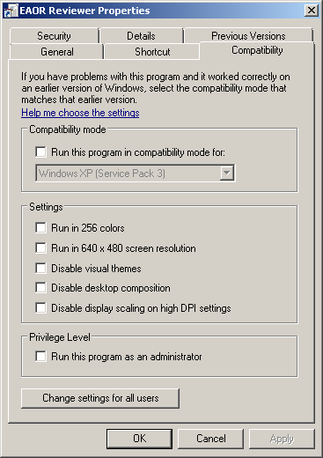
  - Check “Run this program as an administrator.”

  - Click Apply and OK.
  - Try to open the EAOR program again.

