Table of Contents
- Installation Requirements 2
- Obtaining the Installation File 3
- Begin the Installation Process 8
Appendix A – MDAC Updates 31
Appendix B – Microsoft .NET Framework 4.5.1/4.5.2… 33
.Net Frameworks 4.5.1/4.5.2 33
Checking Windows Version and Updates 35
Appendix C – EAOR Network Installation… 37
For installations after the first one 38
For installations that upgrade to a newer version of EAOR 39
Appendix D – EAOR Folder Permissions Error 40
Windows 7/8/10 40
Appendix E – Crystal Reports Error 43
Appendix F – EAOR ‘has stopped working’ Error .56
Appendix G – Adding new Emission Unit (EU) or New SCC– Error message popup.. ……………58
Appendix H – Install Microsoft Access Database Driver – Microsoft.ACE.OLEDB.12.0…….……64
Appendix I – Install 7-Zip Software……………………………………………………………………75

Installation Requirements
Before you begin - To install EAOR Version 2019-1 on your computer, you must have Administrator rights. If you do not have Administrator rights on your machine, or if you are not sure what this means, contact your System Administrator for assistance. You may also need an Internet connection during installation if your computer does not have the software needed by EAOR. This Internet connection is used by the installation process to retrieve software needed by EAOR Version 2019-1. It is recommended that you close all other applications during this installation.
Minimum System Requirements - This section describes the minimum configuration requirements for a computer where EAOR Version 2019-1 is to be installed. If the minimum requirements are not met, EAOR Version 2019-1 setup will block the installation of the redistributable package. Specifically, note that you cannot install the .NET Framework on a computer running the Microsoft Windows 10 operating system (On Windows 8 and above, the .NET Framework is an operating system component and cannot be independently Uninstalled).
Required software - EAOR Version 2019-1 uses the Microsoft Data Access Component (MDAC) 2.8 SP1 or later and the .NET Frameworks 4.5.1/4.5.2.
- MDAC allows programs to use the Access database and is required for EAOR Version 2019-1 to work correctly. Please see Appendix A for installing MDAC and Appendix H for MS Access Driver.
- The Microsoft .NET Framework is a component of the Microsoft Windows® operating system used to build and run Windows-based applications. If the version of this software is not on your computer, the setup process will use your connection to the Internet to install it for you. Please see Appendix B for more information about the .NET Framework updates.
Operating System Requirements - To install EAOR Version 2019-1, you must have one of the following operating systems with Microsoft Internet Explorer 5.5 or later installed on your computer:
- Microsoft Windows 2008/2012 Server, service pack and critical updates available from the Microsoft Security Web site (https://www.microsoft.com/en-us/download/details.aspx?id=5842)
- Microsoft Windows 7/8/10. (for Window 7 -After January 14, 2020, Microsoft will no longer provide security updates or support for PCs with Windows 7.)
Hardware Requirements - The minimum hardware requirements include:
- Central Processing Unit (CPU) Intel Pentium core i3, 2.4 GHZ or the minimum CPU required for running the operating system, whichever is higher.
- Random Access Memory (RAM) 4 GB or the minimum RAM required for running the operating system, whichever is higher.
- Hard Drive with 400 MB of free space.
- USB Flash Driver or CD standard disk drive (for submitting/importing/exporting data). This is optional if you have an Internet connection.
- Conventional Mouse or other pointing device.
Network Installation – Please see Appendix C for instructions on how to install EAOR for multiple computers on a network.

Obtaining the Installation File
    - You may download the EAOR Version 2019-1 Installation files from the Internet at Florida’s DEP EAOR webpage https://floridadep.gov/air/permitting-compliance/content/annual-operating-report. Click on the EAOR Version 2019-1 Installation link under the Download Software title.
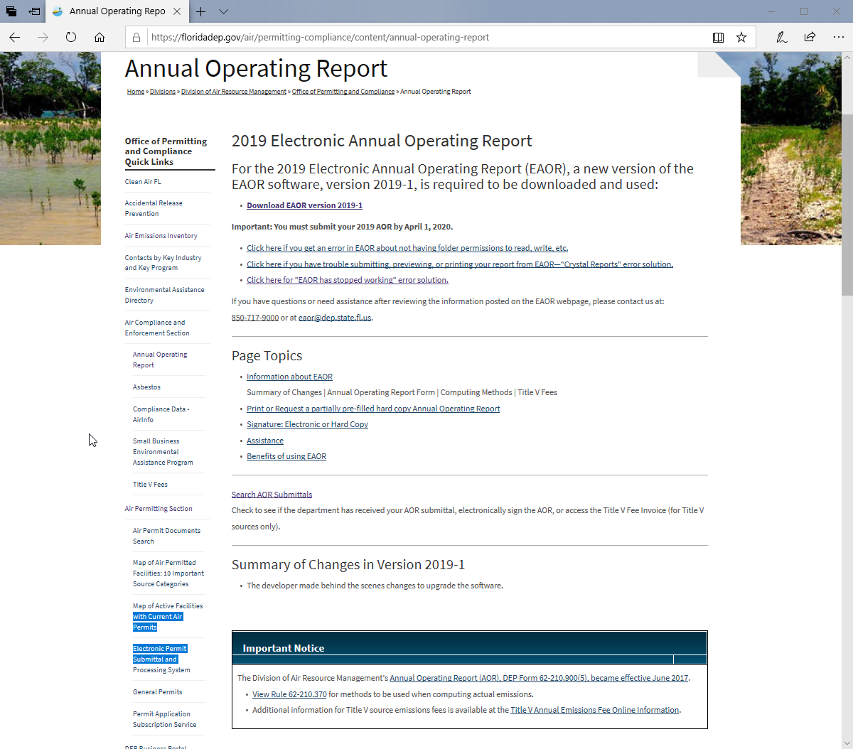

    - This will take you to the Software Download Website. Click on the link, “Click here to Download EAOR Version 2019-1”.
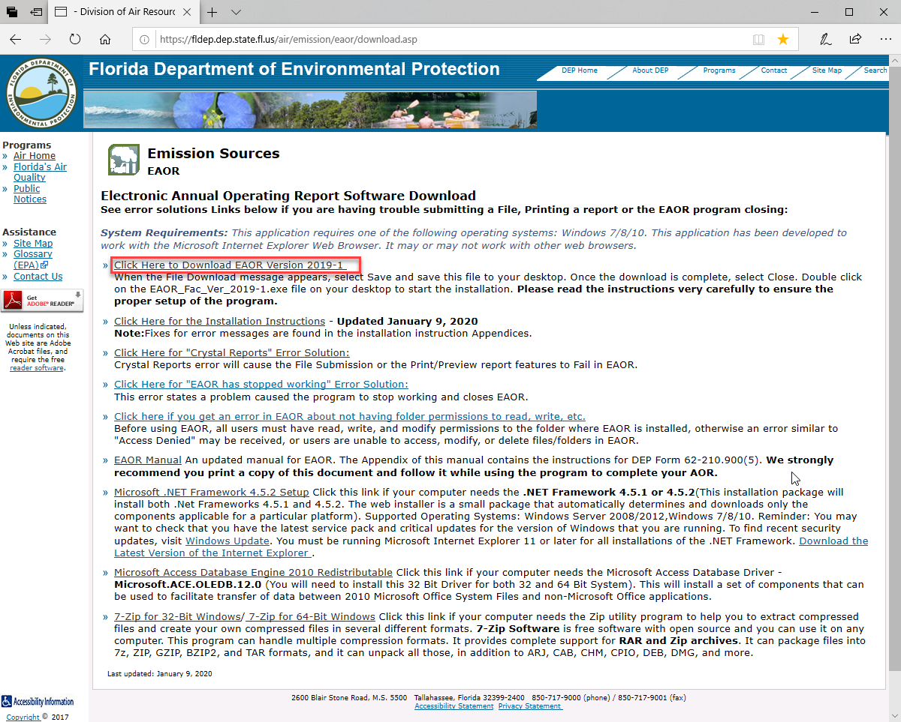

    - The link will display a File Download message box. Click on the down arrow next to the Save button and then select Save As.

    - In the Save As box, select your Desktop or EAOR Default folder (C:\EAOR) or a temporary folder where you want to save the EXE.
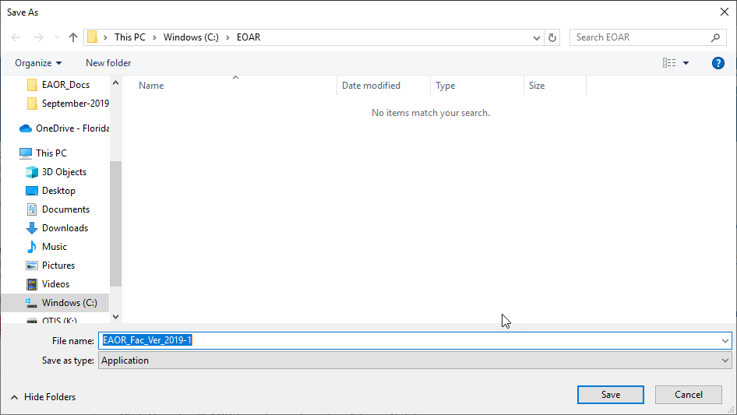

Once the Downloading is finished then Click the Run button.

Once clicking the Run button, then it will show the Defender SmartScreen Filter, click on the More info link and then Run anyway option as shown below to run the program.
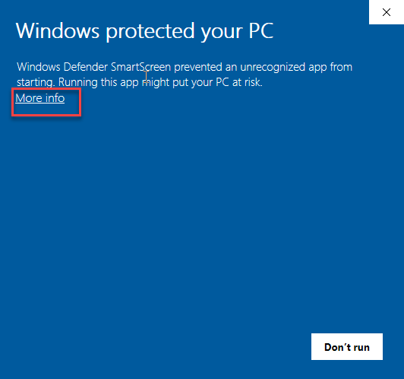
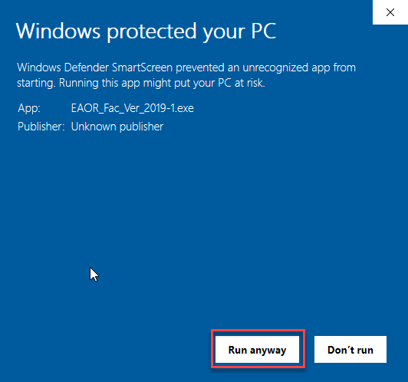

Begin the Installation Process
    - Once the installation file is downloaded to your local computer, right click on the filename or Icon that says EAOR_Fac_Ver_2019-1.exe and Select Run as Administrator as shown below:
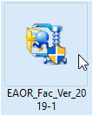
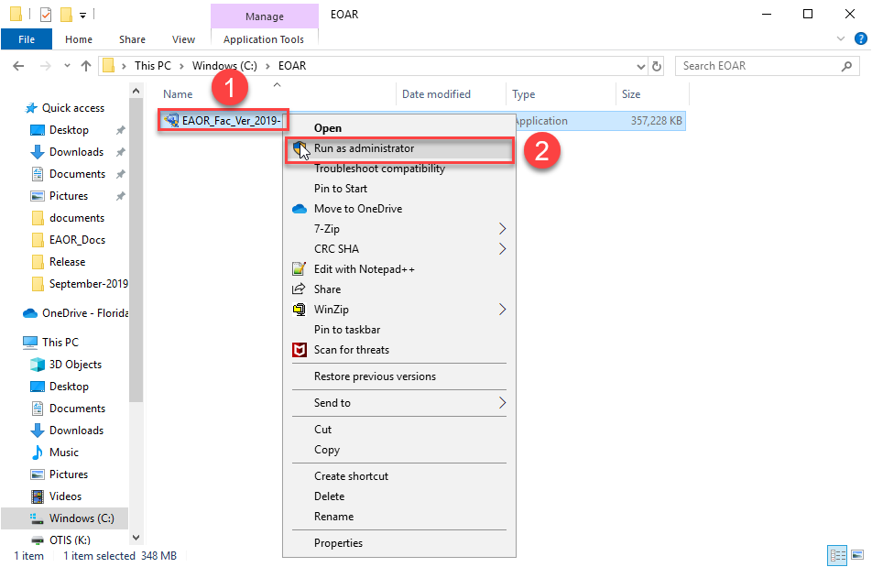

a) Click “More info” and then Run anyway option as shown below to run the program if you get a Windows Defender SmartScreen Message as below (After you click Run as administrator):

b) Select “Yes” if you get a User Account Control Message as below (After you click Run as administrator):
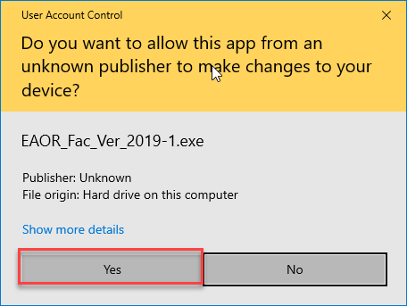

c) After selecting ‘Yes’ the installation message box will open, as shown below.

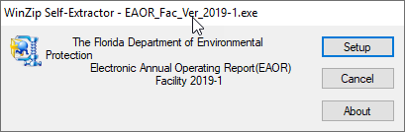

    - Click on the Setup button to start the installation process.
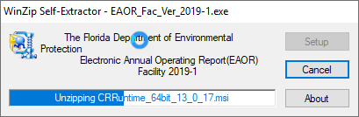
    - You will see the message below, click on the Accept button to continue.
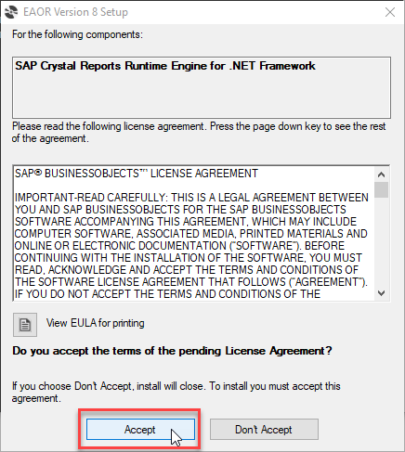

    - When you click on the Accept button on the window as shown above, then you’ll see the following dialog box.
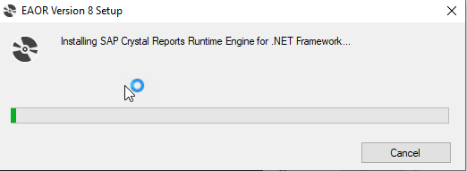

Note (If EAOR Installation Failed): For a few systems, if crystal reports is already installed, then EAOR Installer will show the following popup message. You need to close that popup, and Uninstall SAP Crystal Reports runtime engine for .Net Framework, and then run the EAOR_Fac_Ver_2019-1.exe again.
To Uninstall SAP Crystal Reports runtime engine for .NET Framework: Go to your computer’s Control Panel > Programs > Programs and Features > select SAP Crystal Reports runtime engine for .NET Framework. Please confirm the program was completely uninstalled and is no longer in the Programs list; then run the EAOR_Fac_Ver_2019-1.exe again.
(If you do not see the popup error as shown below, then continue with the installation process in the next step.)

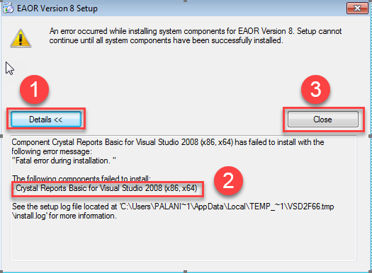

    - If you encounter the following error then please continue with the next step, otherwise Skip to Step 8 (in Section III).

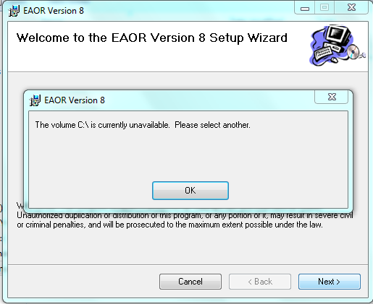

      - Download the EAOR Facility installation file to the desktop (or) EAOR Default folder (C:\EAOR).

      - After Downloading the EAOR Setup file will be show as below.
. 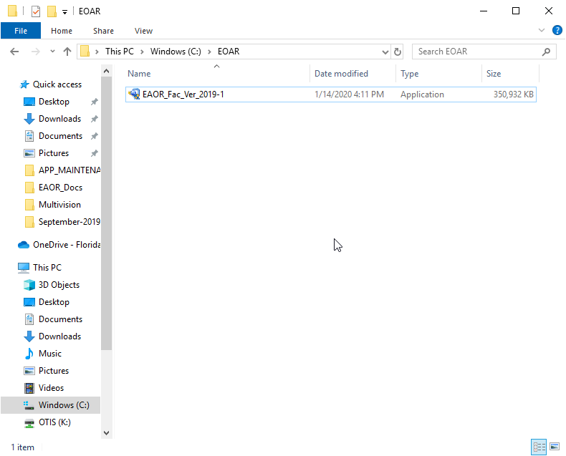

      - Unzip the EAOR Setup file saved to the desktop (or) EAOR Default folder (C:\EAOR). Right click on EAOR_Fac_Ver_2019-1 and select 7-Zip option and then select Extract “EAOR_Fac_Ver_2019-1\”

. 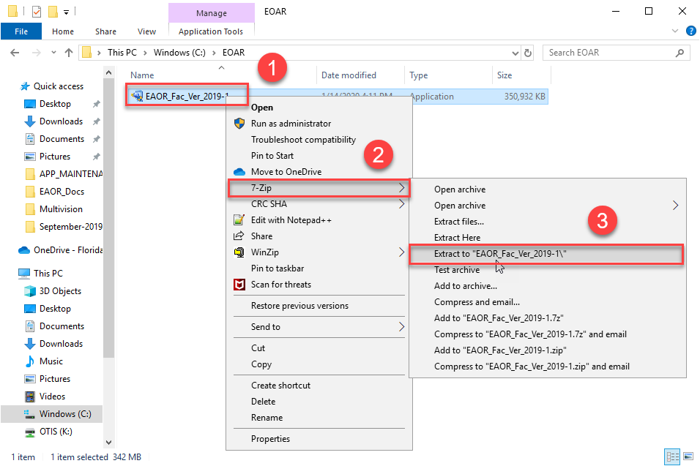

      - 7-Zip Extractor Progress will displayed as below and then select Close button and then Select the Folder “C:\EAOR\EAOR_Fac_Ver_2019-1”.

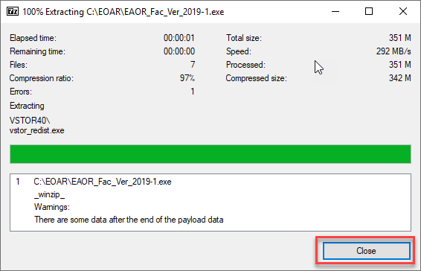

      - After unzipping, the Folder and Files will be displayed as shown below.

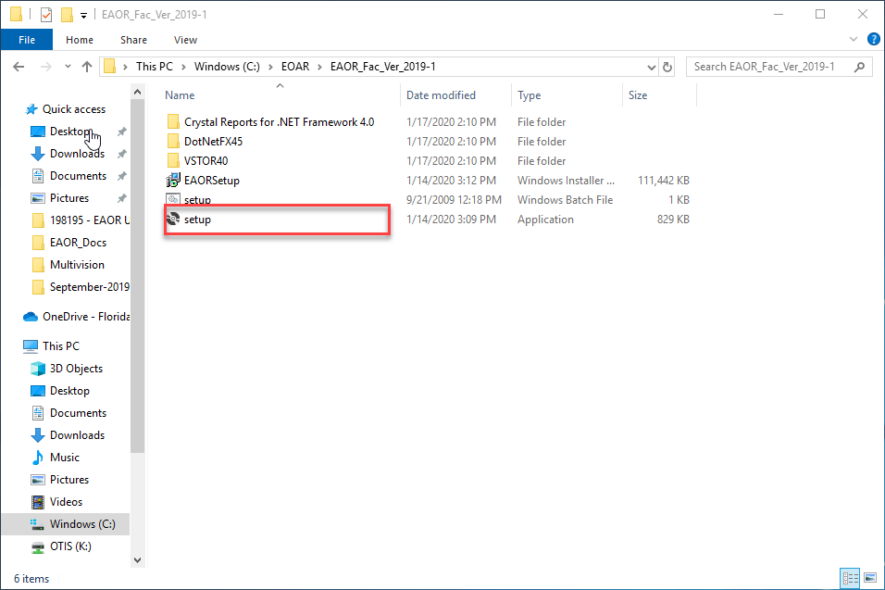

e) Right click on the filename Setup.exe and Select Run as administrator as shown below:
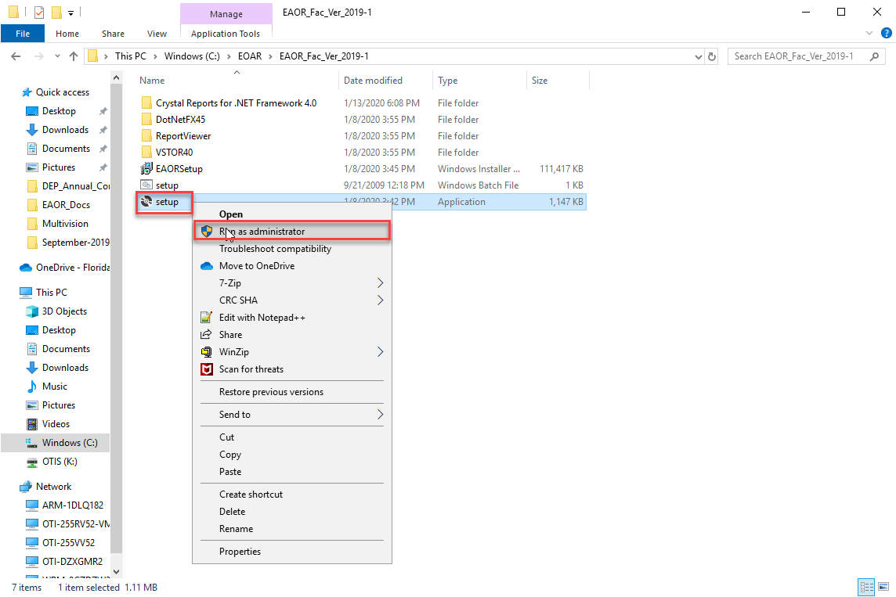

f) Select “Yes” if you get a User Account Control Message as below (After you clicked Run as administrator):

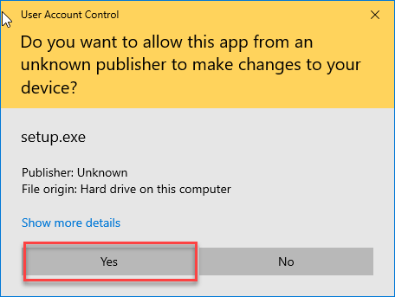

6. You will see the SAP Crystal Reports Runtime Engine for .NET Framework License Agreement message,
as shown below, Select Accept.
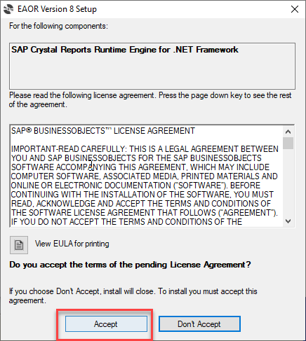

7. When you click on the Accept button in the window as shown above, then you will see the dialogue window box open.

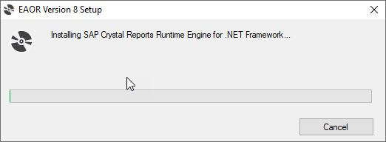

9.

- You will see the Welcome message, as shown below.
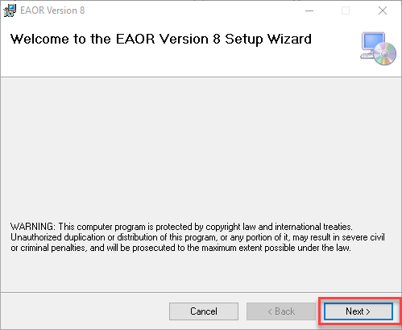

9. Please read the Warning message and then click Next to continue the installation.
. 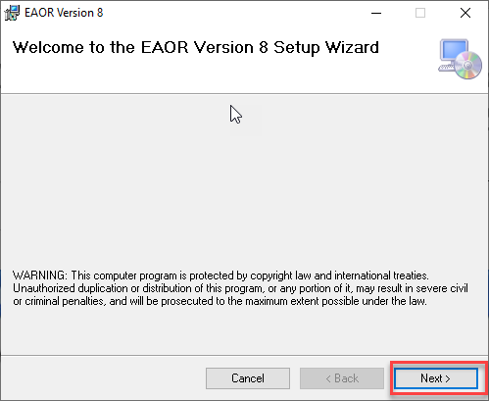

- You will see the

- Select Installation Folder message, giving you options:
  - To change the folder location of the EAOR application, use the browse button to locate a different folder.
  - To check to see if your computer has the disk space needed to install EAOR, click on the Disk Cost button.
  - Change the installation option so others that use the computer cannot use EAOR, click on the Just me radio button.

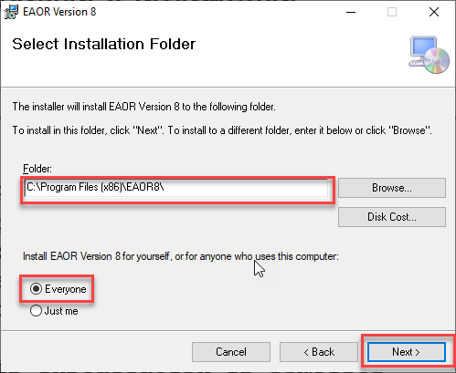

- Once you have made any changes that are needed, or if the default options are acceptable, you will see the EAOR Information message. This message includes the Division of Air Resource Management phone number and email. Click the Next button to continue the installation process.
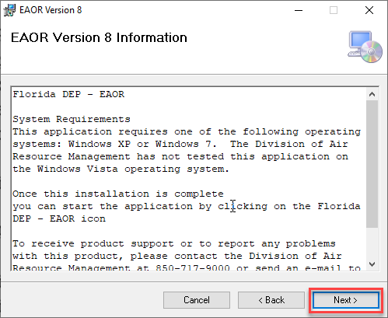

- When you click next from the EAOR Information message, then you will see the Confirm Installation message, as shown below. Click Next to continue (or Back to return to the EAOR Information message, or Cancel to quit the installation process).
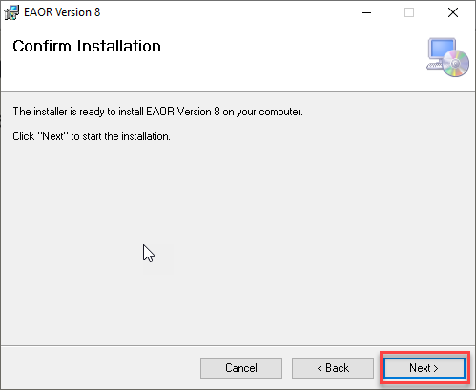

- When you click next from the Confirm Installation message, you will see the Installation EAOR message, as shown below. (You may click Cancel if you want to stop the installation process).

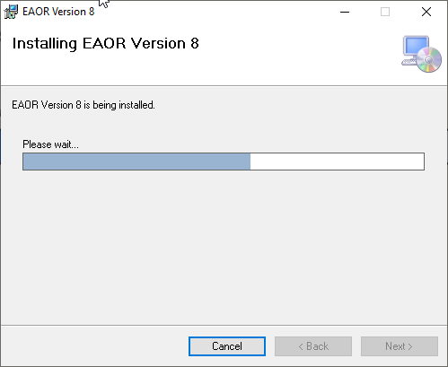

- Next you will see an important Information message for the Administrator who is installing this application for others who do not have Administrator rights. All users must have read, write, and modify *permissions to the EAOR application folder in order to use EAOR. Click on the Next button to continue.
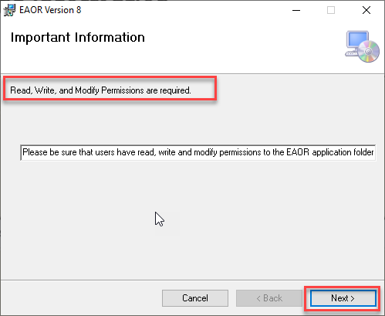

* Note: Appendix D provides instructions on how to set the permissions to the EAOR application folder; this must be done prior to using the EAOR.

- Then you will see the Installation Complete message. Click the Close button.
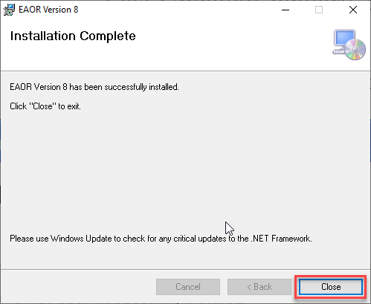

- You will see the Florida DEP-EAOR v8 program group on your Start menu. 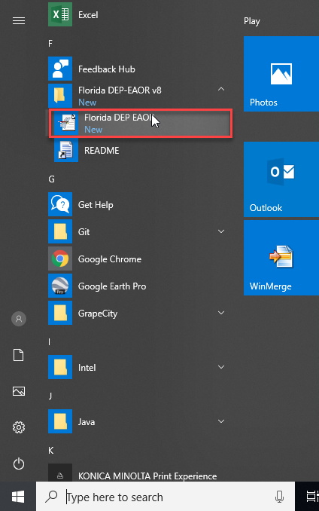

- Before using EAOR users must have read, write, and modify permissions to the folder where EAOR is installed or an error will appear saying they do not have folder permissions to read, write, or modify. Please go to Appendix D in this document for instructions on how to edit the permissions (on page 40).

- You will see the Florida DEP EAOR icon on your desktop.

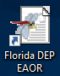

- Right click on Florida DEP EAOR icon and Select Properties
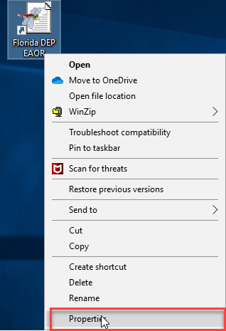

- Select Compatibility option and Select the Checkbox in Run this program as an Administrator (make sure it was checked) and then select OK button as below.
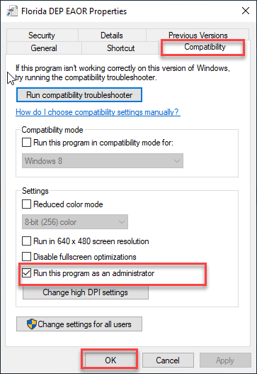
- You may start EAOR by clicking on the Florida DEP EAOR icon on your start menu or on your desktop and then Select “Yes” if you get a User Account Control Message as below.
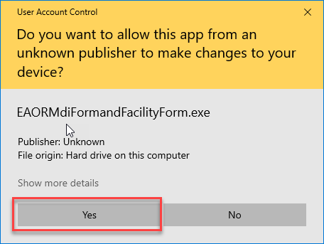

- If this is the first time EAOR has been opened on the computer or if the EAOR code tables need to be updated, you will see the following three message boxes. Click the OK button on the first one below entitled Code Tables Update Required to continue.
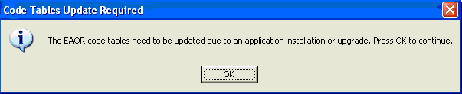
Next you will see the Updating Code Tables message below for a few seconds while the code tables are updated.
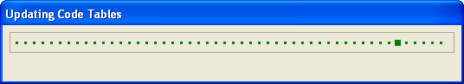
When the code table updates are complete, you will see the EAOR Code Tables Update message below. Click the OK button to continue.
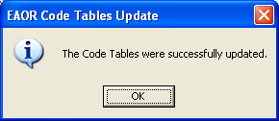

- The EAOR Version 2019-1 application will open and you will see a screen similar to the one below. To confirm you have the correct version of EAOR software installed, click on ‘Help’ in the bar menu on the top left-hand side of the EAOR screen, then go to “About EAOR” as shown below. (You may click the ‘Exit EAOR’ button on the Easy Start Menu to close the application.)
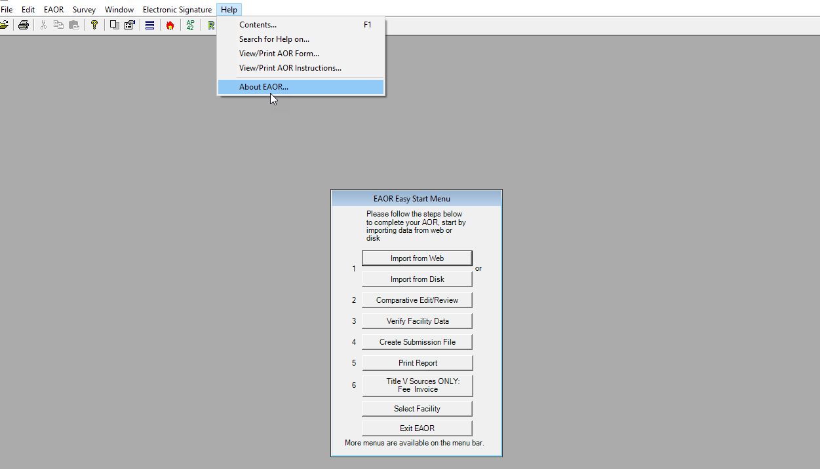

Go to “About EAOR” and confirm the Version is 2019-1 prior to using EAOR:

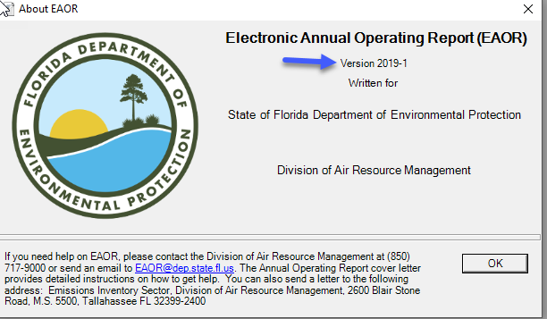

Appendix A – MDAC Updates
- MDAC may need to be installed on PCs running Windows XP. If you are running the Windows 7 operating system MDAC comes preinstalled as an operating system component (WDAC – Windows Data Access Components).

- Installing Microsoft Data Access Component (MDAC) – When the User’s computer does not have MDAC installed, EAOR Version 2019-1 will not install until the User downloads and installs a copy from the Microsoft website. The version recommended is: MDAC 2.8 SP1 or later. It is available from the Microsoft Download Center at www.microsoft.com. The MDAC can be downloaded from:

https://www.microsoft.com/en-us/download/details.aspx?id=5793

- Click on the Download button to begin the process.

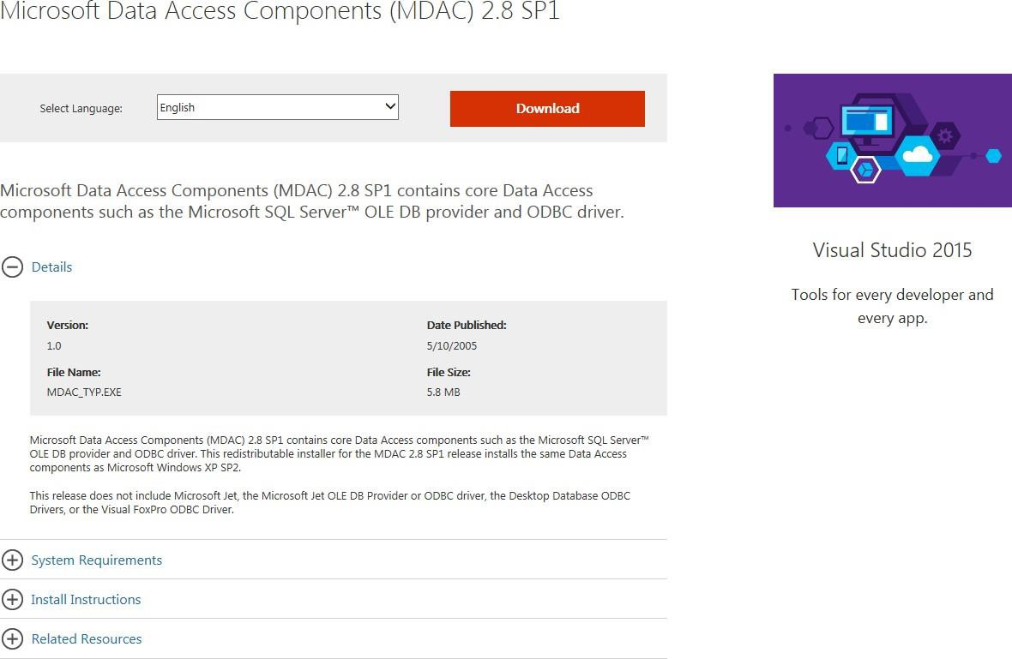

- Once you click the Download button, the website responds with the following window. Click on the Run button to begin the installation or click on the Save button to save the installation file to your computer to begin the installation at a later time.
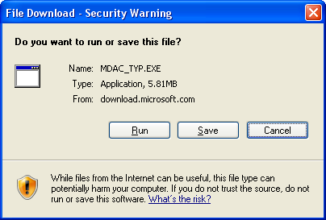
- After you complete the MDAC installation, please continue the EAOR installation.

Appendix B – Microsoft .NET Framework 4.5.1/4.5.2
  - The .Net Frameworks 4.5.1/4.4.2 may need to be installed on PCs running Windows 7. If you are running the Windows 8/10 operating system .Net Framework 4.6 as on OS Component and we cannot install this .Net Framework.
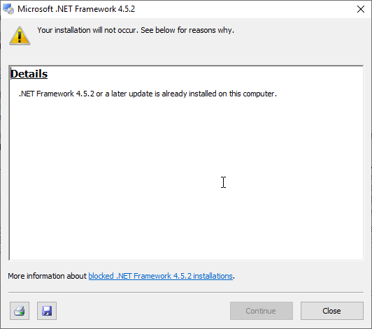

If you're using the Windows operating system, the .NET Framework may already be installed on your computer. In addition, if you install an app that requires the .NET Framework, the app's setup program might install a specific version of the .NET Framework on your computer. In some cases, you may see a dialog box that asks you to install the .NET Framework. If you've just tried to run an app when this dialog box appears and if your computer has Internet access, you can go to a webpage that lets you install the missing version of the .NET Framework. For more information, see the Installation guide.
In general, you shouldn't uninstall versions of the .NET Framework that are installed on your computer. There are two reasons for this:
- If an app that you use depends on a specific version of the .NET Framework, that app may break if that version is removed.

- Some versions of the .NET Framework are in-place updates to earlier versions. For example, the .NET Framework 3.5 is an in-place update to version 2.0, and the .NET Framework 4.8 is an in-place update to versions 4 through 4.7.2. For more information, see .NET Framework Versions and Dependencies.
On Windows versions before Windows 8, if you do choose to remove the .NET Framework, always use Programs and Features from Control Panel to uninstall it. Never remove a version of the .NET Framework manually. On Windows 8 and above, the .NET Framework is an operating system component and cannot be independently uninstalled.
Note that multiple versions of the .NET Framework can coexist on a single computer at the same time. This means that you don't have to uninstall previous versions in order to install a later version.
In general, you should not uninstall any versions of the .NET Framework that are installed on your computer, because an application you use may depend on a specific version of the .NET Framework.

Windows 10 (all editions) includes the .NET Framework 4.6 as an OS component, and it is installed by default.

Checking Windows Version and Updates

  - To check your computer’s Operating system & System Type (32-bit or 64-bit).
Select the Start button > Settings > System > About
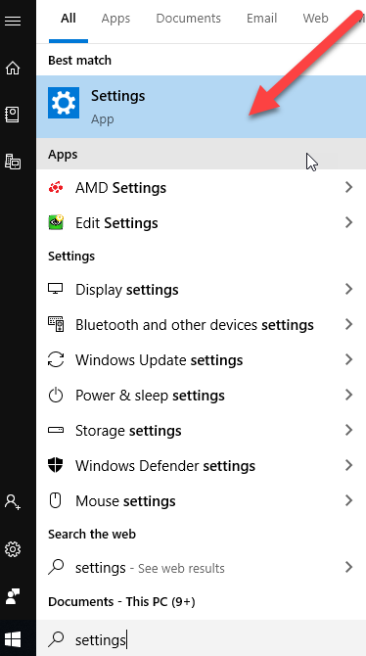

  - Under Device Specification ->System type, see if you're running a 32-bit or 64-bit version of Windows
Under Windows specifications, check which edition and version of Windows your device is running.
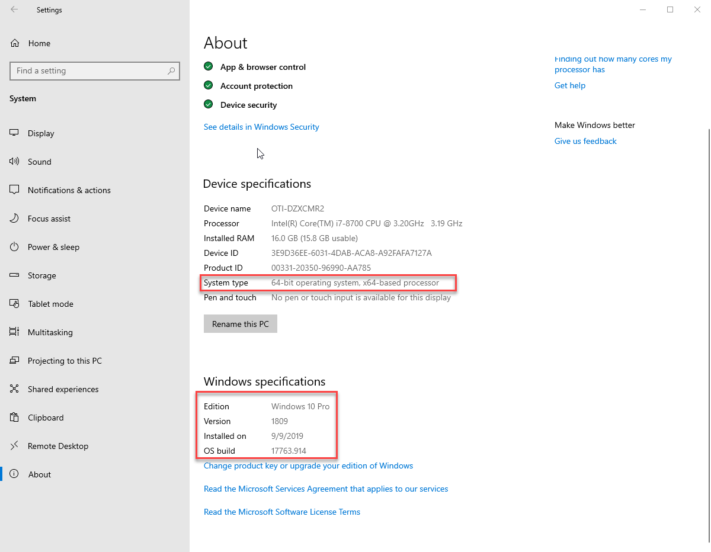

Appendix C – EAOR Network Installation
The following instructions are for installing EAOR for multiple users through the network. For installing EAOR on the first computer follow steps 1 through 7. For the installations on other computers after the first one, follow steps 8 through 14. If you are upgrading to a newer version of EAOR, please follow steps 15 through 17.

- Install EAOR on the first local computer following the steps in Section II and III, found on pages 2 through 11, of these instructions.

- Copy the Data folder from the local installation, usually this is in C:\Program Files\EAOR8 to the Network.
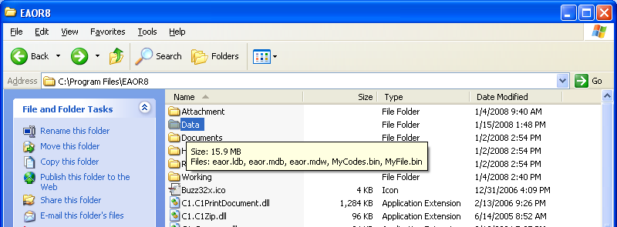
- Go to File, Options and Browse or enter the network path in the DB Path field. In the Example below the network path is \\Arm-air2k\o drive\Brandt\Active Applications\EAOR\Data.
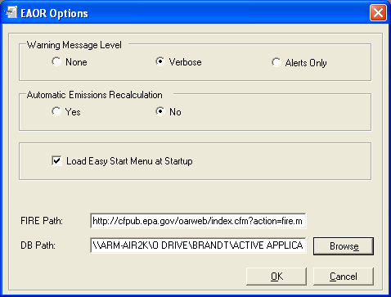
- After you have entered the DB Path, click OK to continue.

- You should see the Changes to the Database location … message as show below. Click OK.
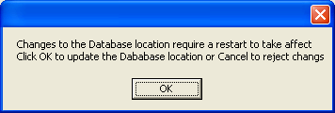
- Exit EAOR.

- Both the Network Database and the local database are updated; you need to have both Data directories.

For installations after the first one:

- Install EAOR on the local computer.

- Copy the Data folder from the Network to the local installation, usually this is in C:\Program Files\EAOR8. You will get a message similar to the one below. Click the Yes to All button.
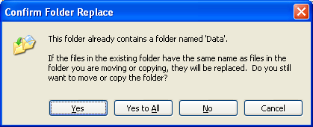
- Go to File, Options and Browse or enter the network path in the DB Path field. In the Example below the network path is \\Arm-air2k\o drive\Brandt\Active Applications\EAOR\Data. Your network path will be different.
- After you have entered the DB Path, click OK to continue.

- You should see the Changes to the Database location ... message as show below. Click OK
- Exit EAOR

- Both the Network Database and the local database are updated; you need to have both Data directories.

For installations that upgrade to a newer version of EAOR:

- Install the newer version on the local computers to update the version.

- Copy the Data folder from one of the local computers to the network. You will get a message similar to the one below. Click the Yes to All button.
- If in addition to updating the version of EAOR, you are also adding a new local computer to use the network version of EAOR, please follow the steps for installations after the first one, numbers 8 through 14.

Appendix D – EAOR Folder Permissions Error

Windows 7/8/10

- Go to C:\Program Files\ (if you have the 32-bit version), otherwise go to C:\Program Files (x86)\ (if you have the 64-bit version). After opening the appropriate Program Files folder, then right click on the EAOR8 folder. Select Properties, then go to the Security tab.

- Select the Users account from the list and then click on the Edit button.

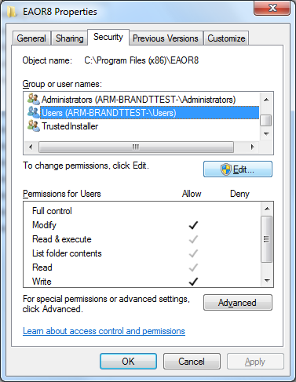

- Select Users again from the list and click on the Modify check box then click on the
Apply button:
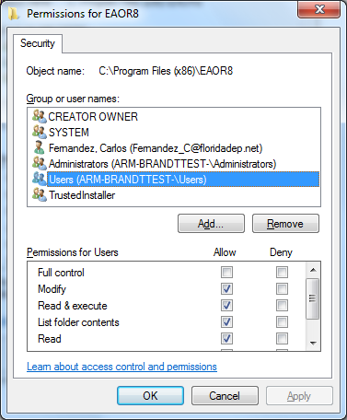

- You’ll be taken back to the dialog box in step 2. The Users permissions should match the permissions in the screenshot below.
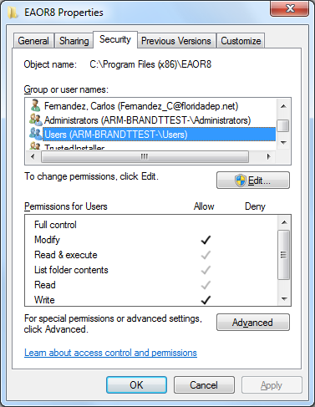

Appendix E – Crystal Reports Error
If you attempt to print/preview reports and/or submit your data file, however receive the following series of similar error messages, then please follow the steps below:
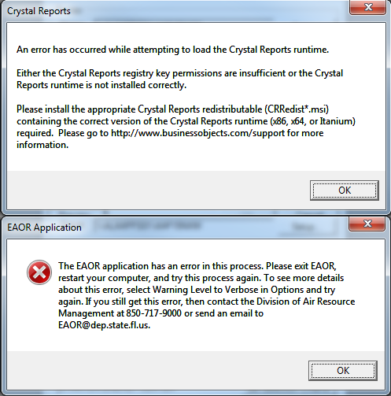
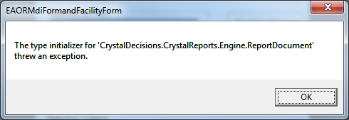

- Uninstall SAP Crystal Reports runtime engine for .NET Framework: Go to Control Panel > Programs > Programs and Features > select SAP Crystal Reports runtime engine for .NET Framework. Please confirm the program was completely uninstalled and is no longer in the Programs list.
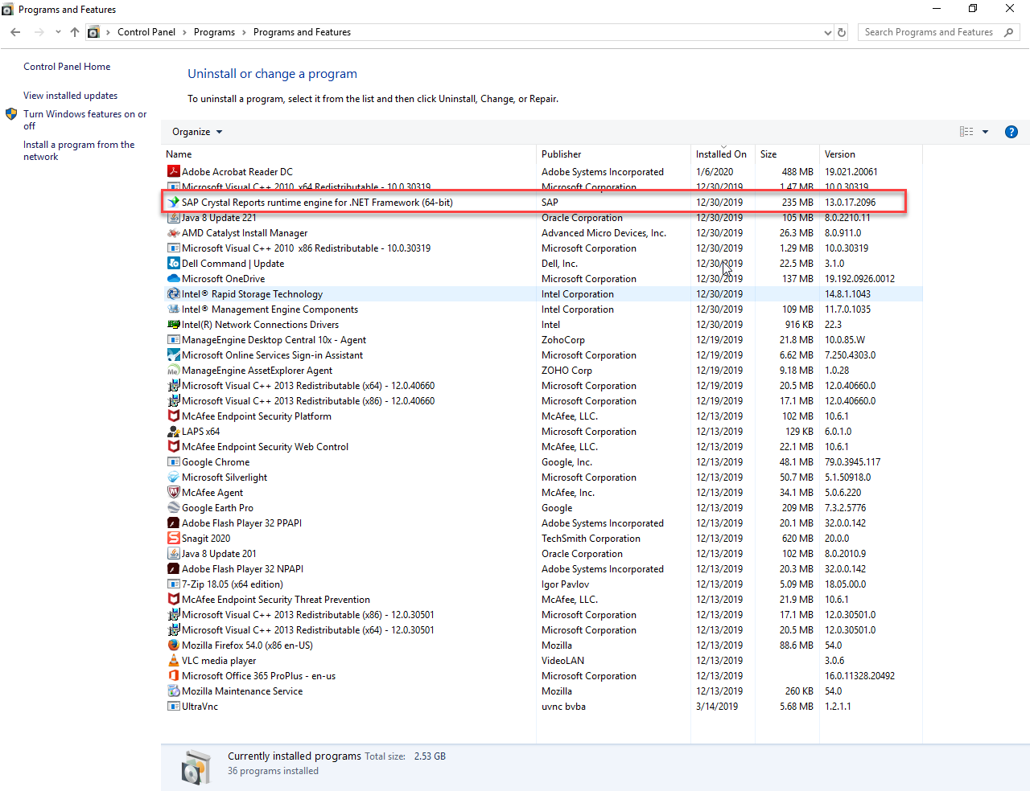

- Install the SAP Crystal Reports runtime engine for .NET Framework (i.e. install CRRuntime_32bit_13_0_17 (x86) for 32-bit OS or install CRRuntime_64bit_13_0_17(x64) for 64-bit OS) from the EAOR Default Folder (You should extract the files from EAOR_Fac_Ver_2019-1 by using 7-zip or WinZip) and then you will see the Setup Files as shown below. Open the Crystal Reports for .NET Framework 4.0 folder, then select the appropriate CRRuntime (check your Computer Name for the Operating System type). Steps 2a, b, c below show: EAOR_Fac_Ver_2019-1 ‘Save As’ to the EAOR Default folder, then the unzipping it to produce the extracted files:

- The link will display a File Download message box. Click on the down arrow next to the Save button and then select Save As.

- In the Save As box, select your Desktop or EAOR Default folder (C:\EAOR) or a temporary folder where you want to save the EXE.

- After Downloading and Unzip EAOR setup file and then Folder & Files will be shown as below (for Unzip go to step III 5.c) 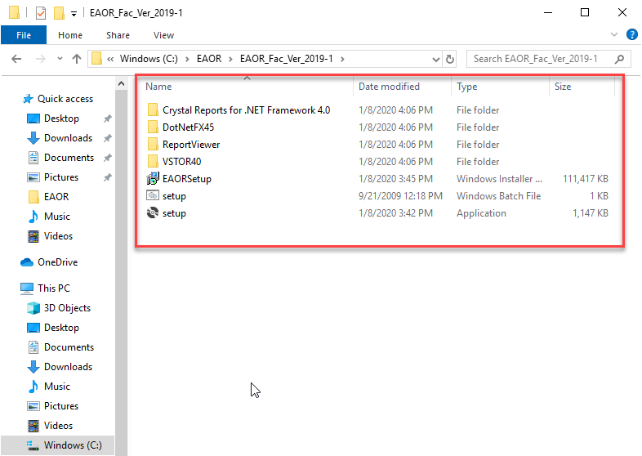

- Right click on the appropriate setup file based on the Operating System type (i.e. for 64-bit OS (CRRuntime_64bit_13_0_17) or for 32-bit CRRuntime_32bit_13-0-17) and Select Install option as follows.

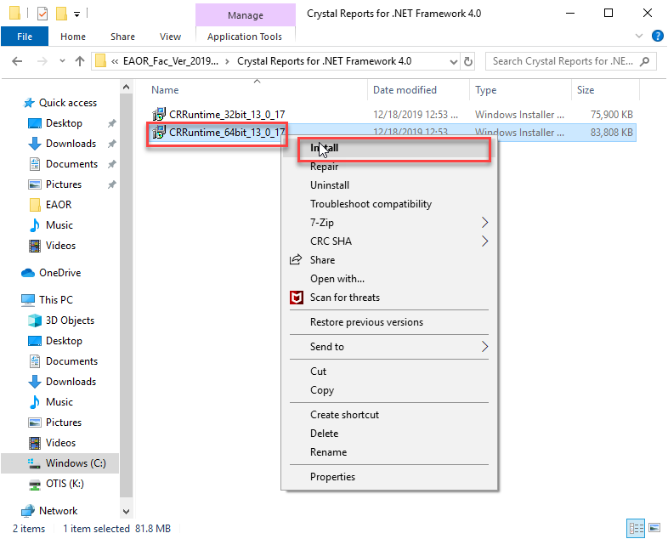

- Click Next button to continue the installation.
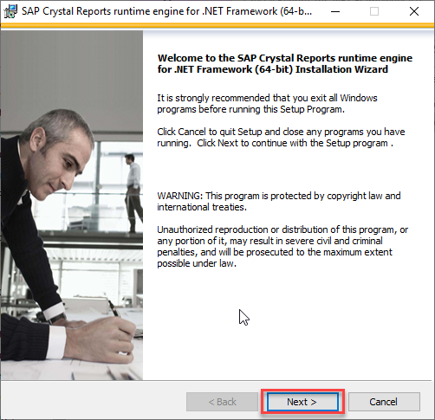

- Select the radio button in I Accept the License Agreement and click Next button to continue the installation.
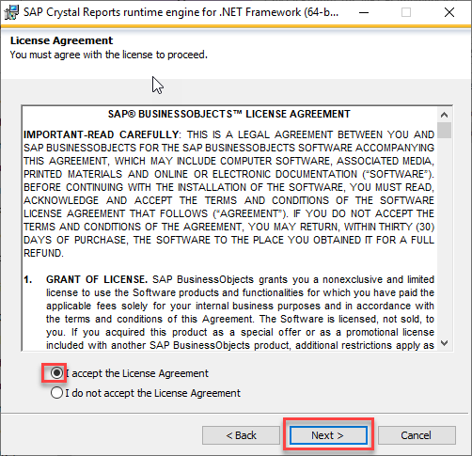

- Click Next button to continue the installation.

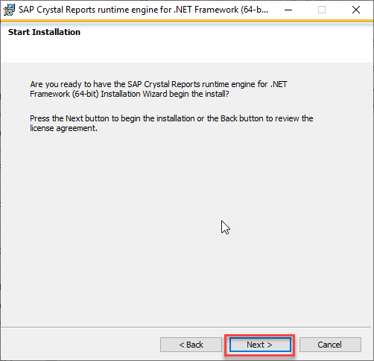

- Select “Yes” if you get a User Account Control Message as below and then the Crystal Report software installation progress status bar will appear (as shown below).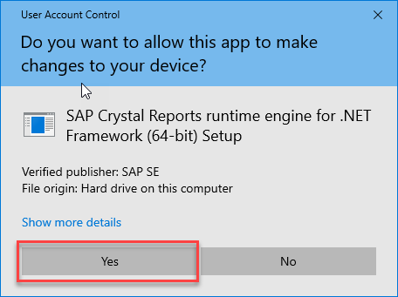

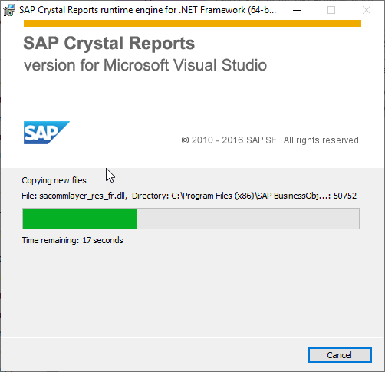

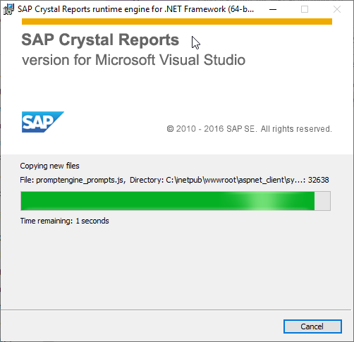

- Once the successful installation is done, click the Finish button to close.
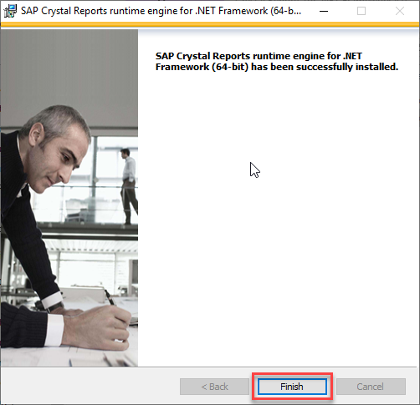

- Verify SAP Crystal Reports runtime for .NET Framework: Go back to your list of Programs from the Control Panel and confirm that the “SAP Crystal Reports runtime for .NET Framework” has been installed.

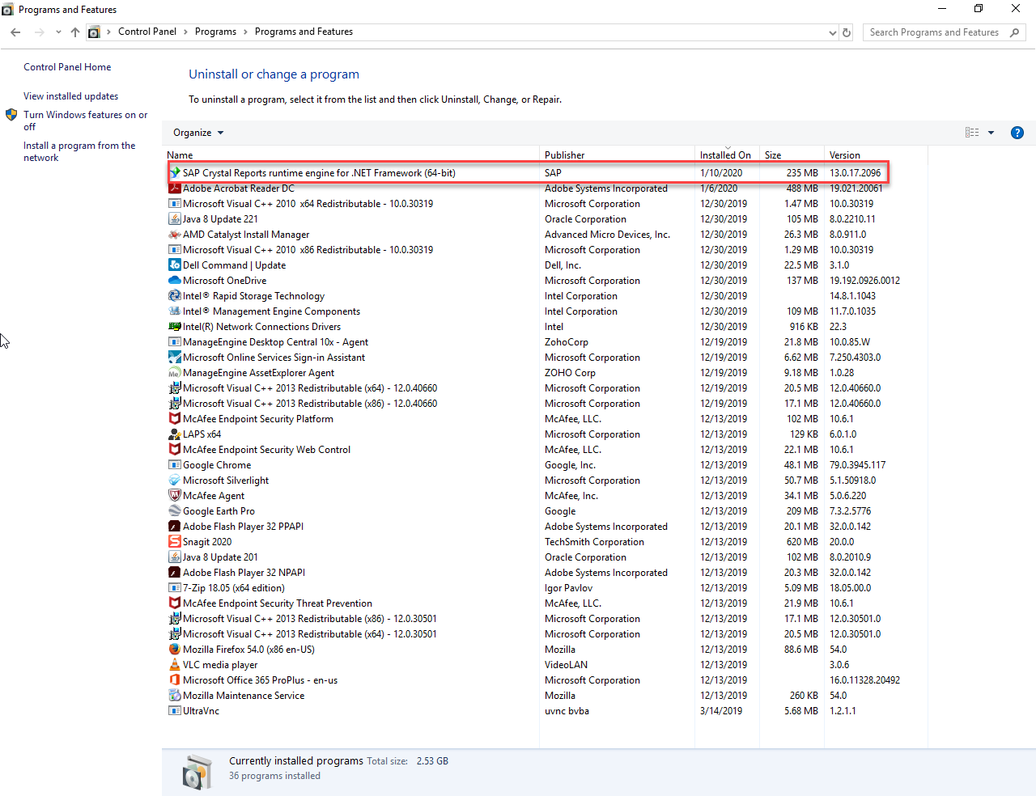

Appendix F – EAOR ‘has stopped working’ Error
If you seem to have a successful install of the EAOR software, but when you go to open the program, the following message appears “Electronic Annual Operating Report has stopped working” or EAOR suddenly closes, then please see below:
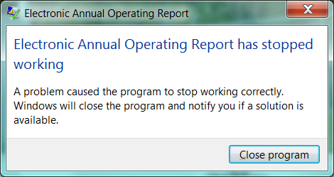

Please do the following:

  - Right click on the EAOR Facility icon on your desktop.
  - Select Properties.
  - Select the Compatibility tab.

  - Check “Run this program as an administrator.”
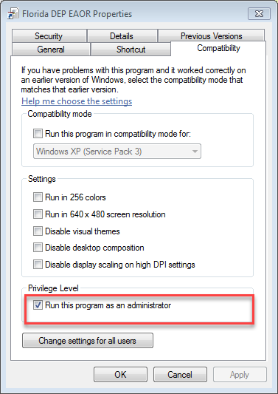

  - Click Apply and OK.
  - Try to open the EAOR program again.

Appendix G – Add New Emission Unit (EU) or New SCC– Error Message Popup
If you ‘Add EU’ in EAOR or (Add SCC) an error message will pop up for 4 times, with detailed screen shots as follows.
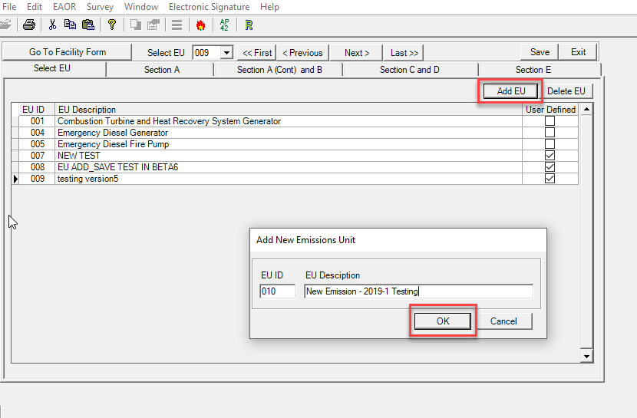
When you Click OK button, after entering the new EU ID & EU Description or new SCC, then errors will pop up approximately 4 times. However, these errors can be ignored.
Press OK button for each error pop up, then the new EU or SCC will be added and displayed in EU grid. The screen shots are as follows.

Error message Screen-1:
For each error message, Press OK and ignore.
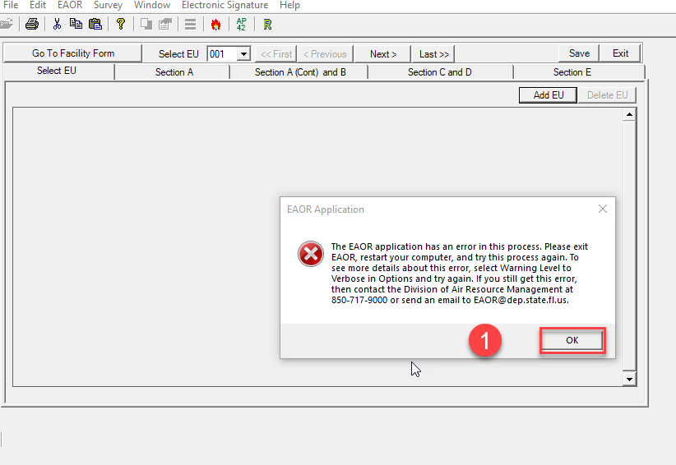

Error message Screen-2:
For each error message, press OK and ignore.
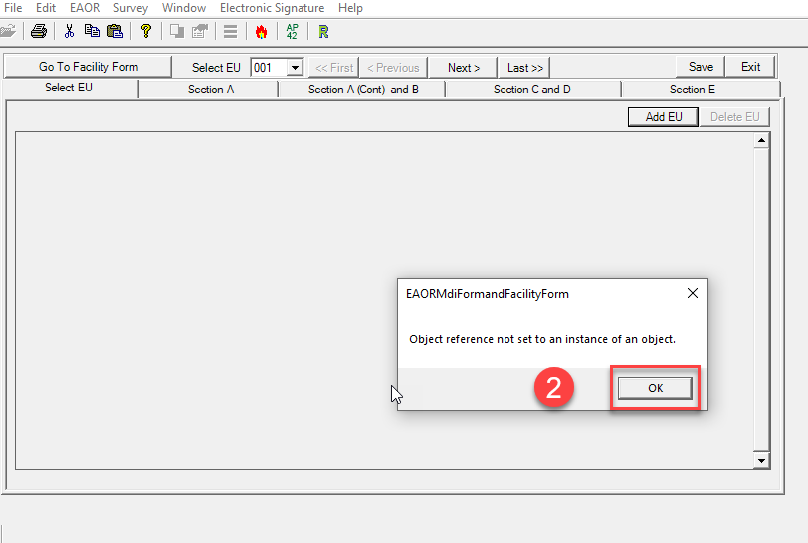

Error message Screen-3:
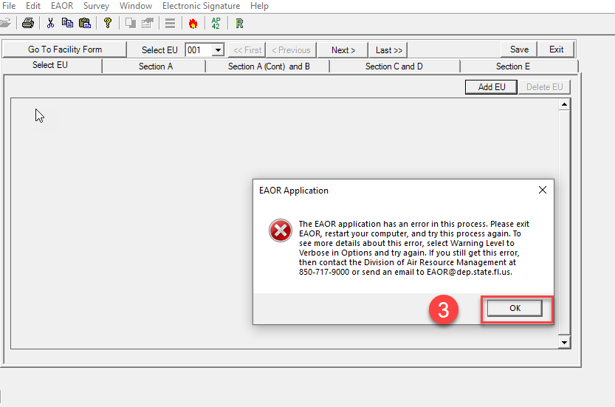

Error message Screen-4:
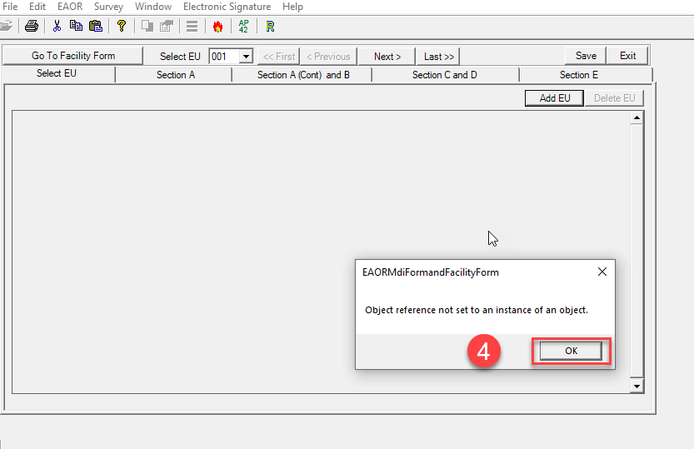

Added new Emission Unit (EU) – Displayed in EU Grid:
The errors finally subside, and the new EU or new SCC are added (e.g. new User Defined EU is shown below).

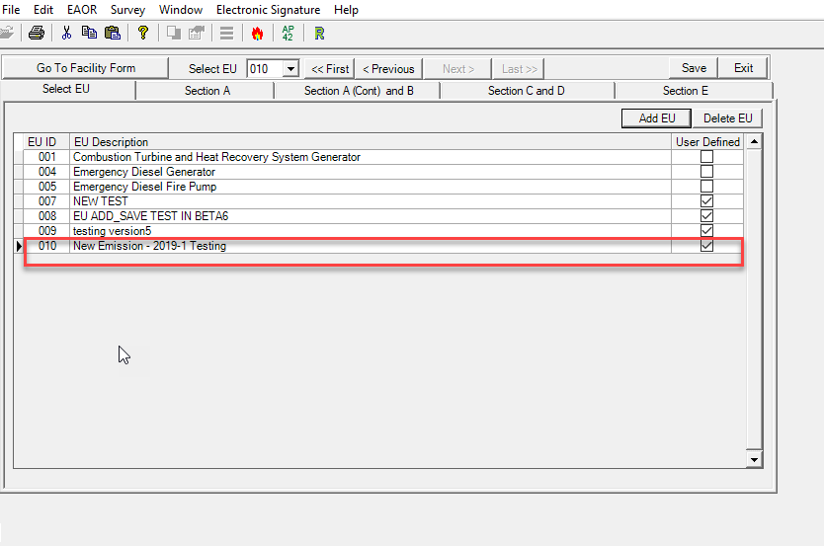

Appendix H - Install Microsoft Access Database Driver – Microsoft.ACE.OLDB.12.0
- Click on the link, “Microsoft Access Database Engine 2010 Redistributable”
- The link will display a File Download message box. Click on the down arrow next to Save button and then select Save as.

- In the Save as box, select your Desktop or EAOR Default Folder (C:\EAOR) or temporary folder where you want to save the AccessDatabaseEngine.exe.

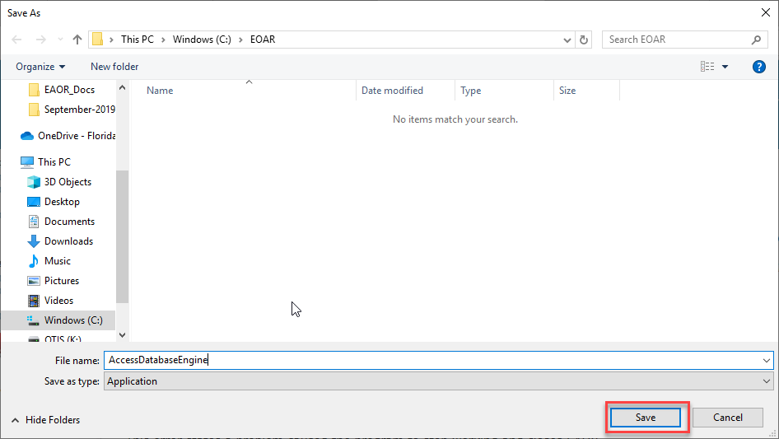
- Once the Save is complete then you will see the message box as shown below, then click the Open folder button.

- After successful Downloading then you will see the downloaded file as shown below.

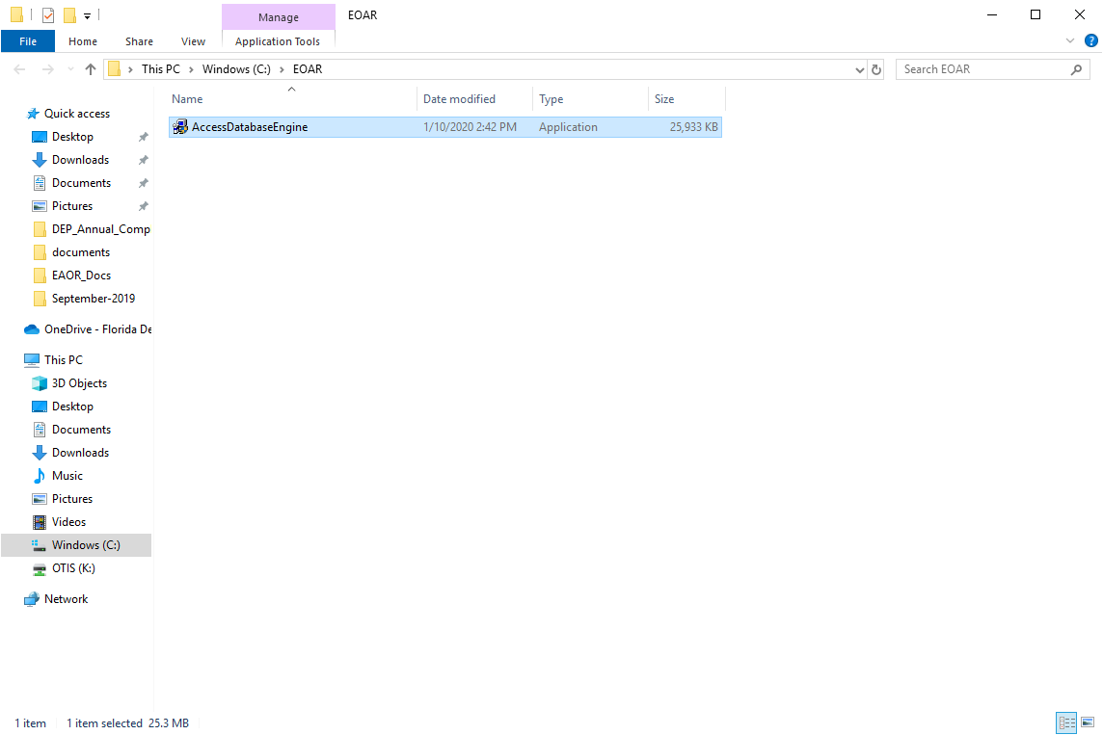

- Right click on AccessDatabaseEngine and Select Run as Administrator as show below.
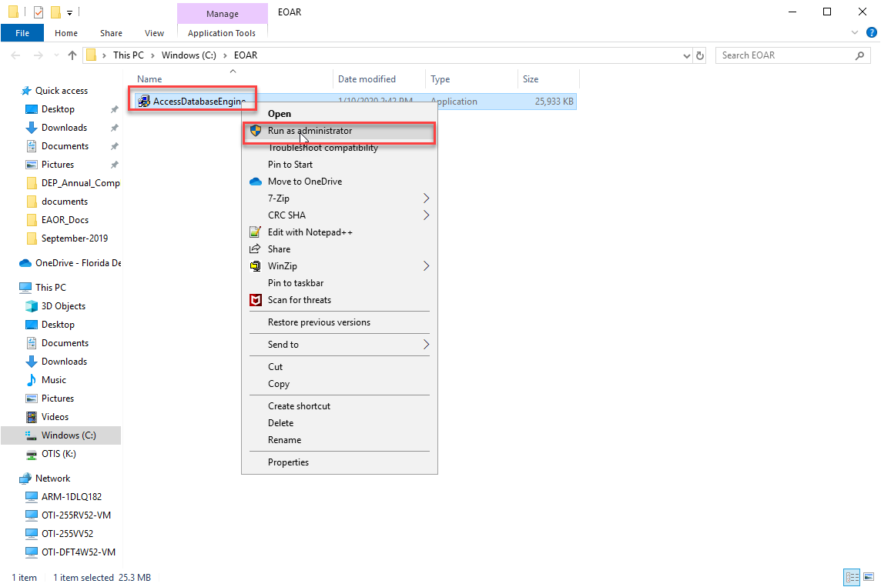
- Select “Yes” if you get a User Account Control Message as below (after you click Run as Administrator)
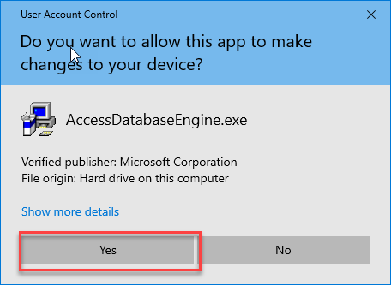
- Click the Next button as below.

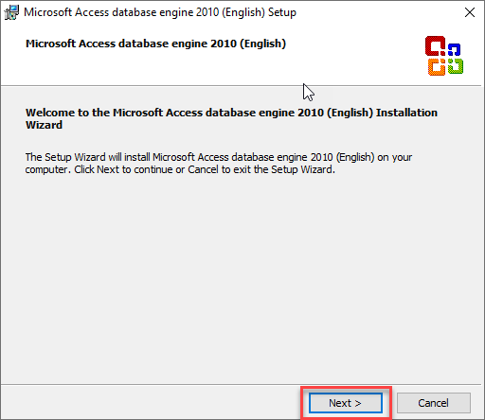

- Select License Agreement Checkbox and click Next button as below.
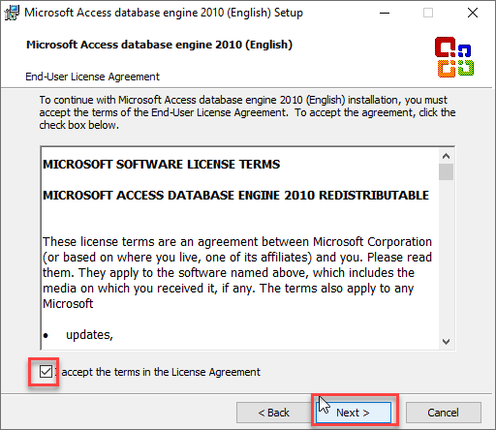

- Select the Folder where you want Install (Usually you don’t need to modify, select the Default Folder C:\Program Files(x86)\Microsoft Office\) and Click Install button.
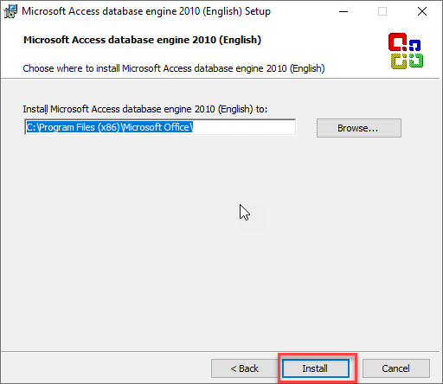

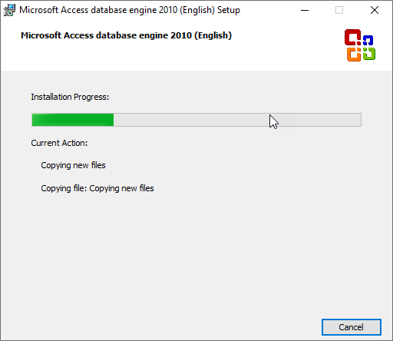

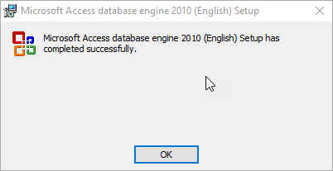

Verify MS Access Database Engine 2010: Go to Control Panel->Program and Features. Please look it in the Program List as mentioned below.
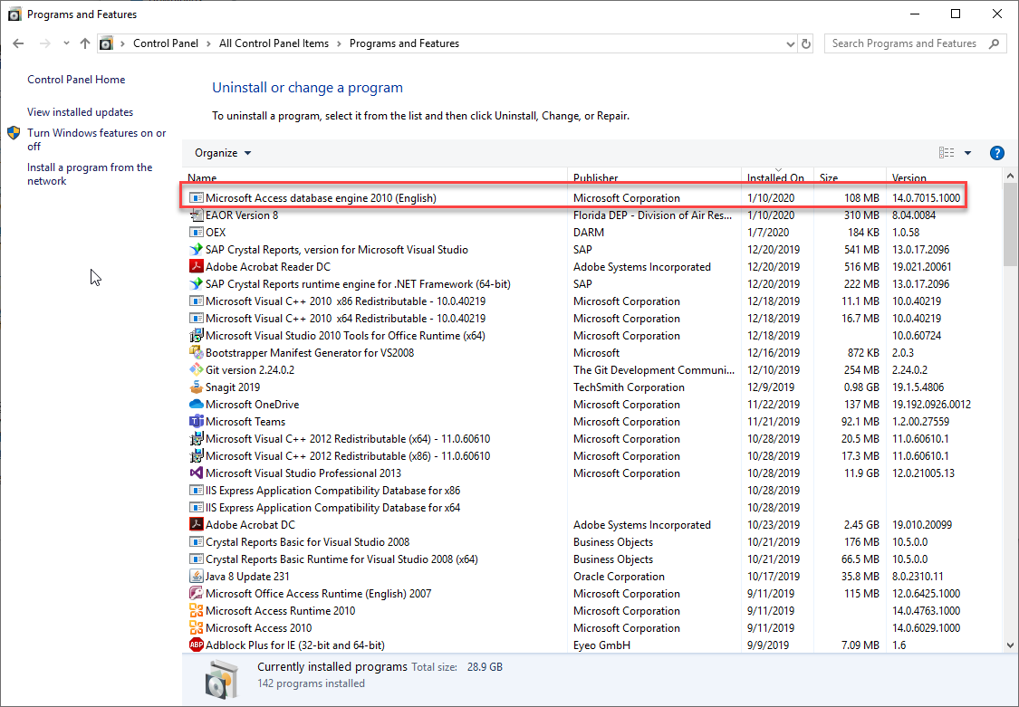

Appendix I – Install 7-Zip Software
1. Click the appropriate link, “7-Zip for 32-Bit Windows or 7-Zip for 64 Windows” based on your operating system.
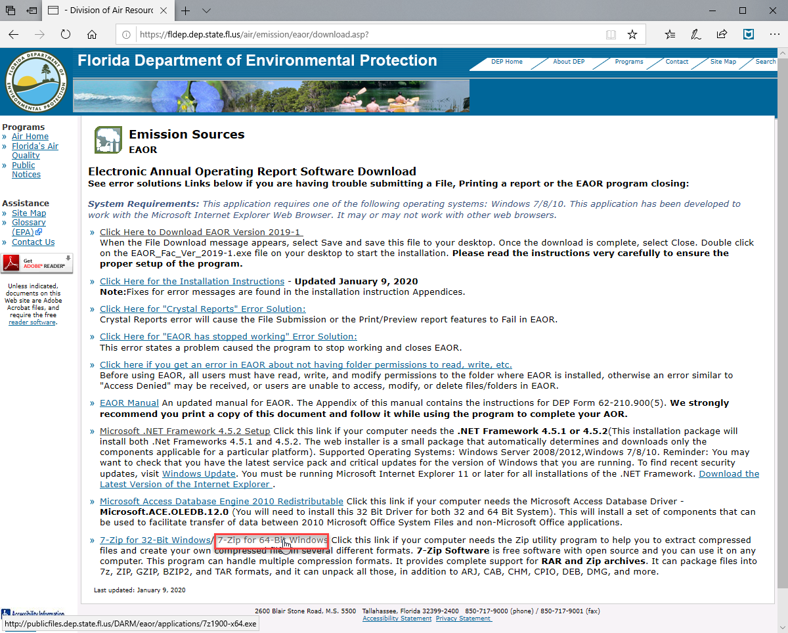
2. The link will display a File Download message box. Click on the down arrow next to
Save button and then select Save as.
3.In the Save as box, select your Desktop or EAOR Default Folder (C:\EAOR) or
temporary folder where you want to save the 7-Zip Software.
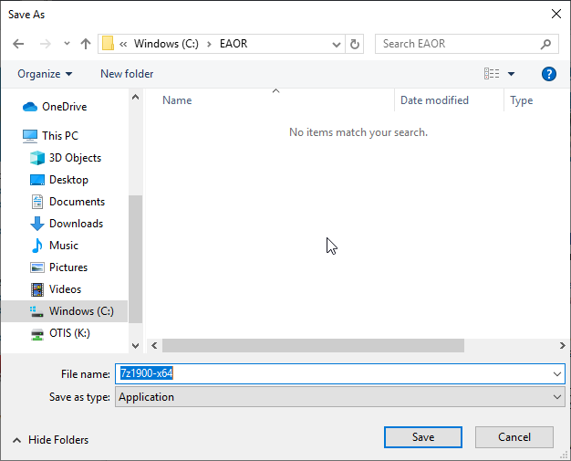

4.Once the Save is complete then you will see the message box as shown below, then click
the Open folder button.

5.After successful Downloading then you will see the downloaded file and then Right click
on the 7z1900-x64.exe and select Run as administrator as shown below.
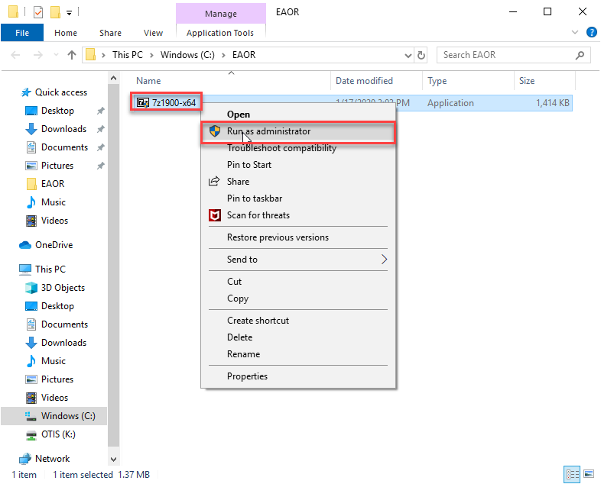

6.Select “Yes” if you get a User Account Control Message as below (after you click Run as
Administrator)
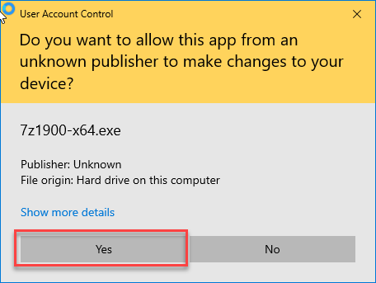

7.Select the Folder where you want Install (Usually you don’t need to modify, select the
Default Folder C:\Program Files\7-Zip\) and Click Install button.
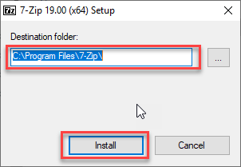

8.You can see the progress bar (It will finish the installation very quickly) and select the
Close button to exit.
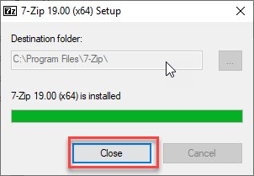

9.Verify the 7-Zip Software, ensure the software is installed and showed correctly (Right
click on the file name or Folder and then look for the option 7-Zip as below)
