Contents
I. Installation Requirements 2
II. Obtaining the Installation File 3
A. Edge Instructions 4
B. Chrome Download Instructions 6
III. Begin the Installation Process 8
IV. Crystal Reports Installation 12
V. .NET Framework 2.0 Installation 13
Appendix A – MDAC Updates 25
Appendix B – Microsoft .NET Framework 3.5 27
Appendix C – Oracle Client Installation 39
Appendix D – EAOR Folder Permissions Error 52
Appendix E – Crystal Reports Error 58
Appendix F – EAOR ‘has stopped working’ Error 65

- Installation Requirements
Before you begin - To install EAOR Reviewer Version 2022-2 on your computer, you must have Administrator rights. If you do not have Administrator rights on your machine, or if you are not sure what this means, contact your System Administrator for assistance. You may also need an Internet connection during installation if your computer does not have the software needed by EAOR. This Internet connection is used by the installation process to retrieve software needed by EAOR Reviewer Version 2022-2. It is recommended that you close all other applications during this installation.
Minimum System Requirements - This section describes the minimum configuration requirements for a computer where EAOR Reviewer Version 2022-2 is to be installed. If the minimum requirements are not met, EAOR Reviewer Version 2022-2 setup will block the installation of the redistributable package. Specifically, note that you cannot install the .NET Framework on a computer running the Microsoft Windows 95 operating system.
Required software - EAOR Reviewer Version 2022-2 uses Microsoft Data Access Component (MDAC) 2.8 SP1 or later and .NET Frameworks 2.0 and 3.5 and for DEP District Office users, the Oracle Client. Microsoft provides MDAC and the .NET Framework and Oracle provides the Oracle Client at no charge.
MDAC is a framework of interrelated Microsoft technologies that allows programmers a uniform and comprehensive way of developing applications that can access almost any data store and is required for EAOR Reviewer Version 2022-2 to work correctly. Please see Appendix A for installing MDAC.
The Microsoft .NET Framework is a component of the Microsoft Windows® operating system used to build and run Windows-based applications. If the version of this software is not on your computer, the setup process will use your connection to the Internet to install it for you. Please see Appendix B for more information about the .NET Framework updates.
Operating System Requirements - To install EAOR Reviewer Version 2022-2, you must have one of the following operating systems with Microsoft Edge or Google Chrome installed on your computer.
Microsoft Windows versions up to 11 are supported by EAOR.
Hardware Requirements - The minimum hardware requirements include:
Central Processing Unit (CPU) Intel Pentium class, 90 megahertz (MHz) or the minimum CPU required for running the operating system, whichever is higher.
Random Access Memory (RAM) 32 MB or the minimum RAM required for running the operating system, whichever is higher.
Hard Drive with 60 MB of free space.
Conventional Mouse or other pointing device.

Obtaining the Installation File

You may download the EAOR Installation files from the DARM Intranet at https://fldep.dep.state.fl.us/arms_reports/eaor/. Click on the link labeled, “Download EAOR Reviewer Software”.
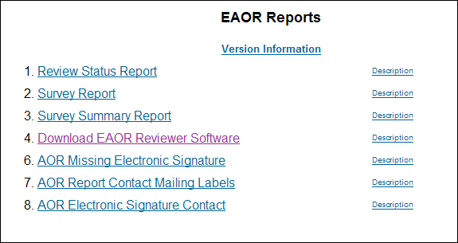
The “Download EAOR Reviewer Software” link takes you to the page that includes the installation file, Installation Instructions, EAOR Manual – Facility Version, EAOR Reviewer Supplemental Manual, Microsoft .NET Framework 3.5 Redistributable, and the Oracle 11g Client. Click on the link, “Download EAOR Reviewer Version 2022-2”.

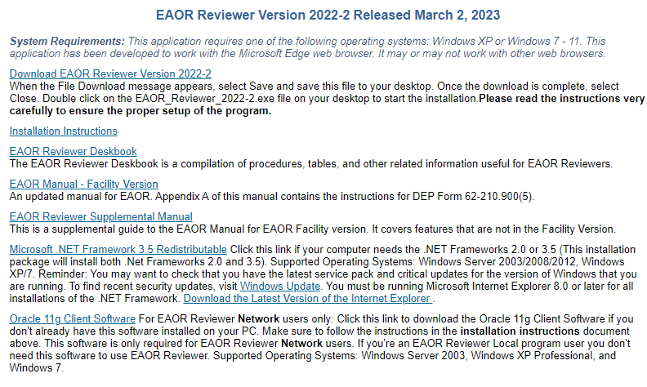

Proceed to either Section I.A Edge Instructions or Section I.B Chrome Instructions

Edge Instructions

A security message will appear.
.
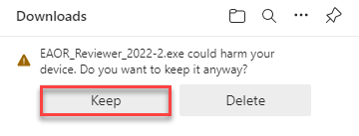
Click Keep. The file will now be downloaded. When complete, select “Open file”

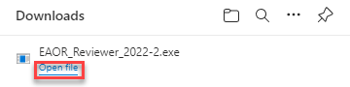

You will now see a Microsoft Defender Smart Screen warning. Click on “More info”

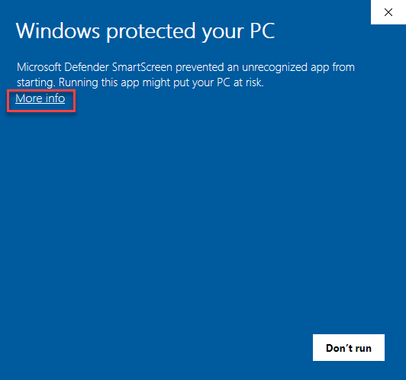
The screen will now display the application name and publisher. Select “Run anyway”

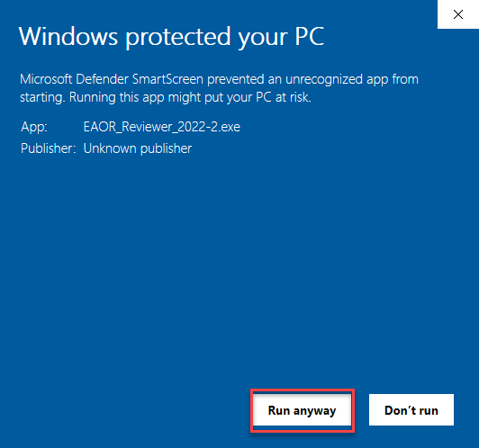

Proceed to Step III, Begin the Installation Process

Chrome Download Instructions

Right click on the “Download EOR Reviewer Version 2022-2 link. Select “Save link as..”

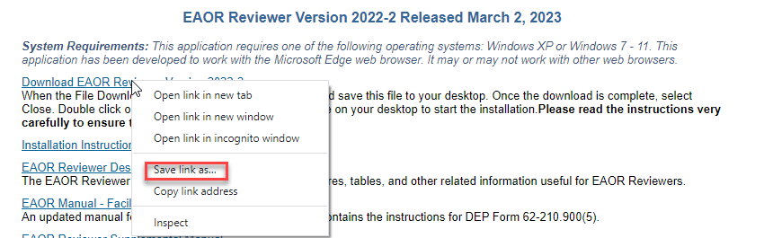

Select a location on your computer to save the file. Once the file is saved, you will be prompted that EAOR_Reviewer_2022_2.exe can’t be downloaded securely.

Click the arrow next to the Discard button and select Keep.

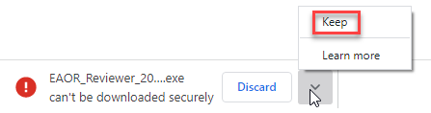

Once you’ve selected “Keep”, the file will be available to run. Click the arrow next to the file name and select “Open”.

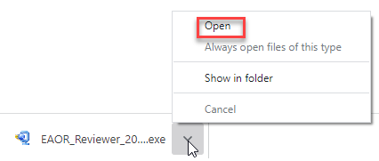

You will now see a Microsoft Defender Smart Screen warning. Click on “More info”

The screen will now display the application name and publisher. Select “Run anyway”

Proceed to Step III, Begin the Installation Process

Begin the Installation Process
You will be presented with a WinZip Self-Extractor screen. Click on “Unzip”.
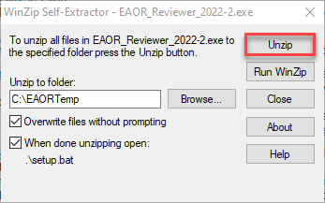
Click “OK” when you see the following:
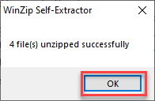
You will then see the Welcome Screen. Click “Next”

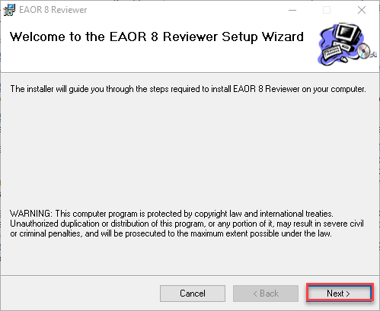

The Select Installation Folder screen will appear. Click “Next”

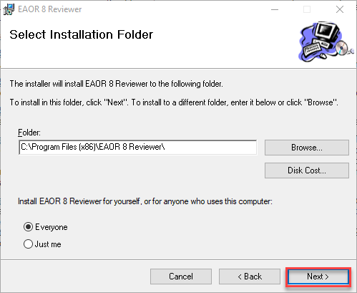

The System requirements screen will then appear. Click “Next.”

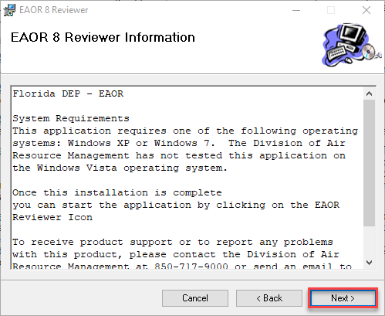

The Confirm Installation screen will appear. Click “Next.”

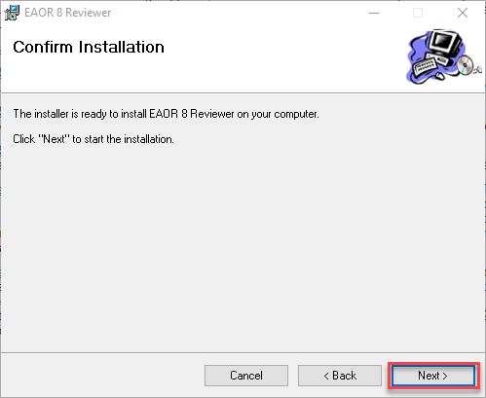

You will then see the User Account Control warning screen. Click “Yes”

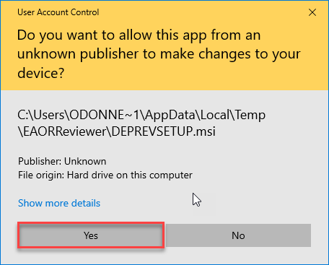

The installation will then proceed. The Important Information screen will then appear. Note that read, write, and modify permissions are absolutely necessary to run EAOR Reviewer. Click “Next.”

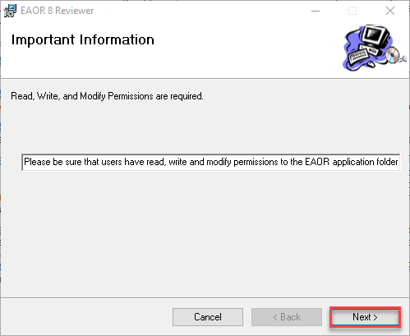

Congratulations, you have now installed EAOR Reviewer! Click “Close” to finish the installation process.

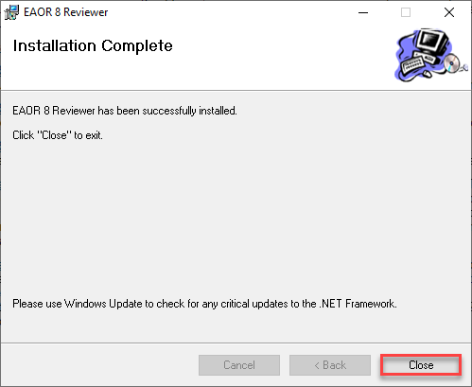

Crystal Reports Installation

You will see the message below and click on “Accept” to continue.

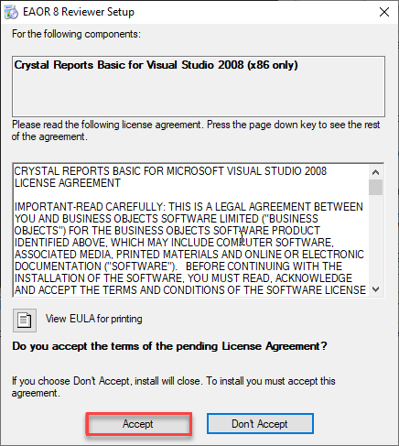

5. When you click on the Accept button on the window above, you’ll see the following dialog
box. Click “Yes.”

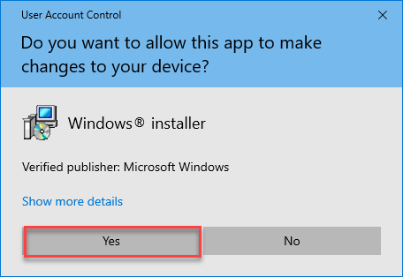

The Crystal Reports installation will then continue. When complete, proceed to Section III, Begin the Installation Process.

.NET Framework 2.0 Installation

If .Net Framework 2.0 is NOT installed on your PC you’ll see the following message. Otherwise you will see the message in step 12.
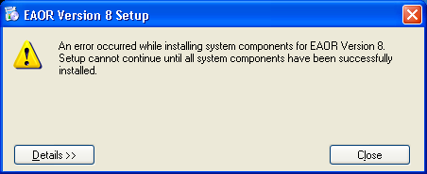
Click on the Details button in the window above to display the error message.
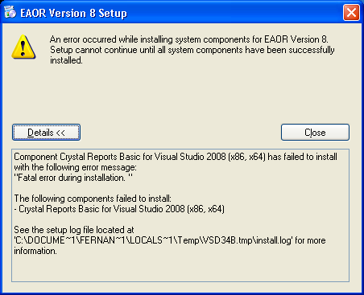
Click on the Close button to close the error dialog box.
If .Net Framework 3.5 or .Net Framework 3.0 is installed on your PC and .Net Framework 2.0 is not installed, you must uninstall .Net Frameworks 3.0 and 3.5 to resolve the above error and should continue with next step, otherwise you’ll see the message in step 12 (Section III).
Remove both .Net Frameworks 3.5 and 3.0 before proceeding to the next step. To remove .Net Framework 3.5 and or 3.0 go to Start Control Panel Add or Remove Programs and select .Net Framework 3.5 from the list and then click on the Change/Remove button:
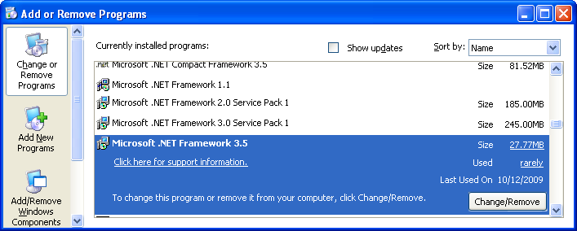
A new Dialog box will appear. Choose the Uninstall option then click on the Next button:
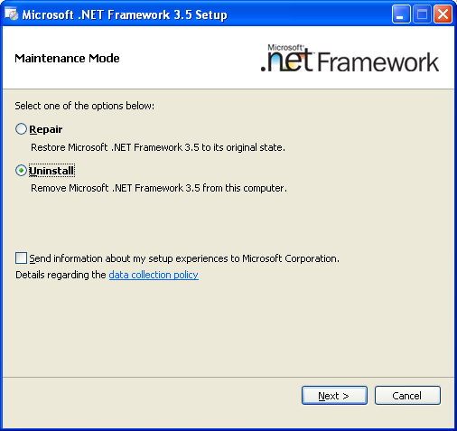
Once .Net Framework 3.5 has been successfully removed repeat this step for .Net Framework 3.0 if it’s also installed on your PC.
- You’ll need to install .Net Frameworks 2.0 and 3.5 before proceeding with the EAOR installation process. To do this go to the EAOR Software Download page at https://fldep.dep.state.fl.us/arms_reports/EAOR/Software/Download.asp and then go to Appendix B in this manual and follow all the steps starting with step 3. Running the .Net 3.5 Framework setup program will install both .Net Frameworks 2.0 and 3.5 on your PC. Once the .Net Framework 3.5 installation is complete go back to Section III step 1 above to install EAOR.
- You will see the Welcome message, as shown below.
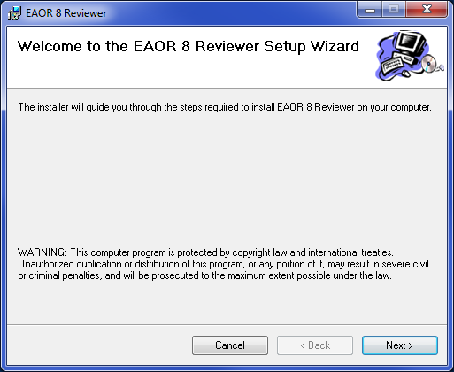
- Please read the Warning message and then click next to continue the installation. You will see the Select Installation Folder message as shown below.
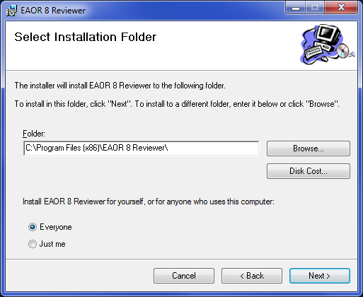
- In the Select Installation Folder message you have the following options:
i) Change the folder location of the EAOR application by clicking the Browse button to locate a different folder
ii) Check to see if your computer has the disk space needed to install EAOR by clicking on the Disk Cost… button
iii) Change the installation option so others that use the computer cannot use EAOR by clicking on the Just me radio button
- When you click on the Accept button on the window above, you’ll see the following dialog box. Once you have made any changes that are needed, or if the default options are acceptable, click the Next button to continue the installation process:
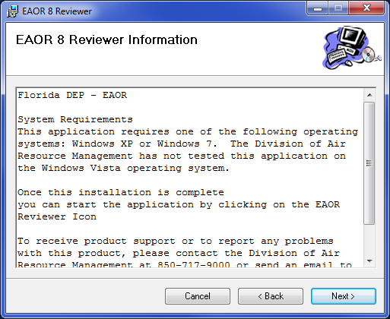
- You will see the EAOR Information message, shown above. This message includes the Division of Air Resource Management phone number and e-mail address. When you click next from the EAOR Information message, you will see the Confirm Installation message, as shown below. You may click Next to continue, back to return to the EAOR Information message, or Cancel to quit the installation process:
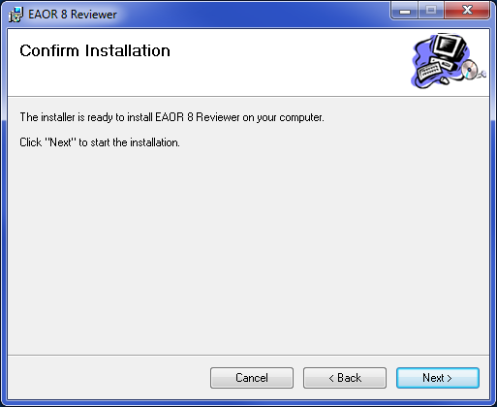
- When you click Next from the Confirm Installation message, you will see the EAOR 8 Reviewer Installation message as shown below. You may click Cancel if you want to stop the installation process:
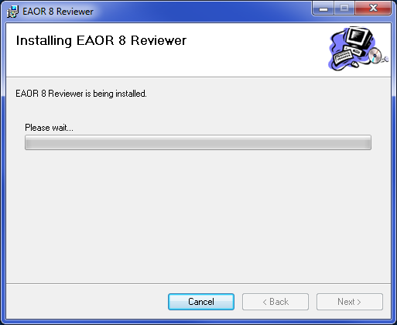
- Next you will see the Important Information screen. Click the Next button on the Important Information message:
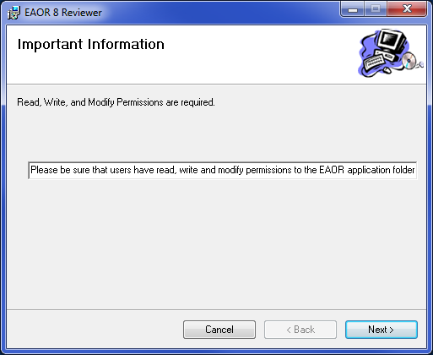
- Then you will see the Installation Complete message. Click the Close button:
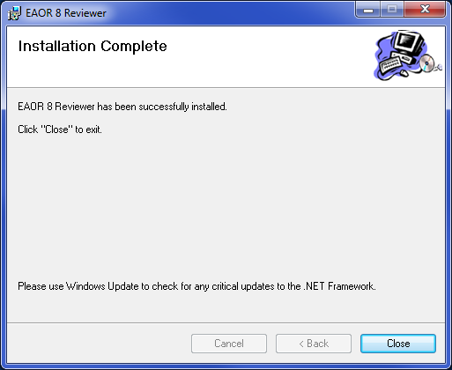
- You will see the EAOR Reviewer program group on your Start menu:
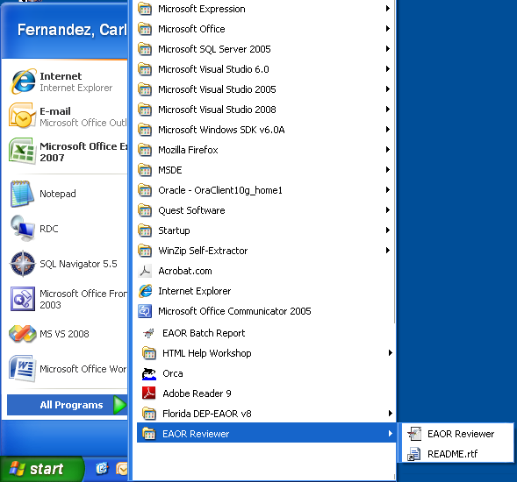
- You will also see the Reviewer EAOR icon on your desktop:
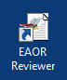
- You may start EAOR Reviewer Version 2022-2 by clicking on the Reviewer EAOR link on your Start menu or the Reviewer EAOR icon on your desktop. If you get an error about the user must have read, write, and modify folder permissions, then go to Appendix D in this document for instructions.
- If you are in a District Office, you should see the Login screen with your Network ID entered into the first field. Type in your Network Password and leave the Connection Type as DEP Employee. Click the OK button.

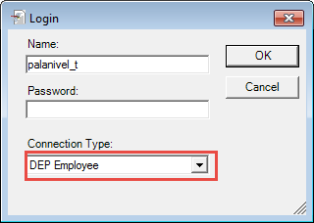
- If you are in a Local Program Office, you should see the Login screen with your Computer or Network ID entered into the first field. Type in your Login Name and Password and Select the Connection Type to Local Program. Click the OK button.

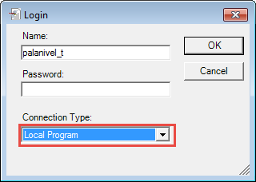
- After you enter a valid password, you should see the EAOR Easy Start Menu, as shown in the following screen shot:
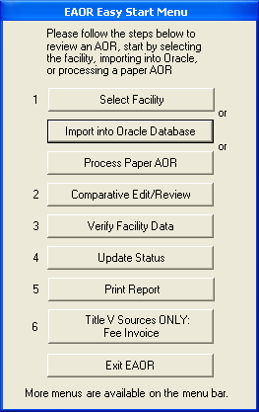
- If you are in a District Office and you receive a message similar to the one below that mentions Oracle client, then your computer needs to have the Oracle client installed or the Oracle file updated. Please see Appendix C:
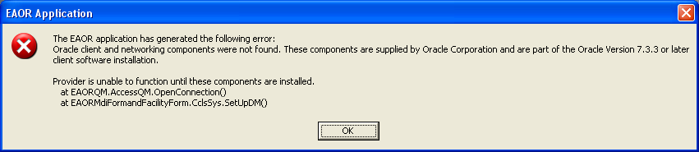

Appendix A – MDAC Updates
- MDAC may need to be installed on PCs running Windows XP. If you are running the Windows 7 operating system MDAC comes preinstalled as an operating system component (WDAC – Windows Data Access Components). Windows 7 users should NOT use the link below to install MDAC.
- Installing Microsoft Data Access Component (MDAC) – When the User’s computer does not have MDAC installed, EAOR Reviewer Version 2022-2 will not install until the User downloads and installs a copy from the Microsoft website. The version recommended is: MDAC 2.8 SP1 or later. It is available from the Microsoft Download Center at www.microsoft.com. The MDAC can be downloaded from:
https://www.microsoft.com/en-us/download/details.aspx?id=5793
- Click on the Download button to begin the process.
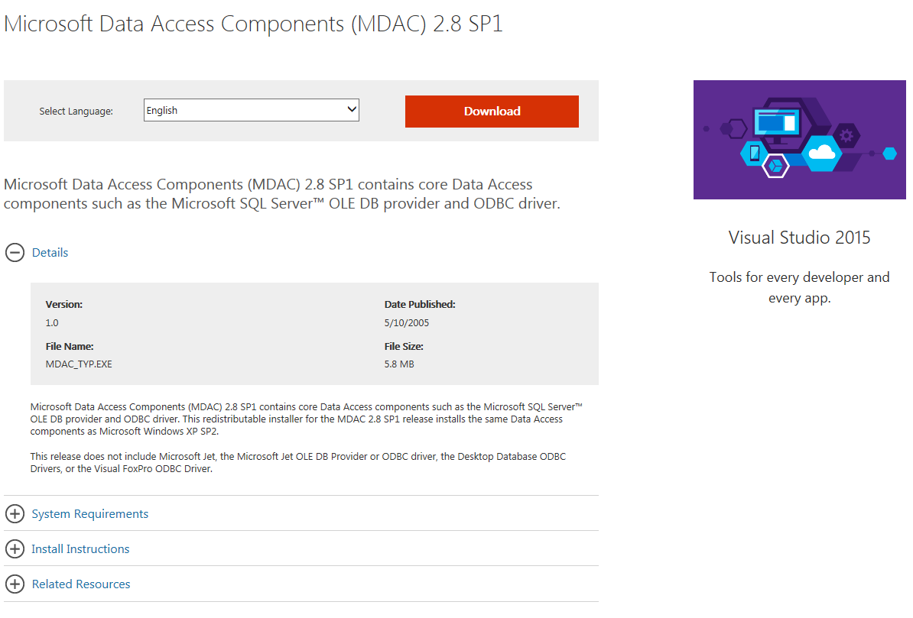

- Once you click the Download button, the website responds with the following window. Click on the Run button to begin the installation or click on the Save button to save the installation file to your computer to begin the installation at a later time.

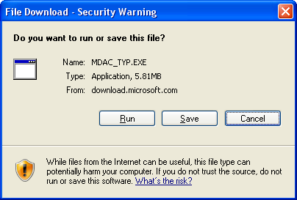
- After you complete the MDAC installation, please continue the EAOR installation.

Appendix B – Microsoft .NET Framework 3.5
- The .Net Frameworks 2.0 and 3.5 may need to be installed on PCs running Windows XP. If you are running the Windows 7 operating system .Net Framework 3.5 with SP1 comes preinstalled as an operating system component (this includes .NET Framework 2.0 SP2, 3.0 SP2 and 3.5 SP1). Windows 7 users should NOT use the link below to install the .Net Frameworks 2.0 and 3.5.
- For computers that do not have Microsoft .NET Framework 3.5, the EAOR Reviewer Version 2022-2 Installation process will display a Windows Installer message similar to the one shown below.

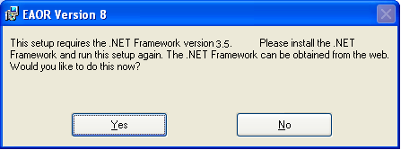

- When you select Yes from the Windows Installer Loader message, you will be taken to the EAOR website as shown in the image below.
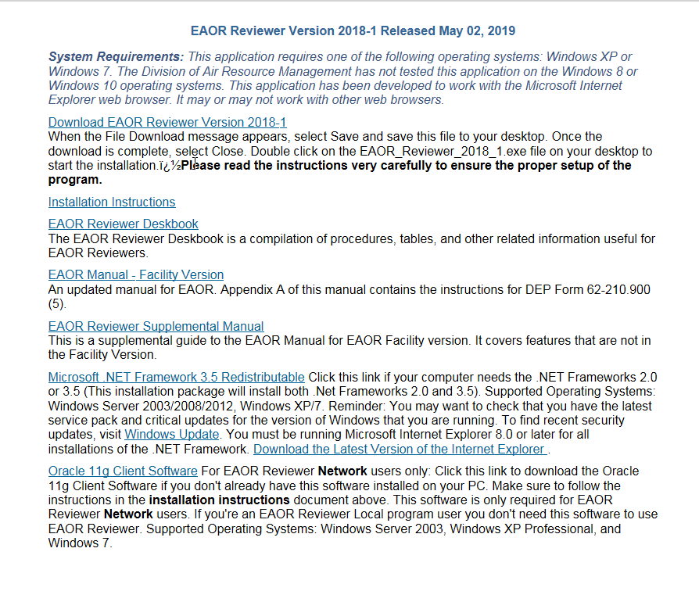

- The Supported Operating Systems for the .NET Framework 3.5 include: Windows Server 2003, Windows Server 2008, Windows Vista and Windows XP. Reminder: You may want to check to see if you have the latest service pack and critical updates for the version of Windows that you are running. To find recent security updates, visit Windows Update. You must also be running Microsoft Internet Explorer 5.01 or later for all installations of the .NET Framework. Install Internet Explorer 8.0.
- Confirm that your version of Windows is included in the supported operating systems list, and that it has the recommended service pack and critical updates.

- This version of EAOR requires both .Net 2.0 and 3.5. If .Net Framework 3.5 or 3.0 is installed on your PC and .Net Framework 2.0 is not installed, then go to step 6 otherwise go to step 7.
- Remove both .Net Frameworks 3.5 and 3.0 before proceeding to the next step. To remove .Net Framework 3.5 and or 3.0 go to Start Control Panel Add or Remove Programs and select .Net Framework 3.5 from the list and then click on the Change/Remove button.
A new Dialog box will appear. Choose the Uninstall option then click on the Next button.
Once .Net Framework 3.5 has been successfully removed repeat this step for .Net Framework 3.0 if it’s also installed on your PC.
- If your computer’s Windows operating system is up to date, click on the Microsoft .NET Framework 3.5 Redistributable link and you should see a dialog box similar to the following image.
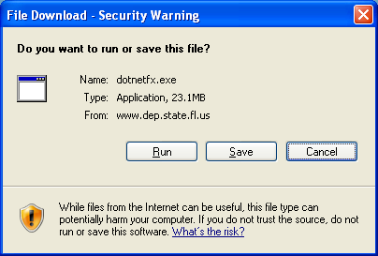

- The File Download – Security Warning will ask if you want to run or save this file. Select Save by clicking on the Save button. When you click on Save, you will see the Save As window as shown below.
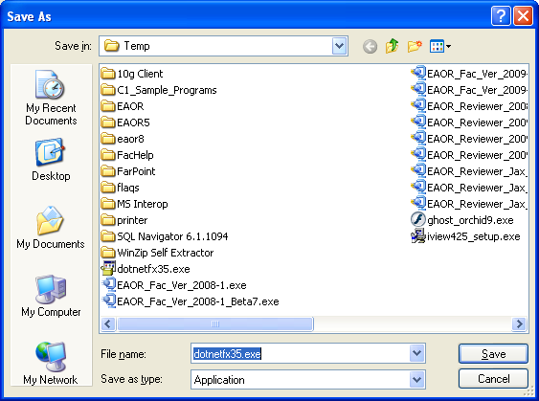

- Select Desktop by clicking on the Desktop icon on the left-hand side of the dialog box. You should see the Percent Completed window as shown in the following image. Click on the check box for Close this dialog box when download completes.

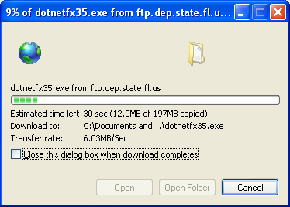

- To begin the .NET Framework 3.5 installation, click on the dotnetfx35.exe icon on your desktop.

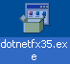
- You may receive the Open File – Security message shown in the following image. Select Run by clicking on the Run button.

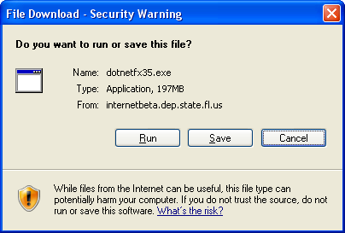

You may also see this message. If so, select Run by clicking on the Run button.

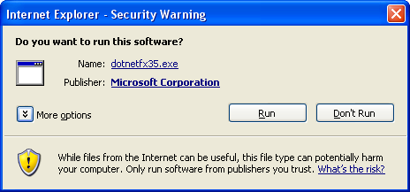

- Now you should see the following messages about Extracting Files and Installing Components.
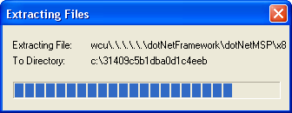

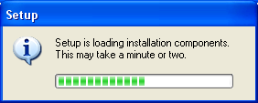

- Next you will see the Microsoft .NET Framework 3.5 Setup license agreement. Read the license agreement and click on the “I have read and ACCEPT …” check box to accept the agreement, and the click the Install button.

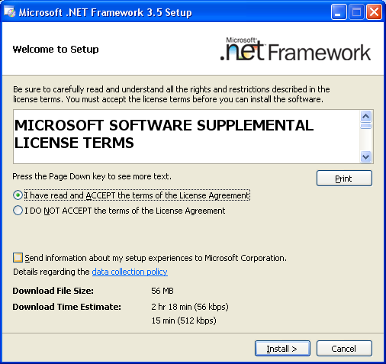

- You will see this download progress message during the installation.

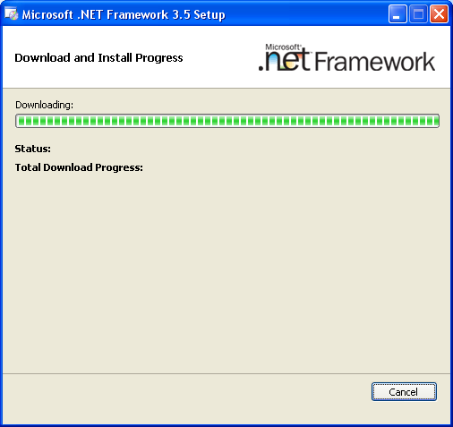

- When the installation is complete, you should see the Setup Complete message. You may close this window by clicking the Exit button and begin installing EAOR Version2022-2.

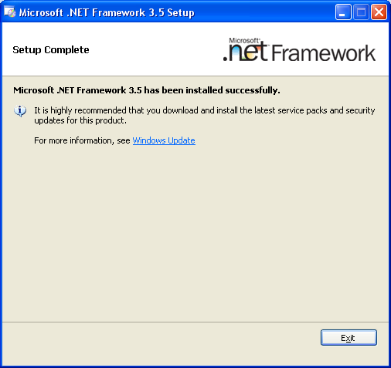

Using the Microsoft Website

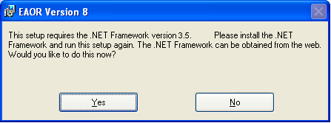

- When you select No from the Windows Installer Loader message, you may obtain the .NET Framework 3.5 by going to the Microsoft website at:
https://www.microsoft.com/en-us/download/details.aspx?id=22
. This link should take you to a page similar to the following.

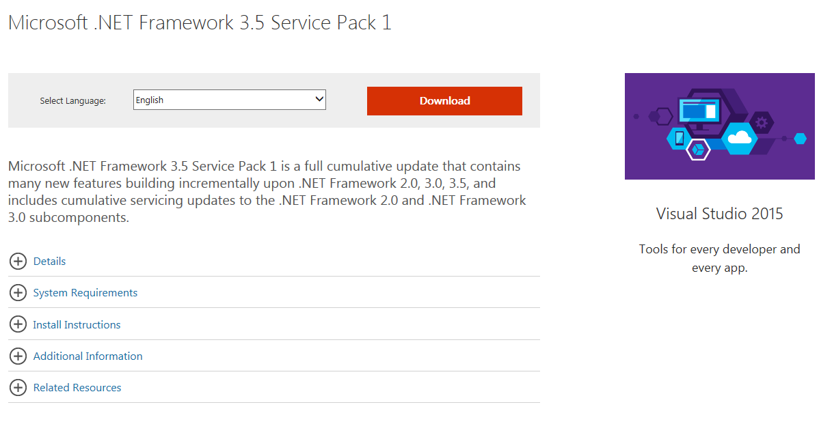

- Click the Download button in the middle left-hand side of the page and you should see the same messages that are presented in this appendix starting with number 8.

Checking Windows Version and Updates

- To check your computer’s operating system version and service pack, click on My Computer and then click on the View System Information under the System Tasks title.

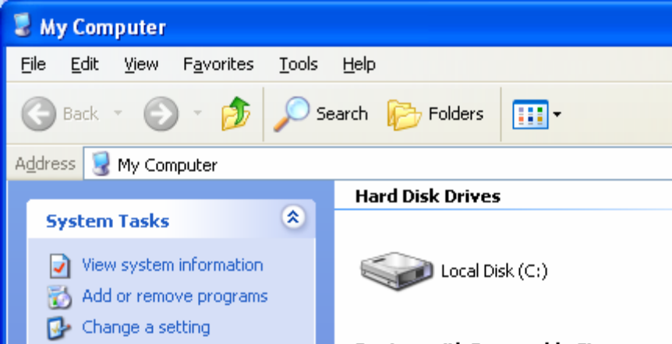

- The system information lists the Operating System Version and Service Pack in the System Properties General tab.

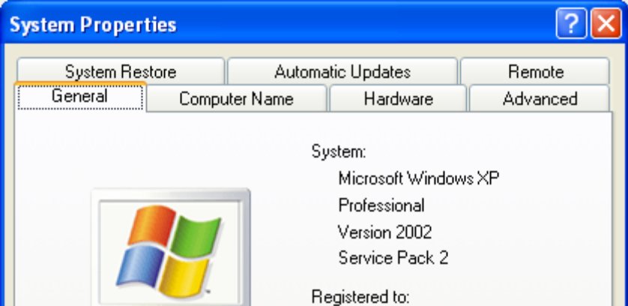

Appendix C – Oracle Client Installation

1. The Oracle 11g Client installation files are on the EAOR Reviewer Software download web site at: https://fldep.dep.state.fl.us/arms_reports/eaor/Software/Download.asp. Click on the link Oracle 11g Client Software.

2. You should see the following dialog box. Click on the Save button and save the file to your desktop or to another folder.

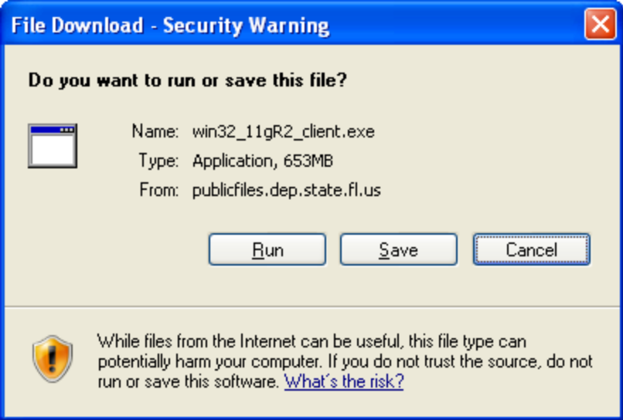

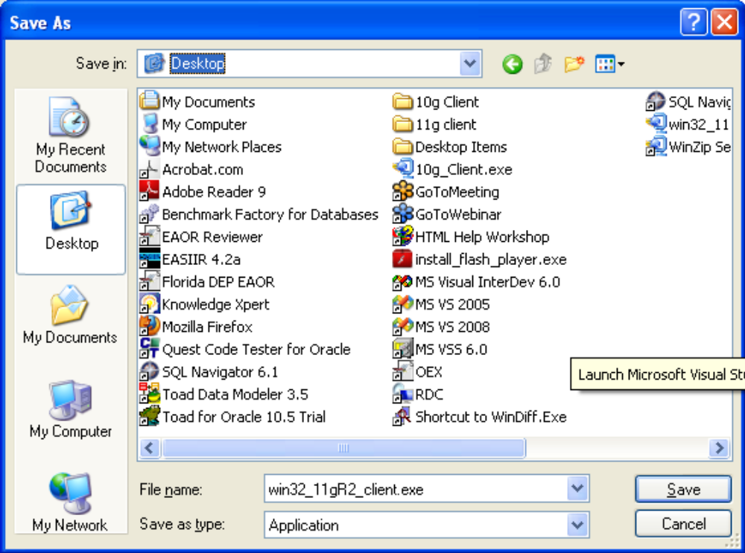

Click on the Close button to close the download dialog box.

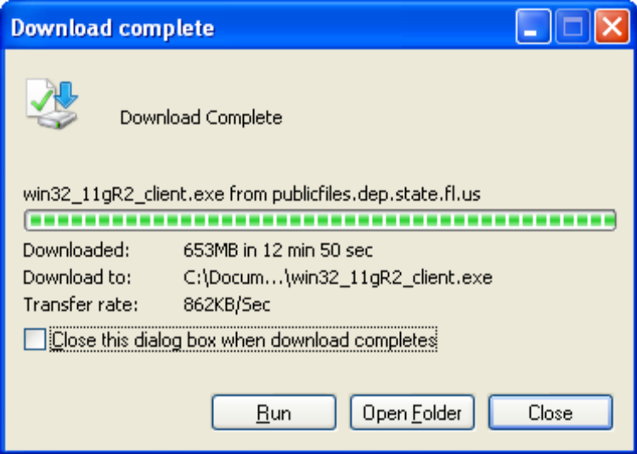

3. Once the file has finished downloading double click on the desktop icon or file called win32_11gR2_client.exe. This is a self extracting zip file.

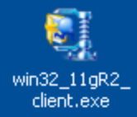

4. You should see the following dialog box. Click on the OK button to continue.

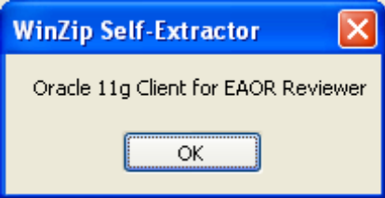

5. Then you’ll see the following dialog box. Under the Unzip to folder section click on the Browse button and select Desktop as the Unzip to folder location.
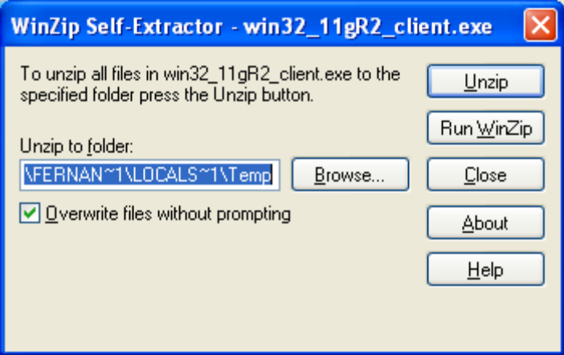

Then click on the OK button.
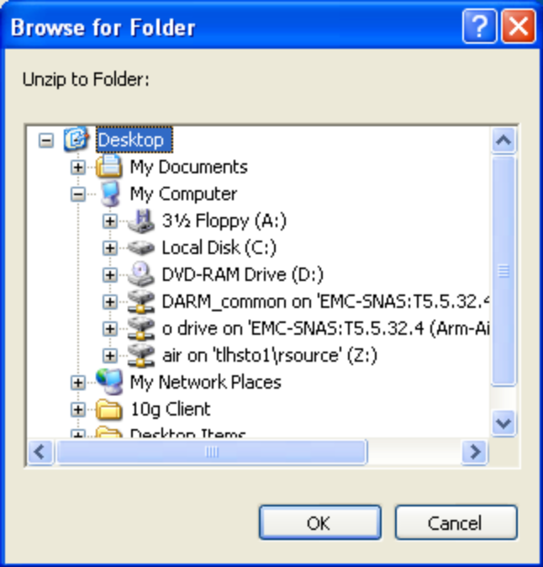

6. Once the Client files have been unzipped you’ll see the following dialog box. Click OK to close the dialog box.

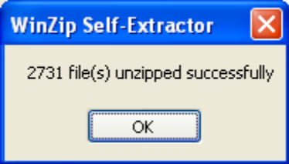

7. A folder called 11g Client should now be on your desktop.
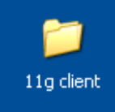
8. Open the 11g client folder on your desktop. Double click on the setup.exe file.
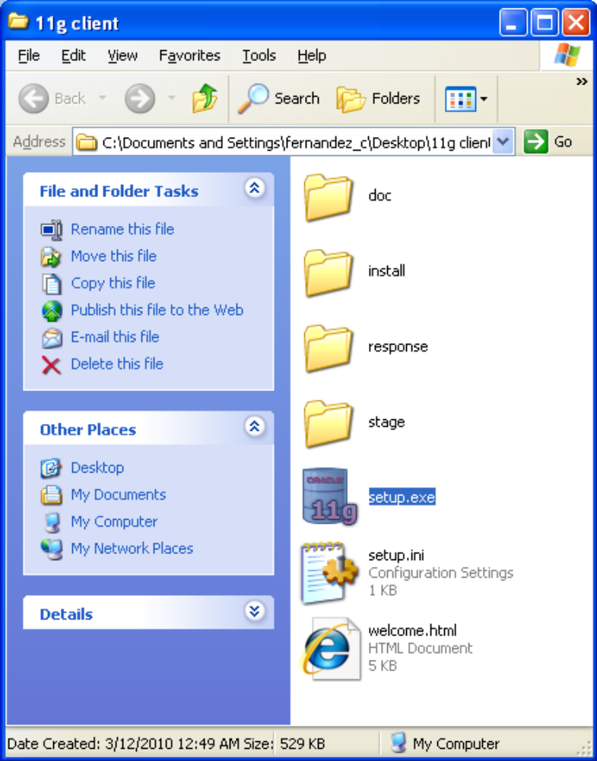

9. Double clicking on the setup.exe file should display the Oracle Universal Installer Welcome screen. Depending on your computer, this may take a few minutes to load and you may see the please wait message shown below.
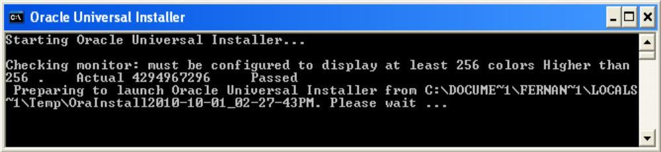

10. When the Oracle Client Installer, as shown below, appears, you may click on the Custom radio button which is at the end of the list. Then click the Next button to continue.
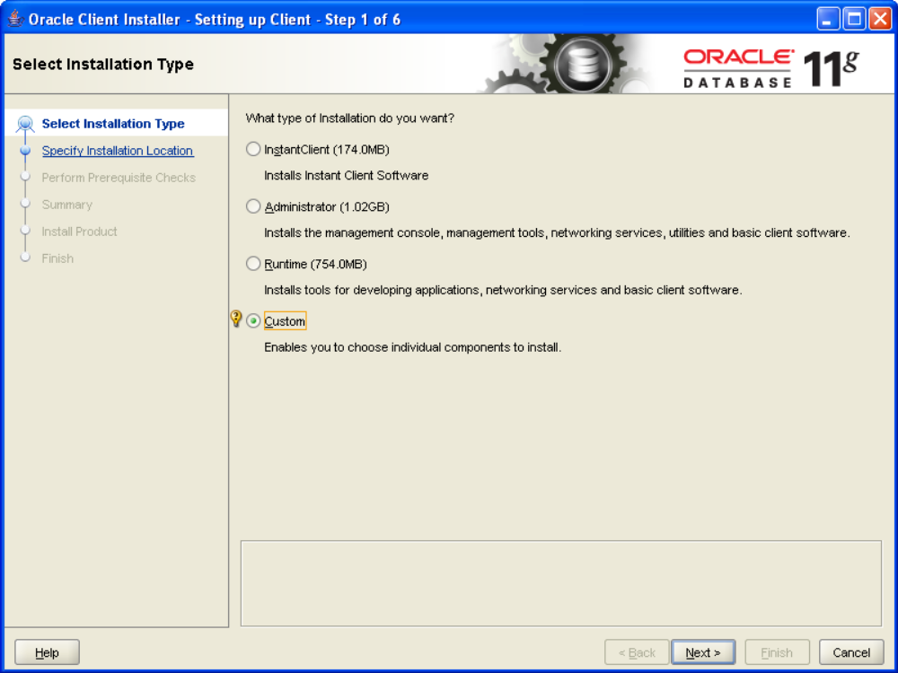

11. The next screen is the Select Product Languages. The default language is English. Click the Next button to continue with the installation.
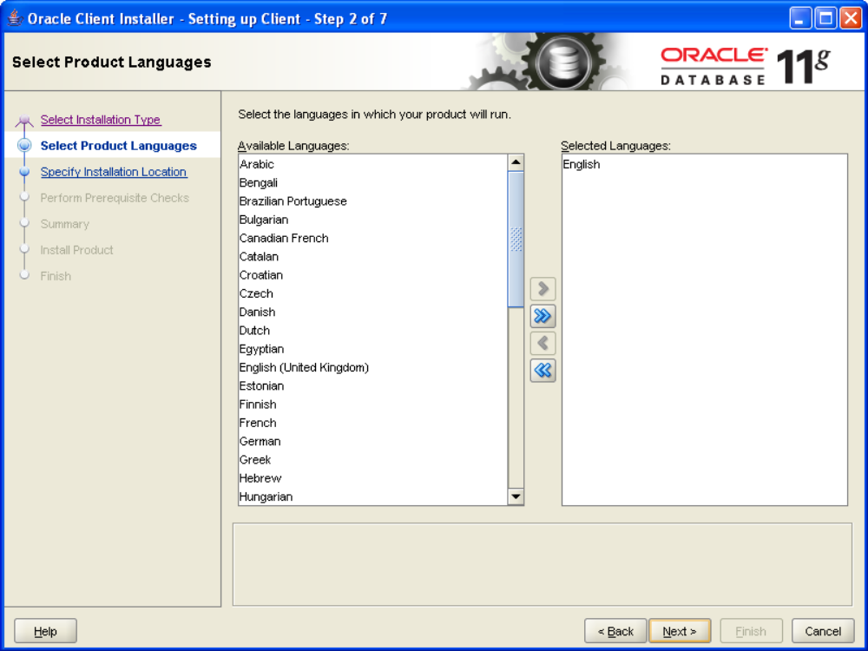

12. The next screen is the Specify Installation Location. Change the Oracle Base field to C:\oracle then click on the Next button.
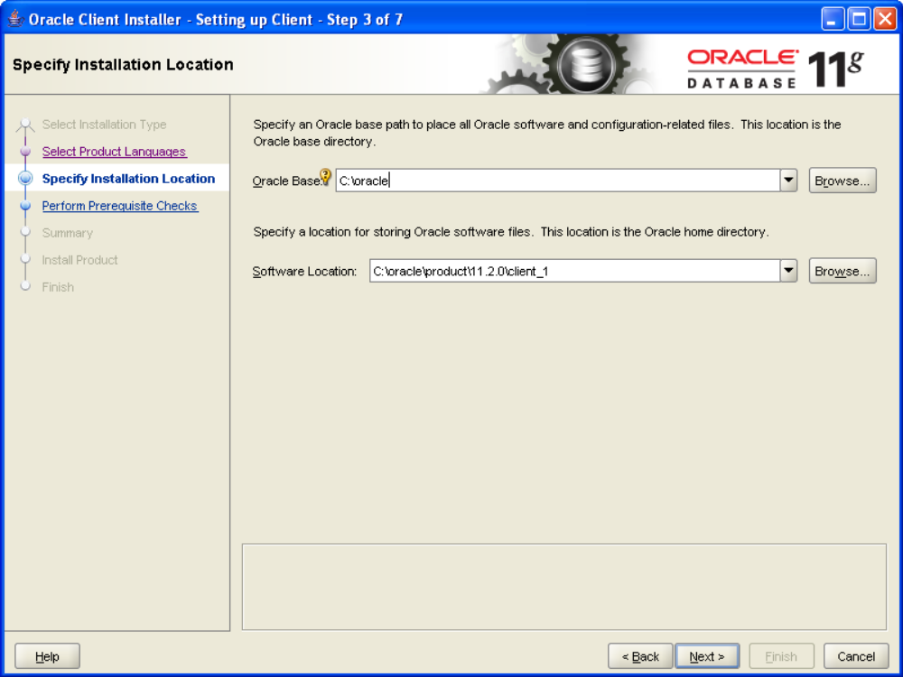

13. The next screen is the Available Product Components. Click on the Oracle ODBC Driver option. Click on the Next button to continue.
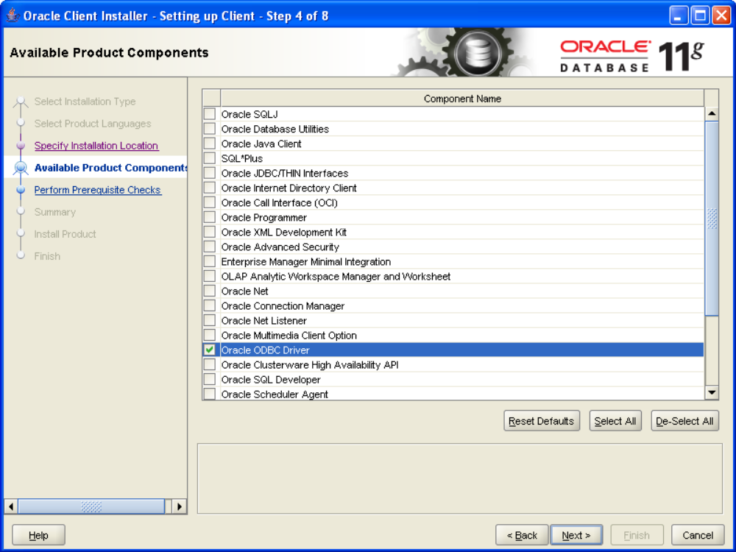

14. The Perform Prerequisite Checks screen will display.
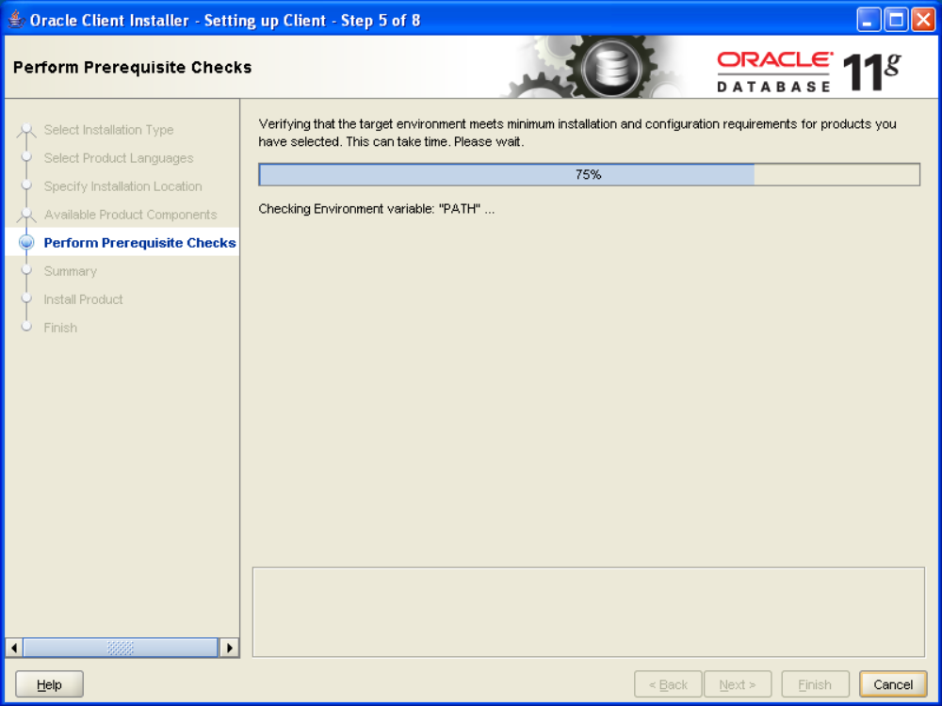

15. The next screen is the Summary. Click the Finish button to start the installation process.
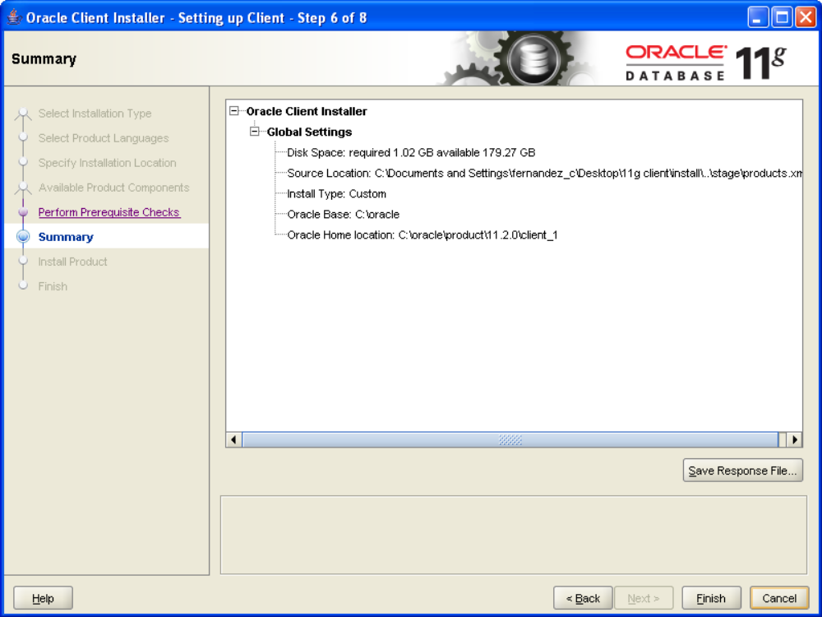

16. During the installation, the screen below will display the installation progress bar.

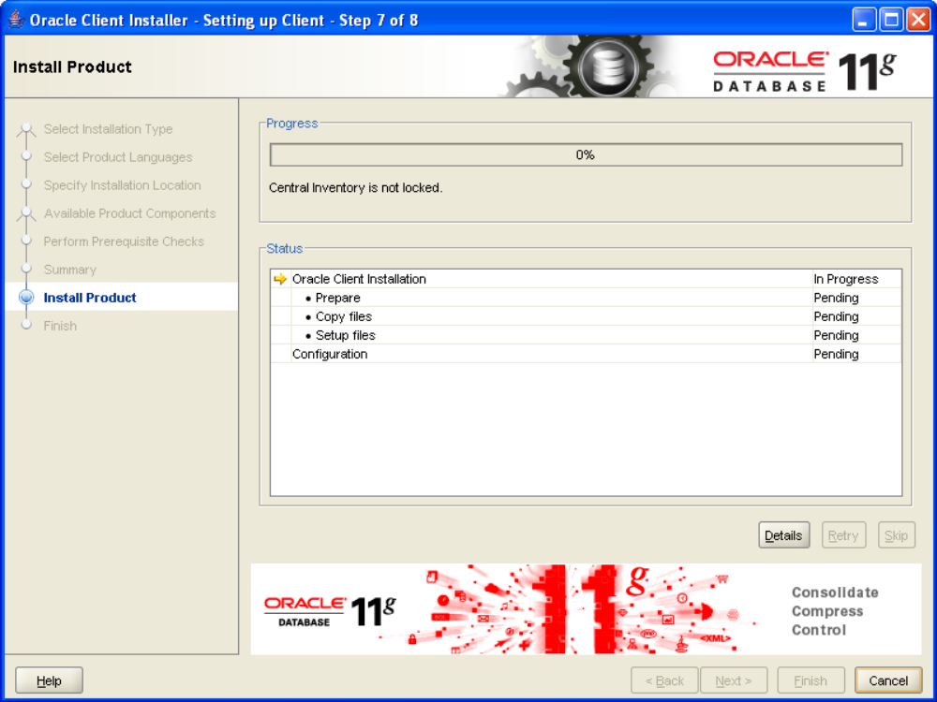

17. When the installation is complete, you will see the Finish screen. Click the Close button to continue.
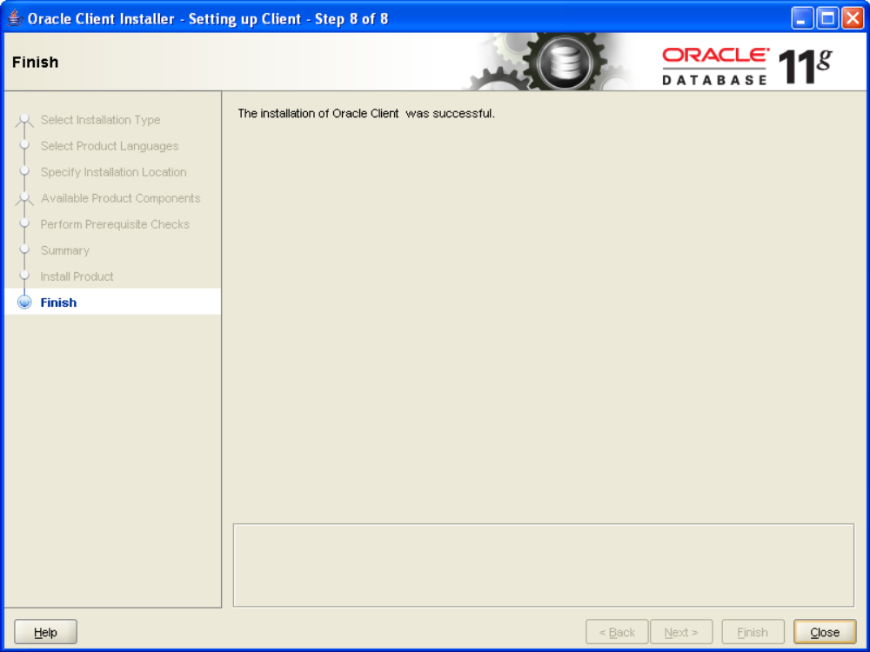

18. When you click the Close button, the window above will close.

Oracle Client is installed

19. When the Oracle Client is installed, you need to include the Oracle Transparent Network Substrate (TNS) information. If you do not have this information, you will receive a message similar to the one below.
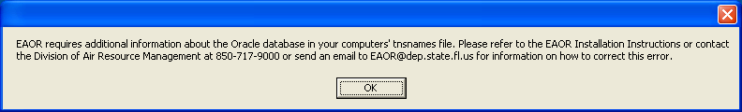
- The tnsnames.ora file is on the Network at: \\fldep1\ARM\All_Common\Emissions Inventory\Oracle-Support\tnsnames . You should copy this file to the directory where the Oracle Client was installed.
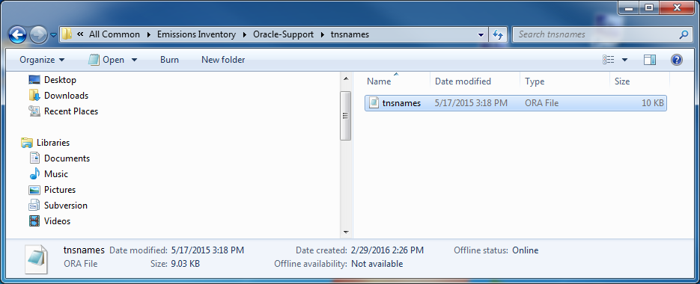

21. The tsnnames.ora file should be added to the \network\ADMIN folder where you installed the Oracle Client. See step number 12 of this section for where the installation path that should be in front of the \network\ADMIN folder. If you already have a tsnnames.ora file in this directory, you will need to edit it to add the EAOR Oracle information.
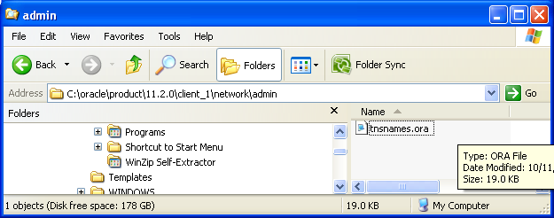

Appendix D – EAOR Folder Permissions Error

Case 1 Windows 7

- Go to C:\Program Files\ (if you have the 32-bit version of Windows 7) otherwise go to C:\Program Files (x86) \ (if you have the 64-bit version of Windows 7) and right click on the EAOR8 Reviewer folder and select Properties and go to the Security tab.

- Select the Users account from the list and then click on the Edit button.

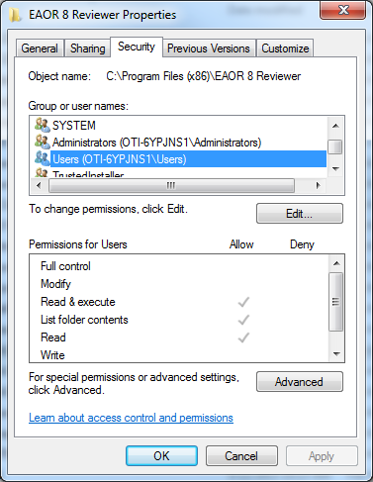

- Select Users again from the list and click on the Modify check box then click on the Apply button
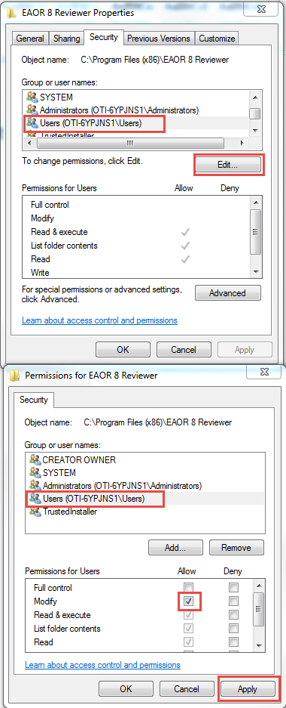

- You’ll be taken back to the dialog box in step 2. The Users permissions should show as selected in the screenshot below.

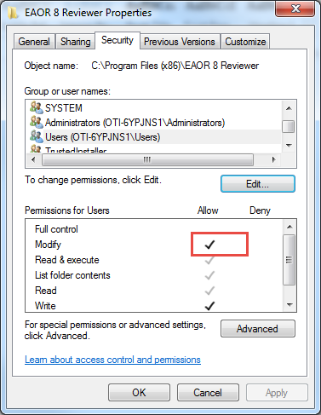

Case 2 Windows 10
- Locate the following folder C:\Program Files\ and right click on the EAOR8 Reviewer folder and select the Properties option, then select the Security tab.

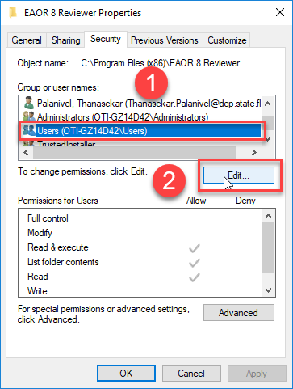

Select the Users group and under Permissions for Users select Modify, Read & Execute, List Folder Contents, Read and Write then click on the Apply button. 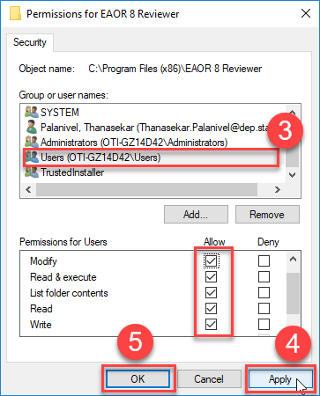

- Verify that the Users group has the following permissions:
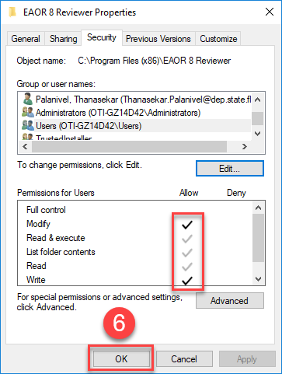

Appendix E – Crystal Reports Error
If you attempt to print/preview reports and/or submit your data file, and you receive the following series of similar error messages, please follow the steps below.

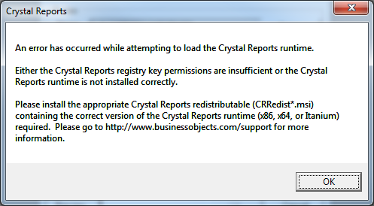
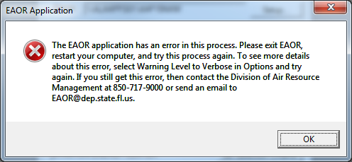
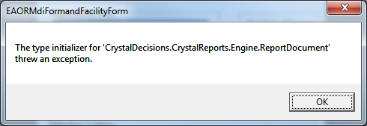

- Uninstall Crystal Reports Basic Runtime for Visual Studio 2008: Go to Control Panel > Programs > Programs and Features > select Crystal Reports Basic Runtime for Visual Studio 2008. Please confirm the program was completely uninstalled and is no longer in the Programs list.
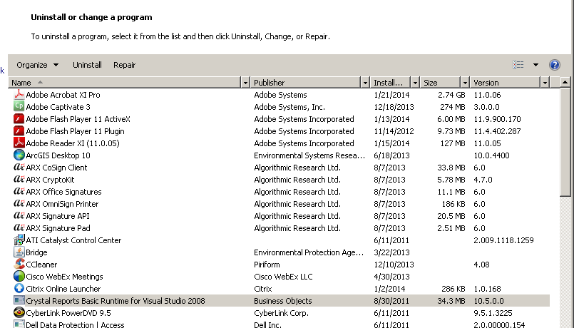

- Download and Install the Crystal Reports software (i.e.10.5 (x86) for 32-bit software running on a 64-bit OS) from the following URL (click on the link below):

http://publicfiles.dep.state.fl.us/DARM/eaor/applications/CRRedist2008_x86.msi

i) The link will display a File Download message box. Click on the down arrow next to the Save button and then Select Save As.

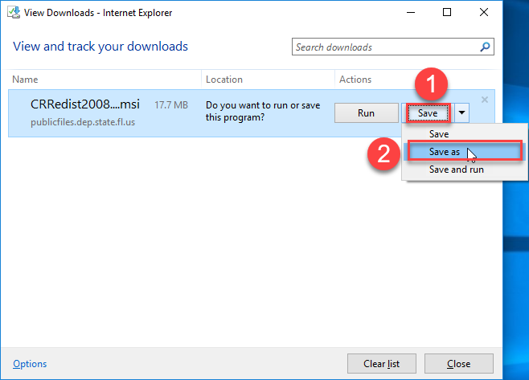

- In the Save As box, select your Desktop or EAOR Default folder (C:\EAOR)
or a temporary folder where you want to save the setup file (CRRedist2008_x86.msi).

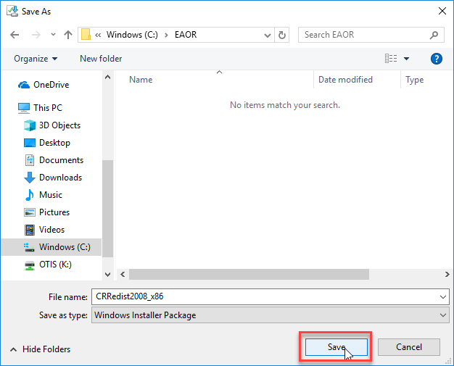

iii) Once the Save is complete then close the download window (click the X as shown in the screen shot below), then go to the folder where you saved the setup file (CRRedist2008_x86.msi).
.
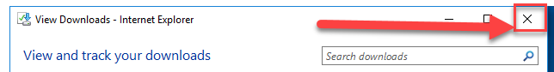

- In the folder where you saved the setup file, right click on the Downloaded file (CRRedist2008_x86.msi) and select ‘Install’ from the list, as shown in the screen shot below.
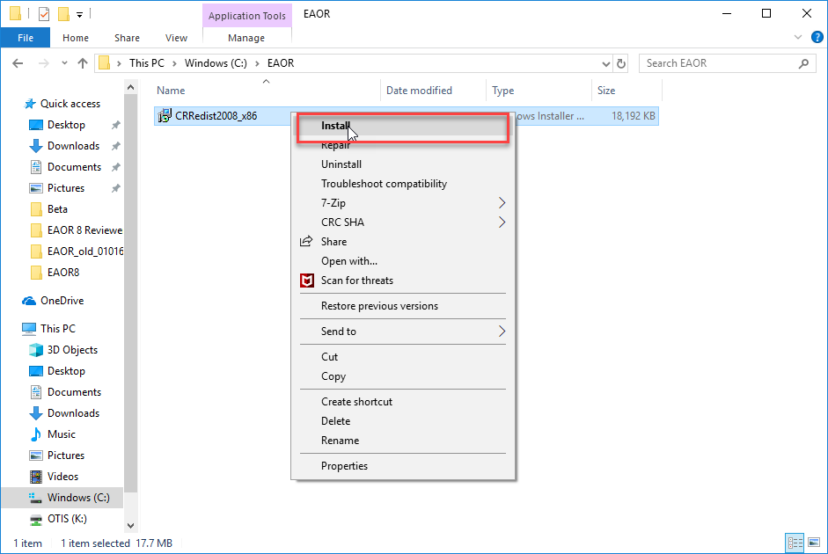
- Once you have clicked on the installation, then you will see the following popup
window for setup initialization:
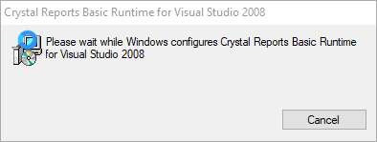
ii) Once the setup initialization is done, then you will see the Security warning for you to Confirm the software install, select Yes to allow the software to install in the system.

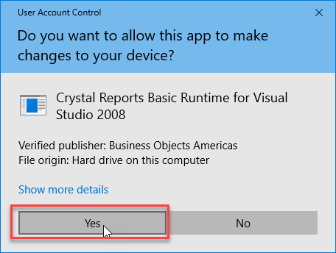
iii) Next, the Crystal Report software installation progress status bar will appear (as shown below). Once the setup has completed, then this popup closes automatically.
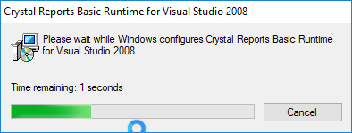

- Go back to your list of Programs from the Control Panel and confirm that the “Crystal Reports Basic Runtime for Visual Studio 2008” has been installed.

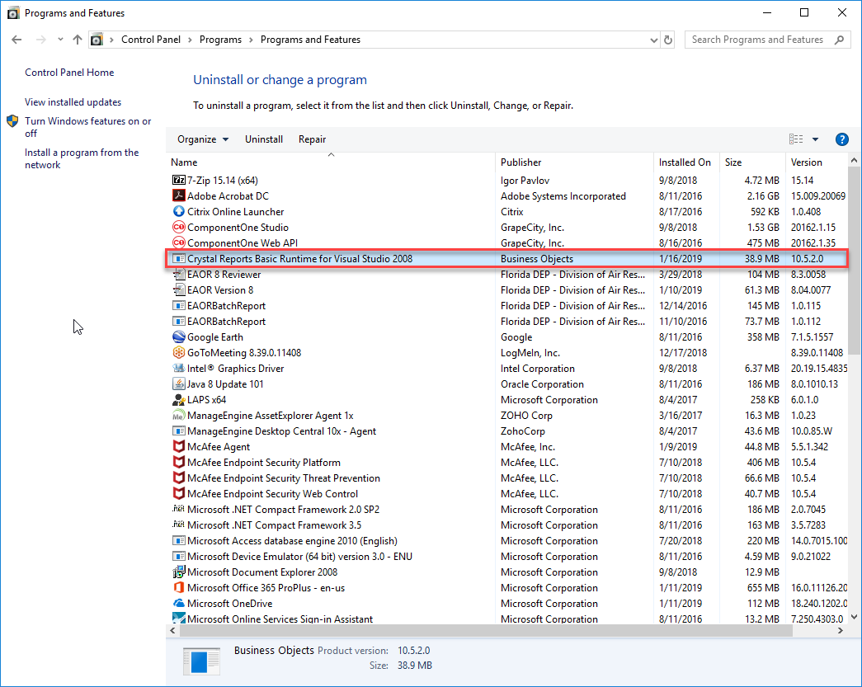

- Open EAOR, try to Print/Preview Reports or if applicable, Submit your data file.

Appendix F – EAOR ‘has stopped working’ Error
If you seem to have a successful install of the EAOR software, but when you go to open the program, the following message appears “Electronic Annual Operating Report has stopped working” or EAOR suddenly closes, then please see below:

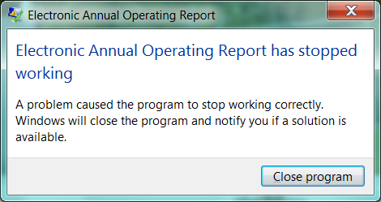

Please do the following:
- Right click on the EAOR Reviewer icon on your desktop.
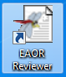

- Select Properties.
- Select the Compatibility tab.

- Check “Run this program as an administrator.”
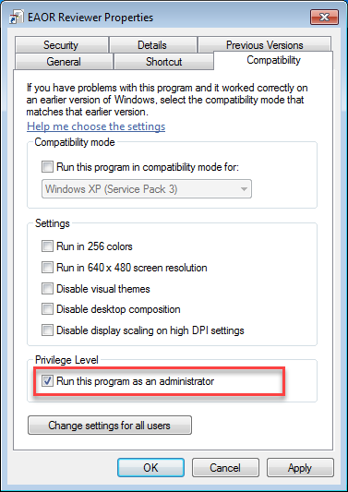
- Click Apply and OK.
- Try to open the EAOR program again.

