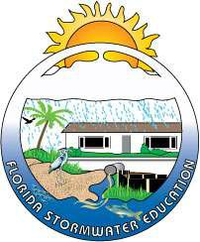
Florida Stormwater, Erosion and Sedimentation Control Inspector Qualification Certificate Program

Dates: September 7th and 8th, 2017

Location: Polk County Natural Resources Division
4177 Ben Durrance Road
Bartow, FL 33830

Registration: Space is Limited, please register early!

To Register Visit: http://www.floridastormwater.com

2-DAY Training Program to obtain state qualification from the Florida Department of Environmental Protection’s Stormwater, Erosion, & Sedimentation Control Inspector Training Program. Course manuals will be provided for each attendee. Bring your own pens, highlighters, sticky notes, etc. as these will not be provided by the instructor. A proctored, closed-book exam will be given on day two. Passing score is 70% or better.

Cost: There is a FEE of $175. However, government employees may attend the training at no charge, and they must still register.

Class Hours: Day 1: 8:30am – 4:30pm

Day 2: 8:30am – 12:00pm (or, upon completion of final exam)

- EARN 12 CONTINUING EDUCATION UNITS (CEUs) FOR CONTRACTOR’S LICENSE PROVIDER NUMBER: 004362 COURSE NUMBER: 0010111
- EARN 8 PROFESSIONAL DEVELOPMENT HOURS (PDHs) FOR FLORIDA PROFESSIONAL ENGINEER’S LICENSE PROVIDER: 0004368

LUNCH: Lunch will be on your own.

Sponsored by Polk County, The Florida Department of Environmental Protection and Cheryl L. Moore Consulting, LLC.

