WIN User Manual

FOR

WIN Phase I
Version 2.03
August 14, 2023

Table of Contents
1. Introduction 7
1.1 Purpose 7
1.2 Help 7
1.3 Contacts 7
1.3.1 WIN Administrator 7
1.3.2 WIN Coordinator 7
1.3.3 Data Provider Administrator (DPA) 9
1.3.4 Data Loader (DL) 9
1.3.5 Monitoring Location Manager (MLM) 9
1.4 Data Upload Overview 9
2. Getting Started: Prepare your Data 12
2.1 Data types and the associated WIN Standards 12
2.1.1 Projects 12
2.1.2 Monitoring Locations – Surface Water (SW) 12
2.1.3 Monitoring Locations – Ground Water (GW) 13
2.1.4 Activities & Results 13
2.2 Getting Started (Initialization) 13
2.2.1 Register within the DEP Business Portal 13
2.2.2 Request a new Organization, if needed 15
2.2.3 Request role for an Existing Organization 16
3. Uploading Data 17
3.1 Overview 17
3.2 Steps to ensure successful file upload and validation 17
3.3 Loading Projects 19
3.3.1 Purpose of the Project 19
3.3.2 Initiating a Project – Add Using Online Interface 19
3.3.3 Initiating a Project – Upload Project(s) 20
3.3.3.1 Using an Existing Configuration 20
3.3.3.2 Upload Project File 20
3.3.3.3 Migrate Projects 21
3.3.4 DEAR Assigns a Project Intended Use 21
3.4 Loading Monitoring Locations 22
3.4.1 Purpose of Monitoring Locations 22
3.4.2 Upload Monitoring Locations 22
3.4.2.1 Using an Existing Configuration 22
3.4.2.2 Upload Monitoring Location File 22
3.4.3 Visually Verify Your Locations 23
3.4.3.1 Verifying Your Location 23
3.4.3.2 Select NHD Reach Code 24
3.4.3.3 Edit Location Data from Map Interface 25
3.4.4 Migrate Your Locations 25
3.5 Loading Activity and Results 26
3.5.1 Create a New Configuration 26
3.5.2 Create Translations 27
3.5.3 Upload Your File Using Configuration 28
3.5.4 Fix Your Data – Basic Validation Rule Errors 28
3.5.4.1 Field Length Errors 30
Global Format Errors 31
3.5.4.2 Code Translation Errors 32
3.5.4.3 Required Value Missing Errors 33
3.5.5 Fix Your Data - Advanced Rule Errors 33
3.5.5.1 Correcting Advanced Errors 34
3.5.5.2 Filtering and Sorting 34
3.5.5.3 Check Adv Errors 35
3.5.6 Edit Staged Data – Record Options 36
3.5.6.1 Export Records with Errors 36
3.5.6.2 Edit Staged Data 36
3.5.6.3 Check Adv Errors 36
3.5.6.4 Migrate Data 36
4. Viewing and Maintaining Migrated Data 37
4.1 Welcome Screen 37
4.1.1 Load Report 37
4.1.2 Monitoring Location List 37
4.1.3 Monitoring Location Detail 38
4.1.3.1 Map Monitoring Location 39
4.2 Search Data 40
4.2.1 Filters 40
4.2.2 Activity List 41
4.2.3 Activity Detail 42
4.2.3.1 Activity Detail - Activity 42
4.2.3.2 Activity Detail - Results 42
4.2.3.3 Activity Detail – Associated Projects 43
4.2.3.4 Activity Detail – Associated QC Activities 43
4.3 Edit Activity 43
4.3.1.1 Edit Activity 43
4.3.1.2 Check Adv Errors 43
4.3.1.3 Migrate Data 43
4.4 Edit Results 43
4.4.1.1 Edit Results 43
4.4.1.2 Check Adv Errors 44
4.4.1.3 Migrate Data 44
5. WIN Application Menu Overview 44
5.1 Home 44
5.1.1 Welcome 44
5.1.2 Sign Out 46
5.2 Manage Data 46
5.2.1 Manage Configuration 46
5.2.2 Staged Data 46
5.2.2.1 Upload Data 46
5.2.2.2 Dataset List 46
5.2.3 Migrated Data 47
5.2.3.1 Load Report 47
5.2.3.2 Search Data 47
5.2.4 Administration 47
5.2.4.1 Audits 47
5.2.4.2 Anomalies 47
5.2.4.3 SVL Requests 47
5.2.4.4 Codes Tables 47
5.2.4.5 Reassign Reach Codes 47
5.3 Manage Account 48
5.3.1 Initialization 48
5.3.1.1 Request New Organization and DPA 48
5.3.1.2 Request Org Role 48
5.3.1.3 Request DEP Role 48
5.3.2 My Account 48
5.3.3 Pending Requests 48
5.4 Reports & Extracts 49
5.4.1 Basic Public Reports 49
5.4.2 Advanced Reports 50
5.4.3 WAVES 50
5.4.4 Manage Saved WAVES 51
5.4.5 Search Data Using a Map 51
5.4.6 WIN Standard Value 53
6. WIN Glossary 53

Table of Figures
Figure 1 - Menu Navigation - Search Data 8
Figure 2 - Organization List and Detail 8
Figure 3 - WIN Upload/Import Process Diagram 11
Figure 4 - DEP Business Portal Registration 13
Figure 5 - WIN Public Welcome Screen 14
Figure 6 - Request New Organization 15
Figure 7 - Request New Role at Organization 16
Figure 8 - Add Project 19
Figure 9 - File Upload screen 21
Figure 10 - Verify Monitoring Locations List 23
Figure 11 - Visually Verify Monitoring Location using Map 24
Figure 12 - Add Configuration - Activity and Results 27
Figure 13 - Translations 28
Figure 14 - Dataset Lists 29
Figure 15 - Staged Data Status 29
Figure 16 - Basic Validation - Field Length Errors 30
Figure 17 - Basic Validation - Global Format Errors 31
Figure 18 - Basic Validation - Code Translation Errors 32
Figure 19 - Basic Validation - Required Value Missing 33
Figure 20 - Staged Data Status - Advanced Validation Errors 34
Figure 21 - Filtering on Data Editable Screens 35
Figure 22 - Load Report 37
Figure 23 - Monitoring Location List 38
Figure 24 - Monitoring Location Detail 39
Figure 25 - Map Monitoring Location 39
Figure 26 - Search Data 40
Figure 27 - Activity List 41
Figure 28 - Activity Detail 42
Figure 29 - Internal WIN Welcome Screen 45
Figure 31 - Advanced Reports 50
Figure 32 - WIN Advanced View & Extraction System (WAVES) 51
Figure 33 - Saved WIN Advanced View & Extraction System (WAVES) 51
Figure 34 - Search Data using a Map 52
Figure 35 - Standard Values 53

Revision History
Date | Comments | Updated By
5/1/2017 | Version 1.0 | Released
9/28/2018 | Created Version 2.0 | Lina Sengupta
10/29/2018 | Created Version 2.01  (Added a caption to figure - 32, updated Table of Figures) | Lina Sengupta
5/29/2019 | 3.5.5.2 Filtering and Sorting, updated to clarify remove value feature | Lina Sengupta
06/30/2023 | Version 2.02 (Updated to match current application) | Brian Weinstein
08/14/2023 | Version 2.03 (Updated Document Links) | Denise Miller

Introduction

Purpose
The purpose of this document is to introduce the Florida Department of Environmental Protection (DEP), Division of Environmental Assessment & Restoration (DEAR) water quality Data Providers to the processes associated with registering users, uploading, and maintaining water quality data through the Watershed Information Network (WIN) web application. This document covers the key steps required to provide data to WIN. WIN is fully supported only by Chrome per standards set by DEP’s Office of Technology and Information Services (OTIS). Compatibility with other browsers cannot be guaranteed. If the WIN application has trouble loading or displaying a screen, please check the browser version being used. If the browser version being used is Chrome and the application is having difficulty loading or displaying a page, please contact your WIN Coordinator.


Help
The application was designed with screen-specific help available, which is not duplicated in this document. If there are questions regarding how to use the screen or the purpose of the screen, relevant guidance can be found by clicking the question mark icon beside the section title on each screen or screen section. The information displayed is designed to provide sufficient details to explain key features of the screen, any role-specific limitations, and the actions available on the screen. WIN Coordinators are available to answer any questions not found in this document or within the screen help text.

Contacts
While there are nine roles within the WIN application, for this guide, focus will be on the five primary types of contacts relevant to the WIN data upload process.

WIN Administrator
The DEP WIN Administrator (WA) should be contacted if you and/or your organization have not yet been approved to upload data to the WIN application. The WA is responsible for confirming new organizations and assigning them to WIN Coordinators and Coordination Areas.

WIN Coordinator
Each reporting organization is assigned to a Coordination Area (e.g., Central District, South District, etc.). Every Coordination Area is assigned at least one WIN Coordinator (WC). This is the individual who will be the primary DEP point of contact for your organization. The WC is available to provide guidance to help facilitate the upload and management of your organization’s data.

If you do not know your Coordination Area or who your WIN Coordinator is, you can find that information in the WIN application on your Organization Detail page or on the Contact List page.

To do so, select the Manage Data Migrated Data Search Data to go to the general Search screen.
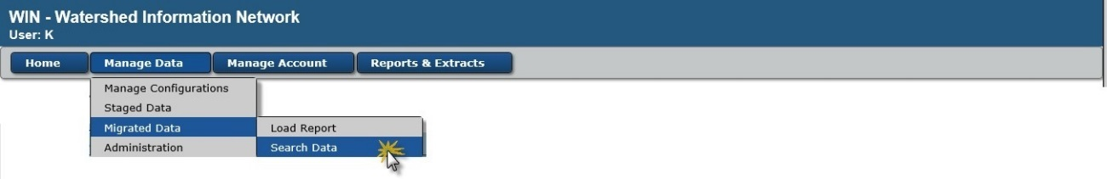
Figure 1 - Menu Navigation - Search Data

From the Search Screen, open the “Organization and Contacts” filter section by clicking on the right arrow. The arrow will turn to a down arrow and the list of filters will be presented. Select your Organization identifier from the “Organization ID” drop down and select the drop down for the “WIN Coordinator”. Your coordinator(s) will be displayed in that drop down.
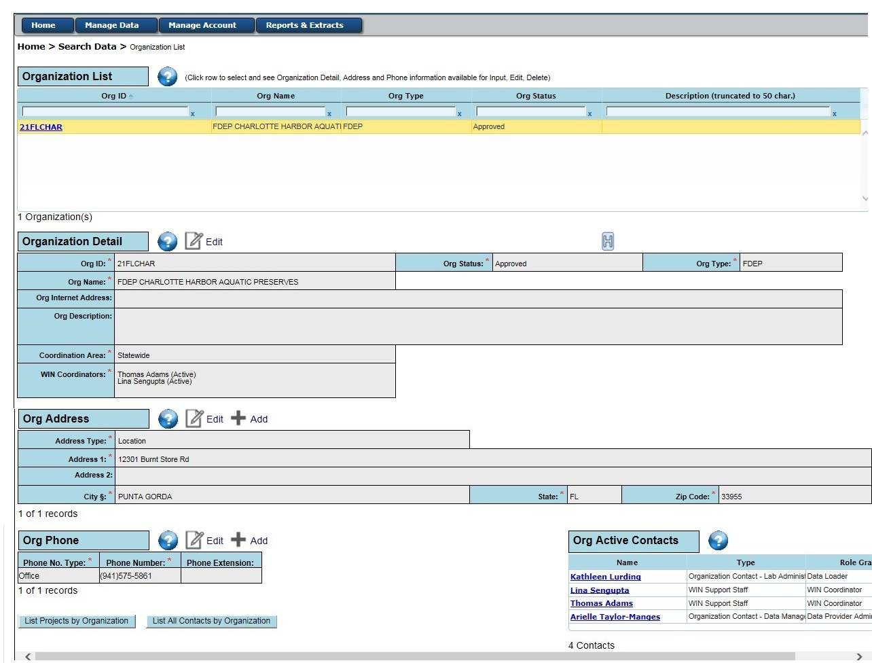
To see full details about your Organization, click on “List Organizations” and select the hyperlink for your Organization ID.

Figure 2 - Organization List and Detail
Alternatively, you can select “List Contacts” to go directly to the list of WIN Coordinators for your organization. From that list you can select each WIN Coordinator to see more details, including their email address and phone numbers.

You can also see a list of all the current WIN Coordinators by Coordination Area at http://publicfiles.dep.state.fl.us/DEAR/WIN/WIN_Contacts.pdf

Data Provider Administrator (DPA)
Each Organization must have at least one Data Provider Administrator (DPA). This is the individual ultimately responsible for approving the additional staff members within their organization who will have authority to upload and manage data. The DPA may manage any file uploaded by any other member of their organization. There can be multiple DPAs for each Organization.

The DPA has the responsibility and authority to approve all other role requests for access to WIN for their Organization and may perform any task authorized by those lower-level roles. They have permission to maintain all organization and project identifier information as well as contact information for any user associated with their organization.

Data Loader (DL)
The Data Loader (DL) is an individual identified to upload or maintain data from their associated Organization to WIN. There can be multiple DLs for each organization. They will work with the organization’s DPA, other DLs, and/or Monitoring Location Manager(s) (MLM) and the organization’s assigned WC. They can manage and view configurations and data in the staging and migrated data environment, including adding a new record and editing existing data for their associated organization. They may respond to any type of anomaly for their organization. They can conduct all activities for the MLM role. An Organization is not required to assign a DL, if the DPA(s) intends to conduct these tasks for their Organization.

Monitoring Location Manager (MLM)
The Monitoring Location Manager (MLM) is an individual identified to upload and visually verify only Monitoring Location data from their associated Organization to WIN. There can be multiple MLMs for each organization. They will work with the Organization’s DPA and/or DL and the Organization’s assigned WC as needed. They can manage ONLY the Monitoring Location configurations and data in the staging and migrated environment for their associated organization. They may respond to Monitoring Location anomalies for their Organization. An Organization is not required to assign a MLM if the DPA(s) and/or DL(s) intends to conduct these tasks for their Organization.

Data Upload Overview
WIN is a web-based system. You will utilize initialization screens to set up your Organization and roles. When submitting data, your text delimited import file will transfer to the DEP application server from which the system will import and check the data in temporary tables according to WIN Standards. This is referred to as the Staging environment. Once cleaned and verified, the data will be migrated into the Production and Warehouse environments where they can be managed and reported. Project and Monitoring Location data must be imported, cleaned, and migrated into the WIN Production tables before Activities and Results data can be loaded. Each project must be approved by your WC before data can be associated to the Project. The WC will contact you to determine if the project is appropriate for WIN (a non-regulatory database) and to assign a Project Intended Use if the Project is approved. Monitoring Locations will need to be visually verified using a mapping interface and must be associated to a National Hydrography Dataset (NHD) Reach Code, if one is applicable, before the Monitoring Location records can be migrated. Activity and Result data will reference the Project ID and Monitoring Location ID within each result row; each Project ID and Monitoring Location ID need to be set up only one time. Please review the WIN Upload/Import Process Diagram in Figure 3.

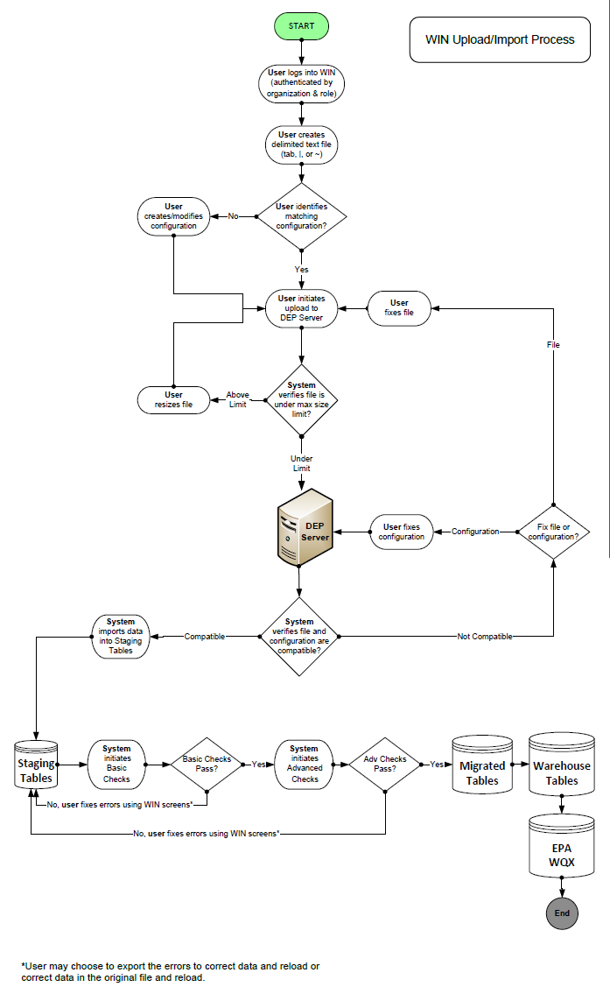
Figure 3 - WIN Upload/Import Process Diagram

Getting Started: Prepare your Data

Data types and the associated WIN Standards
Individual text delimited data files need to be prepared for each data type: Projects, Surface Water Monitoring Locations and/or Ground Water Monitoring Locations, Activities & Results. The text file may either use a pipe (|) or tilde (~) delimiter. Files must pass all WIN minimum data quality standards (MDQS) in order to be migrated. Links to WIN Standards and Examples files are provided below. Example files were developed in Excel in order to provide a spreadsheet format where standard value lists can be selected, and data can be easily viewed.

Files can be converted from Excel to a pipe (|) or tilde (~) delimited file by following the steps listed below:
- Make sure Excel is closed.
- Navigate to the computer’s control panel application.
- Select 'Region and Language'
- Click the 'Additional Settings' button.
- Find the List separator and change it from a comma to your preferred delimiter: | or ~
- Click OK.
- Click OK.
- Open your data file in Excel.
- Save your .xls or .xlsx file as a .csv file.
- Close your Excel file.
- Navigate to your file using Windows Explorer.
- Change the extension of the file name from .csv to .txt.

Each type of data file upload must match a specific Import Configuration file. Your upload file does not have to follow the same order in the example files, nor does it have to contain optional elements that are not relevant to the type of data you are loading. See section 3, Uploading Data, below.

In WIN, some data elements are bound by a Standard Value List (SVL). If your values for these fields are different than the WIN standard values, you will need to translate them. You can change your values to WIN Standard Values before loading your data file or you can set up translations in the Import Configuration. If you are submitting large data files, we advise that you translate your data prior to submitting them to WIN since translations can increase processing time for large datasets.

Please contact your WIN Coordinator if you have any questions as you prepare for WIN.

Projects
Each organization can link an activity to one or more projects for that organization. To see the data fields and WIN Standards for Projects, click here. To see an example Project File in Excel, click here.

Monitoring Locations – Surface Water (SW)
Monitoring Locations are the points where activities are conducted. Information for Surface Water and Spring locations are stored as Surface Water Monitoring Locations. To see the data fields and WIN Standards for Surface Water Monitoring Locations, click here. To see an example Surface Water Monitoring Location File in Excel, click here.

Monitoring Locations – Ground Water (GW)
Monitoring Locations are the locations where activities are conducted. Information for Ground Water locations are stored as Ground Water Monitoring Locations to provide fields for the additional information for Ground Water Wells. To see the data fields and WIN Standards for Ground Water Monitoring Locations, click here. To see an example Ground Water Monitoring Location File in Excel, click here.

Activities & Results
Activities are conducted in relation to one or more Projects for an Organization. To see the data fields and WIN Standards for Activities and Results, click here. To see an example Activities & Results File in Excel, click here.

Getting Started (Initialization)
Now that you have prepared your files for upload, you will need to initialize your organization and role to submit data.

Register within the DEP Business Portal
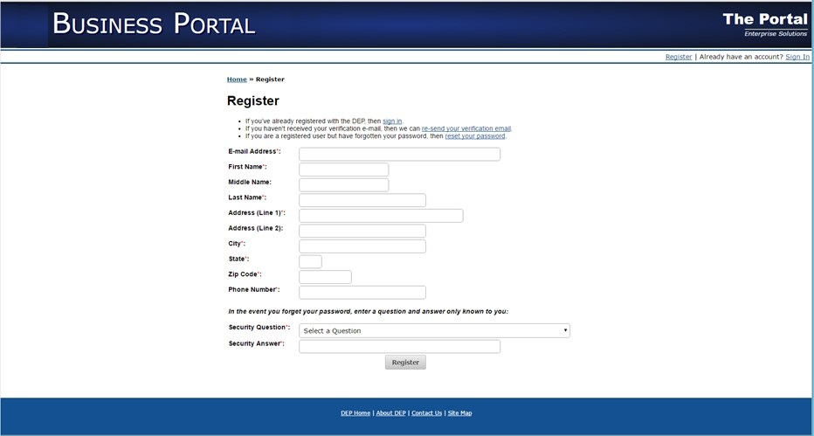
Regardless of the type of role needed, you must first register with the DEP Business Portal to establish an account. Begin by navigating to the DEP Business Portal (http://prodenv.dep.state.fl.us/DepPortal) and select ‘Register’ (in the upper right corner).
Figure 4 - DEP Business Portal Registration

Enter the required information and submit. You will receive an email message with your Login information. DEP staff automatically have an account established and will use their DEP outlook email account and password to sign in by clicking the ‘Login’ button from the WIN Public Welcome Screen.

Once you have established an account with the DEP Business Portal, you may request a new organization and/or a role for an existing organization by either using the buttons on the WIN Public Welcome Screen, or through menu navigation by clicking Manage Account Initialization and selecting the appropriate action from there. Those options are further described below.
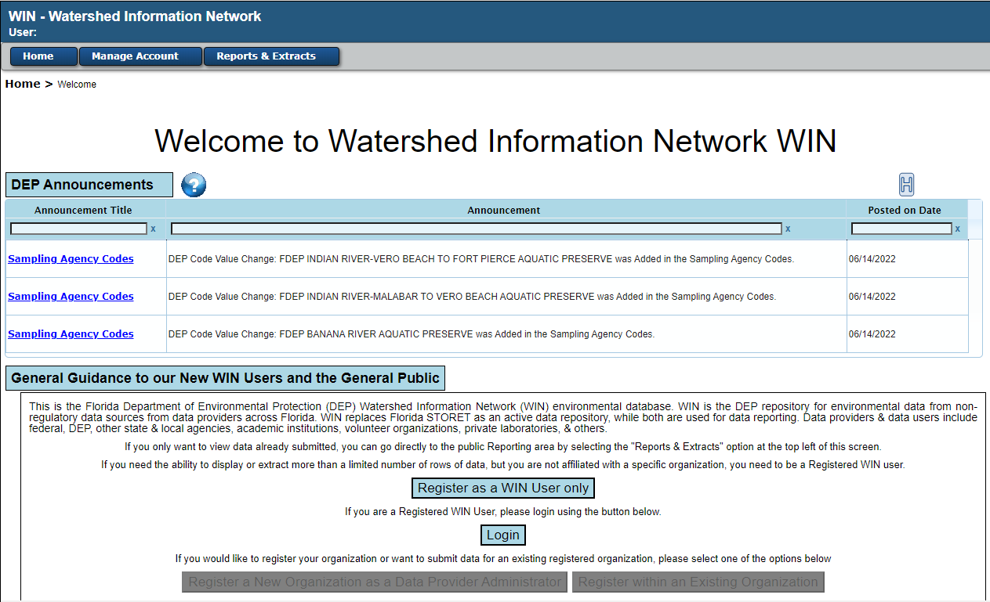
Figure 5 - WIN Public Welcome Screen

Request a new Organization, if needed
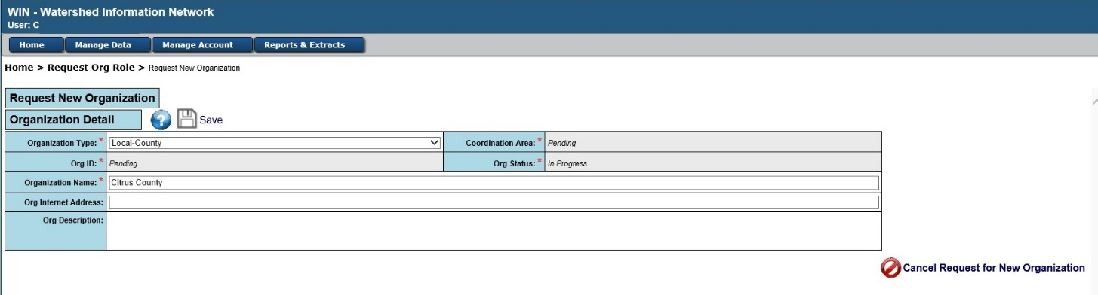
If you need to submit data for a new organization, you will need to submit a request for a new organization. The person initiating this request is automatically assigned the DPA role for the organization. You can add more or edit the DPAs once the organization is established. From the WIN Public Welcome Screen, you can select ‘Request New Organization and DPA’ under the Manage Account menu. You will be taken to the New Organization Role screen to enter your contact information and request the DPA role and then to the New Organization screen to enter the organization information. Once all information is successfully entered, a request will be submitted for approval for the new organization and DPA role. You will receive an email once your request has been reviewed informing you if your request has been approved or denied.

Figure 6 - Request New Organization

Request role for an Existing Organization
If you need to join an existing organization as a Data Provider (DPA, DL or MLM) use the Manage Account menu option to select ‘Request Org Role’ from the Initialization sub menu which is under the Manage Account menu. You will enter your contact information and select the organization you wish to join and submit the request by clicking Save & Request New Role.
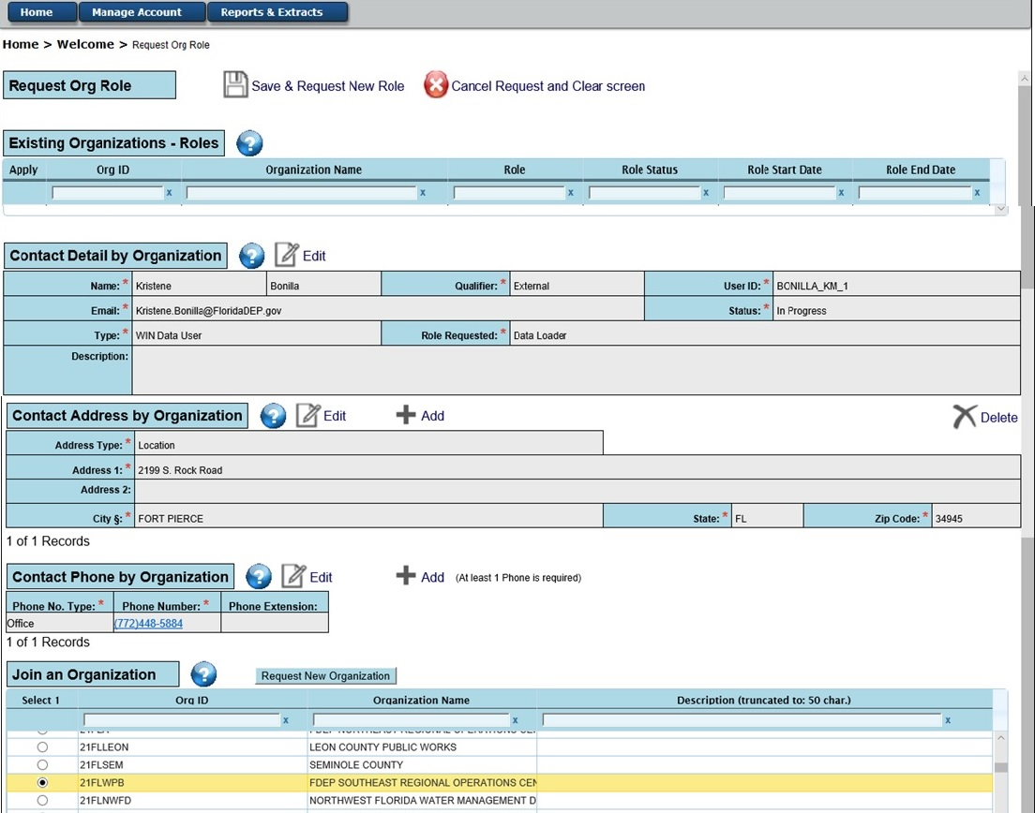
Figure 7 - Request New Role at Organization

You will receive an email once your request has been reviewed informing you if your request has been approved or denied. Once you are approved, you may login from the Public Welcome Screen.

Uploading Data

Overview
Your data will be uploaded based upon the data type: Project, Monitoring Locations (SW) and/or Monitoring Locations (GW), and Activity and Results. Activity and Results must have preloaded Projects and Monitoring Locations prior to loading.

File import configurations are created in WIN based on WIN Standards. When new organizations join WIN, they customize the Import Configurations based on the data they collect. Data that have predefined value options i.e., they are Standard Values Lists (SVL), are defined as drop-down lists. When organizations need additional options in the drop-down lists, WIN provides ability to make request for creating the translations. The process for creating Import Configurations and Translations is similar for the three data types. Example for creating Import Configuration and Translations is described for Activity and Results data type in Sections Create a New Configuration and Create Translations. Once the Import Configuration is available, it can be utilized to upload data.

As data is uploaded, WIN performs data checks based on WIN Standards. The data upload process is exactly same for the three data types and details are in Section Steps to ensure successful file upload and validation.

The steps that are different for Projects and Monitoring Locations are explained in the respective sections for Projects (Section Loading Projects, DEAR Assigns a Project Intended Use) and Monitoring Locations (Section Loading Monitoring Locations, Visually Verify Your Locations).

Error correction steps are common to the three data types and are described under Loading Activities and Results in Section Fix Your Data – Basic Validation Rule Errors and Fix Your Data - Advanced Rule Errors.

Once error resolution is complete and the staged data passes error checks, the import will need to be migrated. After the data is migrated, the status of imported data updates to “Migrated”. If the user does not migrate the import file, it will be purged from WIN after 45 days. All data imports once uploaded to staging unless migrated, will be purged. An automated email is set to remind the data loader about the purge date.

WIN automatically moves the Migrated data to the Warehouse on a pre-set schedule. The status of imported data remains in the Dataset List screen as ‘Migrated’ for 8 days after which it is purged. Data that is purged by WIN, deleted or migrated by data loader are eliminated from Dataset List screen. There is a history of previously uploaded files and their status available by accessing the “H” icon in the upper right corner.

Steps to ensure successful file upload and validation
On the Upload Data Screen, initially File Upload (Organization ID, Type and Config Name) file import parameters are selected. Under the Select One heading, there are two options. You can select a file from your computer using the ‘Choose File’ button to the right of the ‘Files on My Computer’ option or select from ‘Files on DEP Server’ which will contain a list of files you have loaded in the past under this associated organization. This second option is useful if there was an error in your import configuration (and not the data in the file) which prevented the file from being imported. You can simply select the corrected import configuration along with the file that you already loaded from the ‘Files on DEP Server’ drop down.

If your text file has a Header Row with column names, click the Check Box “Ignore Leading Header Row in Upload File”. (Note: If you forget to do this, WIN will read the headers as Translation Errors.).

The Status field displayed in the middle of the screen will initially be blank. Once you have selected all required fields in the ‘File Upload’ screen and have selected your import file, click the “Submit and View File Status” button. Click OK on the next message “Do you want to submit this file for uploading and validation?”. Start Time and a “spinning blue ring” will display while the process is in progress. Status field will update to ‘Uploading’ and the following warning message will be displayed:

‘The HTTP Process is now in progress. Do not navigate from this page while the Status is ‘HTTP Process” or the process will be cancelled”.

While the file import is ongoing, Status will show as “Uploading”. Once file import is complete, validation will begin automatically.

You MUST stay on the Upload Screen as long as the HTTP message is displayed. This means that your file is still being uploaded and/or validated. The Warning message is displayed until file upload is complete and validation has started. Once the Warning message clears, you have the choice to navigate away from the Upload Data screen. Before the upload, “End Time” is blank. After the upload is complete, “End Time” will update. If you were not able to see the “End Time” it is because as soon as the upload is complete, WIN automatically transitions the view to the Dataset List Screen.

On the Dataset List Screen while data validation is in progress, you will see Status as ‘Validating’. After the Validation is complete and no errors are found, you will see the Status transition to ‘Ready for Migration’. Otherwise the Status will display ‘In Staging with Errors’. A hyperlink below Import File ID will be enabled. Using this hyperlink, you can navigate back to the Staged Data Status Screen.

Loading Projects

Purpose of the Project
Projects are created to group together activities performed for the same project purpose. A project is linked to an organization; one or more projects may be linked to an organization. Activities can be linked to one or more projects during the upload of your Activity and Results file; Activities and Results must be linked to at least one Project. Projects can be created using an online interface one at a time or multiple Projects can be created through an upload/import process using a text delimited file.

Initiating a Project – Add Using Online Interface
If you are an authorized user (DPA or DL), you can create a Project for any organization with which you are associated from the Project Detail screen in WIN by clicking on ‘Add’. The system will clear all the fields on the Project Detail screen and display the Save and Cancel options. You will select an Organization, enter a Project ID (must be unique within the selected organization), Project Name,
Description, Start Date, End Date (Optional), Project Type, and Customer (Optional) and save your request for a new Project. Your WIN Coordinator will assign the Project Intended Uses as a part of approving that the project and related data are appropriate for WIN.

If you don’t want to add a Project manually, you can also elect to create an import file for uploading one or more projects at once.
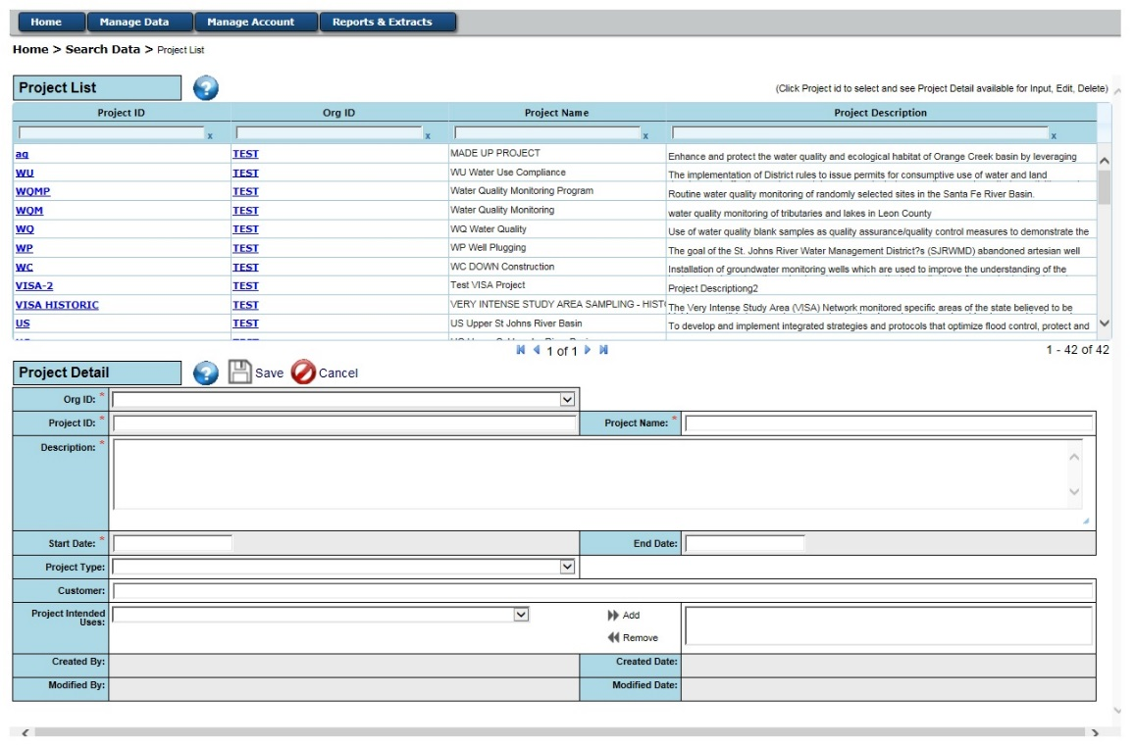
Figure 8 - Add Project

Initiating a Project – Upload Project(s)

Using an Existing Configuration
If you are an authorized user, you can upload one or more Projects to the WIN system. Before uploading your text delimited project file, you must ensure there is an import configuration set up in WIN that matches your file format. Using the Menu Option: Manage Data Manage Configurations, you will see an ‘Import Configuration List’ in the top half of your screen. These are configurations associated to your organization regardless of which user created them. You can use the sort and filter functions to help locate a configuration (Refer to Section Filtering and Sorting). Select a configuration using the radio button and then either click the ‘View’ or ‘Edit’ action button below that grid to see the details of the configuration in the Import Configuration Detail screen. You can also clone one of those configurations using the ‘Clone’ action button and modify it for your use.

If you click either the ‘Show Other Configurations’ or ‘Show System Configurations’, a second grid will appear in the bottom half of the screen. ‘Show Other Configurations’ provides a list of configurations created by all other organizations and ‘Show System Configurations’ lists configurations set up by DEP. Click the radio button next to the configuration of interest and use the action buttons below the list of configurations to ‘View’, ‘Edit’, or ‘Clone’ one of these configurations.

If you need to create a new configuration, select the ‘Add’ action button (Refer to Section Create a New Configuration for further steps).

Upload Project File
Once the data file and configuration are prepared, you will upload the Projects to WIN. You can do one of the following:
- Click on the ‘Upload Data’ button at the bottom right corner of the Import Configuration Detail screen using menus: Manage Data Manage Configs and then click ‘View’ or ‘Edit’ after selecting the matching configuration, or
- Navigate directly to the File Upload screen using the menus: Manage Data Staged Data Upload Data.

On the Upload Data screen under the ‘File Upload’ section, you will select the Organization for which you are uploading data, ‘Project’ from the ‘Type’ drop down, and the configuration that matches your file.

Refer to Section Steps to ensure successful file upload and validation

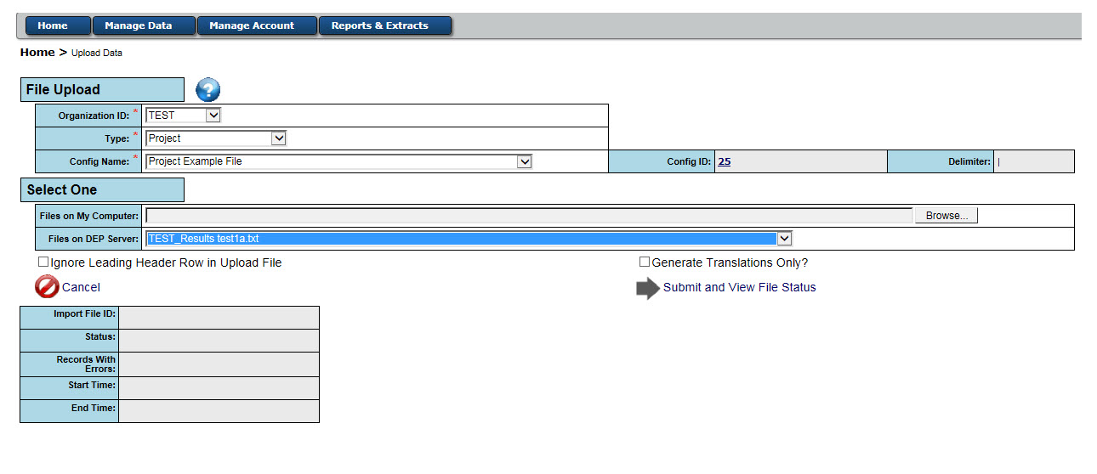
Figure 9 - File Upload screen

Migrate Projects
After the Projects are uploaded, you can view the summary in the Staged Data Status screen to see if there are any Basic or Advanced Errors. Use the menu Manage Data Staged Data ‘Dataset List’ to bring up the list of datasets. Locate your dataset and click on the ‘Import File ID’ hyperlink to be taken to the Staged Data Status screen.

You can use the sort and filter functions to help locate your dataset (Refer to Section Filtering and Sorting). You will need to address the errors identified in your uploaded data. Refer to Section Fix Your Data – Basic Rule Errors and Section Fix Your Data – Advanced Rule Errors for general guidance on resolving errors. Your data file does not have to be error free to migrate the records that are fully cleaned. Once you have at least one record that is free of errors the ‘Migrate Records’ button will be displayed, and only the clean records can be migrated to Production. Records with errors will remain in staging. When you select the ‘Migrate Records’ option, you will be asked if you want to ‘Migrate and Export’, ‘Migrate Only’, or ‘Cancel’.

‘Migrate Only’ will move the cleaned, staged projects into WIN Production. ‘Migrate and Export’ will move the clean, staged projects into WIN Production and generate a text-file export of the clean records for your use. ‘Cancel’ will prevent the records from being migrated into Production at that time.

DEAR Assigns a Project Intended Use
Once a Project is successfully added or migrated to WIN Production, the Project will appear in the Welcome Screen Reminders section for Projects. An authorized DEAR WIN user (WA or WC) will review the project, communicate with the requestor as needed, and assign Project Intended Use(s) to the project if it is approved. Once the Project Intended Use(s) are assigned, the Project will be available for association to Activities and Results.

Loading Monitoring Locations

Purpose of Monitoring Locations
Monitoring Locations are places where sampling (monitoring) activities are conducted. There are two types of Monitoring Locations: Surface Water (SW) and Ground Water (GW). Ground Water monitoring locations can contain Well data in addition to the monitoring location data. Surface Water monitoring locations are composed of Surface Water and Spring monitoring location types. Surface Water and Ground Water Monitoring Locations cannot be loaded in the same file using the same configurations. They must be loaded in different files.

Upload Monitoring Locations

Using an Existing Configuration
If you are an authorized user with the appropriate role, you can upload one or more Monitoring Locations to the WIN system. Before uploading your text-delimited monitoring location file, you must ensure there is an import configuration set up in WIN that matches your file format.
Using the Menu Option: Manage Data Manage Configurations, you will see an ‘Import Configuration List’ in the top half of your screen. These are configurations associated to your organization regardless of which user created them. You can use the sort and filter functions to help locate a configuration (Refer to Section Filtering and Sorting). Select a configuration using the radio button and then either click the ‘View’ or ‘Edit’ action button below that grid to see the details of the configuration in the Import Configuration Detail screen. You can also clone one of these configurations using the ‘Clone’ action button and modify it for your use.

If you click either ‘Show Other Configurations’ or ‘Show System Configurations’, a second grid will appear in the bottom half of the screen. ‘Show Other Configurations’ provides a list of configurations created by all other organizations and ‘Show System Configurations’ lists configurations set up by DEP. Click the radio button next to the configuration of interest and use the action buttons below the list of configurations to ‘View’, ‘Edit’, or ‘Clone’ one of these configurations.

If you need to create a new configuration, select the ‘Add’ action button (Refer to Section Create a New Configuration for further steps).

Upload Monitoring Location File
Once the data file and configuration are prepared, you will upload the Monitoring Locations to WIN. You can do one of the following:
- Click on the ‘Upload Data’ button at the bottom right corner of the Import Configuration Detail screen using menus: Manage Data Manage Configs and then click ‘View’ or ‘Edit’ after selecting the matching configuration; or
- Navigate directly to the File Upload screen using the menus: Manage Data Staged Data Upload Data.

On the Figure 9 - File Upload screen under the ‘File Upload’, you will select the Organization ID for which you are uploading data. From the ‘Type’ drop-down, either select ‘Monitoring Location (SW)’ if your data contain either Surface Water or Spring locations or ‘Monitoring Location (GW)’ if your data contain Well or other ground water locations. Finally, select the configuration that matches your file.

Refer to Section Steps to ensure successful file upload and validation

The Staged Data Status screen provides key information needed for identifying the errors that remain in your file. If any errors exist, you will need to resolve them before proceeding to visually verify your locations. See the section ‘Fix Your Data – Basic Rule Errors’ and the section ‘Fix Your Data – Advanced Rule Errors’ for guidance on resolving errors.

After all Basic and Advanced errors for a monitoring location have been corrected, the monitoring location must be visually verified before it may be associated to a project(s) or to activities and results.

Visually Verify Your Locations
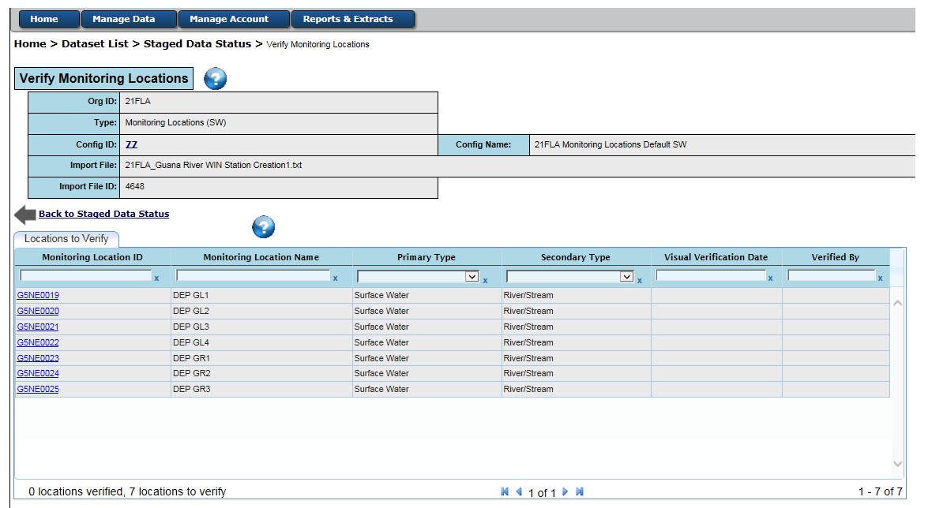
To begin the visual verification process, click one of the hyperlinks within the ‘Verify Monitoring Locations’ grid. You will be transferred to the list of Monitoring Locations that need to be verified. All locations that have passed Basic and Advanced rule validation will be listed on the ‘Locations to Verify’ tab.
Figure 10 - Verify Monitoring Locations List

Verifying Your Location
As you complete the visual verification process, the ‘Visual Verification Date’ and ‘Verified By’ fields will automatically populate. For a location that needs to be verified, click on the Monitoring Location ID hyperlink to bring the point up on the ‘Map Mon Locations’ tab. If the location is wrong, click the location on the map to which the point should be moved to. You can also use the search feature in the top right of the map to manually put in the Latitude and Longitude where you would like to move the monitoring location. The format must be Lat, -Long (e.g., 25.0131, -81.5463). After entering your coordinates, press the enter button and the map will move to the new location. You must then click the point on the map to physically move the location to the new coordinates.

Select NHD Reach Code
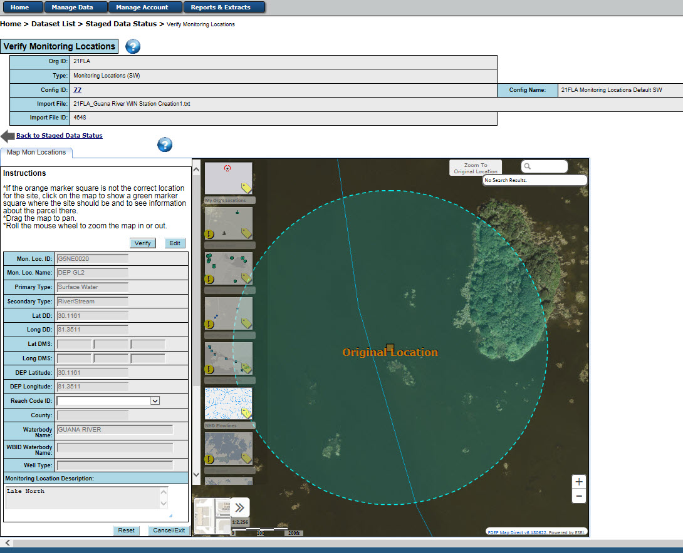
Once you have confirmed your location, the ‘Reach Code ID’ will populate with the USGS National Hydrography Dataset (NHD) reach codes within your map view, ordered by proximity to your point. When you select a value from this drop down, the feature will highlight on the map.
Figure 11 - Visually Verify Monitoring Location using Map

NOTE: Selection of a ‘Reach Code ID’ is not required for the following ‘Secondary Types’: ‘Estuary’, ‘Ocean’, ‘Wetland’, ‘Spring Boil’, ‘Other-Surface Water’, ‘Spring Vent’, ‘Other-Spring’, ‘Well’, or ‘Other-Ground Water’.

Once you have selected the correct reach code for your location, you can click the ‘Verify’ button in the top of the left panel of your screen. NOTE: If the ‘Secondary Type’ and the type associated to the ‘Reach Code ID’ are conflicting, a warning message will be displayed. Also, if your ‘Secondary Type’ is either ‘Ocean’ or ‘Wetland’ and the location does not appear to fall on water, a warning message will be displayed. You may override these warnings if you determine the location and/or selected ‘Reach Code ID’ are correct. The application will give you the option to either go back to the list or stay on the map to verify the next location.

If no Reach Codes exists, you can select the ‘Request New Reach Code’ option from the ‘Reach Code ID’ drop down. A popup window will display the information and ask you to confirm that you want to request a new reach code to assign to this location.

If you have questions regarding assigning a Reach Code to your Monitoring Location, contact your WIN Coordinator.

Edit Location Data from Map Interface
From the Map Mon Locations tab screen, you can click on the ‘Edit’ button to be taken to the Edit Staged Data screen to update the Monitoring Location records that have passed all Basic rules. This does not allow you to change latitude and longitude values, however it will allow you to change the primary and secondary type, the description, and the name of the monitoring location. On the Edit Staged Data screen, while in Edit mode, you can check one or more Monitoring Locations and enter the corrected values in the text field under the column to be updated and then click on ‘Save’. If no records are checked, the button will be ‘Save All’. If you have checked any Monitoring Locations, the button will be ‘Save Selected’. If any Monitoring Locations need to be deleted, you can check the records to be deleted and click on ‘Delete Selected Records’.

Migrate Your Locations
Once you have finished visually verifying your location(s), you can navigate back to the Staged Data Status screen using the ‘Back to Staged Data Status’ button on the ‘Locations to Verify’ tab. If at least one monitoring location passes all validation checks and is visually verified, the ‘Migrate Records’ button will appear. Only the clean and visually verified monitoring location records can be migrated to production. Records with errors or those that have not been visually verified will remain in staging. Upon click, you will be asked if you want to ‘Migrate and Export’, ‘Migrate Only’, or ‘Cancel’.

Loading Activity and Results

Create a New Configuration
As noted in Section Using an Existing Configuration you can utilize an existing configuration or clone a configuration for your use. You can also create a new configuration to meet the needs of your data. The WIN Standard for Activity and Result File is available in WIN standards
Use the menu Manage Data Manage Configurations to bring up the Manage Configuration screen. Under the ‘Import Configuration List’ grid, click on the ‘Add’ action button. Note: All required fields indicated by * need to be populated.

Select the organization, enter a name for the configuration, select ‘Activity and Results’ from the ‘Type’ drop down, enter a description, and select the delimiter that is used in your import file (| or ~). If you would like the system to initiate the setup of translation with values in your import file that do not match WIN Standard Values for you to map those to a WIN Standard Value, then check the ‘Generate Translations’ check box. Refer to Section Create Translations for more information on completing the setup of translation.

In the “Columns’ section you can do the following:
- Change the position of the columns to match your data file by editing the position number or using the ‘Move Up’ or ‘Move Down’ arrows at the bottom of the ‘Column’ grid.
- Check ‘Include’ if this field is in your upload file. To exclude the column, click the ‘Skip/Gen’ radio button instead. Note: if there is an asterisk (*) in the ‘Req’ column, you must either click the ‘Include’ radio button or put a value in the ‘Generate Value’ text box if you want the system to use this value for the associated column every time you upload data using this configuration. When the ‘Generate’ option is used, you do not need to have an empty column in your upload file; the system will generate it for you. If you have the data column in your file but want to default to a value any time it is empty, you can add that default value to the ‘Default Value’ text box and keep the ‘Include’ radio button checked.
- Show the format that your data will be in. This is only relevant for Latitude, Longitude, and Date/Time fields. Number fields will show a format in order to trap errors such as ‘0..003’ but this format it is not editable.
- You can set up translations by clicking the ‘Translate’ button in the ‘Translation’ column. This button is only visible when the data element is bound by a standard value.
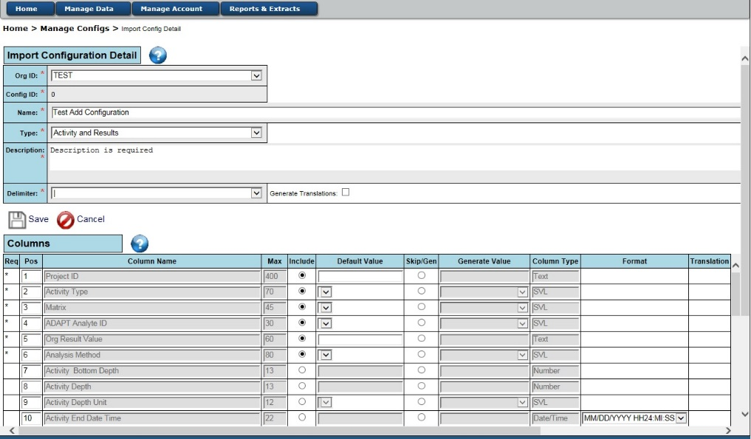
Figure 12 - Add Configuration - Activity and Results

Create Translations

In WIN, some data elements are bound by a Standard Value List (SVL). If your values for those fields are different than the WIN standard values, you will need to translate your values. You can change your values to WIN Standard Values within your data before loading your data file or you can set up translations in the Import Configuration. If you are submitting large data files, we advise that you translate your data prior to submitting them to WIN since translations can increase processing time for large datasets.

To set up translations, navigate to the Import Configuration of interest by using the menus: Manage Data Manage Configs. Select a configuration and click ‘Edit’. Scroll to the data element of interest and click the ‘Translate’ button in the last column called ‘Translation’. Type the value found in your import file in the ‘Translate From’ column. You can then update the ‘Translate To’ column by clicking inside the ‘Select Value For “Translate To”’ column. A drop down will appear for you to select the corresponding WIN standard value. When finished, click ‘Save’.

The system will automatically populate the ‘Translate From’ column any time it finds a non-standard value if you check the ‘Generate Translations Only’ box on the Import Configuration Detail screen (navigate using menus: Manage Data Manage Configs. Select a configuration and click ‘Edit’).

If you want to generate the ‘Translate From’ column for a specific import file rather than any time that configuration is used, you can click the ‘Generate Translations Only’ box on the File Upload screen (navigate using menus: Manage Data Staged Data Upload Data).

Any time you add a new translation to resolve errors, you will need to start the validation process again once your translations are saved. To do this, navigate to your import file using the menu navigation: Manage Data Staged Data Dataset List. Click the associated hyperlink under the ‘Import File ID’ column to navigate to the Staged Data Status screen. Click the ‘Check Errors’ button in the bottom left corner of this screen.

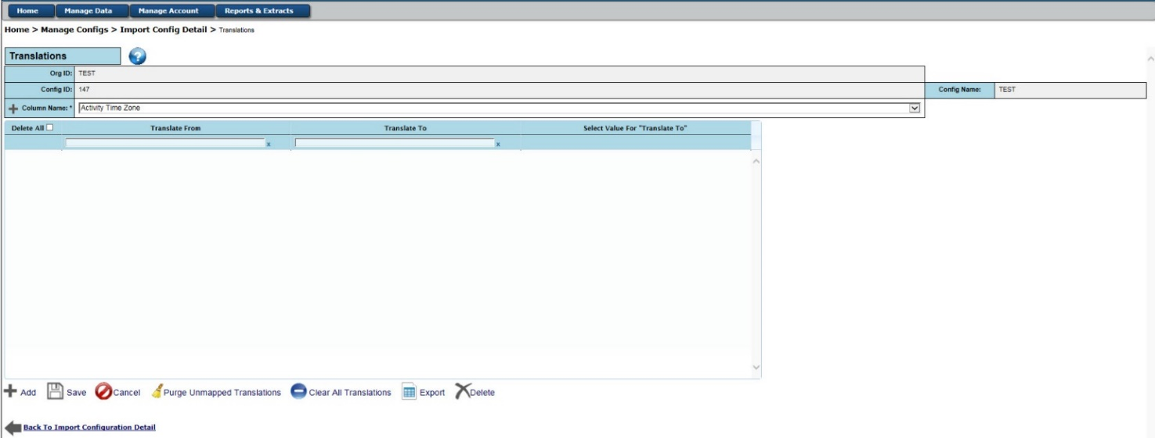

Upload Your File Using Configuration
Once the data file and configuration are prepared, you will upload your Activities and Results to WIN. You can do one of the following:
- Click on the ‘Upload Data’ button at the bottom right corner of the Import Configuration Detail screen using menus: Manage Data Manage Configs. Select a configuration and click ‘Edit’ or
- Navigate directly to the File Upload screen using the menus: Manage Data Staged Data Upload Data.
Figure 13 - Translations
On the Upload Data screen under the ‘File Upload’ section, you will select the Organization ID for which you are uploading data. From the ‘Type’ drop down, select ‘Activity and Results’ and select the configuration that matches your file.

Refer to Section Steps to ensure successful file upload and validation.

Fix Your Data – Basic Validation Rule Errors
Once your file is uploaded to staging, you can use WIN screens to fix the Basic Rule errors that were identified in your data.

You can either transfer to the Staged Data Status off the File Upload screen by clicking the hyperlink record count next to ‘Records With Errors’ or pick your uploaded file from the Dataset List screen displayed when you select the menu Manage Data Staged Data Dataset List.

The Dataset List screen includes all the uploaded files which are still available with errors to be remediated, records to be migrated or, if you prefer, files to be deleted. There is a history of previously uploaded files and their status available by accessing the “H” icon in the upper right corner.

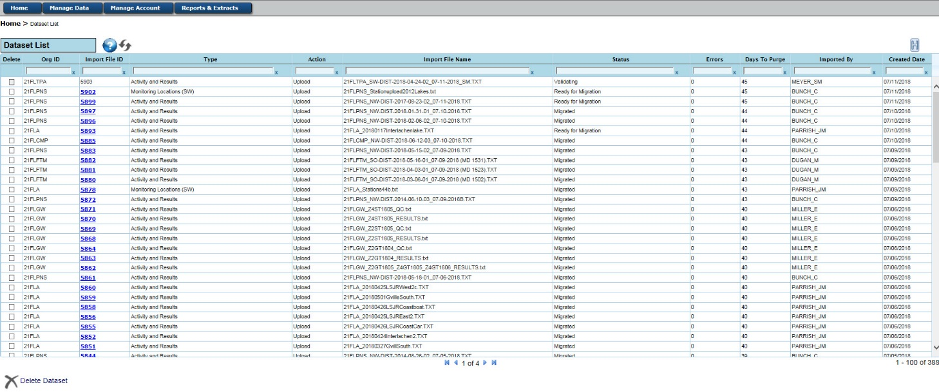
Figure 14 - Dataset Lists
Once you find your import file, you can select the hyperlink under the Import File ID (unique identifier assigned when you uploaded your file) and you will be transferred to the Staged Data Status Screen to see the details of your uploaded file.

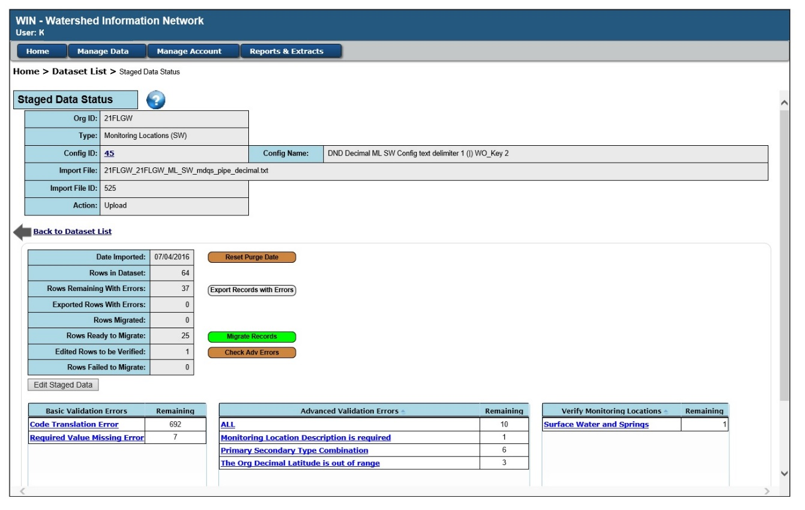
Figure 15 - Staged Data Status

This screen provides general information on your import file and configuration as well as record counts related to remaining errors, rows ready to migrate, etc. In the bottom portion of this screen, hyperlinks are displayed to view any errors identified, by type, within the file.

You should resolve all Basic Validation Errors before working on the Advanced Validation Errors. On the Staged Data Status screen, you can click on one of the hyperlinks under Basic Validation Errors and be taken to the Validation Errors screen. There are four tabs on this screen: Field Length
Errors, Global Format Errors, Code Translation Errors, and Required Value Missing Errors. The hyperlink you clicked will be the tab that is in focus.

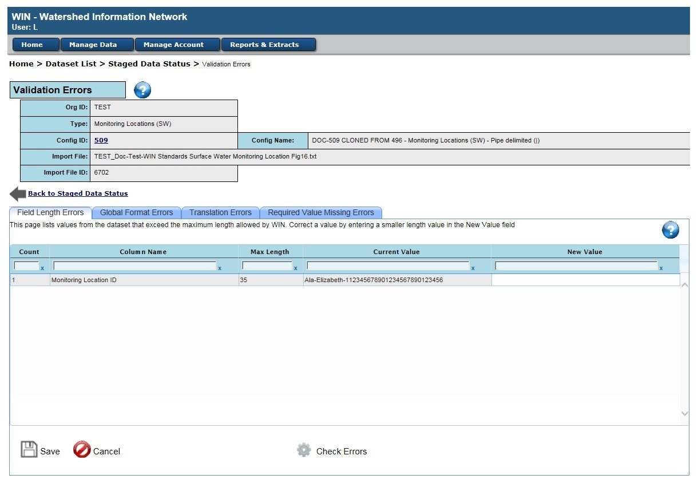
Field Length Errors
Figure 16 - Basic Validation - Field Length Errors

This tab will display records that contain more characters than the maximum allowed. Field lengths are provided in the WIN standards documents. The ‘Count’ column displays the numbers of records in the import file that have the same value as displayed in the ‘Current Value’ column. Enter a value with a valid length in the empty text box beside the data in error and below the ‘New Value’ header. A valid length is one that does not exceed the value shown in the ‘Max Length’ column for the line. You can correct multiple errors and click on ‘Save’ or click on the ‘Save’ after each modification.

Your new values will not replace the ‘Current Value’ and will continue to display as a ‘New Value’ until you run the ‘Check Errors’. This allows you to continue fixing other data errors prior to running the MDQS validation checks. Clicking ‘Check Errors’ allows you to see if you resolved all expected errors.

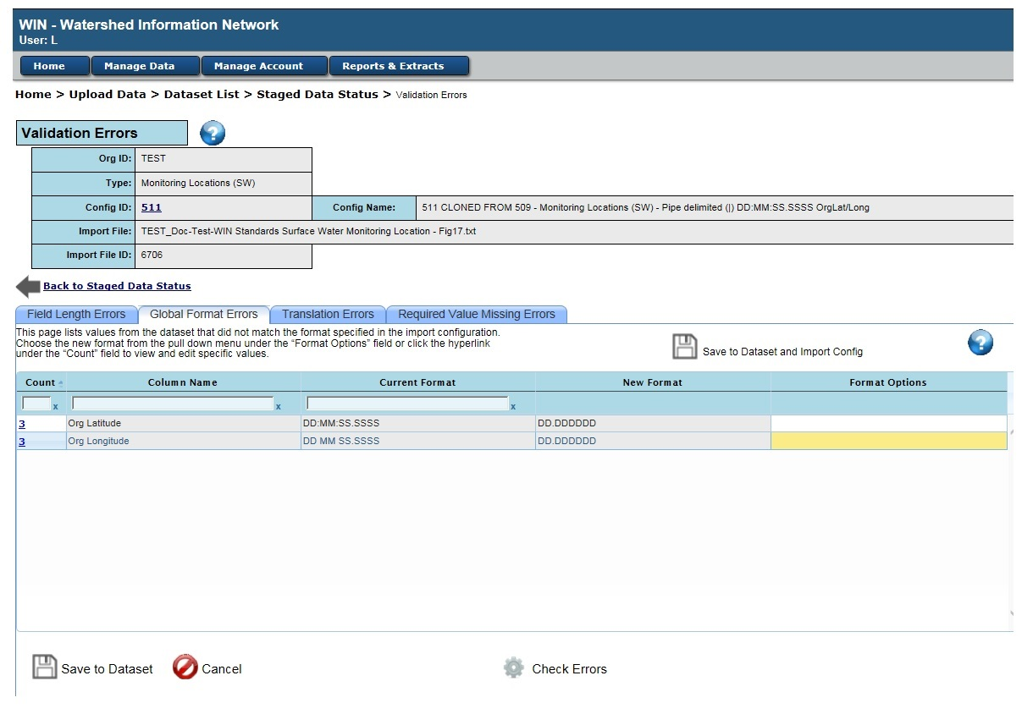
Global Format Errors
Figure 17 - Basic Validation - Global Format Errors

This tab will display records that contain fields where the data do not match the format as defined by the Import Configuration File. For example, if you uploaded a date of 01/13/2016 but you selected the format for that field as DD/MM/YYYY, then either the month is wrong, or the data format is wrong. This will be captured as a Format Error. The ‘Count’ column displays the number of records that have the ‘Current Format’ for the associated ‘Column Name’. You will select the format from the ‘Format Options’ dropdown list that matches the format for your data for the associated ‘Column Name’. Once the New Format is selected, click on ‘Save to Dataset’ at the bottom of the screen if you want to use only this format on the import file you are currently working with. Click on the ‘Save to Dataset and Import Config’ (above the grid) to use this format every time you upload a file using the configuration associated with this imported file.

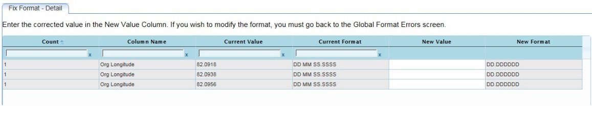
If the error in your data was not related to the format, but rather to the value, then you can select the hyperlinked ‘Count’ value and fix the data on the ‘Fix Format – Detail’ tab. This screen displays the expected format of the selected field and allows you to universally fix invalid values by field.
Above figure shows when configuration Current format was changed to match Current Value.
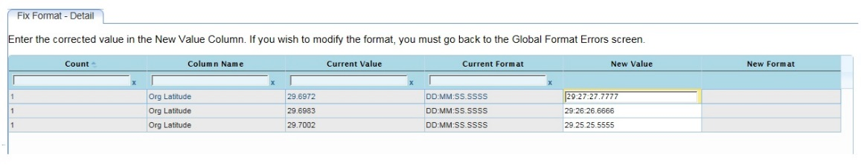
Above figure shows when data New Value was edited to match the Current format configuration.

Your new values will not replace the ‘Current Value’ and will continue to display as a ‘New Value’ until you run the ‘Check Errors’. This allows you to continue fixing other data errors prior to running the MDQS validation checks. You may continue fixing other issues or click the ‘Check Errors’ icon at the bottom of the screen to see if you resolved all expected errors.

Code Translation Errors
This tab will display records that contain a value that does not match a WIN Standard Value List (SVL) entry when one is required. The ‘Count’ column displays the number of records in the import file that have the same non-standard value as displayed in the ‘Translate From’ column. You can select the corresponding WIN SVL by clicking inside the ‘Select Value For “Translate To”’ column. A drop down will appear for you to select the corresponding WIN SVL.
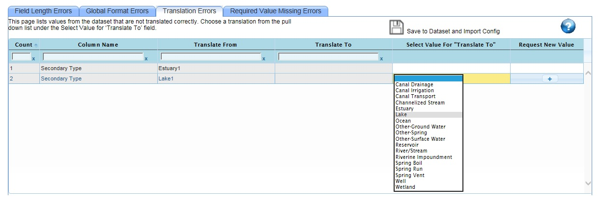
Figure 18 - Basic Validation - Code Translation Errors
When finished mapping each translation, click ‘Save to Dataset’ at the bottom of the screen if you want to use these translations only for the import file you are currently working with. You also have the option to click on the ‘Save to Dataset and Import Config’ (above the grid) to use these translations for this file and every time you upload a file with these non-standard values using this configuration.

Your new values will not replace the ‘Translate From’ and will continue to display as a ‘Translate To’ until you run the ‘Check Errors’. This allows you to continue fixing other data errors prior to running the MDQS validation checks. You may continue fixing other issues or click the ‘Check Errors’ icon at the bottom of the screen to see if you resolved all expected errors.

Required Value Missing Errors
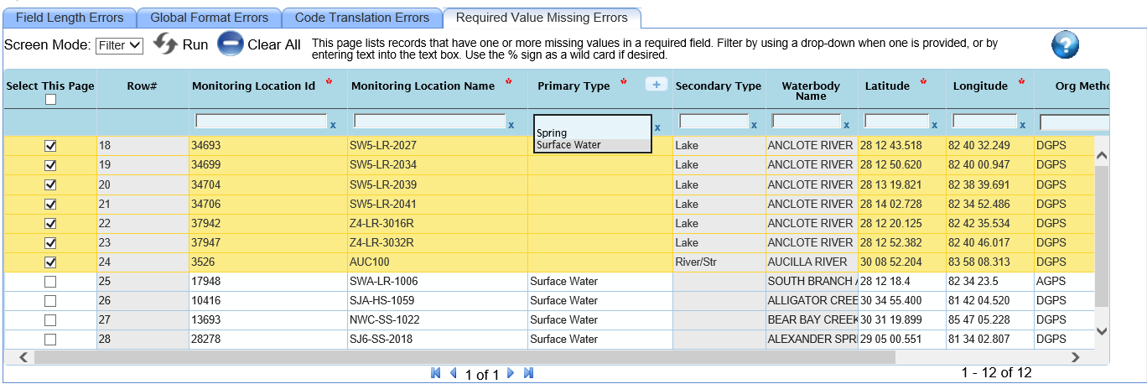
Figure 19 - Basic Validation - Required Value Missing

This tab will display records for which no value was provided in the import file for one or more required fields. You can use the Section Filtering or Sorting functions to find all records that are missing a certain value or correct the records one at a time. To Edit the data, select ‘Edit’ from the ‘Screen Mode’ drop down right below the tabs. Enter a value in the text box below the field names for one or more columns. You can:
- Edit certain rows by checking the corresponding box in the ‘Select This Page’ column and click ‘Save Selected’ at the bottom of the screen; or
- Click the ‘Save All’ button at the bottom of the grid to save the changes to the entire error list for this tab.
You may continue fixing other issues or click the ‘Check Errors’ icon at the bottom of the screen to see if you resolved all expected errors.

Fix Your Data - Advanced Rule Errors
After all Basic Errors are resolved, you will use WIN screens to address all Advanced Validation Errors that were identified in your import file. The rules that are violated will be named in the ‘Advanced Validation Errors’ section of the Staged Data Status screen. If you are on any tab of the ‘Validation Error’ screen for basic errors, you can return to the Staged Data Status screen by clicking the ‘Back to Staged Data Status’ link above the tabs. You can also navigate to your import file using the menu navigation: Manage Data Staged Data Dataset List. Click the associated hyperlink under the ‘Import File ID’ column to transfer to this screen.

Within the ‘Advanced Validation Errors’ section, you can select the hyperlinked rule name to address errors by type or you can select the ‘All’ hyperlink to address all advanced errors.

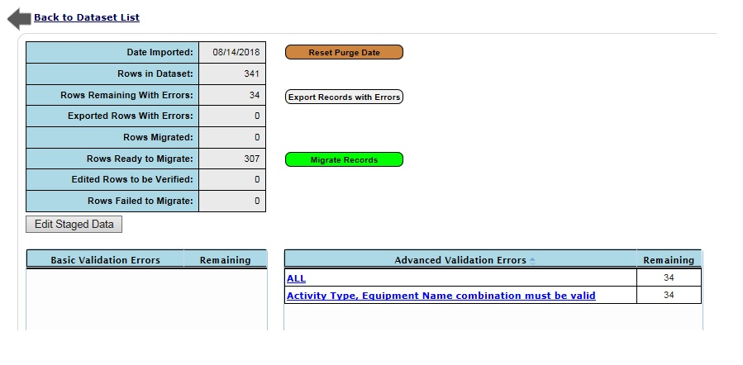
Figure 20 - Staged Data Status - Advanced Validation Errors

The advanced validation checks include checks such as conditionally required values, logical date order, impossible result values, Value Qualifier checks, and so on. Please refer to the WIN standards documents for details.

Correcting Advanced Errors
You can use the Section Filtering or Sorting functions to find all records containing your filter criteria or you can correct errors one at a time. To edit the data, select ‘Edit’ from the ‘Screen Mode’ drop down right above the data grid. Enter a value in the text box below the field names for one or more columns. You can either edit certain rows by checking the corresponding box in the ‘Select This Page’ column and click ‘Save Selected’ at the bottom of the screen or you can click the ‘Save All’ button at the bottom of the grid to save the changes to the entire filtered error list for this tab. You may continue fixing other issues or click the ‘Check Adv Errors’ icon at the bottom of the screen to see if you resolved all expected errors.

Filtering and Sorting
You can sort most lists within the WIN system by clicking on the up / down arrows next to the heading of the field to sort by. Clicking multiple times will alternate sorting in ascending and descending order.

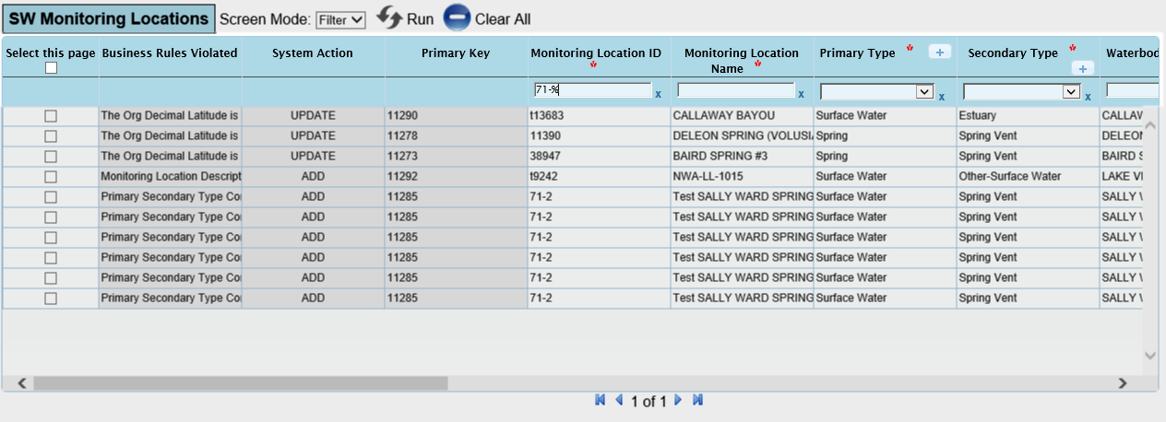
There are two versions of Filtering employed within WIN and both allow for the use of ‘%’ as a wildcard to allow for partial value filtering. One version is used on those screens that also allow updating of data. On those screens, the text box below the heading is used for both filtering and updating. To identify your intended action, you must set the Screen Mode to ‘Filter’ before entering filter information and click on the Run to apply the filtering. There is also a ‘Clear All’ button to clear all filters. Filters on these data management screens will stay applied to allow for editing on the filtered records shown.
Figure 21 - Filtering on Data Editable Screens

The other ‘list only’ screens use the text box below the field heading to filter the data displayed in the list. For example, if you are on the Manage Configs screen and only want to see Project configurations for a certain Organization, you can enter the organization ID in the Organization ID text box and enter ‘Project’ or ‘Pro%’ or ‘%RO%’ in the Configuration Type text box as shown below and then press the Enter key. The search is case insensitive. The system will now limit the list to Project type configurations for the organization specified.

When editing data (Filter mode), there is the ability to search for blank free-form text field values by typing the phrase “isnull” into the filter box (not available for date, numeric, or drop-down fields). To remove a filter, click on the ‘x’ next to the field.

As part of error correction, if data is to be removed, WIN provides a “REMOVE VALUE” function. For text fields, the phrase ‘REMOVE VALUE’ can be typed into the text box to remove the value. For date fields, type ‘ 01/01/0000 ‘ into the text box to remove a date. To remove a value from an SVL dropdown list, select ‘* REMOVE VALUE *’ from the list. Note that values cannot be removed from required WIN fields. Once the Save button is clicked, changes will be refreshed.

Check Adv Errors
After making edits to resolve Advanced Validation Errors, you will need to click on ‘Check Adv Errors’ at the bottom of the ‘Advanced Validation Errors’ screen to check all the records that have not been migrated. This button will only appear when the ‘Screen Mode’ is set to ‘Edit’. You can also run the procedure from the Staged Data Status screen. If you run the procedure from the ‘Advanced Validation’ errors screen, the ‘Activities and Results’ section will be refreshed to remove any records that no longer have any advanced errors after the procedure is completed. If you run it from the Staged Data Status screen the ‘Advanced Validation Errors’ grid will be updated after the procedure completes. It is possible for records for which you resolved issues to now appear with a new issue from the values you entered.

Edit Staged Data – Record Options

Export Records with Errors
From the Staged Data Status screen, you can click on the ‘Export Records with Errors’ button to remove error records from the staged import file and receive a text-file export of the data as it was originally submitted. Depending on the number of records in error, this process could take several minutes.

Edit Staged Data
From the Staged Data Status screen, you can click on the ‘Edit Staged Data’ button to be taken to the Edit Staged Data screen to update records that have passed all Basic rules. On the Edit Staged Data screen, while in Edit mode, you can check one or more activities and enter the correct text in the text field under the column to be updated and then click on ‘Save’. If no activities are checked, the button will be Save All. If you have checked any activities, the button will be Save Selected. If any activities need to be deleted, you can check the activities and click on ‘Delete Selected Records’.

Check Adv Errors
After making changes to the data on the Edit Staged Data screen, you will need to run the Check Adv Errors procedure again to make sure no Advanced Rules have been violated by the changes. Refer to Section Fix Your Data - Advanced Rule Errors for details on this procedure.

Migrate Data
Once all changes have been made to the data and errors are resolved, you will use the Staged Data Status screen to migrate the clean activities and results into the WIN database. The ‘Rows Ready to Migrate’ button is only displayed when there is at least one record in the import file that has passed all Basic and Advanced Validation rules (and, in the case of Monitoring Locations, has been Visually Verified). When the ‘Rows Ready to Migrate’ line is displayed showing at least one record, you can then click on ‘Migrate Records’. Select the Migrate option you wish from within the popup window. The system will migrate the validated activities and results from the staging area into WIN Production.

Viewing and Maintaining Migrated Data

Welcome Screen
The WIN Welcome screen displays DEP Announcements and has a link to the Anomaly List, and Load Report and provides reminders for the following:

- List of Import Files that are about to expire
- Audits that have been entered or updated
- List of Organization Role requests
- List of Code Table requests
- List of Projects that have been recently approved.

Load Report
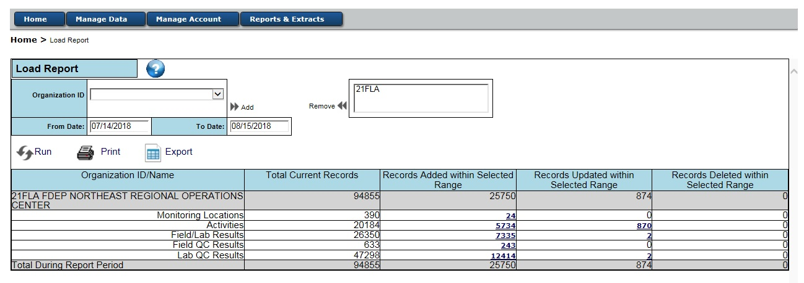
If you have uploaded and migrated a dataset, you can use the Load Report to view the records in WIN Production. Click on the ‘Load Report’ Button to the right of ‘My Reminders’. The Load Report allows you to select the organization(s) and date loaded time frame to view the number of records that were Added, Updated and Deleted for Monitoring Locations, Activities, Field/Lab Results, Field QC Results and Lab QC Results. The number of Monitoring Locations, Activities, Field/Lab Results, Field QC Results and Lab QC Results for each organization currently in the Migrated environment is also displayed in the ‘Total Current Records’ column. You have the capability to export all the data in the report by clicking on the ‘Export’ button or to display the list of records by clicking on the count hyperlink.
Figure 22 - Load Report

Monitoring Location List
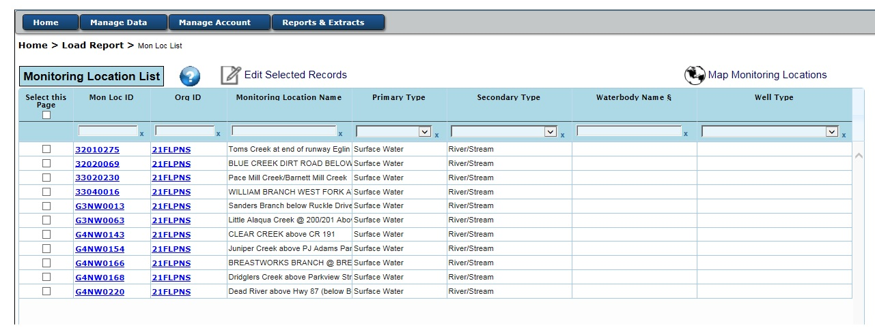
If a count for Monitoring Locations Added or Updated within a Date Range is selected on the Load Report screen, the Monitoring Locations for that count will be displayed on the Monitoring Location List screen. You can also get to the Monitoring Location List screen from the Search Data screen. See the Section Search Data and Section Filters below. If you need to see more detail for a Monitoring Location, you can click on a Mon Loc ID hyperlink to display the detail on a Monitoring Location Detail screen. From the list, you can select multiple monitoring locations to Edit, Map or Export by checking the checkboxes of the desired records and then clicking on the action icon. Refer to the Section Edit Activity below for sending data back to staging for editing.
Figure 23 - Monitoring Location List

Monitoring Location Detail
The Monitoring Location Detail screen displays all the detail for the selected monitoring location. If there are any Anomalies associated with the monitoring location, the Anomaly Identifier (yellow exclamation mark in a circle) will be displayed and, when clicked, will transfer you to the Anomalies Search and List screen. If you are authorized to create anomalies, you can click on Add Anomalies (green exclamation mark in a circle) to be transferred to the Anomaly Detail screen to enter a new anomaly for the monitoring location. You can choose the Edit option to send the monitoring location record back to staging to edit.

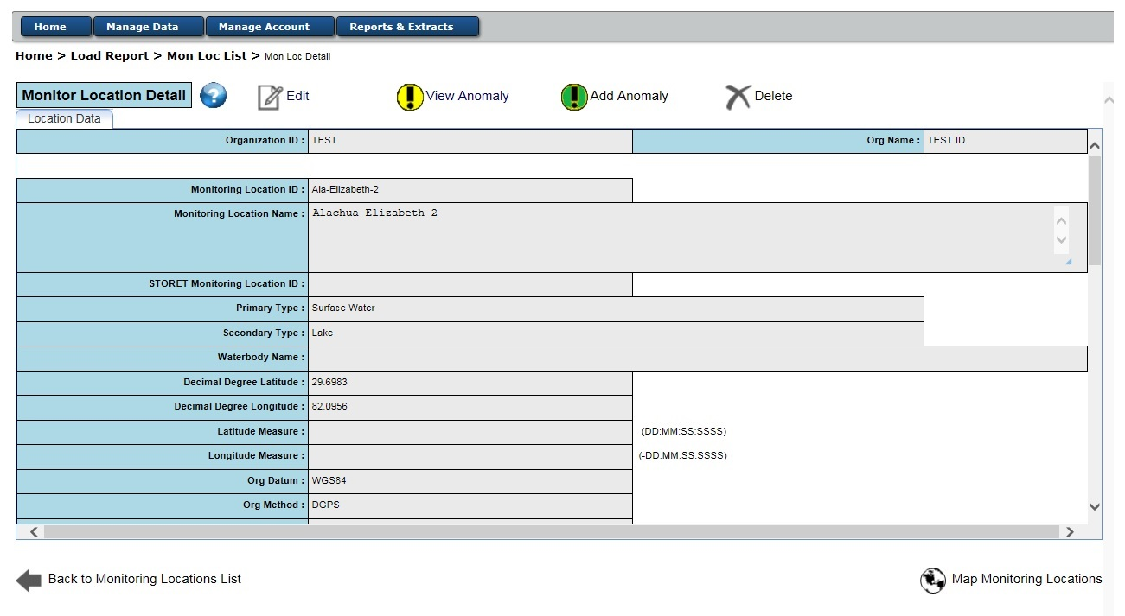
Figure 24 - Monitoring Location Detail

Map Monitoring Location
If you click on Map Monitoring Locations, the location will be displayed on a map. You cannot move the location or update any data from this map. The “Question Mark ?” icon provides a link to FDEP’s help guidance.
Figure 25 - Map Monitoring Location
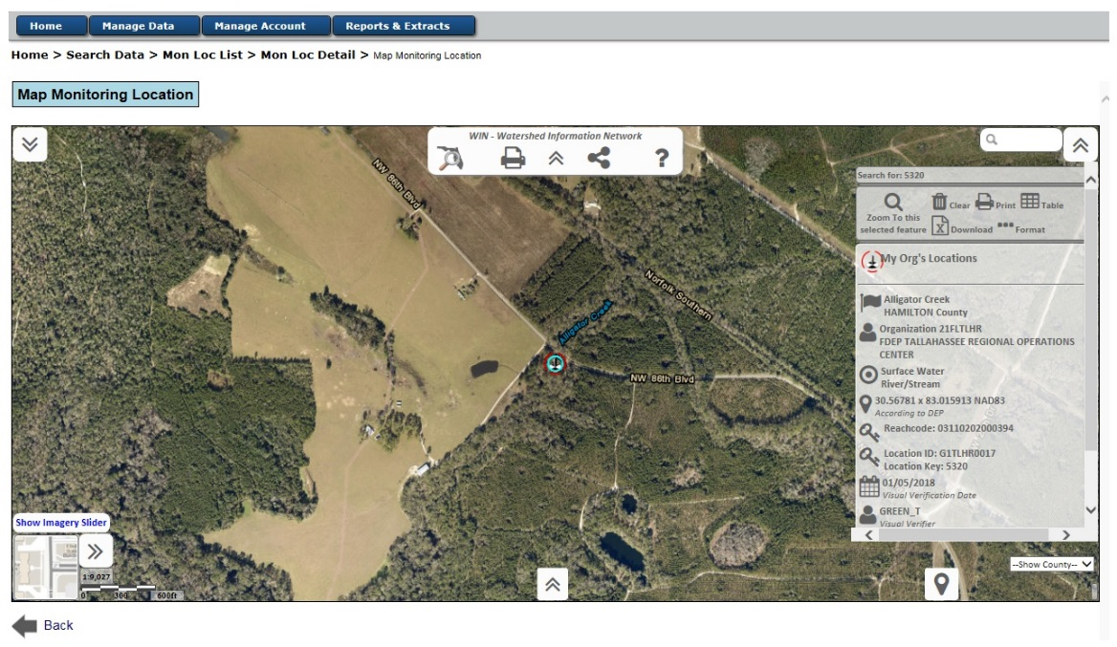

Search Data
The Search Data screen is used to search for Migrated Data. The screen was designed as an Advanced Data Search Tree with filtering parameters for Organizations & Contacts, Projects, Monitoring Locations, and Activities & Results. You can enter filtering criteria at all levels and run a report for the lowest level of the tree that is open. If the Organization & Contacts filter section is the only section open, the “List Organizations” and ‘List Contacts’ will be the list options available. If you then open a section below the Organizations and Contacts, that section will no longer display those two List options.

Filters
The Search Data screen has four sections: Organizations and Contacts, Projects, Monitoring Locations and Activities and Results. You can enter filter criteria in one or all sections. If you enter criteria in the Organizations and Contacts section and then open one of the lower sections, the records in the lower section will be filtered by the criteria entered in the Organizations and Contacts section. If you open the Organizations and Contacts section and enter criteria and then open the Activities and Results section, only the ‘List Activities’ and ‘List Results’ options will be displayed. The records listed will be limited by the organization and contact criteria along with any activities criteria that are entered. Some sections will limit some of the filter options by other filter options that are selected. For example:
- If an Organization ID or Name is selected, most of the rest of the Organization and Contacts fields will be restricted to the values of the selected organization.
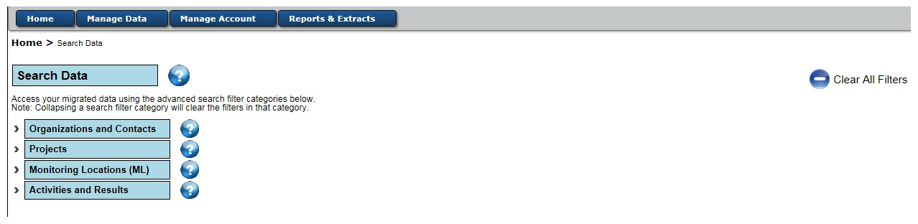
- If a Primary Type of Surface Water is selected in the Monitoring Locations section, the Well Type will be disabled.
Figure 26 - Search Data

Activity List
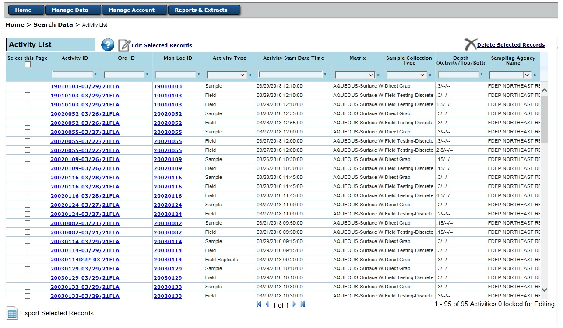
When ‘List Activities’ is selected from the Search Data screen under the ‘Activity and Results’ filter section, the Activity List screen is displayed. All activities in WIN that matched the criteria entered on the Search Data screen will be displayed in the list. If a record has been moved back to staging for editing, it will not have a checkbox. All records with a check box can be selected to be sent back to staging for editing or they can be exported. You can also get to the Activity List screen from the Load Report screen by clicking on ‘Records Added within Selected Range’ or ‘Records Updated within Selected Range’. Refer to the Section Load Report for more details about coming from Load Report. If you want to see all of the detail for a particular activity, you can click on the Activity ID hyperlink to be taken to the Activity Detail screen.
Figure 27 - Activity List

Activity Detail
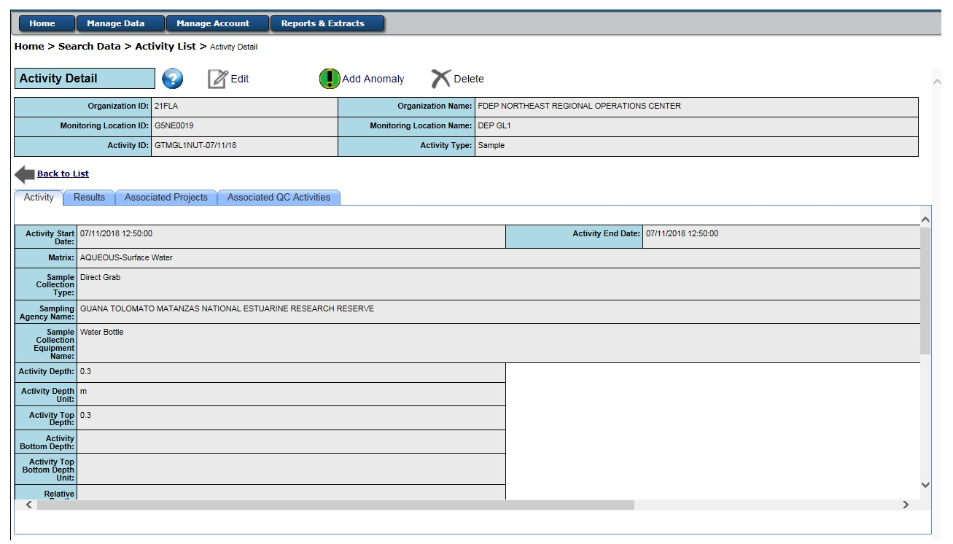
The Activity Detail screen displays all the detail for the selected activity. There are up to three tabs: Results, Associated Projects, and Associated QC Activities.
Figure 28 - Activity Detail

Activity Detail - Activity
If you click on the Activity tab, you will see the details of the activity. You can choose the Edit option at the top of the page to send the Activity record and associated results back to staging to edit. If there are any Anomalies associated with the Activity, the Anomaly Identifier (yellow exclamation mark in a circle) will be displayed, which, when clicked will transfer you to the Anomalies Search and List screen. If you are authorized to create anomalies, you can click on Add Anomalies (green exclamation mark in a circle) to be transferred to the Anomaly Detail screen to enter a new anomaly for the Activity. Click on Delete if you want to delete the Activity, and all associated results.

Activity Detail - Results
If you click on the Results tab, you will see a list of Result records that are associated with the Activity. You can click on a hyperlinked DEP Result ID to see the Result details. You can also select one or more check boxes to ‘Edit Selected Result’, ‘Export Selected Records’ or ‘Delete Selected Records’ using the options at the bottom of the page. You can also click on ‘Add New Result’ to add a new result record associated to this Activity.

Activity Detail – Associated Projects
If you click on the Associated Projects tab, you will see a list of Projects that are associated with the Activity. Newly migrated associated Activities will be listed the day after the Activity is migrated. You can click on a hyperlinked Project ID to see the Project details. On this screen you can ‘Unlink’ a Project from the Activity or ‘Link’ another active project for the Organization to the Activity using the ‘Show Other Project for Org’ button, followed by the ‘Link’. An Activity must be linked to at least one Project.

Activity Detail – Associated QC Activities
If you click on the Associated QC Activities tab, you will see a list of quality control (QC) Activities that are associated with the Activity through the Field Blank Batch ID, the Equipment Blank Batch ID, the Trip Blank Batch ID, or the Master Activity ID field. You can select one or more of the check boxes and choose the Edit option to send the selected Activity record(s) and associated Results back to staging to edit, or you can Export them to a text file for local use.

Edit Activity

Edit Activity
While on the Activity List screen, if you identify any activities that need to be updated, you can check the check box for the records needing to be updated and click on ‘Edit Selected Records’ and have the records moved back to Staging for you to update them. If you are on the Activity Detail screen, you can click on Edit to send that activity back to staging for editing. The system will take all the activities and associated results and move them to the Edit Staged Data screen. On the Edit Staged Data screen, while in Edit mode, you can check one or more activities under the Activities Tab and enter the correct text in the text field under the column(s) to be updated and then click to save you edits. If no activities are checked, the button will be ‘Save All’. If you have checked any activities, the button will be ‘Save Selected’. If any activities need to be deleted, you can check the activities and click on ‘Delete Selected Records’.

Check Adv Errors
After making the changes necessary to the activity records you will need to run the ‘Check Adv Errors’ procedure to validate your changes. After the procedure is completed, you will be taken to the Staged Data Status screen. If any errors are discovered, you will need to correct the errors as explained in the Section Fix Your Data - Advanced Rule Errors.

Migrate Data
Once all changes to the data have been made and any errors are resolved you will use the Staged Data Status screen to migrate the activities back to WIN Production. Verify there are Rows Ready to Migrate and then click on ‘Migrate Records’. Select the Migrate option you wish in the popup window. The system will migrate the updated activities back to WIN.

Edit Results

Edit Results
While on the Result List screen, if you identify any results that need to be updated, you can check the checkbox for the record(s) needing to be updated and click on ‘Edit Selected Records’ to have the records moved back to Staging for you to update them. If you are on the Result Detail screen, you can click on ‘Edit’ to send that result back to staging for editing. The system will take all of the selected results and their associated activities and move them to the Edit Staged Data screen. On the Edit Staged Data screen, while in Edit mode, you can check one or more results under the Results Tab and enter the correct text in the text field under the column(s) to be updated and then click to save your edits. If no results are checked, the button will be ‘Save All’. If you have checked any results, the button will be Save Selected. If any results need to be deleted, you can check the results and click on ‘Delete Selected Records’.

Check Adv Errors
After making the changes necessary to the result records you will need to run the ‘Check Adv Errors’ procedure to validate your changes. After the procedure is completed, you will be taken to the Staged Data Status screen. If any errors are discovered, you will need to correct the errors as explained in the Section Fix Your Data - Advanced Rule Errors.

Migrate Data
Once all changes to the data have been made and any errors are resolved you will use the Staged Data Status screen to migrate the results back to WIN Production. Verify there are Rows Ready to Migrate and then click on ‘Migrate Records’. Select the Migrate option you wish in the popup window. The system will migrate the updated results back to WIN.

WIN Application Menu Overview

Home
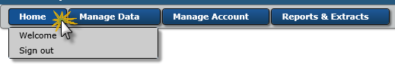
In the upper left section of the Welcome Screen, you will find the available menu buttons. Click on the Home menu and you will find two options: Welcome and Sign Out.

Welcome
There are two versions of the WIN Welcome screen.

The Public Welcome screen is presented to users who have no WIN application permissions (i.e., no ‘role’) and to those who, even if they have a WIN application role, have not yet logged into the DEP Business Portal. This version of the Welcome screen displays current DEP Announcements and describes actions which can be taken to either register a new organization as the DPA or register for a role for an existing organization. If you are not affiliated to an organization and need access to extraction of larger amounts of data, you may register as a WIN User from this screen. At the bottom of this screen, you will find the ‘Login’ option to access the WIN application according to your approved role.

Once logged in, the internal WIN Welcome screen is a ‘dashboard’ of information tailored to the user. It contains the current DEP Announcements as well as organization specific reminders in the ‘My Reminders’ section.

This section contains the following sub-sections:
- Import Files About to Expire: A list of import files still in Staging that will expire soon.
- Latest Audits in WIN: A list of recent Audits to which one or more of your organization’s Results have been linked.
- Role Requests: A list of recently Approved or Declined requests for a role to your organization and all Pending Requests for a role to your organization.
- Standard Value List Request: A list of all recently requested modifications to a standard value list (aka a Code Table) used within the WIN application and the status of that request.
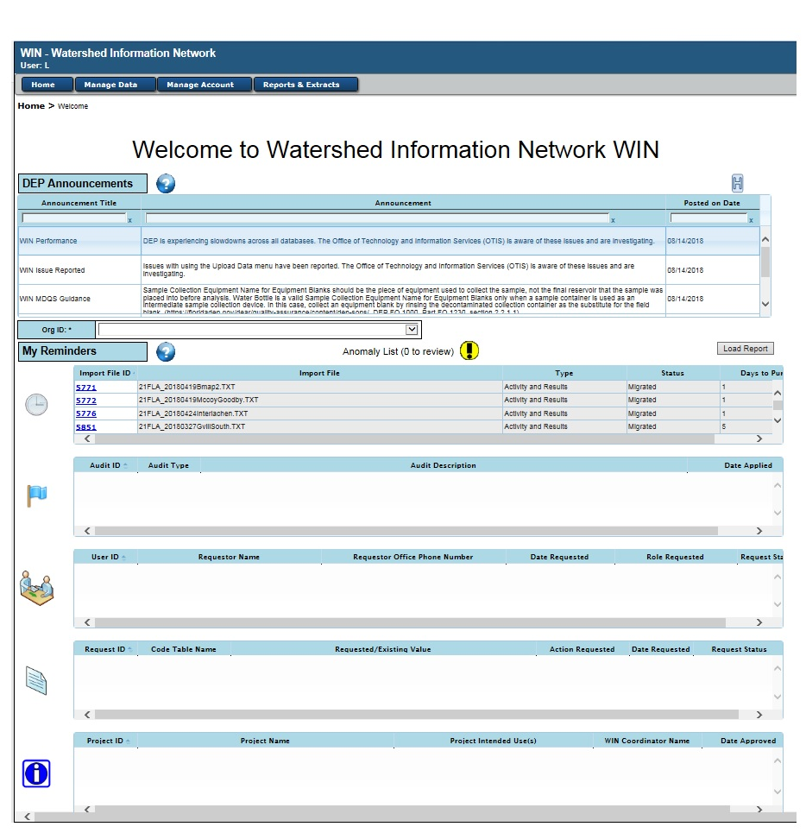
- Projects in Approval Process: A list of projects for your Organization that were recently approved or denied, and all your pending project requests.
Figure 29 - Internal WIN Welcome Screen

The version of the Welcome screen, seen by WIN users who have a role and have logged in using the DEP Business Portal, also includes a button to take you directly to the Load Report. This is an on-screen summary of the records migrated, updated, and deleted for your organization within a time period which you specify. The information can be exported or displayed if the number of records is within the maximum limit.

Sign Out
Selection of this option will navigate you out of the WIN application to the DEP Business Portal so that you can sign out of all DEP applications including WIN. Once you have selected the ‘Sign Out’ option from the ‘Home’ menu in WIN, select the ‘Sign Out’ link in the upper right side of the portal. You can also sign back in on the same screen and display your DEP Business Portal Account Details by clicking your name next to the ‘Sign Out’ hyperlink. To log back into WIN, you can type ‘WIN’ into the Search the Site text box in the upper right corner. This will produce a link back into the WIN application.

Manage Data
Once logged in with your approved role, this menu group allows you to navigate to the various data management areas within the WIN application, based on your permissions.
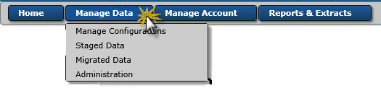

Manage Configuration
The Manage Configurations screen is used to access your previously saved import configurations for your active organization(s). The configurations may be viewed, edited, cloned, or deleted. You can also initiate the creation of a new configuration from this screen or clone one of the System Configurations provided by DEAR or from another organization as a model.

Staged Data
There are two options within this sub-menu which allow you to upload data as well as look at a list of files that remain in the Staging environment. ‘Staging’ is the area where data files are initially imported to address data quality errors, visually verify monitoring locations, and migrate clean records into the WIN database for use in water quality reporting, analysis, and environmental management determinations. Data that are not migrated, remain in ‘Staging’ and are purged after the import file expires (currently set to 45 days) or is explicitly deleted by the user.

Upload Data
This sub-menu option navigates you to the screen used to upload an import data file into the WIN staging area. The uploaded data will be checked to ensure the information meets the Minimum Data Quality Standards (MDQS) for the specific data type (e.g., Projects, Monitoring Locations (SW), Monitoring Locations (GW), and Activities & Results).

Dataset List
This sub-menu option navigates you to the list of imported files for your organization that still have records to either be corrected, migrated, or deleted.

Migrated Data

Load Report
This sub-menu option navigates you to the on-screen summary of the records migrated, updated, and deleted for your organization within a time period which you specify. The information can be exported or displayed if the number of records is within the maximum limit.

Search Data
This sub-menu option navigates you to the screen used to dynamically search the migrated data for your organization(s) using a series of search criteria.

Administration
There are a variety of options within this sub-menu which are displayed based upon your role.

Audits
This sub-menu option is available to all WIN users with a role. Selection of this option navigates you to the screen used to search and list Audits recorded within WIN. From the qualifying list of audits, you can individually select each audit to see the detailed characteristics of the audit and the list of results which may be censored by DEAR for one or more uses based on the findings of the Audit.

Anomalies
This sub-menu option is available to all WIN users with a role. Selection of this option navigates you to the screen used to search and list Anomalies by data type for your organization. Internal DEP users may initiate an anomaly on a record when they need clarification, or if the data contains information that suggests it may be in error. From the qualifying list of anomalies, you can individually select each anomaly to see the detailed characteristics of the anomaly, including the reason for initiating the anomaly (Findings), your response, and the resolution. In an effort to share findings and reduce the number of redundant questions you may receive from DEP, all anomalies are visible to internal DEP analysts.

SVL Requests
This sub-menu option is available to all WIN users with a role. Selection of this option navigates you to the screen used to search and list Standard Value List (SVL) modification requests using a variety of filters. From the qualifying list of SVL Requests, you can individually select each request to see either the code table associated to the request or the detailed characteristics of the request including the request explanation and the DEAR decision.

Codes Tables
This sub-menu option is available to all WIN users with a role. Selection of this option navigates you to the screen used to search and list all the manageable code tables used within the WIN application. Only an authorized WIN Code Manager or the WIN Administrator will have the permission to add, discontinue or edit a value within a managed table, but all users can view the list of codes and the code associations used in the WIN Standards for allowable combinations. There is also an option on this screen to view all of the WIN data rules.

Reassign Reach Codes
This sub-menu option is only available to the WIN Code Manager or the WIN Administrator. It navigates to the screen used to update NHD Reach Code values within existing Monitoring Locations when they are changed by the USGS, or when a Provisional Reach Code is replaced with a new Reach Code.

Manage Account
This menu group allows you to navigate to the various identity and role management areas within the WIN application, based on your permissions.
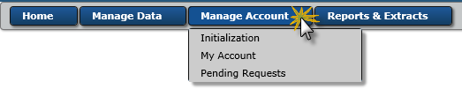

Initialization
This sub-menu includes three options for requesting a new organization or role within the WIN application: Request New Organization and DPA, Request Org Role, Request DEP Role.

Request New Organization and DPA
This sub-menu option navigates the user to the screen on which they can request to create a new reporting organization and register as the Data Provider Administrator (DPA) for that organization. Upon successful completion of those screens, both the organization and the DPA are set to ‘Pending’. The WIN Administrator will approve or deny the request.

Request Org Role
This sub-menu option navigates the user to the screen on which they can request a new role for an existing organization. The request, once saved, is set to ‘Pending’ and will be Approved or Denied by the DPA of the requested organization.

Request DEP Role
This sub-menu option navigates an internal DEP user to the screen on which they can request a new DEP role. The request, once saved, is set to ‘Pending’ and will be approved or denied by the WIN Administrator.

My Account
This sub-menu option navigates the user to the screen which displays all of the roles currently active and previously discontinued. When an individual role is selected, this screen can be used to maintain your address, email and phone information.

Pending Requests
This sub-menu option is only available to the DPAs, the WIN Coordinators, and the WIN Administrator. It navigates to the screen used to Approve or Deny role requests.

Reports & Extracts
This menu group allows you to navigate to the various data reporting areas within the WIN Warehouse, based on your permissions.
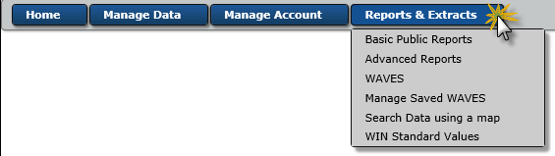

Basic Public Reports
This sub-menu option navigates any user to the Basic Public Reports created to guide the public through the process of finding watershed information based on common requests. Anyone can access the ‘Basic Public Reports’ without logging into the DEP Portal. No WIN role is required to view or extract data as long as the user does not request a large amount of data as a result of their report request.

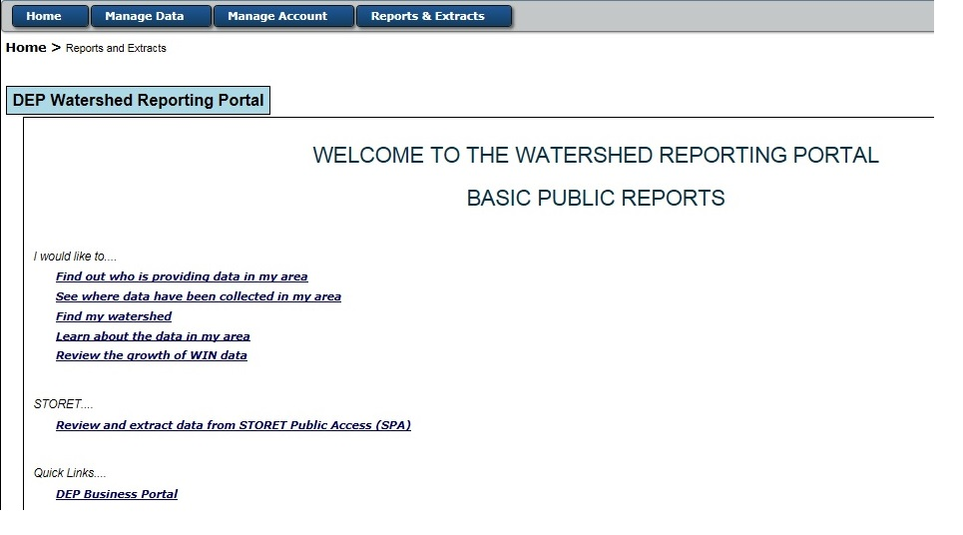
Basic Public Reports sub-menu option will transfer the user the WIN Warehouse screen from which the Basic Public Reports can be accessed. The Basic Public Reports are shown below:

Advanced Reports
This sub-menu option navigates any user to the Advanced Public Reports which provide the capability of searching for data using a map or getting more information about WIN Standard Values. Anyone can access the ‘Advanced Reports’ without logging into the DEP Security. No WIN role is required to view or extract data as long as the user does not request a large amount of data as a result of their report request.

The Advanced Public Reports sub-menu option will transfer the user to the WIN Warehouse screen from which the Advanced Public Reports can be accessed. The Advanced Public Reports are as shown below:
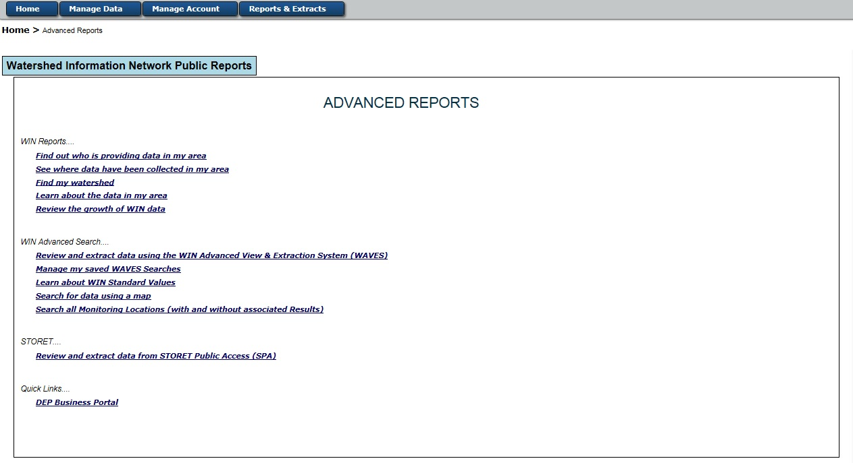
Figure 30 - Advanced Reports

WAVES
This sub-menu option navigates any WIN user who has registered within the DEP Portal to the WIN Advanced View & Extraction System (WAVES) which was designed to allow a user to search the WIN data using a variety of filters and save the query for reuse at a later time.

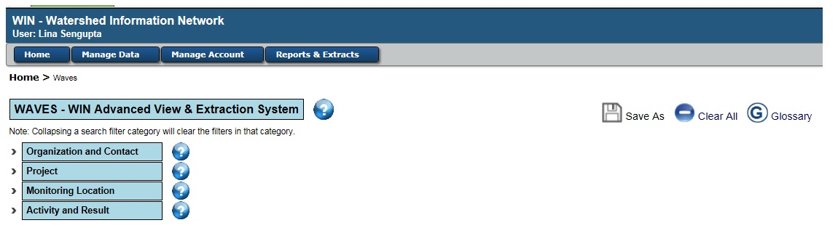
Figure 31 - WIN Advanced View & Extraction System (WAVES)

Manage Saved WAVES
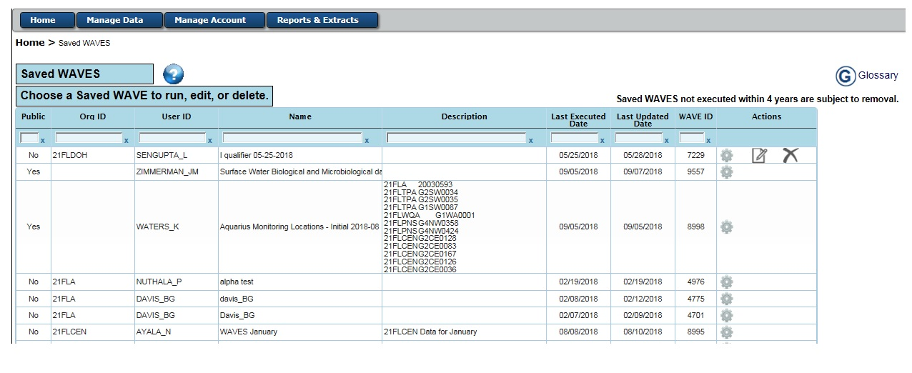
This sub-menu option navigates any WIN user who has registered within the DEP Portal to their organization’s saved WAVES queries which were previously created and saved by someone within their organization, or by the user, to search the WIN data. The user can run, edit, or delete their organization’s saved WAVES from the screen shown below.
Figure 32 - Saved WIN Advanced View & Extraction System (WAVES)

Search Data Using a Map
This sub-menu option navigates any user to go directly to the Advanced Public Report titled ‘Search for Data Using a Map’ shown below. It is designed to guide WIN data users through the process of finding watershed information data based on a map.
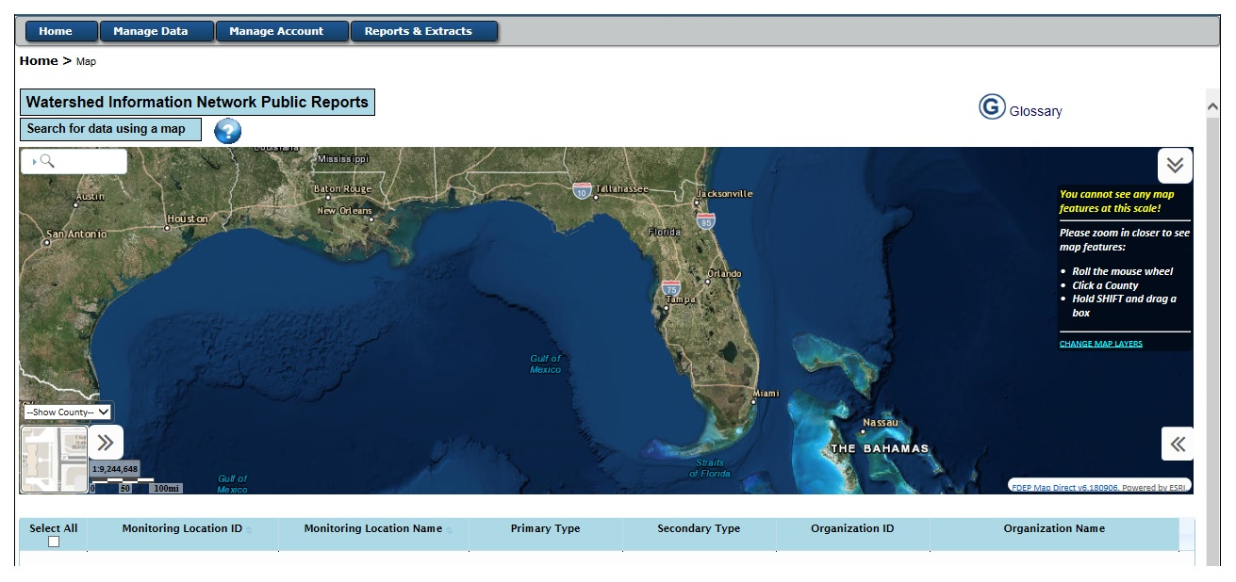
Figure 33 - Search Data using a Map

WIN Standard Value
This sub-menu option navigates any user to go directly to the Advanced Public Report titled ‘Learn about WIN Standard Values’ which will allow the user to access the code values and code details used in the WIN application.
Figure 34 - Standard Values
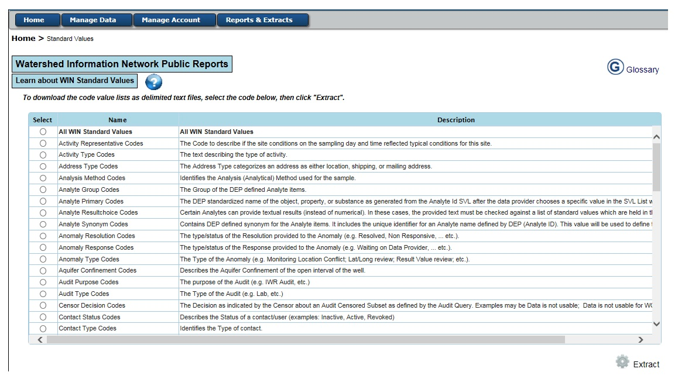

WIN Glossary
There is a general Glossary of Terms available online from within the WIN application as a hyperlink from any WIN Report screens by selecting the Glossary icon on that screen or in this document. Clicking on this icon will open up a new browser tab with the glossary in PDF format.


