Base Bid
The Contractor shall furnish all labor, materials, equipment, supervision, and services necessary to locate, abandon, and reconstruct a septic drainfield for an existing developed property in the Village of North Palm Beach, Florida.
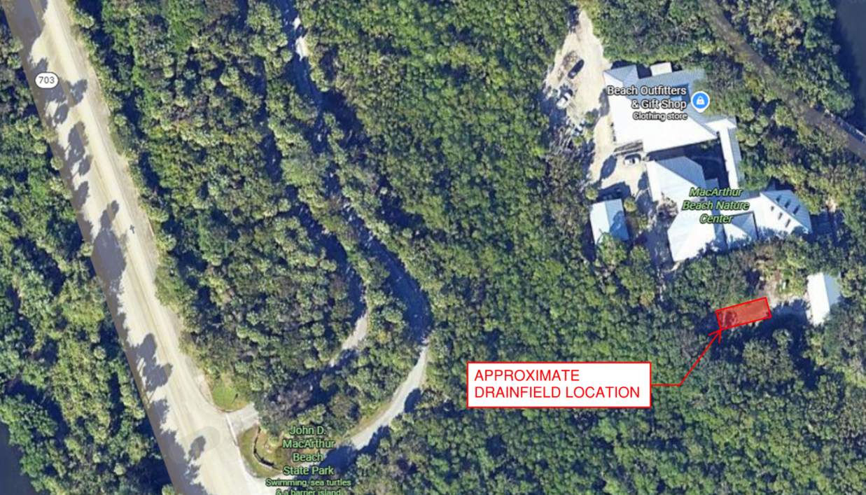
Any changes to the scope of work must be documented in writing and approved by both parties.
PRIOR TO BIDDING, the contractor shall be responsible for field verifying all sizes, dimensions, quantities of materials required and site-specific needs to successfully complete the project. The contractor shall coordinate the scheduling of their on-site observations with FDEP Bureau of Design and Construction (BDC) Construction Project Manager:
Jim McGuire
Jim.McGuire@FloridaDEP.gov
Office: 772-402-9465
Mobile: 772-380-6938
Lump Sum Pricing:
Bid shall include itemized costs per building, including labor, materials, permits, and any additional services required.
1. Project Overview
The project requires:
- Permitting and approval by the Florida Department of Health – Palm Beach County (DOH-PBC)
- Permitting and inspections by the Village of North Palm Beach Building Department
- Continuous operation of the existing sanitary sewer and/or onsite system with no interruption of sanitary service to the facility during regular facility operating hours for the duration of the construction
- Construction of the new septic drain field system without having the existing septic drain field as-built drawings
2. Existing Conditions
- The existing septic drain field location, configuration, and piping are unknown (no as-built documentation available).
- The site is developed and may contain utilities, hardscape, landscaping, and/or structures in proximity to septic components.
- The sanitary system must remain active and usable at all times during construction.
- Contractor shall assume limited site access and shall coordinate all work to minimize disturbance to existing improvements.
- See Appendix for site photos.
3. Contractor Responsibilities – General
The Contractor shall:
- Obtain Permits:
  - Florida Department of Health – Palm Beach County (DOH-PBC)
  - Village of North Palm Beach Building Department
- Conduct all work in accordance with:
  - Florida Administrative Code Chapter 62-6 (Onsite Sewage Treatment and Disposal Systems)
  - Palm Beach County Health Department requirements
  - Village of North Palm Beach codes and ordinances
  - Florida Building Code
  - Manufacturer instructions and accepted industry standards
- Provide a licensed septic contractor and all required specialty subcontractors
- Coordinate all inspections, approvals, and close-outs
- Protect existing site improvements and restore disturbed areas
- Perform construction in accordance with permits obtained for the project
- Contractor to verify the required permits, coordinate with the applicable agencies and obtain necessary permits.

4. Permitting and Agency Coordination
4.1 Health Department Permit
- Prepare and submit all documentation required for a DOH-PBC septic system/drain field permit, including:
  - Site plan
  - System sizing calculations
  - Drain field design
  - Soil information (existing data or field verification as required)
- Schedule and pass all required Health Department inspections
4.2 Village of North Palm Beach Permit
- Obtain required local building/engineering permits
- Coordinate inspections as required by the Village
- Comply with local right-of-way, erosion control, and restoration requirements (if applicable)
5. Site Investigation and Layout
Because no as-builts exist, the Contractor shall:
- Perform exploratory excavation, probing, or locating to identify:
  - Existing septic tank(s)
  - Existing drain field components
  - Sanitary piping connections
  - Existing wet and dry utilities within the project area
- Verify setbacks to structures, property lines, surface water, and utilities
- Coordinate findings with the Engineer/Owner prior to final drain field layout
- Adjust proposed system location as required for code compliance
6. Temporary Sanitary Service Continuity
To maintain uninterrupted sanitary service, the Contractor shall:
- Develop and implement a sanitary continuity plan, which may include:
  - Temporary bypass piping
  - Sequenced construction keeping the existing system operational
  - Temporary holding tank or pump system (if required and approved)
- Ensure no downtime of restroom or sanitary facilities during regular facility operating hours
- Provide emergency response procedures in the event of system disruption or failure of the temporary sanitary service
7. Septic Drain Field Construction
The Contractor shall:
- Install a new drain field system sized and configured per approved Health Department permit
- Furnish and install:
  - Drain field piping
  - Aggregate or approved alternative media
  - Distribution boxes or manifolds
  - Inspection ports as required
- Construct system to approved grades and elevations
- Connect new drain field to the existing or new septic tank as permitted
8. Abandonment of Existing Drain Field
Upon activation of the new drain field and approval by authorities:
- Properly abandon existing drain field components in accordance with DOH-PBC requirements
- Cap or remove piping as directed
- Backfill excavations with suitable material and compact appropriately
9. Testing, Inspections, and Approval
- Coordinate and pass all required inspections, including, but not limited to:
  - Open trench
  - System placement
  - Final approval
- Provide documentation of approval from:
  - Palm Beach County Health Department
  - Village of North Palm Beach
- Ensure system is complete and fully operational prior to project close-out
10. Site Restoration
- Restore all disturbed areas to equal or better condition, including, but not limited to:
  - Landscaping
  - Sod or seed
  - Pavement or hardscape
  - Fencing or site features
- Remove all construction debris from site
- Final grading to prevent ponding and promote positive drainage
11. Deliverables
The Contractor shall provide:
- Health Department permit and final approval documentation
- Village permit and close-out documentation
- Proposed layout/Site plan
- Construction sequencing
- Shop Drawings
- Complete and functioning system in accordance with the project scope
- Septic system record drawing/as-built showing:
  - Actual drain field location
  - Depths
  - Component locations
- Warranty information for installed system
12. Exclusions (Unless Otherwise Included)
- Engineering or soil testing beyond that required by DOH-PBC
- Utility relocation not directly related to septic work
- Structural building modifications
- Environmental remediation unrelated to septic system
13. Assumptions and Clarifications
- Construction sequencing shall be approved prior to initiating work
- Any unforeseen conditions shall be reported immediately to the Owner
- Contractor is responsible for protecting all existing utilities and structures
14. General Conditions
14.1 Project Management and Supervision
- Contractor shall provide on-site supervision as required to coordinate:
  - Health Department inspections
  - Village inspections
  - Sequencing of temporary and permanent septic work
- Superintendent shall be experienced with Florida septic systems and Health Department requirements.
14.2 Construction Schedule and Phasing
- Contractor shall submit a construction sequence that:
  - Maintains continuous sanitary service
  - Minimizes downtime, odors, and disruption to occupants
  - Identifies critical inspection hold points
- Work shall be phased to keep the existing septic system or approved temporary system operational until final approval of the new drain field.
14.3 Site Access and Protection
- Contractor shall:
  - Protect existing structures, utilities, paving, landscaping, and improvements
  - Maintain safe ingress and egress for occupants at all times
  - Install temporary fencing, barricades, and signage as required for site safety
14.4 Utility Coordination
- Contractor shall verify and protect all underground utilities.
- Any damage caused to utilities by Contractor operations shall be repaired at Contractor’s expense.
14.5 Safety and Environmental Controls
- Comply with all OSHA, local, and state safety requirements.
- Provide erosion control and sediment protection where required (silt fence around work area, inlet protection, turbidity barrier, construction entrance/soil tracking, etc.)
- Maintain a clean, sanitary jobsite at all times.
14.6 Inspections and Coordination
- Contractor shall:
  - Schedule and attend all Health Department and Village inspections
  - Correct deficiencies identified by inspectors at no additional cost
  - Provide advance notice of inspections to the Owner or Owner’s representative
14.7 Submittals and Close-Out
The Contractor shall deliver:
- Approved permits and inspection closeout documentation
- Final Health Department approval documentation
- As-built drawing showing:
  - Drain field layout
  - Depths and elevations
  - Septic system components
- Warranty information and maintenance recommendations
14.8 Changes and Unknown Conditions
- Any concealed or unknown conditions differing materially from typical septic construction shall be reported immediately.
- No change in scope or price shall occur without written authorization, except for emergency sanitary protection measures.
14.9 Working Hours and Noise
- Work shall comply with Village of North Palm Beach noise ordinances.
- After-hours work shall require written approval.
14.10 Insurance and Licensing
- Contractor shall maintain all required:
  - Florida contractor licensing
  - Septic system specialty licenses
  - Insurance and bonding as required by the Owner and local authorities

Appendix
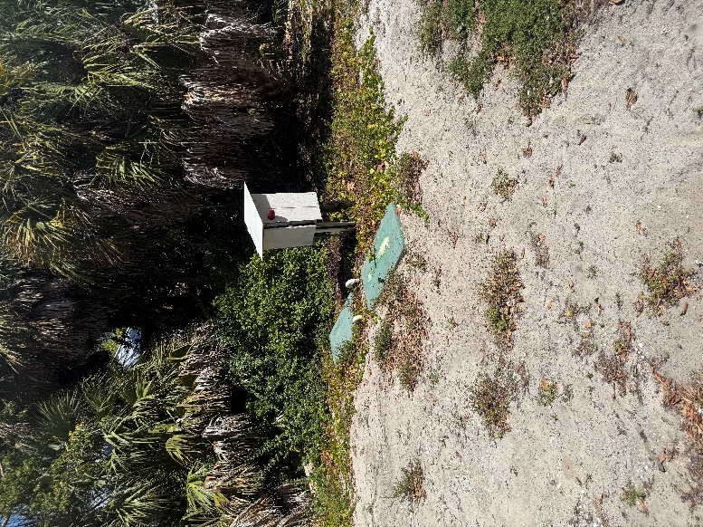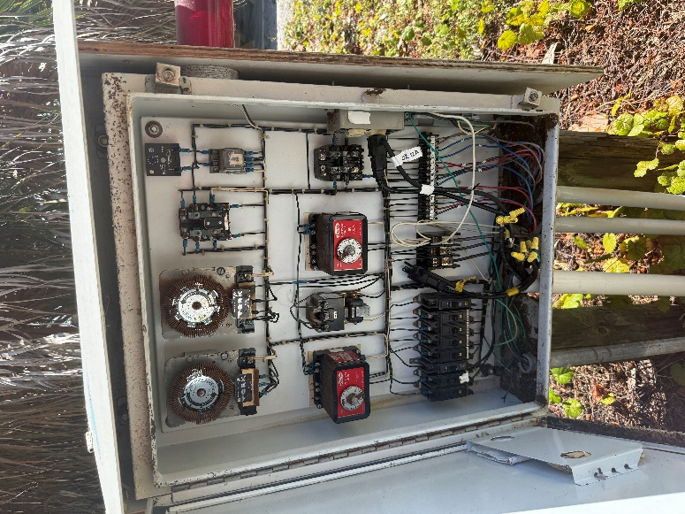
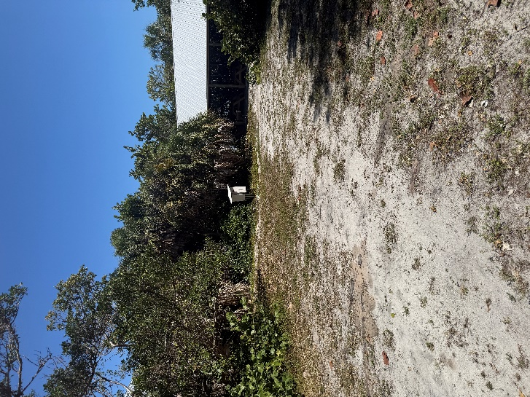
GENERAL NOTES:
1. THE CONTRACTOR IS RESPONSIBLE FOR INSPECTING AND ACCEPTING THE EXISTING CONDITIONS OF THE SITE PRIOR TO BIDDING.
2. ALL DISTURBED AREAS WITHIN THE LIMITS OF RESTORATION SHALL BE REVEGETATED AS SPECIFIED BY THE PARK SERVICE BIOLOGIST.
3. EXISTING UNDERGROUND UTILITIES SHOWN ARE BASED ON THE BEST AVAILABLE INFORMATION. THE CONTRACTOR SHALL ENSURE THAT THE UTILITY SYSTEMS DO NOT CONFLICT WITH THE PROPOSED PROJECT. CONFLICTS SHALL BE REPORTED TO THE PROJECT MANAGER IMMEDIATELY.
4. THE CONTRACTOR IS RESPONSIBLE FOR THE PROTECTION OF ALL UTILITIES. REMOVAL AND/OR RELOCATION OF EXISTING UTILITIES IN CONFLICT WITH THE WORK, CONSTRUCTION OF TEMPORARY UTILITIES IN THE EVENT THAT EXISTING UTILITY SERVICE MUST BE INTERRUPTED AND ANY OTHER CONSTRUCTION RELATED ACTIVITIES THAT MAY AFFECT EXISTING OR PROPOSED UTILITIES. THE INFORMATION SHOWN ON THESE DRAWINGS CONCERNING TYPE AND LOCATION OF UNDERGROUND AND OTHER UTILITIES IS BASED ON INFORMATION PROVIDED BY THE UTILITY OWNERS, AVAILABLE RECORDS, AND SURVEYED FIELD INFORMATION. THE INFORMATION MAY NOT REFLECT ACTUAL CONDITIONS, INCLUDE ALL UTILITIES IN THE AREA, EITHER IN SERVICE OR ABANDONED, OR SHOW THE UTILITIES IN THE CORRECT HORIZONTAL OR VERTICAL LOCATIONS. THE CONTRACTOR WILL MAKE IS OWN DETERMINATION AS TO THE TYPE AND LOCATION OF UTILITIES AS NECESSARY TO ESTABLISH THEIR LOCATIONS AND AVOID DAMAGE.
5. THE CONTRACTOR SHALL BE RESPONSIBLE FOR ESTABLISHING ALL GRADE STAKES, LINES AND LEVELS.
6. THE CONTRACTOR SHALL SOLID SOD ALL DISTURBED AREAS UNLESS OTHERWISE SPECIFIED OR SHOWN. NO SOD WITH MONOFILAMENT OR PLASTIC MESH BACKING WILL BE ALLOWED.
7. NO SEPARATE PAYMENT WILL BE MADE FOR DEWATERING. THE COSTS FOR DEWATERING ARE INCLUDED IN THE UNIT PRICES FOR CONSTRUCTING THIS PROJECT.
8. ALL AREAS, STREETS, DRIVEWAYS, PARKING LOTS, ETC. DISTURBED BY CONSTRUCTION SHALL BE RESTORED BY THE CONTRACTOR TO THEIR ORIGINAL OR BETTER CONDITION.
9. THE CONTRACTOR WILL HAVE ALL REQUIRED PERMITS IN-HAND PRIOR TO BEGINNING CONSTRUCTION, AND WILL PERFORM ALL WORK IN ACCORDANCE WITH THE REQUIREMENTS OF THE PERMITS OBTAINED BY THE OWNER AND THOSE PERMITS OBTAINED BY THE CONTRACTOR.
10. PRIOR TO COMMENCING CONSTRUCTION, THE CONTRACTOR WILL SUBMIT TO THE OWNER'S PROJECT MANAGER A SCHEDULE OF VALUES, A CONSTRUCTION SCHEDULE, AND A SAFETY PLAN.
11. THE CONSTRUCTION SCHEDULE WILL DESCRIBE IN DETAIL HOW THE CONSTRUCTION IS TO BE PHASED, ESTABLISH START AND FINISH DATES FOR ALL SIGNIFICANT CONSTRUCTION ACTIVITIES, AND IDENTIFY ALL CONTROLLING ITEMS OF WORK. THE SCHEDULE IS TO BE APPROVED BY THE OWNER'S PROJECT MANAGER, AND WILL BE UPDATED ON A MONTHLY BASIS TO REFLECT ACTUAL WORK PROGRESS. PAYMENT FOR PREPARING, UPDATING AND SUBMITTING THE SCHEDULE WILL BE INCLUDED IN THE PAY ITEM FOR MOBILIZATION OR OTHER PAY ITEMS AS APPROPRIATE.
12. THE CONTRACTOR SHALL SUBMIT AN EROSION CONTROL PLAN FOR APPROVAL BY THE OWNER'S PROJECT MANAGER AND WILL ADDRESS THE INSTALLATION AND MAINTENANCE OF ALL TEMPORARY AND PERMANENT SEDIMENT AND EROSION CONTROL DEVICES TO BE USED DURING EACH PHASE OF CONSTRUCTION, INCLUDING TREE REMOVAL, CLEARING AND GRUBBING, EXCAVATION, HAULING OF EXCAVATED MATERIALS, AND PLACEMENT OF EMBANKMENT AND BACKFILL. THE PLAN ALSO WILL DETAIL THE EROSION CONTROL MEASURES TO BE EMPLOYED AT ALL STOCKPILE AND CONSTRUCTION STAGING AREAS AND WILL DEFINE THE MAXIMUM LIMITS OF ALL ACTIVE CONSTRUCTION ZONES.
13. ANY NATIONAL GEODETIC SURVEY MONUMENT WITHIN THE LIMITS OF CONSTRUCTION MUST BE PROTECTED. IF IN DANGER OF DAMAGE, THE CONTRACTOR WILL IMMEDIATELY NOTIFY THE PROJECT MANAGER AND:
FDEP, BUREAU OF SURVEY AND MAPPING, MS 105
3900 COMMONWEALTH BLVD.
TALLAHASSEE, FLORIDA 32399
(850) 245-2606 (OFFICE)
(850) 245-2645 (FAX)

14. PRIOR TO ANY SCHEDULED INTERRUPTION OF UTILITY SERVICE, THE CONTRACTOR WILL COORDINATE SUCH INTERRUPTION WITH THE UTILITY PROVIDER AND WILL PROVIDE A MINIMUM 24-HOUR NOTICE TO THE AFFECTED PARTIES. THE CONTRACTOR WILL NOTIFY THE ELECTRIC UTILITY A MINIMUM OF TWO WEEKS PRIOR TO CONSTRUCTION IN THE VICINITY OF THEIR FACILITIES.
15. NO TRENCHES WILL BE ALLOWED TO REMAIN OPEN OVERNIGHT.
16. THE CONTRACTOR IS RESPONSIBLE FOR THE PROTECTION OF VEGETATION ON AND ADJACENT TO THE PROJECT SITE, AND WILL BE SOLELY LIABLE FOR DAMAGE TO VEGETATION ON PROPERTIES ADJACENT TO CONSTRUCTION WORK ZONES. ALL TREES WITHIN THE LIMITS OF CONSTRUCTION ARE TO BE PROTECTED EXCEPT THOSE TREES IDENTIFIED ON THE PLANS TO BE REMOVED. ALL TREES OUTSIDE THE CONSTRUCTION WORK ZONE ARE TO BE PROTECTED TO THE MAXIMUM EXTENT PRACTICABLE. TREE BARRICADES WILL BE INSTALLED AND MAINTAINED AROUND ALL TREES TO BE PROTECTED AS SHOWN ON THE DRAWINGS OR AS DIRECTED BY THE PROJECT MANAGER.
17. THE CONTRACTOR IS RESPONSIBLE TO PLACE AND MAINTAIN ROADSIDE WARNING SIGNS WHEN WORK IS BEING CONDUCTED IN THE PROPERTY RIGHT OF WAY OR WHEN MACHINERY IS ENTERING AND LEAVING THE PROJECT SITE.
18. THE CONTRACTOR IS RESPONSIBLE FOR DISPOSAL OF EXCAVATED MATERIAL OFF-SITE UNLESS OTHERWISE DIRECTED BY THE PROJECT MANAGER.
19. ENSURE THAT ALL EQUIPMENT, PRIOR TO BRINGING ON-SITE, IS WASHED AND FREE OF SOIL, SEED, OR OTHER ORGANIC MATTER. EQUIPMENT MAY BE INSPECTED BY THE OWNER’S REPRESENTATIVE PRIOR TO OFF-LOADING FOR USE. ADDITIONAL CLEANING WILL BE PERFORMED OFFSITE BY THE CONTRACTOR IF THE OWNER’S REPRESENTATIVE DETERMINES IT IS NEEDED.

EROSION CONTROL NOTES:
1. ALL EROSION AND SEDIMENTATION CONTROLS SHALL BE INSTALLED PRIOR TO ANY LAND DISTURBING ACTIVITIES.
2. ALL EROSION AND SEDIMENTATION CONTROLS SHALL BE INSPECTED DAILY AND REPAIRS MADE AS NECESSARY TO ENSURE THE PROPER AND CONTINUED FUNCTION OF THE CONTROL(S).
3. ALL EROSION AND SEDIMENTATION CONTROL SHALL REMAIN IN PLACE UNTIL A PERMANENT VEGETATIVE COVER HAS BEEN ESTABLISHED.
4. UNDER NO CIRCUMSTANCES SHALL SEDIMENTS BE PERMITTED TO EXIT THE PROJECT LIMITS, INCLUDING TRACKING BY VEHICLES ONTO PAVED ROADWAYS. THE CONTRACTOR SHALL MAKE IMMEDIATE REPAIRS OR ENHANCEMENTS TO ANY EROSION CONTROL SYSTEM THAT ALLOWS THE RELEASE OF SEDIMENTS.

