Base Bid Scope of Work
The contractor shall provide a Certificate of Insurance (COI), all labor, materials, equipment, supervision, and permitting to successfully remove two (2) approximately 1200 ft² existing metal roof and masonry columns of two (2) Pavilions structure, as per the contract documents. Any changes to the scope of work must be documented in writing and approved by both parties.
Existing Conditions:
- Existing roof is damaged at both pavilions.
General Information:
- Building No. BL072062 and BL072063.
- Permitting and notification for demolition to all agencies by the contractor, including but not limited to county and FDEP.
- Contractor to verify the required permitting agencies.
- Referenced square footage is approximate. It is the contractor’s responsibility to field verify dimensions. See attached appendix for additional images.
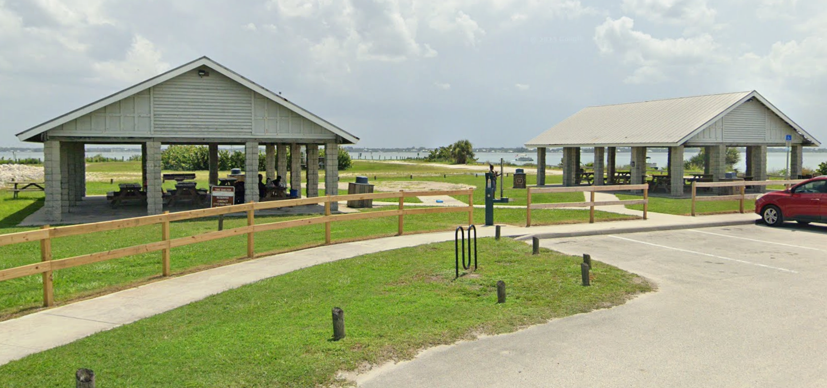
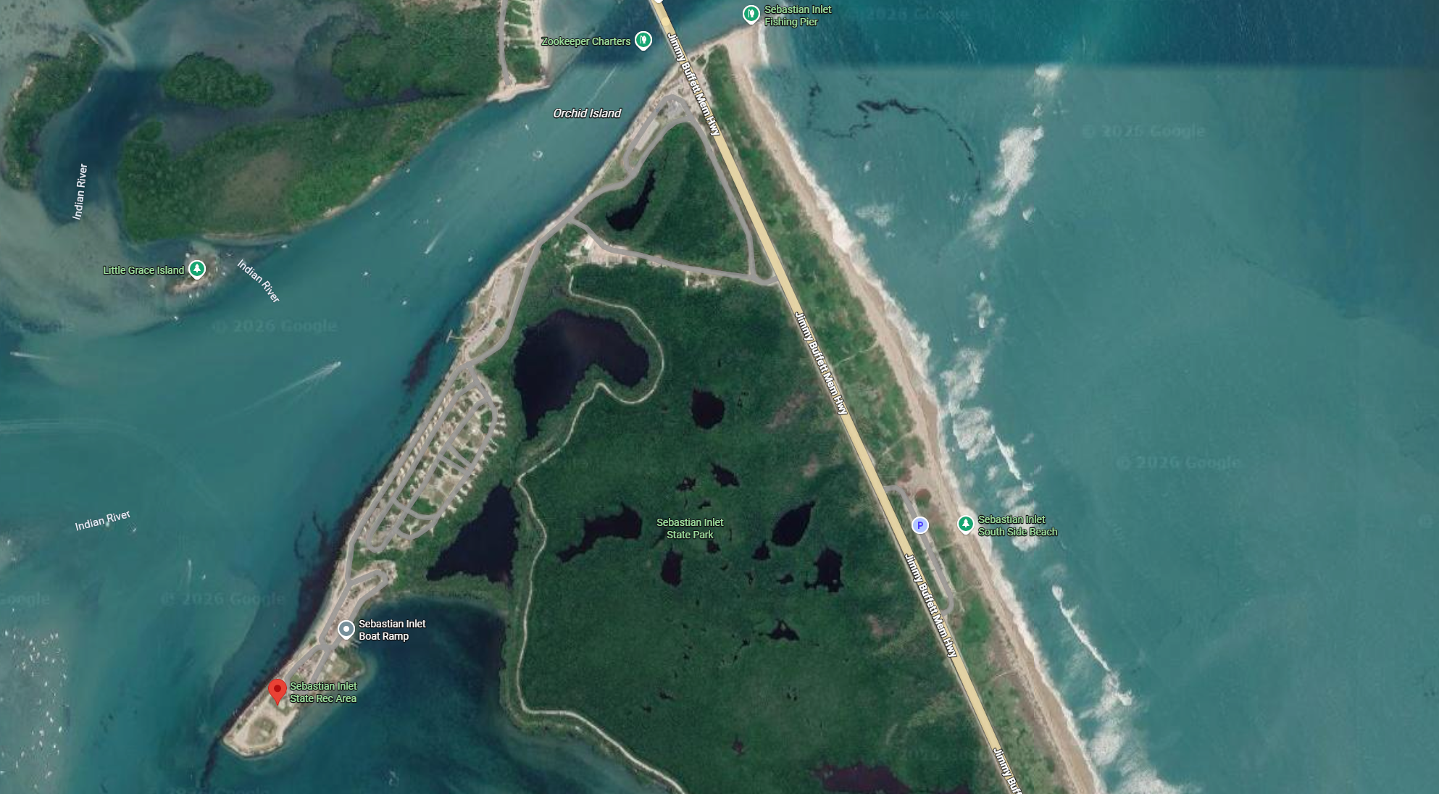
Special Conditions:
- The existing concrete floor slab at both pavilions must remain undisturbed.
- After demolition, fill, patch and finish all the masonry column voids with concrete to match the existing finish floor elevation of floor slab around.
- Park will remove tables, benches, grills, trash enclosures and utilities prior to the construction.
- Refer to the Lead-Based Paint and Asbestos Containing Material report for the existing structures.
PRIOR TO BIDDING, the contractor shall be responsible for field verifying all sizes and dimensions of the structures, quantities of materials and site-specific needs to successfully complete the demolition project. The contractor shall coordinate the scheduling of their on-site observations with FDEP Bureau of Design and Construction (BDC) Construction Project Manager:
Dominique Rouse
dominique.rouse@floridadep.gov
Mobile: (407) 280-1164
Description of Demolition Work:
The contractor shall:
- Utilize appropriate Best Management Practices prior to commencement of demolition, as necessary.
- Remove all existing roof structure and finishing materials.
- Remove all masonry columns up to 1-course below finish floor elevation.
- Remove and dispose of all demolished materials in accordance with all laws and regulations.
- Protect all property and vegetation from damage.
- Repair or replace all damaged property and vegetation to original condition.
- The contractor shall keep/maintain a clean work area and shall remove all unnecessary construction debris daily, including a full sweep of the work area with magnets.
Lump Sum Pricing:
Bid shall include:
- Itemized costs per structure, including labor, materials, permits, and any additional services required.

GENERAL NOTES:
1. THE CONTRACTOR IS RESPONSIBLE FOR INSPECTING AND ACCEPTING THE EXISTING CONDITIONS OF THE SITE PRIOR TO BIDDING.
2. ALL DISTURBED AREAS WITHIN THE LIMITS OF RESTORATION SHALL BE REVEGETATED AS SPECIFIED BY THE PARK SERVICE BIOLOGIST.
3. EXISTING UNDERGROUND UTILITIES SHOWN ARE BASED ON THE BEST AVAILABLE INFORMATION. THE CONTRACTOR SHALL ENSURE THAT THE UTILITY SYSTEMS DO NOT CONFLICT WITH THE PROPOSED PROJECT. CONFLICTS SHALL BE REPORTED TO THE PROJECT MANAGER IMMEDIATELY.
4. THE CONTRACTOR IS RESPONSIBLE FOR THE PROTECTION OF ALL UTILITIES. REMOVAL AND/OR RELOCATION OF EXISTING UTILITIES IN CONFLICT WITH THE WORK, CONSTRUCTION OF TEMPORARY UTILITIES IN THE EVENT THAT EXISTING UTILITY SERVICE MUST BE INTERRUPTED AND ANY OTHER CONSTRUCTION RELATED ACTIVITIES THAT MAY AFFECT EXISTING OR PROPOSED UTILITIES. THE INFORMATION SHOWN ON THESE DRAWINGS CONCERNING TYPE AND LOCATION OF UNDERGROUND AND OTHER UTILITIES IS BASED ON INFORMATION PROVIDED BY THE UTILITY OWNERS, AVAILABLE RECORDS, AND SURVEYED FIELD INFORMATION. THE INFORMATION MAY NOT REFLECT ACTUAL CONDITIONS, INCLUDE ALL UTILITIES IN THE AREA, EITHER IN SERVICE OR ABANDONED, OR SHOW THE UTILITIES IN THE CORRECT HORIZONTAL OR VERTICAL LOCATIONS. THE CONTRACTOR WILL MAKE IS OWN DETERMINATION AS TO THE TYPE AND LOCATION OF UTILITIES AS NECESSARY TO ESTABLISH THEIR LOCATIONS AND AVOID DAMAGE.
5. THE CONTRACTOR SHALL BE RESPONSIBLE FOR ESTABLISHING ALL GRADE STAKES, LINES AND LEVELS.
6. THE CONTRACTOR SHALL SOLID SOD ALL DISTURBED AREAS UNLESS OTHERWISE SPECIFIED OR SHOWN. NO SOD WITH MONOFILAMENT OR PLASTIC MESH BACKING WILL BE ALLOWED.
7. NO SEPARATE PAYMENT WILL BE MADE FOR DEWATERING. THE COSTS FOR DEWATERING ARE INCLUDED IN THE UNIT PRICES FOR CONSTRUCTING THIS PROJECT.
8. ALL AREAS, STREETS, DRIVEWAYS, PARKING LOTS, ETC. DISTURBED BY CONSTRUCTION SHALL BE RESTORED BY THE CONTRACTOR TO THEIR ORIGINAL OR BETTER CONDITION.
9. THE CONTRACTOR WILL HAVE ALL REQUIRED PERMITS IN-HAND PRIOR TO BEGINNING CONSTRUCTION, AND WILL PERFORM ALL WORK IN ACCORDANCE WITH THE REQUIREMENTS OF THE PERMITS OBTAINED BY THE OWNER AND THOSE PERMITS OBTAINED BY THE CONTRACTOR.
10. PRIOR TO COMMENCING CONSTRUCTION, THE CONTRACTOR WILL SUBMIT TO THE OWNER'S PROJECT MANAGER A SCHEDULE OF VALUES, A CONSTRUCTION SCHEDULE, AND A SAFETY PLAN.
11. THE CONSTRUCTION SCHEDULE WILL DESCRIBE IN DETAIL HOW THE CONSTRUCTION IS TO BE PHASED, ESTABLISH START AND FINISH DATES FOR ALL SIGNIFICANT CONSTRUCTION ACTIVITIES, AND IDENTIFY ALL CONTROLLING ITEMS OF WORK. THE SCHEDULE IS TO BE APPROVED BY THE OWNER'S PROJECT MANAGER, AND WILL BE UPDATED ON A MONTHLY BASIS TO REFLECT ACTUAL WORK PROGRESS. PAYMENT FOR PREPARING, UPDATING AND SUBMITTING THE SCHEDULE WILL BE INCLUDED IN THE PAY ITEM FOR MOBILIZATION OR OTHER PAY ITEMS AS APPROPRIATE.
12. THE CONTRACTOR SHALL SUBMIT AN EROSION CONTROL PLAN FOR APPROVAL BY THE OWNER'S PROJECT MANAGER AND WILL ADDRESS THE INSTALLATION AND MAINTENANCE OF ALL TEMPORARY AND PERMANENT SEDIMENT AND EROSION CONTROL DEVICES TO BE USED DURING EACH PHASE OF CONSTRUCTION, INCLUDING TREE REMOVAL, CLEARING AND GRUBBING, EXCAVATION, HAULING OF EXCAVATED MATERIALS, AND PLACEMENT OF EMBANKMENT AND BACKFILL. THE PLAN ALSO WILL DETAIL THE EROSION CONTROL MEASURES TO BE EMPLOYED AT ALL STOCKPILE AND CONSTRUCTION STAGING AREAS AND WILL DEFINE THE MAXIMUM LIMITS OF ALL ACTIVE CONSTRUCTION ZONES.
13. ANY NATIONAL GEODETIC SURVEY MONUMENT WITHIN THE LIMITS OF CONSTRUCTION MUST BE PROTECTED. IF IN DANGER OF DAMAGE, THE CONTRACTOR WILL IMMEDIATELY NOTIFY THE PROJECT MANAGER AND:
FDEP, BUREAU OF SURVEY AND MAPPING, MS 105
3900 COMMONWEALTH BLVD.
TALLAHASSEE, FLORIDA 32399
(850) 245-2606 (OFFICE)
(850) 245-2645 (FAX)

14. PRIOR TO ANY SCHEDULED INTERRUPTION OF UTILITY SERVICE, THE CONTRACTOR WILL COORDINATE SUCH INTERRUPTION WITH THE UTILITY PROVIDER AND WILL PROVIDE A MINIMUM 24-HOUR NOTICE TO THE AFFECTED PARTIES. THE CONTRACTOR WILL NOTIFY THE ELECTRIC UTILITY A MINIMUM OF TWO WEEKS PRIOR TO CONSTRUCTION IN THE VICINITY OF THEIR FACILITIES.
15. NO TRENCHES WILL BE ALLOWED TO REMAIN OPEN OVERNIGHT.
16. THE CONTRACTOR IS RESPONSIBLE FOR THE PROTECTION OF VEGETATION ON AND ADJACENT TO THE PROJECT SITE, AND WILL BE SOLELY LIABLE FOR DAMAGE TO VEGETATION ON PROPERTIES ADJACENT TO CONSTRUCTION WORK ZONES. ALL TREES WITHIN THE LIMITS OF CONSTRUCTION ARE TO BE PROTECTED EXCEPT THOSE TREES IDENTIFIED ON THE PLANS TO BE REMOVED. ALL TREES OUTSIDE THE CONSTRUCTION WORK ZONE ARE TO BE PROTECTED TO THE MAXIMUM EXTENT PRACTICABLE. TREE BARRICADES WILL BE INSTALLED AND MAINTAINED AROUND ALL TREES TO BE PROTECTED AS SHOWN ON THE DRAWINGS OR AS DIRECTED BY THE PROJECT MANAGER.
17. THE CONTRACTOR IS RESPONSIBLE TO PLACE AND MAINTAIN ROADSIDE WARNING SIGNS WHEN WORK IS BEING CONDUCTED IN THE PROPERTY RIGHT OF WAY OR WHEN MACHINERY IS ENTERING AND LEAVING THE PROJECT SITE.
18. THE CONTRACTOR IS RESPONSIBLE FOR DISPOSAL OF EXCAVATED MATERIAL OFF-SITE UNLESS OTHERWISE DIRECTED BY THE PROJECT MANAGER.
19. ENSURE THAT ALL EQUIPMENT, PRIOR TO BRINGING ON-SITE, IS WASHED AND FREE OF SOIL, SEED, OR OTHER ORGANIC MATTER. EQUIPMENT MAY BE INSPECTED BY THE OWNER’S REPRESENTATIVE PRIOR TO OFF-LOADING FOR USE. ADDITIONAL CLEANING WILL BE PERFORMED OFFSITE BY THE CONTRACTOR IF THE OWNER’S REPRESENTATIVE DETERMINES IT IS NEEDED.

EROSION CONTROL NOTES:
1. ALL EROSION AND SEDIMENTATION CONTROLS SHALL BE INSTALLED PRIOR TO ANY LAND DISTURBING ACTIVITIES.
2. ALL EROSION AND SEDIMENTATION CONTROLS SHALL BE INSPECTED DAILY AND REPAIRS MADE AS NECESSARY TO ENSURE THE PROPER AND CONTINUED FUNCTION OF THE CONTROL(S).
3. ALL EROSION AND SEDIMENTATION CONTROL SHALL REMAIN IN PLACE UNTIL A PERMANENT VEGETATIVE COVER HAS BEEN ESTABLISHED.
4. UNDER NO CIRCUMSTANCES SHALL SEDIMENTS BE PERMITTED TO EXIT THE PROJECT LIMITS, INCLUDING TRACKING BY VEHICLES ONTO PAVED ROADWAYS. THE CONTRACTOR SHALL MAKE IMMEDIATE REPAIRS OR ENHANCEMENTS TO ANY EROSION CONTROL SYSTEM THAT ALLOWS THE RELEASE OF SEDIMENTS.

Appendix
