ADaPT Process Flow
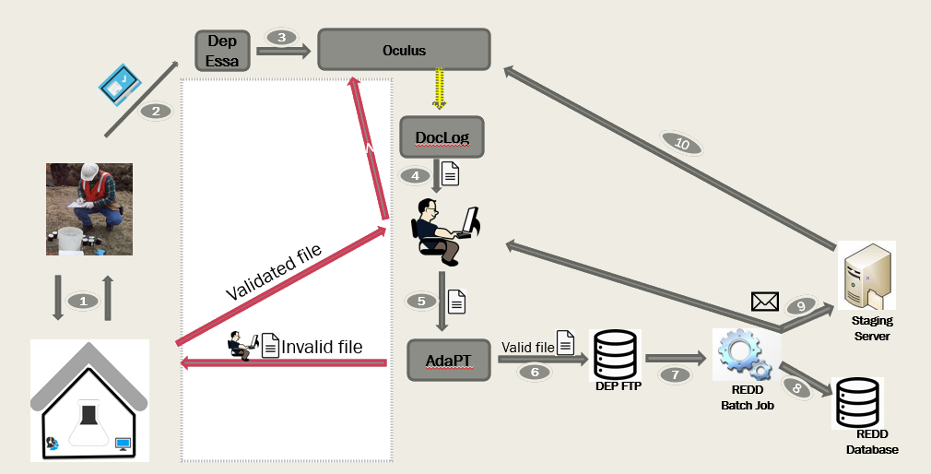

- Samples are collected by field contractors and sent to laboratories for analysis. Collection frequency varies by program and/or cleanup/monitoring type. Laboratories send results back to the field contractors who submitted the samples.
- Field contractors next submit final lab results through the DEP Business Portal, using the ESSA application. Results are formatted in comma delimited format that is pre-defined by DEP.
- Upon submission, ESSA sends a confirmation email to submitters. Submitted files are then uploaded to the DEP document management system, Oculus.
- The DocLog application provides an interface to access the submitted files from Oculus. Using DocLog, DEP staff periodically download the submitted files to their local computer for review.
- Reviewed files are processed using the Automated Data Processing Tool (ADaPT) to check for compliance. Based on the pre-defined rules, ADaPT can output the results as success or failure. Invalid sample files are submitted back to the lab via e-mail with instructions. Lab responds back to DEP staff with corrections. Once a file is deemed valid, it is published into Oculus.
- Valid sample files are also moved to a secure FTP server for further processing
7-9. REDD batch job executes twice daily and performs the following functions:
  - Reads pending files from FTP server.
  - Parses the results and insert into REDD tables.
  - Generates and sends e-mails to program users with sample results.
  - Copy the e-mail content to DEP Staging server.
- REDD invokes the Oculus API to copy the content from Staging Server to Oculus.

