Guide for ADaPT Submissions Through the DEP Business Portal
Florida Department of Environmental Protection
Division of Waste Management
Last Updated: June 14, 2021
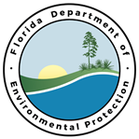

Table of Contents

I. Naming Convention 3
II. Submissions that will be Accepted 4
III. Submissions that will be Rejected 5
IV. Creating an ADaPT Export File 6
V. Updating ADaPT 9
VI. Registering with the DEP Business Portal 11
VII. Registering for a PIN for Hazardous Waste 14
VIII. Submitting a file through the Portal 15
IX. How to Submit ADaPT EDDs to Specific Program Areas in the Division of Waste Management 22
X. Instructional Videos 23
XI. Important Contacts and Resources 23

Naming Convention
All ADaPT submissions performed through the DEP Business Portal (the Portal) will need to follow the exact naming conventions shown below for the respective program. The submission must also include each of the specified components and only the specified components:

Petroleum Restoration Program (PRP) Naming Convention:
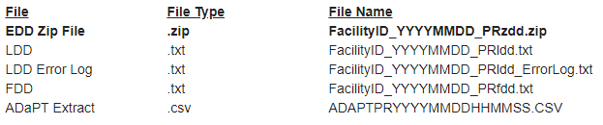

Solid Waste Program (SW) Naming Convention:
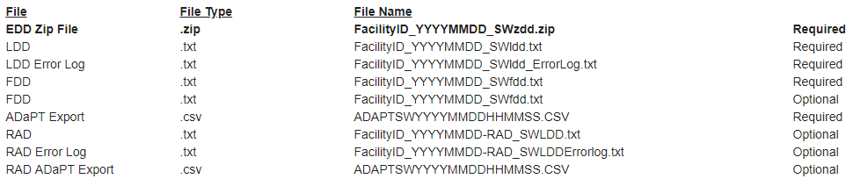
For Solid Waste submissions, your submission may or may not require the files categorized as Optional listed above for radio chemistry

Hazardous Waste Program (HW) Naming Convention:
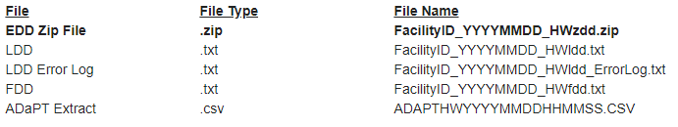
IMPORTANT: .csv files will no longer be acceptable for Field EDDs. For directions on how to create a Field EDD from a Lab EDD with the correct naming convention and file type, please follow the detailed instructions on pages 65-74 of the ADaPT User Guide. If you need to convert a Field EDD from a .csv file to a .txt file, follow these steps:
- Save the Field EDD as a .csv file in Excel
- Import it into ADaPT and run the error check
- Select “View Field EDD”
- Select “Export” (bottom right); this will result in a .txt file

Submissions that will be Accepted
Below are examples of correctly formatted ADaPT submissions. If submissions are not formatted correctly, you will receive an error message explaining what is wrong with the submission. If you are unable to determine why a file will not upload, please contact the respective program area specialist.
Petroleum Restoration Program:
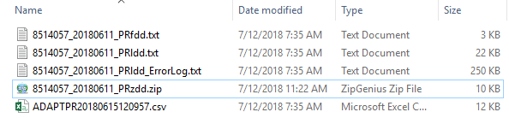
- All PRP ADaPT submissions should include only one Field EDD, one Lab EDD, one Lab Error Log, one ADaPT Export File, and NO additional files.
Solid Waste Program:
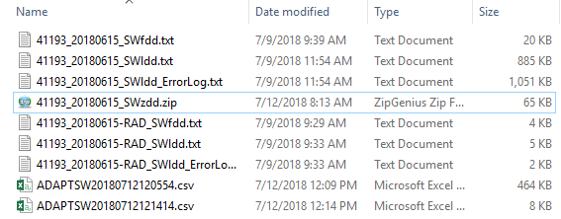
- All SW ADaPT submissions should include only one Field EDD, one Lab EDD, one Lab Error Log, one ADaPT Export File, and NO additional files

OR

- All of the files listed above with an additional Field EDD, Lab EDD, Lab Error Log, and Export File for radio chemistry

Hazardous Waste Program:
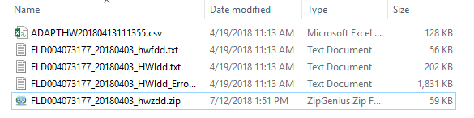
- All HW ADaPT submissions should include only one Field EDD, one Lab EDD, one Lab Error Log, one ADaPT Export File, and NO additional files.
NOTE: Solid Waste and Hazardous Waste ADaPT submissions will also require a Monitoring Report (PDF) – this will not be included in the ZIP file, but as a separate submission. Please review the Submitting a file through the Portal section of this document or view the instructional videos in section IX.

Submissions that will be Rejected
- This file will fail upload because the Field EDD is in .csv format instead of .txt format:
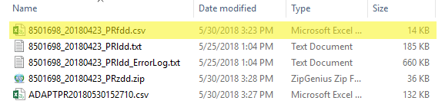
- This file will fail upload because there are additional files included in the submission. Submissions should include only files specified in the requirements outlined for each program in Section II:
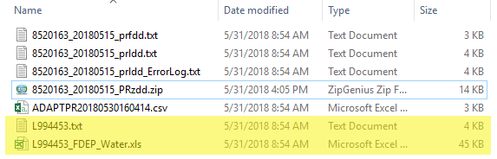
- This file will fail upload because it is missing the ADaPT Export File. All submissions must include an ADaPT Export file. Solid Waste submissions may include two: one for the traditional deliverables and one for radio chemistry deliverables:
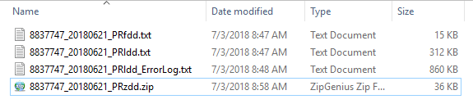

Creating an ADaPT Export File
Complete the following steps to create an ADaPT Export File:
- Click Import Lab EDD to run the Lab EDD, Lab Error Log, and Field EDD through ADaPT by uploading the Lab EDD:
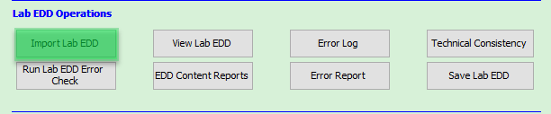

- Click Run Lab EDD Error Check:
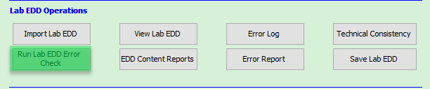

- Click Import Field EDD and allow the Field EDD Error Check to run:
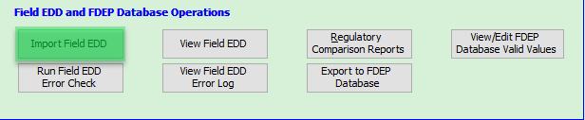

- Click Run Data Review:
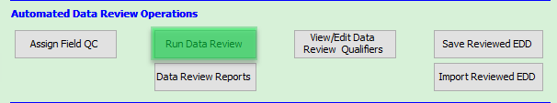

- After reviewing the files, click Export to FDEP Database:
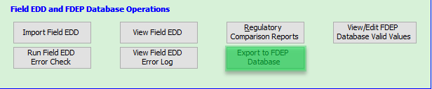

- Click Continue with DWM Database Upload:
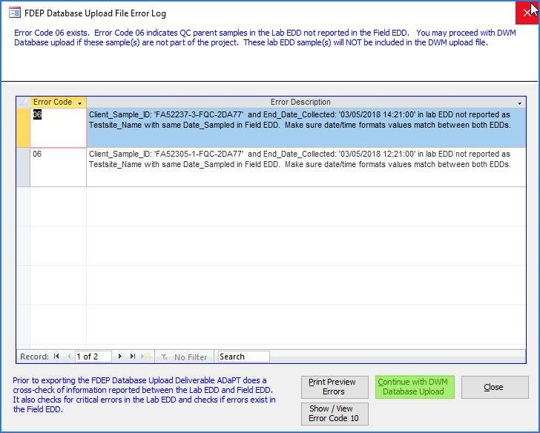

- On the next screen, select Save to disk and be sure to choose a valid file path for where you want to save the export file; click Export:
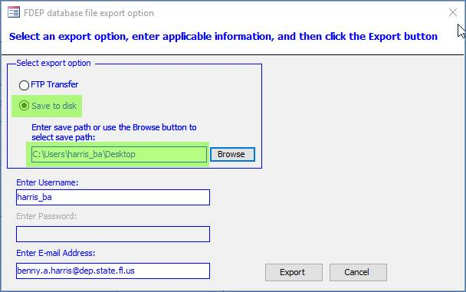
- Next, select Consultant and enter your email address in the top left field; click Continue:
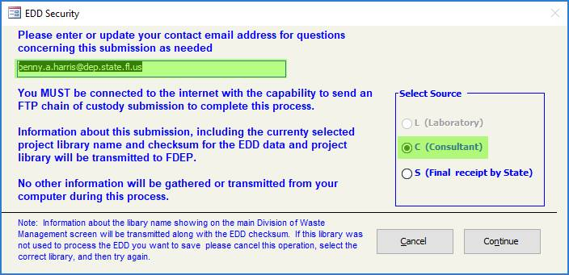

- ADaPT will automatically name the export file and will save it to the designated location selected on the previous screen. The example was saved to my desktop and was named using the appropriate naming convention including a “PR” for the Petroleum Restoration Program area. This file should be included in the compressed zip file. Files lacking the proper export document will be rejected when submitting through the Portal.
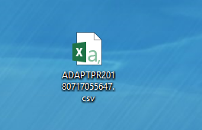

Updating ADaPT
ADaPT 9.0.11 will now automatically name the Lab EDD, Lab EDD Error Log, Field EDD, and ADaPT export file using the file name elements as shown above.

ADaPT is a 32-bit application running under a 32-bit installation of MS Office. Users will need to identify if they are running Windows 32-bit or Windows 64-bit. To determine which version you are running, use the following directions:
- Open System Information by typing “system information” into the windows search bar OR open Control Panel and select “System”

- For both options, look under “System Type” for the required information
System Information:
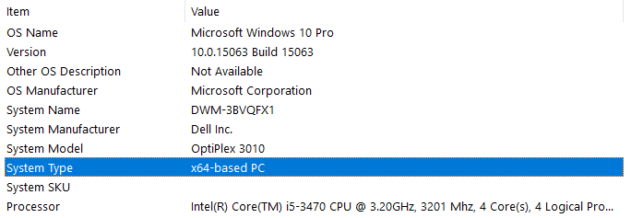

Control Panel > System:
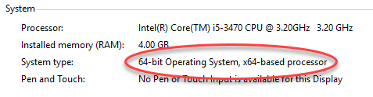
To update ADaPT, download the file for your operating system by clicking the appropriate link below and saving to your local hard drive:
32-bit ADaPT Update OR 64-bit ADaPT Update
Ensure that ADaPT is not running and that you have finished processing all EDDs. Navigate to the appropriate file and double click on it to execute. This program will update the ADaPTModules.accde and ADaPTTables.accdb files and overwrite the existing files.
If you update ADaPT 9.0.11 and encounter any problems, please let us know. Contact information for the ADaPT team can be found here.

Registering for the DEP Business Portal
(1) Go to the DEP Business Portal Welcome page and click Register:
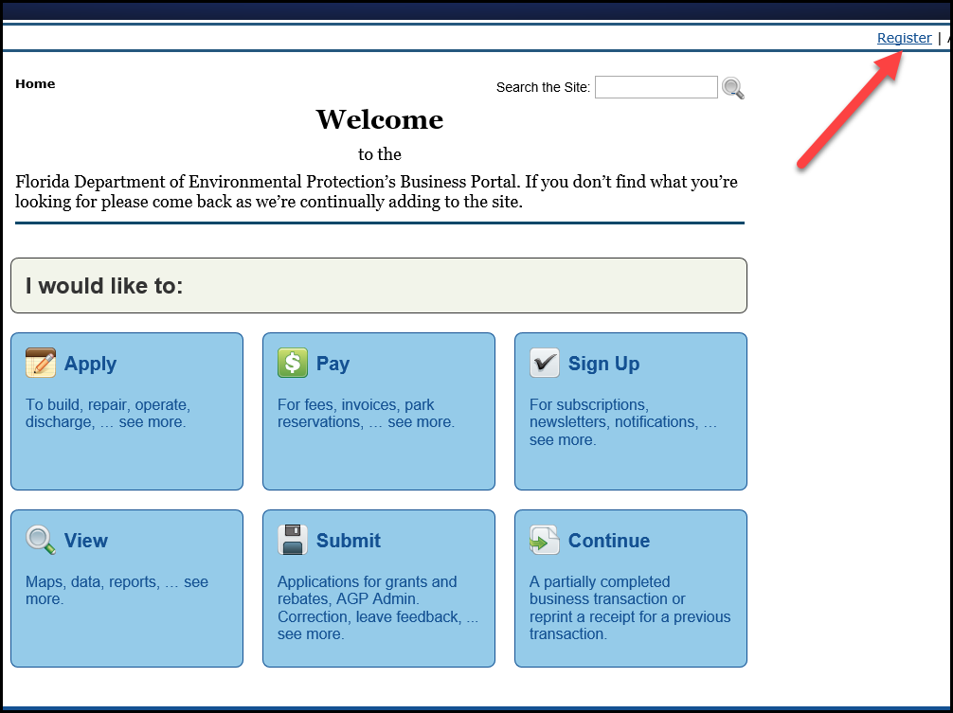

- Complete all fields with * and click Register:
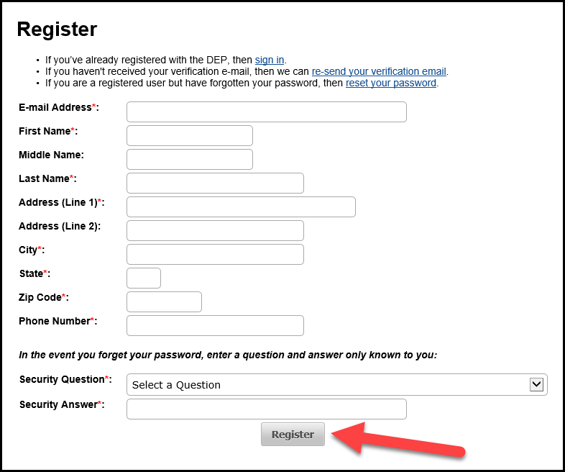

- You will receive and email like the one below; click the link to verify your email:
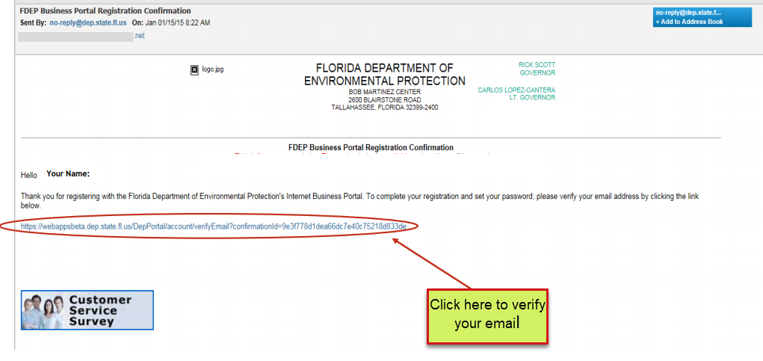

- Enter your security question answer to create and confirm a new password:
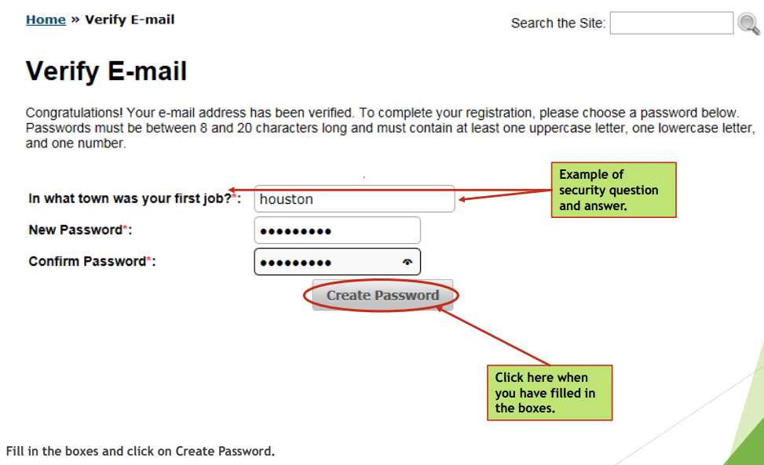

- You are now registered with the Portal and should receive the message below. If you require a PIN for Hazardous Waste submissions, please follow the link circled below:
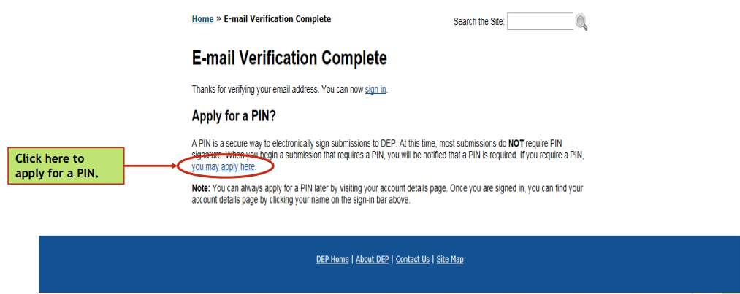

Registering for a PIN for Hazardous Waste
You can find instructions for registering with the DEP Business Portal and creating a PIN for Hazardous Waste submissions here.
Once you have completed the paperwork required for your PIN, please mail the form to the following FDEP location:
Florida Dept. of Environmental Protection
Attn: ESSA Processing
2600 Blair Stone Rd MS#6520
Tallahassee, FL 32399-2400

If you have any questions, please contact the appropriate program area.

Submitting a file through the Portal

- Begin at the DEP Business Portal Welcome page and click Sign In:
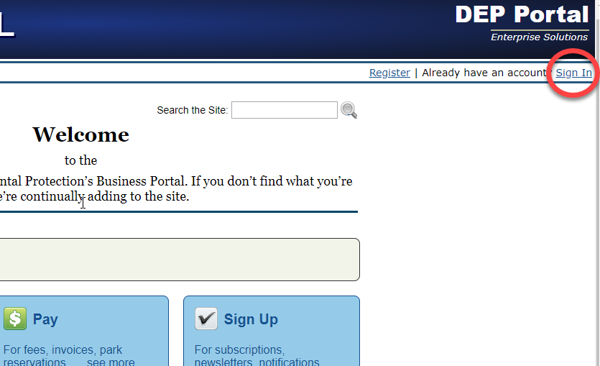

- After signing in, click Submit:
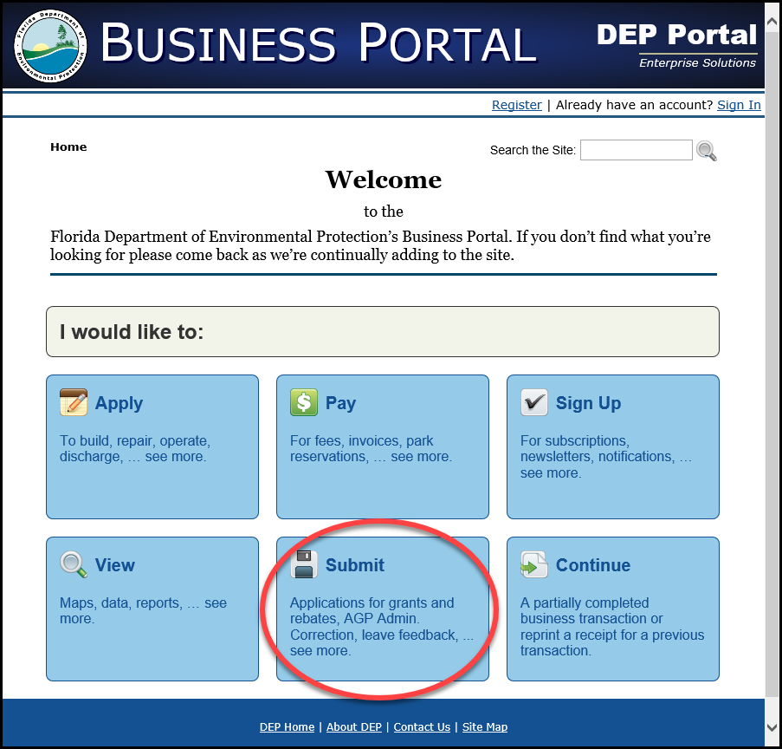

- Then click Report:
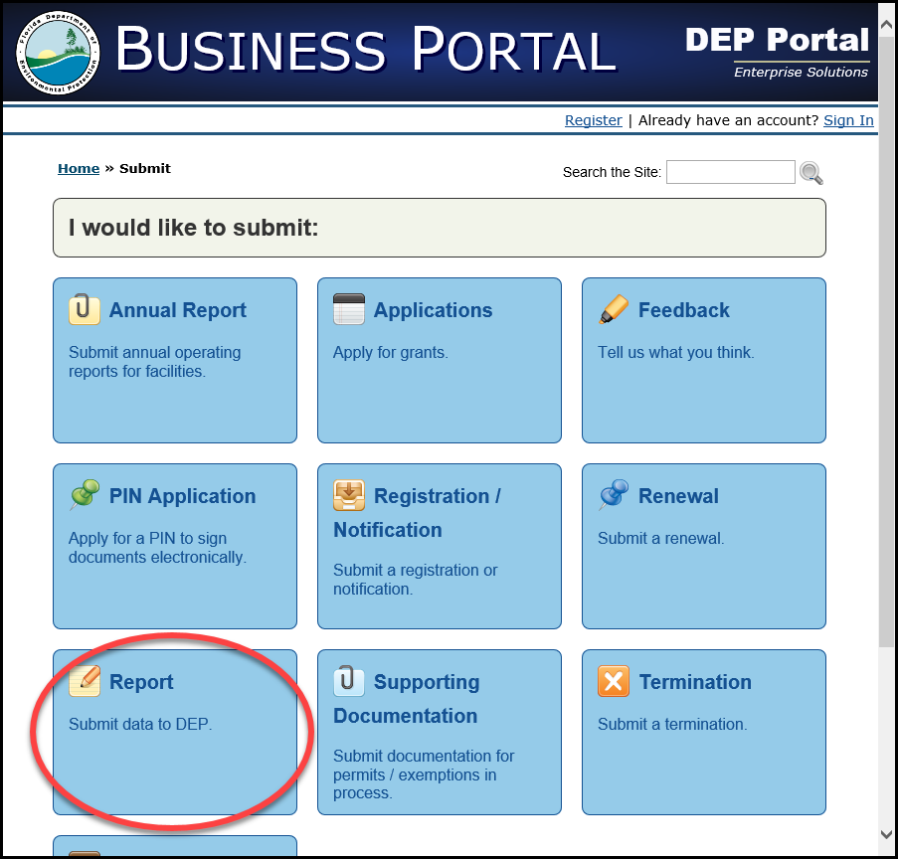

- Then select Electronic Data Deliverable (EDD):
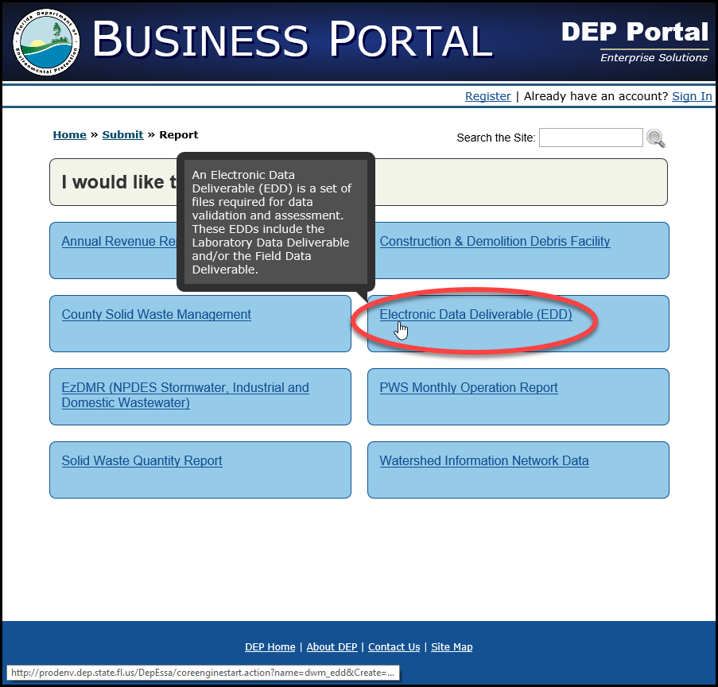

- On the Electronic Data Deliverable (EDD) Submission Introduction screen, click Go to Next Step:
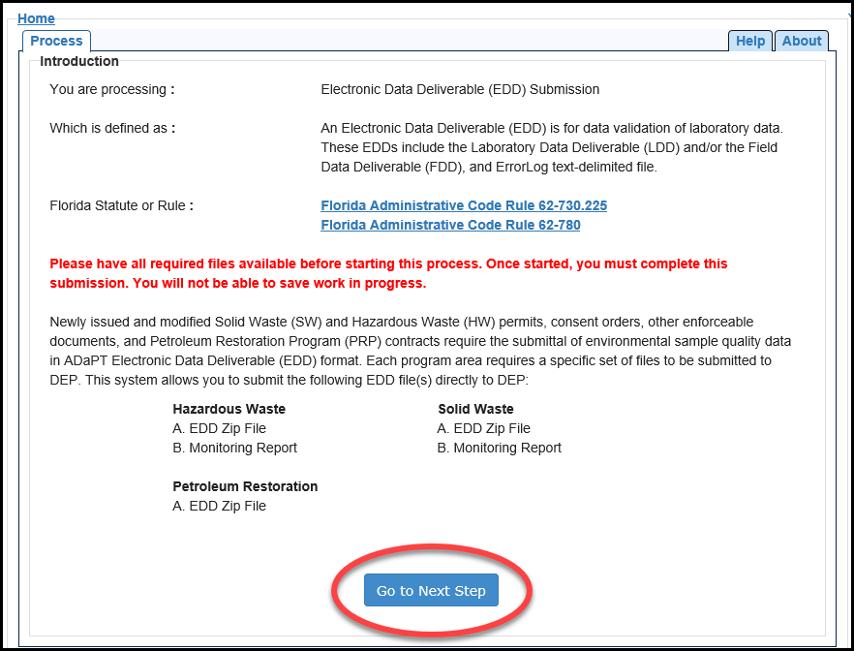
- Select the program area for the file you are submitting and click Save and Go to Next Step:
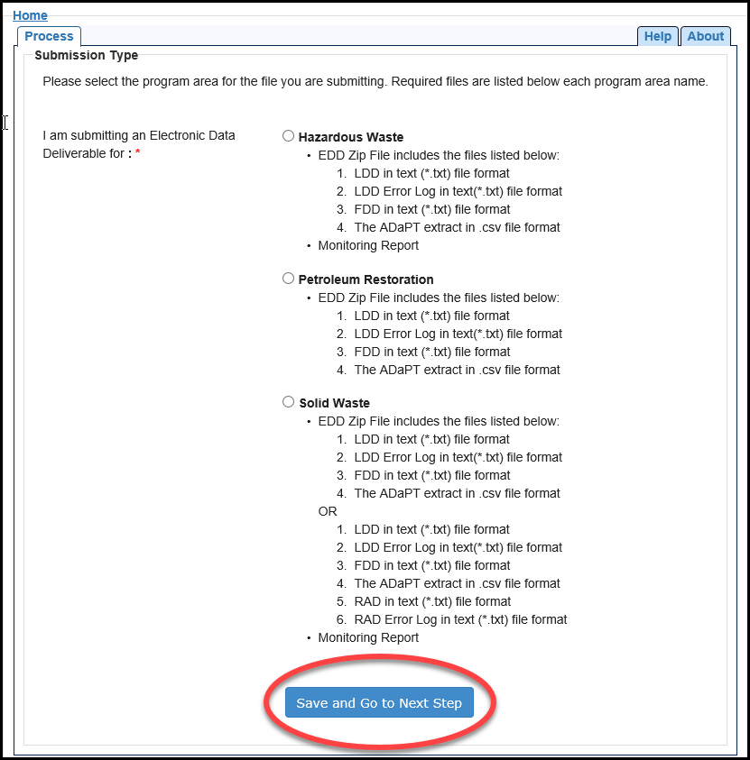

- Enter the Facility ID associated with your submission and click Search and Continue:
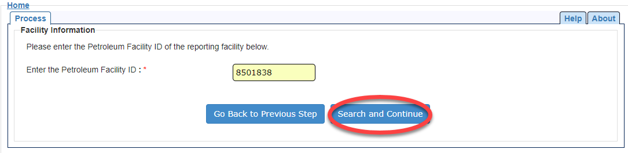

- All information marked with * must be completed correctly to move on to the next selection. Please note, only Petroleum Restoration Program area files will be accepted as “Revision”. All other program areas should always select “New Submission”:
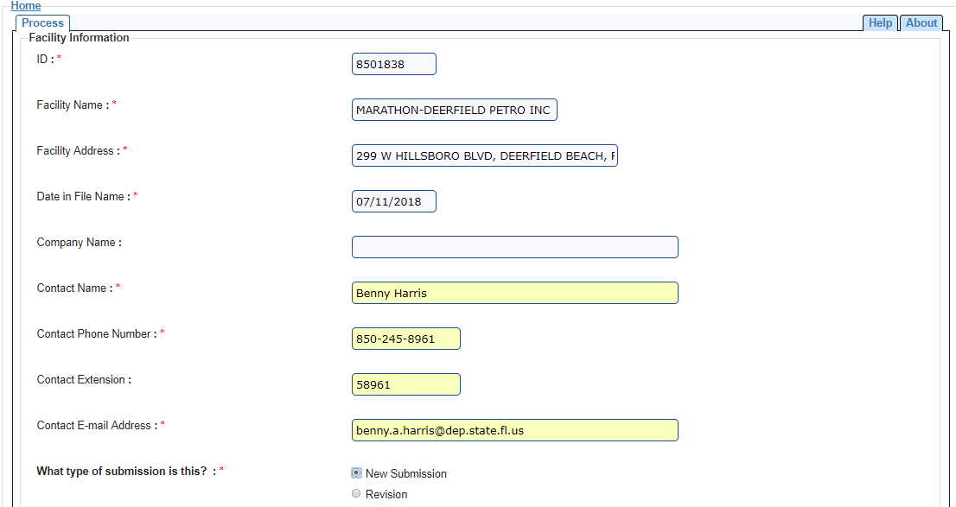

- If applicable, select the correct work order or select “N/A”, then click Save and Go to Next Step:
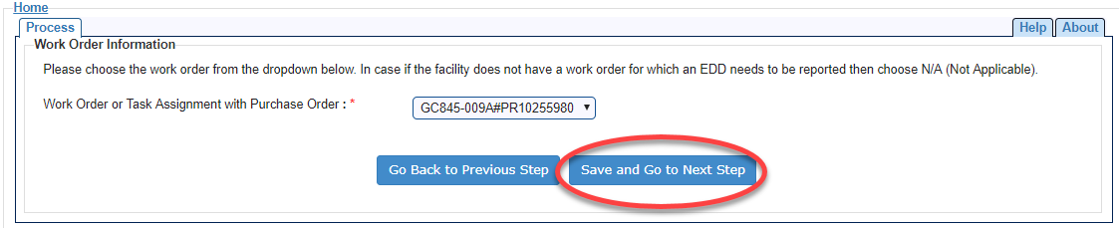

- On the next screen, click Save and Continue:
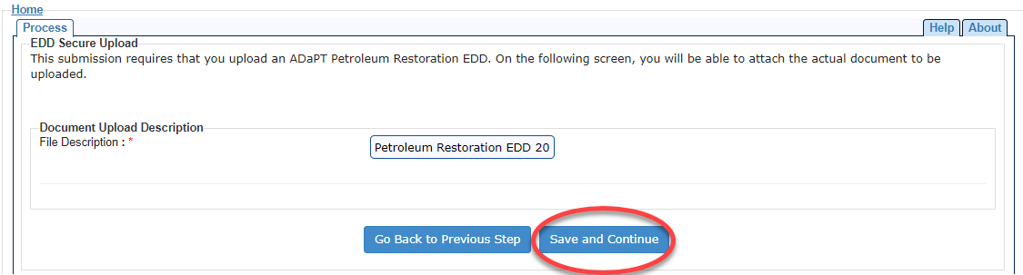

- Select your deliverable for upload by clicking Choose File and then Continue. If your deliverable does not conform to the specifications provided in this document, you will receive a detailed error message.
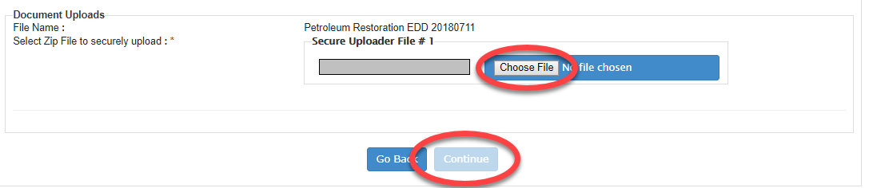

NOTE: There is an additional step for SW and HW (Monitoring report PDF upload). Please view the video tutorials for more specific guidance

If you have any problems, please communicate with one of the ADaPT Contacts.

How to Submit ADaPT EDDs to Specific Program Areas in the Division of Waste Management
Program | Internet | Email
HW - Hazardous Waste | Portal | Submit by mail to project manager
PR - Petroleum Restoration | Portal | PRP.ADaPT@dep.state.fl.us
PR - Petroleum Restoration | Portal | For communication only; do not submit EDDs via email
SW - Solid Waste | Portal | AdaPT.EDDs.and.Reports@dep.state.fl.us
SW - Solid Waste | Portal | For communication only; do not submit EDDs via email
WC - Waste Cleanup | WC FTP Site | Submit by mail to project manager

Instructional Videos
ESSA HW ADaPT EDD Submission
ESSA PRP ADaPT EDD Submission
ESSA SW ADaPT EDD Submission
Creating a Field EDD
ESSA/PIN Registration

Contacts and Resources
For technical assistance with ADaPT software installation or troubleshooting:
Clark Moore, Operational and Program Performance
Clark.B.Moore@floridadep.gov
(850) 245-8739

Petroleum Restoration Program:
Katharine L Hoover
Katharine.L.Hoover@FloridaDEP.gov
PRP.ADaPT@dep.state.fl.us
(850) 245-8713

Hazardous Waste Program:
Amber Igoe
Amber.Igoe@floridadep.gov
(850) 245-8783

Solid Waste Program:
Tayo Olayiwola
Tayo.Olayiwola@floridadep.gov
AdaPT.EDDs.and.Reports@dep.state.fl.us
(850) 245-8746

OR

Chad Fetrow
Chad.Fetrow@floridadep.gov
(850) 245-8785

Additional Resources
- Division of Waste Management ADaPT Page
- ADaPT User Guide
- ADaPT FAQ
- PIN Request Directions

