On 01/28/2022, FDEP discontinued the ftp site that the ADaPT software used for the following processes. Simply click [OK] for the ftp error messages.
- Update ADaPT’s FDEP Database Monitoring Testsite Inventory valid values.
- Export Data Security file:
- When saving a Lab EDD
- When creating an ADAPTXZYYYYMMDDHHMMSS.csv export file during the [Export to FDEP Database] (save to disk option)

After opening ADaPT, from the Main “blue” screen select Go To Division of Waste Management Menu:
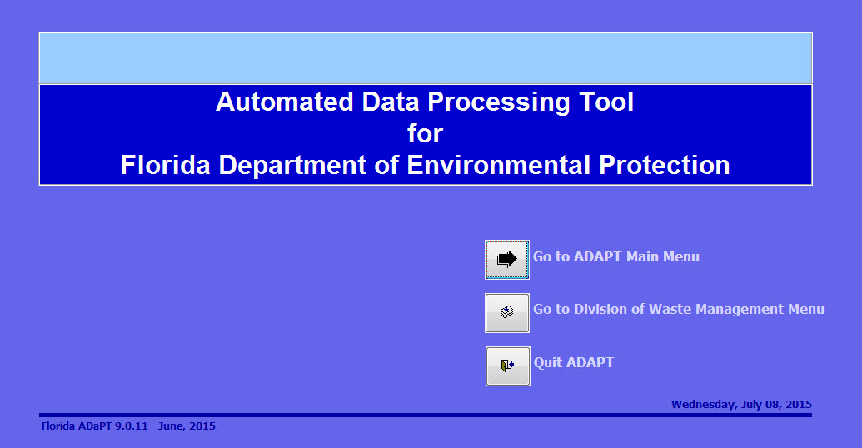

Click [No] when asked if you want to update the FDEP Database valid values:
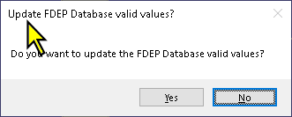

How to update the FDEP Database Valid values (Monitoring Testsite Inventory)
From the FDEP ADaPT web page, find the Monitoring Testsite Inventory link and right-click and save to local drive, then click:
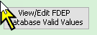
The Monitoring_Testsite_Inventory tab is selected by default:
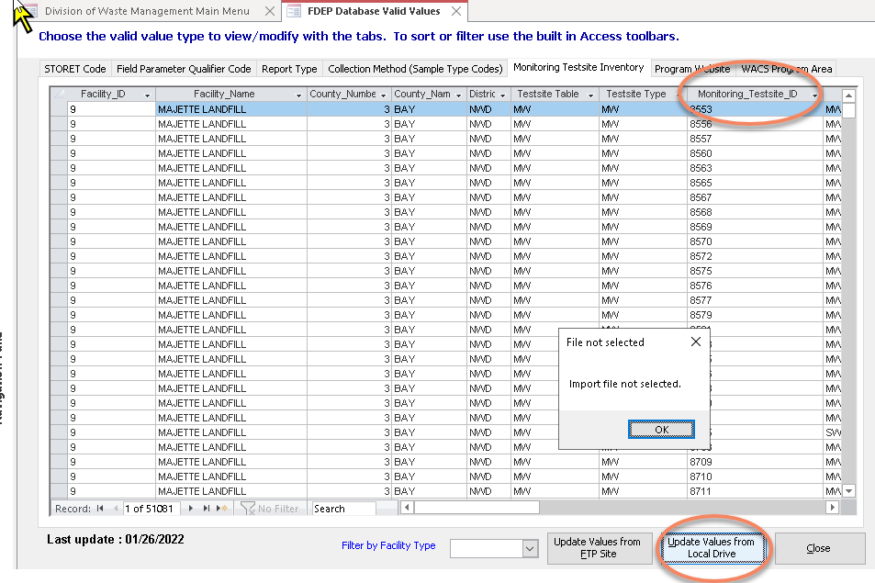
Click [Update Values from Local Drive] and choose the file you just downloaded, “WACS_testsite_inventory.txt”:
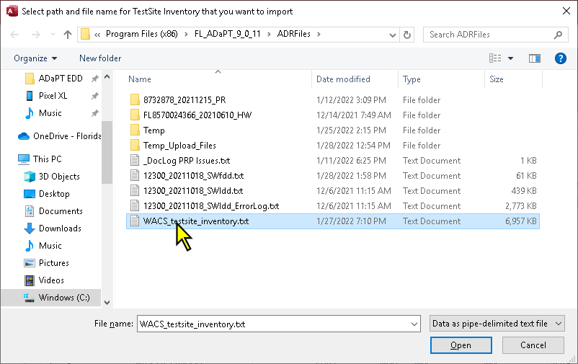

Note that after a successful import of the WACS Monitoring Testsite Inventory, the Last Update date should be the previous weekday (M-F).

How to create an ADAPTXZYYYYMMDDHHMMSS.csv export file during the Export to FDEP Database (save to disk option)

Click on [Export to FDEP Database]:

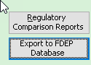
Once you review the Error Log and have corrected all applicable errors, click [Continue with DWM Database Upload]:
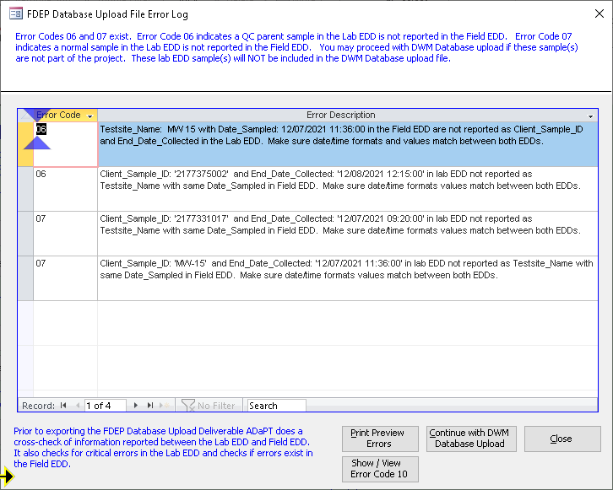
Click [Export]:
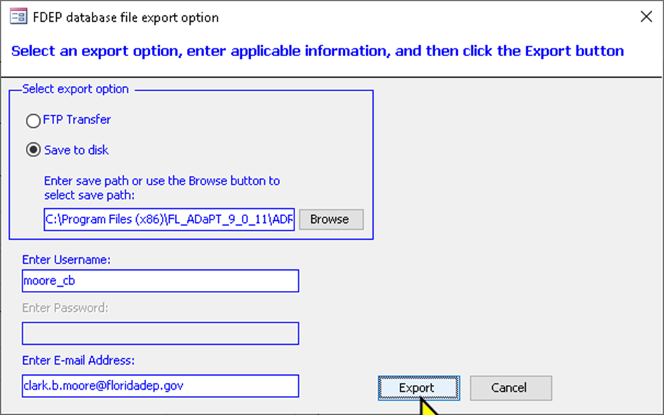
Then click [Continue]:
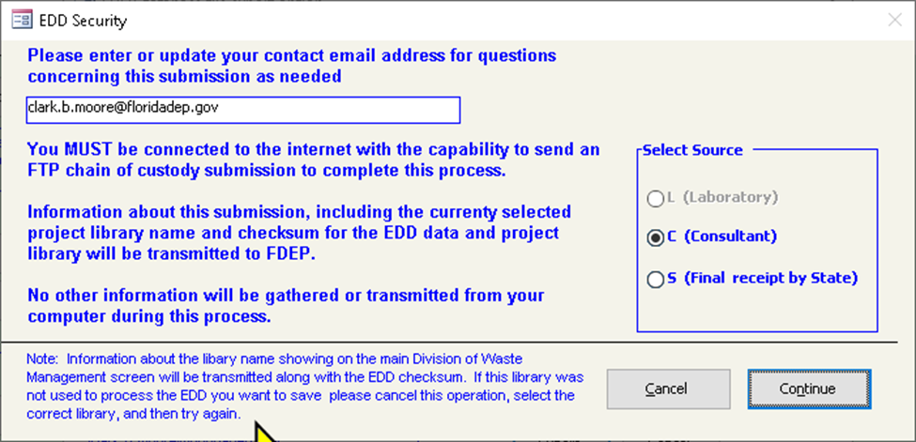

You will receive the following error message:
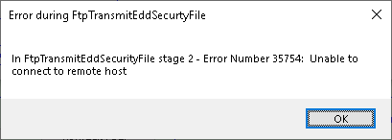
Click [OK] and you will receive a second error message:
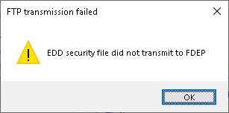
Click [OK] and the ADaPT csv file will be created:
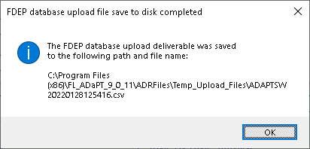
Click [OK]

