How to update the FDEP Database Valid values (Monitoring Testsite Inventory)
From the FDEP ADaPT web page, find the Monitoring Testsite Inventory link and right-click and save to local drive, then click:
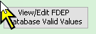
The Monitoring_Testsite_Inventory tab is selected by default:
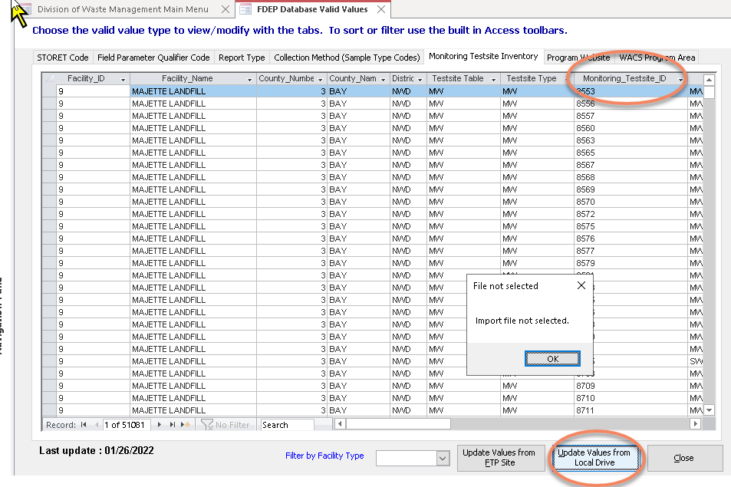
Click [Update Values from Local Drive] and choose the file you just downloaded, “WACS_testsite_inventory.txt”:
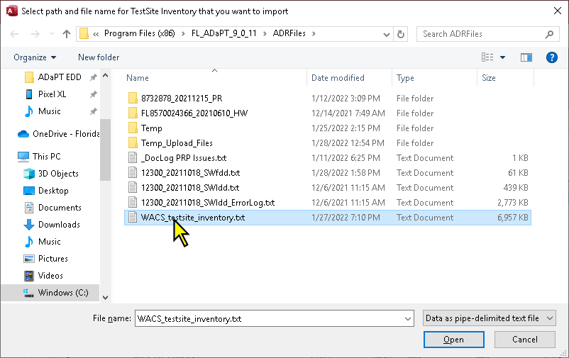

Note that after a successful import of the WACS Monitoring Testsite Inventory, the Last Update date should be the previous weekday (M-F).

