
WECK LABORATORIES, INC.

Services > Other Services > Data Deliverables > Electronic Data Deliverables (EDD) Full List

Electronic Data Deliverables (EDD) Full List

Examples of standard EDDs are available for download. To find out if Weck Laboratories support a specific EDD format not listed here, please contact us.

Weck Standardized EDDs

EDD Name
wweck Standard Excel 2.6
Description
Three worksheet excel (SAMPDATA, QCDATA, LNOTE)

LIMS Standardized EDDs

EDD Name Simple Excel Simple Excel B
Standard Access 2
Standard Access 7 Standard DBASE Standard Excel
Standard Excel Ordered

Standard Excel Transfer

Standard FoxPro Standard Lotus Standard Text/CSV
Standard Text/FxW Standard Text/TAB Standard XML
Description
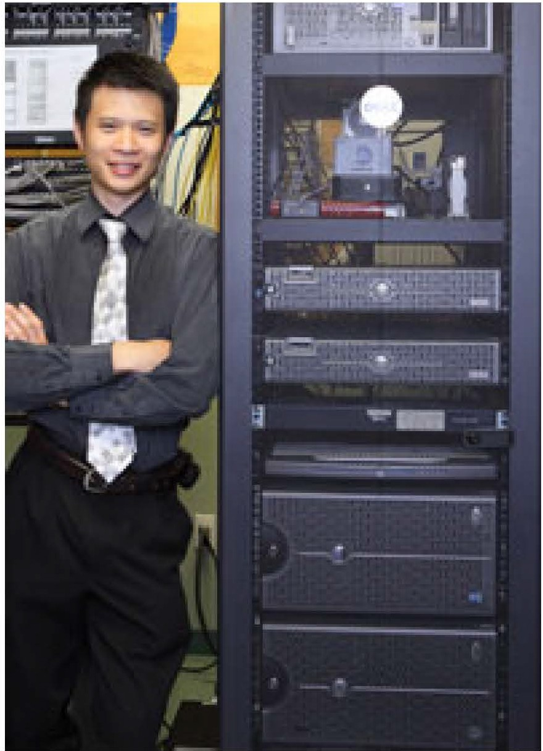
Simple Excel EDD (9 fields) Simple Excel EDD (12 fields)
Standard Access EDD (MS Access version 1.0) Standard Access EDD (MS Access version 3.0) Standard DBASE EDD
Standard Excel EDD
Standard Excel Ordered Excel file format with all Transfer File Fields in an ordered arrangement
Standard Excel Transfer EDD Excel file output, all Transfer file fields new fields added to end of Std Excel EDD format
Standard FoxPro Standard Lotus Standard Text/CSV
Standard Text EDD - Fixed width Standard Text/TAB
Standard extensible Markup Language (XML)

Industry Standardized EDDs

EDD Name ADAPT/ADR ADAPT/ADR (DTSC)
*AK_EDRS
*APG Upload
*APHL Env Typelt
*AWQMS Upload
*AZDEQGW
Analyte Pivot
*Bechtel
wcA Write-On
*CALTrans WCEDEN CH2MHILL V4 CH2MHILL V431
*CHEVRON CIWQS CDF
COELT 1.2a COELT 1.2i
Description
ADAPT/ADR EDD
ADAPT/ADR Department of Toxic Substances Control EDD Alaska Electronic Data Reporting System
CSV file
APHL Env Type lt, csv file format AWQMS Upload EDD, Excel/CSV
Arizona Department of Environmental Quality Groundwater Data Submittal Guidance Document Version 3.3 Inverted Excel Spreadsheet
Bechtel EDD
California State Write-On Cal Trans EDD
California Environmental Data Exchange Network (CEDEN) CH2M Hill EDD version 4
CH2MHILL Version 4.31, CSV
CHEVRON, MS Access DB
California Integrated Water Quality System Data Format
Produces an EDF file with the file type defaulted to Fixed Width Relative Text files, and using the COELT file names instead of the EDF file names. This allows the COELT EDD that is produced to be checked using the EDCC checker.
See COELT 1.2a

EDD Builder EDF 1.2i
*EDMAN v2
*EDMan
*EM EDD 13
*EPA Scribe EPAR2
EPAR2_V14
*EPAR4 EQUIS 3.x wEQUIS Sx
*ERA CSV Upload
*ERIMS v2.1
*ERIMS v2.2
*ERIS
ERPIMS 5.1 LAB
ERPIMS 5.1 PRM ERPIMS LAB DLH 4.0 ERPIMS PRM DLH 4.0
*ESmart EDD wEz EDD
*EZEDD v2121
Enhanced ERPIMS wEnviroData
EnviroData V2008

EnviroData V2010

*FDA_eLEXNET
*FL Validator
*Florida DEP ADAPT
*GEMS EDATA
*GEMS EDATA V6 GIS/Key 2.3
GIS/Key 3.1
*ILEPAGW IRPIMS DLH 3.0
*Illinois xis LINKO LOCUS EIM
Locus EIM 53
*MEDEP
MW ERPIMS DLH 4.0 MW IRPIMS DLH 3.0
*MassDEP
*Michigan DEQ_WMD
*Minn PCA
*Missouri DNR
*NHEMD
*NJDEP
*NJDEP Text

*NPDES DNR

*NYSDEC Excel
*NYSDEC TestResultsQC
*Oregon DOH
*PASDWA Excel
*SAP QM-IOI 4.6
*SCWRB 2
wSDEF 1.5
*SDWIS KY CSV
*SDWIS NC
EDDBuilder Geotracker EDF EDMAN V2 EDD ED Man EDD
Environmental Management Electronic Data Deliverable (Ver 1.3) EPA Scribe, tab delimited text
EPA Region 2 EDD This EDD creates the following files: EPAR2SMP.csv EPAR2TRS.csv or EPAR2TRSQC.csv EPAR2BAT.csv
EPAR2 Version 1.4, February 2010 EPAR4 csv EDD
Earthsoft EQuIS: Environmental Data Management Software EDD version 3 EQuIS 5.X format (BCH,RES,SMP,TST). Also known as EFWEDD
CSV file for uploading PE test data to Environmental Resource Associates ERIMS V2.1, tab delimited text
ERIMS V2.2
US Army Environmental Restoration Information System (ERIS) ERPIMS 5.1 LAB (RES.txt, SAMP.txt,TEST.txt)
ERPIMS 5.1 PRM (RES.txt,SAMP.txt,TEST.txt)
ERPIMS LAB DLH 4.0 (RES.txt,SAMP.txt,TEST.txt) ERPIMS PRM DLH 4.0 (RES.txt,SAMP.txt,TEST.txt)
ESmart EDD
EQuIS EZEDD by EarthSoft EZEDD version 2.1.21
Combined RES.txt, SAMP.txt, and TEST.txt records into one flat fixed-width text file Enviro Data EDD Version 1.6
EnviroData version 2008 creates an Excel spreadsheet with a single worksheet called Envirodata. The worksheet has 119 columns.
EnviroData 2010, creates Excel file. New fields: Detect4, LimitType4, Detects, LimitTypeS, UpperControllimit,
LowerControllimit, RejectionControllimit, RPDLimit, APDLimit eLEXNET_DXM 4.5
Florida Validator, Excel Florida DEP ADAPT EDD GEMS EDATA, csv GEMS EDATA V6, csv
GIS and Data Management Software GIS and Data Management Software IL EPA Groundwater EDD
IRPIMS DLH 3.0 (ERPIMS)
ILLINOIS XLS, Excel (for US Filter) LINKO Data Systems software EDD
Environmental Information Management EDD See LOCUS EIM
Maine DEP VS.2 (Excel)
See ERPIMS See ERPIMS
Massachusetts DEP Michigan DEQ WMD, csv
Minnesota Pollution Control Agency Missouri Dept of Natural Resources EDD
New Hampshire Environmental Monitoring Database NJ DEP, Lotus .wkl
NJDEP srpedi1999 tab delimited text format
National Pollutant Discharge Elimination System - Discharge Monitoring Report: Form 0MB No. 2040-0004 & EPA Form 3320-1
NYSDEC: Produces Excel spreadsheet with 4 work sheets (Sample_vl,TestResults_vl,TestResulsQC_vl,Batch_vl) NYSDEC TestResultsQC_vl worksheet includes samples and QC, no TestResults_vl worksheet
Oregon DOH, csv
Penna. Safe Drinking Water Act Excel Format SAP QM-IOI 4.6
SCWRB 2
California Stormwater Monitoring Coalition (SMC) State of Kentucky SDWIS file in CSV format
State of North Carolina SDWIS file in CSV format (SDWIS v2.3)

*SDWIS NC v3.0
*SDWIS NE CSV
*SDWIS NM CSV
*SDWIS NV XML
*SDWIS SC XML
*SDWIS XML IL
*SDWIS XML IOWA
*SDWIS XML RI
*SDWIS_VACSV SEDD 2a Rev 5.0 SEDD 2a Rev 5.2
*SEDD 2b Rev 5.0
*SEDD 2b Rev 5.2
SEDD SOM0l.1 Exhibit H SMARTS
STEERS EDMR
SWAMP WSWAMP 2.5
*SWRCB ERS 2.0
Sample Analyte Pivot TRANSFER FILE
TRANSFER FILE No Sample Name
*TerraBase Lvl 2
*TetraTech UCMR Text
UCMR3
UCMR3 CDX UCMRXML
*Visual Site Manager 2.0
*WADOE EIM Excel
*WI DNR Text
*WQX
WaterTrax Weston Text Wibby Upload
*Wis DNR LDES
*eDWR_SDWIS
State of North Carolina SDWIS file in CSV format (SDWIS v3.0) State of Nebraska SDWIS file in CSV format
State of New Mexico SDWIS file in CSV format
State of Nevada SDWIS file in XML format
State of South Carolina SDWIS file in XML format. State of Illinois SDWIS file in XML format.
State of Iowa SDWIS file in XML format.
State of Rhode Island SDWIS file in XML format. State of Virginia SDWIS file in CSV format.
EPA Superfund Analytical Services/Contract Laboratory Program (CLP) Staged Electronic Data Deliverable (SEDD) See SEDD 2a Rev 5.0
SEDD 2b Rev 5.0 SEDD 2A/2B Rev. 5.2
Multi-Media, Multi-Concentration, Organic Analytical Service for Superfund (SOM0l.1)
Stormwater Multiple Application and Report Tracking System (SMARTS). SMARTS is derived from CIWQS. STEERS (State of Texas Environmental Electronic Reporting System) DMR (Discharge Monitoring Report) SWAMP v2.2 EDD, specified in "Database Training Document, Last updated May 4, 2005"
SWAMP v2.5 (April 13, 2009)
Regional Water Quality Control Board San Francisco Bay Region Electronic Reporting System 2.0 Pivot Table by Sample Analyte
Promium's Element Database System LIMS Transfer File. See TRANSFER FILE
Terra Base Level 2, pipe delimited
Tetra Tech Flat-file Format and Data Requirements for Electronic Deliverable of Analytical Laboratory Results Output is tab delimited text file.
EPA Unregulated Contaminant Monitoring Regulation supporting the second cycle (UCMR 2) of monitoring. Output is tab delimited text file. Unregulated Contaminant Monitoring Rule 2
Output is tab delimited text file. This is the version of UCMR2 that can be uploaded into the EPA CDX (Central Data Exchange) website.
Output is single XML file. Visual Site Manager 2.0, csv
Washington Dept. of Ecology EIM Excel upload format WI DNR Text
Water Quality Exchange EDD
Drinking Water and Wastewater Data Management System Weston Solution Text-based EDD
Wibby PT Manage system Upload EDD Wisconsin Laboratory Data Entry System
The eDWR SDWIS EDD creates an XML file for uploading into the SDWIS State programs.

Not Listed We can custom create nearly all Standardized or Non-Standardized EDD to fit your project requirements.
Please contact us and send us your EDD specifications.

Over 50 customized EDDs have been developed by Weck Laboratories, Inc!

Notes:

* - This EDD is currently pending, in research, in development, or has not been tested. Please contact us for status.

w - The EDD export tool was specially developed at Weck Laboratories, Inc. Weck Laboratories generally develop their own applications to provide greater service to their clients.

