

Automated Data Processing Tool (ADaPT) User Guide

Version 9.0.11

Division of Waste Management
Florida Department of Environmental Protection
February 22, 2022

Contents

1. Introduction 4
2. Submitting ADaPT EDDs to Specific Program Areas 7
3. Overview of the ADaPT Process 8
4. Detailed ADaPT User Process (Step-by-Step) 10
A. Data Generation (Laboratories) 10
B. Data Submittal (Consultants, Regulated Entities, Laboratories) 15
C. Data Evaluation and Upload to FDEP Database 29
D. Appendix A: Lab EDD Critical Error Check 41
E. Appendix B: Summary of Non-Critical Lab EDD Errors 43
F. Appendix C: Summary of Error Codes During FDEP Databases Export 48
5. ADaPT Installation Instructions 50
6. How to Update ADaPT 52
A. Detailed Instructions for Importing an ADaPT Library 54
7. ADaPT Lab and Field EDD Reference Information 61
A. ADaPT Lab and Field EDD File Names 61
B. I Have an LDD – How do I Produce an FDD? 65
C. Additional Error Checks 78
D. Field Parameters, Field Methods, and Reporting Units 79
E. ADaPT Laboratory Deliverable Specifications (LDD) 80
F. Field EDD Deliverable Specifications 88
8. Petroleum Restoration Program 90
A. Introduction 90
B. File Naming Convention 91
C. ADaPT Process 95
D. Instructions for the Consultant to Submit PRP Zip Files Via the FDEP Business Portal 99
9. Waste Cleanup Program 100
A. Introduction 100
B. Additional Notes Regarding WCP Implementation of ADaPT 101
C. Overview 103
10. Version History 107
11. Glossary of Acronyms 121

Introduction

The Division of Waste Management (DWM) within the Florida Department of Environmental Protection (DEP or FDEP) has implemented the use of an application titled the Automated Data Processing Tool (ADaPT) to evaluate water and soil quality data. Newly issued and modified Solid and Hazardous Waste permits, consent orders, other enforceable documents, and Waste Cleanup Program (WCP) and Petroleum Restoration Program (PRP) contracts require the submittal of environmental sample quality data in ADaPT Electronic Data Deliverable (EDD) format. ADaPT EDD submittals should include three files to properly evaluate the water quality data: 1) Lab EDD (LDD), 2) Field EDD (FDD), and 3) Error Log. Contracts, permits, consent orders or other enforceable documents may require that additional information be submitted.

Program Area ADaPT Submittal
Solid Waste Consent order, permit, or another enforceable document
Hazardous Waste Consent order or other enforceable document
Petroleum Restoration Contract
Waste Cleanup Contract

The requirements for ADaPT EDDs related to DWM reporting is defined in the ADaPT project library for each program. The ADaPT project library serves as the electronic quality assurance (QA) plan and indicates what quality control (QC) elements are required by FDEP.

Click here to view the QA Plan (for DWM).

There may be requirements specified in the ADaPT project library that are not explicitly required in Environmental Protection Agency (EPA) methods. In general, EPA methods and National Environmental Laboratory Accreditation Program (NELAP) QC requirements for laboratory control samples, method blanks, surrogates, matrix spikes and duplicates are included elements in the ADaPT project library for most methods (where applicable and appropriate).

FDEP must receive and be able to evaluate non-project QC samples, spikes, sample duplicates and spike duplicates submitted with EDDs. To ensure anonymity is preserved for the non-project QC samples, all non-project QC samples may be identified by ClientSampleId using the LabSampleId.

When data is exported to Repository for Electronic Data Deliverables (REDD), ADaPT will identify those QC samples that do not have corresponding records in the FDD. For errors related to non-project QC samples, export to REDD can continue because these results will not be uploaded. If the project QC sample(s) did not have any corresponding records in the FDD, cancel the export, add the required records for the project QC sample in the FDD, then re-evaluate the FDD and re-export the data to REDD.

The REDD Oracle table and the Water Assurance Compliance System (WACS) Oracle Database are collectively known as FDEP Databases.

Figure 1. A sample ADaPT error log.
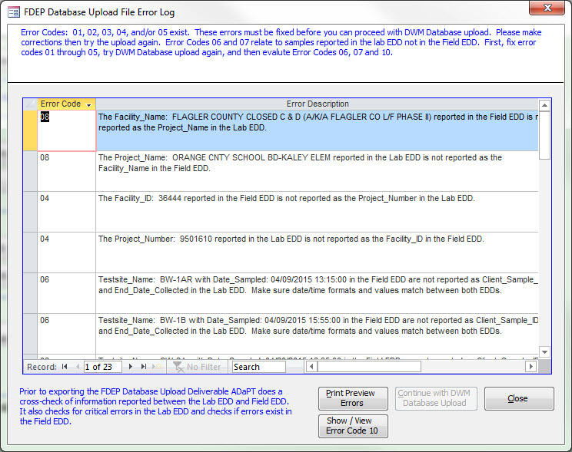

Submitting ADaPT EDDs to Specific Program Areas

ESSA ADaPT EDD Submittal Guide - Includes links to instructional videos.

Program | Area FTP | Email
HW - Hazardous Waste | DEP Business Portal | Submit by mail to project manager
PR - Petroleum Restoration | DEP Business Portal | PRP.ADaPT@dep.state.fl.us  For communication only; do not submit EDDs via email
SW - Solid Waste | DEP Business Portal | AdaPT.EDDs.and.Reports@dep.state.fl.us
WC - Waste Cleanup | WC FTP Site | Submit by mail to project manager

- Overview of the ADaPT Process

Sample Collection
- Sampling team collects samples and field data
- Samples are submitted to the laboratory
- Field data is sent to consultant, lab, or regulated entity (whichever generates the FDD)

Data Generation (Laboratories)
- The lab analyzes samples and creates ADaPT LDD
- Using ADaPT, the lab runs the error check on the LDD and corrects or comments on any errors that have not been resolved
- The lab sends the LDD and Lab Error Log to the regulated entity or consultant

Data Submittal (Consultants, Regulated Entities, Laboratories)
- Using ADaPT, the regulated entity or consultant runs the Error Check on the LDD and corrects or comments on any errors that have not been resolved
- Using ADaPT, the regulated entity or consultant runs the Automated Data Review
- Using ADaPT, the regulated entity, consultant or lab creates and checks the FDD and corrects any errors that have not been resolved
- Using ADaPT, the regulated entity, consultant or lab runs the Regulatory Comparison Report
- The regulated entity, consultant or lab exports the data as a final check and submits the LDD and the FDD in one package to FDEP

FDEP Data Evaluation and Upload to FDEP Databases
- Using ADaPT, FDEP runs the Error Check on the LDD
- Using ADaPT, FDEP runs the Automated Data Review
- Using ADaPT, FDEP checks the FDD for errors
- Using ADaPT, FDEP runs the Regulatory Comparison Report
- Using ADaPT, FDEP exports data to FDEP Databases

Detailed ADaPT User Process (Step-by-Step)

The step-by-step guide to the ADaPT process:

Data Generation (Laboratories)

Step 1. The lab should analyze samples and create an LDD.

Step 2. Then, open ADaPT and select Go to Division of Waste Management Menu.

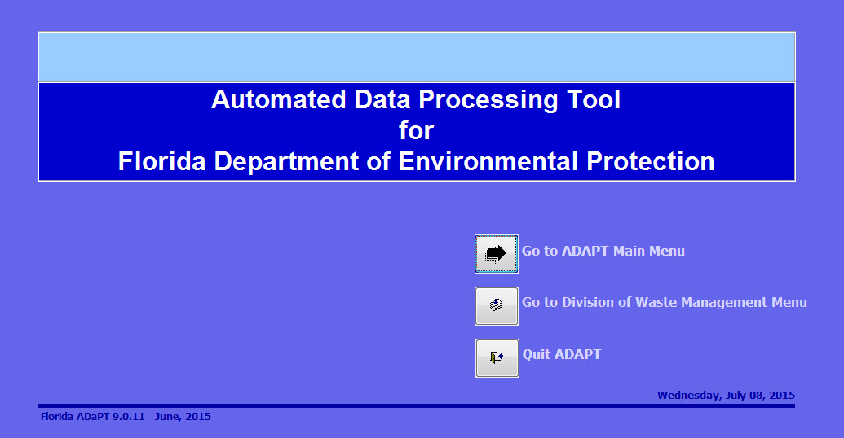

Step 3. Choose the DWM Library from the drop-down box.

If DWM_Library is not an option, download it from the ADaPT Web site, athttps://www.floridadep.gov/waste/waste/content/adapt.
Import the DWM Library with Library Utilities (see Step 3A, 3B, 3C).

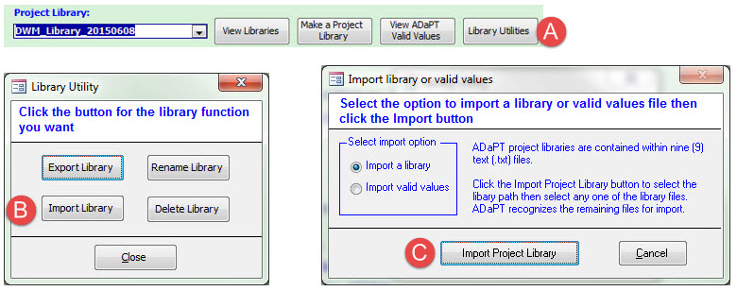

Step 4. In the Lab EDD Operations section, select Import Lab EDD.

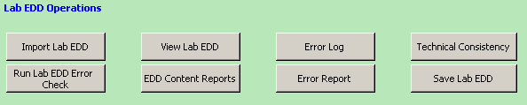

- Once the LDD is imported, a pop-up appears to run the Error Check. Select Run Lab EDD Error Check, which compares the LDD against the DWM Project Library.

- Review the Error Log or Error Report.

- If errors exist, the lab must correct or comment on any errors that have not been resolved. Re-run the Error Check (see Step 4A) before sending the LDD to the regulated entity or consultant. See Appendix A for a discussion of critical errors and Appendix B for a discussion of non-critical errors in the LDD. (The consultant, lab, or regulated entity creates the FDD).

Step 5. The consultant, lab, or regulated entity should open ADaPT (see Step 2).

- In the Field EDD and FDEP Database Operations section, select Import Field EDD (the Error Check will automatically run when the FDD is imported).

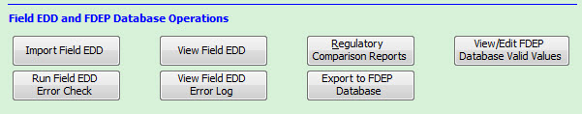

- Select View Field EDD Error Log to correct any errors that have not been resolved. Re-run the error check (Run Field EDD Error Check) before sending the FDD to the consultant and/or regulated entity.

Data Submittal (Consultants, Regulated Entities, Laboratories)

Step 1. The regulated entity or consultant opens ADaPT and selects Go to Division of Waste Management Menu.

Step 2. Choose the DWM Library from the drop-down box.

    - If the DWM Library is not an option, it can be downloaded from the DWM ADaPT webpage https://www.floridadep.gov/waste/waste/content/adapt. Import the DWM Library using ADaPT’s Library Utilities (Step 2A, 2B, 2C).

Step 3. In the Lab EDD Operations section, Import Lab EDD (and associated Lab EDD Error Log). You should get a message that the EDD was imported and was previously checked for errors.

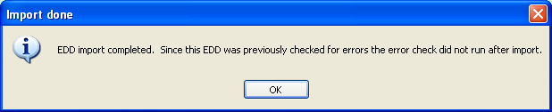

    - Click OK to continue. View the submitted Error Log (to be compared with the Error Log you will generate later).

    - If the message below occurs, the lab did not run the Error Check, did not submit the Error Log with the Lab EDD, the Error Log is not in the same folder as the Lab EDD, or the correct file naming convention was not used.

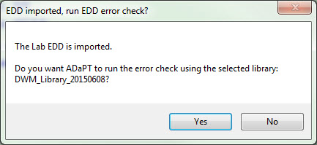

    - Click No and address these issues with the laboratory, then repeat Step 3. Review the submitted Error Log, and then compare it to the Error Log generated after Step 4.

Step 4. Run the Error Check. Select Run Lab EDD Error Check, which compares the LDD against the DWM Project Library.

- Review the Error Log or Error Report.

- If any critical errors exist, send the LDD back to the lab for correction. If any non-critical errors (except 0007) exist, evaluate the lab comments for each error. The Error Types listed in the Error Log should be identical with those Error Types reported in the Error Log produced by the lab. If errors differ between the submitted Error Log (produced by the lab) and the current Error Log, send the LDD back to the lab for corrections or comments on all errors that have not been resolved. See Appendix A for a discussion of critical errors and Appendix B for a discussion of non-critical errors in the LDD.

Step 5. In the Automated Data Review Operations section, select Run Data Review.

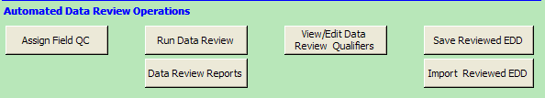

- When prompted to do so, open the Data Review Report menu.

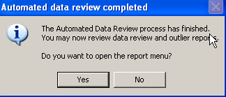

- Review the Data Review Report Menu.

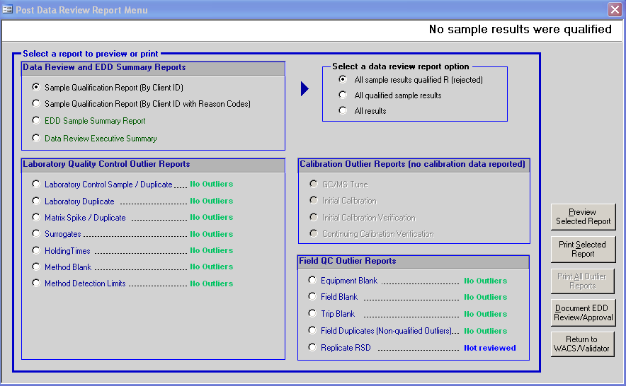

- Review the Sample Qualification Report (By Client ID with Reason Codes) with All sample results qualified R (rejected) option selected. If any outliers exist, review the appropriate report(s):
    - Laboratory Control Sample/Duplicate
    - Laboratory / Duplicate
    - Matrix Spike/Duplicate
    - Surrogates
    - Holding Times
    - Method Blank
    - Method Detection Limits

Step 6. In the Field EDD and FDEP Database Operations section, select Import Field EDD (the Error Check will automatically run when the FDD is imported).

- Select View Field EDD Error Log, correct any errors that have not been resolved, and Export the corrected Field EDD. Rerun the Error Check by selecting Run Field EDD Error Check.

- If errors exist, correct them or send the FDD back to the lab or consultant for corrections.

Step 7. In the Field EDD and FDEP Database Operations section, run Regulatory Comparison Reports, which evaluates the data reported with regulatory limits.

- Select the sample(s) and regulatory limit(s) to evaluate:
    - Select sample(s) and the appropriate criteria.
    - Select Add.
    - Select Continue.

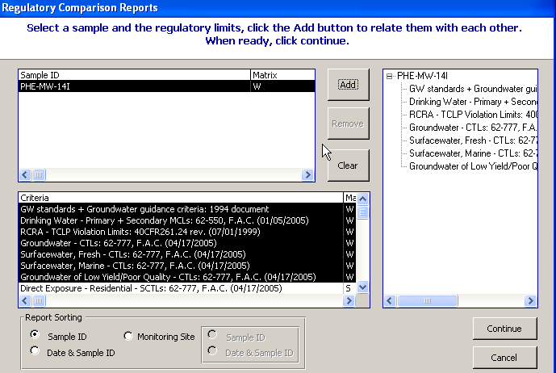

- If you want to save the results of the Regulatory Comparison Report, select output to PDF File and Save to Disk, then Continue to view the report.

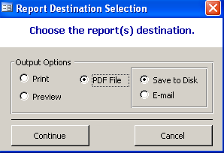

Step 8. As a final error check, click Export to FDEP Database.

- If the FDEP Database Upload File Error Log screen appears, correct the errors in the LDD and/or FDD and re-import the file(s).

    - See Appendix C for a summary on export errors. If you are unable to resolve the export errors, send the LDD and/or FDD to Clark Moore (clark.b.moore@dep.state.fl.us) or Tayo Olayiwola (tayo.olayiwola@dep.state.fl.us). For PRP export errors, please contact Katharine Hoover by e-mail at: PRP.ADaPT@dep.state.fl.us, or by phone: (850) 245-8713.

Step 9. Once all errors have been corrected, or if errors are related to non-project QC samples, select Save to Disk and Export.

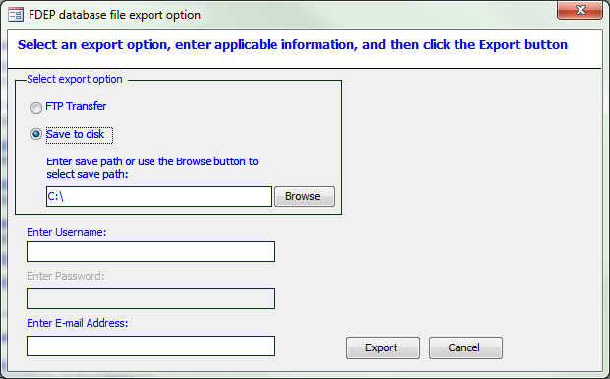

- A message box will appear stating the upload was successful.

- Submit the LDD, FDD, Error Log, and if required, the Groundwater Monitoring Report in one package to FDEP.

Data Evaluation and Upload to FDEP Database

Step 1. FDEP staff performs the following steps – open ADaPT and select Go to Division of Waste Management Menu.

Step 2. Choose the DWM Library from the Project Library drop-down.

    - If the DWM Library is not an option, it can be downloaded from the DWM ADaPT webpage http://publicfiles.dep.state.fl.us/DWM/ADaPT/DWM_Library.zip. Import the DWM Library using ADaPT’s Library Utilities (see Step 2A, 2B, 2C).

Step 3. In the Lab EDD Operations section, select Import Lab EDD (and associated Lab EDD Error Log).

    - You should get a message that the EDD was imported and was previously checked for errors. Click OK to continue.

- Review the Error Log or Error Report submitted with the LDD for errors.

- If any critical errors exist, send the LDD back to the lab or consultant for correction. If any non-critical errors (except 0007) exist, evaluate the lab comments for each error. See Appendix A for a discussion of critical errors and Appendix B for a discussion of non-critical errors for the Error Types listed in the LDD Error Log.

Step 4. In the Lab EDD Operations section, select Run Lab EDD Error Check. Compare the error types and numbers with those reported in the lab’s Error Log. If the lab is not reporting all errors found in the lab’s Error Log, the lab may not be using an FDEP approved project library. The Error Log should be identical with those Error Types reported in the Error Log produced by the lab. If errors differ between the submitted Error Log produced by the lab and the current Error Log, send the LDD back to the lab or consultant for corrections or comments on all errors that have not been resolved.

Step 5. In the Automated Data Review Operations section, select Run Data Review.

- Open the Data Review Report Menu by clicking Yes.

- Review the Data Review Report.

- Review the Sample Qualification Report (By Client ID with Reason Codes) with the option All sample results qualified R (rejected) selected. If any outliers exist, review the appropriate report(s):
    - Laboratory Control Sample/Duplicate
    - Laboratory/Duplicate
    - Matrix Spike/Duplicate
    - Surrogates
    - Holding Times
    - Method Blank
    - Method Detection Limits

Step 6. In the Field EDD and FDEP Database Operations section, select Import Field EDD (the Error Check will automatically run when the FDD is imported).

- Select View Field EDD Error Log.

- If errors exist, send the FDD back to the regulated entity, consultant or lab for correction.

Step 7. In the Field EDD and FDEP Database Operations section, select Regulatory Comparison Reports to compare reported results with the appropriate regulatory limits.

- Choose the sample(s) and regulatory limit(s) you want to evaluate by:
    - Select sample(s) and the appropriate criteria.
    - Select Add.
    - Select Continue.

- If you want to save the results of the Regulatory Comparison Report, select output to PDF File and Save to Disk, then select Continue to view the report.

Step 7.5. If reviewing data for Petroleum Restoration, press F11 to open the left navigation pane for Queries and double-click the “*_____Duplicate_Sample_Date-Times” query.

- Each sample must have a unique timestamp to be uploaded. If there is a value greater than one in the “CountOfClientSampleId” field, return the zip file to the submitter to confirm times are correct.
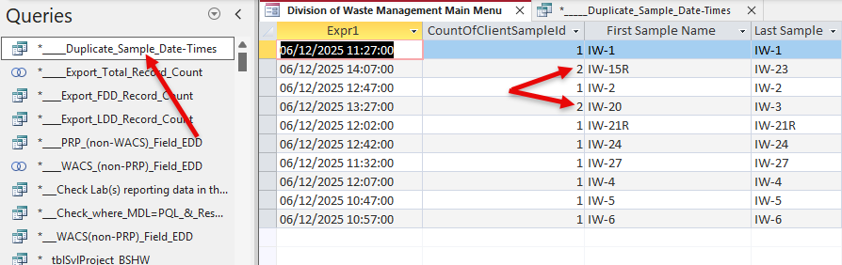

- If the times are confirmed by the submitter, add a second to the “DateCollected” in the Lab EDD and “Date_Sampled” in the Field EDD for all results related to one of the samples with a duplicate time. Repeat for any duplications until there is only one sample per timestamp.

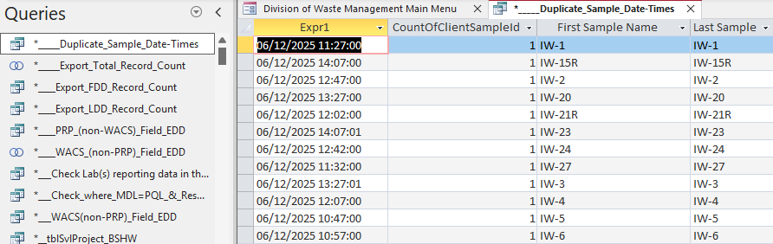

Step 8. In the Field EDD and FDEP Database Operations section, select Export to FDEP Database. If the FDEP Database Upload File Error Log screen appears, errors exist. For any errors that are not for non-project QC samples or for Equipment, Field, or Trip Blanks, send the LDD and FDD back to the regulated entity, consultant, or lab for corrections or comments. See Appendix C for a discussion on export errors.

Step 9. Once all errors have been corrected, or if they are for non-project QC samples, select Save to Disk and Export.

- A message box will appear stating the upload was successful.

Appendix A: Lab EDD Critical Error Check

All LDD and FDD critical errors must be corrected before running the Regulatory Comparison Report or exporting data to REDD. Critical errors include some but not all the required field checks of error code 0001 and the valid value checks of error code 0002.

The 0001 error codes are critical if the EDD is missing values in the following fields:

ClientSampleID Lab_Analysis_Ref_Method_ID
Matrix_ID Lab_Sample_Id
Client_Analyte_ID Analyte_Name
Analyte_Type QC_Type
Analysis_Type PrepBatch_ID
MethodBatch_ID

The 0002 error codes are critical if the EDD has invalid values in the following fields:

Matrix_ID
Lab_Analysis_Ref_Method_ID
Combine values of Matrix_ID and Lab_Analysis_Ref_Method_ID
Client_Analyte_ID
Analyte_Name

Any other required fields with null entries or valid value fields with invalid values (codes) not listed above are not considered to be critical errors.

    - Note: If critical errors occur, the LDD error check will not run all checks because missing or invalid values in these fields can cause false errors. When critical errors occur, the user is asked to correct these and re-run the error check.

Appendix B: Summary of Non-Critical Lab EDD Errors

DEP Staff will review actions for the most common errors.

Error | Field | Error Description | Action/Discussion
0001 | DateCollected | The "DateCollected" field is missing information in this record. | Return to the lab. The DateCollected is needed to evaluate sample holding times and exceedances.
0001 | PercentRecovery | The "PercentRecovery" field is missing information in this record. | Is there a comment that percent recovery is not reportable due to a high level of analyte in the matrix?  YES - No action is required.  NO - Check for an LCS recovery. If there is no LCS recovery, then return to the lab to include LCS data or an explanation.
0001 | PreservationIntact | The "PreservationIntact" field is missing information in one or more records. | Has a Y qualifier been assigned?  YES - If the results are below any applicable criteria, the data needs to be further evaluated by QA. If the results are above any applicable criteria, the data is usable.  NO - Return the LDD back to the lab for an explanation.
0001 | RelativePercentDifference | The "RelativePercentDifference" (RPD) field is missing information in this record. | Is there a comment that they did not identify duplicates, so they cannot calculate the RPD?  YES - No action is required.  NO - Return to the lab to include LCS data or an explanation.
0002 | LabID | The value 'ORL' entered in the LabID field of one or more records is invalid. Please enter the NELAC Lab ID standard value in this field. | Return to the lab for correction.
0002 | PreparationType | The value '3510C' entered in the PreparationType field of this record is invalid. Please enter one of the standard values required for this field. | If the prep method is appropriate and not in the standard values table, notify QA or DEP for additions to the standard value table. If the prep method is inappropriate, return to the lab for corrections or retest.
0002 | ProjectName | The value 'CENTRAL DISPOSAL' entered in the ProjectName field of one or more records is invalid. Please enter one of the standard values allowed in this field. | The lab or consultant must update their facility testsite inventory, use the ProjectName for the specific ProjectNumber (Facility Number) found in the Projects tab in the ADaPT valid values.
0002 | ProjectNumber | The value 'LOWP' entered in the ProjectNumber field of one or more records is invalid. Please enter one of the standard values allowed in this field. | If the Project Number does not match the Facility ID, FDEP Databases export will fail. The lab or consultant must update their facility testsite inventory, to ensure their Facility ID is correct, or contact DEP to update the FDEP Databases facility records.
0002 | ResultUnits | The ResultUnits 'ug/L' reported in this record are incorrect for Sodium in MatrixID AQUEOUS-Other analyzed by method EPA 6010 according to the project library for this method and matrix ID equivalent. | ADaPT’s Regulatory Comparison report will not function and ADaPT will not be able to assign the proper STORET code upon export to FDEP Databases and export will fail. Return the LDD to the lab for correction.
0003 | Result | The value 'ND' entered in the Result field of this record is not numeric. Only numeric characters can be entered in this field. | ADaPT will not be able to export non-numeric results to FDEP Databases. Return the LDD to the lab for correction. All field measured parameters must be reported in the FDD.
0006 | DetectionLimit, ReportingLimit, and LabQualifiers | The Result value of 0.5 ug/L does not equal the Detection Limit value of 0.4 ug/L in this record but the Lab Qualifiers field contains U. | Is the PQL greater than any applicable criteria or standards?  YES - Return the LDD to the lab for justification of the elevated MDL. If this causes the PQL to exceed the criteria or standards, then send back to consultant/permittee to resample or back to the lab to retest depending on analyte hold times.  NO - Data is usable.
0006 | LabQualifiers and ResultComments | The LabQualifiers field contains J but the ResultsComment field in this record is missing a comment. | Return the LDD to the lab for the missing comments.
0007 | ReportingLimit | The 1,2-Dibromo-3-Chloropropane Reporting Limit value of 0.20 ug/L reported in this record for Method EPA 504.1 in Matrix AQUEOUS-Groundwater exceeds the project library reporting limit of 0.1 ug/L (corrected for dilution, if applicable). | Error due to differences in the lab project library and Division of Waste Management Master Library. Is the PQL (RL) greater than any applicable criteria or standards?  YES – Return to consultant/permittee to resample or return to lab to retest depending on the analyte hold times.  NO - No action is required.
0008 | DatePrepared and DateAnalyzed | The DateAnalyzed precedes the DatePrepared in one or more records where ClientSampleID = MW-H-S and LabAnalysisRefMethodID = EPA 300.0 (Sulfate). | EDD must be returned to the lab for correction and resubmitted.
0008 | DateCollected and DateAnalyzed | The DateAnalyzed precedes the DateCollected in one or more records where ClientSampleID = MW-H-S and LabAnalysisRefMethodID = EPA 300.0 (Sulfate). | EDD must be returned to the lab for correction and resubmitted.
0009 | Duplicate records | Two different MethodBatchIDs are reported among those records where ClientSampleID = MW-27S, Method = EPA 8260, AnalysisType = RES, TotalOrDissolved = TOT. | No action required.
0011 | Missing record | A method blank result is missing for Radium-228 analyzed by method RA05 in Prep Batch ID: rad228 with the same matrix equivalent as samples reported in this QC batch and method. | No action required. All sample results < 10X the method Blank contamination will be “J” qualified with the comment that there is contamination in the Method Blank that may affect results.
0012 | Missing record(s) | The LCSD for method 'EPA 6010' in Prep Batch 62864 is missing Arsenic, CAS# (7440382) as a spike. This spike must be reported based on the project library and analytes reported among samples in this batch. | Are there MS and MSD recoveries or an MS and a QC Dup (above the PQL) reported?  Either QC pair may substitute.
0013 | Missing record(s) | No Matrix Spike results with a matrix equivalent to Water are reported in Method Batch 0 for method EPA 351.2. | The lab is required to report accuracy QC data such a s MS/MSDs, if this data is not reported, make sure the lab has an appropriate comment. Too little sample to spike or the QC sample results were high and the Matrix Spike was buried.
0014 | Missing record(s) | No Lab Duplicate results (where QCType = DUP) are reported for method EPA 300.0 (Chloride) and matrix equivalent to Water in MethodBatchID 8121159. | The lab is required to report precision data, either; QC sample and QC duplicates, LCS and LCSDs or MS and MSDs. There should be an appropriate comment as to why this data was not reported. Inform the lab they must report all required QC in the future.
0015 | Missing record(s) | Sample 'RW1S-5' analyzed by method 'EPA 8260' and matrix Water does not report any surrogates required by the project library. | Surrogate results must be reported. If surrogate results are reported, make sure all LabSampleId field entries are the same for each ClientSampleID.
0018 | Extra record(s) | LCS and/or LCSD reported for Method SM18 2320 B and Matrix AQUEOUS-Other but the project library does not require a LCS for this method and matrix equivalent. | Are these miss-identified MS and MSD samples? Are MS and MSD samples reported along with the QC sample and QC sample duplicates? If required, QC is missing. Return to the lab.
0019 | Missing Record | Missing a parent sample record for Carbon-Total Organic, which was reported as a spiked analyte in BARNS RESIDENC EMS analyzed by method EPA 415.1. A parent sample record for Carbon-Total Organic analyzed by this method should be reported in ClientSampleID. | Improper identification of QC sample. Return to the lab for correction. All non-project QC sample results must be reported; they can be reported anonymously using the lab SampleID or indicating non-project QC in some other manner (BatchQC, for example).

Appendix C: Summary of Error Codes During FDEP Databases Export

Error Code | Description | ADaPT’s Action | User Action
01 | Critical required fields missing information in LDD | FDEP Databases upload disabled | Correct and try FDEP Databases upload again
02 | Critical valid value fields with wrong values in LDD | FDEP Databases upload disabled | Correct and try FDEP Databases upload again
03 | Errors exist in FDD | FDEP Databases upload disabled | Correct and try FDEP Databases upload again
04 | Project Number in LDD not reported as WACS_Facility_ID in the FDD or vice versa | FDEP Databases upload disabled | Correct and try FDEP Databases upload again
05 | Sample/Date reported in FDD not reported in LDD | FDEP Databases upload disabled | Correct and try FDEP Databases upload again
06 | ClientSampleID and/or Sample/date reported in LDD not reported in FDD but this sample is a QC parent sample | FDEP Databases upload enabled in the absence of error numbers 01 through 05. User is informed these are parent QC samples not in FDD and that FDEP Databases upload will not include these samples | Proceed with upload if samples are not part of the project. If they are part of the project fix by modifying the FDD to include these sample then try FDEP Databases upload
07 | ClientSampleID and/or Sample/date reported in LDD not reported in FDD and sample is not a QC parent sample | FDEP Databases upload allowed in the absence of error numbers 01 through 05. User is informed these are samples not in FDD and that FDEP Databases upload will not include these samples | Proceed with upload if samples are not part of the project. If they are part of the project fix by modifying the FDD to include these sample then try FDEP Databases upload
10 | One or more of the following field(s) in the field EDD contain duplicate information:  Monitoring_Testsite_ID  Monitoring_Testsite_Name  Date_Sampled  Report_Type | FDEP Databases upload allowed in the absence of error numbers 01 through 05. User is informed of potential duplicate records created in the FDEP Databases export file | Run the “Shoe/View Error 10 Code” report. Make sure Testsite IDs and Testsite_Names match, proper Report Types are used for Field Duplicate, Confirmation and Re-samples, and that the WACS_Testsite_Name for these samples are uniquely identified

The FDD Error Check uses the same error codes as the LDD Error Check, but does NOT have critical errors. Instead, ADaPT prevents the upload of the FDD in these cases, but provides a report listing the problem.

ADaPT Installation Instructions

The ADaPT software is compatible with Microsoft Windows 7, 8.1 or 10 and requires Microsoft Office Access versions 2007, 2010 (32-bit), 2013 (32-bit), 2016 (32-bit), 2019 (32-bit) or Office 365 (32-bit). Screen resolutions of 768 x 1024 and lower can present problems with Access because of the MS Office ribbon. The work-around with Access is to hide the ribbon by clicking on the Home tab or by going to a higher screen resolution.

Some helpful links:

ADaPT_9_0_11_Consultant_FinalReleaseInstallPackage.zip

Installation Instructions for ADaPT 9_0_11.pdf

ComparisonReportFix_09_03_14.pdf

The ADaPT 9.1.11 installation instructions include how to set application file user permissions for the “Everyone” user. Please read through these instructions before running the installation.

The Comparison Report Fix may be necessary if ADaPT 9.0.11 is installed on a machine that never had a working installation of ADaPT 6.4 through 9.0.07 (Beta). If you receive an error message similar to the one below when importing a file into ADaPT, you will need to run the Comparison Report Fix.

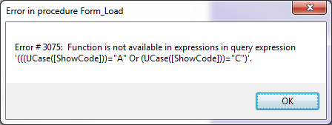

How to Update ADaPT

ADaPT is a 32-bit application running under a 32-bit installation of MS Office. Users will need to identify if they are running Windows 32-bit or Windows 64-bit. To determine which version you are running, use the following directions:
- Open “System Information” by typing system information into the windows search bar OR open Control Panel and select “System”
- For both options, look under “System Type” for the required information
System Information:
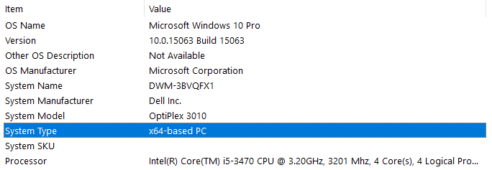
Control Panel > System:
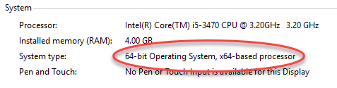

To update ADaPT, download the file for your operating system by clicking the appropriate link below and saving to your local hard drive:
32-bit ADaPT Update OR 64-bit ADaPT Update
Ensure that ADaPT is not running and that you have finished processing all EDDs. Navigate to the appropriate file and double click on it to execute. This program will update the ADaPTModules.accde and ADaPTTables.accdb files and overwrite the existing files.
If you update ADaPT 9.0.11 and encounter any problems, please let us know. Contact information for the ADaPT team can be found here.

With this update, you will have the most recent:
- ADaPT Valid Values
- DWM Library
- Testsite Inventory
- FDEP Database Valid Values
- Field EDD and other queries

Detailed Instructions for Importing an ADaPT Library

Step 1. Download the library from the DWM website to the \FL_ADaPT_9_0_11\LibraryFiles\ folder. Unzip the library if it was downloaded as a zipped file. Unzipping the library will create a new folder with the library name that contains a series of text files (.txt). If the library was not downloaded as a zipped file, no action is required.

Step 2. Select Library Utilities from the green ADaPT main menu screen.

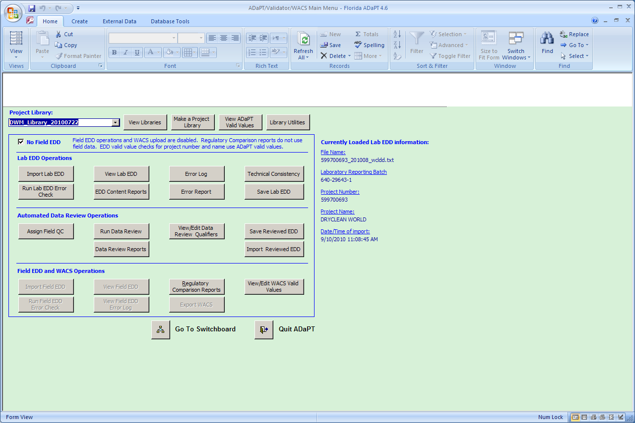

Step 3. Select Import Library.

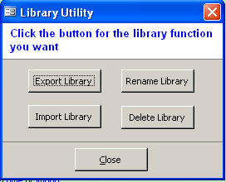

Step 4. Verify that Import a library is selected in the Import library or valid values menu and then select Import Project Library.

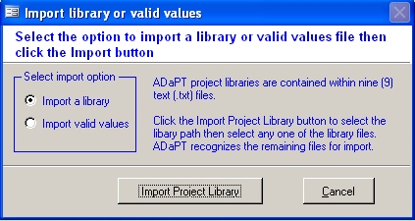

Step 5. If necessary, browse the location where you downloaded the library. If you have multiple libraries, make sure to select the correct one. Typically, you’ll want the most recent library which can be identified by the date as part of the library name. Once you find the correct library, select Open or double click the desired library.

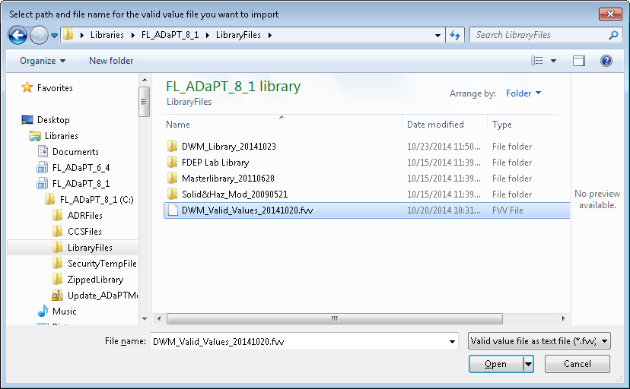

Step 6. Click on the first text file in the library list and select Open.

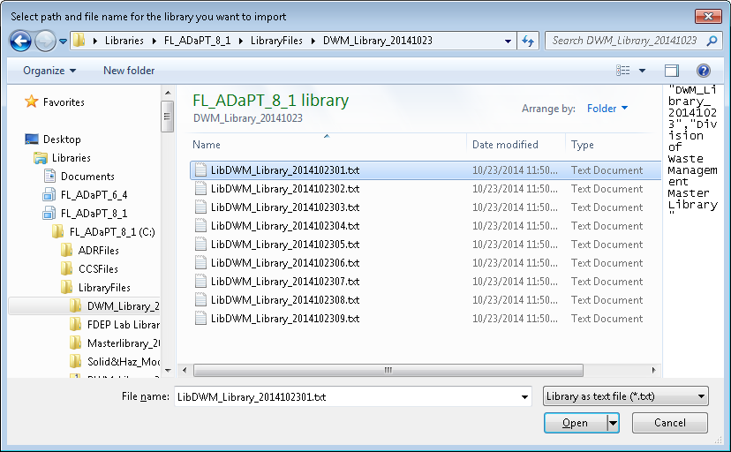

Step 7. ADaPT will then import the library. Note that you only need to select the first text file; ADaPT will automatically load all of the others. ADaPT will confirm if the import was successful.

Step 8. Click OK, then Cancel, then Close to return to the Division of Waste Management Menu.

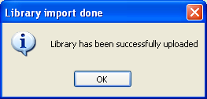

Step 9. Be sure to select the newly uploaded library in the drop-down box in the upper left corner of the Division of Waste Management main menu.

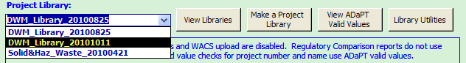

ADaPT Lab and Field EDD Reference Information

ADaPT Lab and Field EDD File Names

The ADaPT EDD set consists of three Electronic Data Deliverable files:

- a Lab EDD (LDD, or sometimes also referred to as LEDD)
- an associated Lab EDD Error Log file
- a Field EDD (FDD, or sometimes also referred to as FEDD)

All three ADaPT files shall be submitted in a comma separated text file with the .txt file extension produced and exported by the ADaPT software.

ADaPT 9.0.11 implements auto-naming of exported LDDs and FDDs with the ability for user input of additional information based on Pogram Area.
ADaPT 9.0.11 automatically names the LDD, Error Log, Reviewed LDD, and FDD to create a file that follows a naming convention according to the file name elements and their order as listed below:
 | Hazardous Waste | Petroleum Restoration | Solid Waste | Waste Cleanup
1. Facility/Project/Site ID (LDD ProjectNumber) | CHAZ Facility ID | STCM Facility ID | WACS Facility ID | ERIC Facility ID, or from COMET or other Waste Cleanup Database.
2. Separator | _ | _ | _ | _
3. Date format (of earliest or latest sample) | YYYYMMDD | YYYYMMDD | YYYYMMDD | YYYYMMDD
4. (-ext) – optional text for (none, AIR, CONF)
5. Separator | _ | _ | _ | _
6. Program Area Code | HW | PR | SW | WC
7. EDD Type | fdd, ldd, ldd_ErrorLog | fdd, ldd, ldd_ErrorLog | fdd, ldd, ldd_ErrorLog | (fdd), ldd, ldd_ErrorLog
8. File Extension | .txt | .txt | .txt | .txt
Example Filenames
Field EDD | FLD046771952_20160915_HWfdd.txt | 8519437_20160425_PRfdd.txt | 45937_20160919_SWfdd.txt | ERIC_5150_20160824_WCfdd.txt
Lab EDD | FLD046771952_20160915_HWldd.txt | 8519437_20160425_PRldd.txt | 45937_20160919_SWldd.txt | ERIC_5150_20160824_WCldd.txt
Lab EDD Error Log | FLD046771952_20160915_HWldd_ErrorLog.txt | 8519437_20160425_PRldd_ErrorLog.txt | 45937_20160919_SWldd_ErrorLog.txt | ERIC_5150_20160824_WCldd_ErrorLog.txt
ADaPT Export csv file | ADAPTHW20161102073831.csv | ADAPTPR20161102073041.csv | ADAPTSW20161102100446.csv | ADAPTWC20161102100258.csv
ADaPT EDD Zip file | FLD046771952_20160915_HWzdd.zip | 8519437_20160425_PRzdd.zip | 45937_20160919_SWzdd.zip | ERIC_5150_20160824_WCzdd.zip
Example Filenames (when Field EDD may not be required)
Field EDD |  | 8519437_20160425-CONF_PRfdd.txt | 45937_20160919-RAD_SWfdd.txt
Lab EDD |  | 8519437_20160425-CONF_PRldd.txt | 45937_20160919-RAD_SWldd.txt | COM_169624_20141105_WCldd.txt
Lab EDD Error Log |  | 8519437_20160425-CONF_PRldd_ErrorLog.txt | 45937_20160919-RAD_SWldd_ErrorLog.txt | COM_169624_20141105_WCldd_ErrorLog.txt
ADaPT EDD Zip file |  |  |  | COM_169624_20141105_WCzdd.zip

Note: These file name elements are defined by each FDEP Program Area in the ADaPT FDEP Database’s Website valid values table.

Submit all lab data (with the exception of radiochemistry results) in a single LDD with a single corresponding FDD for the following reasons:

1. ADaPT performs a number of Technical Consistency checks, and having all the analytical results in one file assures the most comprehensive data check for the following: Nutrients and Total vs. Dissolved, Charge Balance, Major Ions vs. Conductivity, TDS vs. Conductivity, and Analyzed vs. Calculated TDS.

2. It is difficult when checking for the completeness of data submitted (permit required monitoring wells, surface water and leachate for specific lists of analytes and field measured parameters) when data is included in multiple LDDs.

3. Having only one ADaPT EDD data set is more efficient and eliminates confusion for saving the groundwater monitoring data in OCULUS, tracking and processing of data, and exporting the data to the FDEP Databases.

I Have an LDD – How do I Produce an FDD?

The FDD produced needs to conform to the content and format defined in ADaPT Field EDD Deliverable Specifications (see Field EDD Deliverable Specifications).

Suggested Method

If you have an ADaPT LDD and field sampling logs, you can create an FDD using one of several predefined ADaPT queries.

Step 1. Start ADaPT and go to the Division of Waste Management (green) screen.

Step 2. Import an LDD into ADaPT.

Step 3. Press F11 and your ADaPT green screen should look like this:

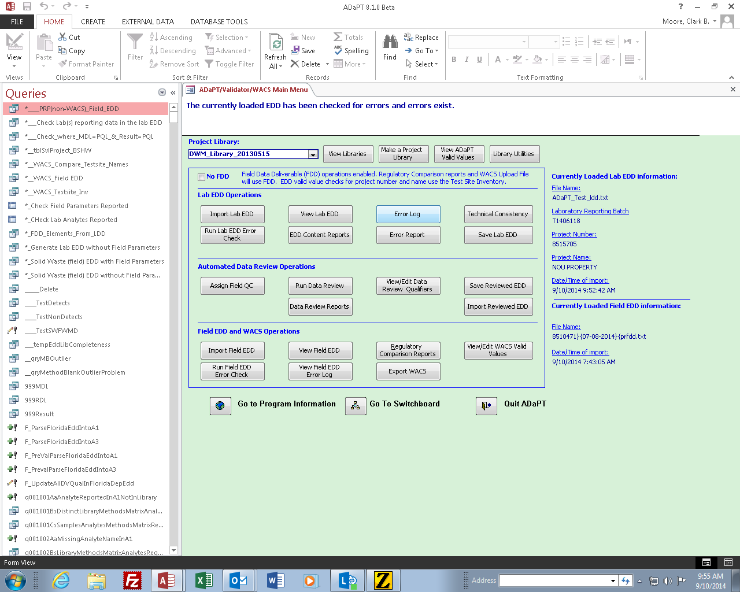

Step 4. If you are producing an FDD for the Petroleum Restoration Program (PRP), double click on the 1st query (alphabetically sorted by Name):

“*____PRP_(non-WACS)_Field_EDD”

Or

95

Step 5. If you are producing an FDD for non-PRP, double click on the 2nd query: “*____WACS_(non-PRP)_Field_EDD”

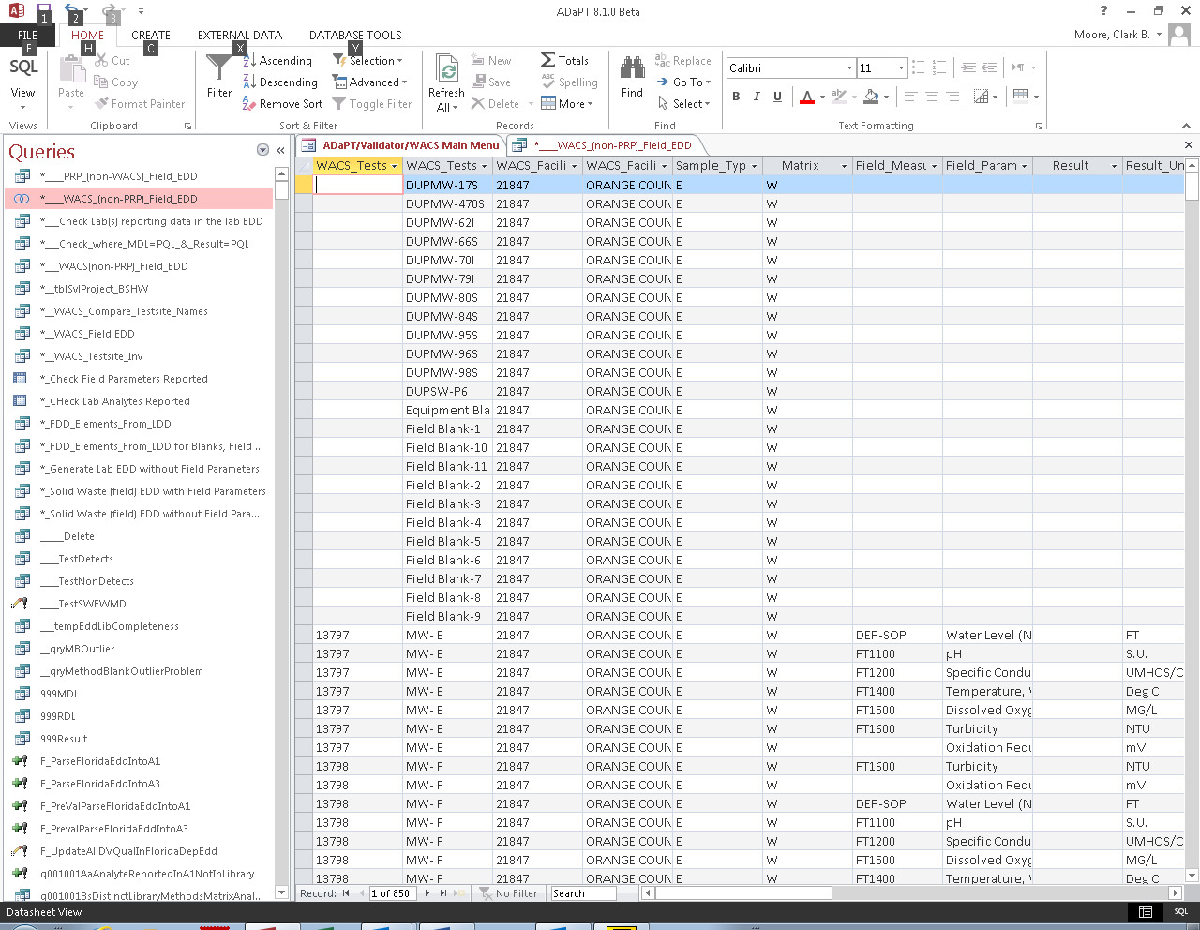

Step 6. Select all content in the resulting FDD table and copy it to the clipboard so it can be copied to Excel (Press Ctrl + A, then Ctrl + C).

Step 7. Open a blank workbook in Excel and press Ctrl + V to paste the FDD table query results from ADaPT into Excel. In Excel, it is easier to remove word wrap.

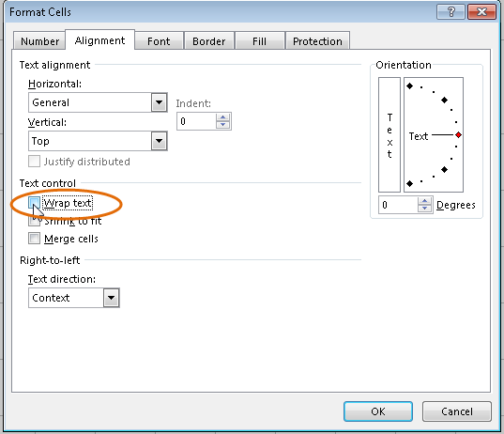

Step 8. Remove all field parameters you do not intend to report. For example, Oxidation Reduction Potential is not usually required. Remove all records from the FDD for those field measured parameters for which results are NOT being reported.

Step 9. For PRP FDDs, The Monitoring_Testsite_ID field will be null for all entries. Currently, there is no way to distinguish non-project from project QC samples. Usually, the lab substitutes the LabSampleID for the ClientSampleID for non-project QC samples. Delete all records in the FDD for non-project QC samples since we do not database these results and there are no field measured parameters to report for these samples. These samples should have fairly long similar alphanumeric or numeric names that do not match any of the Well Names or Well Nos. listed on Form FD 9000-24, GROUNDWATER SAMPLING LOG.

Or

Step 10. For non-PRP FDDs, the Monitoring_Testsite_ID field should be populated for most records. The Monitoring_Testsite_ID will be null for all Equipment, Field and Trip Blanks, and Field Duplicate samples. Monitoring testsite IDs must be manually entered for all Field Duplicate samples. Refer to the Monitoring_Testsite_Inventory tab under the View/Edit FDEP Database Valid Values button in the green screen for Testsite_IDs if they are not already listed in the Field EDD.

The table below shows how the FDD is populated and the required actions necessary to finish creating an FDD.

Field EDD Column | Contains | Required Action
Monitoring_Testsite_ID | Null for PRP, otherwise should be populated; null for Blanks, must be manually populated for Field Duplicate samples
Monitoring_Testsite_Name | Lab EDD ClientSampleID
Facility_ID | Lab EDD ProjectNumber
Facility_Name | Lab EDD ProjectName
Sample_Type | E | Enter appropriate code. View/Edit FDEP Database Valid Values, Collection Method (Sample Type Code)
Matrix | W for LDD QA matrix, S for LDD SO and SED matrices, A for AIR LDD matrix_ID.
Field_Measurement_Method | Populated
Field_Parameter_Name | Populated
Result |  | Enter Result from field sampling log
Result_Units | Populated
Field_Parameter_Qualifier_Code | D | Enter other Field Qualifier Code if more appropriate; View/Edit FDEP Database Valid Values, Field Parameter Qualifier Code
Sampling_Personnel |  | Enter information from Field Sampling Logs
Collection_Agency |  | Enter information from Field Sampling Logs
Date_Sampled | Lab EDD DateCollected
Shipping_Batch_ID | Lab EDD ShippingBatchID, this field may be null
Well_Purged_Flag | Y | Enter Y or N or null, whichever is appropriate
Report_Type | SEMGW for W matrix, ASMNT for S matrix | Enter appropriate code for Specific Program Area; View/Edit FDEP Database Valid Values, Report Type

Step 11. Enter the results for the final field measured parameters (after purging is complete) from the field sampling logs.

Step 12. Check the following remaining fields prior to saving:

Monitoring_Testsite_ID | Null for PRP, otherwise should be populated; null for Blanks, must be manually populated for Field Duplicate samples
Collection Method (Sample_Type_Code) | How was the well purged? View/Edit FDEP Database Valid Values, Collection Method (Sample Type Code)
Field_Parameter_Qualifier_Code | See if any Valid Values for field qualifiers are more appropriate and replace "D" with the more appropriate field qualifier code. View/Edit FDEP Database Valid Values, Field Parameter Qualifier Code
Field_Comments | Enter any appropriate field comments including color and odor observations
Sampling_Personnel | Enter name of person sampling, refer to Field Sampling Logs.
Collection_Agency | Enter company name (consultant or lab), refer to Field Sampling Logs.
Well_Purged_Flag | Y/N for Monitoring Wells or null for surface water, soil and air samples
Report_Type | Refer to View/Edit FDEP Database Valid Values, Report Type specific to the Program Area.

Step 13. In Excel, when you save a .CSV file, if the first column contains no data, as is the case with PRP FDDs, Excel deletes this null column. There are three ways around this. Use whichever one works best for you.

- While in Excel, enter any single (place holder) character in the first row and column (record and field) in the FDD in the Monitoring_Testsite_ID field. Import the .CSV file into ADaPT. In ADaPT, click on View Field EDD and delete the place holder character.

- When creating the FDD, do not remove the field header information and import the .CSV file into ADaPT. In ADaPT, click on View Field EDD and delete the field header row which is usually the last record in the file.

- In Excel, save the FDD as a .TXT file (Tab Delimited); Open the text file in your favorite text editor and do a Global-Find-and-Replace searching for tab and replacing with comma.

Step 14. Import the file into ADaPT and run the Field EDD Error Check.

Step 15. Review the Field EDD Error Log and fix the errors within ADaPT using the View Field EDD button.

Step 16. Rerun the Field EDD Error Check and continue fixing errors until they are eliminated. Repeat Steps 14 and 15 until all errors are eliminated.

Step 17. Perform an export to FDEP Databases (save to disk option) and address all export errors involving project specific samples. See Steps 7 and 8 in the Data Submittal (Consultants, Regulated Entities, Laboratories) Section. Under rare circumstances, this query may miss some important LDD samples that need to be reported in the FDD. These missing FDD samples must be manually entered.

Additional Error Checks

Lab Qualifiers Consistency Check:

- Lab_Qualifiers contains “Y” in sample result record if Preservation_Intact = “No”
- Preservation_Intact = “No” if Lab_Qualifiers in sample result record contains “Y”
- Result exceeds holding time of preparation and/or method requirements if sample result Lab_Qualifiers contains “Q”
- Result > Detection_Limit in associated method blank if Lab_Qualifiers in sample result record or method blank result record contains “V”
- Lab_Qualifiers contains “T” in sample result record if Result < Detection_Limit
- Result < Detection_Limit if Lab_Qualifiers contains “T”
- Lab_Qualifiers contains “U” in sample result record if Result = Detection_Limit
- Result = Detection_Limit if Lab_Qualifiers contains “U”
- Lab_Qualifiers contains “I” or “J” if Detection_Limit < Result < Reporting_Limit
- Detection_Limit < Result < Reporting_Limit if Lab_Qualifiers contains “I”
- Result ≥ Reporting_Limit if Lab_Qualifiers contains “K”
- Lab_Qualifiers does NOT contain “K” if Lab_Qualifiers contains “K”, “L”, “M”, “T”, “V”, “Y”, and/or “I”
- Result_Comment field is populated if Lab_Qualifiers contains “J”
- Result = Reporting_Limit if Lab_Qualifiers contains “M”

Duplicate Record Check

Duplicate records are reported if two or more records hold identical values among the following fields:
Client_Sample_ID
Lab_Analysis_Ref_Method_ID
Lab_Sample_ID
Client_Analyte_ID
Analyte_Name
Analysis_Type
Total_Or_Dissolved

Field Parameters, Field Methods, and Reporting Units

Table 1. Field parameters, field methods, and reporting units.
ClientAnalyteID | Parameter_Name | Units | Matrix | DEP-SOP | Method
2030 | Temperature, Water | Deg C | W | FT1400 | SM2550 B, FDEP FT1400
1880 | Dissolved Oxygen | MG/L | W | FT1500 | SM4500 O (A-G), FDEP FT1500
1900 | pH | S.U. | W | FT1100 | SM4500 H+, EPA 9040, FDEP FT1100
FL-PHYS-007 | Oxidation Reduction Potential | mV | W |  | SM 2580B
2055 | Turbidity | NTU | W | FT1600 | EPA 180.1, SM2130 B, FDEP FT1600
EPA E1647296 | Water Level (NGVD) | FT | W | DEP-SOP | DEP-SOP
1610 | Specific Conductance | UMHOS/CM | W | FT1200 | EPA 120.1, SM2510B, FDEP FT1200
SAMPDPTH | SAMPLE DEPTH | FT | S | DEP-SOP | DEP-SOP

ADaPT Laboratory Deliverable Specifications (LDD)

Table 2. Florida ADaPT Laboratory Deliverable Specifications
Data Element Name | Data Type | Description | Required | SVL | Error Check
Client_Sample_ID | Text(35) | Client’s identifier for a sample. If a sample is analyzed as a duplicate, matrix spike, or matrix spike duplicate, append suffixes “DUP”, “MS”, and “MSD”, respectively. For Lab QC samples such as blanks and LCS enter the LabSampleID in this field. | Yes | No | - Not null  - Length ≤ 35  - Correct naming convention for Lab Duplicates, MS, and MSD samples
Lab_Analysis_Ref_Method_ID | Text(80) | The laboratory reference method ID. Standard values for methods are specified by FDEP and SFWMD. | Yes | Yes | - Not null  - Length ≤ 80  - SVL check against project library
Lab_Sample_ID | Text(35) | Laboratory tracking number for field samples and laboratory generated QC samples. | Yes | No | - Not null  - Length ≤ 35
LabID | Text(7) | Identification of the laboratory performing the analysis. Use DOH certification number, if possible. | Yes | Yes | - Not null  - Length ≤ 7  - SVL check against ADaPT standard value list
Client_Analyte_ID | Text(30) | Unique identifier for an analyte name. This is typically the CAS number, NELAC number, or Florida specified ID number. | Yes | Yes | - Not null  - Length ≤ 30  - SVL check against ClientAnalyteIDs entered in the project library  - Completeness (in the project target analyst list for the method and matrix or reported as a spike or surrogate for the method and matrix, as applicable)
Analyte_Name | Text(60) | The chemical name for the analyte. Values for Analyte Names are specified by FDEP and SFWMD. | Yes | Yes | - Not null  - Length ≤ 60  - SVL check against Analyte Names entered in the project library for a method and matrix  - Spikes reported in EDD for LCS and MS/MSD match project library for method and matrix  - For organics, correct surrogates are reported according to the method requirements established in the project library
Data Element Name | Data Type | Description | Required | SVL | Error Check
Result | Number(10) | Reported result for the analyte | Yes | No | - Not null  - Length ≤ 10  - Numeric except for microbiologicals, which may be text; and REDOX, which may benegative  - Result = MDLif Lab_Qualifiers contains “U”
Error | Text(10) | The two sigma error for radiochemistry results. Do not enter the “+” or “-“ character in this field. | Conditional | No | - Not null for radiochemistry result, spike, and tracer or carrier records  - Numeric  - Length ≤ 10
Result_Units | Text(10) | Units for the result | Yes | Yes | - Not null  - Length ≤ 10  - SVL check against the units entered in project library for the method, matrix, and analyte
Lab_Qualifiers | Text(7) | A string of single letter result qualifiers assigned by the laboratory. Always use the “U” qualifier for non-detects. Other qualifiers may apply. Order is insignificant. | Conditional | Yes | - Not null according to conditions listed at the end of this table  - Length ≤ 7  - SVL check against ADaPT standard values for lab qualifiers  - Consistency check (see list at end of this table)
Detection_Limit | Number(10) | Method detection limit for the measure analyte | Yes | No | - Not null unless target analyte is on exception list or Analyte_Type = “SURR”  - Length ≤ 10  - Numeric  - Less than or equal to the Reporting Limit  - Not zero or negative
Data Element Name | Data Type | Description | Required | SVL | Error Check
Analyte_Type | Text(7) | Defines the type of result such as surrogate, spike, or target compound. | Yes | Yes | - Not null  - Length ≤ 7  - SVL check against the ADaPT standard values for Analyte_Type
Dilution | Number(10) | Overall dilution of the sample aliquot. A value of one (1) corresponds to nominal method conditions. Insert value of one (1) for method blanks, LCS, and LCSD. | Yes | No | - Not null  - Length ≤ 10  - Numeric
Percent_Moisture | Number(10) | Percent of sample composed of water. Enter value for soil and sediments sample only. | Conditional | No | - Not null if matrix is a soil or sediment  - Length ≤ 10  - Numeric
Percent_Recovery | Text(5) | Percent recovery value of a spiked or surrogate compound. If sample dilution yields no or very low recovery enter “DIL”. If sample matrix interference yields no recovery, enter “INT”. If the spike or surrogate was not added to a sample with Analyte_Type = “SPK” or “SURR” enter “NS”. | Conditional | No | - Not null if AnalyteType = “SURR”, “SPK”, or “TRACER”  - Length ≤ 5  - Numeric or “DIL”, “INT”, or “NS”
Relative_Percent_Difference | Number(5) | Relative percent difference between two QC results | Conditional | No | - Not null if AnalyteType = “SPK” and QCType = “LCSD” or “MSD”, or Not null if QCType = “DUP”  - Length ≤ 5  - Numeric
Reporting_Limit | Text(10) | Practical quantitation limit for the measured analyte. Also used as the reporting limit. | Conditional | No | - Not null if AnalyteType = “TRG” or “SPK”  - Length ≤ 10  - Numeric  - Not zero or negative
Data Element Name | Data Type | Description | Required | SVL | Error Check
Project_Number | Text(30) | Number assigned by the client to associate a sample to a project, purchase order, or requisition | Yes | Yes | - Length ≤ 30  - SVL check against ADaPT standard values for Project Number if entered.
Project_Name | Text(90) | Project name assigned by the client | Yes | Yes | - Length ≤ 90  - Check against ADaPT standard values for Project Name if entered.
End_Date_Collected | Date/Time | The date and time of sample collection. Format as: MM/DD/YYYY hh:mm where MM = two digit month, DD = two digit date, YYYY = four digit year, hh = two digit hour, mm = two digit minutes | Conditional | No | - Not null if QCType = “N”, “DUP”, “MS” or “MSD”  - Valid date/time value  - Correctly formatted as MM/DD/YYYY hh:mm  - Logical (does not supersede sample preparation and/or sample analysis date/time value)
Matrix_ID | Text(20) | The sample matrix for the reported analyte. The standard value for Matrix_ID are specified by the State of Florida | Yes | Yes | - Not null  - Length ≤ 20  - SVL check against ADaPT standard values for Matrix_ID
QC_Type | Text(7) | Identifies the type of sample (i.e., method blank, LCS, LCSD, laboratory duplicate, MS, MSD, or normal field sample. For normal field sample enter “N”.) | Yes | Yes | - Not null  - Length ≤ 7  - SVL check against ADaPT standard values for QC_Type
Shipping_Batch_ID | Text(25) | Unique identifier assigned to a cooler or shipping container or group of coolers or shipping containers that link samples together. The Shipping_Batch_ID is provided by the client on the chain of custody. | Conditional | No | - Required if QC_Type = N, DUP, MS, or MSD  - Length ≤ 25
Temperature | Number(10) | Temperature in degrees C of the sample as received by the lab. | No | No | - Numeric, if reported  - Length ≤ 10, if reported
Data Element Name | Data Type | Description | Required | SVL | Error Check
Preparation_Type | Text(25) | The method used to prepare the sample. For methods that do not have a preparation method as part of the analysis enter “No Prep”. | Yes | Yes | - Not null  - Length ≤ 25  - SVL check against ADaPT standard values for Preparation_Type
Analysis_Type | Text(10) | Indicates the type of analysis (i.e., dilutions, re-analyses or re-extracts). This field provides distinction among records when multiple analyses are submitted for the same sample and method. Enter RES for initial analysis. | Yes | Yes | - Not null  - Length ≤ 10  - SVL check against ADaPT standard values for Analysis_Type
Reportable_Result | Text(3) | Indication or whether or not the laboratory chooses an individual analyte result as reportable. Enter “YES” if the result is reportable. Enter “NO” if the result is not. | Conditional | Yes | - Not null if AnalyteType = “TRG”  - Length ≤ 3, if reported  - Value = “YES” or “NO”  - Duplicate “YES” for a given Client_Sample_ID, Method, Matrix, Client_Analyte_ID, and Total_Or_Dissolved value
Date_Prepared | Date/Time | The date and time of sample preparation or extraction. Format as: MM/DD/YYYY hh:mm where MM = two digit month, DD = two digit date, YYYY = four digit year,hh = two digit hour, mm = two digit minutes. For analyses with no preparation, insert the analysis date. | Yes | No | - Not null  - Valid date/time value  - Correctly formatted as MM/DD/YYYY hh:mm  - Logical (Date_Prepared does not precede Date_Collected and supersede Data_Analyzed)
Date_Analyzed | Date/Time | The date and time of sample analysis. Format as: MM/DD/YYYY hh:mm where MM = two digit month, DD = two digit date, YYYY = four digit year, hh = two digit hour, mm = two digit minutes. | Yes | No | - Not null  - Valid date/time value  - Correctly formatted as MM/DD/YYYY hh:mm  - Logical (Date_Analyzed does not precede Date_Collected and/or Date_Prepared)
Total_Or_Dissolved | Text(3) | Indicates if the result is reported on a total or dissolved sample fraction. Report only for aqueous results | Yes | Yes | - Not null  - Reported as “TOT” or “DIS” for water matrices and “N/A” for non-water matrices  - Length ≤ 3
Data Element Name | Data Type | Description | Required | SVL | Error Check
Prep_Batch_ID | Text(13) | Unique laboratory identifier for a batch of samples of similar matrix prepared together for analysis by one method and treated as a group for method blank, LCS, and LCSD association. The Prep_Batch_ID links method blanks and laboratory control samples (LCS/LCSD) to associated samples. | Yes | No | - Not null  - Length ≤ 13  - Each distinct Prep_Batch_ID for a method and matrix has records for the same method and matrix where QCType = “MB” and “LCS”  - Each distinct Prep_Batch_ID for a method and matrix for each MB and LCS contains one or more sample records with the same method, matrix, and Prep_Batch_ID.
Method_Batch_ID | Text(13) | Unique laboratory identifier for a batch of samples of similar matrix analyzed by one method and treated as a group for laboratory duplicate, matrix spike, and matrix spike duplicate association. The Method_Batch_ID links laboratory duplicates, matrix spikes, and matrix spike duplicates to associated samples. | Yes | No | - Not null  - Length ≤ 13  - For non-metal inorganic methods, each distinct Method_Batch_ID for a method and matrix has records reported where QCType = “MS” and “DUP”  - For metals, each distinct Method_Batch_ID for a method and matrix has records reported where QCType = “MS” and “MSD” or QCType = “MS” and “DUP”  - For organic methods, each distinct Method_Batch_ID for a method and matrix has records where QCType = “MS” and “MSD”  - Each Method_Batch_ID for a method and matrix has sample records with the same method, matrix and Method_Batch_ID
Data Element Name | Data Type | Description | Required | SVL | Error Check
Preservation_Intact | Text(3) | Indicates if the sample was preserved properly based on measurement at the time of sample receipt at the laboratory. This applies to each bottle collected. | Yes | Yes | - Not null  - Length ≤ 3  - Reported as “Yes” or “No”  - Preservation_Intact = “No” if Lab_Qualifiers contains “Y”
QC_Spike_Added | Number(5) | Value of spike or surrogate compound entered as a numeric character | Conditional | No | - Length ≤ 5, if reported  - Required for SFWMD
Result_Comments | Text(255) | Free-form text where data provider relates information they consider relevant to the sample that is not included in the above fields. | Conditional | No | - Not null for certain constraints  - Length ≤ 255
Lab_Reporting_Batch_ID | Text(13) | Laboratory identifier for a group of samples and laboratory QC all reported within one EDD or batch. The Lab_Reporting_Batch_ID is equivalent to the sample delivery group, lab work number, login ID, etc. | Yes | No | - Not null  - Length ≤ 13  - The same value is reported in all records within the EDD

Field EDD Deliverable Specifications

Column Order | Field EDD Field Name | Data Type | Description | Required? | SVL | Error Checks
1 | Monitoring_Testsite_ID | Text (SVL) | Monitoring Testsite ID | Depends upon Program | Yes (1) | Testsite Inventory, null for Blanks, null for PRP and WC
2 | Monitoring_Testsite_Name | Text (50) | Testsite Name or Equipment/Field/Trip Blank, Identify Duplicate samples by appending " DUP" | Yes | No | •Length≤50 •Check uniqueness against Location_Code and date. •Not Null
3 | Facility_ID | Text (7) | Facility ID | Yes | Yes (1) | Not Null • SVL from Testsite Inventory table, includes PRP Facilities
4 | Facility_Name | Text((50) | Facility Name | Yes | No | •Length < 50
5 | Collection_Method (Sample_Type_Code) | Text (SVL) | Sample collection type (grab, composite, etc) | Yes | Yes (2) | •SVL code table •Not Null
6 | Matrix_ID | Text (20) | Sample matrix as listed in the SVL | Yes | Yes (3) | •SVL of matrices •Not Null
7 | Field_Measurement_Method | Text (75) | Method used in measuring field parameter | No | Yes | •SVL field methods library •If “Field Parameter Name”, “Field Parameter Name”, “Result”, “Result Units” and “Field Parameter Qualifier Code” are not null, then cannot be null.
8 | Field_Parameter_Name | Text (60) | Name of field parameter | No | Yes (4) | •SVL field methods SVL •Unique for one Client_Sample_ID/End_Collection_Date •If “Field Measurement Method”, “Result”, “Result Units” and “Field Parameter Qualifier Code”are not null then cannot be null.
9 | Result | Text (10) | Result for the field parameter measured | No | No | •0≤Double≤10 •If “Field Measurement Method”, “Field Parameter Name”, “Result Units” and “Field Parameter Qualifier Code” are not null then cannot be null.
10 | Result_Units | Text (10) | Units for field parameter result | No | Yes (4) | •SVL field methods library •If “Field Measurement Method”, “Field Parameter Name”, “Result” and “Field Parameter Qualifier Code”are not null then cannot be null.
11 | Field_Parameter_Qualifier_Code | Text (7) | Qualifier for field parameter result | Condition | Yes (5) | •SVL (D, E, R or !) excluding parameters in DEP QA Rule, 62-160 •Not null if Field_Measurement_Method, Field_Parameter_Name, Result, and Result_Units are not null
12 | Field_Comments | Text (250) | Information about the field sample for which no specific field has been designated | If applicable | No | •Length≤200
13 | Sampling_Personnel* | Text (40) | Person collecting the sample | Yes | No | •Length≤40 •Free Text •Not Null
14 | Collection_Agency* | Text (20) | Agency collecting the sample. | Condition | Yes | •Length≤20 •Not null for SFWMD •Use standard values for SFWMD
15 | Date_Sampled | Date/Time | Date and time sample collection ended. | Yes | No | •MM/DD/YYYY hh:mm •If Begin_Collection_Date is not null, then End_Collection_Date > Begin_Collection_Date •Not Null
16 | Shipping_Batch_ID | Text (25) | Unique identifier assigned to a cooler or group of coolers or shipping containers that link samples together. The Shipping_Batch_ID is provided by the client in the Chain of Custody. | Yes | No | •Length≤25 •Not Null
17 | Well_Purged_Flag | Text (1) | Well purged 3 to 5 volumes? | No | Yes | Length =1 Y or N, can be null for non-MWs
18 | Report_Type | Text (5) | SEMGW, ANNLC, DUP, ASSMT etc. | Yes | Yes | Lenth≤5, Not Null, "DUP" for Duplicate Samples, may be Null for Blanks

Petroleum Restoration Program

Introduction

The Petroleum Restoration Program (PRP) will use the most current version of ADaPT as posted on the FDEP ADaPT website. Laboratory data generated and submitted to the PRP should be analyzed through ADaPT.

ADaPT reporting parameters are defined in an ADaPT Library. The library indicates which quality control (QC) elements are required and the acceptable QC limits for those elements.

All data submitted to the PRP will require use of the DWM ADaPT Library. The library will be periodically updated, and it is important to use the most recent library available. Subscribing to the ADaPT list server will ensure you receive notification when the library is updated.

PRP does not require the submittal of ADaPT EDDs for Air, System (influent and effluent), IDW or pre-burn samples.

File Naming Convention

ADaPT files submitted to the PRP must conform to the PRP naming convention. The Lab Electronic Data Deliverable (Lab EDD or LDD) and Error Log should be submitted in comma-delimited text with the (.txt) file extension format.

ADaPT 9.0.11 will correctly auto name the Lab and Field EDDs provided the facility number is recognized (in the ADaPT Project valid values table). However, it is critical that .zip files be manually named correctly based on the example below. The general format for file names is: 7 digit Facility ID#_ YYY}MMDD_Filename Code. Filename Code is determined according to the example below. The underscore “_“ are part of the file name.

Example:

For Texaco-Sperring (PRP FAC ID #618517002), where the sampling began on January 14, 2011, the corresponding ADaPT file names would be:

 | Description | Filename Sample
ADaPT Lab EDD |  | 8517002_20110114_PRLDD.TXT
ADaPT Error Log |  | 8517002_20110114__PRLDD_ErrorLog.TXT
ADaPT Field EDD |  | 8517002_20110114__PRFDD.TXT
ADaPT Merged Database file |  | ADAPTPRYYYYMMDDHHMMSS.CSV
Zipped file containing the above-referenced files for a single sampling date |  | 8517002_20110114__PRZDD.ZIP

Using the correct Facility ID matched to the exact Facility Name is critical. In the event that the Facility ID or Facility Name is unknown, search for the name or number in the Search box under the Monitoring Testsite Inventory tab of the View/Edit FDEP Database Valid Values button. (Since this table is updated daily, it is a much more accurate method than using the View ADaPT Valid Values button, which is updated every few months).

If ADaPT adds an extra extension (i.e. 8517002_20110114__prldd.txt.txt) to the file name, you will receive an error notice. Windows explorer needs to be adjusted as detailed below:

    - Access Windows Explorer
    - Press Alt to access tabs
    - Tools
    - Folder Options
    - Click View
    - Uncheck Hide extension for known file types
    - Apply
    - OK

ADaPT Process

The use of ADaPT has no impact on the sample collection process. All samples should be collected in accordance with FDEP Groundwater Sampling Standard Operating Procedures (SOP), PRP PCS-004 and PCS-005 and submitted to an appropriate laboratory for analysis.

The following is an outline of the ADaPT process.

Main tasks to be performed by Laboratory:

- Analyze Samples
- Create Lab EDD (LDD)
- Create Field EDD (FDD), if provided by courtesy
- Run ADaPT Error Check, Data Review and Export (check match between LDD and FDD)
- Correct Errors or provide explanations

ADaPT deliverables the Laboratory submits to the Consultant:

- LDD in (*.txt) file format
- LDD Error Log in (*.txt) file format
- FDD in (*.txt) file format, if provided

Main tasks to be performed by Consultant:

- Import the LDD
- Review the Error Log for errors or comments
- Run ADaPT Error Check
- Assure all errors are addressed or explained in the comment field
- Create the FDD (unless the FDD is provided by the lab), Import FDD, run Error check and eliminate all FDD Errors
- Export the FDD and save
- Click on Upload to FDEP Database button and correct any errors if needed
- Save the .csv file

Deliverables the Consultant uploads to PRP FTP site:

- Electronic copy of ADaPT EDDs .zip file for a single sampling event, which includes the following files:
  - LDD in text (*.txt) file format
  - LDD Error Log in text(*.txt) file format
  - FDD in text (*.txt) file format
  - The ADaPT .csv export file (ADAPTPRYYYYMMDDHHMMSS.csv)

Main tasks to be performed by FDEP:

- Assure LDDs and FDDs are submitted in the appropriate formats.
- Assure LDDs and FDDs are submitted using the proper naming convention.
- Assure that the Electronic Copy of ADaPT EDDs are uploaded in correct formats to OCULUS using FTP and the imported folders are QA/QC daily.
- Address any issues with EDDs that have not uploaded to Oculus.

FDEP Site Manager Tasks:

- Ensure that the electronic copy of the zip file with the LDDs, the Lab EDD Error Log, FDD and the database file (ADAPTPRYYYYMMDDHHMMSS.csv) are uploaded in Oculus via the consultant.

FDEP OTIS Employee:

- Data Evaluation and Upload to REDD – FDEP

Instructions for the Consultant to Submit PRP Zip Files using the FDEP Business Portal

Please download the ESSA_ADaPT_EDD_Submittal_Guide. Many sections are included for reference, so you may not need to refer to most sections. Please don’t forget to review the instructional video links, provided in this document.

Waste Cleanup Program

Introduction

The Waste Cleanup Program (WCP) will use the most current version of ADaPT as posted on the FDEP ADaPT website. All laboratory data generated and submitted to the WCP should be analyzed through ADaPT. The WCP will utilize three primary components of ADaPT:

      - The Laboratory Electronic Data Deliverable (EDD) operations,

- Automated Data Review, and

- The Regulatory Comparison reports.

Please note that the WCP will not be requiring completion of a Field EDD at this time.

When working with ADaPT Lab EDDs for the Waste Cleanup program make sure the No FDD Checkbox is checked:

Additional Notes Regarding WCP Implementation of ADaPT

    - The current list of valid values for Site ID and Names and the DWM Library are available on the ADaPT web site. The Valid Values table for WCP must be updated manually using the “Library Utilities” section. The DWM valid values table is updated monthly, so it is recommended to update your copy of the table on a regular basis as well. For instructions on updating the valid values table, see the ADaPT Division of Waste Management Valid Values on the ADaPT web page.

    - The current Site ID should be provided on all correspondence for reference. It is recommended that Site IDs be looked up in ADaPT’s Project valid values table.

    - If a Site ID is not in the valid values table (possible under some circumstances), the consultant and lab should use an interim ID of their choosing. Any error message regarding a missing or invalid Site ID should be ignored. The Site ID will appear in the next refresh of the valid values table once a DEP database record is created for the site.

    - The LDD should be submitted to the consultant/project manager with the laboratory report as is currently done for lab data.

Additional information can be obtained on the DEP ADaPT website or by contacting:

James B. Dalton, P. G.
JJames.B.Dalton@FloridaDEP.gov
(850) 245-8892

Overview

The use of ADaPT has no impact on the sample collection process. All samples should be collected in accordance with FDEP and/or EPA Standard Operating Procedures (SOP) and submitted to an appropriate laboratory for analysis. The following is a brief overview of the ADaPT process.

- Samples are collected and sent to the laboratory. The Site ID is obtained from the most recent version of the DWM valid values table. If a Site ID is not available in the DWM valid values table, then the consultant can assign a Site ID for temporary use. This ID must also be recorded on the Chain of Custody (COC).

- The laboratory will analyze the samples and create an ADaPT LDD.

- The laboratory will run the ADaPT Error Check and automated data review on the LDD. If there are any errors, the lab will either correct the errors or provide explanations for any errors that are not corrected.

- The laboratory will then send the LDD in text file (.txt format) to the consultant or regulated entity. See File Naming Convention above.

- After receipt of the LDD, the consultant will view the LDD and the Error Report. The consultant should contact the lab if there are critical errors or if there are errors that have not been explained by the lab.

- The consultant will assign field QC samples, run the technical consistency checks, and then run the automated data review.

- The consultant will submit the AdaPT EDD zip fie containing; FDD, LDD, Error Log in text format to FDEP.

- The FDEP Project Manager or Program designee will review the LDD and Error Report. If unexplained critical errors or non-critical errors without sufficient explanation still exist, the project manager or program designee will notify the consultant that the errors need to be corrected. It is the consultant’s responsibility to coordinate with the laboratory to address any corrections or explanations not accepted by FDEP. If there are no critical errors, the project manager should run the technical consistency checks, and the automated data review followed by the Regulatory Comparison Report.

    - Main tasks to be performed by FDEP Waste Cleanup staff:
- Review the Lab EDD and Error Report
- Run Technical Consistency checks
- Run Data Review
- Run Regulatory Comparison Report

    - Deliverables Generated:
      - Reviewed Lab EDD and Error Log

10. Version History

Version 9.0.11 (June 2015) has the following changes (from version 8.1.01):

- WACS references were removed from ADaPT labels, command buttons, column headers, and messages and replaced with references to DWM.

- Upload to FDEP database now requires the Lab EDD undergo error check and data review.

- The required field constraint and field length check for Shipping Batch were removed from the FDD error check.

- ADaPT procedures for error checking, data review, forms, and reports were modified to handle single quotes, double quotes, number character (#), and at character (@) in Client SampleID, and single quotes and number character in the Project Name. ADaPT removes carriage return and line feed characters entered in the EDD Result_Comment.

- FDD error checks were modified to handle temporary samples (Sample Type = T).

- The file exported to the FDEP database was modified to: 1) Remove fields never populated. These include Permit_Number, Well_Type, Field_ID, QAP_Sampler, QAP_Lab, Preservative, Water_Classification, and GW_Elevation; 2) Add new fields. These include Client_Analyte_ID, Error, Dilution, Percent_Moisture, and Reporting_Limit; and 3) Format change from fix width file to comma delimited.

- STORET implementation was modified to handle all STORET Code where previously only water and soil/sediment were handled.

- EDD error checks were fixed to correctly report AIR matrices, where applicable.

- Testing performed on 32 and 64 bit version of Windows 7 and 8.1 with Office 2007, 2010, and 2013. ADaPT 9.0.11 is supported on these platforms.

Version 8.1.01 (October 2014) has the following changes (from version 8.0.03):

- Now compatible with Windows 8.1.

- Now compatible with MS Access 2013.

- Allows export of data to multiple program areas as defined in ADaPT tables. Allows export of data for programs with databased monitoring wells, for programs without databased monitoring wells, and for programs that do not collect field data (require a field EDD).

Version 8.0.03 (May 2014) has the following changes (from version 7.1):

- Modify the FL ADaPT Project Valid Value table structure and forms for viewing valid values.

- Modify the program area web pages valid value table structure and forms for viewing valid values.

- Implement auto-naming of exported Lab and Field EDDs with ability for user input of additional information based on Program Area.

- Modify the import of the Lab EDD and Field Data Deliverable to format all date/time values as MM/DD/YYYY HH:MM:SS using 24 hours and leading zeroes.

- ADaPT was recompiled within Access 2007.

Version 7.1 (December 2013) has the following changes (from version 7.0):

      - Modify the Error Log Form to Allow Filtering of Displayed Errors According to the Reportable Results Value.
- Add a check box on the Error Log Form accessed from the standard ADaPT and WACS screens that allows users to toggle between showing all Lab EDD errors or only Lab EDD errors on records where the Reportable Result field is populated with “YES”.
- This filter will only apply to errors that have a Record ID. Errors that do not have a Record ID cannot be filtered.
- The added check box will have a label stating “Only show Errors where Reportable Result = YES”.
- If the check box status is checked the Error Log will only show errors where Reportable Result equals “YES” and errors that do not have a Record ID.
- If the check box status is not checked all EDD errors will show according to the NELAC or CLP option selected prior to viewing the Error Log

      - Modify the error check for Type 0016 Errors so that when a sample is analyzed more than once with multiple dilutions for different analytes, ADaPT considers the Analyte Name in addition to the Client Sample ID and Method before checking for different Analysis Types. With this modification ADaPT will report Error Type 0016 if a given Analyte is reported more than once for a Client Sample ID analyzed by a given method and these records share the same Analysis Type.

      - Modify the error check for Type 0013 Errors so that a missing MSD spike error will not occur if a Laboratory Duplicate precision is reported for that analyte analyzed by the same method and in the same Method Batch.
Version 7.0 (August 2013) has the following changes (from version 6.4):

- During the Save Lab EDD, Save Reviewed EDD, or Export to WACS (save to disk or FTP option) processes, the ADaPT Data Security file is transmitted to DEP via FTP.

- Includes a pop-up notification of Lab or Field EDD changes made from the View Lab EDD, View Field EDD, or Error Log screens.

- Fix for the EDD Error check under the NELAC option (applicable to the WACS/Validator screen) to report EDD surrogates not in the project library as a critical error.

- Fix for where Export to WACS sometimes forced closing the application upon completion.

The ADaPT Data Security file contains the following information in the CSV format:

EDD Filename | Transmission Date/Time | UserName | UserName & TimeStamp (unchanged, unique to each computer) | Lab EDD Filename | Lab EDD MD5 Checksum | Library Name | Library MD5 Checksum | LAB ID (DOH#) | Source (lab, consultant, permittee)

Version 6.4 (August, 2012) has the following changes (from version 4.6):

1. Now compatible with Windows 7 as well as Windows Vista, XP, and 2000.

2. Now compatible with MS Access 2010 as well as MS Access 2007 and 2003.

3. Added a table that contains specific FDEP program area contact information (web pages and email addresses) regarding the use of the ADaPT software.

4. From the WACS/Validator "Green" Screen by default the Lab EDD Error Checker now evaluates the Lab EDD for missing LCS/LCSDs, MS/MSDs and surrogates (when required by the method in the project library). While in the ADaPT Main Menu EDD Error Check tab, for the Hide CLP errors (NELAC protocol) Option, the lab EDD Error Checks were also modified accordingly:
a. A missing MSD is not reported if the LCSD or DUP are reported within a method batch.
b. A missing DUP is not reported if the LCSD or MSD are reported within a method batch.
c. LCS and LCSD spike completeness checks for metals methods were modified to be based on the distinct metals reported among all samples in a Preparation Batch instead of the checked spikes in the LCS/LCSD section of the library; however, these metals must be indicated as LCS/LCSD spikes in the library.
d. MS and MSD spike completeness checks for metals methods were modified to be based on the distinct metals reported among all samples in a Method Batch instead of the list of checked spikes in the MS/MSD section of the library; however, these metals must be indicated as MS/MSD spikes in the library.
e. LCS spike completeness checks for organic methods were modified so that if LCS QC is required by the project library to check for the presence of an LCS in each Preparation Batch, and that among the spiked analytes in that LCS, at least one reported spike is among the target analytes in that Preparation Batch; however, these analytes must be indicated as LCS/LCSD spikes in the library for that method/matrix.
f. MS spike completeness checks for organic methods were modified so that if MS QC is required by the project library to check for the presence of an MS in each Method Batch, and that among the spiked analytes in that MS, at least one reported spike is among of the target analytes in the Method Batch; however, these analytes must be indicated as MS/MSD spikes in the library for that method/matrix.
g. Surrogate completeness checks were modified so all normal samples reported for VOA, HPLC, and GC SVOA methods must report at least one (1) surrogate. This surrogate must be listed in the library for the method and matrix. All normal samples reported for GC/MS SVOA methods must report at least two (2) surrogates per acid or two (2) per base/neutral fraction if analytes from those fractions are reported in the sample. These surrogates must be listed in the library for the method and matrix.
h. Modify data review so that qualifiers for MS/MSD outliers apply to parent sample only.

- Hold Times are now also evaluated when running the Lab EDD Error Check. An ErrorType 0006 is generated if there is a hold time exceedance and the Q qualifier is missing.

6. Update Technical Consistency calculations for Charge Balance and for Analyzed vs. Calculated TDS.
a. The Charge Balance was modified to only use the total result if the dissolved result is not reported.
b. The TDS vs. Calculated TDS check was modified to include the total value in the Calculated TDS calculation if the filtered value is not reported for required and optional analytes. DOC/TOC were added as optional analytes in the Calculated TDS calculation.

7. Added the ability to import EDD error logs created with older versions of ADaPT and display the Errors in both the error log and error reports as they were originally reported.

8. A report titled “No Outliers Report” was added to the Post-Data Review report menu.

9. When printing reports (especially the Print All Outlier Reports) from the Data Review Reports, allow one to choose a default printer (or choose a printer every time) this includes using ADaPT’s PDF converter.

10. The Regulatory Comparison Report now shows the 62-777 Target PQL when applicable.

11. Eliminated the erroneous Error Message; “No Data to Render”; when no results were above the applied criteria, which under specific conditions appears after running the Regulatory Comparison Report. This message was misleading and has been replaced.

12. When data is exported to WACS, the description for ADaPT’s qualifier Reason codes is now appended to any existing lab EDD ResultComments. WACS now contains appropriate comments for all ADaPT assigned data qualifiers.

13. During the Export to WACS process, the following fields are checked for duplicate records; WACS_TestsiteID, WACS_Testsite_Name, Date_Sampled and WACS_Report_type. If duplicates exist a new export to WACS Error 10 is generated in the Error Report. There is a new query that shows the duplicate records in the field EDD. For large field EDDs it is easy to mistakenly assign the same Testsite ID to two different testsites, or to not properly identify field duplicate or re-sampled results with the proper WACS Report Type code.

14. Added 7 new fields to the WACS Testsite Inventory, ADaPT will now accept, process, and upload to WACS the Underground Injection Control data for Monitoring Wells, Injection Wells and Effluent Testsites. You can filter the WACS_Testsite_Inventory and WACS_Report_Type tables within ADaPT for the following specific program areas; Solid Waste, Hazardous Waste and UIC.

15. Check that ALL records in the lab EDD have a ProjectName and ProjectNumber, in the past if one record was null for either the ProjectName or ProjectNumber the data would not upload to WACS.

16. During the lab EDD ErrorCHeck, confirms that the ProjectName and ProjectNumber are valid and associated with one another, if this is not the case an ErrorMessage is generated in the ErrorLog.

Version 4.6 (June 2010) has the following changes:

- Added a check box on the WACS/Validator screen or menu to indicate if an FDD is not present.
  - If checked (meaning no FDD) then:
    - All FDD related features except the Comparison Reports are disabled.
    - Comparison Reports can be created without the FDD.
    - Valid value checks for Project Number and Project Name use the ADaPT valid values for these fields.
  - If unchecked (meaning FDD present) then:
    - All FDD related features are enabled.
    - Valid Value checks for Project Number and Project Name use the WACS_Facility_ID and WACS_Facility_Name from the WACS Testsite Inventory, respectively.

- Modified the Regulatory Comparison Reports for 62-777 Surface Water – Fresh CTLs comparison when Hardness must be factored in the MCL:
  - Hardness defaults to 25 mg/L if reported or calculated less than 25 mg/L.
  - Hardness defaults to 400 mg/L if reported or calculated greater than 400 mg/L.

- Eliminated all references to “Solid Waste” in ADaPT and replace with “Field EDD”FDD.

- Project Number and Project Name were added to the Regulatory Comparison Reports.

- Removed the EDD error check where Lab_Qualifiers field may not contain J when K, L, M, T, V, Y and/or I are included.

- Set “Print Preview” as the default option when running Regulatory Comparison reports.

- Updated both WACS and ADaPT valid values tables.

Version 4.5.2 (November 2009) has the following changes:

- Resolved a problem with missing data review qualifier when RPD exceeded limits.

- Changed the comparison report generator so that user selected samples cannot process against comparison criteria if any one or more of the selected samples do not exist in the FDD. User is now prompted this is the case and asked to select another sample(s).

- Resolved a run time error that occurred when exporting the WACS upload file.

- Resolved the long processing time for method blank data review.

- Resolved a problem of a disabled command button in the comparison report generator when the user cleared the sample association.

- Resolved the issue of exporting the FDD and the user had to explicitly set the dot extension to .txt.

- Added auto compact and repair upon application closure when using the “Quit ADaPT” command button from the WACS/Validator screen. This initializes temporary tables and all auto-number fields preventing the overload error that can occur with some processes.

- Added a feature that prompts users when opening the WACS main form if they want to update the Solid Waste Inventory values from the website.

- Fixed missing data review qualifier in the WACS upload file.

- Modified field duplicate, equipment blank, trip blank, and field blank outlier reports to not truncate long library names.

- Modified the WACS upload file header to include file names for LDDs and FDDs.

- Modified the WACS upload file so the field header names begin where column begins.

- Resolved the missing qualifier reason codes in the “Qualifier Summary Report with Reason Codes”.

Version 4.5.1 (March 2008) has the following changes:

- Increased length of Facility_ID in the WACS upload file.

- Fixes the wrong lab ID showing on EDD error reports.

- Eliminates duplicates in the WACS upload file for analytes reported twice on the same sample by different methods.

- Minor bug fixes.

- New Solid Waste/Hazardous Waste library.

- Updated valid values, STORET codes, and WACS TestSite Inventory information.

Significant ADaPT fixes/enhancements since March 2008 and version 4.0

- Management of non project QC parent sample results.

- Multiple method and analyte updates to Solid Waste Master Library.

- WACS upload file format and logic specifications modifications.

11. Glossary of Acronyms

A

Automated Data Processing Tool

B

C

D

Department of Environmental Protection

Division of Waste Management

E

Electronic Data Deliverable

Environmental Protection Agency

F

Field Electronic Data Deliverable

Florida Department of Environmental Protection

G

H

I

J

K

L

Lab Electronic Data Deliverable

M

N

National Environmental Laboratory Accreditation Program

O

P

Petroleum Restoration Program

Q

Quality Assurance

Quality Control

R

S

Standard Operating Procedure

T

U

V

W

Water Assurance Compliance System

Waste Cleanup Program

X

Y

Z

