ADaPT 9.0.11 Installation Instructions

Pre-Installation:
- Installation of ADaPT 9.0.11 must use the Install Shield installation.

- Before installing ADaPT 9.0.11, it is recommended to uninstall ADaPT 8.1.01 or ADaPT 9.0.07 Beta if these versions are installed. Be sure to first back-up your project libraries to disk.

- Installation of ADaPT 9.0.11 will not remove previously installed versions of ADaPT, but versions older than ADaPT 8.1.01 will likely show an error upon opening. You can still use older versions, but the PDF printer will no longer work in these versions.

- ADaPT 9.0.11 has been compiled as .accdb and .accde files (in the MS Office Access 2007 format) and is compatible with MS Office 2007, 2010, 2013, 2016, 2019 and Office 365 versions of Access.

- If the installation machine does not have a previous working installation of ADaPT 6.4 through ADaPT 9.0.07 Beta, you may need to perform the Comparison Report Fix. Instructions are detailed in the document ComparisonReportFix_09_04_14.pdf.

Note: When installing or running ADaPT with MS Access 2016, 2019 or Office 365:

- If you already have a working installation of ADaPT 9.0.11, you can update to MS Access 2016, 2019 or Office 365 and ADaPT 9.0.11 will be fully functional. Remember to add the ADaPT Program file folder to the MS Access Trust Center’s Trusted Locations as outlined in the installation instructions.

- If you are installing ADaPT 9.0.11 on a computer with MS Access 2016, 2019 or Office 365; you must first install the MS Access 2007 runtime,. If you attempt to install ADaPT 9.0.11 with only MS Access 2016, 2019 or Office 365; you will receive the following Error Message and the installation will fail:
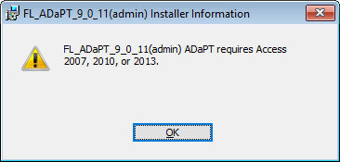
- Ensure you have an installation of both MS Access 2016 and MS Access 2007 runtime and then install ADaPT 9.0.11 following the installation instructions, then uninstall the MS Access 2010 runtime.

Computer requirements:
- One of the following Operating Systems are required:
  - Windows 7 (32 or 64 bit) with latest updates
  - Windows 8.1 (32 or 64 bit) with the latest updates
  - Windows 10 (32 or 64 bit) with the latest updates
  - Windows 11 with the latest updates

Windows XP and Windows Vista are not supported. ADaPT 9.0.11 will not install on a machine with Windows XP or Windows Vista.

- One of the following MS Office Access versions must be installed:
  - Access 2007 with SP3 or later
  - Access 2010 (32 bit) with SP2 or later
  - Access 2013 (32 bit) with SP1
  - Access 2016 (32 bit) with MS Access 2007 runtime
  - Access 2019 (32 bit) with MS Access 2007 runtime
  - Office 365 (32 bit) with MS Access 2007 runtime

Notes:
- The user logged into the installation machine must have full administrator privileges.

For MS Office Access 2007, ensure the Access Trust Center settings enable all Macros.
- For MS Office Access 2010, 2013, 2016, 2019, or Office 365; ensure the Access Trust Center settings enable all Macros and Active X controls.
- MS Access 2007 runtime may be uninstalled after ADaPT 9.0.11 is installed.
- ADaPT 9.0.11 is not supported on Microsoft Office (Access) 2010, 2013, 2016, 2019 or Office 365 as 64-bit installations. This is not the same as the 64 bit Operating System.
- MS Office Access 2003 is no longer supported. ADaPT 9.0.11 will not install on a machine with MS Access 2003.

Installation:
- Copy the ADaPT 9.0.11 installation files and paste them into a temporary folder on the installation machine.

- Right-mouse click on the setup.exe file (blue and white icon) and select “Run as administrator” (this is important).

- When the Install Shield ADaPT installation has completed, the PDF Converter application will install. You may see a notice of “Not responding” during installation of the PDF Printer, but please ignore this and allow the PDF Printer to install. Once the PDF printer has installed, click Finish.

- You should have a desktop icon and a Start Menu item for ADaPT 9.0.11.

If you have a 64 bit Operating System the installation path is: C:\Program Files (x86)\FL_ADaPT_9_0_11

If you have a 32 bit Operating System the installation path is C:\Program Files\ FL_ADaPT_9_0_11

Note: During installation, if you receive “Error 1308 Source file not found”, click the Ignore button to continue the Installation process.

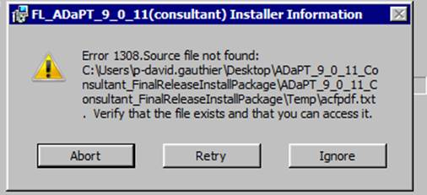

Before opening ADaPT 9.0.11, ensure the ADaPT 9.0.11 application folder’s security settings include the user “Everyone” and that this user has “Full Control”. If this is not done, you may get an error message upon opening ADaPT 9.0.11. To adjust these security setting, follow the steps below:

Note: The following screen shots indicate “FL_ADaPT_8_1” in the form headers. All instructions still apply to ADaPT 9.0.11.

- Right-mouse click on the application folder and select “Properties”

- Click on the Security tab. Scroll down the list of Group or user names and look for “Everyone”. If “Everyone” is not listed, click the Edit button and proceed to Step 3. If “Everyone” is listed, proceed to Step 5:

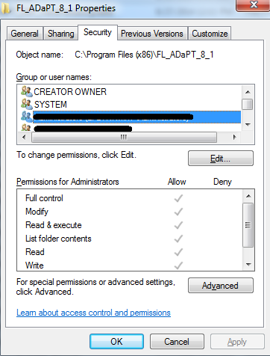

- Click the Add button:

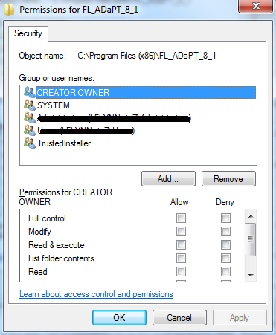

- Type in “Everyone” under Enter the object names to select (examples) and click OK. This will close the screen below. Click OK again:

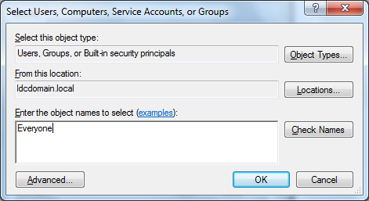
- You should be back to the Security Tab of the folder properties window shown below. Select User “Everyone” in the Group or user names box and then click Edit:

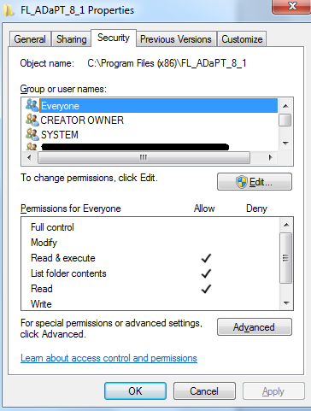

- With User “Everyone” selected, check the Allow box for Full Control, click Apply, and then click OK. This will close the form shown below and take you back to the Security tab of the Properties form. Click OK:

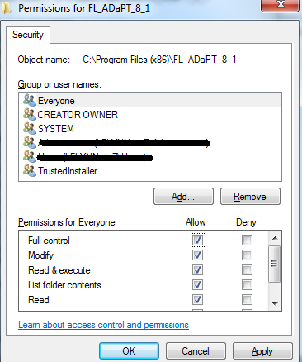

You can now open ADaPT 9.0.11. You will need to import your saved libraries and import an EDD. Installation of ADaPT 9.0.11 creates a desktop icon, so always open ADaPT 9.0.11 using the desktop icon. Desktop icons for previous versions of ADaPT will remain since these previous versions are not uninstalled automatically.

Received Error message after starting ADaPT
ADaPT comes with the AmiUni PDF converter which is incompatible with Windows 10. You may receive the following Error message for the AmiUni PDF converter each time you start ADaPT:
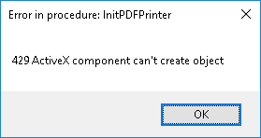
This will not affect any of ADaPT’s functions. If you are using MS Access 2010, 2013, 2016, 2019 or Office 365; you have the option to save any MS Access/ADaPT report in a PDF format. If you are using MS Access 2007 and do not have Adobe Acrobat Writer, there are many free third party PDF converters available should you want to produce a PDF of any ADaPT reports.

