Continuation of REDD Project for FY-2017/2018

All current REDD tickets in Cherwell are included in the event that these tickets are not finished in FY-2016/2017.

Development of REDD into a complete database that integrates well with WACS, STCM, and ERIC is needed. There is an additional proposal that a public internet-based portal page be developed for use labs and consultants to submit ADaPT EDDs. This portal would be used by FDEP delegated staff and private consultants to track the submittal and the processing of ADaPT EDDs.

The ESSA project is currently under development and should be active at the of FY-2016/2017. The public portal will contain links to web based reports used by project managers and site managers to review groundwater, soil and air data. Most web reports for the tracking and review of data have been developed but need to be further consolidated on the Internet public portal web page for all program areas.

Summary of objectives:

1. Modify REDD data upload notification email for PRP
#245489 - Request to Modify ADaPT EDD upload to REDD notification email created 11/4/16
2. Construct REDD Testsite Inventory Table, to be used by Petroleum Restoration and Waste Cleanup, Hazardous Waste and Solid Waste use WACS to house Monitoring Testsite data.
63829.251 - PRP testsite inventory, design a process to load inventory from fillable PDFs.
3. Move all HWC-Field data to REDD
DSD #173611 DWM REDD : Migrate HWCFIELD into REDD
4. Integrate specific REDD email upload statuses to eDocument Log and OCULUS re-indexing for PRP
5. Create PHP report summarizing the REDD List of Uploaded Data
6. DWM REDD “Portal” PHP web page, (worked on in the past by Ravi Teja?); unified web page for submitting, taking data inventory and reviewing ADaPT EDDS for all DWM program areas.
a. Link to Submit ADaPT data (and for some programs Monitoring Reports) for all of DWM
b. Links to eDocument Log PHP report
c. Link to REDD Uploads Summary report (item 5)
d. Link to Brady’s:
i. Regulatory Comparison/Exceedance Report.
ii. Completeness Report
iii. Trend Analysis Report
e. Make sure the reports listed in (d.) function for all DWM programs, PR, HW, SW and WC.
f. Include links to the DOH Lab certification page and to a new report that determines all results uploaded
to REDD are performed by a FL DOH certified lab.
Develop

- Modify REDD data upload notification email for PRP – Ticket #245489 – Request to Modify ADaPT EDD upload to REDD notification email created 11/4/16

Brady Schmidt has finished working on the REDD PHP reports in beta and has moved these reports to production. PRP site Managers and contractors need to review these PHP reports.
When ADaPT data is uploaded to WACS for the Solid and Hazardous Waste programs, a notification email is sent out to interested staff (staff who review environmental lab analytical data) with links to:
- ADaPT EDD zip file in OCULUS
- WACS Regulatory Comparison report
- WACS Completeness report

It is preferable that the ADaPT EDD upload to REDD notification includes the similar links: Eventually this email will also be sent out for all Waste Cleanup data uploaded to REDD.

- ADaPT EDD zip file in OCULUS
- REDD Regulatory Comparison report
- REDD Completeness report

Attached are two examples of ADaPT upload to REDD notification emails with links as described above.
Communication with PRP staff is necessary to see that the wording of this email is appropriate and to ensure the email is sent to the appropriate FDEP staff, FDEP delegated staff and contractors.

For PRP, this email should go out to all Site Managers and ESSA Submittals.
This email modification needs to be first implemented in REDD beta and then the REDD production environments.

Attached is a STCM query that retrieves both the Site Supervisor and Contractor.
As of 03/09/2017 @ 10:00 AM Natasha Lampkin wants only the Site Manager and eDocument Log submitter to be contacted. Natasha will send information so that this query can be updated to retrieve only the latest Site Manager. Potential issue: Is there ever more than one site supervisor due to multiple discharge events?

SELECT DISTINCT STCM_QUERY.STCM_DISCHARGE_INFO.DISCHARGE_FACILITY AS FACILITY_ID,
STCM_QUERY.STCM_DISCHARGE_INFO.DISCHARGE_ID AS DISCHARGE_ID,
STCM_QUERY.STCM_DISCHARGE_INFO.COUNTY AS COUNTY,
STCM_QUERY.STCM_DISCHARGE_INFO.TANK_OFFICE AS TANK_OFFICE,
WACA_SNAP.WACA_USERS.FIRST_NAME AS SM_First,
WACA_SNAP.WACA_USERS.LAST_NAME AS SM_Last,
WACA_SNAP.WACA_USERS.PHONE AS SM_Phone,
WACA_SNAP.WACA_USERS.EMAIL_ADDR AS SM_Email,
STCM_QUERY.PCT_CONTRACTOR_EMPLOYEES.FIRST_NAME AS FIRST_NAME1,
STCM_QUERY.PCT_CONTRACTOR_EMPLOYEES.LAST_NAME AS LAST_NAME1,
STCM_QUERY.PCT_CONTRACTOR_EMPLOYEES.PHONE AS Consultant_Phone,
STCM_QUERY.PCT_CONTRACTOR_EMPLOYEES.EMAIL_ADDRESS AS Consultant_Email
FROM STCM_QUERY.STCM_DISCHARGE_INFO
LEFT JOIN WACA_SNAP.WACA_USERS
ON STCM_QUERY.STCM_DISCHARGE_INFO.FDEP_USER_ID = WACA_SNAP.WACA_USERS.ORACLE_USER_NAME
LEFT JOIN STCM_QUERY.PCT_WORK_ORDERS
ON STCM_QUERY.STCM_DISCHARGE_INFO.DISCHARGE_FACILITY = STCM_QUERY.PCT_WORK_ORDERS.FAC_FACILITY_ID
INNER JOIN STCM_QUERY.PCT_CONTRACTOR_EMPLOYEES
ON STCM_QUERY.PCT_WORK_ORDERS.PCE_PCT_CONTRACTOR_EMPLOYEE_ID = STCM_QUERY.PCT_CONTRACTOR_EMPLOYEES.PCT_CONTRACTOR_EMPLOYEE_ID
WHERE STCM_QUERY.STCM_DISCHARGE_INFO.FDEP_USER_ID_END_DATE IS NULL
--AND WACA_SNAP.WACA_USERS.LAST_NAME LIKE 'CONTOS'
--AND STCM_QUERY.PCT_WORK_ORDERS.END_WO_DATE IS NULL
AND STCM_QUERY.PCT_WORK_ORDERS.CANCELLED_DATE IS NULL
--AND STCM_QUERY.STCM_DISCHARGE_INFO.DISCHARGE_FACILITY IN (8623010, 8731780)
ORDER BY STCM_QUERY.STCM_DISCHARGE_INFO.DISCHARGE_FACILITY,
STCM_QUERY.STCM_DISCHARGE_INFO.DISCHARGE_ID

- Construct REDD Testsite Inventory Table, to be used by Petroleum Restoration and Waste Cleanup –
Ticket #63829.251 – PRP testsite inventory, create process to load inventory from fillable PDFs

In REDD, the Monitoring Testsite Tables should be roughly compatible with WACS, HWCField and meet both PRP and Waste cleanup requirements. The following tables in Item 3 need to be accommodated. Data need to be imported from both HWCFIELD.T_SAMPLE and HWCFIELD.T_SAMPLE_LOCATION tables. In REDD, a process to collect and enter Monitoring Testsite locational and well construction data must be established. Data entry forms, data entry screens, and verification screens are needed for collecting and verifying new testsites. During the upload to REDD process the Facility_ID - Monitoring_Testsite_ID association for PRP and WC must be verified, as is currently done for SW and HW. All data entry forms, data entry screens, verification screens should be accessed through the specific program area’s native application; STCM for Petroleum Restoration and ERIC for the WACS Cleanup program.

Karen Demirpolat has performed some preliminary work creating the following tables in OraDev.
REDD. PRP_EXISTING_MONITOR_WELLS <- Site Survey
REDD.PRP_NEW_WELL_CONSTRUCTIONS <- Well completion form
Two corresponding PDF files have been created, these PDFs are to be filled out by PRP (or WC) Contractors and submitted to FDEP. Data is retrieved from these PDFs, uploaded to REDD (a temporary staging table), and then verified by FDEP staff before the data is moved to permanent REDD tables.
existing_wells_10_5_15.pdf
New_Well_Construction_Log_10_5_15.pdf

Initial data collection and load to REDD

1. Contractor tasked with collecting lat/long data for new/existing monitoring wells
a. New_Well_Construction_Log_08Oct2015

PRP needs to verify mandatory data elements in New_Well_Construction_Log and decide which data elements should be displayed in validation screen and/or subsequently uploaded to the REDD Permanent Testsite table

b. Existing_Monitor_Well_form_08Oct2015

2. Contractor completes PDF and clicks <submit via email> button on form

3. Form received in ADaPT.EDDs.and.Reports@dep.state.fl.us shared mailbox

4. Assigned staff screens form to ensure it is not spam and then saves it to the <designated FTP upload> folder

5. Nightly script runs on all submitted forms in the <designated FTP upload> folder and
a. Automatically extracts PDF form data to populate Temporary Testsite table in REDD
b. Runs STCM lookup for PRP site manager based on STCM Facility ID
c. Sends notification email to PRP Site Manager and <designated testsite/ADaPT coordinator> that
form has been uploaded to temporary table and is ready for verification

6. PRP Site Manager
a. Logs in and navigates to Facility in STCM;
b. Navigates to PRP New Well and Existing Well PDF Submission Validation Form (accessed through
STCM, but populates data in REDD)

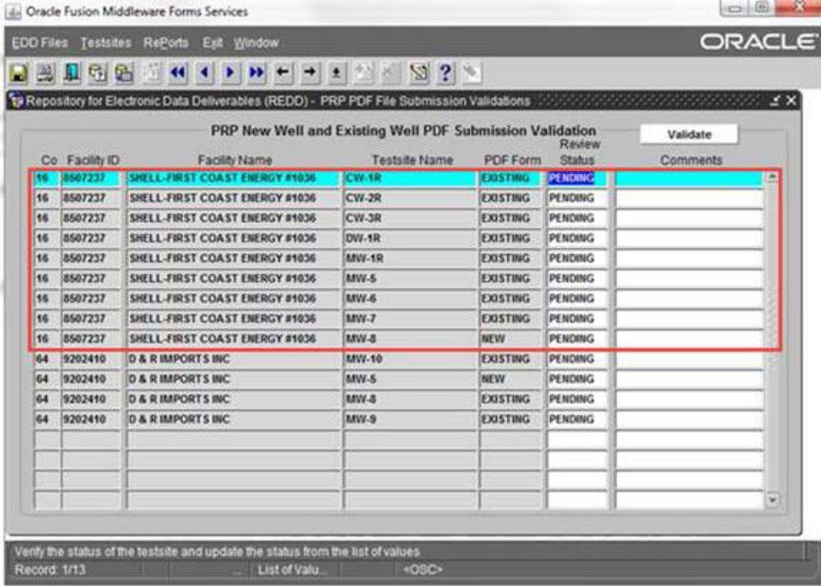

Comments on form:
- Update screen to allow individual testsite validation button – not validate button at the top
- Double click on testsite name to open screen in c.i.?
- If Site Managers are going to be validating, do not want to display sites that are not assigned to the Site Manager
- Display information just for the facility, not all records loaded for review
c. Validates each Testsite individually
i. Click on Testsite Name in above form to open validation screen

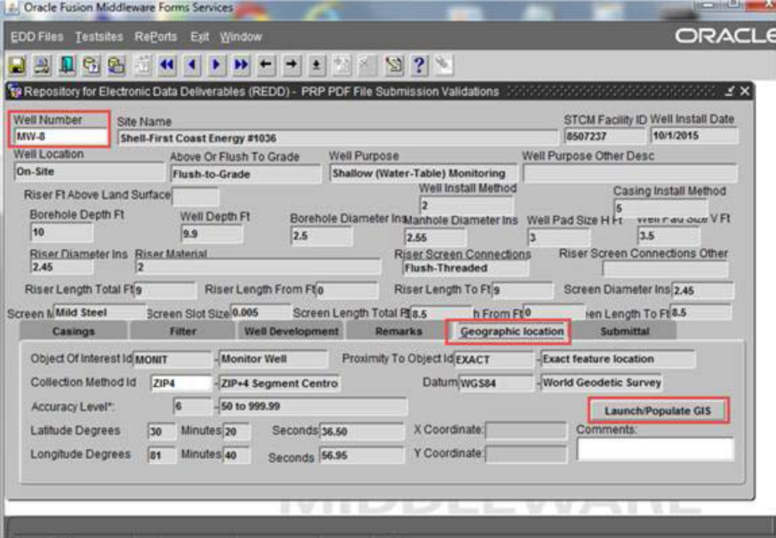
Comment on form:
- Add validation – save and exit button
- Program still needs to decide on fields to include in validation screen and/or uploaded to Permanent Testsite table in REDD
ii. Verify location visually using MapDirect utility - click Return Shape Edits when location
confirmed.

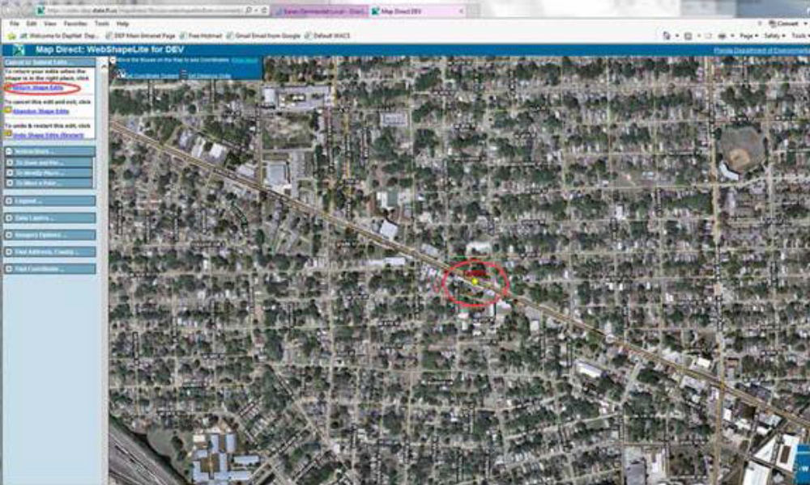

Additions:
- Show facility location on map
- Show cadastral property boundaries on map
iii. When verification is complete, user returns to testsite validation screen in i. and clicks <Validation complete> to save and return to Well listing in b. to enter comments or validate another testsite.

7. Once well validation is complete for one or more testsites, all associated data for validated testsites will be moved to permanent Testsite table in REDD. Invalidated testsite data will remain in list.

Next Steps
- Need to decide on data elements for REDD Permanent Testsite table(s) that can accommodate both PRP
form data, WCP data migrated from HWCFIELD, and new WCP data collection process
- Decide process for failed validation submittals - send them back or make manual corrections? In theory,
Differential GPS method required by PRP should be much more accurate than visual confirmation
through MapDirect.

Additional details given in different outline.

When ADaPT EDD Export Files are loaded into REDD, file information is loaded into table REDD.ADAPT_EDD_FILES and all records within the file are loaded into REDD.ADAPT_EDD_RECORDS.

- If the program area is identified as SW or HW then a database procedure stored in WACS is called and validates the records within the file and if validation is successful then another WACS database procedure is called and data is uploaded into the designated WACS tables.
- If the program area is identified as PRP then a different process takes place. Currently there are no testsite IDs in the export files to perform validation.

Originally it was suggested that the inventory be built based on the data received from the ADaPT export files. As testsites are validated, they will be entered into the permanent table REDD.PCT_MONITOR_WELL_TESTSITES. If the testsite is not found, then a record is inserted into the REDD temporary table REDD.ADAPT_EDD_TESTSITE_TEMP for validation with an initial status of PENDING.

The Designated user(s) would access the REDD testsite validation screen which displays all testsites in the REDD.ADAPT_EDD_TESTSITE_TEMP table.
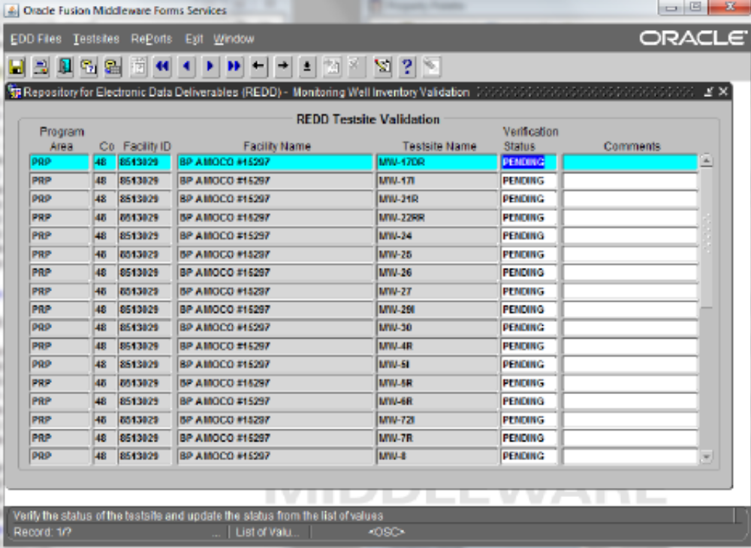
The current plan is to have PRP consultants fill out fillable PDF forms for existing Monitoring Testsites for existing facility wells to submit to the department. The Monitoring well information can be automatically extracted and uploaded to a temporary REDD Monitoring Testsite table. FDEP and contracted Site Managers can then verify each monitoring well in REDD and the well is moved to a permanent Monitoring Well Testsite Inventory Table. Wells will be checked for proper names, lat-longs and physical well construction details.

The user would update the status from PENDING to either VALID or REJECT.

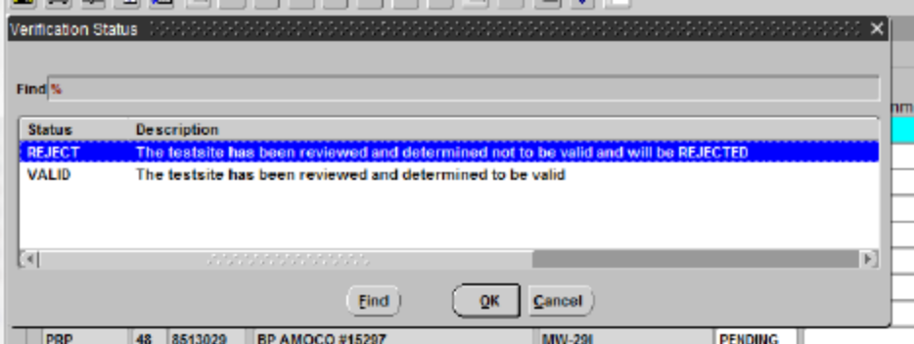

If the status is set to REJECT, then the user will be required to document the reason in the comments field and that record will remain in the table so that this process will not need to be repeated if additional data comes in on an EDD for the same testsite.

When the status is set to VALID and the user commits, the user will receive a confirmation alert message

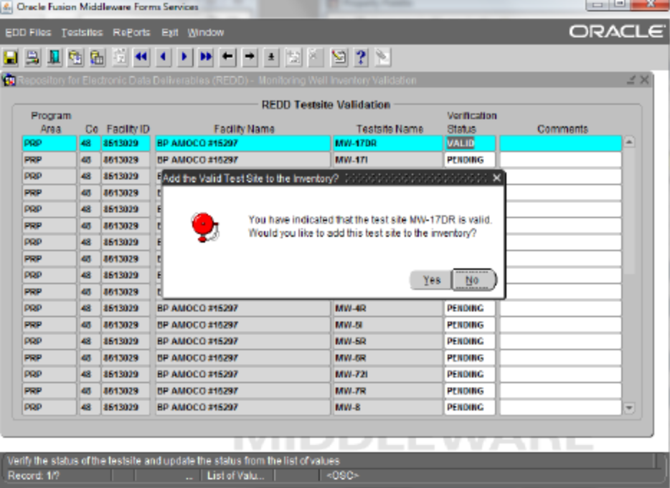

If they click the Yes button to confirm, then
• The testsite is assigned an ID in REDD.PCT_MONITOR_WELL_TESTSITES
• EDD records in REDD.ADAPT_EDD_RECORDS for the testsite are updated with the new ID in ADAPT_EDD_RECORDS table
• The REDD.ADAPT_EDD_FILES processing comments field is updated with a reference to the testsite validation
• The record is deleted from the REDD.ADAPT_EDD_TESTSITE_TEMP table
• Navigation is transferred to the data entry screen for the monitor well testsite to complete entry of the remaining fields
When Navigation is set to the data entry screen, the new testsite is automatically queried and ready for the additional data entry to be performed. These screen shots and the table structure have been modeled after the WACS design. PRP staff need to determine whether this model fits their needs or identify what changes are needed.

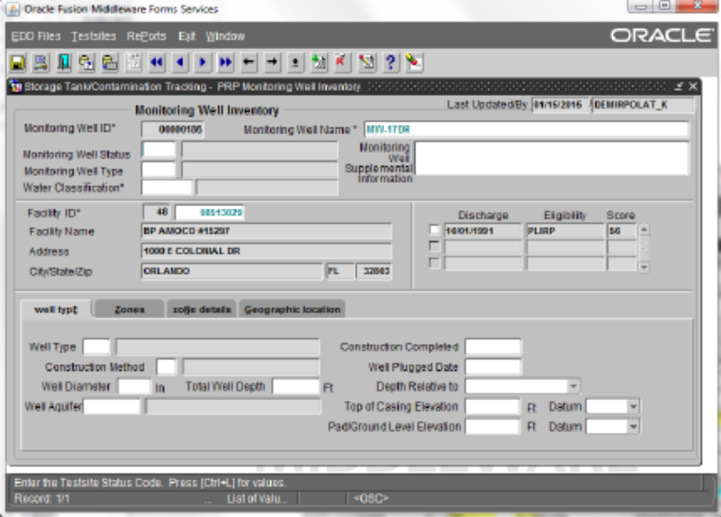

Additional data has been populated on the startup screen.

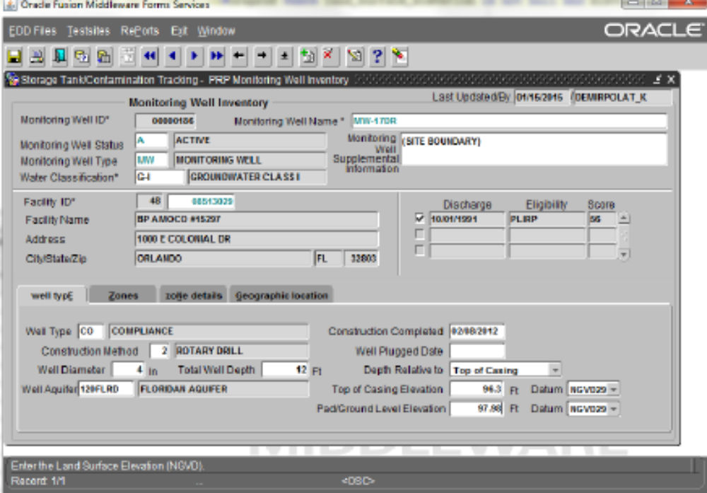

Additional data has been entered for the Zone.

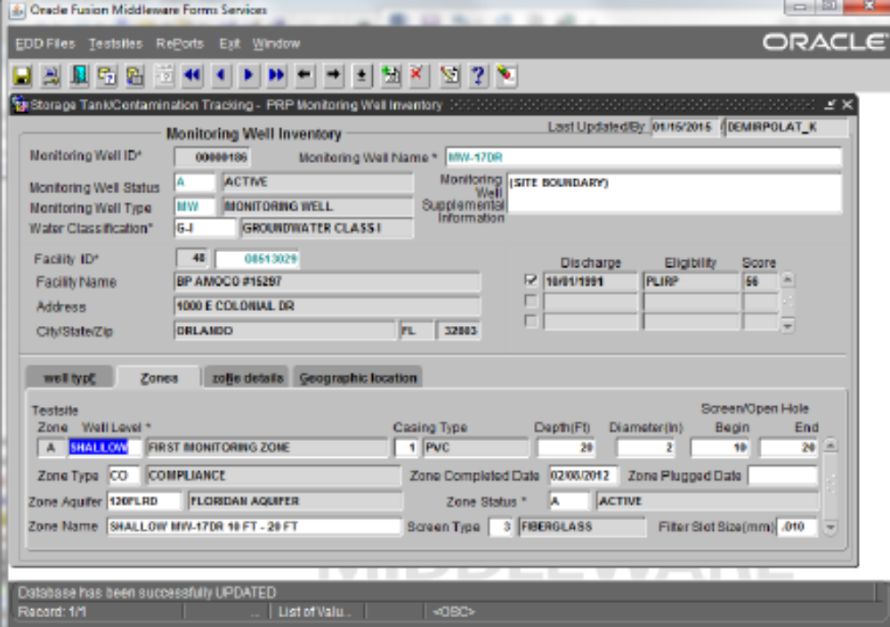

Additional data has been entered for the Zone Details

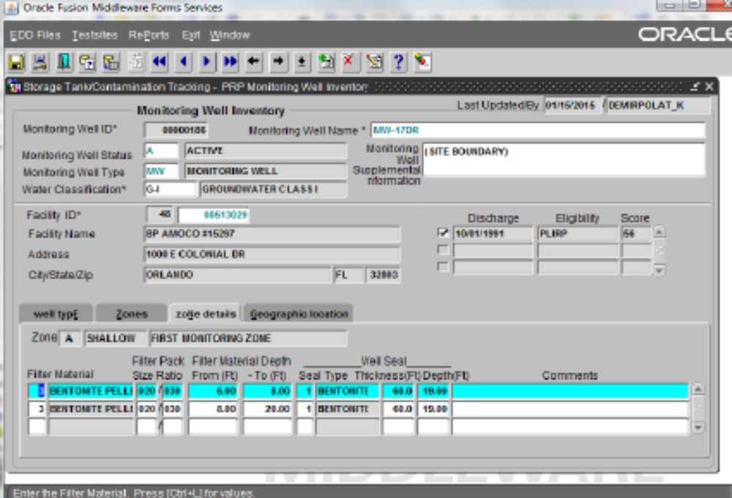

Navigating to the Geographic Location screen initially populates the lat/longs with the facility lat/longs pulled from STCM.

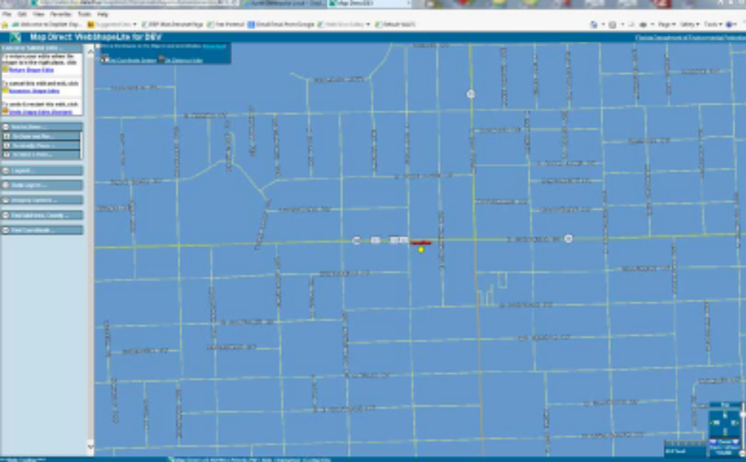

Clicking on the return from WebShapeLite returns navigation to the oracle form and clicking on the “Launch/Populate GIS” button will populate the coordinates and verification fields.

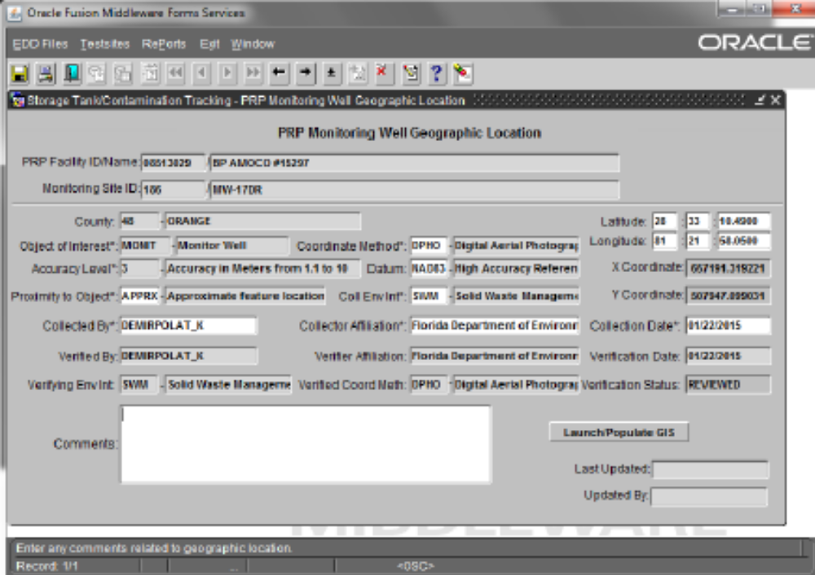

Screen shot showing updates to the File Processing Comments, Testsite ID, and Testsite Valid Indicator for a testsite that was validated from the validation screen and added to the permanent table.

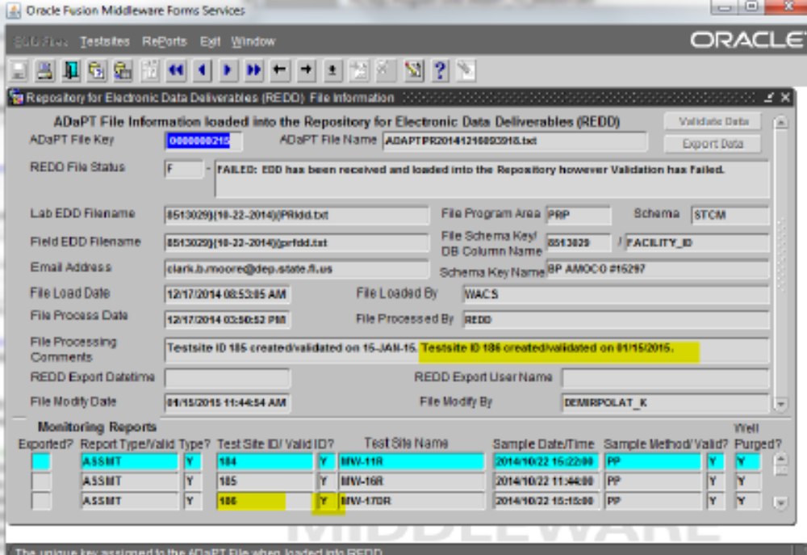

Screen shot showing a query screen displaying reports loaded into REDD

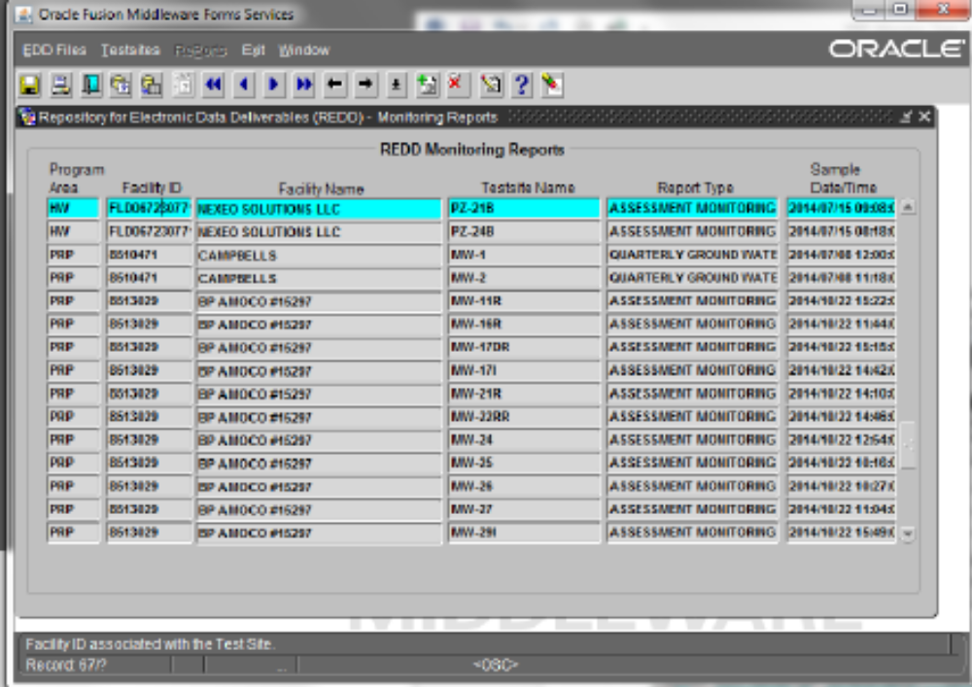

**************************************************************************************************

- Move all HWC-Field data to REDD – DSD #173611 – DWM REDD : Migrate HWCFIELD into REDD

HWC-Field to REDD data migration – disorganized thoughts

WACS (10E6 records) is a more robust database than HWC-Field (2.1E6 records). WACS stores data for the Solid Waste, Hazardous Waste and Underground Injection Control programs. WACS contains more Monitoring Well construction information and meets the Departments Locational Data Standards. WACS includes many more analytes and with the upload of lab and field analytical data using the ADaPT software, adheres more closely to 62-160, F.A.C. in regards to the QA rule and data qualifiers. An advantage of HWC- over WACS is the capability of databasing “temporary” samples; samples that can only be collected once (unable to sample the same location more than once). These samples might include; push wells, soil samples, air samples, one-time surface water sampling. Taking these points into consideration it would be best to model the REDD database table structure after the WACS database table structure with modifications. REDD should use field names that more closely match fields used by the ADaPT Software. It is important that HWC-Field data is converted and either uses updated codes/valid values or incorporates missing codes/valid values in REDD that are required by HWC-Field. REDD already contains HW, PR and SW program area data. Labs producing and submitting HWC-Field data already submit ADaPT lab EDDs. More than half the consultants submitting HWC-Field data also produce and submit ADaPT field EDDs to either the HW, PR or SW programs.

Facility and Monitoring Testsite Inventory tables need to be added to REDD for PRP and Waste Cleanup. Solid Waste and Hazardous Waste programs already have this information in WACS. For Solid and Hazardous Waste, it might be best to create a view of data from WACS in REDD. Alternately, the data can be populated in the new complex REDD data table structure and use the temporary table in REDD when uploading the data to WACS.

In creating this REDD database structure, the decision has to be made whether to capture all ADaPT data is currently done in the REDD_SNAP.ADAPT_EDD_RECORDS; or capture the data that is done in WACS plus a few additional important fields.

Use SQL Developer to copy the Table Structures from WACS and modify them for REDD data table structures from ADaPT.

When data is uploaded to REDD and is Validated, numerous checks are performed on specific data fields. Currently, for Solid and Hazardous Waste, Facility ID and Monitoring Testsite associations are also checked. The Monitoring Testsite Inventory needs to be built into REDD for both Petroleum Cleanup and various Waste Cleanup programs. An important verification that ADaPT rarely but still does miss is the "Qualifier verification?".
ADaPT looks at data qualifiers on an individual basis and WACS verifies the Qualifiers based on their combination but there are qualifier combinations that are occasionally reported that are NOT valid.

The following WACS tables are used to verify data uploaded to REDD for HW, PR SW and WC. (WC lab data has been successfully uploaded to REDD without any field EDDs). Verifying data for the upload to REDD using newly created REDD tables should be considered.

Data Validation | ADaPT (export) | WACS (import to WACS and REDD)
Facility/Testsite Valid? | tblWacs_Svl_SolidWaste_Testsite_Inventory | WACS_SNAP.MONITOR_WELL_TESTSITES
(SW & HW; add for PR and WC)
Sample Type Valid? | tblWacs_Svl_Sample_Type_Codes | WACS_SNAP.WACS_SAMPLE_TYPE_CODES
Storet Valid? | TblWACS_STORET_Numbers | WACS_SNAP.STORET_NUMBER_CODES
Qualifier Valid? | tblSvlLabQualifiers and | WACS_SNAP.TEST_REMARK_TYPE_CODES
 | tblWacs_Svl_Field_Parameter_Qualifier_Code
Report Type Valid? | tblWacs_Svl_Report_Type | WACS_SNAP.WACS_REPORT_TYPE_CODES

REDD_SNAP. | WACS_SNAP. | ADaPT
STORET_NUMBER_CODES | STORET_NUMBER_CODES | TblWACS_STORET_Numbers
MONITORING_TESTSITE_RESULTS | MONITOR_WELL_TEST_RESULTS
MONITORING_TESTSITE_REPORTS | MONITOR_WELL_REPORTS
MONITORING_TESTSITE_INVENTORY | MONITOR_WELL_TESTSITES | tblWacs_Svl_SolidWaste_Testsite_Inventory
FACILITIES | WACS_FACILITIES | tblSvlProject
COUNTY_CODES | WACS_QUERY.COUNTY_CODES
DATA_QUALIFIER_CODES | TEST_REMARK_TYPE_CODES | tblSvlLabQualifiers and
DATA_QUALIFIER_CODES | TEST_REMARK_TYPE_CODES | tblWacs_Svl_Field_Parameter_Qualifier_Code
REPORT_TYPE_CODES | WACS_REPORT_TYPE_CODES | tblWacs_Svl_Report_Type
SAMPLE_TYPE_CODES | WACS_SAMPLE_TYPE_CODES | tblWacs_Svl_Sample_Type_Codes

HWC-Field Tables: Clark has converted these tables in MS Access. Ravi Teja has most, (but less) of this data converted in OraDev.

T_ANALYTICAL – 99.94% converted only surrogates and bogus analytes are not converted
T_AQUIFER has only 609 records, don’t convert/move to REDD.
T_FIELDTEST – converted
T_SAM_LOCATION – This table identifies the physical locations on the surface of the earth where samples have been collected.
32110 records, redundant (except for Temporary samples?)
T_SAMPLE – used in conjunction with T_ANALYTical, TT_FIELDTEST and T_WATER_LEVEL tables.
104516 records
Similar to MONITOR_WELL_REPORTS
T_WATER_LEVEL – converted
T_WELL - This table identifies and describes each well. It also includes any aquifer parameters collected at that well.
8605 records
Similar to MONITOR_WELL_TESTSITES, does not include “Temporary” samples (DP, SS, AIR, etc).

John Sykes stated that T_SAM_LOCATION and T_WELL (Table 1 and 2) are updated only when a new Monitoring well is sampled. HWC-Field uses single POINT_IDs for “Testsite_NAMES”, this field includes both an Alpha code for the Type of Sample/sampling point and a number. The SampleType/SampleLocation code needs to be split into another column. Also, a “Testsite_ID” column needs to be added. Now HWC field verifies each sample by collecting the lat-long for each location, which is redundant. Instead, each sample point will be verified by using the Monitoring Site ID. This is simpler data entry for ADaPT.
Source_ID ProjectNumber, Facility_ID
Point_ID ClientSampleID, Monitoring_Testsite_Name
SAMPLE_ID MONITOR_WELL_REPORT_ID
Combination of Point_ID and Date_Sampled

Converting T_ANALYTICAL data to REDD
The T_Analyte and T_Sample tables were linked to determine the unique combination of the following fields.
CAS
ANALYTE
UNITS
MATRIX
A simple translation table has been created for the matrix conversion. STORET does not distinguish (by Matrix) the difference between Soil and Sediment Samples. This is often indicated in the STORET code Analyte field. If Percent Moisture is had, then it can be determined if the sample is a sediment.
Matrix Conversion HWC-Field to REDD
MATRIX | STORET_Matrix
LIQUID | W
SOLID | S
GAS | A
SEDIMENT | S

Also, in HWC-Field the matrix is indicated in the T_SAMPLE (HWCFIELD) table. This is similar to WACS, where the Testsite Inventory table indicates the type of sample collected.

WATER_CLASSIFICATION_ID | DESCRIPTION
G-I | GROUNDWATER CLASS I
G-II | GROUNDWATER CLASS II
G-III | GROUNDWATER CLASS III
G-IV | GROUNDWATER CLASS IV
SW-I | SURFACE WATER CLASS I
SW-II | SURFACE WATER CLASS II
SW-IIIF | SURFACE WATER (FRESH) CLASS III
SW-IIIM | SURFACE WATER (MARINE) CLASS III
SW-IV | SURFACE WATER CLASS IV
SW-V | SURFACE WATER CLASS V
LC | LEACHATE
S | SOIL OR SEDIMENT
GC | GAS CONDENSATE

The entries in this table determine what 62-777 Criteria or RCRA Criteria are applied in the Exceedance ASP reports. It is important to further delineate the “S” code (for Solids 62-777 Table II, and for Sediment criteria). In REDD, if a similar code table is used for each permanent Monitoring Site and this code is determined for each temporary sample collected; the Exceedance Report will automatically apply the appropriate criteria to the data.

A Translation Table is being created that will have both CAS and ANALYTE fields linked to it and create all fields required to then assign/link to STORET codes. The new fields will be; a pseudo ClientAnalyteID field by removing all dashes from the CAS field. CAS field entries in the new pseudo ClientAnalyteID field are being replaced to match the ANALYTE field with the AnalyteName field in ADaPT and REDD. In some cases, the common CAS entry was used to help determine the proper ANALYTE in assigning the new ClientAnalyteID. Also, the list of 16,522 STORET codes created by EPA was used to help assign STORET codes that are new to ADaPT and REDD. STORET codes are actually five digit numbers, and pseudo STORET Codes are six digits in length. All six digit STORET codes have at least one leading zero. If EPA did not define the STORET code needed then the six digit STORET code that is generated will have a leading nine (9). The Analyte name, matrix, and units are matched as close as possible or the closest non-match may be chosen and the leading 9 is added to generate a new STORET Code.

STORET_Code New field, STORET is not preferable and is thought of as a Primary Key.
ClientAnalyteID (CAS) entries may be reassigned for some analytes
Parameter_Name (ANALYTE) entries may be reassigned for some analytes
Units Any units that do not match will have to be changed and appropriate numeric Results will
have to be numerically converted.
TotalOrDissolved New field, TOT, (DIS if Filtered metal) based on ANALYTE field entries.
Field_Measure New field, “F” for all T_ANALYTE table entries
Matrix Use Matrix conversion table previously listed.

There are a number of Analytes that are misidentified, examples are MADEP VPH and MADEP VPH methods that speciate petroleum hydrocarbons into specific aliphatic or aromatic carbon ranges. In some instances, the aliphatic carbon range is the carbon range for aromatics and vice-versa. The analyte Total Light Petroleum Hydrocarbon or Total Petroleum Hydrocarbon are reported by methods EPA 8260, EPA-18 which should be (M-18), M-18 and TO-15. Here is an excerpt from Method EPA 8260.
“11.7.5 Quantitation of multicomponent parameters such as gasoline range organics
(GROs) and total petroleum hydrocarbons (TPH) using the Method 8260 recommended
internal standard quantitation technique is beyond the scope of this method. Typically,
analyses for these parameters are performed using GC/FID or GC with a MS detector
capability that is available with Method 8015.”

FL-DOH certifies Total Petroleum Hydrocarbons only for water and soil matrices by methods FDEP FL-PRO, EPA 1664A and EPA 1665. Unmatched fields to check the following resources (method used in HWC Field, EPA’s 166522 STORET Code list, John Sykes). Perhaps some analytes are not of importance and need not be migrated.

EPA STORET Code Matrices:

W - WATER
T - TISSUE
S - SEDIMENT
A - AIR
D - SLUDGE
M - METEOROLOGICAL
E - EFFLUENT AND INFLUENT
L - LAND
F - FOOD
O – OTHER

HWC-Field data Ravi Teja has alrady loaded into the ADaPT_Records table.

In ORADEV Ravi Teja created the following tables:
REDD.CL_STORET_CODES
REDD.CL_STORET_CODES_UNITS
REDD.HWC_CL_MISMATCH_UNITS
REDD.HWC_T_ANALYTICAL_RECORDS_TEMP
REDD.HWC_T_FIELDTEST_RECORDS_TEMP
REDD.HWCFIELD_T_ANALYTICAL_RECORDS
REDD.HWCFIELD_T_FIELDTEST_RECORDS
REDD.MISSING_ANALYTES

Ravi Teja 5-7645

**************************************************************************************************

4. Integrate specific REDD email upload statuses to eDocument Log and OCULUS re-indexing for PRP

The outcome of each ADaPT EDD file set uploaded to REDD should be monitored and completely identified using the REDD_SNAP.ADAPT_EDD_FILES. RFSC_REDD_FILE_STATUS_ID. This will help FDEP staff quickly review the upload of all ADaPT EDDs using a PHP web report to be developed based on the attached query (see Item 5). For the PRP program, which processes and uploads the largest number of ADaPT EDDs per day, the correct file status codes that will trigger the process of adding the Termination steps (T) to the eDocument Log should be automatically identified.
- Modify the REDD_SNAP.RED_FILE_STATUS_CODES table adding the new highlighted codes below.

REDD_FILE_STATUS_KEY | CREATE_USER_NAME | CREATE_TS | DESCRIPTION | BEGIN_DATE | END_DATE | MODIFY_USER_NAME | MODIFY_TS
R | REDD | 3/13/2015 | RECEIVED: EDD has been received and loaded into the Repository, no validations have yet been performed. | 3/13/2015
F | REDD | 3/13/2015 | FAILED: EDD has been received and loaded into the Repository however Validation has Failed. | 3/13/2015
V | REDD | 3/13/2015 | FULL VALIDATION: EDD has been received and loaded into the Repository and all records have been successfully validated. | 3/13/2015
PV | REDD | 3/13/2015 | PARTIAL VALIDATION: EDD has been received and loaded into the Repository and SOME records have been successfully validated, however some records failed validation. | 3/13/2015
E | REDD | 3/13/2015 | FULL EXPORT: EDD has been received, loaded into the Repository, all records were successfully validated and all records were exported to the destination schema. | 3/13/2015
PE | REDD | 3/13/2015 | PARTIAL EXPORT: EDD has been received, loaded into the Repository, SOME records were successfully validated and SOME records were exported to the destination schema. | 3/13/2015
PVD | REDD | 201703/13 | PARTIAL VALIDATION due to Duplicate Data EDD has been received and loaded into the Repository and SOME records have been successfully validated, however some records failed validation as this data was duplicate. | 3/13/2017
PED | REDD | 201703/13 | PARTIAL EXPORT due to Duplicate Data: EDD has been received, loaded into the Repository, SOME records were successfully validated and SOME records were exported to the destination schema. | 3/13/2017
FD | REDD | 201703/13 | EDD has been received and loaded into the Repository however Validation has Failed since all records are Duplicate. | 3/13/2017

- Assign the additional codes in the REDD_SNAP.ADAPT_EDD_FILES. RFSC_REDD_FILE_STATUS_ID field for each REDD File Upload as follows.

Upload to REDD email Subject______________Assign Code
Received Duplicate Data: FD
Partial Export due to Duplicate Data: PED
Partial Validation due to Duplicate Data: PVD

- For now, only for PRP when the REDD_File_Status_ID codes REDD_SNAP.ADAPT_EDD_FILES. RFSC_REDD_FILE_STATUS_ID = “V” or = “PV”
Add the workflow step to “RED Confirmation email received”.

- Also, for now only, for PRP when the REDD_File_Status_ID codes REDD_SNAP.ADAPT_EDD_FILES. RFSC_REDD_FILE_STATUS_ID = “V” or = “PV”
Add the workflow step to “Uploaded to OCULUS (T)”.
ONLY if the OCULUS ADaPT EDD can be re-indexed as follows
Catalog: Storage Tanks
Profile: from “Document Review” to “Discovery Compliance”
Document Type: Lab Analytical Reports

- In the event the Program Area is not recognized, the upload process is halted and an email is received similar to the following: “FAILURE: Invalid file name for EDD Production Repository Upload of File ADAPT20160307123028.csv”. When the program area is NOT recognized, the ftp site receives a file ADaPTYYYYMMDDHHMMSS.csv and ADaPTYYYYMMDDHHMMSS.md5. The first line of the csv file contains the following information:
EMAIL>Loury.Migliorelli@dep.state.fl.us</EMAIL><LAB EDD>8501972}{02-09-2016}{PRldd.txt</LAB EDD><FIELD EDD>8501972}{02-09-2016}{PRfdd.txt</FIELD EDD>
If this first line from the ADaPTYYYYMMDDHHMMSS.csv file could be included it would help greatly in identifying which ADaPT EDDs need correcting. The alternative process is through an arduous process of eliminating what files are actually uploaded. This would greatly help in the efficiency of identifying and correcting failed uploads. (These issues can occur when the ADaPT Project valid values is out of date.
The program area is identified using this table and included in the ADaPT upload file.)

5. Create (from existing SQL query) a PHP report summarizing the REDD List of Uploaded Data
Create a PHP REDD web report based on the following query with the following drop down filters, with the ability to save the query report in Excel.
Program Area [All, HW, PR, SW, WC]
Facility_ID [CHAZ, ERIC, STCM, WACS]
Facility_Name [%partial_name%]
County
Date Exported (All, Specific Day, Specific Year, maybe date range)
Sampling Event Date Range or All

SELECT DISTINCT REDD_SNAP.ADAPT_EDD_RECORDS.PROGRAM_AREA AS Program_Area,
REDD_SNAP.ADAPT_EDD_RECORDS.FACILITY_ID AS Facility_ID,
MIN(REDD_SNAP.ADAPT_EDD_RECORDS.FACILITY_NAME) AS Facility_Name,
MIN(REDD_SNAP.ADAPT_EDD_RECORDS.SAMPLE_DATE) AS Start_Sample_Date,
MAX(REDD_SNAP.ADAPT_EDD_RECORDS.SAMPLE_DATE) AS End_Sample_Date,
COUNT(REDD_SNAP.ADAPT_EDD_RECORDS.RESULT) AS Number_of_Records,
REDD_SNAP.ADAPT_EDD_RECORDS.EDD_EXPORT_USERNAME AS User_Name,
REDD_SNAP.ADAPT_EDD_RECORDS.EDD_EXPORT_DATETIME AS Time_Stamp,
REDD_SNAP.ADAPT_EDD_RECORDS.AEF_ADAPT_EDD_FILE_ID AS Export_File_ID,
REDD_SNAP.ADAPT_EDD_FILES.LAB_EDD_FILENAME AS Lab_EDD,
REDD_SNAP.ADAPT_EDD_FILES.FIELD_EDD_FILENAME AS Field_EDD,
REDD_SNAP.ADAPT_EDD_FILES.RFSC_REDD_FILE_STATUS_ID AS REDD_File_Status
FROM REDD_SNAP.ADAPT_EDD_RECORDS
INNER JOIN REDD_SNAP.ADAPT_EDD_FILES
ON REDD_SNAP.ADAPT_EDD_RECORDS.AEF_ADAPT_EDD_FILE_ID = REDD_SNAP.ADAPT_EDD_FILES.ADAPT_EDD_FILE_KEY
WHERE REDD_SNAP.ADAPT_EDD_RECORDS.EDD_EXPORT_DATETIME LIKE '%2016/06/24%'
GROUP BY REDD_SNAP.ADAPT_EDD_RECORDS.PROGRAM_AREA,
REDD_SNAP.ADAPT_EDD_RECORDS.FACILITY_ID,
REDD_SNAP.ADAPT_EDD_RECORDS.EDD_EXPORT_USERNAME,
REDD_SNAP.ADAPT_EDD_RECORDS.EDD_EXPORT_DATETIME,
REDD_SNAP.ADAPT_EDD_RECORDS.AEF_ADAPT_EDD_FILE_ID,
REDD_SNAP.ADAPT_EDD_FILES.LAB_EDD_FILENAME,
REDD_SNAP.ADAPT_EDD_FILES.FIELD_EDD_FILENAME,
REDD_SNAP.ADAPT_EDD_FILES.RFSC_REDD_FILE_STATUS_ID
ORDER BY Program_Area,
Facility_ID

6. DWM REDD “Portal” PHP web page, (worked on in the past by Ravi Teja?) unified web page for submitting, taking data inventory and reviewing ADaPT EDDS for all DWM program areas.

a. Link to Submit ADaPT data (and for some programs Monitoring Reports) for all of DWM
Link to eDocument Log, maybe for specific programs?
b. Links to eDocument Log PHP report
Ground Water EDD Report – This report name needs to be updated.

https://fldeploc.dep.state.fl.us/rcra_epa/DocLog/gwmrReport_02.asp?

Incorporate the following report: Ground Water EDD Report
This report lists all ADaPT EDDS (Electronic Data Deliverables) for a specific sampling event (WACS facility and Year/Month the sampling event began). There are several report result sort options. This report contains links to download the EDD from OCULUS, query WACS facility information and view how the file was processed.
C. Link to REDD Uploads Summary report; the report developed in item 5.
d. Link to Brady’s:
i. Regulatory Comparison/Exceedance Report.
ii. Completeness Report
iii. Trend Analysis Report
All reports available at https://prodlamp.dep.state.fl.us/redd/index.php/Reports/Report_Index/Reports

This web page needs to also link to the appropriate WACS ASP reports on the following web page.
https://fldep.dep.state.fl.us/wacs/DEFAULT_SOLID_WASTE.ASP?

Solid Waste Facility Inventory Report: The “C” link for the Regulatory Comparison/Exceedance Report for SW and HW.

Solid Waste Completeness Report: Modify to include HW
The Completeness Report checks the content of the report results for each Testsite in the specified facility for the specified quarter and year. For each report type, there is a list of required analytes to be tested or recorded. The Completeness Report provides an efficient and easy method to check and make sure that the report for each testsite includes readings for all analytes in the list. The Completeness Report will also include the results for any analytes that are not included in the list. All required analytes in the list for that particular report type are marked 'Template' and all additional analytes are marked 'Non-Template'. Because the requirement list of analytes varies by report type, the results from the testsites are grouped together by report type.

f. Include a link to the DOH Lab certification page https://fldeploc.dep.state.fl.us/aams/index.asp and link to a to-be developed report that determines that all results uploaded to REDD are performed by an FL DOH certified lab. Match the following data in REDD for each record; LabCertificationNumber, LabAnalyticalMethod, ClientAnalyteID and Matrix; with the appropriate data in the corresponding LDS_SNAP schema tables. Translation tables may need to be generated for LabAnalyticalRecords, ClientAnalyteID and Matrix between the LDS_SNAP and REDD_SNAP.ADAPT_EDD_RECORDS tables. Clark Moore will create the translation tables and help develop the query. Translation tables need to be created, maybe in REDD. A PHP report needs to then be created that can be run by Site Supervisors, Project Managers and other FDEP staff for each ADaPT EDD data set uploaded to REDD.

