REDD Development OTIS Project Proposal

Continue development of Repository for Electronic Data Deliverables (REDD). A data
repository has been established for all program analytical results. The next stage
is to expand the repository to track monitoring site location and characteristics
and develop web-based reporting to allow comprehensive presentation and analysis
(e.g., trend evaluation, GIS mapping, etc.).
This project would be classified as tactical because it allows for improved reporting
of field and analytical data for all DWM program areas, and operational because it
will result in more efficient reporting/evaluation of analytical results.
In the near term, create or specify a repository for ADaPT EDD and other monitoring
data for PRP. We also need to further develop a consolidated Oracle-based data
management system for all DWM program areas that includes a flexible import process
for field and analytical data received as ADaPT EDDs and other formats with flexibility
to support UIC or other groundwater and soil sampling ADaPT data imports needed for
the Department.
The analytical results table is in production. Attached at the end of this form
please find the most recent requirements summary for adding testsite inventory tracking
capability.

The proposed unified Division workflow for the receipt of ADaPT EDDs/ (electronic data deliverables) incorporate the following applications, web reports and scripts.
ESSA
OCULUS
eDocument Log
ADaPT Processing and ftp
Scripts to upload data to REDD (and for HW and SW WACS).
REDD email notification
WACS email notification
PHP reports.

Solid and Hazardous Waste programs have been using ADaPT for 7 years.
We want to improve upon and extend the work that SW and HW have developed with the eDocument Log, OCULUS, REDD, WACS, ASP PHP reports and automated email. notifications to be consistently implemented across the entire Division using REDD (Repository of Electronic Data Deliverables). Currently REDD contains only a large table of ADaPT exported data with over 2 E6 records with improvements to the process.
We need to develop REDD into a complete database that integrates well with WACS, STCM, and ERIC. We plan on building a web page that is used by HW, SW< PR and SW to be used by labs and consultants to submit ADaPT EDDs, used by FDEP and delegated staff and private consultants to track the submittal and the processing of ADaPT EDDs including what issues there may be with the data and how these issues were resolved, and include links to web based reports used by project managers and site managers to review groundwater, soil and air data.

Across the Division of Waste Management each program accepts ADaPT EDD (and depending upon the program accompanying associated Environmental Monitoring Reports) via either mail, email or ftp.

Some programs review and database the ADaPT data, others do not.

Program | ADaPT Data Submittal | Correspondence | Database
HW - Hazardous Waste | Project Manager receives CD via snail mail | PM email or AdaPT.EDDs.and.Reports@dep.state.fl.us | Yes
PR - Petroleum Restoration | ftp://ftp.dep.state.fl.us/pub/incoming/OCULUS/PR_ADaPT/ | PRP.ADaPT@dep.state.fl.us | Yes
SW - Solid Waste | AdaPT.EDDs.and.Reports@dep.state.fl.us or ftp://ftp.dep.state.fl.us/pub/WACS-ADaPT/EDDS_and_Reports | AdaPT.EDDs.and.Reports@dep.state.fl.us | Yes
WC - Waste Cleanup | ftp://ftp.dep.state.fl.us/pub/incoming/OCULUS/WC_ADaPT/ | john.sykes@dep.state.fl.u s or Melanie.Sanders@dep.state.fl.us | No

For the PR and WC programs all ADaPT files are submitted via anonymous ftp. It is unknown who submits the files, who to contact when there are issues to resolve. Files are auto-inserted into OCULUS. For Solid Waste and Hazardous Waste files are usually emailed to a shared mailbox and manually inserted into OCULUS. Note: for HW and SW, ADaPT zip files and accompanying Monitoring Reports may be submitted via email or ftp, if via ftp we ask that an email indicating the submittal is also sent.

We want to unify how data is submitted to DWM by using the ESSA (business portable) for all programs to submit data. This is a separate OTIS project with its own SOW. Briefly a consultant, lab, county or site owner submitting ADaPT EDDs and corresponding Environmental Site Monitoring Reports would;
- Log into the portal (a database report is generated identifying the submitter)
- Identify the Program Area
- Identify the facility
- Identify the sampling event date (and possibly identify bureaucratic reason for monitoring)
- Submit files through the web page via ftp that are uploaded to OCULUS
- If this data has been previously submitted; the file submittal will not be allowed and they will be required to contact program area specific personnel preferably by a shared email mailbox.
- Once a new sample event is confirmed by ESSA a new record is generated on the e-Document Log (an Oracle application that tracks the receipt and workflow for the processing of ADaPT EDDs. An email is sent to appropriate staff containing a link to this specific sampling event work-flow.

Currently only the Solid Waste and Hazardous Waste programs are using the eDoc Log. We are modifying the e-Document log to accommodate the PR and eventually the WC programs. We have developed an ASP report that FDEP and delegated staff can use to review the receipt and workflow for the processing of all ADaPT data. Depending upon the program when a new sample event (specific date of sampling for a specific facility) is created on the eDoc Log, an automated email is generated that includes a link to the workflow for that specific sampling event. Site supervisors, Project Managers, Compliance and Enforcement staff

Program Proposed Email Recipients_______________________________________________
HW Bryan Baker’s Tallahassee group, (already functioning)
PR Site Supervisor(s), lookup from STCM
SW Limited Tallahassee staff and specific District (and delegated county staff) depending upon the District location of the Solid waste facility. (already functioning)
WC Project Manager(s) lookup from ERIC

When ADaPT data is uploaded to REDD, emails are generated and emailed to permanent staff who overse the processes (Karen Demirpolat, Clark Moore and Tayo Olayiwola). Emails are also sent to the person who uploaded the data to REDD using the ADaPT software. Currently this is a limited set of people in the Petroleum Restoration program. RADD email notification s fall into one of several categories with the appropriate ADaPT Export file status. The file status is based on a combination of all the individual Record valid data checks. The valid record check is a multiplier of all the individual specific data field validation checks. Individual data field validation is discussed later on.

REDD_File_Status | Description
R | RECEIVED: EDD has been received and loaded into the Repository, no validations have yet been performed.
F | FAILED: EDD has been received and loaded into the Repository however Validation has Failed.
V | FULL VALIDATION: EDD has been received and loaded into the Repository and all records have been successfully validated.
PV | PARTIAL VALIDATION: EDD has been received and loaded into the Repository and SOME records have been successfully validated, however some records failed validation.
E | FULL EXPORT: EDD has been received, loaded into the Repository, all records were successfully validated and all records were exported to the destination schema.
PE | PARTIAL EXPORT: EDD has been received, loaded into the Repository, SOME records were successfully validated and SOME records were exported to the destination schema.

Solid Waste and Hazardous Waste data uploaded to REDD is subsequently Exported to the WACS Oracle database. An augmented data verification is performed during this Export process which also includes Facility and Testsite association verification.

Possible REDD ADaPT EDD Emails regarding outcome of Upload to REDD process.
Validated:
Partial Validation:
Received Duplicate Data:
Exported:
Partial Export:
FAILURE: Invalid file name for EDD Production Repository Upload of File ADAPT20160307123028.csv

ADaPT export files that are uploaded to REDD may have a Fail status for several reasons,

- if the Failure is due to complete “New Data?” verification = N for all records then an email indicating “Received Duplicate Data: Production Repository Upload for File ADAPTPR20160311104710.csv” is generated. In the body of the email the offending ADaPT lab EDD and Field EDD filenames are listed. PRP receives a number of these emails, once they start using ESSA along with the eDocument Log to trach the receipt of ADaPT EDDS; duplicate file submittals will be identified and eliminated.

- In the event the Program Area is not recognized the upload process is halted and we receive an email similar to the following. “FAILURE: Invalid file name for EDD Production Repository Upload of File ADAPT20160307123028.csv”. When the program area is NOT recognized the ftp site receives a file ADaPTYYYYMMDDHHMMSS.csv and ADaPTYYYYMMDDHHMMSS.md5. The first line of the csv file contains the following information;

- EMAIL>Loury.Migliorelli@dep.state.fl.us</EMAIL><LAB EDD>8501972}{02-09-2016}{PRldd.txt</LAB EDD><FIELD EDD>8501972}{02-09-2016}{PRfdd.txt</FIELD EDD>

If we could include this first line from the ADaPTYYYYMMDDHHMMSS.csv file it would help greatly in identify9ng what files Adapt EDDs need correcting.
The alternative process is through an arduous process of eliminating what files are actually uploaded. I believe this would greatly help in the efficiency of identifying and correcting failed uploads.

These issues can occur when the ADaPT Project valid values is out of date.
The program area is identified using this table.

For the Solid and Hazardous Waste programs FDEP staff are already notified by email when data is uploaded to WACS. These emails include links to
- ADaPT EDDs in OCULUS
- WACS Compliance/Exceedance ASP report
- WACS completeness ASP report

For the Petroleum Restoration program and the Waste Cleanup program we would like email notifications sent out to Site Supervisors (STCM) and Project Managers (ERIC) when ADaPT data is uploaded to REDD. WE would include links to;
- ADaPT EDDs in OCULUS
- REDD Compliance/Exceedance ASP report (including trend analysis)
- REDD completeness ASP report

Brady Schmidt is currently developing PHP reports for REDD based on the existing WACS ASP reports mentioned above.

Brady,

To recap our phone conversation; the Compliance report looks good. In my opinion, to mimic earlier reports if you made the headings that are sortable look like hyperlinks, the sort option would be more obvious. Maybe this is no longer popular, of course I certainly am not aware of web page/report trends.

I noticed that the exceedance/compliance report shows results but does not apply any criteria. You mentioned that there was no way to select criteria. since the WACS report used the Testsite Inventory “Water Classification Code” to determine what criteria to apply. I believe in WACS the criteria are applied as follows.

Water Classification Source Criteria___________________________________________________
G-II 4 Groundwater - CTLs: 62-777, F.A.C. (04/17/2005)
WS-IIIF 5 Surfacewater, Fresh - CTLs: 62-777, F.A.C. (04/17/2005)
SW-IIIM 6 Surfacewater, Marine - CTLs: 62-777, F.A.C. (04/17/2005)
Leachate 3 RCRA - TCLP Violation Limits: 40CFR261.24 rev. (07/01/1999)
Gas Condensate 3 RCRA - TCLP Violation Limits: 40CFR261.24 rev. (07/01/1999)

For the proposed REDD Testsite Inventory we should change “Water Classification” to “Matrix Classification”. We can create codes for the six 62-777, F.A.C. Table II Soil Cleanup Target Levels (SCTLs). Especially for WC and PR we can then assign the appropriate SCTLs for each Facility/Site. In REDD I would also like to add column to the new REDD Matrix Classification Codes that would include the appropriate Water/Soil Criteria to apply.

For now, without a Monitoring Testsite Inventory in REDD the best we can do (which I think is worth developing) is to apply Criteria by Sample Matrix.

Matrix Source Criteria__________________________________________________
W 4 Groundwater - CTLs: 62-777, F.A.C. (04/17/2005)
S 8 Direct Exposure - Residential - SCTLs: 62-777, F.A.C. (04/17/2005)

Most of the infrastructure for this report will have been developed, we only have to further differentiate the criteria to apply once the Testsite Inventory, matrix classification and other tables are created in REDD. Please let me know if you would like to discuss what I have proposed any further.

Thank you.
Clark Moore.

The WACS ASP and corresponding REDD PHP reports are briefly described.

The “Completeness report consists of a table that shows the results along with both Lab and FDEP (ADaPT_ assigned qualifiers for all reported analytes for all Monitoring Sites and Dates sampled. For the WACS Solid Waste Completeness report the WACS type Report field is used to match reported analytes to pre-defined (by 62-701 F.A.C) Analytes lists. All Analytes for the specific template are listed and any analytes not reported have null entries. Any additional analytes not found in the template are reported with the phrase “No Match”.

The “compliance”/” Exceedance” report which applies site specific criteria shows any results above the specific applied criteria or any results with lab or FDEP (ADaPT) assigned data QC qualifiers that have the potential to affect the quality of the data. We would like to add the addition of a link for any analyte listed in the compliance/exceedance report to show in a table all historic data for the specific Monitoring Testsite and analyte of interest. If possible for the PHP report, we would like to use a graphic application such as J-query to also show the results graphed. This link needs to be added to the WACS ASP report, WACS contains 24 years’ worth of Solid Waste Data, Redd contains only one year of data.

When ADaPT EDD Export Files are loaded into REDD, file information is loaded into table REDD.ADAPT_EDD_FILES and all records within the file are loaded into REDD.ADAPT_EDD_RECORDS.
If the program area is identified as SW or HW then a database procedure stored in WACS is called and validates the records within the file and if validation is successful then another WACS database procedure is called and data is uploaded into the designated WACS tables.

If the program area is identified as PRP then a different process takes place. Currently there are no testsite IDs in the export files to perform validation.

Originally it was suggested that the inventory be built based on the data received from the ADaPT export files. As testsites are validated they will be entered into the permanent table REDD.PCT_MONITOR_WELL_TESTSITES. If the testsite is not found, then a record is inserted into the REDD temporary table REDD.ADAPT_EDD_TESTSITE_TEMP for validation with an initial status of PENDING.

The Designated user(s) would access the REDD testsite validation screen which displays all testsites in the REDD.ADAPT_EDD_TESTSITE_TEMP table.

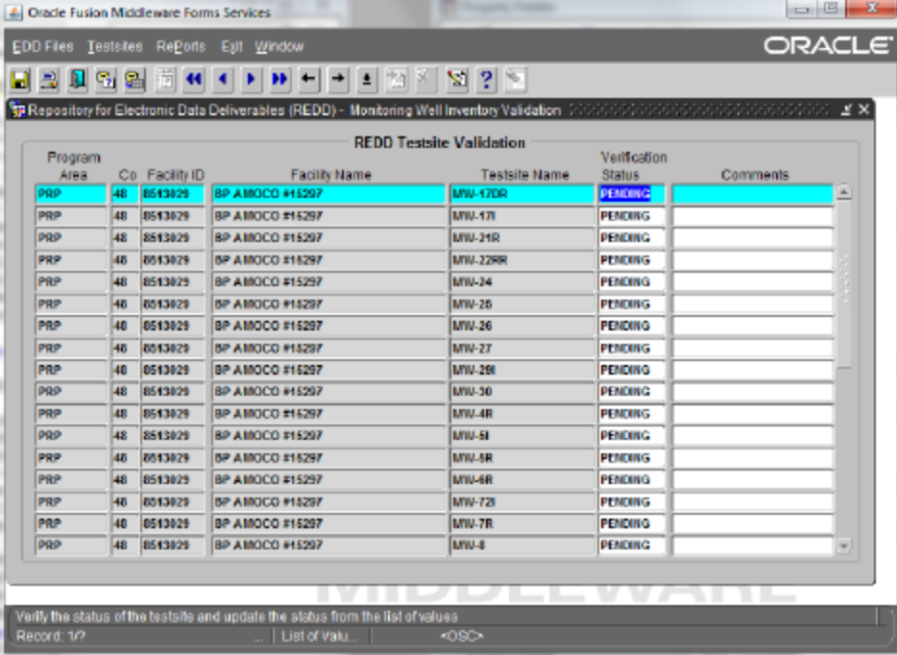

The current plan is to have PRP consultants fill out fillable PDF forms for existing Monitoring Testsites for existing facility wells to submit to the department. The Monitoring well information can be automatically extracted and uploaded to a temporary REDD Monitoring Testsite table. FDEP and contracted Site supervisors can then verify each monitoring well in REDD and the well is moved to a permanent Monitoring Well Testsite Inventory Table. Wells will be checked for proper names, latt-longs and physical well construction details.

The user would update the status from PENDING to either VALID or REJECT.

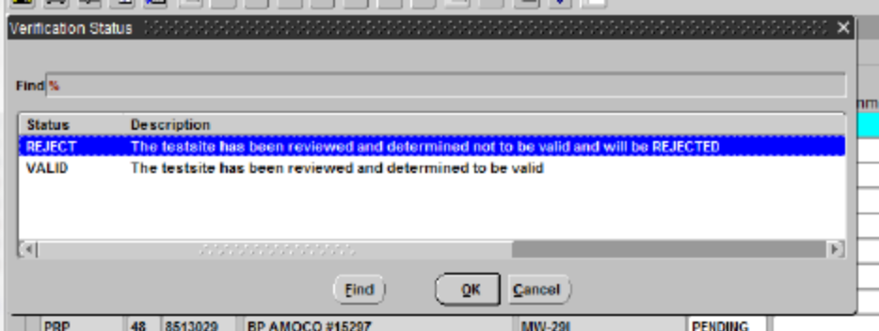

If the status is set to REJECT then the user will be required to document the reason in the comments field and that record will remain in the table so this process will not need to be repeated if additional data comes in on an EDD for the same testsite.
When the status is set to VALID and the user commits, they will receive a confirmation alert message

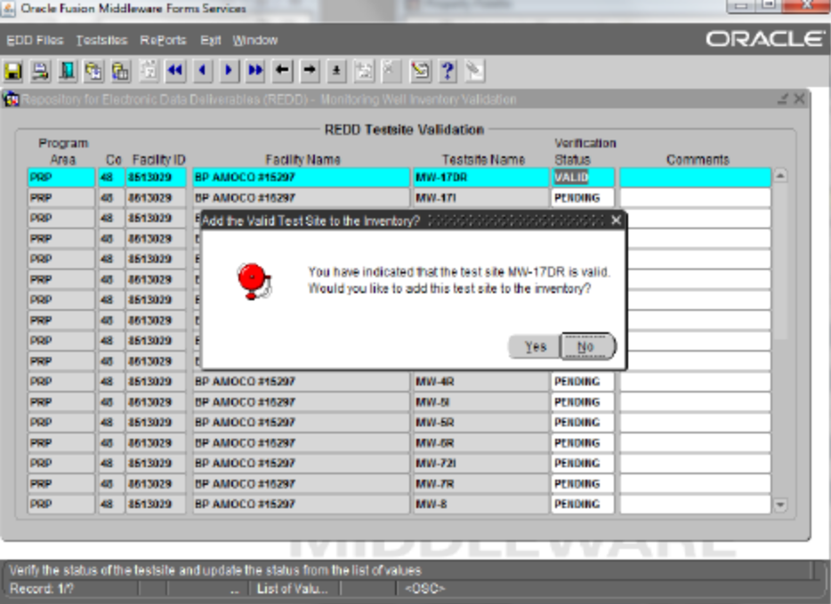

If they click the Yes button to confirm, then
• the testsite is assigned an ID in REDD.PCT_MONITOR_WELL_TESTSITES
• EDD records in REDD.ADAPT_EDD_RECORDS for the testsite are updated with the new ID in ADAPT_EDD_RECORDS table
• the REDD.ADAPT_EDD_FILES processing comments field is updated with a reference to the testsite validation
• the record is deleted from the REDD.ADAPT_EDD_TESTSITE_TEMP table
• Navigation is transferred to the data entry screen for the monitor well testsite to complete entry of the remaining fields.
When Navigation is set to the data entry screen, the new testsite is automatically queried and ready for the additional data entry to be performed. These screen shots and the table structure have been modeled after the WACS design. PRP staff need to determine whether this model fits their needs or identify what changes are needed.

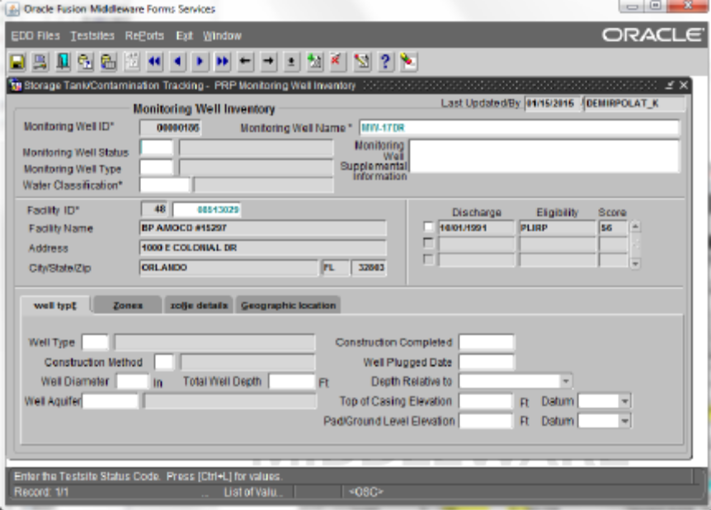

Additional data has been populated on the startup screen.

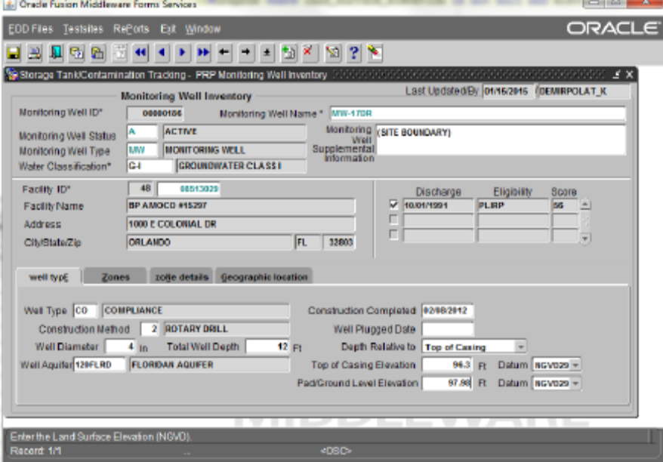

Additional data has been entered for the Zone.

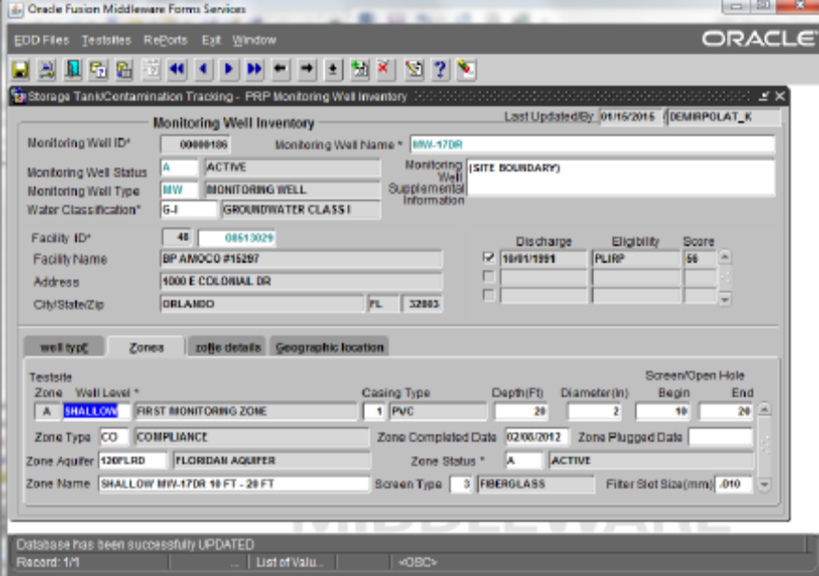

Additional data has been entered for the Zone Details

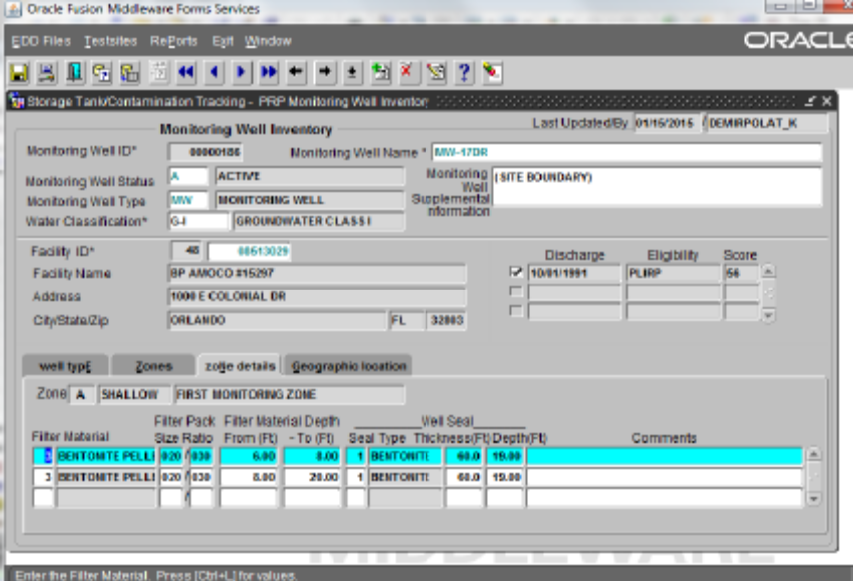

Navigating to the Geographic Location screen initially populates the lat/longs with the facility lat/longs pulled from STCM.

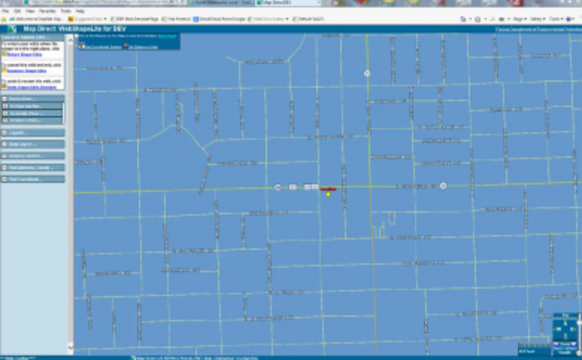

Clicking on the return from WebShapeLite returns navigation to the oracle form and clicking on the “Launch/Populate GIS” button will populate the coordinates and verification fields.

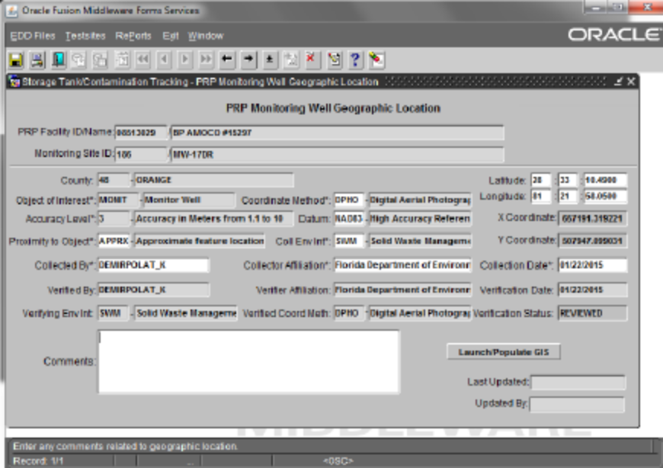

Screen shot showing updates to the File Processing Comments, Testsite ID and Testsite Valid Indicator for a testsite that was validated from the validation screen and added to the permanent table.

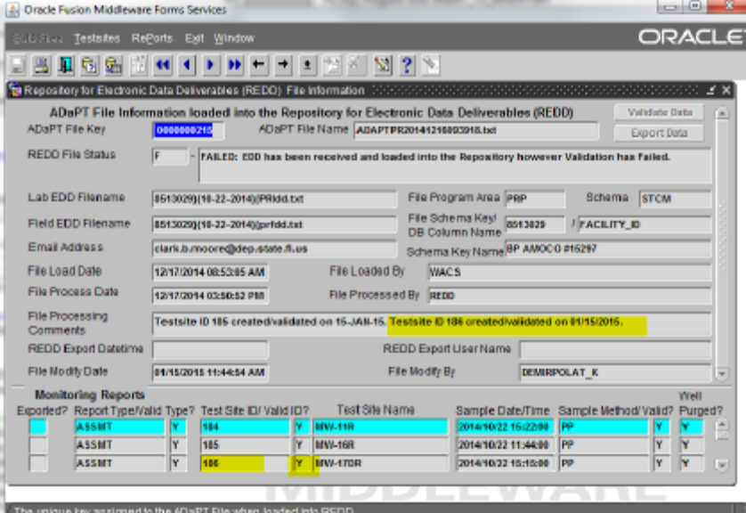

Screen shot showing a query screen displaying reports loaded into REDD

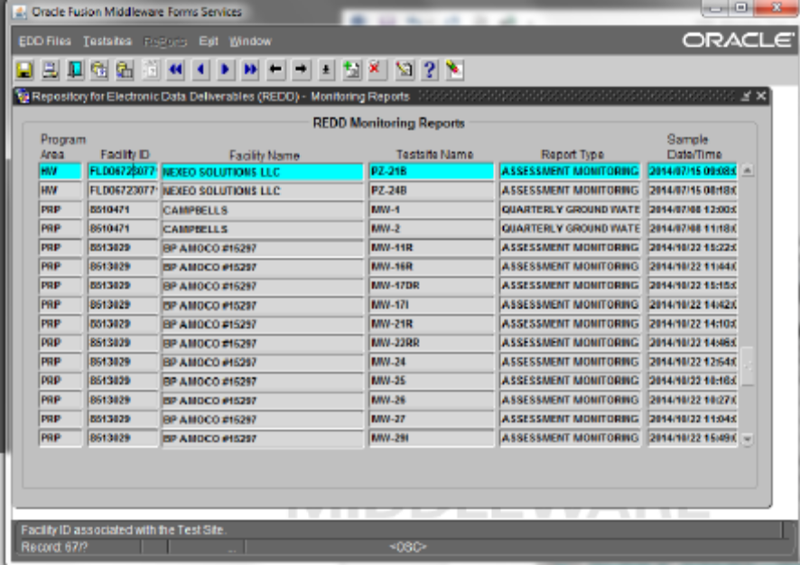

Constraints

Constraints depend upon some decision making.
When data is uploaded to REDD data is Validated, numerous checks are performed on specific data fields. currently for Solid and Hazardous Waste, Facility ID and Monitoring Testsite associations are also checked. We need to build the Monitoring Testsite Inventory into REDD for both Petroleum Cleanup and various Waste Cleanup programs. The question is, do we want to validate Facility and Testsite IDs against WACS or REDD tables for Solid Waste and Hazardous Waste programs. For HW and SW I think it is most efficient to verify data against WACS and not have to copy data from WACS to REDD. The verification queries are merely run using different tables for SW and HW vs. PR and WC. This eliminates the issue of depending upon and further bogging down nightly table refresh processes. In the future if one would like all Monitoring Testsite information to reside in REDD, one would have to change all Monitoring Testsite related forms in WACS to access REDD tables. REDD table update permissions through Oracle forms would have to be granted to all WACS_Clerk and WACS_Admin user roles so that Tallahassee and District Solid Waste staff and Tallahassee Hazardous Waste staff could seamlessly maintain the HW and SW Facility Monitoring Testsite Inventory.

Additionally, the following WACS tables are used to verify data uploaded to REDD for HW, PR SW and WC. (I have successfully uploaded WC lab data to REDD without any field EDDs). We may consider verifying data for the upload to REDD using newly created REDD tables.

Data Validation | ADaPT (export) | WACS (import to WACS and REDD)
Facility/Testsite Valid? | tblWacs_Svl_SolidWaste_Testsite_Inventory | WACS_SNAP.MONITOR_WELL_TESTSITES
(SW & HW; add for PR and WC)
Sample Type Valid? | tblWacs_Svl_Sample_Type_Codes | WACS_SNAP.WACS_SAMPLE_TYPE_CODES
Storet Valid? | TblWACS_STORET_Numbers | WACS_SNAP.STORET_NUMBER_CODES
Qualifier Valid? | tblSvlLabQualifiers and | WACS_SNAP.TEST_REMARK_TYPE_CODES
 | tblWacs_Svl_Field_Parameter_Qualifier_Code
Report Type Valid? | tblWacs_Svl_Report_Type | WACS_SNAP.WACS_REPORT_TYPE_CODES

Which tables do we want to copy over to REDD?
Copying tables over from WACS to REDD means that we are dependent upon overtaxed nightly refreshes.
The STORET code table in WACS contains many historic STORET codes and STORET codes used by UIC. UIC uses STORET codes with multiple units for the same analyte and matrix. I suggest we import and maintain only ADaPT STORET codes in REDD. When STORET codes are added to ADaPT, they must then be added to both REDD and WACS. This is a bit intensive, but WACS is used by other programs that need their own STORET codes.
The other tables are quite static and could be copied from WACS to REDD.
an important verification that ADaPT rarely but still does miss is the "Qualifier verification?".
ADaPT looks at data qualifiers on an individual basis.
WACS verifies the Qualifiers based on their combination.
There are qualifier combinations that are occasionally reported that are NOT valid.

