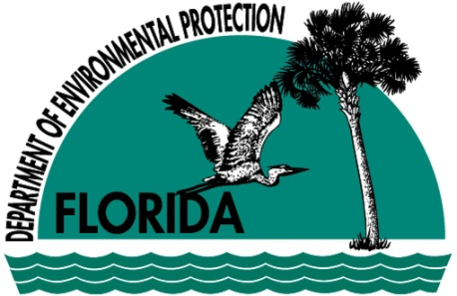

The Acreage Public Meeting

July 30, 2009

This Sheet Contains:

Department of Environmental Protection (DEP)

Contamination Locator Map (CLM)

Public Records in OCULUS

United Technologies Corporation / Pratt and Whitney Cleanup Site

NPDES Industrial Wastewater and UIC Permits at UTC / Pratt and Whitney

Contacts

What is DEP?

- The Department of Environmental Protection (DEP) is the lead agency in State government for environmental management. The Agency’s mission is to protect, conserve and manage Florida’s environment and natural resources.
- The Department is divided into three primary areas: Regulatory Programs, Land and Recreation, and Planning and Management.
- There are six (6) DEP regulatory District offices throughout the State. The DEP Southeast District (SED) Office is located in West Palm Beach, and serves Okeechobee, St. Lucie, Martin, Palm Beach, Broward and Miami-Dade counties.
- Visit the DEP main Web site at http://www.dep.state.fl.us, or visit the DEP SED Web site at http://www.dep.state.fl.us/southeast to learn more about the Department and its services and responsibilities.

What is the Contamination Locator Map (CLM)?

- Contamination Locator Map (CLM) is a Web-based Internet tool developed by DEP that has been made available to the public.
- By specifying an address, a city or a zip code, CLM gives the public the ability to locate sites that are currently under DEP's cleanup oversight.
CLM includes locational information for Brownfield sites, petroleum sites, Superfund sites, and other waste cleanup sites.
- Although all sites in CLM are suspected to be contaminated, further investigation may show that some sites are not contaminated.

- You may access CLM by visiting DEP’s Web site at http://www.dep.state.fl.us and clicking on the CLM button on the right side of the Web page.
- Search results in the vicinity of the specified location are depicted on a map with site name, address, facility identification number, site type and cleanup status (active or pending).
- By using the facility identification number, users may view documents associated with the site by clicking on the direct link to search the DEP’s Web-based document management system known as OCULUS™.
- CLM also has a subscription service that enables you to track cleanup milestones at contaminated sites listed in CLM. You will receive an e-mail notification when a contamination cleanup milestone event occurs at your selected sites. This subscription service is currently available for petroleum cleanup sites only. It will be available later this year for Brownfields, Superfund and other waste cleanup sites.

How can I search public records for Waste Management cases?

- OCULUS™ is a Web-based document management system that allows the public to search and review more than two million documents, related to Waste Management cases.
- The documents are broken into four different categories: Hazardous Waste, Solid Waste, Storage Tanks, and Waste Cleanup.
- Instructions for using OCULUS™ are available on the main OCULUS ™Web site (see link below).
- You can search a site in OCULUS™ by either the name of the site or the identification number shown in CLM.
- To access OCULUS™, visit http://dwmedms.dep.state.fl.us/Oculus/servlet/login.

United Technologies Corporation / Pratt and Whitney Cleanup Site

While there has been increased interest in the cleanup of contamination at this site in Palm Beach County, DEP does not see any direct relationship between this site and The Acreage.
- Pratt & Whitney is currently in compliance with DEP hazardous waste regulations.
- The Facility has a hazardous waste permit (renewed September 8, 2008) that includes operational requirements for a hazardous waste storage area, and requirements for the continuation of corrective actions.
- The Facility was evaluated for entry to the Superfund program in the mid-1980’s. The location was dropped from consideration in 1989 since it was already subject to corrective actions under the federal Resource Conservation and Recovery Act (RCRA).
- There are numerous locations at this Facility that were evaluated for potential contamination. All of the known contamination sites (37) at this Facility have been assessed and remedies have been implemented or are being evaluated. The extent of contamination has been adequately determined for all known sites at the Facility.
- There are numerous groundwater monitoring wells at this Facility. Locations undergoing active cleanup are sampled semi-annually. A different schedule might be implemented for some locations that have been cleaned up, but are still being monitored to determine if the cleanup has been successful.
- EPA and DEP have determined that human health exposure and groundwater contamination migration at the Facility are under adequate control.

NPDES Industrial Wastewater and Underground Injection Control (UIC) Permits at UTC / Pratt and Whitney

- The Southeast District’s Water Facilities (WF) Program issued NPDES Industrial Wastewater and Underground Injection Control (UIC) permits to the Beeline Community Development. The NPDES permit authorizes the injection of treated industrial process wastewaters from the manufacturing area into a deep injection well.
- The Facility discharges various industrial process and non-process wastewaters, and both contact and non-contact stormwater from a number of discharge locations across the property, to both surface waters and groundwater.

Wastewater that may have come into contact with petroleum contaminants are treated through oil/water separators, manual skimming for sheen removal or both methods of treatment, before being released. Process wastewater from the manufacturing area is sent through an acidic/alkali rinse treatment system prior to being sent to the deep well.

In 1985, UTC/Pratt and Whitney constructed an injection well to 3,300 feet below land surface to discharge treated industrial and domestic wastewater. The 10-inch diameter stainless steel (inner casing) well has a capacity of 2.9 million gallons per day. The UIC permit applies to this deep injection well.
- The injection well is monitored by a dual zone monitor well to monitor the any upward migration of the discharge. The dual zone monitor well monitors the lower zone from 1956 to 2050 feet below land surface (bls) and the upper zone from 1000 to 1237 feet bls. Four surficial wells, each 20 feet deep, are located on the four corners of the well pad to monitor the surficial ground water around the well pad. Mechanical integrity tests are performed to provide assurances that the well is not leaking. Monthly monitoring of the effluent is also required.

In March 2008, the Beeline Community Development facility connected to Palm Beach County’s collection system to send wastewater to the East Central Regional Wastewater Treatment Facility (ECRWWTF). Currently, the raw domestic wastewater is being sent to ECRWWTF. The industrial wastewater is going through Palm Beach County’s pretreatment permitting process for approval to send to ECRWWTF.

In June 2009, the Beeline Community Development was issued a permit to plug and abandon the injection well and dual zone monitoring wells. The monitoring wells will be left open to sample for another six months after the UIC well is plugged.

Contacts

Please contact the representatives listed on this sheet if you have questions or would like additional information.

DEP Tallahassee Division of Waste Management

Tim Bahr, Environmental Administrator

(850) 245-8790

Tim.Bahr@dep.state.fl.us

DEP Southeast District Office

Joseph Lurix, Waste Program Administrator

(561) 681-6672

Joe.Lurix@dep.state.fl.us

Linda Brien, Water Facilities Program Administrator

(561) 681-6696

Linda.Brien@dep.state.fl.us

Cristina Llorens, Public Relations Manager

(561) 681-6605

Cristina.Llorens@dep.state.fl.us

Florida State Warning Point

(800) 320-0519

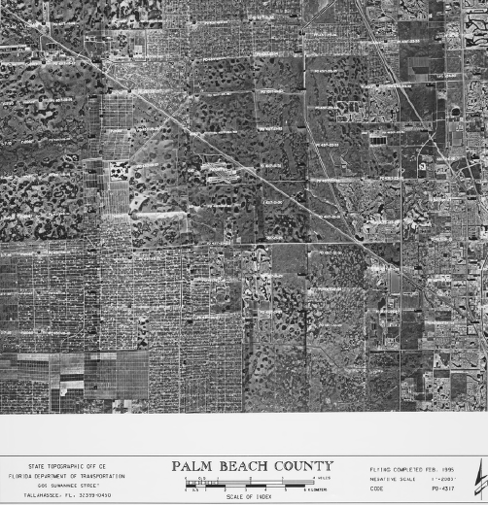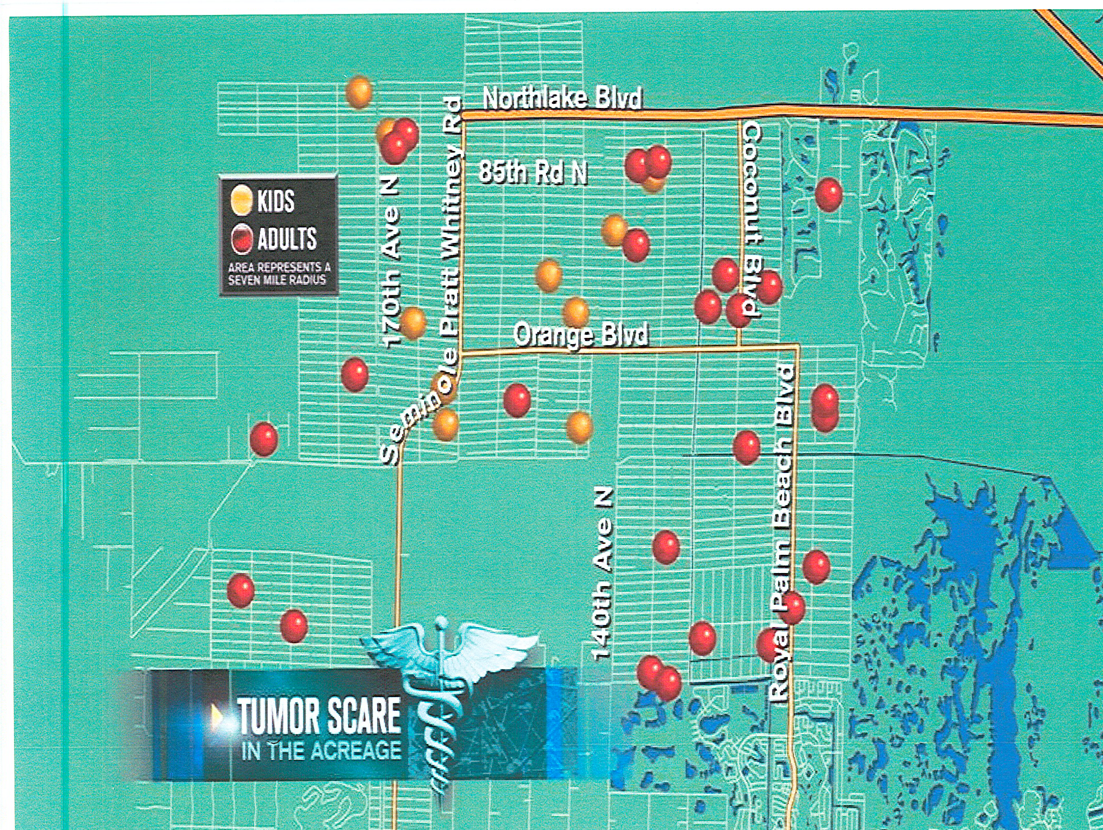
Pratt Whitney
Seminole
Pratt Whitney
Rd.
N. Lake Blvd. .lvBBlvd.

