FLORIDA DEPARTMENT OF ENVIRONMENTAL PROTECTION
Division of Waste Management

INSTITUTIONAL CONTROLS

PROCEDURES GUIDANCE

July 2016

Table of Contents
Preface 5
A. WHAT ARE INSTITUTIONAL CONTROLS? 5
B. WHEN IS THE USE OF AN INSTITUTIONAL CONTROL APPROPRIATE? 6
Engineering Controls (ECs). 7
Engineering Control Maintenance Plan (ECMP). 8
Interim Institutional Controls. 8
Institutional Control on Non-Source Property. 9
Restricting Future use of the Property Based on Actual Conditions of Exposure. 10
Restricting a Portion of the Property. 10
“Low Yield/Poor Quality” Cleanup Target Levels. 12
C. CREATING AND USING INSTITUTIONAL CONTROLS 13
Considerations for Evaluating Local Governmental Controls 15
FDEP FDOT Memorandum of Agreement Understanding (MOAU) 16
Evaluation of Exposure Routes when Using ICs other than RCs 16
Site/Project Manager Review 16
Deed. 18
Legal Description. 18
Survey. 19
Title Report. 20
Owner’s Notice to Existing Encumbrance Holders. 20
State Lands Encumbrances/State Lands Leases. 24
Map of Encumbrances and Restricted Area, and List of Encumbrances. 24
FDEP Permit Reviews. 24
Memo from the site/project manager to the OGC with the following (see sample in Attachment 6): 24
Office of General Counsel (OGC) Review. 25
IC Notice Procedures 26
Additional Notice Requirements at RCRA Facilities per Chapter 62-730, F.A.C. 27
Signature Process for a Restrictive Covenant 27
Recording RCs in the Public Record 27
Post-recording Processing . 28
SRCO with Conditions using Alternative ICs (non-RC option) 28
D. INSTITUTIONAL CONTROLS REGISTRY 28
Special Mapping Requirement for Brownfields Sites. 29
E. ENFORCEMENT OF INSTITUTIONAL CONTROLS 29
F. AMENDING AND REMOVING AN INSTITUTIONAL CONTROL 30
G. SPECIALIZED ATTACHMENTS 31
ATTACHMENTS 32
Attachment 1: Flow Chart Of Restrictive Covenant Approval Process 33
Attachment 2: Institutional Control Tips 34
Attachment 3: Sample Declaration Of Restrictive Covenant, 38
Attachment 3: Form A – Any Section of RC Encumbers the Entire Property 39
Attachment 3: Form B – Only Portions of the Property of Grantor are to be Encumbered 50
Attachment 4: Access Easement Agreement 61
Attachment 5: IC Checklist 65
Attachment 6: Sample Institutional Control Transmittal Package 71
Attachment 7: Sample Site Manager Letter to Person Responsible For Site Rehabilitation 75
Attachment 8: Sample Affidavit of Title 78
Attachment 9: Actual Notice of Intent to Approve Use of Institutional Control for Easement Holders & Financial Institutions 79
Attachment 10: Sample Subordination Of Mortgage To Declaration Of Restrictive Covenant 81
Attachment 11: Sample Joinder and Consent Of Tenants And Lessees 83
Attachment 12: Sample Subordination of Encumbrance To Declaration Of Restrictive Covenant 84
Attachment 13: Sample Joinder And Consent Of Encumbrance Holder 86
Attachment 14: Example Of Encumbrance Map & List Of Easements Affecting Restricted Area 88
Attachment 15: Division Of State Lands/Board Of Trustees Property 91
Summary Of DSL IC Development Procedure 94
Attachment 16: Sample Division Of State Lands Packet 95
Attachment 17: Sample Division Of State Lands Lease Amendment 98
Attachment 18: 18-4.007 Division Of State Lands Management Plans 101
Attachment 19: Template For Constructive Notice Of Intent To Approve Use Of Institutional Control 106
Attachment 20: Template For Constructive Notice Of Intent To Approve Use Of Interim Institutional Control 107
Attachment 21: Florida Administrative Code Rules Regarding Notice 108
Attachment 22: Statutes Regarding Notice Publication 110
Attachment 23: Statute Governing Form Of Affidavit For Proof Of Publication 111
Attachment 24: Statutory Recording Requirements 113
Attachment 25: Institutional Control Registry Data Sheet And Instructions 114
Instructions For Institutional Control Registry Data Sheet 115
Attachment 26: Sample Termination And Release Of Declaration Of Restrictive Covenant 118
Attachment 27: Example Signature Blocks And Certifications 120
Attachment 28: Memorandum Of Understanding Between The South Florida Water Management District And The Florida Department Of Environmental Protection 121
Attachment 29: Superfund Restrictive Covenant Implementation Process 125
Attachment 30: Sample Declaration Of Restrictive Covenant For Superfund Sites 126
Attachment 31: Engineering Controls Reporting And Monitoring 134
Attachment 32: Procedure For Use Of FDEP And FDOT MOU 152
Attachment 33: Sample FDOT Indemnity Agreement With Responsible Party/Discharger 154
Attachment 34: Recorded Reference (Deed Notice) For Florida Department Of Transportation Memorandum Of Understanding Institutional Controls 155
Attachment 35: Definitions And Acronyms 158
Definitions 158
Acronyms 160
Attachment 36: Institutional Controls Quick Reference Table 161

Preface

This document has been prepared as guidance for the Florida Department of Environmental Protection (FDEP or Department), Division of Waste Management (DWM) Tallahassee staff, FDEP District Offices, and those counties under contract with, or delegation from, the FDEP to oversee cleanup of contaminated property. Nothing in this document should be construed as a uniform policy or rule (except for those rules specifically enumerated as such). This document merely provides general information regarding types of Institutional Controls (ICs), outlines the requirements for the internal processing of ICs, and characterizes the DWM’s and the FDEP Office of General Counsel’s (OGC) experiences thus far in this area. This guidance is provided in one document so that all FDEP staff has the same information upon which to base a decision. Agency staff shall not cite this document as authority for taking or refusing to take any agency action. It is anticipated that this document will also be used by those parties considering pursuing site closures with conditions, including responsible parties and owners, and their consultants and lawyers, among others. Such use by those parties may facilitate an understanding of the FDEP internal processing of ICs and result in a quicker processing time.

This document was prepared by the DWM with input from the District Offices and the OGC. If you have any questions regarding the information contained in this document, please contact the appropriate attorney and/or the appropriate technical supervisor in your section. Likewise, if you have any insight or experience you believe should be included in a subsequent version of this document, please contact Peter Cornais, or Mary Stewart.

A. WHAT ARE INSTITUTIONAL CONTROLS?

Sections 376.301 and 376.79, Florida Statutes (F.S.), similarly define ICs as "the restriction on use of, or access to a site to eliminate or minimize exposure to petroleum products' chemicals of concern, drycleaning solvents, or other contaminants. Such restrictions may include, but are not limited to, deed restrictions, restrictive covenants (RC) or conservation easements.” Other forms of ICs that may be acceptable to FDEP include government controls such as local ordinances, permits, agency rules, delineated areas (under Chapter 62-524, F.A.C.), comprehensive land use planning and management, and FDEP consent orders.

ICs are non-engineering legal and legislative controls intended to affect human activities by preventing or reducing exposure to contamination. The IC contains restrictions or prohibitions such as land and resource use restrictions. Restrictive Covenants are the most common form of ICs used by DWM to close contaminated sites. This type of IC is created by the execution of documents that should then be properly recorded in the public records of the county in which the property is located to ensure proper notice and continued effectiveness of the control. This guidance document focuses mainly on Restrictive Covenants (RC), since those are the most common form of ICs. However, this guidance also contains provisions regarding other forms of ICs that do not require recording, including a listing of commonly used ICs, along with examples. (See Section C below).

B. WHEN IS THE USE OF AN INSTITUTIONAL CONTROL APPROPRIATE?

The use of ICs to eliminate or control the potential exposure to contamination is specifically authorized by the Florida Statutes governing global Risk Based Corrective Action (RBCA), petroleum cleanup, drycleaning solvent cleanup, and brownfields. Chapter 62-780, F.A.C., implements the statutory authorization by allowing use of ICs and “alternative cleanup target levels” instead of the default cleanup target levels contained in Chapter 62--777, F.A.C. These rules authorize the use of ICs to achieve FDEP approval for a Site Rehabilitation Completion Order with Conditions (SRCO with Conditions, conditional SRCO, or SRCOC) if the controls are protective of human health, public safety, and the environment. In determining whether a conditional SRCO is appropriate, please look to these rules and any FDEP guidance document on site assessment and remediation regarding the contaminated site. Then determine the actual or potential exposure pathways and develop a list of restrictions that will be necessary to protect human health and the environment from the remaining contamination in light of those pathways.

Chapter 62-780, F.A.C., and the enabling statutory provisions describe the circumstances under which an IC is appropriate. Conceptually, the rule contemplates evaluation of the following:

- Which media are contaminated [e.g., a groundwater use restriction may be appropriate if, among other things, contaminant levels exceed groundwater cleanup target levels (GCTLs)];
- Current and projected use of the affected groundwater and surface water (e.g., a groundwater use restriction may be appropriate if, among other things, there is no current and projected use of the groundwater because the area is served by a municipal water supply);
- Current and projected use of the contaminated property (e.g., a land use restriction may be appropriate if soil contamination greater than the residential but below the commercial/industrial soil cleanup target levels (SCTLs) exists on a property that will not be capped, but exposure is limited to adults in a commercial/industrial setting);
- Development of alternative cleanup target levels (ACTLs) for contaminated property that are based upon maintaining site-specific conditions of exposure (for example, an age restricted community);
- Probability of the contamination spreading, (e.g., a groundwater use restriction may be appropriate if, among other things, the technical documents show that the plume is stable or shrinking);
- Location of receptors (water supply wells, surface water bodies, etc.) and availability of public water supply systems (e.g., a groundwater use restriction may be appropriate if, among other things, there are no water supply wells near the groundwater plume that could provide a pathway for human exposure); and
- Necessity of an engineering control (e.g., the parking lot of a shopping mall may serve as an engineering control to prevent exposure to an area of soil contamination).

Specifically, when selecting restrictions and requirements for an IC, the applicable rules should be followed. For example, if the selected IC is a restrictive covenant that will be recorded with title to and with the property deed, real property law requires such covenants be executed by the current real property owner. Work closely with the property owner, or his or her representative, to find a mutually satisfactory institutional control.

Under certain circumstances, the Department may agree to rely on non-recorded institutional controls to close a site. This is often considered in cases with off-source property contamination (under RMO III).

Engineering Controls (ECs).
ECs, such as physical barriers, caps, covers, slurry walls, fences, methane collection systems, and impermeable barriers, are designed to limit or prevent access and exposure to contamination or are designed to eliminate further migration of the contamination. Where an EC is necessary, an IC should be put in place to ensure that the EC is properly maintained and the FDEP has access to inspect the EC.
Where an EC is necessary, an IC should be recorded.
Future owners of contaminated property might not be willing to continue to maintain and repair an EC if those requirements are not imposed through an IC that “runs with the land,” which is typically a restrictive covenant. That means that all future owners are required by law to comply with the terms of the IC, including maintenance and repair of ECs, and this mechanism is the assurance the FDEP needs to agree with the allowance of alternative cleanup target levels. The nature of the EC and the relationship between the IC and the EC should be very clear in the language in the IC, including any requirements on the future maintenance or repair of the EC, which FDEP expects will be the responsibility of subsequent owners of the property subject to the IC. The current use of the property and the property owner’s long-term plans for the property are of interest to the FDEP in the formulation of the text of the IC to ensure sufficient protection of human health and the environment.

Engineering Control Maintenance Plan (ECMP).
Pursuant to subsection 62-780.680(7), F.A.C., the inspection, monitoring and maintenance requirements for an EC shall be part of the Site Rehabilitation Completion Order (SRCO), shall be retained in the Department’s site file and shall be referenced in the IC to ensure future owners of contaminated property maintain the EC. It is then incumbent upon the property owner (or Person Responsible for Site Rehabilitation) to adhere to these requirements as a condition of the SRCO.

As required by Chapter 62-780, F.A.C., the ECMP referred to as part of the IC shall include a description of the conditions that constitute a failure of the EC. For example, the groundwater contaminant levels, or trend in groundwater contaminant levels, outside a slurry wall that should lead to a repair effort or further investigation should be provided. For engineered caps, the size, depth and frequency (area or time) of breaches in the cap could be specified. See Attachment 31: Engineering Control Reporting & Monitoring for more information.

Interim Institutional Controls.
An interim IC may be appropriate when long term groundwater remediation is projected. The interim IC may make possible the redevelopment or reuse of the property during cleanup.
Some sites may be required by private contract, cleanup agreement, or consent order to implement an IC prior to beginning or completing the cleanup work. In some circumstances, there are also sound environmental reasons for the agency to encourage the implementation of an IC prior to completing the remediation. For example, an Interim IC may be appropriate when restrictions related to areas of defined soil contamination are appropriate, the parties anticipate that remediation will take years to complete, and the FDEP agrees that active remediation will be conducted only on the groundwater contamination. Under such circumstances, for example, an Interim IC might require restrictions on use or the maintenance of an impervious surface (i.e., cap) to prevent exposure to contaminated soils and restrictions on use of groundwater while the groundwater continues to be remediated, either actively or passively, using natural attenuation. When an Interim IC is implemented, remediation of all affected media will not be complete; therefore, the FDEP will not issue a Site Rehabilitation Completion Order with Conditions after the recording of an Interim IC. The procedures for evaluating this Interim IC will be the same as for the permanent IC. However, additional language will need to be included in the document to address the contamination that is under remediation. Please be sure to advise the OGC attorney reviewing the IC if the control is intended to be an interim measure.

When the groundwater has achieved the appropriate cleanup target levels, the Interim IC should be re-evaluated. At that time, the FDEP must evaluate what restrictions, if any, need to be instituted on the property in order to issue a Site Rehabilitation Completion Order (SRCO), conditional or not. If an IC still is necessary, then the complete IC review procedure needs to be conducted (including new or updated title work), and the IC text needs to be amended to remove the interim restrictions that are no longer appropriate and impose the new restrictions that are appropriate. It is the real property owner’s option to either record an amendment to the existing recorded IC or to simply record an entirely new IC to supersede the existing one. See Section F for more information on amending or replacing recorded ICs. Upon implementation of this new IC (or an amendment to an existing IC), the issuance of a SRCO with Conditions may be appropriate. If the Interim IC is no longer appropriate because the requirements for closure under Risk Management Option I (RMO I) have been met, then a termination of the Interim IC should be implemented (with any RC, the termination of the RC is not effective unless the termination document is recorded) and a SRCO without conditions can be issued.

Institutional Control on Non-Source Property.
If the remaining contamination extends off the source property and that contamination otherwise meets the technical and rule requirements for conditional closure, the FDEP site/project manager may be asked if an IC can be placed on the non-source property. There are a number of site-specific issues that should be evaluated prior to approving such a request as described for closure with conditions under RMO III [See subsection 62-780.680(3), F.A.C.]. Because of the complexities in RMO III, and in working with non-source properties, before attempting to answer this question, FDEP project/site managers should contact their supervisor, and coordinate with the appropriate attorney and/or Tallahassee Division staff to discuss the specifics of the contamination and properties in question. If such a request is approved, the governing statute and rule require that notice must be provided to the local government. [See subsection 62-780.220(7), F.A.C.] In these cases, the SRCO (and Restrictive Covenant, if applicable) should reflect the type of control used to effect closure, and may include different language than that typical for closure using a Restrictive Covenant. Additionally, the IC for the non-source property should be prepared (if applicable) and reviewed, along with the title work, and any other necessary documentation for that non-source property. The documentation that is required for such non-source properties will vary depending on site specific factors such as the type of IC being considered, the size of the contaminated area, and the type, location and affected media of the contamination. In some circumstances, notice of proposed controls on non-source properties may need to be given to interest holders in the non-source properties, such as easement holders who may be likely to encounter contamination.

Restricting Future use of the Property Based on Actual Conditions of Exposure.
The Model Restrictive Covenant (Attachment 3) includes a suggested definition of what constitutes “residential uses” that are prohibited on properties where site soils do not meet the default direct exposure residential SCTLs. The Model uses North American Industry Classification System (NAICS) sector codes to define a broad range of activities that could result in use inconsistent with the exposure criteria upon which the Department permits unrestricted (i.e. “residential”) direct exposure to soil. However, the use of NAICS sector codes to define restricted uses is not mandatory and the property owner can propose alternative descriptions of the uses that are restricted or prohibited on the property that are consistent with the degree and nature of the cleanup conducted and actual conditions of exposure. For example, if ACTLs have been developed and approved by the Department for a property based upon a specific set of exposure conditions and assumptions, an alternative description of the prohibited activities, uses or exposure scenarios can be provided in lieu of the Model restriction, so long as the text captures in narrative form the essential exposure assumptions upon which the ACTLs were derived. If the proposed land use restriction differs from what the Model the Department will review the proposal as a request for RMO III with assistance from FDEP in Tallahassee. For example, where the use of the Model restriction on “residential uses” results in potential ambiguity regarding a specific use which is not intended to be prohibited, the Department will consider the addition of specific language to the Model restriction to clarify permitted activities, notwithstanding the broad language of the Model restriction.

Restricting a Portion of the Property.
Restricting only a portion of the property rather than the entirely-owned parcel is allowed, especially when the entire parcel is relatively large and the portion to be restricted is relatively small. However, when a parcel is small, groundwater use restrictions on only a portion of it might not be appropriate if exposure to contamination cannot be sufficiently reduced or eliminated due to the small parcel size. The site/project manager must determine whether a property is large enough that restricting groundwater use on only a portion of the property will be adequately protective. When soil contamination is the only issue, however, the IC may need a cap on only the contaminated portion of the property.

In special circumstances, it may be appropriate and permissible to restrict use of groundwater within a particular aquifer on the property or to a defined geographic area, so long as protection of human health and the environmental is achieved. Factors to consider when evaluating whether a restriction on use of groundwater can be restricted to a particular aquifer on the property include the following:

- The nature and concentrations of contaminants;
- The specific aquifer being impacted, size and location of the contaminant plume;
- The specific aquifer that will not be restricted for access and may be used for consumptive or other purposes;
- The ability to demonstrate isolation of the proposed restricted aquifer from the aquifer(s) that will remain available for use (for example by presence of confining unit(s), application of well construction requirements, limitations on locations of permitted wells, or other means); and
- Interconnections to surface water.

Whether an IC should encumber the entire property or only contaminated portions depends on the nature of the contamination and how that contamination will be addressed by the owner in accordance with the rules in the context of the future land use and planned site development. Attachment 3, Sample Declaration of Restrictive Covenant, consists of Form A and Form B. Form A should be used when the entire property will be encumbered – either by the restrictions required in an IC (for example, a land use restriction or a restriction on the use of groundwater), or by an easement in favor of FDEP across the entire property for access to a restricted portion of the property. Form B should be used when only a portion of the property will be encumbered, provided the FDEP will have access to the restricted portion either because the restricted portion of the property abuts a public right-of-way or FDEP has been granted a separate recorded easement for access to that restricted portion of the property (see Attachment G.4: Access Easement Agreement).

When it is appropriate to restrict less than the entire parcel, the owner can define the area to be restricted by using a legal description of that smaller contaminated area. This can be accomplished in one of two ways. It can be incorporated as the Exhibit A legal description, in which case only the restricted portion is encumbered (i.e., the IC is a lien on the title of only the restricted portion). Alternatively, the legal description of the smaller contaminated area can be incorporated as the Exhibit B legal description (with the Exhibit A legal description describing the entirely-owned property), in which case the entirely-owned property is encumbered (i.e., the IC is a lien on the entirely-owned property), but the restriction applies to only the smaller defined area. For example, if the parcel is 20 acres, only a ¼ acre area of contaminated soil remains, and the only restriction is the maintenance of a cap (e.g., two feet of clean soil), then the legal description of the restricted area in the IC should describe only the contaminated ¼ acre. Along with a legal description of the restricted portion, the owner should include a Specific Purpose Survey, Boundary Survey or Sketch and Description as defined under Chapter 5J-17, F.A.C. (collectively referred to as a “Survey”), using minimum technical standards (MTS). In addition, the Survey should include four corners of the restricted portion labeled with the state plane coordinates (SPC) system or geographical coordinates. The Survey will be an exhibit to the IC, referenced in the body of the RC by the appropriate exhibit reference (e.g. Exhibit B), and incorporated by reference.
If an IC is requested on a non-source property, the DEP project manager should contact his or her supervisor and the appropriate DEP attorney.

Note, however, that when the IC encumbers less than the entirely-owned property, unless the restricted area abuts a public right of way, the FDEP will still need ingress and egress access to that smaller encumbered area for inspection and audit purposes. If the encumbered area does not abut a public right of way, a non-exclusive site access easement in favor of the FDEP should be recorded that grants FDEP access to the encumbered (and restricted) area. This may be provided in the form of a non-exclusive blanket easement over the entire property using a legal description for the entire parcel (i.e., from the granting deed under which the property owner obtained title or as described in the Title Report) for an RC using Form A, or by using Form B for an RC together with a legally described easement area connecting the restricted (encumbered) area to the public right of way. See Attachment 4 for an example of a site access easement. A legal description describing the ingress and egress corridor to the public right of way is necessary for this easement, and the corridor should be identified on the Survey exhibit described above. Finally, the Survey exhibit should be included as an exhibit to the access easement document.

If a property owner proposes to subdivide the property to limit the area to be restricted and requests your input, please be certain that the “contaminated parcel” is of sufficient size to ensure that the potential for groundwater movement and plume migration are adequately addressed if groundwater contamination is an issue.

“Low Yield/Poor Quality” Cleanup Target Levels.
If the responsible party wants to utilize the low yield/poor quality cleanup target levels (CTLs) for groundwater and corresponding leachability-based CTLs for soil, then the IC should identify the property as having poor quality and/or low yield groundwater, and it should prohibit the use of groundwater on the property because of the contaminants that are allowed to remain at higher levels than the default health-based CTLs based on a determination that the groundwater already is of poor quality or low yield. Sample language for a restriction based on poor quality/low yield is included in the Model Restrictive Covenant (Attachment 3).

C. CREATING AND USING INSTITUTIONAL CONTROLS

In almost all cases, an RC will qualify as an acceptable Institutional Control under Section 376.301(22), F.S.(as renumbered pursuant to Ch. 2016-184, Laws of Florida), and Rules 62-780.680(2) and (3), F.A.C. See Attachments 3 and 5, Sample Declaration of Restrictive Covenant (Forms A and B) and IC Checklist. However, a restrictive covenant is not the only acceptable form of an IC. The FDEP will consider other forms of Institutional Controls so long as they meet the definition of “institutional control” in Section 376.301, F.S., and comply with Rules 62-780.680(2) and (3), F.A.C., which fundamentally require the control to be protective of human health, public safety, and the environment. Attachment 36 includes examples of institutional controls other than RCs that could potentially be sufficient for closure under RMO II or III. In some instances, “layering” various ICs may be necessary to ensure the controls are protective of human health, public safety, and the environment.

ICs Other than RCs
It is important to note that, other than cases involving MOAs between the FDEP and other institutional or governmental entities, at the present time, these non-RC controls should only be used to address groundwater contamination at a site (which can include impacts off the source property). When addressing soil contamination using either land use restrictions or an engineering control (e.g., a concrete cap), an RC is the only type of control that effectively ensures that the type of land use remains in perpetuity, or that an engineering control remains in place and is properly maintained to permanently cover the area of soil contamination.

Factors to consider when evaluating whether institutional control other than an RC is adequately protective of human health, public safety, and the environment, include the following:

- The nature and concentrations of contaminants;
- The size and location of the contaminant plume relative to existing and projected improvements on the property;
- The scope and coverage of any applicable local ordinance:
  - Requirement for connection to county/municipal/community water delivery system for both potable and irrigation water;
- Status of site development and existing infrastructure for provision of potable and irrigation water;
- Current and projected use of the property and likelihood of need for additional water use in the future;
- Potential for additional construction in the area (i.e., possibility of dewatering, discharging of contaminated groundwater to surface soils, causing plume migration; etc.); and
- Potential for installation of new stormwater features or enlargement of existing stormwater features at or near the affected property.

When proposing an IC other than an RC, the Person Responsible for Site Rehabilitation (PRSR) should submit much of the same information as in a typical RC package including the Deed and Legal Description. Instead of a draft RC, the PRSR should submit electronic copies of the proposed institutional control and any documentation that is necessary to validate or provide context to the control. For example, in cases where a PRSR is relying on a local ordinance, the ordinance itself should be submitted. Along with the ordinance, a statement explaining whether the property(s) is currently in compliance with that ordinance, and, a statement of whether the ordinance relies upon delegation of authority from another governmental entity, should be submitted. Documentation of that delegation should also be provided. Since some local ordinances are quite lengthy, the PRSR should direct the FDEP to the specific provisions that are relevant.

An additional decision that will have to be made when using an IC of this nature, is whether title work is necessary to identify the holders of encumbrances on the property and later provide them with notice of the proposed closure using the control. [See subsection 62-780.220(7), F.A.C.] This decision should be made on a site by site basis because it depends on both the nature of site as well as the nature of the control. For sites where contamination goes beyond property boundaries, this evaluation is necessary for each parcel. Factors to be considered in this evaluation include:

- Depth to groundwater contamination;
- Status of site development and existing or planned infrastructure on the site;
- Ownership of each property;
- Involvement and knowledge of off-site property owners as to the nature and extent of contamination;
- Nature of the property interests subject to the restriction in relation to the contamination causing the need for restriction;

Considerations for Evaluating Local Governmental Controls
An important factor to consider in evaluating the durability and protectiveness of institutional controls other than RCs is whether the control in question is one that the Department can appropriately rely upon as a long term control.

As specified above, to be legally sufficient, institutional controls must all meet the definition of an institutional control in Section 376.301(22), F.S. (as renumbered in Ch. 2016-184, Laws of Florida) (i.e., “restriction on use or access to a site to eliminate or minimize exposure to petroleum products,’ chemicals of concern, drycleaning solvents, or other contaminants”). Local ordinances that prohibit installation or use of water wells (even in conjunction with a requirement to use of a municipal water supply) are insufficient because the exclusive authority to regulate the consumptive use of groundwater rests with the Department and water management districts (Districts). Courts have recognized and upheld this “exclusive authority.”

In addition, statutory provisions prohibit the Department and Districts from requiring a permit “for domestic consumption of water by individual users.” Because regulation of water use is preempted to the state and the state specifically exempts domestic self-supply from regulation, it would be improper to rely on such prohibitions as institutional controls.

While local ordinances that prohibit the installation or use of potable water wells are not legally sufficient, other, legally sufficient ordinances could suffice as an institutional control after a site specific evaluation. For example, ordinances that require property owners to hook up to a community, county or municipal water system without also requiring the property owners to use the water system could suffice. Or, an ordinance that prohibits the location of wells on property owned by the local government passing the ordinance could likewise suffice.

Keep in mind that legally sufficient local governmental controls must also suffice as controls that are adequately protective of human health and the environment given the specifics of the site in question to be accepted by the Department. For example, these mandatory hook-up ordinances often allow private wells for irrigation or other non-potable purposes. Site/project managers must decide whether continued use of the groundwater for non-potable use is still protective of human health and the environment.

FDEP FDOT Memorandum of Understanding (MOU)
FDEP and FDOT have entered into a Memorandum of Understanding (MOU) (http://www.dep.state.fl.us/waste/misc/dnd/DEP_DOT_MOU_01Aug14.pdf) dated June 16, 2014, that allows petroleum contamination to remain in FDOT rights of way in certain circumstances as set forth therein without the recordation of a restrictive covenant on the affected FDOT property in the public records of the county. However, closure in reliance on this MOU requires additional actions by both the site/project manager and the owner of the source property that are set forth in the MOU. In the spring of 2016, the MOU was undergoing further review by the agencies to increase efficiencies and greater use of this type of IC which may result in an amendment to the MOU. Therefore, to ensure the most recent version is used, the responsible party, site/project manager, and FDEP attorney should be in communication prior to preparing a conditional SRCO proposal in reliance upon this MOU.

As specifically enumerated in Attachment 32, the PRSR should submit a conditional SRCO proposal to FDEP including specified information for the adjacent contaminated FDOT Right of Way (ROW) property. FDEP will review the proposal and, if sufficient, will request that FDOT add a ROW Map Note regarding the existing petroleum contamination. FDOT will acknowledge the request by letter and will record a Map Note on the FDOT ROW Map with an Oculus link to FDEP's Request Letter along with summaries of soil and groundwater data, surveys and other documents detailing the contamination that remains. The Map Note will act as the IC to provide notice regarding the presence of contamination to all parties seeking a FDOT permit to do work in the ROW. FDEP will thereafter issue the conditional SRCO, and the PRSR will record the Map Note reference in the County Records Office.

Evaluation of Exposure Routes when Using ICs other than RCs
Note that when using an institutional control other than an RC, such as a local ordinance, governmental control, or MOU to prevent exposure to contaminated groundwater all potential exposure routes should be considered including the possibility of irrigation wells, possibility of construction worker exposure to groundwater, and possibility of new stormwater features that may affect groundwater flow. The potential that some other exposure routes may exist does not prevent the use of local ordinances or governmental controls, but may suggest a layering of multiple controls.

Site/Project Manager Review
The FDEP or local government site/project manager (including the contracted or delegated local government site/project manager) in conjunction with the designated FDEP or local program professional engineer (PE) or professional geologist (PG) responsible for the technical review for the site, must make the technical determination as to whether a contaminated site has undergone sufficient assessment and, if necessary, remediation that a conditional closure is appropriate under Chapter 62-780, F.A.C. See Attachment 7 for a sample letter from the site/project manager to the Person Responsible for Site Rehabilitation (PRSR) regarding ICs. The site/project manager should provide any FDEP technical guidance regarding the control to the property owner, and should request that the property owner or its agent prepare a draft of the IC package. The FDEP site/project manager should not prepare the IC, but should provide the internet location of the Institutional Controls Procedures Guidance document to the owner or owner’s representative. If, however, FDEP is the PRSR (for example, for contaminated sites being assessed/remediated by the Petroleum Restoration Program), site/project managers should check with their supervisors or OGC on what can be done by the FDEP and by whom.

All questions should be directed initially to the site/project manager. If a question is legal in nature, and early resolution of the question could change how the proposed IC is approached or greatly expedite the review process, the site/project manager may ask OGC to address the issue prior to submission of the IC package. Once the IC package is prepared, the IC and supporting documents should go to the site/project manager, who must determine if the IC document includes the appropriate restrictions or requirements and if the necessary supporting documentation has been provided (See Attachment 5, Checklist. This checklist was created to assist in review of RC packages; however, the checklist provisions relating to groundwater contamination can be considered for non-RC ICs too). The site/project manager is not required to review or comment on the title work assuming the title work was prepared within 6 months of submittal to the site/project manager. If the title work is older than 6 months at the time of submittal to the FDEP site/project manager for review, the site/project manager may request that the title work be updated, which may be provided either by submission of an affidavit of title from the owner confirming the current status of title (See Attachment 8) or by submission of an updated Title Report. The site/project manager should then route those documents to the OGC for legal review, approval, and signature. The FDEP OGC should only receive the request for legal review of the IC directly from the site/project manager and not from the property owner or owner’s representative.

For contracted local government-lead petroleum contaminated sites, the site manager’s decision to allow the use of an IC will be reviewed by one of the Petroleum Restoration Program (PRP) Local Program Coordinators (who will involve the appropriate Tallahassee technical staff, as needed). The District Waste Program Administrator should approve the technical determination for District-lead sites, and the appropriate Tallahassee Program Administrator should approve Tallahassee-lead sites. District staff may always seek input from Tallahassee staff, if desired.

The site/project manager, in conjunction with the designated FDEP or local program PE or PG responsible for the technical review for the site, should review and approve the geological and engineering details prior to forwarding an IC package with supporting documentation to the FDEP OGC. The site/project manager must also review the draft IC to ensure that the IC includes the correct maintenance requirements for, and restrictions on use of, the property, if applicable. Generally, three (3) types of restrictions/requirements are used:

- groundwater restrictions; and/or
- requirement to maintain engineering control (e.g., soil or synthetic cap); and/or
- land use restrictions.

Along with the draft RC document, if applicable, the site/project manager and the OGC need the following prior to reviewing any IC package (see also IC Checklist, Attachment 5):

Deed.
- A copy of the recorded deed should be provided that identifies the current real property owner. The owner of the property shown on the deed should match the name of the person agreeing to restrict the property (the Grantor). If the names do not match, additional information should be provided to clarify ownership. This piece of information is necessary for all types of ICs to be evaluated, whether they are RCs or any other form of an IC, and it is necessary for both source and non-source properties that a PRSR wishes to restrict. In some very limited situations (such as rights of way established by statute or plat map) ownership of a piece of property to be restricted may be established through an instrument other than a deed.

Legal Description.
- A written legal description of the entire parcel should be provided regardless of whether the entire parcel is being restricted or only a portion of the parcel will be restricted. If the entire parcel is being restricted, and the PRSR is using a RC as the IC, then Form A should be used and Exhibit A to the RC should be the legal description of the entire parcel. This legal description should be the same as the legal description found in the deed and in the Title Report. If they are not the same in all three places, an explanation should be provided. FDEP staff may send Surveys to the FDEP Bureau of Survey and Mapping for confirmation of the legal description. Additionally, when only a portion of the parcel will be restricted, a legal description of that smaller portion should also be included. See the next bullet point and RC Form B for more information regarding partially-restricted parcels.

Survey.
- If only a portion of the parcel will be encumbered or restricted, then a Specific Purpose Survey, Boundary Survey or Sketch and Description as defined under Chapter 5J-17, F.A.C., and prepared using the minimum technical standards (MTS) as defined therein (collectively referred to as a “Survey”) should be attached to a RC as an exhibit. In addition, the Survey should include four corners of the designated restricted area labeled with the state plane coordinates (SPC) system or geographical coordinates. The Survey should be a clearly labeled attachment (e.g., Exhibit B) to the RC and the area to be restricted should also be clearly labeled with a label that corresponds to the terminology used to describe it in the text of the document (e.g., “Area of Engineering Control,” “Groundwater Restriction Area”, “Capped Area,” “Location of Slurry Wall,” “Restricted Area”). When identifying the restricted area on the Survey, especially if the restricted area includes engineering controls such as caps or areas of clean fill, be sure to consider any buildings located on the property. Building foundations sometimes act as caps and should be identified as such on the Survey, so that if a building is removed a suitable cap can be constructed and maintained where the building stood. Additionally, when restricting stormwater swales, detention or retention facilities or ditches, any existing stormwater structures should be clearly identified on the Survey, which may require a multi-part composite exhibit, in which case it should be labeled by part (e.g., “Exhibit B-1,” “Exhibit B-2”). Site/project managers should ensure that this attachment correctly locates the area(s) to be restricted. If only a part of the property will be encumbered by the RC and the restricted area does not abut a publically-dedicated right of way, then an access easement as discussed above in “Restricting a Portion of the Property,” should be created. See Attachment 2, Institutional Control Tips, for more information. In cases where there are no stormwater features on the propery to be restricted and the only restriction contemplated is on groundwater use for the entire parcel, and a legal description of the parcel is already provided, there is no need for a survey in addition to the legal description of the property to be restricted.

Title Report.
- A Title Report (which may be in the form of an Ownership and Encumbrance Report, a title insurance commitment, or title insurance policy, so long as it provides all of the information described below) that reflects all parties having a recorded interest in the property, including owners, tenants under recorded leases, lienors, mortgage holders and easement holders, among others, should be submitted with the IC package to be reviewed. The search commences with the instrument constituting the root of title under the Marketable Record Title Act (MRTA) (i.e., evidence of title, such as a deed, that is at least 30 years old) and includes a review of all subsequently recorded instruments, a review of prior recorded instruments (to the extent required by MRTA), and a review of prior recorded instruments that are not eliminated by MRTA. If the Title Report was issued more than six (6) months prior to delivery to FDEP, or if it will be more than six (6) months old by the time the IC is to be approved, then the Owner should provide either an updated Title Report or an Affidavit of Title confirming that the status of title is unchanged from the Title Report provided (see Attachment 8, Sample Affidavit of Title) include complete copies of all existing encumbrances on the property as reported on the Title Report in the IC package sent to OGC. It is not unusual for only a “Memorandum of Lease” or “Notice of Lease”, rather than the entire lease, to be recorded in the public records. If there is such a recorded Memorandum or Notice, provide OGC with a complete copy of the lease along with the Memorandum or Notice. For properties with numerous easements or multiple partially restricted areas, in addition to the encumbrances, the assigned OGC attorney may also request a labeled map, diagram, or Survey showing the locations of all encumbrances in relation to the restricted area. See Attachment 14, Sample Encumbrance Map and List of Encumbrances. If requested, the list of encumbrances should identify which encumbrance intersects with which restricted area. As discussed above, a title report (for the source and possibly even for non-source properties) may or may not be required in evaluating an IC other than an RC.

Owner’s Notice to Existing Encumbrance Holders.
  - The property owner should provide actual notice of FDEP's approval of the use of an IC to holders of existing encumbrances in the property. Such encumbrances include the following recorded documents as well as others: mortgages, liens, financial notes, leases, and easements. Notice should be provided when the proposed restrictions in the IC intersect with the encumbrance holder's property rights (also called a "material conflict"). In the case of mortgages, liens, leases, leaseholds, and some other types of encumbrances, the restriction will always intersect. But, it will not always intersect in the case of some encumbrances such as easements. For example, if the IC restriction forbids groundwater use and the encumbrance property right grants ingress and egress across the surface of the property, then notice to that encumbrance holder is not necessary because there is no intersection (no "material conflict") of the encumbrance right with the IC restriction even though the surface location is the same. However, if the IC restriction includes the requirement for a FDEP approved dewatering plan, and the encumbrance holder's right is for entry into the soil to lay and maintain utility lines, then notice is required for that encumbrance holder because the laying and maintaining of utility lines might require dewatering. The text of the encumbrance document must be examined carefully to determine whether the encumbrance holder right intersects with the IC restriction. See subsection 62-780.220(7), F.A.C. Such notice to encumbrance holders should include information regarding the owner’s intention to utilize an IC and request a Conditional SRCO, the type and location of the restrictions on the property and FDEP contact information. A template is provided. See Attachment 9, Actual Notice of Intent to Approve Use of IC for Easement Holders & Financial Institutions. In some cases when non-RC ICs are considered, notice to all encumbrance holders will not be required. In other cases, due to site specific conditions, such notice will be required. Therefore it is important for PRSRs and case managers to work closely with OGC from the receipt of the request to use an alternative IC that is not an RC. Additional discussion about how to evaluate site specific factors and make these decisions is in the “ICs Other Than RCs” section above.

To facilitate timely review of the notice, FDEP encourages that the notice be provided to encumbrance holders as early as possible; even as early as the time at which the IC package is submitted to FDEP for review. In addition to the template, FDEP also encourages the property owner to provide the encumbrance holder with a Specific Purpose Survey, Boundary Survey or Sketch and Description as defined under Chapter 5J-17, F.A.C., or other scaled map or diagram that accurately shows the location of the contamination and proposed restricted area in relation to the location of the encumbrance (e.g., easement) and a summary table of contaminant concentrations. See Attachment 14 for an example of such a diagram. The site/project manager will review copies of all such notices to existing encumbrance holders, together with proof of delivery to each encumbrance holder. Notice should be provided in accordance with the terms for notice set forth in the recorded instrument (i.e., as described in the mortgage or easement), and if proof of delivery is not required by the recorded instrument, then by certified mail, return receipt requested, signed acknowledgement of receipt obtained by a courier or delivery service, or other commercially recognized method. Regardless of whether notice is specifically addressed by the terms of the recorded instrument, if the encumbrance holder is a business entity formed in or otherwise qualified to do business in the State of Florida, the property owner should also send notice as well to the registered agent of the business entity which may be identified on the Florida Department of State's Division of Corporation Website [www.sunbiz.org]. This will ensure that the notice is properly received and subsequently routed for review within the business entity’s organization.
    - Mortgage Holders (also known as Mortgagees). If there are mortgage holders (typically these are banks) or other holders of financial instruments (collectively referred to throughout this document as mortgage holders), then in addition to the above Notice, a “Subordination of Mortgage” (see Attachment 10) may be obtained by the owner and recorded along with an RC, if a RC is the chosen form of IC. However, FDEP will not need a subordination unless the mortgage materially conflicts with the RC. The FDEP does not expect that material conflicts between the RC and the mortgage will occur very often. Examples of when a material conflict may exist between the RC restrictions and a mortgage include, but are not limited to, the following:
        - the restriction requires an engineering control with an active control system, if the active control includes a substantial recurring expense or if the failure to maintain the active control could result in an imminent hazard (within a few days or weeks). Examples include:
          - active gas collection systems that remove ignitable, corrosive, reactive or toxic vapors (for example, landfill gas or hydrogen sulfide); or
          - maintenance of active containment structures such as holding tanks or ponds that may hold substantial volumes of fluid and any control mechanisms to maintain the appropriate level of material for those structures requiring daily or weekly attention
        - the language of the mortgage itself specifically prohibits limitations on the use of the property or, conversely, requires the property to be used in a manner directly in conflict with the land use restrictions in the RC.
- Easements, Tenants (Lessees), and other Interests (collectively referred to as easement holder). The property owner should review the recorded encumbrances on the property to make a determination as to whether it is appropriate to seek subordination or joinder and consent from holders of recorded encumbrances. See Attachment 12 and 13.
- Examples of situations wherein a property owner may wish to seek a Joinder and Consent include, but are not limited to, the following:
        - the restriction requires an engineering control with an active control system located in the easement, if the active control includes a substantial recurring expense or if the failure to maintain the active control could result in an imminent hazard (within a few days or weeks). Examples include:
          - active gas collection systems that remove ignitable, corrosive, reactive or toxic vapors (for example, landfill gas or hydrogen sulfide); or
          - maintenance of active containment structures such as holding tanks or ponds that may hold substantial volumes of fluid and any control mechanisms to maintain the appropriate level of material for those structures requiring daily or weekly attention.
        - an engineering control located in the easement that requires a cap to prevent direct exposure to contaminated soil or to minimize the leaching of contaminants into the groundwater, and if an easement holder has the right to conduct activities that may interfere with the establishment or maintenance of this control.
        - an easement holder has the right to disturb the soil or ground water for construction and maintenance unless it is demonstrated that during the construction of the use allowed in the easement or its maintenance:
          - the likelihood of mobilizing contamination in groundwater is small, or,
          - the risk posed by exposure is acceptable.
For example, if a city has a stormwater easement on the property that goes through the area with remaining groundwater contamination and has not yet built the stormwater conveyance or retention facility, then the property owner should consider obtaining a Joinder and Consent from the city because in digging the stormwater facility it is likely that the groundwater contamination will be mobilized and move in to the stormwater facility. In cases where the stormwater easement allows continued maintenance of an existing system and such maintenance may mobilize contamination in ground water or there is a risk of direct exposure to contaminated soil, then Joinder and Consent from the encumbrance holder should also be pursued. A property owner may choose to seek Joinder and Consent from a utility or other easement holder for its underground or aboveground easement where the proposed restrictions in the RC encompass the easement. Such easements may provide for construction, maintenance, and repair (including replacement) of transmission, distribution or similar facilities which may result in excavation of contaminated soil or have the potential to mobilize ground water contamination. See Attachments 12 and 13, Sample Subordination of Encumbrance, Sample Joinder and Consent of Encumbrance. Even if a joinder and consent is determined by the property owner to be unnecessary, the owner should notify the easement holder of the existence of the contamination, restriction on use of the property, and the requirement to maintain an engineering control (if applicable) on the property which is subject to the easement. See Attachment 9 for a template Notice letter.

State Lands Encumbrances/State Lands Leases.
- For property owned by the State of Florida (excluding FDOT), if there are any encumbrances such as easements, as with all title work, copies must be provided to the OGC. These need not be certified copies, but should be copies of executed instruments. Those tenants with a State Lands lease must contact the FDEP Division of State Lands since that division, as the representative of the land owner, also must approve of the conditional closure and restrictions. See Attachments 15-18 if the property to be restricted is leased from the State of Florida (Board of Trustees of the Internal Improvement Fund).

Map of Encumbrances and Restricted Area, and List of Encumbrances.
- The property owner should provide a list of recorded encumbrances, in addition to the copies of the recorded encumbrances, for the reviewing FDEP lawyer. The list of encumbrances should identify the right(s) the encumbrance grants to the holder and whether each encumbrance intersects ("materially conflicts") with the restriction. If the restriction could affect, or be affected by, the encumbrance holder’s rights in such a way as to constitute a “material conflict” (as described above under "Owner's Notice to Existing Encumbrance Holders") with a proposed RC, then the owner should acquire either a subordination of encumbrance (for mortgages or and easements) or a joinder and consent (easements only), or the owner should provide actual notice as outlined above in "Owner's Notice to Existing Encumbrance Holders." See Attachments 12 and 13, Sample Subordination of Encumbrance, Sample Joinder and Consent of Encumbrance, and Attachment 9, Actual Notice of Intent to Approve Use of Institutional Control For Easement Holders & Financial Institutions.

If only a portion of the property is restricted, a labeled map, diagram, or Survey showing the locations of all encumbrances in relation to the restricted area should be provided. See Attachment 14, Sample Encumbrance Map and List of Encumbrances.

FDEP Permit Reviews.
- The FDEP’s Division of Waste Management (DWM) will coordinate with the FDEP’s Division of Water Resource Management such that when Environmental Resource Permit (ERP) applications are submitted to the FDEP or to a Water Management District, the permit reviewers will check the DWM Institutional Control Registry to evaluate whether or not there are existing DWM-imposed institutional controls. If an ERP application includes property that is impacted by a DWM institutional control, the permit reviewer should contact the DWM project manager to see whether there is a conflict between the existing restrictions and the proposed use contained in the application for an ERP.

Memo from the site/project manager to the OGC with the following (see sample in Attachment 6):
- Name and contact information for the following persons:
  - FDEP Site/Project manager;
  - Consultant;
  - Real property owner;
  - Real property owner representative;
  - Any other responsible parties; and
  - Buyer (if applicable/available).
- Type(s) of IC; e.g., an RC, a local government ordinance, Rule, MOA or MOU; etc.
- Type of restriction, e.g., water use restriction, mandatory community system hook-up, cap requirement, land use restriction.
- Restrict entire property or partial property restriction.
- Rationale for this recommendation.
- Affected media: e.g., soil, groundwater, surface water, and/or sediment.
- Type of contamination: e.g., petroleum, drycleaning solvents, arsenic, etc.
- Brief site history: e.g., past operation, date of discharge, etc.

Office of General Counsel (OGC) Review.
When the OGC receives an IC package, an OGC paralegal will verify that all required documents are present. If documents are missing, the paralegal will work with the site/project manager, to obtain the missing documents, and, when the IC package is complete, forwards it to the assigned attorney. Once all documents are received in the OGC, an attorney will review the IC package. If the PRSR is proposing an RC, the attorney will determine if the proposed RC is ready for signature or requires changes. After reviewing the RC and supporting documentation, the attorney will provide a list of questions and requested changes to the RC text, as well as questions about notice, if any are needed. The attorney will route the memorandum, consisting of questions and requested textual changes, to the owner or the owner’s representative and to the site/project manager. If an alternative IC, such as local ordinance(s) or MOA, is proposed, then the attorney will review the IC package, including the local ordinance(s) or MOA, for sufficiency to address the type of contamination and restrictions needed and forward any questions as described above.

Typically, the owner should reply with a new draft of the RC, if applicable, additional supporting documents, if requested, and a letter answering questions. The OGC lawyer attorney will review the new information. This process may have several iterations before agreement is reached regarding additional documentation, answers to questions, and the text of the RC, if applicable. If the OGC attorney communicates directly with the owner’s counsel, he or she should copy the site/project manager so the site/project manager knows the status of the IC package at any given time. During this process the site/project manager should be aware of the amount of time the owner takes to reply to FDEP requests for more information or new drafts of an RC.

It should be noted that if an owner’s response takes more than 60 days, the site/project manager should inquire in writing as to the delay. If a response is not forthcoming, the site/project manager can recommend enforcement of Chapter 62-780, F.A.C., at the site. The IC process should not extend for long periods of time as site conditions may change, and other intervening events may make the conclusion of the process difficult.
Important Note:
If an owner’s response takes more than 60 days, the site/project manager should inquire in writing as to the delay. {See respective clean up rules Time Schedules section}

IC Notice Procedures
After the FDEP has issued its letter confirming approval of the recommended conditional closure, and in any case prior to FDEP approval of the IC, notice and a 30-day opportunity to comment on the conditional closure proposal is provided in Rule 62-780.220 in the following manner:
- Notice by regular mail - to local governments with jurisdiction over the property where the contaminated site is located, and to real property owners and resident or business tenants of property subject to the IC. In lieu of mailing, where there are multiple residences, businesses or tenants on any property subject to the proposed IC, the PRSR may publish a Notice of Intent to Approve Use of Institutional Controls. See Attachments 19-23. and
- Encumbrance Notice - to existing mortgage holders, holders of recorded leases and easement or other encumbrance holders identified in the Title Report, by notice made by the owner to the interest holder if the IC limitations or restrictions could impact ("materially conflict with") the encumbrance holder's interest. See above discussion under the Title Section and Attachment 9, and particularly under "Owner's Notice to Existing Encumbrance Holders".

Under Chapter 62-780, F.A.C., notice is to be given within 30 days of FDEP’s approval of the recommendation for conditional closure. Site/project managers should bring this notice requirement to the owners’ attention early in the process because owners are often anxious to obtain the conditional SRCO due to pending real estate transactions or bank financing, and they may be frustrated to learn they have to give this notice and wait another 30 days for comments if notice was not already given.

The site/project manager shall send a copy of the FDEP’s conditional closure approval to any party who provides comments to the FDEP or requests a copy.

While not required by Chapter 62-780, F.A.C., owners cleaning up large-scale, high-interest sites may want to consider inviting the public to public forums to become involved while environmental conditions and risks are being assessed and while plans are being developed. For cleanups managed with EPA as the lead, such public forums may even be required (see the appropriate EPA rules for more information). If public involvement in the development of controls is requested, owners should focus on whether the restrictions, engineering controls, and land use controls have been drafted to adequately explain what the prohibited and permitted uses of the site will be, and whether there are any continuing obligations and conditions required of the property owner and tenants/lessees. Public comment should be accepted in this process and, if warranted, additional meetings and notices can be scheduled.

Additional Notice Requirements at RCRA Facilities per Chapter 62-730, F.A.C.
While the IC process for Resource Conservation and Recovery Act (RCRA) facilities is identical to the above description, please note that an additional public notice and 45-day comment period are required when a site rehabilitation completion order is to be issued. And, like EPA-lead sites, a public forum may be required based on public interest at a RCRA facility. These timeframes should be recognized up front since they can have a significant effect on real estate transactions or other planned development of property.

Signature Process for a Restrictive Covenant
After the RC has been reviewed by the OGC and found to be acceptable under Chapter 376, F.S. and Chapter 62-780, F.A.C., the owner should sign the RC, and if applicable, the Access Easement Agreement, and return it to the site/project manager they are working with in the district, or to OGC for CERCLA, Petroleum based contaminants, or other Tallahassee lead sites. If the property owner is an entity (corporation, LLC, government) only the person with the authority to sign on behalf of that entity can sign the RC and, if applicable, the Access Easement Agreement. See Attachment 27, Examples of Signature Blocks and Certifications. The site/project manager can provide OGC with a scanned copy of the document and the reviewing attorney will electronically sign the RC as being in correct form. The site/project manager will then route it to the appropriate director or delegated authority for signature. The Division Director for the DWM, or his or her designee, should sign all RCs for Tallahassee-lead sites. The District Director or the Director’s designee should sign all RCs for District-lead sites. All RCs for contracted local government-lead sites should be signed by the Division Director for the DWM, or the Director’s designee. Local governments with delegated authority should sign in accordance with the provisions of the delegation agreement.

Recording RCs in the Public Record
After the signing of the RC by the FDEP attorney and Division representative or District Director, the RC should be immediately returned to the property owner, or owner’s representative, as soon as possible for recording in the public records of the county where the restricted property is located and the property deed recorded. The property owner is responsible for all filing fees at petroleum-contaminated sites, unless the property is eligible for state-funded site rehabilitation, in which case recording costs may be paid for by the fund. Property owners of properties that have privately-funded cleanups are responsible for paying the filing fees See Attachment 24, Statutory Recording Requirements.

Post-recording Processing .
The PRSR provides the FDEP site/project manager with a copy of the RC stamped with the county record book and page number on every page of the document, including attachments and exhibits, and showing where and when the RC was recorded. In the case of an RC that is recorded in a county that does not provide free online public access to review recorded documents, the FDEP site/project manager may request an official recorded copy of the RC from the PRSR. After reviewing the recorded RC, the FDEP site/project manager shall issue the SRCO with Conditions, copy OGC, and complete the ICR sheet (see below).

SRCO with Conditions using Alternative ICs (non-RC option)
If the PRSR has proposed an alternative IC, such as reliance upon a local ordinance requiring that a property connects to a municipal water supply or a MOA, then the IC is not recorded because the local ordinance is already a part of the public record or the MOA has been determined by FDEP to be adequately protective. However, the type of IC used should be memorialized in the SRCO with Conditions. The template SRCO normally used with RCs should be modified to reference the specific provisions of the alternative IC upon which the PRSR relies to restrict use or access to the contaminated site. Additionally, a statement will be added to the reopener language in the SRCO to state that if the provisions of the alternate IC relating to the restriction on use are amended, then the contaminated site may be “reopened” and the Conditional SRCO may be revoked.

D. INSTITUTIONAL CONTROLS REGISTRY

FDEP staff shall ensure that information regarding property encumbered with any IC (this includes low-scored site initiative (LSSI) NFAs issued pursuant to s. 376.3071(12)(b), F.S. - for information about LSSI NFA, please contact the Petroleum Restoration Program) is entered into the FDEP’s Institutional Controls Registry (ICR) so that the controls can be audited and enforced. Delegated brownfield county sites and contracted local program county sites with ICs must also be included in the ICR. The site/project manager shall submit a copy of the recorded RC, if applicable, to the FDEP DWM, Director’s Office, and shall complete the electronic “IC Registry Data Sheet” for all ICs, whether recorded or not. (See Attachment 25 for a sample of the contents of the electronic IC Registry Data Sheet; and contact OGC’s IC paralegal for assistance in completing this form). The Conditional SRCO and the referenced IC, whether a recorded RC or an alternative IC, will be scanned into OCULUS and will be a public record. Unless scanned and inserted into OCULUS, all oversized reports and exhibits referenced in an IC should be kept on file with the FDEP for as long as the IC exists and not be destroyed pursuant to any other recordkeeping guidelines. Electronic copies of any recorded instruments will be linked through OCULUS to the FDEP’s Institutional Control Registry (ICR) so that anyone seeking information about a site in the ICR will be able to see the actual recorded IC for that site.

To allow easy access by the FDEP Districts as well as contracted and delegated local governments, this registry is maintained on the FDEP’s DWM home page. The Registry web address is http://www.dep.state.fl.us/waste/categories/brownfields/pages/ICR.htm. (This guidance document is located in the same place under “ICR Guidance.”) Please follow the FDEP locational data standards for GIS submittals (found at https://www.dep.state.fl.us/waste/quick_topics/publications/pss/pcp/GIS-Location-Data-Standard_06Feb15.doc.)

Should any FDEP employee obtain information that a property with an IC has been sub-divided (as is often the case with former military properties and larger tracts), a new ICR Data Sheet should be completed indicating that the current controls now apply to multiple parcels and addresses. The new addresses/parcel numbers and other data should be provided to the DWM in the same manner as the original ICR forms. Also, when ownership of a property in the ICR changes, a new ICR data sheet should be completed reflecting that change.
If FDEP is notified that a property with a control has been subdivided, then a new ICR sheet must be completed indicating that the controls apply to multiple parcels.

Special Mapping Requirement for Brownfields Sites.
Along with the ICR requirements for all sites, there is an additional mapping requirement for brownfields sites. See s. 376.303(5), F.S. If an IC is implemented at any contaminated site in a brownfields area (designated per s. 376.80, F.S.), then the property owner must provide information regarding the IC to the local government for mapping purposes. The local government must then note the existence of the IC on any relevant local land use and zoning maps with a cross-reference to the FDEP’s ICR. If the IC is recorded, then the map notation shall also provide a cross-reference to the book and page number where recorded. If the FDEP subsequently issues an unconditional SRCO for the site (e.g., following resumption of cleanup or due to natural attenuation achieving cleanup target levels for the site), then the local government shall remove the notation from the map. Because this statutory requirement is in a separate section of the statute, and is not included within the “Brownfields Redevelopment Act” in Chapter 376, it is often over-looked. Therefore, FDEP Brownfields Program staff in Tallahassee and the Districts must ensure that this provision is brought to the attention of the property owner and the local government.

E. ENFORCEMENT OF INSTITUTIONAL CONTROLS

ICs are monitored to ensure compliance so that the public health and the environment are adequately protected. If a control or a condition of the SRCO has been ignored or violated, then the FDEP will pursue enforcement, as it deems necessary and appropriate. Enforcement of these provisions should proceed in the same manner and under the same authorities as enforcement cases are handled for other violations.

If you believe that any of the following events has occurred, please immediately contact and coordinate with the appropriate FDEP enforcement attorney:

- A provision of the IC has been violated or ignored (e.g., if the IC prohibits the installation of wells on the property and there is a well on the property that was not approved by the FDEP); or

- An IC has been improperly amended or removed from the public records of the county in which the property is located.

If you believe that the restrictions at a site are not protecting human health or the environment, whether due to changed site conditions, a new release or some other situation, yousite/project managers should contact the OGC program attorney regarding whether conditions have been met for reopening the SRCO for the site, or to determine what other action may be appropriate under the circumstances.

F. AMENDING AND REMOVING AN INSTITUTIONAL CONTROL

To remove an IC, the current property owner may submit a written request to the appropriate program of the FDEP or District. The commonly acceptable reasons to remove a control include: the site’s contamination no longer exceeds the Cleanup Target Levels or water quality standards (recent assessment data would need to be submitted); or the IC should be amended (one form of an IC is to be replaced with another). For other circumstances that may necessitate the temporary removal or modification of an IC such as asphalt, concrete, or soil cap and/or slab or foundation replacement or accessing groundwater from a non-contaminated aquifer, please contact the Site Manager.

An RC should only be removed by execution of a termination of the RC by the appropriate program of the FDEP or District, and the recordation of the signed termination in the public records of the county where the property is located. A sample Termination is included as Attachment 26.

The Termination document should state that the FDEP agrees to remove the control and should also briefly state the reason(s) for removing the IC. Once an IC becomes unnecessary and is removed, all the supporting documents that have been kept on file may be disposed of in the same manner as other FDEP records. However, when an Interim IC is replaced with a final IC, supporting documents for the final IC should be maintained in the usual way (electronically). But, unless scanned into OCULUS, oversized documents should be kept on file with the FDEP and not be destroyed pursuant to any other record-keeping guidelines. An ICR data sheet should be submitted any time an IC is amended or removed so that the ICR can be updated. See Attachment 26, Sample Termination and Release of Declaration of Restrictive Covenant.

It is not always necessary to amend an institutional control to accommodate construction on the property with the control. For example, an owner can replace a parking lot that is serving as an engineering control as long as the new parking lot meets the criteria contained in the SRCO and RC. Likewise, construction with dewatering activities can be conducted when there is contaminated groundwater as long as the owner complies with the RC which typically requires that a plan approved by FDEP’s DWM must be in place to address and ensure the appropriate handling, treatment, and disposal of any extracted groundwater that may be contaminated. However, prior to a property owner fully developing plans for any construction that may interfere with an engineering control or conflict with restrictions in the IC, the owner should contact the District or Tallahassee office that originally approved the IC and provide information about the owner’s plans. At that time the FDEP can provide assistance regarding what measures must be in place to protect human health and the environment. Once construction or development activities are complete, the owner and the FDEP can evaluate whether or not the IC needs to be changed or RC amended.

G. SPECIALIZED ATTACHMENTS

Attached to this guidance are documents provided to assist FDEP staff in processing a request for an IC. With the exception of those attachments that recite the Florida Statutes, Florida Administrative Code, or documents adopted by rule, these attachments do not need to be followed exactly as provided. The FDEP is providing these samples and checklists to help facilitate the processing of IC requests. See Attachment 1 for a flow chart of the RC approval process and Attachment 2 for tips to reduce the review time of an IC. Not cited in the text above are the following:

Attachment 28. Memorandum of Understanding Between the South Florida Water Management District and the Florida Department of Environmental Protection.
Attachment 29. Superfund Restrictive Covenant Implementation Process.
Attachment 30. Sample Declaration of Restrictive Covenant for Superfund Sites.
Attachment 35. Definitions and Acronyms.

ATTACHMENTS

Attachment 1: Flow Chart Of Restrictive Covenant Approval Process
Does the RC package comply with checklist (see Attachment 5)
FDEP PM submits RC package to OGC with cover memo (see sample in Attachment 6)
Issue Conditional SRCO
Yes
Does the OGC attorney have questions or comments?

OGC review
FDEP PM submits information to IC registry, notifies OGC
No
Yes
RPO records RC, submits proof to FDEP PM
COMPLETE
Interim RC?
Director’s Signature
RPO submits draft RC package to FDEP PM
RPO publishes notice of FDEP’s intent to approve use of IC and/or EC
FDEP PM reviews package for completeness
Yes

No

RPO responds to FDEP comments and returns RC package to FDEP
No
RPO signs and submits final RC document to FDEP
OGC signs and transmits final RC with memo to PM for signature by Director
RESTRICTIVE COVENANT APPROVAL PROCESS
Key: FDEP - Department of Environmental Protection OGC - Office of General Counsel RC - Restrictive Covenant SRCO - Site Rehabilitation
IC - Institutional Control PM - Project Manager/Site Manager RPO - Real Property Owner Completion Order

Attachment 2: Institutional Control Tips

- KEEP YOUR TERMS STRAIGHT. The drafter of the RC will sometimes misuse terms such as “property,” “site,” “encumber,” etc. Just as specificity is necessary in Site Rehabilitation Completion Order (SRCO) language when referencing the “contaminated site,” the same is true for RC’s. Make sure the drafter specifically describes what is being encumbered. In some cases, it is the entire property (e.g., groundwater use restrictions); in other cases, only a portion of the property is being encumbered (e.g., a cap covering an area of contaminated soil).

- LIST THE GROUNDWATER RESTRICTION CONDITIONS. Often the drafter will leave out one or more of the groundwater use restriction necessary conditions, i.e., that it does not extend beyond the Property, that the plume does not exceed 1/4 acre, and that it is not migrating. The language to be included depends on which Risk Management Option (RMO) level is being used. The above-listed conditions are required for an RMO II closure, which is the most common. If RMO III is being used, then there may be contamination beyond the property boundaries, and this language would have to be altered. In either case, the Person Responsible for Site Rehabilitation (PRSR) should have established that the groundwater plume is stable or shrinking (i.e., not migrating).

3. MAKE SURE THE SURVEY IS COMPLETE. When only a portion of the property will be subject to the restrictions (such as a cap over contaminated soil), the required Exhibit B Survey should adequately show the location of that portion of the property that is to be restricted. A Specific Purpose Survey, Boundary Survey or Sketch and Description as defined under Chapter 5J-17, F.A.C., and prepared using the minimum technical standards (MTS) as defined therein (collectively referred to as a “Survey”) should be provided showing the location of the restricted area in relationship to the balance of the Property. In addition, the Survey should include four corners of the restricted area labeled with the State Plane Coordinates (SPC) system or geographical coordinates. The Survey should be a clearly labeled attachment (e.g., “Exhibit B”) to the RC and the area to be encumbered should also be clearly labeled (for example, “Area of EC,” “Capped Area,” “Location of Slurry Wall,” “Restricted Area”). When identifying the restricted area on the Survey, especially if the restricted area includes engineering controls such as caps or areas of clean fill, be sure to consider any buildings located on the property. Building foundations sometimes act as caps and should be identified as such on the Survey, so that if a building is removed a suitable cap should be constructed and maintained where the building stood. The Survey should also include location information such as street names and identify existing structures such as buildings, parking lots, pools, and open space. The SPC and geographical coordinate references are necessary to confirm the cap location in the event of changes over time. Note that most county land recording offices have size limitations for documents to be recorded (typically 8.5 x 11-inch limit); therefore, full-size Surveys cannot be recorded. It may be necessary to have a composite exhibit that includes a reduced copy of the overall Survey, but then also include one or more inset maps with the relevant restricted areas identified and clearly labeled.

If groundwater contamination remains, the property is subject to water use restrictions, and the site/project manager approves the continued existence of stormwater swales, detention or retention facilities or ditches on the property, then the Survey should also identify these structures. Additionally, the wording of the RC should be modified to require that these existing stormwater structures cannot be modified without prior FDEP approval because modification of such facilities can affect groundwater gradients and cause plume migration.

4. PROHIBIT GROUNDWATER USE. Sometimes the drafter changes the model language for groundwater restrictions so that no new wells are allowed, but use is NOT prohibited. Please compare the proposed RC language with the model language in the Institutional Controls Procedures Guidance document to ensure the drafter hasn’t removed these important restrictions prohibiting all groundwater use.

5. LET THE PARTIES ENFORCE. Often owners do not want to allow the enforcement of the restrictions by any person other than the FDEP and so delete the sentence in the Sample RC that allows for this. Be sure this sentence is included in the RC: “These restrictions may also be enforced in a court of competent jurisdiction by any other person, firm, corporation, or governmental agency that is substantially benefited by this restriction.” This provision expressly allowing all substantially benefited parties to enforce the RC helps to ensure that the RC will be effective and it is an essential component for the FDEP to agree to a conditional closure.

6. PUT THE EC IN PLACE BEFORE STARTING THE PROCESS. Sometimes, owners want to record the RC prior to having the EC in place; however, as explained in number 3 above, the attached exhibit to the RC has to indicate exactly where the EC is located, so it should be in place prior to execution of the RC. Note: Chapter 62-780, F.A.C., requires that the control be in place and certified by a P.E., so this certification should be included in the PRSR’s No Further Action (NFA) Proposal requesting the SRCO with Conditions from the FDEP. FDEP cannot issue the SRCO until it has proof of RC recording; therefore, the EC should be in place before the RC package and request for the SRCO is submitted.

7. GET A COMPLETE TITLE REPORT (if needed). Very frequently there is not a complete Title Report. This report should be included in any RC package in order for the FDEP to verify the ownership and review any encumbrances on the property. Sometimes a Title Report is submitted, but it excludes a search for easements. A proposed RC package should include a complete Title Report, including a listing of all encumbrances, easements, mortgages, etc., on the subject property and copies of each encumbrance document. Also, the Title Report often does not extend backward in time far enough. Essentially, the Title Report should reflect all parties having an interest in the Property, including owners, lienors and easement holders. The search should commence with the instrument constituting the root of title under the Marketable Record Title Act (MRTA) (evidence of title that is at least 30 years old) and should include a review of all subsequently recorded instruments, as well as a review of prior recorded instruments that are not eliminated by MRTA.

8. SUBMIT ENCUMBRANCE SURVEY AND LIST AND OBTAIN SUBORDINATIONS AND JOINDERS AND CONSENTS (if needed). Very frequently an encumbrance is listed in the Title Report, but there is no explanation offered as to whether the encumbrance conflicts with the restriction(s) in the RC. The PRSR should obtain a Survey showing the locations of all encumbrances in relation to the restricted area(s). The list of encumbrances should identify whether each encumbrance intersects with the restricted area and what right(s) the encumbrance holder has. The FDEP will review this information and determine if a material conflict exists between the rights of a mortgagor or easement holder and the proposed restrictions on the property. Subordinations and Joinders and Consents will not often be required (see page 13-16 for information or contact FDEP OGC about this). However, if the owner chooses to subordinate/join or if a subordination/joinder should be included due to a material conflict, then the best practice is to include all subordinations and joinders in the same document as the RC (e.g., “Declaration of Restrictive Covenant and Subordination of Mortgage”). The documents can be submitted as separate documents; however, care should then be taken to record the subordinations/joinders after the RC is recorded. Drafts of the subordinations and joinder and consents should be included in the RC package submitted to OGC. Signed copies should be recorded with the final RC prior to issuance of the SRCO.

9. USE THE IC CHECKLIST. The PRSR or the attorney preparing the RC should use the IC Checklist that is included in this ICPG found at Attachment 5. This checklist helps the PRSR avoid errors of omission in assembling its RC package.

10. PUBLISH NOTICE. Often PRSRs are not aware of the noticing requirements associated with the use of controls at a contaminated site. Please see Subsections 62-780.220(7) and .680(8), F.A.C., which describe the required constructive notice and subsequent 30-day comment period. If overlooked, this requirement can delay time-sensitive business transactions that are contingent upon the recording of the RC and the subsequent issuance of the SRCO with Conditions.

11. FORMAT CORRECTLY. There are often formatting errors with restrictive covenants, such as failure to leave the 3”x3” blank space in the upper-right-hand corner of the first page of the RC (required per the recording statutes). Page numbers should be in the X of Y format, including the signature pages and exhibits. Exhibits should be properly titled and labeled.

12. EXPLAIN RC DRAFT/SAMPLE RC DIFFERENCES. Where the draft RC uses language different from the sample RC found in the ICPG document, the PRSR should explain the difference in the cover letter.

13. COMPARE LEGAL DESCRIPTIONS. Compare the legal descriptions of the deed, the Title Report, and Exhibit A to the RC. If they are different, the PRSR should explain why.

Attachment 3: Sample Declaration Of Restrictive Covenant,
Forms A And B

Sample Declaration of Restrictive Covenant Forms A and B are in this attachment. Use Form A if any section of the RC encumbers the entire property or if access to the restricted areas will be provided by access provisions of paragraph 4. Use Form B if only portions of the property are to be encumbered and access is available from adjacent public right of way or through a separate recorded access easement agreement.

In the following sample RCs, {{ }} double brackets indicate information that should be provided by the owner/responsible party, instructions for using the template, or optional language (e.g., the word “Interim” in the heading). At least a three inch by three inch (3”x3”) blank space must be reserved at the top right hand corner of the first page, and a one inch by three inch (1”x3”) space must be reserved at the top right hand corner on each subsequent page of the document. Please instruct your office staff to refrain from date stamping in this blocked area.

Once the form is completed, please remove the italicized instructions.

REMEMBER: this is sample language only. The site/project manager shall review and approve of the actual restriction language selected for the RC prior to sending the covenant, with the supporting documentation, to OGC. If there is a consent order addressing this discharge, please mirror exactly the language used in the consent order to describe the discharge, contamination and restrictions in this document. If the consent order was executed some time ago, it may be necessary to clarify that language in the RC; please do so, but reference the consent order language first.

(Please insert page numbers at the bottom of each page in the “page X of Y” format, and ensure that all Exhibits to the RC include such page numbering.)

Attachment 3: Form A – Any Section of RC Encumbers the Entire Property

{{FORM A: THIS FORM SHOULD BE USED IF ANY SECTION OF THE RC ENCUMBERS THE ENTIRE PROPERTY OF GRANTOR OR IF ACCESS TO THE RESTRICTED AREAS WILL BE PROVIDED BY ACCESS PROVISIONS OF PARAGRAPH 4.}}

This instrument prepared by:
{{name, company & full mailing
address of NON-FDEP person
who prepared covenant – typically the real property
owner or attorney}}

DECLARATION OF {{INTERIM}} RESTRICTIVE COVENANT

THIS DECLARATION OF RESTRICTIVE COVENANT (hereinafter “Declaration”) is made by {{property owner}} {{“, a ____________ corporation}} (hereinafter “GRANTOR”) and the Florida Department of Environmental Protection (hereinafter “FDEP”).

RECITALS

A. GRANTOR is the fee simple owner of that certain real property situated in the County of ___________, State of Florida, more particularly described in Exhibit “A” attached hereto and made a part hereof (hereinafter the “Property”) {{attach legal description of the property as Exhibit A (owner name should precisely match GRANTOR); or, if short enough, restate the legal description here as part of the Recital A paragraph.}};

B. The FDEP Facility Identification Number for the Property is {{___________ or EPA # or other #, if applicable}}. The facility name at the time of this Declaration is {{______________ }}. This Declaration addresses the discharge that was reported to the FDEP on {{date}}.

C. {{Basic information regarding contamination, brief history of discharge/cleanup, etc.—it is rarely necessary to list each & every report prepared}}. The discharge of {{drycleaning solvents, petroleum products, etc.; insert the appropriate remaining contaminants}} on the Property is documented in the following reports that are incorporated by reference {{ONLY what is applicable to the remaining contamination on the site should be listed: Example}}:

1. Site Assessment Report dated __________, submitted by {{Company that prepared report}}; and
- Site Assessment Report Addendum dated ______, submitted by {{Company that prepared report}}; and etc.
- No Further Action with Conditions Proposal or Site Rehabilitation Completion Report dated ___________, submitted by {{Company that prepared report}}; and
- Consent Orders

D. The reports noted in Recital C set forth the nature and extent of the contamination described in Recital C that is located on the Property. These reports confirm that contaminated {{soil and/or groundwater and/or surface water and/or sediment}} as defined by Chapter 62-780, Florida Administrative Code (F.A.C.), exists on the Property. Also, these reports document that the groundwater contamination does not extend beyond the Property boundary, that the extent of the groundwater contamination does not exceed 1/4 acre, and the groundwater contamination is not migrating. {{Be sure this is accurate to the particular site. If not, briefly summarize what is correct. This language is included as it is the most common RC under Risk Management Option (RMO) II; however, RMO III does contemplate contamination beyond the Property boundaries, which would require agreement by the adjacent owners to put an RC on their properties as well. If there is no groundwater contamination, state what contamination remains, such as soil or sediment, and where the contamination is located. This is especially true in the case of Interim RCs. State which contamination will be addressed by the restriction and which contamination will continue to be remediated, i.e., “This declaration imposes restrictions on the area of soil contamination. While groundwater should not be utilized, groundwater remediation is ongoing and it is unknown at this time whether a long-term restriction on the use of the groundwater will be required.” Additionally, FDEP prefers that this document NOT be used to indicate which parties are or are not liable for the contamination.}}

{{If the criteria for direct exposure were met using average soil contaminant concentrations calculated based on a 95% Upper Confidence Limit (UCL) approach, the following paragraph should be added: “The criteria for direct exposure of contamination in the soil was based upon an average soil contaminant concentration calculated using
{{If “poor quality” criteria were used in closing the site “These reports confirm that groundwater underlying the Property is ‘poor quality’ as defined by Chapter 62-780, F.A.C.”}}

a 95% Upper Confidence Limit (UCL) approach with an exposure unit (EU) of {{SIZE OF UNIT}} pursuant to Rule 62-780.680, F.A.C. Therefore, the Property may not be subdivided into parcels smaller than {{size}} without prior written approval from FDEP’s Division of Waste Management.” See also paragraph 6 below.}}.

E. It is the intent that the restrictions in this Declaration reduce or eliminate the risk of exposure of users or occupants of the Property and the environment to the contaminants and to reduce or eliminate the threat of migration of the contaminants.

F. FDEP has agreed to issue a Site Rehabilitation Completion Order with Conditions (hereinafter “Order”) upon recordation of this Declaration. FDEP can unilaterally revoke the Order if the conditions of this Declaration or of the Order are not met. Additionally, if concentrations of {{generally, list the contamination that remains, for example, “petroleum products’ chemicals of concern”}} increase above the levels approved in the Order, or if a subsequent discharge occurs at the Property, FDEP may require site rehabilitation to reduce concentrations of contamination to the levels allowed by the applicable FDEP rules. The Order relating to FDEP Facility No. {{9 digit #; or other appropriate tracking number, as applicable}}, can be obtained by contacting the appropriate FDEP district office or Tallahassee program area. {{Only reference an Order if this is a final remedy and an Order will be issued}};

{{If this is an Interim RC (not considered a final remedy), then delete the text of the previous paragraph regarding the Order and use language similar to the following: “FDEP will not issue a Site Rehabilitation Completion Order with Conditions upon recordation of this Declaration because contaminated {{groundwater or soil}} remains at the site at levels above applicable cleanup target levels. Site rehabilitation of the remaining contaminated {{groundwater or soil}} is ongoing. If cleanup target levels are later met, then GRANTOR and FDEP, or their successors and assigns, may agree in writing to amend or remove this Declaration.”}}

G. GRANTOR deems it desirable and in the best interest of all present and future owners of the Property that an Order be obtained and that {{use “an Order be obtained and that” only if this is a final remedy RC for which the site will receive an SRCO with Conditions; delete the phrase if it is an Interim RC and no SRCO is being issued at this time)}} the Property be held subject to certain restrictions {{and engineering controls}}, all of which are more particularly hereinafter set forth.

NOW, THEREFORE, to induce FDEP to issue the Order {{if an Interim RC, then: “in compliance with the consent order in OGC Case #”, or if not consent order, then leave blank}} and for other good and valuable consideration, the receipt and sufficiency of which are hereby acknowledged by each of the undersigned parties, GRANTOR agrees as follows {{while standard in many other real property transactions, FDEP does not require payment for the opportunity to use the conditional closure option; therefore, any discussion of payment in this document is typically inappropriate}}:

1. The foregoing recitals are true and correct and are incorporated herein by reference.

2. GRANTOR hereby imposes the following restrictions and requirements: {{Note: the preparer needs to carefully consider whether the described restriction should be imposed on the entire Property or only on a described portion of the Property. If the restriction applies to a portion of the Property, then the following should be provided as an exhibit: A Specific Purpose Survey, Boundary Survey or Sketches Accompanying Legal Descriptions (collectively, “Survey”) prepared in accordance with the Minimum Technical Standards (MTS) that depicts the restricted area and includes four of its corners referenced to the State Plane Coordinates System or geographical coordinates should be provided. Such a legal description and Survey should be a clearly labeled attachment to the RC (e.g., Exhibit B) and the area to be restricted should also be clearly labeled on the Survey using the same phrasing as is used in the restriction paragraphs below (e.g., “Groundwater Restriction Area,” “Soil Contamination Area,” “Area of EC,” “Capped Area,” “Location of Slurry Wall,” “Restricted Area,” etc., and should be included as part of Exhibit “B”)}}

{{GROUNDWATER USE RESTRICTIONS. In most cases groundwater and stormwater restrictions will apply to the entire Property, rather than to just a portion of the Property. See guidance document for more details regarding the limited circumstances where groundwater or stormwater restrictions can apply to a portion of the Property or a portion of the aquifer. If groundwater use restrictions are to be applied to only a portion of the Property, then a Specific Purpose Survey, Boundary Survey or Sketches Accompanying Legal Descriptions (collectively, “Survey”) prepared in accordance with the Minimum Technical Standards (MTS) that depicts the restricted area and includes four of its corners referenced to the State Plane Coordinates System or geographical coordinates should be provided. Such a legal description and Survey should be a clearly labeled attachment to the RC (e.g., “Exhibit B”) and the area to be groundwater use restricted should also be clearly labeled on the Survey using the same phrasing as is used in the restriction paragraphs below (i.e.., “Groundwater Restriction Area”). If groundwater use will be restricted to a portion of the aquifer, then the aquifer depth above which there will be no groundwater use or access must be clearly specified. The installation of wells accessing groundwater below a contaminated portion of an aquifer must have prior approval by the FDEP’s Division of Waste Management (DWM) and the Water Management Districts}}

a. There shall be no use of the groundwater under the {{“portion of the,” if a portion}} Property {{if a portion then: “described as “Groundwater Restriction Area” in Exhibit B (hereinafter to be referred to as “Groundwater Restriction Area”)”}}. There shall be no drilling for water conducted on the {{“Property” OR “Groundwater Restriction Area,” if a portion}}, nor shall any wells be installed on the {{“Property” OR “Groundwater Restriction Area,” if a portion), other than monitoring or other wells pre-approved in writing by FDEP’s DWM, in addition to any authorizations required by the Division of Water Resource Management and the Water Management Districts. Additionally, there shall be no stormwater swales, stormwater detention or retention facilities, or ditches on the {{“Property” OR “Groundwater Restriction Area,” if a portion). For any dewatering activities, a plan approved by FDEP’s DWM must be in place to address and ensure the appropriate handling, treatment, and disposal of any extracted groundwater that may be contaminated.

{{The following is alternate language for paragraph 2.a. for a Property that has existing stormwater features, the existence of which has been determined not to adversely affect the remaining contamination.}}

{{a. i. There shall be no use of the groundwater under the {{“portion of the” if a portion}} Property {{if a portion then: “described as “Groundwater Restriction Area” in Exhibit B (hereinafter to be referred to as “Groundwater Restriction Area”)”}}. There shall be no drilling for water conducted on the {{“Property” OR “Groundwater Restriction Area,” if a portion}}, nor shall any wells be installed on the {{“Property” OR “Groundwater Restriction Area,” if a portion}} other than monitoring or other wells pre-approved in writing by FDEP’s Division of Waste Management (DWM) in addition to any authorizations required by the Division of Water Resource Management (DWRM) and the Water Management District (WMD).

a.ii. For any dewatering activities on the {{“Property” OR “Groundwater Restriction Area,” if a portion}}, a plan approved by FDEP’s DWM must be in place to address and ensure the appropriate handling, treatment and disposal of any extracted groundwater that may be contaminated.

a.iii. Attached as Exhibit C, and incorporated by reference herein, is a Survey identifying the size and location of existing stormwater swales, stormwater detention or retention facilities, and ditches on the {{“Property” OR “Groundwater Restriction Area,” if a portion}}. Such existing stormwater features shall not be altered, modified or expanded, and there shall be no construction of new stormwater swales, stormwater detention or retention facilities or ditches on the {{“Property” OR “Groundwater Restriction Area,” if a portion}} without prior written approval from FDEP’s DWM in addition to any authorizations required by the DWRM and the WMD. A revised exhibit must be recorded when any stormwater feature is altered, modified, expanded, or constructed.}}

{{SOIL RESTRICTIONS AND REQUIREMENTS. The RC language used to address soils contamination depends in part on whether the concern is Direct Exposure, Leachability, or both [see cleanup criteria in Chapter 62-780, F.A.C., and tables of cleanup target levels (CTLs) in Ch. 62-777, F.A.C., for further guidance.] Additionally, the choice of which RC text to include for soils may depend on the intended future land use. In general, ECs (e.g., caps, parking lots, building foundation, etc.) should be identified on a Survey that is incorporated by reference as Exhibit B. If, however, the EC is to apply to the entire property, then the EC must cover or cap the entire property and be maintained on the entire property. Below are examples.}} Where the soil restriction and requirement language is to apply to a portion of the Property, a Specific Purpose Survey, Boundary Survey or Sketches Accompanying Legal Descriptions (collectively, “Survey”) prepared in accordance with the Minimum Technical Standards (MTS) that depicts the restricted area and includes four corners referenced to the State Plane Coordinates System or geographical coordinates should be provided. Such a legal description and Survey should be a clearly labeled attachment to the RC (e.g., Exhibit B) and the area to be restricted should also be clearly labeled on the Survey using the same phrasing as is used in the restriction paragraphs below (e.g., “Soil Contamination Area,” “Area of EC,” “Capped Area,” “Location of Slurry Wall,” etc.)}}

b.i. {{Use this language when leachability CTLs are exceeded:}} The “Area of Soil Contamination” as located on {{“the portion of,” if a portion}} the Property and shown on Exhibit B shall be permanently covered and maintained with an impermeable material that prevents human exposure and prevents water infiltration (hereinafter referred to as “the Engineering Control”). An Engineering Control Maintenance Plan (ECMP) has been approved by the FDEP. The ECMP specifies the frequency of inspections and monitoring for the Engineering Control and the criteria for determining when the Engineering Control has failed. The Engineering Control shall be maintained in accordance with the ECMP as it may be amended upon the prior written consent of the Department. The ECMP, as amended, relating to FDEP Facility No. {{9 digit #; or other appropriate tracking number, as applicable}}, can be obtained by contacting the appropriate FDEP district office or Tallahassee program area;

{{OR}}

b.i. {{Use this language when the problem is direct exposure of the soil and leachability is not a concern:}} The “Area of Soil Contamination” as located on the {{“the portion of,” if a portion}} the Property as shown on Exhibit B shall be permanently covered and maintained with a minimum of two (2) feet of clean and uncontaminated soil that prevents human exposure {{Note: this is the minimal cap required to address direct exposure, but the owner may opt for a hard surface cap (e.g., a parking lot) depending on intended future land use}}(hereinafter referred to as “the Engineering Control”). An Engineering Control Maintenance Plan (ECMP) has been approved by the Department. The ECMP specifies the frequency of inspections and monitoring for the Engineering Control and the criteria for determining when the Engineering Control has failed. The Engineering Control shall be maintained in accordance with the ECMP as it may be amended upon the prior written consent of the FDEP. The ECMP, as amended, relating to FDEP Facility No. {{9 digit #; or other appropriate tracking number, as applicable}}, can be obtained by contacting the appropriate FDEP district office or Tallahassee program area; and

b.ii. {{Use this language regardless of which b.i. above is used}} Excavation and construction below the Engineering Control is not prohibited on the {{“Property” OR “Soil Contamination Area,” if a portion}} provided any contaminated soils that are excavated are removed and properly disposed of pursuant to Chapter 62-780, F.A.C., and any other applicable local, state, and federal requirements. Nothing herein shall limit any other legal requirements regarding construction methods and precautions that must be taken to minimize risk of exposure while conducting work in contaminated areas. For any dewatering activities, a plan pre-approved by FDEP’s Division of Waste Management must be in place to address and ensure the appropriate handling, treatment, and disposal of any extracted groundwater that may be contaminated. {{If this restriction applies only to the Soil Contamination Area, then insert: “Nothing in this Declaration shall prevent, limit or restrict any excavation or construction at or below the surface outside the boundary of the Engineering Control Area.}}

{{LAND-USE RESTRICTIONS: If the above options describing ECs such as soil caps or concrete pads are not utilized to control exposure, then the following land-use restriction language should be used to address soil contamination. Typically, a soil cap EC and a Land-Use Restriction should not both be used on the same property for the same contamination. A restriction on the use of the land should be clearly and exhaustively described and should apply to the Property, rather than to a portion of the Property. Reliance ONLY on local zoning or land use classifications is insufficient to adequately restrict the use of the land or adequately describe the restriction in perpetuity. Additionally, there is often confusion because the cleanup rule categories for land-use are lumped into “residential” and “commercial/industrial.” This is for ease of use for the look-up tables for cleanup target levels. The categories listed below provide the detail necessary to adequately protect human health based on calculations using the various land-use scenarios’ exposure duration and frequency. The categories are consistent with the Ch. 62-777, F.A.C., cleanup target levels and governing statutes regarding acceptable risk levels under Florida’s risk-based corrective action principles. These codes come from the North American Industry Classification System, United States, 2012, because it is one of the only comprehensive and standardized systems for categorizing human activity and use of the land. Simply using the term “residential,” for example, will create inconsistent application and interpretation of what this limitation means across the state because every local government creates its own definition for each land use category, including “residential.” The categories selected by OGC and the DWM Director are conservative based upon an assumption that the Land-Use Restriction is the only restriction being used. In order to utilize the Land-Use Restriction option for an RMO II closure, contaminant levels in soils should not exceed the “commercial/industrial” cleanup target levels. If using the Land-Use Restriction option for an RMO III closure, then a site-specific alternative cleanup target level may be established using appropriate risk assessment methodologies. Lastly, if the owner wants a land-use restriction but does not want to use the default land-use restrictions listed below, then the RMO III closure option should be conducted. It is recommended that you speak with FDEP site or project manager before pursuing this option.}}

c. The following uses of the Property are prohibited: agricultural use of the land including forestry, fishing and mining; hotels or lodging; recreational uses including amusement parks, parks, camps, museums, zoos, or gardens; residential uses, and educational uses such as elementary or secondary schools, or day care services. These prohibited uses are specifically defined by using the North American Industry Classification System, United States, 2012 (NAICS), Executive Office of the President, Office of Management and Budget. The prohibited uses by code are: Sector 11 Agriculture, Forestry, Fishing and Hunting; Subsector 212 Mining (except Oil and Gas); Code 512132 Drive-In Motion Picture Theaters; Code 51912 Libraries and Archives; Code 53111 Lessors of Residential Buildings and Dwellings; Subsector 6111 Elementary and Secondary Schools; Subsector 623 Nursing and Residential Care Facilities; Subsector 624 Social Assistance; Subsector 711 Performing Arts, Spectator Sports and Related Industries; Subsector 712 Museums, Historical Sites, and Similar Institutions; Subsector 713 Amusement, Gambling, and Recreation Industries; Subsector 721 Accommodation (hotels, motels, RV parks, etc.); Subsector 813 Religious, Grantmaking, Civic, Professional, and Similar Organizations; and Subsector 814 Private Households.

3. In the remaining paragraphs, all references to “GRANTOR” and “FDEP” shall also mean and refer to their respective successors and assigns.

4. For the purpose of monitoring the restrictions contained herein, FDEP is hereby granted a right of entry upon, over and through and access to the Property at reasonable times and with reasonable notice to GRANTOR.

{{The remaining paragraphs 5 – 9 are based on Real Property Law and include necessary language in order to create an enforceable and durable RC. Generally, these paragraphs should not be modified.}}

5. It is the intention of GRANTOR that this Declaration shall touch and concern the Property, run with the land and with the title to the Property, and shall apply to and be binding upon and inure to the benefit of GRANTOR and FDEP, and to any and all parties hereafter having any right, title or interest in the Property or any part thereof. FDEP may enforce the terms and conditions of this Declaration by injunctive relief and other appropriate available legal remedies. Any forbearance on behalf of FDEP to exercise its right in the event of the failure of GRANTOR to comply with the provisions of this Declaration shall not be deemed or construed to be a waiver of FDEP’s rights hereunder. This Declaration shall continue in perpetuity, unless otherwise modified in writing by GRANTOR and FDEP as provided in paragraph 7 hereof. These restrictions may also be enforced in a court of competent jurisdiction by any other person, firm, corporation, or governmental agency that is substantially benefited by these restrictions. If GRANTOR does not or will not be able to comply with any or all of the provisions of this Declaration, GRANTOR shall notify FDEP in writing within three (3) calendar days. Additionally, GRANTOR shall notify FDEP thirty (30) days prior to any conveyance or sale, granting or transferring the Property or portion thereof, to any heirs, successors, assigns or grantees, including, without limitation, the conveyance of any security interest in said Property.

6. In order to ensure the perpetual nature of this Declaration, GRANTOR shall record this declaration, and reference these restrictions in any subsequent lease or deed of conveyance, including the recording book and page of record of this Declaration. Furthermore, prior to the entry into a landlord-tenant relationship with respect to the Property, GRANTOR agrees to notify in writing all proposed tenants of the Property of the existence and contents of this Declaration of Restrictive Covenant.

7. This Declaration is binding until a release of covenant is executed by the FDEP Secretary (or designee) and is recorded in the public records of the county in which the land is located. To receive prior approval from FDEP to remove any requirement herein, cleanup target levels established pursuant to Florida Statutes and FDEP rules must be achieved. This Declaration may be modified in writing only. Any subsequent amendment must be executed by both GRANTOR and FDEP and be recorded by GRANTOR as an amendment hereto.

8. If any provision of this Declaration is held to be invalid by any court of competent jurisdiction, the invalidity of that provision shall not affect the validity of any other provisions of the Declaration. All such other provisions shall continue unimpaired in full force and effect.

9. GRANTOR covenants and represents that on the date of execution of this Declaration that GRANTOR is seized of the Property in fee simple and has good right to create, establish, and impose this restrictive covenant on the use of the Property. {{Do not use the next sentence if an Owner’s Notice to Encumbrance Holder has been utilized.}} GRANTOR also covenants and warrants that the Property is free and clear of any and all liens, mortgages, or encumbrances that could impair GRANTOR’S rights to impose the restrictive covenant described in this Declaration. {{Use the next statement only if any joinders and consents or subordinations are executed.}} A joinder and consent, or subordination of liens, mortgages, or encumbrances, as applicable, is attached hereto.

{{Place a hard page break here so that none of GRANTOR’S signature page is on the pages of text.}}

IN WITNESS WHEREOF, {{GRANTOR}} has executed this instrument, this _____ day of _______________________, 20__.

GRANTOR
{{COMPANY NAME, IF APPLICABLE}}

By: ____________________________
Name: {{PRINTED NAME}}
Title:
Full Mailing Address:

Signed, sealed and delivered in the presence of:

______________________________ Date: __________________________
Witness
Print Name: ____________________

______________________________ Date: __________________________
Witness
Print Name: ____________________

STATE OF ______________________)

COUNTY OF ____________________)

The foregoing instrument was acknowledged before me this _____ day of ____, 20 __, by _____________________________________.

Personally Known _______ OR Produced Identification _________.
Type of Identification Produced ____________________________.

______________________________
Signature of Notary Public

{{Place a hard page break here to ensure that none of FDEP’s signature page is on GRANTOR’s signature page.}}

Approved as to form by the Florida Department of Environmental Protection, Office of General Counsel _____________________________________.

IN WITNESS WHEREOF, the Florida Department of Environmental Protection has executed this instrument, this _____ day of _______________________, 20__.

FLORIDA DEPARTMENT OF
ENVIRONMENTAL PROTECTION
By: _______________________________
Name: ____________________________
Title: ___________________________
Division of Waste Management:
______________ {{fill in blank with either Petroleum Restoration Program or Waste Cleanup Program}}
{{or}}
{{fill in appropriate District Office, if applicable}}
_____________District Office
{{Mailing Address}}, Mail Station {{__}},
{{City}}, Florida {{Zip Code}}
FDEP SITE/PROJECT MANAGERS SHOULD PROVIDE THIS INFORMATION TO OWNER

Signed, sealed and delivered in the presence of:

Witness: _______________________________ Date: __________________
Print Name: ____________________

Witness: _______________________________ Date: __________________
Print Name: ____________________

STATE OF ______________________)
COUNTY OF ____________________)

The foregoing instrument was acknowledged before me this _____ day of ____, 20 __, by __________________________________ as representative for the Florida Department of Environmental Protection.
Personally Known _______ OR Produced Identification ____________.
Type of Identification Produced ________________________________.

______________________________
Signature of Notary Public
______________________________
Print Name of Notary Public
Commission No. _________________
Commission Expires: _____________

Attachment 3: Form B – Only Portions of the Property of Grantor are to be Encumbered

{{FORM B: THIS FORM SHOULD BE USED IF ONLY PORTIONS OF THE PROPERTY OF GRANTOR ARE TO BE ENCUMBERED AND ACCESS IS AVAILABLE FROM ADJACENT PUBLIC RIGHT OF WAY OR THROUGH A SEPARATE RECORDED ACCESS EASEMENT AGREEMENT.}}

This instrument prepared by:
{{name, company & full mailing
address of NON-FDEP person
who prepared covenant – typically the real property
owner or attorney}}

DECLARATION OF {{INTERIM}} RESTRICTIVE COVENANT

THIS DECLARATION OF RESTRICTIVE COVENANT (hereinafter “Declaration”) is made by {{property owner}} {{“, a _______________ corporation}} (hereinafter “GRANTOR”) and the Florida Department of Environmental Protection (hereinafter “FDEP”).

RECITALS

A. GRANTOR is the fee simple owner of that certain real property situated in the County of ___________, State of Florida, more particularly described in Exhibit “A” attached hereto and made a part hereof (hereinafter the “Restricted Property”) {{attach legal description of only the portions of the property that are to be encumbered as Exhibit A (owner name should precisely match GRANTOR); or, if short enough, restate the legal description here as part of the Recital A paragraph.}};

B. The FDEP Facility Identification Number for the Restricted Property is {{__________ or EPA # or other #, if applicable}}. The facility name at the time of this Declaration is {{______________ }}. This Declaration addresses the discharge that was reported to the FDEP on {{date}};

C. {{Basic information regarding contamination, brief history of discharge/cleanup, etc.—it is rarely necessary to list each & every report prepared}}. The discharge of {{drycleaning solvents, petroleum products, etc.; insert the appropriate remaining contaminants}} on the Restricted Property is documented in the following reports that are incorporated by reference {{ONLY what is applicable to the remaining contamination on the site should be listed: Example}}:

- Site Assessment Report dated __________, submitted by {{Company that prepared report}}; and
- Site Assessment Report Addendum dated ______, submitted by {{Company that prepared report}}; and etc.
- No Further Action with Conditions Proposal or Site Rehabilitation Completion Report dated ___________, submitted by {{Company that prepared report}}; and
- Consent Orders}}

D. The reports noted in Recital C set forth the nature and extent of the contamination described in Recital C that is located on the Restricted Property. These reports confirm that contaminated {{soil and/or groundwater and/or surface water and/or sediment}} as defined by Chapter 62-780, Florida Administrative Code (F.A.C.), exists on the Restricted Property. Also, these reports document that the groundwater contamination does not extend beyond the Restricted Property boundaries, that the extent of the groundwater contamination does not exceed 1/4 acre, and the groundwater contamination is not migrating. {{Be sure this is accurate to the particular site. If not, briefly summarize what is correct. This language is included as it is the most common RC under Risk Management Option (RMO) II; however, RMO III does contemplate contamination beyond the Restricted Property boundaries, which would require agreement by the adjacent owners to put an RC on their properties as well. If there is no groundwater contamination, state where the contamination remains, such as soil or sediment. This is especially true in the case of Interim RCs. State which contamination will be addressed by the restriction and which contamination will continue to be remediated, i.e., “This declaration imposes restrictions on the area of soil contamination. While groundwater should not be utilized, groundwater remediation is ongoing and it is unknown at this time whether a long-term restriction on the use of the groundwater will be required. Additionally, FDEP prefers that this document NOT be used to indicate which parties are or are not liable for the contamination.}}

{{If the criteria for direct exposure were met using average soil contaminant concentrations calculated based on a 95% Upper Confidence Limit (UCL) approach, the following paragraph should be added: “The criteria for direct exposure of contamination in the soil was based upon an average soil contaminant concentration calculated using a 95% Upper Confidence Limit (UCL) approach with an exposure unit (EU) of {{SIZE OF UNIT}} pursuant to Rule 62-780.680, F.A.C. Therefore, the Property may not be subdivided into parcels smaller than {{size}} without prior written approval from FDEP’s Division of Waste Management.” See also paragraph 6 below.}}.

{{If “poor quality” criteria were used in closing the site “These reports confirm that groundwater underlying the Property is ‘poor quality’ as defined by Chapter 62-780, F.A.C.”}}

E. It is the intent of the restrictions in this Declaration to reduce or eliminate the risk of exposure of users or occupants of the Restricted Property and the environment to the contaminants and to reduce or eliminate the threat of migration of the contaminants.

F. FDEP has agreed to issue a Site Rehabilitation Completion Order with Conditions (hereinafter “Order”) upon recordation of this Declaration. FDEP can unilaterally revoke the Order if the conditions of this Declaration or of the Order are not met. Additionally, if concentrations of {{generally, list the contamination that remains, for example, “petroleum products’ chemicals of concern”}} increase above the levels approved in the Order, or if a subsequent discharge occurs at the Restricted Property, FDEP may require site rehabilitation to reduce concentrations of contamination to the levels allowed by the applicable FDEP rules. The Order relating to FDEP Facility No. {{9 digit #; or other appropriate tracking number, as applicable}}, can be found by contacting the appropriate FDEP district office or Tallahassee program area. {{Only reference an Order if this is a final remedy and an Order will be issued}};

{{If this is an Interim RC (not considered a final remedy), then delete the previous paragraph regarding the Order and use language similar to the following: “FDEP will not issue a Site Rehabilitation Completion Order with Conditions upon recordation of this Declaration because contaminated {{groundwater or soil}} remains at the site at levels above applicable cleanup target levels. Site rehabilitation of the remaining contaminated {{groundwater or soil}} is ongoing. If cleanup target levels are later met, then GRANTOR and FDEP, or their successors and assigns, may agree in writing to amend or remove this Declaration.”}}

G. GRANTOR deems it desirable and in the best interest of all present and future owners of the Restricted Property that an Order be obtained and that {{delete “an Order be obtained and that” if this is an Interim RC and no SRCO will be issued}} the Restricted Property be held subject to certain restrictions {{and engineering controls}}, all of which are more particularly hereinafter set forth. {{A Specific Purpose Survey, Boundary Survey or Sketches Accompanying Legal Descriptions prepared in accordance with the Minimum Technical Standards (MTS) that depicts the restricted area and includes four corners referenced to the State Plane Coordinates System or geographical coordinates should be provided. Such a legal description and Survey should be a clearly labeled attachment to the RC and the area to be encumbered should also be clearly labeled on the drawing (e.g., “area of EC,” “capped area,” “location of slurry wall,” “restricted area,” etc. and should be included as part of the exhibit).}}

NOW, THEREFORE, to induce FDEP to issue the Order {{or, if an Interim RC: “in compliance with the consent order in OGC Case #”, or if not consent order, then leave blank}} and for other good and valuable consideration, the receipt and sufficiency of which are hereby acknowledged by each of the undersigned parties, GRANTOR agrees as follows {{while standard in many other real property transactions, FDEP does not require payment for the opportunity to use the conditional closure option; therefore, any discussion of payment in this document is typically inappropriate}}:

1. The foregoing recitals are true and correct and are incorporated herein by reference.

2. GRANTOR hereby imposes on the Restricted Property the following restriction{{s}}:

{{GROUNDWATER USE RESTRICTIONS. In most cases groundwater and stormwater restrictions will apply to the entire property, rather than to just restricted portion(s) of the Property. If that is the case, then use RC Form A. See guidance document for more details regarding the limited circumstances where groundwater or stormwater restrictions can apply to only a portion of the Property.}}

a. There shall be no use of the groundwater under the Restricted Property. There shall be no drilling for water conducted on the Restricted Property nor shall any wells be installed on the Restricted Property other than monitoring wells or other wells pre-approved in writing by FDEP’s Division of Waste Management (DWM), in addition to any authorizations required by the Division of Water Resource Management and the Water Management Districts. Additionally, there shall be no stormwater swales, stormwater detention or retention facilities, or ditches on the Restricted Property. For any dewatering activities, a plan approved by FDEP’s DWM must be in place to address and ensure the appropriate handling, treatment, and disposal of any extracted groundwater that may be contaminated. {{If groundwater use will be restricted to a portion of the aquifer, then the aquifer depth above which there will be no groundwater use or access must be clearly specified. The installation of wells accessing groundwater below a contaminated portion of an aquifer must have prior approval by the FDEP’s Division of Waste Management (DWM) and the Water Management Districts}}

{{The following is alternate language for paragraph 2.a. for a Property that has existing stormwater features, the existence of which has been determined not to adversely affect the remaining contamination.}}

{{a. i. There shall be no use of the groundwater under the Restricted Property. There shall be no drilling for water conducted on the Restricted Property, nor shall any wells be installed on the Restricted Property other than monitoring or other wells pre-approved in writing by FDEP’s Division of Waste Management (DWM) in addition to any authorizations required by the Division of Water Resource Management (DWRM) and the Water Management District (WMD).

a.ii. For any dewatering activities on the Restricted Property a plan approved by FDEP’s DWM must be in place to address and ensure the appropriate handling, treatment and disposal of any extracted groundwater that may be contaminated.

a.iii. Attached as Exhibit C, and incorporated by reference herein, is a Survey identifying the size and location of existing stormwater swales, stormwater detention or retention facilities, and ditches on the Restricted Property. Such existing stormwater features shall not be altered, modified or expanded, and there shall be no construction of new stormwater swales, stormwater detention or retention facilities or ditches on the Restricted Property without prior written approval from FDEP’s DWM in addition to any authorizations required by the DWRM and the WMD. A revised exhibit must be recorded when any stormwater feature is altered, modified, expanded, or constructed.}}

{{SOIL RESTRICTIONS: The RC language used to address soils contamination depends in part on whether the concern is Direct Exposure, Leachability, or both [see cleanup criteria in Chapter 62-780, F.A.C., and tables of cleanup target levels (CTLs) in Ch. 62-777, F.A.C., for further guidance.] Additionally, the choice of which RC language to include for soils may depend on the intended future land use. In general, ECs (e.g., caps, parking lots, building foundation, etc.) should be identified on a Survey that is incorporated by reference as Exhibit B. Below are examples.}}

b.i. {{Use this language when leachability CTLs are exceeded:}} The “Area of Soil Contamination” as located on the Restricted Property and shown on Exhibit B shall be permanently covered and maintained with an impermeable material that prevents human exposure and prevents water infiltration (hereinafter referred to as “the Engineering Control”). An Engineering Control Maintenance Plan (ECMP) has been approved by the FDEP. The ECMP specifies the frequency of inspections and monitoring for the Engineering Control and the criteria for determining when the Engineering Control has failed. The Engineering Control shall be maintained in accordance with the ECMP as it may be amended upon the prior written consent of the FDEP. The ECMP, as amended, relating to FDEP Facility No. {{9 digit #; or other appropriate tracking number, as applicable}}, can be obtained by contacting the appropriate FDEP district office or Tallahassee program area;

{{OR}}

b.i {{Use this language when the problem is direct exposure of the soil and leachability is not a concern:}} The “Area of Soil Contamination” as located on the Restricted Property and shown on Exhibit B shall be permanently covered and maintained with a minimum of two (2) feet of clean and uncontaminated soil that prevents human exposure {{Note: this is the minimal cap required to address direct exposure, but the owner may opt for a hard surface cap (e.g., a parking lot) depending on intended future land use}}(hereinafter referred to as “the Engineering Control”). An Engineering Control Maintenance Plan (ECMP) has been approved by the FDEP. The ECMP specifies the frequency of inspections and monitoring for the Engineering Control and the criteria for determining when the Engineering Control has failed. The Engineering Control shall be maintained in accordance with the ECMP as it may be amended upon the prior written consent of the FDEP. The ECMP, as amended, relating to FDEP Facility No. {{9 digit #; or other appropriate tracking number, as applicable}}, can be obtained by contacting the appropriate FDEP district office or Tallahassee program area; and

b.ii. {{Use this language regardless of which b.i. is used above}} Excavation and construction below the Engineering Control is not prohibited on the Restricted Property provided any contaminated soils that are excavated are removed and properly disposed of pursuant to Chapter 62-780, F.A.C., and any other applicable local, state, and federal requirements. Nothing herein shall limit any other legal requirements regarding construction methods and precautions that must be taken to minimize risk of exposure while conducting work in contaminated areas. For any dewatering activities, a plan pre-approved by FDEP’s Division of Waste Management must be in place to address and ensure the appropriate handling, treatment, and disposal of any extracted groundwater that may be contaminated. Nothing in this Declaration shall prevent, limit or restrict any excavation or construction at or below the surface outside the boundary of the Engineering Control Area.

{{LAND-USE RESTRICTIONS: Land use restrictions generally will apply to the entire property, rather than to just restricted portion(s) of the Property. If that is the case use RC Form A. If the above options describing ECs such as soil caps or concrete pads are not utilized to control exposure, then the following land-use restriction language should be used to address soil contamination. Typically, a soil cap EC and a Land-Use Restriction should not both be used on the same property for the same contamination. A restriction on the use of the land must be clearly described. Reliance ONLY on local zoning or land use classifications is insufficient to adequately restrict the use of the land or adequately describe the restriction in perpetuity. Additionally, there is often confusion because the cleanup rule categories for land use are lumped into “residential” and “commercial/industrial.” This is for ease of using the look-up tables for cleanup target levels. The categories listed below provide the detail necessary to adequately protect human health based on calculations using the various land-use scenarios’ exposure duration and frequency. The categories are consistent with the Ch. 62-777, F.A.C., cleanup target levels and governing statutes regarding acceptable risk levels under Florida’s risk-based corrective action principles. These codes come from the North American Industry Classification System, United States, 2012, because it is one of the only comprehensive and standardized systems for categorizing human activity and use of the land. Simply using the term “residential,” for example, will create inconsistent application and interpretation of what this limitation means across the state because every local government creates its own definition for each land use category, including “residential.” The categories selected by OGC and the DWM Director are conservative based upon an assumption that the Land-Use Restriction is the only restriction being used. In order to utilize the Land-Use Restriction option for an RMO II closure, contaminant levels in soils should not exceed the “commercial/industrial” cleanup target levels. If using the Land-Use Restriction option for an RMO III closure, then a site-specific alternative cleanup target level may be established using appropriate risk assessment methodologies. Lastly, if the owner wants a land-use restriction but does not want to use the default land-use restrictions listed below, then the RMO III closure option should be conducted. It is recommended that you speak with FDEP site or project manager before pursuing this option.}}

c. The following uses of the Restricted Property are prohibited: agricultural use of the land including forestry, fishing and mining; hotels or lodging; recreational uses including amusement parks, parks, camps, museums, zoos, or gardens; residential uses, and educational uses such as elementary or secondary schools, or day care services. These prohibited uses are specifically defined by using the North American Industry Classification System, United States, 2012 (NAICS), Executive Office of the President, Office of Management and Budget. The prohibited uses by code are: Sector 11 Agriculture, Forestry, Fishing and Hunting; Subsector 212 Mining (except Oil and Gas); Code 512132 Drive-In Motion Picture Theaters; Code 51912 Libraries and Archives; Code 53111 Lessors of Residential Buildings and Dwellings; Subsector 6111 Elementary and Secondary Schools; Subsector 623 Nursing and Residential Care Facilities; Subsector 624 Social Assistance; Subsector 711 Performing Arts, Spectator Sports and Related Industries; Subsector 712 Museums, Historical Sites, and Similar Institutions; Subsector 713 Amusement, Gambling, and Recreation Industries; Subsector 721 Accommodation (hotels, motels, RV parks, etc.); Subsector 813 Religious, Grantmaking, Civic, Professional, and Similar Organizations; and Subsector 814 Private Households.

3. In the remaining paragraphs, all references to “GRANTOR” and “FDEP” shall also mean and refer to their respective successors and assigns.

4. For the purpose of monitoring the restrictions contained herein, FDEP is hereby granted a right of entry upon, over and through and access to the Restricted Property at reasonable times and with reasonable notice to GRANTOR. Access to the Restricted Property is granted by {{an adjacent public right of way OR an access easement agreement recorded contemporaneously with this declaration.}} {{Note: If FDEP does not have access to the Restricted Property from a public right of way or through a recorded Access Easement Agreement, then use RC Form A.}}

{{The remaining paragraphs 5 – 9 are based on Real Property Law and include necessary language in order to create an enforceable and durable RC. Generally, these paragraphs should not be modified.}}

5. It is the intention of GRANTOR that this Declaration shall touch and concern the Restricted Property, run with the land and with the title to the Restricted Property, and shall apply to and be binding upon and inure to the benefit of GRANTOR and FDEP, and to any and all parties hereafter having any right, title or interest in the Restricted Property or any part thereof. FDEP may enforce the terms and conditions of this Declaration by injunctive relief and other appropriate available legal remedies. Any forbearance on behalf of FDEP to exercise its right in the event of the failure of GRANTOR to comply with the provisions of this Declaration shall not be deemed or construed to be a waiver of FDEP’s rights hereunder. This Declaration shall continue in perpetuity, unless otherwise modified in writing by GRANTOR and FDEP as provided in paragraph 7 hereof. These restrictions may also be enforced in a court of competent jurisdiction by any other person, firm, corporation, or governmental agency that is substantially benefited by these restrictions. If GRANTOR does not or will not be able to comply with any or all of the provisions of this Declaration, GRANTOR shall notify FDEP in writing within three (3) calendar days. Additionally, GRANTOR shall notify FDEP thirty (30) days prior to any conveyance or sale, granting or transferring the Restricted Property or portion thereof, to any heirs, successors, assigns or grantees, including, without limitation, the conveyance of any security interest in said Restricted Property.

6. In order to ensure the perpetual nature of this Declaration, GRANTOR shall record this Declaration, and GRANTOR shall reference these restrictions in any subsequent lease or deed of conveyance, including the recording book and page of record of this Declaration. Furthermore, prior to the entry into a landlord-tenant relationship with respect to the Restricted Property, GRANTOR agrees to notify in writing all proposed tenants of the Restricted Property of the existence and contents of this Declaration of Restrictive Covenant.

7. This Declaration is binding until a release of covenant is executed by the FDEP Secretary (or designee) and is recorded in the public records of the county in which the land is located. To receive prior approval from the FDEP to remove any requirement herein, cleanup target levels established pursuant to Florida Statutes and FDEP rules must be achieved. This Declaration may be modified in writing only. Any subsequent amendments must be executed by both GRANTOR and FDEP and be recorded by GRANTOR as an amendment hereto.

8. If any provision of this Declaration is held to be invalid by any court of competent jurisdiction, the invalidity of that provision shall not affect the validity of any other provisions of the Declaration. All such other provisions shall continue unimpaired in full force and effect.

9. GRANTOR covenants and represents that on the date of execution of this Declaration that GRANTOR is seized of the Property in fee simple and has good right to create, establish, and impose this restrictive covenant on the use of the Property. {{Do not use the next sentence if an Owner’s Notice to Encumbrance Holder has been utilized.}} GRANTOR also covenants and warrants that the Property is free and clear of any and all liens, mortgages, or encumbrances that could impair GRANTOR’S rights to impose the restrictive covenant described in this Declaration. {{Use the next statement only if any joinders and consents or subordinations are executed.}} A joinder and consent, or subordination of liens, mortgages, or encumbrances, as applicable, is attached hereto. {{Place a hard page break here so that none of GRANTOR’s signature page is on the pages of text.}}
IN WITNESS WHEREOF, {{GRANTOR}} has executed this instrument, this _____ day of _______________________, 20__.

GRANTOR
{{COMPANY NAME, IF APPLICABLE}}

By: ____________________________
Name: {{PRINTED NAME}}
Title:
Full Mailing Address:

Signed, sealed and delivered in the presence of:

______________________________ Date: __________________________
Witness
Print Name: ____________________

______________________________ Date: __________________________
Witness
Print Name: ____________________

STATE OF ______________________)

COUNTY OF ____________________)

The foregoing instrument was acknowledged before me this _____ day of ____, 20 __, by _____________________________________.

Personally Known _______ OR Produced Identification _________.
Type of Identification Produced ____________________________.

______________________________
Signature of Notary Public

{{Place a hard page break here so that none of GRANTOR’s signature page is on the pages of text.}}

Approved as to form by the Florida Department of Environmental Protection, Office of General Counsel _____________________________________.

IN WITNESS WHEREOF, the Florida Department of Environmental Protection has executed this instrument, this _____ day of _______________________, 20__.

FLORIDA DEPARTMENT OF
ENVIRONMENTAL PROTECTION

By: _______________________________
Name: _________________________
Title: __________________________
Division of Waste Management
____________ {{fill in blank with either Petroleum Restoration Program or Waste Cleanup Program}}
{{or}}
{{fill in appropriate District, if applicable}}
____________District Office
{{Mailing Address}}, Mail Station {{__}},
{{City}}, Florida {{Zip Code}}
FDEP SITE/PROJECT MANAGER SHOULD PROVIDE THIS INFORMATION TO OWNER

Signed, sealed and delivered in the presence of:

Witness: _______________________________ Date: __________________
Print Name: ____________________

Witness: _______________________________ Date: __________________
Print Name: ____________________

STATE OF ______________________)
COUNTY OF ____________________)

The foregoing instrument was acknowledged before me this _____ day of ____, 20 __, by __________________________________ as representative for the Florida Department of Environmental Protection.
Personally Known _______ OR Produced Identification ____________.
Type of Identification Produced ________________________________.

______________________________
Signature of Notary Public
______________________________
Print Name of Notary Public

Commission No. _________________

Commission Expires: _____________

Attachment 4: Access Easement Agreement

[To be used to ensure access to a restricted area in a partial encumbrance for larger parcels when the owner does not want to encumber the entire larger parcel; or when the parcel will be subdivided, and the owner wishes to have a stand-alone Access Easement Agreement as opposed to incorporating the access easement in the RC.]

ACCESS EASEMENT AGREEMENT
THIS ACCESS EASEMENT AGREEMENT, is made and entered into by and between [insert property owner(s)] whose mailing address is [insert mailing address] (hereinafter referred to as "GRANTOR") a _________________ [insert type of entity, if applicable, i.e., a Florida Corporation, Florida Limited Partnership, etc.], and its successors and assigns, and the FLORIDA DEPARTMENT OF ENVIRONMENTAL PROTECTION and its successors and assigns (hereinafter referred to as "FDEP").
WITNESSETH:
WHEREAS, GRANTOR is the fee simple owner of certain real property (hereinafter "Easement Parcel") located in [insert county] County, Florida, as more particularly described in Exhibit "A", [Exhibit is the legal description & Survey of the easement area which provides access from an existing public right of way to the RC restricted area] attached hereto and by reference made a part hereof; and
WHEREAS, on even date herewith, FDEP and GRANTOR have entered into that certain Declaration of {{Interim}} Restrictive Covenant (the "Restrictive Covenant"), encumbering certain property ("the property"); and
WHEREAS, FDEP desires to use the Easement Parcel in order to gain access to the property for the purpose of inspecting, viewing and monitoring the property and GRANTOR’s compliance with the obligations set forth in the Restrictive Covenant related to the property; and
WHEREAS, FDEP's actions on the property are taken in an attempt to ensure compliance with the requirements contained in the Restrictive Covenant encumbering the property; and
WHEREAS, GRANTOR desires to grant to FDEP an easement for the aforementioned purpose.
NOW, THEREFORE, for and in consideration of the terms, conditions, and mutual covenants contained herein and other good and valuable consideration received by each party, the sufficiency of which are hereby acknowledged, the parties hereby agree as follows:
1. GRANTOR hereby grants to FDEP, its legal successors and assigns, a non-exclusive easement for ingress and egress in and upon the Easement Parcel for the purposes described above (hereinafter, the “Easement”).
2. The terms of the Easement shall commence upon the date of full execution of this Easement and shall continue in perpetuity; provided, however, this Easement shall terminate and be of no further force and effect upon the termination of the Restrictive Covenant by the FDEP.
3. GRANTOR agrees that FDEP and its employees, contractors, and agents shall have ingress and egress to and from the property over and across the Easement Parcel to affect the purposes of this Easement.

4. In order to ensure the perpetual nature of this Easement, the GRANTOR and its successors and assigns shall reference this Easement in any subsequent deed of conveyance, including the recording information for this Easement.

5. GRANTOR hereby represents and warrants that GRANTOR has fee title in the Easement Parcel; and GRANTOR represents and warrants that it has the power and authority to grant this Easement. With respect to its use of the Easement Parcel, FDEP shall be responsible for injury or damage to persons or property for which it is found legally liable.

6. GRANTOR reserves the right to use or authorize others to use the Easement Parcel in any manner not inconsistent with or which will not unreasonably interfere with the rights granted herein, provided, however, that GRANTOR shall not disturb or block access in any way without prior approval from FDEP.
7. In the event FDEP determines that the Easement Parcel is no longer needed for the purposes set forth herein, FDEP may terminate this Easement by notifying GRANTOR, in writing, at least sixty (60) days prior to the date of such termination. In such event, FDEP agrees to execute an instrument in recordable form, releasing this Easement.
8. This Easement shall be binding upon and inure to the benefit of the parties specified herein, their legal representatives, successors and assigns.
9. This Easement does not impact or modify any other legal authority FDEP may have to inspect the Easement Parcel or property for regulatory purposes pursuant to Chapters 376 and 403, Florida Statutes.
10. [Optional - if the easement is long & would take too much time to walk the full length to gain access to the restricted area add the following: GRANTOR shall maintain the Easement Parcel so that a standard sized two-wheeled drive motor vehicle can traverse the Easement Parcel.]
IN WITNESS WHEREOF, the parties hereto have subscribed their names and have caused this Easement to be executed as of the day and year last written below.
[If there is a large space or gap between pages – please insert into that space: "REMAINDER OF PAGE INTENTIONALLY LEFT BLANK"]

IN WITNESS WHEREOF, {{GRANTOR}} has executed this instrument, this __ day of ____________________, 20__.

GRANTOR
{{COMPANY NAME, IF APPLICABLE}}

By: ___________________________
{{PRINTED NAME}}
{{TITLE}}
{{FULL MAILING ADDRESS}}

Signed, sealed and delivered in the presence of:

_________________________ Date: ___________________
Witness
Print Name: __________________________

_________________________ Date: ___________________
Witness
Print Name: __________________________

STATE OF _______________________)

COUNTY OF _____________________)

The foregoing instrument was acknowledged before me this ___ day of _________, 20__.

Personally Known ___ OR Produced Identification ___.
Type of Identification Produced ________________________.

_______________________
Signature of Notary Public

{{Place a hard page break here so that none of FDEP's signature page is on GRANTOR's signature pages.}}

Approved as to form by the Florida Department of Environmental Protection, Office of General Counsel ________________________________.

IN WITNESS WHEREOF, the Florida Department of Environmental Protection has executed this instrument, this ___ day of _____________, 20__.

FLORIDA DEPARTMENT OF
ENVIRONMENTAL PROTECTION

____________________________
{{Name}}
{{Title}}
{{Petroleum Restoration Program or Waste
Cleanup Program or ___________ District Office}}
{{Mailing Address}}
{{City}}, Florida {{Zip Code}}
FDEP SITE/PROJECT MANAGER SHOULD
PROVIDE THIS INFORMATION TO OWNER

Signed, sealed and delivered in the presence of:

_________________________ Date: ___________________
Witness
Print Name: __________________________

_________________________ Date: ___________________
Witness
Print Name: __________________________

STATE OF _______________________)

COUNTY OF _____________________)

The foregoing instrument was acknowledged before me this ___ day of _________, 20__.

Personally Known ___ OR Produced Identification ___.
Type of Identification Produced ________________________.

_______________________
Signature of Notary Public

Attachment 5: IC Checklist

Does site meet statutory and rule requirements that allow an SRCO with conditions? Yes ___ No ___

What restrictions are necessary to reduce or eliminate the risk of exposure? Consider all affected media (i.e., groundwater, soil, surface water, and/or sediments), and determine which type of restrictions are required for each affected medium.

The following technical checklist applies to RMO II sites, which most commonly have contaminated groundwater and/or soil. For RMO III sites, please explain in the cover memo for the IC package how the rule criteria are met and what restrictions are being proposed for the source property and any other affected properties. Decisions for RMO III contaminated sites are very site-specific and may be based on risk assessment analysis or include properties other than the source property; therefore, these sites do not lend themselves to a simple checklist for the technical aspects of site closure. Additionally, the checklist below is a shortened summary of the details provided in Subsection 62-780.680(2), F.A.C. Please refer to the rule for the specific criteria that must be met.

If groundwater is contaminated:
_____Is an interim control proposed?;
OR
_____ (a) Is the plume stable or shrinking?
_____ (b) Is the plume contained within the property boundaries?
_____ (c) Is the plume less than ¼ acre in size? If not, then which of the following alternative scenarios applies (check one or more, as applicable):
(___) groundwater meets low yield or poor quality designation. Please refer to guidance available at http://www.dep.state.fl.us/waste/quick_topics/publications/wc/Guidance_for_Evaluation_of_Low_Yield_Poor_Quality_Criteria.pdf;
(___) an engineering control (EC) prevents plume migration. If an EC is used, e.g., a slurry wall, it should be in place and PE-certified, and it should be identified on an exhibit to the RC (usually Exhibit B) that is a Survey showing the size and location of the EC including State Plane Coordinates or geographical coordinates for four corners.
(___) plume affects or may potentially affect only a marine surface water body.
_____ (d) Does the Property currently include stormwater swales, stormwater detention or retention facilities or ditches? If so, the PRSR should include an exhibit to the RC (usually Exhibit B) that is a survey map identifying the size and location of the existing stormwater features. The RC should include language stating that these existing stormwater features should not be altered, modified or expanded without prior FDEP Division of Waste Management approval in writing, followed by a recorded amendment to the RC.
_______(e) If the PRSR proposes reliance on an alternative form of IC (such as local ordinance or MOA), has the PRSR provided documentation demonstrating reliance on the proposed IC is adequately protective of human health and the environment based upon site conditions.
_______(f) If the PRSR proposes to restrict access to only a portion of the aquifer, has the PRSR provided technically defensible data or documentation demonstrating that accessing groundwater from a shallower aquifer will not cause contamination to migrate and negatively affect the groundwater quality of the deeper aquifer?

If soil is contaminated:
_____ (a) Direct Exposure criteria have been met. Check one or more of the following, as applicable:
(___) The Chapter 62-777, F.A.C., commercial/industrial SCTLs are met;
(___) An engineering control (EC) prevents direct exposure to contaminated soils (which may exceed the commercial/industrial SCTLs with an EC) [See *Note below];
(___) The soil meets alternative SCTLs using site-specific soil properties;
(___) Soil concentrations of the site-specific fractions of TRPHs do not exceed the Chapter 62-777, F.A.C., commercial/industrial SCTLs for the TRPH fractions;
(___) The 95% UCL approach is utilized to calculate average soil contaminant concentrations. If the 95% UCL approach is used, please describe this in the cover memo and include the exposure unit and parcel size.
_____ (b) Leachability criteria have been met. Check one or more of the following, as applicable:
(___) Soil contaminant concentrations do not exceed the alternative leachability-based SCTLs established pursuant to Ch. 62-777, F.A.C., Figure 8;
(___) Direct leachability testing (e.g., SPLP or TCLP) or other acceptable approach was used to meet rule criteria; please refer to guidance at http://www.dep.state.fl.us/waste/quick_topics/publications/wc/GuidanceforDeterminingLeachabilitybySPLPAnalysisDraftVersion1-8.pdf;
(___) An EC that prevents water infiltration has been implemented (e.g., an impervious cap such as a concrete slab, parking lot, building foundation, etc.) [See *Note below];
(___) The soil meets alternative SCTLs using site-specific soil properties;
(___) Soil concentrations of the site-specific fractions of TRPHs do not exceed the alternative leachability-based SCTLs for the TRPH fractions;
(___) PRSR has demonstrated, based on site-specific conditions and at least a year of groundwater monitoring data that contaminants will not leach at concentrations that exceed the rule criteria.

*Note: If an EC is used to address either Direct Exposure or Leachability for soil contamination, it must be in place and PE-certified, and it should be identified on an exhibit to the RC (usually Exhibit B) that is a Survey showing the size and location of the EC and including State Plane Coordinates or geographical coordinates for four corners.

_____If soil contamination presents a Direct Exposure threat, and the PRSR is not utilizing an EC, then the Land Use Restriction language listing the prohibited uses is included in the RC.

_____If the PRSR has elected to use an EC to prevent exposure to contaminated soil, then the Land Use Restriction language has been deleted from the RC.

Restriction Location: Entire Property ____________ Portion of Property ___________

Why are these restrictions adequate? (Found in letter to owner preliminarily agreeing to use of conditional SRCO.) _______________________________________________________________

SRCO will be issued after RC recorded or alternative IC has been approved (Final RC). ___, or
SRCO will not be issued after RC recorded or alternative IC has been approved (Interim RC). ___

All ICs require the following documents:

- Copy of the deed is included. Yes ___ No ___

Does the name of the owner/grantee on the deed match the name of the person who claims to be the property owner? Yes ___ No ___

Property ownership confirmed on county property appraiser web site. Yes ___ No ___

- Legal description of the property to be restricted. Yes _________ No_________

- Has the PRSR published constructive notice regarding use of IC/EC based upon preliminary approval of the Conditional No Further Action Proposal? Yes ___ No ___
  - If yes, where ____________________________________ and when _______________?
  - Has the 30-day comment period elapsed? Yes ___ No___

Non-restrictive covenant ICs require:

- Copy of the document which is to be the IC (i.e., local ordinance, MOU/MOA, etc.) Yes_______ No _________

- Documentation that the property(s) subject to the IC is located within the jurisdiction of the proposed IC. Yes _________ No_______

If a restrictive covenant is appropriate, the following supporting documents (indicated with *) should be provided to the FDEP OGC:

- Legal description of the entire property (Exhibit A to a restrictive covenant) is included even if only a portion of the property will be encumbered/restricted.
Yes ___ No ___

- If only a portion of the parcel will be restricted, then:

A Specific Purpose Survey, Boundary Survey or Sketches to Accompany Descriptions (as defined under Chapter 5J-17, F.A.C.) prepared using the minimum technical standards (MTS)(collectively referred to as a “Survey”) should be provided, and it should include four corners labeled with the State Plane Coordinates (SPC) system or geographical coordinates, clearly labeling the attachment as Exhibit “B,” and labeling the encumbered area on the attachment as “restricted area” or another phrase that tracks the RC language] (Exhibit B to covenant).
Yes ___ No ___ N/A ___

- *Title Report is included [Title search commences with instrument constituting root of title under Marketable Record Title Act (MRTA) that is at least 30 years old and includes review of all subsequently recorded instruments, and prior recorded instruments that are not eliminated by MRTA.] Yes ___ No ___

- *Tax Lien information – either that lien has been removed or copy of lien—is included.
Yes ___ No ___ N/A ___

- *Easements are included (list of any easements & copies of recorded easements.)
Yes ___ No ___ N/A ___

- *A Diagram of the location of the easements in relation to the restricted area is included.
Yes ___ No ___ N/A ___

- *Leases – copies of all recorded leases, subleases and assigned leases are included.
Yes ___ No ___ N/A ___

- *UCC Liens – copies of and releases from any liens are included.
Yes ___ No ___ N/A ___

- A completed and signed Subordination or Joinder and Consent is included only for any liens, leases, easements or other encumbrances that are in material conflict with the provisions of the RC. Yes ___ No ___ N/A ___

- A completed and signed Subordination of Mortgage is included only for each financial institution or lender of existing mortgages for which a material conflict exists with the provisions of the RC. Yes ___ No ___ N/A ___

Is 95% UCL analysis used? Yes ___ No ___
If yes, what is the exposure unit and parcel size? _____________, _______________

*Has the PRSR provided actual notice of the proposed IC/EC to all mortgagors and holders of liens, leases or other encumbrances on the property?
Yes____ No___

*Cover memo to Tallahassee is included. Yes ___ No ___

Will SRCO include properties other than the source property? Yes ___ No ___
If Yes, have all off-source property RPOs been identified? Yes ___ No ___

FDEP Site/Project Mgr. Name___________
Address _______________
Email_________
Phone_____

Prop. Owner Rep. Name________________
Address________________
Email_________
Phone______

Prop. Owner Name________________
Address________________
Email_________
Phone______

Contractor Name _____ ____________
Address________________
Email_________
Phone______

MAIL:
- District-lead sites – mail directly to FDEP OGC Tallahassee, Lea Crandal, Agency Clerk, Agency_Clerk@dep.state.fl.us).
- Contracted-local-government-lead sites – mail directly to the FDEP Local Program Coordinator who will contact the appropriate Tallahassee technical support for review prior to OGC review.

Attachment 6: Sample Institutional Control Transmittal Package

INSTITUTIONAL CONTROL TRANSMITTAL PACKAGE
DECLARATION OF RESTRICTIVE COVENANT
MEMORANDUM OF AGREEMENT for RESTRICTIVE COVENANT RESTRICTIONS RELYING ON LOCAL GOV’T ORDINANCE
OTHER:

The following information is required to open a case in OGC:
TODAY’S DATE:
PARTY/CLIENT NAME:
(This is the name of the PROPERTY OWNER executing the document)
FACILITY/SITE ID:
(FAC ID; COM_/PROJ#)
SITE NAME:
(If referred to by a specific project or the prior owner reference, i.e.: Former Joe’s Junk Shop)
DISCHARGE DATE:
(For petroleum cleanup sites)
BSRA EXECUTION DATE:
(For Brownfield sites)
SITE ADDRESS:
(Should be the physical address or location for these matters)
PROGRAM AREA:
DISTRICT:
COUNTY:
PROJECT/SITE MANAGER:
(DEP staff)
CONTACT INFO:
(Phone) (Email)
PROJECT/SITE MANAGER:
(DELEGATED Program staff, if any)
CONTACT INFO:
(Phone) (Email)
RELATED CASE(s) #
(If any – may be enforcement matter, or prior DRC)
PARCEL ID # if KNOWN

INSTITUTIONAL CONTROL TRANSMITTAL PACKAGE
Page 2 of 3

PROPERTY OWNER NAME: _____________________________________________
ADDRESS: _____________________________________________
EMAIL: _____________________________________________
PHONE: _____________________________________________

PROPERTY REP NAME: __________________________________________
ADDRESS: __________________________________________
EMAIL: __________________________________________
PHONE: __________________________________________

CONSULTANT NAME: __________________________________________
ADDRESS: __________________________________________
EMAIL: __________________________________________
PHONE: __________________________________________

*If another Responsible Party, other than the property owner, is involved in the cleanup, please include their information:

RESPONSIBLE PARTY NAME: __________________________________________
CONTACT INFO: __________________________________________
__________________________________________
__________________________________________
__________________________________________

*If you are aware of a sale pending the processing of this IC, please include the purchaser’s information:

BUYER NAME: __________________________________________
CONTACT INFO: __________________________________________
__________________________________________
__________________________________________
__________________________________________

THE DRC PACKAGE DOCUMENTS: The IC Package should be scanned into Oculus as a single document. The email to the Agency Clerk requesting OGC Review of the IC Package should contain the link to the IC Package to be reviewed.

EMAIL completed form and link to: LEA CRANDALL, AGENCY CLERK
Agency_Clerk@dep.state.fl.us
INSTITUTIONAL CONTROL TRANSMITTAL PACKAGE
Page 3 of 3
SITE/PROJECT SRCO WITH CONDITIONS

The (Division/District/Bureau) has reviewed documentation related to a Site Rehabilitation Completion Order (SRCO) with Conditions recommendation for the above-referenced facility, which has a (petroleum, drycleaning solvent, arsenic, etc.) discharge(s) dated _______. The request for the SRCO with Conditions contains the information required in the FDEP Institutional Controls Procedures Guidance Document dated ________. Herein I have provided a rationale for the (Division/District/Bureau) concurrence with the SRCO with Conditions recommendation.

Remaining contamination is located {only in the groundwater; only in soils; in soils and groundwater; only in surface waters; etc.}.

RATIONALE:

The (Division/District/Bureau/Local Program) has determined that the requirements of Rule 62-780._____, F.A.C., {fill in appropriate program rule} have been met for the above-referenced discharge/incident(s).

Specifically,
[SAMPLES]
- Source contaminated soil was initially removed from the site and subsequently treated with a dual phase extraction system. To reduce the risk of exposure to the remaining contaminated soils (above residential Soil Cleanup Target Levels) land-use restrictions are proposed in the Draft Declaration of Restrictive Covenant for the entire source property. The property is currently being used as a {describe current land use and proposed land use if known}. While it is proposed that excavation can occur on the parcel in the future, the Draft Declaration provides that the soils must be properly disposed in accordance with Chapter 62-780, F.A.C., and that the risk of exposure be minimized to workers.

- The groundwater contaminant plume is limited to less than a quarter acre. It has been demonstrated by more than one year of groundwater monitoring that the groundwater contamination is not migrating away from the localized source area. The contaminant plume is actually limited to a 30-foot radius surrounding recovery well RW-#, and the remaining contaminant levels do not pose an unacceptable risk to human health if groundwater use is restricted. In additions, the consultant prepared a fate and transport model that demonstrated the concentrations of {identify contaminants of concern} in groundwater at the property boundary shall not exceed the applicable cleanup target levels specified in Chapter 62-777, F.A.C.

- The minimal groundwater contamination is being addressed through a restriction in the Draft Declaration that prohibits the use of the groundwater for the entire property. A restriction is also proposed to prohibit the installation of any monitoring wells on the property, which are not pre-approved by FDEP.
It is the (Division/District/Bureau) opinion that the restrictions proposed in the Draft Declaration are adequate to ensure that remaining contamination will not pose an unacceptable risk to human health.

You will find the Attachment 5 Checklist, proof of property ownership (screenshot from county property appraiser website) and the Draft Institutional Control package at the following link to Oculus:

Attachment 7: Sample Site Manager Letter to Person Responsible For Site Rehabilitation

This document is to be used by the site/project manager to concur with a recommendation for conditional closure, to notify the property owner/person responsible for site rehabilitation about the needed restrictions, and to provide information about the location of the Institutional Controls Procedures Guidance document.
{Date}

[Mr. or Ms. or . . .] {Property Owner’s Name}
{Property Owner’s Company (if applicable)}
{Property Owner’s Address}
{City, State Zip Code}

Subject: Acknowledgment of Intent to Propose Conditional Closure
{Facility Name or Contaminated Site Name}
{Street Address}
{City, County}
FDEP Facility ID# or BSRA ID# or other FDEP Tracking Number {xxxxxxxxx}
Discharge Date[s]: {If known, list date(s) (only list the date(s) of the discharge(s) for which a conditional closure will be issued)}} [(petroleum only: select one for each discharge, as applicable) (ATRP) (EDI) (IVPSSRP) (PCPP) (PLRIP) (Non-program)]

Dear [Mr. or Ms. or . . .] {Property Owner’s Last Name}:

The {reviewing entity, e.g., Petroleum Restoration Program (PRP), name of county program, District Office, etc.} has reviewed the {Type of Report}, dated {Date} (received {Date}), [prepared by {Consulting Company}, submitted or prepared and submitted by {Consulting Company}] for the {name of contaminant, e.g., petroleum products, chlorinated solvents, arsenic, etc.} discharge[s] referenced above. The {reviewing entity} is prepared to issue a Conditional Site Rehabilitation Completion Order (SRCO) for this discharge [or these discharges] provided that {Select appropriate option(s): a Declaration of Restrictive Covenant, with the following restrictions on the use of the property, is completed and recorded in the county land office where the property deed is recorded for the above-referenced property and/or based upon reliance on an approved alternative IC}:
1) {Restriction}.

2) {Restriction}.

{3) Alternative approved non-recorded Institutional Control}

{Include the following only when a Restrictive Covenant will be used:
Enclosed for your reference is a Sample Restrictive Covenant to be used as an example when preparing a draft covenant.} You may also access the Department’s Institutional Controls Procedures Guidance (ICPG) document in its entirety by going to www.dep.state.fl.us/waste/categories/pcp. The document title “Institutional Controls Procedures Guidance” appears in the right margin menu [Include the following if a Restrictive Covenant will be executed: and there are PDF as well as Word versions to expedite preparation of the Declaration of Restrictive Covenant. {Signor, e.g., XXXX, Program Administrator, or XXXX, District Director, etc.}, will sign the Declaration of Restrictive Covenant on behalf of the {reviewing entity}.}

The electronic file for this site is located in the FDEP’s Oculus electronic document system located at http://depedms.dep.state.fl.us/Oculus/. In order to log in, click the “PUBLIC OCULUS LOGIN” button or type “netuser” as both the user name and password. On the left hand side of the screen, select the appropriate catalog based on the type of contaminated site (e.g., “Storage Tanks;” “Waste Cleanup;” or “Hazardous Waste”); search by “Property,” and select the “Facility-Site ID” under “Property.” To find the file, enter the facility identification number and click on “Search.” (Note: for petroleum sites, enter only the last seven (7) digits of the FAC ID#; for other sites enter the entire number.) If there are a large number of records you may want to sort them in chronological order by selecting “Document Date” and clicking on “Refresh.”

Please utilize the IC Checklist found in Attachment 5 of the ICPG to help prepare your submittal for FDEP review. The following information should be provided:

1) A copy of the source property’s deed. If a restrictive covenant will be recorded on off-site property’s a copy of those deeds.

2) A copy of the property’s legal description.

3) If proposing a partial encumbrance, then a copy of the legal description for the part of the property that will be restricted as Exhibit B to the restrictive covenant and a Specific Purpose Survey, Boundary Survey or Sketch and Description of the restricted area, as defined under Chapter 5J-17, F.A.C. and prepared using the minimum technical standards (MTS) that includes all corners of the restricted area labeled with the State Plane Coordinates (SPC) system or geographical coordinates.

4) If the IC is a restrictive covenant, an Ownership and Encumbrance Report, Title Insurance Commitment or Title Insurance Policy that reflects all parties having an interest in the Property, including owners, lienors or easement holders. The search should normally commence with the instrument constituting the root of title under the Marketable Record Title Act (MRTA) (evidence of title that is at least 30 years old) and should include a review of all subsequently recorded instruments that are not eliminated by MRTA.

5) If the IC is a restrictive covenant, copies of all documents showing an interest in the property (e.g., mortgages, leases, liens, easements, etc.).

6) A Survey of the location of these interests in the property in relation to location of the proposed restricted area.

7) Copies of the notices required in Attachments 19-21, of the ICPG, as appropriate, or the draft notice and schedule to submit such notices.

8) If the IC is a restrictive covenant, copies of the “Actual Notice of Intent to Approve Use of Institutional Controls” sent to each recorded mortgage holder, easement holder and leaseholder along with evidence of receipt of such notice. See Attachment 9 of the ICPG.

9) If a Restrictive Covenant will be used as the IC, then a copy of the draft RC. If the PRSR proposes reliance on an alternative IC, then copies of the relevant documents and information in support of the alternative IC.

Please provide the above documentation to the {reviewing entity}. Should you have any questions, please contact me at {(xxx) xxx-xxxx} or at the letterhead address.

Sincerely,

{Site/Project Manager’s Name}
{Site/Project Manager’s Title (optional)}
{Reviewing Entity Section}
{Program Name of Reviewing Entity or District}
{Email address}

{If applicable: Enclosure (Sample Restrictive Covenant)}

ec: {Consultant’s Name, Consultant’s Company, Company Address, City, State Zip Code} – {e-mail address}
File

Attachment 8: Sample Affidavit of Title

AFFIDAVIT
STATE OF FLORIDA
COUNTY OF DUVAL
BEFORE ME, personally appeared {name}, who after being sworn, says as follows:
- I am older than eighteen (18) years of age.
- I am the owner of {address of property} OR I am the {position name} of {company name}.
- In that position, I have personal knowledge of all matters set forth in this Affidavit.
- On or about {date} a {Ownership and Encumbrance Report or Title Insurance Commitment or Title Insurance Policy} was prepared by {name of title company} for that certain real estate situated in the County of {county name}, State of Florida located at {address of property}, and more particularly described in “Exhibit A” attached hereto and made a part hereof (hereinafter the “Property”).
- On behalf of the Company, the current owner of the Property, and to the best of my knowledge, the title report accurately reflects the current state of title.

FURTHER AFFIANT SAYETH NAUGHT. _______________________________
{Owner’s or Company’s Name}

_______________________________
{Name of person signing}
{Title of person signing}
______________________________
State of Florida
County of {county name}

The foregoing instrument was presented before me this ____ day of ____________, year of _____ by {name of owner or name of Company person} of {address or name and address of Company}. He is personally known to me or has produced ________________ as identification.

____________________
Notary Signature
_______________________
Name (typed, printed, or stamped)
Notary Public, State of ___________
Commission No.: _______________
My Commission Expires: _________

Attachment 9: Actual Notice of Intent to Approve Use of Institutional Control for Easement Holders & Financial Institutions

A copy of the following notice should be provided to all holders of existing mortgages, easements or recorded leaseholds within the area of any contaminated site for which conditional closure is proposed (whether using an RC or alternative approved ICs). The Department should be provided with complete copies of the notices that have been made, together with proof of delivery of the notice to each interest holder. Notice should be made in accordance with the terms for notice set forth in the recorded instrument, provided, however, if proof of delivery is not required therein, then also by certified mail, return receipt requested, signed acknowledgement of receipt obtained by a courier or delivery service, or other commercially recognized method.

<ON LETTERHEAD OF THE PRSR, if applicable>
{Name of Interest Holder}
{Address of Interest Holder}
Re: Notice of Intent to Conditionally Close a Contaminated Site Using an Institutional Control

Dear {insert name or To Whom It May Concern]:
You are receiving this notice because you are holder of the following recorded instrument: {Insert Name and date of Instrument, along with recording information taken from the Title Report}, (a copy of which is attached hereto), on certain property owned by {Owner’s name} (“Owner”).

In connection with certain environmental site rehabilitation activities on the property, the person responsible for site rehabilitation (PRSR) has requested that the Florida Department of Environmental Protection (FDEP) approve a No Further Action Proposal with Institutional Controls or with Engineering and Institutional Controls and issue a Site Rehabilitation Completion Order with controls for a contaminated site relating to this property. {PRSR} is seeking this order in reference to FDEP Site ID # {site id #} {facility name, address} and intends to restrict exposure to contamination in the following manner: {describe the type of controls such as land use restrictions, water use restrictions, caps over contaminated soil, etc.} that {will be set forth in a Declaration of Restrictive Covenant between the Owner and the FDEP that will further encumber the property; or… by reliance on existing {{insert citation to city/county local ordinance, MOA, etc.}} that require connection to municipal water, prohibit groundwater use in the area, etc., as applicable}.

Attached to this letter is a summary of the history of the contamination addressed by the Institutional Control, including the type of contamination, the affected media and the location of the contamination. Please contact the undersigned if you have any questions regarding this notice. In addition, you may contact {site/project manager’s name & phone number} to discuss the status of the work. Complete copies of the No Further Action Proposal, the {draft restrictive covenant or the alternative IC (such as ordinance or MOA) that is proposed to be relied upon}, and the FDEP’s preliminary evaluation are available for public inspection during normal business hours 8:00 a.m. to 5:00 p.m. Monday through Friday, except legal holidays at FDEP {address of location of documents} or online at http://depedms.dep.state.fl.us/Oculus/. Please use the FDEP Com_, Facility or Project number listed on the FDEP’s preliminary evaluation to communicate with the FDEP or the online document management system (Oculus).

Holders of recorded interests have 30 days from receipt of this notice to provide comments to the FDEP. Within the 30-day comment period, holders of recorded interests may request additional time for review. Such comments should be sent to FDEP {name and address of person who should receive comments and person’s email address}.

Yours sincerely

cc: {FDEP name and address of person who should receive comments}

*We may wish to add a note here that in the case of CERCLA ICs, this template must be altered to indicate that there will not be an SRCO issued after the IC is finalized.

Attachment 10: Sample Subordination Of Mortgage To Declaration Of Restrictive Covenant

SUBORDINATION OF MORTGAGE TO
DECLARATION OF RESTRICTIVE COVENANT
{{If Subordination of Mortgage is used, attach it to the Declaration of RC and change the title to read “Declaration of Restrictive Covenant and Subordination of Mortgage to Declaration of Restrictive Covenant”}}

{{MORTGAGE HOLDER (also referred to as MORTGAGEE), SUCH AS A BANK}}, as the holder of the following described instrument:

Mortgage from {{PROPERTY OWNER, IF CORPORATION, INDICATE TYPE}}, to {{MORTGAGE HOLDER & INDICATE TYPE OF CORPORATION}}, recorded {{DATE RECORDED}}, in Official Records Book {{BOOK NUMBER}}, at page {{NUMBER}}, {{“which mortgage was modified and restated pursuant to....”. -- INDICATE ANY MODIFICATION OF MORTGAGE ALSO BY DATE, BOOK & PAGE}} all recorded among the Public Records of {{COUNTY}} County, Florida

(collectively, the “Mortgage”), hereby subordinates the lien of its Mortgage to the foregoing {{If attached to covenant and to be filed with covenant}} Declaration of Restrictive Covenant by and between {{PROPERTY OWNER}} and the Florida Department of Environmental Protection.

Provided, however, that the Mortgage Holder’s subordination herein shall not be deemed to subordinate any valid claim on the part of the Mortgage Holder to the proceeds of any sale, condemnation proceedings, or insurance, nor shall the leases, rents, and profits of the property described in the Mortgage be affected by the Subordination of Mortgage. The foregoing shall not be construed as a waiver by the mortgage holder of any valid claim it may have according to its interest in the property to the proceeds of any sale, condemnation proceedings, or insurance.

IN WITNESS WHEREOF, the undersigned has executed and delivered this Subordination of Mortgage to Declaration of Restrictive Covenant this ______ day of ______________ 20__.

{{MORTGAGE HOLDER, INDICATE STATE OF CORPORATION}}
WITNESSES:
_____________________________ By: _____________________________

Print Name: ___________________ Print Name: ______________________

Title: ____________________________
______________________________
(CORPORATE SEAL)
Print Name: ____________________

STATE OF FLORIDA
COUNTY OF ________________
The foregoing instrument was acknowledged before me this _____ day of ______________ 20__ by _____________________________, as _________________ of {{MORTGAGE HOLDER}}, a {{STATE}} corporation, on behalf of the corporation, who is personally known to me or who produced _____________________________________ as identification.
__________________________________
Notary Public, State of {{STATE}}
__________________________________
Printed Notary Name
Commission No. _____________________
My Commission Expires: ______________

Attachment 11: Sample Joinder and Consent Of Tenants And Lessees
(Restrictive Covenants only)

JOINDER AND CONSENT OF TENANT
KNOW ALL MEN BY THESE PRESENTS:

THAT {{NAME OF TENANT OR LESSEE}}, {{DESCRIPTION OF TENANT OR LESSEE, if applicable}}, whose mailing address is {{ADDRESS}} (hereinafter “Tenant or Lessee”), hereby certifies that it is the tenant or lessee of that certain {{Lease OR Memorandum of Lease OR Notice of Lease}} dated {{DATE}}, {{if recorded, AND RECORDED {{DATE}}, IN OFFICIAL RECORDS BOOK {{NUMBER}}, AT PAGE {{NUMBER}}, OF THE PUBLIC RECORDS OF {{NAME OF COUNTY}} COUNTY}} (hereinafter “Lease”) which encumbers the property described on Exhibit “A” attached hereto and incorporated herein, owned by {{OWNER NAME}} (hereinafter “Owner”). The Tenant or Lessee hereby joins in and consents to the granting of the Declaration of Restrictive Covenant by the Owner to the Florida Department of Environmental Protection and agrees that the Tenant or Lessee of the Lease joins in and consents to the above referenced Declaration of Restrictive Covenant.

IN WITNESS WHEREOF, this Joinder and Consent is executed by the undersigned this ___ day of ________, 20__.

TENANT OR LESSEE WITNESSES
_____________________
By: ___________________________
Print Name: _____________
Print Name: ____________________

Title: _________________________
______________________
Print Name: ____________

STATE OF FLORIDA
COUNTY OF {{NAME OF COUNTY}}
The forgoing instrument was acknowledged before me this ___ day of ___________ 20__, by ___________________, as _______________________ of _________________________, {{if applicable, A Florida corporation, on behalf of the corporation}}, who is personally known to me or who produced ________________ as identification.
____________________________
Notary Public, State of Florida
____________________________
Printed Notary Name
Commission No. ______________
My Commission Expires: ________

Attachment 12: Sample Subordination of Encumbrance To Declaration Of Restrictive Covenant

SUBORDINATION OF {{TYPE OF ENCUMBRANCE, E.G., EASEMENT}} TO
DECLARATION OF RESTRICTIVE COVENANT
{{If Subordination of Encumbrance is used, attach it to the Declaration of RC and change the title to read “Declaration of Restrictive Covenant and Subordination of {{type of encumbrance}} to Declaration of Restrictive Covenant”}}

{{ENCUMBRANCE HOLDER}}, as the holder of the following described instrument:

{{NAME OF ENCUMBRANCE INSTRUMENT}} by and between {{INSERT PARTY NAMES}} dated {{INSERT DATE}} and recorded {{DATE RECORDED}}, in Official Records Book {{BOOK NUMBER}}, at page {{NUMBER}}, in the Public Records of {{COUNTY}} County, Florida,

the “encumbrance”, hereby subordinates its encumbrance to the foregoing {{If attached to covenant and to be recorded with covenant}} Declaration of Restrictive Covenant by and between {{PROPERTY OWNER}} and the Florida Department of Environmental Protection {{OR if RC was previously recorded, insert: dated INSERT DATE and recorded {{DATE RECORDED}}, in Official Records Book {{BOOK NUMBER}}, at page {{NUMBER}}, in the Public Records of {{COUNTY}} County, Florida}}.
.

IN WITNESS WHEREOF, the undersigned has executed and delivered this Subordination of {{NAME OF ENCUMBRANCE INSTRUMENT}} to the Declaration of Restrictive Covenant this ______ day of ______________ 20__.
{{ENCUMBRANCE HOLDER, STATE OF INCORPORATION}}
WITNESSES:
_____________________________ By: _____________________________
Print Name: ___________________ Print Name: ______________________

Title: ____________________________
______________________________
(CORPORATE SEAL, IF ANY)
Print Name: ____________________

STATE OF FLORIDA
COUNTY OF ________________
The foregoing instrument was acknowledged before me this _____ day of ______________ 20__ by _____________________________, as _________________ of {{ENCUMBRANCE HOLDER}}, {{if a corporation include a {{STATE}} corporation on behalf of the corporation}}, who is personally known to me or who produced _____________________________________ as identification.
__________________________________
Notary Public, State of {{STATE}}
__________________________________
Printed Notary Name
Commission No. _____________________
My Commission Expires: ______________

Attachment 13: Sample Joinder And Consent Of Encumbrance Holder
(Restrictive Covenants only)

JOINDER AND CONSENT OF {{TYPE OF ENCUMBRANCE,
E.G., EASEMENT}} HOLDER

KNOW ALL MEN BY THESE PRESENTS:

THAT {{ENCUMBRANCE HOLDER}}, {{if applicable A MUNICIPAL CORPORATION CREATED AND EXISTING UNDER THE LAWS OF THE STATE OF FLORIDA}}, whose mailing address is {{ADDRESS}} (hereinafter “{{TYPE OF ENCUMBRANCE}} Holder”), hereby certifies that it is the holder of that certain {{TYPE OF ENCUMBRANCE}} dated {{DATE}}, and recorded {{DATE}}, in Official Records Book {{NUMBER}}, at page {{NUMBER}}, of the Public Records of {{COUNTY NAME}} County which encumbers the property described on Exhibit “A” attached hereto and incorporated herein, owned by {{OWNER}} (hereinafter “Owner”). The {{TYPE OF ENCUMBRANCE}} Holder hereby joins in and consents to the granting of the Declaration of Restrictive Covenant by the Owner to the Florida Department of Environmental Protection and agrees that the {{TYPE OF ENCUMBRANCE }} shall be subordinated to the foregoing Declaration of Restrictive Covenant by and between {{PROPERTY OWNER}} and the Florida Department of Environmental Protection {{OR if RC was previously recorded, insert: dated INSERT DATE and recorded {{DATE RECORDED}}, in Official Records Book {{BOOK NUMBER}}, at page {{NUMBER}}, in the Public Records of {{COUNTY}} County, Florida}}.

IN WITNESS WHEREOF, this Consent and Joinder is executed by the undersigned this ___ day of ______________, 20__.

{{ENCUMBRANCE HOLDER}}
WITNESSES:
_____________________________ By: _____________________________
Print Name: ___________________ Print Name: ______________________
Title: ____________________________
______________________________
(CORPORATE SEAL, IF ANY)
Print Name: ____________________
ATTEST:
____________________________
{{NAME}} {{POSITION}}

STATE OF FLORIDA
COUNTY OF {{COUNTY}}
The forgoing instrument was acknowledged before me this ___ day of ___________ 20__, by ___________________, as _______________________ of _________________________, {{A FLORIDA MUNICIPAL CORPORATION, ON BEHALF OF THE CORPORATION if applicable}}, who is personally known to me or who produced ________________ as identification.
____________________________
Notary Public, State of Florida
____________________________
Printed Notary Name
Commission No. _____________
My Commission Expires: _________________

Attachment 14: Example Of Encumbrance Map & List Of Easements Affecting Restricted Area
(See next two pages)
AND
EXAMPLE OF DIAGRAM FOR OWNER’S NOTICE TO EXISTING ENCUMBRANCE HOLDERS (see third page)

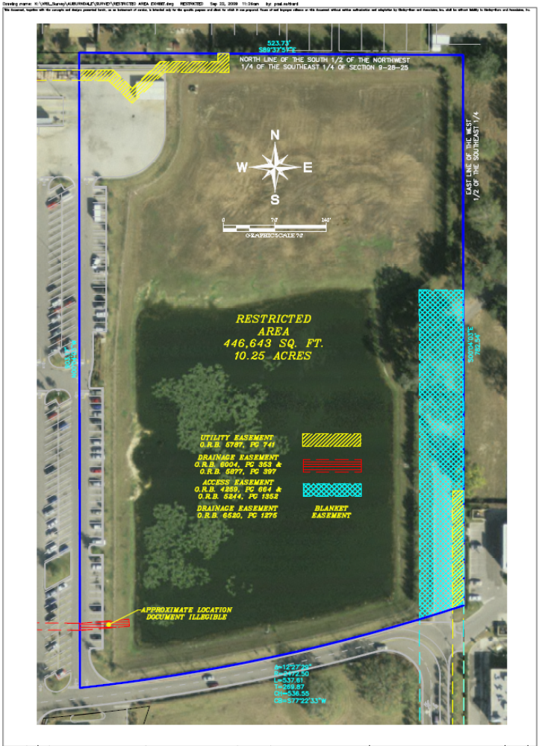
EASEMENTS AFFECTING RESTRICTED AREA

EASEMENT BOOK PAGE AFFECTS/DOES NOT AFFECT
UTILITY EASEMENT 3359 1786 DOES NOT AFFECT
ACCESS EASEMENT 4259 664 AFFECTS
INGRESS/EGRESS EASEMENT 4259 672 DOES NOT AFFECT
ACCESS EASEMENT 5244 1352 AFFECTS
UTILITY EASEMENT 5568 1508 DOES NOT AFFECT
UTILITY EASEMENT 5655 907 DOES NOT AFFECT
ACCESS EASEMENT 5727 1514 DOES NOT AFFECT
ACCESS EASEMENT 5773 1143 DOES NOT AFFECT
UTILITY EASEMENT 5787 741 AFFECTS
SANITARY SEWER EASEMENT 5787 758 DOES NOT AFFECT
DRAINAGE SANITARY EASEMENT 5877 397 AFFECTS
DRAINAGE SANITARY EASEMENT 6004 353 AFFECTS (CORRECTIVE EASEMENT FOR 5877/397)
DRAINAGE EASEMENT 6520 1275 AFFECTS (BLANKET OVER WM PROPERTY)
EASEMENTS W/ COVENANTS 7329 401 DOES NOT AFFECT

EXAMPLE OF DIAGRAM FOR OWNER’S NOTICE TO EXISTING ENCUMBRANCE HOLDERS

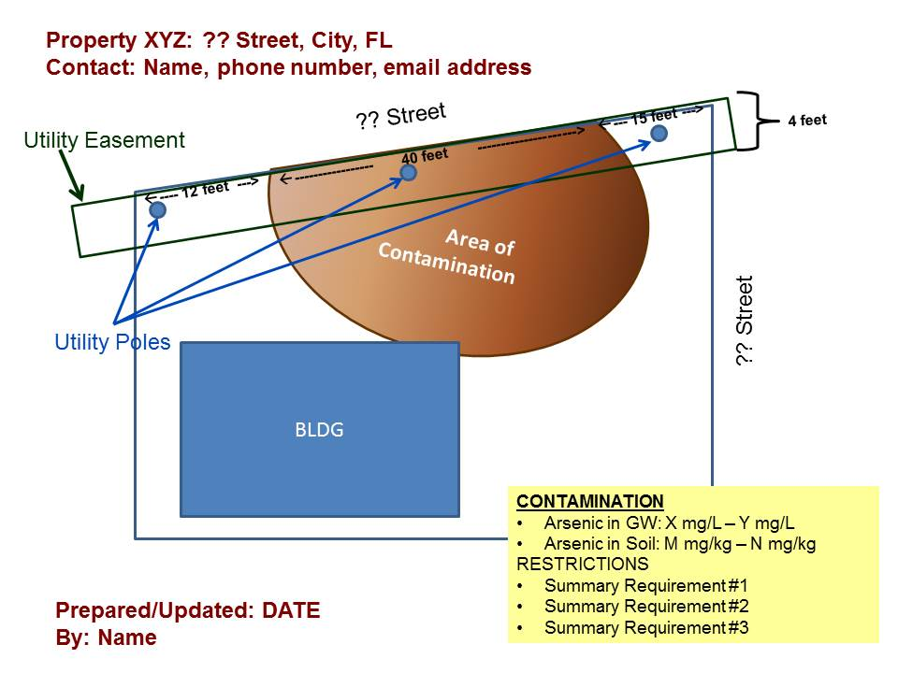

Attachment 15: Division Of State Lands/Board Of Trustees Property

If the State of Florida is the property owner, you should contact the FDEP Division of State Lands (DSL) to discuss needed restrictions on the property. As with any property owner, the DSL must first approve the conditional closure and the restrictions. Both parties must agree upon the form of the IC.

The Board of Trustees of the Internal Improvement Trust Fund (BOT or Board) consists of the Governor, the Commissioner of Agriculture, the Attorney General, and the Chief Financial Officer. The BOT is vested with authority regarding the acquisition, administration, management, control, supervision, conservation, protection, and disposition of all state-owned lands, excluding certain transportation, port and special district lands. Pursuant to Section 253.03, F.S., the Board is responsible for the creation of an overall and comprehensive plan of development for the acquisition, management, and disposition of state-owned lands. Section 253.03(7)(a), F.S., directs the Board by statute to maintain a public land office (DSL’s Land Title Records Office) in which are deposited and preserved all records, surveys, plats, maps, field notes, and patents, and all other title documents for state-owned lands. These records are consulted and searched in the event the BOT considers the sale of the lands.

Pursuant to statute, the FDEP, primarily through the DSL, performs all staff duties and functions related to the acquisition, administration, and disposition of state lands. All entities managing state-owned conservation lands must prepare and submit for review a management plan, which in addition to describing the property, must address:

  - A description of past uses;
  - A detailed description of existing and planned use(s);
  - A detailed assessment of the impact of planned uses on the renewable and non-renewable resources of the property and a detailed description of the specific actions that will be taken to protect, enhance, and conserve these resources and to mitigate damage caused by such uses;
  - A description of management needs and problems for the property; and
  - A description of executive directives that constrain the use of such property.

Each plan for conservation lands is scheduled to be regularly updated. DSL, as staff to the BOT, provides guidance and recommendations to ensure that these plans meet statutory and rule requirements. If any DSL tenant or any other entity disagrees with DSL's recommendations, DSL can place the plan before the BOT for consideration. Pursuant to Section 259.036, F.S., DSL is responsible for coordinating the review of land management activities. If a parcel of BOT land is not being managed in accordance with the approved plan, the BOT has the power to revoke its lease of such lands to that entity.

FDEP can impose the same kinds of restrictions on DSL properties as it can on any other (e.g., groundwater use prohibition).

a. Site/Project Manager

If a request for a conditional closure is submitted to the FDEP for state-owned property by a tenant (not DSL) and if such a request is approved, the Site/Project Manager must write a comprehensive letter to the tenant (copying DSL) stating why the request has been approved; what the restrictions must be; including ECs, if applicable; where the restrictions will apply and what ICs are necessary (the site/project manager may want to attach a copy of the State Lands portion of this IC Guidance Document). It is then the tenant’s responsibility to seek authorization from DSL to move forward. Similarly, for state-owned contaminated sites at which the DEP’s Site Investigation Section (SIS) is performing site rehabilitation under the State-Owned Lands Cleanup Program (SOLCP), which is state-funded and state-managed, the SIS site/project manager should write the letter described above and seek authorization from the DSL on behalf of the tenant.

b. Division of State Lands Institutional Controls:

Should DSL agree to conditional closure, then DSL must prepare a memorandum to the DWM agreeing to the following combination of controls, all of which together create the IC mechanism for DSL properties (see Attachments 16-18).

- The Management Plan and Land Title Records for the DSL property:

FDEP DSL will amend the management plan for the DSL property to contain the use restrictions and EC restrictions (as applicable).

FDEP DSL will place a notice in its Land Title Records for the property stating that its use is restricted in perpetuity, specifically indicating how the property’s use is restricted, until such time that the contamination issues on the property have been remediated to state and federal standards that would allow other uses. This notice will declare further that the title to the property shall be encumbered to include such restrictions on its future use, if the Board ever determines the property to be surplus to state needs and decides to sell it. As required by statute, the FDEP maintains land title and lease records for all lands that the Board owns (DSL’s Land Title Records). These records are consulted and searched prior to transfer of the property from state ownership. Such restrictions in these files will alert state staff to limit the property’s future uses in any deed of conveyance, and these files may be utilized to provide post-closure notice, as more fully described at 40 CFR § 264.119(b) (1). The state management plan will include the restrictions until the contamination issues have been remediated to state and federal standards that would allow other uses. Additionally, the leases should be amended by the DSL to reflect the new restrictions.

- Leaseholders notice:

A copy of the management plan and notices advising that use of the property is restricted will be provided to all holders of leases, subleases or assigned leases of the property until such time that the contamination issues on the property have been remediated to state and federal standards that would allow other uses.

- Future Transfer of Ownership of BOT Property:

DSL must inform future owners of state property prior to transfer of ownership by providing a copy of the state management plan to the prospective owner(s). At the time BOT contracts to sell or otherwise convey the property, the contract shall contain a provision that requires the new owner to encumber the property with an RC that contains all the use prohibitions, water use restrictions and ECs imposed on the property by the state management plan and that has been preapproved by FDEP. The contract shall also require the new owner to record the restrictive covenant immediately after the deed to the property is recorded. The RC will include the restrictions until the contamination issues have been remediated to state and federal standards that would allow other uses.

RCs must also include a requirement that such future owners grant site access to the FDEP for the purpose of determining compliance with the use restrictions. The covenant will continue in perpetuity unless the FDEP determines that site contamination in all affected media no longer exceeds cleanup target levels established pursuant to Florida Statutes and FDEP rules.

- IC Registry:

The above use restrictions are to be included in the FDEP DWM ICs Registry.

c. Supporting documentation:

The DWM wants to ensure that the State of Florida in fact, owns the subject property in “fee”. Consequently, information from DSL to that effect, whether by deed or some other mechanism, must be included in the IC packet of documents submitted to OGC for review. Additionally, DWM needs to know who the current tenant is on the subject property and include that party in the negotiations.

Summary Of DSL IC Development Procedure

The following is a summary of the above procedure that should be followed for an institutional control on state owned land generally in the order listed here:

- Tenant sends Conditional Closure Request to DWM/District (Site Manager reviews it). The Conditional Closure Request should state: why the request for conditional closure is appropriate/the intended engineering and or institutional controls; whether engineering controls are in-place (if so, then include the engineering control inspection/maintenance plan and any Professional Engineer certifications for the engineering controls); the proposed area(s) of the engineering and restrictions, and a draft notice of intent to use institutional controls to be published by the tenant. (Note that this is the same thing that we ask from our non-DSL site RPs/Consultants.)

- DWM Site Manager writes a comprehensive letter to the tenant (Responsible Party - RP) and copies DSL stating why the request for conditional closure is approved.

- Tenant must then pursue authorization from DSL. This includes providing any documents or surveys requested by DSL and then following DSL procedures for the development of amendments to the Management Plan and the Lease. The tenant should also include an engineering control inspection/maintenance plan and any Professional Engineer certifications for the engineering controls once they are in place.

- DSL should follow through with establishing the amendments to the Management Plan and Lease to incorporate the use restrictions and engineering controls.

- DSL should place a notice in its Land Title Records for the property stating that it is restricted in perpetuity, listing the restriction, and stating that a deed restriction with the same use restrictions, engineering controls, and engineering control inspection/maintenance plan, must be included in any deed of conveyance away from state ownership.

- DSL should then provide copies of 1) the amended management plan; 2) the amended lease; and 3) the notice in the State Land Title Records to the DWM/District site manager.

- DWM/District should issue the Conditional Site Rehabilitation Completion Order including the amended lease, which includes the engineering and institutional control information as an attachment.

- DWM/District should then complete and forward the completed Institutional Control Registry Data Sheet to DWM_ICR@dep.state.fl.us, who then should place the institutional control for the DSL property onto the Institutional Control Registry.

Attachment 16: Sample Division Of State Lands Packet

DIVISION OF STATE LANDS MEMORANDUM TO
DIVISION OF WASTE MANAGEMENT

Florida Department of
Memorandum Environmental Protection

Date:

To: Appropriate District Director or Program Administrator
Division of Waste Management

From: Director
Division of State Lands

Subject: Conditional Site Rehabilitation Completion Order
Facility Name
Facility address
Facility City, County
FDEP Facility ID#
Discharge Date:
___________________________________________________________________

In response to your Division's request for an IC on state lands currently managed by the ________________ (LESSEE), the following is provided in lieu of removal or other remediation of {{petroleum, solvent, arsenic, etc.}}-impacted soils or water at the site.

BACKGROUND: The Board of Trustees of the Internal Improvement Trust Fund (Board) consists of the Governor, Attorney General, Chief Financial Officer, and the Commissioner of Agriculture, and is vested with the acquisition, administration, management, control, supervision, conservation, protection, and disposition of all state-owned lands, excluding certain transportation, port and special district lands. Pursuant to Section 253.03, F.S., the Board is responsible for the creation of an overall and comprehensive plan of development for the acquisition, management, and disposition of state-owned lands. Pursuant to Section 253.03(7) (a), F.S., the Board is directed by statute to maintain a public land office in which are deposited and preserved all records, surveys, plats, maps, field notes, patents, and all other title documents for state-owned lands. These records are consulted and searched by DSL staff when the Board considers the transfer of the lands as surplus.

Pursuant to statute, the Department of Environmental Protection (FDEP), primarily through the Division of State Lands (DSL), performs all staff duties and functions related to the acquisition, administration, and disposition of state lands. It is important to note, however, that the entire FDEP is staff to the Board of Trustees. All entities managing state-owned lands must prepare and submit a management plan for review, which in addition to describing the property, must address:

- A description of past uses
- A detailed description of existing and planned uses
- A detailed assessment of the impact of planned uses on the renewable and non-renewable resources of the property and a detailed description of the specific actions that will be taken to protect, enhance and conserve these resources and to mitigate damage caused by such uses
- A description of management needs and problems for the property
- A description of executive directives that constrain the use of such property.

Each plan is scheduled to be regularly updated. DSL, as staff to the Board, provides guidance and recommendations to ensure that these plans meet statutory and rule requirements. If LESSEE or any other entity disagrees with DSL's recommendations, DSL can place the plan before the Board for consideration. If a parcel of Board land is not being managed in accordance with the approved plan, the Board has the power to revoke the lease.

FACILITY NAME: FACILITY ADDRESS (known by any other name?). LESSEE leases state-owned lands for the operation of___________________, and LESSEE must prepare a land management plan for the property. This land management plan must address land use and environmental issues, such as soil and water contamination and other environmental hazards. FDEP Division of Waste Management site managers will coordinate with LESSEEs to determine appropriate property use changes and requirements to be incorporated into the plan (e.g., “LESSEE will modify the lease to require closure of irrigation wells.”). LESSEE is required, pursuant to Section 18-2.021, F.A.C., to submit its plan to the DSL for review. The Division of Waste Management must review and approve of all plans related to soil and/or groundwater contamination remediation and other environmental hazards prior to plan submittal to DSL. If DSL has any objections to the plan, DSL must present the plan to the Board for final consideration.

LESSEE’S management plan for the {{FACILITY NAME OR DSL NAME}}, which includes the lands affected by the contaminated {{soils and/or groundwater}}, has been updated to reference the contamination issue and includes as an attachment an executed copy of Amendment No. ## to Lease No. ####, which amends LESSEE’s lease to include the institutional and engineering control restriction language requested in the Division of Waste Management (or its contracted entity) letter of {{DATE}}, to LESSEE. A copy of the amended management plan is attached for your file. The management plan amendment requires that the property {{(OR a portion of the property)}} {{insert a summary describing the restrictions placed on this property; e.g., groundwater use restrictions, soil cap requirements, land use restrictions, etc. Each site is different and the restrictions are site specific, so please describe only what is specific to this site.}} The lease amendment implements the restrictions for the term of the lease; however, the Division of State Lands agrees that upon transfer of the property, institutional and engineering controls shall be recorded in the county land records where the title deed to the property is recorded, and thereafter shall run with the land and with the title to the property and continue in perpetuity, unless modified in writing by DSL and DEP's Division of Waste Management. This means that all future leases must include the same requirements and use restrictions, and any transfer of the property must be accompanied by the recording of a restrictive covenant that includes the same requirements and use restrictions.

As required by statute, DSL maintains land title and lease records for all Board lands. These records are consulted and searched by DSL staff prior to transfer of the property out of state ownership. DSL will place a notice in the title and lease files for this property that lists the restrictions at the contaminated site until such time as the affected site meets state and federal standards that would allow other uses. This notice will declare further that a restrictive covenant shall be recorded in the county land records where the title deed to the property is recorded if the Board ever determines the property to be surplus to state needs and decides to transfer it. A restrictive covenant recorded in the county land records where the title deed to the property is recorded will restrict the future uses of the property.

The DSL submits that these actions will restrict use of the affected lands and provide adequate long-term control in lieu of a Declaration of Restrictive Covenant for as long as the lands are owned by the state, and in perpetuity after the recording of a restrictive covenant in the county land records where the title deed to the property is recorded. If you have any questions, please contact _________________with the Bureau of Public Land Administration. ______________ may be reached at 850-245-____.

Attachment 17: Sample Division Of State Lands Lease Amendment

DIVISION OF STATE LANDS LEASE AMENDMENT

WHEREAS, LESSOR, by virtue of Section 253.03, Florida Statutes, holds title to certain lands and property for the use and benefit of the State of Florida; and

WHEREAS, on the _____ day of _______, ______, LESSOR and LESSEE entered into Lease Number _____; and

WHEREAS, LESSOR and LESSEE desire to amend the lease to include institutional restrictions required as a result of a discharge from {{describe the operations or event, if known, that resulted in the discharge.}}

NOW THEREFORE, in consideration of the mutual covenants and agreements contained herein, the parties hereto agree as follows:

1. The DATE, survey, prepared by ___________________., identifying the area of restriction (OR “area that must be capped” OR similar language) is hereby added as Exhibit B.
2. The following additional section is hereby added in its entirety as Section ______:
"The area as located on the {{DATE}}, survey, prepared by ________________attached hereto as Exhibit B and by reference made a part hereof ("restricted area"), shall be permanently covered and maintained with an impermeable material that prevents human exposure and prevents water infiltration. Excavation and construction is not prohibited within the contaminated area provided that any contaminated soils that are excavated are removed and properly disposed of pursuant to applicable Florida Department of Environmental Protection ("DEP") rules.

3. Nothing herein shall limit or conflict with any legal requirements regarding construction methods and precautions that must be taken to minimize risk of exposure while conducting work in the contaminated areas.

4. The restrictions contained herein are for the benefit of the Florida Department of Environmental Protection ("DEP") and are binding upon LESSEE until a release of covenant is executed by LESSOR and the Secretary of DEP, or designee. To receive prior approval from DEP to remove any requirement herein, cleanup target levels established pursuant to Florida Statutes and DEP rules must have been achieved. The restrictions contained herein may be modified in writing only. Any subsequent amendment must be executed by both the LESSOR and LESSEE, or their respective successors and assigns.

- It is understood and agreed by LESSOR AND LESSEE that in each and every respect the terms of the Lease Number ____ except as amended shall remain unchanged and in full force and effect and the same are hereby ratified, approved and confirmed by LESSOR AND LESSEE.
IN WITNESS WHEREOF, the parties have caused this Lease Amendment to be executed on the day and year first above written.

BOARD OF TRUSTEES OF THE INTERNAL
IMPROVEMENT TRUST FUND OF THE
STATE OF FLORIDA

______________________________ BY:_____________________________(SEAL)
Witness OPERATIONS & MANAGEMENT CONSULTANT
Print/Type Witness Name MANAGER, BUREAU OF PUBLIC
_______________________________ LAND ADMINISTRATION, DIVISION
Witness OF STATE LANDS, DEPARTMENT OF
________________________________ ENVIRONMENTAL PROTECTION
Print/Type Witness Name

STATE OF FLORIDA "LESSOR"
COUNTY OF LEON

The foregoing instrument was acknowledged before me this ___ day of _____20__, by Operations and Management Consultant Manager, Bureau of Public Land Administration, Division of State Lands, Florida Department of Environmental Protection, as agent for and on behalf of the Board of Trustees of the Internal Improvement Trust Fund of the State of Florida. She is personally known to me.
__________________________
Notary Public, State of Florida
___________________________
Print/Type Notary Name
Commission Number:
Commission Expires:

Approve as to Form and Legality
By:___________________________
Amendment No. ____ to Lease No. ______
________________________________________________________________
_____________________________ By: ______________________(SEAL)
Witness_____________________________ _________________________________
Print/Type Witness Name Print/Type Name
______________________________ __________________________________
Witness Title: _____________________
______________________________ “LESSEE”
Print/Type Witness Name

STATE OF FLORIDA
COUNTY OF LEON
The foregoing instrument was acknowledged before me this __day of ____________, 20__ by
_____________________as ____________________________of the State of Florida Department of Environmental Protection. He/she is personally known to me.
_______________________________
Notary Public, State of Florida
_______________________________
Print/Type Notary Name
Commission number:
Commission Expires:

Attachment 18: 18-4.007 Division Of State Lands Management Plans

Plans submitted to the Division of State Lands for committee review under requirements of Section 253.034, F.S., should contain, where applicable to the management of resources, the following:

- Lease Number: {{3145 – Leon County – 23.51 acres}}

The common name of the property: {{Kirkman Building}}

- A map showing the location and boundaries of the property plus any structures or improvements to the property.

[x] Attached ATTACHMENT # 1
[ ] To Be Obtained (not on hand at this time)

- The legal description and acreage of the property.

[x] Attached ATTACHMENT #2
[ ] To Be Obtained (not on hand at this time)

- The degree of title interest held by the Board, including reservations and encumbrances such as leases. ATTACHMENT #3

Easements {{# 29285 and 27833; Ina S. Thompson Child Care Center;
DHSMV Credit Union and Leon County Kindergarten.}}

- The land acquisition program (e.g. C.A.R.L., E.E.L., Save Our Coast), if any, under which the property was acquired.

Title was acquired by the Florida Board of Trustees as a site for {{the DHSMV
General Headquarters.}}

- The designated single use or multiple use management for the property,
Including other managing agencies.

{{Multiple use – DHSMV General Headquarters; Ina S. Thompson Child Care
Center; DHSMV Credit Union and Leon County Kindergarten.}}

- Proximity of property to other significant State, local, or federal land or water resources.

{{Across Apalachee Parkway – 300 yards – State Division of Forestry,
Division Office: 2912 Apalachee Parkway, Tallahassee, FL 32399, Koger
Center – 100% occupied by State; and 1 ½ miles – new State Satellite Office
Complex – Capital Circle}}

- A statement as to whether the property is within an aquatic preserve or a designated area of critical State concern or an area under study for such designation.

{{No – Urban land complex/parking lot and buildings.}}

- The location and description of known and reasonably identifiable renewable and non-renewable resources of the property including, but not limited to, the following:

- Brief description of soil types, using U.S.D.A. maps when available;

{{Orangeburg – Urban land complex, 2 to 12 percent slopes}}

- Archaeological and historical resources;

{{See ATTACHMENT # 4
The Department will follow the Division of Historical Resources’ policy for
Management Procedures for Archaeological and Historic Sites and Properties on State Owned or controlled lands 4189}}

- Water resources including the water quality classification for each water body and the identification of any such water body that is designated as an Outstanding Florida Waters;

{{None – Urban land complex parking lot and buildings. }}

- Fish and Wildlife and their habitat;

{{See ATTACHMENT # 5
None – Urban land complex/parking lot and buildings. Natural Area
Inventory states the property is mostly cleared land and element
occurrence of a habitat is unlikely. }}

- State and federally listed endangered or threatened species and their habitat;

{{None. Urban land complex/parking lot and buildings. Natural Area Inventory states the property is mostly cleared land and element occurrence of a habitat is unlikely.}}

- Beaches and dunes;

{{None. Urban land complex/parking lot and buildings. }}

- Swamps, marshes and other wetlands;

{{None. Urban land complex/parking lot and buildings. }}

- Mineral resources, such as oil, gas and phosphate;

{{None. Urban land complex/parking lot and buildings.}}

- Unique natural features, such as coral reefs, natural springs, caverns, large sinkholes, virgin timber stands, scenic vistas, and natural rivers and streams; and

{{None. Urban land complex/parking lot and buildings.}}

- Outstanding native landscapes containing relatively unaltered flora, fauna, and geological conditions.

{{None. Urban land complex/parking lot and buildings.}}

- A description of actions the agency plans, to locate and identify unknown resources such as surveys of unknown archaeological and historical resources.

{{None. Urban land complex/parking lot and buildings.}}

- The identification of resources on the property that are listed in the
Natural Area Inventory.

{{See ATTACHMENT # 6
None. Natural Area Inventory states mostly cleared land and element occurrence of a habitat is unlikely}}

- A description of past uses, including any unauthorized uses of the property.

{{Prior to DHSMV Site, this acreage was a cow pasture. The past use has been to house the Department of Hwy. Safety & Motor Vehicles, parking facilities, Ina S. Thompson Child Care Center, Leon County Kindergarten and DHSMV Credit Union.}}

- A detailed description of existing and planned use(s) of the property.

{{Existing: Same as 12 above. A “D” wing has been added to the Kirkman Bldg.
(1993-94). No changes are planned in the Credit Union, Child Care Center or the Kindergarten.}}

- A description of alternative or multiple uses of the property considered by the managing agency and an explanation of why such uses were not adopted.

{{At the present time, the managing agency is not planning to add additional uses of this property.}}

- A detailed assessment of the impact of planned uses on the renewable and non-renewable resources of the property and a detailed description of the specific actions that will be taken to protect, enhance and conserve these resources and to mitigate damage caused by such uses.

{{No new construction is planned for the site in the future and a holding pond was constructed to deal with stormwater to run off from the parking lot. This system is connected to the City of Tallahassee’s stormwater drainage system.}}

- A description of management needs and problems for the property.

{{The property is an urban land complex with parking lots, building, manicured lawn and a few trees.}}

- Identification of adjacent land uses that conflict with the planned use of the property, if any.

{{The adjacent land usages are urban residential, business establishments, county fire department and forestry station.}}

- A description of legislative or executive directives that constrain the use of such property.

{{The property was originally purchased to provide a site for the general headquarters of the FDEP. This original constraint has been modified to allow the construction of the DHSMV Credit Union, the modification of one facility to be used as the Ina S. Thompson Child Care Center.
Herein is established an environmental constraint in accordance with ATTACHMENT # 7 and as defined in Amendment # 2 to the property lease. }}

- A finding regarding whether each planned use complies with the State Lands Management Plan, particularly whether such uses represent “balanced public utilization”, specific agency statutory authority, and other legislative or executive constraints.

{{This Department is in compliance with State Land Mgt. Plan. Chapter 319, 320, 321 and 322 Florida Statutes specify the Agency’s statutory authority.}}

- An assessment as to whether the property, or any portion, should be declared surplus.

{{None.}}

- Identification of other parcels of land within or immediately adjacent to the property that should be purchased because they are essential to management of the property.

{{Not sure any land is available to be purchased in this area.}}

- A description of the management responsibilities of each agency and how such responsibilities will be coordinated, including a provision that requires that the managing agency consult with the Division of Archives, History and Records Management before taking actions that may adversely affect archaeological or historic resources.

{{See ATTACHMENT #

The Department will follow the Division of Archives, History and Records Management’s policy as outlined in “Management Procedures for the Protection of
Archaeological and Historical Sites and Properties.}}

- Historical Sites and Properties:
A statement concerning the extent of public involvement and local government participation in the development of the plan, if any, including a summary of comments and concerns expressed.

{{Rezoning hearing that preceded the Ina S. Thompson Child Center involved considerable public and local government comment related to the multiple uses of the property and possible traffic congestion. However, these concerns were satisfied and rezoning was accepted by the Leon County Commission.}}

Specific Authority 253.03 (7), 253.034 (4), (5) FS. Law Implemented 253.034 (4), FS.
History – New 4-4-84, Formerly 16Q-23.07, Transferred from 16Q-23.007.

Attachment 19: Template For Constructive Notice Of Intent To Approve Use Of Institutional Control

Pursuant to subsections 62-780.220(7) and .680(8), F.A.C., the Person Responsible for Site Rehabilitation (PRSR) is required to provide constructive notice of the Department’s intent to approve the PRSR’s No Further Action Proposal with Controls (either an institutional control or both engineering and institutional controls). The PRSR must provide the notice prior to the Department’s approval of such proposal (but within 30 days after the Department’s conditional approval of the proposal). Pursuant to subsection 62-110.106(5), F.A.C., the PRSR must publish the notice at its expense in the legal advertisements section of a newspaper of general circulation (i.e., meeting the requirements of ss. 50.011 and 50.031, F.S.) in the county in which the effects of the Department’s proposed action will occur. The PRSR must provide proof of publication within seven days of the publication by furnishing the Department with a uniform affidavit in substantially the form prescribed in s. 50.051, F.S. The following template meets this constructive notice requirement. Replace the information inside the brackets with information specific to the site.

STATE OF FLORIDA
DEPARTMENT OF ENVIRONMENTAL PROTECTION
NOTICE OF PROPOSED AGENCY ACTION

The Florida Department of Environmental Protection (FDEP) gives notice that it proposes to approve a No Further Action Proposal with Institutional Controls or with Engineering and Institutional Controls and issue a Site Rehabilitation Completion Order with controls for a contaminated site. {PRSR} is seeking this order in reference to FDEP Site ID # {site id #} {facility name, address} and intends to restrict exposure to contamination in the following manner: {describe the type of controls such as land use restrictions, water use restrictions, caps over contaminated soil, etc.}.

Complete copies of the No Further Action Proposal, the proposed Institutional Control {i.e., a draft restrictive covenant, a local ordinance restricting water use, etc.}, and the FDEP’s preliminary evaluation are available for public inspection during normal business hours 8:00 a.m. to 5:00 p.m. Monday through Friday, except legal holidays at FDEP {address of location of documents}.

Local governments with jurisdiction over the property subject to the Institutional Control, real property owner(s) of any property subject to the Institutional Control, and residents of any property subject to the Institutional Control have 30 days from publication of this notice to provide comments to the FDEP. Such comments must be sent to FDEP {name and address of person who should receive comments and person’s email address}.

*This notice will need to be altered for CERCLA ICs, to indicate that an SRCO will not be forthcoming for those sites (the next notice is a good basis) upon establishing the RC (or we need to make a note here that this notice is not required for CERCLA ICs).

Attachment 20: Template For Constructive Notice Of Intent To Approve Use Of Interim Institutional Control

The following template meets the constructive notice requirement for the use of an interim IC. Replace the information inside the brackets with information specific to the site.

STATE OF FLORIDA
DEPARTMENT OF ENVIRONMENTAL PROTECTION
NOTICE OF PROPOSED AGENCY ACTION

The Florida Department of Environmental Protection (FDEP) gives notice that it proposes to approve use of an interim institutional control in the form of a Declaration of Restrictive Covenant at a contaminated site while site rehabilitation is ongoing. {PRSR} is seeking this Declaration in reference to FDEP Site ID # {site id number}, {facility name, address} and intends to restrict exposure to contamination in the following manner: {describe the type of controls such as land use restrictions, water use restrictions, caps over contaminated soil, etc.}.

Complete copies of the draft Declaration of Restrictive Covenant, and FDEP’s preliminary evaluation are available for public inspection during normal business hours 8:00 a.m. to 5:00 p.m., Monday through Friday, except legal holidays at FDEP {address of location of documents}.

Local governments with jurisdiction over the property subject to the institutional control, real property owner(s) of any property subject to the institutional control, and residents of any property subject to the institutional control have 30 days from publication of this notice to provide comments to FDEP. Such comments must be sent to FDEP {name and address of person to receive comments and person’s email address}.

Attachment 21: Florida Administrative Code Rules Regarding Notice

62-110.106(5), (8) & (9), Florida Administrative Code
(5) Notices: General Requirements. Each person who files an application for a Department permit or other approval may publish or be required to publish a notice of application or other notice as set forth below in this section. Except as specifically provided otherwise in this paragraph, each person publishing such a notice under this section shall do so at his own expense in the legal advertisements section of a newspaper of general circulation (i.e., one that meets the requirements of Sections 50.011 and 50.031 of the Florida Statutes) in the county or counties in which the activity will take place or the effects of the Department’s proposed action will occur, and shall provide proof of the publication to the Department within seven days of the publication. For federally enforceable general permits approved by the Department for air operations, however, notice of a draft permit shall be published in the Florida Administrative Weekly, in accordance with 40 C.F.R. sec. 70.7(h)(1). In addition to the provisions of this section, other specific requirements for notices are as follows: notices for variances and waivers are governed by Rule 62-110.104, F.A.C., notices for federally enforceable air operation permits are governed by Rule 62-210.350, F.A.C., notices for exemptions from water quality criteria are governed by paragraph 62-4.243(1)(a), F.A.C., those for exemptions for water bodies classified for navigation, utility, and industrial use are governed by paragraph 62-4.243(2)(a), F.A.C., notices for exemptions from the limitations imposed on mixing zones are governed by paragraph 62-4.244(1)(c), F.A.C., notices for general permits are generally governed by subsection 62-4.530(5), F.A.C., notices on site-specific alternative criteria are governed by subparagraph 62-302.800(4)(c)7., F.A.C., notices for “noticed general permits” in the environmental resource permitting program are governed by paragraphs 62-343.090(1)(d)-(e), (2)(c), and (2)(h)-(j), F.A.C., notices on permits for underground injection wells are governed by Rule 62-528.315, F.A.C., notices on wastewater facility permits are governed by Rule 62-620.550, F.A.C., notices for general permits for solid waste transfer stations are governed by subsection 62-701.801(7), F.A.C., and notices (including the federal requirement for such notice to be broadcast over one or more local radio stations) for hazardous waste permits are governed by subsections 62-730.220(9) and (11), F.A.C.
(8) Notice of Proposed Agency Action (Non-permitting). On a matter other than a permit application, the Department or any applicant, petitioner for a variance or waiver, party to a consent order, or person seeking the Department’s authorization or approval of a report, plan, proposal, or other request (excluding any request for hearing) may publish or be required to publish notice of the proposed action in substantially the following format:
State of Florida Department of Environmental Protection Notice of Proposed Agency Action
The Department of Environmental Protection gives notice that it proposes [insert phrase describing the agency action proposed (e.g., to approve a consent order)] in reference to [a description and location of the subject matter or activity covered by the action, the Department’s identification number, and the name and address of any person to whom the action is directed]. Complete copies [of any document and accompanying material expressing the proposed agency action] are available for public inspection during normal business hours 8:00 a.m. to 5:00 p.m., Monday through Friday, except legal holidays, at [name and address of office].
[Insert the language setting forth the notice of rights, as provided in paragraph (12) of this rule, below, except that references in that notice to deadlines of fourteen days shall be replaced by references to twenty-one days.]
(9) Proof of Publication. Notice to substantially affected persons on applications for Department permits or other authorizations is an essential and integral part of the state environmental permitting process. Therefore, no application for a permit or other authorization for which published notice is required shall be granted until proof of publication of notice is made by furnishing a uniform affidavit in substantially the form prescribed in Section 50.051 of the Florida Statutes, to the office of the Department issuing the permit or other authorization. Applicants for hazardous waste permits must also comply with subsection 62-730.220(11), F.A.C.

Attachment 22: Statutes Regarding Notice Publication

ss. 50.011 and 50.031, Florida Statutes
50.011 Where and in what language legal notices to be published.--Whenever by statute an official or legal advertisement or a publication, or notice in a newspaper has been or is directed or permitted in the nature of or in lieu of process, or for constructive service, or in initiating, assuming, reviewing, exercising or enforcing jurisdiction or power, or for any purpose, including all legal notices and advertisements of sheriffs and tax collectors, the contemporaneous and continuous intent and meaning of such legislation all and singular, existing or repealed, is and has been and is hereby declared to be and to have been, and the rule of interpretation is and has been, a publication in a newspaper printed and published periodically once a week or oftener, containing at least 25 percent of its words in the English language, entered or qualified to be admitted and entered as periodicals matter at a post office in the county where published, for sale to the public generally, available to the public generally for the publication of official or other notices and customarily containing information of a public character or of interest or of value to the residents or owners of property in the county where published, or of interest or of value to the general public.
50.031 Newspapers in which legal notices and process may be published.--No notice or publication required to be published in a newspaper in the nature of or in lieu of process of any kind, nature, character or description provided for under any law of the state, whether heretofore or hereafter enacted, and whether pertaining to constructive service, or the initiating, assuming, reviewing, exercising or enforcing jurisdiction or power, by any court in this state, or any notice of sale of property, real or personal, for taxes, state, county or municipal, or sheriff's, guardian's or administrator's or any sale made pursuant to any judicial order, decree or statute or any other publication or notice pertaining to any affairs of the state, or any county, municipality or other political subdivision thereof, shall be deemed to have been published in accordance with the statutes providing for such publication, unless the same shall have been published for the prescribed period of time required for such publication, in a newspaper which at the time of such publication shall have been in existence for 1 year and shall have been entered as periodicals matter at a post office in the county where published, or in a newspaper which is a direct successor of a newspaper which together have been so published; provided, however, that nothing herein contained shall apply where in any county there shall be no newspaper in existence which shall have been published for the length of time above prescribed. No legal publication of any kind, nature or description, as herein defined, shall be valid or binding or held to be in compliance with the statutes providing for such publication unless the same shall have been published in accordance with the provisions of this section. Proof of such publication shall be made by uniform affidavit.

Attachment 23: Statute Governing Form Of Affidavit For Proof Of Publication

Section 50.051 Proof of publication; form of uniform affidavit.--The printed form upon which all such affidavits establishing proof of publication are to be executed shall be substantially as follows:
NAME OF NEWSPAPER

Published (Weekly or Daily)

(Town or City) (County) FLORIDA
STATE OF FLORIDA
COUNTY OF _____:
Before the undersigned authority personally appeared _____, who on oath says that he or she is _____ of the _____, a _____ newspaper published at _____ in _____ County, Florida; that the attached copy of advertisement, being a _____ in the matter of _____ in the _____ Court, was published in said newspaper in the issues of _____.
Affiant further says that the said _____ is a newspaper published at _____, in said _____ County, Florida, and that the said newspaper has heretofore been continuously published in said _____ County, Florida, each _____ and has been entered as periodicals matter at the post office in _____, in said _____ County, Florida, for a period of 1 year next preceding the first publication of the attached copy of advertisement; and affiant further says that he or she has neither paid nor promised any person, firm or corporation any discount, rebate, commission or refund for the purpose of securing this advertisement for publication in the said newspaper.
Sworn to and subscribed before me this _____ day of _____, (year) , by _____, who is personally known to me or who has produced (type of identification) as identification.
(Signature of Notary Public)
(Print, Type, or Stamp Commissioned Name of Notary Public)
(Notary Public)

______________________________
Print Name of Notary Public

Commission No. ________________

Commission Expires: ____________

Attachment 24: Statutory Recording Requirements

695.26 Requirements for recording instruments affecting real property.—1997/2015
  - No instrument by which the title to real property or any interest therein is conveyed, assigned, encumbered, or otherwise disposed of shall be recorded by the clerk of the circuit court unless:
  - The name of each person who executed such instrument is legibly printed, typewritten, or stamped upon such instrument immediately beneath the signature of such person and the post-office address of each such person is legibly printed, typewritten, or stamped upon such instrument;
  - The name and post-office address of the natural person who prepared the instrument or under whose supervision it was prepared are legibly printed, typewritten, or stamped upon such instrument;
  - The name of each witness to the instrument is legibly printed, typewritten, or stamped upon such instrument immediately beneath the signature of such witness;
  - The name of any notary public or other officer authorized to take acknowledgments or proofs whose signature appears upon the instrument is legibly printed, typewritten, or stamped upon such instrument immediately beneath the signature of such notary public or other officer authorized to take acknowledgment or proofs;
  - A 3-inch by 3-inch space at the top right-hand corner on the first page and a 1-inch by 3-inch space at the top right-hand corner on each subsequent page are reserved for use by the clerk of the court; and
  - In any instrument other than a mortgage conveying or purporting to convey any interest in real property, the name and post-office address of each grantee in such instrument are legibly printed, typewritten, or stamped upon such instrument.
  - If a name or address is printed, typewritten, or stamped on an instrument in a position other than the position required by subsection (1), the clerk of the circuit court may, in her or his discretion, accept the instrument for recordation if she or he determines that the connection between the signature and the name or the name and the address is apparent.

Attachment 25: Institutional Control Registry Data Sheet And Instructions
(Instructions below Data Sheet)
(Double click inside frame to open datasheet)

Instructions For Institutional Control Registry Data Sheet
(Data sheet above)

Database: This should identify the database in which this facility is currently tracked (e.g., STCM, COMET, etc.)

County: Select the County of the Facility from drop down menu.

DEP Facility ID Number: List the number (or name) in which the facility is currently tracked

Facility Name: List the name of the Facility

Facility Address: List the actual Street Address of the Facility with the institutional control (not the headquarters office or mailing address)

City: List the city of the Facility

Zip: List the facility Zip Code

Section/Township/Range: List the Section/Township and Range of the Facility

Book #/Page#/Parcel ID: List the plat book #, page # and parcel ID of the recorded instrument

Lat/Long: List the Latitude and Longitude in days, minutes and seconds.

Lat/Long Acquisition method: Select the method of acquisition used to obtain the facility’s latitudinal and longitudinal coordinates (e.g. GPS or map, etc.) from drop down menu.

Institutional Control Mechanism: Select the applicable Institutional Control Mechanism (e.g. Restrictive Covenant, Consent Order, Memorandum of Agreement, etc.) from drop down menu.

Date Institutional Control Recorded:
For Conservation Easements, Restrictive Covenants or Deed Notices: This is the date the actual instrument was recorded by the property owner with the appropriate county land office. A receipt (typically this is a copy of the restrictive covenant that is stamped with the book and page number in the upper right hand corner of the document) indicating when and where the covenant was recorded.

Memorandum of Agreements, Permits or Other: This is the date the agreement, permit or other instrument was fully executed.

Program Area: Select from the drop down menu the FDEP program responsible for overseeing the property remediation, determined by the type of contamination present or by the state and/or federal laws and rules that will govern the cleanup (e.g. Petroleum, Brownfields, Drycleaning, RCRA, Global RBCA, Solid Waste and CERCLA (i.e., Superfund).

Date Order Issued: This is the date that the Site Rehabilitation Completion Order with Conditions was issued by the DEP.

Date Institutional Control was Removed: This is the date that the institutional control was removed (unrecorded by the property owner).

Institutional Control Type: Select the specific restriction(s) imposed by the Institutional Control Mechanism (e.g. Groundwater Use Restriction, Land Use Restriction, Digging Restriction, etc.) from drop down menu.

Engineering Control: Select the engineering control(s) imposed by the Institutional Control Mechanism (e.g. Impervious Cap, Bottom Barriers, Clean Fill, etc.) from the drop down menu.

Contaminated media: Select the media(s) specifically being addressed by the Institutional Control Type (e.g. Groundwater, Soil, Sediment, etc.) that’s being recorded from the drop down menu.

Contamination: Select the category of contamination being addressed by the Institutional Control Type (e.g. Petroleum [additives included], Inorganic Metallic and Non-metallic, Chlorinated Solvents, Phenols, etc.) that’s being recorded from the drop down menu.

Note: The institutional control type, engineering control, contaminated media and contamination are linked fields. Additionally, there can be multiple institutional control types for each institutional control mechanism. For example, a Restrictive Covenant (institutional control mechanism) may restrict groundwater access due to groundwater contaminated with petroleum chemicals of concern. The same mechanism may also require a concrete cap and digging restrictions due to soil contaminated with petroleum chemicals of concern. Under this situation, the following should be entered into the datasheet:

Restrictive Covenant ____ ___10/21/00_ _Petroleum _11/30/00_
Institutional Control Mechanism Date Recorded Program Area _{Date Order Issued} _{Date IC Removed}

₁._Water Use Restriction_ NONE_ GROUNDWATER___PETROLEUM___
_{Institutional Control Type} _{Engineering Control} _{Contaminated Media} _{Contamination}

₂._EC MAINTENANCE___ _CAP___ _SOIL_____ PETROLEUM___
_{Institutional Control Type} _{Engineering Control} Contaminated Media Contamination

₃._DIGGING RESTRICTION_ NONE SOIL____ PETROLEUM
_{Institutional Control Type} _{Engineering Control} _{Contaminated Media} _{Contamination}

4.______________________________ __________________ _________________ _________________
_{Institutional Control Type} _{Engineering Control} _{Contaminated Media} _{Contamination}

Last Inspection: This is the date that the facility was inspected by FDEP or its agents to verify that the institutional control was in place.

Comments: This should include any appropriate comments pertaining to the facility. Please note that this will be displayed on the web for public use. So…please keep comments brief and professional.

Legal Description: This is the legal description of the property and may be attached to this data sheet rather than transcribed in this space.

Please convert both the executed conditional SRCO and clerk stamped copy of the institutional control to .pdf and e-mail to “DWM ICR” (DWM_ICR@dep.state.fl.us). Additionally, send any questions regarding entering data in this Data Sheet to this same e-mail address.

Attachment 26: Sample Termination And Release Of Declaration Of Restrictive Covenant

This Instrument Prepared by: 3 X 3 block in
{{Name}}. Upper right corner
{{Address}} For use by recording
Date: {{Date}} office.

TERMINATION AND RELEASE OF
DECLARATION OF RESTRICTIVE COVENANT

THIS TERMINATION AND RELEASE OF DECLARATION OF RESTRICTIVE
COVENANT ("Termination") is made by the FLORIDA DEPARTMENT OF ENVIRONMENTAL PROTECTION (hereinafter "FDEP").

WHEREAS, Owner and FDEP entered into that certain Declaration of Restrictive Covenant dated {{date}} which was recorded in Official Records Book {{book #}}, Page {{page #}} of the Public Records of {{name of county}} County, Florida (the "Declaration") affecting that certain real property situated at {{address}} in the City of {{name of city}} in the County of {{name of county}}, State of Florida, more particularly described in Exhibit "A" attached hereto and made a part hereof (hereinafter the "Property").

WHEREAS, FDEP desires to terminate the Declaration because {{reason for termination}}, and therefore the property no longer needs to be restricted against {{type of restriction in the existing restrictive covenant}}.

NOW THEREFORE, FDEP hereby terminates the Declaration, and the Property is hereby released from the restrictive covenants contained in the Declaration.
This Termination will be recorded in the Public Records of {{name of county}} County which will terminate the Declaration. Nothing contained in this Termination is intended nor shall be construed to terminate or release any restriction or condition affecting any other property than the property more particularly described in the Declaration.
(Signature Page to follow)

IN WITNESS WHEREOF, the parties have executed this instrument, this ____ day of ______________, {{year}}.
.
Signed, sealed and delivered in the presence of:

Approved as to form by the Florida Department of Environmental Protection, Office of General Counsel._____________________________________

FLORIDA DEPARTMENT OF
ENVIRONMENTAL PROTECTION

By: ___________________________________
{{name of person signing}}
{{title of person signing}}
{{name of person’s office}}

____________________________________ Date: ____________________
Witness
Print Name: __________________________

____________________________________ Date: ____________________
Witness
Print Name: __________________________

STATE OF FLORIDA

COUNTY OF _______________________

The foregoing instrument was acknowledged before me this
____ day of ______________, {{year}}, by ______________
Personally Known ____ OR Produced Identification ________.
Type of Identification Produced ____________________________________________.

________________________________________
Signature of Notary Public

________________________________________
Print Name of Notary Public

Commission No. __________________________

Commission Expires: _______________________

Attachment 27: Example Signature Blocks And Certifications

Often, the owner of the property who signs the RC is a business entity rather than an individual. To assist FDEP staff in identifying the appropriate person to sign an RC on behalf of a business entity owner, example signature blocks and certifications of authority to sign/bind are provided in the FDEP OGC Enforcement Manual and are available at this link: http://dep.state.fl.us/legal/Enforcement/appendix/models/signatory.docx.

PLEASE NOTE: In most cases, you will not need to use a certification of authority. The sample certifications are only for use when you are unable to verify that the person seeking to sign the RC is an officer, manager, or general partner. If, based on the information available on SUNBIZ (http://www.sunbiz.org/), you can verify that the person seeking to sign the RC is authorized to do so (see who can sign for each type of business entity in the signature blocks below), then you do not need to refer to the sample certifications or contact OGC for advice.

Information about business entities and their officers, manager, etc. is available at SUNBIZ (www.sunbiz.org/search.html). For businesses not listed there, contact OGC for advice on naming the proper parties.

Attachment 28: Memorandum Of Understanding Between The South Florida Water Management District And The Florida Department Of Environmental Protection

MEMORANDUM OF UNDERSTANDING BETWEEN THE
SOUTH FLORIDA WATER MANAGEMENT DISTRICT
AND THE
FLORIDA DEPARTMENT OF ENVIRONMENTAL PROTECTION

This MEMORANDUM OF UNDERSTANDING (MOU) is entered into on this ________ day of _____________, 2000, between the “Parties,” the South Florida Water Management District, 3301 Gun Club Road, West Palm Beach, Florida 33406, a public corporation of the State of Florida (“DISTRICT”), and the Florida Department of Environmental Protection, a public agency of the State of Florida, 3900 Commonwealth Boulevard, Tallahassee, Florida 32399 (“FDEP”).

WITNESSETH:

THAT WHEREAS, the DISTRICT is an independent taxing authority, created by the Florida Legislature and given those powers and responsibilities enumerated in Chapter 373, Florida Statutes (F.S.); and

WHEREAS, the DISTRICT is empowered to enter into contractual arrangements with public agencies, private corporations or other persons, pursuant to Section 373.083, F.S.; and

WHEREAS, the Kissimmee River Restoration Project (the “Project”) is included in the DISTRICT Save Our Rivers (“SOR”) program established to acquire and manage lands under the statutory standards and criteria of that program pursuant to Chapter 373, F.S.; and

WHEREAS, the DISTRICT is obligated to acquire certain lands within the Project and certify that acquisition is complete to U.S. Army Corps of Engineers; and

WHEREAS, some of the lands which the DISTRICT is obligated to acquire contain abandoned cattle vats (“Vats”), which were installed by landowners as part of state and local tick eradication programs; and

WHEREAS, the DISTRICT and the FDEP entered into a Memorandum of Understanding dated February 7, 1994 (“1994 MOU”), in which the parties agreed to a procedure that permitted the DISTRICT to continue the acquisition of lands required for the Project, including those which contain Vats, and which allowed for appropriate and timely remediation of contamination problems associated with Vats; and

WHEREAS, the DISTRICT has identified two sites with Vats on lands it has acquired for the Project (“Sites”), the Sites being further identified as follows:

A. Continental Land and Cattle Company Site, located approximately 1000 feet east of Kissimmee River approximately six miles north of State Road 68 along Micro Bluff Road in Okeechobee County, at latitude 27°30’17”N, longitude 81°11’26”W;

B. Gum Slough Site, located approximately 3.5 miles southwest of the Kissimmee River and 13.5 miles north of State Road 98 along Micro Bluff Road in Okeechobee County, at latitude 27°36’26”N, longitude 81°06’06”W;

WHEREAS, between 1996 and 1998, Dames & Moore, as consultants for the DISTRICT, presented to the FDEP Risk Assessment Closure Reports and/or Corrective Action Reports (“Reports”) for each of the Sites, as indicated by the following table:

CDV NAME | DAMES & MOORE  JOB NO. | CORRECTIVE ACTION  REPORT DATE | RISK ASSESSMENT  REPORT DATE
CONTINENTAL LAND & CATTLE CO. | 10582-048-024 | 06/10/96 | July 14, 1998
GUM SLOUGH | 10582-051-024 | 01/24/97 | July 14,1998

WHEREAS, the Reports described remediation conducted at the Sites by or on behalf of the DISTRICT, including removal and disposal or proper closure of the Vats, removal of contaminated soils and some remediation of contaminated groundwater; and monitoring of groundwater at the Sites; all of which were undertaken in fulfillment of the DISTRICT’S obligations under the 1994 MOU; and

WHEREAS, Dames & Moore also completed risk assessment and/or corrective action reports for each site which are set forth in each of the Reports; and

WHEREAS, the risk assessment and/or corrective action reports resulted in recommendations in the Reports that the Sites be recommended as No Further Action (“NFA”) in accordance with the methodology used by the Environmental Protection Agency; and

WHEREAS, the DISTRICT and the FDEP have agreed to a procedure, set forth herein, which will allow the DISTRICT to continue the project, make the necessary certification to the U.S. Army Corps of Engineers, and manage the Sites in a manner that will ensure that their NFA status will not result in any potential threat to human health or the environment;

NOW THEREFORE, the DISTRICT and FDEP do hereby agree as follows:

1. The FDEP concurs with the recommendations contained in the Reports that the Sites be classified as NFA, with the understanding that the DISTRICT will manage the Sites in the manner set forth in paragraph 3 below.

2. Unless and until any changes are made under the provisions of paragraph 4 below, the DISTRICT shall continue to manage the Sites as Restricted I or Restricted II Sites, in order to ensure that human exposure at the Sites will be limited in a manner consistent with the recommendations in the Reports. For the purposes of this MOU these terms have the following meaning:

Restricted I – Involves extensive but less than full-time contact with the site. Includes parks or recreation areas that receive heavy use (soccer and baseball fields, park and picnic areas close to residential areas); and agriculture sites where farming practices result in moderate site contact (approx. 100 days/yr.).

Restricted II – Involves infrequent site contact. Examples may include campgrounds in state parks, hiking trails away from populated areas, and agriculture sites where farming practices result in very limited site contact (two weeks total per year or less).

3. The District shall manage the sites as follows:

CDV NAME | SITE CLASSIFICATION | ADDITIONAL RESTRICTIONS
CONTINENTAL LAND & CATTLE CO. | Restricted II | No Groundwater Contact Allowed
GUM SLOUGH | Restricted II | No Groundwater Contact Allowed

4. The DISTRICT shall notify the FDEP of any changes in use of any of the Sites that would result in their being managed or otherwise used in any manner inconsistent with their current management status as described in paragraph 3 above, prior to making such changes or otherwise agreeing that those changes be made. In addition, the DISTRICT shall notify FDEP prior to taking any agency action to sell, lease or otherwise transfer any of its interest in any of the Sites. Some changes in land use may require that additional remediation be completed.

5. The DISTRICT and the FDEP understand that the DISTRICT may discover other Vats in the process of undertaking its activities under the Project. The parties agree that the MOU may be amended from time to time to include other Sites using procedures similar to those set forth in this MOU.

6. Nothing herein constitutes an admission or acknowledgement by either party that the DISTRICT, as owner or operator of any of the Sites, is liable to the State or any other person or entity for any costs, damages, or penalties associated with the discharge, evaluation, contamination, assessment, or remediation of substances that were used in the Vats at the Sites.

7. This MOU may be amended only with the written approval of both Parties.

8. All notices and other communications required or permitted under this MOU shall be in writing and shall be (as elected by the person giving such notice) 1) hand delivered, or 2) mailed (airmail if international) by registered or certified mail (postage prepaid), return receipt requested, 3) sent by any form of overnight mail, and addressed, or 4) faxed to:

TO DISTRICT:

Director, Land Management Division,
Construction and Land Management Department
P.O. Box 24680
West Palm Beach, Florida 33416

Overnight Mail address:
3301 Gun Club Road
West Palm Beach, Florida 33406

Fax (561) 687-6436

TO FDEP:

Fax ___________________________

or to such other address as any party may designate by notice complying with the terms of this subparagraph. Each such notice shall be deemed delivered on 1) the date delivered if by personal delivery, or 2) on the date upon which the return receipt is signed or delivery is refused or the notice is designated by the postal authorities as not deliverable, as the case may be, if mailed, or 3) one day after mailing by any form of overnight mail service, or 4) the date of confirmed receipt of the fax.

9. This MOU states the entire understanding between the parties and supersedes any written oral representations, statements, negotiations, or agreements as to the contrary.

The parties or their duly authorized representatives hereby execute this MOU on the date first written above.
SOUTH FLORIDA WATER MANAGEMENT
DISTRICT, BY ITS GOVERNING BOARD

By: __________________________________ Executive Director

FLORIDA DEPARTMENT OF ENVIRONMENTAL
PROTECTION

By: ____________________________________
Secretary

Attachment 29: Superfund Restrictive Covenant Implementation Process

- The Institutional Control approach is developed in the ROD.

- After the ROD is approved and at the appropriate stage of the cleanup, a scoping call/meeting should be held to discuss the restrictive covenant implementation process and identify issues associated with the implementation of a restrictive covenant. The EPA RPM, Site Attorney, IC Attorney, State PM, State Attorney, EPA IC coordinator, and PRP and/or property owner should participate in the call.

- After the scoping call, the EPA RPM and EPA Site Attorney should develop the first draft of the restrictive covenant. (90 days)

- Once all items in the FDEP guidance checklist have been completed, the EPA RPM should route the draft package to the FDEP PM and copy the EPA Attorneys for initial review. The State PM should review and comment to the EPA RPM. (60 days)

- EPA and FDEP will discuss any proposed revisions and develop language that is acceptable for everyone. (30 days)

- Once the language is agreed upon, the FDEP PM routes to Dan Blackwell for OGC review and comment. The FDEP PM will include the distribution list to Dan. Once it’s determined that the package is complete, he will send an email to the FDEP PM and EPA RPM. Upon legal review, any revisions will be discussed between FDEP PM, Attorney, and EPA. (60 days)

- The draft restrictive covenant will then be sent to the PRP and/or property owner for review. (60 days)

- If any changes are suggested by the PRP and/or property owner, then EPA and FDEP discuss the suggested revisions. If necessary, a meeting could be held with all parties at the FDEP office to negotiate the final language. (60 days)

- Either EPA or the PRP/property owner will publish public notice in a local newspaper to satisfy 62-780.680(8). All comments come to the FDEP PM. (60 days)

- Once public comments are addressed, the EPA RPM sends to the property owner for signature. (15 days)

- After signature by the property owner, EPA forwards to the FDEP PM to be routed through OGC for signature by the Director, Division of Waste Management. (30 days)

- Once signed, the FDEP PM forwards the restrictive covenant to property owner for filing in the public records office of the county in which the property is located. (30 days)

- The property owner will then send a recorded copy to FDEP and EPA. (15 days)

Attachment 30: Sample Declaration Of Restrictive Covenant For Superfund Sites

This instrument prepared by:

COMPANY NAME
ADDRESS

DECLARATION OF RESTRICTIVE COVENANTS

This Declaration of Restrictive Covenants (hereinafter “Declaration”) is given by XXXX, a Florida corporation, (“Grantor”), having an address of XXX, XX County, Florida to the State of Florida Department of Environmental Protection (hereinafter “FDEP” or “Grantee”).

RECITALS

A. WHEREAS, Grantor is the fee simple owner of a parcel of land situated in the county of XX County, State of Florida, more particularly described in Exhibit “A” attached hereto and made a part hereof (hereinafter the "Property");

B. WHEREAS, The Property subject to this restrictive covenant is a portion of the property known as the XXX Superfund Site ("Site"), which the U.S. Environmental Protection Agency ("EPA"), pursuant to Section 105 of the Comprehensive Environmental Response, Compensation and Liability Act ("CERCLA"), 42 U.S.C. § 9605, proposed for the National Priorities List, set forth at 40 C.F.R. Part 300, Appendix B, by publication in the Federal Register on May 11, 2000, at 65 Fed. Reg. 30482.

C. WHEREAS, in a Record of Decision dated XXX (the "ROD"), the EPA Region 4 Regional Administrator selected a "remedial action" for the Site.

D. WHEREAS, a remedial action selected pursuant to the EPA ROD will be performed on the Site.

E. WHEREAS, contaminants in excess of allowable concentrations for unrestricted use will remain at the Property after completion of the remedial action.

F. WHEREAS, it is the intent of the restrictions in this declaration to reduce or eliminate the risk of exposure of the contaminants to the environment and to users or occupants of the property and to reduce or eliminate the threat of migration of the contaminants.

G. WHEREAS, it is the intention of all parties that EPA is a third party beneficiary of said restrictions and said restrictions shall be enforceable by the EPA, FDEP, and their successor agencies.

H. WHEREAS, the parties hereto have agreed 1) to impose on the Property use restrictions as covenants that will run with the land for the purpose of protecting human health and the environment; and 2) to grant an irrevocable right of access over the Property to the Grantee and its agents or representatives for purposes of implementing, facilitating and monitoring the remedial action; and

I. WHEREAS, Grantor deems its desirable and in the best interest of all present and future owners of the Property that the Property be held subject to certain restrictions and changes, that will run with the land, for the purpose of protecting human health and the environment, all of which are more particularly hereinafter set forth.

NOW THEREFORE, Grantor, on behalf of itself, its successors, its heirs, and assigns, in consideration of the recitals above, the terms of the Record of Decision, and other good and valuable consideration, the adequacy and receipt of which is hereby acknowledged, does hereby covenant and declare that the Property shall be subject to the restrictions on use set forth below, which shall touch and concern and run with the title of the property, and does give, grant and convey to the Grantee, and its assigns, 1) an irrevocable use restriction and site access covenant of the nature and character, and for the purposes hereinafter set forth and 2), the perpetual right to enforce said covenants and use restrictions, with respect to the Property. Grantor further agrees as follows:

a. The foregoing recitals are true and correct and are incorporated herein by reference.

b. Grantor hereby imposes on the Property the following restrictions:

1. Restrictions on use: The following covenants, conditions, and restrictions apply to the use of the Property:

- Contaminated groundwater shall not be used until State groundwater standards and the groundwater cleanup standards identified in the ROD are met.

- There shall be no drilling for water conducted on the Property nor shall any wells, including monitoring wells, be installed on the Property unless pre-approved by FDEP and EPA. [FDEP & EPA can add or delete well construction criteria on a site-specific basis at the Scoping Meeting]

- Attached as Exhibit B, and incorporated by reference herein, is a survey map identifying the size and location of existing stormwater swales, stormwater detention or retention facilities, and ditches on the Property. Such existing stormwater features shall not be altered, modified or expanded without prior approval from the FDEP. Additionally, there shall be no construction of new stormwater swales, stormwater detention or retention facilities or ditches on the Property without prior written approval from the FDEP.

[If there are no existing stormwater features on the Property, use the following language] There shall be no stormwater swales, stormwater detention or retention facilities, or ditches constructed on the Property unless previously approved by FDEP.

- For any dewatering activities, a plan must be submitted and approved by FDEP to address and ensure the appropriate handling, treatment, and disposal of any extracted groundwater that may be contaminated.

- The Property shall only be used for industrial purposes. There shall be no agricultural use of the land including forestry, fishing and mining; no hotels or lodging; no recreational uses including amusement parks, parks, camps, museums, zoos, or gardens; no residential uses, and no educational uses such as elementary and secondary schools, or day care services. [FDEP & EPA can add or delete restrictions on a site-specific basis at the Scoping Meeting] These restrictions may only be modified pursuant to Paragraph 3 of this Declaration. If the Property is to be used other than for industrial purposes, FDEP may require additional response actions.

- On-site engineering controls, including buildings, concrete slabs, and pavement on the Property, as identified in Exhibit B, shall be maintained. This restriction may only be modified pursuant to Paragraph 3 of this Declaration. Should future development require the disturbance of on-site engineering controls, additional response actions may be necessary. For any construction activities, a plan must be submitted and approved by FDEP and EPA to address and ensure the appropriate management of any contaminated soil that may be encountered.

2. Irrevocable Covenant for Site Access: Grantor hereby grants to the Grantee, its agents and representatives, an irrevocable, permanent and continuing right of access at all reasonable times to the Property for purposes of:

a) Implementing the response actions in the ROD;

b) Verifying any data or information submitted to EPA and Grantee;

c) Verifying that no action is being taken on the Property in violation of the terms of this instrument or of any federal or state environmental laws or regulations;

d) Monitoring response actions on the Site and conducting investigations relating to contamination on or near the Site, including, without limitation, sampling of air, water, sediments, soils, and specifically, without limitation, obtaining split or duplicate samples;

e) Conducting periodic reviews of the remedial action, including but not limited to, reviews required by applicable statutes and/or regulations; and

3. Modification: This Declaration shall not be modified, amended, or terminated without the written consent of FDEP or its successor agency. FDEP shall not consent to any such modification, amendment or termination without the written consent of EPA.

4. (a) Reserved rights of Grantor: Grantor hereby reserves unto itself, its successors, its heirs, and assigns, all rights and privileges in and to the use of the Property which are not incompatible with the restrictions, rights and covenants granted herein.

(b) Reserved Rights of EPA: Nothing in this document shall limit or otherwise affect EPA’s rights of entry and access or EPA’s or authority to take response actions under CERCLA, the NCP, or other federal law.

(c) Reserved Rights of Grantee: Nothing in this document shall limit or otherwise affect Grantee’s rights of entry and access or authority to act under state or federal law.

5. Notice requirement: Grantor agrees to include in any instrument conveying any interest in any portion of the Property, including but not limited to deeds, leases and mortgages, a notice which is in substantially the following form:

NOTICE: THE INTEREST CONVEYED HEREBY IS SUBJECT TO A DECLARATION OF RESTRICTIVE AND AFFIRMATIVE COVENANTS, DATED_____________, 200_, RECORDED IN THE PUBLIC LAND RECORDS ON ____________, 20___, IN BOOK _______, PAGE _____, IN FAVOR OF, AND ENFORCEABLE BY, THE STATE OF FLORIDA DEPARTMENT OF ENVIRONMENTAL PROTECTION.

Within thirty (30) days of the date any such instrument of conveyance is executed, Grantor must provide Grantee and EPA with a certified true copy of said instrument and, if it has been recorded in the public land records, its recording reference.

6. Administrative Jurisdiction: FDEP or any successor state agency having administrative jurisdiction over the interests acquired by the State of Florida by this instrument is the Grantee. EPA is a third party beneficiary to the interests acquired by XXX.

7. Enforcement: The Grantee shall be entitled to enforce the terms of this instrument by resort to specific performance or legal process. These restrictions may also be enforced in a court of competent jurisdiction by any other person, firm, corporation or governmental agency that is substantially benefited by this Declaration. All remedies available hereunder shall be in addition to any and all other remedies at law or in equity, including CERCLA. It is expressly agreed that EPA is not the recipient of a real property interest but is a third party beneficiary of the Declaration of Restrictive Covenants, and as such, has the right of enforcement. Enforcement of the terms of this instrument shall be at the discretion of the entities listed above, and any forbearance, delay or omission to exercise its rights under this instrument in the event of a breach of any term of this instrument shall not be deemed to be a waiver by the Grantee of such term or of any subsequent breach of the same or any other term, or of any of the rights of the Grantee under this instrument.

8. Damages: Grantee shall be entitled to recover damages for violations of the terms of this instrument, or for any injury to the remedial action, to the public or to the environment protected by this instrument.

9. Waiver of certain defenses: Grantor hereby waives any defense of laches, estoppel, or prescription.

10. Covenants: Grantor hereby covenants to and with the Grantee, that the Grantor is lawfully seized in fee simple of the Property, that the Grantor has a good and lawful right and power to sell and convey it or any interest therein, that the Property is free and clear of encumbrances, except those noted on Exhibit C attached hereto.

11. Notices: Any notice, demand, request, consent, approval, or communication that either party desires or is required to give to the other shall be in writing and shall either be served personally or sent by first class mail, postage prepaid, referencing the Site name and Site ID number and addressed as follows:

To Grantor: To Grantee:

Program Administrator,
Waste Cleanup Program
FDEP M.S. 4505
2600 Blair Stone Road
Tallahassee, FL 32399

To EPA:

U.S. EPA, Region 4
Waste Management Division
Superfund Remedial and Technical Services Branch
Section Chief, Section D
61 Forsyth Street, SW
Atlanta, GA 30303

12. Recording in Land Records: Grantor shall record this Declaration of Restrictive and Affirmative Covenants in timely fashion in the Official Records of XX County, Florida, with no encumbrances other than those noted in Exhibit C, and shall rerecord it at any time Grantee may require to preserve its rights. Grantor shall pay all recording costs and taxes necessary to record this document in the public records.

13. General provisions:

a) Controlling law: The interpretation and performance of this instrument shall be governed by the laws of the United States or, if there are no applicable federal laws, by the law of the state where the Property is located.

b) Liberal construction: Any general rule of construction to the contrary notwithstanding, this instrument shall be liberally construed in favor of the grant to effect the purpose of this instrument and the policy and purpose of CERCLA. If any provision of this instrument is found to be ambiguous, an interpretation consistent with the purpose of this instrument that would render the provision valid shall be favored over any interpretation that would render it invalid.

c) Severability: If any provision of this instrument, or the application of it to any person or circumstance, is found to be invalid, the remainder of the provisions of this instrument, or the application of such provisions to persons or circumstances other than those to which it is found to be invalid, as the case may be, shall not be affected thereby.

d) Entire Agreement: This instrument sets forth the entire agreement of the parties with respect to rights and restrictions created hereby, and supersedes all prior discussions, negotiations, understandings, or agreements relating thereto, all of which are merged herein.

e) No Forfeiture: Nothing contained herein will result in a forfeiture or reversion of Grantor's title in any respect.

f) Joint Obligation: If there are two or more parties identified as Grantor herein, the obligations imposed by this instrument upon them shall be joint and several.

g) Successors: The term "Grantor", wherever used herein, and any pronouns used in place thereof, shall include the persons and/or entities named at the beginning of this document, identified as "Grantor" and their personal representatives, heirs, successors, and assigns. The term "Grantee", wherever used herein, and any pronouns used in place thereof, shall include the persons and/or entities named at the beginning of this document, identified as "Grantee" and their personal representatives, heirs, successors, and assigns. The rights of the Grantee and Grantor under this instrument are freely assignable, subject to the notice provisions hereof.

h) Captions: The captions in this instrument have been inserted solely for convenience of reference and are not a part of this instrument and shall have no effect upon construction or interpretation.

i) Counterparts: The parties may execute this instrument in two or more counterparts, which shall, in the aggregate, be signed by both parties; each counterpart shall be deemed an original instrument as against any party who has signed it. In the event of any disparity between the counterparts produced, the recorded counterpart shall be controlling.

TO HAVE AND TO HOLD unto the State of Florida Department of Environmental Protection and its successors and assigns forever.

IN WITNESS WHEREOF, Grantor has caused this Agreement to be signed in its name.

Executed this ______ day of ____________, 20__.

GRANTOR: _________________________
President
XXX COMPANY.

Signed, sealed and delivered in the presence of:

____________________________________________
Witness: Print Name Date

_____________________________________________
Witness: Print Name Date

STATE OF FLORIDA
COUNTY OF ___________

On this ___ day of ______, 20__, before me, the undersigned, a Notary Public in and for the State of Florida, duly commissioned and sworn, personally appeared ___________________, known to be the President of XXX Company, Inc., the corporation that executed the foregoing instrument, and acknowledged the said instrument to be the free and voluntary act and deed of said corporation, for the uses and purposes therein mentioned, and on oath stated that they are authorized to execute said instrument.

Witness my hand and official seal hereto affixed the day and year written above.

_____________________________
Notary Public in and for the
State of Florida

My Commission Expires: __________

Approved as to form by the Florida Department of Environmental Protection, Office of General Counsel._____________________________

STATE OF FLORIDA DEPARTMENT
OF ENVIRONMENTAL PROTECTION

By: ______________________________

Signed, sealed and delivered in the presence of:

___ __________________________________________
Witness: Print Name Date

_____________________________________________
Witness: Print Name Date

STATE OF FLORIDA
COUNTY OF ____________

On this ___ day of ______, 20__, before me, the undersigned, a Notary Public in and for the State of Florida, duly commissioned and sworn, personally appeared ___________________, known to be the Secretary of the Florida Department of Environmental Protection, the State Agency that executed the foregoing instrument, and acknowledged the said instrument to be the free and voluntary act and deed of said Agency, for the uses and purposes therein mentioned, and on oath stated that they are authorized to execute said instrument.

Witness my hand and official seal hereto affixed the day and year written above.

_____________________________
Notary Public in and for the
State of Florida

My Commission Expires: __________.

Attachments: Exhibit A - Legal Description of the Property
Exhibit B - Survey Map
Exhibit C - Existing Liens and Encumbrances on the Property
(to be determined through/by title examination successor agencies)

Attachment 31: Engineering Controls Reporting And Monitoring

Introduction

The use of Institutional Controls (IC) and Engineering Controls (EC) is common when closing sites under the Risk Based Corrective Action (RBCA) procedures described in rule Chapter 62-780, Florida Administrative Code (F.A.C.).

Institutional Controls are formal restrictions on property such as a land use restriction, a groundwater use restriction or a requirement that an EC be maintained. ICs are recorded on the deed for an affected property and can be verified through review of the local property records.

Engineering Controls eliminate risk by physically preventing exposure to contaminated media or physically isolating contaminated media. ECs take many different forms, from various types of caps and cover material (permeable and impermeable) to slurry walls. The integrity of an EC can be adequately assessed only by field inspection or monitoring data review. ECs may be for either prevention of direct exposure to contaminated soil (e.g., permeable and impermeable caps) or for protection of groundwater either through prevention of infiltration that can cause leaching (e.g., impermeable caps) or through containment of the groundwater plume (e.g., slurry walls). The inspection, monitoring and maintenance requirements for an EC (collectively EC Maintenance requirements) will be part of the Site Rehabilitation Completion Order (SRCO) and the IC per Chapter 62-780, F.A.C. It is then incumbent upon the property owner (or PRSR) to adhere to these requirements as a condition of the SRCO.

Evaluating Proposed Engineering Controls

Engineering Controls can be proposed under a wide variety of circumstances. The purpose of an engineering control is to address risk of exposure by preventing contact with contaminated media or by otherwise physically interrupting an exposure pathway (e.g., an impermeable cap to prevent leaching.)

An EC may be proposed at any time during a cleanup. Per the requirements of Section 62-780.680, F.A.C., a proposed EC must be in a document that is signed and sealed by a Professional Engineer (PE) registered in Florida and it must include a statement by the signing PE that, to the best of his or her knowledge, the engineering control is consistent with commonly accepted engineering practices, is appropriately designed for its intended purpose, and has been implemented. For a newly constructed EC, the statement must be supported by an EC design document that contains the detailed design specifications for the EC. For an existing structure that will serve as an EC (e.g. a gas station driveway and parking lot), the statement must be supported by a detailed report of all measurements, testing and other considerations that led the PE to certify the EC. The supporting information must include any EC Maintenance requirements, including the frequency of inspections and monitoring, and the criteria for determining when an EC has failed. The EC Maintenance requirements will be site-specific based on the type and extent of contamination and the ECs intended purpose. DEP site managers and PEs must use professional judgment to determine if the EC will be protective and if the proposed EC Maintenance schedule is appropriate based on the potential risk that will result if the EC fails. Note that the DEP PE is not expected to provide professional certification of the structural integrity of the proposed control. The Order approving the EC should include the EC Maintenance criteria (see below).

If a PRSR declines to include an EC Maintenance plan with its EC design, then the EC cannot be considered adequately protective and a conditional closure should not be approved. In such cases, the correspondence notifying the PRSR that its EC design is inadequate should include specific direction for the PRSR to continue the site rehabilitation process as required by Chapter 62-780, F.A.C.

Orders for ECs

An EC will be approved in a DEP Order. In most cases, this order will be the Site Rehabilitation Completion Order (SRCO), although a specific “Engineering Control Approval Order” could be used if circumstances dictate. The rule requires the PRSR to provide constructive notice of DEP’s intent to approve the implementation of any controls (ICs and ECs) to the local government and to the owners and residents of any properties that will be subject to controls [see subsections 62-780.220(7) and .680(8), F.A.C.]. Therefore, DEP must provide an “intent to approve” the SRCO to the PRSR (similar to the intent to approve a Temporary Point of Compliance) that directs the PRSR to provide the required notice. Any objections raised should be resolved among the PRSR, affected parties and DEP prior to EC implementation whenever possible. However, the official opportunity for affected parties to challenge the use of an EC will be following issuance of the SRCO. Following resolution of any objections that result from the notice of intent to approve the EC, the PRSR will implement the EC and have a Florida-registered PE certify, as discussed in the previous section of this document, that to the best of his or her knowledge, the engineering control is consistent with commonly accepted engineering practices, is appropriately designed for its intended purpose, and has been implemented. Upon receiving the certification of EC implementation and proof of IC recordation, DEP can issue the SRCO. Ideally, any comments or objections will have been addressed prior to issuance of the SRCO, but a copy of the SRCO should still be provided to all parties who expressed an interest based upon the notice they received from the PRSR. The SRCO provides another point of entry if their concerns have not been satisfied.

Inspection, Monitoring and Maintenance (EC Maintenance)

Per Chapter 62-780, F.A.C., at the end of the site rehabilitation process, the SRCO and IC will also include the EC Maintenance requirements. The Conditional SRCO will briefly describe the EC Maintenance requirements. Failure to perform EC Maintenance as described in the SRCO can result in revocation of the SRCO by DEP.

While a summary of the EC Maintenance requirements is sufficient for the SRCO, the IC itself should include a detailed description of the EC Maintenance requirements (as an Exhibit to the IC) that is similar to, if not the same as, that provided in the approved EC design document. The EC Maintenance requirements in the IC also should include a description of the conditions that constitute a failure of the EC. For example, the groundwater contaminant levels, or trend in groundwater contaminant levels, outside a slurry wall that should lead to a repair effort or further investigation should be provided. For engineered caps, the size, depth and frequency (area or time) of breaches in the cap could be specified.

A properly engineered and constructed impermeable cap is presumed to prevent infiltration that might cause leaching. Therefore, post-closure groundwater monitoring is not required, but periodic inspections by the property owner or PRSR to verify that the cap is intact, functional and continues to serve its intended purpose are required by Chapter 62-780, F.A.C. Because routine inspection of a slurry wall normally is not possible, periodic monitoring of the groundwater to verify containment of a groundwater plume by a slurry wall or similar sub-surface EC is also required by Chapter 62-780, F.A.C. EC Maintenance requirements for a slurry wall must include sampling and analysis of a down-gradient well.

A PRSR has no obligation to routinely report the results of EC Maintenance inspections or sampling to DEP. However, a PRSR must report a failure of an EC designed to prevent the migration of a contaminated groundwater plume (e.g., slurry wall) within 30 days of discovery whenever the PRSR’s monitoring indicates that groundwater is migrating [see subparagraph 62-780.680(2)(c)2., F.A.C.]. Because routine reporting is not required, the “monitoring” of an EC after an SRCO has been issued is different from pre-SRCO monitoring such as in the Natural Attenuation Monitoring phase of site rehabilitation. Even though a failure of an EC designed solely to prevent direct exposure or leaching is not required to be reported to DEP, it is required to be repaired immediately.

As noted above, any failure of an EC to prevent migration of a plume must be reported to DEP within 30 days of discovery. If the PRSR reports that it has already taken the appropriate steps to repair the EC, DEP should review the actions taken to repair the EC and determine if they were adequate. If the failure has not been corrected, then the PRSR may submit an EC repair plan to DEP for approval or may implement the repair at its own risk. In either case, the PRSR must complete the repair as soon as practicable, to avoid a “reopener” scenario that could result in SRCO revocation. If extensive repairs are required such that the validity of the original EC design is questionable, then it may be necessary to revoke the SRCO. If it is not possible to adequately repair the EC, then additional site rehabilitation and an alternative remedy will be required.

DEP can require repair of any type of EC if it independently discovers a failure. The SRCO can be revoked if the PRSR does not repair the EC as soon as practicable.

Other than failures of an EC constructed to prevent plume migration, there is no requirement that the PRSR notify DEP or send a report with the results of its inspection and monitoring. When a PRSR receives an SRCO, conditional or not, the Order is final agency action and no further routine interaction with DEP is required with regard to the cleanup of that contaminated site. The PRSR, or property owner, is only required to contact DEP in the event of plume-control EC failure as described above, creating a “reopener” scenario.

DEP IC/EC Audit Program

To provide a level of assurance that the PRSRs are fulfilling their obligations under their ICs, the Waste Cleanup Program has established a program to independently verify both ICs and ECs on a five-year cycle. This effort is called ICECAP (IC/EC Audit Program). State contractors are tasked to review the county property records to verify that the restrictions are currently recorded on the deed, interview property owners to determine if they are aware of the property use restrictions, and inspect the property for any signs that the restrictions are not being maintained (e.g., wells installed where they are prohibited, breaches in an impermeable cap, etc.). The results of the inspections are sent to DEP site managers and the Office of General Counsel for further action.

The goal of ICECAP is to perform inspections at least every 5 years to ensure that the ICs/ECs are in place and effective. Other DEP cleanup programs may also periodically inspect IC/ECs. As part of the recorded IC, the property owners who own conditionally closed sites grant site access to DEP for inspection purposes.


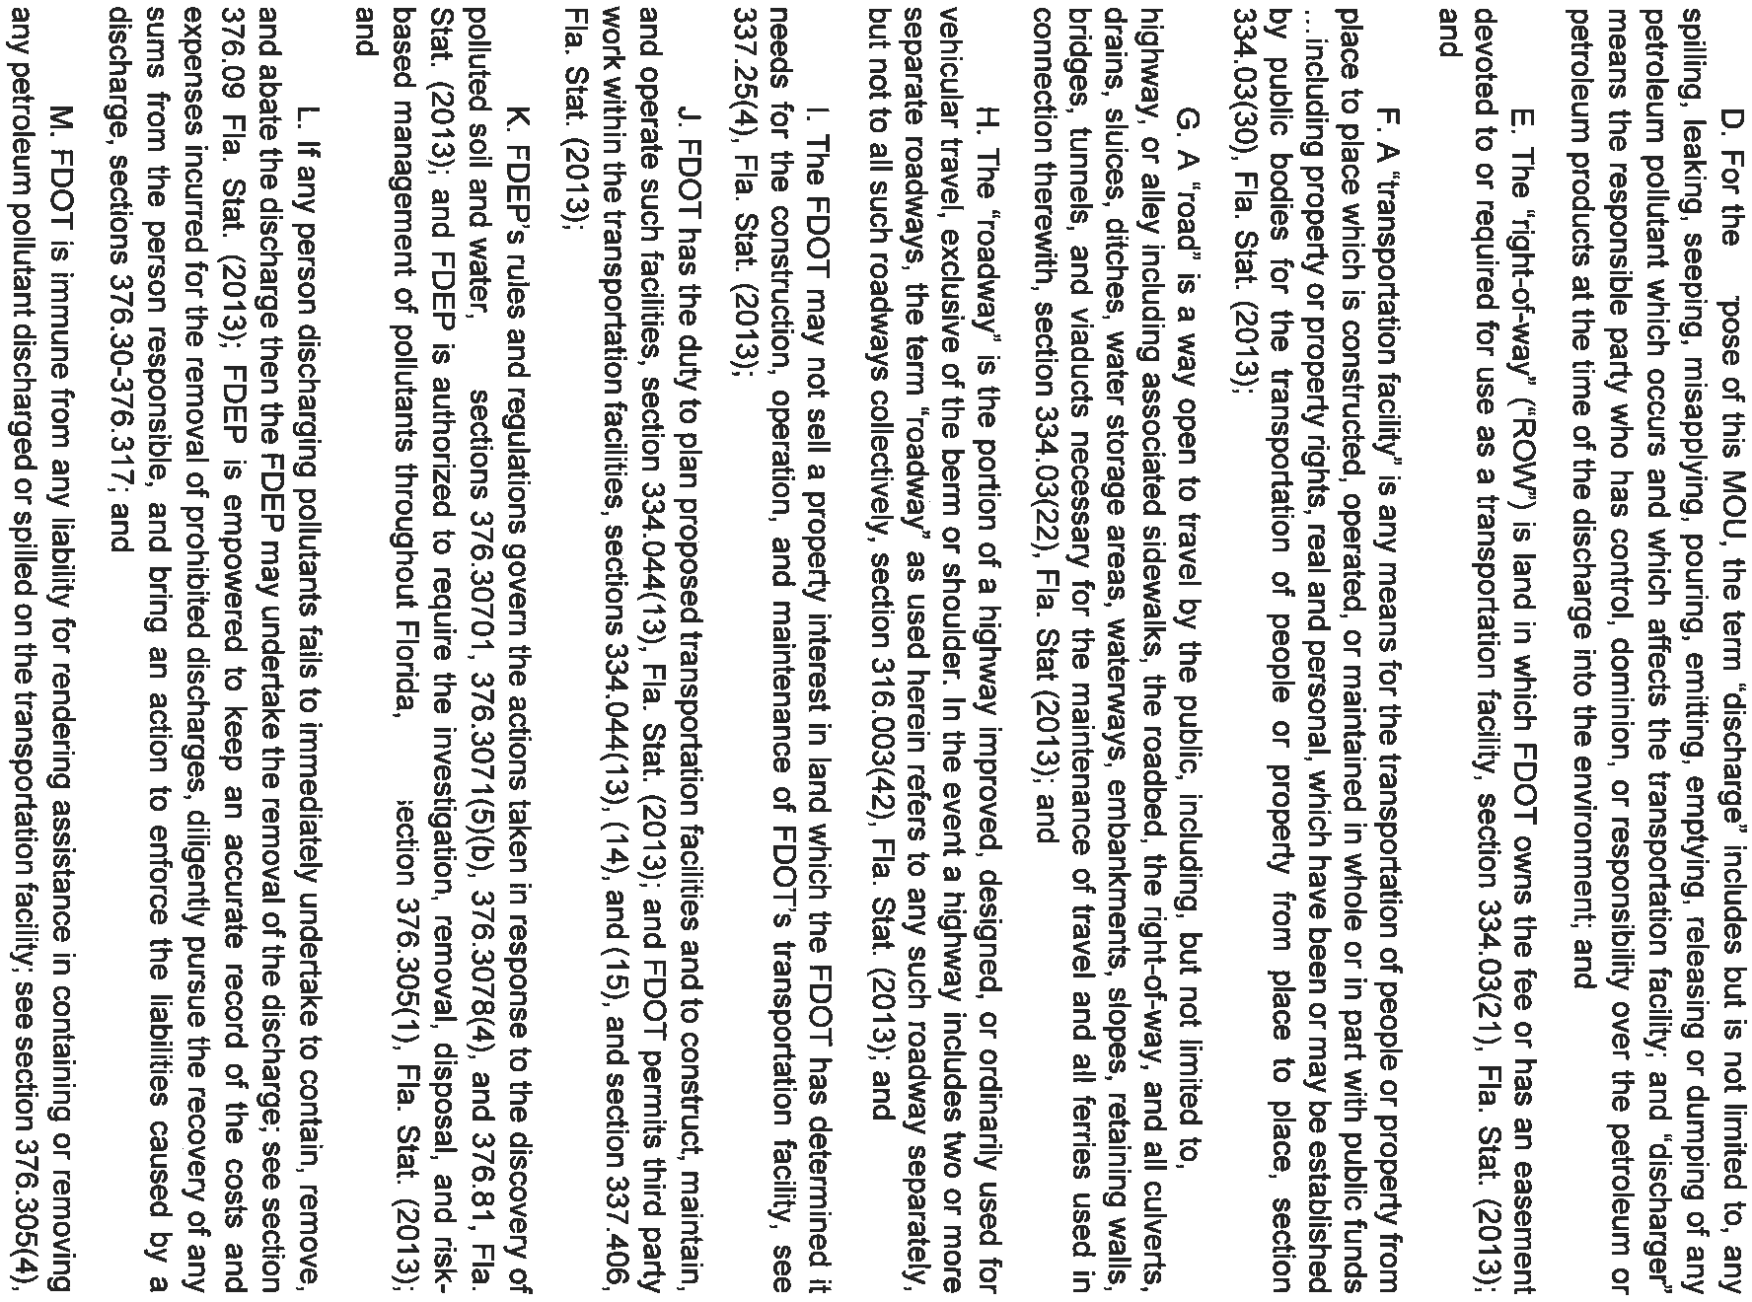





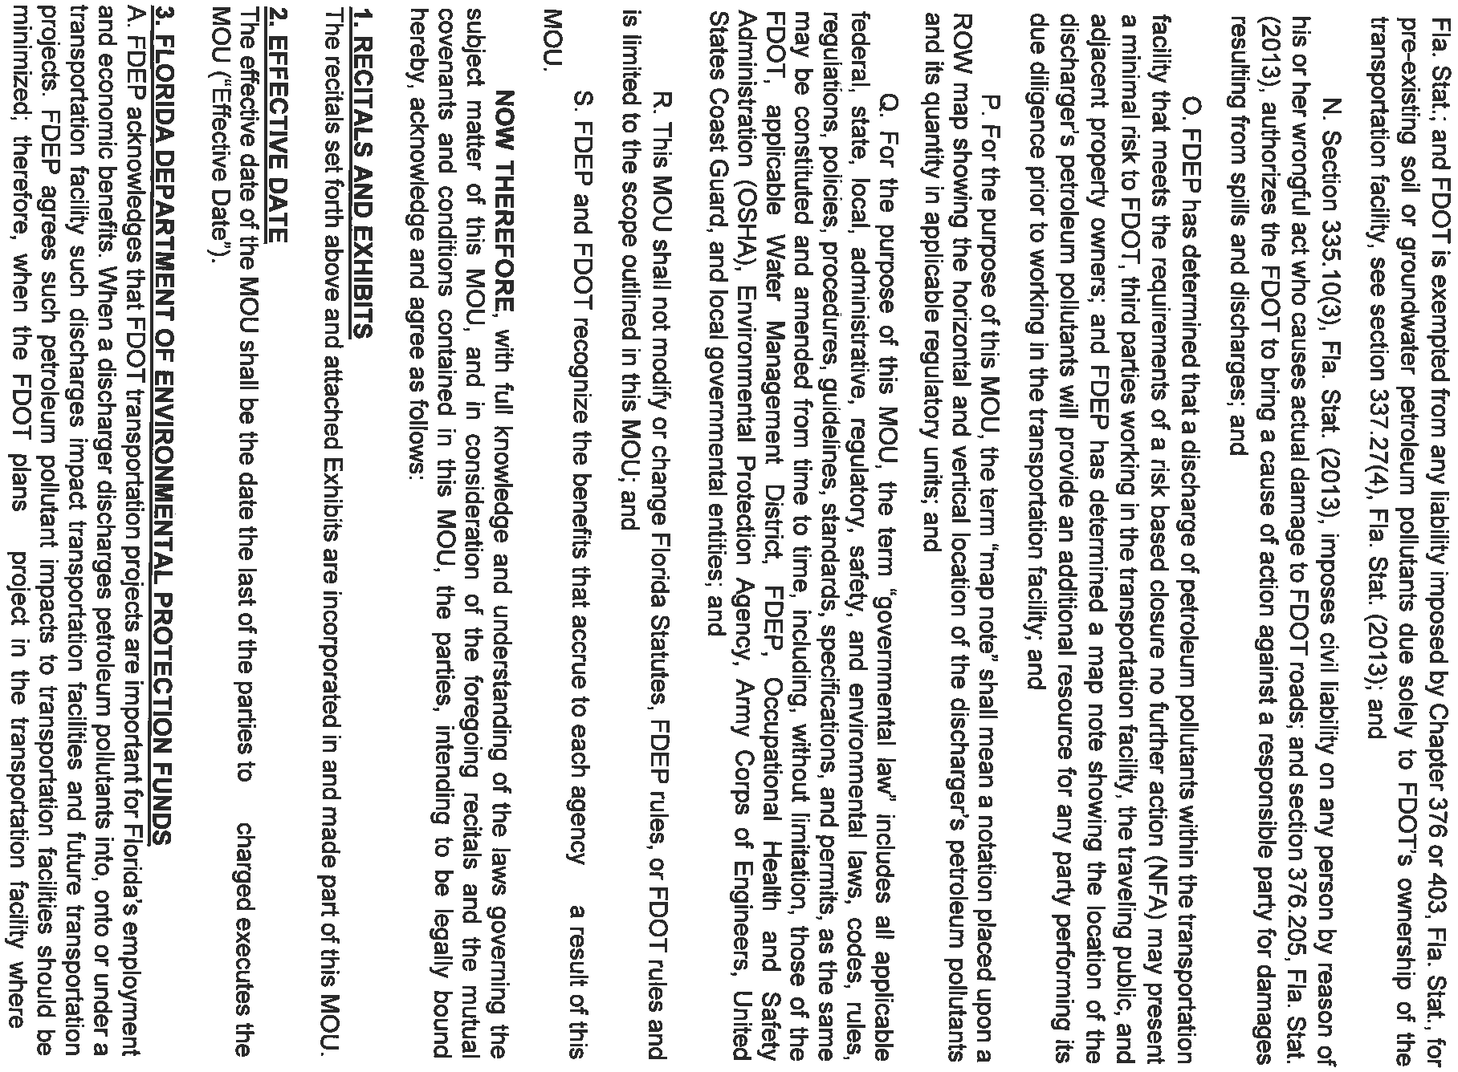




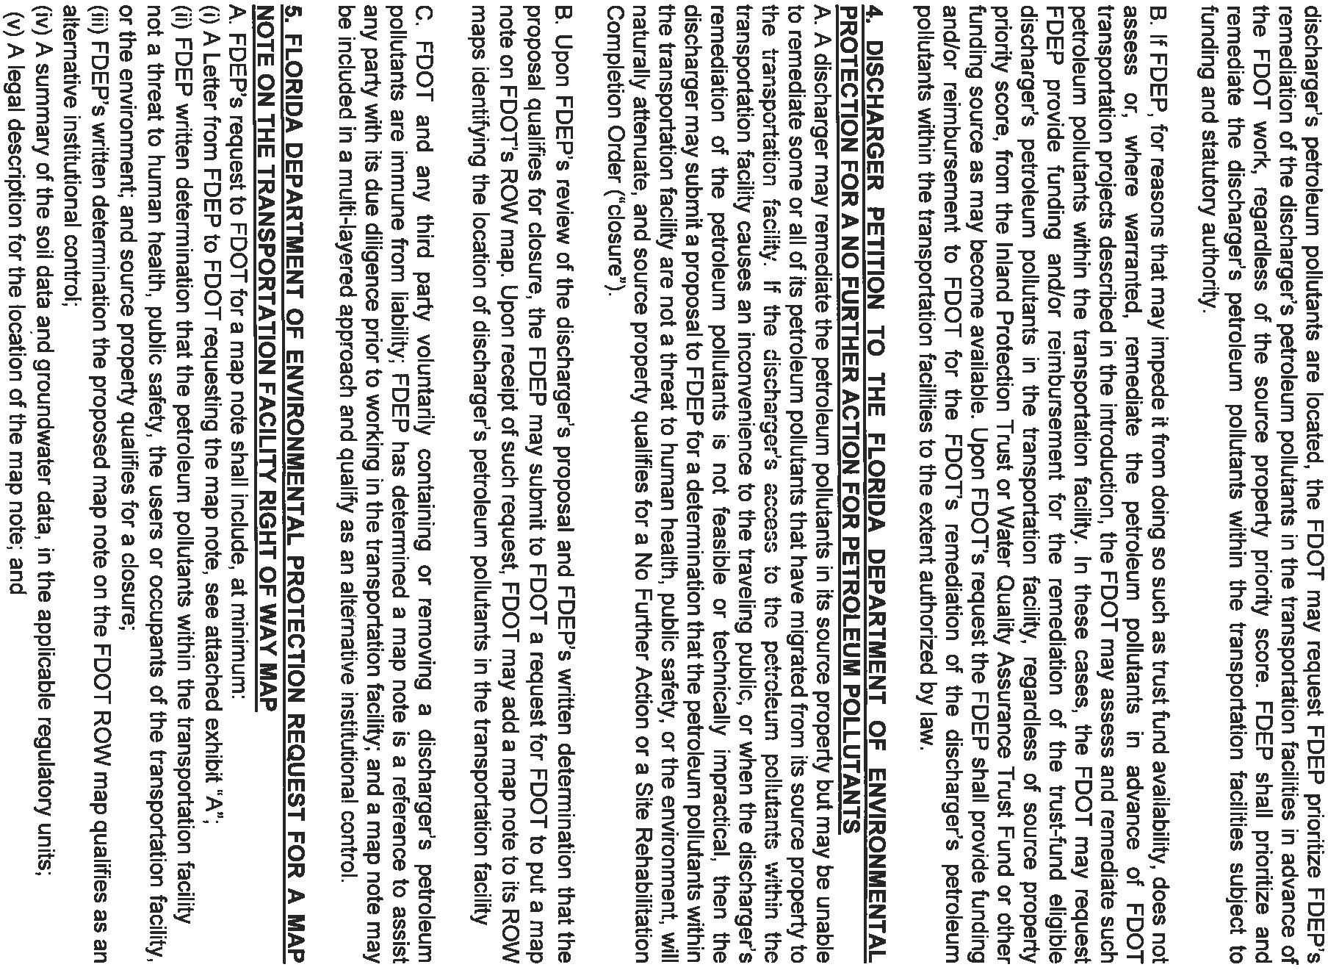


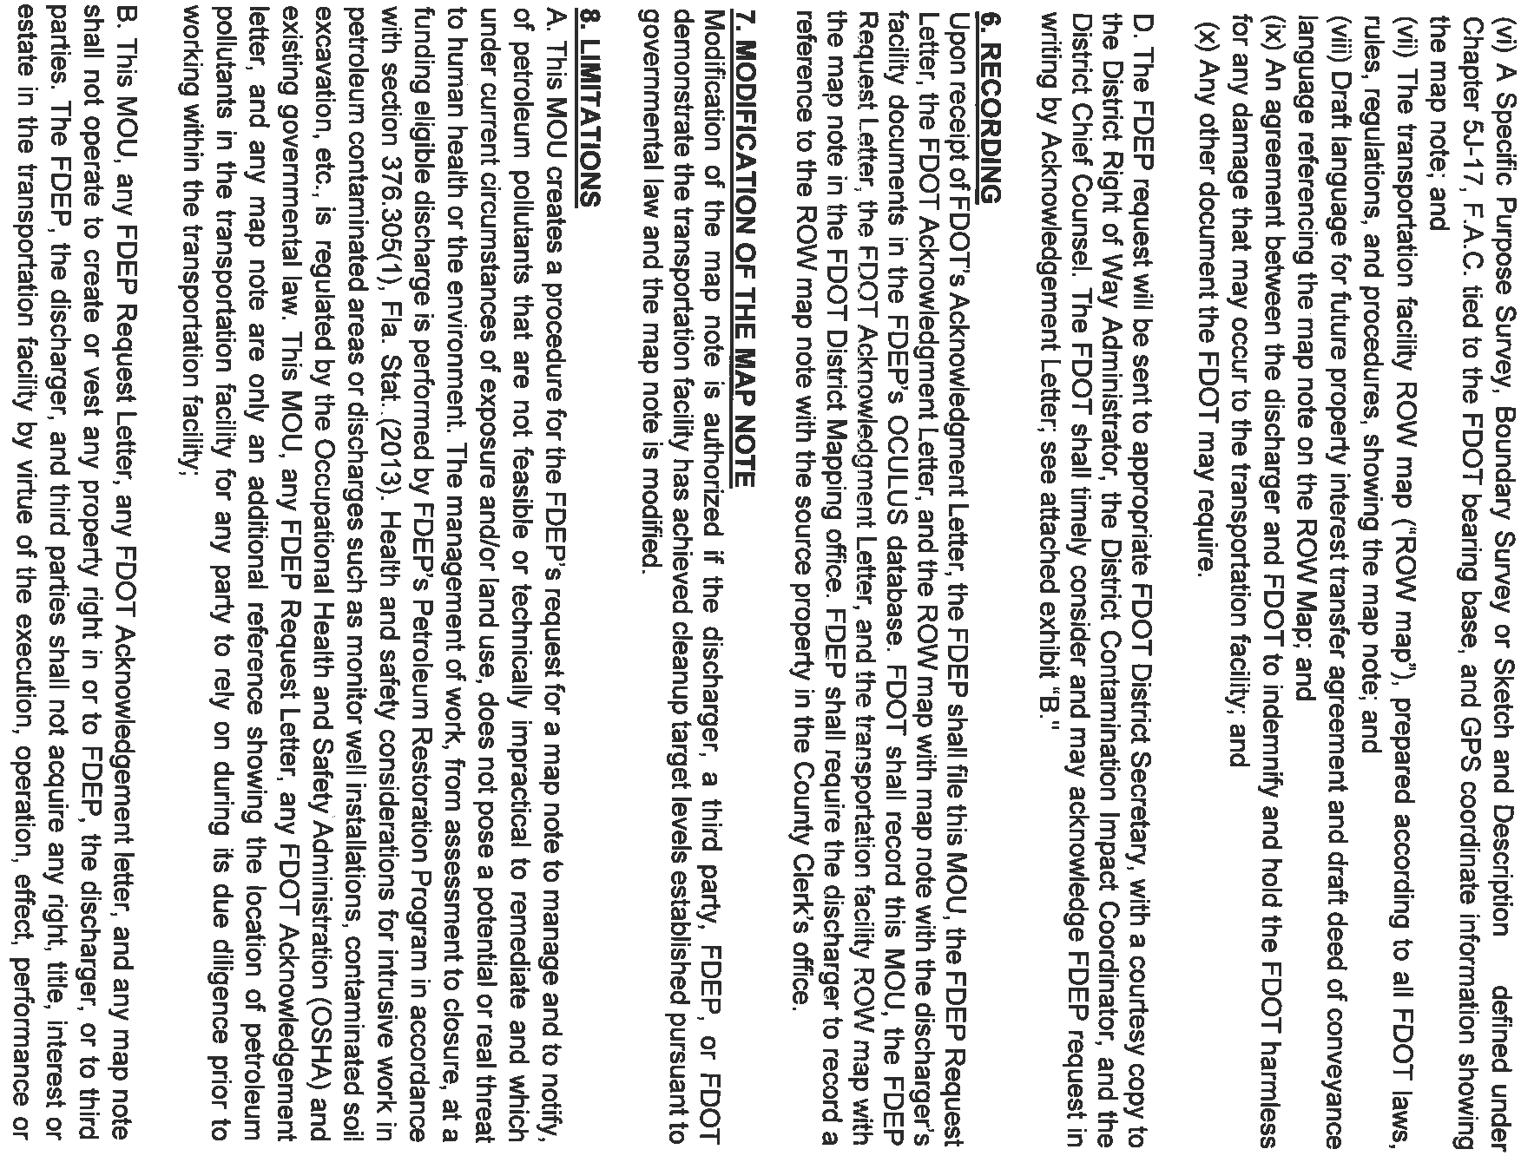

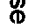

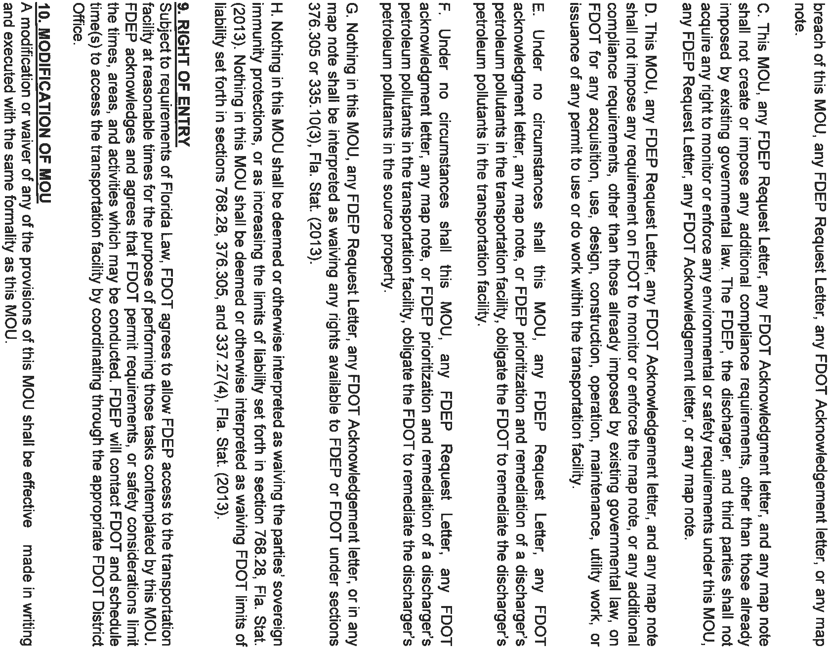

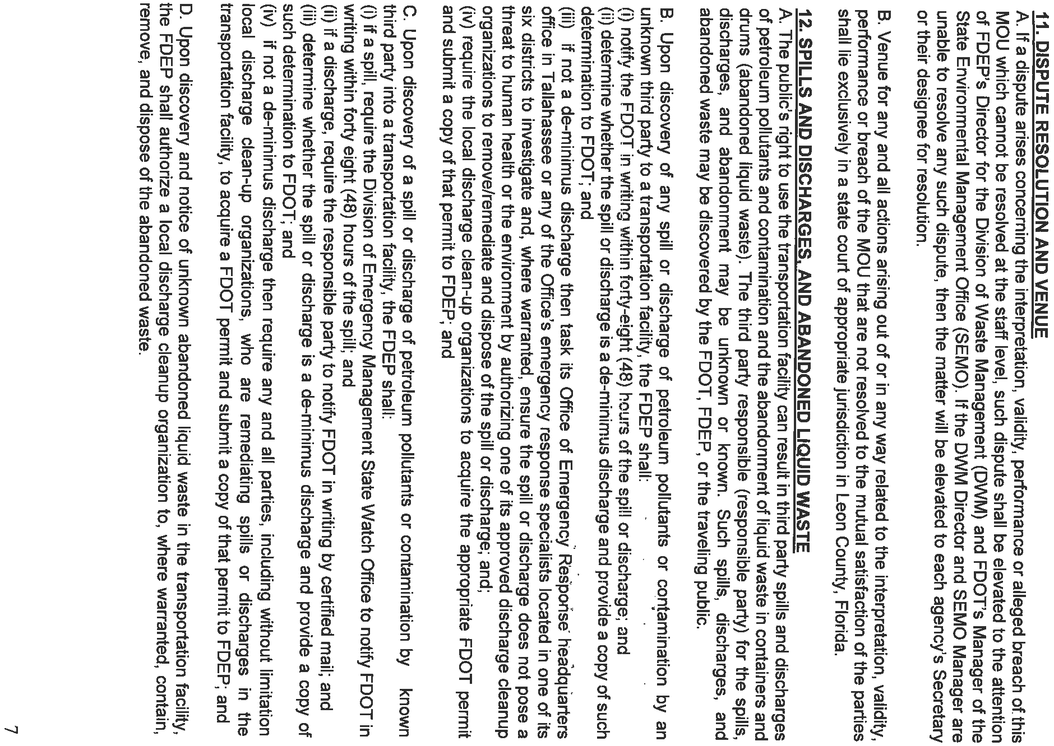




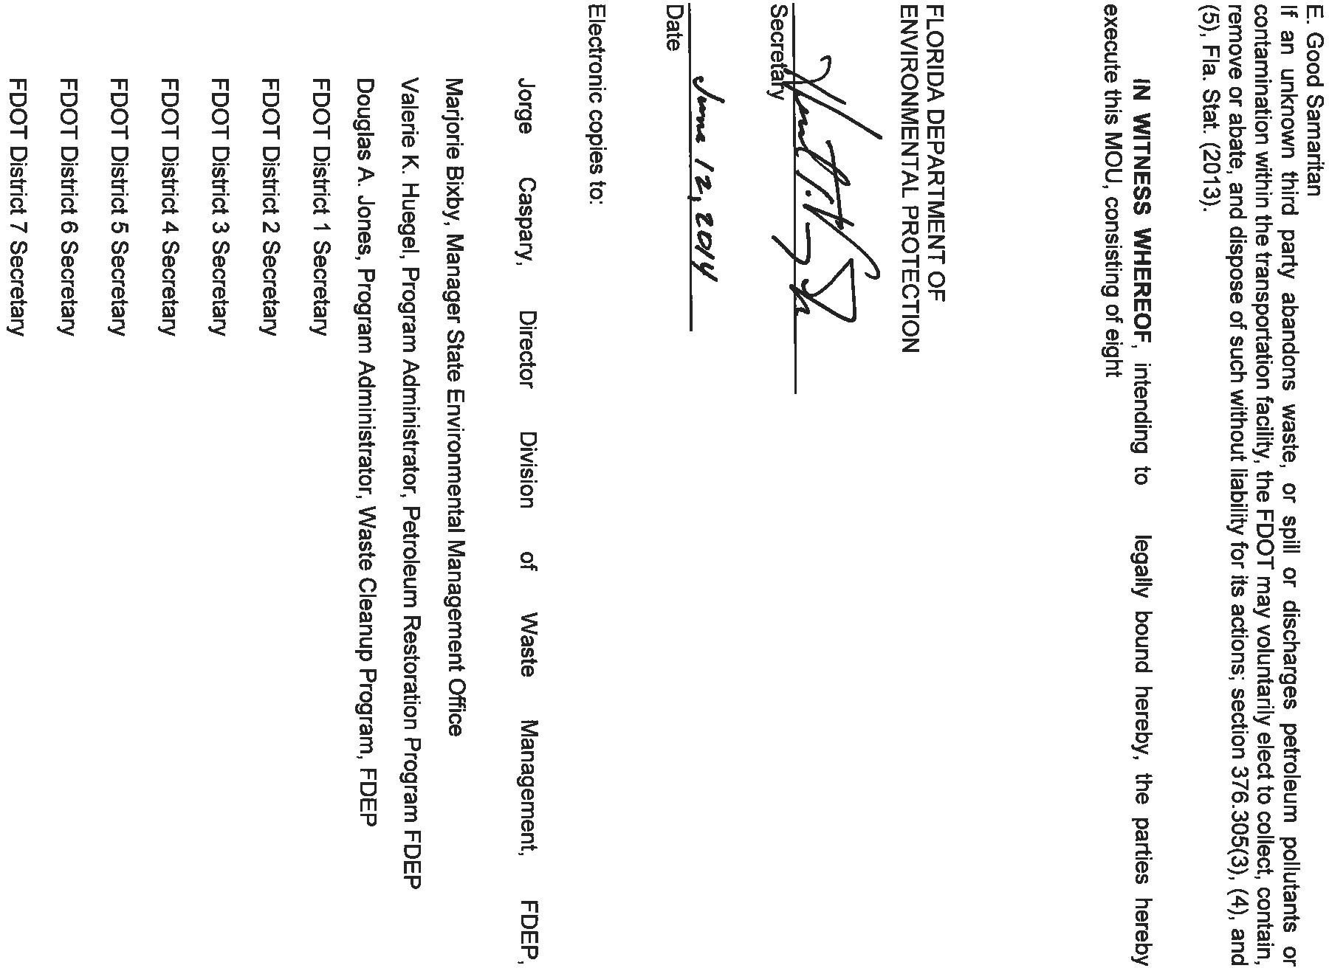







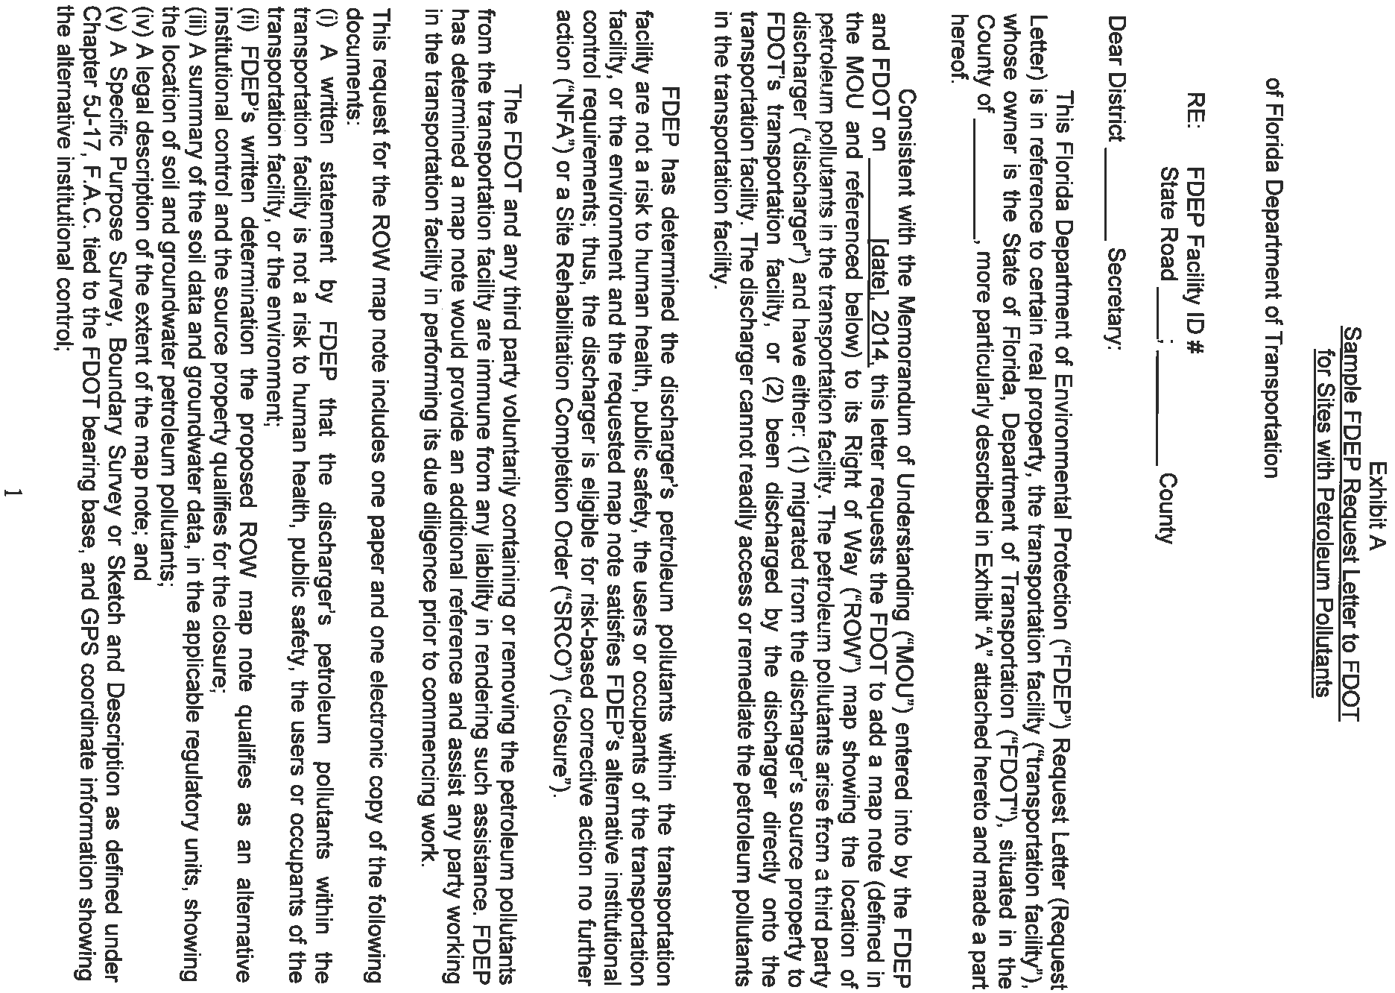


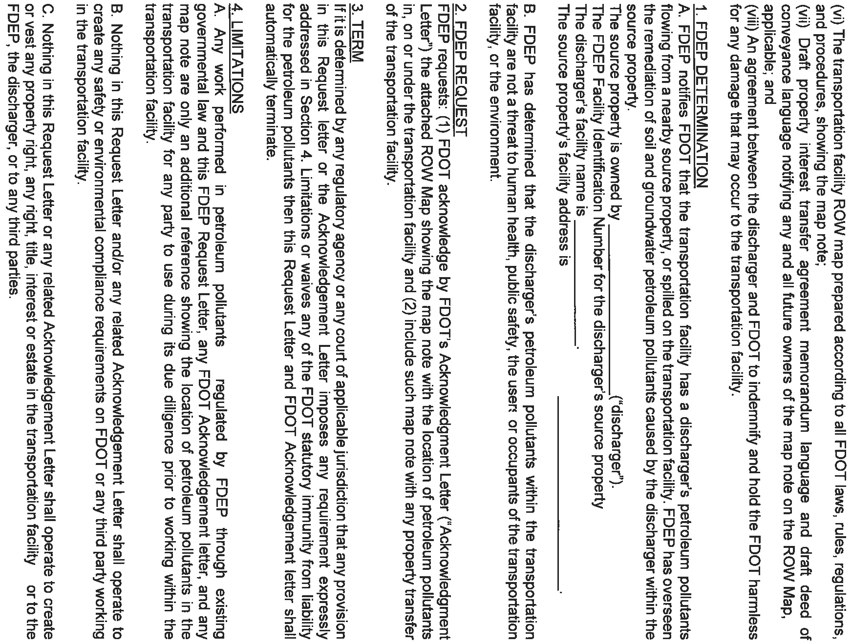



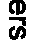

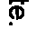

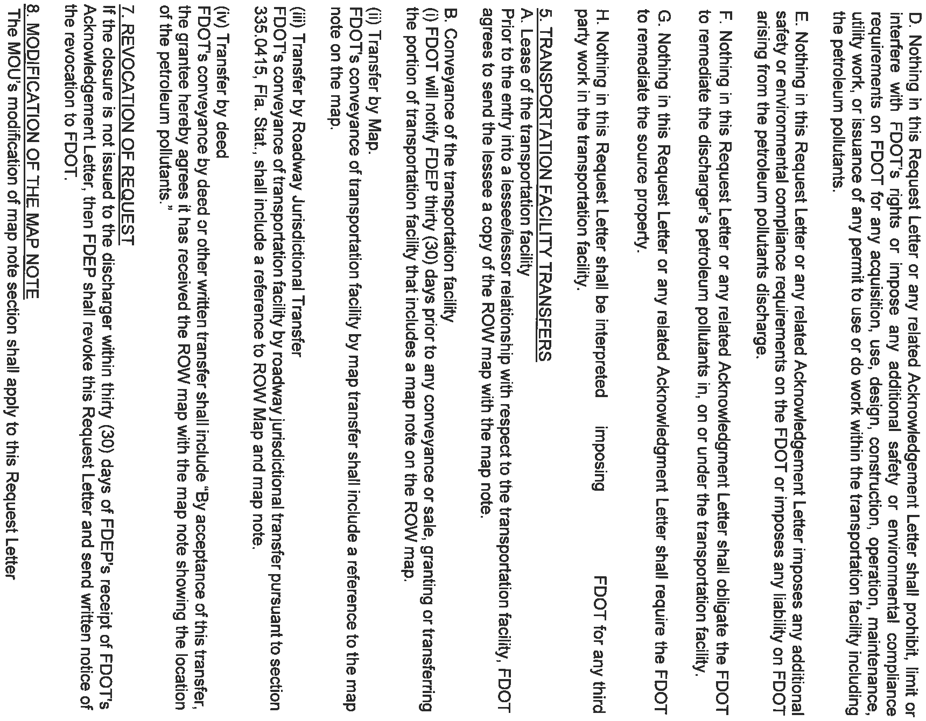




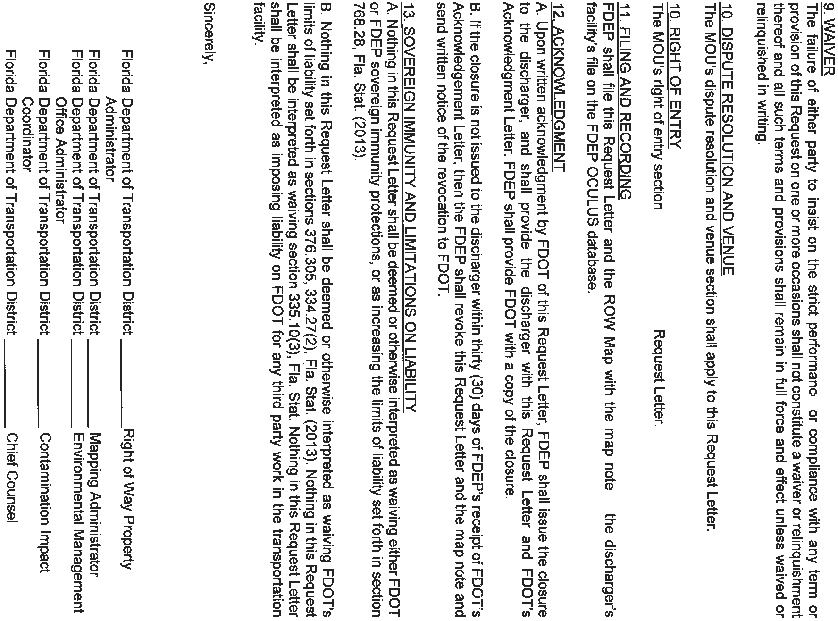





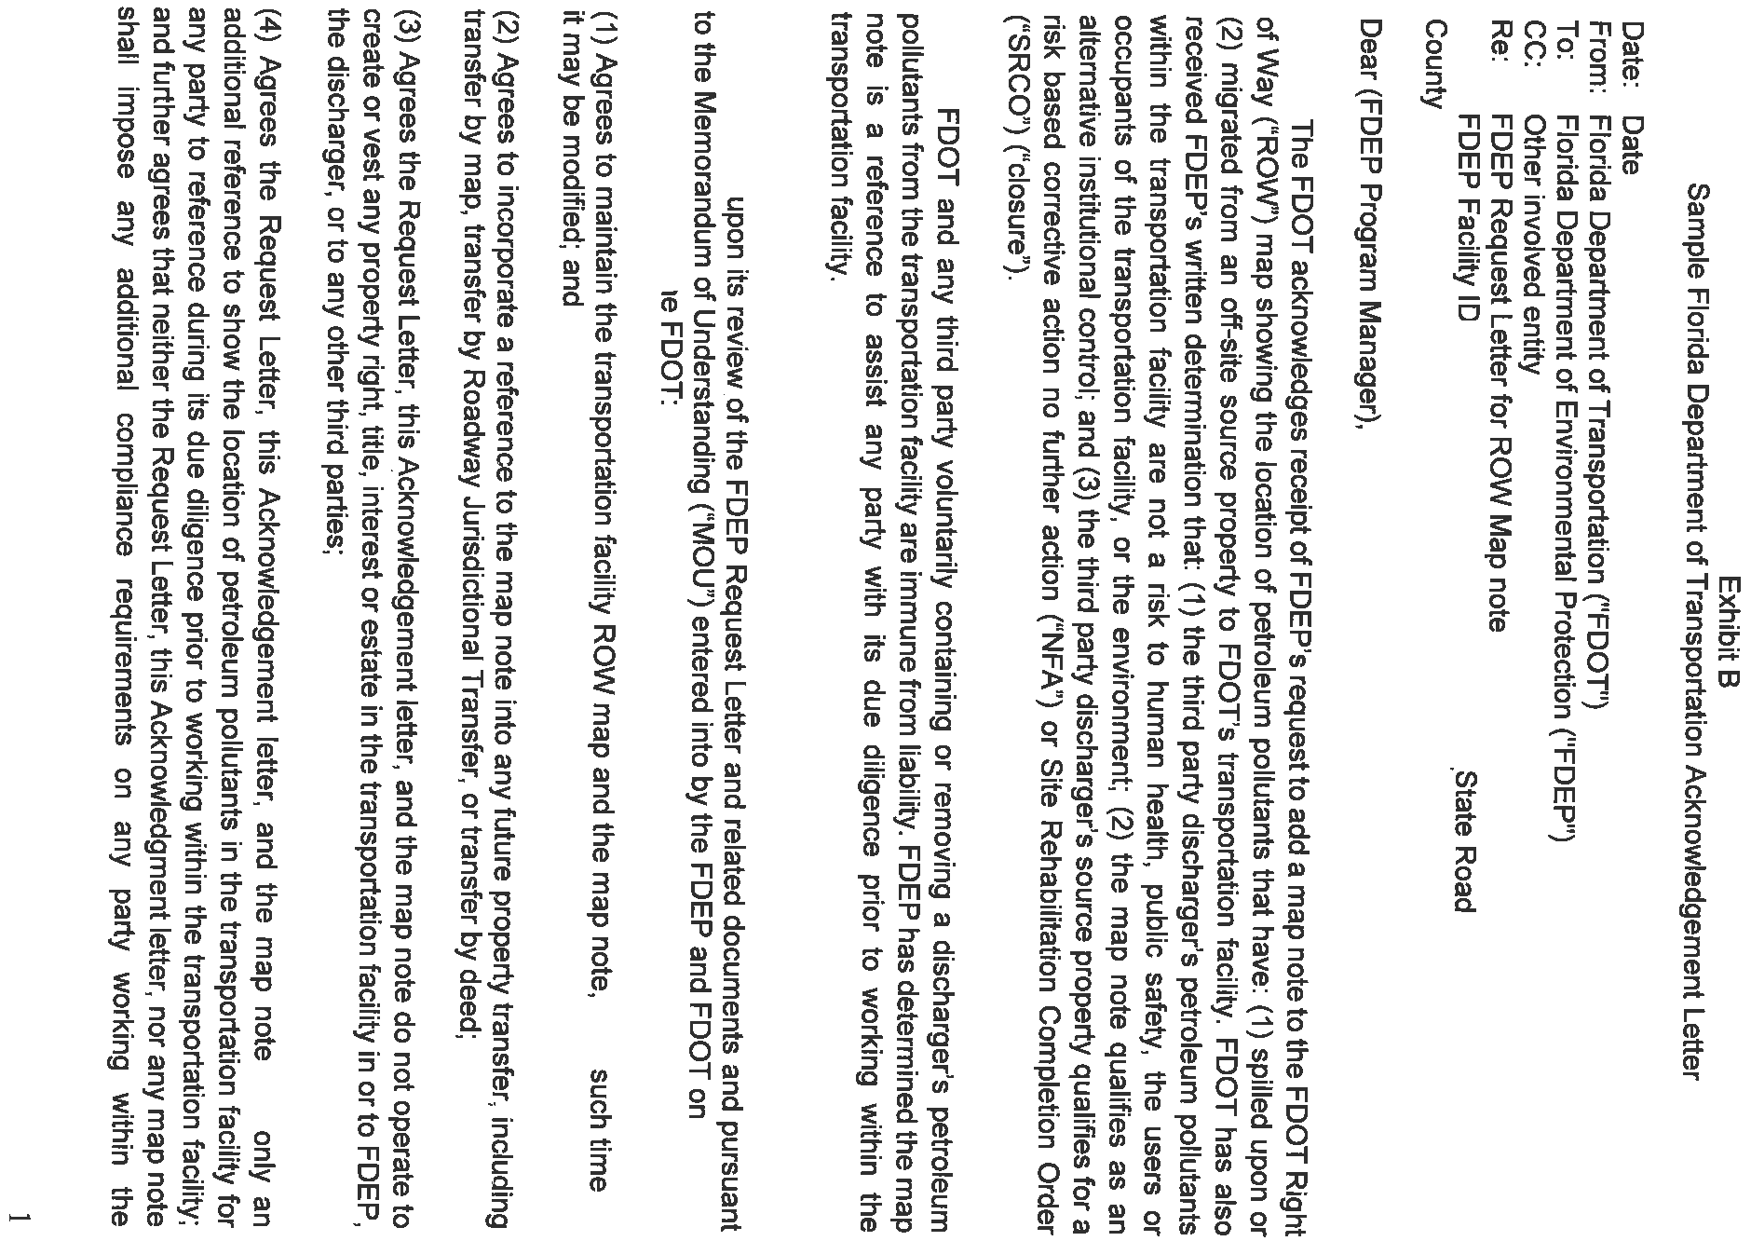






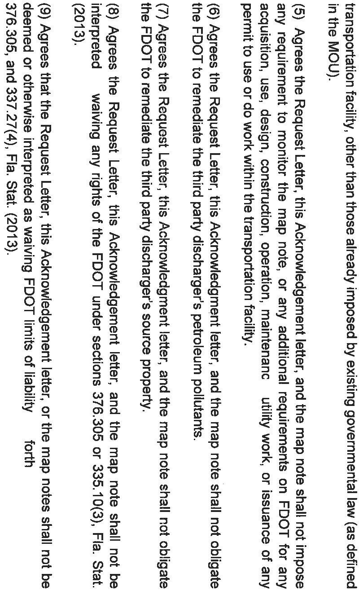






Attachment 32: Procedure For Use Of FDEP And FDOT MOU

The following is the procedure for the use of the MOU as an institutional control on contaminated FDEP Right of Way property. The following actions should take place in order.

1. The Responsible Party (RP)/Discharger should submit a proposal to FDEP for a Conditional Site Rehabilitation Completion Order (CSRCO) that includes information for FDOT Right of Way (ROW) property. The proposal for the FDOT ROW portion should include:
- Special purpose survey, boundary survey or sketch and description as defined under Chapter 5J-17, F.A.C., tied to the FDOT bearing base, and station and offset, and GPS coordinate information showing the map note;
- Summary of soil and/or groundwater data;
- Legal description and map note restricted area;
- Proposed restrictions and requirements;
- DOT ROW Map and Note signed and sealed by a Florida licensed surveyor;
- Indemnity agreement between FDOT and RP/Discharger. See Attachment 33; and
- Recorded reference (aka “deed notice”) (to be recorded on the non-ROW source-property after FDOT creates the Map Note)

2. FDEP should review the RP/Discharger Proposal. FDEP should request that FDOT add the ROW Map Note to its ROW Maps.

- FDEP should send to FDOT the MOU Exhibit A Request Letter (see Exhibit A of the MOU www.dep.state.fl.us/waste/misc/dnd/DEP_DOT_MOU_01Aug14.pdf) and the following attachments:

    - Letter Attachment 1 - summary of soil and/or groundwater data;
    - Letter Attachment 2 - special purpose survey, boundary survey or sketch and description as defined under Chapter 5J-17, F.A.C., tied to the FDOT bearing base, and station and offset, and GPS coordinate information showing the map note restricted area, and a legal description of the restricted area;
    - Letter Attachment 3 - DOT ROW Map Note: diagram of restricted area on ROW map with the following notation:
Petroleum Impacted Area
FDEP ID# ____________________ (from STCM, COMET, etc.) FDOT ID# ____________________(Item-Segment No., Financial Project No., Project No.)
SRCO dtd ___/___/___
    - Letter Attachment 4 - Indemnity Agreement between FDOT and RP/Discharger.

- FDEP should send the Request Letter and Letter Attachments to the following FDOT parties:

    - District Secretary;
    - cc: District ROW Administrator, District Contamination Impact Coordinator, District Chief Counsel and others per the MOU;
    - Mail Jocelyn Croci (FDOT) the originals of the signed and sealed specific survey with Map Note and signed indemnity agreement.

3. The RP/Discharger should publish constructive notice of the use of the DOT MOU as the IC for the DOT ROW property.

4. DOT should do the following:

- Send FDEP the Acknowledgement Letter (MOU Exhibit B) with the ROW Map showing the map note (MOU Ex A.2., www.dep.state.fl.us/waste/misc/dnd/DEP_DOT_MOU_01Aug14.pdf);
- Record the following with the DOT Mapping Office:
    - MOU;
    - FDEP Request Letter and Letter Attachments;
    - FDOT Acknowledgement Letter – to include RWMS recording; and
    - Transportation facility ROW map with the Map Note; and

5. FDEP should do the following:

- Upload the MOU, the FDEP Request Letter and exhibits, the FDOT Acknowledgment Letter, and the ROW Map with Map Note into RP/Discharger’s facility number in FDEP Oculus database;
- Require the RP/Discharger to record a reference (aka deed notice) to the DOT ROW Map Note with the source property in the county records office.

6. RP/Discharger should record a reference (aka deed notice) to the FDOT Map Note in the county land records office and provide a recorded copy of it to and FDEP.

7. FDEP should:

- Receive notification that the reference (deed notice) is recorded with the source property records in the county records office,
- Issue the SRCOC within 30 days of receipt of the FDOT Acknowledgement Letter with notification of recording Map Note; and
- Provide a link to all the above documents to RP/Discharger and DOT.

8. FDOT should:

- Update the transportation facility ROW Map Note in the FDOT district mapping office with the date of SRCO issuance; and
- Provide the updated ROW map with the CSRCO date to FDEP for scanning and recording in OCULUS.

Attachment 33: Sample FDOT Indemnity Agreement With Responsible Party/Discharger

Indemnification Agreement

In accordance with paragraph 5.A.(ix), Memorandum of Understanding (MOU), dated June 16, 2014, by and between the State of Florida Department of Environmental Protection (FDEP) and the State of Florida Department of Transportation (FDOT), collectively the parties, which addresses discharges of petroleum pollutants from off-site source properties to state transportation facilities, the FDOT accepts this Indemnification Agreement as executed by {{name of party providing indemnification}} (the Requestor), who has sought closure of the {{name of property}} Property FDEP SITE {{number}} (site) from FDEP and FDOT. Petroleum products have migrated from the Requestor’s property into a portion of the FDOT’s {{name of ROW}} in {{city, county}}, FL, (Transportation Facility), see attached Exhibit A. FDEP has requested FDOT place a Map Note on its right-of-way map showing the location of the site’s petroleum pollutants within the Transportation Facility. FDOT is amenable to FDEP’s request given the Requestor’s willingness to execute and perform this Indemnification Agreement.

THEREFORE, the {{Requestor's name}} agrees to indemnify FDOT and to hold it harmless for any damage that may occur to the Transportation Facility arising from or as a result of the site’s petroleum pollutants. The Requestor agrees to defend, indemnify and hold FDOT harmless from any liability arising from the site’s petroleum pollutants. Further, Requestor agrees to be responsible for any damage sustained by FDOT as a result of the site’s petroleum pollutants.

Requestor's Signature _____________________________________

Requestor's Printed Name_______________________________

Requestor's Address____________________________________________________________

Requestor's Telephone Number/Email address___________________/ ______

Signed, sealed and delivered in the presence of:

______________________________________________ Date:________________________
Witness
Print Name:____________________________________

______________________________________________ Date:________________________
Witness
Print Name:____________________________________

STATE OF ________________________________)
COUNTY OF ______________________________)

The forgoing instrument was acknowledged before me this ____ day of _________, 20__, by
__________________________________________.

Personally Known ____ OR Produced Identification____.
Type of Identification Produced ____________________.

_________________________________
Signature of Notary Public

Attachment 34: Recorded Reference (Deed Notice) For Florida Department Of Transportation Memorandum Of Understanding Institutional Controls

This instrument prepared by
and return to:
_____________________
_____________________

_____________________

NOTICE OF PETROLEUM DISCHARGE AFFECTING FDOT PROPERTY
THIS NOTICE OF PETROLEUM DISCHARGE AFFECTING FDOT PROPERTY (hereinafter “Notice”) is made this _____ day of _______________, 20 __, by __________________ (hereinafter “OWNER).
RECITALS
A. OWNER is the fee simple owner of that certain real property more particularly described on Exhibit “A” attached hereto and made a part hereof (hereinafter the “Property”)
B. There are “petroleum pollutants” (as that term is defined in the Memorandum of Understanding [hereinafter "MOU"] referred to below) which are emanating from a discharge located on or under the Property, and such petroleum pollutants are going into, onto, or under an adjacent “transportation facility” as that term is defined in the MOU referred to below and in Section 334.03(30), Florida Statutes;
C. The Florida Department of Environmental Protection (hereinafter “FDEP”) has determined that the circumstances of such petroleum pollutants satisfy FDEP requirements for a risk based corrective action no further action (hereinafter “NFA”) determination or a Site Rehabilitation Completion Order (hereinafter “SRCO”) pursuant to the provisions of the MOU between FDEP and the Florida Department of Transportation (hereinafter “FDOT”) dated June 16, 2014;
D. Pursuant to the procedures contemplated by the terms of the MOU, FDOT has added a “map note” to the applicable FDOT Right of Way map for the affected transportation facility. A copy of that map note is attached to this Notice as Exhibit “B” and is made a part hereof (hereinafter “Map Note”). The Map Note shows the location of the existing petroleum pollutant contamination within the transportation facility;
E. It is the intent of this Notice to facilitate FDEP’s and FDOT’s use of the Map Note to manage and to notify any and all parties of the presence of petroleum pollutants that are not feasible or are technically impractical to remediate and which FDOT and FDEP have determined under current circumstances of exposure and/or land use do not pose a potential or real threat to human health or the environment. Through the above described MOU process FDEP has determined that the Map Note qualifies as an alternative institutional control.
NOW, THEREFORE, to induce FDEP to issue the SRCO or the NFA determination and for other good and valuable consideration, the receipt and sufficiency of which are hereby acknowledged, OWNER agrees as follows:
- The foregoing recitals are true and correct and are incorporated herein by reference.
- It is the intention of OWNER that this Notice shall touch and concern the Property, run with the land and with the title to the Property, and shall apply to and be binding upon and inure to the benefit of OWNER, FDOT and FDEP, and to any and all parties hereafter having any right, title or interest in the Property or any part thereof. All references to “OWNER”, “FDEP” and “FDOT” shall also mean and refer to their respective successors and assigns.
- In order to ensure the perpetual nature of these provisions, OWNER shall reference these Notice provisions in any subsequent lease or deed of conveyance, including the recording book and page of record of this Notice.
- This Notice is binding until a release is executed by OWNER and the FDEP Secretary (or designee) and is recorded in the public records of the county in which the Property is located.
- If the Map Note is modified pursuant to Section 7 of the MOU, FDEP agrees to allow OWNER to terminate this Notice. This Notice may be modified in writing only. If there is any subsequent amendment to this Notice, it must be executed by both FDEP and OWNER. FDEP agrees to inform OWNER of any modification of the MOU, as is authorized by Section 10 of the MOU.
- If any provision of this Notice is held to be invalid by any court of competent jurisdiction, the invalidity of that provision shall not affect the validity of any other provisions of the Notice. All such other provisions shall continue unimpaired in full force and effect.
- This Notice shall not operate to create or vest any property right in or to FDEP, FDOT, or to third parties. FDEP, FDOT and third parties shall not acquire any right, title, interest or estate in the Property by virtue of the execution, operation, effect, performance or breach of the MOU, the Map Note or this Notice.
- OWNER covenants and represents that on the date of execution of this Notice that OWNER is seized of the Property in fee simple and has good right to create, establish, and record this Notice.
IN WITNESS WHEREOF, OWNER has executed this instrument, this _____ day of _______________, 20__.
OWNER
{{COMPANY NAME, IF APPLICABLE}}
By:
Name: ________________
Title:__________________
Full Mailing Address:
___________________
___________________
___________________

Signed, sealed and delivered in the presence of:
Date:
Witness
Print Name:
Date:
Witness
Print Name:
STATE OF )
COUNTY OF )
The foregoing instrument was acknowledged before me this _____ day of _______________, 20__, by ______________________________ as ___________ of ________________________, a _______________________, on behalf of the _________________________________.

Personally Known _______________ OR Produced Identification _______________. Type of Identification Produced _______________.
Signature of Notary Public

Attachment 35: Definitions And Acronyms

Definitions

All terms used in this guidance document have the meanings set forth in Chapter 62-780, F.A.C., or applicable provisions of Chapter 376, Fla. Stat.

The following additional terms are defined for the purpose of this guidance document:

Conservation Easement. A “right or interest in real property which is appropriate to retaining land or water areas predominantly in their natural, scenic, open, agricultural, or wooded condition; retaining such areas as suitable habitat for fish, plants, or wildlife; retaining the structural integrity or physical appearance of sites or properties of historical, architectural, archeological, or cultural significance; or maintaining existing land uses “and which prohibit or limit certain uses. See Section 704.06, Fla. Stat.

Deed Restriction. A clause in a deed included by the seller that restricts future use of the land in a manner specified in the deed.

Easement. An interest in land owned by another person, consisting in the right to use or control the land, or an area above or below it, for a specific limited purpose (for example, for access).

Encumbrance. A lien on the title applicable to a particular parcel of real property.

Encumbrance Map. A scaled and labeled map, diagram, or survey showing the locations of all encumbrances identified in the Title Report relative to the proposed areas to be restricted by the restrictive covenant. (See Attachment 14 for example).

Engineering Controls (EC). “Engineering control” means use of existing features (such as buildings) or modifications to a site to reduce or eliminate the potential for migration of, or exposure to, contaminants. Examples of modifications include physical or hydraulic control measures, capping, point-of-use treatments, or slurry walls. See Section 62-780.200(14), F.A.C.

Institutional Control (IC). “[T]he restriction on use or access to a site to eliminate or minimize exposure to petroleum products' chemicals of concern, drycleaning solvents, or other contaminants. Such restrictions may include, but are not limited to, deed restrictions, restrictive covenants or conservation easements.” See Sections 376.301(22) and 376.79(10), Fla. Stat.

Institutional Control Registry (ICR). A registry of real properties prepared by FDEP to assist with tracking those properties upon which an institutional control has been imposed pursuant to the provisions contained in Chapters 376 or 403, F.S. and to allow the public and local governments to monitor the status of those controls. See Section 376.303(6), F.S. The Registry website address is
http://www.dep.state.fl.us/waste/categories/brownfields/pages/ICR.htm.

Interim Institutional Control. An institutional control that is entered into between the property owner and the FDEP prior to completion of the cleanup work.

Joinder and Consent. A written agreement by which one holding an interest in or encumbrance on real property (such as a party to a lease or an easement holder) agrees to the execution and recordation of an interest in the real property.

Lessee (tenant). One who has a possessory interest in real property under a lease.

Lessor (landlord). An entity who makes real property available for use by another party for a period of time with a lease and who retains title to or ownership.

Lienor (lien holder). A party that holds a legally enforceable right (lien) on real property such as a mortgage.

Minimum Technical Standards (MTS). The Minimum Technical Standards for preparation of a survey set forth in Chapter 5J-17.050-.052, F.A.C.

Mortgagee (mortgage holder). The creditor or lender that holds a mortgage interest on real property.

Ownership and Encumbrance Report. A report prepared by a title insurance company that reflects all parties having a recorded interest in the property, including owners, tenants under recorded leases, lienors, and easement holders, based on a title search that commences with the instrument constituting the root of title under Florida’s Marketable Record Title Act.

Restrictive Covenant (RC). A private agreement, in a deed or other written instrument that restricts the use or occupancy of real property, and the uses to which the property may be put.

Subordination. An agreement by which one who holds an otherwise senior interest (such as a mortgage) agrees to subordinate that interest to a normally lesser (usually later recorded) interest.

State Plane Coordinate (SPC) System. The system of plane coordinates which has been established by the National Ocean Service for defining and stating the positions or locations of points on the surface of the earth within the state using the zones established by the National Ocean Service in NOAA Manual NOS NGS 5, State Plane Coordinate System of 1983. The appropriate projection and zone designation shall be indicated and included in any description using the Florida State Plane Coordinate System. See Section 177.031(19), Fla. Stat.

Survey. A Specific Purpose Survey, Boundary Survey or Descriptions and Sketches to Accompany Descriptions, as defined under Chapter 5J-17, F.A.C. prepared using the Minimum Technical Standards defined in Chapter 5J-17, F.A.C.

Title Report. An Ownership and Encumbrance Report, a title insurance commitment or title insurance policy, that reflects all parties having a recorded interest in the property, including owners, tenants under recorded leases, lienors, and easement holders, based on a title search that commences with the instrument constituting the root of title under Florida’s Marketable Record Title Act.

18-1.004 Title.
(1) Initial Title Report. In order for the Division to obtain appraisals, a title report, including an adequate legal description of the property to be acquired sufficient to inform the Division and the fee appraisers of the status of ownership, encumbrances, exceptions, reservations, previous ownership history, and tax assessment history shall be obtained. If an acquiring agency has initiated the acquisition or the acquisition is for the benefit of an acquiring agency, then the title report shall be furnished to the Division by the acquiring agency.

Acronyms

DWM | FDEP Division of Waste Management
EC | Engineering Controls
F.A.C. | Florida Administrative Code
F.S. | Florida Statutes
GCTL | Groundwater Cleanup Target Level
GPS | Global Positioning System
IC | Institutional Control
ICECAP | Institutional Control/Engineering Control Audit Program
ICR | FDEP’s Institutional Control Registry
ICPG | Institutional Controls Procedures Guidance
MOA | Memorandum of Agreement
MOU | Memorandum of Understanding
OGC | FDEP’s Office of General Counsel
PRP | Petroleum Restoration Program
RC | Restrictive Covenant
SRCO | Site Rehabilitation Completion Order
SPC | State Plane Coordinates system
SCTL | FDEP’s Soil Cleanup Target Level
WCP | Waste Cleanup Program

Attachment 36: Institutional Controls Quick Reference Table

Institutional Control | Description | Documentation Required from PRSR  (electronic copy preferred) | Departmental Considerations
Declaration of Restrictive Covenant | A recordation made in the county property records by a property owner, and agreed to by DEP, restricting use of or access to property in order to control the spread of contamination or exposure to contamination. | - Draft Restrictive Covenant.  - Deed to property.  - Legal description of property to be restricted.  - Survey of area of restriction (if different from whole property or if there are stormwater features that need to be maintained).  - Title report.  - Constructive notice.  - Actual notice to holders of interest in the real property to be restricted. | - Most common type of IC received by the Department.  - Since many of these are/have been done, review can be accomplished quickly.  - This type of control runs with the land in perpetuity due to statutory exclusion from the Marketable Records Title Act (MRTA).
Municipal or County Ordinance requiring connection to water system | A local government regulation requiring that property owners hook up to an existing system that supplies potable water. | - Copy of the ordinance, or specific web link to documentation, the property owner wishes to rely upon, including maps supporting the characterization of the contamination property as within the service area and within the required proximity to the water system.  - Document or statement that property is either undeveloped or connected to water system.  - Deed to source property.  - Constructive notice.  - Actual notice to any offsite property owners, if contamination goes beyond property lines.  - Possibly deeds to off source properties impacted. This decision to be made on a case by case basis.  - Possibly title work to determine encumbrances for both the source and non-source properties. This decision to be made on a case by case basis. | - This type of IC is only contemplated for groundwater contamination.  - OGC must evaluate any ordinance proposed to ensure the ordinance is valid and meets the definition of IC in statute.  - Is this type of IC adequately protective considering the contamination at issue? I.E. is there a significant exposure risk if the contaminated GW is utilized or spread for non-potable uses.
Memorandum of Agreement for Land Use Controls (MOALUC) or Memorandum of Agreement for Restrictive Covenant (MOARC) for Ports and Airports | An agreement between a governmental or quasi-governmental entity with a high degree of control over access to the contaminated media. | - Draft MOA (MOALUC, MOARC, other names possible) – these are complex documents, generally developed between OGC and governmental entities’ counsel.  - Deed(s) to property.  - Legal description of property to be restricted.  - Details about known existing contamination.  - Construction Management Plan (for some agreements- this can also be handled in the body of the MOA)  - Title report.  - Constructive notice.  - Actual notice to holders of interest in the real property to be restricted. | - This type of IC is limited to governmental or quasi-governmental entities that have appropriate control over access to contaminated media within their jurisdiction.
Interagency Agreement (DOT MOU is our only current example) | An agreement between agencies that controls access to and exposure/spread of contamination. | - Signed Interagency agreement that sets out framework for the IC – this is a complex document.  - Proposal for a map note – developed with and acceptable to DEP and DOT, includes a request letter from DEP, summaries of soil and groundwater data and surveys and other documents detailing contamination.  - Reference to map note to be recorded in County land records. | - Currently, the only such agreement we have in place is the DOT MOU.  - DOT MOU is limited to petroleum contamination only in DOT ROWs. Adding other contaminants is currently being negotiated between DEP and DOT.
Land Management Plans for State Owned Lands Lands (currently Board of Trustees lands only, see above for DOT). | Plans developed by DEP or possibly other agencies for land owned and controlled by the state. | - Management plan.  - Statement from both the leasee and staff with DEP DSL approving the control. | - These can only be enacted on state owned lands.
Delineated areas under 62-524 | Areas that have been identified by rule of the Department as contaminated, which are used to inform decisions by Water Management Districts (WMD) on well and consumptive use permits (CUP). | - Rule reference to the specific part of 62-524 delineating the area  - Constructive notice  - Possibly title work to determine encumbrance holders for both source and non-source properties. This determination to be made on a case by case basis.  - Actual notice to any off-site property owners affected. | - Currently delineated areas are limited to those areas already adopted by rule. Those include historic EDB sites, some superfund/CERCLA sites and a few miscellaneous sites. Since delineated areas target potable water well installations, may still need to consider whether there is a significant exposure risk if the contaminated GW is utilized or spread for non-potable uses.
Municipal or County Zoning or Land Use Classifications, DRIs, Development Orders, or Deed Notices | Zoning classifications, land use categories, Development of Regional Impact Final Orders, development orders, or deed notices. | - These will all require various different components to form complete packages. All of them may be acceptable as part of a layered IC, but it is not likely that any of them can form the basis of an IC alone. Communicate with OGC early in the development of any closure plan that includes the use of these types of controls.  - Constructive notice | - These may provide some utility if layered along with other controls.
Conservation Easements | An easement given by the Property Owner for conservation purposes. | - Draft conservation easement and supporting documentation (much of this is similar to the supporting documentation required for a Restrictive Covenant, see the Conservation Easement handbook, SLER 1515 for specifics).  - Constructive notice | - This type of IC is recognized by statute, but may not be a good fit for controlling access to or spread of contamination.  - Requests to evaluate this type of IC should be forwarded to OGC early in the process of developing the IC.

Sections 376.30701(2)(d), 376.3071(5)(b)4, 376.3078(4)(d) and 376.81(1)(d), F.S.
Also see Rule 62-780.650 and 62-780.680, F.A.C.
Risk Management Options Level II and III (RMO II and RMO III) are the options for a Site Rehabilitation Completion Order with institutional controls and are available when the controls are protective of human health, public safety, and the environment and are agreed to by the property owners of the affected properties. See Subsections 62-780.680(2) and .680(3), F.A.C.
A Professional Engineer would need to certify that the parking lot is competent for use as a cap, and an IC would need to require proper maintenance of the parking lot cap.
See Attachment 31: Engineering Controls Reporting and Monitoring.
There may be certain instances when the FDEP, to ensure the durability of the Engineering Control, may request that the owners/responsible parties present evidence that they have sufficient financial resources to maintain the Engineering Control.
As described on page 12, below, in certain circumstances the FDEP will agree to rely on existing governmental controls that may exist on non-source property, as an alternative to the requirement that a restrictive covenant be recorded on non-source property.
The North American Industry Classification System (NAICS) is the standard used by Federal statistical agencies in classifying business establishments for the purpose of collecting, analyzing, and publishing statistical data related to the U.S. business economy.
The owner of a property with isolated areas of soil contamination exceeding residential direct exposure SCTLs, but not exceeding commercial/industrial or leachability SCTLs, could elect to address the contamination in a variety of ways: (1) by implementing a property-wide IC restricting future land use to non-residential uses (as defined by the Department) or (2) by capping those areas where soil exceeds the residential SCTLs and describing in the IC the smaller contaminated area where the cap must be maintained. If the IC is to encumber only a portion of the property, then in order to avoid the possibility of creating title issues for the property owner, the recorded IC should show as an exhibit only the legal description and Survey (as defined below) of the restricted area. The IC should not attach a description of the entire parcel (unless included for the purpose of providing the FDEP with access to the restricted areas). Of course, the files maintained by the FDEP will include the description of the entire property as well as the restricted area, so in any event the legal description of the entirely-owned property must be submitted.
If an IC has been recorded with FDEP approval, the IC will run with the land and with the title to the property, and if the property is later subdivided the IC will continue to bind each affected lot within the subdivision. If the FDEP learns of such a subdivision, the IC Registry information should be updated to reflect the new multiple addresses. See Section E, IC Registry, below. If an IC has been approved by the FDEP and recorded for a property, and the criteria for direct exposure were met using a 95% Upper Confidence Limit (UCL) approach, then several things need to be evaluated. First, if the property is being divided into parcels smaller than the Exposure Unit (EU) used in the 95% UCL calculation, then there must be a showing to the FDEP that the contamination is no longer on the property (in which case those restrictions may be removed; see Section F, “Removing or Amending an IC,” below); or that subsequent sampling indicates that the contamination on the source property now meets conditional SRCO levels without the need for use of the 95% UCL (in which case the IC should be modified to remove the 95% UCL language and associated restrictions in the IC, see Section F below); or that subsequent sampling indicates that the contamination on each parcel derived from the source property now meets SRCO levels using the 95% UCL.
Restrictive covenants and deed restrictions are similar. Some differences lie in when the restriction is imposed and who is permitted to enforce it. In either case, the owner of the property must impose the restriction. A deed restriction is a restriction included in the deed of conveyance created and recorded by the seller of real property to control the use of the property by the buyer and any subsequent owners and may be enforceable by the seller against the buyer and successive owners of the property, depending on the language in the deed restriction. A restrictive covenant is created and recorded by the owner of the property to limit his or her own actions as well as those of subsequent owners of the property and is enforceable by third party beneficiaries named in the covenant (for example, the FDEP).
Attachment 3 consists of Sample Declaration of Restrictive Covenant Forms A and B. Form A should be used when the entirely owned parcel will be encumbered, and Form B should be used when only a portion of the parcel will be encumbered.
“Layered” ICs are used if a proposed control, alone, is insufficient to provide the necessary protections, but multiple controls, together may provide the desired level of protection. These controls may include notices that are warnings to the public that a hazard may exist at the property. Examples of such notices include: warning signs posted at a property; legal notices in a newspapers of general circulation; “Deed Notices” that contain information but impose no obligations; and government advisories.
In November 2013, the Division of Waste Management issued a memorandum regarding institutional controls, including the use of institutional controls that do not require RCs. Revisions to this Institutional Control Program Guidance in 2016 restate and clarify that November 2013 memorandum.
See § 373.217(2), Fla. Stat. (stating that Chapter 373 is “the exclusive authority for requiring permits for the consumptive use of water.”); § 373.217(3), Fla. Stat. (Specifically stating that if any provision of Part II of Chapter 373, as amended, “is in conflict with any other provision, limitation, or restriction which is now in effect under any law or ordinance of this state or any political subdivision or municipality, or any rule or regulation promulgated thereunder, Part II shall govern and control, and such other law or ordinance or rule or regulation promulgated thereunder shall be deemed superseded for the purpose of regulating the consumptive use of water.” An exception is made for the Florida Electrical Power Plant Siting Act.); & § 373.217(4), Fla. Stat. (expressly preempting “the regulation of the consumptive use of water.”).
See Marion County. v. Greene, 5 So. 3d 775, 777 (Fla. 5th DCA 2009); Sw. Florida Water Mgmt. Dist. v. Charlotte County, 774 So. 2d 903, 918 (Fla. 2nd DCA 2001); Thomas v. Sw. Florida Water Mgmt. Dist., 864 So. 2d 455, 456 (Fla. 5th DCA 2003); and Heartland Environmental Council v. DCA and Highlands County, ¶ 169, DOAH Case No. 94-2095GM.
§ 373.219(1), Fla. Stat. Domestic consumption includes “the use of water for the individual personal household purposes of drinking, bathing, cooking, or sanitation” and “[a]ll other uses shall not be considered domestic.” § 373.019(6), Fla. Stat.
The sample RC and review process will be modified based on who is the site manager. District-Lead Sites The District should modify any of the sample RCs attached to this guidance document to indicate that the District is the FDEP signing representative, that the technical documents referenced in the covenant are on file at the District office, and that the District’s address is the location of stored documents. (Counties with delegated programs that are not required to obtain FDEP approval of technical decisions should follow the “District-Lead Sites” instructions). FDEP-Contracted Local Government Lead Sites The FDEP-contracted local government site/project manager must submit the draft RC and accompanying documentation to the appropriate FDEP liaison. For petroleum sites, after reviewing, the FDEP liaison will send the documents to a FDEP technical reviewer in the Petroleum Restoration Program (PRP). The PRP reviewer is the Professional Engineer (PE) or Professional Geologist (PG) on the county team. If approved on its technical merits, all of the above documentation, including supporting legal documents, must be forwarded to FDEP OGC with a cover memo indicating who performed the FDEP technical review. See Sample Memo to OGC, Attachment 6. If the FDEP technical reviewer determines that the site is not yet ready for an IC, the documentation will be returned to the contracted local government. (Counties with delegated programs that do require FDEP-approval of technical decisions should follow the instructions for “FDEP-Contracted Local Government Lead Sites” throughout this document).
Any reference to “FDEP technical professional staff” includes not only staff in the six FDEP Districts and the Tallahassee headquarters office, but also FDEP contracted local governments and delegated programs and FDEP contracted private site/project managers (hereinafter referred to as site/project manager).
See Chapter 2016-184, section 9, Laws of Florida
Generally, both land use restrictions and soil cap engineering controls do not need to be included at the same time, unless there are areas of contaminated soil not covered by the engineering control. Redundancy of restrictions is not typically necessary.
A copy of the recorded deed is necessary, but the copy does not need to be certified.
The legal description in the RC and Title Report will not match the legal description of the deed if the RC is intended to encumber only a portion of the property (i.e., some area less than the entirely owned parcel as described in the deed).
The terminology used to describe the area to be restricted should be used within statement two (2) of the RC, and it should be the same terminology used on the survey to identify the location of the restricted area.
In the event there is a conflict between the drawing of a portion of the property, the SPC or geographical coordinates and a written legal description of the same portion, the written legal description will control.
When a title search is performed in the county property records, all recorded instruments with legal descriptions that overlap with the legal description of the property that is the subject of the title search will be identified. All such recorded instruments have an effect on the title to the property and will somehow affect or encumber the property rights of the property owner. Some previously recorded encumbrances will conflict with a prospective RC making it necessary for the owner to seek subordination or joinder and consent (as applicable) from the holders of those encumbrances. If those previously recorded instruments are not subordinated, or their holders do not join and consent, then those encumbrances take priority over a subsequently recorded RC and the RC could fail as to that encumbrance. However, if certain conditions exist, a notice to existing easement, mortgage or other lien holders is acceptable in lieu of a joinder and consent or subordination. For further guidance see next page.
The examples of a material conflict between the restrictions in a proposed RC and an existing encumbrance outlined in the guidance should not be construed as the only instances where a material conflict may exist. Whether or not a material conflict exists is a matter for the property owner and encumbrance holder to determine and resolve, if possible. For this reason, FDEP encourages the property owner to engage in dialogue with encumbrance holders early in the process to resolve any potential issues.
Remember, in evaluating whether to pursue a conditional SRCO and an RC, the assessment and other data is based upon the conditions of the property at the time the assessment and remediation work was conducted which is prior to, for example, the construction of a stormwater facility.
When a title search is performed, all recorded documents that are related to the property described in the original property deed, and that affect the rights of the owner, are identified.
See Section 695.26, F.S.
Where an alternative IC is to be relied upon as an alternative to a restriction on groundwater usage, the items marked with an “*” should be provided.
Petroleum Local Programs must send this memo to PRP Local Program Coordinator. PRP technical staff will request additional information if necessary or forward the package to FDEP OGC with a memo concurring with the Petroleum Local Program.
This summary provides guidance on the administrative requirements for inspection, monitoring, maintenance and reporting for engineering controls. For discussion of some of the technical aspects of the various types of controls please see the white paper from the Contaminated Soils Forum Engineering Controls Focus Group “Engineering Controls Final Report”
The Petroleum Restoration Program uses the term “provisional approval” to describe this advance notice.

