CHAPTER 62-342

MITIGATION BANKS

62-342.100 Intent

62-342.200 Definitions

62-342.470 Establishment of Mitigation Credits

62-342.600 Mitigation Service Area

62-342.650 Land Use Restrictions on Mitigation Banks

62-342.700 Financial Responsibility

62-342.100 Intent.
(1) The Department recognizes that, in certain instances, adverse impacts of activities regulated under part IV of Cchapter 373, F.S., can be offset through the utilization of Mmitigation Ccredits from a permitted Mitigation Bank. This rule provides criteria for this mitigation alternative to complement existing mitigation criteria and requirements. This Cchapter is supplemental to and does not supersede any other criteria and requirements in rules promulgated under part IV of Cchapter 373, F.S.
(2) The responsibilities for implementing this Cchapter are described in Operating and Delegation Agreements between the Department of Environmental Protection (“Department”) and the water management districts (“Districts”). The Agreements are incorporated by reference in subsection 62-113.100(3), F.A.C. The term “Agency” applies to the Department or a District, as applicable, throughout this Cchapter.
(3) The Agency intends that Mitigation Banks be used to minimize mitigation uncertainty associated with traditional mitigation practices and provide greater assurance of mitigation success. It is anticipated that the consolidation of multiple mitigation projects into larger contiguous areas will provide greater assurance that the mitigation will yield long-term, sustainable, regional ecological benefits. Mitigation Banks shall be consistent with Agency endorsed watershed management objectives and emphasize Rrestoration and Eenhancement of degraded ecosystems and the Ppreservation of uplands and wetlands as intact ecosystems rather than alteration of landscapes to create wetlands. This is best accomplished through Rrestoration of ecological communities that were historically present. The establishment and use of Mitigation Banks in or adjacent to areas of national, state, or regional ecological significance is encouraged, provided the area in which the Mitigation Bank is proposed to be located is determined appropriate for a Mitigation Bank and the Mitigation Bank meets all applicable permitting criteria.
(4) Nothing in this Cchapter shall affect the mitigation requirements set forth in any Mitigation Bank agreement or any permit issued under Cchapter 84-79, Laws of Florida, or part IV of Cchapter 373, F.S., prior to (eff. date) February 2, 1994. If a permittee wishes to substantially modify a Mitigation Bank previously established by agreement or permit, the permittee must comply with this Cchapter. Additionally, some Mitigation Banks may be subject to the version of this section existing prior to July 1, 1996, under Ssections 373.4136(9) and (10), F.S., and will not be affected by amendments adopted after that date. This Cchapter does not prohibit an applicant from proposing project-specific, pre-construction on-site or off-site mitigation, without establishing a Mitigation Bank.
Rulemaking Authority 373.4131, 373.4136(11) FS. Law Implemented 373.4131, 373.4135, 373.4136 FS. History–New 2-2-94, Formerly 17-342.100, Amended 5-21-01, 2-19-15, Amended__________.

62-342.200 Definitions.
Terms used in this chapter shall have the meanings specified below.
(1) “Banker” means an entity that financially funds, creates, operates, manages, or maintains a Mitigation Bank pursuant to a Mitigation Bank Permit.
(2) “Bank Construction Phase” means the period necessary to implement the permitted work including, but not limited to, implementing site security measures, restoring or enhancing hydrology, restoring or enhancing land surface or drainage, installing plants, and conducting initial earth moving and land management activities (such as well/ditch plugging, restoration burning, chopping, thinning, or initial treatment or removal of invasive exotic or nuisance species). This phase begins with implementation of any permit required activities and phase ends with Agency acceptance of the As-Built Certification submitted by the Qualified Restoration Supervisor.
(3) “Bank Operational Phase” means the phase following the Bank Construction Phase when permitted activities are conducted to achieve the ecological conditions described by the Mitigation Bank Permit success criteria, and monitoring is performed and reported. This phase ends with an Agency determination that the defined success criteria and targets set forth in the Mitigation Bank Permit have been met and all Mitigation Credits have been released.
(4) “Bank Perpetual Phase” means the phase following full implementation of construction and operational activities prescribed in the Mitigation Bank permit, the Mitigation Bank has achieved Success, and all Mitigation Credits have been released. Perpetual land management activities, as outlined in the permitted mitigation plan, shall continue to the degree necessary to maintain and sustain the improved ecological condition. The entity responsible for this phase may be the Banker or the permit may be transferred to a Perpetual Management Steward.
(5) “Creation” means, for purposes of this Chapter, the manipulation of the physical, chemical, or biological characteristics present to develop an aquatic resource that did not previously exist at an upland site. Creation results in a gain in aquatic resource area and functions. Mitigation Banks should emphasize the Restoration and Enhancement of degraded ecosystems that were historically present, rather than alteration of landscapes to create wetlands.
(6)(2) “Department” means the Department of Environmental Protection.
(7)(3) “District” means a water management district as established in Cchapter 373, F.S.
(8)(4) “Ecological Value” means the value of functions performed by uplands, wetlands and other surface waters to the abundance, diversity, and habitats of fish, wildlife, and listed species. These functions include, but are not limited to: providing cover and refuge; breeding, nesting, denning, and nursery areas; corridors for wildlife movement; food chain support; and natural water storage, natural flow attenuation, and water quality improvement, which enhance fish, wildlife and listed species utilization.
(9) “Enhancement” means, for purposes of this Chapter, a type of mitigation that involves the manipulation of the physical, chemical, or biological characteristics of a site with the goal of improving natural or historic functions of a degraded resource. Enhancement results in a gain in aquatic resource functions, but does not result in a gain in aquatic resource area.
(10)(8) “Mitigation Bank” or “Bank” means a project permitted under Ssection 373.4136, F.S., undertaken to provide for the withdrawal of Mmitigation Ccredits to offset adverse impacts authorized by a permit under part IV of Cchapter 373, F.S.
(11)(7) “Mitigation Bank Permit” means a permit issued to a Bbanker to construct, operate, manage, and maintain a Mitigation Bank.
(12)(5) “Mitigation Credit” means a standard unit of measure which represents the increase in Eecological Vvalue resulting from Rrestoration, Eenhancement, Ppreservation, or Ccreation activities authorized by a Mitigation Bank Permit.
(13)(6) “Mitigation Service Area” means the geographic area within which Mitigation Credits from a Mitigation Bank may be used to offset adverse impacts of activities regulated under part IV of Cchapter 373, F.S.
(14) “Perpetual Management Steward” means the entity that has accepted responsibility from the Banker to manage the Mitigation Bank property to ensure the continued ecological success throughout the Bank Perpetual Phase, but is not responsible for the investment performance of the financial assurance mechanism.
(15) “Preservation” means, for purposes of this Chapter, a type of mitigation that does not involve the manipulation of the physical, chemical, or biological characteristics of the site, but which retains the current functions and continued maturation of a site in a protected condition. Preservation does not result in the gain of aquatic resource area or functions.
(16) “Qualified Restoration Supervisor” or “QRS” means the sole individual with the contractual obligation and authority to implement the Mitigation Bank Permit conditions and serve as the principal contact. This person must demonstrate to the Agency that they have the experience and qualifications necessary to successfully complete the type of mitigation project(s) proposed within the Mitigation Bank Permit. This person represents the Mitigation Bank and oversees all aspects of the ecological Restoration, Enhancement, Preservation, or Creation activites, including but not limited to: project construction and operation, adaptive management, and monitoring of all permit conditions and requirements, until such time as the bank is transferred to the Perpetual Management Steward.
(17)(9) “Regional Watershed” means a watershed as delineated in the following maps. (Figures 1, 2, 3, 4, and 5.)
Figure 1: Northwest Florida Water Management District ‒ “Regional Watersheds of the NWFWMD for Mitigation Banks, 7 Watersheds” (February 19, 2015), which is incorporated by reference herein.
Figure 2: Suwannee River Water Management District – “Watersheds of the SRWMD Mitigation Banks, 7 Watersheds” (February 19, 2015), which is incorporated by reference herein.
Figure 3: St. Johns River Water Management District – “Regional Watersheds for Mitigation Banking” (October 1, 2013), Appendix A, Figure 10.2.8-2, Applicants Handbook Volume II, which is incorporated by reference in subparagraph 62-330.010(4)(b)3., F.A.C., [October 1, 2013] (http://www.flrules.org/Gateway/reference.asp?No=Ref-03181), and in subsections 40C-4.091(1) [October 1, 2013] (https://www.flrules.org/Gateway/reference.asp?No=Ref-02524), 40C-42.091(1) [October 1, 2013] (https://www.flrules.org/Gateway/reference.asp?No=Ref-02525), and 40C-44.091(1), F.A.C., [October 1, 2013] (https://www.flrules.org/Gateway/reference.asp?No=Ref-02526).
Figure 4: Southwest Florida Water Management District – “Drainage Basins and Watersheds within the Southwest Florida Water Management District” (October 1, 2013), Figure 2.6, Applicants Handbook Volume II, is incorporated by reference in subparagraph 62-330.010(4)(b)4., F.A.C., [October 1, 2013] (http://www.flrules.org/Gateway/reference.asp?No=Ref-03176), and in rule 40D-4.091, F.A.C., [October 1, 2013] (https://www.flrules.org/Gateway/reference.asp?No=Ref-02527).
Figure 5: South Florida Water Management District – Appendix D: “SFWMD Basins for Cumulative Impact Assessments & Mitigation Bank Service Areas” (October 1, 2013), Applicants Handbook Volume II, including Appendices A through D, is incorporated by reference in subparagraph 62-330.010(4)(b)5., F.A.C., [October 1, 2013] (https://www.flrules.org/Gateway/reference.asp?No=Ref-02528), and in paragraph 40E-4.091(1)(a), F.A.C., [October 1, 2013] (https://www.flrules.org/Gateway/reference.asp?No=Ref-02529).
A copy of the incorporated material identified above also may be obtained from the Agency Internet site or by contacting staff in an Agency office identified in the “References and Design Aids, Volume I,” available at http://www.dep.state.fl.us/water/rulesprog.htm#erp.

Figure 1: Northwest Florida Water Management District ‒ “Regional Watersheds of the NWFWMD for Mitigation Banks, 7 Watersheds” (February 19, 2015)

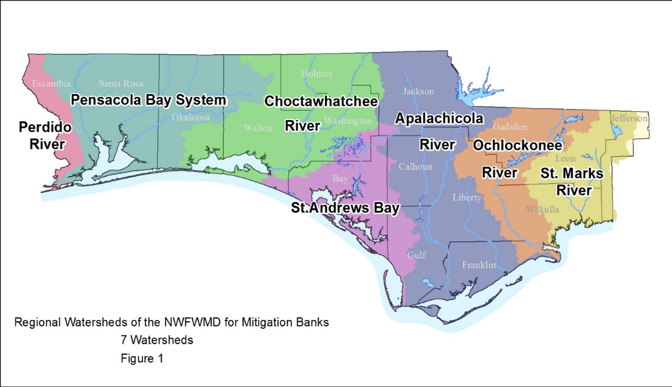

Figure 2: Suwannee River Water Management District ‒ “Watersheds of the SRWMD Mitigation Banks, 7 Watersheds” (February 19, 2015)
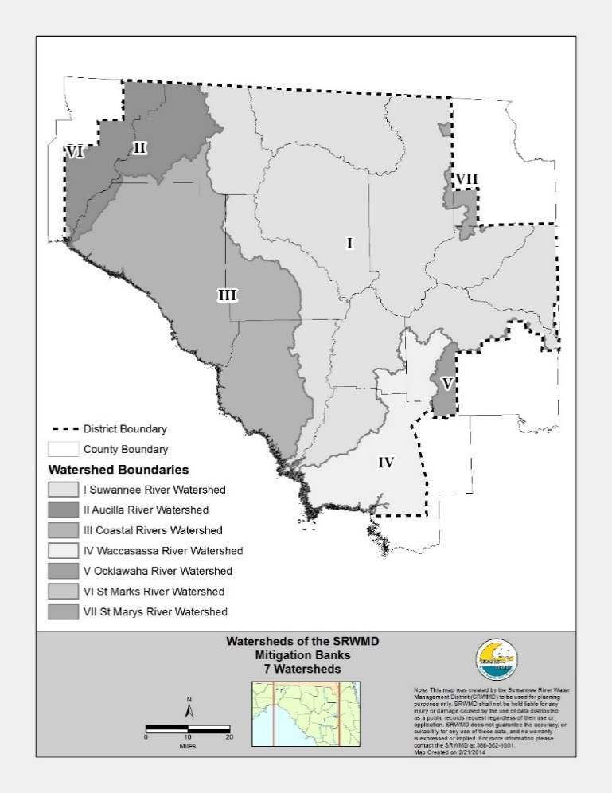

Figure 3: St. Johns River Water Management District ‒ “Regional Watersheds for Mitigation Banking” (October 1, 2013)
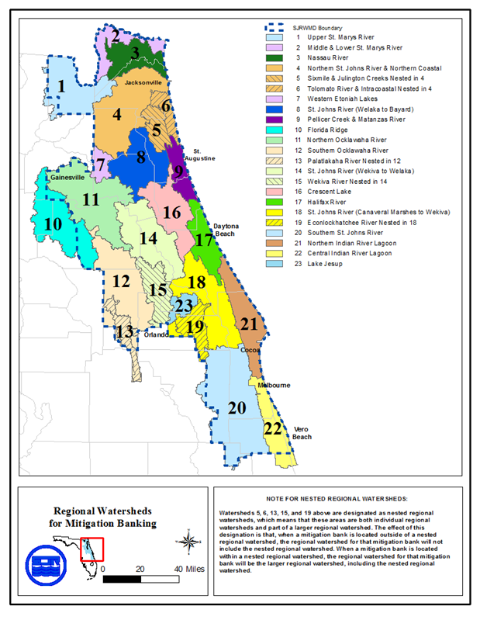
Figure 4: Southwest Florida Water Management District ‒ “Drainage Basins and Watersheds within the Southwest Florida Water Management District” (October 1, 2013)
Figure 5: South Florida Water Management District – Appendix D: “SFWMD Basins for Cumulative Impact Assessments & Mitigation Bank Service Areas” (October 1, 2013)
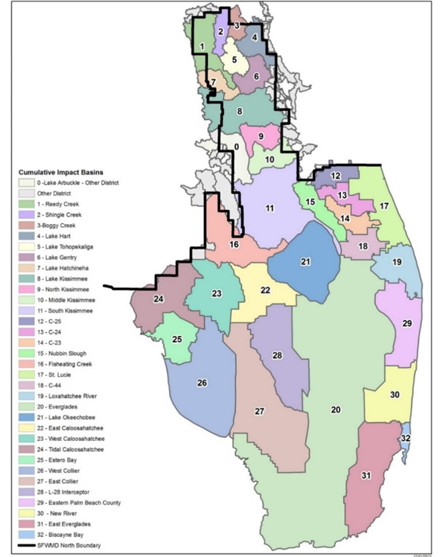

(18) “Release” means a permit modification by the Agency wherein Mitigation Credits are awarded to the Mitigation Bank ledger and are made available for withdrawal.
(19) “Reservation Letter” means a letter from a Banker to the applicant of a pending environmental resource permit, consent order, or similar, wherein the Banker commits to reserve a specified amount and type of Mitigation Credits for a specified time. A Reservation Letter may only be issued for Mitigation Credits which have been released to the Mitigation Bank ledger and are available for withdrawal.
(20) “Restoration” means, for purposes of this Chapter, a type of mitigation that involves the manipulation of the physical, chemical, or biological characteristics of a site with the goal of returning natural or historic functions to a former or degraded aquatic resource.
(21)(10) “Success” means when a Mitigation Bank achieves the parameters of meets the success criteria provided in the Mitigation Bank Permit and in Ssection 10.3.6 of Applicant’s Handbook, Volume I, incorporated by reference in Rrule 62-330.010, F.A.C.
(22) “Withdrawal” means a permit modification approved by the Agency wherein released Mitigation Credits are deducted from the Agency ledger to offset adverse impacts.

Rulemaking Authority 373.4131, 373.4136(11) FS. Law Implemented 373.4131, 373.4135, 373.4136 FS. History–New 2-2-94, Formerly 17-342.200, Amended 12-12-94, 8-21-00, 5-21-01, 2-19-15, Amended_____________.

62-342.470 Establishment of Mitigation Credits.
(1) Based upon the information submitted by the applicant, and an assessment of the proposed Mitigation Bank under the criteria of Ssection 373.4136, F.S., the Agency will assign a number of potential Mitigation Credits to the proposed Mitigation Bank, or phases thereof.
(2) Mitigation Credits assigned for Eenhancement, Rrestoration or Ppreservation of wetlands or uplands will be based on the extent of improvement in Eecological Vvalue resulting from these activities as determined by Chapter 62-345, F.A.C. using a functional assessment method relative to that obtained by successfully creating one acre of wetland. In determining the degree of improvement in Eecological Vvalue, the following factors will be considered. However, no credits shall be released until the requirements of Rrules 62-342.650 and 62-342.700, F.A.C., are met.
(a) The extent to which target hydrologic regimes can be achieved and maintained.
(b) The extent to which management activities promote natural ecological conditions, such as natural fire patterns.
(c) The proximity of the Mitigation Bank to areas with regionally significant ecological resources or habitats, such as national or state parks, Outstanding National Resource Waters and associated watersheds, Outstanding Florida Waters and associated watersheds, and lands acquired or to be acquired through governmental or non-profit land acquisition programs for environmental conservation; and the extent to which the Mitigation Bank establishes corridors for fish, wildlife, or listed species to those resources or habitats.
(d) The quality and quantity of wetland or upland Rrestoration, Eenhancement, Ppreservation, or Ccreation.
(e) The ecological and hydrological relationship between wetlands and uplands in the Mitigation Bank.
(f) The extent to which the Mitigation Bank provides habitat for fish and wildlife, especially habitat for species listed as threatened, endangered, or of special concern, or provides habitats which are unique for that Mmitigation Sservice Aarea.
(g) The extent to which the lands that are to be preserved are already protected by existing state, local, or federal regulations or land use restrictions.
(h) The extent that lands to be preserved would be adversely affected if they were not preserved.
(i) Any special designation or classification of the affected waters and lands.
(3) Some Mitigation Credits may be released for use prior to meeting all of the performance success criteria specified in the Mitigation Bank Permit. The initial withdrawal of a credit, or any portion thereof, begins the timeframe to reach final success as assessed using Chapter 62-345, F.A.C. The complete release of all Mmitigation Ccredits awarded will only occur after the Bbank meets all of the success criteria specified in the permit. The number of credits and schedule for release shall be determined based upon the performance criteria for the Mitigation Bank, the success criteria for each mitigation activity, and a consideration of the factors listed in Ssection 373.4136(5), F.S. However, no credits shall be released until the requirements of Rrules 62-342.650 and 62.342.700, F.A.C., are met. Additionally, no credits awarded for freshwater Ccreation shall be released until the final success criteria included in the Mitigation Bank Permit are met.
(4) If at any time the Bbanker is not in material compliance with the terms of the Mitigation Bank Permit, no Mitigation Credits may be withdrawn. Mitigation Credits shall again be available for withdrawal if the Bbanker comes back into compliance.
(5) The Mitigation Bank Permit shall contain a ledger listing the number and type of Mitigation Credits in the Mitigation Bank. The ledger will provide the potential maximum number and type of Mitigation Credits which would be available for withdrawal when the Mitigation Bank meets all of the performance and success criteria in the permit.
(6) Mitigation Credits that have been released may be used to offset adverse impacts from an activity regulated under part IV, Cchapter 373, F.S. Mitigation Ccredits may be used in whole or in part. However, Mitigation Credits in increments of less than a hundredth of one credit shall not be used.
(7) The Agency shall maintain a ledger of the Mitigation Credits available in each Mitigation Bank. Mitigation Credits shall be withdrawn as a minor modification of the Mitigation Bank Permit. To use Mitigation Credits, the impact permit applicant must submit to the agency permitting the impact, a Reservation Letter documentation from the Bbanker demonstrating that Mitigation Credits have been reserved, sold, or transferred to the impact permit applicant., and that the banker has requested that the Mitigation Credits be withdrawn from the Mitigation Bank. If the agency permitting the impact determines that use of the Mitigation Credits proposed by the impact permit applicant is appropriate to offset the adverse impacts, the agency permitting the impact it shall require the notify the Agency. Upon receipt of this notice, the Agency shall determine if a sufficient number and type of Mitigation Credits are available, be withdrawn prior to the issuance of the impact permit or as a condition of the impact permit. The Banker shall submit a minor modification application requesting the Mitigation Credits be withdrawn from the official Agency Bank ledger within 60 days of receiving a request from the impact permittee. as a minor modification of the Mitigation Bank Permit, and notify the agency permitting the impact and the banker by letter of the withdrawal of the Mitigation Credits and the remaining balance of Mitigation Credits.
(8) When the Department or a District is the Bbanker, each Agency shall maintain its own ledger. The District or Department shall annually submit a report of the Mitigation Credits sold, transferred, or used from its Mitigation Bank to the permitting Agency.
Rulemaking Authority 373.4131, 373.4136(11) FS. Law Implemented 373.4131, 373.4135, 373.4136, 373.414, FS. History–New 2-2-94, Formerly 17-342.470, Amended 5-21-01, 2-19-15, Amended_____________.

62-342.600 Mitigation Service Area.
(1) A Mitigation Service Area will be established for each Mitigation Bank in the Mitigation Bank Permit under the criteria of Ssection 373.4136(6), F.S. Except as provided herein, Mitigation Credits may only be withdrawn to offset adverse impacts in the Mitigation Service Area. The boundaries of the Mitigation Service Area shall depend upon the geographic area where the Mitigation Bank could reasonably be expected to offset adverse impacts.
(2) A Mitigation Service Area may be larger than the Rregional Wwatershed if the Mitigation Bank provides exceptional ecological value such that adverse impacts to wetlands outside the Rregional Wwatershed could reasonably be expected to be adequately offset by the Mitigation Bank because of local ecological or hydrological conditions. A Mitigation Service Area may be smaller than a Rregional Wwatershed, if adverse impacts throughout the Rregional Wwatershed cannot reasonably be expected to be offset by the Mitigation Bank because of local ecological or hydrological conditions.
(3) Mitigation Service Areas may overlap and Mitigation Service Areas for two or more Mitigation Banks may be approved for a Rregional Wwatershed.
(4) If the requirements in Rrule 62-342.300, F.A.C., are met, the following projects or activities shall be eligible to use a Mitigation Bank, notwithstanding the fact that they are not completely located within the Mitigation Service Area:
(a) Projects with adverse impacts partially located within the Mitigation Service Area.
(b) Linear projects, such as roadways, transmission lines, distribution lines, pipelines, or railways.
(c) Projects with total adverse impacts of less than one-half acre in size.
(5) When Mitigation Credits are applied to offset adverse impacts within the same Rregional Wwatershed as the Mitigation Bank, the Mitigation Credit requirement shall be the same as that specified for mitigation on the project site.
(6) When Mitigation Credits are applied to offset adverse impacts outside the Rregional Wwatershed, the Mitigation Credit requirement shall be higher than that specified for mitigation on the project site if necessary to adequately offset the adverse impacts of the project, except for linear projects, as referenced in paragraph (4)(b), above, when the impact being offset is within the Mitigation Service Area of the Mitigation Bank to be used. The closest Mitigation Bank to the adverse impacts with the appropriate amount and type of Mitigation Credits shall be the preferred option.
Rulemaking Authority 373.4136(11) FS. Law Implemented 373.4135, 373.4136 FS. History–New 2-2-94, Formerly 17-342.600, Amended 12-12-94, 5-21-01, Amended_____________..

62-342.650 Perpetual Protection of Land Use Restrictions on Mitigation Banks.
(1) Before Mitigation Credits may be released to used from a Mitigation Bank or any phase of a Mitigation Bank, the Bbanker shall either:
(a) Cause a fee interest to be conveyed to the Board of Trustees of the Internal Improvement Trust Fund (“Board of Trustees”); or
(b) cCause a conservation easement to be conveyed to both the Department and the District. The grantor of a conservation easement may convey a conservation easement to additional grantees, but such conveyance shall be subordinate to the conservation easement granted to the Department and the District. Mitigation Banks on federal, state, or water management district owned land shall be encumbered in perpetuity by conservation easements, or other mechanisms shall be employed to ensure protection preservation according to the Mitigation Bank Permit.
(2) If the Mitigation Bank is located within an area identified in an Agency acquisition plan, and the Agency determines that the ecological value of the bank can be increased by incorporating the bank into the Agency’s land management programs, the Agency may award additional Mitigation Credits if the fee interest in the bank is conveyed to the Agency as opposed to a conservation easement.
(2)(3) All conservation easements shall be granted in perpetuity without encumbrances, unless such encumbrances do not adversely affect the ecological viability of the Mitigation Bank. All conservation easements shall be of a form and content sufficient to ensure protection preservation of the Mitigation Bank according to the permit, and shall, at a minimum, meet requirements and restrictions of Ssection 704.06, F.S., except as provided in subsection 62-342.650(7)62-342.650(9), F.A.C. The conservation easement shall also provide that the Bbanker shall have access to the property and the authority to perform all acts necessary to ensure compliance with the Mitigation Bank Permit (unless the Bbanker is the fee owner of the property), and that the Agency shall have access and the authority to perform these acts if the Bbanker fails to do so.
(4) All real property conveyances of the fee interest shall be in fee simple and by statutory warranty deed, without encumbrances that adversely affect the integrity of the Bbank, and are acceptable to the Board of Trustees. The Board of Trustees will accept a quit claim deed to aid in clearing minor title defects or otherwise resolve a boundary question in the Mitigation Bank.
(3)(5) As part of providing reasonable assurance that the Mitigation Bank site will be protected preserved in perpetuity, the grantor of the property or conservation easement shall provide the following unless the Agency determines during the permit review process such items are not necessary to ensure protection preservation of the Mitigation Bank according to the permit:
(a) A boundary survey of the real property interest being conveyed. The survey must be certified, by a land surveyor and mapper, registered in the State of Florida, to meet the requirements of the Agency and the minimum technical standards set forth by the Florida Board of Professional Surveyors and Mappers in Rrules 5J-17.050 through 5J-17.052, F.A.C., under Ssection 472.027, F.S.
(b) A certified appraisal or other documentation demonstrating the market value of the property or interest to be conveyed to determine the appropriate amount of title insurance.
(c) A marketable title commitment issued to the Agency as beneficiary in an amount at least equal to the fair market value, as established in paragraph 62-342.650(3)(b)62-342.650(5)(b), F.A.C., of the interest being conveyed. The commitment date of the title information shall be no older than 90 days. An owner’s title insurance policy (ALTA Form B) naming the Agency as beneficiary shall be issued to the Agency within the time frames specified by the permit. The coverage, form, and exceptions of the title insurance policy shall ensure that the Mitigation Bank will be protected preserved according to the Mitigation Bank Permit.
(d) A current Phase I environmental site assessment audit identifying any environmental problems which may affect the liability of the Agency or Board of Trustees and any additional audits as are necessary to ensure that the Agency or the Board of Trustees is not subject to liability under federal or state laws relating to the treatment or disposal of hazardous substances or ownership of land upon which hazardous substances are located, or to ensure that there are no not hazardous substances present on the property which would adversely affect construction, operation implementation, and perpetual management of the Mitigation Bank.
(4)(6) The Agency shall require additional documentation or actions from the grantor of the conservation easement or fee interest if such additional documentation or actions are necessary to ensure that the Mitigation Bank will be protected in accordance with preserved according to the Mitigation Bank Permit.
(5)(7) The Bbanker shall pay the documentary revenue stamp tax and all other taxes or costs associated with the conveyance, including the cost of recording the deed or conservation easement and any other recordable instruments required by the Agency or Board of Trustees, unless prohibited or exempt by law, as a condition of the receipt of the conveyance.
(6)(8) All real estate taxes and assessments which are or which may become a lien against the property shall be satisfied of record by the Bbanker before recording the conservation easement. If necessary, the Bbanker shall, in accordance with Ssection 196.295, F.S., place funds in escrow with the county tax collector. The mitigation Bbanker shall also provide the Agency with annual documentation demonstrating that such taxes and assessments have been paid.
(7)(9) As a condition of receipt of the conveyance, the Bbanker shall remove all abandoned personal property, solid waste, or hazardous substances from the property that: reduces the proposed Eecological Vvalue of the property; will adversely affect the construction, operation implementation, or management of the Bbank; will adversely affect the construction, alteration, operation, maintenance, abandonment, or removal of any surface water management system to be constructed in the Bbank; or poses a risk of liability to the Board of Trustees or the Agency.
(8)(10) The Bbanker shall record the conservation easement or property deed required in the Mitigation Bank Permit. The Bbanker shall submit to the Agency the original recorded conservation easement or property deed as soon as such document is returned from the public records office.
Rulemaking Authority 373.4131, 373.4136(11) FS. Law Implemented 373.4131, 373.4135, 373.4136, 373.41365, 373.414, 403.0877, FS. History–New 2-2-94, Formerly 17-342.650, Amended 12-12-94, 5-21-01, 2-19-15, Amended_____________..

62-342.700 Financial Responsibility.
(1) To provide reasonable assurances that the proposed Mitigation Bank will meet the requirements of Ssection 373.4136, F.S., this Rrule, and the associated permit conditions, non-governmental Bbankers shall provide proof of financial responsibility for: (a) the Bank Cconstruction Phase and Bank Operation Phase implementation of the bank, and (b) the Bank Pperpetual Mmanagement Phase of the bank, as required in this Ssection. Governmental entities shall provide proof of financial responsibility under subsection 62-342.700(16)62-342.700(15), F.A.C. The amount of financial responsibility provided in the mechanisms required in this Rrule shall be based on the cost estimates determined under subsection 62-342.700(14)62-342.700(13), F.A.C.
(2) Submitting Financial Responsibility Documentation. The applicant shall provide draft documentation of the cost estimate and required financial responsibility mechanisms described in subsections 62-342.700(5) through (13)(11) and 62-342.700(13), F.A.C., with the permit application, and shall submit to the Agency the executed or finalized documentation within the time frames specified in the permit. The provisions of this subsection section shall also apply to any modifications to the Mitigation Bank Permit.
(3) General Terms for Financial Responsibility Mechanisms. In addition to the specific provisions regarding financial responsibility mechanisms for construction and operation implementation in subsection 62-342.700(4), F.A.C., and perpetual management in subsection 62-342.700(13)62-342.700(12), F.A.C., the applicant shall comply with the following terms shall be complied with:
(a) The financial responsibility mechanisms shall be payable at the direction of the Agency to its designee or to a standby trust or standby escrow. The financial responsibility mechanism shall be retained by the Agency if it is of a type which is retained by the beneficiary according to industry best practices standards.
(b) Demonstration of financial responsibility shall be continuous until complete satisfaction of the applicable permit conditions and approved release of financial responsibility by the Agency.
(c) Collectively, the financial responsibility mechanisms must guarantee that the Bbanker will perform all of its obligations under the permit. Within 90 days after receipt by both the Bbanker and the Agency of a notice of cancellation or termination of a financial responsibility mechanism, the Bbanker shall establish a financial responsibility mechanism that meets the criteria of this Rrule, subject to the Agency’s written approval. Failure to establish a replacement financial responsibility mechansim within the 90-day period will itself be grounds for the Agency to draw on the existing financial responsibility mechanism prior to its cancellation or termination.
(d) A Bbanker may satisfy the requirements of this subsection section by establishing more than one acceptable financial responsibility mechanism per Mitigation Bank. Whenever more than one mechanism is used, the Bbanker shall identify the specific financial responsibility mechanism for each individual activity on the cost estimate as required under subsection 62-342.700(14)62-342.700(13), F.A.C.
(e) A Bbanker shall may not use a financial responsibility mechanism allowed under this section for more than one Mitigation Bank. The amount of funds available through the mechanism must be no less than the sum of funds that would be required for separate mechanisms for each Mitigation Bank.
(f) A Bbanker must notify the Agency by certified mail within 10 days after the commencement of a voluntary or involuntary proceeding:
1. To dissolve the Bbanker;
2. To place the Bbanker in receivership;
3. For entry of an order for relief against the Bbanker under Title 11 of the United States Code; or
4. A general assignment of its assets for the benefit of creditors under Cchapter 727, F.S.
A Bbanker will be without the required financial assurance in the event of the suspension or revocation of the authority of any trustee to act as trustee, or in the event of a bankruptcy or receivership of the issuing institution of a financial responsibility mechanism, or the revocation of the authority of such institution to issue such instruments. The Bbanker must notify the Agency within 10 days, and establish other financial assurance within 60 days after such an event.
(4) Financial Responsibility for Construction and Operation Phase Implementation.
(a) No financial responsibility shall be required where the construction and operation implementation of the Mitigation Bank, or a phase thereof, is completed and successful, as determined by the Agency pursuant to the final success criteria in the Permit, prior to the release withdrawal of any Mitigation Ccredits.
(b) Financial responsibility for the construction and operational implementation activities of the Mitigation Bank, or each phase thereof, may be established by surety bonds, performance bonds, irrevocable letters of credit, insurance policies, escrow accounts, endowment funds, or trust funds, as described below.
(c) The amount of financial responsibility established shall equal 110 percent of the cost of construction and implementation of the Mitigation Bank, or each phase thereof, in accordance with subsection 62-342.700(14)62-342.700(13), F.A.C., and as adjusted in accordance with subsection 62-342.700(15)62-342.700(14), F.A.C., during the course of the project. When the Bbank has been completely constructed, implemented, and is trending toward success in compliance with the permit, the respective amount of financial responsibility shall be released.
(d) The financial responsibility mechanism shall be become effective, executed, and funded to the full cost estimate amount in accordance with paragraph 62-342.700(4)(c), F.A.C., prior to the release of any Mmitigation Ccredits.
(5) Surety or Performance Bond.
(a) A Bbanker may satisfy the requirements of paragraph subsection 62-342.700(1)(a), F.A.C., for construction and operational activities by obtaining a surety or performance bond that conforms to the requirements of this subsection. The company issuing the bond must be authorized to do business in Florida. The company must also be among those listed as acceptable sureties in the latest Circular 570 of the U.S. Department of the Treasury (July 1, 2023)(July 1, 2017), which is incorporated by reference herein and available at (insert link) http://www.flrules.org/Gateway/reference.asp?No=Ref-09504, or a Florida-domiciled surety or insurance company with at least an A- rating from the A.M. Best and authorized to write individual bonds up to 10 percent of the policyholder’s surplus. The Bbanker shall provide documentation evidencing that the bond company meets these requirements.
(b) The surety or performance bond shall be worded in substantial conformance with Form 62-342.700(5), “Mitigation Bank Surety Performance Bond to Demonstrate (Construction and Operation Implementation or Perpetual Management) Financial Assurance” (effective date)(June 12, 2018), which is incorporated by reference herein and available at (insert link) http://www.flrules.org/Gateway/reference.asp?No=Ref-09498. This form and all the forms incorporated in Rrule 62-342.700, F.A.C., also are available from the Department of Environmental Protection’s Internet site, https://floridadep.gov/water/submerged-lands-environmental-resources-coordination/content/forms-environmental-resource; or by contacting the Division of Water Resource Management, Department of Environmental Protection, 2600 Blair Stone Road, MS #2500, Tallahassee, Florida 32399-2400, (850)245-8336. Deviations from the form shall be identified to, and submitted to, and approved by to the Agency.
(c) Under the terms of the bond, the surety shall become liable on the bond obligation when the mitigation Bbanker fails to perform under the terms of the Mitigation Bank Permit. In all cases, the surety’s liability shall be limited to the sum stated in the bond.
(d) The mitigation Bbanker who uses a surety or performance bond to satisfy the requirements of subsection 62-342.700(4), F.A.C., must establish a standby escrow or standby trust fund when the surety or performance bond is acquired. Under the terms of the bond, all amounts paid by the surety under the bond will be deposited directly into the standby escrow or standby trust fund for distribution by the agent or trustee in accordance with the Agency’s instructions. The standby escrow agreement and standby trust fund agreement must meet the requirements specified in subsections 62-342.700(9) and 62-342.700(10), F.A.C., respectively.
(e) The bonding company shall provide notice of cancellation of a bond by certified mail to the Bbanker and to the Agency. Cancellation may not occur, however, during the 120 days beginning on the date of receipt of the notice of cancellation by both the Bbanker and the Agency, as evidenced by the return receipt.
(f) A bond may be canceled by the Bbanker if the Agency has given prior written consent. The Agency shall provide such consent when either the Bbanker substitutes alternative financial assurance allowed under this Rrule and such alternate financial assurance is approved by the Agency and is effective, or the Agency approves release of financial assurance in accordance with paragraph 62-342.700(4)(c), F.A.C.
(6) Irrevocable Letter of Credit.
(a) A mitigation Bbanker may satisfy the requirements of paragraph 62-342.700(1)(a) subsection 62-342.700(1), F.A.C., for construction and operation activities by obtaining an irrevocable letter of credit that conforms to the requirements of this paragraph subsection. The irrevocable letter of credit shall be provided by a federally insured depository that is “well capitalized” or “adequately capitalized” as defined in Section 38 of the Federal Deposit Insurance Act [12 USC 1831o(b)], incorporated by reference herein and available at http://www.flrules.org/Gateway/reference.asp?No=Ref-09505. The Bbanker shall submit documentation evidencing that the federally insured depository is appropriately capitalized.
(b) The irrevocable letter of credit shall be worded in substantial conformance with Form 62-342.700(6), “Mitigation Bank Irrevocable Letter of Credit to Demonstrate (Construction and Operation Implementation or Perpetual Management) Financial Assurance” (effective date) (June 12, 2018) [available at (insert link) http://www.flrules.org/Gateway/reference.asp?No=Ref-09499, and as described in paragraph (5)(b), above], incorporated by reference herein. Deviations from the form shall be identified to, and submitted to, and approved by to the Agency.
(c) A mitigation Bbanker who uses an irrevocable letter of credit to satisfy the requirements of subsection 62-342.700(4), F.A.C., must also establish a standby escrow or standby trust fund when the irrevocable letter of credit is acquired. Under the terms of the irrevocable letter of credit, all amounts paid pursuant to a sight draft by the Agency will be deposited by the issuing institution directly into the standby escrow or standby trust fund to be distributed by the agent or trustee in accordance with instructions from the Agency. This standby escrow or standby trust fund must meet the requirements specified in subsections 62-342.700(9) and 62-342.700(10), F.A.C., respectively.
(d) Letters of credit must be irrevocable and issued for a period of at least one year, and the expiration date must be automatically extended for a period of at least one year unless, at least 120 days prior to the expiration date, the issuing institution notifies both the Bbanker and the Agency by certified mail of a decision not to extend the expiration date. The terms of the irrevocable letter of credit must provide that the 120 days begins on the date when both the Bbanker and the Agency have received the notice, as evidenced by the return receipts.
(7) Insurance Policy.
(a) A mitigation Bbanker may satisfy the requirements of paragraph subsection 62-342.700(1)(a), F.A.C., for construction and operational implementation activities by obtaining an insurance policy that conforms to the requirements of this paragraph subsection. The insurance policy shall be provided by an insurance company that is authorized to transact insurance in the State of Florida and has at least an A- rating from the A.M. Best. The Bbanker shall provide documentation to the Agency evidencing that the insurance company meets these requirements.
(b) The insurance policy must be worded in substantial conformance to Form 62-342.700(7), “Mitgation Bank Insurance Coverage Form” (June 12, 2018), incorporated by reference herein [available at http://www.flrules.org/Gateway/reference.asp?No=Ref-09500 and as described in paragraph (5)(b), above]. Deviations from the form to meet insurance company documentary requirements must satisfy all criteria listed on the “Mitigation Bank Insurance Coverage Form” and be identified to, and submitted to, and approved by to the Agency.
(c) The insurance policy must be issued for a period of no less than one year beyond the anticipated completion and success of the Mmitigation Bbank, or the last success criterion insured, which ever occurs first based on the construction and operation implementation schedule in the Mmitigation Bbank Ppermit.
(d) The insurance policy must be non-cancellable for the term of the policy. The insurance policy shall include a provision to notify the Agency and Bbanker by certified mail at least 120 days prior to the termination of the policy, nonrenewal of the policy, or a change to the terms and conditions of the policy. The insurance policy must automatically renew for the same terms and conditions of the policy unless the insurance company provides notice of nonrenewal to the Bbanker and the Agency as required in this subsection.
(e) Under the terms of the insurance policy, the Agency must have the authority to file claims when the Bbanker either fails to perform under the terms of the Mmitigation Bbank Ppermit, as determined solely by the Agency, or fails to replace the insurance policy with an alternative financial responsibilty mechanism prior to the termination of the insurance policy. The insurance policy must afford the Agency with the sole authority to determine whether the action taken or proposed to be taken by the insurance company is sufficient to satisfy a claim made by the Agency. A claim is satisfied when the amount received by the Agency is greater than or equal to the most recent approved cost estimate or adjustment in accordance with subsections 62-342.700(14) and 62-342.700(15) 62-342.700(13) and 62-342.700(14), F.A.C., respectively, and the Bbank is in compliance with the terms of the permit.
(f) The mitigation Bbanker who uses an insurance policy to satisfy the requirements of subsection 62-342.700(4), F.A.C., must establish a standby escrow or standby trust fund when the insurance policy is acquired. Under the terms of the insurance policy, all amounts paid by the insurance company in satisfaction of a claim will be deposited directly into the standby escrow or standby trust fund for distribution by the agent or trustee in accordance with the Agency’s instructions.
(g) The declarations declaration’s page of the insurance policy shall include all of the following items:
1. Insured location – the Bbank address;
2. Mitigation Bbank Ppermit number;
3. Insurer’s claim’s notice address;
4. Regulatory entities and addresses, to include the U.S. Army Corps of Engineers;
5. Surplus line agent – name, address, license number;
6. Producing agent’s name, address, and other contact information;
7. Insured’s name, address, and other contact information;
8. Policy premium;
9. Limit of liability;
10. Policy inception and expiration dates;
11. Service fee;
12. Premium receipts tax; and
13. Deductible amount.
(8) Escrow.
(a) A mitigation Bbanker may satisfy the requirements of subsection 62-342.700(1), F.A.C., for construction and operational or perpetual management activities by a deposit of cash into an interest-bearing escrow account with the Florida Department of Financial Services.
(b) The escrow agreement must be worded in substantial conformance with to Form 62-342.700(8), “Escrow (Standby Escrow) Agreement” (June 12, 2018), incorporated by reference herein [available at http://www.flrules.org/Gateway/reference.asp?No=Ref-09503 and as described in paragraph (5)(b), above]. Deviations from the form must be identified to, and submitted to, and approved by to the Agency.
(c) The escrow agreement must be irrevocable until the Agency approves release of financial security in accordance with paragraph 62-342.700(4)(c), F.A.C., and authorizes a final payout.
(9) Standby Escrow.
(a) A Bbanker using a surety or performance bond, irrevocable letter of credit, or insurance policy shall contemporaneously establish either a standby escrow with the Florida Department of Financial Services meeting the requirements of this subsection or a standby trust fund under subsection 62-342.700(10), F.A.C.
(b) The standby escrow agreement shall be worded in substantial conformance with Form 62-342.700(8), F.A.C., incorporated by reference in paragraph 62-342.700(8)(b), F.A.C., except that the agreement will identify that it is establishing a standby escrow account. Deviations from the form must be identified to, and submitted to, and approved by to the Agency.
(c) The standby escrow agreement must be irrevocable until the Agency determines that it is no longer required.
(10) Standby Trust Fund.
(a) A mitigation Bbanker using a surety or performance bond, irrevocable letter of credit, or insurance policy shall contemporaneously establish either a standby trust fund meeting the requirements of this subsection or a standby escrow under subsection 62-342.700(9), F.A.C. The trustee of the standby trust shall be an entity that has the authority to act as a trustee and whose trust operations are regulated and examined by a federal agency or an agency of the State of Florida. The Bbanker shall provide documentation evidencing such regulation and examination to the Agency.
(b) The standby trust agreement shall be worded in substantial conformance with Form 62-342.700(10), “Mitigation Bank Standby Trust Fund Agreement to Demonstrate (Construction and Operation Implementation or Perpetual Management) Financial Assurance” (effective date) (June 12, 2018) [available at (insert link) http://www.flrules.org/Gateway/reference.asp?No=Ref-09502 and as described in paragraph (5)(b), above], incorporated by reference herein. Deviations from the form shall be identified to, and submitted to, and approved by to the Agency. This Fform and Forms 62-342.700(11)(a) and 62-342.700(11)(b) Form 62-342.700(11), incorporated in subsection 62-342.700(11), F.A.C., references the Investment Company Act of 1940, as amended, 15 U.S.C. 80a-1 et seq. (December 23, 2022) (February 19, 2015), which is incorporated by reference herein and available at (insert link) http://www.flrules.org/Gateway/reference.asp?No=Ref-05064 and as described in paragraph (5)(b), above. A copy of the Act may also be obtained by contacting the Division of Water Resource Management, Department of Environmental Protection, 2600 Blair Stone Road, MS #2500, Tallahassee, Florida 32399-2400, (850)245-8336.
(11) Trust Fund.
(a) A mitigation Bbanker may satisfy the requirements of subsection 62-342.700(1), F.A.C., for construction and operational or perpetual management activities by establishing a trust fund that conforms to the requirements of this subsection section. The trustee of the trust fund shall be an entity that has the authority to act as a trustee and whose trust operations are regulated and examined by a federal agency or an agency of the State of Florida. The Bbanker shall provide documentation evidencing proof of such regulation and examination to the Agency.
(b) The trust fund agreement must be worded in substantial conformance with to Form 62-342.700(11)(a) or 62-342.700(11)(b) 62-342.700(11), “Mitigation Bank Trust Fund Agreement to Demonstrate (a. Construction and Operation Implementation or b. Perpetual Management) Financial Assurance” (effective date) (June 12, 2018) [available at (insert link) http://www.flrules.org/Gateway/reference.asp?No=Ref-09501 and as described in paragraph (5)(b), above], incorporated by reference herein. Deviations from the form shall be identified to, and submitted to, and approved by to the Agency.
(12) Endowment
(a) A Banker may satisfy the requirements of subsection 62-342.700(1), F.A.C., for construction and operation or perpetual management activities by establishing an endowment that conforms to the requirements of this subsection. The endowment holder, or the investment manager retained by the endowment holder to manage the endowment, shall be an entity that is a Registered Investment Adviser (RIA) with the U.S. Securities and Exchange Commission (SEC) and whose endowment operations are regulated and examined by a federal agency or an agency of the State of Florida. The Banker shall provide documentation evidencing proof of such regulation and examination to the Agency.
(b) The endowment agreement must be worded in substantial conformance with Form 62-342.700(12), “Mitigation Bank Endowment Agreement to Demonstrate (a. Construction and Operation or b. Perpetual Management) Financial Assurance” (effective date) [available at (insert link) and as described in paragraph (5)(b), above], incorporated by reference herein. Deviations from the form shall be identified to, submitted to, and approved by the Agency.
(13)(12) Financial Responsibility for Perpetual Management.
(a) A Bbanker shall establish financial assurance for the perpetual management of the Mitigation Bank, or phase thereof, using the financial responsibility mechanisms described in subsections 62-342.700(8), 62-342.700(11), or 62-342.700(12)62-342.700(5), through 62-342.700(11), F.A.C., except that an insurance policy under subsection 62-342.700(7), F.A.C., may not be used. When an escrow agreement, or trust fund, or endowment is used, the requirements of subsections 62-342.700(8), and 62-342.700(11), and 62-342.700(12), F.A.C., respectively, must be met and all references to perpetual management in Forms 62-342.700(8) and 62-342.700(11) shall be selected. When a surety bond, performance bond, guarantee bond, or irrevocable letter of credit is used, a standby trust und agreement must be established by the banker, and the requirements of subsections 62-342.700(5), 62-342.700(6), 62-342.700(9) and 62-342.700(10), F.A.C., respectively, must be met, and all references to perpetual management in Forms 62-342.700(8) and 62-342.700(11) shall be selected.
(b) The amount of financial responsibility provided shall be calculated using an assumed sufficient to be reasonably expected to generate annual investment return no greater than the long-term real investment return objective stated in the most recent Florida Retirement System (FRS) Defined Benefit Plan Investment Policy Statement effective January 1 of each year, less applicable administrative fees, to demonstrate a projected net annual investment return at least annual revenue equal to the annual cost of perpetual management, established under subsection 62-342.700(14) 62-342.700(13), F.A.C., at an assumed average rate of return of six percent per annum, for the Bbank, or for Bbanks constructed in phases, for all phases for which Mitigation Ccredits have been released.
(c) The financial responsibility mechanism must be in effect and executed prior to the withdrawal first release of credits from to the Mitigation Bank, or applicable phase thereof. The financial responsibility mechanism for perpetual management may be funded over time as credits are sold for a period not to exceed five years from the first credit withdrawal. When funding over time, the initial investment amount shall be sufficient to satisfy fifty percent of paragraph 62-342.700(14)(c), F.A.C.
(14)(13) Cost estimates.
(a) For the purposes of determining the amount of financial responsibility that is required in this subsection section, the Bbanker shall submit a detailed written estimate, in current dollars, of the total cost of construction and operation implementation and of the cost of perpetual management of the Mitigation Bank. When the Agency determines it is appropriate, tThe written cost estimate shall be certified by a licensed professional whose license authority in the State of Florida includes the ability to provide such estimates.
(b) The cost estimate for construction and operation implementation shall include all costs associated with completing construction and operation implementation of the Mitigation Bank, or phase thereof, including, as applicable, earthmoving, planting, exotic/nuisance vegetation removal, prescribed fire, land surveying, structure installation, site security, administrative fees, consultant fees, taxes, monitoring activities and reports, and any other costs associated with construction and operation.
(c) The cost estimate for the perpetual management of the Mitigation Bank shall be based on the costs of maintaining, and managing operating, and periodic replacement of any structures, exotic/nuisance vegetation control controlling nuisance or exotic species, prescribed fire management, site security, consultant fees, monitoring activities and reports, taxes, and any other costs associated with perpetual management. The amount of financial responsibility shall equal the cost of perpetual management for the Bbank, or, for Bbanks constructed in phases, for all phases for which Mitigation Ccredits have been released.
(d) The Bbanker shall submit written cost estimates with verifiable documentation basis for the estimates to the Agency along with the financial responsibility mechanism. If more than one financial responsibility mechanism is proposed for the construction and operation implementation or for perpetual management, the cost estimate shall specify the appropriate mechanism for each itemized cost.
(e) The costs shall be estimated based on a third party performing the work at the fair market value of services. The source of any cost estimates shall be indicated and dated.
(15)(14) Cost adjustments.
(a) Every two years, the Bbanker shall undertake an estimate of the costs of the remaining construction and operation implementation, and perpetual management. In accordance with subsection 62-342.700(14), F.A.C., tThe Bbanker shall submit the estimate to the Agency in writing certified by a person licensed in the State of Florida to provide such estimates, accompanied by supporting documentation. Construction, operational implementation activity costs, and perpetual management costs shall be listed separately. The Agency shall review the cost adjustment statement and supporting documentation to determine if sufficent documentation has been provided to they reflect all construction costs, operational implementation costs, and perpetual management costs. If the cost adjustment statement and supporting documentation accurately reflect a good faith estimate of all construction costs, operation implementation costs, and perpetual management costs, the Agency shall approve the cost adjustment statement.
(b) At each cost adjustment, the Bbanker shall revise the construction, operation implementation, and perpetual management cost estimate for inflation and changes in the costs to complete or undertake the current phase of the Mitigation Bank or appropriate phase thereof in accordance with subsection 62-342.700(14)62-342.700(13), F.A.C.
(c) Revised cost estimates shall be used as the basis for modifying the financial responsibility mechanisms for Bank Construction Phase and Bank Operational Phase. If the value of any financial responsibility mechanism is less than the total amount of the current construction and implementation and perpetual management cost estimates, the Bbanker shall, upon Agency approval of the cost adjustment statement, increase the value of the financial mechanism to reflect the new estimate within 60 days. If the value of the construction and operation any funding mechanism is greater than the total amount of the current cost estimate, the Bbanker may reduce the value of the funding mechanism to reflect the new estimate upon receiving written Agency approval of the cost adjustment statement.
(d) Revised cost estimates and the performance of financial investments shall be used as the basis for modifying the financial responsibility mechanisms for the Bank Perpetual Phase. If the value of any financial responsibility mechanism is less than the total amount of the current perpetual management requirements of paragraph 62-342.700(13)(c), F.A.C., the Banker shall, upon Agency approval of the cost adjustment statement, increase the value of the financial mechanism within 60 days. The sufficiency of the perpetual management funding may be revised by the Agency with any modification, or credit release, and before transfer to the Bank Perpetual Phase.
(e)(d) The Agency shall require adjustment of the amount of financial responsibility provided for construction, operation, implementation and perpetual management at times other than the cost adjustment period when the estimated costs associated with compliance with the permit conditions exceed the current amount of financial responsibility and such financial assurances are deemed necessary to ensure compliance with the permit conditions.
(f)(e) The Bbanker may provide revised cost estimates more frequently than every two years. If at any time the banker learns that actual costs exceed estimated costs by more than 25 percent, the Bbanker shall provide a revised cost estimate and adjust the corresponding amount of financial responsibility under this Rrule.
(16)(15) Financial Responsibility for Governmental, Non-Department and Non-Water Management District, Mitigation Banks.
(a) A governmental entity other than the Department or Districts shall demonstrate reasonable assurances that it can meet the construction and operational implementation requirements in the Mitigation Bank Permit by any of the mechanisms in subsection 62-342.700(4), F.A.C., above, or by other financial mechanisms which are sufficient to meet the requirements of this subsection section.
(b) Governmental entities other than the Department or Districts shall establish a trust fund, or other sufficient financial mechanism for the perpetual management of the Mitigation Bank which meets the requirements of subsection 62-342.700(12)62-342.700(11), F.A.C., above. The trust fund for perpetual management may be funded as Mitigation Credits are withdrawn, provided that the trust fund is fully funded when all Mitigation Credits are withdrawn. Governmental entities shall comply with the cost adjustment provisions in subsection 62-342.700(15)62-342.700(14), F.A.C.
Rulemaking Authority 373.4131, 373.4135(1), 373.4136(11) FS. Law Implemented 373.4131, 373.4135, 373.4136, 373.41365, 373.414, 403.0877 FS. History–New 2-2-94, Formerly 17-342.700, Amended 12-12-94, 9-12-95, 5-21-01, 2-19-15, 6-12-18, Amended_____________.

