APPLICANT'S HANDBOOK:

REGULATION OF STORMWATER MANAGEMENT SYSTEMS
CHAPTER 40C-42, F.A.C.

December 3, 2006
As Adopted for Use by the
Department of Environmental Protection
[Effective Date]

ST. JOHNS RIVER WATER MANAGEMENT DISTRICT
4049 Reid Street
Palatka, FL 32177-2529
(386) 329-4500

http://www.sjrwmd.com/handbooks/pdfs/stwthdbk.pdf

TABLE OF CONTENTS
Page
PART I - POLICY AND PROCEDURES
1.0 Introduction...............................................................................................................1-1
1.1 Policy ..........................................................................................................................1-1
1.2 Purpose of Handbook..................................................................................................1-1
1.3 Organization of Handbook .........................................................................................1-1
1.4 Applicable Statutes and Rules ....................................................................................1-2
1.5 Summary of District Surface Water Management System Rules ..............................1-2
1.6 Relationship to Other District Permits .......................................................................1-4

2.0 Definitions. ................................................................................................................2-1

3.0 Activities Requiring a Permit ..................................................................................3-1
3.1 Date of Implementation ..............................................................................................3-1
3.2 Permits Required ........................................................................................................3-1
3.3 Permit Thresholds .......................................................................................................3-2
3.4 Exemptions .................................................................................................................3-3
3.5 Subthreshold Applications and Permits .....................................................................3-4

4.0 Application Preparation ..........................................................................................4-1
4.1 Pre-application Conference ........................................................................................4-1
4.2 Application Form ........................................................................................................4-1
4.3 Permit Processing Fee ................................................................................................4-1
4.4 Checklist for Application Completeness ....................................................................4-1
4.5 Application Processing Procedures ............................................................................4-2

5.0 Procedures for Processing General Permits ..........................................................5-1
5.1 Standard General Permit Criteria ...............................................................................5-1
5.2 Standard General Permit Categories ..........................................................................5-1
5.3 Upgrade to Individual Permit .....................................................................................5-3
5.4 Procedures Required ...................................................................................................5-3
5.5 Initial Receipt ..............................................................................................................5-4
5.6 Request for Additional Information ............................................................................5-4
5.7 Staff Evaluation ...........................................................................................................5-5

6.0 Procedures for Processing Individual Permits ......................................................6-1
6.1 Individual Permit Categories ..................................................................................... 6-1
6.2 Procedures Required .................................................................................................. 6-1
6.3 Initial Receipt ............................................................................................................. 6-1
6.4 Request for Additional Information .......................................................................... 6-1
6.5 Staff Evaluation ......................................................................................................... 6-2
6.6 Regulatory Meeting ................................................................................................... 6-4
ii
7.0 Permits........................................................................................................................7-1
7.1 Duration ..................................................................................................................... 7-1
7.2 Expiration and Extension .......................................................................................... 7-1
7.3 Operation Phase Permits............................................................................................ 7-1
7.4 Enforcement and Inspection ...................................................................................... 7-2
7.5 Compliance ................................................................................................................ 7-2
7.6 Permit Transfers ........................................................................................................ 7-6
7.7 Permit Modifications ................................................................................................. 7-7
7.8 Permit Revocation ..................................................................................................... 7-8
7.9 References.................................................................................................................. 7-9

PART II - CRITERIA FOR EVALUATION
8.0 Criteria for Evaluation.............................................................................................8-1
8.1 Purpose .......................................................................................................................8-1
8.2 Source of Criteria .......................................................................................................8-1
8.3 Requirements for Issuance .........................................................................................8-1
8.4 State Water Quality Standards ...................................................................................8-2
8.5 Surface Water Management Basin Criteria................................................................8-2

9.0 Design and Performance Criteria............................................................................9-1
9.1 Erosion and Sediment Control ...................................................................................9-1
9.2 Oil and Grease Control .............................................................................................. 9-3
9.3 Public Safety .............................................................................................................. 9-5
9.4 Basin Side Slope Stabilization................................................................................... 9-5
9.5 Maintenance Access .................................................................................................. 9-5
9.6 Legal Authorization ................................................................................................... 9-6
9.7 Tailwater ................................................................................................................... 9-6
9.8 Peak Discharge Attenuation ...................................................................................... 9-8
9.9 Conveyance ...............................................................................................................9-13
9.10 Professional Certification ........................................................................................9-13
9.11 Sensitive Karst Area Basin Design Criteria ............................................................9-14
9.12 On-Line and Off-line Stormwater Systems............................................................. 9-24
9.13 References................................................................................................................ 9-25

10.0 Dry Detention Design and Performance Standards ............................................10-1
10.1 Description ............................................................................................................... 10-1
10.2 Treatment Volume ................................................................................................... 10-1
10.3 Recovery Time .........................................................................................................10-2
10.4 Outlet Structure ........................................................................................................ 10-2
10.5 Ground Water Table, Basin Floor, and Control Elevation .......................................10-2
10.6 Basin Stabilization ................................................................................................... 10-3
10.7 Basin Configuration ................................................................................................. 10-3
10.8 Inlet Structures ......................................................................................................... 10-3
10.9 Maintenance ............................................................................................................. 10-3

11.0 Design Criteria and Guidelines for Retention Systems .......................................11-1
11.1 Description ............................................................................................................... 11-1
11.2 Treatment Volume ................................................................................................... 11-4
11.3 Recovery Time ........................................................................................................ 11-4
11.4 Basin Stabilization ................................................................................................... 11-5
11.5 Retention Basin Construction .................................................................................. 11-5
11.6 References................................................................................................................ 11-6

12.0 Underdrain Design and Performance Criteria ....................................................12-1
12.1 Description ............................................................................................................... 12-1
12.2 Treatment Volume ................................................................................................... 12-1
12.3 Recovery Time ........................................................................................................ 12-2
12.4 Safety Factor ............................................................................................................ 12-2
12.5 Underdrain Media .................................................................................................... 12-2
12.6 Filter Fabric.............................................................................................................. 12-3
12.7 Inspection and Cleanout Ports ................................................................................. 12-3
12.8 Basin Stabilization ................................................................................................... 12-3
12.9 References................................................................................................................ 12-3

13.0 Exfiltration Trench Design and Performance Criteria .......................................13-1
13.1 Description ............................................................................................................... 13-1
13.2 Treatment Volume ................................................................................................... 13-4
13.3 Recovery Time ........................................................................................................ 13-4
13.4 Safety Factor ............................................................................................................ 13-5
13.5 Minimum Dimensions ............................................................................................. 13-5
13.6 Filter Fabric.............................................................................................................. 13-5
13.7 Inspection and Cleanout Structures ......................................................................... 13-6
13.8 Ground Water Table ................................................................................................ 13-6
13.9 Construction ............................................................................................................. 13-6
13.10 Alternative Designs ................................................................................................. 13-7
13.11 References................................................................................................................ 13-7

14.0 Wet Detention Design and Performance Criteria ................................................14-1
14.1 Description ................................................................................................................14-1
14.2 Treatment Volume .....................................................................................................14-1
14.3 Recovery Time ..........................................................................................................14-4
14.4 Outlet Structure .........................................................................................................14-4
14.5 Permanent Pool .........................................................................................................14-4
14.6 Littoral Zone .............................................................................................................14-9
14.7 Littoral Zone Alternatives ........................................................................................14-9
14.8 Pond Depth ..............................................................................................................14-10
14.9 Pond Configuration .................................................................................................14-10
14.10 Ground Water Table ..............................................................................................14-11
14.11 Pre-treatment..........................................................................................................14-12
14.12 Pond Side Slopes ...................................................................................................14-13
14.13 Direct Discharges to Class I, Class II, or OFWs or Shellfishing Waters ..............14-13
14.14 References..............................................................................................................14-13

15.0 Design Criteria and Guidelines for Swale Systems ..............................................15-1
15.1 Description ................................................................................................................15-1
15.2 Treatment Volume ....................................................................................................15-4
15.3 Recovery Time .........................................................................................................15-4
15.4 Dimensional Requirements ......................................................................................15-4
15.5 Stabilization ..............................................................................................................15-5

16.0 Design Criteria and Guidelines for Wetland ........................................................16-1
Stormwater Management Systems
16.1 Description ............................................................................................................... 16-1
16.2 Types of Wetlands that may be Utilized for Stormwater Treatment ...................... 16-1
16.3 Treatment Volume ................................................................................................... 16-1
16.4 Recovery Time ........................................................................................................ 16-2
16.5 Inlet Structures ......................................................................................................... 16-2
16.6 Wetland Function .................................................................................................... 16-2
16.7 Residence Time ....................................................................................................... 16-2
16.8 Monitoring ............................................................................................................... 16-3
16.9 Dredge and Fill ........................................................................................................ 16-3
16.10 Alternative Criteria .................................................................................................. 16-3
16.11 References................................................................................................................ 16-4

PART III - OPERATION AND MAINTENANCE
17.0 Legal Operation and Maintenance Entity Requirements ..................................17-1
17.1 Acceptable Operation and Maintenance Entities .................................................... 17-1
17.2 Entity Requirements ............................................................................................... .17-2
17.3 Phased Projects ........................................................................................................ 17-4
17.4 Construction Phase Entity ....................................................................................... 17-4
17.5 Application Submittal .............................................................................................. 17-5

18.0 Operation Phase Permits........................................................................................18-1
18.1 Requirements for Transfer to Operation Phase Permit ........................................... 18-1

19.0 Monitoring and Operational Maintenance Requirements .................................19-1
19.1 Monitoring and Inspection Requirements ............................................................... 19-1
19.2 Maintenance Requirements for all Permitted Systems ........................................... 19-2
19.3 Maintenance Requirements for Specific Types of Stormwater Management
Systems ....................................................................................................................19-2
19.4 Non-functioning Systems ........................................................................................ 19-4

PART IV - ALTERNATIVE TREATMENT SYSTEMS
20.0 Design Criteria and Guidelines for Stormwater Systems ...................................20-1
20.1 Description ............................................................................................................... 20-1
20.2 Reuse Volume.......................................................................................................... 20-3
20.3 Permanent Pool ........................................................................................................ 20-3
20.4 Littoral Zone ........................................................................................................... .20-4
20.5 Littoral Zone Alternatives ....................................................................................... 20-5
20.6 Pond Depth .............................................................................................................. 20-5
20.7 Pond Configuration ................................................................................................. 20-5
20.8 Ground Water Table ................................................................................................ 20-6
20.9 References................................................................................................................ 20-6

21.0 Design Criteria and Guidelines for Vegetative Natural Buffers ........................21-1
(THIS SECTION HAS BEEN DELETED)

22.0 Compensating Stormwater Treatment ................................................................22-1
22.1 Overtreatment .......................................................................................................... 22-1
22.2 Off-Site Compensation ............................................................................................ 22-1

23.0 Filtration Design and Performance Criteria ........................................................23-1
23.1 Description ............................................................................................................... 23-1
23.2 Treatment Volume ................................................................................................... 23-7
23.3 Recovery Time ........................................................................................................ 23-7
23.4 Safety Factor ............................................................................................................ 23-8
23.5 Filter Media ............................................................................................................. 23-8
23.6 Filter Fabric.............................................................................................................. 23-9
23.7 Ground Water Table ................................................................................................ 23-9
23.8 Inspection and Cleanout Ports ................................................................................. 23-9
23.9 Operation and Maintenance Entity .......................................................................... 23-9
23.10 References................................................................................................................ 23-9

PART V - METHODOLOGIES AND DESIGN EXAMPLES
24.0 Methodologies and Design Example for the Modified Rational Hydrograph
Method ....................................................................................................................24-1
24.1 Description ............................................................................................................... 24-1
24.2 Example Problem for the Modified Rational Hydrograph Method ........................ 24-5
24.3 References................................................................................................................ 24-7

25.0 Methodologies and Design Examples for Dry Detention Systems .....................25-1
25.1 Designing the Drawdown Structure ........................................................................ 25-1
25.2 Example Design Calculations for Dry Detention Systems ..................................... 25-3

26.0 Methodologies and Design Examples for Retention Systems ............................26-1
26.1 Infiltration Processes ............................................................................................... 26-1
26.2 District-Sponsored Research on Retention Systems ............................................... 26-1
26.3 Accepted Methodologies and Design Procedures for Retention Basin Recovery . 26-4
26.4 Recommended Field and Laboratory Tests for Aquifer Characterization............26-11
26.5 Design Example for Retention Basin Recovery ...................................................26-27
26.6 References..............................................................................................................26-30

27.0 Methodologies and Design Examples for Underdrain Systems .........................27-1
27.1 Spacing Underdrain Laterals ................................................................................... 27-1
27.2 Length of Underdrain Required and Basin Dimensions ......................................... 27-2
27.3 Drain Size ................................................................................................................ 27-5
27.4 Sizing of Drains Within the System ........................................................................ 27-6
27.5 Example Design Calculations for Underdrain Systems .......................................... 27-6
27.6 References................................................................................................................ 27-9

28.0 Methodologies and Design Example for Exfiltration Trench Systems ..............28-1
28.1 Calculating Storage Capacity of an Exfiltration Trench ......................................... 28-1
28.2 Estimating Recovery Time ...................................................................................... 28-2
28.3 Design Example for Sizing an Exfiltration Trench ................................................. 28-3
28.4 Alternative Design Procedures ................................................................................ 28-4
28.5 References................................................................................................................ 28-5

29.0 Methodology and Design Example for Wet Detention Systems ........................29-1
29.1 Calculating Permanent Pool Volumes .................................................................... 29-1
29.2 Sizing the Drawdown Structure .............................................................................. 29-3
29.3 Mean Depth of the Pond .......................................................................................... 29-5
29.4 Design Example ....................................................................................................... 29-5
29.5 References................................................................................................................ 29-9

30.0 Methodology and Design Example for Swale Systems .......................................30-1
30.1 Runoff Hydrograph and Volume............................................................................. 30-1
30.2 Infiltration Hydrograph and Volume....................................................................... 30-3
30.3 Velocity .................................................................................................................... 30-4
30.4 Capacity ................................................................................................................... 30-9
30.5 Vertical Unsaturated and Lateral Saturated Infiltration .......................................... 30-9
30.6 Example Design Calculations for Swale Systems .................................................. 30-9
30.7 References..............................................................................................................30-15

31.0 Methodology and Design Examples for Stormwater Reuse Systems ................31-1
31.1 Overview.................................................................................................................. 31-1
31.2 Equivalent Impervious Area .................................................................................... 31-1
31.3 Reuse Volume.......................................................................................................... 31-2
31.4 Reuse Rate ............................................................................................................... 31-3
31.5 Rate-Efficiency-Volume (REV) Curves ................................................................. 31-3
31.6 Design Examples for Stormwater Reuse Systems .................................................. 31-4
31.7 References................................................................................................................ 31-7

32.0 Methodology and Design Examples for Vegetative Buffers ...............................32-1
(THIS SECTION HAS BEEN DELETED)

33.0 Methodology and Design Examples for Filtration ..............................................33-1
33.1 Calculating Recovery Time Utilizing Darcy's Equation ......................................... 33-1
33.2 Hydraulic Gradient .................................................................................................. 33-2
33.3 Permeability ............................................................................................................. 33-2
33.4 Flow Area ................................................................................................................ 33-5
33.5 Incremental Drawdown Analysis ............................................................................ 33-6
33.6 Safety Factor ............................................................................................................ 33-7
33.7 Pipe Capacity ........................................................................................................... 33-7
33.8 Example Design Calculations for Filter Systems.................................................... 33-7
33.9 References..............................................................................................................33-11

PART VI - APPENDICES
Appendix
A Chapter 40C-42, F.A.C.
B Application Form, Notice of Receipt, and Instructions for Completing Application
C As-Built Forms
D Inspection Forms
E Checklist of Stormwater Rule Criteria
F Model Language for Operation and Maintenance Documents
G Permit Review Process Flowchart
H Class I, Class II, and Outstanding Florida Waters Within the SJRWMD

PART I
POLICY AND PROCEDURES

- Introduction

Chapter 40C-42, F.A.C., entitled “Environmental Resource Permits: Regulation of Stormwater Management Systems” governs stormwater management systems which are designed and constructed or implemented to control discharges necessitated by rainfall events. These systems may incorporate methods to collect, convey, store, absorb, inhibit, treat, use or reuse water to prevent or reduce flooding, overdrainage, environmental degradation and pollution, or otherwise affect the quality and quantity of discharges. Standard general and individual environmental resource stormwater permits are required under this Chapter for construction, operation, maintenance, alteration, removal, or abandonment for systems that are not permitted under provisions of Cchapter 40C-4, 40C-40 or 62-341 40C-400, F.A.C. Permits issued under this rule must be consistent with the objectives of the District and not cause harm to the water resource.

1.1 Policy

The District's policy is to assist those affected by the regulation of stormwater management systems rule (Cchapter 40C-42, F.A.C.) to understand the environmental resource stormwater permitting program and complete the required applications. The final determination of appropriate procedures to be followed will be made by reference to Cchapters 120 and 373, F.S., and Cchapters 28-106, 28-107, 40C-1, 40C-4, 40C-40, 40C-41 and 40C-42, F.A.C.

1.2 Purpose of Handbook

The purpose of this handbook is to provide applicants, potential applicants, and other interested persons, with information and guidance regarding the environmental resource stormwater permit program. Both the rule and the application process are explained in a more "user friendly" format.

1.3 Organization of Handbook

This handbook is divided into five parts which provide information regarding the following:
- Policy and procedures (Part I)
- Criteria used in permit evaluation (Part II)
- Requirements for operation and maintenance of stormwater management systems (Part III)
- Criteria for alternative stormwater treatment systems (Part IV)
- Methodologies which are useful in designing systems to meet the specified criteria (Part V)
Parts I, II, and III are incorporated by reference into Cchapter 40C-42, F.A.C. Supplemental material such as relevant rules and application forms can be found in the appendices of this handbook.

If an applicant or potential applicant has any questions about these procedures or wishes to have Department District staff assistance in interpreting them or in completing an application, he or she is encouraged to contact the applicable office of the Department SJRWMD's Department of Resource Management at the appropriate location given below:

Florida Department of Environmental Protection  Northeast District  7825 Baymeadows Way, Suite B200  Jacksonville, Florida 32256-7577 | Florida Department of Environmental Protection  Central District  3319 Maguire Boulevard, Suite 232  Orlando, Florida 32803-3767
Florida Department of Environmental Protection
Southwest District
13051 N Telecom Parkway
Temple Terrace, FL 33637-0926

Orlando Field Office  618 East South Street  Orlando, FL 32801  (407) 897-4300  for projects located in  Lake, Orange, Polk,  Seminole and Volusia Co. | Melbourne Field Office  305 East Drive  Melbourne, FL 32904  (407) 984-4940  for projects located in  Brevard, Indian River,  Okeechobee and Osceola Co.
District Headquarters  P.O. Box 1429  Palatka, Florida 32178-1429  (904) 329-4500  for projects located in  Alachua, Flagler, Marion  and Putnam Co. | Jacksonville Field Office  7775 Baymeadows Way, Suite 102  Jacksonville, FL 32256  (904) 730-6270  for projects located in  Baker, Bradford, Clay,  Duval, Nassau, and St. Johns Co.

Unless otherwise specified, the term "District" in this handbook refers to the St. Johns River Water Management District. Florida Statutes are abbreviated as "F.S." Rules under the Florida Administrative Code are abbreviated as "F.A.C." The term “ERP” in this handbook refers to the District's Environmental Resource Permit program.

1.4 Applicable Statutes and Rules

The environmental resource stormwater permit application process is governed by Chapters 120, 373 and 403, F.S., and Chapters 28-106, 28-107, 40C-1, 40C-4, 40C-40, 40C-41, 40C-42, 62-1, 62-3, 62-40, and 62-302, F.A.C. A copy of Chapter 40C-42, F.A.C., is included in Appendix A of this handbook.

1.5 Summary of District Surface Water Management System Rules

The District has implemented several different rules that regulate surface water
management systems:

- Chapter 40C-4, F.A.C. (Environmental Resource Permits: Surface Water Management Systems)
- Chapter 40C-40, F.A.C. (Standard General Environmental Resource Permits)
- Chapter 40C-41, F.A.C. (Environmental Resource Permits: Surface Water Management Basin Criteria)
- Chapter 40C-42, F.A.C. (Environmental Resource Permits: Regulation of Stormwater Management Systems)
- Chapter 40C-44, F.A.C. (Environmental Resource Permits: Regulation of Agricultural Surface Water Management Systems)
- Chapter 62-341 40C-400, F.A.C. (Noticed General Environmental Resource Permits)

1.5.1 Chapter 40C-4, F.A.C.

Chapter 40C-4, F.A.C., provides for the regulation of surface water management systems which are above the thresholds explained in section 3.3 of the Applicant's Handbook: Management and Storage of Surface Waters. Surface water management systems include both stormwater management systems and other surface water works. The rule establishes procedures which are to be followed in obtaining a permit and it lists the criteria which must be met in order to obtain a permit. Individual and conceptual approval environmental resource permits are issued pursuant to Chapter 40C-4, F.A.C. For more information, refer to the Applicant's Handbook: Management and Storage of Surface Waters.

1.5.2 Chapter 40C-40, F.A.C.

Chapter 40C-40, F.A.C., provides for a shortened permitting procedure for surface water management systems which are relatively small-scale (see section 3.3 of the Applicant's Handbook: Management and Storage of Surface Waters for a description of thresholds) and which meet the criteria established in Chapter 40C-4, F.A.C. These types of permits are known as standard general environmental resource permits.

1.5.3 Chapter 40C-41, F.A.C.

Chapter 40C-41, F.A.C., establishes criteria which must be met for systems within specified geographic areas of special concern. These criteria are in addition to the ones established in Chapters 40C-4, 40C-40, and 40C-42, F.A.C., and are applicable to individual, standard general, and conceptual approval environmental resource permits and environmental resource stormwater permits.

1.5.4 Chapter 40C-42, F.A.C.

Chapter 40C-42, F.A.C., provides for the regulation of stormwater management systems associated with projects which are above the thresholds explained in section 3.3 of this handbook. It establishes procedures which are to be followed in obtaining a permit and contains the criteria which must be met in order to obtain a permit. These types of permits are known as either individual or standard general environmental resource stormwater permits.

1.5.5 Chapter 40C-44, F.A.C.

Chapter 40C-44, F.A.C., provides for the regulation of certain surface water management systems for agricultural operations (both new and existing) that exceed the thresholds listed in section 3.2 of the Applicant's Handbook: Agricultural Surface Water Management Systems. It establishes procedures which are to be followed in obtaining a permit and it lists the criteria which must be met in order to obtain a permit. For more information, refer to the Applicant's Handbook: Agricultural Surface Water Management Systems.

1.5.6 Chapter 62-341 40C-400, F.A.C.

Chapter 62-341 40C-400, F.A.C., provides for noticed general environmental resource permits authorizing the construction, alteration, operation, maintenance, removal or abandonment of certain specified surface water management systems. It establishes procedures which are to be followed in providing notice to the District, and lists the criteria which must be met to qualify for a noticed general environmental resource permit. A system which complies with all requirements for a noticed general permit, is not required to obtain a permit under Chapters 40C-4, 40C-40, or 40C-44, F.A.C. For more information, refer to Chapter 62-341 40C-400, F.A.C.

1.6 Relationship to Other Permits

As summarized above, the District has implemented regulations for five permit types that regulate stormwater or surface waters. The specific Florida Administrative Code sections are the appropriate place to find the permitting thresholds.

1.6.1 Environmental Resource Permits

When the construction, alteration, removal, operation, maintenance, or abandonment of a stormwater management system requires that an environmental resource permit be obtained pursuant to Chapters 40C-4, or 40C-40, F.A.C., the system must comply with the standards of Chapter 40C-42, F.A.C., to meet the District's water quantity and quality criteria in Chapter 40C-4, F.A.C. Therefore, the requirements of Chapter 40C-42, F.A.C., shall be reviewed as part of a permit application under those Chapters. A separate permit application under the regulation of stormwater management systems is not required. The applicant must provide the technical information required on the Joint Application for Environmental Resource Permit/Authorization to Use State Lands/Federal Dredge and Fill Permit form as part of the application under Chapters 40C-4 or 40C-40, F.A.C., to demonstrate compliance with Chapter 40C-42, F.A.C. If the applicant requests a separate environmental resource stormwater permit, the applicant must notify the District of any other District permits, exemptions, or certifications which either have been or will be requested for the project.

When a standard general environmental resource stormwater permit is required pursuant to Chapter 40C-42, F.A.C., and an individual environmental resource permit is required pursuant to Chapter 40C-4, F.A.C., for the same system, the time frames of Chapter 40C-4, F.A.C., shall apply to the issuance of the standard general environmental resource stormwater permit.

2.0 Definitions

The following definitions are used by the District to clarify its intent in implementing the Regulation of Stormwater Management Systems rule.

- "Appropriate Registered Professional" or "Registered Professional" means, for purposes of this rule, a professional registered in Florida with the necessary expertise in the fields of hydrology, drainage, flood control, erosion and sediment control, and stormwater pollution control to design and certify stormwater management systems. Examples of registered professionals may include professional engineers licensed under Chapter 471, F.S., professional landscape architects licensed under Chapter 481, F.S., and professional geologists licensed under Chapter 492, F.S., who have the referenced skills.

- "As-Built Drawings" means plans certified by an appropriate registered professional or registered surveyor which accurately represents the constructed condition of a system.

- "Completion of Construction" means the time at which the stormwater management system is first placed into operation, when the project passes final building inspection or when the project receives a certificate of occupancy, whichever occurs first.

- "Construction" means any activity including land clearing, earth-moving or the erection of structures which will result in the creation of a system.

- "Control Device" or "Bleed-down Device" means that element of a discharge structure which allows the gradual release of water under controlled conditions.

- "Control Elevation" means the lowest elevation at which water can be released through the control device or withdrawn by a stormwater reuse system.

- "Detention with filtration" or "Filtration" means the selective removal of pollutants from stormwater by the collection and temporary storage of stormwater and the subsequent gradual release of the stormwater into surface waters in the state through at least 2 feet of suitable fine textured granular media such as porous soil, uniformly graded sand, or other natural or artificial fine aggregate, which may be used in conjunction with filter fabric and/or perforated pipe.

- "Detention" or "To Detain" means the collection and temporary storage of stormwater with subsequent gradual release of the stormwater.

- "Direct Discharge" means, for purposes of this Chapter, either a point or nonpoint discharge which enters Class I, Class II, Outstanding Florida Waters, or Class III waters which are approved, conditionally approved, restricted, or conditionally restricted for shellfish harvesting without an adequate opportunity for mixing and dilution to prevent significant degradation. Examples of direct discharge include the following:

- Discharge without entering any other water body or conveyance prior to release to the Class I, Class II, Outstanding Florida Water, or Class III waters which are approved, conditionally approved, restricted, or conditionally restricted for shellfish harvesting.

- Discharge into an intermittent watercourse which is a tributary of a Class I, Class II, Outstanding Florida Water, or Class III waters which are approved, conditionally approved, restricted, or conditionally restricted for shellfish harvesting.

- Discharge into a perennial watercourse which is a tributary of a Class I, Class II, Outstanding Florida Water, or Class III waters which are approved, conditionally approved, restricted, or conditionally restricted for shellfish harvesting when there is not an adequate opportunity for mixing and dilution to prevent significant degradation.

- "Dry Detention" means a system designed to collect and temporarily store stormwater in a normally dry basin with subsequent gradual release of the stormwater.

- "Effective Grain Size" means the diameter of filter sand or other aggregate that corresponds to the 10 percentile finer by dry weight on the grain size distribution curve.

- "Intermittent Watercourse" means a stream or waterway that flows only at certain times of the year, flows in a direct response to rainfall, and is normally an influent stream except when the ground water table rises above the normal wet season level.

- "Littoral zone" means, in reference to stormwater management systems, that portion of a wet detention or stormwater reuse pond which is designed to contain rooted aquatic plants.

- "Off-line" means the storage of a specified portion of the stormwater in such a manner so that subsequent runoff in excess of the specified volume of stormwater does not flow into the area storing the initial stormwater.

- "Operational Maintenance" means any activity or repair required to keep a stormwater management system functioning as permitted and designed.

- "Operate" or "Operation" means to cause or to allow a system to function.

- "Perennial Watercourse" means a stream or waterway which is not an intermittent watercourse.

- "Permanent Pool" means that portion of a wet detention or stormwater reuse pond, which normally holds water, (e.g., between the normal water level and pond bottom), excluding any water volume claimed as wet detention treatment volume pursuant to paragraph 40C-42.026(4)(a), F.A.C., or stormwater reuse volume pursuant to section 20.2 of this handbook.

- "Pollution" means the presence in waters of the state of any substances, contaminants, or manmade or man-induced impairment of waters or alteration of the chemical, physical, biological, or radiological integrity of water in quantities or at levels which are or may be potentially harmful or injurious to human health or welfare, animal or plant life, or property or which unreasonably interfere with the enjoyment of life or property, including outdoor recreation unless authorized by applicable law.

- "Registered Surveyor" means a registered professional land surveyor licensed in the state of Florida under Chapter 472, F.S.

- "Reconstruction" means rebuilding or construction in an area upon which construction has previously occurred.

- "Retention" means a system designed to prevent the discharge of a given volume of stormwater runoff into surface waters in the state by complete on-site storage. Examples may include excavated or natural depression storage areas, pervious pavement with subgrade, or above ground storage areas.

- "Seasonal high ground water table elevation" means the highest level of the saturated zone in the soil in a year with normal rainfall.

- "Semi-impervious" means land surfaces which partially restrict the penetration of water; included as examples are porous concrete and asphalt pavements, limerock, and certain compacted soils.

- "Sensitive Karst Areas" means those areas of the District delineated in Chapters 40C- 4 and 40C-41, F.A.C., in which the Floridan aquifer is at or near the land surface.

- "Stormwater" means the flow of water which results from, and which occurs immediately following, a rainfall event.

- "Stormwater Discharge Facility" means a stormwater management system which discharges stormwater into surface waters of the state.

- "Stormwater Management System" means a system which is designed and constructed or implemented to control discharges which are necessitated by rainfall events, incorporating methods to collect, convey, store, absorb, inhibit, treat, use, or reuse water to prevent or reduce flooding, overdrainage, environmental degradation and water pollution or otherwise affect the quantity and quality of the discharges.

- "Stormwater Reuse" means to prevent the discharge of a given volume of stormwater into surface waters of the state by deliberate application of stormwater for irrigation (such as irrigation of golf courses, cemeteries, highway medians, parks, playgrounds, school yards, retail nurseries, agricultural lands, and residential and commercial properties) or industrial uses (such as cooling water, process water, and wash water).

- “Surface Water Management System" or "System" means a stormwater management system, dam, impoundment, reservoir, appurtenant work, or works, or any combinations thereof. The terms “surface water management system” or “system” include areas of dredging or filling, as those terms are defined in subsections 373.403(13) and 373.403(14), F.S.

(31) "Swale" means a manmade trench which:

(a) Has a top width to depth ratio of the cross-section equal to or greater than 6:1, or side slopes equal to or greater than 3 feet horizontal to 1 foot vertical.

(b) Contains contiguous areas of standing or flowing water only following a rainfall event.

- Is planted with or has stabilized vegetation suitable for soil stabilization, stormwater treatment, and nutrient uptake.

- Is designed to take into account the soil erodibility, soil percolation, slope, slope length, and drainage area so as to prevent erosion and reduce pollutant concentration of any discharge.

- "Underdrain" means a drainage system installed beneath a stormwater holding area to improve the infiltration and percolation characteristics of the natural soil when permeability is restricted due to periodic high water table conditions or the presence of layers of fine textured soil below the bottom of the holding area. These systems usually consist of a system of interconnected below-ground conduits such as perforated pipe, which simultaneously limit the water table elevation and intercept, collect, and convey stormwater which has percolated through the soil.

- "Underground Exfiltration Trench" or "Exfiltration Trench" means a below-ground system consisting of a conduit such as perforated pipe surrounded by natural or artificial aggregate which is utilized to percolate stormwater into the ground.

- "Uniformity Coefficient" means the number representing the degree of homogeneity in the distribution of particle sizes of filter sand or other granular material. The coefficient is calculated by determining the D60/D10 ratio where D10 and D60 refer to the particle diameter corresponding to the 10 and 60 percentile of the material which is finer by dry weight.

- "Waters" are as defined in subsection 373.019(20) (8), F.S.

- "Wet detention" means the collection and temporary storage of water in a permanently wet impoundment in such a manner as to provide for treatment through physical, chemical, and biological processes with subsequent gradual release of the stormwater.

- "Wetlands Stormwater Management System" means a stormwater management system which incorporates those wetlands described in subsection 40C-42.0265(2), F.A.C., into the stormwater management system to provide stormwater treatment.

- "Works" means all artificial structures, including, but not limited to, canals, conduits, channels, culverts, pipes, and other construction that connects to, draws water from, drains water into, or is placed in or across the waters in the state (subsection 373.403(5), F.S.).

3.0 Activities Requiring a Permit

3.1 Date of Implementation

Chapter 40C-42, F.A.C., became effective on April 1, 1986. Revisions occurred on October 1, 1987, May 30, 1990, August 11, 1991, September 25, 1991, March 21, 1993, April 11, 1994, and October 3, 1995, and December 3, 2006.

3.2 Permits Required

Any person proposing to construct, alter, operate, maintain, remove, or abandon a stormwater management system, which requires a permit pursuant to section 3.3, except those exempted pursuant to section 3.4, or noted in section 1.6, shall apply to the Department District for a standard general or individual environmental resource stormwater permit, prior to the commencement of construction, alteration, removal, operation, maintenance, or abandonment of the stormwater management system. The permit required "thresholds" are listed in section 3.3 of this handbook. Activities below these thresholds are considered to have a minor impact on water resources and are not regulated. Please be aware that no construction, alteration, removal, operation, maintenance, or abandonment of a stormwater management system shall be undertaken without a valid standard general or individual environmental resource stormwater permit unless it is below the thresholds listed or exempt.

Although certain activities may exceed a threshold, the Department District may elect to "exempt" them in the rule from a requirement to obtain a permit, usually because the activity is regulated by another agency or permit process (see section 3.4).

A "standard general environmental resource stormwater permit" is available for stormwater management systems which follow specific requirements as outlined in section 5. A standard general environmental resource stormwater permit is approved at the staff level and does not require action by the District's Governing Board.

An "individual environmental resource stormwater permit" requires action by the District's Governing Board. Stormwater management systems which are required to obtain a permit and do not qualify for a standard general environmental resource stormwater permit are required to obtain an individual environmental resource stormwater permit. Please refer to section 6 for a discussion of individual permit processing procedures.

The Department Board will not issue separate permits for parts of a system, except for a system which is to be constructed in phases.

3.3 Permit Thresholds

3.3.1 New Stormwater Management Systems

A standard general or individual environmental resource stormwater permit is required under this Chapter for construction (including operation and maintenance) of a stormwater management system which serves a project that exceeds any of the following thresholds:

- Construction of 4,000 square feet or more of impervious or semi-impervious surface area subject to vehicular traffic. This area includes roads, parking lots, driveways, and loading zones.

- Construction of 9,000 5,000 square feet total or more of building area or other impervious surface area not subject to vehicular traffic.

- Construction of 5 acres or more of recreational area. Recreational areas include but are not limited to golf courses, tennis courts, putting greens, driving ranges, or ball fields.

3.3.2 Existing Stormwater Management Systems

A permit is required under this Chapter for alteration, removal, reconstruction, or abandonment of existing stormwater management systems which serve a project which may be expected to result in any of the following:

- Increase pollutant loadings (including sediments) in stormwater runoff from the project.

- Increase in peak discharge rate.

- Decrease in onsite or instream detention storage.

- Replacement of roadside swales with curb and gutter.

- Construction of 4,000 square feet or more of impervious or semi-impervious surface area subject to vehicular traffic. This area includes roads, parking lots, driveways, and loading zones.

- Construction of 9,000 5,000 square feet or more of building area or other impervious surface area not subject to vehicular traffic.

- Construction of 5 acres or more of recreational area. Recreational areas include but are not limited to golf courses, tennis courts, putting greens, driving ranges, or ball fields.

3.3.3 Cumulative Activity

These thresholds include all cumulative activity which occurs on or after September 25, 1991.

3.3.4 Impervious Surface

For purposes of this section, the calculation of the amount of impervious surface does not include water bodies.

3.4 Exemptions

The following types of stormwater management systems are exempt from the notice
and permit requirements of Chapter 40C-42, F.A.C.:

- Systems designed to accommodate only one single family dwelling unit, duplex, triplex, or quadruplex, provided the single unit, duplex, triplex or quadruplex is not part of a larger common plan of development or sale.

- Systems which are designed to serve single family residential projects, including duplexes, triplexes and quadruplexes, of less than 10 acres total land area and which have less than 2 acres impervious surface and if the systems:

- Comply with all regulations or ordinances applicable to stormwater management adopted by a city or county;

- Are not part of a larger common plan of development or sale;,

- Discharge into a stormwater management system exempted or permitted by the District under this chapter which has sufficient capacity and treatment capability as specified in this chapter and is owned, maintained, or operated by a city, county, special district with drainage responsibility, or water management district; however, this exemption does not authorize discharge to a system without the system owner's prior written consent.

- Systems that qualify for a noticed general permit pursuant to Chapter 62-341 40C- 400, F.A.C., and which comply with the requirements of such noticed general permit.

3.5 Subthreshold Applications and Permits

Applications received by the District prior to the rule revisions effective April 11, 1994, and which do not require a permit pursuant to section 3.3, above, may be withdrawn by the applicant.

Permits issued by the District for stormwater management systems which no longer require a permit pursuant to section 3.3, above, may be abandoned or the permit relinquished by the permittee subject to the following:

- Local government may have concurrent jurisdiction with the District over a stormwater system. The permittee is not relieved by this rule of the responsibility to comply with any other applicable rules or ordinances which may govern such system.

- The permittee provides reasonable assurance that there will not be a violation of state water quality standards as set forth in Chapters 62-302 and 62-550, F.A.C.;

- The permittee provides reasonable assurance that adjacent or nearby properties not owned or controlled by the applicant will not be adversely affected by drainage or flooding; and

- The permittee must apply to the District for and receive written authorization from the District prior to abandonment of the system. The District will authorize abandonment upon determination that the permittee has provided the information of (b) and (c).

4.0 Application Preparation

4.1 Pre-application Conference

At the applicant's request, Department District staff will arrange for and participate in a preapplication conference. At a pre-application conference, the staff will be prepared to discuss with the applicant such information as:

- Application completion, processing and evaluation procedures

- Information which will be required for evaluation of the application

- The criteria which will be used in evaluation of the application

- Other hydrological, environmental or water quality data

To schedule a pre-application conference, potential applicants should contact the
appropriate Department District office as outlined in section 1.3.

4.2 Application Form

The application form for an environmental resource stormwater permit has been adopted by rule (see Rule 62-343.900 section 40C-42.900, F.A.C.). A copy of the application form is included in Appendix B of this handbook. This form must be used when making application for an individual or standard general environmental resource stormwater permit for construction, reconstruction, operation, maintenance, alteration, removal, or abandonment of new or existing stormwater systems.

4.3 Permit Processing Fee

A non-refundable permit processing fee as specified by subsection 62-4.050(4) section 40C-1.603, F.A.C., is required for the processing of each application for individual or standard general environmental resource stormwater permits or for a permit modification, and must be submitted concurrently with the filing of an application. An application submitted without the fee will not be considered complete.

4.4 Checklist for Application Completeness

The following items must be submitted at the time of filing an application:

- The appropriate application form with all spaces filled in (submit five copies)

- Detailed construction plans and recent aerial photographs as requested on the application form (submit three copies)

- A current location map with the property boundaries clearly indicated (submit five copies);

- Notice-of-receipt of application (section C of the application form) with supporting documentation (submit five copies)

- Additional information requested at the pre-application conference as described in section 4.1 above

- The application fee

- The information (depending on type of treatment system) as outlined in Supplemental Sheet H of the application form.

The requirement to submit multiple copies shall not apply when the application package is received electronically via the District’s E-Permitting website at www.sjrwmd.com

4.5 Application Processing Procedures

The previous sections describe preparation of permit applications that are required under the regulation of stormwater management systems. Sections 5 and 6 contain a detailed discussion on the application processing procedures for standard general and individual environmental resource stormwater permits, respectively. An overview on how the two types of permits are processed by the District is provided in Appendix G.

5.0 Procedures for Processing Standard General Permits

5.1 Standard General Permit Criteria

District standard general environmental resource stormwater permits differ from individual permits in that they are granted by rule rather than upon Board approval, to all systems which meet standard general permit design and performance criteria.

To receive a standard general permit, the system must:

(a) Meet certain threshold requirements described in section 3.3 of this handbook

(b) Be designed, constructed and operated in accordance with District criteria described in Parts II and III of this handbook

The person who seeks a standard general permit must submit a complete standard general environmental resource stormwater permit application to the District at least 30 days prior to undertaking the activity and must receive District authorization prior to proceeding.

5.2 Standard General Permit Categories

The following types of stormwater management systems qualify for a standard general environmental resource stormwater permit and will be processed according to the administrative procedures set forth in Cchapter 40C-40, F.A.C.:

- A system which discharges into a stormwater management system which is permitted pursuant to subsection (b), (c), or (d), below, or section 6.1, or which was previously approved pursuant to a noticed exemption under Rule section 62 17-25.030, F.A.C., where the appropriate treatment criteria specified in this cChapter and applied to the permitted or exempt system are not exceeded by the discharge; however, this does not authorize discharge to the permitted or exempt system without the system owner's prior written consent. Applicants must provide written documentation of the approval pursuant to Rule section 62 17-25.030, F.A.C., to the Department District.

- A system which meets the applicable design and performance standards of section 9 and which complies with any one or more of the following:

- Dry detention systems within project areas less than 5 acres in size, and which serve a drainage area less than 5 acres in size and which meet the criteria of section 10.

- Retention systems which meet the criteria of section 11.

3. Underdrain systems which meet the criteria of section 12.

4. Underground exfiltration systems which meet the criteria of section 13.

5. Wet detention systems which meet the criteria of section 14.

6. Swale systems which meet the criteria of section 15.

- Modification or reconstruction by a city, county, state agency, federal agency, or special district with drainage responsibility, of an existing stormwater management system which is not intended to increase the original design capacity, and which will not increase pollution loading, or change points of discharge in a manner that would adversely affect the designated uses of waters in the state.

- Paving of existing public dirt roads by a public entity if all of the following conditions are met:

- The road will not serve new development.

- Additional traffic lanes are not added to the road.

- The traffic load is not expected to significantly increase.

- The drainage system serving the road is not significantly altered.

- Erosion and sediment controls are utilized to prevent turbidity during construction.

- The project does not involve dredging or filling in wetlands or other surface waters, other than ditches that were excavated through uplands.

- Permanent vegetative cover is established on both sides of the pavement within the road right-of-way.

- Swale blocks, or other means, are utilized to retain runoff and promote infiltration in areas with soil having good infiltration (i.e., U.S. Department of Agriculture Soil Conservation Service (SCS) hydrologic soil groups "A" and "B").

- Wetlands stormwater management systems which meet the design and performance criteria in sections 9 and 16.

- Systems which are proposed to satisfy the requirements for permit issuance (given in subsection 8.3) by employing an alternative treatment methodology (including those systems described in sections 20-23 of this handbook) or devices other than those described in subsection 5.2 or wetlands stormwater management systems described in section 16. An affirmative showing by the applicant that the system design will provide treatment equivalent to retention systems described in section 11 will create a presumption in favor of satisfying those standards listed in section 8.3. In addition, systems which have a direct discharge to Class I, Class II, Outstanding Florida Waters, or Class III waters which are approved, conditionally approved, restricted, or conditionally restricted for shellfish harvesting must provide an additional level of treatment (i.e., additional treatment volume and off-line treatment) pursuant to section 10 - 16 or an alternative demonstrated by the applicant to be equivalent.

5.3 Upgrade to Individual Permit

If, upon Department District staff review of a standard general environmental resource stormwater permit application, one of the following factors is present, an individual permit will be required:

(a) The system does not qualify for one of the standard general permit categories listed in section 5.2.

(b) Department District staff has a reasonable doubt that Department District standard general permit criteria for evaluation are met.

(c) A substantial objection to the project has been filed with the Department District. Substantial objection means a written statement directed to the Department Governing Board regarding a permit which identifies the objector, concerns hydrologic or environmental impacts of the proposed activity, and relates to applicable rule criteria.

Upon determination that one of the factors listed above is present, Department District staff will notify the applicant that the application has been upgraded to an individual environmental resource stormwater permit and that the provisions of section 6 will be followed.

5.4 THIS SECTION NOT ADOPTED FOR USE BY THE DEPARTMENT

5.5 THIS SECTION NOT ADOPTED FOR USE BY THE DEPARTMENT

5.6 THIS SECTION NOT ADOPTED FOR USE BY THE DEPARTMENT

5.7 THIS SECTION NOT ADOPTED FOR USE BY THE DEPARTMENT

6.0 THIS CHAPTER NOT ADOPTED FOR USE BY THE DEPARTMENT

7.0 Permits

7.1 THIS SECTION NOT ADOPTED FOR USE BY THE DEPARTMENT

7.2 THIS SECTION NOT ADOPTED FOR USE BY THE DEPARTMENT

7.3 Operation Phase Permits

An application to construct, alter, or maintain a system also includes an application
to operate the system.

For permits which include construction, the permit will be issued with a condition
that the operation and maintenance phase permit becomes effective upon satisfactory
completion of the permitted construction or alteration (as demonstrated by the
submission of certified "as-builts") and compliance with all conditions of the permit.
Until the operation phase becomes effective, the permittee remains responsible for
operation and maintenance of the stormwater management system. Please refer to
Part III of this handbook for more information on operation phase permits.

7.3.1 Responsibility for Operation and Maintenance

The entity responsible for permanent operation and maintenance of the system (owner, developer, lessee, homeowners association, public body, etc.) in the operation and maintenance phase of the permit must be identified in the permit application. The permit applicant is responsible for operation and maintenance until such time that construction is complete and all conditions necessary for operation are met. Please refer to Part III of this handbook for more information on acceptable operation and maintenance entities.

7.4 Enforcement and Inspection

One condition of each permit is that Department District authorized staff, upon proper identification, will have permission to enter, inspect and observe the system to insure compliance with the permitted plans and all conditions included in the permit issued by the Department District (see section 7.56.3).

Chapter 373, F.S. provides for the enforcement of Department and District rules by both administrative and civil complaint. In addition to the authority of the Governing Board to enforce, the Department District has the authority to obtain the assistance of county and city officials in the enforcement of the rules (see sections 373.603 and 373.609, F.S.). A violation of any provision of chapter 373, F.S., chapters 40C-4, 40C-40, 40C-41, 40C-42, F.A.C., or orders of the Department District Governing Board, is a second degree misdemeanor and the violator may be subject to prosecution.

7.5 Compliance

7.5.1 Permitted Plans

All construction and operation of the stormwater management system must be in conformance with the plans permitted by the Department District. If in doubt of the correct date of the permitted plans, one can refer to the authorization statement contained within the stormwater permit issued by the Department District. This statement contains the date the permitted plans were received by the Department District.

7.5.2 Permit Conditions

The Department Governing Board may impose upon any permit granted pursuant to Cchapter 40C-42, F.A.C., such reasonable conditions as are necessary to assure that the permitted system will not be inconsistent with the overall objectives of the District and will not be harmful to the water resources of the District.

7.5.3 Standard Limiting Permit Conditions

In addition to project-specific special conditions, 19 general limiting conditions are included on all permits issued pursuant to Cchapter 40C-42, F.A.C., unless waived by the Department Governing Board upon its determination that the conditions are inapplicable for the work authorized by a given permit.

These conditions include a statement of permit duration, requirements for other Department District permits or permit modifications, construction sequence and timely completion of the stormwater management system, requirements for as-built certification, requirements for adequate erosion and sedimentation control during and after construction, submittal of appropriate operation and maintenance documents, site inspections, and permit transfers. The conditions are listed below:

1. This permit for construction will expire five years from the date of issuance unless otherwise specified by a special condition of the permit.

2. Permittee must obtain a permit from the Department District prior to beginning construction of subsequent phases or any other work associated with this project not specifically authorized by this permit.

3. Before any offsite discharge from the stormwater management system occurs, the retention and detention storage must be excavated to rough grade prior to building construction or placement of impervious surface within the area served by those systems. Adequate measures must be taken to prevent siltation of these treatment systems and control structures during construction or siltation must be removed prior to final grading and stabilization.

4. The permittee must maintain a copy of this permit complete with all conditions, attachments, exhibits, and permit modifications in good condition at the construction site. The complete permit must be available for review upon request by Department District representatives. The permittee shall require the contractor to review the complete permit prior to commencement of the activity authorized by this permit.

5. All activities shall be implemented as set forth in the plans, specifications and performance criteria as approved by this permit. Any deviation from the permitted activity and the conditions for undertaking that activity shall be considered a violation of this permit.

6. Department District authorized staff, upon proper identification, must be granted permission to enter, inspect and observe the system to insure conformity with the plans and specifications approved by the permit.

7. Immediately prior to, during construction, and for the period of time after construction to allow for stabilization of all disturbed areas, the permittee shall implement and maintain erosion and sediment control best management practices, such as silt fences, erosion control blankets, mulch, sediment traps, polyacrylamide (PAM), temporary grass seed, permanent sod, and floating turbidity screens to retain sediment on-site and to prevent violations of state water quality standards. These devices shall be installed, used, and maintained at all locations where the possibility of transferring suspended solids into the receiving waterbody exists due to the permitted work, and shall remain in place at all locations until construction is completed and soils are permanently stabilized. All best management practices shall be in accordance with the guidelines and specifications described in the State of Florida Erosion and Sediment Control Designer and Reviewer Manual (Florida Department of Transportation and Florida Department of Environmental Protection, 2007, unless a project-specific erosion and sediment control plan is approved as part of the permit. If project-specific conditions require additional measures during any phase of construction or operation to prevent erosion or control sediments beyond those specified in the approved erosion and sediment control plan, the permittee shall implement additional best management practices as necessary, in accordance with the guidelines and specifications in the State of Florida Erosion and Sediment Control Designer and Reviewer Manual, Prepared for Florida Department of Transportation & Florida Department of Environmental Protection by HydroDynamics Incorporated in cooperation with Stormwater Management Academy, June 2007. The permittee shall correct any erosion or shoaling that causes adverse impacts to the water resources as soon as practicable. Once project construction has been deemed complete, including the re-stabilization of all side slopes, embankments, and other disturbed areas, and before conversion of the permit to the operation and maintenance phase, all silt screens and fences, temporary baffles, and other materials that are no longer required for erosion and sediment control shall be removed. Prior to and during construction, the permittee shall implement and maintain all erosion and sediment control measures (best management practices) required to retain sediment on-site and to prevent violations of state water quality standards. All practices must be in accordance with the guidelines and specifications in Chapter 6 of the Florida Land Development Manual: A Guide to Sound Land and Water Management (Florida Department of Environmental Regulation 1988), which are hereby incorporated by reference, unless a project specific erosion and sediment control plan is approved as part of the permit, in which case the practices must be in accordance with the plan. If site specific conditions require additional measures during any phase of construction or operation to prevent erosion or control sediment, beyond those specified in the erosion and sediment control plan, the permittee shall implement additional best management practices as necessary, in accordance with the specification in Chapter 6 of the Florida Land Development Manual: A Guide to Sound Land and Water Management (Florida Department of Environmental Regulation 1988). The permittee shall correct any erosion or shoaling that causes adverse impacts to the water resources.

8. If the permitted system was designed by a registered professional, within 30 days after completion of the stormwater system, the permittee must submit to the Department District the following: District Form No. 62-343.900(5), 40C-1.181(13) (As Built Certification By a Registered Professional), signed and sealed by an appropriate professional registered in the State of Florida, and two (2) sets of "As Built" drawings when a) required by a special condition of this permit, b) the professional uses "As Built" drawings to support the As Built Certification, or c) when the completed system substantially differs from permitted plans. This submittal will serve to notify the Department District staff that the system is ready for inspection and approval.

9. If the permitted system was not designed by a registered professional, within 30 days after completion of the stormwater system, the permittee must submit to the Department District the following: District Form No. 62-343.900(6) 40C-1.181(14) (Inspection Certification) (As Built Certification), signed by the permittee and two (2) sets of "As Built" drawings when required by a special condition of this permit, or when the completed system substantially differs from permitted plans. This submittal will serve to notify the Department District staff that the system is ready for inspection and approval.

10. Stabilization measures shall be initiated for erosion and sediment control on disturbed areas as soon as practicable in portions of the site where construction activities have temporarily or permanently ceased, but in no case more than seven (7) days before the construction activity in that portion of the site has temporarily or permanently ceased.

11. Should any other regulatory agency require changes to the permitted system, the permittee shall provide written notification to the Department District of the changes prior to implementation so that a determination can be made whether a permit modification is required.

12. Within thirty (30) days after sale or conveyance of the permitted stormwater management system or the real property on which the system is located, the owner in whose name the permit was granted shall notify the Department District of such change of ownership. Transfer of this permit shall be in accordance with the provisions of Rule section 62-343.130 40C-1.612, F.A.C. All terms and conditions of this permit shall be binding upon the transferee. The permittee transferring the permit shall remain liable for any corrective actions that may be required as a result of any permit violations prior to such sale, conveyance or other transfer.

13. The stormwater management system must be completed in accordance with the permitted plans and permit conditions prior to the initiation of the permitted use of site infrastructure. The system must be completed in accordance with the permitted plans and permit conditions prior to transfer of responsibility for operation and maintenance of the stormwater management system to a local government or other responsible entity.

14. The operation phase of the permit shall not become effective until the requirements of Condition No. 8 or 9 have been met, the Department District determines that the system complies with the permitted plans, and the entity approved by the Department District in accordance with Rule section 40C-42.027, F.A.C., accepts responsibility for operation and maintenance of the system. The permit cannot be transferred to such an approved, responsible operation and maintenance entity until the requirements of Rule section 40C-42.028, F.A.C., are met, and the operation phase of the permit becomes effective. Following inspection and approval of the permitted system by the Department District in accordance with Rule section 40C-42.028, F.A.C., the permittee shall request transfer of the permit to the responsible approved operation and maintenance entity, if different from the permittee. Until the permit is transferred pursuant to subsection 40C-42.028(4), F.A.C., the permittee shall be liable for compliance with the terms of the permit.

15. Prior to lot or unit sales, or upon completion of construction of the system, whichever occurs first, the Department District must receive the final operation and maintenance document(s) approved by the Department District and recorded, if the latter is appropriate. For those systems which are proposed to be maintained by county or municipal entities, final operation and maintenance documents must be received by the Department District when maintenance and operation of the system is accepted by the local government entity. Failure to submit the appropriate final document will result in the permittee remaining personally liable for carrying out maintenance and operation of the permitted system.

16. This permit does not eliminate the necessity to obtain any required federal, state, local and special district authorizations prior to the start of any activity approved by this permit. This permit does not convey to the permittee or create in the permittee any property right, or any interest in real property, nor does it authorize any entrance upon or activities on property which is not owned or controlled by the permittee, or convey any rights or privileges other than those specified in the permit and Cchapter 40C-42, F.A.C.

17. The permittee shall hold and save the Department District harmless from any and all damages, claims, or liabilities which may arise by reason of the activities authorized by the permit or any use of the permitted system.

18. The permittee shall immediately notify the Department District in writing of any previously submitted information that is later discovered to be inaccurate.

19. Activities approved by this permit shall be conducted in a manner which does not cause violations of state water quality standards.

7.5.4 Special Conditions

Unique aspects of each project may require that special conditions be added to the environmental resource stormwater permit. These conditions cover such things as submittal of inspection reports, supervision during installation of high maintenance systems, construction of wet detention systems, construction in karst sensitive areas, wetland preservation and/or creation requirements, erosion and sediment control, water quality sampling or any other circumstance not covered in the 19 general limiting conditions. Please consult Part III for more information on inspection report special conditions.

7.5.5 Noncompliance

Noncompliance by performing activities which have not been authorized by permit and are not exempt, or by failure to adhere to permit conditions is subject to the appropriate compliance or enforcement action (see section 7.4). Compliance forms used for As-Built certification or to report monitoring data are contained in Appendices C and D, respectively.

7.6 THIS SECTION NOT ADOPTED FOR USE BY THE DEPARTMENT

7.7 THIS SECTION NOT ADOPTED FOR USE BY THE DEPARTMENT

7.8 THIS SECTION NOT ADOPTED FOR USE BY THE DEPARTMENT

7.9 References

Livingston, E.H., E. McCarron, J. Cox, P. Sanzone. 1988. The Florida Land Development Manual: A Guide to Sound Land and Water Management. Florida Department of Environmental Regulation, Nonpoint Source Management Section, Tallahassee, Florida.

PART II
CRITERIA FOR EVALUATION

8.0 Criteria for Evaluation

8.1 Purpose

The criteria in Cchapter 40C-42, F.A.C., have been approved by the Governing Board for use in evaluating environmental resource stormwater permit applications. The criteria are used in evaluating applications for standard general and individual permits. The staff recommendation on permit approval for any permit will be based upon a determination of whether the proposed system meets the criteria for evaluation.

8.2 Source of Criteria

The criteria for evaluation have been developed from guidelines established in:

- Chapter 373, F.S. (Water Resources Act of 1972)
- Chapter 403, F.S., (Environmental Control)
- Chapter 62-25, F.A.C., (Regulation of Stormwater Discharge)
- Chapter 62-40, F.A.C., (State Water Policy)
- Chapter 40C-4, F.A.C., (Environmental Resource Permits: Surface Water Management Systems)
- Chapter 40C-40, F.A.C., (Standard General Environmental Resource Permits)
- Chapter 40C-41, F.A.C., (Environmental Resource Permits: Surface Water Management Basin Criteria)
- Chapter 62-3, F.A.C., (Water Quality Standards)
- Chapter 62-302, F.A.C. (Surface Water Quality Standards)

8.3 Requirements for Issuance

In order to obtain a standard general or individual environmental resource stormwater permit, an applicant must give reasonable assurance that the stormwater management system:

- Will not result in discharges from the system to surface and ground water of the state that cause or contribute to violations of state water quality standards as set forth in Cchapters 62-3, 62-4, 62-302 and 62-550, F.A.C., including any anti-degradation provisions of paragraphs sections 62-4.242(1)(a) and (b), subsection 62-4.242(2) and (3), and Rule 62-302.300, F.A.C., and any special standards for Outstanding Florida Waters and Outstanding National Resource Waters set forth in subsections 62-4.242(2) and (3), F.A.C.

- Will not adversely affect drainage and flood protection on adjacent or nearby properties not owned or controlled by the applicant,

- Will be capable of being effectively operated and maintained, and

- Meets any applicable surface water management basin criteria contained in Cchapter 40C-41, F.A.C.

8.4 State Water Quality Standards

State water quality standards are established by the Department DER and are set forth in Cchapters 62-3, 62-4, 62-302, 62-520, 62-522, and 62-550, F.A.C. Surface and ground water discharges from stormwater management systems can not cause or contribute to a violation of state water quality standards. Systems in compliance with Cchapter 40C-42, F.A.C., are presumed to meet state water quality standards.

8.4.1 Surface Water Quality Standards

State water quality standards for surface waters are contained in Cchapter 62-302, F.A.C. The standards apply at the point of mixing of discharge from the system with waters of the state.

8.4.2 Ground Water Quality Standards

State water quality standards for ground water are set forth in Cchapters 62-520, 62-522, and 62-550 62-3, F.A.C. Rule Section 62-520.400 17-3.402, F.A.C., specifies minimum criteria for ground water. In addition to the minimum criteria, Class G-I and G-II ground water must meet primary and secondary drinking water quality standards for public water systems established pursuant to the Florida Safe Drinking Water Act, which are listed in Rules sections 62 17-550.310 and 320, F.A.C.

Only the minimum criteria apply within a zone of discharge, as determined in Chapter section 62-522 62-28.700, F.A.C. A zone of discharge is defined as a volume underlying or surrounding the site and extending to the base of a specifically designated aquifer or aquifers, within which an opportunity for the treatment, mixture or dispersion of wastes into receiving ground water is afforded. Generally, stormwater systems have a zone of discharge 100 feet from the system boundary or to the project's property boundary, whichever is less.

8.5 Surface Water Management Basin Criteria

Chapter 40C-41, F.A.C., establishes additional criteria which are used in reviewing applications for permits in certain hydrologic basins. The only three basins in the Department District which have has additional criteria for Chapter 40C-42, F.A.C., are is the Sensitive Karst Basin, the Lake Apopka Hydrologic Basin, and the Wekiva Recharge Protection Basin. The This sensitive Karst Bbasin covers western Alachua and western Marion counties (See Figures 9.4, 9.5, and 9.6). The design criteria for the Sensitive Karst Basin are discussed in section 9.11 of this handbook. The Lake Apopka Hydrologic Basin covers Western Orange and eastern Lake Counties (see Figure 41-5 in Chapter 40C-41, F.A.C.). The design criteria for the Lake Apopka Hydrologic Basin are discussed in Subsections 40C-41.043(3) and 40C-41.063(8), F.A.C. The Wekiva Recharge Protection Basin covers eastern Lake, western Orange, western Seminole, and western Volusia Counties (See Figure 41-6 in Chapter 40C-41, F.A.C.) The design criteria for the Wekiva Recharge Protection Basin are discussed in subsection 40C-41.043(5) and paragraph 40C-41.063(3)(a), F.A.C.

9.0 Design and Performance Criteria

The Governing Board has adopted criteria which provide a presumption for meeting the requirements for issuance listed in section 8.3.1. The criteria discussed below are located in Rule section 40C-42.025, F.A.C., and are applicable to all stormwater management systems unless otherwise noted. This handbook also contains BMP-specific criteria which are discussed in sections 10-16 and 20-22 of this handbook.

9.1 Erosion and Sediment Control

9.1.1 Overview

Uncontrolled erosion and sediment from land development activities can result in costly damage to aquatic areas and to both private and public lands (Livingston et al. 1988). Excessive sediment blocks stormwater conveyance systems, plugs culverts, fills navigable channels, impairs fish spawning, clogs the gills of fish and invertebrates, and suppresses aquatic life.

An effective erosion and sediment control plan is essential for controlling stormwater pollution during construction. An erosion and sediment control plan is a site specific plan which specifies the location, installation, and maintenance of best management practices to prevent and control erosion and sediment loss at a construction site. The erosion and sediment control plan is submitted as part of the permit application and should be clearly shown on the construction plans for the development. Erosion and sediment control plans range from very simple for small, single phase developments to complex for large, multiple phased projects. Additional measures may be required if it becomes apparent that the proposed plan is not sufficient to address unforeseen circumstances such as extreme rainfall events or construction delays.

The regulation of stormwater management systems rule requires that erosion and sediment control practices be utilized during construction of the project. The rule criteria is described below.

9.1.2 Erosion and Sediment Control Requirements

Erosion and sediment control best management practices shall be used as necessary during construction to retain sediment on-site. These management practices must be designed according to specific site conditions and shall be shown or clearly referenced to published standards on the construction plans for the development. The contractor must be furnished with the information pertaining to the implementation, operation, and maintenance of the erosion and sediment control plan. In addition, sediment accumulation in the stormwater system from construction activities must be removed to prevent a loss of storage volume.

9.1.3 Principles of Erosion and Sediment Control

For an erosion and sediment control plan to be effective, Livingston et al. (1988) recommends that the following principles be utilized:

(a) Plan the development to fit the particular topography, soils, drainage patterns, and natural vegetation of the site.

(b) Minimize both the extent of the area exposed at any one time and the duration of such exposure.

(c) Apply erosion control practices to prevent excessive on-site damage.

(d) Apply control practices to protect the disturbed area from off-site runoff.

(e) Keep runoff velocities low (less than erosive velocities) and retain runoff on the site.

(f) Stabilize disturbed areas immediately after final grade has been attained.

(g) Implement a thorough maintenance and follow-up program.

These seven principles are usually integrated into a system of vegetative and structural measures along with other management techniques to develop a plan to prevent erosion and control movement of sediment. Livingston et al. (1988) reports that in most cases, a combination of limited grading, limited time of exposure, and a judicious selection of erosion control practices and sediment trapping systems will prove to be the most practical method of controlling erosion and the associated production and transport of sediment. Permit applicants, system designers, and contractors can refer to the State of Florida Erosion and Sediment Control Designer and Reviewer Manual, Prepared for Florida Department of Transportation & Florida Department of Environmental Protection by HydroDynamics Incorporated in cooperation with Stormwater Management Academy, June 2007 and the latest edition of the Florida Department of Transportation Drainage Manual (FDOT 1987) and The Florida Land Development Manual (Livingston et al. 1988) for further information on erosion and sediment control. These manuals provide guidance for the planning, design, construction, and maintenance of erosion and sediment control practices. Copies of Chapters 3 and 6 of The Florida Land Development Manual (Livingston et al. 1988) can be obtained upon request from any District permitting office (see section 1.3 for the location of the nearest office).

9.2 Oil and Grease Control

Systems which receive stormwater from areas with a greater than 50 percent impervious area (excluding water bodies) or which are a potential source of oil and grease (e.g., gasoline station) must include a baffle, skimmer, grease trap or other mechanism suitable for preventing oil and grease from leaving the stormwater system in concentrations that would cause a violation of water quality standards. A typical illustration of a skimmer on an outlet structure is shown is Figure 9-1.

9.3 Public Safety

9.3.1 Basin Side Slopes

Normally dry basins designed to impound more than two feet of water or permanently wet basins must contain side slopes that are no steeper than 4H:1V out to a depth of two feet below the control elevation. As an alternative, the basins can be fenced or otherwise restricted from public access if the slopes must be deeper due to space or other constraints.

9.3.2 Control Structures

Control structures that are designed to contain more than two feet of water within the structure under the design storm and have openings of greater than one foot minimum dimension must be restricted from public access.

9.4 Basin Side Slope Stabilization

All stormwater basin side slopes shall be stabilized by either vegetation or other material to minimize erosion of the basin.

9.5 Maintenance Access

Regular maintenance is crucial to the long term effectiveness of stormwater management systems. The systems must be designed to permit personnel and equipment access and to accommodate regular maintenance activities. For example, high maintenance features such as inlets, outlets, and pumps should be easily accessible to maintenance equipment and personnel.

Legal authorization, such as an easement, deed restrictions, or other instrument must be provided establishing a right-of-way or access for maintenance of the stormwater management system unless the operation and maintenance entity wholly owns or retains ownership of the property. The following are requirements for specific types of maintenance access easements:

- Easements must cover at least the primary and high maintenance components of the system (i.e., inlets, outlets, littoral zones, filters, pumps, etc.).

Figure 9-1. Oil skimmer detail for a typical outfall structure (N.T.S.)

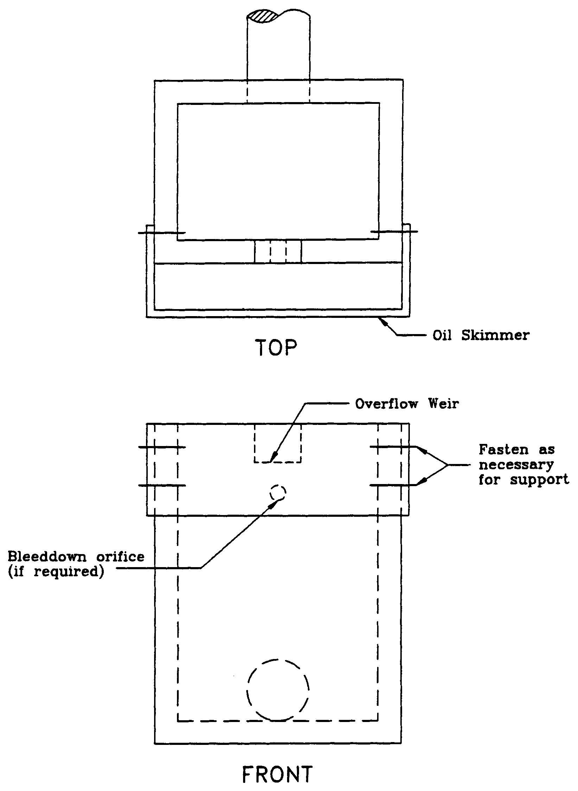

- Easements for waterbodies, open conveyance systems, stormwater basins and storage areas must meet the following requirements:

- Include the area of the water surface measured at the control elevation

- Be a minimum of 20 feet from the edge of water at the control elevation or top of bank and include side slopes no steeper than 4H:1V

(c) Easements adjacent to water control structures must be 20 feet wide.

(d) Easements for piped stormwater conveyance must be a minimum of the width of the pipe plus 4 times the depth of the pipe invert.

(e) Access easements must be 20 feet wide from a public road or public right-of way to the stormwater management system.

(f) As an alternative, the applicant may propose other authorization for maintenance access provided the applicant affirmatively demonstrates that equipment can enter and perform the necessary maintenance on the system.

9.6 Legal Authorization

Applicants which propose to utilize offsite areas not under their control to satisfy the requirements for issuance listed in section 8.3.1 must obtain sufficient legal authorization prior to permit issuance to use the area. For example, an applicant who proposes to locate the outfall pipe from the stormwater basin to the receiving water on an adjacent property owner's land must obtain a drainage easement or other appropriate legal authorization from the adjacent owner. A copy of the legal authorization should be submitted with the permit application.

9.7 Tailwater

"Tailwater" refers to the water elevation (or pressure) at the final discharge part of the stormwater management system. Tailwater is an important component of the design and operation of nearly all stormwater management systems and can affect any of the following management objectives of the system:

(a) Peak discharge from the stormwater management system

(b) Peak stage in the stormwater management system

(c) Level of flood protection in the project

(d) Recovery of peak attenuation and stormwater treatment volumes

- Control elevations, normal water elevation regulation schedules, and ground water management

9.7.1 Tailwater Design and Performance Criteria

The regulation of stormwater management systems rule requires that stormwater
management systems (except retention and exfiltration systems) must provide a
gravity or pumped discharge that effectively operates (i.e., meets applicable rule
criteria) under one of the following tailwater conditions:

(a) Maximum stage in the receiving water resulting from the mean annual 24-hour storm. This storm depth is shown on the isopluvial map in Figure 9-2. Generally, applicants utilizing this option would model the receiving waters utilizing standard hydrologic and hydraulic methods for the mean annual 24-hour storm to determine peak stages at various points of interest. Lower stages may be utilized if the applicant demonstrates that flow from the project will reach the receiving water prior to the time of maximum stage in the receiving water. See sections 12.6 and 12.9 of the Applicant's Handbook: Management and Storage of Surface Waters for more information on designing detention basins with tailwater influences.

(b) Mean annual high tide for tidal areas. This elevation is the average of all the high tides for each year. This elevation may be determined from tide charts or other similar information.

(c) Mean annual seasonal high water elevation. This elevation may be determined by water lines on vegetation or structures, historical data, adventitious roots or other hydrological or biological indicators, design of man-made systems, or estimated by a registered professional using standard hydrological methods based on the site and receiving water characteristics.

(d) The applicant may propose applicable criteria established by a local government, state agency, or stormwater utility with jurisdiction over the project. However, the Department District must accept the use of alternative criteria. In this case, the applicant is encouraged to consult with Department District staff prior to submitting an application.

9.8 Peak Discharge Attenuation

9.8.1 Overview

Urbanization increases total runoff volume, peak discharge rates, and the magnitude and frequency of flood events (Miller 1982). With an increase in the number of flood events a stream is subjected to, the potential for accelerated erosion of both the stream banks and channel bottom is enhanced (Miller 1982). Proper design of detention

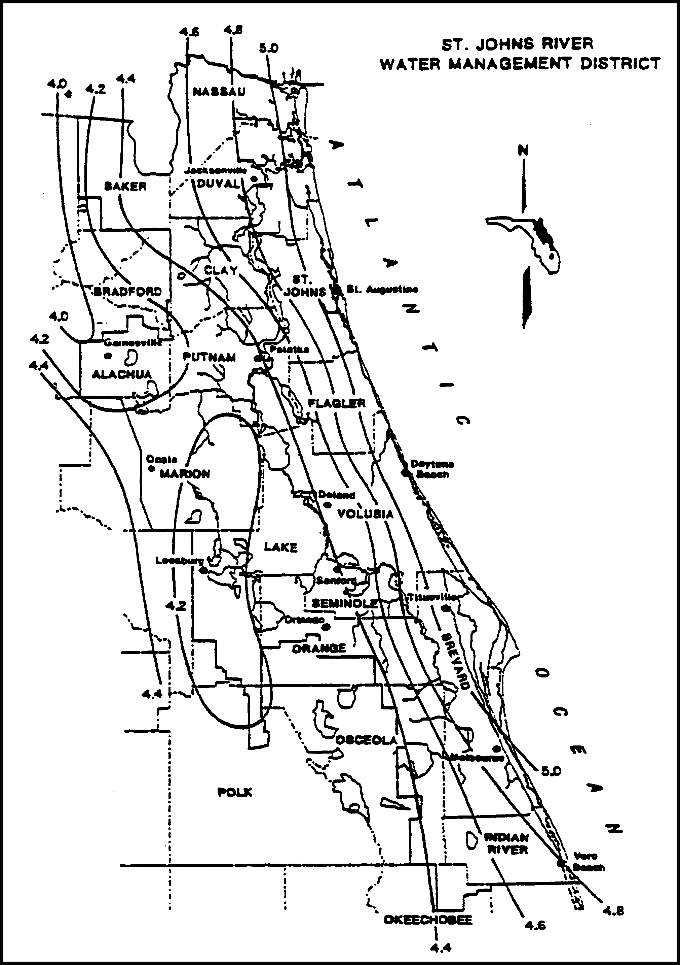

Figure 9-2. Mean Annual 24-Hour Maximum Rainfall, inches (Source: Rao, 1991)

systems to limit post-development peak discharge rates to predevelopment rates can minimize some of the stormwater effects of urbanization.

9.8.2 Selection of Design Storm

Proper selection of the design storm for peak discharge control is crucial to determining the effectiveness of the detention basin. Historically, the District only regulated the peak discharge from large storm events (i.e., 25-year, 24-hour storm) for larger systems requiring an environmental resource permit under Cchapter 40C-4, F.A.C. Unfortunately, the following drawbacks to this approach were noted:

(a) If a detention pond is only designed to reduce the peak of the 25-year storm, the discharge rates from lesser events such as the 2, 5, and 10-year flood events may not be controlled (Miller 1982). The ineffectiveness of controlling small flood events may appear to be unimportant with respect to flood damages. However, these more frequent events do cause localized flood damage and are of prime importance as a cause of channel erosion (Lakatos 1982).

(b) Cumulative water quantity impacts may occur from several projects below the Chapter 40C-4, F.A.C., thresholds located within the same watershed.

To address these concerns, the rule requires that the peak discharge rate from highly impervious projects be controlled for the mean annual, 24-hour storm event. The mean annual 24-hour storm (approximately 2.5-year return period) was selected as the design event for this rule because the shape and form of natural channels is controlled by approximately the 2-year return frequency storm (Schueler 1987) and the District has published information on the depth and distribution for this storm event (Rao 1991). The rainfall depth for the mean annual 24-hour storm for the District is shown in Figure 9-2. The rainfall depth at a particular location may be established by interpolating between the nearest isopluvial lines.

9.8.3 Relationship to Chapter 40C-4 Peak Discharge Criteria

Applicants who must obtain both an environmental resource permit and an environmental resource stormwater permit under the provisions of Cchapters 40C-4 and 40C-42, F.A.C., respectively, for a project must design the system to meet the peak discharge requirements of both. This can be accomplished by designing a multi-staged outlet structure to attenuate both the 25-year and mean annual storm events. See Figure 9-3 for a conceptual design of a multi-staged outlet structure. Examples of multi-staged outlet structures include two staged weirs, risers with
multiple orifice controls, and combinations of weir and orifice controls.

Figure 9-3. Conceptual design of a multi-stage outlet structure

9.8.4 Peak Discharge Criteria for Stormwater Management Systems

The post-development peak discharge rate must not exceed predevelopment rates for
the mean annual 24-hour storm for systems serving both of the following:

(a) New construction area greater than 50% impervious (excluding water bodies)

(b) Projects for the construction of new developments as described in section 3.3.

Note: Both of these conditions must be met before a project is required to comply with the peak discharge criterion. Also, projects which modify existing systems are exempt from this criterion pursuant to condition (b), above. Pervious concrete and turf blocks are not considered impervious surface for this purpose, however, compacted soils and limerock are considered impervious for purposes of this section.

9.8.5 Alternative Peak Discharge Criteria

As an alternative to the peak discharge criteria in section 9.8.4, applicants may propose to utilize applicable storm event, duration, or criteria specified by a local government, state agency (including FDOT), or stormwater utility with jurisdiction over the project. However, the Department District must accept the use of the alternative criteria. Applicants proposing to use alternative criteria are encouraged to have a pre-application conference with Department District staff.

9.8.6 Accepted Methodologies

A peak discharge analysis typically consists of generating predevelopment and postdevelopment runoff hydrographs, routing the post-development hydrograph through a detention basin, and sizing an overflow structure to control post-development discharges at or below predevelopment rates.

The Department District has accepted several methodologies for computation of runoff hydrographs for environmental resource stormwater permits. These methods include the following:

(a) Natural Resources Conservation Service (SCS) Curve Number and Unit Hydrograph Method

(b) Santa Barbara Urban Hydrograph (SBUH) Method

(c) Modified Rational Hydrograph Method

The SCS and SBUH methods are described in sections 10.3 and 13.0 of the Applicant's Handbook: Management and Storage of Surface Waters. Therefore, a detailed discussion of these methods will not be presented in this handbook. The reader is also encouraged to consult Suphunvorranop (1985) or Wanielista (1990) for a complete description of the SCS method. Wanielista (1990) also provides a good overview of the SBUH method.

9.8.7 Modified Rational Hydrograph Method

The rational method is a popular method for estimating peak runoff rates for small urban areas. The rational method gives peak discharge rates rather than a runoff hydrograph.

The rational formula can be modified to generate a runoff hydrograph by utilizing the rainfall intensity for various increments of a design storm. A methodology for generating runoff hydrographs utilizing the modified rational hydrograph method is presented in section 24.

Similar to the rational method, use of the modified rational hydrograph method should be limited to small drainage basins with short times of concentration. Therefore, the rule restricts use of the modified rational method to systems meeting the following criteria:

(a) The drainage area is less than 40 acres.

(b) The predevelopment time of concentration for the system is less than 60 minutes.

(c) The post-development time of concentration for the system is less than 30 minutes.

Note: The Department District does not accept the modified rational hydrograph method for use in Cchapter 40C-4, F.A.C., peak discharge design storms (i.e., 25-year). If a project requires a peak discharge analysis under both Cchapters 40C-4 and 40C-42, F.A.C., the applicant may utilize the modified rational method only for the storm specified in Cchapter 40C-42, F.A.C., (i.e., mean annual storm) provided the above criteria are met.

9.8.8 Computer Programs Accepted by the Department District

Numerous computer programs have been written to solve the runoff hydrograph and detention basin routing calculations required in a peak discharge analysis. The Department District has screened many of these programs proposed by applicants for use in Cchapter 40C-4, F.A.C., and Cchapter 40C-42, F.A.C., permit applications. In order to evaluate and review computer programs, applicants are asked to provide detailed documentation of the model and make test runs using input data provided in test problems supplied by the Department District. If the model is sound from a theoretical standpoint and the results compare favorably with those of a benchmark standard model (such as HEC-1), the program is accepted for use in permit submittals under both Cchapters 40C-4 and 40C-42, F.A.C. Readers should contact the Department District office nearest them (see section 1.3) for a copy of the test problems and/or the current list of models screened by the Department District.

The Department District only reviews the models for a minimum level of proficiency. The Department District can neither endorse any program nor certify program results.

Applicants are encouraged to receive Department District acceptance of programs not on the list prior to application submittal to avoid permitting delays associated with review of the model.

9.9 Conveyance

Projects which alter existing conveyance systems (e.g., rerouting an existing ditch) must not adversely affect existing conveyance capabilities. It is presumed a system will meet this criterion if one of the following are met:

(a) The existing hydraulic capacity is maintained in the new system. This can be accomplished by maintaining existing headwater and tailwater conditions.

(b) The applicant demonstrates that changes in flood elevation and velocities will not adversely impact upstream or downstream off-site property. For example, this criterion may be satisfied by demonstrating that there is no increase in damages to existing off-site property (e.g., roads, buildings) resulting from changes in the existing flood elevations. Also, the applicant should demonstrate that proposed velocities are non-erosive or that erosion control measures (e.g., rip-rap, concrete lined channels, etc.) are sufficient to safely convey the flow.

(c) The criteria in section 10.5.2(b), Applicant's Handbook: Management and Storage of Surface Waters is met.

(d) As an alternative, the applicant may propose to utilize an applicable criteria established by a local government, state agency, or stormwater utility with jurisdiction over the project. However, Department District staff must approve the use of this criteria.

9.10 Professional Certification

All construction plans and supporting calculations submitted to the Department District must be signed, sealed, and dated by an appropriate registered professional (i.e., engineer, geologist, or landscape architect) as required by the relevant statutory provisions (i.e., Cchapters 471, 481, or 492, F.S.) when the design of the stormwater management system requires the services of a registered professional.

9.11 Sensitive Karst Area Basin Design Criteria

Chapter 40C-41, F.A.C., establishes additional surface water management criteria which are used in reviewing applications for permits in designated hydrologic basins. The Sensitive Karst Areas Basin covers those portions of western Alachua and western Marion counties within the SJRWMD boundaries (Figures 9-4, 9-5, and 9-6). The design criteria for the Sensitive Karst Area Basin is found in subsection 40C-41.063(6), F.A.C., and is discussed in section 9.11.2, below.

The Floridan aquifer is the drinking water source for most of the population in the SJRWMD. In parts of Alachua and Marion counties, the limestones that make up or comprise this aquifer are at or very near the land surface and potential sources of pollution. Potential contamination of the Floridan aquifer from surface pollutant sources in these areas is greater than within the rest of the District due to the hydrogeology and geology of these "sensitive karst areas." "Karst" is a geologic term used to describe areas where sinkhole formation is common and landscapes are formed by the solution of limestone.

9.11.1 Hydrogeology of the Sensitive Karst Areas Basin

Throughout the majority of the District the highly porous limestone which contains the Floridan aquifer is overlain by tens to hundreds of feet of sands, clays, and other material. This material acts as a buffer, isolating the Floridan aquifer from surface pollutants. Surface water seeps through this material slowly which allows for filtration, adsorption, and biological removal of contaminants.

However, in the Sensitive Karst Areas (SKA) the limestone which contains the Floridan aquifer exists at, or virtually at, land surface (Figure 9-7). The absence of cover material allows rapid movement of surface water into the aquifer with little treatment. The SKA are areas of high recharge for the Floridan aquifer. Floridan aquifer ground water levels vary from land surface to approximately 60 feet below land surface in the SKA.

A factor which makes the SKA particularly prone to stormwater contamination is the formation of solution pipe sinkholes. Solution pipe sinkholes are common in these areas and form due to the collapse of surficial material into vertical cavities that have been dissolved in the upper portion of the limestone (Figure 9-7). They are also formed by the movement of surface material into the porous limestone of the SKA. In most cases, the solution pipes are capped by a natural plug of sands and clays (Figures 9-7 and 9-8). If the cap is washed out, the resulting solution pipe sinkhole (Figure 9-9) can act as a direct avenue for the movement of inadequately treated stormwater into the Floridan aquifer.

Solution pipe sinkholes often form in the bottom of stormwater retention basins. The capping plug may be reduced by excavation of the pond. Stormwater in the basin may increase the hydraulic head on the remaining plug. Both of these factors can wash the plug down the solution pipe. Solution pipes act as natural drainage wells and can drain stormwater basins.

Figure 9-4. Karst areas in the St. Johns River Water Management District

Figure 9-5 Alachua County karst area

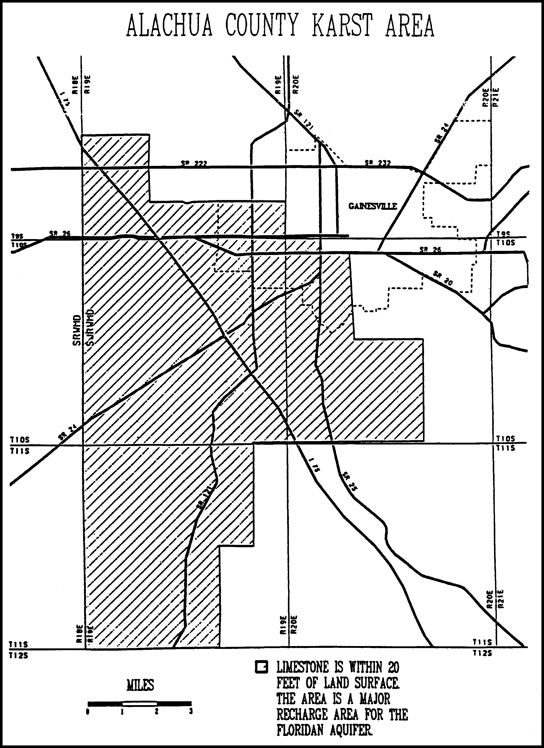

Figure 9-6 Marion County karst area

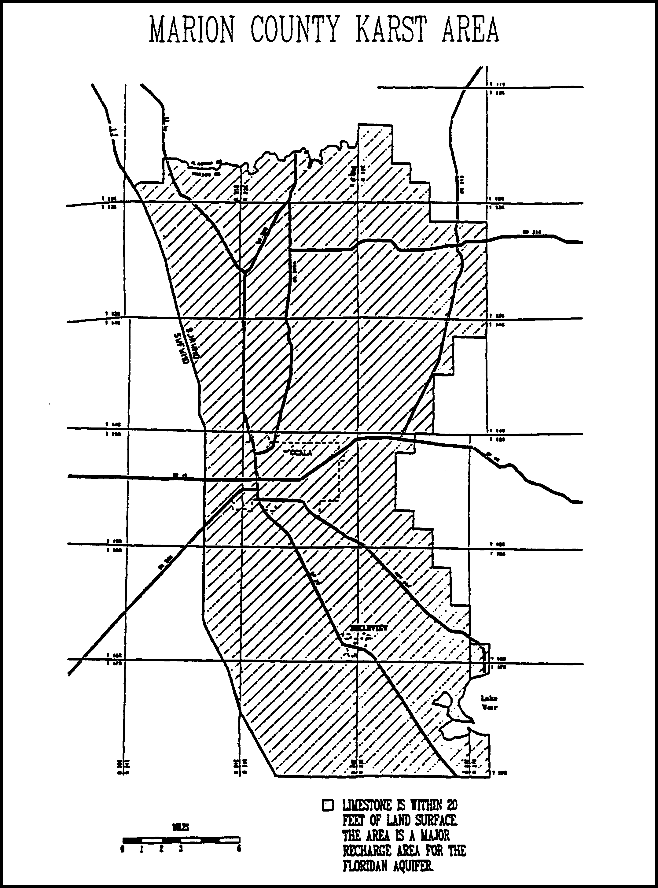

Figure 9-7 Generalized geologic section in karst sensitive area

Figure 9-8 Generalized geologic section in karst sensitive area with excavated retention basin

Figure 9-9. Generalized geologic section in karst sensitive area with excavated retention basin

The irregular weathering of the limestone surface in the SKA causes uncertainty and errors in determining the depth from land surface to limestone. For example, in Figure 9-7, boring A would show limestone much deeper than it would actually be encountered during excavation, shown at boring B. This potential for error must be considered for site investigations when evaluating site borings.

The SKA has been delineated within the District using two criteria:

(a) The area is a major recharge area, defined by the United States Geological Survey (USGS) as 10 to 20 inches annual recharge, for the Floridan aquifer.

(b) The porous limestone of the Floridan aquifer occurs within 20 feet of the land surface.

Delineations were made using the best available data, including boring and geologic data from the District, the Florida Geologic Survey, and the USGS. As additional data becomes available, the delineation of these areas can be further refined if needed. A generalized map of the SKA is shown in Figure 9-4; detailed maps are provided in Figures 9-5 and 9-6. If needed, maps of the SKA on USGS Quad Sheets are available for viewing in the Palatka and Altamonte Springs offices.

9.11.2 Design Criteria for Sensitive Karst Areas

The stormwater system should be designed to assure adequate treatment of the water before it enters the Floridan aquifer. The system design should prevent the formation of solution pipe sinkholes in the basins. To protect the Floridan aquifer, the Department District requires the following minimum design features for all projects in the SKA:

(a) A minimum of three feet of unconsolidated soil material between the surface of the limestone bedrock and the bottom and sides of the stormwater basin. Excavation and backfill of suitable material may be made to meet this criteria. This provides reasonable assurance of adequate treatment of stormwater before it enters the Floridan aquifer.

(b) Stormwater storage areas should be as shallow as possible with a horizontal bottom (no deep spots). In general, the size of a stormwater storage basin can be minimized by providing retention throughout the project site by using shallow landscaped areas and swales.

(c) Maximum basin depth of 10 feet. (Items (b) and (c) reduce the potential for solution pipe sinkhole formation cause by a large hydraulic head.)

(d) Fully vegetated basin side slopes and bottom. Vegetation plays a critical role in the removal of contaminants from stormwater and stabilization of side slopes. In the SKA, droughty, highly alkaline soils are common and prevent successful establishment of commonly used grasses such as bahia. Typically poor survival of vegetation in stormwater basins in the SKA has demonstrated the need for mat-forming vegetation which can tolerate these conditions.

Two species of grasses are best suited for use in retention basins in the SKA. These grasses are discussed below:

St. Augustine: This grass can tolerate high alkalinity and brief inundation. However, irrigation is required to foster a healthy cover during dry periods.

Bermuda: This grass can grow in alkaline conditions, is drought resistant, and can stand brief inundation. It is also a low maintenance species which provides excellent cover and soil stabilization. Bermuda grass grows in a thick mat, eventually covering all exposed soil. It recovers quickly after even extended drought. Mowing is rarely required because bermuda creeps laterally rather than growing vertically. Seed is available commercially and is inexpensive.

The above conditions represent the minimum design requirements for systems in the SKA. Depending on the potential for contamination to the Floridan aquifer, more stringent criteria may apply. Industrial and some commercial sites will normally require more stringent design features. Some of the more stringent site specific design requirements which may be necessary include:

(a) More than 3 feet of material between the limestone bedrock surface and the bottoms and sides of retention basins

(b) Basin liners (Clay or geotextile)

(c) Sediment trapping structures at stormwater inlets

(d) Off-line treatment

(e) Special stormwater system design

(f) Ground water monitoring

(g) Paint/solvent and water separators

If the design of the proposed stormwater management systems does not include the minimum design criteria discussed in this section, an analysis must be submitted to the Department District that provides reasonable assurance that the ground water quality standards as set forth in Cchapters 62-520, 62-522, and 62-550 17-3, F.A.C., are met.

9.12 On-Line and Off-line Stormwater Systems

Pollutants in stormwater runoff from urbanized areas generally exhibit the "first flush" effect. This is the phenomenon where the concentration of pollutants in stormwater runoff are highest during the early part of the storm with concentrations declining as the runoff continues (Livingston 1986). Substantial reductions in pollutants loads will occur when this first flush is captured and treated. Therefore, each Best Management Practice (BMP) specifies a required volume of stormwater runoff to be captured and treated (i.e., treatment volume) prior to release to surface or ground water.

There are two basic types of configurations for capturing the treatment volume: online and off-line systems. On-line systems (Figure 9-10) consist of a storage area which provides storage of the required treatment volume for smaller storm events and, if required, temporary detention storage for peak discharge control during larger storm events. Runoff volumes in excess of the treatment volume mix with the treatment volume in the basin and transport a portion of the pollutant mass load over the basin control structure.

Off-line treatment systems (Figure 9-11) divert the treatment volume into a basin which is designed for storage and treatment of the applicable treatment volume. Runoff volumes in excess of the treatment volume by-pass the off-line basin and are discharged to the receiving water or routed to a detention basin if peak discharge attenuation is required. A diversion box (Figure 9-12) may be utilized to divert the treatment volume to the off-line basin and route subsequent flows away from the off-line basin.

Off-line systems are generally more effective at removing pollutants than on-line systems because accumulated pollutants cannot be "flushed out" during storm events that produce runoff volumes exceeding the treatment storage volume. Consequently, on-line systems must treat a greater volume of runoff than off-line systems to reduce the likelihood of flushing accumulated pollutants out of the system and achieve the pollutant removal goals required by the Water Resource Implementation Rule State Water Policy (Cchapter 62-40, F.A.C.). Treatment volumes for each of the stormwater treatment practices described in Cchapter 40C-42, F.A.C., is discussed in the section for that BMP (sections 10-16).

The treatment storage provided in an off-line system can be considered in the stage/storage calculations for peak discharge attenuation. Off-line systems should be designed to bypass essentially all additional stormwater runoff volumes greater than the treatment volume to a discharge point or other detention storage area. Of course, there will be some incremental additional storage in the off-line system associated with the hydraulic grade line at the weir structure in the typical diversion structure. This will depend on the size of the weir, but the weir should be sized to pass the design flow with minimal headwater.

Proposed off-line systems which will also serve to provide significant detention storage above the off-line treatment volume storage will be considered to function as on-line systems. These systems should either be designed to meet on-line treatment volume requirements or the designer should discuss the merits of the particular

Figure 9-10. On-line treatment system

Figure 9-11. Off-line treatment system

Figure 9-12. Diversion box (N.T.S.)

system (in terms of potential of flushing accumulated pollutants) with Department District staff in a pre-application conference.

9.13 References

Florida Department of Transportation. 1987. Drainage Manual, Volume 2B -Procedures. Tallahassee, Florida.

Lakatos, D.F. and R.H. Kropp. 1982. Stormwater Detention - Downstream Effects on Peak Flow Rates. In Proceedings of the Conference on Stormwater Detention Facilities, ed. W. DeGroot, pages 105 - 120. Engineering Foundation, American Society of Civil Engineers, New York.

Livingston, E.H. 1985. The Stormwater Rule: Past, Present and Future. In Stormwater Management: An Update, pages 43 - 49. University of Central Florida, Environmental Systems Engineering Institute, Orlando, Florida.

Livingston, E.H., E. McCarron, J. Cox, P. Sanzone. 1988. The Florida Land Development Manual: A Guide to Sound Land and Water Management. Florida Department of Environmental Regulation, Nonpoint Source Management Section, Tallahassee, Florida.

Miller, A.C. 1982. Hydraulic Effects on Streams. In Proceedings of the Conference on Stormwater Detention Facilities, ed. W. DeGroot, pages 94 - 104. Engineering Foundation, American Society of Civil Engineers, New York.

Rao, D.V. 1991. 24-Hour Rainfall Distributions for Surface Water Basins Within the St. Johns River Water Management District, Northeast Florida. St. Johns River Water Management District Technical Publication No. 91-3. Palatka, Florida.

Schueler, T.R. 1987. Controlling Urban Runoff: A Practical Manual for Planning and Designing Urban BMP's. Metropolitan Washington Council of Governments, Washington, D.C.

Suphunvorranop, T. 1985. A Guide to SCS Runoff Procedures. St. Johns River Water Managment District Technical Publication No. 85-5. Palatka, Florida.

Wanielista, M.P. 1990. Hydrology and Water Quantity Control. John Wiley & Sons. New York.

10.0 Dry Detention Design and Performance Criteria

10.1 Description

Dry detention systems are normally dry storage areas which are designed to store a defined quantity of runoff and slowly release the collected runoff through an outlet structure to adjacent surface waters. After drawdown of the stored runoff is completed, the storage basin does not hold any water, thus the system is normally "dry." A schematic of a typical dry detention system is presented in Figure 10-1.

Dry detention basins are similar to retention systems in that the basins are normally dry. However, the main difference between the two systems is that retention systems are designed to percolate the stored runoff into the ground while dry detention systems are designed to discharge the runoff through an outlet structure to adjacent surface waters.

Sedimentation is the primary pollutant removal process which occurs in dry detention systems. Unfortunately, only pollutants which are primarily in particulate form are removed by sedimentation. Therefore, the pollutant removal efficiency of dry detention systems is not as great as systems such as retention and wet detention which remove both dissolved and particulate pollutants. Because of the limited pollutant removal efficiency of dry detention, this BMP must only be utilized where no other general permit BMP is feasible. For example, use of dry detention must be restricted to the following situations:

(a) Where high ground water table or soil conditions limit the feasibility of other BMPs such as retention, and

(b) Small drainage basins (less than 5 acres). For larger projects (greater than 5 acres) other BMPs like wet detention should be utilized instead of dry detention.

Therefore, general permits stormwater management systems utilizing dry detention are limited to systems within project areas less than 5 acres in size, and which serve drainage area less than 5 acres in size.

There are several design and performance criteria which must be met in order for a dry detention system to meet the rule requirements. A description of each design criterion is presented below.

10.2 Treatment Volume

The first flush of runoff should be detained in a dry detention basin and slowly released through the control structure. For discharges to Class III receiving water bodies, the rule specifies off-line detention of the first one inch of runoff or 2.5 inches of runoff from the impervious area, whichever is greater.

Figure 10-1 Dry detention (N.T.S.)

For direct discharges to Class I, Class II, OFWs, or Class III waters which are approved, conditionally approved, restricted, or conditionally restricted for shellfish harvesting, the applicant should provide dry detention for at least an additional fifty percent of the applicable treatment volume specified for off-line dry detention in (a), above. Off-line detention must be provided for at least the first one inch of runoff or 2.5 inches of runoff from the impervious area, whichever is greater, of the total amount of runoff required to be treated.

Dry detention removes less pollutants on a per unit basis than the other treatment systems enumerated in the rule. Therefore, dry detention systems must treat a greater volume of stormwater than the other treatment practices specified in the rule to achieve an equivalent level of pollutant removal.

10.3 Recovery Time

The outfall structure should be designed to drawdown one-half the required treatment volume specified above between 24 and 30 hours following a storm event. Design equations for sizing an orifice and a "V" notch weir to meet the recovery time are given in section 25.

10.4 Outlet Structure

The outlet structure must include a drawdown device (such as an orifice, "V" or square notch weir) set to slowly release the treatment volume (see Figures 10-2 and 10-3 for conceptual schematics). In addition, the structure must include a device to prevent the discharge of accumulated sediment, minimize exit velocities, and prevent clogging. Examples of such devices include perforated riser enclosed in a gravel jacket and perforated pipes enclosed in sand or gravel (see Figure 10-5).

In addition, the control elevation should be set at or above the design tailwater elevation so the basin can effectively recover the treatment storage.

10.5 Ground Water Table, Basin Floor, and Control Elevation

To minimize ground water contributions and ensure the basin floor is normally dry, the control elevation and basin floor should be set at least one foot above the seasonal high ground water table elevation. Sumps may be placed up to one foot below the control elevation. The basin floor should be level or uniformly sloped toward the control structure. The system should only contain standing water within 3 days of a storm event. Continuous standing water in the basin may also reduce the aesthetic value of the system and may promote mosquito production.

10.6 Basin Stabilization

The dry detention basin should be stabilized with permanent vegetative cover.

Figure 10-2 Typical dry detention outfall structure with orifice (N.T.S.)

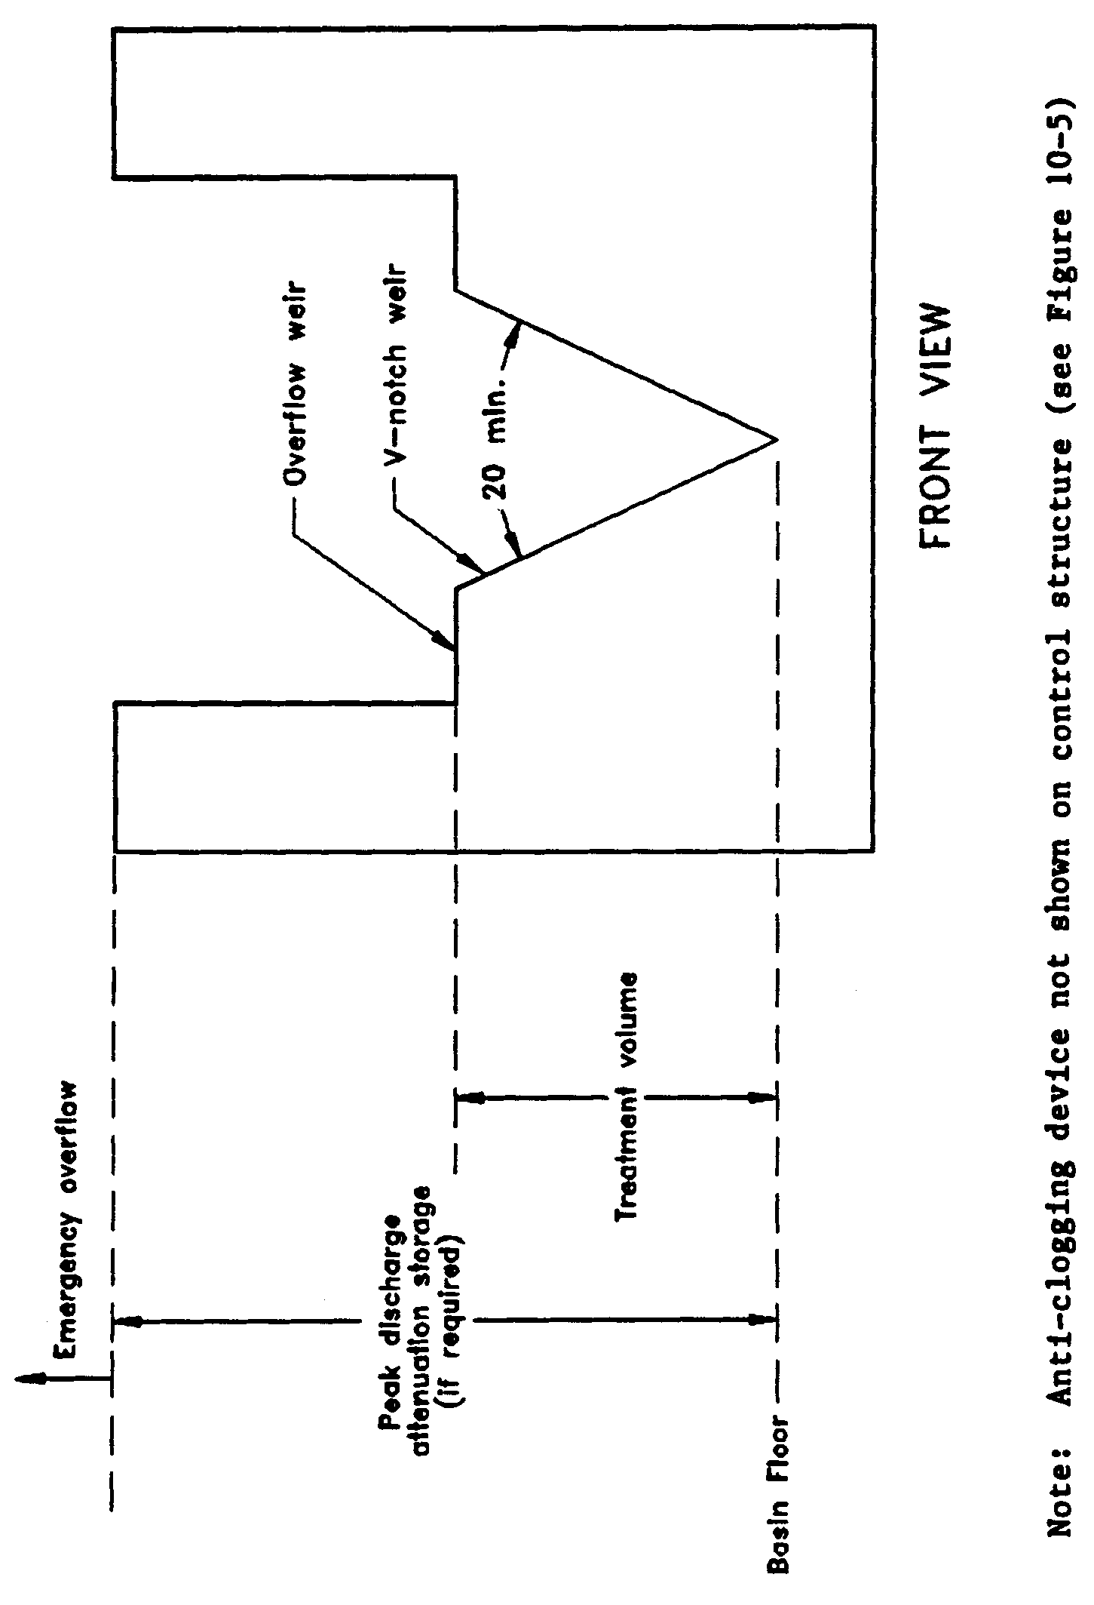

Figure 10-3. Typical dry detention outfall structure with “V”-notch weir (N.T.S.)

Figure 10-5. Devices to prevent clogging in dry detention control structures (Source: Schueler, T.R. 1987. Controlling Urban Runoff: A Practical Manual for Planning and Designing Urban BMP’s. Metropolitan Washington Council of Governments, Washington, D.C.)

10.7 Basin Configuration

The average length to width ratio of the dry detention basin must be at least 2:1. Under these design conditions, short circuiting is minimized and pollutant removal efficiency is maximized.

If short flow paths are unavoidable, the effective flow path can be increased by adding diversion barriers such as peninsulas or baffles to the basin. Examples of good and poor basin configurations are given in Figure 10-4.

10.8 Inlet Structures

Inlet structures should be designed to dissipate the energy of water entering the basin.

10.9 Maintenance

Dry detention systems must include provisions for removal of sediment and debris from the basin and mowing and removal of grass clippings.

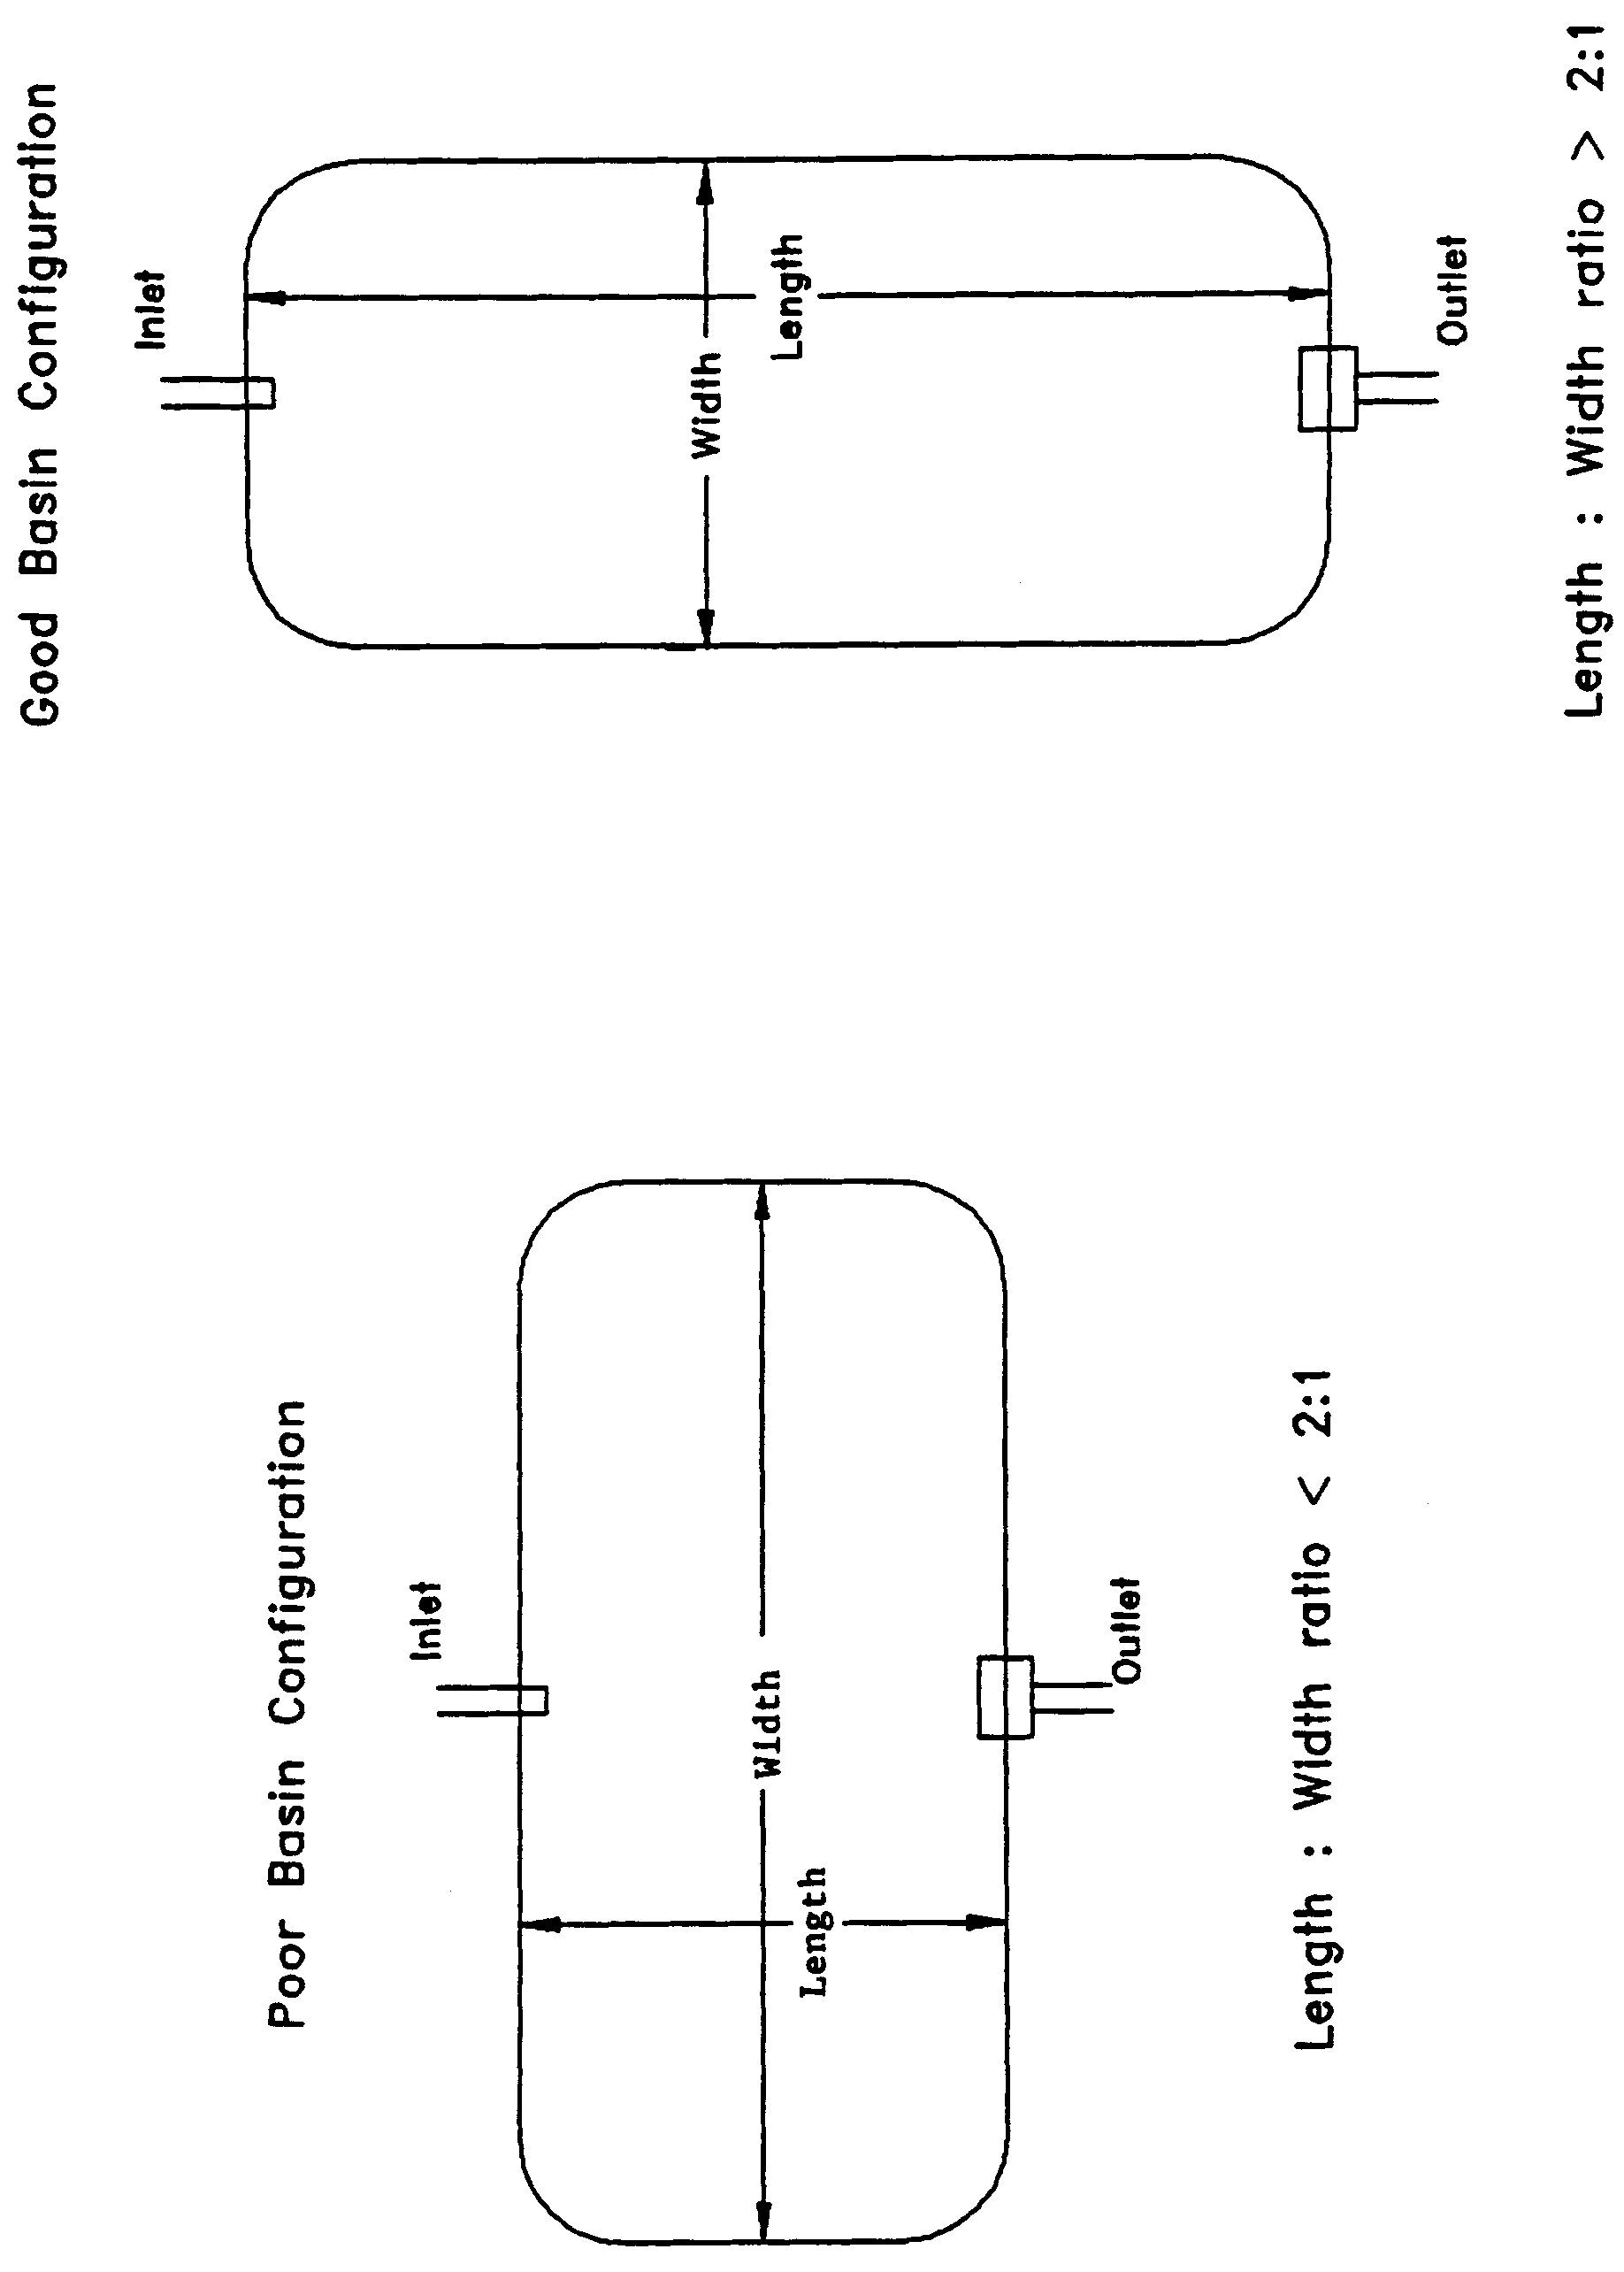

Figure 10-4. Examples of good and poor dry detention pond configurations (N.T.S.)

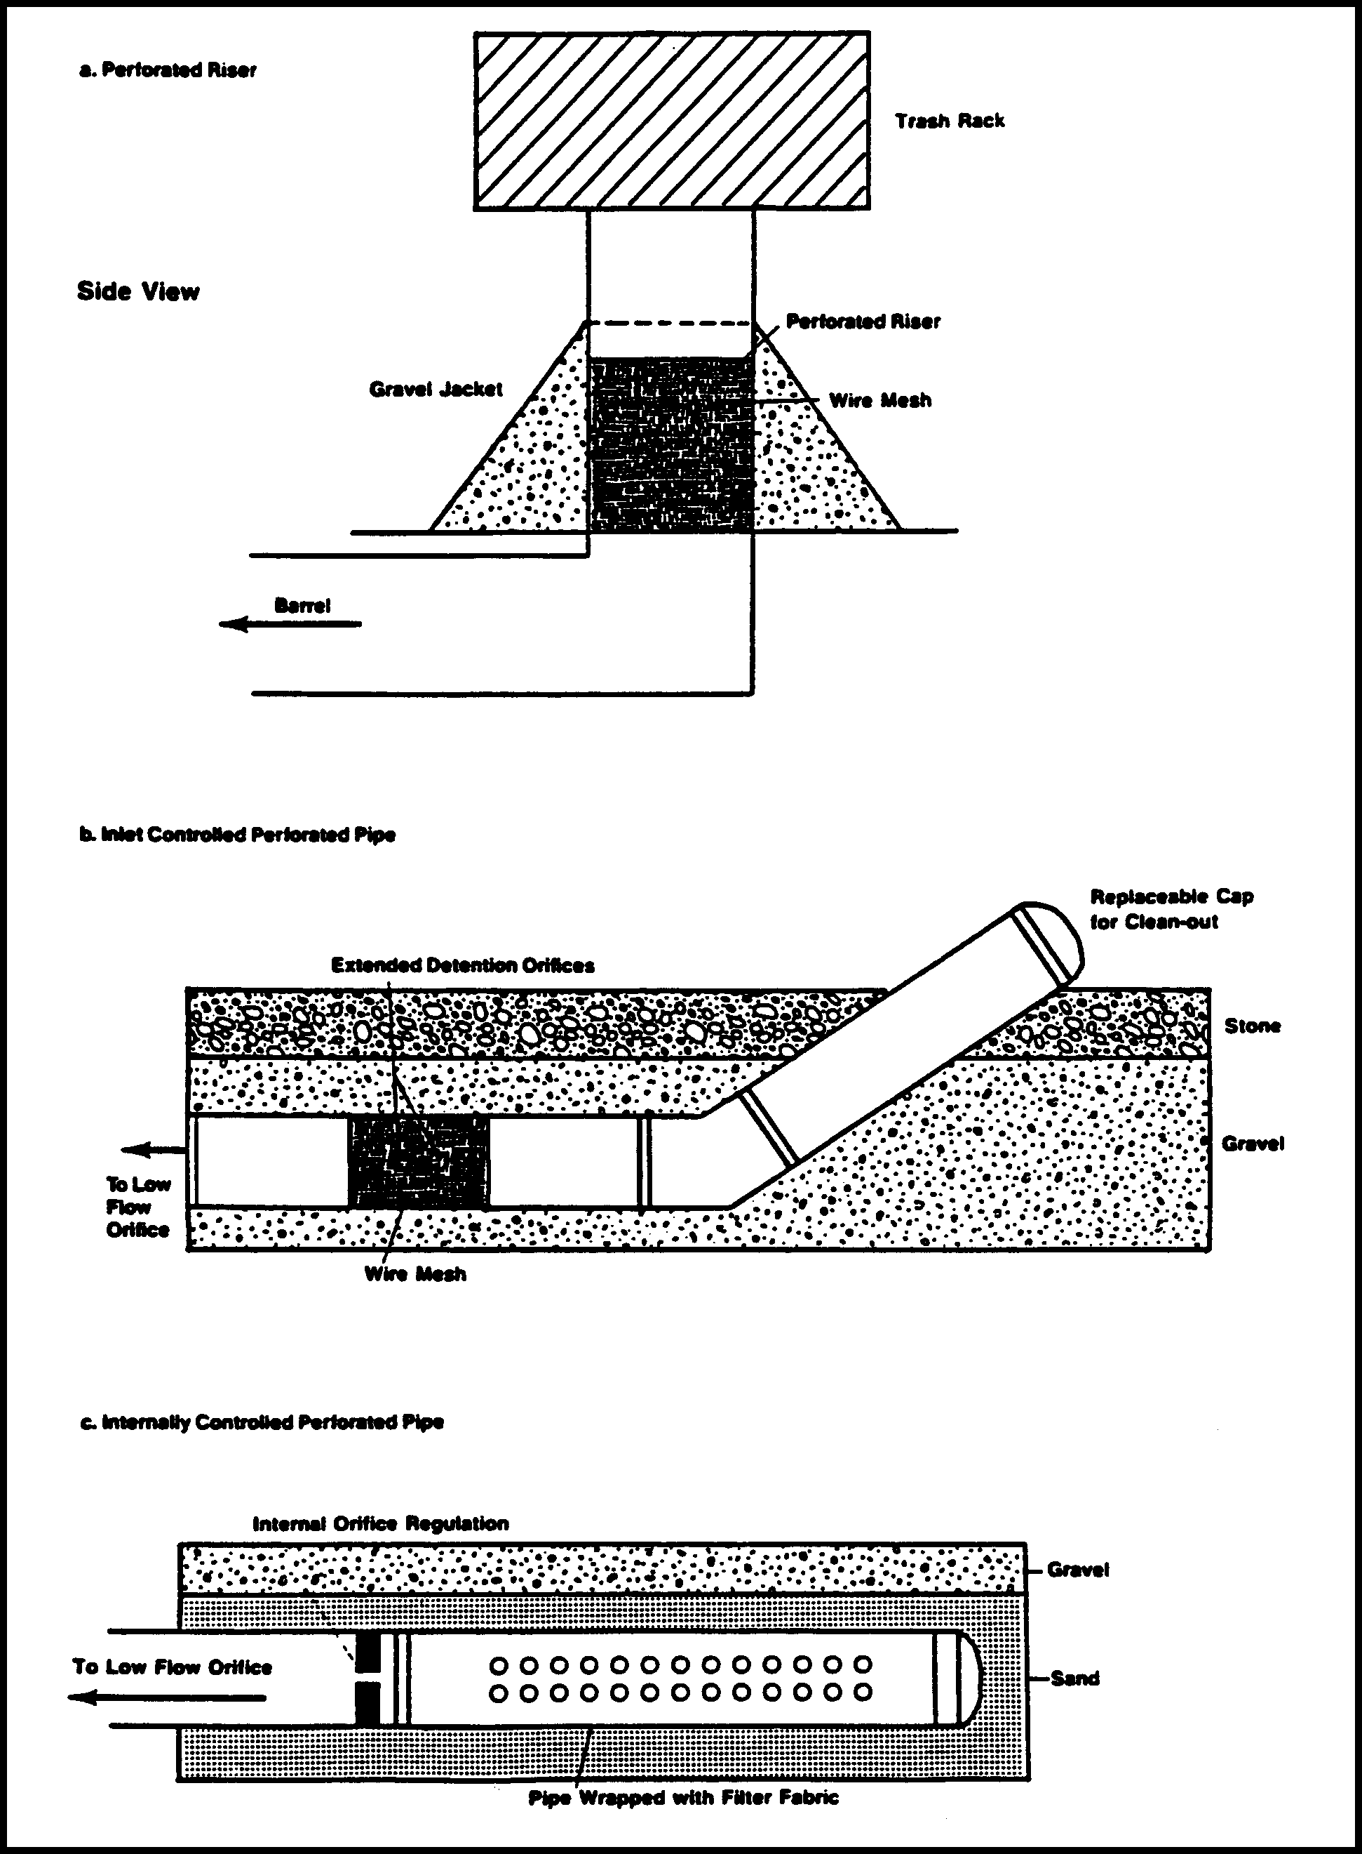

Figure 10-5. Devices to prevent clogging in dry detention control structures (Source: Schueler, T.R. 1987. Controlling Urban Runoff: A Practical Manual for Planning and Designing Urban BMP’s. Metropolitan Washington Council of Governments, Washington, D.C.)

11.0 Design Criteria and Guidelines for Retention Systems

11.1 Description

Retention system is defined as a storage area designed to store a defined quantity of runoff, allowing it to percolate through permeable soils into the shallow ground water aquifer. Stormwater retention works best using a variety of retention
systems throughout the project site. Examples of retention systems include:

- Man-made or natural depressional areas where the floor is graded as flat as possible and turf is established to promote infiltration and stabilize the basin slopes (see Figure 11-1)
- Shallow landscaped areas designed to store stormwater
- Vegetated swales with swale blocks or raised inlets
- Pervious concrete with continuous curb

Soil permeability and water table conditions must be such that the retention system can percolate the desired runoff volume within a specified time following a storm event. After drawdown has been completed, the basin does not hold any water, thus the system is normally "dry." Unlike detention basins, the treatment volume for retention systems is not discharged to surface waters.

Retention systems provide excellent removal of stormwater pollutants. Substantial amounts of suspended solids, oxygen demanding materials, heavy metals, bacteria, some varieties of pesticides and nutrients such as phosphorus are removed as runoff percolates through the vegetation and soil profile.

Retention systems should not be located in close proximity to drinking water supply wells. Chapter 62-555 17-22, F.A.C., requires stormwater treatment facilities to be at least 100 feet from any public supply well. Chapter 40C-41, F.A.C., provides additional design features for systems constructed in Sensitive Karst Areas of the District where the drinking water aquifer is close to the land surface (see section 9.11).

Besides pollution control, retention systems can be utilized to promote the recharge of ground water to prevent saltwater intrusion in coastal areas or to maintain groundwater levels in aquifer recharge areas. Chapter 40C-41, F.A.C., contains recharge criteria for the Wekiva Recharge Protection Basin and the Tomoka River and Spruce Creek Hydrologic Basins (see sections 11.3.1 and 11.5.1 of the Applicant's Handbook: Management and Storage of Surface Waters). Retention systems can also be used to meet the runoff volume criteria for projects requiring a permit under Cchapters 40C-4 or 40C-40, F.A.C., which discharge to land-locked lakes (see section 10.4 of the Applicant’s Handbook: Management and Storage of Surface Waters).

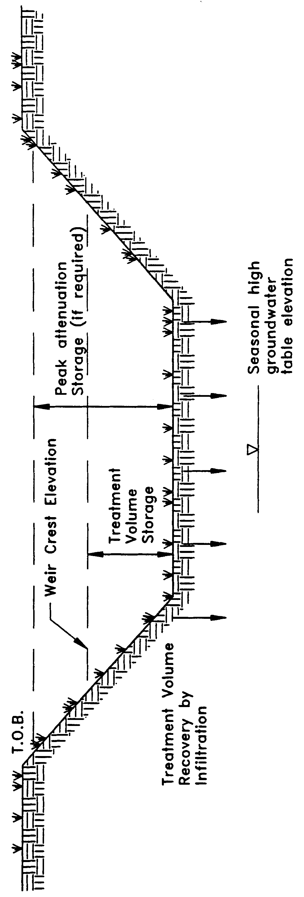

Figure 11-1. Retention (N.T.S.)

There are several design and performance criteria specific to retention systems which are described below.

11.2 Treatment Volume

The first flush of runoff should be routed to the retention basin and percolated into the ground. For systems which discharge to Class III receiving water bodies, the rule specifies one of the following:

(a) Off-line retention of the first one-half inch of runoff or 1.25 inches of runoff from the impervious area, whichever is greater.

(b) On-line retention of an additional one half inch of runoff from the drainage area over that volume specified for off-line treatment.

(c) On-line retention that provides for percolation of the runoff from the three year, one-hour storm.

(d) On-line retention of the runoff from one inch of rainfall or 1.25 inches of runoff from the impervious area, whichever is greater, for systems which serve an area with less than 40 percent impervious surface and that contain only U.S. Department of Agriculture Natural Resources Conservation Service (SCS) hydrologic group "A" soils.

For direct discharges to Class I, Class II, OFWs, or Class III waters which are approved, conditionally approved, restricted, or conditionally restricted for shellfish harvesting the applicant should provide retention for one of the following:

(a) At least an additional fifty percent of the applicable treatment volume specified for off-line retention in (a), above. Off-line retention must be provided for at least the first one-half inch of runoff or 1.25 inches of runoff from the impervious area, whichever is greater, of the total amount of runoff required to be treated.

(b) On-line retention of an additional fifty percent of the treatment volume specified in (b), above.

(c) On-line retention of the runoff from the three-year, one-hour storm.

(d) On-line retention that provides at least an additional 50 percent of the runoff volume specified in (d), above, for systems which serve an area with less that 40 percent impervious surface and that contain only U.S. Department of Agriculture Natural Resources Conservation Service (SCS) hydrologic group "A" soils.

11.3 Recovery Time

The retention system must provide the capacity for the appropriate treatment volume of stormwater specified in section 11.2 within 72 hours following a storm event assuming average antecedent moisture conditions. In retention systems, thestormwater is drawn down by natural soil infiltration and dissipation into the ground water table, evaporation, or evapotranspiration, as opposed to underdrain systems which rely on artificial methods like drainage pipes.

Antecedent moisture condition (AMC) refers to the amount of moisture and storage in the soil profile prior to a storm event. Antecedent soil moisture is an indicator of wetness and availability of soil to infiltrate water. The AMC can vary from dry to saturated depending on the amount of rainfall received prior to a given point in time. Therefore, "average AMC" means the soil is neither dry or saturated, but at an average moisture condition at the beginning of a storm event when calculating recovery time for retention systems.

The antecedent condition has a significant effect on runoff rate, runoff volume, infiltration rate, and infiltration volume. The infiltration volume is also known as the upper soil zone storage. Both the infiltration rate and upper soil zone storage are used to calculate the recovery time of retention systems and should be estimated using any generally accepted and well documented method with appropriate parameters to reflect drainage practices, seasonal high water table elevation, the AMC, and any underlying soil characteristics which would limit or prevent percolation of storm water into the soil column.

A detailed methodology, including ground water mounding, with design examples for calculating retention basin recovery is presented in section 26 of this handbook.

11.4 Basin Stabilization

The retention basin should be stabilized with pervious material or permanent vegetative cover. To provide proper treatment of the runoff in very permeable soils, permanent vegetative cover must be utilized when U.S. Department of Agriculture Natural Resources Conservation Service (SCS) hydrologic group "A" soils underlie the retention basin, except for pervious pavement systems.

11.5 Retention Basin Construction

11.5.1 Overview

Retention basin construction procedures and the overall sequence of site construction are two key factors that can control the effectiveness of retention basins. Sub-standard construction methods or construction sequence can render the basin inoperable prior to completion of site development.

Since stormwater management systems are typically required to be constructed during the initial phases of site development, retention basins are often exposed to poor quality surface runoff. Stormwater runoff during construction contains considerable amounts of suspended solids, organics, clays, silts, trash and other undesirable materials. For example, the subgrade stabilization material utilized during construction of roadways and pavement areas typically consist of clayey sand or soil cement. If a storm occurs when these materials are exposed (prior to placement of the roadway wearing surface), considerable amounts of these materials end up in the retention basin. Another source of fine material generated during construction is disturbed surface soil which can release large quantities of organics and other fine particles. Fine particles of clay, silt, and organics at the bottom of a retention basin create a poor infiltrating surface (Andreyev and Wiseman 1989).

11.5.2 Construction Requirements

The following construction procedures are recommended to avoid degradation of retention basin infiltration capacity due to construction practices (Andreyev and Wiseman 1989):

(a) Initially construct the retention basin to rough grade by under-excavating the basin bottom and sides by approximately 12 inches.

(b) After the drainage area contributing to the basin has been fully stabilized, the interior side slopes and basin bottom should be excavated to final design specifications. The excess soil and undesirable material should be carefully excavated and removed from the pond so that all accumulated silts, clays, organics, and other fine sediment material has been removed from the pond area. The excavated material should be disposed of beyond the limits of the drainage area of the basin.

(c) Once the basin has been excavated to final grade, the entire basin bottom should be deep raked and loosened for optimal infiltration.

(d) Finally, the basin should be stabilized according the section 11.4, above.

11.6 References
Andreyev, N.E., and L.P. Wiseman. 1989. Stormwater Retention Pond Infiltration Analysis in Unconfined Aquifers. Prepared for Southwest Florida Water Management District, Brooksville, Florida.

12.0 Underdrain Design and Performance Criteria

12.1 Description
Stormwater underdrain systems consist of a dry basin underlain with perforated drainage pipe which collects and conveys stormwater following percolation from the basin through suitable soil. Underdrain system are generally used where high water table conditions dictate that recovery of the stormwater treatment volume cannot be achieved by natural percolation (i.e, retention systems) and suitable outfall conditions exist to convey flows from the underdrain system to receiving waters. Schematics of a typical underdrain system are shown in Figures 12-1 and 12-2.

Underdrain systems are intended to control both the water table elevation over the entire area of the treatment basin and provide for the drawdown of the treatment volume. Underdrains are utilized where the soil permeability is adequate to recover the treatment volume since the on-site soils overlay the perforated drainage pipes.

Underdrain systems provide excellent removal of stormwater pollutants. Substantial amounts of suspended solids, oxygen demanding materials, heavy metals, bacteria, some varieties of pesticides and nutrients such as phosphorus are removed as runoff percolates through the vegetation and soil profile.

There are several design and performance criteria which must be met in order for a underdrain system to meet the rule requirements. The underdrain rule criteria are described below.

12.2 Treatment Volume

The first flush of runoff should be detained in a dry detention basin and percolated through the soil. For discharges to Class III receiving water bodies, the rule specifies either of the following treatment volumes:

(a) Off-line retention of the first one-half inch of runoff or 1.25 inches of runoff from the impervious area, whichever is greater, or

(b) On-line retention of an additional one half inch of runoff from the drainage area over that volume specified for off-line treatment.

For direct discharges to Class I, Class II, OFWs, or Class III waters which are approved, conditionally approved, restricted, or conditionally restricted for shellfish harvesting the applicant should provide retention for either of the following:

- At least an additional fifty percent of the applicable treatment volume specified for off-line retention in (a), above. Off-line retention must be provided for at least the first one-half inch of runoff or 1.25 inches of runoff from the impervious area, whichever is greater, of the total amount of runoff required to be treated.

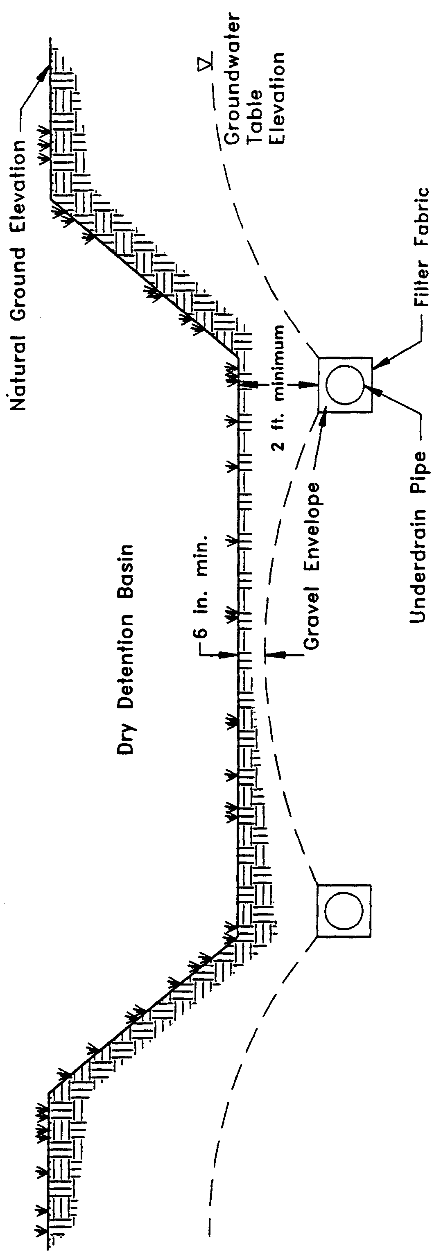

Figure 12-1. Cross-section of underdrain system (N.T.S.)

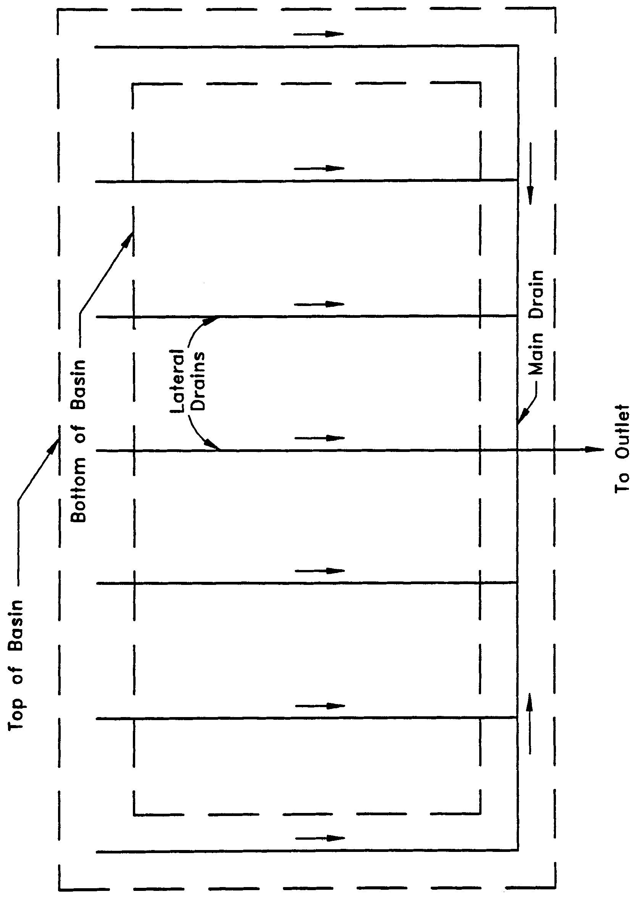

Figure 12-2. Top view of underdrain system (N.T.S.)

- On-line retention of the runoff from the three-year, one-hour storm or an additional fifty percent of the treatment volume specified in (b), above, whichever is greater.

12.3 Recovery Time

The system should be designed to provide for the drawdown of the appropriate treatment volume specified in section 12.2 within 72 hours following a storm event. The treatment volume is recovered by percolation through the soil with subsequent transport through the underdrain pipes. The system should only contain standing water within 72 hours of a storm event.

The pipe system configuration (e.g., pipe size, depth, pipe spacing, and pipe inflow capacity) of the underdrain system must be designed to achieve the recovery time requirement. Underdesign of the system will result in reduced hydraulic capacity. This, in turn, will result in a reduction in storage between subsequent rainfall events and an associated decrease in the annual average volume of stormwater treated resulting in a reduction of pollutant removal (Livingston et al. 1988). Such circumstances also reduce the aesthetic value of the system and may promote mosquito production. A detailed methodology with design examples for calculating retention basin recovery is presented in section 27. The benefits of gravel envelopes around perforated pipes are discussed in section 25.

12.4 Safety Factor

The underdrain system must be designed with a safety factor of at least two unless the applicant affirmatively demonstrates based on plans, test results, calculations or other information that a lower safety factor is appropriate for the specific site conditions. Examples of how to apply this factor include but are not limited to the following:

(a) Reducing the design percolation rate by half

(b) Designing for the required drawdown within 36 hours instead of 72 hours.

12.5 Underdrain Media

To provide proper treatment of the runoff, at least two feet of indigenous soil must be between the bottom of the basin storing the treatment volume and the outside of the underdrain pipes (or gravel envelope as applicable).

12.6 Filter Fabric

Underdrain systems should utilize filter fabric or other means to prevent the soil from moving into and clogging perforated pipe.

12.7 Inspection and Cleanout Ports

To facilitate maintenance of the underdrain system, capped and sealed inspection and cleanout ports which extend to the surface of the ground should be provided, at a minimum, at the following locations for each drainage pipe:

(a) The terminus

(b) At every 400 feet or every bend of 45 or more degrees, whichever is shorter.

12.8 Basin Stabilization

The underdrain basin should be stabilized with permanent vegetative cover and should contain standing water only immediately following a rainfall event.

12.9 References
Livingston, E.H., E. McCarron, J. Cox, P. Sanzone. 1988. The Florida Land Development Manual: A Guide to Sound Land and Water Management. Florida Department of Environmental Regulation, Nonpoint Source Management Section, Tallahassee, Florida.

13.0 Exfiltration Trench Design and Performance Criteria

13.1 Description

Exfiltration trench is a subsurface system consisting of a conduit such as perforated pipe surrounded by natural or artificial aggregate which temporarily stores and infiltrates stormwater runoff (Figure 13-1). Stormwater passes through the perforated pipe and infiltrates through the trench walls and bottom into the shallow groundwater aquifer. The perforated pipe increases the storage available in the trench and helps promote infiltration by making delivery of the runoff more effective and evenly distributed over the length of the system (Livingston et al. 1988). Generally, exfiltration trench systems are utilized where space is limited and/or land costs are high (i.e., downtown urban areas).

Soil permeability and water table conditions must be such that the trench system can percolate the required stormwater runoff treatment volume within a specified time following a storm event. The trench system is returned to a normally "dry" condition when drawdown of the treatment volume is completed. Like retention basins, the treatment volume in exfiltration trench systems is not discharged to surface waters. Thus, exfiltration is considered a type of retention system.

Like other types of retention systems, exfiltration trench systems provide excellent removal of stormwater pollutants. Substantial amounts of suspended solids, oxygen demanding materials, heavy metals, bacteria, some varieties of pesticides and nutrients such as phosphorus are removed as runoff percolates through the soil profile. Exfiltration trench systems should not be located in close proximity to drinking water supply wells. Chapter 62-555 17-22, F.A.C., requires stormwater treatment systems to be at least 100 feet from any public supply well. Chapter 40C-41, F.A.C., provides additional design features for systems constructed in Sensitive Karst Areas of the District where the drinking water aquifer is close to the land surface (see section 9.11).

Besides pollution control, exfiltration trench systems can be utilized to promote the recharge of ground water and to prevent saltwater intrusion in coastal areas, or to maintain groundwater levels in aquifer recharge areas. Chapter 40C-41, F.A.C., contains recharge criteria for the Wekiva Recharge Protection Basin and the Tomoka River and Spruce Creek Hydrologic Basins (see sections 11.3.1 and 11.5.1 of the Applicant's Handbook: Management and Storage of Surface Waters). Exfiltration trench systems can also be used to meet the runoff volume criteria for projects requiring an environmental resource permit under Cchapters 40C-4 or 40C-40, F.A.C., which discharge to land-locked lakes (see section 10.4 of the Applicant's Handbook: Management and Storage of Surface Waters).

The operational life of an exfiltration trench is believed to be short (possibly 5 to 10 years) for most exfiltration systems. Sediment accumulation and clogging by fines can reduce the life of an exfiltration trench (Wanielista et al. 1991). Total

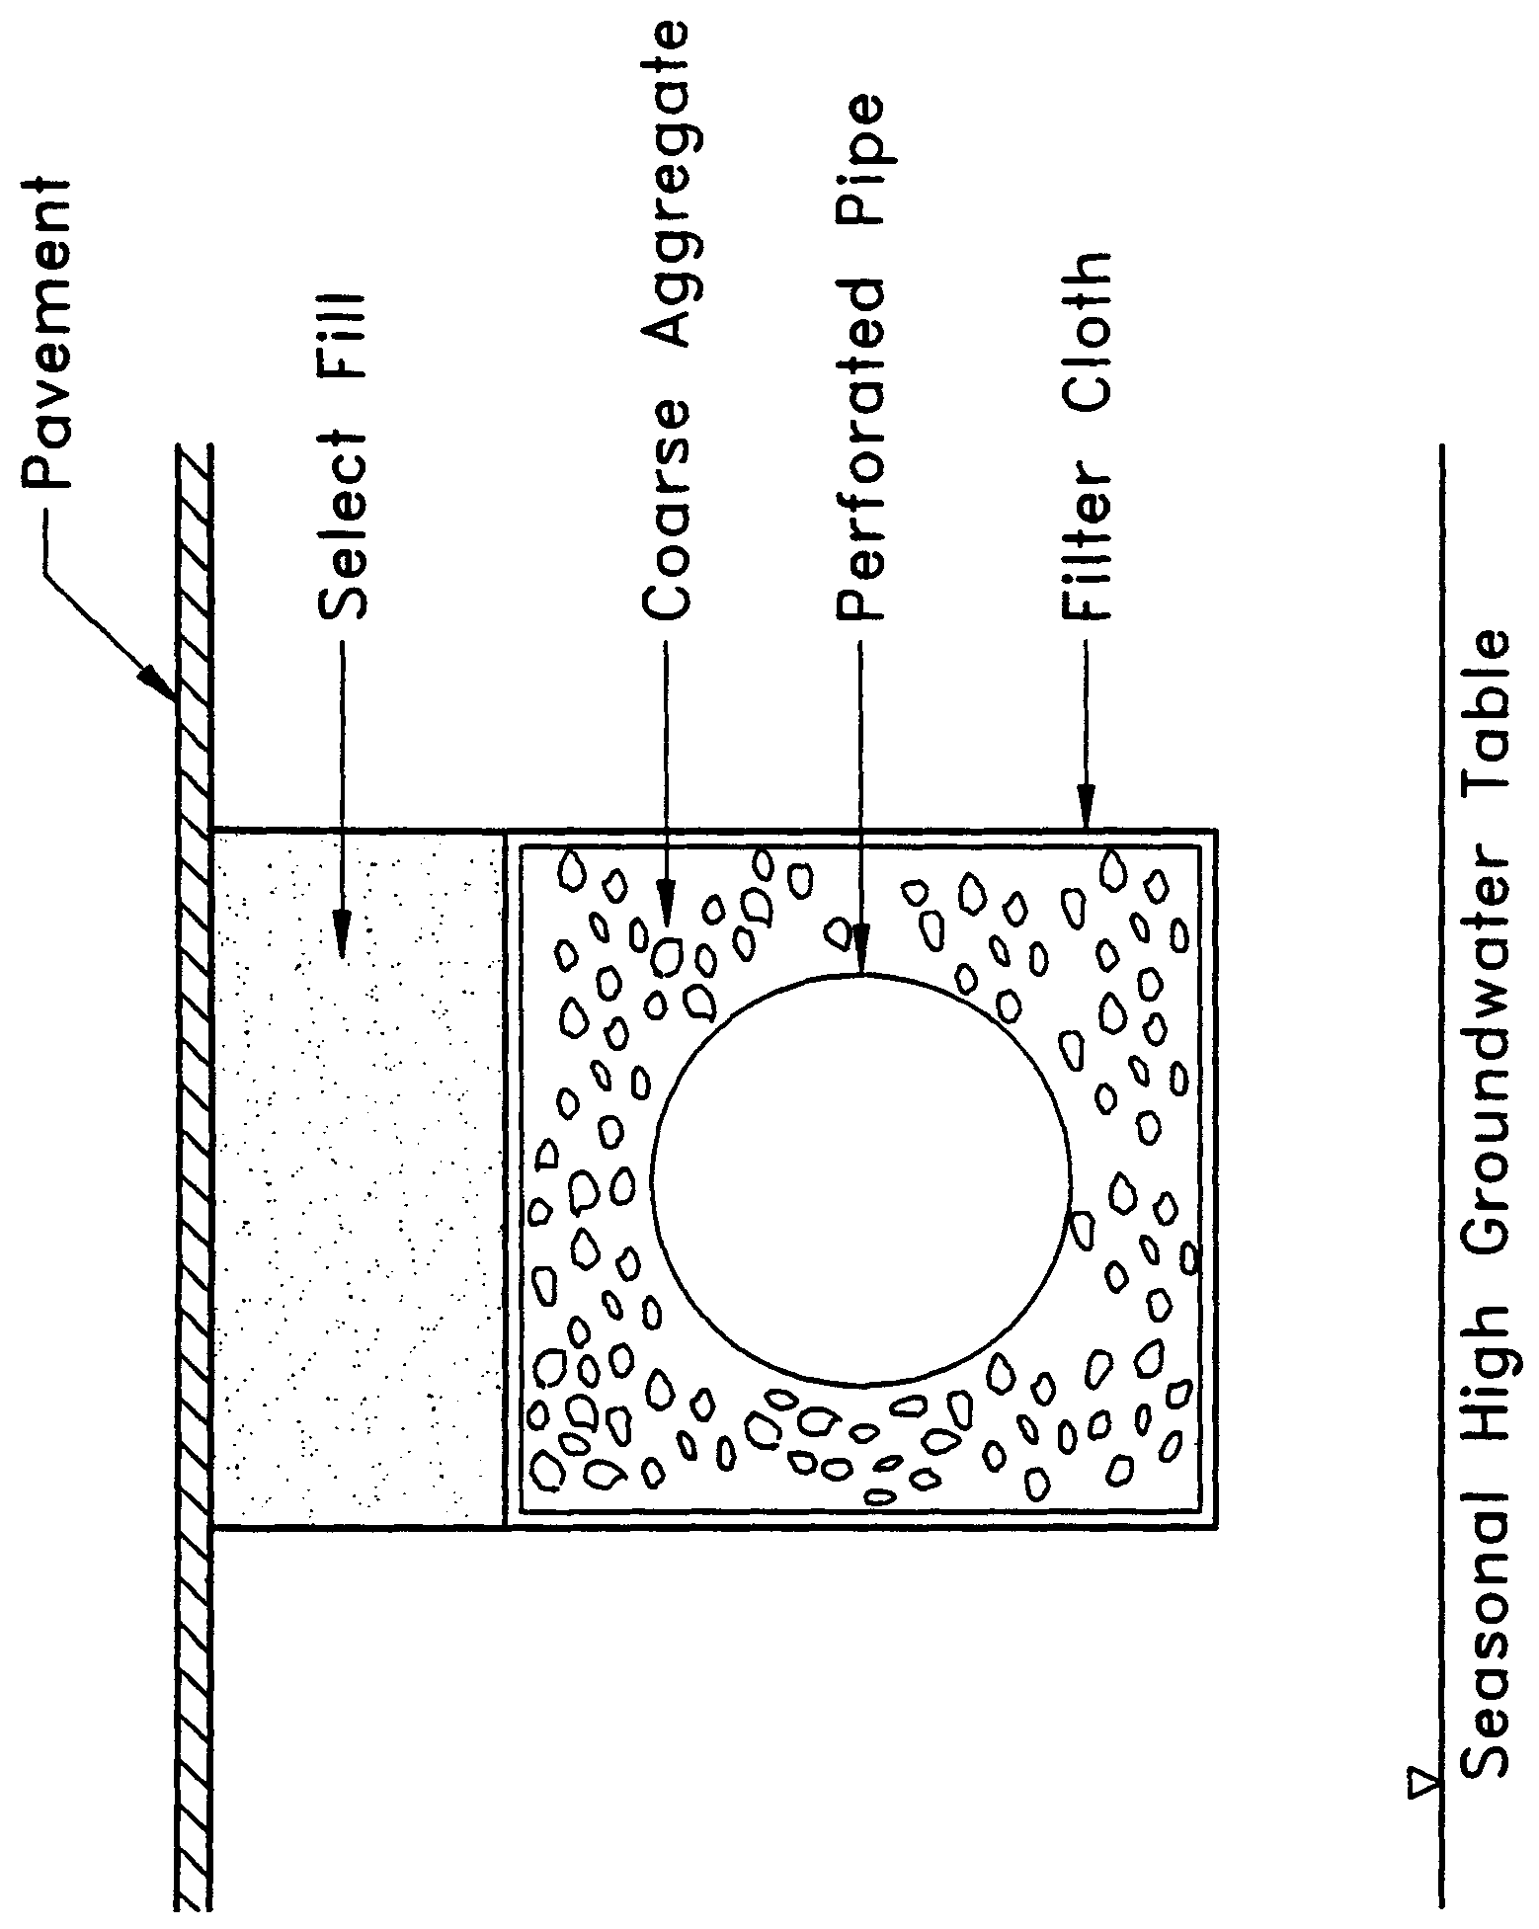

Figure 13-1. Cross-section of typical underground exfiltration trench (N.T.S.)

replacement of the trench may be the only possible means of restoring the treatment capacity and recovery of the system. Periodic replacement of the trench should be considered routine operational maintenance when selecting this management practice.

There are several design and performance criteria which must be met in order for an exfiltration trench system to meet the rule requirements. A description of each criterion is presented below.

13.2 Treatment Volume

The first flush of runoff should be collected in the exfiltration trench and infiltrated into the surrounding soil. For systems which discharge to Class III receiving water bodies, the rule specifies either of the following:

(a) Off-line storage of the first one-half inch of runoff or 1.25 inches of runoff from the impervious area, whichever is greater.

(b) On-line storage of an additional one half inch of runoff from the drainage area over that volume specified for off-line treatment.

For direct discharges to Class I, Class II, OFWs, or Class III waters which are approved, conditionally approved, restricted, or conditionally restricted for shellfish harvesting the applicant should provide storage for either of the following:

- At least an additional fifty percent of the applicable treatment volume specified for off-line storage in (a), above. Off-line storage must be provided for at least the first one-half inch of runoff or 1.25 inches of runoff from the impervious area, whichever is greater, of the total amount of runoff required to be treated.

- On-line storage of the runoff from the three-year, one-hour storm or an additional fifty percent of the treatment volume specified in (b), above, whichever is greater.

Exfiltration trench systems must be designed to have the capacity to retain the required treatment volume without considering discharges to ground or surface waters. An example calculation for calculating the storage capacity of an exfiltration trench is given in section 28.

13.3 Recovery Time

The system should be designed to provide for the appropriate treatment volume of stormwater runoff specified in section 13.2 within 72 hours following a storm event assuming average antecedent moisture conditions. The stormwater is drawn down by infiltration into the soil.

Antecedent moisture condition (AMC) refers to the amount of moisture and storage in the soil profile prior to a storm event. Antecedent soil moisture is an indicator of wetness and availability of soil to infiltrate water. The AMC can vary from dry to saturated depending on the amount of rainfall received prior to a given point in time. Therefore, "average AMC" means the soil is neither dry or saturated, but at an average moisture condition at the beginning of a storm event when calculating recovery time for exfiltration systems.

The antecedent condition has a significant effect on runoff rate, runoff volume, infiltration rate, and infiltration volume. The infiltration volume is also known as the upper soil zone storage. Both the infiltration rate and upper soil zone storage are used to calculate the recovery time of retention systems and should be estimated using any generally accepted and well documented method with appropriate parameters to reflect drainage practices, seasonal high water table elevation, the AMC, and any underlying soil characteristics which would limit or prevent percolation of storm water into the soil column.

A methodology with design examples for calculating exfiltration trench recovery is
presented in section 28.

13.4 Safety Factor

The exfiltration trench system must be designed with a safety factor of at least two unless the applicant affirmatively demonstrates based on plans, test results, calculations or other information that a lower safety factor is appropriate for the specific site conditions. For example, two possible ways to apply this factor are:

(a) Reducing the design percolation rate by half

(b) Designing for the required drawdown within 36 hours instead of 72 hours

13.5 Minimum Dimensions

The perforated pipe should be designed with a 12 inch minimum pipe diameter and a three 3 foot minimum trench width. The perforated pipe should be located within the trench section to minimize the accumulation of sediment in the aggregate void storage and maximize the preservation of this storage for stormwater treatment. To meet this goal, it is recommended that the perforated pipe be located at or within 6 inches of the trench bottom. The maximum trench width will be limited by the rate at which stormwater can effectively fill the void storage within the trench.

13.6 Filter Fabric

Exfiltration trench systems should be designed so that aggregate in the trench is enclosed in filter fabric. This serves to prevent migration of fine materials from the surrounding soil that could result in clogging of the trench. Wanielista et al. (1991) reports that woven fabric (Mirafi 700XG) performed better in mixed sand and silty soil than non-woven fabric (Mirafi 140N). On the other hand, the 140N had higher exfiltration rates in sandy soils than the woven fabric.

Filter fabric may also be utilized directly surrounding the perforated pipe. In this instance, sedimentation of particulates will occur in the perforated pipe. Consequently, the pipe is more prone to clogging and reductions in capacity will occur more often than usual. Livingston et al. (1988) points out that while this may seem unacceptable, the pipe may be cleaned relatively easy using high pressure hoses, vacuum systems, etc. On the other hand, designs without the fabric directly surrounding the perforated pipe requires complete replacement when clogging occurs.

13.7 Inspection and Cleanout Structures

Inspection and cleanout structures which extend to the surface of the ground should be provided, at a minimum, at the inlet and terminus of each exfiltration pipe. Inlet structures should include sediment sumps. These inspection and cleanout structures provide three primary functions:

(a) Observation of how quickly the trench recovers following a storm

(b) Observation of how quickly the trench fills with sediment

(c) Maintenance access to the perforated pipe

(d) Sediment control (sumps)

Standard precast concrete inlets and manholes are widely used to furnish the inspection and cleanout access.

13.8 Ground Water Table

The exfiltration trench system should be designed so that the invert elevation of the trench is at least two feet above the seasonal high ground water table elevation unless the applicant affirmatively demonstrates based on plans, test results, calculations or other information that an alternative design is appropriate for the specific site conditions.

13.9 Construction

During construction, every effort should be made to limit the parent soil and debris from entering the trench. Wanielista (1991) reports complete failure (no exfiltration) when a 1" to 2" thickness of parent soil and stormwater solids were added to an exfiltration trench. Applicants and system designers should consult section 9.1 of this handbook and the State of Florida Erosion and Sediment Control Designer and Reviewer Manual, Prepared for Florida Department of Transportation & Florida Department of Environmental Protection by HydroDynamics Incorporated in cooperation with Stormwater Management Academy, June 2007 Chapters 3 and 6 of The Florida Land Development Manual (Livingston et al. 1988) for information on erosion and sediment control. Any method used to reduce the amount of fines entering the exfiltration trench during construction will extend the life of the system (Wanielista et al. 1991). The use of an aggregate with minimal fines is also recommended (Wanielista et al. 1991).

13.10 Alternative Designs

Wanielista et al. (1991) describes an alternative procedure for designing exfiltration trenches based on long term mass balance of an exfiltration system utilizing local rainfall conditions. Fifteen years of hourly precipitation data from six regions in Florida were used as input for the mass balance. From these simulations, design curves for exfiltration systems were developed. These curves relate the rate at which stored runoff is removed from the trench to the volume of storage within the trench. These curves can be used to design an exfiltration trench based on diversion efficiencies of 50%, 60%, 70%, 80%, 85%, 90%, and 95%. In lieu of the requirements of section 13.2, the Department District accepts this methodology for those areas of the District (i.e., Jacksonville and Orlando) for which the curves have been developed. Applicants designing systems which discharge to Class III receiving waters should use the 80% curve and those that direct discharge to Class I, Class II, and Outstanding Florida Waters should utilize the 95% curve.

13.11 References

Branscome, J., and R.S. Tomasello. 1987. Field Testing of Exfiltration Systems. South Florida Water Management District Technical Publication 87-5. West Palm Beach, Florida.

Livingston, E.H., E. McCarron, J. Cox, and P. Sanzone. 1988. The Florida Land Development Manual: A Guide to Sound Land and Water Management. Florida Department of Environmental Regulation, Nonpoint Source Management Section, Tallahassee, Florida.

South Florida Water Management District. 1987. Management and Storage of Surface Waters Permit Information Manual, Volume IV. West Palm Beach, Florida.

Wanielista, M.P., M.J. Gauthier, and D.L. Evans. 1991. Design and Performance of Exfiltration Systems. Department of Civil and Environmental Engineering, University of Central Florida, Orlando, Florida.

14.0 Wet Detention Design and Performance Criteria

14.1 Description

To meet the objectives of the Stormwater Rule, the traditional flood attenuation pond was modified to maximize water quality treatment processes. These modified detention ponds are identified by the name "wet detention systems." These systems are permanently wet ponds which are designed to slowly release collected stormwater runoff through an outlet structure. A schematic of a typical wet detention system is shown in Figure 14-1.

Wet detention systems are the recommended BMP for sites with moderate to high water table conditions. The Department District strongly encourages the use of wet detention treatment systems for the following two reasons. First, wet detention systems provide significant removal of both dissolved and suspended pollutants by taking advantage of physical, chemical, and biological processes within the pond (CDM 1985). Second, the complexity of BMPs such as underdrains are not encountered in a wet detention pond control structure. Wet detention systems offer an effective alternative for the long term control of water levels in the pond, provide a predictable recovery of storage volumes within the pond, and are easily maintained by the maintenance entity.

In addition to providing good removal of pollutants from runoff, wet detention systems also provide other benefits such as flood detention, passive recreation activities related adjacent to ponds, storage of runoff for irrigation, and pleasing aesthetics. As stormwater treatment systems, these ponds should not be designed to promote in-water recreation (i.e., swimming, fishing, and boating).

There are several components in a wet detention system which must be properly designed to achieve the level of stormwater treatment required by Cchapter 40C-42, F.A.C.. A description of each design feature and its importance to the treatment process is presented below. The design and performance criteria for wet detention systems are discussed below.

14.2 Treatment Volume

For wet detention systems, the design treatment volume is the greater of the
following:

(a) one inch of runoff over the drainage area

(b) 2.5 inches times the impervious area (excluding water bodies)

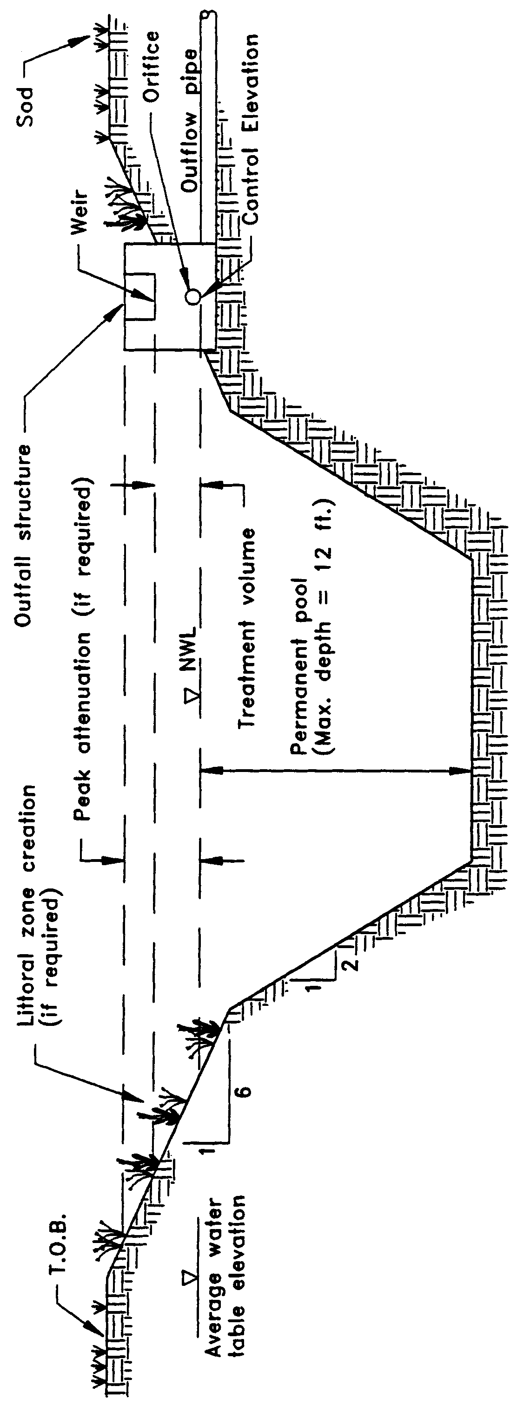

Figure 14-1. Wet detention (N.T.S.)

Additional treatment volume may be required for systems which discharge directly to Class I, Class II, Outstanding Florida Waters, or Class III waters which are approved, conditionally approved, restricted, or conditionally restricted for shellfish harvesting (see section 14.13).

14.3 Recovery Time

The outfall structure should be designed to drawdown one-half the required treatment volume between 48 and 60 within 24 and 30 hours following a storm event, but no more than one-half of this volume will be discharged within the first 24 hours. Design equations for sizing an orifice and a "V" notch weir to meet the recovery time are given in section 29.

14.4 Outlet Structure

The outlet structure generally includes a drawdown device (such as an orifice, "V" or square notch weir) set to establish a normal water control elevation and slowly release the treatment volume (see Figures 14-2 and 14-3 for schematics). The design of the outfall structure must also accommodate the passage of ground water baseflows and flows from upstream stormwater management systems (see Figure 14-4).

The control elevation should be set at or above the design tailwater elevation so the pond can effectively recover the treatment storage. Also, drawdown devices smaller than 6 3 square inches of cross-section area that is 2 inches wide minimum width or less than 20 degrees for "V" notches shall include a device to eliminate clogging. Examples of such devices include baffles, grates, screens, and pipe elbows.

14.5 Permanent Pool

A significant component and design criterion for the wet detention system is the storage capacity of the permanent pool (i.e., section of the pond which holds water at all times). The permanent pool should be sized to provide at least a 14-day residence time during the wet season (June - October). A methodology of how to calculate the residence time is given in section 29.

Important pollutant removal processes which occur within the permanent pool include: uptake of nutrients by algae, adsorption of nutrients and heavy metals onto bottom sediments, biological oxidation of organic materials, and sedimentation (CDM 1985). Uptake by algae is probably the most important process for the removal of nutrients. Sedimentation and adsorption onto bottom sediments is likely the primary means of removing heavy metals (CDM 1985).

The storage capacity of the permanent pool must be large enough to detain the untreated runoff long enough for the treatment processes described above to take place. Since one of the major biological mechanisms for pollutant removal in a wet

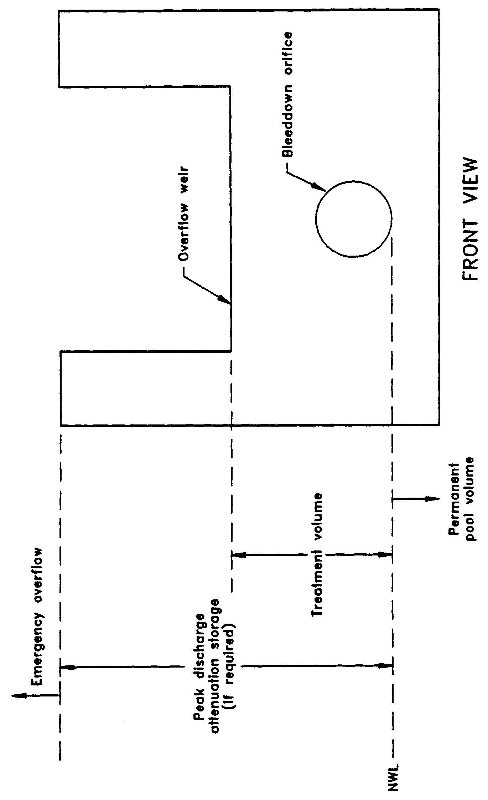

Figure 14-2. Typical wet detention outfall structure (N.T.S.)

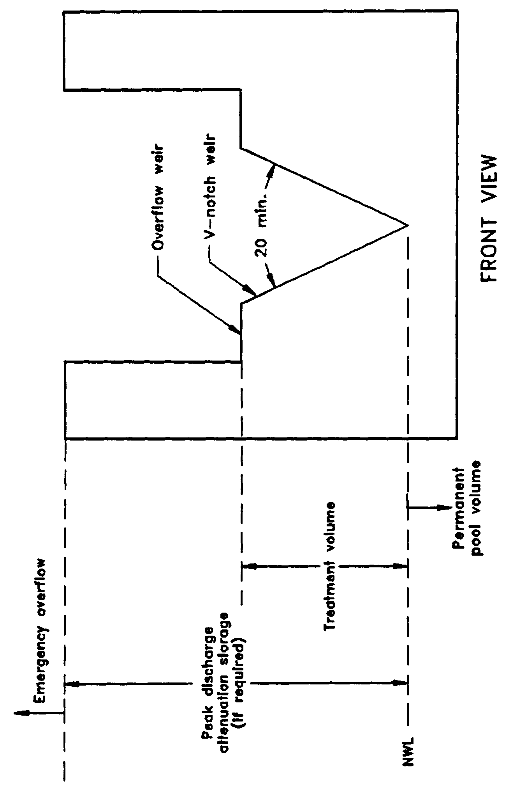

Figure 14-3. Typical wet detention outfall structure with "V"-notch weir (N.T.S.)

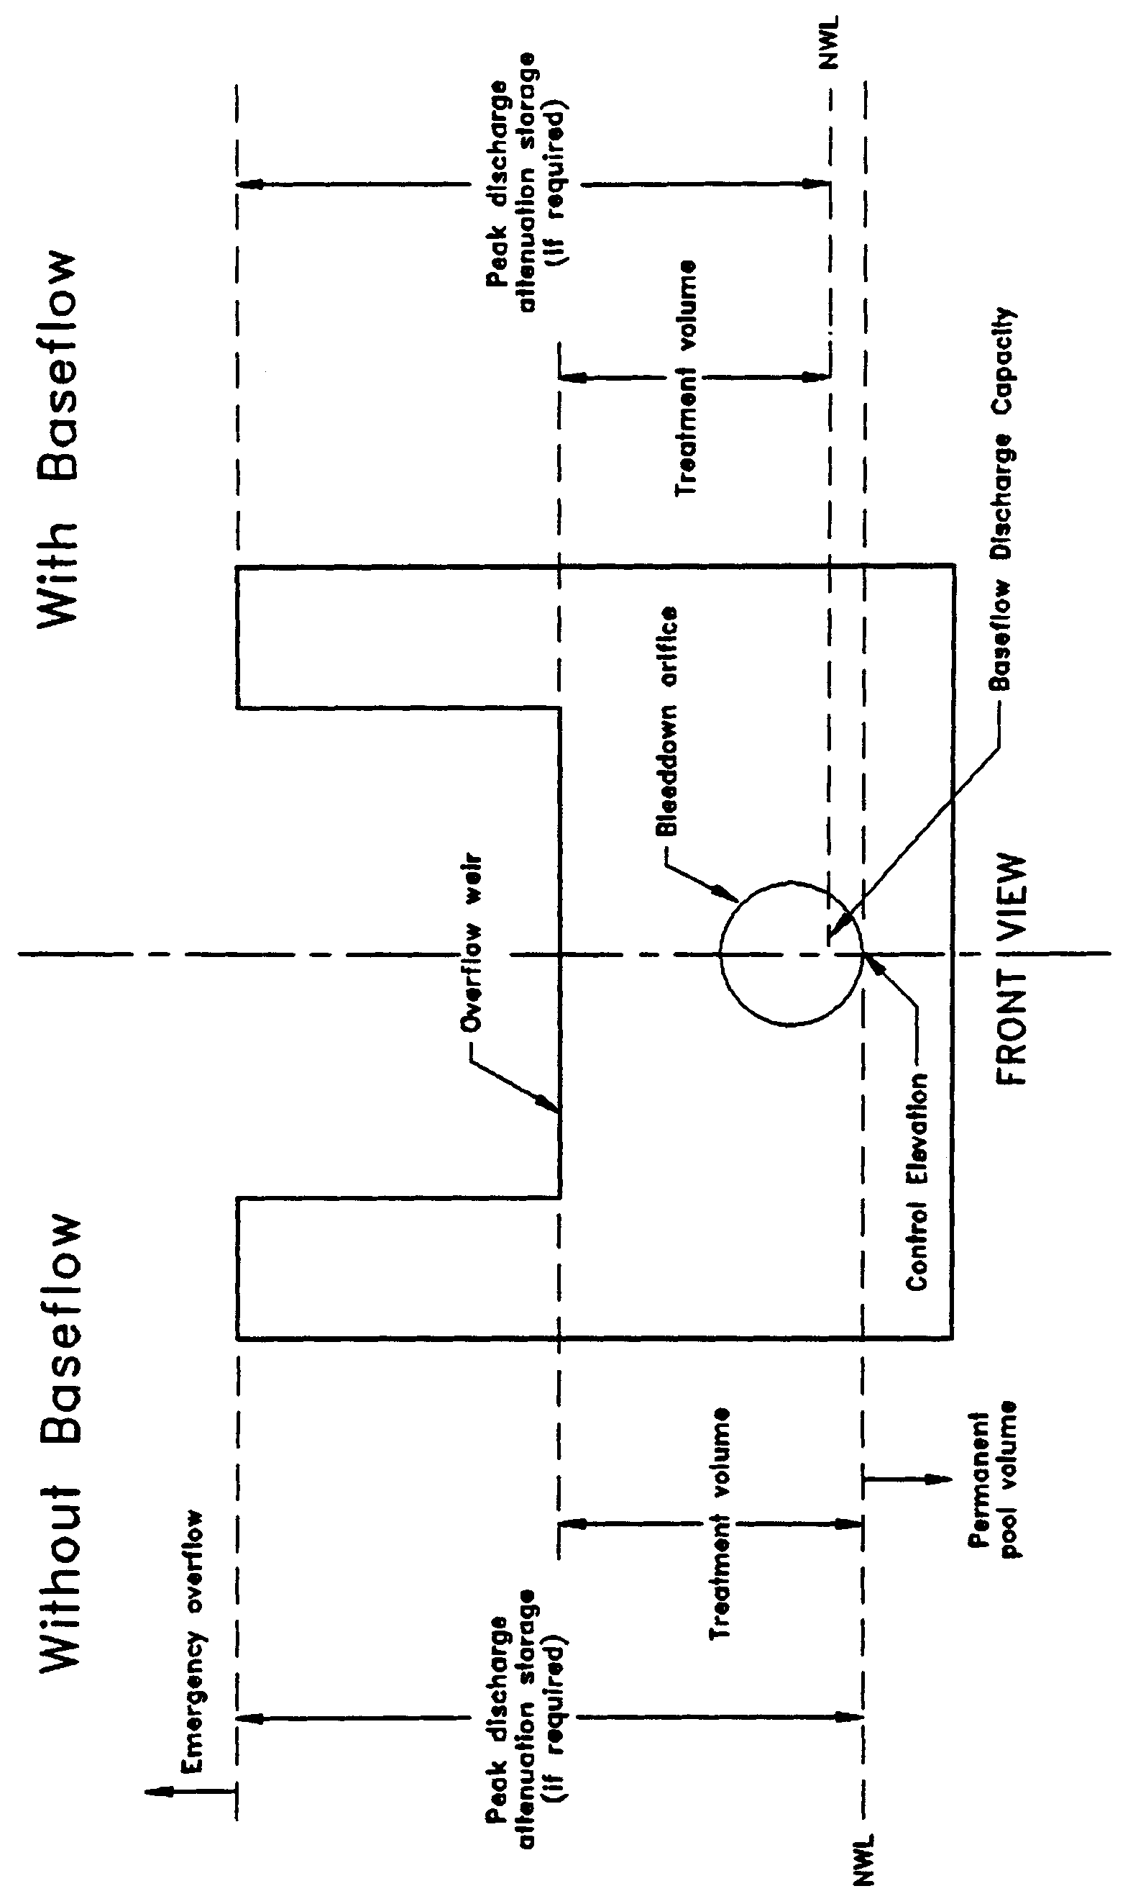

Figure 14-4. Typical wet detention outfall structure with and without baseflow conditions (N.T.S.)

detention basin is phytoplankton growth, the average hydraulic residence time of the pond must be long enough to ensure adequate algal growth (CDM 1985). A
residence time of 2 weeks is considered to be the minimum duration that ensures
adequate opportunity for algal growth (CDM 1985).

Additional permanent pool volume may be required for wet detention systems which directly discharge to Class I, Class II, or Outstanding Florida Waters (see section 14.13).

14.6 Littoral Zone

The littoral zone is that portion of a wet detention pond which is designed to contain rooted aquatic plants. The littoral area is usually provided by extending and gently sloping the sides of the pond down to a depth of 2-3 feet below the normal water level or control elevation. Also, the littoral zone can be provided in other areas of the pond that have suitable depths (i.e., a shallow shelf in the middle of the lake).

The littoral zone is established with native aquatic plants by planting and/or the placement of wetland soils containing seeds of native aquatic plants. A specific vegetation establishment plan must be prepared for the littoral zone. The plan must consider the hydroperiod of the pond and the type of plants to be established. Livingston et al. (1988) has published a list of recommended native plant species suitable for littoral zone planting. In addition, a layer of muck can be incorporated into the littoral area to promote the establishment of the wetland vegetation. When placing muck, special precautions must be taken to prevent erosion and turbidity problems in the pond and at its discharge point while vegetation is becoming established in the littoral zone.

The following is a list of the design criteria for wet detention littoral zones:

(a) The littoral zone shall be gently sloped (6H:1V or flatter). At least 30 percent of the wet detention pond surface area shall consist of a littoral zone. The percentage of littoral zone is based on the ratio of vegetated littoral zone to surface area of the pond at the control elevation.

(b) The treatment volume should not cause the pond level to rise more than 18 inches above the control elevation unless the applicant affirmatively demonstrates that the littoral zone vegetation can survive at greater depths.

(c) Within 24 months of completion of the system, 80 percent coverage of the littoral zone by suitable aquatic plants is required.

(d) Planting of the littoral zone is recommended to meet the 80% coverage requirement. As an alternative to planting, portions of the littoral zone may be established by placement of wetland top soils (at least a four inch depth) containing a seed source of desirable native plants. When utilizing this alternative, the littoral zone must be stabilized by mulching or other means and at least the portion of the littoral zone within 25 feet of the inlet and outlet structures must be planted.

14.7 Littoral Zone Alternatives

As an option to establishing and maintaining vegetative littoral zones as described in
section 14.6, the applicant can provide either:

(a) An additional 50% of the appropriate permanent pool volume as required in section 14.5 or 14.13, or

(b) Pre-treatment of the stormwater prior to the stormwater entering the wet detention pond. The level of pre-treatment must be at least that required for retention, underdrain, exfiltration, or swale systems. See section 14.11 for additional information on pre-treatment.

Providing a larger permanent pool or pre-treatment will compensate for the pollutant removal benefits associated with a well vegetated littoral zone. However, even under the above alternatives, shallow portions of the wet detention pond may be colonized with nuisance species such as cattails that will need to be controlled. This should be considered routine operational maintenance.

14.8 Pond Depth

The rule requires a maximum pond depth of 12 feet and a mean depth (pond volume divided by the pond area at the control elevation) between 2 and 8 feet. Many of the nutrients and metals removed from the water column accumulate in the top few inches of the pond bottom sediments (Yousef et al. 1990). If a pond is deep enough, it will have a tendency to stratify, creating the potential for anaerobic conditions developing at the bottom of the pond (CDM 1985). An aerobic environment should be maintained throughout the water column in wet detention ponds in order to minimize the release of nutrients and metals from the bottom sediments (Yousef et al. 1990). The maximum depth criteria minimizes the potential for significant thermal stratification which will help maintain aerobic conditions in the water column that should maximize sediment uptake and minimize sediment release of pollutants.

On the other hand, the minimum mean depth criteria minimizes aquatic plant growth which may be excessive if the pond is too shallow.

14.9 Pond Configuration

The average length to width ratio of the pond must be at least 2:1. Yousef et al. (1990) reports that it is important to maximize the flow path of water from the inlets to the outlet of the pond to promote good mixing (i.e., no dead spots). Under these design conditions, short circuiting is minimized and pollutant removal efficiency and mixing is maximized.

If short flow paths are unavoidable, the effective flow path can be increased by adding diversion barriers such as islands, peninsulas, or baffles to the pond. Inlet structures should be designed to dissipate the energy of water entering the pond. Examples of good and poor pond configurations are given in Figure 14-5.

14.10 Ground Water Table

To minimize ground water contributions which may lower treatment efficiencies, the control elevation should be set at or above the normal on-site ground water table elevation (Yousef et al. 1990). This elevation may be determined by calculating the average of the seasonal high and seasonal low ground water table elevations.

Ground water inflow (baseflow) must be considered when the control elevation is set below the normal ground water table elevation or the project utilizes underdrains (i.e., road underdrains) to control ground water conditions on-site. The design of the outfall structure must provide for the discharge of baseflow at the design normal water level in the pond. Baseflow rates must be included in the drawdown calculations for the outfall structure. Baseflow should also be considered in the permanent pool residence time design. Establishment of the normal water level in the pond will also be influenced by baseflow conditions (see Figure 14-4).

14.11 Pre-treatment

"Pre-treatment" is defined as the treatment of a portion of the runoff prior to its entering the wet detention pond. Pre-treatment increases the pollutant removal efficiency of the overall stormwater system by reducing the pollutant loading to the wet detention pond. Pre-treatment may be used to enhance the appearance of the wet detention pond or meet the additional treatment criteria for discharges to receiving water which are classified as Class I, Class II, Outstanding Florida Waters (OFWs), or Class III waters which are approved, conditionally approved, restricted, or conditionally restricted for shellfish harvesting.

For developments where the appearance of the lake is important, pre-treatment can reduce the chances of algal blooms and slow the eutrophication process. Some types of pre-treatment practices include utilizing vegetative swales for conveyance instead of curb and gutter, perimeter swales or berms around the lake, oil and grease skimmers on inlet structures, retention storage in swales with raised inlets, or shallow landscaped retention areas (when soils and water table conditions will allow
for adequate percolation).

For systems in which pre-treatment is utilized to meet the additional design criteria
requirements for systems which direct discharge to Class I, Class II, OFWs, or Class III waters which are approved, conditionally approved, restricted, or conditionally

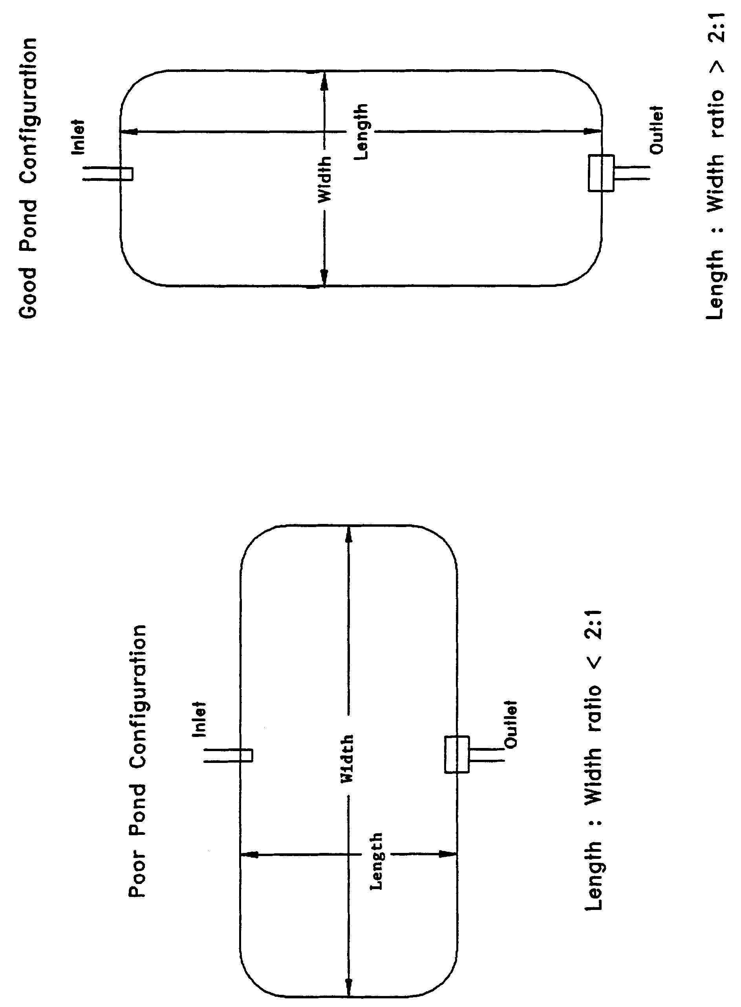

Figure 14-5. Examples of good and poor wet detention pond configurations (N.T.S.)

restricted for shellfish harvesting, pre-treatment practices must meet the appropriate design and performance criteria for that BMP. Acceptable types of pre-treatment include the following:

- Retention systems which meet the design and performance criteria in section 11,

(b) Underdrain systems which meet the design and performance criteria in section 12,

(c) Exfiltration trench section 13, or

(d) Swales systems which meet the design and performance criteria in section 15.

Alternative pre-treatment methods will be evaluated on a case-by-case basis by the Department District. Applicants or system designers are encouraged to meet with Department District staff in a pre-application conference if alternative methods are proposed.

14.12 Pond Side Slopes

The pond must be designed so that the average pond side slope measured between the control elevation and two feet below the control elevation is no steeper than 3:1 (horizontal:vertical). Because the pond sediments are an important component in the wet detention treatment processes, this criterion will ensure sufficient pond bottom/side slope area for the appropriate processes to occur.

14.13 Direct Discharges to Class I, Class II, OFWs, or Shellfishing Waters

Wet detention systems which discharge to Class I, Class II, OFWs, or Class III waters which are approved, conditionally approved, restricted, or conditionally restricted for shellfish harvesting, must provide either:

(a) An additional fifty percent of both the required treatment and permanent pool volumes

(b) Pre-treatment of the stormwater prior to the stormwater entering the wet detention pond. The level of pre-treatment must be at least that required for retention, underdrain, exfiltration, or swale systems (see section 14.11).

14.14 References

Camp Dresser & McKee Inc (CDM). 1985. An Assessment of Stormwater
Management Programs. Prepared for Florida Department of Environmental
Regulation, Tallahassee, Florida.

Livingston, E.H., E. McCarron, J. Cox, P. Sanzone. 1988. The Florida Land
Development Manual: A Guide to Sound Land and Water Management. Florida
Department of Environmental Regulation, Nonpoint Source Management Section,
Tallahassee, Florida.

Yousef, Y.A., M.P. Wanielista, L.Y. Lin, and M. Brabham. 1990. Efficiency
Optimization of Wet Detention Ponds for Urban Stormwater Management (Phase I
and II). University of Central Florida, Orlando, Florida

15.0 Design Criteria and Guidelines for Swale Systems

15.1 Description

Swales are a man-made or natural system shaped or graded to required dimensions and designed for the conveyance and rapid infiltration of stormwater runoff. Swales are designed to infiltrate a defined quantity of runoff through the permeable soils of the swale floor and side slopes into the shallow ground water aquifer (Figure 15-1). Turf is established to promote infiltration and stabilize the side slopes. Soil permeability and water table conditions must be such that the swale can percolate the desired runoff volume from the 3-year, 1-hour storm event. The swale holds water only during and immediately after a storm event, thus the system is normally "dry." Unlike retention basins, swales are "open" conveyance systems. This means there are no physical barriers such as berms or check-dams to impound the runoff in the swale prior to discharge to the receiving water.

Swales provide excellent removal of stormwater pollutants. Substantial amounts of suspended solids, oxygen demanding materials, heavy metals, bacteria, some varieties of pesticides and nutrients such as phosphorus are removed as runoff percolates through the vegetation and soil profile. Swale systems should not be located in close proximity to drinking water supply wells. As required by Cchapter 62-555 17-22, F.A.C., stormwater treatment facilities must be at least 100 feet from any public supply well. Additional design criteria are established for swale systems constructed in Karst Sensitive Areas of the District where the drinking water aquifer is close to the land surface (see section 9.11).

Besides pollution control, swale systems can be utilized to promote the recharge of groundwater to prevent saltwater intrusion in coastal areas, and to maintain ground water levels in aquifer recharge areas. Swales can be incorporated into the design of a stormwater management system to meet the recharge criteria for the Wekiva Recharge Protection Basin and the Tomoka River and Spruce Creek Hydrologic Basins (see sections 11.3.1 and 11.5.1 of the Applicant's Handbook: Management and Storage of Surface Waters) or the runoff volume criteria for projects requiring permits under Cchapters 40C-4 or 40C-40, F.A.C., which discharge to land-locked lakes (see section 10.4 of the Applicant's Handbook: Management and Storage of Surface Waters).

Swales can also be utilized to provide pre-treatment of runoff prior to its release to another treatment BMP such as wet detention (see section 14.11) or wetlands stormwater management systems (see section 16.4). Pre-treatment reduces the pollutant loading to the downstream treatment system, increases the pollutant efficiency of the overall stormwater management system, and reduces maintenance. In some cases, pre-treatment may be used to meet the additional treatment criteria for discharges to sensitive receiving waters (Class I, Class II, and OFWs). For developments where the appearance of the downstream system (i.e, wet detention

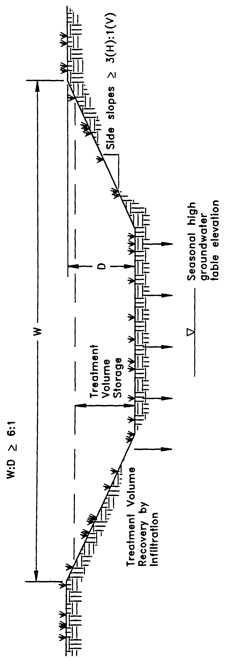

Figure 15-1. Cross-section of swale system (N.T.S.)

lake) is important, pre-treatment can reduce the probability of algal blooms occurring and slows the eutrophication process.

The design and performance criteria specific to swale systems are described in the
following sections.

15.2 Treatment Volume

The runoff from the site should be routed to the swale system for conveyance and percolation into the ground. For systems which discharge to Class III receiving water bodies, the swales should be designed to percolate 80% of the runoff from the 3-year, 1- hour storm. The remaining 20% of the runoff from the 3-year, 1-hour storm event may be discharged offsite by the swale system.

Swale systems which directly discharge to Class I, Class II, OFWs, or Class III waters which are approved, conditionally approved, restricted, or conditionally restricted for shellfish harvesting, should be designed to percolate all of the runoff from the 3-year, 1-hour storm.

15.3 Recovery Time

Swale systems must provide the capacity for the specified treatment volume of stormwater and contain no contiguous areas of standing or flowing water within 72 hours following the storm event referenced in section 15.2 assuming average antecedent moisture conditions. The treatment volume must be provided by percolation through the soil, evaporation, or evapotranspiration.

Antecedent moisture condition (AMC) refers to the amount of moisture and storage in the soil profile prior to a storm event. Antecedent soil moisture is an indicator of wetness and availability of soil to infiltrate water. The AMC can vary from dry to saturated depending on the amount of rainfall received prior to a given point in time. Therefore, "average AMC" means the soil is neither dry or saturated, but at an average moisture condition at the beginning of a storm event when calculating recovery time for swale systems.

The antecedent condition has a significant effect on runoff rate, runoff volume, infiltration rate, and infiltration volume. The infiltration volume is also known as the upper soil zone storage. Both the infiltration rate and upper soil zone storage are used to calculate the recovery time of retention systems and should be estimated using any generally accepted and well documented method with appropriate parameters to reflect drainage practices, seasonal high water table elevation, the AMC, and any underlying soil characteristics which would limit or prevent percolation of storm water into the soil column.

A detailed methodology with design examples for sizing swales to percolate the runoff from the 3-year, 1-hour storm event is presented in section 30.

15.4 Dimensional Requirements

Swales must have a top width to depth ratio of the cross-section equal to or greater than 6:1 or side slopes equal to or greater than 3:1 (horizontal to vertical).

15.5 Stabilization

Swales should be stabilized with vegetative cover suitable for soil stabilization, stormwater treatment, and nutrient uptake. Also, the swale should be designed to take into account the soil errodibility, soil percolation, slope, slope length, and drainage area so as to prevent erosion and reduce pollutant concentrations (see section 30 for design examples).

16.0 Design Criteria and Guidelines for Wetlands Stormwater Management Systems

16.1 Description

Wetlands are an essential part of nature's stormwater management system. Important wetland functions include the conveyance and storage of stormwater. These function to dampen flooding impacts; reduce flood flows and velocity of stormwater which in turn reduces erosion, increases sedimentation, and helps the assimilation of pollutants typically carried in stormwater. Accordingly, there is interest in the incorporation of natural wetlands into stormwater management systems, especially wetlands which have been previously drained. This concept provides an opportunity to use wetlands to meet the requirements of the stormwater rule. In addition, by using wetlands for stormwater management, drained wetlands can be revitalized and landowners and developers have greater incentive to preserve or restore wetlands (Livingston 1989).

For wetlands stormwater management systems the Department District must attempt to ensure that a proposed wetlands stormwater management system is compatible with the existing ecological characteristics of the wetlands proposed to be utilized for stormwater treatment. The Department District must also ensure that water quality standards will not be violated by discharges from wetlands stormwater management system. To achieve these goals, specific performance criteria are set forth in the stormwater rule and are described below for systems which incorporate wetlands for stormwater treatment.

16.2 Permit Application Administrative Procedures

An application for an environmental resource stormwater permit to use a wetland stormwater management systems will be processed by the District as an individual permit application according to the administrative procedures set forth in chapter 40C-4, F.A.C. See section 6 of this handbook for additional information on processing individual permit applications.

16.2 3 Types of Wetlands that may be Utilized for Stormwater Treatment

The only wetlands which may be considered for use to provide stormwater treatment
are those which are:

(a) Isolated wetlands; and

- Those which would be isolated wetlands, but for a hydrologic connection to other wetlands or surface waters via another watercourse that was excavated through uplands.

16.3 4 Treatment Volume

The system should be part of a comprehensive stormwater management system that utilizes wetlands in combination with other best management practices to provide treatment of the runoff from the project. For systems discharging to Class III waters, the rule specifies treatment of the runoff from the greater of the following:

(a) First one inch of runoff, or

(b) 2.5 inches times the impervious area.

Those systems which directly discharge to Class I, Class II, OFWs, or Class III waters which are approved, conditionally approved, restricted, or conditionally restricted for shellfish harvesting, shall provide an additional fifty percent of the applicable treatment volume specified above.

If the wetland alone cannot provide the treatment volume, then other best management practices should be incorporated upstream and outside of the wetland to store the proper level of runoff. Utilization of other BMPs must not adversely affect the ability of the wetlands stormwater management system from meeting the requirements of this section. Example design methodologies for calculating the treatment volume are given in section 29.3.

16.4 5 Recovery Time

The system should be designed to bleed down one-half the applicable treatment volume specified above between 60 and 72 hours following a storm event. A methodology for sizing a structure to meet the recovery time criteria is given in section 29.2.

16.5 6 Inlet Structures

Inlet structures should be designed to dissipate the energy of runoff entering the wetland and minimize the channelized flow of stormwater. Methods include, but are not limited to, sprinklers, pipe energy dissipators, overland flow or spreader swales.

16.6 7 Wetland Function

The use of wetlands for stormwater treatment must meet the criteria in section 12.0, Environmental Consideration, of the Applicant’s Handbook: Management and Storage of Surface Waters, adopted by reference in paragraph 62-330.200(2)(i) section 40C-4.091, F.A.C. Pretreatment can reduce the impact of untreated stormwater upon the wetland. In addition, pre-treatment can be utilized to attenuate stormwater volumes and peak discharge rates so that the wetland's hydroperiod is not adversely altered (Livingston 1989). Swale conveyances and lakes adjacent to the wetland are typical pretreatment practices.

16.7 8 Residence Time

The design features of the system should maximize residence time of the stormwater within the wetland to enhance the opportunity for the stormwater to come into contact with the wetland sediment, vegetation, and micro-organisms (Livingston 1989). This can be accomplished by several means. The inlets and outlets should be located to maximize the flow path through the wetland. Energy dissipators and spreader swales can promote overland flow and reduce the possibility of channelized flow occurring. In some instances, berms in wetlands can act as baffles to increase the flow path of surface flow through the wetland.

16.8 9 Monitoring

In order to establish a reliable, scientifically valid data base upon which to evaluate the performance criteria and the performance of the wetlands stormwater management system, a monitoring program may be required. Monitoring programs shall provide the Department District with comparable data for different types of wetlands and drainage designs. Data to be collected may include but not be limited to:

(a) Sedimentation rate

(b) Sediment trace metal concentrations

(c) Sediment nitrogen and phosphorus concentrations

(d) Changes in the frequency, abundance and distribution of vegetation

(e) Inflow and outflow water quality for nutrients, metals, turbidity, oils and greases, bacteria and other parameters related to the specific site conditions

Inflow and outflow water quality parameters will be monitored on such storm event occurrences as established by the Department District based on a site specific basis. The Department District shall eliminate the requirement to continue the monitoring program upon its determination that no further data is necessary to evaluate the performance criteria or ensure compliance with the performance criteria and applicable water quality standards.

16.9 10 Dredge and Fill

If the applicant proposes to dredge or fill in the wetlands used for stormwater treatment, the Department District in its review of the permit application shall evaluate the adverse effects of the dredging or filling on the treatment capability of the wetland.

16.10 11 Alternative Criteria

If the applicant is unable to show compliance with the performance criteria sections 16.3 - 16.10 11, above, the applicant may qualify for an environmental resource stormwater permit to use a wetlands stormwater management system permit using alternative design and performance criteria if the applicant affirmatively demonstrates that the use of the wetlands meets the criteria in section 12.0, Environmental Consideration, of the Applicant’s Handbook: Management and Storage of Surface Waters and the applicant complies with the requirements for issuance in section 8.3.

16.11 12 References

Livingston, E.H. 1989. The Use of Wetlands for Urban Stormwater Management. In Design of Urban Runoff Quality Controls, ed. L.A. Roesner, B. Urbonas, and M.B. Sonnen, pages 467-490. American Society of Civil Engineers. New York.

PART III.
OPERATION AND MAINTENANCE

Proper operation and maintenance (O&M) is crucial to the long-term effectiveness of stormwater management systems. Operation and maintenance is a perpetual obligation that runs for the life of the system. The criteria in Part III address the legal requirements for an O&M entity and the minimum maintenance and inspection requirements for the stormwater management system during the operation phase of the project.

17.0 Legal Operation and Maintenance Entity Requirements

17.1 Acceptable Operation and Maintenance Entities

The Department District considers the following entities to be acceptable for meeting the requirements necessary to ensure that a stormwater management system will be operated and maintained in compliance with the requirements of the Stormwater Rule (Cchapter 40C-42, F.A.C.) and other District regulations in Cchapters 40C-4 or 40C-40, F.A.C.:

(a) Governmental entities including:

1. Local governmental units including counties or municipalities, or Municipal Service Taxing Units established pursuant to section 125.01, F.S.

2. Active water control districts created pursuant to Cchapter 298, F.S., or drainage districts created by special act, or Community Development Districts created pursuant to Cchapter 190, F.S., or Special Assessment Districts created pursuant to Cchapter 170, F.S., or Water Management Districts created pursuant to Cchapter 373, F.S.

3. State or federal agencies.

(b) Duly constituted stormwater, communication, water, sewer, electrical or other public utilities,

- Property owner or developers who do not intend to convey the property to multiple third parties,

(d) Profit or non-profit corporations including homeowners associations, or

(e) Lessees, as long as lease agreement specifies O&M responsibilities.

17.2 Entity Requirements

17.2.1 Requirements for Governmental Entities

If the operation entity is to be a public body, such as a county, city or drainage district, a preliminary letter of acceptance from the public body is to be submitted as part of the permit application. A final letter of acceptance by the governing body is required before the operation permit can become effective. This documentation (draft and final letter) must clearly indicate what portions of the stormwater system will be maintained by the public body. In some cases an additional entity will be required for maintenance activities not undertaken by the public body.

17.2.2 Entity Requirements for Property Owners or Developers

The property owner or developer is normally not acceptable as a responsible entity when the property is intended to be subdivided. The property owner or developer may be acceptable in any one of the following circumstances:

(a) Written proof is furnished in the appropriate form either by letter or resolution, that a governmental entity or such other acceptable entity as set forth in section 17.1 above, will accept the operation and maintenance of the stormwater management system at a time certain in the future such as at termination of a construction or performance bond.

(b) Proof of bonding or assurance of a similar nature is furnished in an amount sufficient to cover the cost of the operation and maintenance of the stormwater management system for at least five years.

(c) The property is wholly owned by the permittee and ownership is intended to be retained. For example, this would apply to a farm, corporate office or single industrial facility.

(d) The ownership of the property is retained by the permittee and is either leased or rented to third parties such as in shopping centers or mobile home parks. The property owner must either retain O&M responsibility or specifically provide for it in the lease so as to ensure the system is maintained.

17.2.3 Entity Requirements for Profit or Non-Profit Corporations Including Homeowners Associations

Profit or non-profit corporations including homeowners associations, property owners associations, condominium owners associations or master associations shall be acceptable only under certain conditions that ensure that the corporation has sufficient financial, legal and administrative capability to provide for the long term operation and maintenance of the stormwater management system.

If the entity is a homeowners association or other private entity, the preliminary documents verifying the existence of (intent to establish) such an organization and its capacity to accept operational responsibility must be submitted along with plans for operation of the system. Submittal of final documents are usually a condition of the permit. A final letter of acceptance by the homeowners association must be submitted before an operation phase permit can become effective. The District has developed recommended language that can be included in developing the preliminary and final documents. A copy of this language can be found in Appendix F.

17.2.4 Entity Requirements for Multimember Associations

If a multimember association such as a Homeowner, Property Owner, Condominium or Master Association is proposed, the owner or developer must submit Articles of Incorporation for the Association, and Declaration of Covenants and Restrictions (see Appendix F for a copy of recommended language), or such other organizational and operational documents which affirmatively assign authority and responsibility for the operation or maintenance of the stormwater management system. These documents must be submitted to the Department District as part of the permit application.

The Association shall have sufficient powers reflected in its organizational or operational documents to:

(a) Operate and maintain the stormwater management system as permitted or exempted by the Department District.

(b) Establish rules and regulations.

(c) Assess members a fee for the cost of operation and maintenance of the system, and enforce collection of such assessments.

(d) Contract for services (if the Association contemplates employing a maintenance company) to provide the services for operation and maintenance.

(e) Exist in perpetuity. The Articles of Incorporation must provide that if the association is dissolved the stormwater management system shall be transferred to and maintained by an entity acceptable to the Department District as defined in section 17.1 above. Transfer of maintenance responsibility shall be effectuated prior to dissolution of the association.

(f) Enforce the restrictions relating to the operation and maintenance of the stormwater management system.

(g) Provide that the portions of the Declarations which relate to the operation and maintenance may be enforced by the Department District in a proceeding at law or in equity.

(h) Require that amendments to the documents which alter the stormwater management system beyond maintenance in its original condition must receive Department District approval prior to taking effect.

17.2.5 Entity Requirements for Lessees

If the entity is a lessee, the lessee must provide a copy of the lease agreement, and if the lease does not specify maintenance responsibilities, a separate document stating that the lessee will be responsible for maintenance and operation of the system. Documentation must also be provided by the owner indicating that it will operate and maintain the system in accordance with the permitted plans upon expiration of the lease. Also, the owner must include in this documentation, a statement that if the property is sold during or after the term of the lease, owner will notify the Department District of the sale within 30 days and notify the new property owner of the condition requiring the new owner to assume operation and maintenance of the system.

17.3 Phased Projects

17.3.1 Same Entity

If an Operation and Maintenance entity (e.g., a Master Association) is proposed for a project which will be constructed in phases, and subsequent phases will utilize the same stormwater management systems as the initial phase or phases, the entity shall have the ability to accept responsibility for the operation and maintenance of stormwater management system for future phases of the project.

17.3.2 Independent Entities

If the development scheme contemplates independent operation and maintenance entities for different phases, and the stormwater management system is integrated throughout the project, the entities either separately or collectively shall have the authority and responsibility to operate and maintain the stormwater management system for the entire project. That authority shall include easements for stormwater management which provide access to enter and maintain the various systems, should any sub-entity fail to maintain a portion of the stormwater management system within the project.

17.4 Construction Phase Entity

The applicant is an acceptable entity from the time construction begins until the stormwater management system is dedicated to and accepted by a legal entity established pursuant to section 40C-42.027, F.A.C., and further explained in sections 17.1 and 17.2, above. The stormwater permit application form includes an O&M section to be completed by the applicant. By completing and executing this section, the applicant acknowledges and accepts O&M responsibility until the Department District approves transfer of responsibility to another entity.

This section of the application form provides sufficient documentation if the applicant is also the construction phase O&M entity. If the applicant does not intend to be the O&M entity during the construction phase, supporting documents identifying the construction phase O&M entity must be provided with the initial permit application submittal. The construction phase O&M entity must meet the requirements explained in sections 17.1 and 17.2, above.

17.5 Application Submittal

The supporting documents submitted as part of the permit application should identify all operation and maintenance entities for the construction and operation phase of the project. If the project is intended for operation and maintenance by more than one entity, then the division of responsibility of each entity must be described in the application submittal. Draft or final versions of the appropriate documents mentioned in the previous sections must be submitted with the permit application.

18.0 Operation Phase Permits

Permits for construction of a stormwater management system are generally issued with up to a five year duration. However, operation and maintenance of the system must continue for the life of the system. Therefore, the Department District has established operation phase permits for projects where construction is complete.

18.1 Requirements for Transfer to Operation Phase Permit

18.1.1 General Provisions

The Department District will transfer the permit to the maintenance entity upon request, once all the following conditions set forth below for converting the construction permit to an operation permit have been met:

(a) Construction of the project is complete.

(b) The project is determined to be in compliance with the permitted plans.

(c) An appropriate entity exists for maintenance of the system.

1. The permittee has submitted documentation to the Department District showing that adequate provisions have been made for the operation and maintenance of the system and for meeting permit conditions. Entities which qualify to operate and maintain systems for purposes of this rule are listed in section 17. Documentation must include an affirmative indication that the entity intends to or agrees to take over maintenance responsibility for the system unless the transfer is associated with the conversion of the construction permit to its operation phase and the maintenance entity exists as approved under the permit.

(d) The appropriate conditions in section 18.1.2 or 18.1.3, below, have been met.

18.1.2 Systems Designed by a Registered Professional

In addition to the general provisions in section 18.1.1, above, the operation phase of a stormwater management system permit which was designed by an appropriate registered professional does not become effective until all of the following criteria have occurred:

(a) Within 30 days after completion of construction of the stormwater management system, permittee shall submit a signed and sealed certification by an appropriate registered professional indicating that the system has been constructed and shall notify the Department District that the system is ready for inspection by the Department District.

(b) The certification prepared by a registered professional (not necessarily the project design registered professional but one who has been retained by the permittee to provide professional services during the construction phase of project completion) shall be made on form 62-343.900(5) number 40C-1.181(13), "As Built Certification by a Registered Professional" (see Appendix C for a copy of this form).

(c) The registered professional shall certify that either:

1. The system has been constructed substantially in accordance with approved plans and specifications.

2. Any deviations from the approved plans and specifications will not prevent the system from functioning in compliance with the requirements of the Stormwater Rule (Cchapter 40C-42, F.A.C.). The registered professional shall note and explain substantial deviations from the approved plans and specifications and provide two copies of as-built drawings to the Department District.

(d) The certification shall be based upon on-site observation of construction (scheduled and conducted by the professional or by a project representative under his or her direct supervision) or review of as-built drawings for the purpose of determining if the work was completed in compliance with approved plans and specifications.

(e) As-built drawings shall be the permitted drawings revised to reflect any changes made during construction. Both the original and revised specifications must be clearly shown. The plans must be clearly labeled as "as-built" or "record" drawings. All surveyed dimensions and elevations required shall be certified by a registered surveyor. The following information, at a minimum, shall be verified on the as-built drawings:

1. Dimensions and elevations of all discharge structures including all weirs, slots, gates pumps, pipes, and oil and grease skimmers.

2. Locations, dimensions, and elevations of all exfiltration or underdrain systems including cleanouts, pipes, connections to control structures, and points of discharge to the receiving waters.

3. Dimensions, elevations, contours, or cross-sections of all treatment storage areas sufficient to determine stage-storage relationships of the storage area and the permanent pool depth and volume below the control elevation for normally wet systems, when appropriate.

4. Dimensions, elevations, contours, final grades, or cross-sections of the system to determine flow directions and conveyance of runoff to the treatment system.

5. Dimensions, elevations, contours, final grades, or cross-sections of all conveyance systems utilized to convey off-site runoff around the system.

6. Existing water elevation(s) and the date determined.

7. Elevation and location of benchmark(s) for the survey.

18.1.3 Systems Not Designed by a Registered Professional

In addition to the general provisions in section 18.1.1, the operation phase of a stormwater management system permit which was not designed by an appropriate registered professional does not become effective until the following has occurred:

(a) Within 30 days after completion of construction of the stormwater management system, permittee shall submit a certification on form EN-44 number 40C-1.181(14), "As Built Certification" (see Subsection 40C-42.900(3), F.A.C. Appendix C for a copy of this form) that the system has been constructed in accordance with the design approved by the Department District and that the system is ready for inspection by the Department District.

19.0 Monitoring and Operational Maintenance Requirements

The operation and maintenance entity is required to monitor and maintain the permitted stormwater management system during the operation phase of the permit. The following sections detail the minimum requirements for monitoring and maintaining stormwater systems.

19.1 Monitoring and Inspection Requirements

The operation and maintenance entity is required to provide for periodic inspections of the stormwater management system to ensure that the system is functioning as designed and permitted. The entity shall submit inspection reports to the Department District certifying that the stormwater management system is operating as designed. In addition, the entity will state in the report what operational maintenance has been performed on the system. The reports shall only be required for those systems which are subject to operation phase permits pursuant to section 18, unless indicated otherwise in a permit condition. The reports shall be submitted to the Department District as follows unless otherwise required by a permit condition:

19.1.1 Inspection Reports for Retention, Underdrain, Wet Detention, Swales, and Wetland Stormwater Management Systems

Inspection reports for retention, underdrain, wet detention, swales, and wetland stormwater management systems shall be submitted two years after the completion of construction and every two years thereafter on the appropriate form listed below:
(a) Form number EN-46 40C-1.181(15), "Registered Professional's Inspection Report," for systems designed by a registered professional
(b) Form number EN-47 40C-1.181(16), "Statement of Inspection Report," for systems not designed by a registered professional
Copies of these inspection forms are located in Appendix D.
Reports for those systems located in the Sensitive Karst Areas (SKA) basin must be submitted pursuant to section 19.1.3 below.
19.1.2 Inspection Reports for Dry Detention, Exfiltration Trench, Stormwater Reuse, Filtration, and Pumped Systems
Inspection reports for dry detention, exfiltration, stormwater reuse, filtration, and pumped systems shall be submitted one year after the completion of construction and every two year thereafter on form number EN-46 40C-1.181(15), "Registered Professional's Inspection Report." A registered professional must sign and seal the report certifying the dry detention, exfiltration, or pumped system is operating as designed. However, reports for those systems in the Sensitive Karst Areas basin must be submitted pursuant to section 19.1.3 below.

19.1.3 Inspection Reports for System in the Sensitive Karst Area
Systems in the Sensitive Karst Areas (SKA) basin must be inspected monthly for the occurrence of sinkholes and solution pipes. The inspection reports for these systems must be submitted to the Department District annually on the appropriate form listed below:
(a) Form number EN-46 40C-1.181(15), "Registered Professional's Inspection Report," for systems designed by a registered professional
(b) Form number EN-47 40C-1.181(16), "Statement of Inspection Report," for systems not designed by a registered professional
See section 9.11 for a description of the SKA basin.
19.1.4 Master Stormwater Management Systems
Permittees which operate stormwater management systems that are designed and constructed to accept stormwater from several parcels within the drainage area served by the system shall notify the Department District annually of the stormwater discharge volumes of all new parcels which have been allowed to discharge into the system in the previous year and shall certify that the maximum allowable treatment volume of stormwater has not been exceeded.
19.2 Maintenance Requirements for all Permitted Systems
The following operational maintenance activities shall be performed on all permitted systems on a regular basis or as needed:
(a) Removal of trash and debris
(b) Inspection of inlets and outlets
(c) Removal of sediments or vegetation when the storage volume or conveyance capacity of the stormwater management system is below design levels
(d) Stabilization and restoration of eroded areas
19.3 Maintenance Requirements for Specific Types of Stormwater Management Systems
In addition to the general maintenance practices listed in section 19.2 above, specific operational maintenance activities are required for depending on the type system.
19.3.1 Retention, Swale, and Underdrain Systems
Retention, swale and underdrain systems shall include provisions for:
(a) Mowing and removal of grass clippings.
(b) Aeration, tilling, or replacement of topsoil as needed to restore the percolation capability of the system. If tilling or replacement of the topsoil is utilized, vegetation must be reestablished within 60 days of disturbance of the topsoil.
19.3.2 Exfiltration Trench
Exfiltration systems shall include provisions for removal of sediment and debris from inlets, sediment sumps, and pipes.
19.3.3 Wet Detention
Wet detention systems shall include provisions for operational maintenance of the littoral zone. Replanting shall be required if the percentage of vegetative cover falls below the permitted level. It is recommended that native vegetation be maintained in the littoral zone as part of the system's operation and maintenance plan. Undesirable species such as cattail and exotic plants should be controlled if they become a nuisance.
19.3.4 Stormwater Reuse
Stormwater reuse systems shall include provisions for the repair of irrigation lines, pumps, sprinkler heads, and other pertinent components of the reuse system. Reuse systems shall include provisions for operational maintenance of the littoral zone. Replanting shall be required if the percentage of vegetative cover falls below the permitted level. It is recommended that native vegetation be maintained in the littoral zone as part of the system's operation and maintenance plan. Undesirable species such as cattail and exotic plants must be controlled if they become a nuisance.
19.3.5 Sensitive Karst Areas
Systems in sensitive karst areas shall include provisions for the repair of any sinkhole or solution pipe that develops in the system.
19.3.6 Dry Detention
Dry detention systems shall include provisions for removal of sediment and debris from the basin and mowing and removal of grass clippings.
19.4 Non-functioning Systems
If the system is not functioning as designed and permitted, operational maintenance must be performed immediately to restore the system. If operational maintenance measures are insufficient to bring the system back to the design and performance standards of this chapter, the permittee must either modify the system or construct an alternative design. A permit modification must be obtained from the Department District prior to constructing such modification or alternative design.

PART IV
ALTERNATIVE TREATMENT SYSTEMS

The systems described in Part IV are alternative methods, not adopted by rule, for meeting the pollutant removal goals of the stormwater rule.
20.0 Design Criteria and Guidelines for Stormwater Reuse Systems
20.1 Description
Stormwater reuse systems are designed to prevent the discharge of a given volume of stormwater into surface waters of the state by deliberate application of stormwater runoff for irrigation or industrial uses. Examples of areas that can be irrigated include golf courses, cemeteries, highway medians, parks, playgrounds, school yards, retail nurseries, agricultural lands, and residential and commercial properties. Industrial uses include cooling water, process water, and wash water.
A stormwater reuse pond is similar to a wet detention system described in section 14 except for the drawdown of the treatment volume storage. For typical wet detention ponds, the treatment volume is released at a controlled rate by a drawdown orifice or weir. However, in a stormwater reuse system the drawdown structure is replaced by a mechanical reuse system which recovers the treatment volume storage by withdrawing water from the pond. In a reuse pond the treatment volume is termed "reuse volume" and the "control elevation" is the lowest elevation at which water can be withdrawn from the pond by the reuse system. Like wet detention, stormwater reuse systems are a recommended BMP for sites with moderate to high ground water table conditions. A schematic a typical reuse pond is shown in Figure 20-1.
The Department District encourages the use of stormwater reuse systems because of the following benefits they provide:
(a) Reduction of runoff volume discharged to the receiving waters
(b) Reduction of pollutants discharged to the receiving waters
(c) Substitution of stormwater use instead of potable ground water withdrawals
(d) Potential economic savings from not having to pay user fees for potable water.

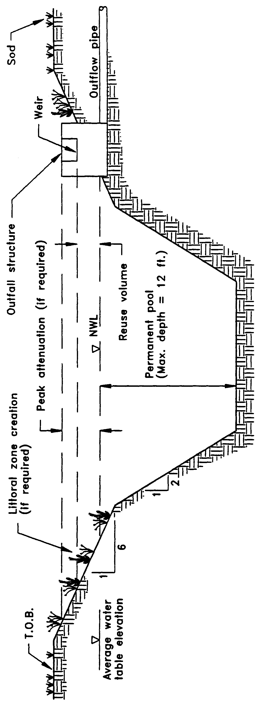
Figure 20-1. Stormwater reuse system (N.T.S.)

Stormwater reuse systems provide significant removal of both dissolved and suspended pollutants by taking advantage of physical, chemical, and biological processes associated with wet detention systems and the recycling of constituents back to the landscape by reuse systems that irrigate with stormwater (Wanielista et al. 1991). Reuse systems can be utilized to meet the runoff volume criteria for MSSW projects which discharge to land-locked lakes (see section 10.4 of the MSSW Applicants Handbook).
In addition, stormwater reuse ponds also provide other benefits such as flood detention, recreation activities adjacent to ponds, and pleasing aesthetics. As stormwater treatment systems, these ponds should not be designed to promote in-water recreation (i.e., swimming, fishing, and boating).
There are several components in a stormwater reuse system which must be properly designed to achieve the level of stormwater treatment required by chapter 40C-42, F.A.C. A description of each design feature and its importance to the treatment process is presented below. These criteria are not intended to preclude the reuse of stormwater from other types of stormwater management systems such as wet detention. The reader will notice that several of these criteria are the same as those for wet detention systems as described in section 14.
20.2 Reuse Volume
A portion of the runoff from the site must be stored in the pond and subsequently withdrawn through the reuse system. For systems which discharge to Class III receiving water bodies, the rule specifies that the system reuse at least 50 percent of the average annual runoff discharging to the reuse pond.
Stormwater reuse systems which directly discharge to Class I, Class II, OFWs, or Class III waters which are approved, conditionally approved, restricted, or conditionally restricted for shellfish harvesting, must reuse at least 90 percent of the average annual runoff discharging to the pond. A methodology for designing reuse systems to meet the above criteria is presented in section 31.
20.3 Permanent Pool
The permanent pool is that portion of a pond which is designed to hold water at all times (i.e., below the control elevation). The permanent pool should be sized to provide at least a 14-day residence time during the wet season (June - October). A description of the pollutant removal processes which occur in the permanent pool is given in section 14.5 and a methodology for calculating the residence time is given in section 29.

20.4 Littoral Zone
The littoral zone is that portion of a stormwater reuse pond which is designed to contain rooted aquatic plants. The littoral area is usually provided by extending and gently sloping the sides of the pond down to a depth of 2-3 feet below the normal water level or control elevation. Also, the littoral zone can be provided in other areas of the pond that have suitable depths (i.e., a shallow shelf in the middle of the lake).
The littoral zone is established with native aquatic plants by planting and/or the placement of wetland soils containing seeds of native aquatic plants. A specific vegetation establishment plan must be prepared for the littoral zone. The plan must consider the hydroperiod of the pond and the type of plants to be established. Livingston et al. (1988) has published a list of recommended native plant species suitable for littoral zone planting. In addition, a layer of muck can be incorporated into the littoral area to promote the establishment of the wetland vegetation. When placing muck, special precautions must be taken to prevent erosion and turbidity problems in the pond and at its discharge point while vegetation is becoming established in the littoral zone.
The following is a list of the design criteria for stormwater reuse littoral zones:
(a) The littoral zone shall be gently sloped (6H:1V or flatter). At least 30 percent of the stormwater reuse pond surface area shall consist of a littoral zone. The percentage of littoral zone is based on the ratio of vegetated littoral zone to surface area of the pond at the control elevation.
(b) The treatment volume should not cause the pond level to rise more than 18 inches above the control elevation unless the applicant affirmatively demonstrates that the littoral zone vegetation can survive at greater depths.
(c) Within 24 months of completion of the system, 80 percent coverage of the littoral zone by suitable aquatic plants is required.
(d) Planting of the littoral zone is recommended to meet the 80% coverage requirement. As an alternative to planting, portions of the littoral zone may be established by placement of wetland top soils (at least a four inch depth) containing a seed source of desirable native plants. When utilizing this alternative, the littoral zone must be stabilized by mulching or other means and at least the portion of the littoral zone within 25 feet of the inlet and outlet structures must be planted.

20.5 Littoral Zone Alternatives
As an option to establishing and maintaining vegetative littoral zones as described in section 20.4, the applicant can provide either:
(a) An additional 50% of the permanent pool volume as required in section 20.3, or
(b) Pre-treatment of the stormwater prior to the stormwater entering the stormwater reuse pond. The level of pre-treatment must be at least that required for retention, underdrain, exfiltration, or swale systems. See section 14.11 for additional information on pre-treatment.
Providing a larger permanent pool or pre-treatment will compensate for the pollutant removal benefits associated with an established littoral zone. However, even under the above alternatives, a portion of the stormwater reuse pond may be colonized with nuisance species that will need to be controlled. This should be considered routine operational maintenance.
20.6 Pond Depth
The rule requires a maximum pond depth of 12 feet and a mean depth (pond volume divided by the pond area at the control elevation) between 2 and 8 feet. This criterion is needed because many of the nutrients and metals removed from the water column accumulate in the top few inches of the pond bottom sediments (Yousef et al. 1990). If a pond is deep enough, it will have a tendency to stratify, creating the potential for anaerobic conditions developing at the bottom of the pond (CDM 1985). An aerobic environment should be maintained throughout the water column in wet ponds in order to minimize the release of nutrients and metals from the bottom sediments (Yousef et al. 1990). The maximum depth criteria minimizes the potential for significant thermal stratification which will help maintain aerobic conditions in the water column that should maximize sediment uptake and minimize sediment release of pollutants. On the other hand, the minimum mean depth criteria is required because aquatic plant growth may become excessive if the pond is too shallow.
20.7 Pond Configuration
The average length to width ratio of the pond should be at least 2:1. If short flow paths are unavoidable, the effective flow path can be increased by adding diversion barriers such as islands, peninsulas, or baffles to the pond. Inlet structures should be designed to dissipate the energy of water entering the pond.

20.8 Ground Water Table
To minimize ground water contributions which may lower treatment efficiencies, the control elevation should be set at or above the normal on-site groundwater table elevation (Yousef et al. 1990). This elevation may be determined by calculating the average of the seasonal high and seasonal low groundwater table elevations.
If the control elevation is proposed to be set lower than this elevation, ground water inflow must be considered in the calculation of average residence time, estimated normal water level in the pond, and pollution removal efficiency of the system.
20.9 References
Camp Dresser & McKee Inc (CDM). 1985. An Assessment of Stormwater Management Programs. Prepared for Florida Department of Environmental Regulation, Tallahassee, Florida.
Livingston, E.H., E. McCarron, J. Cox, P. Sanzone. 1988. The Florida Land Development Manual: A Guide to Sound Land and Water Management. Florida Department of Environmental Regulation, Nonpoint Source Management Section, Tallahassee, Florida.
Yousef, Y.A., M.P. Wanielista, L.Y. Lin, and M. Brabham. 1990. Efficiency Optimization of Wet Detention Ponds for Urban Stormwater Management (Phase I and II). University of Central Florida, Orlando, Florida.
Wanielista, M.P., Y.A. Yousef, G.M. Harper, T.R. Lineback, L. Dansereau. 1991. Precipitation, Inter-Event Dry Periods, and Reuse Design Curves for Selected Areas of Florida. University of Central Florida, Orlando, Florida.

Section 21.0
Design Criteria and Guidelines for Vegetative Natural Buffers

(THIS SECTION HAS BEEN DELETED)

22.0 Compensating Stormwater Treatment
Occasionally, applicants find that it is impractical to construct a stormwater management system to capture the runoff from a portion of the project site due to extreme physical site conditions or right-of-way problems. Two methods have been developed to compensate for the lack of treatment for a portion of a project. The first method is to treat the runoff that is captured to a greater extent than required by rule (i.e., "overtreatment"). The second method is to provide treatment for an off-site area which currently is not being treated (i.e., "off-site compensation"). Each method is designed to furnish the same level of treatment as if the runoff from the entire project site was captured and treated according to the rule.
Either of these methods should only be utilized as a last resort and the applicant is strongly encouraged to schedule a pre-application conference with Department District staff to discuss the project if these alternative are being considered. Other rule criteria, such as peak discharge attenuation, will have to be met if the applicant utilizes these methods. Each alternative is described in more detail in the following sections.
22.1 Overtreatment
Overtreatment means to treat the runoff from the project area that does flow to a treatment system to a higher level than the rule requires to make up for the lack of treatment for a portion of the project. The average treatment efficiency of the areas treated and the areas not treated must meet the pollutant removal goals of Chapter 40C-42, F.A.C., (i.e., 80% removal for discharges to Class III waters and 95% removal for systems which discharge to Class I, Class II, OFWs, or Class III waters which are approved, conditionally approved, restricted, or conditionally restricted for shellfish harvesting). To meet these goals, the area not being treated generally must be small (less than 10%) in relation to the area which is captured and treated. Staff can aid in determining the proper level of overtreatment for a particular situation.
22.2 Off-site Compensation
Off-site compensation means to provide treatment to an existing developed area which currently is not being treated to compensate for the lack of treatment for portions of the proposed project due to space constraints. The following conditions must be met when utilizing off-site compensation:
a) The off-site treatment system must serve an existing developed area for which no treatment is presently provided, required, or permitted.
b) The off-site land area being treated must serve a similar or more intensive land use than the on-site area being compensated for.
c) The proposed off-site treatment system must meet the applicable criteria of chapter 40C-42, F.A.C., including legal authorization to utilize the off-site area for stormwater treatment and provisions for operation and maintenance of the system.
d) The off-site area must be in the same watershed as the proposed project.

23.0 Filtration Design and Performance Criteria
23.1 Description
Stormwater filtration systems consist of a perforated pipe which collects and conveys stormwater following infiltration and percolation through suitable soil, sand, or aggregate filter. Filters are generally used where space, soil permeability, and/or high water table conditions dictate that recovery of the stormwater treatment volume cannot be achieved by natural percolation (i.e, retention systems) or sedimentation (i.e., wet detention systems). The filter trench is normally backfilled to the surface with aggregate material that is more permeable than the surrounding soil. Pollutant removal occurs as the prescribed volume of stormwater passes through the filter media surrounding the conduit.
Filters are normally installed in the bottom or along the banks of detention basins and may be utilized in either dry or wet basins. The most common wet systems utilize either side-bank or "shelf" filters (Figures 23-1 and 23-2, respectively). Shelf filters (Figure 23-2) are the preferred alternative from a hydraulic performance and maintenance standpoint. In normally dry basins, the filters can be located in the bottom of the basin or along the side of the bank (Figures 23-3 and 23- 4, respectively). Again, locating the filter beneath the basin (Figure 23-4) is preferable to side bank filters.
A filtration system may also function to lower the water table in its immediate vicinity to some limited extent. However, unlike underdrain systems, filter systems are not necessarily designed with this objective. The Department District generally requires the placement of filter systems above the ground water table (see section 23.8).
Filters are a maintenance-intensive BMP because of the likelihood that they will become clogged over time. Filters must routinely be cleaned by pressure back washing or replaced. In most cases, partial or total replacement of the sand filter is required after it becomes clogged. Periodic replacement of the filter should be considered when selecting this BMP.
The pollutant removal capabilities of filtration systems has been documented to be limited (Harper and Herr 1993). Only pollutants which are primarily in particulate form are trapped by the filter media. Therefore, the pollutant removal efficiency of filters systems is not as great as systems such as retention and wet detention which remove both dissolved and particulate pollutants. Because of the limited pollutant removal efficiency of dry detention, this BMP must only be utilized where no other general permit BMP is feasible. Filters in wet basins (Figures 23-1 and 23-2) are preferable to filters in dry basins (Figures 23-3 and 23-4) because of the added pollutant removal capabilities of the permanent pool of the wet basin (Harper and Herr 1993).
Filters appear to be best suited for small drainage areas such as small, highly impervious commercial/industrial sites that are well stabilized with little potential for eroded soils. For larger projects (greater than 5 acres) other BMPs like wet detention should be utilized instead of filters.
Filters are not recommended for use in subdivisions where natural soil can erode and wash into the filter and where homeowners associations are commonly responsible for maintenance of the system.
The design and performance criteria specific to filtration systems is presented below.
23.2 Treatment Volume
The first flush of runoff should be detained in a wet or dry detention basin and filtered through the porous filter media. For discharges to Class III receiving water bodies, the rule specifies either of the following:
(a) Off-line detention with filtration of the first one inch of runoff or 2.5 inches of runoff from the impervious area, whichever is greater
(b) On-line detention with filtration of an additional one half inch of runoff from the drainage basin area over the volume specified for off-line treatment.
For direct discharges to Class I, Class II, OFWs, or Class III waters which are approved, conditionally approved, restricted, or conditionally restricted for shellfish harvesting, the applicant should provide detention with filtration for either of following:
(a) At least an additional fifty percent of the applicable treatment volume specified for off-line filtration in (a), above. Off-line detention with filtration must be provided for at least the first one inch of runoff or 2.5 inches of runoff from the impervious area, whichever is greater, of the total amount of runoff required to be treated.
(b) On-line detention with filtration of the runoff from the three-year, one-hour storm or an additional fifty percent of the treatment volume specified in (b), above, whichever is greater.

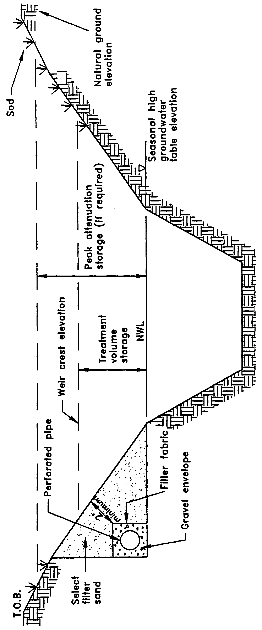
Figure 23-1. Side-bank filters in a wet basin (N.T.S.)
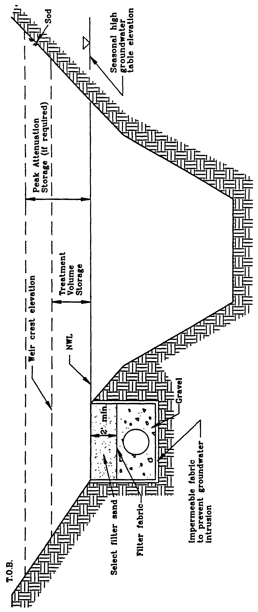
Figure 23-2. Filter shelf in a wet basin (N.T.S.)
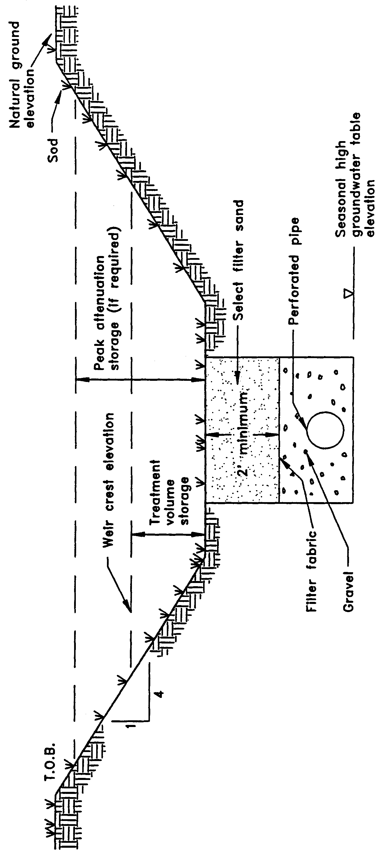
Figure 23-3. Dry detention with filtration (N.T.S)
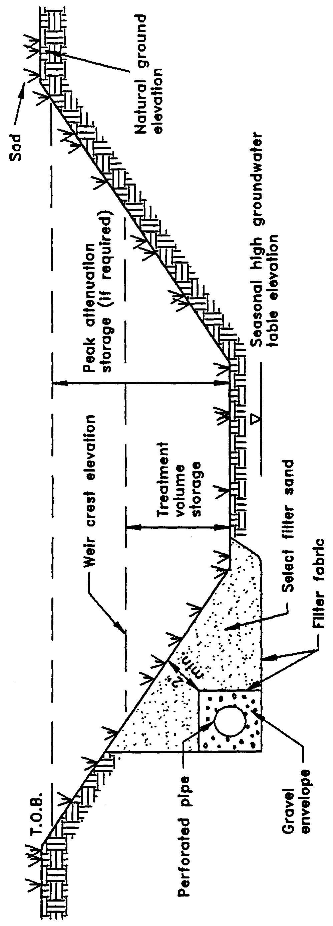
Figure 23-4. Dry detention with side-bank filters (N.T.S.)
23.3 Recovery Time
The system should be designed to provide for the appropriate treatment volume of stormwater specified in section 23.2 within 72 hours following a storm event. A suitable configuration (e.g., trench area, depth, pipe diameter, hydraulic conductivity of filter media, and openings in the perforated pipe) of the filter system must be designed to achieve the recovery time requirement.
Additional capacity must be provided in the filter system if inflows from the surrounding ground water table, upstream underdrain systems (i.e., road underdrain systems), or treatment volumes from upstream stormwater systems are routed to the filter system. Underdesign of the system will result in reduced hydraulic capacity. This, in turn, will result in a reduction in storage between subsequent rainfall events and an associated decrease in the annual average volume of stormwater treated resulting in a reduction of pollutant removal (Livingston et al. 1988). Such circumstances may also reduce the aesthetic value of the system and may promote mosquito production.
A detailed methodology with design examples for calculating retention basin recovery is presented in section 33.
23.4 Safety Factor
The filter system must be designed with a safety factor of at least two unless the applicant affirmatively demonstrates based on plans, test results, calculations or other information that a lower safety factor is appropriate for the specific site conditions. Examples of how to apply this factor include but are not limited to the following:
(a) Reducing the design percolation rate by half
(b) Doubling the length of the filtration system
(c) Designing for the required drawdown within 36 hours instead of 72 hours.
23.5 Filter Media
The filter media should have pore spaces large enough to provide sufficient flow capacity so that the permeability of the filter is equal to or greater than the surrounding soil. The design shall ensure that the particles within the filter do not move. When sand or other fine textured aggregate other than natural soil is used for filtration, the filter material should be of quality sufficient to satisfy the following requirements:
(a) Washed (less than 1 percent silt, clay and organic matter) unless filter cloth is used which is suitable to retain the silt, clay and organic matter within the filter. Calcium carbonate aggregate is not an acceptable filter media.
(b) Uniformity coefficient of 1.5 or greater but not more than 4.0.
(c) Effective grain size of 0.20 to 0.55 millimeters in diameter.
These criteria are not intended to preclude the use of multilayered filters nor the use of materials to increase ion exchange, precipitation or the pollutant absorption capacity of the filter.
23.6 Filter Fabric
Filtration systems should utilize filter fabric or other means to prevent the filter material from moving into and clogging the perforated pipe.
23.7 Ground Water Table
The filter system should be designed so that the invert elevation of the perforated pipe is above the seasonal high ground water table (SHGWT) elevation. If the pipe is proposed to be set below this elevation, contributions from the surrounding ground water may reduce the ability of the system to recover the treatment volume in the required time. Filter systems placed below the SHGWT elevation should be separated by structural means from the hydraulic contribution of the surrounding water table or ground water inflow must be considered in sizing the system to meet the required recovery time.
23.8 Inspection and Cleanout Ports
To facilitate maintenance of the filter system, capped and sealed inspection and cleanout ports which extend to the surface of the ground should be provided, at a minimum, at the following locations for each drainage pipe:
(a) The terminus
(b) Every 400 feet or every bend of 45 or more degrees, whichever is less.
23.9 Operation and Maintenance Entity
Filtration systems are not recommended when the operation and maintenance entity is a homeowners association.
23.10 References
Harper, H.H. and J.L. Herr. 1993. Treatment Efficiency of Detention with Filtration Systems. St. Johns River Water Management District Special Publication SJ93-SP12, Palatka, Florida.
Livingston, E.H., E. McCarron, J. Cox, P. Sanzone. 1988. The Florida Land Development Manual: A Guide to Sound Land and Water Management. Florida Department of Environmental Regulation, Nonpoint Source Management Section, Tallahassee, Florida.

PART V
METHODOLOGIES AND DESIGN EXAMPLES
The methodologies in Part V are intended to aid applicants in designing stormwater management systems to meet the design and performance criteria in Parts II and IV. These methodologies are by no means the only acceptable method for designing stormwater management systems. Applicants proposing to use alternative methodologies are encouraged to consult with Department District staff in a pre-application conference.
Numerous computer programs have been written to solve the methodologies presented in Part V of this handbook. The Department District has screened many of these programs proposed by applicants for use in MSSW and Stormwater permit applications. In order to evaluate and review computer programs, applicants are asked to provide detailed documentation of the model and make test runs. If the model is sound from a theoretical standpoint and the results compare favorably with those of a benchmark standard model, the program is accepted for use in MSSW and Stormwater permit submittals. Readers should contact the Department District office nearest them (see section 1.3) for a copy of the current list of models screened by the Department District.
The District only reviews the models for a minimum level of proficiency. The Department District can neither endorse any program nor certify program results.
Applicants are encouraged to receive Department District acceptance of programs not on the list prior to application submittal to avoid permitting delays associated with review of the model.

24.0 Methodology and Design Example for the Modified Rational Hydrograph Method
24.1 Description
The rational method is a popular method for estimating peak runoff rates for small urban areas. The rational formula is expressed as:
Q_{P} = C I A (24-1)
where: Q_{P} = Peak runoff rate (cfs)
C = Runoff coefficient
I = Rainfall intensity (in/hr)
A = Drainage area (acres)

Values for the runoff coefficient (C) are contained in Table 24-1. The intensity (I) is determined from intensity-duration-frequency (IDF) curves such as those published by the FDOT (1987a). The rational method gives peak discharge rates rather than a runoff hydrograph.
Table 24-1. Runoff Coefficients (C) for a Design Storm Return Period of Ten Years or Less¹
 |  | Sandy Soils |  | Clay Soils
Slope | Land Use | Min. | Max. | Min. | Max.
Flat (0-2%) | Lawns | 0.05 | 0.10 | 0.13 | 0.17
 | Rooftops and pavement | 0.95 | 0.95 | 0.95 | 0.95
 | Pervious pavements² | 0.75 | 0.95 | 0.90 | 0.95
 | Woodlands | 0.10 | 0.15 | 0.15 | 0.20
 | Pasture, grass, and farmland³ | 0.15 | 0.20 | 0.20 | 0.25
 | Residential
 | SFR: 1/2 acre lots and larger | 0.30 | 0.35 | 0.35 | 0.45
 | SFR: smaller lots and duplexes | 0.35 | 0.45 | 0.40 | 0.50
 | MFR: apartments, condominiums | 0.45 | 0.60 | 0.50 | 0.70
 | Commercial and Industrial | 0.50 | 0.95 | 0.50 | 0.95
Rolling (2-7%) | Lawns | 0.10 | 0.15 | 0.18 | 0.22
 | Rooftops and pavements | 0.95 | 0.95 | 0.95 | 0.95
 | Pervious pavements² | 0.80 | 0.95 | 0.90 | 0.95
 | Woodlands | 0.15 | 0.20 | 0.20 | 0.25
 | Pasture, grass, and farmland³ | 0.20 | 0.25 | 0.25 | 0.30
 | Residential
 | SFR: 1/2 acre lots and larger | 0.35 | 0.50 | 0.40 | 0.55
 | SFR: smaller lots and duplexes | 0.40 | 0.55 | 0.45 | 0.60
 | MFR: apartments, condominiums | 0.50 | 0.70 | 0.60 | 0.80
 | Commercial and Industrial | 0.50 | 0.95 | 0.60 | 0.95
Steep (>7%) | Lawns | 0.15 | 0.20 | 0.25 | 0.35
 | Rooftops and pavements | 0.95 | 0.95 | 0.95 | 0.95
 | Pervious pavements² | 0.85 | 0.95 | 0.90 | 0.95
 | Woodlands | 0.20 | 0.25 | 0.25 | 0.30
 | Pasture, grass, and farmland³ | 0.25 | 0.35 | 0.30 | 0.40
 | Residential
 | SFR: 1/2 acre lots and larger | 0.40 | 0.55 | 0.50 | 0.65
 | SFR: smaller lots and duplexes | 0.45 | 0.60 | 0.55 | 0.70
 | MFR: apartments, condominiums | 0.60 | 0.75 | 0.65 | 0.85
 | Commercial and Industrial | 0.60 | 0.95 | 0.65 | 0.95

Sources: Florida Department of Transportation, 1987; Wanielista, 1990
¹For 25- to 100-yr recurrence intervals, multiply coefficient by 1.1 and 1.25, respectively, and the product cannot exceed 1.0.
²Coefficients assume good ground cover and conservation treatment.
³Depends on depth and degree of permeability of underlying strata.
Note: SFR = Single Family Residential;
MFR = Multi-Family Residential
However, the Suwannee River Water Management District (1990) reports that the traditional rational formula can be modified to generate a runoff hydrograph by utilizing the rainfall intensity for various increments of the storm. The rate of discharge at any point in time during a storm can be calculated by combining the rainfall intensity for that time increment with the traditional rational formula. The modified rational hydrograph equation is as follows:
Q = C (I/P_{Total}) (P_{Total}) A (24-2)
where: Q = Discharge for a given time increment (cfs)
C = Runoff coefficient
I/P_{Total} = Intensity for a given time increment (in/hr-in)
P_{Total} = Total rainfall depth (in)
A = Drainage area (acres)

The Suwannee River Water Management District (SRWMD) modified rational method, which was also adopted by the Florida Department of Transportation (FDOT) for their Drainage Connection permits (FDOT 1987b), utilizes rainfall data from the SRWMD and FDOT to determine values of I/P_{Total} and P_{Total} respectively. The SRWMD requires applicants to analyze the system for several storm frequencies over various durations to determine the "critical" storm (i.e., the storm event which requires the most storage for peak discharge attenuation).
To transfer this methodology to the St. Johns River Water Management District (SJRWMD), staff derived values of I/P_{Total} at 15 minute increments (see Table 24-2) from long term historic rainfall records within the SJRWMD for the mean annual, 24-hour storm as reported by Rao (1991). The applicant is only required to analyze the system for this rainfall distribution because it includes rainfall depths corresponding to the mean annual storm for durations up to and including 24 hours. Values of P_{Total} within the SJRWMD for the mean annual, 24-hour storm are found in Figure 9-2.
Similar to the rational method, use of the modified rational hydrograph method should be limited to small drainage basins with short times of concentration (SRWMD 1990). Therefore, the rule restricts use of the modified rational method for systems meeting the following criteria:
(a) The drainage area is less than 40 acres.
(b) The pre development time of concentration for the system is less than 60 minutes.
(c) The post development time of concentration for the system is less than 30 minutes.
Note: The Department District does not accept the modified rational hydrograph method for use in MSSW peak discharge design storms (i.e., 25-year). If a project requires a peak discharge analysis for multiple design storms to comply with both the MSSW and Stormwater rules, the Department District recommends that the system be analyzed for both design storm events using an acceptable hydrograph methodology as described in section 10.3 of the MSSW Applicant's Handbook. As an alternative, the applicant may utilize the modified rational method only for the storm specified in the Stormwater rule (i.e., mean annual storm) provided the above criteria are met.

Table 24-2. SJRWMD Mean Annual, 24-Hour Storm Distribution for the Modified Rational Hydrograph Method

Time  (hrs) | I/P_{Total}  (in/hr-in) | Time  (hrs) | TimeI/P_{Total}  (hrs)(in/hr-in)
0.00 | 0.000 | 12.25 | 0.256
0.25 | 0.008 | 12.50 | 0.204
0.50 | 0.008 | 12.75 | 0.116
0.75 | 0.004 | 13.00 | 0.092
1.00 | 0.008 | 13.25 | 0.080
1.25 | 0.008 | 13.50 | 0.068
1.50 | 0.008 | 13.75 | 0.044
1.75 | 0.008 | 14.00 | 0.040
2.00 | 0.008 | 14.25 | 0.036
2.25 | 0.008 | 14.50 | 0.036
2.50 | 0.008 | 14.75 | 0.032
2.75 | 0.012 | 15.00 | 0.028
3.00 | 0.008 | 15.25 | 0.020
3.25 | 0.008 | 15.50 | 0.020
3.50 | 0.008 | 15.75 | 0.020
3.75 | 0.012 | 16.00 | 0.016
4.00 | 0.008 | 16.25 | 0.016
4.25 | 0.012 | 16.50 | 0.016
4.50 | 0.008 | 16.75 | 0.016
4.75 | 0.012 | 17.00 | 0.016
5.00 | 0.012 | 17.25 | 0.012
5.25 | 0.008 | 17.50 | 0.016
5.50 | 0.012 | 17.75 | 0.012
5.75 | 0.012 | 18.00 | 0.012
6.00 | 0.012 | 18.25 | 0.012
6.25 | 0.016 | 18.50 | 0.012
6.50 | 0.012 | 18.75 | 0.012
6.75 | 0.012 | 19.00 | 0.012
7.00 | 0.016 | 19.25 | 0.012
7.25 | 0.016 | 19.50 | 0.008
7.50 | 0.016 | 19.75 | 0.012
7.75 | 0.016 | 20.00 | 0.008
8.00 | 0.016 | 20.25 | 0.012
8.25 | 0.020 | 20.50 | 0.008
8.50 | 0.020 | 20.75 | 0.008
8.75 | 0.020 | 21.00 | 0.008

Table 24-2—Continued

Time  (hrs) | I/P_{Total}  (in/hr-in) | Time  (hrs) | TimeI/P_{Total}  (hrs)(in/hr-in)
9.00 | 0.020 | 21.25 | 0.012
9.25 | 0.032 | 21.50 | 0.008
9.50 | 0.032 | 21.75 | 0.008
9.75 | 0.032 | 22.00 | 0.008
10.00 | 0.040 | 22.25 | 0.008
10.25 | 0.044 | 22.50 | 0.008
10.50 | 0.048 | 22.75 | 0.008
10.75 | 0.072 | 23.00 | 0.008
11.00 | 0.084 | 23.25 | 0.008
11.25 | 0.104 | 23.50 | 0.008
11.50 | 0.132 | 23.75 | 0.008
11.75 | 0.436 | 24.00 | 0.004
12.00 | 1.080 | 24.00 | 0.004

24.2 Example Problem for the Modified Rational Hydrograph Method
Given: A = 3 acres Project Location = Titusville
C_{pre} = 0.35 C_{post} = 0.85
Determine: Utilizing the modified rational method determine the predevelopment and postdevelopment runoff hydrographs for the mean annual, 24-hour storm.
Step 1. Determine P_{Total} for the project location.
From Figure 9-2, the rainfall depth (P_{Total}) for the mean annual, 24-hour storm for Titusville is 5.0 inches.
Step 2. Set up the modified rational equations for both predevelopment and post-development conditions utilizing equation 24-2.
Q_{pre} = (3 ac) (0.35) (5.0 in) (I/P_{Total}) = (5.25)(I/P_{Total})
Q_{post} = (3 ac) (0.85) (5.0 in) (I/P_{Total}) = (12.75)(I/P_{Total})
Step 3. Utilizing the values of I/P_{Total} in Table 24-2, calculate the predevelopment and postdevelopment runoff hydrographs at 15-minute increments for the mean annual, 24-hour storm. See Table 24-3 for the Q_{pre} and Q_{post} hydrographs.
Step 4. From Table 24-3, the postdevelopment peak discharge rate is greater than the pre-development rate. Therefore, the postdevelopment runoff hydrograph should be routed through a detention basin and discharge structure with a suitable stage-storage-discharge relationship such that the peak discharge rate from the basin is less than or equal to the predevelopment peak rate of 5.67 cfs.
24.3 References
Florida Department of Transportation. 1987a. Drainage Manual, Volume 2A - Procedures. Tallahassee, Florida.
Florida Department of Transportation. 1987b. Handbook for Drainage Connection Permit. Tallahassee, Florida.
Rao, D.V. 1991. 24-Hour Rainfall Distributions for Surface Water Basins Within the St. Johns River Water Management District, Northeast Florida. St. Johns River Water Management District Technical Publication No. 91-3, Palatka, Florida.
Suwannee River Water Managment District. 1990. MSSW Handbook. Live Oak, Florida.

Table 24-3. Pre- and Post-Development Hydrographs for the Modified Rational Example Problem

Time  (hrs) | I/P_{Total} | Q_{pre}  (cfs) | Q_{post}  (cfs)
0.00 | 0.000 | 0.000 | 0.000
0.50 | 0.008 | 0.044 | 0.104
0.75 | 0.004 | 0.020 | 0.052
1.00 | 0.008 | 0.044 | 0.104
1.25 | 0.008 | 0.044 | 0.104
1.50 | 0.008 | 0.044 | 0.104
1.75 | 0.008 | 0.044 | 0.104
2.00 | 0.008 | 0.044 | 0.104
2.25 | 0.008 | 0.044 | 0.104
2.50 | 0.008 | 0.044 | 0.104
2.75 | 0.012 | 0.064 | 0.152
3.00 | 0.008 | 0.044 | 0.104
3.25 | 0.008 | 0.044 | 0.104
3.50 | 0.008 | 0.044 | 0.104
3.75 | 0.012 | 0.064 | 0.152
4.00 | 0.008 | 0.044 | 0.104
4.25 | 0.012 | 0.064 | 0.152
4.50 | 0.008 | 0.044 | 0.104
4.75 | 0.012 | 0.064 | 0.152
5.00 | 0.012 | 0.064 | 0.152
5.25 | 0.008 | 0.044 | 0.104
5.50 | 0.012 | 0.064 | 0.152
5.75 | 0.012 | 0.064 | 0.152
6.00 | 0.012 | 0.064 | 0.152
6.25 | 0.016 | 0.084 | 0.204
6.50 | 0.012 | 0.064 | 0.152
6.75 | 0.012 | 0.064 | 0.152
7.00 | 0.016 | 0.084 | 0.204
7.25 | 0.016 | 0.084 | 0.204
7.50 | 0.016 | 0.084 | 0.204
7.75 | 0.016 | 0.084 | 0.204
8.00 | 0.016 | 0.084 | 0.204
8.25 | 0.020 | 0.104 | 0.256
8.50 | 0.020 | 0.104 | 0.256
8.75 | 0.020 | 0.104 | 0.256
9.00 | 0.020 | 0.104 | 0.256

Table 24-3—Continued

Time  (hrs) | I/P_{Total} | Q_{pre}  (cfs) | Q_{post}  (cfs)
9.25 | 0.032 | 0.168 | 0.408
9.50 | 0.032 | 0.168 | 0.408
9.75 | 0.032 | 0.168 | 0.408
10.00 | 0.040 | 0.212 | 0.508
10.25 | 0.044 | 0.232 | 0.560
10.50 | 0.048 | 0.252 | 0.612
10.75 | 0.072 | 0.380 | 0.920
11.00 | 0.084 | 0.440 | 1.072
11.25 | 0.104 | 0.548 | 1.328
11.50 | 0.132 | 0.692 | 1.684
11.75 | 0.436 | 2.288 | 5.560
12.00 | 1.080 | 5.672 | 13.772
12.25 | 0.256 | 1.344 | 3.264
12.50 | 0.204 | 1.072 | 2.600
12.75 | 0.116 | 0.608 | 1.480
13.00 | 0.092 | 0.484 | 1.172
13.25 | 0.080 | 0.420 | 1.020
13.50 | 0.068 | 0.356 | 0.868
13.75 | 0.044 | 0.232 | 0.560
14.00 | 0.040 | 0.212 | 0.508
14.25 | 0.036 | 0.188 | 0.460
14.50 | 0.036 | 0.188 | 0.460
14.75 | 0.032 | 0.168 | 0.408
15.00 | 0.028 | 0.148 | 0.356
15.25 | 0.020 | 0.104 | 0.256
15.50 | 0.020 | 0.104 | 0.256
15.75 | 0.020 | 0.104 | 0.256
16.00 | 0.016 | 0.084 | 0.204
16.25 | 0.016 | 0.084 | 0.204
16.50 | 0.016 | 0.084 | 0.204
16.75 | 0.016 | 0.084 | 0.204
17.00 | 0.016 | 0.084 | 0.204
17.25 | 0.012 | 0.064 | 0.152
17.50 | 0.016 | 0.084 | 0.204
17.75 | 0.012 | 0.064 | 0.152
18.00 | 0.012 | 0.064 | 0.152
18.25 | 0.012 | 0.064 | 0.152
18.50 | 0.012 | 0.064 | 0.152

Table 24-3—Continued

Time  (hrs) | I/P_{Total} | Q_{pre}  (cfs) | Q_{post}  (cfs)
18.75 | 0.012 | 0.064 | 0.152
19.00 | 0.012 | 0.064 | 0.152
19.25 | 0.012 | 0.064 | 0.152
19.50 | 0.008 | 0.044 | 0.104
19.75 | 0.012 | 0.064 | 0.152
20.00 | 0.008 | 0.044 | 0.104
20.25 | 0.012 | 0.064 | 0.152
20.50 | 0.008 | 0.044 | 0.104
20.75 | 0.008 | 0.044 | 0.104
21.00 | 0.008 | 0.044 | 0.104
21.25 | 0.012 | 0.064 | 0.152
21.50 | 0.008 | 0.044 | 0.104
21.75 | 0.008 | 0.044 | 0.104
22.00 | 0.008 | 0.044 | 0.104
22.25 | 0.008 | 0.044 | 0.104
22.50 | 0.008 | 0.044 | 0.104
22.75 | 0.008 | 0.044 | 0.104
23.00 | 0.008 | 0.044 | 0.104
23.25 | 0.008 | 0.044 | 0.104
23.50 | 0.008 | 0.044 | 0.104
23.75 | 0.008 | 0.044 | 0.104
24.00 | 0.004 | 0.020 | 0.052
24.25 | 0.000 | 0.000 | 0.000

25.0 Methodology and Design Example for Dry Detention
25.1 Designing the Drawdown Structure
The rule requires that no more than half the treatment volume should be discharged in the first 24 - 30 hours after the storm event. A popular means of meeting this requirement is to use an orifice or a weir. The following subsections show procedures for sizing an orifice and V-notch weir to meet the drawdown requirements.
25.1.1 Designing an Orifice
Discharge (Q) through an orifice is given by:
(25-1)
where: Q = Rate of discharge (cfs)
A = Orifice area (ft²)
G = Gravitational constant = (32.2 ft/sec²)
H = Depth of water above the flow line (center) of the orifice (ft)
C = Orifice coefficient (usually assumed = 0.6)
The average discharge rate (Q) required to drawdown half the treatment volume (TV) in a desired amount of time (t) is:
(25-2)
where: TV = Treatment Volume (ft³)
t = Recovery time (hrs)
CF = Conversion Factor = 3600 sec/hr
The depth of water (h) should be set to the average depth above the flow line between the top of the treatment volume and the stage at which half the treatment volume has been released:
(25-3)
where: h₁ = Depth of water between the top of the treatment volume and the flow line of the orifice (ft)
h₂ = Depth of water between the stage when half the treatment volume has been released and the flow line of the orifice (ft)
Equation 25-1 can be rearranged to solve for the area (A):
(25-4)
The diameter (D) of an orifice is calculated by:
(25-5)
where: D = Diameter of the orifice (ft)
25.1.2 Designing a V-notch Weir
Discharge (Q) through a V-notch opening in a weir can be estimated by:
(25-6)
where: Q = Discharge (cfs)
θ = Angle of V-notch (degrees)
h_{v} = Head on vertex (invert) of notch (ft)
The average discharge rate (Q) required to draw down half the treatment volume (TV) in a desired amount of time (t) is:
(25-7)
where: TV = Treatment Volume (ft³)
t = Recovery time (hrs)
CF = Conversion Factor = 3600 sec/hr
The depth of water (h_{v}) should be set to the average depth above the vertex of the notch between the top of the treatment volume and the stage at which half the treatment volume has been released:

(25-8)
where: h_{v1} = Depth of water between the top of the treatment volume and the vertex of the notch (ft)
h_{v2} = Depth of water between the stage when half the treatment volume has been released and the vertex of the notch (ft)
Equation 25-6 can be rearranged to solve for the V-notch angle (θ):
(25-9)
Substituting Equation 25-7 into Equation 25-9 and simplifying gives:
(25-10)
25.2 Example Design Calculations for Dry Detention Systems
Given:
Commercial development
Class III receiving waters
Project area = 0.66 acres
Project percent impervious (not including pond area) = 37%
Off-site drainage area = 0 acres
Seasonal high groundwater elevation at the proposed basin = 6.2 ft
Design tailwater elevation = 6.1 ft
Off-line treatment

The proposed detention basin has the following stage-storage relationship:
Stage  (ft) | Storage  (ac-ft) | Stoarage  (ft³)
6.3 | 0.000 | 0
6.4 | 0.010 | 36
6.5 | 0.022 | 958
6.6 | 0.034 | 1481
6.7 | 0.047 | 2047
6.8 | 0.064 | 2788

Design Calculations:
Step 1. Calculate the required treatment volume.
For off-line treatment by dry detention, the rule requires a treatment volume of 1 inch of runoff or 2.5 inches times the impervious area, whichever is greater.
Treatment volume required = (0.66 ac)(1 inch) = 0.055 ac-ft
(one inch of runoff) 12 in/ft
(2.5 inches times % imp.) = (0.66 ac)(2.5 in)(0.37) = 0.051 ac-ft
12 in/ft
Therefore, treatment volume = 0.055 ac-ft
Step 2. Set the elevation of the basin floor and the control structure.
Set the detention basin floor and control structure above the design tailwater elevation and at least one foot above the seasonal high water table elevation. Therefore, set the floor elevation at 6.3 ft.
Set an overflow weir at the top of the treatment volume storage to discharge runoff volumes greater than the treatment volumes. Utilizing the stage-storage relationship, 0.055 ac-ft of storage is between 6.7 and 6.8 feet. Interpolate between 6.7 and 6.8 ft to find the weir elevation:
Weir elevation = (6.8 - 6.7 ft) x (0.055 ac-ft - 0.047 ac-ft) + 6.7 ft = 6.75 ft
(0.064 ac-ft - 0.047 ac-ft)
Step 3. Size the outfall structure to recover one-half the treatment volume in 24 hours. For this example, we will design both a circular orifice and V-notch weir to recover the treatment volume.
Option A) Orifice Design
Size a circular orifice to recover one-half the treatment volume in 24 hours. Since the size of the orifice has yet to be determined, use the invert elevation of the orifice as an approximation of the flow line (center) of the orifice. After calculating the orifice size, adjust the flow line elevation and calculate the orifice size again. If the difference in flow line elevations in negligible, the orifice design is adequate.
Trial #1
Treatment volume depth (h₁) = 6.75 ft - 6.30 ft = 0.45 ft
One-half the treatment volume = 0.055 ac-ft x 0.5 = 0.0275 ac-ft
Interpolate between 6.6 and 6.5 ft to find the elevation at one-half the treatment volume:
elevation at one-half = (6.6 - 6.5 ft) x (0.0275 ac-ft - 0.022 ac-ft) + 6.5 ft = 6.55 ft
treatment volume (0.034 ac-ft - 0.022 ac-ft)

h₂ = 6.55 ft - 6.3 ft = 0.25 ft
From Equation 25-3:
h = (0.45 ft + 0.25 ft) = 0.35 feet
2

The average flow rate (Q) required to drawdown one-half the treatment volume in 24 hours is found from Equation 25-2:

Q = 0.055 ac-ft x 43560 ft²/ac x 1 x 1 hr = 0.0139 cfs
2 24 hrs 3600 sec

Find the area (A) of the orifice utilizing Equation 25-4:
Given: C = 0.6
G = 32.2 ft/sec²
From Equation 25-5, the orifice diameter (D) is:
Trial #2
Adjust h₁, h₂, and the orifice diameter (D) to the flow line of the orifice.
Flow line elevation = 6.30 ft + 0.079 ft = 6.34 ft
2

h₁ = 6.75 ft - 6.34 ft = 0.41 ft
h₂ = 6.55 ft - 6.34 ft = 0.21 ft

h = 0.41 ft + 0.21 ft = 0.31 ft
2

Adjusted flow line elev. = 6.30 ft + 0.0813 ft = 6.34 ft
2

This trial is acceptable because there is no difference between the flow line elevations. Therefore, a 0.98 inch diameter circular orifice at invert elevation 6.3 will meet the recovery time criteria. The diameter may be rounded up to 1.0 inch for construction purposes.
Some mechanism, such as a gravel jacket or perforated pipe wrapped with filter fabric, must be provided to minimize clogging (see section 10-4). The designer should check that the discharge rate is not limited by the selected anti-clogging device.
Option B) V-notch weir
Size a V-notch weir to recover one-half the treatment volume in 24 hours. The vertex (invert) of the notch will be set at the detention basin floor elevation (6.30 ft). Next, calculate the depth of water between the top of the treatment volume and the vertex of the notch (h_{v1}):
Treatment volume depth (h_{v1}) = 6.75 ft - 6.30 ft = 0.45 ft
Find the depth of water between the stage when half the treatment volume has been released and vertex of the notch (h_{v2}):
One-half the treatment volume = 0.055 ac-ft x 0.5 = 0.0275 ac-ft
Interpolate between 6.6 and 6.5 ft to find the elevation at one-half the treatment volume:
elevation at one-half = (6.6 - 6.5 ft) x (0.0275 ac-ft - 0.022 ac-ft) + 6.5 ft = 6.55 ft
treatment volume (0.034 ac-ft - 0.022 ac-ft)

h_{v2} = 6.55 ft - 6.3 ft = 0.25 ft

The average depth of water above the notch (h_{v}) is determined from Equation 25-8:
h_{v} = (0.45 ft + 0.25 ft) = 0.35 feet
2

From Equation 25-10, calculate the angle of the V-notch (θ):
Therefore, a 8.8 degree V-notch weir with top elevation at 6.75 ft and vertex elevation at
6.30 ft will meet the recovery time criteria.

Some mechanism, such as a gravel jacket or perforated pipe wrapped with filter fabric, must be provided to minimize clogging (see section 10-4). The designer should check that the discharge rate is not limited by the selected anti-clogging device.

26.0 Methodology and Design Examples for Retention Systems
The most common type of retention system consists of man-made or natural depression areas where the floor is graded as flat as possible and turf is established to promote infiltration and stabilize basin side slopes. Soil permeability and water table conditions must be such that the retention system can percolate the desired runoff volume within a specified time following a storm event.
26.1 Infiltration Processes
When runoff enters the retention basin, standing water in the basin begins to infiltrate. Water in the retention basin exits the basin in two distinct stages, either vertically (Stage One) thorough the basin bottom (unsaturated flow) or laterally (Stage Two) through the side slopes (saturated flow). One flow direction or the other will predominate depending on the height of the water table in relation to the bottom of the basin. The following paragraph briefly describes the two stages of infiltration and subsequent subsections present accepted methodologies for calculating infiltration rates and recovery times for unsaturated vertical (Stage One) and saturated lateral (Stage Two) flow.
Initially, the subsurface conditions are assumed to be the seasonal high ground water table (SHGWT) below the basin bottom, and the soil above the SHGWT is unsaturated. When the water begins to infiltrate, it is driven downward in unsaturated flow by the combined forces of gravity and capillary action. The water penetrates deeper and deeper into the ground and fills the voids in the soil. Once the unsaturated soil below the basin becomes saturated, the water table "mounds" beneath the basin (Figure 26-1). At this time, saturation below the basin prevents further vertical movement and water exiting the basin begins to flow laterally (Mongeau 1991). For successful design of retention basins, both the unsaturated and saturated infiltration must be accounted for and incorporated into the analysis (Andreyev and Wiseman 1989).
26.2 District-Sponsored Research on Retention Systems
The District has noticed difficulties during the past several years pertaining to the design, construction, and operation of retention basins located where soil infiltration is limited. To improve the effectiveness of retention systems, the District conducted full-scale hydrologic monitoring of retention basins. This field data was used to evaluate and to recommend hydrogeologic characterization techniques and design methodologies for computing the time of percolation of impounded stormwater runoff. Although all of the retention basins selected for instrumentation were located within the Indian River Lagoon Basin of the SJRWMD where soil infiltration potential is, for the most part, limited, the results of the study and the design recommendations have district-wide applicability for similar areas where water table and soil conditions limit percolation. Funding for the study was provided through the Indian River Lagoon Basin Surface Water Improvement and Management (SWIM) program. Copies of the report may be obtained from the District librarian in Palatka headquarters (see section 1.3 for address and phone number). The reader should request District Special Publication SJ93-SP10.
The study included design recommendations on field and laboratory methods of aquifer characterization and methodologies for computing recovery time. Acceptable methodologies for calculating retention basin recovery are presented in section 26.3 and recommended field and laboratory aquifer characterization testing methods are presented in section 26.4, below. These recommendations are based, in part, on the results in District Special Publication SJ93-SP10.
26.3 Accepted Methodologies and Design Procedures for Retention Basin Recovery
26.3.1 Accepted Methodologies
Acceptable methodologies for calculating retention basin recovery are presented below in Table 26-1. Vertical unsaturated flow methodologies are described in more detail in section 26.3.3 and lateral saturated flow methodologies are presented in section 26.3.4.

Table 26-1. Accepted Methodologies for Retention Basin Recovery

Vertical Unsaturated Flow | Lateral Saturated Flow
Green and Ampt Equation | Simplified Analytical Method
Hantush Equation | PONDFLOW
Horton Equation | Modified MODRET
Darcy Equation
Holton Equation

Several of these methodologies are available commercially in computer programs which the Department District has screened. In order to evaluate and review computer programs, applicants are asked to provide detailed documentation of the model and make test runs. If the model is sound from a theoretical standpoint and the results compare favorably with those of a benchmark standard model, the program is accepted for use in MSSW and Stormwater permit submittals. Readers should contact the Department District office nearest them for a copy of the current list of models screened by the District. See section 1.3 for the phone numbers and addresses of the Department District offices.
The Department District only reviews the models for a minimum level of proficiency. The Department District can neither endorse any program nor certify program results.
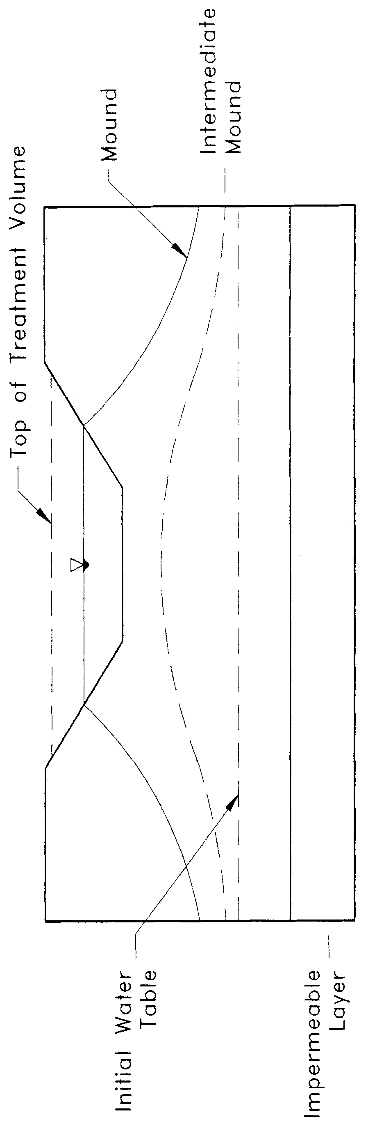

Figure 26-1. Groundwater Mounding Beneath a Retention System. (Source: Andreyev and Wiseman, 1989).
Applicants are encouraged to receive Department District acceptance of programs not on the list prior to application submittal to avoid permitting delays associated with review of the model.
If applicants wish to calculate retention basin recovery by hand, acceptable methodologies for vertical unsaturated and lateral saturated flow are described in sections 26.3.3 and 26.3.5, respectively. A design example for each flow condition is presented below in section 26.5.
26.3.2 Design Procedures
It is recommended that, unless the normal seasonal high water table is over 6 inches below the basin bottom, unsaturated flow prior to saturated lateral mounding be conservatively ignored in recovery analysis. In other words, there should be no credit for soil storage immediately beneath the basin if the seasonal high water table is within 6 inches of the basin bottom. This is not an unrealistic assumption since the height of capillary fringe in fine sand is on the order of 6 inches and a partially mounded water table condition may be remnant from a previous storm event, especially during the wet season.
It is also recommended that the filling of the pond with the treatment volume be simulated as a "slug" loading (i.e., treatment volume fills the pond within an hour).
26.3.3 Accepted Methodology for Estimating Vertical Unsaturated Flow
Vertical unsaturated flow consists of primarily downward movement of water stored in the basin into an unsaturated portion of the soil profile existing beneath the basin (Mongeau 1991). Vertical unsaturated flow only applies when the groundwater table or mound is below the retention basin bottom. Acceptable methodologies for calculating unsaturated vertical infiltration are included in Table 26-1. Each of the equations, however, are based on design assumptions that may not always be appropriate. In general the Green and Ampt equation is the most appropriate for conditions that typically occur in retention basin design. Andreyev and Wiseman (1989) utilized the following methodology in the MODRET computer program to estimate recovery in retention basins during unsaturated vertical flow. This methodology, which can easily be solved by hand, utilizes the modified Green and Ampt infiltration equation:
(26-1)
where: I_{d} = Design infiltration rate
K_{vu} = Unsaturated vertical hydraulic conductivity
FS = Factor of safety (recommend FS = 2.0)

The time to saturate (t_{sat}) the soil mass below the basin is:
(26-2)
where: t_{sat} = Time to saturate soil below the basin
h_{b} = Height of basin bottom above the groundwater table
f = Fillable porosity (generally 0.2 to 0.3)

See Figure 26-2 for a schematic of the retention basin with the appropriate design parameters illustrated for vertical unsaturated flow conditions.
The total volume of water required to saturate the soil below the basin bottom (V_{u}) can be calculated as follows:
(26-3)
where: A_{b} = Area of basin bottom
Likewise, the height of water required to saturate the soil below the basin bottom (h_{u}) can be calculated using:
(26-4)
Recovery of the treatment storage will occur entirely under vertical unsaturated flow conditions when:
(a) Treatment volume ≤ V_{u} ; or
(b) Height of the treatment volume (h_{v}) in the basin ≤ h_{u}
If recovery of the treatment storage occurs entirely under vertical unsaturated conditions, analysis of the system for saturated lateral flow conditions will not be necessary.
This simplified approach is conservative because it does not consider the horizontal movement of water from the ground water mound that forms during this stage. In cases where the horizontal permeability is great, a more accurate estimate of the total vertical unsaturated flow can be obtained by using the Hantush equation. However, horizontal permeability of the unsaturated zone must be determined using an appropriate field or laboratory test.

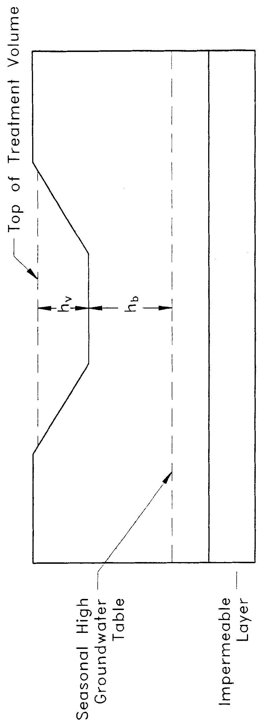

Figure 26-2. Design Parameters for Analysis of Stage One (Vertical) Flow (Source: Andreyev and Wiseman, 1989).
The factor of safety (FS) is recommended to account for flow losses due to basin bottom siltation and clogging. For most sandy soils the fillable porosity (f) is approximately 0.2 to 0.3. The unsaturated vertical hydraulic conductivity (K_{vu}) can be measured using the field testing procedures or laboratory methods recommended in section 26.4.
A design example for utilizing the above methodology is presented below in section 26.5.
26.3.4 Accepted Methodologies for Lateral Saturated Flow
If the ground water mound is at or above the basin bottom, the rate of water level decline in the basin is directly proportional to the rate of mound recession in the saturated aquifer. The Simplified Analytical Method, PONDFLOW, and Modified MODRET methodologies are generally acceptable for retention basin recovery analysis under lateral saturated flow conditions. These models are all similar in that the receiving aquifer system is idealized as a laterally infinite, single-layered, homogenous, isotropic water table aquifer of uniform thickness, with a horizontal water table prior to hydraulic loading. If these assumptions are not reasonable, these models may not be applicable and a more appropriate model will be required.
All of the accepted models require input values for the pond dimensions, retained stormwater runoff volume, and the following set of aquifer parameters:
- Thickness or elevation of base of mobilized (or effective) aquifer
- Weighted horizontal hydraulic conductivity of mobilized aquifer
- Fillable porosity of mobilized aquifer
- Ambient water table elevation which, for design purposes is usually the normal seasonal high water table

In addition, to these one-layered, uniform aquifer idealization models accepted above, more complicated fully three dimensional models with multiple layers (such as MODFLOW) may be used. In order to use such three dimensional models, however, much more field data is necessary to characterize the three dimensional nature of the aquifer.
A brief description of each of the models recommended in Special Publication SJ93-SP10 is provided below. The reader is encouraged to consult the Special Publication for a more detailed description.
MODRET
MODRET is a methodology developed by Andreyev and Wiseman (1989) for the Southwest Florida Water Management. The saturated analysis module of MODRET is essentially a pre- and post-processor for the USGS three-dimensional ground water flow model MODFLOW. The MODRET model also has the capability to calculate unsaturated vertical flow from retention basins using the Green and Ampt equation. Unsaturated flow takes place prior to the ground water mound intersecting the basin bottom.
The input parameters in the MODRET pre-processor are use to create MODFLOW input files. After the MODFLOW program is executed, the MODRET post-processor extracts and prints the relevant information from the MODFLOW output files. MODRET allows the user to input time-varying recharge (such as a hydrograph from a storm event) and calculate saturated flow out of the basin during recharge (i.e., a storm event).
During the study presented in Special Publication SJ93-SP10, it was discovered that the MODRET model was producing unstable MODFLOW solutions when modeling the recovery of some of the sites. This problem generally occurs when one or a combination of the following is true:
- The pond dimensions are relatively large (greater than 100 feet)
- The aquifer is relatively thin (less than 5 feet)
- The horizontal hydraulic conductivity is relatively low (less than 5 ft/day)

Upon further review, the MODRET model was modified in the study to correct this instability problem by changing the head change criterion for convergence to 0.001 ft from 0.01 ft. The original MODRET model with this modification is therefore referred to as "Modified MODRET."
PONDFLOW
PONDFLOW is a retention recovery computer model developed by Kuhns (1990). It is similar to MODRET in that is uses a finite difference numerical technique to approximate the time varying ground water profile adjacent to the basin. Also, like MODRET it can accommodate a time-varying recharge to the pond, account for seepage during the storm, and also calculates vertical unsaturated flow using Darcy's Equation.
Simplified Analytical Method (SAM)
The Simplified Analytical Method is a product of the study presented in District Special Publication SJ93-SP10. Figure 26-9 depicts the basic elements of the SAM. The integral for recovery time may be solved numerically or using commercially available software.
The SAM is somewhat conservative since it assumes that, for a prescribed runoff volume, the rise in the pond stage occurs instantaneously and there is no credit for seepage during the storm event.
26.3.5 Methodology for Analyzing Recovery by Lateral Saturated Flow by Hand
One methodology for analyzing lateral saturated flow from retention basins by hand is presented by Andreyev and Wiseman (1989) as part of their MODRET report. During the District's retention basin study presented in Special Publication SJ93-SP10, it was discovered that the MODRET model was producing unstable MODFLOW solutions when modeling the recovery of some of the retention basins monitored. This problem generally occurs when one or a combination of the following is true:

- The pond dimensions are relatively large (greater than 100 feet)
- The aquifer is relatively thin (less than 5 feet)
- The horizontal hydraulic conductivity is relatively low (less than 5 ft/day)

Therefore, the above parameters should be checked prior to utilizing the MODRET lateral saturated flow analysis presented below.
Andreyev and Wiseman (1989) used the MODFLOW groundwater flow computer model developed by the U.S. Geological Survey to generate a series of dimensionless curves to predict retention basin recovery under lateral saturated flow (Stage Two) conditions. The dimensionless parameters can be expressed as:
(26-5)
(26-6)
where: F_{x} = Dimensionless parameter representing physical and hydraulic characteristics of the retention basin and effective aquifer system (x-axis)
F_{y} = Dimensionless parameter representing percent of water level decline below a maximum level (y-axis)
W = Average width of the retention basin, midway between basin bottom and water level at time t (ft)
K_{H} = Average horizontal hydraulic conductivity (ft/day)
D = Average saturated thickness of the aquifer (ft)
t = Cumulative time since saturated lateral (Stage Two) flow started (days)
h_{c} = Height of water in the basin above the initial ground water table at time t (ft)
H_{T} = Height of water in the basin above the initial ground water table at the start of saturated lateral (Stage Two) flow (ft)

The average saturated thickness of the aquifer (D) can be expressed as:
(26-7)
where: H = Initial saturated thickness of the aquifer (ft)
The height of water in the basin above the initial groundwater table at the start of saturated lateral (Stage Two) flow (H_{T}) is:
(26-8)
where: h₂ = Height of water in the basin above the basin bottom at the start of saturated lateral (Stage Two) flow (ft)
Figure 26-3 contains an illustration of the design parameters for analysis of saturated lateral (Stage Two) flow conditions. The design parameters for a retention system utilizing both unsaturated vertical (Stage One) and saturated lateral (Stage Two) flow is represented in Figure 26-4.
The equation for F_{x} can be rearranged to solve for the time (t) to recover the remaining treatment volume under saturated lateral (Stage Two) flow:
(26-9)
Andreyev and Wiseman (1989) developed four families of dimensionless curves for fillable porosity (f) = 0.1, 0.2, 0.3, and 0.4. Five individual curves, for length to width ratios of 1, 2, 4, 10, and 100 were developed for each family. The resulting dimensionless curves are presented on Figures 26-5 through 26-8. These curves can be used to calculate the recovery time given the hydraulic parameters of the aquifer, the recharge rate, and the physical configuration of the basin. An example design problem utilizing both unsaturated vertical (Stage One) and saturated lateral (Stage Two) flows to estimate the recovery time is given below in section 26.5.
Section 26.4 Recommended Field and Laboratory Tests for Aquifer Characterization
The following field and laboratory investigation and testing guidelines are recommended for aquifer characterization and are described in more detail in Special Publication SJ93-SP10.

26.4.1 Definition of Aquifer Thickness
Standard Penetration Test (SPT) borings (ASTM D-1586) or auger borings (ASTM D 1452) should be used to define the thickness of the mobilized aquifer (i.e., depth to "hardpan" or restrictive layer) especially where the ground water table is high. This type of boring provides a continuous measure of the relative density/consistency of the soil (as manifested by the SPT "N" values) which is important for detecting the top of cemented or very dense "hardpan" type layers. Such layers restrict the vertical movement of ground water and are found over much of the District. If carefully utilized, manual "bucket" auger borings can also be used to define the thickness of the aquifer. Power flight auger borings may also be used with caution since this method may result in some mixing of soil from a given level with soils from strata above, thus masking the true thickness of the aquifer. To avoid this problem, technical guidelines for continuous flight auger borings are included in Appendix C of the District Special Publication SJ93-SP10.
Preferably, the SPT borings should be continuously sampled at least 2 feet into the top of the hydraulically restrictive layer. If a restrictive layer is not encountered, the boring should be extended to at least 10 feet below the bottom of the pond. As a minimum, the depth of the exploratory borings should extend to the base elevation of the aquifer assumed in analysis, unless nearby deeper borings or well logs are available.
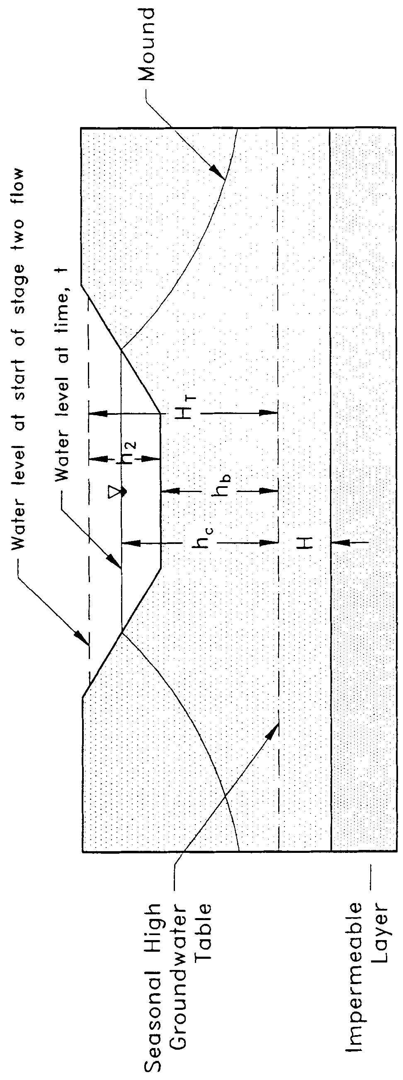

Figure 26-3. Design Parameters for Groundwater Mounding Analysis for Stage Two (Lateral) Flow (Source: Andreyev and Wiseman, 1989)

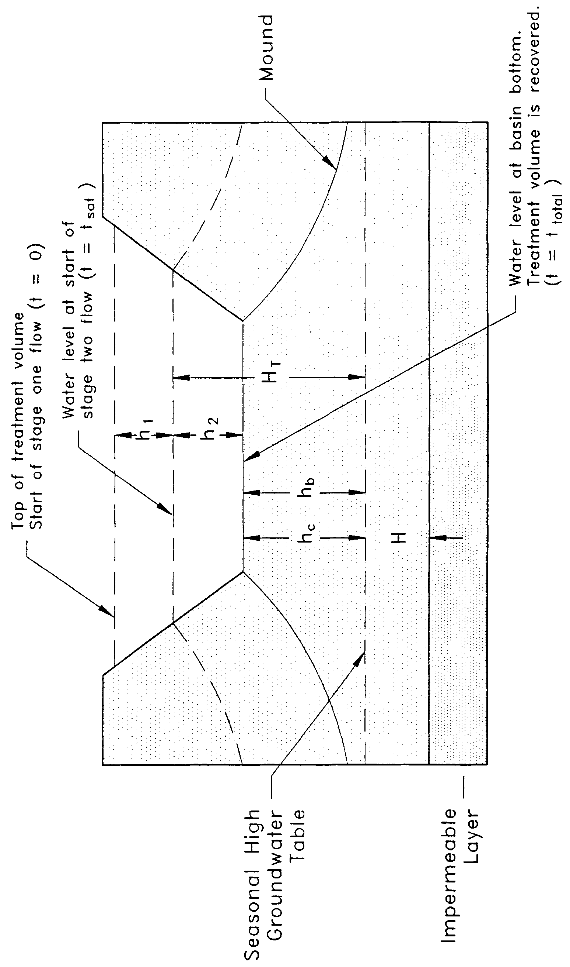
Figure 26-4. Design Parameters for Groundwater Mounding Analysis for Stage One and Stage Two Flow (Source: Andreyev and Wiseman, 1989).

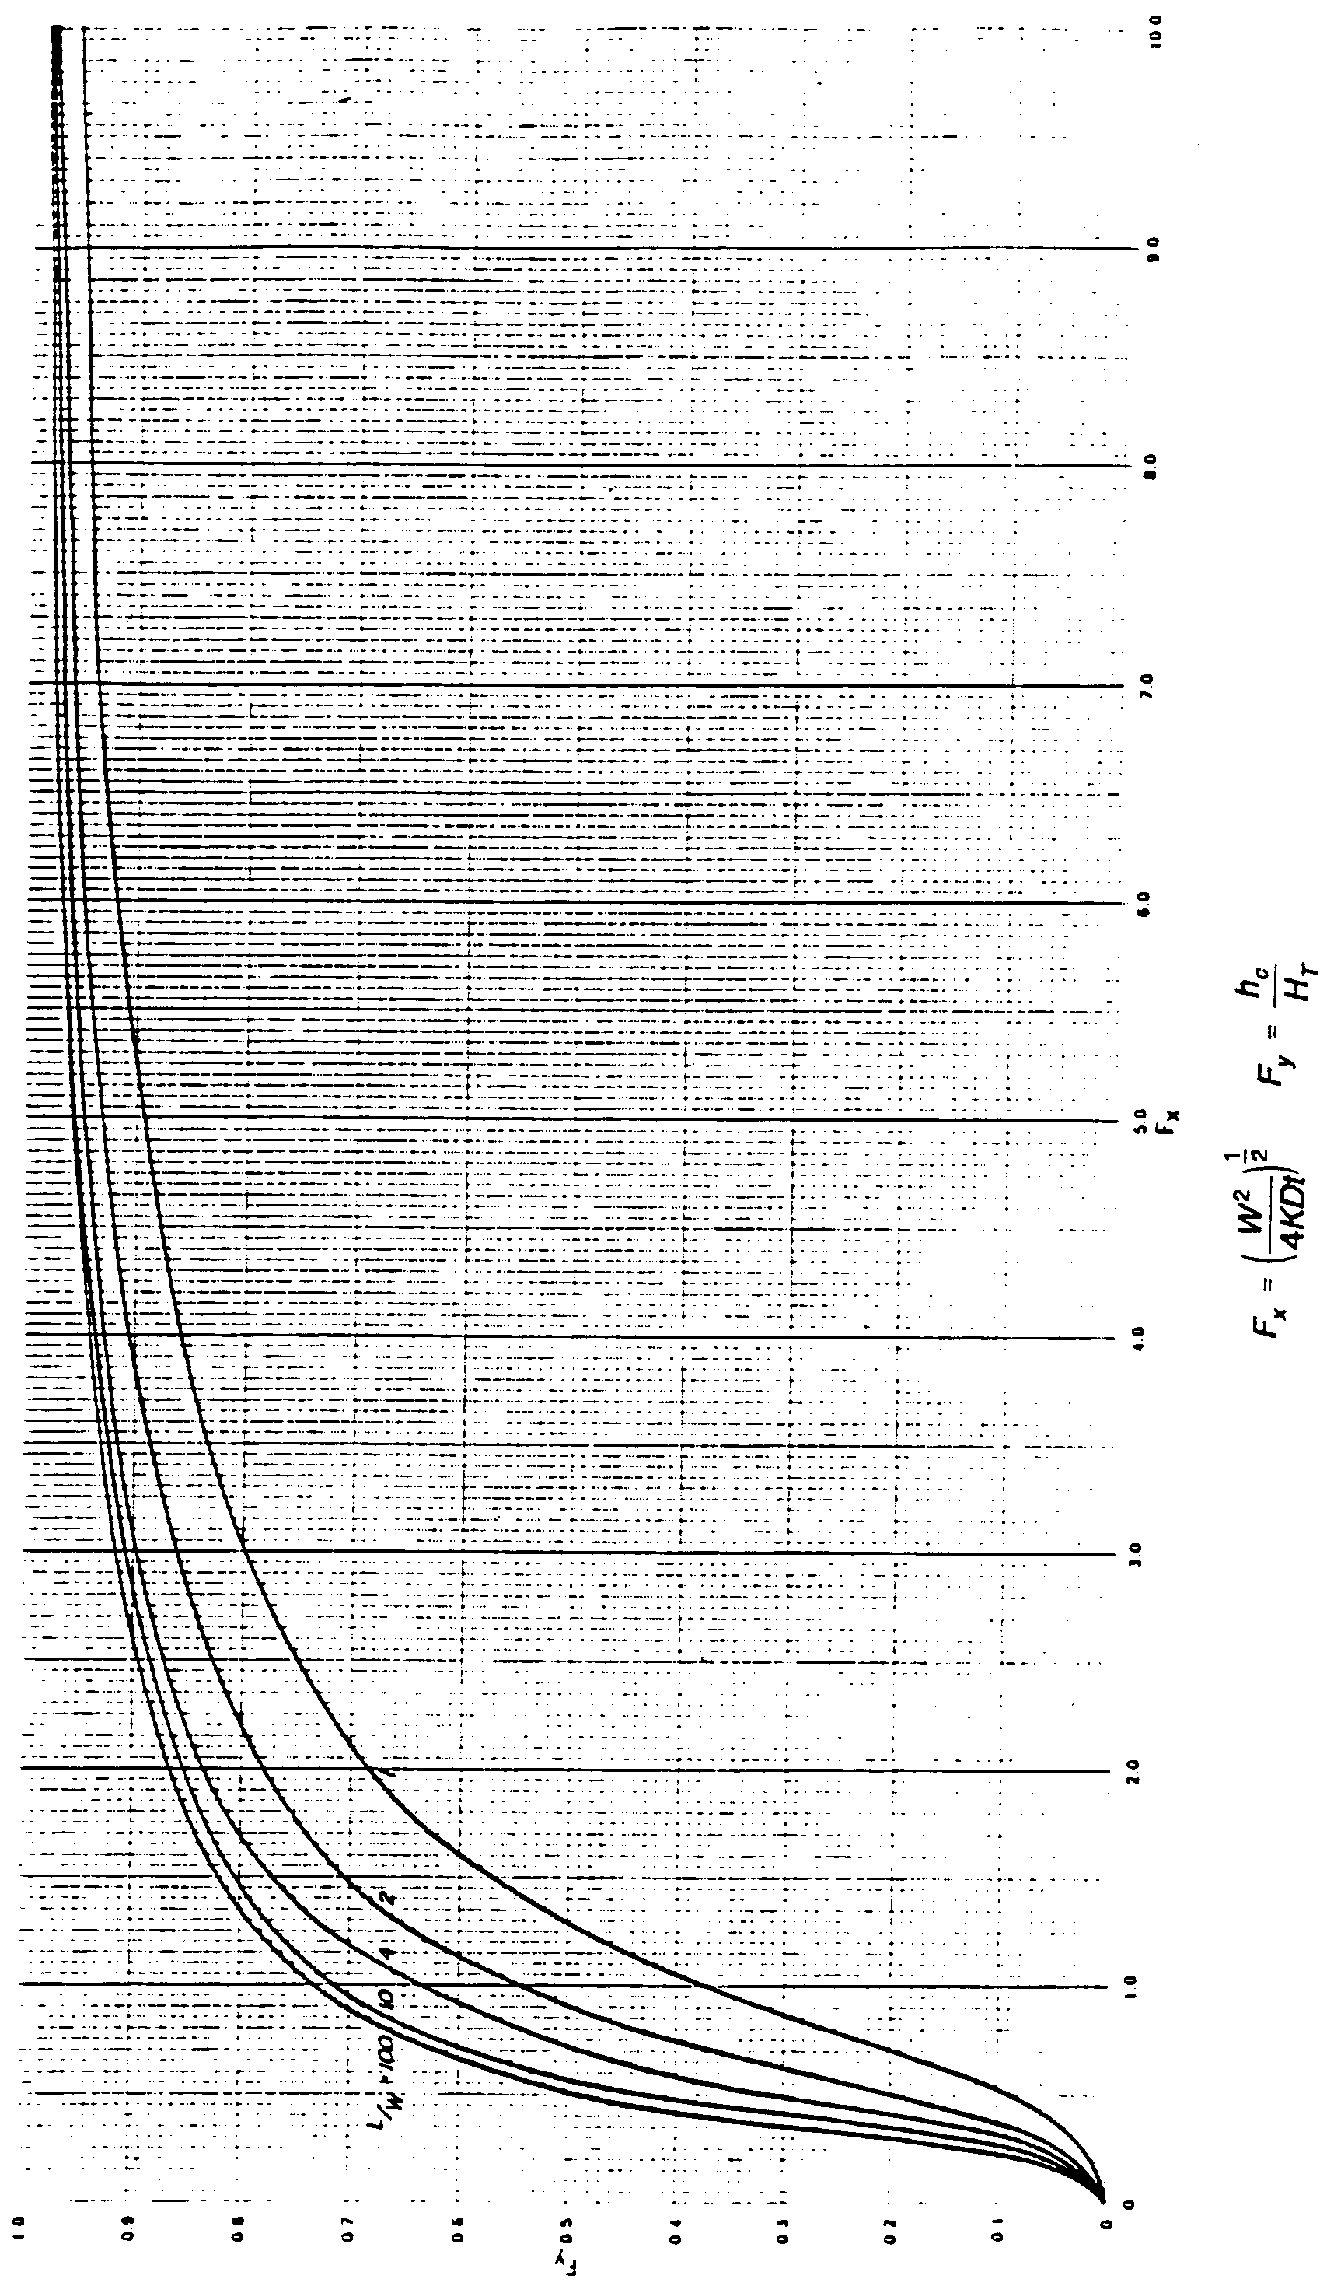
Figure 26-5. Dimensionless Curves Relating Basin Design Parameters to Basin Water Level in a Rectangular Retention Basin Over an Unconfined Aquifer (f = 0.1) (Source: Andreyev and Wiseman, 1989).
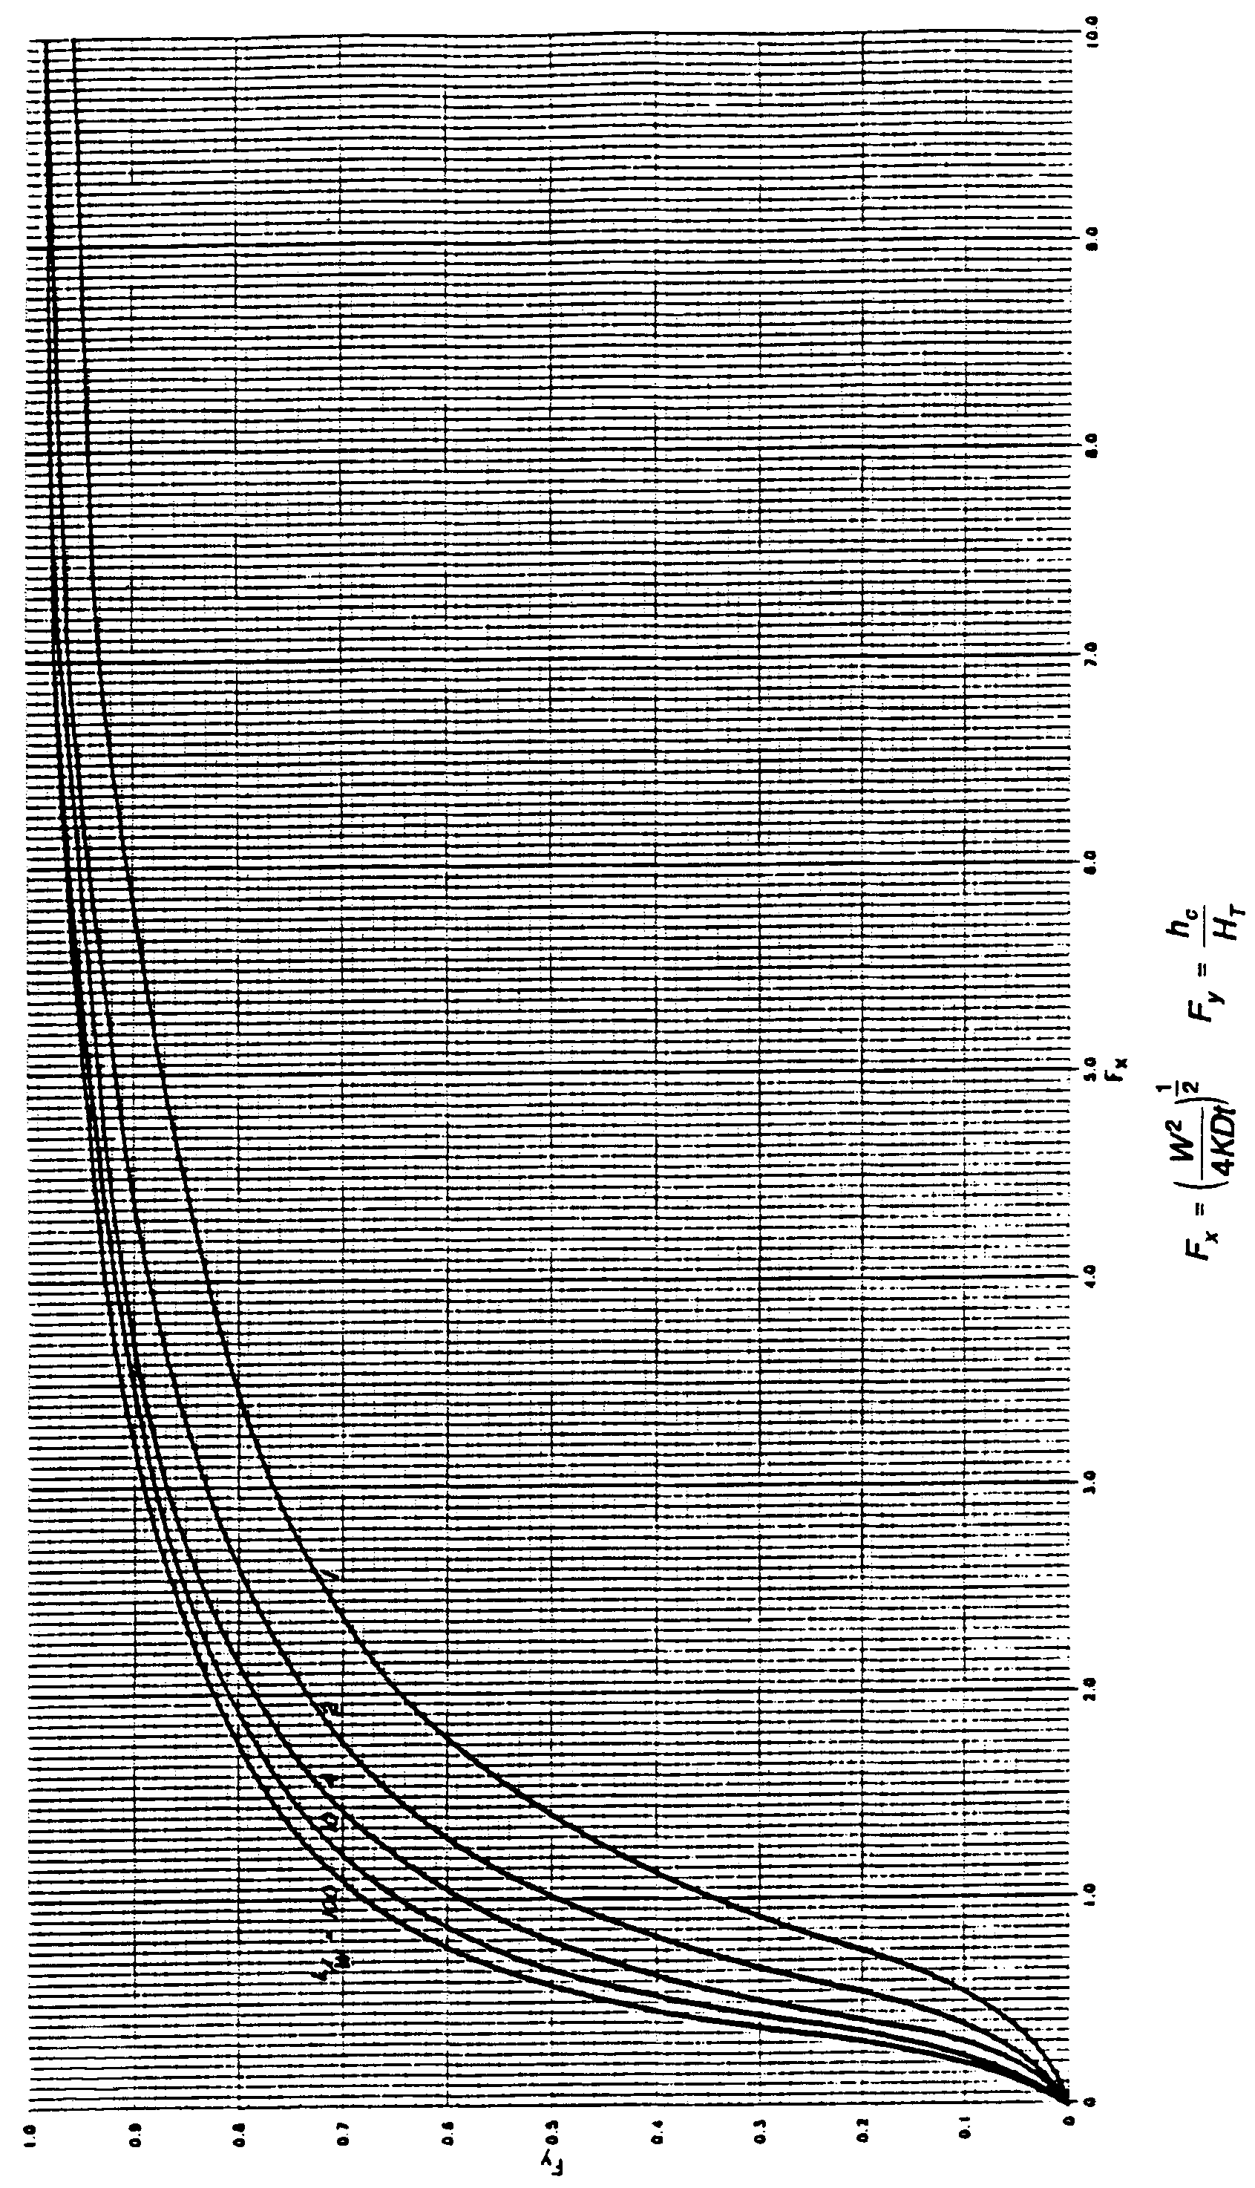
Figure 26-6. Dimensionless Curves Relating Basin Design Parameters to Basin Water Level in a Rectangular Retention Basin Over an Unconfined Aquifer (f = 0.2) (Source: Andreyev and Wiseman, 1989).
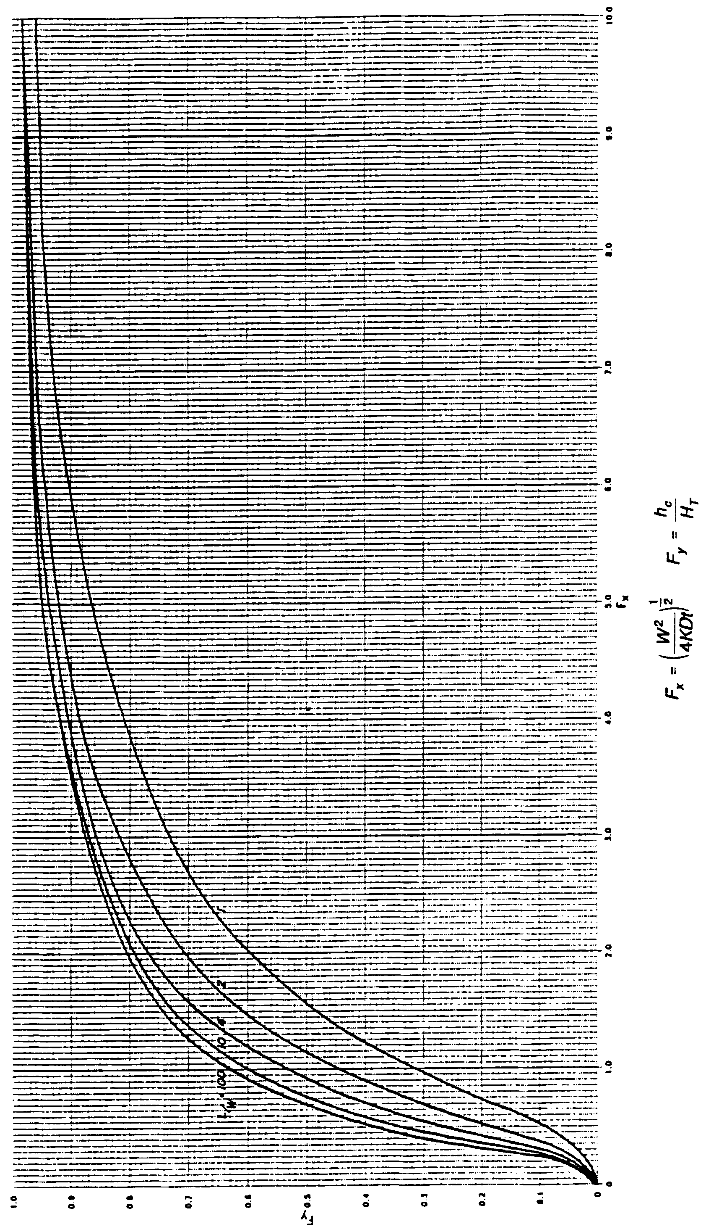

Figure 26-7. Dimensionless Curves Relating Basin Design Parameters to Basin Water Level in a Rectangular Retention Basin Over an Unconfined Aquifer (f = 0.3) (Source: Andreyev and Wiseman, 1989).
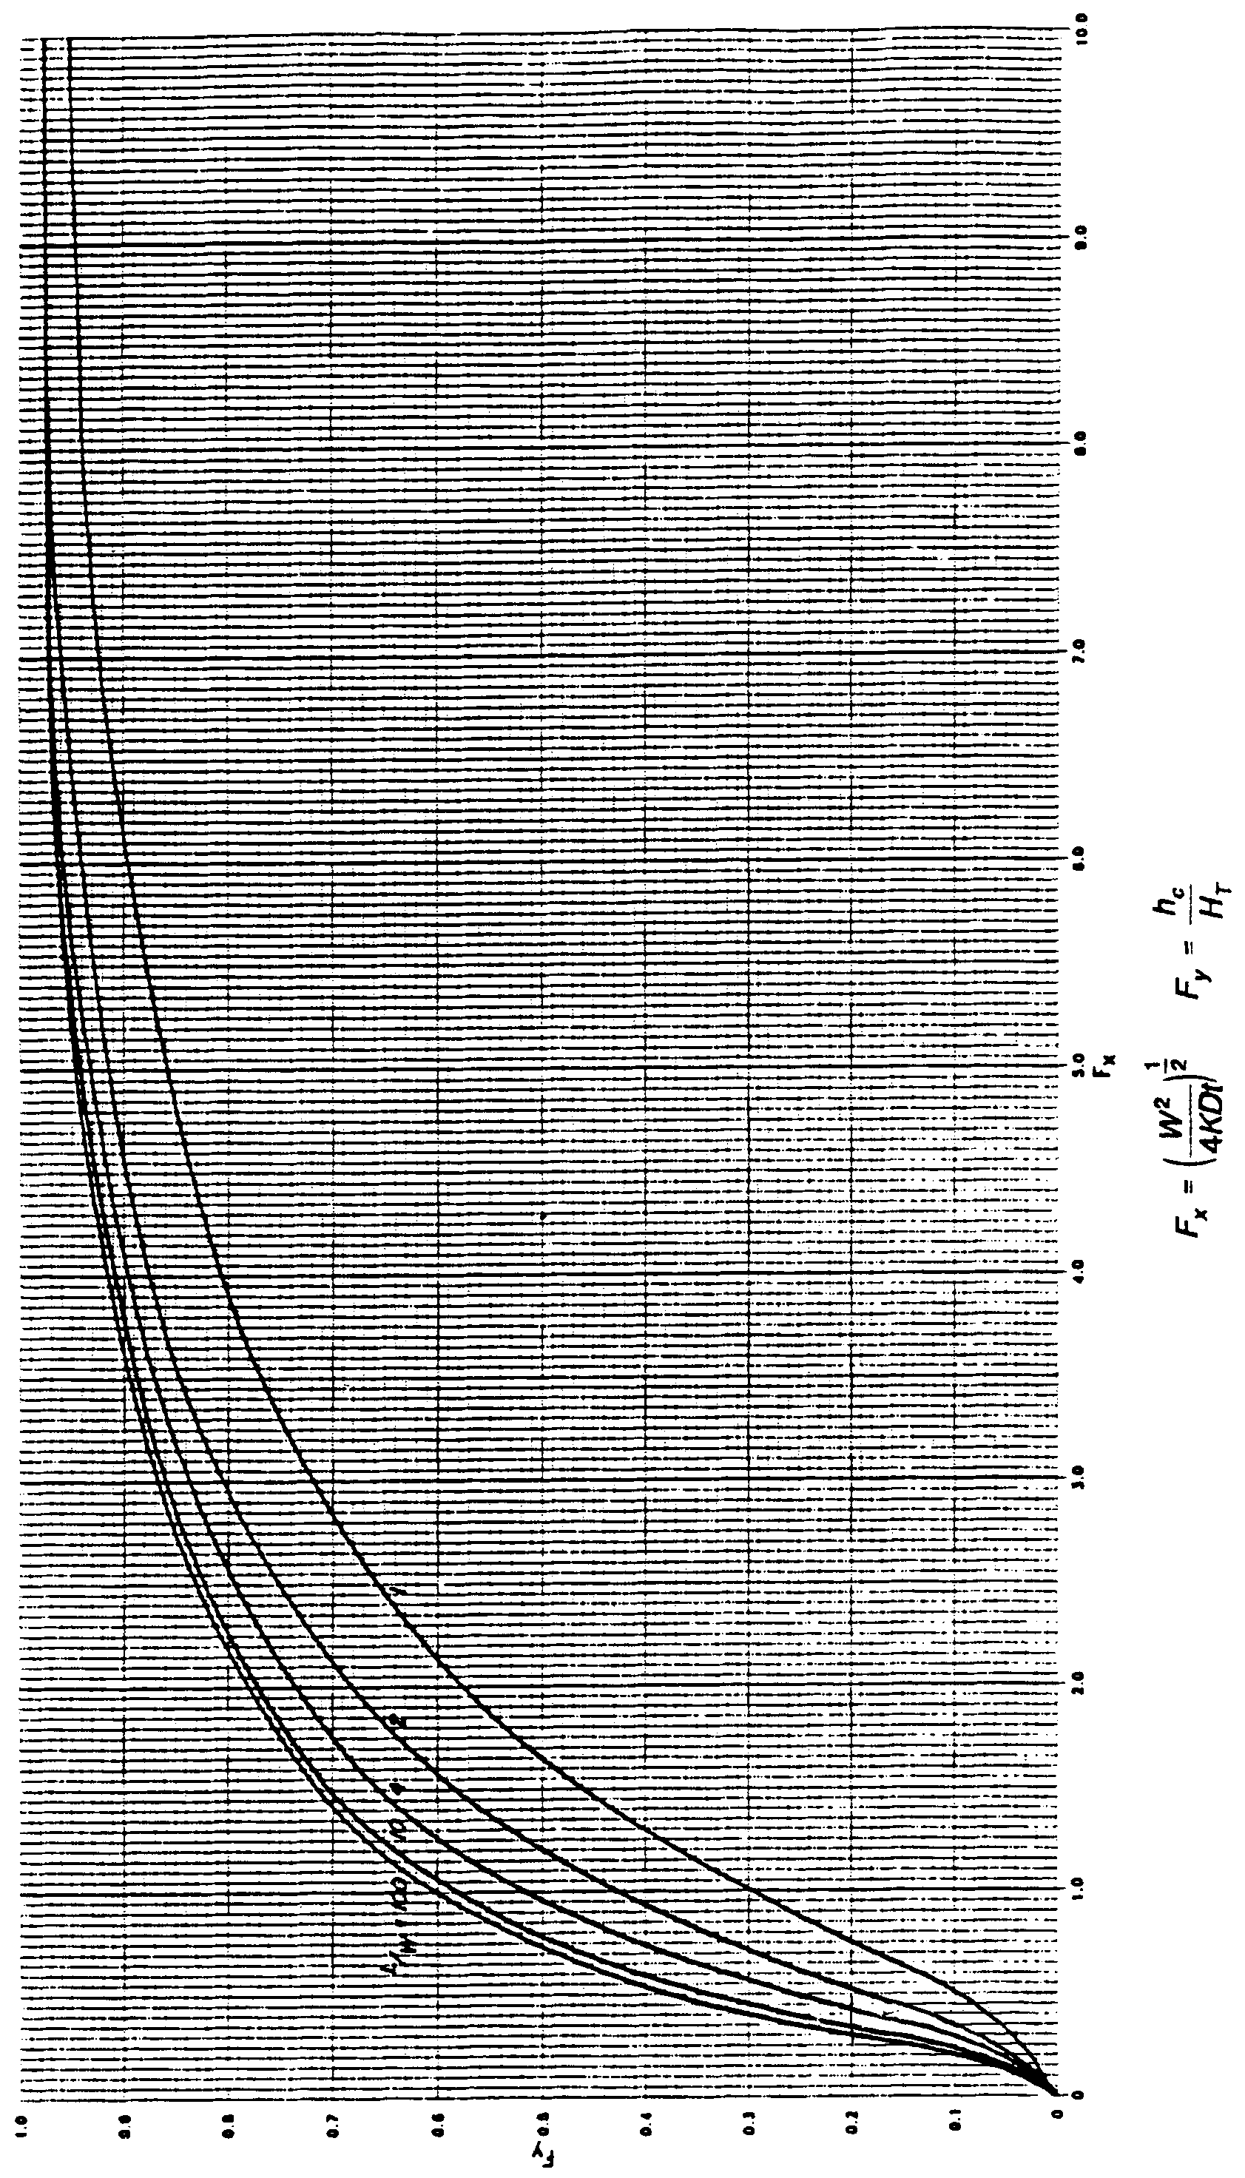

Figure 26-8. Dimensionless Curves Relating Basin Design Parameters to Basin Water Level in a Rectangular Retention Basin Over an Unconfined Aquifer (f = 0.4) (Source: Andreyev and Wiseman, 1989).

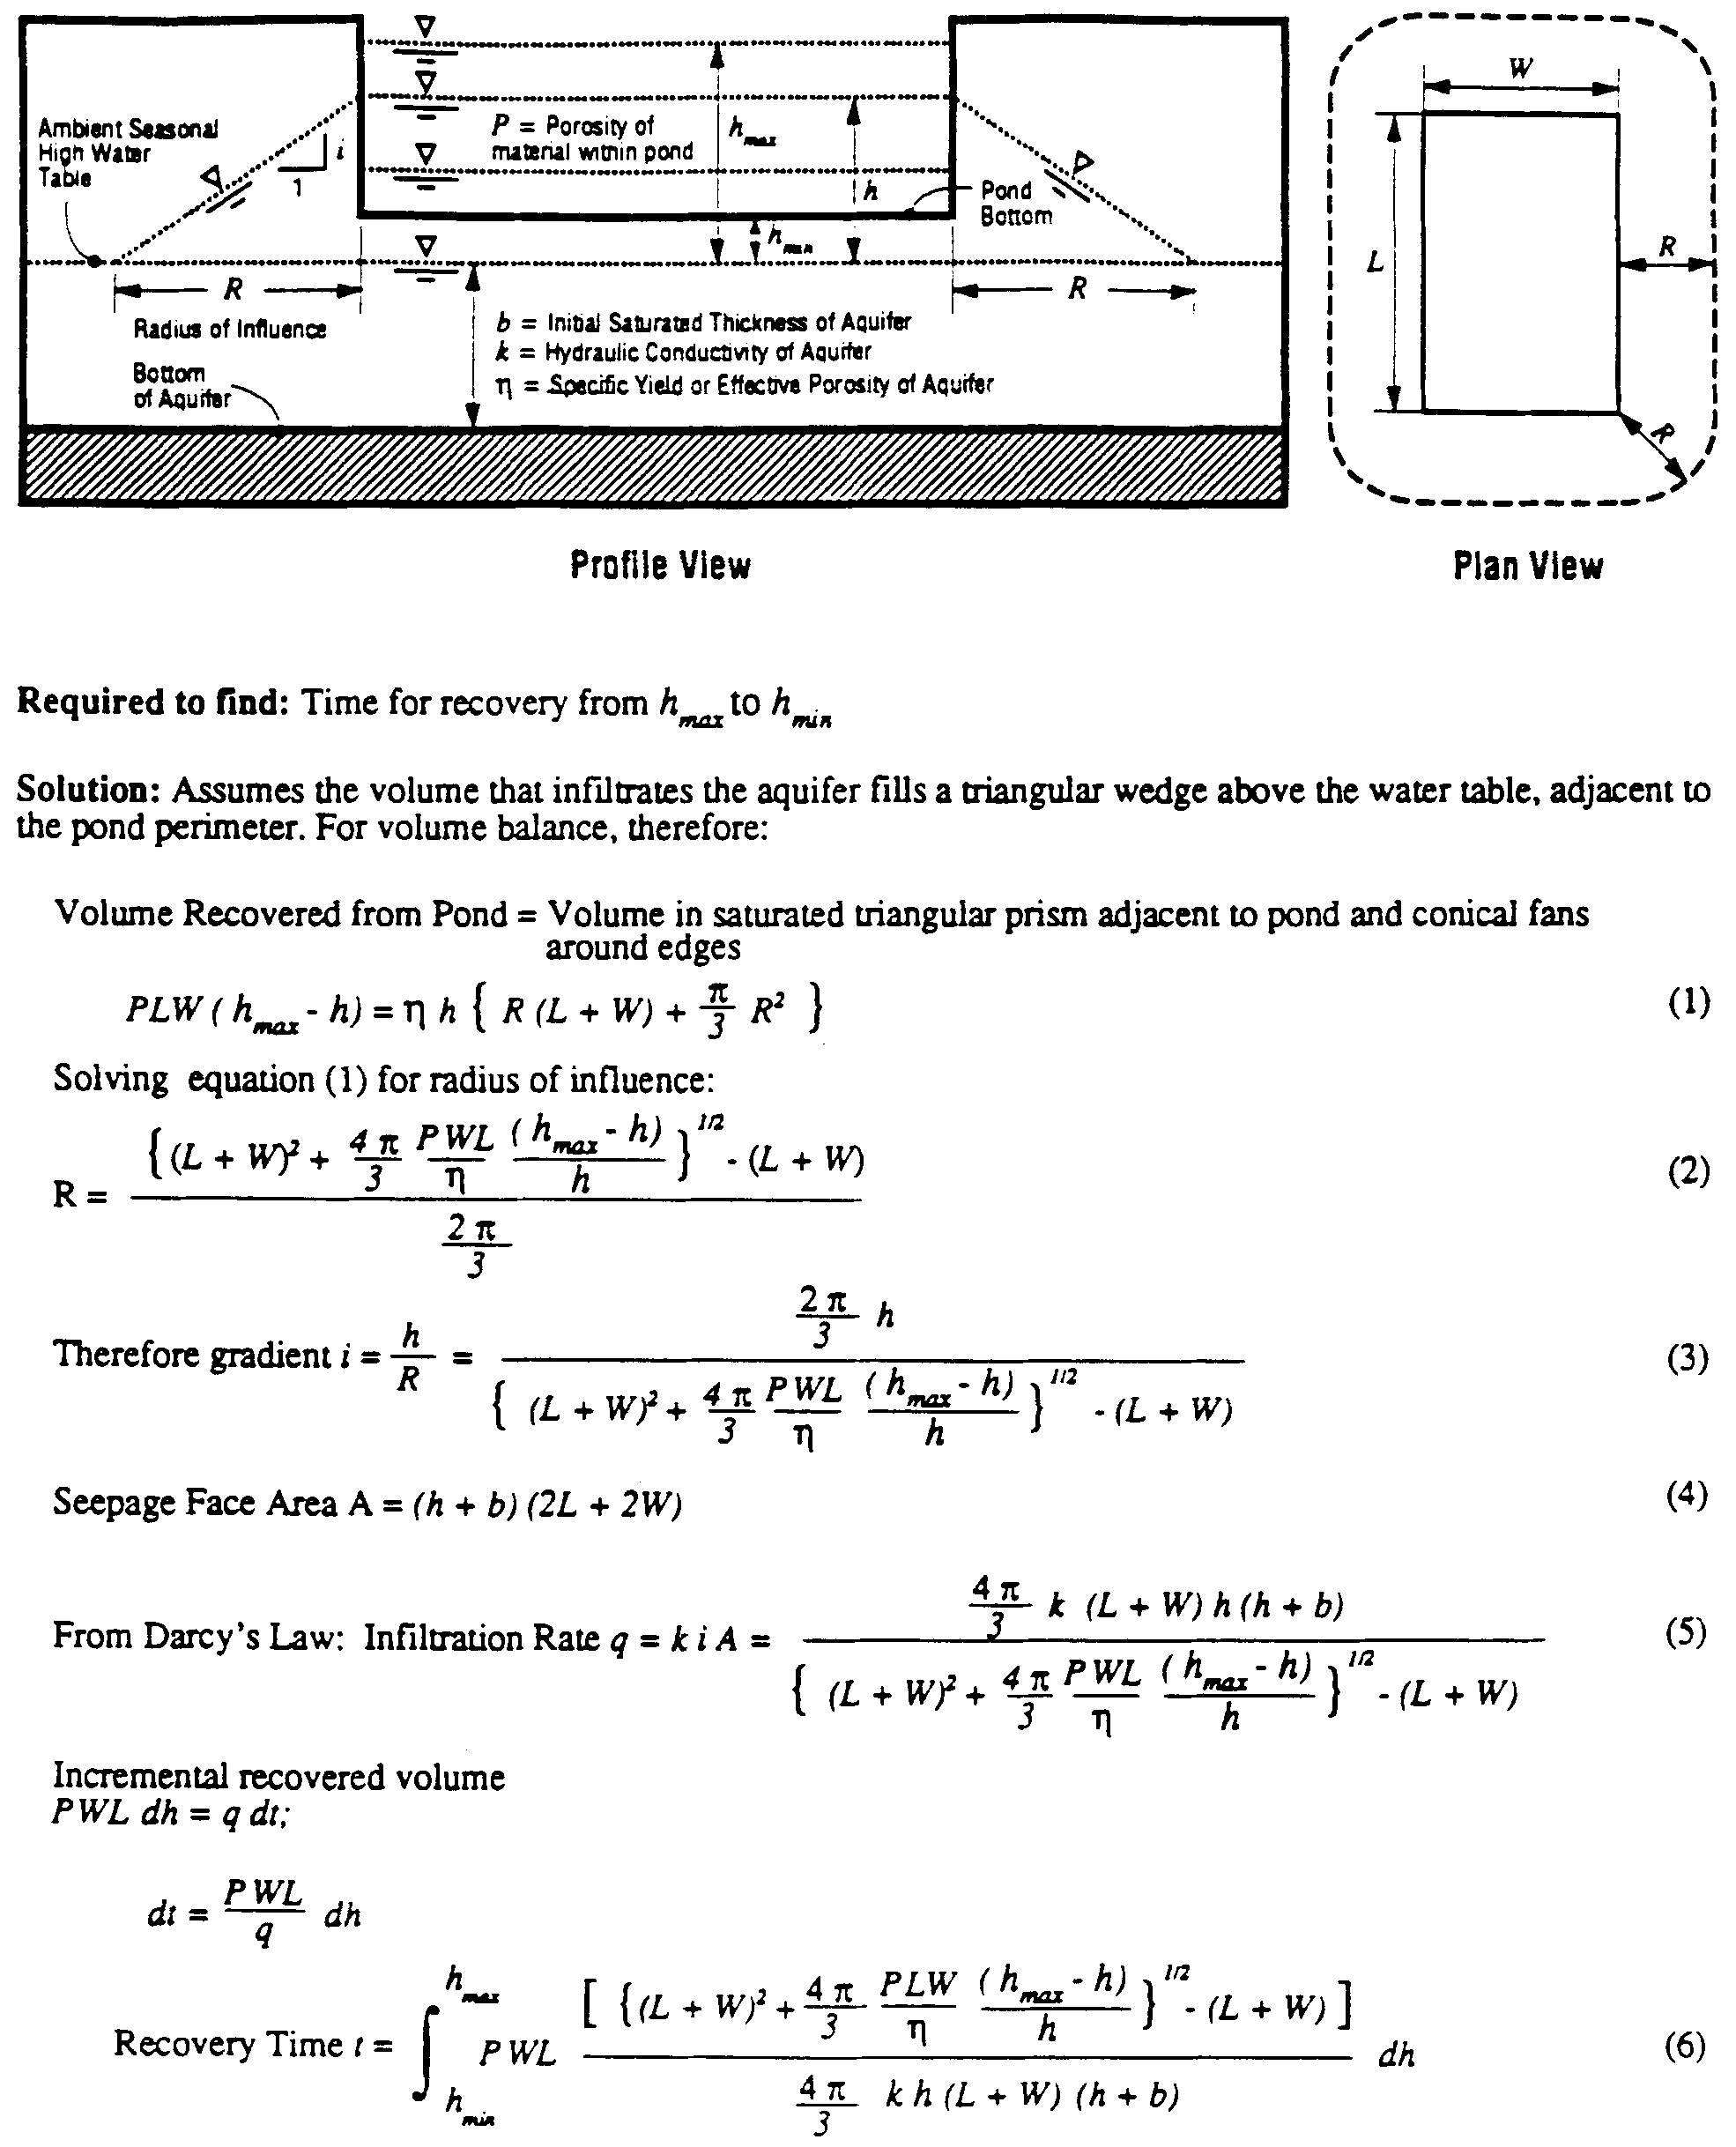

Figure 26-9. Simplified Analytical Method (Source: SJRWMD Special Publication SJ93-SP10)

The number of borings required to characterize the receiving aquifer of a retention basin depends on the anticipated areal and vertical variability of the aquifer. The local experience of the geotechnical engineer also plays an important role in the selection of the number of borings. As a guide, Andreyev and Wiseman (1989) suggest the following empirical equation to estimate the number of exploratory borings required:
(26-10)
where: B = Number of borings required
A = Average area of basin (acres)
L = Length of basin (ft)
W = Width of basin (ft)

Ground surface elevations at the boring locations should be surveyed if there is significant relief in the locality of the borings.
26.4.2 Estimated Normal Seasonal High Ground Water Table
In estimating the normal seasonal high ground water table (SHGWT), the contemporaneous measurements of the water table are adjusted upward or downward taking into consideration numerous factors, including: antecedent rainfall, redoximorphic features (i.e., soil mottling), stratigraphy (including presence of hydraulically restrictive layers), vegetative indicators, effects of development, and hydrogeologic setting. The application of these adjustments requires considerable experience.
In general, the measurement of the depth to the ground water table is less accurate in SPT borings when drilling fluids are used to maintain an open borehole. Therefore, when SPT borings are drilled, it may be necessary to drill an auger boring adjacent to the SPT to obtain a more precise stabilized water table reading. In poorly drained soils, the auger boring should be left open long enough (at least 24 hours) for the water table to stabilize in the open hole.
26.4.3 Estimation of Horizontal Hydraulic Conductivity of Aquifer
The following hydraulic conductivity tests are recommended for retention systems:
a) Laboratory hydraulic conductivity test on undisturbed sample (Figure 26-10)
b) Uncased or fully screened auger hole using the equation on Figure 26-11
c) Cased hole with uncased or screened extension with the base of the extension at least one foot above the confining layer (Figure 26-12)
d) Pump test or slug test, when accuracy is important and hydrostratigraphy is conductive to such a test method.
Of the above methods, the most cost effective is the laboratory permeameter test on an undisturbed horizontal sample. However, it becomes difficult and expensive to obtain undisturbed hydraulic conductivity tube samples under the water table or at depths greater than 5 feet below ground surface. In such cases -- where the sample depth is over 5 feet below ground surface or below the water table -- it is more appropriate to use the insitu uncased or fully screened auger hole method (Figure 26-11) or the cased hole with uncased or screened extension (Figure 26-12).
The main limitation of the laboratory permeameter test on a tube sample is that it represents the hydraulic conductivity at a point in the soil profile which may or may not be representative of the entire thickness of the mobilized aquifer. In most cases, the sample is retrieved at a depth of 2 to 3 feet below ground surface where the soil is most permeable, while the mobilized aquifer depth may be 5 to 6 feet. It is therefore important to use some judgment and experience in reviewing the soil profile to estimate the weighted hydraulic conductivity of the mobilized aquifer. It is not practical or economical to obtain and test permeability tubes at each point in the soil profile where there is a change in density, degree of cementation, or texture. Some judgment and experience must therefore be used to estimate representative hydraulic conductivities of the less permeable zones of the mobilized aquifer. In such an evaluation, geotechnical engineers usually consider, among other factors, particle size distribution (particularly the percent of roots, sample orientation (i.e., horizontal or vertical), remolding, and compaction. Valuable insight into the variation of saturated hydraulic conductivity with depth in typical Florida soils can be gleaned from the comprehensive series of soil characterization reports published by the Soil Science Department at the University of Florida. As an additional guide, Figure 26-13 presents an approximate correlation between hydraulic conductivity of poorly graded fine sands in Florida versus the percent by dry weight passing the U.S. No. 200 sieve.
The uncased or fully screened auger hole or cased hole with uncased or screened extension hydraulic conductivity test methods are suitable for use where the mobilized aquifer is stratified and there is a high water table. Ideally, these tests should be screened over the entire thickness of the mobilized aquifer to obtain a representative value of the weighted horizontal hydraulic conductivity. Tests performed below the water table avoid the need to saturate the soil prior to testing. If the mobilized aquifer is thick with substandard saturated and unsaturated zones, it is worthwhile to consider performing a laboratory permeameter test on an undisturbed sample from the upper unsaturated profile and also performing one the institute tests to characterize the portion of the aquifer below the water table.

Pump tests are appropriate for thick aquifers (greater than 10 feet) without intermediate hydraulically restrictive layers of hardpan, etc. Pump tests are the most expensive of the recommended hydraulic conductivity test methods. Therefore, it is recommended that pump tests be used in cases where the mobilized aquifer is relatively thick (greater than 10 feet)

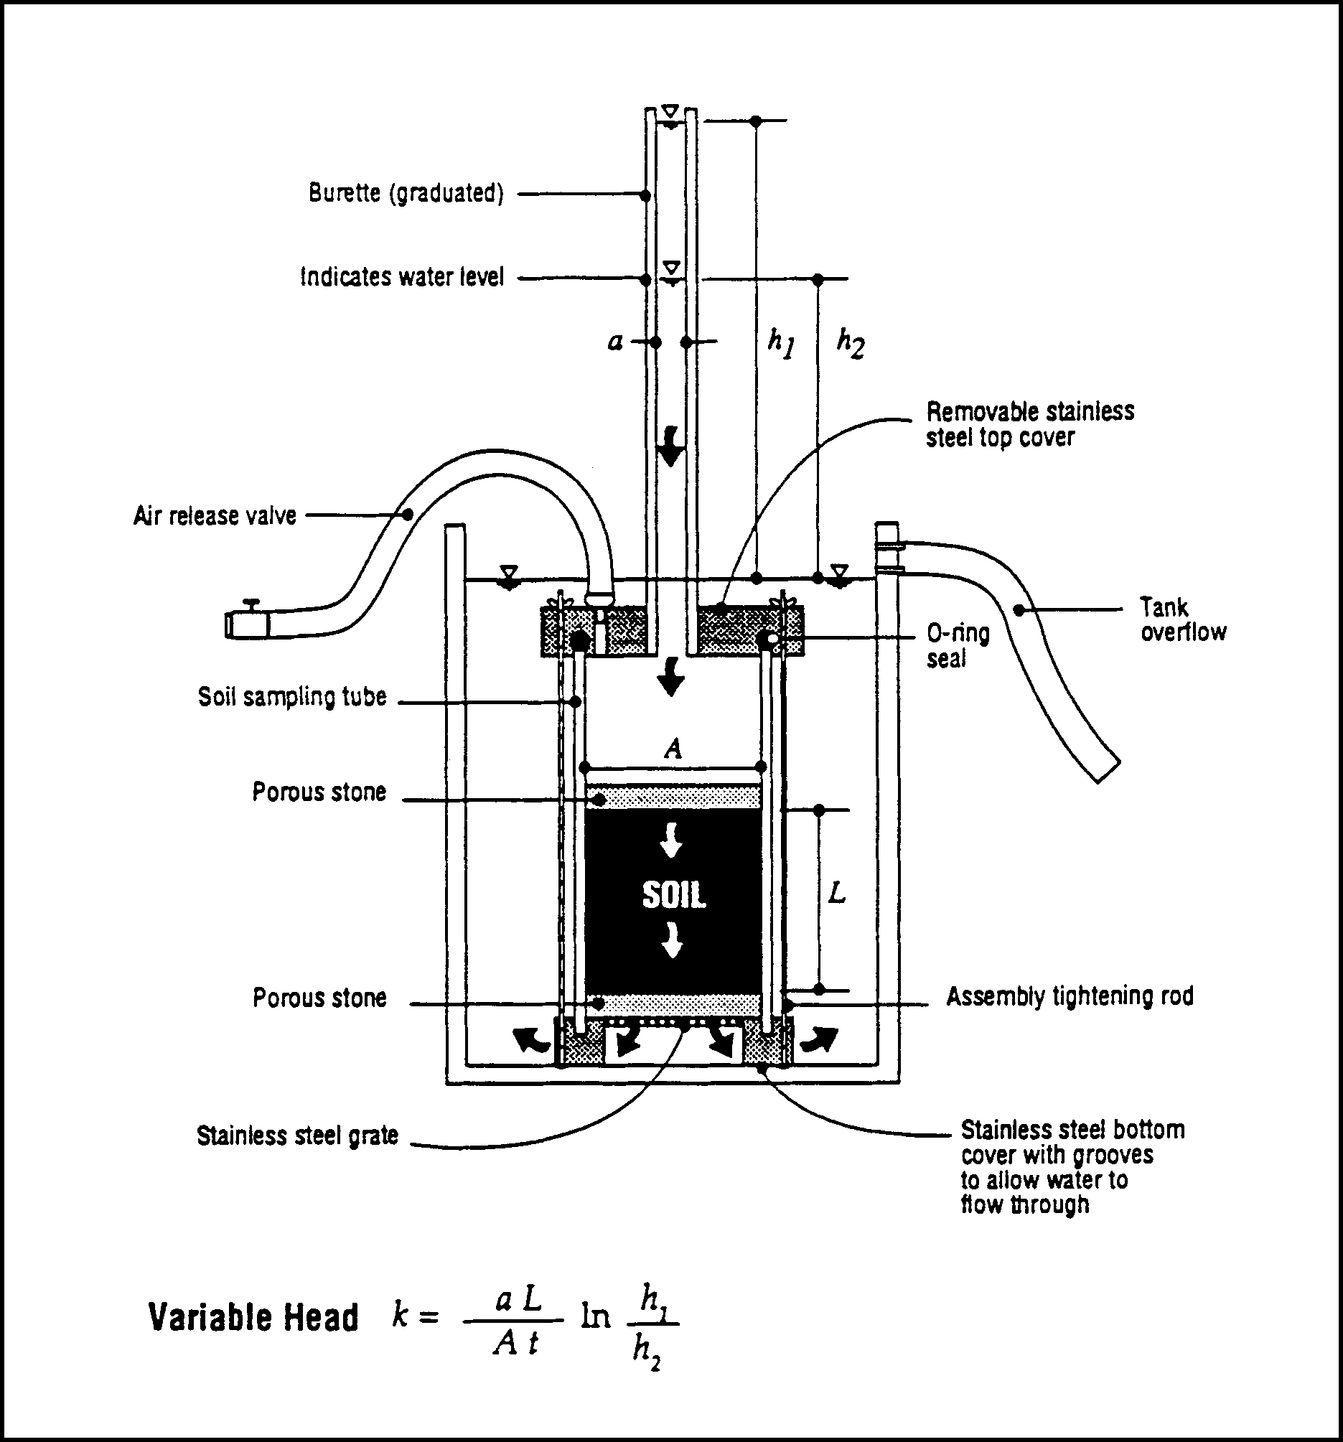
Figure 26-10. Laboratory Permeameter Test (PSI/Jammal & Associates Test Equipment) (Source: SJRWMD Special Publication SJ93-SP10)

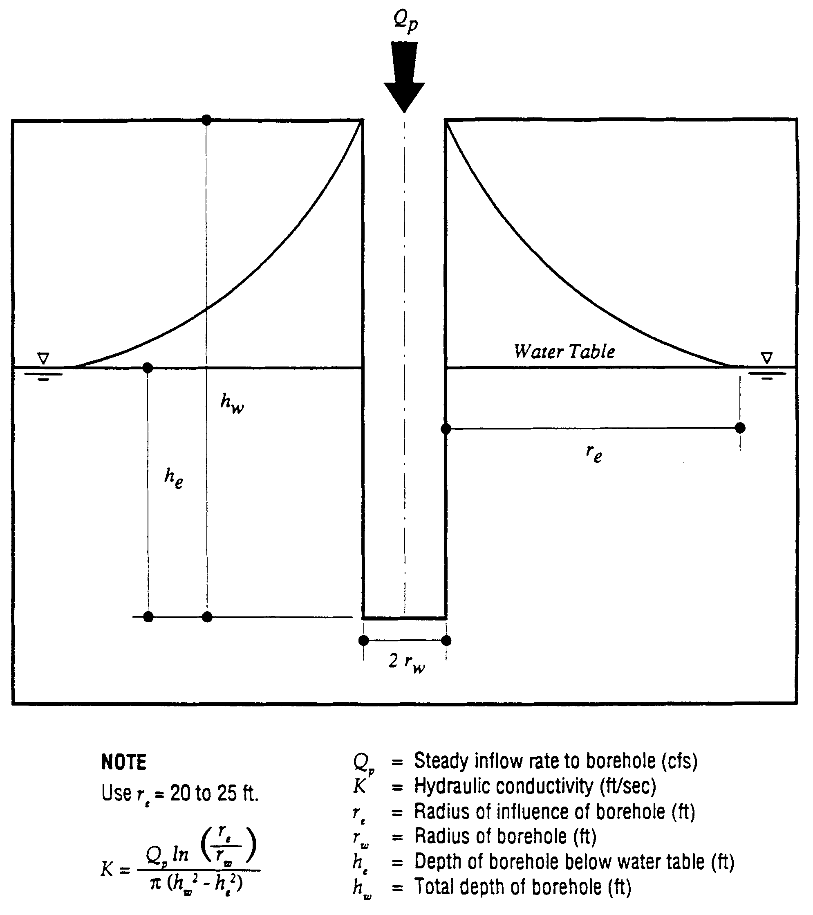

Figure 26-11. Field Hydraulic Conductivity Test: Uncased or Fully Screened Auger Hole, Constant Head (Source: SJRWMD Special Publication SJ93-SP10)

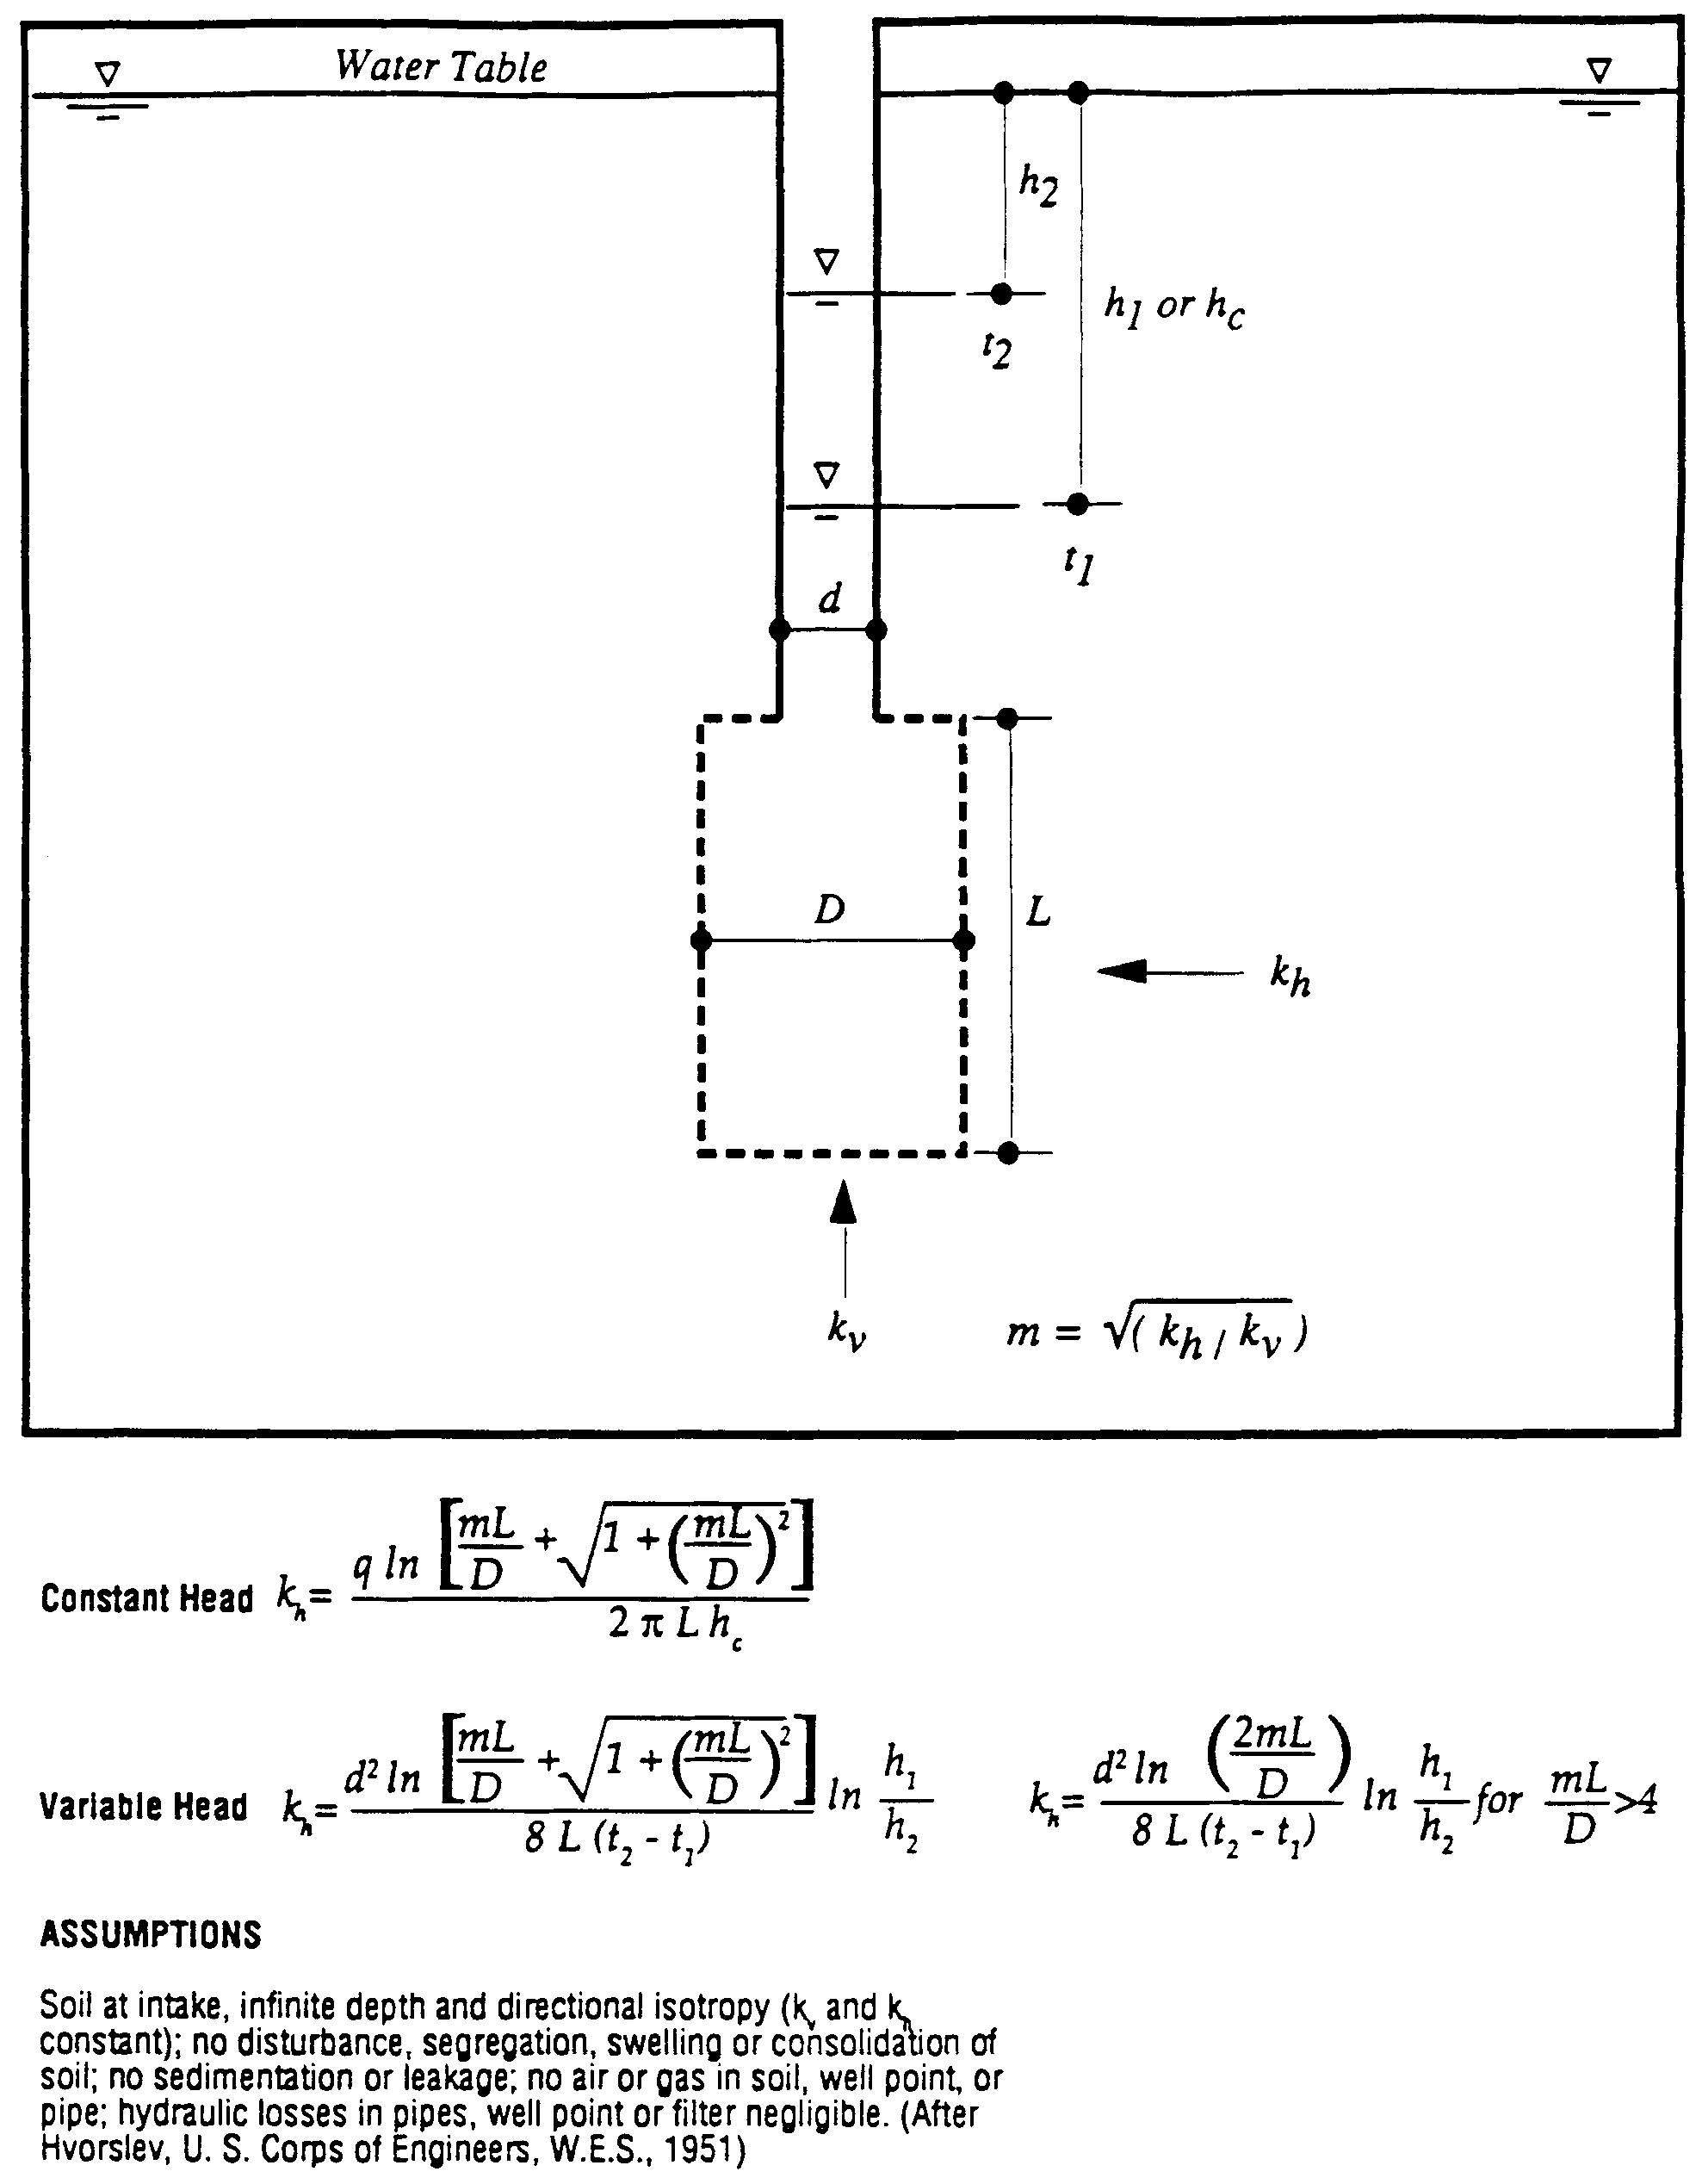

Figure 26-12. Field Hydraulic Conductivity Test: Cased Hole with Uncased or Screened Extension (Source: SJRWMD Special Publication SJ93-SP10)

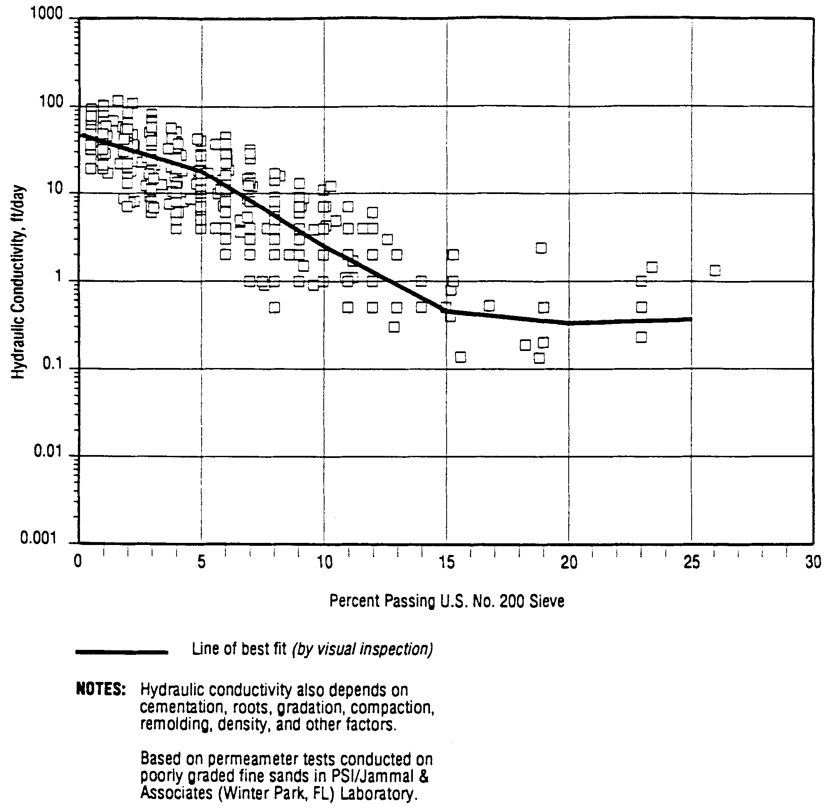

Figure 26-13. Correlation of Hydraulic Conductivity with Fraction by Weight Passing the U. S. No. 200 Sieve (Poorly Graded Fine Sands in Florida) (Source: SJRWMD Special Publication SJ93-SP10)

and where the environmental, performance, or size implications of the system justifies the extra costs of such a test.
For design purposes, a hydraulic conductivity value of over 40 ft/day should not be used for fine-grained sands and 60 ft/day for medium-grained sands.
The selection of the number of hydraulic conductivity tests for a specific project depends of the local experience and judgement of the geotechnical engineer. Andreyev and Wiseman (1989) recommends one hydraulic conductivity test plus one more test for every four soil borings.
26.4.4 Vertical Hydraulic Conductivity
The unsaturated vertical infiltration rate (K_{vu}) can be measured using a double ring infiltrometer test. The field test should be conducted at the same elevation as the proposed basin bottom or lower, if possible. The surface at the test site should be compacted to simulate pond bottom conditions after construction. Field measurements of K_{vu} at depths of more than 1 to 2 feet may not be possible, however, correlation of shallow strata test results with deeper strata may be possible. If field measurements of K_{vu} are not possible, measure the saturated vertical hydraulic conductivity (K_{vs}) by obtaining undisturbed tube sample in the vertical direction. Conduct laboratory permeameter test and then estimate K_{vu} using an empirical correlation of K_{vu} versus K_{vs} (Andreyev and Wiseman 1989):
(26-11)
26.4.5 Estimation of Fillable Porosity
In Florida, the receiving aquifer system for retention basins predominantly comprises poorly graded (i.e., relatively uniform particle size) fine sands. In these materials, the water content decreases rather abruptly with the distance above the water table and they therefore have a well-defined capillary fringe.
Unlike the hydraulic conductivity parameter, the fillable porosity value of the poorly graded fine sand aquifers in Florida are in a much narrower range (20 to 30 percent), and can therefore be estimated with much more reliability. For fine sand aquifers, it is therefore recommended that a fillable porosity in the range 20 to 30 percent be used in infiltration calculations. The higher values of fillable porosity will apply to the well- to excessively-drained, hydrologic group "A" fine sands, which are generally deep, contain less than 5 percent by weight passing the U.S. No. 200 (0.074 mm) sieve, and have a natural moisture content of less than 5 percent. No specific field or laboratory testing requirements is recommended to estimate this parameter.
26.5 Design Example for Retention Basin Recovery
The following design example is for estimating retention basin recovery by hand utilizing the methodologies in sections 26.3.3 and 26.3.5.
Given: Commercial project discharging to Class III waters
Drainage area = 1.5 acres
Percent impervious = 60%
Off-site drainage area = 0 acres
On-line treatment
f = 0.30; K_{vs} = 2 ft/day; K_{H} = 10 ft/day; FS = 2.0
Basin bottom elevation = 20.0 feet
Seasonal high groundwater table elevation = 17.0 feet
Impervious layer elevation = 14.0 feet
Rectangular retention basin with bottom dimensions of length = 100 ft and width = 50 ft

The proposed detention basin has the following stage-storage relationship:
Stage  (ft) | Storage  (ft³)
20.00 | 0
20.25 | 1278
20.50 | 2615
20.75 | 4011
21.00 | 5468
21.25 | 6988

Objective: Calculate the time to recover the treatment volume.
Design Calculations

Part I. Calculate the Treatment Volume and
the Height of the Treatment Volume in the Basin
Step 1. Calculate the required treatment volume. For on-line retention, the rule requires retention of 0.5 inches of runoff or 1.25 inches times the impervious area, whichever is greater, plus an additional 0.5 inch.
0.5" volume = (1.5 ac) (0.5 in) (43560 ft²/ac) = 2723 ft³
12 in/ft
1.25" x imp. area = 1.5 ac (0.6) (1.25 in) (43560 ft²/ac) = 4084 ft³
12 in/ft

Total treatment volume = 2723 + 4084 = 6807 ft³
Step 2. Calculate the height of the treatment volume in the basin. Using the stage/storage data, we see that 6807 ft³ is between elevation 21.0 and 21.25 ft. Interpolating:
Treatment vol. elev. = (21.25 - 21.0 ft) x (6807 ft³ - 5468 ft³) + 21.0 ft = 21.22 ft
(6988 ft³ - 5468 ft³)

Part II. Unsaturated Vertical Flow Analysis
Step 3. Determine if saturated lateral (Stage Two) flow will occur.
Treatment volume depth (h_{v}) = 21.22 - 20.00 ft = 1.22 ft
From Equation 26-4, the height of water to saturate the soil (h_{u}) is:
h_{u} = f (h_{b}) = 0.3 (3 ft) = 1.05 ft
Saturated lateral flow will occur since h_{v} > h_{u}
Step 4. Calculate the volume of water infiltrated in unsaturated vertical (Stage One) flow and the time to infiltrate this volume. The area of basin bottom (A_{b}) is:
A_{b} = 50 ft x 100 ft = 5000 ft²
Utilizing Equation 26-3, the volume infiltrated during Stage One (V_{u}) is:
V_{u} = 5000 ft² (3 ft) 0.35) = 5250 ft³
The unsaturated vertical hydraulic conductivity (K_{vu}) is determined from Equation 26-11:
K_{vu} = 2 (2 ft/day) = 1.33 ft/day
3
The design infiltration rate (I_{d}) is found from Equation 26-1:
I_{d} = 1.33 ft/day = 0.67 ft/day
2
From Equation 26-2, the time to saturate soil beneath the basin (t_{sat}) is:
t_{sat} = (3 ft)(0.35) = 1.57 days
0.67 ft/day
Part III. Saturated Lateral Flow Analysis
Step 5. Calculate the remaining treatment volume to be recovered under saturated lateral (Stage Two) flow conditions.
Remaining volume to be infiltrated under saturated lateral flow = 6807 - 5250 = 1557 ft³
Calculate the elevation of treatment volume at the start of saturated lateral flow by interpolating:
Treatment volume elev. = (20.50 - 20.25 ft) x (1557 ft³ - 1278 ft³) + 20.25 ft = 20.30 ft
at start of saturated (2615 ft³ - 1278 ft³)
lateral flow

Step 6. Calculate F_{y} and F_{x}
When the treatment volume is recovered (time t = t_{Total}) the water level is at the basin bottom. Hence, the height of the water level above the initial groundwater table (h_{c}) will be equal to h_{b}.
h_{c} = h_{b} = 3 ft (at t = t_{Total})
The height of water in the basin at the start of saturated lateral flow (h₂) is:
h₂ = 20.3 - 20.0 = 0.3 ft
From Equation 26-8:
H_{T} = h_{b} + h₂ = 3.0 + 0.3 = 3.3 ft
F_{y} is determined from Equation 26-6:
F_{y} = 3 ft = 0.91
3.3 ft
When the water level is at the basin bottom (time t = t_{Total}) the basin length (L) = 100 ft and the basin width (W) = 50 ft.
Basin length to width ratio (L/W) = 100 ft = 2
50 ft
Determine F_{x}.

From Figure 26-7; F_{x} = 4.65 (for f = 0.3, L/W = 2, and F_{y} = 0.91)

Step 7. Calculate the time to recover the remaining treatment volume under saturated lateral flow.
H = 17.0 - 14.0 = 3.0 ft
The average saturated thickness (D) can be found from Equation 26-7:
D = H + hc = 3.0 + 3.0 = 4.5 ft
2 2
The time (t) to recover the remaining treatment volume under lateral saturated flow conditions is determined from Equation 26-9:

t = (50 ft)² = 0.62 days
(4) (10 ft/day) (4.5 ft) (4.75)²

Part IV. Calculate Total Recovery Time
Step 8. Total time to recover the treatment volume (t_{Total}) equals the time to recover during unsaturated vertical flow plus the time to recover under lateral saturated conditions.
Total recovery time (t_{Total}) = 1.57 days + 0.62 days = 2.19 days or 53 hours
Therefore, the design meets the 72 hour recovery time criteria.
26.6 References
Andreyev, N.E., and L.P. Wiseman. 1989. Stormwater Retention Pond Infiltration Analysis in Unconfined Aquifers. Prepared for Southwest Florida Water Management District, Brooksville, Florida.
Kuhns, G.L. 1990. PONDFLOW II - Stormwater Recovery Analysis Program. User Manual (unpublished).
Mongeau, M.L. 1991. Groundwater Considerations. In Stormwater Management: A Designer's Course. Florida Engineering Society, Orlando, Florida.
Professional Service Industries, Inc. (PSI), Jammal & Associates Division. 1993. Full-Scale Hydrologic Monitoring of Stormwater Retention Ponds and Recommended Hydro-Geotechnical Design Methodologies. Prepared for St. Johns River Water Management District, Palatka, Florida. Special Publication SJ93-SP10.

27.0 Methodology and Design Example for Underdrain Systems
27.1 Spacing Underdrain Laterals
Optimum drain spacing for drainage laterals is influenced by soil permeability, drain depth, water table elevation desired after installation of the system, and site characteristics. The following procedure used to design underdrain systems are largely based on techniques used to design agricultural subsurface drainage systems. The procedures in this section are adapted from Livingston et al. (1988).
Underdrain spacing can be determined by the "ellipse equation" which is expressed as (SCS 1973):
(27-1)
where: S = Drain spacing (ft)
K = Permeability rate of the soil (ft/hr)
M = Height of water table above drain (after drawdown) measured at the midpoint between laterals (ft)
A = Height of drain above impermeable layer (ft)
Q = Drainage coefficient (ft/hr)
Refer to Figure 27-1 for an illustration of the variables used in the ellipse equation.
The drainage coefficient (q) is the rate of water removal to obtain the required 72-hour recovery of the treatment volume and to lower the free water surface a specified depth below the basin bottom. In the ellipse equation, the drainage coefficient (q) is expressed in the same units as the permeability (K). The drainage coefficient (q) can be expressed as (Livingston et al. 1988):
(27-2)
where: c = Depth from the ground surface to water table (after drawdown) (ft)
t = Recovery time (hr)
Based on Figure 27-1, the height of the water table above the drain (m) is given by:
m = d - c (27-3)
where: d Depth to drainage pipe from the natural ground surface elevation (ft)
The height of the drain above the impermeable barrier (a) is:
a = D - d (27-4)
where: D = Depth to impermeable layer from the natural ground surface elevation (ft)
When there is no impermeable barrier present, the depth to the impermeable layer (D) should be assumed at a depth equal to twice the drain depth (d).
The ellipse equation is based on steady state conditions and the assumption that ground water inflow from outside the area is slight. For this reason the use of the ellipse equation should be limited to conditions in which:
(a) The hydraulic gradient of the undisturbed water table is one percent (0.01 feet per foot) or less. Under these conditions there is likely to be very little ground water flow or movement from outside the system.
(b) The site is underlain by a impermeable barrier at relatively shallow depths (twice the depth of the drain (d) or less) which restricts vertical flow and forces the percolating water to flow horizontally toward the drain.
(c) A gravel envelope surrounds the perforated drainage pipes so that flow restrictions into the drain are minimized.
(d) The height of drain above impermeable layer (a) is less than or equal to the depth to the drainage pipe (d).
27.2 Length of Underdrain Required and Basin Dimensions
It is desirable to keep both the bottom and sides of the detention area dry. To maintain a dry basin bottom, the Department District recommends the distance between the basin bottom and water table after drawdown be at least 6 inches (see Figure 27-1). Maintaining r  6 inches will ensure that the floor of the basin is above the ground water table capillary zone.
If the side slope and shape of the detention basin are known, it is possible to determine the dimensions of the basin and the exact length of drain pipe needed. The area (A_{L}) served by each lateral in a rectangular basin is given by (see Figure 27-2):
A_{L} = S (L + S) (27-5)
where: A_{L} = Area served by each lateral (ft²)
L = Length of lateral (ft)

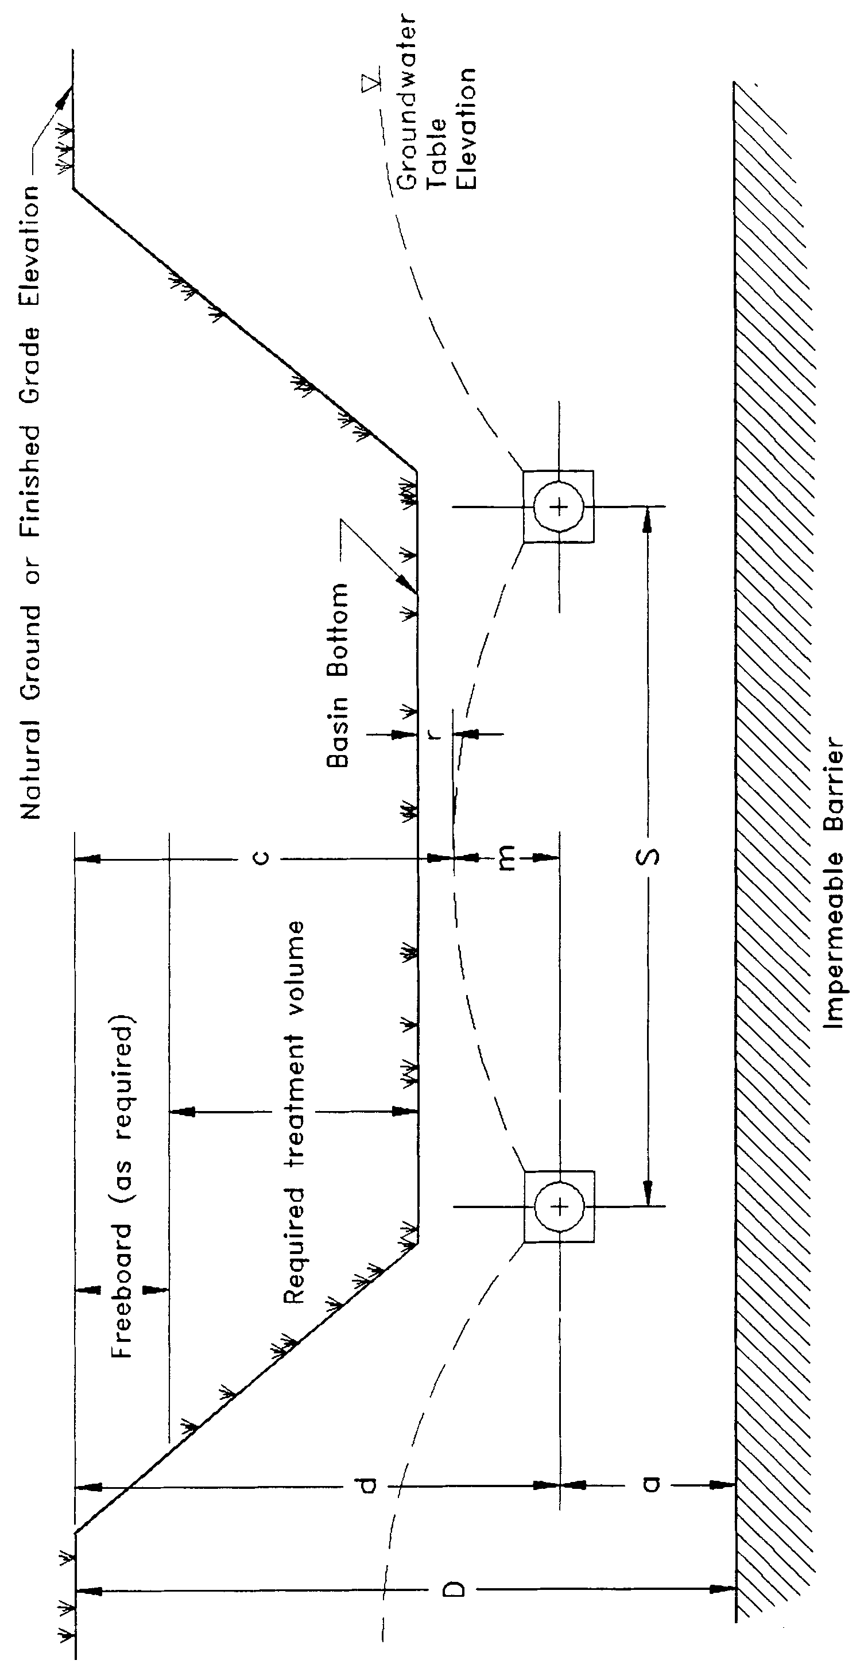
Figure 27-1. Cross-section of underdrain system illustrating variables used in the ellipse equation (N.T.S.)

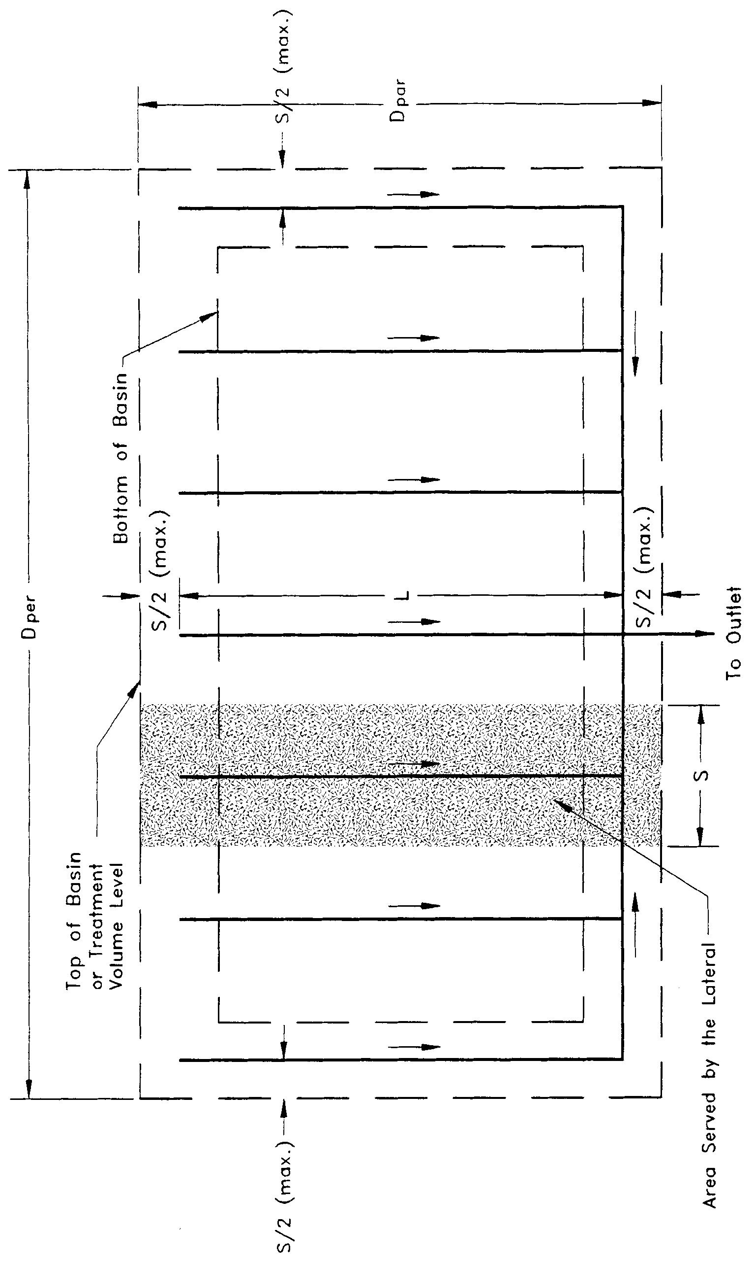
Figure 27-2. Top view of underdrain system illustrating variables used in the ellipse equation (N.T.S.)

The total area served by all the laterals (A_{TL}) is:
A_{TL} = A_{L} N (27-6)
where: N = Number of laterals
The top area of the detention basin (A_{BT}) can be expressed as:
ABT = DPAR DPER (27-7)
where: A_{BT} = Top area of the detention basin (ft²)
D_{PAR} = Distance of top of basin in the direction parallel to the laterals (ft)
D_{PER} = Distance of top of basin in the direction perpendicular to the laterals (ft)
Setting the total area served by the laterals (A_{TL}) so that it is equal to the area of the detention basin as measured from the top of bank dimensions (A_{BT}), will ensure that both the bottom and sides of the basin remain dry between storm events. In this case the criteria for the lateral spacings and the top dimensions of the basin are determined as follows:
(27-8)
(27-9)
(27-10)
Top Area: D_{PAR} (D_{PER})  A_{TL} (27-11)
Given the lateral spacing (S) and two of the three variables L, D_{PAR}, or D_{PER}, the designer can solve for the unknown variable using the equations in this section. An example problem for designing an underdrain system is given in section 27.5.
27.3 Drain Size
The discharge from a drain may be found by the following formula (SCS 1973):
(27-12)
where: Q_{r} = Relief drain discharge (cfs)
S = Drain spacing (ft)
L = Drain length (ft)
q = Drainage coefficient (in/hr)
CF = Conversion factor = 43200

Subsurface drains ordinarily are not designed to flow under pressure. The hydraulic gradient is considered to be parallel with the grade line of the underdrain. The flow in the drain is considered to be open-channel flow. The size conduit required for a given capacity is dependent on the hydraulic gradient and the roughness coefficient (n) of the drain. Commonly used materials have n values ranging from about 0.011 for good quality smooth plastic pipe to about 0.025 for corrugated metal. When determining the size of drain required for a particular situation the n value of the product to be used must be known. This information will normally be available from the manufacturer. The diameter pipe required for a given capacity, hydraulic gradient, and four different n values may be determined from Figures 27-3, 27-4, 27-5, and 27-6.
The area to the right of the broken line in the charts indicates conditions where the velocity of flow is expected to be less than 2.0 ft/sec. Lower velocities may present a problem with siltation in areas of fine soils.
27.4 Sizing of Drains Within the System
The previous discussion on drain size deals with the problem of selecting the proper size for a drain at a specific point in the stormwater system. In drainage systems with laterals and mains, the variation of flow within a single line may be great enough to warrant changing size in the line. This is often the case in long drains or system with numerous laterals. The example problem in section 27.5 illustrates a method for such a design.
27.5 Example Design Calculations for Underdrain Systems
Given: Desired depth of the treatment volume in the basin = 3 feet
Desired basin freeboard = 1 ft
4" minimum pipe diameter
3" gravel envelope on each side of the drainage pipes
Minimum distance between basin bottom and top of the gravel envelope = 2 feet = m + r
Depth from natural ground to impermeable barrier = 7.5 feet
Area of basin (measured from top of treatment volume) = 7260 ft²
Maximum top dimension of basin perpendicular to drainage laterals = 30 feet
K = 1.0 ft/hr
Slope of laterals = 0.2%
n = 0.015
Safety factor = 2.0
"T" shaped drainage network (similar to Figure 27-2)

Objective: Design an underdrain system to lower the water level to a level 6" below the basin bottom within 72 hours.

Design Calculations:
Step 1. Calculate the required drain spacing.
First determine the depth to the drain line from natural ground surface (d) from the following relationship:
Depth to the drain line from = Depth of treatment volume in the basin + depth of
natural ground surface (d) freeboard + depth of soil between basin floor and
envelope + depth of gravel envelope + drain radius
d = 3 ft + 1 ft + 2 ft + 3 in + 2 in = 6.42 ft
12 in/ft 12 in/ft
Determine the height of the drain above the impermeable layer (a) by utilizing Equation 27-4:
a = D - d = 7.5 - 6.42 = 1.08 ft
Depth to water table after drawdown (c) = treatment volume depth + freeboard depth + r
c = 3 ft + 1 ft + 6 in = 4.5 ft
12 in/ft
From Equation 27-3:
m = d - c = 6.42 ft - 4.5 ft = 1.92 ft

Determine the drainage coefficient (q) from Equation 27-2 with t = 36 hrs to incorporate a safety factor of 2 (i.e., 72/2 = 36):
q = c = 4.5 ft = 0.125 ft/hr = 1.5 in/hr
t 36 hr
The spacing (S) is determined from Equation 27-1:
Determine the number of laterals (N) utilizing Equation 27-9:
Since the laterals should be located no farther than S/2 from the top of the basin, use two laterals spaced 15 ft apart and located 5 ft inside the top of basin. The two laterals will be connected to a main line with an outlet pipe intersecting at the midpoint of the main line.
Step 2. Calculate the length of the laterals.
Use Equation 27-11 with A_{BT} = A_{TL}:
Find the length of each lateral (L) from Equation 27-8:
Step 3. Size the drainage laterals. The flow per lateral (Q_{r}) is found from Equation 27-12:
From Figure 27-5 with slope = 0.002 and n = 0.015, the capacity of a 4" pipe is 0.074 cfs. Since this is less than the flow rate that each lateral must convey, a 4" drain will not be sufficient for the entire length of the lateral and the size will have to be increased. Start the design process at the upper end of the drain using a minimum size of 4 inches. First, compute the distance that the drain would carry the flow on the assumed grade. The accretion per 100 would be:
The distance (in 100-foot sections) down gradient that a 4" drain would be adequate is:
The 4" drain pipe is adequate for 135 feet of line. Continue these calculations for the next size pipe (5-inch) which has a maximum capacity of 0.13 cfs (from Figure 27-5).
The 5" drain would be adequate for 242 feet. Of this 242 feet, 138 would be 4" drain; and the remaining 104 feet would be 5" pipe. Since the total length required for each lateral is 227 feet, the amount of 5" drain needed is:
227 ft - 138 ft = 89ft of 5" drain per lateral
In summary, each lateral should contain 138 ft of 4" drain and 89 ft of 5" drain, although practical applications might consider 5" drain for the entire 227 ft.
Step 4. Size the main and outlet lines.
Assume the outlet intersects the main line at the midpoint. With only two laterals in the system, the main will not intersect any other laterals before reaching the outlet. Therefore, a 5" drain 10 feet in length on either side of the outlet will be sufficient for the main line.
Flow in the outlet = 0.122 cfs per lateral x 2 laterals = 0.244 cfs
From Figure 27-5, with slope = 0.002 and n = 0.015; a flow of 0.244 cfs is greater than the capacity of a 6" but less than the capacity of a 8" drain. Therefore, use 8" drain for the outlet.
27.6 References
Livingston, E.H., E. McCarron, J. Cox, P. Sanzone. 1988. The Florida Land Development Manual: A Guide to Sound Land and Water Management. Florida Department of Environmental Regulation, Nonpoint Source Management Section, Tallahassee, Florida.

Natural Resources Conservation Service (SCS). 1973. Drainage of Agricultural Lands. Water Information Center, Port Washington, New York.

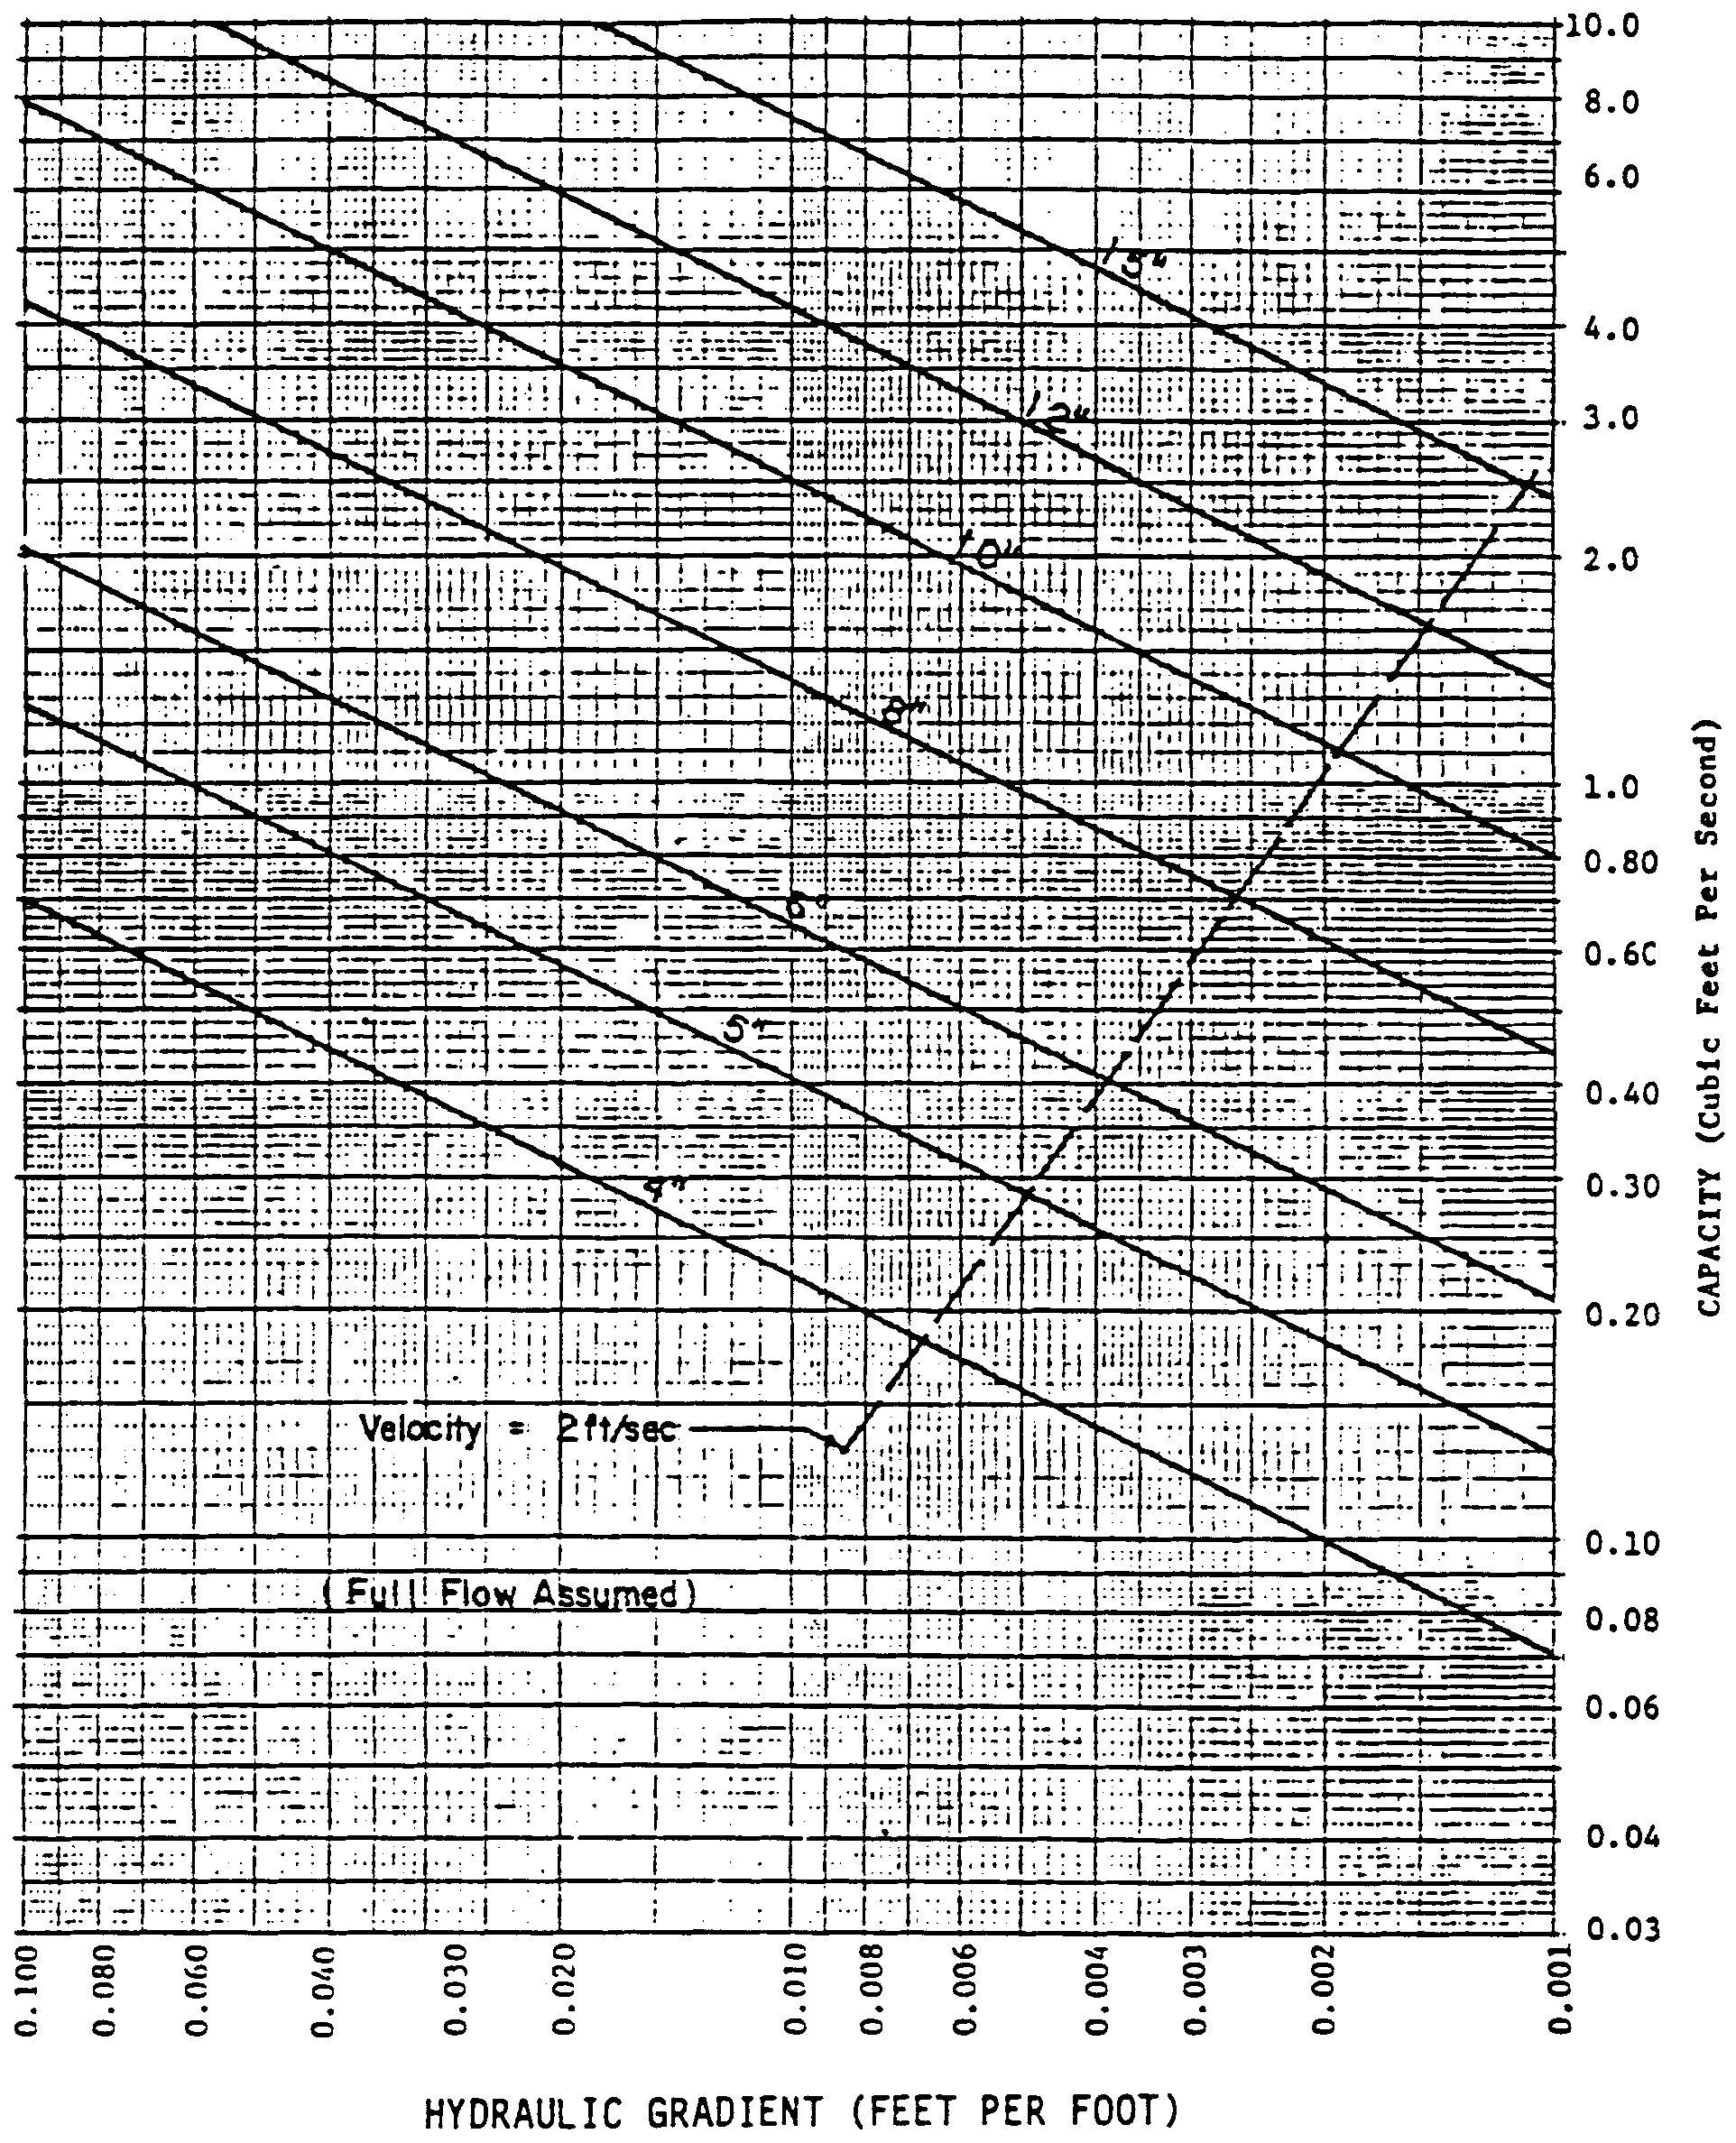
Figure 27-3. Subsurface Drain Capacity Chart - "n" = 0.011 (Source USDA-SCS)
Source: Livingston et al., 1988

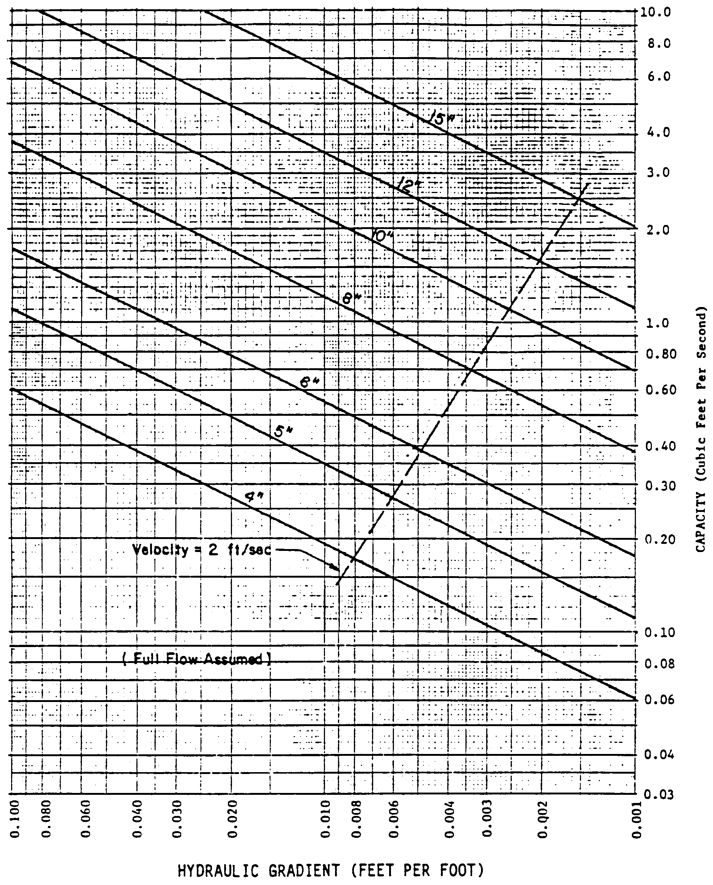
Figure 27-4. Subsurface Drain Capacity Chart - "n" = 0.013 (Source USDA-SCS)
Source: Livingston et al., 1988

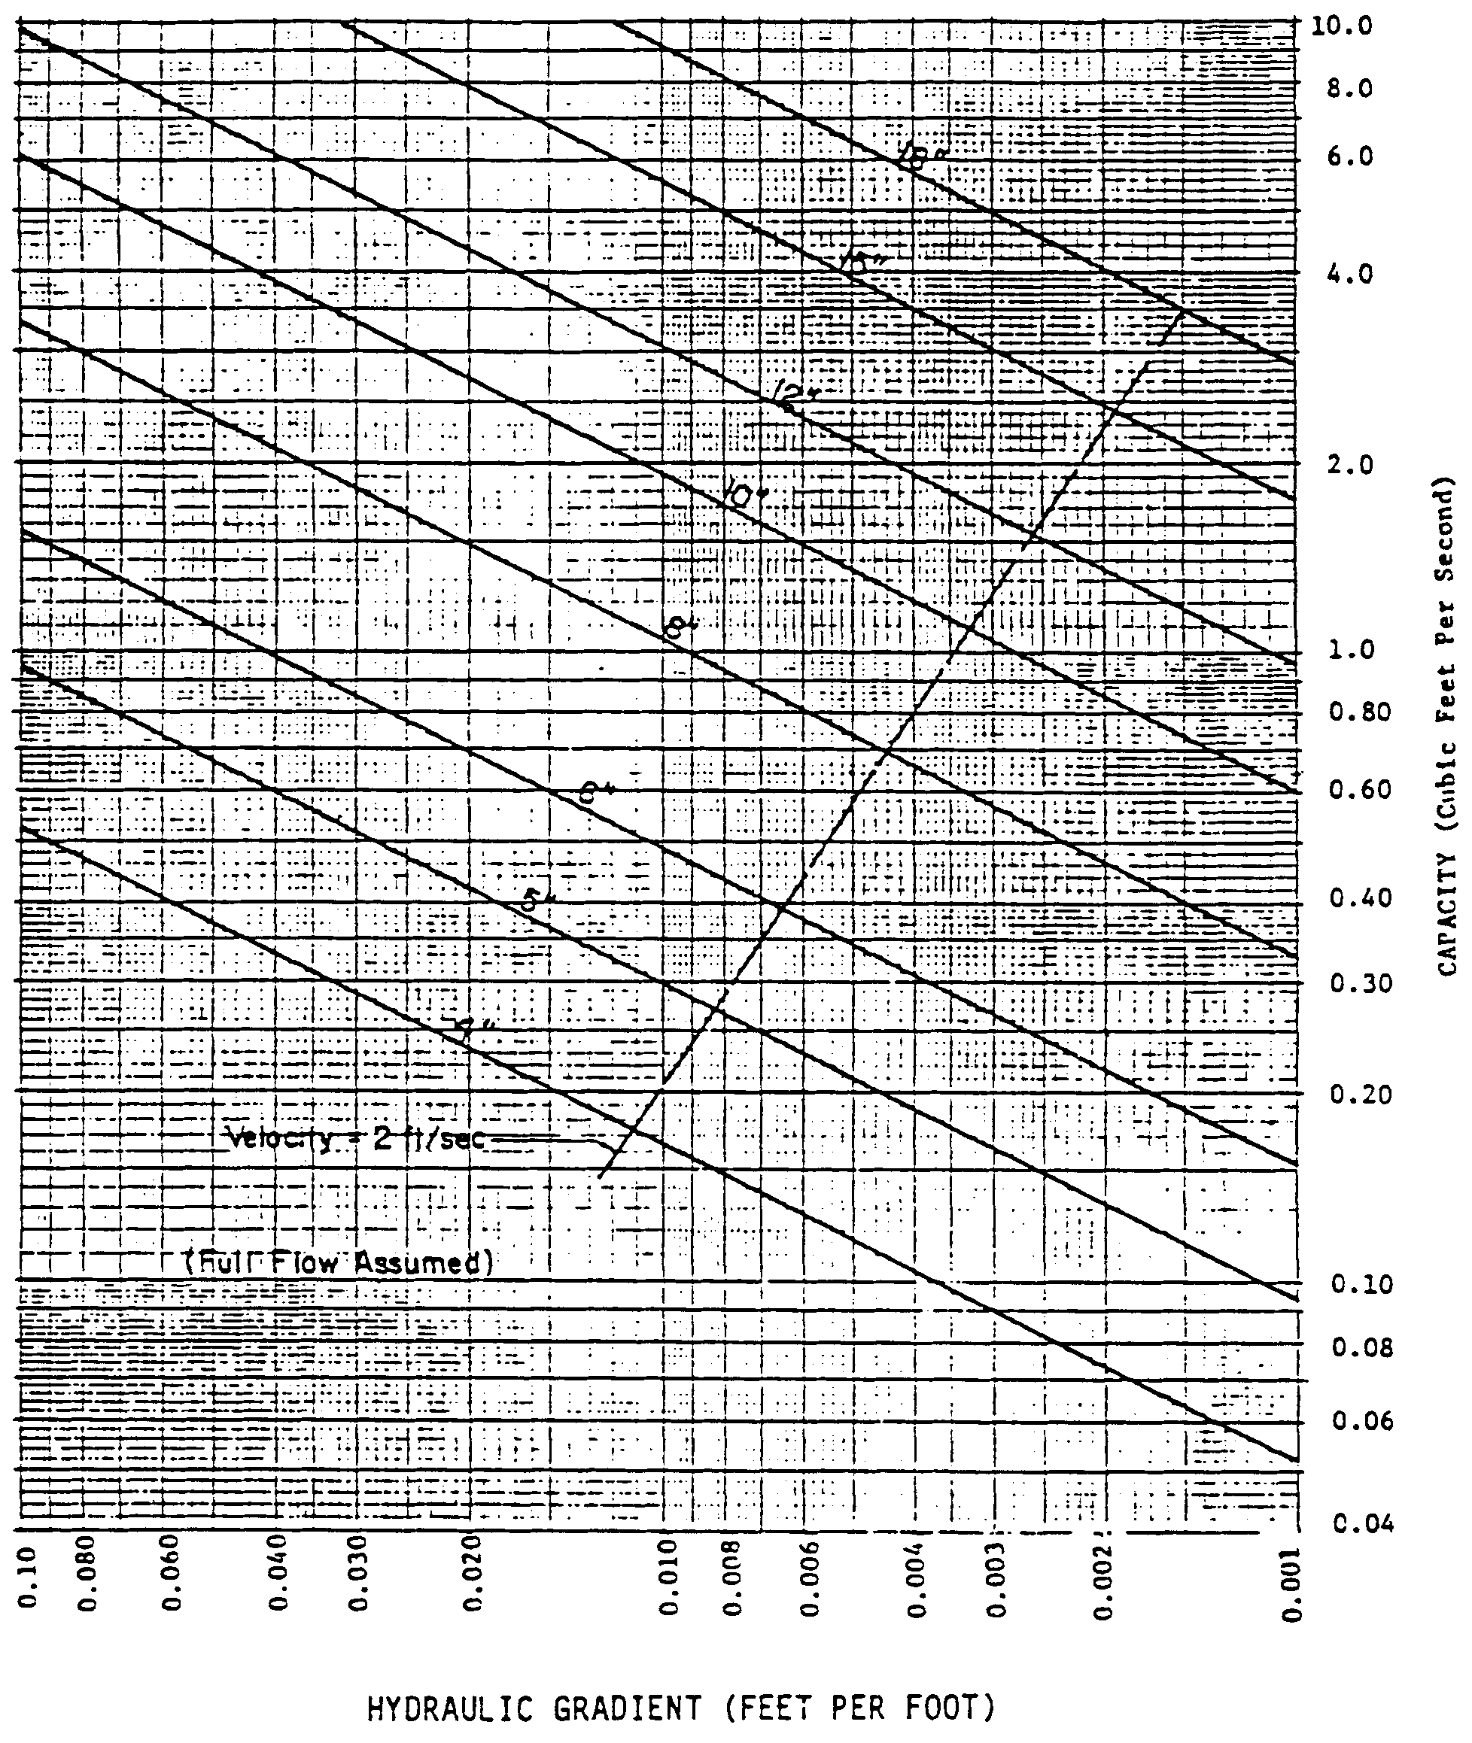 Figure 27-5. Subsurface Drain Capacity Chart - "n" = 0.015 (Source USDA-SCS)
Source: Livingston et al., 1988

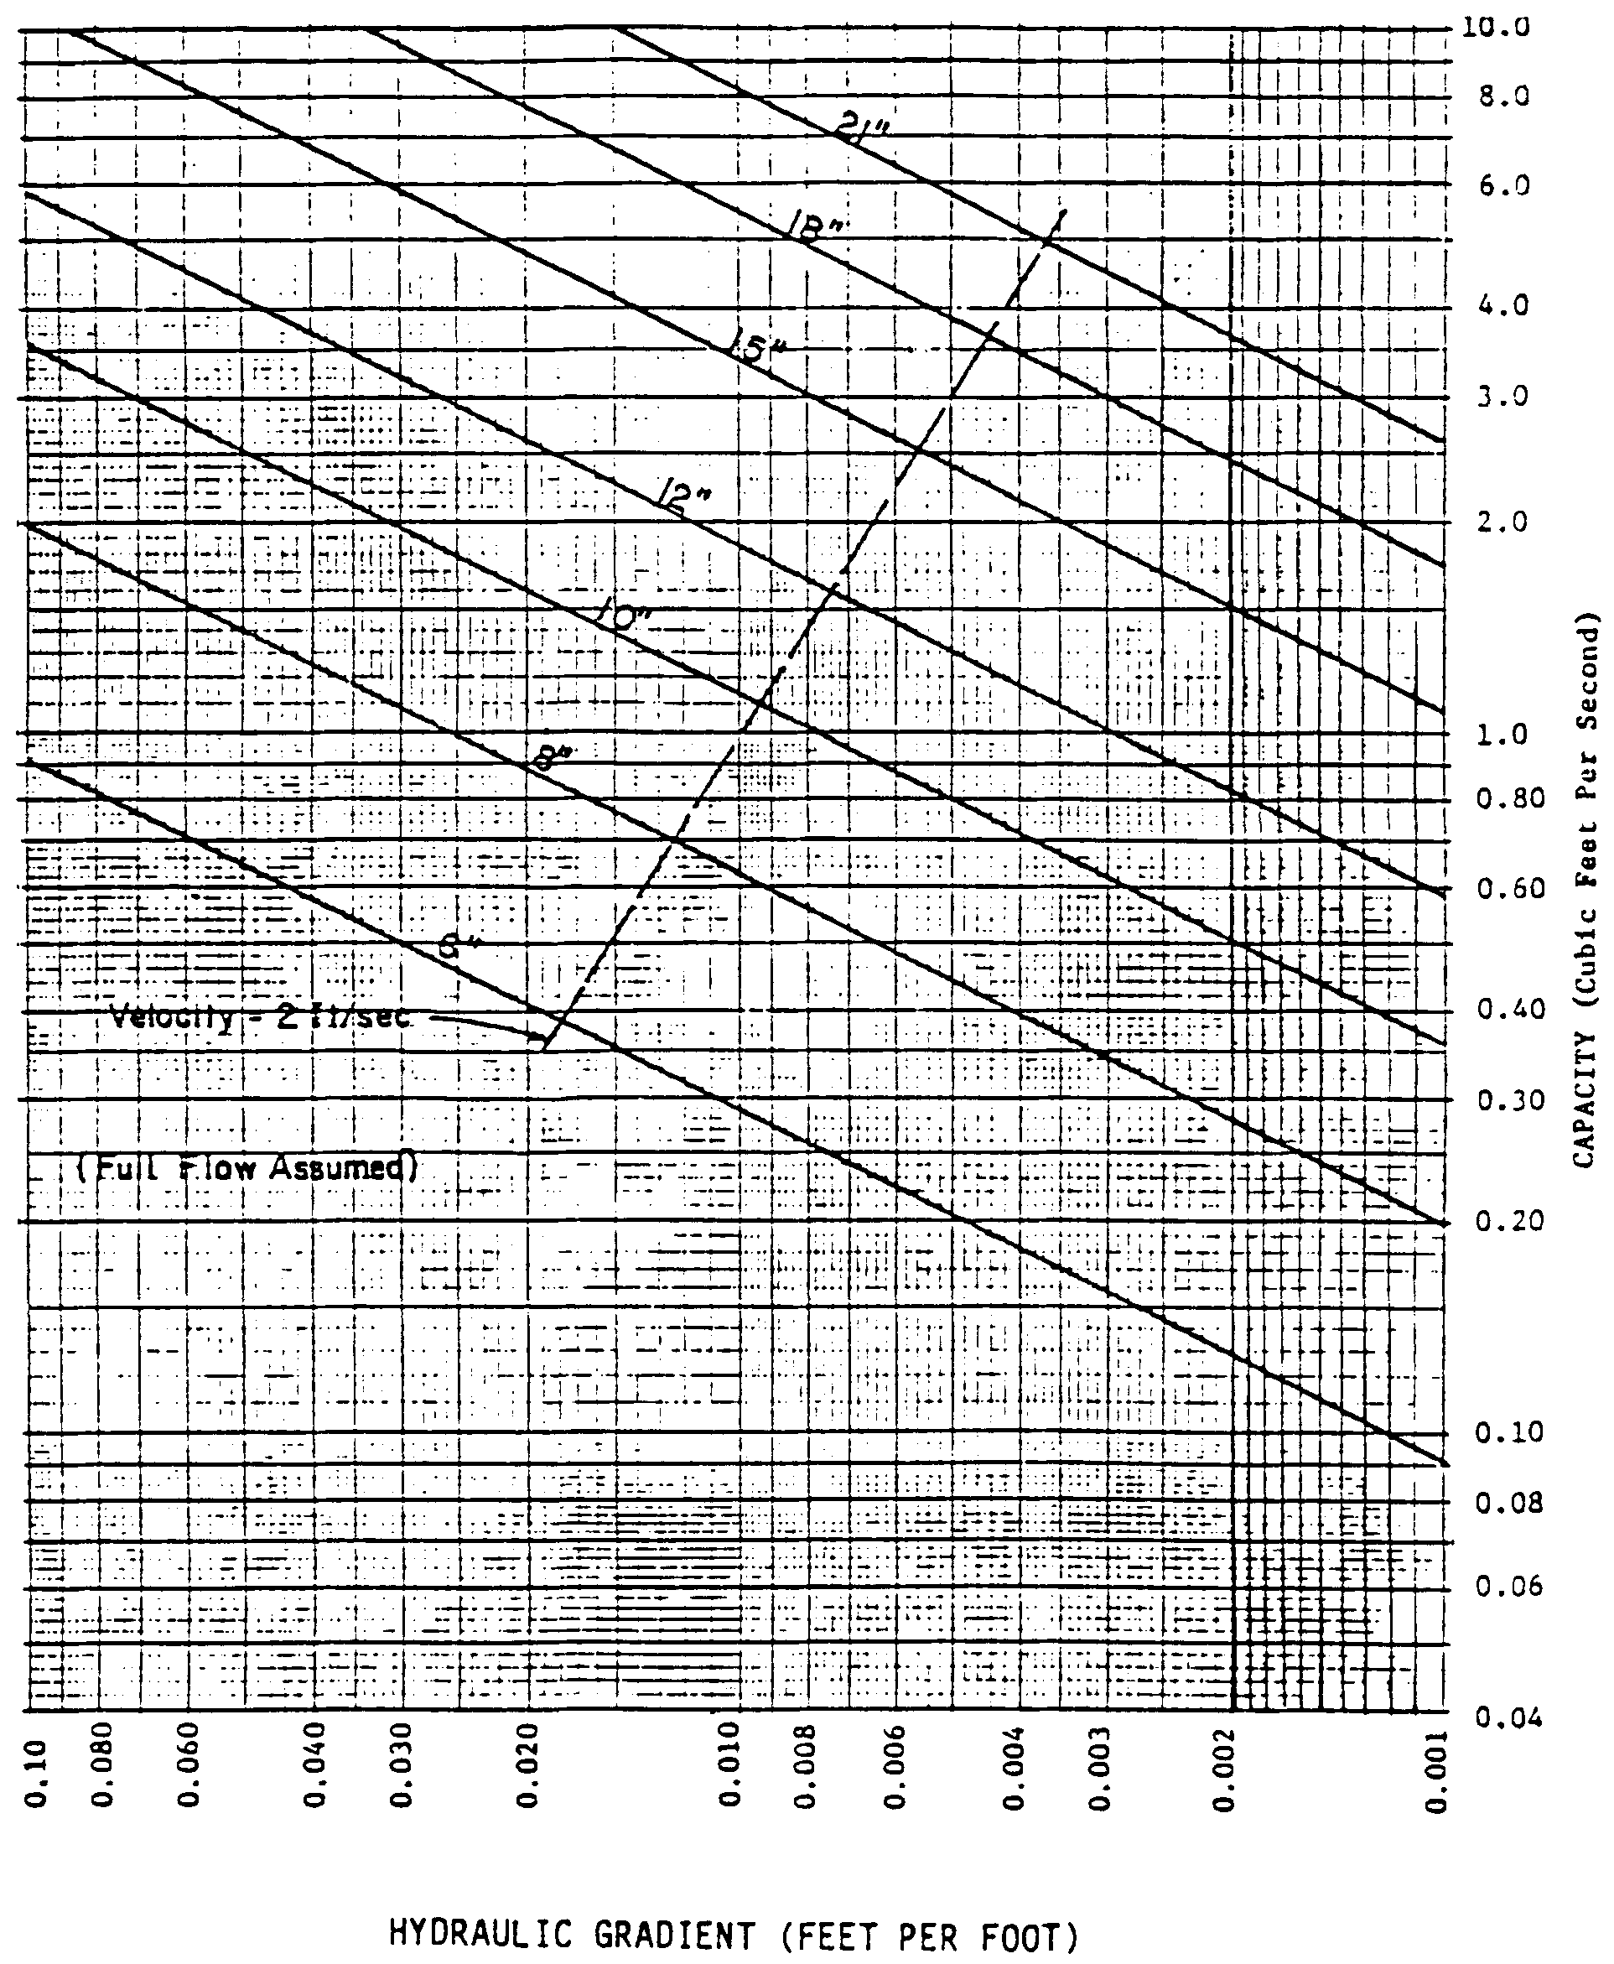
Figure 27-6. Subsurface Drain Capacity Chart - "n" = 0.025 (Source USDA-SCS)
Source: Livingston et al., 1988

28.0 Methodology and Design Example for Exfiltration Trench Systems

28.1 Calculating Storage Capacity of an Exfiltration Trench
The storage volume of a trench (V_{TR}) can be expressed as:
(28-1)
where: V_{TR} = Total storage volume of the trench
V_{P} = Volume of the pipe
V_{S} = Volume of the void spaces in the trench aggregate
The volume in a pipe (V_{P}) is:
(28-2)
where: A_{P} = Pipe area
L = Length of pipe = length of trench
The area of a pipe (A_{P}) is:
(28-3)
where: d = Pipe diameter
Substituting Equation 28-3 into Equation 28-2 gives:
(28-4)
The volume of the void spaces in the trench aggregate (V_{S}) can be expressed as:
(28-5)
where: A_{T} = Trench area
f = Fillable porosity of the aggregate
The area of a trench (A_{T}) with rectangular cross-section is:
(28-6)
where: W = Trench width
H = Trench height

The capacity of a trench (V_{TR}) with rectangular cross-section can now be expressed by substituting Equations 28-2 through 28-6 into Equation 28-1:
(28-7)
Equation 28-7 can be simplified to:
(28-8)
28.2 Estimating Recovery Time
The infiltration design methodologies and geotechnical tests recommended in section 26 for retention systems are applicable to exfiltration trenches. It is recommended that, unless the normal seasonal high water table is over 6 inches below the trench bottom, unsaturated flow prior to saturated lateral mounding be conservatively ignored in recovery analysis. In other words, there should be no credit for soil storage immediately beneath the trench if the seasonal high water table is within 6 inches of the trench bottom. This is not an unrealistic assumption since the height of capillary fringe in fine sand is on the order of 6 inches and a partially mounded water table condition may be remnant from a previous storm event, especially during the wet season.
It is also recommended that the filling of the trench with the treatment volume be simulated as a "slug" loading (i.e., treatment volume fills the trench within an hour).
28.2.1 Limiting Exfiltration Rates
Wanielista et al. (1991) reports that because of sediment buildup on the fabric, the rate at which water can exfiltrate through the filter fabric will decline over time and approach a value substantially lower than initial rates and then generally remain constant at this level. This value is designated as the limiting exfiltration rate for the trench. The limiting exfiltration rate is the lowest sustained rate at which the water can be expected to flow through the fabric, after long term loading. Wanielista et al. (1991) found the limiting exfiltration rate to be 0.5 in/hr through the fabric.
Wanielista et al. (1991) reports that woven fabric (Mirafi 700XG) performed better in mixed sand and silty soil than non-woven fabric (Mirafi 140N). On the other hand, the non-woven fabric had higher exfiltration rates in sandy soils than the woven fabric. If the filter fabric is "matched" to the soil type, the limiting exfiltration rate can be increased to 1.0 in/hr.
The above limiting exfiltration rates through the fabric should be compared to the permeability of the parent soil and for conservative designs, the lesser of the two values should be used in the recovery time calculations.
28.3 Design Example for Sizing an Exfiltration Trench
Given: Treatment Volume = 500 ft³
f (soil) = 0.3; f (aggregate) = 0.5; K_{vs} = 2 ft/day; K_{H} = 5 ft/day; FS = 2.0
Seasonal high groundwater table elevation = 17.0 feet
Impervious layer elevation = 14.0 feet
Trench bottom elevation = 21.0 ft
Pipe invert elevation = 22.0 ft

Objective: Size an exfiltration trench to store the treatment volume and recover within 72 hours.
Design Calculations
Step 1. Select the trench dimensions.
Pipe diameter (d) = 24 in
Rectangular trench cross-section with:
Trench width (W) = 6 ft
Trench height (H) = 4 ft
Step 2. Calculate the length of trench (L) required to store the treatment volume.
From Equation 28-8:
L = 73.7 ft
Since pipe lengths are usually sold in twenty foot lengths, round up to L = 80 ft
Step 3. Check for lateral saturated infiltration (see section 26 for a complete description of infiltration processes). Determine the volume infiltrated during unsaturated vertical flow (V_{u}) from Equation 26-3:
V_{u} = A_{b} f h_{b}

Area of trench bottom (A_{b}) = 80 ft x 6 ft = 480 ft²
Height of trench bottom above the ground water table (h_{b}) = 21.0 ft - 17.0 ft = 4.0 ft
V_{u} = (480 ft²) (4 ft) (0.3) = 576 ft³
Lateral saturated infiltration will not occur since the volume infiltrated during vertical unsaturated flow (V_{u}) is greater than the treatment volume of 500 ft³.
Step 4. Calculate the time to saturate the soil beneath the trench (t_{sat}). From Equation 26-11, the unsaturated vertical hydraulic conductivity (K_{vu}) is:
The design infiltration rate (I_{d}) is determined using Equation 26-1:
Since I_{d} is less than the limiting exfiltration rate through the filter fabric (0.5 in/hr) use the value of I_{d} calculated above in the design analysis.
The time elapsed to saturate soil beneath the trench (t_{sat}) is found from Equation 26-2:
Therefore, the design meets the 72 hour recovery time criterion.
28.4 Alternative Design Procedures
Wanielista (1991) has developed an alternative procedure for designing off-line exfiltration trenches based on the long term mass balance of an exfiltration system utilizing local rainfall conditions. Fifteen years of hourly precipitation data from six regions in Florida were used as input for the mass balance. From these simulations, design curves for exfiltration systems were developed. These curves relate the rate at which stored runoff is removed from the trench to the volume of storage within the trench. These curves can be used to design an exfiltration trench based on diversion efficiencies of 50%, 60%, 70%, 80%, 85%, 90%, and 95%.
The Department District accepts this methodology for those areas of the District (i.e., Jacksonville and Orlando) for which the curves have been developed. Applicants designing systems which discharge to Class III receiving waters should use the 80% curve and those that direct discharge to Class I, Class II, and Outstanding Florida Waters should utilize the 95% curve.
28.5 References
Wanielista, M.P., M.J. Gauthier, and D.L. Evans. 1991. Design and Performance of Exfiltration Systems. Department of Civil and Environmental Engineering, University of Central Florida, Orlando, Florida.

29.0 Methodology and Design Example for Wet Detention
29.1 Calculating Permanent Pool Volumes
The residence time of a pond is defined as the average time required to renew the water volume (permanent pool volume) in the pond and can be expressed as:
(29-1)
where: RT = Residence time (days)
PPV = Permanent Pool Volume (ac-ft)
FR = Average Flow Rate (ac-ft/day)
Solving Equation 29-1 for the permanent pool volume (PPV) gives:
(29-2)
The average flow rate (FR) during the wet season (June - October) can be expressed by:
(29-3)
where: DA = Drainage area to pond (ac)
C = Runoff coefficient (see Table 24-1 for a list of recommended values for C)
R = Wet season rainfall depth (in)
WS = Length of wet season (days) (June - October = 153 days)
The depth of the wet season rainfall (R) for areas of the District is shown in Figure 29-1. The rainfall depth at a particular location may be established by interpolating between the nearest isopluvial lines.
Substituting Equation 29-3 into Equation 29-2 gives:
(29-4)
where: CF = Conversion factor = 12 in/ft

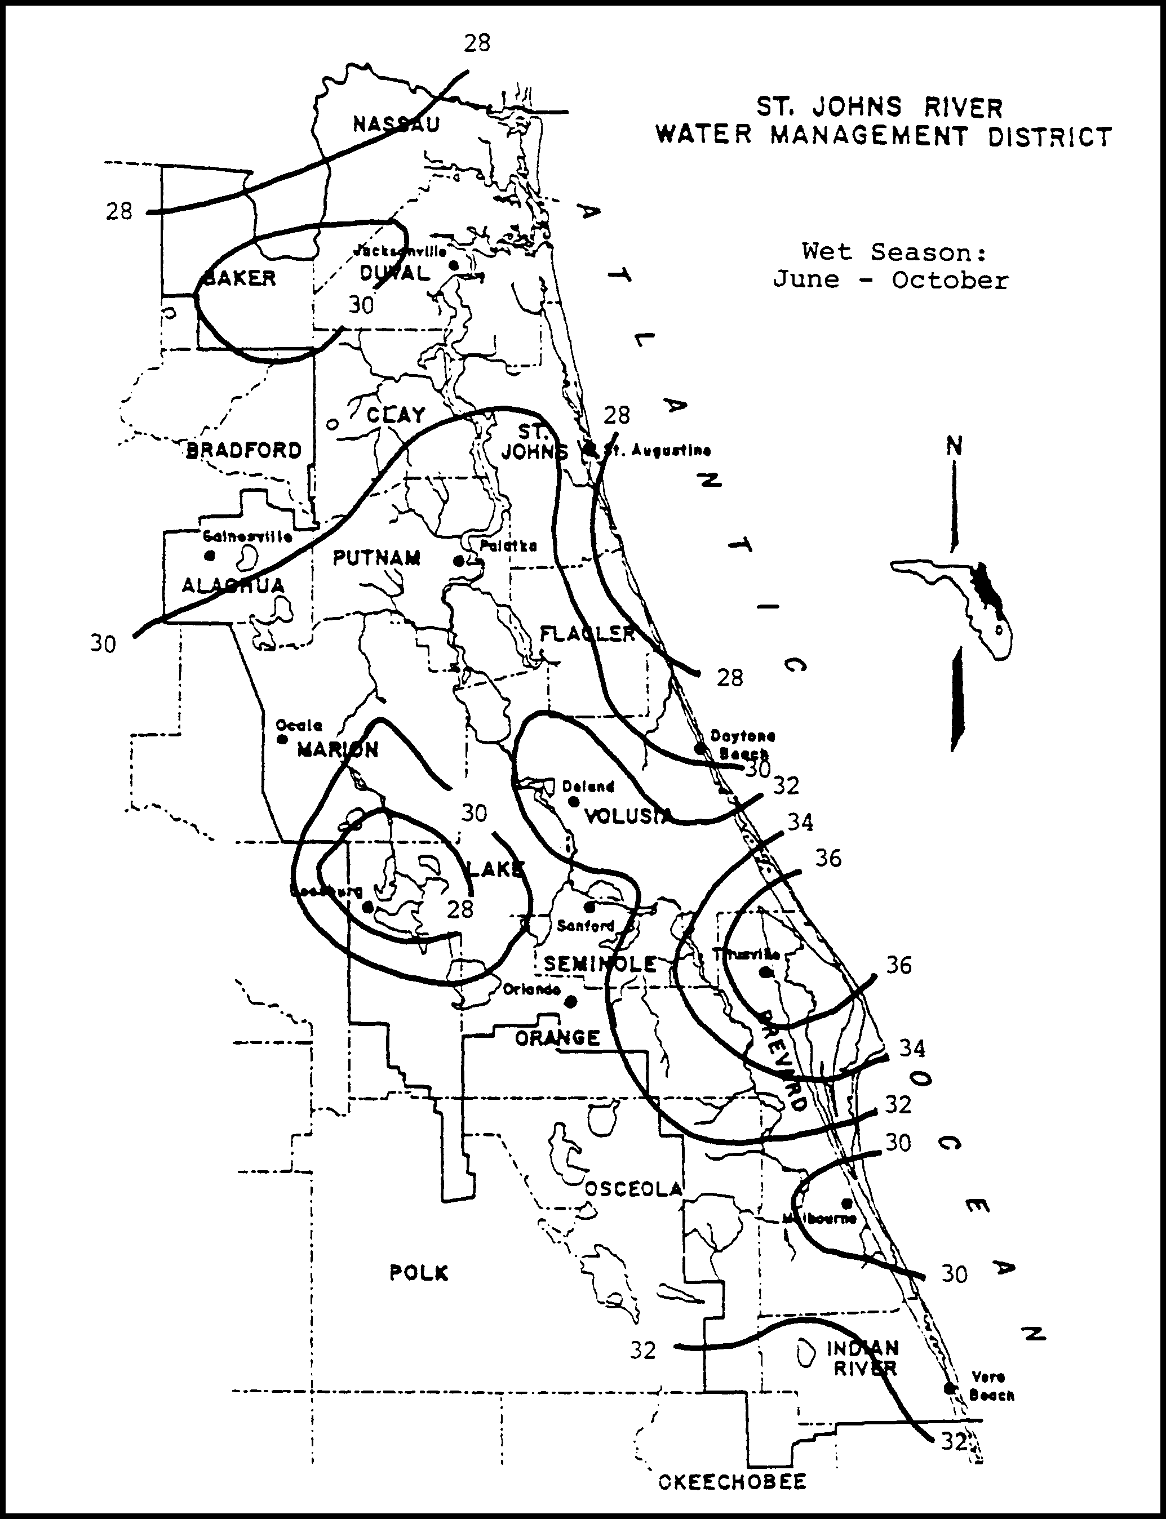

Figure 29-1. Wet Season Normal Rainfall, inches (Source: Rao, et al., 1990)

29.2 Sizing the Drawdown Structure
The rule requires that no more than half the treatment volume should be discharged in the first 24 to 30 hours after the storm event. A popular means of meeting this requirement is to use an orifice or a weir. The following subsections show procedures for sizing an orifice and V-notch weir to meet the drawdown requirements.
29.2.1 Sizing an Orifice
The orifice equation is given by:
(29-5)
where: Q = Rate of discharge (cfs)
A = Orifice area (ft²)
G = Gravitational constant = (32.2 ft/sec²)
H = Depth of water above the flow line (center) of the orifice (ft)
C = Orifice coefficient (usually assumed = 0.6)
The average discharge rate (Q) required to drawdown half the treatment volume (TV) in a desired amount of time (t) is:
(29-6)
where: TV = Treatment Volume (ft³)
t = Recovery time (hrs)
CF = Conversion Factor = 3600 sec/hr

The depth of water (h) should be set to the average depth above the flow line between the top of the treatment volume and the stage at which half the treatment volume has been released:
(29-7)
where: h₁ = Depth of water between the top of the treatment volume and the flow line (ft)
h₂ = Depth of water between the stage when half the treatment volume has been released and the flow line of the orifice (ft)
Equation 29-5 can be rearranged to solve for the area (A):
(29-8)
The diameter (D) of an orifice is calculated by:
(29-9)
where: D = Diameter of the orifice (ft)
29.2.2 Sizing a V-notch Weir
Discharge (Q) through a V-notch opening in a weir can be estimated by:
(29-10)
where: Q = Discharge (cfs)
ø = Angle of V-notch (degrees)
h = Head on vertex of notch (ft)

The average discharge rate (Q) required to draw down half the treatment volume (TV) in a desired amount of time (t) is:
(29-11)
where: TV = Treatment Volume (ft³)
t = Recovery time (hrs)
CF = Conversion Factor = 3600 sec/hr

The depth of water (h) should be set to the average depth above the vertex of the notch between the top of the treatment volume and the stage at which half the treatment volume has been released:
(29-12)
where: h₁ = Depth of water between the top of the treatment volume and the vertex of the notch (ft)
h₂ = Depth of water between the stage when half the treatment volume has been released and the vertex of the notch (ft)
Equation 29-10 can be rearranged to solve for the V-notch angle ():
(29-13)
Substituting Equation 29-11 into Equation 29-13 and simplifying gives:
(29-14)

29.3 Mean Depth of the Pond
The mean depth (MD) of a pond can be calculated from:
(29-15)
where: MD = Mean depth of the pond (ft)
A_{P} = Area of pond measured at the control elevation (ft²)

29.4 Design Example
Given:
Residential development in Melbourne
Class III receiving waters
Project area = 100 acres; Project runoff coefficient = 0.4
Project percent impervious (not including pond area) = 30%
Off-site drainage area = 10 acres; Off-site percent impervious = 0%
Off-site runoff coefficient = 0.2
Seasonal high groundwater elevation at the proposed lake = 20.0 ft
Design tailwater elevation = 19.5 ft
Pond area at elevation 20.0 ft = 5.0 acres
Non-littoral zone option

The proposed wet detention lake has the following stage-storage relationship:
Stage  (ft) | Storage  (ac-ft)
9.0 | 0.0
20.0 | 17.0
25.0 | 35.5

Design Calculations:
Step 1. Calculate the required treatment volume. The Department District requires a treatment volume of either 1 inch of runoff or 2.5 inches times the impervious area, whichever is greater.
Treatment volume required = (110 ac.)(1 inch) = 9.17 ac-ft
(one inch of runoff) 12 in/ft

(2.5" times % imp.) = [(100 - 5.0 ac)(0.3) + (10 ac)(0)] (2.5 in.) = 5.94 ac-ft
(excludes pond area) 12 in/ft
Treatment volume = 9.17 ac-ft
Step 2. Set the elevation of the control structure.
Set the orifice invert at or above the normal water table and design tailwater elevation. Therefore, set the orifice invert elevation at 20.0 ft.
Set an overflow weir at the top of the treatment volume storage to discharge runoff volumes greater than the treatment volumes. Utilizing the stage-area-storage relationship, interpolate between 20.0 and 25.0 ft.
Step 3. Calculate the minimum permanent pool volume that will provide the required residence time. Since the non-littoral zone option is being utilized, the permanent pool must be sized to provide a residence time of at least 21 days (i.e., 14 days plus an additional 50%) during the wet season (June - October).
The length of the wet season (WS) = 153 days
From Figure 29-1, the wet season rainfall depth (R) for Melbourne = 30 inches
For a non-littoral zone option, the minimum residence time (RT) = 21 days
The runoff coefficient (C) for the drainage area to the wet detention pond is:
Utilizing Equation 29-4:
The pond volume below elevation 20.0 feet is 17.0 ac-ft. Therefore, adequate storage is provided to satisfy the permanent pool criteria.
Step 4. Size a circular orifice to recover one-half the treatment volume in 48 hours. Since the size of the orifice has yet to be determined, use the invert elevation of the orifice as an approximation of the flow line (center) of the orifice. After calculating the orifice size, adjust the flow line elevation and calculate the orifice size again.
Treatment volume depth (h₁) = 22.48 ft - 20.00 ft = 2.48 ft
From Equation 29-7:
The average flow rate (Q) required to drawdown one-half the treatment volume is found from Equation 29-6:
Find the area (A) of the orifice utilizing Equation 29-8:
Given: C = 0.6
G = 32.2 ft/sec²

From Equation 29-9, the orifice diameter (D) is:
Adjust h₁, h₂, and the orifice diameter (D) to the flow line of the orifice.
20.25 ft vs 20.24 ft = 0.01 ft difference which is acceptable
Step 5. Check the mean depth of the pond. The mean depth of the permanent pool must be between 2 and 8 feet. From Equation 29-15:
mean depth = 17.0 ac-ft = 3.4 ft which is consistent with the mean depth criteria.
5.0 ac
Additional Steps.
In a typical design, the applicant would have to design the following:
(a) Pond shape to provide at least 2:1 length to width ratio
(b) Alignment of inlets and outlets to promote mixing and maximize flow path
(c) Overflow weir to safely pass the design storm event(s) at pre-development peak discharge rates.
29.5 References
Rao, D.V., S.A. Jenab, and D.A. Clapp. 1990. Rainfall Analysis for Northeast Florida, Part V: Frequency Analysis of Wet Season and Dry Season Rainfall. St. Johns River Water Management District, Technical Publication No. 90-3, Palatka, Florida.

30.0 Methodology and Design Example for Swales
Infiltration from swale systems follows the same processes discussed in section 26.1 for retention systems. However, unlike retention systems, swales are an "open" conveyance facility which must infiltrate a specified portion of runoff from the three-year, one-hour storm without the aid of berms, check dams, etc. Also, the swale must be sized to convey a design storm without being subjected to erosive velocities. The following methodology, which is adapted from Livingston et al. (1988), is recommended for designing swales to percolate the desired portion of runoff and to convey the design flow rate with acceptable velocities.
30.1 Runoff Hydrograph and Volume
The rational method can be utilized to estimate peak runoff rates for small urban areas. The traditional rational formula is expressed as:
Q = C I A (30-1)
where: Q = Peak runoff rate (cfs)
C = Runoff coefficient
I = Rainfall intensity (in./hr)
A = Drainage area (acres)

Values for the runoff coefficient (C) are contained in Table 24-1. The intensity (I) is determined from intensity-duration-frequency (IDF) curves such as those published by the Florida Department of Transportation (1987).
A simplified runoff hydrograph for a specific design storm with given duration (D) can be constructed given the time of concentration (Tc) of the drainage area. As seen in Figure 30-1, this modified simplified runoff hydrograph is a modification of the traditional rational formula. The implied assumption behind Figure 30-1 is that the drainage basin time of concentration (Tc) is less than the duration (D) of the design storm event.
The peak runoff rate from this simplified hydrograph method is not the "traditional" rational peak discharge rate at the basin time of concentration but a sustained and lower peak runoff rate (Q_{P}) resulting from the rainfall intensity as determined for the desired duration of the storm. The sustained peak runoff rate is expressed as:
Q_{P} = C I_{D} A (30-2)
where: Q_{P} = Peak runoff rate from the 3-year, 1-hour rainfall intensity (cfs)
I_{D} = Average rainfall intensity for a one hour duration (in./hr)

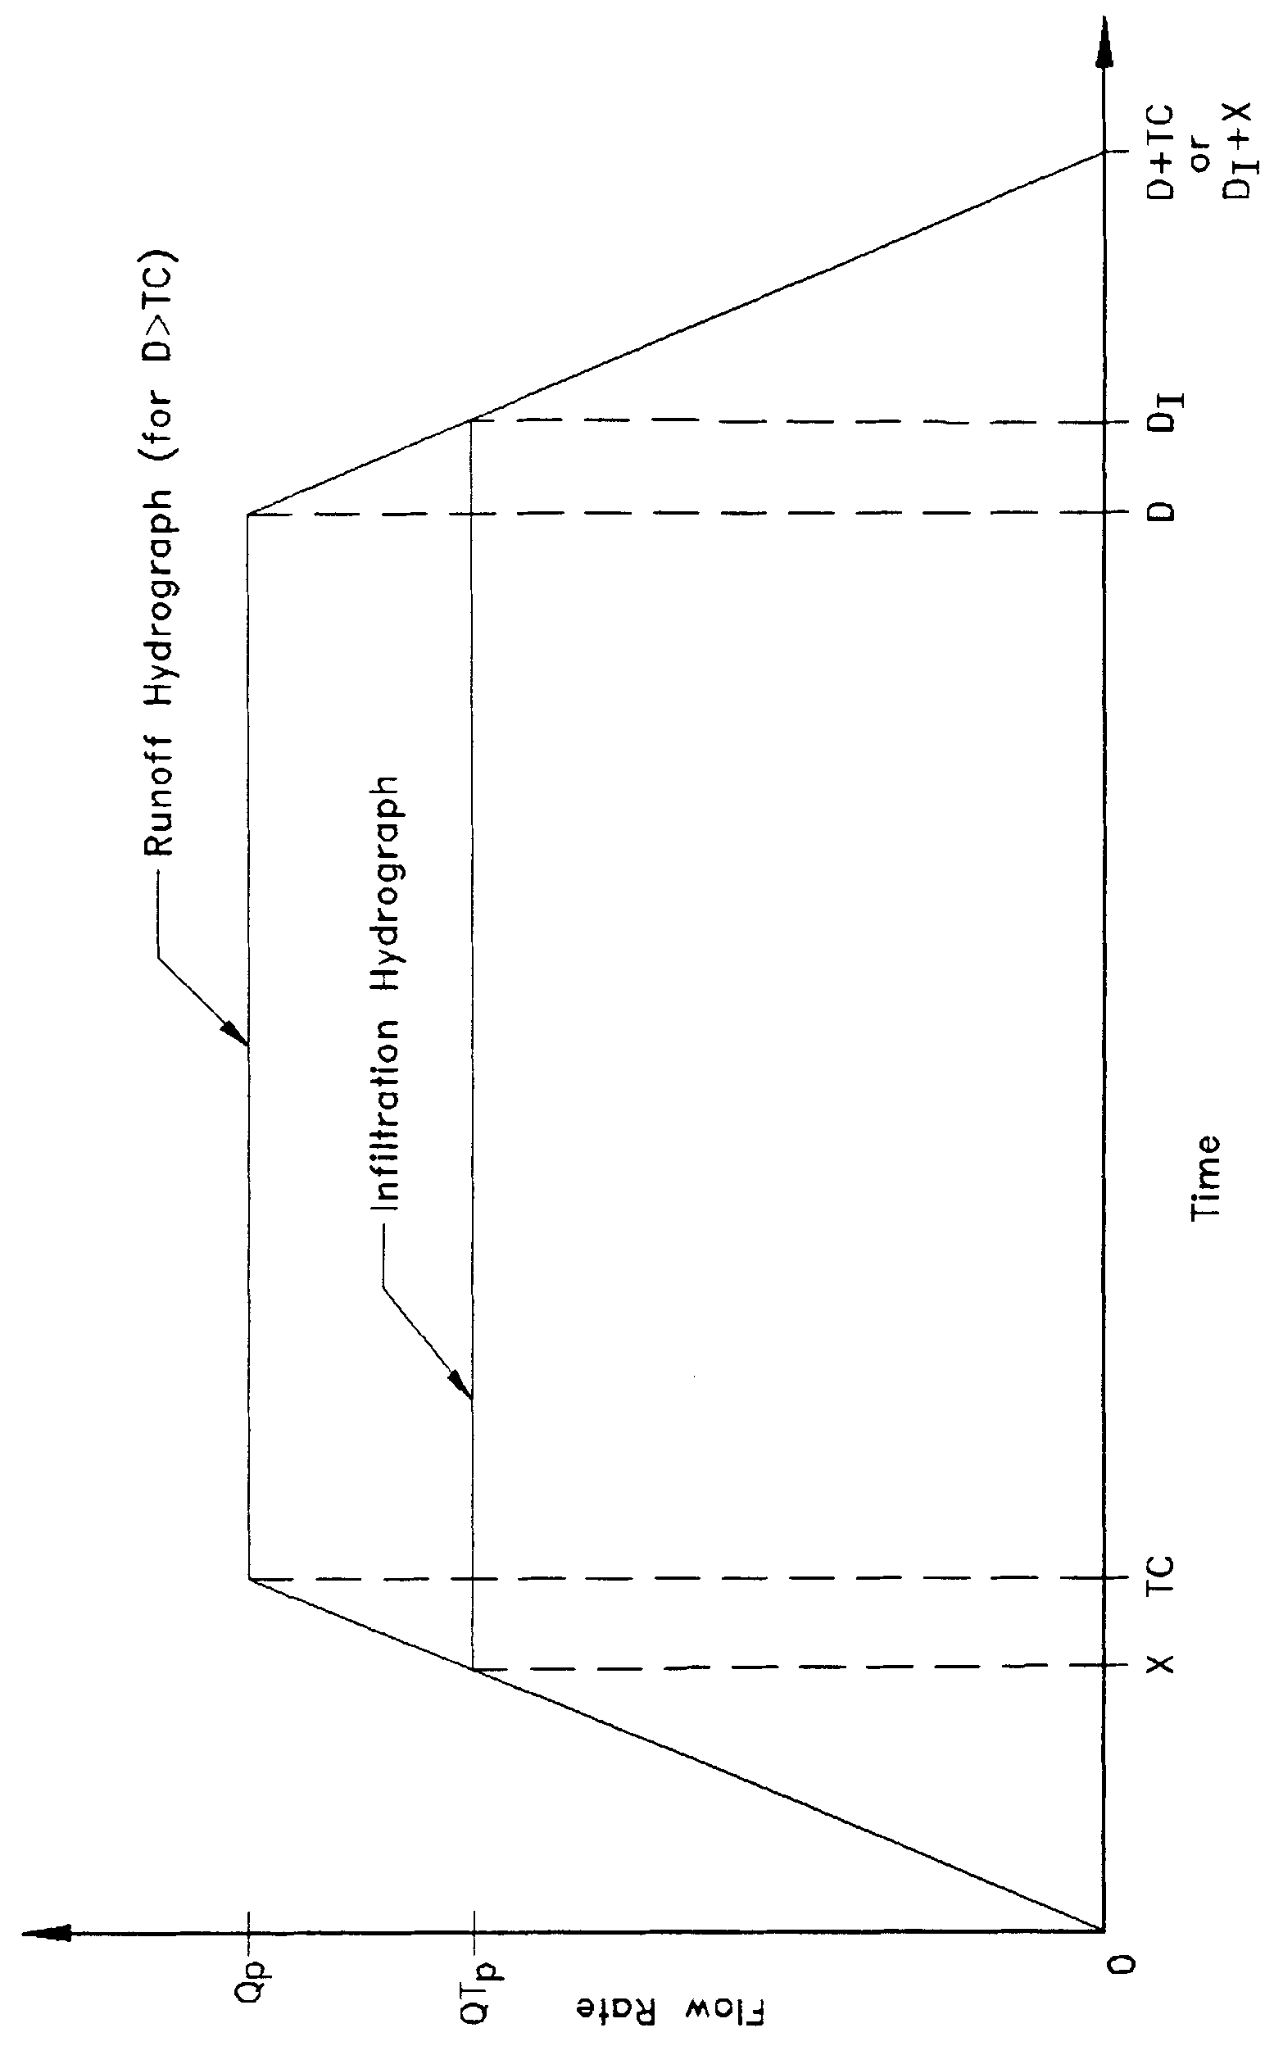

Figure 30-1. Simplified Runoff and Infiltration Hydrographs

The volume of runoff (V_{R}) is equal to the area under the runoff hydrograph curve in Figure 30-1 and can be expressed as:
(30-3)
which can be simplified to:
(30-4)
where: V_{R} = Volume of runoff (ft³)
Tc = Time of concentration (hr)
D = Rainfall duration (hr)

30.2 Infiltration Hydrograph and Volume
The peak infiltration rate and volume should be calculated using one of the acceptable methodologies listed in section 26.3.4 for vertical unsaturated infiltration. Utilizing the modified Green and Ampt Equation (described in section 26.3.4) the peak infiltration rate is the design infiltration rate (I_{d}) and is expressed as:
(30-5)
where: I_{d} = Design infiltration rate (ft/hr)
K_{vu} = Unsaturated vertical hydraulic conductivity (ft/hr)
FS = Factor of safety (recommend FS = 2.0)

The area of swale bottom and side slopes (A_{b}) in which infiltration will occur is:
(30-6)
where: A_{b} = Area of swale bottom and side slopes in which infiltration will occur (ft²)
L = Length of swale (ft)
P = Wetted perimeter (ft)

The peak infiltration flow rate (Qi_{P}) is:
(30-7)
where: Qi_{P} = Peak infiltration flow rate (ft³/hr)
The wetted perimeter (P) is dependent on the geometry of the swale. Equations for the wetted perimeter for three common swale shapes are given in Figure 30-2.
A simple infiltration hydrograph can be constructed as in Figure 30-1. The volume infiltrated is the area under the infiltration hydrograph curve and can be expressed as:
(30-8)
and simplified to:
(30-9)
where: V_{I} = Volume of runoff infiltrated (ft³)
D_{I} = Time from the beginning of the storm to the end of the peak infiltration flow rate (hr)
X = Time from D_{I} to the end of the runoff hydrograph (hr)

Based on Figure 30-1, D_{I} can be expressed as:
D_{I} = D + Tc - X (30-10)
and X can be expressed as:
(30-11)
Substituting equations 30-10 and 30-11 into 30-9 gives:
(30-12)
If the volume infiltrated (V_{I}) is greater than or equal to the required portion (i.e, 80%) of the runoff volume (V_{R}) then the design is adequate for treatment purposes. In addition, the design should be checked to ensure that the swale can convey the design storm runoff without reaching erosive velocities.
30.3 Velocity
The velocity of flow in an open channel can be found from Manning's Equation:
(30-13)
where: V = Average velocity in the channel (ft/sec)
n = Manning's roughness coefficient, based on the lining of the channel
R = Hydraulic radius (ft)
S = Slope of the channel (ft/ft)

The maximum permissible velocity for various channel slopes and types of vegetative cover is given in Table 30-1. The velocity of flow in the swale (calculated using the Manning's equation) will be non-erosive if it is less than the maximum permissible velocity given in Table 30-1.
The hydraulic radius (R) is dependent on the geometry of the swale. Equations for the hydraulic radius for three common swale shapes are given in Figure 30-2.
Manning's roughness coefficient (n) can be determined from Table 30-2 and Figure 30-3. In utilizing Table 30-2, mowed conditions are recommended for analysis of the swale infiltration
capacity. The retardance class under mowed conditions result in lower n values, shallower flow depths, and less wetted perimeter for infiltration. Unmowed conditions may be more appropriate for swale analysis under flood flow conditions. The retardance class under unmowed conditions result in higher n values. This will yield more conservative flow depths which may be more appropriate for establishing floodwater elevations in the swale.

Table 30-1. Permissible Velocities for Grass-Lined Channels

Channel Slope | Lining | Permissible  Velocity  (ft/sec)
0 – 5% | Bermuda grass  Bahia  Bluestem (broomsedges)  Grass-legume mixture  Sericea lespedeza  Annual lespedeza  Small grains (temporary) | 6.0  5.0  5.0  4.0  2.5  2.5  2.5
5 – 10% | Bermuda grass  Bahia  Bluestem (broomsedges)  Grass-legume mixture | 5.0  4.0  4.0  4.0
Source: Livingston et al. 1988

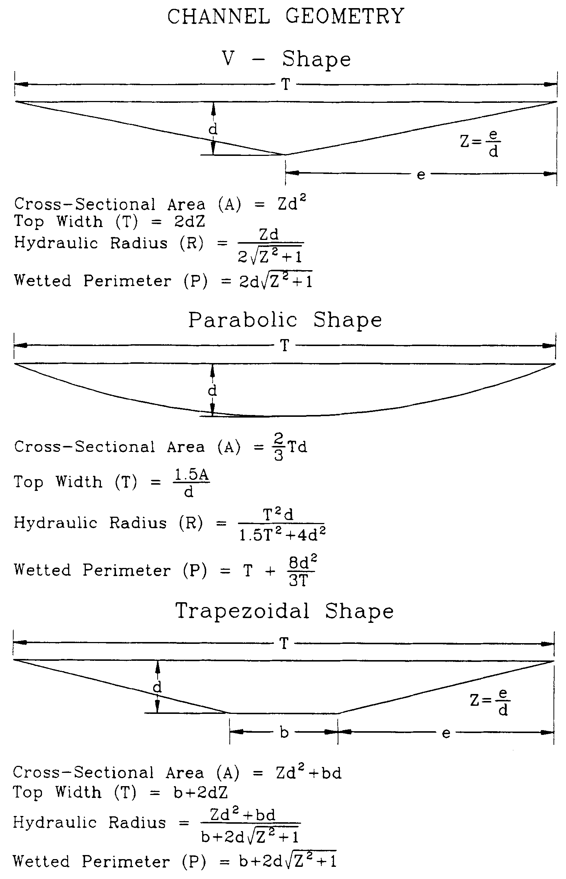
Figure 30-2. Typical Waterway Shapes and Mathematical Expressions for Calculating Cross-sectional Area, Top Width, Hydraulic Radius and Wetted Perimeter
Source: Livingston et al. 1988

Table 30-2. Classification of Vegetation Cover as to Degree of Retardance
Retardance  Class | Cover | Condition
A | Bluestem (broomsedges) | Excellent stand, tall  (average 36")
B | Bermuda or Bahia | Good stand, tall (average 12")
 | Native Grass mixture  (bluestem, vasey grass, and  other long and short wet  prairie grasses) | Good stand, unmowed
 | Lespedeza sericea | Good stand, not woody  tall (average 19')
C | Bahia | Good stand, uncut (6-8")
 | Bermuda grass | Good stand, mowed  (average 6")
 | Centipede grass or  St. Augustine | Very dense (average 6")
D | Bermuda or Bahia | Good stand, cut to 2.5" height
 | Lespedeza sericea | Cut to 2" height  Very good stand before cutting
E | Centipede grass or  St. Augustine | Good stand, cut to 1.5" height

Source: Livingston et al. 1988

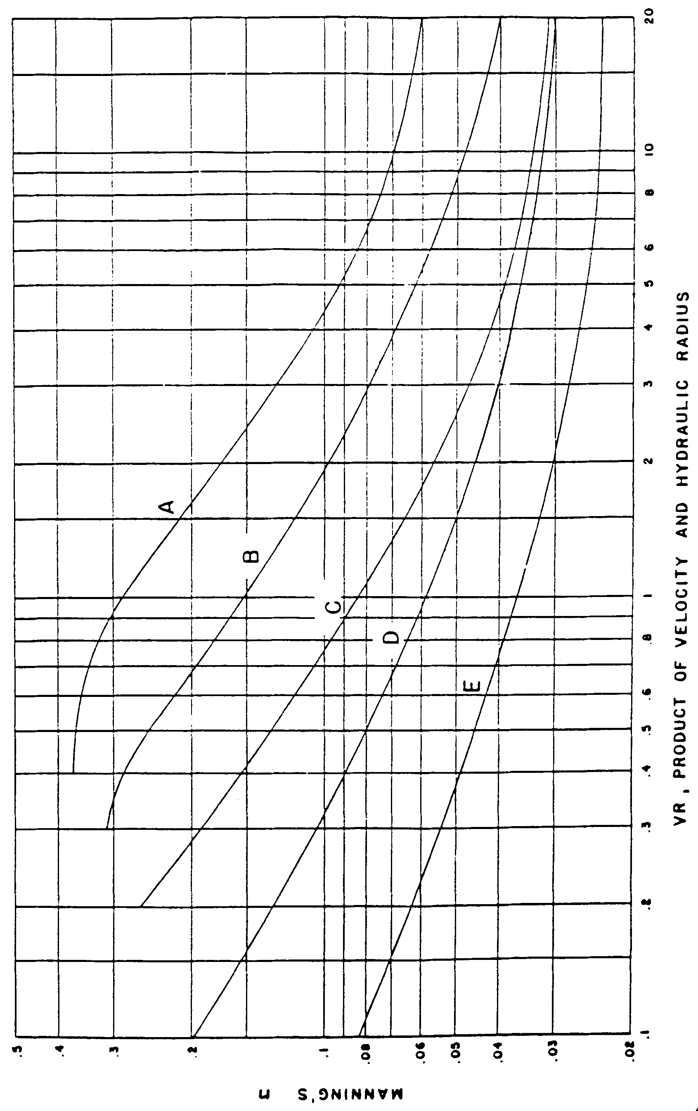
Figure 30-3. Manning's "n" Related to Velocity, Hydraulic Radius and Vegetal Retardance
Source: Livingston et al. 1988

30.4 Capacity
Manning's Equation (Equation 30-13) and the Continuity Equation (Q = V A) can be combined to determine flow capacity of an open channel:
(30-14)
where: Q = Flow in the channel (ft³/sec)
A = Cross-section area of the channel (ft²)

The cross-sectional area (A) is dependent on the channel shape and equations for the cross-sectional area for three common swale shapes are given in Figure 30-2.
In addition to the treatment capacity of the swale, the design of the swale must be adequate to provide flood protection in accordance with the requirements of local agencies.
30.5 Vertical Unsaturated and Lateral Saturated Infiltration
The design of the swale system should be checked using one of the accepted methodologies in section 26 to insure that lateral saturated infiltration does not occur. Lateral saturated infiltration occurs when the ground water table "mounds" beneath the swale and intercepts the swale bottom. See section 26 for a complete description of infiltration processes.
Utilizing the methodology described in section 26.3.4, the volume infiltrated under vertical unsaturated flow (V_{u}) is determined from Equation 26-3:
where: V_{u} = Volume of water required to saturate the soil below the swale
h_{b} = Height of swale bottom above the ground water table
f = Fillable porosity (generally 0.2 to 0.3)

If V_{u} > V_{R} infiltration will occur entirely under vertical unsaturated flow conditions.
30.6 Example Design Calculations for Swale Systems
Given: Residential project in Palatka discharging to Class III waters
Drainage area = 10 acres
Post-development runoff coefficient = 0.4
Tc = 20 minutes; S = 3%
f = 0.3; K_{vs} = 36 in/hr; FS = 2.0; h_{b} = 10 ft
Rectangular project site with dimensions of length = 660 ft and width = 660 ft
Three streets each 600 ft long with swales on both sides
Objective: Design a swale system to percolate the required treatment volume and check the capacity and velocity of the swales.
Design Calculations
Step 1. Determine Q_{P} and V_{R}.
For swales discharging to Class III waters, the rule requires percolation of 80% of the runoff from the 3-year, 1-hour storm.
From the Florida Department of Transportation IDF Curve (FDOT 1987) for Zone 5 (Palatka) the average intensity (i) for the 3-year, 1-hour storm is 2.6 in./hr.
The sustained peak runoff rate (Q_{p}) is determined from Equation 30-2:
Q_{P} = (0.4) 2.6 in./hr (10 ac) = 10.4 cfs
The volume of runoff (V_{R}) is found by utilizing Equation 30-4:
V_{R} = (10.4 cfs) (60 min) (60 sec/min) = 37440 ft³
Since each swale serves approximately an equal drainage area and project land use, the peak runoff rate (Q_{P}) per swale represents a more realistic flow for design of the treatment function for the swale. The peak runoff flow rate (Q_{P}) per swale is:
Step 2. Select swale dimensions and determine flow depth and infiltration area. Assume a "V - shaped" swale. For maintenance and public safety reasons, limit the side slopes to no steeper than 4:1. Try swales with 6:1 side slopes. From Figure 30-2:
(30-15)
(30-16)
where: d = Normal depth of flow in the channel (ft)
Use Figures 30-3 and Table 30-2 to determine Manning's roughness coefficient (n). From Table 30-2 for Bahia grass, assume the grass as a good stand and mowed. Therefore, the retardance class = class D and n = 0.04 for design of the swale treatment capacity. A more overgrown condition (retardance class = B and n = 0.077) should be considered for conveyance and level of service flood protection design.
To solve for the normal depth (d), first rearrange Equation 30-14 to give:
Substituting the above values of Q, n, and S:
Trial #1: Assume d = 0.50 ft. From Equation 30-15 the cross-sectional area (A) is:
A = 6 (0.50 ft)² = 1.5 ft²
Determine the hydraulic radius (R) from Equation 30-16:
R = 0.49 (0.5 ft) = 0.245 ft
Therefore
R^{2/3} A = (0.245)^{2/3} 1.5 = 0.59
Since 0.59  0.27, try another value for d.
Trial #2: Assume d = 0.37 ft
From Equation 30-15:
A = 6 (0.37 ft)² = 0.82 ft²
From Equation 30-16:
R = 0.49 (0.37 ft) = 0.18 ft
and:
R^{2/3} A = (0.18)^{2/3} 1.5 = 0.26
Since 0.26  0.27, the value of d = 0.37 ft is acceptable.
Also from Figure 30-2, the wetted perimeter (P) is:
The total length of swales, L = (3 streets) (2 swales / street) (600 ft / swale) = 3600 ft
From Equation 30-6, the total infiltration area (A_{b}) can be determined:
A_{b} = L P = (3600 ft) 4.5 ft = 16200 ft²
The infiltration area (A_{b}) per swale is:
A_{b} per swale = (600 ft) 4.5 ft = 2700 ft² per swale
Step 3. Check for lateral saturated infiltration (see section 26 for a complete description of infiltration processes).
Volume infiltrated under vertical unsaturated flow (V_{u}) is determined from Equation 26-3:
V_{u} = A_{b} f h_{b} = 16200 ft² (0.3) 10 ft = 48600 ft³
Since V_{u} > V_{R} infiltration will occur entirely under vertical unsaturated flow conditions. Therefore, analysis of lateral saturated infiltration will not be required for this example.
Step 4. Calculate the peak infiltration flow rate (Qi_{P}).
The unsaturated vertical hydraulic conductivity (K_{vu}) is found by Equation 26-11:
From Equation 30-5, the design infiltration rate (I_{d}) is:
The peak infiltration rate (Qi_{P}) per swale is determined by Equation 30-7 with the infiltration area (A_{b}) per swale = 2700 ft²:
Qi_{P} per swale = 12 in./hr (2700 ft² per swale) (1 ft / 12 in.) (1 hr / 60 min)
Qi_{P} per swale = 45.0 ft³/min = 0.75 ft³/sec per swale
Step 5. Calculate the volume of water infiltrated (V_{I}) per swale and compare to the required infiltration volume. From Equation 30-12 with T_{c} = 20 min; D = 60 min; Qi_{P} = 45.0 ft³/min; and Q_{P} = 1.73 ft³/sec:
V_{I} per swale = 3210 ft³ per swale
Total V_{I} = 3210 ft³ per swale x 6 swales = 19259 ft³
Required infiltration volume for discharges to Class III receiving waters is 80% of the runoff volume (V_{R}):
The required infiltration volume = 0.8 V_{R} = 0.8 (37440 ft³) = 29952 ft³
Since the volume of runoff infiltrated (V_{I}) < required infiltration volume (80% of V_{R}) the design is inadequate.
Step 6. Revise the swale section to provide more infiltration surface area. Try a trapezoidal section with an 8 ft bottom width (b) and 4:1 side slopes. From Figure 30-2:
(30-17)
(30-18)
(30-19)
where: b = Bottom width of a trapezoidal channel (ft)
Assume a value for d and then compare AR^{2/3} for the trapezoidal channel with the value of AR^{2/3} determined in Step 2., above. From Step 2.: A R^{2/3} = 0.27
Assume d = 0.13 ft. From Equation 30-17, the cross-sectional area (A) is:
A = 8 (0.13) + 4 (0.13)² = 1.11 ft²
The hydraulic radius (R) is determined from Equation 30-18:
A R^{2/3} = (1.11 ft²) (0.12)^{2/3} = 0.27
Since 0.27 = 0.27, the value of d = 0.13 ft is acceptable.
The wetted perimeter (P) is found from Equation 30-19:
P = 8 + 8.25 (0.13 ft) = 9.07 ft
The infiltration area (A_{b}) per swale is determined from Equation 30-6:
A_{b} per swale = L P = (600 ft) 9.07 ft = 5442 ft² per swale
Utilizing Equation 30-7, the peak infiltration rate (Qi_{P}) per swale is:
Qi_{P} per swale = 12 in./hr (5442 ft²) (1 ft / 12 in.) (1 hr / 60 min)
Qi_{P} per swale = 90.7 ft³/min = 1.51 ft³/sec
From Equation 30-12, the volume infiltrated (V_{I}) per swale is:
V_{I} per swale = 5668.8 ft³ per swale
Total volume of runoff infiltrated (V_{I}) = 6 swales (5668.8 ft³ per swale) = 34013 ft³
Required infiltration volume = 0.8 V_{R} = 0.8 (37440 ft³) = 29952 ft³
Since the volume of runoff infiltrated (V_{I}) > required infiltration volume the design is adequate.
Step 7. Calculate the velocity in the swale and compare with permissible values. From Table 30-1, for Bahia grass the maximum permissible velocity (V_{max}) is 5.0 ft/sec.
Calculate the velocity of the swales from Equation 30-13:
The calculated velocity of flow in the swale (1.57 ft/sec) will be non-erosive since it is less than the maximum permissible velocity (5 ft/sec) given in Table 30-1.

30.7 References
Florida Department of Transportation. 1987. Drainage Manual, Volume 2A - Procedures. Tallahassee, Florida.
Livingston, E.H., E. McCarron, J. Cox, P. Sanzone. 1988. The Florida Land Development Manual: A Guide to Sound Land and Water Management. Florida Department of Environmental Regulation, Nonpoint Source Management Section, Tallahassee, Florida.

31.0 Methodology and Design Examples for Stormwater Reuse Systems
31.1 Overview
Water budgets are utilized to design stormwater reuse systems. A water budget is an accounting of water movement onto, within, and off of an area. The purpose of developing a water budget for stormwater reuse systems is to quantify the reduction in offsite discharge by reuse for a given period of time. Individual components of water supply, storage, use, and movement must be accounted for in the water budget. Calculation of these components requires knowledge of the watershed characteristics, reuse area (if irrigation is to be used), desired percentage of runoff to be reused, reuse volume, reuse rate, rainfall data, and evaporation data.
Using the above parameters, Wanielista et al. (1991) simulated the long term behavior of reuse ponds over time for various locations in Florida. The results of the simulations are presented in Rate-Efficiency-Volume (REV) curves. The REV curves can be used to design stormwater reuse systems to meet the performance criteria described in section 20.
Important assumptions that must be kept in mind when using the REV curves include:
a) Net ground water movement into or out of the pond is assumed to be zero.
b) The reuse rate is constant over time.
c) The mean annual evaporation from the pond equals the mean annual rainfall on the pond.
d) The results are long term averages based on historical rainfall records. The results will not give an indication of conditions during a wet or dry year.
To design a reuse system which does not meet one of the above assumptions, the applicant can develop a site specific water budget analysis to meet the performance criteria described in section 20. A detailed description of the water budget analysis with a design example is provided in the District's Agricultural Surface Water Management Systems Applicant's Handbook.
The following sections and example problems summarize the REV curve methodology presented by Wanielista et al. (1991) for the design of stormwater reuse systems.

31.2 Equivalent Impervious Area
When designing stormwater reuse systems, the runoff characteristics of the watershed must be determined. The overall runoff coefficient (C) for an area composed of different surfaces can be determined by weighting the runoff coefficients for the surfaces with respect the total areas they encompass:
(31-1)
where: C_{N} = Runoff coefficient for surface N (see Table 24-1 for values of C)
A_{N} = Area of surface N

This weighted runoff coefficient (C) is termed the effective runoff coefficient and is representative of the entire watershed.
The equivalent impervious area (EIA) is equal to the product of the total area of the watershed (A) and the effective, or weighted, runoff coefficient (C) for the watershed:
(31-2)
where: EIA = Equivalent impervious area (acres)
C = Effective runoff coefficient for the watershed
A = Area of watershed (acres)

The area of the EIA is defined as the area of a completely impervious watershed that would produce the same volume of runoff as the actual watershed. For example, a 20 acre watershed with an effective runoff coefficient (C) of 0.5 would have an EIA of 10 acres (20 ac x 0.5). If one inch of rain fell on this 10 acre impervious area, the runoff volume would be 10 ac-in (10 ac x 1 in). If the same amount of rain fell on the actual watershed the runoff volume would not change:
20 ac (1 in) (0.5) = 10 ac-in
The EIA will be expressed in acres throughout this methodology. The use of the EIA serves to generalize the model so that it can be applied to a watershed of any size and runoff characteristics.
The EIA for a watershed should include the area of the pond when using this methodology.

31.3 Reuse Volume
The reuse volume (V) is the amount of runoff stored in the reuse pond between the top of the permanent pool and the invert of the overflow structure (see Figure 20-1). This volume is akin to the treatment volume in wet detention systems. The major difference between a reuse pond and a wet detention pond is the operation of this storage volume. For wet detention systems, the treatment volume is designed to be discharged to adjacent surface waters via an overflow structure. On the other hand, in a reuse pond the reuse volume (V) is reused and not discharged to adjacent surface waters.
Reuse volumes are expressed in units of inches over the EIA. The values can be converted to more practical units using simple conversions (see the example problems in section 31-6).
31.4 Reuse Rate
Reuse rate (R) is the rate at which stormwater runoff is reused. On the REV curves, the units used for reuse rate are inches per day over the EIA. The values can be converted to more practical units using simple conversions (see the example problems in section 31-6).
Many reuse applications will involve an area to be irrigated. For instance, an apartment complex may irrigate grass and other landscaped common areas. Recommended irrigation rates for turfgrasses in Florida vary from 0.38 inches per week in the winter to 2.25 inches per week in the summer (Wanielista et al. 1991). Wanielista (1992) reports average demands of approximately one inches per week for turfgrass irrigation systems in Florida.
Use of constant reuse rate for irrigation applications tends to over estimate the efficiency of the system due to the lack of reuse during periods of heavy rainfall. Therefore, the Department District recommends that the reuse efficiency (E), defined as the percentage of runoff that is reused, be increased by 5% to compensate for use of a constant reuse rate. For example, if the required reuse efficiency (E) is 50% and a constant reuse rate (R) is utilized, then the system should be designed for E = 55%.
The designer should consult a landscape irrigation specialist for the design of the irrigation system and the recommended irrigation rates.
31.5 Rate-Efficiency-Volume (REV) Curves
Wanielista et al. (1991) used long term rainfall records for 25 Florida rainfall stations in a model that simulated the behavior of a reuse pond over time. Both the rate of reuse from the pond and the reuse volume were varied . The reuse efficiency (E), defined as the percentage of runoff that is reused, was calculated as the reuse volume and reuse rate were varied. The product of the simulations is presented in Rate-Efficiency-Volume (REV) curves. The REV curves relate the reuse rate (R), the efficiency (E), and the reuse volume (V) of the pond. The curves reflecting several reuse efficiencies track the appropriate combinations of reuse rates and reuse volumes. Information concerning any two of these three variables is necessary for the determination of the third.
The REV curves are generalized for application to watersheds of any size or runoff coefficient via the EIA. The units of both the reuse rate and reuse volume are based on the EIA.
Wanielista et al. (1991) developed a REV chart for each of the 25 rainfall station locations used in the simulations. Individual REV charts are specific to geographical regions with similar meteorological characteristics. The designer should use the one closest to the site for design. The REV charts for stations within the SJRWMD are presented in Figures 31-1 through 31-8 and are listed in Table 31-1 below.

Table 31-1. REV Charts for Stations within the SJRWMD

STATION NAME | FIGURE NUMBER
Jacksonville | 31-1
Marineland | 31-2
Gainesville | 31-3
Daytona Beach | 31-4
Orange City | 31-5
Orlando | 31-6
Lisbon | 31-7
Melbourne | 31-8
Vero Beach | 31-9

On every REV chart there is a curve for each of the following efficiency levels (in percentage): 50, 60, 70, 80, 90, and 95. The range of the curves are restricted by practical applicability. A reuse rate of greater than 0.30 inches per day over the EIA would require such hugh quantities of supplement that the pond would act as no more than a large reservoir in the piping network of a groundwater irrigation system. And the cost of the land needed to store a volume exceeding 7.0 inches on the EIA would not be economical.
The following example problems illustrate the use of the REV charts, reuse rate, reuse volume, and EIA in the design of stormwater reuse systems.
31.6 Design Examples for Stormwater Reuse Systems
The following example problems only cover the design of the reuse rate, reuse volume, and efficiency. In a typical design, the applicant would also have to design the following:
(a) Irrigation system (if irrigation is utilized)
(b) Permanent pool size and depth
(c) Pond shape to provide at least 2:1 length to width ratio
(d) Alignment of inlets and outlets to promote mixing and maximize flow path and
(e) Overflow weir to safely pass the design storm event(s) at pre-development peak discharge rates
(f) Littoral zone (if required)
Example Problem #1 (Determine R; Given E and V)
Given: 10 acre watershed in Orlando that is 70% impervious
Runoff coefficient for the pervious area = 0.2
Reuse volume available in a pond = 109,000 ft³
Area available for irrigation = 2.5 acres
Reuse efficiency = 50%

Objective: Determine the reuse rate (R)
Design Calculations
Step 1. Determine the EIA. From Equation 31-1, the runoff coefficient (C) is:
The effective impervious area (EIA) is found from Equation 31-2:
Step 2. Convert the reuse volume (V) units to inches over the EIA.

Step 3. Find the reuse rate (R). From the Orlando REV chart (Figure 31-6),
R = f (50%, 3.95 inches) = 0.068 inches per day over the EIA
Step 4. Convert the reuse rate units to inches per week over the irrigated area.
Therefore, irrigation of 1.45 inches per week over the 2.5 acre irrigation area will achieve 50% efficiency with the given reuse volume.
Example Problem #2 (Determine V; given E and R)
Given: 20 acre watershed in Melbourne that is 50% impervious
Pervious C = 0.3
6 acres are available for irrigation at a rate of 2 inches per week
Required efficiency is 90%

Objective: Determine the reuse volume (V)
Design Calculations
Step 1. Determine the EIA. From Equation 31-1, the runoff coefficient (C) is:
The effective impervious area (EIA) is found from Equation 31-2:
Step 2. Convert the reuse rate units to inches per week over the EIA.
Step 3. Find the reuse volume (V). From the Melbourne REV chart (Figure 31-7),
V = f (90%; 0.13 inches/day over the EIA) = 6.5 inches over the EIA
Step 4. Convert the reuse volume (V) units to ft³
Therefore, 306735 ft³ of reuse volume is needed in the pond.
Example Problem #3 (Determine E; Given R and V)
Given: 3.5 acre watershed in Orlando that is 100% impervious
Reuse volume (V) = 0.875 ac-ft
2.87 acres are available for irrigation at a rate of 1.75 inches per week

Objective: Determine the reuse efficiency (E)

Design Calculations
Step 1. Determine the EIA. Since the site is 100% impervious, the EIA = 3.5 acres
Step 2. Convert the reuse volume (V) units to inches over the EIA.
Step 3. Convert the reuse rate units to inches per week over the EIA.
Step 4. Determine the efficiency from the Orlando REV chart (Figure 31-6).
E = f (0.205 inches/day; 3.0 inches) = 90%
31.7 References
Wanielista, M.P., Y.A. Yousef, G.M. Harper, T.R. Lineback, L. Dansereau. 1991. Precipitation, Inter-Event Dry Periods, and Reuse Design Curves for Selected Areas of Florida. University of Central Florida, Orlando, Florida.
Wanielista, M.P. 1992. Private Communication. University of Central Florida, Orlando, Florida.

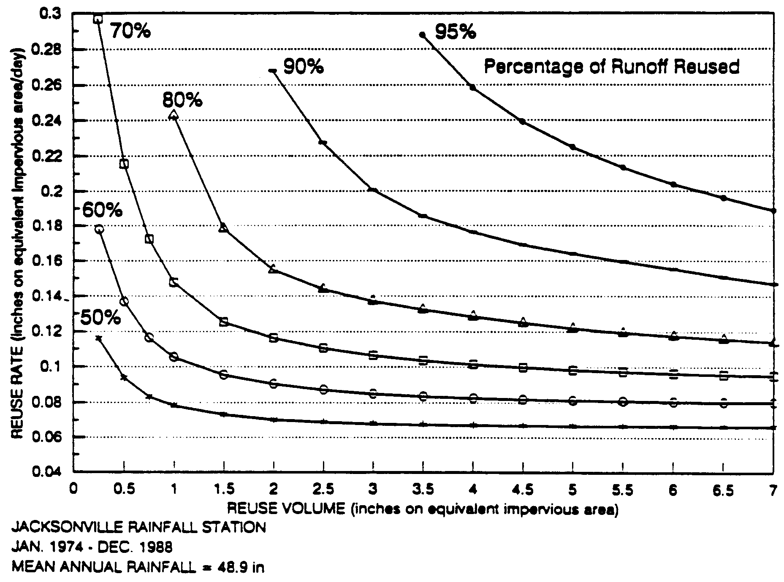

Figure 31-1. REV Chart for Jacksonville

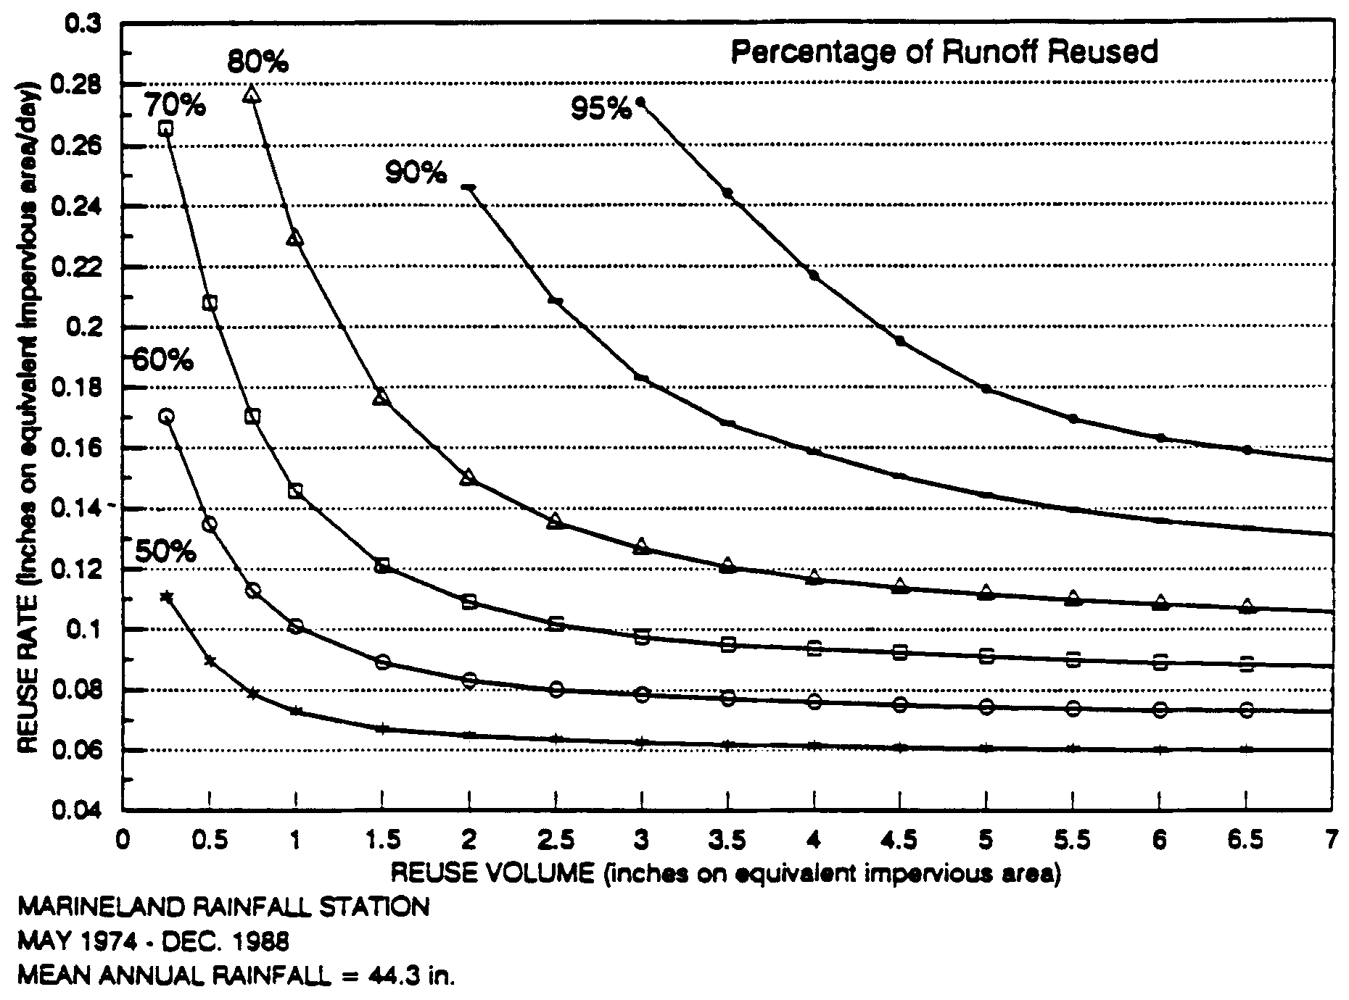
Figure 31-2. REV Chart for Marineland

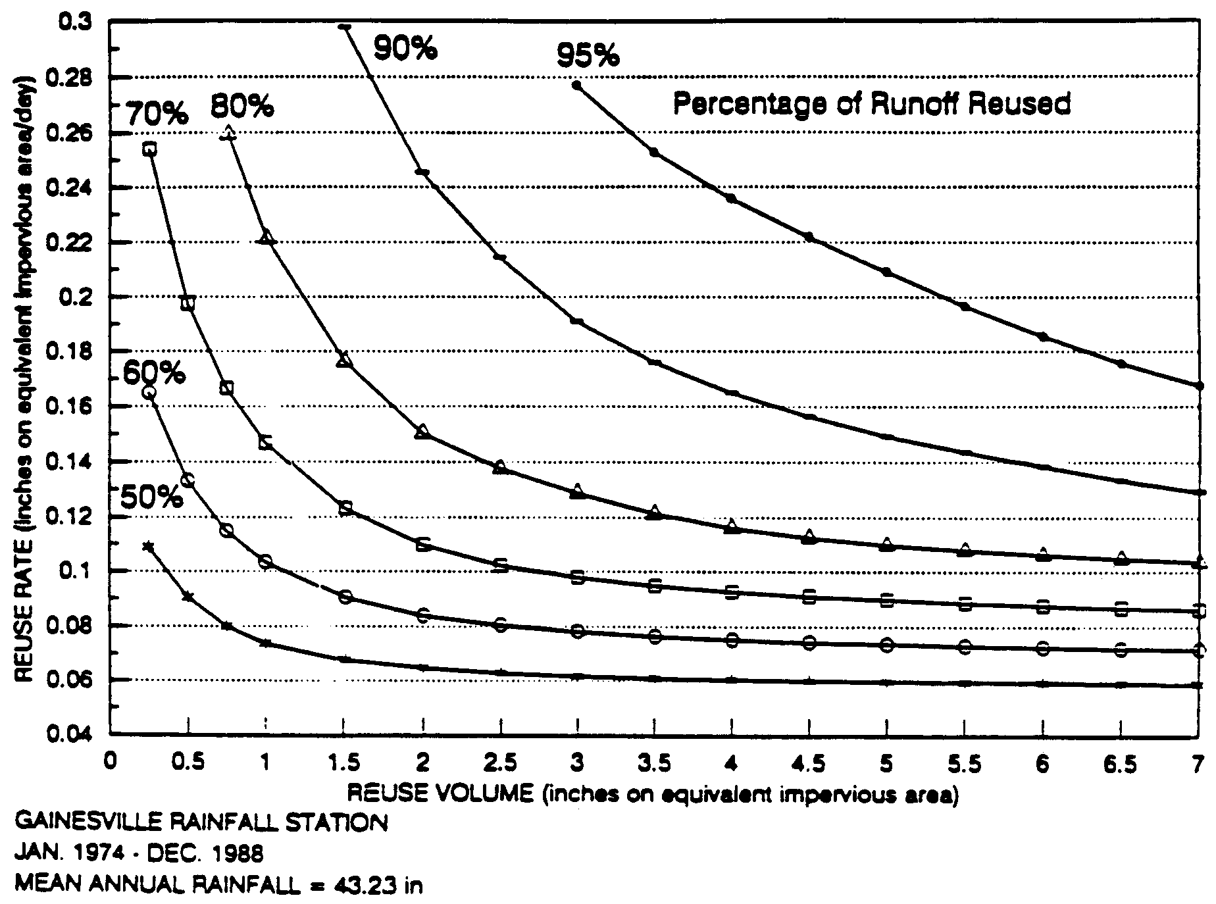

Figure 31-3. REV Chart for Gainesville

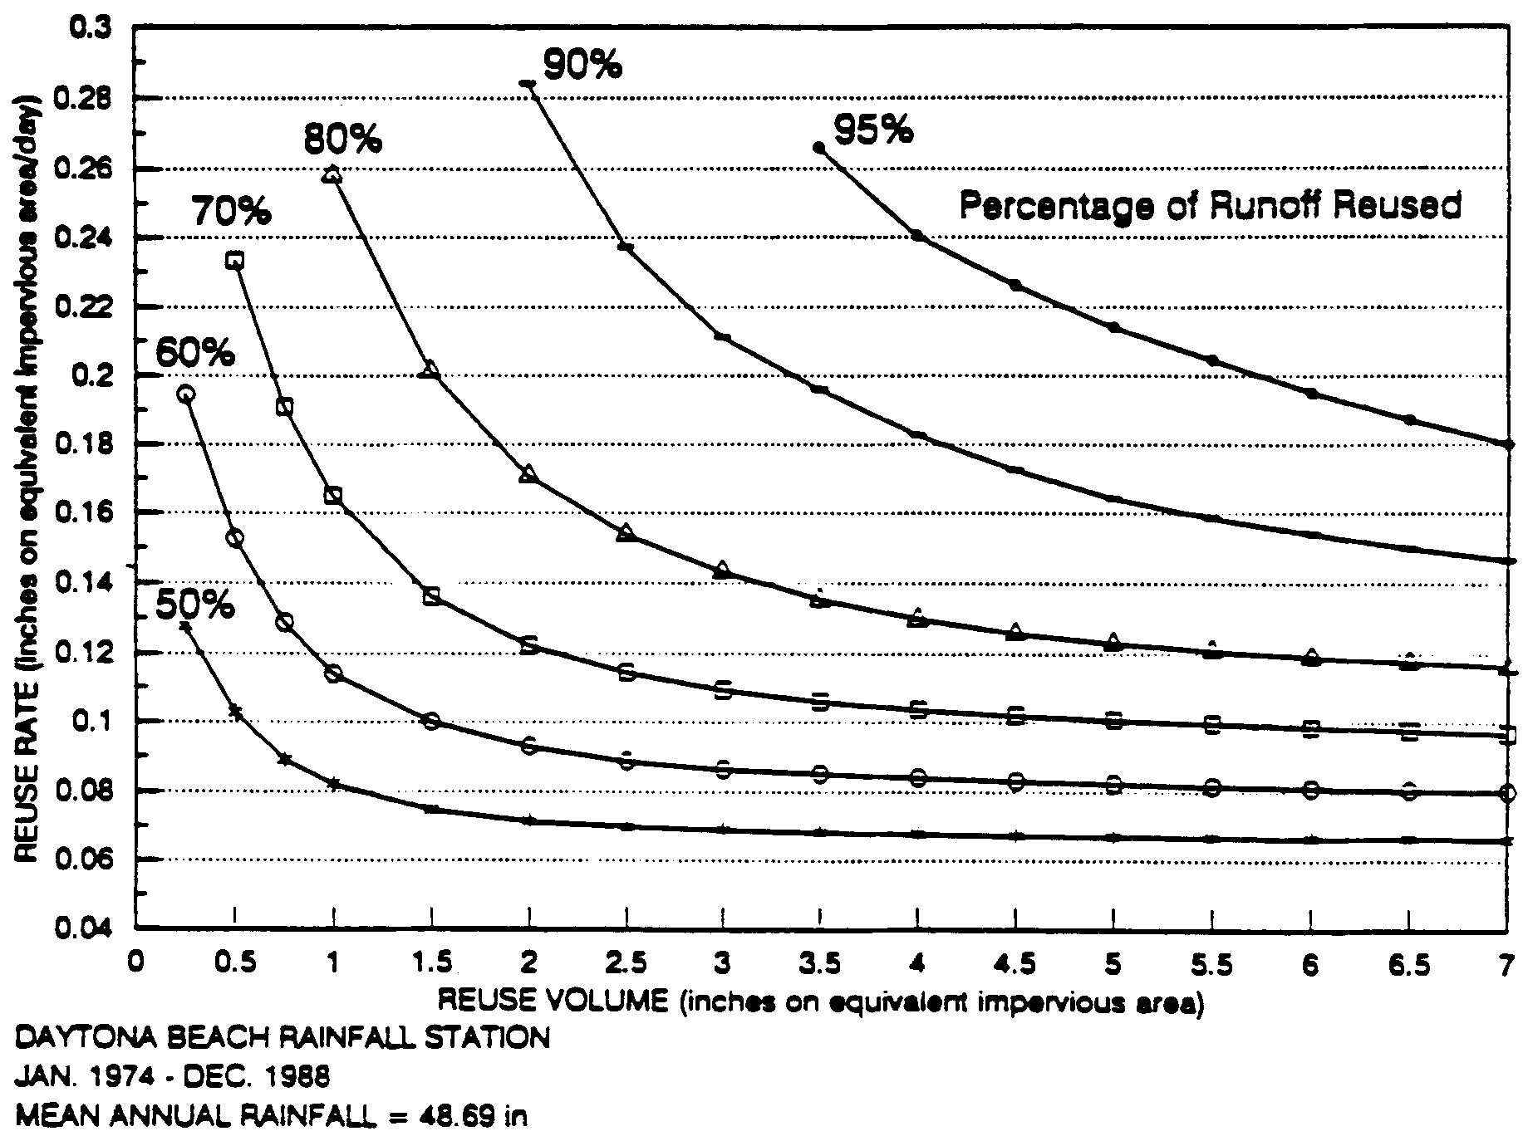

Figure 31-4. REV Chart for Daytona Beach

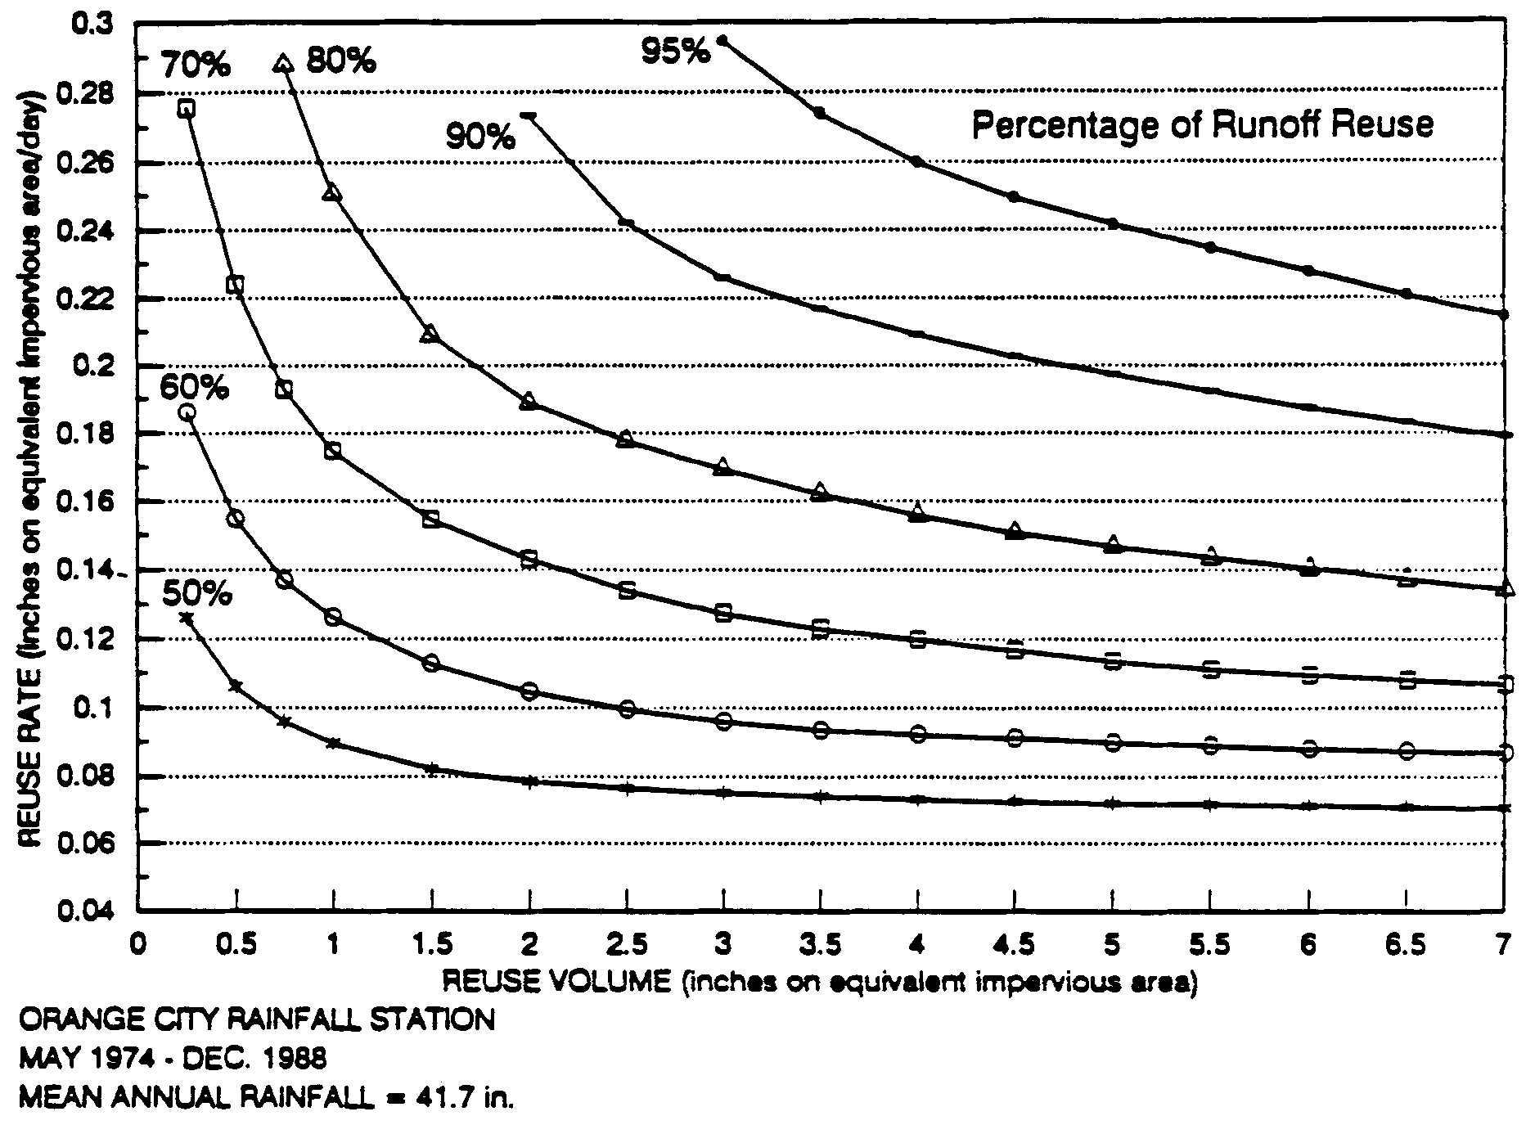

Figure 31-5. REV Chart for Orange City

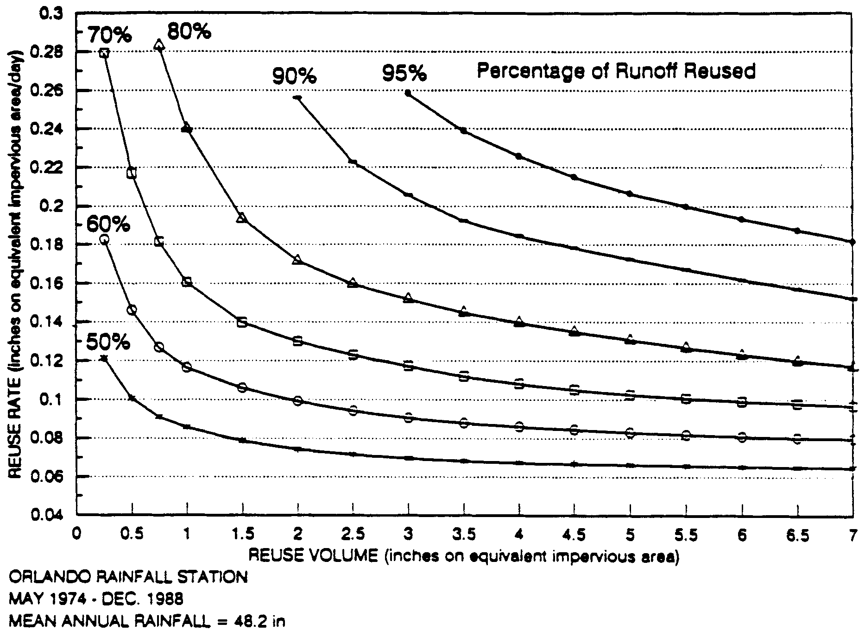

Figure 31-6. REV Chart for Orlando

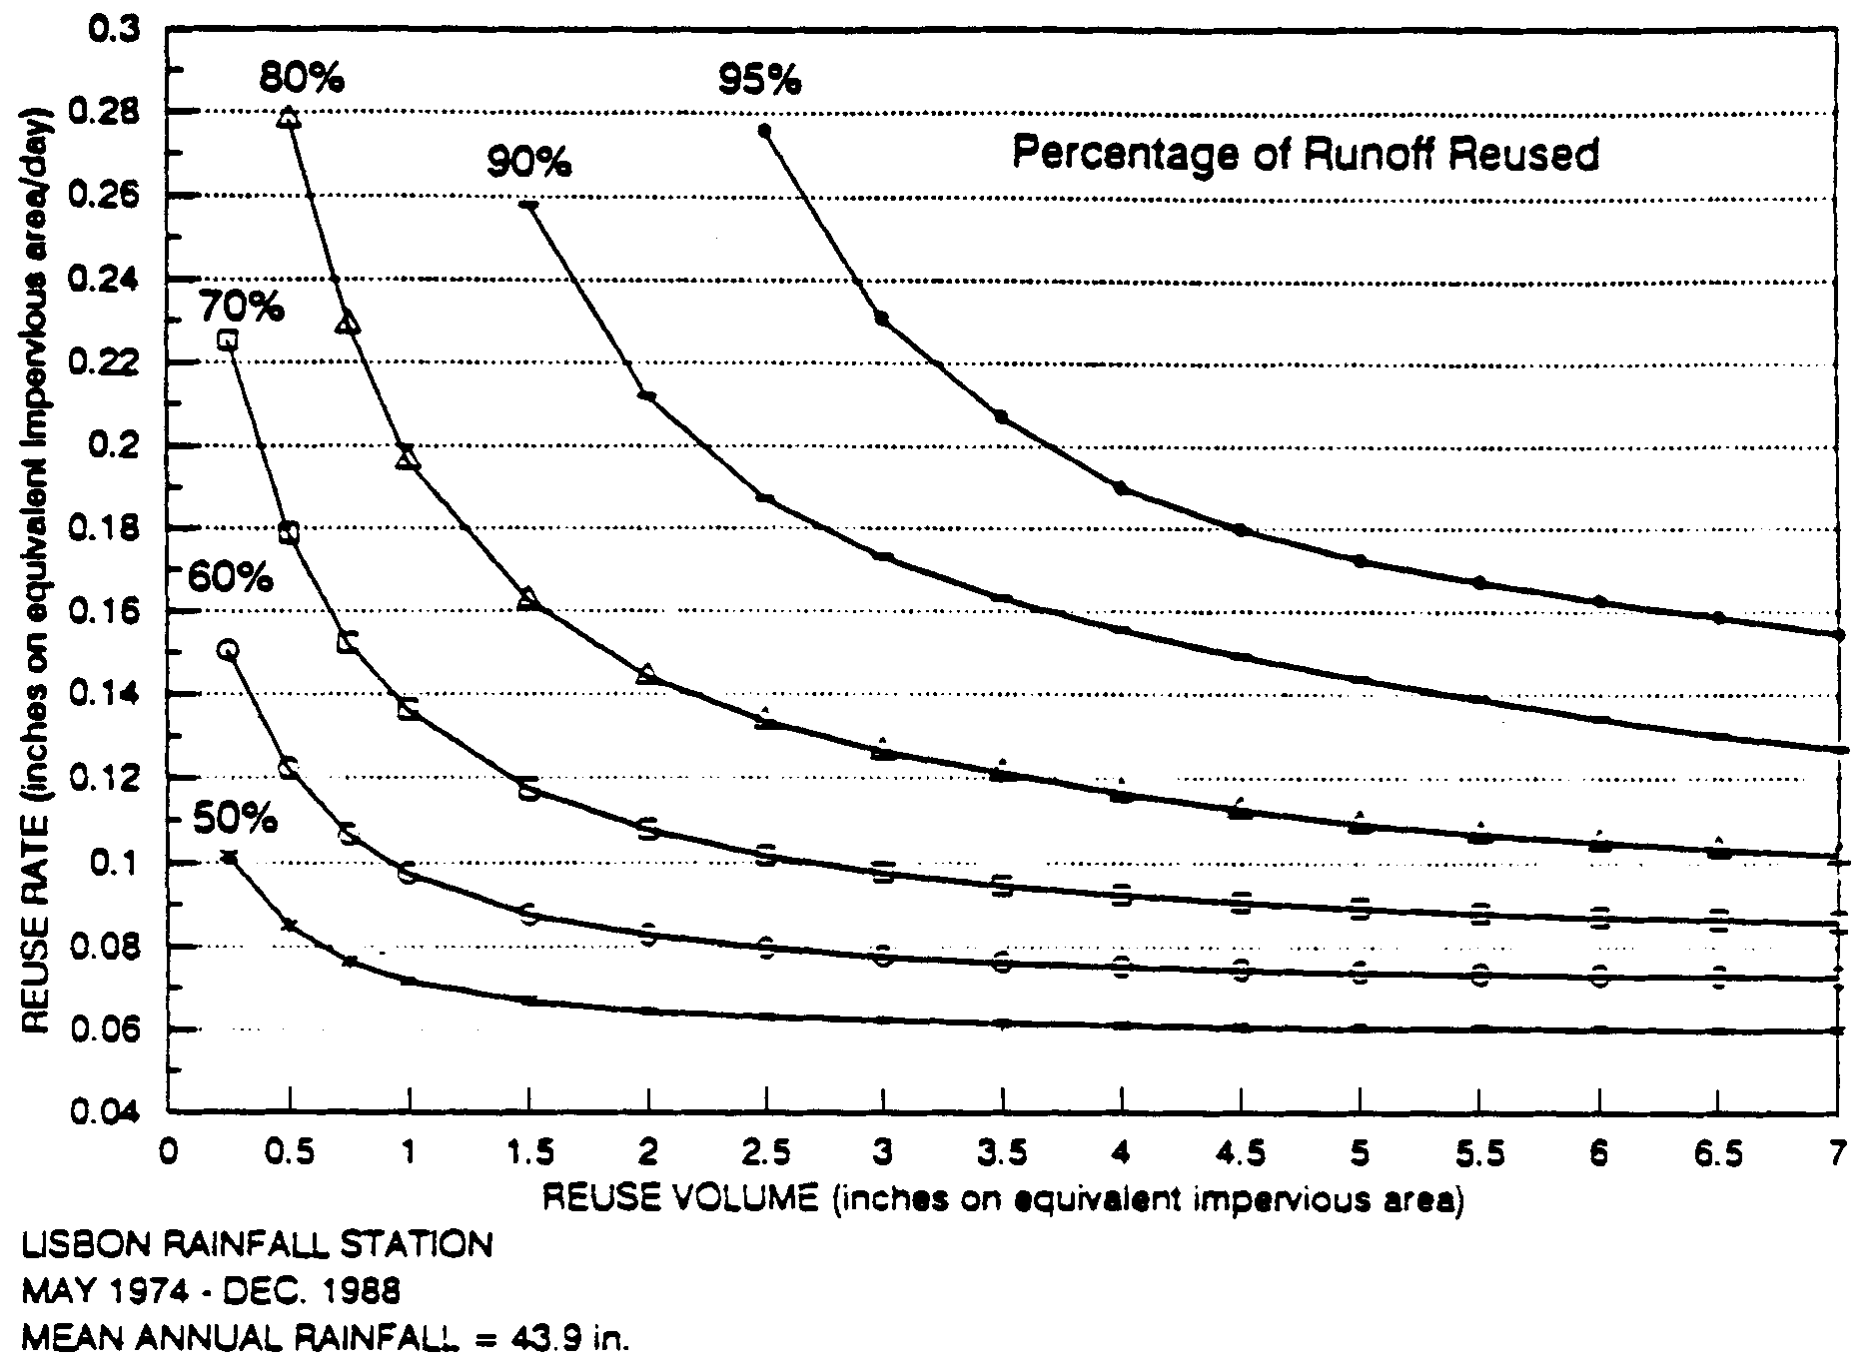

Figure 31-7. REV Chart for Lisbon

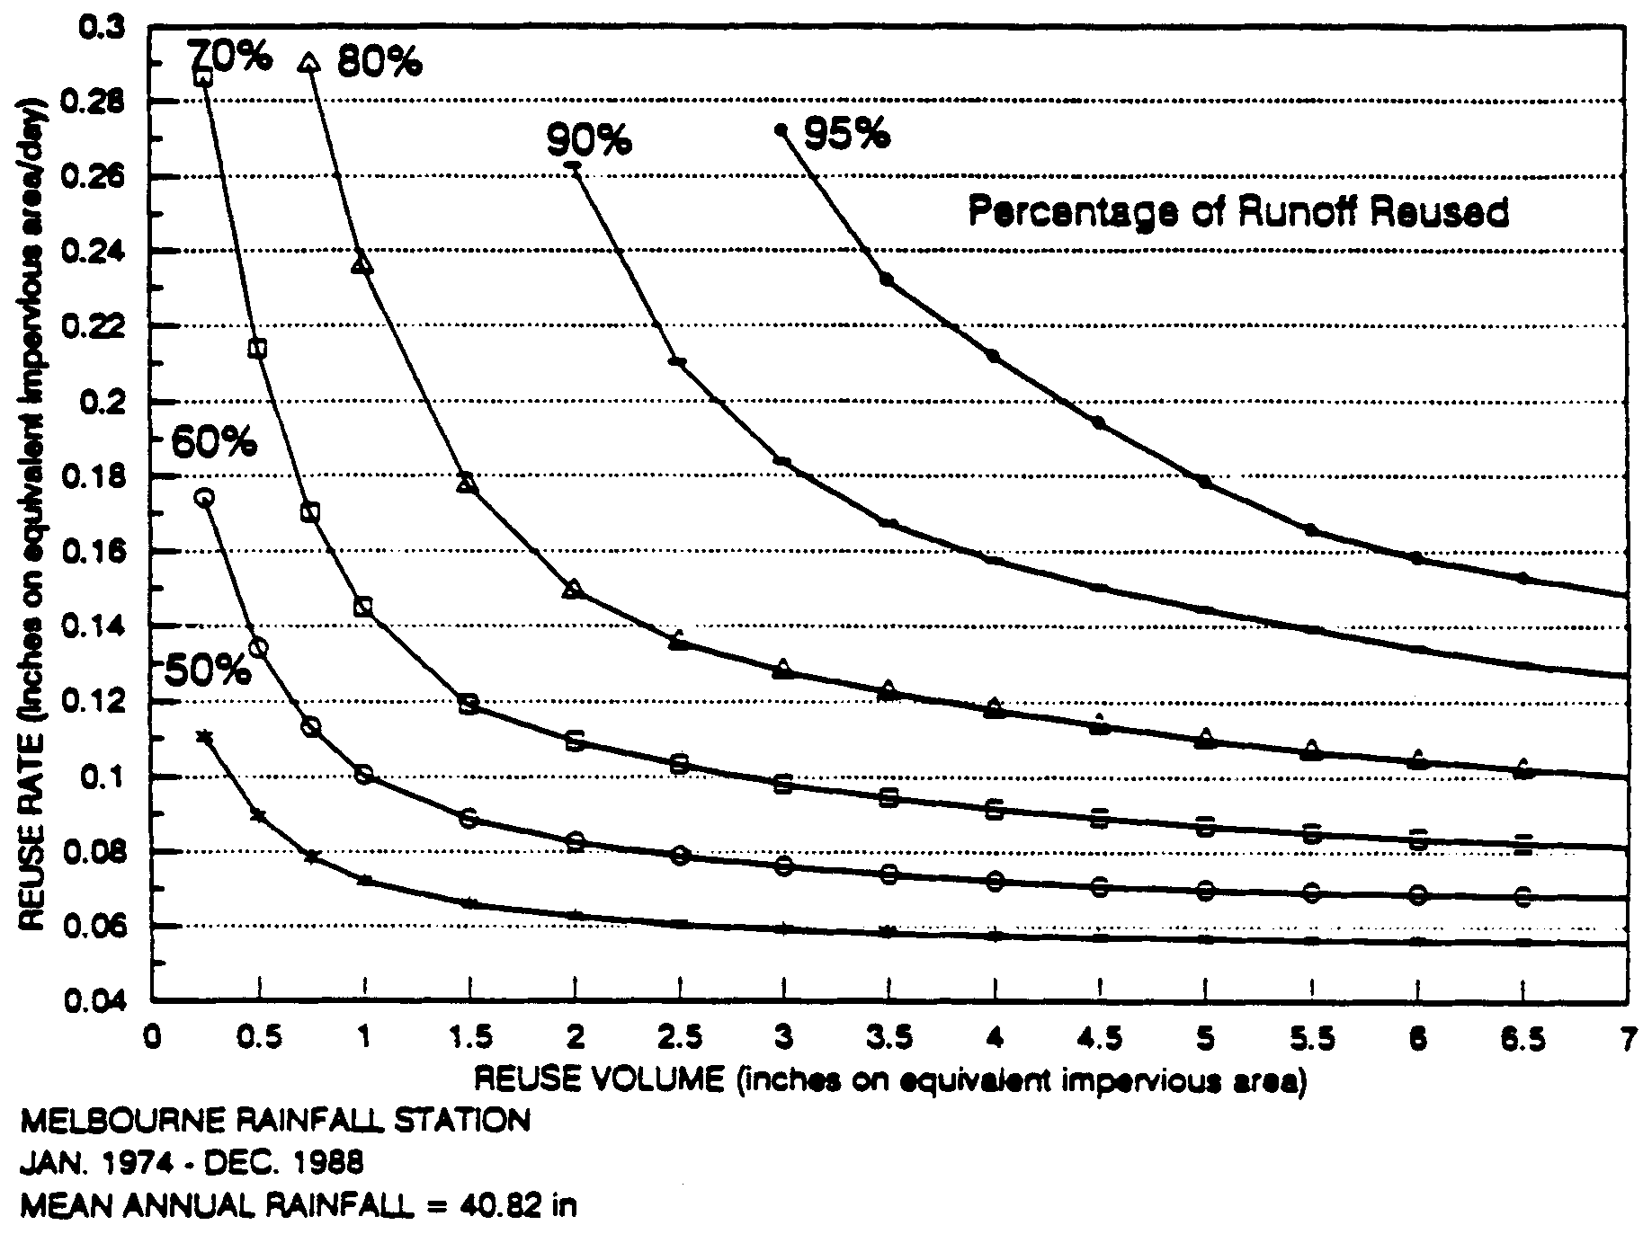

Figure 31-8. REV Chart for Melbourne

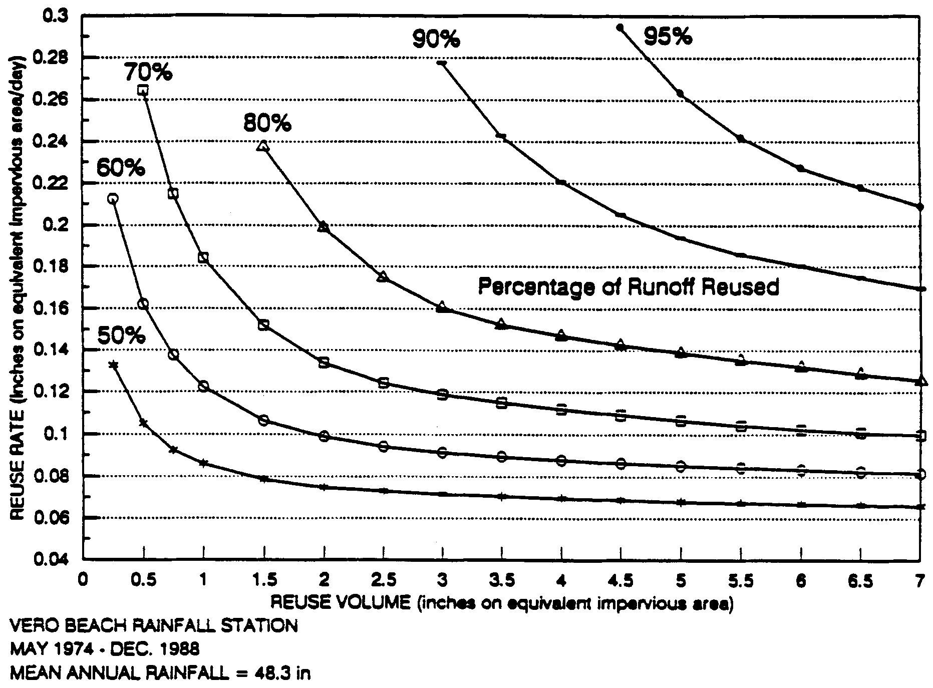

Figure 31-9. REV Chart for Vero Beach

Section 32.0
Methodology and Design Examples for Vegetated Natural Buffers

(THIS SECTION HAS BEEN DELETED)

33.0 Methodology and Design Examples for Filtration
33.1 Calculating Recovery Time Utilizing Darcy's Equation
The Darcy's equation can be utilized to calculate recovery times for filtration systems. The Darcy Equation for saturated flow through porous media is written:
V = K i (33-1)
where: V = Velocity of flow through the porous media (ft/hr)
K = Permeability rate of filter media (ft/hr)
i = Hydraulic gradient (ft/ft)

The rate of flow (Q) passing a given cross-sectional area of saturated soil (A) is:
Q = V A (33-2)
where: Q = Rate of flow (ft³/hr)
A = Area of flow (ft²)

Combining equations 33-1 and 33-2:
Q = K i A (33-3)
Equation 33-3 can be applied in a number of acceptable ways to design filtration systems. These methodologies include incremental drawdown analysis, flow nets, and analytical adaption of the falling head equation. The method selected should take into account the fact that the flow rate varies over time as the filter system recovers the treatment volume.
In the incremental drawdown analysis, the flow through the filter system is evaluated incrementally with respect to pond stage elevation to determine the recovery time. The instantaneous rate of discharge (Q) is calculated at various stages of drawdown or storage elevations in the basin. The time necessary to draw down each increment of storage is summed and compared to the desired recovery time. The design (eg., length) of the filter system is usually finalized by trial and error until the desired recovery time is achieved. See section 33.7 for detailed design examples.
The methodology in the following sections describes the incremental drawdown analysis and the associated variables used in the analysis. Applicants proposing to utilize other methods are encouraged to consult with Department District staff prior to application submittal.
33.2 Hydraulic Gradient
The hydraulic gradient (i) between two points is equal to the difference in hydraulic head at each point divided by the distance between the points as measured along the flow path. The hydraulic gradient (i) may be expressed as:
(33-4)
where: i = Hydraulic gradient
∆H = Difference in hydraulic head between the free water surface in the basin and a horizontal reference plane (usually chosen passing through the flow line of the filter pipe) (ft)
D = Distance of the path of flow through the porous media (ft)

The hydraulic gradient (i) can be readily obtained from scaled drawings of the filtration system (see Figures 33-1 and 33-2). The details within the construction plans should provide sufficient information to reproduce a scaled drawing to measure flow lengths.
For side-bank filters, the flow path varies with the drop in water surface elevation (Figure 33-1). The flow path for each increment can be assumed to be the average of the flow paths below the top elevation of the given increment. For example, for increment #2 of Figure 33-1, the average flow path can be assumed to be:
Average Flow Path for Increment #2 = D2 + D3 + D4 + D5 (33-5)
4
For increment #4 in Figure 33-1, the average flow path can be assumed to be:
Average Flow Path for Increment #4 = D4 + D5 (33-6)
2
For vertical filters the flow path distance (D) is constant for each increment of the analysis (Figure 33-2).
33.3 Permeability
The permeability (K) should be selected with respect to surrounding soils. Once the system is constructed, soils will migrate into the filter and reduce the conductivity. Therefore, design permeabilities of the filter which are far greater than the permeability of the surrounding soils should be avoided. In Table 33-1, below, recommended permeability (K) values are given for each soil type.

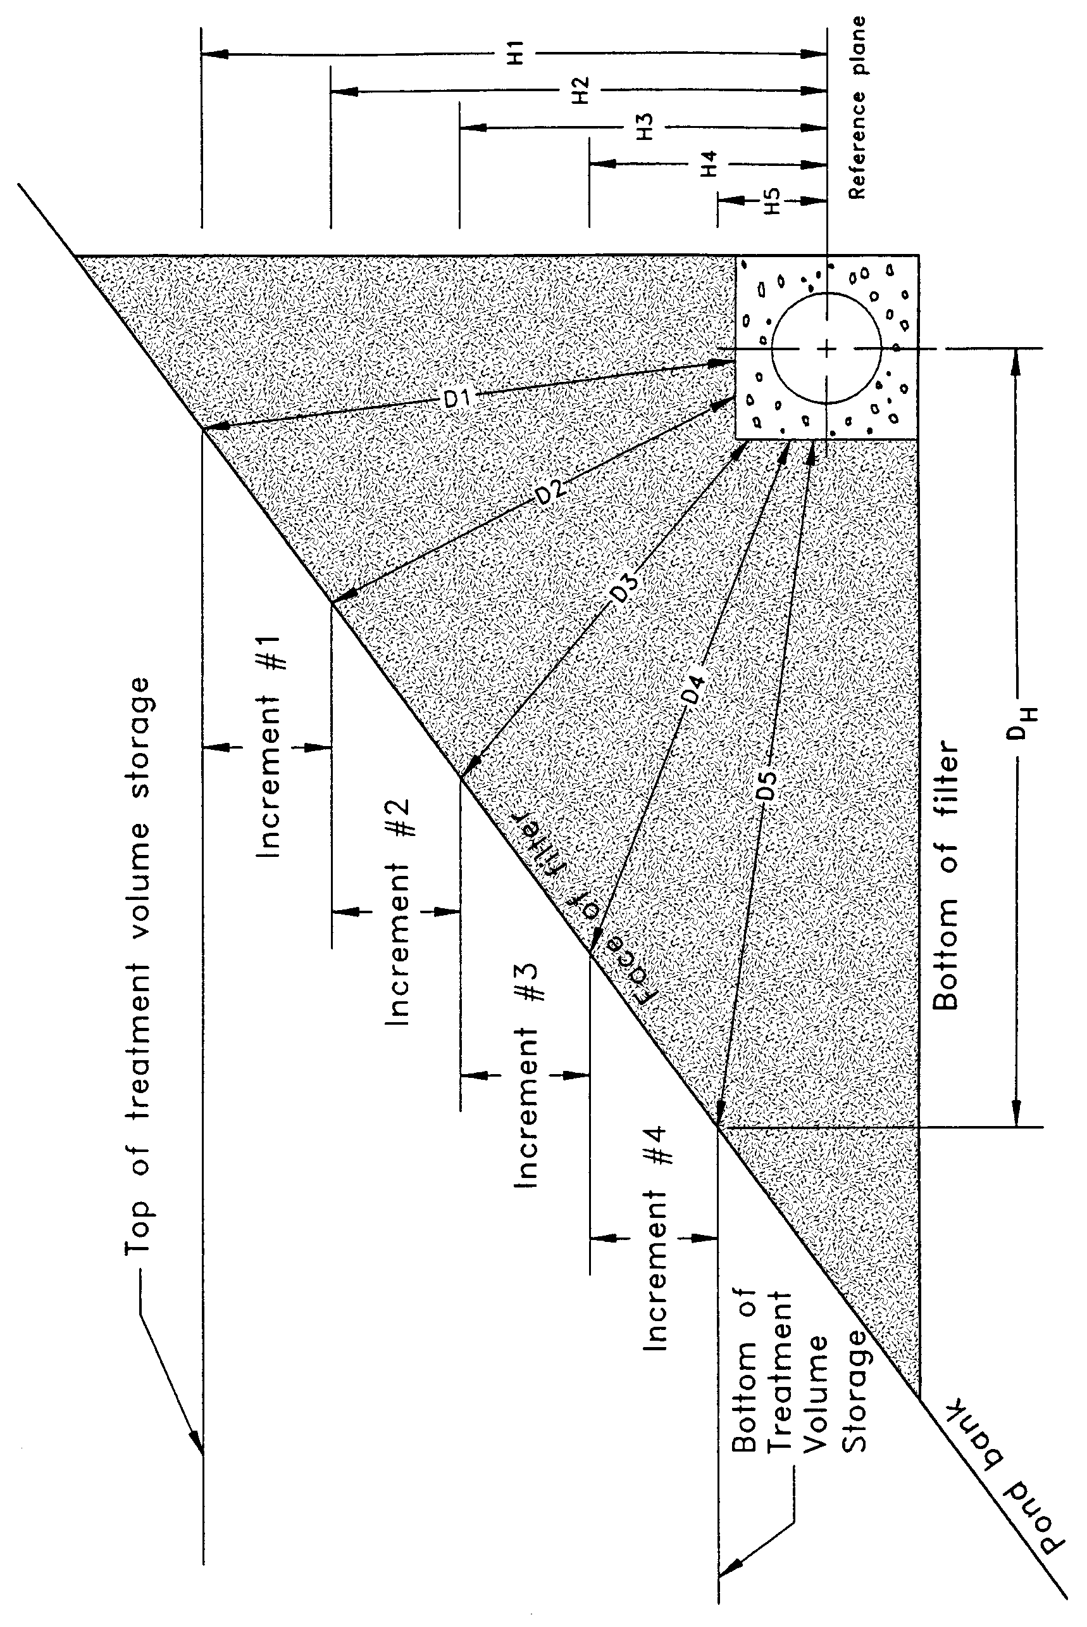
(N.T.S.)
Figure 33-1. Cross-section of Side-bank Filter Illustrating the Parameters Used in Calculating Hydraulic Gradient (i) for Lateral Flow Conditions (adapted from Livingston et al 1988)

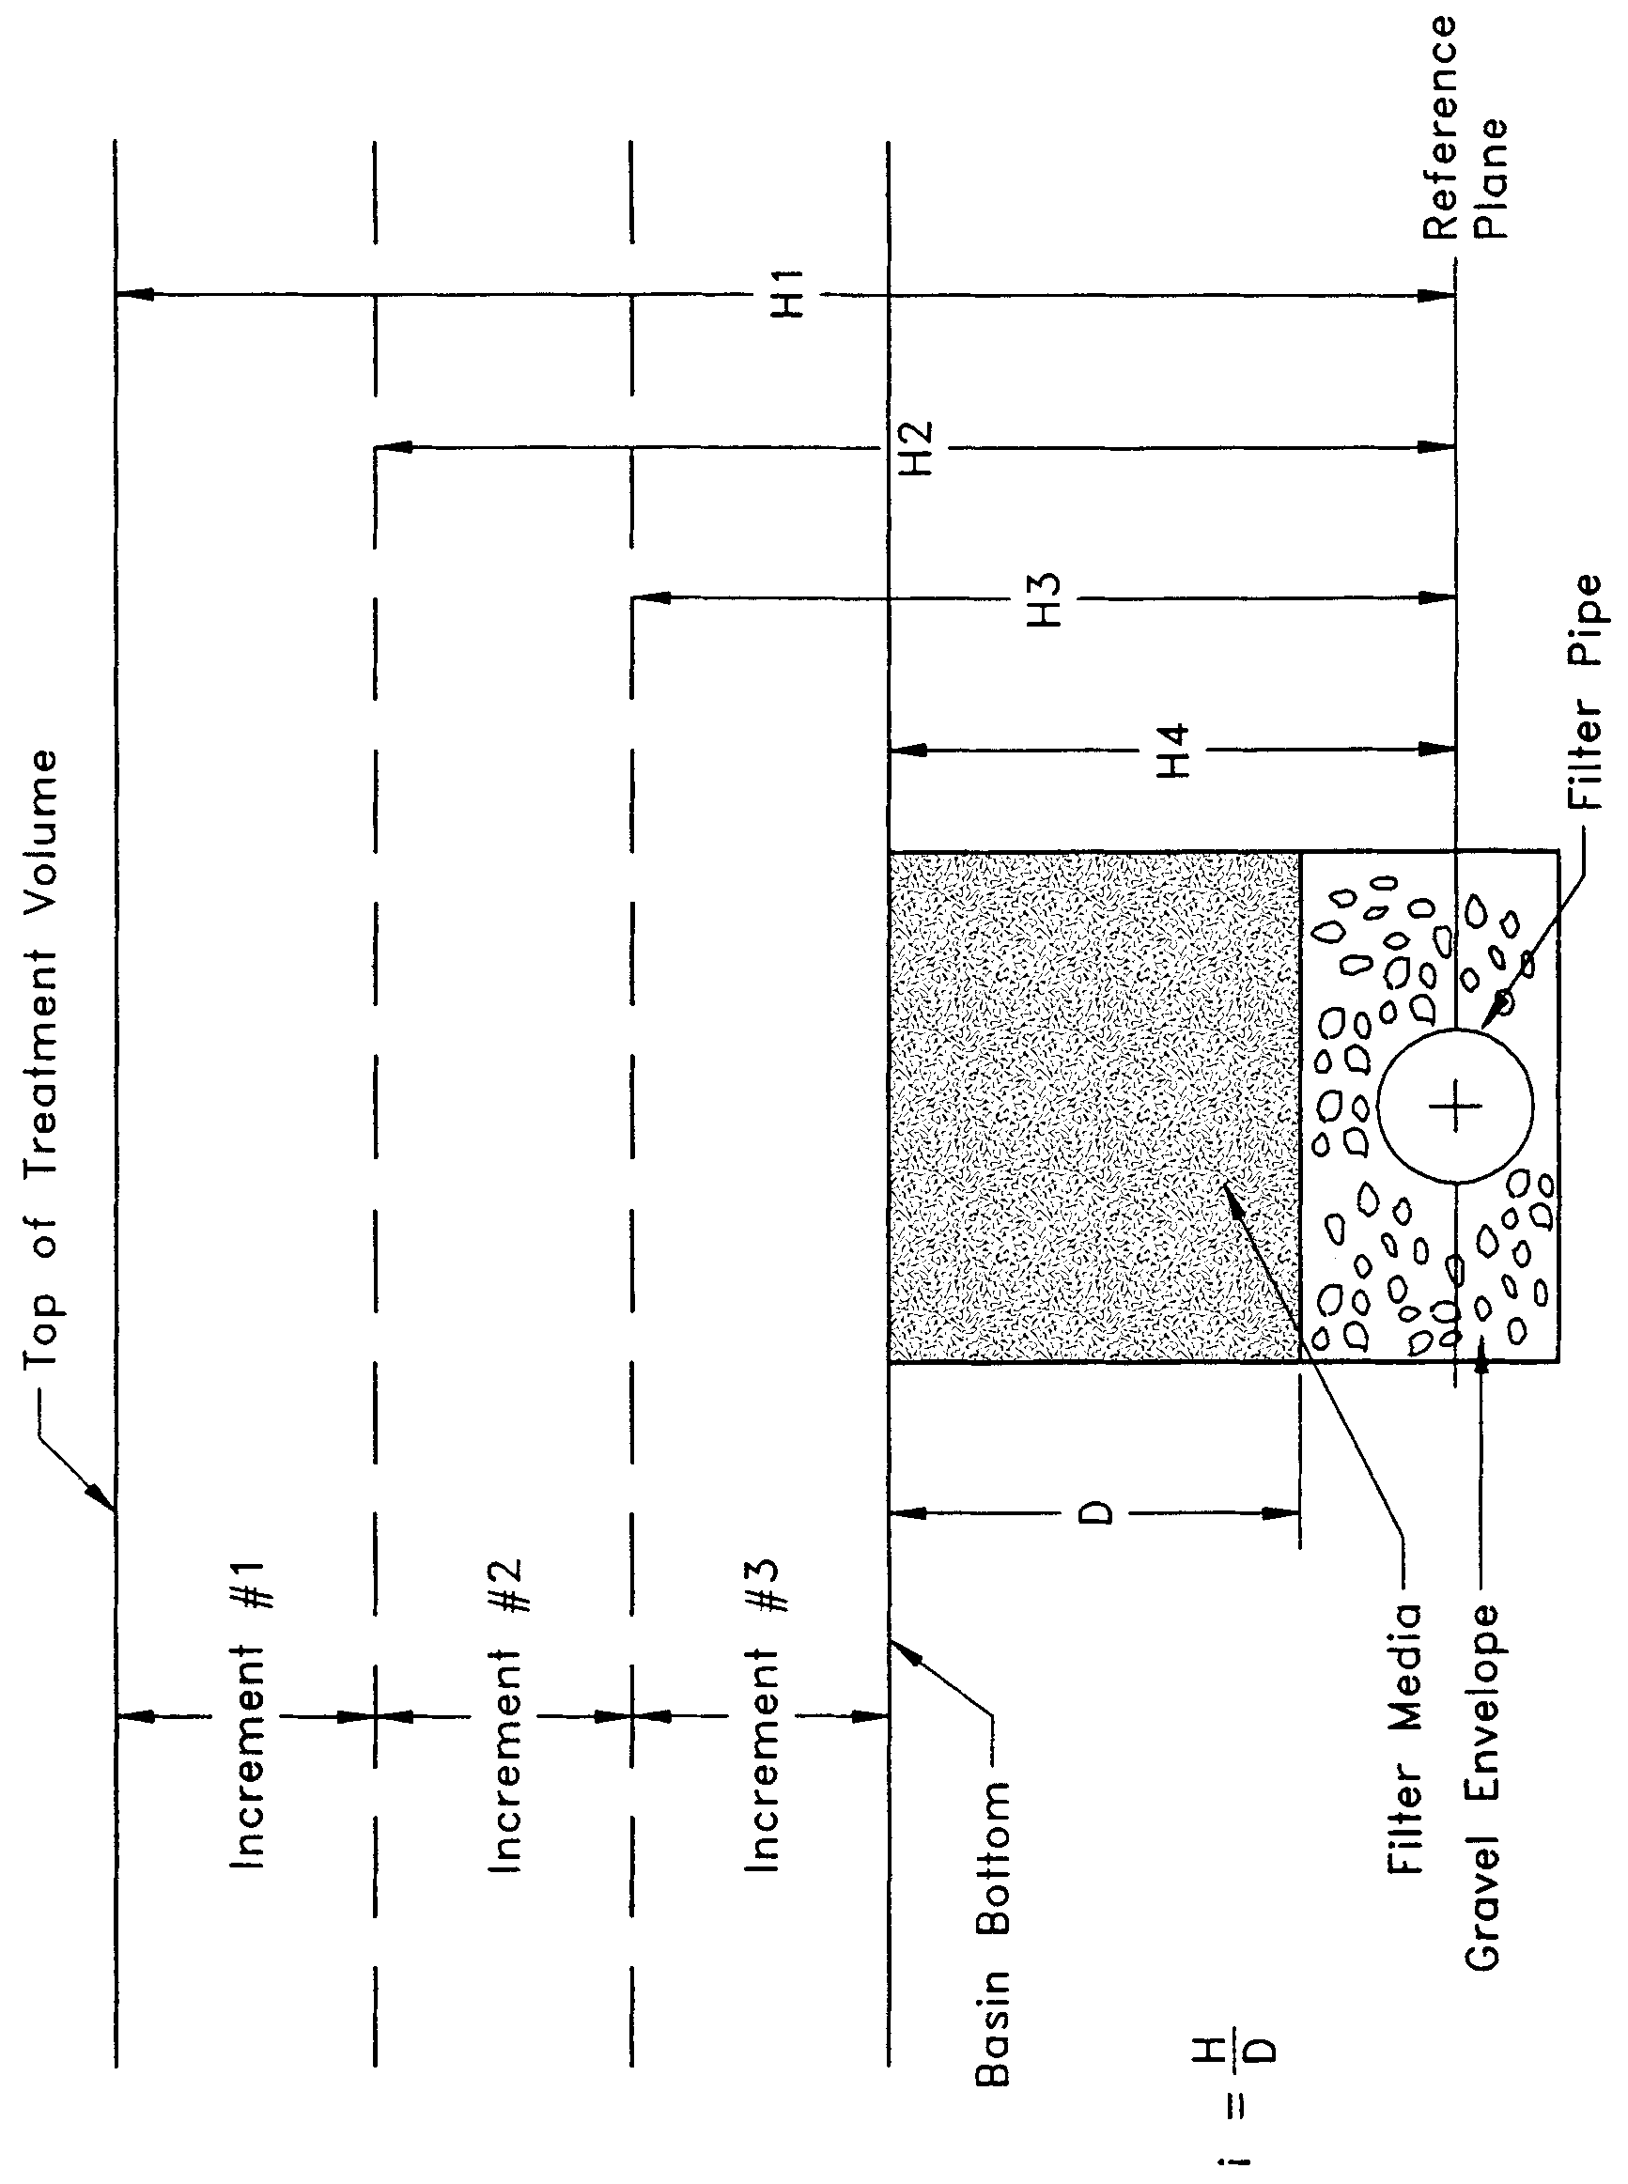

Figure 33-2. Cross-section of Basin-bottom Filter Illustrating the Parameters Used in Calculating Hydraulic Gradient (i) for Vertical Flow Conditions
For "wet" filter systems, a permeability (K) for Soil Type "A" may be utilized since most soil particles will settle out in the wet pond prior to reaching the filter media. Permeability values should be reduced by 25% when sod is proposed to be laid over the filter media. On the other hand, K values may be increased by 25% when a gravel envelope is placed around the perforated pipe (Harper and Herr, 1993).
Table 33-1. Recommended Permeability (K) Values
Recommended permeability (K) values for use in design of filtration systems based on types of soil in which the filter will be placed.
Soil Type | K (ft/hr)
A | 2.5
B | 2.0
C | 1.0
D | 0.5
A/D | 2.5
B/D | 1.5
C/D | 0.5

33.4 Flow Area
The flow area (A) for use in equation 33-3 is the cross-sectional flow area of the filter media and is calculated as:
A = W L (33-7)
where: W = Width of saturated filter media perpendicular to the direction of flow (ft)
L = Length of filter media (ft)

For vertical filters, the width of filter media (W) remains constant with the drop in water surface elevation. See example problem #2 in section 33-7 for example calculation for vertical filters.
However, for sidebank filters, the width of saturated filter media (W) can vary along the flow path (D) as flow converges toward the perforated drain pipe and with the falling water surface elevation. The design filter width (W) for sidebank filters should be taken as the average of the converging saturated filter width. One method of estimating the design filter width (W) is to take the average of the saturated filter width at the filter surface and the width of the saturated filter media at the drain pipe (or gravel envelope as appropriate). Another method is to utilize the saturated filter width at the midpoint of the flow path through the filter media as the design filter width (W).
33.5 Incremental Drawdown Analysis
The discharge rate (Q) can be calculated at the various increments of drawdown or stages in the basin by substituting Equation 33-4 into equation 33-3:
(33-8)
To calculate the recovery time of the system, the flow rate (Q) can be expressed as a function of time (Q = V/t), substituted in Equation 33-8 and rearranged to solve for time (t) as follows:
(33-9)
where: t = Time (hrs)
V = Volume to be discharged (ft³).

Equation 33-9 can be solved for each increment of treatment volume and the time calculated to drawdown each increment summed to give the total recovery time for the filter design. Example formats for calculating the recovery time utilizing the incremental Darcy's method for side-bank and vertical filters is presented in Figures 33-4 and 33-5, respectively. Example problems utilizing this methodology is given below in section 33.7.
The increment of analysis, although not a direct parameter of Darcy's equation, is an important parameter which effects the length of filter required to meet the rule criteria. To produce the most accurate result, the increment should not be larger than 0.1 feet. Smaller increments may be appropriate when the depth in the detention basin of the required treatment volume is shallow (e.g., if the treatment volume is only 0.2 feet deep).
33.5.1 Alternative Methodologies
Besides the incremental analysis presented above, other acceptable methodologies exists for designing filtration systems. The incremental method presented on page 6-274 of The Florida Land Development Manual (Livingston et al 1988) is acceptable for designing side bank filters (Harper and Herr 1993). The only difference between this methodology and that presented above is the calculation of the flow path distance (D) variable used in determining the hydraulic gradient (i) (equation 33-3) for side bank filters. For vertical filters, the flow path distance (D) is the same between the two methodologies.
The Falling Head equation presented on page 6-268 of The Florida Land Development Manual (Livingston et al 1988) is acceptable for designing vertical filters (Harper and Herr 1993).
33.6 Safety Factor
A safety of 2 is recommended when designing filtration systems (see section 23.4). The methodologies and permeability values recommended above for designing filter systems are conservative so designers utilizing these procedures are not required to provide a safety factor. The only exception is when the incremental method is utilized for designing vertical filters. In this case, a safety factor of 2 is recommended since Harper and Herr (1993) report that this procedure overpredicts recovery times by about a factor of 2.
33.7 Pipe Capacity
The capacity of the pipe must be always checked to ensure that the pipe can convey the design flow rates. This can be readily calculated using a modified form of the Manning's Equation:
(33-10)
where: d_{i} = Inside pipe diameter (in)
n = Manning's coefficient of roughness
Q_{p} = Peak design discharge rate (cfs)
S = Slope of the pipe (ft/ft)

If the pipe cannot convey the peak flow rate, additional head losses must be considered in the recovery time or a larger size pipe must be used.
33.8 Example Design Calculations for Filter Systems
Example Problem #1. Side Bank Filter
Given:
Commercial development
Class III receiving waters
Project area = 0.66 acres
Project percent impervious (not including pond area) = 37%
Off-site drainage area = 0 acres
Seasonal high groundwater elevation at the proposed basin = 5.7 ft
Design tailwater elevation = 5.6 ft
Off-line treatment
Type B soils
4:1 side slopes
Side-bank filter with square cross-section gravel envelope around the perforated pipe (gravel envelope width = 3")
Pipe n = 0.016; Pipe S = 0.0012

The proposed detention basin has the following stage-storage relationship:

Stage  (ft) | Storage  (ac-ft) | Storage  (ft³)
6.3 | 0.000 | 0
6.4 | 0.010 | 436
6.5 | 0.022 | 958
6.6 | 0.034 | 1481
6.7 | 0.047 | 2047
6.8 | 0.064 | 2788

Objective: Design a side bank filter using the incremental method
Design Calculations:
Step 1. Calculate the required treatment volume.
For off-line treatment by filtration, the rule requires a treatment volume of 1 inch of runoff or 2.5 inches times the impervious area, whichever is greater.
Treatment volume required = (0.66 ac.)(1 inch) = 0.055 ac-ft
(one inch of runoff) 12 in/ft
(2.5 inches times % imp.) = (0.66 ac)(2.5 in.)(0.37) = 0.051 ac-ft
12 in/ft
Therefore, treatment volume = 0.055 ac-ft or 2396 ft³
Step 2. Set the elevation of the filter pipe and control structure.
Set the filter pipe invert at or above the seasonal high water table and design tailwater elevation. Therefore, set the filter pipe invert elevation at 5.7 ft.
Set an overflow weir at the top of the treatment volume storage to discharge runoff volumes greater than the treatment volumes. Utilizing the stage-storage relationship, 0.055 ac-ft of storage is between 6.7 and 6.8 feet. Interpolate between 6.7 and 6.8 ft. to find the weir elevation:
Weir elevation = (6.8 - 6.7 ft) x (0.055 ac-ft - 0.047 ac-ft) + 6.7 ft = 6.75 ft
(0.064 ac-ft - 0.047 ac-ft)
Treatment volume depth = 6.75 - 6.3 ft = 0.45 ft
Step 3. Determine the K value
From Table 33-1, the permeability (K) = 2.0 ft/hr for Type B soils
Add 25% to the K value since a gravel envelope is utilized.
Design K = 2.0 ft/hr x 1.25 = 2.5 ft/hr
Step 4. Size the filter to draw down the treatment volume in at least 72 hours.
For a selected pipe diameter, length, and slope, utilize the incremental Darcy's equation to determine the recovery time for a side-bank filter with a gravel envelope. If the drawdown time is greater than 72 hours or the pipe diameter is inadequate to convey the flows, the pipe variables must be adjusted and the drawdown time recalculated until the desired results are obtained.
Trial 1: Pipe diameter = 6 in.
Pipe length = 200 feet
The calculations for trial #1 are shown in Figure 33-5. For this trial, the drawdown is greater than the required 72 hours. Therefore, increase the pipe length for trial #2.
Trial 2: Pipe diameter = 6 in.
Pipe length = 280 feet
From this trial (Figure 33-6), the time to recover the required treatment volume is less than 72 hours. Also, the selected pipe diameter is adequate to convey the peak flow rate. Therefore, the design for trial #2 is adequate.
Additional Steps.
In a typical design, the applicant would also design the following:
(a) Filter media to meet the required specifications
(b) Cleanout and inspection ports
(c) Filter fabric to prevent the filter media from migrating into the gravel envelope and perforated pipe.
Example Problem #2
Given:
Treatment Volume = 3710 ft³
K = 2.5 ft/hr
Basin side slopes = 3:1
Basin floor elevation = 20.7 ft
Vertical filter with a square cross-section gravel envelope around the perforated pipe (gravel envelope width = 3")
Pipe n = 0.016

The proposed detention basin has the following stage-storage relationship:

Stage  (ft) | Storage  (ft³)
22.0 | 15445
21.9 | 11827
21.8 | 8478
21.7 | 5394
21.6 | 2569
21.5 | 0

Objective: Design a vertical filter using the incremental method
Design Calculations
Step 1. Determine the K value. From section 33.6, a safety factor of 2 will be required since the incremental method is being used to design the filter system.
Design K (with safety factor of 2) = 2.5/2 = 1.25 ft/hr
Add 25% to the K value to account for the gravel envelope around the filter pipe.
Design K = 1.25 ft/hr x 1.25 = 1.56 ft/hr
Step 2. Determine the pipe invert elevation and calculate the recovery time.
Trial #1: Pipe inside diameter = 6.00 inches
Pipe length = 50 feet
Pipe invert elevation = Bottom of basin elev. - depth of filter media - gravel
envelope width - pipe diameter
Pipe invert = 21.5 ft - 2 ft - 3 in - 6 in = 18.75 ft
12 in/ft 2 in/ft
This trial (Figure 33-7) shows that, the time to recover the required treatment volume is less than 72 hours. The pipe diameter is also adequate to convey the peak flow rate. Therefore, the design for trial #1 is adequate.
33.9 References
Harper, H.H. and J.L. Herr. 1993. Treatment Efficiency of Detention with Filtration Systems. St. Johns River Water Management District, Special Publication SJ93-SP12, Palatka, Florida.
Livingston, E.H., E. McCarron, J. Cox, P. Sanzone. 1988. The Florida Land Development Manual: A Guide to Sound Land and Water Management. Florida Department of Environmental Regulation, Nonpoint Source Management Section, Tallahassee, Florida.

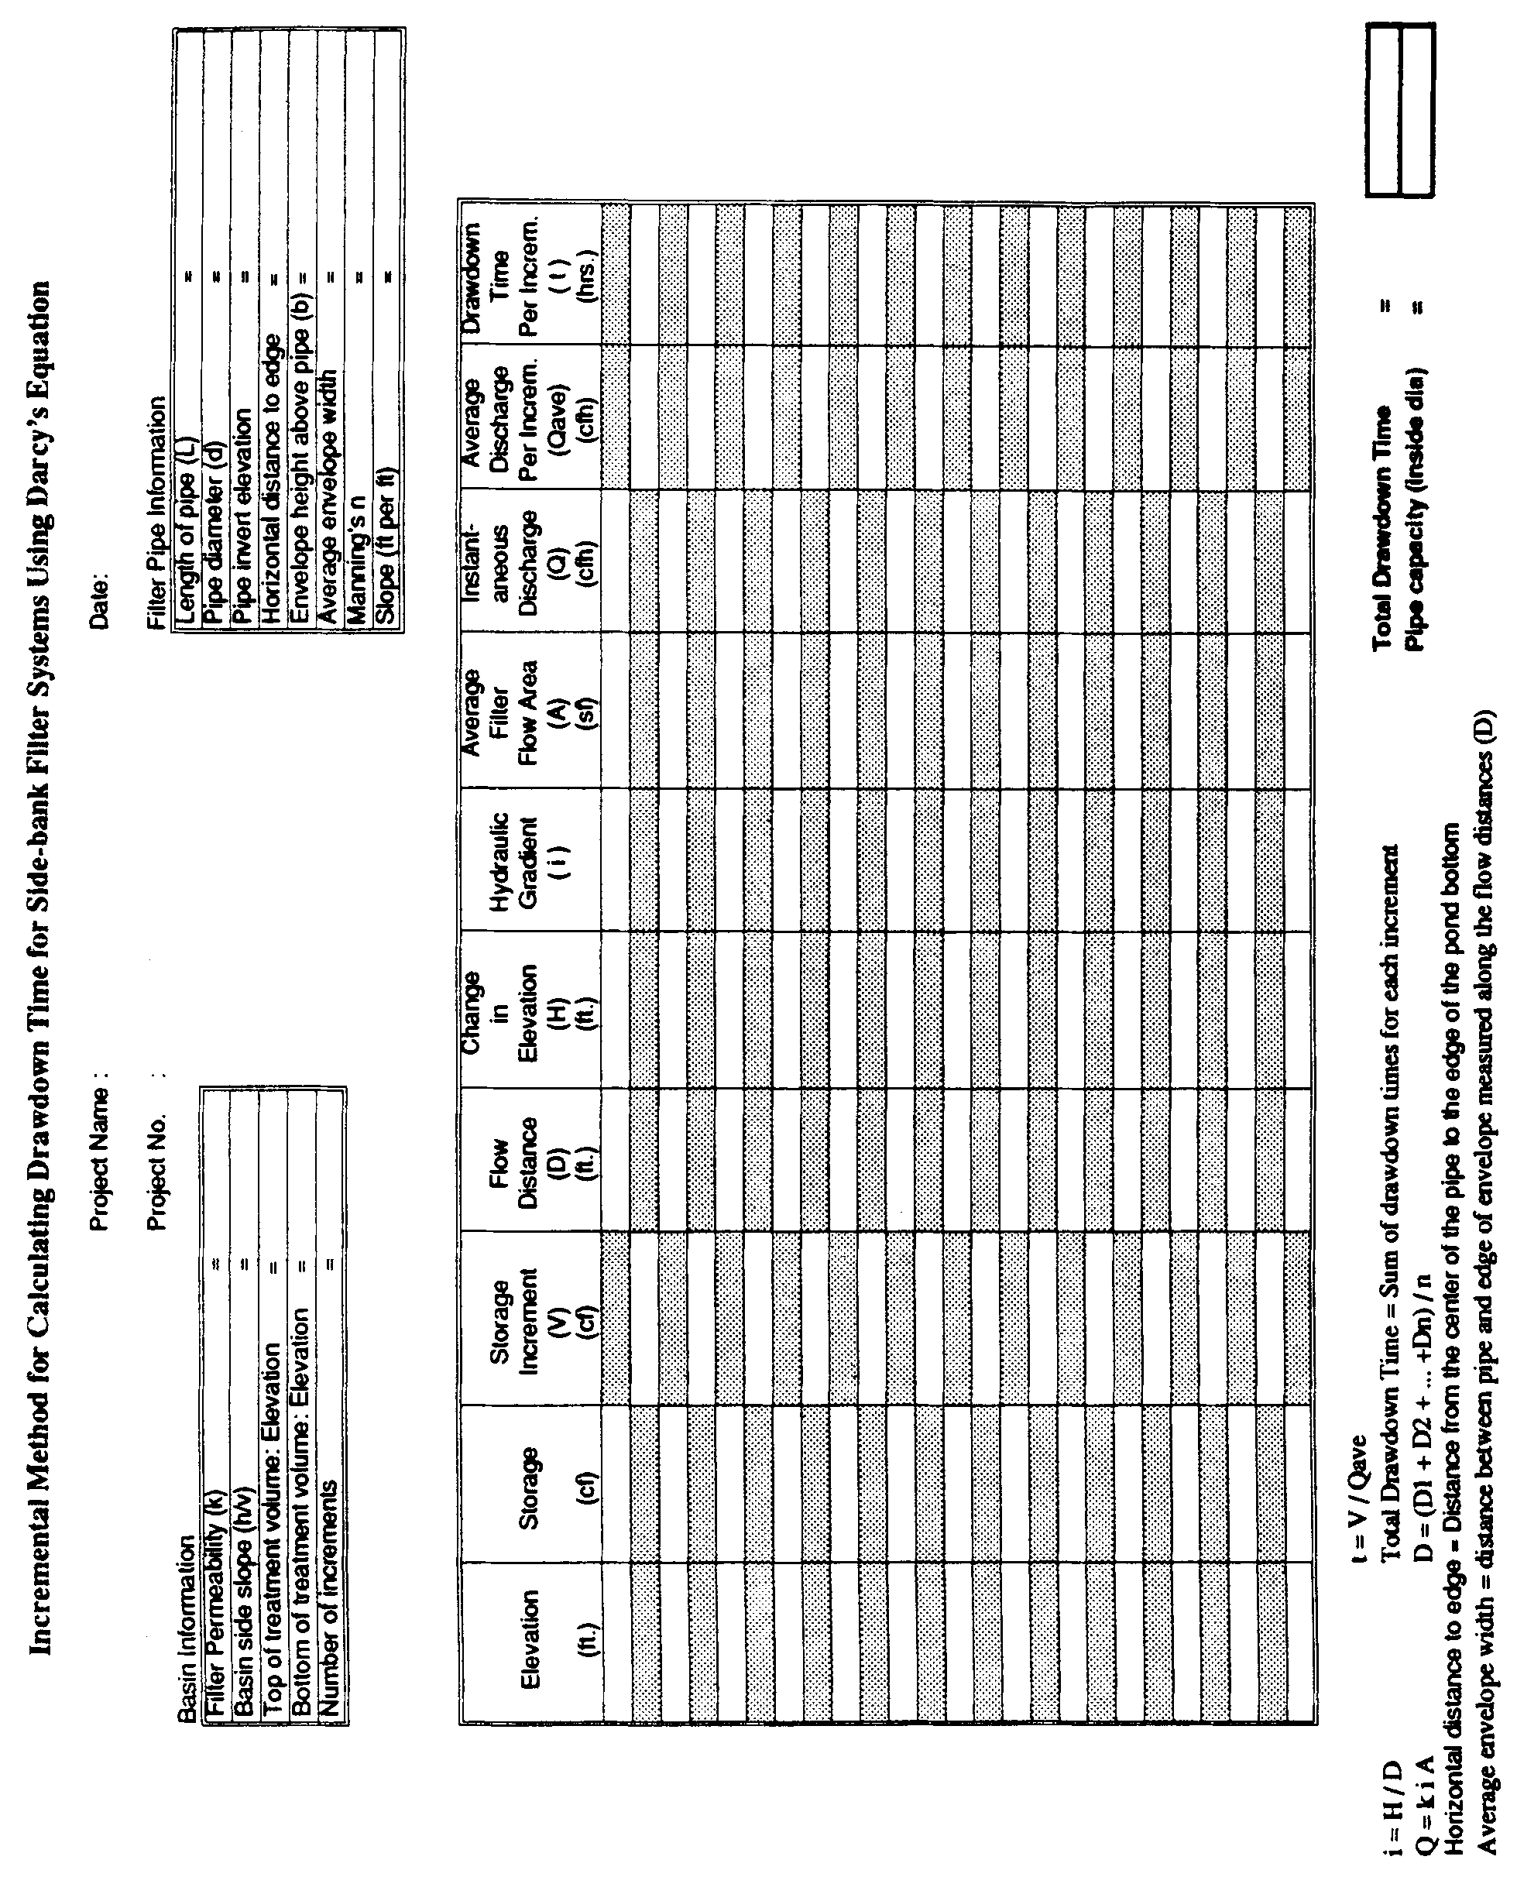

Figure 33-3. Example Format for Calculating Drawdown Time for Side-bank Filter Systems

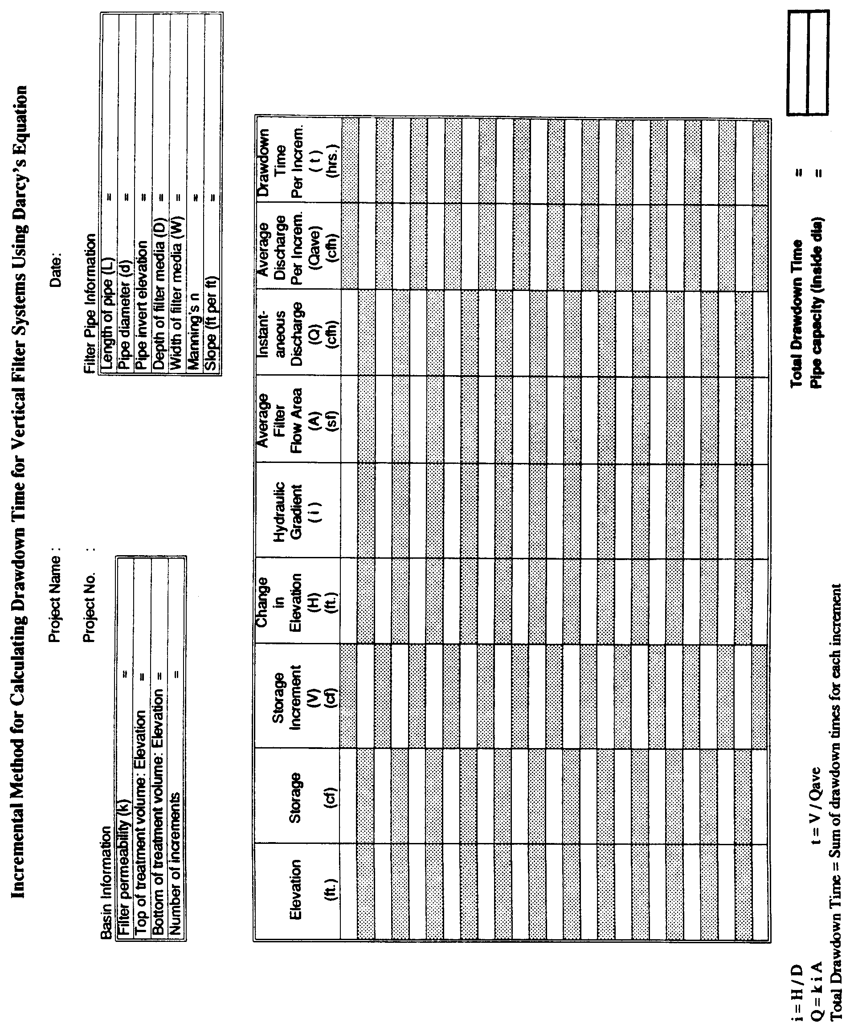

Figure 33-4. Example Format for Calculating Drawdown Time for Vertical Filter Systems

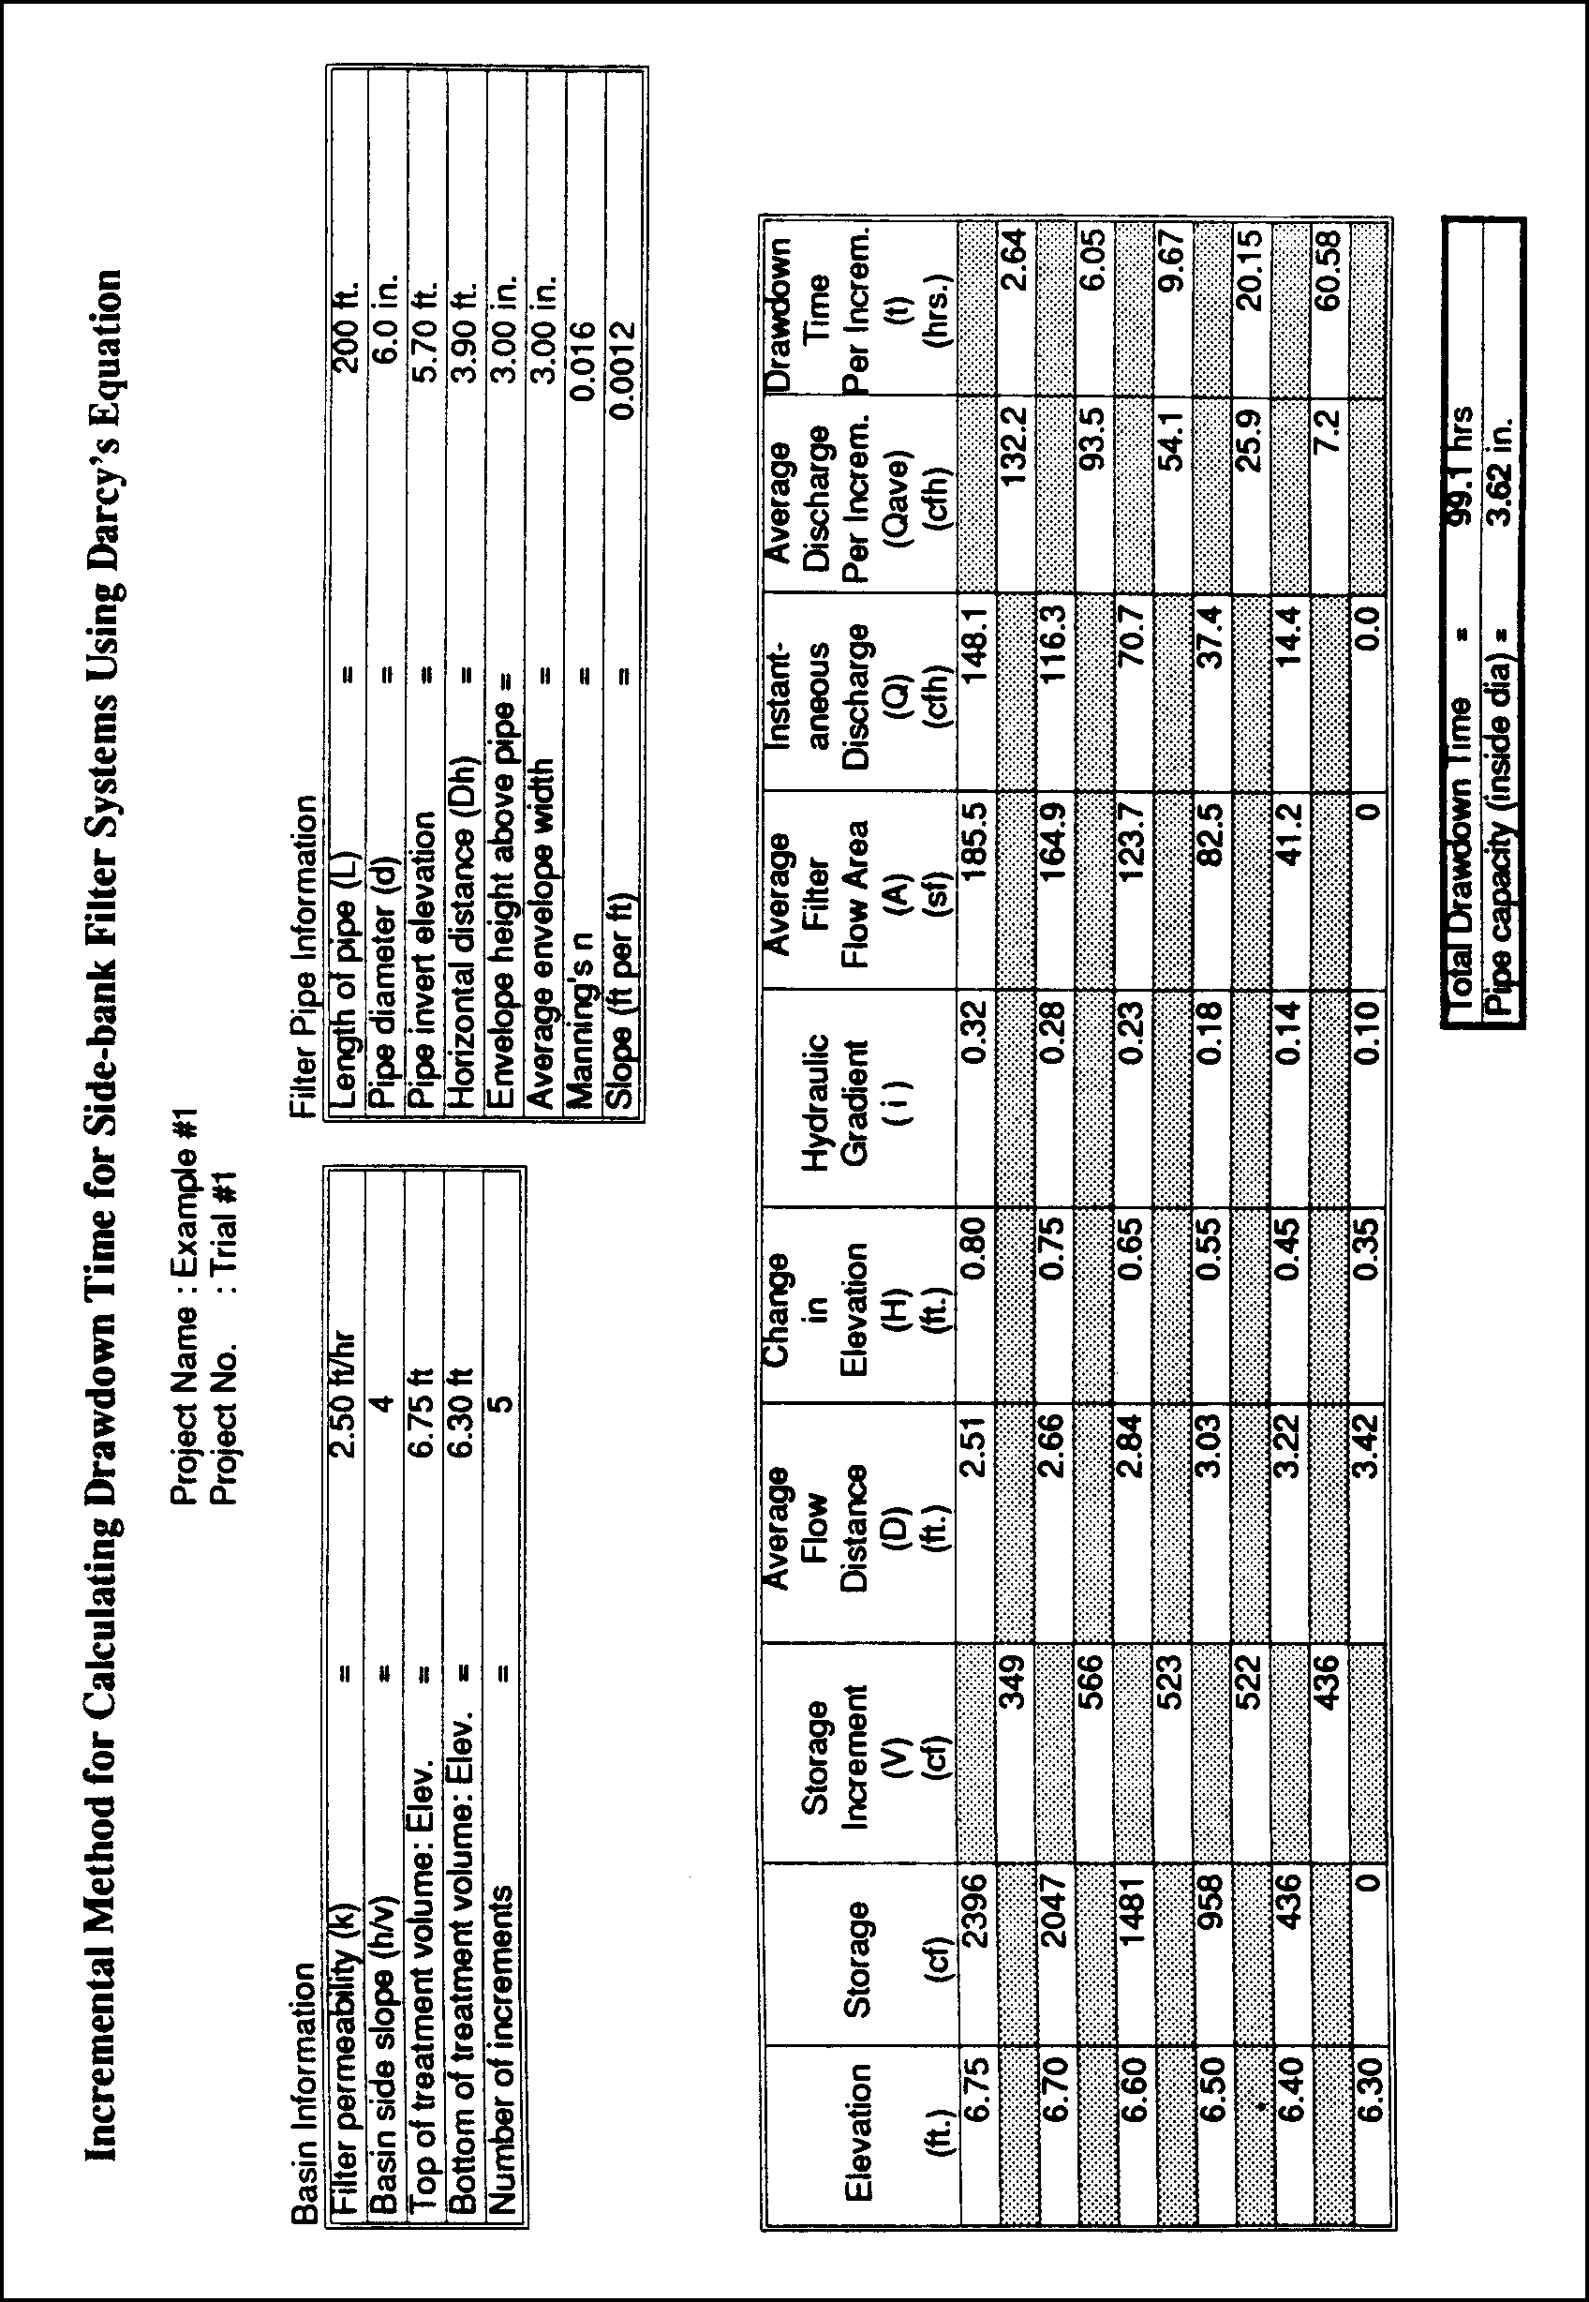

Figure 33-5. Calculations for Example Problem #1; Trial #1

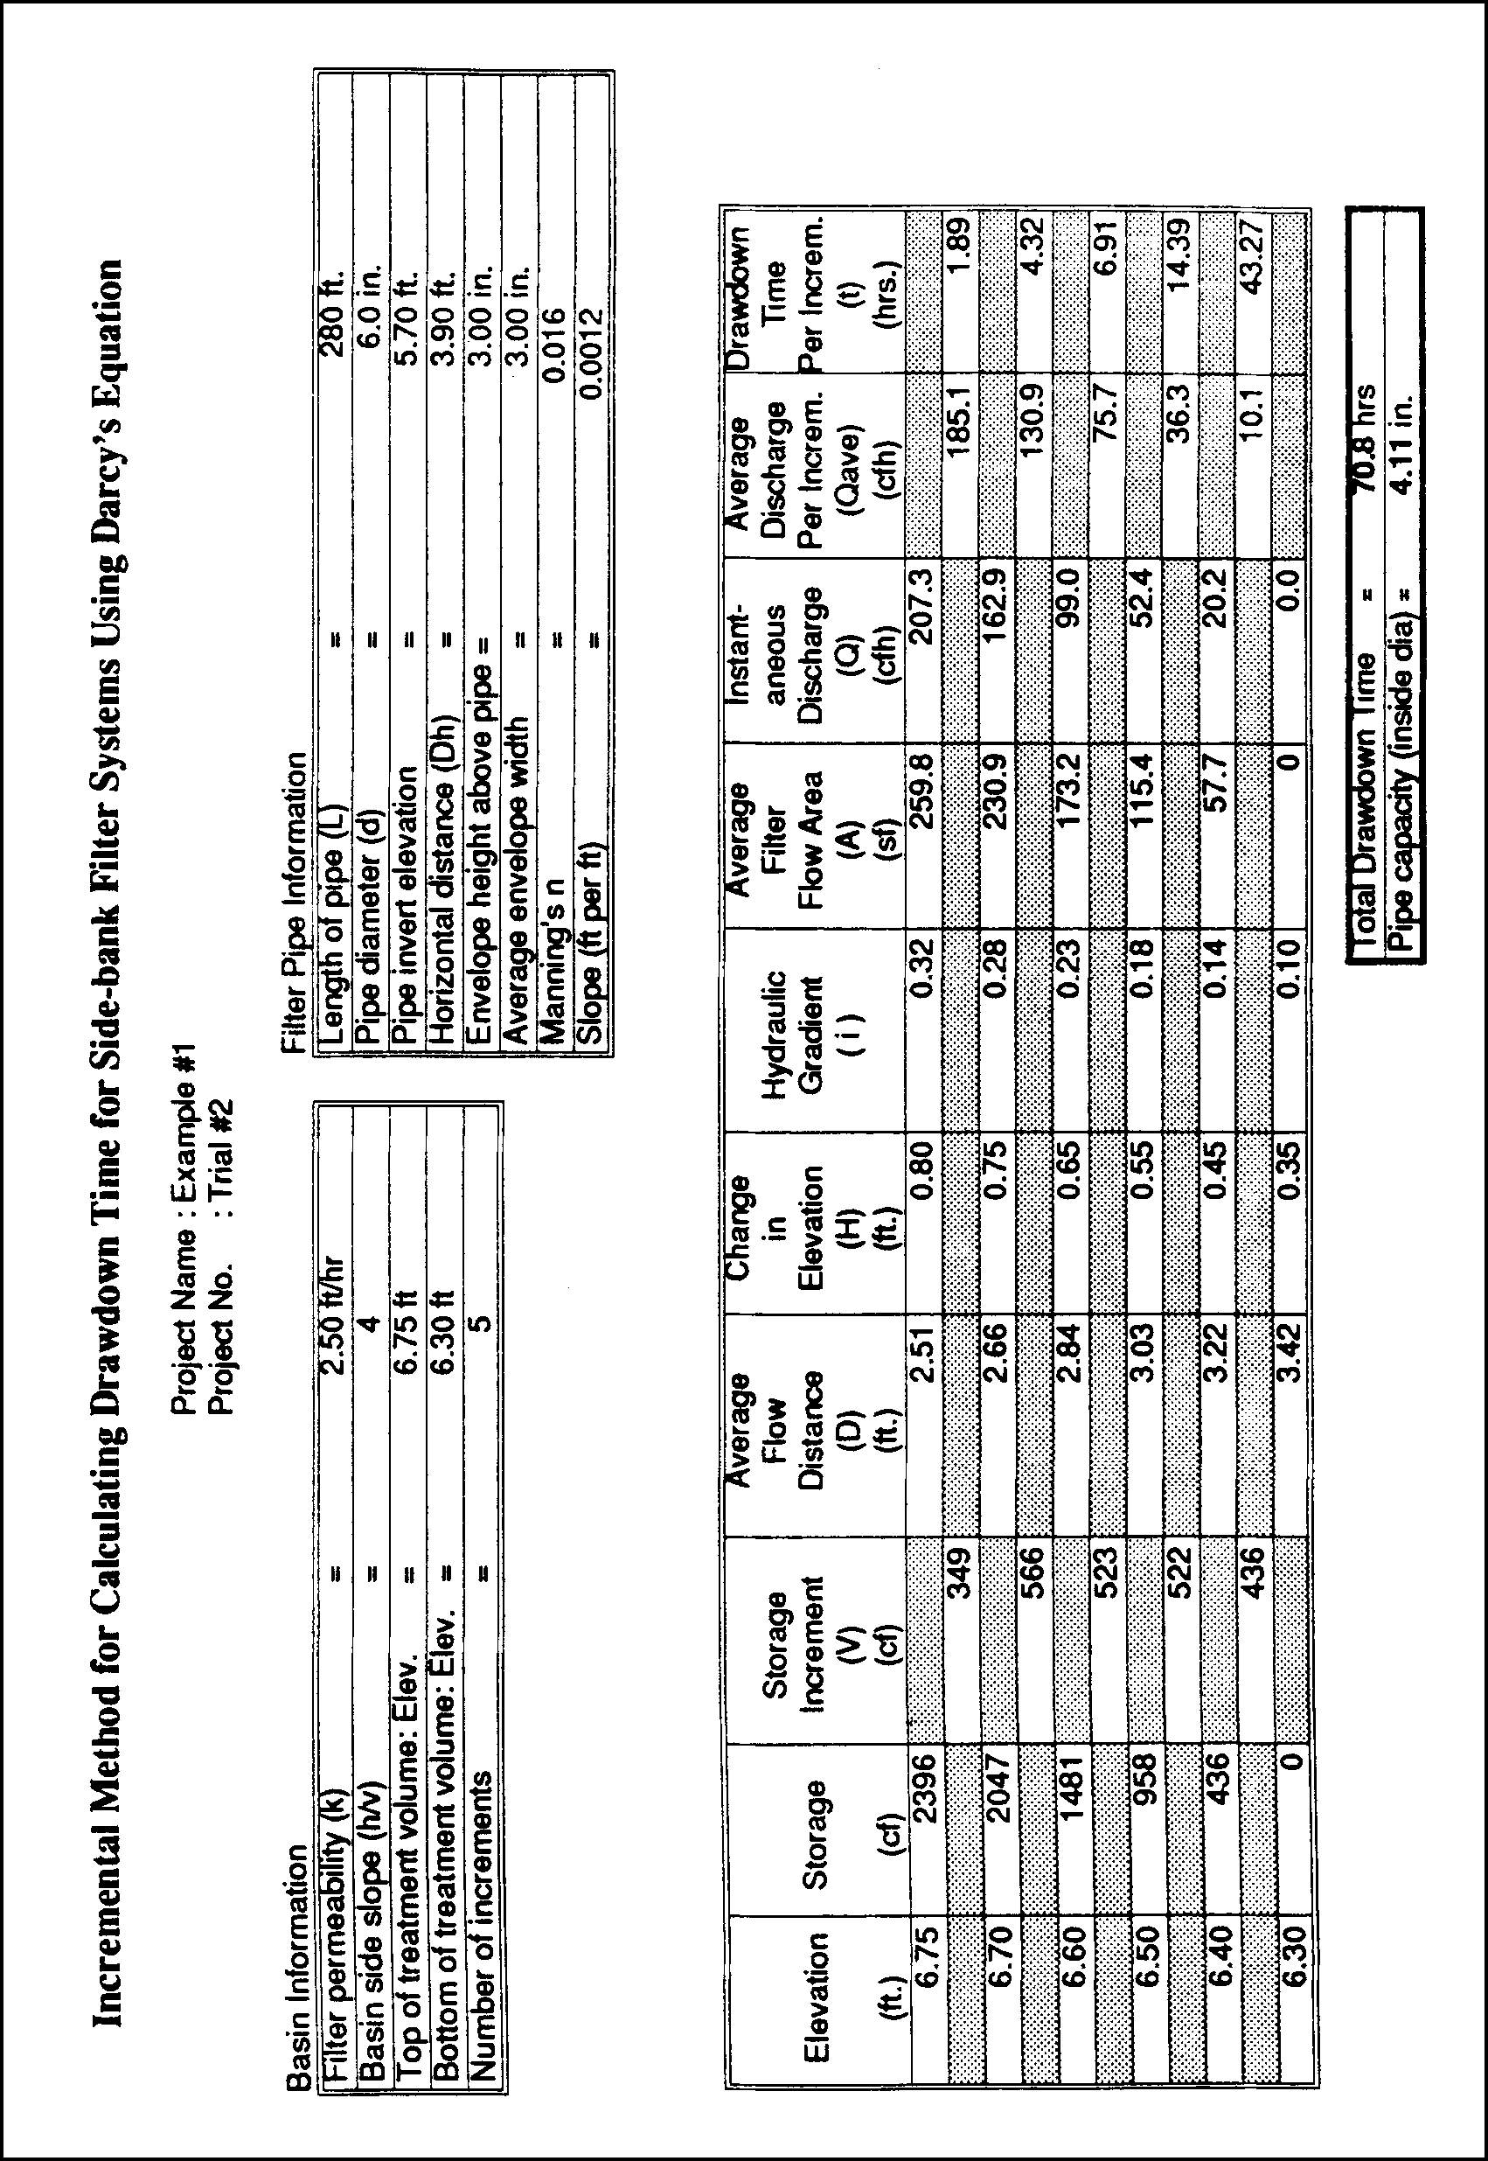
Figure 33-6. Calculations for Example Problem #1; Trial #2

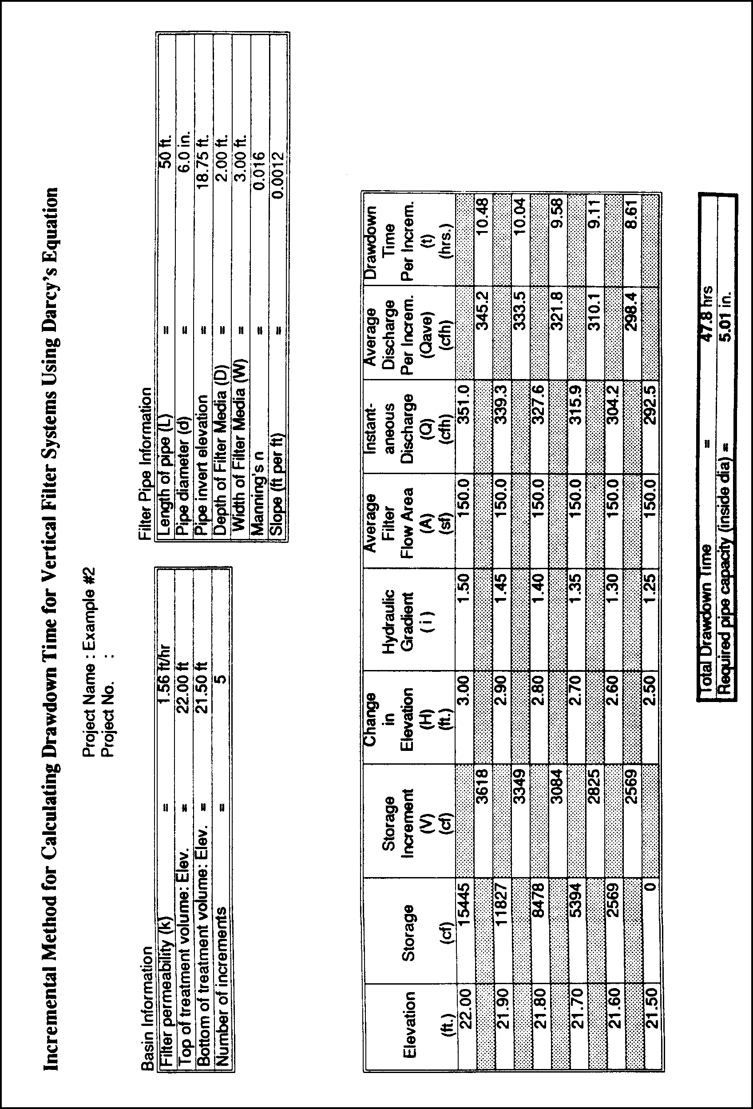
Figure 33-7. Calculations for Example Problem #2

Appendix A – Chapter 40C-42, F.A.C.

Environmental Resource Permits:
Regulation of Stormwater Management Systems

http://www.sjrwmd.com/rules/pdfs/40C-42.pdf

Appendix B

Application Form, Notice of Receipt and
Instructions for Completing Application

http://www.sjrwmd.com/rules/pdfs/40C49001.pdf

Appendix C

As-Built Forms

http://www.sjrwmd.com/rules/pdfs/en45.pdf
http://www.sjrwmd.com/rules/pdfs/en44.pdf

APPENDIX D

Inspection Forms

http://www.sjrwmd.com/rules/pdfs/en46.pdf
http://www.sjrwmd.com/rules/pdfs/en47.pdf

APPENDIX E

Checklist of Stormwater Rule Criteria

APPENDIX E
CHECKLIST OF RULE CRITERIA

This appendix contains a checklist of the design, performance, operation, and maintenance rule
criteria in the Stormwater Applicant's Handbook and is intended to aid applicants in preparing their application submittals.

Criteria Handbook Section

General Design and Performance Criteria
Erosion and Sediment Control 9.1
Oil and Grease Control 9.2
Public Safety 9.3
Basin Side Slope Stabilization 9.4
Maintenance Access 9.5
Legal Authorization 9.6
Tailwater 9.7
Peak Discharge Attenuation 9.8
Conveyance 9.9
Professional Certification 9.10
Sensitive Karst Area Basin Design Criteria 9.11

Specific Design and Performance Criteria
Dry Detention Systems
Treatment Volume 10.2
Recovery Time 10.3
Outlet Structure 10.4
Ground Water Table, Basin Floor, and Control Elevation 10.5
Basin Stabilization 10.6
Basin Configuration 10.7
Inlet Structures 10.8

Retention Systems
Treatment Volume 11.2
Recovery Time 11.3
Basin Stabilization 11.4
Basin Construction 11.5

Underdrain Systems
Treatment Volume 12.2
Recovery Time 12.3
Safety Factor 12.4

Appendix E (continued)

Underdrain Media 12.5
Filter Fabric 12.6
Inspection and Cleanout Ports 12.7
Basin Stabilization 12.8

Exfiltration Trench Systems
Treatment Volume 13.2
Recovery Time 13.3
Safety Factor 13.4
Minimum Dimensions 13.5
Filter Fabric 13.6
Inspection and Cleanout Structures 13.7
Ground Water Table 13.8
Construction 13.9

Wet Detention Systems
Treatment Volume 14.2
Recovery Time 14.3
Outlet Structure 14.4
Permanent Pool 14.5
Littoral Zone 14.6
Littoral Zone Alternatives 14.7
Pond Depth 14.8
Pond Configuration 14.9
Ground Water Table 14.10
Pre-treatment 14.11
Pond Side Slopes 14.12
Discharges to Class I, Class II, or OFWs 14.13

Swale Systems
Treatment Volume 15.2
Recovery Time 15.3
Dimensional Requirements 15.4
Stabilization 15.5

Wetland Stormwater Management Systems
Types of Wetlands 16.3
Treatment Volume 16.4
Recovery Time 16.5
Inlet Structures 16.6
Wetland Function 16.7
Residence Time 16.8

Appendix E (continued)

Monitoring 16.9
Dredge and Fill 16.10

Operation and Maintenance Requirements
Legal Operation and Maintenance Entity Requirements
Acceptable Operation and Maintenance Entities 17.1
Entity Requirements 17.2
Phased Projects 17.3
Construction Phase Entity 17.4
Application Submittal 17.5

Operation Phase Permits
Requirements for the Transfer to Operation Phase Permit 18.1

Monitoring and Operational Maintenance Requirements
Monitoring and Inspection Requirements 19.1
Maintenance Requirements for all Permitted Systems 19.2
Maintenance Requirements for Specific Systems 19.3
Non-functioning Systems 19.4

Alternative Stormwater Treatment System Design and Performance Criteria
Stormwater Reuse Systems
Reuse Volume 20.2
Permanent Pool 20.3
Littoral Zone 20.4
Littoral Zone Alternatives 20.5
Pond Depth 20.6
Pond Configuration 20.7
Ground Water Table 20.8

Vegetative Buffers
Contributing Area 21.2
Vegetation 21.3
Buffer Width 21.4
Maximum Buffer Slope 21.5
Minimum Buffer Length 21.6
Runoff Flow Characteristics 21.7
Maintenance Access 21.8
Maintenance and Inspection 21.9

Appendix E (continued)

Compensating Stormwater Treatment
Overtreatment 22.1
Off-Site Compensation 22.2

Filtration Systems
Treatment Volume 23.2
Recovery Time 23.3
Safety Factor 23.4
Filter Media 23.5
Filter Fabric 23.6
Ground Water Table 23.7
Inspection and Cleanout Ports 23.8
Operation and Maintenance Entity 23.9

APPENDIX F

MODEL LANGUAGE FOR DECLARATION OF COVENANTS AND RESTRICTIONS

DECLARATION OF COVENANTS AND RESTRICTIONS

DEFINITIONS

"Surface Water or Stormwater Management System" means a system which is designed and constructed or implemented to control discharges which are necessitated by rainfall events, incorporating methods to collect, convey, store, absorb, inhibit, treat, use or reuse water to prevent or reduce flooding, overdrainage, environmental degradation, and water pollution or otherwise affect the quantity and quality of discharges from the system, as permitted pursuant to Chapters 62-330 and 62-343, F.A.C.

USE OF PROPERTY

Surface Water or Stormwater Management System

The _________________ Association shall be responsible for the maintenance, operation and repair of the surface water or stormwater management system. Maintenance of the surface water or stormwater management system(s) shall mean the exercise of practices which allow the systems to provide drainage, water storage, conveyance or other surface water or stormwater management capabilities as permitted by the Department of Environmental Protection (Department). The Association shall be responsible for such maintenance and operation. Any repair or reconstruction of the surface water or stormwater management system shall be as permitted, or if modified as approved by the Department.

AMENDMENT

Any amendment to the Covenants and Restrictions that alter the surface water or stormwater management system, beyond maintenance in its original condition, including the water management portions of the common areas, must have the prior approval of the Department.

ENFORCEMENT

The Department shall have the right to enforce, by a proceeding at law or in equity, the provisions contained in this Declaration which relate to the maintenance, operation and repair of the surface water or stormwater management system.

ARTICLES OF INCORPORATION

Duties

The Association shall operate, maintain and manage the surface water or stormwater management system(s) in a manner consistent with the requirements of Department Permit No._________ and applicable Department rules, and shall assist in the enforcement of the restrictions and covenants contained herein.

Powers

The Association shall levy and collect adequate assessments against members of the Association for the costs of maintenance and operation of the surface water or stormwater management system.

ASSESSMENTS

The assessments shall be used for the maintenance and repair of the surface water or stormwater management systems including but not limited to work within retention areas, drainage structures and drainage easements.

DISSOLUTION LANGUAGE

In the event of termination, dissolution or final liquidation of the Association, the responsibility for the operation and maintenance of the surface water or stormwater management system must be transferred to and accepted by an entity which would comply with Rule 62-346.130, F.A.C., and be approved by the Department prior to such termination, dissolution or liquidation.

EXISTENCE AND DURATION

Existence of the Association shall commence with the filing of these Articles of Incorporation with the Secretary of State, Tallahassee, Florida. The Association shall exist in perpetuity.

CHECKLIST FOR HOMEOWNER/PROPERTY OWNER ASSOCIATION DOCUMENTS

Application or Permit No.
Project Name

This checklist is to be used by staff in the review of Homeowner/Property Owner Association (Association) Article of Incorporation, Declaration of Protective Covenants, Deed Restrictions, Declaration of Condominium or other recorded documents (Documents) for compliance with section 17.2 of the Applicant’s Handbook, Regulation of Stormwater Management Systems. This checklist also may be useful by applicants to ensure that the documents submitted to the Department for review are complete.

I. POWERS AND ATTRIBUTES OF THE ASSOCIATION

Pursuant to Section 17.2 the Articles of Incorporation or other documents of record shall set forth-general powers and attributes of the association.

A. Do the documents give the Association the following powers?

1. To own and convey property; ; page number

2. To operate and maintain common property, including the permitted surface water management system ; page number

3. The power to establish rules and regulations ; page number

4. To assess members and enforce assessments ; page number

5. To sue and be sued ; page number and

6. To contract for services to provide for operation and routine custodial maintenance ; page number

7. To require all owners of real property or units to be members of the corporation or association ; page number

8. To demonstrate that the land on which the surface water management system is located is owned or otherwise controlled by the corporation or association to the extent necessary to operate and maintain the system or convey operation and maintenance to another entity ; page number

II. LEGAL DESCRIPTION AND EASEMENTS

A. Do the documents cover the entire project according to the legal description?
If not, which phase(s) does it cover?

B. Is the legal description included as an exhibit? ; Exhibit number

C. Is the legal description by plat? Are golf courses, if any, platted?

D. Where or how will conservation, drainage, access and maintenance easements be dedicated?

E. 1. Are drainage, access and maintenance easements defined and reserved/dedicated to the operating entity? ; page number

2. Does the dedication/reservation state that the easement may not be removed from its intended use by subsequent owners or others? ; page number

3. If a reservation or dedication to the operating entity is not included in the documents, please identify the document(s) where such a reservation or dedication is made.

F. Are conservation easement use restrictions defined and included in the documents? ; page number

III. OWNERSHIP AND MAINTENANCE—MULTIMEMBER ASSOCIATIONS

A. Pursuant to section 17.2.4(a), the documents should state that it is the responsibility of the Association to “operate and maintain the stormwater management system.” Do the documents provide that the association shall operate and maintain the surface water management system? ; page number

B. Pursuant to section 17.2.4(c), there must be a method to assess members a fee for the cost of operation and maintenance of the system.” Do the documents provide that the association can assess and collect for the operation, maintenance and replacement of the surface water management system through regular and special assessments? ; page number

IV. AMENDMENTS, DURATION AND DISSOLUTION

- Any proposed amendment to the Association’s documents affecting the surface water management system (including environmental conservation areas and the water management portions of the common areas) must be submitted to the Department for a determination of whether the amendment necessitates a modification of the environmental resource permit. If a modification is necessary, the Department will so advise the permittee. The amendment affecting the surface water management system may not be finalized until any necessary permit modification is approved by the Department or the Association is advised that a modification is not necessary.”

Is an amendment section included, which requires Department approval if the surface water management system, environmental conservation areas, and/or water management portions of common areas requested by the permit would be affected? ; page number

B. Section 17.2.4(e) states that the Association must “exist in perpetuity.” However, should the Association dissolve, the operational documents must provide that the surface water management system shall be transferred to and maintained by one of the entities identified in sections 17.1(a) through (e), who has the powers listed in section 17.2, and who has the ability to accept responsibility for the operation and routine custodial maintenance of the surface water management system.

1. Do the documents provide that the Association shall exist in perpetuity? ; page number

2. If the Association is dissolved, are their provisions requiring the surface water management system, property containing the surface water management system and water management portions of common areas required to be conveyed to an entity meeting the requirements explained above? ; page number

V. MITIGATION MONITORING AND MAINTENANCE

If wetland mitigation monitoring is required by the environmental resource permit and the operational entity must be responsible to carry out this obligation, the rules and regulations shall state that it will be the Association’s responsibility to complete the task successfully, including meeting all conditions associated with mitigation maintenance and monitoring. If monitoring and/or maintenance of mitigation areas are required by the permit, please answer the following questions.

A. If wetland mitigation monitoring will be the responsibility of the Association, do the Association documents indicate that the Association shall be responsible for mitigation monitoring? ; page number

B. Are any requirements pertaining to perpetual mitigation maintenance included in the documents? ; page number

VI. ENFORCEMENT

A. The Department has the right to take enforcement action, including a civil action for an injunction and penalties, against the Association to compel it to correct any outstanding problems with the surface water management system facilities or in mitigation or conservation areas under the responsibility or control of the Association.

Do the Association documents indicate that the Department has the right to take enforcement action against the Association as stated above? ; page number

VII. PHASED PROJECTS OR INDEPENDENT ASSOCIATIONS

A. If a master association is proposed for a project which will be constructed in phases and subsequent phases will use the same surface water management system, does this Association have the ability to accept future phases into the Association? ; page number

B. If the development contemplates independent associations for different phases, but proposes an interdependent water management system for the different phases:

1. Do the documents provide that the independent associations, if any, have the right to utilize the permitted surface water management system? ; page number

2. Do the documents delineate maintenance responsibilities between the parties and grant ingress and egress easements for maintenance? ; page number

Additional Documents Required Prior to Construction Completion Certification

Prior to or simultaneous with the submittal of the construction completion/construction certification statement, the following additional documents will be required:

1. Filed copy of the articles of incorporation;

2. Recorded copy of deed restrictions and associated exhibits;

3. Copy of the certificate of incorporation;

4. Copies of all plats; and

5. A signed written statement from the proposed transferee that it has reviewed the Department permit and project design and will be bound by all terms and conditions of the permit, including all compliance requirements, for the duration of the permit.

Application No(s).

Permit No.

Project Name:

CERTIFICATION

I, , on behalf of in the capacity as , hereby certify to the following pertaining to the above project:

[per 17.2.4, SJRWMD A.H., Regulation of Stormwater Management Systems] I certify that the Home or Property Owners' or Condominium or Community or Master-Association has the following general powers and attributes set forth in the Articles of Incorporation or other documents on the page numbers indicated:

- The power to:  - Operate and perform routine custodial maintenance of the surface water management system as exempted or permitted by the Department, including all lakes, retention areas, culverts and related appurtenances;  - Establish rules and regulations;  - Assess members and enforce assessments;  - Contract for services to provide for operation and maintenance services;  - Exist in perpetuity, and, if dissolved, to transfer responsibility for operation and maintenance of the stormwater management system to an entity acceptable to the Department; and  - Enforce restrictions relating to operation and maintenance of the stormwater management system. | Page no.  Page no.  Page no.  Page no.  Page no.  Page no.

[per 17.2.4(c), , SJRWMD A.H., Regulation of Stormwater Management Systems] I further certify that the following covenants and restrictions are contained in the Declaration of Protective Covenants, Declaration of Condominium, Deed Restrictions or Articles of Incorporation (documents) on the page numbers indicated:

- The Association is responsible for the operation and maintenance of the surface water management system described in the permit. | Page no.
- Provisions for the Association to have the authority to establish rules and regulations | Page no.
- The Association is responsible for assessing and collecting fees for the operation and maintenance of the surface water management system. | Page no.
- Any amendment proposed to these documents which would affect the surface water management system (including environmental conservation areas and water management portions of the common areas) will be submitted to the Department for a determination of whether the amendment necessitates a modification of the permit. Any amendment affecting the surface water management system will not be finalized until any necessary permit modification is approved by the Department or the Association is advised that a modification is not necessary. | Page no.
- Provisions relating to the operation and maintenance of the stormwater management system may be enforced by the Department in a proceeding at law or in equity. | Page no.
- That Association shall exist in perpetuity. However, should the Association dissolve, the surface water management system will be transferred to and maintained by one of the entities identified in sections17.1(a) through (e), of the SJRWMD Applicant’s Handbook Regulation of Stormwater Management Systems, who has the powers, covenants and restrictions listed in section 17.2.4(a) through (h), including the responsibility for establishment of a suitable entity for the operation and routine custodial maintenance of the stormwater water management system prior to its dissolution. | Page no.

- If wetland mitigation or monitoring is required the association shall be responsible to carry out this obligation. The rules and regulations state that it shall be the Association's responsibility to complete the task successfully, including meeting all (permit) conditions associated with wetland mitigation, maintenance and monitoring. | Page no.
- The Department has the right to take enforcement action, including a civil action for an injunction and penalties, against the Association to compel it to correct any outstanding problems with the surface water management system facilities or in mitigation or conservation areas under the responsibility or control of the Association. | Page no.
- The environmental resource permit and its conditions will be attached to the rules and regulations as an exhibit. The Registered Agent for the Association will maintain copies of all further permitting actions for the benefit of the Association. | Page no.

[per 17.3.2 SJRWMD A.H. Regulation of Stormwater Management Systems] If the project is a phased project or has independent associations, I further certify that the following powers and duties are contained in the documents:

- The (Master) Association has the power to accept into the association subsequent phases or entities, that will utilize the same surface water management system, and that the (Master) Association will be responsible for operation and maintenance of the entire system; or | Page no.
- a. The documents provide that independent associations have the right to use the permitted surface water management system; | Page no.
- The documents delineate operation and maintenance responsibilities between the independent associations, separately or collectively; | Page no.
- Cross easements for drainage, and ingress and egress for maintenance, copies of which are attached, have been granted between all independent associations utilizing the surface water management system. | Page no.

________________________________________________________
Signature

State of Florida
County of __________________________________)

I HEREBY CERTIFY that on the __________ day of _________________________, 20______, before me, an officer authorized in the State aforesaid and in the County aforesaid to take acknowledgements by ____________________________________________________________________, who is personally known to me or has produced _______________________________________________________ as identification and who did (did not) take an oath.

________________________________________________________
Notary Public, State of Florida

APPENDIX G

Permit Review Process Flowchart

APPENDIX H

Class I, Class II, And Outstanding Florida Waters
Within The St. Johns River Water Management District

Appendix H

Class I, Class II, and Outstanding Florida Waters
within the St. Johns River Water Management District

Chapter 40C-42, F.A.C., requires a baseline level of treatment for stormwater management
systems which discharge to Class III water bodies and an additional level of treatment for
systems which discharge to Class I, Class II, or Outstanding Florida Waters (OFWs). The
designated use for each classification is as follows:

Class I Potable Water Supplies
Class II Shellfish Propagation or Harvesting
Class III Recreation, Propagation and Maintenance of a Healthy, Well-Balanced Population of Fish and Wildlife

Outstanding Florida Waters are waters designated by the Environmental Regulation Commission
as worthy of special protection because of their natural attributes. Generally, OFWs include
surface waters in the following areas:

a) National Parks
b) National Preserves
c) National Wildlife Refuges
d) National Seashores
e) National Marine Sanctuaries
f) National Estuarine Research Reserves
g) certain waters in National Monuments
h) certain waters in National Forests
i) State Parks
j) State Wilderness Areas
k) Wild and Scenic Rivers
l) State Aquatic Preserves
m) water in areas acquired through donation, trade, or purchase under the Environmental Endangered Lands Bond Program, Conservation and Recreation Lands Program, Land Acquisition Trust Fund Program, and Save Our Coast Program

Waters that are found to have exceptional recreation or ecological significance which are not
protected as above may also be designated as OFWs. Such "Special Waters" OFWs include
several rivers, lakes and lake chains, and estuarine areas. It should be noted that many of the
OFWs overlap geographically and that several of the Class II waters are also OFWs.

A quick reference guide of Class I, Class II, and OFWs in the St. Johns River Water
Management is included in Table H-1. Actual rule language describing Class I and Class II
waters in found in section 62-302.600, F.A.C., and the rule language for OFWs is in section 62-
302.700, F.A.C. The actual rule language changes periodically and is generally more complex
than Table H-1. The rule language takes precedent over this table and should be consulted when
there is a question as to specific boundaries.
Table H-1. Class I, Class II, and Outstanding Florida Waters within the St. Johns River Water
Management District

County | Water Body | Class
Alachua | Lochloosa Lake  Marjorie Kinnan Rawlings State Historical Site  Orange Lake, River Styx, Cross Creek  Paynes Prairie State Preserve | OFWs
Baker | Okefenokee National Wildlife Refuge  St. Marys River - Middle Prong | OFWs
Brevard | St. Johns River & Tributaries - Lake Washington Dam south including Sawgrass Lake and Lake Hellen Blazes | Class I
 | Goat Creek  Kid Creek  Trout Creek | Class II
 | Mosquito Lagoon*  Indian River* | Class II  and OFWs
 | Banana River Aquatic Preserve  Canaveral National Seashore  Merritt Island National Wildlife Refuge  St. Johns National Wildlife Refuge  Sebastian Inlet State Recreation Area | OFWs
Clay | Black Creek – North Fork  Kingsley Lake  Mike Roess Gold Head Branch State Park | OFWs
Duval | Ft. George River  Intracoastal Waterway*  Nassau River and Creek  Pumpkinhill Creek | Class II
 | Big Talbot Island State Park  Little Talbot Island State Park  Nassau Valley State Reserve  Ft. George Island  Nassau River – St. Johns River Marshes Aquatic Preserve | OFWs
Flagler | Matanzas River (Intracoastal Waterway)* | Class II
 | Pellicer Creek | Class II  and OFWs
 | Bulow Creek State Park  Flagler Beach State Recreation Area  Haw Creek State Preserve  Tomoka Marsh State Aquatic Preserve  Washington Oaks State Gardens | OFWs

* complex - see rule
Table H-1—Continued

County | Water Body | Class
Indian River | Blue Cypress Lake  St. Johns River and Tributaries | Class I
 | Indian River* | Class II and OFWs
 | Indian River North Beach  Pelican Island National Wildlife Refuge  Sebastian Inlet State Recreation Area | Class II
Lake | Alexander Springs and Alexander Springs Creek  Clermont Chain of Lakes  Hontoon Island State Park  Juniper Creek  Lake Woodruff National Wildlife Refuge  Lake Dorr  Lake Griffin State Recreation Area  Lake Louisa State Park  Lower Wekiva River State Reserve  Wekiva River System* | OFWs
Marion | Juniper Creek  Juniper Springs  Lake Kerr  Little Lake Kerr  Ocklawaha River  Orange Lake, Cross Creek, River Styx  Salt Springs and Salt Springs Run  Silver River and Silver River State Park | OFWs
Nassau | Alligator Creek  Nassau River and Creek*  South Amelia River*  Waters between South Amelia River & Alligator Creek | Class II
 | Amelia Island State Recreation Area  Fort Clinch State Park  Nassau River - St. Johns River Marshes  Nassau Valley State Reserve | OFWs
Orange | Econlockhatchee River System  Rock Springs Run State Reserve  Wekiva River System*  Wekiwa Springs State Park  William Beardall Tosohatchee State Reserve | OFWs
Osceola | Econlockhatchee River System  Three Lakes Ranch | OFWs

* complex - see rule

Table H-1—Continued

County | Water Body | Class
Putnam | Haw Creek State Preserve  Lake Kerr  Little Lake Kerr  Ravine State Gardens | OFWs
St. Johns | Matanzas River, Intracoastal Waterway*  Salt Run*  Tolomato River (North River)* | Class II
 | Guano River*  Pellicer Creek | Class II and  OFWs
 | Anastasia State Recreation Area  Faver-Dykes State Park  Guana River State Park | OFWs
Seminole | Econlockhatchee River System  Lower Wekiva River State Reserve  Spring Hammock  Wekiva River System*  Wekiwa Springs State Park | OFWs
Volusia | Indian River*  Indian River North*  Indian River Lagoon* | Class II
 | Mosquito Lagoon* | Class II and OFWs
 | Blue Springs State Park  Bulow Creek State Park  Canaveral National Seashore  DeLeon Springs State Recreation Area  Haw Creek State Preserve  Hontoon Island State Park  Lake Woodruff National Wildlife Refuge  Lighthouse Point State Recreation Area  Merritt Island National Wildlife Refuge  New Smyrna Sugar Mill Ruins State Historic Site  North Peninsula State Recreation Area  Spruce Creek  Stark Tract  Tomoka Marsh Aquatic Preserve  Tomoka River  Tomoka State Park  Volusia Water Recharge Area  Wekiva River System* | OFWs

* complex - see rule

Table H-1—Continued

References:

Sections 62-302.600 and 62-302.700, Florida Administrative Code

Florida Department of Environmental Regulation. 1987. Atlas of Outstanding Florida Waters.
Water Resources Programs Section, Tallahassee, Florida.

Florida Department of Environmental Regulation. June 1992. Listing of Outstanding Florida
Waters by County. Standards and Monitoring Section, Tallahassee, Florida.

See Sections 2.4 and 2.5, A.H. v. II.
Although not specifically required by Section 12.3.3, A.H. v. I, the inclusion of conservation easement use restrictions in the documents is considered informative.

