FGS Collaborates with the Florida Wildlife Conservation Commission
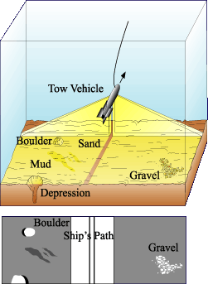
The Florida Geological Survey is collaborating with its sister agency, the Florida Wildlife Conservation Commission (FWCC) by investigating the shallow sea floor off the shores of west and northwest Florida. Florida is part of a larger landmass known as the Florida Platform. Approximately half of the platform’s landmass is submerged beneath the Gulf of Mexico and the Atlantic Ocean. The shallow submerged portions of the Florida Platform along the coast provides unique habitats for game fish and other marine animals that are important to the economy of Florida. There may also exist economic mineral deposits and other geologic features of interest that are currently undiscovered. This collaborative effort is providing important information about Florida’s northwest coastal zone.
Diagram illustrating how side-scan sonar works. Photo credit: Marine Sonic

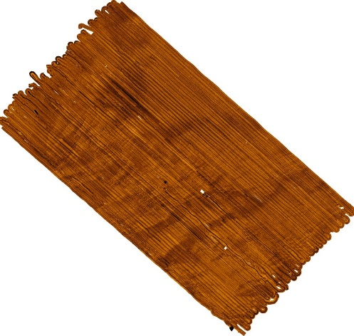
The FWCC is using the FGS’ 50-foot research vessel, the RV GeoQuest, to collect side-scan sonar data over selected areas of interest. The researchers deploy a tow-behind device, called a “tow-fish,” that sends out sonic pulses which bounce off the sea floor and are returned to a microphone. By calculating the time it takes for the pulses to bounce off the sea floor and return to the microphone, it is possible to generate an “image” of the sea floor along the vessel’s track. Areas that show abrupt changes in bottom topography could be locations where rock exposures provide protective habitat for many species of marine animals. By identifying areas where rock is exposed on the sea floor, geologists obtain an understanding of the geology of the area. These images, coupled with video, photographs, and sea-floor samples, may one day allow the FGS to produce geologic maps for this important and understudied part of the state.
Side-scan sonar mosaic showing submerged paleo drainage channels.
Contact: Dan Phelps, P.G.

