Walter Schmidt Museum of Florida Geology Opens at New FGS Facility
Over the past 108 years, geologists at the Florida Geological Survey collected thousands of rock, mineral, and fossil specimens from throughout Florida. The FGS has maintained these collections, provided displays for the public, and made the collections accessible to scientists over the years. The lobby of former FGS headquarters, the Herman Gunter Building, displayed various collections ranging from calcite specimens to an articulated skeleton of an 18 million year old dugong (a medium-sized marine mammal that resembles a manatee). These exhibits were dismantled, packed, and moved into our new facility at 3000 Commonwealth Boulevard in February of this year. The specimens were cleaned, repaired (if needed), updated with new labels and put on display at the new facility in time for the Fall FGS Open House, which was held during Earth Science Week. Hundreds of visitors were able to explore our museum and discover what make Florida’s geology unique.
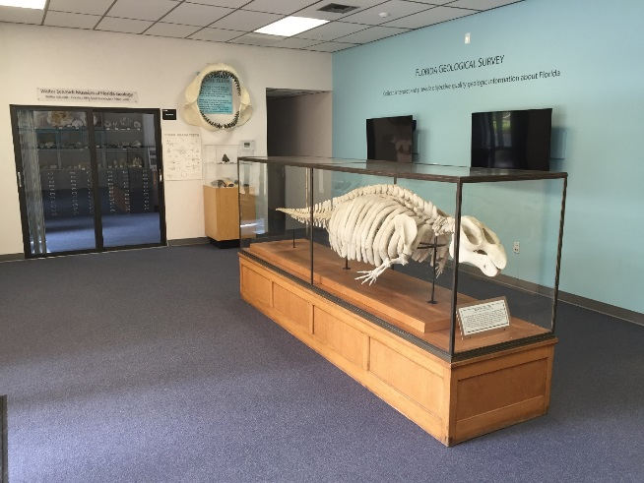
The new facility has two areas dedicated to exhibits of geologic interest. Upon entering the museum area, guests are greeted by the fossil dugong skeleton, which has been a focal point for FGS visitors for decades. Other exhibits include two video monitors that display various slide shows of Florida’s geologic features and videos depicting FGS activities and educational information about Florida’s geology. Along the west wall of the lobby area, visitors can view an exhibit of fossil shark teeth, a full size replica of an extinct mako shark, various vertebrate fossils, and a display of agatized coral heads from the Withlacoochee River. The mako shark jaw and the coral heads were loaned to the FGS by the Florida Museum of Natural History (FLMNH), with whom the FGS has enjoyed a long, collaborative relationship. Over the decades, thousands of vertebrate and invertebrate fossil specimens collected by FGS staff have been transferred to the FLMNH for further study and archiving.
A sliding glass door separates the lobby museum displays from various exhibits that range from calcite specimens and speleothems (cave deposits) to fossil echinoids and petrified wood. Some specimens of note include calcite-filled fossil clam shells from Okeechobee County, and calcite crystal-laden limestone boulders collected from Citrus County. The legacy of Florida’s fifth State Geologist, Walter Schmidt, is honored with the museum’s name: The Walter Schmidt Museum of Florida Geology.
Many of the items on display in this area were collected by FGS staff geologists or donated by people who have worked with the FGS over the years. We welcome contributions of museum-quality specimens from public and private entities alike.
Contact: Harley Means, P.G.

