DEP/FGS Employee Jackie Lloyd Retires with Honors

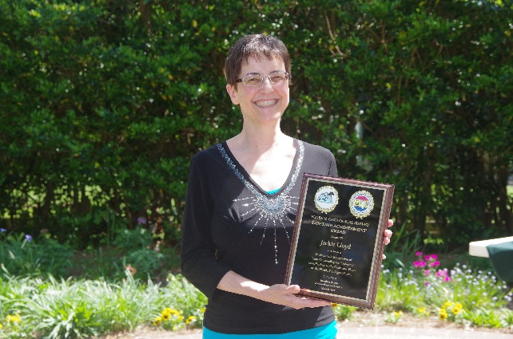
The end of 2015 is certainly a bittersweet time for the Florida Geological Survey (FGS) as staff bid a fond farewell to Jacqueline Lloyd, a Professional Geologist Administrator at FGS. After 34 years with the FGS, Jackie is retiring in order to relax and pursue new opportunities and adventures. “The FGS will certainly never be the same without her,” said Director Jon Arthur as he presented Lloyd with FGS’ most distinguished Herman Gunter Lifetime Achievement Award this past spring. “I do not know anybody more efficient and productive than Jackie - she will be missed.”
Jackie Lloyd accepts the Herman Gunter Lifetime Achievement Award at the FGS Awards Luncheon.

Originally hired as a Geologist II on August 25, 1981, Jackie was immensely successful at the FGS, eventually moving on to head up the Administration Section as a Professional Geologist Administrator and serving as Assistant State Geologist. Over her career, she was a collaborator for 30 publications, completed the Certified Public Manager Program, earned five FGS Extra Effort Awards, FGS Employee of the Year, a FGS Sustained Exemplary Performance Award, and also a DEP Star Award. Those who had the pleasure of working with Jackie know what a true asset she is. She has always been willing to go above and beyond to fill in any needs of the DEP/FGS, whether it be in a scientific or administrative capacity. Jackie’s combination of talents and personality are one-of-a-kind and irreplaceable. She is intelligent, intuitive, positive, caring and a pleasure to work with. Her qualities and knowledge of the FGS and the Department are part of what made her such a tremendous part of the FGS leadership team. Jackie is truly deserving of significant recognition, and is wished success, happiness, and good health in her retirement.

