FGS Current Projects Instructions
Upon opening the FGS projects map you will be presented with an information window like the one below.
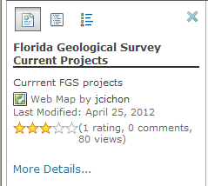
There are three buttons (or tabs) at the top of the window. The first one gives you information about the map, the second lists the contents of the map and the third shows the legend. You may have to toggle between the second and third buttons to get the legend symbology to show correctly (this is an ArcGIS online quirk). If you click on the “more details” link it will take you to a page with more information about the map and some simple instructions about identifying projects.
If you select the legends button you will get a window like the one below (if you don’t see any symbols click on one of the other buttons and then the legend button again).
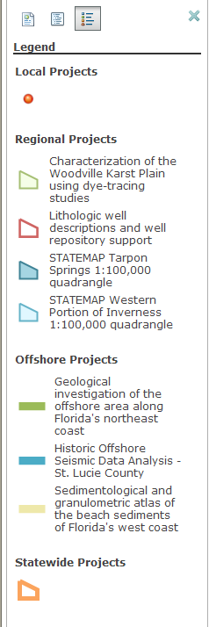
If you would like to know more about a project simply click on one of the symbols in the map (see below). A window will pop up with information about that particular project. A large orange box (polygon) represents the FGS statewide current projects. When you select a local (or regional) project in the map, ArcGIS online will automatically select all of the statewide projects since they contain the area of the local or regional features. Therefore, after selecting your local (or regional) project of interest, check the blue section at the top of the information window. The blue section will say 1 of 7 (depends on number of statewide current projects) and have an arrow indicating that you can scroll through these other choices. The 6 other choices are the statewide projects. You can also click anywhere within the orange box that doesn't contain a point or regional polygon to obtain just the statewide project information.

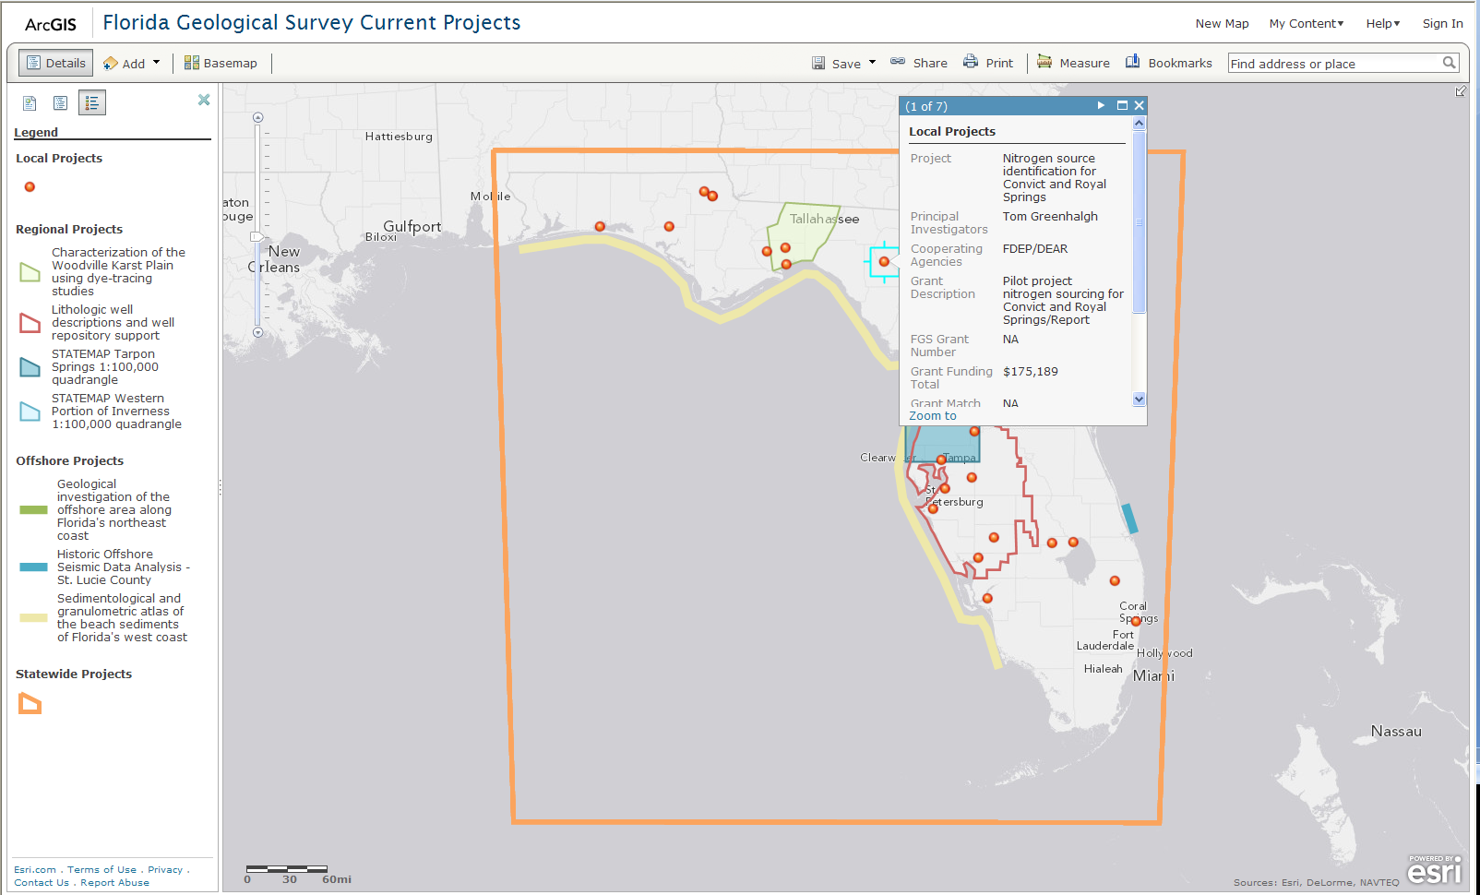
If you would like to add a different basemap (aerial, topography) you can select one by hitting the Basemap button at the top of the map (see above). You will not be able to save the map but you can customize it while you have it open.

