FY 13-14

FGS Business Plan
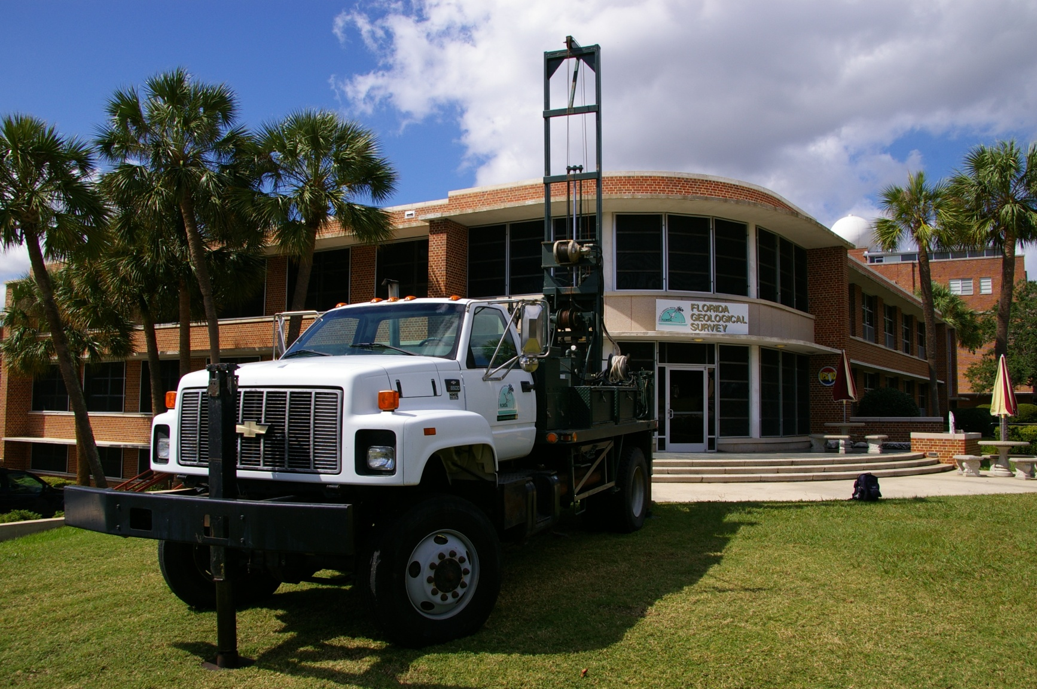

Office of the Florida Geological Survey
Florida Department of Environmental Protection
Version 14.0

EXECUTIVE SUMMARY
The Florida Geological Survey (FGS) within the Florida Department of Environmental Protection (DEP) is located in the Gunter Building on the Florida State University campus in Tallahassee, Florida. The FGS mission is to “Collect, interpret and provide objective quality geologic information about Florida.”

The FGS, established in 1907 with enacting law Chapter 377, Part I, Florida Statutes (F.S.), is the sole agency in Florida responsible for collecting, interpreting, disseminating, storing and maintaining solid earth geologic data from uplands and submerged lands of the state. This includes: maintaining a geologic sample repository and database, a research library, field and laboratory equipment, and disseminating numerous series of professional publications to the public and to repository libraries throughout Florida, the United States and the world. Geologic data and interpretations are provided to governmental agencies, land-use planners, environmental and engineering consultants, universities, mineral owners and exploration companies, industry, and the public in support of resource conservation, protection and recovery, as well as human health protection. More than one-third of DEP programs rely on geologic data and services of the FGS.

Current FGS staffing includes 27.5 FTE employees and 10 OPS employees. The FGS is led by the Director and State Geologist who oversees and directs three sections:
- Administration Section, which provides administrative support for the FGS programs;
- Applied Geoscience Services Section, which uses the basic geological research data and maps to generate, analyze, interpret and disseminate hydrogeologic data and information to decision makers at all levels of government, academia, the consulting community and the public at large ; and
- Geological Investigations Section, which focuses on basic geological research, mapping, and assessments
Current appropriations to the FGS total $2,980,088. State trust funds totaling $2,265,774 provide the FGS base operating budget. The remaining $714,314 is spending authority from the Federal Grants Trust Fund and the State Grants and Donations Trust Fund. The actual allowable expenditures from these funds are determined by successfully seeking and receiving grant awards from federal, state and local granting entities.
As required by Chapter 377.075, F.S. , DEP/FGS provides geoscience data and interpretations to the general public, industry, and government agencies of all levels, with focus on “the practical bearing of the subjects of such investigations on the well-being of this state and the citizens of this state” (Chapter 377.075 (4)(a), F.S.). The basic geologic research conducted by the FGS is necessary to all applied geologic and hydrogeologic research projects which in turn have a bearing on the well-being of the state and its citizens.
Emphasis on providing timely, accurate and objective geologic data and maps to DEP’s regulatory programs is essential to meeting the DEP Secretary’s priority to get the water right in Florida. Providing reliable geological information that is interpreted consistently across the state while protecting the environment also assists with the Secretary’s other priority for a more certain regulatory process.
TABLE OF CONTENTS

EXECUTIVE SUMMARY 2
MISSION, VISION & CORE VALUES 4
CLIENT SERVICES 5
ORGANIZATIONAL STRUCTURE 7
Office of the Director and State Geologist 8
Administration 8
Applied Geoscience Services 8
Geological Investigations 8
BUDGET OVERVIEW 9
Key Performance Measures & Indicators 11
FGS MID AND LONG-TERM GOALS 25
CONTINUOUS IMPROVEMENT, ACHIEVEMENTS & SUCCESSES 26

LIST OF APPENDICES
Appendix A. REVISION HISTORY 27
APPENDIX B. FLORIDA DEPARTMENT OF ECONOMIC OPPORTUNITY 5-YEAR STRATEGIC PLAN AT A GLANCE 28
APPENDIX C. FGS 4th QUARTER BUDGET PROJECTION—FY13/14 29
APPENDIX D. FGS STAFF DEVELOPMENT PLAN FOR FY13/14 30
APPENDIX E. SHARED SAVINGS INCENTIVE PLAN 43
APPENDIX F. PROPOSED FGS STAFF DEVELOPMENT PLAN FOR FY 14-15 45
APPENDIX G. DRAFT FY 15-16 LBR REDUCTION PROPOSAL 1 OF 2 60
APPENDIX H. DRAFT FY 15-16 LBR REDUCTION PROPOSAL 2 OF 2 61
APPENDIX I. DRAFT FY 15-16 LBR--FGS STATEMAP PROGRAM OPS TO FTE CONVERSION 62

MISSION, VISION & CORE VALUES
Mission
The Florida Department of Environmental Protection (DEP), the State’s lead agency for environmental management and stewardship, is a diverse agency, established to protect and manage our State’s natural resources, including our air, water, and land.
The mission of the Florida Geological Survey (FGS) is to “collect, interpret and provide objective quality geologic information about Florida.”
Vision
The FGS is the premier state government institution specializing in geoscience research and assessments to provide objective quality data and interpretations. Environmental, conservation, and public-welfare issues are addressed through applied field and laboratory investigations supported by our geologic sample and research libraries as well as collaborative efforts within DEP and with other regulatory or policy-making entities. The FGS is dedicated to facilitating a culture of responsible environmental stewardship. This is achieved by proactively sharing knowledge through accessible geoscience data, active participation on advisory committees, research and assessment publications, websites, public and technical presentations and educational activities.
Core Values
- Excellence: We provide objective, quality science and information to facilitate decision-making and sustainable practices in support of public health, safety and welfare.
- Integrity: We hold ourselves to the highest possible degree of professionalism, and ethical standards.
- Service: We provide excellence in service to our customers, treating each with dignity and respect.
- Stewardship: We promote environmental protection and conservation through research, assessments, education and outreach.
- Innovation: We integrate and personify the FGS and the DEP missions in our workplace culture, embracing innovative ideas and intellectual advancement to carry out these missions.
- Collaboration: We partner with others to achieve common goals through shared information and resources.
- Teamwork: Each member of our team is implicitly valued and mutually respected as we remain united in our successes, failures and challenges. Camaraderie and enjoyment are the spirit of the organization.

CLIENT SERVICES
The FGS has four client segments which are effectively addressed. These clients expect that the FGS will reasonably, respectfully, and responsibly respond to requests for geological information, interpretation and services.
The Citizens, Businesses, and Visitors of Florida
The citizen and business clients of the FGS include the general public, private consultants and industry representatives. Services provided on behalf of these clients include:
- Geological data including sinkhole assessments, hydrogeochemical information, well inventories, mineral resource information, and geological maps;
- Hydrogeological data, assessments and maps;
- Library services including distribution of FGS publications;
- Access to and assistance with examining geological samples from the FGS Sample Repository;
- Public outreach events and publications;
- Presentations to K-12 classrooms, scout troops, and citizen organizations; and
- Science fair judging at local and regional level.
The Academic Community
The services provided to the academic community include all of those listed above for citizens, visitors and the business sector. Additional services provided on behalf of these clients include:

- On-the-job training for both undergraduate and graduate students through grant-funded project employment;
- Presentations by FGS Professional Geologists for students within the State University System; and
- Advisors to students within the State University System.
DEP and Other Agencies
The FGS provides information to and cooperates with numerous other programs within DEP and other agencies. Services provided include, but are not limited to:
- Sinkhole information, assessment and response;
- Aquifer system mapping;
- Project-driven groundwater quality monitoring;
- Springs investigations, documentation and monitoring;
- Springshed delineation;
- Off shore springs investigation and documentation;
- Surface water – groundwater interaction studies;
- Water-rock interaction studies;
- Dissolved constituents in groundwater;
- Evaluation of sources of arsenic and other trace metals in groundwater;
- Aquifer vulnerability assessment;
- Provide mineral assessments for state land transactions;
- Provide library materials and publications;
- Provide the services of the FGS Research Librarian for scientific/topical reference and background information searches;
- Install monitoring wells as requested by state agencies;
- Refine mapping of Florida’s geology on both 1:24,000 and 1:100,000 scales;
- Identify locations and analyze quality of sands for beach restoration;
- Provide basic geologic information and interpretation of geologic data;
- Addressing requests from media; and
- Providing geoscience information, data and interpretation to DEP Executive Leadership and elected officials

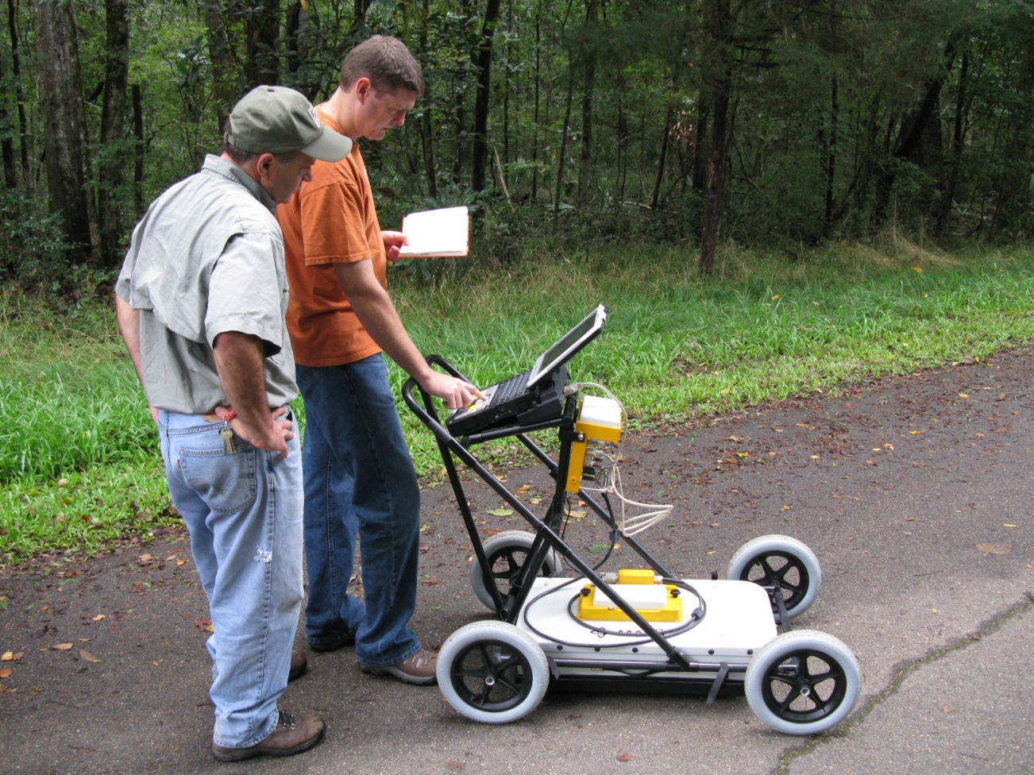
Figure 1. FGS Ground Penetrating Radar Study, Florida Caverns State Park

ORGANIZATIONAL STRUCTURE
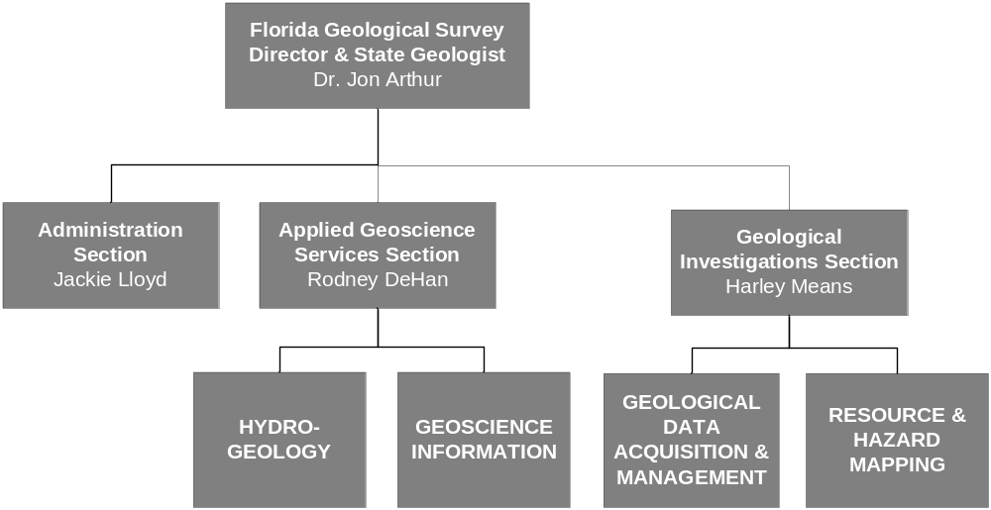

Figure 2. FGS Organizational Structure, FY 2013 - 2014
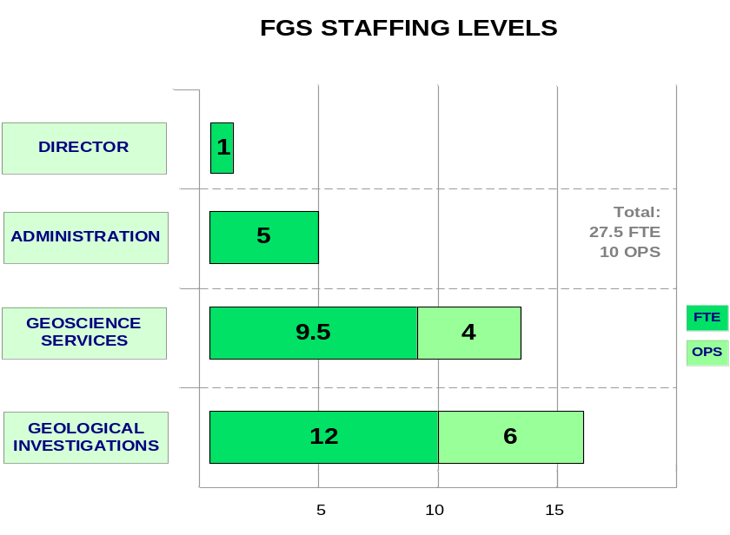
Figure 3. FGS Staffing Levels, FY 2013 - 2014

PROGRAM DESCRIPTIONS

Office of the Director and State Geologist
- Leadership and administration of the FGS
- Planning, budgeting, prioritization of research and program goals
- Serve as the State Geologist of Florida, offering geoscience expertise to DEP programs and other state agencies, federal entities, industry, and the public

Administration
- Management of personnel, budget, contracts, grants, purchasing, and property
- Coordination of geologically-related legislative issues
- Coordination of communications

Applied Geoscience Services
- Administers Hydrogeology and Geoscience Information Programs
- Aquifer vulnerability and aquifer storage and recovery assessments
- Springshed delineation and related water quality assessments
- Surface water – groundwater interaction assessments and studies
- Evaluates sources of arsenic and other trace metals in groundwater
- Hydrogeological assessments for regulatory and land use applications

Geological Investigations
- Administers both the Geological Data Acquisition and Management and the Resource and Mapping Programs
- Collects and interprets statewide surface and subsurface geophysical and geological data within upland, offshore, near shore, beach and estuarine environments
- Obtains and describes rock cores and cuttings to improve knowledge of Florida geology; maintains these acquisitions within the FGS Geological Sample Repository
- Conducts statewide geologic, geomorphic and mineral resource mapping and maintains, updates and disseminates information on Florida’s lithostratigraphic nomenclature
- Maintains Subsidence Incident Reports Database and responds to requests for sinkhole and other geologic hazard assessments
- Sustains core statutory mandate to investigate and report on Florida’s stratigraphy, mineralogy, sedimentology, and paleontology

BUDGET OVERVIEW

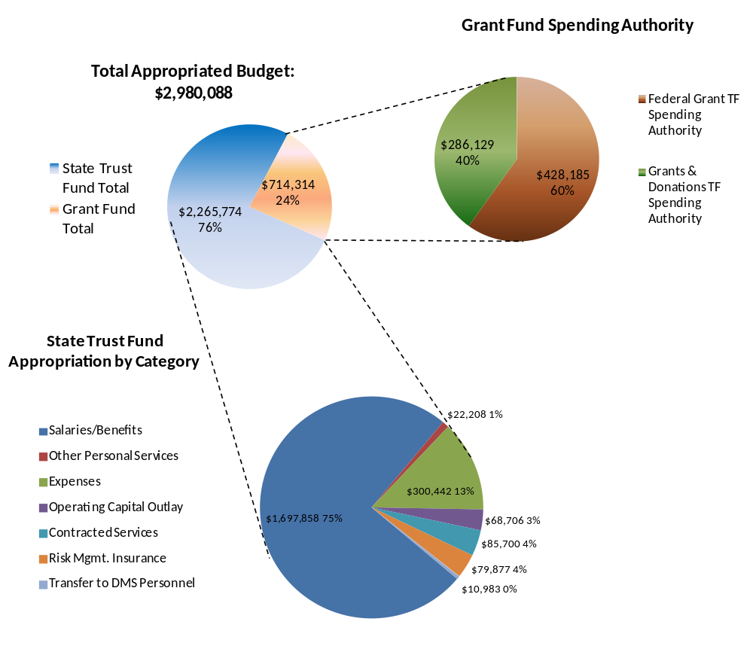
Figure 4. FGS Budget Overview, FY 2013 – 2014
- The bar graph for the FGS allotted and expended amounts for prior, current, and projected Fiscal Years does not include grant-funds because grant fund allotments are spending authority only and the actual grant funds available are determined by grant awards received.
- The allotments shown for FY 2013 – 2014 are as approved; however, the FGS anticipates requesting a budget amendment to realign budget categories due to:
- The move to 3000 Commonwealth building, where there will be a lease rather than individual contracts for building maintenance as existed prior to the move, requiring a shift from the Contracted Services to the Expense category.
- A requested shift from Expense to OPS category to cover essential functions.
- The allotments for FY 2014 – 2015 are based on our best estimate at this time for the shifted category allotments.
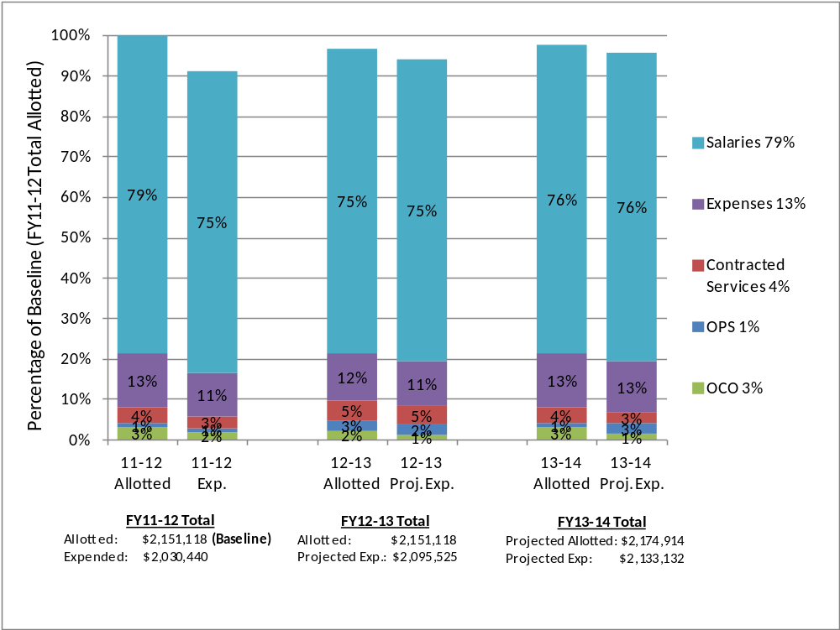
Figure 5. FGS Base Operating Budget Allotments and Expenditures Relative to FY11-12 Allotments as a Baseline

Key Performance Measures & Indicators

Florida Geological Survey
Department of Economic Opportunity 5 Yr Plan: # 18, 19, 20, 25
Getting the Water Right in Florida |  |  |  |  |  | Secretary Priority
Acquire & Archive geologic data |  |  |  |  |  | FGS Priority
FGS Goal A1: Serve as state geologic, data and geosciences information repository
KPM | Action | KPI | Responsible Party | Baseline | Target /  Due Date |  | Q1 | Q2 | Q3 | Q4
A1a. GIS coverages created for projects or significant mapping requests require metadata to document source and dates of creation | Create and verify metadata for GIS data within two months after data coverage is completed | Created metadata verified | Geoscience Information | n/a | All GIS coverages completed/Ongoing |  | All cover-ages up to date | All cover-ages up to date | All cover-ages up to date

FGS Goal A2: Increase the volume of subsidence incident reports recorded

KPM | Action | KPI | Responsible Party | Baseline | Target /  Due Date | Q1 | Q2 | Q3 | Q4
A2a. Develop a work plan for implementing a web form to report possible sinkholes that will “auto-populate” subsidence incident reports (SIR) database | Explore options to develop or implement web form for subsidence incident reports. Set up verification process to ensure good quality data is added to the database | Completion of SIR’s database web form work plan. | Geoscience Information and Resource and Hazard Mapping | 50% PDF is available and submitted via email; geologist populates database upon verifying accuracy of form. | Complete/ April 2014 | 60%; Working with OTIS to develop method to serve out form | 65%  Arranged with OTIS to set us up as a pilot program  to receive data | 65%;Awaiting OTIS assistance
A2b. Establish a project management plan, including a communications plan to request all publically available sinkhole data with intent to incorporate it into the Subsidence Incident Report database | Develop project management plan for acquisition of publically-available sinkhole data | Plan developed | Geoscience Information and Geological Investigations |  | Plan complete/ Dec 2014 | Not started; will mesh with DEM project | 10% | 30%; met officials in three counties as part of DEM project; will expand requests statewide
FGS Goal A3: Scan geophysical logs, update metadata and make available via the Internet.
KPM | Action | KPI | Responsible Party | Baseline | Target /  Due Date | Q1 | Q2 | Q3 | Q4
A3a. Create work plan to assess and consolidate agency-wide geophysical logs and make publically available | Coordinate with O&G Section, UIC Program, and other agencies housing logs; utilize GIS platform | Work plan created | Hydrogeology &  Geoscience Information | 50%  O&G ready; UIC Temp logs available awaiting outward facing server with storage from OTIS | Complete plan/ Dec 2014 | 50%; awaiting storage from OTIS | 60%  UIC and Oil and Gas logs received;  Storage issues unresolved | 60%;UIC and Oil and Gas logs received;Storage issues unresolved

Department of Economic Opportunity 5 Yr Plan: #18, 19, 20, 25
Getting the Water Right in Florida and Creating a Consistent and Certain Regulatory Process Secretary Priority
Conduct Geologic Research and Assessment FGS Priority
FGS Goal B1: Increase areal extent of digital geologic/hydrogeologic mapping
KPM | Action | KPI | Responsible Party | Baseline | Target /  Due Date | Q1 | Q2 | Q3 | Q4
B1a. Annual geologic mapping of at least 2000 square miles by September 2014 (based on Federal FY) | Conduct STATEMAP and other mapping projects | Square miles mapped. | Geological Investigations | 2000 sq. miles | 2000 sq.mi mapped by Sept 2014 | STATEMAP deliverable (1990 sq.mi) submitted and NPS project (185 sq.mi.) partially delivered | FY 14-15 STATEMAP proposal submitted and next portion of NPS due next quarter | 2,175 miles mapped and FY 14-15 proposal was funded and project is underway
B1b. Complete delinea-tion of three currently un-delineated first magnitude springsheds | Collect, process and interpret samples from springsheds to delineate watershed boundaries | Number un-delineated springsheds delineated | Hydrogeology | To Be Devel-oped (TBD, un-funded) | 3 delineated /Jun 2014 pending funding | Pending funding | Pending funding; FTE hired for potentiometric surface mapping | Pending funding;  Submitted proposal to SRWMD for project.
B1c. Design and develop an onshore/ offshore geologic mapping program | Review onshore and offshore areas and possible approaches for effective mapping | Program developed | Resource & Hazard Mapping | 25% | Program developed/Dec 2013 | BOEM proposal submit-ted reflects part of program | 100%, BOEM proposal submitted and FWC project being planned | 100%
B1d. Develop plan to map 200 line-miles off eastern Florida coastline to identify sand resources suitable for beach re-nourishment | Set up grid pattern for geophysical surveys covering 200 line-miles. Process raw data and conduct interpretive analysis | Plan developed | Resource & Hazard Mapping | TBD; Applied to BOEM for grant funding | Project plan developed/ August 2014 | 100%, Plan developed;  proposal submit-ted to BOEM | Waiting on BOEM proposal to be funded | Waiting on BOEM proposal to be funded

FGS Goal B2: Understand geochemical processes of trace metal mobilization in groundwater
KPM | Action | KPI | Responsible Party | Baseline | Target /  Due Date | Q1 | Q2 | Q3 | Q4
B2a. Complete two new water-rock batch-reactor column studies | Carry out chemical analyses of various fluid compositions after interactions with rock materials | Number of studies completed | Hydrogeology | TBD pending funding; one study starting in 8/2013 in cooperation with UF | 2 column studies/ May 2014 | First (Q2 correction) column study 80% complete at UF; first FGS core samples to arrive 10/13 | First column study 95% complete; received samples 11/13 | First column study complete;  Whole rock analysis underway.No funds for second study
B2b. Compare Orange County bench study results and Aquifer Storage and Recovery (ASR) field results | Analyze bench study data and ASR field data; conduct comparative statistical analyses to determine correlations and use as a predictive tool | Study completed | Hydrogeology | TBD | Comparison completed/December 2014 | On hold; awaiting staff replacement | On hold; awaiting staff replacement | Data being reviewed;  10%
B2c. Complete one study of groundwater and ASR sites using trace metals | Use trace metals of known concentration in groundwater and at ASR sites as Arsenic controls. Detect levels and analyze results to better understand chemical interactions and variability with depth, temperature, and rock type | Number of studies completed | Hydrogeology | TBD/ pending funding | 1 study completed/December 2014 | Pending funding | Pending funding | Pending funding; However, last year’s similar study published as Report of Investigation 113

FGS Goal B3: Understand surface water and groundwater interaction in Florida karst environments
KPM | Action | KPI | Responsible Party | Baseline | Target /  Due Date | Q1 | Q2 | Q3 | Q4
B3a. Document and quantify interaction between ground and surface waters using techniques such as dye-tracing | Deploy materials and instruments for rapid field work when significant rain event occurs. Analyze and fold data into other research projects, activities and published information to construct accurate watershed boundaries of the Woodville Karst Plain to calculate water budgets and develop predictive models. | Number of Dye tracing studies conducted | Hydrogeology | 25%; Field data collection com-pleted; data analyses pending availabil-ity of resources to be done. | 2 studies completed/Dec 2014 | 30%;  Analyt-ical data received; awaiting availabil-ity of resources to proceed | 45%;  Data received; first study report in prepara-tion | 50%;  Report outline prepared; writing in progress
B3b. Delineate the southern and eastern boundary of the Wakulla and Spring Creek springsheds to determine water budget | Analyze springshed data and develop shape files for GIS tools to show delineations | Boundaries delineated | Hydrogeology | 60% | Boundaries delineated/April Dec 2014 | 65% | 65%;  Selecting monitor stations for eastern boundary | 65%; Research proposals submitted to FGS management to update and refine this KPM.

Department of Economic Opportunity 5 Yr Plan: #18, 19, 20, 25
Getting the Water Right in Florida and Creating a Consistent and Certain Regulatory Process Secretary Priority
Disseminate Geologic Information FGS Priority
FGS Goal C1: Improve quality, integration, accessibility and dissemination of geologic information
KPM | Action | KPI | Responsible Party | Baseline | Target /  Due Date | Q1 | Q2 | Q3 | Q4
C1a. Continue to improve user-friendliness of FGS website based on user survey and critical review and seek to increase the number of web visitors by 10% annually | Review survey responses from users; implement suggestions from FSU “pro-bono” review | User feedback survey developed | Geoscience Information | 243,161 web visitors during FY12/13 | 267,477/  June 2014 | 190,536  visitors during 1st Quarter  FY13/14 | 377,715  Visitors through 12/31/13;  Target achieved | 515,570  Cumula-tive Visitors through 3/6/14
C1b. Maintain 100% positive customer service comments by the end of each fiscal year | Review monthly DEP e-mail customer satisfaction report | Percent positive customer service comments | Director | 100% during 12/13 | 100%/June 2014 | 100%; ongoing | 100%; ongoing | 100%; ongoing
C1c. Conduct at least six in-house outreach events by June 30th of each year | Conduct events at FGS headquarters such as Earth Science Week (ESW) Open House and Scout Nights | Number of in-house outreach events | Geological Investigations | 6 | 6 events / Jun 2014 | 2 ESW Open House& 2 Scout nights sched-uled in October | Four events conducted; Open House and Scout night in-house events | Six cumulative events conducted Staff assisted with science fair project, FSU Capstone Course Warehouse Work-shop

 | KPM | Action |  | KPI |  | Responsible Party |  | Baseline |  | Target /  Due Date |  | Q1 |  | Q2 |  | Q3 | Q4
C1d. Plan and execute “Ribbon Cutting” Event at new location within one month after move |  |  | Plan and conduct ribbon cutting event after move to new location. Develop communication plan in coordination with DEP Communications. | Event held | Administration, Geological Investigations, and Director |  | n/a |  | Fall 2013 Reschedule when move date is set |  | n/a |  | n/a |  | n/a
 | C1e. Conduct at least six Statewide outreach activities/fieldtrips/public presentations throughout the state by June 30th of each year. | Develop and conduct 2 fieldtrips for the public, and deliver 4 public presentations |  | Number of statewide outreach activities |  | Applied Geoscience Services & Geological Investigations; Director |  | 6 |  | 6 events/ Jun 2014 |  | 8 present-ations & 1 field trip com-pleted |  | 14 outreach events completed to date |  | 21 complete (Next FY increase baseline)
 | C1f. Design, develop and implement public access to the FGS Wells Database. | Explore options and internal beta-test by December 2013; evaluate and conduct external beta-test by April 2014; evaluate and implement by July 2014. |  | Public access to FGS Wells Database developed and implemented |  | Geoscience Information |  | 25%  Design complete |  | Complete/ Jul 2014 |  | 30%; litho data being compiled |  | 40%; internal interface working; compiling data |  | 50%; Action Plan developed;  Quality checking data.
 | C1g. Create master geoscience research database | Develop and implement master geoscience database |  | Master geoscience database showing recent and active research and assessment activity and making it available to DEP and WMDs |  | Applied Geoscience Services & Geological Investigations; Director |  | N/A |  | Complete/ Dec 31, 2013 |  | 20%; coordi-nating with OTIS |  | 20%; exploring non-OTIS options |  | 80%  Deciding final choice of online map engine

 | FGS Goal C1: Improve quality, integration, accessibility and dissemination of geologic information
 | KPM |  | Action |  | KPI |  | Responsible Party |  | Baseline |  | Target /  Due Date |  | Q1 |  | Q2 |  | Q3 |  | Q4
 | C1h. Complete Biennial Report for calendar years 2011 & 2012 |  | Gather information from staff; draft report in same format as BR26. Budget information will be based on state FY; all other information on calendar year. |  | Biennial Report completed |  | Geoscience Information |  | 50% complete as of 7/1/13 |  | Completed/ Sept 2013 |  | 95%;  Awaiting review |  | 95%;  Awaiting review |  | 100% Completed
 | C1i. Release quarterly FGS News and Research within one month after the end of each quarter |  | Gather information from staff; draft news reports; coordinate with DEP Communications |  | FGS Newsletter completed each quarter |  | Administration  and Geoscience Information |  | News-letter each qtr |  | Winter 2013 |  | 100% Summer 2013 issue released |  | 100%  Fall 2013 issue released |  | 100%  Winter 2014 issue released
Department of Economic Opportunity 5 Yr Plan: #18, 19, 20, 25
Getting the Water Right in Florida and Creating a Consistent and Certain Regulatory Process Secretary Priority
Program Effectiveness and Efficiency FGS Priority
FGS Goal D1: Provide effective leadership
KPM |  | Action |  | KPI |  | Responsible Party |  | Baseline |  | Target /  Due Date |  | Q1 |  | Q2 |  | Q3 |  | Q4
D1a. Lead the Florida Geological Survey |  | To develop our next generation of leaders & reinforce core values, conduct a minimum of 4 leadership sessions for FGS personnel. Topics may include such areas as mentoring, leadership skills, strategic goals and prioritization, adaptive management, project management and integrity/ethics. |  | Was content summary submitted to the Deputy Secretary within one week of the leadership session? |  | Director |  | Quarter-ly sessions |  | Send summary within 1 week from each quarterly session |  | Leader-ship Session held on 9/27/13; summary report submit-ted 10/4 |  | Leader-ship Session held on 12/23/13; report submitted |  | Leader-ship session held on 3/3/14; report submitted

KPM |  | Action |  | KPI |  | Responsible Party |  | Baseline |  | Target /  Due Date |  | Q1 |  | Q2 |  | Q3 |  | Q4
D1b. Lead the Florida Geological Survey |  |  | Design, implement and periodically review a Staff Development Plan as an integral part of the FGS Business Plan to accomplish goals and objectives with a more focused, rewarded and well-trained workforce |  | Was Staff Development Plan designed, implemented and reviewed? |  | Director |  | $17,811 spent on training during FY12/13 |  | $30,000 training budget |  | Plan designed, approved 9/12 & implemented; Q1 total spent = $2,489 |  | Q2 cumula-tive total spent = $9,579.51 |  | Q3 cumula-tive total spent = $16,053
 |  |  |  |  |  |  |  |  |  |  | Reviewed by 1st week following end of each quarter.
 |  |  |  |  |  |  |  |  |  |  | Designed and imple-mented by July 19, 2013.
 | D1c. Execute your Business Plan |  | Benchmark the FGS against similar organizations, review every program for relevance and effectiveness, and hold the FGS accountable for continuous improvement |  | Were benchmarking and review exercises conducted and relevance and effectiveness determined? |  | Director |  | n/a |  | Quarterly bench-marking and reviews |  | 25% |  | 50% |  | 75%
 | D1d. Execute your Business Plan |  | Incorporate a 3-5 year strategic plan into the FGS Business Plan |  | Were quarterly meetings for status updates conducted? |  | Director |  | n/a |  | Quarterly meeting updates |  | Met 9/26/13 |  | Met 12/19/13 |  | Met 3/25/14
 | D1e. Execute your Business Plan |  | Provide Deputy Secretary with single page summary of quarterly update to Business Plan within 30 days of the quarterly meetings |  | Single page summary of quarterly update provided to Deputy Secretary? |  | Director |  | 0% |  | Quarterly Updates |  | Quarterly update submitted |  | Quarterly update submitted |  | Quarterly update submitted

KPM | Action | KPI | Responsible Party | Baseline | Target /  Due Date | Q1 | Q2 | Q3 | Q4
D1f. Reduce your cost of doing business | Analyze and automate repetitive manual processes, develop a paper reduction plan and reduce the number of paper transactions | Facilitate electronic processes and increase the use of these electronic processes by 10% | Director;  Jackie Lloyd | 0% | Increase electronic processes by 10% | Increased by 20% with travel cosign process | Increased by an additional 20% with paperless p-card approval process | Reduced paper use by 26% since April 2013
D1g. Reduce your cost of doing business | Quarterly budget updates should be provided to the Deputy Secretary’s Office within 1 week of receiving actual expenditures for each quarter. Quarterly updates should include a revised fiscal year-end forecast. | Were quarterly budget updates with fiscal year-end forecast provided? | Director;  Jackie Lloyd & Traci Billingsley | Quarter-ly as scheduled by Budget Office. | Quarterly updates | See Apndx C | See Apndx C | See Apndx C
D1h. Increase customer outreach | Identify ways to improve performance or customer service | Monthly summary of outreach effort to Deputy Secretary | Director | 0% | Two contacts per month and monthly summary report | July, Aug & Sept reports done | Oct, Nov & Dec reports done | Jan, Feb & Mar reports done
D1i. Make Personnel Safety a Priority | Ensure zero Lost Time Injuries in your office. Develop and implement efforts to evaluate historical injuries, eliminate safety hazards and improve safety awareness among staff. | Were evaluations conducted, safety hazards eliminated and safety awareness improved? | Director;  Jan DeLaney | 0 Lost Time Injuries for  FY 12/13 | Zero Lost Time Injuries | Zero Lost Time Injuries | Zero Lost Time Injuries | Zero Lost Time Injuries

KPM | Action | KPI | Responsible Party | Baseline | Target /  Due Date | Q1 | Q2 | Q3 | Q4
D1j. Make Personnel Safety a Priority | Should injury occur, Director will personally interview the injured employee; evaluate sequence of events that led to the injury and make recommendations to eliminate a reoccurrence | Personal interview and recommend-ations developed to prevent reoccurrence shared with peers in other DEP offices and Deputy Secretary | Director | 4 First Notice of Injury for FY 12/13 | Interview & recom-mendations to peers and Deputy Secretary within 30 days of injury. | NA; no injuries | NA; no injuries | 2 injuries; neither required medical care; inter-views done and recom-menda-tions sub- mitted
FGS Goal D2: Inform elected officials concerning geologic data/geologic processes
KPM | Action | KPI | Responsible Party | Baseline | Target /  Due Date | Q1 | Q2 | Q3 | Q4
D2a. By each August preceding legislative session, identify geologic “hot issues” and how best to inform applicable local and state elected officials in Florida in accordance with DEP protocols | Use advisory groups and literature reviews of opinion makers to highlight possible hot issues | Geologic "hot issues" identified; shared with Legislative Affairs | Director | 0% | Issues identified and shared/ Aug 2013 | Q3 Correc-tion: 100% completed 20% | Ongoing for next FY | Ongoing for next FY

FGS Goal D2: Improve program efficiency and effectiveness
KPM | Action | KPI | Responsible Party | Baseline | Target /  Due Date | Q1 | Q2 | Q3 | Q4
D2b. Implement improved project management and resource prioritization plan | Conduct process analysis of current project management and resource prioritization processes to eliminate un-necessary steps and increase efficiency; develop and train employees on resulting improved process | Processes reviewed and improved | Director, Leadership Team, and representative employees from each Section | 50% | Reviewed and improved/ Dec 2013  April 2014  (Date shifted due to staff workloads; pilot process analysis scheduled to begin in Jan 2014) | Sarah attended Continu-ous Improve-ment Training; planning meeting for FGS scheduled | Planning meeting for FGS scheduled | Two 5S presentations held; 12 projects & teams identified
D2c. Finalize FGS Business Plan for FY 2013-2014 by July 2013 | Define FGS priorities in alignment with DEP Secretary’s priorities; identify and characterize customers, products & services; define goals and objective within this framework; determine strategies, responsible parties, and measures | Plan completed | Director, Leadership Team with input from entire staff | 100% | Completed/ Jul 2013 | 100% Done | NA | NA

KPM |  | Action |  | KPI | Responsible Party | Baseline | Target /  Due Date | Q1 | Q2 | Q3 | Q4
D2d. Additional cross-training in geophysical logging, analysis, and interpretation techniques by 2014 |  | Incorporate into Staff Development Plan. Focus on analysis and interpretation training for those who had geophysical logging training during FY12/13. |  | Training completed according to Staff Development Plan | Director, Leadership Team | 9 staff received geophys. training during FY12/13 | 10 staff to receive geophys. training by  Jul 2014 | Training approved | Training will be scheduled next quarter | Training delay due to MFMP registra-tion
 | D2e. Prepare legislative issue proposal for 2015 Legislative Session to develop and implement FGS Advisory Group |  | Draft legislative issue. | Issue drafted. | Director | NA | June 2014 | NA | NA | NA
D2f. Support DEP’s Oil and Gas (O&G) Section in rule making required by the passage of the Natural Gas Storage Bill |  | Provide support as needed. |  | Support provided. | Director and Applied Geoscience Services Section | NA | June 2014 (subject to change according to O&G Section needs) | 2014 Session LBR sub-mitted for O&G geol. support position | Respond-ing to requests for assistance as needed | Respond-ing to requests for assistance as needed
FGS Goal D3: Improve intra-DEP Communications
KPM |  | Action |  | KPI | Responsible Party | Baseline | Target /  Due Date | Q1 | Q2 | Q3 | Q4
D3a. Identify DEP program area contacts for intra-agency DEP Applied Geology Workgroup led by the FGS |  | Identify DEP Program area contacts via internet and intranet search; delegation by program administrator |  | Contacts identified; allowing time for District and Division reorganizations to settle | Director, Leadership Team | 75% | Contacts identified/ Dec 2013 | In progress | In progress | Invitation sent

KPM | Action | KPI | Responsible Party | Baseline | Target /  Due Date | Q1 | Q2 | Q3 | Q4
D3b. Implement DEP Applied Geology Workgroup | Begin regular meetings of network; offer webinars, improve intra-agency geoscience communication | Division and District meetings scheduled | Director, Leadership Team | 75% | Jan 2014 | Plan drafted | Plan under review | Plan finalized
D3c. Establish routine communications procedures | Outline and test communications procedures to determine which are most effective; initiate meetings with Divisions and Districts | Communication procedures in place | Director, Leadership Team | 50% | Outlined and tested/ Jul 2014 | Plan drafted | Plan under review | Testing
D3d. Develop plan for increased collaborative and training efforts, including webinars with other DEP programs | Refine needs per results of FGS-DEP Needs Assessment and discussions with Applied Geology Workgroup | Collaborative projects in place | Director, Leadership Team | n/a | Plan developed/Dec 20132014 | Date revised to align with previous 3 KPMs | Plan under review | Testing

FGS MID AND LONG-TERM GOALS
Midterm Goals
- Move to 3000 Commonwealth Boulevard during 2014.
- Create a master geoscience research database during 2014 making recent and active research and assessment activity known and accessible to DEP (including Water Management District) managers.
- Support DEP’s Oil and Gas Section in rule making effort required by passage of natural gas storage bill during 2013/2014.
- Establish a project management plan during 2014, including a communications plan to request all publically available sinkhole data, with intent to incorporate it into the Subsidence Incident Report database.
- Create and publish statewide potentiometric maps of Florida’s aquifers twice per year, in collaboration with Water Management Districts. Make such maps available to the WMDs and other entities as needed starting in 2014.
- Publish updated geomorphic map of the State of Florida during 20142015.
- Create a project management plan during 2014 to incorporate all DEP-owned (including WMDs) geophysical logs into a single online database. The plan will include all existing and new geophysical logs as well as digitizing any paper logs that are not already available in digital form.
- Prepare for legislative issues to be presented to DEP Leadership in June 2014.
- By July 2015, upon approval to proceed and with legislative authority, develop FGS advisory group.
- Conduct geologic needs assessment of WMD programs during 2014; and repeat DEP geologic needs assessment during 2015.
- In collaboration with WMD and USGS, working through DEP’s Office of Water Policy, establish a revised hydrostratigraphic nomenclature and naming methodology for Florida by 2015.
- Develop petroleum geology sub-surface characterization and mapping strategies by 2015, pending addition of expertise to agency.
Long-term Goals
- Develop a relative vulnerability map for sinkhole formation potential in Florida during 2016.
- Make all available geophysical logs in the agency, including WMDs, available via the Internet during 2016.
- During 2017, update geologic brochures for Florida State Parks with significant geological features.
- Develop relative recharge or vulnerability maps for four first-magnitude springs by 2018.
- Develop a statewide Florida Aquifer Vulnerability Assessment (FAVA) coverage for the Floridan Aquifer System by 2018.
- Develop maps and related database of known major conduits conveying groundwater to first magnitude springs and incorporate with a statewide dye tracing database by 2017.
- Create Geologic Atlas of Florida as a series of county fact sheets for 25% of the state during 2017.
- Complete detailed lithostratigraphic and hydrostratigraphic framework for at least 25% of the state by 2018.
- Create a geochemical and mineralogical atlas framework of aquifer media for the state based on lithostratigraphic and hydrostratigraphic units by 2018.

CONTINUOUS IMPROVEMENT, ACHIEVEMENTS & SUCCESSES
Continuous Improvement
- Improved grant proposal process in order to maximize opportunities to successfully obtain grant awards.
- Developed and began implementing Staff Development Plan to improve productivity, effectiveness, cross-functional abilities, ability to respond to emerging issues, employee retention and succession potential.
- Processes identified for improvement are FGS server file storage/organization and internal project management.
- Completion of GIS coverages and related metadata for inclusion within DEP library.
- Continue implementation of intra-agency geoscience communication and training.
- FGS Wells Database has been created and tested and is being improved as we use it.
- Incorporation of project-specific geologic data into FGS Wells Database.
- FGS News and Research New letter has been redesigned for digital distribution.
Achievements & Successes
- Reduced FGS annual paper consumption by an estimated 23% since April 2012.
- Comprehensive and prompt response to sinkhole events, media inquiries and public awareness.
- Reclassified vacant position from Professional Geologist I to Environmental Consultant to periodically produce statewide potentiometric surface maps of the Floridan aquifer system and other aquifers in support of DEP and WMD programmatic needs.
- Increased intra-agency collaboration and awareness of FGS capabilities and resources to better meet the geoscience needs of the regulatory and non-regulatory programs.
- Developed and implemented FGS quarterly news releases through DEP’s Office of Communications. Two issues have been published and a third is in preparation.
- Established methodology to continuously update GIS coverage of karst features.
- As of December 2012, all FGS publications have been scanned and are publically accessible.
- Continuation of needs assessment by visiting the regulatory districts and presenting FGS resources and capabilities as well as determining district geological needs and priorities. These visits provide increased collaboration, support and efficiency.
- All FGS publications are now digitized and available online.
- Achieved 85% reduction in paper publications stored at the DEP Warehouse.
- Scanned 75% of the FGS geophysical logs.
- Worked with the Bureau of Beaches and Coastal Systems to consolidate space and resources.

Appendix A. REVISION HISTORY
06-27-2013: Office of the Florida Geological Survey Business Plan Version 14.0 draft submitted.
07-01-2013: Revisions by Carla Gaskin received and accepted.
07-24-2013: Revised KPM/KPI table and mid- and long-term goals per Leadership Team and staff input.
07-24-2013: Input Shared Savings Incentive Plan as received from Deputy Secretary’s office.
10-21-2013: First FY13/14 quarterly update.
12-31-2013: Second FY13/14 quarterly update.
3-31-2014: Third FY13/14 quarterly update.

APPENDIX B. FLORIDA DEPARTMENT OF ECONOMIC OPPORTUNITY 5-YEAR STRATEGIC PLAN AT A GLANCE
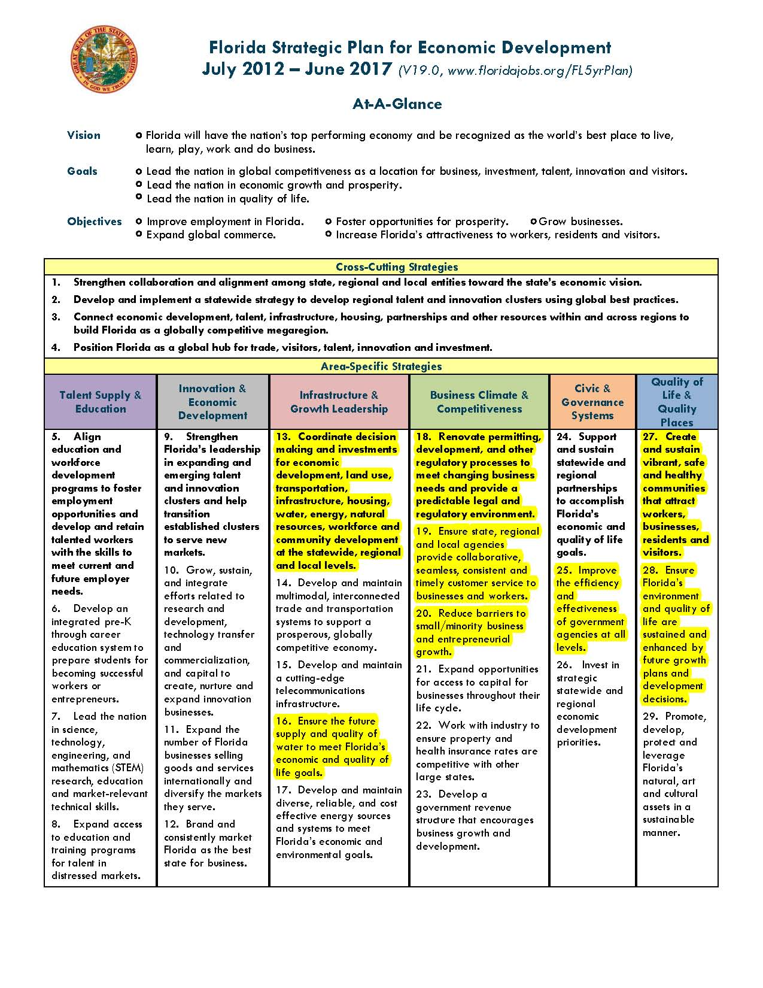

APPENDIX C. FGS 4th QUARTER BUDGET PROJECTION—FY13/14
Category | Grant Funds | Approved Budget | YTD Expenditures & Encumbrances | Additional Expenditures Projected | End of Year Projected Balance | Comments
030000 OPS | 261019 FGTF | 454,721 | 169,006 | 164,193 | 121,522
040000 Expense | 261019 FGTF | 111,965 | 49,158 | 55,519 | 7,288
100777 Contr Srvs | 261019 FGTF | 71,799 | 0 | 0 | 71,799
030000 OPS | 339074 G&DTF | 119,947 | 8,377 | 16,323 | 95,247
040000 Expense | 339074 G&DTF | 60,905 | 16,435 | 15,988 | 28,482
060000 OCO | 339074 G&DTF | 21,000 | 0.00 | 0.00 | 21,000
100777 Contr Srvs | 339074 G&DTF | 78,077 | 6,830 | 2,370 | 68,877
Category | Operating Funds | Approved Budget | YTD Expenditures & Encumbrances | Additional Expenditures Projected | End of Year Projected Balance | Comments
010000 S&B | 408001 IITF | 439,688 | 242,907 | 193,379 | 3,402 | Projected expenditures includes $10,000 non-recurring cost reduction holdback.
010000 S&B | 423001 LATF | 624,385 | 358,386 | 261,011 | 4,988
010000 S&B | 499001 MTF | 282,772 | 179,145 | 112,308 | (8,681) | Cover with CM from WQATF.
060000 OCO | 499001 MTF | 48,868 | 2,250 | 48,868 | 0 | Drill rig & field equipment; projection includes $17,279 for cost reduction holdback.
100777 Contr Srvs | 499001 MTF | 5,700 | 3,520 | 0 | 2,180
010000 S&B | 780001 WQATF | 387,708 | 211,901 | 159,357 | 16,450 | Projected expenditures includes $30,000 recurring cost reduction holdback.
030000 OPS | 780001 WQATF | 51,008 | 31,830 | 15,373 | 3,805 | OPS funds to be transferred to S&B next FY with OPS to FTE conversion.
040000 Expense | 780001 WQATF | 300,442 | 155,081 | 120,361 | 5,000 | Expense needed next FY for PC refresh, move to new location, field & research costs, & training. Projected expenditures includes $20,000 non-recurring cost reduction holdback.
060000 OCO | 780001 WQATF | 19,838 | 0 | 18,001 | 1,837 | IT, field, and lab equipment.
100777 Contr Srvs | 780001 WQATF | 80,000 | 65,575 | 67,575 | 12,425 | Contr Srvs needed next FY for move to new location & possible outsourced research costs.
Adjustments to budget:  - Reduction of $939 in TR/DMS/HR SVCS/STW Category, August 2013.  - Increase in S&B, $34,655, September 2013 for October cost of living raises.  - Increase in OPS & decrease in FTE S&B of $25,000 for January 2014 Env. Consultant new hire.  - BA to increase FGTF budget authority in OPS ($167,000) & Expense ($32,000) to cover new grants.  - OPS EOY projected balance includes AHCA funds added to OPS in Feb 2014 & placed in reserve (FGTF-$3,800; GDTF-$3,800; WQATF-$3,800). |  |  |  |  | Cost Reduction Plan: 10% reduction over last FY’s spending would be $206,758. This would require deleting 3 ½ positions. The FGS cannot meet its mission with this 13% reduction in workforce. Alternative proposal is a 10% increase in savings (totaling $47,279) over the prior year savings by:  - Deleting ½-time position and reducing S&B by $30,000 through the LBR.  - Reducing OCO by outsourcing services & renting scientific equipment.  - Non-recurring cost reductions of $10,000 in IITF S&B and $20,000 WQATF Expense.
APPENDIX D. FGS STAFF DEVELOPMENT PLAN FOR FY13/14
To simplify the process for obtaining approvals for mission critical employee development such as training, conference attendance, etc., while ensuring that funds are being spent in an appropriate and justified manner, each Director is expected to develop an annual plan for their respective District/Division. The plan should include, at a minimum, the information below. Once approved by the Deputy Secretary’s Office, if there are no changes to the listed information, then no further approval is required except for travel documents which should be submitted to Carla Gaskin for approval prior to attendance. Any changes to the plan require a re-submittal of the entire plan for approval.
Total Annual Operating Budget: $2,265,774 |  |  | Total Annual Expense Budget: $300,442 |  | FY 2012-13 Approved Training Budget: $32,000 (1.5%) Total Annual Training Budget: |  |  |  |  | $32,084
(Note: draft totals $36,889; some training events may not be scheduled based on the Director’s priorities and discretion; in addition, scheduling conflicts and workload priority shifts may result in the cancellation of some of the training events. Total training expenditures not to exceed $30,000.)
FGS Administration Section
Date of Event | Location | Name of Event | Requested Attendees (Name & Title) | Purpose of event: (T)raining or (O)utreach |  | If Purpose is Training or Professional/Technical Development, Estimate Savings to be Realized for Each Attendee | If Purpose is Outreach, Describe Benefit to DEP | Total Requested Event Cost (Training Cost, Associated Fees, Travel, Per Diem, Etc.) | Amount of Remaining “Employee Development” Budget
TBD | FGS Office, Tallahassee | Basic to intermediate Microsoft Office software training | Sarah Allen, AA II; Traci Billingsley, Business Manager; Eric Harrington, Admin Secretary | T |  | Due to the fact that these staff members use Microsoft Office programs daily, increased knowledge of their use will only make work more productive and timely. |  | $0 | $32,084
TBD | FGS Office, Tallahassee | Microsoft Access intermediate to advanced classes | Jan DeLaney, Env. Supervisor | T |  | Jan will be able to use Microsoft Access for efficient tracking of FGS Databases |  | $0 | $32,084
TBD | FGS Office, Tallahassee | Microsoft Project Management | Jan DeLaney, Env Supervisor; Jackie Lloyd, PG Admin | T |  | This will increase efficiency, and thus save time and money. |  | $0 | $32,084
TBD | FGS Office, Tallahassee | Oculus, MFMP, P-card, Travel | Sarah Allen, AA II; Eric Harrington, Admin Secretary | T |  | This is part of the Admin Section’s cross-training plan. Educating admin staff on how to perform all administrative duties improves operational efficiency. |  | $0 | $32,084
Date of Event | Location | Name of Event | Requested Attendees (Name & Title) | Purpose of event: (T)raining or (O)utreach |  | If Purpose is Training or Professional/Technical Development, Estimate Savings to be Realized for Each Attendee | If Purpose is Outreach, Describe Benefit to DEP | Total Requested Event Cost (Training Cost, Associated Fees, Travel, Per Diem, Etc.) | Amount of Remaining “Employee Development” Budget
TBD | Tallahassee | Various Safety Training Courses | Eric Harrington, Admin Secretary | T |  | Eric Harrington is the Safety Officer for FGS, and needs to have up-to-date knowledge regarding safety, which will reduce costs in workers’ comp and injuries in general. |  | $0 | $32,084
TBD | FGS Office, Tallahassee | Supervisor Training | All Supervisors at FGS | T |  | Supervisory Training on DEP Training website. Director will choose 2 mandatory, and 2 optional for each supervisor at FGS. |  | $0 | $32,084
TBD | Tallahassee | Intermediate to Advanced Microsoft Excel training | Jackie Lloyd, PG Admin; Jan DeLaney, Env Supervisor; Sarah Allen, Admin Assistant II; Traci Billingsley, Business Manager; Chantel Iacoviello | T |  | Excel is used on a daily basis by these staff members, and being able to use the program as efficiently as possible will undoubtedly leave to cost savings and increased productivity. |  | $0 | $32,084
TBD | FGS Office, Tallahassee | Budget tracking, contract and grant tracking/management, and finance and accounting specific to DEP (i.e. FLAIR). | Sarah Allen, AA II | T |  | This is part of the Admin Section’s cross-training plan. Educating admin staff on how to perform all administrative duties improves operational efficiency. |  | $0 | $32,084
Date of Event | Location | Name of Event | Requested Attendees (Name & Title) | Purpose of event: (T)raining or (O)utreach |  | If Purpose is Training or Professional/Technical Development, Estimate Savings to be Realized for Each Attendee | If Purpose is Outreach, Describe Benefit to DEP | Total Requested Event Cost (Training Cost, Associated Fees, Travel, Per Diem, Etc.) | Amount of Remaining “Employee Development” Budget
TBD | FGS Office, Tallahassee | Quicken self-guided training with the following books: Quicken 2012 the Official Guide; Quicken 2012 Quicksteps | Sarah Allen, AAII, Eric Harrington, Admin Secretary | T |  | This is part of the Admin Section’s cross-training plan. Educating admin staff on how to perform all administrative duties improves operational efficiency. |  | $0 | $32,084
TBD | Tallahassee | Human Resources & Personnel Management | Sarah Allen, AA II | T |  | As Personnel Liaison for FGS, developing Sarah’s knowledge in this area is helpful to the FGS. |  | $0 | $32,084
 | TBD - in state day trips | Field and laboratory shadowing; up to two days per year; no cost day trips preferred | Jackie Lloyd, PG Admin; Jan DeLaney, Env Supervisor; Sarah Allen, AA II; Traci Billingsley, Business Manager; Eric Harrington, Admin Secretary | T |  | No cost day trips are preferred. This will enable admin staff members to experience field work done by FGS Geologists and therefore improve the service provided to them. Invite other DEP staff to participate. |  | $750 | $31,334
Date of Event | Location | Name of Event | Requested Attendees (Name & Title) | Purpose of event: (T)raining or (O)utreach |  | If Purpose is Training or Professional/Technical Development, Estimate Savings to be Realized for Each Attendee | If Purpose is Outreach, Describe Benefit to DEP | Total Requested Event Cost (Training Cost, Associated Fees, Travel, Per Diem, Etc.) | Amount of Remaining “Employee Development” Budget
TBD | Washington, DC | AASG Fall Liaison | Jon Arthur, Dir & State Geologist | O |  |  | FGS Director as AASG President Elect is expected to organize, lead, and participate in Liaison, an outreach event in Washington DC, where the nation's state geologists meet with federal agencies (e.g., NASA re: LIDAR), congressional staff (cooperative program support) and NGOs (i.e., National Mining Assoc., National Groundwater Association, National Research Council) regarding collaborative opportunities and clarifying geoscience needs of the state and nation. | $1,900 | $29,434
3/17-20/2014 | Washington, DC | AASG Spring Liaison | Jon Arthur, Dir & State Geologist | O |  |  | FGS Director as AASG President Elect is expected to organize, lead, participate in Liaison, an outreach event in Washington DC, where the nation's state geologists meet with federal agencies (e.g., NASA re: LIDAR), congressional staff (cooperative program support) and NGOs (i.e., National Mining Assoc., National Groundwater Association, National Research Council) regarding collaborative opportunities and clarifying geoscience needs of the state and nation. | $1,900 | $27,534

Date of Event | Location | Name of Event | Requested Attendees (Name & Title) | Purpose of event: (T)raining or (O)utreach | If Purpose is Training or Professional/Technical Development, Estimate Savings to be Realized for Each Attendee | If Purpose is Outreach, Describe Benefit to DEP | Total Requested Event Cost (Training Cost, Associated Fees, Travel, Per Diem, Etc.) | Amount of Remaining “Employee Development” Budget
6/9-13/2014 | Lexington, KY | AASG Annual Meeting | Jon Arthur, Dir & State Geologist | T/O | Annual meeting of the AASG; conduct business, hold workshops on leading edge national issues such as water, climate, energy, data preservation and public policy. | Interaction with state geologist colleagues nationwide; explore strategies to keep geoscience agencies effective, identify collaborative opportunities and nationwide initiative funding strategies, such as the successful geothermal data project funded by DOE; through which Florida has a grant. | $2,600 | $24.934
Administration Section Total |  |  |  |  |  |  | $7,150 | $24,934

FGS APPLIED GEOSCIENCE SERVICES SECTION
Date of Event | Location | Name of Event | Requested Attendees (Name & Title) | Purpose of event: (T)raining or (O)utreach | If Purpose is Training or Professional/Technical Development, Estimate Savings to be Realized for Each Attendee | If Purpose is Outreach, Describe Benefit to DEP | Total Requested Event Cost (Training Cost, Associated Fees, Travel, Per Diem, Etc.) | Amount of Remaining “Employee Development” Budget
On-demand | FGS Office, Tallahassee | Effective Writing for Professionals (Webinar) | Cindy Fischler, PGII and all interested staff. | T | Staff publish articles and make presentations at technical workshops, scientific writing will improve quality thus the reception of presentations by the scientific community. |  | $300 | $28,519
June 9-13, 2014 | Bethlehem, PA | Wavelength dispersive spectroscopy/Scanning electron microscopy training | Cindy Fischler, PGII | T | Expertise required for ongoing geochemistry projects in support of regulatory activities. Course title: Quantitative X-ray Microanalysis: Problem Solving using EDS and WDS Techniques |  | $3,900 | $24,619
2/11-2/12/14 | Gainesville, FL | UF Water Institute Symposium | Stuart Norton, Environmental Consultant | T | Our hydrogeology group needs to stay abreast of current research on and drivers of Florida’s water quality decision making. |  | $450 | $24,484
3/24-3/28 | Pittsburgh, PA | Advanced Well Technologies | Levi Hannon, ES I (DWRM); Dan Phelps, PG I | T | Advanced and emerging well construction methods; stay apprised of techniques and technologies to better protect groundwater resources and environmental health during well development activities. |  | $0 | $24,484
On demand | FGS Office, Tallahassee | Adobe Acrobat Fundamentals | Doug Calman, Geologic Research Librarian | T | This training will allow our librarian to prepare pdf documents for staff and customers from new and existing sources. |  | $0 | $24,484
On demand | FGS Office, Tallahassee | Cloud Computing | Doug Calman, Geologic Research Librarian | T | This training supports the library’s ultimate migration to digital, on demand resources. |  | $0 | $24,484
10/7-9/13 | Dallas, TX | Environmental geochemistry of metals | Cindy Fischler, PGII | T | This training supports research on arsenic in ground water |  | $2,500 | $21,184
9/9/ 2013 | Orlando, FL | Aquifer Storage and Recovery 13 Conference | Cindy Fischler, PGII | O | Coordinate with/invite other WMD and DEP staff. | DEP benefits from dissemination of research results and staying apprised of current ASR research. | $500 | $21,484
6/1-4/2014 | Newark, DE | Digital Mapping Techniques Workshop | Jim Cichon, ES III, Rick Green, PG II | T | This training supports awareness of the latest technologies and approaches in digital mapping. |  | $3,200 | $18,284
11/13/ 2013 | Tallahassee | Seven Hills Regional Users Group GIS Workshop | Jim Cichon, ES III; Alan Baker, PGI; Michelle Ladle, ES II; Lee Hartman, Lab. Tech IV | T | Our GIS group needs to be aware of the latest advances in this field and to establish networks with workers in this field for possible collaboration. |  | $360 | $17,924
TBD | FGS Office, Tallahassee | ArcGIS for Server: Site Configuration and Administration (online, one fee for all attendees) | Jim Cichon, ES III; Alan Baker, PGI and others | T | Allow for setting up multiple editing sessions of a GIS database, eliminating the need for multiple user copies and the poor management of dead-end datasets. Also allows for the setup of a QA/QC manager to oversee all of the edits and accept/reject/flag those edits. OTIS does not offer the course, however, if they do we will coordinate and offer these funds in support. |  | $1,515 | $16,409

Date of Event | Location | Name of Event | Requested Attendees (Name & Title) | Purpose of event: (T)raining or (O)utreach | If Purpose is Training or Professional/Technical Development, Estimate Savings to be Realized for Each Attendee | If Purpose is Outreach, Describe Benefit to DEP | Total Requested Event Cost (Training Cost, Associated Fees, Travel, Per Diem, Etc.) | Amount of Remaining “Employee Development” Budget
TBD | FGS Office, Tallahassee | Python language programming for ArcGIS | Jim Cichon, ES III; Alan Baker, PGI and others | T | Allows for setting up the automation of various GIS related tasks. Tasks that we would like to automate first are the update process for our FGS Wells and geophysical logs database layers. With the python language for ArcGIS we can set up tools and scheduled programs that will run and keep datasets up-to-date. OTIS does not offer the course, however, if they do we will coordinate and offer these funds in support. |  | $1,500 | $14,909
TBD | FGS Office, Tallahassee | Lyrassis and Web Junction online library training courses | Doug Calman, Geologic Research Librarian | T | This training will keep our librarian abreast of the latest methodologies in library science. |  | $465 | $14,444
Applied Geoscience Services Section Total |  |  |  |  |  |  | $10,490 | $14,444

 | FGS GEOLOGICAL INVESTIGATIONS SECTION
 | Date of Event | Location | Name of Event |  | Requested Attendees (Name & Title) |  | Purpose of event: (T)raining or (O)utreach | If Purpose is Training or Professional/Technical Development, Estimate Savings to be Realized for Each Attendee | If Purpose is Outreach, Describe Benefit to DEP | Total Requested Event Cost (Training Cost, Associated Fees, Travel, Per Diem, Etc.) |  | Amount of Remaining “Employee Development” Budget
May-14 |  | October 5-9 |  | 14th Annual Sinkhole Conference |  | Clint Kromhout, PG I | T | One of the primary functions of the FGS is to disseminate geologic information about karst and sinkholes. By attending this national meeting Clint will learn the latest research and techniques being used to mitigate sinkhole activity, which is a huge economic issue for Florida. Clint will present a poster on the FEMA-DEM Sinkhole Project and discuss the project with karst specialists. |  | $2,500 | $11,944
Feb. 13-14 (field trip) and 15-18 conference |  | Panhandle field trip then the meeting in Gainesville |  | North American Paleontological Convention |  | Harley Means, PG Administrator | T and O | Keeping abreast of the latest science related to paleontology allows staff scientists to better interpret the geologic framework of Florida. | Highlighting the paleontology of Florida will potentially bring more scientists and more grant funding to the state which will bolster the knowledge base and shed more light on Florida’s geology and geologic resources. | $0 | $11,944

Date of Event |  | Location |  |  | Name of Event |  |  | Requested Attendees (Name & Title) |  |  | Purpose of event: (T)raining or (O)utreach |  |  | If Purpose is Training or Professional/Technical Development, Estimate Savings to be Realized for Each Attendee |  |  | If Purpose is Outreach, Describe Benefit to DEP |  |  | Total Requested Event Cost (Training Cost, Associated Fees, Travel, Per Diem, Etc.) |  |  | Amount of Remaining “Employee Development” Budget
 | Jan-14 |  |  | Tallahassee |  |  | Certified Public Manager (CPM) Course Level III |  |  | Clint Kromhout, PG I |  |  | T |  |  | This will allow Clint's continued participation in the Certified Public Manager series. Clint has shown interest and potential as a future manager and leader at the FGS. Developing that potential will increase the probability that FDEP will retain this high quality employee in whom we have invested. |  |  |  |  |  | $300 |  | $11,644
Regular-ly offered |  |  | FGS Office, Tallahassee |  |  | Online GIS Training - multiple modules |  |  | Dan Phelps, PG I |  |  | T |  |  | One of the primary functions of the FGS is to disseminate geologic information through the creation of graphics and maps. By taking part in this training Dan will learn ArcGis techniques being used nationwide to analyze and display remote sensing derived. Coordinate with OTIS. |  |  |  |  |  | $672 |  | $10,972

Date of Event | Location |  | Name of Event |  |  | Requested Attendees (Name & Title) |  |  | Purpose of event: (T)raining or (O)utreach |  | If Purpose is Training or Professional/Technical Development, Estimate Savings to be Realized for Each Attendee |  | If Purpose is Outreach, Describe Benefit to DEP |  | Total Requested Event Cost (Training Cost, Associated Fees, Travel, Per Diem, Etc.) |  | Amount of Remaining “Employee Development” Budget
Multiple |  | Houston or another out of state location |  | Mud School |  |  | Dave Paul, PG II, Eric Thomas, Eng Tech IV |  |  | T |  | Halliburton's Mud School for water well drilling provides valuable training in the proper use of drilling muds and additives to stabilize boreholes to enhance drilling efficiency and core recovery, and avoid waste through excessive application. The class is free, the only costs are travel, meals, lodging, and per diem. The estimate is based on 2 staff members, 2 days of travel and 5 days of training, $100/night lodging, and $500/person round trip airfare. These numbers are subject to change based on booking dates. |  |  |  | $2,792 | $8,180
10/27-31/13 |  | Denver, CO |  | Geological Society of America annual meeting, 125th Anniversary with emphasis on geologic mapping. |  |  | Christopher Williams (CW), PG I, Harley Means (HM), PG Supervisor, Jon Arthur, Dir & State Geologist |  |  | T/O |  | Learn the latest information about geologic research relevant to Florida (karst, groundwater, erosion, climate science, geologic mapping, etc.). Cost savings will easily equal expenditure as staff apply what is learned at GSA to their current and future projects. |  | Interaction with geologists from other states to brainstorm funding opportunities, cost-saving ideas related to geologic research; connect with funding agencies; and interact with researchers doing work relevant to Florida and its environment. CW will present results of the NPS geomorphic-mapping grant project; and HM will share FGS geologic research results. Director’s involvement in AASG Mid-year Meeting provides professional interaction with multiple federal government agencies and national-level geoscience entities. |  | $4,700 | $3,480
Date of Event | Location |  | Name of Event |  |  | Requested Attendees (Name & Title) |  |  | Purpose of event: (T)raining or (O)utreach |  | If Purpose is Training or Professional/Technical Development, Estimate Savings to be Realized for Each Attendee |  | If Purpose is Outreach, Describe Benefit to DEP |  | Total Requested Event Cost (Training Cost, Associated Fees, Travel, Per Diem, Etc.) |  | Amount of Remaining “Employee Development” Budget
10-27 thru 30, 2013 |  | Tallahassee |  | Borehole Geophysical Log interpretation |  |  | Clint Kromhout, PG I Dave Paul, PG II, Rick Green, PG II, Harley Means, PG Suprv, Dan Phelps, PG I, Cindy Fischler, PG I, Frank Rupert, PG III, Tom Greenhalgh, PG I, Christopher Williams, PG I, Paul Hansard, PG III, Andy Smith, PG II, Alan Baker, PG I |  |  | T |  | Being able to interpret geophysical logs will add to the abilities of staff PG's to decipher the geology of the state in areas where we may not have cores or cuttings providing the cost savings realized from not drilling a core. Coordinate with/invite WMD and DEP staff as possible. |  |  |  | $1,000 | $2,480
To be deter-mined |  | TBD - In state |  | PG Field Training - travel and per diem needed to get staff geologists into the field to see outcrops and exposures around the state. |  |  | Alan Baker, PG I, Cindy Fischler, PG II, Rick Green, PG II, Tom Greenhalgh, PG I, Paul Hansard, PG III, Clint Kromhout, PG I, Harley Means, PG Suprv, Dan Phelps, PG I, Frank Rupert, PG III, Christopher Williams, PG I, Dave Paul, PG II, Jon Arthur, Dir & State Geologist |  |  | T |  | Staff expertise in geology needs to be broad and encompass the entire state. Field exposures and the geologic context give staff geologists a better understanding of the complex geology of the state and allow them to gain first-hand knowledge that allows staff to do a better job and be well versed in statewide geology. Coordinate with/invite WMD staff as possible. |  |  |  | $1,700 | $780
9/17/ 2013 |  | Webinar |  | National Groundwater Association Hydrochemistry Series |  |  | Paul HansardCindy Fischler, PGII |  |  | T |  | This highly cost-efficient training provides courses at $160 each for the following topics: 1) Environmental isotopes in the hydrologic cycle, 2) Nitrogen Species and Reactions in Contaminated Groundwater, 3) Isotope Tools to Date Groundwater |  | s |  | $480 | $300
10/11-12/13 |  | Niceville, FL |  | Southeastern Geological Society Meeting and Field Trip - NW Florida Pleistocene geology |  |  | Guy Means, PG Suprv |  |  | O |  | Coordinate with/invite other WMD and DEP staff. |  | SEGS is an organization dedicated to Florida's geologic community. Gives state PG's the opportunity to meet and learn about state geology and interact with FGS staff. |  | $300 | $0
Geologic Investigations Section Total |  |  |  |  |  |  |  |  |  |  |  |  |  |  |  | $14,444
OVERALL TOTAL |  |  |  |  |  |  |  |  |  |  |  |  |  |  |  | $32,084

APPENDIX E. SHARED SAVINGS INCENTIVE PLAN

Background
- Organizations perform better, innovative solutions are more likely, and morale will be highest, when there is an atmosphere of self-esteem, confidence and independence. This is only possible when there are expectations to perform, and people are acknowledged and rewarded based on their accomplishments.
- DEP’s regulatory programs have realized significant performance gains and budget savings by empowering people, reducing layers of management, eliminating workflow silos, setting clear performance expectations and holding regulatory staff accountable to those expectations.
- Significant gains in efficiency have also resulted in major savings. Across DEP’s regulatory programs, approximately $18.5 million in operating funding was reverted at the end of the 2011/2012 fiscal year. Over $23 million in operating funding was reverted at the end of the 2012/2013 fiscal year. The Shared Savings Incentive Plan (SSIP) will continue to promote increased efficiencies, performance and savings.
- Statutory authority is provided in Section 216.1815, Florida Statutes, for agencies to retain a portion of the savings generated each year for employee bonuses. DEP's regulatory programs were able to receive approval from the Legislative Budget Commission (LBC) in June 2013 to provide bonuses to our highest performing staff based on the savings generated during the 2012/2013 fiscal year.
- It is our desire to seek approval once again from the LBC at the end of this fiscal year for additional employee bonuses based on savings generated by the Regulatory Programs during the 2013/2014 fiscal year. If approved, the 2013/2014 proposed bonus pool will be distributed among the Regulatory Programs as follows:

Distribution Among Regulatory Programs
- Internal Benchmarks: How well did the Program meet or exceed their goals and expectations laid out within their Business Plan? Meeting these goals and expectations is required to participate in the bonus plan.
- Cost Reductions: Programs’ efforts to reduce costs without minimizing services or compromising environmental protection. This is further assured because no program is eligible if they do not first meet performance criteria laid out in their Business Plans.
- Customer Service Feedback: Rankings based on feedback from internal and/or external reviews.

General Criteria for All SSIPs
- Each Director is responsible for the specific design and implementation of their SSIP. However, at a minimum, the following criteria shall be followed:
- No bonus should exceed 20% of the target recipient’s annual salary;
- No bonus should fall below $750;
- Successful Business Plan metrics should be the standard for eligibility by the recipient’s program area;
- The highest performing program area should receive the largest portion of the total bonus amount;
- The lowest performing program area should not be bonus eligible;
- Individual achievement based on SMART goals should be the standard for employee eligibility;
- The highest performing employee within an eligible program area should receive the highest bonus;
- The lowest performing employee within an eligible program area should not be bonus eligible.

Program Specific SSIP
- Staff may be eligible for bonuses based on the following criteria:

There are many deserving employees at the FGS who exhibit outstanding and efficient performance. Top and exemplary performers are also top producers who yield a maximum return on investment in service to the State of Florida. Based on this premise, and based on Regulatory Program SSIP general criteria, FGS section administrators submit nominations to be considered by the Director. The Director shall consider nominations in context of the general criteria, section performance and overall prioritization relative to available funds.

APPENDIX F. PROPOSED FGS STAFF DEVELOPMENT PLAN FOR FY 14-15
To simplify the process for obtaining approvals for mission critical employee development such as training, conference attendance, etc., while ensuring that funds are being spent in an appropriate and justified manner, each Director is expected to develop an annual plan for their respective District/Division. The plan should include, at a minimum, the information below. Once approved by the Deputy Secretary’s Office, if there are no changes to the listed information, then no further approval is required except for travel documents which should be submitted to Tori Deal for approval prior to attendance. Any changes to the plan require a re-submittal of the entire plan for approval.
Florida Geological Survey
FY 2014-2015 EMPLOYEE DEVELOPMENT PLAN
 | Total Annual Operating Budget: | $2,457,646 |  |  | Total Annual Training Budget: |  |  | $39,159
 | Total Annual Expense Budget: | $300,442 |  |  | 2% |  |  | of the Operating Budget is dedicated to Employee Development
 |  |  |  |  | 13% |  |  | of the Expenses Budget is dedicated to Employee Development
Submitted by:
 |  |  | Director |  |  |  | Date
Approved by:
 |  |  | Deputy Secretary/Assistant Deputy Secretary |  |  |  | Date
Approved by:
 |  |  | Secretary |  |  |  | Date
Administration Section
Date of Event | Name of Event & Location | Requested Attendees  (Name & Title) |  | Purpose of event: (T)raining or (O)utreach | If Purpose is TRAINING or Professional/Technical DEVELOPMENT: Estimate Savings to be Realized for Each Attendee |  |  | If Purpose is OUTREACH: Describe Benefit to DEP | TOTAL Requested Event Cost (Training Cost, Associated Fees, Travel, Per Diem, Etc.) |  | Amount of Remaining from the “Employee Development” Budget
TBD | Field and laboratory shadowing; up to two days per year; no cost. In state day trips. | Sarah Allen, AA II; Traci Billingsley, Business Manager |  | T | No cost day trips. This will enable admin staff members to experience field work done by FGS Geologists and therefore improve the service provided to them. Invite other DEP staff to participate. |  |  |  | $0 |  | $39,159
TBD | Supervisor Training. FGS Office, Tallahassee | All Supervisors at FGS |  | T | Supervisory training on DEP Training website. Director will choose 2 mandatory, and 2 optional for each supervisor at FGS. |  |  |  | $0 |  | $39,159
Date of Event | Name of Event & Location | Requested Attendees  (Name & Title) |  | Purpose of event: (T)raining or (O)utreach | If Purpose is TRAINING or Professional/Technical DEVELOPMENT: Estimate Savings to be Realized for Each Attendee |  |  | If Purpose is OUTREACH: Describe Benefit to DEP | TOTAL Requested Event Cost (Training Cost, Associated Fees, Travel, Per Diem, Etc.) |  | Amount of Remaining from the “Employee Development” Budget
Fall 2014 | AASG Fall Liaison, Washington DC | Jon Arthur, Dir & State Geologist |  | O |  |  |  | FGS Director as AASG President is expected to participate in Liaison, an outreach event in Washington DC, where the nation's state geologists meet with federal agencies (e.g., NASA re: LIDAR), congressional staff (cooperative program support) and NGOs (i.e., National Mining Assoc., National Groundwater Association, National Research Council) regarding collaborative opportunities and clarifying geoscience needs of the state and nation. | $2,000 |  | $37,159
Date of Event | Name of Event & Location | Requested Attendees  (Name & Title) |  | Purpose of event: (T)raining or (O)utreach | If Purpose is TRAINING or Professional/Technical DEVELOPMENT: Estimate Savings to be Realized for Each Attendee |  |  | If Purpose is OUTREACH: Describe Benefit to DEP | TOTAL Requested Event Cost (Training Cost, Associated Fees, Travel, Per Diem, Etc.) |  | Amount of Remaining from the “Employee Development” Budget
Spring 2015 | AASG Spring Liaison in Washington, D.C. | Jon Arthur, Dir & State Geologist |  | O |  |  |  | FGS Director as AASG President is expected to participate in Liaison, an outreach event in Washington DC, where the nation's state geologists meet with federal agencies (e.g., NASA re: LIDAR), congressional staff (cooperative program support) and NGOs (i.e., National Mining Assoc., National Groundwater Association, National Research Council) regarding collaborative opportunities and clarifying geoscience needs of the state and nation. | $2,000 |  | $35,159
Date of Event | Name of Event & Location | Requested Attendees  (Name & Title) |  | Purpose of event: (T)raining or (O)utreach | If Purpose is TRAINING or Professional/Technical DEVELOPMENT: Estimate Savings to be Realized for Each Attendee |  |  | If Purpose is OUTREACH: Describe Benefit to DEP | TOTAL Requested Event Cost (Training Cost, Associated Fees, Travel, Per Diem, Etc.) |  | Amount of Remaining from the “Employee Development” Budget
6/13-18/2015 | AASG Annual Meeting. Flagstaff, AZ. | Jon Arthur, Dir & State Geologist |  | T/O | Annual meeting of the AASG; conduct business, hold workshops on leading edge national issues such as water, climate, energy, data preservation and public policy. |  |  | Interaction with state geologist colleagues nationwide; explore strategies to keep geoscience agencies effective, identify collaborative opportunities and nationwide initiative funding strategies, such as the successful geothermal data project funded by DOE; through which Florida has a grant. | $2,600 |  | $32,559
Administration Section Total |  |  |  |  |  |  |  |  | $6,600

Geological Investigations Section
Date of Event | Name, Location and Date of Event | Requested Attendees  (Name & Title) | Purpose of event: (T)raining or (O)utreach | If Purpose is TRAINING or Professional/Technical DEVELOPMENT: Estimate Savings to be Realized for Each Attendee | If Purpose is OUTREACH: Describe Benefit to DEP | TOTAL Requested Event Cost (Training Cost, Associated Fees, Travel, Per Diem, Etc.) | Amount of Remaining from the “Employee Development” Budget
TBD | ESRI GIS mid-level courses (24 total). Location: Tallahassee | Christopher Williams, P.G. I | Training to facilitate upcoming Geomorphic Map of Florida Revision | Thousands of dollars may be saved by having Christopher trained in GIS and not having to use other technical staff |  | $640 | $31,919
Mar-15 | Geological Society of America SE Section Meeting. Location TBA. | Clint Kromhout, P.G. II, Christopher Williams, P.G. I, Rick Green, P.G. II | Training and Outreach | Cost savings reflected in having staff familiar with the latest geologic information and techniques. | Interaction with potential funding sources and other geoscience professionals helps FGS stay informed of the latest in technology and geoscience. | $2,500 | $29,419
Date of Event | Name, Location and Date of Event | Requested Attendees  (Name & Title) | Purpose of event: (T)raining or (O)utreach | If Purpose is TRAINING or Professional/Technical DEVELOPMENT: Estimate Savings to be Realized for Each Attendee | If Purpose is OUTREACH: Describe Benefit to DEP | TOTAL Requested Event Cost (Training Cost, Associated Fees, Travel, Per Diem, Etc.) | Amount of Remaining from the “Employee Development” Budget
TBD | SE Geological Society Field Trips, at Various Florida Locations, up to 3 events | Christopher Williams, PG I, Harley Means, PG Administrator | Training and Outreach | Will provide PG’s exposure to geologic sites through field trips which are necessary for learning the geology of Florida. | Interaction with other Florida PG’s will benefit both FGS, FDEP, and other geology professionals by sharing information and expertise. | $800 | $28,619
TBD | Staff PG field experience. Location: quarries, pits and natural geologic exposures around Florida. | All FGS Professional Geologists | Training | Staff PG's need to see geologic exposures in order to learn the geology of the state. Having knowledgeable staff who are well versed in the states geology will potentially save the State thousands of dollars annually. |  | $1,000 | $27,619
Date of Event | Name of Event & Location | Requested Attendees  (Name & Title) | Purpose of event: (T)raining or (O)utreach | If Purpose is TRAINING or Professional/Technical DEVELOPMENT: Estimate Savings to be Realized for Each Attendee | If Purpose is OUTREACH: Describe Benefit to DEP | TOTAL Requested Event Cost (Training Cost, Associated Fees, Travel, Per Diem, Etc.) | Amount of Remaining from the “Employee Development” Budget
6/1-4/2015 | Digital Mapping Techniques Workshop. Location TBA. | Seth Bassett, ES III, Rick Green, PG II | T | This training supports awareness of the latest technologies and approaches in digital mapping. |  | $3,600 | $24,019
TBD | Mt. Sopris Geophysical Logging Class, Tallahassee, FL | Dan Phelps, PG II | T | This training supports Dan’s new responsibilities for geophysical logging for FGS projects. |  | $3,000 | $21,019
TBA | OSHA 40-hour refresher. Location: Tallahassee | Dan Phelps, PG II | T | Required field safety. |  | $0 | $21,019
5/11-14/15 | Coastal Sediments Conference, 2015 in San Diego, CA. | Dan Phelps, PG II | T | Interaction with other coastal geology professionals to remain current in this field. |  | $0 | $21,019
2/4-6/15 | 2015 National Conference on Beach Preservation Technology. Location: Clearwater Beach, Florida. | Dan Phelps, PG II | T | Interaction with other coastal geology professionals to remain current in this field. |  | $0 | $21,019
Date of Event | Name of Event & Location | Requested Attendees  (Name & Title) | Purpose of event: (T)raining or (O)utreach | If Purpose is TRAINING or Professional/Technical DEVELOPMENT: Estimate Savings to be Realized for Each Attendee | If Purpose is OUTREACH: Describe Benefit to DEP | TOTAL Requested Event Cost (Training Cost, Associated Fees, Travel, Per Diem, Etc.) | Amount of Remaining from the “Employee Development” Budget
TBD | Certified Public Manager classes. Location: Tallahassee or nearby city. 4 classes as available throughout FY 14-15 | Clint Kromhout, PG II | T | Better management skills for FGS managers will ultimately lead to cost savings and efficiency that is hard to quantify. |  | $1,000 | $20,019
Geological Investigations Section Total |  |  |  |  |  | $ 12,540

Geoscience Information and Data Management Section
Date of Event | Name, Location and Date of Event | Requested Attendees  (Name & Title) | Purpose of event: (T)raining or (O)utreach | If Purpose is TRAINING or Professional/Technical DEVELOPMENT: Estimate Savings to be Realized for Each Attendee | If Purpose is OUTREACH: Describe Benefit to DEP | TOTAL Requested Event Cost (Training Cost, Associated Fees, Travel, Per Diem, Etc.) | Amount of Remaining from the “Employee Development” Budget
TBD | Adobe Acrobat Fundamentals. Location: Online | Doug Calman, Geologic Research Librarian | T | For creating, combining and editing PDFs for customers |  | $0 | $20,019
TBD | Word 2013: Performing basic tasks. Location: Online | Doug Calman, Geologic Research Librarian | T | To improve efficiency in using Microsoft Word "in the cloud" |  | $0 | $20,019
TBD | Wordshare ILL-Lending (Recording) Online | Doug Calman, Geologic Research Librarian | T | Using new interlibrary loan system which starts this May |  | $0 | $20,019
TBD | Lyrassis and Web Junction online library training courses. Location: Online | Doug Calman, Geologic Research Librarian | T | Creating, cataloging and archival preservation of metadata for digital media and other publications |  | $150 | $19,869
TBD | Copy Cataloging of digital Resources (RDA). Location: Online | Doug Calman, Geologic Research Librarian | T | Downloading expert cataloging records for digital resources |  | $199 | $19,670
Date of Event | Name of Event & Location | Requested Attendees  (Name & Title) | Purpose of event: (T)raining or (O)utreach | If Purpose is TRAINING or Professional/Technical DEVELOPMENT: Estimate Savings to be Realized for Each Attendee | If Purpose is OUTREACH: Describe Benefit to DEP | TOTAL Requested Event Cost (Training Cost, Associated Fees, Travel, Per Diem, Etc.) | Amount of Remaining from the “Employee Development” Budget
14-Nov | Fall 2014 Seven Hills Regional Users Group GIS Workshop. Location: online | Jim Cichon, Env. Consultant; Alan Baker, PGII; Michelle Ladle PGI, Lee Hartman, ESII; Seth Bassett ESIII, Rick Green, PG II; Levi Hannon, OPS ES I | O |  | GIS group maintains awareness of latest advances in the field of GIS and establishes a network with other professionals and students in this field for possible collaboration and work ideas | $630 | $19,040
TBD | Python Programming for Scientists, Engineers and Analysts.  Location: online | Seth Bassett, ESIII | T | Python course specifically designed with scientists, engineers and analysts in mind. Five day online course focuses on processing large datasets, manipulating arrays, performing statistical calculations and plotting results. |  | $2,100 | $16,940

Date of Event | Name of Event & Location | Requested Attendees  (Name & Title) | Purpose of event: (T)raining or (O)utreach | If Purpose is TRAINING or Professional/Technical DEVELOPMENT: Estimate Savings to be Realized for Each Attendee | If Purpose is OUTREACH: Describe Benefit to DEP | TOTAL Requested Event Cost (Training Cost, Associated Fees, Travel, Per Diem, Etc.) | Amount of Remaining from the “Employee Development” Budget
TBD | Online GIS Training - multiple modules. Location: Online | Michelle Ladle, PG I | T | Training, Multiple courses on 3D Visualization Techniques, Sharing content in a GIS and configuring content using ArcGIS. One of the main functions of the FGS is to disseminate geologic information through publications, maps and also to make available to other agencies and the public. This training will help the GDM section achieve those functions |  | $1,800 | $15,140
Date of Event | Name of Event & Location | Requested Attendees  (Name & Title) | Purpose of event: (T)raining or (O)utreach | If Purpose is TRAINING or Professional/Technical DEVELOPMENT: Estimate Savings to be Realized for Each Attendee | If Purpose is OUTREACH: Describe Benefit to DEP | TOTAL Requested Event Cost (Training Cost, Associated Fees, Travel, Per Diem, Etc.) | Amount of Remaining from the “Employee Development” Budget
TBD | Online MS training; multiple modules.  Location: Online | Michelle Ladle, PG I | T | Training courses in database fundamentals. One of the main functions of the FGS is to disseminate geologic information. This training will aid the GIDM Section in achieving this function. |  | $0 | $15,140
TBD | Borehole Geophysical Log interpretation. Location TBD. | Clint Kromhout, PG II Dave Paul, PG Supervisor, Rick Green, PG II, Harley Means, PG Suprv, Dan Phelps, PG II, Cindy Fischler, PG I, Frank Rupert, PG Administrator, Tom Greenhalgh, PG I, Christopher Williams, PG I, Alan Baker, PG II | T | Being able to interpret geophysical logs will add to the abilities of staff PG's to decipher the geology of the state in areas where we may not have cores or cuttings providing the cost savings realized from not drilling a core. |  | $0 | $15,140
Geoscience information and Data Management Total |  |  |  |  |  | $4,879
Geological Sample Acquisition and Management Section
Date of Event | Name, Location and Date of Event | Requested Attendees  (Name & Title) | Purpose of event: (T)raining or (O)utreach | If Purpose is TRAINING or Professional/Technical DEVELOPMENT: Estimate Savings to be Realized for Each Attendee | If Purpose is OUTREACH: Describe Benefit to DEP | TOTAL Requested Event Cost (Training Cost, Associated Fees, Travel, Per Diem, Etc.) | Amount of Remaining from the “Employee Development” Budget
Jan-15 | Mud School. Location: Houston, TX.  This class is free. The cost estimate is based on 2 staff members, 2 days of travel and 5 days of training, $100/night lodging, and $500/person round trip airfare. These numbers are subject to change based on booking dates. Training is typically offered during 3 different weeks in January. | Robert Cleveland, ES I and Guy Richardson, ETII | T | Halliburton's Mud School for water well drilling provides valuable training in the proper use of drilling muds and additives to stabilize boreholes to enhance drilling efficiency and core recovery, and avoid waste through excessive application. |  | $2,000 | $13,140
Date of Event | Name of Event & Location | Requested Attendees  (Name & Title) | Purpose of event: (T)raining or (O)utreach | If Purpose is TRAINING or Professional/Technical DEVELOPMENT: Estimate Savings to be Realized for Each Attendee | If Purpose is OUTREACH: Describe Benefit to DEP | TOTAL Requested Event Cost (Training Cost, Associated Fees, Travel, Per Diem, Etc.) | Amount of Remaining from the “Employee Development” Budget
April 15, 2015 | MSHA Training.  Location: Tallahassee | All field personnel | T | FGS field and drill crews are required to have MSHA safety training in order to work in active mines. DEP has trainers on staff and no cost is expected. |  | $0 | $13,140
May-15 | FGWA Annual Trade Show & Convention. Location: Orlando Florida. Held annually in May. | David Paul, PGS and Robert Cleveland, ES I and Eric Thomas, ES I | T | Licensed water well contractors are required to earn 12 credits of continuing education to maintain the license. The Florida Groundwater Assn Convention provides a range of classes under various topics including safety, business practices, regulatory updates, and drilling techniques. The WWC license is a 2 year license and credits may be earned any time during the 2 years between license renewals. |  | $0 | $13,140
Geol. Sample Acquisition and Management Section Total |  |  |  |  |  | $2,000
Applied Geoscience Services Section
Date of Event | Name, Location and Date of Event | Requested Attendees  (Name & Title) | Purpose of event: (T)raining or (O)utreach | If Purpose is TRAINING or Professional/Technical DEVELOPMENT: Estimate Savings to be Realized for Each Attendee | If Purpose is OUTREACH: Describe Benefit to DEP | TOTAL Requested Event Cost (Training Cost, Associated Fees, Travel, Per Diem, Etc.) | Amount of Remaining from the “Employee Development” Budget
9/8-13/14 | Carbonates applied to hydrocarbon exploration and exploitation. Location: Houston, TX. | Cindy Fischler, P.G. II | T | This training supports research on carbonate rocks, with emphasis on analysis of hydrocarbon reservoirs, but with potential applications to detailed aquifer characterization and analysis as well. The skills learned can assist the state's oil and gas program and other regulatory programs engaged in carbonate aquifer projects and issues. |  | $4,500 | $8,640
Date of Event | Name of Event & Location | Requested Attendees  (Name & Title) | Purpose of event: (T)raining or (O)utreach | If Purpose is TRAINING or Professional/Technical DEVELOPMENT: Estimate Savings to be Realized for Each Attendee | If Purpose is OUTREACH: Describe Benefit to DEP | TOTAL Requested Event Cost (Training Cost, Associated Fees, Travel, Per Diem, Etc.) | Amount of Remaining from the “Employee Development” Budget
TBD | Practical Geostatistics, Spatial Statistics. Location: Online | Jim Cichon, Environmental Consultant | T | This is statistical training teaching skills used in conjunction with the FGS potentiometric surface mapping efforts. |  | $280 | $8,360
TBD | Practical Geostatistics, Modeling and Spatial Analysis. Location: Online | Jim Cichon, Environmental Consultant | T | This is statistical training teaching skills used in conjunction with the FGS potentiometric surface mapping efforts. |  | $520 | $7,840
TBD | Practical Geostatistics: Classical Statistics. Location: Online | Jim Cichon, Environmental Consultant | T | This is statistical training teaching skills used in conjunction with the FGS potentiometric surface mapping efforts. |  | $340 | $7,500
TBD | Reservoir Modeling and Characterization | Petroleum Geologist | T | This will provide key concepts and methods required to properly characterize a reservoir and to build a reliable static model. Specific emphasis to integration of data on geological scale. |  | $4,000 | $3,500
Date of Event | Name of Event & Location | Requested Attendees  (Name & Title) | Purpose of event: (T)raining or (O)utreach | If Purpose is TRAINING or Professional/Technical DEVELOPMENT: Estimate Savings to be Realized for Each Attendee | If Purpose is OUTREACH: Describe Benefit to DEP | TOTAL Requested Event Cost (Training Cost, Associated Fees, Travel, Per Diem, Etc.) | Amount of Remaining from the “Employee Development” Budget
TBD | Advanced Groundwater Flow and Transport Modeling Course. Location: TBD | Stuart Norton. Environmental Consultant | T | This training supports DEP hydrogeologic modeling projects across a number of programs. It will provide assessment of potential contaminant impacts to the waters of the state and allow evaluation of proposed remedial actions, and it will facilitate the organization of environmental data for public presentation. |  | $3,500 | $0
Applied Geoscience Services Total |  |  |  |  |  | $13,140
 |  |  |  |  | TOTAL FGS SDP BUDGET | $39,159

APPENDIX G. DRAFT FY 15-16 LBR REDUCTION PROPOSAL 1 OF 2

DEPARTMENT OF ENVIRONMENTAL PROTECTION
FY 2015-16 LEGISLATIVE BUDGET REQUEST

PROPOSED REDUCTION PROPOSAL

DIVISION/OFFICE: Florida Geological Survey

REDUCTION ISSUE TITLE: Reduce DEP/FGS Administration Support Staffing

TOTAL AMOUNT: -$30,000.00

REDUCTION ISSUE PRIORITY: _1__ of _2__

- REDUCTION ISSUE DESCRIPTION:

This proposed reduction eliminates a ½ time position. The funding reduction is $30,000.00 from WQATF in Salaries and Benefits category and $9,262.00 in rate from LATF.

- REDUCTION ISSUE IMPACT:

This reduction will have a moderate impact on administrative support as this position is currently vacant and these duties have been assumed by other positions that already have a full work load.

COST SUMMARY:

Budget Entity Title | Appropriation Category Title | Fund Title | FTE | $ Amount  (no cents)
Florida Geological Survey | Salaries and Benefits | Water Quality Assurance Trust Fund 2780 | -.5 | ($30,000.00)
TOTAL |  |  |  | ($30,000.00)

Note: This position is in the Land Acquisition Trust Fund with an associated rate of $9,262. Due to other position changes, the excess dollars are in the Water Quality Assurance Trust Fund.

APPENDIX H. DRAFT FY 15-16 LBR REDUCTION PROPOSAL 2 OF 2

DEPARTMENT OF ENVIRONMENTAL PROTECTION
FY 2015-16 LEGISLATIVE BUDGET REQUEST

PROPOSED REDUCTION PROPOSAL

DIVISION/OFFICE: Florida Geological Survey

REDUCTION ISSUE TITLE: Reduce DEP/FGS OCO Funds

TOTAL AMOUNT: -$17,278.56

REDUCTION ISSUE PRIORITY: _2__ of _2__

- REDUCTION ISSUE DESCRIPTION:

This proposed reduction eliminates $17,278.56 in OCO funds.

- REDUCTION ISSUE IMPACT:

OCO funds are used for needed field, research and IT equipment. Recent reductions in the cost of IT equipment has shifted most of the IT costs to the Expense category. Additional reductions in the OCO category can be accommodated by renting equipment or outsourcing laboratory analyses.

COST SUMMARY:

Budget Entity Title | Appropriation Category Title | Fund Title | FTE | $ Amount  (no cents)
Florida Geological Survey | OCO | Minerals Trust Fund 2499 | 0 | ($17,278.56)
TOTAL |  |  |  | ($17,278.56)

APPENDIX I. DRAFT FY 15-16 LBR--FGS STATEMAP PROGRAM OPS TO FTE CONVERSION
DEPARTMENT OF ENVIRONMENTAL PROTECTION
FY 2015-16 LEGISLATIVE BUDGET REQUEST

NEW ISSUE PROPOSAL

DIVISION/OFFICE: Florida Geological Survey

NEW ISSUE TITLE: Florida Geological Survey STATEMAP Program OPS to FTE Conversion

TOTAL AMOUNT: 0 OPERATING ISSUE:
FIXED CAPITAL OUTLAY:
NEW ISSUE PRIORITY: _1__ of _1__

- STATE OF FLORIDA BENEFIT:
All resources requested above the recurring base must explain the return on investment and provide details of how additional resources would contribute to one or more of the following statewide benefits. Check the box or boxes that apply.

Economic development; Job creation; A compelling state or public need

Briefly explain how the requested resources will provide the above benefit(s) and a return on investment to the State of Florida.
This request would convert an Environmental Specialist III OPS position to a FTE position from the federally-funded STATEMAP program.

- NEED FOR ADDITIONAL FUNDING: Discuss why these improvements cannot be achieved within existing resources.
This request does not require additional budget but a change in funding category from OPS to FTE. The FTE position is an existing position to be transferred to the FGS for this purpose; no supporting expenses or capital outlay is requested.

Please list of projects anticipated to be funded by this issue, if available, or the most current list of projects funded, where applicable.
The project to be supported is the STATEMAP program.

Note any impacts that proposed reductions may have on this program/project.
There are no significant impacts from the proposed reductions on this program.

COST SUMMARY: List the funding and any FTE needed by budget entity, category, and fund. Show the name of the budget entity, appropriation category title and fund title (Insert additional rows if needed).
Budget Entity Title | Appropriation Category Title | Fund  Title | FTE | $ Amount  (No cents)
Florida Geological Survey | Other Personal Services | Federal Grants Trust Fund - 2261 |  | ($65,026)
Florida Geological Survey | Salaries and Benefits | Federal Grants Trust Fund – 2261 | 1 | $65,026
(Transferring Program) | Salaries and Benefits | Federal Grants Trust Fund – 2261 | -1 | See footnote**
TOTAL |  |  | 0 | 0

**Position & rate to be transferred to the FGS; Rate = $40,948.44

- PROGRAM PERFORMANCE: List the program objectives that will benefit from this request and the associated metrics (measures) that will improve as a result. Explain how the requested resources will be used to achieve these improvements.

This requested change will improve the efficiency of geologic mapping and the associated geologic product output measure. Efficiency is improved through recruitment and retention of professional staff.

Dept. of Environmental Protection
Florida Geological Survey
Dr. Jon Arthur
Director and State Geologist
Jonathan.arthur@dep.state.fl.us

3000 Commonwealth Blvd.
Mail Stop 720
Tallahassee, FL 32399-3000
www.dep.state.fl.us/mainpage/programs/geo.htm
P: 850-617-0300
F: 850-617-0341

