CHINSEGUT WILDLIFE & ENVIRONMENTAL AREA’S
BIG PINE TRACT
INVASIVE EXOTIC PLANT REMOVAL

Withlacoochee Invasive Upland Plant Working Group
FY 10-11

Florida Fish & Wildlife Conservation Commission
Chad Allison, Project Leader
Chinsegut Wildlife & Environmental Area (WEA)
17260 Necklace Warbler Rd
Brooksville, FL 34614
Phone: 352.592.5715
Fax: 352.592.5633
Cell: 863.581.4163
E-MAIL: chad.allison@myfwc.com

This project will utilize contractual services to maintain control of Cogongrass (Imperata cylindricata), Japanese Climbing Fern (Lygodium japonicum), Air Potato (Dioscorea bulbifera), Rosary Pea (Arbrus precatorius), Skunk Vine (Paederia foetida), and Rose Natal Grass (Melinis repens = Rhynchelytrum repens) found within 205 acres of the WEA’s 1140 acres as described below. The project is proposed to take place during the fall of 2010.

PROJECT LOCATION

The Florida Fish & Wildlife Conservation Commission’s Big Pine Tract is located north of US 41 and south of County Road 476 (Lake Lindsay Rd.) <5 miles northeast of Brooksville, FL. The Big Pine tract entrances are located on the east and west side of Old Crystal River Road (see Map A).

PROJECT DESCRIPTION

- The targeted area consists of approximately 205 acres of treatable land area within the 450 acre Big Pine tract (designated as a PCL). Affected plant communities include sandhill, upland mixed forest, upland hardwood, and dome swamp (see Figure 1).
- Note the map’s irregular design to the north within the boundary/break depiction. This line accurately reflects an existing fence separating FWC property managed by the USDA from the Big Pine Tract’s proposed treatment area (see Figure 1).
- Of this 205 acre proposal, 84% (172 acres) was treated in the Fall of 2009 and 41% (84 acres) is being treated throughout the spring of 2010 by Randel’s Landclearing, an Invasive Plant Regional Contractor (see Figures 2 & 3). The additional 33 acres not treated by Randel’s during FY 09-10 have been treated through in-house and non-IPM contractual exotic plant treatment annually since the fall of 2006.
- 2009-2010 contracted treatments targeted those species included in this proposal as well as Chinese Tallow (Sapium sebiferum), Coral Ardisia (Ardisia crenata), Camphor Tree (Cinnamomum camphora), Tropical Soda Apple (Solanum viarum), and Chinaberry (Melia azedarach).
- Units surrounding the 205 acre proposal have received a combination of in-house and non-IPM contractual exotic plant treatment annually since the fall of 2006. Emphasis has been and continues to be placed on grasses (cogon and natal), vines (skunk, air potato, and rosary pea), and ferns (Japanese climbing).
- Due to the presence of exotics on surrounding property, Area Management has chosen to take an inward-out approach to contract exotic plant management. Coupled with fire and occasional mechanical applications, it is the intent to convert from a widespread area wide contract offensive to one more focused on in-house perimeter defense.

WORK SPECIFICAIONS

- Foliar (leaves and stems) herbicide application with glyphosate shall be used to treat Cogon grass (Imperata cylindricata), Japanese climbing fern (Lygodium japonicum), and Rose natal grass (Melinis repens = Rhynchelytrum repens). If Lygodium vines have been allowed to reach the trees, they should be cut back and only treat the remaining part of the plant.
- Foliar (leaves and stems) herbicide application with triclopyr shall be used to treat Air Potato (Dioscorea bulbifera) and Rosary Pea (Abrus precatorius). If Dioscorea or Abrus vines have been allowed to reach the trees, they should be cut back and only treat the remaining part of the plant.

- Foliar (leaves and stems) herbicide application with glyphosate or triclopyr shall be used to treat Skunk Vine (Paederia foetida). If vines have been allowed to reach the trees, they should be cut back and only treat the remaining part of the plant.

- Herbicide will be applied per label rates. Foliar spraying will use a low-pressure spray to minimize drift. All herbicide mixes should contain a non-ionic surfactant to ensure proper adhesion. Vegetation will be left to decompose on site.

- Data will be provided for species treated and number of stems or area of each species treated within individual burn blocks/units. The contractor must provide an estimation of area treated (ft²) or # of individual plants and date of all treated infestations of exotics within each burn block/unit.

- The contractor may use other herbicides and herbicide applications with site manager approval.

OTHER REQUIREMENTS & PROVISIONS

- There is a 500 gallon water tower well at the Big Pine Tract. It will be filled with water as needed by Area staff.

- Several species of rare plants are found within the small northwest burn unit of the Big Pine tract. Presence of exotics is minimal. Area staff asks that any exotics detected be removed by hand or treated with a small enough herbicide applicator so as to guarantee zero non-target mortality.

- Methods and equipment shall be utilized in such a manner as to minimize ground disturbance.

- Trash, litter, and debris (including chemical containers) are to be removed daily.

- The FWC shall provide appropriate access to the site for the duration of the project. The Contractor will likely need 4-wheel drive and/or ATV access to much of the project site.

- It shall be the responsibility of the Contractor to keep gates closed and locked while conducting work and after leaving the project site.

- Security of equipment and materials is the responsibility of the Contractor.

- The FWC reserves the right to restrict access during periods when roads may be damaged.

PROJECT TIME FRAME

- Contractor will be required to treat the area once during the fiscal year (fall treatment). The treatment must be initiated no earlier than September 1, 2010 and should be completed by November 31, 2010 (or before the first freeze). It is the Area’s intent that exotic species be treated just prior to dormancy when frost/freezing is not a threat and herbicide uptake is enhanced.

ADDITIONAL CRITERIA

- The Big Pine tract is designated by FNAI as a Public Conservation Land (PCL). In addition it is recognized as one of the oldest tracts of Longleaf pine in the state.

- Funding for herbicide applications has historically come from Non-Carl enhancement funds. More recently, federal restoration grants have supplemented Non-Carl funding. WEA staff continue to implement effective means by which future treatments will proceed (i.e. frequent fire regime, aggressive perimeter control, increased volunteer usage, continued staffing, continued Non-Carl and additional grant funding, etc.)

- The site has established populations of native grasses, trees, and shrubs to support re-vegetation. Several endemic plant species occur including Florida Greeneyes (Berlandiera subacaulis), Pine Hyacinth (Clematis baldwinii), Pineland Lobelia (Lobelia homophylla), Silkbay (Persea borbonia var. humilis), Florida False Sunflower (Phoebanthus grandiflorus), and Florida Scrub Skullcap (Scutellaria arenicola).

- Sandhill along with its associated rare and imperiled species represents the most common plant community within the tract. Rare and imperiled species of Florida’s sandhill and the Big Pine Tract include the Sherman’s fox squirrel (Sciurus niger shermani), gopher tortoise (Gopherus polyphemus), Indigo snake (Drymarchon corais couperi), Florida mouse (Podomys floridanus), and the gopher frog (Rana capito).

- The Chinsegut Wildlife & Environmental Area’s Nature Center hosts multiple workshops, hikes, and wildlife viewing opportunities at the Big Pine Tract throughout the year. The Nature Center offers hands-on literature describing exotics and there are 2 designated hiking trails at the Big Pine Tract (Tortoise and Longleaf). These activities increase awareness of the importance of natives and the dangers of exotics and are estimated at reaching approximately 2500 people a year.

BIG PINE TRACT
PROJECT LOCATION

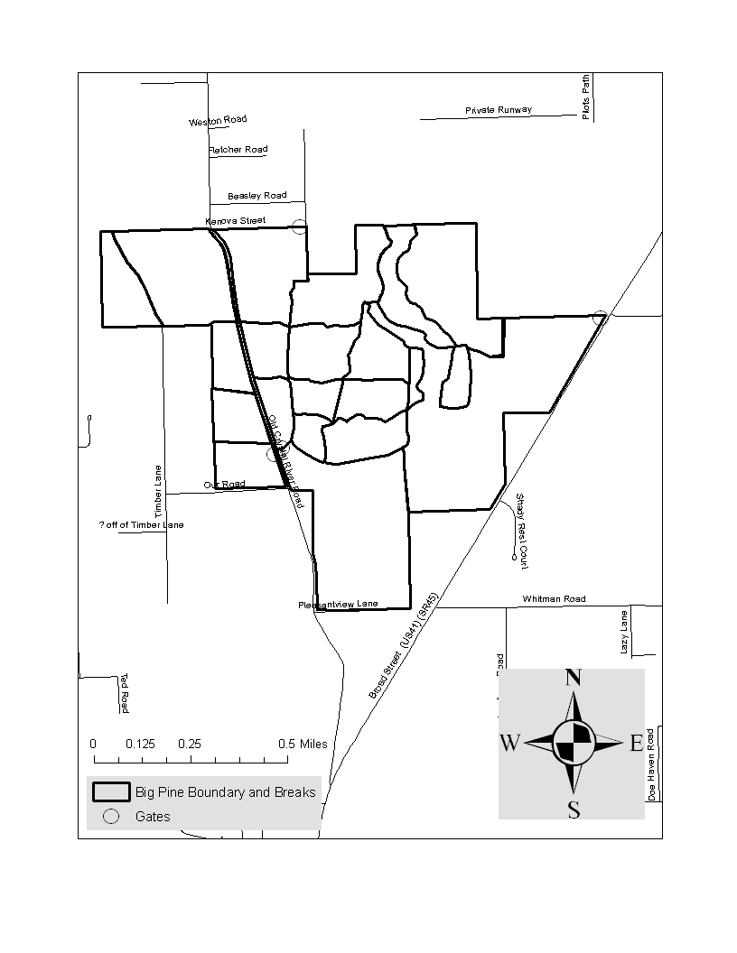
* Map A

BIG PINE TRACT
PROJECT DESCRIPTION

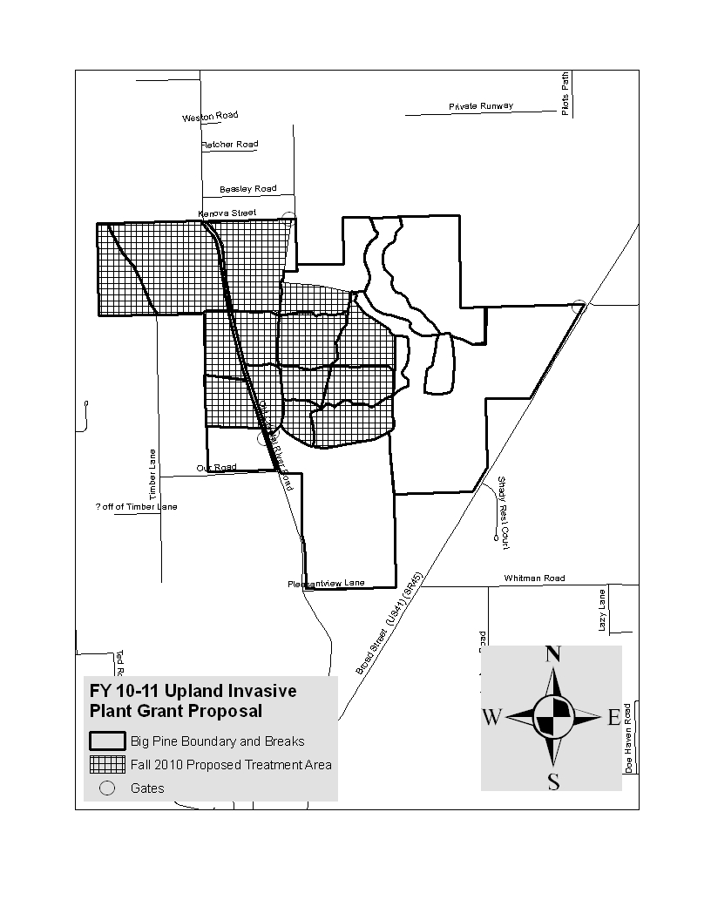

* Figure 1

BIG PINE TRACT
PROJECT DESCRIPTION
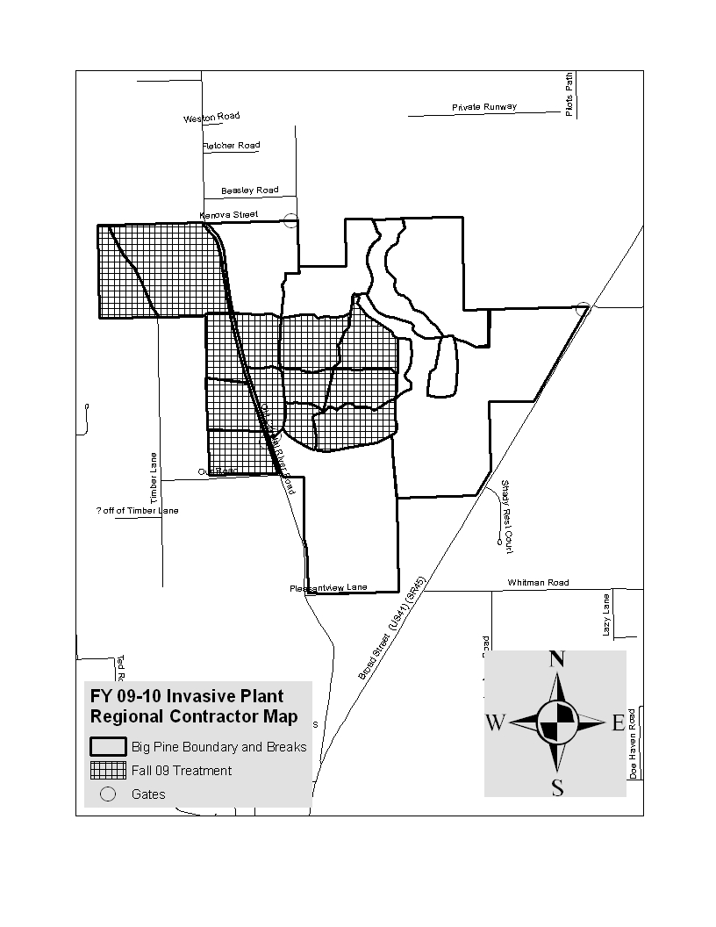

* Figure 2

BIG PINE TRACT
PROJECT DESCRIPTION

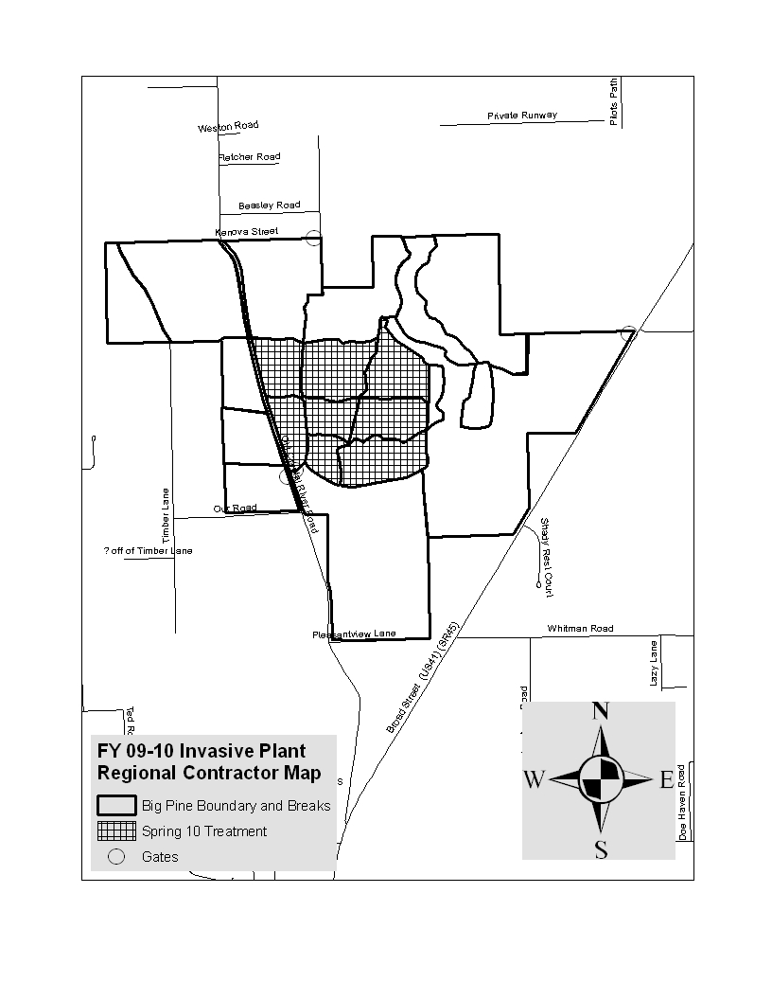

* Figure 3

