Section 1
Introduction

1.1 Background
Biscayne Bay, located within coastal Miami-Dade County (County), is a subtropical, shallow estuary in southeast Florida (Figure 1-1). From the mainland coast on the west to the barrier islands on the east, Biscayne Bay encompasses nearly 430 square miles and is widely used by residents and tourists for commercial and recreational purposes. A renowned travel destination and real estate market, Biscayne Bay is considered the blue heart of Miami-Dade County. Biscayne Bay is home to two State aquatic preserves, a State-designated critical wildlife area, a national park, and a national marine sanctuary.
Biscayne Bay is designated a Class III water body and has been further designated an Outstanding Florida Water under Section 62-302.700, Florida Administrative Code (FAC).. This classification affords the bay a high level of protection from water quality degradation as established by the Florida Department of Environmental Protection (FDEP). Fish consumption; and recreation are allowable activities within Class III waters, and as a matter of policy the County supports the propagation and maintenance of a healthy, well-balanced population of fish and wildlife.
Based on the level of protection afforded to Biscayne Bay, the County and other local stakeholders, as well as the FDEP, are working together to address water quality impairments in the Biscayne Bay watershed. With FDEP support, the Biscayne Bay Commission was formed on June 3, 2021, by the Florida legislature as an advisory council to FDEP to unite the efforts of the local and state stakeholders for coordinated plans, programs, and public outreach. The Biscayne Bay Commission held its inaugural meeting on January 4, 2022. The first order of business was to review and consolidate existing programs and projects into a strategic plan for bay improvement.
Figure 1-1 shows Biscayne Bay along with the jurisdictional areas, each of which represents a potential stakeholder and participant in the restoration process. Figure 1-2 illustrates the FDEP water body identification (WBID) units.

1.2 Description of Biscayne Bay and History
The following paragraphs describe the bay and its history as documented in the Biscayne Bay Aquatic Preserves Management Plan (FDEP 2013). Biscayne Bay is the largest estuary in Florida and is contiguous with the southern Florida Everglades and Florida Bay. The land surrounding the bay is the historical home of the Seminole, Miccosukee, and Tequesta Indian tribes. The hydrology of southeast Florida is unique because of its dynamic interaction between surface water and groundwater. Biscayne Bay is downstream of the Lake Okeechobee watershed. The Everglades wetlands were historically connected to Biscayne Bay by water flowing through rivers and streams that carved through the Atlantic Coastal Ridge. The ridge parallels the coast along the northern part
Figure 1-1 Biscayne Bay Location Map

Figure 1-2 Water Body Identification Boundaries

of the County and is farther inland along the southern section. The transverse glades were low-lying areas that cut through the Atlantic Coastal Ridge and allowed surface water to flow into Biscayne Bay.
Until Arch Creek Military Trail (now US1) was built during 1855–1859, the Miami area was only accessible by boat. As the Miami area grew, the Atlantic Intracoastal Waterway (AIWW) was dredged into the bay by 1912 to further accommodate inshore travel by larger vessels. Seagrasses and algal beds were impacted when channels were dug to allow access for ships with deeper drafts as well as when the dredged material (spoils) was piled next to the channels. At least 20 islands were created or enlarged within the bay as a result of dredging and spoil material placement. Today these islands serve as recreation areas and have been restored as part of the County’s habitat restoration projects to restore native vegetation.
Aside from groundwater inputs, Biscayne Bay historically received surface waters from the north and west. In the northern bay, the Oleta River, Arch Creek, Biscayne Creek, Little River, and the Miami River provided surface flow through low areas of the Atlantic Coastal Ridge. Today, most of these waterways have been dredged into canals or altered from their historical footprint. In the 1950s, the U.S. Army Corps of Engineers (USACE) began the construction of the Central and Southern Florida Project, a major Everglades drainage program, creating a complex system of canals, levees, dams, and pump stations that were built to provide protection from seasonal flooding to former marsh land being used for agriculture and real estate development. Meant to prevent flooding in low-lying developed areas and to protect the shallow freshwater Biscayne aquifer (which serves as the main drinking water source for south Florida) from saltwater intrusion, the canals and levees constructed by USACE route surface water runoff from the urban and agricultural areas toward Biscayne Bay. Today, water flow in the primary canal system is managed by the South Florida Water Management District (SFWMD) through a complex system of levees, pump stations, and control structures. The secondary canal system is managed by the County.
Until the 1950s, there was no large-scale sewage treatment system within the County and waste was released into bay waters. In the 1970s, three County-owned centralized treatment plants were built close to coastal locations so that treated sewage effluent could be piped offshore (now known as the North and Central District Wastewater Treatment Plants) or injected 2,000 feet below the Biscayne aquifer into the saline, nonpotable Lower Floridan aquifer. (for the South District Wastewater Treatment Plant).
For management purposes, Biscayne Bay can be divided into three major sections. These three distinctive sections are: northern, central, and southern. Northern Biscayne Bay includes the area where the Oleta River empties into Biscayne Bay and ends at the Rickenbacker Causeway, near the mouth of the Miami River. Within the northern section, there are basins that vary in residence time, salinity, depths, adjacent hydrological alterations, shoreline type, and resources present. According to Cantillo et al. (2000), the area in Biscayne Bay with the largest number of organisms once occurred in northern Biscayne Bay, within the Little River Basin. This area is described as having “high water clarity, large diversity, and great productivity of organisms.” The northern and central portions of the bay connect to the Atlantic Ocean through one natural and three human-made inlets between barrier islands.
Rapid population growth and development in southeast Florida contributed to impacts on natural systems. Loss of habitat due to human encroachment has affected many species, including those of commercial and recreational importance. Reduced groundwater flow from the Biscayne aquifer reaching surface waters, can be exacerbated by freshwater demands from development and can impact natural systems throughout. Stormwater runoff, septic systems near the bay, and associated nutrient discharges negatively affect local water quality.
The Biscayne aquifer is a shallow and highly permeable aquifer made up of porous limestone, which leaves it readily susceptible to contamination from urban and agricultural land uses on the surface. The geology of southeastern Florida is characterized by the shallow surficial water (occurring near the surface) of the Biscayne aquifer and the deeper Floridan aquifer. The Biscayne aquifer provides groundwater discharge flows, depending on geology, into Biscayne Bay, which provides a salinity regime that has allowed flora and fauna in all stages of their life cycles to find a home.
Since the late 1800s, Biscayne Bay has been affected by human activities including dredging and filling, construction of major drainage canals, land development of shorelines, and construction of islands and causeways. Water quality and environmental threats to Biscayne Bay include stormwater runoff, discharges from freshwater canals, potential increases in future flows, failing and/or properly operating septic tank systems near surface waters, sewer overflows, bay shoreline development and armoring, improper vessel use and operation, human overuse of natural resources, and possible groundwater influences. These sources have caused excess nutrients, higher chlorophyll a (a measure of algal biomass), and loss of seagrasses.
The Biscayne Bay Management Plan was jointly prepared by the Miami-Dade County Planning Department and the Department of Environmental Resources Management (DERM) and was adopted in 1981 with the objective of implementing programs to support restoration and enhancement of the bay. One of the principal recommendations in the plan involved the establishment of the Biscayne Bay Management Committee, a 15-member coordinating body composed of representatives of local, state, and federal government, as well as citizens.
On February 5, 2019, the Miami-Dade Board of County Commissioners adopted Resolution No. R-165-19, establishing the Biscayne Bay Task Force (Task Force). The Task Force is as a nine-member advisory board consisting of appointed professionals representing civil engineers, coastal real estate developers, water quality and ecology experts, coastal managers, environmental regulators, resilience experts, and the community at large. The Task Force was charged to meet to review prior studies, relevant data, and evaluations, and management planning and policy documents related to Biscayne Bay as well as to receive recommendations related to the health and management of the bay.
The Biscayne Bay Task Force Report and Recommendations (2020) concluded that despite the many layers of county, state, and federal protection for water quality, habitat, and wildlife, Biscayne Bay is at a tipping point. Historically, Biscayne Bay received freshwater along its shoreline as water traveled south and east, mixing with water from the Atlantic Ocean. Today, natural freshwater flows have been replaced by pulsed, point source discharges from dredged canals, intended to offer flood protection and move water away from inland areas. Canals can intercept groundwater, and more than half of the freshwater received by the bay enters via the northernmost canals where the most notable seagrass losses have occurred. Additionally, stormwater runoff may carry pollutants and contribute to the degradation of the quality of the water entering canals and Biscayne Bay. The timing, source, and quality of freshwater delivered to the bay can and has influenced the health, diversity, and distribution of the flora and fauna that compose the Biscayne Bay ecosystem. While there may be a general awareness in south Florida of the importance of the Biscayne aquifer and the need to protect the quality of the groundwater in this aquifer as the sole source of drinking water, there is less known about the connection of the aquifer to Biscayne Bay and the Bay’s dependence on large volumes of clean, fresh water for its ecological health. Hydrological changes, water management practices, upland development, and aged infrastructure have contributed to degraded water quality, seagrass die-offs and algal blooms. These effects have been studied in part through data collected via the County’s surface water quality and benthic habitat monitoring programs and data from other agencies and institutions.
DERM’s water quality and seagrass survey data, as well as review of scientific literature and academic studies presented as part of the Task Force’s work, indicate that chronic, low-level nutrient loading and/or acute, pulsed nutrient loading is linked to seagrass loss in Biscayne Bay. Excess nutrients can lead to a shift from a seagrass-dominated habitat with clear water, low turbidity, and low levels of algae in the water column, to an algae-based ecosystem that is turbid and reduces habitat essential for fish, birds, marine mammals, and other marine species. Sources of nutrients can include pet waste, fertilizers, and yard clippings and can be conveyed by stormwater outfalls. Other sources may include leaky sewer infrastructure and septic tank system effluent. Unique challenges presented by storms and sea level rise compound and complicate these existing issues.
To address the water quality concerns of Biscayne Bay and to prepare a comprehensive plan for restoration, the entire bay must be considered as major influences. When a water body is considered by FDEP for impairment, water quality data are used to categorize (segregated into WBIDs) its status into five subsets as identified in Table 1-1.
Table 1-1 Florida Department of Environmental Protection Assessment Category
Subset | Water Body Category
1 | Attains all designated uses
2 | Attains some designated uses and insufficient or no information to determine if remaining uses are attained
2a | Attains one or more designated uses and an alternative restorative plan or TMDL has been completed
3 | No or limited data available to determine attainment of designated uses
4 | Impaired for one or more designated use but does not require TMDL
5 | Water quality standard is not being attained and a TMDL is required
Note: Total Maximum Daily Load (TMDL)

There are subsets of many of these categories, the most important of which is Category 4b of Section 303(d) of the Clean Water Act, which identifies waters that are “impaired for one or more designated uses but does not require TMDL development because the water will attain water quality standards due to existing or proposed measures.”
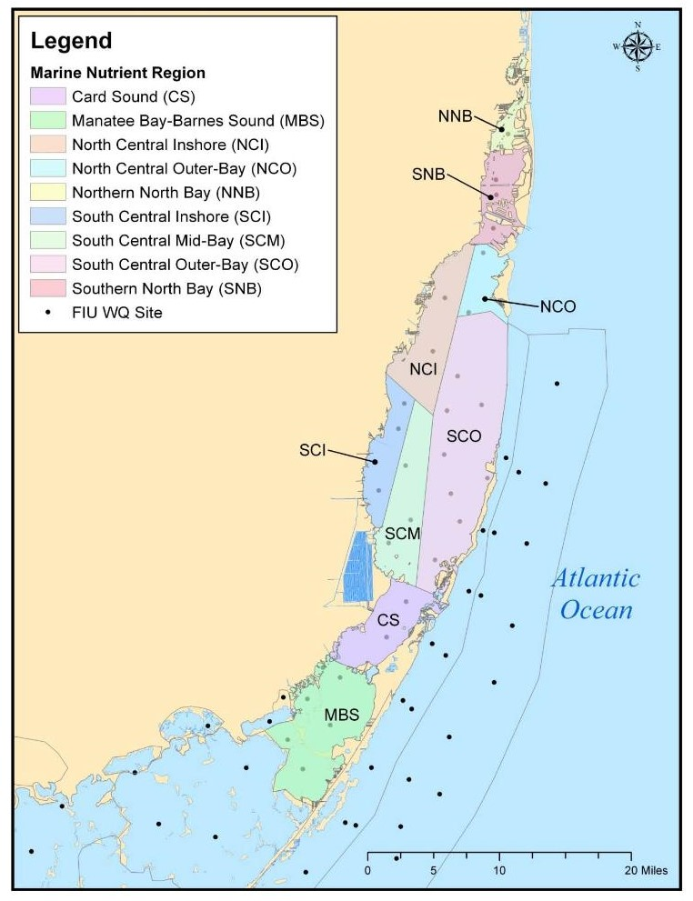
Currently, FDEP has assessed Biscayne Bay relative to the designated numeric nutrient criteria (NNC) rules and has identified most of the bay as impaired because of exceedances of chlorophyll a. According to FDEP’s “Site-Specific Information in Support of Establishing Numeric Nutrient Criteria in Biscayne Bay” (FDEP 2011), the bay was divided into regions as illustrated in Figure 1-3, with criteria identified in Table 1-2.
Figure 1-3 Marine Nutrient Regions for Biscayne Bay
(Source: FDEP(2011)
Table 1-2 Florida Department of Environmental Protection Numeric Nutrient Criteria for Biscayne Bay
Segment | Abbreviation | TP (mg/l as AGM) | TN (mg/l as AGM) | Chla (µg/l as AGM)
Card Sound | CS | 0.008 | 0.33 | 0.5
Barnes Sound¹ | MBS | 0.007 | 0.58 | 0.4
North Central Inshore | NCI | 0.007 | 0.31 | 0.5
North Central Outer-Bay | NCO | 0.008 | 0.28 | 0.7
Northern North Bay | NNB | 0.012 | 0.30 | 1.7
Southern Central Inshore | SCI | 0.007 | 0.48 | 0.4
Southern Central Mid-Bay | SCM | 0.007 | 0.35 | 0.2
South Central Outer-Bay | SCO | 0.006 | 0.24 | 0.2
Southern North Bay | SNB | 0.010 | 0.29 | 1.1
- Barnes Sound is in Group 5 Florida Keys – Upper Keys Planning Unit whereas the remaining segments are in Group 4 Biscayne Bay Intracoastal Planning Unit.
- Total Phosphorus (TP)
- Total Nitrogen (TN)
Based on the most recent assessment of these waters relative to nutrients and chlorophyll a, the FDEP has determined that all but Card Sound are impaired by chlorophyll a. Therefore, based on this information, the FDEP would classify most of these waters as Category 5 with a TMDL required. To achieve water quality restoration more quickly than the TMDL/Basin Management Action Plan (BMAP) process led by the FDEP, Miami-Dade County has begun the process for study and implementation of a locally driven alternative restoration plan (RAP) for the Biscayne Bay watershed. This plan will be referred to as the Northern Biscayne Bay 4b Phase 1 (RAP) to be consistent with the FDEP terminology as defined above. The acceptance of the RAP by the FDEP requires secretarial approval and will become a binding agreement between the County and the FDEP.

1.3 Northern Biscayne Bay Subset
Because the study and assessment of large estuarine systems such as Biscayne Bay will take several years to complete (based on the experience of Tampa Bay and Sarasota Bay, each of which was studied through the National Estuary Program), it is also expected that the study and implementation of remediation activities for Biscayne Bay will require many years. However, several mitigative activities are available to be implemented in the short term, subject to availability of FDEP grant funding. Miami-Dade County intends to obtain FDEP Wastewater Grant Program funding to provide septic to sewer projects in the northern Biscayne Bay area. Eligibility for the State’s Wastewater Grant Program funding is contingent upon the projects occurring as part of a BMAP or RAP. To expedite the County’s ability to apply for grant funds this funding cycle (2022–2023), Miami-Dade County offers this Phase 1 RAP for the northern Biscayne Bay as part of a phased approach to developing a countywide RAP as a path toward restoration for the entire Biscayne Bay system. Miami-Dade County and its stakeholders are committing to developing and implementing a RAP for the entire Biscayne Bay watershed over time. The RAP Study Area for this initial phase is shown in Figure 1-4.

Figure 1-4 Reasonable Assurance Plan Study Area

1.4 Future Biscayne Bay Reasonable Assurance Plan Phases
As part of Miami-Dade County’s and stakeholders’ commitment to developing a RAP that encompasses the entire Biscayne Bay watershed, the future phases of the RAP are identified below. Future phases largely adhere to WBID boundaries.
The identification of phases was informed by the two main drivers for a Reasonable Assurance Plan: (1) impairment of Biscayne Bay itself and (2) the mayoral directive to be eligible for the State’s wastewater funding to address nutrient pollution for septic to sewer projects in the area with the highest density of vulnerable septic tank systems. To accommodate both drivers, a five-phase approach is proposed, starting with north Biscayne Bay and ending with the southernmost portion of the bay proper.
Figure 1-5 shows the phases of the Biscayne Bay RAP. Each phase is described below.
- Phase 1 – North Biscayne Bay. This phase considers the area in the northern part of the watershed that contains the septic to sewer projects for which Miami-Dade County intends to obtain a grant. This phase is on track to be completed by September 30, 2022.
- Phase 2 – North Biscayne Bay. This phase considers the rest of the watershed for the north Biscayne Bay area including the barrier islands. This phase is expected to be completed by September 2023.
- Phase 3 – North Central Biscayne Bay. This phase will overlap Phase 4, which includes a major part of the bay proper. This phase will be started along with Phase 4 because a general water quality model of the bay will be needed for both phases. Once the model is completed, Phase 3 will be completed first, followed by Phase 4. Phase 3 should be completed by September 2024.
- Phase 4 – Central Biscayne Bay. This is the major portion of the estuary. The work on this portion will be started in Phase 3, including a comprehensive water quality model of the entire bay. This phase should be completed by September 2025.
- Phase 5 – South Biscayne Bay. This includes the southernmost part of the bay up to Card Sound. This phase should be completed by September 2026.

1.5 Organization of the Northern Biscayne Bay Phase 1 Reasonable Assurance Plan
The Northern Biscayne Bay Phase 1 RAP document is organized below according to the FDEP’s Guidance on Developing Water Quality Restoration Plans as Alternatives to Total Maximum Daily Loads – Assessment Category 4b and 4e Plans (FDEP 2021). Sections include the following:
- Description of the Impaired Water Body
- Description of Waterbody or Aquatic Ecological Goals
- Description of Proposed Actions
Figure 1-5 Biscayne Bay Reasonable Assurance Plan Phases

- Description of Monitoring and Reporting Results
- Commitment to Proposed Corrective Actions
The sections listed above have been summarized from EPA’s 9-elements of a watershed restoration plan. Additional information will include the impaired waters list for the area, existing TMDLs, scientific references, Biscayne Bay Commission information, public and stakeholder information, and septic to sewer grant information. The information provided in phase I of the RAP, will be consistent with the requirements of EPA’s 9-elements of a watershed restoration plan

Section 302.700(9) (a) – National Park (86, 94); (h) Aquatic Preserve (82); (10)(a)1. Outstanding National Resource Waters (89)

