Section 3
Description of Waterbody Goals and Aquatic Ecological Goals
This section discusses the water quality and ecological goals for the Phase 1 RAP Study Area. Existing ambient water quality criteria are discussed as well as interim nutrient targets in addition to ecological goals for Northern Biscayne Bay within the RAP Study Area.

3.1 Applicable Water Quality Criteria

3.1.1 Canals
The narrative water quality criteria for nutrients in paragraphs 62-302.530(47)(a) and (b), F.A.C., applies to all Class I, Class II, and Class III waters. The criteria have been numerically interpreted in 62-302.531, F.A.C., for the majority of the waterbodies in the State of Florida (FDEP, 2022). However, only the narrative nutrient criterion is in effect for wetlands, tidal streams, non-perennial streams, and ditches, canals and other conveyances, or segments of conveyances that are man-made, or predominantly channelized, unless a site-specific numeric interpretation has been established by FDEP. South Florida canals currently do not have a numerical interpretation of the nutrient standard. Therefore, the narrative water quality criteria listed below apply to both the Little River (C-7) and Biscayne (C-8) Canals (:
- 62-302.530(47)(a): “The discharge of nutrients shall continue to be limited as needed to prevent violations of other standards contained in this chapter. Man-induced nutrient enrichment (total nitrogen or total phosphorus) shall be considered degradation in relation to the provisions of Rules 62-302.300, 62-302.700, and 62-4.242, F.A.C.”
- 62-302.530(47)(b): “In no case shall nutrient concentrations of a body of water be altered so as to cause an imbalance in natural populations of aquatic flora or fauna.”
The C-7 and C-8 (WBIDs 3287 and 3285) Canals are not currently considered impaired for nutrients by the DEP and do not have established site specific numeric nutrient criteria. Both the C-7 and C-8 Canal WBIDs have adopted TMDLs for fecal coliform. These WBIDs are also on the study list for dissolved oxygen (percent saturation). Average and median nutrient concentration at two stations in the canals is summarized below in Table 3-1.
Table 3-1 Average Nutrient Concentration in the C-7 and C-8 Canals
Location | TN (mg/l) |  | TP (mg/l)
Location | Average | Median | Average | Median
9/2020 - 12/2021 | 0.98 | 0.96 | 0.030 | 0.030
1990 - 2021 | 1.22 | 1.20 | 0.025 | 0.022
9/2020 - 12/2021 | 0.69 | 0.73 | 0.022 | 0.024
1990 - 2021 | 0.91 | 0.88 | 0.018 | 0.015

3.1.2 Estuary
As discussed in Section 2, the applicable NNC for Biscayne Bay within the RAP Study Area are defined in Subparagraphs 62-302.532(1)(h)5., F.A.C. and 62-302.532(1)(h)9., F.A.C. and summarized below in Table 3-2.
Table 3-2 Numeric Nutrient Criteria (NNC) Applicable to Biscayne Bay
Parameter/Estuary Segment | Existing Long-Term Geometric Mean | Maximum AGM  (not to be exceeded more than once in a 3-year period)
Total Phosphorus
Northern North Bay (ENRH5) | 0.010 mg/l | 0.012 mg/l
Southern North Bay (ENRH9) | 0.008 mg/l | 0.010 mg/l
Total Nitrogen
Northern North Bay (ENRH5) | 0.24 mg/l | 0.30 mg/l
Southern North Bay (ENRH9) | 0.23 mg/l | 0.29 mg/l
Chlorophyll a
Northern North Bay (ENRH5) | 1.41 µg/l | 1.70 µg/l
Southern North Bay (ENRH9) | 0.85 µg/l | 1.10 µg/l
Source: (FDEP, 2011)

3.1.3 Outstanding Florida Waters
Section 403.061(27) of the Florida Statutes grants FDEP the authority to establish rules that provide for a special category of waterbodies within the State referred to as “Outstanding Florida Waters” (OFW) which are deemed worthy of special protection because of their natural attributes. As outlined in the “Fact Sheet about Outstanding Florida Waters” (FDEP 2021b), discharges regulated through a regulatory permitting program of FDEP or a Water Management District (WMD) that are proposed within an OFW must not lower background ambient water quality. For purposes of an OFW designation, background water quality is the water quality a year prior to OFW designation or the year before a complete permit application, whichever water quality is better. FDEP and the WMDs cannot issue permits for direct discharges to OFWs that would lower ambient water quality. In most cases, this affects new wastewater discharges directly into an OFW, and requires increased treatment for stormwater discharging directly into an OFW. Activities that require an environmental resource permit (ERP) for stormwater generally must undergo additional treatment when discharging to an OFW. To accommodate this, treatment systems are designed to achieve a 95 percent reduction in pollutant loads compared to stormwater discharged to non-OFW waters, where an 80 percent reduction is generally required (FDEP, 2021c). FDEP and the WMDs also may not issue permits for indirect discharges that would significantly degrade a nearby waterbody designated as an OFW.
The Biscayne Bay Aquatic Preserve was designated in 1974 and the Biscayne Bay - Cape Florida to Monroe County Line Aquatic Preserve was designated in 1975. The bay was then designated as an OFW at different dates; the two aquatic preserves in 1979 and 1982, respectively per 62-302.700, F.A.C.: Special Protection, Outstanding Florida Waters, Outstanding National Resource Waters. Biscayne National Park was also designated a national monument in 1968 and a national park in 1980. Available water quality (i.e., nutrient) data were reviewed during this time period for monitoring stations within or in close proximity to the RAP Study Area. Stations with historical water quality data included stations BB09, BB17 and 21FLA28040349 (Figure 3-1). Of the three stations, 21FLA28040349 has the earliest period of record with data recorded prior to 1978 for chlorophyll a, TN, and TP which are summarized in Figures 3-2, 3-3, and 3-4, respectively. Stations BB09 and BB17 did not have recorded data until the 1979 to 1980 time period. Many of the concentration values at 21FLA28040349 recorded prior to 1978 for chlorophyll a and TP were “0” as can be seen in the figures. The few non-zero concentration values prior to 1978 averaged 1.2 ug/l for chlorophyll a. The average TN concentration was 0.065 mg/l in 1978 and 0.53 mg/l from 1974 through 1978. For TP, the average concentration in 1978 was 0.03 mg/l and 0.07 mg/l from 1976 through 1978 when non-zero values were consistently recorded.

3.2 Aquatic and Ecological Goals in Biscayne Bay
Over time, Biscayne Bay has experienced seagrass die-offs. The most notable losses have occurred in the last decade and are primarily associated with three regions of the bay, including portions of North Biscayne Bay that coincide with the RAP Study Area. A rigorous study by the County’s Department of Regulatory and Economic Resources (RER) Division of Environmental Resources Management (DERM), considering water quality and seagrass survey data, scientific literature and academic studies, concluded that chronic low-level nutrient loading and/or acute pulsed nutrient loadings are most likely linked to seagrass loss in the bay. The County’s Report on the Findings of the County’s Study on the Decline of Seagrass and Hardbottom Habitat in Biscayne Bay - Directive 171537 (2019) found that working to reduce anthropogenic impacts to water quality and seagrass habitats is the first step towards the goal for promoting recovery of seagrasses within Biscayne Bay. The following paragraphs summarize information presented in the County’s 2019 Report regarding seagrass losses in Biscayne Bay.
Miami-Dade County is unique in being one of a few counties that is home to all seven species of seagrasses found in the state of Florida. The seven species include:
- Thalassia testudinum (Turtle grass)
- Syringodium filiforme (Manatee grass)
- Halodule wrightii (Shoal grass)
- Halophila decipiens (Paddle grass)
- Halophilia johnsonii (Johnson’s seagrass)
- Halophilia engelmannii (Star grass)
- Ruppia maritima (Widgeon grass)
Historically, Biscayne Bay has been an oligotrophic estuary where limited availability of nitrogen and phosphorus is vital to the health and development of seagrass communities. Phosphorus is considered to be the limiting nutrient in this estuary. It has the ability to bind to the calcium carbonate sediments characteristic of the bay, and its availability plays an important role in plant growth in a marine environment. Several researchers, including Caccia and Boyer (2007) and Burkholder et. al. (2007), acknowledge and/or directly attribute seagrass decline to ecosystems becoming eutrophic or having an over-enrichment of nutrients.

Figure 3-1 Biscayne Bay Monitoring Stations with Historical Data
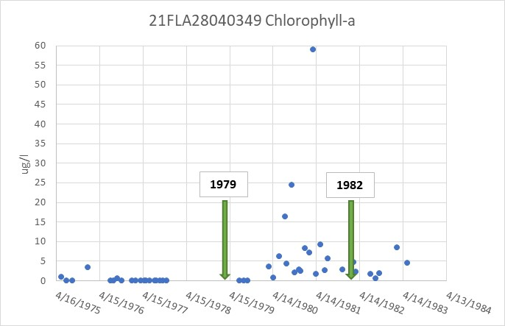
Figure 3-2 Northern Biscayne Bay Historical Chlorophyll a Concentration near the RAP Study Area (Station 21FLA28040349)

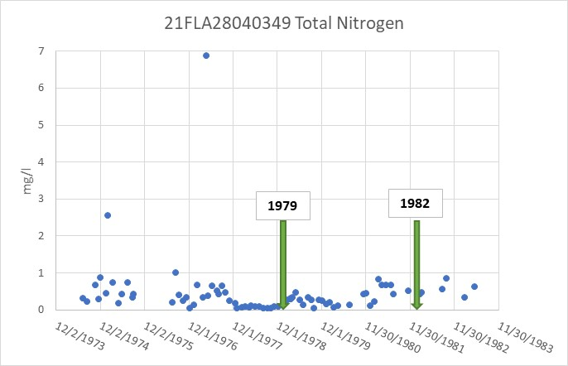
Figure 3-3 Northern Biscayne Bay Historical TN Concentration near the RAP Study Area (Station 21FLA28040349)
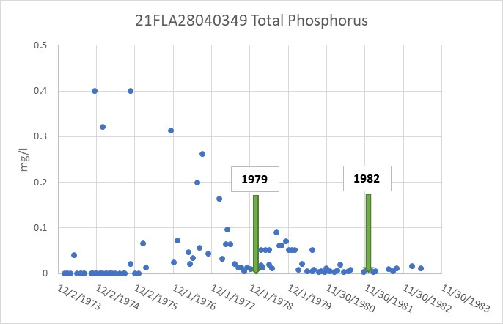
Figure 3-4 Northern Biscayne Bay Historical TP Concentration near the RAP Study Area (Station 21FLA28040349)

Researchers at FIU as well as NOAA support the County’s findings that phosphorus and chlorophyll a have trended higher in the bay over the last 20 years (Millette et. al., 2018). The frequency of algal blooms and seagrass losses have increased since 2005. The association between bacteria, ammonia (NH₃), and phosphorus has also been documented by the County and linked with human waste indicators such as artificial sweetener and nitrogen isotopes. It is difficult to determine the exact quantity of nutrients that lead to the decline of seagrass as the bay is an open system and nutrients are continuously cycled through the ecosystem and also interact with marine algae. Seagrass beds also serve to sequester nutrients and their ability to uptake nutrients may be dependent on the species of seagrass, species density, and other factors such as temperature and salinity. Nutrient enrichment can also represent itself as a sudden shift in biomass rather than a gradual change in growth correlated with the rate of nutrient addition. Therefore, there is not necessarily a direct linear relationship between the variation in nutrient concentrations observed through water quality monitoring and the loss of seagrass in a particular area.
Chronic loading of low-level nutrients and/or acute pulsed nutrient loading is linked to seagrass loss worldwide within highly urbanized coastal areas (Burkholder et. al., 2007) and can occur in waters with limited tidal flushing such as the Julia Tuttle Basin in North Biscayne Bay where nutrient loads are both concentrated and frequent. This has also been observed in other estuaries in the State of Florida including the Indian River Lagoon. Over time, this dynamic can cause the habitat to shift from a macrophyte (i.e., aquatic plants) dominated system to a phytoplankton (i.e., algae) based system. Algae blooms can cause further deterioration of water quality, remove important molecularly available elements, and prevent sunlight from reaching aquatic plants which is vital to their growth. A healthy seagrass habitat is dominated by low biomass of algae evidenced by low levels of chlorophyll a and therefore high water clarity.
In North Biscayne Bay, the Julia Tuttle Basin, located within the RAP Study Area (Figure 3-5), historically served as habitat for a dense seagrass community dominated by Syringodium filiforme (Manatee grass) which can thrive under higher nutrient conditions. The Manatee grass found in this area grew to densities and shoot length indicative of nutrient enrichment. A sudden die-off of seagrass (a loss of 1,300 acres or 77%) in this area was observed from 2013-2016 as shown in Figure 3-6. A review of historical data for two water quality stations in the basin showed peaks in phosphorus in 2014 and 2015 and the highest average of chlorophyll a was also documented in 2014. Consultation by County staff with local academia experts suggested that the seagrass species composition and large biomass was indicative of nutrient enrichment and the die off was likely driven by the significant oxygen demand needed to support the high biomass.
Similarly, the 79th Street Basin (also located within the RAP Study Area and shown on Figure 3-5) exhibited significant seagrass loss in 1998 although it was not as heavily investigated at the time. A review of the data however indicated similar conditions of high biomass and excessive nutrient enrichment.
In addition to seagrass losses, Biscayne Bay has also experienced fish kills in recent years. The largest and most widespread fish kill occurred in August 2020 and was documented by the Miami Waterkeeper (with input from the Biscayne Bay Science Coordination Group) in the “Fish Kill in Biscayne Bay: A Report”. Much of the data referenced and cited in this report was collected and analyzed by the Miami Dade County RER DERM. The Miami Waterkeeper tracked public reports of fish kills and maintained a database of the information. Their analysis concluded that at least 27,640 fish, representing 56 species were killed during this event. Reports of fish kills were most heavily concentrated in the Julia Tuttle Basin in northern Biscayne Bay. Following observations of the fish kill, algae blooms were also recorded over large areas in northern Biscayne Bay. Scientists and experts who were consulted reached a consensus that the cause of this event was due to low DO levels in the bay. In parts of northern Biscayne Bay, DO levels less than 1 mg/l and/or 0 mg/l were measured. These low measurements were observed specifically near Pelican Harbor/79th Street Causeway and the Little River/Belle Meade area. Water temperatures were also very high (~90° F). The most significant number of fish deaths were reported at Morningside Park which is located within the RAP Study Area. Based on review of canal flow data in 2020, it was observed that the discharge canals experienced several sharp pulses of anomalously high flow and one of these flow pulses coincided with the August 2020 fish kill event. It is possible that the high flow rates may have exacerbated the already low DO levels by delivering large nutrient inputs to the bay via canal waters containing little dissolved oxygen. Following the August event, a smaller fish kill occurred near North Bay Village in October 2020. FIU is currently developing the Biscayne Bay Operational Hydrodynamic and Water Quality Model. This model will provide high resolution representation of dynamics within the bay including velocity, water depth, deposition patterns, and pollutant concentration. When it is finalized, it will provide a further understanding of the bay hydrodynamics and causes of fish kill events and other environmental impacts.
Various factors, both anthropogenic and natural, have the potential to impact seagrass health, aquatic life, and hardbottom communities of Biscayne Bay. These include anthropogenic activities on the land surface or within the bay, naturally occurring events such as hurricanes, and the changes to the bay’s ecosystem due to sea level rise. The County and stakeholders acknowledge it

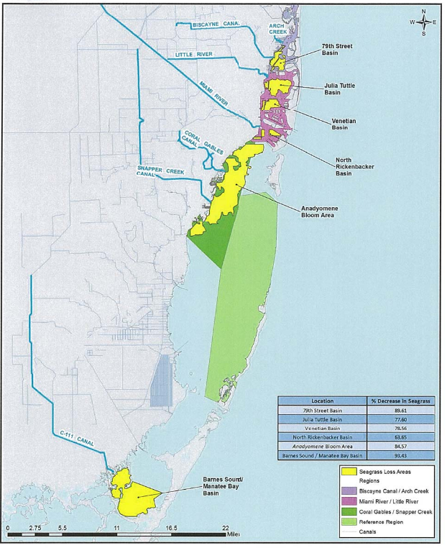
Figure 3-5 Biscayne Bay Basins with Seagrass Losses (Source: Miami-Dade County 2019)

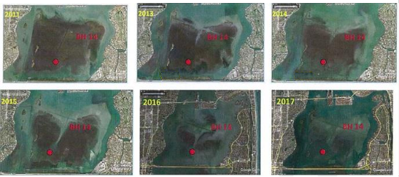
Figure 3-6 Time Series of Seagrass Loss in Julia Tuttle Basin (Source: Miami Dade, 2019)
is not feasible to eliminate all pollutant sources to the bay; however, working to reduce anthropogenic impacts to water quality, water clarity, and seagrass habitat, with a focus on phosphorus reduction and nutrient reduction overall, provides the best opportunity for seagrass recovery.
Therefore, the recovery of seagrasses and the return of a healthy balanced ecosystem is the long-term ecological goal for the overall Biscayne Bay RAP (to be completed over multiple phases).
The County recognizes that full recovery of seagrass communities after a significant loss is a complex ecological process that can take many years, even decades, to occur. The overall Biscayne Bay RAP will be a multi-phase process that addresses the long-term goal of seagrass recovery, including setting specific targets in upcoming phases, and requires a more comprehensive and rigorous analysis that sets the appropriate water quality targets for the bay and potentially for canals to achieve seagrass restoration goals.
This Phase 1 RAP is the first step in addressing a subset of potential impacts described throughout this section. Certain anthropogenic activities including untreated stormwater runoff, fertilizers, OSTDSs, and sanitary sewer overflows contribute nutrient loadings to canals and ultimately to the bay, and these sources can be addressed more readily than can evaluations of baseflow, groundwater contributions, and other potential sources. Therefore, interim water quality targets will be established as part of this Phase 1 RAP, which can be finalized or become recommended water quality targets in upcoming phases, as described in the following sub-section.

3.3 Interim Waterbody and Ecological Goals and Required Load Reductions
As stated in the previous section, the overall Biscayne Bay RAP will be a multi-phase process that addresses the long-term goal of seagrass recovery with a more comprehensive and rigorous analysis that determines the most appropriate water quality targets to achieve these goals, including setting seagrass restoration targets that would be met largely through nutrient reduction goals being achieved over time. Until more appropriate water quality targets are determined, this Phase I RAP will rely on the current applicable numeric nutrient criteria (NNC) for Biscayne Bay as defined in Subparagraphs 62-302.532(1)(h)5 F.A.C. and 62-302.532(1)(h)9 F.A.C. (previously summarized in Table 3-2) as the interim water quality target for the bay estuary segments within the RAP Study Area. As future phases of the RAP are completed and additional data are compiled, the water quality targets will be assessed more rigorously to determine appropriate nutrient reductions that work towards achieving seagrass restoration goals.
The following sub-sections discuss the estimated load reduction required from the RAP Study Area to meet the NNC.

3.3.1 WASP Model Application with Nutrient Load Reductions
An initial review of the calculated Annual Geometric Mean (AGM) values for 2015 – 2021, based on running the NNC tool of FDEP’s Impaired Waters Rule (IWR) Database (Run62), showed that WBIDs 3226H5 and 3226H6 have AGM values that exceeded the NNC for those WBIDs (i.e., had AGM values that exceeded the NNC for chlorophyll a more than once in a three-year period). The observed AGM values were used to estimate a percent chlorophyll a concentration reduction for the 2015 – 2021 period that would meet the chlorophyll a NNC requirement. That potential required reduction was applied to the preliminary screening modeling using the USEPA WASP for chlorophyll a concentrations calculated in segments H5 and H6 to establish model chlorophyll a goals for the two segments. Nitrogen and phosphorus load reductions in the C-7 and C-8 Canal were then evaluated to establish the required reduction to meet the model chlorophyll a goals.

3.3.1.1 Proposed Chlorophyll-a Goals
Table 3-3 lists the chlorophyll a AGM values calculated for WBIDs 3226H5 and 3226H6 during the 2015-2021 period. Values in bold italics exceed the NNC for chlorophyll a. Values are also presented for WBID 3226H3, which represents the southern boundary of the model and affects concentrations in the WASP segments (refer back to Figure 2-19) based on tidal mixing.
Table 3-3 Observed Chlorophyll-a AGMs
Year | Chlorophyll a AGM (ug/l) Observed | % Reduction | Reduced Chlorophyll a AGM (ug/l) | Existing WASP Chlorophyll a (ug/l) | WASP Chlorophyll a Target (ug/l)
3226H5 (Chlorophyll a NNC = 1.7 ug/l)
2015 | 2.2 | 25% | 1.65 | 2.55 | 1.91
2016 | 2.2 | 25% | 1.65 | 2.55 | 1.91
2017 | 2.2 | 25% | 1.65 | 2.55 | 1.91
2018 | 1.2 | 25% | 0.90 | 2.55 | 1.91
2019 | 1.6 | 25% | 1.20 | 2.55 | 1.91
2020 | 2.3 | 25% | 1.73 | 2.55 | 1.91
2021 | 1.5 | 25% | 1.13 | 2.55 | 1.91
3226H6 (Chlorophyll a NNC = 1.1 ug/l)
2015 | 2.1 | 40% | 1.26 | 2.11 | 1.27
2016 | 1.6 | 40% | 0.96 | 2.11 | 1.27
2017 | 1.8 | 40% | 1.08 | 2.11 | 1.27
2018 | 1.6 | 40% | 0.96 | 2.11 | 1.27
2019 | 1.3 | 40% | 0.78 | 2.11 | 1.27
2020 | 1.6 | 40% | 0.96 | 2.11 | 1.27
2021 | 1.2 | 40% | 0.72 | 2.11 | 1.27
3226H3 (Chlorophyll a NNC = 1.1 ug/l)
2015 | 1.4 | 10% | 1.26 | 1.06 | 0.95
2016 | 0.9 | 10% | 0.81 | 1.06 | 0.95
2017 | 1.2 | 10% | 1.08 | 1.06 | 0.95
2018 | 1.2 | 10% | 1.08 | 1.06 | 0.95
2019 | 0.5 | 10% | 0.45 | 1.06 | 0.95
2020 | 0.8 | 10% | 0.72 | 1.06 | 0.95
2021 | 0.5 | 10% | 0.45 | 1.06 | 0.95

For each WBID, the “% reduction” is established and applied to each year’s AGM, such that there is no exceedance of the chlorophyll a NNC more than once in a three-year period. The same “% reduction” is then applied to the modeled WASP chlorophyll a concentration in segments H5 and H6 (and to the boundary H3) to determine the chlorophyll a goal in segments H5 and H6, and an adjusted chlorophyll a boundary concentration at H3 (this assumes that WBID 3226H3 is meeting the NNC in conjunction with meeting the NNC in WBIDs 3226H5 and 3226H6).

3.3.1.2 H3 Boundary Concentration Adjustment
As discussed above, the H3 boundary concentration was reduced from 1.06 ug/l to 0.95 ug/l under the premise that WBID 3226H3 will be meeting NNC requirements. Presumably, the lower chlorophyll a at boundary H3 should also reflect a corresponding reduction in nutrient concentrations. It is not clear how that reduction should be quantified in this analysis since this analysis was limited as noted in previous sections based on priorities and schedule. Further analyses for this interaction could be done in future phases to further quantify the load reduction needs and potential benefits on chlorophyll a levels and reductions.
To establish the adjusted nutrient concentrations, the H3 chlorophyll a data were reviewed to assess how the reduction in chlorophyll a concentration related to the 90% confidence interval of the average distribution (standard deviation). For chlorophyll a, the lower boundary concentration is about 80% of the observed average to the low end of the 90% confidence interval. For the nutrients, the values were also calculated as 80% of the average to the low end of the 90% confidence interval. A comparison of the original and adjusted H3 boundary concentrations is presented in Table 3-4.
Table 3-4 Adjusted H3 Boundary Concentrations (Assuming NNC Met in WBID 3226H3)
Water Quality Constituent | Boundary Concentrations
Water Quality Constituent | H3 existing | H3 adjusted to meet NNC
Salinity (ppt) | 33.7 | 33.7
Total Nitrogen (mg/l) | 0.130 | 0.106
Organic Nitrogen | 0.102 | 0.082
Ammonia Nitrogen | 0.011 | 0.009
Nitrate Nitrogen | 0.017 | 0.015
Total Phosphorus (mg/l) | 0.0050 | 0.0043
Organic Phosphorus | 0.0016 | 0.0016
Inorganic Phosphorus | 0.0034 | 0.0027
Phytoplankton (ug/l) | 1.06 | 0.95

3.3.1.3 Estimate of Required Canal Load Reductions
The estimation of required canal nutrient load reductions was conducted by reducing the C-7 Canal and C-8 Canal boundary nutrient concentrations to achieve an assumed overall load reduction target (e.g., 40% reduction). The overall reduction further assumed a target concentration common to both canals, which means that the C-7 Canal has a higher percent removal target because it has higher concentrations than the C-8 Canal under current conditions.
Several trials of the WASP model indicated that an overall reduction of 35% (applied uniformly to nitrogen and phosphorus) met the estimated bay chlorophyll- a goals in the WASP segments. This corresponds to a 40% reduction in the C-7 Canal nitrogen and phosphorus and 21% reduction in the C-8 Canal nitrogen and phosphorus. The associated target TN and TP concentrations in the canals are 0.68 mg/l TN and 0.018 mg/l TP.
Table 3-5 shows the modeled WASP segment concentrations under existing conditions and with the estimated required load reductions. Associated annual loads and flow-weighted concentrations for current condition and reduced load conditions are summarized in Table 3-6.
Table 3-5 WASP Segment Concentrations under Existing Conditions and with Canal Load Reductions
Water Quality Constituent | Modeled Concentration
Water Quality Constituent | Existing | With Canal Load Reduction
Segment H5 (WASP chlorophyll a target = 1.91 ug/l)
Salinity (ppt) | 29.1 | 29.1
Total Nitrogen (mg/l) | 0.242 | 0.180
Nitrate Nitrogen (mg/l) | 0.027 | 0.031
Total Phosphorus (mg/l) | 0.0076 | 0.0058
Inorganic Phosphorus (mg/l) | 0.0035 | 0.0030
Chlorophyll-a (ug/l) | 2.55 | 1.36
Segment H6 (WASP chlorophyll a target = 1.27 ug/l)
Salinity (ppt) | 30.5 | 30.5
Total Nitrogen (mg/l) | 0.217 | 0.161
Nitrate Nitrogen (mg/l) | 0.025 | 0.026
Total Phosphorus (mg/l) | 0.0070 | 0.0054
Inorganic Phosphorus (mg/l) | 0.0036 | 0.0030
Chlorophyll-a (ug/l) | 2.11 | 1.25

Table 3-6 Canal Nutrient Loads and Concentrations for Current Conditions and Conditions with Estimated Required Load Reduction
Nutrient Load or Concentration | C-7 Canal | C-8 Canal | Combined
Current Annual TN Load (lb/yr) | 456,029 | 188,442 | 644,471
Current TN Average Concentration (mg/l) | 1.10 | 0.87 | 1.02
Estimated TN Reduction Required (%) | 42% | 26% | 37%
Reduced TN Load (lb/yr) | 264,497 | 139,447 | 403,944
Reduced TN Average Concentration (mg/l) | 0.64 | 0.64 | 0.64
Annual TN Load Reduction (lb/yr) | 191,532 | 48,995 | 240,527
Current Annual TP Load (lb/yr) | 10,982 | 4,982 | 15,964
Current TP Average Concentration (mg/l) | 0.027 | 0.023 | 0.025
Estimated TP Reduction Required (%) | 44% | 35% | 41%
Reduced TP Load (lb/yr) | 6,150 | 3,238 | 9,388
Reduced TP Average Concentration (mg/l) | 0.015 | 0.015 | 0.015
Annual TP Load Reduction (lb/yr) | 4,832 | 1,744 | 6,576

3.3.1.4 Comparison of WASP Results with “Report Card” Program
As discussed in Section 2, Miami Dade County RER DERM has developed a “report card” that assesses water quality in Biscayne Bay based on factors such as seagrass coverage, benthic habitat, water clarity, concentrations of nutrients, bacteria, and chlorophyll a.
Table 3-7 summarizes the nutrient and chlorophyll a values used as the basis for report card scoring of the areas identified as Northern North Bay – B (NNB-B) and Southern North Bay – A (SNB – A), which correspond to WASP segments H5 and H6, respectively. The scoring is on a scale from 1 (lowest) to 5 (highest), using the following approach to evaluate the AGM for a given year:
- 5 = less than the 25th percentile value
- 4 = between the 25th percentile and the long-term limit
- 3 = between long term limit and 0.8 times the upper limit
- 2 = between 0.8 times upper limit and the upper limit
- 1 = exceeding the upper limit
The numeric scores are also related to a “stoplight” score where a score of 4 or 5 is “green” (good), a score of 3 is “yellow” (fair), and score of 1 or 2 is “red” (poor).
Table 3-7 Water Quality Values for Assessing Water Quality Report Card Scores
Water Quality Constituent | Criteria from Literature or Rule |  | Calculated by DERM
Water Quality Constituent | Long-Term Limit | Upper Limit | 25th Percentile DERM Data | 0.8 Times Upper Limit
Chlorophyll a (ug/l) | 1.05 | 1.65 | 0.27 | 1.32
Total Phosphorus (mg/l) | 0.004 | 0.009 | 0.004 | 0.007
Total Nitrogen (mg/l) | 0.135 | 0.38 | 0.187 | 0.304
Source: Miami-Dade County
The “report card” scoring is based on an annual AGM, whereas the WASP model concentration results reflect an average value. To estimate AGM values from the WASP results, the observed data were reviewed to determine the overall ratio of the average to AGM for TN, TP, and chlorophyll a. The ratios were then used to convert the modeled average value into an estimated AGM value.
Table 3-8 presents the WASP average concentration, applied ratio of average to AGM, resultant estimated AGM value, and the report card score based on the estimated AGM using the WASP analysis. In all cases, the results show a score of 4 or 5 which correspond to a “green” rating in the green-yellow-red scorecard.
Table 3-8 Report Card Scores based on WASP Results with Load Reduction
Water Quality Constituent | WASP Average Concentration | Average / AGM Ratio | Estimated WASP AGM | Estimated Report Card Score
Segment H5 (Area Northern North Bay – B (NNB-B))
Chlorophyll a (ug/l) | 1.36 | 1.38 | 0.99 | 4 (between 25th percentile and Long-Term Limit)
Total Phosphorus (mg/l) | 0.0058 | 1.59 | 0.0036 | 5 (less than 25th percentile)
Total Nitrogen (mg/l) | 0.180 | 1.29 | 0.140 | 5 (less than 25th percentile)
Segment H6 (Area Southern North Bay – A (SNB-A))
Chlorophyll a (ug/l) | 1.23 | 1.37 | 0.90 | 4 (between 25th percentile and Long-Term Limit)
Total Phosphorus (mg/l) | 0.0058 | 1.67 | 0.0035 | 5 (less than 25th percentile)
Total Nitrogen (mg/l) | 0.166 | 1.30 | 0.128 | 5 (less than 25th percentile)

