

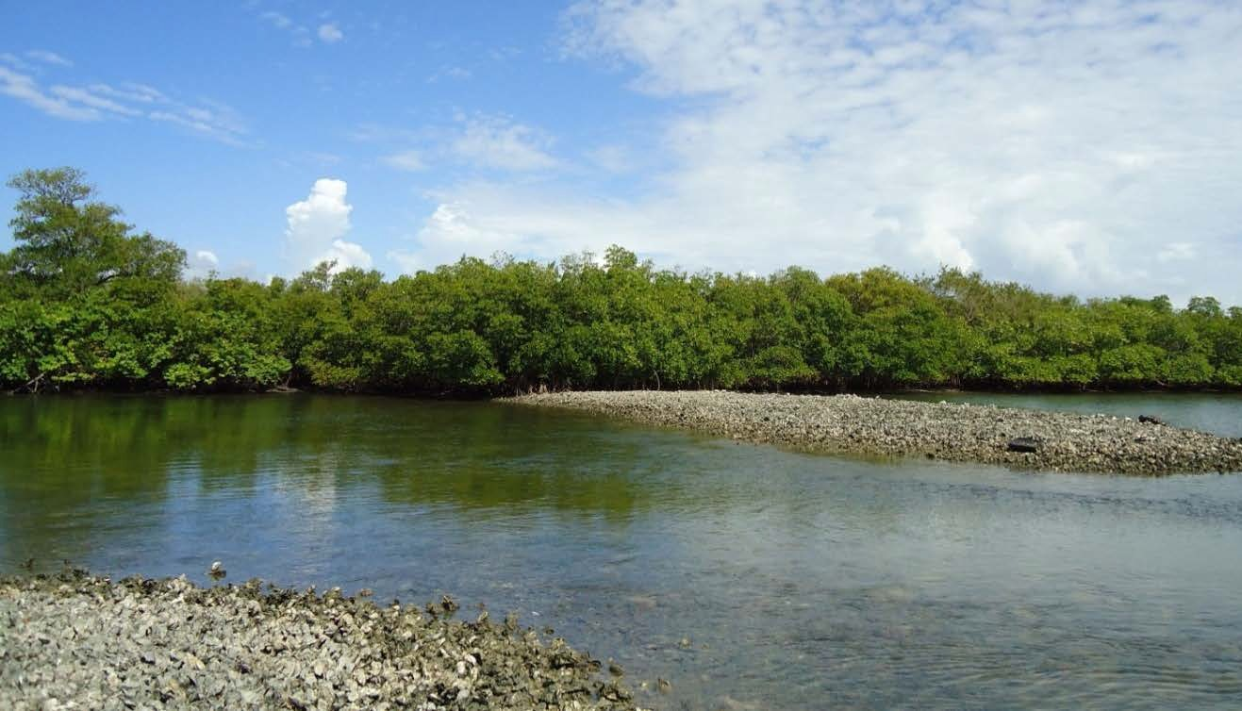

Mosquito Lagoon Reasonable Assurance Plan (RAP)
Water Quality Targets for Mosquito Lagoon
Volusia County and Mosquito Lagoon RAP Stakeholder Group
August 2018

MOSQUITO LAGOON REASONABLE ASSURANCE PLAN (RAP)
Water Quality Targets for Mosquito Lagoon

Prepared for: Volusia County 2560 West SR 44
DeLand, Florida 32720

and

Mosquito Lagoon RAP Stakeholder Group

Prepared by:
Janicki Environmental, Inc. 1155 Eden Isle Dr. NE
St. Petersburg, FL 33704

Project No. 22015-012-01

August 2018

EXECUTIVE SUMMARY

Mosquito Lagoon is located in the extreme northern extent of the greater Indian River Lagoon (IRL) system though it differs from the rest in a number of ways. Mosquito Lagoon has a low watershed to estuary surface area ratio. It is extremely shallow with hydrologic connections to the Atlantic Ocean in the north and to the rest of IRL through the Haulover Canal in the south. The Mosquito Lagoon also differs as the extreme losses of seagrasses observed recently in the other parts of the IRL system have not occurred to the nearly same extent.

Several local stakeholders, including Volusia County and the cities of New Smyrna Beach, Edgewater, and Oak Hill, have embarked on the development of the Mosquito Lagoon Reasonable Assurance Plan (RAP). The development of a RAP is a stakeholder-led effort to map out a plan to address a water quality impairment identified by Florida’s Impaired Waters Rule assessment process. By agreeing to the RAP, the local stakeholders are expected to implement projects to address the impairment by reducing the identified causative pollutant so that the waters can meet the appropriate criteria. Though it is developed on a voluntary basis, it is regulatory in nature as it is approved by the Secretary of the Florida Department of Environmental Protection (FDEP) and approved by the US Environmental Protection Agency (USEPA). This effort is to address the impairment due to elevated chlorophyll a concentrations throughout Mosquito Lagoon. As a RAP is developed to address waters not meeting water quality criteria, it does not address all issues that may be manifested in the lagoon.

A critical element to a RAP is the definition of the water quality targets to be achieved by the implementation of the plan. FDEP established Numeric Nutrient Criteria (NNC) in 2014 for the three Estuarine Nutrient Regions (ENRs) in Mosquito Lagoon building upon the work of the St. Johns River Water Management District (FDEP, 2014). Recognizing the reference period identified by the District did not reflect the wide range of environmental conditions experienced by the lagoon, the FDEP used a method to scale the available annual values based on the reference period to allow for the inclusion of a range of environmental conditions. These values were used to determine the current NNC.

The objective of this report is to review the current FDEP criteria and make a recommendation for appropriate criteria that are robust and defensible. This analysis benefits greatly from the availability of additional seagrass and water quality data to define a reference period. The first step to defining an appropriate reference period was to examine the seagrass coverage in each ENR. This examination found that the seagrass coverage was relatively consistent in the Central and Southern ENR from 1992 through 2015. The second step was to determine if the water quality data met the screening thresholds prescribed by the USEPA and FDEP known as the “three-legged stool” which examines water clarity and dissolved oxygen for the protection of flora and fauna and algal blooms for human health concerns. The water quality data achieved these thresholds for the years 1992 to 2010. The period following 2010 was excluded from the reference period given the occurrence of algal blooms in those years. Applying the reference period 1992 to 2010 to the available ambient water quality data resulted in the estimation of the annual geometric means for total nitrogen, total phosphorus, and chlorophyll a for the three ENRs of Mosquito Lagoon. Table ES-1 presents a comparison of the previously approved criteria and those proposed from the current analysis.

Table ES-1. Comparison of the current criteria and the NNC proposed by this analysis.
ENR | Current NNC | Proposed NNC
North  TN (mg/L) TP (mg/L) Chlorophyll a (µg/L) | 0.51  0.05  4.0 | 0.65  0.06  4.9
Central  TN (mg/L) TP (mg/L) Chlorophyll a (µg/L) | 0.65  0.05  3.4 | 0.85  0.06  5.0
South  TN (mg/L) TP (mg/L) Chlorophyll a (µg/L) | 1.14  0.03  2.5 | 1.31  0.05  5.2

Initial comments have arisen due to concerns that the proposed criteria are greater than those developed by FDEP. A couple of points should be considered when evaluating the appropriateness of the proposed criteria. First, the data available to define the original reference period was limited to the period prior to and including 2008. The additional data available (2009-2016) for analysis, including seagrass estimates, allow for a defensible definition for the targets. Secondly, an examination of the nutrient loads showed that the loadings from the original reference period (2004-2008) exceed those from other similar periods in the record (Janicki Environmental, 2017), which indicates it is less protective and may not be the best representation of conditions.

TABLE OF CONTENTS

EXECUTIVE SUMMARY iii
TABLE OF CONTENTS v
LIST OF FIGURES v
LIST OF TABLES v
1 INTRODUCTION 1
1.1 Background 1
1.2 Objective 1
2 APPROACH AND RATIONALE 3
2.1 FDEP Approach 3
2.2 Proposed Approach to Establishing Water Quality Targets for Mosquito Lagoon 4
2.3 Data Sources 5
2.3.1 Seagrasses 5
2.3.2 Water Quality 7
2.4 Proposed Reference Period 7
2.4.1 Seagrass Reference Period 7
2.4.2 Justification of the Proposed Reference Period 8
2.4.3 Water Clarity 8
2.4.4 Dissolved Oxygen 9
3 PROPOSED ALTERNATIVE WATER QUALITY TARGETS 11
3.1 Alternative 1: Mean of the Annual Geometric Means 12
3.2 Alternative 2: 80% Prediction Interval 12
3.3 Method Performance 12
4 CONCLUSIONS AND RECOMMENDATIONS 17
5 REFERENCES 17
APPENDIX A WATER QUALITY SAMPLING MAPS A-1
APPENDIX B WATER QUALITY TREND RESULTS B-1
APPENDIX C – Accounting of data used in “Three-legged” Stool Analysis C-1
APPENDIX D from FDEP (2012) “Overview of Approaches for Numeric Nutrient Criteria Development in Marine Waters” D-1

LIST OF FIGURES

Figure 1-1. Mosquito Lagoon and its Watershed. 2
Figure 2-1. Seagrass coverage (green bars) in the North (top), Central (middle) and South (bottom) ENRs of Mosquito Lagoon. Median deep-edge depths are represented by blue dots. 6
Figure B1. Time series of mean monthly chlorophyll a concentrations in the North (upper), Central (middle) and South (bottom) ENRs of Mosquito Lagoon. 3
Figure B2. Time series of mean monthly TN concentrations in the North (upper), Central (middle) and South (bottom) ENRs of Mosquito Lagoon. 4
Figure B3. Time series of mean monthly TP concentrations in the North (upper), Central (middle) and South (bottom) ENRs of Mosquito Lagoon. 5
Figure B4. Time series of mean monthly salinity concentrations in the North (upper), Central (middle) and South (bottom) ENRs of Mosquito Lagoon. 6

LIST OF TABLES

Table 2-1. Current numeric nutrient criteria not to be exceeded more than once in three years. 4
Table 2-2. Evaluation of water quality data by ENR with regards to the EPA “Three-legged Stool”. 10
Table 3-1. Annual Geometric Means for each Mosquito Lagoon ENR. 11
Table 3-2 Water quality targets based on Alternative 1: Mean of 1992-2010 AGMs. 12
Table 3-3. Water quality targets based on Alternative 2: Upper 80% Prediction Limit. 12
Table 3-4. Comparison of the current NNCs and two alternative expressions of the Mosquito Lagoon water quality targets. 13
Table 3-5. Assessment of the compliance with the current NNC and the two alternative expressions of the Mosquito Lagoon water quality targets for the North ENR. Units: TN (mg/L), TP (mg/L), Chl a (µg/L). 14
Table 3-6. Assessment of the compliance with the current NNC and the two alternative expressions of the Mosquito Lagoon water quality targets for the Central ENR. Units: TN (mg/L), TP (mg/L), Chl a (µg/L). 15
Table 3-7. Assessment of the compliance with the current NNC and the two alternative expressions of the Mosquito Lagoon water quality targets for the South ENR. Units: TN (mg/L), TP (mg/L), Chl a (µg/L). 16
Table B1. Results of the seasonal Kendall Tau trends test. Units: TN (mg/L), TP (mg/L), Chl a (µg/L). N=number of samples, p=probability of a greater Τ, Slope=slope of trend line, Magnitude=relative magnitude of the change over time. 2
Table C-1. Counts of available Secchi Disk, Chlorophyll a and dissolved oxygen data by ENR, year and season (D=Dry, W=wet). 2

INTRODUCTION
Volusia County, along with local stakeholders, has partnered with the Florida Department of Environmental Protection (FDEP) on the development of a Reasonable Assurance Plan for the protection of Mosquito Lagoon and to ensure it meets its designated uses and complies with numeric nutrient criteria. In 2016, the stakeholders chose the team of Jones Edmunds and Associates, Inc. and Janicki Environmental, Inc. to provide technical support for this endeavor. Documents and materials prepared for this collaboration are collected on a Teamwork site hosted by Wildwood Consulting, Inc., facilitators for FDEP.

Background

A Reasonable Assurance Plan (RAP) outlines a path to reduce loads to impaired waters in order to bring them into compliance with state and federal criteria. Unlike a Basin Management Action Plan (BMAP), the RAP is a stakeholder led effort to reach compliance with measurable goals while a BMAP is led by the State when a Total Maximum Daily Load (TMDL) has been determined.

In the case of Mosquito Lagoon, the criteria to be met are the Numeric Nutrient Criteria (NNC) for total nitrogen (TN), total phosphorus (TP) and chlorophyll a. The method for determining the current criteria is laid out in the 2014 Report on Numeric Nutrient Criteria for Estuaries (FDEP, 2014). This document describes the processes used to develop NNC for estuaries throughout the state. Where they could, FDEP relied upon local knowledge to assist in the effort. In the case of Mosquito Lagoon, staff of the St. Johns River Water Management District (SJRWMD) had already completed an effort to develop nutrient thresholds based on a reference period from 2004
– 2008 expressed as a five-year rolling average (Steward et al., 2010). It should be noted that 2008 was the last year water quality data were available for analysis. Since the typical approach used by FDEP is to express criteria as not to be exceeded more than once in a three-year period, FDEP chose to reevaluate that effort. Given that the approach taken by FDEP is a reference period approach a critical element of the approach is the definition of the reference period. The reference period should be representative of a “good” or “healthy” period for the waterbody and encompass a reasonably lengthy period of time during which a wide range of environmental (i.e., meteorologic) conditions occurred. FDEP utilized the same reference period, 2004 – 2008 in their effort, but rescaled the remaining data in the period of record (1989-2010) to expand the range of environmental conditions.

Objective

The objective of this technical memorandum is to review the existing NNC for the three Estuarine Nutrient Regions (ENRs) of Mosquito Lagoon (Figure 1) and to evaluate whether those criteria are adequate for the development of the RAP. A review of the data used and the specific analytical approach used by FDEP is provided below.

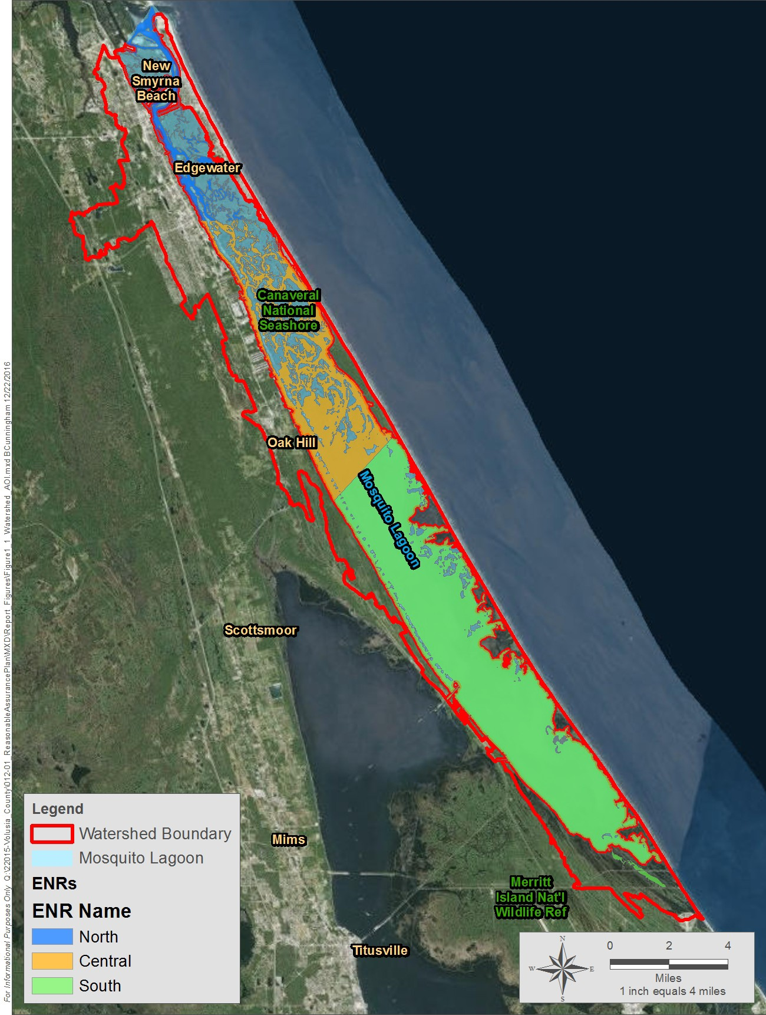

Figure 1-1. Mosquito Lagoon and its Watershed.

APPROACH AND RATIONALE

The establishment of water quality targets for an estuary typically is achieved by following five steps:

- Identification of resource of concern
- Identification of appropriate, measurable metrics,
- Identification of the appropriate data sources,
- Definition of a reference period, and
- Determination of water quality targets.

The following discussion summarizes the approach used by FDEP to establish numeric nutrient criteria (NNC) and the proposed approach taken to refine, as needed, the NNC previously established.

2.1 FDEP Approach
As discussed above, FDEP developed NNC for Mosquito Lagoon in 2014 (FDEP, 2014). FDEP implicitly addressed the five steps typically used to establish estuarine NNC:

    - Resource of concern – seagrasses
    - Metrics – total nitrogen (TN). Total phosphorus (TP), chlorophyll a
    - Data sources – FDEP Impaired Waters data base
    - Reference period - As previously stated, FDEP used the same reference period, 2004 – 2008, proposed by Steward et al., 2010. Their rationale for the choice of this reference period was:
      - TN and TP for that period were the lowest of any 5-year period within the full period of record.
      - The rainfall record of 2004 – 2008 (annual cumulative rainfall ranged from 32 – 57 inches) was not much different from the previous 5, 10, or 15 years; thus, the rainfall-runoff relationship and its effect on nutrient loadings and concentrations should not be appreciably different from one period to the next.
      - Chlorophyll a during 2004 – 2008 was the lowest of any 5-year period within the full period of record and is consistent with the TMDL chlorophyll a targets established for other Florida estuaries, typically ≤ 7 µg/L annual average.
      - The trophic status was considered “good” (mesotrophy to oligo-mesotrophy) and not nutrient impaired according to state water policy.
    - Determination of water quality targets - FDEP recognized that the reference period recommended by Steward et al. (2010) included only 5 years with limited inter-annual variability in environmental conditions. To expand on the range of conditions FDEP utilized a method that created an ENR specific rescaling factor by dividing the reference period (2004-2008) mean annual geometric mean (AGM) by the mean of the remainder of the period of record (1989-2010, excluding 2011 and 2013 given the presence of brown tides in those years) AGMs. This factor was then used to rescale the non-reference period AGMs, thus artificially decreasing them while still representing the long-term variability of the period of record. These could be included in the determination of the criteria and were used for the remainder of the analyses.

FDEP then had to establish the allowable magnitude and frequency of excursions from the targets based on the reference period within a defined level of statistical certainty. In the FDEP document Overview of approaches for numeric nutrient criteria development in marine water, (FDEP, 2012), they determined that the prediction interval was the best statistical tool to determine that threshold. The upper prediction limit of a prediction interval is calculated as:
𝑃. 𝐼. = $e^{(\overline{y}+t_{\left(∝,n-1\right)}*\sqrt{σ_{y}^{2}+σ_{y }^{2}/n)}}$

where,

𝑦� = the mean of the log transformed data
𝜎2 = the variance of the log transformed data
𝑦
N = sample size (in this case the number of years)

The above equation along with the estimate of true standard deviation was used by FDEP to calculate the 80% prediction interval limits. This represents the level that achieves the desired reference period conditions.

Table 2-1 presents the NNC for each of the three ENRs as finalized by FDEP in 2014. Non-compliance occurs if these NNC are exceeded more than once in a 3-year period.

Table 2-1. Current numeric nutrient criteria not to be exceeded more than once in three years.
ENR | Total Nitrogen (mg/L) | Total Phosphorus (mg/L) | Chlorophyll a  (µg/L)
North Mosquito Lagoon | 0.51 | 0.049 | 4.0
Central Mosquito Lagoon | 0.65 | 0.048 | 3.4
South Mosquito Lagoon | 1.14 | 0.034 | 2.5

Proposed Approach to Establishing Water Quality Targets for Mosquito Lagoon

Review of the FDEP approach concluded that;

    - Seagrasses are the appropriate resource of concern
    - TN, TP, and chlorophyll a are the appropriate, measurable metrics to be used.
    - The primary data source is the FDEP impaired waters database updated for this process to include data collected through 2015.
    - Use of the annual geometric means as a metric account for extreme values within any given year.
    - The FDEP approach to the calculation of the NNC was appropriate and statistically sound. In particular, the use of the 80% prediction interval is defensible.
    - Finally, the definition of the reference period becomes paramount. There are several points that should be mentioned regarding the 2004-2008 reference period previously identified:
      - There are significantly more data available that can be used effectively in defining the reference period, including both seagrass and water quality data. Figure 2-1 presents seagrass coverage and median depth of the deep edges of the seagrasses in each ENR. Clearly, the seagrass area and deep edges have remained relatively consistent through the period displayed. Therefore, it can be reasonably concluded that the water quality conditions, particularly light attenuation, during that period supported the observed seagrass conditions.
      - The increase in available data also provides a more representative long-term set of meteorological conditions.
      - As FDEP (2012) summarized, “Criteria established to maintain an existing condition must account for the full range of variance so that realistic expectations of future conditions may be established. Estimates of variance that do not include both spatial and temporal components fail to fully account for the range of natural variability within a system, and thus criteria derived from such estimates are prone to more statistical error, particularly Type I, than intended.”
      - The 2004-2008 reference period was the 5-year period that had the lowest concentrations observed during the 1989-2008 period for which data are currently available. This is surely a conservative method. That was the significant point made by Duarte et al. (2009) when they concluded “Understanding ecosystem response to multiple shifting baselines is essential to set reliable targets for restoration efforts.”

      - The choice of the 2004-2008 reference period is also in question given that the nutrient loading to Mosquito Lagoon was greater during this 5-year period than any other similar period during the period of record for which loading data exist between 2004-2015 (Janicki Environmental, 2018).

Given these points, an alternative approach to defining the reference period is being proposed.

As discussed, there is agreement with the resource of concern (seagrasses), metrics (TN, TP, and chlorophyll a), data sources, and analytical methods used to define the water quality targets (NNC) by FDEP. The following presents the specific data sources, proposed reference period, and two alternatives to the expression of the water quality targets.

Data Sources

Seagrasses
There are three primary sources of seagrass data for Mosquito Lagoon with the appropriate spatial and temporal scales for this project: aerial photography, mean deep edge depth measurements, and transect monitoring.

    - The SJRWMD, utilizing aerial photographs, provides estimates of seagrass extent that are delineated within a geographic information system which allows managers to evaluate changes in seagrass acreage over time. This method allows for comparisons within different segmentation schemes and for inclusion in other analyses. The photographs utilized for mapping prior to 1994 were acquired between January and April and since have been acquired generally between May and August. Efforts to produce maps occurs every 2 to 3 years with data currently available for most of the lagoon system for the following 12 years: 1943, 1992, 1994, 1999, 2003, 2005, 2006, 2007, 2009, 2011, 2013, and 2015.
    - From the aerially mapped seagrass coverages, the mean deep edge depths by segment are determined following the methods described in detail in Steward et al., 2005. The seagrass polygons are overlaid upon the 1996 bathymetric transect data points and depths assigned to the deep edge boundary. A 15.8 meter buffer is used to ensure assignment of a point along the line. Points from the shallow edges (generally less than 0.1 meters), known dredge-fill operations, bare areas within the seagrass polygons and those greater than 3.5 m were excluded from further analysis. From the remaining points, the median deep edge depth is calculated.
    - Seagrass transect monitoring consists of having a trained observer swim the length of a fixed transect line and record attributes every 10 meters regarding seagrass species present, percent coverage, epiphyte and macroalgae presence, canopy height, water depth, light availability. Beginning in 1994, transect monitoring has occurred twice a year, once during the winter and the other during the summer.

These seagrass data were collected by the SJRWMD and were provided by Ms. Lori Morris (personal communication). Plots of seagrass coverage and median deep-edge depths by year for each ENR are shown in Figure 2-1.

Of the available seagrass data, seagrass areal extent is the most appropriate metric to define estuarine health. Seagrass aerial extent has been used previously in Mosquito Lagoon by the St. Johns River Water Management District (SJRWMD) and the US EPA. Seagrass areal extent has also been used by the FDEP to determine the TMDL in north Indian River Lagoon. Seagrass extent has also been used in Tampa Bay, Sarasota Bay, Charlotte Harbor, and Chesapeake Bay to name a few.

The aerial mapped seagrass coverages provided by the District undergo extensive quality assurance. Ground truth data are collected separately for signature identification and mapping accuracy. Maps are not accepted unless the minimum % accuracy is achieved and usually range between 85-90%. As such there is a high degree of confidence in the mapped seagrass coverages. Seagrass transects on the other hand do not undergo similar QA/QC procedures as compared to the aerials. The seagrass transect data are limited in their spatial scale and difficult to extrapolate across the entire lagoon limiting their utility for this effort.

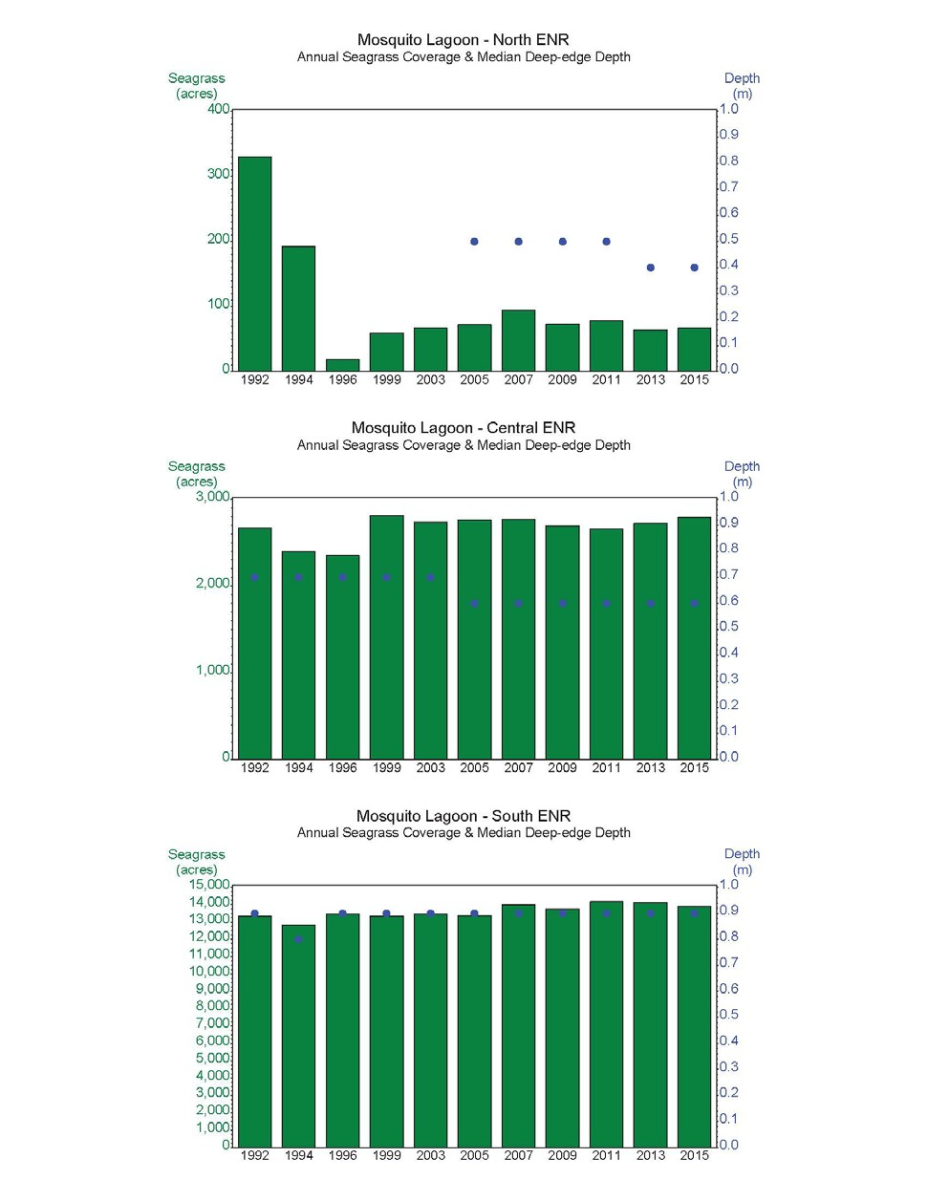

Figure 2-1. Seagrass coverage (green bars) in the North (top), Central (middle) and South (bottom) ENRs of Mosquito Lagoon. Median deep-edge depths are represented by blue dots.

Water Quality

There were also three sources of water quality data for Mosquito Lagoon:

    - The FDEP IWR Run 53 dataset is a subset of the Florida STORET environmental data repository. Data meeting strict quality assurance criteria are selected for the IWR database. The IWR is the dataset used by FDEP for assessment. The dataset is made available as a SAS dataset and MS Access Database.
    - Volusia County Environmental Management Division maintains a dataset in MS EXCEL of data collected in-house and via agreements with the SJRWMD. These data are submitted to FDEP STORET and included in the IWR dataset.
    - The SJRWMD maintains its own in-house database with access via the internet through the Environmental Retrieval Tool (http://webapub.sjrwmd.com/agws10/edqt/). It houses the data collected by the District internally.

Data from the three data sources were combined to ensure the most complete dataset that coincided with the nutrient loading data being developed. The FDEP IWR Run 53 dataset was used in the analyses presented in this report. Data provided by the Volusia County Environmental Management Division and the SJRWMD were also included in the analyses presented in this report. These three sources were combined, screened for duplication and further checked for quality assurance issues and compiled as a SAS dataset for further analysis. The data were finally reviewed in cooperation with FDEP staff which recommended the removal of certain LAKEWATCH (21FLKWAT) data from the analysis due to upload errors. FDEP also excluded data from the Florida Department of Agricultural and Consumer Services (21FLSEAS) for quality assurance reasons. Data from the Marine Resources Council of East Florida (21FLMRC) were excluded due to issues with the DO percent saturation results.

Appendix A presents maps of the sampling locations. Appendix B presents the results for a series of trend analyses of the water quality data used to establish the Mosquito Lagoon water quality targets (Janicki Environmental, 2017B).

Proposed Reference Period

A defensible reference period should represent a period of time during which there is demonstrated support for a waterbody’s designated use, i.e., relatively healthy condition. It should quantitatively describe the metrics of interest. Early efforts utilized a short reference period with ideal conditions. The reference period should represent long-term variability in the resource of concern and the chosen metrics by which the water quality targets are defined.

Seagrass Reference Period
Seagrasses have been used as the biological indicator in estuaries throughout Florida, including the adjacent Indian River Lagoon. Plots of seagrass acreages and median deep edge depths for each Mosquito Lagoon ENR are shown above in Figure 2-1. Mosquito Lagoon has been identified as the northern most extent of seagrasses on Florida’s East Coast (EPA, 2013). It is also generally held that Mosquito Lagoon is the location where oysters become the dominant subaquatic habitat, particularly in the North ENR. Losses shown in the North ENR have not been fully explored (Ms. Lori Morris, personal communication) but the fact that seagrasses are not the dominant submerged habitat than perhaps the earlier photos were interpreting oysters as seagrasses. If we accept as fact, that the seagrass loss is real, then it is necessary to explain what caused the losses expressed in the graphic. The losses in the North ENR cannot be attributed to water quality as a review of the annual geometric means shown in Table 3.1 indicate that the values at this time are similar to those found in later periods.

In the Central and Southern ENRs, the seagrass area and deep-edges have remained stable over a long period of time and demonstrate that the waters within that period must have been of sufficient quality to maintain seagrasses during the 1992-2015 period. However, there are significant concerns with regards to a series of algal blooms that have been observed since 2011. A report by a consortium of experts concluded that attempts to explain the initiation and persistence of the 2011 superbloom using available data highlighted some key gaps in understanding (IRL 2011 Consortium, 2015). Questions still remain about the nature and causes of blooms in the Indian River Lagoon. Given these uncertainties in the causes of the algal blooms that have occurred during 2011 through 2016, a seagrass reference period between the years 1992–2010 is proposed for the Mosquito Lagoon Reasonable Assurance Plan.

Justification of the Proposed Reference Period
In the 2014 FDEP report “Numeric Nutrient Criteria for Estuaries Addressed in the August 1, 2013 Report to the Governor and Legislature” (FDEP, 2014), FDEP outlined a method for evaluating the proposed reference period that follows guidance provided by EPA. Often referred to as the Three-legged Stool, this method includes evaluation of three parameters:

- Water clarity,
- DO, and
- Chlorophyll a.

Justification of the proposed reference period is achieved by demonstrating the compliance of the water quality conditions within that period with thresholds for each of these parameters.

Water Clarity
The water clarity target is based on the desire to support seagrasses in the waterbodies of concern. EPA defined the light requirements that generally support a wide range of seagrass types. That requirement is that 20% of the incident light reaches the depth target. The depth target is the mean of the seagrass deep-edge data provided by the SJRWMD (Ms. Lori Morris, personal communication) for the reference period, 1992-2010, for the Central and South ENRs (Figure 2-1). Steward et al. (2010) recognized that while oysters were the primary aquatic resource establishing a depth target was still appropriate for the North ENR. For this work, the depth target for the Central ENR was assumed to be appropriate for the North ENR.

The typical method for measuring water clarity in a waterbody is done using a Secchi disc. The following algorithm converts depth targets to a Secchi disc depth target to evaluate compliance:

$${SD}_{target}=\frac{1.44}{-\ln{(0.2)}}D_{target}$$

where:

Dtarget = the depth target of 0.6 m, 0.6 m, and 0.9 m for the North, Central, and South ENRs respectively and

1.44 = the factor that relates percent light attenuation to concomitantly measured Secchi disc depth (FDEP, 2014).

Compliance for the clarity “leg” of the stool is met if the upper 90% confidence interval of the mean annual Secchi depth for a given year and ENR is greater than the SDtarget of 0.5 m, 0.5 m, and 0.8 m as calculated above for the North, Central, and South ENRs, respectively.
The seagrass depth target reported by EPA (2012) was considered. EPA determined the depth target as the maximum colonization depth determined from seagrass extent maps for 1943 and 2009. Only one depth target was reported for Mosquito Lagoon, 1.1 m. As the goal of this project was to determine different criteria for each of the three ENRs, the approach described above was deemed more defensible as it accounted for the spatial variability between ENRs during the reference period used to set the criteria.

Dissolved Oxygen
Compliance with the DO “leg” is examined by estimating the frequency of non-compliance with the DO standards established by the State of Florida. In concept, achieving compliance with the DO standards provides full aquatic life support for the estuarine fauna, similar to the water clarity-seagrass paradigm.

The DO criteria were recently revised by FDEP. Previous DO standards were expressed as a concentration. The revised standards are expressed as a percent saturation. The daily average percent DO saturation shall not be below 42% in more than 10% of the samples from a given water quality sampling station. The change to percent saturation was to incorporate the dependence on temperature and salinity not accounted for in the concentration values.

To evaluate compliance with the DO “leg”, the daily mean percent DO saturation was calculated for each station. The daily mean station data were then compared to the 42% standard. Compliance is achieved if fewer than 10% of the daily mean values in a given year fall below 42% DO saturation.

    - Chlorophyll a – Algal Blooms
EPA (2012) analysis of chlorophyll a data and algal bloom occurrences arrived at a threshold for chlorophyll a of 20 µg/L, and concluded that the probability of an algal bloom occurrence increased as this threshold is exceeded. For this third “leg”, chlorophyll a data were assessed by determining the percentage of samples within a given ENR and year with more than 20 µg/L chlorophyll a. If the result was less than 10% then it was determined to meet the designated use.

Evaluation of the compliance of the proposed reference period included analysis of all three “legs”. Each of these parameters was evaluated for each year in the proposed reference period of 1992 – 2015. The results were tabulated and are shown in Table 2-2. By ENR, all years that complied with the three “legs” are shown in green in this table. In contrast, those that did not comply are shown in red. The 1999 clarity value for the South ENR meets the 0.8 meter SDtarget depth. Given that the SDtarget depth represents the 90% confidence interval, it is reasonable to conclude that since the observed clarity is equal to the target, it should be considered in compliance. Table C-1 in Appendix C provides a summary of the available DO saturation, Secchi depths and chlorophyll a data by ENR, year, and season that were used in the “three-legged” evaluation for each of the parameters.

Table 2-2. Evaluation of water quality data by ENR with regards to the EPA “Three-legged Stool”.
Year | 90% CI Mean Annual Secchi Depth (m) |  |  | Percent of Mean Daily Values with DO Saturation  < 42% |  |  | Percent of Samples with Chlorophyll a > 20 µg/L
Year | North | Central | South | North | Central | South | North | Central | South
1992 | 1.4 | 1.1 | 1.3 | 0 | 0.5 | 3.1 | 2.1 | 2.7 | 5.9
1993 | 1.5 | 1.2 | 1.7 | 0 | 0 | 0 | 0.0 | 1.5 | 0.0
1994 | 1.3 | 1.1 | 1.2 | 0 | 0 | 0 | 0.0 | 0.6 | 0.0
1995 | 1.4 | 1.2 | 1.6 | 0 | 0 | 0 | 0.0 | 1.2 | 0.0
1996 | 1.4 | 1.3 | 1.3 | 0 | 0 | 0 | 1.4 | 3.0 | 0.0
1997 | 1.5 | 1.2 | 1.2 | 0 | 0 | 0 | 0.0 | 0.0 | 0.0
1998 | 1.4 | 1.1 | 1.0 | 0 | 0 | 0 | 0.0 | 2.6 | 1.7
1999 | 1.4 | 1.1 | 0.8 | 0 | 0 | 0 | 0.0 | 1.5 | 0.0
2000 | 1.2 | 1.1 | 1.5 | 0 | 0 | 0 | 0.0 | 0.0 | 0.0
2001 | 1.5 | 1.0 | 1.5 | 0 | 0 | 0 | 0.0 | 0.9 | 0.0
2002 | 1.2 | 1.1 | 1.3 | 0 | 0 | 0 | 0.0 | 0.6 | 0.0
2003 | 1.5 | 1.1 | 1.4 | 0 | 0 | 0 | 0.0 | 0.0 | 0.0
2004 | 1.3 | 1.0 | 1.1 | 0 | 0 | 0 | 0.0 | 0.0 | 0.0
2005 | 1.4 | 1.0 | 1.3 | 0 | 0 | 0 | 8.3 | 0.0 | 0.0
2006 | 1.2 | 1.0 | 1.2 | 0 | 0 | 0 | 0.0 | 0.0 | 0.0
2007 | 1.2 | 1.0 | 1.5 | 0 | 0 | 0 | 0.0 | 0.0 | 0.0
2008 | 1.3 | 1.0 | 1.8 | 0 | 0 | 0 | 0.0 | 0.0 | 0.0
2009 | 1.4 | 1.0 | 1.6 | 0 | 0 | 0 | 0.0 | 8.3 | 0.0
2010 | 1.5 | 1.0 | 1.6 | 0 | 0 | 0 | 0.0 | 5.4 | 0.0
2011 | 1.4 | 0.9 | 1.1 | 0 | 0 | 0 | 3.0 | 8.7 | 33.3
2012 | 1.4 | 0.8 | 1.0 | 0 | 10.8 | 0 | 9.5 | 23.1 | 33.3
2013 | 1.6 | 1.0 | 1.4 | 0 | 0 | 0 | 34.2 | 31.6 | 31.3
2014 | 1.3 | 1.0 | 1.8 | 0 | 21.4 | 0 | 0.0 | 3.0 | 0.0
2015 | 1.2 | 0.8 | 0.9 | 0 | 0 | 5 | 0.0 | 16.1 | 50.0

If in any year a “leg” is found in non-compliance, that year was removed from consideration as part of the reference period. Thus, 2011, 2012, 2013, and 2015 were removed as part of the reference period. This result is confirmed by the occurrence of algal blooms that were observed in those years. This approach concurs with the recent update of the TMDLs for North, Central, and Banana River to the south (Janicki Environmental, 2017a). Therefore, the proposed reference period to be used in the development of water quality targets for each of the

Mosquito Lagoon ENRs includes 1992–2010, a period when seagrasses were stable and when water quality met the Three-legged Stool test.

PROPOSED ALTERNATIVE WATER QUALITY TARGETS

In earlier discussions with FDEP staff regarding the existing NNCs, it was suggested that if an alternative to those NNCs was justifiable, then it would be prudent to evaluate more than one alternative. Using the data from the 1992-2010 reference period, the following two alternatives are offered. Table 3-1 presents the AGMs for each ENR that were used to compute two alternative water quality targets.

The first alternative to the expression of the water quality targets is simply the mean of the AGMs for each year in the reference period.

The second alternative expression follows the approach used by FDEP in the 2014 report on NNCs. The primary objective of the reference period (healthy existing conditions) approach is to establish magnitude and frequency limits, which if exceeded in the future, would allow one to conclude with sufficient statistical certainty that the new distribution is not consistent with the reference period condition. As FDEP (2012) concluded, it is prudent that a future AGM is consistent with the reference period distribution. Thus, the use of a prediction interval is the “most appropriate statistical tool.”

Table 3-1. Annual Geometric Means for each Mosquito Lagoon ENR.
Year | North ENR |  |  | Central ENR |  |  | South ENR
Year | TN  (mg/L) | TP  (mg/L) | Chlorophyll a  (µg/L) | TN  (mg/L) | TP  (mg/L) | Chlorophyll a  (µg/L) | TN  (mg/L) | TP  (mg/L) | Chlorophyll a  (µg/L)
1992 | 1.12 | 0.07 | 5.2 | 1.05 | 0.07 | 5.8 | 1.08 | 0.05 | 4
1993 | 0.73 | 0.04 | 5.8 | 0.54 | 0.04 | 5.4 | 0.45 | 0.04 | 4.5
1994 | 0.75 | 0.06 | 4.8 | 0.82 | 0.07 | 4.9 | 0.97 | 0.06 | 5.9
1995 | 0.6 | 0.06 | 4.1 | 0.84 | 0.06 | 4 | 0.94 | 0.04 | 5.2
1996 | 0.58 | 0.06 | 4 | 0.7 | 0.05 | 3.5 | 0.89 | 0.02 | 4.3
1997 | 0.54 | 0.05 | 3.5 | 0.78 | 0.06 | 3.6 | 1.41 | 0.04 | 3.5
1998 | 0.48 | 0.05 | 4 | 0.78 | 0.06 | 5 | 1.77 | 0.04 | 4.4
1999 | 0.5 | 0.05 | 4.7 | 0.7 | 0.05 | 5 | 1.51 | 0.05 | 7.8
2000 | 0.45 | 0.05 | 2.7 | 0.62 | 0.05 | 3.4 | 1 | 0.02 | 3.9
2001 | 0.5 | 0.04 | 3.2 | 0.77 | 0.04 | 3.2 | 0.91 | 0.02 | 4.3
2002 | 0.46 | 0.04 | 3.1 | 1.24 | 0.04 | 2.7 | 1.47 | 0.02 | 3.2
2003 | 0.46 | 0.06 | 2.6 | 0.74 | 0.05 | 1.5 | 1.13 | 0.02 | 0.8
2004 | 0.43 | 0.05 | 1.9 | 0.61 | 0.05 | 1.5 | 1.01 | 0.02 | 1.7
2005 | 0.38 | 0.05 | 4.9 | 0.58 | 0.05 | 3.3 | 1.08 | 0.02 | 1.9
2006 | 0.34 | 0.03 | 2 | 0.48 | 0.03 | 2 | 0.9 | 0.03 | 1.7
2007 | 0.38 | 0.04 | 2.9 | 0.51 | 0.04 | 2.1 | 0.73 | 0.02 | 1.1
2008 | 0.44 | 0.04 | 4.8 | 0.5 | 0.03 | 3.6 | 0.69 | 0.02 | 2.1
2009 | 0.42 | 0.04 | 5.3 | 0.49 | 0.03 | 4.5 | 0.79 | 0.02 | 2.5
2010 | 0.4 | 0.03 | 3.3 | 0.57 | 0.04 | 5.2 | 0.99 | 0.04 | 4.8

Alternative 1: Mean of the Annual Geometric Means

This option is the simpler of the two and is the most conservative. As the mean for the period of record, it takes into account the temporal variability within the reference period, a time that was shown to protect both flora and fauna. It should be noted that as the mean of the reference period, it will allow years to fail the criteria despite having already demonstrated that they support the designated use. The resulting water quality targets are shown in Table 3-2. Compliance would be achieved if these targets are not exceeded more than once in any three-year period.

Table 3-2 Water quality targets based on Alternative 1: Mean of 1992-2010 AGMs.
ENR | TN  (mg/L) | TP  (mg/L) | Chlorophyll a  (µg/L)
North Mosquito Lagoon | 0.54 | 0.05 | 3.8
Central Mosquito Lagoon | 0.72 | 0.05 | 3.6
South Mosquito Lagoon | 1.06 | 0.03 | 3.5

Alternative 2: 80% Prediction Interval

As discussed, FDEP determined that the upper limit of the 80% prediction interval was the best statistical tool for the job (FDEP, 2012). Appendix D presents the documentation provided by FDEP to support their conclusion. The prediction limit corresponds to concentrations that are expected to result in an annual geometric mean higher in only 10% of future years, given the range of data in the reference period. The resulting water quality targets using this method are shown in Table 3-3. Compliance would be achieved if these targets are not exceeded more than once in any three-year period.

Table 3-3. Water quality targets based on Alternative 2: Upper 80% Prediction Limit.
ENR | TN  (mg/L) | TP  (mg/L) | Chlorophyll a  (µg/L)
North Mosquito Lagoon | 0.65 | 0.06 | 4.9
Central Mosquito Lagoon | 0.85 | 0.06 | 5.0
South Mosquito Lagoon | 1.31 | 0.05 | 5.2

Method Performance

The water quality targets, including the current NNC, Alternative 1 and Alternative 2, were used to assess each of the observed AGMs for each Mosquito Lagoon ENR. Table 3-4 presents a comparison of the current NNCs and two alternative expressions of the Mosquito Lagoon water quality targets. The current NNCs presented for this comparison were based on a different reference period with rescaled AGMs, artificially decreasing the values. The results in Table 3-4 reflect the differences in the bathymetry, connections between ENRs as well as with the North IRL and Atlantic Ocean, and the watersheds that drain to these waterbodies. A discussion of these differences is presented in a technical memorandum (Janicki Environmental, 2017b).

Despite the differences in the reference periods, the current NNC TP targets in all three ENRs are very similar to the TP targets for the two alternatives (Table 3-4). In contrast, the TN targets increase from the North ENR to the South ENR in both Alternatives 1 and 2. This result may be due to the connection of the North ENR to the Atlantic Ocean via the Ponce Inlet. Tidal exchange through this inlet results in a dilution of the estuarine waters with ocean waters that typically have characteristically low TN concentrations. The observed differences in the chlorophyll a targets are relatively small (the largest is only 2.7 µg/L) especially given the degree of uncertainty in the measurements within the range of chlorophyll a data for this system.

Table 3-4. Comparison of the current NNCs and two alternative expressions of the Mosquito Lagoon water quality targets.
ENR | Current NNC | Alternative 1 | Alternative 2
North  TN (mg/L) TP (mg/L) Chlorophyll a (µg/L) | 0.51  0.05  4.0 | 0.54  0.05  3.8 | 0.65  0.06  4.9
Central  TN (mg/L) TP (mg/L) Chlorophyll a (µg/L) | 0.65  0.05  3.4 | 0.72  0.05  3.6 | 0.85  0.06  5.0
South  TN (mg/L) TP (mg/L) Chlorophyll a (µg/L) | 1.14  0.03  2.5 | 1.06  0.03  3.5 | 1.31  0.05  5.2

Table 3.5 presents an assessment of the compliance with the current NNC and the two alternative expressions of the Mosquito Lagoon water quality targets for the North ENR. There are two important observations to be assessed. First, there is clearly a difference in compliance during the early period from 1992 to 1996. During this period, there is a general lack of compliance with the current NNC and Alternative 1 as opposed to Alternative 2. Also, as expected, non-compliance with all three thresholds can be seen in the years during which blooms occurred.

Tables 3-6 and 3-7 present the assessment of compliance with the current NNC and the two alternative expressions of the Mosquito Lagoon water quality targets for the Central and South ENRs, respectively. The results show agreement with the observations made in North ENR. There is a general lack of compliance with the current NNC and Alternative 1 during the early period from 1992 to 1996. This result is questionable given the relative consistency of seagrass coverage during this period (Figure 2-1). There is more consistent compliance with Alternative 2 thresholds which is concordant with the observed seagrass data. As expected, non-compliance with all three thresholds can be seen in the years during which blooms occurred.

Table 3-5. Assessment of the compliance with the current NNC and the two alternative expressions of the Mosquito Lagoon water quality targets for the North ENR. Units: TN (mg/L), TP (mg/L), Chl a (µg/L).
 | Current NNC |  |  | Alternative 1 |  |  | Alternative 2
Parameter | TN | TP | Chl a | TN | TP | Chl a | TN | TP | Chl a
Target | 0.51 | 0.05 | 4 | 0.54 | 0.05 | 3.8 | 0.65 | 0.06 | 4.9
1992 | 1.12 | 0.07 | 5.2 | 1.12 | 0.07 | 5.2 | 1.12 | 0.07 | 5.2
1993 | 0.73 | 0.04 | 5.8 | 0.73 | 0.04 | 5.8 | 0.73 | 0.04 | 5.8
1994 | 0.75 | 0.06 | 4.8 | 0.75 | 0.06 | 4.8 | 0.75 | 0.06 | 4.8
1995 | 0.6 | 0.06 | 4.1 | 0.6 | 0.06 | 4.1 | 0.6 | 0.06 | 4.1
1996 | 0.58 | 0.06 | 4 | 0.58 | 0.06 | 4 | 0.58 | 0.06 | 4
1997 | 0.54 | 0.05 | 3.5 | 0.54 | 0.05 | 3.5 | 0.54 | 0.05 | 3.5
1998 | 0.48 | 0.05 | 4 | 0.48 | 0.05 | 4 | 0.48 | 0.05 | 4
1999 | 0.5 | 0.05 | 4.7 | 0.5 | 0.05 | 4.7 | 0.5 | 0.05 | 4.7
2000 | 0.45 | 0.05 | 2.7 | 0.45 | 0.05 | 2.7 | 0.45 | 0.05 | 2.7
2001 | 0.5 | 0.04 | 3.2 | 0.5 | 0.04 | 3.2 | 0.5 | 0.04 | 3.2
2002 | 0.46 | 0.04 | 3.1 | 0.46 | 0.04 | 3.1 | 0.46 | 0.04 | 3.1
2003 | 0.46 | 0.06 | 2.6 | 0.46 | 0.06 | 2.6 | 0.46 | 0.06 | 2.6
2004 | 0.43 | 0.05 | 1.9 | 0.43 | 0.05 | 1.9 | 0.43 | 0.05 | 1.9
2005 | 0.38 | 0.05 | 4.9 | 0.38 | 0.05 | 4.9 | 0.38 | 0.05 | 4.9
2006 | 0.34 | 0.03 | 2 | 0.34 | 0.03 | 2 | 0.34 | 0.03 | 2
2007 | 0.38 | 0.04 | 2.9 | 0.38 | 0.04 | 2.9 | 0.38 | 0.04 | 2.9
2008 | 0.44 | 0.04 | 4.8 | 0.44 | 0.04 | 4.8 | 0.44 | 0.04 | 4.8
2009 | 0.42 | 0.04 | 5.3 | 0.42 | 0.04 | 5.3 | 0.42 | 0.04 | 5.3
2010 | 0.4 | 0.03 | 3.3 | 0.4 | 0.03 | 3.3 | 0.4 | 0.03 | 3.3
2011 | 0.55 | 0.03 | 5.5 | 0.55 | 0.03 | 5.5 | 0.55 | 0.03 | 5.5
2012 | 0.72 | 0.06 | 6.6 | 0.72 | 0.06 | 6.6 | 0.72 | 0.06 | 6.6
2013 | 0.62 | 0.04 | 9.5 | 0.62 | 0.04 | 9.5 | 0.62 | 0.04 | 9.5
2014 | 0.41 | 0.04 | 4 | 0.41 | 0.04 | 4 | 0.41 | 0.04 | 4
2015 | 0.69 | 0.09 | 10.3 | 0.69 | 0.09 | 10.3 | 0.69 | 0.09 | 10.3

Table 3-6. Assessment of the compliance with the current NNC and the two alternative expressions of the Mosquito Lagoon water quality targets for the Central ENR. Units: TN (mg/L), TP (mg/L), Chl a (µg/L).
 | Current NNC |  |  | Alternative 1 |  |  | Alternative 2
Parameter | TN | TP | Chl a | TN | TP | Chl a | TN | TP | Chl a
Target | 0.65 | 0.05 | 3.4 | 0.72 | 0.05 | 3.6 | 0.85 | 0.06 | 5.0
1992 | 1.05 | 0.07 | 5.8 | 1.05 | 0.07 | 5.8 | 1.05 | 0.07 | 5.8
1993 | 0.54 | 0.04 | 5.4 | 0.54 | 0.04 | 5.4 | 0.54 | 0.04 | 5.4
1994 | 0.82 | 0.07 | 4.9 | 0.82 | 0.07 | 4.9 | 0.82 | 0.07 | 4.9
1995 | 0.84 | 0.06 | 4 | 0.84 | 0.06 | 4 | 0.84 | 0.06 | 4
1996 | 0.7 | 0.05 | 3.5 | 0.7 | 0.05 | 3.5 | 0.7 | 0.05 | 3.5
1997 | 0.78 | 0.06 | 3.6 | 0.78 | 0.06 | 3.6 | 0.78 | 0.06 | 3.6
1998 | 0.78 | 0.06 | 5 | 0.78 | 0.06 | 5 | 0.78 | 0.06 | 5
1999 | 0.7 | 0.05 | 5 | 0.7 | 0.05 | 5 | 0.7 | 0.05 | 5
2000 | 0.62 | 0.05 | 3.4 | 0.62 | 0.05 | 3.4 | 0.62 | 0.05 | 3.4
2001 | 0.77 | 0.04 | 3.2 | 0.77 | 0.04 | 3.2 | 0.77 | 0.04 | 3.2
2002 | 1.24 | 0.04 | 2.7 | 1.24 | 0.04 | 2.7 | 1.24 | 0.04 | 2.7
2003 | 0.74 | 0.05 | 1.5 | 0.74 | 0.05 | 1.5 | 0.74 | 0.05 | 1.5
2004 | 0.61 | 0.05 | 1.5 | 0.61 | 0.05 | 1.5 | 0.61 | 0.05 | 1.5
2005 | 0.58 | 0.05 | 3.3 | 0.58 | 0.05 | 3.3 | 0.58 | 0.05 | 3.3
2006 | 0.48 | 0.03 | 2 | 0.48 | 0.03 | 2 | 0.48 | 0.03 | 2
2007 | 0.51 | 0.04 | 2.1 | 0.51 | 0.04 | 2.1 | 0.51 | 0.04 | 2.1
2008 | 0.5 | 0.03 | 3.6 | 0.5 | 0.03 | 3.6 | 0.5 | 0.03 | 3.6
2009 | 0.49 | 0.03 | 4.5 | 0.49 | 0.03 | 4.5 | 0.49 | 0.03 | 4.5
2010 | 0.57 | 0.04 | 5.2 | 0.57 | 0.04 | 5.2 | 0.57 | 0.04 | 5.2
2011 | 0.68 | 0.05 | 8.1 | 0.68 | 0.05 | 8.1 | 0.68 | 0.05 | 8.1
2012 | 0.95 | 0.06 | 9.5 | 0.95 | 0.06 | 9.5 | 0.95 | 0.06 | 9.5
2013 | 0.71 | 0.07 | 9.1 | 0.71 | 0.07 | 9.1 | 0.71 | 0.07 | 9.1
2014 | 0.75 | 0.07 | 5.9 | 0.75 | 0.07 | 5.9 | 0.75 | 0.07 | 5.9
2015 | 0.67 | 0.08 | 6.8 | 0.67 | 0.08 | 6.8 | 0.67 | 0.08 | 6.8

Table 3-7. Assessment of the compliance with the current NNC and the two alternative expressions of the Mosquito Lagoon water quality targets for the South ENR. Units: TN (mg/L), TP (mg/L), Chl a (µg/L).
 | Current NNC |  |  | Alternative 1 |  |  | Alternative 2
Parameter | TN | TP | Chl a | TN | TP | Chl a | TN | TP | Chl a
Target | 1.14 | 0.034 | 2.5 | 1.06 | 0.03 | 3.5 | 1.31 | 0.04 | 5.2
1992 | 1.08 | 0.05 | 4 | 1.08 | 0.05 | 4 | 1.08 | 0.05 | 4
1993 | 0.45 | 0.04 | 4.5 | 0.45 | 0.04 | 4.5 | 0.45 | 0.04 | 4.5
1994 | 0.97 | 0.06 | 5.9 | 0.97 | 0.06 | 5.9 | 0.97 | 0.06 | 5.9
1995 | 0.94 | 0.04 | 5.2 | 0.94 | 0.04 | 5.2 | 0.94 | 0.04 | 5.2
1996 | 0.89 | 0.02 | 4.3 | 0.89 | 0.02 | 4.3 | 0.89 | 0.02 | 4.3
1997 | 1.41 | 0.04 | 3.5 | 1.41 | 0.04 | 3.5 | 1.41 | 0.04 | 3.5
1998 | 1.77 | 0.04 | 4.4 | 1.77 | 0.04 | 4.4 | 1.77 | 0.04 | 4.4
1999 | 1.51 | 0.05 | 7.8 | 1.51 | 0.05 | 7.8 | 1.51 | 0.05 | 7.8
2000 | 1 | 0.02 | 3.9 | 1 | 0.02 | 3.9 | 1 | 0.02 | 3.9
2001 | 0.91 | 0.02 | 4.3 | 0.91 | 0.02 | 4.3 | 0.91 | 0.02 | 4.3
2002 | 1.47 | 0.02 | 3.2 | 1.47 | 0.02 | 3.2 | 1.47 | 0.02 | 3.2
2003 | 1.13 | 0.02 | 0.8 | 1.13 | 0.02 | 0.8 | 1.13 | 0.02 | 0.8
2004 | 1.01 | 0.02 | 1.7 | 1.01 | 0.02 | 1.7 | 1.01 | 0.02 | 1.7
2005 | 1.08 | 0.02 | 1.9 | 1.08 | 0.02 | 1.9 | 1.08 | 0.02 | 1.9
2006 | 0.9 | 0.03 | 1.7 | 0.9 | 0.03 | 1.7 | 0.9 | 0.03 | 1.7
2007 | 0.73 | 0.02 | 1.1 | 0.73 | 0.02 | 1.1 | 0.73 | 0.02 | 1.1
2008 | 0.69 | 0.02 | 2.1 | 0.69 | 0.02 | 2.1 | 0.69 | 0.02 | 2.1
2009 | 0.79 | 0.02 | 2.5 | 0.79 | 0.02 | 2.5 | 0.79 | 0.02 | 2.5
2010 | 0.99 | 0.04 | 4.8 | 0.99 | 0.04 | 4.8 | 0.99 | 0.04 | 4.8
2011 | 1.08 | 0.07 | 11.5 | 1.08 | 0.07 | 11.5 | 1.08 | 0.07 | 11.5
2012 | 1.33 | 0.06 | 13.7 | 1.33 | 0.06 | 13.7 | 1.33 | 0.06 | 13.7
2013 | 1.03 | 0.05 | 10.4 | 1.03 | 0.05 | 10.4 | 1.03 | 0.05 | 10.4
2014 | 0.85 | 0.03 | 3.3 | 0.85 | 0.03 | 3.3 | 0.85 | 0.03 | 3.3
2015 | 1.01 | 0.06 | 10.8 | 1.01 | 0.06 | 10.8 | 1.01 | 0.06 | 10.8

CONCLUSIONS AND RECOMMENDATIONS

Evaluation of the current NNCs developed by FDEP indicated that while the analytical approach was defensible the choice of the 2004-2008 reference period represented a limited range of environmental variability. An analysis of existing seagrass and water quality data supports the proposed reference period of 1992–2010 as shown by the compliance with the EPA Three-legged Stool. Two alternative expressions of the water quality target options were evaluated. Alternative 2 is the recommended expression of the Mosquito Lagoon water quality targets for two reasons. First, as FDEP concluded the use of a prediction interval approach is the “most appropriate statistical tool”. Their conclusion is supported by the need to establish magnitude and frequency limits, which if exceeded in the future, would allow one to conclude with sufficient statistical certainty that the new distribution is not consistent with the reference period condition. Secondly, Alternative 2 is recommended as there is clear concordance with both the observed stability in seagrass coverage and deep edges and the years in which algal blooms were present in Mosquito Lagoon.

REFERENCES
Duarte, C.M., Conley, D.J., Carstensen, J. 2009. Return to Neverland: Shifting Baselines Affect Eutrophication Restoration Targets. Estuaries and Coasts. 32:29-36.

EPA, 2012. Technical support document for U.S. EPA’s proposed rule for numeric nutrient criteria for Florida’s estuaries, coastal waters, and south Florida inland flowing waters, Volume 1: Estuaries. Washington, DC: Office of Water.

FDEP, 2012. Overview of approaches for numeric nutrient criteria development in marine waters. Tallahassee, FL: Standards and Assessment Section.

FDEP, 2014. Report on Numeric Nutrient Criteria for Estuaries, October 2014. Tallahassee, FL: Standards and Assessment Section.

Janicki Environmental, 2017a. Revised TMDL Report for Nutrient TMDLs for the Indian River Lagoon and Banana River Lagoon. Janicki Environmental, Inc. In prep.

Janicki Environmental, 2017b. Mosquito Lagoon Water Quality and Associated Data Summary, Janicki Environmental, Inc.

Janicki Environmental, 2018. Determination of the Mosquito Lagoon Nutrient Loading Targets. Prepared for the Volusia County and Mosquito Lagoon RAP Stakeholder Group. , Janicki Environmental, Inc.

IRL 2011 Consortium, 2015. 2011 Superbloom Report: Evaluating Effects and Possible Causes with Available Data. St. Johns River Water Management District.

Steward J. S., R.W. Virnstein, L. J. Morris, and E.F. Lowe, 2005. Setting seagrass depth, coverage, and light targets for the Indian River Lagoon system, Florida. Estuaries 28:923-935.

Steward, J.S., D.J. Christian, W.C. Green, M.A. Lasi, and J.D. Miller, 2010. Using multiple lines of evidence for developing numeric nutrient criteria for Mosquito Lagoon, Florida. St. Johns River Water Management District, Department of Water Resources.

Steward, J.S. and Lowe, E.F., 2010. General empirical models for estimating nutriet load limits for Florida’s estuaries and inland waters. Limnol. Oceanogr. 55, 433-445.

APPENDIX A WATER QUALITY SAMPLING MAPS

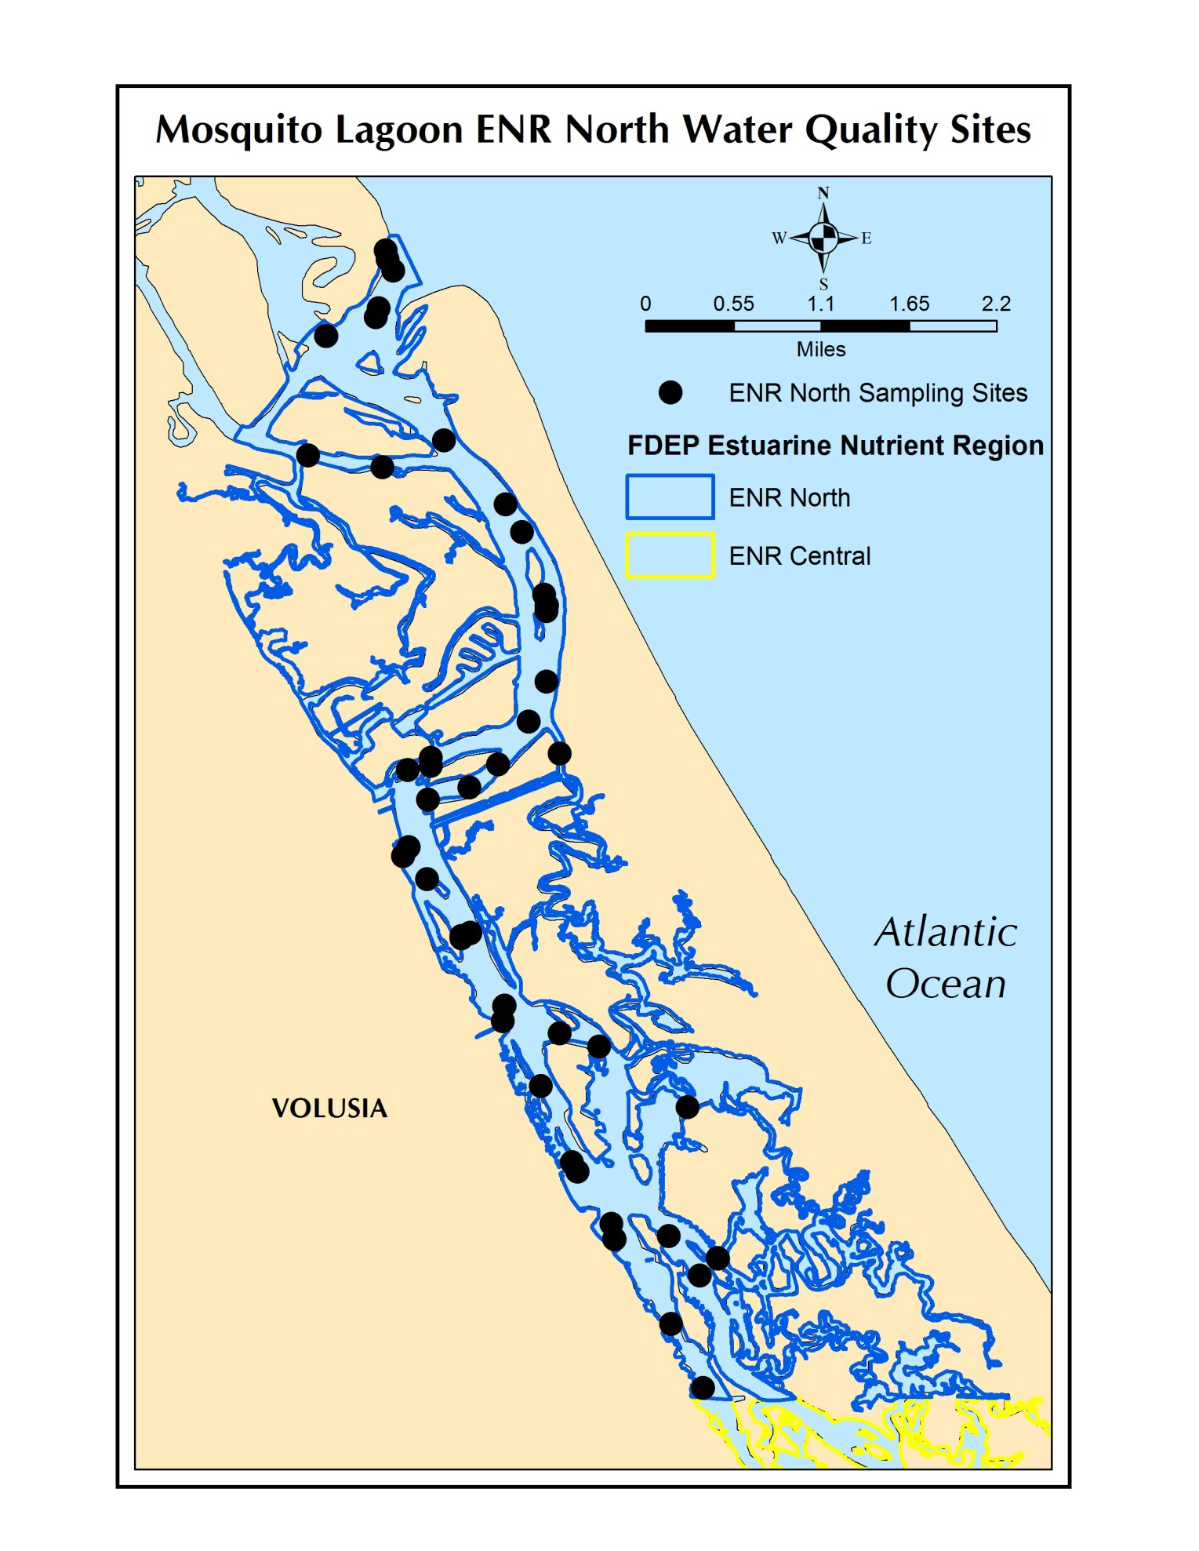

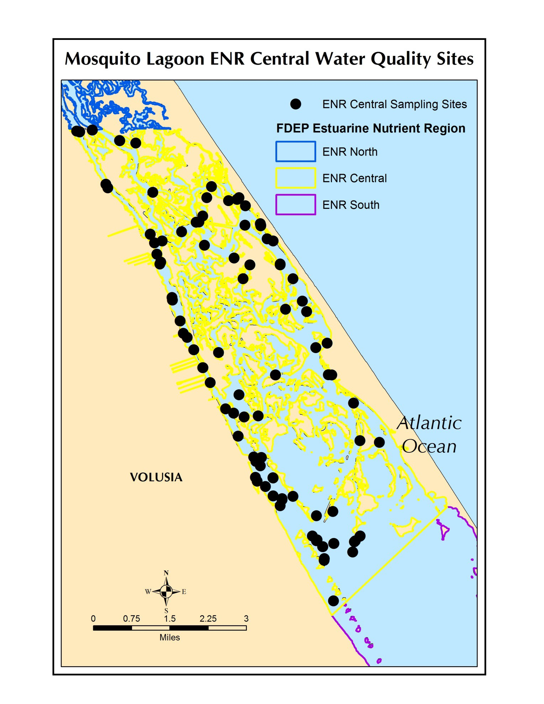

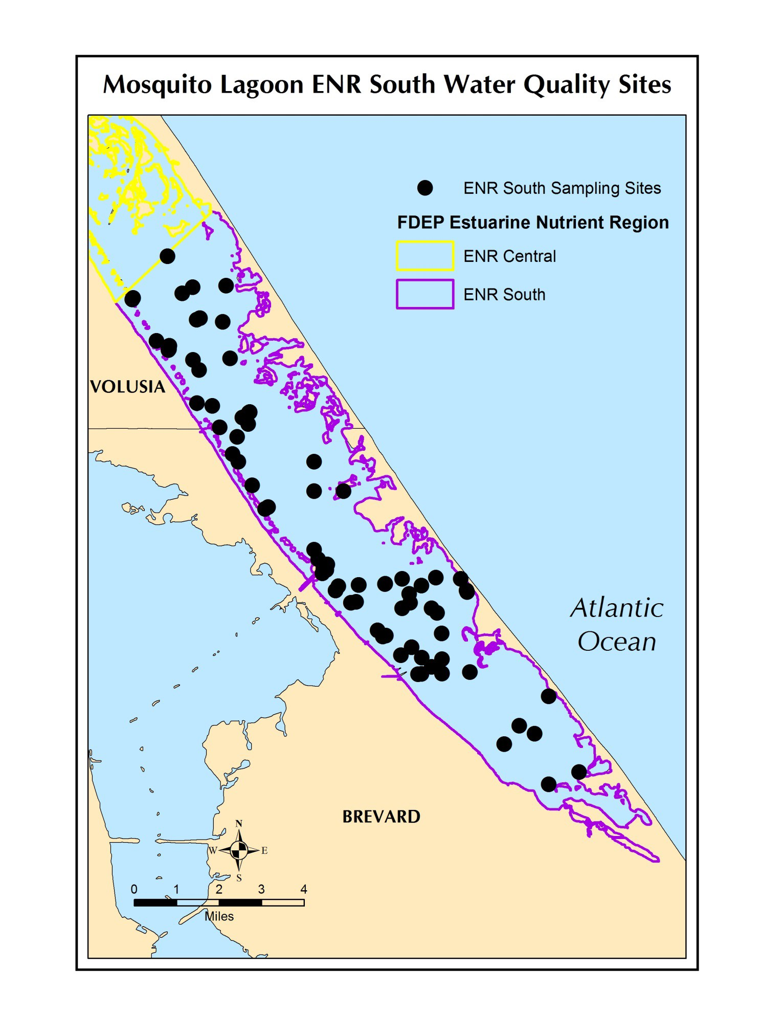

APPENDIX B WATER QUALITY TREND RESULTS

Temporal trends in water quality were assessed using time-series analyses to examine trends in water quality conditions in each ENR. ENR monthly mean water quality values were submitted for trend tests for the following parameters: TN, TP, chlorophyll a, and salinity. The period of time spanned 1989-2015 and was assessed to determine their suitability for trend and status analysis. If the data met the requirements for inclusion then the following assessment was made to determine the analysis path:

  - A data point was defined for the purposes of assessing sampling sizes as the mean of all stations and sampling levels (surface, middle, bottom) within a basin;
  - Trend testing was performed for the period of record corresponding to the beginning of monthly water quality sampling provided at least 60 samples and 5 years of monthly data were available for analysis.

All of the trend analyses were completed using a seasonal Kendall Tau approach. This approach removes seasonal trends that are common in water quality data as a result of seasonal fluctuations in temperature and rainfall and allows better resolution of increasing or decreasing trends in the data, independent of seasonal trends. The core statistical testing procedures were provided by the Environmental Protection Agency’s (EPA’s) seasonal Kendall Tau Fortran programs available from the EPA Laboratory in Corvallis, Oregon. The authors developed statistical software to drive these core programs, and produce the automated outputs.

The results are summarized in Table B1 and shown in Figures B1-B4.

For all nutrient parameters, TN, TP, or chlorophyll a, the results either indicated no trends or decreasing trends. In the North ENR, both TN and TP were decreasing, and TN decreasing the in the Central ENR. Increasing trends in salinity were seen in both the North and South ENRs.

Table B1. Results of the seasonal Kendall Tau trends test. Units: TN (mg/L), TP (mg/L), Chl a (µg/L). N=number of samples, p=probability of a greater Τ, Slope=slope of trend line, Magnitude=relative magnitude of the change over time.
ENR | Parameter | Begin Year | End Year | Median | N | p | Slope | Trend | Magnitude
North | Chlorophyll a | 1989 | 2015 | 4.61 | 315 | 0.895 | -0.004 | No Trend
North | TN | 1989 | 2015 | 0.57 | 310 | 0.001 | -0.016 | Decreasing | Small
North | TP | 1989 | 2015 | 0.05 | 312 | 0.034 | -0.001 | Decreasing | Small
North | Salinity | 1989 | 2015 | 33.93 | 315 | 0.044 | 0.088 | Increasing | Small
Central | Chlorophyll a | 1989 | 2015 | 4.97 | 314 | 0.687 | -0.008 | No Trend
Central | TN | 1989 | 2015 | 0.77 | 304 | 0.000 | -0.016 | Decreasing | Small
Central | TP | 1989 | 2015 | 0.06 | 312 | 0.818 | 0.000 | No Trend
Central | Salinity | 1989 | 2015 | 33.40 | 323 | 0.052 | 0.105 | No Trend
South | Chlorophyll a | 1989 | 2015 | 4.50 | 313 | 0.471 | 0.016 | No Trend
South | TN | 1989 | 2015 | 1.13 | 284 | 0.196 | -0.007 | No Trend
South | TP | 1989 | 2015 | 0.04 | 296 | 0.857 | 0.000 | No Trend
South | Salinity | 1989 | 2015 | 32.87 | 322 | 0.023 | 0.214 | Increasing | Small

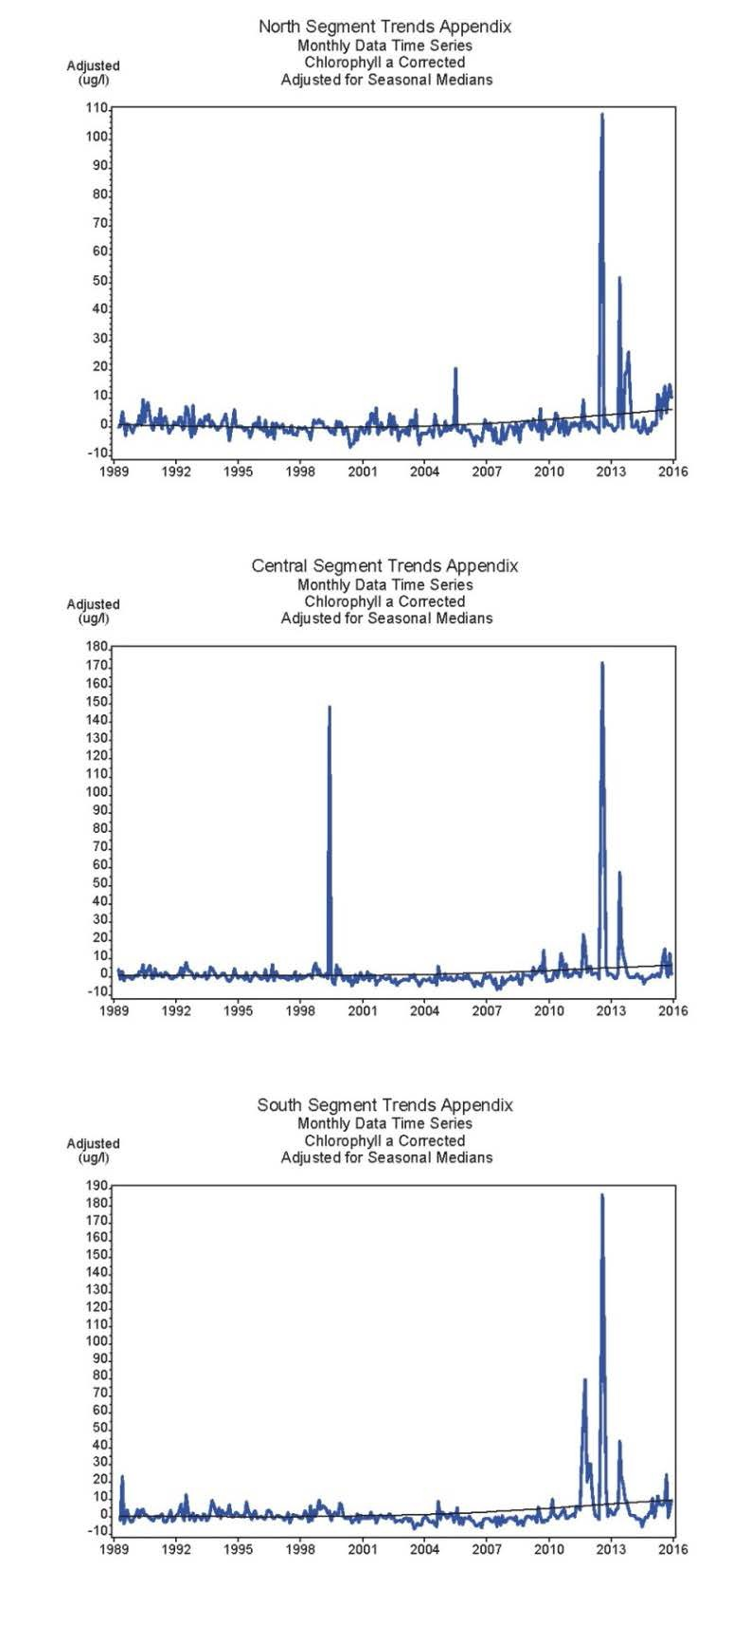

Figure B1. Time series of mean monthly chlorophyll a concentrations in the North (upper), Central (middle) and South (bottom) ENRs of Mosquito Lagoon.

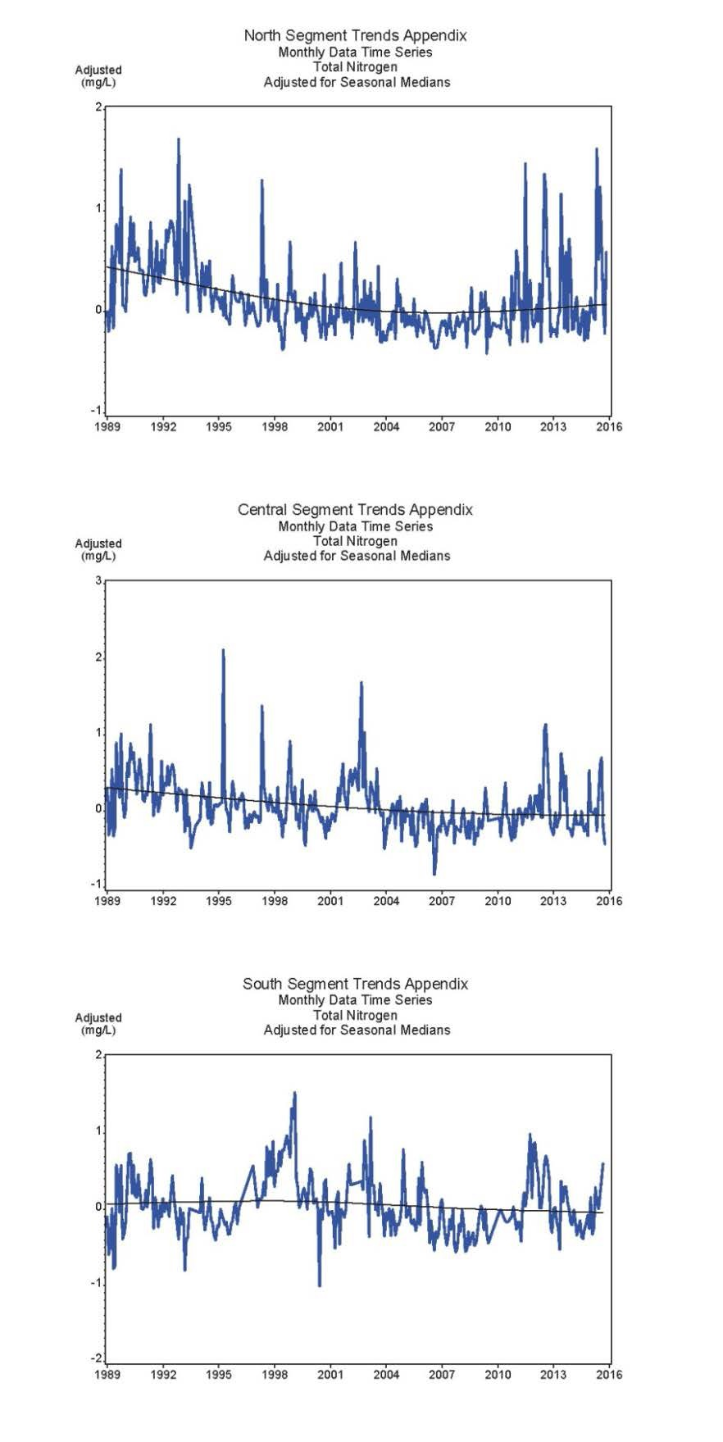

Figure B2. Time series of mean monthly TN concentrations in the North (upper), Central (middle) and South (bottom) ENRs of Mosquito Lagoon.

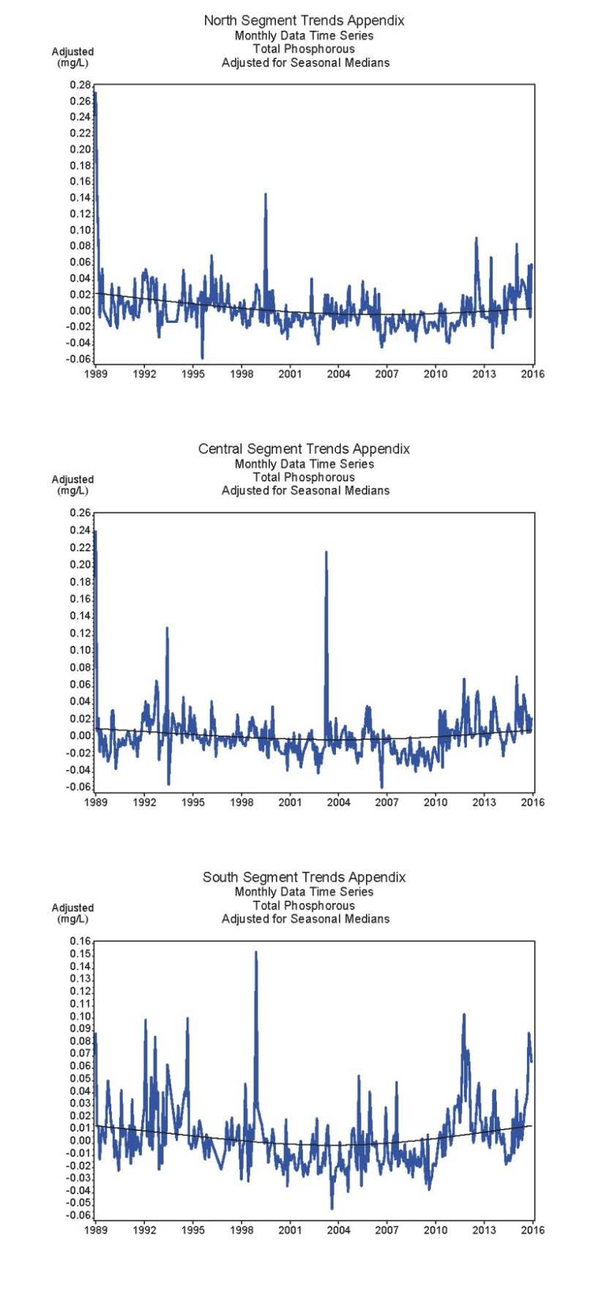

Figure B3. Time series of mean monthly TP concentrations in the North (upper), Central (middle) and South (bottom) ENRs of Mosquito Lagoon.

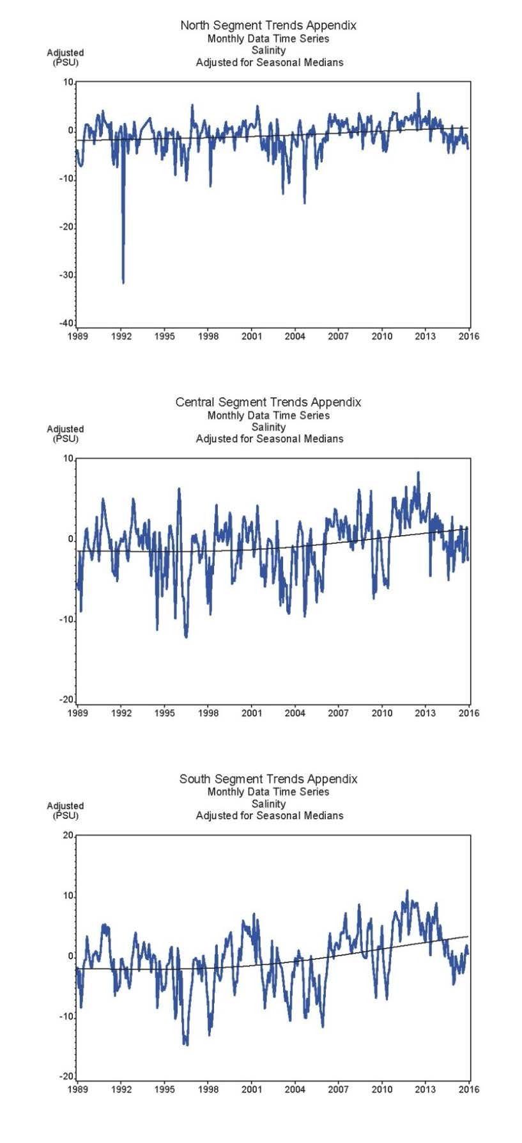

Figure B4. Time series of mean monthly salinity concentrations in the North (upper), Central (middle) and South (bottom) ENRs of Mosquito Lagoon.

APPENDIX C – Accounting of data used in “Three-legged” Stool Analysis

Table C-1. Counts of available Secchi Disk, Chlorophyll a and dissolved oxygen data by ENR, year and season (D=Dry, W=wet).
Year | Secchi Disk |  |  |  |  |  |  |  |  | Chlorophyll a |  |  |  |  |  |  |  |  | Dissolved Oxygen
Year | North |  |  | Central |  |  | South |  |  | North |  |  | Central |  |  | South |  |  | North |  |  | Central |  |  | South
Year | D | W | TOT. | D | W | TOT. | D | W | TOT. | D | W | TOT. | D | W | TOT. | D | W | TOT. | D | W | TOT. | D | W | TOT. | D | W | TOT.
1992 | 56 | 38 | 94 | 86 | 65 | 151 | 18 | 13 | 31 | 51 | 46 | 97 | 84 | 66 | 150 | 9 | 8 | 17 | 76 | 88 | 164 | 99 | 94 | 193 | 16 | 16 | 32
1993 | 72 | 25 | 97 | 64 | 14 | 78 | 4 | 2 | 6 | 43 | 39 | 82 | 68 | 67 | 135 | 5 | 6 | 11 | 73 | 25 | 98 | 75 | 24 | 99 | 7 | 4 | 11
1994 | 122 | 83 | 205 | 105 | 75 | 180 | 9 | 5 | 14 | 58 | 43 | 101 | 97 | 67 | 164 | 7 | 5 | 12 | 119 | 73 | 192 | 105 | 60 | 165 | 9 | 4 | 13
1995 | 112 | 83 | 195 | 111 | 71 | 182 | 7 | 6 | 13 | 58 | 44 | 102 | 102 | 66 | 168 | 7 | 6 | 13 | 91 | 62 | 153 | 98 | 56 | 154 | 6 | 5 | 11
1996 | 198 | 129 | 327 | 176 | 105 | 281 | 30 | 25 | 55 | 123 | 87 | 210 | 140 | 93 | 233 | 29 | 24 | 53 | 182 | 107 | 289 | 161 | 89 | 250 | 30 | 25 | 55
1997 | 135 | 101 | 236 | 106 | 123 | 229 | 36 | 30 | 66 | 118 | 94 | 212 | 127 | 101 | 228 | 34 | 29 | 63 | 252 | 172 | 424 | 129 | 114 | 243 | 24 | 35 | 59
1998 | 146 | 108 | 254 | 138 | 97 | 235 | 45 | 26 | 71 | 146 | 104 | 250 | 136 | 95 | 231 | 35 | 24 | 59 | 247 | 202 | 449 | 144 | 95 | 239 | 28 | 11 | 39
1999 | 105 | 48 | 153 | 93 | 48 | 141 | 30 | 21 | 51 | 102 | 47 | 149 | 86 | 45 | 131 | 29 | 19 | 48 | 121 | 37 | 158 | 91 | 36 | 127 | 15 | 16 | 31
2000 | 47 | 23 | 70 | 51 | 28 | 79 | 21 | 18 | 39 | 45 | 23 | 68 | 43 | 25 | 68 | 20 | 16 | 36 | 40 | 20 | 60 | 43 | 23 | 66 | 15 | 18 | 33
2001 | 46 | 41 | 87 | 66 | 42 | 108 | 66 | 40 | 106 | 37 | 33 | 70 | 65 | 41 | 106 | 66 | 39 | 105 | 38 | 33 | 71 | 66 | 42 | 108 | 66 | 40 | 106
2002 | 51 | 44 | 95 | 97 | 78 | 175 | 106 | 86 | 192 | 43 | 36 | 79 | 98 | 78 | 176 | 106 | 89 | 195 | 40 | 40 | 80 | 94 | 84 | 178 | 106 | 68 | 174
2003 | 57 | 59 | 116 | 63 | 19 | 82 | 76 | 15 | 91 | 18 | 10 | 28 | 49 | 10 | 59 | 66 | 14 | 80 | 16 | 10 | 26 | 51 | 10 | 61 | 70 | 15 | 85
2004 | 61 | 45 | 106 | 27 | 20 | 47 | 88 | 54 | 142 | 19 | 10 | 29 | 22 | 10 | 32 | 88 | 53 | 141 | 13 | 15 | 28 | 16 | 13 | 29 | 81 | 48 | 129
2005 | 51 | 30 | 81 | 39 | 37 | 76 | 59 | 30 | 89 | 7 | 5 | 12 | 21 | 15 | 36 | 47 | 13 | 60 | 11 | 9 | 20 | 27 | 32 | 59 | 42 | 30 | 72
2006 | 44 | 40 | 84 | 24 | 28 | 52 | 30 | 39 | 69 | 12 | 6 | 18 | 19 | 15 | 34 | 30 | 39 | 69 | 18 | 20 | 38 | 22 | 28 | 50 | 30 | 39 | 69
2007 | 47 | 44 | 91 | 29 | 17 | 46 | 38 | 20 | 58 | 19 | 17 | 36 | 25 | 14 | 39 | 38 | 20 | 58 | 24 | 24 | 48 | 26 | 16 | 42 | 36 | 18 | 54
2008 | 42 | 32 | 74 | 26 | 19 | 45 | 25 | 20 | 45 | 18 | 12 | 30 | 26 | 19 | 45 | 25 | 20 | 45 | 17 | 18 | 35 | 23 | 20 | 43 | 14 | 24 | 38
2009 | 48 | 15 | 63 | 14 | 10 | 24 | 21 | 15 | 36 | 12 | 7 | 19 | 14 | 10 | 24 | 21 | 14 | 35 | 12 | 7 | 19 | 14 | 10 | 24 | 21 | 15 | 36
2010 | 47 | 39 | 86 | 28 | 24 | 52 | 18 | 15 | 33 | 19 | 23 | 42 | 20 | 17 | 37 | 17 | 15 | 32 | 26 | 23 | 49 | 27 | 24 | 51 | 18 | 15 | 33
2011 | 19 | 14 | 33 | 26 | 20 | 46 | 14 | 10 | 24 | 19 | 14 | 33 | 26 | 20 | 46 | 14 | 10 | 24 | 19 | 13 | 32 | 26 | 17 | 43 | 14 | 8 | 22
2012 | 15 | 9 | 24 | 26 | 27 | 53 | 18 | 13 | 31 | 15 | 6 | 21 | 26 | 13 | 39 | 21 | 9 | 30 | 15 | 8 | 23 | 26 | 23 | 49 | 18 | 12 | 30
2013 | 24 | 15 | 39 | 19 | 16 | 35 | 21 | 18 | 39 | 24 | 14 | 38 | 19 | 19 | 38 | 27 | 21 | 48 | 15 | 12 | 27 | 18 | 16 | 34 | 20 | 18 | 38
2014 | 17 | 10 | 27 | 17 | 60 | 77 | 26 | 20 | 46 | 17 | 10 | 27 | 17 | 50 | 67 | 29 | 28 | 57 | 15 | 10 | 25 | 15 | 60 | 75 | 32 | 23 | 55
2015 | 14 | 13 | 27 | 15 | 14 | 29 | 22 | 16 | 38 | 14 | 13 | 27 | 16 | 15 | 31 | 26 | 22 | 48 | 14 | 13 | 27 | 16 | 18 | 34 | 29 | 20 | 49

C-2

APPENDIX D from FDEP (2012) “Overview of Approaches for Numeric Nutrient Criteria Development in Marine Waters”

2.4 Frequency and Duration
To be protective, the duration of the criteria (e.g., annual geometric mean, long-term mean) must be linked to the response time frame of the sensitive endpoint. For example, when criteria are derived based on 96-hour acute toxicity testing, a 1- to 24-hour averaging period would be fully appropriate. Likewise, a 4-day averaging period is protective when criteria are based on chronic toxicity testing. If a sufficiently robust cause-effect relationship demonstrates that an adverse response occurs over a short time frame, then short-term averaging periods (e.g., 1 to 30 days) would be appropriate for nutrient criteria, provided the response can be linked to nonattainment of the designated use. If, however, such a short-term response cannot be demonstrated, or there is no indication of designated use impairment, then longer averaging periods are scientifically defensible.
For example, nutrient averaging periods over the period of a year were used by the Department and EPA to assess the chlorophyll a response to nutrient enrichment in Florida lakes. Regression analyses using daily sample data were extremely weak. When data were evaluated based on annual average natural log-transformed data, sufficiently robust relationships were found. EPA used these relationships to propose nutrient criteria for Florida lakes expressed as annual geometric means. Coincidentally, the use of an annual geometric mean was consistent with the derivation of the magnitude and observed response time frame.
Because criteria derived using the “healthy existing conditions” approach are not linked to any particular response time frame, this approach does not suggest any inherently protective duration. However, an analysis of the relationships between chlorophyll a and phosphorus and nitrogen concentration in Florida’s healthy estuaries demonstrates the linkage between long-term nutrient levels and response. The Department has preliminary evidence suggesting that a long-term duration is in fact appropriate for the purposes of establishing NNC (Figure 8). Additionally, decisions regarding the duration of the averaging period should involve practical considerations, such as establishing an effective strategy for describing the baseline distribution and the development of a reasonable assessment test for determining whether future monitoring data are consistent with the baseline.
As previously stated, there is an established precedent for using annual geometric means for this type of application. Since the goal of a reference-based approach is to maintain the long-term average condition (trophic status), describing and assessing the variability around the annual geometric mean is especially suitable for this purpose. Durations over shorter periods would be associated with much greater variability around the central tendency and would not be any more effective at detecting deviations from the baseline distribution. Therefore, the Department is proposing that the duration be expressed over a period of one to five year.

Figure 8. Relationship between long-term geometric mean chlorophyll a and TP (upper panel) and TN (lower panel) from 75 healthy Florida estuary segments.

Annual Limit
Given the goal of maintaining an existing frequency distribution, a scientifically defensible approach would be to use the frequency and duration components, in conjunction with magnitude, to assess whether the distribution has shifted upward (or potentially downward in estuaries such as Apalachicola Bay). Such an assessment methodology may be derived statistically when given the stated management goal of no more than a 10% Type I error rate. This assessment of the Type I error rate is related only to addressing the null hypothesis that future monitoring data are equivalent to the baseline distribution. This Type I error does not take into account the possibility that a higher nutrient threshold would be fully protective of the use. The Type I error rate, for the current application, may be defined as the rate of incorrectly identifying waters as nutrient impaired, based simply on an exceedance of the statistically derived threshold, when in fact the system is biologically healthy.
The target error rate may be achieved by establishing a NNC that acknowledges inherent natural and analytical variability of the dataset that represents the current condition. This involves targeting maintenance of the current condition on average by utilizing representations of confidence limits around the mean of the dataset, with a specified frequency and duration. Setting a cap using this upper confidence level (assessment limit) represents an upper end of the frequency distribution around the long-term average target. If conditions remain below that limit, then confidence is provided that long term concentrations have not increased. Previous proposals by EPA have utilized 3-year assessment periods to express the magnitude and duration nutrient criteria components. Although it is possible to construct a test that achieves the 10% Type I error rate target over a 3-year period, a slightly longer period (5 years) will provide better long-term control Type I errors where there is significant autocorrelation between years, Type II error rates, and will more fully capture climatic cycles [e.g., El Niño, La Niña, and the Atlantic Multidecadal Oscillation (AMO)].
An acceptable excursion frequency can be set using a 3-year period as the basis of assessment. The excursion frequency should account for inter-annual nutrient patterns and be established at a frequency that allows for effective and timely nutrient control; that is, it should account for and allow natural inter-annual variability associated with climatic cycles, and recognize that multiple high nutrient years can occur in succession. A consideration of this inter-annual correlation would suggest that the excursion frequency should allow for multiple excursions in a three-year period, such as two out of five or three out of five years. However, regulatory agencies often target a more rapid assessment period to allow for the implementation of corrective action in a timely manner, making less frequent excursions more desirable for expressing the criteria (e.g., only once in a 3-year period).
Once an acceptable excursion frequency has been selected, a nutrient target can be set at a level that is expected to result in no more than a 10% Type I error rate, given the observed variability in the baseline dataset. The target is set at a percentile or upper prediction interval that corresponds with a 3-year cumulative exceedance probability of no more than 0.8, calculated using Equation 1. For example, an exceedance frequency of no more than once in a 3-year period can be set at the long-term 80th percentile (Table 6). The appropriate exceedance probability was selected by using the Excel goal seek function to find a percentile (i.e., the probability of an annual geometric mean greater than the given percentile) that would achieve a cumulative 1- out of 3-year probability of an exceedance rate of no more than 0.9.
In this example, an exceedance of the 1-in-3-year test accurately predicts that the long-term average concentration has increased. Likewise, the target of a 10% Type I error can also be achieved by setting the allowable excursion frequency to 0 or 2 years out of 3 years by setting the annual criterion magnitude to approximately the long-term 97th or 54thpercentiles, respectively. From a management perspective, allowing less frequent excursions (e.g., once in a 3-year period) would provide a more effective nutrient control strategy than waiting for a full 3 years to take corrective actions. Furthermore, not allowing for any exceedances (i.e., 0 in 3 years) is not realistic, since this would not allow for the full range of natural variability and would result in an excessive number of false positive exceedances. Therefore, the Department is proposing to derive protect nutrient thresholds based on a no more than 1-in-3 year excursion frequency.
Table 6. Probability and cumulative probability of observing X and ≤ X exceedances, respectively, in a 3-year period, given an annual exceedance probability of 0.20. Probabilities were calculated based on the binomial probability function (Equation 1).
X  (# exceedances) | P(X)  (probability of X exceedances  in 3 trials) | Cumulative P  (probability of ≤X exceedances)
0 | 0.512 | 0.512
1 | 0.384 | 0.896
2 | 0.096 | 0.992
3 | 0.008 | 1.000

Because nutrient data very typically follow or approximate a log-normal distribution, the Department has historically used a geometric mean and log-normal statistics to describe nutrient distributions and calculate upper percentiles (Section 62-302.530, F.A.C.; Payne et al. 1999, 2000, 2003). The approximation of a percentile using this method requires knowing or estimating the long-term mean ($\overline{X}$) and standard deviation (σ). For the determination of applicable NNC, the mean is set to the long-term network geometric mean (e.g., 13.1 µg/L for the example of St. Joseph Bay), and the standard deviation is based on the variability observed within the baseline dataset.
The parameters $\overline{X}$ and σ are estimated from available data that were collected over a given period. Because the goal of the criterion is to maintain a long-term average concentration, it is imperative to estimate the full range of variability within a waterbody, given all sources of variance. Furthermore, Section 62-302.530, F.A.C., states that “in applying the water quality standards, the Department shall take into account the variability occurring in nature and shall recognize the statistical variability inherent in sampling and testing procedures.” The full range of variability or true inter-annual variance is composed of annual, spatial, and within-year (sampling) effects, such that the annual average concentration on the log scale is given as:
Ln (annual geometric mean concentration) = mean + year effect + site effect + within year effect + error.
The variances associated with site and year effects are based on TP concentrations that have been averaged over spatial or temporal scales and are thus less influenced by short-term events. The site effect provides an estimate of the spatial variability within the waterbody, while the year effect represents inter-annual variability, which is largely driven by climatic and hydrologic cycles. However, it also important to realize that long-term variability is still influenced to some degree by shorter-term phenomena. The overall influence of these phenomena will diminish with longer averaging periods. For example, a single storm event can result in TP concentrations that are elevated well above the long-term average concentrations for a short period (due to factors such as sediment resuspension). If by chance a sample were collected during this period, then the influence of the storm would clearly affect the results for the given sample date and the within-year variance, and the event would also result in a higher overall annual average for the year. Furthermore, the influence of this single short-term event would affect longer term averages of the annual averages (e.g., 3, 4, and 5 years). However, the overall influence of a single event, no matter how unusually high, will diminish as more data over longer periods are averaged.
In ecosystems minimally affected by human disturbance, the observed or sampled average condition within a waterbody (and resulting data distribution) is the result of the sum of a number of random processes operating on different temporal and spatial scales. Criteria established to maintain an existing condition must account for the full range of variance so that realistic expectations of future conditions may be established. Estimates of variance that do not include both spatial and temporal components fail to fully account for the range of natural variability within a system, and thus criteria derived from such estimates are prone to more statistical error, particularly Type I, than intended.
Methods of sampling to measure compliance with established nutrient criteria should be compatible with the procedures to establish the criteria (Davis et al. 2001). The compatibility of sampling methods, for distributional derived criteria, would require that future sampling be conducted across the same number of stations within a specified geographic area (or even the same set of stations) and with a consistent sampling methodology, including number of annual samples (for additional discussion on this topic, see Section 6). However, while regulatory agencies are required to assess criteria compliance at all times and all places, funding to conduct fixed long-term monitoring is limited. To meet the requirements of the CWA within budgetary constraints, regulatory agencies are typically forced to use “found data”—i.e., agencies are not typically making ambient compliance determinations based on fixed monitoring stations or consistent monitoring designs. The “found data” are collected for a variety of purposes over varying spatial and temporal scales, with a range of sampling frequencies. Therefore, it is highly unlikely that future compliance data will be wholly consistent with the baseline dataset used to derive NNC. The location of stations will change over time, as will the number of samples used to assess waters, and thus the true long-term variance in the system will be greater than would be calculated based on a straight calculation of inter-annual variance. In other words, spatial and within-year variance cannot be assumed to be fixed.
One solution to this problem is to account for the influence of spatial and sample (within-year) variance. This approach attempts to account for the added variability expected from a non-fixed monitoring design. The true inter-annual standard deviation for a network of stations is calculated as:
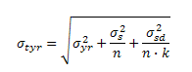
(2)
where,
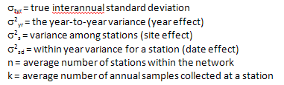

The within-year variance is calculated as the pooled within-year variance across stations and years. Equation 2 applies if criteria are intended to be applied as a spatial average across a waterbody and was developed based on the variance analysis describe by Walker (1981) and Knowlton et al. (1984). The use of this approach assumes that the baseline dataset was drawn from a reasonably homogeneous waterbody and that there are not significant temporal trends in the dataset. If the waterbody is not homogenous, then it should further segmented prior to criteria derivation. The values of n and k are not fixed and could be assumed to be random variables, although the values will fall within a limited range. The average number of stations and annual number of samples per station were used as the best estimates of expected n and k, respectively.
Alternatively, the set values of n or k could be used to investigate the influence of more or less intensive future monitoring designs. Equation 2 can be used to calculate the true (expected) long-term inter-annual variability around the network long-term average network concentration. An example of a calculation for the Central Florida Bay segment of Florida Bay is presented to illustrate the approach. Only site-years with at least four samples were included in the calculations. Table 7 summarizes the spatial and temporal variance components and potential criterion components.
Table 7. Summary of TP, TN, and chlorophyll a variance components, long-term average concentrations, and upper prediction limits for the Central Florida Bay segment of Florida Bay. The variance components and average network concentrations are on the natural log scale. Calculations were based on sites with at least four samples per year. Limits are presented for illustration purposes and do not represent final criteria recommendations or proposal. The segmentation of Florida Bay is explained in the Florida Bay technical support document.

Component | TP (mg/L) | TN (mg/L) | Chlorophyll a (µg/L)
Spatial variance (σ²_{s}) | 0.2767 | 0.0636 | 0.3208
Inter-annual variance(σ²_{yr}) | 0.2992 | 0.3446 | 0.4621
Within-year standard variance (σ²_{sd}) | 0.5039 | 0.3780 | 0.9820
Average number of stations within the network (n) | 4 | 4 | 4
Average number of annual samples collected at a station (k) | 11.7 | 11.7 | 11.6
Average network Ln | -4.274 | -0.324 | 0.315
Spatially averaged geometric mean (µg/L) | 0.0139 | 0.723 | 1.371
True inter-annual standard deviation (σ_{tyr}) | 0.3384 | 0.3504 | 0.5098
N (Number of Years | 14 | 14 | 14
One-sided t value | 0.870 | 0.870 | 0.870
Upper 80% prediction limit (1:3 years) | 0.0189 | 0.992 | 2.17

The primary objective of the healthy existing conditions approach is to establish magnitude and frequency limit(s), which if exceeded in the future, would allow one to conclude with sufficient statistical certainty that the new distribution is not consistent with the baseline distribution. In other words, the Department wants to be confident that a future annual geometric mean is consistent with the baseline dataset distribution, rather than from some different data distribution. Given this goal, the use of a “prediction interval” is the most appropriate statistical tool. Prediction intervals are used to estimate the range of future data, such that 100(1-α) % of the future data will fall within the prediction interval and 100(α) % will fall outside the interval (Helsel and Hirsch 2002). Helsel and Hirsch (2002) provide an equation to calculate an asymmetric (log-normal) prediction interval. An upper prediction limit can be calculated as:
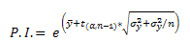(3)
where,
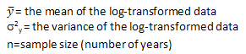
Equation 3 and the estimate of the true long-term standard deviation (σ_{tyr} ) from Equation 2 were used to calculate the upper 80 percent prediction limits on annual geometric mean nutrient concentrations for Florida’s estuaries. The upper limit is used because the resulting value represents a level that should not be routinely exceeded, resulting in maintenance of current conditions or lower. In other words, if the cap is not exceeded, we have confidence that nutrient concentration conditions have not increased. These limits correspond to annual geometric mean concentrations that are expected to be higher in only 10% of future years, given the range of spatial and temporal variability measured during the baseline periods for these waters. Therefore, it also represents a level that would be expected to result in a no more than 10% Type I error if applied as an annual geometric mean, not to be exceeded more than once in a 5-year period. Table 7 presents an example of the upper 80 percent prediction limits for Central Florida Bay.
It should be noted that prediction limits are generally greater than the corresponding percentile value and may be thought of as the percentile plus a confidence interval. While the Department concluded that this is appropriate given the uncertainty associated with future monitoring data, MTAC members requested an example the magnitude of difference between an upper prediction interval and the corresponding percentile. For the Central Florida Bay segment, the 80 percent prediction limit (not to be exceeded more than once in a 3-year period), is 0.0189 mg/L for TP, 0.992 mg/L for TN, and 2.17 µg/L for chlorophyll. For the same dataset, the 80th percentile of the data distribution is 0.0185 mg/L for TP, 0.971 mg/L for TN, and 2.10 µg/L for chlorophyll.

Twenty percent of the future annual geometric mean values are expected to be above the upper 80th prediction interval.
The 10% Type I error rate may be confirmed by using Equation 1 and summing the probabilities of observing 0 and 1 exceedances, given that p equals 0.20.
An upper (one-sided) 80% prediction limit is equivalent to a (two-sided) 60% prediction interval.

