Documentation in Support of Category 4e

Waterbody/Watershed Identification
 | Organization | City of St. Petersburg
 | Point of Contact | Brejesh Prayman, P.O. Box 2842, St. Petersburg, FL, 33731-2842
 | Waterbody(s) | Bayou Creek (WBID 1709D), St. Petersburg
 | No. Waterbody / Pollutant Combinations | Bayou Creek, located in south St. Petersburg, is an urban creek that discharges into a shallow bay known as Little Bayou (WBID 1709 – Big Bayou Basin W). The creek is classified as a Class III Freshwater body while the receiving waterbody (WBID 1709), is classified as a Class II Estuary water. Bayou Creek (WBID 1709D) has been identified as an impaired waterbody due to exceeding the water quality criteria for dissolved oxygen (percent saturation), Escherichia coli bacteria, and nutrient (chlorophyll-a and total phosphorus) concentrations. However, historical data is lacking and causes of impairments are difficult to discern. Both the creek (WBID 1709D) and bayous (WBID 1709) are located within Group 1 – Tampa Bay basin.
Description of Baseline Conditions
 | Watershed(s) | Bayou Creek and Receiving Waterbodies – WBIDs 1709D and 1709.
 | Baseline Data | Based on the limited additional water quality analysis and results from the Technical Memo for Little Bayou / Basin Q Water Quality Analysis (Attachment 1), Bayou Creek (WBID 1709D) would be classified as impaired for elevated TP, but not TN. When evaluating the chlorophyll-a data, elevated concentrations since 2013 resulted in sufficient annual geometric mean exceedances of 20μg/L to assess the waterbody as impaired for chlorophyll-a. Similarly, the Escherichia coli data collected within WBID 1709D compared to the Escherichia coli criterion shows many monthly events with values elevated above the regulatory standard.  Based upon the findings displayed in Attachment 1, the Bayou Creek watershed (WBID 1709D) would be determined to be impaired for TP, DO, Chl-a and Escherichia. coli bacteria. However, there is insufficient data to determine if the downstream waters of Little Bayou, and the southern portion of the Big Bayou Estuary WBID (1709) are similarly impaired.  Attachment 1: Technical Memo for Little Bayou / Basin Q Water Quality Analysis: gives detailed baseline data for the aforementioned parameters of concern.
 | Map | See Figures 1 below and in Attachment 1: Technical Memo for Little Bayou / Basin Q Water Quality Analysis.  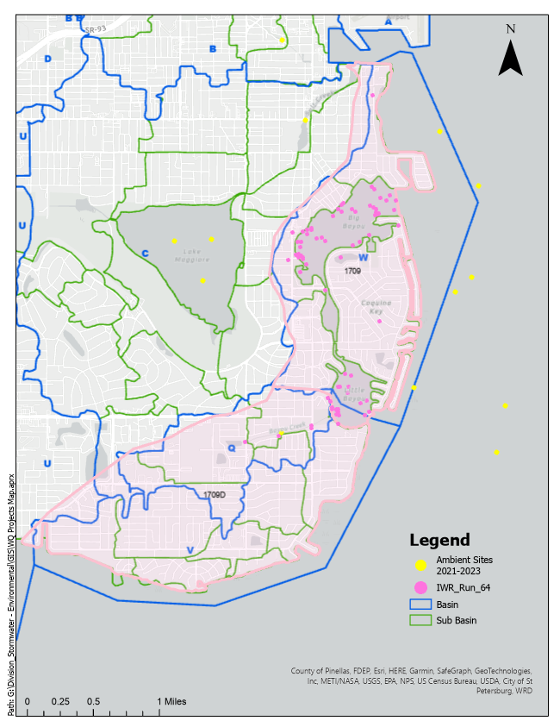  Figure 1: Group 1 WBIDS 1709 and 1709D highlighted along with more localized Basins and Sub-Basins as identified by the City of St. Petersburg.

Evidence of Watershed Approach
 | Area of Effort | As identified in Attachment 2: Little Bayou Basin Q Water Quality Improvements, there are four potential restoration projects that may contribute appropriate strategies to better identify, and subsequently reduce, the water quality impairments for both Bayou Creek and it’s receiving waters. This work includes and prioritizes supplemental water quality data collection with microbial source tracking (MST).
 | Key Stakeholders Involved and Their Roles | City of St. Petersburg Departments: Water Resources; Stormwater, Pavement, and Traffic Operations; Community Services; Marketing, Engineering; and Parks and Resources  Tampa Bay Estuary Program  The City is the main stakeholder to address water quality concerns in this basin. The City conducts water quality sampling and analyses, maintains the MS4 system, routinely sweeps streets as part of a greater maintenance program, funds projects through the Engineering Capital Improvement Program (CIP) and is working on a City-Wide Stormwater Master Plan that will identify and prioritize future projects. The City’s Community Services and Marketing Departments help to get important information out into the Community and will help with future education and outreach efforts in this basin as needed.  The Tampa Bay Estuary Program (TBEP) is a key stakeholder as Tampa Bay is the ultimate receiving waterbody for this basin. The City and TBEP have proactively decided to move forward with a separate project to develop restoration plans with the goal to restore tidal flows to the downstream portions of Bayou Creek near the connection to Little Bayou. TBEP has solicited funding for this project through the Bipartisan Infrastructure Law and is currently working with the City to develop an Agreement for the project.
 | Watershed Plan & Other Supporting Documentation | The City of St Petersburg, with help from environmental consultants, identified the need for greater water quality sampling and analysis within Bayou Creek (WBID 1709D) and Big Bayou – Basin W Bayou (WBID 1709) to guide future restoration projects for water quality improvements especially regarding bacteria. See Attachment 3: Draft Task Authorization for Little Bayou Creek Water Quality Monitoring.  The first step will be to develop a Work Plan to provide guidelines on the types, frequencies, and details of the information to collect. This Work Plan will form the basis of implementing this work and determining what data is sufficient to help better understand how Bayou Creek (and its contributing watershed) affect the receiving waters of Little Bayou.  Bi-monthly sampling at seven locations is proposed to be sampled for a year, over the wet and dry seasons to capture the seasonality of the inputs into the creek and state of impairment of the waterway.  The water quality laboratory samples will be submitted to a certified laboratory for analyses per FDEP or EPA methods. Samples will also be analyzed for microbial concentrations and filtered for future microbial source tracking.  If “hot spots” are identified during sample analysis for bacteria, microbial source tracking will be conducted to determine the origin(s) and inform restoration projects.
 | Point Sources and Indirect Source Monitoring (Sites) | The entire area is regulated by a Municipal Separate Storm Sewer System (MS4) permit, NPDES MS4 Permit No. FLS000007-005. There are no permitted point source discharges in the basin, and the entire watershed is served by central sanitary sewer facilities. The 2021 MS4 Annual Report is included as Attachment 4.
 | Nonpoint Sources | The Bayou Creek watershed has an approximate area of 537 acres with most of the input being from stormwater systems. There are no wastewater outfalls into the creek or into the downstream waters of Little Bayou. See Figures 8 and 9 in Attachment 1: Technical Memo for Little Bayou / Basin Q Water Quality Analysis.
 | Water Quality Criteria | The City is proactively pursing adequate study plans and timeframes necessary to determine the pollutant sources that contribute to the impairments of concern, and to develop the projects and/or programs to address the water quality issues so water quality will be improved and thereby postponing and potentially avoiding receiving a Total Maximum Daily Load (TMDL) for the basin.  The Water Quality Improvements Plan recognized the need for supplemental water quality data collection along with MST if bacterial hotspots are identified. All four candidate projects are identified in Attachment 2: Little Bayou Basin Q Water Quality Improvements.
 | Restoration Work | Existing efforts include the completion of a Little Bayou Basin Q Water Quality Improvements plan which provides the basis for future projects and is included here as Attachment 2: Little Bayou Basin Q Water Quality Improvements.  Projects 1 and 2: are supplemental water quality data collection projects. The City has approved the Bayou Creek Water Quality Monitoring project included here as Attachment 3: Draft Task Authorization for Little Bayou Creek Water Quality Monitoring. The City will also include microbial source tracking if “hotspots” are identified during the year-long water quality data collection project.  Within this plan, water quality and microbial monitoring of Bayou Creek and nearshore areas will be conducted over a period of 12 months, to help understand the seasonal and spatial sources and magnitude of inputs into the Creek as well as its receiving waters. The efforts proposed below will allow the City to:  - Understand what is entering Bayou Creek from the surrounding watershed, the quantity and timing of these inputs, and how they affect water quality not only in the Creek but also in the Bayou; and  - Help the City work towards developing a restoration plan to enhance hydrologic management and improve water quality in Little Bayou. This restoration plan is scheduled to be completed by March 2025 with projects identified for the FY26 CIP budget (which begins October 1, 2025, for the City).  Project 3: is a restoration project. There is a small lagoon near 4th St. S that is now covered with invasive freshwater vegetation like water lettuce suggesting that historical tidal connections have largely been lost. Increasing the reach of tidal waters could potentially increase salinity helping to control nuisance vegetation along with providing opportunities for intertidal habitat creation and emergent tidal wetland enhancements.  Furthermore, the City continues to develop lake management plans for the City’s approximately 80 lakes that it manages and has hired a Stormwater Environmental Services/Lakes Manager to recommend and oversee operations on all lakes.  The City is completing a Master Stormwater Plan to be used as a guiding document for the next twenty-five years. Capital projects will be scored based on a ranking matrix including cost/benefit ratios, impacted/priority basins, community redevelopment areas, benefits to water quality, and more. While the overall goal is for stormwater quantity impacts, water quality will also be an important project component. It is unknown at this time how many future projects will be identified in WBIDS 1709 and 1709D.

Critical Milestones/Monitoring
 | Anticipated Critical Milestone(s) and Completion Dates: |  | Restoration Projects 1 and 2 (Water Quality Monitoring with MST):  - March 2024: Finalize Scope  - April 2024: Work Plan Development and Kick-off Meeting. 12-month water quality data collection begins to include two “first flush” events  - September 2024: Progress Report on initial findings of water quality investigations. This is an opportunity to modify the work plan approve microbial source tracking for “hotspots.”  - April 2025: All field work is completed for water quality. Approval will be given to conduct microbial source tracking if “hotspots” are identified. Based on draft report, allocate specific CIP project funding for FY 26 and FY 27  - September 2025: Final report with data review and future project recommendations.  - October 2025: Begin design for CIP projects.  - October 2026: Construction begins.  Restoration Project 3 (Restoring Tidal Flows and Lagoon Restoration):  - November 2023: Letter Agreement with Stantec Consulting Inc. to begin background data collection for “Little Bayou Lagoon Restoration.”  - March 2024: Design and modeling begin.  - June 2024: Permitting begins, pre-construction monitoring begins.  - September 2024: Final Design complete.  - January 2025: Permitting complete. Construction bidding begins.  - January 2026: Construction complete. Post-monitoring begins.  Restoration Project 4 (Public Education and Community Engagement): These efforts will be ongoing throughout the project timelines listed above but will be mostly implemented after the associated projects are completed and community needs are identified.
 | Monitoring Component |  | To better understand the factors that contribute to the impairment of the Bayou Creek and the receiving waters of Little Bayou, water quality monitoring will be conducted over a period of 12 months for the following parameters:  - Field parameters (salinity, temperature, dissolved oxygen, turbidity, pH)  - Nutrients (ammonia, nitrate-nitrite, total Kjeldahl nitrogen, total nitrogen, ortho-phosphorus, total phosphorus)  - Fecal Indicator Bacteria (Escherichia coli, Enterococcus, fecal coliforms)  - Microbial Source Tracking via DNA analysis if sampling demonstrates “hot spots”  See Attachment 3: Draft Task Authorization for Little Bayou Creek Water Quality Monitoring.  Monitoring is concurrent with established monitoring through the City’s water quality monitoring creek station (51-02) located at latitude 27.717703 longitude -82.642009 and includes total nitrogen, total Kjeldahl nitrogen, total phosphorous, ammonia, biochemical oxygen demand, chlorophyll, E. coli, conductivity, bottom depth, dissolved oxygen, flow, pH, salinity, turbidity, water temperature, nitrate-nitrite, and total suspended solids. It is important to note that not every parameter is collected or evaluated for during every sampling event. The Water Quality Report Card found in Attachment 4: The 2022 MS4 Annual Report on page 22 of Attachment B gives a site breakdown for specific parameters.
Other Key Dates
 | Estimated Delisting Date | WBIDs 1709D (Bayou Creek) and 1709 (Big Bayou – Basin W) are included in the State’s Group 1 Tampa Bay basin. The most recent review and assessment cycle was completed in 2022. The impairments described in this alternative restoration plan are Escherichia coli, dissolved oxygen (percent saturation) and nutrients (chlorophyll-a and total phosphorus). The earliest opportunity for delisting would occur during the current biennial assessment, to be adopted in the spring of 2024, however, this is prior to the implementation of all the projects described in this plan and it is unlikely that the impaired parameters will attain applicable water quality standards. Once all the proposed projects have been implemented, an improvement in water quality within this watershed is expected. If determined by an updated dataset (subsequent biennial assessment cycle) that the parameters in question are no longer impaired, DEP may request these WBIDs to be delisted from the federal 303(d) List (if applicable).
Financial Commitments

 | Estimated Implementation Cost |  | The City has already spent about half of the allocated $220,000 project cost for “Little Bayou Basin Q Water Quality Improvements” with future costs outlined in Attachment 3: Draft Task Authorization for Little Bayou Creek Water Quality Monitoring.
 | Land Acquisition  (if applicable) |  | Funding Source: ______________________________________________________________  N/A
 | Design and Construction  (if applicable) |  | Funding Source: City of St Pete Engineering and Capital Improvements Department Fund 4013  There are multiple sources of funding for future design and constructions projects for Little Bayou. Please note that funding other than for “Little Bayou Water Quality Improvements” is not strictly to be used for one project or area but is available as potential project funding if justified.
  Project Title | FY23 | FY24 | FY25 | FY26 | FY27 | FY28
  Little Bayou WQ Imps | $120,000
  Stormwater System Resiliency Enhancements | $500,000 | $500,000 | $500,000 | $500,000 | $500,000 | $500,000
  Master Plan Projects | $250,000 | $400,000 | $300,000 | $1M | $10M | $22M
References:

Attachment 1: Technical Memo for Little Bayou / Basin Q Water Quality Analysis
Attachment 2: Little Bayou Basin Q Water Quality Improvements
Attachment 3: Draft Task Authorization for Little Bayou Creek WQ Monitoring.
Attachment 4: The 2022 (Y5C4) MS4 Annual Report
Attachment 5: Street Sweeping Frequency and Metrics for Zones 4 and 11

Attachment 1 –

Attachment 2 –
Attachment 3 –

Attachment 4 –

Attachment 5 –

