The City of St. Petersburg’s Stormwater, Pavement and Traffic Operations department sweeps the entirety of Zones 4 and 11 (WBIDS 1709D and 1709) every 6.5 weeks throughout the year. Please note the quantities below are for the entirety of the zone and are not WBID specific.
Within Zone 4, the total miles swept during the last NPDES permit cycle, from July 1, 2022 through June 30, 2023 yielded 1,832 total miles swept with 20,385 cubic feet of material collected for an estimated 1,056 lbs TN removed and 575 lbs TP removed*.
For the same time period for Zone 11, 1,566 total miles were swept with 19,386 cubic feet of material collected for an estimated 1,004 lbs TN removed and 547 lbs TP removed*.
*Estimated reductions calculated using the 2019 FSA MS4 Load Reduction Assessment Tool

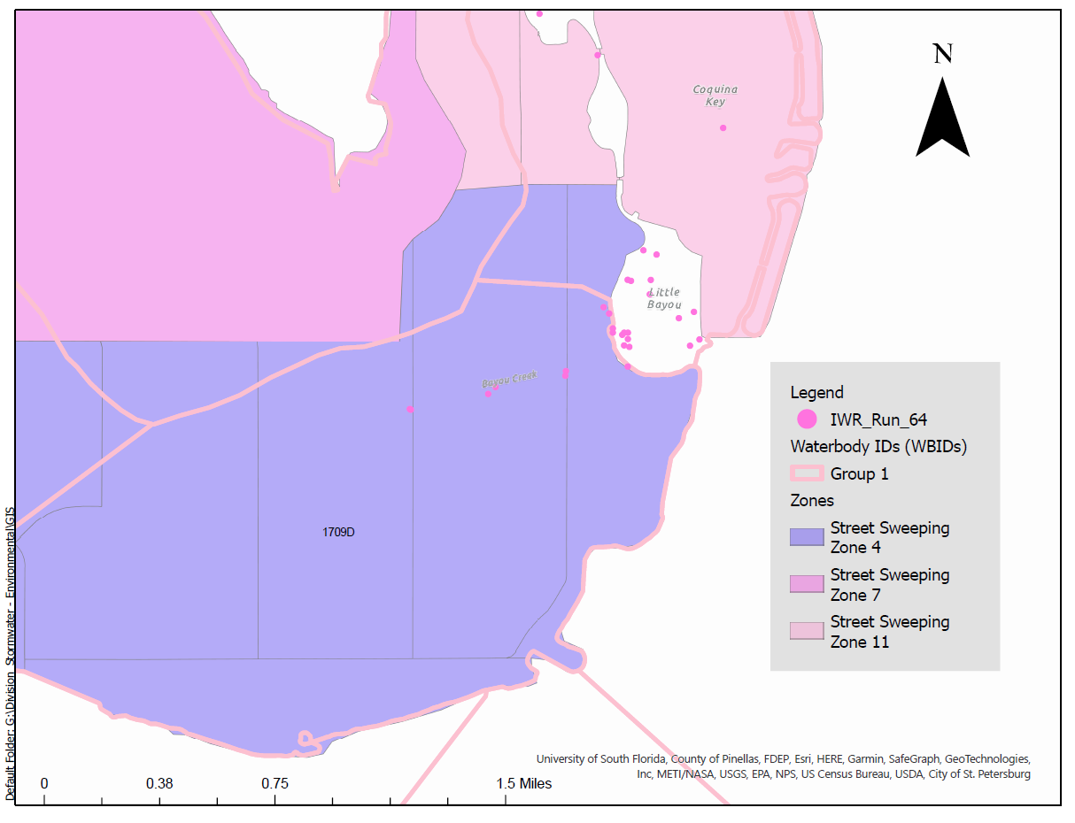
DRAFT

