Documentation in Support of Category 4e

Waterbody/Watershed Identification
 | Organization | Polk County
 | Point of Contact | Greg Knothe, 4177 Ben Durrance Rd.  Bartow, FL 33830, GregKnothe@polk-county.net, 863-534-7377 ext. 252
 | Waterbody(s) | Lake Deeson (WBID 1449A)
 | No. Waterbody / Pollutant Combinations | 1 waterbody segment: Verified Impaired for Chlorophyll-a, Total Nitrogen, and Total Phosphorus. The annual geometric means have exceeded their applicable criteria more than once in a three-year period.
 | EPA Completed TMDL | No
Description of Baseline Conditions
 | Watershed(s) | Basin Group 3, Sarasota Bay - Peace - Myakka
 | Baseline Data | Data presented below was gathered from FDEP’s comprehensive verified list 09/22/2022 and IWR run 64 (Microsoft access database). Verified period assessment data are in bold.  Lake Deeson:  Water quality stations:  21FLPOLKDEESON1  21FLTPA G3SW0075  21FLTPA TPDEESN01L  Total Nitrogen: Annual Geometric Means exceeded the nutrient criteria more than once in a three-year period. Verified period used to determine impairment bolded:  2011 (2.09 mg/L)  2012 (2.10 mg/L)  2013 (2.13 mg/L)  2014 (2.39 mg/L)  2015 (1.59 mg/L)  2016 (1.24 mg/L)  2017 (1.55 mg/L)  2018 (1.39 mg/L)  2019 (1.03 mg/L)  2020 (1.37 mg/L)  2021 (1.79 mg/L)  2022 (2.17 mg/L)  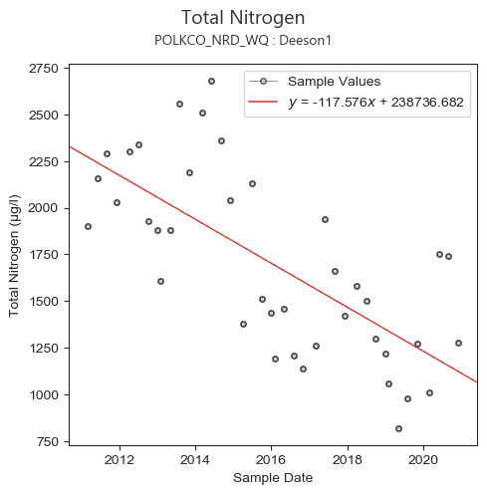  Chlorophyll-a: Annual Geometric Means exceeded the nutrient criteria more than once in a three-year period. Verified period used to determine impairment bolded:  2011 (45 µg/L)  2012 (56 µg/L)  2013 (49 µg/L)  2014 (51 µg/L)  2015 (38 µg/L)  2016 (33 µg/L)  2017 (44 µg/L)  2018 (37 µg/L)  2019 (31 µg/L)  2020 (36 µg/L)  2021 (49 µg/L)  2022 (61 µg/L)  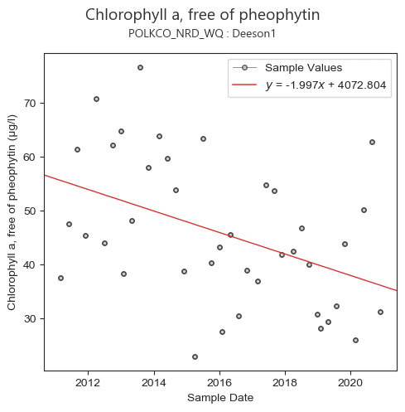  Total Phosphorus: Annual Geometric Means exceeded the nutrient criteria more than once in a three-year period. Verified period used to determine impairment bolded:  2011 (0.05 mg/L)  2012 (0.07 mg/L)  2013 (0.06 mg/L)  2014 (0.05 mg/L)  2015 (0.05 mg/L)  2016 (0.05 mg/L)  2017 (0.06 mg/L)  2018 (0.06 mg/L)  2019 (0.03 mg/L)  2020 (0.05 mg/L)  2021 (0.06 mg/L)  2022 (0.07 mg/L)  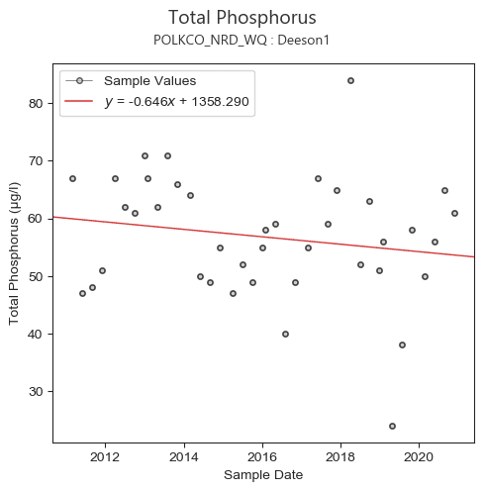  Biology: This waterbody is not impaired for this parameter since the average score of at least two temporally independent LVI scores were ≥ 43 and the last two most recent LVI scores were ≥ 43.  21FLTPA TPDEESN01L (04JUN2013: Score: 33)  21FLTPA G3SW0075 (01JUN2020: Score: 55)  21FLTPA G3SW0075 (27JUN2021: Score: 56)

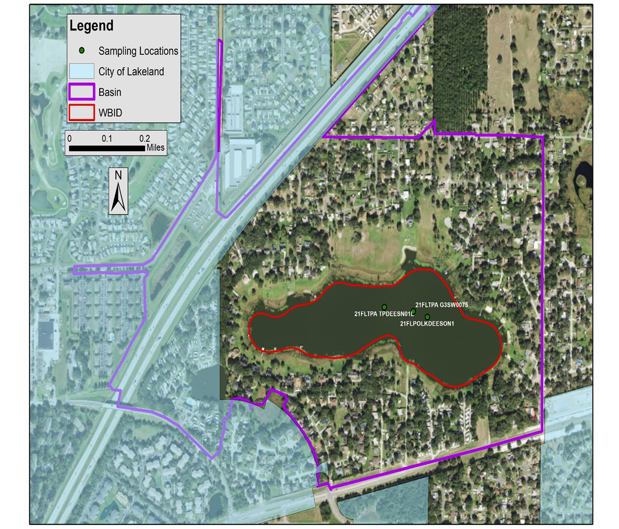
Figure 1. Map of Lake Deeson WBID boundaries, basin delineation, City of Lakeland boundaries, and all water quality sampling locations for verified period.

Evidence of Watershed Approach
 | Area of Effort | Lake Deeson (47 acres) is in the northwest portion of Polk County. The lake’s WBID is entirely within unincorporated Polk County, but lake’s contributing basin is located in unincorporated Polk County and the City of Lakeland jurisdictional boundaries.
 | Key Stakeholders Involved and Their Roles | Polk County and City of Lakeland. The SWFWMD and FDEP may be involved in future restoration projects by providing grant funding.
 | Watershed Plan & Other Supporting Documentation | The contributing basin to Lake Deeson (WBID 1449A) is relatively small (340 acres). It was considered a closed basin prior to the County establishing a pump station on the west side of the lake. Lake Deeson is impaired for Chlorophyll-a, Total Phosphorus, and Total Nitrogen. Generally, over the past 10 years the lake’s data is depicting a downward trend for all three impairment parameters, which may be due to the lake level increasing (Figure 2) and the natural recruitment/establishment of native emergent and submersed vegetation within the littoral shelf (LVI scores increased from 33 to 55 from 2013 to 2020, respectively).The establishment of a robust aquatic macrophyte community and associated epiphytic complexes in the littoral shelf may have helped reduced nitrogen levels through assimilation and adsorption. While the increased water levels may have diluted the TN and TP concentrations, thereby reducing algae production. Regardless of the cause of the downward trend of these water quality parameters, it is a beneficial starting point to initiate these water quality enhancement projects, with a goal of meeting state water quality standards.  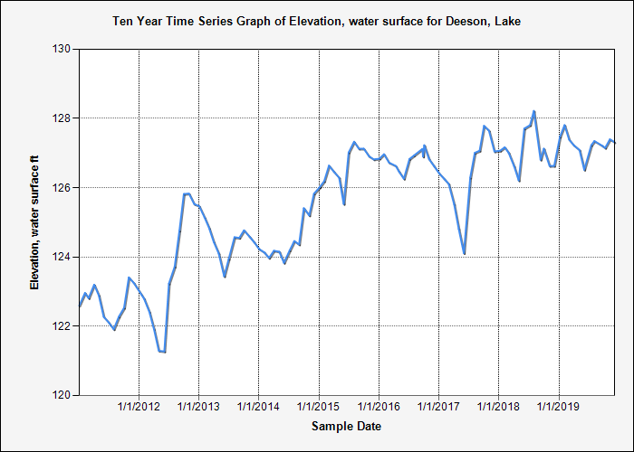  Figure 2. Water levels over the past 10 years (2010 – 2020) for Lake Deeson.  Our watershed plan is to improve the water quality in Lake Deeson by identifying and satisfying water quality data gaps, studying the ground water quality entering the lake, providing educational outreach, confirming outfall locations for the Lake Deeson Basin, and determining the feasibility of other BMPs to implement. The County completed a feasibility study for a sediment inactivation project on the lake. The study assessed the lake bathymetry, sediment volume, and sediment characterization. Based on results, the county plans to carry out a sediment inactivation project that will mitigate an estimated 2,498 lbs. of phosphorus in the top 4-cm of sediment and water column. Additional monitoring will be carried out to assess the results of the sediment inactivation project.  Additionally, the County will analyze grab samples at outfall locations to determine pollutant loading and the feasibility of implementing outfall retrofits or nutrient reduction strategies. The County also expanding its street sweeping program to include all county roads within the Lake Deeson basin.  Through the implementation of these water quality enhancement and monitoring projects the County feels confident that FDEP established water quality goals (Numerical Nutrient Criteria, NNC) for Lake Deeson will be achieved.
 | Point Sources and Indirect Source Monitoring (Sites) | Lake Deeson has a small contributing basin which was originally considered a closed basin. However, the County installed a pump station on the west side of the lake to alleviate flooding issues (Figure 3). This pump station is set to pump when water level elevations are above 129.0’ and pump down to 128.5’. The pumped water flows through a conveyance system that empties into Lake Crago. There are 2 major and 2 minor outfalls within the County’s jurisdiction of the Lake Deeson basin.  There are no point sources directly contributing to the lake. Data was collected from the FDEP Geospatial open data website: NPDES Stormwater Facilities and Activities layer. There are no multi-sector generic permits for stormwater discharge associated with industrial activity within the Lake Deeson basin.  The entire area is regulated by a Municipal Separate Storm Sewer System (MS4) permit # FLS000015-004, issued by FDEP to Polk County and co-permittees (City of Lakeland and Florida Department of Transportation).  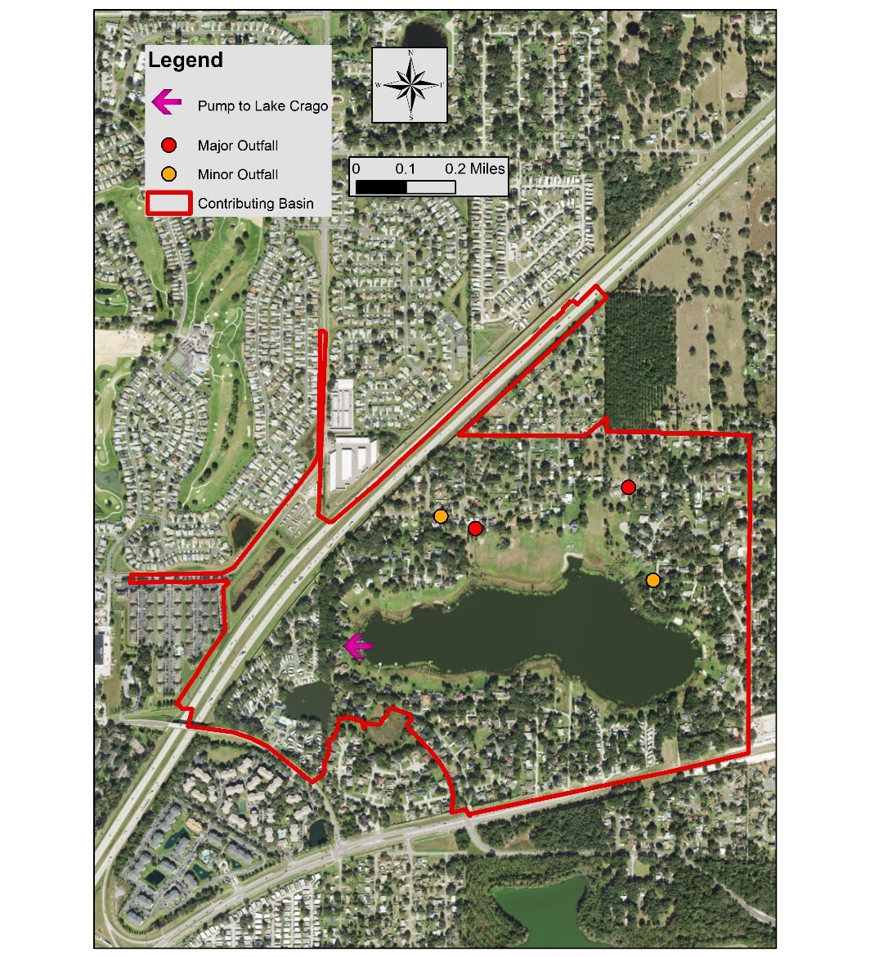  Figure 3. Map of major and minor outfalls in the Lake Deeson contributing basin and pump station location.
 | Nonpoint Sources | List and Describe: Land uses (including % and type); pollutant loading sources.  The anthropogenic land use account for 76.1%, natural areas comprise 23.8% and agricultural areas including range lands, pastures, crops, and tree crops represent 0.1% of the Lake Deeson contributing basin.  Utilizing the FDEP’s Landscape Development Intensity Index (LDI) and the SWFWMD LULC 2017 data the 100-meter buffer around Lake Deeson is primarily residential (78.8%) and natural (21.2%) land uses. The resulting LDI value for the 100-meter buffer around Lake Deeson is 7.05. This high LDI score indicates a high level of human activities that may adversely impact the ecological processes and natural communities of the lake.
  SWFWMD 2017 FLUCCS: Landuse Description | Area (acres) | Percent
  COMMERCIAL AND SERVICES | 4.4 | 1.3
  OPEN LAND | 16.4 | 4.8
  TREE CROPS | 0.3 | 0.1
  LAKES | 50.4 | 14.8
  RESERVOIRS | 3.0 | 0.9
  VEGETATED NON-FORESTED WETLANDS | 4.2 | 1.2
  VEGETATED NON-FORESTED WETLANDS | 1.9 | 0.6
  EMERGENT AQUATIC VEGETATION | 0.3 | 0.1
  SHORELINES | 3.7 | 1.1
  INTERMITTENT PONDS | 1.1 | 0.3
  RESIDENTIAL MED DENSITY 2 TO 5 DWELLING UNITS PER ACRE | 192.1 | 56.5
  RESIDENTIAL HIGH DENSITY | 23.1 | 6.8
  RESIDENTIAL HIGH DENSITY | 4.1 | 1.2
  TRANSPORTATION | 35.0 | 10.3
  Total: | 340.1 | 100.0
 | Water Quality Criteria | Lake Deeson is a low color, high alkalinity lake (lake assessment type 2). Based on the procedure for determining NNC, outlined in Rule 62-302.531, F.A.C., the NNC for nutrients in Lake Deeson are 20 µg/L, 1.05 mg/L – 1.91 mg/L, and 0.03 mg/L – 0.09 mg/L for chlorophyll-a, total nitrogen, and total phosphorus, respectively, which is anticipated to be achieved upon successful completion of all water quality restoration projects.
 | Restoration Work | Underway:  Public education: the County regularly conducts educational and outreach events that teach the importance of stormwater pollution/management, as well as freshwater ecology. We also hold illicit discharge presentations that help inform the public and other governmental employees when and how to report pollution in the MS4.  Outreach and Educational Programs:  - Annual Water, Wings & Wild Things educational event sponsoring more than 2,000 second grade students from Polk County at the Polk Discovery Center  - 7 Rivers Water Festival  - Polk County Water Atlas  - Lake’s Education Action Drive (LEAD), a Polk County partner  - IFAS extension  - School presentations as part of the Great American Teach in  - Distribution of educational materials including Stormwater Pollution Prevention  - Illicit Discharge Classes  - “Dump no waste drains to lake” signs on storm drains  Fertilizer Ordinance: Polk County passed a Fertilizer Ordinance in 2013 that provides water quality benefits throughout the county.  Invasive Plant Management: The County is the lead agency in the cooperative invasive plant management program with the Florida Fish and Wildlife Conservation Commission. The County regularly evaluates and targets invasive plants for treatment to encourage native aquatic plant growth. The County regularly conducts point intercept and LVI surveys that aid aquatic plant management and herbicide treatments. In the recent years, Lake Deeson has not required substantial invasive plant management. Additionally, the LVI scores of the lake have been increasing over time.  County-Wide Outfall Evaluation: In 2017 the County hired consultants to conduct a GIS assessment using LIDAR data to locate and confidence rank all outfalls. Over 2,000 new outfalls were identified throughout the county. Currently the County is field verifying newly identified outfalls. This project will give a better understanding of the amount and location of outfalls as well as aid in stormwater modeling and assessments. The field verification of the outfall assessment for this basin was completed.  Seepage Meter Study: The County conducted a study by installing and monitoring 4 seepage meters on the lake. The meters were installed in fiscal year (FY 20/21) and were monitored for 1 year (sampled bimonthly for a total of 6 sampling events). Samples were analyzed in the County’s water quality laboratory. This study provided insight into the quality and quantity of shallow groundwater entering the lake. The areas of installation were selected to maximize the range of land use and topographic characteristics in upland areas. The meters were installed in areas with and without septic tanks to identify possible contributions of septic tank areas. Additional source tracking analysis may be completed in the future.  The study found that in Lake Deeson, the average daily TN groundwater load (Figure 4) was highest at LD-01 while loads were relatively low at the remaining stations. LD-01 also had the highest average TN groundwater load of all 6 lakes in the seepage study in Polk County. The average daily TP groundwater load (Figure 5) was highest at LD-01. TP groundwater loading was generally low in Lake Deeson compared to the other 6 study lakes. Potential nutrient sources surrounding Lake Deeson include septic tanks and stormwater infrastructure.  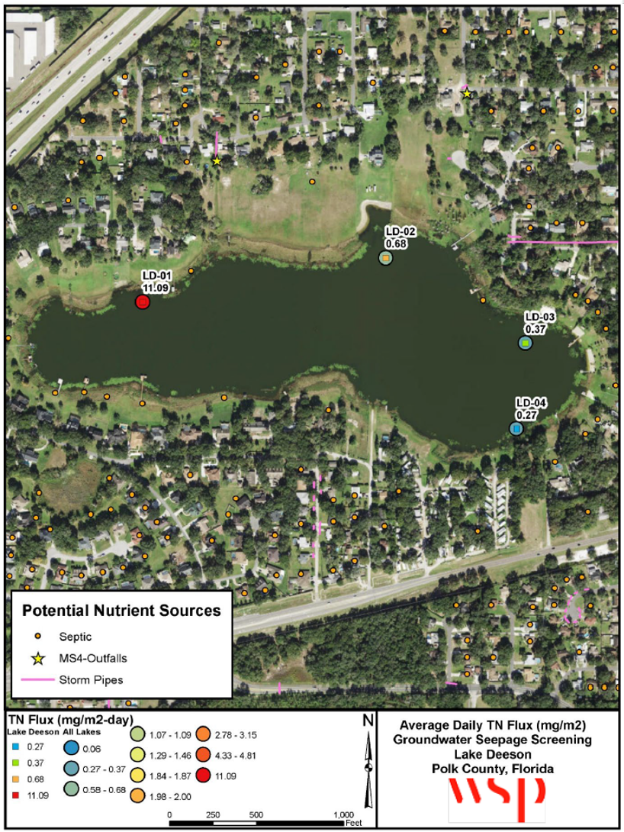  Figure 4. Map of Average Daily TN Load (Flux) at Lake Deeson.  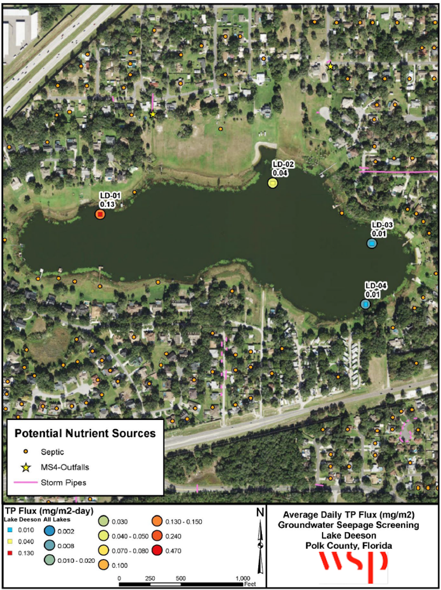  Figure 5. Map of Average Daily TP Load (Flux) at Lake Deeson.  Sediment Inactivation Study and Implementation: The sediment inactivation feasibility study has been completed in order to determine the benefits to water quality for Lake Deeson. The County conducted bathymetry mapping and determined the volume of fine sediments within the lake (Figure 6). Sediment core samples were collected at 4 locations in the lake and analyzed for % solids in addition to the following phosphorus fractions as mg P/kg: labile, reductant-soluble, metal-oxide, organic, and apatite/residual (Figures 7 and 8). Lake Deeson was determined to be an ideal candidate for sediment inactivation project since the sediments are in localized areas or pockets, sufficient volume of sediment with high soluble reactive phosphorus (SRP), the lake is relatively deep (approximately 13’) therefore sediments are not easily disturbed or resuspended by wind fetch or boat traffic, and the lake has little flushing (i.e., no canals in or out, only a pump station that removes water when near flood elevation).  We determined that a full lake treatment with EutroSORB G would have the greatest benefit. EutroSORB G is a granular lanthanum-modified bentonite clay for sediment phosphorus inactivation. The lanthanum ions adsorbed to the clay matrix react preferentially with free phosphate compounds in water removing SRP and rapidly forms a highly stable insoluble mineral. The resulting mineral complex becomes integrated as an inert component into the natural sediments of the waterbody and is not bioavailable. Due to the specificity of EutroSORB G to phosphate it will continually bind new incoming phosphorus from internal and external sources. During application, EutroSORB G is first mixed with water and applied as a slurry evenly over the surface of the lake. The proposed project is planned to be implemented before the end of FY 2024/2025 (Environmental Resource Permit received May 31, 2024, Permit number: 43047730.000) with the application of ~125,000 pounds of EutroSORB G to mitigate an estimated 2,498 lbs of phosphorus in the top 4-cm of sediment and water column. Studies have found that lanthanum-based products are superior to aluminum sulfate (alum) due to lower flock formation, better ecotoxicological profile, and pH has minimal effect on binding efficiency to phosphorus.  Monitoring will be essential to track and quantify improvements made in Lake Deeson water quality. Water quality samples will be collected pre-treatment, two weeks post-treatment, and then monthly for twelve months and analyzed for total phosphorus (TP), SRP, dissolved oxygen (DO), and temperature. In addition to the water quality monitoring program post-treatment sediment core samples will be collected from 4 sites and analyzed for % solids in addition to the following phosphorus fractions as mg P/kg: labile, reductant-soluble, metal-oxide, organic, and apatite/residual.  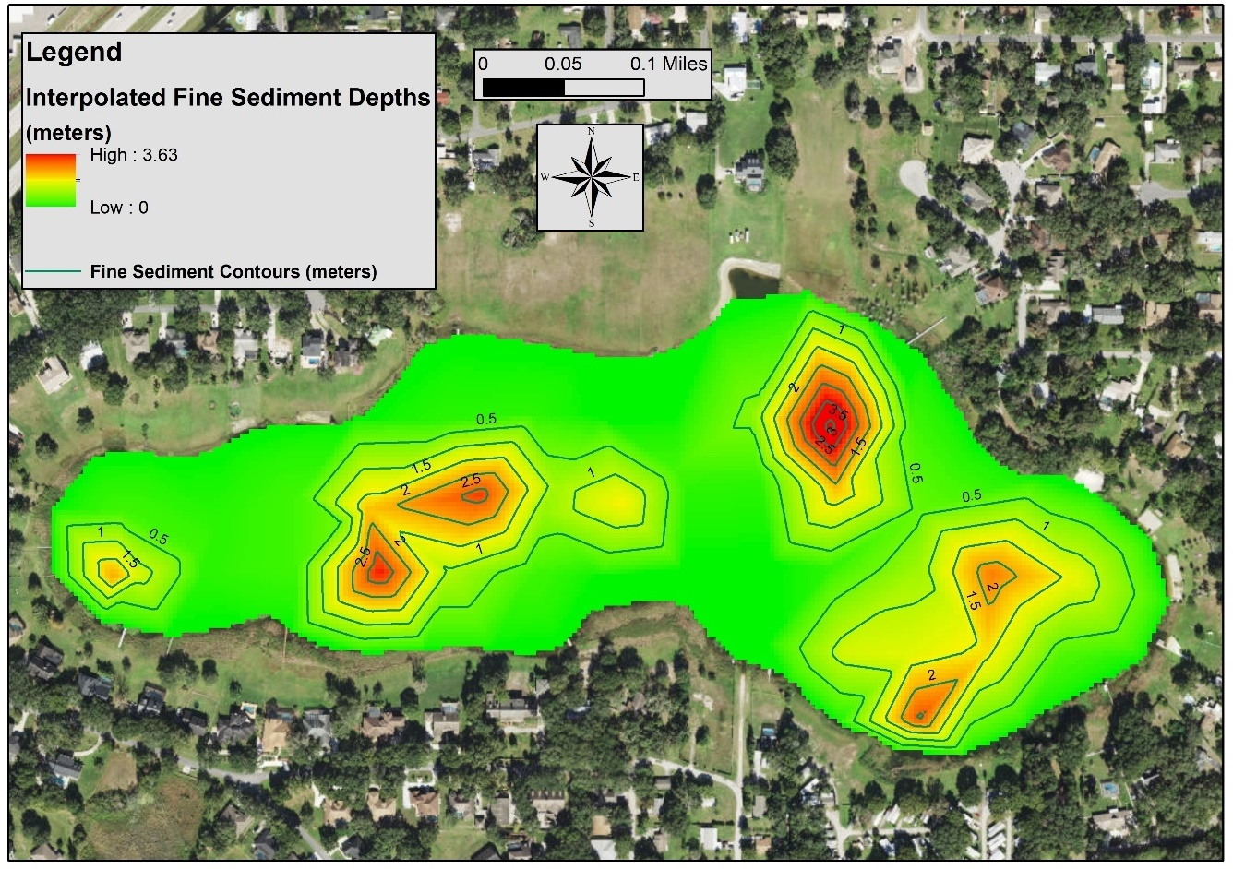  Figure 6. Map of fine sediment depths in Lake Deeson.  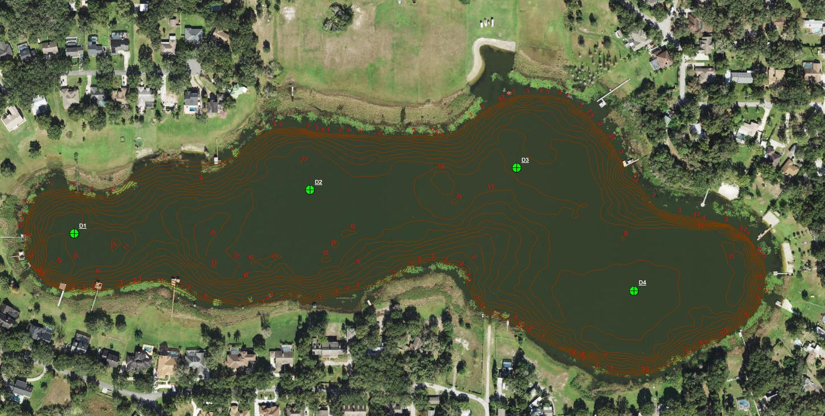  Figure 7. Sediment sample locations.  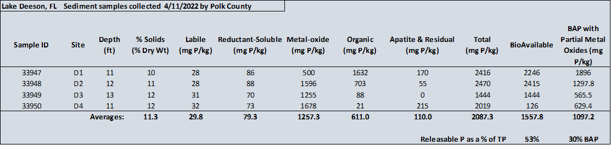  Figure 8. Results from sediment fractionation.  Street Sweeping Program: As of April 2022, the County expanded its street sweeping program to add all county roads within the basin (3.4 miles/month or 40.8 miles/year, Figure 9). Using the Florida Stormwater Associations BMP load reduction calculator and average removal of total solids from previous data from the County, the sweeping program will remove approximately 2.0 pounds of TP/year and 3.7 pounds of TN/year.  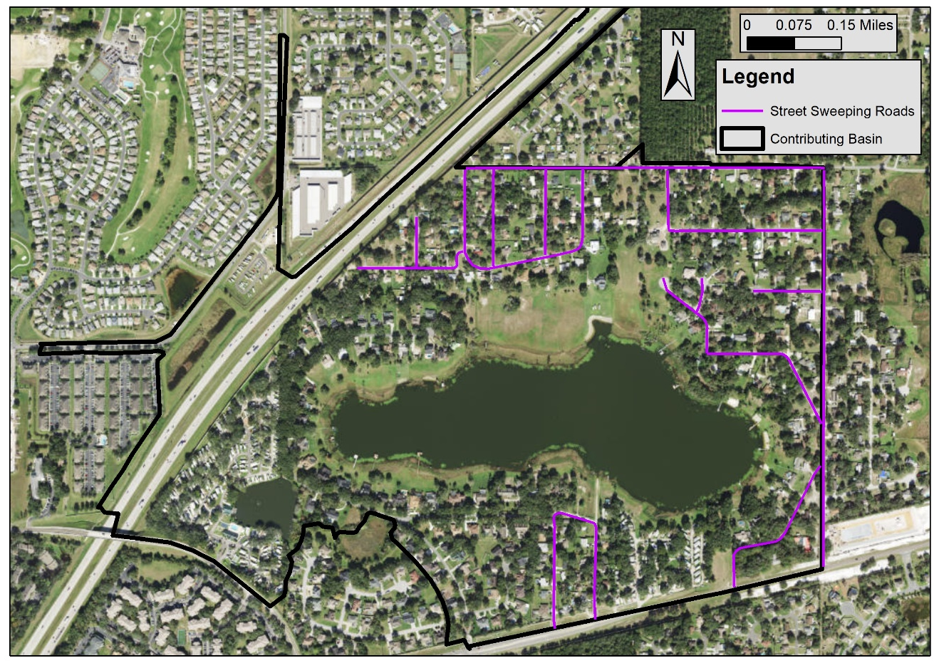  Figure 9. Updated expanded street sweeping program within the Lake Deeson contributing basin.  Conceptual/Feasibility:  Natural Systems Improvement: Polk County will be completing vegetation monitoring on the lake to determine the best vegetation enhancement options. Once surveyed the County may submit projects for district cooperative funding and/or FWC AHREs funding if deemed beneficial. However, currently the lake is exceeding FDEP LVI thresholds.  Outfall Nutrient Loading Study: In accordance with the seepage meter study, the County will be assessing outfall loading through grab samples to determine which outfalls have the highest nutrient loading. Once finalized, the County will determine the feasibility of mitigating nutrient loading from these outfalls.

Critical Milestones/Monitoring
 | Anticipated Critical Milestone(s) and Completion Dates: |  | Seepage Meter Study: The County has a consultant currently under contract that has installed and began monitoring 3 seepage meters on Lake Deeson. The meters were installed in FY 20/21 and were monitored for 1 year (sampled bimonthly for a total of 6 sampling events). Samples were analyzed in the County’s water quality laboratory. Additional source tracking analysis may be completed in the future, dependent on initial results. The County may maintain the seepage meters after study by consulting firm if deemed valuable. This project was completed in 2023.  Sediment Inactivation Study and Implementation: Sediment inactivation study completed in FY 21/22 and implementation planned to occur before the end of the FY 24/25.  Street Sweeping Program: The expanded street sweeping program in the Lake Deeson basin began in April 2022 and will be carried out indefinitely (as funding permits).
 | Monitoring Component |  | Existing and expanded water quality monitoring program by Polk County Parks and Natural Resource Division:  Ambient water quality sampling program carried out by the County includes quarterly sampling events in the lake for 20 parameters (see table below).  The County will initiate a 1-year, monthly water quality sampling project (same analytes below) in the lake to provide a more robust water quality data set to evaluate seasonal trends.  Lake Vegetation Index (LVI) surveys will be conducted at a minimum of every other year to assess the condition of vegetation and changes due to restoration activities.
  Analyte | MDL | Unit | PQL | Unit | Sample Type
  Lab
  Alkalinity as CaCO₃ | 0.6 | mg/L | 6.0 | mg/l | Grab
  Chloride | 0.75 | mg/L | 2.5 | mg/l | Grab
  Chlorophyll a | 3.0 | µg/L | 6.0 | µg/L | Grab
  Chlorophyll a corrected | 3.0 | µg/L | 6.0 | µg/L | Grab
  Color | 2.0 | PCU | 5.0 | PCU | Grab
  Nitrogen ammonia | 0.01 | mg/L | 0.04 | mg/l | Grab
  Nitrogen Kjeldahl | 0.10 | mg/L | 0.40 | mg/l | Grab
  Nitrogen Nitrate + Nitrite | 0.01 | mg/L | 0.04 | mg/l | Grab
  Nitrogen Total | 0.11 | mg/L | 0.44 | mg/l | Grab
  Phosphorus Ortho | 0.01 | mg/L | 0.04 | mg/l | Grab
  Phosphorus Total | 0.02 | mg/L | 0.04 | mg/l | Grab
  Sulfate | 3.6 | mg/L | 5.0 | mg/l | Grab
  Total Suspended Solids | 0.4 | mg/L | 3.0 | mg/l | Grab
  Turbidity | 0.1 | NTU | 0.5 | NTU | Grab
  Field
  Temperature |  |  |  |  | Field-YSI
  Conductivity |  |  |  |  | Field-YSI
  DO % saturation |  |  |  |  | Field-YSI
  DO mg/L |  |  |  |  | Field-YSI
  pH |  |  |  |  | Field-YSI
  Secchi |  |  |  |  | Field
  *Grab samples are collected following FDEP SOP FS2100
Other Key Dates
 | Estimated Date for Delisting from Verified List or Removal from Study List | Lake Deeson (WBID 1449A) is in the state’s Group 3 Sarasota Bay – Peace – Myakka Basin, located within the Southwest District. The current review and assessment cycle (Cycle 22-24) is expected to be completed in the spring of 2024; The impairments described in this alternative restoration plan are nutrients (chlorophyll-a, total nitrogen and total phosphorus). The earliest opportunity for delisting would occur during the next biennial assessment cycle (2024-2026). Once all the proposed projects have been implemented, an improvement in water quality is expected. At which time sufficient data will be acquired to fully assess the waterbody. If determined by the updated data set that the parameters in question are no longer impaired, DEP is expected to request the WBID be delisted from the federal 303(d) list (if applicable). If this water does not meet delisting requirements, this waterbody will remain in assessment category 4e for an additional assessment cycle.

Financial Commitments

 | Estimated Implementation Cost | Street Sweeping Project: ~$1,020 per year (estimated cost)  Sediment Inactivation Implementation: $481,000  Water Quality and Biological Monitoring:  •Seepage Meter Study: $23,008.50  •Monthly Water Quality Sampling 1 year: $12,708  •Outfall Grab Samples: ~$6,680  •LVIs: $1,200 per event  Outfall Inventory Update: ~$3,750
 | Land Acquisition  (if applicable) | Funding Source:  Total……………………………………………………………………...$____NA___
 | Design and Construction  (if applicable) | Funding Source: Polk County was awarded an Innovative Technology Grant from the FDEP for the implementation of the sediment inactivation project in the amount of $481,000.  Total……………………………………………………………………...$___$481,000____

