Documentation in Support of Category 4e

Waterbody/Watershed Identification
 | Organization | City of Winter Haven
 | Point of Contact | Dustin Everitt, 500 3rd Street NW, Winter Haven, FL 33881
 | Waterbody(s) | WBID 1488R, Lake Idyl
 | No. Waterbody / Pollutant Combinations | One waterbody segment; verified impaired for nutrients (chlorophyll-a, total nitrogen, and total phosphorus) during the Sarasota Bay – Peace – Myakka Group 3/Biennial Assessment Cycle 20-22
 | EPA Completed TMDL | Has EPA completed a TMDL for the impaired waterbody segment(s) listed in this document? No
Description of Baseline Conditions
 | Watershed(s) | Basin Group 3: Sarasota Bay – Peace – Myakka
 | Baseline Data | Numeric Nutrient Criteria  Impairment was determined using IWR Run 64 for the verification period between January 1, 2013, and June 30, 2020. Data were collected from the IDYL1 station by Polk County Natural Resources staff.  The following table displays the baseline water quality data summary and exceedances for the verified period. (Highlighted values are periods when AGMs exceeded the NNC)  Chlorophyll-a  Numeric nutrient criterion: AGM ≤ 20 µg/L; AGM chlorophyll-a values exceeded NNC in 2017, 2018, 2019, 2020, and 2021.  Total Nitrogen  Numeric nutrient criterion: AGM ≤ 1.05 mg/L (when AGM Chl-a values exceed 20 µg/L; AGM total nitrogen values exceeded NNC in 2017, 2018, 2020, and 2021.  Total Phosphorus  Numeric nutrient criterion: AGM ≤ 0.03 mg/L (when AGM Chl-a values exceed 20 µg/L); AGM total phosphorus values exceeded NNC in 2017, 2018, 2020, and 2021.  Bioassessment  A Lake Vegetation Index (LVI) assessment of station EXTBIO3USFWI92 was conducted by Polk County on 8/6/2020 with the waterbody receiving an LVI score of 22. FDEP conducted a recent LVI assessment of Lake Idyl in 2022 at the 21FLCENG3CE0058. The final score for this assessment was 17.  City of Winter Haven staff conduct aquatic vegetation monitoring which involves collection of species composition data via point-intercept sampling and abundance data using SONAR logging. The following table displays the percent area cover (PAC), percent of sample comprised of FISC invasive species, and Menhenick’s species richness index values during the last five assessments:  *Outlier PAC value; likely due to error during SONAR logging
  AGM Concentrations
  Year | Chl-a (ug/L) | TN (mg/L) | TP (mg/L)
  2014 | 6.0 | 0.74 | 0.03
  2015 | NA | NA | NA
  2016 | 9.0 | 0.85 | 0.06
  2017 | 57.0 | 1.80 | 0.1
  2018 | 37.0 | 1.45 | 0.06
  2019 | 32.0 | 1.00 | 0.03
  2020 | 29.0 | 1.17 | 0.06
  2021 | 37.0 | 1.19 | 0.07
  Assessment Date | PAC | Invasive Species % | Menhenick Richness
  2/22/2018 | 52.9 | 4.35 | 1.25
  2/22/2019 | 3.6* | 16.67 | 0.91
  2/21/2020 | 35.2 | 13.33 | 1.64
  2/5/2021 | 52.9 | 24.0 | 1.0
  1/21/2022 | 53.0 | 6.06 | 1.39

 | 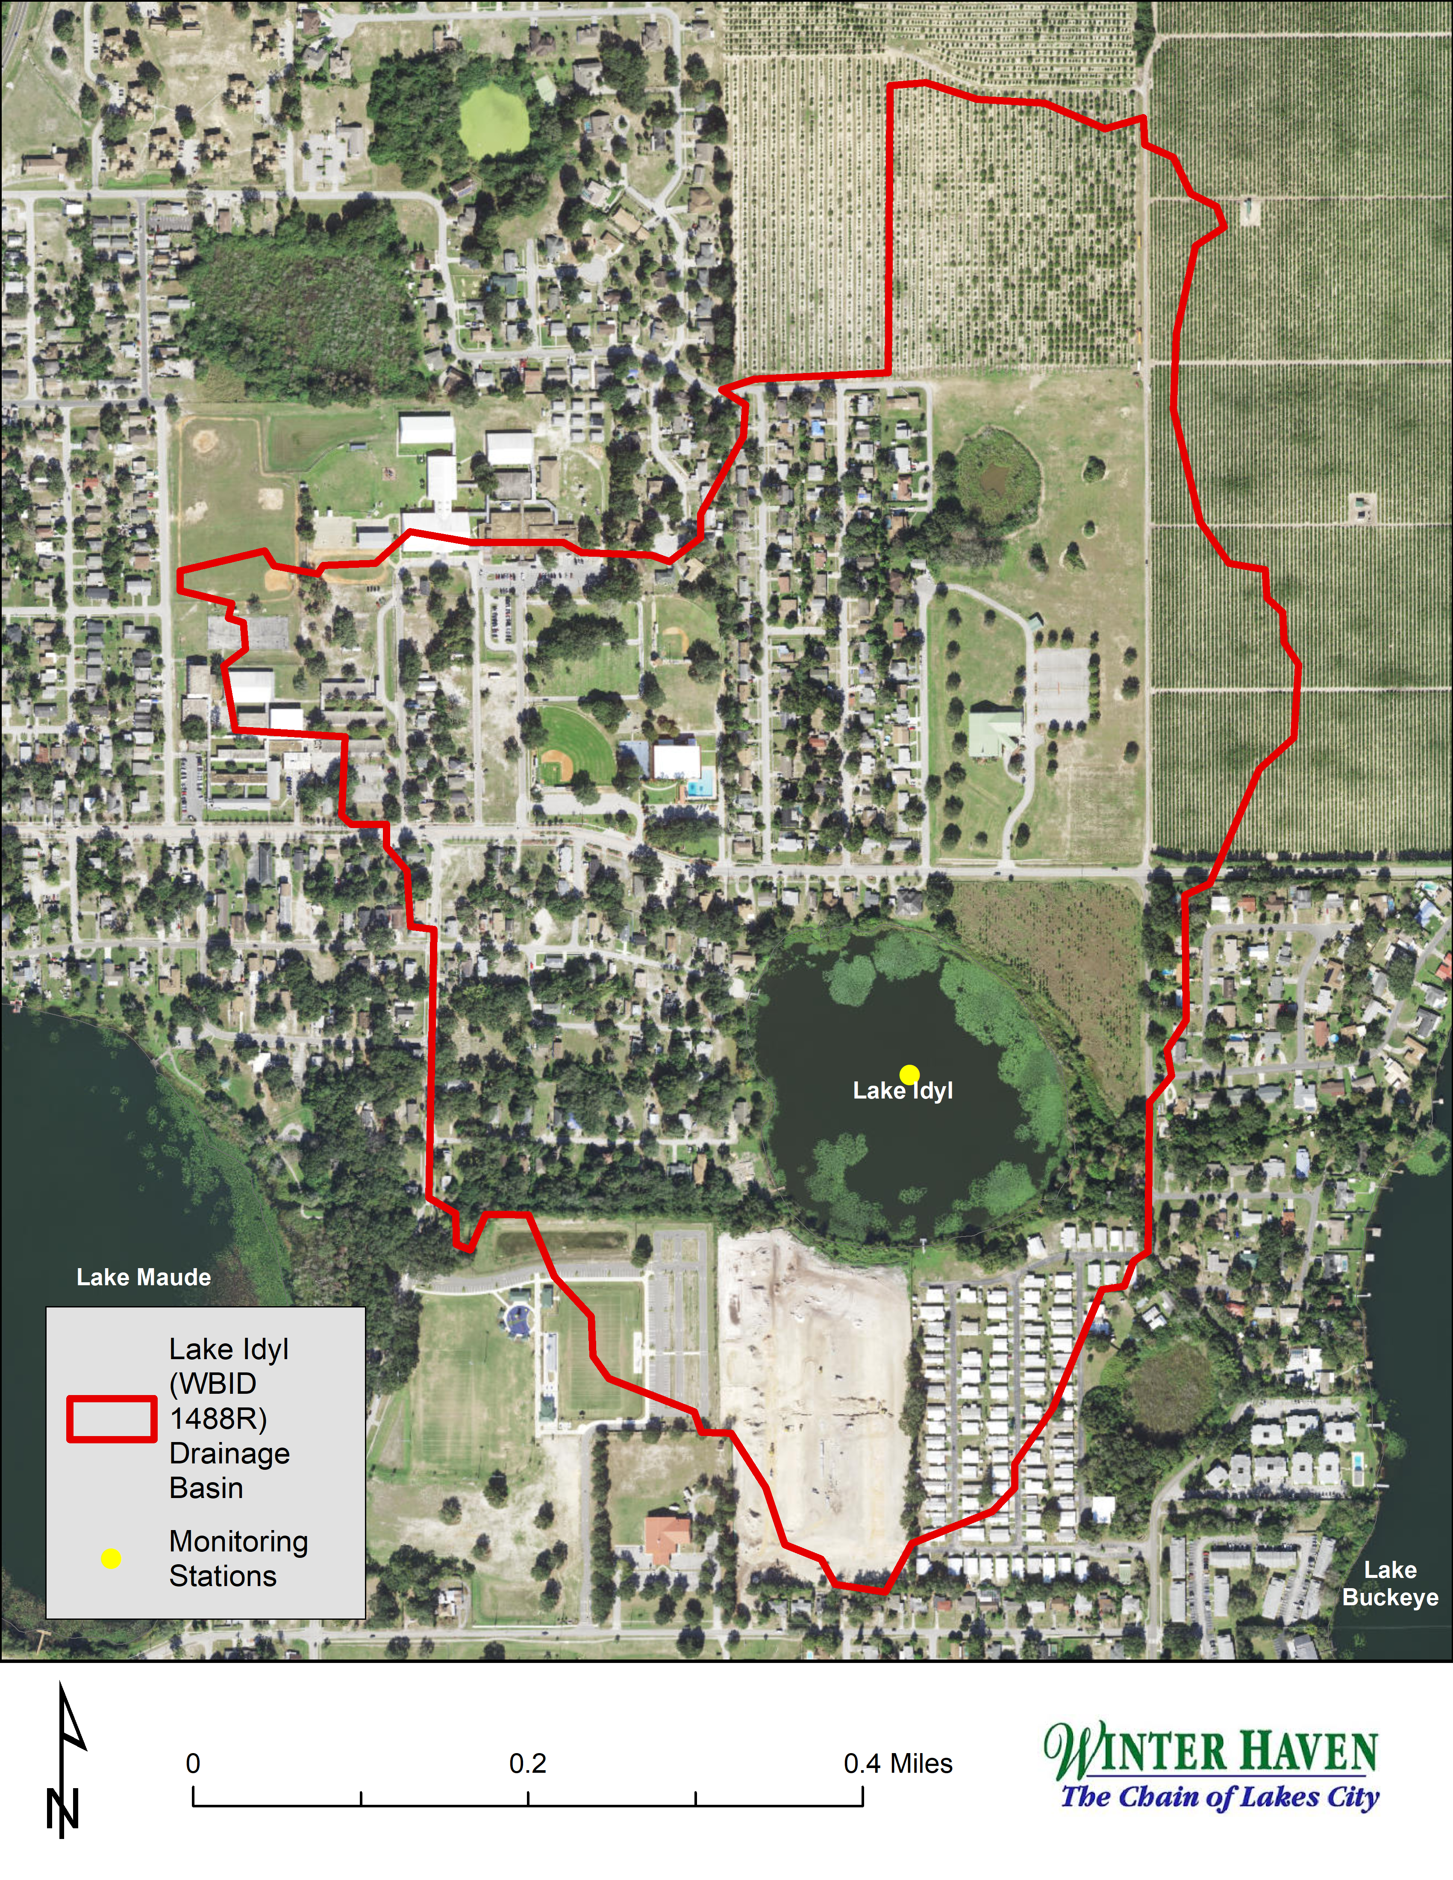Map | Lake Idyl (WBID 1488R) Location Map

Evidence of Watershed Approach
 | Area of Effort | Lake Idyl (WBID 1488R) is a 19 acre waterbody located within the City of Winter Haven limits, in central Polk County. A 198 acre drainage basin directly contributes stormwater to the waterbody—primarily from the north. Additionally, Lake Idyl is hydrologically linked to several other lakes in the Winter Haven area. Upstream flow is received from Lakes Silver (WBID 1504B), Martha (WBID 1488P), and Maude (WBID 1488Q). Overflow from Lake Idyl travels to Lakes Buckeye (WBID 1488S), Fannie (WBID 14882), Hamilton (WBID 15041), and eventually to the Peace Creek Drainage Canal (WBID 1539).
 | Key Stakeholders Involved and Their Roles | The City of Winter Haven and Polk County are partners in the evaluation of Lake Idyl and the planning of restoration projects. The FDEP and SWFWMD may be involved as potential funding partners for stormwater restoration projects in this area.
 | Watershed Plan & Other Supporting Documentation | The area includes the watershed drainage area from Lake Idyl within WBID 1488R. This WBID is impaired for nutrients (Chlorophyll-a, Total Nitrogen, and Total Phosphorus) based on the annual geometric means exceeding their applicable Numeric Nutrient Criteria more than once in a three-year period. The restoration objectives are outlined by the Winter Haven Watershed Management Plan, developed by Chastain Skillman in 2019. This management plan utilizes hydrologic modeling to estimate annual stormwater pollutant loads at 1,010 lbs/year of TN, 165 lbs/year of TP, and 22,118 lbs/year of TSS. As a result, restoration activities will focus on mitigating a portion of these loads via structural stormwater BMPs.  The WBID drainage area corresponds to the key project as follows: Priority Problem Area 1 in the Winter Haven Watershed Management Plan.
 | Point Sources and Indirect Source Monitoring (Sites) | There is one major MS4 outfall that discharges to Lake Idyl located approximately at Martin Luther King Jr. Blvd & 9th Court NE. There has currently been no targeted outfall monitoring at this location. However, ambient water quality monitoring, conducted by Polk County, has been ongoing.  The entire area is regulated by a Municipal Separate Storm Sewer System (MS4) permit FLS000015-004.  Note: Generic Permits for stormwater discharge from large and small construction activities are considered temporary; therefore, are not included in this listing.
 | Nonpoint Sources | The primary anthropogenic land uses in the Lake Idyl drainage basin are medium density residential (23.6%) and institutional (18.2%). The table below details the land uses found within the watershed.  There are six known Onsite Sewage Treatment & Disposal (OSTD) systems located within the Lake Idyl drainage basin (see map below). Two of these are located within close enough proximity of the waterbody to constitute potential non-point source pollutant loading. At this time, the Winter Haven Water Utility ranks septic-to-sewer conversion in this area as a low priority.
  FLUCCS Land Use Description | Percentage of Basin
  RESIDENTIAL MED DENSITY | 23.6%
  INSTITUTIONAL | 18.2%
  VEGETATED NON-FORESTED WETLANDS | 12.7%
  TREE CROPS | 10.9%
  RECREATIONAL | 7.3%
  EMERGENT AQUATIC VEGETATION | 5.5%
  CROPLAND AND PASTURELAND | 3.6%
  OPEN LAND | 3.6%
  OTHER OPEN LANDS | 3.6%
  RESIDENTIAL HIGH DENSITY | 3.6%
  UPLAND HARDWOOD | 3.6%
  LAKES | 1.8%
  WET PRAIRIES | 1.8%
 | Water Quality Criteria | Lake Idyl is a class 3F waterbody with an applicable lake assessment type of 2 (color ≤ 40 PCU and alkalinity > 20mg/L CaCO3). Based on numeric nutrient criteria, AGM concentrations should be at or below 20 µg/L, 1.91 mg/L, and 0.09 mg/L for chlorophyll-a, total nitrogen, and total phosphorus, respectively. If chlorophyll-a AGMs exceed this threshold, AGM total nitrogen and total phosphorus concentrations should be 1.05 mg/L, and 0.03 mg/L, respectively. It is anticipated that following implementation of the restoration projects outlined in this document Lake Idyl will attain applicable water quality standards.
 | Bioassessment Criteria | The Lake Vegetation Index (LVI) requires a score ≥ 43 to meet the biological impairment threshold. According to the 2020 LVI assessment, Lake Idyl’s vegetation community suffers from several issues: presence of several invasive species, low species richness, and a lack of sensitive species. The primary invasive species present are Eichoonia crassipes, Oxycaryum cubense, and Ludwigia peruviana. It is anticipated that tussock removal efforts, outlined in this plan, should have a positive impact on the vegetation community by reducing available habitat for these invasive species and creating areas for native and/or sensitive species.

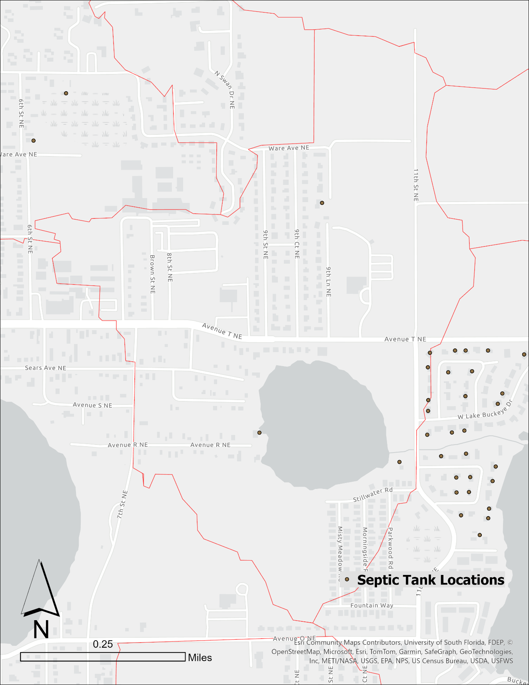
Lake Idyl OSTD Map

 | Restoration Work | Street Sweeping  The City of Winter Haven conducts street sweeping on roadways within the Lake Idyl drainage basin. A total of 1.69 centerline miles are swept monthly. This equates to an estimated annual pollutant load reduction of 18.86 lbs of total nitrogen and 10.26 lbs of total phosphorus.  (See Lake Idyl Street Sweeping Map)  W772 Stormwater Improvements  The City of Winter Haven, in a cooperative funding partnership with the SWFWMD (W772), is in the process of constructing structural stormwater improvements to capture and treat onsite runoff at the city-owned Recreation and Cultural Center. The improvements are anticipated to reduce Lake Idyl’s pollutant load by an estimated 2.59 lbs of total phosphorus and 517 lbs of total suspended solids annually. This project is currently in the bidding phase and construction is expected to be completed before the end of the 2024 calendar year.  (See W772 Stormwater BMPs; Sheet C5.3 MLK Blvd NE Drainage Plan)  Lake Idyl Stormwater Improvements  Identified as priority problem area 1 within the Winter Haven Watershed Management Plan, the City of Winter Haven has established a conceptual design for stormwater improvements within the Lake Idyl drainage basin. This multi-phase concept, which currently includes structural stormwater improvements (e.g. exfiltration pipes and a baffle box), is estimated to capture 54.9 lbs of total nitrogen and 8.6 lbs of total phosphorus annually. This project is currently in the design phase and awaiting funding. The city is expected to apply for grant and/or cooperative funding during the 2023-2024 fiscal year.  (See Figure 37: Priority Area 1 – Drainage Area Map)  Lake Idyl Sediment Inactivation  Due to the presence of highly organic sediments, the city is exploring a sediment inactivation project. The project seeks to limit phosphorus flux into the water column via the application of EutroSORB G. Based on sediment sampling, EutroPHIX recommends three broadcast EutroSORB G applications over the course of three years. Dosing calculations estimate 55,634 lbs of EutroSORB G be applied, in three separate annual 18,545 lbs applications.  Aquatic Vegetation Management/Tussock Removal/Habitat Restoration  Due to Lake Idyl’s shallow morphology and organic substrate, the lake supports large stands of spatterdock (Nuphar advena) that have led to an increased prevalence of tussocks and the growth of invasive species. The City of Winter Haven has identified the harvesting of tussocks as a potential avenue for nutrient reduction. While current literature on the pollutant load reduction efficiency of tussock removal is sparse, the city plans to explore opportunities to quantify these removal efficiencies by conducting a plant tissue analysis study. Additionally, the removal of tussocks may help to improve Lake Idyl’s future LVI scores due to a reduction of invasive species (i.e. Ludwigia peruviana, Eichhornia crassipes)

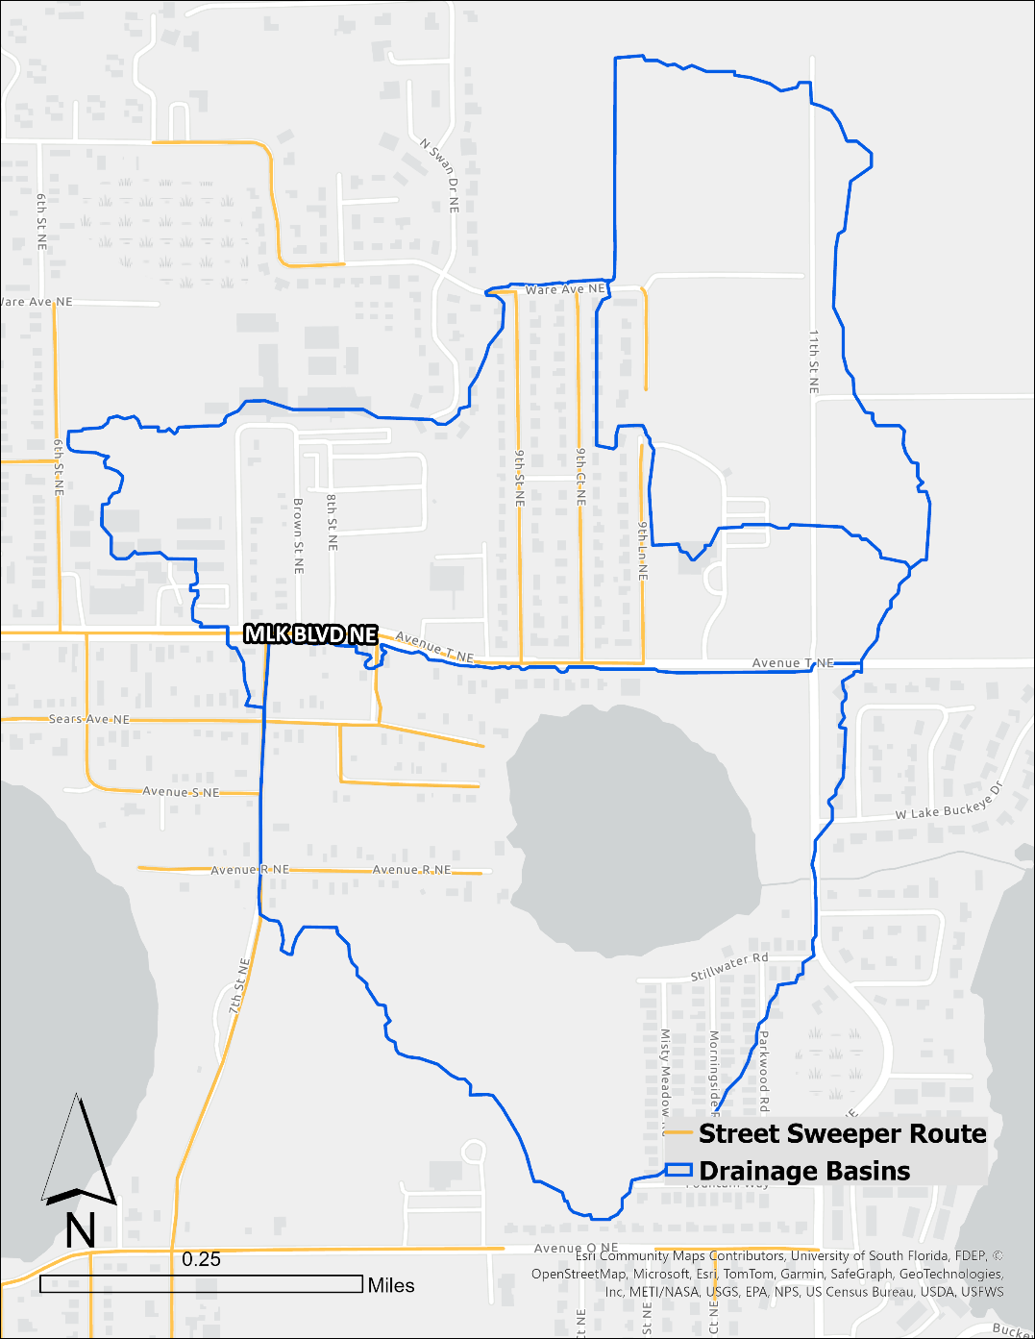
Lake Idyl Street Sweeping Map
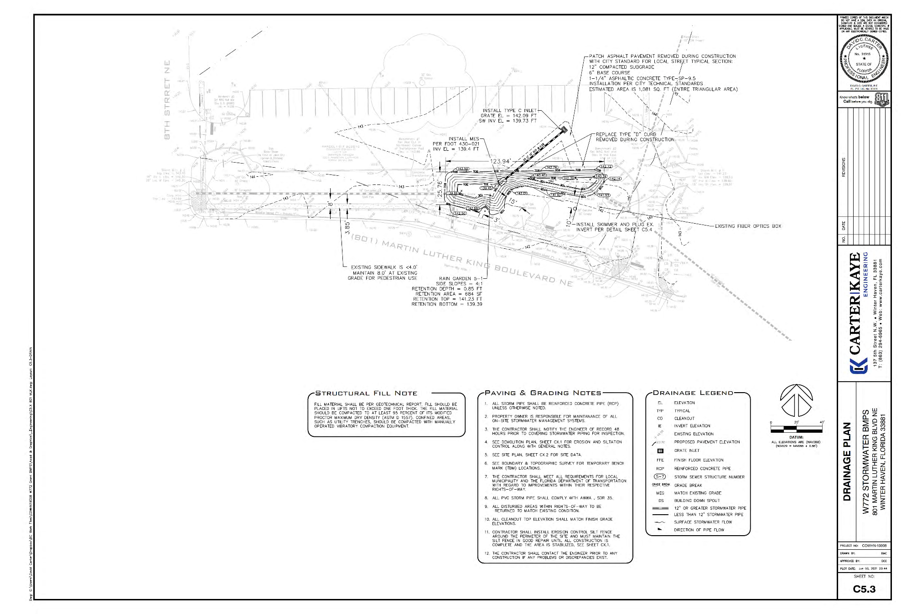
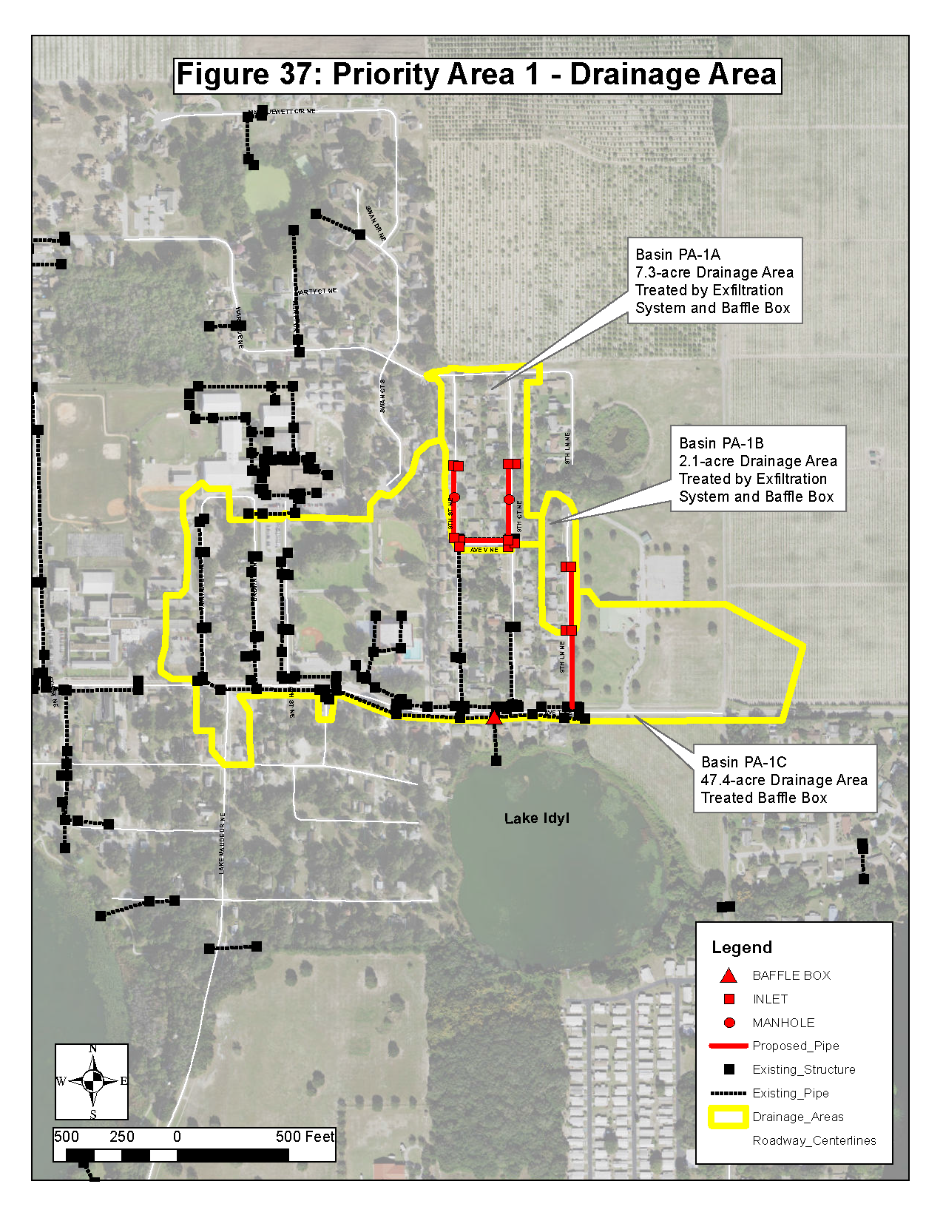

Critical Milestones/Monitoring
 | Anticipated Critical Milestone(s) and Completion Dates: |  | W772 Stormwater Improvements  - Construction contract bidding and award completed November 2023.  - Construction should be complete by July 2024.  Lake Idyl Stormwater Improvements  - The City will be submitting applications for the FDEP 319 Stormwater Grant and SWFWMD Cooperative Funding before September 2024.  - Final project designs will be dependent on available funding opportunities.  - Bid requests will be submitted pending the availability of funds.  Lake Idyl Sediment Inactivation  - Sediment sampling occurred in January 2024.  - EutroSORB dosing calculations were performed in March 2024.  - City of Winter Haven is currently seeking grant opportunities to assist with the funding of this project.  - Pending funding approval, first EutroSORB G application likely starting in FY2025 with subsequent applications occurring in 2026 and 2027  Aquatic Vegetation Management/Tussock Removal/Habitat Restoration  - The City will plan to submit grant applications for a pilot study to quantify nutrient reduction from aquatic plant removal.
 | Monitoring Component |  | Ambient water quality monitoring is currently conducted by Polk County NRD through center-of-lake grab samples on a quarterly frequency. The City may supplement Polk County’s ambient water quality monitoring with monthly ambient sampling and targeted water quality monitoring at the major stormwater outfall.  Monitoring will include, but may not be limited to the following parameters:  Parameter Detection Limit Method*  Chlorophyll-a MDL: 3ug/l PQL: 6ug/l SM 10200H-2011  Total Nitrogen MDL: 0.11mg/l PQL: 0.44mg/l EPA 351.2 + EPA 353.2  Total Phosphorus MDL: 0.01mg/l PQL: 0.04mg/l EPA 365.4  Biological monitoring is currently conducted by Polk County and City of Winter Haven. Polk County conducts LVI assessments according to SOP LVI 1000 & 2200. The County has planned to place all Polk lakes on a 2-year rotating schedule. Since the last LVI for Lake Idyl was conducted in 2022, the next is scheduled to take place in 2024. The City conducts aquatic vegetation abundance and species composition assessments utilizing the Florida Fish and Wildlife (FWC) protocol employed in the Invasive Plant Management Division. These surveys are conducted annually and the City plans to continue monitoring aquatic plant communities in this manner for the foreseeable future.
Other Key Dates
 | Estimated Date for Delisting from Verified List or Removal from Study List | WBID 1488R is included in the State’s Group 3 Sarasota Bay – Peace – Myakka Basin, located within the Southwest District. The current review and assessment cycle (Cycle 22-24) is expected to be completed in the spring of 2024. The impairments described in this alternative restoration plan are nutrients (chlorophyll-a, total nitrogen and total phosphorus). The earliest opportunity for delisting would occur during the next biennial assessment cycle (2024-2026). Once all the proposed projects have been implemented, an improvement in water quality is expected. At which time sufficient data will be acquired to fully assess the waterbody. If determined by the updated data set that the parameters in question are no longer impaired, DEP is expected to request the WBID be delisted from the federal 303(d) list (if applicable).

Financial Commitments

 | Estimated Implementation Cost | The total estimated project cost, including land acquisition (if applicable) was (is):  Street Sweeping:  - Annual labor & maintenance costs: $24,830  W772 Stormwater BMPs:  - Lake Idyl portion of project construction costs: $124,588  - Total project construction costs: $624,617  - Estimated 20-year O&M costs: $3000.  Lake Idyl Stormwater Improvements:  - Estimated project costs: $1,518,946.  - Estimated 20-year O&M costs: $246,000.  Lake Idyl Sediment Inactivation:  - Project cost: Approximately $367,186  Aquatic Vegetation Management/Tussock Removal/Habitat Restoration  - Project cost: Dependent on scope of project and ability to locate a vegetation tissue analysis laboratory; TBD.
 | Land Acquisition  (if applicable) | Funding Source:  Total……………………………………………………………………...$ Not applicable
 | Design and Construction  (if applicable) | Funding Source:  W772 Stormwater BMPs  SWFWMD Cooperative Funding Agreement: $120,000  Total……………………………………………………………………...$120,000.00
References:

- Winter Haven Watershed Management Plan; Chastain Skillman, 2019

