Documentation in Support of Category 4e

Waterbody/Watershed Identification
 | Organization | Florida Department of Environmental Protection
 | Point of Contact | Kevin O’Donnell, 2600 Blairstone Rd Tallahassee, FL 32399  Kevin.ODonnell@dep.state.fl.us, (850) 245-8469  Jessica Mostyn, 2600 Blairstone Rd Tallahassee, FL 32399  Jessica.mostyn@dep.state.fl.us, (850) 245-8441
 | Waterbody(s) | WBID 1623K – Saddle Creek Below Lake Hancock
 | No. Waterbody / Pollutant Combinations | Group 3 Cycle 3  WBID 1623K – Nutrients (Chlorophyll-a), Nutrients (Total Nitrogen) and Dissolved Oxygen (Percent Saturation)
 | EPA Completed TMDL | EPA has completed a dissolved oxygen and nutrient TMDL for Saddle Creek.
Description of Baseline Conditions
 | Watershed(s) | Sarasota Bay – Peace – Myakka – Group 3  Upper Peace River – FDEP Southwest District  WBID 1623K – Saddle Creek Below Lake Hancock
 | Baseline Data | Group 3 Cycle 3 – IWR Run 52, 2016  (Verification Period: January 1, 2008 through June 30, 2015)  1623K - Nutrients (Chlorophyll-a)  Stream Criterion: AGM ≤ 20 µg/L, annual geometric mean chlorophyll-a values exceeded the criterion in 2008, 2010, 2011, 2012, 2013 and 2014, with values of 311 µg/L, 124 µg/L, 345 µg/L, 441 µg/L, 88 µg/L and 63 µg/L respectively.  Stations used in the Chlorophyll-a assessment:  21FLSWFD24764  1623K - Nutrients (Total Nitrogen)  Stream Criterion: AGM ≤ 1.65 mg/L, annual geometric mean total nitrogen values exceeded the criterion in 2008, 2010, 2011, 2012, 2013 and 2014 with values of 9.98 mg/L, 3.29 mg/L, 3.60 mg/L, 3.84 mg/L, 2.52 mg/L and 1.37 mg/L, respectively.  Stations used in Total Nitrogen assessment:  21FLSWFD24764  1623K – Dissolved Oxygen (Percent Saturation)  Stream impairment threshold: ≥ 38%; The group 3 cycle 3 exceedance ratio for the verified period was 34/67.  Stations used in the DO percent saturation assessment:  21FLSWFD24764, 21FLTPA 275521581 49358, 21FLSWFD825596, 21FLTPA G3SW0022, 21FLTPA G3SW0023, 21FLTPA G3SW0024, 21FLTPA G3SW0025  See table below for a baseline water quality data summary for the Group 3 Cycle 3 Verified Period.
  Nutrient AGM - Verified Period
  Year | CHLAC (µg/L) | TN (mg/L) | TP (mg/L)
  2008 | 311 | 9.98 | 0.66
  2010 | 124 | 3.29 | 0.35
  2011 | 345 | 3.6 | 0.37
  2012 | 441 | 3.84 | 0.39
  2013 | 375 | 3.44 | 0.38
  2014 | 63 | 1.37 | 0.15
  2015 | 167 | 1.06 | 0.29
 | Map | 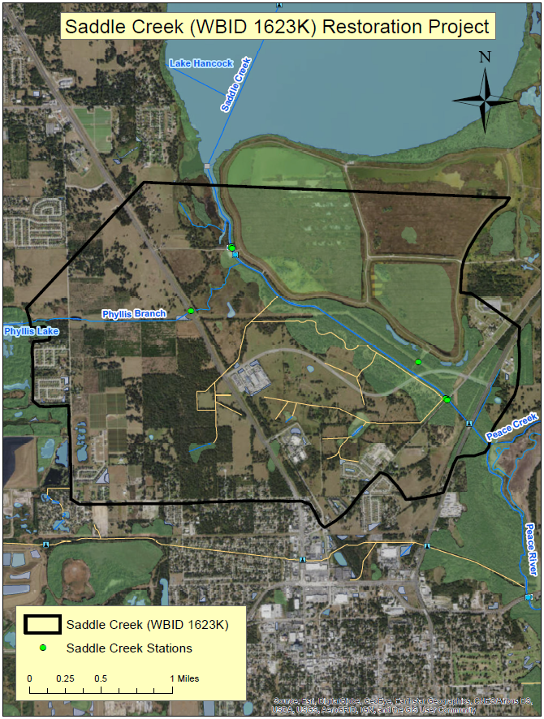

Evidence of Watershed Approach
 | Area of Effort | The Saddle Creek watershed (WBID 1623K) is located in the West central part of Polk County, within the city of Bartow and has an area of roughly 6.5 square miles. The Lake Hancock outfall treatment project is located directly to the South of Lake Hancock in the northern portion of WBID 1623K and is directly connected to Saddle Creek. The Lake Hancock outfall treatment project has an area of approximately 1,000 acres.
 | Key Stakeholders Involved and Their Roles | The key stakeholders that have been instrumental in developing and executing these restoration projects are listed below.  - Southwest Florida Water Management District  - Polk County  - City of Bartow  - Department of Environmental Protection
 | Watershed Plan & Other Supporting Documentation | The area includes the watershed drainage area from Lake Hancock within WBID 1623L where extensive natural resource management is taking place. WBID 1623K is impaired for Nutrients (Chlorophyll-a), Nutrients (Total Nitrogen) and Dissolved Oxygen (Percent Saturation) based on the AGMs for nutrients and the number of exceedances for the sample size for dissolved oxygen. The objectives outlined by the Lake Hancock lake level modification project and the Lake Hancock outfall treatment project will address these impairments.  The WBID drainage area corresponds to the key project as follows: Lake Hancock lake level modification project and the Lake Hancock outfall treatment project.
 | Point Sources and Indirect Source Monitoring (Sites) | There are several NPDES Facilities that discharge indirectly to WBID 1623K. These facilities are listed in the table below. There are no direct NPDES surface water dischargers located within this WBID.  All land areas within the State of Florida surrounding this WBID are regulated by a Municipal Separate Storm Sewer System (MS4) permit – NPDES MS4 Permit No. FLS000015, permitee is Polk County. The most current MS4 permit was issued on October 26, 2016 and expires on October 25, 2021.  http://www.polk.wateratlas.usf.edu/npdes/?section=MS4 Permit  The entire area is regulated by a Municipal Separate Storm Sewer System (MS4) permit #FLS000015  Note: Generic Permits for stormwater discharge from large and small construction activities are considered temporary; therefore, are not included in this listing.
  NPDES Facility ID | NPDES Facility Name
  FLR10LA46 | SWFWMD Lake Hancock Lake Level Modification P-11 Structure
  FLR10KX88 | Lake Hancock Outfall Wetland Project
  FLR10Q791 | Summertimes Plantation
  FLR10R973 | Big Oaks Buick Pontiac GMC
  FLR10LH59 | Bartow Northern Connector
  FLR10CO45 | Michael Holley Buick Pontiac GMC Car Dealership
  FLR10KB88 | FDOT FIN 408268 5 52 01 SR-35_700
  FLR10ET03 | Griffin's Green
  FLR10AL51 | Silver Companies Bartow Site
  FLR10FA17 | Magnolia Walk - Phase 2
  FLR10MO43 | Magnolia Walk - Phase 2
  FLR10PR31 | ADP of Polk LLC/HQ of Polk LLC
  FLR10NN77 | Magnolia Walk - Phase 2
  FLR10W237 | Meetinghouse
  FLRNEE355 | Flanders Precisionaire Inc - Manufacturing Facility
  FLR10Y219 | Bridgeport Phase 2
  FLR10RD03 | Lyle Oaks Subdivision
 | Nonpoint Sources | The land use breakdown for the Saddle Creek watershed is as follows:  Urban and Built-Up – 36.46%  Agriculture – 38.28%  Rangeland – 0.00%  Upland Forest – 12.33%  Water – 0.28%  Wetlands – 9.66%  Barren Land – 0.00%  Transportation, Communication, and Utilities – 2.99%  Special Classifications – 0.00%  The anthropogenic land use component is approximately 77.73%  Wastewater Facilities in Area:  There are no wastewater facilities within this WBID  Solid Waste Facilities in area:  There are no solid waste facilities within this WBID
 | Water Quality Criteria | It is expected that the Class III freshwater water quality standards for Chlorophyll-a and Total Nitrogen will be attained upon implementation of the specified watershed improvement projects. It is also expected that the water quality criteria for Dissolved Oxygen will be attained.
 | Restoration Work | Lake Hancock is a 4,500-acre lake in the headwaters of the Peace River watershed that extends 120 miles downriver to Charlotte Harbor. As part of the District’s objectives of restoring storage, flows, aquifer recharge, and water quality in the Basin, two extensive water resource enhancement projects have been implemented involving Lake Hancock. These projects include the “Lake Hancock Lake Level Modification Project” and the “Lake Hancock Outfall Treatment System.”  The Lake Hancock Lake Level Modification Project involved replacing the P-11 Water Conservation Structure that was built in 1963. The new structure allows the District to maintain higher lake levels, increasing the elevation from 98.7 feet above sea level to 100 feet (NGVD 29). The proposed normal operating level of 100 feet was determined to be the approximate historical level of the lake before the area was mined for phosphate and the natural lake outlet deepened. The additional stored water will be released into the upper Peace River during dry periods to help achieve minimum flow requirements for the upper river from Bartow to Zolfo Springs. The old structure was located on Saddle Creek in Bartow and was manually operated. The new structure is remotely operated.  The Lake Hancock Outfall Treatment Project involved constructing a 1,000-acre treatment wetland to improve water quality leaving the lake. The wetland treatment system was built on part of the 3,500-acre parcel of land formerly known as Old Florida Plantation. Water flows through large areas of wetland vegetation where nutrients and other pollutants can be removed from the water before it is released back into Saddle Creek and then flows South into the Peace River. A detailed breakdown of the various components included in the engineering of this project are listed below.  Cell Grading  Because the existing topography of this area is highly variable, level grading within the cell boundaries was not economically practical. The high elevations will be cut down to the maximum grades. With the exception of deep zone excavation and the excavation of high areas, no other internal cell grading was completed. Excavated materials were distributed on-site to fill low areas within the cells. Earthwork volumes were calculated using Autodesk Land Development Desktop (LDD) software grid method. A proposed three-dimensional surface was then created and compared to the existing digital terrain model provided by the District. Earthwork volumes were reported only for amount of material to be removed above the maximum elevation (i.e. cut volumes only).  Deep Zones  Transverse deep zones are provided for flow distribution and habitat diversity. Deep zones were constructed at the inlet and outlet of each wetland cell, and at intermediate locations within each cell as needed to approximate “plug-flow” hydraulics. Deep zones were excavated to a depth of 4 feet below the average wetland grade, with side slopes of 3:1 or flatter. The deep zone bottom was excavated at a minimum width of 20 feet. The below figure shows a typical profile view through a surface-flow constructed wetland cell with deep zones.  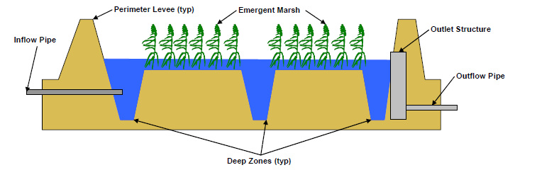  Levees  Levees are needed to compartmentalize the system and provide vehicular access around the site. Perimeter levee tops have a minimum width of 20 feet and side slopes are at least 3 to 1 or less for maintenance access. Levee top elevations are established based upon the sum of the design water surface elevation (incorporating peak flow head loss), the storage depth needed for life-cycle sediment accretion, and freeboard for specified storm events. Levee tops are hardened with limestone base and gravel for vehicle traffic. Intermediate levees are constructed with reduced top widths and lower top elevations to balance cut and fill quantities. Emergency overflow notches are constructed in each levee in the event cell outlet structures become obstructed. Overflows are directed first to adjacent cells, with the ultimate discharge directed to Lower Saddle Creek. Design criteria for the buffer cell levees differ from the treatment cell levees due to the greater depth of impounded water required to provide gravity flow. Earthwork volumes to bring levees to required elevations was calculated using LDD grid volume techniques. Earthwork volumes were reported only for amount of additional fill required to bring levees to required elevation and minimum configuration.  Outlet Canal  Multiple outlet structures and culverts are located within the 1,095-acre layout to provide operational flexibility. The primary point of discharge is through a new outlet aeration device and channel that discharges to Lower Saddle Creek southeast of the P-11 structure.  Raw Water Pump Station  The raw water pump station is located on the south shore of Lake Hancock. The pump station consists of multiple pumps with a combined capacity of 52 cfs. The force main from the station to the buffer cell is outfitted with gate valves to allow direct discharge to each treatment cell.  Water Control Structures  Water control structures are required at the outlets from each cell. Control structures consist of concrete boxes fitted with adjustable rectangular weir plates. Weirs are adjustable by hand wheel operation. Culverts are used to transfer water from the weir boxes to the downstream cells. Weirs and culverts are sized to pass the maximum design flows with the minimum practical head loss.  Cascade Aeration Outlet Structure  Outlet structures provide for the discharge of treated flow from the outlet canal to Lower Saddle Creek. The structures consist of a sluice gate and stair-step concrete apron that follows the slope of the perimeter levee. The passive aeration structures provide an increase in dissolved oxygen concentration prior to final discharge. Gates at the downstream end of the cascade structure direct treated water to Lower Saddle Creek.  Instrumentation  Instrumentation requirements include flow metering devices and water level recorders. A flow meter is required on the discharge from the pump station so that accurate measurements of the inflow can be determined. Water level recorders are required at the upstream and downstream ends of each cell.  Boat Ramps  Ramps are provided for airboat access to the interior of each wetland cell. Ramps are constructed of compacted fill material placed at a 6:1 slope from the levee top to wetland cell grade.  Planting  Options for vegetation establishment within treatment wetland cells include natural recruitment and planting. Natural recruitment is a reasonable approach for full-scale system vegetation establishment but may not result in adequate plant cover within the constraints of the District’s schedule for beginning operations. Some planting or seeding may be required to supplement natural recruitment. Careful scheduling of construction activities will be necessary to allow maximum plant growth prior to the start of routine operations. All levees will be hydro-seeded for erosion protection.  See below figure for schematic of the outfall treatment project.  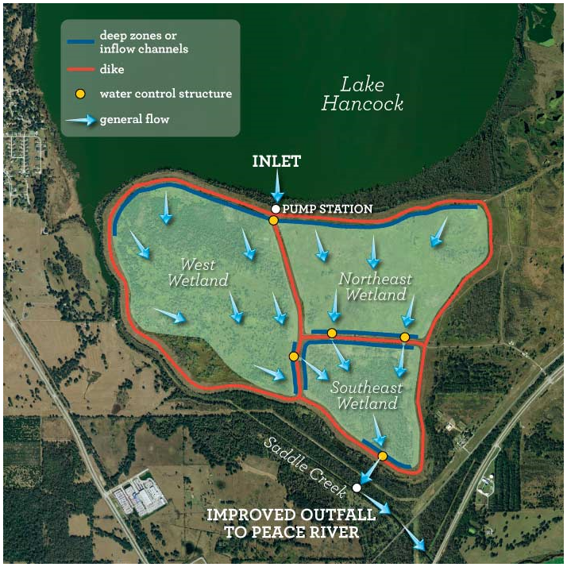  In addition to the major restoration projects previously described, the following figure is a general overview of all the natural resource management that is ongoing in the Lake Hancock watershed.  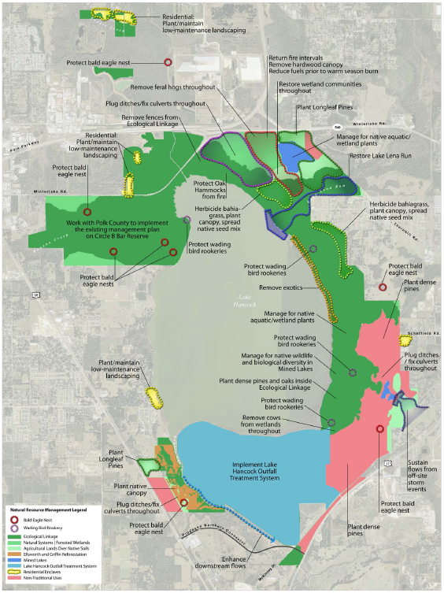

Critical Milestones/Monitoring
 | Anticipated Critical Milestone(s) and Completion Dates: |  | Lake Hancock Lake Level Modification Project  The Lake Hancock Lake Level Modification Project involved replacing the P-11 Water Conservation Structure that was built in 1963. The new structure allows the District to maintain higher lake levels, increasing the elevation from 98.7 feet above sea level to 100 feet (NGVD 29). The proposed normal operating level of 100 feet was determined to be the approximate historical level of the lake before the area was mined for phosphate and the natural lake outlet deepened. The additional stored water will be released into the upper Peace River during dry periods to help achieve minimum flow requirements for the upper river from Bartow to Zolfo Springs. The old structure was located on Saddle Creek in Bartow and was manually operated. The new structure is remotely operated.  Below is a timeline of when critical milestones were completed for this project.  - Evaluation:  - May 2003–August 2004  - Preliminary design, engineering and conceptual permitting:  - August 2004–June 2007  - Final design, engineering, permitting & construction documents:  - October 2007–November 2011  - Construction:  - November 2011– April 2015  - Post project monitoring by the Water Management District:  - September 2015 – September 2019  Lake Hancock Outfall Treatment Project Overview  The Lake Hancock Outfall Treatment Project involved constructing a 1,000-acre treatment wetland to improve water quality leaving the lake. The wetland treatment system was built on part of the 3,500-acre parcel of land formerly known as Old Florida Plantation. Water flows through large areas of wetland vegetation where nutrients and other pollutants will be removed from the water before it enters the Peace River.  Below is a timeline of when critical milestones were completed for this project.  - Feasibility and selection of treatment method:  - February 2004–February 2006  - Engineering testing, design, permitting and construction documents:  - March 2006–October 2010  - Construction and startup:  - September 2011– May 2015
 | Monitoring Component |  | Monitoring and Performance Optimization  Monitoring and data analysis are key to successful wetland operation. Because of the limited selection of controls available to the wetland operator, and due to the relatively slow response time of a wetland to operational changes, data trends need to be followed to anticipate system performance changes before they become extreme. Routine wetland monitoring for operational control includes the following groups of parameters:  - Inflows and outflows  - Inflow and outflow water quality  - Water stage and depth  - Plant community dominance and health  The below table is the proposed operational monitoring program for the Lake Hancock outfall treatment project.  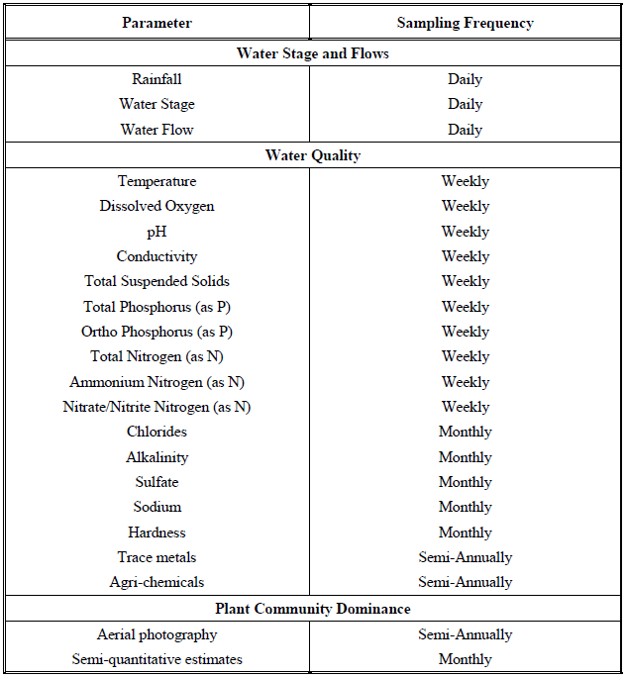  Inflows and Outflows  Knowledge of water inflows and outflows is imperative for estimating wetland performance. Inflows and outflows will be measured on a continuous basis using the monitoring equipment provided with this project. Inflows will be estimated based on pumping records and flow meter output. Water outflows will be estimated using water stage recorders and applicable weir equations. Water stage will be measured in each cell. Staff gauges will be located at the up and down-gradient ends of each cell. A continuous stage recorder will be installed near the outlet of each cell. These recorders will provide a continuous record of water levels. Knowledge of these levels is critical for assessing the system water balance, estimating nutrient removal performance, and understanding the effects of water depth on wetland plant communities.  Inflow and Outflow Water Quality  Inflows and outflows will be monitored for the following parameters and at the specified  sampling intervals: Field parameters and nutrients: temperature, pH, dissolved oxygen, specific conductance, total suspended solids, total phosphorus, ortho-phosphorus, total nitrogen, ammonium nitrogen, nitrate/nitrite nitrogen – weekly Major water quality parameters: chlorides, sulfate, sodium, hardness, alkalinity – monthly Non-routine water quality parameters: trace metals and agri-chemicals – semi-annually The purpose of this water quality monitoring is to provide a record of performance of the wetland for water quality improvement. Analysis of this system performance will be utilized to make informed operations and maintenance decisions. Sampling for trace metals and agrichemicals is recommended during the start-up phase but may not be required long-term if the results are consistently below threshold toxicity limits.  The estimated finished water quality for water discharging from the Lake Hancock outfall treatment project into Saddle Creek.  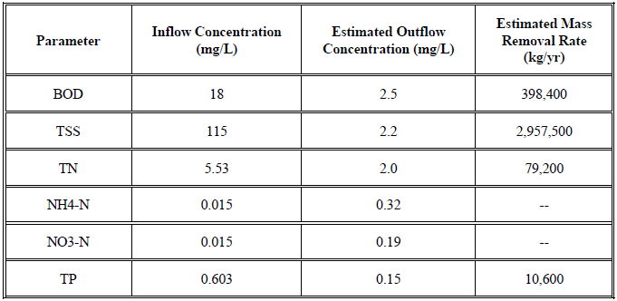
Other Key Dates
 | Estimated Delisting Date | WBID 1623K is in the state’s Group 3 Basin in the DEP Southwest District. The current review and assessment cycle (cycle 4) is scheduled for 2021. This waterbody is currently impaired for nutrients (chlorophyll-a), nutrients (total nitrogen) and dissolved oxygen (percent saturation), the earliest opportunity for delisting would happen during the upcoming cycle 4 assessment. However, if this WBID doesn’t meet delisting requirements, it will be placed in assessment category 4e, which will postpone TMDL development.

Financial Commitments

 | Estimated Implementation Cost | The total project cost, including land acquisition was $63,400,000.  The estimated 20-year operation and maintenance cost is $TBD.
 | Land Acquisition  (if applicable) | Funding Source:  In 2003, the District purchased a 3,535-acre parcel of land formerly known as the Old Florida Plantation property with approximately 4 miles of shoreline bordering the southern and southeastern shore of Lake Hancock at a cost of $30.5 million. In a more recent acquisition, the District purchased a 231-acre parcel known as the Saddle Creek property for $4.9 million located along Saddle Creek just south of Structure P-11 between the creek and U.S. Highway 98.  Total……………………………………………………………………...$35,400,000
 | Design and Construction  (if applicable) | Funding Source:  Total……………………………………………………………………...$28,000,000
References:

"Lake Hancock Land Use and Management Plan” by Southwest Florida Water Management District. January 2010.

“Lake Hancock Restoration Management Plan, Final Report” by CDM - Camp Dresser & McKee January 2002.

