Documentation in Support of Category 4e

Waterbody/Watershed Identification
 | Organization | Florida Department of Environmental Protection
 | Point of Contact | Kevin O’Donnell, 2600 Blairstone Rd Tallahassee, FL 32399  Kevin.ODonnell@dep.state.fl.us, (850) 245-8469  Frank Powell, 3900 Commonwealth Boulevard Tallahassee, Florida 32399  Frank.Powell@dep.state.fl.us, (850) 245-3188
 | Waterbody(s) | WBID 3259M – Ten Thousand Islands
 | No. Waterbody / Pollutant Combinations | Based on data from IWR run 56 these waterbodies are impaired for these parameters: WBID 3259M – Nutrients (Chlorophyll-a), Nutrients (Total Nitrogen) and Dissolved Oxygen (Percent Saturation)
 | EPA Completed TMDL | EPA has not completed a TMDL for the impaired waterbody segment listed in this document.
Description of Baseline Conditions
 | Watershed(s) | Everglades West Coast – Group 1  Southwest Coast – FDEP South District  WBID 3259M - Ten Thousand Islands
 | Baseline Data | Group 1 Cycle 4 – IWR Run 55, 2018  (Verification Period: January 1, 2011 through June 30, 2018)  3259M - Nutrients (Total Nitrogen)  ENRE8 Criterion: AGM ≤ 0.41 mg/L, annual geometric mean TN values exceeded the criterion in 2015, 2016, 2017 and 2018 with values of 0.5 mg/L, 0.61 mg/L, 0.5 mg/L and 0.45 mg/L respectively.  ENRE9 Criterion: AGM ≤ 0.61 mg/L, annual geometric mean TN values exceeded the criterion in 2015, 2017 and 2018 with values of 0.74 mg/L, 0.6 mg/L and 0.71 mg/L respectively.  ENRE10 Criterion: AGM ≤ 0.44 mg/L, annual geometric mean TN values exceeded the criterion in 2015, 2016 and 2017, with values of 0.48 mg/L, 0.6 mg/L and 0.53 mg/L, respectively.  Stations used in Total Nitrogen assessment:  ENRE8: 21FLFTM G1SD0054, 21FLSFWMTTI71, 21FLSFWMTTI72, 21FLSFWMTTI75, 21FLSFWMTTI75B, 21FLSFWMTTI75C, 21FLWQA G1SD0008, 21FLWQA G1SD0009  ENRE9: 21FLFTM EVRGWC0001FTM, 21FLFTM EVRGWC0002FTM, 21FLFTM EVRGWC0003FTM, 21FLFTM EVRGWC0004FTM, 21FLFTM G1SD0058, 21FLSFWMTTI51B  ENRE10: 21FLFMRIFLW200643, 21FLFTM G1SD0053, 21FLSFWMTTI68B  21FLSFWMTTI69, 21FLSFWMTTI76B, 21FLWQA G1SD0004, 21FLWQA G1SD0005  3259M - Nutrients (Chlorophyll-a)  ENRE8 Criterion: AGM ≤ 4.1 µg/L, annual geometric mean chlorophyll-a values exceeded the criterion in 2017, with a value of 4.2 µg/L.  ENRE9 Criterion: AGM ≤ 3.9 µg/L, annual geometric mean chlorophyll-a values exceeded the criterion in 2015, with a value of 4.2 µg/L.  ENRE10 Criterion: AGM ≤ 3.4 µg/L, annual geometric mean chlorophyll-a values exceeded the criterion in 2015 and 2017 with values of 3.6 µg/L and 3.5 µg/L respectively.  Stations used in the Chlorophyll-a assessment:  ENRE8: 21FLFTM G1SD0054, 21FLSFWMTTI71, 21FLSFWMTTI72, 21FLSFWMTTI75, 21FLSFWMTTI75B, 21FLSFWMTTI75C, 21FLWQA G1SD0008, 21FLWQA G1SD0009  ENRE9: 21FLFTM EVRGWC0001FTM, 21FLFTM EVRGWC0002FTM, 21FLFTM EVRGWC0003FTM, 21FLFTM EVRGWC0004FTM, 21FLFTM G1SD0058, 21FLSFWMTTI51B  ENRE10: 21FLFMRIFLW200643, 21FLFTM G1SD0053, 21FLSFWMTTI68B  21FLSFWMTTI69, 21FLSFWMTTI76B, 21FLWQA G1SD0004, 21FLWQA G1SD0005  Dissolved Oxygen (Percent Saturation)  DOSAT impairment threshold: ≥ 42 %; The group 1 cycle 4 exceedance ratio for the verified period is 173/1183.  Stations used in the DO percent saturation assessment:  21FLFTM G1SD0054, 21FLSEAS66SEAS028, 21FLSEAS66SEAS029, 21FLSEAS66SEAS034, 21FLSEAS66SEAS035, 21FLSEAS66SEAS036, 21FLSEAS66SEAS037, 21FLSEAS66SEAS038, 21FLSEAS66SEAS281, 21FLSEAS66SEAS299, 21FLSEAS66SEAS300, 21FLSEAS66SEAS301, 21FLSEAS66SEAS302, 21FLSEAS66SEAS303, 21FLSFWMTTI71, 21FLSFWMTTI72, 21FLSFWMTTI75, 21FLSFWMTTI75B, 21FLSFWMTTI75C, 21FLWQA G1SD0008, 21FLWQA G1SD0009  21FLFTM EVRGWC0001FTM, 21FLFTM EVRGWC0002FTM, 21FLFTM EVRGWC0003FTM, 21FLFTM EVRGWC0004FTM, 21FLFTM G1SD0058, 21FLSFWMTTI51B, 21FLFMRIFLW200643, 21FLFTM G1SD0053, 21FLSEAS56SEAS007, 21FLSEAS56SEAS010, 21FLSEAS66SEAS007, 21FLSEAS66SEAS010, 21FLSEAS66SEAS077, 21FLSEAS66SEAS111, 21FLSEAS66SEAS112, 21FLSEAS66SEAS113, 21FLSEAS66SEAS187, 21FLSEAS66SEAS401, 21FLSEAS66SEAS771, 21FLSFWMTTI68B, 21FLSFWMTTI69, 21FLSFWMTTI76B, 21FLWQA G1SD0004,  21FLWQA G1SD0005
 | Map | 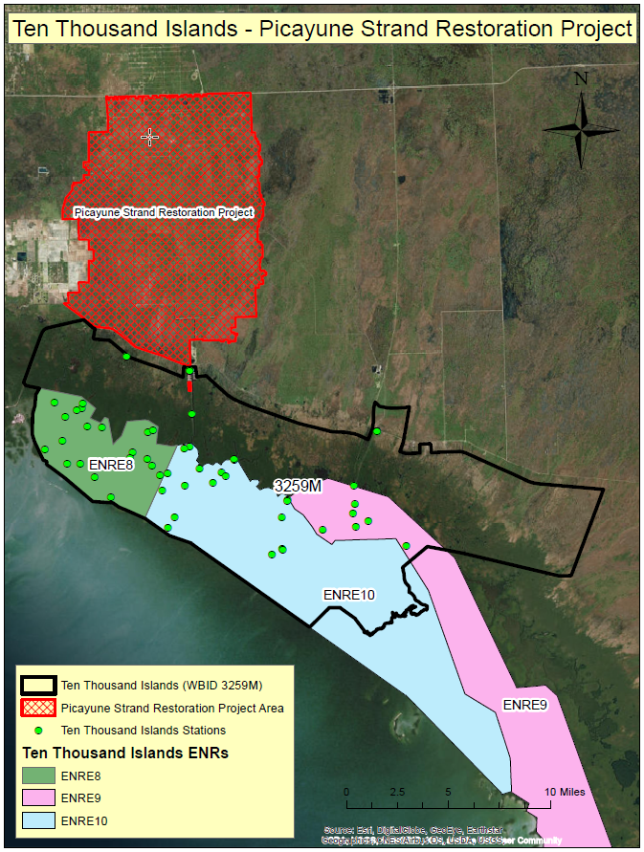

Evidence of Watershed Approach
 | Area of Effort | The Ten Thousand Islands watershed (WBID 3259M) is located in the Southwestern part of Collier County and has an area of roughly 199 square miles. The Picayune Strand Restoration Project (PSRP) is located to the North of WBID 3259M and is directly connected to the Ten Thousand Islands watershed via the Faka Union Canal system. The Picayune Strand Restoration Project has an area of approximately 60,160 acres.
 | Key Stakeholders Involved and Their Roles | The Army Corps of Engineers is in continuous coordination with Federal and state resource agencies, business organizations, environmental organizations, and private citizen groups for the PSRP. The Corps is also coordinating with the federally recognized Tribal interests to ensure their participation with the design and implementation of this project. This extensive coordination is a result of the magnitude of the Corps and the SFWMD efforts to implement the components of the PSRP. Collier County has worked diligently to gain the support and partnership of all other interested local groups/organizations, including the following:  - City of Marco Islands  - Everglades City  - Collier County  - South Florida Water Management District
 | Watershed Plan & Other Supporting Documentation | The area includes the watershed drainage area from across 85 square miles of western Collier County that were drained for an extensive residential development within WBIDs 3278V (Rookery Bay (Inland East Segment)), 3278I (Faka Union (South Segment)) and 3259M (Ten Thousand Islands). WBID 3259M is impaired for Nutrients (Chlorophyll-a), Nutrients (Total Nitrogen) and Dissolved Oxygen (Percent Saturation) based on the AGMs for nutrients and the number of exceedances for the sample size for dissolved oxygen. The objectives outlined by the Picayune Strand Restoration Project will address these impairments.  The WBID drainage area corresponds to the key project as follows: Picayune Strand Restoration Project
 | Point Sources and Indirect Source Monitoring (Sites) | There are several NPDES Facilities that discharge indirectly to or near WBID 3259M – Ten Thousand Islands:  - Everglades Airpark Parallel Taxiway to Runway: Permit FLR20AD48  - 15 – 33: Permit FLR10W182  - Everglades Outpost: Permit FLR10N445  - ORV Trailheads: Permit FLR10MQ80  - US 41 (SR 90): Permit FLR10MA20  - PRA – Bicy 104 – 1: Permit FLR10HI15  - Waterside Enterprises LLC – The Moorings at Barron River: Permit FLR10FW83  - Partners Cove: Permit FLR10EF32  All land areas within the State of Florida surrounding the two WBIDs are regulated by a Municipal Separate Storm Sewer System (MS4) permit – NPDES MS4 Permit No. FLR04E037, Permittee is Collier County. The most current MS4 permit was issued on November 16, 2017 and expires on February 23, 2028.  https://www.colliercountyfl.gov/your-government/divisions-s-z/stormwater-management/stormwater-pollution-prevention-npdes-permits/ms4  The entire area is regulated by a Municipal Separate Storm Sewer System (MS4) permit # FLR04E037.  Note: Generic Permits for stormwater discharge from large and small construction activities are considered temporary; therefore, are not included in this listing.
 | Nonpoint Sources | The Land use breakdown for the Ten Thousand Islands is as follows:  Urban and Built-Up – 0.54%  Agriculture – 0.01%  Rangeland – 0.20%  Upland Forest – 0.12%  Water – 28.07%  Wetlands – 70.99%  Barren Land – 0.05%  Transportation, Communication, and Utilities – 0.03%  Special Classifications – 0.00%  The anthropogenic land use component is approximately 0.57%  Wastewater Facilities in Area:  Port of the Islands WRF  Everglades City, City of - WWTF  Solid Waste Facilities in area:  Seaboard Village Mobile Home Park
 | Water Quality Criteria | It is expected that the Class III water quality standards derived from the Numeric Nutrient Criteria associated with ENRE8, ENRE10, and ENRE9 for Nutrients (Chlorophyll-a) and Nutrients (Total Nitrogen) will be attained upon implementation of the specified watershed improvement projects. It is also expected that the water quality criteria for Dissolved Oxygen (Percent Saturation) will be attained.
 | Restoration Work | General Picayune Strand Restoration Project overview.  Restoring the Picayune Strand involves plugging 48 miles of canals, originally dug to provide flood protection for a sprawling 55,000-acre residential area that was never built and removing roads that impede sheet flow. The building and operating of 3 pump stations will allow natural resource and water managers to direct fresh water to drained wetlands, as well as maintain current levels of flood protection on adjacent land. Removing 260 miles of crumbling roads and management of non-native vegetation will further enhance restoration efforts.  These features will restore a natural and beneficial sheet flow of water to the Ten Thousand Islands National Wildlife Refuge. This will bring back the native ecosystem by increasing the groundwater levels. Along with restoring freshwater wetlands, the Picayune Strand Restoration Project will improve estuarine water quality and reduce unnatural freshwater inflows.  The upper two miles of the Prairie Canal were plugged in early 2004 and the lower five miles were plugged in 2006-2007. The Corps took over the construction of the remaining project phases after the completion of Prairie Canal.  The Merritt Pump Station construction contract was awarded in October 2009 with construction beginning in December 2009. This phase included the Merritt Pump Station, tieback levee, spreader canal, road removal, and Merritt Canal plugging. The construction on the Merritt Pump Station was completed in September 2014. The Merritt Pump Station officially designated S-488 began pumping water into the Picayune Strand Restoration Area in June of 2015 and was transferred to the SFWMD in May 2016. Additionally, the Merritt Canal plugging commenced in November 2014 and was completed in June 2015.  The Faka Union Pump Station construction contract was awarded in November 2010 with construction starting in January 2011. The Faka Union construction phase included the Faka Union Pump Station, tieback levee, spreader canal, road removal, and Faka Union Canal plugging. The construction on the Faka Union Pump Station was completed in the summer of 2017 and was transferred to the SFWMD in January 2018.  The Miller Pump Station construction contract was awarded in September 2013. The project is scheduled to be completed in May 2019 and transferred to the SFWMD in June 2019. Hydrological analyses have shown flood protection features would be needed before the Faka Union and Miller Canals could be plugged. Therefore, the Faka Union and Miller Canals will not be plugged until the completion of the western (6L’s agricultural area) flood protection feature in order to maintain current levels of flood protection for adjacent lands when the project is complete. The Faka Union Canal is the largest canal within the project area and thereby conveys the largest amount of freshwater to the Port of the Islands (POI) Basin. Since most of the flows into the POI Basin are from the Faka Union Canal, the manatee mitigation feature must be complete before this canal can be plugged. Implementation of the western protection feature, and the manatee mitigation feature are contingent upon approval of an increased project cost which is currently being sought through a Limited Reevaluation Report (LRR) to Congress.  The objective is to restore and enhance wetlands in Picayune Strand and adjacent public lands by reducing the amount of over-drainage and restoring the sheetflow needed for environmental restoration. With the restoration of the wetlands, there will be more retention of nutrients and the water quality of the coastal estuaries will improve by moderating the large salinity fluctuations and reducing the nutrient inputs from the Faka Union Canal.  See below figure for layout of projects.  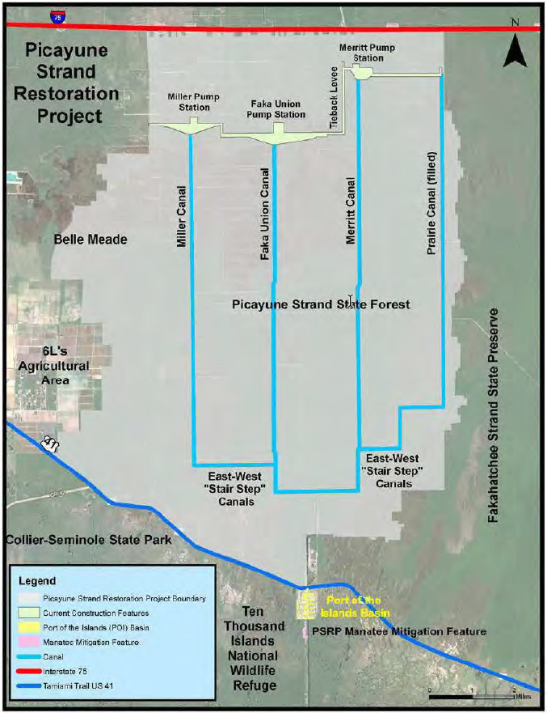
Area of Reo
Critical Milestones/Monitoring
 | Anticipated Critical Milestone(s) and Completion Dates: |  | Merritt Canal Pump Station  Contract awarded:  October of 2009  Features:  - 810-cubic feet per second (cfs) pump station, spreader canal and tie-back levee.  - Plug 13.5 miles of canals to block flow.  - Remove and degrade 95 miles of roads and tram roads.  Construction Start:  Winter of 2009  Construction Completion:  Fall of 2014  Transfer to SFWMD:  May of 2016  Faka Union Pump Station  Contract awarded:  November of 2010  Features:  - 2,650-cubic feet per second (cfs) pump station, spreader canal and tie-back levee.  - Plug 12 miles of canals to block flow.  - Remove and degrade 100 miles of roads.  Construction Start:  Winter of 2011  Construction Completion:  Summer of 2017  Transfer to SFWMD:  January of 2018  Miller Pump Station  Contract awarded:  September of 2013  Features:  - 1,250-cubic feet per second (cfs) pump station, spreader canal and tie-back levee.  - Plug 13 miles of canals to block flow.  - Remove and degrade 65 miles of roads.  Construction Start:  Winter of 2013  Construction Completion:  May of 2019  Transfer to SFWMD:  June of 2019
 | Monitoring Component |  | Water quality monitoring is a cooperative effort between several entities, including DEP, the South Florida Water Management District, the Florida Marine Research Institute and DACS. Sampling frequency varies by site depending on site classification, parameter group, and hydrologic conditions (e.g., water depth and flow). The South Florida Water Management District water control structures (both inflows and outflows) were typically sampled biweekly when flowing; otherwise, sampling was performed monthly. Generally, interior monitoring stations were sampled monthly for most parameters. Pesticide monitoring is conducted across the entire District at 15 sites on a biannual basis. An overview of the water quality monitoring projects, including project descriptions and objectives with limited site-specific information, is available on the District’s web site at www.sfwmd.gov/environmentalmonitoring.  In addition, components of several existing surface water monitoring initiatives will be leveraged to obtain applicable data for the Picayune Strand Restoration Plan. These geographical and scientifically relevant programs are the Collier County Water Quality (CCWQ) monitoring program, the South Florida Estuarine Water Quality Monitoring Network, and the FDEP Rookery Bay National Estuarine Research Reserve Continuous Monitoring Network. These programs are currently funded by the SFWMD (District) through cost share agreements and incorporate both significant portions of both the fresh and estuarine components identified for evaluation of the restoration project.  The cost of implementing the environmental monitoring plan is estimated to be $7.4 million, with an average annual cost of $778,000.
Other Key Dates
 | Estimated Delisting Date | WBID 3259M is in the state’s Group 1 Basin, in the DEP South District. The current review and assessment cycle (cycle 4) is currently ongoing in 2019. This waterbody will be put in category 4e (Ongoing Restoration Activities) during the cycle 4 assessment. This waterbody will be reassessed with the potential of delisting from the 303(d) List during the departments group 1 cycle 5 assessment scheduled for 2023.

Financial Commitments

 | Estimated Implementation Cost | The Picayune Strand Restoration Project was authorized in the Water Resources Development Act (WRDA) of 2007, with a total cost of $375.33 million. The current Section 902 limit in FY 2013 price levels is $505.5 million. The 2013 certified project current cost estimate is $612 million, requiring authorization of additional project funding of $106 million above the 2007 Section 902 limit authorization level.  The estimated 20-year operation and maintenance cost is to be determined.
 | Land Acquisition  (if applicable) | Funding Source:_________________________________________________________________  Total project real estate cost……………………………………………………..$193,043,100
 | Design and Construction  (if applicable) | Funding Source:  Total……………………………………………………………………...$612 million
References:

"Environmental Assessment and Proposed Finding of no Significant Impact: Picayune Strand Restoration Project” by U.S. Army Corps of Engineers, Jacksonville District: November 2014.

“Final Independent External Peer Review Report Picayune Strand Restoration Project (PSRP), Draft Limited Reevaluation Report (LRR) and Environmental Assessment Post-Authorization Change Report” by Battelle 505 King Avenue Columbus, OH 43201 for Department of the Army U.S. Army Corps of Engineers Ecosystem Restoration Planning Center of Expertise Nashville District: June 26, 2013.

