

Willoughby Creek Stormwater Quality Improvement Project
Florida Department of Environmental Protection Grant NS035
Stuart, Martin County, Florida

Water Quality Monitoring Report
August 2020 to July 2021

Attention:
Zach Hughes
Martin County
2401 SE Monterey Road
Stuart, Florida 34996

Prepared by:
Ecological Associates, Inc.
P.O. Box 405 Jensen Beach, Florida 34958
Phone: (772) 334-3729 ~ Fax: (772) 334-4925
Email: info@ecological-associates.com

August 26, 2021

TABLE OF CONTENTS

1.0 INTRODUCTION 1

2.0 MATERIALS AND METHODS 2

3.0 RESULTS 8

4.0 CONCLUSION 11

APPENDICES

APPENDIX A
SITE PHOTOGRAPHS APPENDIX A

APPENDIX B
SUMMARY OF RAINFALL APPENDIX B

APPENDIX C
SUMMARY OF COLLECTED FIELD MEASUREMENTS APPENDIX C

APPENDIX D
FIELD SHEETS APPENDIX D

APPENDIX E
TOTAL PHOSPHORUS TABLE 1
TOTAL NITROGEN TABLE 2
TOTAL SUSPENDED SOLIDS TABLE 3

APPENDIX F
LABORATORY REPORTS APPENDIX F

1.0 INTRODUCTION

Ecological Associates (EAI) has prepared this Water Quality Monitoring Report for the Willoughby Creek Stormwater Quality Improvement Project as required by the Florida Department of Environmental Protection (DEP) Grant Agreement No. NS035. The Quality Assurance Project Plan (QAPP) was approved by DEP in April 2020 to determine the effectiveness of the constructed Willoughby Creek Stormwater Treatment Area (STA).

The Willoughby Creek STA is a 24.50-acre system which utilizes a combination of deep wet detention lakes and shallow treatment wetlands with native herbaceous submergent and emergent plants, along with storm pipes, associated ditch bottom inlets, control structures, and a sheet pile weir. The STA is designed to provide water quality improvements to 222 acres that contribute to the Willoughby Creek watershed. Stormwater from the Willoughby Creek watershed enters the STA through a 55-inch corrugated metal pipe culvert which travels into the western STA cell (STA 2). Additional inflow points include stormwater from the fairgrounds and the light industrial area located west of the Willoughby Creek basin as well as seven locations that flow directly into STA 2. Water within STA 2 travels northeast through a control structure at the northeastern corner of the STA and into the eastern STA cell (STA 1). From STA 1, the water discharges downstream through an overflow weir structure into Willoughby Creek. One additional inflow point originating from the Martin County Airport flows directly into STA 1.

The sampling locations for monitoring, as identified in the QAPP, were chosen due to the unique data insights provided by each location. The Willoughby Creek Inflow captures sheet flow from the surrounding residential, light industrial, roadway, and airport areas and is an ideal location to sample with easy access to a confined upstream source. The other culvert inflows into STA 2, with the exception of the Fairground Ditch, do not have accessible sampling locations are conducive to flow-weighted sample collection. Sampling at the Creek Inflow point provide values that can be used to determine a portion of the nutrient input into the system. Sampling at the Control Structure provides data that can be used to determine the minimum amount of nutrient reduction by comparison to the data collected at the Creek Inflow. The data will also provide most of the nutrient input data for STA 1, however as noted above, there is another inflow into STA 1 downstream of this structure that originates from a pond within the Martin County Airport. The Outflow Weir was sampled to provide data on the final nutrient load leaving the Willoughby Creek Stormwater Quality Improvement Project area. It will be compared to both the Creek Inflow and Control Structure data. The Fairground Ditch captures sheet flow and other runoff from the Martin County Fairgrounds and the light industrial area located to the west, including the flea market. The ditch typically lacks water, therefore grab sample collection was the most cost-efficient option. The data collected from the Ditch inflow provides nutrient values that could represent some of the inflow within the southern section of STA 2.

The Willoughby Creek Stormwater monitoring program was designed to evaluate the Total Nitrogen (TN), Total Phosphorus (TP), and Total Suspended Solids (TSS) nutrient load reduction of the constructed Willoughby Creek STA over 12 months. Samples were collected via autosampler and grab sampling at three locations and via grab sampling at one location, as shown in Figure 1, during thirteen separate events occurring between August 2020 and June 2021. Monitoring efforts continued through July, although no qualifying rainfall events occurred to trigger sampling during the scheduled biweekly timeframes. This report describes the materials and methods used to collect, preserve, and analyze the samples (specifically highlighting any deviations from the approved QAPP) and summarizes the results obtained from those analyses.

2.0 MATERIALS AND METHODS

Unless otherwise noted, the approved QAPP was used as the basis for the monitoring and all procedures employed adhered to the applicable DEP Standard Operating Procedures (SOPs).

Key Personnel

Since approval of the QAPP in April 2020, EAI has remained the primary contractor – responsible for equipment setup, field operations, sample transfer to the laboratories, data analysis, and preparation of this report. Changes to EAI staff includes Tirzah Chichester (Field Technician; Tirzah@ecological-associates.com), as additional personnel responsible for preparing and supplying equipment and sample containers, field equipment and field meter calibration, and sample collection. Another EAI staff, Michelle Luce (Biologist; M.Luce@ecological-associates.com), assisted with evaluating data, performing calculations for field and laboratory data, and performing, verifying, and approving any audits, data validations, and usability assessments.

Jupiter Environmental Laboratories, Inc. has remained the primary subcontractor – responsible for preparing and supplying sample containers, analyzing samples for Total Phosphorus and Total Suspended Solids, and transporting samples to the other subcontractor laboratory, Florida-Spectrum Environmental Services, Inc., for the Total Nitrogen analyses. Changes to key personnel in this laboratory include TSS Analyst, Taylor James (561-575-0030), as additional personnel responsible for laboratory sample analyses, evaluating data, and performing calculations on laboratory data.

Florida-Spectrum Environmental Services, Inc. remained the secondary subcontractor laboratory, responsible for analyzing samples for Total Nitrogen . Changes to key personnel at this laboratory include the addition of Oswald Chinkoo (954-978-6400), Sophia Andre (954-978-6400), and Trevor Davis (954-978-6400) for personnel responsible for laboratory sample analyses.

Project Description and Monitoring Design

As depicted in Figure 1, sampling sites were assigned from north to south. The Willoughby Creek Inflow (Site 1) sampling point (Lat. 27.173130, Long. -80.222588) is located north of the STA system at the point where water from Willoughby Creek enters the culvert which discharges into the western STA cell (STA 2). The Control Structure (Site 2) sampling point (Lat. 27.173154, Long. -80.221861) is located within the control structure between STA 2 and the eastern STA (STA 1) on the west side of the weir which conveys water from STA 2 to STA 1. The Outflow Weir (Site 3) sampling point (Lat. 27.173073, Long. -80.219272) is located on the west side of the weir which conveys water from STA 1 into Willoughby Creek. The Fairground Ditch (Site 4) sampling point (Lat. 27.169917, Long. -80.222712) is located at the fairground ditch inflow into STA 2.

An autosampler, with accessory equipment including a flowmeter, was located at Sites 1-3 (Appendix A). Deployment of the equipment was per DEP SOP FC 1000, and sampling was conducted in accordance with DEP SOP FS 2000. Samples for TN and TP at Sites 1-3 were composite samples collected via autosampler as described in the QAPP, however sampling of TSS was not consistent with the approved QAPP. In order to chemically preserve the TN and TP composite samples, the autosampler bags were acidified prior to sample collection, which prohibited the analysis of TSS from the sample aliquots. Instead, samples for TSS at Sites 1-3 were collected via grab sample using a Beta Van Dorn horizontal sampling bottle the day the TN and TP composite samples were retrieved from the autosampler. All samples at Site 4 were collected via grab sample. Sampling was triggered following distinct rainfall events with a sum of 0.2 to 1.5 inches of rain within 24 hours. Grab samples and field measurements were collected at the same time that composite samples were retrieved from the autosampler.

Deviations from the QAPP collection criteria occurred during several sampling events. During Event 1 (8/5/2020) time-weighted sampling triggered autosampler collection following the qualifying rainfall event due to flowmeter programming issues. Grab samples were collected for TP and TN during Event 6 (10/26/2020) due to autosampler collection malfunctions at the Inflow and Control Structure. Samples for TP and TN analysis were not collected due to autosampler equipment malfunctions during Event 2 (8/18/2020) at the Inflow Creek and during Event 12 (5/12/2021) at the Control Structure.

Field Measurements and Laboratory Analytes

As required in Section A.9.a of the QAPP, the following field measurements were collected at each sampling point during each event: flow, pH, temperature, specific conductivity, salinity, and dissolved oxygen.

Samples were collected during each of the thirteen events at Sites 1-3, and Site 4 during Event 7 (11/10/2020) when adequate water depth was present, and analyzed for the following analytes:

TABLE 1. WILLOUGHBY CREEK STA ANALYTES COLLECTED

Parameter | Minimum Detection Limit (MDL) |  |  | Sample Method
Parameter | Approved in QAPP | Jupiter Environmental | Spectrum Environmental | Sample Method
Total Phosphorus (TP) | 0.0050 mg/L | 0.00500 mg/L¹ |  | Composite²
Total Nitrogen (TN) | 0.040 mg/L |  | 0.00250 mg/L | Composite²
Total Suspended Solids (TSS) | 4.0 mg/L | 4.00 mg/L |  | Grab
¹ TP from Events 7 (Inflow only) and 12 (all Sites) were processed with MDL of 0.0100 mg/L.
² As specified in the QAPP, samples for TP and TN were collected via grab at Site 4.

FIGURE 1-1: WILLOUGHBY CREEK STA STORMWATER QUALITY IMPROVEMENT PROJECT LOCATION
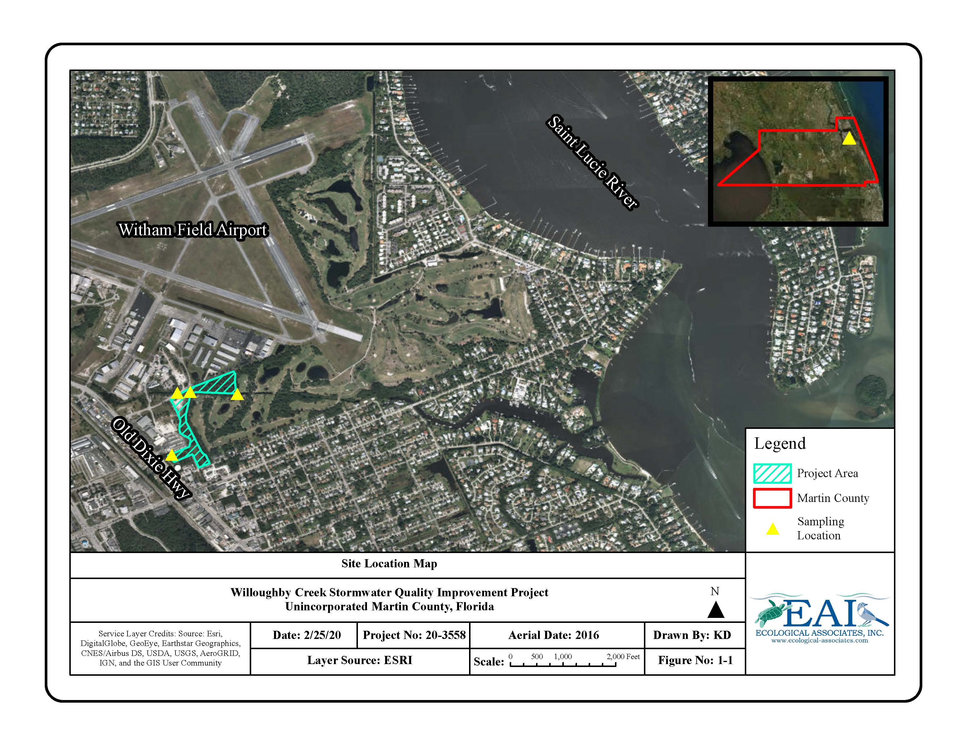

FIGURE 1-2: WILLOUGHBY CREEK STA STORMWATER QUALITY IMPROVEMENT PROJECT SAMPLING LOCATOINS (EASTERN PORTION)
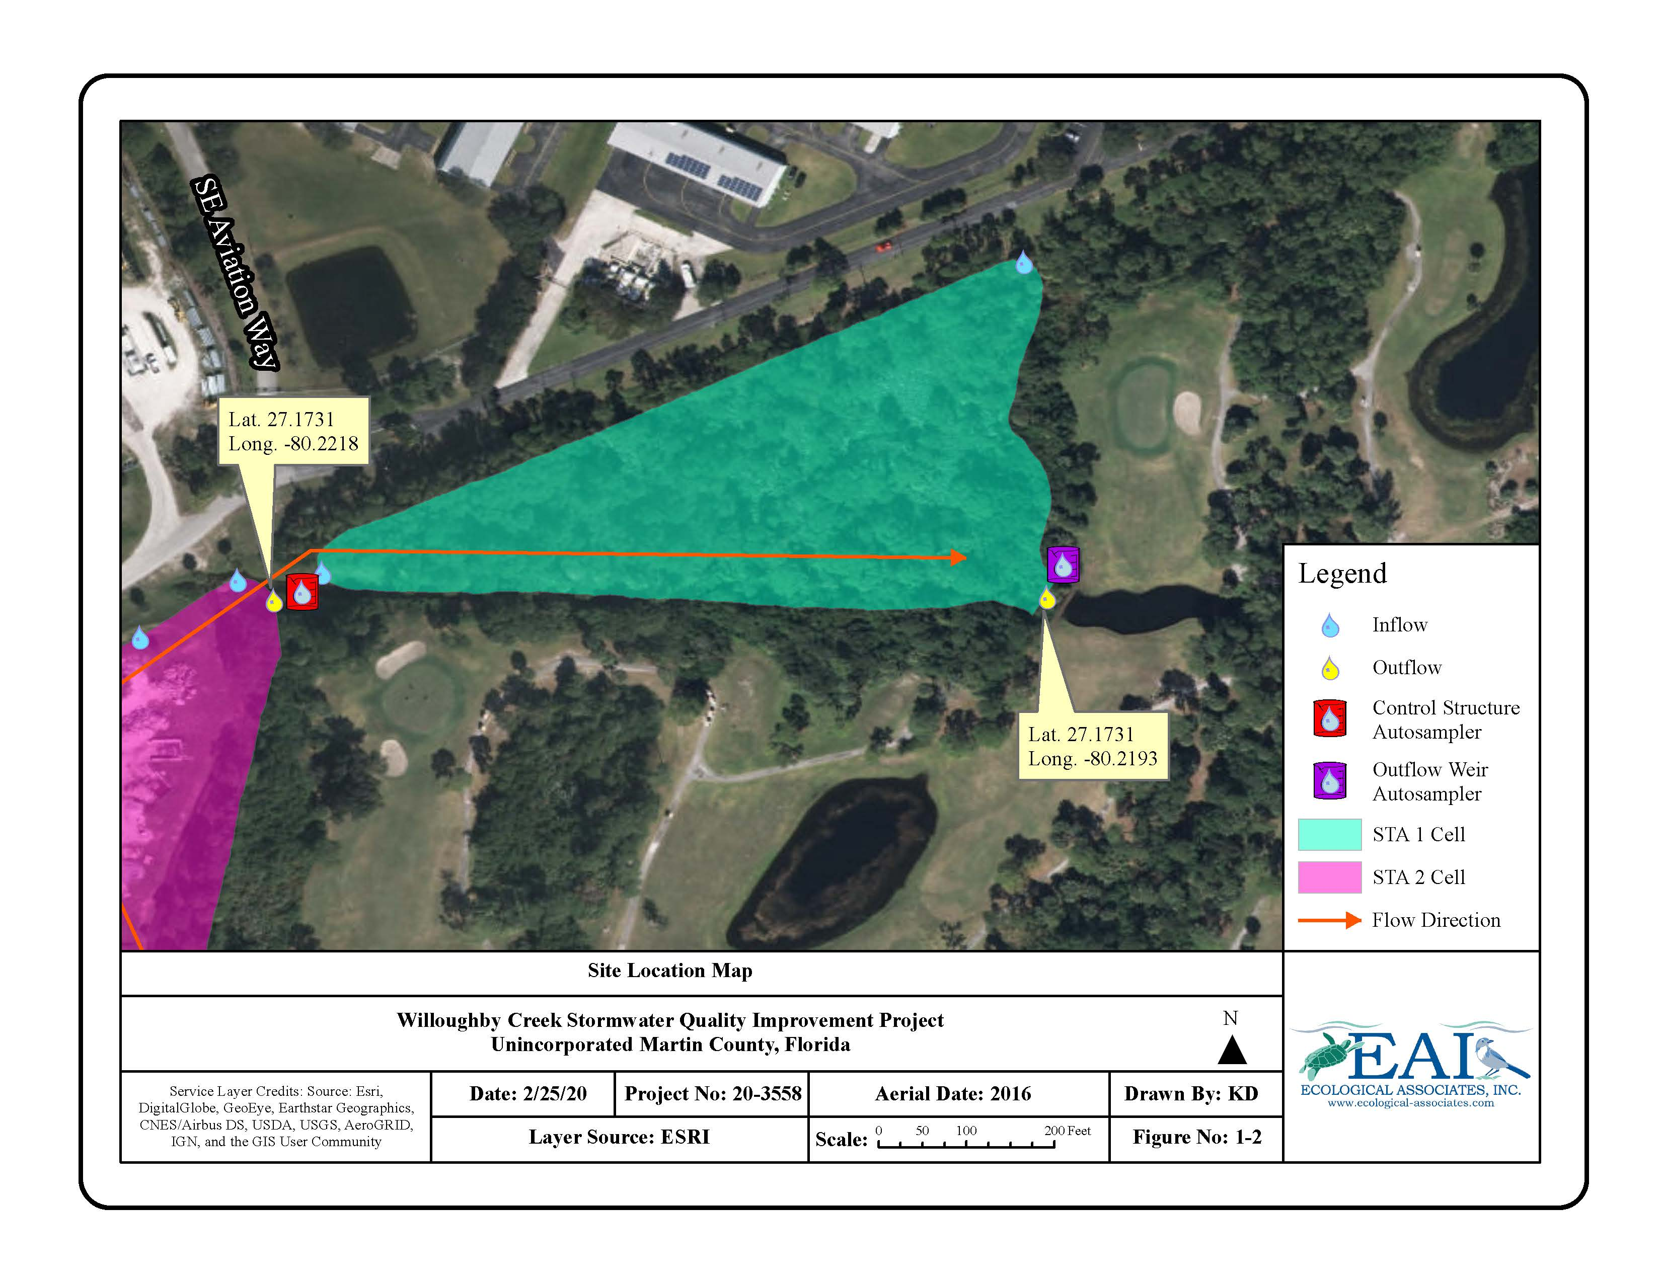

FIGURE 1-3: WILLOUGHBY CREEK STA STORMWATER QUALITY IMPROVEMENT PROJECT SAMPLING LOCATOINS (WESTERN PORTION)
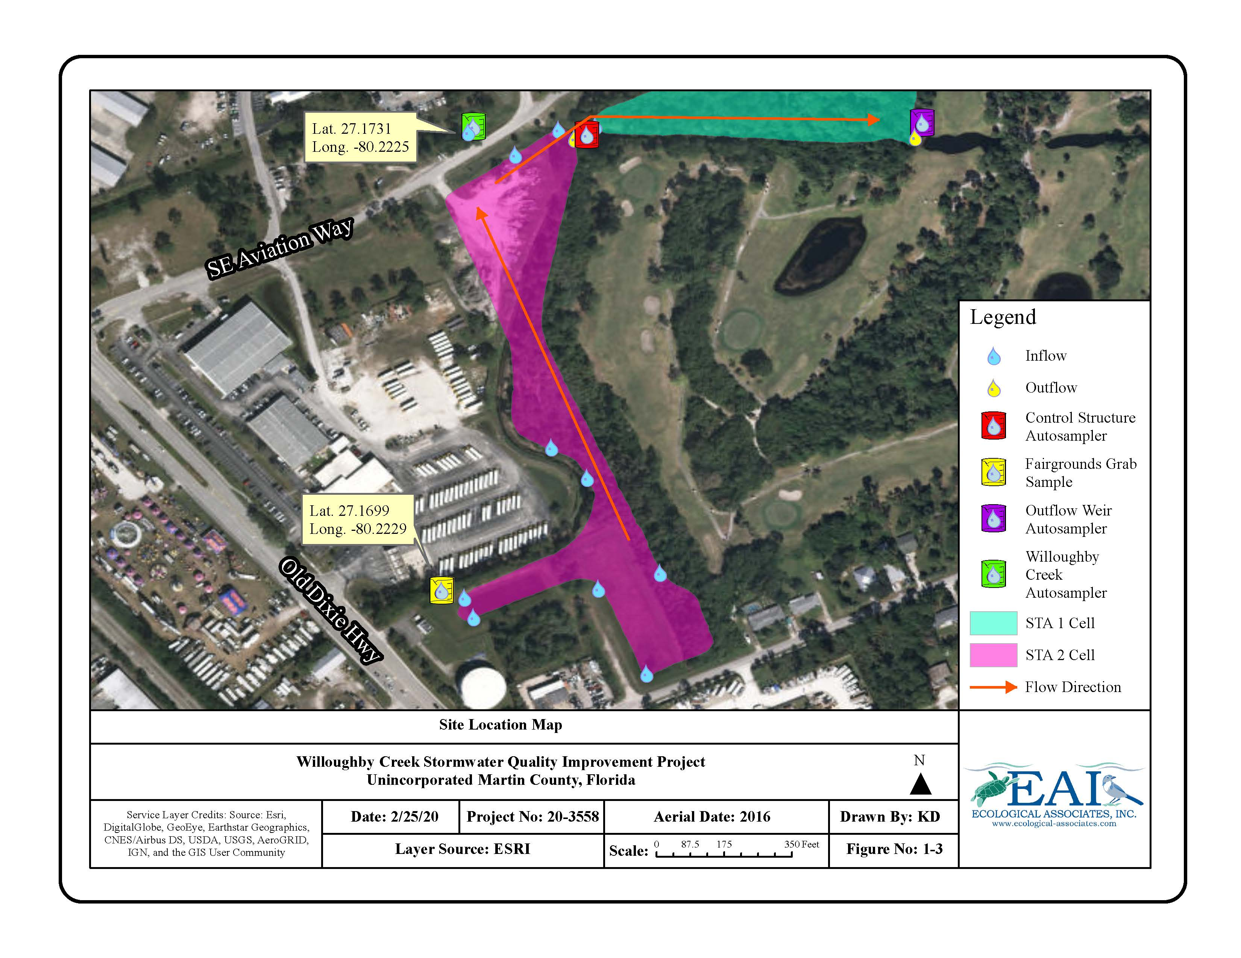
Sample Collection and Documentation Procedures

Unless otherwise noted, sample collection, equipment preparation, decontamination, and documentation procedures conformed to the requirements and criteria in DEP Standard Operating Procedures (SOPs) FA 1000, FC 1000, FD 1000, FQ 1000, FS 1000, FS 2000, and FS 2100.

Sample Collection Equipment and Devices

As approved in Section B.2 of the QAPP, sub-samples for the composite sample were collected in clean autosampler bags within collection bottles using an ISCO Autosampler (Model 6712). Grab samples were collected using a Beta Van Dorn horizontal sampling bottle deployed mid-stream.

Sample Compositing Procedures

As approved in Section B.3 of the QAPP, flow-weighted composite samples were taken over the event hydrograph at each sampling location. The samples were composited depending upon the time of concentration and flow into and out of the Willoughby Creek Stormwater Improvement Project Area. Section B.3 of the approved QAPP stated that each composite sample would include 6-10 evenly distributed aliquots; however, due to programming constraints within the flowmeters, a minimum of 6, but up to 24, discrete aliquots collected over the hydrograph period were used for each composite sample.

Sample Preservation and Holding Times

Pursuant to DEP SOP Table FS 1000-4, thermal preservation (cool, ≤ 6º C) of samples is required for the following analytes: TN, TP, and TSS. To avoid the significant expense of refrigerated autosamplers, the values for TN and TP collected using autosamplers should be qualified. Once composited, all samples were immediately placed on ice and transported to the laboratory in coolers. All samples met to the chemical preservation requirements outlined in DEP SOP Table FS 1000-4. Using the last scheduled sample time as the holding start time (Section 3.3.1, DEP SOP FS1006), all sample holding times conformed to DEP SOP Table FS 1000-4.

Field Testing Methods

Measurements for total water depth, water clarity depth, and surface water quality sample collection depth were taken in accordance with general field testing procedures described in DEP SOP FC 1000 and FS 2100. Measurement of pH, specific conductance, temperature, and dissolved oxygen conformed to the requirements and criteria in DEP SOPs FT 1000, FT 1100, FT 1200, FT 1400, and FT 1500.

Field Testing Equipment

Water flow was measured (in gallons per minute or cubic meters per second at one to five-minute intervals) using the LaserFlow Non-Contact Velocity Sensor and the Signature Flow Meter located at Site 1 and using the 2110 Ultrasonic Flow Module and the Signature Flow Meter at Site 2 and Site 3. A Hach Hydrolab Quanta Multi-Probe Meter was used at each location to collect field measurements for DO (mg/L), pH, specific conductance (mS/cm), and temperature (º C). A secchi disk was used to record depth clarity measurements in meters.

Field Documentation Requirements

Documentation for field activities meet the applicable requirements of the QA Rule (Chapter 62-160, F.A.C.) and is in conformance with DEP SOPs FD 1000, FS 1000, FC 1000, and FS 2100.

Laboratory Analyses

Analyses were performed by laboratories accredited by the Florida Department of Health - Jupiter Environmental Laboratories, Inc. (DOH Certification No. E86546), Florida Spectrum Environmental Services, Inc. (DOH Certification No. E86006) - and were in accordance with the NELAC Quality Manual (QM #E86546 Rev. 2016D).

Evaluation of Data

Field and laboratory data have been evaluated using the procedures and criteria outline in DEP SOP DEP-EA-001/07 to determine its quality and usability. Where quality control failures occurred, data has been qualified using the appropriate codes from Table 1 in the QA Rule (Chapter 62-160, F.A.C.).

3.0 RESULTS

Rainfall and Flow

Thirteen (13) monitoring events were triggered by rainfall between August 2020 and June 2021, although rainfall was monitored for potential triggers through July 2021. Total precipitation at the Martin County Airport, located immediately north of the Willoughby STA, for each qualifying 24-hour rainfall event ranged from 0.23 inches to 1.05 inches with an average of 0.48 inches (Table 2). Rainfall calculations are based on the accumulated precipitation from 0:00 to 24:00 the day the distinct rainfall event occurred. Onsite flow is noted as adequate if water movement within the STA was visible during the event. Daily rainfall for each event can be found in Appendix B.

The 24-hour rainfall total for Event 12 (5/12/2021) did not meet the minimum criteria specified in the QAPP, therefore that data has been removed from the average rainfall calculation. Events 3 (9/15/2021) and 11 (4/13/2021) experienced sampling issues, however, based on the collection timeline, data is included for the analyses. Initial autosampler collection for Event 3 failed at the Inflow Creek and Outflow Weir following the qualifying rainfall on 9/13/2020. No samples were collected, the autosamplers were reset, and collection was started on 9/14/2020, within 24 hours of the initial rainfall trigger. During Event 11 qualifying rain occurred on 4/11/2021, however the rainfall event was accompanied by lighting and the control structure autosampler could not be triggered remotely, therefore all autosamplers were triggered manually the following morning, 4/12/2021, within 24 hours of the initial rainfall event.

TABLE 2: WILLOUGHBY CREEK STA RAINFALL EVENT SUMMARY

Event Number¹ | Rainfall Trigger Date | Total 24-Hour Basin Precipitation (in) for Rainfall Event | Observed Onsite Flow
1 | 8/04/2021 | 0.23 | Adequate
2 | 8/17/2021 | 0.31 | Adequate
3 | 9/13/2021 | 0.48 | Adequate
4 | 9/28/2021 | 0.53 | Adequate
5 | 10/12/2021 | 0.53 | Adequate
6 | 10/25/2021 | 0.23 | Adequate
7 | 11/09/2021 | 0.42 | Adequate
8 | 12/07/2021 | 0.99 | Adequate
9 | 2/16/2021 | 0.29 | Adequate
10 | 3/31/2021 | 0.38 | Adequate
11 | 4/11/2021 | 1.05 | Adequate
12 | 5/11/2021 | 0.05 | Adequate
13 | 6/20/2021 | 0.34 | Adequate
Average Rainfall per Event |  | 0.48
¹ The 24-hr rainfall total for Event 12 did not meet minimum criteria specified in QAPP.

Average flow rates at the Creek Inflow, Control Structure, and Outflow Weir the day sampling commenced from 0:00 to 23:55, excluding Event 12, are presented in Table 3. Event dates represent the day the samples were retrieved from the autosamplers. Daily flow data was retrieved from the autosamplers and provided to Martin County via email on 8/20/2021. Measurements at the Creek Inflow frequently registered a flow rate of 0 Gallons per Minute (GPM), signaling a potential velocity reading error, possibly as a result of floating vegetation obscuring the Laser Flow Sensor from receiving an accurate signal, debris on the device, or due to turbulent water where a distinct flow direction could not be registered. Onsite observations included both scenarios. Readings of 0 GPM have been removed from the average calculations. Average flow for Event 12 at the Control Structure is only based on 19 data points, since the remaining flow data recorded as 0 GPM were removed.

At the Creek Inflow, flow data was not recorded during Event 1 and Event 2 due to programming issues, and during Event 13 when the flowmeter was set to read but not record data. Flow data from August 2020 through December 2020 was not recorded at the Control Structure as the Signature Flowmeter was programmed to read but not record flow. In addition, flow data was not recorded at the Control Structure from June 1 through most of June 20, 2021, as the flowmeter had malfunctioned but was reset prior to triggering the autosampler to initiate sample collection. To supplement the missing data, average flow is compared to staff gauge height in Figure 2.

TABLE 3: WILLOUGHBY CREEK STA AVERAGE FLOW (GPM) EVENT SUMMARY

Event Number ¹ | Date Autosampler Initialized | Event Date | Creek Inflow | Control Structure | Outflow Weir
1 | 8/04/2020 | 8/05/2020 | N/A | N/A | 665.11
2 | 8/17/2020 | 8/18/2020 | N/A | N/A | 855.01
3 | 9/14/2020 | 9/15/2020 | 107.53 | N/A | 1145.40
4 | 9/28/2020 | 9/29/2020 | 279.37 | N/A | 605.07
5 | 10/12/2020 | 10/13/2020 | 138.09 | N/A | 1605.50
6 | 10/25/2020 | 10/26/2020 | 112.05 | N/A | 1398.43
7 | 11/09/2020 | 11/10/2020 | 67.20 | N/A | 2318.06
8 | 12/07/2020 | 12/08/2020 | 90.44 | N/A | 945.86
9 | 2/26/2021 | 2/17/2021 | 99.82 | 55.87 | 363.36
10 | 3/31/2021 | 4/01/2021 | 135.03 | 1.82 | 55.25
11 | 4/12/2021 | 4/13/2021 | 124.31 | 100.25 | 275.16
12 | 5/11/2021 | 5/12/2021 | 149.67 | 1679.91 | 23.40
13 | 6/20/2021 | 6/21/2021 | N/A | 81.04 | 282.77
Average per Event |  |  | 131.71 | 59.75 | 792.18
¹ The 24-hr rainfall total for Event 12 did not meet minimum criteria specified in QAPP.

FIGURE 2: WILLOUGHBY CREEK STA AVERAGE FLOW (GPM) TO GAUGE HEIGHT EVENT SUMMARY
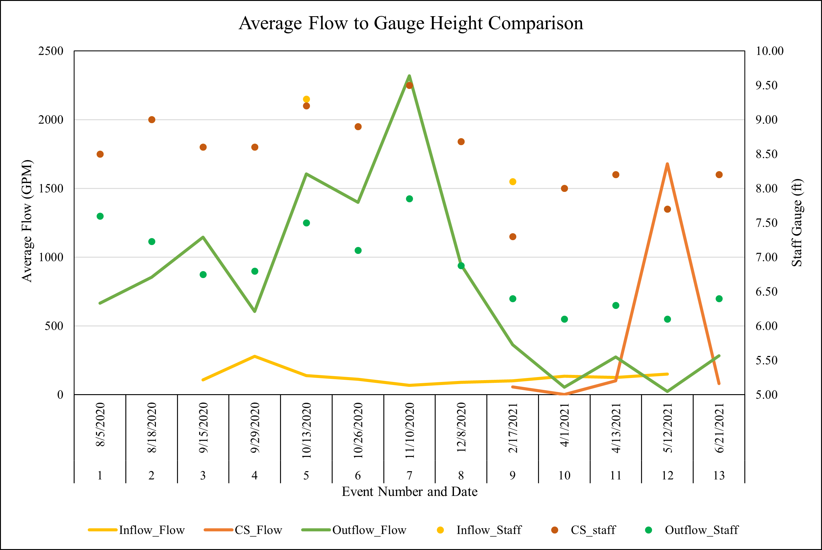

￼

Field & Depth Measurements

Field and depth measurements recorded during the monitoring events are summarized in Appendix C. The field sheets can be found in Appendix D. The average recorded field measurements, all sample depths combined, are described in Table 4. Field measurement data not bracketed by acceptable calibrations or verifications, and data collected during Event 12, are excluded from the average calculations. The average recorded depth measurements are described in Table 5.

TABLE 4: WILLOUGHBY CREEK STA AVERAGE FIELD MEASUREMENTS

Site | Location | Temp.  (°C) | SpC (mS/cm) | Salinity (PSS) | pH | DO  (mg/L)
1 | Creek Inflow | 26.52 | 0.24 | 0.12 | 5.94 | 3.15
2 | Control Structure | 26.71 | 0.26 | 0.12 | 6.10 | 4.28
3 | Outflow Weir | 27.21 | 0.27 | 0.13 | 5.90 | 6.04
4 | Fairground Ditch | 24.07 | 0.09 | 0.01 | 5.39 | 7.15

TABLE 5: WILLOUGHBY CREEK STA AVERAGE DEPTH MEASUREMENTS

Site | Location | Secchi Depth (m) | Total  Depth (m) | Sample Depth (m) | Staff Gauge Reading (ft)
1 | Creek Inflow | 0.78 | 0.99 | 0.54 | 8.63
2 | Control Structure | 0.44 | 2.47 | 1.21 | 8.56
3 | Outflow Weir | 0.69 | 0.92 | 0.50 | 6.91
4 | Fairground Ditch | 0.15 | 0.15 | 0.15 | N/A

Analyte Values

Samples were analyzed for Total Phosphorus (TP), Total Nitrogen (TN), and Total Suspended Solids (TSS). TP and TN samples were not collected at the Creek Inflow during Event 2 (8/18/2020 and at the Control Structure during Event 12 (5/12/2021) as a result of autosampler failure. During Event 6, grab samples were collected for TP and TN at the Creek Inflow and Control Structure due to autosampler malfunctions. The results are summarized by analyte in Appendix E, and the laboratory reports can be found in Appendix F. Table 6 provides the average analyte value based on the thirteen (13) events, excluding Event 12 since total rainfall did not meet the criteria specified in the QAPP. Values analyzed but below Minimum Detection Limit (MDL), represented by a reported value of U, were treated as zero values in the calculations. The analyte values for the Fairground Ditch are based on a single event. Reduction values are calculated from the average nutrient loads for each site (excluding the ditch, which only had one data collection). Note that negative reduction values indicate an increase in an analyte.

TABLE 6: WILLOUGHBY CREEK STA AVERAGE ANALYTE VALUES

Site | Location | TP  (mg/L) | TN  (mg/L) | TSS  (mg/L)
1 | Creek Inflow | 0.088 | 0.740 | 12.3
2 | Control Structure | 0.046 | 0.693 | 5.5
3 | Outflow Weir | 0.045 | 0.614 | 5.6
4 | Fairground Ditch | 0.049 | 0.281 | 8.6
Reduction from Inflow to Control Structure |  | 0.042 | 0.047 | 6.8
Reduction from Control Structure to Outflow |  | 0.018 | 0.078 | -0.1
Reported Reduction from Inflow to Outflow |  | 0.043 | 0.126 | 6.7

4.0 CONCLUSION

The Willoughby Creek Stormwater Quality Improvement Project area is a 24.50-acre system which receives water from the 222-acre Willoughby Creek watershed and releases water back into Willoughby Creek to the east. To determine the effectiveness of the Stormwater Treatment Area in nutrient load reduction, water samples were collected and analyzed over thirteen (13) events from August 2020 to July 2021.

Dissolved oxygen improved as water moved through the system. The lowest DO values were typically recorded at the Inflow, with an average of 3.15 mg/L for all qualifying events combined, and the highest readings recorded at the Outflow, with an average of 6.04 mg/L, excluding Event 7 where the Fairgrounds ditch had higher DO.

A reduction in average TP, TN, and TSS nutrient values between the Inflow and Outflow was reported for all qualifying events combined. As outlined in the QAPP, the Total Maximum Daily Loads (TMDL) established for the St. Lucie Estuary are 0.081 mg/L for TP and 0.720 mg/L for TN. The average values for TP and TN at the Outflow (Site 3) were 0.045 mg/L and 0.614 mg/L, respectively, below the corresponding TMDLs. In addition, the average value for TSS at the Outflow was 5.6 mg/L, a reduction of 6.7 mg/L from the average value recorded at the Inflow.

The Grant Work Plan of the DEP Grant Agreement Number NS035 reported nutrient reduction expectations of 65% for TP and 37% for TN per year. When comparing average values, TP was reduced by 49% and TN by 17%. In addition, TSS was reduced by 54%, all qualifying events combined. This indicates that the STA is trending toward effectiveness. With the continued growth of wetland vegetation, and the development of more natural chemical and biological processes throughout the project area, nutrient levels can be expected to decrease even more over time.

