Documentation in Support of Category 4e

Waterbody/Watershed Identification
 | Organization | Florida Department of Environmental Protection
 | Point of Contact | Kevin O’Donnell, 2600 Blair Stone Rd Tallahassee, FL 32399  Kevin.odonnell@floridadep.gov, (850) 245-8469
 | Waterbody(s) | WBID 8037D – Gulf of Mexico (Cedar Key)
 | No. Waterbody / Pollutant Combinations | WBID 8037D – Nutrients (Chlorophyll-a)
 | EPA Completed TMDL | EPA has not completed a TMDL for the impaired waterbody segment listed in this document.
Description of Baseline Conditions
 | Watershed(s) | Suwannee – Group 1  FDEP Northeast District  WBID 8037D – Gulf of Mexico (Cedar Key)
 | Baseline Data | Group 1 Cycle 4 – IWR Run 56, 2018  (Verification Period: January 1, 2011, through June 30, 2018)  8037D - Nutrients (Chlorophyll-a)  Estuary Nutrient Criterion (ENRX15): AGM ≤ 10.9 µg/L, annual geometric mean chlorophyll-a values exceeded the criterion in 2011, 2014, and 2015, with values of 18.2 µg/L, 13 µg/L, 11.7 µg/L respectively.  8037D - Nutrients (Total Nitrogen)  Estuary Nutrient Criterion (ENRX15): AGM ≤ 0.79 mg/L, annual geometric mean total nitrogen values exceeded the criterion in 2011 with a value of 0.86 mg/L.  8037D - Nutrients (Total Phosphorus)  Estuary Nutrient Criterion (ENRX15): AGM ≤ 0.06 mg/L, annual geometric mean total phosphorus values exceeded the criterion in 2011 with a value of 0.073 mg/L.  Stations used in the Nutrient Assessment:  21FLA 23020031, 21FLWQA 30SEAS053, 21FLWQA 30SEAS712, 21FLWQA 30SEAS118, 21FLWQA 30SEAS702, 21FLWQA 30SEAS111, 21FLWQA 30SEAS710, 21WQSPWACASAS1, 21FLA 23021011, 21FLA 23021012, 21FLWQA 30SEAS080, 21FLWQA 30SEAS715  See table below for a baseline water quality data summary for the Group 1 Cycle 4 Verified Period.  Below is a map displaying the stations with nutrient data that were used during the assessment to determine impairment. The same stations displayed in the map will be used to determine progress towards attaining water quality standards.
  Nutrient AGMs - Verified Period
  Year | CHLAC (µg/L) | TN (mg/L) | TP (mg/L)
  2011 | 18.2 | 0.86 | 0.073
  2012 | 6.8 | 0.59 | 0.037
  2013 | 5.6 | 0.51 | 0.031
  2014 | 13 | 0.61 | 0.048
  2015 | 11.7 | 0.67 | 0.059
  2016 | 6.7 | 0.51 | 0.038
  2017 | 8.5 | 0.59 | 0.042
 | Map | 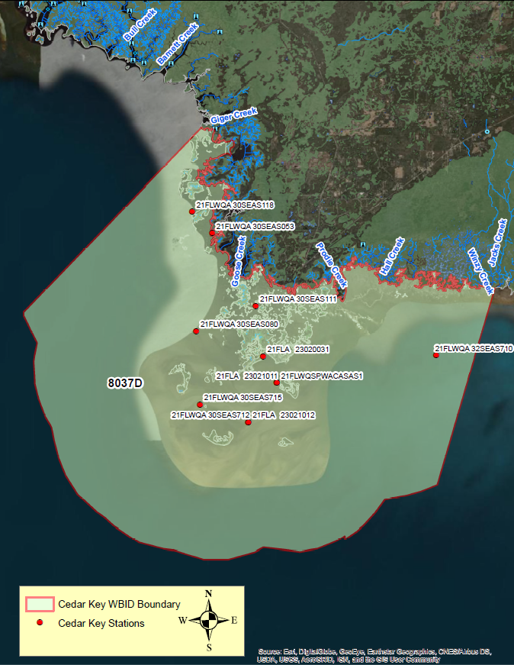

Evidence of Watershed Approach
 | Area of Effort | The Cedar Key watershed (WBID 8037D) is located in the Southern, coastal portion of Levy County, near the city of Cedar Key, and has an area of roughly 119 square miles. The Cedar Key watershed is located roughly 6 miles southeast of the mouth of the Suwannee River. The activities outlined in The Suwannee River Basin Management Action Plan (BMAP), as well as the hydrologic modification project happening within the Cedar Key watershed will address the nutrient impairment within this waterbody. The Suwannee River BMAP area comprises three sub-basins (Lower Suwannee River, Middle Suwannee River, and Withlacoochee River) and encompasses 1,323,662 acres in eastern Dixie, eastern Madison, western Hamilton, northeast and eastern Lafayette, western Levy, western Gilchrist, small pockets of Taylor and Columbia counties, and the majority of Suwannee County. Population centers within the BMAP include Live Oak and Branford in Suwannee County, Mayo in Lafayette County, Bell and Trenton in Gilchrist County, Fanning Springs in Gilchrist and Levy counties, Chiefland in Levy County, and Madison, and Lee and Madison County. Population centers within the Cedar Key watershed include the City of Cedar Key and the City of Chiefland  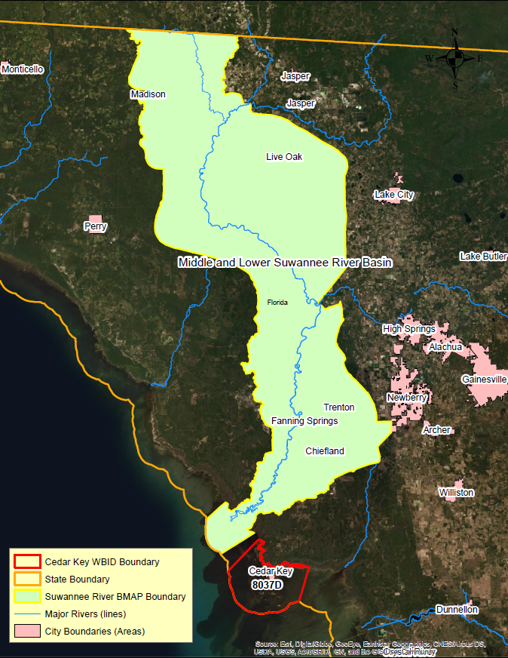
 | Key Stakeholders Involved and Their Roles | The Florida Department of Environmental Protection adopted the Suwannee River BMAP by Secretarial Order in June 2018, as part of its statewide watershed management approach to restore and protect Florida's water quality. The plan was developed in coordination with stakeholders, identified below, with participation from affected local, regional, and state governmental interests; elected officials and citizens; and private interests. However, this BMAP has not yet gone into effect pending legal challenges.  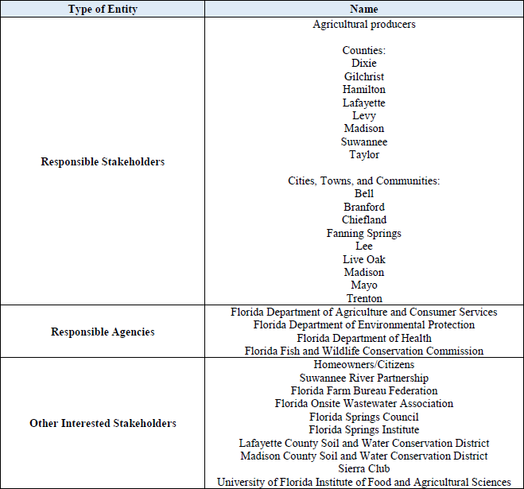  Specifically, the restoration efforts included in this document, within the Cedar Key watershed, were developed with coordination from local stakeholders. These entities include Levy County, the City of Cedar Key, the U.S. Fish and Wildlife Services, the Suwannee River Water Management District, and the University of Florida Institute of Food and Agriculture Sciences.
 | Watershed Plan & Other Supporting Documentation | The area includes the drainage area from the Suwannee River watershed, where extensive restoration efforts are taking place. WBID 8037D is impaired for Nutrients (Chlorophyll-a) based on the annual geometric means for nutrients. The objectives outlined by the Suwannee River BMAP will address this impairment.  Station 21FLWQA 32SEAS710 is located on the East side of WBID 8037D and is the farthest stations away from the mouth of the Suwannee River. This station has nutrient averages that are half that of station 21FLWQA 30SEAS118. Station 21FLWQA 30SEAS118 is located on the West side of WBID 8037D and is the station closest to the mouth of the Suwannee River. This difference in nutrient concentrations can, in part be attributed to the influence of the nutrient load coming from the Suwannee River. Below is a table displaying the nutrient averages for the above-mentioned stations, showing that the concentrations are not distributed evenly and are instead driven by spatial factors.  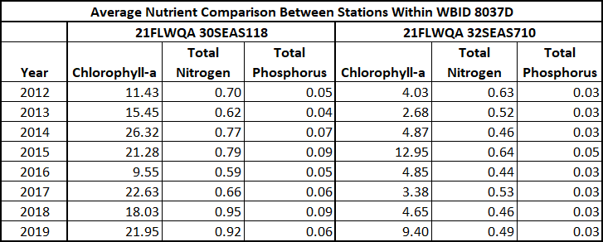  Cedar Key (WBID 8037D) encompasses a relatively small area compared to the upstream Suwannee River watershed. When looking at nutrient concentrations across the Cedar Key watershed, it is clear that a large portion of the nutrient loads are coming from sources outside the WBID boundary. There is only one active permit within the WBID and the landuse is roughly 93% water and 5.8% wetland. When looking at the magnitude of potential sources, the nearby Suwannee River and the entirety of its 1.3-million-acre watershed stand out as a potentially significant source. Therefore, reductions in nutrients from the upstream Suwannee River are expected to result in nutrient reductions in the downstream waters of Cedar Key.
 | Point Sources and Indirect Source Monitoring (Sites) | There is one wastewater facility within this watershed. The facility name is Cedar Key WRF and the permit number is FL0031216.  There is no Municipal Separate Storm Sewer System (MS4) permit for this area.  Note: Generic Permits for stormwater discharge from large and small construction activities are considered temporary; therefore, are not included in this listing.
 | Nonpoint Sources | The land use breakdown for the Cedar Key watershed is as follows:  Urban and Built-Up – 0.58%  Agriculture – 0.00%  Rangeland – 0.07%  Upland Forest – 0.12%  Water – 93.39%  Wetlands – 5.80%  Barren Land – 0.01%  Transportation, Communication, and Utilities – 0.04%  Special Classifications – 0.00%  The anthropogenic land use component is approximately 0.61%  Wastewater Facilities in Area:  Cedar Key WRF - FL0031216  Solid Waste Facilities in area:  There are no solid waste facilities within this WBID  It was determined that displaying land use percentages for the upstream contributing watershed was the most meaningful depiction of the Cedar Key watershed characteristics because Cedar Key is a coastal waterbody that is proximate to the mouth of the Suwanee River, and the Suwanee River is responsible for most of the nutrient loading to Cedar Key.  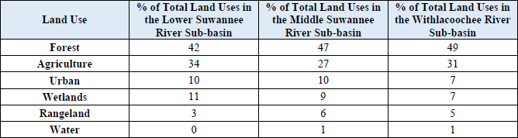  Based on the Nitrogen Source Inventory Loading Tool (NSILT) estimates, the below pie charts depict the estimated percentage of nitrogen loading to groundwater by source in the springshed for each sub-basin. Farm fertilizer (FF) and livestock waste (LW) (mainly from dairies and beef cattle cow-calf operations) are responsible for more than 85% of the nitrogen sources in each springshed.  Loading by source in the Lower Suwannee River Springshed  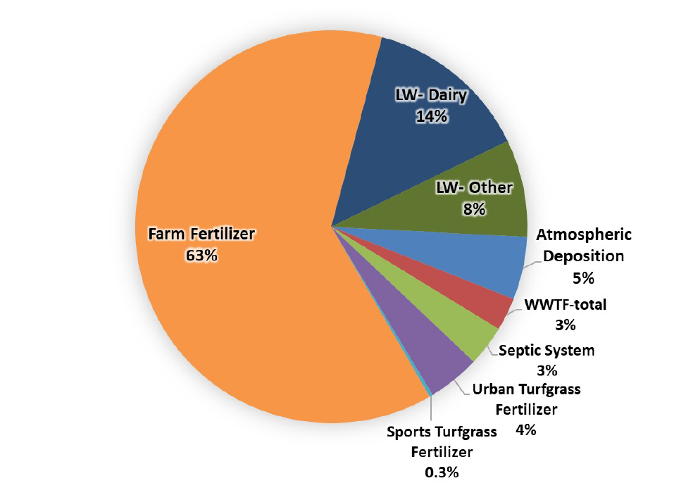  Loading by source in the Middle Suwannee River Springshed  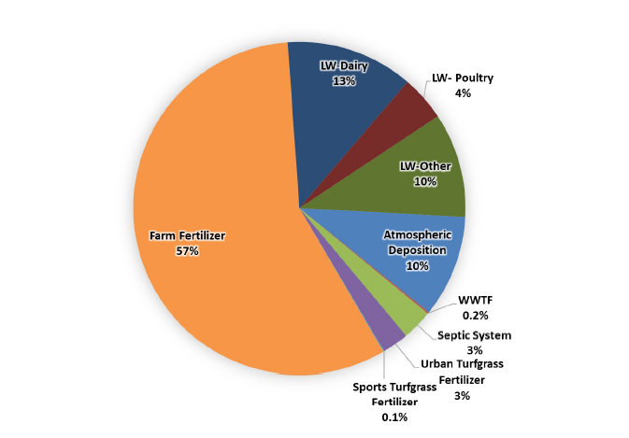  Loading by source in the Withlacoochee River Springshed  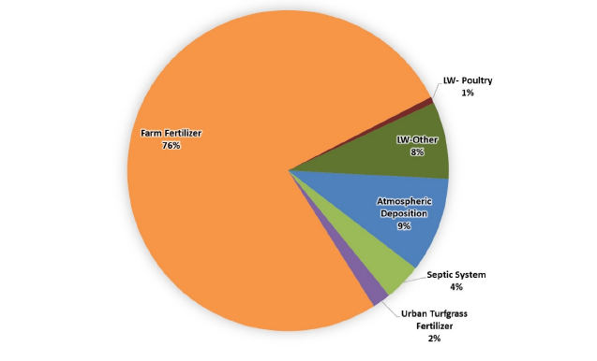
 | Water Quality Criteria | It is expected that the Class III Coastal (ENRX15) water quality standards for Chlorophyll-a will be attained upon implementation of the Cedar Key hydrologic restoration project, as well as the specified upstream watershed improvement projects (outlined in the BMAP) reducing nutrients from the sources listed above.
 | Restoration Work | The restoration work outline in this section, is two-fold. There is an extensive hydrologic modification project that is in the final engineering phase, that is aimed at facilitating a more natural estuarine balance of the local waters by providing a more natural flow exchange between the estuarine waters of the Suwannee Sound and its numerous freshwater tributaries. The second part of the restoration efforts are in conjunction with the Lower Suwannee River Basin Management Action Plan (BMAP). This is an extensive effort aimed at reducing nutrient loads to groundwater and ultimately area springs, as well as nutrient loads exiting the Suwannee River by targeting sources throughout the watershed.  Area Hydrologic Modifications:  The overarching goal of the project is to restore the estuarine balance of the system by providing a more natural flow exchange between the estuarine waters of Suwannee Sound and its numerous freshwater tributaries. The 194 miles of roads and trails developed for the commercial timber industry across the 53,000-acre Lower Suwannee River Wildlife Refuge serve as dikes and lateral diversions altering the natural flow patterns and restricting the flow of freshwater in ways suspected of truncating the salinity gradient of tidal creeks and concentrating Sound salinity during dry periods.  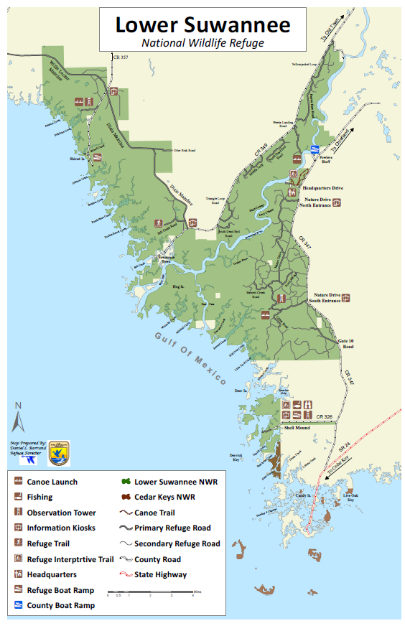  Although, the goal of this project is not necessarily to restore pre-development hydrologic conditions, the removal of these roads will lead to a more natural flow regime and will facilitate the natural delivery of fresh water from the Refuge to the estuary to benefit and enhance ecological functions. The added offshore flow will help restore tidal flushing, which, in-turn will help reduce elevated nearshore nutrient concentrations. In addition to hydrologic alterations associated with the Refuge road network, portions of the bottomlands and flatwoods within the Refuge were utilized for logging and commercial silviculture prior to public ownership and as such, many historically wet areas were bedded and have drag scars also contributing to altered overland flow paths. Approaches meeting the prime objectives that also improve the terrestrial hydroecology of the refuge are desired, but palustrine habitat restoration is a secondary priority.  The project proposes to develop hydrologic restoration and enhancement alternatives using proven methodologies, existing data including LiDAR, and working with the Suwannee River Water Management District (SRWMD) and the USFWS National Wildlife Refuge (NWR) Team. The project includes online data collection, field reconnaissance, development of a GIS modeling database, existing and proposed hydrologic modeling, and development of restoration alternatives with associated modeling and preparation of design concepts.  The figure below shows the project area, broken down into sub-basins that were used in the hydrologic model.  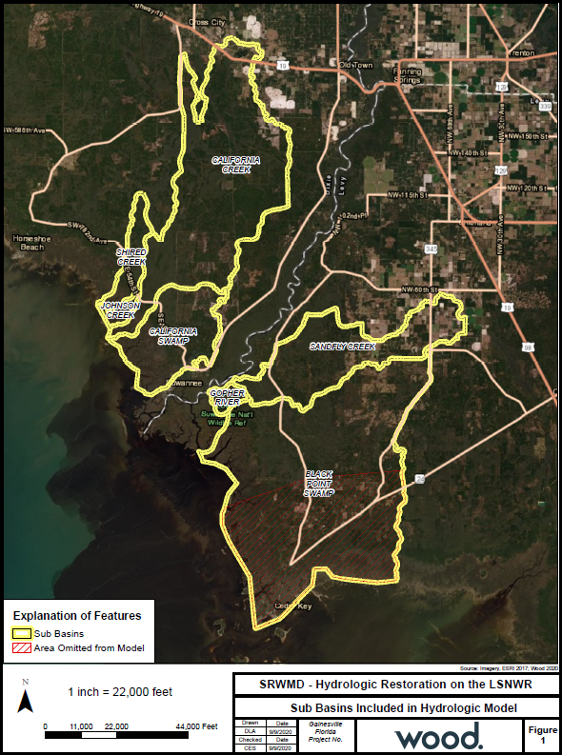  The considered alternatives will restore to the greatest extent practicable hydrologic conditions in the Refuge. The Dixie Mainline will receive special consideration because of its dual use as a public road used for evacuations. The scope does not include designing improvements for the Dixie Mainline Road to meet hurricane evacuation-route standards. There will be close coordination with Refuge and District staff and other interested parties regarding the desired level of service of public access roads and Refuge maintenance roads when considering road removal versus treatments allowing continuity of access.  This project was initiated 3 years ago, however, a scope of work was recently received and a Notice to Proceed on the Engineering and Design part of the project was just completed.  Although, the benefits of such an extensive project are far-reaching and will be measured for years to come, some of the anticipated benefits are, this project will restore, in part, the natural hydrologic connection from the refuge to the coastal waters by breaching or improving the under-road conveyance of sheet flow. This will improve the estuarine conditions/balance of the nearshore waters including Suwannee Sound, improve water conveyance especially in drought conditions, and minimize our maintenance costs of repairing flood eroded roads, culverts, etc., and limit the days we have to close the refuge due to flooding.  Basin Management Action Plan Activities:  In addition to the hydrologic restoration project outlined above, The management strategies and watershed improvement projects are listed in table B-1 of the Suwannee River BMAP located at the following link https://floridadep.gov/sites/default/files/Suwannee%20Final%202018.pdf. The management strategies are ranked with a priority of high, medium, or low. In 2016, the Florida Legislature amended the Watershed Restoration Act (Section 403.067, F.S.), creating additional requirements for all new or revised BMAPs. BMAPs must now include planning-level details for each listed project, along with their priority ranking.  Project status was selected as the most appropriate indicator of a project’s priority ranking based primarily on the need for funding. Projects with a "completed" status were assigned a low priority. Projects classified as "underway" were assigned a medium priority because some resources have been allocated to these projects, but additional assistance may be needed for the project to be completed. High priority was assigned to projects listed with the project status "planned" as well as certain "completed" projects that are ongoing each year (any project with one of these project types: "street sweeping," "catch basin inserts/inlet filter cleanout," "public education efforts," "fertilizer cessation," "fertilizer reduction," or "aquatic vegetation harvesting"), and select projects that are elevated because substantial, subsequent project(s) are reliant on their completion.

Critical Milestones/Monitoring
 | Anticipated Critical Milestone(s) and Completion Dates: |  | Below is an anticipated, upcoming timeline for the Cedar Key hydrologic modification project.  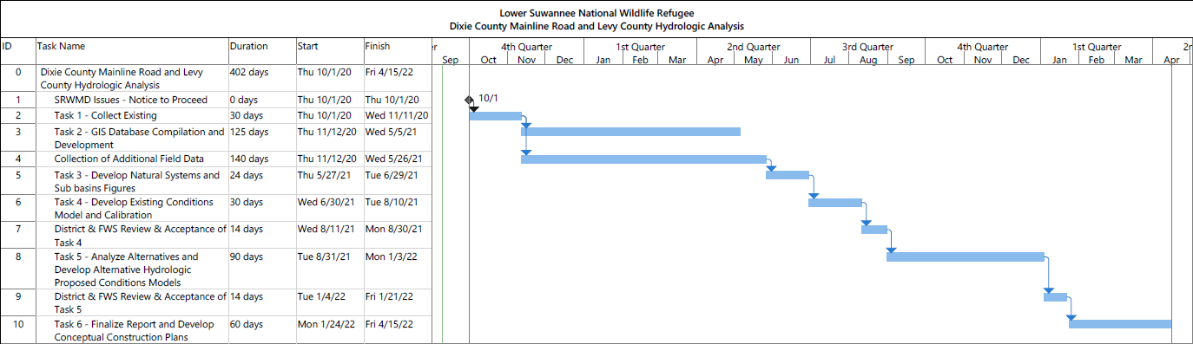  Additionally, the implementation schedule of restoration projects restoring the Cedar Key watershed is driven by the BMAP implementation process. This plan defines nitrogen reduction milestones for 5-year (30%), 10-year (50%), and 15-year (20%) implementation, so that the TMDLs will be met no later than the 20-year goal. Further, the total reductions and project credits may be adjusted under the adaptive management approach used for the BMAP. This approach requires regular follow-up to ensure that management strategies are carried out and that their incremental effects are assessed. This process acknowledges that there is some uncertainty associated with the outcomes of proposed management strategies and the estimated response of concentration at the springs. As more information is gathered and progress towards each 5-year milestone is reviewed, additional management strategies to achieve the TMDLs will be developed or existing strategies refined to better address the sources of nutrient loading.  The overall load reduction targets set within the BMAP are 30% of the total within 5 years, 80% of the total within 10 years, and 100% of the total within 15 years. DEP will evaluate progress towards these milestones and will report to the Governor and Florida Legislature. DEP will adjust management strategies that reduce loading to the aquifer to ensure the target concentrations are achieved.  The below table lists the estimated nitrogen reduction schedule for the BMAP area, by milestone. Progress will be tracked yearly, and adjustments made as needed. At the 5-year milestone, progress will be assessed, and load reductions adjusted as necessary. Entities have flexibility in the types and locations of projects as long as they achieve the overall required load reductions.  Below is a table displaying the nitrogen reduction schedule (lb-N/yr)  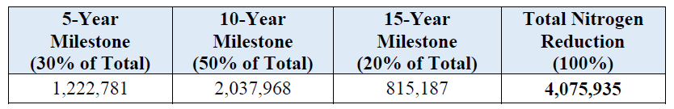  Listed below is a summary of potential credits for the Suwannee River BMAP to meet the TMDL.  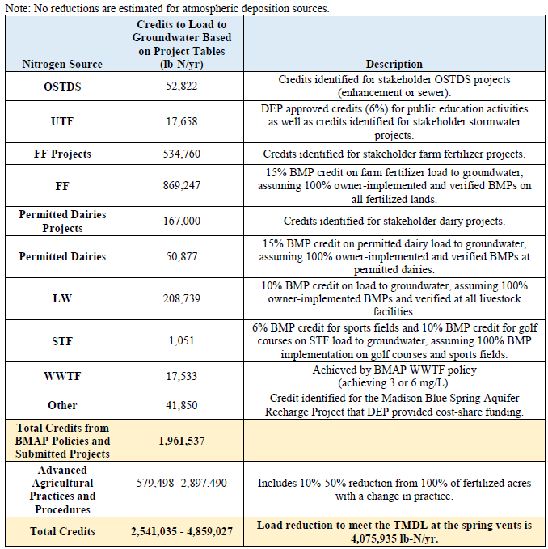  Methods for Evaluating Progress  DEP will work with stakeholders to track project implementation and organize the monitoring data collected each year. The project and monitoring information will be presented in an annual update. Stakeholders have agreed to meet annually after the adoption of the BMAP to follow up on plan implementation, share new information, and continue to coordinate on TMDL restoration-related issues. The following activities may occur at annual meetings:  Implementation data and reporting:  • Collect project implementation information from stakeholders, including FDACS agricultural BMP enrollment and FDOH-issued permits, and compare with the BMAP schedule.  • Discuss the data collection process, including any concerns and possible improvements to the process.  • Review the monitoring plan implementation  Sharing new information:  • Report on results from water quality monitoring and trend information.  • Provide updates on new management strategies in the basin that will help reduce nutrient loading.  • Identify and review new scientific developments on addressing nutrient loads and incorporate any new information into annual progress reports.  Coordinating on TMDL restoration–related issues:  • Provide updates from DEP on the basin assessment cycle and activities related to any impairments, TMDLs, and BMAP.  • Obtain reports from other basins where tools or other information may be applicable to the Suwannee River Basin TMDLs.  Adaptive Management Measures:  Adaptive management involves making adjustments in the BMAP when circumstances change or monitoring indicates the need for additional or more effective restoration strategies. Adaptive management measures may include the following:  • Implementing procedures to determine whether additional cooperative strategies are needed.  • Using criteria/processes for determining whether and when plan components need revision because of changes in costs, project effectiveness, social effects, watershed conditions, or other factors.  • Revising descriptions of stakeholders' roles during BMAP implementation and after BMAP completion.  • Updating information on corrective actions (and any supporting documentation) being implemented as data are gathered to refine project implementation schedules and performance expectations.  Key components of adaptive management are to share information and expertise include tracking plan implementation, monitoring water quality and pollutant loads, and holding periodic meetings.
 | Monitoring Component |  | Focused objectives are critical for a monitoring strategy to provide the information needed to evaluate implementation success. Since the BMAP implementation involves an iterative process, the monitoring efforts are related to primary and secondary objectives. The primary objectives focus on achieving water quality targets, while the secondary  objectives focus on water quality parameters that can be used to provide information for future refinements of the BMAP. The monitoring strategy may be updated as necessary.  Primary objectives:  • Measure the water quality and biological response in the impaired springs, river, and/or groundwater at the beginning of the BMAP period and during implementation.  • Document nutrient trends in the Suwannee River Basin and associated springs and groundwater.  • Focus BMP efforts by using water quality results combined with appropriate project information and land use in conjunction with statistical and spatial analysis tools.  Secondary objectives:  • Identify areas where groundwater data and modeling might help in understanding the hydrodynamics of the system.  • Confirm and refine nutrient removal efficiencies of agricultural and/or urban BMPs.  • Develop an advanced BMP implementation plan.  • Identify and implement more effective nutrient reduction strategies.  • Use nitrogen isotope and tracer sampling for evaluating nitrogen contributions from organic and inorganic sources.  Water Quality Parameters, Frequency, and Network  To achieve the objectives listed above, the monitoring strategy focuses on two types of indicators to track improvements in water quality: core and supplemental. The core indicators are directly related to the parameters causing impairment in the river or associated springs. Supplemental indicators are monitored primarily to support the interpretation of core water quality parameters. The monitoring network is established for a variety of purposes.  For this BMAP, nitrate is considered to be the core parameter measured, to track progress in decreasing nitrogen concentrations in groundwater and the water surfacing at the spring vents. By reducing nutrients (nitrogen and phosphorus) concentrations throughout the BMAP watershed, the nutrient load flowing downstream within the Suwannee River will be greatly reduced. With this reduction, the nutrient load entering the nearshore waters at the mouth of the Suwannee River (including the waters adjacent to Cedar Key) will also be reduced. With these anticipated reductions, the concentrations of the response variable (chlorophyll-a) will also be reduced. The other parameters are considered supplementary parameters for the BMAP, as they build information about groundwater and the spring but are not direct measurements of impairment.  At a minimum, the core parameters will be tracked to determine the progress that has been made towards meeting the TMDLs and/or achieving the NNC. Resource responses to BMAP implementation may also be tracked. A significant amount of time may be needed for changes in water chemistry to be observed.  Below are tables, listing of core and supplemental parameters that will be monitored through the BMAP.  Core Water Quality Indicators  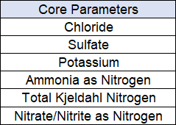  Supplemental Water Quality Indicators and Field Parameters  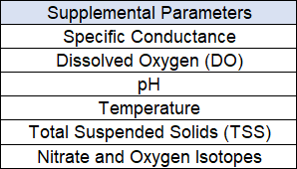  Biological Response Measures  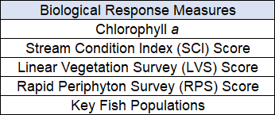  Initially, data from the ongoing sampling effort being conducted by SRWMD will be used to determine progress towards the primary objectives. Surface water and groundwater monitoring network locations were selected to track changes in water quality and allow the annual evaluation of progress toward achieving the TMDL. The below figure shows the locations of the river and spring stations currently being sampled that will be used for the BMAP monitoring in the Suwannee River Basin.  The secondary (research) objectives will be developed based on the results of the actions occurring in the adjoining Santa Fe Basin Restoration Focus Area (RFA). The number and location of the monitoring wells to be sampled or installed will be determined after the initial effort in the Santa Fe Basin RFA provides information on the state of the system and where additional monitoring might be most effective. DEP and SRWMD will be responsible for activities to satisfy secondary monitoring objectives.  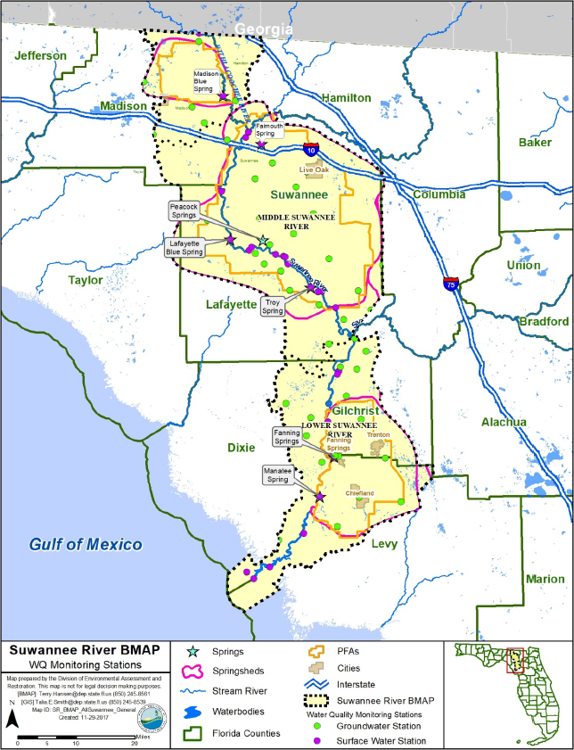
Other Key Dates
 | Estimated Date for Delisting from Verified List or Removal from Study List | WBID 8037D is in the state’s Group 1 Basin in the DEP Northeast District. The current review and assessment cycle (the initial biennial assessment) is scheduled for completion in 2022. This waterbody is currently impaired for nutrients (chlorophyll-a) and the earliest opportunity for delisting would happen during the upcoming biennial assessment. However, if this WBID doesn’t meet delisting requirements, it will remain in assessment category 4e, which will postpone TMDL development.

Financial Commitments

 | Estimated Implementation Cost | For a list of funding sources and amounts, displayed by project, see Appendix B in the Suwannee BAMP document (link provided above). Possible load reductions include projects resulting from policies for owner-implemented best management practices (BMPs) for farm fertilizer, dairy waste, and other livestock waste; wastewater treatment facility (WWTF) upgrades; policies to reduce urban turfgrass fertilizer (UTF) application; and voluntary onsite sewage treatment and disposal system (OSTDS) enhancements or conversions to sewer.  Successful BMAP implementation requires commitment, dedicated state funding, and follow-up. Stakeholders have expressed their intention to carry out the plan, monitor its effects, and continue to coordinate within and across jurisdictions to achieve nutrient reduction goals. As the TMDLs must be achieved within 20 years, DEP, water management districts (WMDs), FDOH, and FDACS will implement management strategies using the annual Legacy Florida appropriation from the legislature of at least $50 million to reduce nitrogen in impaired OFS. DEP, working with the coordinating agencies, will continue to invest existing funds and explore other opportunities and potential funding sources for springs restoration efforts.  With these extensive upstream restoration efforts taking place, including commitments through intention and funding, it is anticipated that the water quality in and around the nearshore waters of Cedar Key will be improved. As stated, this is a long-term goal by several state and federal agencies to reduce nutrient loads and to help restore the area watershed (adjacent to Cedar Key) to a more natural flow regime.  The total project cost, including land acquisition, is not applicable.  The estimated 20-year operation and maintenance cost is not applicable.
 | Land Acquisition  (if applicable) | Maintaining land at lower intensity uses through land purchases or easements for conservation and recreational use is one strategy that can help reduce water quality impacts in the Suwannee River Basin. The below table identifies fee acquisitions and conservation easements acquired by SRWMD since Fiscal Year (FY) 2007−08 through the Florida Forever Program. These acquisitions are for the entire SRWMD jurisdiction, including the Suwannee River Basin.  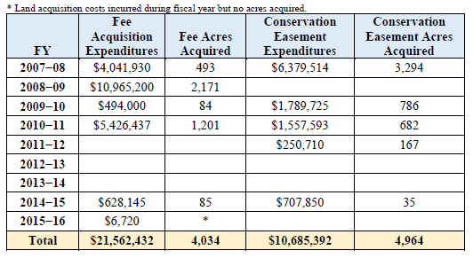  Funding Source:  Total……………………………………………………………………...$21,562,432
 | Design and Construction  (if applicable) | Funding Source:  Total……………………………………………………………………...$TBD
References:

“Suwannee River Basin Management Action Plan (Lower Suwannee River, Middle Suwannee River, and Withlacochee River Sub-basins)” by Florida Department of Environmental Protection. June 2018.

“task Work Assignment Regarding Hydrologic Restoration on the Lower Suwannee National Wildlife Refuge – Engineering and Design Phase” by Wood Environmental & Infrastructure Solutions, Inc. September 10, 2020.

