Documentation in Support of Category 4e for WBID 1537A: Lake Bonnet

Waterbody/Watershed Identification
 | Organization | City of Lakeland (COL) – Local Government Agency
 | Point of Contact | Laurie Smith, 407 Fairway Avenue, Lakeland, FL 33801, laurie.smith@lakelandgov.net, 863-834-6276
 | Waterbody(s) | WBID ID 1537A – Lake Bonnet
 | No. Waterbody / Pollutant Combinations | 1 waterbody segment; Verified and/or Impaired for Biology, Lead, and Nutrients (Total Nitrogen) on the Tampa Bay Tributaries Group 2/ Cycle 4 Verified List, and for Nutrients (Chlorophyll-a and Total Phosphorous) on the Tampa Bay Tributaries Group 2/ Cycle 3 Verified List.
 | EPA Completed TMDL | EPA has not completed a TMDL for the impaired waterbody segment listed in this document.
Description of Baseline Conditions
 | Watershed(s) | Basin Group 2, Tampa Bay Tributaries, Hillsborough River (HUC 03100205)
 | Baseline Data | The available Cycle 3 and 4 data for Lake Bonnet are provided below. Bioassessments, Sample Exceedances for Lead (Pb), and Annual geometric mean (AGM) Chlorophyll-a (CHLA), Total Nitrogen (TN), and Total Phosphorous (TP) were reviewed to assess verified impairments during the 2009 through 2012, and 2013 through 2020 Verified periods. The long-term true color and alkalinity geometric means were calculated to be 29.5 PCU and 44.2 mg/L, respectively, using the long-term period of record data from 2009 to 2020. Data were obtained from Impaired Waters Run 60.
  WBID | Waterbody Name | Parameter | Criterion Concentration or Threshold Not Met | Data*
  1537A | Lake Bonnet | Biology | Average score of at least two temporally independent LVI scores ≥ 43; or either of the two most recent LVI scores ≥ 43; or if there are only two LVI scores and there is less than or equal to a 20 point difference. | LVI (n=2)  WBID Mean (19)  Mean 1 (9), Mean 2 (29)
  WBID | Waterbody Name | Parameter | Criterion Concentration or Threshold Not Met | Data*
  1537A | Lake Bonnet | Lead | Pb ≤ e(1.273[lnH]-4.705) µg/L | 15/15**
  1537A | Lake Bonnet | Nutrients (CHLA) | ≤ 20 µg/L | AGMs#  2009 (134 µg/L)  2010 (94 µg/L)  2011 (156 µg/L)  2012 (144 µg/L)  2013 (82 µg/L)  2015 (138 µg/L)  2016 (149 µg/L)  2017 (97 µg/L)  2018 (102 µg/L)  2019 (91 µg/L)  2020 (84 µg/L)
  1537A | Lake Bonnet | Nutrients (TN) | Chl-a AGM ≤ 20 µg/L, TN AGM ≤ 1.91 mg/L;  If Chl-a has Insufficient or No Data to calculate AGM or if Chl-a AGM > 20 µg/L, TN AGM ≤ 1.05 mg/L | AGMs  2009 (3.78 mg/L)  2010 (3.00 mg/L)  2011 (4.98 mg/L)  2012 (4.33 mg/L)  2013 (2.99 mg/L)  2014 (2.81 mg/L)  2015 (4.15 mg/L)  2016 (4.27 mg/L)  2017 (3.46 mg/L)  2018 (3.29 mg/L) 2019 (1.87 mg/L)  2020 (3.05 mg/L)
  1537A | Lake Bonnet | Nutrients (TP) | Chl-a AGM ≤ 20 µg/L, TP AGM ≤ 0.09 mg/L;  If Chl-a has Insufficient or No Data to calculate AGM or if Chl-a AGM > 20 µg/L, TP AGM ≤ 0.03 mg/L | AGMs  2009 (0.26 mg/L)  2010 (0.20 mg/L)  2011 (0.28 mg/L)  2012 (0.27 mg/L)  2013 (0.24 mg/L)  2014 (0.20 mg/L)  2015 (0.31 mg/L)  2016 (0.15 mg/L)  2017 (0.24 mg/L)  2018 (0.25 mg/L)  2019 (0.15 mg/L)  2020 (0.21 mg/L)
  *Bolded values represent data used in the 2013 to 2020 verified period assessment. Non-bolded values either do not meet the data sufficiency requirements used by FDEP to verify impairment, or they represent data from previous verified impairment assessment periods.
  ** Verified Period (7.5 year period; beginning and ending date vary by group/cycle combination); Where data are presented as x/y, x represents the number of exceedances and y represents the total number of samples.
  #Data for 2014 were not available in IWR Run 60.
 | Map | Attachment 1 delineates the watershed area.

Evidence of Watershed Approach
 | Area of Effort | Lake Bonnet is located within the Hillsborough River watershed and the immediate contributing subwatershed to the lake is 770 acres in size. The lake is located within the Lakeland/Bone Valley Upland lake region of Florida. Lake Bonnet encompasses a surface area of approximately 79 acres and is located northwest of downtown Lakeland, in central Polk County, Florida. Maximum water depth is 13.1 feet, with an average water depth of 4.0 feet. Lake Bonnet’s western boundary is formed by the North Brunnell Parkway embankment. The water elevation in Lake Bonnet is controlled by an outfall structure, which discharges water beneath Brunnell Parkway to a canal that flows westward to Lake Blanton, and subsequently into Itchepackesassa Creek.
 | Key Stakeholders Involved and Their Roles | The City of Lakeland oversees Lake Bonnet assessment and restoration projects. The Florida Department of Economic Opportunity (DEO) recently issued a Notice of Intent to award the City of Lakeland $42.9 million for the restoration of Lake Bonnet and improvement of stormwater systems and drainage conveyances in the Lake Bonnet drainage basin to be implemented beginning in FY21 (please see Attachment 10). Bonnet Springs Park (BSP), a non-profit entity constructing a regional use public park on the eastern border of Lake Bonnet is also considered a stakeholder. BSP is constructing multiple stormwater retention and treatment facilities on the park property that will intercept and treat significant amounts of stormwater from the upgradient drainage basin prior to its discharge to Lake Bonnet. The Southwest Florida Water Management District (SWFWMD) and/or Florida Department of Environmental Protection (FDEP) may be involved in future restoration projects by providing cooperative funding.
 | Watershed Plan & Other Supporting Documentation | Impaired Waters Listing  The area includes the watershed drainage area from the Lake Bonnet watershed within 1537A. This WBID is impaired for nutrients (chlorophyll-a, TP, and TN), lead, and biology (LVI scores <43) based on the years the AGMs and sample sizes were exceeded during the Verified Periods (2009-2012 and 2015-2018).  Watershed Plan  The City’s overall Watershed Plan to restore Lake Bonnet includes a portfolio of large-scale projects to improve water quality in the lake. The City will focus on the implementation of structural and non-structural stormwater improvements in the watershed and in the lake, and will also include sediment and erosion control, stormwater quality improvement, sediment removal/inactivation, wetland fringe rehydration, aquatic vegetation enhancement, street sweeping and public education. The recommended projects from Wood’s 2018 Lake Bonnet Pollutant Source Reduction Feasibility Study report provided updated pollutant load estimates (both internal and external), identified the basins generating the highest stormwater pollutant load from stormwater drainage basins within the Lake Bonnet watershed, provided a bathymetric survey and geotechnical results, evaluated internal sediment loading, and estimated the groundwater quantity and quality contributions to the lake. The report proposed various stormwater best management practices (BMPs) and sediment restoration alternatives (further detail is provided in the Restoration Work Section). Laboratory analyses of stormwater and sediment samples as compared with historical surface water quality monitoring data indicated that internal nutrient cycling from sediment flux has a significant impact on water quality conditions in the lake.  Supporting Documentation  The sediment characterization and phosphorus fractionation study results from Wood’s Pollutant Source Reduction Feasibility Study found that Lake Bonnet sediments act as a considerable source for both nitrogen and phosphorus with an average load of 86,882 lbs/yr and 25,666 lbs/yr, respectively, which is contributed from the sediment to the water column via internal cycling driven by diffusive flux. Therefore, water quality restoration projects will also focus on sediment management alternatives such as chemical amendment and/or targeted sediment removal, in addition to addressing stormwater loads.
 | Point Sources and Indirect Source Monitoring (Sites) | There are 44 inputs that discharge to Lake Bonnet subwatershed, including 12 minor outfalls, four retention/detention outfalls, six stormwater discharges, 17 end of pipe inputs, and five major outfalls (please see Attachment 2). The majority of the existing residential developments within the watershed utilize sanitary sewer for wastewater treatment provided by the City of Lakeland.  The entire area is regulated by a MS4 permit # FLS000015-004, issued by FDEP to Polk County and co-permittee City of Lakeland.  Note: Generic Permits for stormwater discharge from large and small construction activities are considered temporary; therefore, are not included in this listing.
 | Nonpoint Sources | The southern and western banks of Lake Bonnet are lined with residential structures and roadways, while the northern and eastern banks are densely vegetated. The Lake Bonnet watershed consists mostly of residential and commercial land use (please see Attachments 3 and 4).  Land use in the surrounding areas of the lake has evolved over time. Areas north of the lake were formerly owned by CSX, and operated as a railway switchyard, refueling depot, and maintenance yard. This property is currently being redeveloped as Bonnet Springs Park. In the same general area, People’s Gas operated a coal gasification plant. Since both facilities have been decommissioned, the FDEP has designated the property as a Brownfield site.  The primary nonpoint sources of nutrients are internal sediment loading, stormwater runoff, and groundwater seepage inputs.  The stormwater runoff nutrient pollutant load into Lake Bonnet is one order of magnitude less for TP and two orders of magnitude less for TN than that compared to the nutrient load from the sediments, but the stormwater runoff impacts accumulate and are the source of internal legacy loads.
 | Water Quality Criteria | Lake Bonnet is a low-color lake with high alkalinity (lake assessment type 2). Based on the procedure for determining numeric nutrient criteria (NNC), outlined in Rule 62-302.531, F.A.C., the NNC for nutrients in Lake Bonnet are 20 ug/L, 0.03 – 0.09 mg/L, and 1.05 – 1.91 mg/L for chlorophyll-a, total phosphorus, and total nitrogen, respectively, which is anticipated to be achieved upon successful implementation of the Water Quality Restoration Plan noted above.
 | Restoration Work | Individual project locations, descriptions, cost and completion dates (actual and  anticipated) are included below and summarized in greater detail within Attachment 5.  Ongoing  - The City of Lakeland has a robust street sweeping program in place where the streets within the Lake Bonnet watershed are swept approximately once to twice per month; downtown Lakeland streets within the contributing drainage of Lake Bonnet are swept twice per week. See Attachment 6 for the current street sweeping routes and schedule.  - Polk County passed a Fertilizer Ordinance in 2013 which was adopted by the City of Lakeland. See Attachment 8 for ordinance document. Additional relevant City ordinances are provided at the end of this document for reference.  - The City regularly participates in educational and outreach events that provide education regarding stormwater pollution and lake ecology. The education and outreach program consists of public events, social and digital media, and school presentations:  - Public events such as the annual Green Celebration Earth Day event every April  - Annual Water, Wings & Wild Things educational event sponsoring more than 2,500 second grade students from Polk County  - School presentations to more than 10 classrooms annually as part of the Great American Teach in each November (K-5)  - Cardboard Boat Challenge and Lakes Festival attended by more than 500 participants each October  - Social Media (City of Lakeland Facebook and Instagram) posts featuring “Water Warriors Tuesday” and “Lakefront Friday” with 486,000 impressions in FY19 and up almost 300,000 in FY20  - The City has produced public service announcements featuring Toby’s Water Warriors (Toby the Turtle, Finn the Fish, Ollie the Otter, and Hope the Heron) highlighting the importance of healthy lakes and stormwater pollution prevention actions that are shown before each movie screening at Lakeland movie theaters, (as well as on multiple cable TV channels combining for more than 2,000,000 views annually  - Distribution of educational materials including educational activity books, Adopt a Lake, Living at the Lake, and Stormwater Pollution Prevention brochures (more than 1,000 pieces annually)  - The City has robust submerged and emergent aquatic plant management plans that include targeted removal of nuisance and invasive species and introduction of beneficial aquatic plants for water quality and shoreline protection.  - Employment of a City Environmental Code Enforcement Officer that focuses on stormwater pollution prevention and illicit discharge identification and elimination activities within City limits.  Completed  - City of Lakeland and Bonnet Springs Park (BSP) – Completed in 2021  - Multiple stormwater retention and treatment facilities were constructed on the BSP in 2021, totaling $9 million. These projects included the construction of stormwater retention ponds, wet meadows, a 7-acre constructed “lagoon”, and installation of a pollution control baffle box. The design of these facilities utilized and enhanced natural systems for storage and treatment of runoff entering the BSP property prior to discharging to Lake Bonnet.  - Lake Bonnet Bathymetric survey  - Lake Bonnet Submerged Aquatic Vegetation (SAV) survey  Planned  Specific pollutant load reductions were not calculated for the Lake Bonnet projects, but the cumulative effect of these projects will reduce nutrient loadings and will improve water quality of the subject waters.  The City of Lakeland has been awarded a $42.9 million grant for improvements to the Lake Bonnet Drainage Basin and the lake. This grant is administered by the Florida DEO as part of the Rebuild Florida Mitigation Infrastructure Program.  - Four restoration projects are planned within the Lake Bonnet Watershed with an estimated cost of $53 million. Several of the projects are expected to commence upon approval of the 4e application, while some are currently underway, with an estimated completion date of 2026. These projects will focus on improvement of surface water quality, habitats, stormwater treatment and attenuation, reductions in sediment transport from erosion, and focused sediment management. Specifically, the projects include the following components:  - Upstream stormwater enhancement and treatment  - In-lake water storage and quality improvement  - In-lake debris mitigation  - Natural systems restoration (rehydration of wetland fringe)  - Dredging and/or capping of sediments  - Submerged and emergent aquatic plant management  - Stormwater Infiltration Area design focused on recharging the surficial aquifer, raingarden projects

Critical Milestones/Monitoring
 | Anticipated Critical Milestone(s) and Completion Dates: |  | Additional information is contained within Attachment 5.  - Storage and Treatment of Off-Site Runoff – Completed February 2021  - Bonnet Springs Lagoon – In progress, with an anticipated completion date of June 2021  - Dredging and Habitat Restoration - Planned, with an anticipated completion date of 2024  - Drainage Retrofits - Planned, with an anticipated completion date of 2026  - In-Lake Debris Mitigation - Planned, with an anticipated completion date of 2026
 | Monitoring Component |  | Existing and ongoing City of Lakeland and Polk County Division of Natural Resources ambient water quality monitoring programs:  The City of Lakeland’s Lakes & Stormwater Division completes ambient monitoring of Lake Bonnet on a quarterly basis.  A list of parameters sampled, as part of the ambient monitoring program, is provided as Attachment 7.  Wood sediment flux sampling for City of Lakeland:  Between April 3, 2018 and April 9, 2018 four piston tube samples and 12 vibracore samples were collected from Lake Bonnet for geochemical testing. After review of the initial phosphorous fractionation data, intact sediment flux cores were collected on August 27, 2018, which were used to calculate sediment nutrient flux rates, internal loads and to assess the effectiveness of various treatment alternatives. In-situ measurements of pH, temperature, specific conductance, and dissolved oxygen were also collected in the lake at various depths to inform optimal lab test conditions. A full list of parameters can be found in Appendix B of the Lake Bonnet Pollutant Source Reduction Feasibility Study (Attachment 9).  City of Lakeland Phytoplankton Monitoring:  Phytoplankton samples are collected quarterly and analyzed for cyanobacteria. The City samples phytoplankton on a quarterly basis and data can be provided upon request.  SWFWMD water level monitoring program:  The SWFWMD records water levels monthly (since 2007) at Station 19072.
  Lake | Station | Start Date | End Date | Number of Samples
   |  |  |  | TN  (mg/L) | TP  (mg/L) | TSS  (mg/L) | ChlA (ug/) | ChlA C (ug/L)
  Lake Bonnet | COL Station 1 | 12/13/1988 | 11/17/2020 | 135 | 135 | 231 | 135 | 34
  Lake Bonnet | Bonnet-COL | 1/7/2014 | 11/17/2020 | 21 | 21 | 19 | 19 | 19
  Lake Bonnet | PCWRD Bonnet-COL | 9/19/2007 | 3/16/2021 | 26 | 49 | 26 | 44 | 44
Other Key Dates
 | Estimated Date for Delisting from Verified List or Removal from Study List | WBID 1537A (Lake Bonnet) is in the state’s Group 2 Tampa Bay Tributaries Basin. The current review and assessment cycle (the initial biennial assessment) is scheduled for completion in 2022. This waterbody is currently impaired for biology, lead and nutrients (chlorophyll-a, total nitrogen and total phosphorus) and the earliest opportunity for delisting would happen during the upcoming biennial assessment. However, if these parameters do not meet delisting requirements, they will remain in assessment category 4e for an additional biennial assessment cycle, which will postpone TMDL development.

Financial Commitments

 | Estimated Implementation Cost | Total Financial Commitment of Completed Projects $_9 million__.  Total Anticipated Ongoing /Planned Financial Commitments $_53.5 million___*  The estimated 20-year operation and maintenance cost is $_250,000____ (if applicable).  *The cost includes a $42.9 million CBDG-MIT Grant for FY21. Additional grant applications may be submitted for subsequent activities, including SWFWMD CFI and/or 319(h) Clean Water Act Section grants.
 | Land Acquisition  (if applicable) | Funding Source:  Total……………………………………………………………………...$__NA_____

References:

City of Lakeland Codes/Ordinances:
Code of the City of Lakeland, Ordinance no. 5080, Chapter 86, Section 86-3:
It shall be unlawful for any person to throw, spill, place deposit or leave, or cause to be thrown, spilled, placed, deposited or left, or to permit any servant, agent or employee to throw, spill, place deposit in or upon any street, highway, alley, sidewalk, park or other public place in the city any dirt, sweepings, filth, shells, garbage, vegetables, dead carcasses, sewage, slops excrement, compost, stable manure, ashes, soot, tin cans, rags, wastepaper, leaves, brush, weeds, grass, straw, hay, excelsior, shavings, barrels, crates, boxes, litter, or loose combustible material; materials subject to be carried by the wind, or unwholesome, noisome or putrescible matter of any kind.

Code of the City of Lakeland Land Development Regulations under Natural Resource Protection Regulations, Article no. 34.06.05.01:
Adequate measures of erosion control shall be established upon all applicable sites. Compilation of all features on site may necessitate unified measures of control. Adequate measure of control shall be defined as those needed to minimize or eliminate any transfer or removal of soil from a site during a rainfall event.

Code of the City of Lakeland, Chapter 86, Ordinance 5080 Section 86-4
It shall be unlawful for any person to allow any swill, slops or malodorous or noxious liquids to run, drop, or fall into or upon any sidewalk, street, alley, park, lake, stream, or other public place and it shall be unlawful for any person to allow any water, grease, or any slippery matter to fall, drop, or to be deposited upon any sidewalk, street, highway, or alley within the city.

MS4 Annual Report: ftp://ftp.dep.state.fl.us/pub/NPDES_Stormwater/Phase_I_MS4s/FLS000015_Polk_County/Lakeland/Permit%204%20Year%203%20Annual%20Report/

Attachments: Supporting Documentation
- Lake Bonnet Location Map
- Lake Bonnet Contributing Outfalls Map
- Lake Bonnet Land Use Map
- Land Use Description and Acreage Table
- City of Lakeland Completed & Planned Projects
- City of Lakeland Street Sweeping Route and Zones
- Water Quality Monitoring Program Sampled Parameters Table
- Polk County Fertilizer Ordinance (provided under separate cover as a .zip file)
- Wood 2018. Lake Bonnet Pollutant Source Reduction Feasibility Study (provided under separate cover as a .zip file)
- Florida DEO Notice of Intent to Award (provided under separate cover)

Attachment 1- Location Map
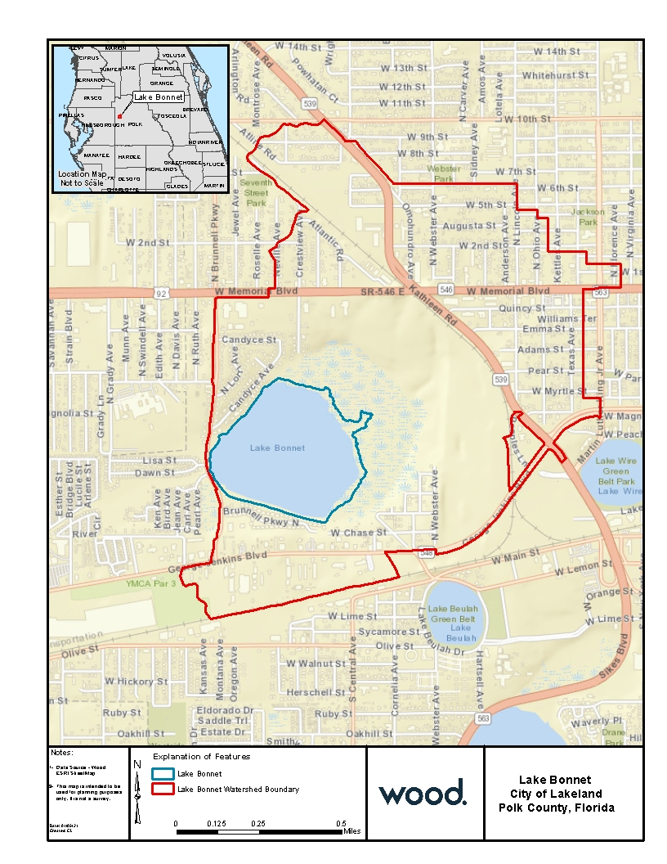

Attachment 2- Contributing Outfalls Map
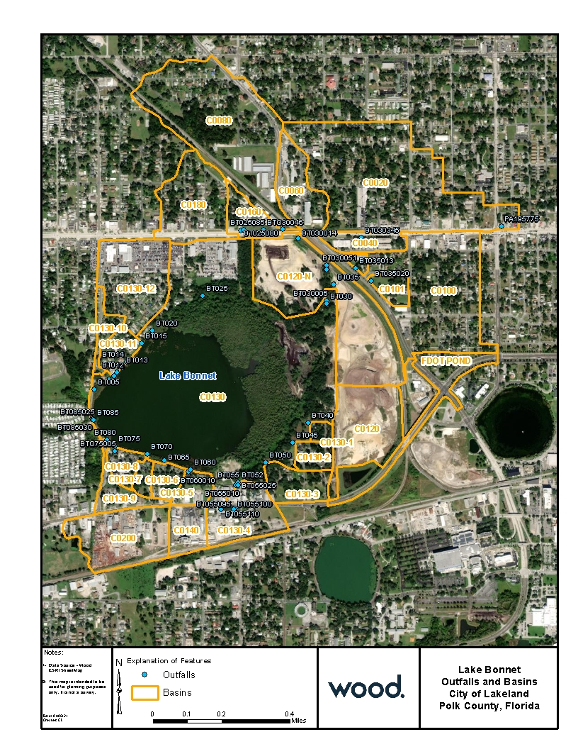

Attachment 3- Land Use Map
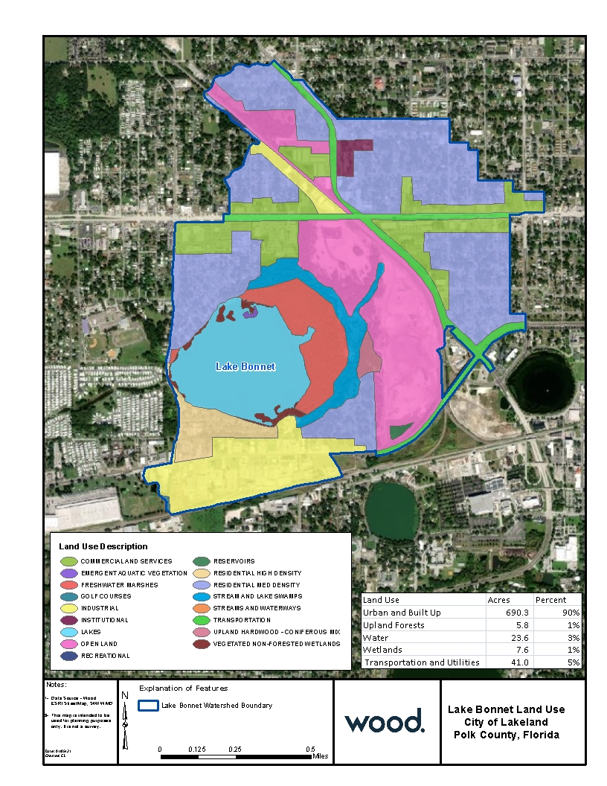

Attachment 4- Land Use Description Table

FLUCCS CODE | LAND USE DESCRIPTION | AREA (AC) | PERCENT
1200 | RESIDENTIAL MED DENSITY | 239.0 | 31.10%
1400 | COMMERCIAL AND SERVICES | 139.3 | 18.13%
1300 | RESIDENTIAL HIGH DENSITY | 84.7 | 11.02%
1700 | INSTITUTIONAL | 82.9 | 10.79%
1800 | RECREATIONAL | 77.6 | 10.10%
8100 | TRANSPORTATION | 41.0 | 5.33%
1900 | OPEN LAND | 38.0 | 4.95%
1500 | INDUSTRIAL | 28.8 | 3.75%
5300 | RESERVOIRS | 22.9 | 2.98%
4340 | HARDWOOD CONIFER MIXED | 5.8 | 0.75%
6410 | FRESHWATER MARSHES | 4.7 | 0.61%
6440 | EMERGENT AQUATIC VEGETATION | 2.3 | 0.30%
5200 | LAKES | 0.7 | 0.10%
6150 | STREAM AND LAKE SWAMPS (BOTTOMLAND) | 0.6 | 0.08%
TOTAL |  | 768 | 100.00%

Attachment 5

City of Lakeland Stormwater Projects in the Lake Bonnet Watershed
Completed / In Progress Projects
Project Name | Description |  | Cost | Restoration Activity |  | Completion Date
Storage and Treatment of Off-Site Runoff | The existing culvert entering the site under Kathleen road was extended and connected to a pretreatment device and then to a series of wet meadows and wet ponds where the runoff is stored and treated before reaching Lake Bonnet. |  | $6,800,000 | Implement pre-treatment devices and a series of wet meadows/marshes and wet ponds to provide storage and reduce runoff. Utilizing natural systems for storage and treatment |  | February 2021
Bonnet Springs Lagoon | Where Bonnet Springs meets the existing forested wetland, a new open water “lagoon” feature will be created to provide extra storage and treatment in Lake Bonnet |  | $2,200,000 | Additional storage will aid in reducing runoff from offsite, provide additional treatment, and reduce flooding |  | June 2021
Attachment 5 (cont’d)

Planned Future Projects
Project Name | Description |  | Cost | Restoration Activity | Estimated Completion Date
Dredging and Habitat Restoration | Rehabilitate the wetlands and Lake Bonnet by implementing innovative in-lake sediment trap technology to cost effectively remove the nutrient rich muck and restore groundwater and surface water hydraulics of the system |  | $23,250,000 | Water quality improvement through nutrient removal | 2024
Drainage Retrofits | Implement a combination of stormwater drainage improvements to the system |  | $20,000,000 | Additional water quality benefits will be evaluated and incorporated as feasible | 2026
In-Lake Debris Mitigation | Harvesting of algae in the lake to reduce bio debris. Implementation of a pump and treat system to remove nutrients from the water |  | $10,250,000 | Mitigation of nutrients reducing the potential for HABs in the lake, and improving lake water clarity to support restoration of natural aquatic plants | 2026

Attachment 6- Street Sweeping Routes and Zones
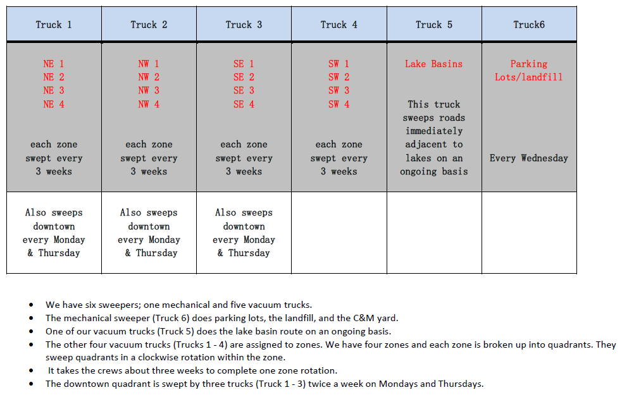

Attachment 6- Street Sweeping Routes and Zones

Attachment 7- Water Quality Monitoring Program Parameters

Ambient Monitoring Program Sampled Water Quality Parameters
Alkalinity, Total
Chloride
Chlorophyll a, corrected for pheophytin
Chlorophyll-a, uncorrected for pheophytin
Dissolved Oxygen
Hardness, Ca + Mg
Iron
Magnesium
Nitrogen, ammonia (NH3) as NH3
Nitrogen, Kjeldahl
Nitrogen Oxides (NOx)
Total Nitrogen (TN)
pH
Phosphorus as P
Phosphorus, orthophosphate as P
Secchi disk depth
Sodium
Specific conductance
Sulfur, sulfate (SO4) as SO4
Temperature, water
Total Suspended Solids (TSS)
True Color
Turbidity

