ATTACHMENT B

G-3273 Constraint relaxation and s-356 field test
DRAFT OPERATIONAL STRATEGY

Prepared by
Department of the Army
Jacksonville District Corps of Engineers

October 2012

FIELD TEST Operational STRATEGY

This field test is a separate and parallel action from Everglades Restoration Transition Plan (ERTP), which is, at this time, the successor of the Interim Operational Plan for Protection of the Cape Sable Seaside Sparrow (IOP) 2006. Implementation of ERTP is expected October 2012. The 1st year of the field test will include maintaining the current 7.5 ft NGVD maximum operating limit in the L-29 Canal while incrementally relaxing the G-3273 constraint and utilizing S-356 for control of potential increased seepage. Information obtained from this field test, if successful with achievement of field test goals and objectives, is planned to be used to support subsequent consideration of further incremental modifications to the current ERTP operations to allow higher maximum stages in the L-29 canal, increased flow eastward to North East Shark River Slough (NESRS) from Water Conservation Area 3A (WCA-3A) following completion of the Modified Water Deliveries to Everglades National Park (MWD) Tamiami Trail Modifications (TTM) Project component, and adjustments needed to the current 8.5 Square Mile Area (SMA) Project component Interim Operating Criteria (2011) during a 2nd year of the G-3273/S-356 field test.

The intent of this operational strategy is to utilize S-333, S-355A, S-355B and S-356 to best achieve the field test project objectives while maintaining the objectives of IOP 2006/ERTP. The WCA-3A Regulation Schedule (including Rainfall Plan), and the Interim Operating Criteria for the 8.5 SMA Project component will continue to govern water management operations during the test period with the exception of a modified G-3273 stage constraint. It is anticipated that during the test the combined flows through S-333, S-355A, S-355B and S-356 will be more than what would have otherwise been discharged through these features under pre-test IOP 2006/ERTP operations.

The operational strategy does not preclude S-334 from being used for existing project functions, including but not limited to:

- Convey excess water from WCA-3A to the Canal 111 (C-111) Detention Areas and the C-111 Canal as required by Column 2 within IOP 2006/ERTP

- Water supply to Taylor Slough, the L-31N and C-111 Canals

The operations contained in this field test will be implemented over the period from 1 June 2013 to 31 May 2014. If weather or other system conditions during the one-year test period do not provide sufficient data for a conclusive field test, the test may be extended. Data will be analyzed as described in the Analysis and Performance Measures section included below. All elevations in this document are in feet, National Geodetic Vertical Datum of 1929 (feet, NGVD) unless otherwise stated. This field test will help provide additional information for use in support of future phases of the IOP 2006/ERTP. G-3273 criteria will be implemented as shown in Table 1, with system conditions being continuously monitored and allowing adjustments to be made as needed for the duration of the field test.

Table 1: G-3273 Targeted Criteria
January | February | March | April | May | June | July | August | September | October | November | December
7.2* | 7.2* | 7.0* | 7.0* | 6.9* | 6.9* | 7.0* | 7.1* | 7.3* | 7.5* | 7.4* | 7.3*
* It is important to note that the G-3273 constraint may be raised up to 7.5 pending system conditions. Intent is to provide the necessary latitude to adapt to system conditions rather than be bounded by months only.

Operational Strategy for L-29 Canal

Maintain L-29 canal stage at 7.5 (average of S-333 tailwater and S-334 headwater). To achieve this, the priority listed below will be followed.

- Utilize S-333, this may include releasing more than the 55% percent of the allowed Rainfall Plan distribution otherwise known as the S-333 target flow

- Utilize S-355A and S-355B in addition to S-333 whenever S-355A or S-355B headwater exceeds L-29 canal stage (average of S-333 tailwater and S-334 headwater) by at least 0.2 feet. General equation is as follows: S-355A/B headwater ≥ L-29 canal stage + 0.2.

- Utilize S-356 in addition to S-333, S-355A and S-355B when the following conditions occur:
  - S-356 headwater is greater than or equal to 5.6 (chosen to turn on before S-338 opens)
  - S-335 and S-336 are closed
  - S-333 is accomplishing its Rainfall Plan target flow

If L-29 canal stage is expected to exceed 7.5, the priority listed below will be followed (based upon the features being utilized at the time).

- Turn off S-356

- Close S-355A and S-355B

- Match S-333 with S-334 flows (IOP 2006/ERTP)

- Close S-333

Operational Strategy for L-31N Canal

The L-31N Canal will be maintained at the same levels as those intended under IOP 2006/ERTP, to achieve this, the priority listed below will be followed.

- Utilize S-356 when the following conditions occur:
  - S-356 headwater is greater than or equal to 5.6 (chosen to turn on before S-338 opens)
  - S-335 and S-336 are closed
  - S-333 is accomplishing its Rainfall Plan target flow

Utilize IOP 2006/ERTP to maintain L-31N and South Dade Conveyance System (SDCS) canal levels including both Column 1 and 2. Operational flexibility is anticipated to be used as needed within the bounds of IOP 2006/ERTP to adjust to resulting local conditions. Existing IOP 2006/ERTP operational criteria along the SDCS (i.e. L-31N and C-111) will remain unchanged.

ADDITIONAL OPERATIONAL CONSIDERATIONS

For this test, releases from S-334 correspond to both water supply deliveries to SDCS as well as IOP 2006/ERTP Column 2 operations. Because of this, the transition from maintaining L-29 at 7.5 to both water supply deliveries and Column 2 operations is listed below.

- Turn off S-356

- Open S-334

- If desirable, maintain L-29 canal stage at 7.5 by following “Operational Strategy for L-29 Canal” outlined above

WATER SUPPLY OPERATIONS

No changes to water supply operations are proposed. It is anticipated that water supply deliveries to the SDCS will not be needed when S-356 is pumping. If S-356 is pumping and S-334 and/or S-335 are to be utilized to deliver water supply to SDCS, then S-356 will stop pumping, as stated above.

ANALYSIS & PERFORMANCE MEASURES

- A field test monitoring and assessment plan has been developed.

- Data analysis to quantify seepage into L-31N (the pump should be operated under MWD to mitigate for increased seepage due to MWD implementation, not existing seepage amounts) and identify the zone of influence for hydrologic effects.

- The volume of water sent to NESRS (S-333, S-355A, S-355B, S-356) during this test period (G-3273 above 6.8) will be compared to the historical volume (G-3273 above IOP 2006/ERTP constraint of 6.8) of water that was sent to NESRS (S-333, S-355A, S-355B).

- The volume of water sent to the 8.5 SMA detention cell/ Stormwater Treatment Area (STA) (S-357) and L-31N/C-1W (S-331, S-338) during this test period (G-3273 above 6.8) will be compared to the historical volume (G-3273 above IOP 2006/ERTP constraint of 6.8) of water that was sent to L-31N/C-1W (S-331, S-338).

- In addition, the effect of the test on 8.5 SMA detention cell/STA water level and the western portion of 8.5 SMA will be assessed for determination of the implementable extent of G-3273 modification/removal.

- The historic rainfall as measured at S-331 will be compared to the rainfall at S-331 during this test period.

- The list of gages to be used for the analysis is shown in Table 2. A map of the gages and structures is shown in Figure 1.

- Water quality sampling and analysis will be performed to assess water quality conditions associated with the G-3273 field test and use of the S-356 pump station.

Table 2: Gages for surface water hydrologic monitoring of the G-3273 Constraint Relaxation and S-356 Field Test.

Feature | Parameter | Purpose | Performance Measure
S-333 | HW, TW, Q | Determine volume | B, C, D
S-334 | HW, TW, Q | Determine volume | B, C, D, H
S-336 | HW, TW, Q | Determine volume | B, C, D
S-355A | HW, TW, Q | Determine volume | B, C, D
S-355B | HW, TW, Q | Determine volume | B, C, D
S-356 | HW, TW, Q | Determine volume | B, C, D, H
G-3273 | Stage | Determine duration, recession rate | B, C, D, E
S-357 | HW, TW, Q | Determine volume, frequency of use | B, C, D, E
S-331 | HW, TW, Q, Precipitation | Determine volume, frequency of use | B, C, D, E, F
S-338 | HW, TW, Q | Determine volume, frequency of use | B, D
G-3574 | Stage | Determine duration, recession rates | B, C, D, E
G-3576 | Stage | Determine duration, recession rates | B, C, D, E
G-3577 | Stage | Determine duration, recession rates | B, C, D, E
G-3578 | Stage | Determine duration, recession rates | B, C, D, E
G-3272 | Stage | Determine duration, recession rates | B, C, D, E
G-596 | Stage | Determine duration, recession rates | B, C, D, E, F
G-3626 | Stage | Determine duration, recession rates | B, C, D, E, F
G-3627 | Stage | Determine duration, recession rates | B, C, D, E, F
G-3628 | Stage | Determine duration, recession rates | B, C, D, E, F
LPG1 | Stage | Determine duration, recession rates | B, C, D, E, F
LPG2 | Stage | Determine duration, recession rates | B, C, D, E, F
LPG3 | Stage | Determine duration, recession rates | B, C, D, E, F
LPG5 | Stage | Determine duration, recession rates | B, C, D, E, F
LPG7 | Stage | Determine duration, recession rates | B, C, D, E, F
LPG8 | Stage | Determine duration, recession rates | B, C, D, E, F
NE1 | Stage | Determine duration, recession rates | C, E
NE2 | Stage | Determine duration, recession rates | C, E
NE4 | Stage | Determine duration, recession rates | C, E
G-3557 | Stage | Determine duration, recession rates | C, D, E
G-3558 | Stage | Determine duration, recession rates
Notes: HW – Headwater stage; TW – Tailwater stage; Q – Discharge (cfs)

Figure 1: Surface water hydrologic monitoring gage locations for the G-3273 Constraint Relaxation and S-356 Field Test.

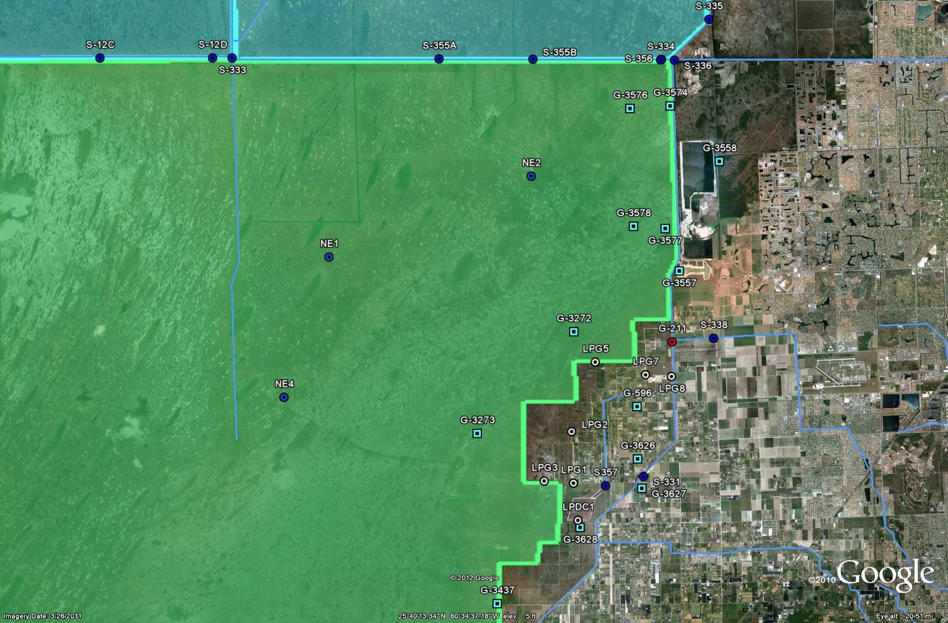
L-29
L-31N

