ATTACHMENT C

G-3273 Constraint relaxation and s-356 field test
DRAFT monitoring plan

Prepared by
Department of the Army
Jacksonville District Corps of Engineers

October 2012

Table of Contents

G-3273 Constraint Relaxation and S-356 Field Test MonitOring Plan 5
Introduction 5
Goals 8
G-3273 Constraint Relaxation and S-356 Field test hydrologic monitoring 10
Surface Water Monitoring 10
Groundwater Monitoring 12
Groundwater Level, Flow Rate, and Flow Direction 12
Groundwater Quality 14
G-3273 CONSTRAINT RELAXATION AND S-356 FIELD TEST SPECIES MONITORING 16
PROGRAMMATIC WATER QUALITY MONITORING 20
G-3273 CONSTRAINT RELAXATION AND S-356 FIELD TEST SURFACE AND GROUNDWATER QUALITY MONITORING 22
Desired Water Quality Outcomes 22
Monitoring Requirements to Support Water Quality Monitoring Plan Outcomes 22
Water Quality Monitoring Plan for G-3273 Constraint Modifications and S-356 Field Test 24
PROGRAMMATIC CULTURAL RESOURCE MONITORING 27
Monitoring Report 27
REFERENCES CITED 27

LIST OF TABLES

Table 1. G-3273 Targeted Criteria 10
Table 2. Gages for surface water hydrologic monitoring of the G-3273 Constraint Relaxation and S-356 Field Test. 11
Table 3. Characteristics measured in existing monitoring wells. 12
Table 4. Ground and surface water quality data from the L31NN well cluster and S-336, respectively. 15
Table 5. Cape Sable seaside sparrow bird count and population estimates by year as recorded by the Everglades National Park range-wide survey. 17
Table 6. Discontinuous hydroperiod (number of days inundated) as measured at the specified gages within each CSSS subpopulation between DATE. 18

LIST OF FIGURES

Figure 1. Surface water hydrologic monitoring gage locations for the G-3273 Constraint Relaxation and S-356 Field Test. 6
Figure 2. Groundwater monitoring well locations along L-30 and L-31N. Image showing locations of monitor wells near the confluence of canals L-29, L-30, and L-31N. Red line along L-31N is the seepage barrier location. 7
Figure 3. Hydrogeologic cross-section (A - A’) with monitoring well screen depths in the Biscayne Aquifer. Well construction data superimposed on the geologic cross section A - A’. Values indicated at the top of each well are surface elevations, in FT NGVD 1929. Values at the bottom of each well are elevations of top and bottom of the screen, in FT NGVD, 1929. Stratigraphic picks were interpreted from optical borehole images by Cunningham et al. (2006) and Cunningham and Sukop (2011). The Miami Limestone and the Fort Thompson Formation include the Biscayne Aquifer. 8
Figure 4. Plot showing groundwater flow rate and water level changes in L31NS well cluster during January 2008. Plot shows fluctuations in groundwater level and velocity that result from pumping at the Kendall Rock mine, located approximately 1 mile east of this station. 14
Figure 5. Cape Sable Seaside Sparrow subpopulations (A-F) and designated Critical Habitat Units (U1-U5). 19
Figure 6. Surface water-quality sampling locations for G-3273 constraint modification and S-356 Field Test. 26
Figure 7. Location of S-356 Pump Station in Relation to S-333 and other Monitoring Gages. 27
Figure 8. Location of key structures near S-356. 27
Figure 9. Location of key features in vicinity of the S-333. 27
Figure 10. Location of S-151 in relation to L-67A canal and potential sources of water quality impacts. 27

G-3273 Constraint Relaxation and S-356 Field Test MonitOring Plan

Introduction
Conditions within the action area such as, but not limited to, surface water levels, groundwater levels, rainfall, and pumping rates will be monitored for consideration in the decision-making process for U.S. Army Corps of Engineers (USACE) water management operations related to Water Conservation Area 3 (WCA-3), South Dade Conveyance System (SDCS), and Everglades National Park (ENP). The WCA-3A Periodic Scientists Calls (PSC), held between USACE, SFWMD, FWS and other stakeholders serves as an ongoing discussion of Central and Southern Florida (C&SF) Project and species conditions. The monitoring and reporting of hydrological, meteorological, ecological and multiple species conditions is critical to achieving the field test objectives.

This Monitoring Plan includes the gage locations, monitor well locations, species and monitoring protocols to meet the stated goals and objectives of the field test. For details pertaining to water management operational criteria, refer to 2006 Interim Operational Plan for Protection of the Cape Sable Seaside Sparrow (IOP) /2012 Everglades Restoration Transition Plan (ERTP) (http://www.saj.usace.army.mil/Divisions/Planning/Branches/Environmental/Projects_Sparrow.htm). Surface water monitoring gages are shown in Figure 1. Monitoring well locations and screen depths in the Biscayne Aquifer are shown in Figure 2 and Figure 3, respectively. To be comprehensive, information on the existing programmatic water quality monitoring as well as the programmatic cultural resource monitoring needs are also included in this monitoring plan. All elevations in this document are in feet, National Geodetic Vertical Datum of 1929 (feet, NGVD) unless otherwise stated.

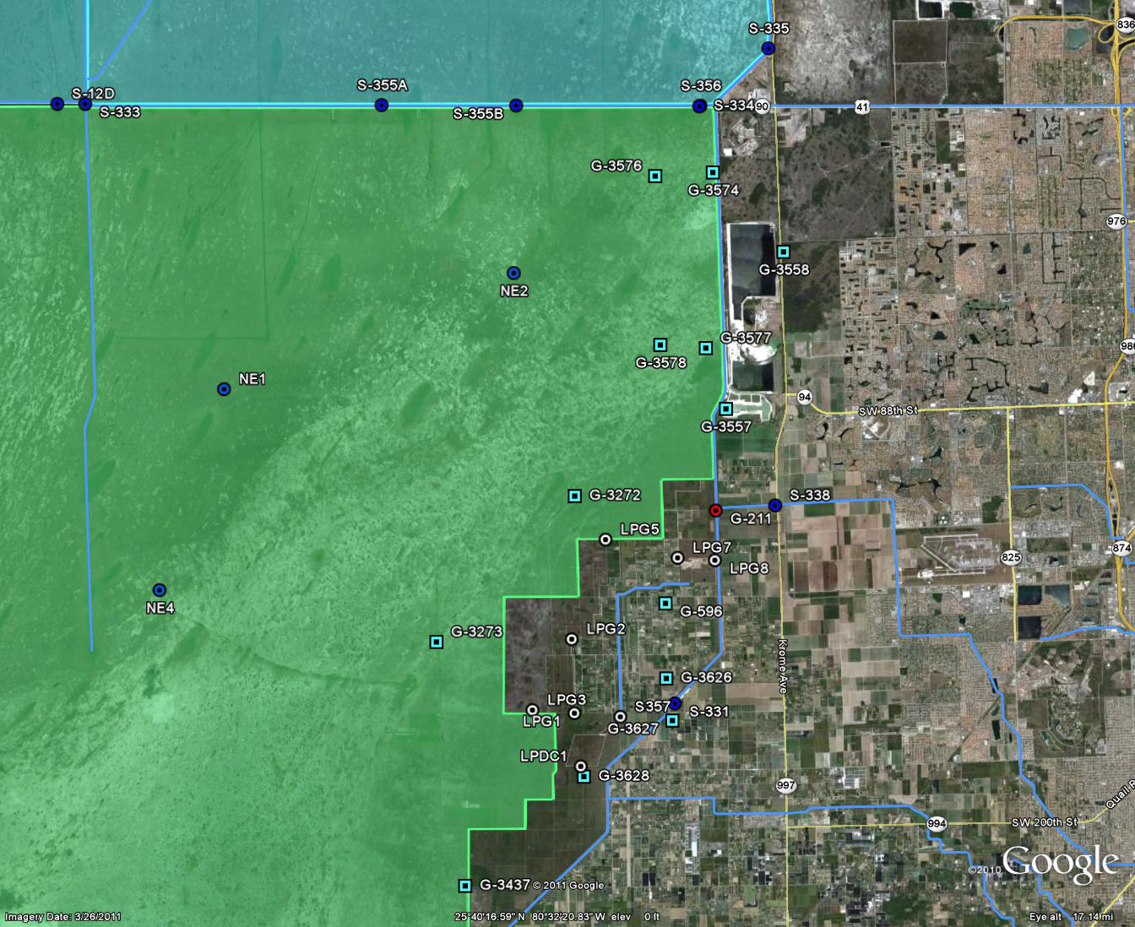
L-29
L-31N

Figure 1. Surface water hydrologic monitoring gage locations for the G-3273 Constraint Relaxation and S-356 Field Test.

Figure 2. Groundwater monitoring well locations along L-30 and L-31N. Image showing locations of monitor wells near the confluence of canals L-29, L-30, and L-31N. Red line along L-31N is the seepage barrier location.

A’. A.

Figure 3. Hydrogeologic cross-section (A - A’) with monitoring well screen depths in the Biscayne Aquifer. Well construction data superimposed on the geologic cross section A - A’. Values indicated at the top of each well are surface elevations, in FT NGVD 1929. Values at the bottom of each well are elevations of top and bottom of the screen, in FT NGVD, 1929. Stratigraphic picks were interpreted from optical borehole images by Cunningham et al. (2006) and Cunningham and Sukop (2011). The Miami Limestone and the Fort Thompson Formation include the Biscayne Aquifer.

Goals
This monitoring plan was developed with the intent of ensuring that field test goals and objectives are met. These goals represent a series of testable hypotheses that guide evaluation of this plan. The overall goals of the G-3273 Constraint Relaxation and S-356 Field Test are:

- To increase water deliveries from WCA-3A to ENP through Northeast Shark River Slough (NESRS) by increasing and/or removal of the G-3273 stage constraint for the benefit of natural resources.
- To evaluate operational testing and regulatory compliance of the S-356 pump station using a robust surface water and groundwater hydrologic monitoring program, coupled with surface water sampling protocols. Findings will support an FDEP operating permit application and will contribute to the development of future water management operating criteria.
- Implement field test for up to one-year (1 June 2013 through 31 May 2014) to evaluate operational testing conditions under wet season and dry season conditions. If weather conditions during the one-year test period do not provide sufficient data for a conclusive field test, the test may be extended.
- To maximize flexibility of the existing infrastructure to improve conditions in WCA-3A and NESRS with or without the use of S-356.

G-3273 Constraint Relaxation and S-356 Field test hydrologic monitoring

Surface Water Monitoring
The USACE Jacksonville District receives data from various sensors and data collection platforms to monitor surface water flows and levels. Automated timed processes provide provisional near-real-time data required for water management operations. Additional data are also received through an interagency data exchange program among South Florida Water Management District (SFWMD), United States Geological Survey (USGS) and ENP. A World Wide Web homepage includes various hydro-meteorological data including but not limited to: ground water elevations, surface water stages, precipitation, wind speed and direction, and barometric pressure and can be accessed at
http://www.saj.usace.army.mil/Divisions/Operations/Branches/MultiProject/WaterMgt/index.htm.
In addition, ERTP-related documentation can be accessed at http://devl.saj.usace.army.mil/Divisions/Planning/Branches/Environmental/Projects_ERTP.htm. G-3273 criteria will be implemented as shown in Table 1. System conditions will be continuously monitored and adjustments will be made as needed.

Table 1. G-3273 Targeted Criteria
January | February | March | April | May | June | July | August | September | October | November | December
7.2* | 7.2* | 7.0* | 7.0* | 6.9* | 6.9* | 7.0* | 7.1* | 7.3* | 7.5* | 7.4* | 7.3*
* It is important to note that the G-3273 constraint may be raised up to 7.5 pending system conditions. Intent is to provide the necessary latitude to adapt to system conditions rather than be bounded by months only.

The list of gages to be used for the analysis is shown in Table 2.

Table 2. Gages for surface water hydrologic monitoring of the G-3273 Constraint Relaxation and S-356 Field Test.
Feature | Parameter | Purpose
S-333 | HW, TW, Q | Determine volume
S-334 | HW, TW, Q | Determine volume
S-336 | HW, TW, Q | Determine volume
S-355A | HW, TW, Q | Determine volume
S-355B | HW, TW, Q | Determine volume
S-356 | HW, TW, Q | Determine volume
G-3273 | Stage | Determine duration, recession rate
S-357 | HW, TW, Q | Determine volume, frequency of use
S-331 | HW, TW, Q, Precipitation | Determine volume, frequency of use
S-338 | HW, TW, Q | Determine volume, frequency of use
G-3574 | Stage | Determine duration, recession rates
G-3576 | Stage | Determine duration, recession rates
G-3577 | Stage | Determine duration, recession rates
G-3578 | Stage | Determine duration, recession rates
G-3272 | Stage | Determine duration, recession rates
G-596 | Stage | Determine duration, recession rates
G-3626 | Stage | Determine duration, recession rates
G-3627 | Stage | Determine duration, recession rates
G-3628 | Stage | Determine duration, recession rates
LPG1 | Stage | Determine duration, recession rates
LPG2 | Stage | Determine duration, recession rates
LPG3 | Stage | Determine duration, recession rates
LPG5 | Stage | Determine duration, recession rates
LPG7 | Stage | Determine duration, recession rates
LPG8 | Stage | Determine duration, recession rates
NE1 | Stage | Determine duration, recession rates
NE2 | Stage | Determine duration, recession rates
NE4 | Stage | Determine duration, recession rates
G-3557 | Stage | Determine duration, recession rates
G-3558 | Stage | Determine duration, recession rates
Notes: HW– headwater stage; TW– tailwater stage; Q– discharge (cfs)

Groundwater Monitoring

Groundwater Level, Flow Rate, and Flow Direction
Hydrologic conditions in WCA-3B and the NESRS are controlled by interactions between surface water and groundwater of the Biscayne Aquifer. To evaluate these interactions and their effects on regional flows between WCA-3B and NESRS, a groundwater monitoring program is proposed using existing instrumented wells. Monitor wells are located mostly north and south of Tamiami Trail near or on the L-30 and L-31N levees, and on tree islands in southeast WCA-3B (Figure 2) The L-30 and L-31N monitor wells are instrumented with heat-pulse flowmeters that measure groundwater flow rate, flow direction, and level. Groundwater characteristics are measured hourly, and data are transmitted through a SCADA system to an off-site receiver at Desert Research Institute (DRI), Reno, Nevada. Hydrogeologic data are evaluated at DRI for quality control, then packaged and delivered monthly in spreadsheets. Most of these wells were constructed for baseline monitoring in advance of L-30 Seepage Management Pilot Project (SMPP) cut-off wall construction. The L-30 SMPP project was cancelled in 2010, but data acquisition continued through 30 September 2011. Instrumented monitoring wells were re-engaged in October 2012 to continue baseline groundwater data collection prior to the field test, and also to quantify effects of the test itself.

Several State and Federal agencies have constructed monitor wells along Tamiami Trail in WCA-3B and adjacent to ENP. Monitor wells were constructed for different projects during the last two decades. This proposed groundwater monitoring plan will coordinate data acquisition from all wells shown in (Figure 2)Error! Reference source not found.. The result will be a comprehensive groundwater monitoring network that will provide detailed data to evaluate effects of S-356 pump station operation. (Table 3) shows the different monitor wells and clusters by agency, and the data that currently exist for these wells.

Table 3. Characteristics measured in existing monitoring wells.

Of particular importance are those monitor wells/well clusters that are instrumented with heat-pulse flowmeters and pressure transducers, which measure groundwater flow rate, flow direction and water level. In the event that S-356 pump station field test affects seepage direction and flow rate, data from these wells will show the directional and rate changes of groundwater flow from WCA-3B and ENP. The zone of influence of the pumping stress will be defined by comparison of baseline data with field test data.

Changing groundwater flow velocity and level has been observed previously at the L31NN well cluster, in response to pumping activity at nearby Lake Belt mines Figure. Therefore, heat-pulse flowmeters installed in additional well clusters (improved since these earlier models) are appropriate for detecting changing groundwater flow patterns that result from pumping stresses at S-356.

Local to sub-regional pumping stresses are known to perturb groundwater flow direction and level in the study area. Examples of pumping stresses include the Miami-Dade Water and Sewer (MDWSA) Authority Northwest wellfield (Sonenshein and Hofstetter, 1990; Krupa et al., 2001), Lake Belt mining operations (Figure 4), and pump station operations (Krupa and Hill, 2002). Groundwater level, and flow rate and direction changes were observed at the onset of pumping at the MDWSA Northwest wellfield, currently permitted at 90 million gallons per day (MGD; equal to 139 cfs). However, these effects were limited to regions east of the Dade-Broward levee, and drawdown of groundwater did not impinge on the L-30 canal or ENP (Sonenshein and Hofstetter, 1990; Krupa et al., 2001). Operation of pump station S-7 (2,490 cfs; Broward and Palm Beach Counties) showed perturbations to groundwater flow and also surface water quality. Operational testing at the S-7 pumping station showed significant mixing of ground and surface water in the headwater side of the pump station, and significant seepage when head and tailwater elevations differed more than 3 feet. High head differences between head and tailwater can drive seepage of anoxic, higher specific conductance groundwater into the tailwater pool. The hydrogeologic setting of the S-7 pumping station differs from that of S-356 and has five times its pumping capacity. It will not be known whether this mixing effect will occur at S-356 until the operational field test is conducted. Water-quality changes observed at S-7 are not directly applicable to the field test proposed in this document.

In July 2012, construction of a 2-mile long seepage barrier was completed at the northern terminus of the L-31N levee, south of Tamiami Trail. The seepage barrier is composed of cement-bentonite slurry that is pumped into a pre-excavated trench. The dimensions of the seepage barrier are: 2 miles long, 32-inches wide, and 35-ft deep below land surface (approximately -30 ft NGVD29). The primary objective of this seepage barrier is to reduce groundwater flow rate eastward out of NESRS. This objective is currently under evaluation.

The L-31N seepage barrier may complement, and possibly enhance the effect of S-356 pump station operation on NESRS water levels. During S-356 field testing, surface water (and likely groundwater seepage) direction and velocity will change, as water is transmitted westward along L-29. The seepage barrier will reduce groundwater flow rate to the east, causing mounding and groundwater retention in NESRS. Higher groundwater (and consequently surface water) levels will enable more water to flow westward down L-29. The S-356 pump station test, along with the L-31N seepage barrier will minimize or eliminate the “circular pumping” scenario where surface water from L-31 and L-29 is pumped westward into NESRS, only to seep into the Biscayne Aquifer and flow eastward out of ENP.

Figure 4. Plot showing groundwater flow rate and water level changes in L31NS well cluster during January 2008. Plot shows fluctuations in groundwater level and velocity that result from pumping at the Kendall Rock mine, located approximately 1 mile east of this station.

Groundwater Quality
Biscayne Aquifer water quality has moderate carbonate alkalinity, low chloride and total phosphorus concentrations, and low specific conductance values (Table 4). Precipitation percolates through the peats and limestones in the recharge areas of western Miami-Dade County, dissolving mineral constituents as groundwater flows to the east and southeast toward the coast. Limited groundwater quality data are available on the SFWMD database DBHydro, and the USGS database NWIS. All groundwater quality data in the immediate vicinity of L-29, L-30, and L-31N were obtained from the L31NN monitoring well cluster (Table 4). There are no groundwater quality data available for the Bird Drive Recharge Area, or other areas adjacent to the L-30/L-31N transect.

Groundwater quality data are compared to the limited available surface water data obtained at the S-336 structure, 300 ft east of Krome Avenue (Table 4). These limited data sets show that groundwater and surface water are statistically indistinguishable. Water level variations in the Biscayne Aquifer and canal stage will affect local direction of seepage (that is, into or from the canal).

A detailed groundwater quality characterization task is not included in this monitoring plan for the following reasons: 1) groundwater hydrologic data will indicate the extent of seepage during pre-test and field test conditions; and 2) regulatory compliance will be established using the detailed surface water monitoring program performed during the S-356 field test.

Table 4. Ground and surface water quality data from the L31NN well cluster and S-336, respectively.
The S-336 structure is located on the L-29 (or C-4) canal approximately 300 ft east of Krome Ave. All data were obtained from DBHydro (SFWMD).

It is critical to evaluate trends in groundwater levels, flow rate and direction during pre-test and field test conditions to evaluate the effect of pumping stresses in the field area. Existing data from all monitor wells along L-30 and L-31NN are now being imported into a “Google Earth”-based data visualization tool to better evaluate seasonal and annual ground water flow variations. This data visualization tool will enable a semi-quantitative evaluation of groundwater flow variations resulting from wet and dry season conditions, canal stage variations, and the S-356 field test. The data visualization tool will be developed at ERDC-CHL in Vicksburg MS, and will ready by February 2013.

G-3273 CONSTRAINT RELAXATION AND S-356 FIELD TEST SPECIES MONITORING

USACE will continue existing hydrologic and species monitoring plans to ensure that the Incidental Take of the endangered Cape Sable seaside sparrow (CSSS) as defined within the U.S. Fish and Wildlife Service (FWS) 2010 Biological Opinion (BO) is not exceeded as a result of the G-3273 Constraint Relaxation and S-356 Field Test. The 2010 FWS ERTP BO Incidental Take Statement Reinitiation Triggers are defined below:

- Sparrow Population: Re-initiation of consultation must occur if the annual CSSS population estimate falls below 2,915 sparrows [Mean population estimate 2001-2009 = 3,145 + 230]).

Presently, the known distribution of the CSSS is restricted to two areas of marl prairies east and west of Shark River Slough in the Everglades region (within ENP and Big Cypress National Preserve) and the edge of Taylor Slough in the Southern Glades Wildlife and Environmental Area in Miami-Dade County (Figure 5). ENP staff first undertook a comprehensive survey of the CSSS in 1981 to identify all areas where sparrows were present. This survey, hereafter referred to as the range-wide survey, resulted in the first complete range map for the CSSS (Bass and Kushlan 1982; Kushlan and Bass 1983). The survey design consisted of a one-kilometer survey grid over any suspected CSSS habitat. As much of CSSS habitat is inaccessible, a helicopter was employed and landed at the intersection of each grid line (i.e. every 1 kilometer). At each site, the researchers would record every CSSS seen or heard (singing males) within an approximate 200 meter radius of their landing location (Curnutt et al. 1998). From the resulting range map, Curnutt et al. (1998) divided the CSSS into six separate subpopulations, labeled as A through F (Figure 5), with subpopulation A (CSSS-A) as the only subpopulation west of Shark River Slough. After the 1981 survey, the population was not surveyed again until 1992. The range-wide survey has been performed annually since 1992, although the number of survey locations has changed from a high of over 850 sites in 1992 to a low of 250 sites in 1995 (Cassey et al. 2007).

Bass and Kushlan (1982) also devised a methodology of translating the range-wide survey results into an estimate of population size. To account for females (only males sing) and CSSS outside the audio detection range, the number of birds counted is multiplied by a factor of sixteen (15.87 rounded to 16). In order to confirm the validity of this estimation factor, Curnutt et al. (1998) compared the bird counts from the range-wide survey with actual mapped territories on intensive study plots and found it to be adequate given normal population fluctuations. More recent research indicates that this estimation factor may be overestimating population abundance within the smaller CSSS subpopulations (i.e. CSSS-A, C, D, F) due to the presence of floater males and a male-biased sex ratio (Boulton et al. 2009a).

Based on the range-wide surveys, total CSSS populations have declined from approximately 6,600 individuals during the period from 1981-1992, to approximately 3,120 in 2009 (Table 5) . ENP will continue to conduct range-wide surveys on an annual basis. USACE will seek this information from ENP to measure this Reinitiation Trigger.

Table 5. Cape Sable seaside sparrow bird count and population estimates by year as recorded by the Everglades National Park range-wide survey.

Population/ Year | CSSS-A |  | CSSS-B |  | CSSS-C |  | CSSS-D |  | CSSS-E |  | CSSS-F |  | Total
 | BC | EST | BC | EST | BC | EST | BC | EST | BC | EST | BC | EST | BC | EST
2001 | 8 | 128 | 133 | 2,128 | 6 | 96 | 2 | 32 | 53 | 848 | 2 | 32 | 204 | 3,264
2002 | 6 | 96 | 119 | 1,904 | 7 | 112 | 0 | 0 | 36 | 576 | 1 | 16 | 169 | 2,704
2003 | 8 | 128 | 148 | 2,368 | 6 | 96 | 0 | 0 | 37 | 592 | 2 | 32 | 201 | 3,216
2004 | 1 | 16 | 174 | 2,784 | 8 | 128 | 0 | 0 | 40 | 640 | 1 | 16 | 224 | 3,584
2005 | 5 | 80 | 142 | 2,272 | 5 | 80 | 3 | 48 | 36 | 576 | 2 | 32 | 193 | 3,088
2006 | 7 | 112 | 130 | 2,080 | 10 | 160 | 0 | 0 | 44 | 704 | 2 | 32 | 193 | 3,088
2007 | 4 | 64 | 157 | 2,512 | 3 | 48 | 0 | 0 | 35 | 560 | 0 | 0 | 199 | 3,184
2008 | 7 | 112 | NS | NS | 3 | 48 | 1 | 16 | 23 | 368 | 0 | 0 | 34 | 544*
2009 | 6 | 96 | NS | NS | 3 | 48 | 2 | 32 | 27 | 432 | 0 | 0 | 38 | 608*
2010 | 8 | 128 | 119 | 1904 | 2 | 32 | 4 | 64 | 57 | 912 | 1 | 16 | 191 | 3,056
2011 | NA | NA | NA | NA | NA | NA | NA | NA | NA | NA | NA | NA | NA | NA
BC Bird Count
EST Estimate
NS Not Surveyed
NA: Not Available
* These numbers do not reflect a significant decline in CSSS population. CSSS-B, the largest and most stable subpopulation, was not surveyed in 2008 or 2009. Adding the 2007 CSSS-B population estimate of 2,512 birds to those of the other subpopulations, the estimated total CSSS population size is 3,056 and 3,120 birds for 2008 and 2009, respectively.

- CSSS Habitat, Eastern Marl Prairies: Re-initiation of consultation must occur if operations that raise water levels from groundwater to surface water conditions beyond 0.6 mile of S-332 Detention Areas prior to June 1.

USACE asked for clarification of the time period for this trigger (November 2010), however, until clarification is provided USACE is assuming that water levels must be below ground surface elevation prior to the FWS-defined CSSS breeding period starting March 1. Thus, USACE is delimiting the period of analysis for this trigger to March 1 through June 1, 2011, until otherwise directed. In order to assess this reinitiation trigger water levels at Gage MRSHOP B1, Gage MRSHOP C1 and Gage NTS-10 will be monitored throughout the test period to ensure that operations do not raise water levels from groundwater to surface water conditions throughout the period between March 1 and June 1 throughout the duration of the G-3273 Constraint Relaxation and S-356 Field Test. If water levels transition from groundwater to surface water conditions during the time period between March 1 and June 1, USACE will conduct a retrospective review of water management operations to determine the potential cause(s) of the reversal and how future operations can avoid exceeding these thresholds.

- Cape Sable Seaside Sparrow Habitat: Western Marl Prairies: Re-initiation of consultation must occur if fewer than 60 consecutive days with water levels below ground surface occur at NP-205 between March 1 and July 15 due to water releases in 2 consecutive years.

USACE will continue current monitoring of water levels at Gage NP-205 in CSSS-A to determine whether this Incidental Take Re-initiation Trigger has been achieved. In accordance with WCA-3A-ENP-ENP/SDCS Water Control Manual and 2006 IOP/2012 ERTP, closure periods on the S-12 structures designed to provide suitable nesting conditions within CSSS-A during CSSS breeding season will help to prevent exceedances of this trigger.

In addition to the 2010 FWS BO Incidental Take Statement Re-initiation Triggers, USACE will also continue to monitor the series of existing hydrological gages listed in (Table 6) to measure potential hydrologic impacts within the six CSSS subpopulations and within designated CSSS critical habitat (Figure 5).

Table 6. Discontinuous hydroperiod (number of days inundated) as measured at the specified gages within each CSSS subpopulation between DATE.

Sub-Population | Gage | Discontinuous Hydroperiod  (Days Inundated) | Within 90-210 Preferred Hydroperiod?
A | NP-205
A | P-34
B | NP-44
C | E-112
D | EVER-4
E | NP-206
F | RG-2

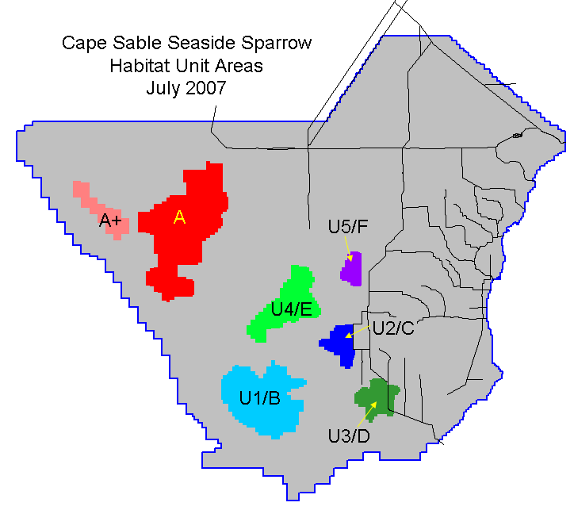
Figure 5. Cape Sable Seaside Sparrow subpopulations (A-F) and designated Critical Habitat Units (U1-U5).

PROGRAMMATIC WATER QUALITY MONITORING

There is an extensive and robust surface water quality monitoring program currently in place with sampling routinely conducted for all relevant parameters at all key structures in the C&SF water management system.

Current surface water quality monitoring is focused toward meeting permit and other mandate requirements, as well as providing information for infrastructure management and environmental restoration. Current broad-scoped monitoring mandates include the Everglades Settlement Agreement/Consent Decree (1995), the Total Phosphorus Rule, the Non-Everglades Construction Project (NECP) Permit, and the Canal-111 Emergency Order #9 (Exhibit B of Executive Order (E.O.) 9). Monitoring required by the aforementioned mandates is described in the South Florida Water Management District’s (SFWMD) monitoring projects: Conservation Area Materials Budget, Park Inflows North, Park Inflows East, Everglades Protection Area, Phosphorus Source Control Project, and NECP.

As changes to infrastructure and management progress, it is inevitable that changes to the monitoring plan must occur. Anticipated future project components that will require review of the current surface water quality monitoring include, but are not limited to, the following: Tamiami Trail Modifications, 8.5 Square Mile Area, C-111 Spreader Canal Phase I, G-3273 Constraint Modification and S-356 Field Test, and the S-355s.

USACE is committed to working collaboratively with FDEP, SFWMD and other agencies and Tribes to identify operational measures within the framework of the 2012 ERTP Environmental Impact Statement (EIS) and Water Control Plan and consistent with C&SF project purposes in an effort to avoid exceedance of water quality standards in WCA-3B and ENP. USACE will work with these parties to develop an adaptive management approach and coordination protocol to identify concerns and engage in discussions regarding implementation of operations to respond to issues including but not limited to:

- Dryouts in WCA-3A and their effects on surface water quality concentrations delivered into Shark River Slough (SRS)
- Changes in surface water flow velocity, which may affect water quality concentrations
- Methods for coordinating with agencies, to document operational decisions and to provide periodic updates to the TOC
- Adequacy of the existing monitoring network to guide and analyze effectiveness of operational decisions

The adaptive management approach will be conducted through routine, collaborative coordination with SFWMD operational staff along with other Federal and State representatives (i.e., WCA-3A Periodic Scientists Calls) and will ensure utilization of State monitoring data with appropriate documentation of implemented operations outlined in the Water Control Plan.

In the event of an exceedance of the water quality criterion for total phosphorus in Shark River Slough and/or upon the request of any member of the Technical Oversight Committee (TOC), the USACE will provide a report to the TOC documenting the operations, operational decisions and factors weighed in making those decisions (such as the requirements to meet project purposes, issues identified in the adaptive management approach such as endangered species, and input provided by the state of Florida regarding water quality concerns, etc.) and hydrological, meteorological and climatological conditions preceding the exceedance. USACE will consider TOC (consensus or individual) operational input within the flexibility of the Water Control Plan.

G-3273 CONSTRAINT RELAXATION AND S-356 FIELD TEST SURFACE AND GROUNDWATER QUALITY MONITORING

Desired Water Quality Outcomes
- Characterize surface water quality and volume discharged from the S-356 pump station into Northeast Shark River Slough (NESRS). Evaluate how pumping affects water quality of the surface water flowing into the ENP Shark River Slough. Operation of the S-356 pump station is consistent with the 1992 Modified Water Deliveries to Everglades National Park (MWD) GDM intent. That is, only pumping to recycle the additional seepage into the L-31N Canal caused by MWD increased flows into ENP. Pumping is expected to improve water quality flowing into NESRS because recycled ENP seepage should be low in phosphorus.
- Delineate, to the maximum extent practical, the zone of influence in the Biscayne Aquifer that occurs during pump station operational testing. Influences include changes in the groundwater levels, flow rate and flow direction as indicated by hourly heat-pulse flowmeter data from all monitor wells. No model simulations are proposed at this time, but pre-test and field test data will be imported into a Google-Earth data visualization tool. This will help the operators and stakeholders to better understand potential impacts from future development within the area of pumping influence.
- Identify sources of the S-356 pump intake water. Define, to the maximum extent practical, the percentage of groundwater from WCA-3B seepage versus ENP seepage and how these percentages vary with different operations and different stage conditions experienced during the field test. This will help to develop a better understanding of potential water quality changes associated with S-356 pump operations.
- Characterize the quality and quantity of additional water delivered to the NESRS via S-333 resulting from the G-3273 stage constraint relaxation. Increased flows at the S-333 must be carefully evaluated.
- Gain a better understanding of how G-3273 stage constraint relaxation and S-356 pump operations could be associated with changes to water quality entering ENP. One hypothesis is that operation of the S-356 consistent with the 1992 GDM intent (only recycling seepage) will tend to improve water quality. Another hypothesis is that additional flows through the S-333 into the SRS under certain conditions will not have a negative impact on water quality.

Monitoring Requirements to Support Water Quality Monitoring Plan Outcomes
Objective 1: Please refer to Draft Water Quality Monitoring Plan section within this document for monitoring required to meet Objective 1. In addition to the required information outlined in the Draft Water Quality Monitoring Plan the predicted and actual S-356 pumping quantities will be required as well any additional predicted and actual flows at S-333 caused by modification of the G-3273 constraint. The requirement for the monitoring identified in the water quality monitoring section will vary based on the weather conditions. During a dry year the window for the monitoring requirement will be very limited and possibly nonexistent. During a wet year, the monitoring could be required for a large portion of that year particularly if the rainfall is well distributed throughout that year.

Objectives 2 and 3: A groundwater monitoring program will be conducted using existing and updated instrumented monitoring wells located north and south of Tamiami Trail. Data acquired at these monitoring stations will enable evaluation of groundwater response (flow rate, flow direction, stage response, etc.) prior to and during operation of S-356. The hydrology and water management team will provide predicted and actual surface water flows at S-356 and S-333 for the test increment being considered. In order to evaluate water quality for a given test increment, the predicted flow increase at S-333 associated with the G-3273 relaxation is required. The Groundwater Monitoring Plan section provides further details. A surface water monitoring plan will also quantify changes in surface flows resulting from S-356 pumping associated with the G-3273 relaxation in order to determine whether or not urban surface water is being drawn into the S-356 intake. Refer to Surface Water Monitoring Plan section for full details.

Objectives 4 and 5: Rapid lab turnaround (24-48 hours from collection) is required for Total Phosphorus (TP) analyses of the weekly S-333 grab sample taken by SFWMD. TP Analyses can be performed either by SFWMD or samples can be shipped to the USACE Contract Lab. Rapid turnaround will also be conducted on a weekly S-356 grab during the S-356 field test. USACE proposes that a monitoring point upstream of S-333 at S-151 should also be designated to determine water quality upstream of S-333. A discussion about the necessity of S-9 and S-9A flows and nutrient concentration data should be considered by the water quality technical team.

A weekly sample or biweekly rapid turnaround TP grab sample at the monitoring point upstream of S-151 may provide useful additional information to the operators. S-9 and S-9A phosphorus concentrations and flows may also require rapid turnaround, if consideration of this station data is recommended. The goal is have information available to the USACE operations team that will allow consideration of potential water quality impacts from increased flows into NESRS via S-333 associated with the G-3273 constraint relaxation.

A water quality technical team will interpret data and evaluate potential water quality changes associated with the relaxation of the G-3273 constraint and operation of S-356 pump station. The invitation to participate in the water quality technical team will be extended to all governmental and Tribal representatives, with participation from the FDEP, SFWMD, ENP, DERM, and the Miccosukee Tribe being identified as the most critical members for this team. If participation is not possible for all primary agencies, a strong effort will be made to inform the appropriate water quality points of contact in those agencies concerning the methods and analyses being conducted by this team. This assessment will be routinely provided to the USACE Water Management Section during time periods when increased flows through S-333 are being considered due to the G-3273 constraint relaxation. This water quality technical team would meet weekly (more or less frequently as appropriate) during the field test period when conditions exist that would allow additional S-333 flows into NESRS. The meeting purpose is to provide timely information to the USACE Water Management Section. The frequency and duration at which the G-3273 constraint serves to restrict S-333 flows is variable from year to year and is dependent on weather conditions and WCA-3A stage levels.

To provide the information to the USACE Water Management Section for a specific test increment, the water quality team will:

- Evaluate the near real time (i.e. lab analyses available 2-3 days after collection) TP data for S-333 and S-356. The S-151 TP data (i.e. lab analysis available 2-3 days after collection) may result from a weekly or biweekly sample. S-9 and S-9A phosphorus concentrations and flow data may require a rapid turnaround time.
- Use Walkers’ predictive equations to estimate concentrations at the S-12s and S-333 during increased S-333 flows into the NESRS associated with the G-3273 constraint modification are being considered.
- Evaluate the most currently available yearly flow weighted mean calculation for the SRS and the corresponding flow-weighted mean compliance target.
- Obtain the predicted S-333 flows and S-356 flows from the hydrology and Water Management Section. The predicted increase in S-333 flows due to the G-3273 constraint relaxation must also be provided in order for the water quality analyses to be performed. Obtain actual flows and flow increases at S-333 due to the G-3273 constraint modification.
- Other metrics accepted by the team could be used in the evaluation. SRS water quality performance metrics could be used to provide input to the operators. These SRS metrics are intended to be developed for the implementation of ERTP which could be useful for this test.
- With the information above, the water quality team would provide an assessment of how increased flows at the current time and under the current set of circumstances could potentially affect Settlement Agreement compliance under the existing conditions. A calculation would be performed to update the predicted impacts from the particular increment of the test.
The water quality team would provide the analysis to the USACE Water Management Section as to whether, under the existing conditions, the increased flows through S-333, due to the G-3273 constraint relaxation may be associated with water quality changes for the specific test increment being analyzed. The intent of this test is to gather information on temporary operations and to assist in the development of a regional operations plan that would be implemented on a more routine basis.

Water Quality Monitoring Plan for G-3273 Constraint Modifications and S-356 Field Test

Please refer to Figure 6 and Figure 7 for clarification of surface water sampling locations, frequency and type (i.e. grab or autosampler) of sampling required for the test in proximity to the S-356. Additional graphics (Figures 8, 9 and 10) are also provided for C&SF Project features and to indicate other surface water monitoring locations (S-333 and S-151). The water quality team will require the actual and predicted flows at S-356 and the predicted flow increase as well as the actual increase (as best as can be practically quantified) at S-333 for a given test increment due to G-3273 constraint modification. These flow data are required in order to perform the water quality analyses, and will be provided by the Hydrology and Water Management Sections.

Description of sampling:
- Auto sampler installed at S-356. Daily composite sample (time driven) to be analyzed (during pump operations) for TP. One daily composite sample will be analyzed if the pump station is operated at any time during a given 24 hour period. Normal lab turnaround for these samples will be required.
- Weekly grab sample for TP at S-356 will be analyzed with a rapid lab turnaround (i.e. results available 2-3 days after collection) during a week that the S-356 pump is operating or expected to operate.
- Pre-test (before S-356 pump station field test for each wet season or onset of wet season conditions) and post-test (predicted end of yearly test period, while the S-356 pump is still running) grab samples will be analyzed from the head water/tailwater of G-211, S-356, S-336 and S-335 and on either side of the S-24A structure (one in the canal and the other on the west side of the structure that can be practically accessed by sampling crew). Surface water TP samples from the west side of the S-24A structure will characterize ENP surface water adjacent to L-31N levee. Additional existing monitoring sites that are currently being sampled in the vicinity of the S-24A structure (if any), within the ENP, or other sample sites determined as representative of ENP surface water conditions, also need to be identified so that additional ENP surface water background data are available for the water quality team’s assessments. Additional monitoring site information would help to confirm whether any unexpected values at the ENP monitoring point (S-24A) are representative of the ENP or a localized anomaly.
- Weekly grab samples to be taken at the S-333 and will be analyzed with a rapid lab turnaround (i.e. 2-3 days after collection) for TP during the S-356 field test (only during time periods of potential S356 operations).
- Biweekly grab samples to be taken on the North side (upstream) of the S-151 structure on a bi-weekly basis during active testing period of year (S-356 could be operated). Sample will be processed for TP with rapid lab turnaround (i.e. 2-3 days after collection).

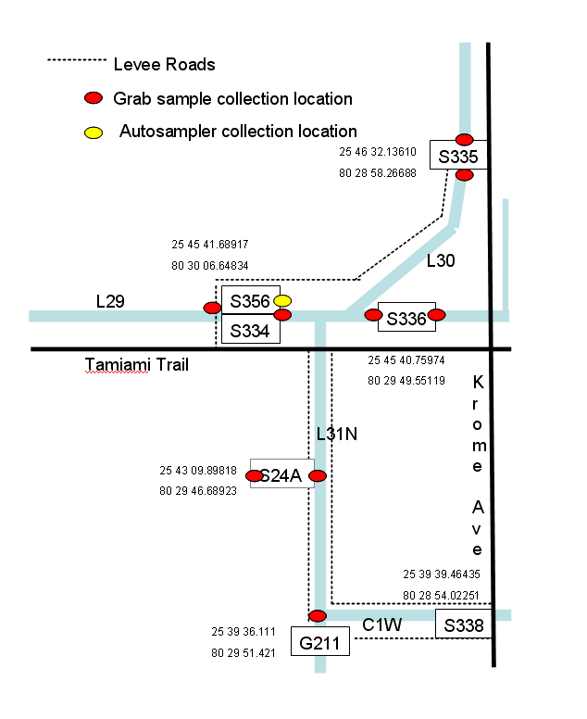
Figure 6. Surface water-quality sampling locations for G-3273 constraint modification and S-356 Field Test.

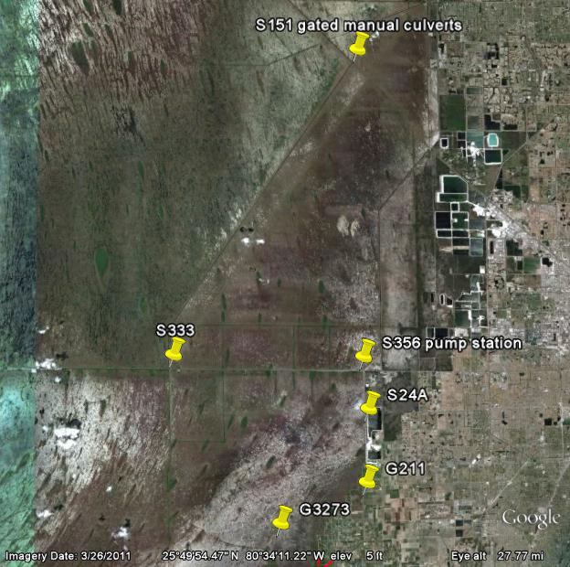
Figure 7. Location of S-356 Pump Station in Relation to S-333 and other Monitoring Gages.

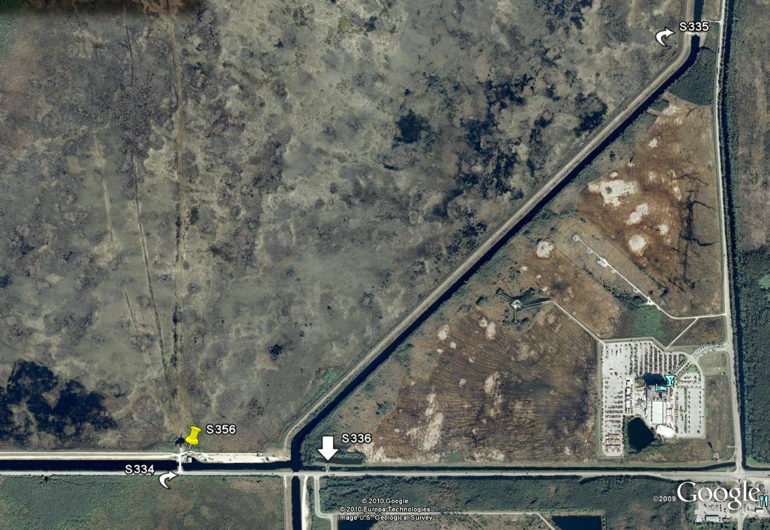
Figure 8. Location of key structures near S-356.
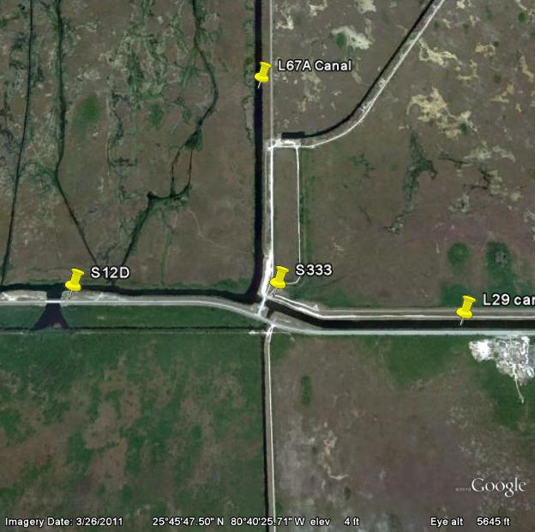
Figure 9. Location of key features in vicinity of the S-333.
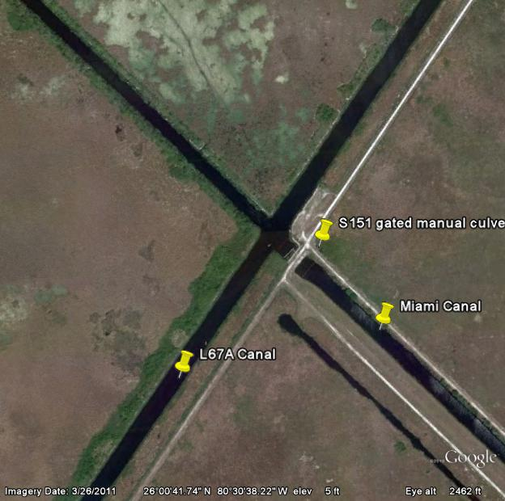
Figure 10. Location of S-151 in relation to L-67A canal and potential sources of water quality impacts.

PROGRAMMATIC CULTURAL RESOURCE MONITORING

USACE is working on a survey strategy to understand the effects of hydrologic changes on significant cultural resources as part of the ERTP Programmatic Agreement. However, the duration of effects to cultural resources within ENP resulting from the G-3273 Constraint Relaxation and S-356 Field Test are not adverse due to the short time span of the test and controls established through this monitoring plan. Typically, hydrologic effects associated with water regulation are cumulative over a long period of time. In addition, it is anticipated that the relative increase in water depth is minor and should not flood any known archeological site beyond that which is typical throughout the year. Therefore, cultural resources monitoring efforts established under the ERTP Final EIS and the associated ERTP Programmatic Agreement will be utilized to understand how the field test performs in relation to relative water depth located adjacent to known archeological resources and tree islands within ENP.

The monitoring efforts will allow a clearer understanding of the effects of the volume of water discharged into ENP and how this volume spreads south throughout NESRS. They will also provide a better understanding of the zone of influence of water across the cultural landscape. Finally, the monitoring efforts will provide valuable information to better understand effects of water on cultural resources for the larger MWD Project.

The monitoring effort will identify and link known archeological sites within ENP to known elevation data for tree islands within NESRS utilizing the Everglades Depth and Elevation Network (EDEN) and water elevations for known tree islands (http://sofia.usgs.gov/eden/water_level_percentiles_map.php. The monitoring will compile water elevation data associated with known archeological sites within NESRS. The monitoring will also ensure that no known archeological sites are adversely affected by the test by ensuring that no sites are flooded that do not typically flood during the hydrologic pattern cycle. When water levels monitored through EDEN trigger alerts, as specified in ERTP Programmatic Agreement, the test will be suspended to ensure that no adverse affects occur to archaeological sites. In addition, the monitoring will also serve to meet a USACE requirement for archeological monitoring within MWD, Tamiami Trail Modifications, Final Limited Reevaluation Report and Environmental Assessment.

Upon completion of the test, data obtained from the field test study will be utilized to compare the period of performance to identify a similar rainfall cycle and compare changes in water elevation on known archeological resources. A comparison will also be performed against the previous wettest and driest year within the prior 10 years of EDEN data so that a better understanding of the variation can also be developed.

Monitoring Report
Information gained during monitoring of G-3273 Constraint Relaxation and S-356 Field Test will be included in a separate report.

REFERENCES CITED

Cunningham, K.J., Wacker, M.A., Robinson, E., Dixon, J.F., and Wingard, G.L., 2006. A cyclostratigraphic and borehole-geophysical approach to development of a three-dimensional conceptual hydrogeologic model of the karstic Biscayne Aquifer, southeastern Florida. U.S. Geological Survey Scientific Investigations Report 2005-5235. 69 p. plus CD.

Cunningham, K.J. and Sukop, M.C., 2011. Multiple technologies applied to characterization of the porosity and permeability of the Biscayne Aquifer, Florida. U.S Geological Survey Open-File Report 2011-1037, 8 pp.

Krupa, S., Hill, S., and Bevier, C., 2001. Miami-Dade County northwest wellfield groundwater velocity investigation. South Florida Water Management District technical publication WS-1, dated January 2001, 24 pp. plus appendices.

Sonenshein, R.S. and Hofstetter, R.H., 1990. Hydrologic effects of well-field operations in a wetland, Dade County, Florida. U.S.Geological Survey Water-Resources Investigations Report 90-4143,

This page intentionally left blank

This page intentionally left blank

