Final
Jackson Blue Spring and Merritts Mill Pond Basin Management Action Plan

Division of Environmental Assessment and Restoration
Water Quality Restoration Program
Florida Department of Environmental Protection

with participation from the
Jackson Blue Spring Basin Stakeholders

May 2018



2600 Blair Stone Rd.
Tallahassee, FL 32399
floridadep.gov

Acknowledgments
The Florida Department of Environmental Protection adopted the Jackson Blue Basin Management Action Plan by Secretarial Order as part of its statewide watershed management approach to restore and protect Florida's water quality. The plan was developed in coordination with stakeholders, identified below, with participation from affected local, regional, and state governmental interests; elected officials and citizens; and private interests.
Florida Department of Environmental Protection
Noah Valenstein, Secretary
Table A-1. Jackson Blue Basin stakeholders
Type of Entity | Name
Responsible Stakeholders | Agricultural producers  Jackson County  Town of Malone  Town of Bascom
Responsible Agencies | Florida Department of Agriculture and Consumer Services  Florida Department of Environmental Protection  Florida Department of Health  Florida Fish and Wildlife Conservation Commission  Northwest Florida Water Management District
Other Interested Stakeholders | Citizens  Florida Farm Bureau Federation  Florida Onsite Wastewater Association  Florida Springs Council  Florida Springs Institute  Jackson County Soil and Water Conservation District  University of Florida Institute of Food and Agricultural Sciences

Appendix A contains links to important sources referenced in this document. For additional information on the watershed management approach for the Jackson Blue Spring Basin, contact:
Terry Hansen, P.G., FCCM
Professional Geologist Administrator
Florida Department of Environmental Protection
Water Quality Restoration Program, Watershed Planning and Coordination Section
2600 Blair Stone Road, Mail Station 3565
Tallahassee, FL 32399-2400
Email: terry.hansen@dep.state.fl.us
Phone: (850) 245–8561

Table of Contents
Acknowledgments 2
Table of Contents 3
List of Figures 5
List of Tables 6
List of Acronyms and Abbreviations 7
Executive Summary 9
Section 1 : Background 13
1.1 Legislation 13
1.2 Water Quality Standards and Total Maximum Daily Loads (TMDLs) 13
1.3 BMAP Requirements 14
1.4 BMAP Area 14
1.5 PFAs 14
1.6 Other Scientific and Historical Information 17
1.7 Stakeholder Involvement 17
1.8 Description of BMPs Adopted by Rule 18
Section 2 : Implementation to Achieve the TMDLs 19
2.1 Allocation of Pollutant Loads 19
2.2 Prioritization of Management Strategies 24
2.3 Load Reduction Strategy 25
2.4 OSTDS Management Strategies 25
2.5 UTF Management Strategies 29
2.6 STF Management Strategies 30
2.7 Agricultural Sources Management Strategies 30
2.8 WWTF Management Strategies 33
2.9 Atmospheric Deposition Management Strategies 34
2.10 Future Growth Management Strategies 35
2.11 Protection of Surface Water and Groundwater Resources through Land Conservation 35
2.12 Commitment to Implementation 36
Section 3 : Monitoring and Reporting 37
3.1 Methods for Evaluating Progress 37
3.2 Adaptive Management Measures 37
3.3 Water Quality and Biological Monitoring 38
Appendices 44
Appendix A. Important Links 44
Appendix B. Projects to Reduce Nitrogen Sources 45
Appendix C. PFA Report 49
Appendix D. OSTDS Remediation Plan 50
Appendix E. NSILT Report 58
Appendix F. FDACS BMPs 62
Appendix G. Future Growth Strategies of Local Jurisdictions 73

List of Figures
Figure ES- 1. Jackson Blue BMAP and PFA boundaries 11
Figure 1. Jackson Blue BMAP and PFA boundaries 15
Figure 2. Loading to groundwater by source in the BMAP area 23
Figure 3. OSTDS locations in the BMAP area 27
Figure 4. Groundwater and surface water stations sampled in the Jackson Blue BMAP area 41
Figure D-1. OSTDS locations in the BMAP area 54
Figure F-1. Agricultural lands in the Jackson Blue Springshed and Merritts Mill Pond Basin 65

List of Tables
Table A-1. Jackson Blue Basin stakeholders 2
Table ES-1. WWTF effluent standards 11
Table 1. Restoration targets for Jackson Blue Spring and Merritts Mill Pond 13
Table 2. BMPs and BMP manuals adopted by rule as of June 2017 18
Table 3. Estimated nitrogen load to groundwater by source in the BMAP area 20
Table 4. Total reductions to meet the TMDLs 23
Table 5. Nitrogen reduction schedule (lb-N/yr) 24
Table 6. Summary of potential credits for Jackson Blue Spring Basin projects to meet the TMDLs 25
Table 7. Estimated individual OSTDS improvements to groundwater 28
Table 8.Estimated reduction credits for additional OSTDS enhancement or sewer * 28
Table 9. Current project credits to reduce UTF loading to groundwater 29
Table 10. Maximum UTF load reductions based on existing public education credit policies 30
Table 11. Estimated reductions for additional agricultural projects and practices 32
Table 12. Potential for additional load reductions to groundwater 33
Table 13. Wastewater effluent standards for the BMAP area 34
Table 14. Stakeholder conservation land purchases in the BMAP area 35
Table 15. Core water quality indicators 39
Table 16. Supplemental water quality indicators and field parameters 39
Table 17. Biological response measures 42
Table B-1. Stakeholder projects to reduce nitrogen sources 46
Table D-1. Estimated reduction credits for OSTDS enhancement or sewer* 52
Table E-1. Range of environmental attenuation of nitrogen from a detailed literature review 60
Table F-1. Agricultural land use within the Jackson Blue Springshed and 62
Table F-2 Fertilized crop lands within the Jackson Blue Springshed and 63
Table F-3. Livestock lands within the Jackson Blue Springshed and 63
Table F-4. Key management and structural BMPs adopted by FDACS OAWP 66
Table F-5. BMP enrollment in the Jackson Blue Springshed and Merritts Mill Pond as of December 31, 2018 69
Table F-6. Agricultural acreage and BMP enrollment in the Jackson Blue Springshed and Merritts Mill Pond Basin as of December 31, 2017 70
Table F-7. Beyond BMP implementation 71
Table G-1. Future growth strategies of Jackson County 73

List of Acronyms and Abbreviations
ac Acre
AWT Advanced Wastewater Treatment
ATU Aerobic Treatment Unit
BAF Biochemical Attenuation Factor
BMAP Basin Management Action Plan
BMPs Best Management Practices
CAFO Concentrated Animal Feeding Operation
CASTNET Clean Air Status and Trends Network
cfs Cubic Feet Per Second
CMAQ Community Multiscale Air Quality
CRF Controlled Release Fertilizer
CUFS Chamber Upflow Filter and Skimmer
DEP Florida Department of Environmental Protection
DMR Discharge Monthly Report
DO Dissolved Oxygen
F.A.C. Florida Administrative Code
F.A.R. Florida Administrative Register
FDACS Florida Department of Agriculture and Consumer Services
FDOH Florida Department of Health
FF Farm Fertilizer
FGS Florida Geological Survey
FLUCCS Florida Land Use Cover and Forms Classification System
FOWA Florida Onsite Wastewater Association
FSAID ILG Florida Statewide Agricultural Irrigation Demand Irrigated Lands Geodatabase
F.S. Florida Statutes
FY Fiscal Year
FYN Florida Yards and Neighborhoods
GIS Geographic Information System
gpd Gallons Per Day
HA Habitat Assessment
IA Implementation Assurance
IV Implementation Verification
in/yr Inch Per Year
lb-N/yr Pounds of Nitrogen Per Year
LVS Linear Vegetation Survey
LW Livestock Waste
MFL Minimum Flow and Level
mgd Million Gallons Per Day
mg/L Milligrams Per Liter
MIL Mobile Irrigation Lab
N Nitrogen
NA Not Applicable
NADP National Atmospheric Deposition Program
NASS National Agricultural Statistics Service
NELAC National Environmental Accreditation Conference
NELAP National Environmental Accreditation Program
NNC Numeric Nutrient Criteria
NOI Notice of Intent
NPDES National Pollutant Discharge and Elimination System
NSF NSF International (formerly National Sanitation Foundation)
NSILT Nitrogen Source Inventory Loading Tool
NTN National Trends Network
NWFWMD Northwest Florida Water Management District
OAWP Office of Agricultural Water Policy (FDACS)
OFS Outstanding Florida Spring
OSTDS Onsite Sewage Treatment and Disposal System
PBTS Performance-based Treatment System
PFA Priority Focus Area
PNRS Passive Nitrogen Sedimentation System
PSA Public Service Announcement
QA/QC Quality Assurance/Quality Control
RIB Rapid Infiltration Basin
RPS Rapid Periphyton Survey
SBIO DEP Statewide Biological Database
SCI Stream Condition Index
SOP Standard Operating Procedure
STF Sports Turfgrass Fertilizer
STORET Florida Storage and Retrieval System
SWFWMD Southwest Florida Water Management District
SWIM Surface Water Improvement and Management
TDEP Total Atmospheric Deposition Model
TMDL Total Maximum Daily Load
TN Total Nitrogen
TP Total Phosphorus
TSS Total Suspended Solids
UFA Upper Floridan Aquifer
UF–IFAS University of Florida Institute of Food and Agricultural Sciences
USDA U.S. Department of Agriculture
UTF Urban Turfgrass Fertilizer
WAFR Wastewater Facility Regulation (Database)
WBID Waterbody Identification (Number)
WIN Florida Watershed Information Network (Database)
WMD Water Management District
WWTF Wastewater Treatment Facility

Executive Summary
Jackson Blue Spring Basin
The Florida Springs and Aquifer Protection Act (Chapter 373, Part VIII, Florida Statutes [F.S.]), provides for the protection and restoration of Outstanding Florida Springs (OFS), which comprise 24 first magnitude springs, 6 additional named springs, and their associated spring runs. The Florida Department of Environmental Protection (DEP) has assessed water quality in each OFS and determined that 24 of the 30 OFS are impaired for the nitrate form of nitrogen. Jackson Blue Spring is an impaired OFS.
The Jackson Blue Spring and Merritts Mill Pond (Jackson Blue) Basin Management Action Plan (BMAP) area comprises encompasses 141 square miles in Jackson County (Figure ES-1), east of the City of Marianna. The overall contributing area is approximately 154 square miles with 8 % in Alabama and 92 % in Florida. The BMAP addresses the Florida portion only.
Jackson Blue Priority Focus Area (PFA)
The PFA (see Appendix C) comprises 67,517 acres and includes much of the springshed for Jackson Blue and downstream springs in Florida where recharge and soil characteristics indicate vulnerability. It also includes an area in the springshed where groundwater travel to the springs has been documented to occur rapidly or has the potential for rapid movement. In addition, the PFA includes areas of agricultural land use and urban development, where there is the potential for significant contributions of nitrogen to the aquifer and springs based on recharge and soil characteristics.
Nitrogen Source Identification, Required Reductions, and Options to Achieve Reductions
DEP set nitrate water quality restoration targets of 0.35 milligrams per liter (mg/L) for Jackson Blue Spring and Merritts Mill Pond in 2013.
In the BMAP area, irrigated and non-irrigated farm fertilizer (FF) represent 45 % and 40 %, respectively, of the total nitrogen loading to groundwater, based on the results of the Nitrogen Source Inventory Loading Tool (NSILT) developed by DEP.
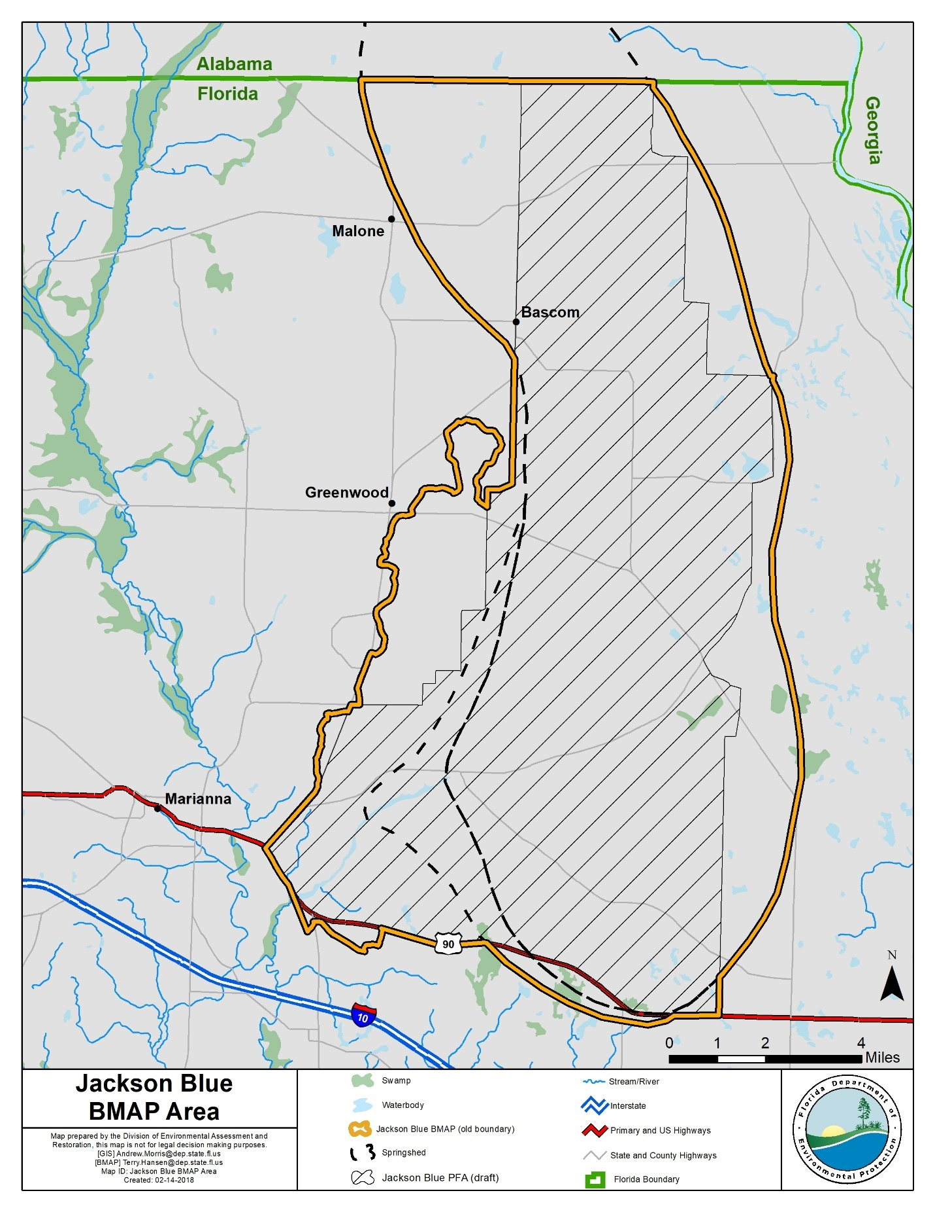
Figure ES- 1. Jackson Blue BMAP and PFA boundaries

The total load reduction for the BMAP area required to meet the total maximum daily loads (TMDLs) at the spring vent is 651,982 pounds of nitrogen per year (lb-N/yr). To measure progress towards achieving the necessary load reduction, DEP has established the following milestones:
- 195,595 lb-N/yr (30 %) within 5 years.
- 325,991 lb-N/yr (50 %) within 10 years.
- 130,396 lb-N/yr (20 %) within 15 years.
- A total of 651,982 lb-N/yr within 20 years.
The policies and submitted projects included within this BMAP are estimated to achieve a reduction of 330,287 to 708,260 lb-N/yr. The BMAP is designed to achieve 80 % of the effort within 10 years of adoption and 100 % within 15 years. DEP will evaluate progress towards these milestones and will report to the Governor and Florida Legislature. DEP will adjust management strategies to ensure the target concentrations are achieved.
There are currently 20 projects to improve water quality (see Appendix B), of which 8 projects have estimated load reductions. Possible load reductions include projects resulting from policies for owner-implemented best management practices (BMPs) for FF and livestock waste (LW); and voluntary onsite sewage treatment and disposal system (OSTDS) conversions enhancements or conversions to sewer.
Restoration Approaches
- New OSTDS – Upon BMAP adoption, the OSTDS remediation plan prohibits new systems on lots of less than 1 acre within the PFAs, unless the system includes enhanced treatment of nitrogen as defined by the OSTDS remediation plan, or unless the OSTDS permit applicant demonstrates that sewer connections will be available within 5 years. Local governments and utilities are encouraged to develop master wastewater treatment feasibility plans to identify specific areas to be sewered within 20 years of BMAP adoption. The OSTDS remediation plan is incorporated as Appendix D.
- Wastewater Treatment Facilities (WWTFs) – Although there are no WWTFs currently in the BMAP area, for consistency with other springs-related BMAPs, the effluent standards listed in Table ES-1 will apply to future WWTFs in the BMAP area.

Table ES-1. WWTF effluent standards
gpd = Gallons per day
95% of the Permitted Capacity  (gpd) | Nitrogen Concentration Limits for Rapid Infiltration Basins (RIBs) and Absorption Fields  (mg/L) | Nitrogen Concentration Limits for All Other Land Disposal Methods, Including Reuse  (mg/L)
Greater than 100,000 | 3 | 3
20,000 to 100,000 | 3 | 6
Less than 20,000 | 6 | 6

- Urban Turfgrass Fertilizer (UTF) – UTF sources can receive up to 6 % credit for the DEP-approved suite of public education and source control ordinances. Sources have the option to collect and provide monitoring data to quantify reduction credits for additional measures.
- Sports Turfgrass Fertilizer (STF) – STF sources include golf courses and other sporting facilities. Golf courses can receive up to 10 % credit for implementing the Golf Course BMP Manual. Other sports fields can receive up to 6 % credit for managing their fertilizer applications to minimize transport to groundwater.
- FF – All FF sources are required to implement BMPs or perform monitoring to demonstrate compliance with the TMDL. A 15 % reduction to groundwater is estimated for owner-implemented BMPs. Additional credits could be achieved through better documentation of reductions achieved through BMP implementation or the implementation of additional agricultural projects and practices, such as precision irrigation, soil moisture probes, controlled release fertilizer, and cover crops.
- LW – All LW sources are required to implement BMPs or perform monitoring. A 10 % reduction to groundwater is estimated for owner-implemented BMPs. Additional credits could be achieved through better documentation of reductions achieved through BMP implementation.

: Background

Legislation
Chapter 373, Part VIII, Florida Statutes (F.S.), the Florida Springs and Aquifer Protection Act, provides for the protection and restoration of Outstanding Florida Springs (OFS), which comprise 24 first magnitude springs, 6 additional named springs, and their associated spring runs. The Florida Department of Environmental Protection (DEP) has assessed water quality in each OFS and determined that 24 of the 30 OFS are impaired for the nitrate form of nitrogen. Jackson Blue Spring is an impaired OFS. Development of the basin management action plan (BMAP) to meet the new requirements of the Florida Springs and Aquifer Protection Act for the Jackson Blue Basin was initiated in 2017.

Water Quality Standards and Total Maximum Daily Loads (TMDLs)
A TMDL represents the maximum amount of a given pollutant that a waterbody can assimilate and still meet water quality criteria. Jackson Blue Spring and Merritts Mill Pond are Class III waterbodies with a designated use of recreation, propagation, and the maintenance of a healthy, well-balanced population of fish and wildlife. These waters are impaired by nitrate nitrogen, which in excess has been demonstrated to adversely affect flora or fauna through the excessive growth of algae. Excessive algal growth results in ecological imbalances in the springs and river and can produce human health problems, foul beaches, inhibit navigation, and reduce the aesthetic value of the resources.
Jackson Blue Spring forms the headwaters of the 270-acre Merritts Mill Pond, which forms the headwaters of Spring Creek, a tributary to the Chipola River (which is designated as an Outstanding Florida Water [OFW]). The Chipola River is the largest tributary in Florida to the Apalachicola River. Jackson Blue Spring and Merritts Mill Pond support a complex aquatic ecosystem and together are an important cultural and economic resource for the state.
In addition to Jackson Blue Spring, 7 named springs contribute to Merritts Mill Pond. Jackson Blue Spring contributes approximately 69 % of the total flow of Merritts Mill Pond (as measured at the pond outfall), the 7 minor springs contribute 14 %, and the remaining 17 % is from other unmeasured sources.
DEP adopted nutrient TMDLs for Jackson Blue Spring and Merritts Mill Pond in 2013 (Table 1). The TMDLs established a monthly average nitrate target of 0.35 milligrams per liter (mg/L) of nitrate to be protective of the aquatic flora or fauna. The period of record for water quality data evaluated for the TMDLs was January 1, 2001 through June 30, 2007.
Table 1. Restoration targets for Jackson Blue Spring and Merritts Mill Pond
Waterbody or Spring Name | Waterbody Identification (WBID) Number | Parameter | TMDL (mg/L)
Jackson Blue Spring | 180Z | Nitrate, monthly average | 0.35
Merritts Mill Pond | 180A | Nitrate, monthly average | 0.35

BMAP Requirements
Section 403.067(7), F.S., provides DEP the statutory authority for the BMAP Program. A BMAP is a comprehensive set of strategies to achieve the required pollutant load reductions. In addition to specifying BMAP statutory authority, the Florida Springs and Aquifer Protection Act (Part VIII of Chapter 373, F.S.) describes additional requirements for 30 springs.

BMAP Area
The BMAP area (Figure 1) comprises 88,934 acres in Jackson County, east of the City of Marianna. The BMAP area contains one OFS and several other springs. This area includes the surface water basin as well as the groundwater contributing areas for the spring (or springsheds). Springsheds for the OFS were delineated or reviewed by Northwest Florida Water Management District (NWFWMD) with input from the Florida Geological Survey (FGS). A springshed is the area of land that contributes water to a spring or group of springs, mainly via groundwater flow.

PFAs
In compliance with the Florida Springs and Aquifer Protection Act, this BMAP delineates a PFA which is defined as the area(s) of a basin where the Floridan aquifer is generally most vulnerable to pollutant inputs and where there is a known connectivity between groundwater pathways and an OFS. The PFA provides a guide for focusing restoration strategies where science suggests these efforts will most benefit the springs. The documents that describe the delineation process for each PFA are on the DEP website. The link to the PFA document is provided in Appendix C.

Description
Nitrogen sources are more likely to influence groundwater quality under certain conditions. For example, where soils are sandy and well drained, less nitrogen is converted to gas and released into the atmosphere or taken up by plants, compared with other soil types. Therefore, local soils play a role in how much nitrogen travels from the land surface to groundwater in a specific springshed. Also, the underlying geologic material influences the vulnerability of the underlying aquifers and the rate of lateral movement within the Floridan aquifer toward the springs and river. These conditions, and others, were considered in the delineation of the PFA (see Appendix C).
Following BMAP adoption, DEP will ensure that the GIS files associated with the PFA boundary are available to the public on the DEP Map Direct webpage.

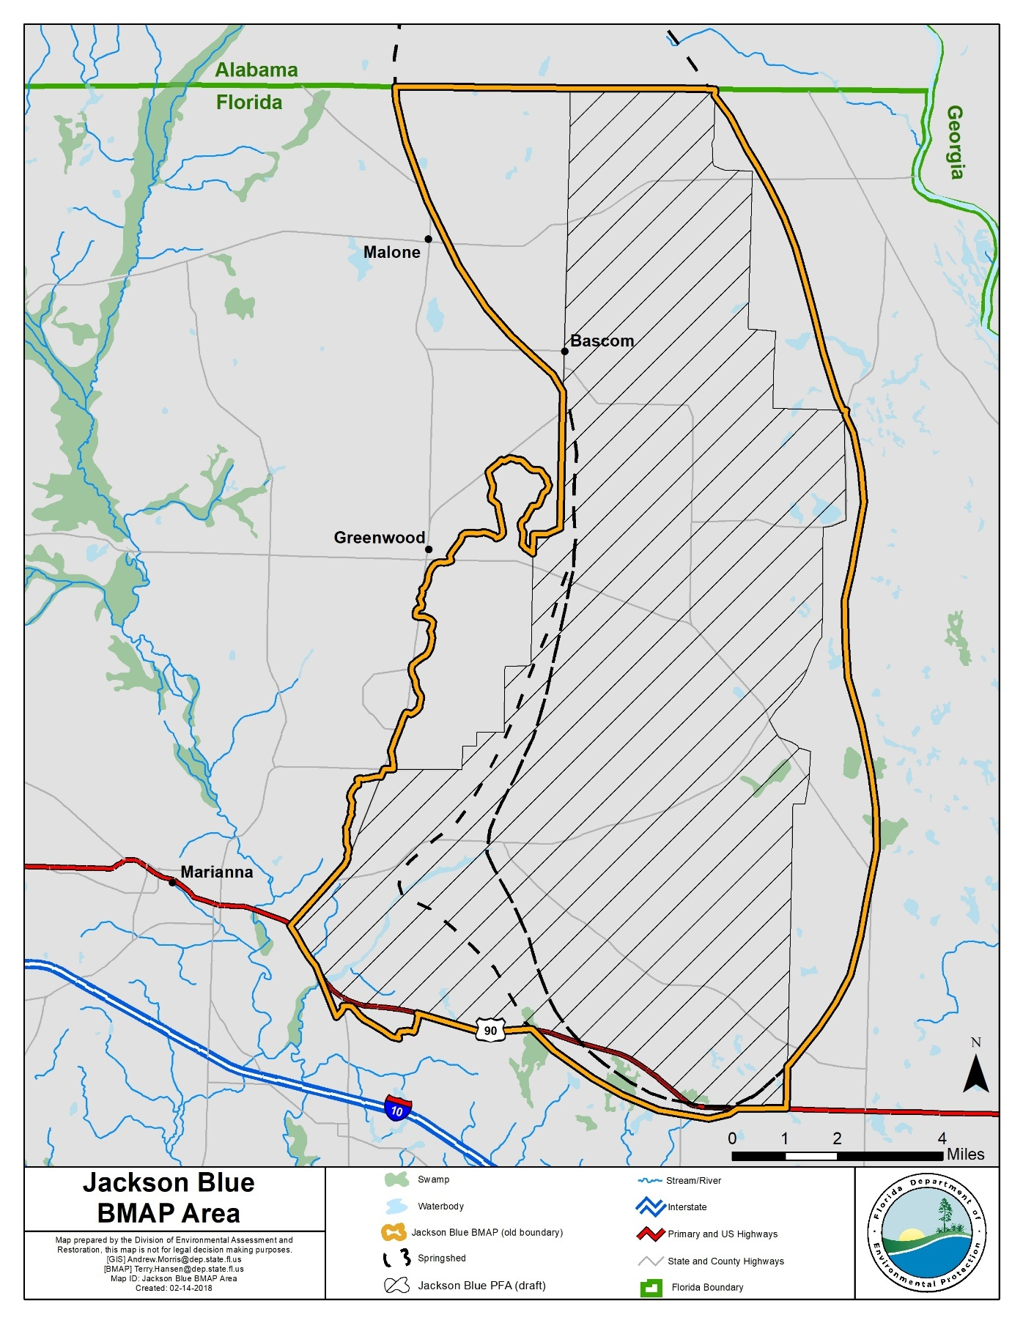
Figure 1. Jackson Blue BMAP and PFA boundaries

Additional Requirements
In accordance with Section 373.811, F.S., the following activities are prohibited in the PFA in the Jackson Blue BMAP:
- New domestic wastewater disposal facilities, including rapid infiltration basins (RIBs), with permitted capacities of 100,000 gpd or more, except for those facilities that meet an advanced wastewater treatment (AWT) standard of no more than 3 mg/L total nitrogen (TN) on an annual permitted basis.
- New OSTDS on lots of less than one acre inside the PFAs unless additional nitrogen treatment is provided, as specified in the OSTDS remediation plan (see Appendix D for details).
- New facilities for the disposal of hazardous waste.
- The land application of Class A or Class B domestic wastewater biosolids not in accordance with a DEP-approved nutrient management plan establishing the rate at which all biosolids, soil amendments, and sources of nutrients at the land application site can be applied to the land for crop production, while minimizing the amount of pollutants and nutrients discharged to groundwater or waters of the state.
- New agricultural operations that do not implement BMPs, measures necessary to achieve pollution reduction levels established by DEP, or groundwater monitoring plans approved by a WMD or DEP.

Additional Requirements for Biosolids and Septage Application Sites
In the PFA, the aquifer contributing to the spring is highly vulnerable to contamination by nitrogen sources and soils have a high to moderate tendency to leach applied nitrogen. DEP previously documented elevated nitrate concentrations in groundwater beneath septage application zones in spring areas. To assure that nitrogen losses to groundwater are minimized from permitted application of biosolids and septage in the PFA, the following requirements apply to newly-permitted application sites and existing application sites upon permit renewal.
All permitted biosolids application sites that are agricultural operations must be enrolled in the Florida Department of Agriculture and Consumer Services (FDACS) BMP Program or be within an agricultural operation enrolled in the FDACS BMP Program for the applicable crop type. Implementation of applicable BMPs will be verified by FDACS in accordance with Chapter 5M-1, Florida Administrative Code (F.A.C.). Permitted biosolids application sites that are new agricultural operations must also comply with Subsection 373.811(5), F.S. Biosolids application sites must be certified as viable agricultural operations by an acknowledged agricultural professional such as an agricultural consultant or agricultural extension agent. Effective nutrient management practices must be ongoing at the application zones in the permit. Plant uptake and harvesting are vital components of the nutrient management plan to remove nitrogen and prevent it from leaching to groundwater. If DEP determines that the site is not a viable agricultural site implementing a nutrient management plan, corrective action will be required.
Groundwater monitoring for nitrate is required for all biosolids and septage land application sites in the PFA to assure compliance with nutrient management objectives in this BMAP. However, groundwater monitoring is not required if the site nutrient management plan limits biosolids application rates of TN with no adjustment for available nitrogen normally allowed by subsections 62-640.500(5) and (6), F.A.C. (e.g. for a recommended fertilizer rate of 160 pounds of nitrogen per acre, only 160 pounds of TN per acre shall be applied). For septage application, groundwater monitoring is not required if the site nutrient management plan limits application rates to 30,000 gallons per acre for sites accepting mixtures of septage and grease (food establishment sludge) or to 40,000 gallons per acre for sites accepting septage without grease. The permit renewal application will include a trend analysis for nitrate in groundwater monitoring wells during the previous permit cycle, and an evaluation of the potential for the facility to cause or contribute to exceedance of the TMDL.
Changes are proposed to the upcoming FDACS Cattle BMP Manual revision that will likely impact biosolid application. This will necessitate coordination between FDACS and DEP permitting staff.

Other Scientific and Historical Information
In preparing this BMAP, DEP collected and evaluated credible scientific information on the effect of nutrients, particularly forms of nitrogen, on springs and springs systems. Some of the information collected is specific to the Jackson Blue Basin, while other references provided information on related knowledge for restoring springs, such as nitrogen-reducing technologies, the treatment performance of OSTDS, and runoff following fertilizer applications.

Stakeholder Involvement
Stakeholder involvement is critical to develop, gain support for, and secure commitments in a BMAP. The BMAP process engages stakeholders and promotes coordination and collaboration to address the pollutant load reductions necessary to achieve the TMDLs. DEP invites stakeholders to participate in the BMAP development process and encourages public participation and consensus to the greatest practicable extent. Table A-1 lists the stakeholders who participated in the development of this BMAP.
During the development of the Jackson Blue BMAP, DEP held a series of meetings involving stakeholders and the general public. The purpose of these meetings was to consult with stakeholders to gather information, evaluate the best available science, develop an OSTDS remediation plan (including a public education plan), define management strategies and milestones, and establish monitoring requirements. All meetings were open to the public and noticed in the Florida Administrative Register (F.A.R.). Additionally, a public meeting on the current draft BMAP was held on March 28, 2018, and was noticed in the F.A.R. and in local newspapers.
Upon BMAP adoption, DEP intends to facilitate annual meetings with stakeholders to review progress towards achieving the TMDLs.

Description of BMPs Adopted by Rule
Table 2 lists the adopted BMPs and BMP manuals relevant to this BMAP.
Table 2. BMPs and BMP manuals adopted by rule as of June 2017
Agency | F.A.C. Chapter | Chapter Title
FDACS Office of Agricultural Water Policy (OAWP) | 5M-6 | Florida Container Nursery BMP Guide
FDACS OAWP | 5M-8 | BMPs for Florida Vegetable and Agronomic Crops
FDACS OAWP | 5M-9 | BMPs for Florida Sod
FDACS OAWP | 5M-11 | BMPs for Florida Cow/Calf Operations
FDACS OAWP | 5M-12 | Conservation Plans for Specified Agricultural Operations
FDACS OAWP | 5M-13 | BMPs for Florida Specialty Fruit and Nut Crop Operations
FDACS OAWP | 5M-14 | BMPs for Florida Equine Operations
FDACS OAWP | 5M-16 | BMPs for Florida Citrus
FDACS OAWP | 5M-17 | BMPs for Florida Dairies
FDACS OAWP | 5M-18 | Florida Agriculture Wildlife BMPs
FDACS OAWP | 5M-19 | BMPs for Florida Poultry
FDACS Division of Agricultural Environmental Services | 5E-1 | Fertilizer
FDACS Division of Aquaculture | 5L-3 | Aquaculture BMPs
FDACS Florida Forest Service | 5I-6 | BMPs for Silviculture
FDACS Florida Forest Service | 5I-8 | Florida Forestry Wildlife BMPs for  State Imperiled Species
DEP | 62-330 | Environmental Resource Permitting

: Implementation to Achieve the TMDLs

Allocation of Pollutant Loads
DEP collected and evaluated credible scientific information on the effect of nutrients, particularly forms of nitrogen, on Jackson Blue Spring, described below.

Nutrients in the Springs and Spring Systems
DEP developed the Nitrogen Source Inventory Loading Tool (NSILT) to provide information on the major sources of nitrogen in the groundwater contributing area for the OFS. In addition, this tool is used to estimate nitrogen loads to groundwater from these sources in the spring contributing area. The NSILT is a GIS- and spreadsheet-based tool that provides spatial estimates of the relative contribution of nitrogen from major nitrogen sources and accounts for the transport pathways and processes affecting the various forms of nitrogen as they move from the land surface through the soil and geologic strata.
The first major factor to consider in estimating the loading to groundwater in the NSILT is the attenuation of nitrogen as it moves from its source through the environment, before it reaches the Upper Floridan aquifer (UFA). The movement of nitrogen from the land surface to groundwater is controlled by biological and chemical processes that occur as part of the nitrogen cycle, as well as hydrogeological processes. Many of these processes attenuate (impede or remove) the amount of nitrogen transported to groundwater. An understanding of how water moves through the subsurface and the processes that transform the different forms of nitrogen is essential for estimating nitrogen loading to groundwater from various sources.
A second major factor to consider in estimating the loading to groundwater is the geologic features in the springshed and the related "recharge rate." Water movement between the shallow groundwater (surficial aquifer, where present) and the deeper aquifer (UFA) is slowed by a low permeability layer of clay, silt, and fine sand that retards the vertical movement of infiltrating water from the surface. The UFA occurs in limestone that can be prone to dissolving, and, over geologic time, the development of numerous karst features (sinkholes, caves, and conduits). These features allow water from the land surface to move directly and relatively rapidly into the aquifer and in some areas for groundwater in the aquifer to move rapidly to the springs.
Potential recharge rates from the surface to the UFA are affected by variations in the geologic materials and the presence of karst features. DEP estimated the recharge rate ranges and grouped them into three rate categories, which were applied in the NSILT:
- Low recharge (1 to 5 inches per year [in/yr]).
- Medium recharge (5 to 15 in/yr).
- High recharge (15 in/yr or greater).
In the NSILT, DEP applied different attenuation factors to different types of sources, so that various biological, chemical, and hydrogeological effects could be estimated. The attenuation that was applied means that the amount of nitrogen leaving a source (such as a livestock operation or a newly fertilized yard) reduces the amount of nitrogen predicted to reach the aquifer. In the NSILT estimates, the attenuation rates ranged from 90 % (for atmospheric deposition) to 25 % (for wastewater disposal in a RIB). This means that, for these examples, only 10 % of nitrogen from atmospheric deposition is expected to reach the aquifer, while 75 % of nitrogen from a RIB is expected to reach groundwater, because the remainder is attenuated by various chemical and biological processes.
Phosphorus is naturally abundant in the geologic material underlying much of Florida and is often present in high concentrations in surface water and groundwater. Monitoring and evaluation of phosphorus and influences on the springs continues as the nitrate TMDLs are implemented.

Estimated Nitrogen Loads
Table 3 lists the estimated nitrogen loads to groundwater by source. Note that urban stormwater loads are included in UTF estimates, while agricultural stormwater loads are included in FF and LW estimates. Nitrogen loading to surface water will be reduced through the activities and strategies for the sources identified in this chapter for groundwater loading.
Table 3. Estimated nitrogen load to groundwater by source in the BMAP area
Nitrogen Source | Estimated Total Nitrogen Load to Groundwater  (lb-N/yr) | % Contribution
OSTDS | 19,109 | 3
UTF and STF | 3,435 | <1
Atmospheric Deposition | 35,484 | 5
Irrigated FF | 333,763 | 45
Non-Irrigated FF | 292,158 | 40
LW | 54,010 | 7
Total | 737,959 | 100

Assumptions and Considerations
The NSILT estimates are based on the following assumptions and considerations:
- NSILT Nitrogen Inputs – The methods used to estimate nitrogen inputs for each pollutant source were based on a detailed synthesis of information, including direct water quality measurements, census data, surveys, WWTF permits, published scientific studies and reports, and information obtained in meetings with agricultural producers. For some pollutant source categories, nitrogen inputs were obtained using assumptions and extrapolations, and as a result, these inputs could be subject to further refinement if more detailed information becomes available.
- OSTDS Load Contribution – A per capita contribution to an OSTDS of 9.012 lb-N/yr was used to calculate loading from OSTDS. The average household contribution was estimated based on 2010 U.S. Census Bureau data on the average number of people per household for Jackson County of 2.86 persons.
- Nitrogen Attenuation Factors –To estimate the amount of nitrogen loading to the aquifer, DEP applied two nitrogen attenuation factors. Biological and chemical processes that occur as part of the nitrogen cycle, as well as hydrogeological processes, control the movement of nitrogen from the land surface to groundwater. Biochemical attenuation accounts for biochemical processes that convert or transform the different forms of nitrogen, while hydrogeological attenuation accounts for spatial variations that affect the rate of water infiltrating through geological media to recharge the UFA. Given the relatively large range of literature-reported values of biochemical nitrogen attenuation for each source category, DEP used an average biochemical attenuation factor for each source based on land use practices and hydrogeological conditions (i.e., recharge) in the contributing areas.
Other assumptions and considerations for BMAP implementation include the following:
- Unquantified Project Benefits – Nitrogen reductions for some of the projects and activities listed in this BMAP cannot currently be quantified. However, because of their positive impact, it is assumed that these actions will help reduce pollutant loads, and estimated loading reductions may be determined at a later date and assigned to these activities.
- Atmospheric Deposition – Atmospheric sources of nitrogen are local, national, and international. Atmospheric sources are generally of low nitrogen concentration compared with other sources and are further diminished through additional biological and chemical processes before they reach groundwater. Atmospheric deposition sources and trends will be reevaluated periodically.
- OSTDS Inventory and Loading Calculations – The total number of OSTDS in the basin is estimated based on local information and Florida Department of Health (FDOH) data. Future BMAPs and the associated OSTDS loading calculations may be adjusted based on improved data on the number and location of existing septic systems, and may include additional OSTDS installed since BMAP adoption.
- PFA – The PFA provides a guide for focusing strategies where science suggests efforts will best benefit the springs. The PFA boundary may be adjusted in the future if additional relevant information becomes available.
- Project Collection Period – The BMAP project collection period is limited to projects after a certain date, based on the data used to calculate the reductions needed. Reductions from older projects are already accounted for in the baseline loading. Projects completed in the springshed after July 1, 2007, were considered for inclusion in this BMAP.
- Legacy Sources – Land uses or management practices not currently active in the basin may still be affecting the nitrate concentration of the springs. The movement of water from the land surface through the soil column to the UFA and through the UFA to the spring system varies both spatially and temporally and is influenced by local soil and aquifer conditions. As a result, there may be a delay between when nitrogen input to the UFA occurs and when that load ultimately arrives at an OFS. The impact of this delay is not fully understood known.
- Implementation Schedule – BMAP implementation is a 20-year process. This plan defines nitrogen reduction milestones for 5-year (30 %), 10-year
(50 %), and 15-year (20 %) implementation, so that the TMDLs will be met no later than the 20-year goal (see Section 2.1.6 for further details). Further, the total reductions and project credits may be adjusted under the adaptive management approach used for the BMAP. This approach requires regular follow-up to ensure that management strategies are carried out and that their incremental effects are assessed. This process acknowledges that there is some uncertainty associated with the outcomes of proposed management strategies and the estimated response of concentration at the springs. As more information is gathered and progress towards each 5-year milestone is reviewed, additional management strategies to achieve the TMDLs will be developed or existing strategies refined to better address the sources of nitrogen loading.
- Changes in Spring Flows – The role of this BMAP is specifically to promote the implementation of projects that reduce the nitrogen load to groundwater, while the minimum flows and levels (MFLs) established for specific springs address water flows and levels. To maximize efforts between the two programs, spring protection projects should provide both water quality and quantity benefits.

Loading by Source
From the Jackson Blue NSILT estimates, the pie chart in Figure 2 depict the estimated percentage of nitrogen loading to groundwater by source in the BMAP area. Irrigated and non-irrigated FF are responsible for 85 % of the nitrogen sources in the BMAP area. Stormwater loading to groundwater is incorporated into the various source categories.
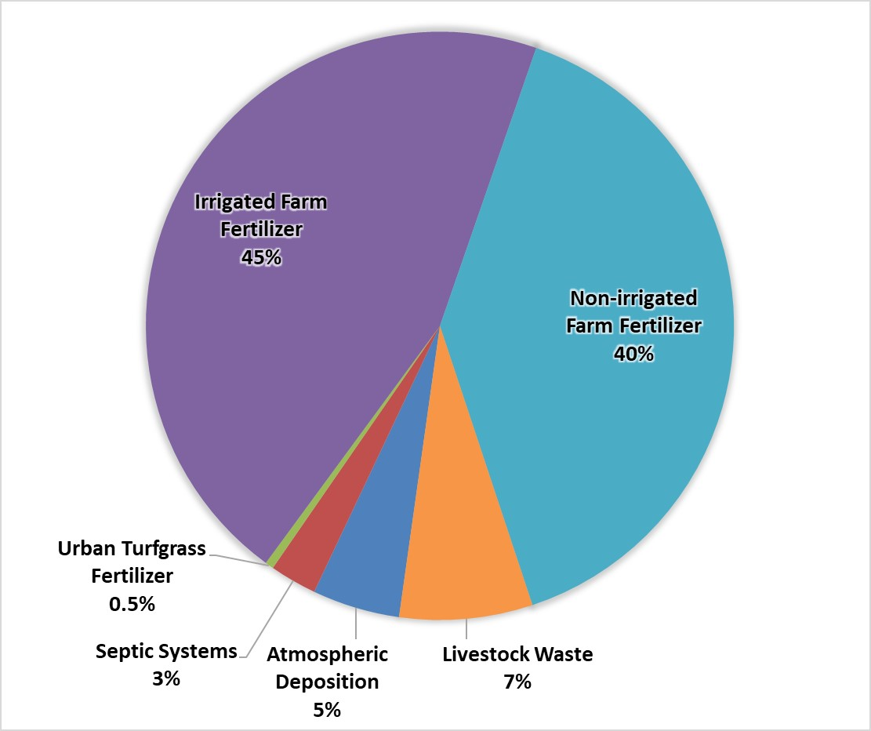

Figure 2. Loading to groundwater by source in the BMAP area

Loading Allocation
The nitrogen source reductions are based on the measured nitrate loads at the spring vent, along with the TMDL target nitrate concentration. Table 4 lists the measured nitrate (as nitrogen) loads at the spring vent compared with the TMDL loading based on a target nitrate concentration of 0.35 mg/L. The difference between the spring vent loading and the TMDL loading estimate is the required reduction to meet the TMDLs. The total load that is required to be reduced in the basin is being allocated to the entire.

Table 4. Total reductions to meet the TMDLs
Description | Nitrogen Loads (lb-N/yr) | Notes Regarding Data Used
Total Load at Spring Vent | 719,234 | Upper 95% confidence interval - nitrate data and flow data from 2012 to 2017 (97.73 cubic feet per second [cfs])
TMDL Load | 67,252 | TMDL target is 0.35 mg/L and using the same flow data from 2012 to 2017
Required Reduction | 651,982

Description of 5-, 10-, and 15-year Milestones/Reduction Schedule
The overall load reduction targets are 30 % of the total within 5 years, 80 % of the total within 10 years, and 100 % of the total within 15 years. DEP will evaluate progress towards these milestones and will report to the Governor and Florida Legislature. DEP will adjust management strategies to ensure the target concentrations are achieved.
Table 5 lists the estimated nitrogen reduction schedule, by milestone. Progress will be tracked yearly and adjustments made as needed. At the 5-year milestone, progress will be assessed and load reductions adjusted as necessary. Entities have flexibility in the types and locations of projects as long as they achieve the overall required load reductions. The monitoring of existing groundwater and springs sampling locations is essential. Section 2.3 describes detailed source reduction strategies.
Table 5. Nitrogen reduction schedule (lb-N/yr)
5-Year  Milestone  (30 % of Total) | 10-Year Milestone  (50 % of Total) | 15-Year Milestone  (20 % of Total) | Total Nitrogen Reduction  (100 %)
195,595 | 325,991 | 130,396 | 651,982

Prioritization of Management Strategies
The management strategies listed in Appendix B are ranked with a priority of high, medium, or low. In 2016, the Florida Legislature amended the Watershed Restoration Act (Section 403.067, F.S.), creating additional requirements for all new or revised BMAPs. BMAPs must now include planning-level details for each listed project, along with their priority ranking.
Project status was selected as the most appropriate indicator of a project’s priority ranking based primarily on need for funding. Projects with a "completed" status were assigned a low priority. Projects classified as "underway" were assigned a medium priority because some resources have been allocated to these projects, but additional assistance may be needed for the project to be completed. High priority was assigned to projects listed with the project status "planned" as well as certain "completed" projects that are ongoing each year (any project with one of these project types: "street sweeping," "catch basin inserts/inlet filter cleanout," "public education efforts," "fertilizer cessation," "fertilizer reduction," or "aquatic vegetation harvesting"), and select projects that are elevated because substantial, subsequent project(s) are reliant on their completion.

Load Reduction Strategy
The total load reduction to groundwater needed to meet the TMDLs is 651,982 lb-N/yr. Based on the totals of all the credits from BMAP actions and policies, the range of total reductions to groundwater is between 330,287 to 708,260 lb-N/yr (see Table 6).
To achieve reductions outside the scope of the policies listed, additional project options are available to local entities but have not been planned. Other efforts could be pursued to further reduce the nitrogen load to groundwater in the Jackson Blue springshed. Including both BMAP projects and practices and additional agricultural projects and practices.
Table 6. Summary of potential credits for Jackson Blue Spring Basin projects to meet the TMDLs
Nitrogen Source | Credits to Load to Groundwater Based on Project Tables (lb-N/yr) | Description
OSTDS | 3,294 | Credits identified for stakeholder OSTDS projects  (enhancement or sewer)
UTF | 206 | DEP approved credits (6%) for public education activities  as well as credits identified for stakeholder stormwater projects
Atmospheric Deposition | ‒ | No reduction
FF Projects | 5,400 | Credits identified for stakeholder farm fertilizer projects
FF | 93,888 | 15% BMP credit on farm fertilizer load to groundwater,  assuming 100% owner-implemented BMPs on  all fertilized lands
LW | 5,401 | 10% BMP credit on load to groundwater, assuming 100%  owner-implemented BMPs at all livestock facilities
STF | ‒ | 6% BMP credit for sports fields and 10% BMP credit for golf courses on STF load to groundwater, assuming 100% BMP implementation on golf courses and sports fields
WWTF | ‒ | Achieved by BMAP WWTF policy if BMAP-wide  (achieving 3 or 6 mg/L)
Total Credits from BMAP Policies and Submitted Projects | 108,198
Additional Agricultural Projects and Practices | 222,098 – 600,071 | Pursue additional practices over next 20 years. Contingent upon funding. Includes 10%-50% reduction from 100% of fertilized acres with a change in practice
Total Credits | 330,287 -708,260 | Estimated load reduction to meet the TMDLs is 651,982 lb-N/yr

OSTDS Management Strategies
Overall, there are currently an estimated 479 OSTDS in the PFA on lots less than one acre, based on FDOH estimates. This BMAP lists three specific projects (Appendix B) that reduce nitrogen loading from existing OSTDS on variably sized parcels by a total of 3,294 lb-N/yr. Figure 3 shows the locations of all OSTDS in the BMAP area, including the PFA.
In addition to the three listed projects, DEP assessed the overall OSTDS loading compared with other nitrogen sources in the PFA, as well as the relative loading in the wider BMAP area. Based on these assessments, DEP has determined that for the Jackson Blue BMAP area, OSTDS contribute less than 20 % of nonpoint source nitrogen pollution to the OFS. Per the Jackson Blue NSILT, septic systems contribute 3 % pollutant loading in the springshed areas and 3 % of the nitrogen loading in the PFA. Irrespective of the percent contribution, nitrogen loading from OSTDS contribute to the significant degradation of the groundwater, and DEP has determined that an OSTDS remediation plan is necessary to achieve the TMDLs and to limit the increase in nitrogen loads from future growth. Accordingly, the OSTDS remediation plan prohibits the installation of new conventional systems on lots less than 1 acre within the PFA. The OSTDS remediation plan is incorporated as Appendix D.

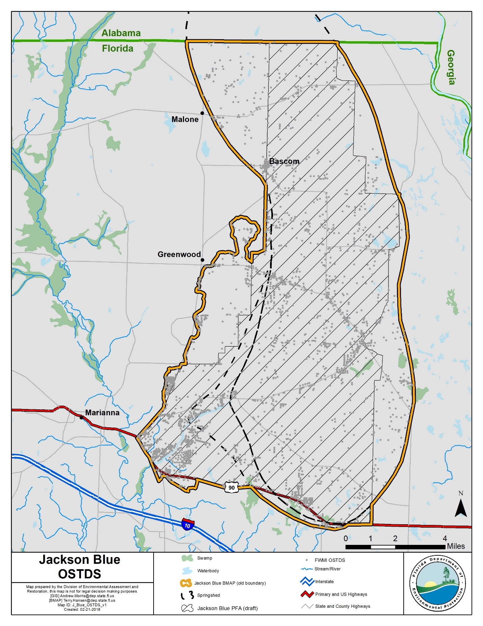
Figure 3. OSTDS locations in the BMAP area
In addition to the actions outlined in the OSTDS remediation plan (incorporated into this BMAP as Appendix D), remedial efforts on existing conventional OSTDS could achieve nitrogen reductions.
Table 7 summarizes the nitrogen inputs, attenuation and recharge factors, and loads to groundwater for a conventional OSTDS. The conventional OSTDS nitrogen input is based on a per capita contribution of 9.012 lb-N/yr. This value is multiplied by the estimated number of people using the system (i.e., 2.86 persons per household in Jackson County). Percent reductions for enhanced or replaced systems are applied to the conventional OSTDS nitrogen groundwater loads to valuate possible improvements to groundwater. Enhanced OSTDS can achieve an estimated 65 % improvement in the load to groundwater compared to a conventional system. OSTDS replaced by sewer reduce the conventional nitrogen inputs by an estimated 95 %, assuming a sewer connection to a WWTF meeting AWT levels. The results show an estimated nitrogen reduction (i.e., credit) of 7.5 in high recharge areas, 4.2 in medium recharge areas, and 0.8 in low recharge areas for each enhanced OSTDS and an estimated nitrogen reduction of 11.0 in high recharge areas, 6.1 in medium recharge areas, and 1.2 in low recharge areas for each replaced OSTDS.
Table 7. Estimated individual OSTDS improvements to groundwater
Recharge Category | Conventional OSTDS Load To Groundwater (lb-N/yr/OSTDS) | Reduction to Groundwater  (lb-N/yr/OSTDS)
Recharge Category | Conventional OSTDS Load To Groundwater (lb-N/yr/OSTDS) | Enhanced OSTDS | Replaced OSTDS
Nitrogen Input | 26 | ‒ | ‒
Attenuation (0.5) | 12.9 | ‒ | ‒
Low Recharge (0.1) | 1.3 | 0.8 | 1.2
Medium Recharge (0.5) | 6.4 | 4.2 | 6.1
High Recharge (0.9) | 11.6 | 7.5 | 11.0

Table 8 lists the potential reductions associated with OSTDS enhancement and replacement for OSTDS on lots less than one acre and greater than one acre in the PFA. Using these "credits," reductions associated with OSTDS projects may be determined.
The estimates in the table indicate that nitrogen loading could be substantially reduced if all OSTDS sources are addressed. However, OSTDS are a relatively minor source in comparison to other sources in the basin. Estimated costs for retrofitting (onsite treatment improvements) or removing (sewering) OSTDS range from $10,000 to $20,000 per system, which would be anticipated to be offset somewhat by cost-share from state funds. These costs can be refined as projects are completed and detailed cost data are available. The overall reduction goal is 651,982; thus, the targets cannot be achieved through OSTDS alone.
Table 8.Estimated reduction credits for additional OSTDS enhancement or sewer *
*Estimated reductions listed in the table are for either enhancement or sewer per parcel classification. Reductions cannot be combined for the same parcel classification but can be combined between the different classifications. For example, the sewer credit associated with parcels less than one acre in size can be combined with the sewer credit associated with parcels one acre or greater in size.
Recharge Area | OSTDS Parcels Less Than One Acre in PFA | Credit for Sewer (lb-N/yr) | Credit for Enhancement (lb-N/yr) | OSTDS Parcels One Acre and Greater in PFA | Credit for Sewer (lb-N/yr) | Credit for Enhancement (lb-N/yr)
High | 460 | 5,069 | 3,468 | 1,504 | 16,572 | 11,339
Medium | 19 | 116 | 116 | 44 | 269 | 184
Total | 479 | 5,185 | 3,548 | 1,548 | 16,841 | 11,523

UTF Management Strategies
UTF consists of fertilizers applied to the turfgrass typically found in residential and urban areas (including residential lawns and public green spaces). It is applied by either the homeowner or a lawn service company on residential properties, while on nonresidential properties, it may be applied by contractors or maintenance staff.

Fertilizer Ordinance Adoption
As required by the Florida Legislature, as described in Subsection 373.807(2), F.S., local governments with jurisdictional boundaries that include an OFS or any part of a springshed or the delineated PFA of an OFS, are required to develop, enact, and implement a fertilizer ordinance by July 1, 2017. The statutes require any ordinance to be based, at a minimum, on the DEP model ordinance for Florida-friendly fertilizer use on urban landscapes.

Prioritized Management Strategies and Milestones
Based on the Jackson County landscape ordinance in place at the time of BMAP adoption and implementation of the Florida Yards and Neighborhoods (FYN) Program, the associated credits for UTF reductions to groundwater are 120 lb-N/yr (see Table 9). Additional environmental benefits could be credited if the counties and municipalities implement other public education efforts and source control ordinances, as described below.
Local stormwater projects that treat urban runoff, including nitrogen from urban fertilizer, are also in place (see Appendix B), with the estimated reduction to groundwater to be determined.
Table 9. Current project credits to reduce UTF loading to groundwater
Project Category | Project Credits Based on Management Actions in Appendix B  (lb-N/yr)
Landscape Ordinance | 17
FYN Program | 103
Total Project Credits | 120

Since there is uncertainty about the data used in the NSILT estimates to calculate the UTF loading to groundwater, DEP will work toward collecting better data by documenting reductions with the stakeholders. Also, DEP will work with the stakeholders to develop additional measures to reduce fertilizer application.

Additional UTF Reduction Options
The anticipated reduction from UTF sources is currently limited to 6 % of the estimated load to groundwater. This reduction can be achieved through a 6 % total credit if Jackson County has an applicable fertilizer ordinance, landscape ordinance, irrigation ordinance, and pet waste ordinance; carries out public education activities; and implements the FYN Program (Table 10). Currently, Jackson County has an adopted landscape ordinance and implements the FYN Program for a total credit of 120 lb-N/yr. An additional 86 lb-N/yr reduction could be achieved through public education and source control efforts.
Table 10. Maximum UTF load reductions based on existing public education credit policies
UTF  Source Control Measures | Credit, Based on Estimated Load to Groundwater  (%) | Possible Nitrogen Credits  (lb-N/yr)
Fertilizer Ordinance | 0.50 | 17
Pet Waste Ordinance | 0.50 | 17
Landscape Ordinance | 0.50 | 17
Irrigation Ordinance | 0.50 | 17
FYN Program | 3.00 | 103
Public Education Program | 1.00 | 34
Total Possible Credits | 6.00 | 206

Appendix E contains technical support information that further explains the concepts presented in this section, including nitrogen loading by source category, reduction obligations, and management strategies.

STF Management Strategies
STF areas fall into two main categories that are evaluated separately: golf courses and sporting facilities such as baseball, football, soccer, and other fields. There are no identified golf courses or sporting facilities located within the BMAP area.

Agricultural Sources Management Strategies
Based on data provided by FDACS, there are 41,559 agricultural acres in the basin: 16,854 acres are fertilized croplands, 2,135 acres are livestock lands, and 9,145 acres are classified as both fertilized croplands and livestock lands.

FF Loading
Nitrogen in agricultural fertilizer is applied at varying rates, depending on the crop and individual farm practices. The NSILT estimated total nitrogen load to groundwater from irrigated FF is 333,763 lb-N/year and 292,158 lb-N/yr from non-irrigated FF, approximately 85 % of the total nitrogen load to groundwater in the BMAP area. FF includes commercial inorganic fertilizer applied to row crops, field crops, pasture, and hay fields.

LW Loading
Agricultural practices specific to LW management were obtained through meetings with University of Florida Institute of Food and Agricultural Sciences (UF-IFAS) extension staff, FDACS field representatives, agricultural producers, and stakeholders. The NSILT estimated total nitrogen load to groundwater from LW is 54,010 lb-N/year, or 7 % of the total nitrogen load to groundwater.

Prioritized Management Strategies and Milestones
Subsection 403.067, F.S., requires agricultural nonpoint sources in a BMAP area either to submit to FDACS a notice of intent (NOI) and implement the applicable FDACS-adopted BMPs, which provides a presumption of compliance with water quality standards, or conduct water quality monitoring prescribed by DEP or NWFWMD that demonstrates compliance with water quality standards. Further, based on the Florida Springs and Aquifer Protection Act, Subsection 373.811(5), F.S., prohibits any new agricultural operations in BMAP areas that do not implement applicable FDACS BMPs upon the commencement of those operations, implement measures necessary to achieve pollution reduction levels established by DEP, or follow a water management district– or DEP-approved monitoring plan to demonstrate compliance with water quality standards. Failure to submit to FDACS an NOI and implement BMPs or conduct monitoring that demonstrates compliance may result in enforcement action by DEP.
FDACS will work with applicable producers within the BMAP area to ensure enrollment and, within the first five-year period, verify implementation of BMPs. In addition, FDACS will undertake projects involving precision irrigation, soil moisture probes, and cover crop planting, contingent on the availability of funds for cost share. As of December 31, 2017, there were NOIs on 36 % of the agricultural acreage in the Jackson Blue BMAP area (23,162 of 41,559 agricultural acres). No producers are conducting water quality monitoring in lieu of implementing BMPs at this time. Appendix B lists project information. Appendix F provides detailed information on BMPs and agricultural practices in the BMAP area.
With crop-specific BMP enrollment or monitoring for FF areas, an estimated 93,888 lb-N/yr reduction to groundwater can be achieved, based on an average reduction of 15 % in the nitrogen load to groundwater. While DEP has listed larger percentage reductions in nitrogen from agricultural BMPs in estimating benefits to surface waters, the best data available on benefits to groundwater from BMPs indicate a 15 % reduction in the load to groundwater where owner-implemented BMPs are in place. In addition to groundwater reductions from owner-implemented BMPs on fertilized lands, an additional 5,400 lb-N/yr in reductions are estimated from specific stakeholder projects on fertilized lands. This number could increase as more data are collected on the impact of BMPs to groundwater.
For all livestock operations, owner-implemented BMPs are expected to achieve a reduction of 5,401 lb-N/yr, using an estimated 10 % reduction in the load to groundwater from owner-implemented BMPs at livestock operations.
Summarizing the reductions discussed above, the total reduction from BMP implementation of all agricultural sources is 104,689 lb-N/yr.

Additional Agricultural Reduction Options
Further reductions can be achieved through implementing additional agricultural projects or practices, including land acquisition and conservation easements. NWFWMD is implementing projects to encourage low input agriculture and water quality improvement technologies. Examples of these projects include providing incentives for producers to transition to less intensive cropping systems, changing land use to fallow or native landscape, or changing the type of cropping system. Other reductions associated with the implementation and modification of BMPs may be realized through ongoing studies and data collection. Basin-specific studies are underway to evaluate and demonstrate the effectiveness of BMPs on a site-specific basis.
Additional reductions may also be achieved through implementing additional agricultural projects and practices. Table 11 lists these projects and practices with their estimated load reductions, based on existing crop types. FDACS supplied the acreages, load reductions associated with applicable practices, and estimated the costs of implementation.
Table 11. Estimated reductions for additional agricultural projects and practices
Action | Acreage | High Estimated Reduction Credit  (lb-N/yr) | Medium Estimated Reduction Credit  (lb-N/yr)
Rotational Production | 12,366 | 88,807 | 49,337
Precision Irrigation | 12,011 | 3,360 | 1,866
Soil Moisture Probes (95) | 12,555 | 40,727 | 22,626
Precision Fertilization | 12,011 | 37,328 | 20,738
Controlled Release Fertilizer | 1,363 | 3,680 | 2,044
Cover Crops | 12,538 | 101,560 | 56,422
Total | 63,048 | 275,462 | 153,033

The projects and practices listed in Table 11 are a component of the reductions to groundwater that could be achieved through changes in practices (Table 12). For example, a 75 % reduction of fertilizer loss to groundwater on 25 % of the fertilized lands would result in an estimated reduction of 117,360 lb-N/yr. Note that these estimates are averaged over the entire basin, and the recharge characteristics of a specific site and the fertilization practices for specific crops may change the estimated reduction for specific acres with a conservation easement or change in fertilization.
Table 12. Potential for additional load reductions to groundwater
% of Fertilized Acres with a Change in Practice | Number of Fertilized Acres with a Change in Practice | 100%  Reduction in Load to Groundwater  (lb-N/yr reduced) | 75% Reduction in Load to Groundwater  (lb-N/yr reduced) | 50% Reduction in Load to Groundwater  (lb-N/yr reduced) | 25% Reduction in Load to Groundwater  (lb-N/yr reduced) | 10% Reduction in Load to Groundwater  (lb-N/yr reduced)
100 | 42,720 | 625,921 | 469,441 | 312,961 | 156,480 | 62,592
75 | 32,040 | 469,441 | 352,081 | 234,720 | 117,360 | 46,944
50 | 21,360 | 312,961 | 234,720 | 156,480 | 78,240 | 31,296
25 | 10,680 | 156,480 | 117,360 | 78,240 | 39,120 | 15,648
10 | 4,272 | 62,592 | 46,944 | 31,296 | 15,648 | 6,259

Beyond enrolling producers in the FDACS BMP Program and verifying implementation, FDACS will work with DEP to improve the data used to estimate agricultural land uses in the springshed. FDACS will also work with producers to implement a suite of agricultural projects and research agricultural technologies on properties where they are deemed technically feasible and if funding is made available. The acreages provided by FDACS are preliminary estimates of the maximum acreages and will be evaluated and refined over time. As presented here, these projects are based on planning-level information. Actual implementation would require funding as well as more detailed designs based on specific information, such as actual applicable acreages and willing landowners.

WWTF Management Strategies
The role of WWTFs is to receive and treat domestic wastewater. There are no WWTFs in the Jackson Blue BMAP area.

Wastewater Management Standards and Reuse Management
The Florida Springs and Aquifer Protection Act prohibits new domestic wastewater disposal facilities in the PFA, including RIBs, with permitted capacities of 100,000 gpd or more, except for those facilities that provide AWT that reduces total nitrogen in the effluent to 3 mg/L or lower, on an annual permitted basis.
To provide regulatory consistency in the BMAP area and among other springs-related BMAPs in the state, DEP requires the nitrogen effluent limits listed below in any new wastewater permit issued to a facility that discharges within the BMAP area, unless the utility/entity can demonstrate reasonable assurance that the reuse or land application of effluent would not cause or contribute to an exceedance of the nitrate concentrations established by the TMDLs. To demonstrate reasonable assurance, the utility/entity shall provide relevant water quality data, physical circumstances, or other site-specific credible information needed to show their facility would not cause a nitrate concentration that would be greater than 0.35 mg/L at the spring vent. This demonstration may include factors such as dilution, site-specific geological conditions, research/studies, including dye tracer tests, and groundwater transport modeling. Should DEP concur with the reasonable assurance demonstration request, the TN effluent requirements established here may be modified for the applicant or waived.
The nitrogen effluent limits listed in Table 13 will be applied as an annual average to all new WWTFs with a DEP-permitted discharge. New effluent standards will take effect at the time of permit issuance or no later than five years after BMAP adoption, whichever is sooner.
Table 13. Wastewater effluent standards for the BMAP area
95% of the Permitted Capacity  (gpd) | TN Concentration Limits for RIBs and Absorption Fields  (mg/L) | TN Concentration Limits for All Other Land Disposal Methods, Including Reuse  (mg/L)
Greater than 100,000 | 3 | 3
20,000 to 100,000 | 3 | 6
Less than 20,000 | 6 | 6

Additionally, new wastewater permits in the BMAP area must require at least quarterly sampling of the effluent discharge for TN and report these sampling results in the discharge monitoring reports (DMRs) submitted to DEP.
DEP encourages the reuse of treated wastewater for irrigation as a water conservation measure. The expansion of reuse water for irrigation can reduce reliance on the Floridan aquifer for water supply. The nitrogen load to groundwater from reuse water is expected to be reduced through these WWTF policies, as improvements in reuse water quality will both reduce loads from this source and limit future increases in loading from reuse because of higher treatment levels.

Atmospheric Deposition Management Strategies

Summary of Loading
Atmospheric deposition is largely a diffuse, albeit continual, source of nitrogen. Nitrogen species and other chemical constituents are measured in wet and dry deposition at discrete locations around the U.S. In 2014, Schwede and Lear published a hybrid model for estimating the total atmospheric deposition of nitrogen and sulfur for the entire U.S., referred to as "TDEP." Deposition data from several monitoring networks—including the Clean Air Status and Trends Network (CASTNET), the National Atmospheric Deposition Program (NADP) Ammonia Monitoring Network, the Southeastern Aerosol Research and Characterization Network, and modeled data from the Community Multiscale Air Quality (CMAQ) Modeling System—are combined in a multistep process with National Trends Network (NTN) wet deposition values to model total deposition. The TDEP model run used for the NSILT included data from 2011 to 2013.

Description of Approach
Atmospheric sources of nitrogen are local, national, and international. Atmospheric sources are generally of low nitrogen concentration compared with other sources and are further diminished through additional biological and chemical processes before they reach groundwater. Atmospheric deposition sources and trends will be re-evaluated periodically.

Future Growth Management Strategies
Local land development regulations, comprehensive plans, ordinances, incentives, BMPs, environmental resource permit requirements, and consumptive use permit limits provide mechanisms for protecting water resources and reducing the impact of new development and other land use changes as they occur. They are the primary mechanisms available to address additional nitrogen loadings from urban and agricultural growth. Future agricultural operations will be subject to the same requirements as existing operations regarding the implementation of FDACS-adopted BMPs and potentially other measures (Section 2.6).
The associated increased load from fertilizer to groundwater must also be addressed in addition to the current loads. Future development must connect to central sewer, if available. or include nitrogen-reducing OSTDS, as described in Appendix D. This BMAP recognizes the local protections described in Appendix G as important components of the BMAP and encourages local governments to further strengthen local watershed protection frameworks.

Protection of Surface Water and Groundwater Resources through Land Conservation
Maintaining land at lower intensity uses through land purchases or easements for conservation and recreational use is one strategy that can help reduce water quality impacts in the Jackson Blue Spring Basin. Table 14 identifies the completed and underway land conservation purchases in the BMAP area.
Table 14. Stakeholder conservation land purchases in the BMAP area
Managing Entity | Name of Conservation Purchase | Acreage | Acquisition Cost | Acquisition Status
Jackson County | Blue Springs Recreation Area | 348 | $256,556 | Completed
Jackson County | Blue Springs Recreation Area | 20 | $258,790 | Completed
Jackson County | Blue Springs Recreation Area | 1,717 | $303,367 | Completed
NWFWMD | Pittman Property | 167 | $686,568 | Underway
Total |  | 2,252 | $1,505,281

Commitment to Implementation
Successful BMAP implementation requires commitment, dedicated state funding, and follow-up. Stakeholders have expressed their intention to carry out the plan, monitor its effects, and continue to coordinate within and across jurisdictions to achieve nutrient reduction goals. As the TMDLs must be achieved within 20 years, DEP, FDACS, and NWFWMD will implement management actions with a portion of the annual $50 million state appropriations to reduce nitrogen in the Jackson Blue Spring Basin.

: Monitoring and Reporting

Methods for Evaluating Progress
DEP will work with stakeholders to track project implementation and organize the monitoring data collected each year. The project and monitoring information will be presented in an annual update. Stakeholders have agreed to meet annually after the adoption of the BMAP to follow up on plan implementation, share new information, and continue to coordinate on TMDL restoration-related issues. The following activities may occur at annual meetings:
Implementation data and reporting:
- Collect project implementation information from stakeholders, including FDACS agricultural BMP enrollment and FDOH-issued permits, and compare with the BMAP schedule.
- Discuss the data collection process, including any concerns and possible improvements to the process.
- Review the monitoring plan implementation, as detailed in Section 3.3.
Sharing new information:
- Report on results from water quality monitoring and trend information.
- Provide updates on new management strategies in the basin that will help reduce nutrient loading.
- Identify and review new scientific developments on addressing nutrient loads and incorporate any new information into annual progress reports.
Coordinating on TMDL restoration–related issues:
- Provide updates from DEP on the basin assessment cycle and activities related to any impairments, TMDLs, and BMAP.
- Obtain reports from other basins where tools or other information may be applicable to the TMDLs.

Adaptive Management Measures
Adaptive management involves making adjustments in the BMAP when circumstances change or monitoring indicates the need for additional or more effective restoration strategies. Adaptive management measures may include the following:
- Implementing procedures to determine whether additional cooperative strategies are needed.
- Using criteria/processes for determining whether and when plan components need revision because of changes in costs, project effectiveness, social effects, watershed conditions, or other factors.
- Revising descriptions of stakeholders' roles during BMAP implementation and after BMAP completion.
- Updating information on corrective actions (and any supporting documentation) being implemented as data are gathered to refine project implementation schedules and performance expectations.
Key components of adaptive management are to share information and expertise include tracking plan implementation, monitoring water quality and pollutant loads, and holding periodic meetings.

Water Quality and Biological Monitoring

Objectives
Focused objectives are critical for a monitoring strategy to provide the information needed to evaluate implementation success. Since the BMAP implementation involves an iterative process, the monitoring efforts are related to primary and secondary objectives. The primary objectives focus on achieving water quality targets, while the secondary objectives focus on water quality parameters that can be used to provide information for future refinements of the BMAP. The monitoring strategy may be updated as necessary.
Primary objectives:
- Measure the water quality and biological response in the impaired springs, river, and/or groundwater at the beginning of the BMAP period and during implementation.
- Document nutrient trends in the Jackson Blue Spring Basin and associated springs and groundwater.
- Focus BMP efforts by using water quality results combined with appropriate project information and land use in conjunction with statistical and spatial analysis tools.
Secondary objectives:
- Identify areas where groundwater data and modeling might help in understanding the hydrodynamics of the system.
- Confirm and refine nutrient removal efficiencies of agricultural and/or urban BMPs.
- Develop an advanced BMP implementation plan.
- Identify and implement more effective nutrient reduction strategies.
- Use nitrogen isotope and tracer sampling for evaluating nitrogen contributions from organic and inorganic sources.

Water Quality Parameters, Frequency, and Network
To achieve the objectives listed above, the monitoring strategy focuses on two types of indicators to track improvements in water quality: core and supplemental (Table 15 and Table 16, respectively). The core indicators are directly related to the parameters causing impairment in the river or associated springs. Supplemental indicators are monitored primarily to support the interpretation of core water quality parameters. The monitoring network is established for a variety of purposes.
For this BMAP, nitrate is considered to be the key core parameter measured, to track progress in decreasing nitrogen concentrations in groundwater and the water surfacing at the spring vent. The other parameters are considered supplementary parameters for the BMAP, as they build information about groundwater and the spring but are not direct measurements of impairment.
At a minimum, the core parameters will be tracked to determine the progress that has been made towards meeting the TMDLs and/or achieving the numeric nutrient criteria (NNC). Resource responses to BMAP implementation may also be tracked. A significant amount of time may be needed for changes in water chemistry to be observed.
Table 15. Core water quality indicators
Core Parameters
Chloride
Sulfate
Potassium
Ammonia as Nitrogen
Total Kjeldahl Nitrogen
Nitrate/Nitrite as Nitrogen

Table 16. Supplemental water quality indicators and field parameters
Supplemental Parameters
Specific Conductance
Dissolved Oxygen (DO)
pH
Temperature
Total Suspended Solids (TSS)
Nitrate and Oxygen Isotopes

Initially, data from the ongoing sampling effort being conducted by NWFWMD at the spring vent as well as sampling performed by DEP will be used to determine progress towards the primary objectives. Surface water and groundwater monitoring network locations were selected to track changes in water quality and allow the annual evaluation of progress toward achieving the TMDL. Figure 4 shows the locations of the river and spring stations that will be used for the BMAP monitoring in the Jackson Blue Basin.
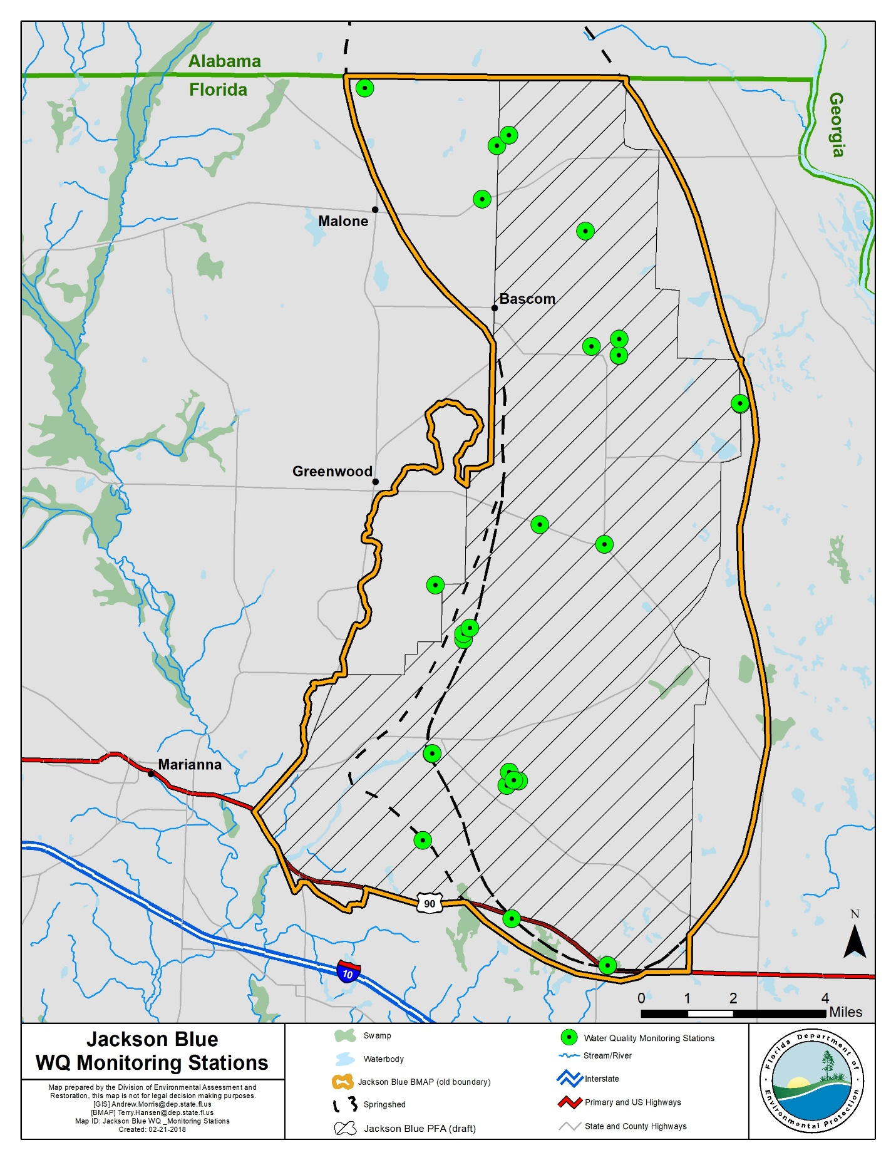
Figure 4. Groundwater and surface water stations sampled in the Jackson Blue BMAP area

Biological Monitoring
Biological resource responses represent improvements in the overall ecological health of the Jackson Blue Spring and Merritts Mill Pond (see Table 17).
Table 17. Biological response measures
Biological Response Measures
Chlorophyll a
Stream Condition Index (SCI) score
Linear Vegetation Survey (LVS) score
Rapid Periphyton Survey (RPS) score
Key fish populations

An RPS will be conducted to assess the abundance and variety of algae in the river. An LVS will be conducted to assess the types and density of vegetation present in the river and to identify the native versus non-native species. An SCI will be conducted to measure the number of different organisms present in the river. In addition, habitat assessments (HAs) will be conducted to assess the river conditions and habitat present to support the SCI evaluation. Water quality samples will also be collected with the biological monitoring.

Data Management and Assessment
As of June 30, 2017, water quality data in Florida are entered by the entity collecting the data into the Florida Watershed Information Network (WIN) Database, which has replaced the Florida Storage and Retrieval System (STORET). DEP pulls water quality data directly from WIN for impaired waters evaluations and TMDL development. Data providers are required to upload their data regularly, so the information can be used as part of the water quality assessment process and for annual reporting. Data providers should upload their data to WIN upon the completion of the appropriate quality assurance/quality control (QA/QC) checks. All data collected in the last quarter of the calendar year should be uploaded no later than April 1 of the following year.
Biological data are stored in the DEP Statewide Biological (SBIO) Database. Biological data collected by data providers should also be uploaded regularly, after the appropriate QA/QC checks. All biological data collected in the last quarter of the calendar year should be uploaded no later than April 1 of the following year.
The water quality data will be analyzed during BMAP implementation to determine trends in water quality and the health of the biological community. A wide variety of statistical methods are available for the water quality trend analyses. The selection of an appropriate data analysis method depends on the frequency, spatial distribution, and period of record available from existing data. Specific statistical analyses were not identified during BMAP development.

QA/QC
Stakeholders participating in the monitoring plan must collect water quality data in a manner consistent with Chapter 62-160, F.A.C., and the DEP standard operating procedures (SOPs) for QA/QC required by rule. The most current version of these procedures is available on the DEP website. For BMAP-related data analyses, entities should use National Environmental Laboratory Accreditation Conference (NELAC) National Environmental Laboratory Accreditation Program (NELAP)–certified laboratories or other labs that meet the certification and other requirements outlined in the DEP SOPs.

Appendices

Appendix A. Important Links
The links below were correct at the time of document preparation. Over time, the locations may change and the links may no longer be accurate. None of these linked materials are adopted into this BMAP.
- DEP Website: http://www.floridadep.gov
- DEP Map Direct Webpage: https://ca.dep.state.fl.us/mapdirect/
- Florida Statutes: http://www.leg.state.fl.us/statutes
  - Florida Watershed Recovery Act (Section 403.067, F.S.)
  - Florida Springs and Aquifer Protection Act (Part VIII of Chapter 373, F.S.)
- DEP Model Ordinances: http://fyn.ifas.ufl.edu/fert_ordinances.html
- DEP Standard Operating Procedures for Water Quality Samples:
- https://floridadep.gov/dear/quality-assurance/content/dep-sops
- NELAC NELAP: https://fldeploc.dep.state.fl.us/aams/index.asp
- FDACS BMPs: https://www.freshfromflorida.com/Business-Services/Best-Management-Practices-BMPs/Agricultural-Best-Management-Practices
- FDACS BMP and Field Staff Contacts: http://www.freshfromflorida.com/Divisions-Offices/Agricultural-Water-Policy
- Florida Administrative Code (Florida Rules): https://www.flrules.org/
- NWFWMD SWIM Plans: https://www.nwfwater.com/Water-Resources/Surface-Water-Improvement-and-Management
- NWFWMD 2017 Consolidated Annual Report: https://www.nwfwater.com/Data-Publications/Reports-Plans/Consolidated-Annual-Reports
- UF–IFAS Research: http://research.ifas.ufl.edu/

Appendix B. Projects to Reduce Nitrogen Sources
Prioritization of Management Strategies
The management strategies in Table B-1 are ranked with a priority of high, medium, or low. In 2016, the Florida Legislature amended the Watershed Restoration Act (Section 403.067, F.S.), creating additional requirements for all new or revised BMAPs. BMAPs must now include planning-level details for each listed project, along with their priority ranking.
Project status was selected as the most appropriate indicator of a project’s priority ranking based primarily on need for funding. Projects with a "completed" status were assigned a low priority. Projects classified as "underway" were assigned a medium priority because some resources have been allocated to these projects, but additional assistance may be needed for the project to be completed. High priority was assigned to projects listed with the project status "planned" as well as certain "completed" projects that are ongoing each year (any project with one of these project types: "street sweeping," "catch basin inserts/inlet filter cleanout," "public education efforts," "fertilizer cessation," "fertilizer reduction," or "aquatic vegetation harvesting"), and select projects that are elevated because substantial, subsequent project(s) are reliant on their completion.
Description of the Management Strategies
Responsible entities submitted these management strategies to the department with the understanding that the strategies would be included in the BMAP, thus requiring each entity to implement the proposed strategies in a timely way and achieve the assigned load reduction estimates. However, this list of strategies is meant to be flexible enough to allow for changes that may occur over time. Any change in listed management strategies, or the deadline to complete these actions, must first be approved by the department. Substituted strategies must result in equivalent or greater nutrient reductions than expected from the original strategies.
While the 20-year planning period for this BMAP is 2018 to 2038, projects completed since July 1, 2007 count toward the overall nitrogen reduction goals.
Estimated nitrogen reductions are subject to refinement based on DEP verification and/or on adjustment to calculations based on loading to groundwater rather than surface water. Agriculture load reductions (FDACS-01 and FDACS-02) assume 100 % enrollment and verification. Projects with a designation of TBD (to be determined) denotes information is not currently available, but will be provided by the stakeholder when it is available. Projects with a designation of N/A (not applicable) indicates the information for that category is not relevant to that project. Projects with a designation of "Not Provided" denotes that information was requested by DEP but was not provided by the lead entity.

Table B-1. Stakeholder projects to reduce nitrogen sources

Lead Entity | Project No. | Project Name | Project Description | Project Type | Project Status | Start Date | Estimated  Completion Date | Nitrogen Source Addressed by Project | Estimated  Nitrogen Load Reduction  (lb-N/yr) | Cost Estimate | Funding Source | Funding Amount
FDACS | FDACS-01 | BMPs Implementation and Verification - Farm Fertilizer | Implementation of existing BMPs on applicable acreage. Up to 15% reduction in load to groundwater. | Agricultural BMPs | Underway | Underway | TBD | FF | 93,888 | TBD | TBD | TBD
FDACS | FDACS-02 | BMPs Implementation and Verification - Livestock Waste | Implementation of existing BMPs at applicable facilities. Up to 10% reduction in load to groundwater. | Agricultural BMPs | Underway | Underway | TBD | LW | 5,401 | TBD | TBD | TBD
Jackson County | JC-01 | Indian Springs Sewer Extension Phase 1 | Convert 125 residential septic systems to central sewer. | Wastewater Service Area Expansion | Underway | 2016 | 2018 | OSTDS | 1,671 | $1,450,000 | DEP | $1,450,000
Jackson County | JC-02 | Indian Springs Sewer Extension Phase 2A | Phase 2A includes the Magnolia Blossom, Oak Drive, and partial Seminole Drive segments (convert 89 residential systems to sewer). | Wastewater Service Area Expansion | Planned | 2018 | TBD | OSTDS | 695 | $2,000,000 | DEP | $2,000,000
Jackson County | JC-03 | Blue Spring Road Sewer Extension | Provide central sewer service to Blue Springs Recreational Area and approximately 74 homes in the Blue Springs area. The project will also include removing the public park septic system at Jackson Blue Spring, and provide sewer service to homes adjacent to Merritts Mill Pond. | Wastewater Service Area Expansion | Underway | 2017 | 2020 | OSTDS | 838 | $3,566,749 | DEP | $3,566,749
Jackson County | JC-04 | Jackson Blue Spring  Recreation Area  Improve-ments | Stormwater improvements. | BMP Treatment Train | Underway | 2017 | Not Provided | UTF | Not Provided | Not Provided | Not Provided | Not Provided
Jackson County | JC-05 | Jackson Blue Spring Recreation Area Stormwater Improvement Project | Design and construction of a stormwater management system that captures and treats stormwater at Jackson Blue Spring. In addition, will stabilize and restore approximately 250-300 linear feet of shoreline. | Stormwater System Upgrade | Underway | 2017 | 2021 | UTF | TBD | $751,200 | DEP/ Local Match | DEP: $729,200 Local: $22,000
Jackson County | JC-06 | Education | Landscape ordinance; implementation of FYN Program. | Education Efforts | Underway | 2013 | 2017 | UTF | 120 | N/A | N/A | N/A
NWFWMD | NWF-01 | Agricultural BMPs and Equipment Cost-Share Program | Cost-share funding for agricultural BMPs and equipment to improve water use efficiency and reduce nutrient loading. Assisted 50 producers through 2017. 20% reduction in TN reported. Cost estimate is cumulative since FY 13-14. | Agricultural BMPs | Underway | 2013 | TBD | FF | TBD | $6,698,595 | DEP/ FDACS/ Jackson Soil and Water Conservation District | DEP: $4,239,500 Producers Match: $1,959,095
NWFWMD | NWF-02 | Blue Springs Plantation, Inc. | Fee simple acquisition and protection of 394 acres adjacent to Jackson Blue Spring. | Land Acquisition | Canceled | 2015 | N/A | N/A | N/A | N/A | N/A | N/A
NWFWMD | NWF-03 | Lakeshore Farms II, LLC | Fee simple or less-than-fee acquisition and protection of 598 agricultural acres in the Jackson Blue groundwater contributing area. | Land Acquisition | Canceled | N/A | N/A | N/A | N/A | N/A | N/A | N/A
NWFWMD | NWF-04 | Pittman Property Land Acquisition | Less-than-fee acquisition and protection of 167 agricultural acres in the Jackson Blue groundwater contributing area. | Land Acquisition | Underway | 2017 | 2018 | N/A | N/A | $686,568 | DEP | $686,568
NWFWMD | NWF-05 | Sod-Based Crop Rotation Grant Program | Grants to producers to rotate sod in existing crop fields to improve water quality and reduce water use demands around Jackson Blue Spring. | Agricultural BMPs | Underway | 2017 | 2022 | FF | TBD | $806,032 | U.S. EPA/  DEP/ Producers/ NWF-WMD | U.S. EPA/DEP: $480,032 NWFWMD: $256,000 Producers: $70,000
NWFWMD | NWF-06 | Apalachicola River and Bay Surface Water Improvement and Management (SWIM) Plan | Implementation and periodic review and update of the Apalachicola SWIM Plan. | Study | Completed | 2015 | 2017 | N/A | N/A | $99,290 | National Fish and Wildlife Foun-dation (NFWF) | $99,290
NWFWMD | NWF-07 | Claiborne Aquifer Water Supply | Testing of the Claiborne aquifer in Jackson Blue Spring contributing area to determine viability as alternative water source to offset demand on Floridan aquifer. | Study | Underway | 2015 | 2018 | N/A | N/A | $440,000 | DEP | $440,000
NWFWMD | NWF-08 | Mobile Irrigation Laboratory | Annual contract to support water quantity evaluations and retrofits with producers across the NWFWMD, but largely concentrated in Jackson County. | Agricultural BMPs | Underway | 2005 | TBD | N/A | N/A | $745,063 | NWF-WMD | $745,063
NWFWMD | NWF-09 | Sod-Based Crop Rotation Education | Annual contract to provide education and outreach in NWFWMD jurisdiction on sod-based crop rotation. | Agricultural BMPs | Underway | 2004 | TBD | FF | N/A | $543,000 | NWF-WMD | $543,000
NWFWMD | NWF-10 | BMPs | BMPs implemented as part of the District's FY 2013/2014 funding cycle. | Agricultural BMPs | Completed | 2013 | 2014 | FF | 5,400 | Not Provided | NWF-WMD | Not Provided
UF-IFAS | IFAS-01 | Sod-Based Crop Rotation Pilot Project | Demonstration project for up to four sod farms to improve water quality and quantity over a four-year period. | Agricultural BMPs | Underway | 2014 | 2018 | FF | TBD | $806,032 | DEP/ NWF-WMD/ Ag. Producers | DEP: $480,032 NWFWMD: $256,000 Ag. Producers: $70,000
Town of Malone | TM-01 | Malone High School Sanitary Sewer Connection Project | Connect Malone High School to the Malone WWTP, abandoning 10 septic systems. | Wastewater Service Area Expansion | Underway | 2017 | 2020 | OSTDS | 90 | $432,077 | DEP | $432,077

Appendix C. PFA Report
A PFA (Jackson Blue Spring, October 2017) is defined as the area(s) of a basin where the Floridan aquifer is generally most vulnerable to pollutant inputs and where there is a known connectivity between groundwater pathways and an OFS. As required by the Florida Springs and Aquifer Protection Act, DEP delineated a PFA for the Jackson Blue Spring Basin. This PFA is adopted and incorporated by reference into this BMAP. Detailed information on the PFA is available in report format at the following link:
http://publicfiles.dep.state.fl.us/DEAR/BMAP/Adopted%20BMAPs/Jackson%20Blue/PFA/.

Appendix D. OSTDS Remediation Plan
The Florida Aquifer and Springs Protection Act specifies that if during the development of a BMAP for an OFS, DEP identifies OSTDS as contributors of at least 20 % of nonpoint source nitrogen pollution in a PFA or if DEP determines remediation is necessary to achieve the TMDL, the BMAP shall include an OSTDS remediation plan. Based on the Jackson Blue NSILT estimates and GIS coverages, OSTDS contribute approximately 3 % of the pollutant loading in the PFAs. Although this is a small percentage, DEP has determined that an OSTDS remediation plan is necessary to achieve TMDLs and to limit the increase in nitrogen loads from future growth. Irrespective of the percent contribution from OSTDS, DEP has determined that an OSTDS remediation plan is necessary to achieve the TMDLs and to limit the increase in nitrogen loads from future growth.
D.1 Plan Elements
D.1.1 Permits for Installation of New OSTDS
Per statute, new OSTDS on lots of less than one acre are prohibited within PFAs, if the addition of the specific systems conflicts with an OSTDS remediation plan incorporated into an OFS BMAP (see Section 373.811(2), F.S.). This OSTDS remediation plan prohibits the installation of new conventional systems on lots of less than one acre within the PFAs, unless the OSTDS includes enhanced treatment of nitrogen or unless the OSTDS permit applicant demonstrates that sewer connections will be available within 5 years. Local governments and utilities are encouraged to develop master wastewater treatment feasibility plans to identify specific areas to be sewered within 20 years of BMAP adoption. To aid in implementation, the DEP Map Direct webpage includes a detailed downloadable springs PFA boundary shapefile. DEP also maintains on its website an interactive map of the PFA and BMAP boundaries; the map can be easily searched for specific street address locations.
FDOH permits the installation of new OSTDS pursuant to Chapter 64E-6, F.A.C., which includes not only systems installed on a property where one has not previously been installed, but also systems installed to replace illegal systems, systems installed in addition to existing systems, and other new systems. FDOH permitting requirements with respect to the definition of "new" or "less than one acre" will be followed for this remediation plan. For FDOH to issue a permit for a new OSTDS on a lot of less than one acre within a PFA, the system must include at least one of the following nitrogen reducing enhancements:
- Features allowed pursuant to FDOH rule, such as in-ground nitrogen-reducing biofilters (media layer systems).
- Features consistent with and identified in the FDOH Florida Onsite System Nitrogen Removal Strategy Studies report, such as in-tank nitrogen-reducing biofilters.
- Other FDOH-approved treatment systems capable of meeting or exceeding the NSF Standard 245 nitrogen removal rate before disposing the wastewater in the drain field, such as aerobic treatment units (ATU) and performance-based treatment systems (PBTS). For FDOH-approved treatment systems that meet NSF 245, but do not meet or exceed the minimum treatment level expected from the in-ground nitrogen-reducing biofilters, the drain fields, at minimum, shall be installed with a 24-inch separation between the bottom of the drain field and the seasonal high-water table.
D.12 Other Plan Elements
Statutes also require that OSTDS remediation plans contain the following elements.
- An evaluation of credible scientific information on the effect of nutrients, particularly forms of nitrogen, on springs and spring systems. (See Section D.2.)
- Options for repair, upgrade, replacement, drain field modification, the addition of effective nitrogen-reducing features, connection to a central sewer system, or other action. (See Section D.3.)
- A public education plan to provide area residents with reliable, understandable information about OSTDS and springs. (See Section D.4.)
- Cost-effective and financially feasible projects necessary to reduce the nutrient impacts from OSTDS. (See Section 2 and Appendix B.)
- A priority ranking for each project for funding contingent on appropriations in the General Appropriations Act. (See Section 2 and Appendix B.)
The Florida Springs and Aquifer Protection Act defines an OSTDS as a system that contains a standard subsurface, filled, or mound drain field system; an aerobic treatment unit; a graywater system tank; a laundry wastewater system tank; a septic tank; a grease interceptor; a pump tank; a solids or effluent pump; a waterless, incinerating, or organic waste–composting toilet; or a sanitary pit privy that is installed or proposed to be installed beyond the building sewer on land of the owner or on other land on which the owner has the legal right to install such a system. The term includes any item placed within, or intended to be used as a part of or in conjunction with, the system. The term does not include package sewage treatment facilities and other treatment works regulated under Chapter 403, F.S.
D.2 Collection and Evaluation of Credible Scientific Information
As discussed in Section 2, DEP developed the NSILT, a planning tool that provides estimation of nitrogen loading sources to groundwater based on the best available scientific data for a particular geographic area. The results were peer reviewed by NWFWMD, FDOH, and FDACS. Additional technical support information concerning the NSILT can be found in Appendix F.

D.3 Remediation Options
The NSILT estimates that OSTDS contribute approximately 3 % of the pollutant loading to groundwater in the PFA. Table D-1 lists the number of existing OSTDS in the PFA and the estimated nitrogen reductions associated with enhancement or connection to sewer. Figure D-1 shows the areas where OSTDS are located.
Table D-1. Estimated reduction credits for OSTDS enhancement or sewer*
*Estimated reductions listed in the table are for either enhancement or sewer per parcel classification. Reductions cannot be combined for the same parcel classification but can be combined between the different classifications. For example, the sewer credit associated with parcels less than one acre in size can be combined with the sewer credit associated with parcels one acre or greater in size.
Recharge Area | OSTDS Parcels Less Than One Acre in PFA | Credit for Sewer (lb-N/yr) | Credit for Enhancement (lb-N/yr) | OSTDS Parcels One Acre and Greater in PFA | Credit for Sewer (lb-N/yr) | Credit for Enhancement (lb-N/yr)
High | 460 | 5,069 | 3,468 | 1,504 | 16,572 | 11,339
Medium | 19 | 116 | 116 | 44 | 269 | 184
Total | 479 | 5,185 | 3,548 | 1,548 | 16,841 | 11,523

As required by statute, this OSTDS remediation plan identifies remediation options for existing OSTDS, including repair, upgrade, replacement, drain field modification, the addition of effective nitrogen-reducing features, connection to a central sewer system, or other action. More simply, remediation options can be classified as enhancement or replacement. Enhancement options consist of systems identified in either existing FDOH rules or existing and ongoing FDOH studies, or systems not otherwise prohibited by FDOH. Examples of enhancements include in-ground nitrogen-reducing biofilters (media layer systems); in-tank nitrogen-reducing biofilters; and ATU or PBTS capable of meeting or exceeding the NSF Standard 245 nitrogen removal rate before disposing wastewater in the drain field.
Nitrogen impacts from new development could also be reduced through prohibiting new conventional OSTDS on all lot sizes, throughout the BMAP area, or both.
DEP, FDOH, and local governments will develop programs to provide funding to homeowners and individuals to upgrade existing OSTDS by adding nutrient reducing features. Although upgrading existing OSTDS to include nitrogen reducing features is not required by this BMAP, upgrades would be beneficial within the PFAs and throughout the BMAP area. The funding program will be designed to prioritize OSTDS where it is most economical and efficient to add nutrient reducing features (i.e., systems needing a permit for a repair or modification, within the PFA, and on lots of less than one acre).
To facilitate incorporation of nitrogen reducing features at the time of a permit to repair or modify an existing OSTDS, FDOH will pursue regulatory solutions to accomplish the following objectives:
- Update OSTDS rule language regarding permits, variances, and waivers to include consideration of DEP-adopted OSTDS remediation plans.
- Update OSTDS rules to allow installation of passive remediation systems, including systems featuring liners, nitrogen reducing material, or both underneath the drain field.
Figure D-1. OSTDS locations in the BMAP area

D.4 Public Education Plan
DEP and FDOH will develop and disseminate educational material focused on homeowners and guidance for builders and septic system contractors. The materials will identify the need for advanced, nitrogen reducing OSTDS along with the requirements for installing nitrogen reducing technologies under this OSTDS remediation plan. DEP will coordinate with industry groups such as Florida Home Builders Association and FOWA.
During the development of this BMAP, the following list of steps, target audiences, consideration of appropriate messaging, and preparation of materials/resources were identified.
- Step 1 – Understand the data and issues associated with OSTDS.
- Step 2 – Identify existing and short-term activities to address the issues.
- Step 3 – Undertake a pilot project outreach and social marketing campaign.
- Step 4 – Identify future actions for basin wide implementation.
Target Audiences
- Schools (bottom-up curriculum; kids to adults).
- Utilities.
- Builders/realtors/developers/business community.
- Residents.
- Septic system contractors.
- Septic system owners.
- Homeowner associations.
- Civic groups.
- Local environmental groups.
- Policymakers (local, regional, and state).
- Public officials.
Messaging
- Convey cost of doing nothing.
- Preserving our waterways.
- Conventional septic systems provide minimal nitrogen treatment; septic system enhancement is needed.
- Septic system enhancement options.
- Promote springshed identity.
- People need to understand water (where it comes from and where it goes).
- Relate septic system pollution to other successful pollution abatement.
- Leave no trace (outdoor ethics).
- Establish connection between springs and septic systems.
- Your watershed/springshed. Your future. Your choice.
- We are all part of the problem and all part of the solution (show negative and positive contributions by people).
- Keep the message simple.
Materials/Resources
- FDOH public service announcements (PSAs) on septic systems.
- Florida Onsite Wastewater Association (FOWA) PSAs on septic systems.
- City of Tallahassee's Think About Personal Pollution Program.
- Southwest Florida Water Management District (SWFWMD) springs education webpage.
- Social media.
- Fact sheets and answers to frequently asked questions.
- Utility bill inserts.
- Websites (local jurisdictions).
- Local FDOH offices.
- Brochures and flyers.
- Billboards.
- Workshops.
- Tool kits.
- Television and radio commercials.

Appendix E. NSILT Report
E.1 NSILT Data
An NSILT workbook was completed for the Jackson Blue Basin that delineated groundwater contributing areas for Jackson Blue Spring and Merritts Mill Pond. This technical support information identifies the data sources relied upon during NSILT development and documents the major assumptions used by DEP when applying the NSILT approach to the springshed in the Jackson Blue BMAP.
The general NSILT approach involves estimating the nitrogen load to the surface for various source categories based on land use. The NSILT subjects the surface loading to recharge and attenuation to derive the estimated load to groundwater at the top of the aquifer. The estimated load to groundwater determines the scope of reduction strategies needed in the BMAP for each source category. For additional information about the general NSILT approach, see any of the NSILT reports posted online at http://publicfiles.dep.state.fl.us/DEAR/NSILT
E.1.1 General Data Inputs
Hydrogeology and Aquifer Recharge
Within the Jackson Blue Spring-Merritts Mill Pond contributing area, there is minimal surface drainage with considerable local recharge into the UFA which is the predominant source of ground water in this area. Within this region of Florida, there is insufficient data quantifying recharge; therefore, soil drainage is utilized as an indicator for recharge. This soil data is obtained from the National Cooperative Soil Survey SSURGO dataset.
Land Use
Land use information is from NWFWMD based on the 2012 Florida Land Use Cover and Forms Classification System (FLUCCS); 2014 property appraiser data for Jackson County; 2013 Farm Service Agency (FSA) aerial photography of crops and land use classifications based on the FLUCCS; 2014 National Agricultural Statistics Service (NASS) Cropscape satellite imagery-based land use data designed to capture the 2014 growing season; and 2014 FSAID irrigated agricultural lands based on field verification for farming operations.
E.1.2 Land Surface Nitrogen Inputs
Atmospheric Deposition
Atmospheric deposition information is derived from the TDEP hybrid model (Schwede and Lear 2014) that inputs wet and dry monitoring network data for the U.S. and calculates an estimated TN deposition load. The data set is comprised of data from 2011 to 2013.
WWTFs
There are no WWTFs located within the Jackson Blue BMAP groundwater contributing areas.
OSTDS
FDOH is continuously updating the OSTDS inventory for the entire state, known as the "Florida Water Management Inventory." The results of this process are used to estimate the total number of OSTDS.
The population served by the OSTDS was estimated using the 2010 U.S. Census Bureau data. Data were used to estimate the effective population and OSTDS usage. This resulted in a per capita contribution of 9.012 lb-N/yr.
UTF (including STF)
Nitrogen in fertilizer used in urban areas was assumed to be applied mostly to golf courses and residential lawns. UTF inputs in the groundwater contributing areas were estimated using fertilizer sales data compiled by FDACS. It was assumed that the majority of the fertilizer was purchased locally and that out-of-county sales of fertilizer were not significant.
The FDACS sales reports provide data for the entire county, while only a portion of the county is included within the contributing areas. To estimate the amount of fertilizer applied just within the contributing areas, the NWFWMD land use coverage was used to provide a breakdown of the land area likely to receive urban fertilizers (residential lands, recreational facilities, and golf courses). The land areas were totaled for the entire county as well as the land areas representing soil drainage classes. These summations were used to calculate a land use percentage relative to the entire county for urban lands in the different drainage classes. These percentages were then applied to the total fertilizers sold for urban uses.
FF
Crop acreage was identified by using a composite land use coverage comprised of data from FSAID, NWFWMD land use, NASS Cropscape, FSA, and Jackson County Property Appraiser. Agricultural fertilizer is applied at varying rates, depending on crop type and farm practices. Estimated applications rates are based on UF-IFAS recommendations. The associated application rate was applied to the calculated acreage for the corresponding crop types by drainage area by contributing area to estimate FF input.

LW
Livestock population estimates were obtained through the United States Department of Agriculture (USDA) Census of Agriculture (CoA) 2012 census report. As was the case with the fertilizer sales data, CoA provides full county information and land use percentages were utilized to estimate the BMAP area populations. Nitrogen waste factors were assigned for each animal type and applied to the estimated livestock populations to estimate the nitrogen input to the land surface.
Estimated Nitrogen Inputs to Land Surface
The estimated input from each source category above is summed and a relative percent calculated.

E.1.3 Nitrogen Attenuation and Loading to Groundwater
The two types of attenuation that are evaluated are biochemical attenuation factors (BAFs) and hydrogeological attenuation (recharge for each soil drainage class).
BAFs and Uncertainty Factors
The BAFs used to account for the processes affecting the movement of nitrogen from each source category in the subsurface are based on literature review of studies in Florida and similar areas. The BAFs in Table E-9 are the result of this evaluation. The BAF is used to estimate what percent of the surface input could infiltrate to groundwater. For example, if 70 % of urban fertilizer is biologically attenuated, then the remaining 30 % could infiltrate to the groundwater. The environmental attenuation of nitrogen from specific sources within the categories can vary substantially, both spatially and with depth in the subsurface, and will affect the amount of nitrogen leaching to groundwater and the relative contribution of nitrogen from each source category. The range in nitrogen attenuation can result from variability in soil properties, crop types, agricultural practices, nitrogen storage, volatilization of ammonia to the atmosphere, uptake by vegetation, denitrification, and other removal processes.
The potential range in nitrogen attenuation for each source is shown in Table E-9.
Table E-1. Range of environmental attenuation of nitrogen from a detailed literature review
N Source Category | Low-Level Attenuation (%) | Attenuation Used  for This Analysis (%) | High-Level Attenuation (%)
Atmospheric Deposition | 85 | 90 | 95
WWTFs-RIBs | 10 | 25 | 40
WWTFs-Sprayfield | 50 | 60 | 75
Septic Systems | 40 | 50 | 75
Livestock Operations | 80 | 90 | 95
Farm Fertilizers | 50 | 80 | 85
Urban Fertilizers | 50 | 70 | 85

Hydrogeological Attenuation (i.e. Recharge)
The recharge rate for the area where the surface input is calculated is based on the soil drainage map previously described. To account for variations in recharge rates to the UFA, non-attenuated nitrogen inputs in well drained recharge areas are multiplied by a weighting factor of 0.9, while nitrogen inputs are multiplied by a weighting factor of 0.7 for moderately drained recharge areas and 0.1 for poorly drained recharge areas.

Estimated Nitrogen Loads to Groundwater
The surface inputs by source category are adjusted by applying the BAFs for the appropriate source category and location-based recharge factors to estimate the load to groundwater by source category. It is important to note that this load is estimated for the top of the aquifer. As the load interacts with the aquifer, additional factors likely modify it prior to discharge at the spring vents.
E.2 References
Schwede, D.B., and G.G. Lear. 2014. A novel hybrid approach for estimating total deposition in the United States. Atmospheric Environment 92: 207–220.
U.S. Department of Agriculture Census of Agriculture website: https://www.agcensus.usda.gov.

Appendix F. FDACS BMPs
F.1 Implementation of Agricultural BMPs
Agricultural nonpoint sources in a BMAP area are required by state law (Subsection 403.067[7], F.S.) either to implement FDACS-adopted BMPs, which provides a presumption of compliance with water quality standards, or to conduct water quality monitoring prescribed by DEP or NWFWMD. Failure either to implement BMPs or conduct monitoring may result in enforcement action by DEP.
Growers who implement BMPs may be eligible for cost-share funding from FDACS, NWFWMD, or others to defray partially the costs of implementation. Through OAWP, the Florida Forest Service, and the Division of Aquaculture, FDACS develops, adopts, and assists producers in implementing agricultural BMPs to improve water quality and water conservation.
FDACS identified potential land for enrollment in the FDACS BMP Program within the Jackson Blue Springs and Merritts Mill Pond BMAP area using the Florida Statewide Agriculture Irrigation Demand (FSAID) IV geodatabase.
Table F-1 summarizes the land use data for agriculture in the Jackson Blue Springshed and Merritts Mill Pond Basin. Based on the FSAID IV geodatabase, the total agricultural lands within the Jackson Blue Springshed and Merritts Mill Pond Basin is 41,559 acres. Table F-2 summarizes the agricultural land by crop type that was estimated to be fertilized and the corresponding acreages. The primary agricultural fertilized land use in the Jackson Blue Springshed is cropland which comprises 73 % of the fertilized land use in the springshed. Table F-3 provides a summary of the agricultural lands with livestock. It is important to note that some of the agricultural lands include more than one agricultural practice.
Figure F-1 shows the approximate location of the agricultural lands based on the FSAID within the Jackson Blue Springshed and Merritts Mill Pond Basin.
Table F-1. Agricultural land use within the Jackson Blue Springshed and
Merritts Mill Pond Basin
Agricultural Nitrogen Loading Category | Acres
Crop Fertilizer Lands only | 16,854
Livestock Lands only | 2,135
Crop Fertilizer and Livestock Lands | 9,145
Abandoned/Fallow/Former | 13,425
Total | 41,559

Table F-2 Fertilized crop lands within the Jackson Blue Springshed and
Merritts Mill Pond Basin
Crop Type | Application Rate (lbs/acre) | Acres
Corn | 210 | 757
Cotton (includes areas with crop rotation) | 120 | 5,668
Cotton/Oats | 220 | 434
Cropland and Pastureland | 60 | 3,543
Grass/Pasture | 80 | 332
Hay | 160 | 3,983
Improved Pasture | 60 | 5,602
Ornamentals | 90 | 2
Peanuts | 20 | 5,003
Peanuts/Wheat | 80 | 502
Row Crops | 60 | 10,594
Soybeans | 35 | 28
Watermelons | 175 | 144
Total | - | 36,592

Table F-3. Livestock lands within the Jackson Blue Springshed and
Merritts Mill Pond Basin
Livestock Category | Acres
Cropland and Pastureland | 3,542
Improved Pasture | 5,602
Herbaceous (Dry Prairie) | 170
Mixed Upland Non-forested | 42
Other Open Lands (Rural) | 473
Pasture | 52
Unimproved Pasture | 643
Woodland Pastures | 755
Total | 11,279

Agricultural land use data are critical for determining agricultural nonpoint source loads and developing strategies to reduce those loads in a BMAP area, but there are inherent limitations in the available data. The time of year when land use data are collected (through aerial photography) affects the accuracy of photo interpretation. Flights are often scheduled during the winter months due to weather conditions and reduced leaf canopies, and while these are favorable conditions for capturing aerial imagery, they make photo interpretation for determining agricultural land use more difficult (e.g., more agricultural lands are fallow in the winter months) and can result in inappropriate analysis of the photo imagery. There is also a significant variation in the frequency with which various sources of data are collected and compiled, and older data are less likely to capture the frequent changes that often typify agricultural land use. In addition, agricultural activity being conducted on the land is not always apparent. For example, acreage classified as improved pasture may be used for a cow-calf operation, consist of forage grass that is periodically harvested for hay, or simply be a fallow vegetable field awaiting planting. Finally, the classification method itself may be an issue. For example, property appraiser data assigns an agricultural land use designation to an entire parcel, although agricultural production may only be conducted on a portion of the parcel. Because of error in the collection and characterization of land use data and changes in land use over time, agricultural land use acreage estimates are subject to adjustment.

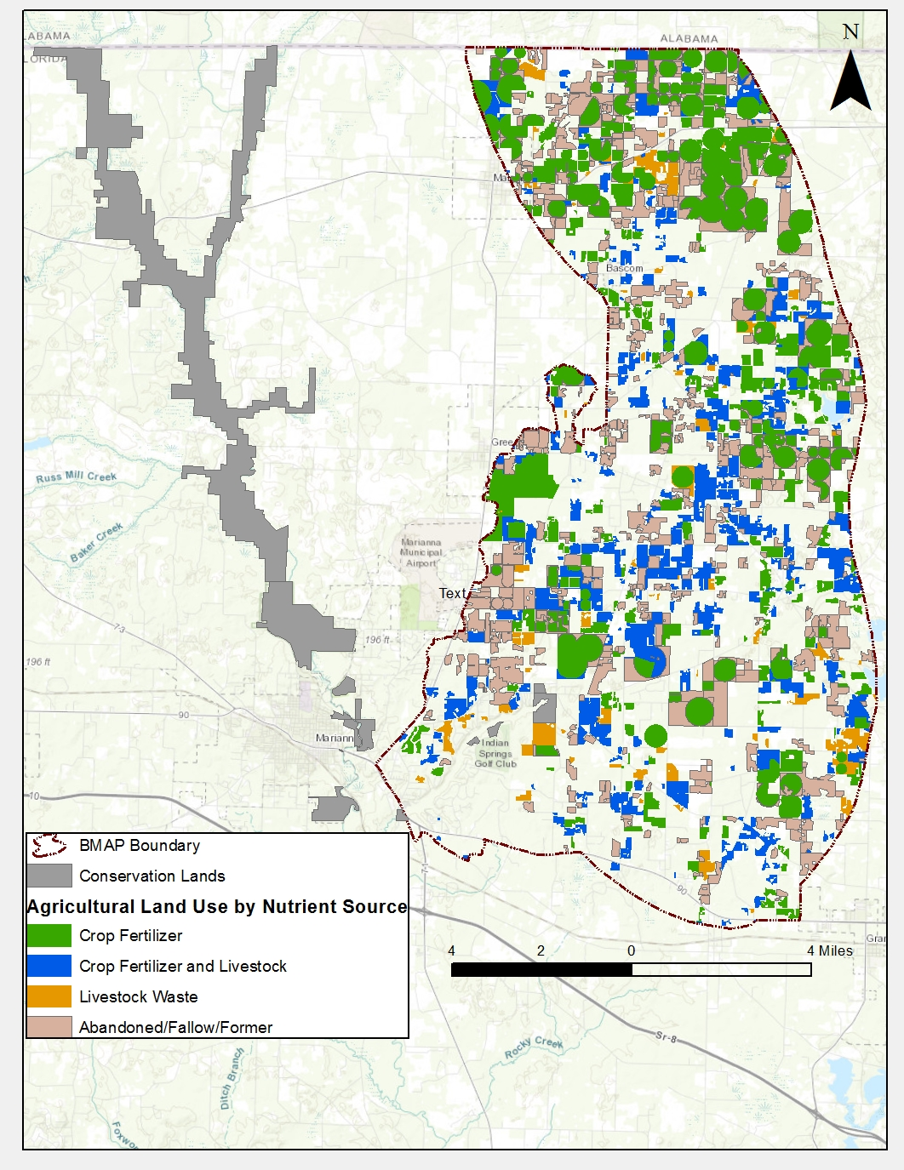
This map is the product of the Department of Agriculture and Consumer Services, Office of Agricultural Water Policy. It represents estimated areas of production agriculture, it is not binding, and does not otherwise affect the interests of any persons, including any vested rights or existing uses of real property. The accuracy and reliability of this map is not guaranteed. Production agricultural acreage is affected by continual changes in land use, crop production, and other socioeconomic factors.
Figure F-1. Agricultural lands in the Jackson Blue Springshed and Merritts Mill Pond Basin

F.2 Agricultural BMPs
BMPs are individual or combined practices determined through research, field-testing, and expert review to be effective and practicable means for improving water quality, considering economic and technological feasibility. FDACS has authority for establishing agricultural BMPs through the Florida Forest Service (Silviculture BMP Program), Division of Aquaculture (Aquaculture Certification Program), and OAWP (all other agricultural BMP programs). As of February 2018, OAWP has adopted manuals for cow-calf, statewide citrus, vegetable and agronomic crops, nurseries, equine operations, specialty fruit and nut, sod, dairy, and poultry operations. Development is underway for a small farms manual, and adoption is expected in 2018. The sod and cow-calf manuals are currently under review and revision.
The OAWP BMPs fall into two categories: structural and management. Structural BMPs, e.g., water-control structures and fencing, involve the installation of structures or changes to the land and are usually costlier than management BMPs. Management BMPs, such as nutrient and irrigation management, comprise the majority of the practices and often are not readily observable. Nutrient management addresses fertilizer type, amount, placement, and application timing, and it includes practices such as soil and tissue testing, application methods, correct fertilizer formulations, and setbacks from water resources. Irrigation management consists of maintenance, scheduling, and other measures that improve the overall efficiency of irrigation systems. FDACS-funded mobile irrigation labs (MILs) are available to evaluate irrigation system efficiency and provide recommendations to producers to improve efficiency. The implementation of these recommendations results in billions of gallons of water saved throughout the state and helps reduce nutrient runoff and leaching.
Table F-4 identifies key management and structural BMPs applicable to agricultural operations in the springshed. By definition, BMPs are developed to be technically and economically feasible. However, FDACS BMP manuals do contain some BMPs that may be affordable only with financial assistance through cost-share programs. The BMP checklists allow producers to indicate whether implementing a BMP requires financial assistance.
Information on the BMP manuals and field staff contact information can be obtained here: http://www.freshfromflorida.com/Divisions-Offices/Agricultural-Water-Policy. Printed BMP manuals can be obtained by contacting OAWP field staff.
Table F-4. Key management and structural BMPs adopted by FDACS OAWP
BMP Category | BMP | Description
Nutrient Management (Right Source) | Use of Correct Formulations | Use of fertilizer formulations that are appropriate for the environmental conditions. Includes enhanced efficiency fertilizers, as warranted.
Nutrient Management (Right Rate) | Soil and Tissue Testing  Nutrient Budgeting | Used to base fertilizer applications on plant needs and available nutrients in the soil; helps prevent the over application of fertilizer.  Consideration of all nutrient sources, such as commercial fertilizers, biosolids, legumes, manure, and nutrient-laden irrigation water to ensure that fertilization meets crop nutrient requirements.
Nutrient Management (Right Placement) | Precision Application of Nutrients | Use of specialized equipment for precise placement of nutrients on targeted areas at specified rates; reduces total amount used and prevents stray applications.
Nutrient Management (Right Timing) | Split Fertilizer Applications | Multiple applications timed with optimal growth stages; allows plants to assimilate nutrients more efficiently; reduces nutrient loss in leaching and runoff.
Nutrient Management (Special Fertilization Practices) | Special Fertilization Practices | Commodity specific fertilization practices to address nuances on a case-by-case basis.
Nutrient Management (Fertilizer Storage and Handling) | Fertilizer Storage and Handling | Proper location/storage of bulk fertilizer products to prevent nutrient loadings.  Use of appropriate dedicated or temporary mix/load areas located away from waterbodies to prevent nutrient loading.
Irrigation and Water Table Management | Irrigation Scheduling | Planning when to irrigate to reduce water and nutrient losses, based on available soil moisture content, evapotranspiration levels, recent rainfall, and time of day.
Irrigation and Water Table Management | Irrigation System Maintenance | Use of Mobile Irrigation Labs to identify efficiency issues, maintenance, and incorporation of potential upgrades to irrigation system.
Irrigation and Water Table Management | Wellhead Protection | Establishing safe practices around irrigation and drinking water wells.
Water Resource Protection | Buffers and Setbacks | Fertilizer application setbacks from waterbodies (e.g., wetlands, watercourses, sinks, springs, etc.) and use of appropriate buffers around water resource features.
Water Resource Protection | Ditch Maintenance and Water Control Structures | Use of rip rap, sediment traps, staging structures, and permanent vegetative bank cover to minimize erosion and transport of nutrient-laden sediments.
Water Resource Protection | Erosion Control | Vegetated strips of land designed to reduce nutrients and sediments in surface water runoff from fields, pastures, and livestock high-intensity areas before it reaches downstream waterbodies.
Livestock Management | Manure Management | Appropriate storage and disposal of animal waste.
Livestock Management | Water Requirements and Sources | Use of upland livestock watering ponds and/or water troughs; minimizes manure deposition in waterbodies.
Livestock Management | Forage, Pasture and Grazing Management | Movement of cattle to different grazing areas on a planned basis; prevents concentrated waste accumulations and denuding of pasture areas. May involve fencing.  Also involves siting of cowpens, supplemental feed areas, etc., away from waterbodies to minimize nutrient loadings.
Livestock Management | Use Exclusion | Used when stream banks have significant rill or gully erosion because of cattle trampling.
Operations Management | Fertilizer Storage | Proper location/storage of bulk fertilizer products to prevent nutrient loadings.

F.3 BMP Enrollment
Figure F-2 shows the acres enrolled in the FDACS BMP Program in the Jackson Blue Springshed and Merritts Mill Pond Basin as of December 31, 2017. Table F-5 lists the acres enrolled in the FDACS BMP Program by manual. Given that the enrolled acres where BMPs are implemented can contain nonproduction acres (such as buildings, parking lots, and fallow acres), only the enrollment for the land classified as agriculture based on the FSAID is also included in the tables.
As of December 31, 2017, the NOIs cover approximately 29,877 acres in the Jackson Blue Springshed and Merritts Mill Pond Basin. No producers are conducting water quality monitoring in lieu of implementing BMPs at this time.
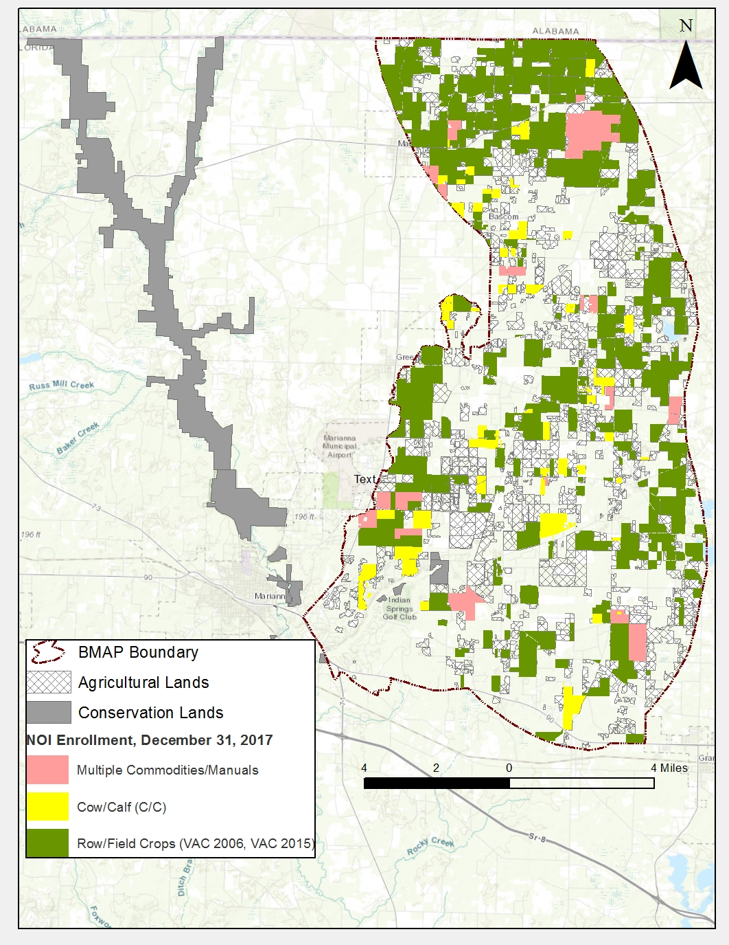
This map is the product of the Department of Agriculture and Consumer Services, Office of Agricultural Water Policy. It represents estimated areas of production agriculture, it is not binding, and does not otherwise affect the interests of any persons, including any vested rights or existing uses of real property. The accuracy and reliability of this map is not guaranteed. Production agricultural acreage is affected by continual changes in land use, crop production, and other socioeconomic factors.

Table F-5. BMP enrollment in the Jackson Blue Springshed and Merritts Mill Pond as of December 31, 2018

Table F-6. Agricultural acreage and BMP enrollment in the Jackson Blue Springshed and Merritts Mill Pond Basin as of December 31, 2017
Related FDACS BMP Programs | NOI Acreage Enrolled | FSAID Agricultural Land Use Acres within NOIs
Cow/Calf Operations | 3,159 | 2,086
Cow/Calf Operations and Row/Field Crops | 2,923, | 2,191
Row Field Crops | 23,795 | 18,885
Total | 29,877 | 23,162

F.4 FDACS OAWP Role in BMP Implementation and Follow-Up
OAWP works with producers to submit NOIs to implement the BMPs applicable to their operations, provides technical assistance to growers, and distributes cost-share funding, as available, to eligible producers for selected practices. OAWP follows up with growers through site visits to evaluate the level of BMP implementation and record keeping, identify areas for improvement, if any, and discuss cost-share opportunities.
When DEP adopts a BMAP that includes agriculture, it is the agricultural producer’s responsibility to implement BMPs adopted by FDACS to help achieve load reductions. If land use acreage corrections and BMP implementation do not fully account for the current agricultural load reduction allocation, it may be necessary to develop and implement additional projects and practices that reduce nutrients from agricultural nonpoint sources. In that case, FDACS will work with DEP and NWFWMD to identify appropriate options for achieving further agricultural load reductions.
Section 403.067, F.S., requires that, where water quality problems are demonstrated despite the proper implementation of adopted agricultural BMPs, FDACS must reevaluate the practices, in consultation with DEP, and modify them if necessary. Continuing water quality problems will be detected through the BMAP monitoring component and other DEP and NWFWMD activities. If a reevaluation of the BMPs is needed, FDACS will also include NWFWMD and other partners in the process.
F.5 OAWP Implementation Assurance Program
OAWP formally established its Implementation Assurance (IA) Program in 2005 in the Suwannee River Basin as part of the multi-agency/local stakeholder Suwannee River Partnership. In 2007, OAWP initiated the IA Program in the Lake Okeechobee Watershed and launched a standardized follow-up program for the remaining areas of the state in 2013, beginning with the Ridge Citrus and Indian River Citrus BMPs. Because of program-specific needs, the follow up process for each of these three components was different. In early 2014, OAWP began to streamline the IA Program to ensure consistency statewide and across commodities and BMP manuals.
The IA Program was based on interactions with producers during a site visit by OAWP staff. Site visits were conducted by OAWP field staff and technicians as workload allowed. For the visits, field staff and technicians used a standard form (not BMP specific) developed in 2014. This form focused on nutrient management, irrigation management, and water resource protection BMPs common to all of the BMPs that were adopted by rule. The paper forms were submitted to OAWP staff and compiled into a spreadsheet, and the data are reported annually.
Additional emphasis was given to verifying the implementation of BMPs by enrolled producers with the enactment of Chapter 2016-1, Laws of Florida. That legislation directed OAWP to formalize an Implementation Verification (IV) Program into rules. The IV rule, effective on November 1, 2017, provides the structure for a statewide uniform implementation verification system, including assessments of the status of implementation, compliance assistance to aid producers in achieving full implementation, and referral to DEP for producers who are not implementing BMPs., (Chapter 5M-1, F.A.C.).
F.6 Beyond BMPs
Beyond enrolling producers in the FDACS BMP Program and verifying implementation, FDACS will work with DEP to improve the data used to estimate agricultural land uses in the springshed. FDACS will also work with producers to implement a suite of agricultural projects and research agricultural technologies on properties where they are deemed technically feasible and if funding is made available.
Table F-6 summarizes potential practices that could be implemented in this BMAP area. It is important to note that the research projects listed in the table are being conducted in the Suwannee River Basin. At some future point, the findings of these studies may be applicable to the Jackson Blue Springshed and Merritts Mill Pond Basin. Actual implementation would require funding as well as more detailed design based on specific information, such as actual applicable acreages and willing landowners.
Table F-7. Beyond BMP implementation
Category | Name | Description
Practices | Precision Irrigation | Deployment of equipment, procedures, and training to improve location, volume, and timing of irrigation to match crop needs more precisely.
Practices | Soil Moisture Probes | Deployment, training, technical support, and use of soil moisture probes to manage irrigation systems.
Practices | Cover Crops | Planting of cover crops between production cycles to increase soil organic content, improve nutrient retention, and reduce erosion.
Research | Bioreactors | Bioreactors/denitrification walls and onsite capture and reuse of high-N water.
Research | Rotational Production | Conversion of conventional production operations to planned rotational production incorporating grass and cover crops. May include cattle.
Research | Soil Moisture Sensor Deployment and Calibration | Installation, training, monitoring, and research on use of electronic soil moisture sensors, including correlations to nutrient movement through the root zone.
Research | Controlled Release Fertilizer (CRF) | Application of new and developing fertilizer products that become available to crops via dissolution over longer periods in the growing season.
Research | Reuse of High Nutrient Value Water Sources | Study of potential sources of high nutrient value water, potential beneficial reuse sites, legal and regulatory obstacles, and costs.

Appendix G. Future Growth Strategies of Local Jurisdictions
Table G-1. Future growth strategies of Jackson County
Local Jurisdiction | Strategy Name | Description | Strategy Type | Status
Jackson County | Ordinance 87-4 | Private Sewage Disposal System | Ordinance | Completed
Jackson County | Ordinance 97-01 | Water and Sewer Systems for Unincorporated Urban-Character Areas | Ordinance | Completed
Jackson County | Ordinance 97-01 | Section 102-93: Septic tanks shall be constructed, repaired, altered, enlarged and maintained in accordance with plans and specifications approved by FDOH, county environmental health unit. Package sewage treatment plants for on-site sewage disposal shall be constructed, repaired, altered, enlarged and maintained in accordance with plans and specifications approved by DEP. | Ordinance | Completed
Jackson County | Ordinance 97-01 | Section 102-93: No septic tank or other on-site waste disposal facility shall be installed where a public sewer or combined sewer is accessible to the premises involved. A public sewer or combined sewer shall be accessible to the premises if the public sewer lines are within 200 feet or less distance from the nearest point on the property line. A public sewer or combined sewer at a distance greater than 200 feet from the nearest property line may be deemed accessible to a proposed development as a result of the issuance of a county development order, or as a result of the approval by the board of county commissioners of a preliminary or final subdivision plat. | Ordinance | Completed
Jackson County | Ordinance 97-01 | Section 102-204: The county may require, as a condition of service or as a condition of development approval, a developer to install necessary lines, lift stations and appropriate appurtenances for reuse of effluent for irrigation of lawns, common areas, golf courses, etc. The county may charge a reasonable fee for use of the effluent to offset the cost of operation and maintenance of the reuse system. | Ordinance | Completed
Jackson County | Ordinance 2013-06 | Landscape Ordinance | Ordinance | Completed
Jackson County | Future Land Use Policy 6.2 | Develop land development code language with the support of DEP and NWFWMD to provide measures for protecting high magnitude springs. | Comprehensive Plan | Completed
Jackson County | Conservation Policy 1.5 | Throughout the county the maximum residential density is one (1) dwelling unit per acre for undeveloped land having severe septic tank soil suitability ratings and where sewer lines are not available, except where density restrictions are more stringent. | Comprehensive Plan | Completed
Jackson County | Conservation Policy 2.6 | All new proposals for public wastewater facilities shall require a feasibility study for reuse of wastewater. The County shall require reuse of wastewater where feasible. | Comprehensive Plan | Completed
Jackson County | Conservation Policy 2.9 | Lots for which septic tanks are the intended method of sewage disposal shall not be created unless the size and configuration of the lot would allow for the permitting of a septic tank system consistent with state regulations in place at that time. | Comprehensive Plan | Completed
Jackson County | Conservation Policy 9.1 | Protect high magnitude springs using the latest science and technology available. The County will adopt all state and federal rules identified by statute and will develop language as state and federal funding is made available. | Comprehensive Plan | Completed
Jackson County | Conservation Policy 9.2 | Develop appropriate language in order to minimize the contribution of nitrates to groundwater to foster long-term stewardship of springs, special design, and BMPs. | Comprehensive Plan | Completed
Jackson County | Conservation Policy 10.1 | The County will coordinate with FGS, NWFWMD, and DEP to map major spring basins as federal, state, or regional funding becomes available. | Comprehensive Plan | Completed
Jackson County | Conservation Policy 11.1 | Using FGS, NWFWMD, and DEP databases and federal, state, and regional funding, the County will identify and delineate buffer areas around major springs and sinkholes and swallets with direct connection to the aquifer. | Comprehensive Plan | Completed
Jackson County | Conservation Policy 11.4 | Where it is not possible to fully avoid negative impacts through limiting or prohibiting land use activities, the impact of use and development within one-quarter (1/4) mile of first magnitude springs shall be minimized and mitigated to the maximum feasible extent. | Comprehensive Plan | Completed
Jackson County | Conservation Policy 11.5 | The maximum residential density within 1/4 mile of a first magnitude springs is 1 unit per acre. | Comprehensive Plan | Completed
Jackson County | Conservation Objective 12 | Manage the amount of fertilization and water use within a designated radius from springs. | Comprehensive Plan | Completed
Jackson County | Conservation Policy 12.1 | The County will promote and support the use of NWFWMD/UF-IFAS “No Till Soil Management” programs within the county. | Comprehensive Plan | Completed
Jackson County | Conservation Policy 12.2 | Support NWFWMD and UF-IFAS efforts to manage agricultural water use within major spring basin areas. | Comprehensive Plan | Completed
Jackson County | Conservation Policy 13.4 | All golf course siting, design, construction, and management shall implement the prevention, management, and monitoring practices, detailed in the golf course siting, design, and management chapter of the DEP publication entitled Protecting Florida’s Springs Manual – Land Use Planning Strategies and Best Management Practices (November 2002). | Comprehensive Plan | Completed
Jackson County | Conservation Objective 14 | Landscaping design and management practices shall be implemented that reduce impacts to springs and other karst features within the setbacks defined in Table 4.1 of this Chapter. | Comprehensive Plan | Completed
Jackson County | Conservation Policy 14.4 | All landscaping for development within a delineated spring basin shall conform to BMPs as stated in the Guidelines for Model Ordinance Language for Protection of Water Quality and Quantity Using Florida Friendly Lawns and Landscapes (DEP, September 2, 2003). | Comprehensive Plan | Completed
Jackson County | Conservation Policy 14.5 | The County shall encourage managing existing and future lawns and landscapes at all County facilities using the educational guidelines contained in the UF-IFAS Florida Yards and Neighborhoods Program, Environmental Landscape Management (ELM) principles and BMPs. Such guidelines shall include practices that are designed to reduce nitrate infiltration into ground and surface water. | Comprehensive Plan | Completed
Jackson County | Conservation Objective 15 | The volume, recharge, and treatment of stormwater runoff within the County shall be designed to provide protection to springs and springsheds. | Comprehensive Plan | Completed
Jackson County | Conservation Policy 15.1 | BMPs shall be used in combination as part of a BMP treatment plan to protect water quality and minimize flooding. BMPs shall be used in the design of stormwater management facilities and systems. | Comprehensive Plan | Completed
Jackson County | Conservation Objective 16 | Coordinate with local governments to ensure a consistent approach to springs, springshed, and aquifer protection. | Comprehensive Plan | Completed
Jackson County | Conservation Policy 16.1 | The County will support the implementation of an interlocal agreement that specifies responsibilities for land development regulation, stormwater management, and other matters that impact the springs and springshed. The interlocal agreement shall contain joint strategies for spring protection to be implemented by all local governments within an identified springshed. | Comprehensive Plan | Completed
Jackson County | Intergovernmental Coordination Objective 16 | Coordinate with local governments to ensure a consistent approach to springs, springshed, and aquifer protection. | Comprehensive Plan | Completed
Jackson County | Infrastructure Policy 1.1.2 | Systems for all types of development within Commercial and Industrial Land Use categories or any land use category within the urban service area shall be conditioned to require that users be connected to central water and sewer facilities within 365 days after receiving notice of availability of public water or sewer supply or collection system lines. | Comprehensive Plan | Completed
Jackson County | Infrastructure Policy 1.2.4 | In areas to be served by on-site wastewater treatment systems, final development orders shall not be issued prior to demonstration that applicable federal, state, and local permits for on-site wastewater treatment systems have been obtained. | Comprehensive Plan | Completed
Jackson County | Infrastructure Policy 1.2.7 | Development shall not be permitted in areas not served by public sanitary sewer unless site is approved by DEP or another designated agency for in-ground septic system or developer agrees to provide a state-permitted sewer system concurrent with the development. | Comprehensive Plan | Completed
Jackson County | Infrastructure Policy 1.4.2 | The County will continue to support participation in watershed protection efforts. Efforts to identify and protect critical watershed areas will include use of the land development code, BMPs, or acquisition. Jackson County will continue to seek funding opportunities for watershed management and protection projects. | Comprehensive Plan | Completed
Jackson County | Infrastructure Objective 2.1 | Use sound management practices regarding prime groundwater aquifer recharge areas and natural drainage features through adoption of land development regulations and establishment of coordination mechanisms with federal, state, and local agencies. | Comprehensive Plan | Completed
Jackson County | Infrastructure Objective 2.2 | Conserve and protect potable water resources from adverse impacts through adoption of the land development code and BMPs coordinating with federal, state, and local agencies. | Comprehensive Plan | Completed

