Draft

5-Year Review of the
Caloosahatchee Estuary
Basin Management Action Plan

Division of Environmental Assessment and Restoration
Water Quality Restoration Program
Florida Department of Environmental Protection

with participation from the
Caloosahatchee Estuary Stakeholders

November 2017



2600 Blair Stone Rd.
Tallahassee, FL 32399
www.dep.state.fl.us

Acknowledgments
The Caloosahatchee Estuary Basin Management Action Plan, adopted in November 2012, was prepared as part of a statewide watershed management approach to restore and protect Florida's water quality. This 2017 5-Year Review for the Caloosahatchee Estuary Basin Management Action Plan was prepared in partial fulfilment of Paragraph 373.4595(4)(b), Florida Statutes. Both documents were prepared by the Florida Department of Environmental Protection with participation from the Caloosahatchee Estuary stakeholders identified below.

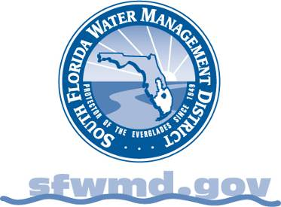

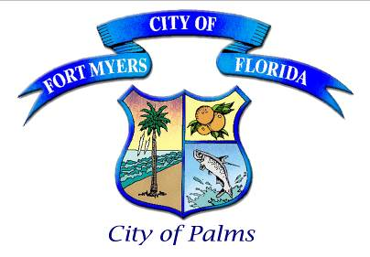

For additional information on the watershed management approach in the Caloosahatchee Estuary Basin, contact:
Kevin Williams, Basin Coordinator
Florida Department of Environmental Protection
Watershed Restoration Program, Watershed Planning and Coordination Section
2600 Blair Stone Road, Mail Station 3565
Tallahassee, FL 32399-2400
Email: Kevin.C.Williams@dep.state.fl.us
Phone: (850) 245–8086

Table of Contents

Acknowledgments 2
List of Acronyms and Abbreviations 6
Executive Summary 8
Chapter 1: Background Information 10
1.1 Water Quality Standards and Total Maximum Daily Loads (TMDLs) 10
1.1.1 Caloosahatchee Estuary TMDLs 10
1.2 Caloosahatchee Estuary Basin Management Action Plan (BMAP) 12
1.2.1 Caloosahatchee BMAP Pollutant Reduction and Discharge Allocations 12
Chapter 2: Assessing Progress 15
2.1 Projects To Achieve the TMDL 15
2.2 Other Coordinating Agency Efforts 16
2.2.1 Agriculture/FDACS 16
2.2.2 SFWMD 16
2.3 Water Quality Monitoring and Evaluation 17
2.3.1 Ambient Water Quality Monitoring. 17
2.3.2 Biological Monitoring 19
2.3.3 Water Quality Evaluation 19
Data Management and Processing 19
Statistical Analyses 21
Chapter 3: Recommendations 30
3.1 Milestones 30
3.2 Modeling and Allocations 32
3.3 Water Quality Monitoring 35
3.3.1 Revised Tier System 35
3.3.2 Recommended Additional Monitoring 36
Appendices 38
Appendix A: BMAP Projects 38
Appendix B: Future BMAP Projects 47
Appendix C: BMAP Monitoring Network and Recommended Revisions 50
Appendix D: Agricultural Enrollment and Reductions 62
Appendix E: Water Quality Data Processing and Analysis Methods 66

List of Figures
Figure ES-1. Progress towards the Caloosahatchee TN TMDL through May 31, 2017 9
Figure 1. Caloosahatchee Estuary Basin 11
Figure 2. Comparison of TN time series for estuary WBIDs and Station S79 29
Figure 3. Comparison of TP time series for estuary WBIDs and Station S79 29
Figure 4. Progress towards the Caloosahatchee Estuary BMAP milestones 32
Figure 5. 2017 HSPF model 33
Figure 6. 2017 EFDC model grid 34
Figure 7. Highest HSPF-simulated volumes for Caloosahatchee Estuary tributaries 36
Figure 8. Frequency distribution of daily mean discharge (tidally filtered) at USGS stations, 2007–13 37
Figure 9. Current and recommended flow monitoring locations 37
Figure C-1. Tidal Caloosahatchee BMAP stations monitored by Cape Coral, Fort Myers, and Lee County 54
Figure C-2. Tidal Caloosahatchee BMAP stations monitored by DEP, SCCF, SFWMD, and USGS 55
Figure C-3. Revised Tier 1 Tidal Caloosahatchee BMAP stations 59
Figure C-4. Revised Tier 2 Tidal Caloosahatchee BMAP stations 60
Figure C-5. Revised Tier 3 Tidal Caloosahatchee BMAP stations 60
Figure D-1. BMP enrollment in the Tidal Caloosahatchee Watershed as of March 31, 2017 65

List of Tables
Table 1. Designated use attainment categories for Florida surface waters 10
Table 2. Caloosahatchee Estuary TMDL 12
Table 3. TN required reductions in the Tidal Caloosahatchee Basin 13
Table 4. Required load reductions by entity 13
Table 5. Projects submitted by year 15
Table 6. Projects to achieve the TMDL 15
Table 7. Reductions towards the TMDL 16
Table 8. Water quality indicators and field parameters 18
Table 9. Summary of trend analysis results for TN concentrations at tributary stations 22
Table 10. Summary of trend analysis results for TP concentrations at tributary stations 25
Table 11. Summary of trend analysis results for TN concentrations in Caloosahatchee Estuary WBIDs and at Station S79 27
Table 12. Summary of trend analysis results for TP concentrations in Caloosahatchee Estuary WBIDs and at Station S79 28
Table A-1. Charlotte County projects 38
Table A-2. City of Cape Coral projects 38
Table A-3. City of Fort Myers projects 40
Table A-4. LA-MSID projects 41
Table A-5. FDOT projects 42
Table A-6. Lucaya CDD projects 42
Table A-7. Lee County projects 43
Table A-8. FDACS notice of intent (NOI) enrollment reduction estimates as of March 31, 2017 46
Table B-1. Future BMAP projects for planning and funding purposes 48
Table C-1. BMAP monitoring network 51
Table C-2. Revised BMAP monitoring network 56
Table C-3. SFWMD biological monitoring 61
Table C-4. DEP biological monitoring 61
Table D-1. Agricultural acreage in the Tidal Caloosahatchee Basin 63
Table D-2. BMP enrollment for the Tidal Caloosahatchee Basin as of March 31, 2017 64
Table E-1. Initial list of stations selected for processing 70
Table E-2. Summary of POR and data availability for tributary stations 71
Table E-3. Summary of POR and data availability for WBID datasets 72

List of Acronyms and Abbreviations
ABSORB Aquifer Benefit and Storage for the Orange River Basin
ACT Autocorrelation Function
AWWTF Advanced Wastewater Treatment Facility
BMAP Basin Management Action Plan
BMP Best Management Practice
BOD5 Biochemical Oxygen Demand Five-Day
CDD Community Development District
CRE Caloosahatchee River Estuary
DEP Florida Department of Environmental Protection
DO Dissolved Oxygen
DOC Dissolved Organic Carbon
DON Dissolved Organic Nitrogen
ECWCD East County Water Control District
EFDC Environmental Fluid Dynamics Code (Model)
EPA U.S. Environmental Protection Agency
FDACS Florida Department of Agriculture and Consumer Services
FDOT Florida Department of Transportation
F.A.C. Florida Administrative Code
F.S. Florida Statutes
FY Fiscal Year
FYN Florida Yards and Neighborhoods (Program)
FWRA Florida Watershed Restoration Act
GIS Geographic Information System
HSPF Hydrologic Simulation Program-FORTRAN (Model)
IA Implementation Assurance
LA Load Allocation
LA-MSID Lehigh Acres Municipal Services Improvement District
lbs/yr Pounds Per Year
MDL Minimum Detection Limit
mg/L Milligrams Per Liter
MI Multiple Imputation
MK Mann-Kendall
MS4 Municipal Separate Storm Sewer System
N/A Not Applicable
NECTR North East Caloosahatchee Tributaries Restoration Project
NEEPP Northern Everglades and Estuaries Protection Program
NOI Notice of Intent
NPDES National Pollutant Discharge Elimination System
O&M Operations and Maintenance
OAWP Office of Agricultural Water Policy (FDACS)
OSTDS Onsite Sewage Treatment and Disposal System
POR Period of Record
PSA Public Service Announcement
QA/QC Quality Assurance/Quality Control
SCCF Sanibel-Captiva Conservation Foundation
SFER South Florida Environmental Report
SFWMD South Florida Water Management District
SK Seasonal Kendall
SR State Road
STORET STOrage and RETrieval (Database)
TBD To Be Determined
TKN Total Kjeldahl Nitrogen
TMDL Total Maximum Daily Load
TN Total Nitrogen
TOC Total Organic Carbon
TP Total Phosphorus
TSD Time Series Decomposition
TSS Total Suspended Solids
USGS U.S. Geological Survey
WBID Waterbody Identification (Number)
WIN Watershed Information Network
WLA Wasteload Allocation
WWTF Wastewater Treatment Facility
WWTP Wastewater Treatment Plant
WY Water Year

Executive Summary
Total Maximum Daily Load (TMDL)
The Florida Department of Environmental Protection (DEP) identified the Caloosahatchee Estuary as impaired by nutrients (chlorophyll a) in 2005. In December 2009, DEP adopted the Caloosahatchee Estuary TMDL for total nitrogen (TN), which contributes to chlorophyll a concentration impairments in the Caloosahatchee River and Estuary downstream of the Franklin Lock and Dam.
The Caloosahatchee Estuary Basin Management Action Plan (BMAP) was adopted in November 2012 to implement the TN TMDL in the watershed. The BMAP is implemented in a phased approach to allow for adaptive management. At the end of each 5-year phase, a formal review will be completed. This 5-Year Review was prepared to provide an update on the status of implementation at the end of the first phase and recommendations for future phases of the BMAP. The 5-Year Review establishes milestones as required in Subparagraph 403.067(7)(a)6., Florida Statutes (F.S.), and describes progress towards the first 5-year milestone. The milestones are established in 5-year increments with the goal of achieving the TMDL in 20 years, as outlined in Paragraph 373.4595(4)(b), F.S. DEP will re-evaluate the implementation status of this BMAP every 5 years to determine whether improvements are being achieved. Any necessary revisions to the BMAP will be adopted by DEP Secretarial Order.
Summary of Load Reductions
Over the first 5 years of implementation, 73 projects were completed and an additional 15 underway or planned projects were added to the BMAP. The projects completed to date are estimated to achieve total reductions of 217,008 lbs/yr of TN, or 56 % of the reductions needed to meet the portion of the TMDL allocated to the Tidal Caloosahatchee Basin. Figure ES-1 shows progress towards the TN TMDL load reductions.
Water Quality and Biological Monitoring
The existing Caloosahatchee BMAP monitoring network consists of 81 stations monitored by local entities, 15 stations monitored by DEP, and 10 stations monitored by the South Florida Water Management District (SFWMD). These stations are currently organized into a 4-tier system; however, a recommendation is being made to revise the network to a 3-tier system.
In addition, the SFWMD conducts biological sampling for oysters and seagrass, and DEP staff conduct quarterly sampling for seagrass as part of the BMAP monitoring plan.

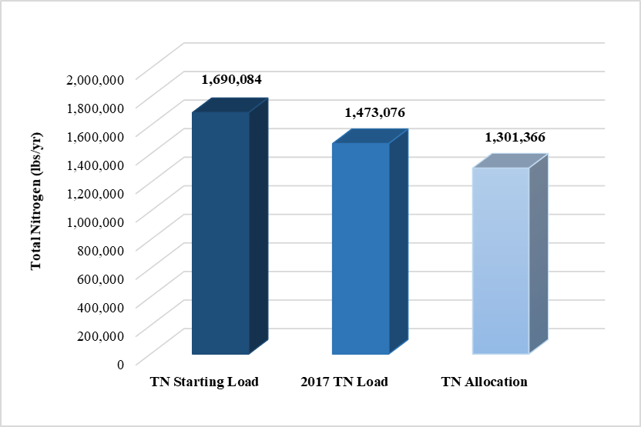
Figure ES-1. Progress towards the Caloosahatchee TN TMDL through May 31, 2017

Chapter 1: Background Information

Water Quality Standards and Total Maximum Daily Loads (TMDLs)
Florida's water quality standards are designed to ensure that surface waters fully support their designated uses, such as drinking water, aquatic life, recreation, and agriculture. Currently, most surface waters in Florida, including those in the Caloosahatchee Estuary, are categorized as Class III waters, meaning they must be suitable for recreation and must support fish consumption and the propagation and maintenance of a healthy, well-balanced population of fish and wildlife. Table 1 lists all designated use classifications for Florida surface waters.
Table 1. Designated use attainment categories for Florida surface waters
¹ Class I, I-Limited, and II waters additionally include all Class III uses.
² Class I-Limited classification was approved by the Environmental Regulation Commission on July 26, 2016. However, the classification has not yet been approved by the U.S. Environmental Protection Agency (EPA) and is therefore not currently in effect for Clean Water Act purposes.
Classification | Description
Class I¹ | Potable water supplies
Class I-Limited^{1,2} | Treated potable water supplies
Class II¹ | Shellfish propagation or harvesting
Class III | Fish consumption; recreation, propagation and maintenance of a healthy,  well-balanced population of fish and wildlife
Class III-Limited | Fish consumption, recreation or limited recreation, and/or propagation and maintenance of a limited population of fish and wildlife
Class IV | Agricultural water supplies
Class V | Navigation, utility, and industrial use (no current Class V designations)

Section 303(d) of the federal Clean Water Act requires that every two years each state must identify its "impaired" waters, including estuaries, lakes, rivers, and streams, that do not meet their designated uses. Florida Department of Environmental Protection (DEP) staff in the Division of Environmental Assessment and Restoration are responsible for assessing Florida's waters for inclusion on the Verified List of Impaired Waters and Study List, which is then provided to the EPA as an annual update to the state "303(d) list." In 2005, DEP identified the Caloosahatchee Estuary (Figure 1) as impaired for dissolved oxygen (DO) and nutrients.

Caloosahatchee Estuary TMDLs
DEP develops and adopts TMDLs for the waterbody segments it identifies as impaired. A TMDL is the maximum amount of a specific pollutant that a waterbody can assimilate while maintaining its designated uses. In December 2009, DEP adopted the Caloosahatchee Estuary TMDL for total nitrogen (TN), which is linked to high chlorophyll a concentrations in the Caloosahatchee River and Estuary downstream of the Franklin Lock and Dam (S-79). The TMDL includes the three segments with waterbody identification (WBID) numbers that make up the Caloosahatchee Estuary: WBIDs 3240A, 3240B, and 3240C.

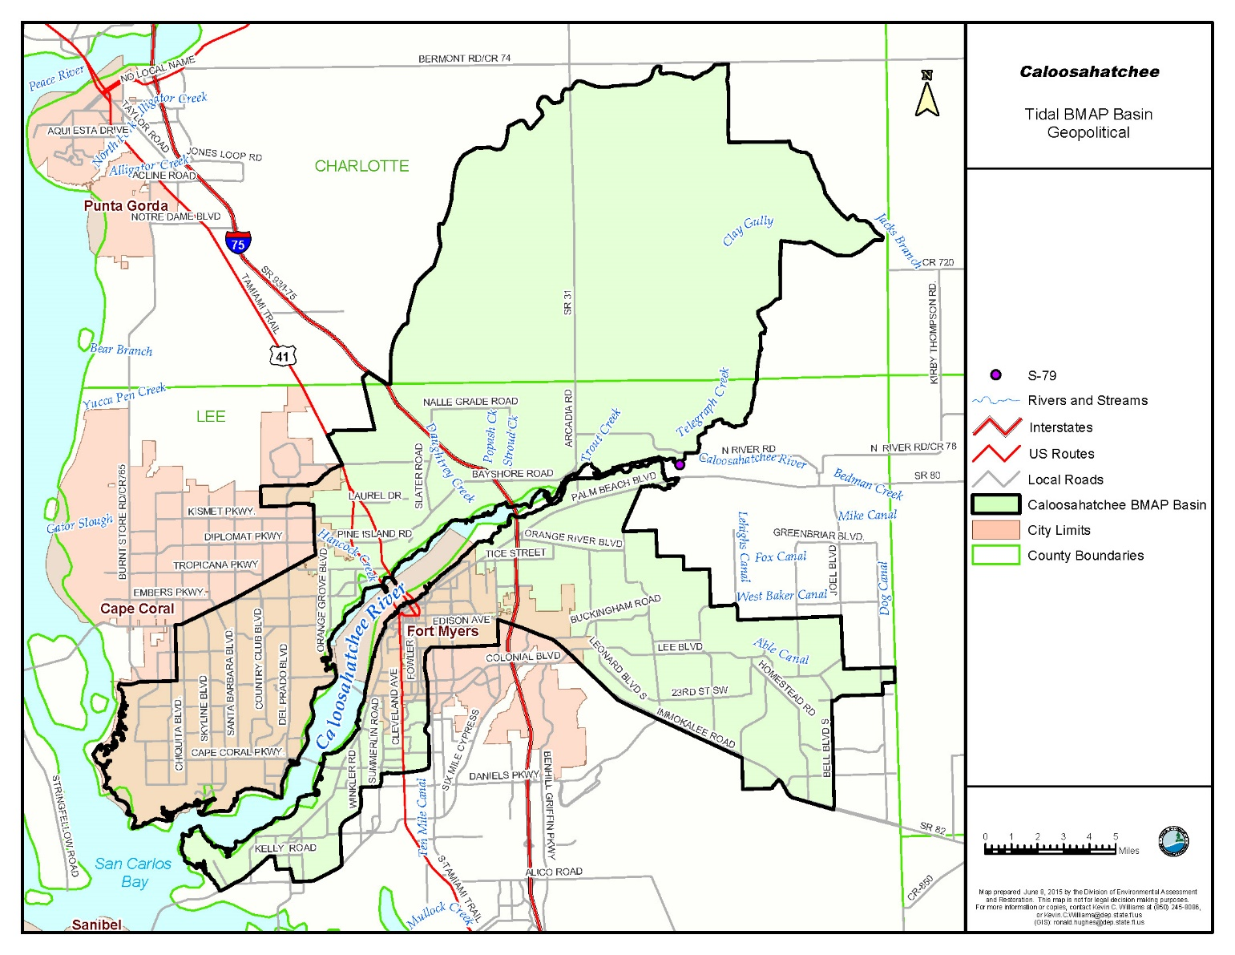
Figure 1. Caloosahatchee Estuary Basin

Adopted TMDLs must establish reasonable and equitable allocations that will alone, or in conjunction with other management and restoration activities, attain the TMDL. Allocations may be to individual sources, source categories, or basins that discharge to the impaired waterbody. The allocations identify either the amount of pollutant discharge (such as pounds per year [lbs/yr]) or the percent of its loading the source designation must reduce (reduction allocation). Currently, the TMDL allocation categories are as follows:
- Wasteload Allocation (WLA) is the allocation to point sources permitted through the National Pollutant Discharge Elimination System (NPDES) Program, including the following:
- Wastewater Allocation is the allocation to industrial and domestic wastewater facilities.
- NPDES Stormwater Allocation is the allocation to NPDES stormwater permittees that operate municipal separate storm sewer systems (MS4s). These permittees are treated as point sources under the TMDL Program.
- Load Allocation (LA) is the allocation to nonpoint sources, including agricultural sources.
During TMDL development a comparison of the Existing Condition with the TMDL and Background Conditions, as well as previous research in the estuary, demonstrated a required 23 % TN load reduction. This meant reducing the current stormwater runoff load of 1,690,084 lbs/yr by 388,719 lbs/yr. Table 2 lists the TMDL and pollutant load allocations adopted by rule for the watershed (based on updates to the watershed loading).
The TMDL includes estimates of TN loading in the Tidal Caloosahatchee Basin from watershed stormwater sources, point source facilities, and mainstem upstream inputs (Lake Okeechobee and the Caloosahatchee River). The upstream inputs will be addressed by separate TMDLs (existing and future) for loads generated above Control Structure S-79. This TMDL focused on load reductions from stormwater sources generated below S-79.
Table 2. Caloosahatchee Estuary TMDL
¹ The domestic wastewater treatment plant and stormwater loads have been updated since the original TMDL report.
² The TMDL load applies only to stormwater loads and is based on loads that have been updated since the original TMDL report.
Parameter | WLA for Wastewater (lbs/yr) | Current Domestic Wastewater Loading (lbs/yr)¹ | WLA for NPDES Stormwater  (% Reduction) | LA  (% Reduction) | Current Stormwater Loading (lbs/yr)¹ | TMDL Load (lbs/yr)²
TN | Permitted loads | 64,158 | 23 | 23 | 1,690,084 | 1,301,365

Caloosahatchee Estuary Basin Management Action Plan (BMAP)
Rule-adopted TMDLs may be implemented through BMAPs, which contain strategies to reduce and prevent pollutant discharges through various cost-effective means. During the TMDL process, DEP and the affected stakeholders jointly develop BMAPs or other implementation approaches. A basin may have more than one BMAP, based on practical considerations. Stakeholder involvement is critical to the success of the TMDL Program and varies with each phase of implementation to achieve different purposes. The BMAP development process is structured to achieve cooperation and consensus among a broad range of interested parties. DEP, the South Florida Water Management District (SFWMD), and stakeholders representing other agencies, governments, and interested parties helped in the preparation of the BMAP.

Caloosahatchee BMAP Pollutant Reduction and Discharge Allocations
Under the Florida Watershed Restoration Act (FWRA), the TMDL allocation adopted by rule may be an "initial" allocation among point and nonpoint sources. In such cases, the "detailed" allocation to specific point sources and specific categories of nonpoint sources must be established in the BMAP. Both initial and detailed allocations must be determined based on several factors listed in the FWRA, including cost-benefit, technical and environmental feasibility, implementation time frames, and others. Table 3 lists the existing loads and required TMDL reductions.
Table 3. TN required reductions in the Tidal Caloosahatchee Basin
¹ The domestic wastewater treatment plant (WWTP) loads have been updated from the original TMDL report.
² The stormwater runoff load is the load below S-79 and has been updated from the original TMDL report.
³ The required reduction is based on the 23 % defined in the original TMDL report.
Tidal Caloosahatchee Basin | Domestic WWTP Point Sources  (lbs/yr) | Stormwater Runoff Load  (lbs/yr) | Total Load  (lbs/yr)
TN Existing Load | 64,158¹ | 1,690,084² | 1,754,242
Required Reduction³ | 0 | 388,719 | 388,719

During the initial stages of BMAP development, DEP worked with the stakeholders to disaggregate the total TN load by entity. The acreage and loading information for each stakeholder was calculated using output from the Hydrologic Simulation Program-FORTRAN (HSPF) model. Geographic information system (GIS) coverage was then used to help determine allocations.
The TMDL did not include detailed allocations for the wastewater treatment facilities (WWTFs) in the basin. Therefore, the BMAP only assigned detailed allocations for the stormwater sources in the Tidal Caloosahatchee Basin. The load reduction was allocated based on a stakeholder's percentage of the developed load. Table 4 lists the allocation of the load reductions for entities in the Caloosahatchee Estuary BMAP area.
Table 4. Required load reductions by entity
Entity | TN Starting Nonbackground Load  (lbs/yr) | TN Allowable Load  (lbs/yr) | TN Load Reduction (lbs/yr)
City of Cape Coral | 142,892 | 39,478 | 103,414
City of Fort Myers | 56,547 | 15,623 | 40,924
Lehigh Acres Municipal Services Improvement District (LA-MSID) /formerly East County Water Control District (ECWCD) | 52,141 | 14,405 | 37,736
Lucaya Community Development District (CDD) | 183 | 51 | 132
Lee County | 194,623 | 53,770 | 140,853
Charlotte County | 1,303 | 360 | 943
Florida Department of Transportation (FDOT) | 12,601 | 3,481 | 9,119
Agriculture | 76,821 | 21,224 | 55,597
Total | 1,690,084 | 1,301,366 | 388,719

The management actions and adaptive management approach described in the BMAP will address TN reductions until the TMDLs are attained. The phased BMAP approach allows for the implementation of projects over multiple years designed to achieve incremental reductions, while simultaneously monitoring and conducting studies to better understand the water quality dynamics (sources and response variables) in the watershed.
Additional details about the sources, modeling development process, and implementation assumptions and considerations are provided in the 2009 TMDL report and 2012 BMAP.

Chapter 2: Assessing Progress
  - Projects To Achieve the TMDL
DEP annually reviews each entity's progress towards completing projects listed in the BMAP and achieving the assigned allocations based on the details described in the current TMDL and BMAP. These details may be refined as part of the modeling that is currently being updated. Table 5 depicts the annual project totals by entity as of May 31, 2017. Table 6 outlines the number of projects that each entity has committed to in the BMAP and annual progress reports, along with the status of those projects as of May 31, 2017. Table 7 summarizes the allocations and reductions achieved by each entity in the BMAP as of May 31, 2017.
Table 5. Projects submitted by year
* The FDACS project is the Best Management Practice (BMP) Enrollment Program, for which updates have been submitted to DEP annually.
Lead Entity | 2012 | 2013 | 2014 | 2015 | 2016 | 2017 | Total Projects
Agriculture/Florida Department of Agriculture and Consumer Services (FDACS)* | 1 | * | * | * | * | * | 1
Charlotte County | 1 | 0 | 0 | 0 | 0 | 0 | 1
City of Cape Coral | 13 | 0 | 1 | 1 | 1 | 0 | 16
City of Fort Myers | 10 | 0 | 1 | 0 | 0 | 0 | 11
FDOT | 8 | 0 | 0 | 0 | 0 | 0 | 8
LA-MSID | 6 | 0 | 0 | 0 | 1 | 3 | 10
Lee County | 23 | 0 | 0 | 2 | 3 | 12 | 40
Lucaya CDD | 1 | 0 | 0 | 0 | 0 | 0 | 1
Total | 63 | 0 | 2 | 3 | 5 | 15 | 88

Table 6. Projects to achieve the TMDL
* The FDACS project is the BMP Enrollment Program.
Lead Entity | Total Projects | Completed | Underway | Planned
Agriculture/FDACS* | 1 | 1 | 0 | 0
Charlotte County | 1 | 1 | 0 | 0
City of Cape Coral | 16 | 16 | 0 | 0
City of Fort Myers | 11 | 11 | 0 | 0
FDOT | 8 | 8 | 0 | 0
LA-MSID | 10 | 7 | 3 | 0
Lee County | 40 | 28 | 9 | 3
Lucaya CDD | 1 | 1 | 0 | 0
Total | 88 | 73 | 12 | 3

Table 7. Reductions towards the TMDL
* Reductions to date include TN reductions associated with projects completed as of May 31, 2017.
Lead Entity | TN Required Reduction  (lbs/yr) | TN Reduction  to Date*  (lbs/yr) | % of Allocation Achieved
Agriculture/FDACS | 55,597 | 31,169 | 56
Charlotte County | 943 | 381 | 40
City of Cape Coral | 103,414 | 82,785 | 80
City of Fort Myers | 40,924 | 21,533 | 53
FDOT | 9,119 | 11,490 | 126
LA-MSID | 37,736 | 23,532 | 62
Lee County | 140,853 | 46,118 | 33
Lucaya CDD | 132 | 0 | 0
Total | 388,718 | 217,008 | 56

  - Other Coordinating Agency Efforts
FDACS and the SFWMD have coordinated efforts with DEP to focus on achieving the TMDL and maintaining compliance with state water quality standards. Those efforts are briefly summarized below.

Agriculture/FDACS
The BMAP identifies 30,241 agricultural acres in the estuary watershed. As of March 31, 2017, 19,084 are enrolled in the FDACS BMP Program. This figure equates to 63 % enrollment of the agricultural acreage based on the HSPF model in the Tidal Caloosahatchee Basin covered by the FDACS BMP Program. The reductions associated with the enrollment through March 31, 2017, are estimated to be 31,169 lbs/yr TN, or 56 % of the reductions required for agricultural lands in the BMAP area.
FDACS Office of Agricultural Water Policy (OAWP) has also provided $29,369.46 in cost-share assistance for cross fencing, which facilitates rotational grazing, on a 1,000-acre cow/calf operation. An additional $21,030.54 will be provided to complete the fencing project. In Fiscal Year (FY) 2017–18, FDACS will provide more funding to install livestock watering facilities on the same operation.

SFWMD
While the SFWMD is not a lead agency on any specific projects identified in the BMAP, it was involved in numerous restoration activities in the Caloosahatchee River Basin that moved forward during the BMAP reporting period. Regional projects with both water storage and water quality benefits progressed. Highlights of advancements made in key SFWMD-involved projects in the watershed upstream of the BMAP area during the BMAP reporting period (through May 31, 2017) are listed below.

Caloosahatchee River (C-43) West Basin Storage Reservoir Project
The purpose of this project is to aid in capturing regulatory releases from Lake Okeechobee and to collect and store runoff from the basin that is currently discharged to the river. Water will be released when needed during the dry season to the estuary to help provide essential flows that will result in a more stable salinity regime. In 2015, the SFWMD issued the first of four construction packages, including preloading and demolition work; the work is scheduled to be completed by August 2017. In 2016, the SFWMD issued the second construction package, for the S-476 pump station construction; this work is scheduled to be completed by April 2018.
C-43 Water Quality Treatment and Testing Facility Project
The SFWMD and Lee County are partners in the development and implementation of the project. The project goals are to demonstrate and implement cost-effective, wetland-based strategies for reducing pollutant loadings to the Caloosahatchee River and its downstream estuarine ecosystems, particularly the recalcitrant fraction of dissolved organic nitrogen (DON) that is more difficult to remove than other forms ordinarily found in fertilizers. Phase I, initiated in 2015, includes bioassays and mesocosms. Bioassays are being performed to determine the fraction of biologically available DON in the Caloosahatchee River. These results will inform the mesocosm design. Mesocosms are being used to assess potential surface water nitrogen removal rates using different plant communities and hydrologic loading rates. Phase I mesocosm construction was completed in June 2016, and mesocosm operations, maintenance, and monitoring are planned through December 2018.
Lake Hicpochee Hydrologic Enhancement – North Project (Phase 1)
The objective of the project is to provide shallow water storage, rehydrate a portion of the lake bed to promote habitat restoration, and increase capacity for ancillary water quality enhancements. The project includes a shallow storage feature and a spreader canal to deliver excess stormwater runoff from the C-19 Canal to the northern portion of Lake Hicpochee as needed. The final regulatory authorizations for Phase I of this project were completed in January 2017. Construction began in March 2017 and is scheduled to be completed by September 2018.
  - Water Quality Monitoring and Evaluation
The Caloosahatchee Estuary BMAP monitoring plan was designed to enhance the understanding of basin loads, identify areas with high nutrient concentrations, and track water quality trends. The information gathered through the monitoring plan measures progress toward achieving the TMDL and provides a better understanding of watershed loading. The BMAP monitoring plan consists of ambient water quality sampling and biological monitoring.

2.3.1 Ambient Water Quality Monitoring.
Focused objectives are critical for a monitoring strategy to provide the information needed to evaluate implementation success. The primary and secondary objectives of the monitoring strategy for the Caloosahatchee Estuary are described below. These objectives are used to evaluate the success of the BMAP, help interpret the data collected, and provide information for potential future refinements of the BMAP. All BMAP data providers have agreed to upload ambient water quality data to the STOrage and RETrieval (STORET) Database and Watershed Information Network (WIN) at least once every six months, upon completion of the appropriate quality assurance/quality control (QA/QC) checks.
Primary Objective
- To enhance the understanding of basin loads, identify areas with high nutrient concentrations, and track water quality trends. This information will measure progress toward achieving the TMDL and provide a better understanding of the watershed loading.
Secondary Objective
- To identify areas or tributaries in the watershed with high loadings of nutrients to better focus management efforts.
To achieve the objectives above, the monitoring strategy focuses on two types of indicators to track water quality trends: core and supplemental (Table 8). The core indicators are directly related to the parameters causing impairment in the river. Supplemental parameters are monitored primarily to support model development and refinement. Supplemental indicators will also be used for the interpretation of core water quality parameters.
Table 8. Water quality indicators and field parameters
* Should be monitored as a core parameter in WBIDs with DO impairments.
Core Parameters | Supplemental Parameters
Chlorophyll a (Corrected)  Dissolved Oxygen (DO)  Nitrate/Nitrite as N  pH – Field  Specific Conductance/Salinity  Temperature  Total Kjeldahl Nitrogen (TKN)  Total Phosphorus (TP)  Total Suspended Solids (TSS) | Biochemical Oxygen Demand (BOD5)*  Color  Dissolved Organic Carbon (DOC)  Total Organic Carbon (TOC)  Turbidity

During the first phase of BMAP implementation, Cape Coral continued water quality monitoring in the basin and has uploaded the data to STORET. Fort Myers and Lee County also continued water quality monitoring in the basin, and the monitoring data for the reporting period were uploaded into STORET. The SFWMD continued monitoring at 10 stations in the BMAP area, and the monitoring data for the reporting period were uploaded to WIN in July 2017 (further information on this monitoring and associated data results are reported in the 2017 South Florida Environmental Report [SFER] – Volume I, Chapter 8C, available on the SFWMD website). DEP has also continued water quality monitoring at 15 stations in the basin. Appendix C lists the stations in the BMAP monitoring network for easy reference.

2.3.2 Biological Monitoring
The SFWMD conducts biological sampling for oysters and seagrass in the Caloosahatchee Estuary and San Carlos Bay. Seagrass monitoring is focused between March and September, and two sites are also monitored in December. Oyster density at all four sites is monitored monthly. Further information on this monitoring and associated data results is reported in the 2017 SFER – Volume I, Chapter 8C. DEP continues to carry out seagrass monitoring in the basin at the stations listed in Table C-3 in Appendix C.

2.3.3 Water Quality Evaluation
To help track implementation progress for the Caloosahatchee BMAP, a water quality evaluation was completed using data available as of May 31, 2017. Trend analyses were conducted as part of the 5-Year Review to track changes in individual freshwater tributaries in the Tidal Caloosahatchee Watershed and in the impaired Caloosahatchee Estuary WBIDs. The results from the water quality trend analyses for select stations and WBIDs are described below, and Appendix E describes the methods used to retrieve, process, and analyze the data.

Data Management and Processing
STORET served as the primary repository of ambient water quality data for the state until 2017. DEP impaired waters evaluations have been based on water quality data from STORET. Ambient water quality data collected as part of the BMAP were uploaded into STORET for long-term storage and availability by the BMAP stakeholders. All BMAP data providers have agreed to upload ambient water quality data to STORET at least once every six months, upon completion of the appropriate QA/QC checks. The SFWMD uploads its data into STORET at least once per year. In 2017, the primary repository of ambient water quality data for DEP was switched from STORET to WIN, and some data for these analyses was obtained from WIN.
Stations in the BMAP monitoring network are divided into three tiers (Tier 1, Tier 2, and Tier 3) as part of the recommended revisions in Section 3.3. In addition to the revised tier system, all stations are assigned a general location in the BMAP area: estuary, tributary, or bay. Appendix C lists all stations in the current and revised BMAP monitoring network, along with a description of the recommended tiered system for reference. Only Tier 1 stations were selected for this initial processing and analysis for the 5-Year Review because of the higher level of data availability (i.e., the number of data points within a year and the number of years of data available), and sampling frequency compared with the Tier 2 and Tier 3 stations. The full BMAP monitoring network includes several more stations (Tier 2 or 3) that are not currently assigned to Tier 1. However, those stations may be used as part of other future efforts once sufficient data become available.
The Tier 1 tributary stations in the watershed were processed on an individual station basis to determine if the datasets were sufficient to meet the requirements for trend analysis. Stations that met the criteria were analyzed for trends. The Tier 1 estuary station data were aggregated into groups by WBIDs, processed, and then analyzed for trends on a WBID basis. All data from the Tier 1 stations in each of the three TMDL WBIDs (3240A, 3230B, and 3240C) were pooled to develop an aggregated dataset on a WBID basis. Table E-1 contains the initial list of stations that were selected for processing, including the data provider, latitude, longitude, waterbody type, and whether the station was grouped by WBID or analyzed on an individual station basis.
The water year (WY) established for this region is May 1 to April 30. May 1, 2007, to April 30, 2017, was selected as the general working period of record (POR) for these water quality analyses to assess trends, and included a five-year data period prior to and after BMAP adoption in November 2012. The POR for some stations had to be modified to account for significant missing data (greater than one year).
Parameters selected for analysis were TN (or the required nitrogen species that allow for the calculation of TN) and total phosphorus (TP). TN and TP data were retrieved from STORET for the stations listed in Table E-1, except for SFWMD Stations S79, CES03, CES04, CES05, CES06, and CES08, which were retrieved from WIN. After data were retrieved from STORET and WIN, the data were processed and analyzed using several QC checks (and industry standard statistical diagnostics) that addressed the following items: depths of data collection, fatal qualifier codes, temporal independence, serial correlation, and seasonality.
During data processing of the initial set of Tier 1 tributary stations, an assessment was performed to determine data sufficiency by counting the number of viable data points (after the data were processed for QC), to assess major data gaps and approximate sampling frequencies. Table E-2 lists the POR and the number of samples collected at each individual station or in the WBIDs selected for analysis. Although May 2007 was initially selected as the working POR, none of the individual tributary stations had available data prior to May 2008 for TN or TP. Therefore, the working POR was shortened for the individual tributary stations to nine years for most of the stations with longer PORs. Table E-3 lists the POR and the number of samples compiled for each of the WBID datasets and Station S79 selected for analysis.
Based on a more detailed review of the individual station PORs and data gaps, it was found that four stations (Stations CALUSA0054FTM, CFMCARRELL, CFMMANUEL, and CFMWINKLER) had a number of data points collected in at least a five-year period. However, there were large data gaps in the PORs, and it was determined that those stations did not have enough data points in a five-consecutive year period, which is a minimum requirement for trend analysis. Therefore, those four stations were not used in further analyses (Table E-2). In addition, no TP data were available for six stations in STORET (Stations 300, 400, 470, 540, 590, and 600). Therefore, only TN was further processed and analyzed for trends at those six stations. Two stations, CALUSA0024FTM and CALUSA0025FTM had no data available prior to 2011. However, sufficient data were available to conduct further analyses, and so a shorter POR was analyzed for those stations. Finally, one station (18-6GR) had wide data gaps between November 2014 and April 2017. Data from June 2008 to November 2014 still met the minimum five-year data requirement, and that POR was used for subsequent processing and trend analysis.
After QC processing was completed and a near-final dataset was prepared for each station (or WBID), monthly means were calculated for datasets with more than one data point available in one given month. The monthly means were calculated to aid other analyses that were needed to further assess the data prior to trend analysis completion. These analyses included various time series analysis techniques, such as autocorrelation function (ACF) and time series decomposition (TSD), to review the potential for serial correlation and/or seasonality (i.e., seasonal patterns) that may affect the results of the trend analysis.
If months of data were missing from the specific time series for a dataset POR, then a variety of methods were used to fill the data gaps before the TSD analysis could be completed. The gap-filling methods used depended on the number of data points that had to be filled, and included multiple imputation and interpolation. Appendix E contains complete details of the specific steps and methodologies used for data processing and analysis.

Statistical Analyses
Only datasets that met the QC objectives mentioned above and described in Appendix E were ultimately used for trend analysis. Nonparametric statistical techniques were used to identify monotonic trend analyses with the Seasonal Kendall and Mann-Kendall trend tests. Nonparametric tests such as Mann-Kendall are robust against outliers and large data gaps, and data are not required to conform to a particular distribution for nonparametric analyses. Seasons for the Seasonal Kendall trend test were ascribed to months, since data were typically collected monthly.
Prior to running trend analyses, it was necessary to conduct an ACF analysis to assess whether seasonality or serial correlation was impacting the data. To parse out any potential impacts of seasonality on the trend analyses, a TSD analysis was conducted to confirm notions of possible seasonality that may have been suggested by the ACF analysis. TSD requires the time series dataset to be complete, with no data gaps. Thus, before decomposing time series into seasonal and trend components, all data gaps should be filled with an appropriate value. For the purpose of these analyses, the multiple imputation (MI) method was used to backfill datasets where interpolation was not possible so that a TSD analysis could be conducted. Appendix E contains additional details on the MI methodology.
Seasonal Kendall and Mann-Kendall Trend Results for Individual Stations
Tables 9 and 10 summarize the trend analysis results for both Mann-Kendall and Seasonal Kendall for TN and TP, respectively, for individual stations. In addition, the tables list the potential for seasonal patterns that may affect the trend analysis result. It should be noted that even if the p-value is statistically significant (if it is less than 0.05), the result may not be ecologically significant. For example, if a trend is found to be significantly declining (negative trend), but the slope is near 0, then it may not be realistic to assume an improvement in water quality that may have a measurable ecological effect in any reasonable time frame (i.e., years to decades).
When potential seasonality patterns were observed from the ACF analysis, then the gap-filled and seasonally adjusted trend data were used for trend analyses. If the converse were true where no obvious seasonality pattern was observed from the ACF analysis, then the nongap-filled or nondecomposed data were used for trend analysis, referred to as the "nondecomposed" datasets. This is an important consideration when performing trend analyses, since the two datasets are quite different and a false positive or false negative significance value could result during trend analysis if the incorrect dataset is used for trend analysis.
Of the 20 stations analyzed for TN, none had statistically significant increasing trends, 3 had decreasing trends, and 17 stations did not show any statistically significant trends. Of the 14 stations analyzed for TP, 2 had statistically significant increasing trends, 3 had decreasing trends, and 9 stations did not show any statistically significant trends.
Table 9. Summary of trend analysis results for TN concentrations at tributary stations
Note: P-values listed in bold indicate statistical significance (p<0.05).
mg/L = Milligrams per liter.
¹ Even if the P-value is determined to be statistically significant, then the result may not be ecologically significant. For example, if a trend is statistically significantly declining (negative trend) but the slope is near 0, then it may not be realistic to assume that an improvement in water quality by reductions in TN or TP may positively impact the ecological system in a measurable way. Based on the review of ACF and TSD results.
² A negative trend indicates a downward or decreasing trend, which may suggest an improvement in water quality. The opposite is true for a positive trend, which may indicate an increase and possibly a decline in water quality.
³ Based on the review of ACF and TSD analysis results.
⁴ If "decomposed," then a potential seasonality pattern was observed from the ACF and/or TSD results. Therefore, gap-filled, seasonally adjusted, decomposed trend data were used for the trend analyses.
⁵ If "nondecomposed," then no obvious seasonality pattern was observed; therefore, a regular processed dataset (not gap-filled or decomposed) was used for the trend analyses.
Trend Test | Station | Parameter | Tau | P-value | Slope¹ | Statistical  Trend Test Interpretation² | Data Series Used^{3, 4, 5}
Seasonal Kendall | 300 | TN (mg/L) | -0.037 | 0.584 | -0.0004 | No significant trend | Nondecomposed
Mann-Kendall | 300 | TN (mg/L) | -0.037 | 0.586 | -0.0004 | No significant trend | Nondecomposed
Seasonal Kendall | 400 | TN (mg/L) | -0.026 | 0.707 | -0.0003 | No significant trend | Nondecomposed
Mann-Kendall | 400 | TN (mg/L) | -0.026 | 0.710 | -0.0003 | No significant trend | Nondecomposed
Seasonal Kendall | 470 | TN (mg/L) | -0.027 | 0.699 | -0.0004 | No significant trend | Nondecomposed
Mann-Kendall | 470 | TN (mg/L) | -0.027 | 0.701 | -0.0004 | No significant trend | Nondecomposed
Seasonal Kendall | 540 | TN (mg/L) | 0.015 | 0.828 | |slope|< 0.0001 | No significant trend | Nondecomposed
Mann-Kendall | 540 | TN (mg/L) | 0.015 | 0.830 | |slope|< 0.0001 | No significant trend | Nondecomposed
Seasonal Kendall | 590 | TN (mg/L) | -0.059 | 0.390 | -0.0007 | No significant trend | Nondecomposed
Mann-Kendall | 590 | TN (mg/L) | -0.059 | 0.392 | -0.0007 | No significant trend | Nondecomposed
Seasonal Kendall | 600 | TN (mg/L) | -0.043 | 0.535 | -0.0001 | No significant trend | Nondecomposed
Mann-Kendall | 600 | TN (mg/L) | -0.043 | 0.537 | -0.0001 | No significant trend | Nondecomposed
Seasonal Kendall | 22-7GR | TN (mg/L) | -0.073 | 0.265 | -0.0121 | No significant trend | Decomposed
Mann-Kendall | 22-7GR | TN (mg/L) | -0.073 | 0.266 | -0.0121 | No significant trend | Decomposed
Seasonal Kendall | 16-3GR | TN (mg/L) | -0.083 | 0.203 | -0.0068 | No significant trend | Decomposed
Mann-Kendall | 16-3GR | TN (mg/L) | -0.083 | 0.203 | -0.0068 | No significant trend | Decomposed
Seasonal Kendall | 20-9GR | TN (mg/L) | -0.196 | 0.003 | -0.0294 | Negative significant trend | Decomposed
Mann-Kendall | 20-9GR | TN (mg/L) | -0.196 | 0.003 | -0.0294 | Negative significant trend | Decomposed
Seasonal Kendall | 23-5GR | TN (mg/L) | 0.043 | 0.507 | 0.0052 | No significant trend | Decomposed
Mann-Kendall | 23-5GR | TN (mg/L) | 0.043 | 0.509 | 0.0052 | No significant trend | Decomposed
Seasonal Kendall | 24-7GR | TN (mg/L) | -0.061 | 0.353 | -0.0087 | No significant trend | Decomposed
Mann-Kendall | 24-7GR | TN (mg/L) | -0.061 | 0.354 | -0.0087 | No significant trend | Decomposed
Seasonal Kendall | 27-6GR | TN (mg/L) | -0.056 | 0.390 | -0.0088 | No significant trend | Decomposed
Mann-Kendall | 27-6GR | TN (mg/L) | -0.056 | 0.391 | -0.0088 | No significant trend | Decomposed
Seasonal Kendall | POWLGR20 | TN (mg/L) | -0.164 | 0.012 | -0.0273 | Negative significant trend | Decomposed
Mann-Kendall | POWLGR20 | TN (mg/L) | -0.164 | 0.012 | -0.0273 | Negative significant trend | Decomposed
Seasonal Kendall | 18-6GR | TN (mg/L) | -0.016 | 0.835 | -0.0002 | No significant trend | Nondecomposed
Mann-Kendall | 18-6GR | TN (mg/L) | -0.016 | 0.838 | -0.0002 | No significant trend | Nondecomposed
Seasonal Kendall | 25-GR20 | TN (mg/L) | -0.014 | 0.860 | -0.0004 | No significant trend | Nondecomposed
Mann-Kendall | 25-GR20 | TN (mg/L) | -0.014 | 0.864 | -0.0004 | No significant trend | Nondecomposed
Seasonal Kendall | 27O-GR20 | TN (mg/L) | -0.231 | < 0.001 | -0.0396 | Negative significant trend | Decomposed
Mann-Kendall | 27O-GR20 | TN (mg/L) | -0.231 | < 0.001 | -0.0396 | Negative significant trend | Decomposed
Seasonal Kendall | CALUSA0024FTM | TN (mg/L) | 0.044 | 0.578 | 0.0037 | No significant trend | Decomposed
Mann-Kendall | CALUSA0024FTM | TN (mg/L) | 0.044 | 0.581 | 0.0037 | No significant trend | Decomposed
Seasonal Kendall | CALUSA0025FTM | TN (mg/L) | -0.022 | 0.781 | -0.0002 | No significant trend | Nondecomposed
Mann-Kendall | CALUSA0025FTM | TN (mg/L) | -0.022 | 0.784 | -0.0002 | No significant trend | Nondecomposed
Seasonal Kendall | DEEPGR10 | TN (mg/L) | -0.012 | 0.861 | -0.0002 | No significant trend | Nondecomposed
Mann-Kendall | DEEPGR10 | TN (mg/L) | -0.012 | 0.863 | -0.0002 | No significant trend | Nondecomposed
Seasonal Kendall | BILLGR20 | TN (mg/L) | -0.011 | 0.865 | -0.0002 | No significant trend | Nondecomposed
Mann-Kendall | BILLGR20 | TN (mg/L) | -0.011 | 0.867 | -0.0002 | No significant trend | Nondecomposed

Table 10. Summary of trend analysis results for TP concentrations at tributary stations
Note: P-values listed in bold indicate statistical significance (p<0.05).
mg/L = Milligrams per liter.
¹ Even if the P-value is determined to be statistically significant, then the result may not be ecologically significant. For example, if a trend is statistically significantly declining (negative trend) but the slope is near 0, then it may not be realistic to assume that an improvement in water quality by reductions in TN or TP may positively impact the ecological system in a measurable way. Based on the review of ACF and TSD results.
² A negative trend indicates a downward or decreasing trend, which may suggest an improvement in water quality. The opposite is true for a positive trend, which may indicate an increase and possibly a decline in water quality.
³ Based on the review of ACF and TSD results.
⁴ If "decomposed," then a potential seasonality pattern was observed from the ACF and/or TSD analysis. Therefore, gap-filled, seasonally adjusted, decomposed trend data were used for the trend analyses.
⁵ If "nondecomposed," then no obvious seasonality pattern was observed; therefore, a regular processed dataset (not gap-filled or decomposed) was used for the trend analyses.
Trend Test | Station/WBID | Parameter | Tau | P-value | Slope¹ | Statistical Trend Test Interpretation² | Data Series  Used^{3, 4, 5}
Seasonal Kendall | 22-7GR | TP (mg/L) | 0.042 | 0.549 | |slope|< 0.0001 | No significant trend | Nondecomposed
Mann-Kendall | 22-7GR | TP (mg/L) | 0.042 | 0.551 | |slope|< 0.0001 | No significant trend | Nondecomposed
Seasonal Kendall | 16-3GR | TP (mg/L) | -0.121 | 0.063 | -0.0016 | No significant trend | Decomposed
Mann-Kendall | 16-3GR | TP (mg/L) | -0.121 | 0.063 | -0.0016 | No significant trend | Decomposed
Seasonal Kendall | 20-9GR | TP (mg/L) | -0.129 | 0.047 | -0.0026 | Negative significant trend | Decomposed
Mann-Kendall | 20-9GR | TP (mg/L) | -0.129 | 0.047 | -0.0026 | Negative significant trend | Decomposed
Seasonal Kendall | 23-5GR | TP (mg/L) | -0.052 | 0.426 | -0.0013 | No significant trend | Decomposed
Mann-Kendall | 23-5GR | TP (mg/L) | -0.052 | 0.427 | -0.0013 | No significant trend | Decomposed
Seasonal Kendall | 24-7GR | TP (mg/L) | -0.396 | < 0.001 | -0.0061 | Negative significant trend | Decomposed
Mann-Kendall | 24-7GR | TP (mg/L) | -0.396 | < 0.001 | -0.0061 | Negative significant trend | Decomposed
Seasonal Kendall | 27-6GR | TP (mg/L) | 0.036 | 0.581 | |slope|< 0.0001 | No significant trend | Nondecomposed
Mann-Kendall | 27-6GR | TP (mg/L) | 0.036 | 0.583 | |slope|< 0.0001 | No significant trend | Nondecomposed
Seasonal Kendall | POWLGR20 | TP (mg/L) | -0.058 | 0.383 | -0.0002 | No significant trend | Nondecomposed
Mann-Kendall | POWLGR20 | TP (mg/L) | -0.058 | 0.384 | -0.0002 | No significant trend | Nondecomposed
Seasonal Kendall | 18-6GR | TP (mg/L) | 0.038 | 0.613 | |slope|< 0.0001 | No significant trend | Nondecomposed
Mann-Kendall | 18-6GR | TP (mg/L) | 0.038 | 0.615 | |slope|< 0.0001 | No significant trend | Nondecomposed
Seasonal Kendall | 25-GR20 | TP (mg/L) | -0.348 | < 0.001 | -0.0095 | Negative significant trend | Decomposed
Mann-Kendall | 25-GR20 | TP (mg/L) | -0.348 | < 0.001 | -0.0095 | Negative significant trend | Decomposed
Seasonal Kendall | 27O-GR20 | TP (mg/L) | -0.100 | 0.127 | -0.0006 | No significant trend | Decomposed
Mann-Kendall | 27O-GR20 | TP (mg/L) | -0.100 | 0.128 | -0.0006 | No significant trend | Decomposed
Seasonal Kendall | CALUSA0024FTM | TP (mg/L) | 0.009 | 0.907 | 0.0001 | No significant trend | Decomposed
Mann-Kendall | CALUSA0024FTM | TP (mg/L) | 0.009 | 0.911 | 0.0001 | No significant trend | Decomposed
Seasonal Kendall | CALUSA0025FTM | TP (mg/L) | 0.305 | < 0.001 | 0.0038 | Positive significant trend | Decomposed
Mann-Kendall | CALUSA0025FTM | TP (mg/L) | 0.305 | < 0.001 | 0.0038 | Positive significant trend | Decomposed
Seasonal Kendall | DEEPGR10 | TP (mg/L) | 0.030 | 0.644 | 0.0001 | Positive significant trend | Decomposed
Mann-Kendall | DEEPGR10 | TP (mg/L) | 0.030 | 0.646 | 0.0001 | Positive significant trend | Decomposed
Seasonal Kendall | BILLGR20 | TP (mg/L) | 0.006 | 0.925 | |slope|< 0.0001 | No significant trend | Nondecomposed
Mann-Kendall | BILLGR20 | TP (mg/L) | 0.006 | 0.923 | |slope|< 0.0001 | No significant trend | Nondecomposed

Seasonal Kendall and Mann-Kendall Trend Results for Estuary WBIDs
Tables 11 and 12 summarize the Mann-Kendall and Seasonal Kendall trend analysis results for TN and TP concentrations for the Caloosahatchee Estuary WBIDs and S79, respectively. Of the three estuary WBIDs, none had statistically significant trends for TN, while all three had statistically significant decreasing trends for TP. Station S79 did not have a statistically significant trend for TN and had a statistically significant decreasing trend for TP.
Table 11. Summary of trend analysis results for TN concentrations in Caloosahatchee Estuary WBIDs and at Station S79
Note: P-values listed in bold indicate statistical significance (p<0.05).
mg/L = Milligrams per liter.
¹ Even if the P-value is determined to be statistically significant, then the result may not be ecologically significant. For example, if a trend is statistically significantly declining (negative trend) but the slope is near 0, then it may not be realistic to assume that an improvement in water quality by reductions in TN or TP may positively impact the ecological system in a measurable way. Based on the review of ACF and TSD results.
² A negative trend indicates a downward or decreasing trend, which may suggest an improvement in water quality. The opposite is true for a positive trend, which may indicate an increase and possibly a decline in water quality.
³ Based on the review of ACF and TSD results.
⁴ If "decomposed," then a potential seasonality pattern was observed from the ACF and/or TSD analysis. Therefore, gap-filled, seasonally adjusted, decomposed trend data were used for the trend analyses.
⁵ If "nondecomposed," then no obvious seasonality pattern was observed; therefore, a regular processed dataset (not gap-filled or decomposed) was used for the trend analyses.
Trend Test | Station/WBID | Parameter | Tau | P-value | Slope¹ | Statistical  Trend Test Interpretation² | Data Series Used^{3, 4, 5}
Seasonal Kendall | 3240A | TN (mg/L) | 0.058 | 0.350 | 0.0030 | No significant trend | Decomposed
Mann-Kendall | 3240A | TN (mg/L) | 0.058 | 0.351 | 0.0030 | No significant trend | Decomposed
Seasonal Kendall | 3240B | TN (mg/L) | -0.041 | 0.539 | -0.0004 | No significant trend | Nondecomposed
Mann-Kendall | 3240B | TN (mg/L) | -0.041 | 0.541 | -0.0004 | No significant trend | Nondecomposed
Seasonal Kendall | 3240C | TN (mg/L) | 0.048 | 0.482 | 0.0005 | No significant trend | Nondecomposed
Mann-Kendall | 3240C | TN (mg/L) | 0.048 | 0.484 | 0.0005 | No significant trend | Nondecomposed
Seasonal Kendall | S79 | TN (mg/L) | 0.014 | 0.845 | 0.0001 | No significant trend | Nondecomposed
Mann-Kendall | S79 | TN (mg/L) | 0.014 | 0.848 | 0.0001 | No significant trend | Nondecomposed

Table 12. Summary of trend analysis results for TP concentrations in Caloosahatchee Estuary WBIDs and at Station S79
Note: P-values listed in bold indicate statistical significance (p<0.05).
mg/L = Milligrams per liter.
¹ Even if the P-value is determined to be statistically significant, then the result may not be ecologically significant. For example, if a trend is statistically significantly declining (negative trend) but the slope is near 0, then it may not be realistic to assume that an improvement in water quality by reductions in TN or TP may positively impact the ecological system in a measurable way. Based on the review of ACF and TSD analysis results.
² A negative trend indicates a downward or decreasing trend, which may suggest an improvement in water quality. The opposite is true for a positive trend, which may indicate an increase and possibly a decline in water quality.
³ Based on the review of ACF and TSD analysis results.
⁴ If "decomposed," then a potential seasonality pattern was observed from the ACF and/or TSD analysis. Therefore, gap-filled, seasonally adjusted, decomposed trend data were used for the trend analyses.
⁵ If "nondecomposed," then no obvious seasonality pattern was observed; therefore, a regular processed dataset (not gap-filled or decomposed) was used for the trend analyses.
Trend Test | Station/WBID | Parameter | Tau | P-value | Slope¹ | Statistical  Trend Test Interpretation² | Data Series Used^{3, 4, 5}
Seasonal Kendall | 3240A | TP (mg/L) | -0.273 | < 0.001 | -0.0015 | Negative significant trend | Decomposed
Mann-Kendall | 3240A | TP (mg/L) | -0.273 | < 0.001 | -0.0015 | Negative significant trend | Decomposed
Seasonal Kendall | 3240B | TP (mg/L) | -0.725 | < 0.001 | -0.0095 | Negative significant trend | Decomposed
Mann-Kendall | 3240B | TP (mg/L) | -0.725 | < 0.001 | -0.0095 | Negative significant trend | Decomposed
Seasonal Kendall | 3240C | TP (mg/L) | -0.633 | < 0.001 | -0.0105 | Negative significant trend | Decomposed
Mann-Kendall | 3240C | TP (mg/L) | -0.633 | < 0.001 | -0.0105 | Negative significant trend | Decomposed
Seasonal Kendall | S79 | TP (mg/L) | -0.428 | < 0.001 | -0.0063 | Negative significant trend | Decomposed
Mann-Kendall | S79 | TP (mg/L) | -0.428 | < 0.001 | -0.0063 | Negative significant trend | Decomposed

In addition to trend analysis, the time series for the estuary WBIDs were compared with the individual estuary station, S79, as shown in Figures 2 and 3. Based on results from the comparison of time series of the estuary WBIDs and Station S79, it can be seen that Station S79 has had higher TN concentrations than the other WBIDs since at least 2014, although most of the datasets seem to have similar patterns. WBID 3240B had one very high value for TN and TP that may have been an outlier. The outliers were not removed, since Mann-Kendall analyses are not affected by outliers.

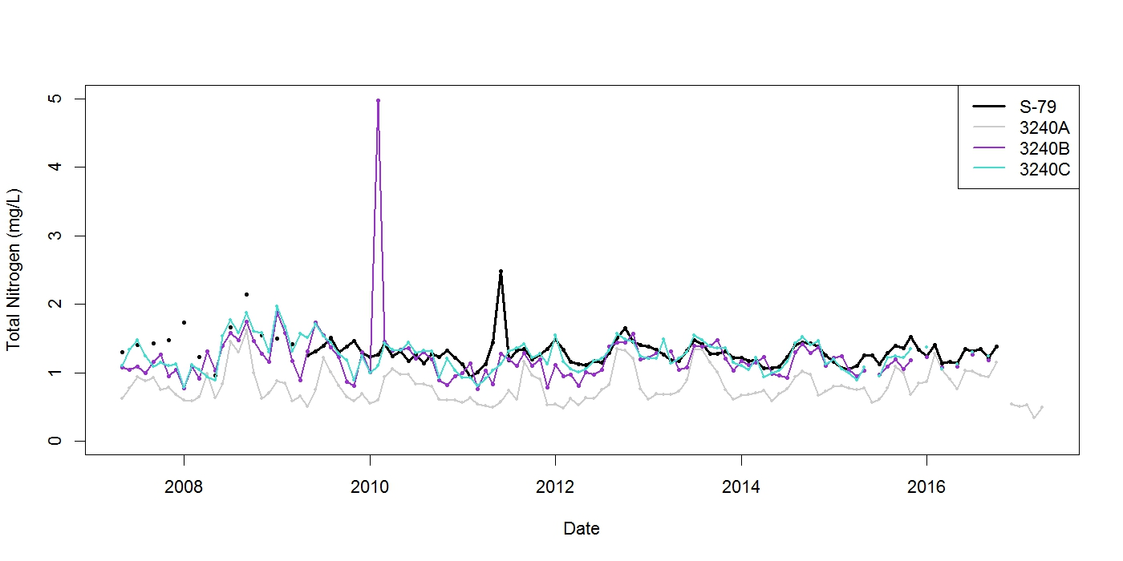
Figure 2. Comparison of TN time series for estuary WBIDs and Station S79

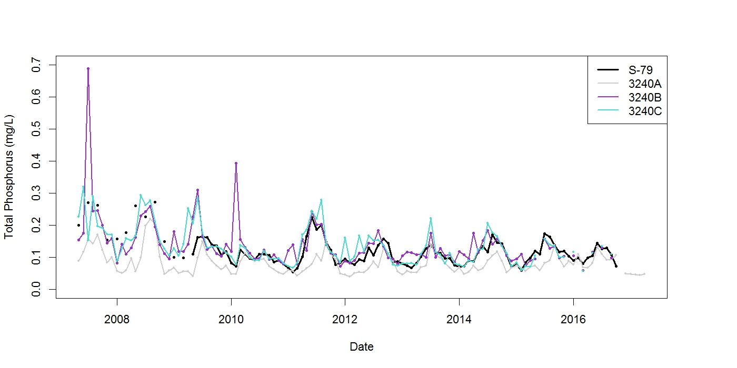
Figure 3. Comparison of TP time series for estuary WBIDs and Station S79

Chapter 3: Recommendations
The BMAP implements phased TN reductions according to Subparagraph 403.067(7)(a)1., F.S., for the portion of loading generated in the Tidal Caloosahatchee Basin, downstream of S-79. The purpose of this 5-Year Review is to evaluate implementation activities that have taken place during the first 5-year phase. The recommendations included here are for future implementation activities that may be incorporated into a revised BMAP and adopted by Secretarial Order.
This first phase included significant restoration efforts by stakeholders, and the implementation process will continue in order to help meet the TMDL. The projects and other activities, collected through stakeholder participation, are estimated to achieve TN reductions of 217,008 lbs/yr (or 56 %) by the end of the first 5-year phase. The milestones described here were developed in collaboration with stakeholders through the submission of project information.
DEP is also currently reviewing the assigned allocations to determine whether changes are appropriate to reflect anticipated updated modeling results. DEP and participating stakeholders also recommend revisions to the BMAP monitoring network to help prioritize monitoring resources and improve the way progress is tracked.
  - Milestones
As provided in Subparagraph 403.067(7)(a)6., BMAPs:
"must include milestones for implementation and water quality improvement, and an associated water quality monitoring component sufficient to evaluate whether reasonable progress in pollutant load reductions is being achieved over time."
The Caloosahatchee Estuary BMAP is also governed by Section 373.4595, F.S., as a part of the Northern Everglades and Estuaries Protection Program (NEEPP). Paragraph 373.4595(4)(b), F.S., states:
"The department shall develop an implementation schedule establishing 5-year, 10-year, and 15-year measurable milestones and targets to achieve the total maximum daily load no more than 20 years after adoption of the plan. The initial implementation schedule shall be used to provide guidance for planning and funding purposes and is exempt from chapter 120. Upon the first 5-Year Review, the implementation schedule shall be adopted as part of the plans. If achieving the total maximum daily load within 20 years is not practicable, the implementation schedule must contain an explanation of the constraints that prevent achievement of the total maximum daily load within 20 years, an estimate of the time needed to achieve the total maximum daily load, and additional 5-year measurable milestones, as necessary."
The 5-Year Review document memorializes information related to the assessment of progress, and allows for stakeholder involvement in the methods of assessing progress and revising the BMAP as appropriate. The projects and activities in the BMAP are key to reducing TN in the estuary. The estimated benefits of these implemented activities should be tracked to show stakeholder efforts by determining a percentage towards the total required reductions that should be achieved at each milestone. These project reduction estimates are based on the same simulated loads generated for the TMDL. To meet TMDL reductions within 20 years of BMAP adoption, the following percent reduction goals are proposed for each milestone:
- 5-year milestone (Years 1 to 5): 50 % or 194,360 lbs/yr TN.
- 10-year milestone (Years 6 to 10): 80 % or 310,975 lbs/yr TN.
- 15-year milestone (Years 11 to 15): 95 % or 369,283 lbs/yr TN.
Of the 88 projects submitted towards the 5-year milestone, 73 have been completed, for a total estimated reduction of 217,008 lbs/yr TN (Figure 4). Fifteen projects were submitted for completion by the 10-year milestone for the Caloosahatchee Estuary BMAP. Of those submitted projects, 8 were quantified, with estimated reductions totaling 93,629 lbs/yr TN (a cumulative 10-year total of 310,637 or 80 %). Two projects were submitted for completion by the 15-year milestone. Sufficient information regarding the estimated reductions for these projects has not been identified but will be included in future reports. Appendix B contains more information on the status of funding for these future projects.
Projects included in this Review are necessary components for restoration in the basin. Section 3.2 discusses the current efforts towards the application of the HSPF and Environmental Fluid Dynamics Code (EFDC) models in the basin that may lead to future revisions of the detailed stakeholder allocations. Many projects are not far enough along in their development to quantify TN reductions or to have obtained full funding at the time this Review was published. Based on the current and future project information provided by stakeholders, DEP anticipates that it is practicable to achieve reductions sufficient to meet the TMDL within 20 years.

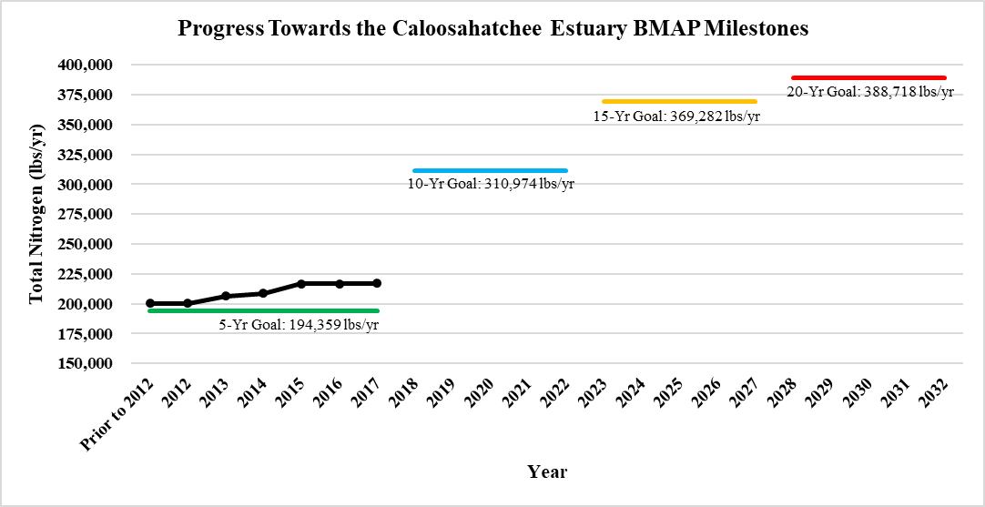
Figure 4. Progress towards the Caloosahatchee Estuary BMAP milestones

  - Modeling and Allocations
During the BMAP process, several items were identified that should be addressed in future watershed management cycles for the consideration of the load reductions for stakeholders below S-79 to ensure that the most accurate information is used in future BMAPs. DEP has agreed to update the model or evaluate whether this is necessary in the next BMAP phase (Years 6 through 10).
The DEP TMDL Program has been leading discussions with stakeholders regarding model refinement and the path forward in the Caloosahatchee Watershed. The revised models have been improved with additional data and input provided by stakeholders. The updated model set is being used to develop new TMDLs in impaired tributaries in the upper Caloosahatchee watersheds. In addition, the model is being used to evaluate whether an update to the estuary TMDL is necessary. Based on the outcome of this modeling application, adjustments to the detailed allocations may be appropriate for continued restoration.
The HSPF model (Figure 5) has been used to simulate overland processes and stream geochemistry in the Caloosahatchee Watershed. In May 2017, the DEP TMDL Program produced an initial report of the preliminary model results and incorporated stakeholder feedback into the model simulations. The TMDL Program is currently working on a focused HSPF model to investigate causative pollutant(s) and the path forward for TMDLs in impaired tributaries in the East Caloosahatchee, West Caloosahatchee, and S-4 Basins.

Figure 5. 2017 HSPF model

The EFDC model (Figure 6) has been used to simulate three-dimensional hydrodynamics and estuary geochemistry in the Caloosahatchee Estuary. In May 2017, the DEP TMDL Program produced a report on the preliminary model results. In response to stakeholder feedback, additional model versions were developed. The TMDL Program and stakeholders are currently working together to decide on the most appropriate EFDC model scenarios and a path forward for the estuary TMDL.

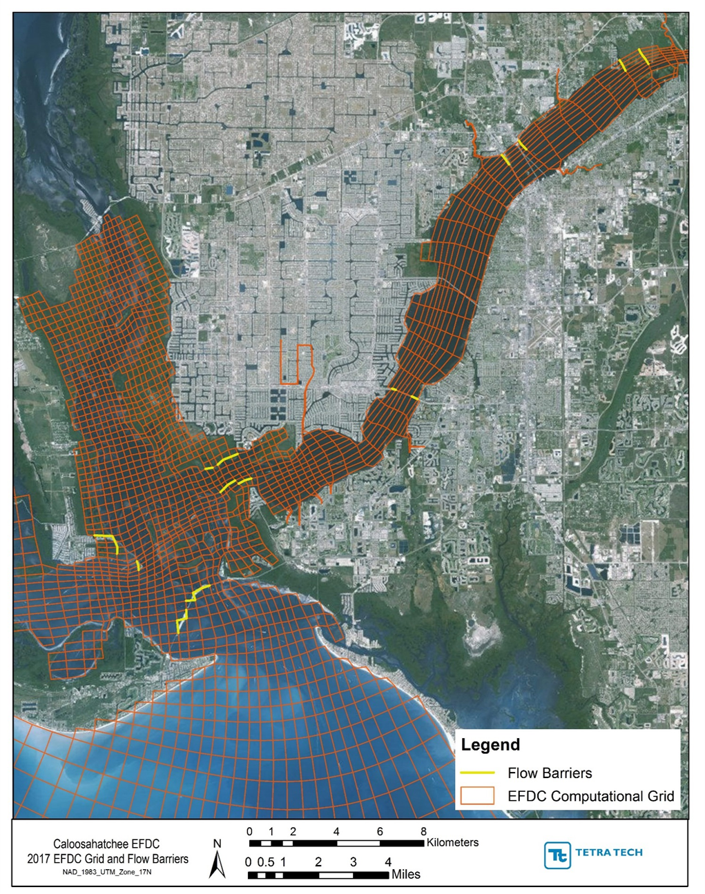
Figure 6. 2017 EFDC model grid

  - Water Quality Monitoring
The 5-Year Review of the Caloosahatchee Estuary BMAP provides an opportunity to improve key components of the plan and make further progress to achieve the TMDL. DEP and participating stakeholders recommend revising the BMAP monitoring network to help prioritize monitoring and track BMAP progress. Recommendations for the monitoring network include implementing a new tier system for the sampling stations and removing two stations from the network. The proposed changes will go into effect after BMAP revision and official adoption by the DEP Secretary.
    - Revised Tier System
The following revisions to the tier system are recommended:
- Tier 1 stations will be the primary/priority stations used to track BMAP progress over the long term. If at any point it is necessary to reduce efforts in the basin, these stations should be the last stations impacted.
- Tier 2 stations can be used for regional analyses or other secondary analyses.
- Tier 3 stations are owned by the U.S. Geological Survey (USGS) or the Sanibel-Captiva Conservation Foundation (SCCF). Data from these stations is not expected to be uploaded into STORET/WIN and can be used for other purposes as designated by DEP.
In addition to the revised tier system, all stations will be assigned a general location in the BMAP area. Stations in the estuary WBIDs (3240A, 3240B, and 3240C) will be designated as "Estuary" stations. Monitoring sites located in tributaries in the Tidal Caloosahatchee Basin will be designated as "Tributary" stations. Stations outside the BMAP boundary and in San Carlos Bay will be designated as "Bay" stations.
Specific recommended changes include the following:
- Adding the CALUSA0006FTM, CALUSA0007FTM, and CALUSA0010FTM stations to the Tier 1 class as soon as sufficient TN data and POR are available.
- Replacing the CALUSA0023FTM station, which is used to monitor a portion of the Orange River, with CALUSA0054FTM.
- Removing the CALUSA0009FTM and CALUSA0011FTM stations, which are near SFWMD Tier 1 Stations CES04 and CES05, respectively.
- Changing the CES03 station's classification to Tier 1 to capture temporal changes in that segment of the Caloosahatchee River.
- Incorporating LA-MSID Stations 22 and 27 into the revised monitoring network in Tier 2. These stations collect data in the BMAP area for many of the core parameters listed in the BMAP. LA-MSID Stations 11, 14, and 15 are outside the current BMAP boundary but are being incorporated as Tier 2 stations, since they are in the Caloosahatchee Watershed and may provide pertinent data.
If the recommended revisions to the BMAP monitoring network are implemented, TN concentrations will be monitored at 99 stations: 22 in the Caloosahatchee Estuary, 68 in the tributaries, and 9 in San Carlos Bay. Appendix C contains details on the current and recommended Caloosahatchee Estuary BMAP monitoring networks.

3.3.2 Recommended Additional Monitoring
The Caloosahatchee Estuary TMDL is calculated as a load, combining concentration and flow data. Flow monitoring is currently being performed at two locations in the BMAP area: USGS at Whiskey Creek and SFWMD at S-79. To better track progress in load reductions in the tributaries, flow monitoring stations should be introduced to additional estuarine tributaries.
Based on simulated (Figure 7) and historical measured data (Figure 8), tributaries with the highest flows to the estuary are Orange River and Telegraph Creek. Therefore, DEP recommends monitoring flow on these tributaries, at a minimum (Figure 9).
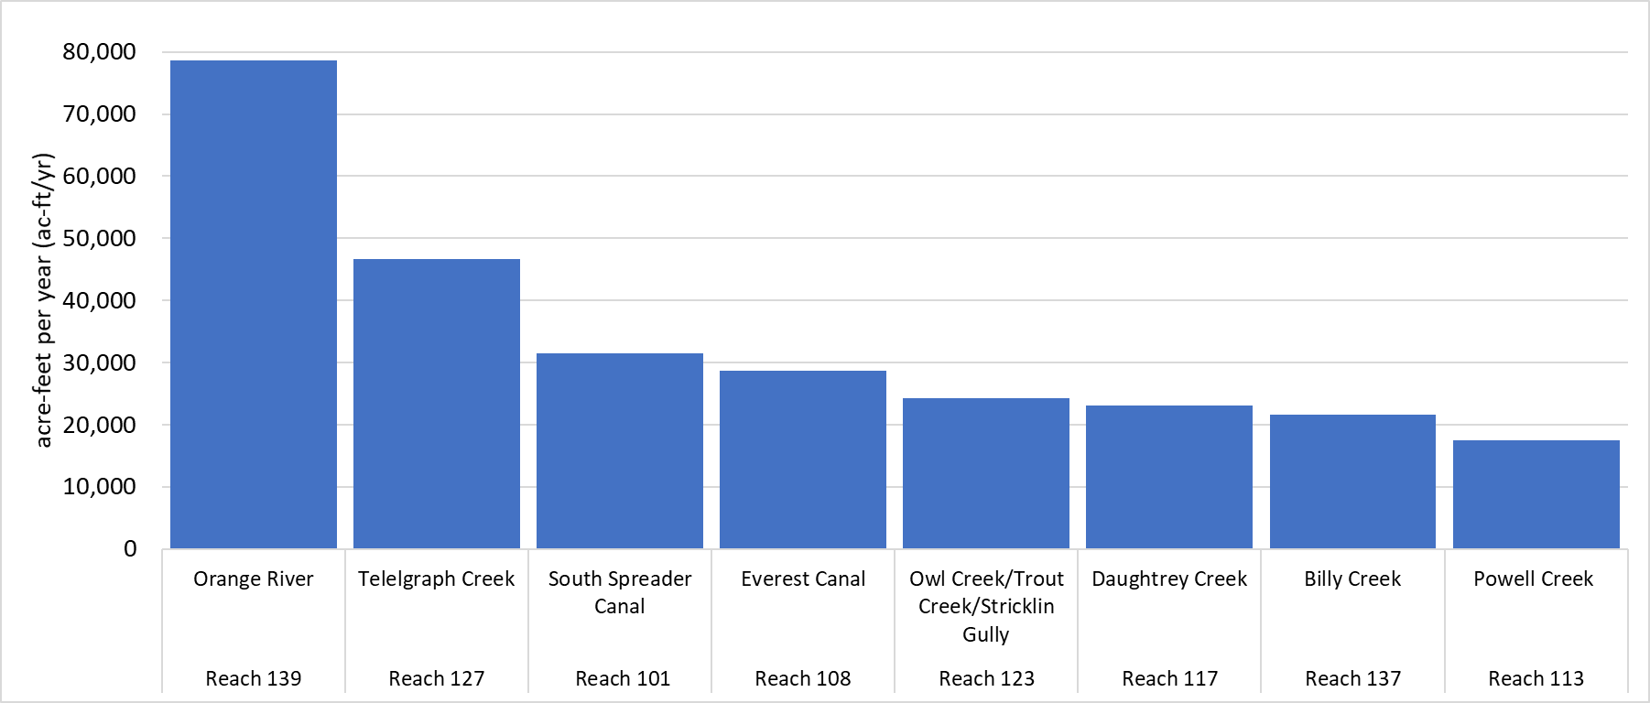
Figure 7. Highest HSPF-simulated volumes for Caloosahatchee Estuary tributaries
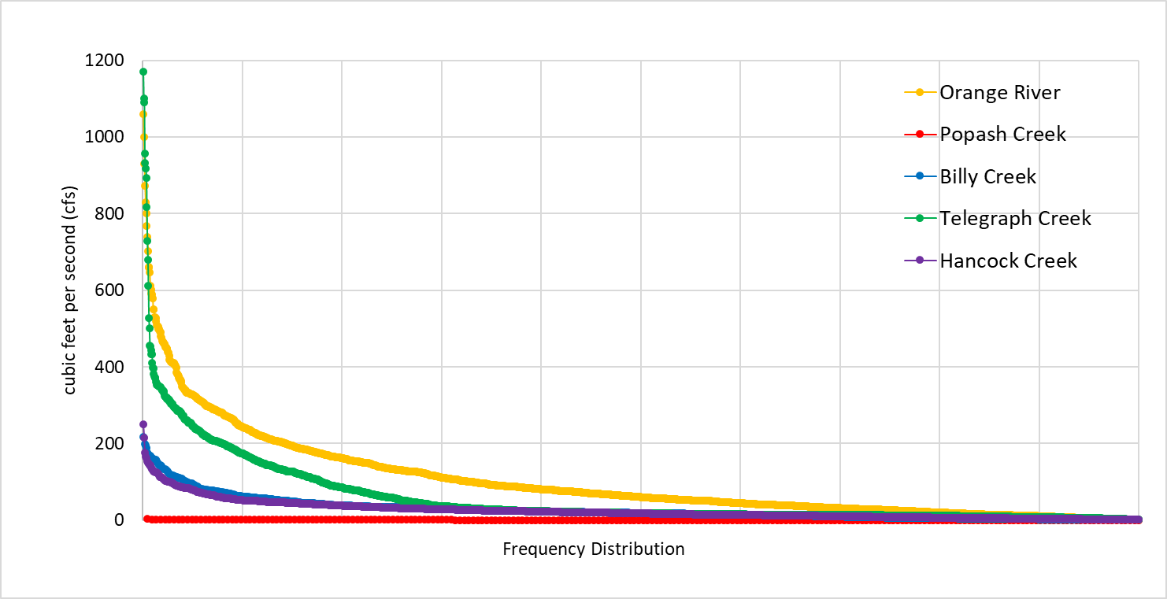
Figure 8. Frequency distribution of daily mean discharge (tidally filtered) at USGS stations, 2007–13

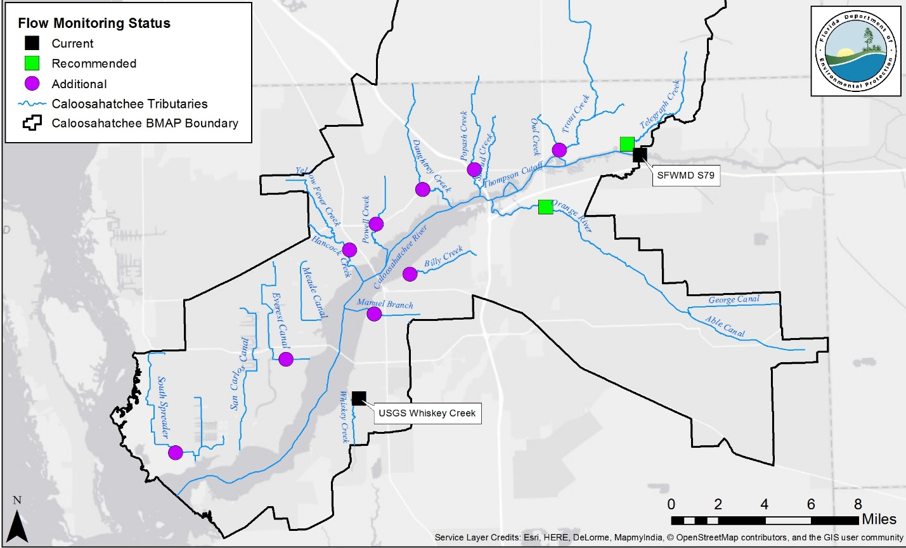
Figure 9. Current and recommended flow monitoring locations

Appendices

Appendix A: BMAP Projects
The tables in this appendix list the implementation status of the BMAP projects as of May 31, 2017. The tables list the nutrient reduction (in lbs/yr) attributable to each individual project. These projects were submitted to provide reasonable assurance to DEP that each entity has a plan on how to meet its allocation. However, the list of projects is meant to be flexible enough to allow for changes that may occur over time, provided that the reduction is still met within the specified period.
Table A-1. Charlotte County projects
N/A = Not applicable
Completion Date | Project Number | Project Name | Description | Project Type | Project Status | Acres Treated | TN Reduction (lbs/yr) | DEP Contract Agreement Number | Cost | Cost Annual O&M | Funding Source | Partners
Prior to 2012 | CH-01 | Education Efforts | FYN, landscaping ordinance, irrigation ordinance, fertilizer ordinance, pamphlets, public service announcements (PSAs), website, inspection/illicit discharge program. | Education Efforts | Completed | N/A | 381 | Information not provided | Information not provided | Information not provided | Information not provided | Information not provided
Total Project Reduction = 381 lbs/yr
Total TN Reduction Required = 943 lbs/yr

Table A-2. City of Cape Coral projects
¹ Projects were listed but had unproven credit.
O&M = Operations and maintenance; N/A = Not applicable
Completion Date | Project Number | Project Name | Description | Project Type | Project Status | Acres Treated | TN Reduction (lbs/yr) | DEP Contract Agreement Number | Cost | Cost Annual  O&M | Funding Source | Partners
N/A | CC-01 | Education Efforts | FYN, landscaping ordinance, irrigation ordinance, fertilizer ordinance, pet waste ordinance, pamphlets, PSAs, website, illicit discharge program. | Education Efforts | Completed | N/A | 15,429 | Information not provided | Information not provided | $2,000 | Information not provided | Information not provided
Prior to 2012 | CC-02 | SE-1 Swale/Inlet Replacement | Installed raised inlets to provide additional water quality in roadside swales. | Grass Swales with Swale Blocks or Raised Culverts | Completed | Information not provided | Information not provided | Information not provided | Information not provided | Information not provided | Information not provided | Information not provided
Prior to 2012 | CC-03 | SW-1 Swale/Inlet Replacement | Installed raised inlets to provide additional water quality in roadside swales. | Grass Swales with Swale Blocks or Raised Culverts | Completed | Information not provided | Information not provided | Information not provided | Information not provided | Information not provided | Information not provided | Information not provided
Prior to 2012 | CC-04 | SW-2 Swale/Inlet Replacement | Installed raised inlets to provide additional water quality in roadside swales. | Grass Swales with Swale Blocks or Raised Culverts | Completed | Information not provided | Information not provided | Information not provided | Information not provided | Information not provided | Information not provided | Information not provided
Prior to 2012 | CC-05 | SW-3 Swale/Inlet Replacement | Installed raised inlets to provide additional water quality in roadside swales. | Grass Swales with Swale Blocks or Raised Culverts | Completed | Information not provided | Information not provided | Information not provided | Information not provided | Information not provided | Information not provided | Information not provided
Prior to 2012 | CC-06 | SW-4 Swale/Inlet Replacement | Installed raised inlets to provide additional water quality in roadside swales. | Grass Swales with Swale Blocks or Raised Culverts | Completed | Information not provided | Information not provided | Information not provided | Information not provided | Information not provided | Information not provided | Information not provided
Prior to 2012 | CC-07 | SW-5 Swale/Inlet Replacement | Installed raised inlets to provide additional water quality in roadside swales. | Grass Swales with Swale Blocks or Raised Culverts | Completed | Information not provided | Information not provided | Information not provided | Information not provided | Information not provided | Information not provided | Information not provided
Prior to 2012 | CC-08 | SE Pipe Replacement | SE pipe replacement. | Stormwater System Rehabilitation | Completed | Information not provided | Information not provided | Information not provided | Information not provided | Information not provided | Information not provided | Information not provided
Prior to 2012 | CC-09 | Unit 23-SE 8th St. Drainage | Unit 23-SE 8th St. drainage. | Stormwater System Rehabilitation | Completed | Information not provided | Information not provided | Information not provided | Information not provided | Information not provided | Information not provided | Information not provided
Prior to 2012 | CC-10 | Freshwater Canal Detention | Regulation of freshwater canals through existing control structures. | Control Structure | Completed | 10,702 | 33,585 | Information not provided | Information not provided | Information not provided | Information not provided | Information not provided
Prior to 2012 | CC-11 | Freshwater Canal Irrigation | Pump stormwater stored in canals into irrigation supply network. | Stormwater Reuse | Completed | Information not provided | 32,305 | Information not provided | Information not provided | Information not provided | Information not provided | Information not provided
Prior to 2012 | CC-12 | Weir #6 Elevation/  Basin 12 | Installed riser on weir in freshwater canal system to provide additional retention volume in canals. | Control Structure | Completed | 932 | See CC-10 | Information not provided | Information not provided | Information not provided | Information not provided | Information not provided
Prior to 2012 | CC-13 | Weir #1 Elevation/  Basin 15 | Installed riser on weir in freshwater canal system to provide additional retention volume in canals. | Control Structure | Completed | 1,314 | See CC-10 | Information not provided | Information not provided | Information not provided | Information not provided | Information not provided
N/A | CC-14 | Street Sweeping | Street sweeping of downtown area, alleys, and commercial roads. | Street Sweeping | Completed | N/A | 876 | Information not provided | Information not provided | $360,000 | Information not provided | Information not provided
2015 | CC-15 | Septic to Sewer Phase Out Project | Phase out septic tanks in Southwest 6/7 area. | Wastewater Service Area Expansion | Completed | 2,560 | TBD | Information not provided | Information not provided | Information not provided | Information not provided | Information not provided
2015 | CC-16 | Catch Basin Cleanout | Catch basin cleanouts from Caloosahatchee Watershed areas. | Catch Basin Insert/  Inlet Filter Cleanout | Completed | Information not provided | 590 | Information not provided | Information not provided | $170,000 | Information not provided | Information not provided
Total Project Reduction = 82,785 lbs/yr
Total TN Reduction Required = 103,414 lbs/yr

Table A-3. City of Fort Myers projects
O&M = Operations and maintenance; N/A = Not applicable
Completion Date | Project Number | Project Name | Description | Project Type | Project Status | Acres Treated | TN Reduction (lbs/yr) | DEP Contract Agreement Number | Cost | Cost Annual  O&M | Funding Source | Partners
Prior to 2012 | FM-01 | Manuels Branch Watershed Imp. | Exfiltration trenches. | Exfiltration Trench | Completed | 125 | 836 | Information not provided | Information not provided | Information not provided | Information not provided | Information not provided
N/A | FM-02 | Education Efforts | FYN, fertilizer ordinance, pamphlets, PSAs, website, illicit discharge program. | Education Efforts | Completed | N/A | 2,101 | Information not provided | Information not provided | Information not provided | Information not provided | Information not provided
Prior to 2012 | FM-03 | Utility and Streetscape Improvements | Installation of Stormceptors™. | StormceptorTM Unit | Completed | 118 | 40 | Information not provided | Information not provided | Information not provided | Information not provided | Information not provided
Prior to 2012 | FM-04 | Manuels Branch Siltation Structures | Installation of siltation structure designed to receive incoming flow, reduce its velocity, and allow for settling of suspended particles. | Control Structure | Completed | 643 | 1,078 | Information not provided | Information not provided | Information not provided | Information not provided | Information not provided
Prior to 2012 | FM-05 | Manuels Branch Control Structures | Series of two weirs constructed along Manuel's Branch between Royal Palm Ave. and Grand Ave. that act as detention structures for purpose of increasing storage and attenuation in canal. | Control Structure | Completed | 438 | 2,202 | Information not provided | Information not provided | Information not provided | Information not provided | Information not provided
Prior to 2012 | FM-06 | Billy's Creek Wetland | Filter marsh park. | Filter Marsh | Completed | 1,632 | 4,025 | Information not provided | Information not provided | Information not provided | Information not provided | Information not provided
2013 | FM-07 | Brookhill Utility Drainage Improvement | Installation of Stormceptors™. | StormceptorTM Unit | Completed | Information not provided | 11 | Information not provided | Information not provided | Information not provided | Information not provided | Information not provided
N/A | FM-08 | Street Sweeping | Four zones swept at varying frequencies based on pollutant accumulation. | Street Sweeping | Completed | N/A | 2,582 | Information not provided | Information not provided | Information not provided | Information not provided | Information not provided
2015 | FM-09 | Ford Street Preserve | Constructed wetland treatment system that removes pollutants from Ford Street Canal, which serves 811 acres of highly urbanized watershed. | Wetland Treatment | Completed | 811 | 7,293 | Information not provided | Information not provided | Information not provided | Information not provided | Information not provided
2013 | FM-10 | Riverfront Development Phase 1 | Wet detention pond. | Wet Detention Pond | Completed | Information not provided | 90 | Information not provided | Information not provided | Information not provided | Information not provided | Information not provided
2014 | FM-11 | Carrell Canal Water Quality Retrofit | Two detention areas, five filter marshes, and golf course renovation. | BMP Treatment Trains | Completed | Information not provided | 1,275 | Information not provided | Information not provided | Information not provided | Information not provided | Information not provided
Total Project Reduction = 21,533 lbs/yr
Total TN Reduction Required = 40,924 lbs/yr

Table A-4. LA-MSID projects
O&M = Operations and maintenance; N/A = Not applicable; TBD = To be determined
Note: On June 10, 2015, the ECWCD became LA-MSID. Projects in the BMAP document beginning with "EC" now refer to LA-MSID.
Completion Date | Project Number | Project Name | Description | Project Type | Project Status | Acres Treated | TN Reduction (lbs/yr) | DEP Contract Agreement Number | Cost | Cost Annual  O&M | Funding Source | Partners
N/A | EC-01 | Education/Fertilizer | Education. | Education Efforts | Completed | N/A | 1,646 | Information not provided | Information not provided | Information not provided | Information not provided | Information not provided
Prior to 2012 | EC-02 | Freshwater Canal Detention | Regulation of freshwater canals through existing control structures. | Control Structure | Completed | 32,555 | 7,940 | Information not provided | Information not provided | Information not provided | Information not provided | Information not provided
Prior to 2012 | EC-03 | Weir Elevation Improvements | Replacement of weir structures at increase control elevations to provide additional attenuation. | Control Structure | Completed | 32,555 | 7,543 | Information not provided | Information not provided | Information not provided | Information not provided | Information not provided
Prior to 2012 | EC-04 | Harn's Marsh  Phases I and II | Replacement of weir structures and redirection of flows into filter marsh. | Control Structure | Completed | 32,555 | 4,682 | Information not provided | Information not provided | Information not provided | Information not provided | Information not provided
Prior to 2012 | EC-05 | Jim Flemming Eco-Park | Wetland rehydration and treatment. | Hydrologic Restoration | Completed | 5 | 39 | Information not provided | Information not provided | Information not provided | Information not provided | Information not provided
2013 | EC-06 | Mirror Lake Phase I | Detention pond. | Wet Detention Pond | Completed | 32,555 | 1,357 | Information not provided | Information not provided | Information not provided | Information not provided | Information not provided
2017 | EC-07 | Aquifer Benefit and Storage for Orange River Basin (ABSORB)  (Southwest Lehigh Weirs) | Increase canal control elevations and local groundwater levels by constructing 25 new weirs. | Control Structure | Underway | 5,760 | 1,975 | S0721 | $2,532,311 | Information not provided | DEP/FDOT | DEP/FDOT
2017 | EC-08 | S-AW-1 Weir Elevation Improvements | Replacement of weir structures at increase control elevations to provide additional attenuation. | Control Structure | Completed | 640 | 325 | N/A | $400,000 | $15,000 | LA-MSID | N/A
2018 | EC-09 | Mirror Lake Phase 2 | Detention pond. | Wet Detention Pond | Underway | 32,555 | 4,938 | N/A | $500,000 | TBD | LA-MSID/SFWMD | SFWMD
2020 | EC-10 | West Marsh Preserve | Wetland rehydration and treatment. | Hydrologic Restoration/  Filter Marsh | Underway | 32,555 | 2,015 | N/A | $12,000,000 | TBD | LA-MSID/FDOT/ Lee County | FDOT/Lee County
Total Project Reduction = 23,532 lbs/yr
Total TN Reduction Required = 37,736 lbs/yr

Table A-5. FDOT projects
O&M = Operations and maintenance; N/A = Not applicable
Completion Date | Project Number | Project Name | Description | Project Type | Project Status | Acres Treated | TN Reduction (lbs/yr) | DEP Contract Agreement Number | Cost | Cost Annual O&M | Funding Source | Partners
Prior to 2012 | FDOT-01 | Existing Stormwater Dry Ponds | Dry detention pond. | Dry Detention Pond | Completed | 6 | 55 | Information not provided | Information not provided | Information not provided | Information not provided | Information not provided
Prior to 2012 | FDOT-02 | Discontinuing Fertilization | No longer fertilizing rights-of-way in watershed. | Fertilizer Cessation | Completed | 465 | 1,941 | Information not provided | Information not provided | Information not provided | Information not provided | Information not provided
N/A | FDOT-03 | Education Efforts | Pamphlets, PSAs, illicit discharge program. | Education Efforts | Completed | N/A | 232 | Information not provided | Information not provided | Information not provided | Information not provided | Information not provided
N/A | FDOT-04 | Street Sweeping | 2,992 pavement miles swept annually. | Street Sweeping | Completed | N/A | 577 | Information not provided | Information not provided | Information not provided | Information not provided | Information not provided
Prior to 2012 | FDOT-05 | Ditch Blocked Swales | Swales with ditch blocks. | Grass Swales with Swale Blocks or Raised Culverts | Completed | 166 | 826 | Information not provided | Information not provided | Information not provided | Information not provided | Information not provided
Prior to 2012 | FDOT-06 | Swales Without Ditch Blocks | Swales without blocks. | Grass Swales without Swale Blocks or Raised Culverts | Completed | 1,353 | 4,949 | Information not provided | Information not provided | Information not provided | Information not provided | Information not provided
Prior to 2012 | FDOT-07 | Existing Stormwater Wet Ponds | Wet detention pond. | Wet Detention Pond | Completed | 155 | 2,646 | Information not provided | Information not provided | Information not provided | Information not provided | Information not provided
Prior to 2012 | FDOT-08 | State Road (SR) 78 Project | Wet detention pond. | Wet Detention Pond | Completed | 80 | 264 | Information not provided | Information not provided | Information not provided | Information not provided | Information not provided
Total Project Reduction = 11,490 lbs/yr
Total TN Reduction Required = 9,119 lbs/yr

Table A-6. Lucaya CDD projects
N/A = Not applicable
 | Project Number | Project Name | Description | Project Type | Project Status | Acres Treated | TN Reduction (lbs/yr)
 | LU-1 | Education/ Fertilizer | Education | Education Efforts | Ongoing | N/A | 0
Total Project Reduction = 0 lbs/yr
Total TN Reduction Required = 132 lbs/yr

Table A-7. Lee County projects
O&M = Operations and maintenance; N/A = Not applicable; TBD = To be determined
¹ Project was listed but had unproven credit.
Completion Date | Project Number | Project Name | Description | Project Type | Project Status | Acres Treated | TN Reduction (lbs/yr) | DEP Contract Agreement Number | Cost | Cost Annual O&M | Funding Source | Partners
Prior to 2012 | LC-01 | Yellow Fever Creek Preserve | Land purchase and conversion to conservation land use. | Land Acquisition | Completed | 220 | 32 | Information not provided | $3,323.506.74 | $11,703 | Information not provided | Information not provided
Prior to 2012 | LC-02 | Billy's Creek Preserve | Land purchase and conversion to conservation land use. | Land Acquisition | Completed | 51 | 17 | Information not provided | $2,500,000 | N/A | Information not provided | Information not provided
Prior to 2012 | LC-03 | Six Mile Cypress Preserve | Land purchase and conversion to conservation land use. | Land Acquisition | Completed | 1,219 | 13 | Information not provided | $71,475,196 | $149,212 | Information not provided | Information not provided
Prior to 2012 | LC-04 | Bob Jane's Preserve | Land purchase and conversion to conservation land use. | Land Acquisition | Completed | 1,979 | 0 | Information not provided | $41,538,620 | $639,924 | Information not provided | Information not provided
Prior to 2012 | LC-05 | Buckingham Trails Preserve | Land purchase and conversion to conservation land use. | Land Acquisition | Completed | 576 | 13 | Information not provided | $12,584,000 | $18,708 | Information not provided | Information not provided
Prior to 2012 | LC-06 | Caloosahatchee Cks Preserve | Land purchase and conversion to conservation land use. | Land Acquisition | Completed | 911 | 15 | Information not provided | $8,175,706 | $81,323 | Information not provided | Information not provided
Prior to 2012 | LC-07 | Deep Lagoon Preserve | Land purchase and conversion to conservation land use. | Land Acquisition | Completed | 117 | 3 | Information not provided | $4,475,664 | $9,915 | Information not provided | Information not provided
Prior to 2012 | LC-08 | Hickory Swamp Preserve | Land purchase and conversion to conservation land use. | Land Acquisition | Completed | 67 | 3 | Information not provided | $467,000 | $3,856 | Information not provided | Information not provided
Prior to 2012 | LC-09 | Orange River Preserve | Land purchase and conversion to conservation land use. | Land Acquisition | Completed | 59 | 3 | Information not provided | $1,755,000 | $2,966 | Information not provided | Information not provided
Prior to 2012 | LC-10 | Prairie Pines Preserve | Land purchase and conversion to conservation land use. | Land Acquisition | Completed | 331 | 3 | Information not provided | $11,790,530 | $190,454 | Information not provided | Information not provided
Prior to 2012 | LC-11 | Telegraph Creek Preserve | Land purchase and conversion to conservation land use. | Land Acquisition | Completed | 1,715 | 0 | Information not provided | $23,900,000 | $54,639 | Information not provided | Information not provided
Prior to 2012 | LC-12 | West Marsh Preserve | Land purchase and conversion to conservation land use. | Land Acquisition | Completed | 218 | 3 | Information not provided | $4,631,625 | N/A | Information not provided | Information not provided
Prior to 2012 | LC-13 | Yellow Fever Creek Preserve | Land purchase and conversion to conservation land use. | Land Acquisition | Completed | 118 | 0 | Information not provided | $3,323,507 | $11,703 | Information not provided | Information not provided
N/A | LC-15 | Education Efforts | FYN, landscaping ordinance, irrigation ordinance, fertilizer ordinance, pamphlets, PSAs, website, illicit discharge program. | Education Efforts | Completed | N/A | 20,445 | Information not provided | $392,441 | N/A | Information not provided | Information not provided
N/A | LC-16 | Street Sweeping | Materials from roadway and gutter sweeping. | Street Sweeping | Completed | N/A | 490 | Information not provided | $694,176 | N/A | Information not provided | Information not provided
2013 | LC-17 | NFM Powell Creek Extension/  Lost Lane Levee | Conveyance improvements to increase residence time, rehydrate offsite wetlands on adjacent properties, and accommodate offsite flows. | Hydrologic Restoration | Completed | 397 | 2,976 | Information not provided | $3,485,817 | $17,101 | Information not provided | Information not provided
Prior to 2012 | LC-18 | Whiskey Creek Weir Reconstruction | Retention lake weir repairs to restore originally intended design and operation. | Control Structure | Completed | 550 | 3,364 | Information not provided | Information not provided | Information not provided | Information not provided | Information not provided
Prior to 2012 | LC-19 | Caloosahatchee Creeks | Hydrologic restoration. | Hydrologic Restoration | Completed | 6,567 | 4,251 | Information not provided | Information not provided | Information not provided | Information not provided | Information not provided
2013 | LC-20 | Powell Creek Filter Marsh | Created wetland areas, boardwalks, and trails and stabilized crossing of Powell Creek. | Filter Marsh | Completed | 1,170 | 1,693 | Information not provided | $618,000 | $38,395 | Information not provided | Information not provided
TBD | LC-21 | Nalle Grade Stormwater Park | Dry retention and wet detention ponds. | Stormwater Treatment Area | Underway | 720 | TBD | S0727 | $3,500,000 | Information not provided | DEP | DEP
Prior to 2012 | LC-22 | Deep Lagoon Hydrologic Restoration | Hydrologic restoration and enhancement, water conservation, wildlife habitat enhancement, and flood protection for surrounding area. | Hydrologic Restoration | Completed | 1,022 | 3,097 | Information not provided | $210,959 | Information not provided | SFWMD | SFWMD
Prior to 2012 | LC-23 | Popash Creek Restoration | Hydrologic restoration to more natural flow regime by increasing water storage on property and improving both onsite and offsite flows. | Hydrologic Restoration | Completed | 3,517 | 6,596 | Information not provided | $1,726,625 | $16,920 | Information not provided | Information not provided
Prior to 2012 | LC-24 | Billy's Creek Wetland | Billy Creek Filter Marsh Park. | Filter Marsh | Completed | 1,632 | 2,684 | Information not provided | $2,500,000 | Information not provided | Information not provided | City of Fort Myers
2016 | LC-25 | Caloosahatchee Creeks Preserve – West Restoration | Hydrologic restoration. | Hydrologic Restoration | Completed | 1,295 | 110 | Information not provided | $250,000 | Information not provided | Information not provided | Information not provided
TBD | LC-26 | Yellow Fever Creek – Gator Slough Transfer Facility | Return historical flow from Gator Slough Canal system to Yellow Fever Creek. | Hydrologic Restoration | Underway | Information not provided | TBD | S0840 | TBD | Information not provided | DEP | DEP
TBD | LC-27 | Prairie Pines Preserve Restoration | Restoration of historical flows and enhancement and restoration of wetlands. | Hydrologic Restoration | Planned | 2,334 | TBD | S0895 | $500,000 | $28,295 | DEP | DEP
2017 | LC-28 | BMAP Plan Development – Basin Study | Basin study to identify pollutant sources and identify further actions to reach reduction goals. | Studies | Completed | N/A | N/A | Information not provided | $195,831 | N/A | Information not provided | Information not provided
TBD | LC-29 | Caloosahatchee River-North Fort Myers Nutrient and Bacteria Source Identification Study | Watershed study to investigate interactions between onsite sewage treatment and disposal systems (OSTDS), groundwater, and surface waters in Caloosahatchee Estuary. | Studies | Underway | N/A | Information not provided | Information not provided | $181,352 | N/A | Information not provided | Information not provided
2012 | LC-30 | Waterway Estates WWTF Closure | Closure of facility with direct discharge to Caloosahatchee. | WWTF Diversion to Reuse | Completed | Information not provided | 307 | Information not provided | Information not provided | Information not provided | Information not provided | Information not provided
Information not provided | LC-31 | Six Mile Cypress Preserve North Hydrologic Restoration | Wetland creation, addition of control structures, berms, berm breaches to connect natural and created wetlands, and restoration of historical hydrologic conditions to reduce discharge into Caloosahatchee River. | Hydrologic Restoration | Completed | Information not provided | Information not provided | Information not provided | Information not provided | Information not provided | SFWMD/FDOT | SFWMD/FDOT
Information not provided | LC-32 | Bob Jane's Preserve Environmental Restoration | Hydrologic improvements in portion of preserve via berms, beaches, and ditch blocks. | Hydrologic Restoration | Completed | Information not provided | TBD | S0871 | Information not provided | Information not provided | DEP/SFWMD | DEP/SFWMD
Information not provided | LC-33 | Telegraph Creek Preserve | Ditch blocks and native plantings in conveyances. | Hydrologic Restoration | Completed | Information not provided | TBD | S0873 | $107,337 | $54,639 | DEP | DEP
TBD | LC-34 | West Marsh Preserve Filter Marsh | Creation and enhancement of wetland marsh ecosystem, including hydraulic connection for water quality improvement and stormwater attenuation. | Filter Marsh | Underway | Information not provided | TBD | Information not provided | Information not provided | Information not provided | Lee County/  LA-MSID | LA-MSID
TBD | LC-35 | C-43 Water Quality Treatment and Testing Facility Project (*study/land acquisition) | Project to demonstrate and implement cost-effective, wetland-based strategies for reduction of DON. | Studies | Underway | N/A | N/A | Information not provided | $10,000,000 | N/A | Lee County/DEP/ SFWMD | SFWMD
TBD | LC-36 | Fichter's Creek Restoration Project | Restoration of hydroperiod and water quality in Fichter's Creek. | Hydrologic Restoration | Underway | Information not provided | 1,453 | Information not provided | $2,000,000 | Information not provided | Information not provided | Information not provided
TBD | LC-37 | Spanish Creek at Daniel's Preserve Restoration | Restoration of wetland hydroperiod and sheetflow attenuation. | Hydrologic Restoration | Underway | Information not provided | 112 | S0864 | $400,000 | Information not provided | DEP | DEP
TBD | LC-38 | Deep Lagoon Pollutant Load Reduction Phase 2-Watershed Analysis Report | Basin study to identify pollutant sources and identify further actions to reach reduction goals. | Studies | Underway | N/A | N/A | Information not provided | $70,000 | Information not provided | Information not provided | Information not provided
TBD | LC-39 | North Fort Myers FPL Feasibility Study | Study to identify areas of high nutrient loads and potential BMPs to improve water quality and reduce flooding. | Studies | Underway | N/A | N/A | S0894 | $200,000 | N/A | DEP | DEP
TBD | LC-40 | Sunniland/Nine Mile Run Drainage Improvements | Replacement of failing water control structures and reconnection of flowways to Hickory Swamp and Buckingham Trails Preserve. | Hydrologic Restoration | Planned | Information not provided | Information not provided | LP3602B | $2,000,000 | Information not provided | DEP | DEP
TBD | LC-41 | Caloosahatchee Tributary Canal Rehabilitation:  L-3 | Reshaping canal banks, littoral planting, and possible addition of control structure(s). | Regional Stromwater Treatment | Planned | Information not provided | Information not provided | N/A | $500,000 | Information not provided | Lee County/  City of Fort Myers | City of Fort Myers
Total Project Reduction = 46,118 lbs/yr
Total TN Reduction Required = 140,853 lbs/yr

Table A-8. FDACS notice of intent (NOI) enrollment reduction estimates as of March 31, 2017
2004 SFWMD Land Use | Acreage | TN Load Delivered  (lbs/yr) | TN Reduction Estimate  (%) | TN Reduction (lbs/yr)
Citrus | 976 | 895 | 10 | 89
Cropland/Improved Pasture/Tree Crops | 30,241 | 124,320 | 25 | 31,080
Total | 31,217 | 125,214 |  | 31,169

Total TN Reduction Required = 55,597 lbs/yr

Appendix B: Future BMAP Projects
In accordance with Chapter 2016-1, Laws of Florida, every new and revised BMAP will be required to include more detailed project information than was previously included in BMAPs and annual progress reports. Chapter 403.067, F.S., directs new and revised BMAPs to include the following:
- A ranked list of projects with a planning-level cost estimate and estimated date of completion for each project.
- The source and amount of financial assistance to be made available by DEP, a water management district, or other entity for each project, if applicable.
- A planning-level estimate of each project's expected load reduction, if applicable.
The BMAP requires stakeholders to implement their projects to achieve reductions as soon as practicable. However, the full implementation of the BMAP will be a long-term process. While some of the projects and activities contained in the BMAP were recently completed or are currently ongoing, several projects require more time to design, secure funding, and construct. While funding for the projects may not have been identified yet, funding limitations do not affect the requirement that every entity must implement the activities listed in the BMAP.
Since BMAP implementation is a long-term process, the TMDL established for this basin will not be achieved in the next five years, nor will it be achieved by the actions of the stakeholders in the estuarine portion alone. It is understood that all waterbodies can respond differently to the implementation of reduced loadings to meet applicable water quality standards. Regular follow-up and continued coordination and communication by the stakeholders will be essential to ensure the implementation of management strategies and assessment of incremental effects.
As a first step towards compiling the lists of projects that will be required in a revised Caloosahatchee Estuary BMAP, DEP requested information from stakeholders on future projects that have potential for additional load reductions in the basin. Funding has not yet been identified for many of these future projects (listed in Table B-1), and the continual funding of projects is a key part of meeting reductions required to achieve the TMDL. This list will be updated as project collection and verification efforts are refined.

Table B-1. Future BMAP projects for planning and funding purposes
O&M = Operations and maintenance; N/A = Not applicable; TBD = To be determined
Lead Entity | Project Number | Project Name | Description | Project Type | Project Status | Acres Treated | TN Reduction (lbs/yr) | Cost | Cost Annual O&M | Funding Source | Funding Status
Lee County | F-01 | FPL Powerline Easement – Water Quality Improvement | Hydrologic reconnection of watershed for water quality improvement. Reconnect flow-ways in Popash Creek Preserve at south end, terminating at Caloosahatchee River. | Hydrologic Restoration | Future | TBD | 0 | $300,000 | TBD | Lee County,  DEP S0894
Lee County | F-02 | Filter Marshes in Priority Watersheds | Filter marshes in priority tributaries. | Filter Marsh | Future | Information not provided | 64,067 | TBD | TBD | TBD | Unfunded
Lee County | F-03 | Six Mile Cypress Slough Rehydration | Restoration of historical watershed boundaries and historical flow patterns, and rehydration of slough. | Hydrologic Restoration | Future | 17,636 | 15,634 | $3,843,270 | TBD | TBD | Unfunded
Lee County | F-04 | GS-10 Caloosahatchee Crosslink Project | Regional project to balance freshwater flows, improve regional water quality, restore habitat, and reduce TN load to Caloosahatchee. | Regional Stormwater Treatment | Future | Information not provided | 9,855 | TBD | TBD | Lee County/  LA-MSID | Unfunded
Lee County | F-05 | North East Caloosahatchee Tributaries Restoration Project (NECTR) | Improve water quality, water storage and attenuation, flood protection, and habitat restoration in several highly disturbed watersheds in northeastern Lee County. | Hydrologic Restoration | Future | Information not provided | TBD | TBD | TBD | RESTORE Act | Partially funded through Restore Act, but total costs have not been determined.
Lee County | F-06 | Olga Shores Preserve and Filter Marsh | Located directly on Caloosahatchee, project would provide water quality treatment for local drainage features and/or directly from river. | Filter Marsh | Future | Information not provided | 1,981 | $2,659,059 | TBD | TBD | Reported cost is land acquisition only; construction cost TBD
Lee County | F-07 | Pet Waste Ordinance | Pet waste ordinance to establish requirements for proper disposal of pet waste. | Regulations, Ordinances, and Guidelines | Future | N/A | 1,840 | N/A | N/A | Lee County | Unfunded
Lee County | F-08 | Lee Civic Center Revitalization | Pervious pavers, vegetated natural buffers, rain gardens, and pond rehabilitation. | Pervious Pavement | Future | Information not provided | 217 | TBD | TBD | Lee County | Unfunded
Lee County | F-09 | Aquatic Vegetation Harvesting | Aquatic vegetation harvesting. | Aquatic Vegetation Harvesting | Planned | Information not provided | TBD | TBD | TBD | Lee County | Fully funded
Lee County | F-10 | Fiesta Village Advanced Wastewater Treatment Facility (AWWTF) – Construction of Deep Injection Well | AWWTF effluent disposal is currently reuse and permitted outfall to Caloosahatchee. Addition of deep injection well will be used as wet weather disposal to eliminate discharges to Caloosahatchee. | WWTF Disposal Site | Planned | Information not provided | TBD | TBD | TBD | Lee County Utilities
Lee County | F-11 | North Fort Myers Septic to Sewer Conversions | Septic to sewer conversions. | Wastewater Service Area Expansion | Future | Information not provided | TBD | TBD | TBD | Lee County Utilities | Unfunded
Lee County | F-12 | C-43 Water Quality Treatment and Testing Facility Project (constructed project based on study results) | Demonstrate and implement cost-effective, wetland-based strategies for reduction of DON. | Stormwater Treatment Area | Planned | Information not provided | TBD | TBD | TBD | Lee County/ DEP/  SFWMD | Unfunded
Charlotte County | F-13 | Pet Waste Ordinance | Pet waste ordinance. | Regulations, Ordinances, and Guidelines | Future | N/A | 35 | TBD | TBD | TBD | Unfunded
Charlotte County | F-14 | Pond | Construct pond in Caloosahatchee BMAP area. | TBD | Future | Information not provided | TBD | TBD | TBD | TBD | Unfunded
Charlotte County | F-15 | Street Sweeping | Street sweeping. | Street Sweeping | Future | N/A | TBD | TBD | TBD | TBD | Unfunded
LA-MSID (formerly ECWCD) | F-16 | Mirror Lakes Golf Course Phase I | Purchase 70-acre golf course. | Land Acquisition | Future | 70 | TBD | TBD | TBD | TBD
LA-MSID (formerly ECWCD) | F-17 | Mirror Lakes Golf Course Phase II | Convert 70-acre golf course into wetland detention facility. | Hydrologic Restoration/  Filter Marsh | Future | 1,600 | TBD | TBD | TBD | TBD

Appendix C: BMAP Monitoring Network and Recommended Revisions
The Caloosahatchee Estuary BMAP monitoring plan was designed to enhance the understanding of basin loads, identify areas with high nutrient concentrations, and track water quality trends. The BMAP monitoring plan currently consists of the ambient water quality sampling described below.
The monitoring stations are organized into a tiered sampling design, as follows:
- Tier 1: Stations listed in the BMAP monitoring plan as essential and mandatory for tracking water quality trends both in the Caloosahatchee River and in documenting watershed pollutant reductions. Stations should be sampled monthly for all core parameters. Sampling stations, parameters, frequency, and other elements of this strategy may be modified as appropriate to match changing environmental conditions and funding resources. However, any modifications made must not affect the ability of the monitoring network to fulfill the objectives noted below.
- Tier 2: Stations that are currently sampled either in the BMAP area or in a tributary contributing to the overall load. These stations will help in understanding the total load in the watershed, and DEP supports continued monitoring.
- Tier 3: Nonstakeholder sampling stations. Data from these stations are extremely useful, and DEP supports continued monitoring.
- Tier 4: Florida (DEP/SFWMD) sampling stations.
TN concentrations are monitored at 92 stations in the adopted BMAP monitoring network (excluding Tier 3 stations); 21 in the Caloosahatchee Estuary, 64 in the tributaries, and 7 in San Carlos Bay. The network of stations is listed in Table C-1 and shown in Figures C-1 and C-2.

Table C-1. BMAP monitoring network
¹ NPDES outfall. Data from stations currently listed as NPDES outfall stations will not be included in any ambient monitoring analysis.
² Discontinued April 1, 2013.
³ Formerly CALUSA0023FTM and 28020109.
Agency | Site Name | Tier | River or Watershed Station
City of Cape Coral | 210 | 2 | Watershed
City of Cape Coral | 242 | 2 | River
City of Cape Coral | 243 | 2 | Watershed
City of Cape Coral | 262 | 2 | Watershed
City of Cape Coral | 275 | 2 | Watershed
City of Cape Coral | 280 | 2 | Watershed
City of Cape Coral | 290 | 2 | Watershed
City of Cape Coral | 295 | 2 | Watershed
City of Cape Coral | 300 | 1 | Watershed
City of Cape Coral | 310 | 2 | Watershed
City of Cape Coral | 315 | 2 | Watershed
City of Cape Coral | 350 | 1 | River
City of Cape Coral | 355 | 2 | Watershed
City of Cape Coral | 390 | 2 | Watershed
City of Cape Coral | 400 | 1 | Watershed
City of Cape Coral | 430 | 2 | Watershed
City of Cape Coral | 470 | 1 | Watershed
City of Cape Coral | 510 | 2 | Watershed
City of Cape Coral | 540 | 1 | Watershed
City of Cape Coral | 550 | 2 | Watershed
City of Cape Coral | 590 | 1 | Watershed
City of Cape Coral | 600 | 1 | Watershed
City of Ft. Myers | BCP1-10 | 2 | Watershed
City of Ft. Myers | BCP4-10 | 2 | Watershed
City of Ft. Myers | CFMBILLY3 | 2 | Watershed
City of Ft. Myers | CFMBILLY6 | 2 | Watershed
City of Ft. Myers | CFMCARRELL | 2 | Watershed
City of Ft. Myers | CFMMANUEL | 1 | Watershed
City of Ft. Myers | CFMWINKLER | 1 | Watershed
DEP | 28020110 | 4 | River
DEP | 28020111 | 4 | River
DEP | CALUSA0005FTM | 4 | River
DEP | CALUSA0006FTM | 4 | River
DEP | CALUSA0007FTM | 4 | River
DEP | CALUSA0008FTM | 4 | River
DEP | CALUSA0009FTM | 4 | River
DEP | CALUSA0010FTM | 4 | River
DEP | CALUSA0011FTM | 4 | River
DEP | CALUSA0012FTM | 4 | River
DEP | CALUSA0013FTM | 4 | River
DEP | CALUSA0014FTM | 4 | River
DEP | CALUSA0054FTM³ | 4 | Watershed
DEP | CALUSA0024FTM | 4 | Watershed
DEP | CALUSA0025FTM | 4 | Watershed
Lee County | 16-18GR | 2 | Watershed
Lee County | 16-3GR | 1 | Watershed
Lee County | 18-6GR | 1 | Watershed
Lee County | 20-29GR | 2 | Watershed
Lee County | 20-9GR | 1 | Watershed
Lee County | 20A-11GR | 2 | Watershed
Lee County | 20A-19GR | 2 | Watershed
Lee County | 21-7GR | 2 | Watershed
Lee County | 22-18GR | 2 | Watershed
Lee County | 22-7GR | 2 | Watershed
Lee County | 23-27GR | 2 | Watershed
Lee County | 23-5GR | 1 | Watershed
Lee County | 24-19GR | 2 | Watershed
Lee County | 24-7GR | 1 | Watershed
Lee County | 25-GR20 | 2 | Watershed
Lee County | 26-GR20 | 2 | Watershed
Lee County | 27-6GR | 1 | Watershed
Lee County | 27O-GR20 | 1 | Watershed
Lee County | 28-5GR | 1 | Watershed
Lee County | 29-8GR | 1 | Watershed
Lee County | 40-18GR | 2 | Watershed
Lee County | 40-32GR | 2 | Watershed
Lee County | BILLGR20 | 2 | Watershed
Lee County | BILLGR60¹ | 2 | Watershed
Lee County | DEEPGR10 | 1 | Watershed
Lee County | DEEPGR50 | 1 | Watershed
Lee County | DEEPGR90 | 2 | Watershed
Lee County | GATOR91 | 2 | Watershed
Lee County | PI-01 | 1 | River
Lee County | PI-02 | 1 | River
Lee County | PI-13 | 2 | River
Lee County | PI-14 | 1 | River
Lee County | POWLGR20 | 1 | Watershed
Lee County | POWLGR51¹ | 1 | Watershed
Lee County | POWLGR81 | 2 | Watershed
Lee County | WHISGR10¹ | 1 | Watershed
Lee County | WHISGR50¹ | 2 | Watershed
Lee County | YFC-CI¹ | 2 | Watershed
SCCF | RECON-Fort Myers | 3 | River
SCCF | RECON-Gulf of Mexico | 3 | River
SCCF | RECON-Shell Point | 3 | River
SCCF | RECON-Tarpon Bay | 3 | River
SFWMD | CES03 | 4 | River
SFWMD | CES04 | 4 | River
SFWMD | CES05 | 4 | River
SFWMD | CES06 | 4 | River
SFWMD | CES07 | 4 | River
SFWMD | CES08 | 4 | River
SFWMD | CES09 | 4 | River
SFWMD | CES11 | 4 | River
SFWMD | ROOK471 (former Point Ybel) | 4 | River
SFWMD | S79 | 4 | River
USGS | Billy's Creek² | 3 | Watershed
USGS | Caloosahatchee River at Marker #52² | 3 | River
USGS | Caloosahatchee River at Punta Blanca² | 3 | River
USGS | Caloosahatchee River at Shell Point² | 3 | River
USGS | Hancock Creek² | 3 | Watershed
USGS | McIntyre Creek at Sanibel Island | 3 | River
USGS | Orange River² | 3 | Watershed
USGS | Popash Creek² | 3 | Watershed
USGS | Telegraph Creek² | 3 | Watershed
USGS | Whiskey Creek | 3 | Watershed

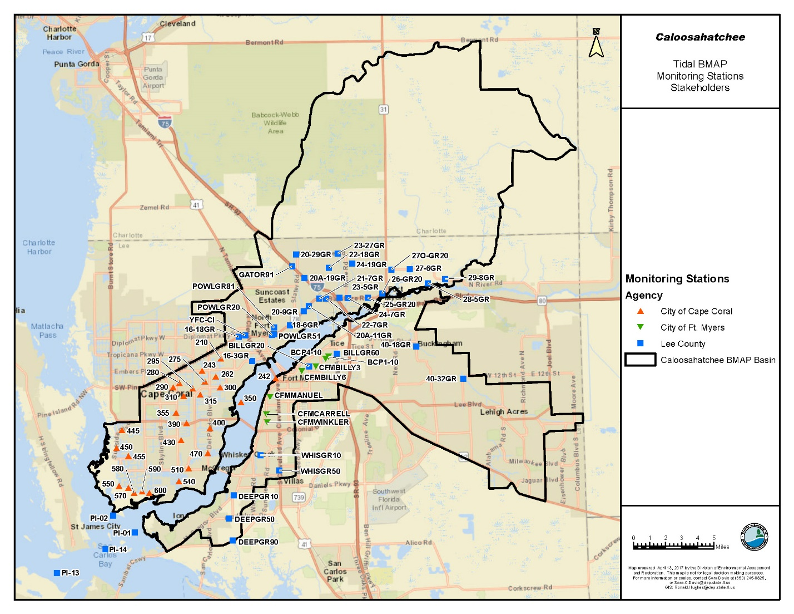
Figure C-1. Tidal Caloosahatchee BMAP stations monitored by Cape Coral, Fort Myers, and Lee County

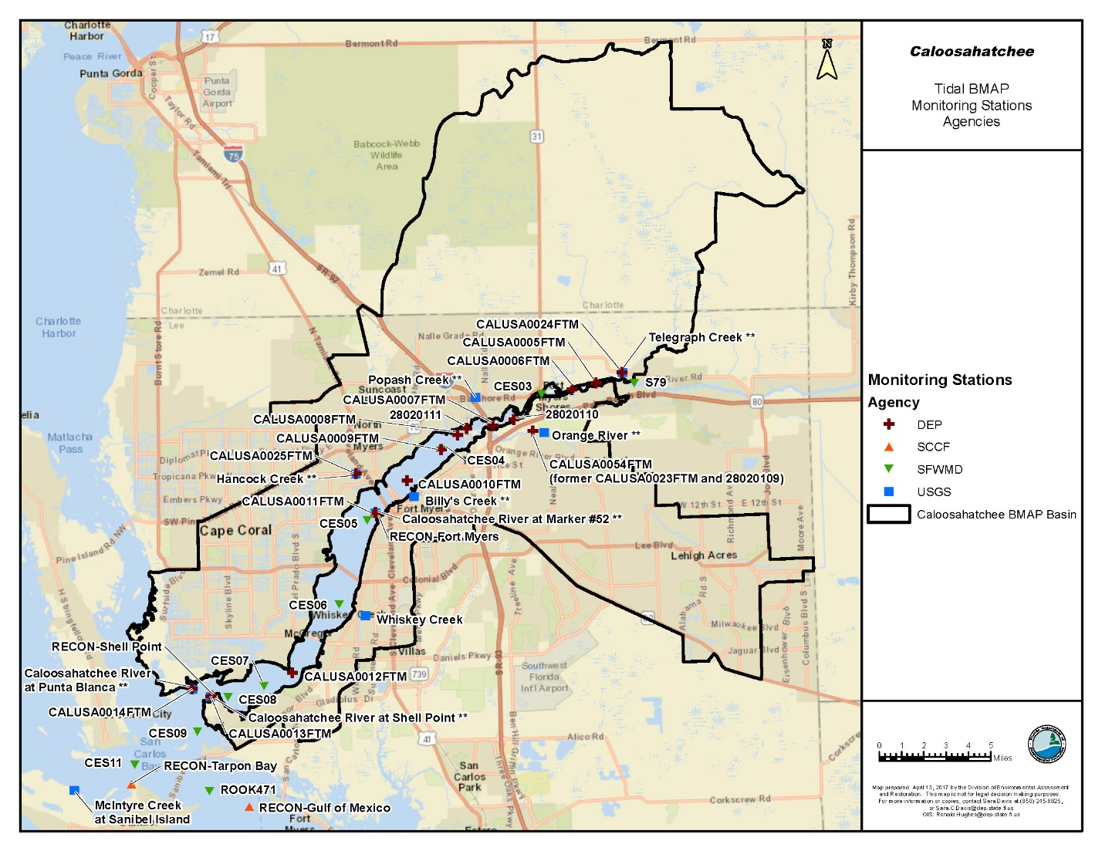
Figure C-2. Tidal Caloosahatchee BMAP stations monitored by DEP, SCCF, SFWMD, and USGS

Recommended Revisions
For future implementation phases, one recommendation is to reorganize the ambient water quality monitoring stations into a three-tiered system, as follows:
- Tier 1: Stations that will be the primary/priority stations used to track BMAP progress over the long term. If at any point it is necessary to reduce efforts in the basin, these stations should be the last stations impacted.
- Tier 2: Stations that can be used for regional analyses or other secondary analyses.
- Tier 3: Stations owned by USGS or SCCF that are not currently uploaded into DEP databases. Data from these stations may be used for other monitoring purposes as necessary.
If the recommended revisions to the BMAP monitoring network are implemented, TN concentrations will be monitored at 99 stations: 22 in the Caloosahatchee Estuary, 68 in the tributaries, and 9 in San Carlos Bay. The revised network of stations is listed in Table C-2 and shown in Figures C-3, C-4, and C-5.
Table C-2. Revised BMAP monitoring network
¹ NPDES outfall. Data from stations currently listed as NPDES outfall stations will not be included in any ambient monitoring analysis.
² Discontinued April 1, 2013. Section 3.3.2 describes recommendations for additional flow monitoring at these locations.
³ Formerly CALUSA0023FTM and 28020109.
⁴ Stations are in the Caloosahatchee Watershed but outside the current BMAP area boundary.
Notes: N/A = Not applicable. Bold denotes that a change is recommended for the station. Remove = Recommended that station be excluded from revised network.
Agency | Site Name | Current Tier | River or Watershed Station  (current) | Tier Recommendation | Bay, Estuary, or Tributary (revised)
City of Cape Coral | 210 | 2 | Watershed | 2 | Tributary
City of Cape Coral | 242 | 2 | River | 2 | Estuary
City of Cape Coral | 243 | 2 | Watershed | 2 | Tributary
City of Cape Coral | 262 | 2 | Watershed | 2 | Tributary
City of Cape Coral | 275 | 2 | Watershed | 2 | Tributary
City of Cape Coral | 280 | 2 | Watershed | 2 | Tributary
City of Cape Coral | 290 | 2 | Watershed | 2 | Tributary
City of Cape Coral | 295 | 2 | Watershed | 2 | Tributary
City of Cape Coral | 300 | 1 | Watershed | 1 | Tributary
City of Cape Coral | 310 | 2 | Watershed | 2 | Tributary
City of Cape Coral | 315 | 2 | Watershed | 2 | Tributary
City of Cape Coral | 350 | 1 | River | 2 | Estuary
City of Cape Coral | 355 | 2 | Watershed | 2 | Tributary
City of Cape Coral | 390 | 2 | Watershed | 2 | Tributary
City of Cape Coral | 400 | 1 | Watershed | 1 | Tributary
City of Cape Coral | 430 | 2 | Watershed | 2 | Tributary
City of Cape Coral | 470 | 1 | Watershed | 1 | Tributary
City of Cape Coral | 510 | 2 | Watershed | 2 | Tributary
City of Cape Coral | 540 | 1 | Watershed | 1 | Tributary
City of Cape Coral | 550 | 2 | Watershed | 2 | Tributary
City of Cape Coral | 590 | 1 | Watershed | 1 | Tributary
City of Cape Coral | 600 | 1 | Watershed | 1 | Tributary
City of Ft. Myers | BCP1-10 | 2 | Watershed | 2 | Tributary
City of Ft. Myers | BCP4-10 | 2 | Watershed | 2 | Tributary
City of Ft. Myers | CFMBILLY3 | 2 | Watershed | 2 | Tributary
City of Ft. Myers | CFMBILLY6 | 2 | Watershed | 2 | Tributary
City of Ft. Myers | CFMCARRELL | 2 | Watershed | 1 | Tributary
City of Ft. Myers | CFMMANUEL | 1 | Watershed | 1 | Tributary
City of Ft. Myers | CFMWINKLER | 1 | Watershed | 1 | Tributary
DEP | 28020110 | 4 | River | 2 | Estuary
DEP | 28020111 | 4 | River | 2 | Estuary
DEP | CALUSA0005FTM | 4 | River | 2 | Estuary
DEP | CALUSA0006FTM | 4 | River | 1 | Estuary
DEP | CALUSA0007FTM | 4 | River | 1 | Estuary
DEP | CALUSA0008FTM | 4 | River | 2 | Estuary
DEP | CALUSA0009FTM | 4 | River | Remove | N/A
DEP | CALUSA0010FTM | 4 | River | 1 | Estuary
DEP | CALUSA0011FTM | 4 | River | Remove | N/A
DEP | CALUSA0012FTM | 4 | River | 1 | Estuary
DEP | CALUSA0013FTM | 4 | River | 1 | Estuary
DEP | CALUSA0014FTM | 4 | River | 1 | Estuary
DEP | CALUSA0054FTM³ | 4 | Watershed | 1 | Tributary
DEP | CALUSA0024FTM | 4 | Watershed | 1 | Tributary
DEP | CALUSA0025FTM | 4 | Watershed | 1 | Tributary
Lee County | 16-18GR | 2 | Watershed | 2 | Tributary
Lee County | 16-3GR | 1 | Watershed | 1 | Tributary
Lee County | 18-6GR | 1 | Watershed | 1 | Tributary
Lee County | 20-29GR | 2 | Watershed | 2 | Tributary
Lee County | 20-9GR | 1 | Watershed | 1 | Tributary
Lee County | 20A-11GR | 2 | Watershed | 2 | Tributary
Lee County | 20A-19GR | 2 | Watershed | 2 | Tributary
Lee County | 21-7GR | 2 | Watershed | 2 | Tributary
Lee County | 22-18GR | 2 | Watershed | 2 | Tributary
Lee County | 22-7GR | 2 | Watershed | 1 | Tributary
Lee County | 23-27GR | 2 | Watershed | 2 | Tributary
Lee County | 23-5GR | 1 | Watershed | 1 | Tributary
Lee County | 24-19GR | 2 | Watershed | 2 | Tributary
Lee County | 24-7GR | 1 | Watershed | 1 | Tributary
Lee County | 25-GR20 | 2 | Watershed | 1 | Tributary
Lee County | 26-GR20 | 2 | Watershed | 2 | Tributary
Lee County | 27-6GR | 1 | Watershed | 1 | Tributary
Lee County | 27O-GR20 | 1 | Watershed | 1 | Tributary
Lee County | 28-5GR | 1 | Watershed | 2 | Estuary
Lee County | 29-8GR | 1 | Watershed | 2 | Tributary
Lee County | 40-18GR | 2 | Watershed | 2 | Tributary
Lee County | 40-32GR | 2 | Watershed | 2 | Tributary
Lee County | BILLGR20 | 2 | Watershed | 1 | Tributary
Lee County | BILLGR60¹ | 2 | Watershed | 2 | Tributary
Lee County | DEEPGR10 | 1 | Watershed | 1 | Tributary
Lee County | DEEPGR50 | 1 | Watershed | 2 | Tributary
Lee County | DEEPGR90 | 2 | Watershed | 2 | Tributary
Lee County | GATOR91 | 2 | Watershed | 2 | Tributary
Lee County | PI-01 | 1 | River | 1 | Bay
Lee County | PI-02 | 1 | River | 1 | Bay
Lee County | PI-13 | 2 | River | 2 | Bay
Lee County | PI-14 | 1 | River | 1 | Bay
Lee County | POWLGR20 | 1 | Watershed | 1 | Tributary
Lee County | POWLGR51¹ | 1 | Watershed | 2 | Tributary
Lee County | POWLGR81 | 2 | Watershed | 2 | Tributary
Lee County | WHISGR10¹ | 1 | Watershed | 2 | Tributary
Lee County | WHISGR50¹ | 2 | Watershed | 2 | Tributary
Lee County | YFC-CI¹ | 2 | Watershed | 2 | Tributary
LA-MSID | Station 11⁴ | N/A | N/A | 2 | Tributary
LA-MSID | Station 14⁴ | N/A | N/A | 2 | Tributary
LA-MSID | Station 15⁴ | N/A | N/A | 2 | Tributary
LA-MSID | Station 22 | N/A | N/A | 2 | Tributary
LA-MSID | Station 27 | N/A | N/A | 2 | Tributary
SCCF | RECON-Fort Myers | 3 | River | 3 | Estuary
SCCF | RECON-Gulf of Mexico | 3 | River | 3 | Bay
SCCF | RECON-Shell Point | 3 | River | 3 | Estuary
SCCF | RECON-Tarpon Bay | 3 | River | 3 | Bay
SFWMD | CES03 | 4 | River | 1 | Estuary
SFWMD | CES04 | 4 | River | 1 | Estuary
SFWMD | CES05 | 4 | River | 1 | Estuary
SFWMD | CES06 | 4 | River | 1 | Estuary
SFWMD | CES07 | 4 | River | 2 | Estuary
SFWMD | CES08 | 4 | River | 1 | Estuary
SFWMD | CES09 | 4 | River | 2 | Bay
SFWMD | CES11 | 4 | River | 1 | Bay
SFWMD | ROOK471 (former Point Ybel) | 4 | River | 1 | Bay
SFWMD | S79 | 4 | River | 1 | Estuary
USGS | Billy's Creek | 3 | Watershed | Remove² | Tributary
USGS | Caloosahatchee River at Marker #52 | 3 | River | Remove² | N/A
USGS | Caloosahatchee River at Punta Blanca | 3 | River | Remove² | N/A
USGS | Caloosahatchee River at Shell Point | 3 | River | Remove² | N/A
USGS | Hancock Creek | 3 | Watershed | Remove² | N/A
USGS | McIntyre Creek at Sanibel Island | 3 | River | Remove² | N/A
USGS | Orange River | 3 | Watershed | Remove² | N/A
USGS | Popash Creek | 3 | Watershed | Remove² | N/A
USGS | Telegraph Creek | 3 | Watershed | Remove² | N/A
USGS | Whiskey Creek | 3 | Watershed | 3 | Tributary

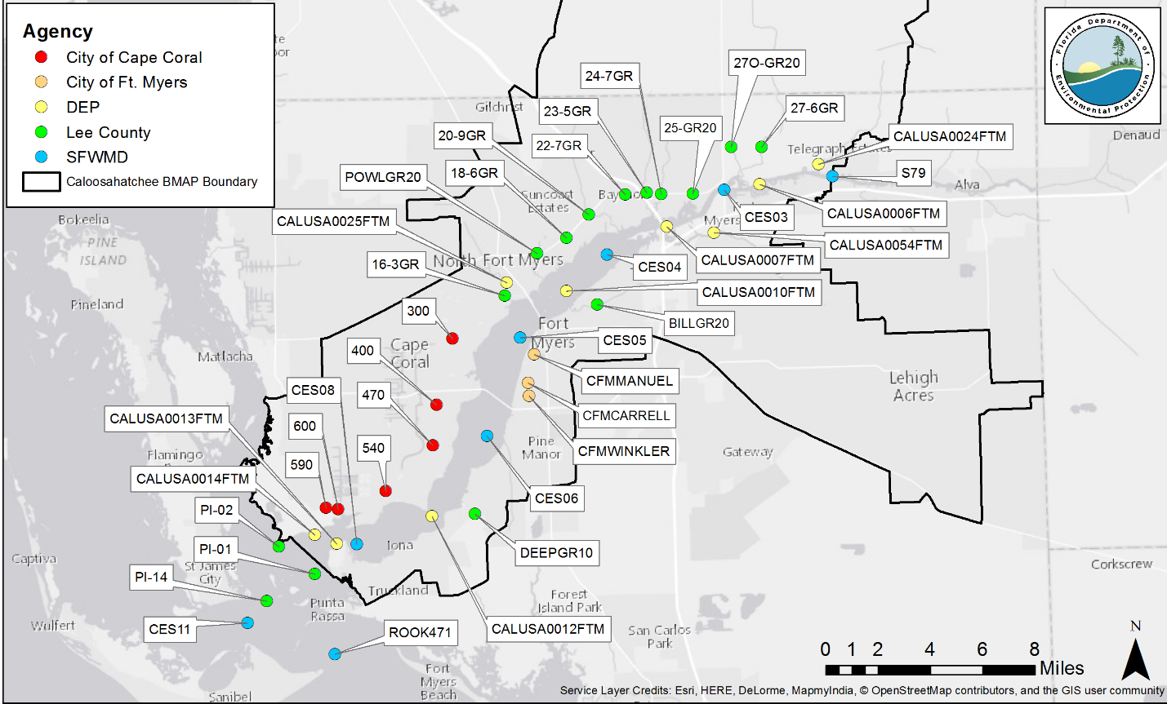
Figure C-3. Revised Tier 1 Tidal Caloosahatchee BMAP stations

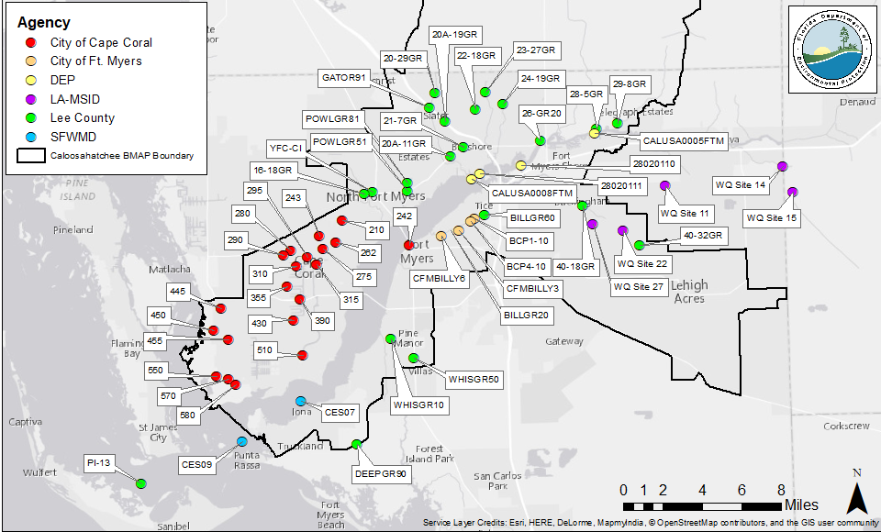
Figure C-4. Revised Tier 2 Tidal Caloosahatchee BMAP stations

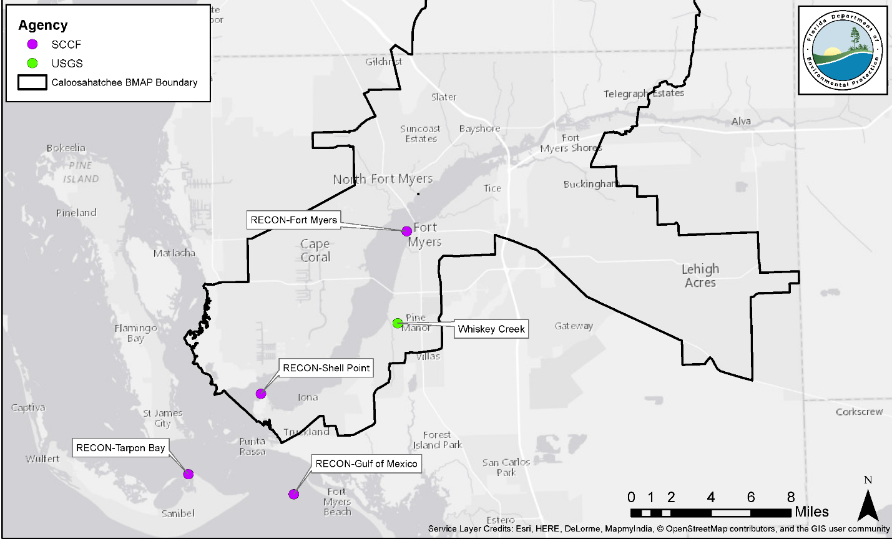
Figure C-5. Revised Tier 3 Tidal Caloosahatchee BMAP stations

Biological Monitoring
Currently, the SFWMD conducts biological sampling for oysters and seagrass in the Caloosahatchee Estuary and San Carlos Bay, and DEP conducts seagrass monitoring in the basin. No changes to the biological monitoring are being recommended as a part of this Review, and the monitoring should continue as described in Tables C-2 and C-3.
Table C-3. SFWMD biological monitoring
¹ 20 randomly generated points in the Upper Caloosahatchee River Estuary (CRE). Points are generated monthly depending on the previous month's results.
² 3-meter x 3-meter quadrant divided into 9-square-meter quadrants.
Project | Station Name | Sampling Frequency
Estuary Patch Scale  Seagrass Monitoring | Upper CRE1 | March, May, July, and September – 20 Quadzilla^{1,2}
Estuary Patch Scale  Seagrass Monitoring | CRE_2 | March, April, May, June, July, August, September,  and December – 30 Quads
Estuary Patch Scale  Seagrass Monitoring | CRE_4 | March, May, July, and September – 30 Quads
Estuary Patch Scale  Seagrass Monitoring | CRE_5 | March, May, July, and September – 30 Quads
Estuary Patch Scale  Seagrass Monitoring | CRE_6B | March, May, July, and September – 30 Quads
Estuary Patch Scale  Seagrass Monitoring | CRE_7 | March, May, July, and September – 30 Quads
Estuary Patch Scale  Seagrass Monitoring | CRE_8 | March, April, May, June, July, August, September, and December – 30 Quads
Oyster Monitoring | Pepper Tree Pointe | Monthly: Recruitment, growth, predation, disease, reproductive condition
Oyster Monitoring | Iona Cove | Monthly: Recruitment, growth, predation, disease, reproductive condition.  Twice yearly: Density, size
Oyster Monitoring | Bird Island | Monthly: Recruitment, growth, predation, disease, reproductive condition.  Twice yearly: Density, size
Oyster Monitoring | Kitchel Key | Monthly: Recruitment, growth, predation, disease, reproductive condition.  Twice yearly: Density, size

Table C-4. DEP biological monitoring
Project | Station Name | Sampling Frequency
Seagrass Monitoring | CR02 | Quarterly
Seagrass Monitoring | CR04 | Quarterly
Seagrass Monitoring | CR05 | Quarterly
Seagrass Monitoring | SC03 | Quarterly
Seagrass Monitoring | MP04 | Quarterly
Seagrass Monitoring | MP05 | Quarterly

Appendix D: Agricultural Enrollment and Reductions
All agricultural nonpoint sources in the Caloosahatchee Estuary BMAP area are statutorily required either to implement FDACS-adopted BMPs or to conduct water quality monitoring prescribed by DEP or the applicable water management district that demonstrates compliance with water quality standards (Paragraph 403.067[7][b], F.S.). Under Paragraph 403.067(7)(c), F.S., the implementation of FDACS-adopted, DEP-verified BMPs in accordance with FDACS rules provides a presumption of compliance with state water quality standards.
FDACS OAWP Role in BMP Implementation and Follow-Up
The OAWP works with producers to submit NOIs to implement the BMPs applicable to their operations, provides technical assistance to growers, and distributes cost-share, as available, to eligible producers for selected practices. The OAWP follows up with growers through site visits to evaluate the level of BMP implementation and record keeping, identify areas for improvement, if any, and discuss cost-share opportunities.
When DEP adopts a BMAP that includes agriculture, it is the agricultural producer's responsibility to implement BMPs adopted by FDACS to help achieve load reductions. The model used for the 2009 TMDL and 2012 BMAP combines all agricultural land uses into two categories: "citrus" and "cropland/improved pasture/tree crops." The model estimated that the total agricultural land use in the basin was 30,244 acres, with the associated TN load being 214,153 lbs/yr. Using these calculations as the base TN loading for agriculture and applying a reduction of 30 % for all enrolled lands designated as "cropland/improved pasture/tree crops" and 10 % for all enrolled lands designated as "citrus," FDACS developed a preliminary estimate of load reductions associated with 100 % enrollment. Based on these assumptions, if all of the agricultural lands identified in the HSPF can be enrolled in the BMP Program and producers implement these BMPs, the expected nutrient reduction is 52,627 lbs TN/yr.
If land use acreage corrections and BMP implementation do not fully account for the current agricultural load reduction allocation, it may be necessary to develop and implement cost-assisted field- or regional-level treatment options that remove nutrients from farms and other nonpoint sources. In that case, FDACS will work with DEP and the SFWMD to identify appropriate options for achieving further agricultural load reductions.
FDACS OAWP Implementation Assurance (IA) Program
The OAWP formally established the IA Program in 2005 in the Suwannee River Basin as part of the multi-agency/local stakeholder Suwannee River Partnership. In early 2014, the OAWP began to streamline the IA Program to ensure consistency statewide and across commodities and BMP manuals. This effort resulted in a single IA site-visit form, which is currently used by OAWP staff.
Additional emphasis was given to verification of implementation of BMPs by enrolled producers with the enactment of Chapter 2016-1, Laws of Florida. That law directed the OAWP to formalize the Implementation Verification Program into rule. In December 2016, the OAWP published a notice of rule development. As of February 2017, draft rule language has been distributed and presented at a public workshop. This draft rule language provides the structure for a statewide uniform implementation verification system, including assessment of the status of implementation, compliance assistance to aid producers in achieving full implementation, and referral to DEP for producers who are not implementing BMPs.
Beyond BMPs
Beyond enrolling producers in the FDACS BMP Program and verifying implementation, FDACS is working with DEP to improve the data used to estimate agricultural land uses in the watershed. FDACS is also working with producers to identify and implement a suite of agricultural projects and research agricultural technologies on properties where they are deemed technically feasible and where funding can be made available. The implementation of these projects would require funding as well as more detailed design based on site-specific information, such as applicable acreages and willing landowners.
Table D-1. Agricultural acreage in the Tidal Caloosahatchee Basin
¹ FDACS staff-adjusted acreage for purposes of enrollment is based on a review of more recent aerial imagery in the basin and local staff observations.
N/A = Not applicable
2004 SFWMD Land Use | 2004 Acres | FDACS-Adjusted Acres¹
Pasture (2100, 2110, 2120, 2130) | 29,890.2 | 28,981.2
Row/Field/Mixed Crops | 6,081.9 | 6,041.3
Fallow Cropland | 1,499.3 | N/A
Horse Farm | 24.3 | 24.3
Citrus | 817.7 | 359.1
Fruit Orchards/Other Groves | 154.1 | 154.1
Tree Nurseries | 230.3 | 230.3
Ornamentals | 285.1 | 285.1
Specialty Farms | 67.2 | 67.2
Dairies | 37.9 | 37.9
Total | 39,088 | 36,181

Table D-2. BMP enrollment for the Tidal Caloosahatchee Basin as of March 31, 2017
¹ Acreage enrolled as part of the Babcock Ranch cow/calf operation was not classified as agricultural land use in the model land use coverage.
Related FDACS BMP Programs | Acreage Enrolled | Related NOIs | TMDL Model Agricultural Land Use Acres with NOIs¹
Cow/Calf Operations | 69,054 | 11 | 18,162
Nurseries | 537 | 23 | 399
Specialty Fruit and Nut | 29 | 1 | 21
Citrus | 20 | 1 | 19
Sod Operations | 452 | 1 | 428
Vegetable and Agronomic Crops | 121 | 1 | 55
 | 70,212 | 38 | 19,084

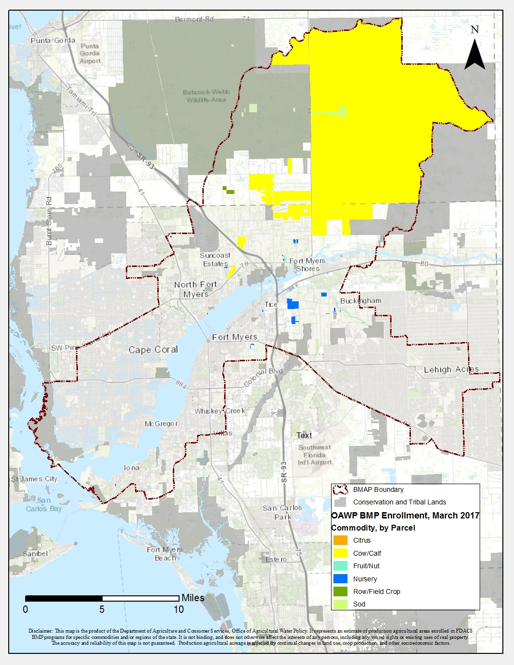
Figure D-1. BMP enrollment in the Tidal Caloosahatchee Watershed as of March 31, 2017

Appendix E: Water Quality Data Processing and Analysis Methods
For this 5-Year Review, trend analyses were conducted on available data from Tier I stations in the Caloosahatchee Estuary BMAP network from an overall POR of May 1, 2007, to April 30, 2017. STORET data were processed using the methods described below, and only data that meet QC objectives were used in the analyses. Nonparametric statistical techniques were used to identify monotonic trend analyses in a statistically rigorous way with the Seasonal Kendall trend test. Data are not required to conform to a particular distribution for nonparametric analyses. Nonparametric tests are also robust against outliers and large data gaps. Section 2.3 in the main report summarizes the analyses and results; additional details on the methods are provided below.
Data Download
TN and TP data from WIN and STORET:
  - Station S79.
  - Tier 1 Estuary WBIDs:
    - 3240A (Stations: CALUSA0012FTM, CALUSA0014FTM, CES05, CES06, CES08).
    - 3240B (Stations: CALUSA0010FTM, CES04).
    - 3240C (CALUSA0006FTM, CALUSA0007FTM, CES03).

  - Tier 1 Tributary Stations: 300, 400, 470, 540, 590, 600, 16-3GR, 18-6GR, 20-9GR, 22-7GR, 23-5GR, 24-7GR, 25-GR20, 27-6GR, 27O-GR20, DEEPGR10, POWLGR20, BILLGR20, CFMMANUEL, CFMWINKLER, CFMCARRELL, CALUSA0025FTM, CALUSA0054FTM, CALUSA0024FTM.
Station data were retrieved from STORET and WIN for the designated POR for Tier 1 estuary and tributary stations:
  - POR:
    - Overall POR was May 1, 2007, through April 30, 2017.
Data Processing (in order of operation)
Nutrient Characteristic Selection:
  - TP: Phosphorus as P
  - TN: TN, Nitrogen Ion, or (TN=TKN + (NO2 + NO3)) -whichever was available
Sample Depth:
  - If "surface water," "midwater," and "bottom" samples were collected at a station for the same parameter on the same day, then only the "surface water" sample was retained for analysis:
    - Only surface samples, which included samples collected at depths equal to/less than 1.0 m, were used in the analyses.

Data Qualifiers:
  - Data with result qualifiers of "A," "F," "G," "H," "K," "L," "N," "O," "T," "V," "Y," or "?" were not used in the analysis, as per Table 1, Data Qualifier Codes, in Rule 62-160.700, Florida Administrative Code (F.A.C.), Quality Assurance.
  - Data with a result qualifier of "I" were only used if a corresponding minimum detection level (MDL) was listed:
    - Data with qualifier of "I" with corresponding comment "*Present<QL" were not used in the analysis.
  - Data with a result qualifier of "U" were reviewed:
    - If not already present, a result qualifier of "U" was assigned to any data with a result value of "*Non-Detect."
    - Data with a result value of "*Not Reported" were deleted unless they also had a value qualifier of "U."
    - Data with a result value or qualifier that indicated values were below the MDL were reviewed within the dataset's POR. If it was determined that the analytical methods were changed during the POR resulting in differences in the MDL, the highest MDL value was used as the uniform MDL for the entire POR.
    - Data with a result qualifier of "U" were processed in accordance with Subsection 62-303.320(12), F.A.C., Aquatic Life-Based Water Quality Criteria Assessment. Results reported by a laboratory with the "U" data qualifier code were assessed as half the reported result or half the criterion (whichever was lower).
Estuary Data:
  - Station data were combined by WBID (parameters kept separate) for processing and analysis.
Tributary Data:
  - Station data were processed and analyzed on an individual basis.
Temporal Processing:
  - Same Day Average: If multiple surface water data points were collected on the same day, then values were averaged.
  - Four Day Medians: If multiple surface water data points were collected within 4 days of each other, then median values were calculated.
  - Monthly Time Series: If multiple data points existed within a month, the monthly average was calculated for each month.
Processing for Statistical Tests:
  - Data were processed according to the needs of each statistical test and formatted for use in the R statistical program.
  - Sampling Frequency:
    - Monthly data series were used for analysis.
    - Missing data entries were populated with NA values to provide an equal number of points for each station and parameter.
  - Data Gap Filling:
    - If a test did not require continuous series, missing values were left as NA.
    - Linear Interpolation:
      - For tests that required continuous data series (e.g., TSD), linear interpolation was used to backfill the missing data for all gaps that were 1 month long.
    - MI:
      - For tests that required a continuous data series (e.g., TSD), gaps larger than one month, but less than 1 year, were filled using MI. Unlike simple linear interpolation or a linear regression methodology, the MI method involves backfilling of missing data with a set of plausible values (instead of just 1 value) based on Bayesian (probability-based) relationships. Rubin (1987) and Su et al. (2011) provide theoretical and implementation details about using MI for backfilling data gaps:
        - 6 sets of probable values were produced for each missing value using MI.
        - The average of the 6 probable values was used to fill in the corresponding missing value.
        - Appropriate pre- and post-diagnostic checks were done to ensure the statistically valid implementation of multiple imputation method.
    - For tests that required a continuous data series, if data gaps of more than 1 year existed, then the series was truncated, and the longest available continuous series was used for trend analysis.
    - If a series did not have at least 5 years of continuous data, it was not used for trend analysis.

Statistical Analyses
Spatial Associations:
  - Time series plots of estuary WBIDs vs. Station S79.
Trend Analysis:
  - ACF:
    - Autocorrelation was conducted to evaluate seasonal patterns and/or serial correlation (monthly/bimonthly, quarterly, or annual seasons).
      - ACF was conducted first on monthly, nongap-filled series to determine seasonality.
      - It was run again on gap-filled and decomposed (see below) trend- component of time series data to check for any serial correlation.
  - TSD:
    - If seasonality was evident from ACF plots on nongap-filled data, the time series was first backfilled using linear interpolation or multiple imputation (see Data Gap Filling) and subsequently decomposed into trend and seasonal components (based on annual seasonality patterns and assuming fixed seasonal component).
    - The trend component from the TSD was extracted and Mann-Kendall and Seasonal Kendall tests were conducted to determine presence of monotonic trends.
  - Mann-Kendall Tests:
    - Mann-Kendall (MK) and Seasonal Kendall (SK) tests (using month as the "season"):
      - Before running MK or SK tests, the time series data were checked for serial correlation and seasonality using ACF.
      - If serial correlation was evident in ACF, first-order differencing (i.e., creating a new time-series by subtraction of consecutive terms in the time-series) was done to remove serial correlation prior to conducting MK or SK tests:
        - Both MK and SK tests were conducted on monthly, nongap-filled, and nondecomposed series if no seasonality was evident (after removal of serial correlation if present).
        - For time-series with evident seasonality, MK and SK tests were conducted on the decomposed trend-component to identify positive or negative significant trends independent of seasonal effects.

Table E-1. Initial list of stations selected for processing
Data Provider | Station ID | Latitude | Longitude | Waterbody Type | Grouped by WBID or Individual Tributary
SFWMD | S79 | 26.72293 | -81.6932 | Estuary | Individual Estuary
DEP | CALUSA0014FTM | 26.529 | -82.0177 | Estuary | Grouped - 3240A
DEP | CALUSA0013FTM | 26.52389 | -82.0044 | Estuary | Grouped - 3240A
DEP | CALUSA0012FTM | 26.53831 | -81.9452 | Estuary | Grouped - 3240A
SFWMD | CES05 | 26.6366 | -81.8887 | Estuary | Grouped - 3240A
SFWMD | CES06 | 26.5823 | -81.9102 | Estuary | Grouped - 3240A
SFWMD | CES08 | 26.5233 | -81.992 | Estuary | Grouped - 3240A
DEP | CALUSA0010FTM | 26.662 | -81.8594 | Estuary | Grouped - 3240B
SFWMD | CES04 | 26.6817 | -81.8338 | Estuary | Grouped - 3240B
DEP | CALUSA0007FTM | 26.69683 | -81.7965 | Estuary | Grouped - 3240C
DEP | CALUSA0006FTM | 26.71933 | -81.7386 | Estuary | Grouped - 3240C
SFWMD | CES03 | 26.71669 | -81.7606 | Estuary | Grouped - 3240C
City of Cape Coral | 400 | 26.60004 | -81.9412 | Tributary | Individual Tributary
City of Cape Coral | 470 | 26.57763 | -81.9438 | Tributary | Individual Tributary
City of Cape Coral | 540 | 26.55265 | -81.9734 | Tributary | Individual Tributary
City of Cape Coral | 300 | 26.63661 | -81.9305 | Tributary | Individual Tributary
City of Cape Coral | 590 | 26.54393 | -82.0107 | Tributary | Individual Tributary
City of Cape Coral | 600 | 26.54282 | -82.0033 | Tributary | Individual Tributary
City of Ft. Myers | CFMMANUEL | 26.62714 | -81.88 | Tributary | Individual Tributary
City of Ft. Myers | CFMWINKLER | 26.60407 | -81.8838 | Tributary | Individual Tributary
City of Ft. Myers | CFMCARRELL | 26.6114 | -81.884 | Tributary | Individual Tributary
DEP | CALUSA0054FTM (former CALUSA0023FTM and 28020109) | 26.69287 | -81.7674 | Tributary | Individual Tributary
DEP | CALUSA0024FTM | 26.73004 | -81.7017 | Tributary | Individual Tributary
DEP | CALUSA0025FTM | 26.6671 | -81.8965 | Tributary | Individual Tributary
Lee County | 27-6GR | 26.74015 | -81.7369 | Tributary | Individual Tributary
Lee County | 20-9GR | 26.70413 | -81.8447 | Tributary | Individual Tributary
Lee County | 27O-GR20 | 26.74029 | -81.7557 | Tributary | Individual Tributary
Lee County | 23-5GR | 26.71575 | -81.8086 | Tributary | Individual Tributary
Lee County | 24-7GR | 26.71507 | -81.7998 | Tributary | Individual Tributary
Lee County | POWLGR20 | 26.68313 | -81.8774 | Tributary | Individual Tributary
Lee County | 18-6GR | 26.69142 | -81.8589 | Tributary | Individual Tributary
Lee County | DEEPGR10 | 26.53916 | -81.9185 | Tributary | Individual Tributary
Lee County | 16-3GR | 26.65997 | -81.8977 | Tributary | Individual Tributary
Lee County | 22-7GR | 26.71514 | -81.822 | Tributary | Individual Tributary
Lee County | 25-GR20 | 26.71496 | -81.78 | Tributary | Individual Tributary
Lee County | BILLGR20 | 26.65424 | -81.8404 | Tributary | Individual Tributary

Table E-2. Summary of POR and data availability for tributary stations
Note: N/A = Not applicable. *Only includes useful POR start/end. Other data exist past this end point but were not used in analyses.
**Station did not have five consecutive years of data in STORET. Data were not used for trend analysis from these stations.
WBID | Station | Parameter | POR Start | POR End | Number of Samples
3240A2 | 300 | TN | May-08 | Mar-17 | 104
3240A2 | 300 | TP | N/A | N/A | 0
3240A1 | 400 | TN | May-08 | Mar-17 | 103
3240A1 | 400 | TP | N/A | N/A | 0
3240A1 | 470 | TN | May-08 | Mar-17 | 103
3240A1 | 470 | TP | N/A | N/A | 0
3240A1 | 540 | TN | May-08 | Mar-17 | 104
3240A1 | 540 | TP | N/A | N/A | 0
3240A1 | 590 | TN | May-08 | Mar-17 | 103
3240A1 | 590 | TP | N/A | N/A | 0
3240A1 | 600 | TN | May-08 | Mar-17 | 103
3240A1 | 600 | TP | N/A | N/A | 0
3240O | 16-3GR | TN | May-08 | Apr-17 | 106
3240O | 16-3GR | TP | May-08 | Apr-17 | 106
3240O | 18-6GR | TN | Jun-08 | Nov-14* | 86
3240O | 18-6GR | TP | Jun-08 | Nov-14* | 86
3240F | 20-9GR | TN | May-08 | Apr-17 | 107
3240F | 20-9GR | TP | May-08 | Apr-17 | 107
3240F | 22-7GR | TN | May-08 | Jan-17 | 96
3240F | 22-7GR | TP | May-08 | Jan-17 | 96
3240Q | 23-5GR | TN | May-08 | Apr-17 | 107
3240Q | 23-5GR | TP | May-08 | Apr-17 | 107
3240M | 24-7GR | TN | May-08 | Apr-17 | 107
3240M | 24-7GR | TP | May-08 | Apr-17 | 107
3240M | 25-GR20 | TN | May-08 | Nov-14* | 78
3240M | 25-GR20 | TP | May-08 | Nov-14* | 78
3240M | 27-6GR | TN | May-08 | Apr-17 | 107
3240M | 27-6GR | TP | May-08 | Apr-17 | 107
3240M | 27O-GR20 | TN | May-08 | Feb-17 | 106
3240M | 27O-GR20 | TP | May-08 | Feb-17 | 106
3240J | BILLGR20 | TN | May-08 | Apr-17 | 108
3240J | BILLGR20 | TP | May-08 | Apr-17 | 108
3236A | CALUSA0024FTM | TN | Jan-11 | Apr-17 | 76
3236A | CALUSA0024FTM | TP | Jan-11 | Apr-17 | 76
3236A | CALUSA0025FTM | TN | Jan-11 | Apr-17 | 76
3236A | CALUSA0025FTM | TP | Jan-11 | Apr-17 | 76
3236A | CALUSA0054FTM | TN | Mar-13 | Apr-17** | 9
3236A | CALUSA0054FTM | TP | Mar-13 | Apr-17** | 9
3236A | CFMCARRELL | TN | Jan-13 | Dec-16** | 48
3236A | CFMCARRELL | TP | May-08 | Dec-16** | 74
3236A | CFMMANUEL | TN | May-08 | Dec-16** | 74
3236A | CFMMANUEL | TP | May-08 | Dec-16** | 74
3236A | CFMWINKLER | TN | Jan-13 | Dec-16** | 48
3236A | CFMWINKLER | TP | May-08 | Dec-16** | 74
3236A | DEEPGR10 | TN | May-08 | Apr-17 | 108
3236A | DEEPGR10 | TP | May-08 | Apr-17 | 108
3236A | POWLGR20 | TN | May-08 | Apr-17 | 105
3236A | POWLGR20 | TP | May-08 | Apr-17 | 105

Table E-3. Summary of POR and data availability for WBID datasets
WBID | Parameter | POR Start | POR End | Number of Samples
3240A | TN | May-07 | Apr-17 | 119
3240A | TP | May-07 | Apr-17 | 119
23240B | TN | May-07 | Sep-16 | 106
23240B | TP | May-07 | Sep-16 | 107
3240C | TN | May-07 | Sep-16 | 107
3240C | TP | May-07 | Sep-16 | 107
S79 | TN | May-07 | Oct-16 | 102
S79 | TP | May-07 | Oct-16 | 102

