Jacks Branch at Norris Road
Location Map:
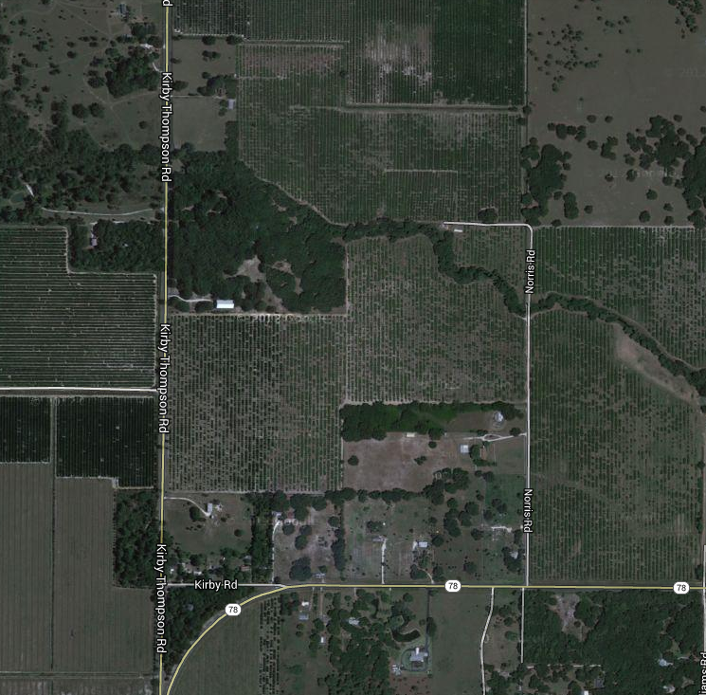
Photo of Norris Road Bridge, taken by AIM Engineering & Surveyors, Inc.
