Section 7.0. Sanibel-Captiva Conservation Foundation Data Sondes:
In 2007 the Sanibel-Captiva Conservation Foundation (SCCF) established the River Estuary Coastal Observing Network (RECON) to monitor water quality changes between Lake Okeechobee and the Gulf of Mexico (http://www.sccf.org/content/114/About-SCCF-and-RECON.aspx). Dr. Eric Milbrandt, the director of the marine laboratory was contacted to obtain the data sonde data sets, which were provided by the database manager Dr. Alex Rybak on October 26, 2011. As described in the request form to obtain the data, it is understood that the data being collected for SCCF is in a preliminary form, subject to change and SCCF provides no warranty, expressed or implied, as to the accuracy, reliability or completeness of these preliminary public data. The Department accepts and assumes all responsibility of the use of data, with all faults and agrees to hold the SCCF harmless from and against any damage, loss, or liability arising from the use of RECON data provided.

Observations from five sites were evaluated (Figure 7.1). The Tarpon Bay site was not analyzed due to the limited period of record.

Figure 7.1. RECON Data Sonde Sites
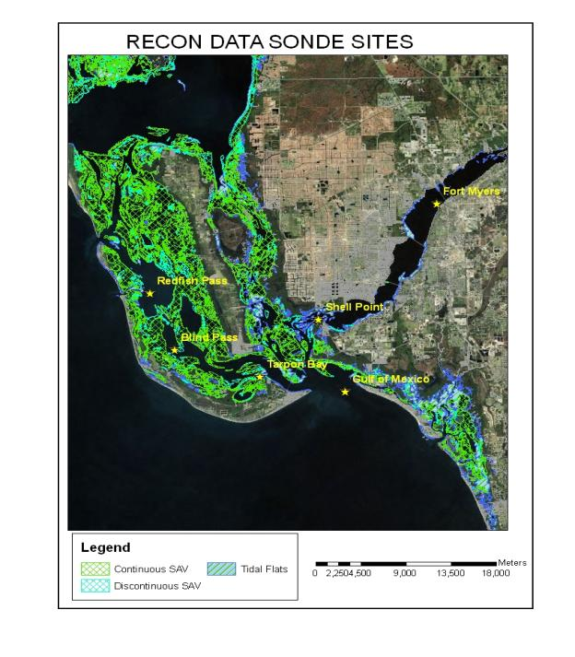
Fort Myers
The sonde is located in the Caloosahatchee River, approximately 22.3 km from the S-79 structure and 29.4 km from the Gulf of Mexico. The average depth of sonde measurements was 2.17 meters (total depth is 3.47 m). Tides are mixed with a mean range of 0.94 feet. Observations were available starting in December 2007. Nearfield characteristics of the site are shown in Figure 7.2.
Figure 7.2. Fort Myers Data Sonde Location
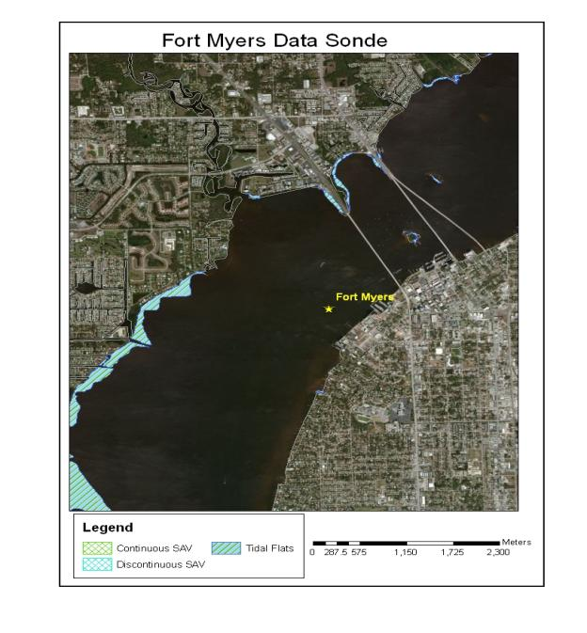
Time Series plots of daily average DO, DOSAT, and salinity conditions recorded at the Fort Myers site are presented in Figures 7.3 – 7.5. Approximately 27 percent of the daily mean salinities indicated that fresh water conditions prevailed at this site. Daily ranges in DO and DOSAT are graphed in Figures 7.6 and 7.7. A statistical summary of the daily average for DO and DOSAT is given in Table 7.1. Less than 20 percent of the daily minimum DO values were below the Class III marine criteria of 4 mg/L while nearly 25 percent of the daily average DO values were below 5 mg/L.
Figure 7.3. Station Fort Myers Daily Average DO Time Series

Figure 7.4. Station Fort Myers Daily Average DOSAT Time Series

Figure 7.5. Station Fort Myers Daily Average Salinity Time Series

Figure 7.6. Station Fort Myers Daily DO Range Time Series

Figure 7.7. Station Fort Myers Daily DOSAT Range Time Series

Table 7.1. Summary Statistics for Station Fort Myers Daily Average DO and DOSAT
Statistic | DO  Daily Ave | DO  Daily Min | DO  Daily Range | DOSAT  Daily Ave | DOSAT  Daily Min | DOSAT  Daily Range
N of cases | 1324 | 1324 | 1324 | 1324 | 1324 | 1324
Minimum | 1.47 | 0.24 | 0.20 | 21.02 | 3.50 | 3.41
Maximum | 9.80 | 9.47 | 6.43 | 112.39 | 103.84 | 94.70
Mean | 6.18 | 5.51 | 1.43 | 79.55 | 70.63 | 19.53
Standard Dev | 1.55 | 1.71 | 0.89 | 16.38 | 18.34 | 12.79
1 % | 2.37 | 1.20 | 0.33 | 33.34 | 16.87 | 4.39
5 % | 3.36 | 2.27 | 0.49 | 44.97 | 31.62 | 6.53
10 % | 4.10 | 3.22 | 0.59 | 56.23 | 44.68 | 7.88
20 % | 4.81 | 4.13 | 0.75 | 65.18 | 56.21 | 9.77
25 % | 5.17 | 4.43 | 0.82 | 70.04 | 60.58 | 10.68
30 % | 5.40 | 4.69 | 0.90 | 73.92 | 64.38 | 11.57
40 % | 5.89 | 5.21 | 1.03 | 80.58 | 70.69 | 13.65
50 % | 6.35 | 5.71 | 1.19 | 84.29 | 75.79 | 15.73
60 % | 6.73 | 6.15 | 1.36 | 87.12 | 79.39 | 18.26
70 % | 7.08 | 6.52 | 1.62 | 90.15 | 82.61 | 22.04
75 % | 7.29 | 6.74 | 1.76 | 91.44 | 84.19 | 24.24
80 % | 7.50 | 6.97 | 1.98 | 92.64 | 85.77 | 27.29
90 % | 8.07 | 7.58 | 2.61 | 96.19 | 89.28 | 37.30
95 % | 8.54 | 8.11 | 3.27 | 99.12 | 92.05 | 46.61
99 % | 9.11 | 8.71 | 4.57 | 105.12 | 97.07 | 63.87

Daily minimum, maximum, and average measurements of DO and DOSAT taken during the worktime period of 8 AM to 5 PM were used to calculate the corresponding DO and DOSAT ranges for comparison with the daily average DO and DOSAT concentrations. Worktime averages and ranges in DO and DOSAT are illustrated in Figures 7.8 – 7.11, respectively. Worktime daily minimum and maximum values were compared to the daily average value to evaluate how a grab sample collected during typical worktime hours would compare to the daily average. The daily worktime minimum and maximum DO and DOSAT values were used with the corresponding daily values to assess the relative range in a grab sample around the daily average. Cumulative frequency plots of the worktime daily ranges for DO and DOSAT are shown in Figures 7.12 and 7.13. Distributions around the daily average using both the worktime minimum and worktime maximum were very similar. A statistical summary for the cumulative frequency based upon the larger relative differences are given in Table 7.2. Both DO and DOSAT worktime measurements would be on average within 11 percent of the respective daily average.
Figure 7.8. Station Fort Myers Worktime Daily DO Average Time Series

Figure 7.9. Station Fort Myers Worktime Daily DOSAT Average Time Series

Figure 7.10. Station Fort Myers Worktime Daily DO Range Time Series

Figure 7.11. Station Fort Myers Worktime Daily DOSAT Range Time Series

Figure 7.12. Station Fort Myers Cumulative Frequency Plot of Worktime Daily Minimum and Maximum as a Percent of Daily DO Average
Figure 7.13. Station Fort Myers Cumulative Frequency Plot of Worktime Daily DOSAT Minimum and Maximum as a Percent of Daily DOSAT Average
Table 7.2. Summary Statistics for Station Fort Myers Worktime Daily DO and DOSAT Ranges as a Fraction of Daily Averages
Statistic | Daily DO Range Fraction | Daily DOSAT Range Fraction
N of cases | 1312 | 1312
Minimum | -2.71 | -2.80
Maximum | 70.49 | 70.75
Mean | 10.10 | 10.37
Standard Dev | 9.37 | 9.21
1 % | 0.73 | 0.77
5 % | 1.97 | 2.48
10 % | 2.74 | 3.15
20 % | 3.78 | 4.12
25 % | 4.22 | 4.66
30 % | 4.76 | 5.07
40 % | 5.86 | 6.19
50 % | 7.12 | 7.52
60 % | 8.69 | 9.10
70 % | 10.94 | 11.25
75 % | 12.68 | 12.88
80 % | 14.91 | 14.83
90 % | 20.91 | 20.96
95 % | 26.74 | 26.73
99 % | 49.40 | 49.47

Hourly measurements were averaged to illustrate the diel pattern in DO and DOSAT at Fort Myers (Figures 7.14 and 7.15). The overall mean DO (6.18 mg/L) and DOSAT (79.55 %) are included on the figures. Daily minimum and maximum values typically occur around 8 AM and 7 PM, respectively.
Figure 7.14. Fort Myers Diurnal DO Pattern

Figure 7.15. Fort Myers Diurnal DOSAT Pattern

Shell Point
The sonde is located in the lower portion of the Caloosahatchee River, approximately 41.5 km from the S-79 structure and 10.4 km from the Gulf of Mexico. The average depth of sonde measurements was 2.33 meters (total depth is 3.63 m). Tides are mixed with a mean range of 0.94 feet. Observations were available starting in January 2008. Nearfield characteristics of the site are shown in Figure 7.16.
Figure 7.16. Shell Point Data Sonde Location
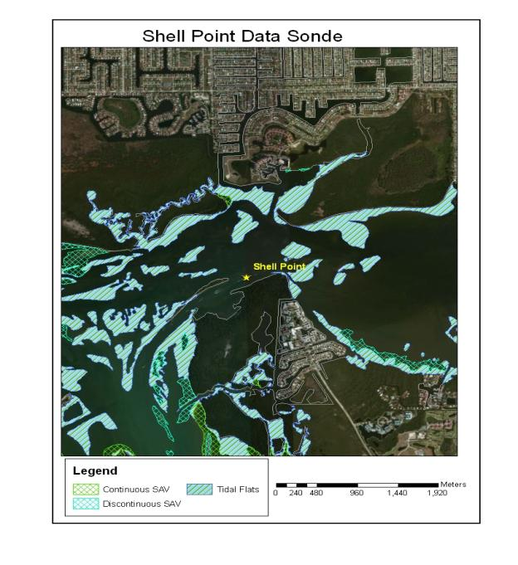
Time Series plots of daily average DO, DOSAT, and salinity conditions recorded at the Shell Point site are presented in Figures 7.17 – 7.19. Daily mean salinities indicated that marine conditions prevailed at this site (minimum daily average salinity was 4.8 PSU). Daily ranges in DO and DOSAT are graphed in Figures 7.20 and 7.21. A statistical summary of the daily average for DO and DOSAT is given in Table 7.3. Approximately 25 percent of the daily minimum and daily average DO values were below the Class III marine criteria of 4 mg/L and 5 mg/L, respectively.
Figure 7.17. Station Shell Point Daily Average DO Time Series

Figure 7.18. Station Shell Point Daily Average DOSAT Time Series

Figure 7.19. Station Shell Point Daily Average Salinity Time Series

Figure 7.20. Station Shell Point Daily DO Range Time Series

Figure 7.21. Station Shell Point Daily DOSAT Range Time Series

Table 7.3. Summary Statistics for Station Shell Point Daily Average DO and DOSAT
Statistic | DO  Daily Ave | DO  Daily Min | DO  Daily Range | DOSAT  Daily Ave | DOSAT  Daily Min | DOSAT  Daily Range
N of cases | 1257 | 1257 | 1257 | 1257 | 1257 | 1257
Minimum | 2.17 | 0.00 | 0.34 | 32.74 | 0.00 | 3.94
Maximum | 9.31 | 9.03 | 6.37 | 102.64 | 98.64 | 93.72
Mean | 5.93 | 5.10 | 1.65 | 83.24 | 70.71 | 25.03
Standard Dev | 1.22 | 1.46 | 0.85 | 12.15 | 14.98 | 13.66
1 % | 3.18 | 2.32 | 0.46 | 47.52 | 34.64 | 5.54
5 % | 3.92 | 2.90 | 0.62 | 56.28 | 43.50 | 8.28
10 % | 4.42 | 3.28 | 0.73 | 65.92 | 49.40 | 9.96
20 % | 4.92 | 3.78 | 0.92 | 74.47 | 57.63 | 12.85
25 % | 5.07 | 3.96 | 1.01 | 77.31 | 60.79 | 14.30
30 % | 5.22 | 4.10 | 1.09 | 79.81 | 62.97 | 15.34
40 % | 5.52 | 4.49 | 1.28 | 83.69 | 68.12 | 18.07
50 % | 5.93 | 5.01 | 1.48 | 86.19 | 73.21 | 22.29
60 % | 6.24 | 5.51 | 1.72 | 88.23 | 77.16 | 26.58
70 % | 6.61 | 6.00 | 2.00 | 90.68 | 80.54 | 31.60
75 % | 6.79 | 6.24 | 2.14 | 91.89 | 82.35 | 33.77
80 % | 6.97 | 6.46 | 2.30 | 93.18 | 84.04 | 36.80
90 % | 7.57 | 7.10 | 2.75 | 96.29 | 88.71 | 43.31
95 % | 8.02 | 7.56 | 3.10 | 98.14 | 91.91 | 49.76
99 % | 8.62 | 8.18 | 4.54 | 101.37 | 95.12 | 64.21

Daily minimum, maximum, and average measurements of DO and DOSAT taken during the worktime period of 8 AM to 5 PM were used to calculate the corresponding DO and DOSAT ranges for comparison with the daily average DO and DOSAT concentrations. Worktime averages and ranges in DO and DOSAT are illustrated in Figures 7.22 – 7.25, respectively. Worktime daily minimum and maximum values were compared to the daily average value to evaluate how a grab sample collected during typical worktime hours would compare to the daily average. The daily worktime minimum and maximum DO and DOSAT values were used with the corresponding daily values to assess the relative range in a grab sample around the daily average. Cumulative frequency plots of the worktime daily ranges for DO and DOSAT are shown in Figures 7.26 and 7.27. Distributions around the daily average using both the worktime minimum and worktime maximum were very similar. A statistical summary for the cumulative frequency based upon the larger relative differences are given in Table 7.4. Both DO and DOSAT worktime measurements would be on average within 14 percent of the respective daily average.
Figure 7.22. Station Shell Point Worktime Daily DO Average Time Series

Figure 7.23. Station Shell Point Worktime Daily DOSAT Average Time Series

Figure 7.24. Station Shell Point Worktime Daily DO Range Time Series

Figure 7.25. Station Shell Point Worktime Daily DOSAT Range Time Series

Figure 7.26. Station Shell Point Cumulative Frequency Plot of Worktime Daily Minimum and Maximum as a Percent of Daily DO Average
Figure 7.27. Station Shell Point Cumulative Frequency Plot of Worktime Daily DOSAT Minimum and Maximum as a Percent of Daily DOSAT Average
Table 7.4. Summary Statistics for Station Shell Point Worktime Daily DO and DOSAT Ranges as a Fraction of Daily Averages
Statistic | Daily DO Range Fraction | Daily DOSAT Range Fraction
N of cases | 1246 | 1245
Minimum | -0.24 | -1.01
Maximum | 109.12 | 106.82
Mean | 12.57 | 13.47
Standard Dev | 9.02 | 9.28
1 % | 1.48 | 1.47
5 % | 3.03 | 3.30
10 % | 3.86 | 4.30
20 % | 5.55 | 6.08
25 % | 6.31 | 6.86
30 % | 7.14 | 7.79
40 % | 8.78 | 9.41
50 % | 10.59 | 11.34
60 % | 12.74 | 13.51
70 % | 15.05 | 16.37
75 % | 16.34 | 17.99
80 % | 18.08 | 19.44
90 % | 23.48 | 25.59
95 % | 28.37 | 30.25
99 % | 50.02 | 46.02

Hourly measurements were averaged to illustrate the diel pattern in DO and DOSAT at Shell Point (Figures 7.28 and 7.29). The overall mean DO (6.18 mg/L) and DOSAT (79.55 %) are included on the figures. Daily minimum and maximum values typically occur around 8 AM and 5 PM, respectively.
Figure 7.28. Shell Point Diurnal DO Pattern

Figure 7.29. Shell Point Diurnal DOSAT Pattern

Redfish Pass
The sonde is located in Pine Island Sound near the Redfish Pass that separated North Captiva Island from Captiva Island, approximately 3.1 km from the Gulf of Mexico. The average depth of sonde measurements was 1.8 meters (total depth is 3.0 m). Tides are mixed with a mean range of 0.94 feet. Observations were available starting in October 2007. Nearfield characteristics of the site are shown in Figure 7.30.
Figure 7.30. Redfish Pass Data Sonde Location
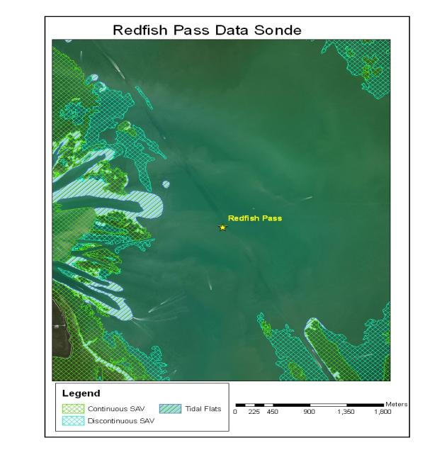
Time Series plots of daily average DO, DOSAT, and salinity conditions recorded at the Redfish Pass site are presented in Figures 7.31 – 7.33. Daily mean salinities indicated that marine conditions prevailed at this site (minimum daily average salinity was 13.2 PSU). Daily ranges in DO and DOSAT are graphed in Figures 7.34 and 7.35. A statistical summary of the daily average for DO and DOSAT is given in Table 7.5. Less than 5 percent of the daily minimum and daily average DO values were below the Class III marine criteria of 4 mg/L and 5 mg/L, respectively.
Figure 7.31. Station Redfish Pass Daily Average DO Time Series

Figure 7.32. Station Redfish Pass Daily Average DOSAT Time Series

Figure 7.33. Station Redfish Pass Daily Average Salinity Time Series

Figure 7.34. Station Redfish Pass Daily DO Range Time Series

Figure 7.35. Station Redfish Pass Daily DOSAT Range Time Series

Table 7.5. Summary Statistics for Station Redfish Pass Daily Average DO and DOSAT
Statistic | DO  Daily Ave | DO  Daily Min | DO  Daily Range | DOSAT  Daily Ave | DOSAT  Daily Min | DOSAT  Daily Range
N of cases | 1381 | 1381 | 1381 | 1381 | 1381 | 1381
Minimum | 0.40 | 0.39 | 0.04 | 6.01 | 5.73 | 0.27
Maximum | 9.19 | 8.93 | 5.92 | 127.63 | 127.50 | 100.87
Mean | 6.54 | 5.81 | 1.53 | 94.93 | 83.57 | 23.87
Standard Dev | 1.05 | 1.26 | 0.87 | 11.97 | 13.56 | 14.05
1 % | 1.56 | 1.01 | 0.32 | 23.04 | 16.43 | 4.07
5 % | 5.21 | 4.05 | 0.53 | 80.21 | 62.28 | 7.40
10 % | 5.59 | 4.46 | 0.64 | 85.94 | 70.00 | 8.98
20 % | 5.92 | 4.92 | 0.82 | 91.23 | 77.20 | 11.73
25 % | 6.03 | 5.06 | 0.89 | 92.55 | 79.42 | 13.10
30 % | 6.15 | 5.23 | 0.99 | 93.53 | 81.00 | 14.37
40 % | 6.36 | 5.48 | 1.15 | 95.29 | 84.02 | 17.31
50 % | 6.53 | 5.77 | 1.34 | 96.61 | 86.25 | 20.84
60 % | 6.73 | 6.14 | 1.58 | 97.90 | 88.44 | 25.21
70 % | 6.99 | 6.42 | 1.84 | 99.31 | 90.63 | 29.44
75 % | 7.15 | 6.60 | 2.01 | 100.15 | 91.84 | 31.80
80 % | 7.35 | 6.85 | 2.15 | 100.95 | 92.79 | 34.59
90 % | 7.80 | 7.43 | 2.62 | 103.76 | 95.45 | 42.07
95 % | 8.04 | 7.68 | 3.10 | 106.99 | 97.46 | 49.32
99 % | 8.52 | 8.22 | 4.71 | 115.10 | 101.06 | 70.73

Daily minimum, maximum, and average measurements of DO and DOSAT taken during the worktime period of 8 AM to 5 PM were used to calculate the corresponding DO and DOSAT ranges for comparison with the daily average DO and DOSAT concentrations. Worktime averages and ranges in DO and DOSAT are illustrated in Figures 7.36 – 7.39, respectively. Worktime daily minimum and maximum values were compared to the daily average value to evaluate how a grab sample collected during typical worktime hours would compare to the daily average. The daily worktime minimum and maximum DO and DOSAT values were used with the corresponding daily values to assess the relative range in a grab sample around the daily average. Cumulative frequency plots of the worktime daily ranges for DO and DOSAT are shown in Figures 7.40 and 7.41. Distributions around the daily average using both the worktime minimum and worktime maximum were very similar. A statistical summary for the cumulative frequency based upon the larger relative differences are given in Table 7.6. Both DO and DOSAT worktime measurements would be on average within 11 percent of the respective daily average.
Figure 7.36. Station Redfish Pass Worktime Daily DO Average Time Series

Figure 7.37. Station Redfish Pass Worktime Daily DOSAT Average Time Series

Figure 7.38. Station Redfish Pass Worktime Daily DO Range Time Series

Figure 7.39. Station Redfish Pass Worktime Daily DOSAT Range Time Series

Figure 7.40. Station Redfish Pass Cumulative Frequency Plot of Worktime Daily Minimum and Maximum as a Percent of Daily DO Average
Figure 7.41. Station Redfish Pass Cumulative Frequency Plot of Worktime Daily DOSAT Minimum and Maximum as a Percent of Daily DOSAT Average
Table 7.6. Summary Statistics for Station Redfish Pass Worktime Daily DO and DOSAT Ranges as a Fraction of Daily Averages
Statistic | Daily DO Range Fraction | Daily DOSAT Range Fraction
N of cases | 1361 | 1361
Minimum | -20.89 | -21.29
Maximum | 77.17 | 77.19
Mean | 10.12 | 10.66
Standard Dev | 7.58 | 7.55
1 % | 1.13 | 1.26
5 % | 2.08 | 2.64
10 % | 2.78 | 3.38
20 % | 4.07 | 4.57
25 % | 4.88 | 5.50
30 % | 5.72 | 6.18
40 % | 6.89 | 7.53
50 % | 8.54 | 9.20
60 % | 10.65 | 11.15
70 % | 12.62 | 13.21
75 % | 13.69 | 14.31
80 % | 14.90 | 15.46
90 % | 18.69 | 19.18
95 % | 22.29 | 22.41
99 % | 34.98 | 35.81

Hourly measurements were averaged to illustrate the diel pattern in DO and DOSAT at Redfish Pass (Figures 7.42 and 7.43). The overall mean DO (6.53 mg/L) and DOSAT (96.61 %) are included on the figures. Daily minimum and maximum values typically occur around 8 AM and 7 PM, respectively.
Figure 7.42. Redfish Pass Diurnal DO Pattern

Figure 7.43. Redfish Pass Diurnal DOSAT Pattern

Blind Pass
The sonde is located in Pine Island Sound near Blind Pass that separated Sanibel and Captiva Islands, approximately 4.4 km from the Gulf of Mexico. According to the RECON site description, Blind Pass as a low or no volume inlet until August 2009 that periodically opened naturally through storms or through dredging. Since late 2009 it has remained open with dredging. The average depth of sonde measurements was 2.16 meters (total depth is 3.61 m). Tides are mixed with a mean range of 0.94 feet. Observations were available starting in October 2007. Nearfield characteristics of the site are shown in Figure 7.44.
Figure 7.44. Blind Pass Data Sonde Location
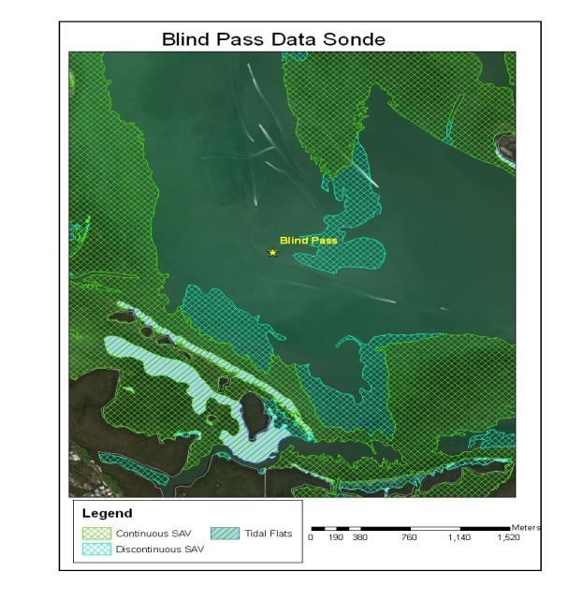
Time Series plots of daily average DO, DOSAT, and salinity conditions recorded at the Blind Pass site are presented in Figures 7.45 – 7.47. Daily mean salinities indicated that marine conditions prevailed at this site (minimum daily average salinity was 19.9 PSU). Daily ranges in DO and DOSAT are graphed in Figures 7.48 and 7.49. A statistical summary of the daily average for DO and DOSAT is given in Table 7.7. Less than 5 percent of the daily minimum and daily average DO values were below the Class III marine criteria of 4 mg/L and 5 mg/L, respectively.
Figure 7.45. Station Blind Pass Daily Average DO Time Series

Figure 7.46. Station Blind Pass Daily Average DOSAT Time Series

Figure 7.47. Station Blind Pass Daily Average Salinity Time Series

Figure 7.48. Station Blind Pass Daily DO Range Time Series

Figure 7.49. Station Blind Pass Daily DOSAT Range Time Series

Table 7.7. Summary Statistics for Station Blind Pass Daily Average DO and DOSAT
Statistic | DO  Daily Ave | DO  Daily Min | DO  Daily Range | DOSAT  Daily Ave | DOSAT  Daily Min | DOSAT  Daily Range
N of cases | 1084 | 1084 | 1084 | 1084 | 1084 | 1084
Minimum | 2.10 | 0.01 | 0.18 | 32.68 | 0.14 | 2.49
Maximum | 8.11 | 8.01 | 6.10 | 113.50 | 101.21 | 91.12
Mean | 6.24 | 5.63 | 1.30 | 89.96 | 80.56 | 20.35
Standard Dev | 0.81 | 1.02 | 0.71 | 8.46 | 10.47 | 11.71
1 % | 4.32 | 3.03 | 0.33 | 65.44 | 48.55 | 4.34
5 % | 4.97 | 4.03 | 0.45 | 76.16 | 62.14 | 6.36
10 % | 5.20 | 4.40 | 0.54 | 80.34 | 68.31 | 7.72
20 % | 5.56 | 4.80 | 0.69 | 84.71 | 73.64 | 9.97
25 % | 5.71 | 4.95 | 0.75 | 85.72 | 75.71 | 11.09
30 % | 5.84 | 5.09 | 0.82 | 86.80 | 77.55 | 12.21
40 % | 6.07 | 5.38 | 1.00 | 88.74 | 80.25 | 15.10
50 % | 6.26 | 5.71 | 1.17 | 90.46 | 82.34 | 18.06
60 % | 6.48 | 5.98 | 1.35 | 92.50 | 84.40 | 21.45
70 % | 6.68 | 6.22 | 1.57 | 94.14 | 86.42 | 25.19
75 % | 6.79 | 6.36 | 1.69 | 95.14 | 87.38 | 27.31
80 % | 6.87 | 6.50 | 1.85 | 96.17 | 88.61 | 29.77
90 % | 7.26 | 6.88 | 2.19 | 99.55 | 91.28 | 35.34
95 % | 7.53 | 7.21 | 2.57 | 102.08 | 93.15 | 41.46
99 % | 7.94 | 7.73 | 3.74 | 107.38 | 96.96 | 60.20

Daily minimum, maximum, and average measurements of DO and DOSAT taken during the worktime period of 8 AM to 5 PM were used to calculate the corresponding DO and DOSAT ranges for comparison with the daily average DO and DOSAT concentrations. Worktime averages and ranges in DO and DOSAT are illustrated in Figures 7.50 – 7.53, respectively. Worktime daily minimum and maximum values were compared to the daily average value to evaluate how a grab sample collected during typical worktime hours would compare to the daily average. The daily worktime minimum and maximum DO and DOSAT values were used with the corresponding daily values to assess the relative range in a grab sample around the daily average. Cumulative frequency plots of the worktime daily ranges for DO and DOSAT are shown in Figures 7.54 and 7.55. Distributions around the daily average using both the worktime minimum and worktime maximum were very similar. A statistical summary for the cumulative frequency based upon the larger relative differences are given in Table7. 8. Both DO and DOSAT worktime measurements would be on average within 10 percent of the respective daily average.
Figure 7.50. Station Blind Pass Worktime Daily DO Average Time Series

Figure 7.51. Station Blind Pass Worktime Daily DOSAT Average Time Series

Figure 7.52. Station Blind Pass Worktime Daily DO Range Time Series

Figure 7.53. Station Blind Pass Worktime Daily DOSAT Range Time Series

Figure 7.54. Station Blind Pass Cumulative Frequency Plot of Worktime Daily Minimum and Maximum as a Percent of Daily DO Average
Figure 7.55. Station Blind Pass Cumulative Frequency Plot of Worktime Daily DOSAT Minimum and Maximum as a Percent of Daily DOSAT Average
Table 7.8. Summary Statistics for Station Blind Pass Worktime Daily DO and DOSAT Ranges as a Fraction of Daily Averages
Statistic | Daily DO Range Fraction | Daily DOSAT Range Fraction
N of cases | 1074 | 1074
Minimum | 0.24 | 0.00
Maximum | 99.79 | 99.79
Mean | 8.90 | 9.41
Standard Dev | 6.65 | 6.60
1 % | 0.70 | 1.15
5 % | 1.92 | 2.42
10 % | 2.76 | 3.17
20 % | 3.88 | 4.39
25 % | 4.34 | 4.92
30 % | 4.92 | 5.48
40 % | 6.24 | 6.67
50 % | 7.48 | 8.05
60 % | 9.21 | 9.76
70 % | 10.94 | 11.57
75 % | 11.87 | 12.36
80 % | 13.29 | 13.78
90 % | 16.10 | 16.59
95 % | 19.69 | 20.11
99 % | 30.37 | 30.48

Hourly measurements were averaged to illustrate the diel pattern in DO and DOSAT at Blind Pass (Figures 7.56 and 7.57). The overall mean DO (6.26 mg/L) and DOSAT (90.46 %) are included on the figures. Daily minimum and maximum values typically occur around 9 AM and 6 PM, respectively.
Figure 7.56. Blind Pass Diurnal DO Pattern

Figure 7.57. Blind Pass Diurnal DOSAT Pattern

Gulf of Mexico
The sonde is located in the Gulf of Mexico, approximately 1,500 m offshore of Fort Myers Beach. The average depth of sonde measurements was 2.47 meters (total depth is 5.07 m). Tides are mixed with a mean range of 0.94 feet. Observations were available starting in November 2007. Nearfield characteristics of the site are shown in Figure 7.58.
Figure 7.58. Gulf of Mexico Data Sonde Location
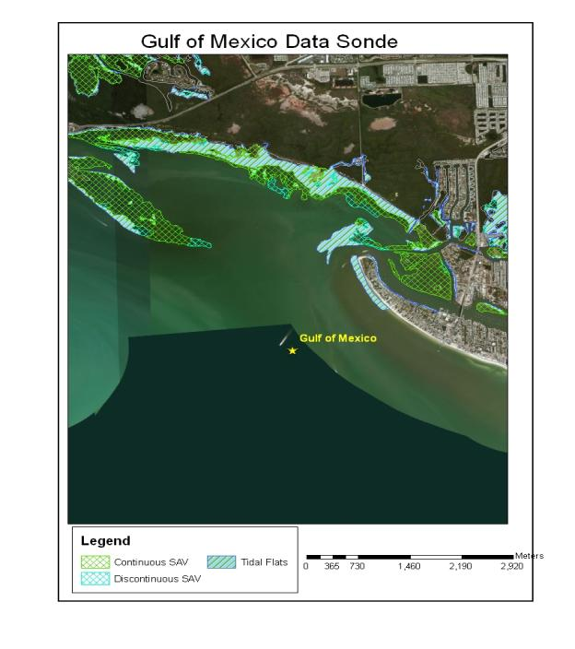
Time Series plots of daily average DO, DOSAT, and salinity conditions recorded at the Blind Pass site are presented in Figures 7.59 – 7.61. Daily mean salinities indicated that marine conditions prevailed at this site (minimum daily average salinity was 26.6 PSU). Daily ranges in DO and DOSAT are graphed in Figures 7.62 and 7.63. A statistical summary of the daily average for DO and DOSAT is given in Table 7.9. Less than 5 percent of the daily minimum and daily average DO values were below the Class III marine criteria of 4 mg/L and 5 mg/L, respectively.
Figure 7.59. Station Gulf of Mexico Daily Average DO Time Series

Figure 7.60. Station Gulf of Mexico Daily Average DOSAT Time Series

Figure 7.61. Station Gulf of Mexico Daily Average Salinity Time Series

Figure 7.62. Station Gulf of Mexico Daily DO Range Time Series

Figure 7.63. Station Gulf of Mexico Daily DOSAT Range Time Series

Table 7.9. Summary Statistics for Station Gulf of Mexico Daily Average DO and DOSAT
Statistic | DO  Daily Ave | DO  Daily Min | DO  Daily Range | DOSAT  Daily Ave | DOSAT  Daily Min | DOSAT  Daily Range
N of cases | 1096 | 1096 | 1096 | 1096 | 1096 | 1096
Minimum | 0.04 | 0.04 | 0.01 | 0.60 | 0.56 | 0.15
Maximum | 8.84 | 8.65 | 3.59 | 114.17 | 104.74 | 58.44
Mean | 6.37 | 5.88 | 1.03 | 92.24 | 84.47 | 16.28
Standard Dev | 0.95 | 1.08 | 0.54 | 10.14 | 10.90 | 9.10
1 % | 4.39 | 3.43 | 0.27 | 62.85 | 50.95 | 3.89
5 % | 5.03 | 4.37 | 0.38 | 80.17 | 68.75 | 5.34
10 % | 5.40 | 4.61 | 0.45 | 84.45 | 72.60 | 6.47
20 % | 5.75 | 5.04 | 0.56 | 88.13 | 78.65 | 8.37
25 % | 5.84 | 5.21 | 0.62 | 89.26 | 80.62 | 9.16
30 % | 5.96 | 5.34 | 0.67 | 90.50 | 81.89 | 10.10
40 % | 6.16 | 5.62 | 0.78 | 91.99 | 84.47 | 12.00
50 % | 6.35 | 5.87 | 0.90 | 93.14 | 86.50 | 14.33
60 % | 6.55 | 6.13 | 1.05 | 94.44 | 88.43 | 16.84
70 % | 6.79 | 6.42 | 1.25 | 95.86 | 89.98 | 19.88
75 % | 7.03 | 6.63 | 1.31 | 96.70 | 90.88 | 21.41
80 % | 7.15 | 6.83 | 1.44 | 97.63 | 91.86 | 23.57
90 % | 7.52 | 7.22 | 1.75 | 100.67 | 93.97 | 28.88
95 % | 7.77 | 7.54 | 2.09 | 104.16 | 95.94 | 33.96
99 % | 8.22 | 8.00 | 2.63 | 109.10 | 100.57 | 43.15

Daily minimum, maximum, and average measurements of DO and DOSAT taken during the worktime period of 8 AM to 5 PM were used to calculate the corresponding DO and DOSAT ranges for comparison with the daily average DO and DOSAT concentrations. Worktime averages and ranges in DO and DOSAT are illustrated in Figures 7.64 – 7.67, respectively. Worktime daily minimum and maximum values were compared to the daily average value to evaluate how a grab sample collected during typical worktime hours would compare to the daily average. The daily worktime minimum and maximum DO and DOSAT values were used with the corresponding daily values to assess the relative range in a grab sample around the daily average. Cumulative frequency plots of the worktime daily ranges for DO and DOSAT are shown in Figures 7.68 and 7.69. Distributions around the daily average using both the worktime minimum and worktime maximum were very similar. A statistical summary for the cumulative frequency based upon the larger relative differences are given in Table 7.10. Both DO and DOSAT worktime measurements would be on average within 8 percent of the respective daily average.
Figure 7.64. Station Gulf of Mexico Worktime Daily DO Average Time Series

Figure 7.65. Station Gulf of Mexico Worktime Daily DOSAT Average Time Series

Figure 7.66. Station Gulf of Mexico Worktime Daily DO Range Time Series

Figure 7.67. Station Gulf of Mexico Worktime Daily DOSAT Range Time Series

Figure 7.68. Station Gulf of Mexico Cumulative Frequency Plot of Worktime Daily Minimum and Maximum as a Percent of Daily DO Average
Figure 7.69. Station Gulf of Mexico Cumulative Frequency Plot of Worktime Daily DOSAT Minimum and Maximum as a Percent of Daily DOSAT Average
Table 7.10. Summary Statistics for Station Gulf of Mexico Worktime Daily DO and DOSAT Ranges as a Fraction of Daily Averages
Statistic | Daily DO Range Fraction | Daily DOSAT Range Fraction
N of cases | 1084 | 1084
Minimum | -1.51 | -0.48
Maximum | 39.75 | 40.13
Mean | 6.91 | 7.41
Standard Dev | 4.94 | 4.96
1 % | 0.26 | 0.87
5 % | 1.29 | 1.94
10 % | 2.06 | 2.48
20 % | 2.96 | 3.49
25 % | 3.39 | 3.96
30 % | 3.87 | 4.41
40 % | 4.72 | 5.15
50 % | 5.71 | 6.14
60 % | 6.77 | 7.28
70 % | 8.39 | 8.82
75 % | 9.47 | 9.81
80 % | 10.34 | 10.72
90 % | 13.17 | 13.88
95 % | 16.59 | 17.20
99 % | 22.78 | 23.51

Hourly measurements were averaged to illustrate the diel pattern in DO and DOSAT at the Gulf of Mexico site (Figures 7.70 and 7.71). The overall mean DO (6.35 mg/L) and DOSAT (93.14 %) are included on the figures. Daily minimum and maximum values typically occur around 8 AM and 7 PM, respectively.
Figure 7.70. Gulf of Mexico Diurnal DO Pattern

Figure 7.71. Gulf of Mexico Diurnal DOSAT Pattern

