To: | Mohammad Sayemuzzaman, DEP
Cc: | Ansel Bubel, DEP  Sara Davis, DEP  Doug Gilbert, DEP  Erin Rasnake, DEP
From: | Brian Watson, PE, PH, D.WRE, Tetra Tech  Matt Burnette, Tetra Tech  Marcy Frick, REM, Tetra Tech  Nikolai Gurdian, Tetra Tech  Erin Lincoln, PH, Tetra Tech
Date: | May 13, 2016, revised June 17, 2016, revised July 5, 2016, revised July 29, 2016, revised August 5, 2016
Subject: | Caloosahatchee River Watershed Model Review and Calibration Refinement –  Draft Task 2 HSPF Model Setup and Hydrology Calibration Results and Recommendations

Table of Contents
1.0 Introduction 4
2.0 Summary 4
3.0 HSPF model Set UP 6
3.1 Subbasin Delineations 6
3.1.1 Reaches with Bidirectional Flow from Tidal Propagation 9
3.1.2 F-TABLE Adjustments 9
3.2 Weather Data 10
3.2.1 NEXRAD Data Processing 11
3.2.2 Comparison to National Climatic Data Center (NCDC) Summary of the Day (SOD) Data 11
3.2.3 Comparison to Lee County Data 18
3.2.4 Storm Event Comparison 21
3.2.5 Climate Data Processing 22
3.3 Land Use Coverage 27
3.3.1 Impervious Land Use Coverage Comparison 27
3.3.2 Pervious Land Use Coverage Comparison 29
3.3.3 Land Use Processing 34
3.4 Agricultural Irrigation Representation 36
3.4.1 Agricultural Irrigation Water Demand 36
3.4.2 Agricultural Irrigation Water Supply Sources 41
3.4.3 Agricultural Irrigation Pumping 47
3.5 Point Sources and Reuse Facilities 50
3.5.1 Available Data 54
3.5.2 Missing Data Assumptions 58
3.5.3 Reuse Water Quality Concentration Research 59
3.6 Septic Systems 60
3.7 Model Parameterization 64
3.7.1 Parameterization Adjustment 64
3.7.2 Parameter Sensitivity Analysis 65
3.8 Specialized Hydrologic and Hydraulic Representations 70
3.8.1 S-4 Basin and Industrial Canal 70
3.8.2 Jacks Branch 72
3.8.3 Fast Creek 74
4.0 HSPF Model Calibration 77
4.1 Flow Calibration 77
4.1.1 USGS Gage Calibration 81
4.1.2 DEP Gage Calibration 83
4.2 Calibration Issues 83
5.0 References 85
Appendix A: Draft 2017 HSPF Flow Calibration Results (observed Negative flows removed) 88
A-1 USGS Gages Calibration Comparison 89
A-2 DEP Gage Calibration Comparison 128
Appendix B: Draft 2017 HSPF Flow Calibration Results (observed Negative flows REPLACED with 0 cfs) 136
B-1 USGS Gages Calibration Comparison 137
B-2 DEP Gage Calibration Comparison 176
Appendix C: 2014 HSPF Flow Calibration Results 184
C-1 USGS Gage Comparison 185
C-1 DEP Gage Comparison 224

Introduction
Tetra Tech and AMEC were contracted by the Florida Department of Environmental Protection (department) to address department and stakeholder issues regarding the setup and calibration of the current versions of the Caloosahatchee River and Estuary Hydrologic Simulation Program – FORTRAN (HSPF) and Environmental Fluid Dynamics Code (EFDC) models. These models will be used to develop total maximum daily loads (TMDLs) for impaired freshwater bodies within the Caloosahatchee River Watershed and to refine the Caloosahatchee tidal estuary TMDLs that the department adopted in 2009. The department provided Tetra Tech with the HSPF model files, as well as the associated report developed by Dynamic Solutions and CDM in 2009. The department provided the EFDC modeling report developed by Dynamic Solutions and CDM in 2009, but did not provide the associated EFDC modeling files. Since 2009, the department has made modifications to both the HSPF and EFDC models, including extending the model simulation time and adjusting the delineation boundaries. The revised HSPF and EFDC model files were provided for review in this project.
The second task in this project was to update the HSPF model to address the recommendations from Task 1 and to evaluate the model’s hydrology calibration. The results presented in this memo are the preliminary hydrology calibration results, and recommendations to improve the hydrology calibration are provided. Based on feedback from the department, Tetra Tech will implement the recommendations to improve the hydrology calibration, as needed.

Summary
During Task 2, Tetra Tech focused the HSPF model updates on the recommendations from the Task 1 memorandum to address major department and stakeholder comments, as well as issues that Tetra Tech identified with the original model that would limit the model’s ability to provide the information needed for the TMDL and basin management action plan (BMAP). For this task, Tetra Tech processed all new data input files for the full model simulation period (January 1, 1996 – December 31, 2014). The department was unable to provide Tetra Tech with the original data processing sheets and information about processing methodologies; therefore, all files had to be reprocessed to ensure that a consistent method was used for the full model simulation period. The initial model calibration for this task focused on the hydrology results in comparison to available measured data in the watershed. The major modifications and changes made by Tetra Tech to the HSPF model are as follows:
- Extended the model simulation period through December 31, 2014 (the 2014 HSPF Model ended on December 31, 2011).
- Updated the model subbasin delineations by delineating to U.S. Geological Survey (USGS) and department flow stations, and delineating to major pumping structures and some major weirs. Delineation to these features will allow hydrology calibration to USGS and department gages, and will assist with representation of agricultural pumping and water transport in the watershed.
- Adjusted reach F-TABLES to represent ponding that occurs behind weirs in the watershed.
- Conducted comparisons of the Next-Generation Radar (NEXRAD) weather data to other rainfall sources to address stakeholder concerns about the applicability of the NEXRAD data for use in the model.
- Processed the NEXRAD rainfall data for use in the model, and processed South Florida Water Management District (SFWMD), Page Field Airport in Fort Myers, and Surface Airways weather station air temperature, dew point temperature, wind speed, cloud cover, evaporation, and solar radiation data for use in the model.
- Compared the 2004, 2008-2009, and 2014 SFWMD land use coverages and compared the 2006 and 2011 National Land Cover Database (NLCD) coverages to determine what changes in land use occurred during the model simulation time period and where these changes occurred.
- Updated the model land use to the 2008-2009 SFWMD coverage to better represent the model time period and to address stakeholder comments about using a more recent land use coverage in the model.
- Added additional land use classifications to better represent the land uses in the watershed, including adding new agricultural classifications to meet requests by the Florida Department of Agriculture and Consumer Services (FDACS). Also added a separate Florida Department of Transportation (FDOT) right-of-way classification.
- Updated effective impervious land use representation using the 2011 NLCD coverage and Sutherland 1995 methodology.
- Mapped the 2014 HSPF Model NEXRAD and land use hydrology parameterization to the new 2017 HSPF Model NEXRAD and land use hydrology parameterization.
- Adjusted model parameterization during the hydrology calibration process to ensure parameters were within suggested literature ranges and to improve model calibration.
- Developed new agricultural irrigation demand time series for five different crop classifications to address stakeholder comments. Changed irrigation water sources to surface water and ground water to better represent irrigation sources.
- Revised the representation of point sources in the watershed and development new assumptions to address incomplete discharge water quality data records.
- Processed reuse facilities for inclusion in the 2017 HSPF Model to more accurately simulate the flows and loads from these sources. Reuse facilities were not included in the previous models.
- Processed septic systems for inclusion in the 2017 HSPF Model, to reflect the septic system loadings in the watershed. Septic systems were not included in the previous models.

HSPF model Set UP

Subbasin Delineations
The Caloosahatchee River Watershed was divided into 102 subbasins in the 2009 and 2014 HSPF Model setups. The subbasin boundaries were delineated using the department’s waterbody identification (WBID) number boundaries, topographic data, and the USGS high resolution National Hydrography Dataset (NHD) (DSLLC and CDM 2009). Tetra Tech revised the 2014 HSPF Model subbasin delineation based on the recommendations provided in the Task 1 memo. Tetra Tech created a new subbasin for the Ninemile Canal, extended the Deep Lagoon Canal subbasin further south based on Lee County recommendations, and delineated to the following four flow stations that were not located near an HSPF subbasin outlet (Figure 1):
- USGS Station 264514080550700 (Industrial Canal at Clewiston)
- USGS Station 02293055 (Orange River near Buckingham)
- USGS Station 264006082000000 (Hancock Creek at Pondella Road)
- DEP Station Yellow Fever Creek (Yellow Fever Creek)
Pumping for agricultural irrigation, and its subsequent bidirectional flow, is known to occur in the southeast area of the Caloosahatchee River Watershed. Pumping is also known to occur at S-77 for flood protection, causing bidirectional flow to occur between S-77 and S-78 structures. In order to identify locations where the agricultural irrigation pumping structures and weirs are located, Tetra Tech conducted a desktop analysis of the agricultural areas of the Caloosahatchee River Watershed. In the southeastern agricultural areas, 18 major pumping structures were identified, along with 59 weir structures, some of which had minor pumping structures. The major pumping structures in the agricultural region were located on reaches that had been identified as having bidirectional flow in the Task 1 memo:
- Townsend Canal
- C-3
- Hilliard Canal
- Flaghole Canal
- Disston Canal
- Industrial Canal
In order to represent the agricultural irrigation pumping that occurred on these canals, the model was redelineated to the pumping structures located on the Townsend Canal, C-3, Hilliard Canal, Flaghole Canal, and Industrial Canal. Tetra Tech also bisected four other long, narrow subbasins located in the southeastern region to provide additional detail and flexibility when representing the subbasin transfers and water storage that occurs in the region due to agricultural irrigation.
The revised 2017 HSPF Model consists of 121 discrete subbasins. The revised Caloosahatchee River Watershed HSPF delineation is provided in Figure 2.
Figure 1: Flow stations in the Caloosahatchee River Watershed
Figure 2: Revised subbasin delineation for the Caloosahatchee River Watershed HSPF model

Reaches with Bidirectional Flow from Tidal Propagation
Several reaches located downstream of S-79 have bidirectional flow caused by tidal propagation. Reaches downstream of S-79 that are not tidally influenced, such as Whiskey Creek, have channel features or structures located near their confluence with the Caloosahatchee River that prevent the tide from moving upstream into the HSPF model reach and subbasin. The following reaches were identified as having bidirectional flow caused by tidal propagation:
- Cape Coral Canals
- Deep Lagoon Canal
- Yellow Fever Creek
- Billy Creek
- Orange River
- Popash Creek
- Telegraph Creek
The Caloosahatchee EFDC model will be extended into the tidally influenced reaches downstream of S-79 that have measured flow data or are located in an impaired WBID, including the Cape Coral canals, Deep Lagoon Canal and nearby inlets, Billy Creek, Yellow Fever Creek, and Popash Creek. The HSPF model will provide the watershed flows and water quality loadings to the EFDC model. The EFDC model will simulate hydrodynamics and in-stream water quality of the tidal reaches, including the influence of the Caloosahatchee River on the reach water quality.

F-TABLE Adjustments
Of the 121 subbasins in the 2017 HSPF Model, 109 drain to a representative reach. There are 12 subbasins that do not have reaches, and these subbasins drain directly to the Caloosahatchee Estuary. In addition, there are 10 transport reaches that do not have a contributing area that connect other reaches in the model, and these transport reaches typically represent drainage canals. Each reach has a function table (F-TABLE) that describes the hydrology of the segment by defining the functional relationship between water depth, surface area, water volume, and outflow in the segment.
The 2009 HSPF Model calculated F-TABLES using cross-section data provided by SFWMD, as well as topographic data. SFWMD compiled the cross-section data for the Caloosahatchee River, Jacks Branch, County Line Ditch, Canal 1, Canal 2, C-19, 42-foot canal, and Hilliard Canal, which came from various unnamed sources. These data were used for the development of the MIKE-SHE model of the Caloosahatchee River (DSLLC and CDM 2009). The cross-sections for the remaining reach segments were estimated using topographic data.
The revised subbasin delineation used for 2017 HSPF Model required that some model reaches be split. The F-TABLES for these reaches were generated using reach length ratios. Additionally, the existing F-TABLES did not represent the ponding that occurred behind weirs in many of the canal systems. In order to maintain water storage in low-flow conditions, Tetra Tech updated the F-TABLES to represent the effect of the weir structures on the following reaches:

- 42-foot canal
- Able Canal
- Big Island Canal
- C-19
- Canal 1
- Canal 2
- Canal 3
- Disston Main Canal
- Duda Canal
- Flag Hole 5
- Hilliard Canal
- Industrial Canal
- Left HH Canal
- LPDD Header Canal
- Roberts Canal
- SR-229 Ditch
- Townsend Canal
- Various unnamed reaches
For each reach F-TABLE adjusted to maintain ponding during low-flow conditions, Tetra Tech used the top of bank elevation and bottom elevation data that was used in the previously developed MIKE-SHE model to calculate the maximum depth for each reach. It was assumed that each weir maintained a minimum depth equal to one half the maximum reach depth. Below this depth, the outflow in each F-TABLE was set to 0. Above this depth, Tetra Tech recalculated outflow based on the Cipoletti Weir Equation (Equation 1).
$Q=3.367Lh^{3/2}$ (Eq. 1)
where Q is discharge (cfs), L is weir length (ft), and h is head (ft).

The length of each weir was estimated using a Google Earth Pro desktop survey. The Cipoletti Weir Equation assumes that each weir is trapezoidal with 4:1 vertical to horizontal side slopes.

Weather Data
The NEXRAD data were provided by SFWMD for the model simulation period (January 1, 1996 – December 31, 2014). NEXRAD data estimate the amount of precipitation in an area based on radar measurement. The data provide estimates of the spatial and temporal distribution of rainfall, while ground surface rainfall gages provide estimates of rainfall at a specific location. NEXRAD data were used in the 2009 and 2014 HSPF Models. However, Lee County was concerned about the accuracy of the NEXRAD data. Lee County compared averaged values from both the NEXRAD data and the Lee County rainfall gage data and found that there was a wide range in average annual measured rainfall, with percent differences between +78% and -41%. To determine whether the NEXRAD data should be used in the 2017 HSPF Model, Tetra Tech conducted several evaluations to compare the NEXRAD data to other sources.

NEXRAD Data Processing
SFWMD provided the NEXRAD precipitation data at hourly time steps for 2,152 cells, sized 2 km by 2 km, which covered the Caloosahatchee River Watershed. The hourly data were averaged into 15 NEXRAD precipitation zones (Figure 3). The NEXRAD zones corresponded to the subbasin delineation boundaries, and were similar in size, with the average NEXRAD area being 58,700 acres. The NEXRAD zones used in the 2017 HSPF Model setup were identical to the 2009 and 2014 HSPF Models.
The SFWMD NEXRAD precipitation data used the raw reflectivity data produced the National Weather Service radars located at Tampa, Melbourne, Jacksonville, Miami, Tallahassee, and Key West. The raw radar data were adjusted using mean field and local bias corrections to agree with rain gauge observation using a 6-hour moving window. During radar data adjustment, the rain gauge data were reviewed to identify gaps in data and potential errors, and periods where the gauges had identified gaps and/or errors were not used for radar data adjustment. After initial processing, monthly radar precipitation totals were compared to the rain gauge observation to identify any potential radar data inconsistencies that needed to be addressed and corrected to improve the radar precipitation representation (Vieux & Associates 2013).

Comparison to National Climatic Data Center (NCDC) Summary of the Day (SOD) Data
The NCDC SOD precipitation data were compiled and processed for comparison to the NEXRAD data. NEXRAD data were summarized by zone as an average of the associated grid cell values for linkage to the HSPF model (Figure 4), which includes the locations of the local NCDC SOD stations. NCDC station descriptions are listed in Table 1.
Table 1: NCDC SOD precipitation monitoring station information
Station ID | Station Name | Elevation (ft) | County | Latitude | Longitude
081651 | Clewiston No. 2 | 18 | Hendry | 26.736111 | -81.049167
081654 | Clewiston | 20 | Hendry | 26.742222 | -80.940000
082298 | Devils Garden | 20 | Hendry | 26.603333 | -81.129167
083186 | Fort Myers FAA/AP | 15 | Lee | 26.586389 | -81.863611
084662 | LaBelle | 16 | Hendry | 26.743333 | -81.432222
085895 | Moore Haven Lock 1 | 35 | Glades | 26.840000 | -81.087222
086657 | Ortona Lock 2 | 20 | Glades | 26.789722 | -81.304444
087397 | Punta Gorda 4 ESE | 20 | Charlotte | 26.916389 | -81.998333

Figure 3: Caloosahatchee River Watershed NEXRAD zones
Figure 4: Caloosahatchee River Watershed NEXRAD zones and NCDC SOD precipitation monitoring stations
As part of the precipitation data processing procedure, the data time series were assessed using a gap analysis that flagged missing time intervals, where a missing interval was defined as 28 consecutive days without a recorded rainfall event. The identification of missing intervals allows for a quick assessment of the monitoring data quality, where a smaller number of missing intervals indicates monitoring data of higher quality. The percent incompleteness for NCDC SOD and NEXRAD zone data are presented in Table 2 and Table 3, respectively.
Table 2: SOD precipitation monitoring station annual percent incompleteness
Year | 081651 | 081654 | 082298 | 083186 | 084662 | 085895 | 086657 | 087397
1996 | 0%*** | 90%* | 93%* | 0%*** | 87%** | 83%** | 0%*** | 94%*
1997 | 0%*** | 91%* | 88%** | 0%*** | 94%* | 97%* | 0%*** | 97%*
1998 | 0%*** | 84%** | 88%** | 84%** | 86%** | 89%** | 0%*** | 92%*
1999 | 0%*** | 61%** | 89%** | 91%* | 64%** | 91%* | 0%*** | 91%*
2000 | 0%*** | 8% | 89%** | 82%** | 55%** | 100% | 0%*** | 90%*
2001 | 0%*** | 52%** | 80%** | 73%** | 25%*** | 64%** | 0%*** | 72%**
2002 | 33%*** | 74%** | 90%* | 100% | 30%*** | 92%* | 71%** | 100%
2003 | 79%** | 38% | 96%* | 100% | 85%** | 100% | 88%** | 99%*
2004 | 100% | 0% | 87%** | 100% | 86%** | 100% | 93%* | 98%*
2005 | 98%* | 0% | 100% | 83%** | 63%** | 100% | 100% | 88%**
2006 | 78%** | 0% | 84%** | 91%* | 3%*** | 84%** | 92%* | 82%**
2007 | 80%** | 0% | 92%* | 100% | 0%*** | 100% | 99%* | 100%
2008 | 91%* | 0% | 91%* | 96%* | 86%** | 88%** | 100% | 81%**
2009 | 79%** | 0% | 87%** | 84%** | 85%** | 88%** | 88%** | 90%*
2010 | 91%* | 0% | 82%** | 100% | 97%* | 99%* | 100% | 86%**
2011 | 92%* | 0% | 96%* | 100% | 98%* | 100% | 100% | 94%*
2012 | 79%** | 0% | 79%** | 84%** | 79%*** | 88%** | 83%** | 74%**
2013 | 90%* | 0% | 72%** | 100% | 100% | 100% | 100% | 93%*
2014 | 100% | 0% | 92%* | 98%* | 100% | 100% | 100% | 89%**
2015 | 100% | 0% | 99%* | 100% | 100% | 100% | 100% | 100%
Avg | 60% | 25% | 89% | 83% | 71% | 93% | 66% | 91%
* 90% - 100% complete.
** 50% - 90% complete.
*** Less than 50% complete.
Table 3: NEXRAD precipitation monitoring percent completeness by zone
Year | Zone 1 | Zone 2 | Zone 3 | Zone 4 | Zone 5 | Zone 6 | Zone 7 | Zone 8 | Zone 9 | Zone 10 | Zone 11 | Zone 12 | Zone 13 | Zone 14 | Zone 15
1996 | 98%* | 98%* | 100% | 100% | 98%* | 100% | 100% | 100% | 100% | 98%* | 100% | 100% | 100% | 100% | 100%
1997 | 100% | 100% | 100% | 100% | 100% | 100% | 100% | 100% | 100% | 100% | 100% | 100% | 100% | 100% | 100%
1998 | 100% | 100% | 100% | 100% | 100% | 100% | 100% | 100% | 100% | 100% | 100% | 100% | 100% | 100% | 100%
1999 | 100% | 100% | 100% | 100% | 100% | 100% | 100% | 100% | 100% | 100% | 100% | 100% | 100% | 100% | 100%
2000 | 100% | 100% | 100% | 100% | 100% | 100% | 100% | 100% | 100% | 100% | 100% | 100% | 100% | 100% | 100%
2001 | 91%* | 91%* | 83%** | 83%** | 92%* | 100% | 92%* | 100% | 100% | 100% | 100% | 100% | 100% | 100% | 100%
2002 | 100% | 100% | 100% | 100% | 100% | 100% | 100% | 100% | 100% | 100% | 100% | 100% | 100% | 100% | 100%
2003 | 100% | 100% | 100% | 100% | 100% | 100% | 100% | 100% | 100% | 100% | 100% | 100% | 100% | 100% | 100%
2004 | 100% | 100% | 100% | 100% | 100% | 100% | 100% | 100% | 100% | 100% | 100% | 100% | 100% | 100% | 100%
2005 | 100% | 100% | 100% | 100% | 100% | 100% | 100% | 100% | 100% | 100% | 100% | 100% | 100% | 100% | 100%
2006 | 100% | 100% | 100% | 100% | 100% | 100% | 100% | 100% | 100% | 100% | 100% | 100% | 100% | 100% | 100%
2007 | 100% | 100% | 100% | 100% | 100% | 100% | 100% | 100% | 100% | 100% | 100% | 100% | 100% | 100% | 100%
2008 | 100% | 100% | 100% | 100% | 100% | 100% | 100% | 100% | 100% | 100% | 100% | 100% | 100% | 100% | 100%
2009 | 100% | 100% | 100% | 100% | 100% | 100% | 100% | 100% | 100% | 100% | 100% | 100% | 100% | 100% | 100%
2010 | 100% | 100% | 100% | 100% | 100% | 100% | 100% | 100% | 100% | 100% | 100% | 100% | 100% | 100% | 100%
2011 | 100% | 100% | 100% | 100% | 100% | 100% | 100% | 100% | 100% | 100% | 100% | 100% | 100% | 100% | 100%
2012 | 92%* | 92%* | 100% | 100% | 100% | 92%* | 100% | 100% | 100% | 100% | 100% | 92%* | 92%* | 92%* | 100%
2013 | 100% | 100% | 100% | 100% | 100% | 100% | 100% | 100% | 100% | 100% | 100% | 100% | 100% | 100% | 100%
2014 | 100% | 100% | 100% | 100% | 100% | 100% | 100% | 100% | 100% | 100% | 100% | 100% | 100% | 100% | 100%
2015 | 100% | 100% | 100% | 100% | 100% | 100% | 100% | 100% | 99%* | 99%* | 100% | 100% | 100% | 100% | 100%
Avg | 99% | 99% | 99% | 99% | 99% | 100% | 100% | 100% | 100% | 100% | 100% | 100% | 100% | 100% | 100%
* 90% - 100% complete.
** 50% - 90% complete.

These tables indicate that the NEXRAD data had a significantly greater precipitation record completeness than the raw data available at the NCDC SOD stations. The zonal NEXRAD data were mostly complete with the average annual percent completeness at 99% or greater. In comparison, the best percent completeness observed at a SOD station is 93% (SOD station 085895), and four of the eight stations were less than 80% complete. Due to the gaps in data at the SOD stations, significant rainfall patching would need to be done to develop a complete rainfall record for the model simulation period. To further illustrate the differences in monitoring quality and results between the NEXRAD and SOD stations, the SOD stations were assigned to its closest NEXRAD zone. Station assignments are shown in Figure 5 and Table 4, along with a comparison of the average annual rainfall totals.
The NEXRAD zones showed, on average, a much greater volume of annual precipitation than the SOD stations, with the exception of SOD stations 082298 and 085895. This phenomenon was caused by the incomplete rainfall records available at most SOD stations. SOD stations 082298 and 085895 had a nearly complete rainfall record throughout the modeling time period, and the average annual precipitation measured at these stations was similar to that average annual precipitation measured in the closest NEXRAD zones. The percent difference between the two data types was 6% at SOD station 082298 and 0% at SOD station 085895.
Figure 5: Caloosahatchee River Watershed NEXRAD zone average annual rainfall and NCDC SOD precipitation monitoring stations
Table 4: NCDC SOD station NEXRAD zone station assignments and average annual rainfall totals
NEXRAD Zone | NEXRAD Annual Pre. (in) | Station 081651 (in) | Station 081654 (in) | Station 082298 (in) | Station 083186 (in) | Station 084662 (in) | Station 085895 (in) | Station 086657 (in) | Station 087397 (in)
Zone 1 | 60.03 | - | - | - | - | - | - | - | 51.63
Zone 2 | 59.11 | - | - | - | 49.64 | - | - | - | -
Zone 9 | 52.91 | - | - | - | - | 40.30 | - | - | -
Zone 12 | 49.49 | - | - | - | - | - | - | 39.48 | -
Zone 13 | 48.73 | - | - | 52.03 | - | - | - | - | -
Zone 14 | 46.02 | - | - | - | - | - | 46.17 | - | -
Zone 15 | 46.40 | 30.28 | 15.21 | - | - | - | - | - | -
- = No data

Comparison to Lee County Data
As an additional check on the NEXRAD data, daily rainfall data collected by Lee County were downloaded and summarized by NEXRAD zone to compare average annual totals. The locations of the Lee County rainfall monitoring gages are shown in Figure 6 and listed in Table 5. Lee County maintains a network of 26 rain gages. Data were available at eight of the stations for the entire 20 year analysis period (1996 through 2015), and at seven station for 15 years during that same period. Four stations had only one year of data. Lee County stations were located in 8 of the 15 HSPF model NEXRAD zones.
Figure 6: Lee County rainfall monitoring locations

Table 5: Lee County rainfall monitoring location descriptions
Rain Gauge Name | Latitude | Longitude | Location
Ten Mile Canal | 26.5474 | -81.8552 | North side of Daniels between Metro and 41.
ALVA (Alva Fire Department) | 26.7064 | -81.6083 | SR 78 To Styles Rd, Alva Fire Department.
BS (Bonita Springs Utilities) | 26.3443 | -81.7549 | E. Terry St, Bonita Spring Utilities.
CW (Corkscrew Water Plant) | 26.4642 | -81.7034 | Alico Rd, Corkscrew Water Plant.
LF (Lake Fairways) | 26.7406 | -81.9362 | US 41 N, Lake Fairways maintenance building.
LH (Lehigh Utilities) | 26.6078 | -81.6340 | Lee Rd. to Coolidge Ave, Lehigh Utilities.
LP (Lakes Park) | 26.5298 | -81.8867 | Summerlin Rd., Lakes Park.
NR (North Reservoir) | 26.7115 | -81.8378 | Bayshore & Samville Rd, Lee County North Res.
OLGA (Olga Water Plant) | 26.7189 | -81.6826 | SR 78 to Werner Dr., Olga Water Plant.
PAGE (Page Field/Lee Tran) | 26.5882 | -81.8557 | Metro Pkwy to Idlewild, Lee Tran.
WTEP (Waste to Energy Plant) | 26.6294 | -81.7624 | Buckingham Rd, Waste to Energy Plant.
YF (Yellow Fever Creek) | 26.6810 | -81.9044 | Herron Rd. & Pine Island Rd, North Ft. Myers.
FMB (Fort Myers Beach Plant) | 26.4913 | -81.9335 | Fort Myers Beach Plant, Pine Rd. Between Summerlin and San Carlos Blvd.
Cecil Web RG-1 | 26.8586 | -81.9628 | Cecil Webb Wildlife MGMT, West side of lane to rangers house.
Gateway | 26.5732 | -81.7366 | Gateway Service District East of Commerce Dr.
Hendry (Hendry County Landfill) | 26.5654 | -81.5214 | Hendry County Landfill @ pump station on hill.
Lover's Key | 26.3853 | -81.8650 | Lover's Key State Recreation Area
Burnt Store Fire Station #7 | 26.7334 | -82.0339 | Fire Station #7 on Burnt Store Rd.
Cecil Webb RG-2 | 26.8528 | -81.8010 | East on Tuckers Grade Blvd in Cecil Webb Wildlife, along berm, North of Road.
Cecil Webb RG-3 | 26.8023 | -81.8344 | Cecil Webb Wildlife, East side along the Power line road.
Big Island West Weir | 26.7859 | -81.6680 | West side of Big Island water control structure in Babcock Ranch.
Popash Creek | 26.7502 | -81.8011 | Popash Creek at Nalle Grade Rd.
​Three Oaks | 26.4179 | -81.7853 | ​Three Oaks Pkwy and Williams Rd.

The comparison of annual rainfall totals at the Lee County locations to the NEXRAD data are presented in Table 6. Only stations that had more than 15 years of data were used for the comparison, with the exception of Big Isla West Weir, as it was the only station located in NEXRAD Zone 2. In four of the NEXRAD zones, the percent difference in annual average precipitation was less than 5%. The percent difference in annual average precipitation in two zones was approximately 8%, and in two other zones it was approximately 20%. In the zones with the greatest percent difference (Zone 1 and Zone 7), NEXRAD estimated the annual average precipitation to be approximately 9 inches greater than the Lee County measured rainfall.
Table 6: Lee County average annual rainfall summarized by NEXRAD zone
NEXRAD Zone | Lee County Stations | Years Analyzed | Lee County Avg Annual Rainfall (in) | NEXRAD Avg Annual Rainfall (in) | % Difference
1 | Yellow Fever Creek | 1999 - 2015 | 50.05 | 59.42 | -18.72%
2 | Lakes Park; Page Field/Lee Tran | 1996 - 2015 | 59.98 | 59.11 | 1.45%
3 | North Reservoir | 1996 - 2015 | 61.73 | 56.55 | 8.39%
4 | Waste to Energy Plant | 1998 - 2015 | 54.91 | 56.96 | -3.73%
5 | Lehigh Utilities; Gateway | 1996 - 2015 | 58.38 | 57.18 | 2.06%
6 | Alva Fire Department; Olga Water Plant | 1996 - 2015 | 54.38 | 57.04 | -4.89%
7 | Big Isla West Weir | 2011 - 2015 | 46.90 | 56.42 | -20.30%
10 | Hendry County Landfill | 1998 - 2015 | 54.53 | 50.08 | 8.16%

Storm Event Comparison
A selection of storm events was examined to compare the measured rainfall totals from the three data sources. The storm events selected occurred in 2008, 2012, and 2013 as shown in Table 7, Table 8, and Table 9, respectively. For the storm events occurring in 2008 and 2012, the NEXRAD data showed larger rainfall totals than for the other data sources, while for the 2012 events greater rainfall totals were recorded at the Lee County and SOD stations for Tropical Strom Debby. Slight variation across data sources is to be expected, however, and the rainfall totals for the selected storm events are generally within 25% of the average across the three data sources.
Table 7: Co-located rainfall totals for the three data sources during select rainfall events for 8/30/2008–9/2/2008
Date | Event | NEXRAD Zone 2 | SOD 12835 | Lee County - Page Field/Lee Tran
8/30/2008 | N/A | 0.42 | 0.21 | 0.22
8/31/2008 | Hurricane Gustav | 0.84 | 0.94 | 0.89
9/1/2008 | Hurricane Gustav | 0.00 | 0.00 | 0.00
9/2/2008 | Tropical Storm Hanna | 0.00 | 0.00 | 0.00
Total | Total | 1.25 | 1.15 | 1.11
Table 8: Co-located rainfall totals for the three data sources during select rainfall events for 5/18/2012–6/27/2012
Date | Event | NEXRAD Zone 2 | SOD 12835 | Lee County - Page Field/Lee Tran
5/18/2012 | Tropical Storm Alberto | 0.02 | 0.01 | 0.02
5/28/2012 | Tropical Storm Beryl | 0.00 | 0.00 | 0.00
5/29/2012 | Tropical Storm Beryl | 0.09 | 0.06 | 0.01
5/30/2012 | Tropical Storm Beryl | 0.01 | 0.00 | 0.00
6/19/2012 | Hurricane Chris | 0.00 | 0.00 | 0.00
6/20/2012 | Hurricane Chris | 0.06 | 0.1 | 0.11
6/21/2012 | Hurricane Chris | 0.15 | 0.03 | 0.02
6/22/2012 | Hurricane Chris | 0.28 | 0.31 | 0.40
6/23/2012 | Tropical Storm Debby | 0.97 | 1.68 | 1.55
6/24/2012 | Tropical Storm Debby | 1.65 | 2.72 | 2.52
6/25/2012 | Tropical Storm Debby | 0.43 | 0.28 | 0.25
6/26/2012 | Tropical Storm Debby | 0.30 | 0.32 | 0.32
6/27/2012 | Tropical Storm Debby | 0.39 | 0.15 | 0.26
Total | Total | 4.35 | 5.66 | 5.46
Table 9: Co-located rainfall totals for the three data sources during select rainfall events for 6/5/2013–6/7/2013
Date | Event | NEXRAD Zone 2 | SOD 12835 | Lee County - Page Field/Lee Tran
6/5/2013 | Tropical Storm Andrea | 0.68 | 0.31 | 0.23
6/6/2013 | Tropical Storm Andrea | 2.25 | 1.78 | 1.81
6/7/2013 | Tropical Storm Andrea | 0.00 | 0.00 | 0.00
Total | Total | 2.93 | 2.09 | 2.04

Based on the analysis of available rainfall data, and a comparison of the NEXRAD data to SOD and Lee County data, Tetra Tech determined that the NEXRAD data should be used in the Caloosahatchee River Watershed HSPF model. The NEXRAD data are the most complete, both spatially and temporally, and are similar in average annual rainfall totals to both the SOD and Lee County data. In addition, the Lee County rainfall data were not available for the eastern portion of the watershed, and rainfall data source inputs should be consistent throughout the entire watershed.

Climate Data Processing
The 2017 HSPF Model used climate data from the Surface Airways (SA) station WBAN 12835 (Page Field Airport), located in Fort Myers (Figure 7). Climate data for WBAN 12835 were obtained from two sources: a web subscription from National Climate Data Center (NCDC), and Integrated Surface Database (ISD) maintained by National Oceanic and Atmospheric Administration (NOAA).
Data processed for modeling use were air temperature, dew point temperature, potential evapotranspiration (PET), wind speed, cloud cover, and solar radiation. Climate data were available for all variables from WBAN 12835, and the datasets were provided in an hourly time step.
The SFWMD also provided climate data collected at station S78W at the Ortona Lock. These datasets were provided at a daily time step, and data comparisons from the two sources were performed to identify the differences between data at daily and hourly time steps (see Figure 8 and Figure 9). The hourly data from WBAN 12835 captured the variability in the climate variables and provided a finer data resolution. Therefore, data from WBAN 12835 were used for all climate variables, with the exception of PET.
Figure 7: Meteorological stations used for climate data processing

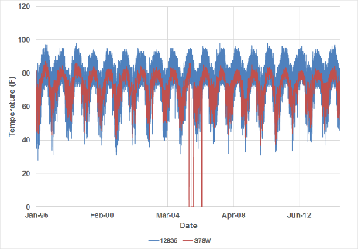
Figure 8: Air temperature comparison between hourly WBAN 12835 data and daily S78W data from 1996 – 2014

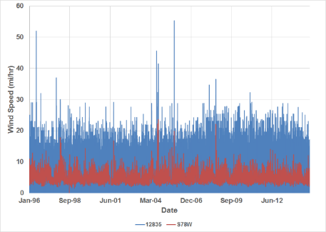
Figure 9: Wind speed comparison between hourly WBAN 12835 data and daily S78W data from 1996 – 2014

When processing the data using the WBAN 12835 climate datasets, if the data gaps were less than 3 hours, the gaps were filled by averaging the available data before and after the gaps. If the data gaps were longer than 3 hours, data from the neighboring SA station WBAN 12842 (Tampa International AP) was used. The data record at WBAN 12835 was almost fully complete, and less than 0.2% of the air temperature data and wind speed data, 3% of cloud cover data, and 5% of the relative humidity data required patching. Patching was only required between 1996 and 1998.
Cloud cover data at WBAN 12835 were provided in terms of sky cover, a verbal description of the cloud cover. Based on the information provided in the User’s Manual of Meteorological Data Analysis and Preparation Tool (MetADAPT 2007), the following MetADAPT numerical assignments for cloud cover estimates from the sky conditions parameters was applied:
- CLR (clear) : 0
- POB (partial obscuration): 1.25
- SCT (scattered): 4.38
- BKN (broken): 7.5
- OVC & OBS (overcast and obscured): 10
Solar radiation was computed using cloud cover and latitude of the station. The CE QUAL-W2 method in MetADAPT was used to compute the solar radiation using sun angle relationships and shading from the cloud cover (Cole 2003).
In order to account for variability in PET across the Caloosahatchee River Watershed, the 2017 HSPF Model used evapotranspiration (ET) data predicted from the Agricultural Field-Scale Irrigation Requirements Simulation (AFSIRS) model (Brown 2013). The daily reference ET was determined by averaging the daily ET value from the centroid of each AFSIRS grid cell contained within each NEXRAD zone. Table 10 shows a comparison between annual ET totals for each NEXRAD zone and S78W for the model simulation period.

Table 10: AFSIRS and S78W annual ET (inches) comparison
Year | Zone 1 | Zone 2 | Zone 3 | Zone 4 | Zone 5 | Zone 6 | Zone 7 | Zone 8 | Zone 9 | Zone 10 | Zone 11 | Zone 12 | Zone 13 | Zone 14 | Zone 15 | S78W
1996 | 55.22 | 55.34 | 55.00 | 54.87 | 54.86 | 54.75 | 54.80 | 54.84 | 54.89 | 55.01 | 54.99 | 55.09 | 55.31 | 55.51 | 55.76 | 57.41
1997 | 53.67 | 53.95 | 53.41 | 53.21 | 53.15 | 53.00 | 53.04 | 53.18 | 53.24 | 53.41 | 53.39 | 53.44 | 53.64 | 53.88 | 54.09 | 44.28
1998 | 56.81 | 56.71 | 56.77 | 56.88 | 57.01 | 56.96 | 57.12 | 57.23 | 57.31 | 57.46 | 57.44 | 57.54 | 57.78 | 58.06 | 58.33 | 44.65
1999 | 57.00 | 57.28 | 56.79 | 56.68 | 56.67 | 56.47 | 56.56 | 56.62 | 56.70 | 56.97 | 56.90 | 56.93 | 57.18 | 57.46 | 57.64 | 48.89
2000 | 58.55 | 58.65 | 58.54 | 58.71 | 58.89 | 58.87 | 59.09 | 59.17 | 59.34 | 59.60 | 59.59 | 59.84 | 60.21 | 60.54 | 60.85 | 55.08
2001 | 55.42 | 55.37 | 55.45 | 55.64 | 55.83 | 55.85 | 56.05 | 56.18 | 56.31 | 56.52 | 56.50 | 56.71 | 57.01 | 57.28 | 57.55 | 56.04
2002 | 53.55 | 53.70 | 53.47 | 53.43 | 53.52 | 53.50 | 53.62 | 53.77 | 53.85 | 53.96 | 53.98 | 54.14 | 54.36 | 54.54 | 54.80 | 56.94
2003 | 55.67 | 55.83 | 55.58 | 55.57 | 55.60 | 55.52 | 55.65 | 55.59 | 55.63 | 55.75 | 55.68 | 55.78 | 55.97 | 56.12 | 56.32 | 53.36
2004 | 57.21 | 57.04 | 57.33 | 57.55 | 57.75 | 57.84 | 58.03 | 57.92 | 58.00 | 58.04 | 58.05 | 58.30 | 58.54 | 58.68 | 58.95 | 54.67
2005 | 55.85 | 55.50 | 55.97 | 56.23 | 56.49 | 56.62 | 56.80 | 56.69 | 56.72 | 56.64 | 56.66 | 56.86 | 56.98 | 57.02 | 57.21 | 52.67
2006 | 59.24 | 59.08 | 59.38 | 59.68 | 59.91 | 59.95 | 60.20 | 60.06 | 60.11 | 60.17 | 60.15 | 60.30 | 60.51 | 60.66 | 60.84 | 55.56
2007 | 58.53 | 58.47 | 58.67 | 58.94 | 59.14 | 59.21 | 59.45 | 59.28 | 59.40 | 59.58 | 59.54 | 59.76 | 60.06 | 60.29 | 60.52 | 55.90
2008 | 56.61 | 56.48 | 56.67 | 56.89 | 57.06 | 57.13 | 57.35 | 57.21 | 57.35 | 57.52 | 57.52 | 57.76 | 58.08 | 58.34 | 58.65 | 55.09
2009 | 58.57 | 58.02 | 59.08 | 59.81 | 60.33 | 60.62 | 61.03 | 61.07 | 61.38 | 61.62 | 61.77 | 62.24 | 62.75 | 63.23 | 63.76 | 54.25
2010 | 55.20 | 54.83 | 55.56 | 55.94 | 56.35 | 56.61 | 56.87 | 57.16 | 57.25 | 57.12 | 57.33 | 57.65 | 57.93 | 58.16 | 58.66 | 54.77
2011 | 57.99 | 57.45 | 58.46 | 59.08 | 59.56 | 59.83 | 60.17 | 60.29 | 60.51 | 60.63 | 60.76 | 61.17 | 61.63 | 62.03 | 62.57 | 55.13
2012 | 56.51 | 56.14 | 56.92 | 57.45 | 57.84 | 58.03 | 58.37 | 58.43 | 58.67 | 58.90 | 58.98 | 59.35 | 59.86 | 60.35 | 60.90 | 55.02
2013 | 55.24 | 54.95 | 55.61 | 56.05 | 56.41 | 56.63 | 56.93 | 56.98 | 57.19 | 57.33 | 57.43 | 57.80 | 58.22 | 58.59 | 59.09 | 54.46
2014 | 56.15 | 55.84 | 56.42 | 56.85 | 57.19 | 57.41 | 57.73 | 57.72 | 57.94 | 58.10 | 58.21 | 58.61 | 59.05 | 59.43 | 59.93 | 56.03
Average | 56.47 | 56.35 | 56.58 | 56.81 | 57.03 | 57.09 | 57.31 | 57.34 | 57.46 | 57.60 | 57.62 | 57.86 | 58.16 | 58.43 | 58.76 | 53.69

Land Use Coverage

Impervious Land Use Coverage Comparison
In order to evaluate change in imperviousness in the Caloosahatchee River Watershed during the model simulation period, Tetra Tech downloaded the 2006 and 2011 NLCD Percent Developed Imperviousness shapefiles and compared the change in imperviousness. The comparison was done prior to model redelineation and used the 2014 HSPF subbasin delineation. The NLCD impervious shapefiles provide the estimated percent area classified as impervious within discrete 30-meter by 30-meter grid cells. The change in percent impervious area was minimal between the two coverages (Table 11). There was a slight decrease in areas with low percentages of impervious areas (0-4% imperviousness) between 2006 and 2011, with 0.36% of the total area in this classification block reclassified as having a higher percentage of imperviousness. There was a 0.05% or less change in all other percent impervious areas classification blocks.
The areas with the largest changes in percent imperviousness classifications occurred in Subbasins 4, 18, and 92 (Table 12). Subbasin 4 is located in North Fort Myers and includes the I-75 corridor, Subbasin 18 is located in Olga, and Subbasin 92 is located in the Cypress Lakes neighborhood. However, most subbasins had minimal changes in percent imperviousness classifications.
Table 11: Percent impervious area in the Caloosahatchee River Watershed in the 2006 and 2011 NLCD coverages
% Impervious Classification | 2006 % of Area | 2011 % of Area | Change in % Area
0-4 | 85.77% | 85.41% | -0.36%
5-9 | 2.38% | 2.35% | -0.02%
10-14 | 1.77% | 1.75% | -0.02%
15-19 | 1.61% | 1.60% | -0.01%
20-24 | 1.51% | 1.51% | 0.00%
25-29 | 1.39% | 1.39% | 0.00%
30-34 | 1.21% | 1.21% | 0.00%
35-39 | 0.99% | 1.00% | 0.01%
40-44 | 0.78% | 0.80% | 0.02%
45-49 | 0.58% | 0.63% | 0.04%
50-54 | 0.42% | 0.46% | 0.05%
55-59 | 0.31% | 0.36% | 0.05%
60-64 | 0.25% | 0.30% | 0.05%
65-69 | 0.22% | 0.27% | 0.05%
70-74 | 0.19% | 0.23% | 0.04%
75-79 | 0.16% | 0.20% | 0.03%
80-84 | 0.13% | 0.16% | 0.03%
85-89 | 0.12% | 0.14% | 0.02%
90-94 | 0.11% | 0.12% | 0.01%
95-100 | 0.09% | 0.10% | 0.01%
Total | 100.00% | 100.00% | 0.00%
Table 12: Percent change in impervious area between 2006 and 2011 in the Caloosahatchee River Watershed by subbasin using the 2014 HSPF delineation
SWS | 0-9% | 10-19% | 20-29% | 30-39% | 40-49% | 50-59% | 60-69% | 70-79% | 80-89% | 90-100%
1 | -0.40% | -0.17% | -0.12% | -0.10% | 0.10% | 0.18% | 0.20% | 0.14% | 0.10% | 0.07%
2 | -2.49%* | -0.59% | -0.22% | -0.03% | 0.61% | 0.81% | 0.93% | 0.69% | 0.26% | 0.05%
3 | -1.01%* | -0.47% | -0.21% | -0.12% | 0.41% | 0.71% | 0.47% | 0.12% | 0.09% | 0.00%
4 | -5.04%** | -0.21% | -0.09% | 0.18% | 0.88% | 1.06%* | 1.28%* | 1.03%* | 0.67% | 0.23%
5 | -1.96%* | -0.69% | -0.46% | -0.13% | 0.38% | 1.30%* | 0.84% | 0.43% | 0.23% | 0.05%
6 | -1.39%* | -0.66% | -0.65% | -0.51% | -0.01% | 0.61% | 0.59% | 1.08%* | 0.70% | 0.25%
7 | -0.87% | -1.22%* | -1.02%* | -0.47% | -0.11% | 0.37% | 0.94% | 0.90% | 0.79% | 0.70%
8 | -0.61% | -0.40% | -0.39% | -0.33% | -0.06% | 0.27% | 0.42% | 0.47% | 0.42% | 0.22%
9 | -1.71%* | -0.33% | -0.26% | -0.09% | 0.19% | 0.33% | 0.58% | 0.57% | 0.35% | 0.38%
10 | -2.51%* | 0.29% | 0.35% | 0.34% | 0.48% | 0.36% | 0.29% | 0.18% | 0.11% | 0.10%
11 | -1.14%* | -0.18% | -0.06% | -0.05% | 0.26% | 0.38% | 0.28% | 0.21% | 0.20% | 0.10%
12 | -0.38% | -0.03% | -0.03% | -0.03% | 0.16% | 0.19% | 0.03% | 0.06% | 0.03% | 0.00%
13 | -0.95% | 0.14% | 0.13% | 0.04% | 0.10% | 0.12% | 0.10% | 0.14% | 0.08% | 0.10%
14 | -1.02%* | 0.33% | 0.12% | 0.06% | 0.21% | 0.18% | 0.07% | 0.03% | 0.02% | 0.00%
15 | -0.39% | -0.10% | -0.10% | -0.21% | 0.10% | 0.13% | 0.08% | 0.26% | 0.18% | 0.05%
16 | -4.22%* | -0.40% | 0.08% | 0.64% | 1.55%* | 1.36%* | 0.76% | 0.20% | 0.04% | 0.00%
17 | -2.34%* | -0.04% | 0.11% | 0.31% | 0.71% | 0.58% | 0.45% | 0.22% | 0.00% | 0.00%
18 | -10.91%*** | 2.85%* | 2.61%* | 1.76%* | 1.45%* | 1.08%* | 0.63% | 0.33% | 0.13% | 0.06%
19 | -0.16% | -0.05% | 0.01% | 0.01% | 0.06% | 0.06% | 0.06% | 0.01% | 0.00% | 0.00%
20 | -0.02% | -0.01% | -0.01% | 0.00% | 0.01% | 0.01% | 0.02% | 0.01% | 0.00% | 0.00%
21 | -0.11% | -0.02% | -0.06% | -0.05% | 0.02% | 0.06% | 0.06% | 0.05% | 0.05% | 0.00%
22 | -0.02% | 0.00% | -0.01% | 0.00% | 0.00% | 0.01% | 0.02% | 0.00% | 0.00% | 0.00%
23 | -0.36% | 0.00% | 0.05% | 0.10% | 0.06% | 0.08% | 0.06% | 0.00% | 0.00% | 0.00%
24 | -0.05% | -0.01% | -0.01% | 0.00% | 0.02% | 0.02% | 0.01% | 0.01% | 0.00% | 0.00%
25 | 0.00% | 0.00% | 0.00% | 0.00% | 0.00% | 0.00% | 0.00% | 0.00% | 0.00% | 0.00%
26 | -0.47% | -0.22% | -0.07% | -0.03% | 0.19% | 0.31% | 0.17% | 0.10% | 0.02% | 0.00%
27 | -0.30% | -0.11% | -0.02% | -0.01% | 0.13% | 0.10% | 0.07% | 0.04% | 0.05% | 0.03%
28 | 0.00% | 0.00% | 0.00% | 0.00% | 0.00% | 0.00% | 0.00% | 0.00% | 0.00% | 0.00%
29 | 0.00% | 0.00% | 0.00% | 0.00% | 0.00% | 0.00% | 0.00% | 0.00% | 0.00% | 0.00%
30 | 0.00% | 0.00% | 0.00% | 0.00% | 0.00% | 0.00% | 0.00% | 0.00% | 0.00% | 0.00%
31 | -0.08% | -0.04% | -0.01% | 0.00% | 0.05% | 0.05% | 0.02% | 0.01% | 0.00% | 0.00%
32 | 0.00% | 0.00% | 0.00% | 0.00% | 0.00% | 0.00% | 0.00% | 0.00% | 0.00% | 0.00%
33 | 0.00% | 0.00% | 0.00% | 0.00% | 0.00% | 0.00% | 0.00% | 0.00% | 0.00% | 0.00%
34 | -0.02% | 0.00% | 0.00% | 0.00% | 0.00% | 0.02% | 0.00% | 0.00% | 0.00% | 0.00%
35 | 0.00% | 0.00% | 0.00% | 0.00% | 0.00% | 0.00% | 0.00% | 0.00% | 0.00% | 0.00%
36 | 0.00% | 0.00% | 0.00% | 0.00% | 0.00% | 0.00% | 0.00% | 0.00% | 0.00% | 0.00%
37 | 0.00% | 0.00% | 0.00% | 0.00% | 0.00% | 0.00% | 0.00% | 0.00% | 0.00% | 0.00%
38 | 0.00% | -0.01% | 0.00% | 0.00% | 0.00% | 0.00% | 0.01% | 0.00% | 0.00% | 0.00%
39 | -0.32% | 0.03% | 0.05% | -0.02% | 0.05% | 0.05% | 0.10% | 0.05% | 0.00% | 0.00%
40 | -1.56%* | -0.55% | -0.39% | -0.14% | 0.16% | 0.36% | 0.68% | 0.68% | 0.45% | 0.29%
41 | -0.14% | -0.02% | -0.01% | 0.00% | 0.03% | 0.05% | 0.05% | 0.03% | 0.01% | 0.01%
42 | 0.00% | 0.00% | 0.00% | 0.00% | 0.00% | 0.00% | 0.00% | 0.00% | 0.00% | 0.00%
43 | 0.00% | 0.00% | 0.00% | 0.00% | 0.00% | 0.00% | 0.00% | 0.00% | 0.00% | 0.00%
44 | -0.11% | 0.00% | 0.00% | 0.00% | 0.03% | 0.03% | 0.06% | 0.00% | 0.00% | 0.00%
45 | 0.00% | 0.00% | 0.00% | 0.00% | 0.00% | 0.00% | 0.00% | 0.00% | 0.00% | 0.00%
46 | -1.21%* | -0.25% | -0.06% | 0.00% | 0.17% | 0.31% | 0.17% | 0.20% | 0.14% | 0.53%
47 | 0.00% | 0.00% | 0.00% | 0.00% | 0.00% | 0.00% | 0.00% | 0.00% | 0.00% | 0.00%
48 | -0.01% | 0.00% | 0.00% | 0.00% | 0.00% | 0.00% | 0.00% | 0.00% | 0.00% | 0.00%
49 | 0.00% | 0.00% | 0.00% | 0.00% | 0.00% | 0.00% | 0.00% | 0.00% | 0.00% | 0.00%
50 | -0.01% | 0.00% | 0.00% | 0.00% | 0.00% | 0.01% | 0.00% | 0.00% | 0.00% | 0.00%
51 | -0.02% | 0.00% | 0.00% | 0.00% | 0.01% | 0.01% | 0.00% | 0.00% | 0.00% | 0.00%
52 | 0.00% | 0.00% | 0.00% | 0.00% | 0.00% | 0.00% | 0.00% | 0.00% | 0.00% | 0.00%
53 | 0.00% | 0.00% | 0.00% | 0.00% | 0.00% | 0.00% | 0.00% | 0.00% | 0.00% | 0.00%
54 | 0.00% | 0.00% | 0.00% | 0.00% | 0.00% | 0.00% | 0.00% | 0.00% | 0.00% | 0.00%
55 | 0.00% | 0.00% | 0.00% | 0.00% | 0.00% | 0.00% | 0.00% | 0.00% | 0.00% | 0.00%
56 | 0.00% | 0.00% | 0.00% | 0.00% | 0.00% | 0.00% | 0.00% | 0.00% | 0.00% | 0.00%
57 | 0.00% | 0.00% | 0.00% | 0.00% | 0.00% | 0.00% | 0.00% | 0.00% | 0.00% | 0.00%
58 | -0.12% | 0.00% | 0.01% | 0.01% | 0.02% | 0.02% | 0.03% | 0.02% | 0.01% | 0.00%
59 | -0.04% | 0.00% | 0.01% | 0.01% | 0.00% | 0.00% | 0.00% | 0.01% | 0.00% | 0.00%
60 | -1.15%* | 0.23% | 0.16% | 0.15% | 0.13% | 0.13% | 0.11% | 0.08% | 0.08% | 0.09%
61 | -0.70% | 0.09% | 0.00% | 0.04% | 0.12% | 0.13% | 0.12% | 0.07% | 0.09% | 0.03%
62 | -0.17% | 0.04% | 0.03% | 0.02% | 0.01% | 0.03% | 0.01% | 0.01% | 0.02% | 0.01%
63 | 0.00% | 0.00% | 0.00% | 0.00% | 0.00% | 0.00% | 0.00% | 0.00% | 0.00% | 0.00%
64 | 0.00% | 0.00% | 0.00% | 0.00% | 0.00% | 0.00% | 0.00% | 0.00% | 0.00% | 0.00%
65 | 0.00% | 0.00% | 0.00% | 0.00% | 0.00% | 0.00% | 0.00% | 0.00% | 0.00% | 0.00%
66 | 0.00% | 0.00% | 0.00% | 0.00% | 0.00% | 0.00% | 0.00% | 0.00% | 0.00% | 0.00%
67 | 0.00% | 0.00% | 0.00% | 0.00% | 0.00% | 0.00% | 0.00% | 0.00% | 0.00% | 0.00%
68 | -0.02% | -0.01% | 0.00% | 0.00% | 0.00% | 0.01% | 0.01% | 0.00% | 0.00% | 0.00%
69 | 0.00% | 0.00% | 0.00% | 0.00% | 0.00% | 0.00% | 0.00% | 0.00% | 0.00% | 0.00%
70 | -0.01% | 0.00% | 0.00% | 0.00% | 0.01% | 0.00% | 0.00% | 0.00% | 0.00% | 0.00%
71 | 0.00% | 0.00% | 0.00% | 0.00% | 0.00% | 0.00% | 0.00% | 0.00% | 0.00% | 0.00%
72 | 0.00% | 0.00% | 0.00% | 0.00% | 0.00% | 0.00% | 0.00% | 0.00% | 0.00% | 0.00%
73 | 0.00% | 0.00% | 0.00% | 0.00% | 0.00% | 0.00% | 0.00% | 0.00% | 0.00% | 0.00%
74 | 0.00% | 0.00% | 0.00% | 0.00% | 0.00% | 0.00% | 0.00% | 0.00% | 0.00% | 0.00%
75 | 0.00% | 0.00% | 0.00% | 0.00% | 0.00% | 0.00% | 0.00% | 0.00% | 0.00% | 0.00%
76 | -0.01% | 0.00% | 0.00% | 0.00% | 0.00% | 0.01% | 0.00% | 0.00% | 0.00% | 0.00%
77 | 0.00% | 0.00% | 0.00% | 0.00% | 0.00% | 0.00% | 0.00% | 0.00% | 0.00% | 0.00%
78 | 0.00% | 0.00% | 0.00% | 0.00% | 0.00% | 0.00% | 0.00% | 0.00% | 0.00% | 0.00%
79 | 0.00% | 0.00% | 0.00% | 0.00% | 0.00% | 0.00% | 0.00% | 0.00% | 0.00% | 0.00%
80 | -2.26%* | 0.45% | 0.37% | 0.33% | 0.37% | 0.37% | 0.29% | 0.08% | 0.00% | 0.00%
81 | 0.00% | 0.00% | 0.00% | 0.00% | 0.00% | 0.00% | 0.00% | 0.00% | 0.00% | 0.00%
82 | 0.00% | -0.01% | 0.00% | 0.00% | 0.00% | 0.01% | 0.00% | 0.00% | 0.00% | 0.00%
83 | -0.72% | -0.10% | -0.06% | 0.03% | 0.29% | 0.24% | 0.18% | 0.10% | 0.04% | 0.01%
84 | -0.01% | -0.01% | 0.00% | 0.00% | 0.00% | 0.00% | 0.01% | 0.00% | 0.00% | 0.00%
85 | -0.03% | -0.02% | 0.00% | 0.00% | 0.01% | 0.02% | 0.01% | 0.01% | 0.01% | 0.00%
86 | -1.14%* | -0.10% | 0.00% | -0.03% | 0.17% | 0.11% | 0.26% | 0.37% | 0.16% | 0.20%
87 | -0.59% | 0.03% | 0.07% | 0.05% | 0.11% | 0.13% | 0.02% | 0.10% | 0.08% | 0.00%
88 | -0.10% | -0.01% | -0.01% | 0.00% | 0.03% | 0.03% | 0.03% | 0.03% | 0.00% | 0.00%
89 | -1.22%* | -0.22% | -0.13% | 0.00% | 0.27% | 0.28% | 0.38% | 0.33% | 0.17% | 0.14%
90 | -0.66% | -0.22% | -0.22% | -0.04% | 0.22% | 0.26% | 0.22% | 0.31% | 0.04% | 0.09%
91 | -0.16% | -0.07% | -0.03% | -0.03% | 0.03% | 0.08% | 0.09% | 0.06% | 0.03% | 0.01%
92 | -11.38%*** | 0.41% | 0.66% | 0.77% | 1.04%* | 2.45%* | 3.72%* | 1.67%* | 0.50% | 0.16%
93 | -3.89%* | 0.04% | 0.19% | 0.17% | 0.62% | 0.78% | 0.95% | 0.61% | 0.31% | 0.22%
94 | -0.80% | -0.57% | -0.27% | -0.04% | 0.23% | 0.47% | 0.57% | 0.25% | 0.08% | 0.08%
95 | -1.18%* | -0.83% | -0.41% | -0.22% | 0.11% | 0.59% | 0.67% | 0.61% | 0.50% | 0.18%
96 | -0.66% | -0.96% | -0.36% | -0.18% | 0.19% | 0.73% | 0.61% | 0.37% | 0.23% | 0.02%
97 | -0.79% | -0.69% | -0.69% | -0.32% | 0.09% | 0.53% | 0.72% | 0.39% | 0.46% | 0.30%
98 | -0.48% | -1.05%* | -0.46% | -0.43% | -0.09% | 0.49% | 0.76% | 0.57% | 0.52% | 0.17%
99 | -1.00%* | -0.86% | -0.60% | -0.24% | 0.12% | 0.74% | 0.96% | 0.53% | 0.33% | 0.02%
100 | -1.69%* | -1.03%* | -0.98% | -0.55% | 0.32% | 0.68% | 1.02%* | 1.38%* | 0.69% | 0.16%
101 | -0.81% | -0.37% | -0.27% | -0.08% | 0.15% | 0.42% | 0.40% | 0.29% | 0.20% | 0.06%
102 | -1.44%* | -0.91% | -0.49% | -0.07% | 0.27% | 0.62% | 0.66% | 0.68% | 0.45% | 0.22%
Total | -0.38% | -0.02% | 0.00% | 0.01% | 0.06% | 0.09% | 0.10% | 0.07% | 0.05% | 0.03%
* 1% - 5% change from 2006 to 2011.
** 5% - 10% change from 2006 to 2011.
*** Greater than 10% change from 2006 to 2011.

Pervious Land Use Coverage Comparison
In order to evaluate change in imperviousness in the Caloosahatchee River Watershed during the model simulation period, Tetra Tech compared land use changes between three SFWMD land use/land cover (LULC) shapefiles. The comparison was done prior to model redelineation and used the 2014 HSPF subbasin delineation. Tetra Tech downloaded and used the SFWMD LULC 2004, 2008-2009, and 2012 Geographic Information System (GIS) coverages for the comparison. For the analysis, Tetra Tech reduced the total number of land use classifications provided by SFWMD by grouping similar land uses (i.e. all 1000 level land use classifications were group together as Low Density Residential). The reduced land use classifications will be used to assign runoff and nutrient loads in the Caloosahatchee River Watershed HSPF model. As noted in the Task 1 memo, a total of 16 separate pervious land uses are now used in the HSPF model. One of the pervious land uses, FDOT Right-of-Way, was not included in the SFWMD LULC shapefiles. FDOT provided a shapefile of their road right-of-ways, which Tetra Tech clipped into the SFWMD LULC during land use processing for the updated HSPF model.
Overall, there was very little change in land use between the 2004, 2008-2009, and 2012 SFWMD LULC coverage (Figure 10). Between the 2004 and 2008-2009 SFWMD LULC coverages, Low Density Residential area increased by approximately 24,000 acres, while the Developed Open Space/Disturbed area decreased by approximately 26,000 acres. This change occurred because land classified as inactive land in the 2004 coverage was reclassified as rural residential in the 2008-2009 coverage. This change in classification was likely not due to an increase in development, but due to a change in how SFWMD classified land use between 2004 and 2008-2009. Between the 2008-2009 and 2012 SFWMD LULC coverages, Citrus Grove acreage decreased by 21,000 acres while Improved and Unimproved Pastures increased by 20,000 acres. This change occurred because land classified as citrus or other groves in 2008-2009 coverage was classified as improved pasture, abandoned groves, or fallow cropland in the 2012 coverage. This change in land use may be due loss of citrus groves from canker, as well as how SFWMD classified the agricultural areas.
Tetra Tech compared the change in land use by subbasin. Table 13 shows the percent change in land use between the 2008-2009 and 2012 SFWMD coverages. Very little change occurred between the two coverages, with the exception of some of the agricultural classes, which was mentioned previously. The change in each land use classification was less than 1% for most subbasins.
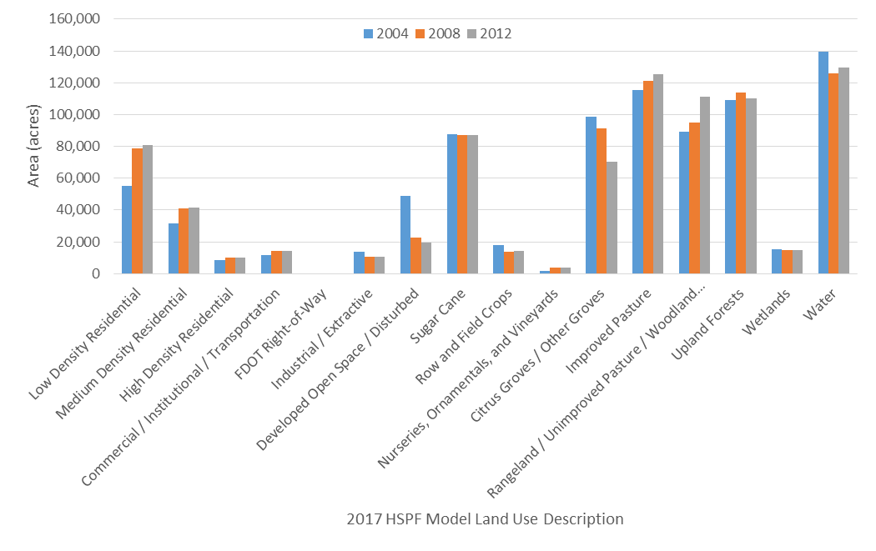
Figure 10: Difference in HSPF reclassification model land use between the 2004, 2008-2009, and 2012 SFWMD coverages

Table 13: Percent change in land use classifications between the 2008-2009 and 2012 SFWMD Coverages in the Caloosahatchee River Watershed by subbasin using the 2014 HSPF delineation
SWS | Code 1 | Code 2 | Code 3 | Code 4 | Code 6 | Code 7 | Code 8 | Code 9 | Code 10 | Code 11 | Code 12 | Code 13 | Code 14 | Code 15 | Code 16
1 | 0.00% | 2.01%* | -1.58%* | -0.68% | 0.00% | 0.26% | 0.00% | 0.00% | 0.00% | 0.00% | 0.00% | -0.03% | 0.45% | -0.01% | -0.42%
2 | -0.91% | 0.79% | -0.75% | 0.03% | 0.00% | 0.36% | 0.00% | 0.00% | 0.75% | 0.00% | 0.00% | -0.10% | -0.45% | -0.55% | 0.83%
3 | 0.00% | 0.00% | 0.00% | 0.00% | 0.00% | 0.00% | 0.00% | 0.00% | 0.00% | 0.00% | 0.00% | 0.00% | 0.00% | -0.84% | 0.84%
4 | -0.06% | -1.13%* | 5.21%** | 2.02%* | -0.32% | -0.76% | 0.00% | -0.94% | 0.00% | 0.00% | -0.72% | 0.86% | -3.58%* | -0.01% | -0.58%
5 | 0.00% | 0.00% | 0.00% | 0.00% | 0.00% | 0.00% | 0.00% | 0.00% | 0.00% | 0.00% | 0.00% | 0.00% | 0.00% | -0.01% | 0.00%
6 | -0.48% | -1.77%* | 3.69%* | 0.69% | 0.48% | -0.46% | 0.00% | 0.00% | 0.00% | 0.00% | -0.24% | 0.14% | -1.76%* | -0.15% | -0.14%
7 | 0.00% | 0.11% | -0.90% | 0.64% | 0.03% | 0.31% | 0.00% | 0.00% | 0.00% | 0.00% | 0.00% | 0.00% | -0.16% | 0.00% | -0.03%
8 | 0.00% | 0.31% | 0.03% | 3.22%* | -2.12%* | -1.08%* | 0.00% | 0.00% | 0.00% | 0.00% | 0.00% | 0.00% | -0.36% | 0.00% | 0.00%
9 | 1.77%* | -1.37%* | 0.08% | 2.52%* | 0.03% | -1.59%* | 0.00% | -0.06% | 0.00% | 0.00% | -0.23% | 0.01% | -0.26% | 0.11% | -1.01%*
10 | 3.07%* | 2.39%* | 0.06% | 0.47% | -0.59% | 0.29% | 0.00% | -2.17%* | 1.48%* | -0.59% | -2.08%* | -3.41%* | 2.42%* | 0.74% | -2.10%*
11 | 7.60%** | 1.77%* | 10.26%^ | 1.58%* | -1.23%* | -19.96%^ | 0.00% | -0.05% | 0.00% | 0.00% | -0.48% | 0.67% | 0.59% | 0.04% | -0.79%
12 | 12.68%^ | -3.61%* | 0.00% | 0.00% | 0.00% | -9.60%** | 0.00% | 0.00% | 0.00% | 0.00% | 0.00% | -0.09% | 2.68%* | 1.65%* | -3.70%*
13 | 36.38%^ | 0.24% | -0.08% | 0.47% | 0.04% | -37.11%^ | 0.00% | 0.00% | 0.00% | 0.00% | 0.00% | -0.01% | 1.11%* | -0.02% | -1.02%*
14 | 44.80%^ | -0.69% | 0.00% | 0.00% | 0.00% | -42.64%^ | 0.00% | 0.00% | 0.00% | 0.00% | 0.02% | -1.66%* | 0.00% | 0.14% | 0.02%
15 | 0.33% | 0.00% | 0.00% | 0.00% | 0.00% | 0.12% | 0.00% | 0.00% | 8.30%** | -7.55%** | -0.81% | 9.10%** | -1.74%* | -0.30% | -7.44%**
16 | 0.58% | 3.72%* | -3.72%* | 0.43% | 0.00% | -0.43% | 0.00% | 0.00% | 0.00% | 0.00% | 0.00% | -4.06%* | 0.84% | -0.72% | 3.36%*
17 | 0.32% | 1.64%* | -1.12%* | 0.00% | 0.00% | 1.95%* | 0.00% | 0.00% | 0.00% | -3.31%* | 3.62%* | -2.67%* | 0.16% | 0.11% | -0.70%
18 | 1.08%* | 16.31%^ | 0.09% | 0.68% | 0.05% | 14.59%^ | 0.00% | 8.02%** | 0.00% | -0.04% | -16.72%^ | -22.37%^ | -4.54%* | 5.05%** | -2.22%*
19 | 40.98%^ | 1.54%* | 0.00% | 0.00% | 0.00% | -40.96%^ | 0.00% | 0.24% | 0.00% | -0.16% | -0.32% | 0.92% | 1.12%* | -0.05% | -3.31%*
20 | 0.25% | -0.35% | 0.00% | 0.00% | 0.00% | 0.05% | 0.00% | -9.22%** | -0.29% | -0.27% | 8.29%** | 0.18% | 2.75%* | 0.06% | -1.43%*
21 | 1.12%* | 0.00% | 0.00% | 0.45% | 0.00% | -0.72% | 0.00% | 0.60% | -0.15% | -0.56% | 1.38%* | -0.03% | -2.26%* | 0.18% | -0.02%
22 | 2.87%* | -2.02%* | 0.00% | 0.00% | 0.00% | -0.33% | 0.00% | 0.00% | -0.52% | -0.65% | 2.21%* | 0.89% | -1.14%* | 0.00% | -1.31%*
23 | 45.93%^ | 0.19% | -0.19% | 0.00% | 0.45% | -37.97%^ | 0.00% | 0.00% | 0.00% | 0.00% | 0.22% | -0.45% | -0.02% | 0.00% | -8.16%**
24 | 7.36%** | -5.10%** | -0.02% | 0.00% | -0.65% | -2.62%* | 0.00% | 0.00% | 0.37% | -6.63%** | -0.43% | 9.26%** | -1.53%* | 0.01% | -0.02%
25 | 0.14% | 0.00% | 0.00% | 0.00% | -1.18%* | 1.52%* | 0.00% | 0.00% | 0.00% | -15.22%^ | 0.00% | 12.79%^ | 0.31% | 0.38% | 1.24%*
26 | 22.27%^ | 0.00% | 0.00% | 0.00% | -14.09%^ | -7.00%** | 0.00% | 0.00% | 0.00% | 0.00% | 0.00% | -2.17%* | 0.00% | 0.05% | 0.93%
27 | 47.59%^ | 0.12% | 0.05% | 0.38% | -0.04% | -47.14%^ | 0.00% | -0.04% | 0.42% | -1.19%* | -0.12% | 0.33% | -0.50% | 0.54% | -0.40%
28 | 0.02% | 0.00% | 0.00% | 0.00% | 2.14%* | 0.48% | 0.00% | -0.10% | 0.00% | 0.00% | -0.58% | -3.33%* | 0.74% | -0.12% | 0.73%
29 | 0.00% | 0.00% | 0.00% | 0.00% | -0.02% | 0.19% | 0.00% | -0.01% | 0.00% | 0.01% | 0.70% | 0.02% | -0.22% | -0.02% | -0.64%
30 | -0.34% | 0.07% | -0.05% | -0.05% | 0.26% | 0.00% | 0.00% | -1.26%* | 0.41% | -1.32%* | 1.18%* | 0.77% | 0.25% | 0.01% | 0.07%
31 | -0.93% | 0.00% | -3.93%* | 4.32%* | -0.02% | 0.67% | 0.00% | 0.00% | 0.16% | -2.07%* | 0.26% | 1.41%* | 0.38% | 0.19% | -0.44%
32 | 0.00% | 0.00% | 0.00% | 0.00% | -0.58% | 0.58% | 0.00% | 0.00% | 0.00% | -1.21%* | 0.00% | 0.94% | 0.10% | 0.02% | 0.16%
33 | 0.08% | -0.09% | 0.00% | -0.03% | -0.04% | 0.20% | -0.06% | -0.36% | 0.11% | 0.42% | 0.20% | 0.75% | -0.02% | -0.07% | -1.10%*
34 | 3.72%* | 0.00% | 0.00% | 0.00% | 1.07%* | -0.78% | 0.00% | 1.59%* | 0.00% | -4.06%* | -0.10% | -1.46%* | -2.42%* | 0.00% | 2.44%*
35 | 1.51%* | 0.00% | 0.00% | 0.00% | 2.76%* | -4.01%* | 0.00% | 0.00% | 0.00% | -1.67%* | -2.57%* | 3.59%* | -1.64%* | 0.00% | 2.04%*
36 | 0.00% | 0.00% | 0.00% | 0.00% | -0.03% | -0.90% | 0.00% | 0.00% | 0.00% | -10.22%^ | 0.00% | 17.12%^ | -5.38%** | 0.00% | -0.59%
37 | 0.00% | 0.00% | 0.00% | 0.00% | -0.34% | 0.34% | 0.00% | 4.00%* | 0.00% | -11.23%^ | 0.00% | 7.23%** | 0.00% | 0.00% | 0.00%
38 | 1.97%* | -1.93%* | 0.00% | 0.29% | 0.42% | -0.11% | 0.00% | -0.68% | 0.77% | -2.02%* | 2.45%* | 1.09%* | 2.30%* | -0.35% | -4.20%*
39 | 2.24%* | 0.00% | 0.00% | -0.64% | 0.00% | -3.59%* | 0.00% | 0.00% | 3.86%* | -0.81% | -3.86%* | 1.37%* | -0.80% | -0.08% | 2.32%*
40 | 3.88%* | -3.52%* | -1.31%* | 4.53%* | -3.38%* | 2.08%* | 0.00% | 0.00% | 0.00% | -0.53% | 0.00% | -2.08%* | 0.68% | -0.17% | -0.18%
41 | 8.82%** | 0.55% | -0.09% | 0.19% | -0.85% | -7.49%** | 0.00% | -1.50%* | 0.05% | -0.29% | 2.89%* | -0.22% | 0.21% | 0.01% | -2.27%*
42 | 0.00% | 0.00% | 0.00% | 0.00% | -11.53%^ | 18.83%^ | 0.00% | 0.00% | 0.00% | 0.00% | -0.18% | -7.11%** | 0.00% | 0.00% | 0.00%
43 | 0.13% | 0.00% | 0.00% | 0.00% | -2.14%* | 2.02%* | 0.00% | 0.00% | 0.00% | 0.00% | 1.01%* | -0.68% | 0.89% | 0.00% | -1.23%*
44 | 1.15%* | 0.00% | -0.81% | 0.81% | -5.79%** | 5.79%** | 0.00% | 0.00% | 1.08%* | -1.08%* | -1.86%* | 0.71% | 0.00% | 0.00% | 0.00%
45 | 0.00% | 0.00% | -0.02% | 0.17% | -1.41%* | -0.38% | -0.06% | 0.00% | 0.00% | -0.18% | 1.84%* | 1.80%* | 0.09% | -0.16% | -1.69%*
46 | 0.00% | -0.62% | -0.73% | 2.41%* | -3.12%* | 4.68%* | 0.00% | 0.00% | 0.00% | -0.23% | -5.06%** | 2.31%* | 0.00% | 0.11% | 0.23%
47 | 0.00% | 0.00% | -0.05% | 0.05% | -1.23%* | 1.22%* | 0.00% | 0.00% | 0.00% | -0.17% | -1.82%* | 1.91%* | 0.17% | 0.10% | -0.19%
48 | 0.00% | 0.00% | 0.00% | 0.00% | -2.56%* | 1.62%* | 0.03% | -0.66% | 0.03% | -0.03% | 0.78% | 0.78% | 0.32% | -0.18% | -0.12%
49 | 0.00% | 0.00% | 0.00% | 0.00% | -12.70%^ | 12.70%^ | 0.00% | 27.30%^ | 0.00% | 0.00% | -27.30%^ | 0.00% | 0.00% | 0.00% | 0.00%
50 | 3.85%* | 0.00% | 0.00% | -0.11% | -6.04%** | 6.04%** | 0.00% | 4.12%* | 0.40% | 0.00% | -9.70%** | 1.19%* | 0.27% | 0.11% | -0.13%
51 | 0.96% | 0.25% | -0.06% | -0.02% | 0.03% | -0.32% | 0.04% | -0.38% | 0.17% | 0.18% | -0.23% | 1.63%* | -0.59% | -0.08% | -1.58%*
52 | 0.26% | 0.00% | 0.00% | 0.00% | -5.19%** | 5.10%** | 0.00% | 0.00% | 0.00% | 0.00% | 0.00% | 2.61%* | -2.59%* | 0.00% | -0.19%
53 | 0.00% | 0.00% | 0.00% | 0.00% | -9.40%** | 9.55%** | -0.73% | 0.00% | 0.00% | 0.00% | 0.00% | 0.11% | -0.11% | 0.00% | 0.57%
54 | 1.05%* | 0.00% | 0.00% | 0.00% | -0.25% | 0.32% | -0.08% | -0.34% | 0.03% | -2.54%* | 1.49%* | 0.94% | -0.45% | 0.00% | -0.17%
55 | 0.00% | 0.00% | 0.00% | 0.00% | -2.61%* | 2.61%* | 0.00% | 0.00% | 0.00% | 0.00% | 1.07%* | -0.28% | -0.18% | 1.84%* | -2.45%*
56 | 0.02% | 0.00% | 0.00% | 0.00% | -0.07% | 0.21% | -0.28% | 0.00% | 0.00% | 0.00% | 0.12% | 0.15% | -0.01% | -0.01% | -0.13%
57 | 0.00% | 0.00% | 0.00% | 0.00% | 0.00% | 0.00% | 6.10%** | 0.00% | 0.00% | -6.10%** | 14.80%^ | -12.49%^ | 0.00% | 0.00% | -2.31%*
58 | 0.01% | -0.02% | 0.00% | 0.10% | -0.19% | 0.32% | 0.45% | 1.53%* | 0.73% | -3.01%* | 0.11% | 0.13% | -0.06% | 0.01% | -0.09%
59 | 0.40% | -0.17% | 0.00% | 0.10% | -2.10%* | 1.39%* | -2.49%* | 0.00% | 2.15%* | -0.13% | 0.22% | 0.31% | -0.31% | 0.71% | -0.09%
60 | -0.36% | 0.44% | -0.01% | 1.34%* | -1.37%* | 1.22%* | -1.01%* | 0.00% | 0.10% | 0.00% | -0.32% | 0.72% | -1.56%* | 0.03% | 0.78%
61 | -0.64% | 0.60% | -0.06% | 0.60% | -2.06%* | 3.24%* | -0.31% | 0.00% | -0.33% | -0.03% | -0.63% | 0.78% | -1.16%* | 0.42% | -0.42%
62 | 0.00% | 0.07% | -0.07% | 0.18% | 0.00% | 0.00% | -0.07% | -0.02% | 0.00% | 0.00% | -0.17% | 0.16% | 0.00% | -0.21% | 0.13%
63 | 0.00% | 0.00% | 0.00% | 0.00% | 0.00% | 0.00% | 0.02% | 0.00% | 0.00% | 0.00% | 0.00% | 0.00% | 0.00% | 0.00% | -0.02%
64 | 0.00% | 0.00% | 0.00% | 0.00% | 0.00% | 0.00% | 0.00% | 0.00% | 0.00% | 0.00% | 0.00% | 0.00% | 0.00% | 0.00% | 0.00%
65 | 0.00% | 0.00% | 0.00% | 0.00% | 3.07%* | 0.00% | -1.55%* | 0.00% | 0.00% | 0.00% | -2.11%* | 4.03%* | -0.11% | -0.77% | -2.55%*
66 | 0.17% | 0.00% | 0.00% | 0.34% | -0.31% | 0.31% | 0.01% | -0.75% | 0.00% | 0.00% | -4.27%* | 4.65%* | 0.00% | 0.00% | -0.14%
67 | 0.78% | -0.03% | 0.00% | 0.00% | 0.19% | -0.49% | 0.00% | 0.56% | 0.00% | 0.00% | -5.39%** | 5.54%** | 0.92% | 0.02% | -2.09%*
68 | 0.01% | -0.01% | 0.00% | 0.01% | 0.05% | -0.10% | 0.00% | 0.34% | 0.32% | 0.00% | 1.49%* | -1.16%* | 0.69% | -0.21% | -1.44%*
69 | 0.01% | 0.00% | 0.00% | 0.00% | -0.15% | 0.14% | 0.00% | 0.00% | 0.44% | -0.44% | 4.04%* | -1.47%* | -1.05%* | -0.01% | -1.51%*
70 | 0.44% | -0.01% | 0.00% | 0.00% | 0.00% | -0.02% | 0.00% | 1.04%* | 0.39% | -0.29% | -4.16%* | 2.87%* | 5.21%** | 0.00% | -5.48%**
71 | 0.67% | 0.00% | 0.00% | 0.00% | -0.10% | -0.28% | 0.00% | 0.14% | 0.45% | -0.39% | 0.05% | -4.12%* | 4.02%* | -0.26% | -0.19%
72 | 0.16% | 0.00% | 0.00% | 0.00% | 0.00% | -0.60% | 0.00% | 0.38% | 0.00% | -1.88%* | -0.41% | 1.43%* | 2.61%* | -0.11% | -1.57%*
73 | 0.99% | 0.00% | 0.00% | 0.00% | 0.00% | -0.05% | 0.00% | 3.74%* | 0.13% | -4.38%* | 2.78%* | 2.05%* | 0.22% | 0.01% | -5.47%**
74 | 0.04% | 0.00% | 0.00% | 0.00% | 0.00% | 0.00% | 0.00% | 0.10% | 0.00% | -3.61%* | 0.39% | 1.27%* | 4.75%* | -0.54% | -2.39%*
75 | -0.03% | 0.00% | 0.00% | 0.00% | 0.00% | -0.65% | 0.00% | -0.81% | 0.00% | -0.03% | 1.19%* | 0.61% | 2.22%* | 0.05% | -2.56%*
76 | 0.02% | 0.00% | 0.00% | 0.00% | 0.00% | 0.00% | 0.00% | -2.90%* | 0.00% | -1.16%* | 2.56%* | 7.24%** | 0.53% | 0.00% | -6.30%**
77 | 0.17% | 0.00% | 0.00% | 0.00% | 0.00% | 0.00% | 0.00% | -2.97%* | 1.27%* | 0.00% | 1.33%* | 5.49%** | -1.97%* | -0.04% | -3.27%*
78 | 0.10% | 0.00% | 0.00% | 0.00% | 0.00% | 0.00% | 0.00% | 1.89%* | 0.00% | 0.00% | -2.69%* | 7.25%** | -0.16% | 0.00% | -6.38%**
79 | -1.90%* | 0.00% | 0.00% | 0.00% | 0.00% | 0.00% | 0.00% | 0.00% | 0.00% | 0.00% | 1.97%* | 1.39%* | -0.89% | 0.00% | -0.56%
80 | 9.18%** | 0.00% | 0.00% | 0.35% | 0.00% | -0.35% | 0.00% | 0.00% | 0.00% | 0.00% | -6.51%** | -1.04%* | -0.29% | -0.16% | -1.18%*
81 | 0.01% | 0.00% | 0.00% | 0.00% | 0.25% | -0.02% | 0.00% | -10.89%^ | 0.00% | -0.03% | 10.21%^ | -0.25% | 1.19%* | 0.04% | -0.50%
82 | 0.97% | 0.00% | -0.15% | 0.15% | 1.83%* | 0.00% | 0.00% | -10.45%^ | -0.31% | 0.00% | 13.75%^ | 0.89% | -0.45% | -0.77% | -5.46%**
83 | 0.21% | 2.05%* | -0.40% | 2.88%* | -0.16% | -2.67%* | 0.00% | 0.31% | 3.68%* | -4.95%* | 1.37%* | -1.86%* | 0.02% | -0.07% | -0.40%
84 | 2.08%* | 0.00% | 0.00% | 0.00% | 1.44%* | 0.05% | 0.00% | -2.89%* | -0.38% | 0.00% | 8.47%** | -6.69%** | 5.20%** | -0.92% | -6.35%**
85 | 0.18% | 0.01% | 0.00% | 0.07% | -0.06% | 0.07% | 0.00% | -0.75% | 0.00% | 0.00% | 3.76%* | -2.02%* | 3.90%* | -3.98% | -1.19%*
86 | -1.27%* | 0.00% | 0.00% | 0.62% | 0.50% | 1.43%* | 0.00% | -7.91%** | -0.16% | 0.00% | 0.15% | 7.71%** | -1.42%* | 0.00% | 0.35%
87 | 1.10%* | 2.98%* | -3.78%* | -0.26% | 0.22% | 0.98% | 0.00% | 0.00% | -0.11% | 0.00% | -0.15% | -1.60%* | -2.10%* | 0.10% | 2.62%*
88 | 0.57% | 0.51% | 0.00% | 0.14% | 0.03% | -0.14% | 0.00% | -0.11% | 0.11% | -0.59% | 0.59% | -1.21%* | 2.91%* | -1.63%* | -1.19%*
89 | 0.50% | 5.54%** | -3.81%* | 0.79% | 0.00% | -0.76% | 0.00% | 0.00% | 0.00% | 0.00% | 0.00% | -0.92% | -0.73% | 0.17% | -0.79%
90 | 0.22% | 1.72%* | -0.35% | 0.30% | 0.00% | -0.26% | 0.00% | 0.00% | 0.00% | 0.00% | 0.00% | 0.00% | -4.36%* | -0.48% | 3.20%*
91 | 0.17% | 7.33%** | -3.15%* | 0.31% | -0.10% | -3.65%* | 0.00% | 0.03% | 0.03% | 0.00% | -0.05% | 3.44%* | 10.92%^ | 0.06% | -15.33%^
92 | 0.75% | 17.42%^ | -7.23%** | 1.49%* | 0.68% | 0.49% | 0.00% | 0.00% | 0.00% | 0.00% | 0.00% | -2.98%* | -2.37%* | 1.73%* | -9.98%**
93 | -3.75%* | 7.96%** | 1.98%* | 0.94% | 0.20% | -2.26%* | 0.00% | 0.00% | 0.00% | 0.00% | -1.61%* | -1.16%* | 3.13%* | 0.81% | -6.25%**
94 | 0.00% | 0.38% | 0.10% | 0.67% | 0.00% | -0.26% | 0.00% | 0.00% | 0.00% | 0.00% | -0.30% | -0.03% | -1.03%* | -0.62% | 1.10%*
95 | -1.82%* | 2.92%* | -0.50% | 1.45%* | -0.02% | -1.32%* | 0.00% | 0.00% | 0.00% | 0.00% | 0.00% | 0.08% | -0.86% | 0.07% | 0.00%
96 | 0.00% | 1.06%* | -1.00%* | 0.00% | 0.00% | -0.02% | 0.00% | 0.00% | 0.00% | 0.00% | 0.00% | 0.00% | 0.00% | -0.03% | 0.00%
97 | -0.76% | 1.30%* | 0.75% | 0.64% | 0.00% | -1.93%* | 0.00% | 0.00% | 0.00% | 0.00% | 0.00% | 0.00% | 0.00% | 0.00% | 0.00%
98 | -16.05%^ | 20.22%^ | -1.82%* | 2.02%* | 1.04%* | -4.96%* | 0.00% | 0.00% | 0.00% | 0.00% | 0.00% | 0.00% | -0.39% | -0.06% | 0.00%
99 | -4.61%* | 4.77%* | 1.09%* | 0.00% | 0.00% | -1.24%* | 0.00% | 0.00% | 0.00% | 0.00% | 0.00% | 0.00% | 0.00% | 0.00% | 0.00%
100 | -28.70%^ | 29.93%^ | -0.36% | 4.44%* | 0.68% | -5.08%** | 0.00% | 0.00% | 0.00% | 0.00% | 0.00% | 0.00% | -0.90% | 0.07% | -0.09%
101 | -33.38%^ | 35.44%^ | 0.15% | 0.39% | 0.15% | -2.68%* | 0.00% | 0.00% | 0.00% | 0.00% | 0.00% | 0.00% | 0.79% | -0.03% | -0.83%
102 | -31.68%^ | 33.84%^ | 0.00% | 3.93%* | 1.28%* | -7.37%** | 0.00% | 0.00% | 0.00% | 0.00% | 0.00% | 0.00% | 0.00% | 0.00% | 0.00%
Total | 2.81% | 1.17% | 0.16% | 0.28% | -0.38% | -3.14% | -0.08% | -0.51% | 0.27% | -0.87% | 0.69% | 0.69% | 0.59% | -0.05% | -1.62%
* 1% - 5% change from 2008-2009 to 2012.
** 5% - 10% change from 2008-2009 to 2012.
^ Greater than 10% change from 2008-2009 to 2012.

Due to the similarities between the two NLCD impervious coverages and three SFWMD LULC coverages, Tetra Tech used one NLCD impervious coverage and one SFWMD LULC coverage in the Caloosahatchee River Watershed HSPF model. The 2008-2009 SFWMD LULC coverage was used to represent land uses because the time period in that coverage occurs near the middle of the modeling time period (1996 through 2014). A NLCD coverage is not available for 2008-2009; therefore, the 2011 NLCD impervious coverage was used in the model.

Land Use Processing
The land use processing was completed with the 2008-2009 SFWMD GIS coverage. Approximately 1,575 acres of the Caloosahatchee River Watershed, located in Charlotte County, were missing from the 2008-2009 SFWMD GIS coverage. Land use data from the 2008 Southwest Florida Water Management District (SWFWMD) GIS coverage were merged with the 2008-2009 SFWMD GIS coverage to fill in the missing area. The SFWMD and SWFWMD land use polygon for the Caloosahatchee River Watershed was intersected with the FDOT Right-of-Way coverage to create a composite land use representation for the watershed. The processed land use coverage is shown in Figure 11.
The final 2017 HSPF Model land use coverage was intersected with the 2011 NLCD impervious coverage to determine the total imperious area in each subbasin. The impervious areas were classified into seven separate impervious land use classifications, and impervious areas associated with similar land uses were grouped together. Impervious areas associated with Low Density Residential and Developed Open Space/Disturbed land uses were combined into the Low Density Residential (Impervious) classification. Impervious areas associated with Sugar Cane, Row and Field Crops, Nurseries / Ornamentals / Vineyards, Citrus Groves / Other Groves, and Improved Pasture land uses were combined into the Agricultural (Impervious) classification. Impervious areas associated with Rangeland / Unimproved Pasture / Woodland Pasture / Shrub, Upland Forests, Wetlands, and Water land uses were combined into the Other (Impervious) classification.
In low and medium density development areas, the mapped impervious coverage (MIA) is not necessarily equal to the effective impervious area (EIA), the amount of impervious area directly connected to a waterbody. In low and medium density areas, rooftops in the single family residential areas are not always connected to the storm sewer or piped directly to the street curb, and runoff from roads is typically directed to grass swales (Sutherland 1995). In high density area, most areas within a basin are directly connected the storm sewer system. The MIA was converted to the EIA through the following equations (Sutherland 1995):
High Density Residential (Impervious): EIA = MIA
Medium Density Residential (Impervious): EIA = 0.4(MIA)^{1.2}
All other land uses: EIA = 0.1(MIA)^{1.5}
The total pervious and impervious land use acreages used in the 2017 HSPF Model are provided in Table 14.
Figure 11: HSPF model processed land use classifications

Table 14: Caloosahatchee River Watershed HSPF model pervious land use and impervious land use classification codes and areas for the 2017 HSPF Model
HSPF Land Use Code | Land Use Description | Land Segment | Total Acreage | % of Area
01 | Low Density Residential (Pervious) | PERLND | 74,606 | 8.5%
02 | Developed Open Space / Disturbed (Pervious) | PERLND | 21,587 | 2.5%
03 | Medium Density Residential (Pervious) | PERLND | 31,118 | 3.5%
04 | High Density Residential (Pervious) | PERLND | 6,162 | 0.7%
05 | Commercial / Institutional / Transportation (Pervious) | PERLND | 8,234 | 0.9%
06 | Industrial / Extractive (Pervious) | PERLND | 7,408 | 0.8%
07 | FDOT Right-of-Way (Pervious) | PERLND | 4,300 | 0.5%
08 | Sugar Cane | PERLND | 90,632 | 10.3%
09 | Row and Field Crops | PERLND | 13,753 | 1.6%
10 | Nurseries / Ornamentals / Vineyards | PERLND | 3,670 | 0.4%
11 | Citrus Groves / Other Groves | PERLND | 91,032 | 10.3%
12 | Improved Pasture | PERLND | 128,792 | 14.6%
13 | Rangeland / Unimproved Pasture / Woodland Pasture / Shrub | PERLND | 102,272 | 11.6%
14 | Upland Forests | PERLND | 121,115 | 13.8%
15 | Wetlands | PERLND | 13,963 | 1.6%
16 | Water | PERLND | 133,590 | 15.2%
01 | Low Density Residential (Impervious) | IMPLND | 4,691 | 0.5%
02 | Medium Density Residential (Impervious) | IMPLND | 9,924 | 1.1%
03 | High Density Residential (Impervious) | IMPLND | 3,760 | 0.4%
04 | Commercial / Institutional / Transportation / Industrial / Extractive (Impervious) | IMPLND | 7,017 | 0.8%
05 | FDOT Right-of-Way (Impervious) | IMPLND | 844 | 0.1%
06 | Agriculture (Impervious) | IMPLND | 699 | 0.1%
07 | Other (Impervious) | IMPLND | 1,242 | 0.1%
N/A | Total | TOTAL | 880,408 | 100.0%

Agricultural Irrigation Representation
The 2009 and 2014 HSPF Models represented agricultural irrigation as a point source that discharged directly to the HSPF model reaches. In the 2017 HSPF Model, agricultural irrigation is applied directly to the land surface. Agricultural irrigation time series were developed using crop water demand, growth coefficients, and evapotranspiration data.

Agricultural Irrigation Water Demand
Crops requiring irrigation in the Caloosahatchee River Watershed were classified into the following five crop categories: (1) sugar cane, (2) nurseries/ornamentals/vineyards, (3) citrus groves/other groves, (4) pasture, and (5) all other crops (including blueberries, melons, peppers, small vegetables, specialty farms, and tomatoes). These categories correspond to the 2017 HSPF Model agricultural land use classifications and to crop classifications in the 2010 Florida Statewide Agricultural Irrigation Demand (FSAID) report and geodatabase.
Using the 2010 FSAID geodatabase, the irrigated acreage of each crop category was determined by subbasin (Figure 12). For each crop category, a general growing season and monthly crop evapotranspiration coefficient were determined. The general growing season information was based on the south zone crop planting and harvesting assumptions information found in the 2010 FSAID report (Table E-1c). Table 15 summarizes the irrigated area by major crop category and growing season for the Caloosahatchee River Watershed.
Table 15: Acreage and growing season for the major crop categories
Crop Category | Growing Season | Area (acres)
Sugar Cane | Perennial | 84,470
Nurseries/Ornamentals/Vineyards | Perennial | 4,281
Citrus Groves/Other Groves | Perennial | 57,121
All Other Crops | September – March | 10,375
Pasture | Perennial | 1,293
Total | Total | 157,540

For each major crop category, an associated monthly crop evapotranspiration coefficient was determined using information from various sources provided by FDACS. FDACS provided the modified Blaney-Criddle model for Excel, which SFWMD uses to determine irrigation needs. The following tables show the monthly growth coefficients for perennial crops and the coefficients for annual crops. The monthly coefficients for perennial crops are based on the water needs of the plant based on the growth stage throughout the year (such as bloom, fruit set, fruit development, and fruit maturation). The coefficients for the annual crops are based on the water demand of the plant at different stages in the three- or four-month growing cycle (such as planting, initiation of flowering, maturity, and harvest).
Table 16: Monthly growth coefficients for perennial crops
Crop | Jan | Feb | Mar | Apr | May | Jun | Jul | Aug | Sep | Oct | Nov | Dec
Citrus | 0.63 | 0.66 | 0.68 | 0.70 | 0.71 | 0.71 | 0.71 | 0.71 | 0.70 | 0.68 | 0.67 | 0.64
Sugarcane | 0.39 | 0.30 | 0.53 | 0.61 | 0.70 | 0.79 | 0.79 | 0.84 | 0.73 | 0.88 | 0.72 | 0.69
Pasture | 0.46 | 0.60 | 0.63 | 0.68 | 0.70 | 0.53 | 0.56 | 0.58 | 0.52 | 0.53 | 0.49 | 0.44
Table 17: Monthly growth coefficients for annual crops – three month growing season
Crop | Month 1 of Growing Season | Month 2 of Growing Season | Month 3 of Growing Season
Melons | 0.56 | 0.79 | 0.72
Tomato | 0.50 | 0.93 | 0.84
Small vegetables | 0.54 | 0.81 | 0.62
Table 18: Monthly coefficients for annual crops – four month growing season
Crop | Month 1 of Growing Season | Month 2 of Growing Season | Month 3 of Growing Season | Month 4 of Growing Season
Melons | 0.52 | 0.75 | 0.79 | 0.71
Tomato | 0.47 | 0.76 | 1.00 | 0.80
Small vegetables | 0.48 | 0.77 | 0.81 | 0.57

Figure 12: FSAID agricultural irrigated areas by crop type

SFWMD also uses the Agricultural Field Scale Irrigation Requirements Simulation (AFSIRS) model to determine agricultural irrigation demand. The model includes a GIS coverage with the reference evapotranspiration (ETo) value for each date (provided 1/1/1996 through 12/31/2014 to match the Caloosahatchee model period) at the center of each of the model grid cells. The AFSIRS model provides information on the irrigated and total root depths by crops, crop water use coefficients, and allowable water use depletions for perennial and annual crops. These factors are shown in Table 19 and Table 20 for perennial and annual crops, respectively.
Table 19: Perennial crops water use coefficient data
Crop | KC¹ by Month
Crop | Jan | Feb | Mar | Apr | May | Jun | Jul | Aug | Sep | Oct | Nov | Dec
Citrus | 0.9 | 0.9 | 0.9 | 0.9 | 0.95 | 1 | 1 | 1 | 1 | 1 | 1 | 1
Container nursery | 1 | 1 | 1 | 1 | 1 | 1 | 1 | 1 | 1 | 1 | 1 | 1
Field nursery | 1 | 1 | 1 | 1 | 1 | 1 | 1 | 1 | 1 | 1 | 1 | 1
Pasture | 0.65 | 0.7 | 0.75 | 0.9 | 0.9 | 0.95 | 0.95 | 0.95 | 0.9 | 0.8 | 0.7 | 0.65
Sugarcane | 0.8 | 0.6 | 0.55 | 0.8 | 0.95 | 1 | 1.05 | 1.05 | 1.05 | 1 | 0.95 | 0.9
Notes:
¹KC = crop water use coefficient; ratio of ET for a specific crop to the reference value of potential ET.
Table 20: Annual crops: root zone and water use coefficient data
Crop | Depth (in)¹ |  | KC²
Melons | 8 | 18 | 0.95 | 0.65
Peppers, green | 8 | 12 | 0.95 | 0.8
Small vegetables | 8 | 12 | 1 | 0.85
Tomato | 9 | 12 | 1.05 | 0.75
Notes:
¹Depth = first column is the minimum annual crop irrigated root zone depth (depth that would be irrigated at the beginning of the growing season). Second column is the maximum irrigated crop root zone depth (maximum root zone depth that would be obtained during peak growth stages, which would be expected to be maintained for the remainder of the crop growing season).
²KC = crop water use coefficient; ratio of ET for a specific crop to the reference value of potential ET. The first KC value correlates to the root depth at the beginning of the growing season and the second value is associated with the root depth at the peak growth stages.

Tetra Tech also found a University of Florida – Institute of Food and Agricultural Science (IFAS) report (Kisekka et al. 2013) that provides information on crop coefficients for perennial and annual crops that are commonly grown in Florida. Table 21 shows the coefficients for perennial crops and Table 22 shows the coefficients for annual crops.
Table 21: Typical crop coefficients (Kc) for perennial crops commonly grown in Florida
Month | Citrus
January | 0.79
February | 0.86
March | 0.93
April | 0.97
May | 1.03
June | 1.05
July | 1.05
August | 1.03
September | 1.00
October | 0.95
November | 0.87
December | 0.79
Table 22: Typical crop coefficients (Kc) at various growth stages for annual crops commonly grown in Florida
Crop | Initial Stage | Mid-stage | Late-stage
Tomatoes | 0.4 | 0.9 | 0.75
Green pepper | - | 1.05 | 0.9
Strawberries | 0.2–0.4 | 0.5 | 0.6

For sugar cane, the monthly crop evapotranspiration coefficients were determined using a monthly average of the data presented in Table 16 and Table 19. For nurseries/ornamentals/vineyards, the monthly crop evapotranspiration coefficients were determined from the data in Table 19, as it was the only reference that included data for nurseries. For citrus groves/other groves, the monthly evapotranspiration coefficients were determined used a monthly average of the data in Table 16, Table 19, and Table 21. For all other crops, the monthly crop evapotranspiration coefficients were determined using a weighted average of the various crop coefficients (blueberries, melons, peppers, small vegetables, specialty farms, and tomatoes) found in Table 17, Table 18, Table 20, and Table 21. Since this category includes crops with different growing seasons, only the crops growing in any specific month were used for weighting in that month. For pasture, the monthly evapotranspiration crop coefficients were determined from the data in Table 16 and Table 19. Table 23 summarizes the monthly crop evapotranspiration rates by major crop category.
Table 23: Monthly crop evapotranspiration rates by major crop category (in/day)
Month | Sugar Cane | Nurseries/  Ornamentals/  Vineyards | Citrus Groves/  Other Groves | All Other Crops | Pasture
January | 0.60 | 1.00 | 0.77 | 0.54 | 0.56
February | 0.45 | 1.00 | 0.81 | 0.77 | 0.65
March | 0.54 | 1.00 | 0.84 | 0.75 | 0.69
April | 0.71 | 1.00 | 0.86 | 0.00 | 0.79
May | 0.83 | 1.00 | 0.90 | 0.00 | 0.80
June | 0.90 | 1.00 | 0.92 | 0.00 | 0.74
July | 0.92 | 1.00 | 0.92 | 0.00 | 0.76
August | 0.95 | 1.00 | 0.91 | 0.00 | 0.77
September | 0.89 | 1.00 | 0.90 | 0.49 | 0.71
October | 0.94 | 1.00 | 0.88 | 0.82 | 0.67
November | 0.84 | 1.00 | 0.85 | 0.84 | 0.60
December | 0.80 | 1.00 | 0.81 | 0.57 | 0.55

The 2010 FSAID geodatabase provides information on the areas within the Caloosahatchee River Watershed that are irrigated including the type of crop, type of irrigation, acres that are irrigated, and an estimate of water needed for irrigation based on the FSAID model. Tetra Tech determined an area-weighted average irrigation efficiency based on the efficiencies of different irrigation methods in the 2010 FSAID Report. Table 24 shows the area-weighted irrigation efficiency for each major crop category.
Table 24: Irrigation efficiency for each major crop category
Crop Category | Irrigation Efficiency
Sugar Cane | 0.700
Nurseries/Ornamentals/Vineyards | 0.627
Citrus Groves/Other Groves | 0.858
All Other Crops | 0.711
Pasture | 0.704
The reference crop potential evapotranspiration (ET0) was determined using the predictions from the AFSIRS model (Brown 2013). Daily average ET0 was determined for each NEXRAD zone. The daily values were disaggregated to an hourly time step for input into the HSPF model. The disaggregation routine was based on the length of each day.
The irrigation application volume for each subbasin was determined using crop acreages, crop evapotranspiration time series, and the subbasin assigned NEXRAD zone precipitation data. Irrigation application was calculated as the difference between PET (in) and effective precipitation (P_{e}). P_{e} was calculated using equation 1 and equation 2 (USDA 1993).

P_{e} = SF * (0.70917 P_{t}^{0.82416}) – 0.11556) * (10^{0.02426ETc}) Equation 1

SF = (0.531747 + 0.295164 D – 0.057697 D² + 0.003804 D³) Equation 2

where P_{t} is the monthly total precipitation (in.), D is equal to 50 percent of the available water capacity of the soil (in.), and ET_{c} is the monthly crop evapotranspiration demand
A P_{e} of 0.2 inches was defined as the critical amount of rainfall that results in no irrigation on that day or the succeeding day. Available water capacity of the soil (in/in) was determined on a subbasin basis using Soil Survey Geographic (SSURGO) database coverage for the Caloosahatchee River Watershed. In order to convert the volumetric available water capacity to a unit available water capacity, the volumetric available water capacity was multiplied by the crop root depth (Table 25).
Table 25: Total crop root depth (in)
Crop Category | Root Depth (in)
Sugar Cane | 36
Nurseries/Ornamentals/Vineyards | 8
Citrus Groves/Other Groves | 60
All Other Crops | 12
Pasture | 24

Agricultural Irrigation Water Supply Sources
Agricultural irrigation water demands were established for the Caloosahatchee River Watershed HSPF model based on the methods described above (Section 3.4.1). Irrigation water demand time series were developed for each cropland type and NEXRAD precipitation zone represented in the model (e.g. sugar cane fields in NEXRAD Zone 2), and these time series were input into the model at a daily time step.
In the HSPF model, water needed to satisfy the irrigation demands can be obtained from external sources (i.e. deep ground water or neighboring watershed), model simulated shallow ground water, or model stream reaches. However, the HSPF model has a limitation where the irrigation module that allows for water to be withdrawn from reaches only allows water to be withdrawn from one reach in each NEXRAD zone.
In order to establish irrigation sources in the 2017 HSPF Model, permitted wells (Figure 13) and agricultural irrigation sources (Figure 14) in the Caloosahatchee River Watershed were reviewed. The agricultural irrigation shapefile, provided by SFWMD, displays the dominant source of irrigation water in each region. Information was not available that provided the daily, monthly, or yearly distribution of irrigation water for each subbasin or region.
In regions where ground water was the dominant source of water, the permitted well shapefile coverage was used to determine the percentage and location of ground water used for irrigation purposes. Permitted wells that withdraw ground water from the water table aquifer or from the surficial aquifer were identified as using shallow ground water resources. Deep ground water wells were established as those that withdrawal from the Lower Tamiami, Floridan, Sandstone, Hawthorn or other aquifer. The fraction of ground water pumping from shallow and deep aquifers in each subbasin was determined based on the pump capacity provided in the permitted wells shapefiles. The pump capacities for shallow and deep wells in subbasin 125, for example, were 695 and 7,500 cfs. Shallow and deep ground water irrigation sources were then established as 8% and 92%, respectively. In regions that did not contain permitted wells but were classified as using ground water for agricultural irrigation, surface water was used to supply irrigation.
In regions where the Caloosahatchee River or Lake Okeechobee was identified as the dominant source of irrigation water, it was assumed that water from local reaches and canals was withdrawn for irrigation purposes. In each NEXRAD zone, the reach with the largest volume of storage water was selected to be used for surface water withdrawals. For agricultural irrigation in subbasins where the source was unclassified, water sources were established as either shallow ground water or external based on the presence of wells in the subbasin. Fractions of irrigation water from these sources were applied to cropland segments within each subbasin. Some subbasin overlaid more than one dominant source region. In these subbasins, water was withdrawn from various sources based on the fraction of irrigated agricultural land located in each dominant source region.
The assigned fractions of irrigation water from the three sources used in the 2017 HSPF Model are shown in Table 26. Irrigation water applied to cropland is routed to interception storage, the soil surface, upper soil zone, lower soil zone, and active ground water storage following the distribution shown in Table 27.

Figure 13: Permitted wells in the Caloosahatchee River Watershed
Figure 14: Water sources for agricultural irrigation in the Caloosahatchee River Watershed

Table 26: Agricultural irrigation sources for subbasins in the Caloosahatchee River Watershed HSPF Model
Subbasin | Surface Water | Shallow Ground Water | External Sources
101 | 0% | 0% | 100%
102 | 0% | 0% | 100%
103 | 0% | 0% | 100%
104 | 0% | 0% | 100%
105 | 0% | 0% | 100%
106 | 0% | 0% | 100%
107 | 0% | 0% | 100%
108 | 0% | 0% | 100%
109 | 0% | 0% | 100%
110 | 0% | 0% | 100%
111 | 0% | 0% | 100%
112 | 0% | 0% | 100%
113 | 0% | 0% | 100%
114 | 0% | 0% | 100%
115 | 0% | 0% | 100%
116 | 0% | 0% | 100%
117 | 0% | 100% | 0%
118 | 0% | 0% | 100%
119 | 0% | 100% | 0%
120 | 0% | 100% | 0%
121 | 0% | 100% | 0%
122 | 0% | 100% | 0%
123 | 0% | 0% | 100%
124 | 0% | 100% | 0%
125 | 0% | 100% | 0%
126 | 0% | 0% | 100%
127 | 0% | 99% | 1%
128 | 0% | 100% | 0%
129 | 0% | 0% | 100%
130 | 0% | 0% | 100%
131 | 0% | 0% | 100%
132 | 0% | 100% | 0%
133 | 0% | 0% | 100%
134 | 0% | 0% | 100%
135 | 0% | 0% | 100%
136 | 0% | 100% | 0%
137 | 0% | 0% | 100%
138 | 0% | 100% | 0%
139 | 0% | 0% | 100%
140 | 0% | 0% | 100%
141 | 0% | 0% | 100%
142 | 0% | 0% | 100%
143 | 0% | 0% | 100%
144 | 0% | 0% | 100%
145 | 0% | 0% | 100%
146 | 0% | 0% | 100%
147 | 0% | 82% | 18%
148 | 0% | 4% | 96%
149 | 0% | 51% | 49%
150 | 0% | 66% | 34%
151 | 22% | 31% | 47%
152 | 100% | 0% | 0%
153 | 0% | 0% | 100%
154 | 36% | 29% | 35%
155 | 0% | 49% | 51%
156 | 100% | 0% | 0%
157 | 100% | 0% | 0%
158 | 100% | 0% | 0%
159 | 100% | 0% | 0%
160 | 100% | 0% | 0%
161 | 100% | 0% | 0%
162 | 100% | 0% | 0%
163 | 0% | 9% | 91%
164 | 61% | 5% | 34%
165 | 65% | 0% | 35%
166 | 100% | 0% | 0%
167 | 100% | 0% | 0%
168 | 27% | 1% | 72%
169 | 0% | 22% | 78%
170 | 0% | 15% | 85%
171 | 22% | 7% | 71%
172 | 100% | 0% | 0%
173 | 100% | 0% | 0%
174 | 100% | 0% | 0%
175 | 0% | 75% | 25%
176 | 63% | 11% | 26%
177 | 6% | 8% | 86%
178 | 2% | 33% | 66%
179 | 0% | 25% | 75%
180 | 3% | 47% | 50%
181 | 5% | 0% | 95%
182 | 100% | 0% | 0%
183 | 93% | 6% | 1%
184 | 100% | 0% | 0%
185 | 100% | 0% | 0%
186 | 100% | 0% | 0%
187 | 36% | 0% | 64%
188 | 100% | 0% | 0%
189 | 5% | 95% | 0%
190 | 100% | 0% | 0%
191 | 100% | 0% | 0%
192 | 100% | 0% | 0%
193 | 100% | 0% | 0%
194 | 67% | 0% | 33%
195 | 100% | 0% | 0%
196 | 35% | 65% | 0%
197 | 100% | 0% | 0%
198 | 100% | 0% | 0%
199 | 100% | 0% | 0%
200 | 87% | 0% | 13%
201 | 100% | 0% | 0%
202 | 100% | 0% | 0%
203 | 100% | 0% | 0%
204 | 100% | 0% | 0%
205 | 100% | 0% | 0%
206 | 100% | 0% | 0%
207 | 100% | 0% | 0%
208 | 100% | 0% | 0%
209 | 100% | 0% | 0%
210 | 0% | 0% | 100%
211 | 100% | 0% | 0%
212 | 100% | 0% | 0%
213 | 100% | 0% | 0%
214 | 100% | 0% | 0%
215 | 100% | 0% | 0%
216 | 100% | 0% | 0%
217 | 100% | 0% | 0%
218 | 100% | 0% | 0%
219 | 100% | 0% | 0%
220 | 100% | 0% | 0%
221 | 0% | 0% | 100%
Notes:
Surface water and shallow ground water supplies for irrigation are withdrawn from the model reaches and active ground water storage, respectively. Sources of water that are external to the HSPF model domain (e.g. ground water pumped from deep aquifers) that are used to satisfy agricultural irrigation demands are also applied to cropland in the model.

Table 27: Irrigation application target fractions
Target | Fraction
Interception storage | 0.4
Soil surface | 0.2
Upper soil zone | 0.2
Lower soil zone | 0.1
Active ground water storage | 0.1

Agricultural Irrigation Pumping
The reaches with bidirectional flow caused by agricultural pumping and flood protection pumping are located south of the Caloosahatchee River where the land use is predominately agriculture. The bidirectional flow occurs when large pumps transport water upstream over man-made levees and dikes located in the canals. Farmers use the water in the canals for agricultural irrigation, and remove the water from the main canals to a network of smaller ditches and canals that can transport water across their property and, in some areas, transport water across the HSPF model subbasin delineation boundaries. Water not used by the farmers for irrigation is returned towards the Caloosahatchee River via gravity flow. The following reaches were identified as having bidirectional flow caused by agricultural pumping and irrigation (Figure 15):
- Caloosahatchee River (between S-77 and S-78)
- Townsend Canal
- C-3
- Hilliard Canal
- Flaghole Canal
- Disston Canal
- Industrial Canal
Figure 15: Reaches with bidirectional flow due to agricultural and flood protection pumping

Water pumped upstream through the C-3 is transported west by farmers and returns to the Caloosahatchee River via gravity flow through the C-2 and C-1. Water pumped upstream through the Townsend Canal is transported east and returns to the Caloosahatchee River via gravity flow in the Roberts Canal and Fast Creek (George Creek).
The HSPF model does not have the ability to represent bidirectional flow. In order to represent bidirectional flow in the agricultural time series, Tetra Tech evaluated a methodology to withdraw water from downstream reaches and input that water into upstream reaches to represent the pumping. Pumping records are not available to provide information as to the timing and volume of water moved through the canal systems. It was assumed that pumping occurred when precipitation was not sufficient to satisfy crop requirements and farmers need supplementary water supplies. Furthermore, it was assumed that the volume of water pumped upstream in each canal was directly related to crop irrigation demands. Farmers likely pump excess water supplies from the main stem of the river to ensure that crop irrigation demands can be fully satisfied. Water supplies not used by the farmers are returned to the downstream reaches and Caloosahatchee River via gravity flow.
The timing and volume of water pumped to irrigate cropland likely varies according to irrigation demands in the region. Irrigation demand time series were developed for citrus, improved pasture, nursery/ornamentals, sugar cane, and row and field crops by NEXRAD weather zone. The volume of water routed through a canal each day to satisfy the local irrigation requirement was computed as follows:
$$P_{ci}=I_{ci}A_{c}S_{c}f$$
where P_{ci} is the flow of water pumped for irrigation of crop c on day i [cfs]; I_{ci} is the irrigation demand for crop c on day i [in/d]; A_{c} is the irrigated field area of crop c [ft²]; S_{c} is the fraction of the irrigation demand satisfied with surface water resources; and f is a unit conversion factor. Relevant information about the irrigated cropland in the Caloosahatchee River Watershed model is provided in Table 28. Excess water, computed as a fraction of the daily irrigation demand, is pumped through the canals, retained in model reaches, and then returned to the Caloosahatchee River. It was assumed that the water retained in canal reaches decreased as supplies are pumped further from the main stem.
Table 28: Modeled cropland irrigated with pumped water supplies
Canal | Crop Irrigated with Pumped Water | Irrigated Area (acres) | Fraction of Irrigation Demand Supplied by Surface Water | Mean Daily Depth of Water Applied for Irrigation (in/d)
Townsend Canal | Citrus | 23,748 | 0.78 | 0.014
Townsend Canal to LPDD Header Canal 1 | Citrus | 18,742 | 0.90 | 0.013
C-3 Canal | Sugar cane | 9,870 | 0.83 | 0.012
C-3 Canal | Citrus | 13,138 | 0.72 | 0.013
Hilliard Canal | Sugar cane | 18,167 | 0.96 | 0.013
Hilliard Canal | Citrus | 10,487 | 1.00 | 0.014
Disston Canal | Sugar cane | 45,920 | 1.00 | 0.012

However, as discussed in Section 3.4.2, the HSPF model has a limitation where the irrigation module only allows for water to be withdrawn from one reach in each NEXRAD zone. To satisfy agricultural irrigation demand, water was withdrawn from the major reaches in each NEXRAD zone, which typically corresponded to the most downstream reach in each area where bidirectional pumping occurred. Since water was being withdrawn to satisfy irrigation demand, insufficient quantities of water were available to meet the pumping demand. When insufficient quantities were available, the HSPF model would augment the withdrawn flow with water from an external source, causing an overall increase in baseflows in the model.
The agricultural irrigation pumping and bidirectional flow that occurs throughout the Caloosahatchee River Watershed agricultural area was therefore assumed to be implicitly represented through the agricultural irrigation module. As stated previously, this setup removes water from one reach in each NEXRAD zone and distributes water throughout the zone, including upstream subbasins. However, bidirectional flow was represented through modification to the HSPF model hydraulic representation in the S-4 basin, which includes both the Disston Canal and Industrial Canal. Section 3.8.1 has additional information on the hydraulic setup and representation in the S-4 basin.

Point Sources and Reuse Facilities
The department provided Tetra Tech with the permit and discharge monitoring report (DMR) data for the three domestic wastewater (DW) and industrial wastewater (IW) treatment facilities with surface water discharges that will be included in the HSPF model (see Table 29 and Figure 16). The department also provided the data for the 11 reuse facilities in the watershed with permitted discharges greater than 0.09 MGD, which will be included in the HSPF model (see Table 30 and Figure 17). Additionally, the department provided data for six point sources discharging directly to the EFDC model (see Table 31).
Table 29: NPDES facilities to include in the 2017 HSPF Model
NPDES ID | Facility Name | Type | Design Capability (MGD)
FL0037541 | E R Jahna Ind - Ortona Mine | IW | 4
FL0040088 | Cape Coral, City of - RO WTP | IW | 1.2
FL0040665 | Clewiston, City of - WWTF | DW | 1.5
Table 30: Reuse facilities to include in the 2017 HSPF Model
Facility ID | Facility Name | Facility Type | Usage(s) | Permitted Capacity (MGD)
FL0021261 | Fort Myers Central AWWTF | DW | Irrigation and commercial uses | 6.0
FL0030007 | Cape Coral, City of - Everest WRF | DW | Irrigation | 29.4
FL0039829 | Fiesta Village Advance Wastewater Treatment Plant | DW | Stormwater lake storage | 2.976
FL0040665 | Clewiston, City of - WWTF | DW | Land application system (LAS) and irrigation | 2.02
FLA014283 | LaBelle, City of | DW | LAS | 0.750
FLA014290 | Port LaBelle | DW | Percolation pond | 0.499
FLA014548 | Del Prado WWTF (formerly North Fort Myers Utility) | DW | Irrigation | 5.251
FLA014565 | Lehigh Acres WWTP | DW | Percolation ponds and irrigation | 4.040
FLA014676 | River Trails Mobile Home Park | DW | Percolation pond | 0.097
FLA016891 | Glades County Correctional | DW | LAS and wetland application site | 0.315
FLA144215 | Fort Myers Beach STP | DW | Irrigation, commercial uses, and ponds | 5.540
Table 31: Point sources in the EFDC Model
NPDES ID | Facility Name | Type | Design Capacity (MGD) | EFDC Model Cell I | EFDC Model Cell J
FL0021261 | Fort Myers Central AWWTF | DW | 11 | 71 | 31
FL0021270 | South AWWT Facility | DW | 12 | 61 | 31
FL0030007 | Cape Coral, City of - Everest WRF | DW | 15.1 | 62 | 32
FL0030325 | Waterway Estates | DW | 5 | 65 | 36
FL0039829 | Fiesta Village Advanced WWTF | DW | 1.5 | 55 | 30
FL0001490 | Florida Power and Light Fort Myers | IW | 590.6 | 79 | 15

Figure 16: Wastewater facilities included in the HSPF model

Figure 17: Major and minor reuse facilities located in the Caloosahatchee River Watershed

Available Data
The observed average flow and water quality results for each of the facilities are shown in Table 32. The number of end of pipe flow and water quality parameter observations reported by each facility are shown in Table 33. For most parameters, results were reported monthly. The period of record for the available data is shown in Table 34. The available measured data for these facilities were used in the HSPF model to determine the total loading from each facility. The data were used to fill short- and long-term gaps in the data records. For example, if a facility has total nitrogen (TN) data for ten years of the modeling period, the long-term average of the measured data was used to represent the expected TN concentration for the remaining portion of the simulation period, where data were unavailable.

Table 32: Observed average value for available flow and water quality data for NPDES and reuse facilities
Facility Type | Permit | FLOW (cfs) | NH3 (mg/L) | NOx (mg/L) | OrgN (mg/L) | TN (mg/L) | PO4 (mg/L) | OrgP (mg/L) | TP (mg/L) | BOD5 (mg/L) | TSS (mg/L) | DO (mg/L) | WTEM (Deg C)
NPDES (HSPF) | FL0037541 | 9.49 | 0.021* | >0.1* | - | 0.29* | - | - | >0.1* | >2.0* | 3.6* | - | -
NPDES (HSPF) | FL0040088 | 3.15 | - | - | - | 1.81 | - | - | 0.23 | - | - | 7.56 | -
NPDES (HSPF) | FL0040665 | 2.36 | 0.38 | 0.23 | 6.50 | 7.11** | - | - | 0.25 | 3.43 | 4.19 | 5.06 | 26.73
NPDES (EFDC) | FL0021261 | 4.88 | - | - | - | 1.65 | - | - | 0.15 | 2.41 | 4.50 | 5.52 | -
NPDES (EFDC) | FL0021270 | 12.81 | - | - | - | 2.04 | - | - | 0.19 | 1.98 | 3.45 | 5.76 | -
NPDES (EFDC) | FL0030007 | 7.36 | - | - | - | 1.04 | - | - | 0.13 | 2.20 | 1.38 | 5.89 | -
NPDES (EFDC) | FL0030325 | 1.32 | - | - | - | 1.20 | - | - | 0.08 | 1.64 | 0.94 | 7.07 | -
NPDES (EFDC) | FL0039829 | 2.90 | 0.07 | 0.08 | 0.63 | 0.93 | - | - | 0.10 | 1.47 | 0.59 | 5.98 | -
NPDES (EFDC) | FL0001490 | 822.14 | 0.12 | 0.22 | 0.88 | 1.22 | 0.07 | 0.04 | 0.11 | - | 7.36 | - | 32.95
Reuse | FL0021261 | 2.55 | - | - | - | - | - | - | - | 2.00 | 3.78 | - | -
Reuse | FL0030007 | 10.74 | - | - | - | - | - | - | - | 2.13 | 2.00 | - | -
Reuse | FL0039829 | 2.30 | 0.06 | 0.53 | - | - | - | - | - | 0.93 | 1.23 | - | -
Reuse | FL0040665 | 1.86 | - | - | - | 12.34 | - | - | 1.94 | 4.74 | 4.89 | - | -
Reuse | FLA014283 | 0.75 | - | 4.02 | - | - | - | - | - | 3.03 | 5.73 | - | -
Reuse | FLA014290 | 0.37 | - | 3.13 | - | - | - | - | - | 6.13 | 5.01 | - | -
Reuse | FLA014548 | 1.68 | - | 7.25 | - | - | - | - | - | 1.36 | 1.19 | - | -
Reuse | FLA014565 | 2.87 | - | 6.62 | - | 13.21 | - | - | - | 2.04 | 0.79 | - | -
Reuse | FLA014676 | 0.09 | - | 0.63 | - | - | - | - | - | 4.43 | 6.88 | - | -
Reuse | FLA016891 | 0.34 | - | - | - | - | - | - | - | 4.22 | 4.01 | - | -
Reuse | FLA144215 | 3.59 | - | 8.44 | - | 11.24 | - | - | 3.87 | 1.53 | 1.71 | - | -
* Denotes single sample reported in permit application.
** Calculated.
- = No data.
Table 33: Number of observations for available flow and water quality data for NPDES and reuse facilities
Facility Type | Permit | FLOW (cfs) | NH3 (mg/L) | NOx (mg/L) | OrgN (mg/L) | TN (mg/L) | PO4 (mg/L) | OrgP (mg/L) | TP (mg/L) | BOD5 (mg/L) | TSS (mg/L) | DO (mg/L) | WTEM (Deg C)
NPDES (HSPF) | FL0037541 | 111 | 1 | 1 | - | 1 | - | - | 1 | 1 | 1 | - | -
NPDES (HSPF) | FL0040088 | 113 | - | - | - | 10 | - | - | 6 | 153 | - | - | -
NPDES (HSPF) | FL0040665 | 159 | 33 | 33 | 12 | - | - | - | 160 | 155 | 158 | 158 | 33
NPDES (EFDC) | FL0021261 | 103 | - | - | - | 175 | - | - | 174 | 175 | 174 | 168 | -
NPDES (EFDC) | FL0021270 | 154 | - | - | - | 152 | - | - | 154 | 155 | 155 | 145 | -
NPDES (EFDC) | FL0030007 | 111 | - | - | - | 58 | - | - | 59 | 59 | 60 | 59 | -
NPDES (EFDC) | FL0030325 | 124 | - | - | - | 126 | - | - | 126 | 124 | 122 | 78 | -
NPDES (EFDC) | FL0039829 | 159 | 34 | 33 | 34 | 147 | - | - | 157 | 157 | 157 | 158 | -
NPDES (EFDC) | FL0001490 | 59 | 11 | 11 | 11 | 11 | 11 | 11 | 11 | - | 14 | - | 11
Reuse | FL0021261 | 142 | - | - | - | - | - | - | - | 110 | 110 | - | -
Reuse | FL0030007 | 36 | - | - | - | - | - | - | - | 111 | 111 | - | -
Reuse | FL0039829 | 99 | 2 | 2 | - | - | - | - | - | 79 | 80 | - | -
Reuse | FL0040665 | 76 | - | - | - | 142 | - | - | 142 | 179 | 152 | - | -
Reuse | FLA014283 | 36 | - | 36 | - | - | - | - | - | 36 | 36 | - | -
Reuse | FLA014290 | 47 | - | 108 | - | - | - | - | - | 109 | 107 | - | -
Reuse | FLA014548 | 27 | - | 13 | - | - | - | - | - | 25 | 25 | - | -
Reuse | FLA014565 | 30 | - | 30 | - | 25 | - | - | - | 29 | 28 | - | -
Reuse | FLA014676 | 41 | - | 30 | - | - | - | - | - | 30 | 30 | - | -
Reuse | FLA016891 | 16 | - | - | - | - | - | - | - | 22 | 29 | - | -
Reuse | FLA144215 | 9 | - | 4 | - | 9 | - | - | 9 | 9 | 9 | - | -
- = No data.
Table 34: Period of record for available flow and water quality data for NPDES and reuse facilities
Facility Type | Permit | FLOW (cfs) | NH3 (mg/L) | NOx (mg/L) | OrgN (mg/L) | TN (mg/L) | PO4 (mg/L) | OrgP (mg/L) | TP (mg/L) | BOD5 (mg/L) | TSS (mg/L) | DO (mg/L) | WTEM (Deg C)
NPDES (HSPF) | FL0037541 | 10/1/2002 - 12/1/2014 | 11/1/2011 | 11/1/2011 | - | 11/1/2011 | - | - | 11/1/2011 | 11/1/2011 | 11/1/2011 | - | -
NPDES (HSPF) | FL0040088 | 1/1/1999 - 6/1/2010 | 1/1/1999 - 6/1/2010 | - | - | 6/1/2008 - 12/1/2011 | - | - | 6/1/2008 - 12/1/2011 | - | - | 1/1/1999 - 1/1/2012 | -
NPDES (HSPF) | FL0040665 | 4/1/1999 - 12/1/2014 | 4/1/1999 - 12/1/2014 | 4/1/2012 - 12/1/2014 | 4/1/2012 - 12/1/2014 | - | - | - | 4/1/1999 - 12/1/2014 | 4/1/1999 - 12/1/2014 | 4/1/1999 - 12/1/2014 | 4/1/1999 - 12/1/2014 | 4/1/2012 - 12/1/2014
NPDES (EFDC) | FL0021261 | 4/1/2006 - 12/1/2014 | - | - | - | 5/1/2000 - 12/1/2014 | - | - | 5/1/2000 - 12/1/2014 | 5/1/2000 - 12/1/2014 | 5/1/2000 - 12/1/2014 | 1/1/2001 - 12/1/2014 | -
NPDES (EFDC) | FL0021270 | 12/1/1999 - 12/1/2014 | - | - | - | 2/1/2000 - 11/1/2014 | - | - | 2/1/2000 - 12/1/2014 | 12/1/1999 - 12/1/2014 | 12/1/1999 - 12/1/2014 | 12/1/1999 - 12/1/2014 | -
NPDES (EFDC) | FL0030007 | 6/1/2000 -10/1/2014 | - | - | - | 6/1/2000 - 9/1/2008 | - | - | 6/1/2000 - 9/1/2008 | 6/1/2000 - 9/1/2008 | 6/1/2000 - 9/1/2008 | 6/1/2000 - 9/1/2008 | -
NPDES (EFDC) | FL0030325 | 1/1/2000 - 10/1/2012 | - | - | - | 1/1/2000 - 10/1/2012 | - | - | 1/1/2000 - 10/1/2012 | 1/1/2000 - 10/1/2012 | 1/1/2000 - 10/1/2012 | 1/1/2000 - 4/1/2010 | -
NPDES (EFDC) | FL0039829 | 6/1/2000 - 12/1/2014 | 2/1/2010 - 1/1/2014 | 2/1/2010 - 1/1/2014 | 2/1/2010 - 1/1/2014 | 6/1/2000 - 1/1/2014 | - | - | 6/1/2000 - 12/1/2014 | 6/1/2000 - 12/1/2014 | 6/1/2000 - 12/1/2014 | 6/1/2000 - 12/1/2014 | -
NPDES (EFDC) | FL0001490 | 1/1/1999 - 12/1/2014 | 6/1/2012 - 12/1/2014 | 6/1/2012 - 12/1/2014 | 6/1/2012 - 12/1/2014 | 6/1/2012 - 12/1/2014 | 6/1/2012 - 12/1/2014 | 6/1/2012 - 12/1/2014 | 6/1/2012 - 12/1/2014 | - | 12/1/2006 - 12/1/2014 | - | 6/1/2012 - 12/1/2014
Reuse | FL0021261 | 9/1/2000 - 2/1/2013 | - | - | - | - | - | - | - | 10/1/2005 - 12/1/2014 | 10/1/2005 - 12/1/2014 | - | -
Reuse | FL0030007 | 11/1/2011 - 12/1/2014 | - | - | - | - | - | - | - | 9/1/2005 - 12/1/2014 | 9/1/2005 - 12/1/2014 | - | -
Reuse | FL0039829 | 9/1/2003 - 12/1/2014 | 2/1/2009 - 5/1/2009 | 2/1/2009 - 5/1/2009 | - | - | - | - | - | 9/1/2003 - 11/1/2014 | 9/1/2003 - 1/1/2014 | - | -
Reuse | FL0040665 | 4/1/1998 - 8/1/2005 | - | - | - | 4/1/1998 - 4/1/2011 | - | - | 4/1/1998 - 4/1/2011 | 4/1/1998 - 12/1/2014 | 4/1/1998 - 12/1/2014 | - | -
Reuse | FLA014283 | 6/1/2011 - 5/1/2014 | - | 6/1/2011 - 5/1/2014 | - | - | - | - | - | 6/1/2011 - 5/1/2014 | 6/1/2011 - 5/1/2014 | - | -
Reuse | FLA014290 | 2/1/2011 - 12/1/2014 | - | 8/1/2005 - 12/1/2014 | - | - | - | - | - | 8/1/2005 - 12/1/2014 | 8/1/2005 - 12/1/2014 | - | -
Reuse | FLA014548 | 1/1/2012 - 3/1/2014 | - | 3/1/2013 - 3/1/2014 | - | - | - | - | - | 1/1/2012 - 3/1/2014 | 1/1/2012 - 3/1/2014 | - | -
Reuse | FLA014565 | 1/1/2012 - 12/1/2014 | - | 1/1/2012 - 12/1/2014 | - | 1/1/2012 - 3/1/2014 | - | - | - | 1/1/2012 - 12/1/2014 | 1/1/2012 - 12/1/2014 | - | -
Reuse | FLA014676 | 2/1/2010 - 12/1/2014 | - | 1/1/2012 - 12/1/2014 | - | - | - | - | - | 1/1/2012 - 12/1/2014 | 1/1/2012 - 12/1/2014 | - | -
Reuse | FLA016891 | 12/1/2012 - 6/1/2014 | - | - | - | - | - | - | - | 1/1/2011 - 6/1/2014 | 1/1/2011 - 6/1/2014 | - | -
Reuse | FLA144215 | 1/1/2015 - 10/1/2015 | - | 6/1/2015 - 10/1/2015 | - | 1/1/2015 - 10/1/2015 | - | - | 1/1/2015 - 10/1/2015 | 1/1/2015 - 10/1/2015 | 1/1/2015 - 10/1/2015 | - | -
- = No data.

Missing Data Assumptions
When available, measured water quality data were used to represent the point source and reuse facility discharge flows and concentrations and to fill gaps in the data record. However, as shown above, measured data were not available for many parameters. In order to provide parameter concentrations for the facilities, Tetra Tech identified default assumptions that were used for the NPDES facilities (Table 35) and reuse facilities (Table 36). These assumptions were based on available data from all facilities in the watershed and information obtained from studies conducted in south Florida (see Section 3.5.3).
Four of the NPDES facilities also had corresponding reuse permits (FL0021261, FL0030007, FL0039829, and FL0040665). One facility, FL0040665, had measured nutrient data for both the surface water discharge (NPDES) and reuse system discharge. The average observed TN concentration for the NPDES discharge was 7.11 mg/L while the average observed reuse concentration was 12.34 mg/L. The average observed TP concentration for the NPDES discharge was 0.25 mg/L while the average observed reuse concentration was 1.94 mg/L. It is believed that these observed differences in nutrient concentrations arise from different advanced treatment processes between the surface water discharges and reuse system discharges. Because of the differences in average observed nutrient concentration between the NPDES surface water discharge and the reuse system discharge, Tetra Tech determined that data from the source of the reuse water (NPDES facility) could not be used as an assumption of the reuse water quality.
Table 35: Recommended default assumptions for missing flow and water quality data for NPDES facilities
Constituent | Parameter ID | Minor (<1.0 MGD) | Major (>1.0 MGD) | Rationale
Total Phosphorus | TP | 0.15 mg/L | 0.15 mg/L | Average of available data = 0.15 mg/L; range of 0.08 - 0.25 mg/L
Orthophosphate | PO4 | 0.135 mg/L (90% of TP) | 0.105 mg/L (70% of TP) | Professional recommendation
Organic Phosphorus | OrgP | 0.015 mg/L (10% TP) | 0.045 mg/L (30% of TP) | Professional recommendation
Total Nitrogen | TN | 2.00 mg/L (sum of species) | 2.00 mg/L (sum of species) | Average of available data = 1.92 mg/L; range of 0.29 - 7.11 mg/L
Ammonia | NH3 | 0.15 mg/L (7.5% of TN) | 0.15 mg/L (7.5% of TN) | Average of available data = 0.15 mg/L; range of 0.021 - 0.38 mg/L
Nitrate+Nitrite | NOx | 0.15 mg/L (7.5% of TN) | 0.15 mg/L (7.5% of TN) | Average of available data = 0.16 mg/L; range of 0.08 - 0.23 mg/L
Organic Nitrogen | OrgN | 1.70 mg/L (85% of TN) | 1.70 mg/L (85% of TN) | Average of available data = 2.67 mg/L; range of 0.08 - 0.23 mg/L
5-day BOD | BOD5 | 2.0 mg/L | 2.0 mg/L | Average of available data = 2.16 mg/L; range of 0.63 - 6.50 mg/L
Dissolved Oxygen | DO | 6.0 mg/L | 6.0 mg/L | Average of available data = 6.12 mg/L; range of 5.06 - 7.56 mg/L
Total Suspended Solids | TSS | 3.5 mg/L | 3.5 mg/L | Average of available data = 3.25 mg/L; range of 0.59 - 7.36 mg/L
Water Temperature | WTEM | 20.0 °C October through March 30.0 °C April through September | 20.0 °C October through March 30.0 °C April through September | Professional recommendation
Table 36: Recommended default assumptions for missing flow and water quality data for reuse facilities
Constituent | Parameter ID | Minor (<1.0 MGD) | Major (>1.0 MGD) | Rationale
Total Phosphorus | TP | 3.0 mg/L | 3.0 mg/L | Average of available data = 2.91 mg/L; range of 0.078 - 3.98 mg/L
Orthophosphate | PO4 | 2.7 mg/L (90% of TP) | 2.1 mg/L (70% of TP) | Professional recommendation
Organic Phosphorus | OrgP | 0.3 mg/L (10% TP) | 0.9 mg/L (30% of TP) | Professional recommendation
Total Nitrogen | TN | 12.0 mg/L (sum of species) | 12.0 mg/L (sum of species) | Average of available data = 12.27 mg/L; range of 0.0 - 25.5 mg/L
Ammonia | NH3 | 0.6 mg/L (5% of TN) | 0.6 mg/L (5% of TN) | Average percent of Total Nitrogen
Nitrate+Nitrite | NOx | 6.0 mg/L (50% of TN) | 6.0 mg/L (50% of TN) | Average percent of Total Nitrogen
Organic Nitrogen | OrgN | 5.4 mg/L (45% of TN) | 5.4 mg/L (45% of TN) | Difference between TN and (NOx + NH3)
5-day BOD | BOD5 | 3.0 mg/L | 3.0 mg/L | Average of available data = 2.96 mg/L
Dissolved Oxygen | DO | 6.0 mg/L | 6.0 mg/L | Professional recommendation
Total Suspended Solids | TSS | 3.5 mg/L | 3.5 mg/L | Average of available data = 3.38 mg/L
Water Temperature | WTEM | 20.0 °C October through March 30.0 °C April through September | 20.0 °C October through March 30.0 °C April through September | Professional recommendation

Reuse Water Quality Concentration Research
Tetra Tech found five references that describe expected water quality concentrations for point source and reuse facilities. The relevant information is described below.
The Manatee County Utilities Department reported the average seasonal TN and total phosphorus (TP) concentrations contained in the county’s reclaimed water. These concentrations were determined using weekly analytical data from each of the county’s three water reclamation facilities as shown in Table 37.
Table 37: Manatee County average seasonal reclaimed water concentrations
Nutrient | Dry Season (Oct – May) Avg. Conc. (mg/L) | Dry Season (Oct – May) Range (mg/L) | Wet Season (Jun – Sep) Avg. Conc. (mg/L) | Wet Season (Jun – Sep) Range (mg/L)
TN | 14 | 4 – 33 | 12 | 5 – 30
TP | 7 | 0.1 – 25 | 2 | 0.6 – 5

The U.S. Environmental Protection Guidelines for Water Reuse provided the following information:
- Ammonia limit of 0.5 mg/L in Miami-Dade County.
- Florida Urban Reuse Guidelines (Table 4-7): BOD₅ = 30 mg/L (monthly average), TSS = 5 mg/L (max).
- Florida Agricultural Reuse Guidelines (Table 4-9): BOD₅ = 30 mg/L (monthly average), TSS = 5 mg/L (max).
- Florida Environmental Reuse Guidelines (Table 4-13): BOD₅ = 6.25 mg/L (monthly average), TSS = 6.25 mg/L (monthly average), TSS = 10 mg/L (max), NH₃ = 3.75 mg/L (monthly average), NH₃ = 4.0 mg/L (max), TP = 2 mg/L (monthly average), TP = 4 mg/L (max), TN = 3.75 mg/L (monthly average), TN = 6 mg/L (max).
The Everglade City Florida Case Study (Rony Joel, P.E., DEE, AEC Water) provided the department’s annual average treatment standards of BOD₅ = 20 mg/L, TSS = 5 mg/L, TN = no limit, and TP = no limit.
Chapter 62-610, Florida Administrative Code, states that “nitrate concentration in applied reclaim water shall not exceed 12 mg/L,” and that “reclaimed water shall not contain more than 10 mg/L TSS unless the system is designed to provide reliability in operation and maintenance.”
The primary difference between reuse water that has received secondary or advanced treatment processes is the amount of nutrients that remain in the water. Tertiary treatment generally removes 75% of the nitrogen and phosphorus contained in water subjected to only secondary treatment. The nutrient content of reclaimed water will vary greatly depending on the facility-specific treatment processes used (Tchobanoglous et al., 2003; Asano et al., 2007).

Septic Systems
Septic systems are designed to collect and treat wastewater that is eventually discharged into the surrounding soil, and this loading from septic systems can increase nutrient loads in waterbodies. Properly functioning septic systems do not fully remove nutrients from the wastewater supply and these nutrients leach into the local surface and subsurface waters. Conventional septic systems, for example, have an average nitrogen removal efficiency of 20% (Swann 2001) and failing septic systems can be even less efficient. Septic systems were not included in the 2009 or 2014 HSPF Models. Tetra Tech developed estimated septic flows and loads for each subbasin in the 2017 HSPF Model, and these loads were input into the model.
The department provided Tetra Tech with a GIS coverage from Lee County with the septic systems in their county, as well as a GIS coverage from the Florida Department of Health (FDOH) with the septic systems in the entire Caloosahatchee River Watershed. Tetra Tech used the Lee County GIS septic system coverage for subbasins located in Lee County. However, this coverage is only for the unincorporated portions of the county; therefore, the FDOH coverage was used to identify septic systems in the incorporated portions of the county. The FDOH GIS septic system coverage was also used to identify septic systems in the Caloosahatchee River Watershed outside of Lee County.
Based on feedback from the department, the effluent concentrations and decay rates from U.S. Environmental Protection (USEPA) 2002 were appropriate to use in the Caloosahatchee River Watershed HSPF model. The department suggested that a decay rate for nitrate + nitrite (NO_{x}) of 0.0011/day would be more reflective of conditions in the Caloosahatchee River Watershed. The septic system effluent concentrations and decay rates that were used in the model are shown in Table 38. These values can be adjusted, as needed, during the Task 3 water quality model calibration to better match conditions in the watershed.
Table 38: Septic system effluent concentrations and decay rates
Parameter | Effluent Concentration (mg/L) | Decay Rate (1/day)
BOD₅ | 105 | 0.16
OrgN | 0.458 | 0.1
TAM | 10.5 | 0.1
NO_{x} | 59.3 | 0.0011
OrgP* | 0.3 | 0.014
PO₄* | 0 | 0.014
TSS | 0 | 0
* Assumes that 90% of phosphorus is sorbed to sediment.

The department provided the travel times based on the distance from the septic system to a waterbody shown in Table 39. The information in this table is based on an interpretation of the results from a recent study in the City of Port St. Lucie, Florida, by Sayemuzzaman and Ye 2015.
Table 39: Travel time based on distance from septic system to waterbody
Buffer Zone | Travel Distance (m) | Average Velocity (m/day) | Average Travel Time (days)
1 | <50 | 0.182 | 137.6
2 | 51-200 | 0.126 | 1385.7
3 | >200 | 0.060 | 9641.0

The concentration of each parameter for each buffer zone was calculated using the effluent concentration and decay rates in Table 38 and the travel times in Table 39. The concentrations used in the model, including concentrations for dissolved oxygen (DO) and temperature, are provided in Table 40.
Table 40: Parameter concentrations in each buffer zone
Parameter | Buffer Zone 1 Concentration (mg/L) | Buffer Zone 2 Concentration (mg/L) | Buffer Zone 3 Concentration (mg/L)
BOD₅ | 0.000 | 0.000 | 0.000
OrgN | 0.000 | 0.000 | 0.000
TAM | 0.000 | 0.000 | 0.000
NO_{x} | 50.971 | 12.914 | 0.001
OrgP | 0.044 | 0.000 | 0.000
PO₄ | 0.000 | 0.000 | 0.000
TSS | 0.000 | 0.000 | 0.000
DO | 4.000 | 4.000 | 4.000
Temp (°C) | 16.600 | 16.600 | 16.600

A watershed-wide septic system failure rate of 6.5% was determined based on the number of repair permits in the FDOH GIS coverage from 2013. The number of septic systems and percentage of failing tanks by county and for the entire watershed are shown in Table 41.
Table 41: Septic system failure rate based on FDOH coverage
Area | # of Septic Systems | # Failing Systems | % Failing Systems
Charlotte County | 80 | 5 | 6.3%
Glades County | 308 | 97 | 31.5%
Hendry County | 1,897 | 391 | 20.6%
Lee County* | 54,140 | 3,163 | 5.8%
Entire Watershed | 56,425 | 3,656 | 6.5%
* The number of septic systems is based on Lee County’s coverage for the unincorporated portion of the county.
A watershed-wide average of 2.76 people per household was determined using the county specific information from the U.S. Census Bureau website (USCB 2015). The number of people per household by county and the watershed average are shown in Table 42. It was assumed that each individual used an average of 70 gpd, and that the flow loss rate was 15%.
Table 42: People per household by county and watershed-wide
Area | People per Household
Charlotte County | 2.24
Glades County | 3.05
Hendry County | 3.15
Lee County | 2.59
Watershed Average | 2.76

The distance of each septic to the NHD reach coverage was used to identify the buffer zone (Table 43). The processed septic system flows and water quality loads were aggregated to the subbasin level and incorporated into the Caloosahatchee HSPF model. Static subbasin loads are represented in the model using the HSPF GENER module. Septic system inputs are loaded directly to the simulated reach or, for the subbasins with no reaches, directly to the Caloosahatchee River Estuary.
Table 43: Number of septic systems in each buffer zone
Zone | Number
1 (<50m) | 4,417
2 (51-200m) | 15,730
3 (>200m) | 36,231

The processed non-failing septic system flows and water quality loads were aggregated to the subbasin level and incorporated into the Caloosahatchee HSPF model. Static subbasin loads are represented in the model using the HSPF GENER module. Non-failing septic system inputs are loaded directly to the simulated reach or, for the subbasins with no reaches, directly to the Caloosahatchee River Estuary.
Failing septic systems were simulated implicitly in the HSPF upland buildup/washoff algorithms. The unit area export coefficients established by Harper (1994) and SWET (2004) indicate that the Residential Low Density land use assumes septic tanks are present. Therefore, calibration of the Low Density Residential land use to those target loads implicitly implies failing septic tanks are represented.

Figure 18: Septic system locations and proximity to waterbodies

Model Parameterization
The hydrology parameters for the HSPF PWATER and IWATER modules were mapped from the 2014 HSPF Model to the 2017 HSPF Model by land modules (PERLND/IMPLND) and used for the initial 2017 HSPF model runs. The 2017 HSPF land modules are represented as a three-digit number that indicates both the NEXRAD zone and land use. The 2017 HSPF Model includes 16 pervious land segments and seven impervious land segments. Both pervious and impervious land segments are included for each of the 15 NEXRAD zones. The parameter mapping from the 2014 HSPF Model to the 2017 HSPF Model is shown below in Table 44.
Table 44: Hydrology parameter mapping for HSPF PWATER and IWATER modules
Land Use Description | Land Segment | 2014 HSPF Land Segment ID | 2017 HSPF Land Segment ID
Low Density Residential (Pervious) | PERLND | 8 | 1
Developed Open Space / Disturbed (Pervious) | PERLND | 8 | 2
Medium Density Residential (Pervious) | PERLND | 9 | 3
High Density Residential (Pervious) | PERLND | 7 | 4
Commercial/Institutional/Transportation (Pervious) | PERLND | 6 | 5
Industrial / Extractive (Pervious) | PERLND | 6 | 6
FDOT Right-of-Way (Pervious) | PERLND | 6 | 7
Sugar Cane | PERLND | 1 | 8
Row and Field Crops | PERLND | 1 | 9
Nurseries, Ornamentals, and Vineyards | PERLND | 1 | 10
Citrus Groves / Other Groves | PERLND | 3 | 11
Improved Pasture | PERLND | 2 | 12
Rangeland / Unimproved Pasture / Woodland Pasture / Shrub | PERLND | 2 | 13
Upland Forests | PERLND | 4 | 14
Wetlands | PERLND | 10 | 15
Water | PERLND | 10 | 16
Low Density Residential (Impervious) | IMPLND | 8 | 1
Medium Density Residential (Impervious) | IMPLND | 9 | 2
High Density Residential (Impervious) | IMPLND | 7 | 3
Commercial / Institutional / Transportation / Industrial / Extractive (Impervious) | IMPLND | 6 | 4
FDOT Right-of-Way (Impervious) | IMPLND | 6 | 5
Agriculture (Impervious) | IMPLND | 1 | 6
Other (Impervious) | IMPLND | 6 | 7

Parameterization Adjustment
Hydrologic parameters in the 2014 HSPF Model were found to be outside of the recommended ranges presented in USEPA’s BASINS Technical Note 6: Estimating Hydrology and Hydraulic Parameters for HSPF (USEPA 2000). The following hydrologic parameters were found to be outside the recommended ranges:
- Fraction of evapotranspiration from baseflow (BASETP). The recommended range for BASETP is 0 to 0.05 with a maximum possible value of 0.2. The 2014 HSPF Model used a value of 0.99 for all land uses. BASETP represents the fraction of PET taken directly from baseflow and is, generally, attributable to riparian vegetation. It may be reasonable to have values toward the higher end of the possible range for natural vegetated land cover in areas with a dense stream network (e.g. canals). However, the current configuration appears to be well beyond that range and is applied to all land uses.
- Fraction of evapotranspiration from active ground water (AGWETP). The recommended range for AGWETP is 0 to 0.05 with a maximum possible value of 0.2. The 2014 HSPF Model used a value of 0.5 for all land uses. AGWETP represents the fraction of PET directly taken from shallow ground water and is typically considered as a function of wetlands extent. Thus, it may be reasonable to have values toward the higher end of the possible range for wetland land cover. However, the current configuration appears to be well beyond that range and is applied to all land uses. Since wetlands are a separate pervious land segment in the 2017 Caloosahatchee HSPF Model, AGWETP was set to 0 for all non-wetland land uses and calibrated for the wetland land use.
- Interception storage capacity (CEPSC). The recommended range for CEPSC is 0.03 to 0.2 with a minimum possible value of 0.01. The 2014 HSPF Model used a single set of monthly values that is applicable to all pervious land uses and is assigned 0 for the months of January and December. It is conceivable that an interception would be at a minimum during the winter months, but the assignment of 0 is probably not appropriate. In addition, there should be some variability across land uses (e.g. interception for forested areas should be greater than for urban lawns). Interception storage has been updated to provide variability among both season and land use.
- Lower zone evapotranspiration (LZETP). The recommended range for LZETP is 0.2 to 0.7 with a maximum possible value of 0.9. The 2014 HSPF Model used a range of 0.25 to 1.49, with the highest values assigned to land uses occurring in precipitation zones 1–5. LZETP represents the fraction of PET taken from the lower zone soil layer and is usually considered in terms of vegetation type and density. Lower zone evapotranspiration has been updated to provide variability among both season and land use.
- Ground water recession rate (AGWRC). AGWRC was within the recommended range of 0.85 to 0.99. However, it was set to 0.999 for some land uses and areas of the 2014 HSPF Model. Although this is the maximum possible value for AGWRC and thus not outside of the recommended range, it is high for south Florida.
As part of Task 2, Tetra Tech adjusted BASETP, AGWETP, CEPSC, LZETP, and AGWRC to be within the USEPA 2000 recommended ranges. In addition, Tetra Tech also adjusted the parameterization of infiltration rate (INFILT), upper zone storage (UZSN), lower zone storage (LZSN), lower zone evapotranspiration (LZETP), and ground water recession (AGWRC). In the 2014 HSPF Model, parameterization was similar between land uses. By increasing the number of hydrology calibration stations in the 2017 Caloosahatchee HSPF Model, Tetra Tech was able to adjust these parameters to account for differences between land uses.

Parameter Sensitivity Analysis
A parameter sensitivity analysis was conducted using five of the primary hydrology parameters: ground water recession rate (AGWRC), infiltration rate (INFILT), upper zone storage (UZSN), lower zone storage (LZSN), and lower zone evapotranspiration (LZETP). Results of the sensitivity analysis were compared at two major tributaries in the Caloosahatchee River Watershed: Orange River (USGS 02293055) and Telegraph Creek (USGS 022929176). These two drainage areas have different land use compositions. Orange River is predominantly urban whereas Telegraph Creek is primarily composed of agricultural and natural (i.e. wetland and forest) land use types.
The 2017 HSPF Model version date stamped June 14, 2016, was used as the baseline model. Ten sensitivity scenarios were developed by varying parameters in the baseline model, and the scenarios setups are summarized in Table 45. The monthly average percent flow difference for each sensitivity analysis for the Orange River and Telegraph Creek compared to the baseline model are summarized in Table 46 and Table 47, respectively. Table 48 and Table 49 summarize the total cumulative volume percent difference and flow duration differences at six points along the flow duration curve for the Orange River and Telegraph Creek, respectively, compared to the baseline model. Percent different statistical comparisons were calculated as (Scenario-Baseline)/Baseline. A positive value indicates an increase in flow/volume and a negative value indicates a decrease in flow/volume. The bold numbers highlight the month and points on the flow duration curve where the largest changes in flow/volume occurred due to changes in the parameterization.
Decreasing INFILT by 50% caused model instability, and the HSPF model terminated on July 4, 2008. Therefore, to evaluate INFILT sensitivity, the model results from January 1, 1996 through July 4, 2008 were used (Baseline-2008). For all other parameter sensitivities, the full model simulation period from January 1, 1996 through December 31, 2014 was used (Baseline-2014).
Modifying AGWRC had the most impact on average monthly flows during the late fall and winter months. For Orange River, decreasing AGWRC by 0.01 decreased the monthly average flows by more than 16% in the month of January, whereas an increase of AGWRC by 0.01 increased monthly average flows in January by over 29% (Table 46). At Telegraph Creek, decreasing AGWRC by 0.01 decreased the monthly average flows by more than 30% in the month of January, whereas an increase of AGWRC by 0.01 increased monthly average flows in January by over 58% (Table 47). Modifying AGWRC had the most impact on the 5th and 50th percentile flows, and relatively little influence on total volume and the 95th percentile and maximum flows in Orange River (Table 48) and Telegraph Creek (Table 49). The response of the model to AGWRC modifications agree with preconceived impacts, as AGWRC controls the ground water recession rate, which would be most noticeable during baseflows. Because AGWRC does not have a large impact high flows, it does not impact the total cumulative volume. Sensitivity to AGWRC modification was greater in Telegraph Creek, likely because the watershed has less impervious area than the Orange River watershed, and therefore has a greater percentage of area contributing to infiltration and soil storage capacity, which results in more baseflow.
A change in INFILT had the most impact on average monthly flows during the late fall and winter months. For Orange River, decreasing INFILT by 50% decreased the monthly average flows by more than 17% in the month of December, whereas an increase to INFILT by 50% increased monthly average flows in December by over 10% (Table 46). At Telegraph Creek, decreasing INFILT by 50% increased the monthly average flows by more than 12% in the month of January, whereas increasing INFILT by 50% decreased monthly average flows in January by approximately 4% (Table 47). Modifying INFILT had relatively little influence on total volume at Orange River (Table 48) and Telegraph Creek (Table 49). Decreasing INFILT increased peak flows (95th percentile and maximum flows) and reduced baseflows (5th percentile and minimum flows) for both Orange River and Telegraph Creek, and increasing INFILT had the opposite effect. The response of the model to INFILT modifications agree with preconceived impacts to maximum flow and baseflow. However, the individual monthly results, specifically from November through December, did not necessarily respond as expected. Precipitation is highest in the Caloosahatchee River Watershed during the summer and early fall, typically ranging between 6 and 12 inches a month, and total flow volume increases throughout the summer and is highest in the early fall. Beginning in November, precipitation decreases significantly to less than 1 inch, and total flow volume decreases rapidly to less than 10 cfs during this period. During these months, stormflow is a low percentage of the total flow, and lower INFILT likely prevents replenishment of ground water storage, which causes baseflow derived from ground water storage to be reduced at a greater rate, which results in less streamflow.
Modifying UZSN had the most impact on average monthly flows during the summer months. For Orange River, decreasing UZSN by 50% increased the monthly average flows by 10% in the month of June, whereas increasing UZSN by 50% decreased monthly average flows in July by over 6% (Table 46). At Telegraph Creek, decreasing UZSN by 50% increased the monthly average flows by nearly 29% in the month of May, whereas increasing UZSN by 50% decreased monthly average flows in June by over 18% (Table 47). Modifying UZSN had the most impact on total volume and the 95th percentile and maximum flows for Orange River (Table 48) and Telegraph Creek (Table 49). The response of the model to UZSN modifications agree with preconceived impacts. When the upper zone storage capacity is filled, which would occur more quickly and frequently when UZSN is lower, more overland flow would occur, increasing higher flows. During low flow period, less water would be available to supply the stream with baseflow.
Modifying LZSN had the most impact on average monthly flows during the summer months. For Orange River, decreasing LZSN by 50% increased the monthly average flows by 33% in the month of June, whereas increasing LZSN by 50% decreased monthly average flows in July by over 18% (Table 46). At Telegraph Creek, decreasing LZSN by 50% increased the monthly average flows by nearly 61% in the month of May, whereas increasing LZSN by 50% decreased monthly average flows in May by nearly 27% (Table 47). Modifying LZSN had the greatest impact on total volume, average flows, and the 95th percentile flows for Orange River (Table 48), and all flows except the minimum flows in Telegraph Creek (Table 49). The response of the model to LZSN modifications is seasonal in nature. During the wet summer periods, a decrease in LZSN causes less water to be available and lost to ET, and more water to runoff as overland flow when the storage is full, thereby increasing overall flow volume. An increase in LZSN allows for an increase in water storage, causing more water to be lost through ET during the summer months.
A change in LZETP had the most impact on average monthly flows during the summer months. For Orange River, decreasing LZETP by 0.2 increased the monthly average flows by nearly 16% in the month of June, whereas increasing LZETP by 0.2 decreased monthly average flows in June by over 19% (Table 46). At Telegraph Creek, decreasing LZETP by 0.2 increased the monthly average flows by nearly 41% in the month of May, whereas increasing LZETP by 0.2 decreased monthly average flows in May by over 42% (Table 47). Modifying LZETP resulted in a change in volume greater than 10% for minimum, 5th percentile, and 50th percentile flows in Orange River (Table 48) and a change in volume greater than 10% along the entire flow duration curve of Telegraph Creek, with the exception of the minimum and maximum flows (Table 49). The response of the model to LZTEP modifications agree with preconceived impacts. A lower LZETP values decreases the amount of water lost to ET, and the volume in the lower zone storage would be greater which can supply the stream with more baseflow, and the opposite is true for higher LZETP values.
Table 45: List of sensitivity scenarios
Scenario Description | Parameter | Decrease | Increase
AGWRC Shift | AGWRC | 0.01 | 0.01
INFILT Shift | INFILT | 50% | 50%
UZSN Shift | UZSN | 50% | 50%
LZSN Shift | LZSN | 50% | 50%
LZETP Shift | LZETP | 0.2 | 0.2
Table 46: Monthly average flow percent difference at USGS 02293055
Table 47: Monthly average flow percent difference at USGS 022929176

Table 48: Percent volume difference at USGS 02293055
Table 49: Percent volume difference at USGS 022929176

Specialized Hydrologic and Hydraulic Representations

S-4 Basin and Industrial Canal
The reach referred to as the Industrial Canal in the 2017 HSPF Caloosahatchee models is comprised of five connected canals and is located in the S-4 basin. Flows between Lake Okeechobee and the canals, and the Caloosahatchee River and the canals, are regulated by the SFWMD through the operation of five structures that include a lock, culverts, and major pumping structure:
- S-310 lock connects Lake Okeechobee to the C-21 canal.
- The LD-1 culverts include C1, C1A, and C2 that connect the canal network to Lake Okeechobee via culverts through the dike/levee.
- S-235 connects the LD-3 canal to the Caloosahatchee River.
- S-169 connects the Industrial Canal via C-21 to and S-4 to Lake Okeechobee.
- S-4 pump connects the entire canal network to Lake Okeechobee.
Table 50 describes the operation of each structure in relation to the other structures.
Table 50: S-4 basin structures operations
Lake Okeechobee Stage | S-310 Gate Status | LD-1 Culverts Gate Status | S-235 Gate Status | S-169 Gate Status | Normal Range S-4 High Water
Over 15.5 | Closed | Closed | Full Open | Auto | 11-14
14-15.5 | Full Open | Closed | Full Open | Closed | 11-14
13-14 | Full Open | Closed | Full Open | Closed | 11-14
Below 13 | Full Open | Full Open | Closed | Full Open | Below 13

Operation of the locks, culverts, and pumps is dependent on Lake Okeechobee stage, although operations may differ on occasions from the prescribed operations. The operation schedule is summarized below:
- During major storm events/flooding periods:
  - Water is pumped from C-20, C-21, L-D1, and the Industrial Canal into Lake Okeechobee via the S-4 pump.
  - The S-235 culvert is open, and excess flows from the L-D3 and L-D1 are discharged into the Caloosahatchee River (design flow of 200 cfs).
- When Lake Okeechobee stage is between 13 feet and 15.5 feet:
  - Water is flowing from Lake Okeechobee into the Industrial Canal via the S-310 lock.
  - Water in the Industrial Canal flows south and exits the model domain, draining towards agricultural areas and the Everglades.
  - Water is likely entering the L-D1 via seepage, and excess water is flowing toward the Caloosahatchee River. (0.9 cfs per mile per foot of head gradient).
  - The S-235 culvert is open, and excess flows from the L-D3 and L-D1 are discharged into the Caloosahatchee River (design flow of 200 cfs).
- When Lake Okeechobee stage is below 13 feet:
  - Water is pumped from C-20, C-21, L-D1, and the Industrial Canal into Lake Okeechobee via S-4 pump.
When S-4 is not in operation, water flows out of Lake Okeechobee in a southerly direction through the Industrial Canal at Clewiston. Water is then routed toward the agricultural interior of the model domain, ultimately discharging into the Caloosahatchee River near Lake Hicpochee. When flow in the Industrial Canal is in that direction, measured flows at USGS 264514080550700 are positive. When the S-4 pump is on and removing water from C-20, C-21, L-D1, and the Industrial Canal, measured flows at USGS 264514080550700 are negative. However, even when S-4 pumps are not operational, flows in the S-4 basin are still bidirectional (see Table 51). This may be due to wind, waves, or operation of structures differently than described in the manuals.
Table 51: Flows from the S-4 basin
Date | Flow (cfs)
11/2/1998 | 90
11/3/1998 | 134
11/4/1998 | -28
11/5/1998 | -99
11/6/1998 | 86
11/7/1998 | -108
11/8/1998 | -87
11/9/1998 | 89
11/10/1998 | -77
11/11/1998 | -12
11/12/1998 | 66
11/13/1998 | -103
11/14/1998 | -56
11/15/1998 | 45

When the Lake Okeechobee elevation is between 13 feet and 15.5 feet, waters flows from Lake Okeechobee into the Industrial Canal via the S-310 lock. There are no flow rates for the volume of water that enters the Industrial Canal during this period.
The S-235 culvert is open when the Lake Okeechobee stage is greater than 13 feet. However, there is no discharge information or studies summarizing actual or potential flow from L-D1 and L-D3 into the Caloosahatchee River. The main source of water moving towards the Caloosahatchee River through L-D1 and L-D3 is likely seepage under the L-D1 levee.
In addition, there is no information on pumping rates from C-20, C-21, L-D1, and the Industrial Canal into the neighboring subbasins (i.e. subbasin 216) for agricultural usage, nor is their pumping information from the neighboring subbasins into the canals during flooding periods.
In order to estimate the flow entering the Industrial Canal from the Lake Okeechobee rim canal via the S-310 lock, Tetra Tech used the flow information at USGS 264514080550700 to develop a positive time series of flow entering the Industrial Canal at HSPF model Reach 219. Measured flow in the canal reversed daily at times, potentially due to wind, waves, or structure operation, and during these periods, measured flow at USGS 264514080550700 averaged near 0 cfs. Therefore, in order to represent the overall directional movement of water in the Industrial Canal and total volume, Tetra Tech used a 7-day moving average of the USGS flows to develop the S-310 input time series. Positive values from the 7-day moving average were input into the model into Reach 219 as a point source time series.
Water in the Industrial Canal is used for agricultural irrigation in the S-4 basin, and water in the Industrial Canal also appears to exit the canal through the S-4 basin interior. The Industrial Canal is connected to the S-4 basin interior canals through a system of culverts and pumps. To represent movement of water through the S-4 basin interior, the Reach 219 F-TABLE in the model was setup to hold water in the reach to a depth of 10.0 feet before outflow occurs. When outflow occurs from Reach 219, half of the flows input into Reach 219 are routed downstream into Reach 220, and the remaining half are routed to the S-4 interior into Reach 213. The flows routed to Reach 220 are then routed to the S-4 interior into Reach 213 when depth in Reach 220 exceeds 10.0 feet.
To represent the negative flows in the Industrial Canal and the operation of the S-4 pump, water was pumped from reaches 213, 214, 216, 218, 219, 220, and 999 into the Lake Okeechobee rim canal (outside the HSPF model domain). To be consistent with the development of the positive inflow time series through the S-310 lock, a 7-day moving average was also applied to the S-4 pump withdrawal time series. The fraction of the total withdrawal volume from each reach was determined by reach volume weighting.
Approximately once per year, the total withdrawal volume required for the S-4 pump could not be satisfied without causing one of more model reaches to go dry. During these periods, the S-4 pump time series was reduced by 10% so that the total withdrawal volume could be satisfied without causing reaches to go dry. The model reaches most likely go dry because a portion of the S-4 withdrawal is coming from the area just east of the Industrial Canal, which is outside the HSPF model domain. By reducing the S-4 withdrawal time series, Tetra Tech is accounting for this area.
In addition, a point source time series was added to represent seepage flow under the levee into the LD-1 canal. The daily under seepage time series was applied as a constant rate of 0.9 cfs per mile per foot of head gradient between the lake and the canal (USGS 1969). The levee was approximately 8.75 miles in length. The head difference was calculated using the daily Lake Okeechobee stage recorded at USGS 02276400 and a constant-head value of 13 feet for the LD-1 canal. In order to maintain a constant head in the LD-1 canal, the F-TABLE was modified to represent a weir with no outflow below a pool depth of 13 ft.

Jacks Branch
The 2017 HSPF Model under simulated storm flows at the Jacks Branch gage, which measured discharge from October 1, 2009 through January 3, 2011. The model was able to represent measured storm flows and total flow volumes at USGS 022929176, located in the neighboring watershed, Telegraph Creek. Predictive errors in storm flow and total volume flow was less than 5% at USGS 022929176. Telegraph Creek and Jacks Branch have similar areas and land uses, which indicates that the under representation of storm flows in Jacks Branch was either due to an external or unaccounted for source of flow contributing to the Jacks Branch storm flow or potential errors in high flow measurements at Jacks Branch.
For the 2017 HSPF Model, it was assumed that the error in high flow was due to an external source of flow contributing to Jacks Branch during storms following large precipitation events. The under prediction occurred during the wet period of March through September. An area of land located immediately north of the Jacks Branch watershed appeared to be connected to the watershed via canals and drainage ditches, and was identified as the likely external source of additional storm flow volumes. This assumption was verified with Ben Paswater of the department who confirmed that canals connected this area to the Jacks Branch watershed during high flows.
To represent this external source of water, Tetra Tech attempted to determine the relationship between rainfall and total storm flow, as well as rainfall and the modeled storm flow deficit from October 1, 2009 through January 3, 2011. The storm flow deficit was calculated as the observed flow minus the simulated flow. A relationship was needed to estimate contributing flow from the external source during the remaining modeling period when measured flow data were not available at Jacks Branch. The total storm flow volume was plotted again daily rainfall, and the storm flow volume deficit was plotted against daily precipitation. There was no relationship between the flows and rainfall, likely due to (1) seasonal differences, (2) antecedent moisture conditions, (3) rising and falling limb response, and (4) uncertainty and/or error in measured high flow volume.
There was a relationship between rainfall events greater than 1 inch and storm flows (R²=0.35 for total storm flow volume and R²=0.41 for deficit storm flow volume) as shown in Figure 19. However, only 12 data points were used for these relationships. When this regression equation was used to estimate the storm flow deficit, it underestimated peak flow, because peak flow typically occurred several days following the storm event.
Tetra Tech was able to identify a weak relationship between precipitation and total storm flow volume and deficit storm flow volume when total rainfall was greater than 1 inch using the 7-day moving rainfall total during the wet months (R²=0.16) (Figure 20). The 7-day moving rainfall total accounted for some of the lag time in hydrograph response and antecedent moisture conditions. The deficit flow volume regression formula was applied to the wet months, March through September, for the entire modeling period (January 1, 1996 through December 31, 2014) (Figure 21).
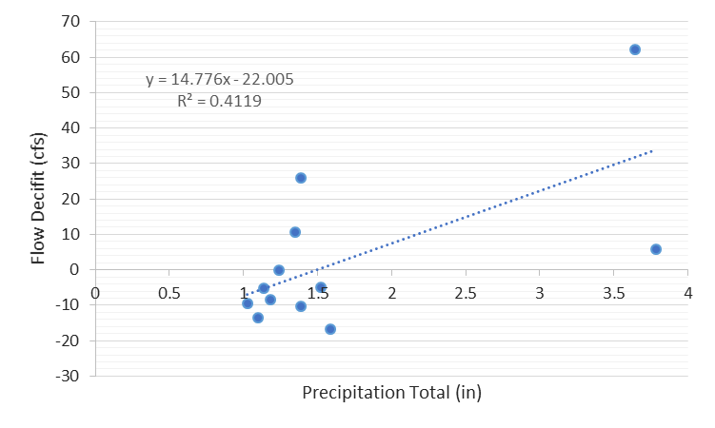
Figure 19: Daily precipitation total greater than 1 inch vs. storm flow deficit at Jacks Branch DEP gage
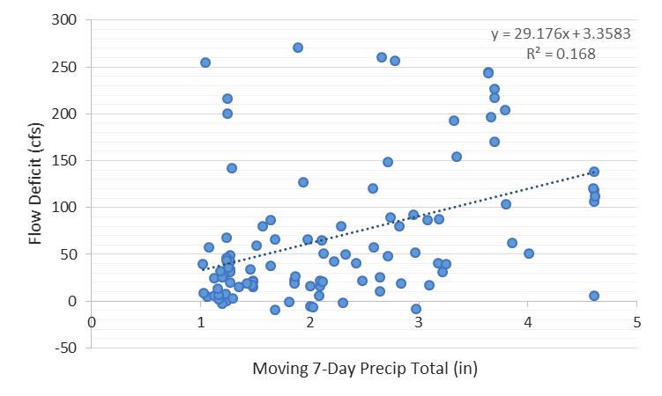
Figure 20: Moving 7-day precipitation totals greater than 1 inch from March through September vs. storm flow deficit at Jacks Branch DEP gage

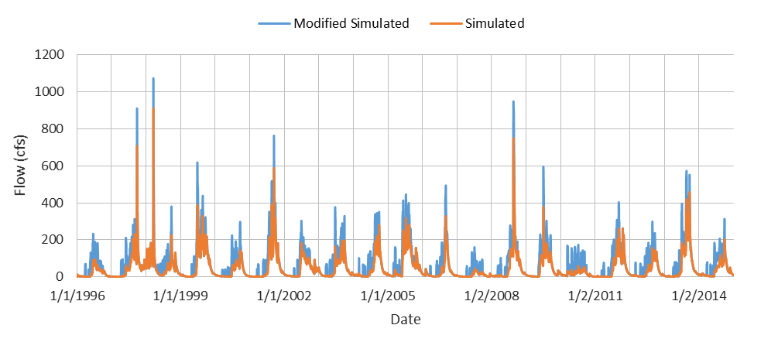
Figure 21: Simulated time series vs. modified simulated time series that includes calculated external source at Jacks Branch DEP gage (01/01/1996 – 12/31/2014)

Fast Creek
The 2017 HSPF Model under simulated storm flows at the Fast Creek gage, which measured discharge from April 4, 2010 through December 8, 2010. According to stakeholder information provided during the site visit, Fast Creek is connected to neighboring subbasins during storm events, and flow from the neighboring watershed is routed to Fast Creek through canals.
To represent the movement of water from the neighboring subbasins, Tetra Tech attempted to determine the relationship between rainfall and total storm flow, as well as rainfall and the modeled storm flow deficit from April 4, 2010 through December 8, 2010. A relationship was needed to estimate contributing flow from the external source during the remaining modeling period when measured flow data were not available at Fast Creek. Similar to Jacks Branch, when the total storm flow volume and the storm flow volume deficit volume was plotted against daily precipitation, there was no relationship between the flows and rainfall. This was likely due to (1) seasonal differences, (2) antecedent moisture conditions, (3) rising and falling limb response, and (4) uncertainty and/or error in measured high flow volume.
Tetra Tech was able to identify a relationship between precipitation and total storm flow volume and deficit storm flow volume when total rainfall was greater than 1 inch using 7-day moving rainfall total during the wet months (R²=0.63) (Figure 22). The 7-day moving rainfall total accounted for some of the lag time in hydrograph response and antecedent moisture conditions.
The deficit flow volume regression formula was calculated for the entire modeling period (January 1, 1996 through December 31, 2014) (Figure 23). However, the flow volume needed to make up the deficit was greater than the total storm flow volumes of the neighboring subbasins. Because of this, storm volume has not been routed from neighboring watersheds to Fast Creek at this time.
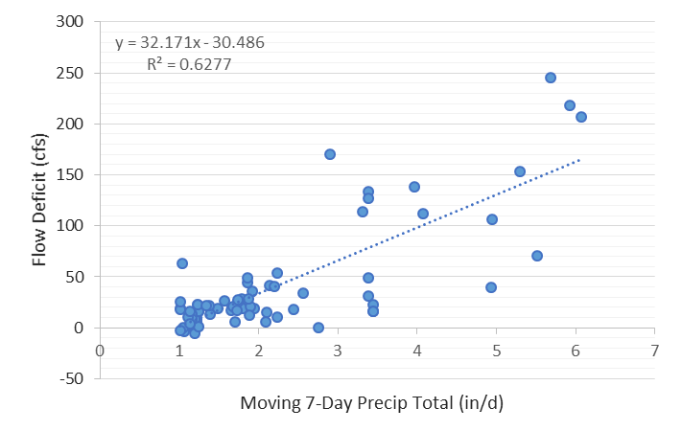
Figure 22: Moving 7-day precipitation totals greater than 1 inch from March through September vs. storm flow deficit at Fast Creek DEP gage

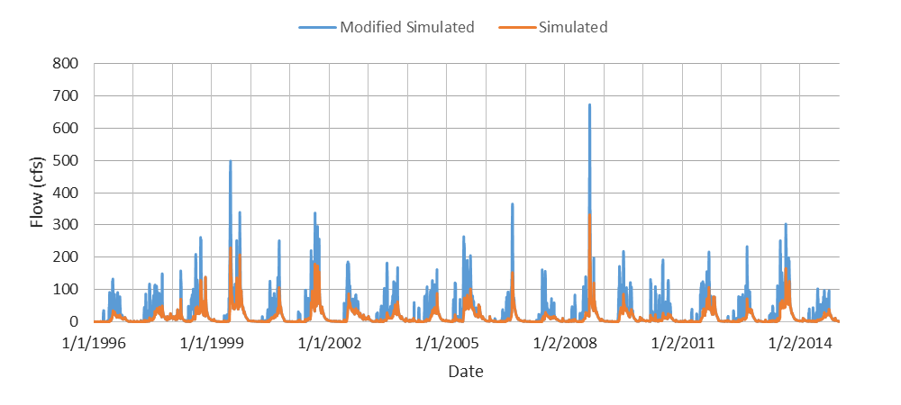
Figure 23: Simulated time series vs. modified simulated time series that includes calculated external source at Fast Creek DEP gage (01/01/1996 – 12/31/2014)

HSPF Model Calibration

Flow Calibration
Tetra Tech completed the draft setup of the 2017 HSPF model and evaluated the initial hydrology calibration results. Tetra Tech compared modeled hydrology outputs to measured hydrology outputs at 18 USGS and department gages. In Appendix A and Appendix B, Tetra Tech has provided daily and monthly average temporal comparison plots, frequency distribution curves, regression plots, and relative error and Nash-Sutcliffe model efficiency statistics for the 13 stations with more than one year of continuous data. Regression plots and temporal comparisons were provided for the 5 stations that had less than one year of data.
Four of the gages are tidally influenced: USGS 022929176 Telegraph Creek, USGS 02293055 Orange River, USGS 02293090 Popash Creek, and USGS 02293190 Billy Creek. Negative flows were also measured at four other gages with more than one year of data: USGS 02292000 Caloosahatchee Canal at Moore Haven, USGS 02292010 Caloosahatchee Canal at S-77 lock, USGS 26451408150700 Industrial Canal, and DEP Jacks Branch. In Appendix A, the negative measurements were removed from the visual comparison and statistical analysis, and in Appendix B the negative flow measurements were set to 0 cfs.
Tetra Tech ran the 2014 HSPF Model and compared outputs from the 2014 HSPF Model the draft 2017 HSPF Model. The 2017 HSPF Model performed better both visually and statistically than the 2014 HSPF Model at almost all stations with more than 1 year of data. The 2014 HSPF Model results are located in Appendix C.
Statistical metrics at each stations were compared to Donigian (2002) performance metrics and given a qualitative rating of Very Good (VG), Good (G), Fair (F), or Poor (P) (Table 52 and Table 53). The statistical summary of calibration results for the 2017 HSPF model and 2014 HSPF model are provided in Table 54 through Table 56. A summary of the draft hydrology calibration at each station, along with potential calibration issues, are provided in the sections below.
Table 52: Donigian 2002 calibration/validation targets or tolerances for percent difference between modeled observed results for hydrologic parameters
Category | Range
Very Good | <10%
Good | 10% - 15%
Fair | 15% - 25%
Poor | >25%
Table 53: Donigian 2002 R² and Nash-Sutcliffe ranges for model performance
Category | Range
Very Good | >0.8
Good | 0.7 - 0.8
Fair | 0.6 - 0.7
Poor | <0.6

Table 54: Statistical summary of 2017 HSPF model hydrological calibration, Appendix A results (negative flows removed)
USGS Station ID | Station Name | R² (monthly) | R² Rating | NSE | NSE Rating | NSE (monthly) | NSE (monthly) Rating | Total Volume % Error | Total Volume % Error Rating
02292000 | Caloosahatchee Canal at Moore Haven | 0.99 | VG | 0.98 | VG | 0.99 | VG | 6.1 | VG
02292010 | Caloosahatchee Canal DWS of S-77 at Moore Haven | 0.99 | VG | 0.98 | VG | 0.99 | VG | -6.4 | VG
02292480 | Caloosahatchee Canal at Ortona Lock near LaBelle S-78 | 0.92 | VG | 0.84 | VG | 0.92 | VG | -3.7 | VG
26451408150700 | Industrial Canal at Clewiston | 0.97 | VG | 0.29 | P | 0.50 | P | -56.4 | P
02292900 | Caloosahatchee River at S-79 near Olga, FL | 0.90 | VG | 0.77 | G | 0.85 | VG | -17.5 | F
02293230 | Whiskey Creek at Fort Myers | 0.76 | G | -0.18 | P | 0.41 | P | -34.6 | P
02293240 | Aries Canal at Cape Coral | 0.69 | F | 0.25 | P | 0.23 | P | -57.4 | P
02293241 | San Carlos Canal at Cape Coral | 0.65 | F | 0.46 | P | 0.61 | F | -11.1 | G
022929176 | Telegraph Creek at State Highway at Olga | 0.86 | VG | 0.82 | VG | 0.85 | VG | 3.2 | VG
02293055 | Orange River near Buckingham | 0.80 | G | 0.47 | P | 0.73 | G | 11.2 | G
02293090 | Popash Creek at Leetana Road near Fort Myers | 0.84 | VG | 0.70 | F | 0.80 | G | 32.5 | P
02293190 | Billy Creek at Fort Myers | 0.85 | VG | 0.35 | P | 0.85 | VG | 2.4 | VG
02293243 | Courtney Canal at Cape Coral | 0.64 | F | 0.59 | P | 0.43 | P | -7.9 | VG
 | DEP Jacks Branch at SR 78 | 0.83 | VG | 0.61 | F | 0.78 | G | -2.8 | VG
 | DEP Fast Creek at SR 80 | 0.33 | P | Additional statistical data not calculated
 | DEP Pollywog Creek at SR 78 | 0.02 | P
 | DEP Powell Creek at SR 78 (13 daily values) | 0.48 | P
 | DEP Stroud Creek (13 daily values) | 0.85 | VG
 | DEP Yellow Fever Creek (13 daily values) | 0.35 | P

Table 55: Statistical summary of 2017 HSPF model hydrological calibration, Appendix B results (negative flows replaced with 0 cfs)
USGS Station ID | Station Name | R² (monthly) | R² Rating | NSE | NSE Rating | NSE (monthly) | NSE (monthly) Rating | Total Volume % Error | Total Volume % Error Rating
02292000 | Caloosahatchee Canal at Moore Haven | 0.99 | VG | 0.98 | VG | 0.99 | VG | 6.2 | VG
02292010 | Caloosahatchee Canal DWS of S-77 at Moore Haven | 0.99 | VG | 0.98 | VG | 0.99 | VG | -5.2 | VG
02292480 | Caloosahatchee Canal at Ortona Lock near LaBelle S-78 | 0.92 | VG | 0.84 | VG | 0.92 | VG | -3.7 | VG
26451408150700 | Industrial Canal at Clewiston | 0.97 | VG | 0.41 | P | 0.55 | P | -49.2 | P
02292900 | Caloosahatchee River at S-79 near Olga, FL | 0.90 | VG | 0.77 | G | 0.85 | VG | -17.5 | F
02293230 | Whiskey Creek at Fort Myers | 0.76 | G | -0.18 | P | 0.41 | P | -34.6 | P
02293240 | Aries Canal at Cape Coral | 0.69 | F | 0.25 | P | 0.23 | P | -57.4 | P
02293241 | San Carlos Canal at Cape Coral | 0.65 | F | 0.46 | P | 0.61 | F | -11.1 | G
022929176 | Telegraph Creek at State Highway at Olga | 0.86 | VG | 0.82 | VG | 0.85 | VG | 3.3 | VG
02293055 | Orange River near Buckingham | 0.80 | G | 0.50 | P | 0.72 | G | 11.2 | G
02293090 | Popash Creek at Leetana Road near Fort Myers | 0.84 | VG | 0.70 | F | 0.80 | G | 34.9 | P
02293190 | Billy Creek at Fort Myers | 0.85 | VG | 0.41 | P | 0.77 | VG | 19.7 | F
02293243 | Courtney Canal at Cape Coral | 0.64 | F | 0.59 | P | 0.43 | P | -7.9 | VG
 | DEP Jacks Branch at SR 78 | 0.83 | VG | 0.61 | F | 0.78 | G | -2.8 | VG
 | DEP Fast Creek at SR 80 | 0.33 | P | Additional statistical data not calculated
 | DEP Pollywog Creek at SR 78 | 0.02 | P
 | DEP Powell Creek at SR 78 (13 daily values) | 0.48 | P
 | DEP Stroud Creek (13 daily values) | 0.85 | VG
 | DEP Yellow Fever Creek (13 daily values) | 0.35 | P

Table 56: Statistical summary of 2014 HSPF model hydrological calibration, Appendix C results (negative flows replaced with 0 cfs)
USGS Station ID | Station Name | R² (monthly) | R² Rating | NSE | NSE Rating | NSE (monthly) | NSE (monthly) Rating | Total Volume % Error | Total Volume % Error Rating
02292000 | Caloosahatchee Canal at Moore Haven | 0.99 | VG | 0.96 | VG | 1.00 | VG | 1.3 | VG
02292010 | Caloosahatchee Canal DWS of S-77 at Moore Haven | 0.99 | VG | 0.97 | VG | 0.98 | VG | -8.8 | VG
02292480 | Caloosahatchee Canal at Ortona Lock near LaBelle S-78 | 0.83 | VG | 0.71 | G | 0.80 | VG | -18.7 | F
26451408150700 | Industrial Canal at Clewiston | 0.08 | P | -0.52 | P | -0.69 | P | -70.5 | P
02292900 | Caloosahatchee River at S-79 near Olga, FL | 0.83 | VG | 0.70 | G | 0.77 | G | -20.6 | F
02293230 | Whiskey Creek at Fort Myers | 0.74 | G | -6.40 | P | 0.70 | G | -12.2 | G
02293240 | Aries Canal at Cape Coral | 0.60 | F | 0.02 | P | -0.15 | P | -83.6 | P
02293241 | San Carlos Canal at Cape Coral | 0.64 | F | 0.37 | P | 0.40 | P | -51.1 | P
022929176 | Telegraph Creek at State Highway at Olga | 0.87 | VG | 0.45 | P | 0.97 | VG | -34.3 | P
02293055 | Orange River near Buckingham | 0.77 | G | 0.23 | P | 0.97 | VG | -35.9 | P
02293090 | Popash Creek at Leetana Road near Fort Myers | 0.78 | G | -0.17 | P | 0.98 | VG | 66.4 | P
02293190 | Billy Creek at Fort Myers | 0.69 | F | -0.16 | P | 0.98 | VG | -9.9 | VG
02293243 | Courtney Canal at Cape Coral | 0.55 | P | 0.27 | P | 0.34 | P | 58.3 | P
 | DEP Jacks Branch at SR 78 | 0.50 | P | 0.38 | P | 0.95 | VG | -40.6 | P

USGS Gage Calibration
- USGS 02292000 Caloosahatchee Canal at Moore Haven, FL (01/01/1997 – 09/30/2003)
  - Gage used to verify upstream boundary condition contribution from Lake Okeechobee
  - Nash-Sutcliffe coefficient better in 2017 HSPF Model than 2014 HSPF Model, total volume error higher in 2017 HSPF Model due to over estimation of low flows
  - U.S. Army Corps of Engineers (USACE) S-77 data used to develop external boundary condition
  - Differences in flow due to differences between USACE flow data and USGS flow data
  - Model was not delineated to gage, and differences in low flow due to runoff from subbasin 215 and a portion of the S-4 basin that is routed to reach 215 (controlled by S-235)
- USGS 02292010 Caloosahatchee Canal DWS of S-77 Moore Haven, FL (05/19/2008 – 12/31/2014)
- Gage used to verify upstream boundary condition contribution from Lake Okeechobee
- Error in total volume better in 2017 HSPF Model than 2014 HSPF Model, error in low flows is higher in 2017 HSPF Model
- USACE S-77 data used to develop external boundary condition
- Differences in flow due to differences between USACE flow data and USGS flow data
  - Model was not delineated to gage, and differences in low flow due to runoff from subbasin 215 and a portion of the S-4 basin that is routed to reach 215 (controlled by S-235)
- USGS 02292480 Caloosahatchee Canal at Ortona Lock near LaBelle S-78 (01/01/1997 – 09/30/2003)
- Error in total volume, high flows, and Nash-Sutcliffe coefficient better in 2017 HSPF Model than 2014 HSPF Model, model has better visual representation in 2017 HSPF Model
  - Over simulation of low flows (between 35 and 100 cfs) may be due to USACE lock operations not being represented in the model
- USGS 26451408150700 Industrial Canal at Clewiston (01/01/1997 – 12/31/2014)
- Canal is highly controlled and measured flows do not correspond to rainfall events (i.e. flows are zero during periods of high rainfall and high during periods of low rainfall)
- When stage in Lake Okeechobee is between 13.0 and 15.5 ft, the S-310 lock is in the open position and there is no record of the flow rate through the S-310 lock into the Industrial Canal
- Positive flows appear under predicted due to hydraulic setup at Industrial Canal which routes some flows directly into S-4 basin interior
  - Negative flows (not included in visual and statistical comparison) are represented by the S-4 withdrawals from the model
- USGS 02292900 Caloosahatchee River at S-79 near Olga, FL (01/01/1997 – 12/31/2014)
- Error in total volume and Nash-Sutcliffe coefficient better in 2017 HSPF Model than 2014 HSPF Model
- Differences in low and high flows may be due to USACE lock operations not being represented in the model

- USGS 02293230 Whiskey Creek at Fort Myers, FL (01/01/1997 – 12/31/2014)
- Nash-Sutcliffe coefficient and flow hydrograph better in 2017 HSPF Model than 2014 HSPF Model indicating overall better visual calibration, although error statistics better in 2014 HSPF model
- Error in low flow – high flow distribution and storm volumes due to HSPF model not capturing storage in reservoir (pond); poor timing due to storage and release
  - Gage is tidally influenced at very high tides
- USGS 02293240 Aries Canal at Cape Coral, FL (01/01/1997 – 08/31/2013)
- Error in total volume, low flows, high flows, and Nash-Sutcliffe coefficient better in 2017 HSPF Model than 2014 HSPF Model, better visual representation in 2017 HSPF Model
  - Although there are no negative flow measurements, gage may be influenced by tides which may cause ponding of water in canal system
- USGS 02293241 San Carlos Canal at Cape Coral, FL (01/01/1997 – 04/03/2013)
- Error in total volume, high flows, and Nash-Sutcliffe coefficient better in 2017 HSPF Model than 2014 HSPF Model, model has better visual representation in 2017 HSPF Model
- Although there are no negative flow measurements, gage may be influenced by tides which may cause ponding of water in canal system
  - Over simulation of baseflows below 1 cfs greatly affect statistics
- USGS 022929176 Telegraph Creek at State Highway at Olga, FL – Big Island Canal (01/01/2008 – 04/09/2013)
- Error in total volume, low flows, high flows, and Nash-Sutcliffe coefficient better in 2017 HSPF Model than 2014 HSPF Model, better visual representation in 2017 HSPF Model
  - Model performs very well with the exception of low flows below 10 cfs, no calibration improvement recommendations
- USGS 02293055 Orange River near Buckingham, FL (01/01/2008 – 04/09/2013)
- Error in total volume, low flows, high flows, and Nash-Sutcliffe coefficient better in 2017 HSPF Model than 2014 HSPF Model, better visual representation in 2017 HSPF Model
  - Model performs very well, no calibration improvement recommendations
- USGS 02293090 Popash Creek at Leetana Road near Fort Myers, FL (01/01/2008 – 04/05/2013)
- Error in total volume, high flows, and Nash-Sutcliffe coefficient better in 2017 HSPF Model than 2014 HSPF Model, better visual representation in 2017 HSPF Model
- Model over simulates summer months 2008 – 2010; under simulates 2011 – 2013
  - Most overestimation occurs for flows below 10 cfs; produces high statistical differences
- USGS 02293190 Billy Creek at Fort Myers, FL (04/01/2008 – 05/08/2013)
- Nash-Sutcliffe coefficient better in 2017 HSPF Model than 2014 HSPF Model, better visual representation in 2017 HSPF Model
- Most overestimation occurs for flow below 10 cfs produces high statistical differences

DEP Gage Calibration
- DEP Jacks Branch at SR 78 (01/01/2010 – 01/03/2011)
- Both the 2014 and 2017 HSPF Models include external inflow to watershed to account for external connections during storm flows
- Error in total volume and Nash-Sutcliffe coefficient better in 2017 HSPF Model than 2014 HSPF Model
- The flow data collected appears to have some irregularities, and high flows may be overestimated at times

Calibration Issues
In setting up the 2017 HSPF Model, Tetra Tech addressed the following items:
- Checked the NEXRAD rainfall data accuracy against other sources in the watershed (refer to Section 3.2).
- Provided a reasonable mechanism to include agricultural irrigation pumping in the model (refer to Section 3.4).
- Re-evaluated key model setups including percent imperviousness (Section 3.3.1) and PET (Section 3.4).
- Updated the hydrology model parameterization to improve calibration (Section 3.7.1).
Based on the draft hydrology calibration results, the following issues were identified. For each issue, Tetra Tech has documented methodology used to improve calibration, and provided recommendations on how alterations to current model setup could improve the hydrology calibration.
Issue #1: The low flows at USGS 02292000 (below 100 cfs) and USGS 02292010 (below 50 cfs) are over simulated.
The model is not delineated to the USGS gages, which are located at the upstream model boundary. Therefore, the results include contributing flow from the downstream subbasin, subbasin 215, as well as a portion of the S-4 basin that is discharging into reach 215. The calibration plots and statistical summary represents the output from reach 215 and includes the internal model area contributing to reach 215 (subbasin 215 and a portion of the S-4 basin). The calibration plots and statistical summary will therefore show this overestimation of low flows.
Issue #2: The flows at USGS 26451408150700 are under simulated.
The hydraulic representation of the S-4 basin has been setup to best represent water movement through the Industrial Canal and remaining canals in the S-4 basin. Flow inputs and flow removals in the Industrial Canal and S-4 basin have been estimated and calculated using the best available data and information. A portion of the flow inputs into the Industrial Canal are routed to the interior of the S-4 basin at times, which causes the visual under simulation at USGS 26451408150700.
Issue #3: The low flows (between 35 and 100 cfs) at USGS 02292480 are over simulated.
The USACE operates the S-78 lock located immediately upstream of the gage, and water may be ponded behind the lock during low flows and releases may be increased during high flows. Tetra Tech is representing the Caloosahatchee River below S-78 as a natural river system and did not include USACE operations, which is likely causing the overestimation of low flows. To improve the model calibration, flow out of subbasin 188 could be forced with the USACE S-78 operations.
Issue #4: The low flows (below 100 cfs) at USGS 02292900 do not match measured data.
The USACE operates the S-79 lock located immediately upstream of the gage, and water may be ponded behind the lock during low flows and releases may be increased during high flows. Tetra Tech is representing the Caloosahatchee River below S-79 as a natural river system and did not include USACE operations, which is likely causing the overestimation of low flows. To improve the model calibration, flow out of subbasin 147 should be forced with the USACE S-79 operations.
Issue #5: At USGS 02293230, there is an error in low flow – high flow distribution, as well as the storm volumes.
This error appears to be caused by the HSPF model not capturing storage in the reservoir (pond) and poor timing due to storage and release. Due to the influence of the structures, model parameterization cannot improve the low flow – high flow distribution. Tetra Tech does not believe the low flow – high flow distribution at the gage can be captured by the HSPF model because of the gage location.
Issue #6: For station USGS 02293240 on the Cape Coral Aries Canal, there is an underestimation of flows.
Tetra Tech evaluated the delineation of the canal network and determined that the current delineation appears to be correct. Tetra Tech evaluated the impervious area representation in this portion of the watershed and adjusted parameterization, including decreasing infiltration, but was not able to improve the overall calibration.
Issue #7: For station USGS 02293241 at the Cape Coral San Carolos Canal, there is an error in the low flow – high flow distribution.
Tetra Tech evaluated the impervious area representation in this portion of the watershed and adjusted parameterization, including decreasing infiltration, but was not able to improve the overall calibration.

References
Asano, T., Burton, F.L., Leverenz, H.L., Tsuchihashi, R., and G. Tchobanoglous. 2007. Water Reuse: Issues, technologies, and Applications. McGraw Hill, New York, NY.
The Balmor Group, LLC. 2010. Florida Statewide Agricultural Irrigation Demand (FSAID). Prepared for the Florida Department of Agriculture and Consumer Services.
Brown, Clay. October 2013. Reference Evapotranspiration (1948-2013) using 51-year Hydrological Reanalysis and North American Regional Reanalysis. SFWMD Water Resources Division, Water Supply Bureau, Hydrologic and Environmental Systems Modeling Section.
Cole, Thomas M. and Wells, Scott A. 2003. CE-QUAL-W2: A Two-Dimensional, Laterally Averaged, Hydrodynymaic and Water Quality Model, Version 3.2. User Manual. Draft Report. Instruction Report EL-03-1. Prepared for the U.S. Army Corps of Engineers, Washington D.C.
Donigian, A.S. 2002. Watershed model calibration and validation: the HSPF experience. AQUA TERRA Consultants. Mountain View, California.
Dynamic Solutions, LLC (DSLLC) and Camp Dresser & McKee, Inc. (CDM). 2009. Section 5: Site Specific Model Selection, Preparation, Verification, Calibration, and Validation for Caloosahatchee River Basin TMDL Model Support. Prepared for the Florida Department of Environmental Protection.
Everglade City, Florida Case Study (Rony Joel, P.E., DEE, AEC Water).
Florida Administrative Code Chapter 62-610 http://www.dep.state.fl.us/legal/rules/wastewater/62-610.pdf.
Florida Department of Health (FDOH). 2013. Onsite Sewage Treatment Disposal Systems GIS Coverage.
Florida Department of Environmental Protection (DEP). 2009. Nutrient TMDL for the Caloosahatchee Estuary, WBID 3240A, 3240B and 3240C. Tallahassee, Florida: Bureau of Watershed Management.
Hamon, R.W. 1961. Estimating Potential Evapotranspiration, In Proceedings of the American Society of Civil Engineers, Journal of the Hydraulic Division, 87(HY3):107–120.
Harper, H.H. 1994. Stormwater loading rate parameters for central and south Florida. Environmental Research and Design, Inc. Orlando, Florida.
Kisekka, Isaya, Kati W. Migliaccio, Michael D. Dukes, Jonathan H. Crane, and Bruce Schaffer. 2013. Evapotranspiration-Based Irrigation Scheduling for Agriculture: Crop Coefficients of Some Commercial Crops in Florida. University of Florida – Institute of Food and Agricultural Sciences. Accessed at: http://edis.ifas.ufl.edu/ae456.
Manatee County Utilities Department. https://www.mymanatee.org.
McCutcheon, Steve C., James L. Martin, and Robert B. Ambrose. 1990. Technical Guidance Manual for Performing Waste Load Allocations, Book III: Estuaries, Part 2: Application of Estuarine Waste Load Allocation Models. U.S. Environmental Protection Agency. Washington, DC.
MetADAPT. 2007. User’s Manual of Meteorological Data Analysis and Preparation Tool.
Monteith, J. L. 1965. Evaporation and environment. Symposia of the Society for Experimental Biology 19: 205–224.
Sayemuzzaman, Mohammad and Ming Ye. August 2015. Estimation of Nitrogen Loading from Converted Septic Systems (2013-14 and 2014-15) to Surface Waterbodies in Port St. Lucie, FL. Department of Scientific Computing, Florida State University. Prepared for the Florida Department of Environmental Protection. Tallahassee, Florida.
Smajstrla, A.G. January 1990. Technical Manual, Agricultural Field Scale Irrigation Requirements Simulation (AFSIRS) Model. Version 5.5. Agricultural Engineering Department. University of Florida, Gainesville. SJRWMD Special Publication SJ2008-SP17.
Soil and Water Engineering Technology (SWET). 2008. Nutrient Loading Rates, Reduction Factors and Implementation Costs Associated with BMPs and Technologies. Prepared for South Florida Water Management District.
South Florida Water Management District (SFWMD). June 2007. Modified Blaney-Criddle for Excel. West Palm Beach, Florida.
Sutherland, R. 1995. Methodology for Estimating the Effective Impervious Area of Urban Watersheds. Technical Note 58, Watershed Protection Techniques, 2(1): pp 282-284.
Swann, C. 2001. “The Influence of Septic Systems at the Subwatershed Level.” in Watershed Protection Techniques. 3(4): 821-834. Center for Watershed Protection. Ellicott City, MD.
Tchobanoglous, G., Burton, F.L., and H.D. Stensel. 2003. Wastewater Engineering: Treatment and Reuse. Fourth Edition. McGraw Hill, New York, NY.
United States Census Bureau (USCB). 2015. Persons per household, 2010-2014. http://www.census.gov/quickfacts/table/PST045215/00.
United States Department of Agriculture (USDA). 1993. Irrigation Water Requirements. Chapter 2, Part 623 in National Engineering Handbook. U.S. Department of Agriculture, Soil Conservation Service. Available online at: http://policy.nrcs.usda.gov/18351.wba.
United States Environmental Protection Agency (USEPA). 2000. BASINS Technical Note 6. Estimating Hydrology and Hydraulic Parameters for HSPF. EPA-823-R00-012. Office of Water, U.S. Environmental Protection Agency. Washington, DC. July 2000.
United States Environmental Protection Agency (USEPA). 2002. Onsite Wastewater Treatment Manual. EPA 625/R-00/008. National Risk Management Research Laboratory, Office of Water, U.S. Environmental Protection Agency. Washington, DC.
United States Environmental Protection Agency (USEPA). 2012. 2012 Guidelines for Water Reuse. EPA/600/R-12/618. September 2012. National Risk Management Research Laboratory, Office of Water, U.S. Environmental Protection Agency. Washington, DC. http://nepis.epa.gov/Adobe/PDF/P100FS7K.pdf.

Vieux & Associates. 2103. Vieux & Associates, Inc. Radar Rainfall Quality Assurance Plan for the South Florida Water Management District. March 28, 2013.

Appendix A: Draft 2017 HSPF Flow Calibration Results (observed Negative flows removed)

A-1 USGS Gages Calibration Comparison
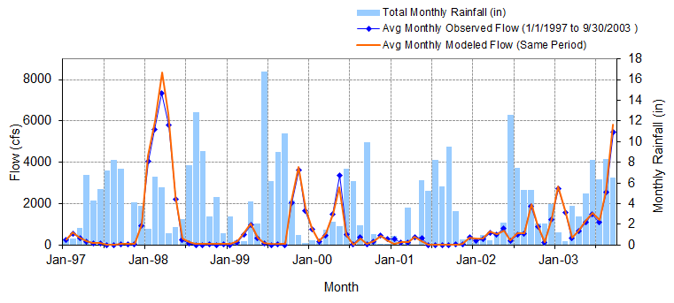
Figure A-1: Mean monthly flow: Model output at Reach 215 vs. USGS 02292000 Caloosahatchee Canal at Moore Haven, FL (01/01/1997 – 09/30/2003)

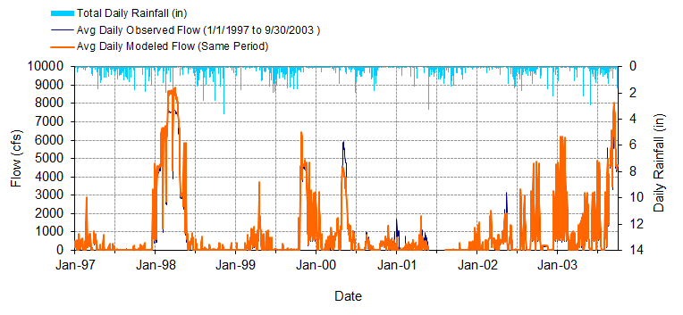
Figure A-2: Mean daily flow: Model output at Reach 215 vs. USGS 02292000 Caloosahatchee Canal at Moore Haven, FL (01/01/1997 – 09/30/2003)

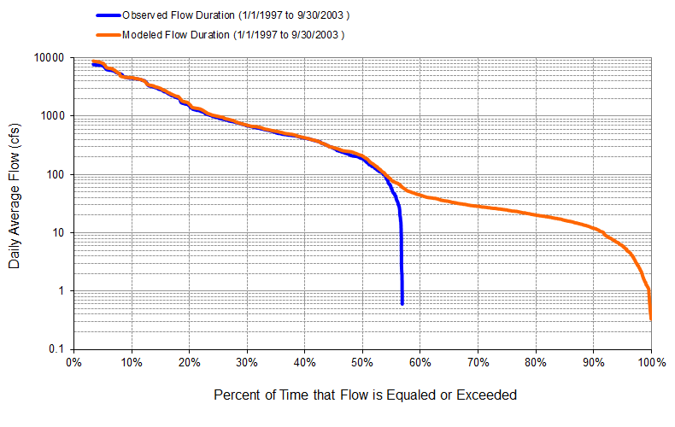
Figure A-3: Flow exceedance: Model output at Reach 215 vs. USGS 02292000 Caloosahatchee Canal at Moore Haven, FL (01/01/1997 – 09/30/2003)

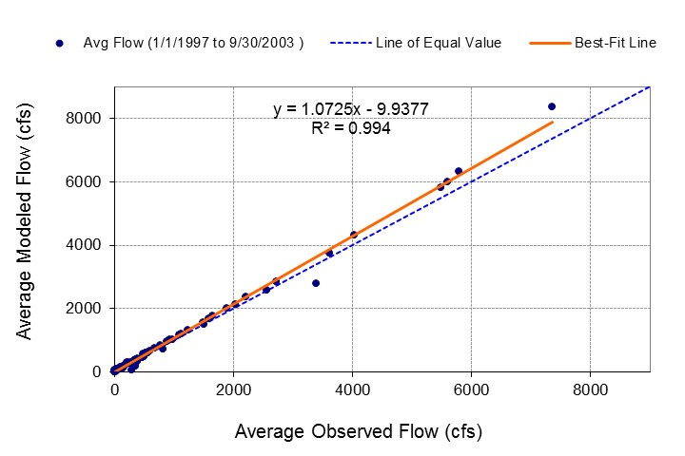
Figure A-4: Monthly flow regression: Model output at Reach 215 vs. USGS 02292000 Caloosahatchee Canal at Moore Haven, FL (01/01/1997 – 09/30/2003)
Table A-1: Summary statistics: Model output at Reach 215 vs. USGS 02292000 Caloosahatchee Canal at Moore Haven, FL (01/01/1997 – 09/30/2003)
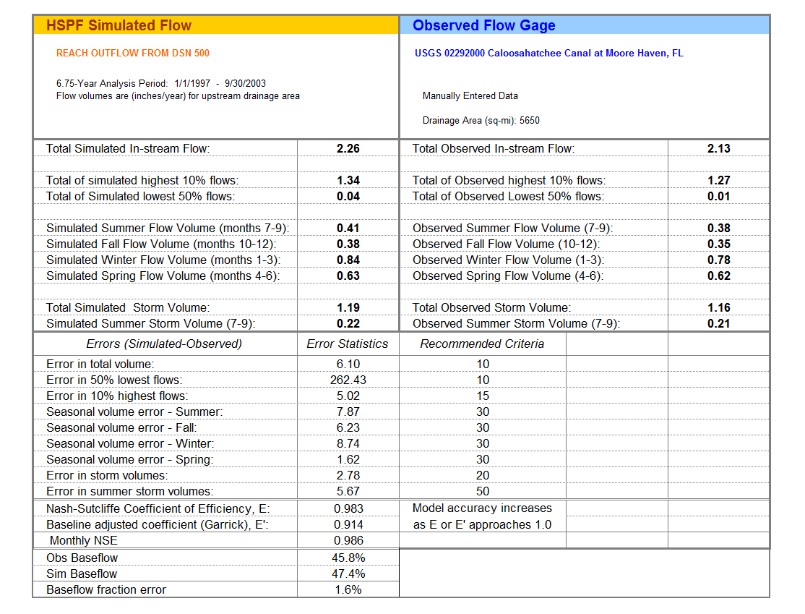
Note: The drainage area in the table is from USGS data, and this area includes a portion of the Lake Okeechobee watershed.
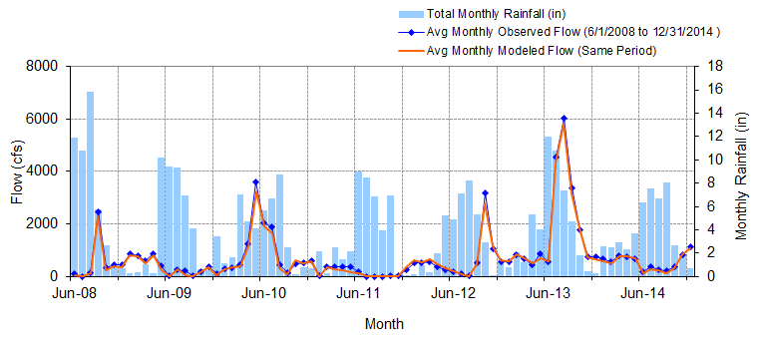
Figure A-5: Mean monthly flow: Model output at Reach 215 vs. USGS 02292010 Caloosahatchee Canal DWS of S-77 at Moore Haven, FL (06/01/2008 – 12/31/2014)

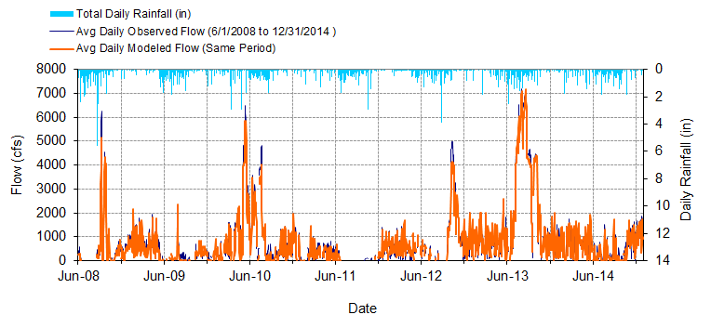
Figure A-6: Mean daily flow: Model output at Reach 215 vs. USGS 02292010 Caloosahatchee Canal DWS of S-77 at Moore Haven, FL (06/01/2008 – 12/31/2014)

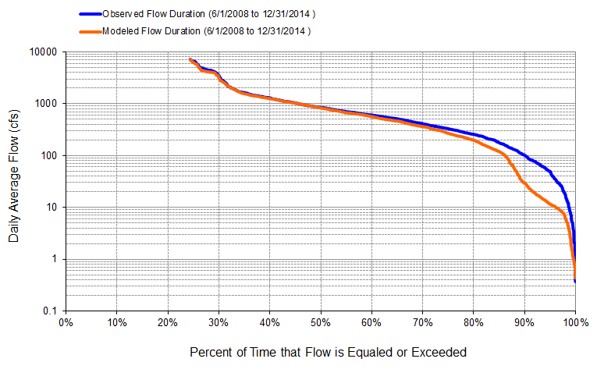
Figure A-7: Flow exceedance: Model output at Reach 215 vs. USGS 02292010 Caloosahatchee Canal DWS at S-77 of Moore Haven, FL (06/01/2008 – 12/31/2014)

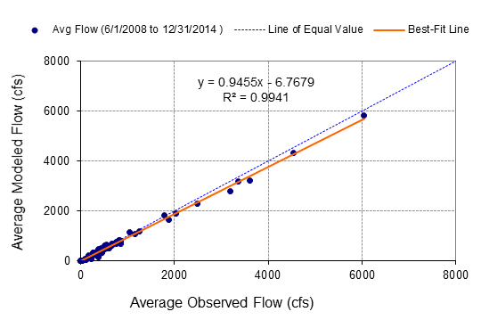
Figure A-8: Monthly flow regression: Model output at Reach 215 vs. USGS 02292010 Caloosahatchee Canal DWS of S-77 at Moore Haven, FL (06/01/2008-12/31/2014)
Table A-2: Summary statistics: Model output at Reach 215 vs. USGS 02292010 Caloosahatchee Canal DWS of S-77 at Moore Haven, FL (06/01/2008 – 12/31/2014)
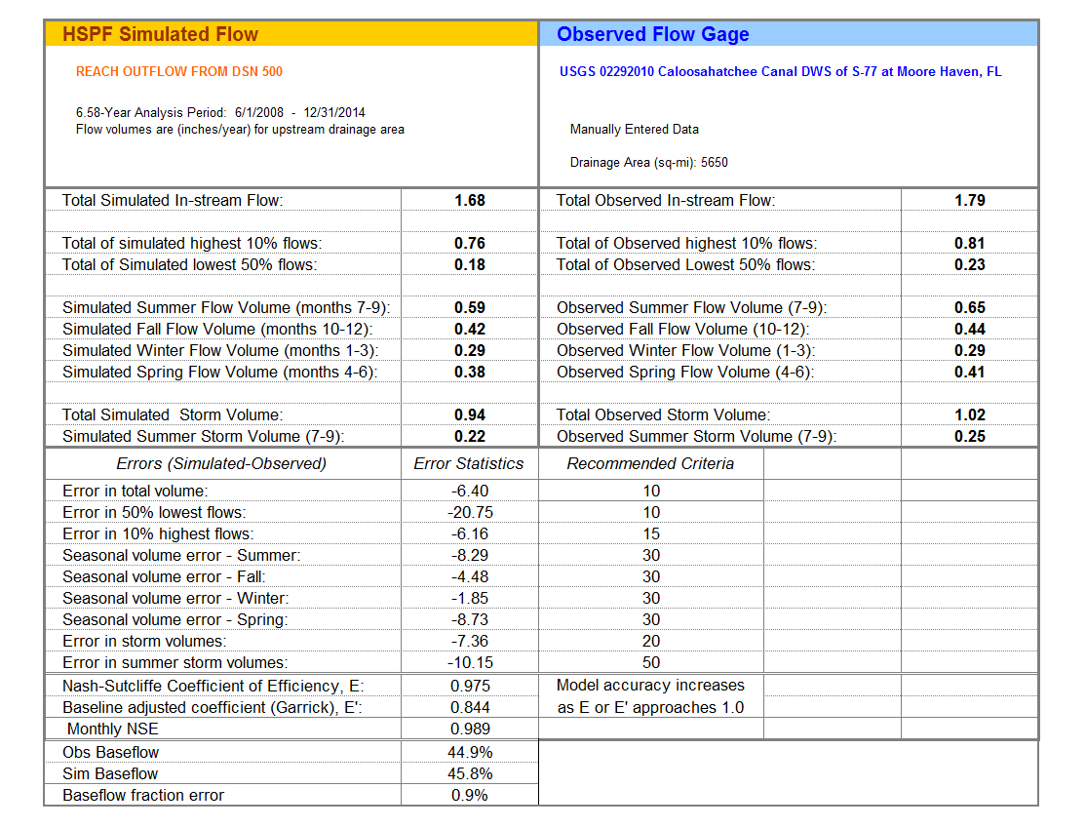
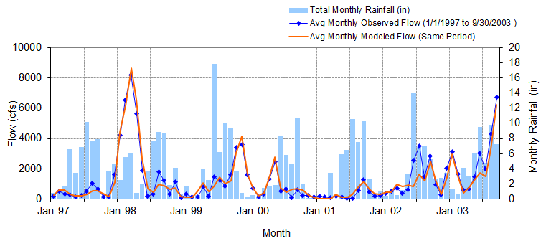
Figure A-9: Mean monthly flow: Model output at Reach 188 vs. USGS 02292480 Caloosahatchee Canal at Ortona Lock near LaBelle S-78 (01/01/1997 – 09/30/2003)

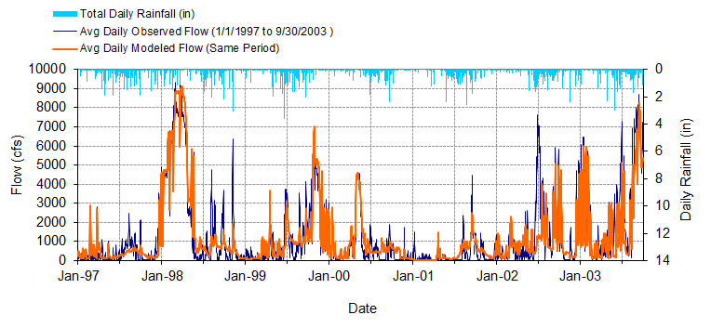
Figure A-10: Mean daily flow: Model output at Reach 188 vs. USGS 02292480 Caloosahatchee Canal at Ortona Lock near LaBelle S-78 (01/01/1997 – 09/30/2003)

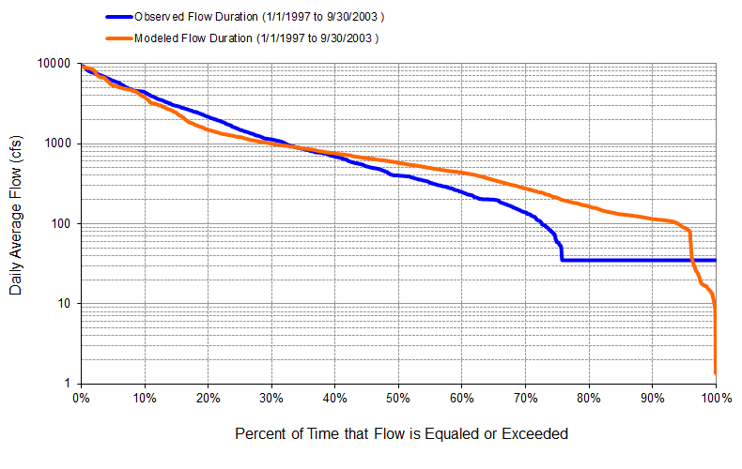
Figure A-11: Flow exceedance: Model output at Reach 188 vs. USGS 02292480 Caloosahatchee Canal at Ortona Lock near LaBelle S-78 (01/01/1997 – 09/30/2003)

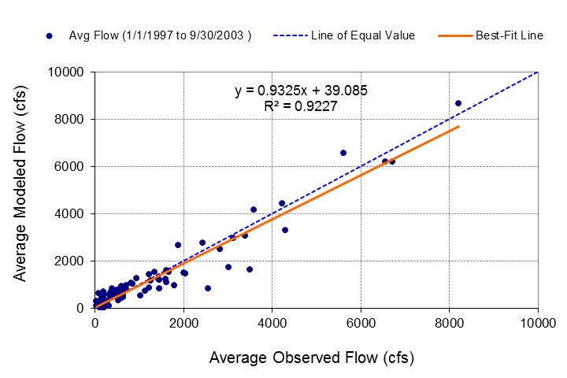
Figure A-12: Monthly flow regression: Model output at Reach 188 vs. USGS 02292480 Caloosahatchee Canal at Ortona Lock near LaBelle S-78 (01/01/1997 – 09/30/2003)
Table A-3: Summary statistics: Model output at Reach 188 vs. USGS 02292480 Caloosahatchee Canal at Ortona Lock near LaBelle S-78 (01/01/1997 – 09/30/2003)
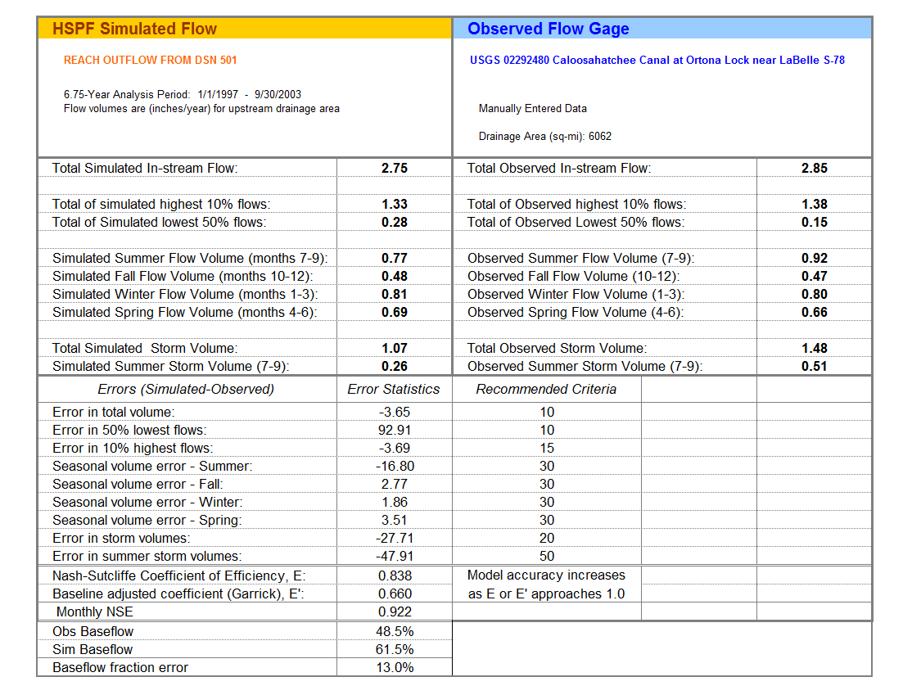
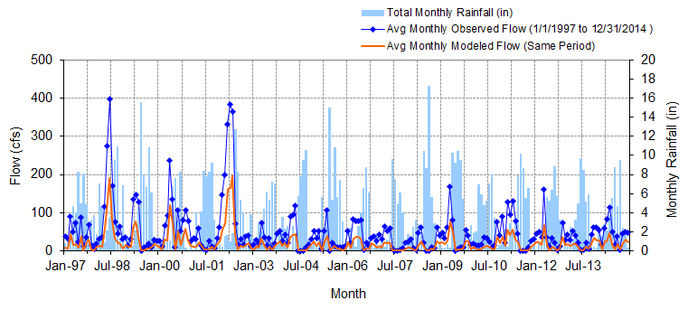
Figure A-13: Mean monthly flow: Model output at Reach 219 vs. USGS 26451408150700 Industrial Canal at Clewiston (01/01/1997 – 12/31/2014)

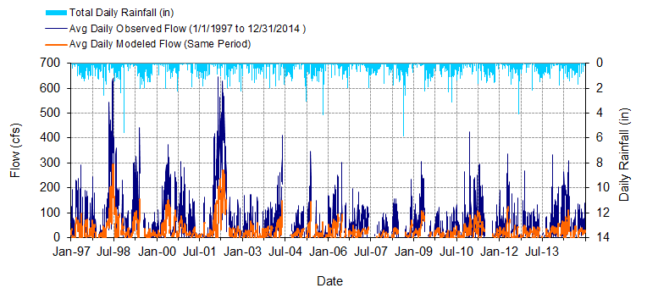
Figure A-14: Mean daily flow: Model output at Reach 219 vs. USGS 26451408150700 Industrial Canal at Clewiston (01/01/1997 – 12/31/2014)

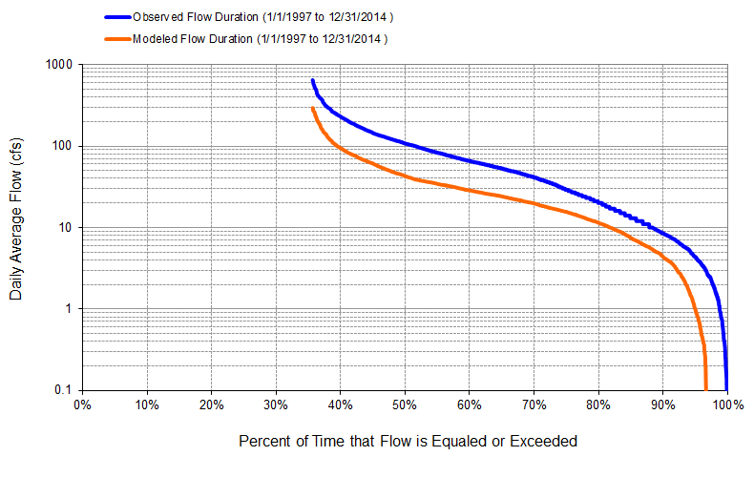
Figure A-15: Flow exceedance: Model output at Reach 219 vs. USGS 26451408150700 Industrial Canal at Clewiston (01/01/1997 – 12/31/2014)

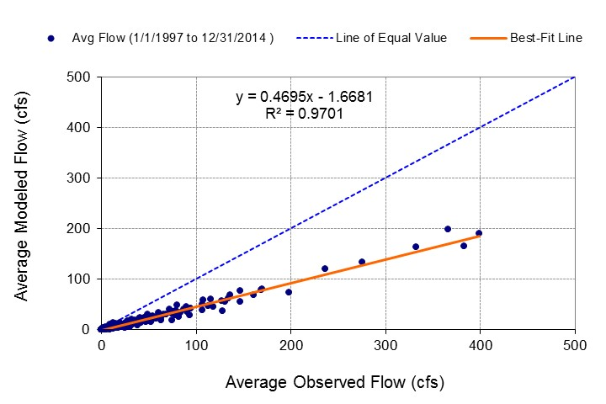
Figure A-16: Monthly flow regression: Model output at Reach 219 vs. USGS 26451408150700 Industrial Canal at Clewiston (01/01/1997 – 12/31/2014)
Table A-4: Summary statistics: Model output at Reach 219 vs. USGS 26451408150700 Industrial Canal at Clewiston (01/01/1997 – 12/31/2014)
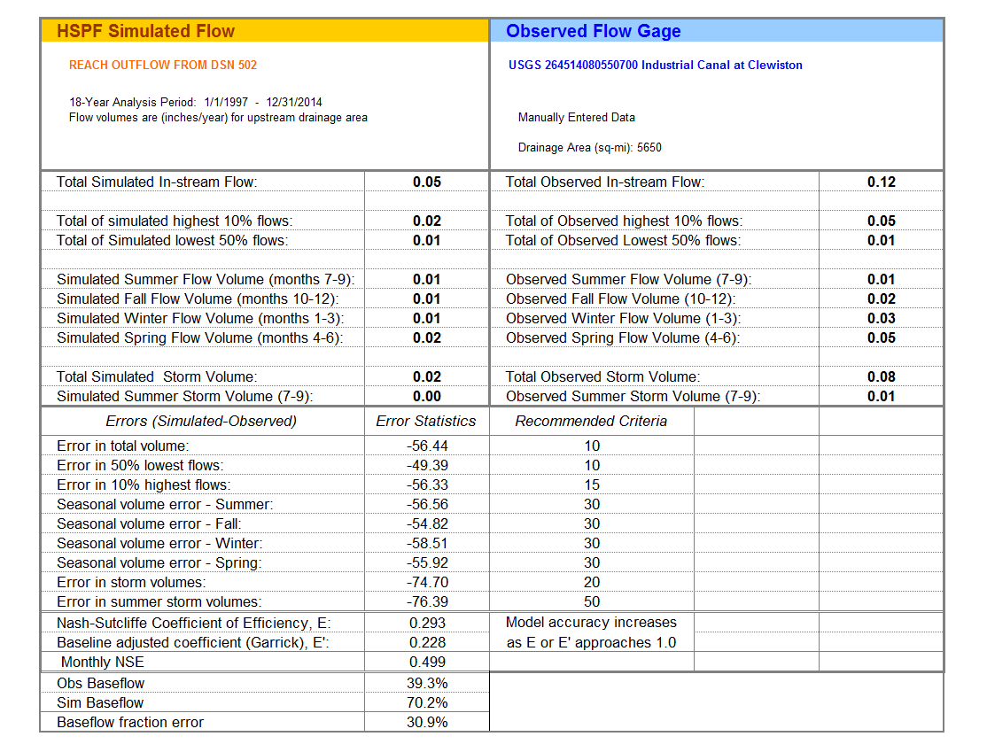
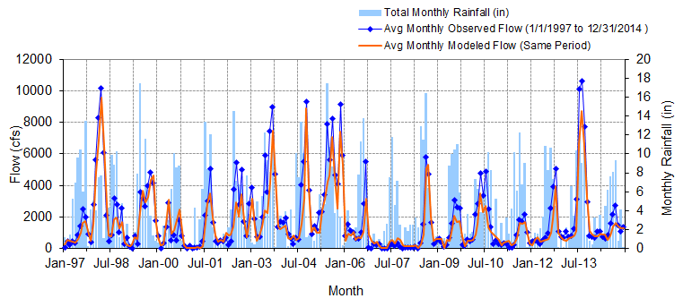
Figure A-17: Mean monthly flow: Model output at Reach 147 vs. USGS 02292900 Caloosahatchee River at S-79 near Olga, FL (01/01/1997 – 12/31/2014)

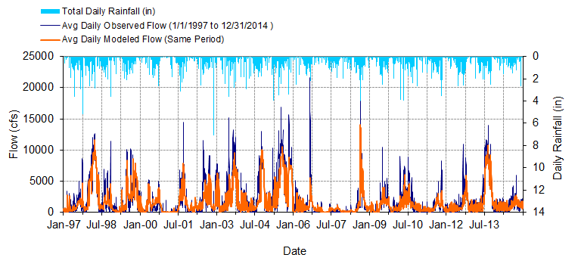
Figure A-18: Mean daily flow: Model output at Reach 147 vs. USGS 02292900 Caloosahatchee River at S-79 near Olga, FL (01/01/1997 – 12/31/2014)

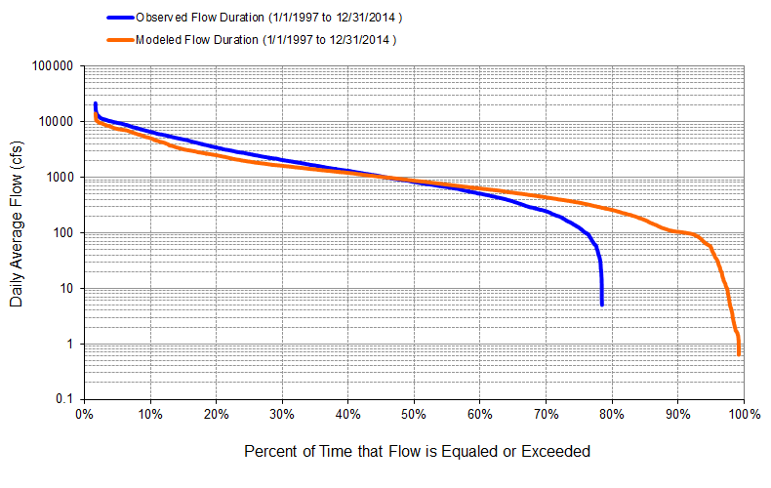
Figure A-19: Flow exceedance: Model output at Reach 147 vs. USGS 02292900 Caloosahatchee River at S-79 near Olga, FL (01/01/1997 – 12/31/2014)

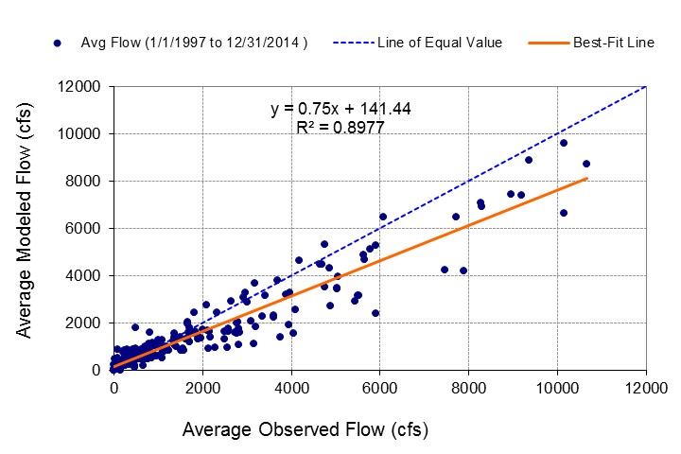
Figure A-20: Monthly flow regression: Model output at Reach 147 vs. USGS 02292900 Caloosahatchee River at S-79 near Olga, FL (01/01/1997 – 12/31/2014)
Table A-5: Summary statistics: Model output at Reach 147 vs. USGS 02292900 Caloosahatchee River at S-79 near Olga, FL (01/01/1997 – 12/31/2014)
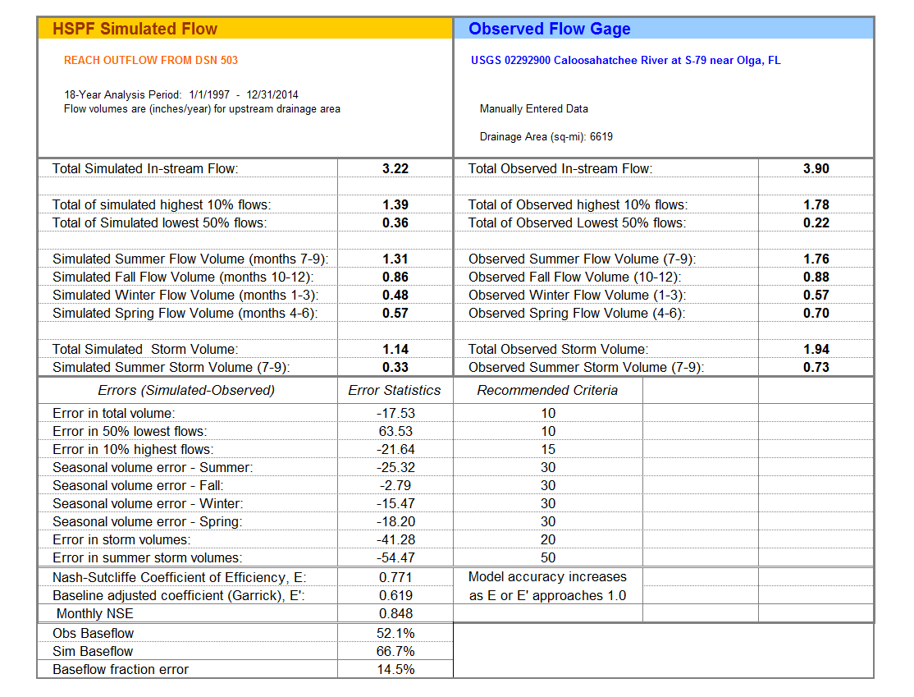
Note: The drainage area in the table is from USGS data, and this area includes a portion of the Lake Okeechobee watershed.

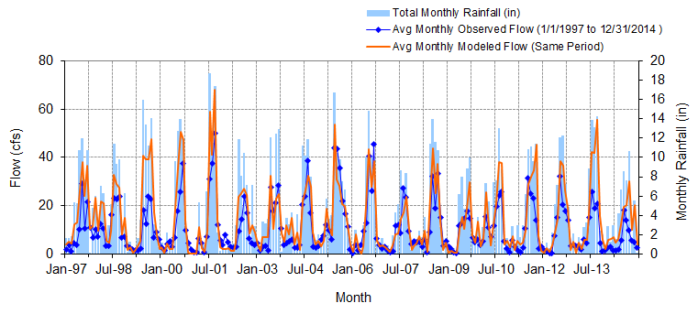
Figure A-21: Mean monthly flow: Model output at Reach 135 vs. USGS 02293230 Whiskey Creek at Fort Myers, FL (01/01/1997 – 12/31/2014)

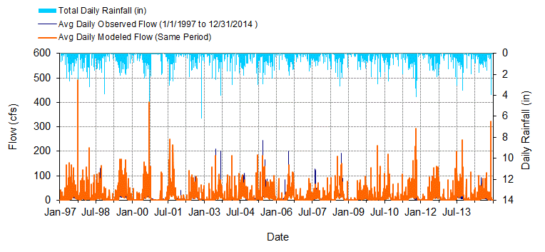
Figure A-22: Mean daily flow: Model output at Reach 135 vs. USGS 02293230 Whiskey Creek at Fort Myers, FL (01/01/1997 – 12/31/2014)

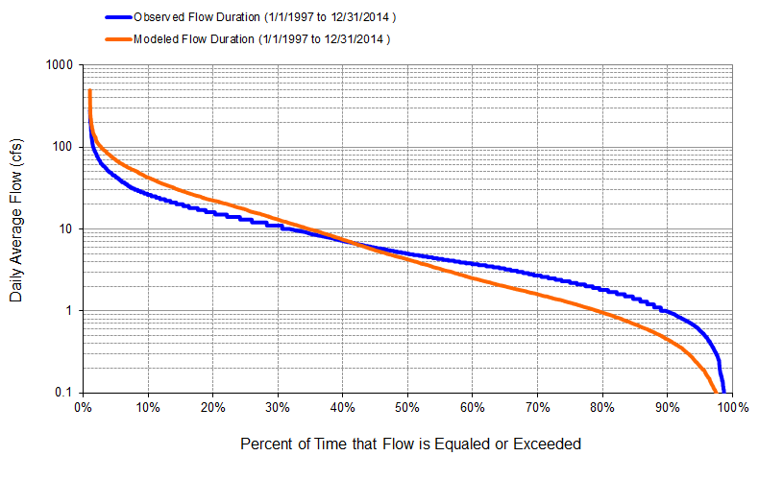
Figure A-23: Flow exceedance: Model output at Reach 135 vs. USGS 02293230 Whiskey Creek at Fort Myers, FL (01/01/1997 – 12/31/2014)

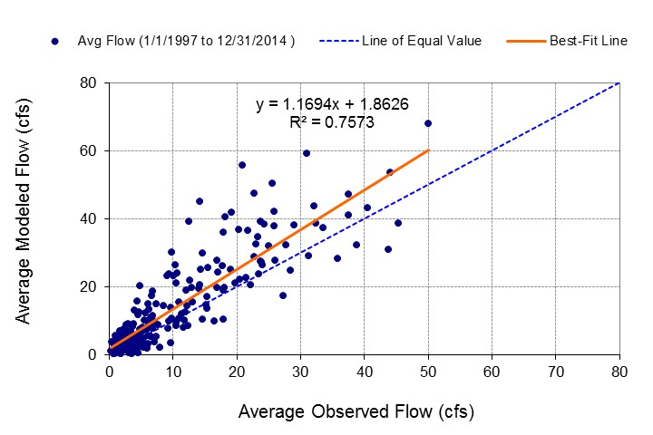
Figure A-24: Monthly flow regression: Model output at Reach 135 vs. USGS 02293230 Whiskey Creek at Fort Myers, FL (01/01/1997 – 12/31/2014)
Table A-6: Summary statistics: Model Output at Reach 135 vs. USGS 02293230 Whiskey Creek at Fort Myers, FL (01/01/1997 – 12/31/2014)
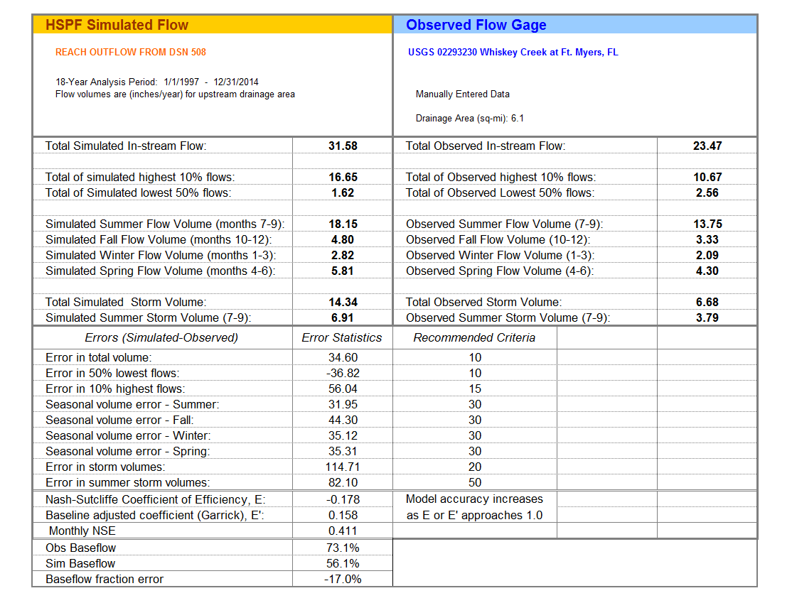
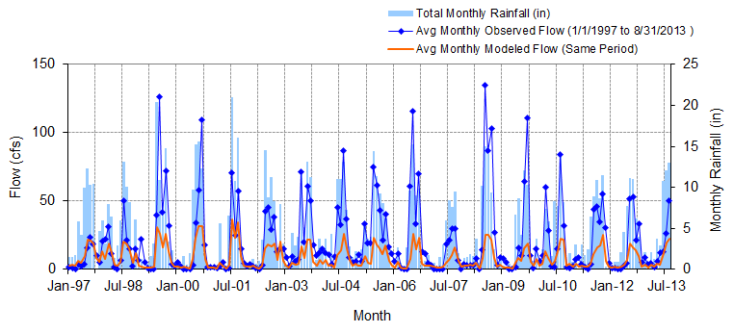
Figure A-25: Mean monthly flow: Model output at Reach 102 vs. USGS 02293240 Aries Canal at Cape Coral, FL (01/01/1997 – 08/31/2013)

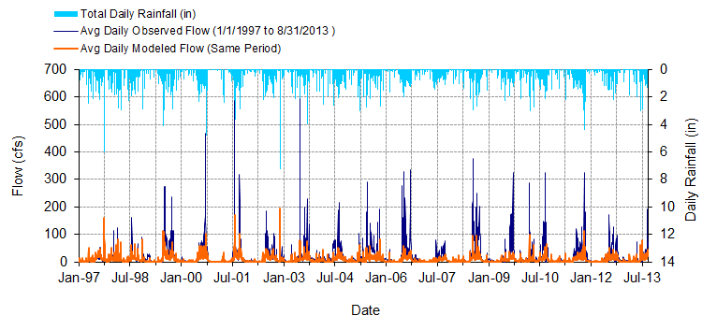
Figure A-26: Mean daily flow: Model output at Reach 102 vs. USGS 02293240 Aries Canal at Cape Coral, FL (01/01/1997 – 08/31/2013)

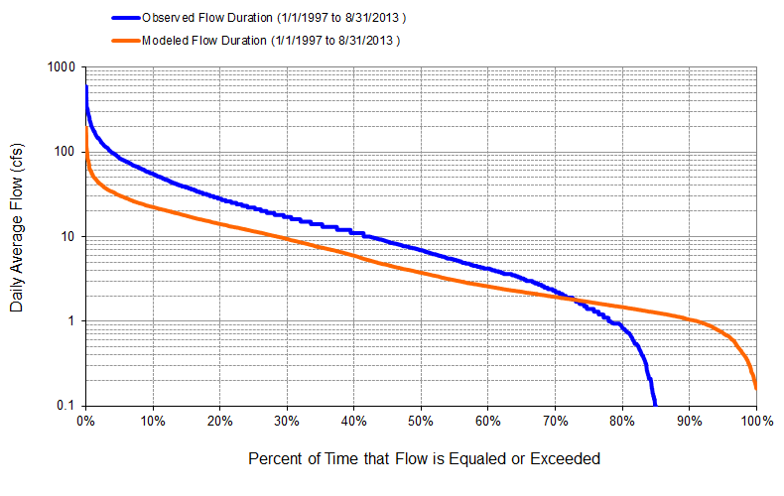
Figure A-27: Flow exceedance: Model output at Reach 102 vs. USGS 02293240 Aries Canal at Cape Coral, FL (01/01/1997 – 08/31/2013)

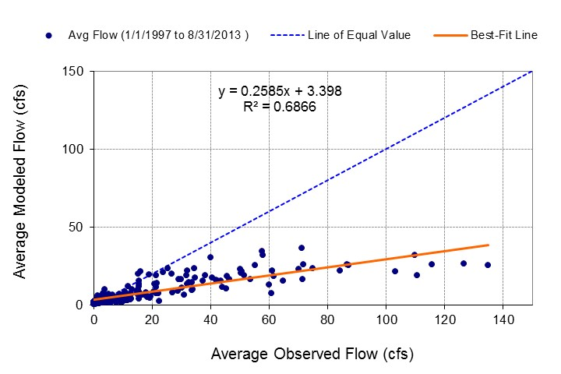
Figure A-28: Monthly flow regression: Model output at Reach 102 vs. USGS 02293240 Aries Canal at Cape Coral, FL (01/01/1997 – 08/31/2013)
Table A-7: Summary statistics: Model output at Reach 102 vs. USGS 02293240 Aries Canal at Cape Coral, FL (01/01/1997 – 08/31/2013)
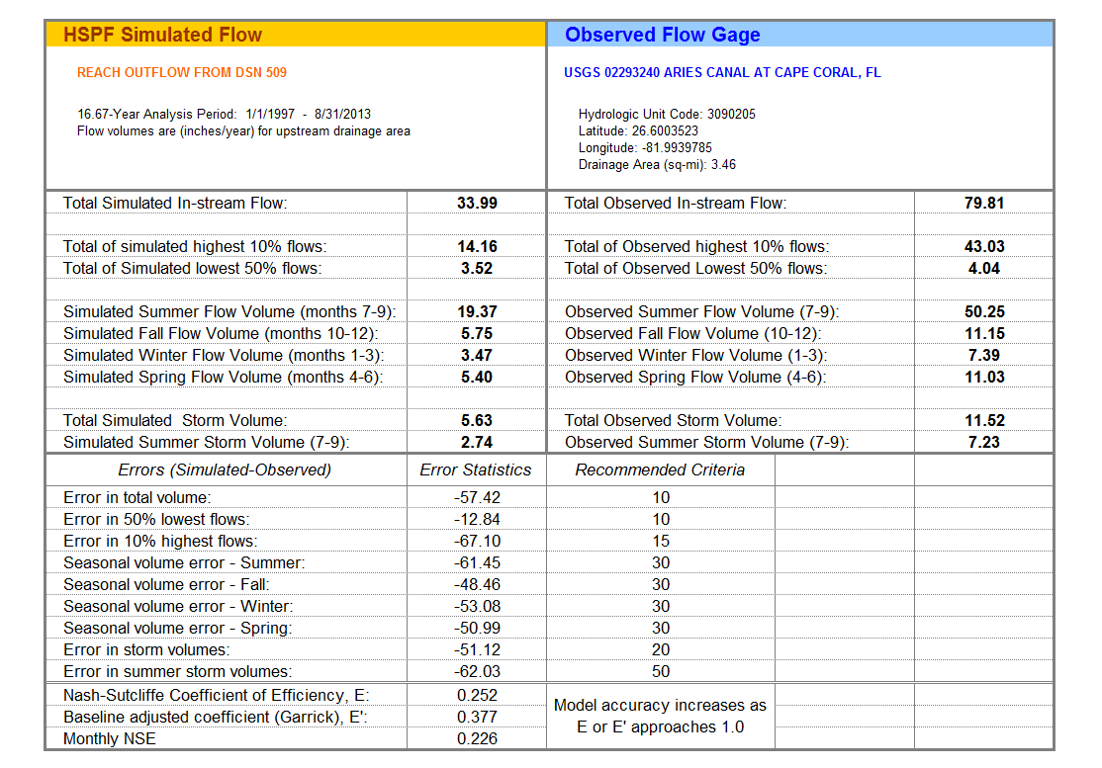

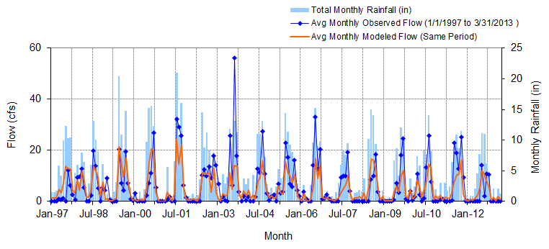
Figure A-29: Mean monthly flow: Model output at Reach 107 vs. USGS 02293241 San Carlos Canal at Cape Coral, FL (01/01/1997 – 03/31/2013)

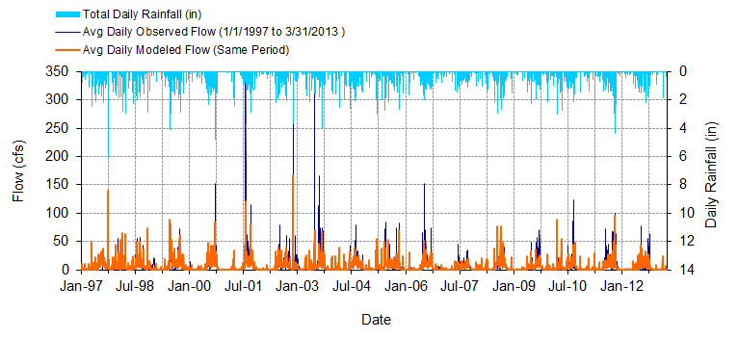
Figure A-30: Mean daily flow: Model output at Reach 107 vs. USGS 02293241 San Carlos Canal at Cape Coral, FL (01/01/1997 – 03/31/2013)

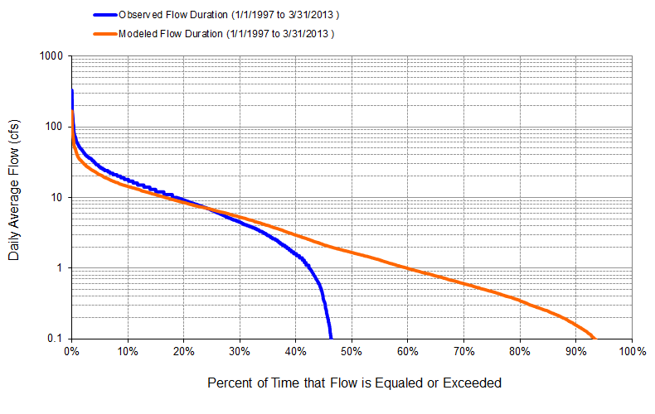
Figure A-31: Flow exceedance: Model output at Reach 107 vs. USGS 02293241 San Carlos Canal at Cape Coral, FL (01/01/1997 – 03/31/2013)

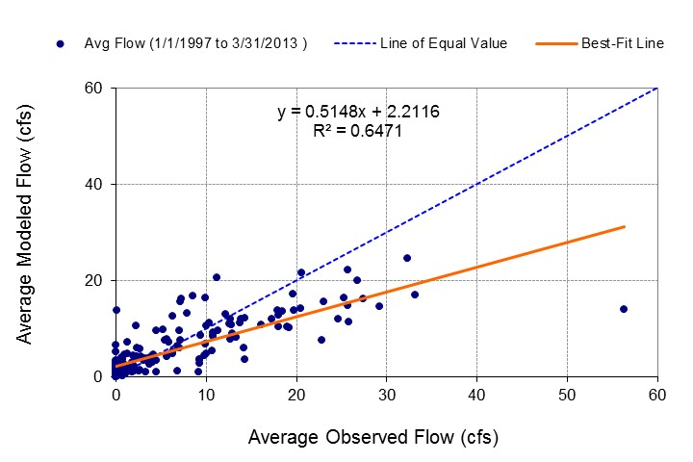
Figure A-32: Monthly flow regression: Model Output at Reach 107 vs. USGS 02293241 San Carlos Canal at Cape Coral, FL (01/01/1997 – 03/31/2013)
Table A-8: Summary statistics: Model output at Reach 107 vs. USGS 02293241 San Carlos Canal at Cape Coral, FL (01/01/1997 – 03/31/2013)
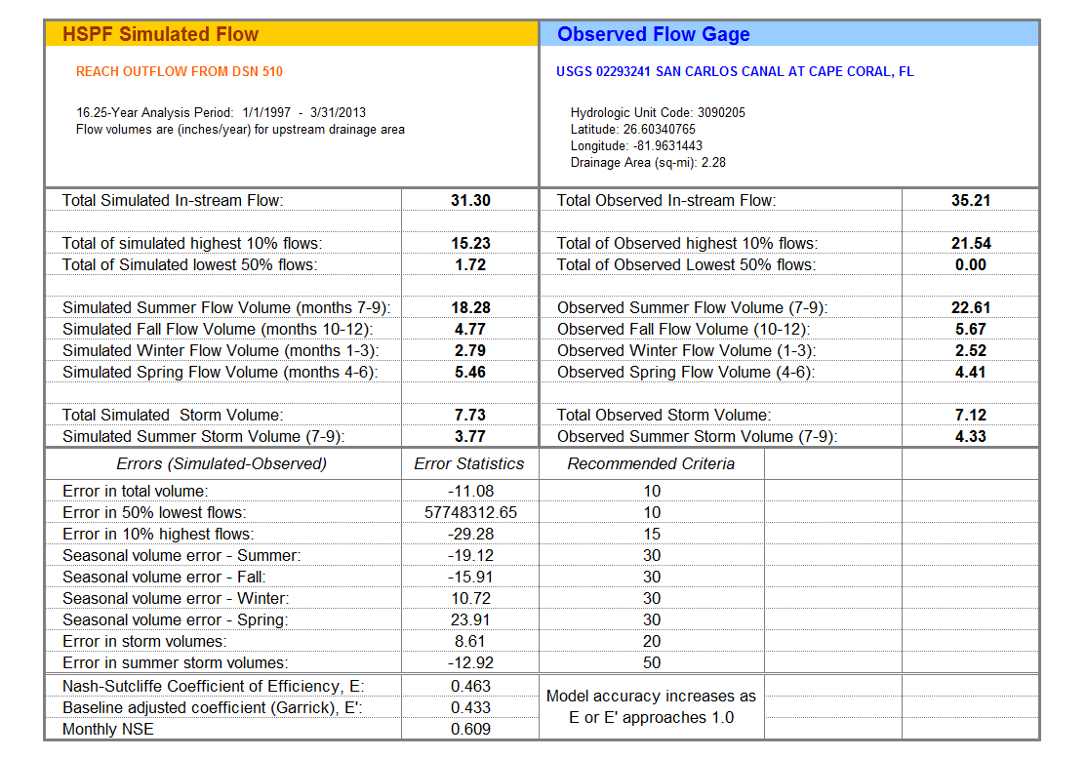

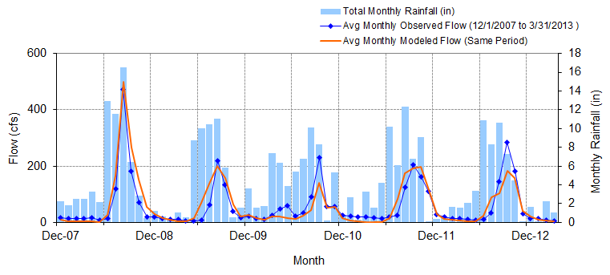
Figure A-33: Mean monthly flow: Model output at Reach 127 vs. USGS 022929176 Telegraph Creek at State Highway at Olga, FL (Big Island Canal) (12/01/2007 – 03/31/2013)

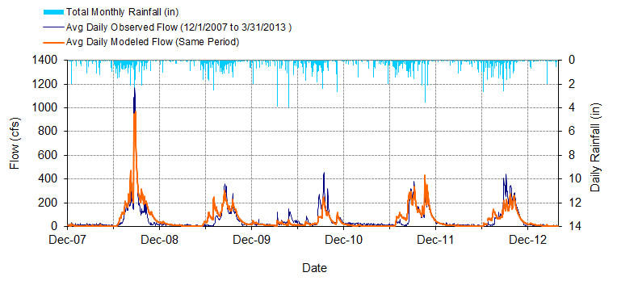
Figure A-34: Mean daily flow: Model output at Reach 127 vs. USGS 022929176 Telegraph Creek at State Highway at Olga, FL (Big Island Canal) (12/01/2007 – 03/31/2013)

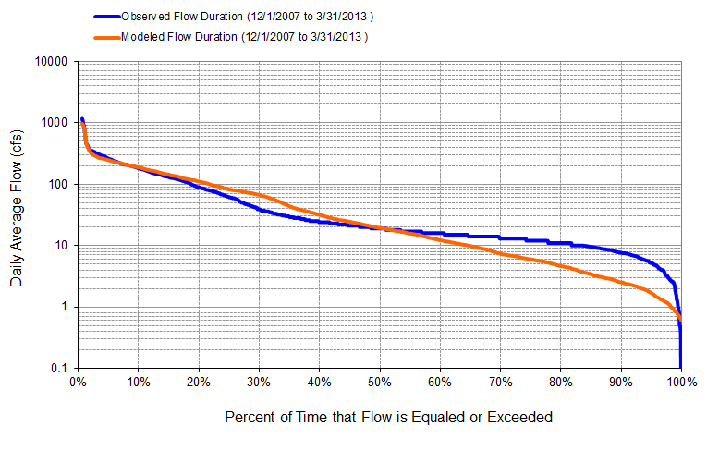
Figure A-35: Flow exceedance: Model output at Reach 127 vs. USGS 022929176 Telegraph Creek at State Highway at Olga, FL (Big Island Canal) (12/01/2007 – 03/31/2013)

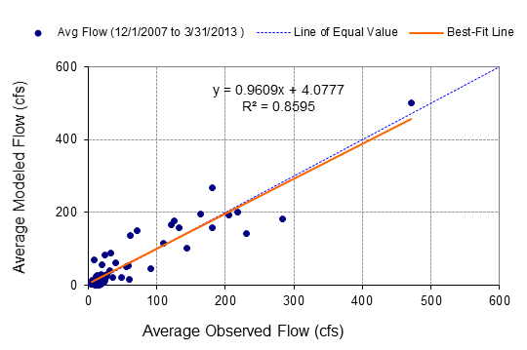
Figure A-36: Monthly flow regression: Model output at Reach 127 vs. USGS 022929176 Telegraph Creek at State Highway at Olga, FL (Big Island Canal) (12/01/2007 – 03/31/2013)
Table A-9: Summary statistics: Model Output at Reach 127 vs. USGS 022929176 Telegraph Creek at State Highway at Olga, FL (Big Island Canal) (12/01/2007 – 03/31/2013)
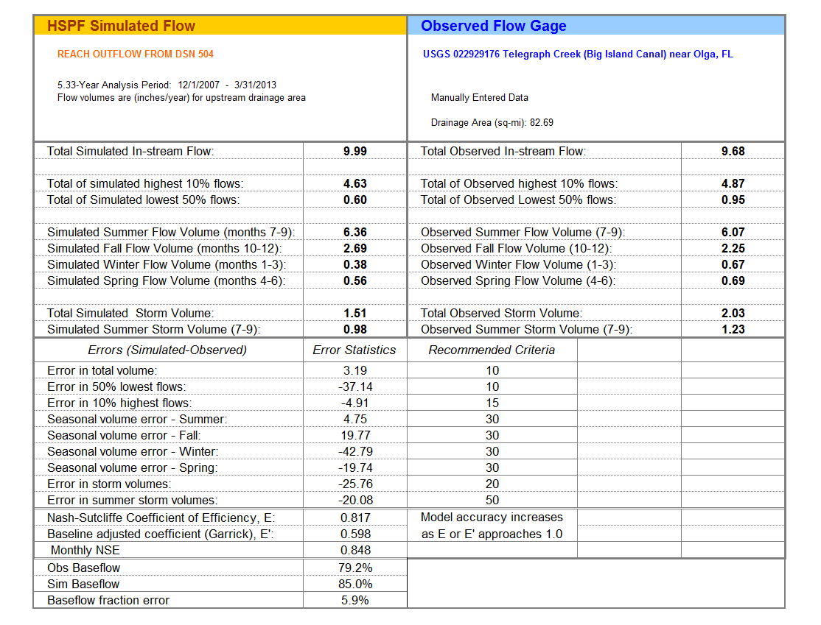
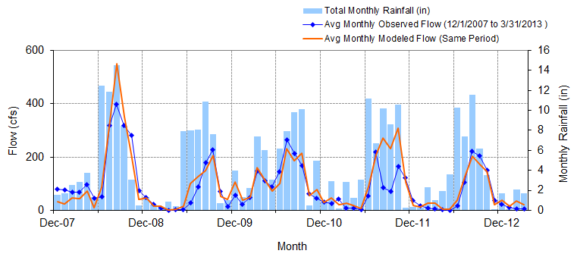
Figure A-37: Mean monthly flow: Model output at Reach 139 vs. USGS 02293055 Orange River near Buckingham, FL (12/01/2008 – 03/31/2013)

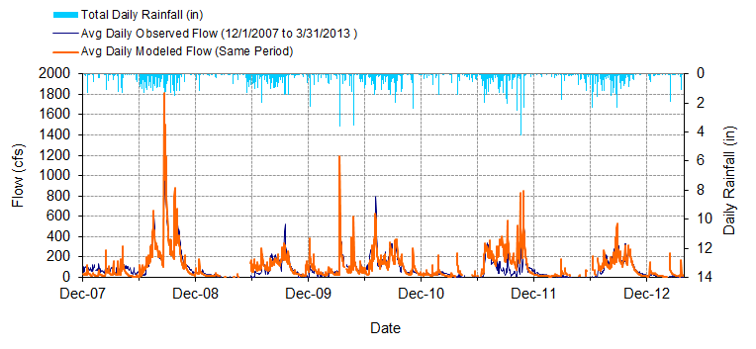
Figure A-38: Mean daily flow: Model output at Reach 139 vs. USGS 02293055 Orange River near Buckingham, FL (12/01/2008 – 03/31/2013)

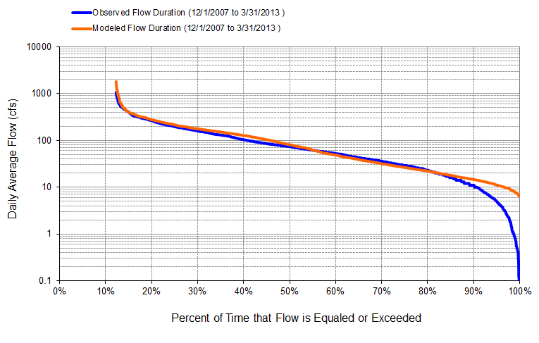
Figure A-39: Flow exceedance: Model output at Reach 139 vs. USGS 02293055 Orange River near Buckingham, FL (12/01/2008 – 03/31/2013)

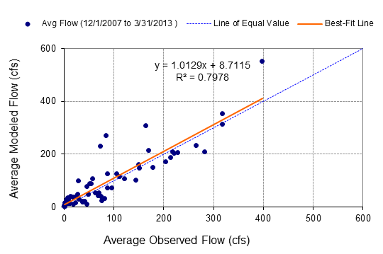
Figure A-40: Monthly flow regression: Model output at Reach 139 vs. USGS 02293055 Orange River near Buckingham, FL (12/01/2008 – 03/31/2013)
Table A-10: Summary statistics: Model Output at Reach 139 vs. USGS 02293055 Orange River near Buckingham, FL (12/01/2008 – 03/31/2013)
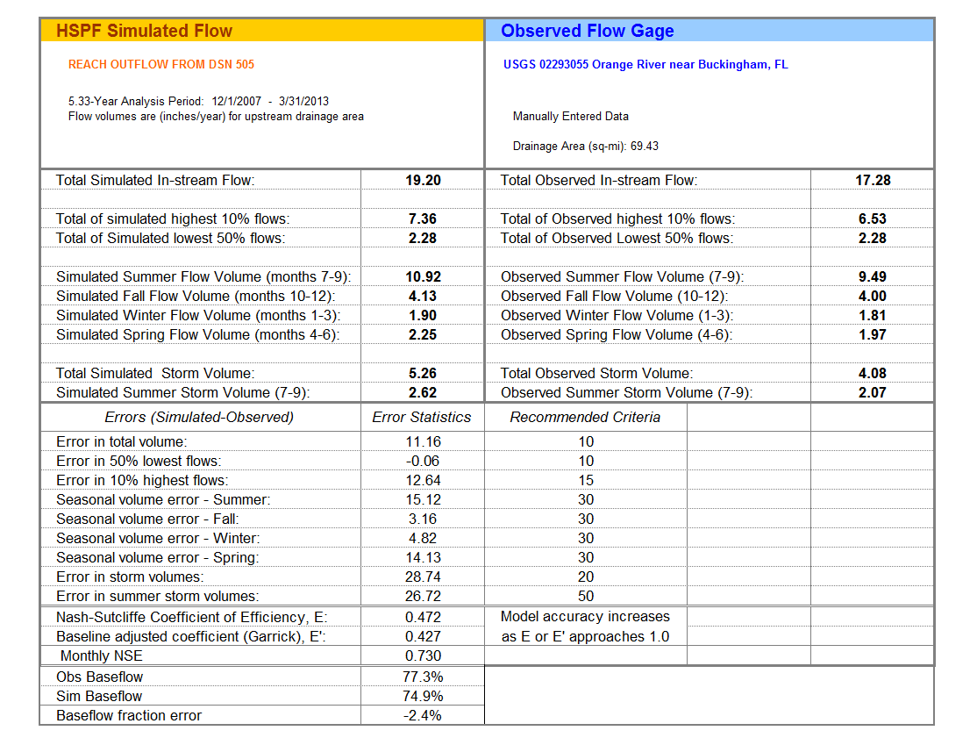
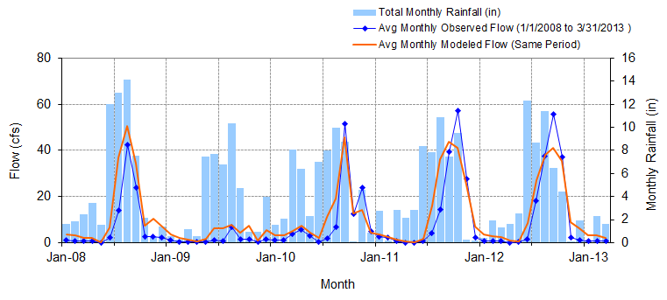
Figure A-41: Mean monthly flow: Model output at Reach 120 vs. USGS 02293090 Popash Creek at Leetana Road near Fort Myers, FL (01/01/2008– 03/31/2013)

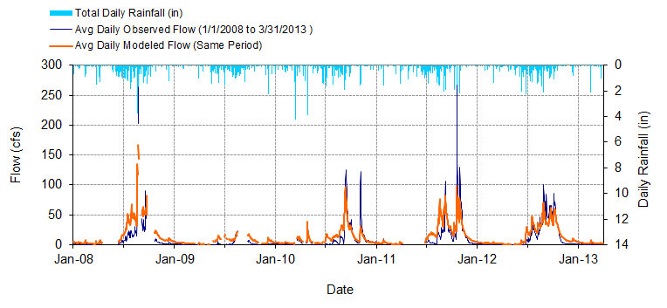
Figure A-42: Mean daily flow: Model output at Reach 120 vs. USGS 02293090 Popash Creek at Leetana Road near Fort Myers, FL (01/01/2008– 03/31/2013)

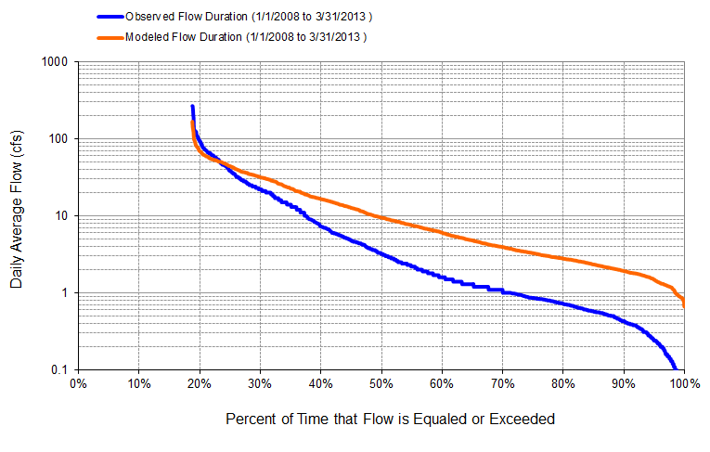
Figure A-43: Flow exceedance: Model output at Reach 120 vs. USGS 02293090 Popash Creek at Leetana Road near Fort Myers, FL (01/01/2008– 03/31/2013)

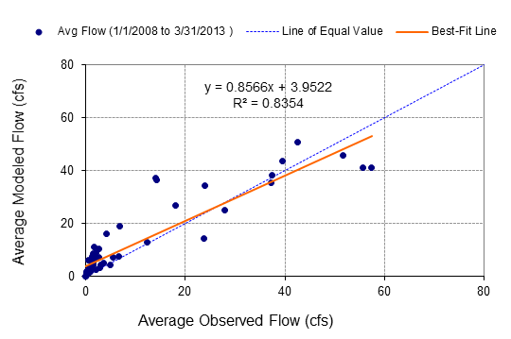
Figure A-44: Monthly flow regression: Model output at Reach 120 vs. USGS 02293090 Popash Creek at Leetana Road near Fort Myers, FL (01/01/2008– 03/31/2013)
Table A-11: Summary statistics: Model output at Reach 120 vs. USGS 02293090 Popash Creek at Leetana Road near Fort Myers, FL (01/01/2008– 03/31/2013)
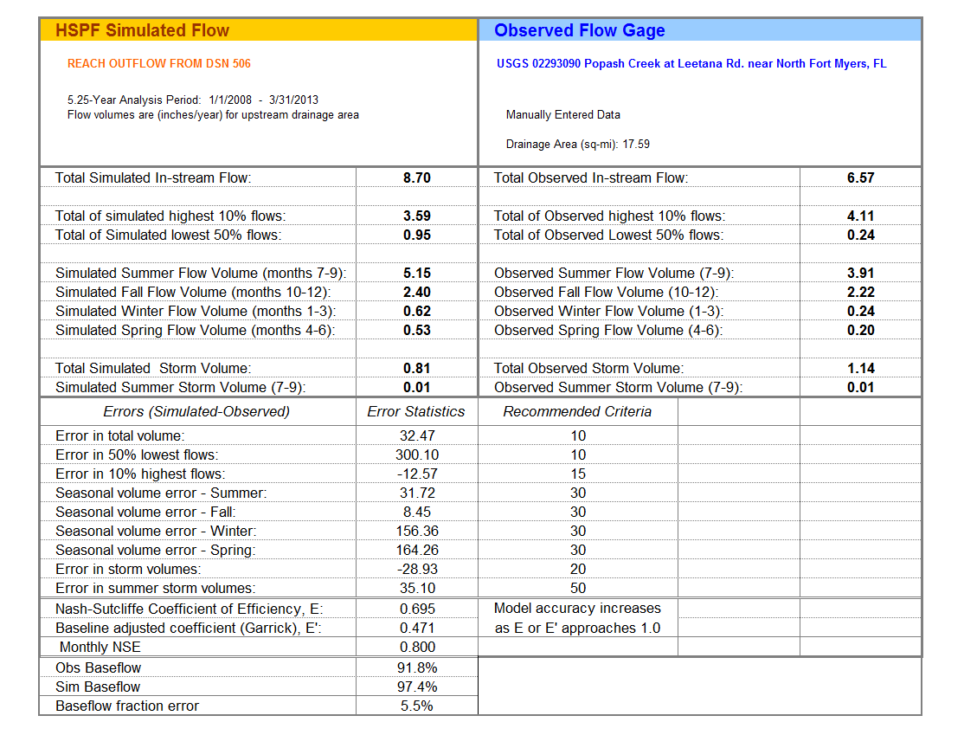

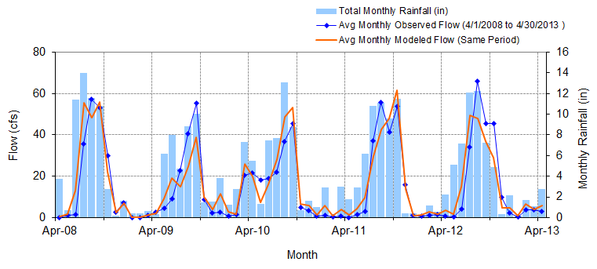
Figure A-45: Mean monthly flow: Model output at Reach 137 vs. USGS 02293190 Billy Creek at Fort Myers, FL (04/01/2008 – 04/30/2013)

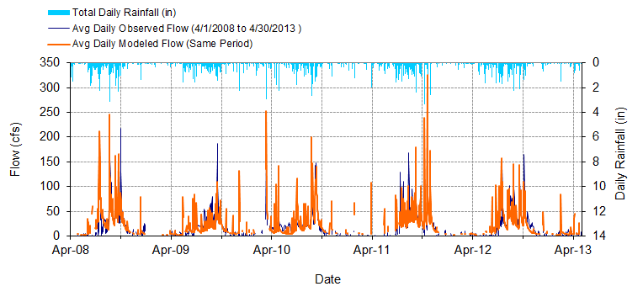
Figure A-46: Mean daily flow: Model output at Reach 137 vs. USGS 02293190 Billy Creek at Fort Myers, FL (04/01/2008 – 04/30/2013)

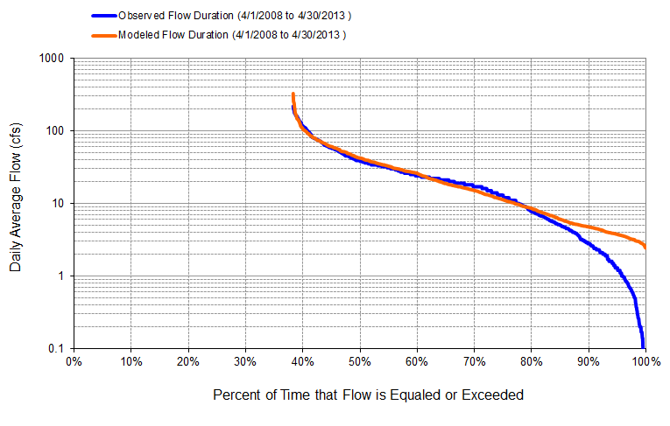
Figure A-47: Flow exceedance: Model output at Reach 137 vs. USGS 02293190 Billy Creek at Fort Myers, FL (04/01/2008 – 04/30/2013)

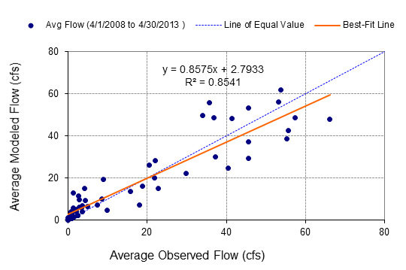
Figure A-48: Monthly flow regression: Flow exceedance: Model output at Reach 137 vs. USGS 02293190 Billy Creek at Fort Myers, FL (04/01/2008 – 04/30/2013)
Table A-12: Summary statistics: Flow exceedance: Model output at Reach 137 vs. USGS 02293190 Billy Creek at Fort Myers, FL (04/01/2008 – 04/30/2013)
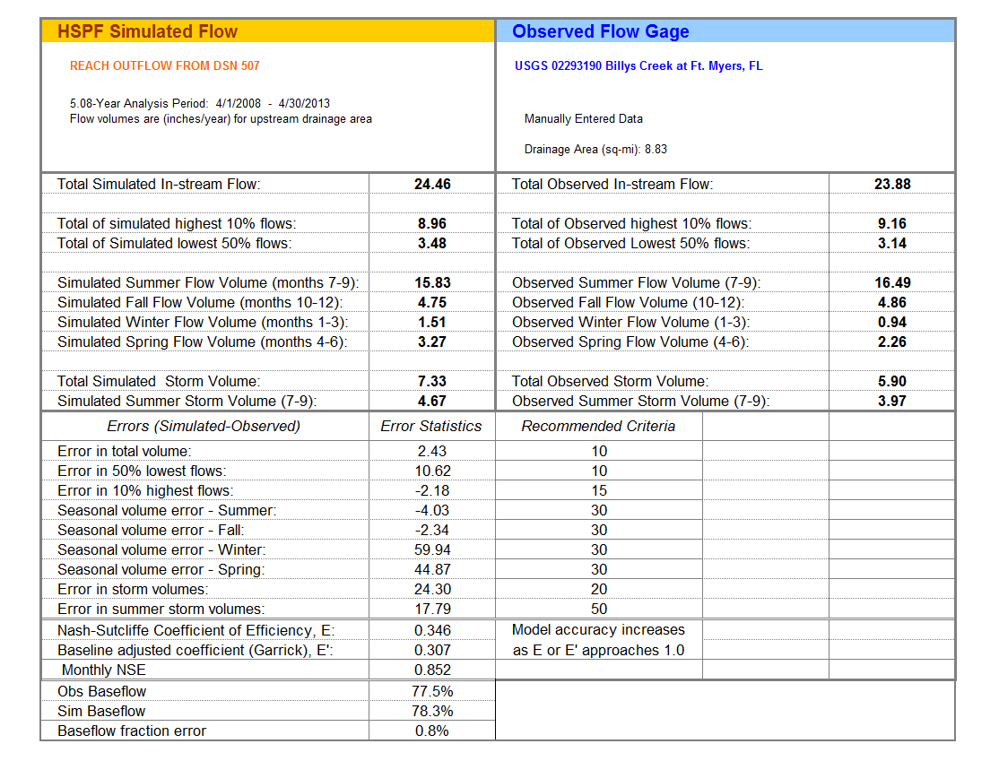

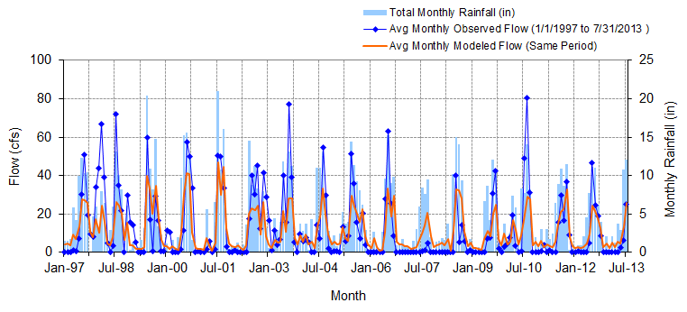
Figure A-49: Mean monthly flow: Model output at Reach 105 vs. USGS 02293243 Courtney Canal at Cape Coral, FL (01/01/1997 – 07/31/2013)

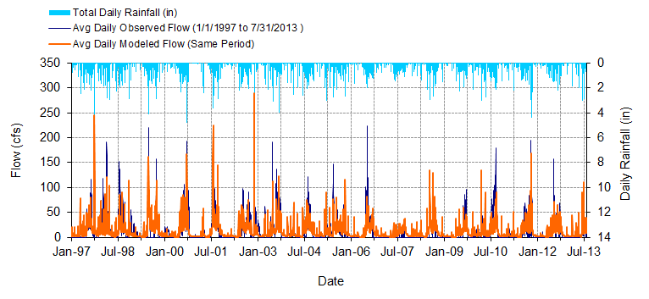
Figure A-50: Mean daily flow: Model output at Reach 105 vs. USGS 02293243 Courtney Canal at Cape Coral, FL (01/01/1997 – 07/31/2013)

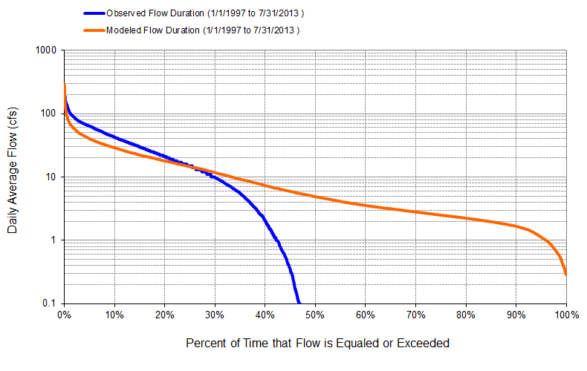
Figure A-51: Flow exceedance: Model output at Reach 105 vs. USGS 02293243 Courtney Canal at Cape Coral, FL (01/01/1997 – 07/31/2013)

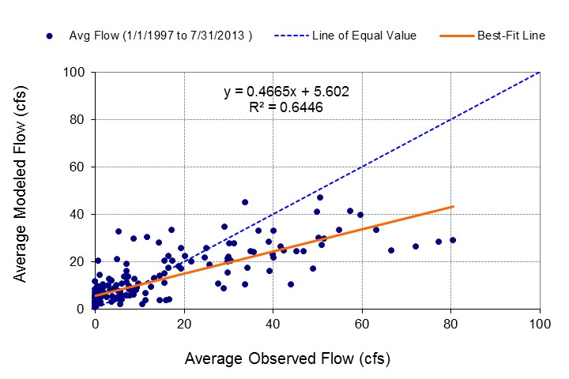
Figure A-52 Monthly flow regression: Model output at Reach 105 vs. USGS 02293243 Courtney Canal at Cape Coral, FL (01/01/1997 – 07/31/2013)
Table A-13: Summary statistics: Model output at Reach 105 vs. USGS 02293243 Courtney Canal at Cape Coral, FL (01/01/1997 – 07/31/2013)
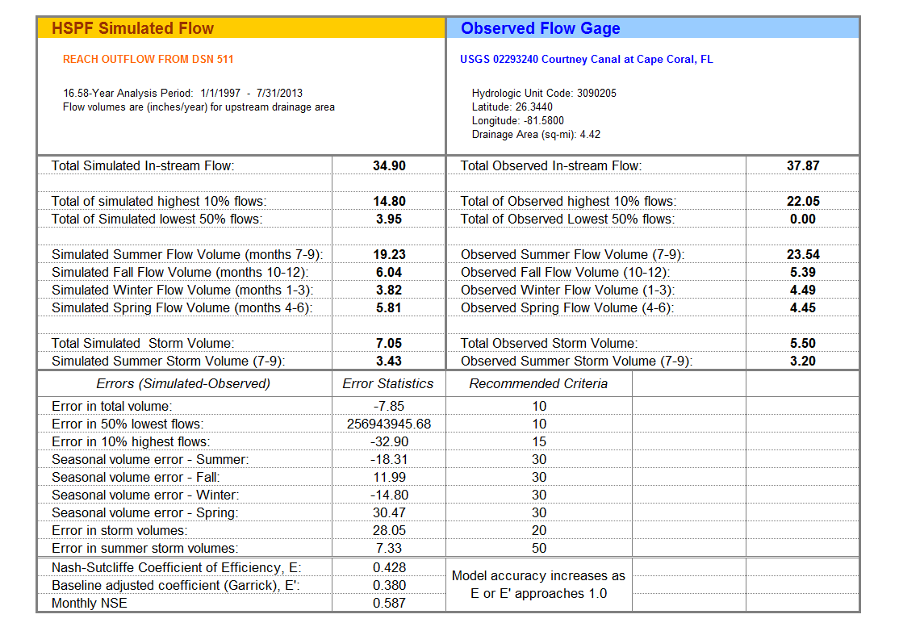

A-2 DEP Gage Calibration Comparison
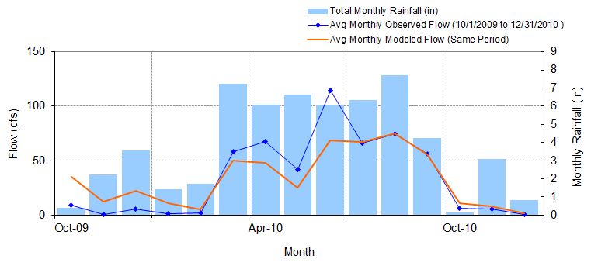
Figure A-53: Mean monthly flow: Model output at Reach 169 vs. DEP Jacks Branch at SR 78 (10/01/2009 – 12/31/2010)

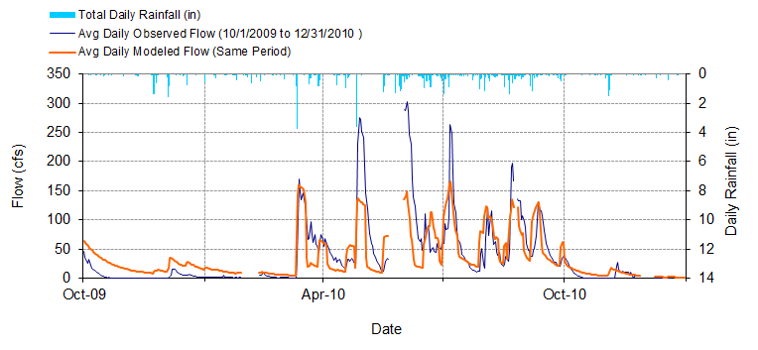
Figure A-54: Mean daily flow: Model output at Reach 169 vs. DEP Jacks Branch at SR 78 (10/01/2009 – 12/31/2010)

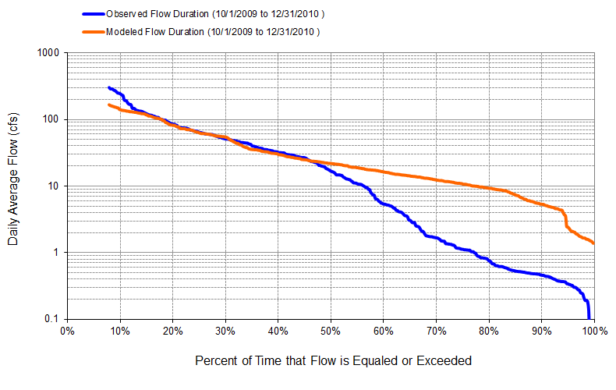
Figure A-55: Flow exceedance: Model Output at Reach 169 vs. DEP Jacks Branch at SR 78 (10/01/2009 – 12/31/2010)

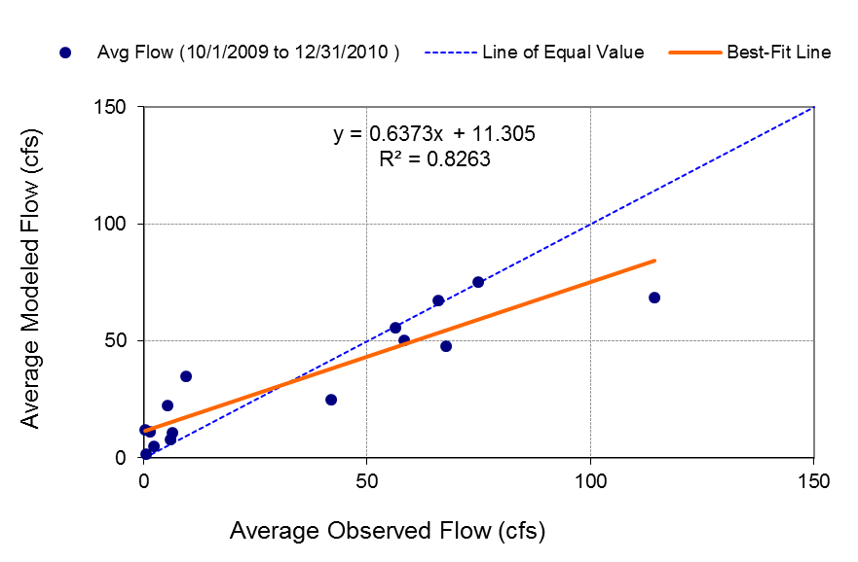
Figure A-56: Monthly flow regression: Model output at Reach 169 vs. DEP Jacks Branch at SR 78 (10/01/2009 – 12/31/2010)
Table A-14: Summary statistics: Model Output at Reach 169 vs. DEP Jacks Branch at SR 78 (10/01/2009 – 12/31/2010)
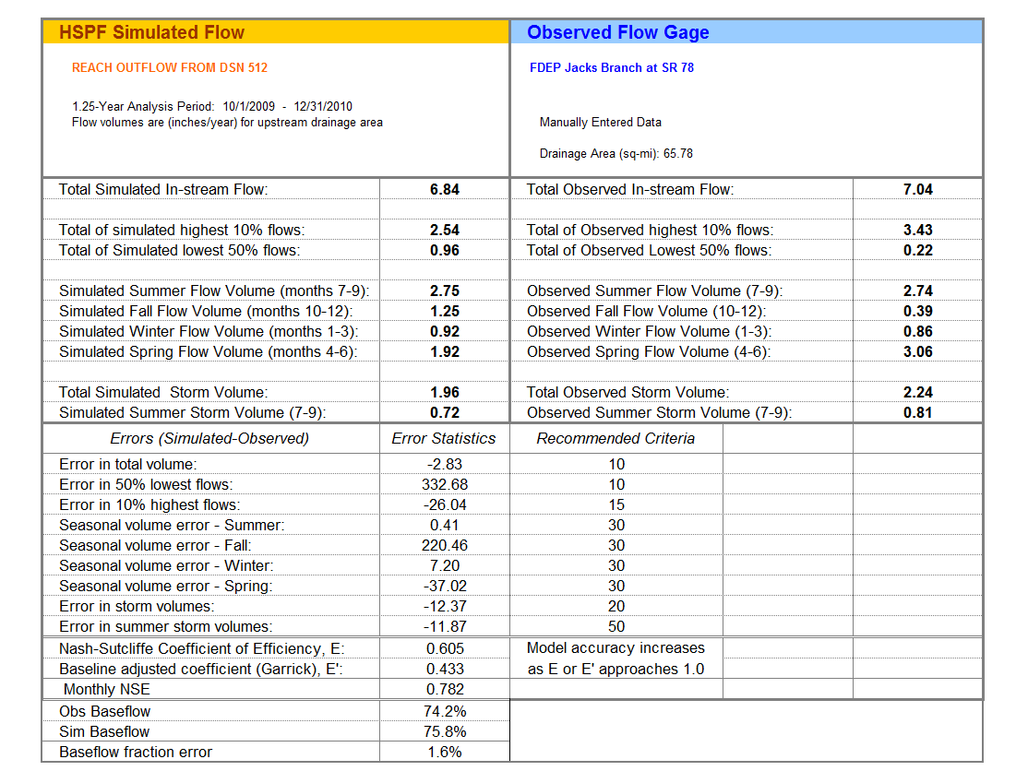
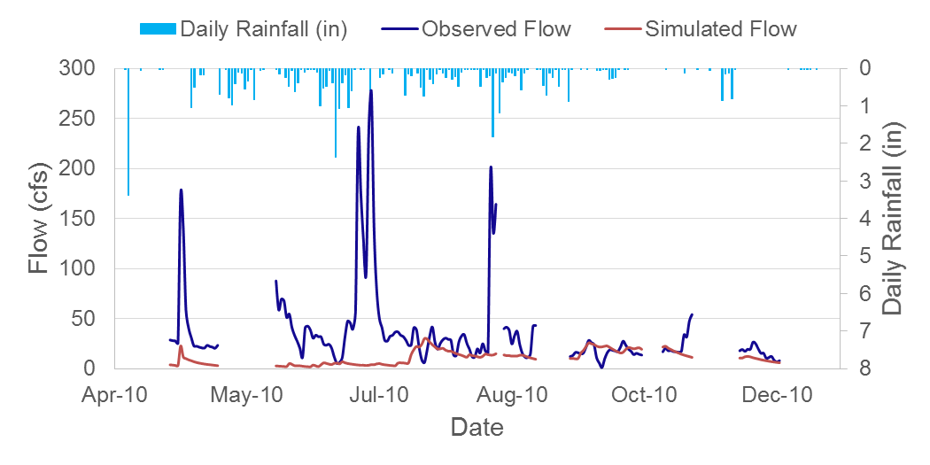
Figure A-57: Mean daily flow: Model output at Reach 173 vs. DEP Fast Creek at SR 80 (05/01/2010 – 11/30/2010)

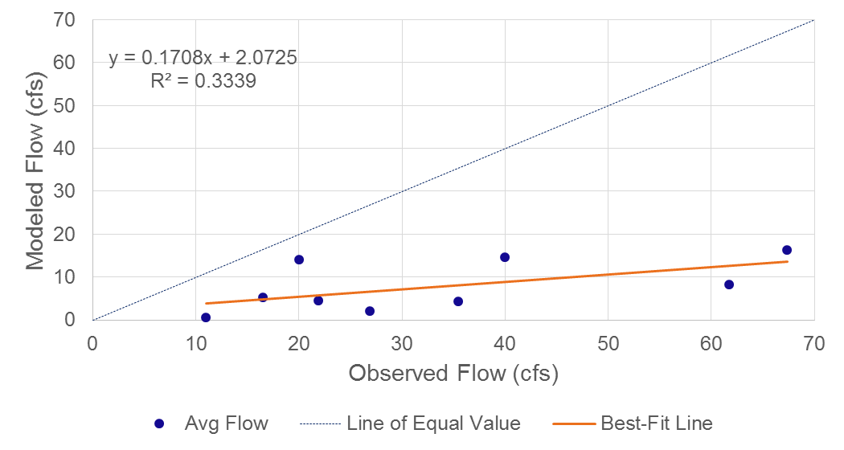
Figure A-58: Monthly flow regression: Model output at Reach 173 vs. DEP Fast Creek at SR 80 (05/01/2010 – 11/30/2010)
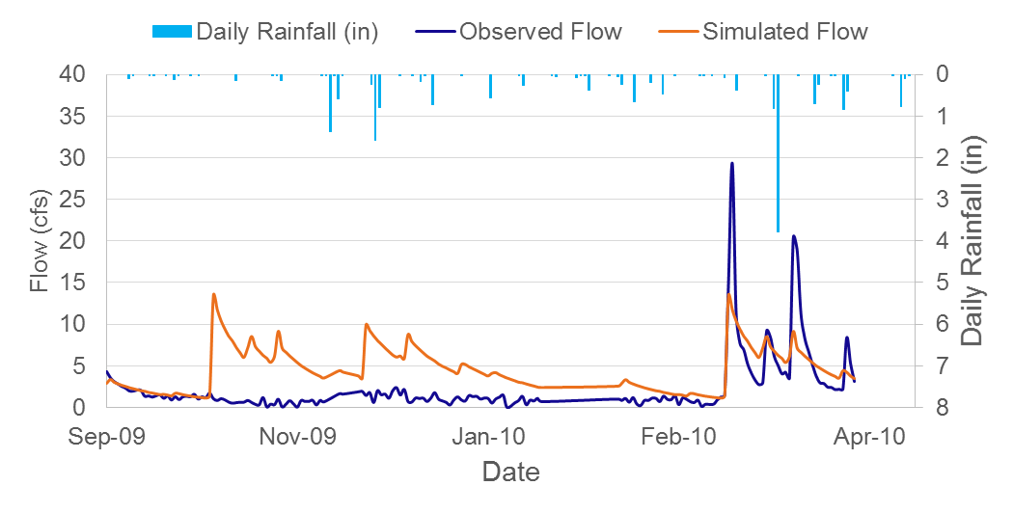
Figure A-59: Mean daily flow: Model output at Reach 179 vs. DEP Pollywog Creek at SR 78 (10/01/2009 – 03/31/2010)

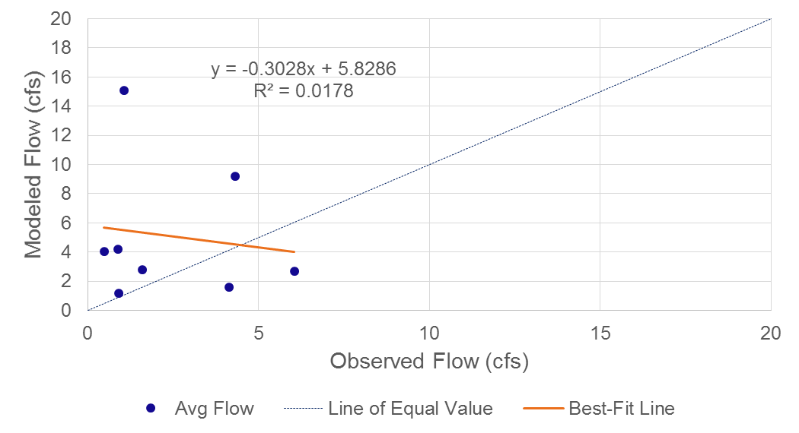
Figure A-60: Monthly flow regression: Model output at Reach 179 vs. DEP Pollywog Creek at SR 78 (10/01/2009 – 03/31/2010)

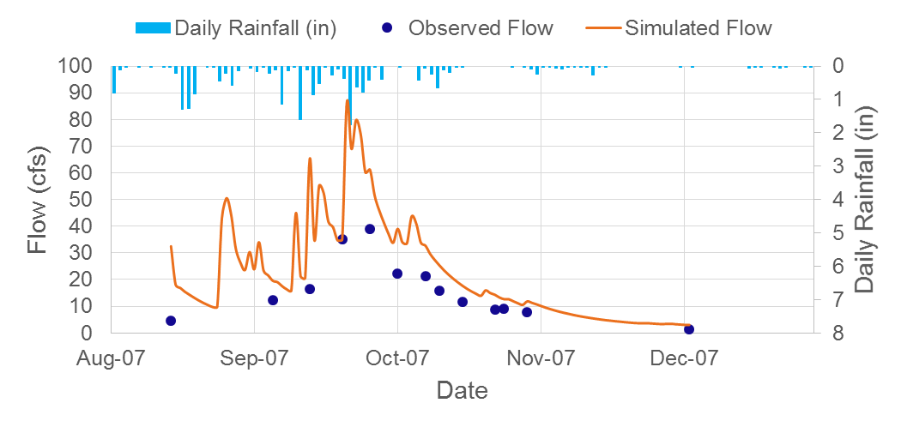
Figure A-61: Mean daily flow: Model output at Reach 115 vs. DEP Powell Creek at SR 78 (13 daily values)

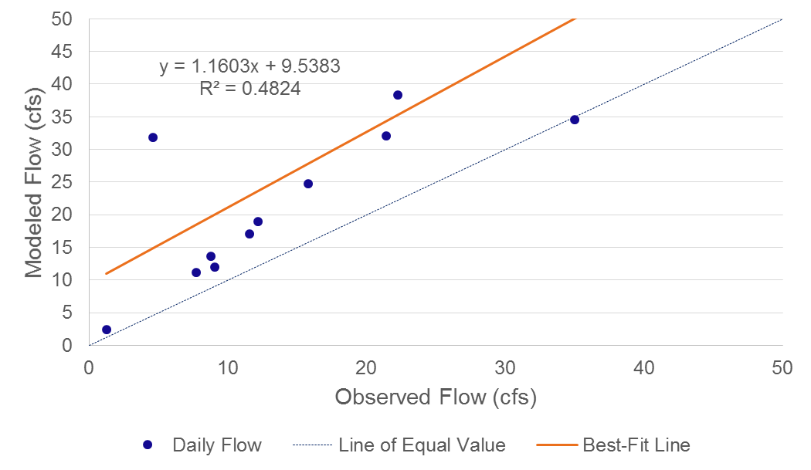
Figure A-62: Daily flow regression: Model output at Reach 115 vs. DEP Powell Creek at SR 78 (13 daily values)
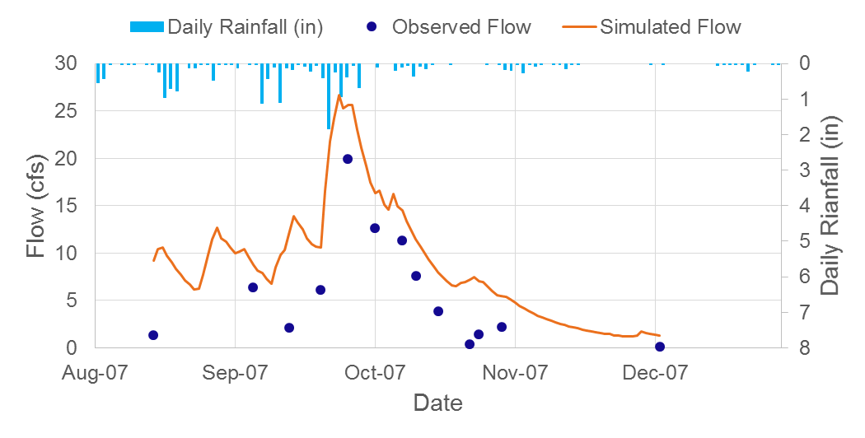
Figure A-63: Mean daily flow: Model output at Reach 121 vs. DEP Stroud Creek (13 daily values)

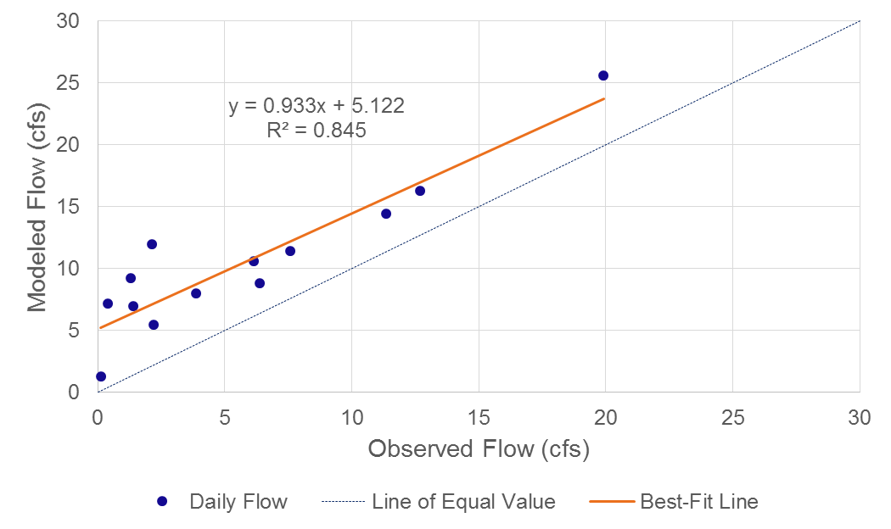
Figure A-64: Daily flow regression: Model output at Reach 121 vs. DEP Stroud Creek (13 daily values)
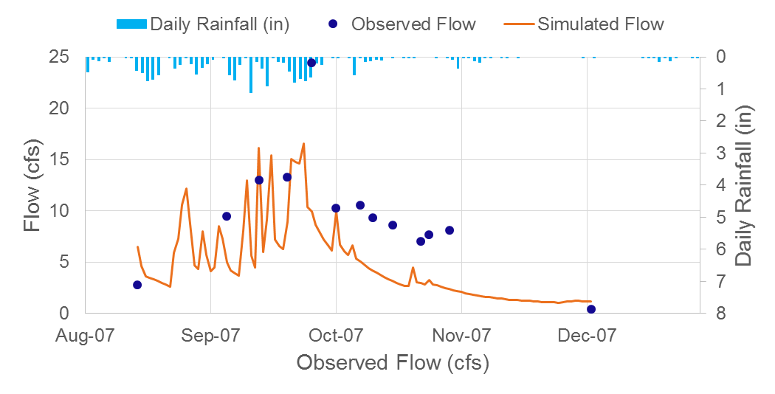
Figure A-65: Mean daily flow: Model output at Reach 112 vs. DEP Yellow Fever Creek (13 daily values)

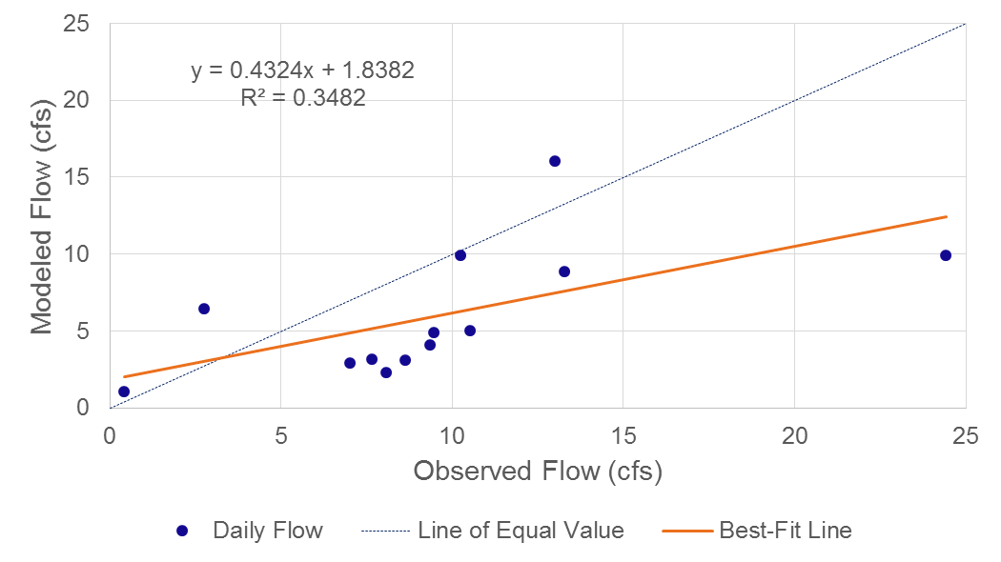
Figure A-66: Daily flow regression: Model output at Reach 112 vs. DEP Yellow Fever Creek (13 daily values)

Appendix B: Draft 2017 HSPF Flow Calibration Results (observed Negative flows REPLACED with 0 cfs)

B-1 USGS Gages Calibration Comparison
Figure B-1: Mean monthly flow: Model output at Reach 215 vs. USGS 02292000 Caloosahatchee Canal at Moore Haven, FL (01/01/1997 – 09/30/2003)

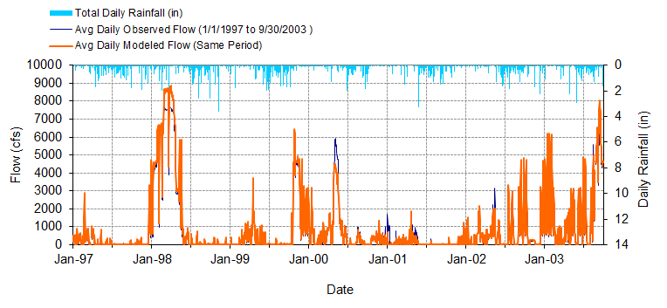
Figure B-2: Mean daily flow: Model output at Reach 215 vs. USGS 02292000 Caloosahatchee Canal at Moore Haven, FL (01/01/1997 – 09/30/2003)

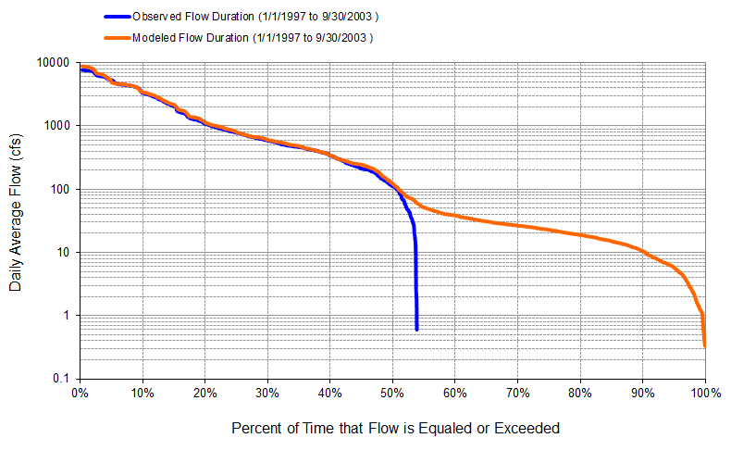
Figure B-3: Flow exceedance: Model output at Reach 215 vs. USGS 02292000 Caloosahatchee Canal at Moore Haven, FL (01/01/1997 – 09/30/2003)
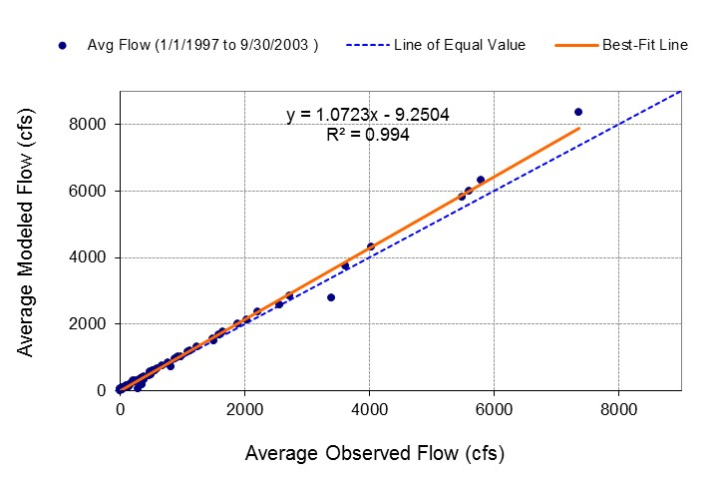
Figure B-4: Monthly flow regression: Model output at Reach 215 vs. USGS 02292000 Caloosahatchee Canal at Moore Haven, FL (01/01/1997 – 09/30/2003)
Table B-1: Summary statistics: Model output at Reach 215 vs. USGS 02292000 Caloosahatchee Canal at Moore Haven, FL (01/01/1997 – 09/30/2003)
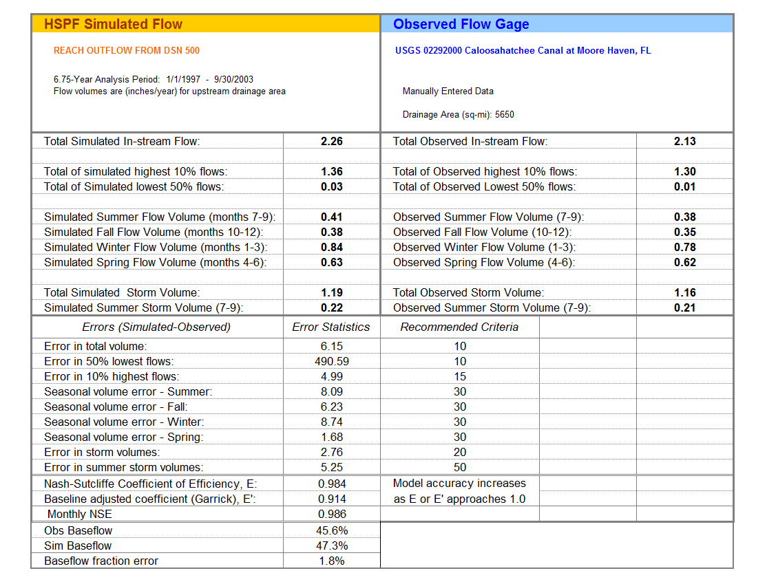
Note: The drainage area in the table is from USGS data, and this area includes a portion of the Lake Okeechobee watershed.

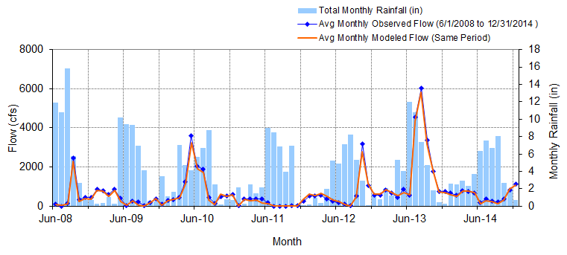
Figure B-5: Mean monthly flow: Model output at Reach 215 vs. USGS 02292010 Caloosahatchee Canal DWS of S-77 at Moore Haven, FL (06/01/2008 – 12/31/2014)

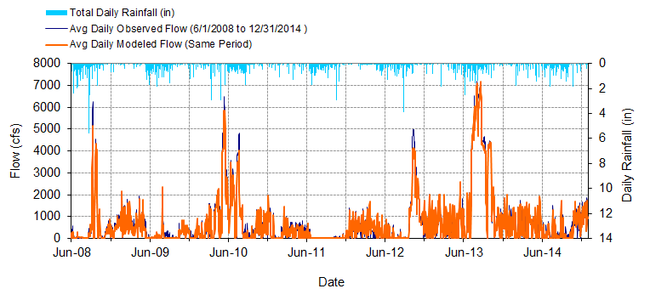
Figure B-6: Mean daily flow: Model output at Reach 215 vs. USGS 02292010 Caloosahatchee Canal DWS of S-77 at Moore Haven, FL (06/01/2008 – 12/31/2014)

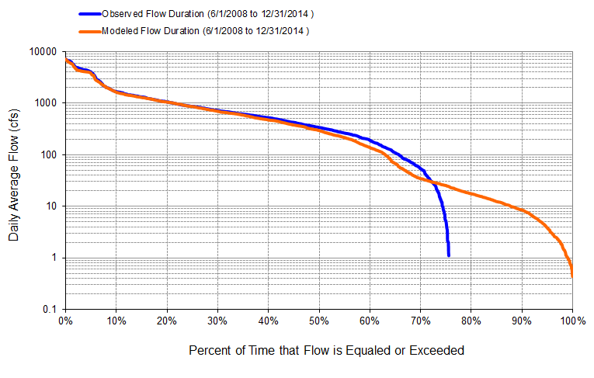
Figure B-7: Flow exceedance: Model output at Reach 215 vs. USGS 02292010 Caloosahatchee Canal DWS at S-77 of Moore Haven, FL (06/01/2008 – 12/31/2014)

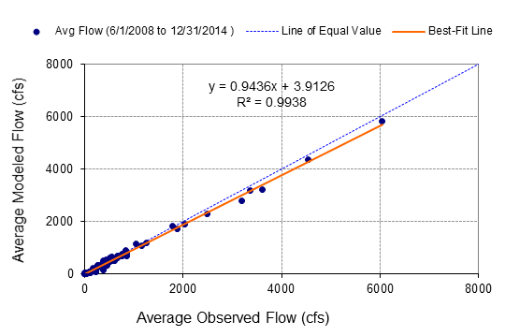
Figure B-8: Monthly flow regression: Model output at Reach 215 vs. USGS 02292010 Caloosahatchee Canal DWS of S-77 at Moore Haven, FL (06/01/2008-12/31/2014)
Table B-2: Summary statistics: Model output at Reach 215 vs. USGS 02292010 Caloosahatchee Canal DWS of S-77 at Moore Haven, FL (06/01/2008 – 12/31/2014)
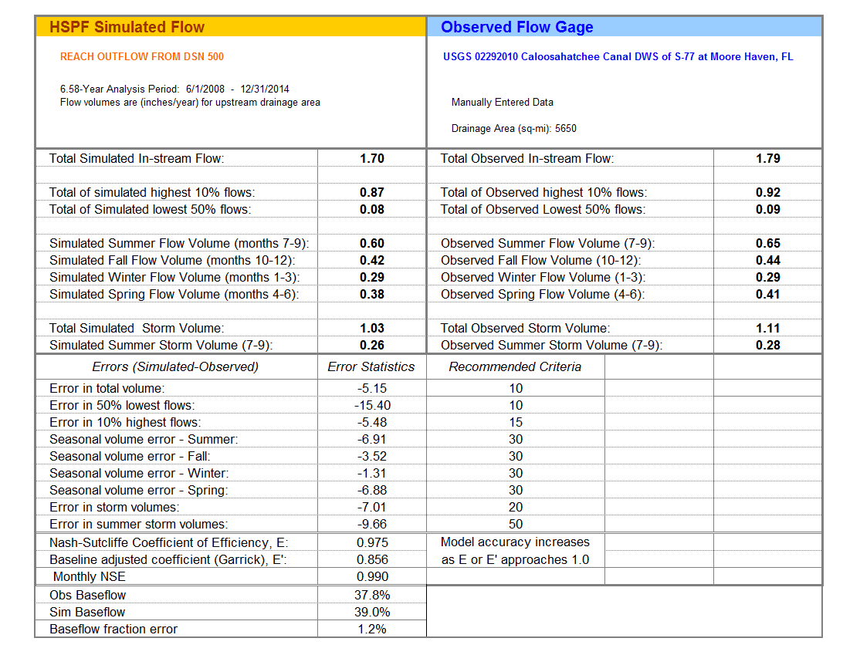
Figure B-9: Mean monthly flow: Model output at Reach 188 vs. USGS 02292480 Caloosahatchee Canal at Ortona Lock near LaBelle S-78 (01/01/1997 – 09/30/2003)

Figure B-10: Mean daily flow: Model output at Reach 188 vs. USGS 02292480 Caloosahatchee Canal at Ortona Lock near LaBelle S-78 (01/01/1997 – 09/30/2003)

Figure B-11: Flow exceedance: Model output at Reach 188 vs. USGS 02292480 Caloosahatchee Canal at Ortona Lock near LaBelle S-78 (01/01/1997 – 09/30/2003)

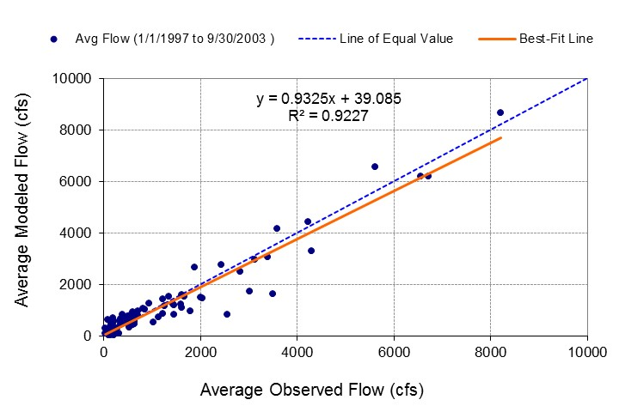
Figure B-12: Monthly flow regression: Model output at Reach 188 vs. USGS 02292480 Caloosahatchee Canal at Ortona Lock near LaBelle S-78 (01/01/1997 – 09/30/2003)
Table B-3: Summary statistics: Model output at Reach 188 vs. USGS 02292480 Caloosahatchee Canal at Ortona Lock near LaBelle S-78 (01/01/1997 – 09/30/2003)
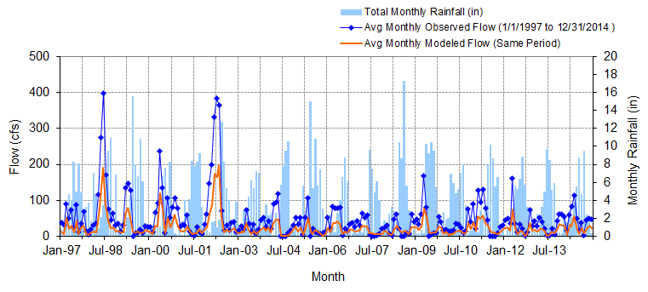
Figure B-13: Mean monthly flow: Model output at Reach 219 vs. USGS 26451408150700 Industrial Canal at Clewiston (01/01/1997 – 12/31/2014)

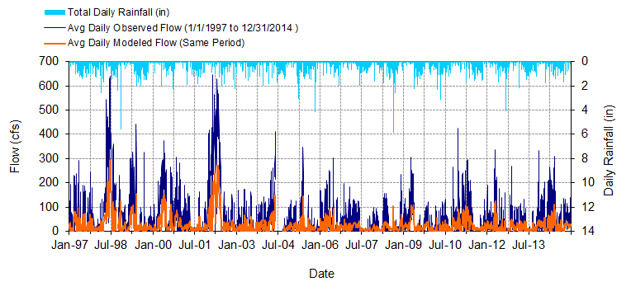
Figure B-14: Mean daily flow: Model output at Reach 219 vs. USGS 26451408150700 Industrial Canal at Clewiston (01/01/1997 – 12/31/2014)

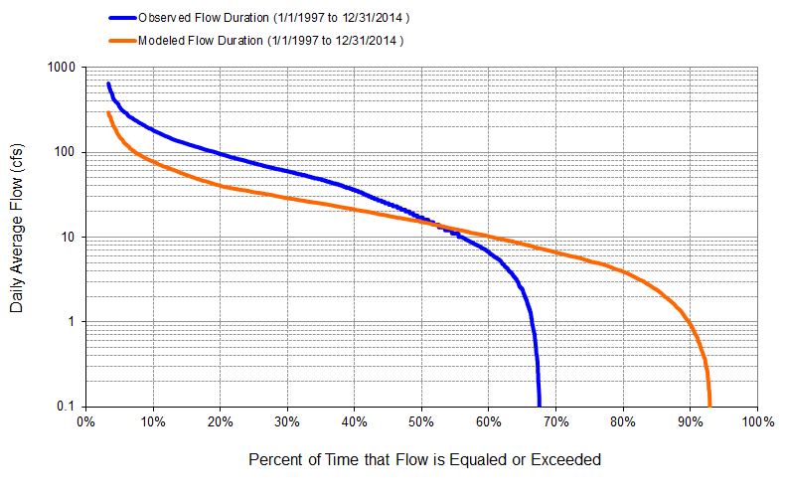
Figure B-15: Flow exceedance: Model output at Reach 219 vs. USGS 26451408150700 Industrial Canal at Clewiston (01/01/1997 – 12/31/2014)

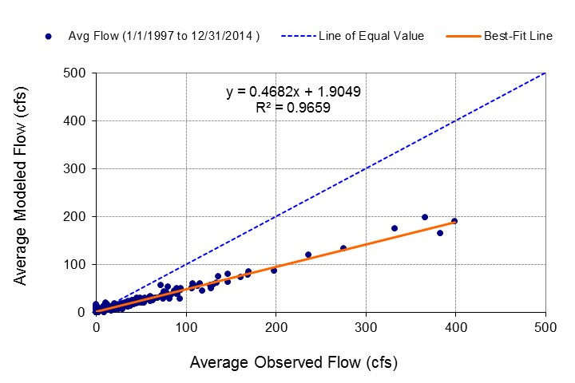
Figure B-16: Monthly flow regression: Model output at Reach 219 vs. USGS 26451408150700 Industrial Canal at Clewiston (01/01/1997 – 12/31/2014)
Table B-4: Summary statistics: Model output at Reach 219 vs. USGS 26451408150700 Industrial Canal at Clewiston (01/01/1997 – 12/31/2014)
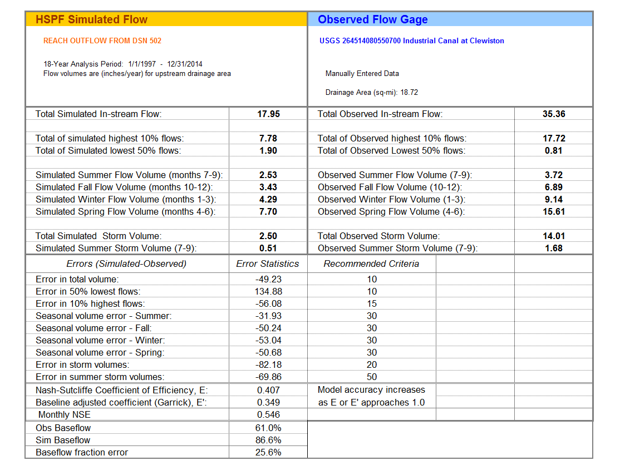
Figure B-17: Mean monthly flow: Model output at Reach 147 vs. USGS 02292900 Caloosahatchee River at S-79 near Olga, FL (01/01/1997 – 12/31/2014)

Figure B-18: Mean daily flow: Model output at Reach 147 vs. USGS 02292900 Caloosahatchee River at S-79 near Olga, FL (01/01/1997 – 12/31/2014)

Figure B-19: Flow exceedance: Model output at Reach 147 vs. USGS 02292900 Caloosahatchee River at S-79 near Olga, FL (01/01/1997 – 12/31/2014)

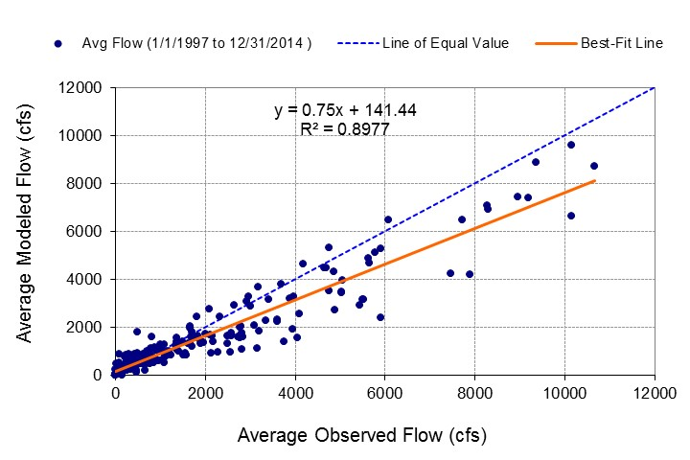
Figure B-20: Monthly flow regression: Model output at Reach 147 vs. USGS 02292900 Caloosahatchee River at S-79 near Olga, FL (01/01/1997 – 12/31/2014)
Table B-5: Summary statistics: Model output at Reach 147 vs. USGS 02292900 Caloosahatchee River at S-79 near Olga, FL (01/01/1997 – 12/31/2014)

Figure B-21: Mean monthly flow: Model output at Reach 135 vs. USGS 02293230 Whiskey Creek at Fort Myers, FL (01/01/1997 – 12/31/2014)

Figure B-22: Mean daily flow: Model output at Reach 135 vs. USGS 02293230 Whiskey Creek at Fort Myers, FL (01/01/1997 – 12/31/2014)

Figure B-23: Flow exceedance: Model output at Reach 135 vs. USGS 02293230 Whiskey Creek at Fort Myers, FL (01/01/1997 – 12/31/2014)

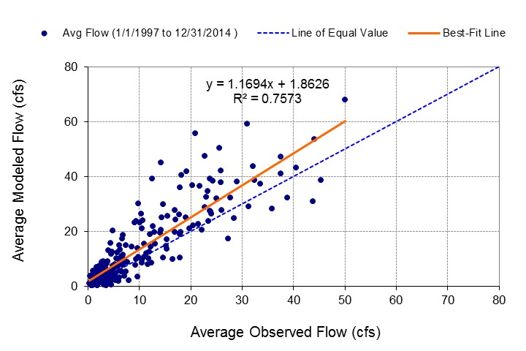
Figure B-24: Monthly flow regression: Model output at Reach 135 vs. USGS 02293230 Whiskey Creek at Fort Myers, FL (01/01/1997 – 12/31/2014)
Table B-6: Summary statistics: Model Output at Reach 135 vs. USGS 02293230 Whiskey Creek at Fort Myers, FL (01/01/1997 – 12/31/2014)
Figure B-25: Mean monthly flow: Model output at Reach 102 vs. USGS 02293240 Aries Canal at Cape Coral, FL (01/01/1997 – 08/31/2013)

Figure B-26: Mean daily flow: Model output at Reach 102 vs. USGS 02293240 Aries Canal at Cape Coral, FL (01/01/1997 – 08/31/2013)

Figure B-27: Flow exceedance: Model output at Reach 102 vs. USGS 02293240 Aries Canal at Cape Coral, FL (01/01/1997 – 08/31/2013)

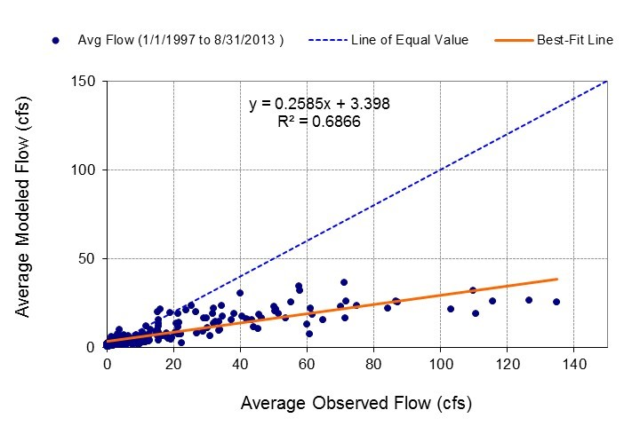
Figure B-28: Monthly flow regression: Model output at Reach 102 vs. USGS 02293240 Aries Canal at Cape Coral, FL (01/01/1997 – 08/31/2013)
Table B-7: Summary statistics: Model output at Reach 102 vs. USGS 02293240 Aries Canal at Cape Coral, FL (01/01/1997 – 08/31/2013)

Figure B-29: Mean monthly flow: Model output at Reach 107 vs. USGS 02293241 San Carlos Canal at Cape Coral, FL (01/01/1997 – 03/31/2013)

Figure B-30: Mean daily flow: Model output at Reach 107 vs. USGS 02293241 San Carlos Canal at Cape Coral, FL (01/01/1997 – 03/31/2013)

Figure B-31: Flow exceedance: Model output at Reach 107 vs. USGS 02293241 San Carlos Canal at Cape Coral, FL (01/01/1997 – 03/31/2013)

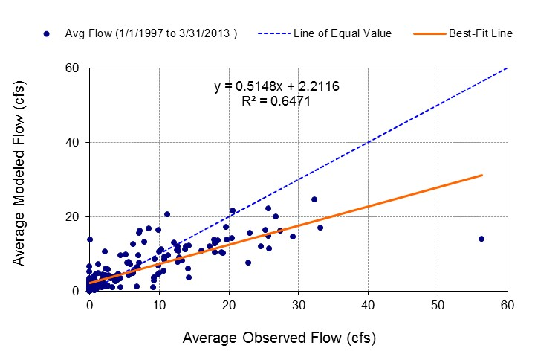
Figure B-32: Monthly flow regression: Model Output at Reach 107 vs. USGS 02293241 San Carlos Canal at Cape Coral, FL (01/01/1997 – 03/31/2013)
Table B-8: Summary statistics: Model output at Reach 107 vs. USGS 02293241 San Carlos Canal at Cape Coral, FL (01/01/1997 – 03/31/2013)

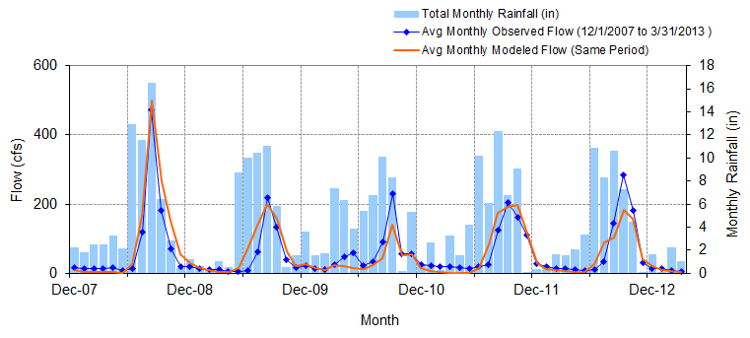
Figure B-33: Mean monthly flow: Model output at Reach 127 vs. USGS 022929176 Telegraph Creek at State Highway at Olga, FL (Big Island Canal) (12/01/2007 – 03/31/2013)

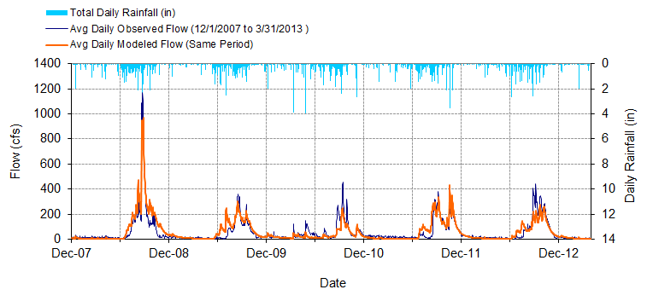
Figure B-34: Mean daily flow: Model output at Reach 127 vs. USGS 022929176 Telegraph Creek at State Highway at Olga, FL (Big Island Canal) (12/01/2007 – 03/31/2013)

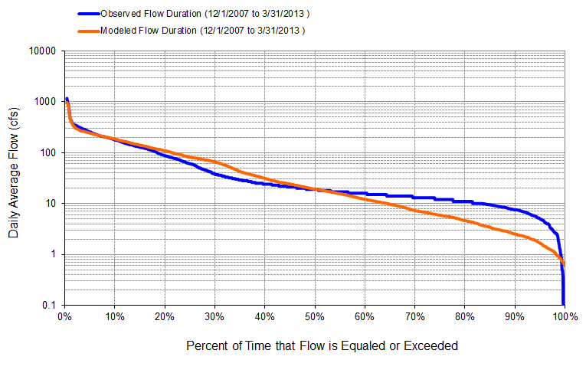
Figure B-35: Flow exceedance: Model output at Reach 127 vs. USGS 022929176 Telegraph Creek at State Highway at Olga, FL (Big Island Canal) (12/01/2007 – 03/31/2013)

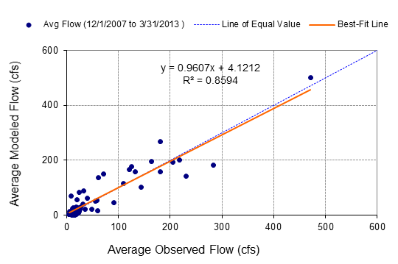
Figure B-36: Monthly flow regression: Model output at Reach 127 vs. USGS 022929176 Telegraph Creek at State Highway at Olga, FL (Big Island Canal) (12/01/2007 – 03/31/2013)
Table B-9: Summary statistics: Model Output at Reach 127 vs. USGS 022929176 Telegraph Creek at State Highway at Olga, FL (Big Island Canal) (12/01/2007 – 03/31/2013)
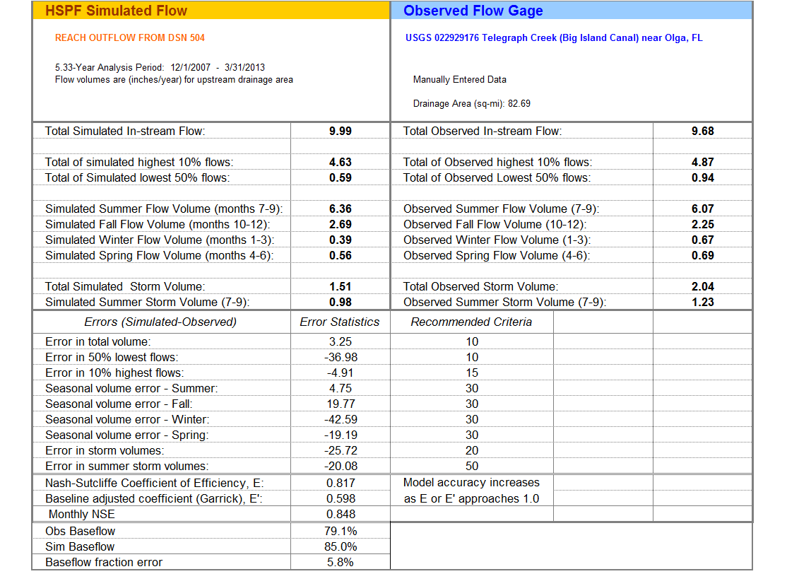
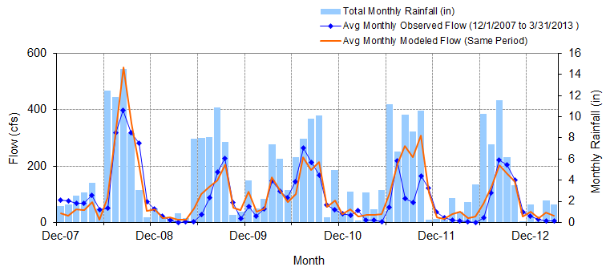
Figure B-37: Mean monthly flow: Model output at Reach 139 vs. USGS 02293055 Orange River near Buckingham, FL (12/01/2007 – 03/31/2013)

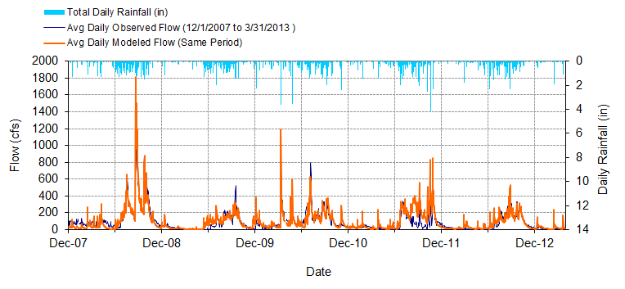
Figure B-38: Mean daily flow: Model output at Reach 139 vs. USGS 02293055 Orange River near Buckingham, FL (12/01/2007 – 03/31/2013)

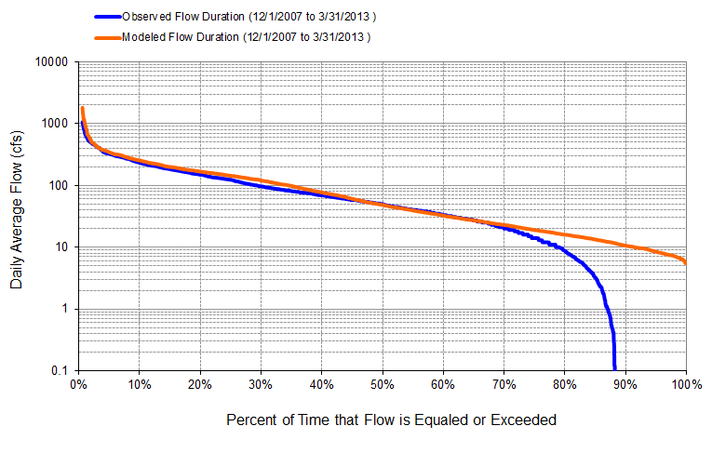
Figure B-39: Flow exceedance: Model output at Reach 139 vs. USGS 02293055 Orange River near Buckingham, FL (12/01/2007 – 03/31/2013)

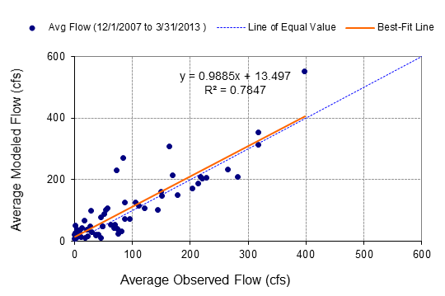
Figure B-40: Monthly flow regression: Model output at Reach 139 vs. USGS 02293055 Orange River near Buckingham, FL (12/01/2007 – 03/31/2013)
Table B-10: Summary statistics: Model Output at Reach 139 vs. USGS 02293055 Orange River near Buckingham, FL (12/01/2007 – 03/31/2013)
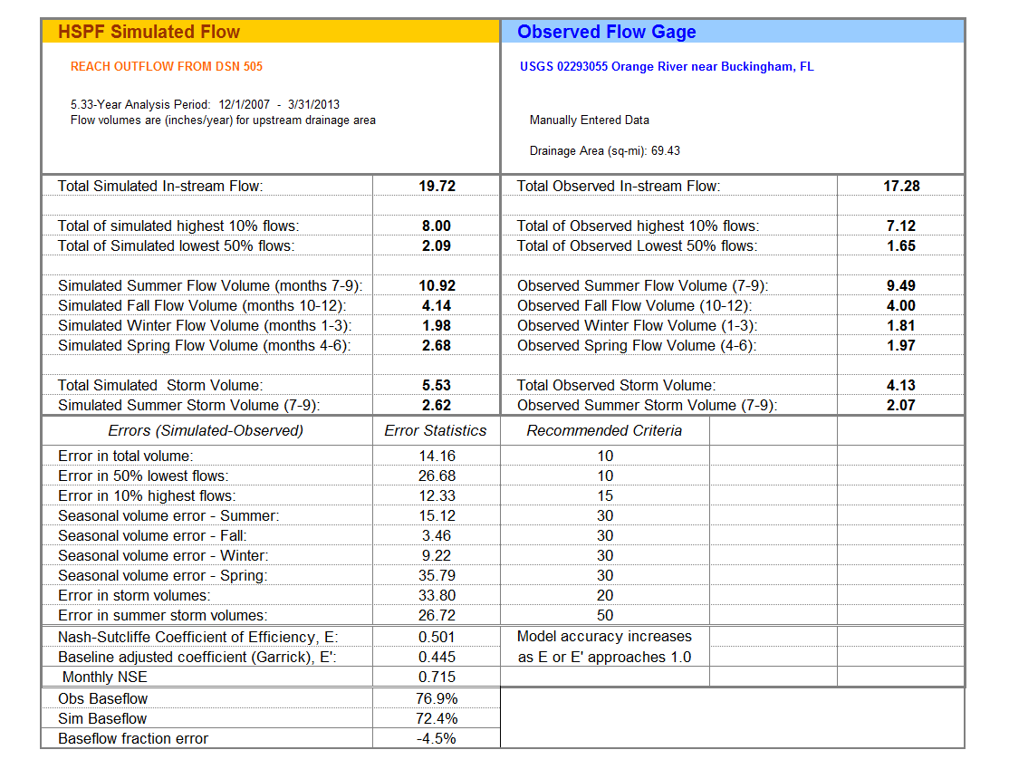
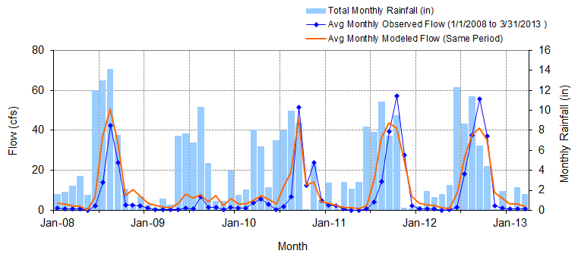
Figure B-41: Mean monthly flow: Model output at Reach 120 vs. USGS 02293090 Popash Creek at Leetana Road near Fort Myers, FL (01/01/2008– 03/31/2013)

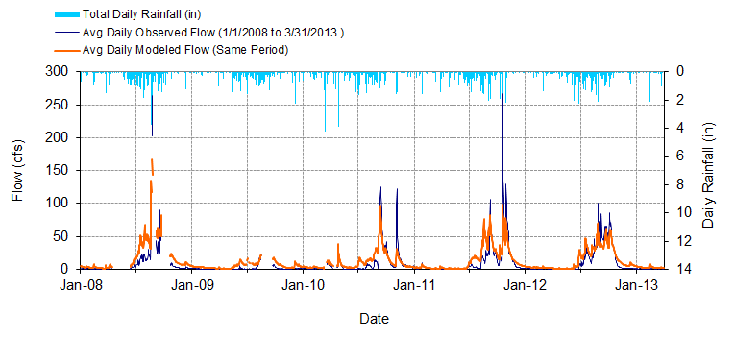
Figure B-42: Mean daily flow: Model output at Reach 120 vs. USGS 02293090 Popash Creek at Leetana Road near Fort Myers, FL (01/01/2008– 03/31/2013)

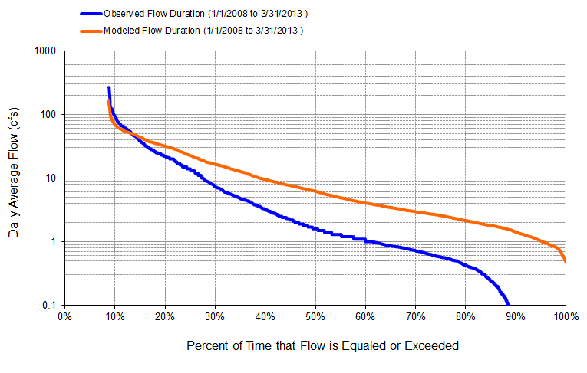
Figure B-43: Flow exceedance: Model output at Reach 120 vs. USGS 02293090 Popash Creek at Leetana Road near Fort Myers, FL (01/01/2008– 03/31/2013)

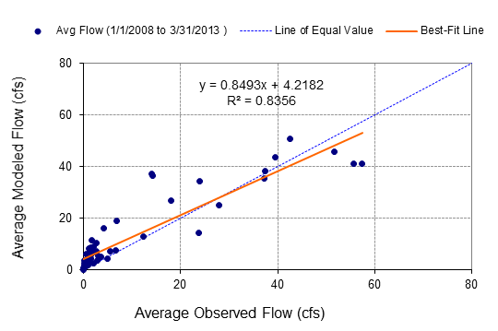
Figure B-44: Monthly flow regression: Model output at Reach 120 vs. USGS 02293090 Popash Creek at Leetana Road near Fort Myers, FL (01/01/2008– 03/31/2013)
Table B-11: Summary statistics: Model output at Reach 120 vs. USGS 02293090 Popash Creek at Leetana Road near Fort Myers, FL (01/01/2008– 03/31/2013)
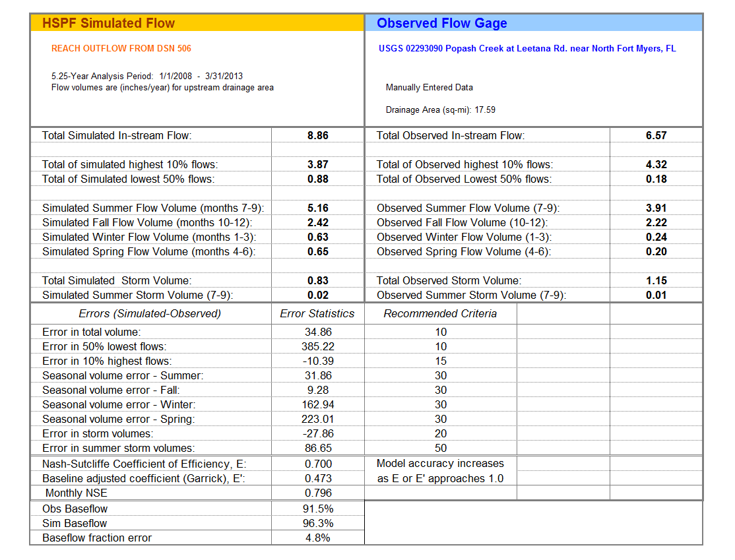

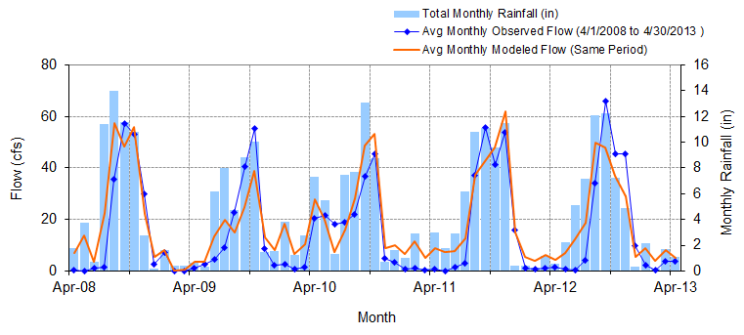
Figure B-45: Mean monthly flow: Model output at Reach 137 vs. USGS 02293190 Billy Creek at Fort Myers, FL (04/01/2008 – 04/30/2013)

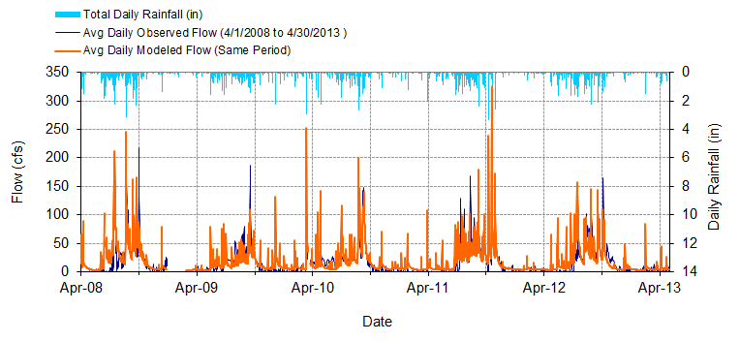
Figure B-46: Mean daily flow: Model output at Reach 137 vs. USGS 02293190 Billy Creek at Fort Myers, FL (04/01/2008 – 04/30/2013)

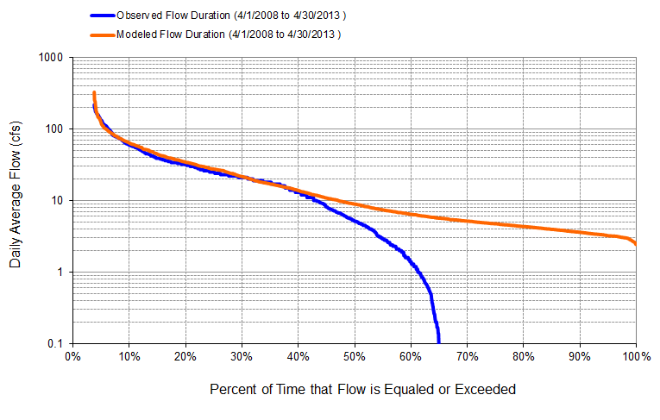
Figure B-47: Flow exceedance: Model output at Reach 137 vs. USGS 02293190 Billy Creek at Fort Myers, FL (04/01/2008 – 04/30/2013)

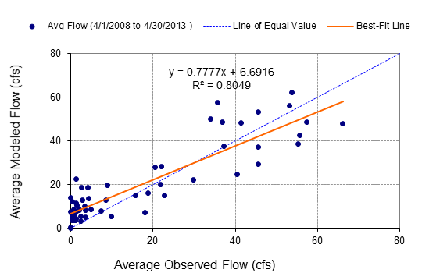
Figure B-48: Monthly flow regression: Flow exceedance: Model output at Reach 137 vs. USGS 02293190 Billy Creek at Fort Myers, FL (04/01/2008 – 04/30/2013)
Table B-12: Summary statistics: Flow exceedance: Model output at Reach 137 vs. USGS 02293190 Billy Creek at Fort Myers, FL (04/01/2008 – 04/30/2013)
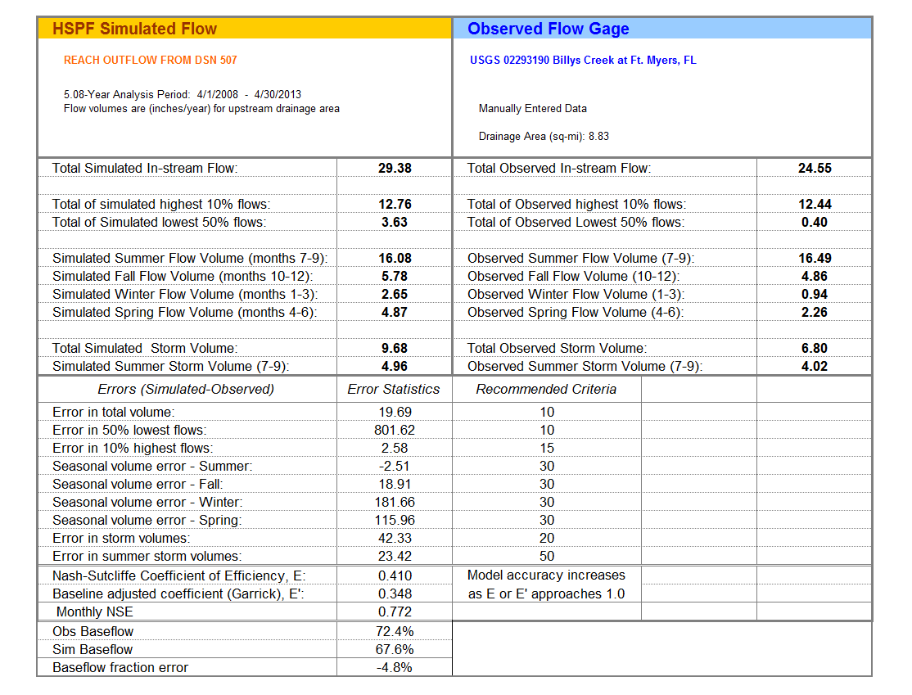

Figure B-49: Mean monthly flow: Model output at Reach 105 vs. USGS 02293243 Courtney Canal at Cape Coral, FL (01/01/1997 – 07/31/2013)

Figure B-50: Mean daily flow: Model output at Reach 105 vs. USGS 02293243 Courtney Canal at Cape Coral, FL (01/01/1997 – 07/31/2013)

Figure B-51: Flow exceedance: Model output at Reach 105 vs. USGS 02293243 Courtney Canal at Cape Coral, FL (01/01/1997 – 07/31/2013)

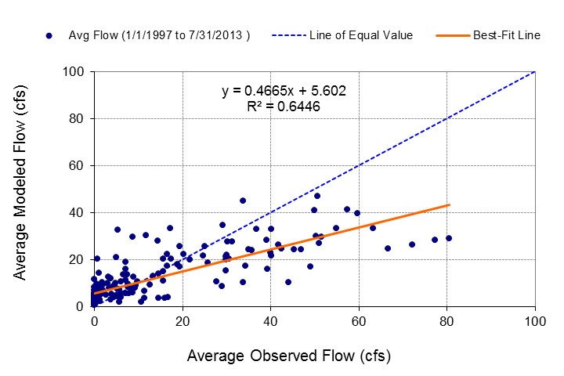
Figure B-52 Monthly flow regression: Model output at Reach 105 vs. USGS 02293243 Courtney Canal at Cape Coral, FL (01/01/1997 – 07/31/2013)
Table B-13: Summary statistics: Model output at Reach 105 vs. USGS 02293243 Courtney Canal at Cape Coral, FL (01/01/1997 – 07/31/2013)

B-2 DEP Gage Calibration Comparison
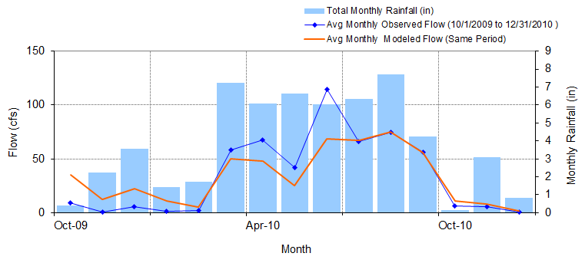
Figure B-53: Mean monthly flow: Model output at Reach 169 vs. DEP Jacks Branch at SR 78 (010/01/2009 – 012/31/2010)

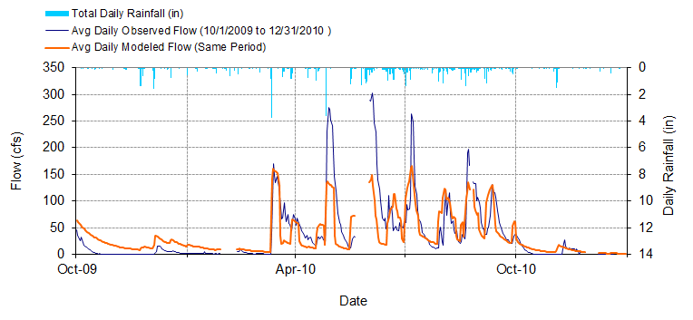
Figure B-54: Mean daily flow: Model output at Reach 169 vs. DEP Jacks Branch at SR 78 (010/01/2009 – 012/31/2010)

Figure B-55: Flow exceedance: Model Output at Reach 169 vs. DEP Jacks Branch at SR 78 (010/01/2009 – 012/31/2010)

Figure B-56: Monthly flow regression: Model output at Reach 169 vs. DEP Jacks Branch at SR 78 (010/01/2009 – 012/31/2010)
Table B-14: Summary statistics: Model Output at Reach 169 vs. DEP Jacks Branch at SR 78 (010/01/2009 – 012/31/2010)
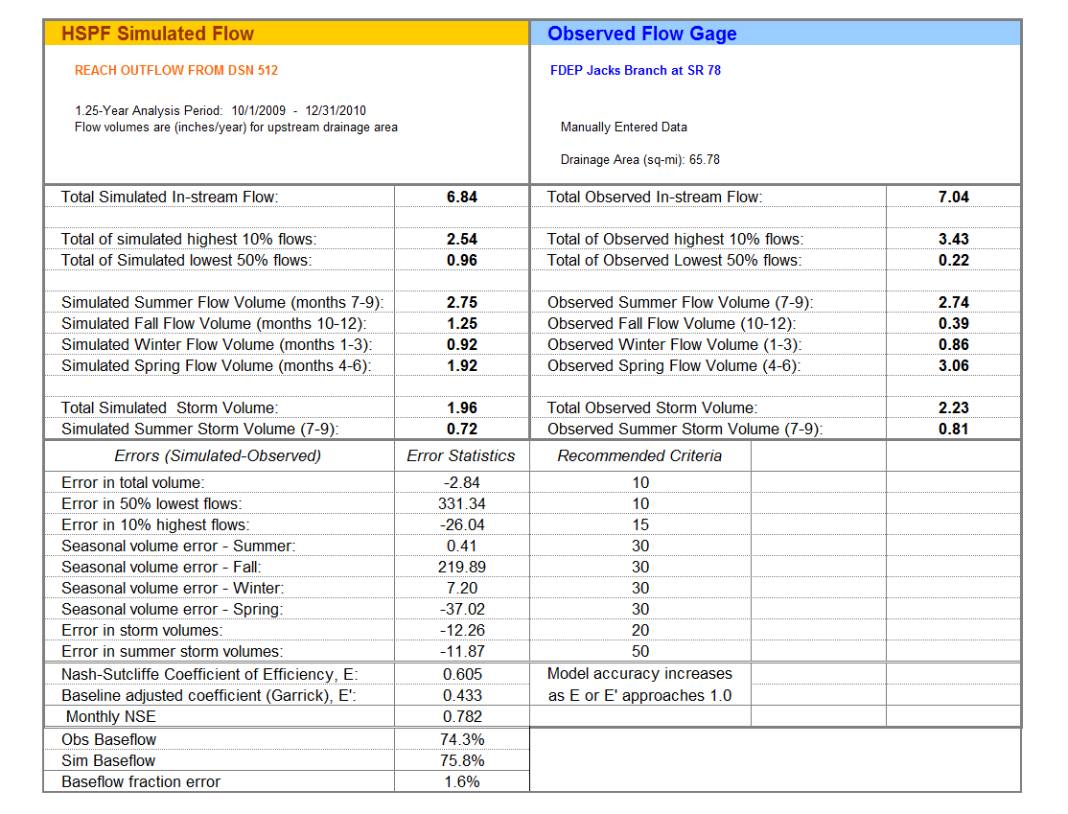
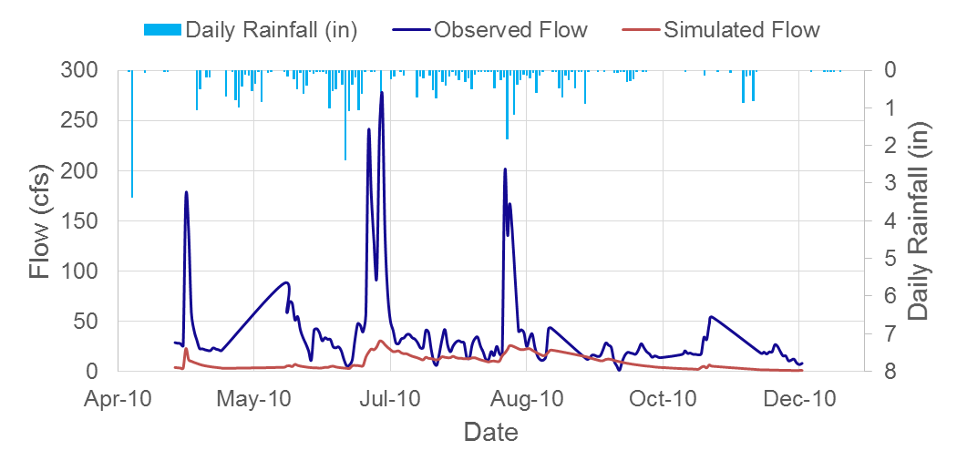
Figure B-57: Mean daily flow: Model output at Reach 173 vs. DEP Fast Creek at SR 80 (04/22/2010 – 12/08/2010)

Figure B-58: Monthly flow regression: Model output at Reach 173 vs. DEP Fast Creek at SR 80 (04/22/2010 – 12/08/2010)

Figure B-59: Mean daily flow: Model output at Reach 179 vs. DEP Pollywog Creek at SR 78 (09/30/2009 – 04/14/2010)

Figure B-60: Monthly flow regression: Model output at Reach 179 vs. DEP Pollywog Creek at SR 78 (09/30/2009 – 04/14/2010)

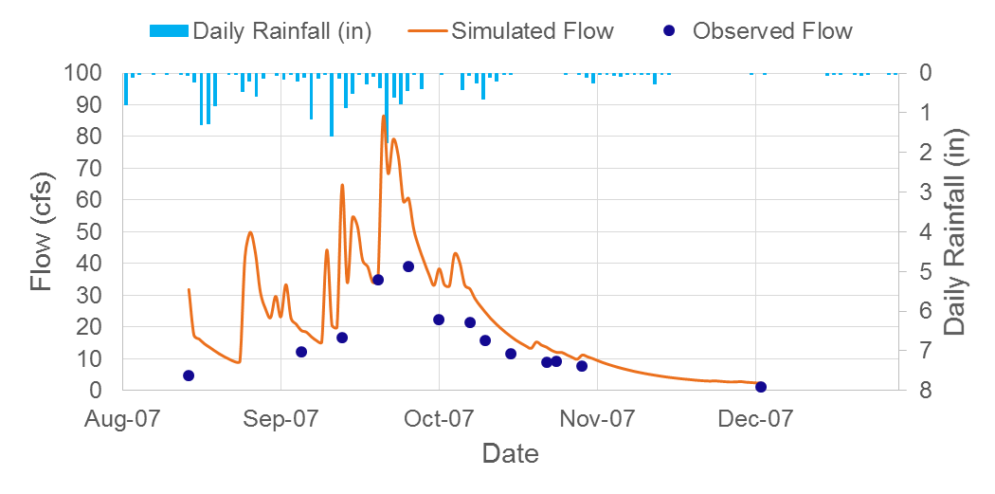
Figure B-61: Mean daily flow: Model output at Reach 115 vs. DEP Powell Creek at SR 78 (13 daily values)

Figure B-62: Daily flow regression: Model output at Reach 115 vs. DEP Powell Creek at SR 78 (13 daily values)

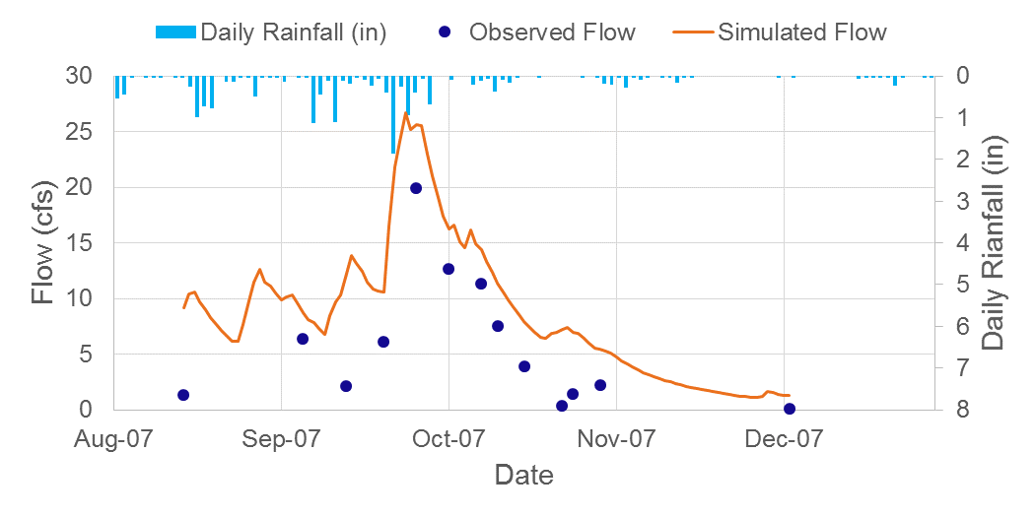
Figure B-63: Mean daily flow: Model output at Reach 121 vs. DEP Stroud Creek (13 daily values)

Figure B-64: Daily flow regression: Model output at Reach 121 vs. DEP Stroud Creek (13 daily values)

Figure B-65: Mean daily flow: Model output at Reach 112 vs. DEP Yellow Fever Creek (13 daily values)

Figure B-66: Daily flow regression: Model output at Reach 112 vs. DEP Yellow Fever Creek (13 daily values)

Appendix C: 2014 HSPF Flow Calibration Results

C-1 USGS Gage Comparison
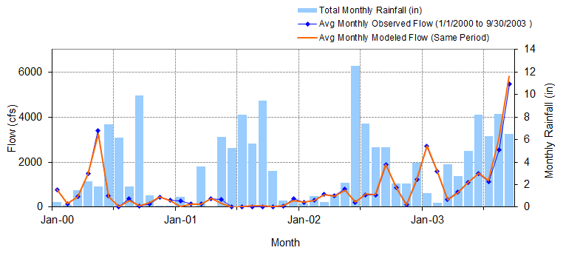
Figure C-1: Mean monthly flow: Model output at Reach 61 vs. USGS 02292000 Caloosahatchee Canal at Moore Haven, FL (01/01/2000 – 09/30/2003)

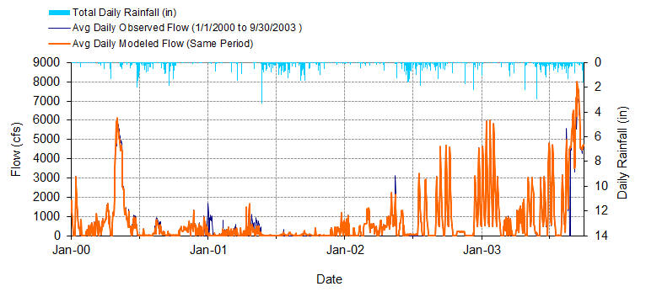
Figure C-2: Mean daily flow: Model output at Reach 61 vs. USGS 02292000 Caloosahatchee Canal at Moore Haven, FL (01/01/2000 – 09/30/2003)

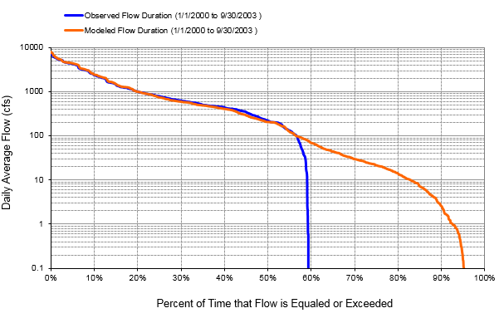
Figure C-3: Flow exceedance: Model output at Reach 61 vs. USGS 02292000 Caloosahatchee Canal at Moore Haven, FL (01/01/2000 – 09/30/2003)

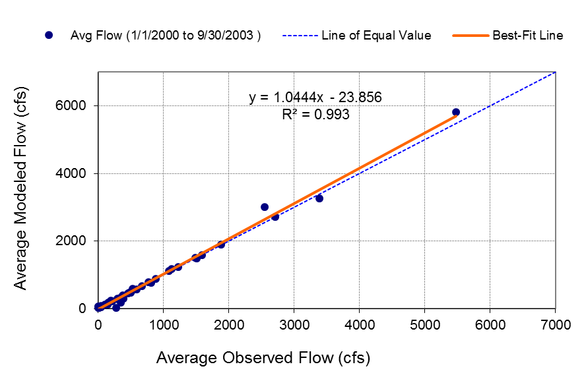
Figure C-4: Monthly flow regression: Model output at Reach 61 vs. USGS 02292000 Caloosahatchee Canal at Moore Haven, FL (01/01/2000 – 09/30/2003)
Table C-1: Summary statistics: Model output at Reach 61 vs. USGS 02292000 Caloosahatchee Canal at Moore Haven, FL (01/01/2000 – 09/30/2003)
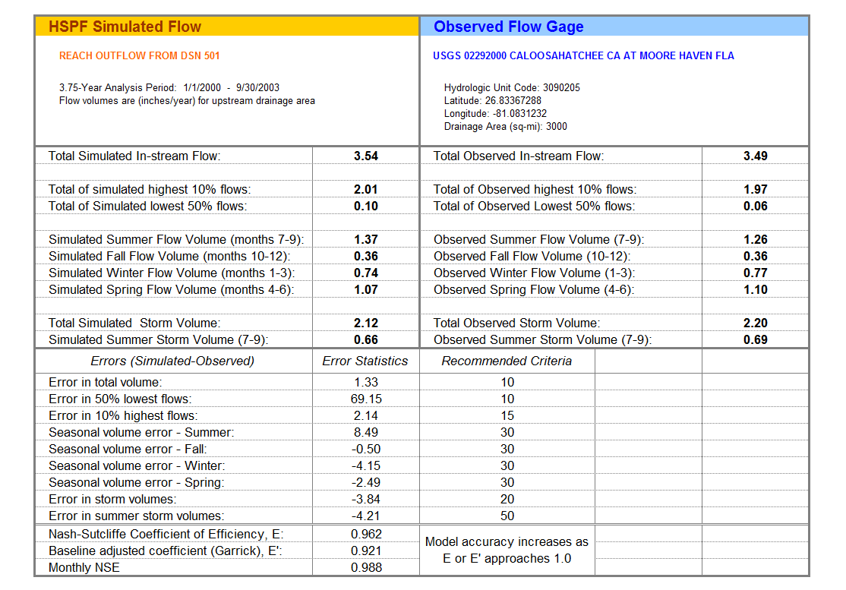

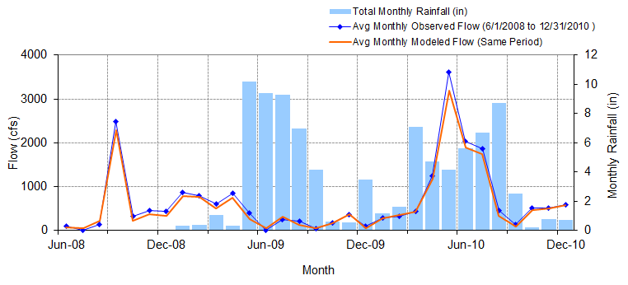
Figure C-5: Mean monthly flow: Model output at Reach 61 vs. USGS 02292010 Caloosahatchee Canal DWS of S-77 of Moore Haven, FL (06/01/2008 – 12/31/2010)

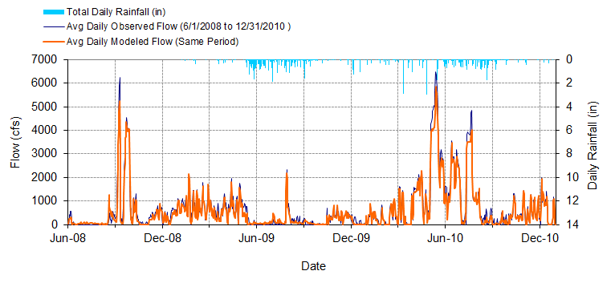
Figure C-6: Mean daily flow: Model output at Reach 61 vs. USGS 02292010 Caloosahatchee Canal DWS of S-77 of Moore Haven, FL (06/01/2008 – 12/31/2010)

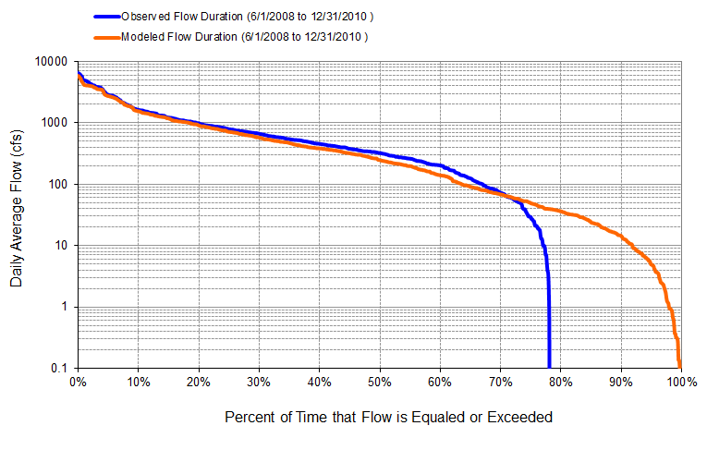
Figure C-7: Flow exceedance: Model output at Reach 61 vs. USGS 02292010 Caloosahatchee Canal DWS of S-77 of Moore Haven, FL (06/01/2008 – 12/31/2010)

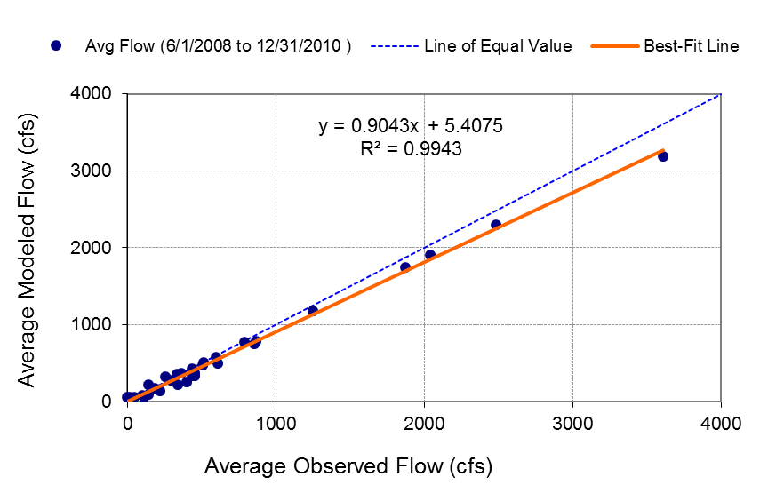
Figure C-8: Monthly flow regression: Model output at Reach 61 vs. USGS 02292010 Caloosahatchee Canal DWS of S-77 of Moore Haven, FL (06/01/2008 – 12/31/2010)

Table C-2: Summary statistics: Model output at Reach 61 vs. USGS 02292010 Caloosahatchee Canal DWS of S-77 of Moore Haven, FL (06/01/2008 – 12/31/2010)
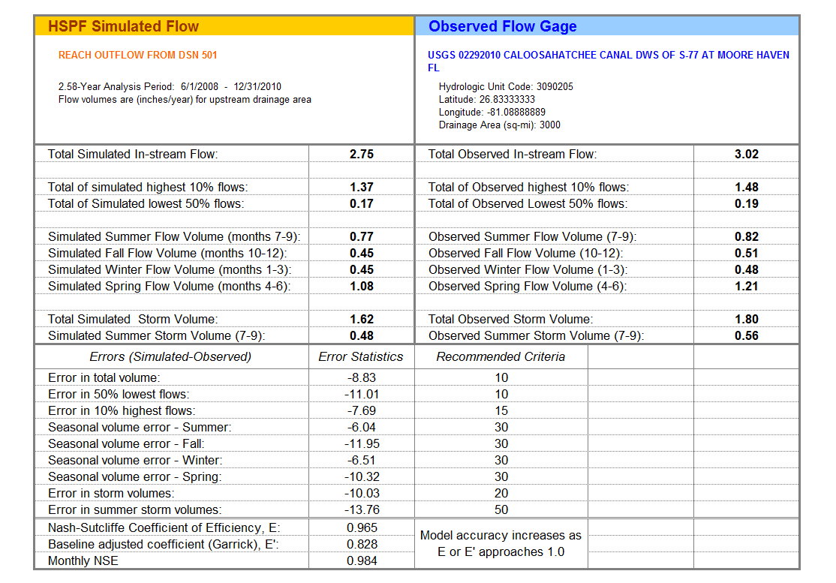

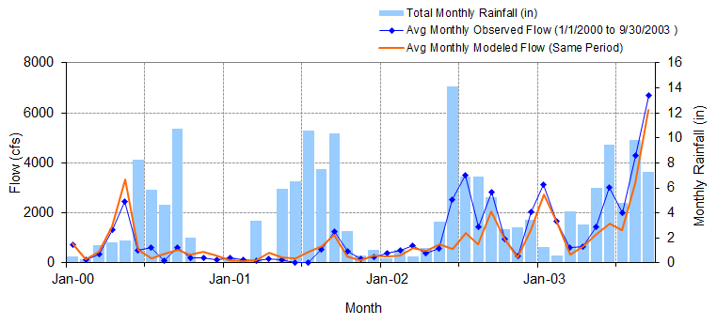
Figure C-9: Mean monthly flow: Model output at Reach 46 vs. USGS 02292480 Caloosahatchee Canal at Ortona Lock near LaBelle S-78 (01/01/2000 – 09/30/2003)

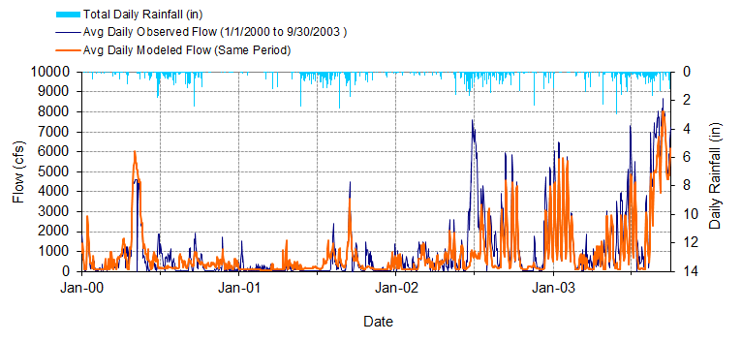
Figure C-10: Mean daily flow: Model output at Reach 46 vs. USGS 02292480 Caloosahatchee Canal at Ortona Lock near LaBelle S-78 (01/01/2000 – 09/30/2003)

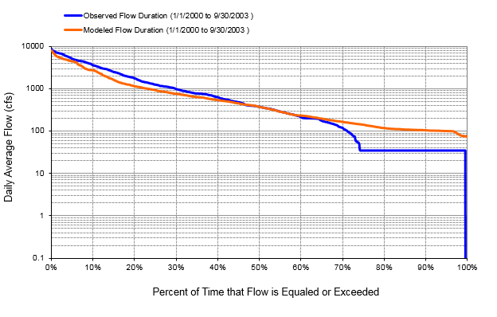
Figure C-11: Flow exceedance: Model output at Reach 46 vs. USGS 02292480 Caloosahatchee Canal at Ortona Lock near LaBelle S-78 (01/01/2000 – 09/30/2003)

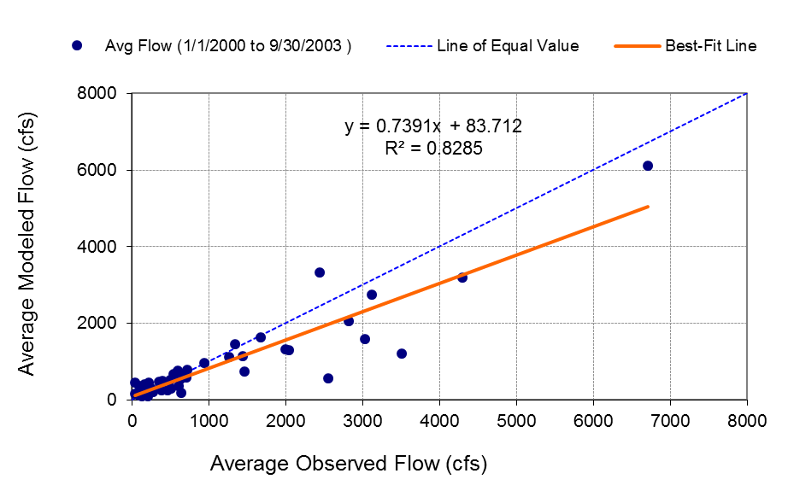
Figure C-12: Monthly flow regression: Model output at Reach 46 vs. USGS 02292480 Caloosahatchee Canal at Ortona Lock near LaBelle S-78 (01/01/2000 – 09/30/2003)
Table C-3: Summary statistics: Model output at Reach 4666 vs. USGS 02292480 Caloosahatchee Canal at Ortona Lock near LaBelle S-78 (01/01/2000 – 09/30/2003)
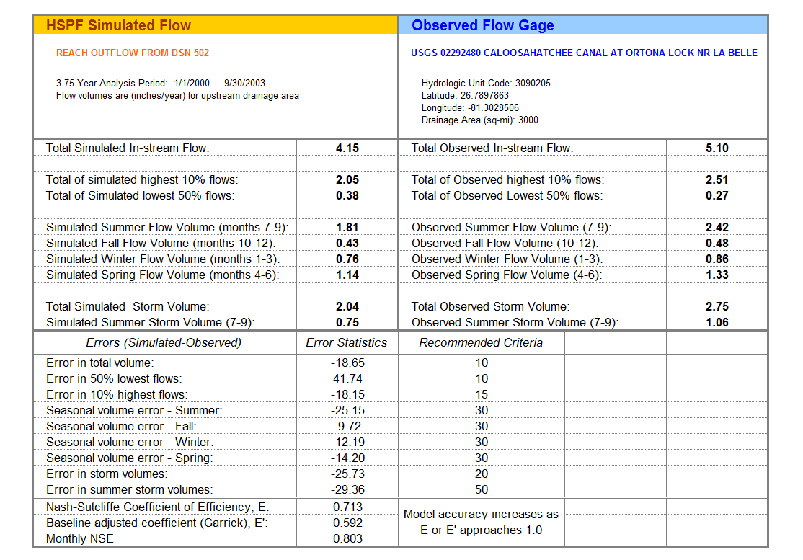

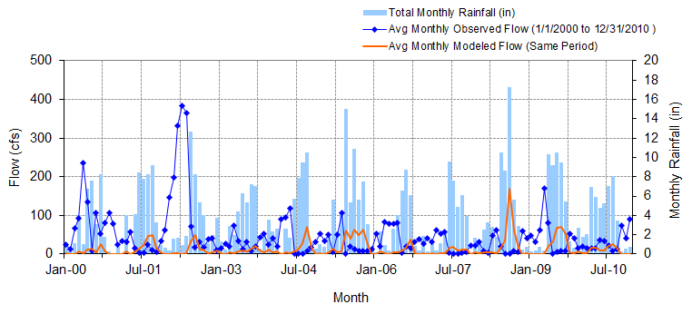
Figure C-13: Mean monthly flow: Model output at Reach 60 vs. USGS 26451408150700 Industrial Canal at Clewiston (01/01/2000 – 12/31/2010)

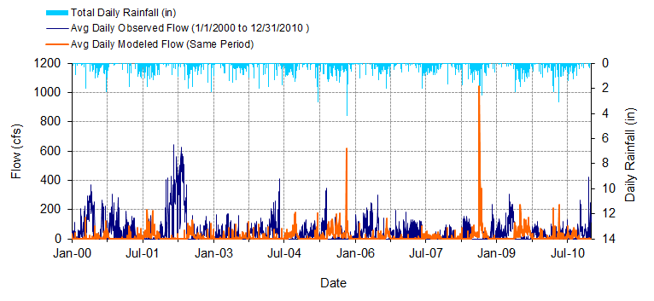
Figure C-14: Mean daily flow: Model output at Reach 60 vs. USGS 26451408150700 Industrial Canal at Clewiston (01/01/2000 – 12/31/2010)

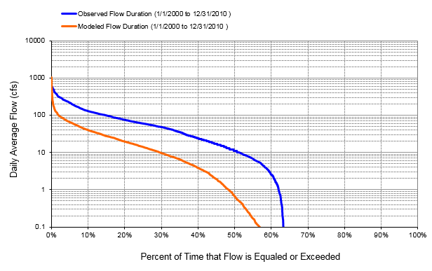
Figure C-15: Flow exceedance: Model output at Reach 60 vs. USGS 26451408150700 Industrial Canal at Clewiston (01/01/2000 – 12/31/2010)

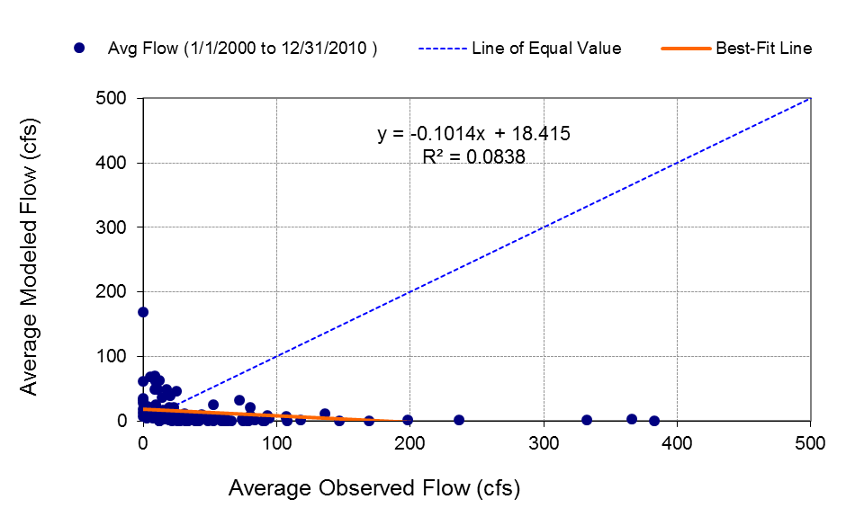
Figure C-16: Monthly flow regression: Model output at Reach 60 vs. USGS 26451408150700 Industrial Canal at Clewiston (01/01/2000 – 12/31/2010)
Table C-4: Summary statistics: Model output at Reach 60 vs. USGS 26451408150700 Industrial Canal at Clewiston (01/01/2000 – 12/31/2010)
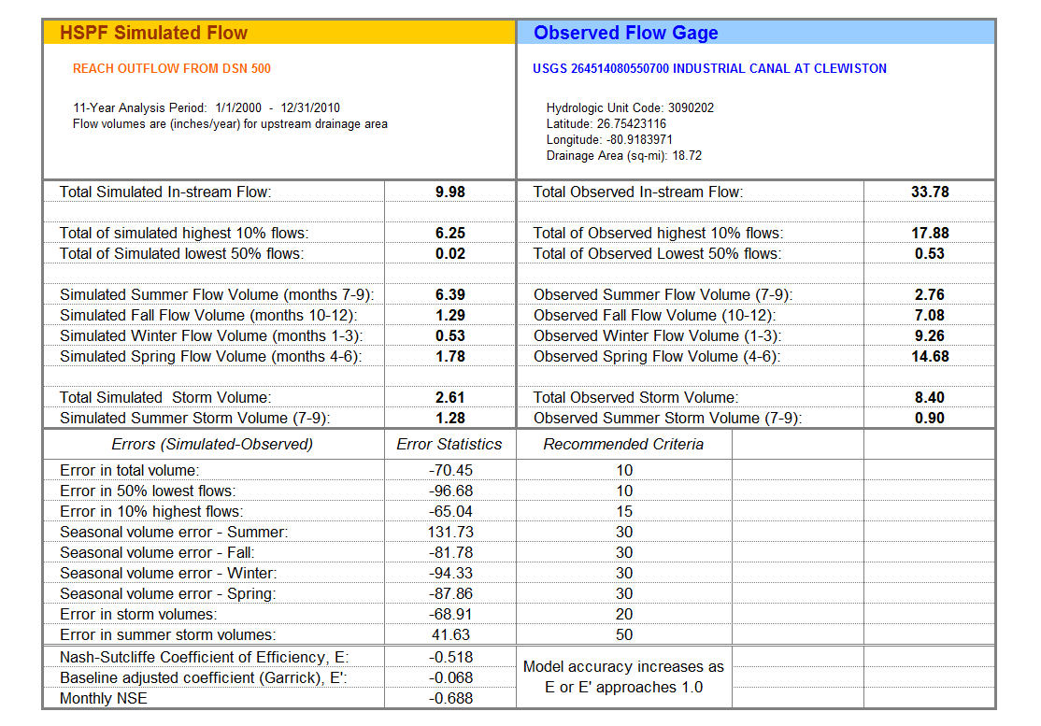
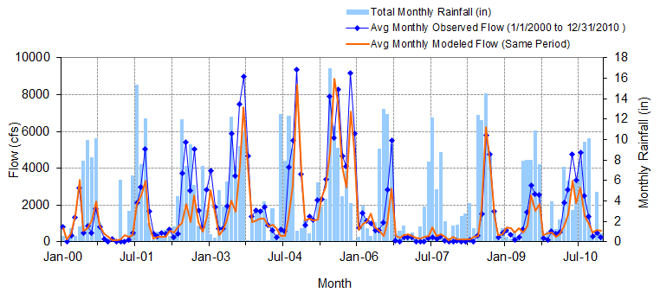
Figure C-17: Mean monthly flow: Model output at Reach 18 vs. USGS 02292900 Caloosahatchee River at S-79 near Olga, FL (01/01/2000 – 12/31/2010)

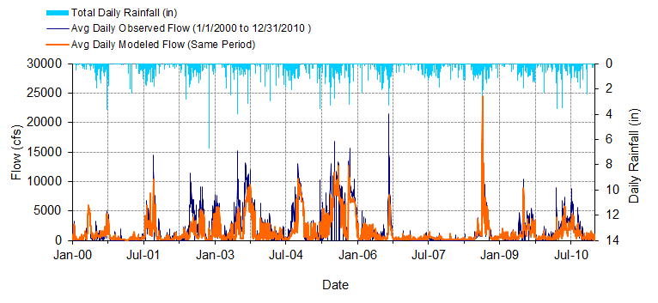
Figure C-18: Mean daily flow: Model output at Reach 18 vs. USGS 02292900 Caloosahatchee River at S-79 near Olga, FL (01/01/2000 – 12/31/2010)

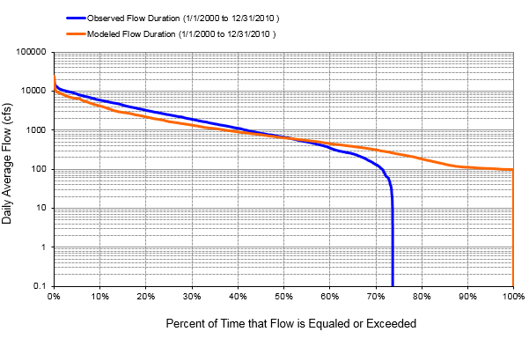
Figure C-19: Flow exceedance: Model output at Reach 18 vs. USGS 02292900 Caloosahatchee River at S-79 near Olga, FL (01/01/2000 – 12/31/2010)

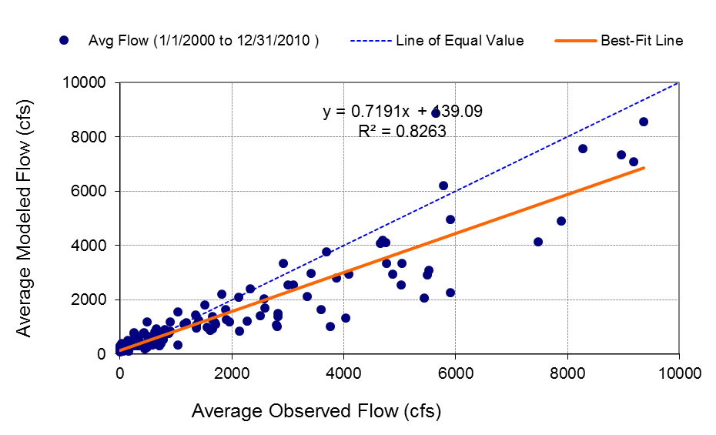
Figure C-20: Monthly flow regression: Model output at Reach 18 vs. USGS 02292900 Caloosahatchee River at S-79 near Olga, FL (01/01/2000 – 12/31/2010)

Table C-5: Summary statistics: Model output at Reach 18 vs. USGS 02292900 Caloosahatchee River at S-79 near Olga, FL (01/01/2000 – 12/31/2010)
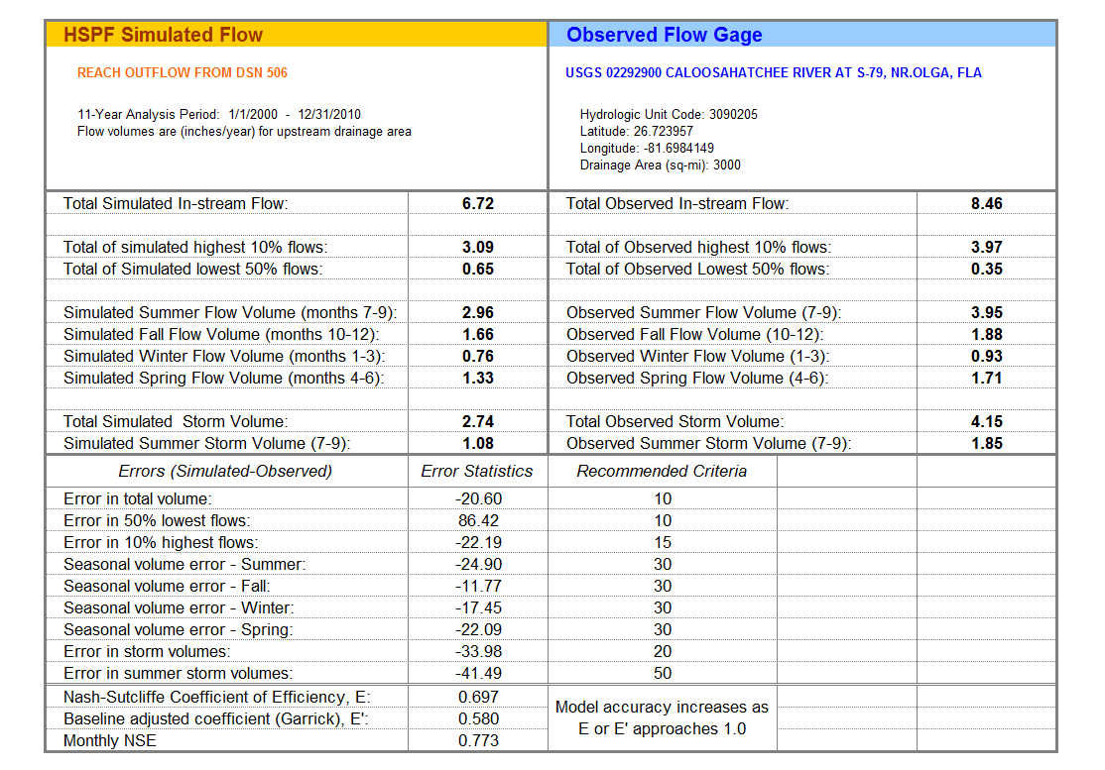

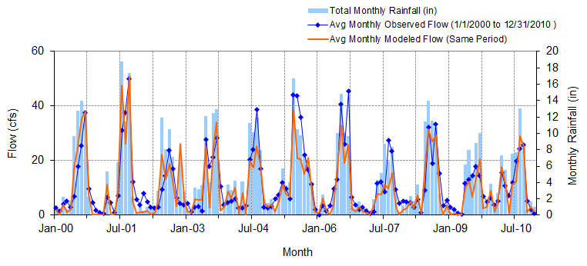
Figure C-21: Mean monthly flow: Model output at Reach 7 vs. USGS 02293230 Whiskey Creek at Fort Myers, FL (01/01/2000 – 12/31/2010)

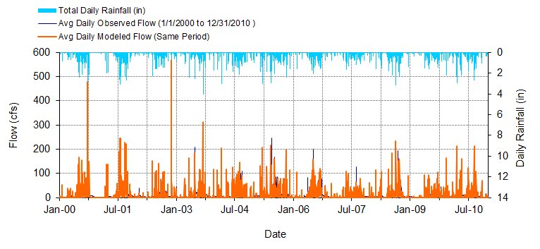
Figure C-22: Mean daily flow: Model output at Reach 7 vs. USGS 02293230 Whiskey Creek at Fort Myers, FL (01/01/2000 – 12/31/2010)

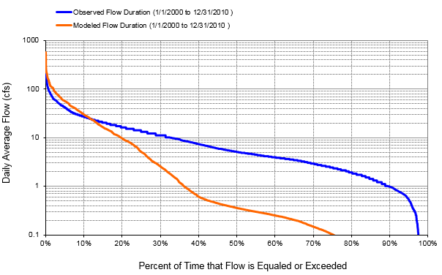
Figure C-23: Flow exceedance: Model output at Reach 7 vs. USGS 02293230 Whiskey Creek at Fort Myers, FL (01/01/2000 – 12/31/2010)

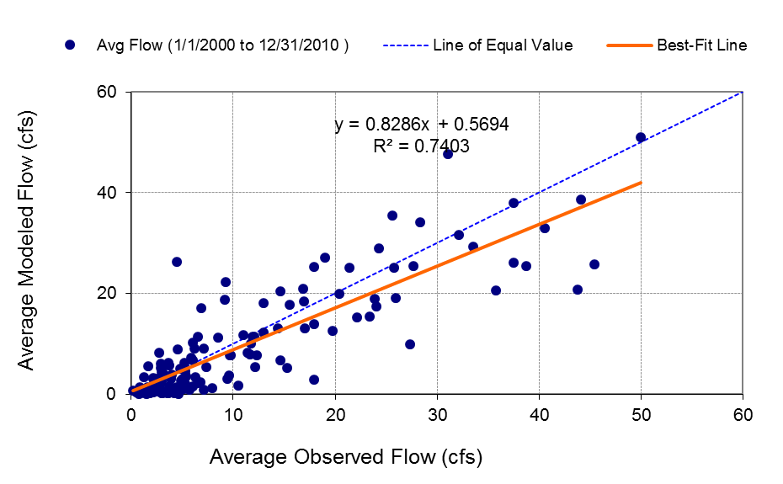
Figure C-24: Monthly flow regression: Model output at Reach 7 vs. USGS 02293230 Whiskey Creek at Fort Myers, FL (01/01/2000 – 12/31/2010)

Table C-6: Summary statistics: Model Output at Reach 7 vs. USGS 02293230 Whiskey Creek at Fort Myers, FL (01/01/2000 – 12/31/2010)
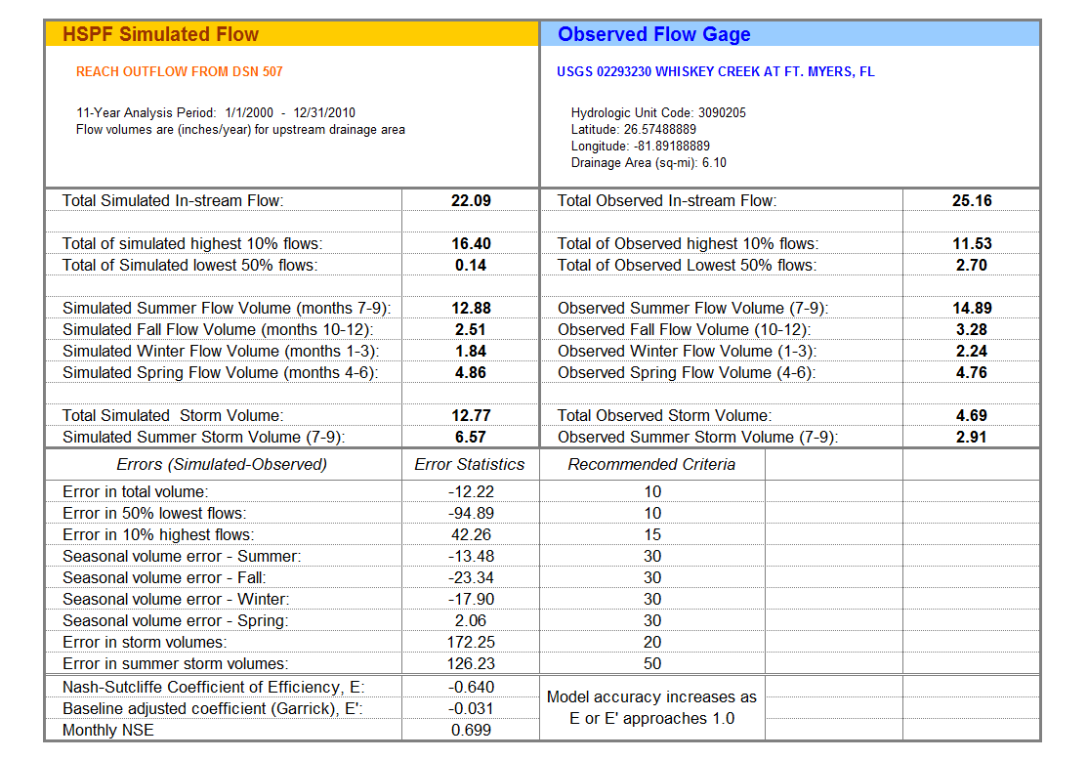

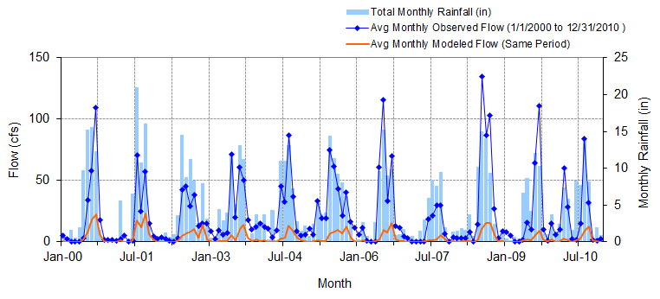
Figure C-25: Mean monthly flow: Model output at Reach 102 vs. USGS 02293240 Aries Canal at Cape Coral, FL (01/01/2000 – 08/31/2010)

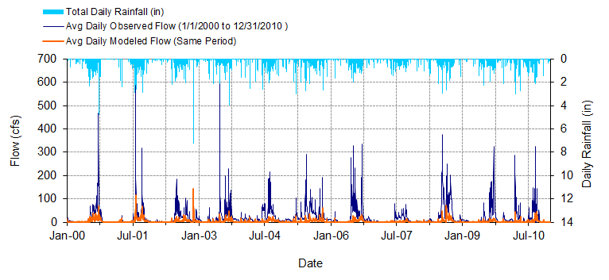
Figure C-26: Mean daily flow: Model output at Reach 102 vs. USGS 02293240 Aries Canal at Cape Coral, FL (01/01/2000 – 08/31/2010)

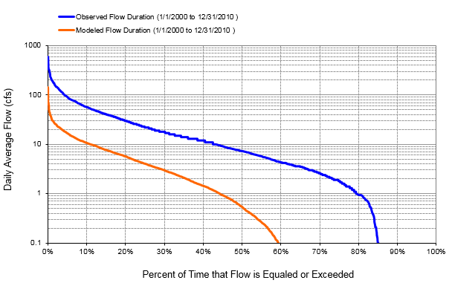
Figure C-27: Flow exceedance: Model output at Reach 102 vs. USGS 02293240 Aries Canal at Cape Coral, FL (01/01/2000 – 08/31/2010)

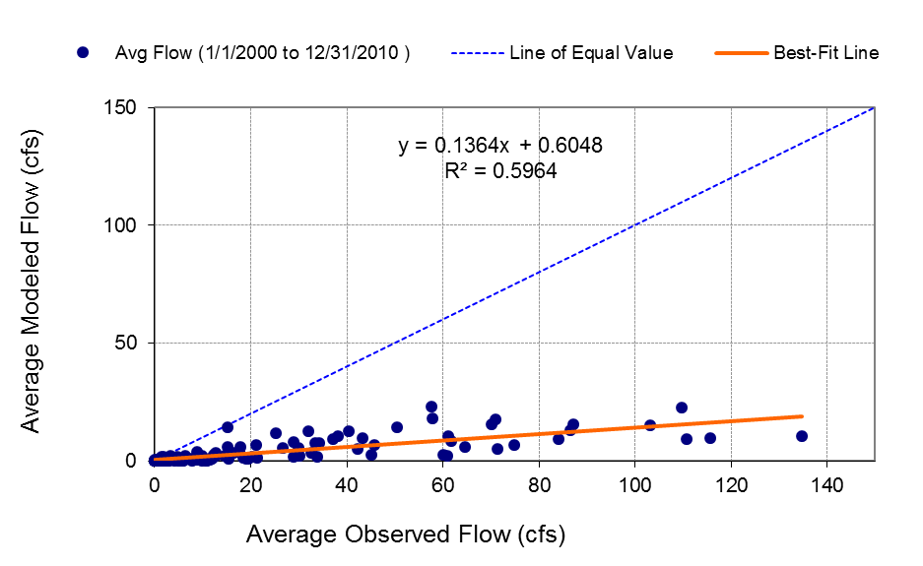
Figure C-28: Monthly flow regression: Model output at Reach 102 vs. USGS 02293240 Aries Canal at Cape Coral, FL (01/01/2000 – 08/31/2010)

Table C-7: Summary statistics: Model output at Reach 102 vs. USGS 02293240 Aries Canal at Cape Coral, FL (01/01/2000 – 08/31/2010)
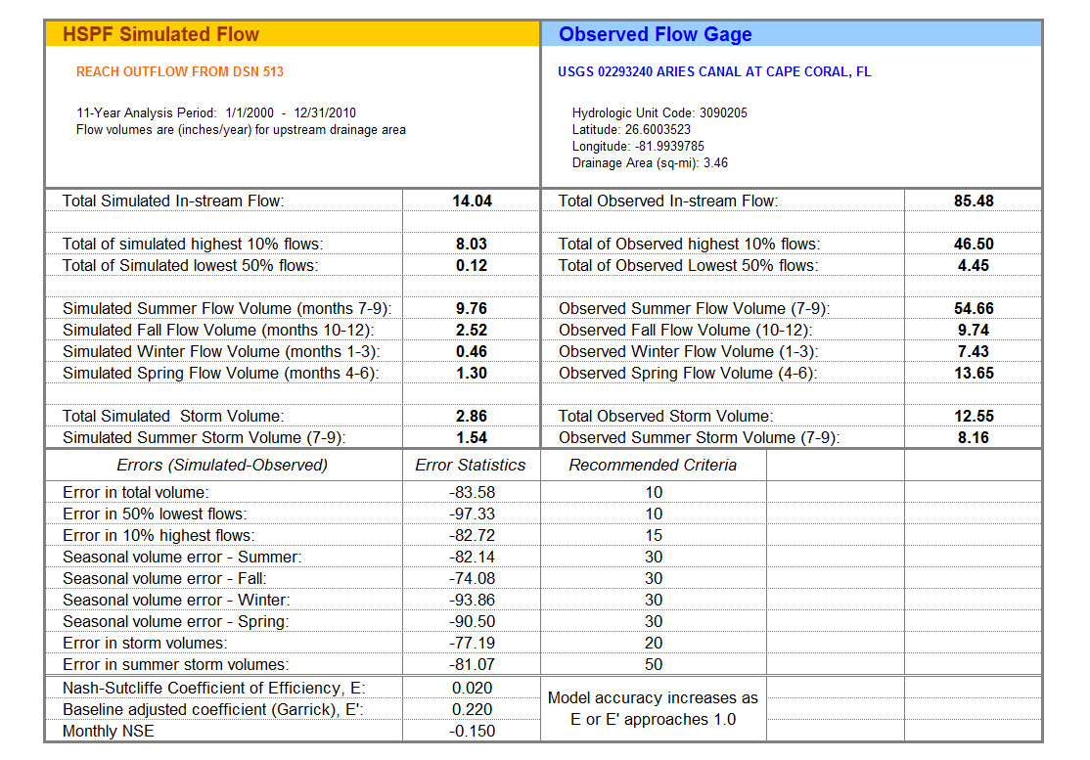

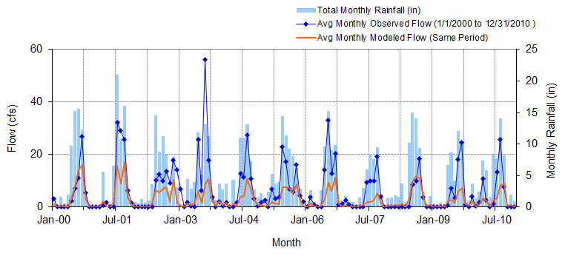
Figure C-29: Mean monthly flow: Model output at Reach 98 vs. USGS 02293241 San Carlos Canal at Cape Coral, FL (01/01/2000 – 04/03/2010)

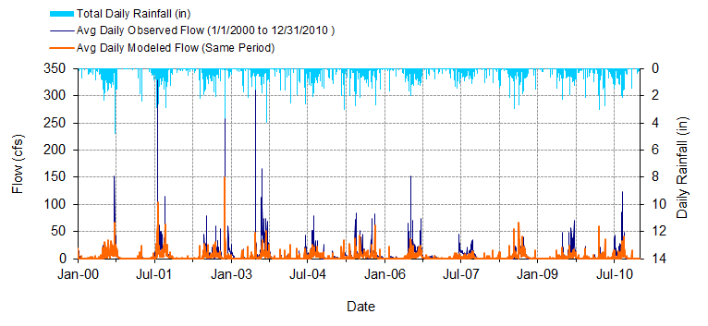
Figure C-30: Mean daily flow: Model output at Reach 98 vs. USGS 02293241 San Carlos Canal at Cape Coral, FL (01/01/2000 – 04/03/2010)

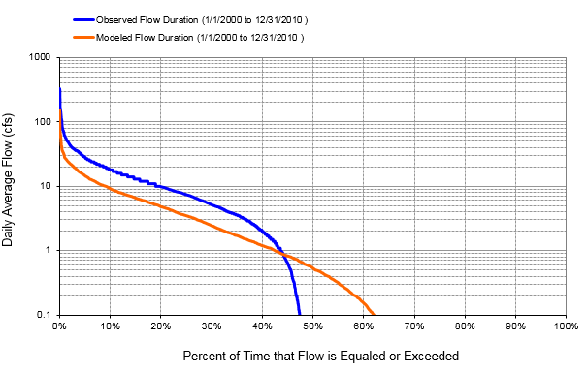
Figure C-31: Flow exceedance: Model output at Reach 98 vs. USGS 02293241 San Carlos Canal at Cape Coral, FL (01/01/2000 – 04/03/2010)

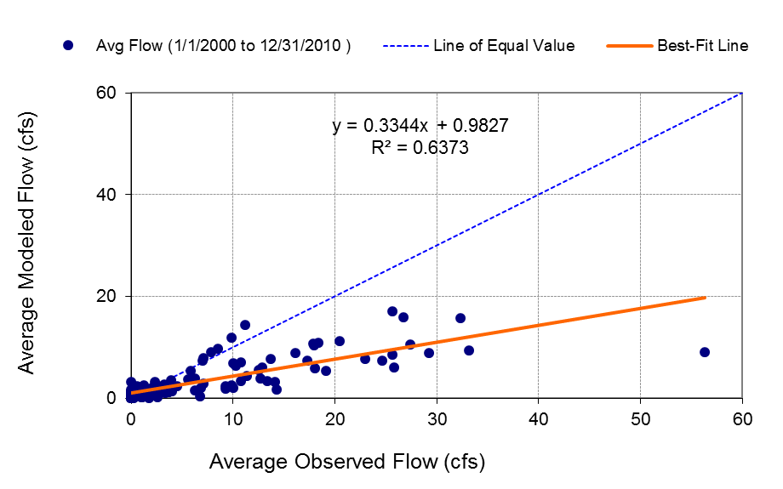
Figure C-32: Monthly flow regression: Model output at Reach 98 vs. USGS 02293241 San Carlos Canal at Cape Coral, FL (01/01/2000 – 04/03/2010)
Table C-8: Summary statistics: Model output at Reach 98 vs. USGS 02293241 San Carlos Canal at Cape Coral, FL (01/01/2000 – 04/03/2010)
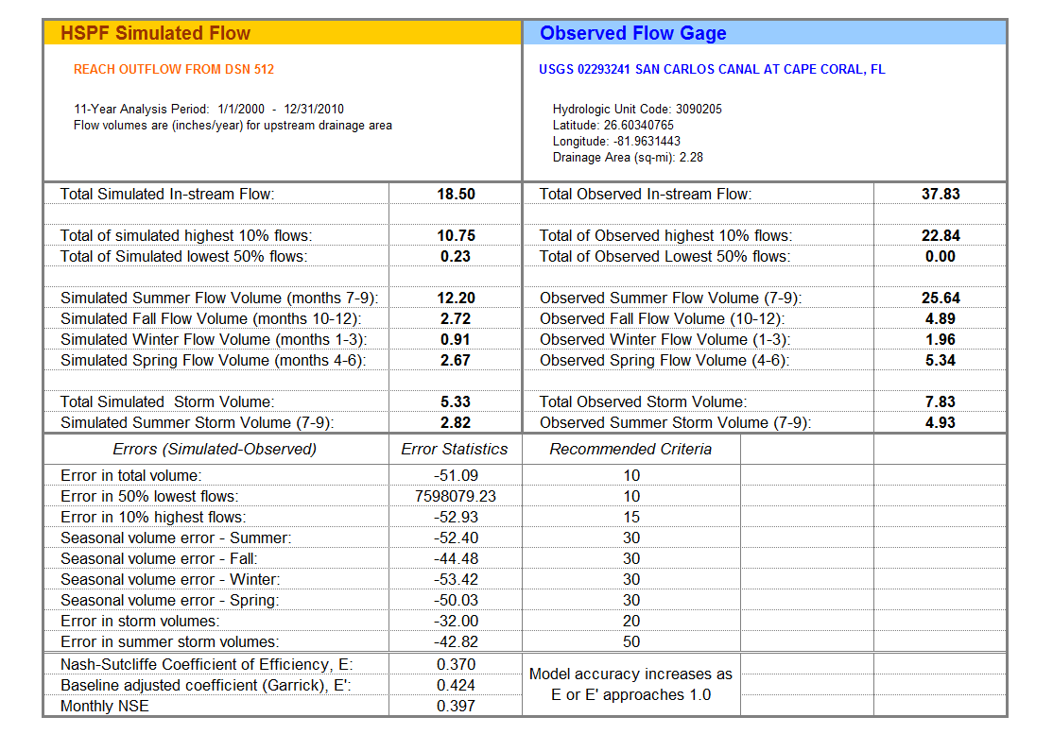

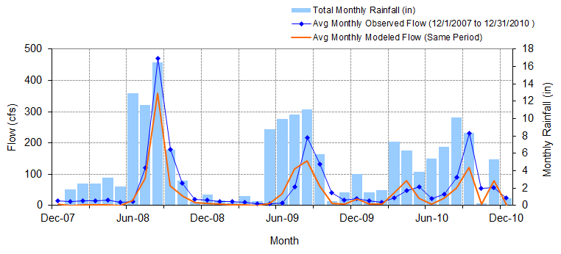
Figure C-33: Mean monthly flow: Model output at Reach 77 vs. USGS 022929176 Telegraph Creek at State Highway at Olga, FL (Big Island Canal) (12/01/2007 – 12/31/2010)

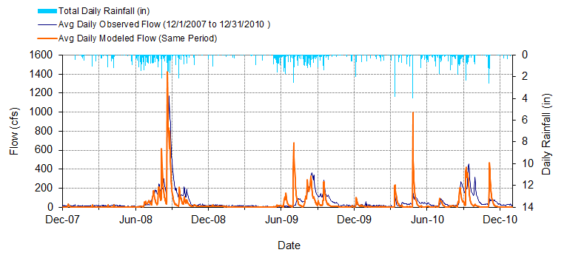
Figure C-34: Mean daily flow: Model output at Reach 77 vs. USGS 022929176 Telegraph Creek at State Highway at Olga, FL (Big Island Canal) (12/01/2007 – 12/31/2010)

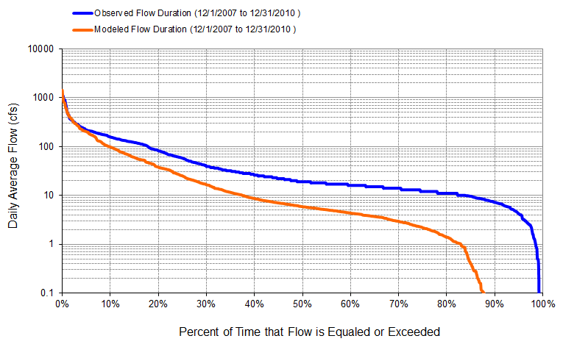
Figure C-35: Flow exceedance: Model output at Reach 77 vs. USGS 022929176 Telegraph Creek at State Highway at Olga, FL (Big Island Canal) (12/01/2007 – 12/31/2010)

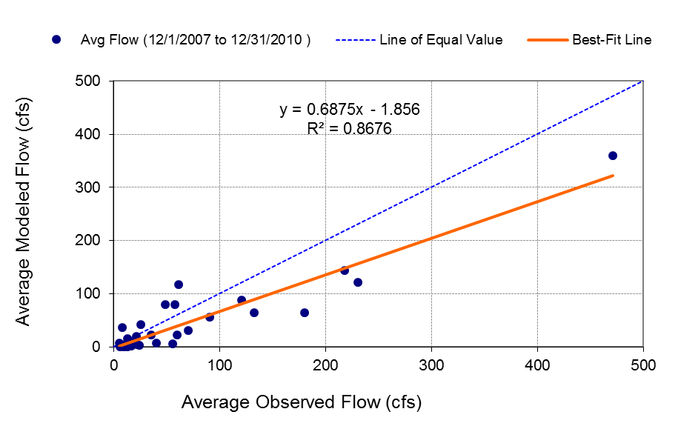
Figure C-36: Monthly flow regression: Model output at Reach 77 vs. USGS 022929176 Telegraph Creek at State Highway at Olga, FL (Big Island Canal) (12/01/2007 – 12/31/2010)

Table C-9: Summary statistics: Model output at Reach 77 vs. USGS 022929176 Telegraph Creek at State Highway at Olga, FL (Big Island Canal) (12/01/2007 – 12/31/2010)
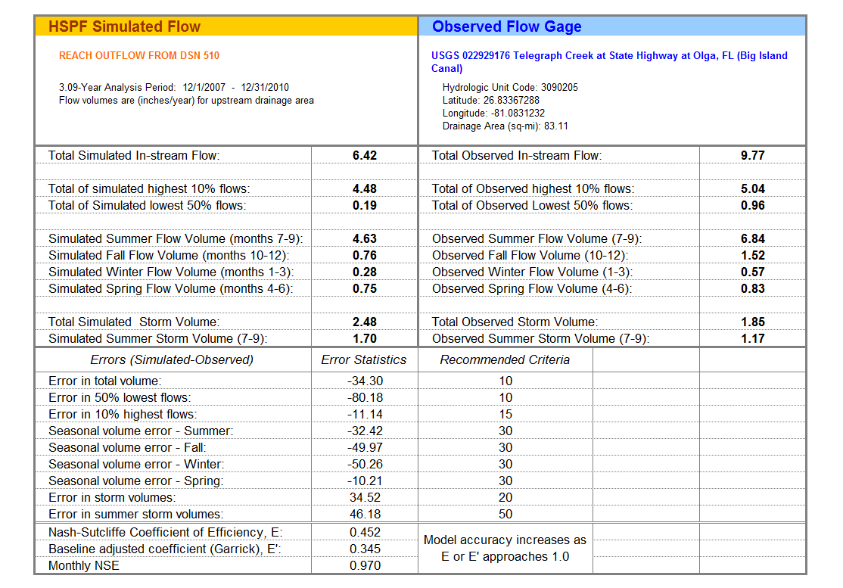
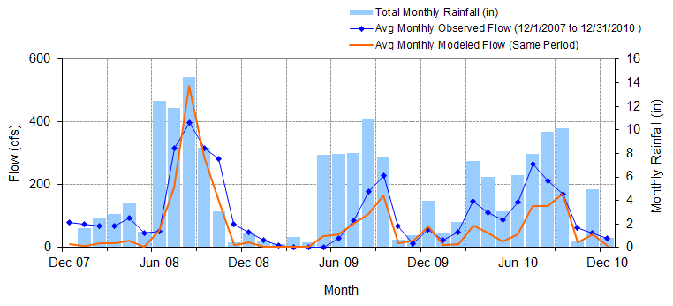
Figure C-37: Mean monthly flow: Model output at Reach 10 vs. USGS 02293055 Orange River near Buckingham, FL (12/01/2007 – 12/31/2010)

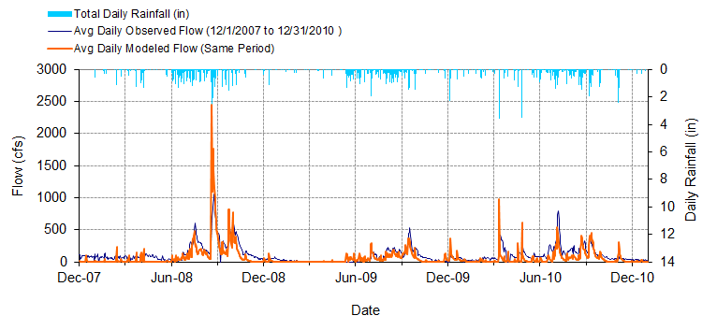
Figure C-38: Mean daily flow: Model output at Reach 10 vs. USGS 02293055 Orange River near Buckingham, FL (12/01/2007 – 12/31/2010)

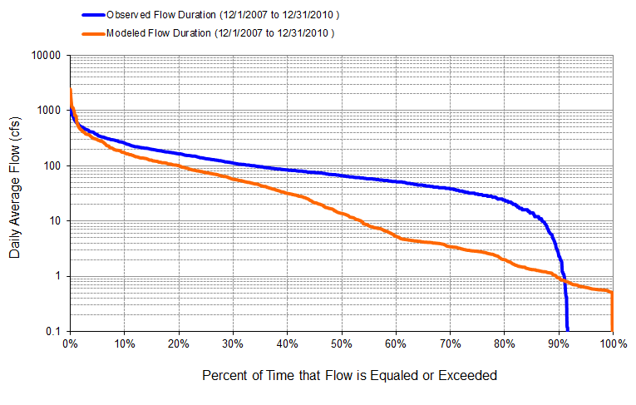
Figure C-39: Flow exceedance: Model output at Reach 10 vs. USGS 02293055 Orange River near Buckingham, FL (12/01/2007 – 12/31/2010)

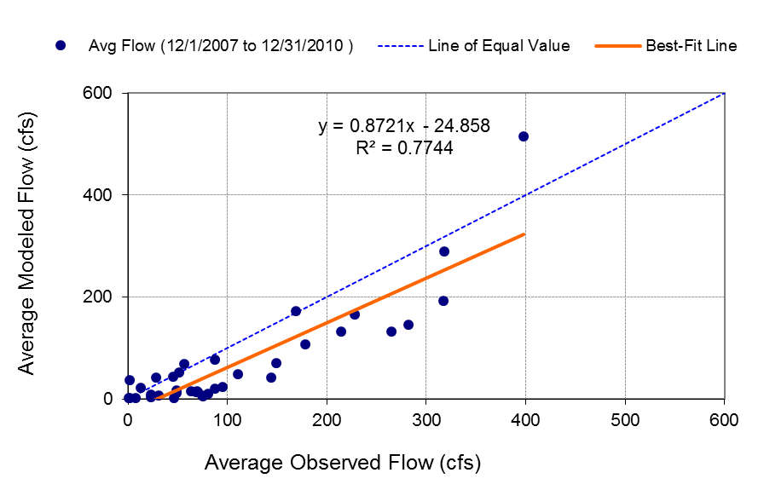
Figure C-40: Monthly flow regression: Model output at Reach 10 vs. USGS 02293055 Orange River near Buckingham, FL (12/01/2007 – 12/31/2010)
Table C-10: Summary statistics: Model output at Reach 10 vs. USGS 02293055 Orange River near Buckingham, FL (12/01/2007 – 12/31/2010)
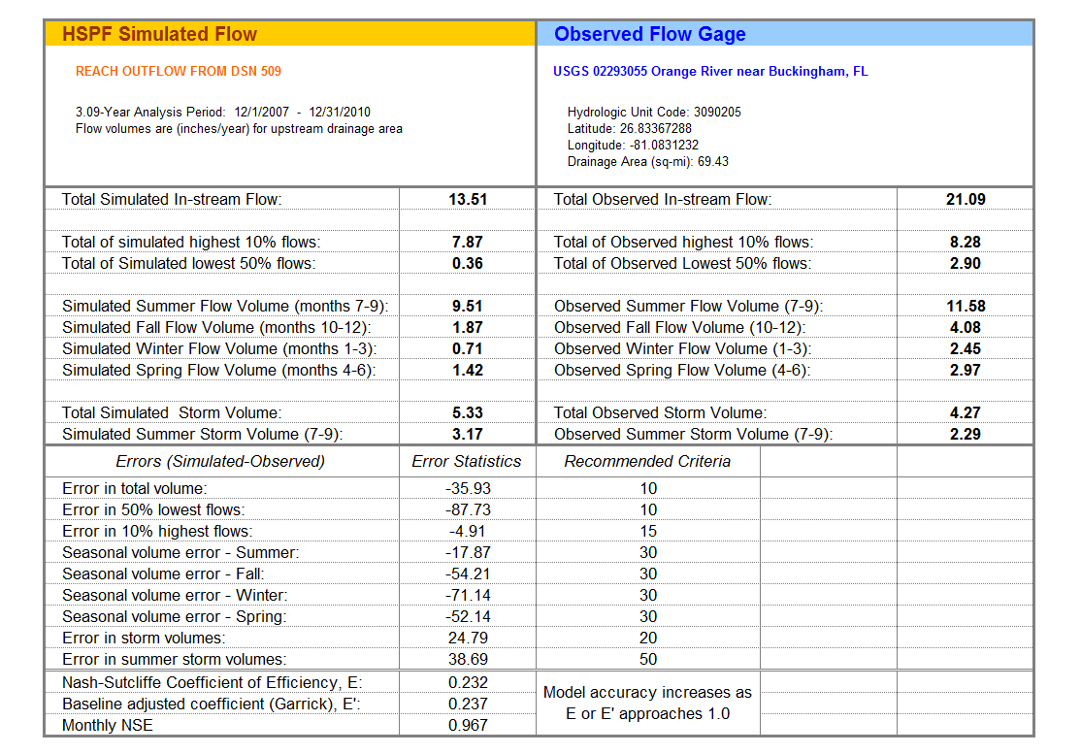
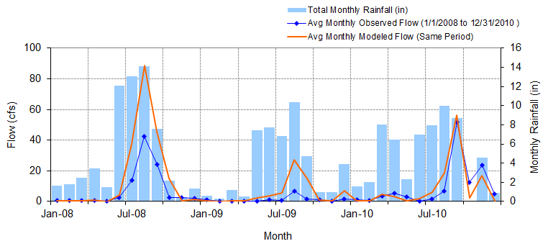
Figure C-41: Mean monthly flow: Model output at Reach 85 vs. USGS 02293090 Popash Creek at Leetana Road near Fort Myers, FL (01/01/2008– 12/31/2010)

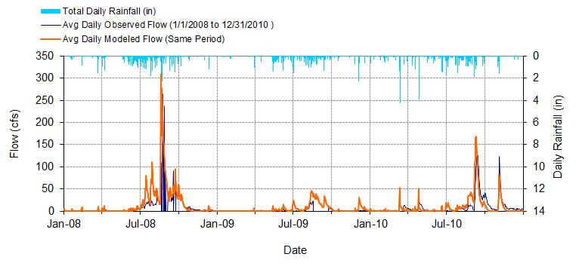
Figure C-42: Mean daily flow: Model output at Reach 85 vs. USGS 02293090 Popash Creek at Leetana Road near Fort Myers, FL (01/01/2008– 12/31/2010)

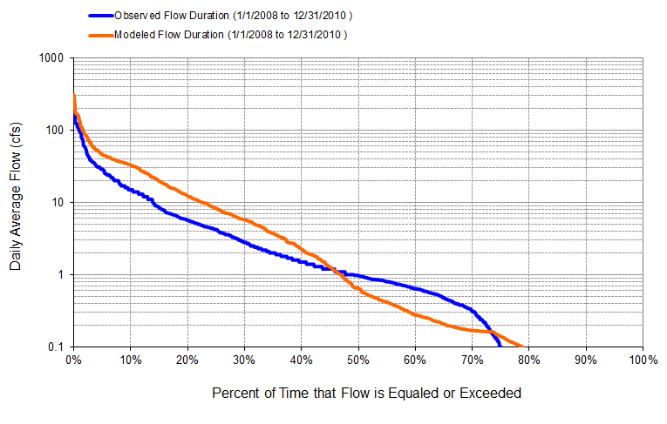
Figure C-43: Flow exceedance: Model output at Reach 85 vs. USGS 02293090 Popash Creek at Leetana Road near Fort Myers, FL (01/01/2008 – 12/31/2010)

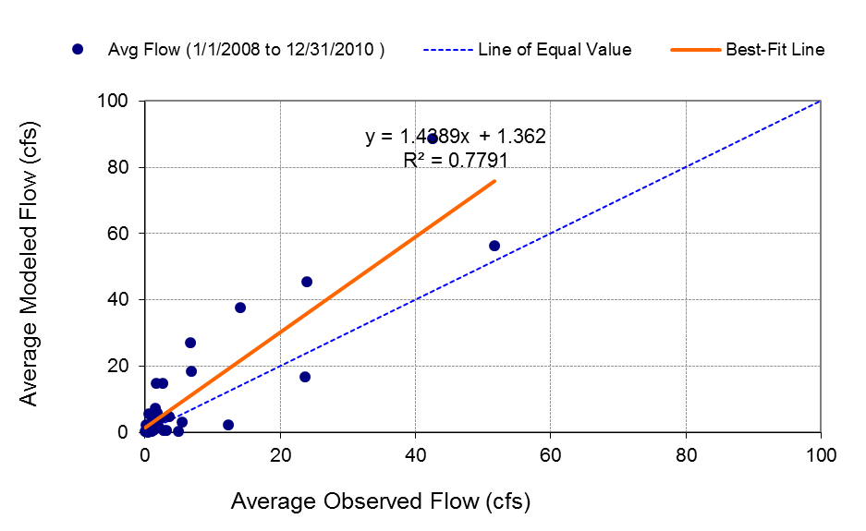
Figure C-44: Monthly flow regression: Model output at Reach 85 vs. USGS 02293090 Popash Creek at Leetana Road near Fort Myers, FL (01/01/2008 – 12/31/2010)

Table C-11: Summary statistics: Model output at Reach 85 vs. USGS 02293090 Popash Creek at Leetana Road near Fort Myers, FL (01/01/2008 – 12/31/2010)
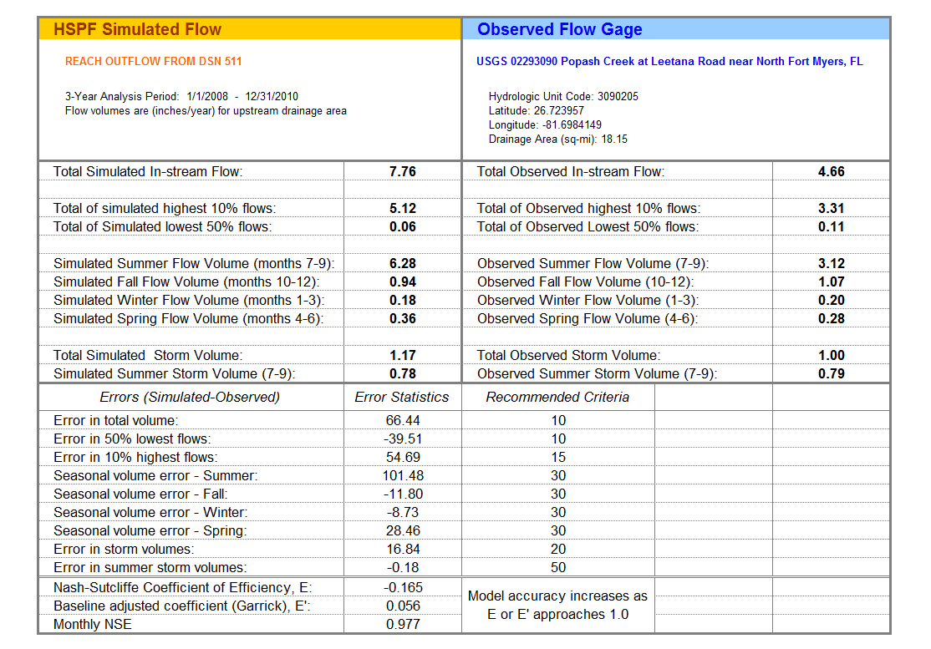
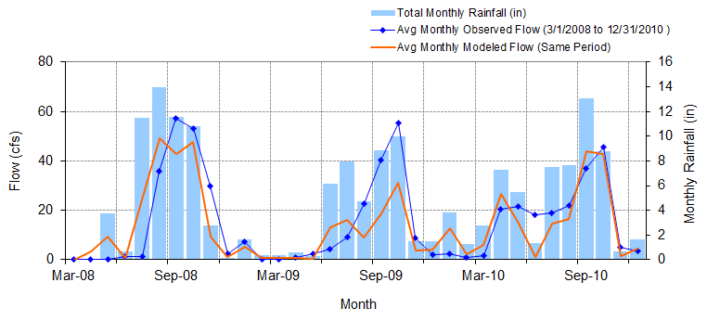
Figure C-45: Mean monthly flow: Model output at Reach 9 vs. USGS 02293190 Billy Creek at Fort Myers, FL (03/01/2008 – 12/31/2010)

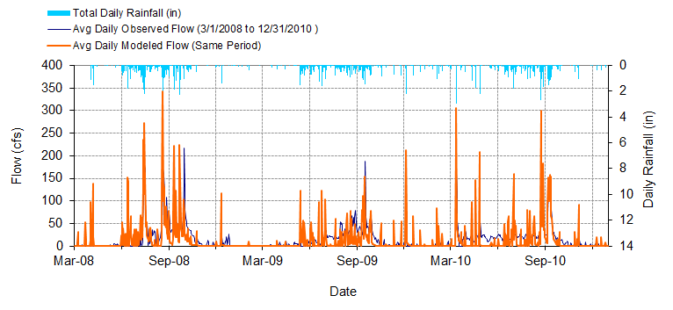
Figure C-46: Mean daily flow: Model output at Reach 9 vs. USGS 02293190 Billy Creek at Fort Myers, FL (03/01/2008 – 12/31/2010)

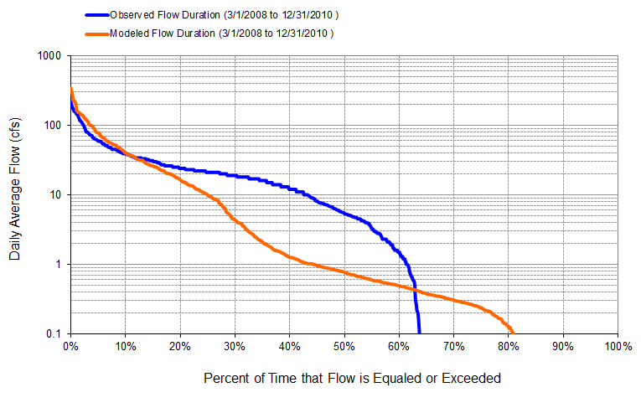
Figure C-47: Flow exceedance: Model output at Reach 9 vs. USGS 02293190 Billy Creek at Fort Myers, FL (03/01/2008 – 12/31/2010)

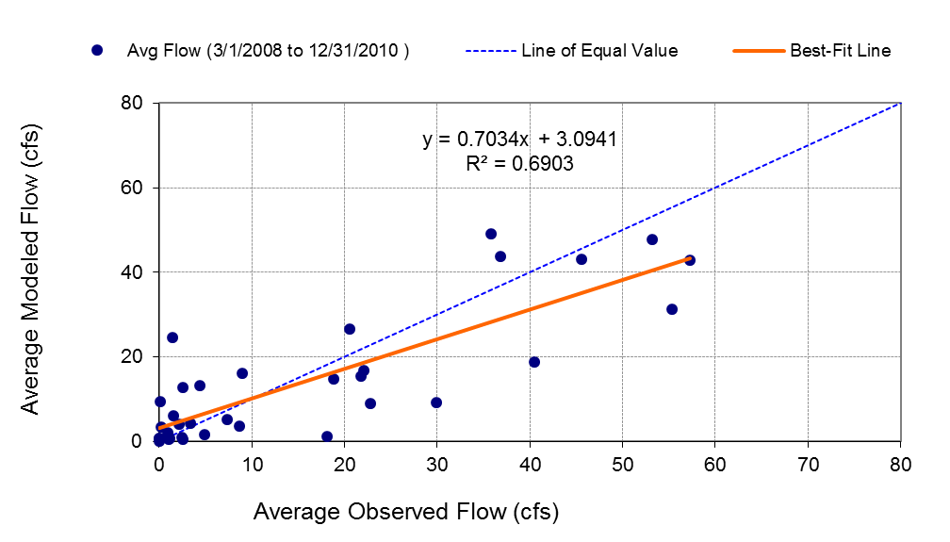
Figure C-48: Monthly flow regression: Model output at Reach 9 vs. USGS 02293190 Billy Creek at Fort Myers, FL (03/01/2008 – 12/31/2010)
Table C-12: Summary statistics: Model output at Reach 9 vs. USGS 02293190 Billy Creek at Fort Myers, FL (03/01/2008 – 12/31/2010)
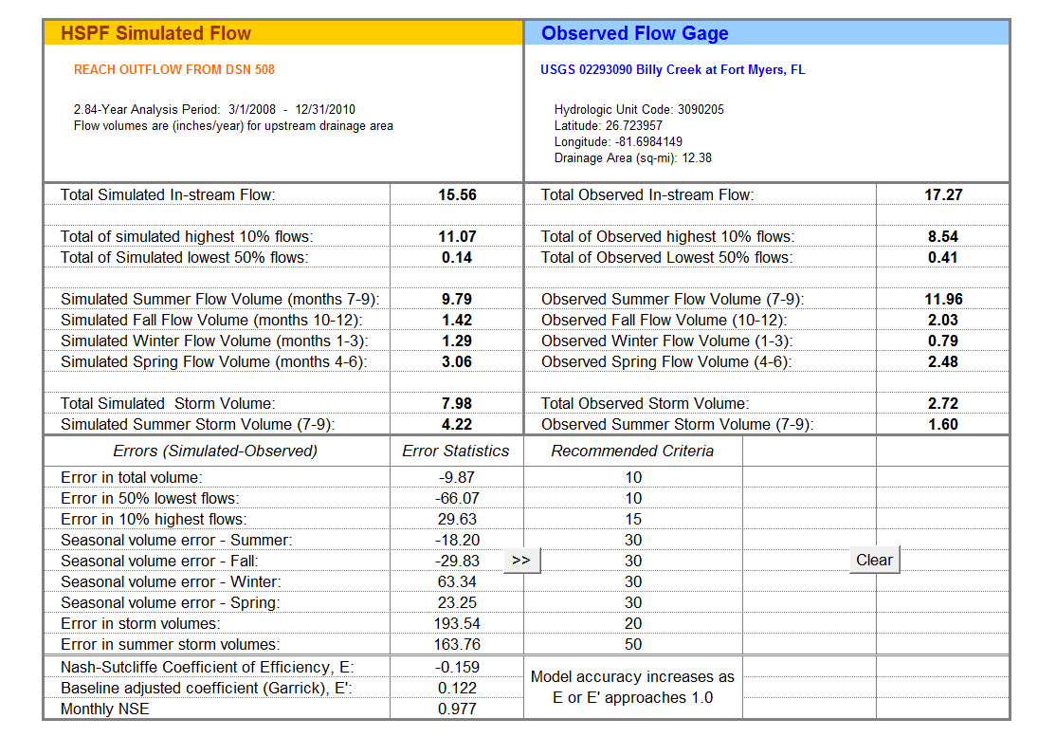
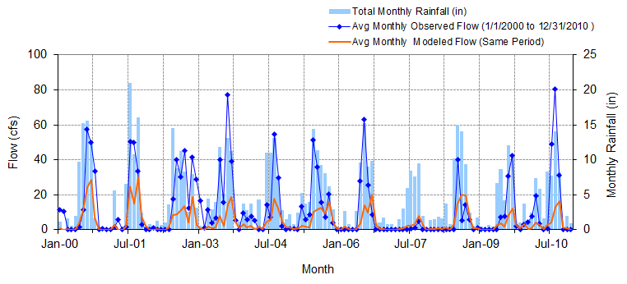
Figure C-49: Mean monthly flow: Model output at Reach 100 vs. USGS 02293243 Courtney Canal at Cape Coral, FL (1/1/2000 - 12/31/2010)

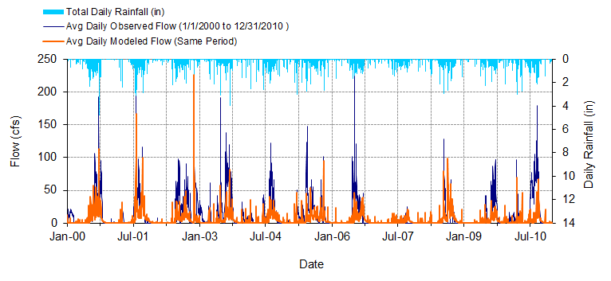
Figure C-50: Mean daily flow: Model output at Reach 100 vs. USGS 02293243 Courtney Canal at Cape Coral, FL (1/1/2000 - 12/31/2010)

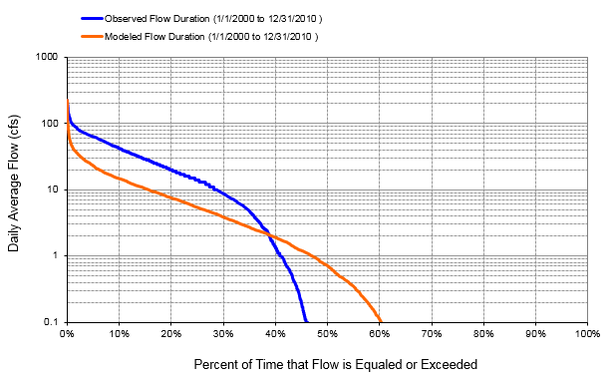
Figure C-51: Flow exceedance: Model output at Reach 100 vs. USGS 02293243 Courtney Canal at Cape Coral, FL (1/1/2000 - 12/31/2010)

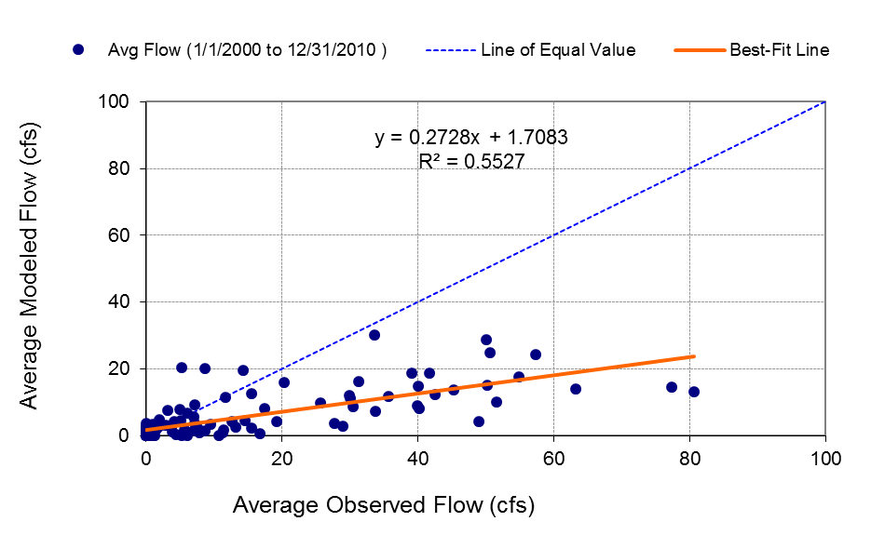
Figure C-52: Monthly flow regression: Model output at Reach 100 vs. USGS 02293243 Courtney Canal at Cape Coral, FL (1/1/2000 - 12/31/2010)
Table C-13: Summary statistics: Model output at Reach 100 vs. USGS 02293243 Courtney Canal at Cape Coral, FL (1/1/2000 - 12/31/2010)
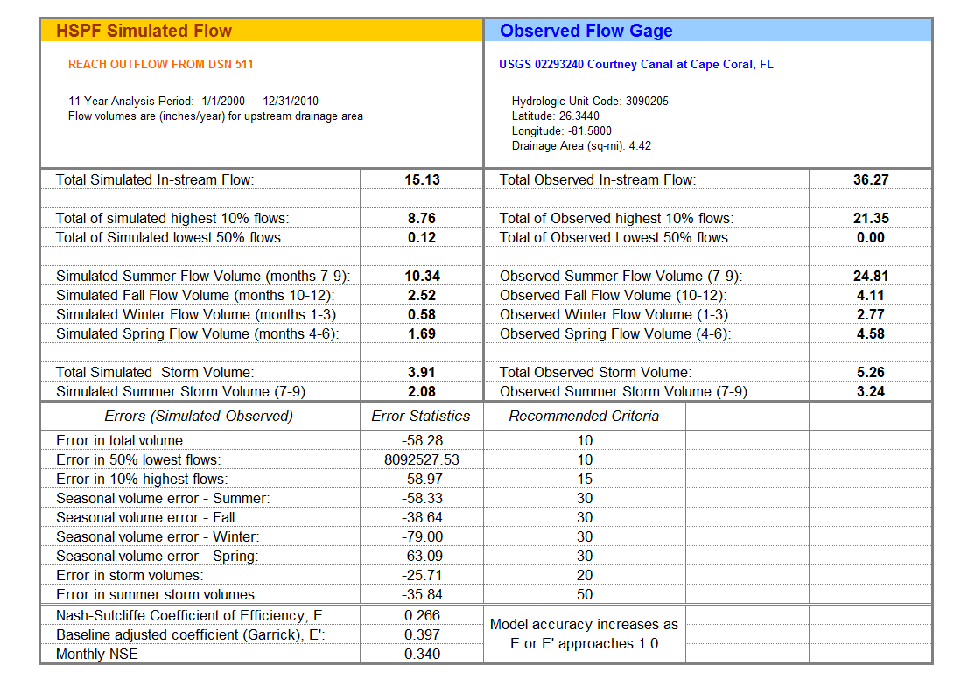

C-1 DEP Gage Comparison
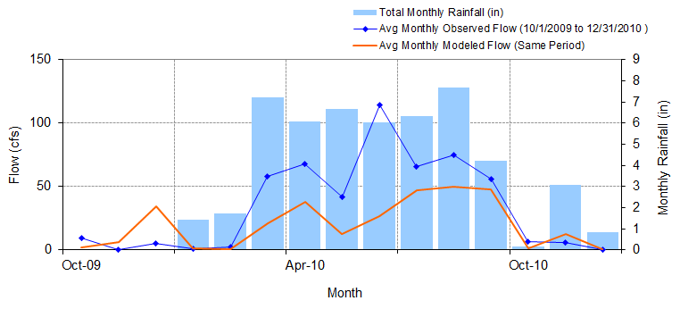
Figure C-53: Mean monthly flow: Model output at Reach 73 vs. DEP Jacks Branch at SR 78 (01/01/2010 – 01/03/2011)

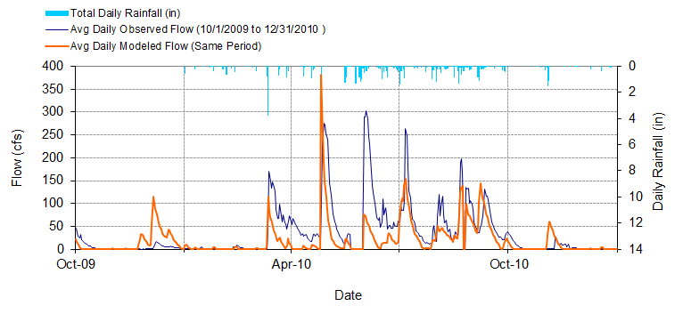
Figure C-54: Mean daily flow: Model output at Reach 73 vs. DEP Jacks Branch at SR 78 (01/01/2010 – 01/03/2011)

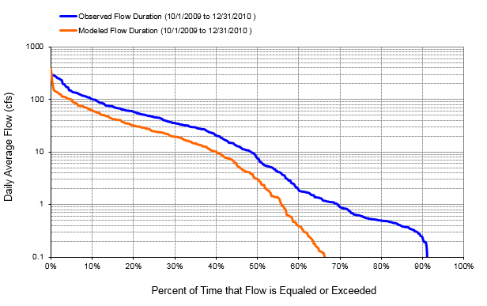
Figure C-55: Flow exceedance: Model Output at Reach 73 vs. DEP Jacks Branch at SR 78 (01/01/2010 – 01/03/2011)

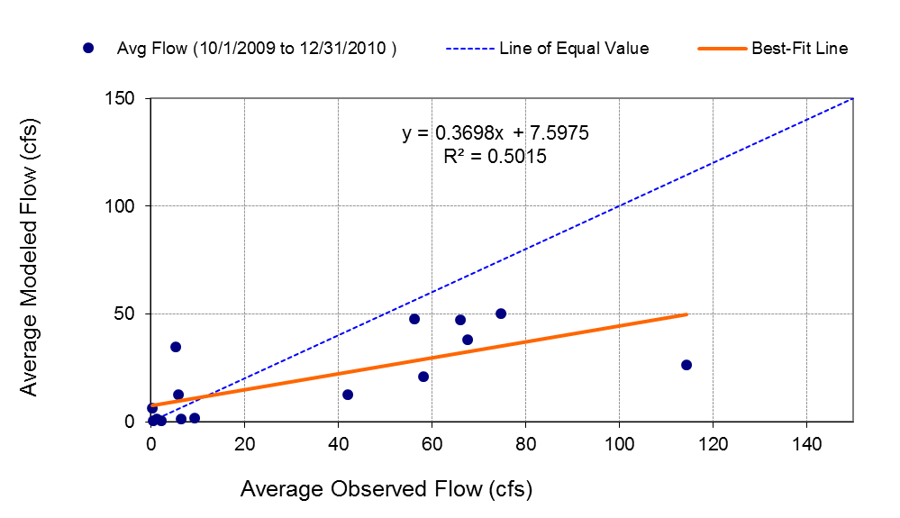
Figure C-56: Monthly flow regression: Model Output at Reach 73 vs. DEP Jacks Branch at SR 78 (01/01/2010 – 01/03/2011)
Table C-14: Summary statistics: Model Output at Reach 73 vs. DEP Jacks Branch at SR 78 (01/01/2010 – 01/03/2011)
