To: | Doug Gilbert, DEP
Cc: | James Albright, DEP  Ansel Bubel, DEP  Sara Davis, DEP  Erin Rasnake, DEP
From: | Brian Watson, PE, PH, D.WRE, Tetra Tech  Marcy Frick, REM, Tetra Tech  Erin Lincoln, PH, Tetra Tech  Rene Camacho, PhD, Tetra Tech  Hugo Rodriquez, PhD, PE, Tetra Tech
Date: | November 15, 2016
Subject: | Caloosahatchee River EFDC Model Light Calibration

Introduction
Tetra Tech and AMEC were contracted by the Florida Department of Environmental Protection (department) to address department and stakeholder issues regarding the set up and calibration of the current versions of the Caloosahatchee River and Estuary Hydrologic Simulation Program – Fortran (HSPF) and Environmental Fluid Dynamics Code (EFDC) models. These models will be used to develop total maximum daily loads (TMDLs) for impaired freshwater bodies within the Caloosahatchee River Basin and to refine the Caloosahatchee tidal estuary TMDLs that the department adopted in 2010.
To aid in the development of the TMDLs, the models were calibrated to water quality, including nutrients, chlorophyll-a, and light attenuation. Light attenuation is an important component of the Caloosahatchee Estuary TMDL, and was used as the endpoint in the 2009 Caloosahatchee Estuary TMDL to assess the impacts of nutrient loads from the watershed on chlorophyll-a and light penetration (Bailey et al 2009). Chlorophyll-a is a component of light extinction, and excess chlorophyll-a can reduce light penetration in the water column. In the 2009 Caloosahatchee Estuary TMDL, nutrient loads from the watershed were reduced to a level that reduced chlorophyll-a concentrations in the estuary to allow for a healthy seagrass community in San Carolos Bay, at the mouth of the Caloosahatchee Estuary.
This memo describes the updates made to the EFDC model to evaluate light attenuation, and the model light calibration results. Throughout this memo, the Dynamic Solutions/CDM model will be referred to as the “2009 Model,” and the department’s updated version of the model will be referred to as the “2014 Model. The new model will be referred to as the “2017 Model,” which is reflective of the project completion date in 2017.

EFDC Light Module EQUATION
Task 4 of this project was to convert the Dynamic Solutions Caloosahatchee River EFDC model (2009 Model), which is a proprietary application, into a public domain application (2017 Model) and incorporate the light module from the existing proprietary model. For this task, Tetra Tech used the DS-EFDC input files for the period of 2008 through 2010, which were provided by the department. Tetra Tech updated and corrected these files for use in the 2017 Model, and then tested the model for the 2008 – 2010 time period.
Tetra Tech updated the existing PD-EFDC model to incorporate the light module from the DS-EFDC model. The existing PD-EFDC model included the following parameters:
${ke}_{b}$ = background light extinction (m⁻¹)
${ke}_{TSS}$ = light extinction coefficient due to inorganic suspended solid (m⁻¹)
${ke}_{Chla}$ = light extinction due to algae chlorophyll-a (m⁻¹), either self-shading equation or simple coefficient equation
The following parameters were added to the PD-EFDC model:
${ke}_{POC}$= light extinction coefficient due to detrital particulate organic carbon (POC), which consists of refractory particulate organic carbon (RPOC) and labile particulate organic carbon (LPOC)
${ke}_{DOC}$= light extinction coefficient due to dissolved organic carbon (DOC)
The final light equation in the updated PD-EFDC model is:
$$Ke = {ke}_{b}+{ke}_{TSS}\left(TSS\right)+{ke}_{Chla}\left(Chla\right)+ {ke}_{POC}(RPOC +LPOC) + {ke}_{DOC}(DOC)$$
Additional information on the update can be found in the Task 4 memo. The PD-EFDC hydrodynamic and water quality models were recalibrated to available data as part of Task 5 and Task 6, respectively.

EFDC Model light Algorithms
In the EFDC model, one of the factors controlling the vertical distribution of light in the water column is the extinction coefficient $K_{e}$ (1/m), which reflects the attenuation of the incident light due to algae shading and particulate organic matter concentration. The equation used to compute $K_{e}$, as stated in Section 2.0, is given as the following:
$$Ke = {ke}_{b}+{ke}_{TSS}\left(TSS\right)+{ke}_{Chla}\left(Chla\right)+ {ke}_{POC}(RPOC +LPOC) + {ke}_{DOC}(DOC)$$
In this equation, ${ke}_{TSS}$, ${ke}_{Chla}$, ${ke}_{DOC}$, and ${ke}_{POC}$ are calibration coefficients. The light extinction coefficient, $K_{e}$, is computed in the EFDC model as a linear function of the concentrations of total inorganic suspended solids (TSS), chlorophyll-a (Chla), dissolved organic carbon (DOC), and particulate organic carbon (POC), specifically refractory particulate organic carbon(RPOC) plus labile organic carbon (LPOC). Light distribution in the water column is simulated using the Beer-Lambert model, which uses the calibrated extinction coefficient ($K_{e}$):
$$I\left(z\right)=I_{o}e^{-K_{e}z}$$
In the Beer-Lambert model, $I\left(z\right)$ is the light intensity at a specific depth ($z$) from the water surface, $I_{o}$ is the light intensity at the water surface, and $K_{e}$ is the light attenuation coefficient (units of distance⁻¹). The impacts of light on phytoplankton production (represented as chlorophyll-a) are included in the EFDC model by assuming that production is directly proportional to the levels of light available in the water column. The general equation for phytoplankton production included in the EFDC model is expressed as:
$$P=P_{Max}*f_{1}*f_{2}*f_{3}$$
In the equation, $P_{Max}$ is the maximum rate of phytoplankton production under optimal conditions of nutrients, light, and temperature;$f_{1}$, $f_{2}$, and $f_{3}$ ($0≤f_{*}≤1$) are dimensionless limiting factors for phytoplankton growth due to nutrients, light, and temperature, respectively; and $P$ is the resulting rate of phytoplankton production. The computational details of $f_{1}$ and $f_{3}$ are presented in Tetra Tech (2007). The limiting factor for light is computed in the EFDC model for each vertical layer using the Steele (1962) model:
$$f_{2}=\frac{2.718*FD}{K_{e}(Z_{b}-Z_{T})}\left(e^{-φe^{-K_{e}Z_{b}}}-e^{-φe^{-K_{e}Z_{T}}}\right)$$
In the Steele (1962) model, $φ=I_{o}/I_{s}$ where $I_{s}$ is the optimal light intensity for phytoplankton production, $Z_{b}$ and $Z_{T}$ are the depths of the bottom and top boundaries of a layer, and $FD$ the fraction of day with light.

efdc WATER QUALITY Boundary Conditions
Task 6 focused on calibrating the Caloosahatchee River EFDC water quality model. As part of the calibration, water quality boundary conditions for both the open water and freshwater boundaries were input into the model. The open water boundaries, located at the Gulf of Mexico, Matlacha Pass, and Pine Island Sound, were determined using measured data, and freshwater boundaries, including flows and water quality constituents from S-79 and other tributaries, were supplied by the Caloosahatchee River HSPF model. These boundary conditions were used to drive water quality in the Caloosahatchee River Estuary, which directly impacts the light attenuation calibration.
Tetra Tech used available observations near the Matlacha Pass and Pine Island Sound northern model boundaries to construct the boundary time series of water quality concentrations. Monitoring stations in the immediate vicinity of the boundaries were selected as the basis to construct the water quality time series for nutrients, phytoplankton biomass, and TSS. Table 1 lists the stations used to develop the water quality boundaries. The stations are in a variety of locations, including the deep channel and immediately adjacent to marsh outflows. By combining the available data from the stations into one time series, the open boundary is able to reflect the overall water quality inputs at the northern boundaries.
Table 1: Monitoring stations used to develop the water quality time series for the northern boundary cells
Location | Station ID
Boundary conditions at boundary cells across J=82, Matlacha Pass | 21FLCHARMPV001
Boundary conditions at boundary cells across J=82, Matlacha Pass | 21FLCHARMPV002
Boundary conditions at boundary cells across J=82, Matlacha Pass | 21FLEECOPI-03
Boundary conditions at boundary cells across J=82, Matlacha Pass | 21FLEECOPI-04
Boundary conditions at boundary cells across J=82, Matlacha Pass | 21FLEECOPI-05
Boundary conditions at boundary cells across J=82, Matlacha Pass | 21FLSEAS62SEAS020
Boundary conditions at boundary cells across J=82, Matlacha Pass | 21FLSEAS62SEAS401
Boundary conditions at boundary cells across J=44, Pine Island Sound | 21FLCHARPIV004
Boundary conditions at boundary cells across J=44, Pine Island Sound | 21FLEECOPI-10
Boundary conditions at boundary cells across J=44, Pine Island Sound | 21FLEECOPI-11

The available water quality concentration data at each station were used to construct the water quality boundary condition time series for the simulation period (Figure 1 through Figure 8). The daily, monthly, and long-term water quality concentrations were similar among the stations. If data were available on a given day for more than one station, the data were averaged to provide a single water quality concentration value for that day for the boundary condition time series. The boundary conditions of phytoplankton biomass were constructed by converting the available observations of Chla to carbon units using a carbon-to-chlorophyll a ratio of 0.04 mgC/μgChla. This was necessary given that phytoplankton biomass is internally simulated in units of carbon in EFDC.

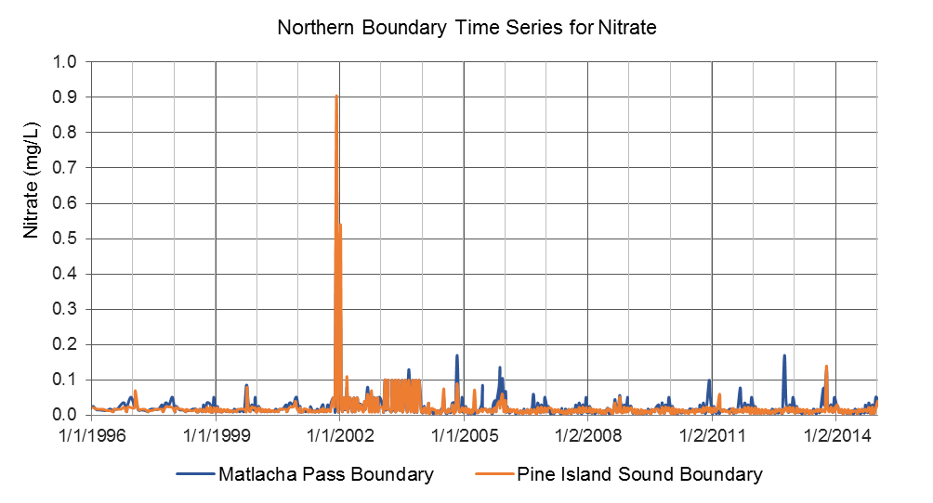
Figure 1: Northern boundary 2017 Model input time series for NO₃ (mg/L)

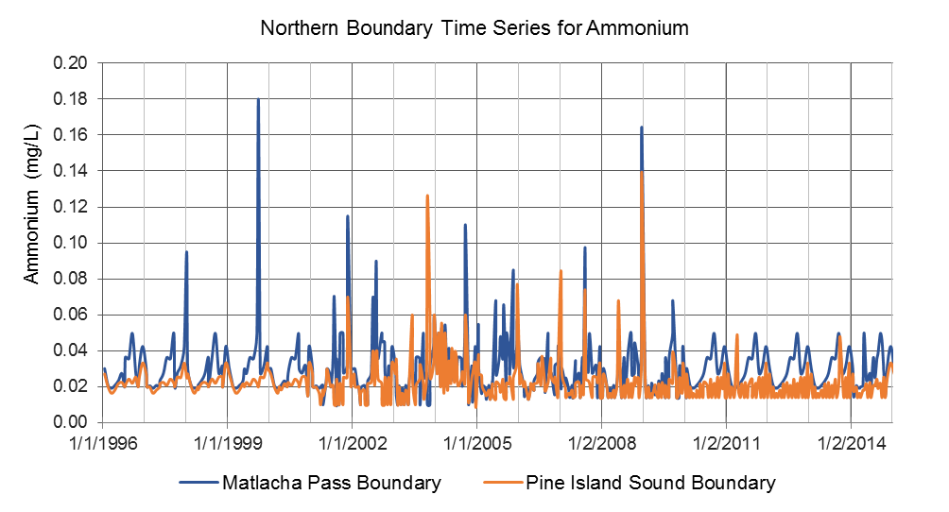
Figure 2: Northern boundary 2017 Model input time series for NH₄ (mg/L)

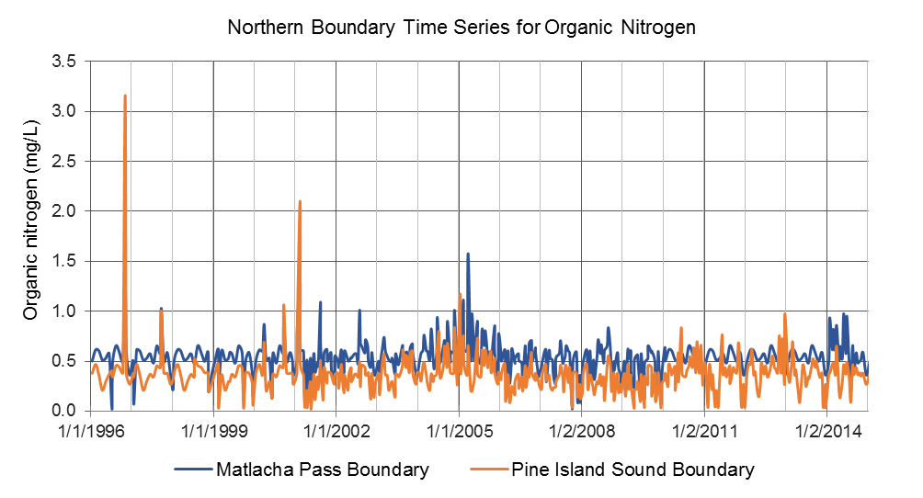
Figure 3: Northern boundary 2017 Model input time series for OrgN (mg/L)

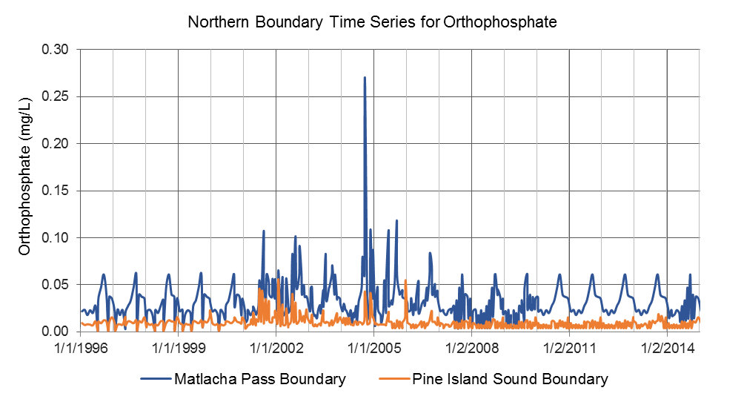
Figure 4: Northern boundary 2017 Model input time series for PO₄ (mg/L)

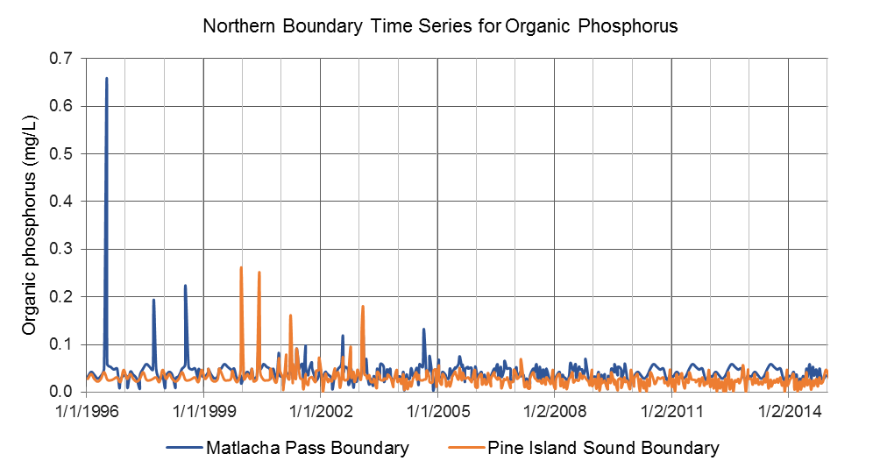
Figure 5: Northern boundary 2017 Model input time series for OrgP (mg/L)

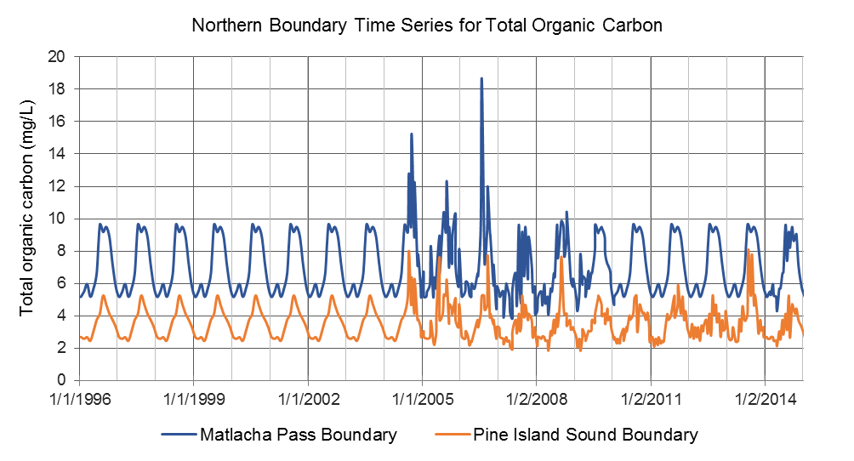
Figure 6: Northern boundary 2017 Model input time series for TOC (mg/L)

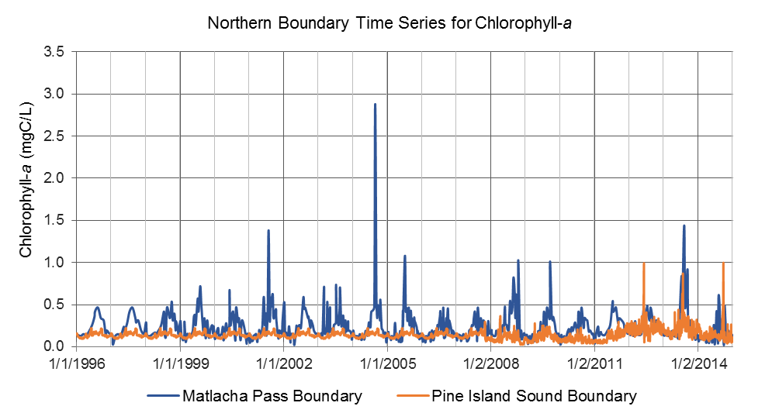
Figure 7: Northern boundary 2017 Model input time series for Chla (mg/L)

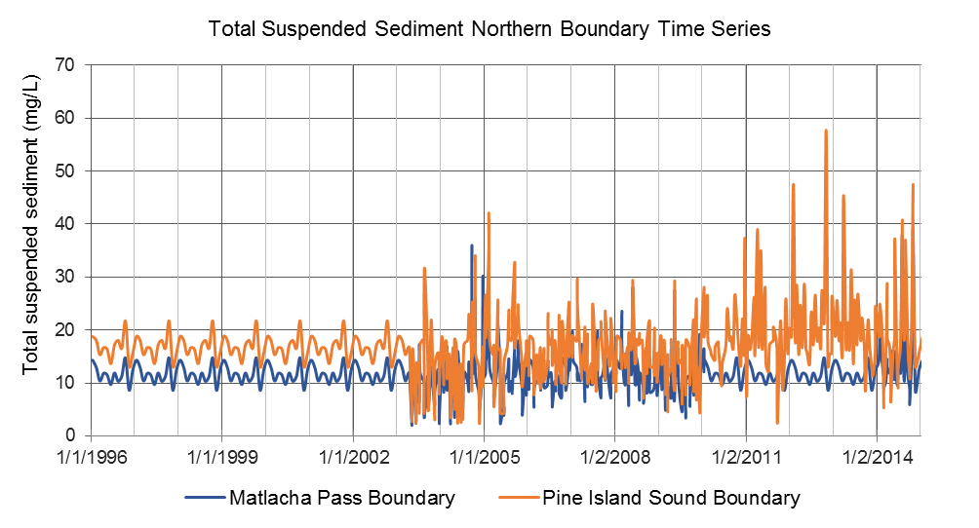
Figure 8: Northern boundary 2017 Model input time series for TSS (mg/L)

At the southern boundary, there were limited water quality observations to support the development of a water quality time series for the EFDC model. Therefore, the model was forced with constant concentrations for the different species of nutrients, phytoplankton biomass, and TSS. Such concentrations were defined based on the concentrations used in the 2014 Model and on recently measured data. Data at 12 stations close to the southern boundary were reviewed to help define the constant concentrations. Table 2 summarizes the values used in the 2017 Model compared to the values used in the 2014 Model.
Table 2: Water quality concentrations assigned at the southern boundary cells
Parameter | 2014 Model | 2017 Model | Observations
NO_{x} | Constant concentration of 0.01 mg/L in Card 33. | Not modified from 2014 Model setup. | The average concentration of the available records is 0.007mg/L, which is within range of the concentration used in the 2014 Model.
NH₄ | Constant concentration of 0.02 mg/L in Card 33. | Constant concentration of 0.05 mg/L in Card 33. | The average concentration of the available records is 0.05 mg/L. This concentration has been included in the 2017 Model setup.
OrgN | Constant concentrations as follows:  RPON = 0.3 mg/L  LPON = 0.03 mg/L  DON = 0.3 mg/L | Constant concentrations as follows:  RPON = 0.17 mg/L  LPON = 0.017 mg/L  DON = 0.17 mg/L | The average OrgN concentration calculated from total nitrogen (TN) and total Kjeldahl nitrogen (TKN) records is 0.35 mg/L. This concentration was partitioned into labile, refractory, and dissolved fractions using the same ratios as the 2014 Model.
PO₄ | Constant concentration of 0.05 mg/L in Card 33. | Constant concentration of 0.03 mg/L in Card 33 | The average concentration of the available records is 0.03 mg/L. Boundary PO₄ concentration has been updated to reflect the new value.
OrgP | Constant concentrations as follows:  RPOP = 0.02 mg/L  LPOP = 0.002 mg/L  DOP = 0.02 mg/L | Constant concentrations as follows:  RPOP = 0.005 mg/L  LPOP = 0.002 mg/L  DOP = 0.005 mg/L | The average concentration of the available Org P records is 0.012 mg/L. Boundary concentrations of RPOP, LPOP, and DOP have been updated to reflect the new values.
OrgC | Constant concentrations as follows:  RPOC = 0.3 mg/L  LPOC = 0.3 mg/L  DOC = 2.5 mg/L | Not modified from 2014 Model setup. | Average concentration of available observations is 3.1 mg/L, which is the same concentration used in the 2014 Model.
Chlorophyll-a | Constant concentration of 1 µg/L for green algae and cyanobacteria in Card 33. | Not modified from 2014 Model setup. | The average concentration of the available records is 1.4 µg/L, which is within range of the 2014 Model. The Chla concentration is input in EFDC in Carbon units using a Carbon-to-chlorophyll ratio of 0.04 mgC/µgChla.
TSS | Constant concentration of 7 mg/L | Constant concentration of 20 mg/L | Average concentration of available data is 20 mg/L. This value was updated in the 2017 model.

The water quality boundary conditions for the different tributaries of the Caloosahatchee River Estuary were defined using the predictions from the HSPF model. However, given that in most cases the output water quality variables from the HSPF model do not directly match the variables simulated in the EFDC model, some processing was necessary to convert the outputs from the HSPF model into the forms simulated by the EFDC model. Table 3 presents a summary of the conversion process conducted to link the HSPF and EFDC models. In Table 3, it is important to note that the organic forms of nitrogen, phosphorus, and carbon from the HSPF model are further discretized into refractory, labile, and dissolved forms. As an example, for carbon, the HSPF model provides two outputs: OrgC_{HSPF} (Total Organic Carbon [TOC]) and ROC_{HSPF} (Refractory Organic Carbon [ROP]). TOC contains dead refractory organic carbon, labile organic carbon, and live organic carbon. When linking the HSPF model to the EFDC model, three forms of organic carbon were input into the EFDC model from the two forms of output from the HSPF model. The values for the particulate fractions (FPc) and dissolved fractions (FDc) were assumed to be calibration parameters since ROC_{HSPF} is completely dissolved.
Table 3: List of water quality variables simulated in the HSPF and EFDC models and conversion process to use the HSPF model outputs as boundaries conditions in the EFDC model
Variable | Variable(s) predicted in HSPF | Variable Simulated in EFDC and process to link HSPF to EFDC
Organic Nitrogen (OrgN) | - OrgN_{HSPF} = Total Organic Nitrogen  - RON_{HSPF} = Refractory Organic Nitrogen  In HSPF OrgN_{HSPF} and RON_{HSPF} are assumed to be dissolved. | OrgN_{EFDC} = RPON_{EFDC} + LPON_{EFDC} + DON_{EFDC}  - RPON_{EFDC} = Refractory Particulate Organic Nitrogen:  RPON_{EFDC}=FP_{N}* RON_{HSPF}  - LPON_{EFDC} = Labile Particulate Organic Nitrogen  LPON_{EFDC} = OrgN_{HSPF} - RON_{HSPF}  - DON_{EFDC} = Dissolved Organic Nitrogen  DON_{EFDC}=FD_{N}* RON_{HSPF}  FP_{N} and FD_{N} are prescribed fractions of particulate and dissolved phases of the RON_{HSPF} for EFDC:  FP_{N}=0.35  FD_{N}=0.65
Ammonium  (NH₄) | - TAM_{HSPF} = Total Ammonium | NH4_{EFDC}=TAM_{HPSF}
Nitrate + Nitrate  (NO₃ + NO₂) | - NO3_{HSPF} + NO2_{HSPF}  Typically NO₂ is only a small fraction of NOx (<5%) | NOx _{EFDC} = NO3_{HPSF} + NO2_{HPSF}
Organic Phosphorus (OrgP) | - OrgP_{HSPF} = Total Organic Phosphorus  - ROP_{HSPF} = Refractory Organic Phosphorus  In HSPF OrgP_{HSPF} and ROP_{HSPF} are assumed to be dissolved. | OrgP_{EFDC} = RPOP_{EFDC} + LPOP_{EFDC} + DOP_{EFDC}  - RPOP_{EFDC} = Refractory Particulate Organic Phosphorus:  RPOP_{EFDC}=FP_{P}* ROP_{HSPF}  - LPOP_{EFDC} = Labile Particulate Organic Phosphorus  LPOP_{EFDC} = OrgP_{HSPF} - ROP_{HSPF}  - DOP_{EFDC} = Dissolved Organic Phosphorus  DOP_{EFDC}=FD_{P}* ROP_{HSPF}  FP_{P} and FD_{P} are prescribed fractions of particulate and dissolved phases of the ROP_{HSPF} for EFDC:  FP=0.35  FD=0.65
Orthophosphate  (PO₄) | - PO4_{HSPF} | - PO4_{EFDC}= PO4_{HSPF}
Organic Carbon (OrgC) | - OrgC_{HSPF} = Total Organic Carbon  - ROC_{HSPF} = Refractory Organic Carbon  In HSPF OrgC_{HSPF} and ROC_{HSPF} are assumed to be dissolved. | OrgC_{EFDC} = RPOC_{EFDC} + LPOC_{EFDC} + DOC_{EFDC}  - RPOC_{EFDC} = Refractory Particulate Organic Carbon:  RPOP_{EFDC}=FP_{C}* ROP_{HSPF}  - LPOC_{EFDC} = Labile Particulate Organic Carbon  LPOP_{EFDC} = OrgP_{HSPF} - ROP_{HSPF}  - DOC_{EFDC} = Dissolved Organic Carbon  DOC_{EFDC}=FD_{C}* ROC_{HSPF}  FP_{C} and FD_{C} are prescribed fractions of particulate and dissolved phases of the ROC_{HSPF} for EFDC:  FPc=0.35  FDc=0.65
Total Suspended Solids  (TSS) | - TSS_{HSPF} | - TSS_{EFDC} = TSS_{HSPF}

For phytoplankton, a constant “seeding” value of 0.05 mgC/L (1.25 µgChla/L) for green algae and 0.05 mgC/L (1.25 µgChla/L) for cyanobacteria (a total phytoplankton concentration of 2.5 µgChla/L for a carbon to chlorophyll-a ratio of 0.04 mgC/µgChla) is currently prescribed in all freshwater boundaries. The outputs from the HSPF model were not directly used for this variable because phytoplankton populations from the watershed (freshwater) are usually different than those encountered in the estuary. The former are generally subject to salinity toxicity and substantial population decay in the estuarine environment. Therefore, freshwater phytoplankton generally do not dictate the evolution of phytoplankton in the saline environment. For modeling purposes, this means that the freshwater boundary conditions can be simplified to reflect only a seeding condition (small constant phytoplankton load to allow growth in the estuary).

Light Extinction Coefficient Calibration
As part of the calibration of the light extinction coefficient $Ke$, the coefficients ${ke}_{TSS}$, ${ke}_{Chla}$, ${ke}_{DOC}$, and ${ke}_{POC}$ were varied and refined in order to match observations of the $K_{e}$ coefficient. In the Caloosahatchee River EFDC model, the $K_{e}$ is defined as:
$$Ke = {ke}_{b}+{ke}_{TSS}\left(TSS\right)+{ke}_{Chla}\left(Chla\right)+ {ke}_{POC}(RPOC +LPOC) + {ke}_{DOC}(DOC)$$
Available measurements of $Ke$ collected during 2000 through 2002 indicate that the levels of light extinction in the system can vary between 0.1 (1/m) and 1.5 (1/m) with an average of 0.5 (1/m). To reproduce these values, a background light extinction coefficient of 0.05 (1/m) was prescribed in the model, and the coefficients related to algae concentration and organic matter concentration were adjusted during calibration.
A list of the values currently included in the EFDC model is presented in Table 4. These values were defined based upon the values included in the 2009 EFDC Model (Bailey et al. 2009), and refined and calibrated based on comparisons between predicted and observed extinction coefficients available during the period 2000-2002 at different locations of the estuary (Figure 9).
Table 4: Calibrated parameters of the light extinction model $K_{e}$
Parameter | 2017 Model Value | 2009 Model Value
$$k_{background}$$ | 0.050 | N/A
$${ke}_{TSS}$$ | 0.052 | 0.052
$${ke}_{Chla}$$ | 0.040 | 0.031
$${ke}_{DOC}$$ | 0.060 | 0.014
$${ke}_{POC}$$ | 0.060 | 0.078
The level of agreement achieved during calibration between the observed and predicted extinction coefficients is presented in Figure 10 through Figure 16. The results indicate that the model is generally able to capture the magnitudes and range of variability of light extinction observed in the system. The comparison between the model predictions and observations of light extinction indicate that the model is able to simulate the average levels of light extinction in the system with values between 0.6 (1/m) and 1.0 (1/m). The simulations are also able to capture the trends and variability of the observations.
A detailed evaluation of the factors impacting the light extinction coefficient suggest that inorganic suspended solids can explain up to 70% of the variability of the light extinction coefficients followed by DOC (16%), Chla (8%), and POC (5%). These values are in good agreement with the values reported in previous investigations of the Caloosahatchee River. Bailey et. al. (2009), citing studies in Charlotte Harbor (the major watershed north of the Caloosahatchee River) and other regions of the Caloosahatchee River, indicated that non-Chla matter, consisting mainly of detritus (POC), as well as minerals (TSS), accounted for approximately 72% of the light extinction in the water column, while color in the form of DOC accounted for 21% and Chla for 4% (see also McPherson and Miller 1987). Other studies indicate that detritus and minerals can represent between 30% and 72% of the light extinction in the estuary, dissolved organic matter between 13% and 66%, and Chla between 4% and 18% (McPherson and Miller 1994; Dixon and Kirkpatrick, 1999).
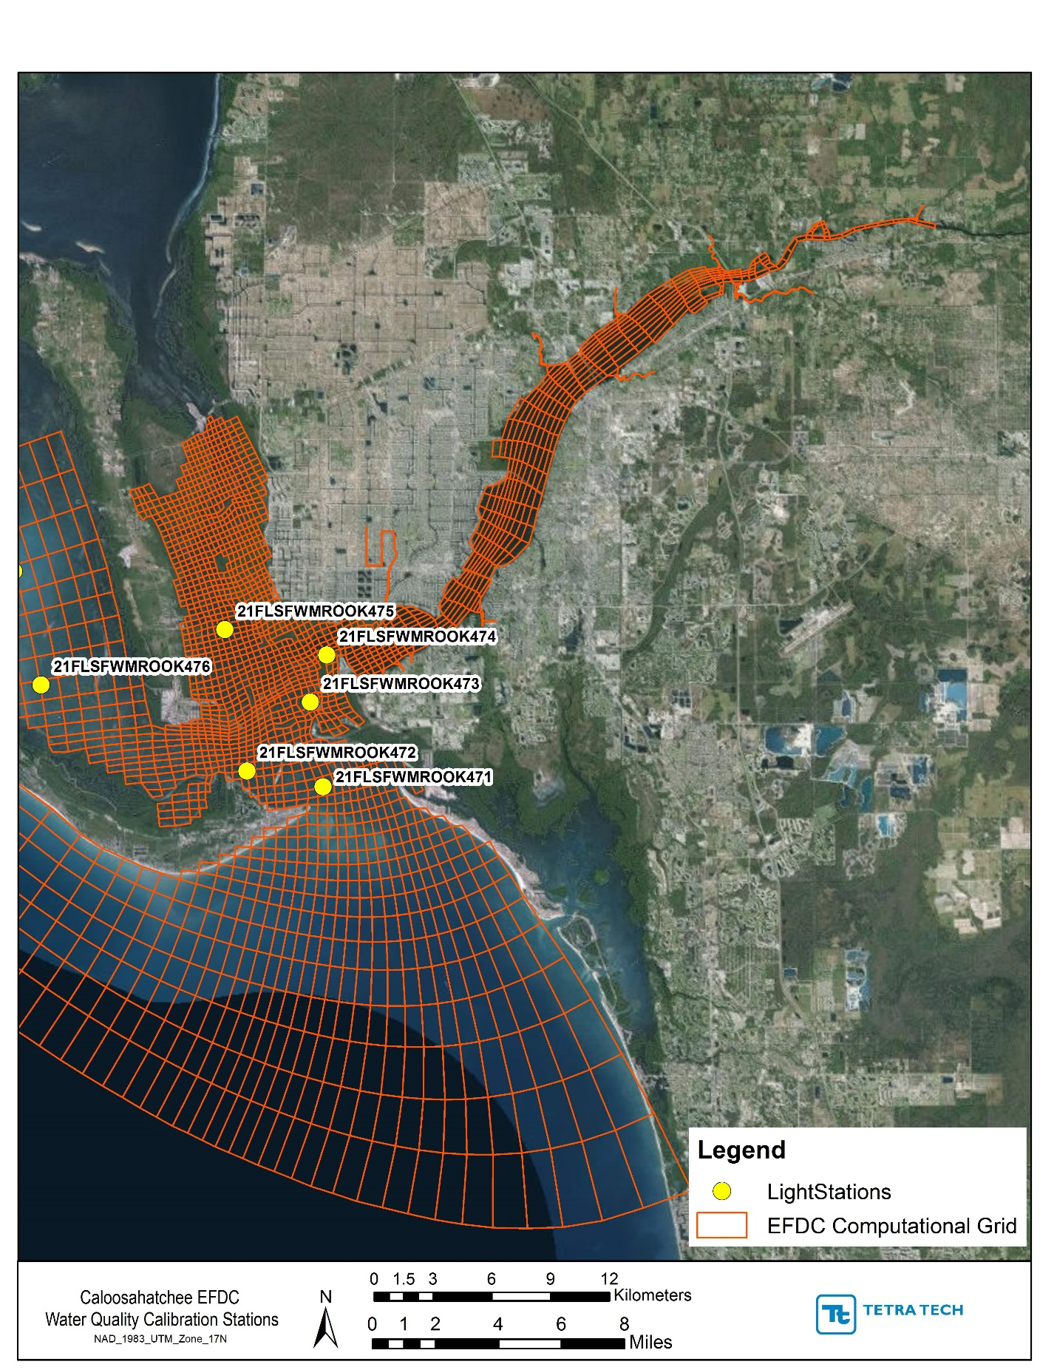
Figure 9: Monitoring stations with measurements of light extinction
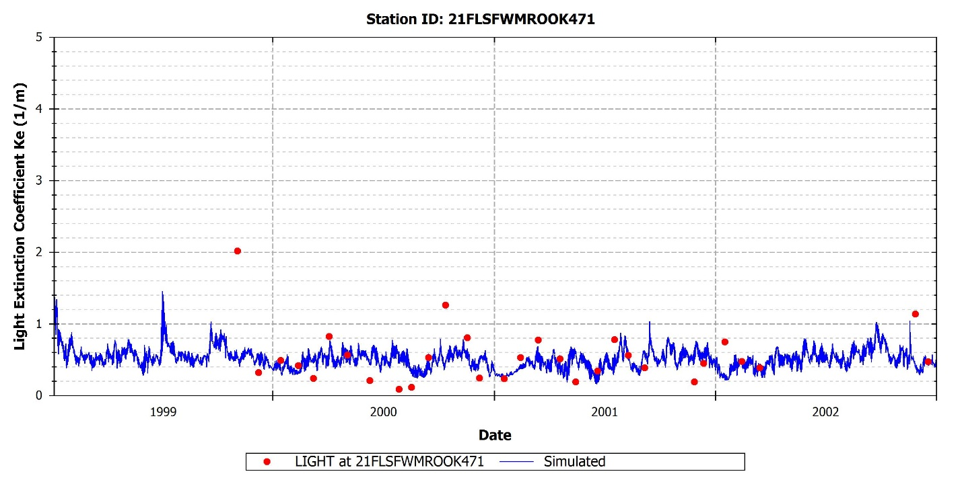
Figure 10: Observed versus predicted light extinction at 21FLSWMROOK471

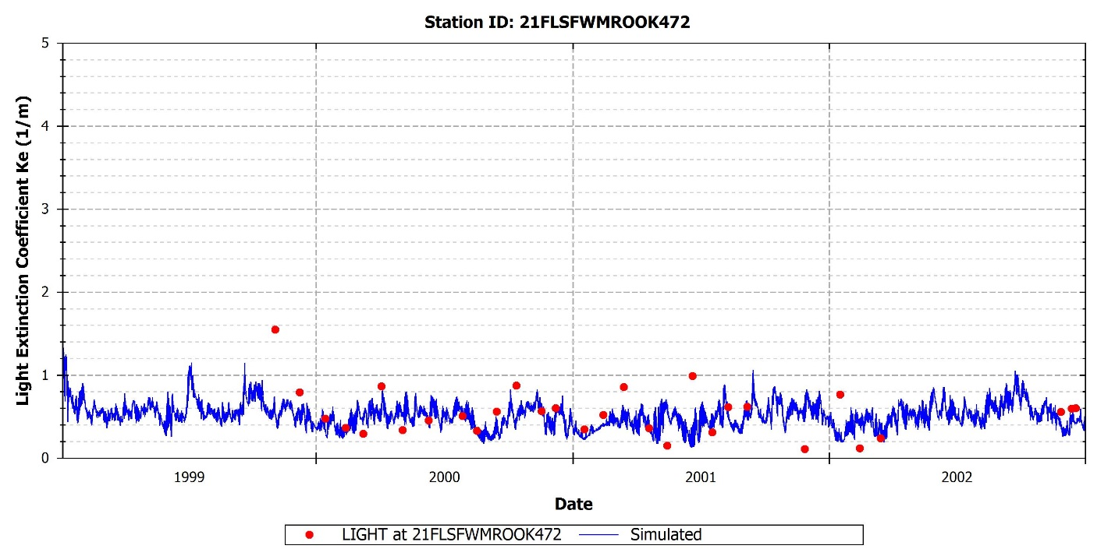
Figure 11: Observed versus predicted light extinction at 21FLSWMROOK472
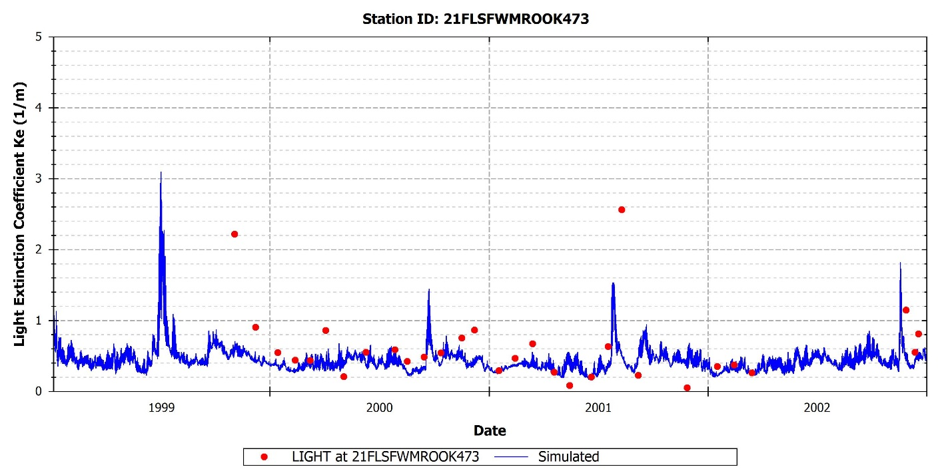
Figure 12: Observed versus predicted light extinction at 21FLSWMROOK473

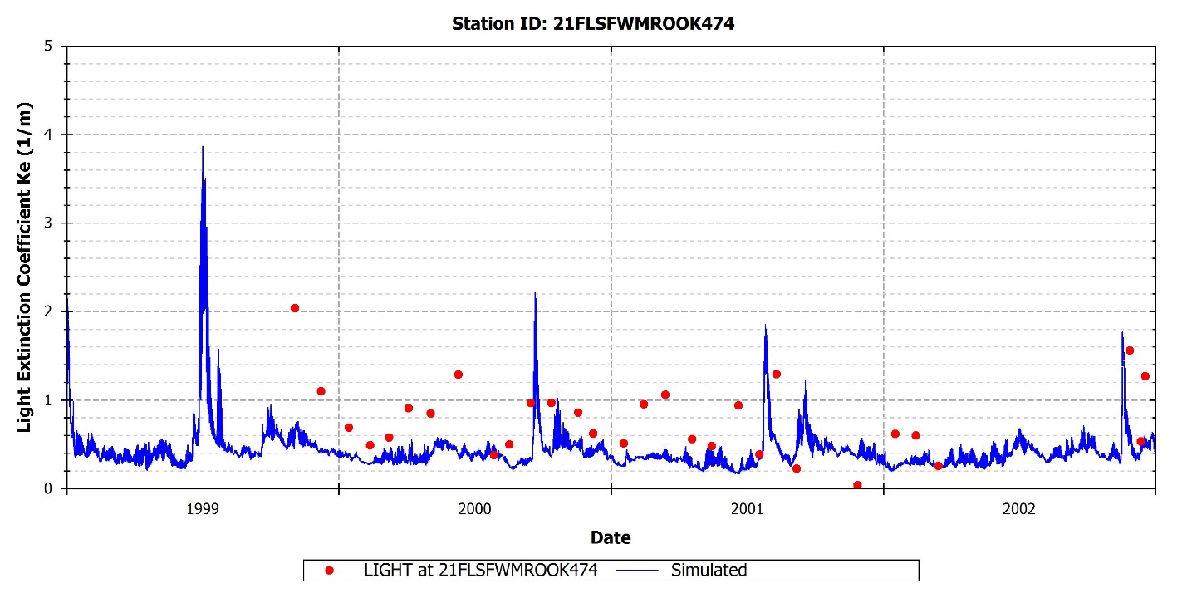
Figure 13: Observed versus predicted light extinction at 21FLSWMROOK474
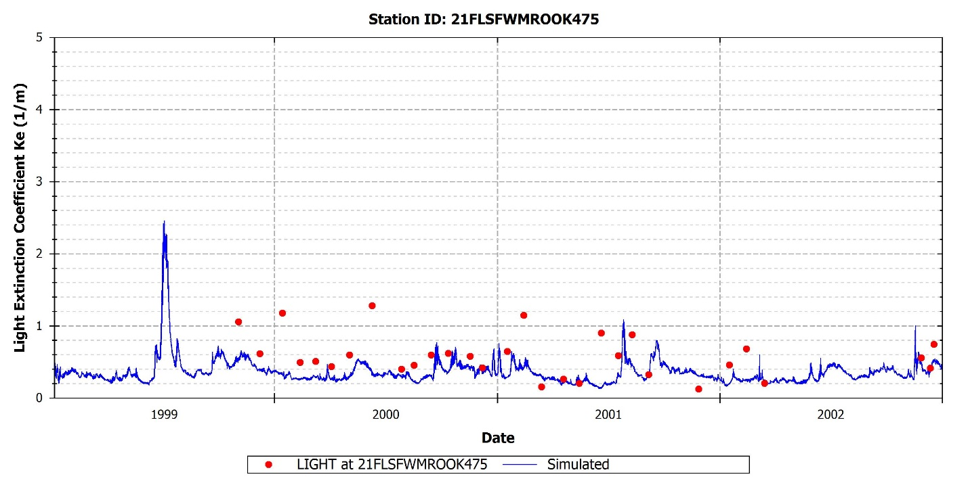
Figure 14: Observed versus predicted light extinction at 21FLSWMROOK475

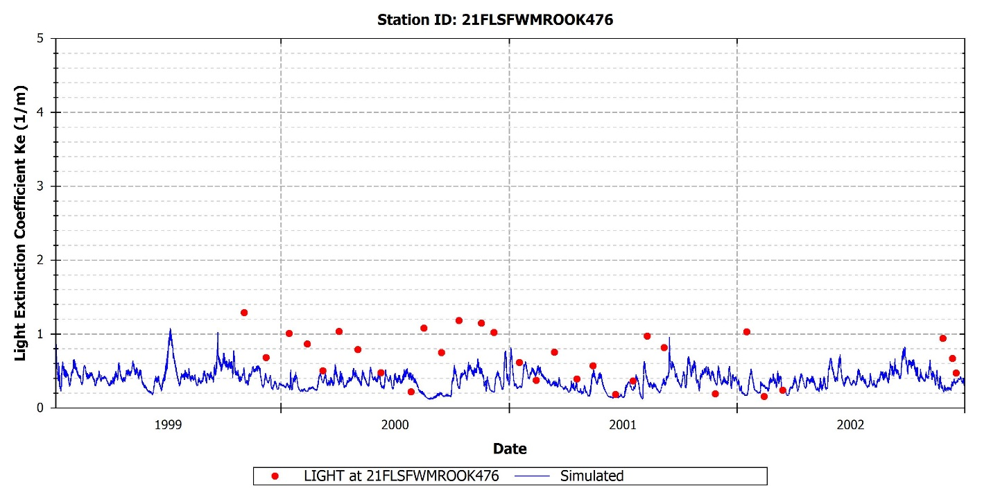
Figure 15: Observed versus predicted light extinction at 21FLSWMROOK476

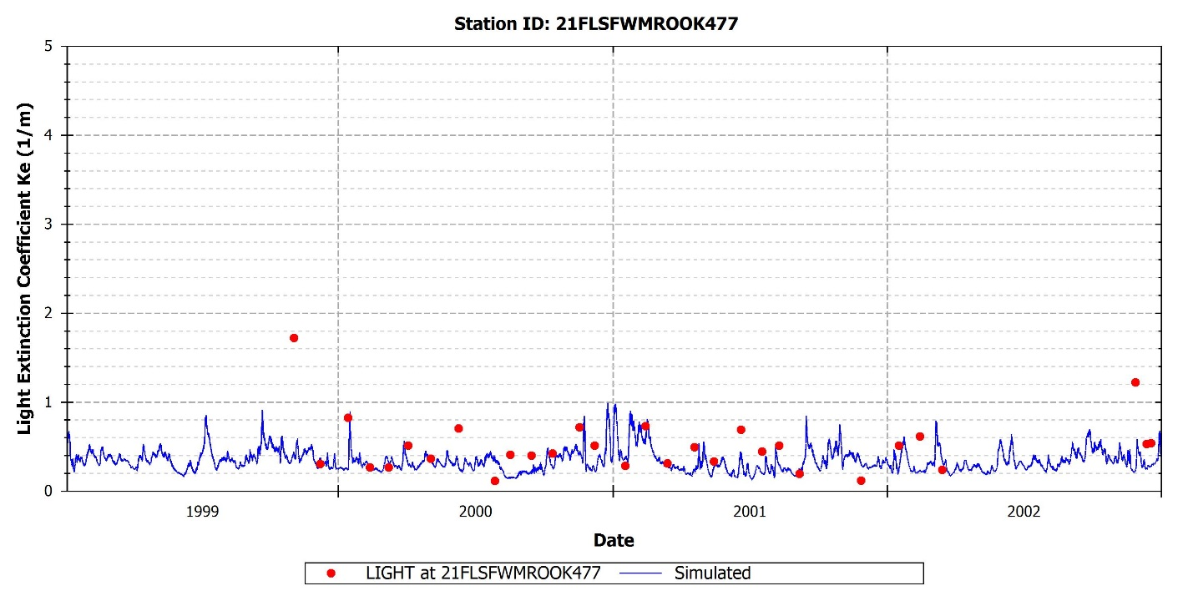
Figure 16: Observed versus predicted light extinction at 21FLSWMROOK477

references
Bailey N., Magley W., Mandrup-Poulsen J., O’Donnell K. and Peets R. 2009. Nutrient TMDL for the
Caloosahatchee Estuary. Final Report. Florida Department of Environmental Protection.

Dixon, L.K., and G.J. Kirkpatrick. 1999. Causes of light attenuation with respect to seagrasses in upper and Lower Charlotte Harbor. Report to the Southwest Florida Water Management District, Surface Water Improvement and Management Program, Tampa, FL, and Charlotte Harbor National Estuary Program.

McPherson, B.F. and R.L. Miller. 1987. The vertical attenuation of light in Charlotte Harbor, a shallow, subtropical estuary, southwestern Florida. Estuarine Coastal Shelf Science 25: 21-737.

McPherson, B.F. and R.L. Miller. 1994. Causes of light attenuation in Tampa Bay and Charlotte Harbor, southwestern Florida. Water Resources Bulletin 30(1): 43-53.

Steele, J.H. 1962. Environmental control of photosynthesis in the sea. Limnology and Oceanography, 7(2): 137-150.

Tetra Tech. 2007. The Environmental Fluid Dynamics Code Theory and Computation Volume 3: Water Quality Module. Fairfax, VA

