To: | Mohammad Sayemuzzaman, DEP
Cc: | Ansel Bubel, DEP  Sara Davis, DEP  Doug Gilbert, DEP  Erin Rasnake, DEP
From: | Brian Watson, PE, PH, D.WRE, Tetra Tech  Madhu Akasapu-Smith, EIT, Tetra Tech  Rene Camacho, Ph. D, Tetra Tech  Marcy Frick, REM, Tetra Tech  Erin Lincoln, PH, Tetra Tech  Hugo Rodriquez, Ph. D, PE, Tetra Tech
Date: | June 3, 2016 revised July 15, 2016 revised August 5, 2016
Subject: | Caloosahatchee River Basin Watershed Model Review and Calibration Refinement –  Task 5 EFDC Model Setup and Hydrodynamic Calibration Results and Recommendations

Table of Contents
1.0 Introduction 4
2.0 Summary 5
3.0 EFDC Model Setup 6
3.1 Model Grid 6
3.2 Bathymetry 10
3.3 EFDC Model Boundary Conditions 12
3.3.1 Tidal Forcings 12
3.3.2 Freshwater Flows 14
3.3.3 Water Temperature 15
3.3.4 Salinity 18
3.3.5 Water Quality Boundary Conditions 18
3.4 Weather Processing 21
3.4.1 Precipitation 21
3.4.2 Relative Humidity 21
3.4.3 Atmospheric Temperature 23
3.4.4 Cloud Cover 23
3.4.5 Solar Radiation 23
3.4.6 Atmospheric Pressure 23
3.4.7 Wind Speed and Direction 24
3.4.8 Quality Assurance (QA) and Weather File 24
3.5 Point Sources 25
3.5.1 Available Data 25
3.5.2 Missing Data Assumptions 27
4.0 EFDC Model Calibration 28
4.1 Water Surface Elevation 30
4.2 Water Temperature 34
4.3 Salinity 39
4.4 Flows 44
4.5 Calibration Issues, Modifications, and Recommendations 50
5.0 References 52
Appendix A: Hydrodynamic Calibration Results 53

Introduction
Tetra Tech and AMEC were contracted by the Florida Department of Environmental Protection (department) to address department and stakeholder issues regarding the set up and calibration of the current versions of the Caloosahatchee River and Estuary Hydrologic Simulation Program – Fortran (HSPF) and Environmental Fluid Dynamics Code (EFDC) models. These models will be used to develop total maximum daily loads (TMDLs) for impaired freshwater bodies within the Caloosahatchee River Basin and to refine the Caloosahatchee tidal estuary TMDLs that the department adopted in 2010. The department provided two sets of EFDC model files that contained data and ran from January 1, 2008 through December 31, 2010, as well as a report on the models developed by Dynamic Solutions and CDM in 2009 (2009 Model). However, the original EFDC model files developed by Dynamic Solutions and CDM that were used to prepare the 2009 report were not located or provided to Tetra Tech. The model files provided by the department were believed to be the department’s updated model (2014 Model), which included modifications to the 2009 Model, such as extending the model simulation time and adjusting the delineation boundaries.
Task 5 of this project was to update the EFDC model to address the recommendations from Task 1 and to evaluate the model’s hydrodynamic calibration. This memo includes the hydrodynamic calibration results, modifications of the changes made, and recommendations to improve the calibration.

Summary
During Task 5, Tetra Tech focused the EFDC model updates on the recommendations from the Task 1 memo to address major department and stakeholder comments, as well as issues that Tetra Tech identified with the original model that would limit the model’s ability to provide the information needed for the TMDL and basin management action plan (BMAP). For this task, Tetra Tech processed all new data input files for the full model simulation period (1996 – 2014). The department was unable to provide Tetra Tech with the original data processing sheets and information about processing methodologies; therefore all files had to be reprocessed to ensure that a consistent method was used for the full model simulation period. The model calibration for this task focused on the hydrodynamic results in comparison to available measured data in the watershed.
The major modifications and changes made by Tetra Tech to the EFDC model are as follows:
- Extended the model simulation period through December 31, 2014 (the 2014 Model ended on December 31, 2010).
- Added cells to the model grid to represent the tidally influenced streams/reaches in impaired waterbody identification (WBID) numbers.
- Revised the model grid to better represent the topographical and hydrographical characteristics of the Caloosahatchee River Estuary.
- Updated the bathymetry using data from the South Florida Water Management District (SFWMD).
- Updated the open, freshwater, north, and south model boundaries using the latest data.
- Processed National Climatic Data Center (NCDC) Summary of the Day (SOD) and NCDC Surface Airways (SA) weather data for precipitation, relative humidity, atmospheric temperature, cloud cover, solar radiation, atmospheric pressure, and wind speed and direction for use in the model.

EFDC Model Setup

Model Grid
The EFDC model grid was modified to better represent the topographical and hydrographical characteristics of the Caloosahatchee River Estuary. The most relevant modifications include:
- Grid alignments to better represent the channel in the riverine region and the sub-channels within the embayment area. Examples of these changes to the grid alignment are shown in Figure 1 and are highlighted by red polygons. The alignment is critical to ensure an appropriate bathymetrical connection between cells and to enable the model to transport salinity from the open areas to upstream areas of the river.
- Removal of cells and blockage of cells in no flow areas. Several cells were removed from the model domain to reflect the presence of islands and obstructions restricting flow circulation in the system. In Figure 1, examples of these areas are highlighted by yellow arrows. The presence of thin obstructions, such as highways in the embayment area, were included in the grid by imposing a no flow condition in one of the sides of the computational cells. These updates are included in the Mask.inp file.
- Reconfiguration of cells within marsh and mangrove areas. Although these areas have a continuous dynamic connectivity to open flow areas, such as the embayment and riverine portions of the Caloosahatchee River, in most cases the exchange of flow occurs through small channels or preferential paths, which convey water from the open areas into and out of these vegetated areas. To reflect this preferential flow condition, cells in the boundary between the vegetated areas and open water areas were removed leaving only cells above channel regions. Examples of these areas are shown in Figure 1 with a purple curve.
- Incorporation of tributaries. In order to assist the department in developing TMDLs for the impaired WBIDs and to assist with model calibration, tributaries and inlets along the Caloosahatchee River were incorporated into the EFDC model grid. The following seven tributaries were added, and have bidirectional flow due to tidal propagation:
  - Cape Coral Canals
  - Deep Lagoon Canal
  - Yellow Fever Creek
  - Billy’s Creek
  - Orange River
  - Popash Creek
  - Telegraph Creek

An additional four inlets were added to the model in the Deep Canal Lagoon WBID (3240A4), which corresponded to locations where measured water quality data were collected in the WBID. Figure 2 shows the revised grid with the tributary and inlet extensions, as well as the locations of the impaired WBID and hydrodynamic/flow stations.
In addition to the changes discussed above to reconfigure the model grid, the model grid was changed from a Sigma grid to a generalized vertical coordinate (GVC) multi-layer grid. The 2009 and 2014 EFDC Models used a sigma grid of four layers, which resulted in cell depths ranging from 0.1 meters to 5 meters. The 2017 EFDC Model was changed to a GVC grid with a maximum of five layers in any cell, with an average cell depth of about 1.5 meters. This adjustment will increase the model’s vertical resolution in the deeper areas and convert shallower, seagrass cells to one layer. The number of layers used in each grid cell are shown in Figure 3.
The above changes constitute the most important updates to the model grid. The final grid may include minor modifications depending on the performance of the model grid during calibration and validation.

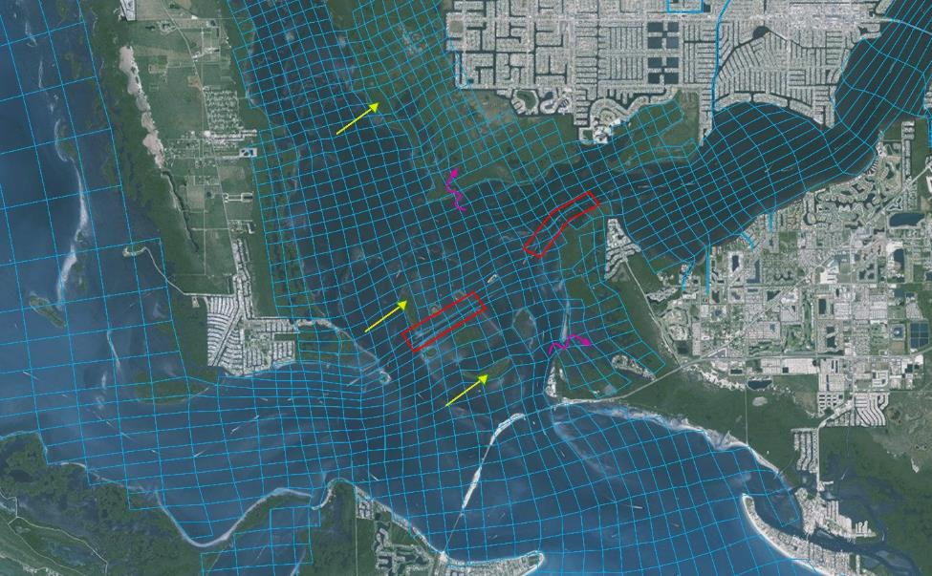
Figure 1: Example of updates to the 2017 EFDC Model grid

Figure 2: 2017 EFDC Model grid tributary and inlet extension locations
Figure 3: 2017 EFDC Model grid GVC layer numbers

Bathymetry
The bathymetry included in the updated model grid was obtained from SFWMD as a Light Detection and Ranging (LiDAR) data file. The file was a composite of topography and nearshore bathymetry at a resolution of a 100 foot cell. The data were downloaded from http://sfwmd.maps.arcgis.com/home/item.html?id=6990312b9775428094d1f81c31790096. The bathymetry was converted to a point shapefile and spatially processed in ArcGIS to assign the average bed elevation to each computation cell in the model grid. The resulting model bathymetry was then manually checked to ensure an appropriate representation of the main channel, which is critical to represent the levels of salinity intrusion observed in the system. The original LiDAR file had units of feet referenced to NAVD 88. Tetra Tech converted the data to meters for the EFDC model grid. Figure 4 shows the bathymetry used in the initial 2017 EFDC Model setup.

Figure 4: 2017 EFDC Model bathymetry

EFDC Model Boundary Conditions

Tidal Forcings
The pressure boundary conditions (tidal forcing) along the north (Matlacha Pass and Pine Island Sound) and south (Gulf of Mexico) open boundaries were defined based upon available reports of tidal harmonic constituents and observed records of water surface elevations (WSE) from nearby National Oceanic and Atmospheric Administration (NOAA) stations. The principal tidal harmonic constituents reported at NOAA station 8725541 Bokellia, Charlotte Harbor, FL (Table 1) were used to construct a WSE time series to force the north open boundaries (Figure 5). The WSE records available at NOAA station 8725110 (Naples, FL) were directly used to force the south open boundary (Figure 5). The phase and amplitude of the WSE time series used to force the north and south model boundaries were adjusted during calibration in order to match the records of WSE available at different stations throughout the estuary.
Table 1: List of principal tidal constituents at NOAA station 8725541 Bokellia, Charlotte Harbor, FL
Harmonic (symbol) | Period (days) | Amplitude (m)
M2 | 0.518 | 0.1098
K1 | 0.997 | 0.1050
O1 | 1.076 | 0.0948
SA | 365.243 | 0.0750
P1 | 1.003 | 0.0368
SSA | 182.621 | 0.0300
S2 | 0.500 | 0.0279
N2 | 0.527 | 0.0201
Q1 | 1.120 | 0.0186
M1 | 1.035 | 0.0110
J1 | 0.962 | 0.0079
K2 | 0.499 | 0.0049
OO1 | 0.929 | 0.0023

Figure 5: 2017 EFDC Model water surface elevation boundary station locations

Freshwater Flows
The freshwater flows at the upstream boundary of the Caloosahatchee River were defined by records available at the U.S. Geological Survey (USGS) station 02292900 (Caloosahatchee River at S-79, Near Olga, FL). The measured S-79 flows were used as opposed to the modeled flows because the manual operation of the S-79 lock was not represented in the HSPF model. The EFDC model will use the modeled water quality results from the HSPF model at S-79. The tributary flows were defined using the flow predictions from the 2017 HSPF Model. For subbasins where there was no representative reach draining to the Caloosahatchee River, runoff flows were divided and input into multiple EFDC cells along the subbasin boundary. The HSPF-EFDC linkages are provided in Table 2.
Table 2: 2017 HSPF-EFDC Model linkages
HSPF Reach/Subbasin | EFDC Cell (I,J) | % Flow used
101 | (40,42) | 100%
103 | (49,47) | 100%
104 | (49,68) | 100%
105 | (49,80) | 100%
106 | (49,58) | 100%
108 | (61,39) | 100%
109 | (65,38) | 100%
110 | (68,45) | 100%
111 | (68,50) | 100%
113 | (70,37) | 100%
116 | (72,45) | 100%
117 | (75,36) | 100%
118 | (76,36) | 100%
119 | (77,35) | 100%
120 | (78,51) | 100%
121 | (79,33) | 100%
122 | (83,34) | 100%
123 | (90,34) | 100%
126 | (94,30) | 100%
127 | (97,42) | 100%
129 | (42,24) | 50%
129 | (38,33) | 50%
130 | (44,26) | 30%
130 | (46,26) | 30%
130 | (49,27) | 40%
131 | (52,29) | 100%
132 | (58,24) | 50%
132 | (54,22) | 50%
133 | (56,30) | 100%
134 | (59,29) | 100%
136 | (68,29) | 30%
136 | (64,29) | 30%
136 | (61,29) | 40%
137 | (70,7) | 100%
138 | (79,14) | 100%
139 | (79,5) | 100%
144 | (85,30) | 50%
144 | (82,30) | 50%
145 | (89,30) | 100%
146 | (95,30) | 50%
146 | (92,30) | 50%
147 | (98,30) | 100%
221 | (97,30) | 100%

Water Temperature
The temperature boundary conditions at the freshwater boundaries, including the upstream boundary of the Caloosahatchee River, were defined using the initial draft water quality 2017 HSPF Model predictions. Water temperature boundaries to the 2017 EFDC Model will be updated with final water quality 2017 HSPF Model prediction after the HSPF model calibration is completed. For the Caloosahatchee River boundary, the model predictions from reach 147 of the HSPF model were used to force the model given the absence of temperature data at station USGS 02292900 (temperature records are only available starting from May 2014).
The temperature boundary conditions along the south open boundary of the model were defined based upon observed records of water temperature available at NOAA station 8725110 (Naples, FL). The records from this station were assumed to be representative of the conditions at the south open boundary. The temperature boundary conditions for the north open boundaries were defined based upon observations available at stations 21FLEECOPI-10, 21FLSEAS62SEASO61, 21FLCHARMPV002, and 21FLEECOPI-04 (Figure 6). The temperature records from stations 21FLEECOPI-10 and 21FLSEAS62SEASO61 were used to generate a time series for the Pine Island Sound boundary. Measured data were available from April 2002 through December 2010. For the periods when measured data were not available (December, 1995 through April 2002, and January 2010 through January 2015), a sinusoidal daily average time series was generated based on the range of the measured temperatures and their seasonal variations (Figure 7). The temperatures records from stations 21FLCHARMPV002 and 21FLEECOPI-04 were used to create the open boundary conditions at the Matlacha Pass boundary. Similar to the approach used to generate the temperature time series at Pine Island Sound, a sinusoidal time series was created to fill the periods with no data. Measured data were available from February 1998 through January 2015, and were used to generate the temperature forcing time series from December 1995 through February 1998 at Matlacha Pass (Figure 8).

Figure 6: 2017 EFDC Model open boundary hydrodynamic station locations
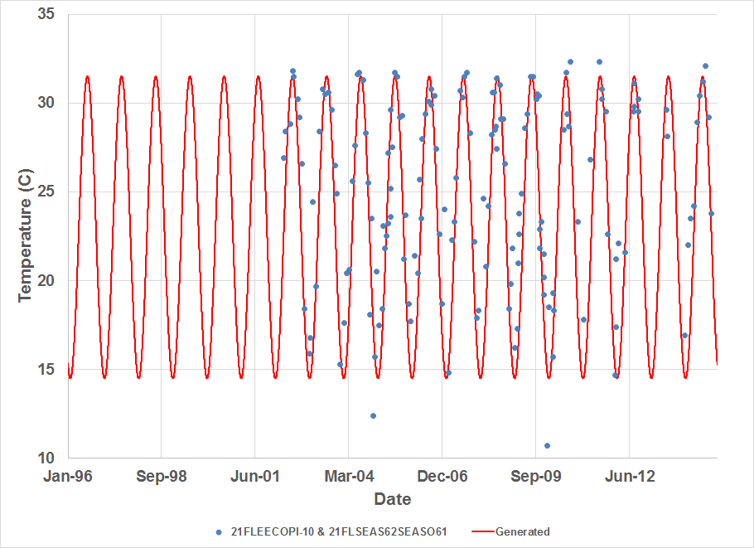
Figure 7: Open boundary temperature time series at Pine Island South

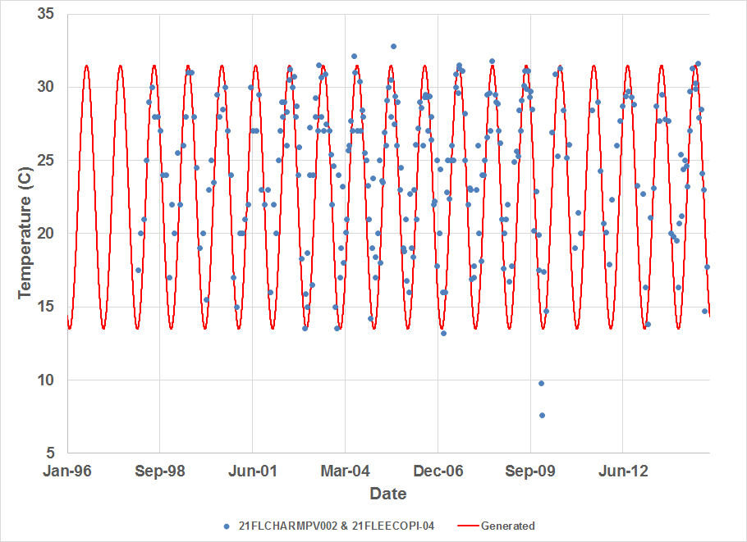
Figure 8: Open Boundary temperature time series at Matlacha Pass

Salinity
A constant salinity concentration of 35 PSU was used to represent the salinity conditions at the south open boundary. Salinity observations from stations 21FLEECOPI-10 and 21FLSEAS62SEASO61 were used to generate a time series for the Pine Island Sound boundary, and stations 21FLCHARMPV002 and 21FLEECOPI-04 were used to generate the time series of salinity for the Matlacha Pass open boundary (Figure 6).

Water Quality Boundary Conditions
Tetra Tech used available observations near the Matlacha Pass and Pine Island Sound northern model boundaries to construct time series of water quality concentrations. Monitoring stations in the immediate vicinity of the boundaries were selected as the basis to construct the water quality time series for nitrate-nitrite (NO_{X}), ammonia (NH₄), organic nitrogen (OrgN), orthophosphate (PO₄), organic phosphorus (OrgP), chlorophyll-a (Chla), and dissolved oxygen (DO). Table 3 lists the stations used to develop the water quality boundary, and the station locations are shown in Figure 9. The stations are located in a variety of locations, including the deep channel and immediately adjacent to marsh outflows. By combining the available data from the stations into one time series, the open boundary is able to reflect the overall water quality inputs at the northern boundaries.
The available water quality concentration data at each station were used to construct the water quality boundary condition time series for the simulation period. The daily, monthly, and long-term water quality concentrations were similar among the stations. If data were available on a given day for more than one station, the data were averaged to provide a single water quality concentration value for that day for the boundary condition time series.
Table 3: Monitoring stations used to develop the water quality time series for the northern boundary cells
Location | Station ID
Boundary conditions at boundary cells across J=82,  Matlacha Pass | 21FLCHARMPV001
 | 21FLCHARMPV002
 | 21FLEECOPI-03
 | 21FLEECOPI-04
 | 21FLEECOPI-05
 | 21FLSEAS62SEAS020
 | 21FLSEAS62SEAS401
Boundary conditions at boundary cells across J=44,  Pine Island Sound | 21FLCHARPIV004
 | 21FLEECOPI-10
 | 21FLEECOPI-11

Figure 9: 2017 EFDC Model open boundary water quality station locations
At the southern boundary, there were limited water quality observations to support the development of a water quality time series for the EFDC model. Therefore, the model was forced with constant concentrations for the different species of nutrients, DO, and phytoplankton biomass. Such concentrations were defined based on the concentrations used in the 2014 EFDC Model and on recently measured data. Data at 12 stations close to the southern boundary (Figure 9) were reviewed to help define the constant concentrations. Table 4 summarizes the values used in the 2017 EFDC Model compared to the values used in the 2014 Model.
Table 4: Water quality concentrations assigned at the southern boundary cells
Parameter | 2014 Model | 2017 Model | Observations
NO₃ | Constant concentration of 0.01 mg/L in Card 33. | Not modified from 2014 Model setup. | The average concentration of the available records is 0.007mg/L, which is within range of the concentration used in the 2014 Model.
NH₄ | Constant concentration of 0.02 mg/L in Card 33. | Constant concentration of 0.05 mg/L in Card 33. | The average concentration of the available records is 0.05 mg/L. This concentration has been included in the 2017 Model setup.
OrgN | Constant concentrations as follows:  RPON = 0.3 mg/L  LPON = 0.03 mg/L  DON = 0.3 mg/L | Constant concentrations as follows:  RPON = 0.17 mg/L  LPON = 0.017 mg/L  DON = 0.17 mg/L | The average OrgN concentration calculated from TN and TKN records is 0.35 mg/L. This concentration was partitioned into labile, refractory, and dissolved fractions using the same ratios as the 2014 Model.
PO₄ | Constant concentration of 0.05 mg/L in Card 33. | Not modified from 2014 Model setup. | The average concentration of the available records is 0.03 mg/L, which is close to the concentration used in the 2014 Model.
OrgP | Constant concentrations as follows:  RPOP = 0.02 mg/L  LPOP = 0.002 mg/L  DOP = 0.02 mg/L | Not modified from 2014 Model setup. | No modifications performed to the concentrations included in the 2014 Model setup.
OrgC | Constant concentrations as follows:  RPOC = 0.3 mg/L  LPOC = 0.3 mg/L  DOC = 2.5 mg/L | Not modified from 2014 Model setup. | Average concentration of available observations is 3.1 mg/L, which is the same concentration used in the 2014 Model.
Chla | Constant concentration of 1 µg/L for green algae in Card 33. | Not modified from 2014 Model setup. | The average concentration of the available records is 1.4 µg/L, which is within range of the 2014 Model.
DO | Not included. | A time series of DO at saturated conditions will be prescribed for this boundary. | The DO saturation concentration will be computed by an equation of state as a function of water salinity and temperature.  A vertical gradient of DO concentration will be included at the boundaries to reflect higher DO concentrations at the surface and lower at the bottom. Observations of DO and/or DO saturation at stations close to the open boundaries will be used to ensure the constructed time series reflect realistic conditions of DO in the area.

Weather Processing
The primary data sources used to create the 2017 EFDC Model weather files (ASER.inp and WSER.inp) for the Caloosahatchee Estuary included the NEXRAD and NCDC SA station. The NEXRAD dataset was provided by SFWMD at hourly time steps. SA data were obtained from two sources: a web subscription from NCDC and Integrated Surface Database (ISD) maintained by NOAA. The time series of precipitation, relative humidity, air temperature, cloud cover, solar radiation, and atmospheric pressure were defined in the ASER.inp file while the time series of wind speed and direction were defined in the WSER.inp file. The weather files were created from January 1, 1996 through December 31, 2014 using the date of December 31, 1995as Julian day 0.

Precipitation
The precipitation time series used in the 2017 EFDC Model was developed using NEXRAD Zone 1 data, which represent the closest dataset to the project area and is consistent with the precipitation dataset used in the 2017 HSPF model.

Relative Humidity
The relative humidity data used in the 2017 EFDC Model setup were defined based on records from station WBAN 12835. Data from January 1996 through May 1997 and January 2014 through December 2014 were downloaded from ISD, and data from June 1998 through December 2013 were received from a web subscription of NCDC. To fill in missing data records, if the data gap was less than 3 hours, the humidity was averaged using the data immediately before and after the gap. If the gap was more than 3 hours, information from the neighboring SA station WBAN 12842 (Tampa International Airport) was used. Gaps in data for more than 3 hours occurred predominantly between 1996 and 1998, and approximately 5% of the relative humidity data from WBAN 12835 had to be patched using data from WBAN 12842.

Figure 10: Weather station locations used to develop the 2017 EFDC Model time series

Atmospheric Temperature
The air temperature data used in the 2017 EFDC Model setup were defined based on records from station WBAN 12835. Data from January 1996 through May 1997 and January 2014 through December 2014 were downloaded from ISD, and data from June 1998 through December 2013 were received from a web subscription of NCDC. To fill in missing data records, if the gap was less than 3 hours, the temperature was averaged using the data immediately before and after the gap. If the gap was more than 3 hours, information from the neighboring SA station WBAN 12842 (Tampa International Airport) was used. Gaps in data for more than 3 hours occurred predominantly between 1996 and 1998, and less than 0.2% of the temperature data from WBAN 12835 had to be patched using data from WBAN 12842.

Cloud Cover
The cloud cover data used in the 2017 EFDC Model setup were defined based on records from station WBAN 12835. Data for cloud cover from ISD were provided in terms of sky cover, a verbal description of the cloud cover. Based on the information provided in the User’s Manual of Meteorological Data Analysis and Preparation Tool (MetADAPT), the following MetADAPT numerical assignments for cloud cover estimates from the sky conditions parameters was applied:
- CLR (clear) : 0
- POB (partial obscuration): 1.25
- SCT (scattered): 4.38
- BKN (broken): 7.5
- OVC & OBS (overcast and obscured): 10
Data from January 1996 through May 1997 and January 2014 through December 2014 were downloaded from ISD, and data from June 1998 through December 2013 were received from a web subscription of NCDC. To fill in missing data records, if the gap was less than 3 hours, the cloud cover from the previous hour was held constant. If the gap was more than 3 hours, information from the neighboring SA station WBAN 12842 (Tampa International Airport) was used. Gaps in data for more than 3 hours occurred predominantly between 1996 and 1998, and approximately 3% of the cloud cover data from WBAN 12835 had to be patched using data from WBAN 12842.

Solar Radiation
Solar radiation was computed using cloud cover and the latitude of station WBAN 12835, which was in closer proximity to the EFDC model grid than the SFWMD S78W weather station. CE QUAL-W2 method in MetADAPT was used to compute the solar radiation using sun angle relationships and shading from the cloud cover (Cole 2003).

Atmospheric Pressure
The atmospheric pressure data used in the 2017 EFDC Model setup were defined based on records from station WBAN 12835. Data from January 1996 through May 1997 and January 2014 through December 2014 were downloaded from ISD, and data from June 1998 through December 2013 were received from a web subscription of NCDC. To fill in missing data records, if the data gap was less than 3 hours, the temperature was averaged using the data immediately before and after the gap. If the gap was more 3 hours, information from the neighboring SA station WBAN 12842 (Tampa International Airport) was used. Pressure from ISD was provided in inches of mercury. The information was converted to millibar for use in the model weather files. Gaps in data for more than 3 hours occurred predominantly between 1996 and 1998, and less than 0.2% of the atmospheric pressure data from WBAN 12835 had to be patched using data from WBAN 12842.

Wind Speed and Direction
The wind speed and direction data used in the 2017 EFDC Model setup were defined based on records from station WBAN 12835, which was closer to the EFDC model grid than the SFWMD S78W weather station. Data from January 1996 through May 1997 and January 2014 through December 2014 were downloaded from ISD, and data from June 1998 through December 2013 were received from a web subscription of NCDC. Direction data from ISD reported as ‘***’ indicated that the air was calm. All the ‘***’ data were replaced with 0. To fill in missing data when gaps were less than 3 hours, the speed was averaged using the data immediately before and after the gap. If the gap was more than 3 hours, information from the neighboring SA station WBAN 12842 (Tampa International Airport) was used. For the missing information for direction, the previous hour direction was held constant. The information was converted to millibar for use in the model weather files. Gaps in data for more than 3 hours occurred predominantly between 1996 and 1998, and less than 0.2% of the wind speed and direction data from WBAN 12835 had to be patched using data from WBAN 12842.

Quality Assurance (QA) and Weather File
QA was performed on monthly total rainfall, maximum hourly rainfall, air temperature, relative humidity, solar radiation, atmospheric pressure, and wind speed and direction to ensure that values were within expected ranges for each month and season. Water Resources Database (WRDB) Graph was used to analyze the time series for all the weather parameters.
Table 5 lists the stations used for creating the weather file for the Caloosahatchee Estuary.
Table 5: Weather parameter assignment for the Caloosahatchee 2017 EFDC Model
Estuary | .alt | .tmp | .hum | .pre | .sr2 | .tsk | .win
Caloosahatchee | 12835 | 12835 | 12835 | NEXRAD Zone1 | 12835 | 12835 | 12835
Where:
.alt = Altimeter Pressure, mbar
.tmp = Dry-bulb Temperature, ºF
.hum = Relative Humidity, %
.pre = Precipitation, in/hr
.sr2 = Cloud-adjusted Solar Radiation, ly/hr
.tsk = Cloud Cover, tenths
.win = Wind Speed and Direction, mi/hr and degrees

Point Sources
The department provided Tetra Tech with the permit and discharge monitoring report (DMR) data for the domestic wastewater (DW) and industrial wastewater (IW) treatment facilities that discharge directly to the EFDC model (see Table 6).
Table 6: Point sources in the 2017 EFDC Model
NPDES ID | Facility Name | Type | Design Capacity (MGD) | EFDC Model Cell I | EFDC Model Cell J
FL0021261 | Fort Myers Central AWWTF | DW | 11 | 71 | 31
FL0021270 | South AWWT Facility | DW | 12 | 61 | 31
FL0030007 | Cape Coral, City of - Everest WRF | DW | 15.1 | 62 | 32
FL0030325 | Waterway Estates | DW | 5 | 65 | 36
FL0039829 | Fiesta Village Advanced WWTF | DW | 1.5 | 55 | 30
FL0001490 | Florida Power and Light Fort Myers | IW | 590.6 | 79 | 15

Available Data
The observed average flow and water quality results for each of the facilities are shown in Table 7. The number of end of pipe flow and water quality parameter observations reported by each facility are shown in Table 8. For most parameters, results were reported monthly. The period of record for the available data is shown in Table 9. The available measured data for these facilities were used in the EFDC model to determine the total loading from each facility. The data were used to fill short- and long-term gaps in the data records. For example, if a facility has total nitrogen (TN) data for ten years of the modeling period, the long-term average of the measured data was used to represent the expected TN concentration for the remaining portion of the simulation period, where data were unavailable.
Table 7: Observed average value for available flow and water quality data for point source facilities
Permit | FLOW (cfs) | NH3 (mg/L) | NOx (mg/L) | OrgN (mg/L) | TN (mg/L) | PO4 (mg/L) | OrgP (mg/L) | TP (mg/L) | CBOD (mg/L) | TSS (mg/L) | DO (mg/L) | WTEM (Deg C)
FL0021261 | 4.88 | - | - | - | 1.65 | - | - | 0.15 | 2.41 | 4.50 | 5.52 | -
FL0021270 | 12.81 | - | - | - | 2.04 | - | - | 0.19 | 1.98 | 3.45 | 5.76 | -
FL0030007 | 7.36 | - | - | - | 1.04 | - | - | 0.13 | 2.20 | 1.38 | 5.89 | -
FL0030325 | 1.32 | - | - | - | 1.20 | - | - | 0.08 | 1.64 | 0.94 | 7.07 | -
FL0039829 | 2.90 | 0.07 | 0.08 | 0.63 | 0.93 | - | - | 0.10 | 1.47 | 0.59 | 5.98 | -
FL0001490 | 822.14 | 0.12 | 0.22 | 0.88 | 1.22 | 0.07 | 0.04 | 0.11 | - | 7.36 | - | 32.95
- = No data.
Table 8: Number of observations for available flow and water quality data for point source facilities
Permit | FLOW (cfs) | NH3 (mg/L) | NOx (mg/L) | OrgN (mg/L) | TN (mg/L) | PO4 (mg/L) | OrgP (mg/L) | TP (mg/L) | CBOD (mg/L) | TSS (mg/L) | DO (mg/L) | WTEM (Deg C)
FL0021261 | 103 | - | - | - | 175 | - | - | 174 | 175 | 174 | 168 | -
FL0021270 | 154 | - | - | - | 152 | - | - | 154 | 155 | 155 | 145 | -
FL0030007 | 111 | - | - | - | 58 | - | - | 59 | 59 | 60 | 59 | -
FL0030325 | 124 | - | - | - | 126 | - | - | 126 | 124 | 122 | 78 | -
FL0039829 | 159 | 34 | 33 | 34 | 147 | - | - | 157 | 157 | 157 | 158 | -
FL0001490 | 59 | 11 | 11 | 11 | 11 | 11 | 11 | 11 | - | 14 | - | 11
- = No data.

Table 9: Period of record for available flow and water quality data for point source facilities
Permit | Flow (cfs) | NH3 (mg/L) | NOx (mg/L) | OrgN (mg/L) | TN (mg/L) | PO4 (mg/L) | OrgP (mg/L) | TP (mg/L) | CBOD (mg/L) | TSS (mg/L) | DO (mg/L) | WTEM (Deg C)
FL0021261 | 4/1/2006 - 12/1/2014 | - | - | - | 5/1/2000 - 12/1/2014 | - | - | 5/1/2000 - 12/1/2014 | 5/1/2000 - 12/1/2014 | 5/1/2000 - 12/1/2014 | 1/1/2001 - 12/1/2014 | -
FL0021270 | 12/1/1999 - 12/1/2014 | - | - | - | 2/1/2000 - 11/1/2014 | - | - | 2/1/2000 - 12/1/2014 | 12/1/1999 - 12/1/2014 | 12/1/1999 - 12/1/2014 | 12/1/1999 - 12/1/2014 | -
FL0030007 | 6/1/2000 -10/1/2014 | - | - | - | 6/1/2000 - 9/1/2008 | - | - | 6/1/2000 - 9/1/2008 | 6/1/2000 - 9/1/2008 | 6/1/2000 - 9/1/2008 | 6/1/2000 - 9/1/2008 | -
FL0030325 | 1/1/2000 - 10/1/2012 | - | - | - | 1/1/2000 - 10/1/2012 | - | - | 1/1/2000 - 10/1/2012 | 1/1/2000 - 10/1/2012 | 1/1/2000 - 10/1/2012 | 1/1/2000 - 4/1/2010 | -
FL0039829 | 6/1/2000 - 12/1/2014 | 2/1/2010 - 1/1/2014 | 2/1/2010 - 1/1/2014 | 2/1/2010 - 1/1/2014 | 6/1/2000 - 1/1/2014 | - | - | 6/1/2000 - 12/1/2014 | 6/1/2000 - 12/1/2014 | 6/1/2000 - 12/1/2014 | 6/1/2000 - 12/1/2014 | -
FL0001490 | 1/1/1999 - 12/1/2014 | 6/1/2012 - 12/1/2014 | 6/1/2012 - 12/1/2014 | 6/1/2012 - 12/1/2014 | 6/1/2012 - 12/1/2014 | 6/1/2012 - 12/1/2014 | 6/1/2012 - 12/1/2014 | 6/1/2012 - 12/1/2014 | - | 12/1/2006 - 12/1/2014 | - | 6/1/2012 - 12/1/2014
- = No data.

Missing Data Assumptions
When available, measured water quality data were used to represent the point source facility discharge flows and concentrations and to fill gaps in the data record. However, as shown above, measured data were not available for many parameters. In order to provide parameter concentrations for the facilities, Tetra Tech identified default assumptions that were used for the point source facilities (Table 10). These assumptions were based on available data from all facilities in the Caloosahatchee River Watershed, including those discharging directly to the HSPF model. Please see the Task 2 memo for information about point sources discharging to the HSPF model.
Table 10: Recommended default assumptions for missing flow and water quality data for point source facilities
Constituent | Parameter ID | Minor (<1.0 MGD) | Major (>1.0 MGD) | Rationale
Total Phosphorus | TP | 0.15 mg/L | 0.15 mg/L | Average of available data = 0.15 mg/L; range of 0.08 - 0.25 mg/L
Orthophosphate | PO4 | 0.135 mg/L (90% of TP) | 0.105 mg/L (70% of TP) | Professional recommendation
Organic Phosphorus | OrgP | 0.015 mg/L (10% TP) | 0.045 mg/L (30% of TP) | Professional recommendation
Total Nitrogen | TN | 2.00 mg/L (sum of species) | 2.00 mg/L (sum of species) | Average of available data = 1.92 mg/L; range of 0.29 - 7.11 mg/L
Ammonia | NH3 | 0.15 mg/L (7.5% of TN) | 0.15 mg/L (7.5% of TN) | Average of available data = 0.15 mg/L; range of 0.021 - 0.38 mg/L
Nitrate+Nitrite | NOx | 0.15 mg/L (7.5% of TN) | 0.15 mg/L (7.5% of TN) | Average of available data = 0.16 mg/L; range of 0.08 - 0.23 mg/L
Organic Nitrogen | OrgN | 1.70 mg/L (85% of TN) | 1.70 mg/L (85% of TN) | Average of available data = 2.67 mg/L; range of 0.08 - 0.23 mg/L
Carbonaceous BOD | CBOD | 2.0 mg/L | 2.0 mg/L | Average of available data = 2.16 mg/L; range of 0.63 - 6.50 mg/L
Dissolved Oxygen | DO | 6.0 mg/L | 6.0 mg/L | Average of available data = 6.12 mg/L; range of 5.06 - 7.56 mg/L
Total Suspended Solids | TSS | 3.5 mg/L | 3.5 mg/L | Average of available data = 3.25 mg/L; range of 0.59 - 7.36 mg/L
Water Temperature | WTEM | 20.0 °C October through March 30.0 °C April through September | 20.0 °C October through March 30.0 °C April through September | Professional recommendation

EFDC Model Calibration
Tetra Tech completed the draft setup of the 2017 EFDC Model and evaluated the draft hydrodynamic calibration results for a five-year calibration period of January 1, 2010 through December 31, 2014. Tetra Tech compared modeled hydrodynamic outputs to measured hydrodynamic outputs at different monitoring stations located throughout the estuary (Figure 11). The following section contains preliminary analyses of the calibration results at stations located in the Caloosahatchee River. Additional calibration plots showing comparisons between observed and predicted time series of WSE, salinity, and temperature are provided in Appendix A.
Figure 11: 2017 EFDC Model hydrodynamic results comparison station locations

Water Surface Elevation
During the calibration of the Caloosahatchee model, the phase and amplitude of the forcing conditions imposed at the open boundary were adjusted, and the spatial distribution of the roughness coefficients was adjusted in order to match the phase and amplitude of the water level observations at NOAA station 8725520 and also at different USGS stations located throughout the estuary.
The phase and amplitude of the open boundary conditions were adjusted because they were defined based on water level data collected in nearby stations and not based on data directly collected at the model open boundaries. The adjustments performed on the open boundary conditions are necessary to account for the travel time and dissipation or magnification that a surface wave from the Gulf of Mexico is subject to before it reaches inside areas of the Caloosahatchee River. The adjustments were defined in the input file PSER.inp and are expressed by a lag time for the phase of the wave and by a multiplicative factor which impacts the amplitude of the wave. In terms of the roughness coefficient, a constant calibrated value of 0.01 meters was specified in the model setup.
The model results are summarized in Table 11 and Figure 12 through Figure 16. In Table 11, the performance statistics for stations reporting only daily maximum and daily minimum water levels (USGS stations 02293205 and 02293210) were computed by comparing the observations against the simulated daily maximum and daily minimum water levels. The results indicate that the model is capable of reproducing the phase and amplitude of the tidal variations within the estuary. The preliminary calibration statistics are overall very good with root mean square error (RMSE) on the order of few centimeters (0.07 – 0.13 m), and index of agreements above 0.86 at most stations. The tidal range, which is the average difference between maximum and minimum water levels during a tidal cycle, varies between approximately 0.5 and 0.9 meters and is well captured by the model. The model matches the timing and amplitude of the tide during spring and neap periods as well as the inter-daily variations observed at the different evaluated stations.

Table 11: Model performance statistics for WSE
Station ID | Mean Measured (m MSL) | Median Measured (m MSL) | 5th Percentile Measured (m MSL) | 95th Percentile Measured (m MSL) | Mean Simulated (m MSL) | Median Simulated (m MSL) | 5th Percentile Simulated (m MSL) | 95th Percentile Simulated (m MSL) | R² | MAE (m MSL) | RMSE (m MSL) | NRMSE | Index of Agrmt
8725520 | 0.08 | 0.10 | -0.21 | 0.36 | 0.17 | 0.19 | -0.09 | 0.46 | 0.76 | 0.110 | 0.13 | 0.66 | 0.86
02293205 - Max | 0.32 | 0.33 | 0.08 | 0.55 | 0.35 | 0.35 | 0.12 | 0.58 | 0.86 | 0.059 | 0.08 | 0.06 | 0.92
02293205 - Min | -0.08 | -0.07 | -0.29 | 0.09 | -0.03 | -0.03 | -0.21 | 0.14 | 0.80 | 0.063 | 0.09 | 0.07 | 0.86
02293210 - Max | 0.35 | 0.35 | 0.14 | 0.55 | 0.31 | 0.30 | 0.09 | 0.53 | 0.92 | 0.055 | 0.07 | 0.12 | 0.93
02293210 - Min | -0.15 | -0.15 | -0.35 | 0.02 | -0.06 | -0.06 | -0.24 | 0.11 | 0.89 | 0.094 | 0.11 | 0.10 | 0.81

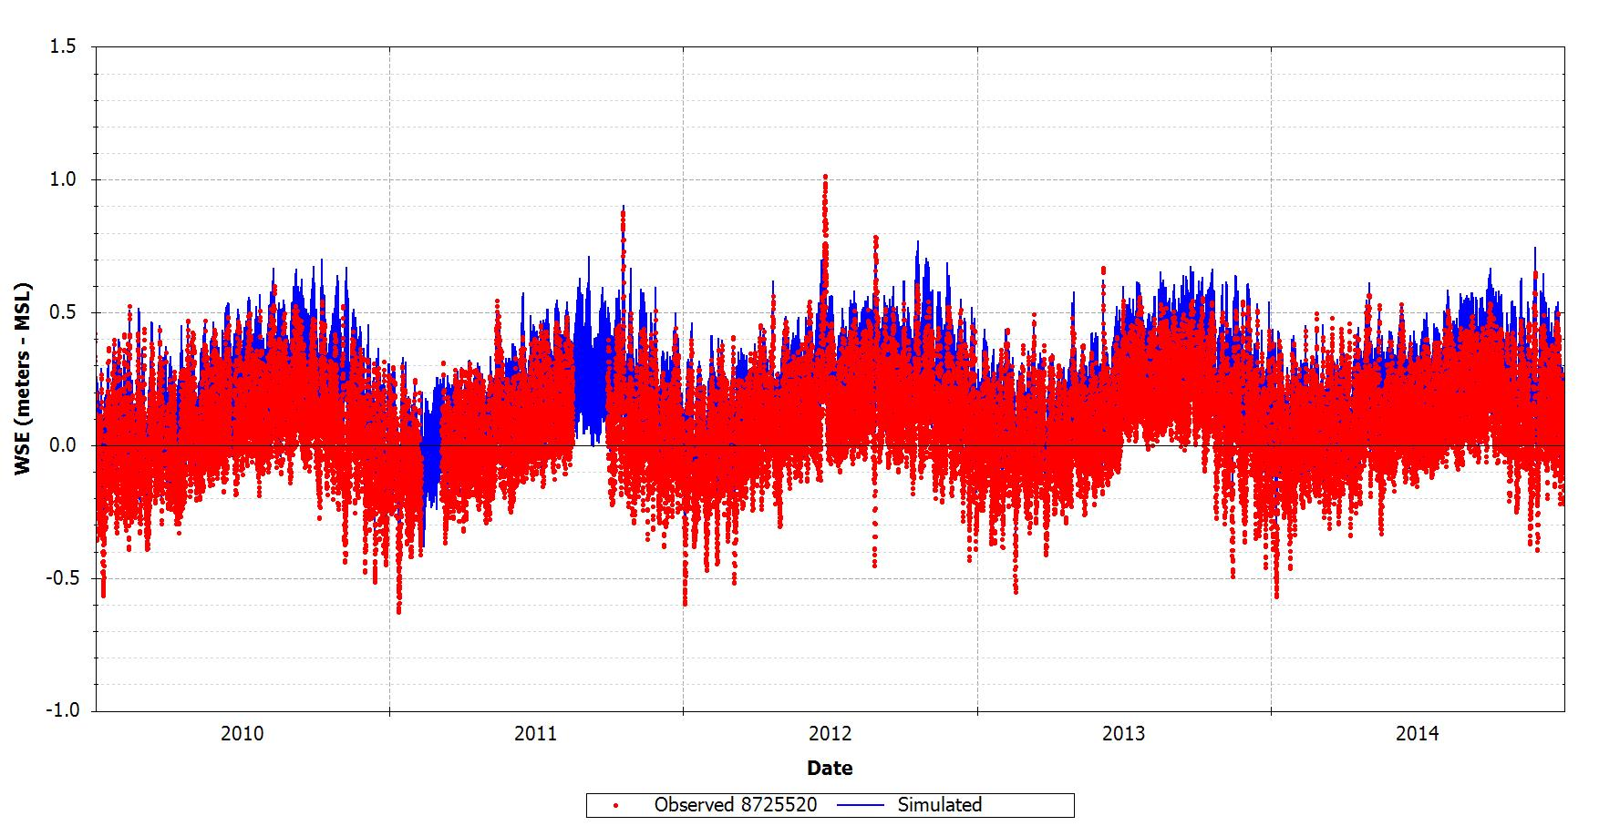
Figure 12: Simulated and observed WSE at NOAA station 8725520, 2010 – 2014

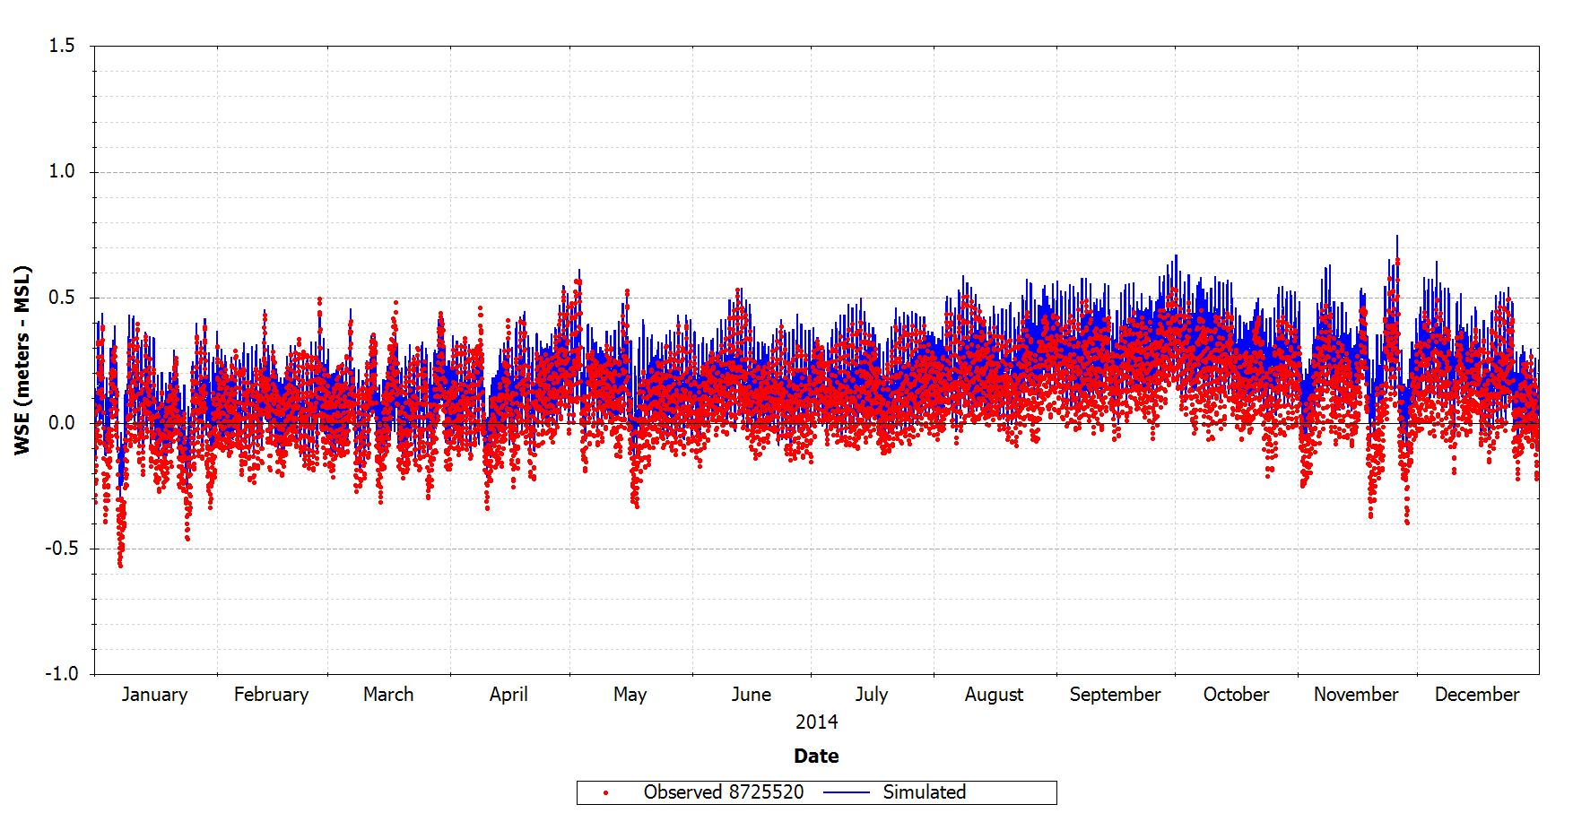
Figure 13: Simulated and observed WSE at NOAA station 8725520, 2014

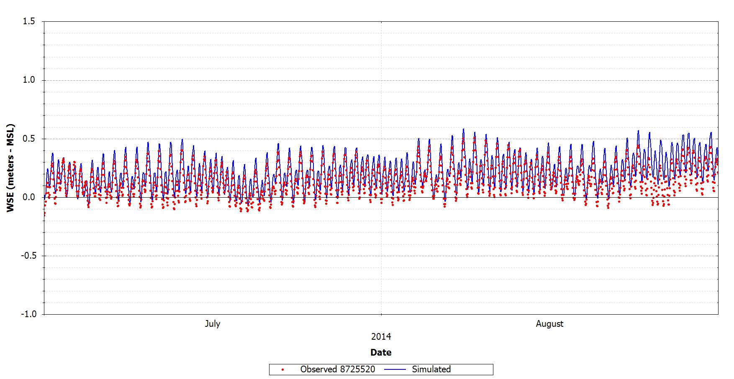
Figure 14: Simulated and observed WSE at NOAA station 8525520, July – August, 2014

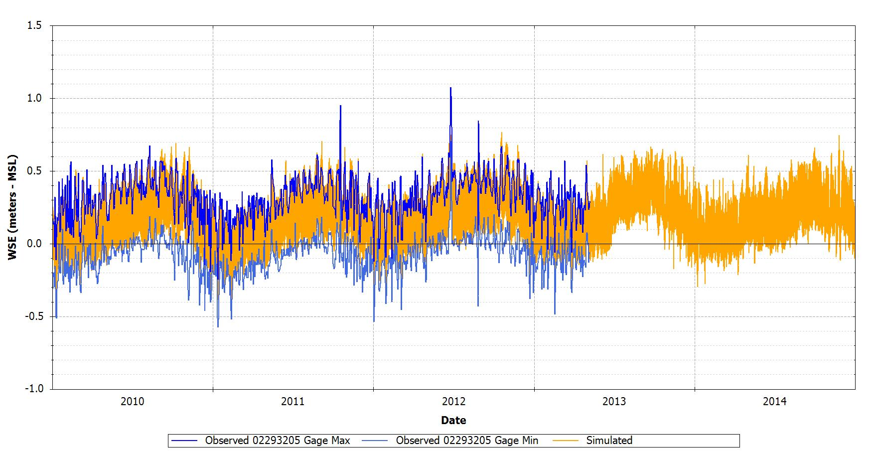
Figure 15: Simulated and observed WSE at USGS 02293205

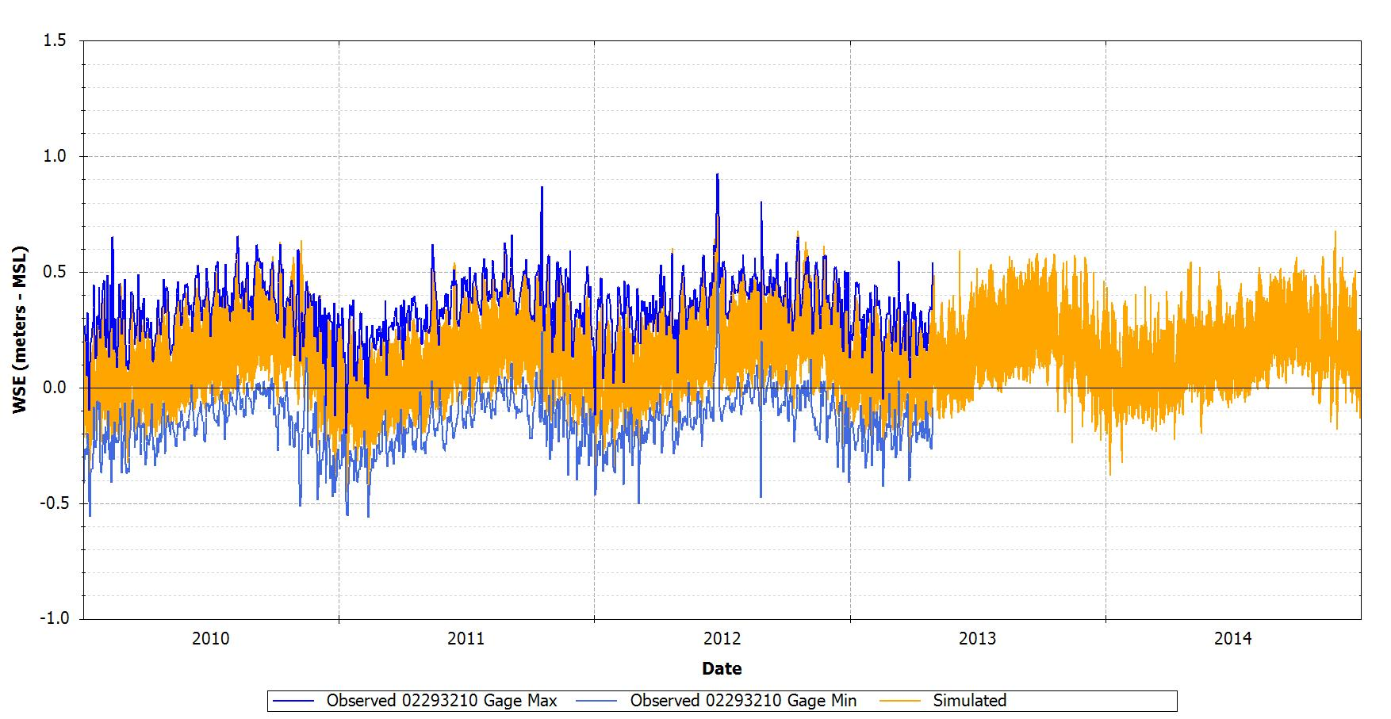
Figure 16: Simulated and observed WSE at USGS 02293210

Water Temperature
A good representation of the vertical and horizontal distribution of temperature and salinity in estuaries is important to correctly represent baroclinic transport resulting from water density variations. The 2017 EFDC Model was calibrated to reproduce temperature measurements collected at several monitoring stations located throughout the estuary. The parameters adjusted during the model calibration were the solar radiation attenuation coefficient and the heat transfer coefficient between the water column and the solid bed. These parameters control most of the vertical structure of heat in the model (Hamrick 1992; Ji 2008). A summary of the preliminary calibration results at selected stations is presented below in Table 12 and Figure 17 through Figure 22. The comparison period shown in these figures ranges from January 1, 2010 through December 31, 2014.
Preliminary calibration results show the model is able to reproduce the overall temperature variations observed in the Caloosahatchee Estuary. The model predictions follow the observed seasonal evolution of water temperature and general inter-daily temperature variations throughout the estuary (Figure 17 through Figure 19). These results used measured temperature data at the S-79 boundary, and the model will be updated with HSPF model temperature concentrations following calibration of the HSPF model. The performance of the EFDC model is not expected to change significantly in the Caloosahatchee River once this update has been made, although there should be an improvement in the tributaries, which currently use uncalibrated HSPF temperature results.

Table 12: Model performance statistics for water temperature
Station ID | Mean Measured (°C) | Median Measured (°C) | 5th Percentile Measured (°C) | 95th Percentile Measured (°C) | Mean Simulated (°C) | Median Simulated (°C) | 5th Percentile Simulated (°C) | 95th Percentile Simulated (°C) | R² | MAE (°C) | RMSE (°C) | NRMSE | Index of Agrmt
21FLEECOCES03SUR | 25.1 | 26.8 | 17.2 | 30.5 | 25.75 | 26.61 | 18.27 | 31.42 | 0.84 | 1.29 | 1.84 | 0.07 | 0.95
21FLFTM CALUSA0008FTM | 26.3 | 27.6 | 19.5 | 31.8 | 27.43 | 28.59 | 21.10 | 32.53 | 0.80 | 1.47 | 2.15 | 0.08 | 0.92
21FLFTM CALUSA0011FTM | 24.8 | 26.9 | 16.2 | 31.0 | 25.51 | 26.81 | 17.29 | 31.50 | 0.85 | 1.64 | 1.99 | 0.08 | 0.95
21FLEECOCES06SUR | 24.6 | 26.1 | 16.0 | 31.0 | 24.9 | 25.44 | 18.46 | 29.72 | 0.78 | 1.78 | 2.28 | 0.09 | 0.93
21FLEECOCES10SUR | 25.0 | 27.2 | 16.2 | 30.8 | 25.46 | 26.26 | 18.38 | 31.52 | 0.77 | 1.77 | 2.27 | 0.09 | 0.93
21FLCHARMPV004 | 23.4 | 25.3 | 14.3 | 30.7 | 24.70 | 26.37 | 16.77 | 30.77 | 0.50 | 2.79 | 4.26 | 0.18 | 0.80

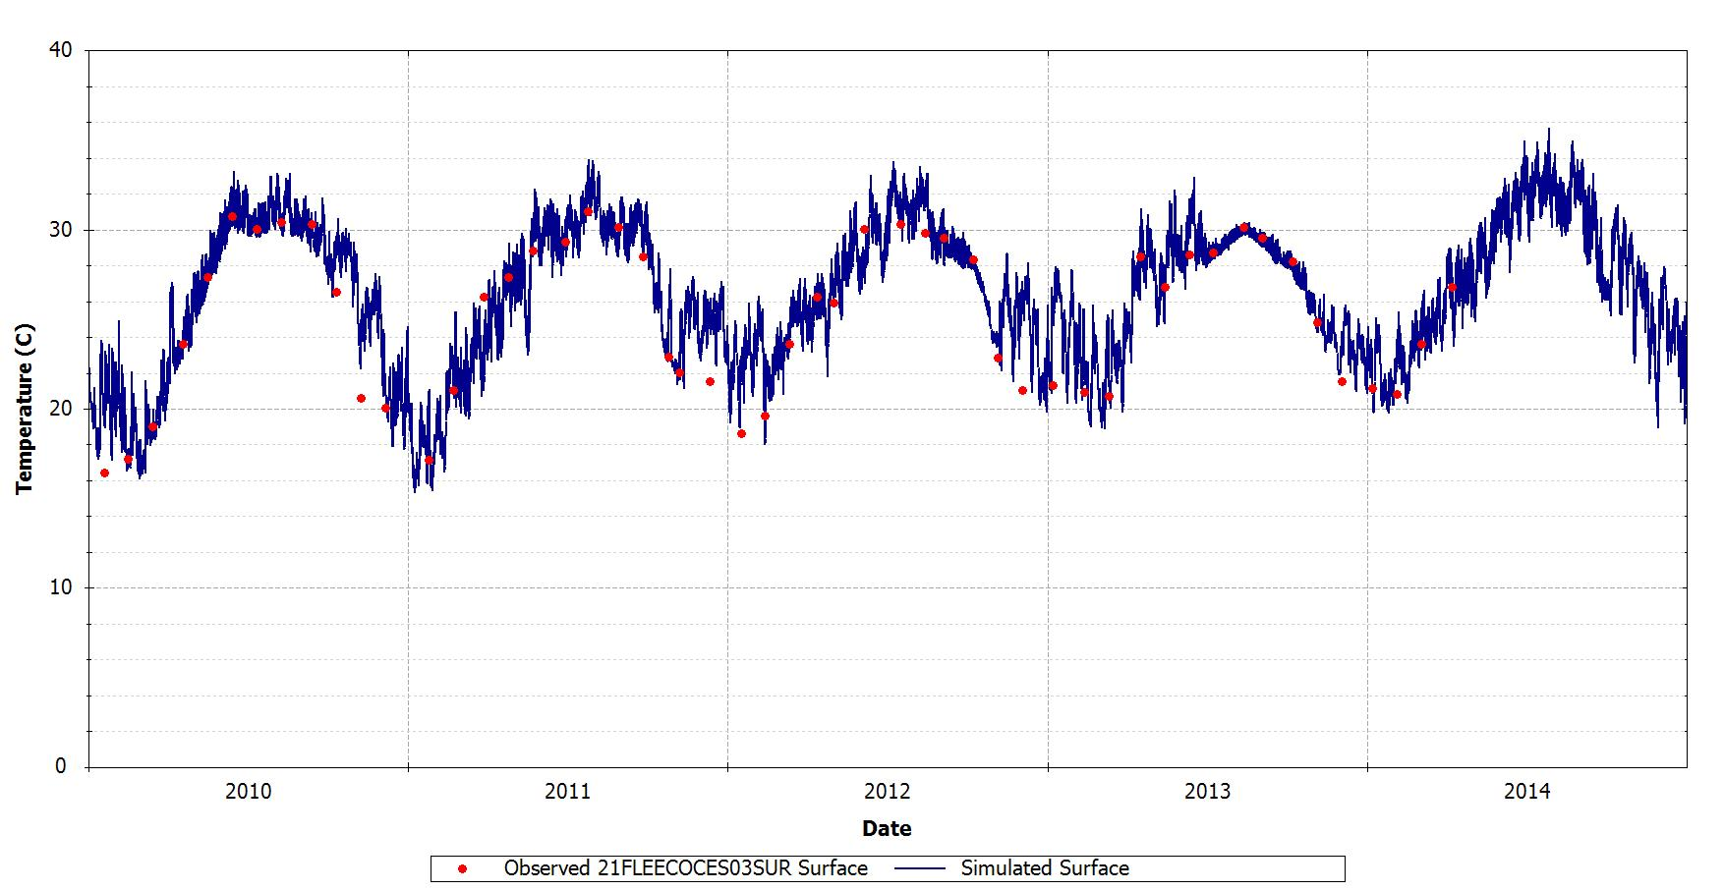
Figure 17: Simulated and observed temperature at 21FLEECOCES03SUR

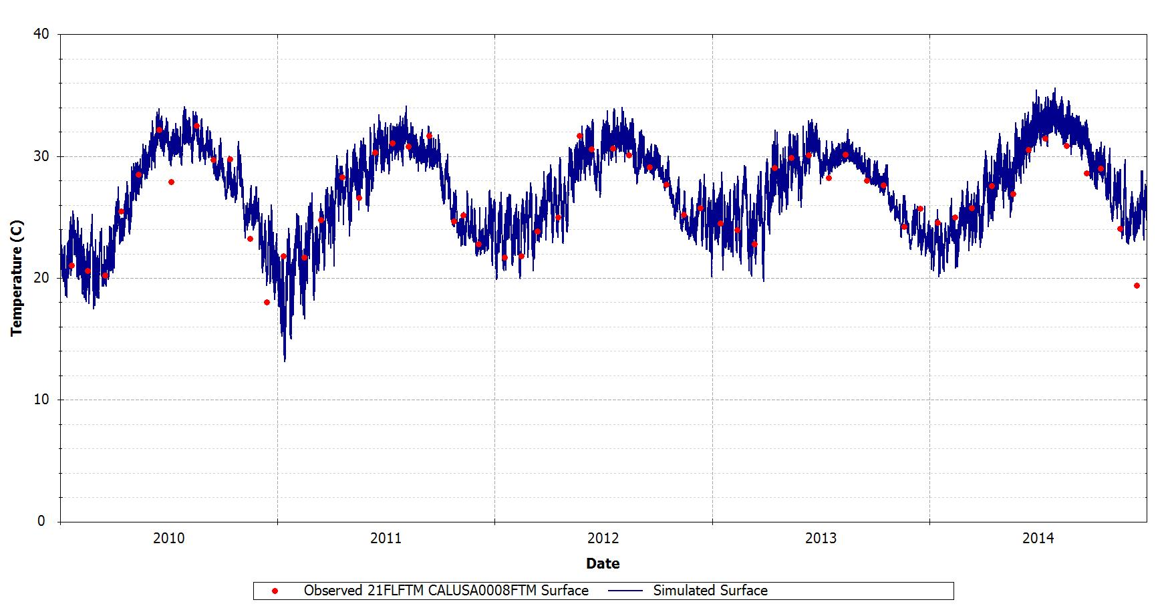
Figure 18: Simulated and observed temperature at 21FLFTM CALUSA0008FTM
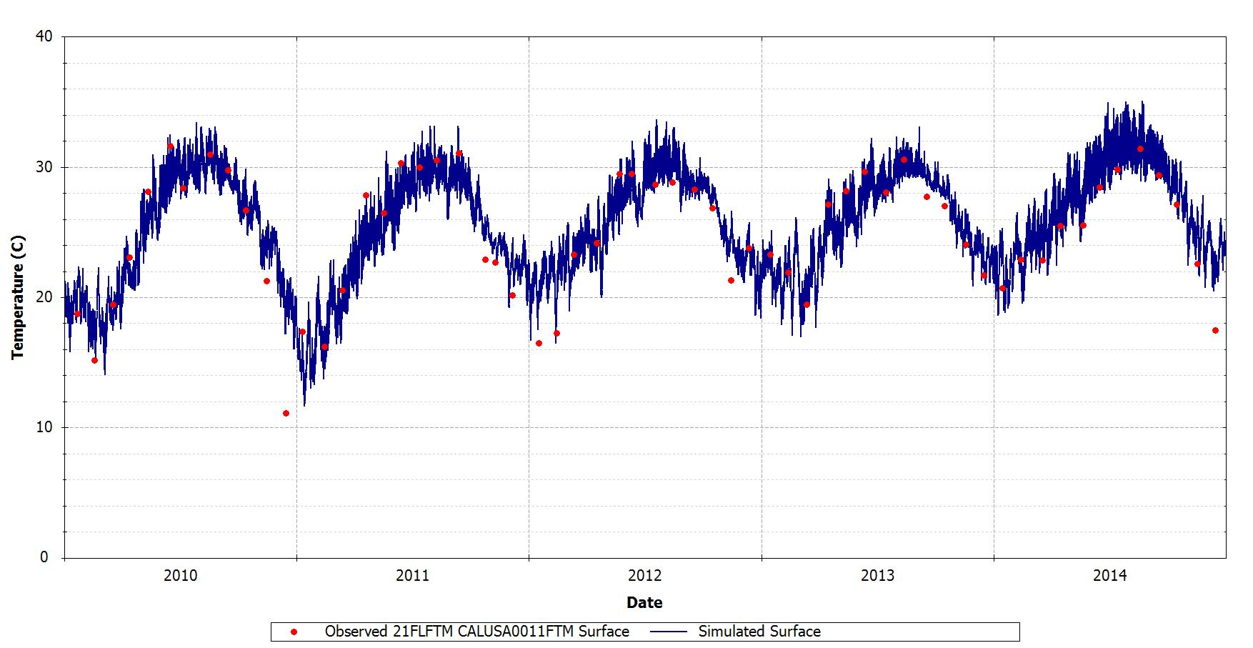
Figure 19: Simulated and observed temperature at 21FLFTM CALUSA0011FTM

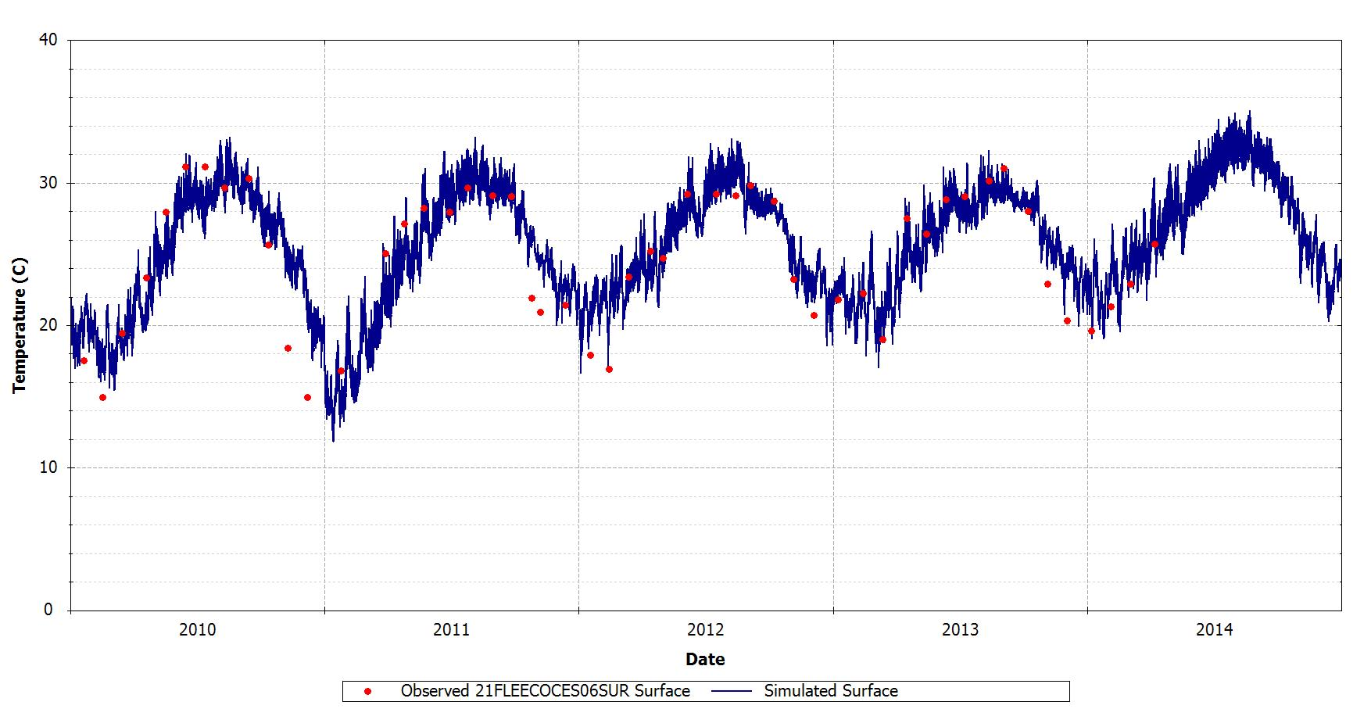
Figure 20: Simulated and observed temperature at 21FLEECOCES06SUR

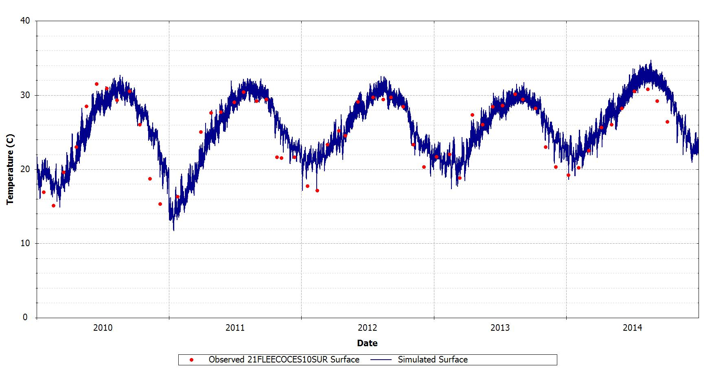
Figure 21: Simulated and observed temperature at 21FLEECOCES10SUR

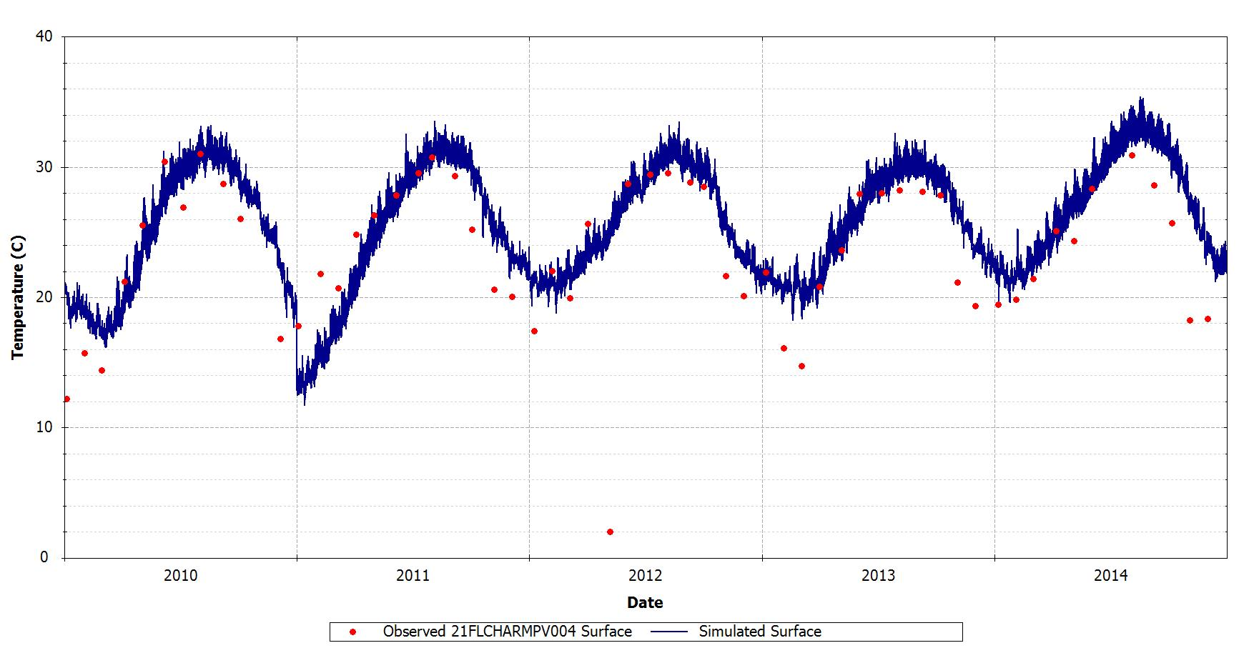
Figure 22: Simulated and observed temperature at 21CHARMPV004

Salinity
Salinity is an indicator of mass transport in estuaries. The calibration of salinity is important to evaluate the capacity of a model to represent transport resulting from density gradients between the freshwater and the ocean water (i.e. baroclinic or density-driven currents), and to ensure a model is able to represent vertical stratification in the system. A summary of the preliminary calibration results at selected stations is presented below in Table 13 and Figure 23 through Figure 28.
Draft calibration results show the model has a good performance predicting salinity in the middle and lower portions of the estuary, along with tributaries in this region (Figure 25 , Figure 28, and Appendix A). In these regions the model simulations are able to follow the seasonal trends and ranges of variation exhibited by the observations. The metrics of model performance are good with small differences between the observed and predicted means and also high index of agrement (0.80 – 0.96). In the upper region of the estuary close to the upstream boundary at S-79 at stations 21FLEECOCES03SUR and 21FLFTM CALUSA008FTM, the performance of the model is lower and the levels of salinity intrusion are not fully captured. In this region, along with nearby tributaries, the model under predicts the observed salinity concentrations (Figure 23, Figure 24, and Appendix A). The model predictions of bottom salinity at 21FLFTM CALUSA008FTM were in closer correspondence to the measured data than the surface salinity predictions at the same station, indicating that the model is able to predict salinity intrusion in the bottom layers.
Table 13: Model performance statistics for salinity
Station ID | Mean Measured (PSU) | Median Measured (PSU) | 5th Percentile Measured (PSU) | 95th Percentile Measured (PSU) | Mean Simulated (PSU) | Median Simulated (PSU) | 5th Percentile Simulated (PSU) | 95th Percentile Simulated (PSU) | R² | MAE (PSU) | RMSE (PSU) | NRMSE | Index of Agrmt
21FLEECOCES03SUR | 2.5 | 1.2 | 0.2 | 11.1 | 0.89 | 0.4 | 0.13 | 5.21 | 0.58 | 1.79 | 2.95 | 1.26 | 0.63
21FLFTM CALUSA0008FTM - Surface | 3.4 | 3.1 | 0.2 | 12.7 | 1.08 | 0.61 | 0.19 | 5.6 | 0.64 | 2.48 | 3.55 | 1.26 | 0.60
21FLFTM CALUSA0008FTM -Bottom | 10.5 | 12.6 | 0.2 | 25.7 | 4.52 | 4.3 | 0.19 | 14.56 | 0.69 | 5.97 | 7.74 | 0.87 | 0.70
21FLFTM CALUSA0011FTM | 8.0 | 8.7 | 0.2 | 20.0 | 5.62 | 5.95 | 0.33 | 12.82 | 0.61 | 3.51 | 4.62 | 0.57 | 0.80
21FLEECOCES06SUR | 10.3 | 12.3 | 0.2 | 23.9 | 10.93 | 13.96 | 0.35 | 21.46 | 0.87 | 2.12 | 2.78 | 0.22 | 0.96
21FLEECOCES10SUR | 19.5 | 23.0 | 1.1 | 33.8 | 20.59 | 23.78 | 1.80 | 32.54 | 0.88 | 2.76 | 3.59 | 0.16 | 0.96
21FLCHARMPV004 | 26.3 | 28.3 | 10.0 | 35.5 | 28.63 | 31.34 | 11.89 | 35.39 | 0.63 | 3.86 | 4.89 | 0.17 | 0.87

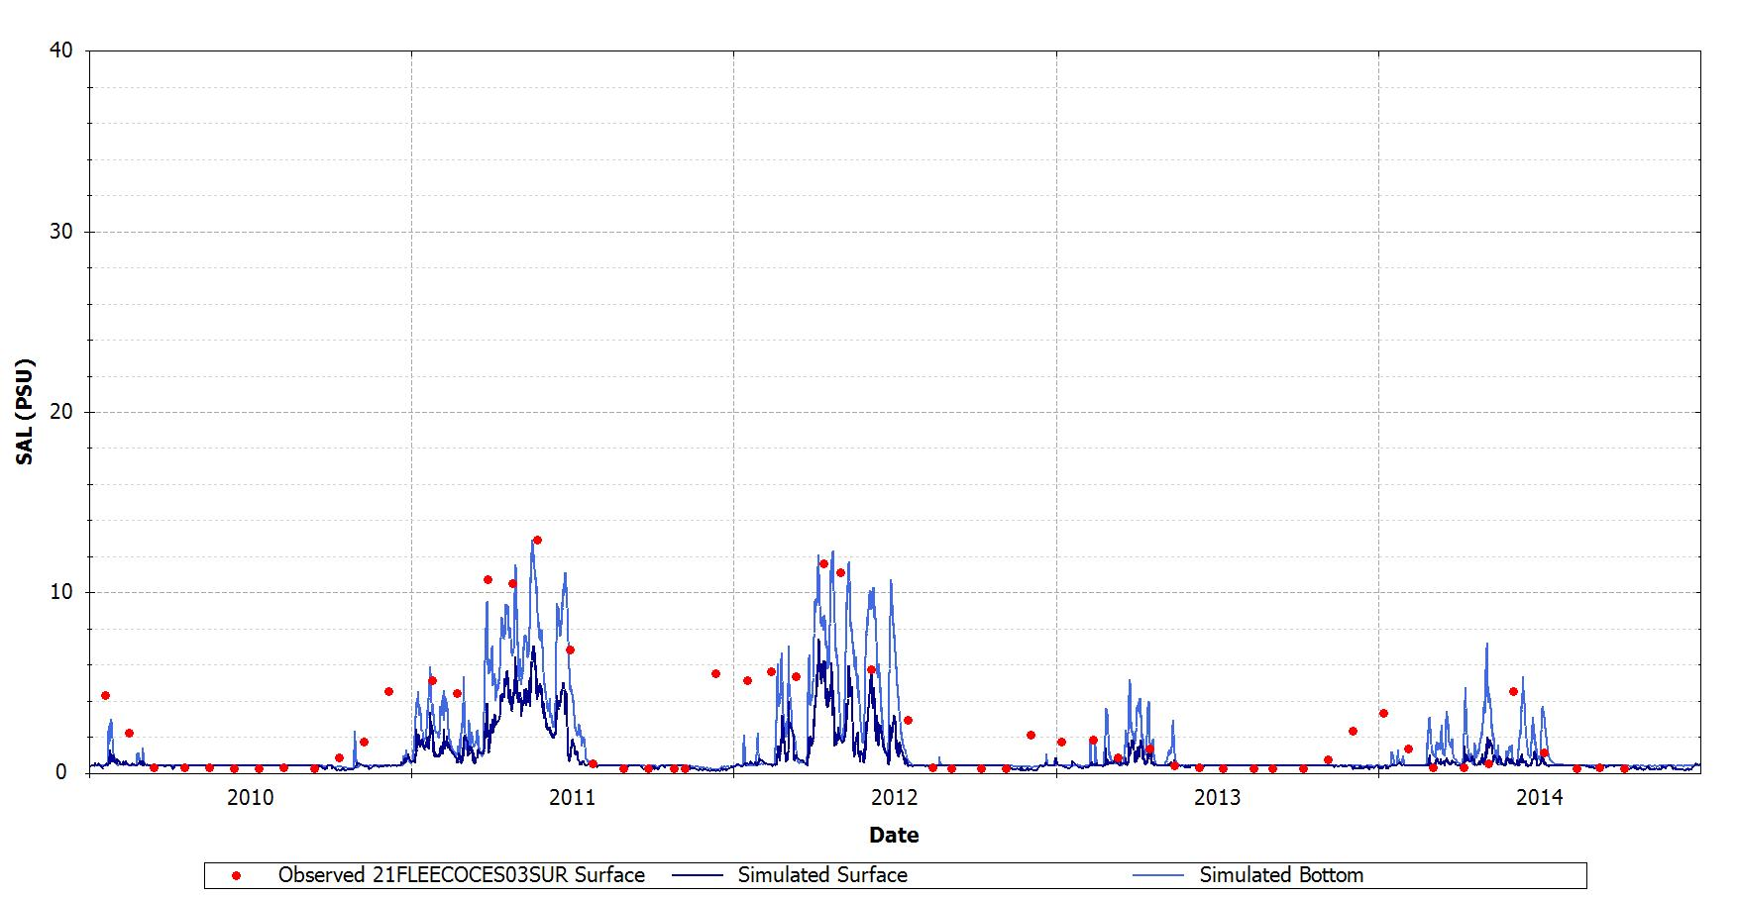
Figure 23: Simulated and observed salinity at 21FLEECOCES03SUR

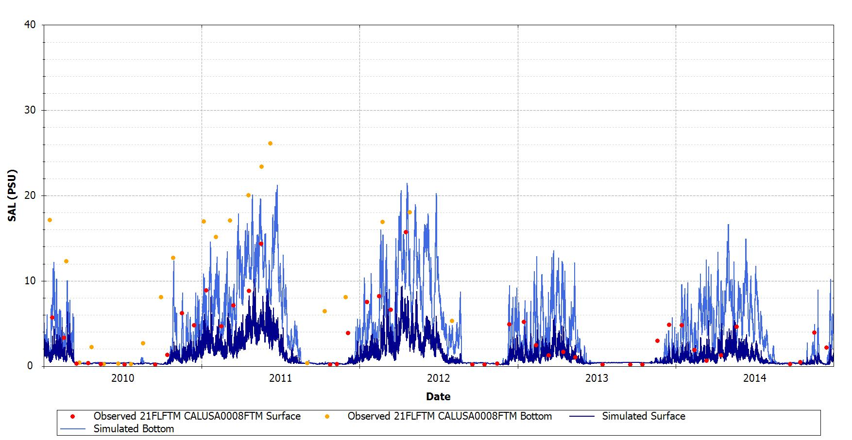
Figure 24: Simulated and observed salinity at 21FLFTM CALUSA0008FTM
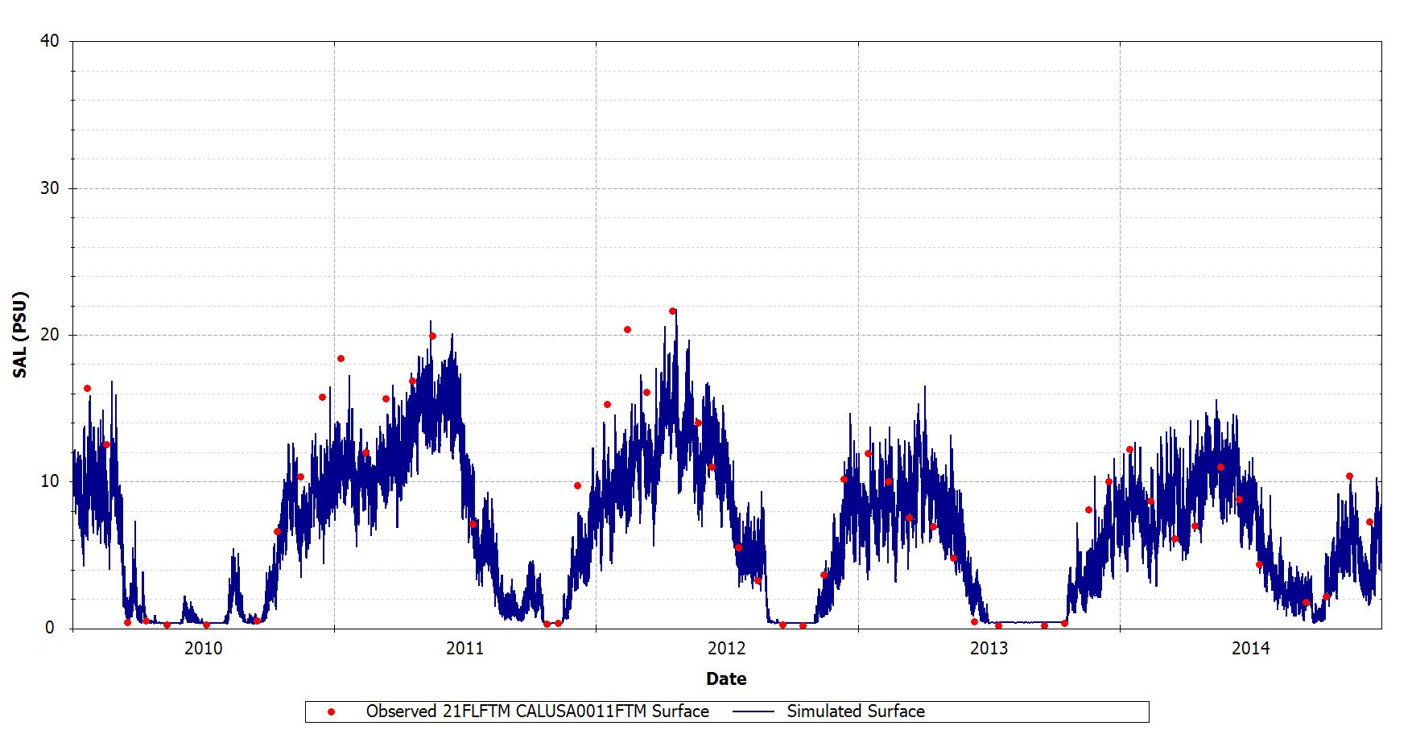
Figure 25: Simulated and observed salinity at 21FLFTM CALUSA0011FTM

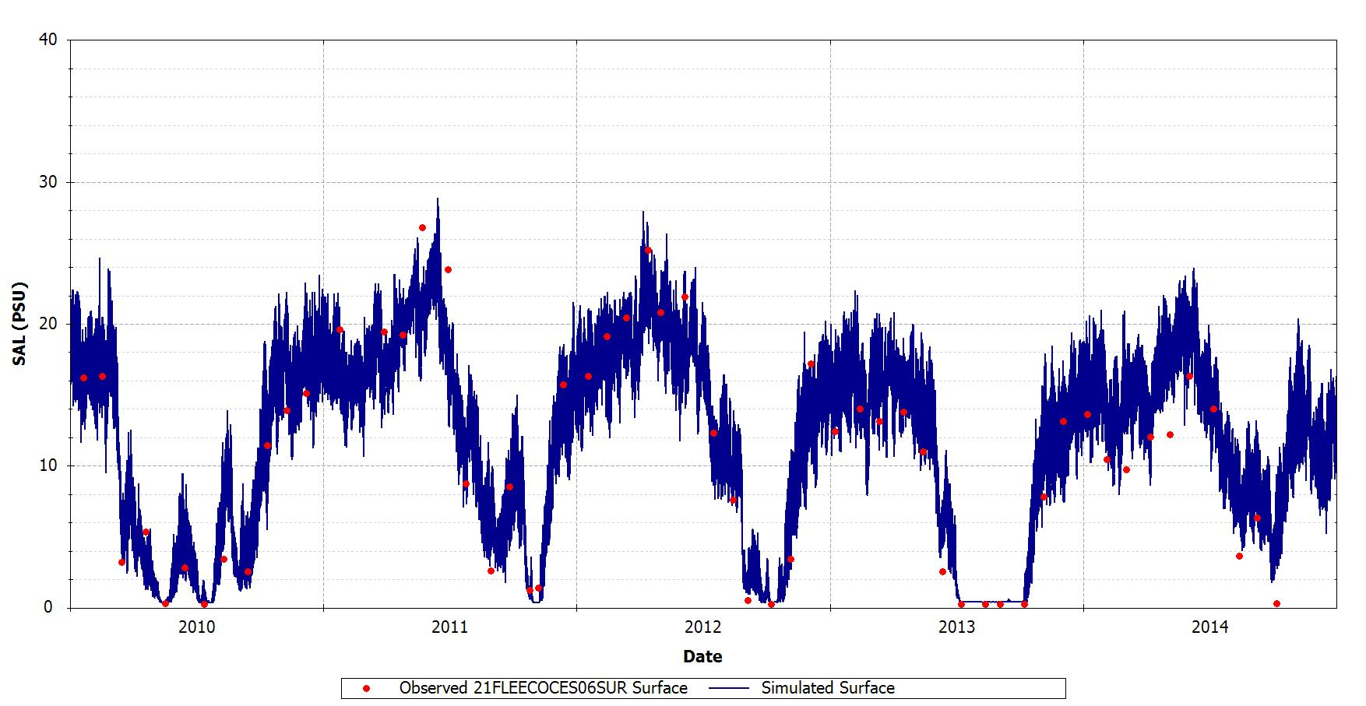
Figure 26: Simulated and observed salinity at 21FLEECOCES06SUR
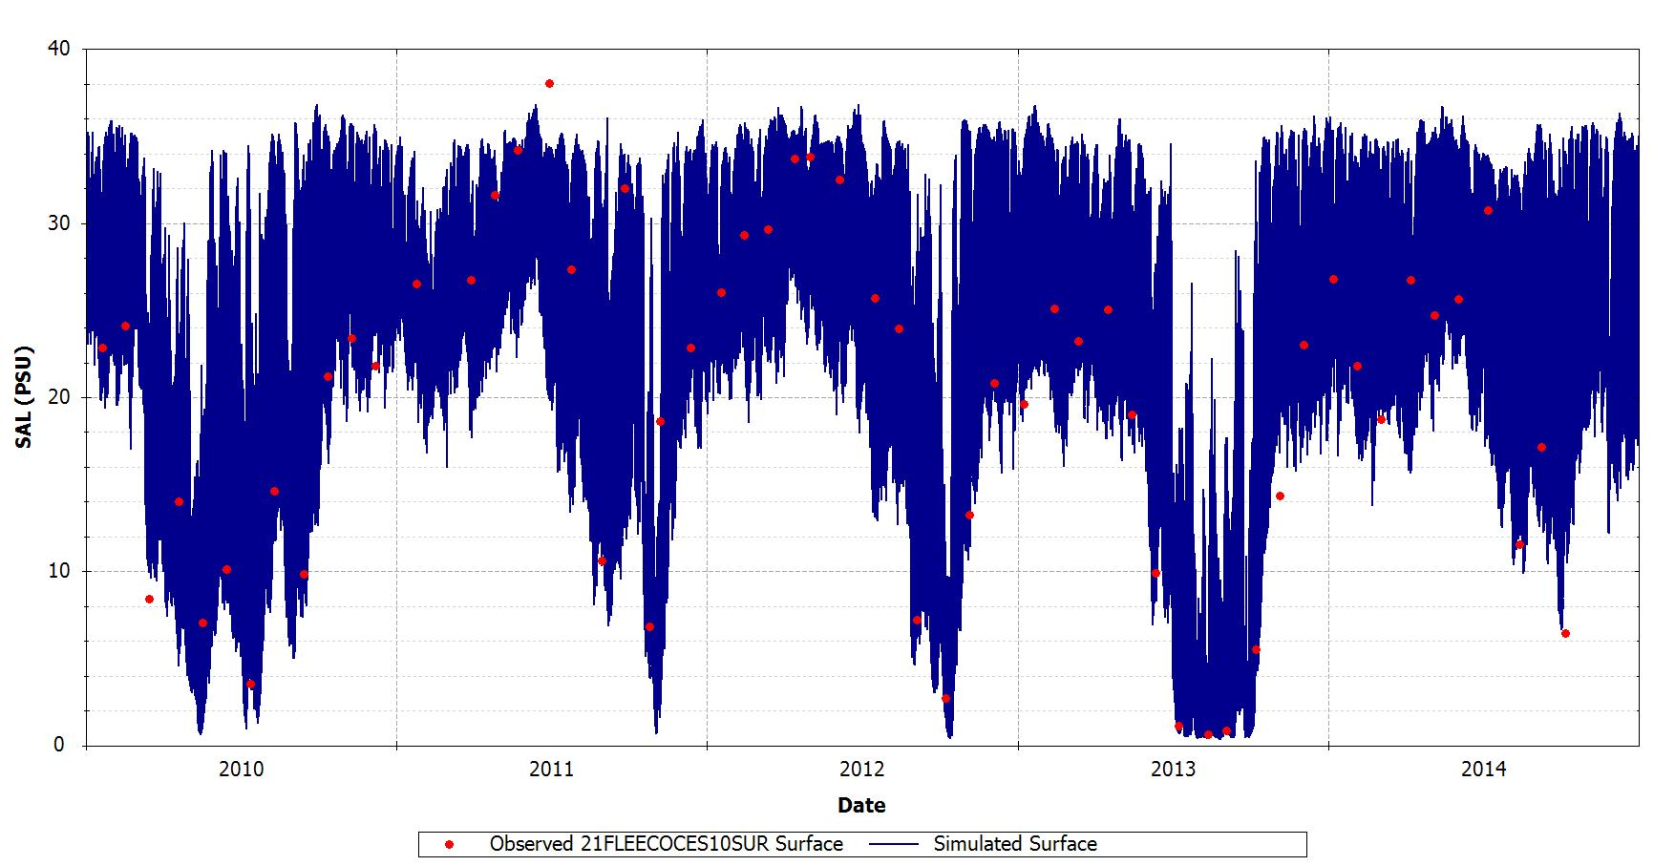
Figure 27: Simulated and observed salinity at 21FLEECOCES10SUR

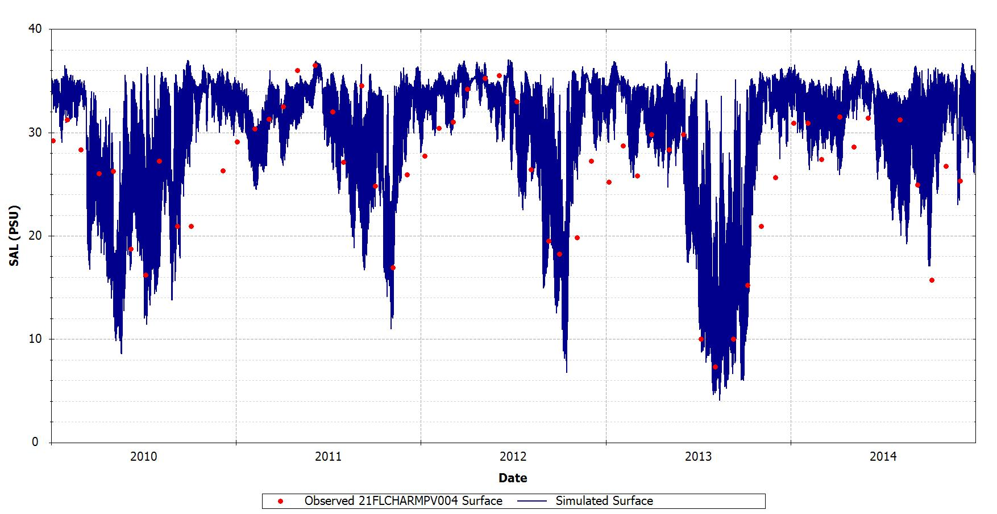
Figure 28: Simulated and observed salinity at 21CHARMPV004

Flows
The 2017 Caloosahatchee EFDC model was calibrated to reproduce tidal flows based on cross section average measurements available at several USGS/USGS-SOFIA (South Florida Information Access) stations across the estuary. The comparison between observed and simulated flows was used to refine the bottom roughness of the model, and to refine the configuration of the model grid and bathymetry. The calibration results are summarized below in Table 14 and from Figure 29 to Figure 37.
In general, the model was able to represent the range and magnitude of the flows observed throughout the estuary. The model performed well during spring and neap periods, although there were small timing discrepancies between the observed and simulated flows which seem to have negatively impacted the model performance statistics and in particular the mean absolute error (MAE) and normalized root mean square error (NRMSE). At most stations the model was able to reproduce the magnitude of the flood and ebb flows and at stations close to the mouth of the estuary the ebb flows seemed to be slightly over predicted (e.g. Figure 35 through Figure 37).

Table 14: Model performance statistics for flow
Station ID | Mean Measured (cms) | Median Measured (cms) | 5th Percentile Measured (cms) | 95th Percentile Measured (cms) | Mean Simulated (cms) | Median Simulated (cms) | 5th Percentile Simulated (cms) | 95th Percentile Simulated (cms) | R² | MAE (cms) | RMSE (cms) | NRMSE | Index of Agrmt
02293205 (Marker 52) | -52.78 | -97.69 | -526.69 | 498.38 | -46.81 | -54.88 | -695.21 | 649.92 | 0.83 | 208.77 | 255.45 | 0.12 | 0.89
2631440820810400 (Punta Blanca) | -51.79 | 15.01 | -1,010.91 | 896.23 | -64.69 | -19.59 | -1,118.99 | 902.66 | 0.88 | 254.16 | 323.96 | 0.11 | 0.94
02293210 (Shell Point) | -28.84 | 9.63 | -396.44 | 308.65 | -30.42 | 16.87 | -519.50 | 383.12 | 0.87 | 128.47 | 57.93 | 0.16 | 0.92

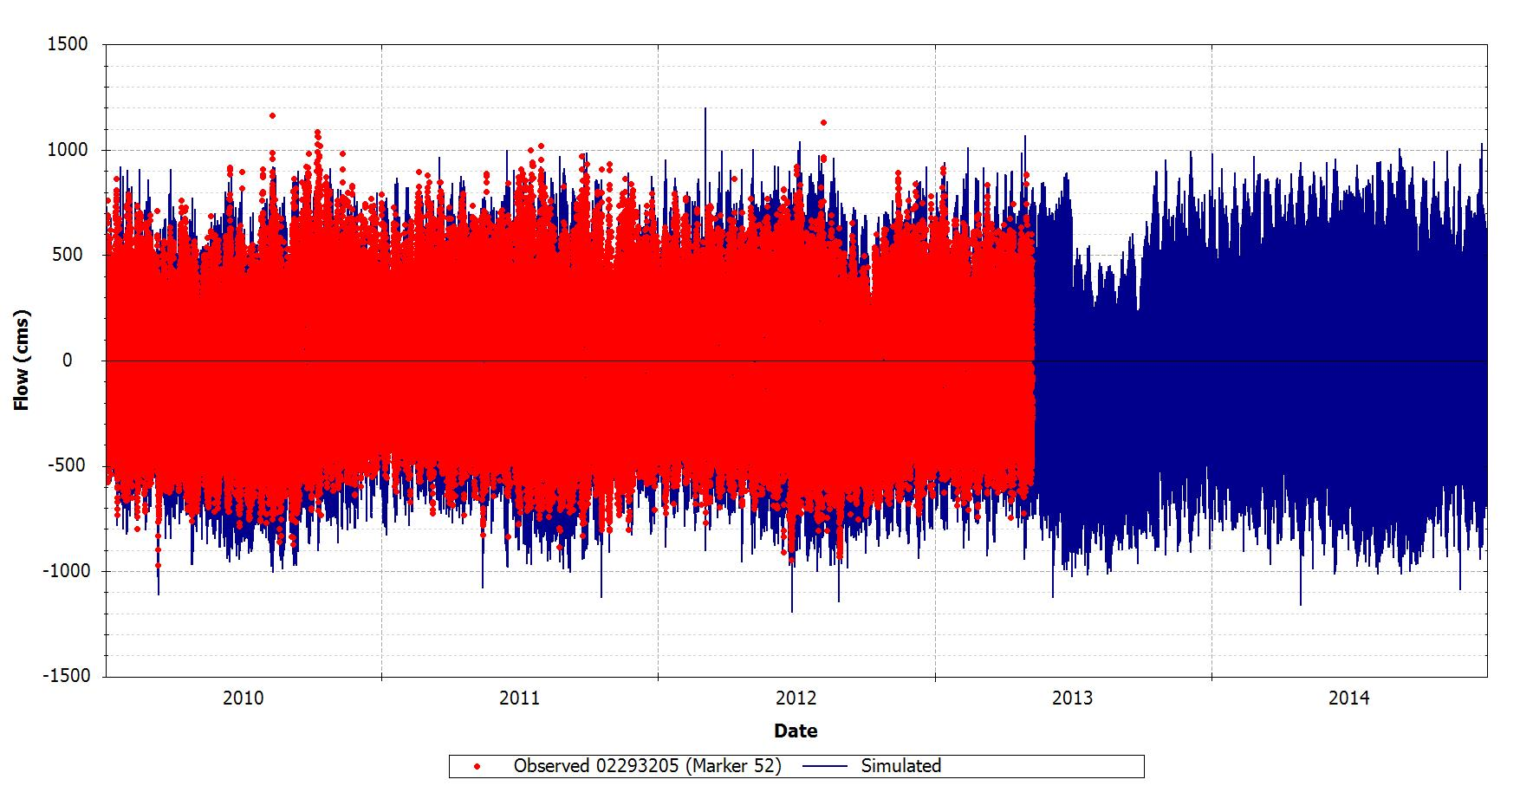
Figure 29: Simulated and observed flow at USGS 02293205 (Marker 52), 2010 – 2014

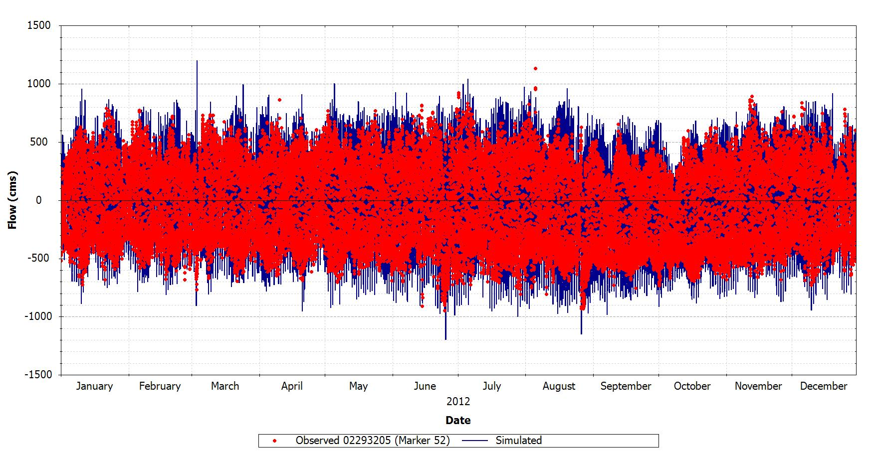
Figure 30: Simulated and observed flow at USGS 02293205 (Marker 52), 2012
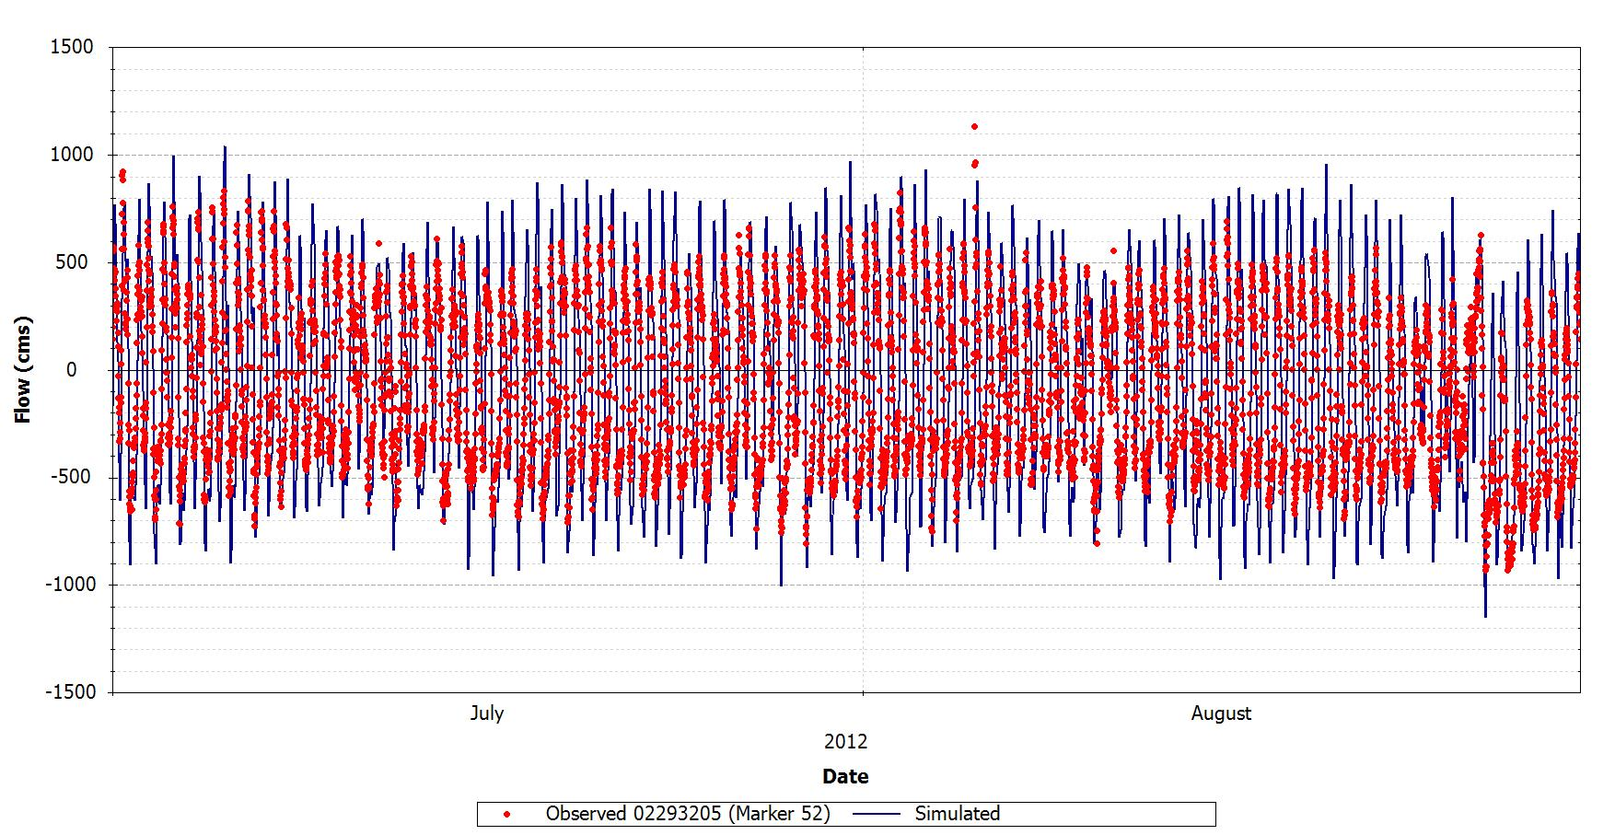
Figure 31: Simulated and observed flow at USGS 02293205 (Marker 52), July – August, 2012

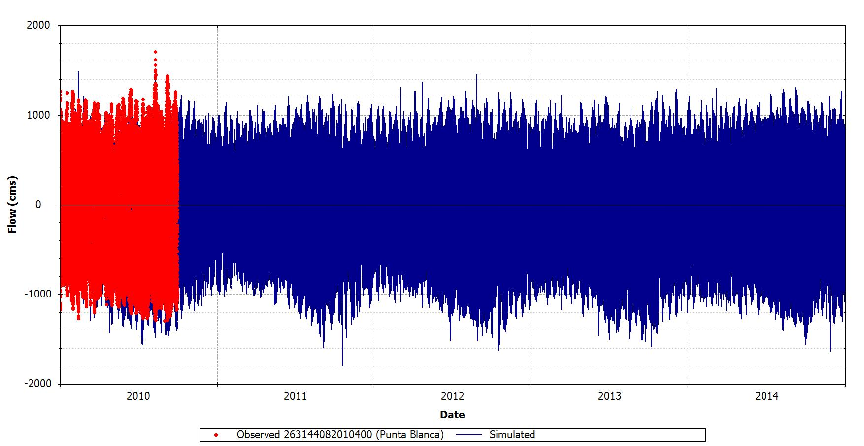
Figure 32: Simulated and observed flow at station 2631440820810400 (Punta Blanca), 2010 – 2014

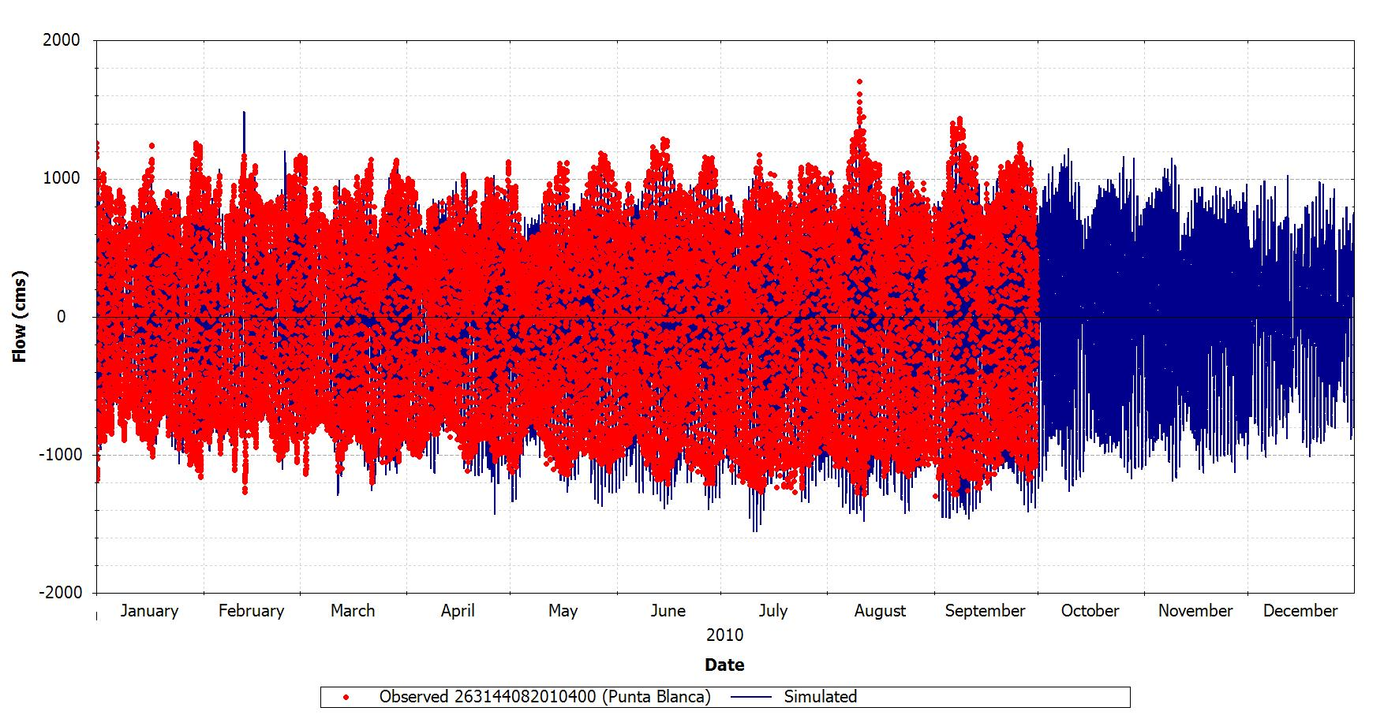
Figure 33: Simulated and observed flow at station 2631440820810400 (Punta Blanca), 2010

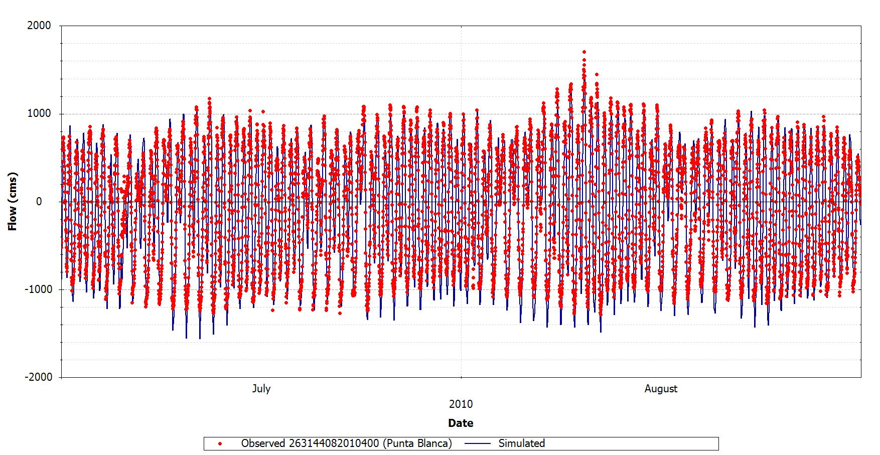
Figure 34: Simulated and observed flow at station 2631440820810400 (Punta Blanca), July – August, 2010

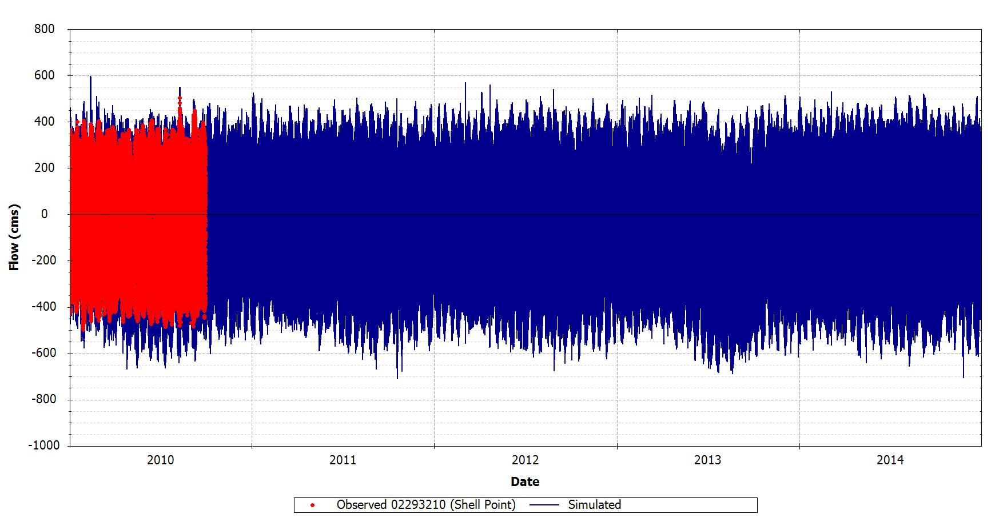
Figure 35: Simulated and observed flow at USGS 02293210 (Shell Point), 2010 – 2014

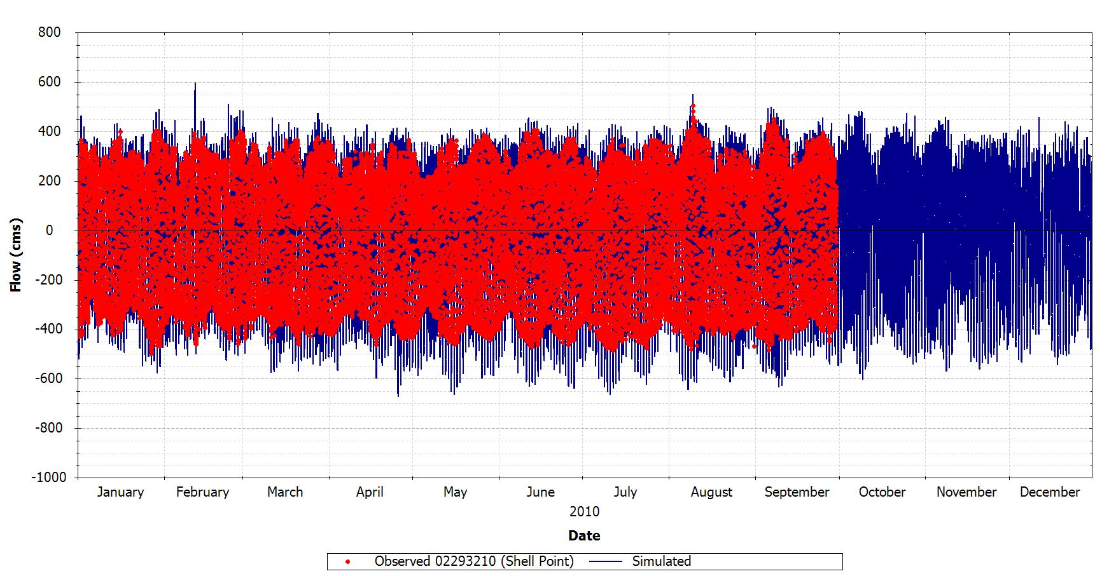
Figure 36: Simulated and observed flow at USGS 02293210 (Shell Point), 2010

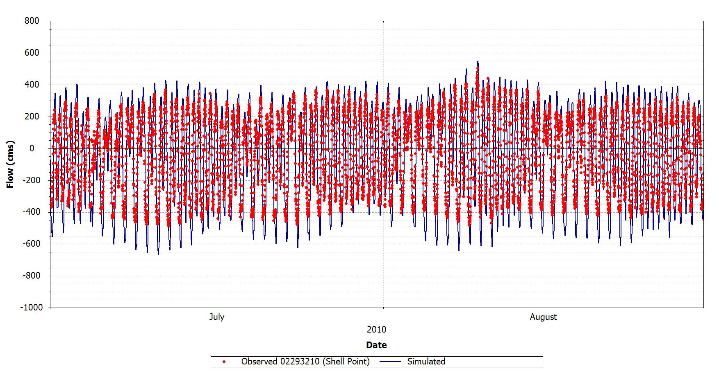
Figure 37: Simulated and observed flow at USGS 02293210 (Shell Point), July – August, 2010

Calibration Issues, Modifications, and Recommendations
Issue #1: There are no bathymetry data available for the tributary channels included in the EFDC model grid.
Modification: The department provided Tetra Tech with a dataset of cross-section information for some of the tributaries. The dataset consisted of surveyed data from Jacks Branch and input data files from the North Fort Myers Mike11 model. The dataset could not be directly used during the setup of the 2017 EFDC Model because the Jacks Branch tributary is located outside the limits of the EFDC model and because the input datasets from the Mike11 model (in .txt format) did not contain data for the tributaries included in the EFDC model.
Tetra Tech adjusted the bathymetry in the tributaries during the model setup and calibration runs to ensure a stable model setup. The data provided by the department, although not directly used in the EFDC model, were used as a reference to define reasonable bathymetric values to the different tributaries in the model.
Issue #2: The model may not be stable between wetting and drying periods in the marsh cells.
Modification: The vegetation parameters for the marsh cells were adjusted during model calibration to ensure the model was stable between wetting and drying periods.
Issue #3: The open boundary conditions need to be adjusted. Currently, the model setup uses the tidal records available at NOAA station 8725110 (Naples, FL).
Modification: During model calibration, Tetra Tech adjusted the phase and amplitude of the WSE time series used to force the south model boundaries. Tetra Tech also used the principal tidal harmonic constituents reported at NOAA station 8725541 (Bokellia, Charlotte Harbor, FL) to construct a WSE time series to force the north open boundaries. The modifications performed during the model setup and calibration runs had a positive impact on the stability and predictive performance of the model.
Issue #4: Salinity intrusion in the riverine portion is limited in the current model setup.
Recommendation: The turbulence parameters, in particular the parameters controlling the stability of the stratification, were adjusted to improve the transport of salinity fronts from the embayment to the upstream regions. The grid cell alignment and channel depth was evaluated and adjusted to better simulate water movement in the estuary.
Issue #5: Temperature is currently under predicted by the model when using the initial HSPF draft temperature results.
Recommendation: The S-79 temperature boundary condition used measured temperature data. The temperature boundary will be replaced with modeled results once the HSPF model is completed.

References
Hamrick, J. M. 1992. A Three-Dimensional Environmental Fluid Dynamics Computer Code: Theoretical and Computational Aspects. The College of William and Mary, Virginia Institute of Marine Science. Special Report 317, 63 pp.
Ji, Zhen-Gang. 2008. Hydrodynamics and Water Quality Modeling Rivers, Lakes and Estuaries. John Wiley & Sons, Inc.

Appendix A: Hydrodynamic Calibration Results

WATER SURFACE ELEVATION
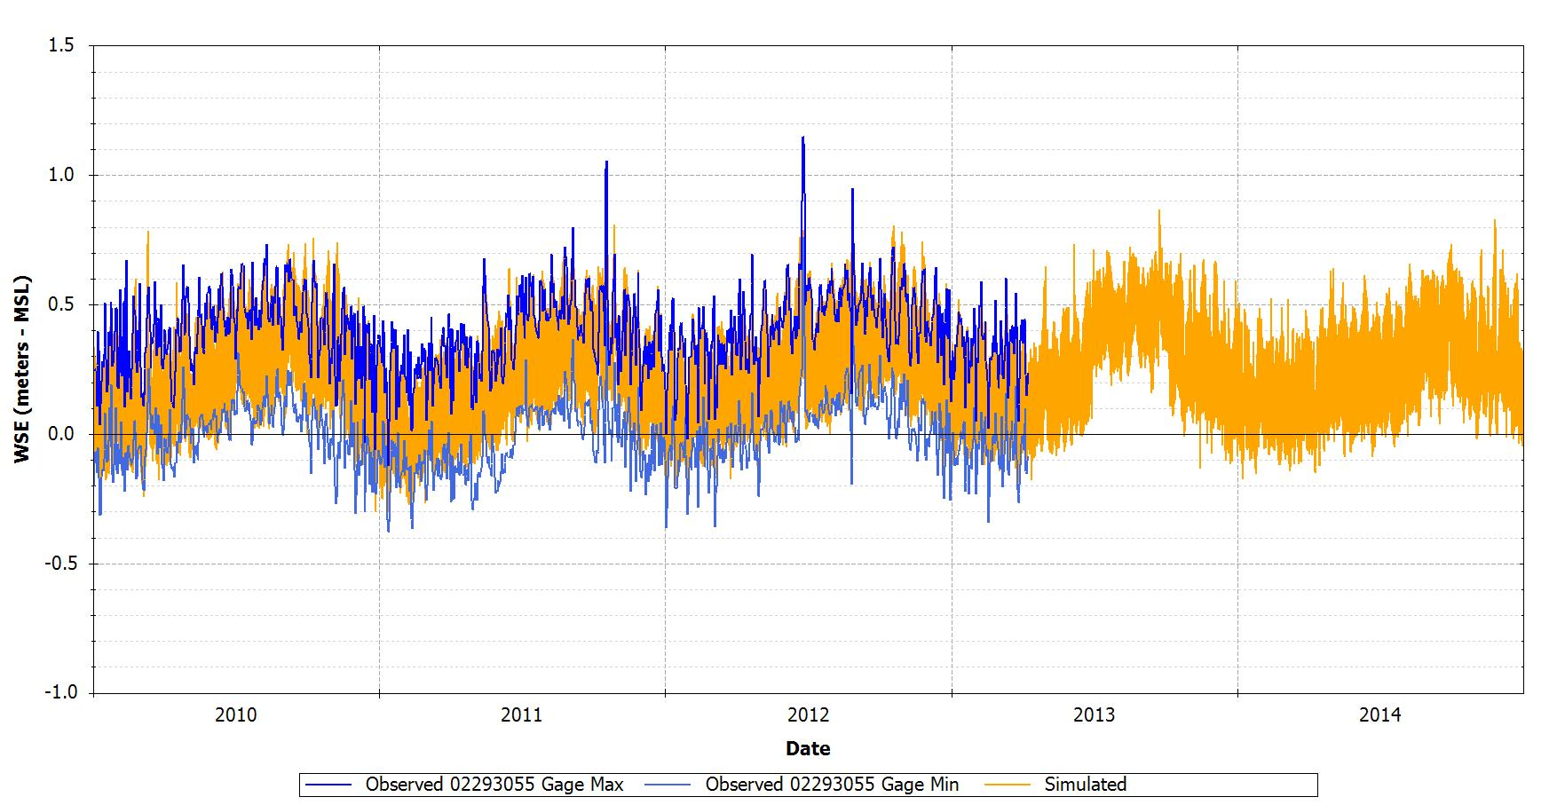
Figure A-1: Simulated and observed WSE at USGS 02293055

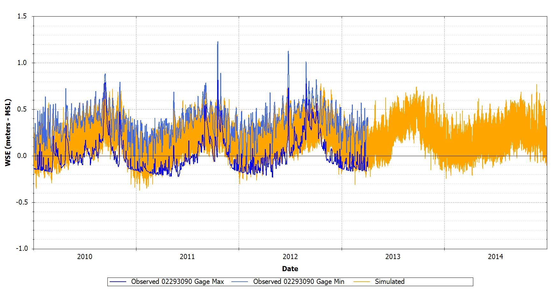
Figure A-2: Simulated and observed WSE at USGS 02293090

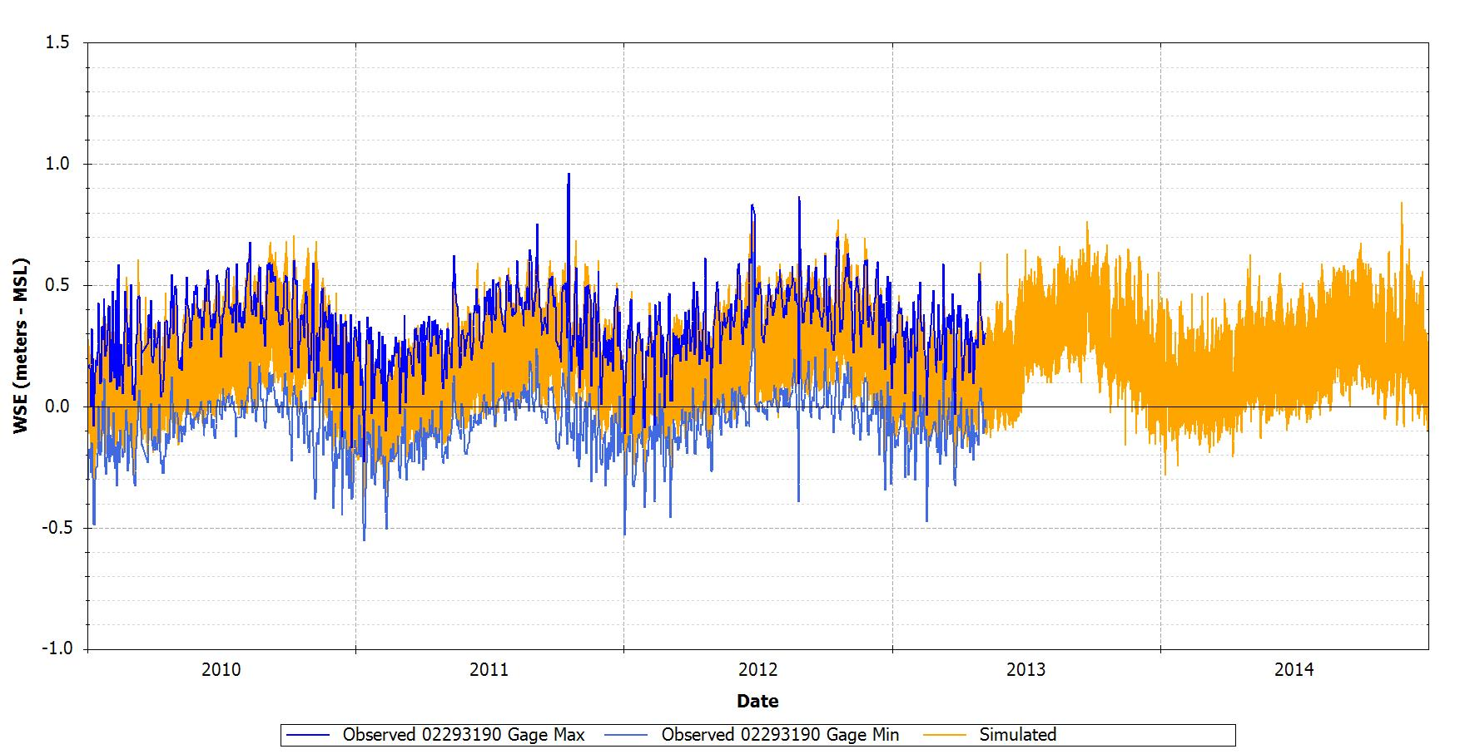
Figure A-3: Simulated and observed WSE at USGS 02293190

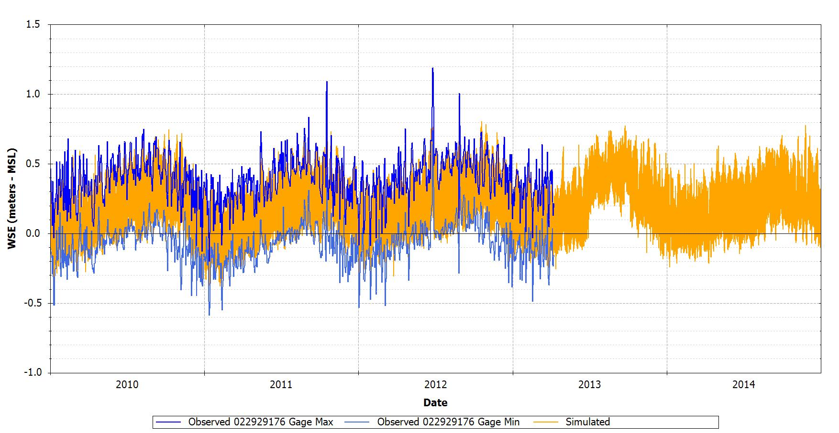
Figure A-4: Simulated and observed WSE at USGS 022929176
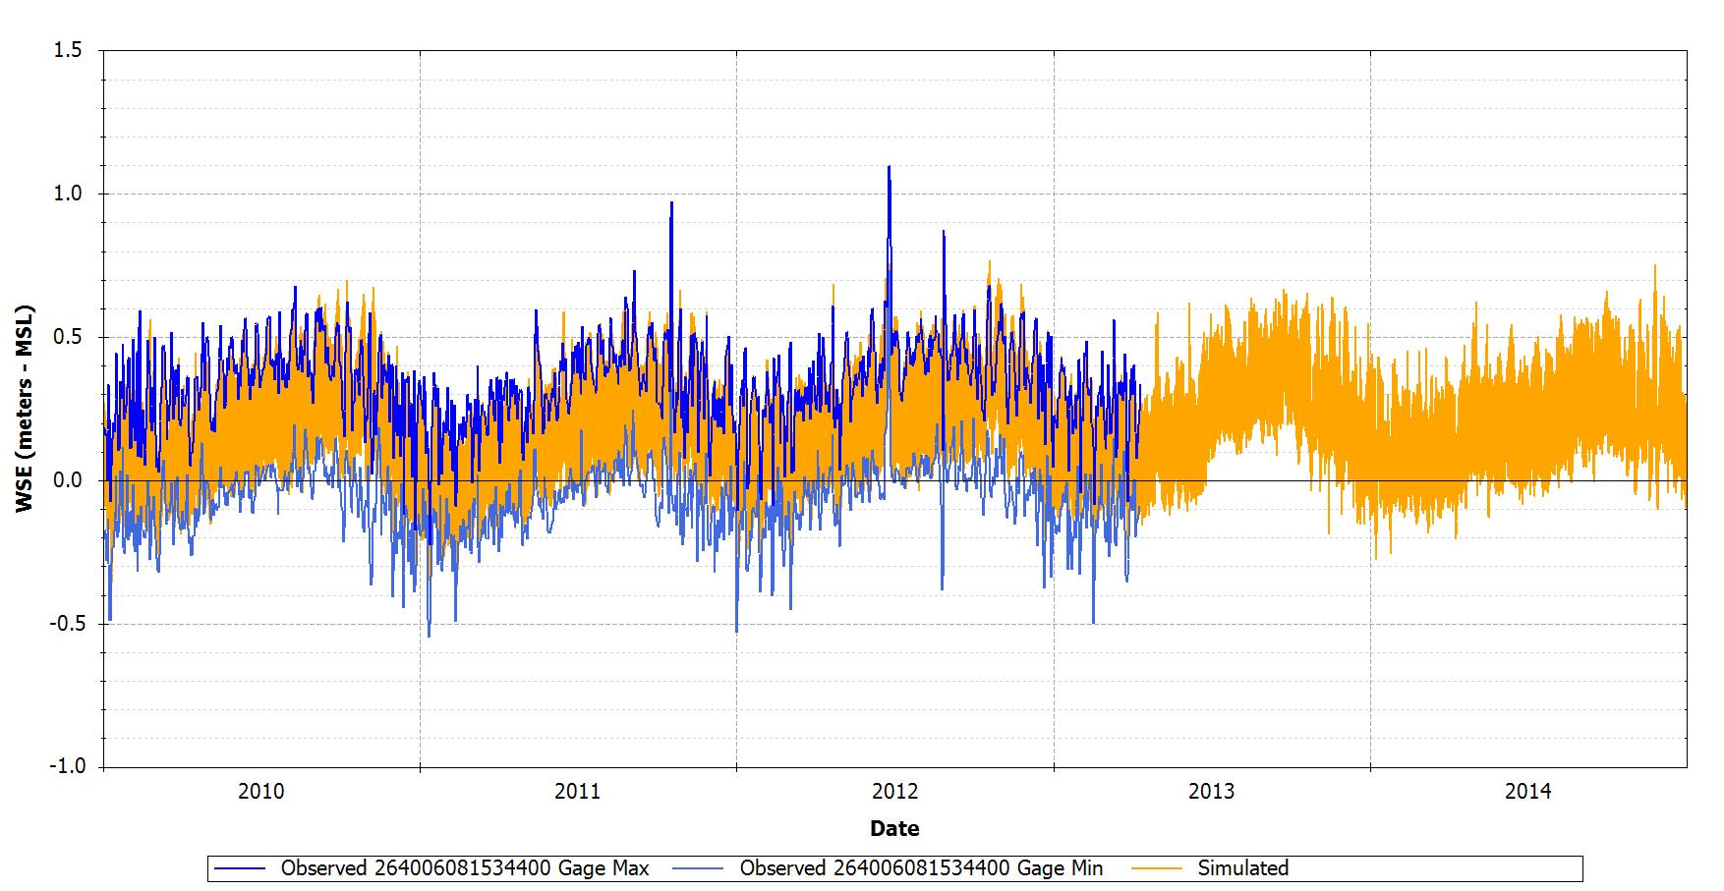
Figure A-5: Simulated and observed WSE at station 264006081534400

TEMPERATURE
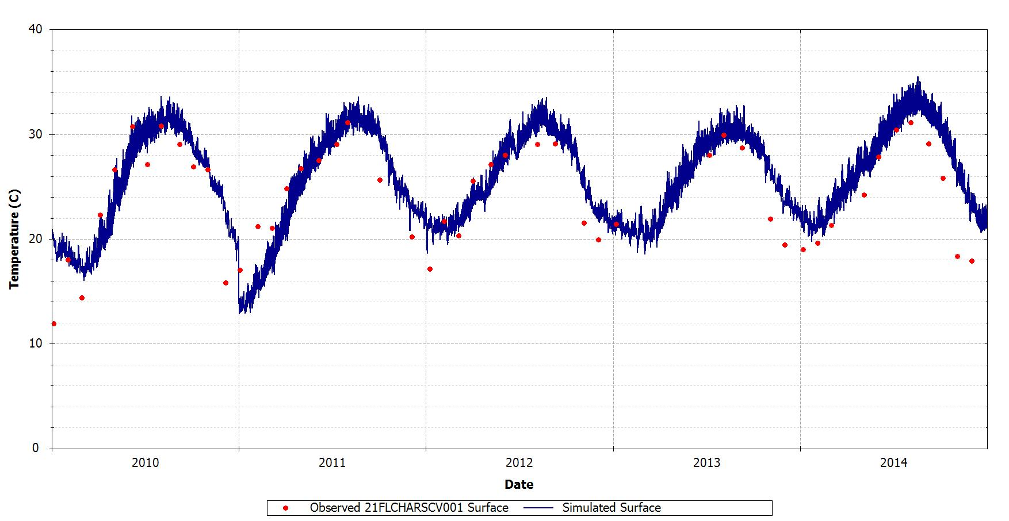
Figure A-6: Simulated and observed temperature at 21FLCHARSCV001

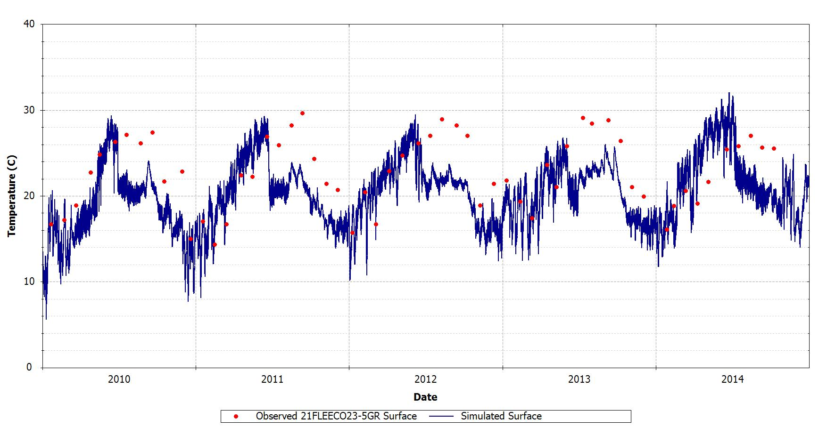
Figure A-7: Simulated and observed temperature at 21FLEECO23-5GR

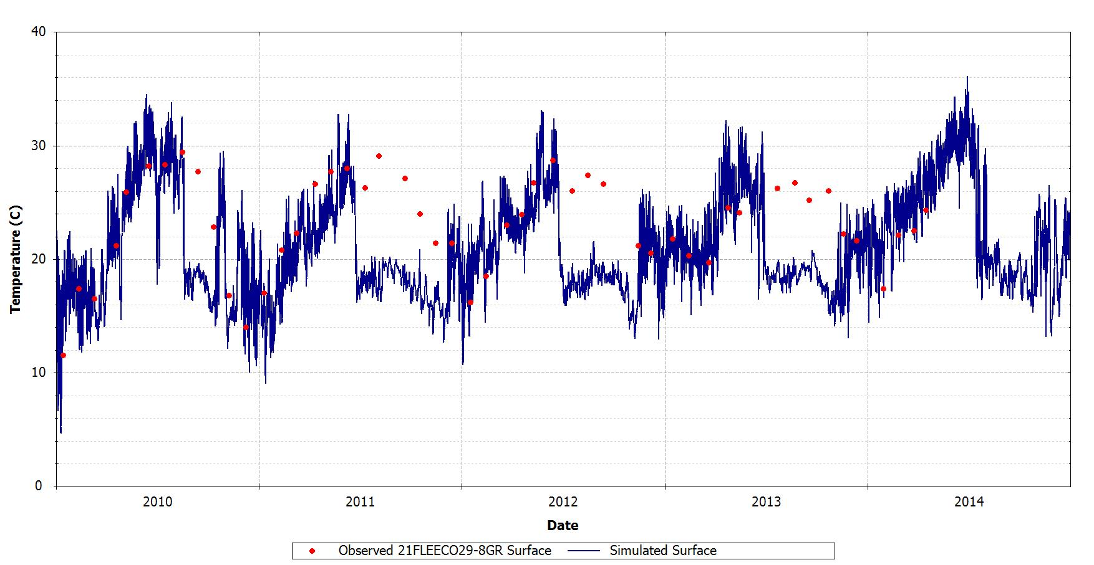
Figure A-8: Simulated and observed temperature at 21FLEECO29-8GR

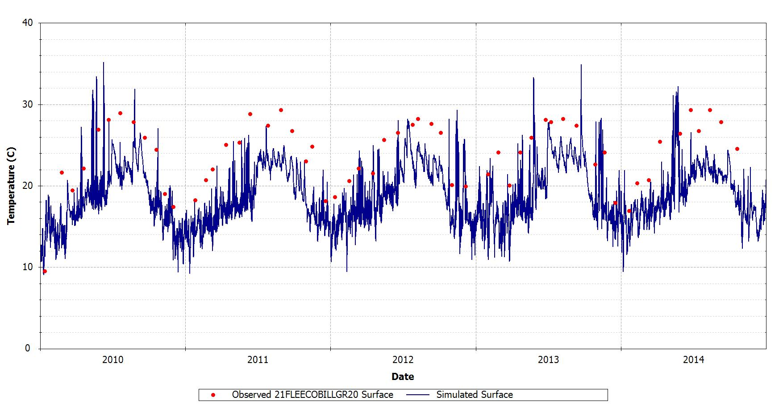
Figure A-9: Simulated and observed temperature at 21FLEECOBILLGR20
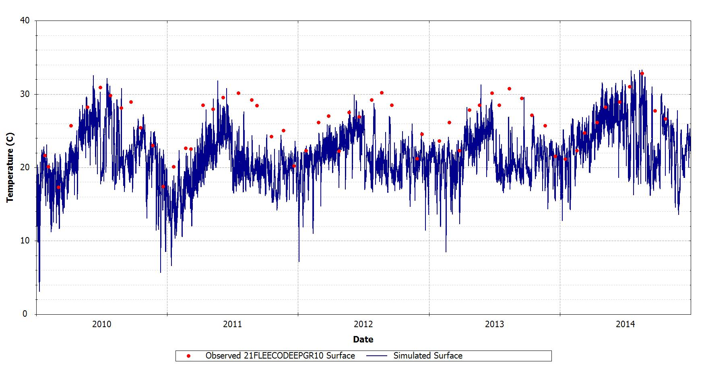
Figure A-10: Simulated and observed temperature at 21FLEECODEEPGR10

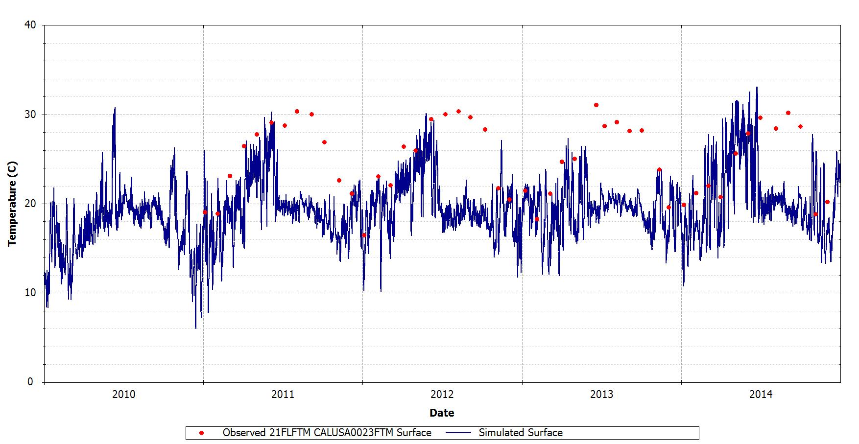
Figure A-11: Simulated and observed temperature at 21FLFTMCALUSA0023FTM

SALINITY
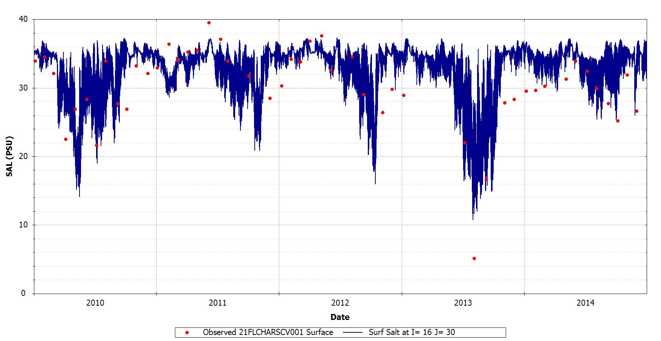
Figure A-12: Simulated and observed salinity at 21FLCHARSCV001

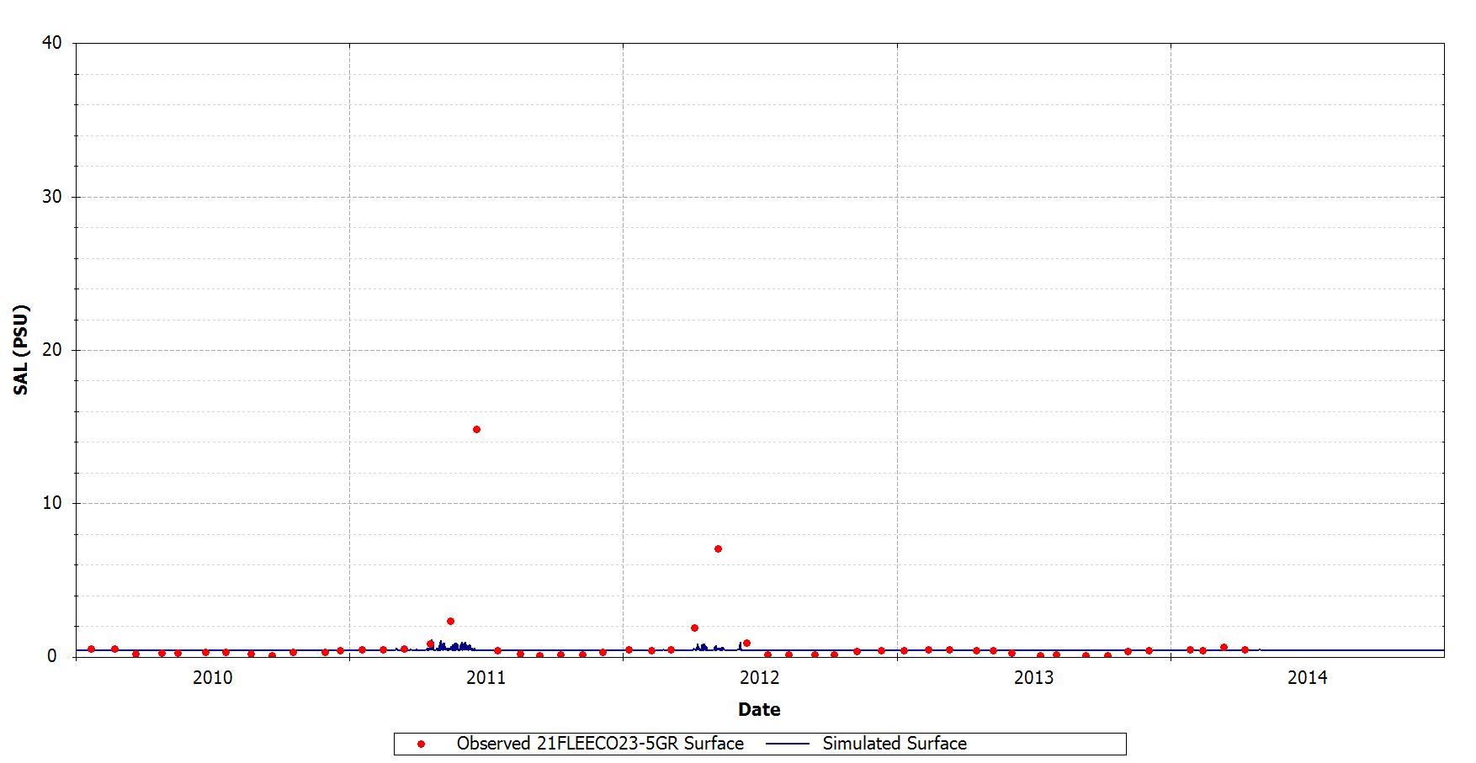
Figure A-13: Simulated and observed salinity at 21FLEECO23-5GR
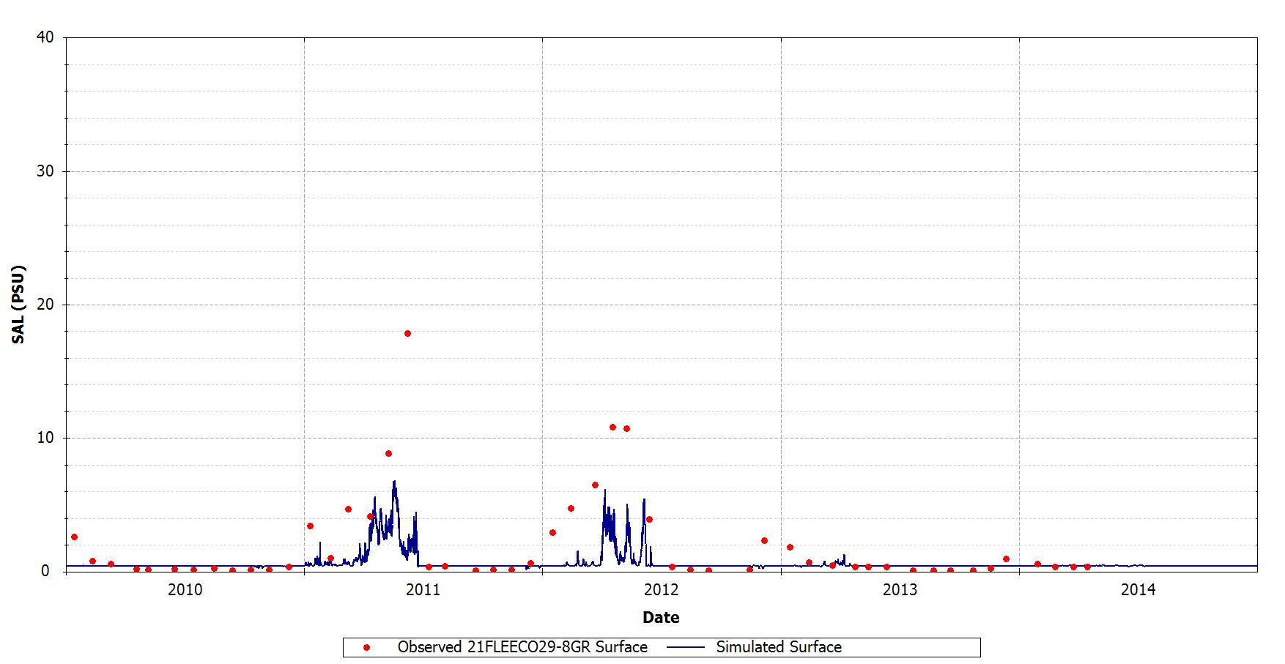
Figure A-14: Simulated and observed salinity at 21FLEECO29-8GR

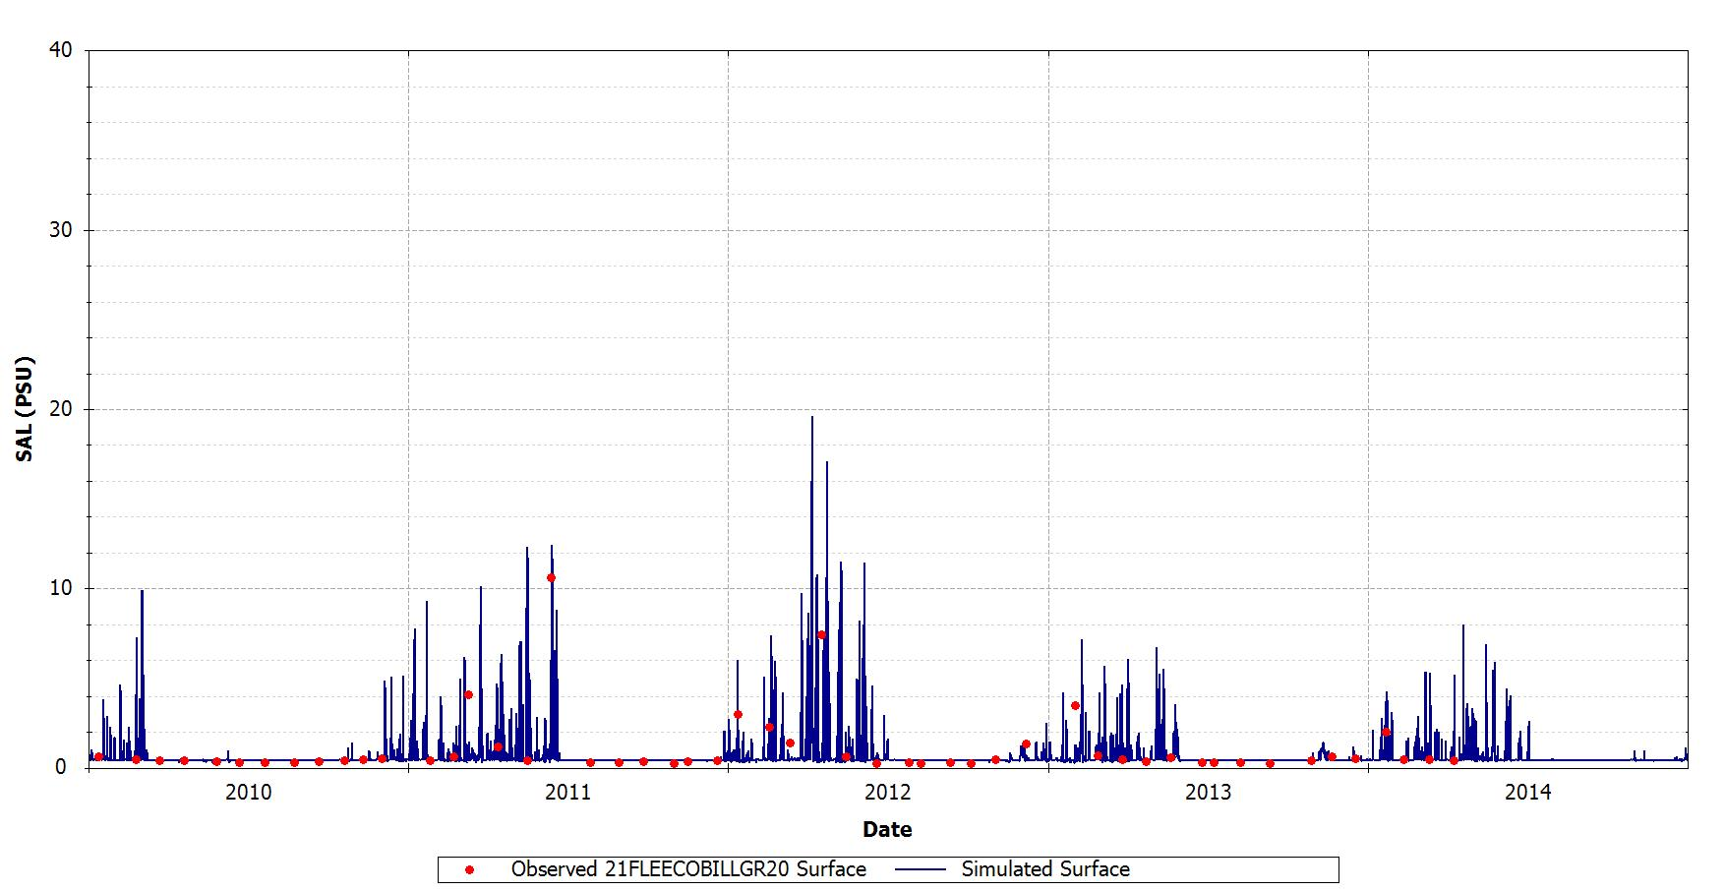
Figure A-15: Simulated and observed salinity at 21FLEECOBILLGR20

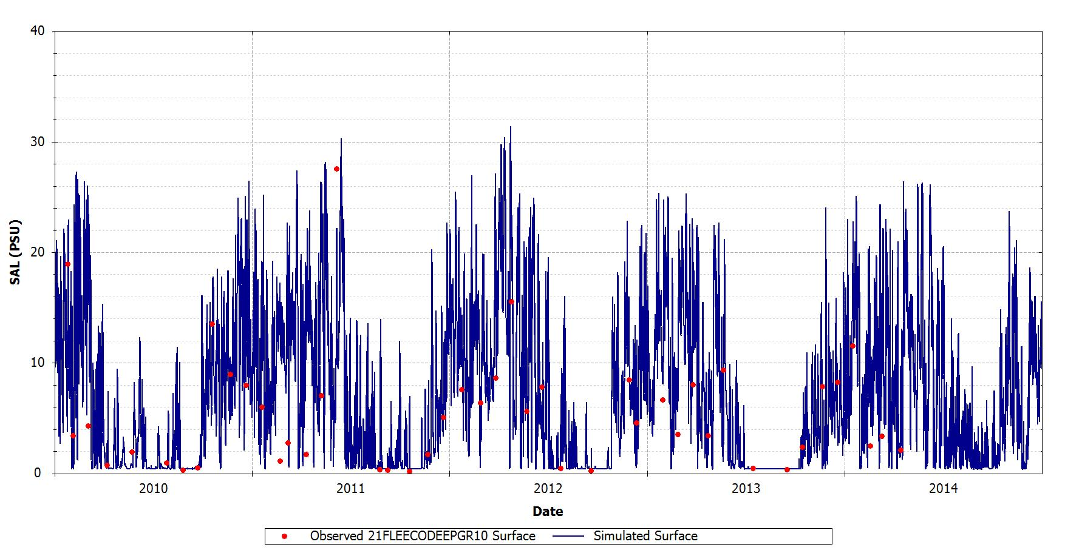
Figure A-16: Simulated and observed salinity at 21FLEECODEEPGR10

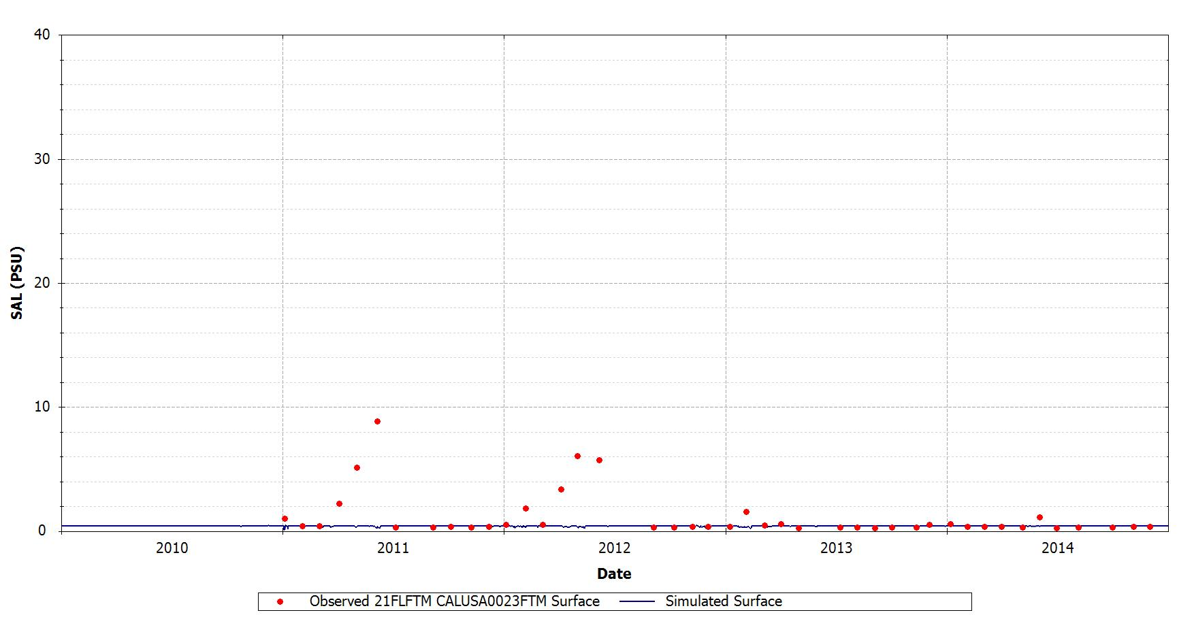
Figure A-17: Simulated and observed salinity at 21FLFTMCALUSA0023FTM

Flow
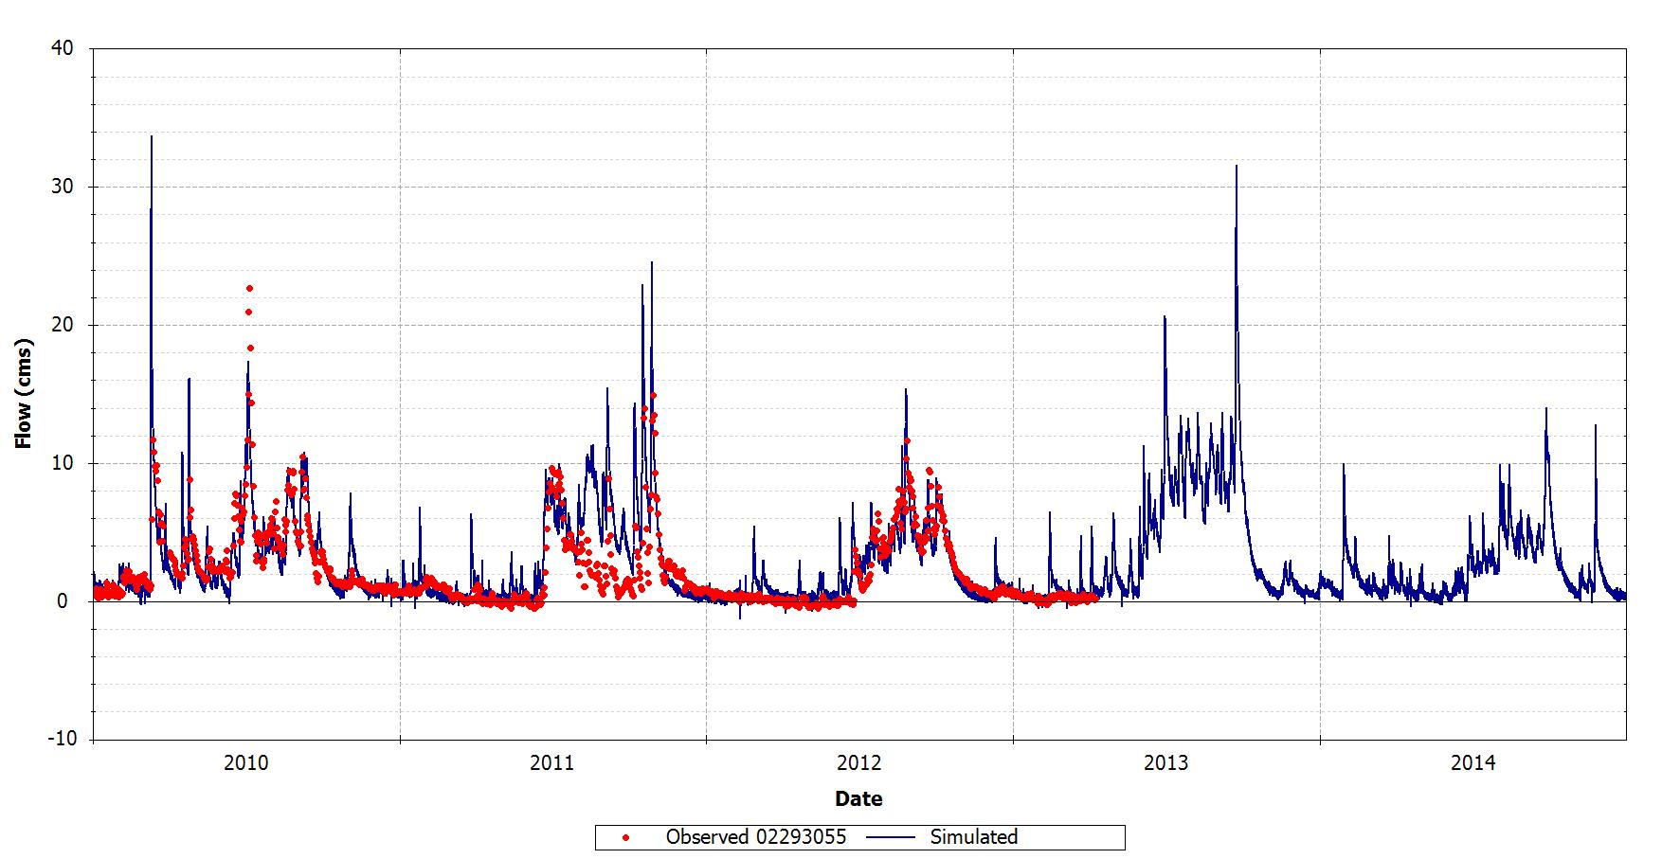
Figure A-18: Simulated and observed flows at USGS 02293055

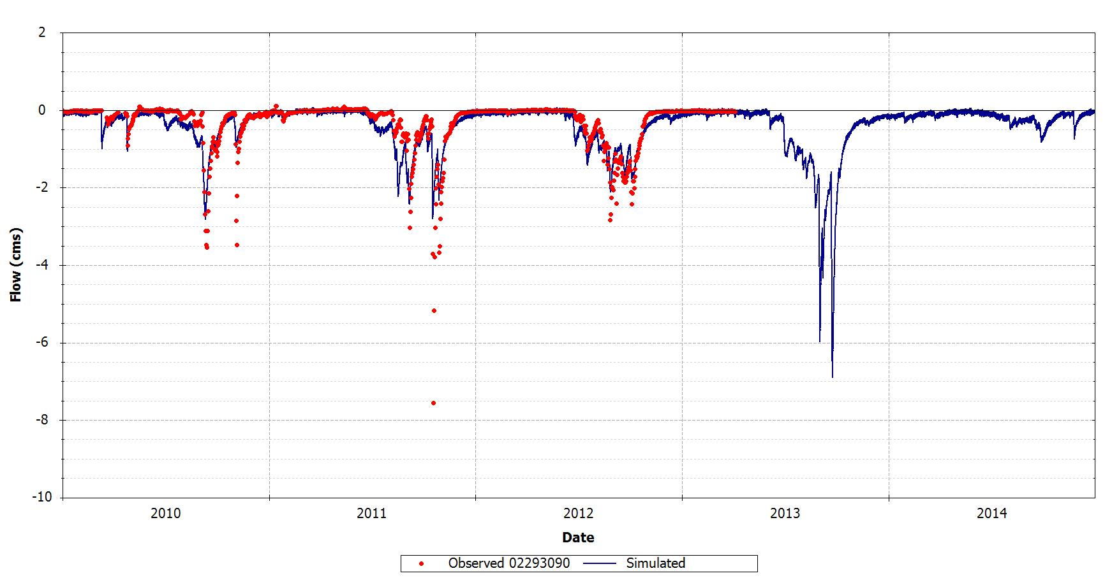
Figure A-19: Simulated and observed flows at USGS 02293090
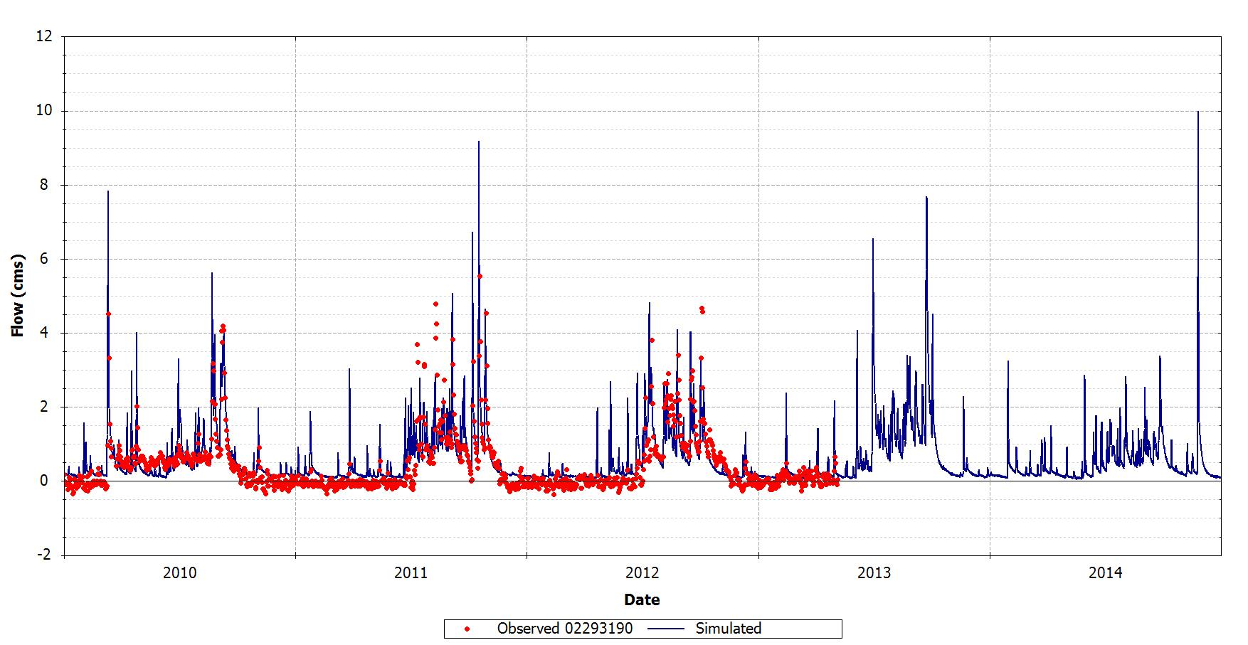
Figure A-20: Simulated and observed flows at USGS 02293190

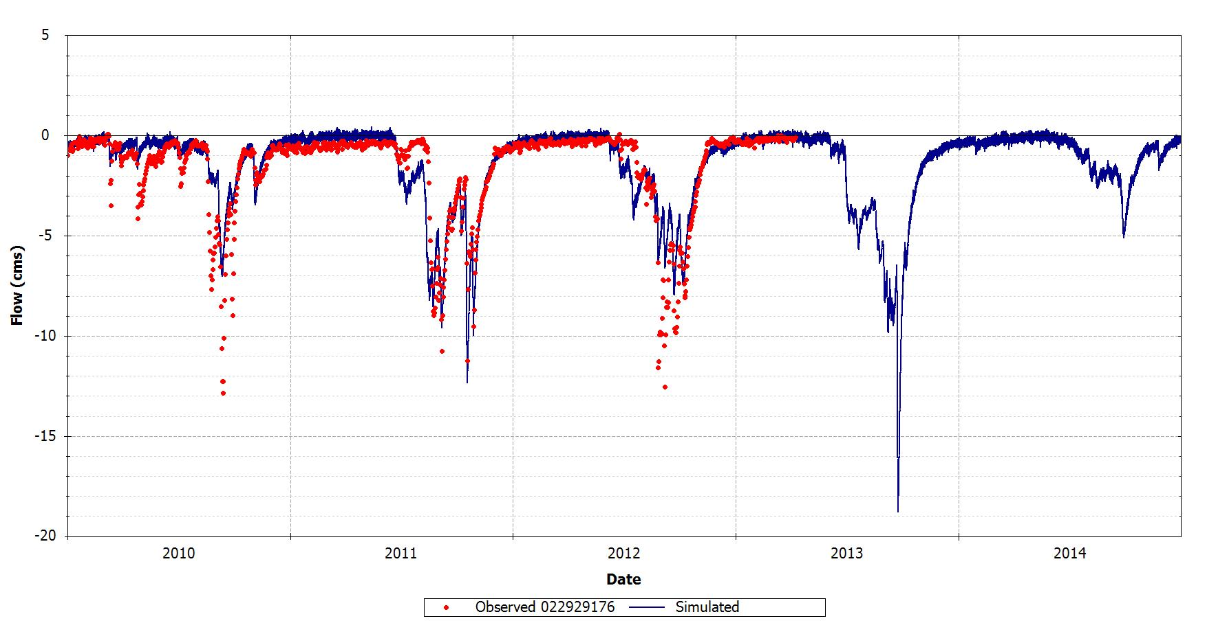
Figure A-21: Simulated and observed flows at USGS 022929176
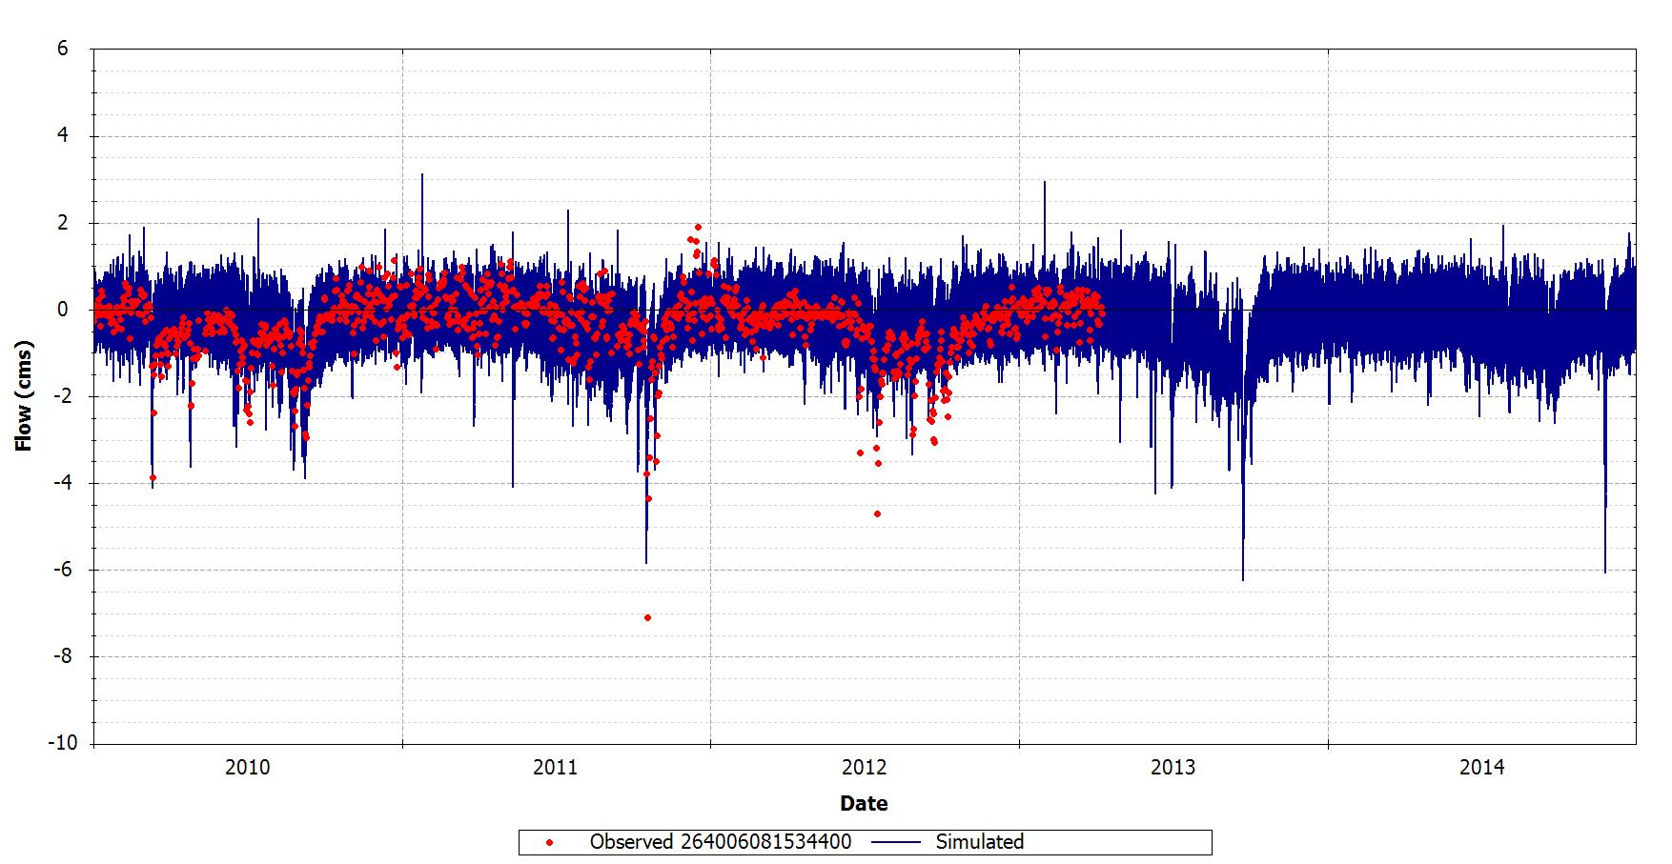
Figure A-22: Simulated and observed flows at station 264006081534400

