To: | Doug Gilbert, DEP  Mohammad Sayemuzzaman, DEP
Cc: | Ansel Bubel, DEP  Sara Davis, DEP  Erin Rasnake, DEP
From: | Brian Watson, PE, PH, D.WRE, Tetra Tech  Madhu Akasapu-Smith, EIT, Tetra Tech  Rene Camacho, Ph. D, Tetra Tech  Marcy Frick, REM, Tetra Tech  Erin Lincoln, PH, Tetra Tech  Hugo Rodriquez, Ph. D, PE, Tetra Tech
Date: | October 14, 2016
Subject: | Caloosahatchee River Basin Watershed Model Review and Calibration Refinement –  Task 6 EFDC Model Setup and Draft Water Quality Calibration Results and Discussion

Table of Contents
1.0 Introduction 4
2.0 Summary 5
3.0 EFDC Model Setup 6
3.1 efdc water quality model 6
3.2 Description of simulated processes 8
3.3 EFDC Water Quality Boundary Conditions 9
3.3.1 Freshwater Boundary Conditions 9
3.3.2 Open Boundary Conditions 11
3.4 Point Sources 15
3.4.1 Available Data 15
3.4.2 Missing Data Assumptions 17
3.5 Weather data 17
4.0 EFDC Model Calibration 18
4.1 Calibration Methodology 18
4.2 Model parameters 20
4.3 Water Quality model calibration and validation analysis 22
4.3.1 Dissolved Oxygen 22
4.3.2 Phytoplankton Biomass 27
4.3.3 Nitrogen 31
4.3.3.1 Total Nitrogen 32
4.3.3.2 Total Kjeldahl Nitrogen 35
4.3.3.3 Ammonium (NH₄) 39
4.3.3.4 Nitrite + Nitrate (NOx) 41
4.3.4 Phosphorus 44
4.3.4.1 Total Phosphorus 44
4.3.4.2 Orthophosphate (PO₄) 48
4.3.5 Light 50
4.4 Calibration Modifications and Recommendations 54
5.0 References 55
Appendix A: WATER QUALITY Calibration Results (2010 – 2014) 56

Introduction
Tetra Tech and AMEC were contracted by the Florida Department of Environmental Protection (department) to address department and stakeholder issues regarding the set up and calibration of the current versions of the Caloosahatchee River and Estuary Hydrologic Simulation Program – Fortran (HSPF) and Environmental Fluid Dynamics Code (EFDC) models. These models will be used to develop total maximum daily loads (TMDLs) for impaired freshwater bodies within the Caloosahatchee River Basin and to refine the Caloosahatchee tidal estuary TMDLs that the department adopted in 2010. The department provided two sets of EFDC model files that contained data and ran from January 1, 2008 through December 31, 2010, as well as a report on the models developed by Dynamic Solutions and CDM in 2009 (2009 Model). However, the original EFDC model files developed by Dynamic Solutions and CDM that were used to prepare the 2009 report were not located or provided to Tetra Tech. The model files provided by the department were believed to be the department’s updated model (2014 Model), which included modifications to the 2009 Model, such as extending the model simulation time and adjusting the delineation boundaries.
Task 1, which was finalized on April 14, 2016, identified the changes and updates that should be made to improve model calibration and address stakeholder concerns related to both the HSPF and EFDC models. Task 2, which was finalized on September 29, 2016, updated the HSPF hydrologic model based on the recommendations set forth in Task 1. Task 3, which is still under development, updated the HSPF model to address the water quality recommendations from Task 1. Task 4, which was finalized on May 5, 2016, converted the existing EFDC model (DS-EFDC), which is a proprietary application, into a public domain application (PD-EFDC) and incorporate the light module from the existing proprietary model. Task 5, which was finalized on October 12, 2016, updated the EFDC model to address the recommendations from Task 1 and to evaluate the model’s hydrodynamic calibration. Task 6, which is presented in this memo, was to update the EFDC water quality module and to evaluate the model’s performance to reproduce observed water quality variables. This memo includes the water quality calibration results and recommendations to improve the calibration.
Throughout this memo, the Dynamic Solutions/CDM model will be referred to as the “2009 Model” and the department’s updated version of the model will be referred to as the “2014 Model.” The new model will be referred to as the “2017 Model,” which is reflective of the project completion date in 2017.

Summary
During Task 6, Tetra Tech focused the EFDC model updates on the recommendations from the Task 1 memo to address major department and stakeholder comments, as well as issues that Tetra Tech identified with the original model that would limit the model’s ability to provide the information needed for the TMDL and basin management action plan (BMAP). For this task, Tetra Tech processed all new data input files for the full model simulation period (1996 – 2014). The department was unable to provide Tetra Tech with the original data processing sheets and information about processing methodologies; therefore all files had to be reprocessed to ensure that a consistent method was used for the full model simulation period. The model calibration for this task focused on the water quality results in comparison to available measured data in the estuarine ecosystem.
Some of the most important modifications and changes made by Tetra Tech to the EFDC model for water quality included the extension of the simulation period through December 31, 2014 (the 2014 Model ended on December 31, 2010) and the update of the biological and chemical kinetic rates of the water quality model based on model calibration to observed datasets of nutrients, phytoplankton biomass, and dissolved oxygen (DO).

EFDC Model Setup

efdc water quality model
A schematic representation of the EFDC water quality module and simulated variables is presented in Figure 1 and Table 1. The water quality module is able to simulate conventional eutrophication processes including several species of phytoplankton and macroalgae, fate and transport of metals, and simple and organic toxicants.
The eutrophication model (Figure 1) is based on the kinetics and processes included in the CE-QUAL-ICM model (Cerco and Cole 1995) and simulates in detail the impacts of nutrient enrichment on phytoplankton primary production and DO. This module simulates the fundamental biochemical processes controlling phytoplankton growth and death, nutrient cycling, and DO availability in the water column. The model in Figure 1 is conceptually shown as a linear system where each box represents the pool of a specific water quality variable and the arrows indicate the internal sources and sinks. The DO module, for example, simulates DO as a function of several factors. The main sources of DO in the water column are atmospheric reaeration and phytoplankton and benthic algae production, while the major sinks are organic matter decomposition, nitrification, phytoplankton and benthic algae respiration, sediment oxygen demand (SOD), and under some circumstances oxygen release to the atmosphere. The external loads from point and nonpoint sources are also considered by the model, as well as the nutrient sediment fluxes (not shown in diagram). These loads are the ultimate forcing factors affecting the water quality of aquatic ecosystems.
A central component of the eutrophication module is the phytoplankton model. At present, the model can simulate up to three different groups of phytoplankton. The use of different phytoplankton groups allows the model to capture seasonal changes in productivity that occur as different phytoplankton populations grow or decay in response to nutrient availability, light, and temperature conditions. For the purpose of this project, only two different phytoplankton groups are activated in the EFDC model: (1) cyanobacteria and (2) green and blue algae. The ultimate purpose of activating the two groups is to increase the flexibility of the model to capture (if necessary) off-seasonal peaks of phytoplankton (early spring or late fall blooms), which are generally difficult to capture with only one group of algae. The use of two phytoplankton groups is reasonable given that, in practice, the measurement of phytoplankton is typically targeted to define the total levels of biomass (in units of chlorophyll-a or carbon) and rarely contains taxonomic analyses to identify the dominant groups of algae present at a particular location and time.

Note: For any variable compartment, entering arrows represent a mass source while exit arrows represent a sink.
Figure 1: Schematic representation of the EFDC water quality module
Table 1: Definition of water quality variables simulated in EFDC
Variable/Definition | Simulated
Carbon | -
RPOC = Refractory Particulate Organic Carbon | Yes
LPOC = Labile Particulate Organic Carbon | Yes
DOC = Dissolved Organic Carbon | Yes
Algae | -
Bg = Green Algae | Yes
Bd = Diatom Algae | No
Bc = Cyanobacteria Algae | Yes
Bm = Macro Algae | No
Nitrogen | -
RPON = Refractory Particulate Organic Nitrogen | Yes
LPON = Labile Particulate Organic Nitrogen | Yes
DON = Dissolved Organic Nitrogen | Yes
NH4 = Ammonium | Yes
NOx = Nitrate + Nitrite | Yes
Oxygen | -
DO = Dissolved Oxygen | Yes
COD = Chemical Oxygen Demand | No
Phosphorus | -
RPOP = Refractory Particulate Organic Phosphorus | Yes
LPOP = Labile Particulate Organic Phosphorus | Yes
DOP = Dissolved Organic Phosphorus | Yes
PO4t = Total Orthophosphate | Yes
PO4d = Dissolved Orthophosphate | Yes
PO4p = Solid-sorbed/particulate Orthophosphate | No
Silica | -
SU = Unavailable Silica | No
SA = Available Biogenic Silica | No
SAd = Dissolved Available Silica | No
SAp = Particulate Available Silica | No
Metals | -
TAM = Total Active Metal | No
Solids | -
TSS = Total Suspended Solids | No
Biological | -
FCB = Fecal Coliform Bacteria | No

Description of simulated processes
The processes simulated in Figure 1 support the evaluation of eutrophication problems in aquatic ecosystems. Some of the most relevant constituents simulated include nitrate + nitrite (NO_{X}), ammonium (NH₄), organic nitrogen (OrgN), orthophosphate (PO₄), organic phosphorus (OrgP), chlorophyll-a, DO, and carbon. In the EFDC model, the organic forms of nitrogen, phosphorus, and carbon are further discretized into refractory, labile, and dissolved forms, which reflect organic compounds of low, medium, and immediate availability for mineralization, respectively.
The fate and transport of nitrogen is modeled by using a mechanistic representation of the nitrogen cycle in natural environments. The EFDC model simulates the mineralization of OrgN, nitrification and denitrification of inorganic nitrogen, phytoplankton uptake of nitrogen, and recycle of phytoplankton nitrogen into the organic pool of nitrogen during phytoplankton respiration and death. The transformation rates are temperature dependent and calibrated for a particular location. Nitrogen has a direct impact in the phytoplankton dynamics and can be a limiting factor for development.
Phosphorus, like nitrogen, is a critical nutrient for phytoplankton development. In the EFDC model, phosphorus can mineralize from the organic forms into the inorganic forms and become available for phytoplankton uptake. The phytoplankton phosphorus can be recycled into the pool of organic phosphorus during phytoplankton respiration and death.
Phytoplankton biomass is internally simulated in carbon units in the EFDC model but can be converted to chlorophyll-a units to allow for the comparison of model results against field observations. The conversion requires the definition of a carbon-to-chlorophyll-a ratio, which expresses a typical concentration of chlorophyll-a present in a phytoplankton cell per unit mass of carbon.
Finally, the EFDC model simulates DO as a function of several factors. The main sources of DO in the water column are atmospheric reaeration and phytoplankton production, while the major sinks are organic matter oxidation, nitrification, phytoplankton respiration, and SOD.

EFDC Water Quality Boundary Conditions

Freshwater Boundary Conditions
The water quality boundary conditions for the different tributaries of the Caloosahatchee River were defined using the predictions from the HSPF model. However, given that in most cases the output water quality variables from the HSPF model do not directly match the variables simulated in the EFDC model, some processing was necessary to convert the outputs from the HSPF model into the forms simulated by the EFDC model. Table 2 presents a summary of the conversion process conducted to link the HSPF and EFDC models. In Table 2, it is important to note that the organic forms of nitrogen, phosphorus, and carbon from the HSPF model are further discretized into refractory, labile, and dissolved forms.
For phytoplankton, a constant “seeding” value of 0.05 mgC/L (1.25 µgChla/L) for green algae and 0.05 mgC/L (1.25 µgChla/L) for cyanobacteria (a total phytoplankton concentration of 2.5 µgChla/L for a carbon to chlorophyll-a ratio of 0.04 mgC/µgChla) is currently prescribed in all freshwater boundaries. The outputs from the HSPF model were not directly used for this variable because phytoplankton populations from the watershed (freshwater) are usually different than those encountered in the estuary. The former are generally subject to salinity toxicity and substantial population decay in the estuarine environment. Therefore, freshwater phytoplankton generally do not dictate the evolution of phytoplankton in the saline environment. For modelling purposes, this means that the freshwater boundary conditions can be simplified to reflect only a seeding condition (small constant phytoplankton load to allow growth in the estuary).
Table 2: List of water quality variables simulated in the HSPF and EFDC models and conversion process to use the HSPF model outputs as boundaries conditions in the EFDC model
Variable | Variable(s) predicted in HSPF | Variable Simulated in EFDC and process to link HSPF to EFDC
Organic Nitrogen (OrgN) | - OrgN_{HSPF} = Total Organic Nitrogen  - RON_{HSPF} = Refractory Organic Nitrogen  In HSPF OrgN_{HSPF} and RON_{HSPF} are assumed to be dissolved. | OrgN_{EFDC} = RPON_{EFDC} + LPON_{EFDC} + DON_{EFDC}  - RPON_{EFDC} = Refractory Particulate Organic Nitrogen:  RPON_{EFDC}=FP_{N}* RON_{HSPF}  - LPON_{EFDC} = Labile Particulate Organic Nitrogen  LPON_{EFDC} = OrgN_{HSPF} - RON_{HSPF}  - DON_{EFDC} = Dissolved Organic Nitrogen  DON_{EFDC}=FD_{N}* RON_{HSPF}  FP_{N} and FD_{N} are prescribed fractions of particulate and dissolved phases of the RON_{HSPF} for EFDC:  FP_{N}=0.35  FD_{N}=0.65
Ammonium  (NH₄) | - TAM_{HSPF} = Total Ammonium | NH4_{EFDC}=TAM_{HPSF}
Nitrate + Nitrate  (NO₃ + NO₂) | - NO3_{HSPF} + NO2_{HSPF}  Typically NO₂ is only a small fraction of NOx (<5%) | NOx _{EFDC} = NO3_{HPSF} + NO2_{HPSF}
Organic Phosphorus (OrgP) | - OrgP_{HSPF} = Total Organic Phosphorus  - ROP_{HSPF} = Refractory Organic Phosphorus  In HSPF OrgP_{HSPF} and ROP_{HSPF} are assumed to be dissolved. | OrgP_{EFDC} = RPOP_{EFDC} + LPOP_{EFDC} + DOP_{EFDC}  - RPOP_{EFDC} = Refractory Particulate Organic Phosphorus:  RPOP_{EFDC}=FP_{P}* ROP_{HSPF}  - LPOP_{EFDC} = Labile Particulate Organic Phosphorus  LPOP_{EFDC} = OrgP_{HSPF} - ROP_{HSPF}  - DOP_{EFDC} = Dissolved Organic Phosphorus  DOP_{EFDC}=FD_{P}* ROP_{HSPF}  FP_{P} and FD_{P} are prescribed fractions of particulate and dissolved phases of the ROP_{HSPF} for EFDC:  FP=0.35  FD=0.65
Orthophosphate  (PO₄) | - PO4_{HSPF} | - PO4_{EFDC}= PO4_{HSPF}
Organic Carbon (OrgC) | - OrgC_{HSPF} = Total Organic Carbon  - ROC_{HSPF} = Refractory Organic Carbon  In HSPF OrgC_{HSPF} and ROC_{HSPF} are assumed to be dissolved. | OrgC_{EFDC} = RPOC_{EFDC} + LPOC_{EFDC} + DOC_{EFDC}  - RPOC_{EFDC} = Refractory Particulate Organic Carbon:  RPOP_{EFDC}=FP_{C}* ROP_{HSPF}  - LPOC_{EFDC} = Labile Particulate Organic Carbon  LPOP_{EFDC} = OrgP_{HSPF} - ROP_{HSPF}  - DOC_{EFDC} = Dissolved Organic Carbon  DOC_{EFDC}=FD_{C}* ROC_{HSPF}  FP_{C} and FD_{C} are prescribed fractions of particulate and dissolved phases of the ROC_{HSPF} for EFDC:  FPc=0.35  FDc=0.65
Dissolved Oxygen  (DO) | - DO_{HSPF} | - DO_{EFDC} = DO_{HSPF}

Open Boundary Conditions
Tetra Tech used available observations near the Matlacha Pass and Pine Island Sound northern model boundaries to construct the boundary time series of water quality concentrations. Monitoring stations in the immediate vicinity of the boundaries were selected as the basis to construct the water quality time series for NO_{X}, NH₄, OrgN, PO₄, OrgP, chlorophyll-a, and DO. Table 3 lists the stations used to develop the water quality boundary, and the station locations are shown in Figure 2. The stations are in a variety of locations, including the deep channel and immediately adjacent to marsh outflows. By combining the available data from the stations into one time series, the open boundary is able to reflect the overall water quality inputs at the northern boundaries.
The available water quality concentration data at each station were used to construct the water quality boundary condition time series for the simulation period. The daily, monthly, and long-term water quality concentrations were similar among the stations. If data were available on a given day for more than one station, the data were averaged to provide a single water quality concentration value for that day for the boundary condition time series.
Table 3: Monitoring stations used to develop the water quality time series for the northern boundary cells
Location | Station ID
Boundary conditions at boundary cells across J=82, Matlacha Pass | 21FLCHARMPV001
Boundary conditions at boundary cells across J=82, Matlacha Pass | 21FLCHARMPV002
Boundary conditions at boundary cells across J=82, Matlacha Pass | 21FLEECOPI-03
Boundary conditions at boundary cells across J=82, Matlacha Pass | 21FLEECOPI-04
Boundary conditions at boundary cells across J=82, Matlacha Pass | 21FLEECOPI-05
Boundary conditions at boundary cells across J=82, Matlacha Pass | 21FLSEAS62SEAS020
Boundary conditions at boundary cells across J=82, Matlacha Pass | 21FLSEAS62SEAS401
Boundary conditions at boundary cells across J=44, Pine Island Sound | 21FLCHARPIV004
Boundary conditions at boundary cells across J=44, Pine Island Sound | 21FLEECOPI-10
Boundary conditions at boundary cells across J=44, Pine Island Sound | 21FLEECOPI-11
Figure 2: 2017 EFDC Model open boundary water quality station locations
At the southern boundary, there were limited water quality observations to support the development of a water quality time series for the EFDC model. Therefore, the model was forced with constant concentrations for the different species of nutrients, DO, and phytoplankton biomass. Such concentrations were defined based on the concentrations used in the 2014 EFDC Model and on recently measured data. Data at 12 stations close to the southern boundary (Figure 2) were reviewed to help define the constant concentrations. Table 4 summarizes the values used in the 2017 EFDC Model compared to the values used in the 2014 Model.
Table 4: Water quality concentrations assigned at the southern boundary cells
Parameter | 2014 Model | 2017 Model | Observations
NO_{x} | Constant concentration of 0.01 mg/L in Card 33. | Not modified from 2014 Model setup. | The average concentration of the available records is 0.007mg/L, which is within range of the concentration used in the 2014 Model.
NH₄ | Constant concentration of 0.02 mg/L in Card 33. | Constant concentration of 0.05 mg/L in Card 33. | The average concentration of the available records is 0.05 mg/L. This concentration has been included in the 2017 Model setup.
OrgN | Constant concentrations as follows:  RPON = 0.3 mg/L  LPON = 0.03 mg/L  DON = 0.3 mg/L | Constant concentrations as follows:  RPON = 0.17 mg/L  LPON = 0.017 mg/L  DON = 0.17 mg/L | The average OrgN concentration calculated from total nitrogen (TN) and total Kjeldahl nitrogen (TKN) records is 0.35 mg/L. This concentration was partitioned into labile, refractory, and dissolved fractions using the same ratios as the 2014 Model.
PO₄ | Constant concentration of 0.05 mg/L in Card 33. | Constant concentration of 0.03 mg/L in Card 33 | The average concentration of the available records is 0.03 mg/L. Boundary PO₄ concentration has been updated to reflect the new value.
OrgP | Constant concentrations as follows:  RPOP = 0.02 mg/L  LPOP = 0.002 mg/L  DOP = 0.02 mg/L | Constant concentrations as follows:  RPOP = 0.005 mg/L  LPOP = 0.002 mg/L  DOP = 0.005 mg/L | The average concentration of the available Org P records is 0.012 mg/L. Boundary concentrations of RPOP, LPOP, and DOP have been updated to reflect the new values.
OrgC | Constant concentrations as follows:  RPOC = 0.3 mg/L  LPOC = 0.3 mg/L  DOC = 2.5 mg/L | Not modified from 2014 Model setup. | Average concentration of available observations is 3.1 mg/L, which is the same concentration used in the 2014 Model.
Chlorophyll-a | Constant concentration of 1 µg/L for green algae and cyanobacteria in Card 33. | Not modified from 2014 Model setup. | The average concentration of the available records is 1.4 µg/L, which is within range of the 2014 Model. The Chla concentration is input in EFDC in Carbon units using a Carbon-to-chlorophyll ratio of 0.04 mgC/µgChla.
DO | Not included. | A time series of DO at saturated conditions will be prescribed for this boundary. | The DO saturation concentration has been computed by an equation of state as a function of water salinity and temperature.  A small vertical gradient of DO concentration is included at the boundaries to reflect higher DO concentrations at the surface and lower at the bottom. Observations of DO and/or DO saturation at stations close to the open boundaries will be used to ensure the constructed time series reflect realistic conditions of DO in the area.

Point Sources
The department provided Tetra Tech with the permit and discharge monitoring report (DMR) data for the domestic wastewater (DW) and industrial wastewater (IW) treatment facilities that discharge directly to the EFDC model (see Table 5). Time series for both flows and water quality loads for these facilities were developed for these facilities and input into the model during initial model setup.
Table 5: Point sources in the 2017 EFDC Model
NPDES ID | Facility Name | Type | Design Capacity (MGD) | EFDC Model Cell I | EFDC Model Cell J
FL0021261 | Fort Myers Central AWWTF | DW | 11 | 71 | 31
FL0021270 | South AWWT Facility | DW | 12 | 61 | 31
FL0030007 | Cape Coral, City of - Everest WRF | DW | 15.1 | 62 | 32
FL0030325 | Waterway Estates | DW | 5 | 65 | 36
FL0039829 | Fiesta Village Advanced WWTF | DW | 1.5 | 55 | 30
FL0001490 | Florida Power and Light Fort Myers | IW | 590.6 | 79 | 15

Available Data
The observed average flow and water quality results for each of the facilities are shown in Table 6. The number of end of pipe flow and water quality parameter observations reported by each facility are shown in Table 7. For most parameters, results were reported monthly. The period of record for the available data is shown in Table 8. The available measured data for these facilities were used in the EFDC model to determine the total loading from each facility. The data were used to fill short- and long-term gaps in the data records. For example, if a facility has TN data for ten years of the modeling period, the long-term average of the measured data was used to represent the expected TN concentration for the remaining portion of the simulation period, where data were unavailable.
Table 6: Observed average value for available flow and water quality data for point source facilities
Permit | FLOW (cfs) | NH3 (mg/L) | NOx (mg/L) | OrgN (mg/L) | TN (mg/L) | PO4 (mg/L) | OrgP (mg/L) | TP (mg/L) | CBOD (mg/L) | TSS (mg/L) | DO (mg/L) | WTEM (Deg C)
FL0021261 | 4.88 | - | - | - | 1.65 | - | - | 0.15 | 2.41 | 4.50 | 5.52 | -
FL0021270 | 12.81 | - | - | - | 2.04 | - | - | 0.19 | 1.98 | 3.45 | 5.76 | -
FL0030007 | 7.36 | - | - | - | 1.04 | - | - | 0.13 | 2.20 | 1.38 | 5.89 | -
FL0030325 | 1.32 | - | - | - | 1.20 | - | - | 0.08 | 1.64 | 0.94 | 7.07 | -
FL0039829 | 2.90 | 0.07 | 0.08 | 0.63 | 0.93 | - | - | 0.10 | 1.47 | 0.59 | 5.98 | -
FL0001490 | 822.14 | 0.12 | 0.22 | 0.88 | 1.22 | 0.07 | 0.04 | 0.11 | - | 7.36 | - | 32.95
- = No data.

Table 7: Number of observations for available flow and water quality data for point source facilities
Permit | FLOW (cfs) | NH3 (mg/L) | NOx (mg/L) | OrgN (mg/L) | TN (mg/L) | PO4 (mg/L) | OrgP (mg/L) | TP (mg/L) | CBOD (mg/L) | TSS (mg/L) | DO (mg/L) | WTEM (Deg C)
FL0021261 | 103 | - | - | - | 175 | - | - | 174 | 175 | 174 | 168 | -
FL0021270 | 154 | - | - | - | 152 | - | - | 154 | 155 | 155 | 145 | -
FL0030007 | 111 | - | - | - | 58 | - | - | 59 | 59 | 60 | 59 | -
FL0030325 | 124 | - | - | - | 126 | - | - | 126 | 124 | 122 | 78 | -
FL0039829 | 159 | 34 | 33 | 34 | 147 | - | - | 157 | 157 | 157 | 158 | -
FL0001490 | 59 | 11 | 11 | 11 | 11 | 11 | 11 | 11 | - | 14 | - | 11
- = No data.

Table 8: Period of record for available flow and water quality data for point source facilities
Permit | Flow (cfs) | NH3 (mg/L) | NOx (mg/L) | OrgN (mg/L) | TN (mg/L) | PO4 (mg/L) | OrgP (mg/L) | TP (mg/L) | CBOD (mg/L) | TSS (mg/L) | DO (mg/L) | WTEM (Deg C)
FL0021261 | 4/1/2006 - 12/1/2014 | - | - | - | 5/1/2000 - 12/1/2014 | - | - | 5/1/2000 - 12/1/2014 | 5/1/2000 - 12/1/2014 | 5/1/2000 - 12/1/2014 | 1/1/2001 - 12/1/2014 | -
FL0021270 | 12/1/1999 - 12/1/2014 | - | - | - | 2/1/2000 - 11/1/2014 | - | - | 2/1/2000 - 12/1/2014 | 12/1/1999 - 12/1/2014 | 12/1/1999 - 12/1/2014 | 12/1/1999 - 12/1/2014 | -
FL0030007 | 6/1/2000 -10/1/2014 | - | - | - | 6/1/2000 - 9/1/2008 | - | - | 6/1/2000 - 9/1/2008 | 6/1/2000 - 9/1/2008 | 6/1/2000 - 9/1/2008 | 6/1/2000 - 9/1/2008 | -
FL0030325 | 1/1/2000 - 10/1/2012 | - | - | - | 1/1/2000 - 10/1/2012 | - | - | 1/1/2000 - 10/1/2012 | 1/1/2000 - 10/1/2012 | 1/1/2000 - 10/1/2012 | 1/1/2000 - 4/1/2010 | -
FL0039829 | 6/1/2000 - 12/1/2014 | 2/1/2010 - 1/1/2014 | 2/1/2010 - 1/1/2014 | 2/1/2010 - 1/1/2014 | 6/1/2000 - 1/1/2014 | - | - | 6/1/2000 - 12/1/2014 | 6/1/2000 - 12/1/2014 | 6/1/2000 - 12/1/2014 | 6/1/2000 - 12/1/2014 | -
FL0001490 | 1/1/1999 - 12/1/2014 | 6/1/2012 - 12/1/2014 | 6/1/2012 - 12/1/2014 | 6/1/2012 - 12/1/2014 | 6/1/2012 - 12/1/2014 | 6/1/2012 - 12/1/2014 | 6/1/2012 - 12/1/2014 | 6/1/2012 - 12/1/2014 | - | 12/1/2006 - 12/1/2014 | - | 6/1/2012 - 12/1/2014
- = No data.

Missing Data Assumptions
When available, measured water quality data were used to represent the point source facility discharge flows and concentrations and to fill gaps in the data record. However, as shown above, measured data were not available for many parameters. In order to provide parameter concentrations for the facilities, Tetra Tech identified default assumptions that were used for the point source facilities (Table 9). These assumptions were based on available data from all facilities in the Caloosahatchee River Watershed, including those discharging directly to the HSPF model. Please see the Task 2 memo for information about point sources discharging to the HSPF model.
Table 9: Recommended default assumptions for missing flow and water quality data for point source facilities
Constituent | Parameter ID | Minor (<1.0 MGD) | Major (>1.0 MGD) | Rationale
Total Phosphorus | TP | 0.15 mg/L | 0.15 mg/L | Average of available data = 0.15 mg/L; range of 0.08 - 0.25 mg/L
Orthophosphate | PO4 | 0.135 mg/L (90% of TP) | 0.105 mg/L (70% of TP) | Professional recommendation
Organic Phosphorus | OrgP | 0.015 mg/L (10% TP) | 0.045 mg/L (30% of TP) | Professional recommendation
Total Nitrogen | TN | 1.50 mg/L (sum of species) | 1.50 mg/L (sum of species) | Average of available data = 1.38 mg/L; range of 0.29 – 2.28 mg/L
Ammonia | NH3 | 0.15 mg/L (10% of TN) | 0.15 mg/L (10% of TN) | Average of available data = 0.15 mg/L; range of 0.021 - 0.38 mg/L
Nitrate + Nitrite | NOx | 0.15 mg/L (10% of TN) | 0.15 mg/L (10% of TN) | Average of available data = 0.16 mg/L; range of 0.08 - 0.23 mg/L
Organic Nitrogen | OrgN | 1.20 mg/L (80% of TN) | 1.20 mg/L (80% of TN) | Average of available data = 1.09 mg/L; range of 0.63 – 1.77 mg/L
Carbonaceous BOD | CBOD | 2.0 mg/L | 2.0 mg/L | Average of available data = 2.16 mg/L; range of 0.63 - 6.50 mg/L
Dissolved Oxygen | DO | 6.0 mg/L | 6.0 mg/L | Average of available data = 6.12 mg/L; range of 5.06 - 7.56 mg/L
Total Suspended Solids | TSS | 3.5 mg/L | 3.5 mg/L | Average of available data = 3.25 mg/L; range of 0.59 - 7.36 mg/L
Water Temperature | WTEM | 20.0 °C October through March 30.0 °C April through September | 20.0 °C October through March 30.0 °C April through September | Typical seasonal variability

Weather data
The weather data from the ASER.inp and WSER.inp files, and in particular the solar radiation and wind speed time series, are used by the EFDC model to force the algae and DO modules. The details of the ASER.inp and WSER.inp files, including the source data used to generate these files, can be found in the Task 5 memo.

EFDC Model Calibration
The calibration of the 2017 EFDC water quality model is based on observations collected between January 1, 2010 and December 31, 2014. Tetra Tech compared modeled water quality outputs to measured records available at different monitoring stations located throughout the estuary. The following section contains the analyses of the draft calibration results at selected stations (Figure 3). Additional calibration results are presented in Appendix A.

Calibration Methodology
The calibration of the model was based on graphical and statistical comparisons between the model predictions and the observations. The temporal analyses were performed using the postprocessor Water Resources Database (WRDB) Graph (version 6.0.0.32), which creates comparison plots using the model results from the EFDC model output file (*.BMD) and available field observations from a WRDB database (*.DBS). WRDB Graph was also used to generate the following goodness-of-fit statistics where represents the time series of model predictions and the time series of observations:

Correlation coefficient:
Mean Absolute Error:

Root Mean Squared Error:

Normalized Root Mean Squared Error:
Index of Agreement:
The correlation coefficient () measures the degree of linear correlation between the trends of two time series, in this case the series of observations and model predictions. It can range from –1 to 1, with negative values indicating that the observed and predicted values tend to vary inversely. It should be recognized that even if the correlation is close to 1, the predicted and observed values may not match each other; they only tend to vary similarly (Stow et al. 2003).
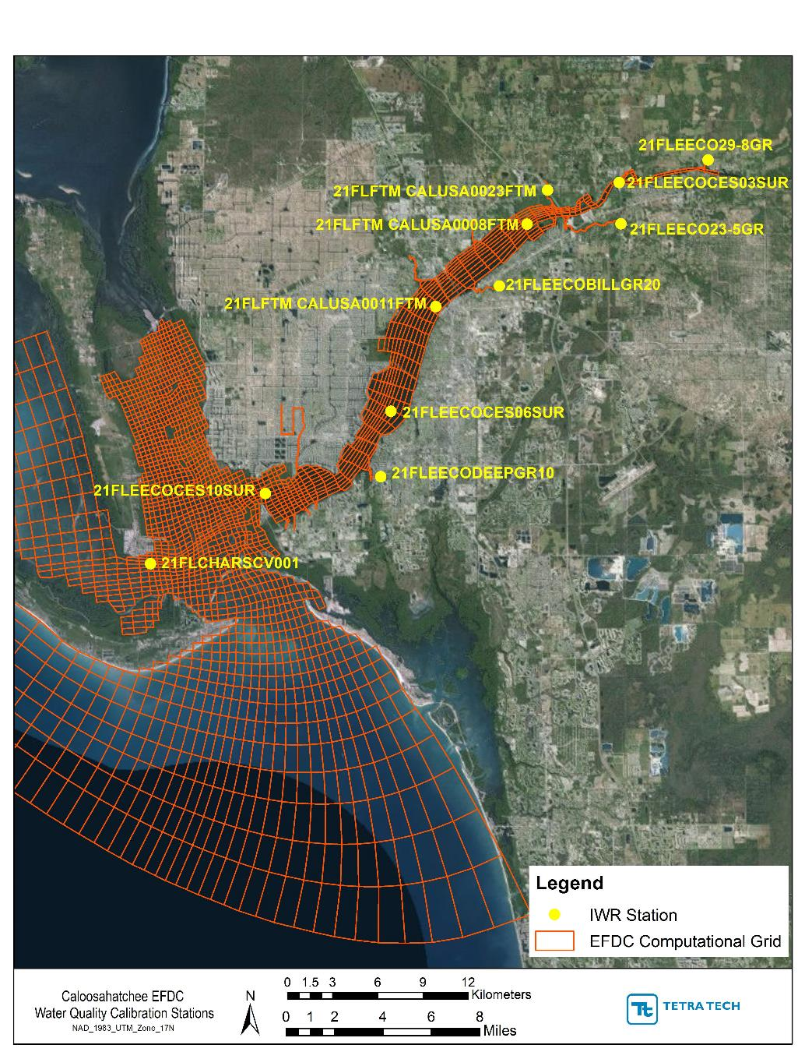
Figure 3: Subset of water quality stations distributed across the Caloosahatchee River
The mean absolute error (MAE) and the root mean squared error (RMSE) are estimates of the average deviation of the model predictions from the observations. The normalized root mean squared error (NRMSE) provides an estimate of the relative importance of the errors with respect to the observations. The MAE, RMSE, and NRMSE constitute indicators of model prediction accuracy (Stow et al. 2003), and the smaller their values, the higher the agreement between the observations and the predictions. Finally, the index of agreement (IA) evaluates the global agreement between the predictions and the observations. Values of the IA range between 0 and 1 with the highest value indicating a perfect match between the two time series. A value of zero indicates that the model predicts individual observations no better than the average of the observations. The computed mean, median, and 5th and 95th percentiles of the simulations and observation are shown for comparison purposes.

Model parameters
During the calibration of the EFDC water quality model, Tetra Tech adjusted the parameters that control some of the most important chemical and biological processes related to nutrient cycling, phytoplankton production and respiration, and DO. Table 10 through Table 14 present a summary of the preliminary model parameter values used in the EFDC model.
Table 10: Constants and parameters for algae
Constant | EFDC Card | Cyanobacteria | Green Algae
Nitrogen Half-Saturation (mg/L) | 08 | 0.01 | 0.01
Phosphorus Half-Saturation (mg/L) | 08 | 0.001 | 0.001
Silica Half-Saturation (mg/L) | 08 | N/A | N/A
Carbon to Chlorophyll-a Ratio (mg C/ µg Chla) | 09 | 0.040 | 0.040
Optimal Depth for Growth (m) | 09 | 1.0 | 1.0
Lower Optimal Temperature for Growth (^{O}C) | 11 | 25.0 | 24.0
Upper Optimal Temperature for Growth (^{O}C) | 11 | 27.5 | 27.0
Suboptimal Temperature Coeff. for Growth | 12 | 0.005 | 0.02
Super-optimal Temperature Coeff. for Growth | 12 | 0.004 | 0.01
Reference Temperature for Metabolism (^{O}C) | 13 | 20.0 | 20.0
Temperature Coeff. for Metabolism | 13 | 0.069 | 0.069
Carbon Dist. Coeff. for Metabolism | 14 | 0.350 | 0.100
Half-Saturation Const. for DOC Excretion (gO²/m³) | 14 | 0.500 | 0.500
Phosphorus Dist. Coeff. of RPOP for Metabolism | 18 | 0.100 | 0.100
Phosphorus Dist. Coeff. of LPOP for Metabolism | 18 | 0.100 | 0.100
Phosphorus Dist. Coeff. of DOP for Metabolism | 20 | 0.600 | 0.600
Phosphorus Dist. Coeff. of PO₄ for Metabolism | 20 | 0.200 | 0.200
Nitrogen Dist. Coeff. of RPON for Metabolism | 22 | 0.050 | 0.050
Nitrogen Dist. Coeff. of LPON for Metabolism | 22 | 0.025 | 0.025
Nitrogen Dist. Coeff. of DON for Metabolism | 24 | 0.300 | 0.300
Nitrogen Dist. Coeff. of DIN for Metabolism | 24 | 0.400 | 0.400
Nitrogen to Carbon Ratio (mg N/ mg C) | 24 | 0.180 | 0.180
Maximum Growth Rate (1/day)* | 45 | 1.000 | 2.000
Basal Metabolism Rate (1/day)* | 45 | 0.090 | 0.090
Predation Rate (1/day)* | 45 | 0.010 | 0.010
Settling Velocity (m/day) | 46 | 0.020 | 0.020
Settling Velocity for Refractory POM (m/day) | 46 | 0.050
Table 11: Constants and parameters for light extinction
Constant | EFDC Card | Value
Light Extinction for Total Suspended Chlorophyll  KeCHL = (0.054 * CHL^{0.6667}) + (0.0088 * CHL)  Where CHL = Total Chlorophyll Concentration (µg/L) | 09 | 0.031
Constant for Light Extinction due to POC and DOC | 45 | 0.06
Background Light Extinction Coeff. (1/m)* | 45 | 0.500
Table 12: Constants and parameters for carbon
Constant | EFDC Card | Value
Carbon Dist. Coeff. for Algae Predation – RPOC | 14 | 0.350
Carbon Dist. Coeff. for Algae Predation – LPOC | 14 | 0.550
Carbon Dist. Coeff. for Algae Predation – DOC | 14 | 0.100
Minimum Dissolution Rate of RPOC (1/day) | 16 | 0.005
Minimum Dissolution Rate of LPOC (1/day) | 16 | 0.075
Minimum Dissolution Rate of DOC (1/day)* | 16 | 0.010
Const. Relating RPOC Dissolution Rate to Total Chla | 16 | 0.000
Const. Relating LPOC Dissolution Rate to Total Chla | 16 | 0.000
Const. Relating POC Dissolution Rate to Total Chla | 16 | 0.000
Reference Temperature for Hydrolysis (^{O}C) | 17 | 20.0
Reference Temperature for Mineralization (^{O}C) | 17 | 20.0
Temperature effect Const. for Hydrolysis | 17 | 0.069
Temperature effect Const. for Mineralization | 17 | 0.069
Oxic Respiration Half-Saturation Const. for DO (gO²/m³) | 17 | 1.000
Half-Saturation Const. for Denitrification (gN/m³) | 17 | 0.100
Ratio of Denitrification Rate to Oxic DOC Respiration Rate | 17 | 0.050
Table 13: Constants and parameters for phosphorus
Constant | EFDC Card | Value
Phosphorus Dist. Coeff. for Algae Predation – RPOP | 18 | 0.350
Phosphorus Dist. Coeff. for Algae Predation – LPOP | 18 | 0.250
Phosphorus Dist. Coeff. for Algae Predation – DOP | 18 | 0.200
Phosphorus Dist. Coeff. for Algae Predation – Inorganic P | 18 | 0.200
Minimum Hydrolysis Rate (1/day) of RPOP | 21 | 0.005
Minimum Hydrolysis Rate (1/day) of LPOP | 21 | 0.075
Minimum Hydrolysis Rate (1/day) of DOP | 21 | 0.100
Const. Relating Hydrolysis Rate of RPOP to Algae | 21 | 0.000
Const. Relating Hydrolysis Rate of LPOP to Algae | 21 | 0.000
Const. Relating Hydrolysis Rate of DOP to Algae | 21 | 0.200
Constant 1 in determining Phosphorus to Carbon Ratio | 21 | 42.0
Constant 2 in determining Phosphorus to Carbon Ratio | 21 | 85.0
Constant 3 in determining Phosphorus to Carbon Ratio | 21 | 200.0
Table 14: Constants and parameters for nitrogen
Constant | EFDC Card | Value
Nitrogen Dist. Coeff. for Algae Predation – RPON | 22 | 0.150
Nitrogen Dist. Coeff. for Algae Predation – LPON | 22 | 0.350
Nitrogen Dist. Coeff. for Algae Predation – DON | 22 | 0.250
Nitrogen Dist. Coeff. for Algae Predation – Inorganic N | 22 | 0.250
Maximum Nitrification Rate (gN/m³/day) | 25 | 0.05
Nitrification Half-Saturation Const. for DO | 25 | 1.000
Nitrification Half-Saturation Const. for NH4 | 25 | 0.050
Reference Temperature for Nitrification (^{O}C) | 25 | 27.0
Suboptimal Temperature Effect Const. for Nitrification | 25 | 0.0045
Super-optimal Temperature Effect Const. for Nitrification | 25 | 0.0045
Minimum Hydrolysis Rate (1/day) of RPON | 26 | 0.005
Minimum Hydrolysis Rate (1/day) of LPON | 26 | 0.075
Minimum Hydrolysis Rate (1/day) of DON | 26 | 0.100
Const. Relating Hydrolysis Rate of RPON to Algae | 26 | 0.000
Const. Relating Hydrolysis Rate of LPON to Algae | 26 | 0.000
Const. Relating Hydrolysis Rate of DON to Algae | 26 | 0.000
Table 15: Constants and parameters for DO
Constant | EFDC Card | Value
Stoichiometric Algae Oxygen to Carbon (gO²/gC) | 28 | 2.670
Stoichiometric Algae Oxygen to Nitrogen (gO²/gN) | 28 | 4.330
Reaeration Constant | 28 | 3.933
Temperature Rate Constant for Reaeration | 28 | 1.024
Reaeration Adjustment Factor | 46 | 1.000

Water Quality model calibration and validation analysis

Dissolved Oxygen
The average concentration of DO in the Caloosahatchee River and Estuary is approximately 7.5 mg/L and varies seasonally between 2 mg/L and 10 mg/L (Figure 4 through Figure 8). The highest concentrations occur during the winter and spring seasons, with observed concentrations typically above 7 mg/L across the estuary, while the minimum concentrations occur during the summer and early fall seasons. During these periods, concentrations are typically below 6 mg/L and can drop as low as 2 mg/L, particularly in the upper regions of the system (e.g. station 21FLEECOCES03SUR in Figure 4).
The comparison between the model predictions and the available observations indicate that the model is able to predict the temporal dynamics and spatial variability of DO in the Caloosahatchee River and Estuary (Figure 4 through Figure 8). The model successfully captures the trends and ranges of DO variation observed during the calibration period, as well as the timing and magnitude of important changes in DO levels, such as the seasonal drops of oxygen concentrations observed at station 21FLEECOCES03SUR (Figure 4). In most stations, particularly those located in the main stem of the Caloosahatchee River, the model predictions match the observations within a ± 1 mg/L error range (Table 16). In other stations, particularly located in the system of small tributaries (see Appendix A), the model over predicts the levels of DO but these overestimations mainly reflect the freshwater boundary conditions created based on the HSPF model results.

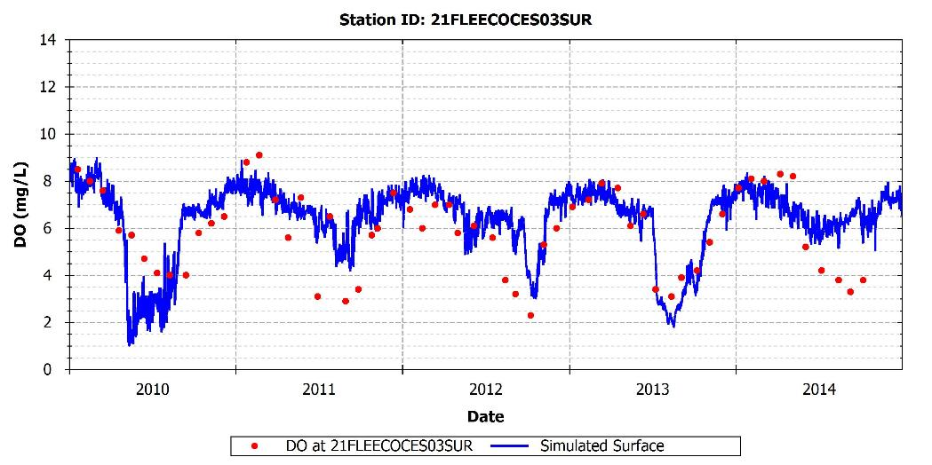
Figure 4: Simulated and observed DO at 21FLEECOCES03SUR

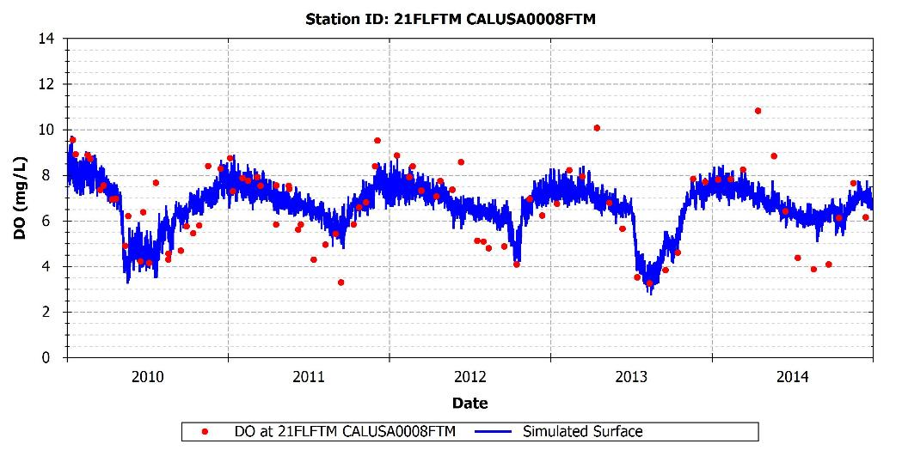
Figure 5: Simulated and observed DO at 21FLFTM CALUSA0008FTM

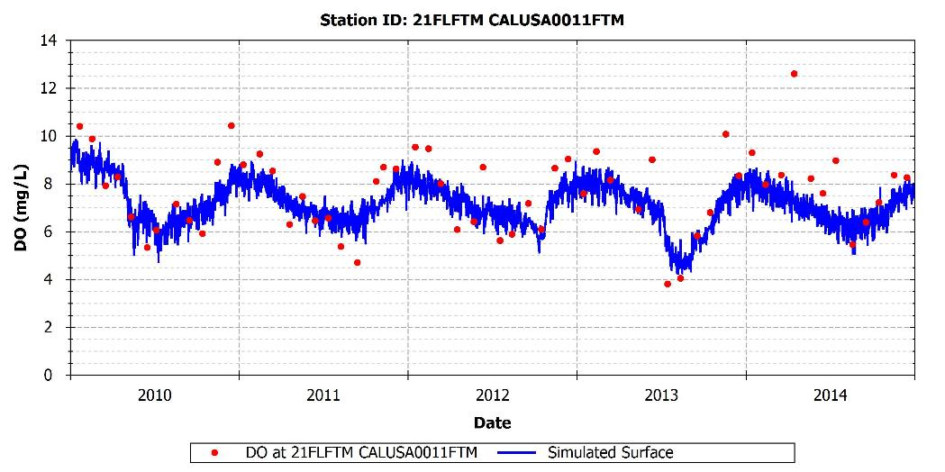
Figure 6: Simulated and observed DO at 21FLFTM CALUSA0011FTM

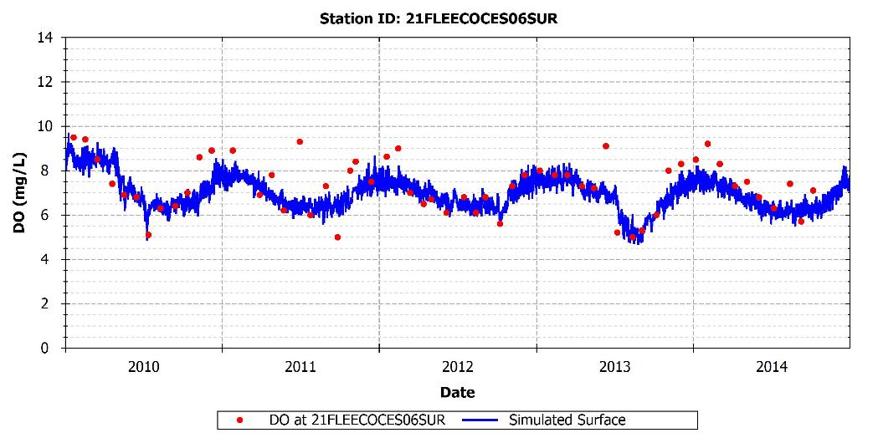
Figure 7: Simulated and observed DO at 21FLEECOCES06SUR

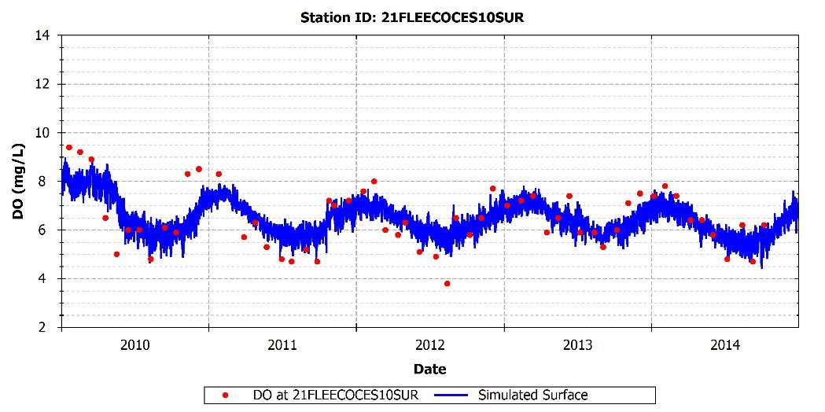
Figure 8: Simulated and observed DO at 21FLEECOCES10SUR

Table 16: Calibration statistics for DO
Station | Measured Mean | Measured Median | Measured 5th %tile | Measured 95th %tile | Simulated Mean | Simulated Median | Simulated 5th %tile | Simulated 95th %tile | R² | MAE | RMSE | NRMSE | IA
21FLEECOCES03SUR | 5.84 | 6.10 | 3.09 | 8.52 | 6.21 | 6.75 | 2.45 | 8.09 | 0.48 | 1.05 | 1.39 | 0.22 | 0.81
21FLEECOCES06SUR | 7.29 | 7.39 | 5.09 | 9.31 | 6.90 | 6.83 | 5.86 | 8.42 | 0.52 | 0.71 | 0.93 | 0.13 | 0.77
21FLEECOCES10SUR | 6.44 | 6.40 | 4.70 | 8.93 | 6.49 | 6.57 | 5.33 | 8.35 | 0.54 | 0.66 | 0.84 | 0.13 | 0.81
21FLFTM CALUSA0008FTM | 6.66 | 7.31 | 3.84 | 9.43 | 6.56 | 6.88 | 4.52 | 7.92 | 0.50 | 1.00 | 1.25 | 0.19 | 0.77
21FLFTM CALUSA0011FTM | 7.82 | 8.19 | 4.74 | 10.43 | 7.23 | 7.30 | 5.65 | 8.60 | 0.36 | 1.15 | 1.80 | 0.24 | 0.59

Phytoplankton Biomass
The observations of phytoplankton biomass (in chlorophyll-a units) available at different locations of the Caloosahatchee River and Estuary show a relatively homogeneous distribution of phytoplankton in the system with most observations falling within the range of 0.5 μg/L – 10 μg/L (Figure 9 to Figure 13). Increases of phytoplankton biomass during the calibration period reflect the existence of highly productive periods, potentially associated with algae blooms in the system. These highly productive events can occur at different periods each year, and may only occur at some locations in the Caloosahatchee River. For example, in 2013 an early spring bloom occurred at 21FLFTM CALUSA0011FTM but not in other Caloosahatchee River stations. In 2010, the bloom appears to occur in the fall.
The model predictions are in general able to reproduce the ranges of variation of phytoplankton biomass at the different stations evaluated (Figure 9 through Figure 13). However, the productivity periods seem to occur in the model during the winter and spring seasons instead of occurring during the summer and early fall as suggested by the observations. The model performance statistics are directly impacted by the discrepancies in the timing of the productive season (Table 17). Further adjustments of the parameters related to phytoplankton production will be conducted to improve the representation of the productivity periods.
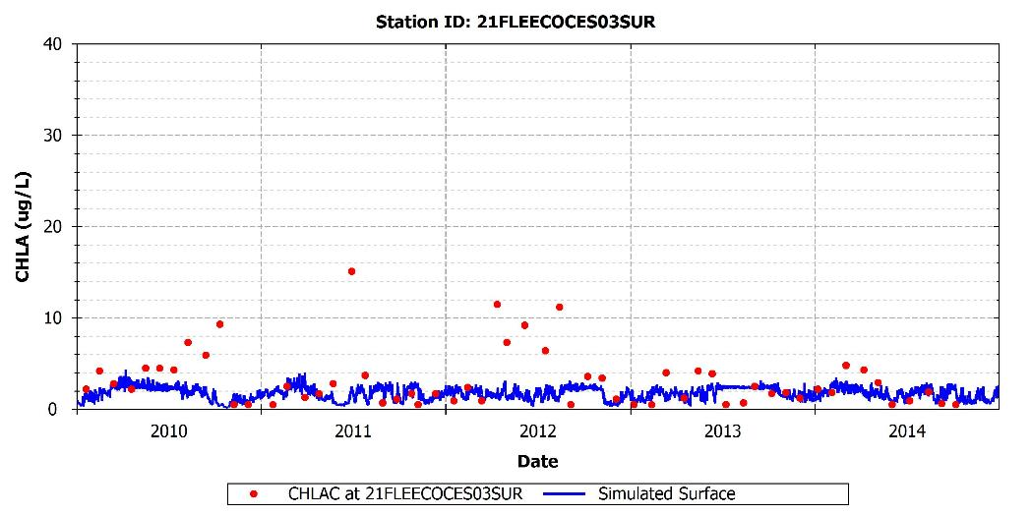
Figure 9: Simulated and observed phytoplankton biomass at 21FLEECOCES03SUR

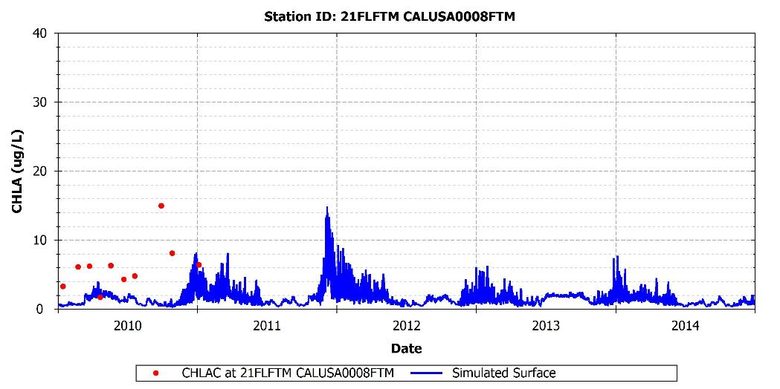
Figure 10: Simulated and observed phytoplankton biomass at 21FLFTM CALUSA0008FTM

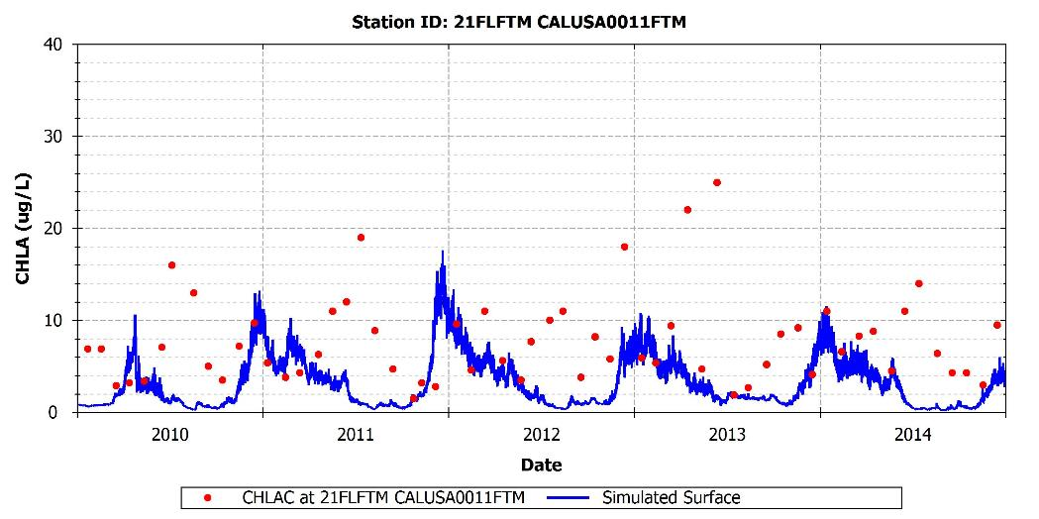
Figure 11: Simulated and observed phytoplankton biomass at 21FLFTM CALUSA0011FTM

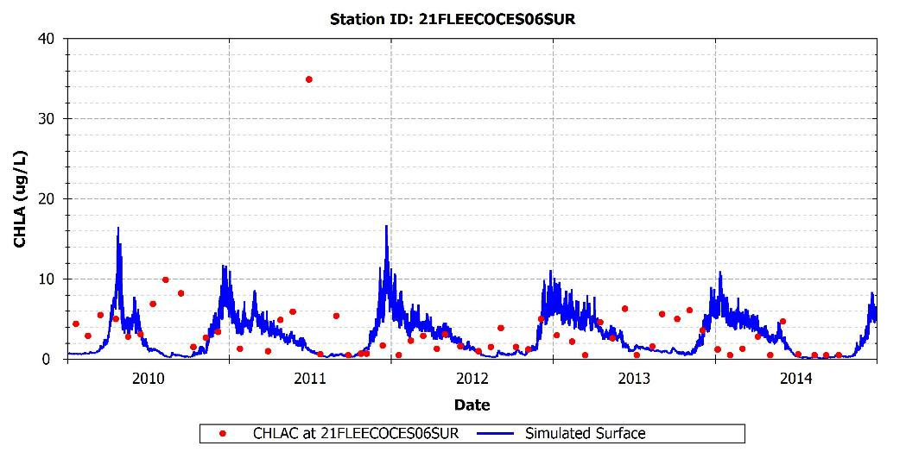
Figure 12: Simulated and observed phytoplankton biomass at 21FLEECOCES06SUR
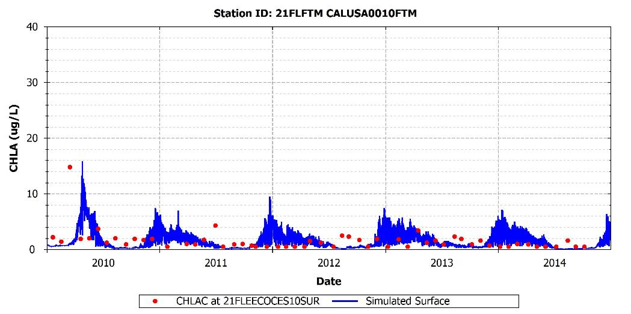
Figure 13: Simulated and observed phytoplankton biomass at 21FLEECOCES10SUR
Table 17: Calibration statistics for phytoplankton biomass
Station | Measured Mean | Measured Median | Measured 5th %tile | Measured 95th %tile | Simulated Mean | Simulated Median | Simulated 5th %tile | Simulated 95th %tile | R² | MAE | RMSE | NRMSE | IA
21FLEECOCES03SUR | 3.16 | 2.45 | 0.50 | 11.22 | 1.80 | 1.94 | 0.82 | 2.58 | 0.00 | 2.14 | 3.48 | 1.48 | 0.13
21FLEECOCES06SUR | 3.41 | 2.80 | 0.50 | 8.37 | 2.44 | 2.59 | 0.26 | 6.64 | 0.02 | 2.89 | 5.47 | 2.06 | 0.14
21FLEECOCES10SUR | 1.52 | 1.20 | 0.50 | 3.76 | 1.48 | 1.34 | 0.12 | 4.03 | 0.00 | 1.47 | 2.44 | 1.65 | 0.22
21FLFTM CALUSA0008FTM | 6.22 | 6.21 | 0.00 | 0.00 | 1.36 | 1.71 | 0.00 | 0.00 | 0.14 | 4.96 | 6.16 | 2.26 | 0.13
21FLFTM CALUSA0011FTM | 7.70 | 7.01 | 2.71 | 18.95 | 2.98 | 2.87 | 0.39 | 8.17 | 0.01 | 5.36 | 7.32 | 1.57 | 0.23

Nitrogen
The available TN observations in the Caloosahatchee River and Estuary in general vary between 0.4 mg/L and 2.5 mg/L for the simulation period (Figure 14 through Figure 23). The availability of nitrogen is higher in the upstream riverine portion of the system where the average TN concentration is approximately 1.5 mg/L (e.g. stations 21FLEECOCES02SUR and 21FLEECOCES03SUR) and lower in the downstream riverine area and embayment area where the average concentration is approximately 0.7 mg/L (e.g. station 21FLEECOCES10SUR). The maximum concentrations of nitrogen typically occur during the summer and fall seasons. The comparison between the model predictions and observations of TN indicate that the model successfully captures the timing, seasonal variability, and concentration levels observed during the calibration period (Table 18 and Figure 14 through Figure 23).
An evaluation of the observed species distribution of nitrogen suggest that the dominant form of nitrogen in the Caloosahatchee River is organic, while the inorganic forms, available for phytoplankton production, are substantially lower. Available observations of inorganic nitrogen show levels of NH₄ ranging between 0.015 mg/L and 0.15 mg/L (Figure 23), with average values close to 0.05 mg/L (Table 20), and levels of NOx ranging between 0.01 mg/L and 0.15 mg/L, with average values of approximately 0.075 mg/L (Figure 24 through Figure 27). The observed concentrations of inorganic nitrogen (NH₄+NOx) vary between 0.1 mg/L and 0.3 mg/L, which represents between 10% and 30% of the TN budget. Although the organic forms of nitrogen can represent up to, or even more than, two-thirds of the TN budget, the observed levels of inorganic nitrogen in the system may be higher than in other estuaries of the Gulf of Mexico where nitrogen can act as a limiting factor for phytoplankton growth, such as in the St. Louis Bay Estuary, Mississippi (Tetra Tech, 2013).
A comparison of the model predictions and observations of NH₄ and NOx (Figure 23 through Figure 27 and Table 20 and Table 21) indicate that the model is in general able to capture the seasonal patterns and concentration levels observed across the system. The model currently slightly over predicts the levels of NO₃ in most of the evaluated stations, and further tuning of the parameters related to the nitrification process will be conducted to improve the NO₃simulations.

Total Nitrogen
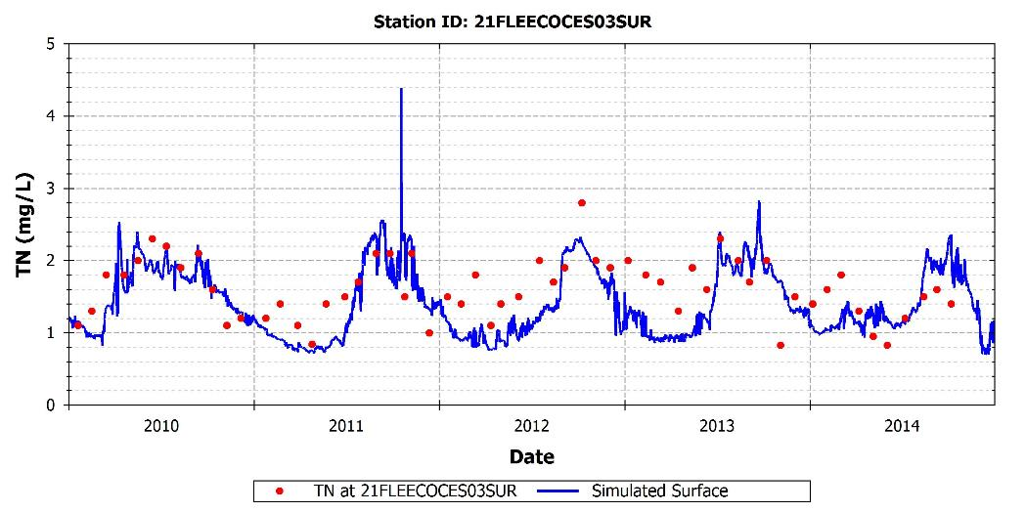
Figure 14: Simulated and observed TN at 21FLEECOCES03SUR

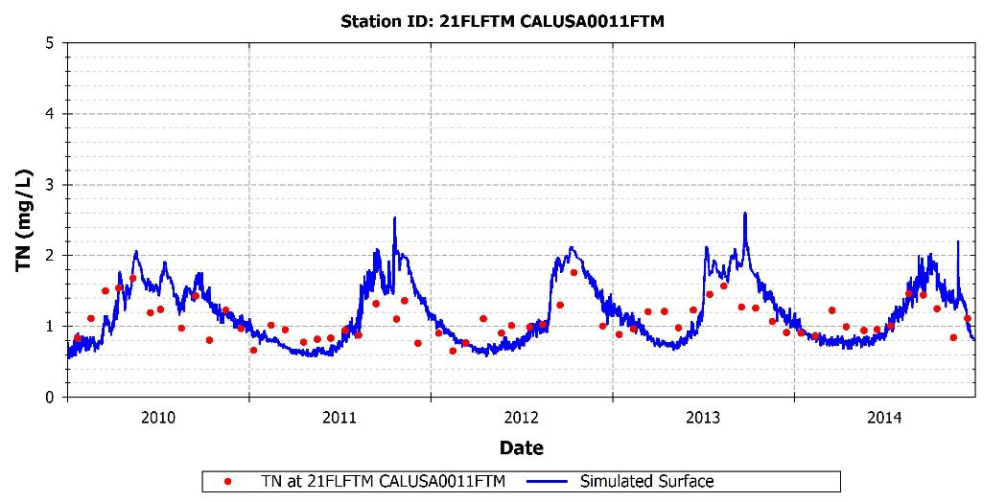
Figure 15: Simulated and observed TN at 21FLFTM CALUSA0011FTM

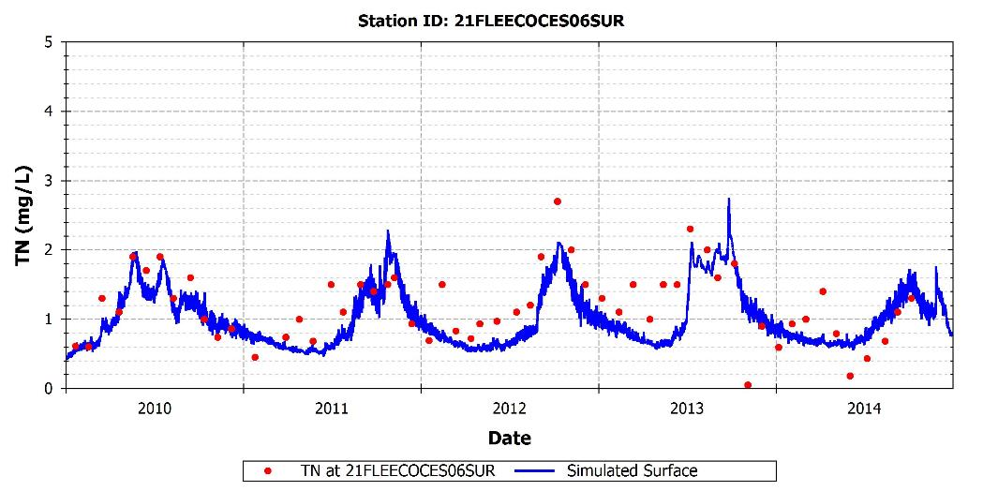
Figure 16: Simulated and observed TN at 21FLEECOCES06SUR

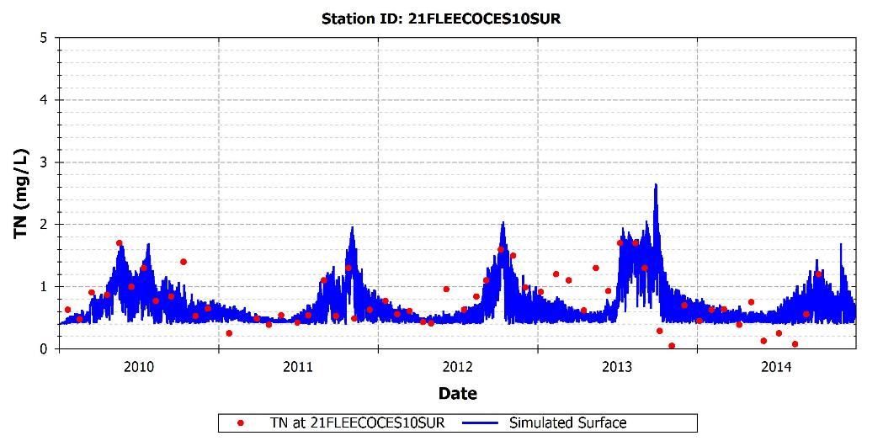
Figure 17: Simulated and observed TN at 21FLEECOCES10SUR

Table 18: Calibration statistics for TN
Station | Measured Mean | Measured Median | Measured 5th %tile | Measured 95th %tile | Simulated Mean | Simulated Median | Simulated 5th %tile | Simulated 95th %tile | R² | MAE | RMSE | NRMSE | IA
21FLEECOCES03SUR | 1.61 | 1.70 | 0.84 | 2.30 | 1.46 | 1.34 | 0.77 | 2.33 | 0.36 | 0.37 | 0.44 | 0.28 | 0.75
21FLEECOCES06SUR | 1.19 | 1.29 | 0.41 | 2.03 | 1.06 | 0.98 | 0.56 | 1.97 | 0.46 | 0.34 | 0.42 | 0.35 | 0.81
21FLEECOCES10SUR | 0.79 | 0.77 | 0.13 | 1.70 | 0.74 | 0.66 | 0.42 | 1.49 | 0.35 | 0.24 | 0.35 | 0.43 | 0.76
21FLFTM CALUSA0011FTM | 1.09 | 1.07 | 0.76 | 1.57 | 1.19 | 1.15 | 0.65 | 2.01 | 0.41 | 0.28 | 0.34 | 0.29 | 0.73

Total Kjeldahl Nitrogen
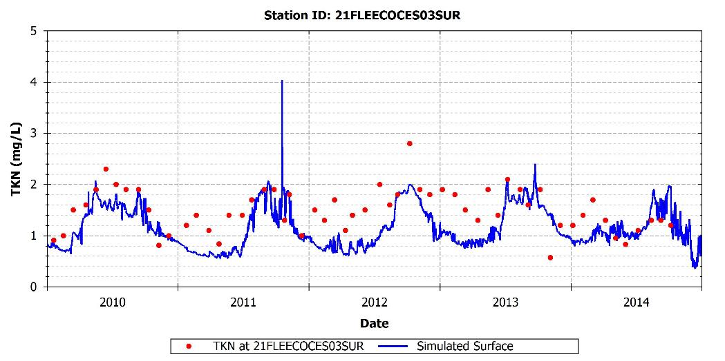
Figure 18: Simulated and observed TKN at 21FLEECOCES03SUR
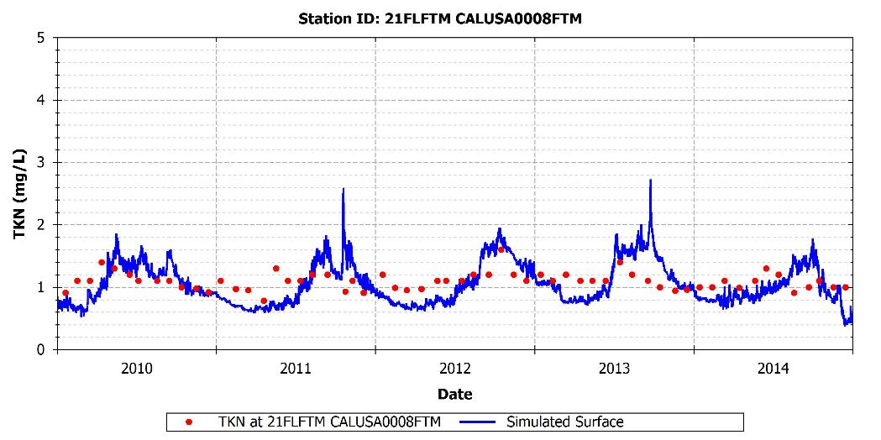
Figure 19: Simulated and observed TKN at 21FLFTM CALUSA0008FTM

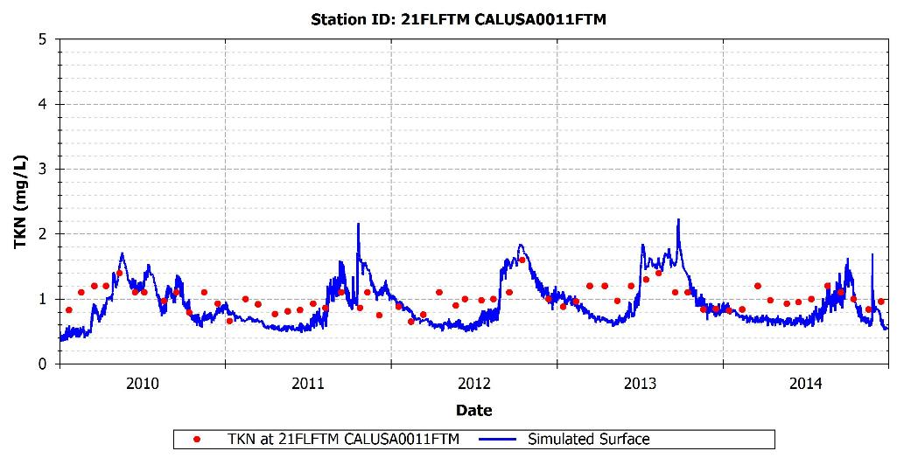
Figure 20: Simulated and observed TKN at 21FLFTM CALUSA0011FTM

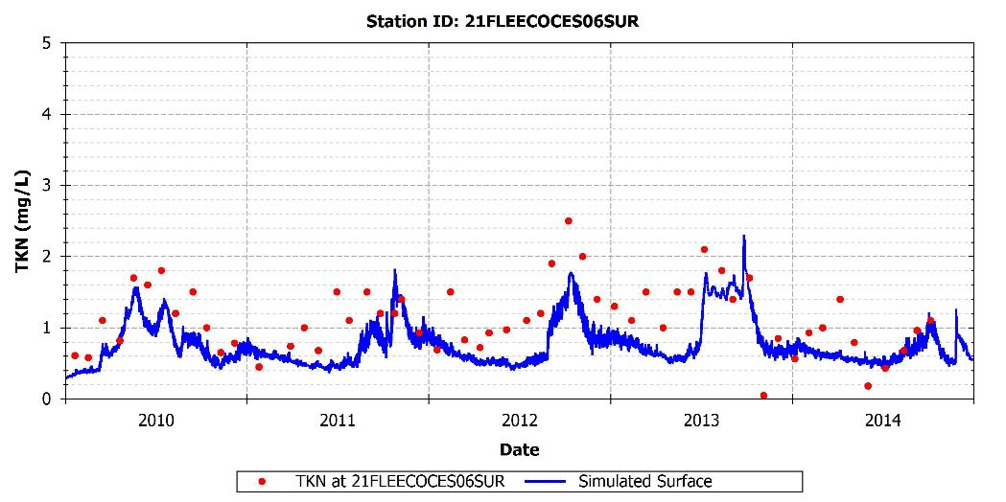
Figure 21: Simulated and observed TKN at 21FLEECOCES06SUR

Figure 22: Simulated and observed TKN at 21FLEECOCES10SUR

Table 19: Calibration statistics for TKN
Station | Measured Mean | Measured Median | Measured 5th %tile | Measured 95th %tile | Simulated Mean | Simulated Median | Simulated 5th %tile | Simulated 95th %tile | R² | MAE | RMSE | NRMSE | IA
21FLEECOCES03SUR | 1.50 | 1.50 | 0.83 | 2.11 | 1.21 | 1.11 | 0.62 | 1.96 | 0.29 | 0.42 | 0.50 | 0.36 | 0.68
21FLEECOCES06SUR | 1.13 | 1.10 | 0.41 | 2.01 | 0.81 | 0.70 | 0.43 | 1.56 | 0.42 | 0.41 | 0.49 | 0.49 | 0.69
21FLEECOCES10SUR | 0.75 | 0.71 | 0.13 | 1.50 | 0.56 | 0.48 | 0.32 | 1.20 | 0.30 | 0.29 | 0.37 | 0.54 | 0.66
21FLFTM CALUSA0008FTM | 1.09 | 1.10 | 0.91 | 1.40 | 1.05 | 1.02 | 0.63 | 1.63 | 0.17 | 0.26 | 0.30 | 0.28 | 0.54
21FLFTM CALUSA0011FTM | 1.00 | 1.00 | 0.75 | 1.40 | 0.92 | 0.84 | 0.52 | 1.59 | 0.27 | 0.26 | 0.30 | 0.31 | 0.66

Ammonium (NH₄)
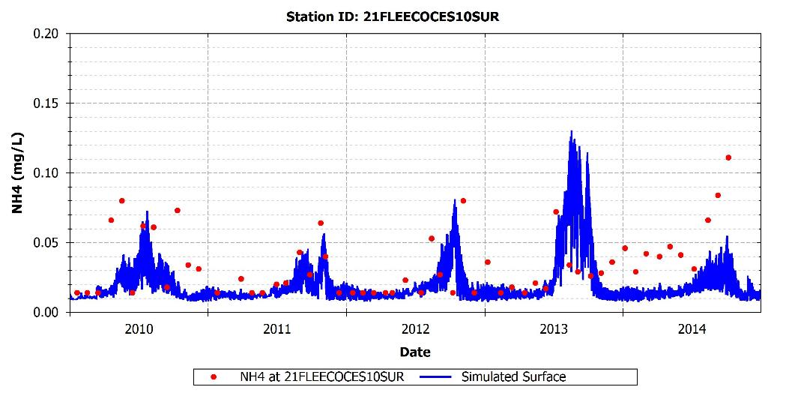
Figure 23: Simulated and observed NH₄ at 21FLEECOCES10SUR

Table 20: Calibration statistics for NH₄
Station | Measured Mean | Measured Median | Measured 5th %tile | Measured 95th %tile | Simulated Mean | Simulated Median | Simulated 5th %tile | Simulated 95th %tile | R² | MAE | RMSE | NRMSE | IA
21FLEECOCES10SUR | 0.05 | 0.04 | 0.01 | 0.13 | 0.02 | 0.02 | 0.01 | 0.06 | 0.05 | 0.03 | 0.05 | 1.35 | 0.31

Nitrite + Nitrate (NOx)
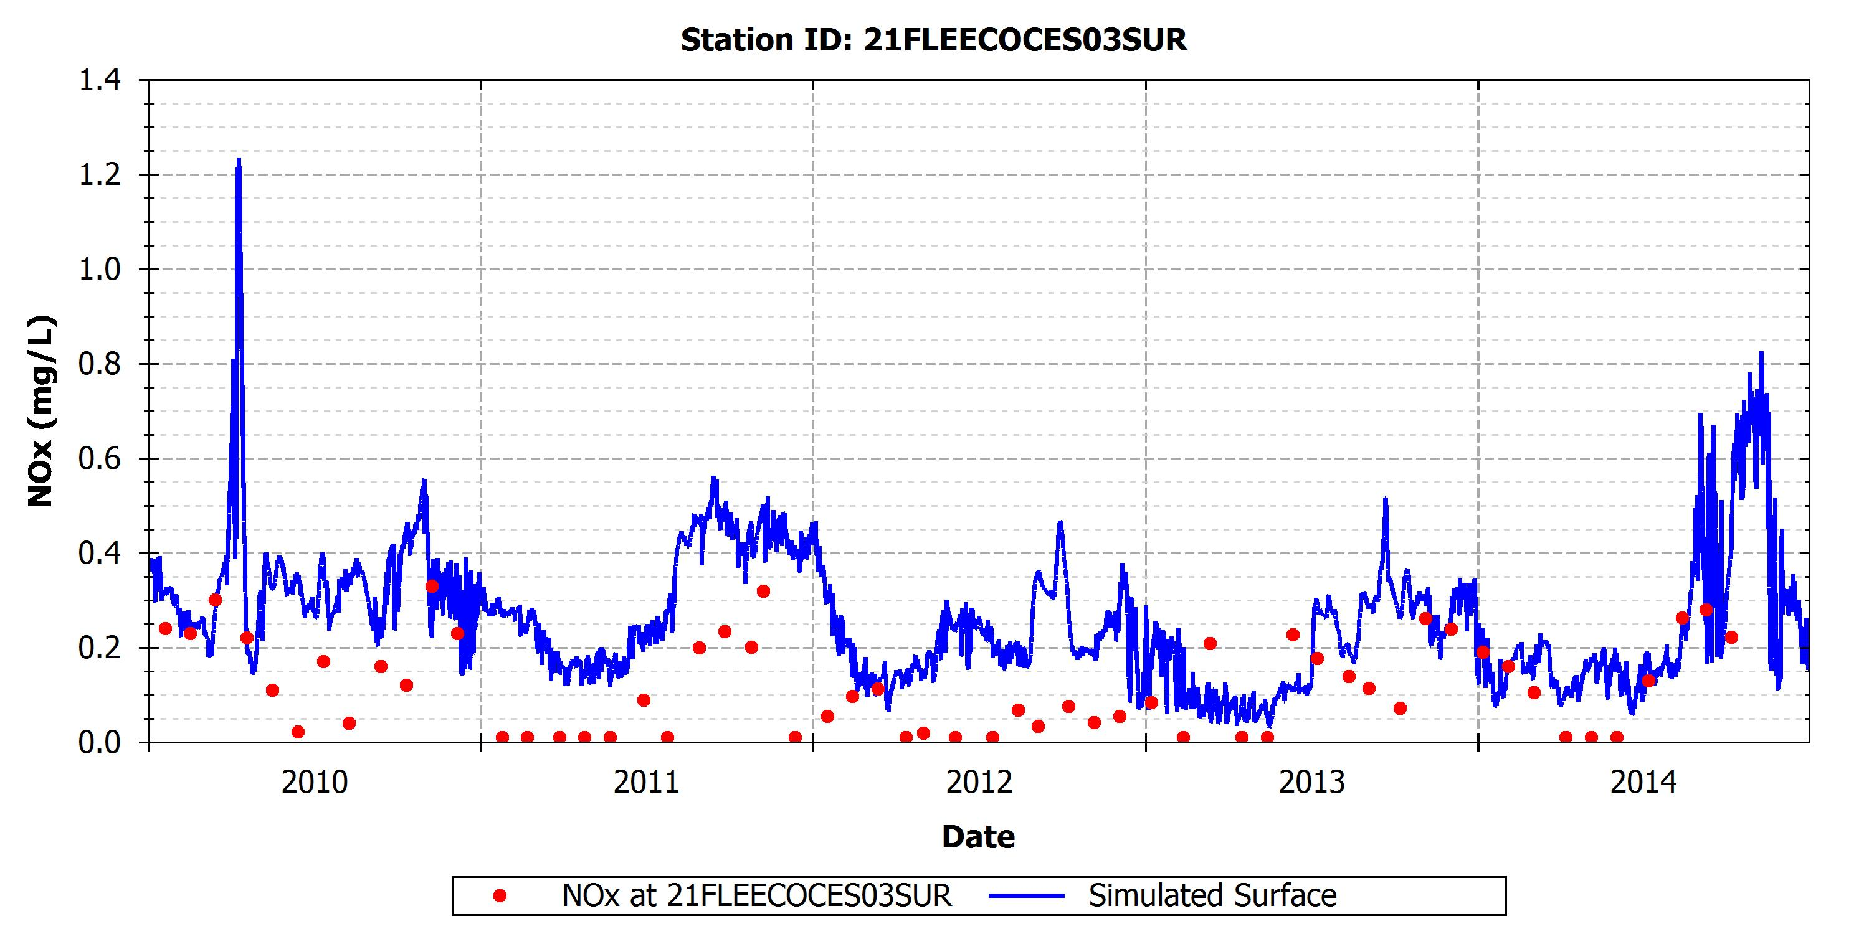
Figure 24: Simulated and observed NOx at 21FLEECOCES03SUR

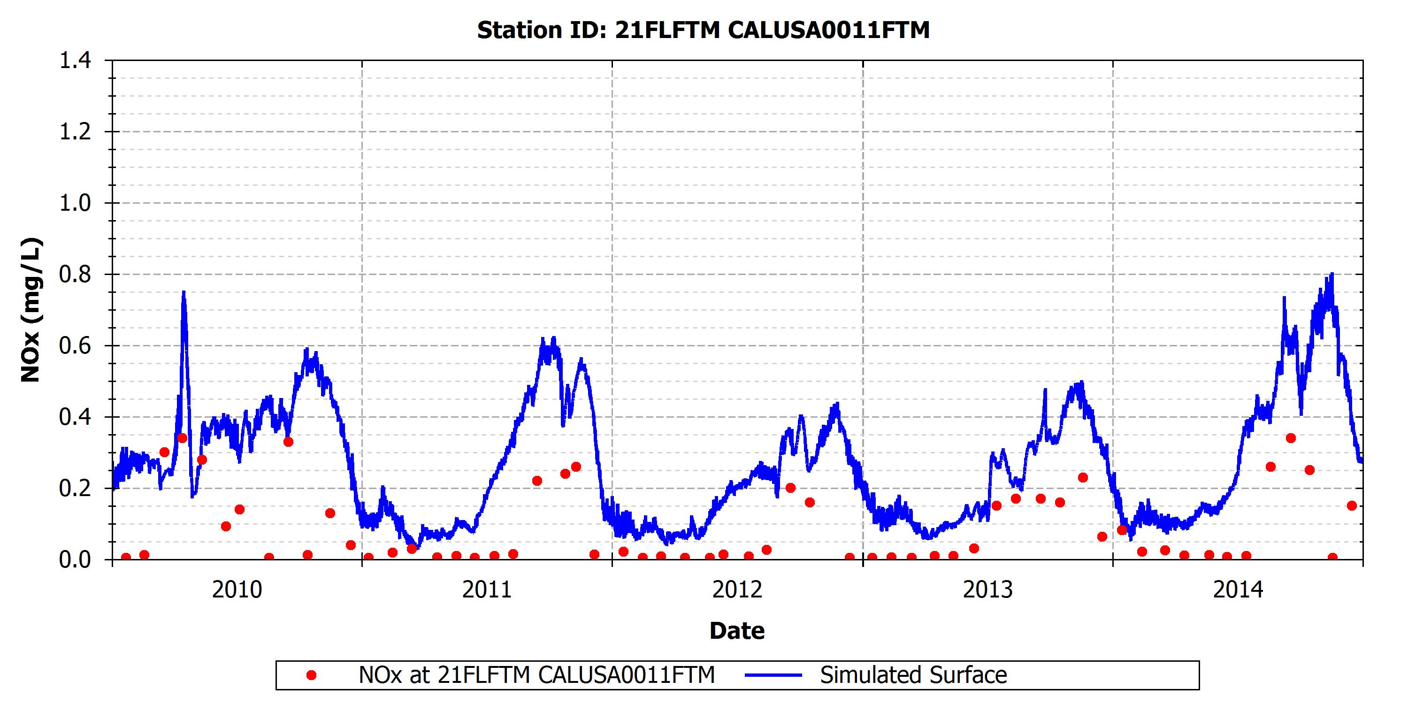
Figure 25: Simulated and observed NOx at 21FLFTM CALUSA0011FTM

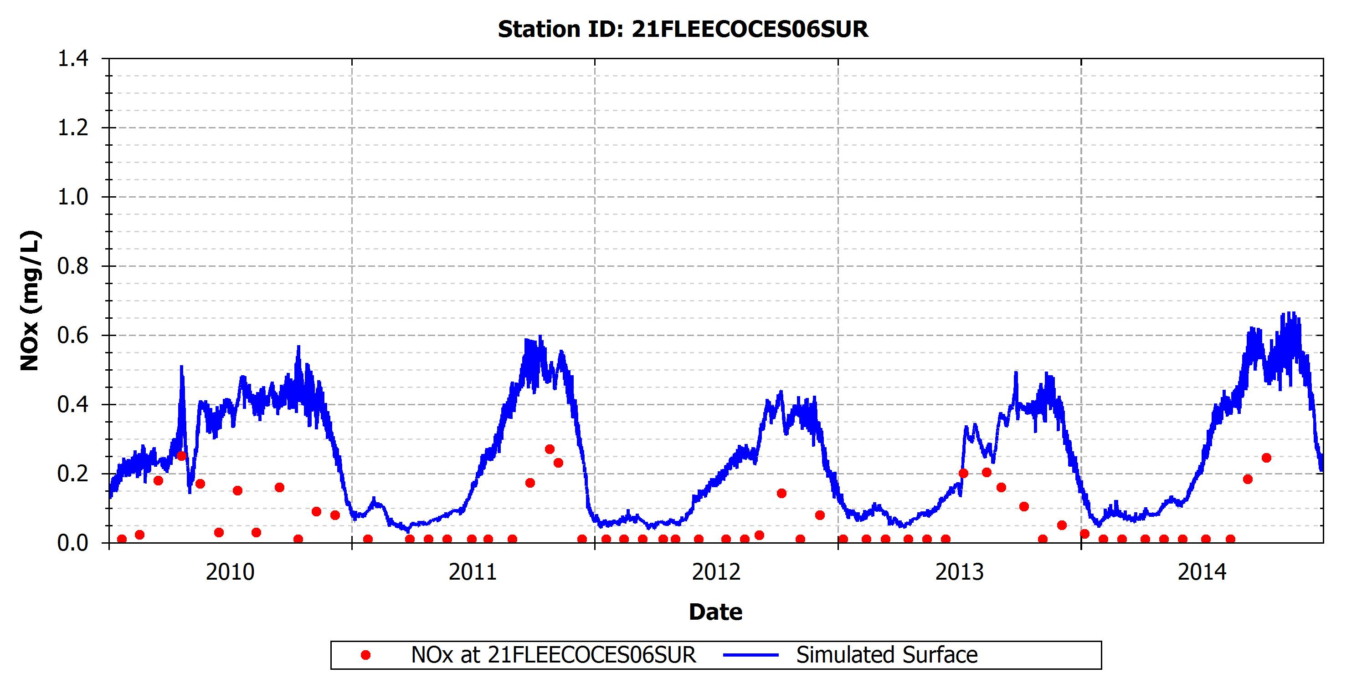
Figure 26: Simulated and observed NOx at 21FLEECOCES06SUR

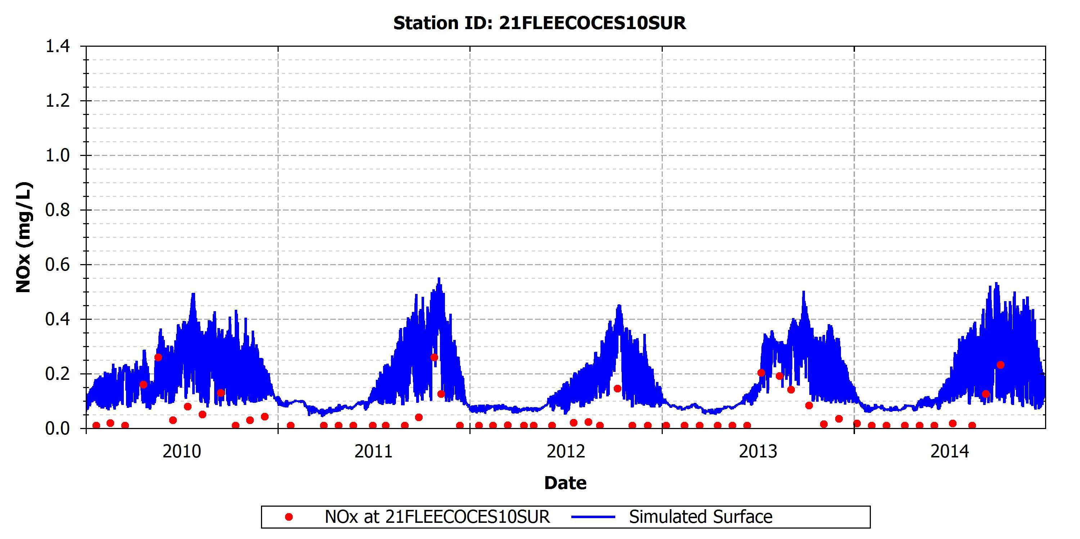
Figure 27: Simulated and observed NOx at 21FLEECOCES10SUR

Table 21: Calibration statistics for NOx
Station | Measured Mean | Measured Median | Measured 5th %tile | Measured 95th %tile | Simulated Mean | Simulated Median | Simulated 5th %tile | Simulated 95th %tile | R² | MAE | RMSE | NRMSE | IA
21FLEECOCES03SUR | 0.12 | 0.11 | 0.01 | 0.30 | 0.25 | 0.25 | 0.08 | 0.47 | 0.13 | 0.15 | 0.18 | 0.97 | 0.50
21FLEECOCES06SUR | 0.06 | 0.01 | 0.01 | 0.25 | 0.25 | 0.26 | 0.06 | 0.50 | 0.41 | 0.19 | 0.22 | 1.45 | 0.57
21FLEECOCES10SUR | 0.05 | 0.01 | 0.01 | 0.24 | 0.18 | 0.18 | 0.07 | 0.40 | 0.38 | 0.13 | 0.15 | 1.33 | 0.57
21FLFTM CALUSA0011FTM | 0.09 | 0.03 | 0.00 | 0.33 | 0.27 | 0.29 | 0.08 | 0.61 | 0.35 | 0.19 | 0.23 | 1.24 | 0.58

Phosphorus
Available water quality observations at different locations of the Caloosahatchee River show that the average TP concentration in the system is approximately 0.1 mg/L, and varies between 0.05 mg/L and 0.2 mg/L. The analysis of the calibration results indicate that the model predictions successfully capture the average values and range of variability of TP (Table 22). The model is also able to capture the timing and seasonal variability of the observations in all stations evaluated (Figure 28 through Figure 31).
The inorganic form of phosphorus, PO₄, which is available for nutrient uptake, varies between 0.01 mg/L and 0.1 mg/L. These PO₄ levels are in general well represented by the model as can be observed in Table 23, Figure 32, and Appendix A.

Total Phosphorus
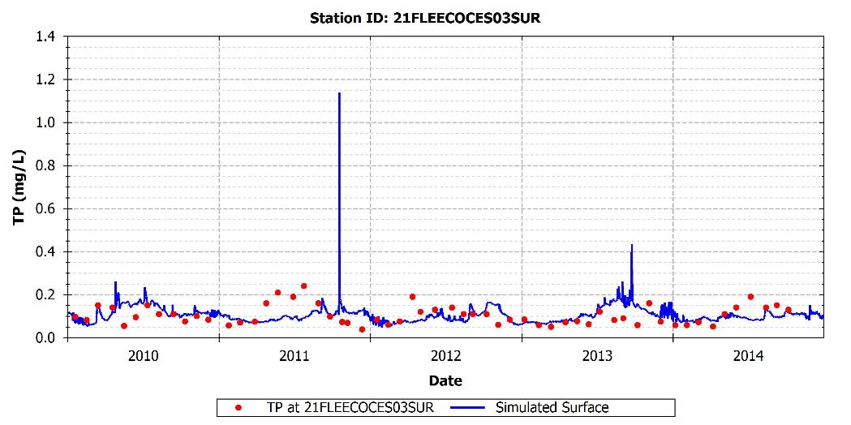
Figure 28: Simulated and observed TP at 21FLEECOCES03SUR

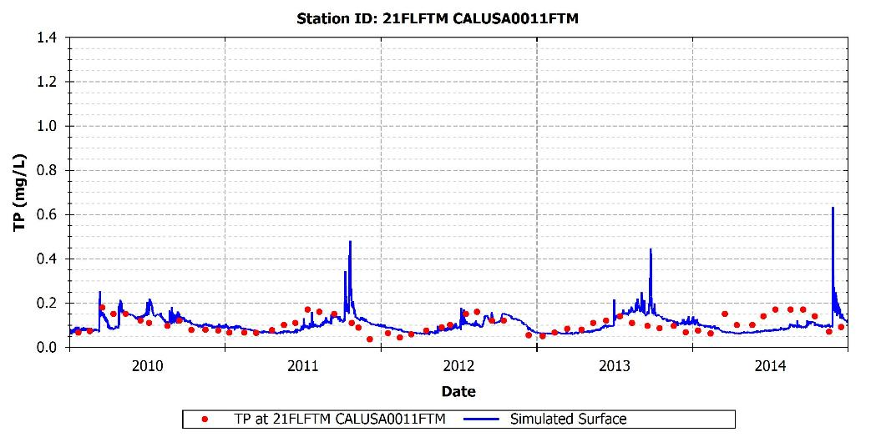
Figure 29: Simulated and observed TP at 21FLFTM CALUSA0011FTM

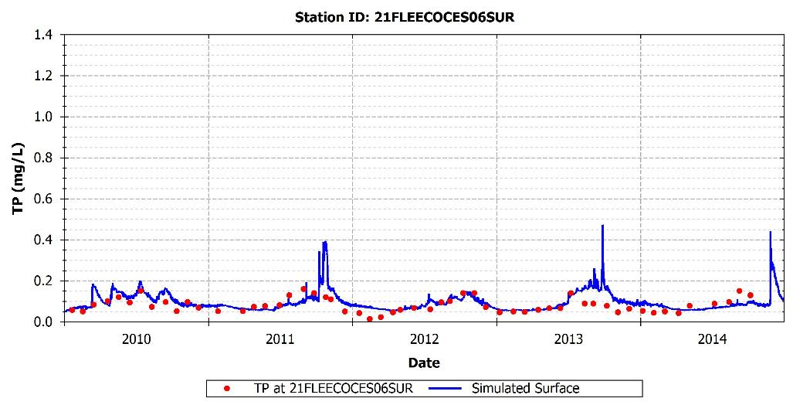
Figure 30: Simulated and observed TP at 21FLEECOCES06SUR

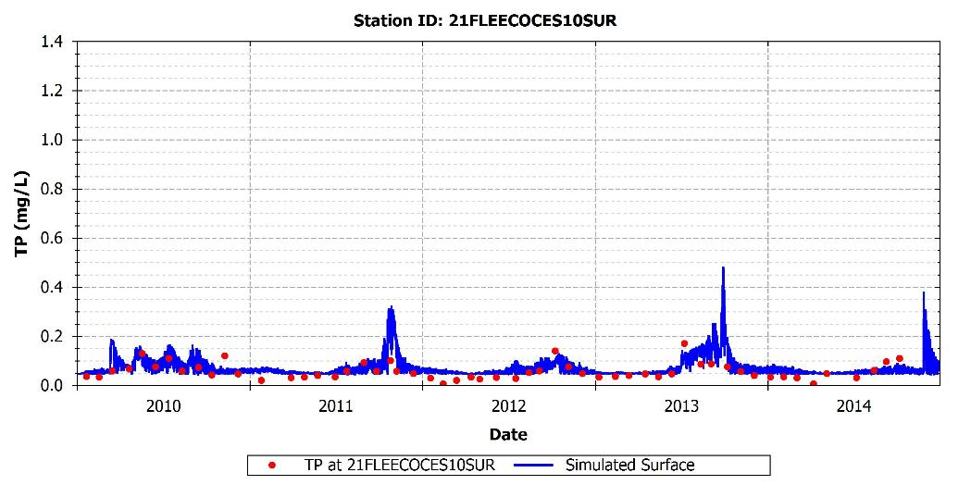
Figure 31: Simulated and observed TP at 21FLEECOCES10SUR

Table 22: Calibration statistics for TP
Station | Measured Mean | Measured Median | Measured 5th %tile | Measured 95th %tile | Simulated Mean | Simulated Median | Simulated 5th %tile | Simulated 95th %tile | R² | MAE | RMSE | NRMSE | IA
21FLEECOCES03SUR | 0.10 | 0.10 | 0.05 | 0.19 | 0.11 | 0.10 | 0.07 | 0.16 | 0.00 | 0.04 | 0.06 | 0.52 | 0.37
21FLEECOCES06SUR | 0.08 | 0.08 | 0.04 | 0.15 | 0.10 | 0.09 | 0.06 | 0.18 | 0.21 | 0.03 | 0.05 | 0.55 | 0.59
21FLEECOCES10SUR | 0.06 | 0.05 | 0.02 | 0.13 | 0.09 | 0.08 | 0.05 | 0.20 | 0.25 | 0.04 | 0.06 | 0.74 | 0.57
21FLFTM CALUSA0011FTM | 0.10 | 0.10 | 0.05 | 0.17 | 0.10 | 0.10 | 0.06 | 0.17 | 0.07 | 0.04 | 0.04 | 0.41 | 0.53

Orthophosphate (PO₄)
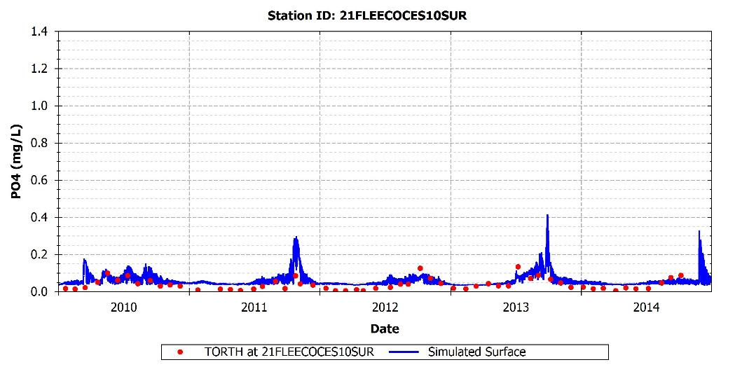
Figure 32: Simulated and observed PO₄ at 21FLEECOCES10SUR

Table 23: Calibration statistics for PO₄
Station | Measured Mean | Measured Median | Measured 5th %tile | Measured 95th %tile | Simulated Mean | Simulated Median | Simulated 5th %tile | Simulated 95th %tile | R² | MAE | RMSE | NRMSE | IA
21FLEECOCES10SUR | 0.04 | 0.03 | 0.004 | 0.10 | 0.06 | 0.05 | 0.036 | 0.15 | 0.25 | 0.03 | 0.04 | 0.8 | 0.67

Light
An adequate representation of the levels of light available for phytoplankton growth is important to correctly capture the available energy for growth. If solar radiation is low in the water column, phytoplankton communities can have insufficient energy to fixate carbon and nutrients and to increase biomass. However, if the levels of solar radiation are too high, phytoplankton can suffer photo-inhibition, which can also impair algae growth.
In the EFDC model, one of the factors controlling the vertical distribution of light in the water column is the extinction coefficient k_{e} (1/m), which reflects the attenuation of the incident light due to algae shading and particulate organic matter concentration. The EFDC model was adjusted to simulate the levels of light extinction observed in data collection efforts conducted between 2000 and 2003 (Figure 33 through Figure 39). The measurements collected during this period indicate that the levels of light extinction in the system can vary between 0.1 (1/m) and 1.5 (1/m) with an average of 0.5 (1/m). To reproduce these values, a background light extinction coefficient of 0.5 (1/m) was prescribed in the model, and the coefficients related to algae concentration and organic matter concentration were adjusted during calibration (Table 11).
The comparison between the model predictions and observations of light extinction indicate that the model is able to simulate the average levels of light extinction in the system with values between 0.6 (1/m) and 1.0 (1/m). The simulations, however, show a lower variability than the observations. This can be partially explained by the fact that the extinction coefficients predicted by the model are representative for the area of each computational cell, which in most cases exceed 1,000 m², while the observations reflect the local conditions of the water column.
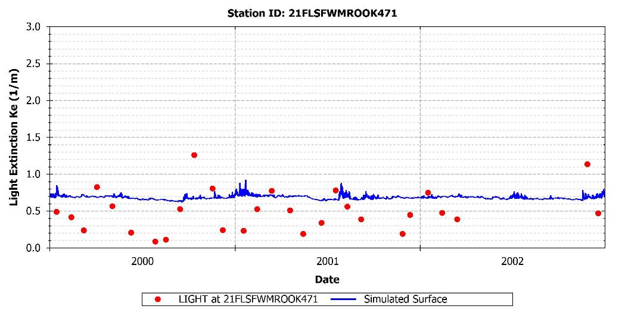
Figure 33: Simulated and observed light extinction at 21FLSFWMROOK471
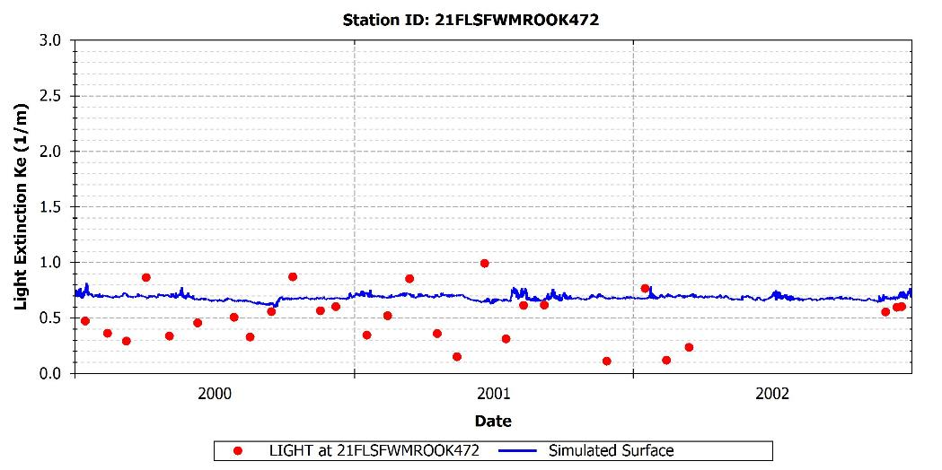
Figure 34: Simulated and observed light extinction at 21FLSFWMROOK472

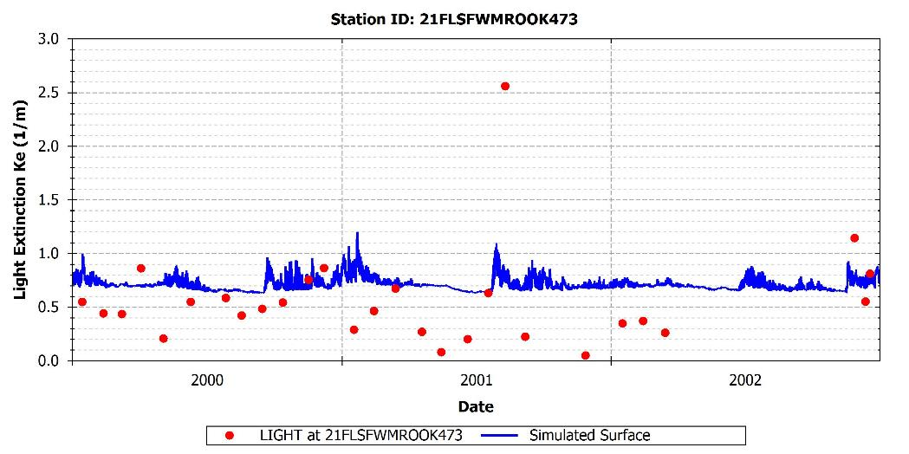
Figure 35: Simulated and observed light extinction at 21FLSFWMROOK473
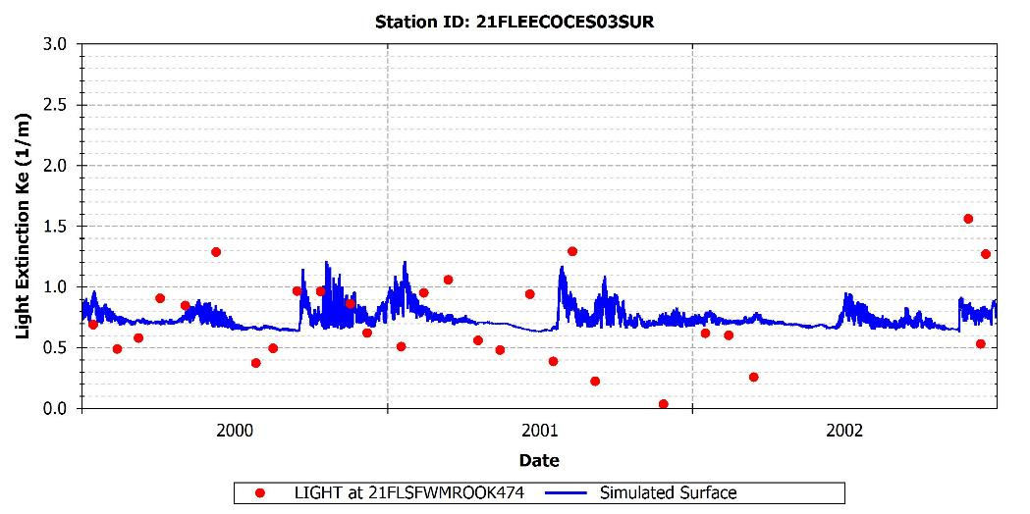
Figure 36: Simulated and observed light extinction at 21FLSFWMROOK474

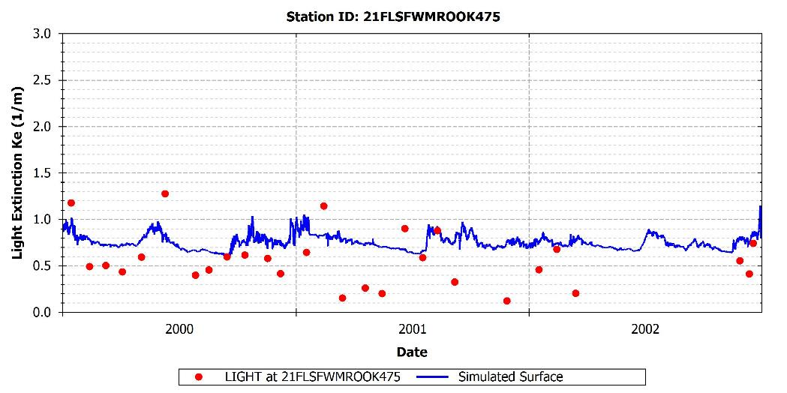
Figure 37: Simulated and observed light extinction at 21FLSFWMROOK475
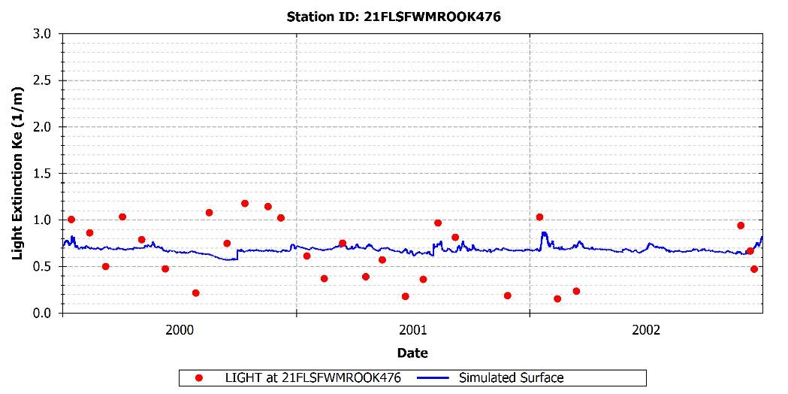
Figure 38: Simulated and observed light extinction at 21FLSFWMROOK476

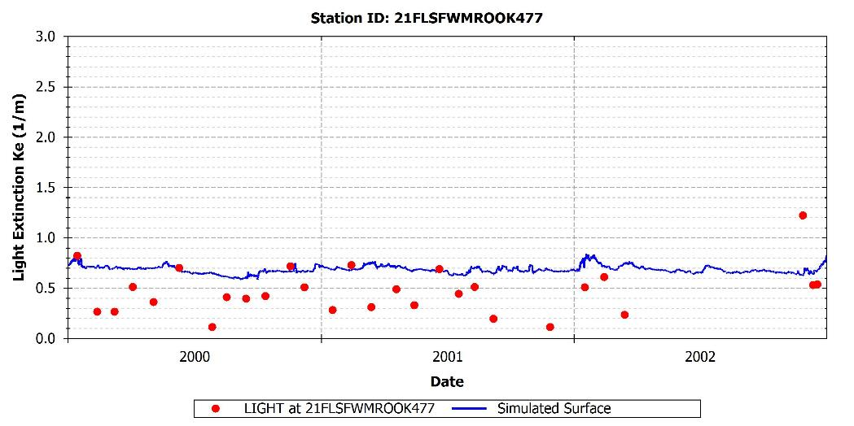
Figure 39: Simulated and observed light extinction at 21FLSFWMROOK477

Calibration Modifications and Recommendations
The following list details the most important modifications and recommendations that will be incorporated to improve the performance of the model:
- Further adjustments of the parameters related to phytoplankton production will be conducted to improve the representation of the productivity periods.
- The model slightly over predicts the levels of NOx in most of the evaluated stations. Further tuning of the parameters related to the nitrification process will be conducted to improve the simulations of NOx.

References
Cerco, C.F. and T.M. Cole. 1994. Three-Dimensional Eutrophication Model of Chesapeake Bay. Volume I: Main Report. Technical Report EL-94-4. U.S. Army Corps of Engineers, Waterways Experiment Station, Vicksburg, MS, May 1994.
Stow, C., Roessler, C., Borsuk, M., Bowen, J., and Rechkhow, K. 2003. Comparison of Estuarine Water Quality Models for Total Maximum Daily Load Development in the Neuse River Estuary. J. Water Resources Planning and Management, 10.1061/(ASCE)0733-9496(2003) 129:4(307), 307-314.
Tetra Tech. 2013. Sources, Fate, Transport, and Effects (SFTE) of Nutrients as a Basis for Protective Criteria in Estuarine and Near-Coastal Waters. Prepared for Gulf of Mexico Alliance.

Appendix A: WATER QUALITY Calibration Results (2010 – 2014)

DISSOLVED OXYGEN

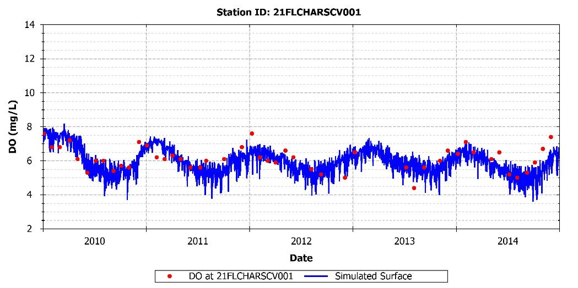
Figure A-1: Simulated and observed DO at 21FLCHARSCV001

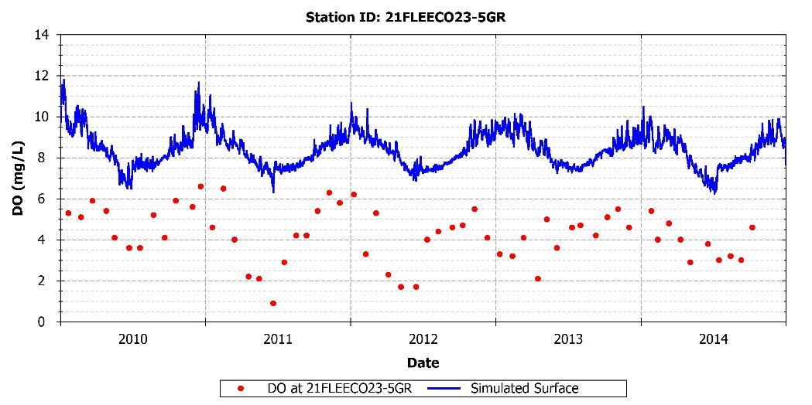
Figure A-2: Simulated and observed DO at 21FLEECO23-5GR
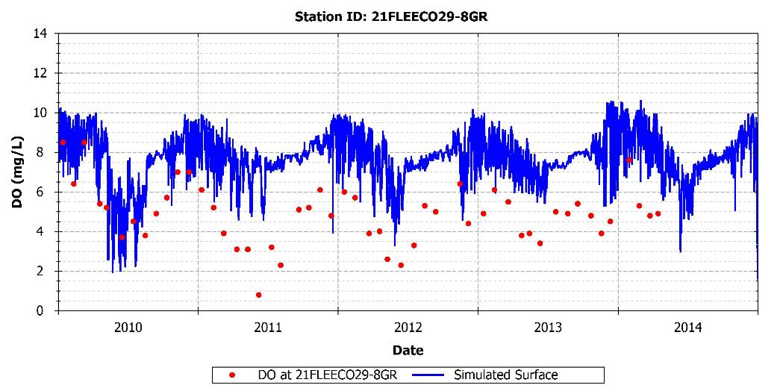
Figure A-3: Simulated and observed DO at 21FLEECO29-8GR

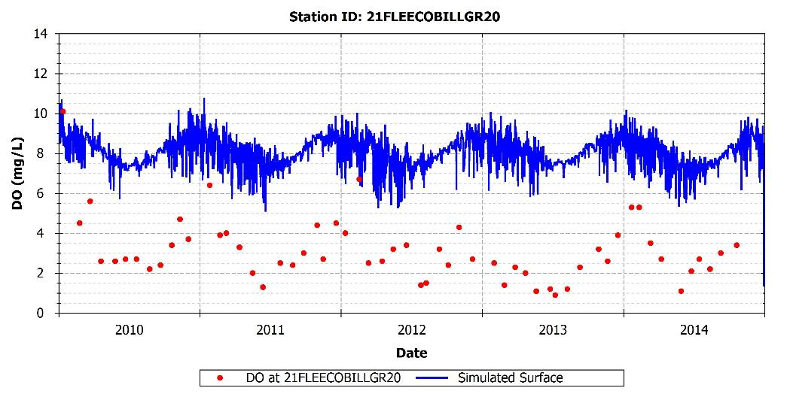
Figure A-4: Simulated and observed DO at 21FLEECOBILLGR20
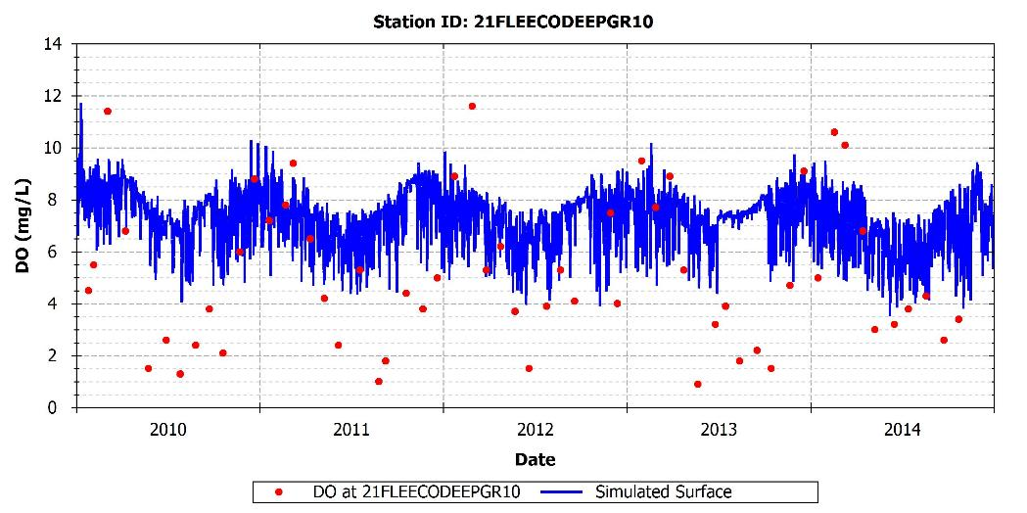
Figure A-5: Simulated and observed dissolved oxygen at 21FLEECODEEPGR10

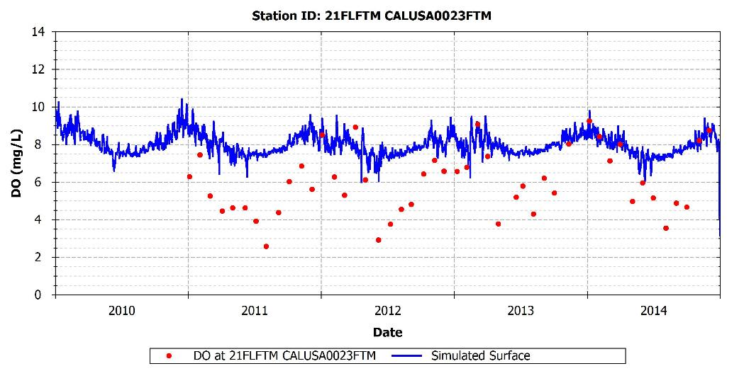
Figure A-6: Simulated and observed dissolved oxygen at 21FLFTM CALUSA0023FTM

PHYTOPLANKTON BIOMASS

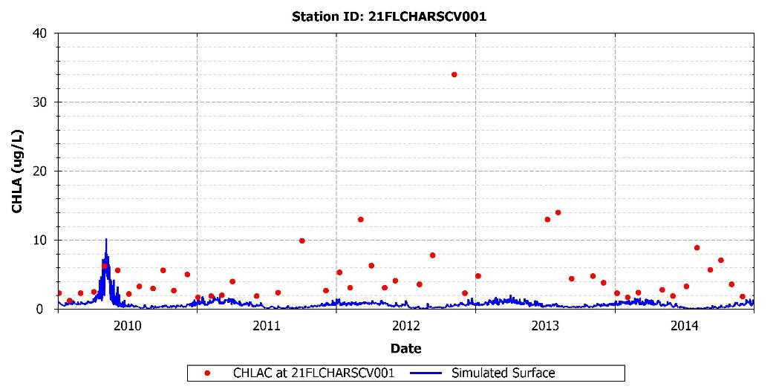
Figure A-7: Simulated and observed phytoplankton biomass at 21FLCHARSCV001

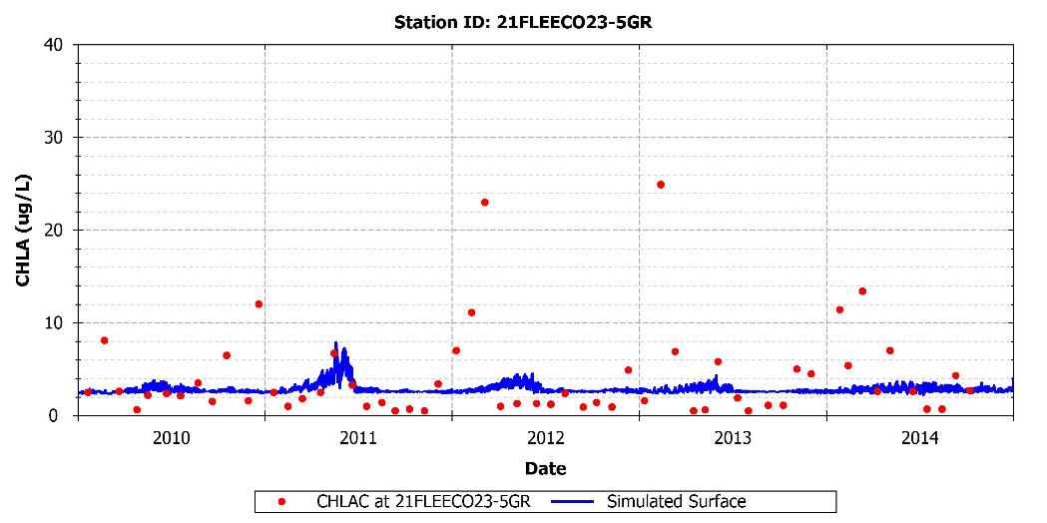
Figure A-8: Simulated and observed phytoplankton biomass at 21FLEECO23-5GR
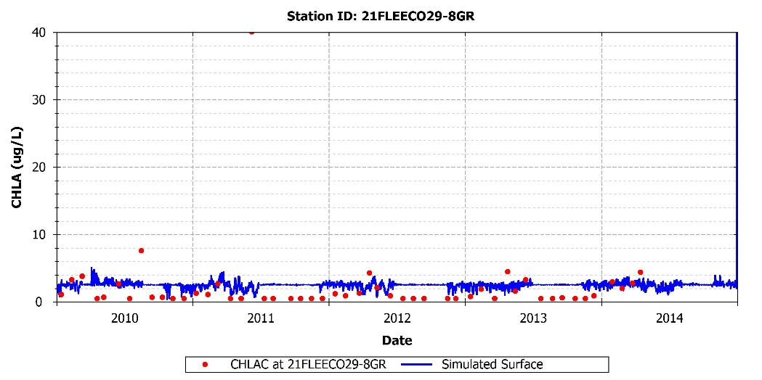
Figure A-9: Simulated and observed phytoplankton biomass at 21FLEECO29-8GR

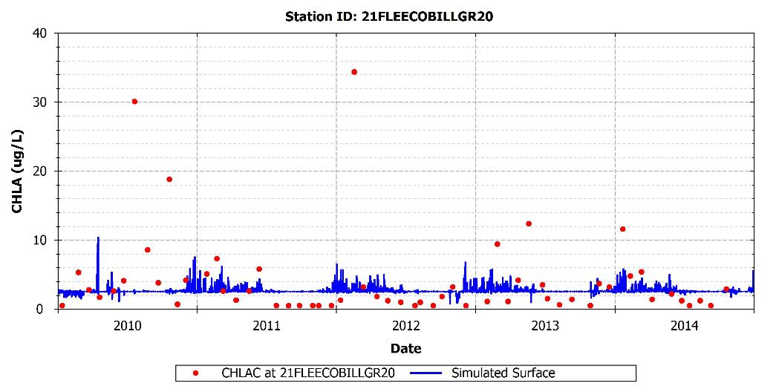
Figure A-10: Simulated and observed phytoplankton biomass at 21FLEECOBILLGR20
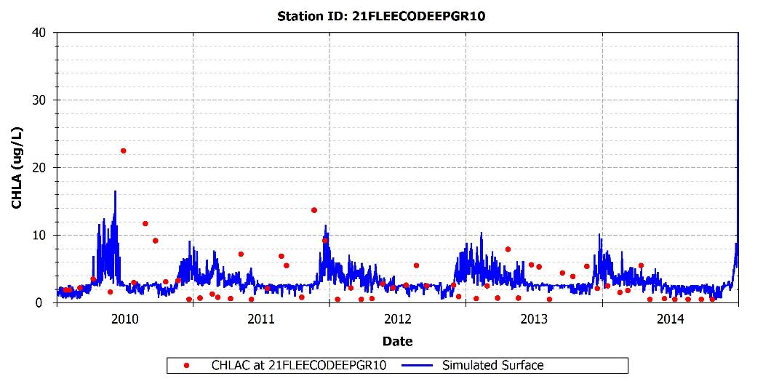
Figure A-11: Simulated and observed phytoplankton biomass at 21FLEECODEEPGR10

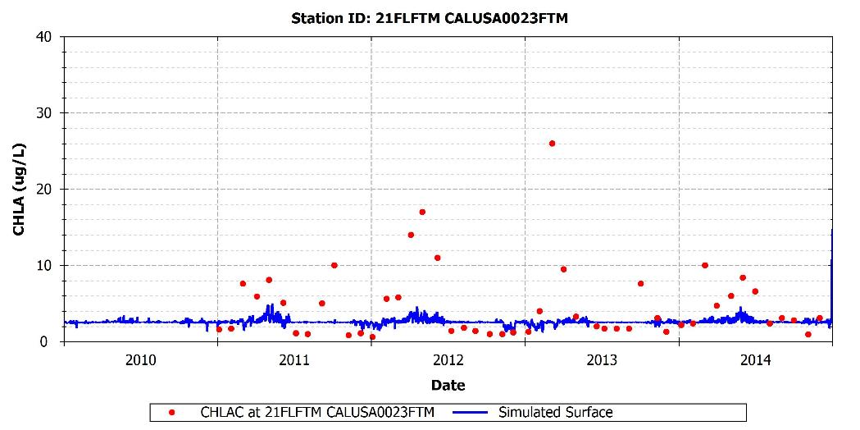
Figure A-12: Simulated and observed phytoplankton biomass at 21FLFTM CALUSA0023FTM

TOTAL NITROGEN

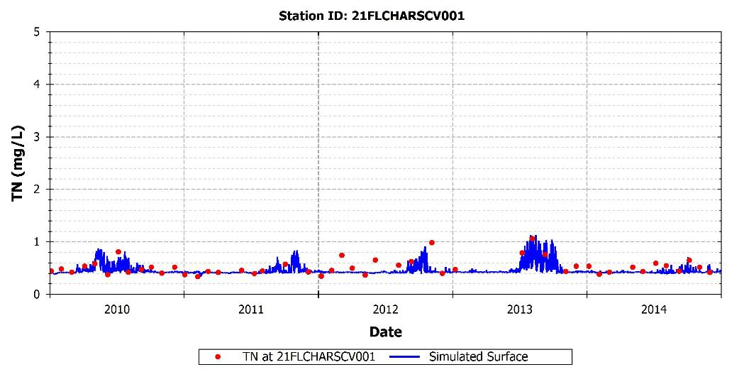
Figure A-13: Simulated and observed TN at 21FLCHARSCV001

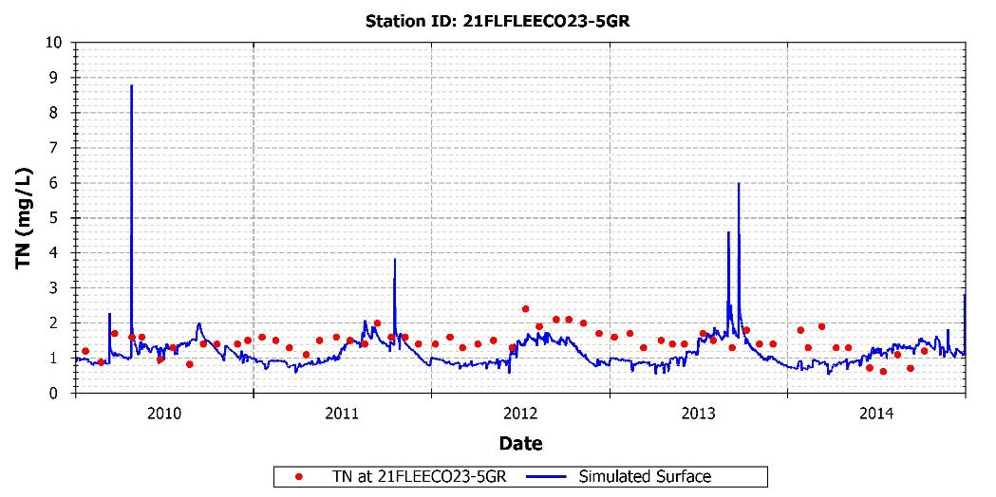
Figure A-14: Simulated and observed TN at 21FLEECO23-5GR
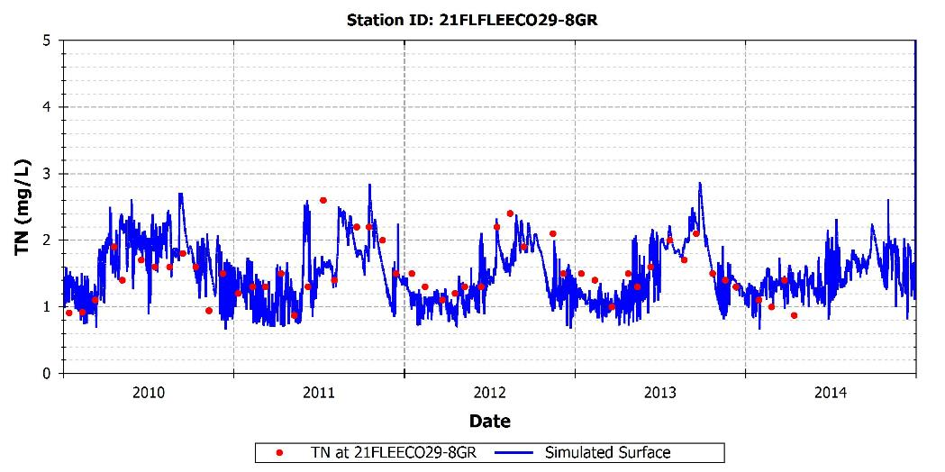
Figure A-15: Simulated and observed TN at 21FLEECO29-8GR

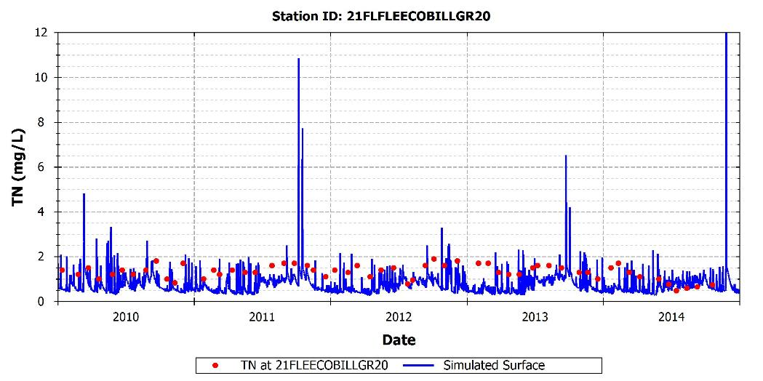
Figure A-16: Simulated and observed TN at 21FLEECOBILLGR20
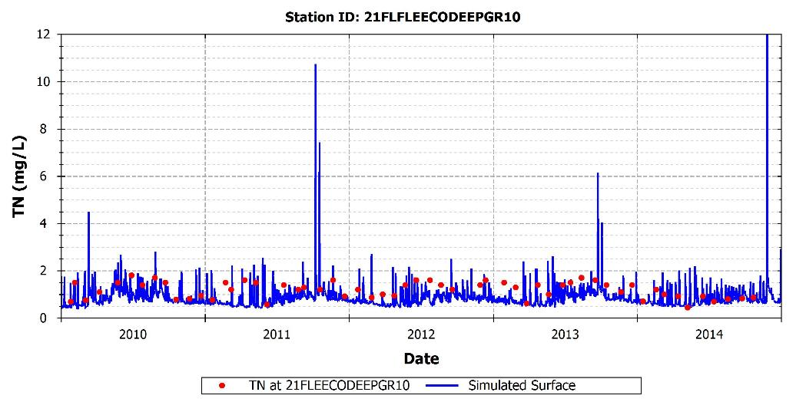
Figure A-17: Simulated and observed TN at 21FLEECODEEPGR10

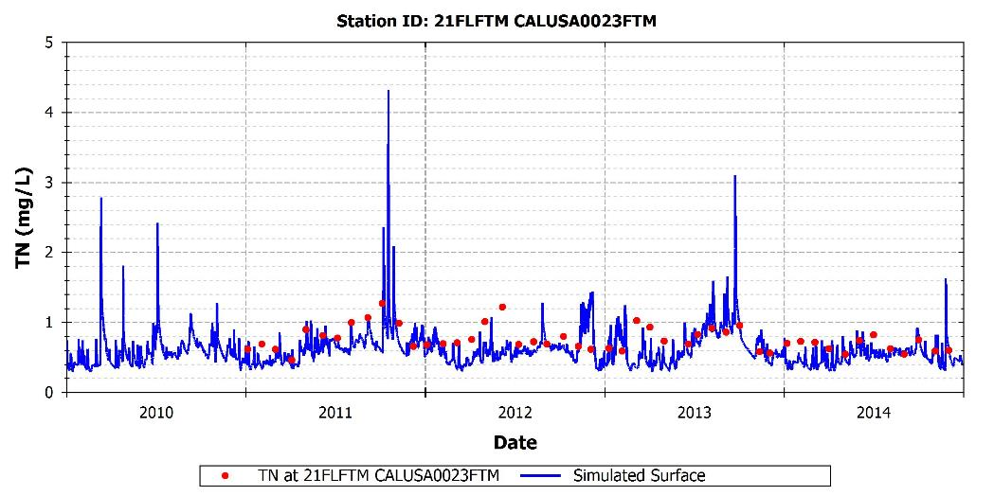
Figure A-18: Simulated and observed TN at 21FLFTM CALUSA0023FTM

AMMONIUM

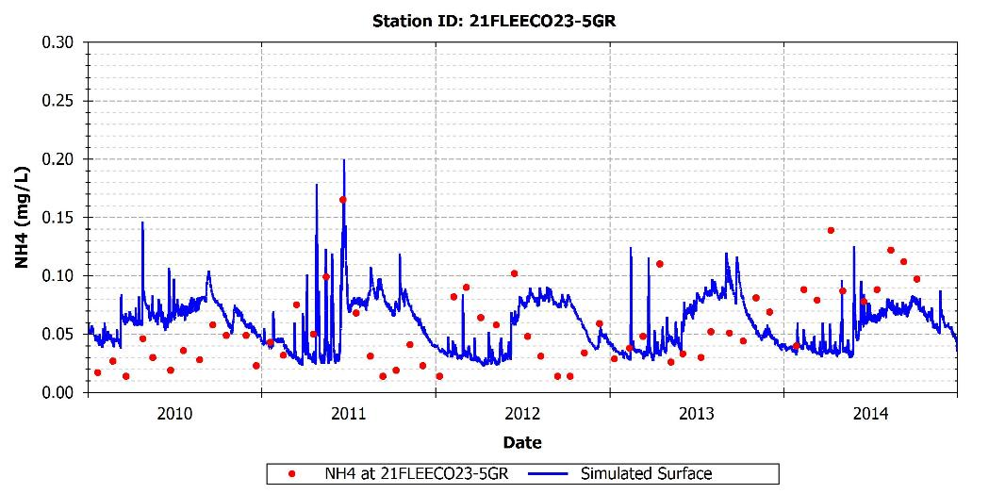
Figure A-19: Simulated and observed NH₄ at 21FLEECO23-5GR

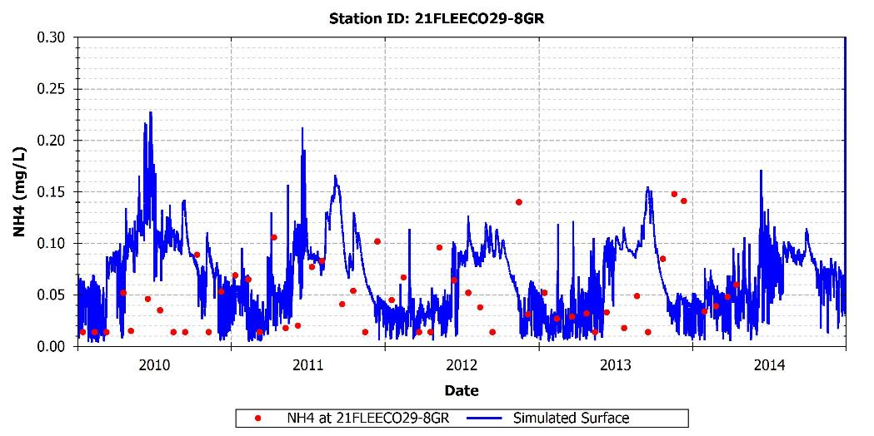
Figure A-20: Simulated and observed NH₄ at 21FLEECO29-8GR
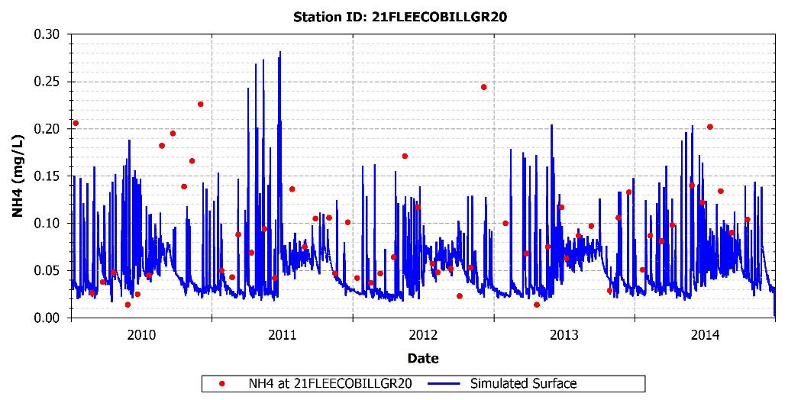
Figure A-21: Simulated and observed NH₄ at 21FLEECOBILLGR20

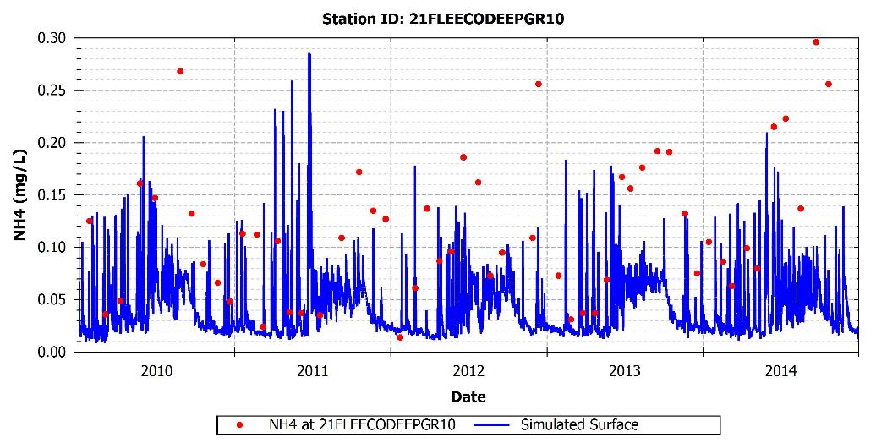
Figure A-22: Simulated and observed NH₄ at 21FLEECODEEPGR10
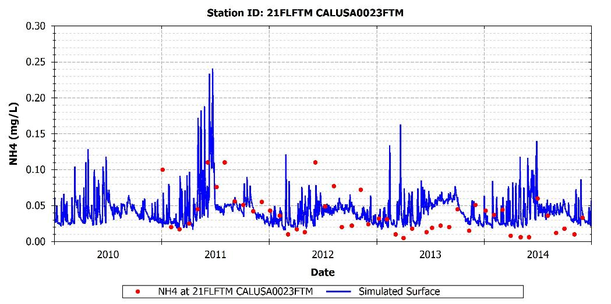
Figure A-23: Simulated and observed NH₄ at 21FLFTM CALUSA0023FTM

NITRATE + NITRITE

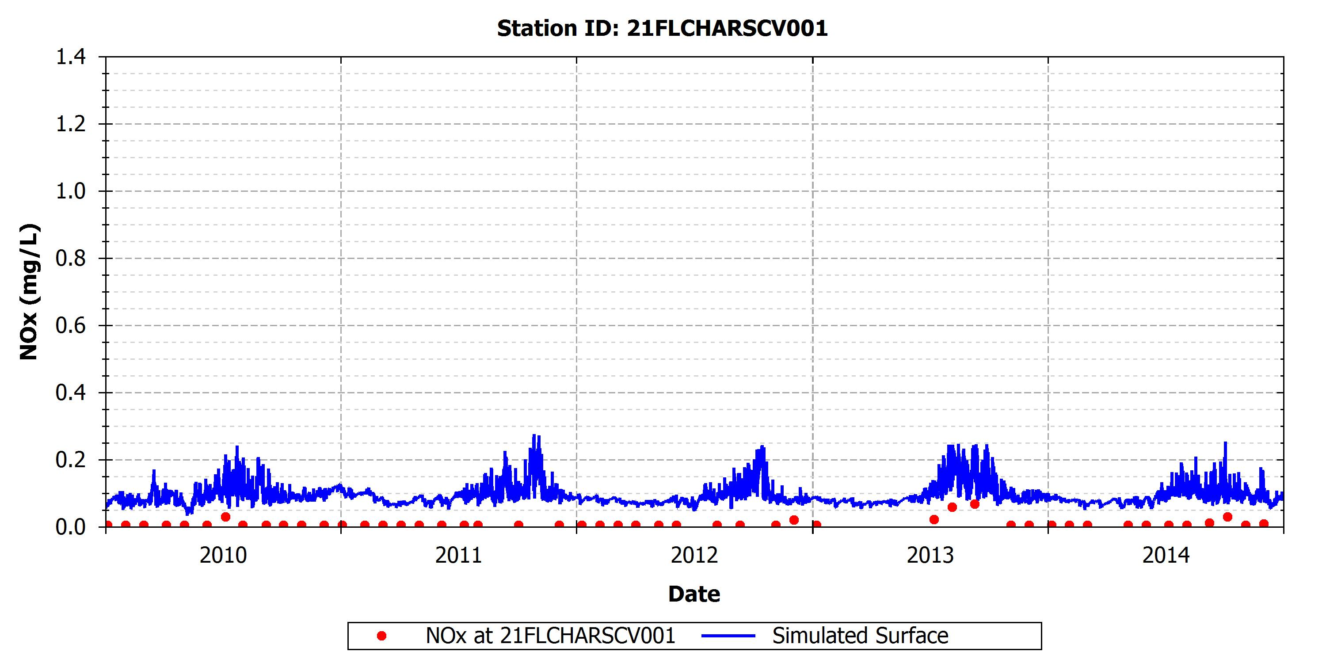
Figure A-24: Simulated and observed NOx at 21FLCHARSCV001

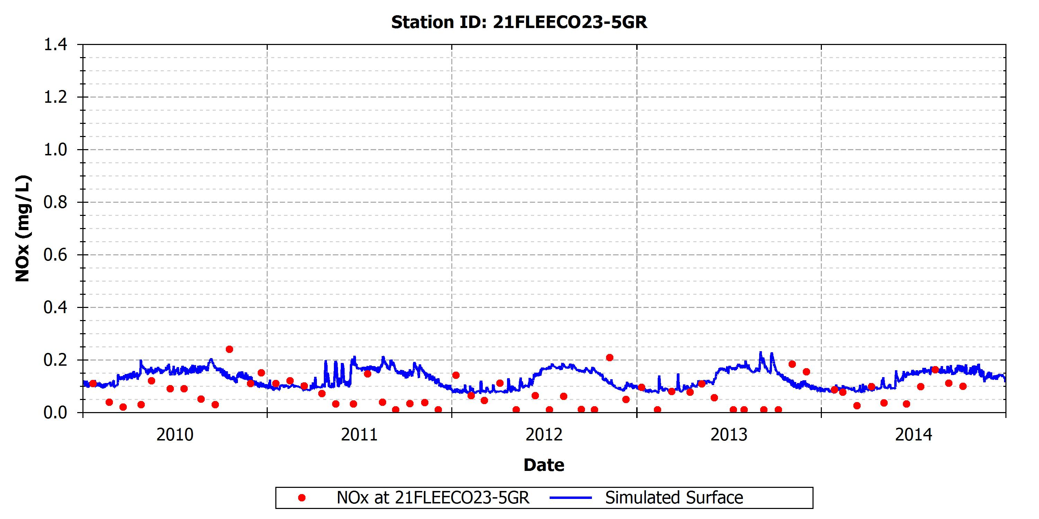
Figure A-25: Simulated and observed NOx at 21FLEECO23-5GR
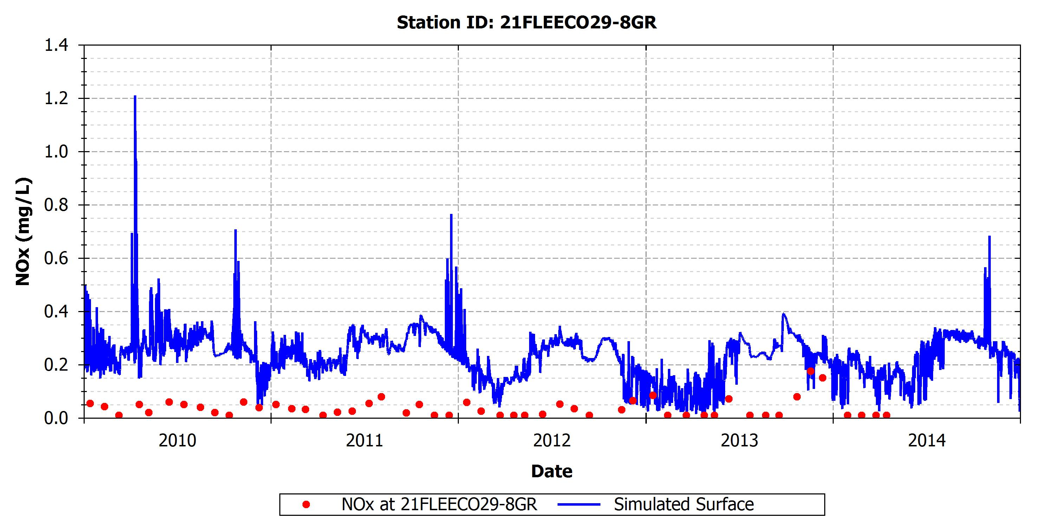
Figure A-26: Simulated and observed NOx at 21FLEECO29-8GR

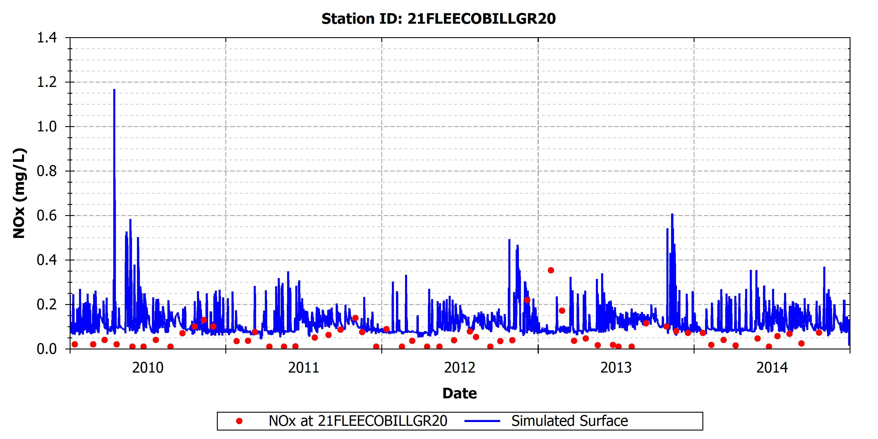
Figure A-27: Simulated and observed NOx at 21FLEECOBILLGR20
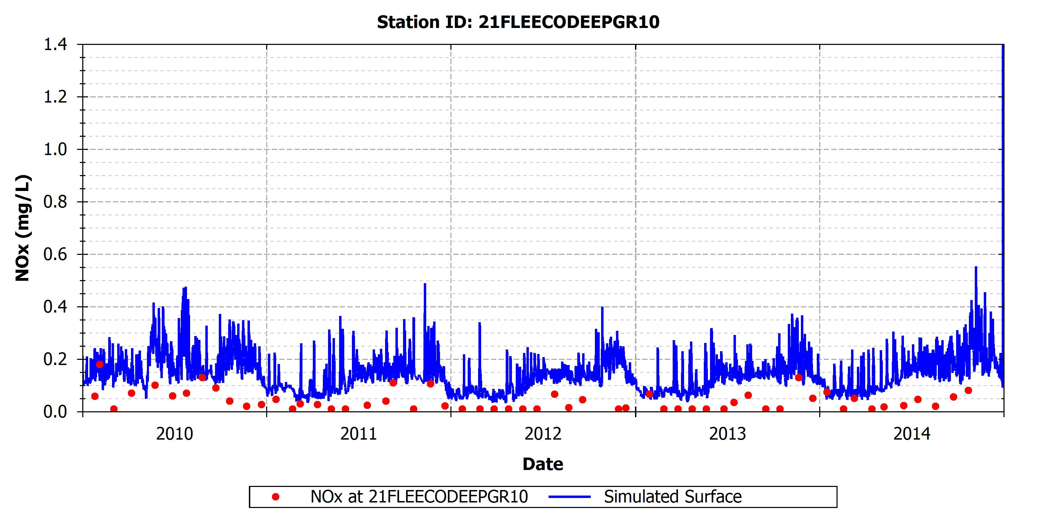
Figure A-28: Simulated and observed NOx at 21FLEECODEEPGR10

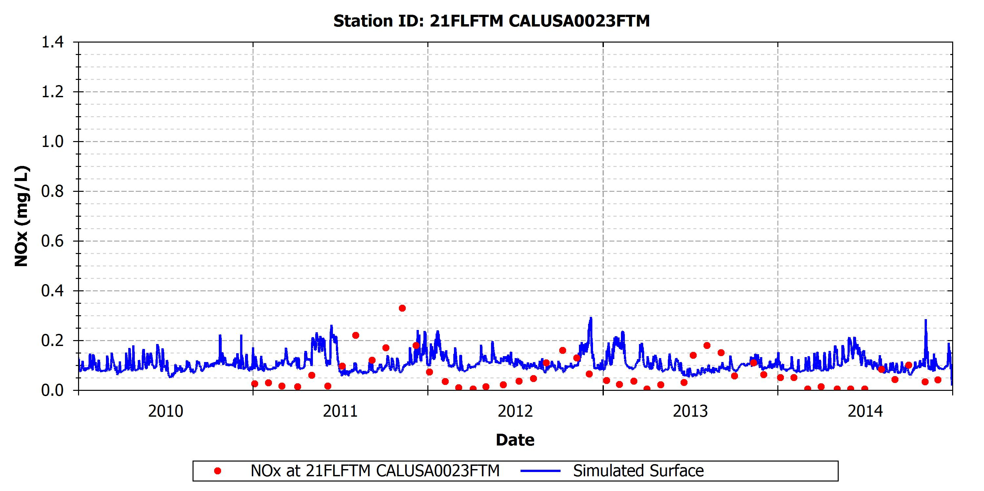
Figure A-29: Simulated and observed NOx at 21FLFTM CALUSA0023FTM

TOTAL KJELDAHL NITROGEN

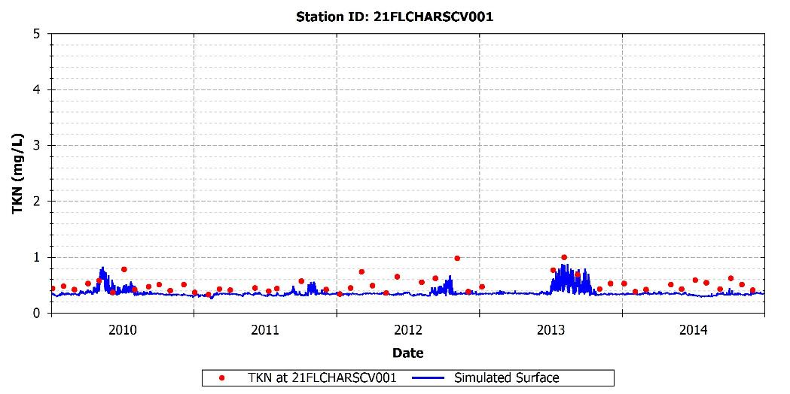
Figure A-30: Simulated and observed TKN at 21FLCHARSCV001

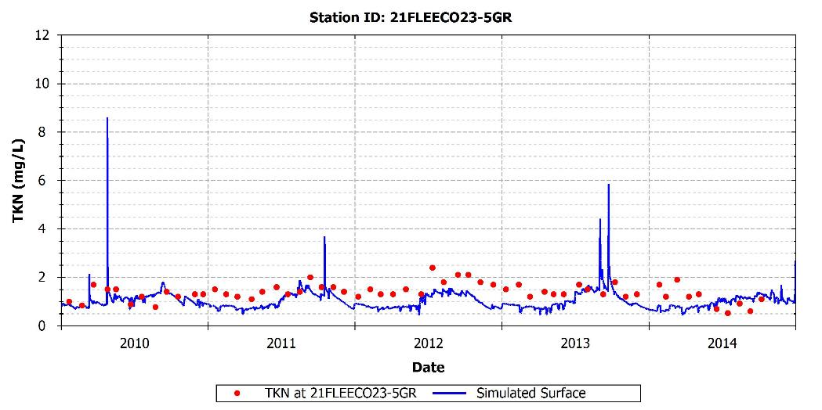
Figure A-31: Simulated and observed TKN at 21FLEECO23-5GR
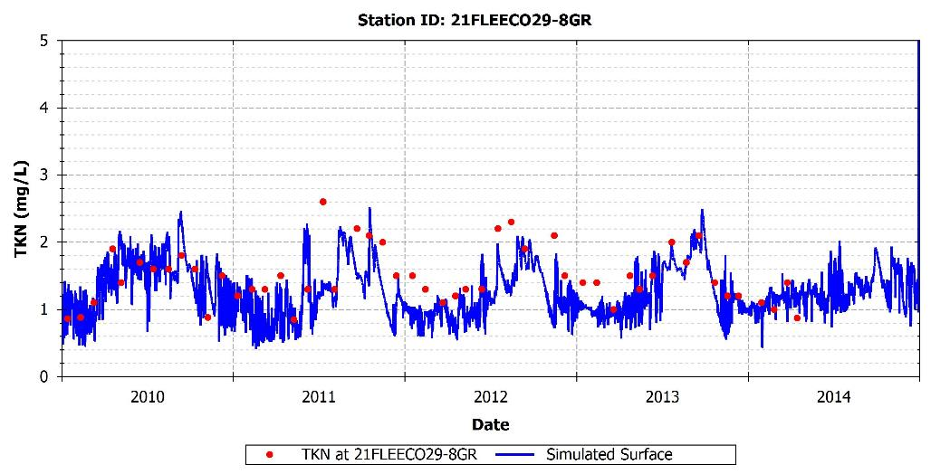
Figure A-32: Simulated and observed TKN at 21FLEECO29-8GR

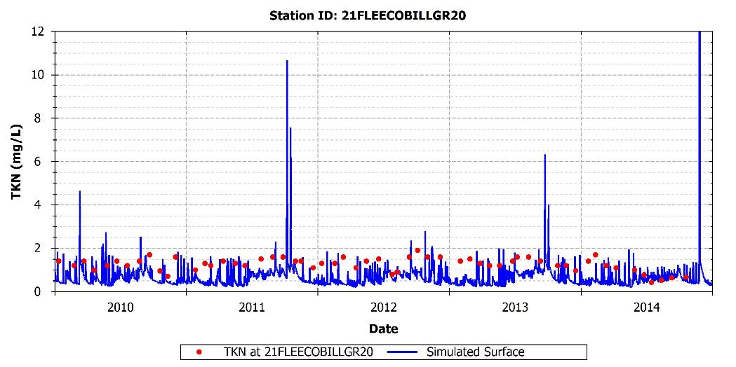
Figure A-33: Simulated and observed TKN at 21FLEECOBILLGR20
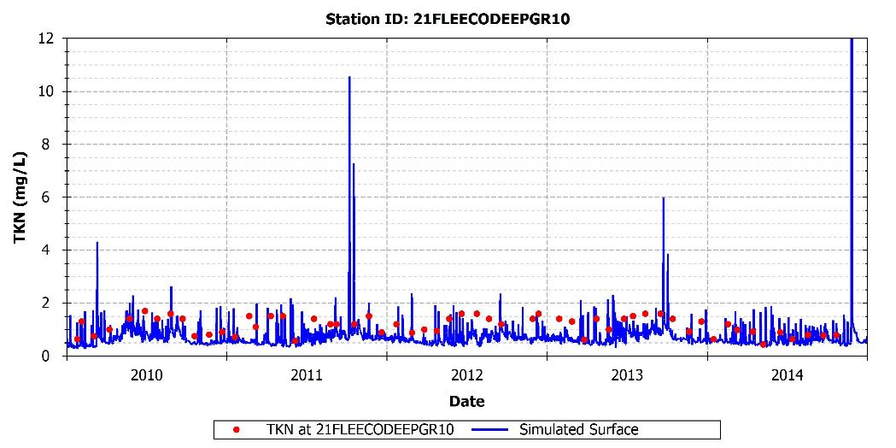
Figure A-34: Simulated and observed TKN at 21FLEECODEEPGR10

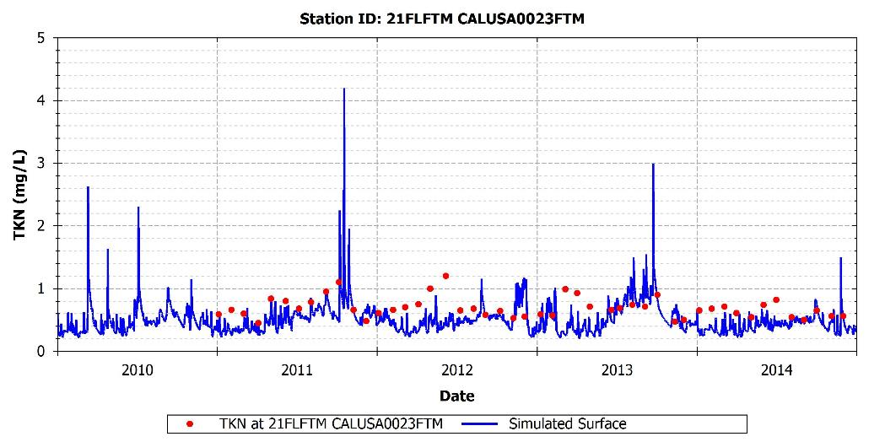
Figure A-35: Simulated and observed TKN at 21FLFTM CALUSA0023FTM

TOTAL PHOSPHORUS

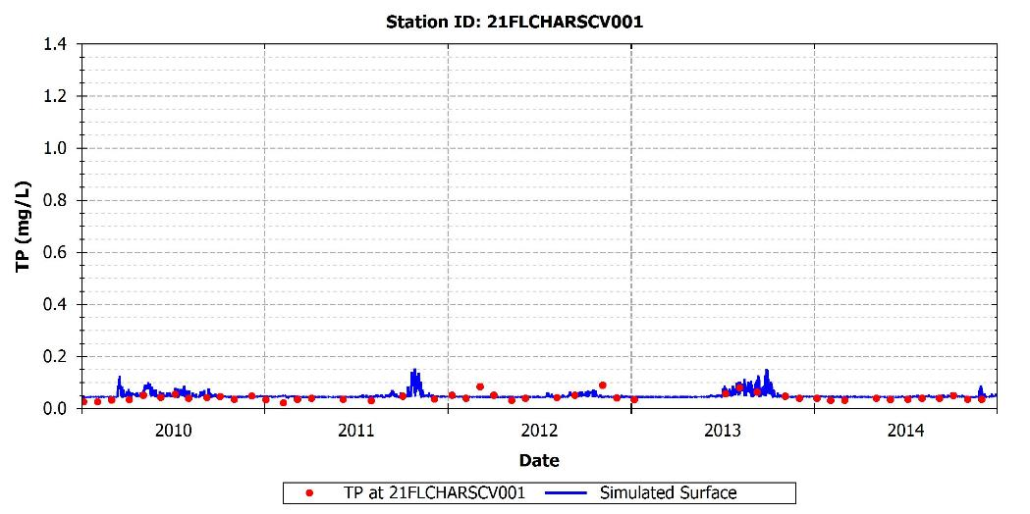
Figure A-36: Simulated and observed TP at 21FLCHARSCV001

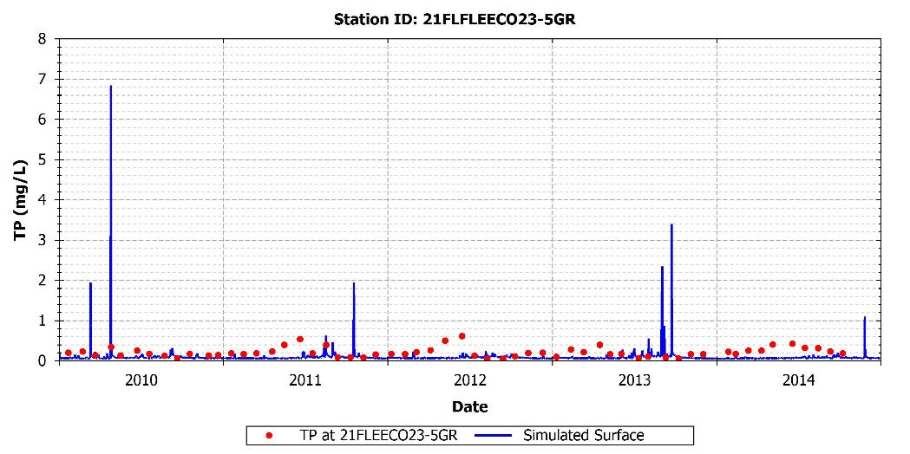
Figure A-37: Simulated and observed TP at 21FLEECO23-5GR
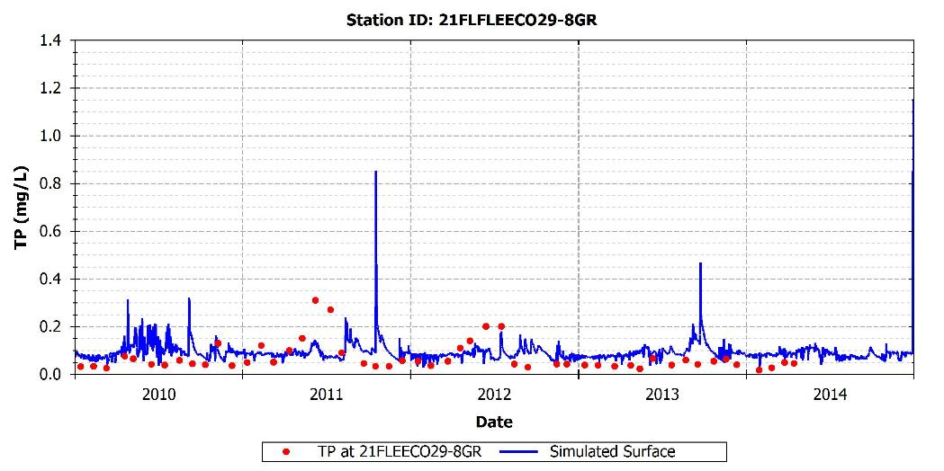
Figure A-38: Simulated and observed TP at 21FLEECO29-8GR

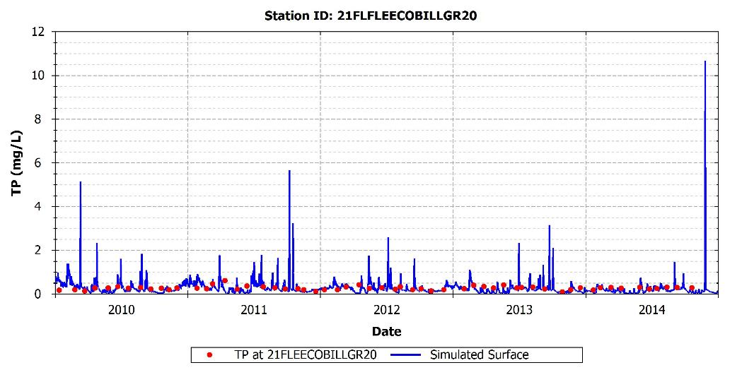
Figure A-39: Simulated and observed TP at 21FLEECOBILLGR20
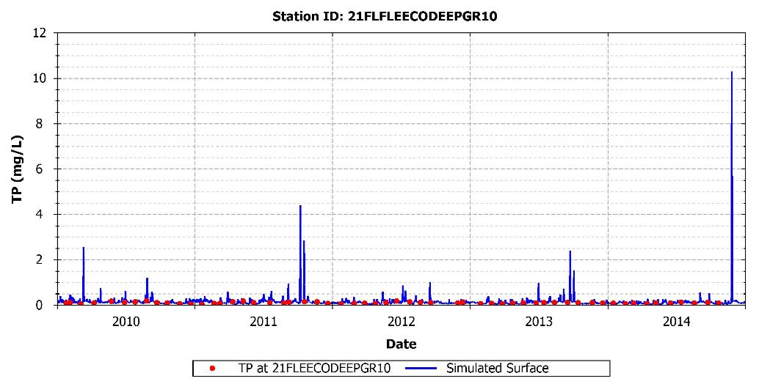
Figure A-40: Simulated and observed TP at 21FLEECODEEPGR10

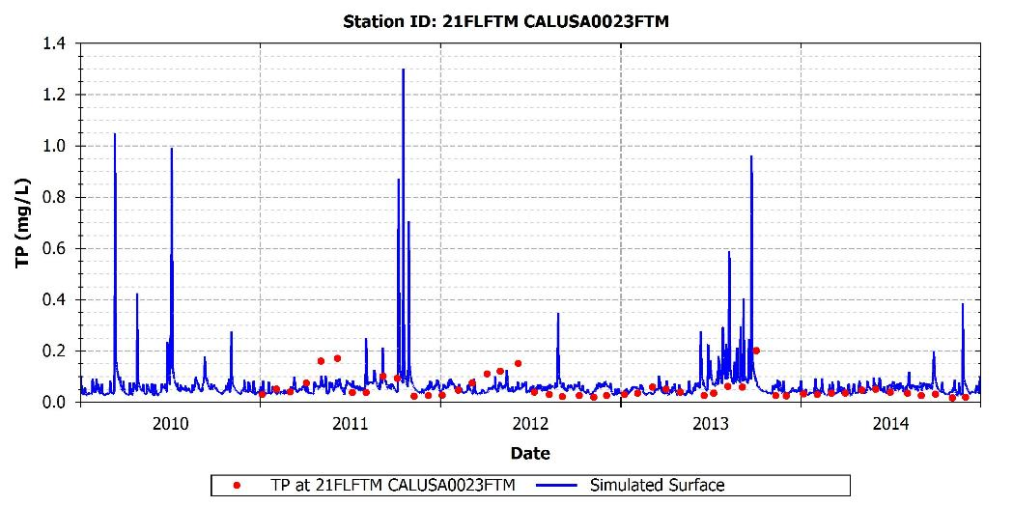
Figure A-41: Simulated and observed TP at 21FLFTM CALUSA0023FTM

ORTHOPHOSPHATE

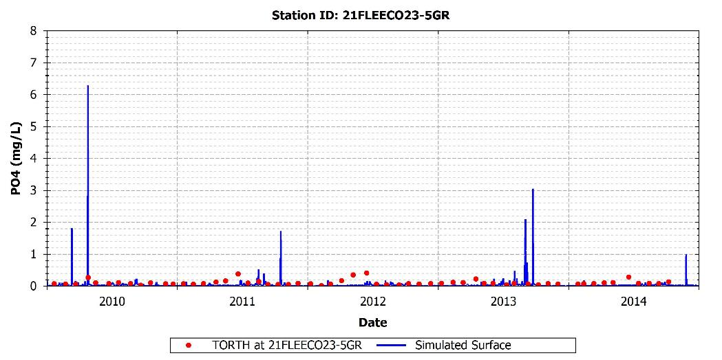
Figure A-42: Simulated and observed PO₄ at 21FLEECO23-5GR

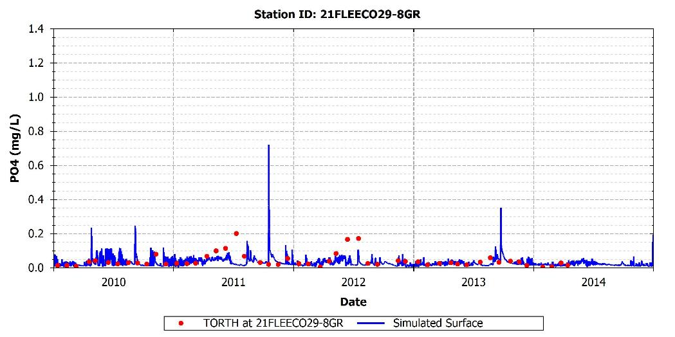
Figure A-43: Simulated and observed PO₄ at 21FLEECO29-8GR
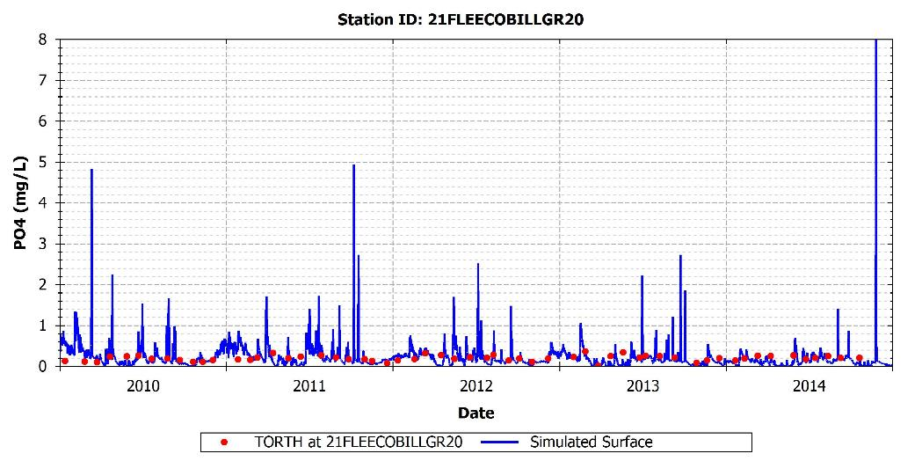
Figure A-44: Simulated and observed PO₄ at 21FLEECOBILLGR20

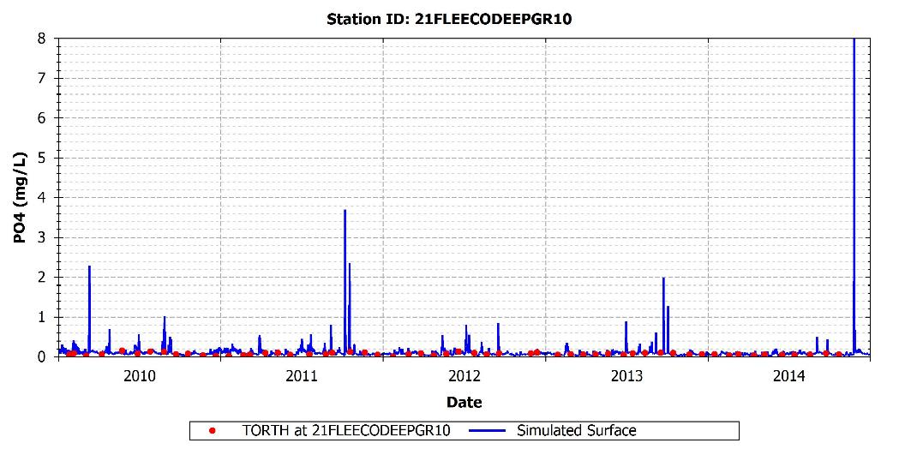
Figure A-45: Simulated and observed PO₄ at 21FLEECODEEPGR10

