Technical Support Document:

Summary of the Technical Basis for a
Site Specific Alternative Criterion for
Dissolved Oxygen in Thomas Creek, Duval and Nassau Counties



Prepared by:
Florida Department of Environmental Protection
Water Quality Standards Program

September 2013

Executive Summary
This report was prepared by the Florida Department of Environmental Protection (DEP) in support of a petition for a Type I Site Specific Alternative Criterion (SSAC) for dissolved oxygen (DO) for Thomas Creek in Duval and Nassau Counties, Florida. The petition for the DO SSAC was made by Anheuser-Busch on behalf of their sod farm, a subsidiary company, Nutri-Turf, LLC. Wastewater from the Jacksonville brewery is sprayed onto the sod fields and runoff is collected in treatment ponds and eventually discharged into the petitioned waterbody. Thomas Creek has a Class III designated use, which requires the protection of recreation, propagation, and maintenance of a healthy, well-balanced population of fish and wildlife. The DO criterion currently applicable to Class III freshwaters, including Thomas Creek, is a minimum of 5.0 mg/L.
The need for the DO SSAC was supported by a demonstration that Thomas Creek is a highly colored, organic-rich, low relief stream that naturally exhibits low DO levels below the current 5.0 mg/L criterion. This conclusion is further substantiated by the area surrounding the creek and the entire watershed being wetland dominated with minimal human disturbance as indicated by a low Landscape Development Intensity index (LDI) value. Additionally, the results of biological sampling in Thomas Creek indicate that a healthy, well balanced aquatic macroinvertebrate community is being maintained despite its naturally low DO regime. None of the waterbody identification units (WBIDs) within the proposed SSAC extent have been listed as impaired for other parameters, including nutrients and BOD. The scientific evidence clearly supports the conclusion that a Type I, natural conditions DO SSAC based on natural conditions, is warranted for this waterbody.
The DO data collected from Thomas Creek and its tributaries upstream of the Anheuser-Busch discharge were used to characterize the distribution of natural background DO levels that could reasonably be expected to occur within the SSAC area. The DO SSAC, shown to fully support the Class III designated use, consisted of an instantaneous minimum not to be exceeded in more than 10 percent of the individual samples and an annual average DO concentration limit not to be exceeded. Taken together these two components will ensure continued maintenance and protection of the existing natural background condition representative of the reference site.
The proposed DO SSAC for Thomas Creek can be expressed as:
The annual average DO concentration shall not be less that 2.6 mg/L,
AND
No more than 10 percent of the individual DO concentration measurements shall be less than 1.6 mg/L.
The DO SSAC will apply to the freshwater portion of Thomas Creek from the headwaters to the location where Thomas Creek becomes predominantly marine. The proposed SSAC extent will include all tributaries between the headwaters and downstream extent.

1. Introduction and Background Information

1.1 Purpose of Document
This report was prepared by the Florida Department of Environmental Protection (DEP) in support of a petition for a Type I Site Specific Alternative Criterion (SSAC) for dissolved oxygen (DO) for Thomas Creek in Duval and Nassau Counties, Florida. The petition for the DO SSAC was made by Anheuser-Busch on behalf of their sod farm, a subsidiary company, Nutri-Turf, LLC. Wastewater from the Jacksonville brewery is sprayed onto the sod fields and runoff is collected in treatment ponds and eventually discharged into the petitioned waterbody. Thomas Creek has a Class III designated use, which requires the protection of recreation, propagation, and maintenance of a healthy, well-balanced population of fish and wildlife. The DO criterion currently applicable to Class III freshwaters, including Thomas Creek, is a minimum of 5.0 mg/L.

1.2 Type I SSAC Requirements (Rule 62-302.800, FAC)
For DEP to approve a Type I Site Specific Alternative Criterion (SSAC) for dissolved oxygen (DO), it must be demonstrated that an alternative criterion is more appropriate for a specified portion of waters of the state. The demonstration must:
- Document that the proposed alternative DO concentrations that are less than the otherwise applicable Class III criterion exist because of natural background conditions;
- Describe the physical nature of the specified water body and the water pollution sources affecting the DO criterion
- Describe the historical and existing water quality of DO including, spatial, seasonal, and diurnal variations, and other parameters or conditions which may affect it;
- Describe the historical and existing biology, including variations, which may be affected by the parameter of concern; and
- Discuss any impacts of the proposed alternative criteria on the designated use of the waters and adjoining waters.
The SSAC documentation must establish the levels and duration of the naturally-occurring low DO concentrations and show that normal fluctuations of DO above these levels are being maintained.

1.3 Physiography and Morphology
Thomas Creek originates in southwest Nassau County and flows east northeast to the Nassau River and is located within the Sea Islands Flatwoods area of the Southern Coastal Plain ecoregion (denoted as Ecoregion 75f by Griffith et al., 1994). This region is characterized by broad coastal barrier islands and salt marshes at the coast, and flat plains, pine flatwoods, and swamps in the vicinity of the study area. Extensive marsh and swamp systems adjacent to the stream systems contribute large amounts of leaf litter, which in turn causes the waters to contain high amounts of organic tannins, lignins, and other humic acid substances. The decomposition of these organic materials imparts a dark brown color to the water and results in naturally low DO that commonly occurs in swamplands and in “blackwater” streams. The mean true color in Thomas Creek based on 32 measurements collected from 2000 through 2009 is 355 platinum-cobalt units (PCU), which is typical of wetland runoff-dominated streams. High color values generally result in decreased photosynthesis (oxygen production) by phytoplankton and submerged aquatic vegetation (SAV) due to reduced light penetration. The typical highly colored water observed during one of the sampling events in Thomas Creek is illustrated in Figure 1.
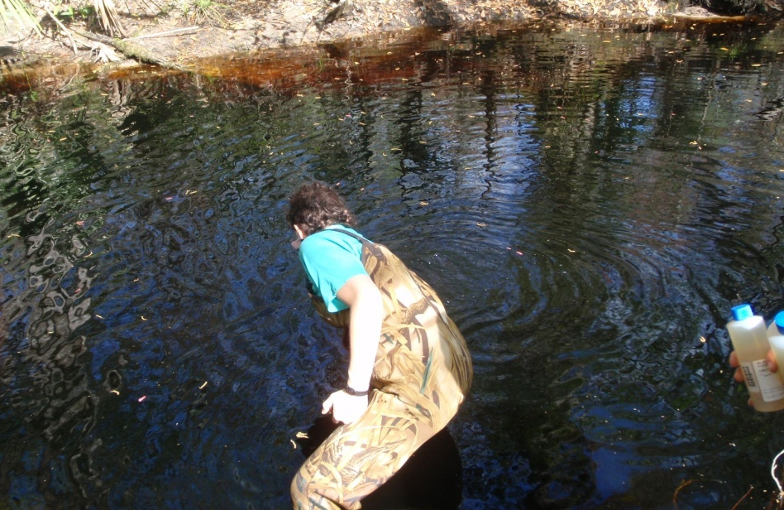

Figure 1. Thomas Creek upstream of US Highway 1 (approximately 575m upstream of STORET station 21FLA 19020034). This photo demonstrates high color, which was 480 PCU on this day.
The riparian zone of Thomas Creek consists of forest and floodplain swamp, which typically extends more than 100 meters from the stream. Direct observations show Thomas Creek to be heavily shaded by an extensive canopy of trees. The system is subject to periodic sluggish to stagnant flows, due to the flat slopes in the basin.
According to the Soil Survey found on the United States Department of Agriculture’s Natural Resources Conservation Service website (http://websoilsurvey.nrcs.usda.gov/app/ HomePage.htm), the soils encompassing the Thomas Creek watershed are predominantly hydric. Hydric soils are defined by the National Technical Committee for Hydric Soils as soils that formed under conditions of saturation, flooding, or ponding for a sufficient period during the growing season to develop anaerobic conditions in the upper part (USDA, Soil Conservation Service, 1987, as revised). The DO in the water that saturates and sits on these wetland soils is depleted by soil microbial activity. Additionally, there is a lack of flow and primary production that would otherwise serve to replenish the DO levels. The low DO water created by hydric conditions flows into Thomas Creek following precipitation events.

2. Results of Site Assessments

2.1 Land Use
Much of the land surrounding Thomas Creek is managed for ecosystem maintenance (See Figure 2). The St. Johns River Water Management District manages the area using a combination of selective timber harvesting, groundcover restoration, reforestation and controlled burns. The City of Jacksonville manages recreation (e.g. canoeing, hiking trails, and fishing) within the Thomas Creek basin. The Florida Fish and Wildlife Conservation Commission (FWCC) oversees hunting-related activities. Wildlife in the area include deer (Odocoileus virginianus), turkey (Meleagris gallopavo), feral hog (Sus scrofa), northern bobwhite (Colinus virginianus), and numerous species of resident and migratory songbirds. Snapping turtle (Chelydra serpentina), Florida cooter (Pseudemys floridana) and otter (Lontra canadensis) also occur along the creek.
The Thomas Creek Wildlife Management Area (WMA) occupies 1,753 acres in northern Duval County, within three miles of the Jacksonville International Airport. The WMA is one of five units of the Thomas Creek Conservation Area, which covers approximately 5,540 acres in both Nassau and Duval counties along Thomas Creek. The conservation area provides valuable flood and water quality protection, and provides healthy, diverse habitat for wildlife and nature-based recreational opportunities. Also, the conservation area protects 10 miles of Thomas Creek's shoreline (FWCC, undated).
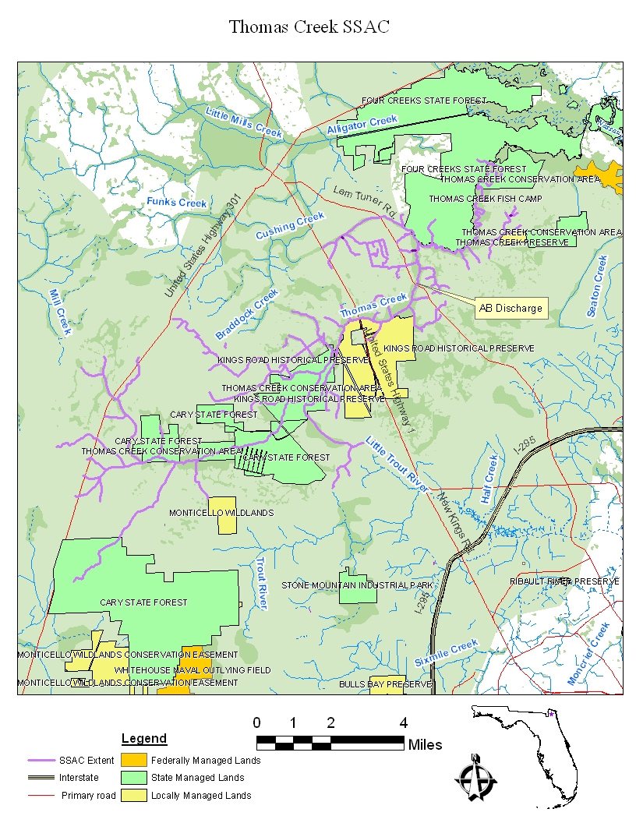
Figure 2. Managed Lands of Thomas Creek.

2.2 Landscape Development Intensity Index (LDI)
The LDI is used to quantify the intensity of human land uses in a watershed. It is calculated from coefficients based on the intensity of the land use in the surrounding area ranging from one to ten, with one consisting of natural land uses and ten consisting of very intense human land uses (Brown and Vivas, 2004). The LDI for a stream or river is calculated as an area weighted average of LDI coefficients within a 100 meter buffer on either side of the river system starting at the point of interest and continuing 10 kilometers upstream, including any upstream tributaries and open water areas (e.g., lakes). Several studies demonstrate that when a water body has a LDI score of two or lower, there is minimal human disturbance and an expectation of healthy, well balanced aquatic communities (DEP, 2008).
The LDI score for Thomas Creek is 1.93, which is indicative of a predominance of natural land uses and minimal anthropogenic inputs that could potentially result in significant human induced reductions of the DO regime. The entire watershed LDI is 2.09, which further demonstrates the benign land uses within the watershed (See Appendix A). The LDI scores were based on 2004, the most recent available, land use data from the St. Johns River Water Management District. Aerial photographs from 2007 were also examined to assess more recent watershed land use and provided additional support that the upstream land use is predominately natural (i.e., forested; Figure 3). Further, there are no permitted point sources, other than Anheuser-Busch, within the basin that could contribute oxygen-demanding substances to the proposed SSAC extent. The DO data used to derive the proposed criteria were collected upstream of Anheuser-Busch’s discharge; therefore, the discharge had not influence on the proposed SSAC value.
On April 20, 2011, staff from the Standards and Assessment Section of DEP surveyed the Thomas Creek watershed, including field verification of land uses, measurement of physical-chemical parameters, and assessment of stream habitat. Field observations by DEP staff during the site survey found little human disturbance in the watershed and further corroborated the LDI scores.
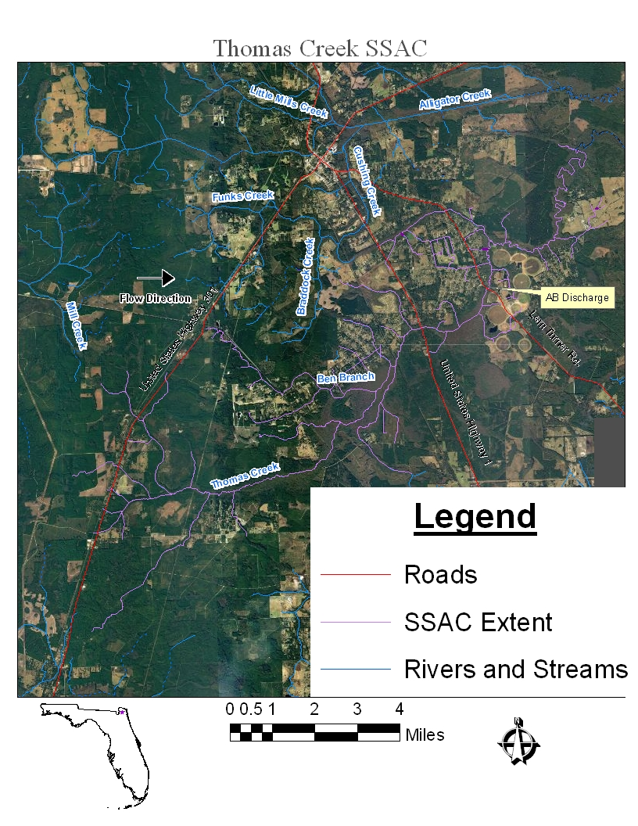
Figure 3. Digital Ortho-Quad 2007 aerial photograph of Thomas Creek.

3. Results of Biological Sampling

3.1 Habitat Assessment
To measure habitat condition, DEP biologists routinely calculate a Habitat Assessment (HA) index whenever stream macroinvertebrate samples are collected (see DEP SOP FT 3100). The index evaluates habitat condition and availability, water velocity, habitat smothering (e.g., by sand and silt), stream channelization, bank stability, and the width and condition of riparian vegetation. Values above 120 (out of a possible score of 160) indicate that most habitat aspects are in the optimal category, and this threshold has been used as a criterion for selection of the proposed SSAC extent (Fore et al., 2007).
Habitat assessment scores were 133 on 3/30/2010 (DEP), 120 on 9/16/2010 (CSA), 134 on 3/8/2011 (DEP), and 124 on 4/20/11 (DEP) for the sampling site at United States Highway 1 (Figure 4). The habitat assessments scores generated at the headwaters of Thomas Creek (STORET station NAS207LV), 145 on 1/28/2006 and 131 on 9/17/2005, were also in the optimal category. These scores indicate that habitat conditions within Thomas Creek are generally optimal for supporting healthy, well-balanced biological communities. The system was characterized by extensive riparian buffer zones, with bald cypress (Taxodium distichum), swamp titi (Cyrilla racemiflora), Carolina ash (Fraxinus caroliniana), tupelo (Nyssa aquatica), sweet gum (Liquidambar styraciflua), black titi (Cliftonia monophylla), red maple (Acer rubrum), and live oak (Quercus virginiana). Except for some areas (bridge crossings and some small areas of human activity), these forested buffers tended to be continuous for at least 100 meters from the edges of the streams. During the April 20, 2011 stream survey, numerous juvenile Florida gar (Lepisosteus platyrhincus) were observed.

3.2 Stream Condition Index (SCI) Sampling
The primary biological assessment conducted in Thomas Creek consisted of multiple Stream Condition Index (SCI) sampling events. The SCI is a multi-metric index that uses attributes of macroinvertebrate community structure and function to definitively indicate the status and health of the stream biota (Fore et al., 2007). The sampling station located at United States Highway 1 (STORET station 21FLA 19020034) ranked in the “healthy” category with a mean SCI score of 44. The mean SCI was calculated based on four SCI samples collected during 2010 and 2011 representing various seasons. The U.S. Highway 1 site exhibited SCI scores of 56 on 3/30/2010 (DEP), 41 on 9/16/2010 (CSA), 30 on 3/8/2011 (DEP), and 48 on 4/20/2011 (DEP). All of which were in the “healthy” category, except for the score of 30 collected on 3/8/2011. The period of record average SCI score was 44.
The low SCI resulting from the 3/8/11 sampling was reviewed in greater detail to discern the cause(s) of the failure. The stream had recently (within the previous 90 days) returned to normal flow conditions following protracted low water conditions. DEP biologists believe that the stream biota were still stressed by the recent low water conditions and this stress contributed to the low SCI score. The higher score collected approximately one month later adds credibility to this conclusion. Furthermore, a bloom of black flies (Simulium) dominated (36-47%) the samples from 3/8/11, which affected several of the metrics contributing to the low SCI score. Simulium is listed as a sensitive taxon for purposes of calculation of the SCI. The replicate SCI samples collected on 3/8/11 contained two to three (mean=2.25) sensitive taxa while previous and subsequent samples from Thomas Creek have had three to four sensitive taxa. The lower number of sensitive taxa on 3/8/11 was most likely due to inadequate community recovery time following low water conditions. The high abundance of Simulium reflected a seasonal bloom of the species resulting from downstream drift following recent rainfall. Despite the low SCI score on 3/8/11, the system was found to support a number of sensitive species including an abundance of Simulium. Furthermore, the stream biota exhibited additional recovery, from the hydrologic stress, within the next month. This recovery would not have occurred if the stream were stressed by water quality conditions, including low DO.
Additionally, SCI sampling conducted in the headwaters of Thomas Creek (STORET station NAS207LV) on September 16, 2005 received a score of 81 which falls into the “exceptional” category. On January 31, 2006, the site received a SCI score of 54 which places it in the “healthy” category. These results, including the presence of sensitive macroinvertebrates at the United States Highway 1, further demonstrate the minimally disturbed nature of the watershed, and that despite the naturally low DO, the designated use is clearly being attained.
The results of multiple biological sampling events conducted in Thomas Creek revealed a healthy well-balanced macroinvertebrate community including a number of sensitive organisms which provides further support that the DO regime fully supports the Class III designated use.
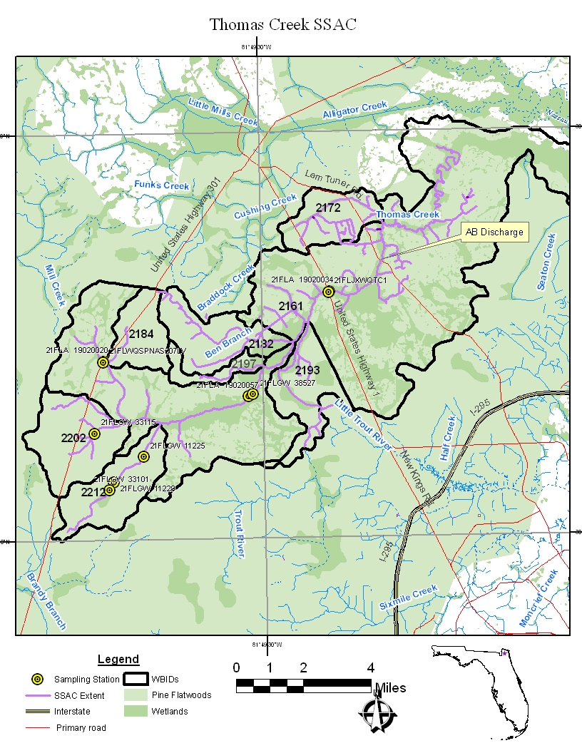
Figure 4. Map showing the locations of stations used to evaluate dissolved oxygen conditions in Thomas Creek.

4. Derivation of the DO SSAC

4.1 Summary of Dissolved Oxygen Levels
The data used to characterize the DO regime for Thomas Creek came from sources representing city government, state government, federal government and private industry. All field and laboratory methods were evaluated to ensure they followed DEP Standard Operating Procedures (SOP’s), and met DEP quality assurance/quality control standards (see http://www.dep.state.fl.us/water/sas/sop/sops.htm). DO samples utilized for the SSAC derivations were collected in Thomas Creek at locations depicted in Figure 4 and consisted of:
- The data provided by the petitioner, Anheuser Busch Brewery and Nutri-Turf Operations, who provided extensive documentation of the DO levels and fluctuations at sites near their facility from sampling over a thirteen year period. However, only the Anheuser-Busch data collected from December 2008 through July 2012 were accompanied by the quality assurance records (calibration data) needed to verify the quality of the measurements. Therefore, only data collected during this time period (December 2008 through July 2012) were used in the derivation of the SSAC. The data were collected quarterly by Advanced Environmental Laboratories, Inc. (AEL), the contracted lab for Anheuser-Busch, at US Highway 1;
- Stream water quality monitoring performed by the City of Jacksonville, sampled from Thomas Creek at US Highway 1 from 2000-2012. Prior to 2011 samples were collected quarterly with the exception of four years: in 2000, six samples were collected; in 2001, 2003, and 2004, three samples were collected. Anheuser Busch Brewery and Nutri-Turf Operations collected conducted sampling more frequently in 2011 (n=32) and 2012 (n=10) to support SSAC development; and,
- Data collected from multiple years and stations for Thomas Creek that were available in STORET. The DO data provided samples for 1998-2011 and was submitted by DEP NE District, DEP’s DO study, and DEP Ambient Program. The DO study was conducted to collect the data necessary to fully assess the accuracy of the existing DO criteria and to develop revised criteria for freshwater systems during 2005 and 2006.
For analyses, the quality assured DO data from Thomas Creek and its tributaries were compiled and provided in Appendix B. The data collected at numerous sample stations upstream of the Anheuser-Busch discharge are summarized by year in Table 1 with the overall distribution of the data provided in Figure 5.

Table 1. Summary of annual and long-term dissolved oxygen concentrations from all data pertaining to Thomas Creek and its tributaries upstream of the Anheuser-Busch discharge. Tenth percentile value was calculated using JMP 9.0.2, SAS Institute, Inc.

Year | N | Mean | Standard Deviation
1998 | 8 | 3.20 | 1.19
1999 | 7 | 4.51 | 2.32
2000 | 7 | 3.23 | 2.18
2001 | 5 | 2.59 | 1.17
2002 | 4 | 3.09 | 1.61
2003 | 3 | 2.62 | 1.01
2004 | 3 | 3.65 | 2.47
2005 | 10 | 3.14 | 1.20
2006 | 6 | 4.52 | 2.65
2007 | 6 | 3.60 | 1.29
2008 | 16 | 5.45 | 2.31
2009 | 12 | 3.42 | 2.06
2010 | 17 | 5.31 | 2.19
2011 | 35 | 3.50 | 2.06
Period of Record | 139 | 3.92 | 2.11
10th Percentile |  | 2.61

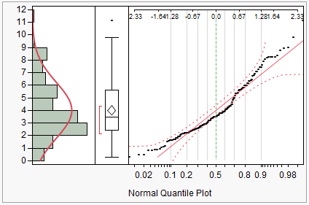

Figure 5. Histogram and normal quantile plot of DO data collected from Thomas Creek and its tributaries upstream of the Anheuser-Busch discharge. Data deviate significantly from a normal distribution.

4.2 SSAC Derivation
The data collected from Thomas Creek and its tributaries upstream of the Anheuser-Busch discharge, described above, were used to characterize the distribution of natural background DO levels that could reasonably be expected to occur within the SSAC area. The DO SSAC for Thomas Creek derived by DEP using these data consisted of two components including an instantaneous minimum not to be exceeded in more than 10 percent of the individual samples and an annual average expectation. Taken together these two components will ensure continued maintenance and protection of the existing natural background condition representative of the proposed SSAC extent. Percentiles were calculated in JMP 9.0 (SAS Institute, Inc.)

4.2.1 Annual Average Limit
The primary objective of the derivation of the Thomas Creek DO SSAC is to establish criteria limits, which if exceeded in the future, would allow one to conclude with statistical certainty that the DO regime has deviated from the natural baseline distribution. Specifically, DEP wants to be able to confidently determine whether an annual mean DO concentration determined in the future is below the level that could be naturally expected based on the distribution observed during the baseline period. Given this goal, a lower percentile is an appropriate statistical tool. The lower tenth percentile of the annual means in Table 1 is 2.6 mg/L. There is an expectation that approximately 10% of the measured annual averages will be below the limit (2.6 mg/L).
Use of the 10th percentile takes into consideration inherent natural variability around the long-term average condition. The annual average limit of 2.6 mg/L represents a level below which it can be concluded with statistical certainty that a future annual average concentration is different from the natural background conditions within Thomas Creek. Conversely, it can be concluded with certainty that annual average concentrations above the limit are consistent with maintenance of the reference distribution.

Individual Sample Limit
In addition to the annual average limit, a DO concentration not to be exceeded by more than 10% of the individual DO measurements was derived as the estimated 10th percentile of the individual DO measurements collected from the headwaters to a downstream location where Thomas Creek becomes predominantly marine (Appendix B). The 10th percentile of the dataset is 1.6 mg/L. Up to 10 percent of the individual DO concentration measurements collected during a year can be expected to be below the 1.6 mg/L 10th percentile concentration. However, if more than 10 percent of the individual measurements are below the 10th percentile (1.6 mg/L), it can be confidently concluded that the DO regime has dropped below the natural background level.
Inclusion of a threshold for instantaneous measurements with a 10 percent exceedance rate reflects natural shorter-term DO fluctuations within the system and protects against DO concentrations falling below the annual average limit for extended periods.

5. Conclusions and Recommendations
Based on a thorough review of all of the available information, DEP supports the development of a Type I SSAC for the Thomas Creek system. The available data, field observations, and analysis provided in this document, indicate that the proposed SSAC extent, represents a minimally disturbed portion of the system with naturally low DO levels. Additionally, biological monitoring data show that the proposed extent fully supports the Class III Designated Use, despite the low DO conditions characteristic of the system. Therefore, the natural DO regime observed at the proposed extent was used as the basis for the recommended DO SSAC for Thomas Creek. The recommended DO SSAC can be expressed as:
The annual average DO concentration shall not be less that 2.6 mg/L,
AND
No more than 10 percent of the individual DO concentration measurements shall be less than 1.6 mg/L.
The DO SSAC will apply to Thomas Creek from the headwaters to a downstream location where Thomas Creek becomes predominantly marine (1500 mg/L chloride concentration), at approximately; N 30.56603, W -81.72888 and include all tributaries. The DO SSAC will apply to WBID’s 2212, 2202, 2184, 2182 2193, 2197, 2172, and 2161 (upstream of N 30.56603, W -81.72888) in Duval and Nassau Counties, Florida as shown in Figure 6.

5.1 Implementation of the SSAC
The 10% exceedance rate allowed for individual measurements is not intended to be compounded with an additional 10% exceedance rate through the use of the binomial assessment methodology applied in Florida’s Impaired Waters Rule (i.e., Paragraphs 62-303.320(1) and 62-303.420(2)).
To accurately assess permit compliance with the SSAC, DEP Water Quality Standard Program recommends a minimum of ten samples per year at each monitoring site. Additionally, because DO is known to exhibit daily and seasonal fluctuations in response to changes in, sunlight, temperature, and flow conditions, the samples collected for each year should be evenly distributed across seasons and time of day to avoid biasing the assessment.
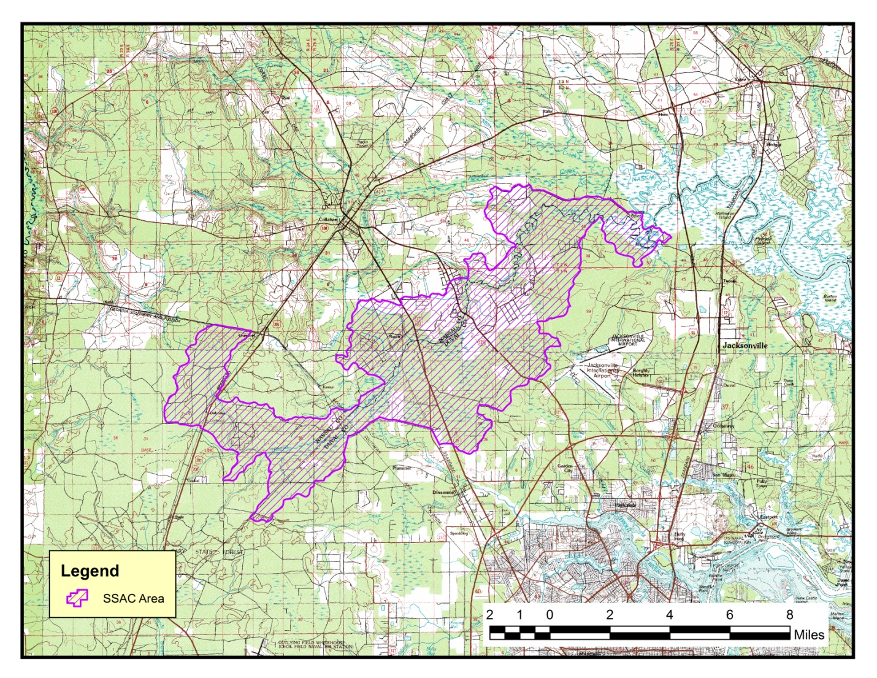
Figure 6. Spatial area of the Thomas Creek dissolved oxygen SSAC. The SSAC applies to IWR Run 44 WBID’s 2212, 2202, 2184, 2182 2193, 2197, 2172, and 2161 (upstream of N 30.56603, W -81.72888) in Duval and Nassau Counties.
Literature Cited
Brown, M. T., and B. Vivas. 2004. Landscape development intensity index. Environmental Monitoring and Assessment 101: 289-309
Florida Fish and Wildlife Conservation Commission. (N. D.) Retrieved from http://myfwc.com/viewing/recreation/wmas/cooperative/thomas-creek-kings- road-unit accessed
Florida Department of Environmental Protection. 2008. State of Florida Numeric Nutrient Criteria Plan. Bureau of Assessment and Restoration Support. Division of Environmental Assessment and Restoration. Florida Department of Environmental Protection. 68 pp.
Fore, L. S., R. Frydenborg, D. Miller, T. Frick, D. Whiting, J. Espy, and L. Wolfe. 2007. Development and Testing of Biomonitoring Tools for Macroinvertebrates in Florida Streams (Stream Condition Index and Biorecon): Final Report to the Florida Department of Environmental Protection. 110 pp.
Griffith, G.E., J.M. Omernik, C.M. Rohm, and S.M. Pierson. 1994. Florida Regionalization Project. Environmental Research Laboratory, United States Environmental Protection Agency, Corvallis, OR.
Helsel, D.R., and R.M. Hirsch. 2002. Statistical Methods in Water Resources. U.S. Department of the Interior, U.S. Geological Survey.
Sokal, R.R. and F.J. Rohlf. 2012. Biometry, Forth Edition. W.H. Freeman and Company, New York, NY. 937 pp.

Appendix A:
Individual DO measurements collected from Thomas Creek and its tributaries upstream of the Anheuser-Busch discharge. Data sources are Advanced Environmental Laboratories, Inc and Anheuser Busch Brewery. (AEL/AB), City of Jacksonville (CoJ), and STORET.

Station | Location | Year | Date | Source | DO Concentration (mg/L)
*N/A | HWY 1 | 2008 | 12/1/08 | AEL/AB | 4.81
*N/A | HWY 1 | 2009 | 1/30/09 | AEL/AB | 4.45
*N/A | HWY 1 | 2009 | 4/3/09 | AEL/AB | 5.80
*N/A | HWY 1 | 2009 | 7/27/09 | AEL/AB | 0.48
*N/A | HWY 1 | 2009 | 8/4/09 | AEL/AB | 0.45
*N/A | HWY 1 | 2009 | 12/11/09 | AEL/AB | 3.48
*N/A | HWY 1 | 2010 | 1/25/10 | AEL/AB | 5.98
*N/A | HWY 1 | 2010 | 2/19/10 | AEL/AB | 7.43
*N/A | HWY 1 | 2010 | 2/22/10 | AEL/AB | 6.12
*N/A | HWY 1 | 2010 | 6/23/10 | AEL/AB | 3.57
*N/A | HWY 1 | 2010 | 8/23/10 | AEL/AB | 2.80
*N/A | HWY 1 | 2010 | 10/1/10 | AEL/AB | 4.92
*N/A | HWY 1 | 2010 | 12/6/10 | AEL/AB | 5.62
*N/A | HWY 1 | 2011 | 1/10/11 | AEL/AB | 8.98
*N/A | HWY 1 | 2011 | 1/17/11 | AEL/AB | 5.32
*N/A | HWY 1 | 2011 | 1/21/11 | AEL/AB | 5.32
*N/A | HWY 1 | 2011 | 1/24/11 | AEL/AB | 6.14
*N/A | HWY 1 | 2011 | 1/31/11 | AEL/AB | 6.39
*N/A | HWY 1 | 2011 | 2/7/11 | AEL/AB | 4.22
*N/A | HWY 1 | 2011 | 3/21/11 | AEL/AB | 3.36
*N/A | HWY 1 | 2011 | 3/28/11 | AEL/AB | 2.01
*N/A | HWY 1 | 2011 | 4/4/11 | AEL/AB | 3.19
*N/A | HWY 1 | 2011 | 4/18/11 | AEL/AB | 2.33
*N/A | HWY 1 | 2011 | 4/25/11 | AEL/AB | 1.55
*N/A | HWY 1 | 2011 | 5/2/11 | AEL/AB | 2.07
*N/A | HWY 1 | 2011 | 5/9/11 | AEL/AB | 2.21
*N/A | HWY 1 | 2011 | 5/16/11 | AEL/AB | 2.86
*N/A | HWY 1 | 2011 | 5/24/11 | AEL/AB | 8.90
*N/A | HWY 1 | 2011 | 6/6/11 | AEL/AB | 2.18
*N/A | HWY 1 | 2011 | 6/13/11 | AEL/AB | 5.70
*N/A | HWY 1 | 2011 | 6/20/11 | AEL/AB | 5.42
*N/A | HWY 1 | 2011 | 6/27/11 | AEL/AB | 1.60
*N/A | HWY 1 | 2011 | 7/11/11 | AEL/AB | 4.28
*N/A | HWY 1 | 2011 | 7/25/11 | AEL/AB | 3.47
*N/A | HWY 1 | 2011 | 8/1/11 | AEL/AB | 3.87
*N/A | HWY 1 | 2011 | 8/5/11 | AEL/AB | 1.11
*N/A | HWY 1 | 2011 | 8/8/11 | AEL/AB | 1.70
*N/A | HWY 1 | 2011 | 8/15/11 | AEL/AB | 0.88
*N/A | HWY 1 | 2011 | 8/22/11 | AEL/AB | 2.90
*N/A | HWY 1 | 2011 | 9/19/11 | AEL/AB | 3.47
*N/A | HWY 1 | 2011 | 10/3/11 | AEL/AB | 3.62
*N/A | HWY 1 | 2011 | 10/17/11 | AEL/AB | 1.52
*N/A | HWY 1 | 2011 | 10/24/11 | AEL/AB | 2.62
*N/A | HWY 1 | 2011 | 11/7/11 | AEL/AB | 4.26
*N/A | HWY 1 | 2011 | 11/14/11 | AEL/AB | 3.21
*N/A | HWY 1 | 2012 | 1/2/12 | AEL/AB | 8.24
*N/A | HWY 1 | 2012 | 1/16/12 | AEL/AB | 11.15
*N/A | HWY 1 | 2012 | 1/23/12 | AEL/AB | 7.61
*N/A | HWY 1 | 2012 | 2/6/12 | AEL/AB | 5.79
*N/A | HWY 1 | 2012 | 3/5/12 | AEL/AB | 8.23
*N/A | HWY 1 | 2012 | 3/23/12 | AEL/AB | 3.79
*N/A | HWY 1 | 2012 | 5/21/12 | AEL/AB | 2.19
*N/A | HWY 1 | 2012 | 7/2/12 | AEL/AB | 2.89
*N/A | HWY 1 | 2012 | 7/9/12 | AEL/AB | 2.38
*N/A | HWY 1 | 2012 | 7/16/12 | AEL/AB | 2.43
21FLJXWQTC1 | HWY 1 | 1998 | 3/3/98 | CoJ | 5.61
21FLJXWQTC1 | HWY 1 | 1998 | 5/12/98 | CoJ | 2.84
21FLJXWQTC1 | HWY 1 | 1998 | 5/27/98 | CoJ | 2.52
21FLJXWQTC1 | HWY 1 | 1998 | 7/27/98 | CoJ | 3.10
21FLJXWQTC1 | HWY 1 | 1998 | 9/15/98 | CoJ | 2.14
21FLJXWQTC1 | HWY 1 | 1998 | 10/19/98 | CoJ | 2.39
21FLJXWQTC1 | HWY 1 | 1998 | 12/8/98 | CoJ | 4.37
21FLJXWQTC1 | HWY 1 | 1999 | 1/13/99 | CoJ | 8.76
21FLJXWQTC1 | HWY 1 | 1999 | 3/10/99 | CoJ | 6.44
21FLJXWQTC1 | HWY 1 | 1999 | 4/21/99 | CoJ | 4.48
21FLJXWQTC1 | HWY 1 | 1999 | 5/26/99 | CoJ | 2.46
21FLJXWQTC1 | HWY 1 | 1999 | 8/25/99 | CoJ | 3.54
21FLJXWQTC1 | HWY 1 | 1999 | 10/19/99 | CoJ | 3.36
21FLJXWQTC1 | HWY 1 | 1999 | 12/15/99 | CoJ | 2.52
21FLJXWQTC1 | HWY 1 | 2000 | 1/31/00 | CoJ | 7.06
21FLJXWQTC1 | HWY 1 | 2000 | 3/2/00 | CoJ | 4.05
21FLJXWQTC1 | HWY 1 | 2000 | 4/26/00 | CoJ | 3.64
21FLJXWQTC1 | HWY 1 | 2000 | 6/5/00 | CoJ | 1.16
21FLJXWQTC1 | HWY 1 | 2000 | 9/21/00 | CoJ | 2.90
21FLJXWQTC1 | HWY 1 | 2000 | 12/5/00 | CoJ | 0.31
21FLJXWQTC1 | HWY 1 | 2001 | 3/7/01 | CoJ | 2.75
21FLJXWQTC1 | HWY 1 | 2001 | 6/19/01 | CoJ | 0.80
21FLJXWQTC1 | HWY 1 | 2001 | 12/20/01 | CoJ | 2.94
21FLJXWQTC1 | HWY 1 | 2002 | 4/10/02 | CoJ | 2.33
21FLJXWQTC1 | HWY 1 | 2002 | 5/30/02 | CoJ | 1.64
21FLJXWQTC1 | HWY 1 | 2002 | 9/16/02 | CoJ | 3.05
21FLJXWQTC1 | HWY 1 | 2002 | 12/5/02 | CoJ | 5.34
21FLJXWQTC1 | HWY 1 | 2003 | 6/25/03 | CoJ | 3.78
21FLJXWQTC1 | HWY 1 | 2003 | 9/29/03 | CoJ | 2.15
21FLJXWQTC1 | HWY 1 | 2003 | 12/15/03 | CoJ | 1.93
21FLJXWQTC1 | HWY 1 | 2004 | 3/24/04 | CoJ | 5.97
21FLJXWQTC1 | HWY 1 | 2004 | 6/23/04 | CoJ | 3.91
21FLJXWQTC1 | HWY 1 | 2004 | 9/23/04 | CoJ | 1.06
21FLJXWQTC1 | HWY 1 | 2005 | 3/23/05 | CoJ | 2.53
21FLJXWQTC1 | HWY 1 | 2005 | 6/22/05 | CoJ | 2.54
21FLJXWQTC1 | HWY 1 | 2005 | 9/20/05 | CoJ | 1.69
21FLJXWQTC1 | HWY 1 | 2005 | 11/29/05 | CoJ | 2.13
21FLJXWQTC1 | HWY 1 | 2006 | 1/24/06 | CoJ | 3.18
21FLJXWQTC1 | HWY 1 | 2006 | 6/14/06 | CoJ | 1.78
21FLJXWQTC1 | HWY 1 | 2006 | 7/17/06 | CoJ | 2.53
21FLJXWQTC1 | HWY 1 | 2006 | 12/7/06 | CoJ | 4.10
21FLJXWQTC1 | HWY 1 | 2007 | 3/12/07 | CoJ | 3.34
21FLJXWQTC1 | HWY 1 | 2007 | 5/21/07 | CoJ | 3.74
21FLJXWQTC1 | HWY 1 | 2007 | 7/17/07 | CoJ | 3.59
21FLJXWQTC1 | HWY 1 | 2007 | 12/4/07 | CoJ | 2.69
21FLJXWQTC1 | HWY 1 | 2008 | 1/28/08 | CoJ | 6.30
21FLJXWQTC1 | HWY 1 | 2008 | 5/13/08 | CoJ | 5.61
21FLJXWQTC1 | HWY 1 | 2008 | 7/14/08 | CoJ | 7.86
21FLJXWQTC1 | HWY 1 | 2008 | 10/27/08 | CoJ | 5.73
21FLJXWQTC1 | HWY 1 | 2009 | 1/26/09 | CoJ | 4.63
21FLJXWQTC1 | HWY 1 | 2009 | 6/12/09 | CoJ | 2.72
21FLJXWQTC1 | HWY 1 | 2009 | 9/8/09 | CoJ | 2.18
21FLJXWQTC1 | HWY 1 | 2009 | 12/10/09 | CoJ | 3.86
21FLJXWQTC1 | HWY 1 | 2010 | 2/18/10 | CoJ | 8.03
21FLJXWQTC1 | HWY 1 | 2010 | 6/24/10 | CoJ | 2.76
21FLJXWQTC1 | HWY 1 | 2010 | 8/24/10 | CoJ | 2.89
21FLJXWQTC1 | HWY 1 | 2010 | 11/8/10 | CoJ | 3.03
21FLJXWQTC1 | HWY 1 | 2011 | 2/28/11 | CoJ | 4.32
21FLJXWQTC1 | HWY 1 | 2011 | 5/19/11 | CoJ | 0.86
21FLJXWQTC1 | HWY 1 | 2011 | 8/22/11 | CoJ | 0.83
21FLA 19020020 | headwaters | 1998 | 7/22/98 | STORET | 2.60
21FLA 19020020 | headwaters | 2000 | 10/11/00 | STORET | 3.50
21FLGW 11225 | Tributary | 2001 | 10/3/01 | STORET | 4.03
21FLGW 11229 | Tributary | 2001 | 10/3/01 | STORET | 2.45
21FLWQSPNAS207LV | headwaters | 2005 | 4/28/05 | STORET | 3.92
21FLWQSPNAS207LV | headwaters | 2005 | 5/2/05 | STORET | 5.59
21FLWQSPNAS207LV | headwaters | 2005 | 7/21/05 | STORET | 3.76
21FLWQSPNAS207LV | headwaters | 2005 | 7/25/05 | STORET | 3.47
21FLWQSPNAS207LV | headwaters | 2005 | 9/16/05 | STORET | 3.85
21FLWQSPNAS207LV | headwaters | 2005 | 9/20/05 | STORET | 1.93
21FLWQSPNAS207LV | headwaters | 2006 | 1/27/06 | STORET | 8.26
21FLWQSPNAS207LV | headwaters | 2006 | 1/31/06 | STORET | 7.27
21FLGW 33101 | Tributary | 2007 | 8/6/07 | STORET | 2.28
21FLGW 33115 | Tributary | 2007 | 8/21/07 | STORET | 5.99
21FLA 19020020 | headwaters | 2008 | 1/3/08 | STORET | 8.20
21FLA 19020034 | HWY 1 | 2008 | 1/3/08 | STORET | 6.30
21FLA 19020057 | TC Rd/Acree Rd | 2008 | 1/3/08 | STORET | 9.80
21FLA 19020020 | headwaters | 2008 | 7/1/08 | STORET | 4.20
21FLA 19020034 | HWY 1 | 2008 | 7/1/08 | STORET | 0.90
21FLA 19020057 | TC Rd/Acree Rd | 2008 | 7/1/08 | STORET | 3.30
21FLA 19020020 | headwaters | 2008 | 10/16/08 | STORET | 5.00
21FLA 19020034 | HWY 1 | 2008 | 10/16/08 | STORET | 2.20
21FLA 19020057 | TC Rd/Acree Rd | 2008 | 10/16/08 | STORET | 6.70
21FLA 19020034 | HWY 1 | 2008 | 11/3/08 | STORET | 3.40
21FLA 19020057 | TC Rd/Acree Rd | 2008 | 11/3/08 | STORET | 6.90
21FLA 19020020 | headwaters | 2009 | 1/7/09 | STORET | 1.82
21FLA 19020034 | HWY 1 | 2009 | 1/7/09 | STORET | 3.77
21FLA 19020057 | TC Rd/Acree Rd | 2009 | 1/7/09 | STORET | 7.44
21FLA 19020034 | HWY 1 | 2010 | 1/29/10 | STORET | 8.36
21FLA 19020034 | HWY 1 | 2010 | 2/16/10 | STORET | 8.22
21FLA 19020020 | headwaters | 2010 | 2/25/10 | STORET | 7.10
21FLA 19020034 | HWY 1 | 2010 | 3/30/10 | STORET | 5.16
21FLA 19020034 | HWY 1 | 2010 | 4/20/10 | STORET | 1.60
21FLGW 38527 | TC/Upstream of HWY 1 | 2010 | 5/13/10 | STORET | 6.76
 |  |  |  | N | 149
 |  |  |  | Average | 4.03
 |  |  | 10th Percentile |  | 1.6

Appendix B:
Thomas Creek Watershed Land Use
Description | Area (km²) | % Area
Residential, Low Density <Less than two dwelling units per acre> | 270.4665 | 9.9%
Medium Density Under Construction | 0.711402 | 0.0%
Commercial and Services | 2.687793 | 0.1%
Improved Pastures | 77.83422 | 2.8%
Unimproved Pastures | 1.054991 | 0.0%
Woodland Pastures | 5.845537 | 0.2%
Row Crops | 1.054999 | 0.0%
Field Crops | 25.42623 | 0.9%
Tree Crops | 0.456404 | 0.0%
Tree Nurseries | 23.56925 | 0.9%
Horse Farms | 16.82712 | 0.6%
Aquaculture | 26.212 | 1.0%
Other Open Lands | 6.856146 | 0.3%
Herbaceous | 2.584471 | 0.1%
Shrub and Brushland | 108.1351 | 4.0%
Mixed Rangeland | 0.000006 | 0.0%
Pine Flatwoods or Mesic Flatwoods | 31.71462 | 1.2%
Upland Hardwood Forests | 3.170975 | 0.1%
Hardwood - Conifer Mixed | 56.82618 | 2.1%
Pine Plantations | 180.7976 | 6.6%
Forest Regeneration | 48.6392 | 1.8%
Reservoirs | 16.29529 | 0.6%
Bay Swamps | 13.61854 | 0.5%
Mixed Wetland Hardwoods | 1061.093 | 38.8%
Cypress | 127.3248 | 4.7%
Hydric Pine Flatwoods | 9.594069 | 0.4%
Wetland Mixed Forest | 515.1469 | 18.8%
Freshwater Marshes | 0.179461 | 0.0%
Wet Prairies | 5.489701 | 0.2%
Emergent Aquatic Vegetation | 1.653618 | 0.1%
Mixed Scrub-Shrub Wetland | 52.78599 | 1.9%
Disturbed Lands | 11.39346 | 0.4%
Rural Land in Transition Without Positive Indicators of Intended Activity | 0.080847 | 0.0%
Roads and Highways | 24.64075 | 0.9%
Electrical Power Transmission Lines | 2.897152 | 0.1%
Surface Water Collection Features | 0.360248 | 0.0%
Total | 2733.424 | 100.0%

Only dates that pass calibration checks were included in the SSAC derivation calculations.
WBID spatial extent based on IWR Run 44.

