Initial Maps on Table (ex. 36”x48” map size zoomed to one WBID)

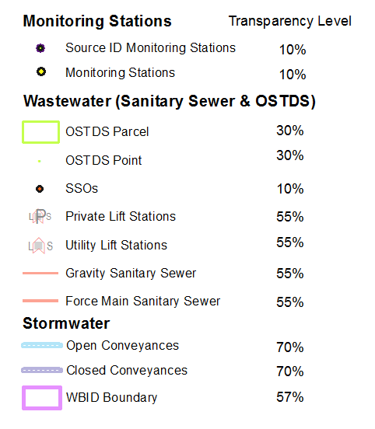
Recommended Layer Name Transparency Level
Monitoring Stations
Source ID Monitoring Stations 10%
Monitoring Stations 10%
Wastewater (Sanitary Sewer & OSTDS)
OSTDS (Point File or Parcel Outline) 30%
*SSOs 10%
Private Lift stations 55%
Utility Lift Stations 55%
Gravity Sanitary Sewer 55%
Force Main Sanitary Sewer 55%
Stormwater
Open Stormwater Conveyance 70%
Closed Stormwater Conveyance 70%
WBID Boundary 57%
Florida NHD 0%

Site Focused Maps & Area of Interest Map (ex. 8.5”x11” zoomed to a few blocks)

Recommended Layer Name Transparency Level
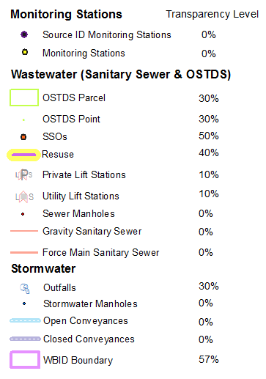
Monitoring Stations
Source ID Monitoring Stations 0%
Monitoring Stations 0%
Wastewater (Sanitary Sewer & OSTDS)
OSTDS (Point File or Parcel Outline) 30%
*SSO's 50%
Reuse 40%
Private Lift stations 10%
Utility Lift Stations 10%
Sewer Manholes (2pt white halo) 0%
Gravity Sanitary Sewer 0%
Force Main Sanitary Sewer 0%
Stormwater
Outfalls 30%
Stormwater Manholes (2pt white halo) 0%
Open Stormwater Conveyance 0%
Closed Stormwater Conveyance 0%
WBID Boundary 57%
Florida NHD 0%

*Recent refers to activities within the last 2 years

